

Italy 

## Prices (2019 and recent evolution)

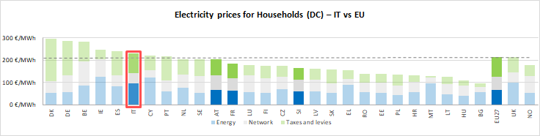see footnote[1]

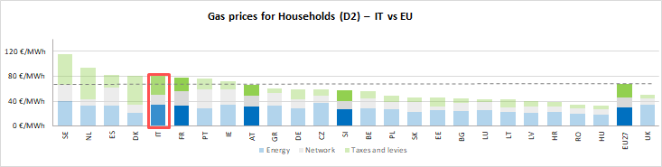

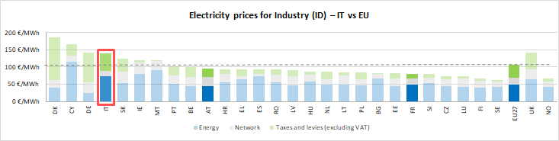

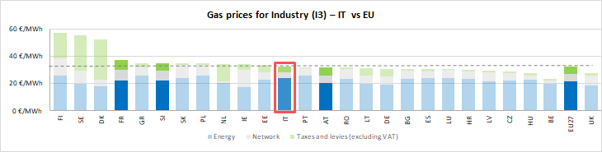

See footnote [2]

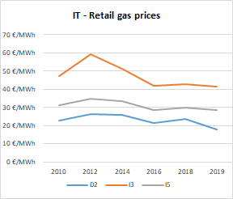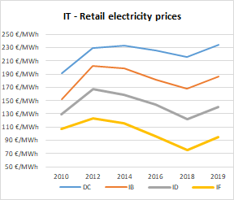

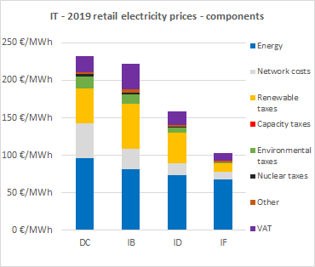

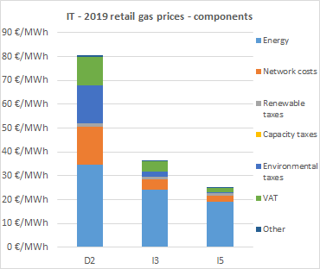

**Oil products prices**

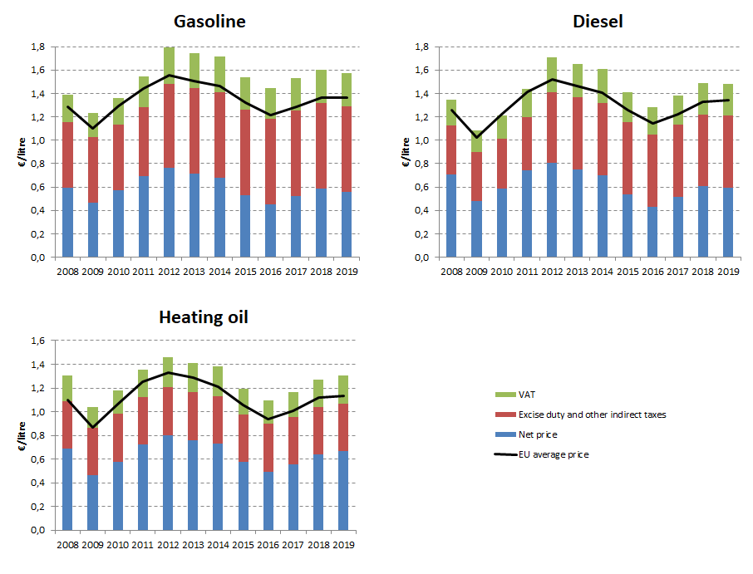

## Energy costs for households, industry and services

**Energy in Household budgets**

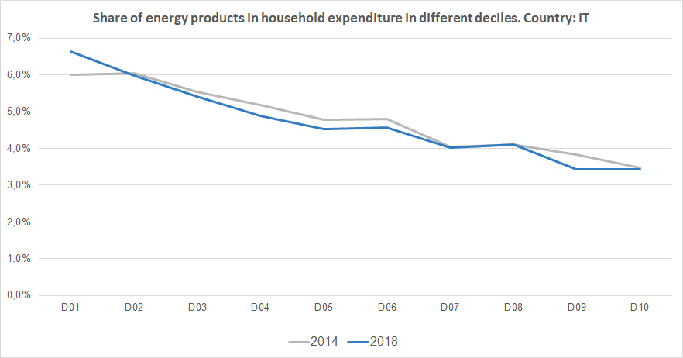

Notes: In 2014 in Italy (grey line) the poorest households (Decile 1) had to spend 6.0% of their total expenditures on energy products. In 2018 (blue line) the share of energy increased to 6.6%.In the case of middle income households (Decile 5), in 2014 they spent 4.8 % of their total expenditure on energy, while in 2018 this value decreased to 4.5%. See footnote [3]

**Energy costs shares in total production costs**

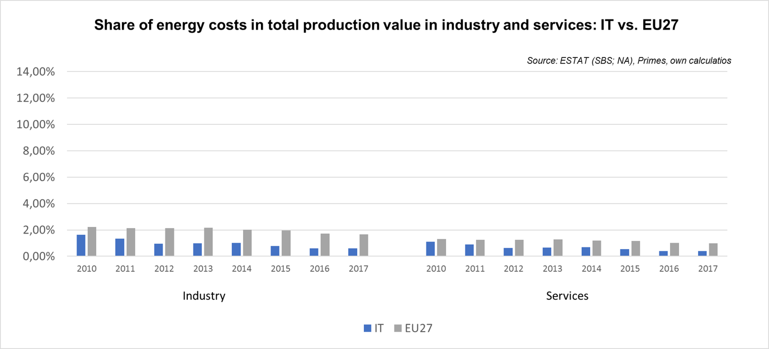

Notes: Data for Malta is only available for 2016. Data for Poland (prior to 2015), Slovenia (prior to 2012) and Greece (prior to 2008) is not available. At the time of extraction, the data for 2018 was not available.

Latvia 

## Prices (2019 and recent evolution)

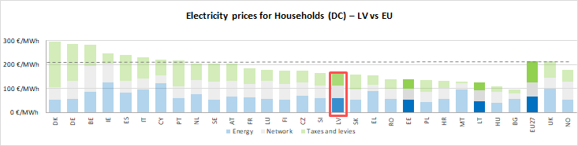See footnote[4]

**Gas prices for Industry (I3) – LV vs EU**

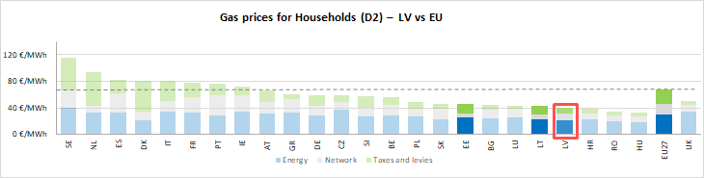

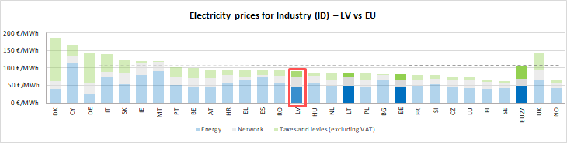

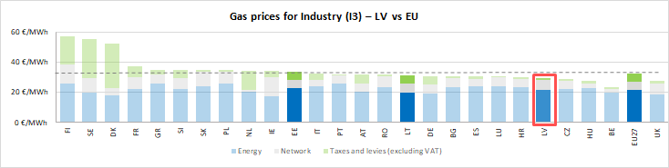



See footnote [5]

(DC)

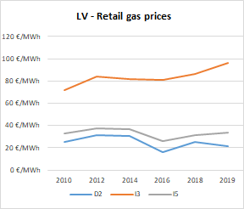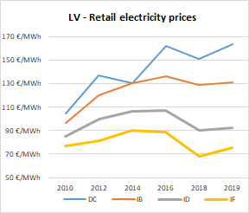

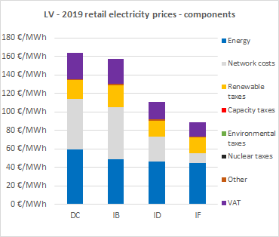

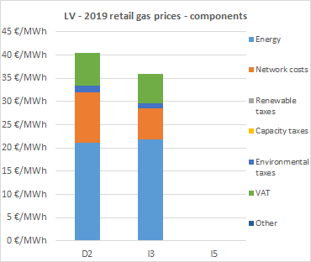

**Oil products prices**

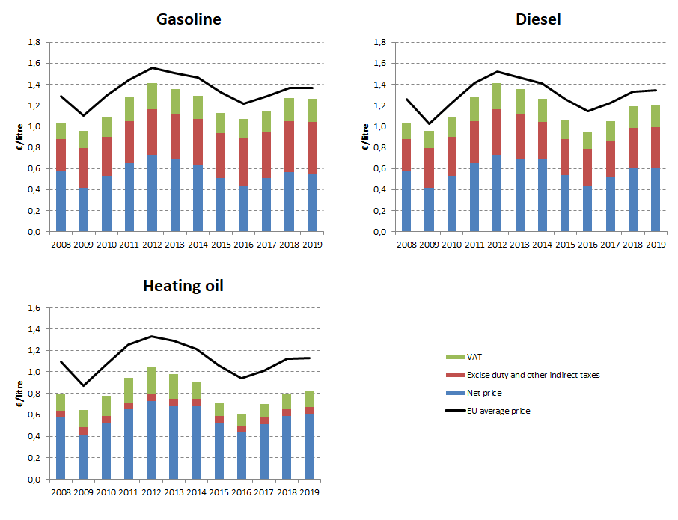

## Energy costs for households, industry and services

**Energy in Household budgets**

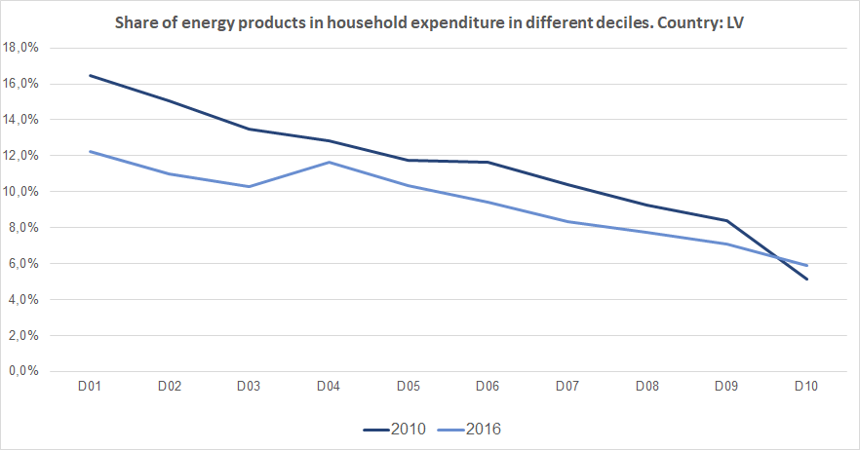

Notes: In 2010 in Latvia (dark blue line) the poorest households (Decile 1) had to spend 16.4% of their total expenditures on energy products. In 2016 (blue line) the share of energy decreased to 12.2%.In the case of middle income households (Decile 5), in 2010 they spent 11.8 % of their total expenditure on energy, while in 2016 this value decreased to 10.4%. See footnote [6]

**Energy costs shares in total production costs**

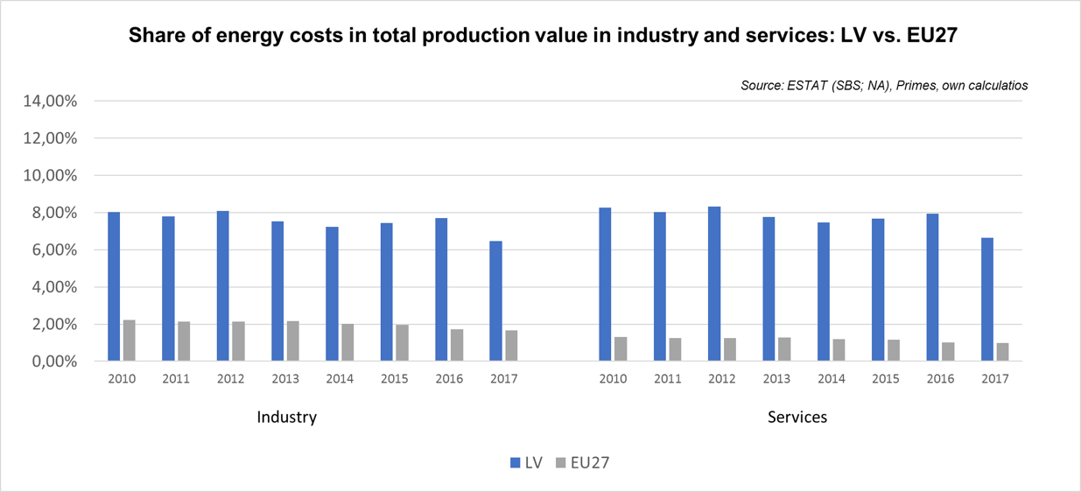

Notes: Data for Malta is only available for 2016. Data for Poland (prior to 2015), Slovenia (prior to 2012) and Greece (prior to 2008) is not available. At the time of extraction, the data for 2018 was not available.

Lithuania 

## Prices (2019 and recent evolution)

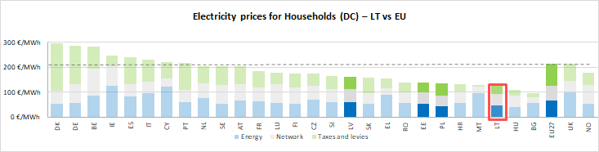see footnote[7]

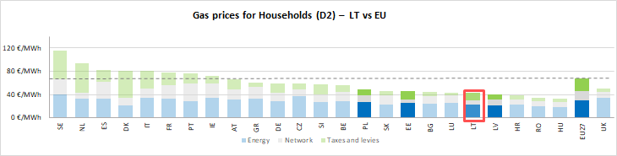

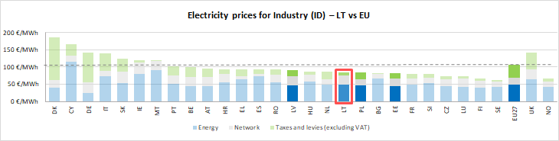

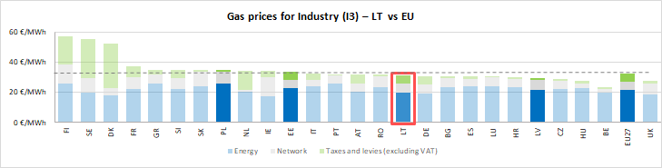



See footnote [8]

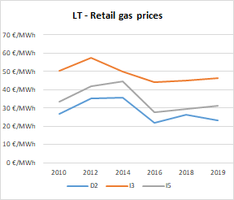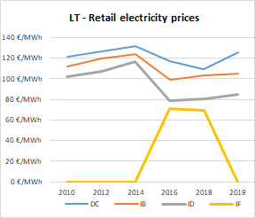

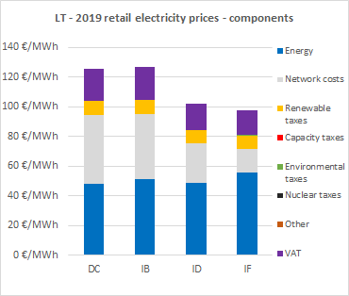

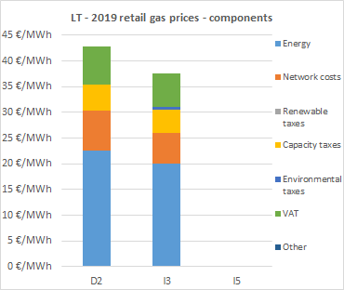

**Oil products prices**

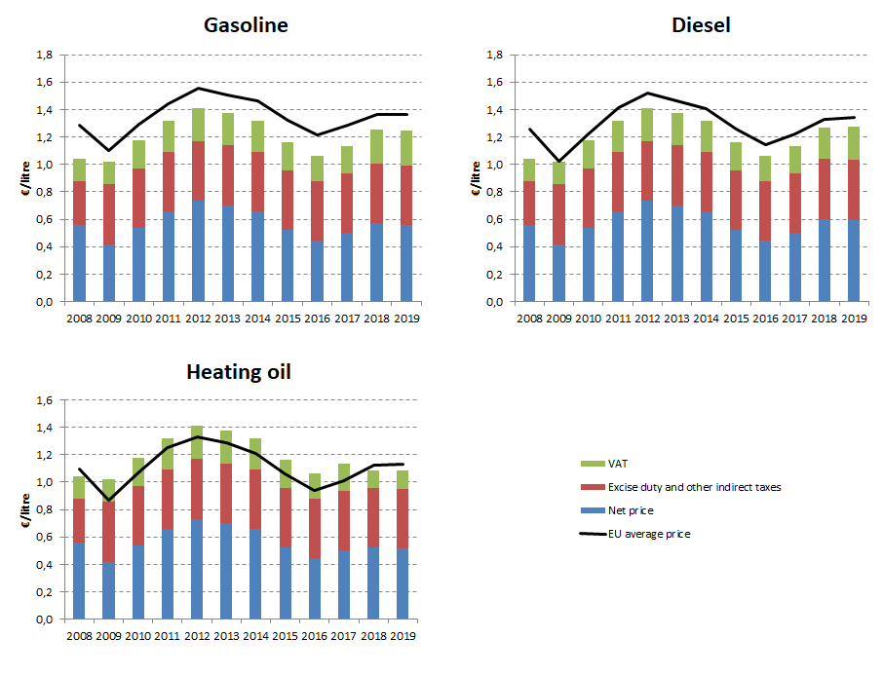

## Energy costs for households, industry and services

**Energy in Household budgets**

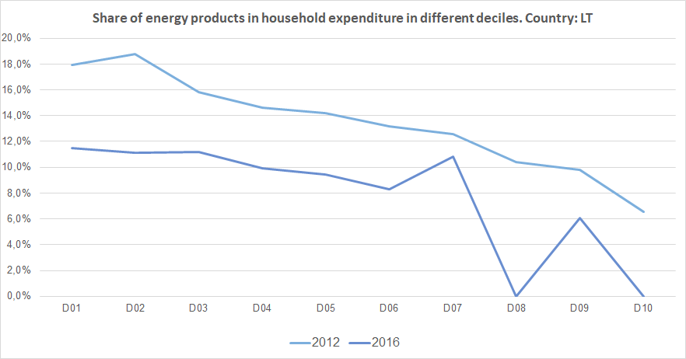

Notes: In 2012 in Lithuania (light blue line) the poorest households (Decile 1) had to spend 17.9% of their total expenditures on energy products. In 2016 (blue line) the share of energy decreased to 11.5%.In the case of middle income households (Decile 5), in 2012 they spent 14.2 % of their total expenditure on energy, while in 2016 this value decreased to 9.4%. See footnote [9]

**Energy costs shares in total production costs**

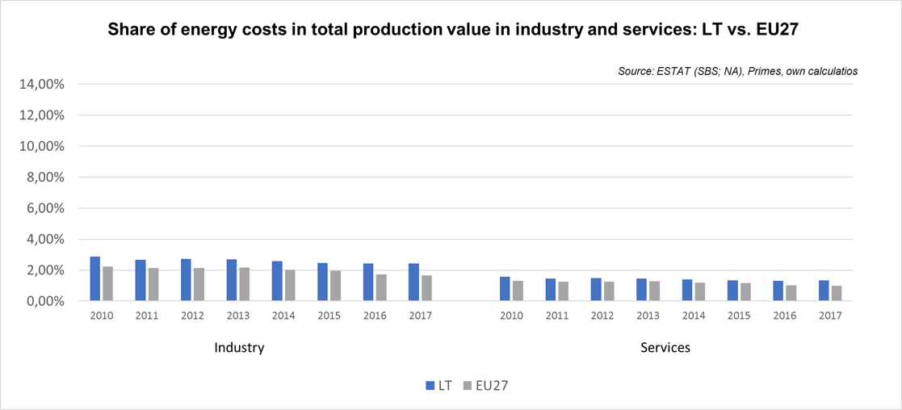

Notes: Data for Malta is only available for 2016. Data for Poland (prior to 2015), Slovenia (prior to 2012) and Greece (prior to 2008) is not available. At the time of extraction, the data for 2018 was not available.

Luxembourg 

## Prices (2019 and recent evolution)

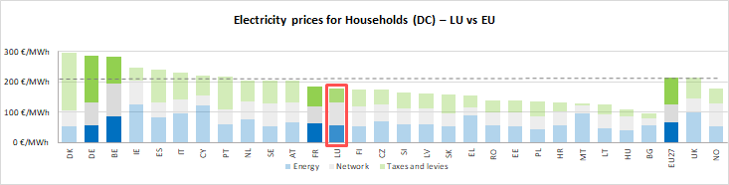see footnote[10]

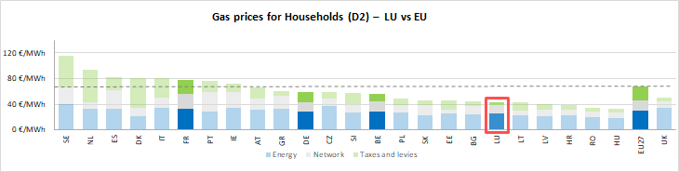

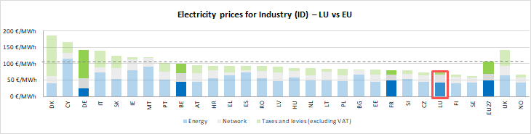

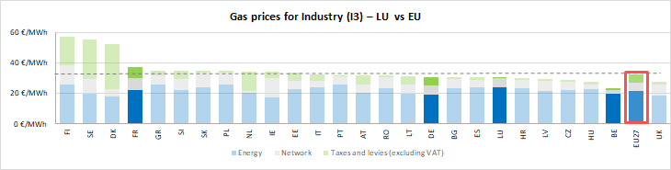

See footnote [11]

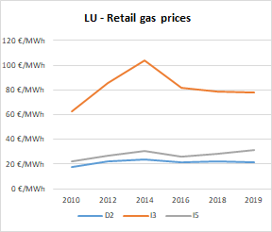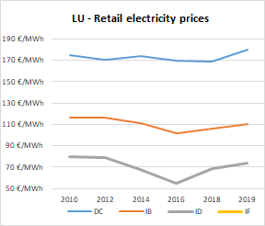

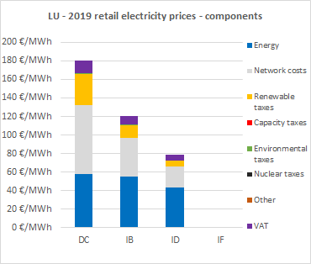**Prices**

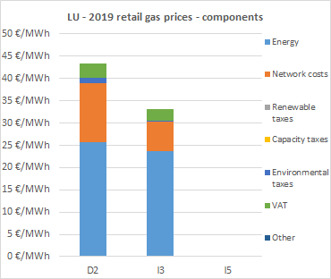

**Oil products prices**

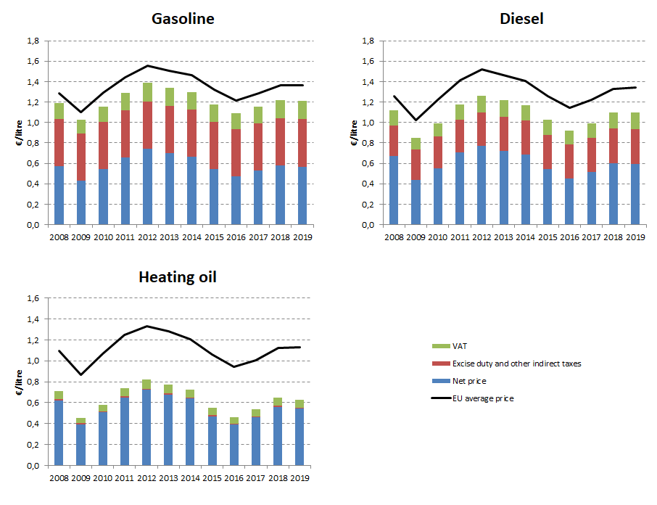

## Energy costs for households, industry and services

**Energy in Household budgets**

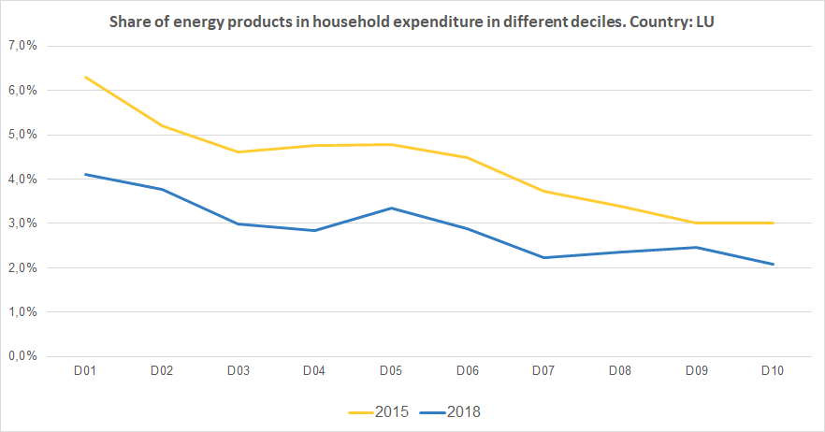

Notes: In 2015 in Luxembourg (yellow line) the poorest households (Decile 1) had to spend 6.3% of their total expenditures on energy products. In 2018 (blue line) the share of energy decreased to 4.1%.In the case of middle income households (Decile 5), in 2015 they spent 4.8 % of their total expenditure on energy, while in 2018 this value decreased to 3.4%. See footnote [12]

**Energy costs shares in total production costs**

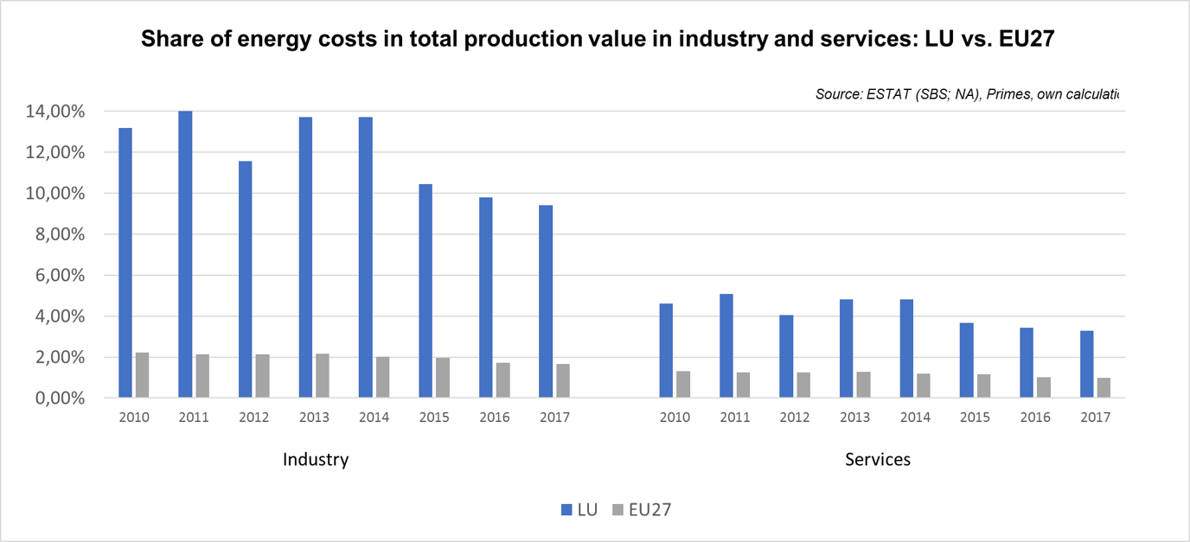

Notes: Data for Malta is only available for 2016. Data for Poland (prior to 2015), Slovenia (prior to 2012) and Greece (prior to 2008) is not available. At the time of extraction, the data for 2018 was not available.

Malta 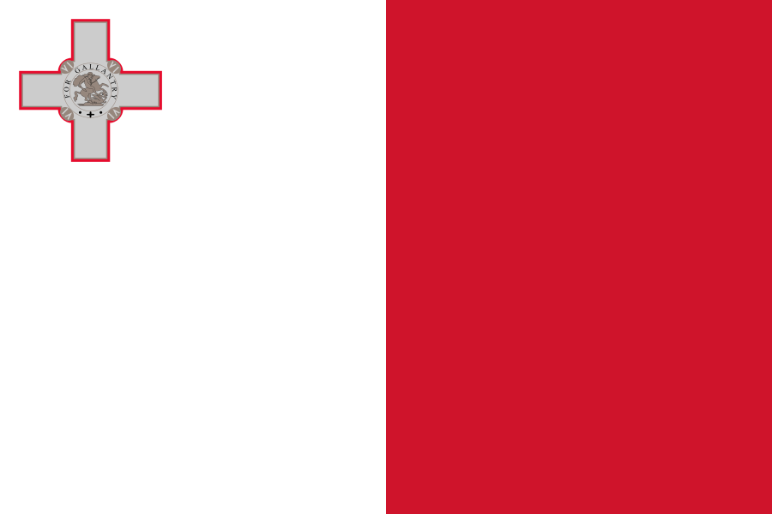

## Prices (2019 and recent evolution)

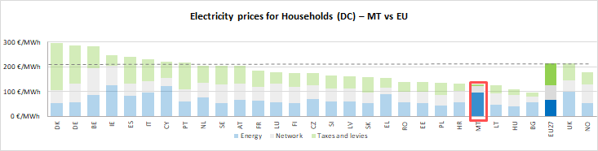see footnote[13]

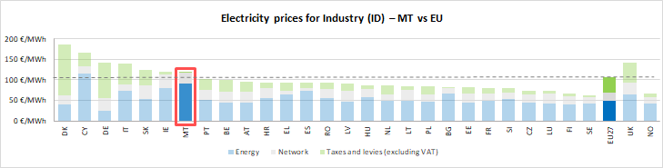



See footnote [14]

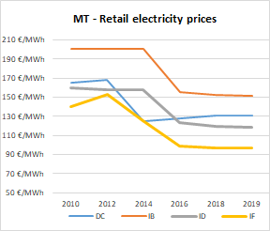

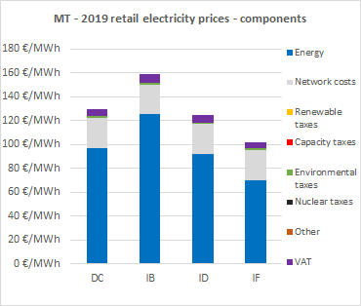

**Oil products prices**

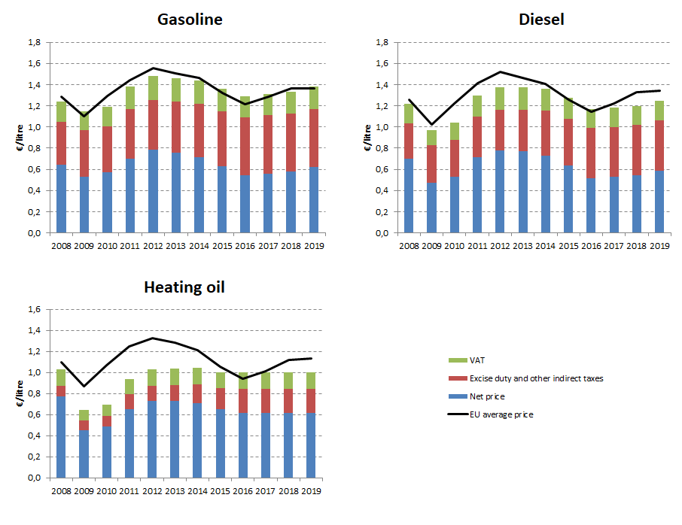

## Energy costs for households, industry and services

**Energy in Household budgets**

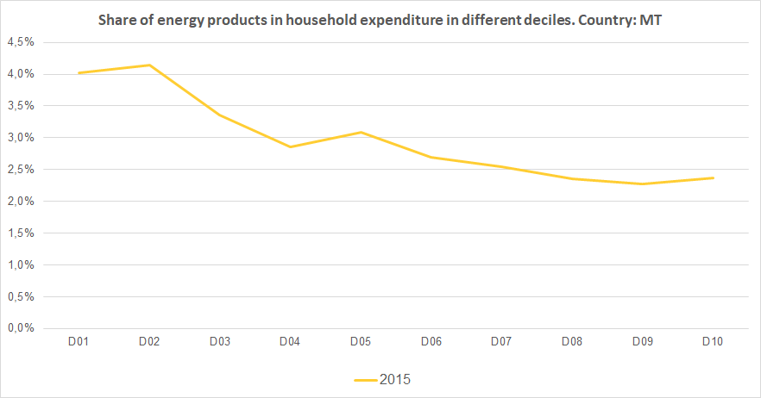

Notes: In 2015 in Malta (yellow line) the poorest households (Decile 1) had to spend 4.0% of their total expenditures on energy products. In the case of middle income households (Decile 5), in the same year they spent 3.1% of their total expenditure on energy. See footnote [15]

**Energy costs shares in total production costs**

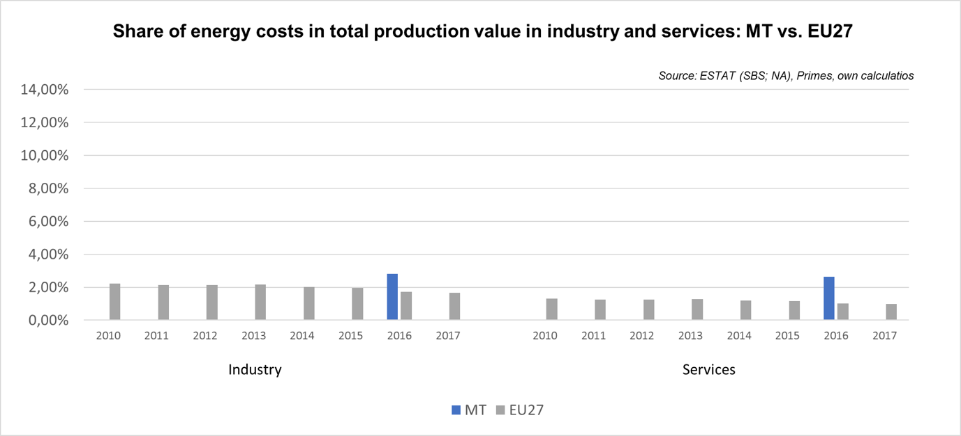

Notes: Data for Malta is only available for 2016. Data for Poland (prior to 2015), Slovenia (prior to 2012) and Greece (prior to 2008) is not available. At the time of extraction, the data for 2018 was not available.

Netherlands 

## Prices (2019 and recent evolution)

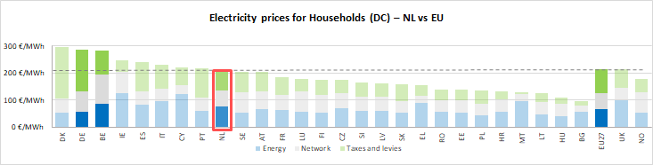

see footnote[16]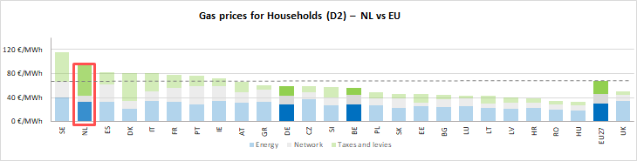

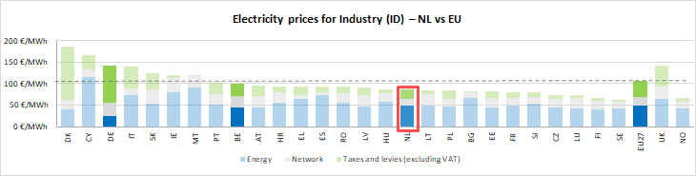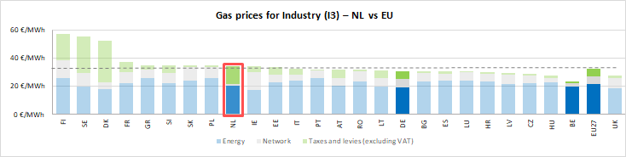

See footnote [17]

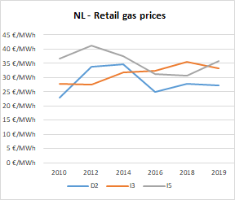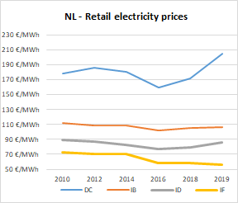

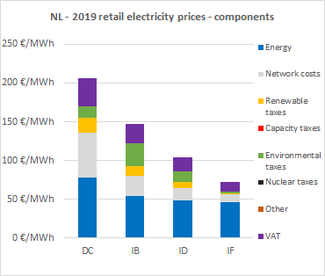

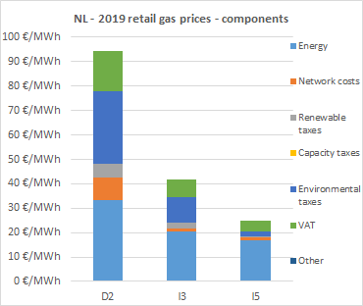

**Oil products prices**

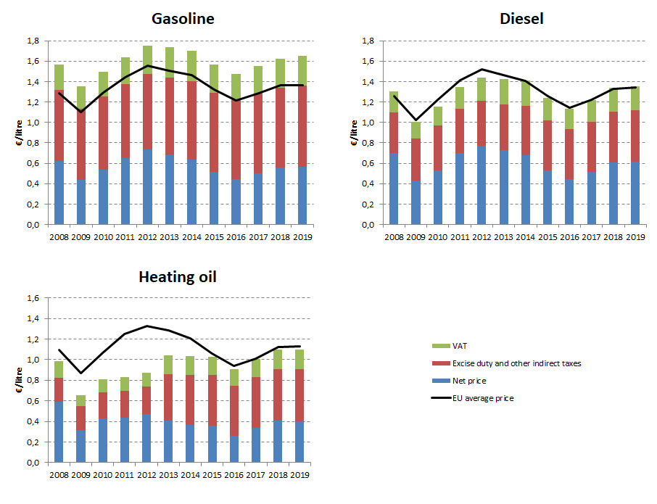

## Energy costs for households, industry and services

**Energy in Household budgets**

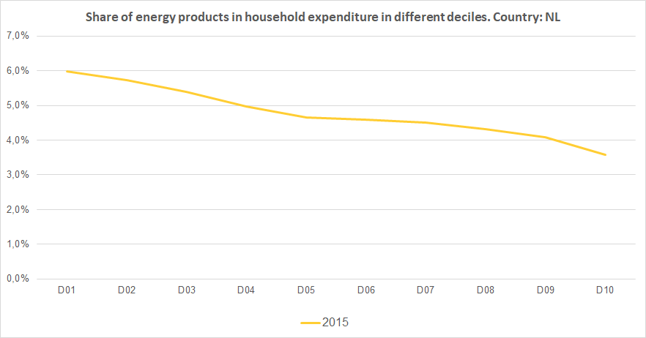

Notes: In 2015 in the Netherlands (yellow line) the poorest households (Decile 1) had to spend 6.0% of their total expenditures on energy products. In the case of middle income households (Decile 5), in the same year they spent 4.7% of their total expenditure on energy. See footnote [18]

**Energy costs shares in total production costs**

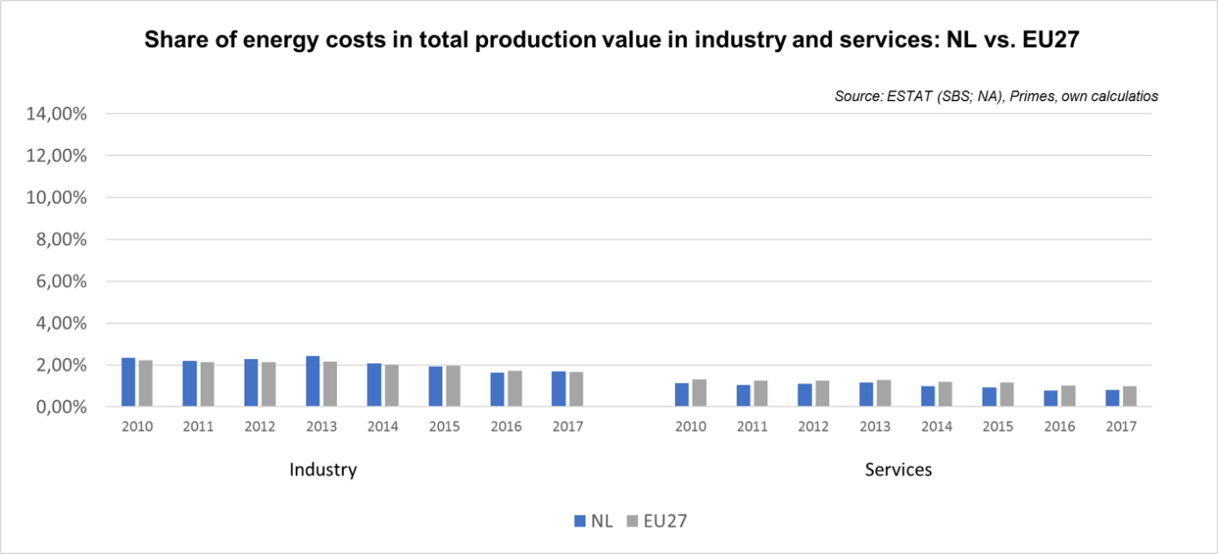

Notes: Data for Malta is only available for 2016. Data for Poland (prior to 2015), Slovenia (prior to 2012) and Greece (prior to 2008) is not available. At the time of extraction, the data for 2018 was not available.

Poland 

## Prices in 2019

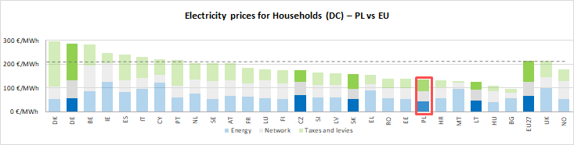

see footnote[19]

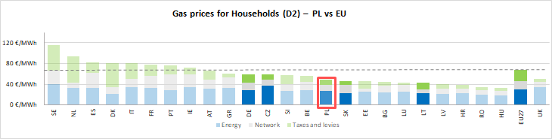

**Prices**

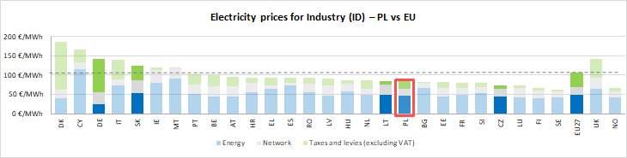

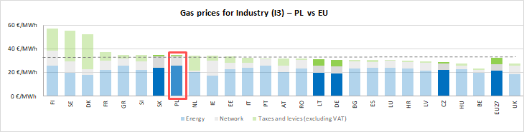

See footnote [20]

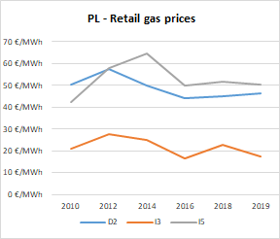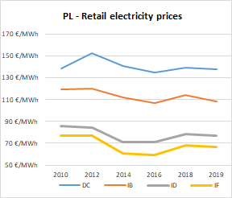

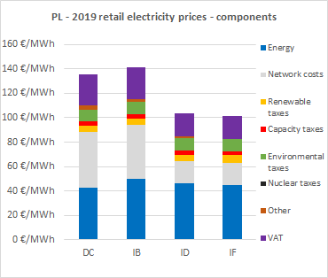

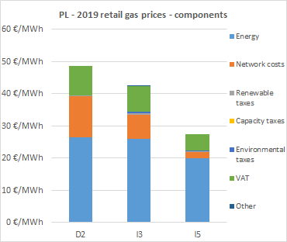

**Oil products prices**

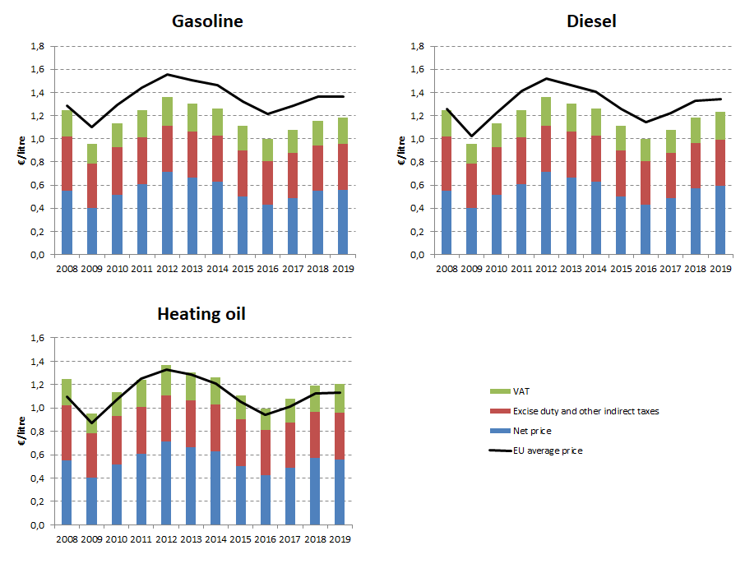

## Energy costs for households, industry and services

**Energy in Household budgets**

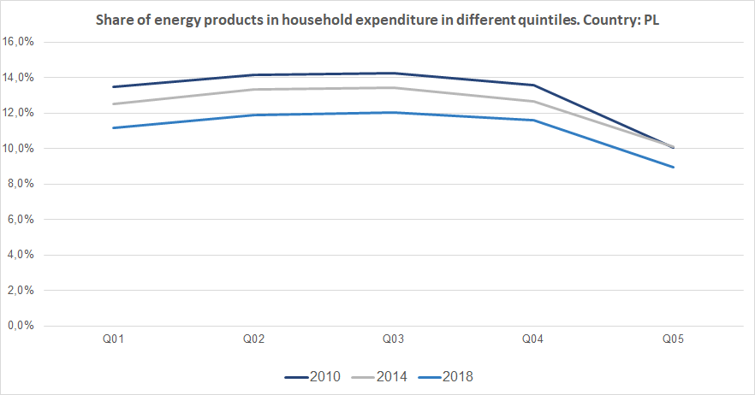

Notes: In 2010 in Poland (dark blue line) the poorest households (Quintile 1) had to spend 13.5% of their total expenditures on energy products. In 2018 (blue line) the share of energy decreased to 11.2%.In the case of middle income households (Quintile 3), in 2010 they spent 14.2% of their total expenditure on energy, while in 2018 this value decreased to 12.0%. See footnote [21]

**Energy costs shares in total production costs**

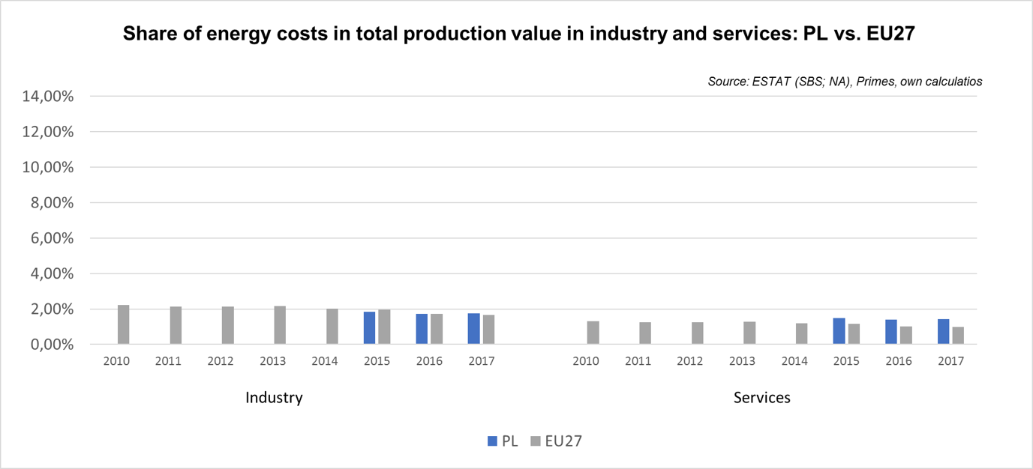

Notes: Data for Malta is only available for 2016. Data for Poland (prior to 2015), Slovenia (prior to 2012) and Greece (prior to 2008) is not available. At the time of extraction, the data for 2018 was not available.

Portugal 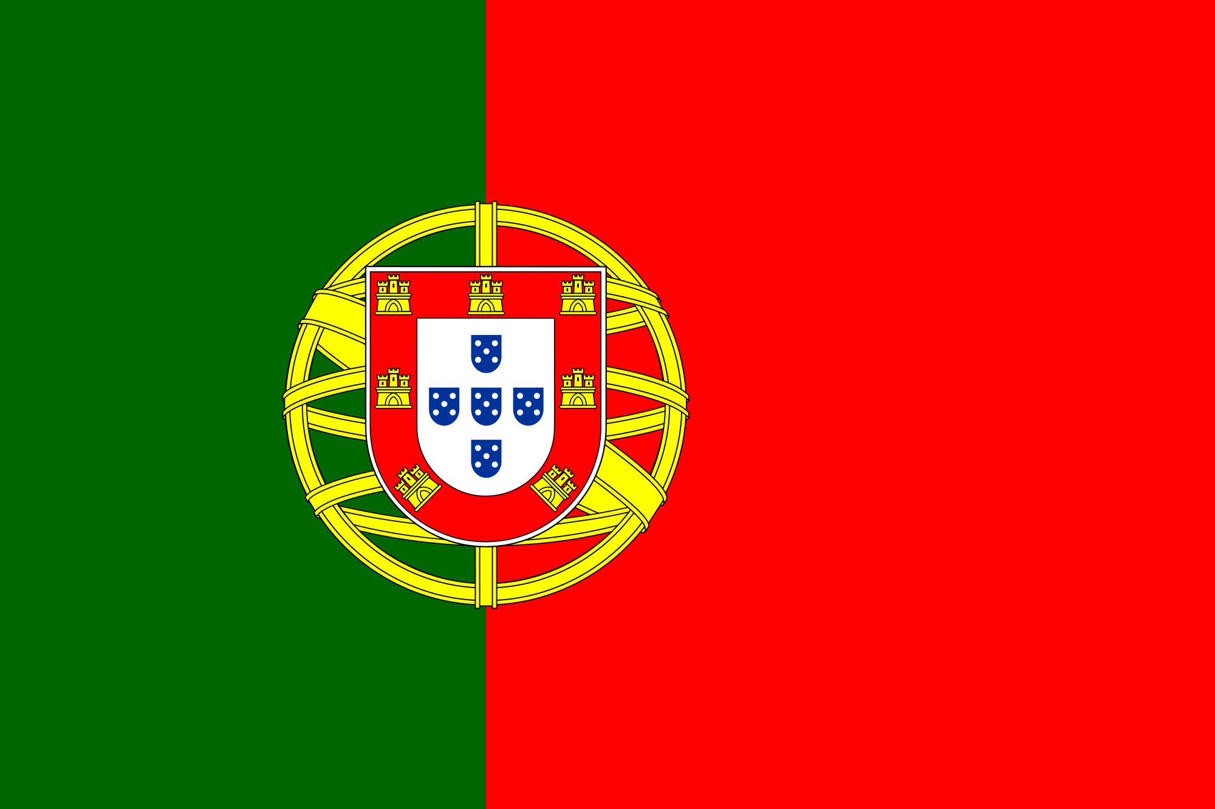

## Prices (2019 and recent evolution)

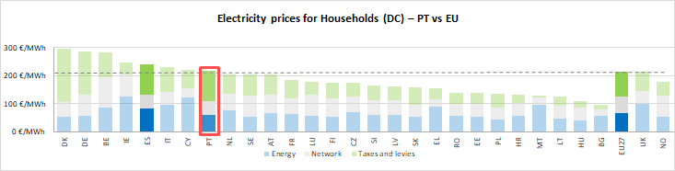

see footnote[22]

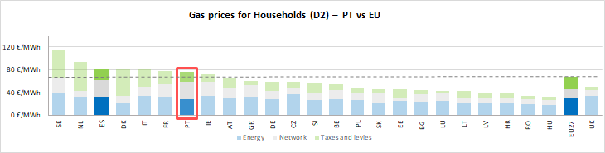

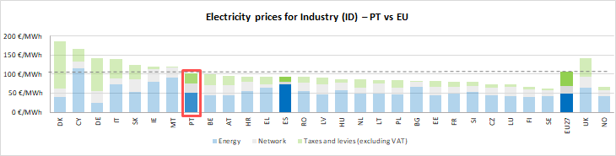

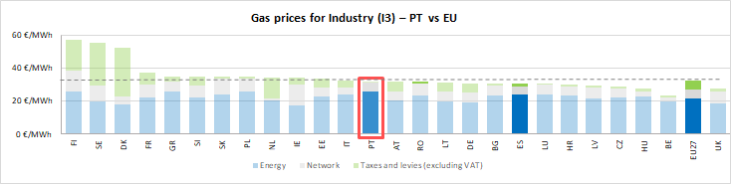

See footnote [23]



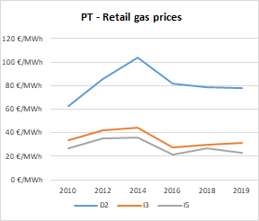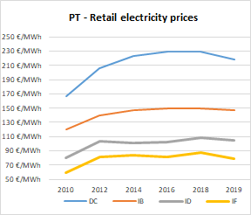

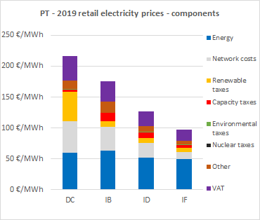

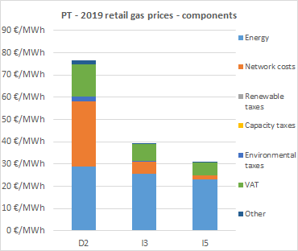

**Oil products prices**

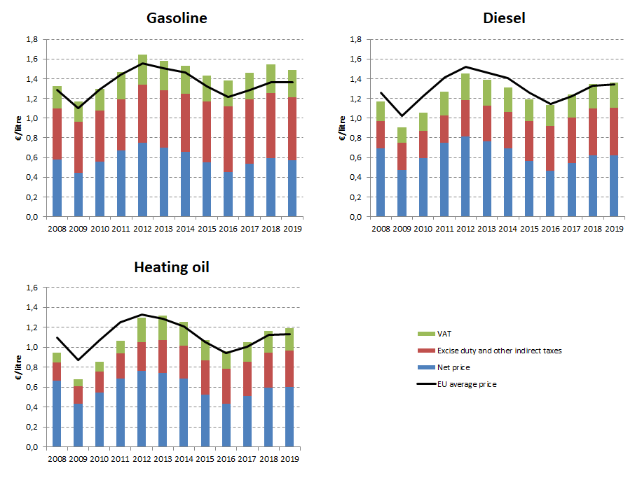

## Energy costs for households, industry and services

**Energy in Household budgets**

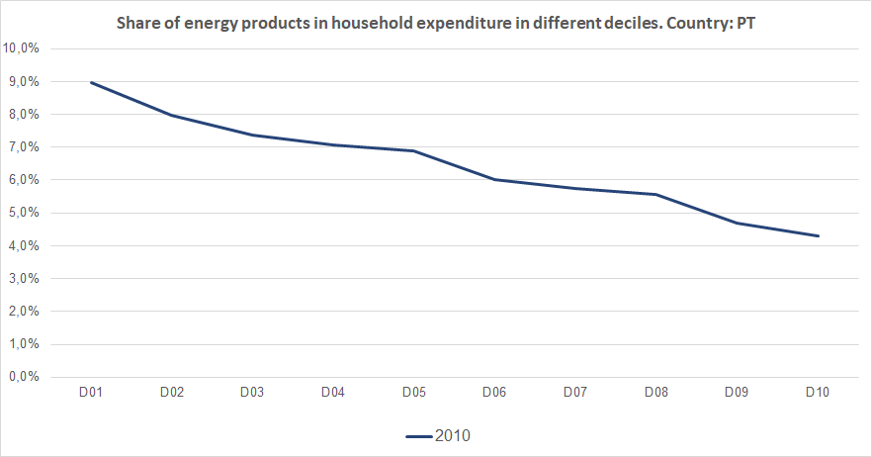

Notes: In 2010 in Portugal (blue dark line) the poorest households (Decile 1) had to spend 9.0% of their total expenditures on energy products. In the case of middle income households (Decile 5), in the same year they spent 6.9% of their total expenditure on energy. See footnote [24]

**Energy costs shares in total production costs**

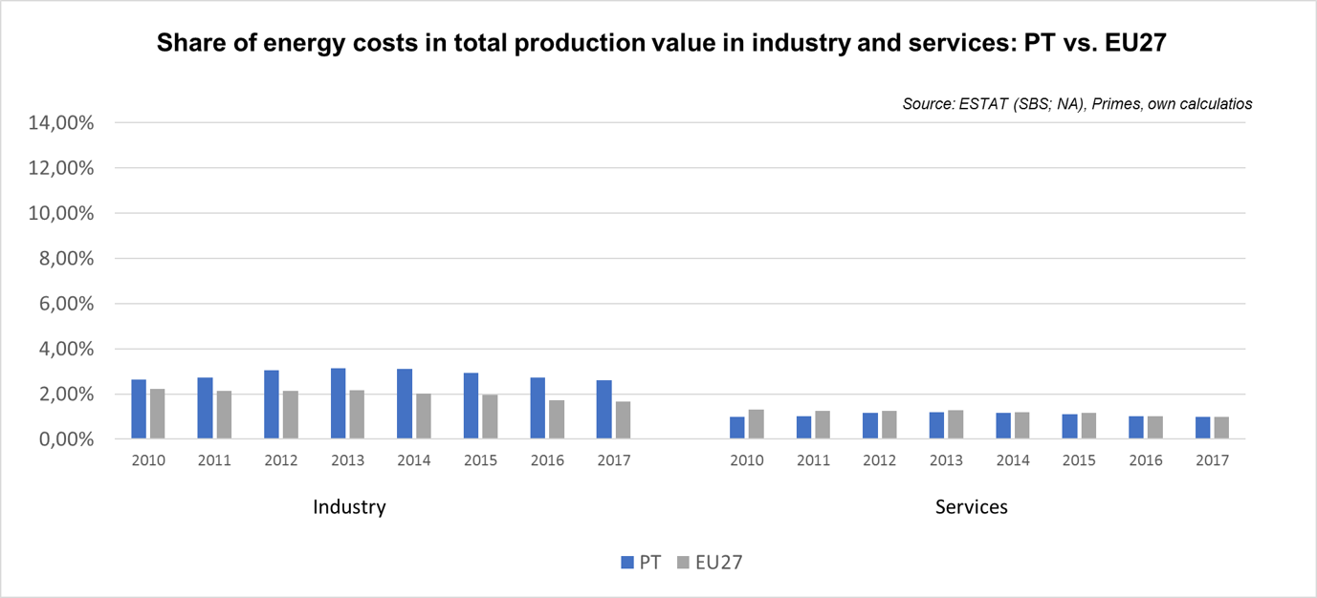

Notes: Data for Malta is only available for 2016. Data for Poland (prior to 2015), Slovenia (prior to 2012) and Greece (prior to 2008) is not available. At the time of extraction, the data for 2018 was not available.

Romania

## Prices (2019 and recent evolution)

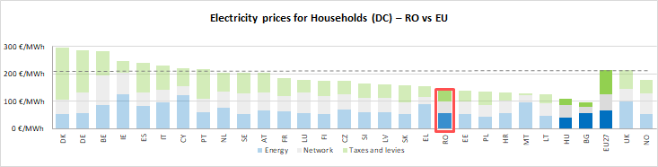 see footnote[25]

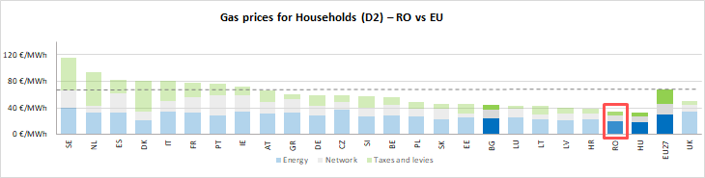

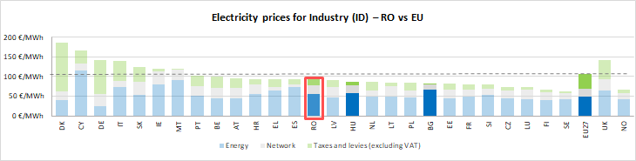

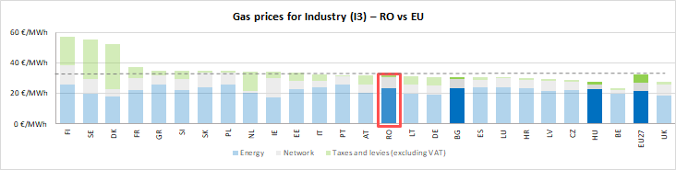



See footnote [26]

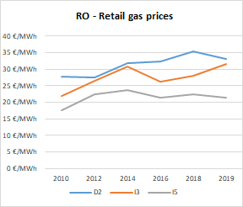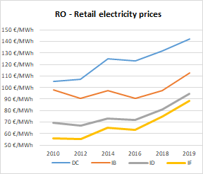

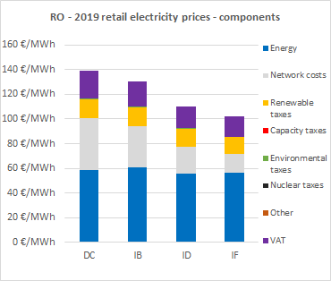

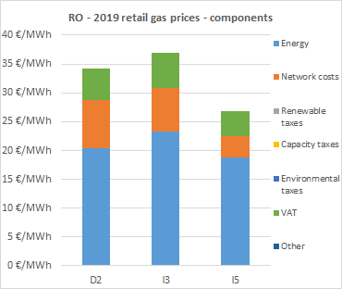

**Oil products prices**

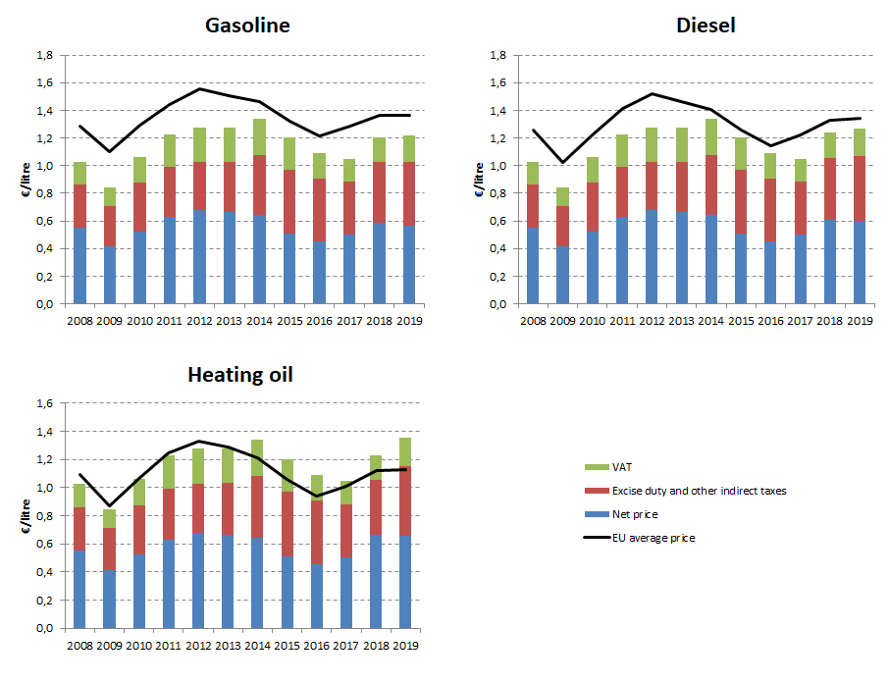

## Energy costs for households, industry and services

**Energy in Household budgets**

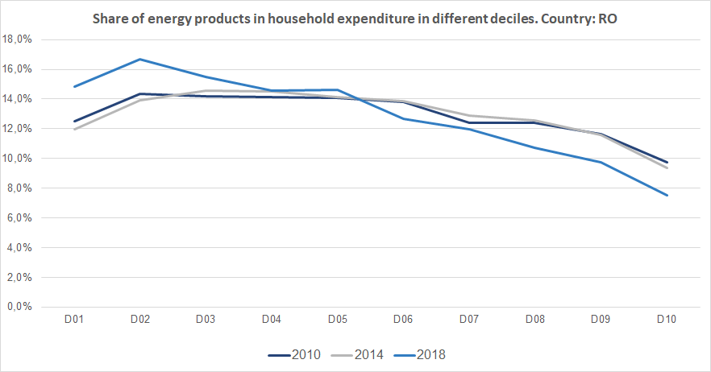

Notes: In 2010 in Romania (dark blue line) the poorest households (Decile 1) had to spend 12.5% of their total expenditures on energy products. In 2018 (blue line) the share of energy increased to 14.8%.In the case of middle income households (Decile 5), in 2010 they spent 14.1% of their total expenditure on energy, while in 2018 this value increased marginally to 14.6%. See footnote [27]

**Energy costs shares in total production costs**

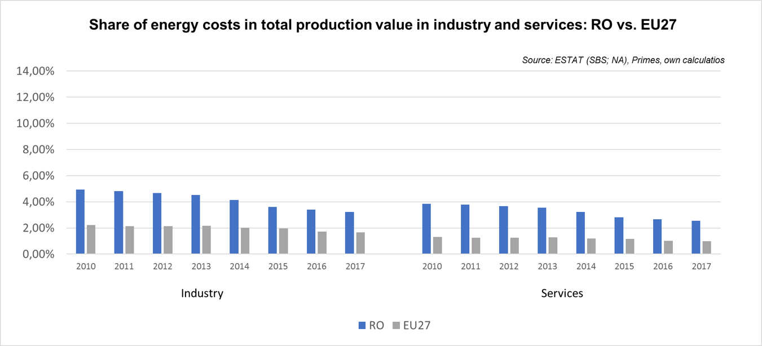

Notes: Data for Malta is only available for 2016. Data for Poland (prior to 2015), Slovenia (prior to 2012) and Greece (prior to 2008) is not available. At the time of extraction, the data for 2018 was not available.

Slovakia

## Prices (2019 and recent evolution)

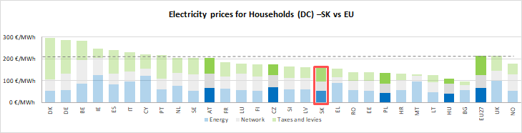

see footnote[28]

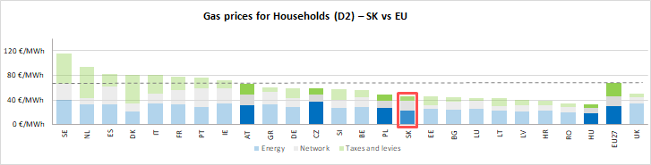

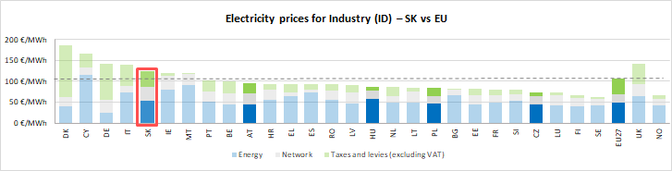

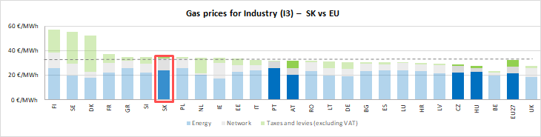

See footnote [29]



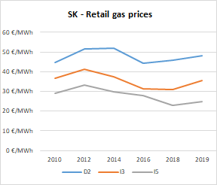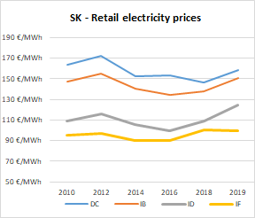

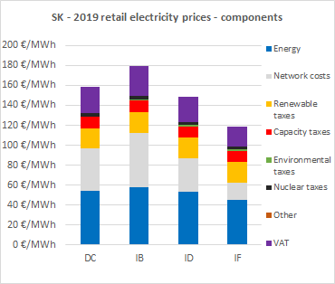

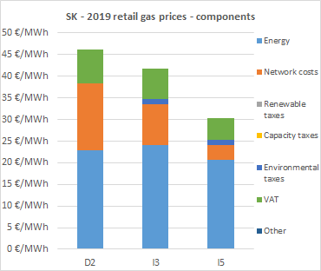

**Oil products prices**

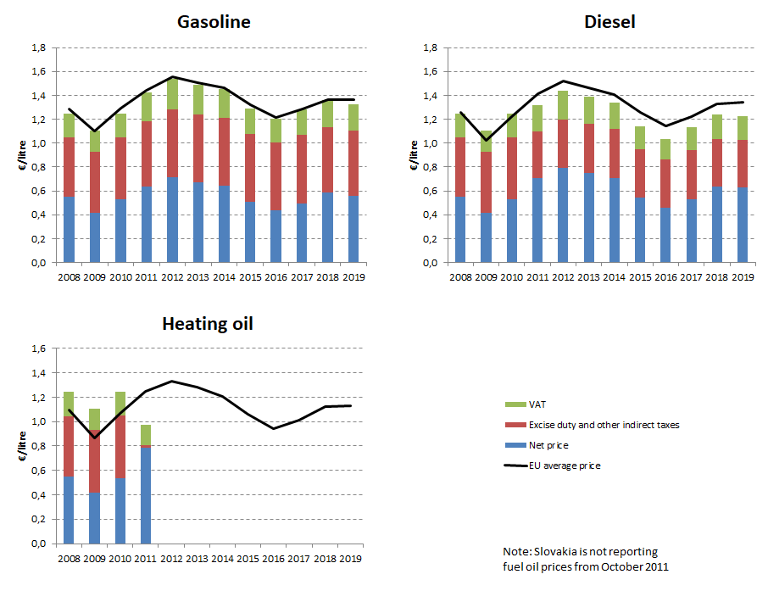

## Energy costs for households, industry and services

**Energy in Household budgets**

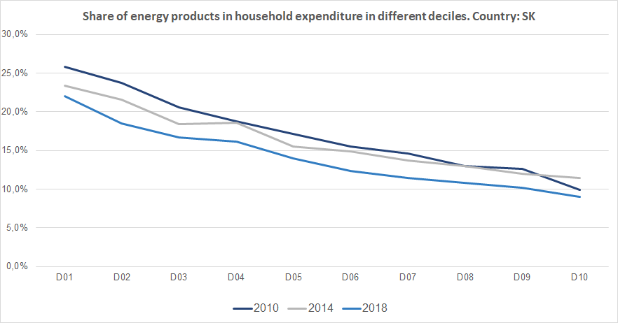

Notes: In 2010 in Slovakia (dark blue line) the poorest households (Decile 1) had to spend 25.8% of their total expenditures on energy products. In 2018 (blue line) the share of energy decreased to 22.1%.In the case of middle income households (Decile 5), in 2010 they spent 17.1% of their total expenditure on energy, while in 2018 this value decreased to 13.9%. See footnote [30]

**Energy costs shares in total production costs**

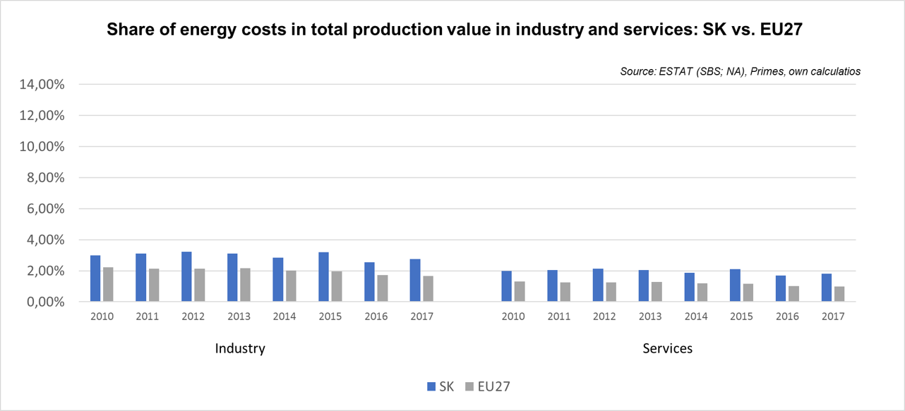

Notes: Data for Malta is only available for 2016. Data for Poland (prior to 2015), Slovenia (prior to 2012) and Greece (prior to 2008) is not available. At the time of extraction, the data for 2018 was not available.

Slovenia 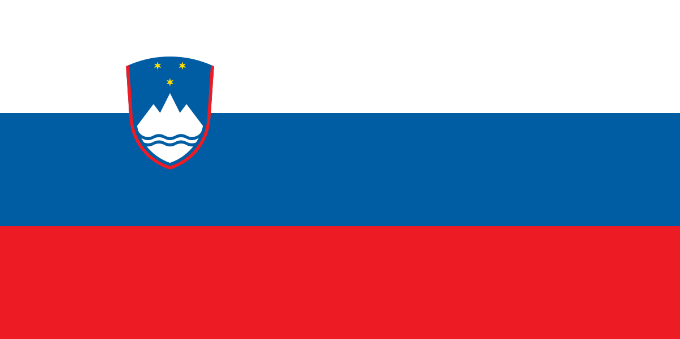

## Prices (2019 and recent evolution)

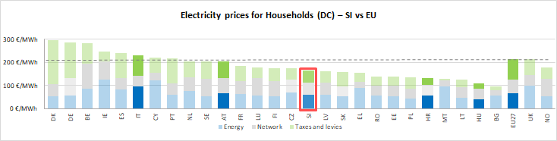

see footnote[31]

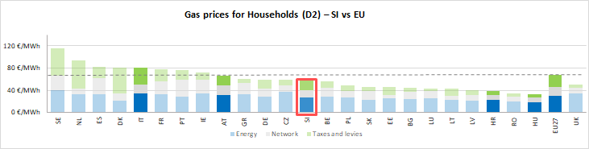

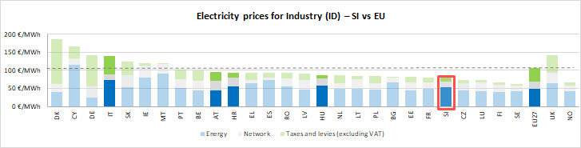

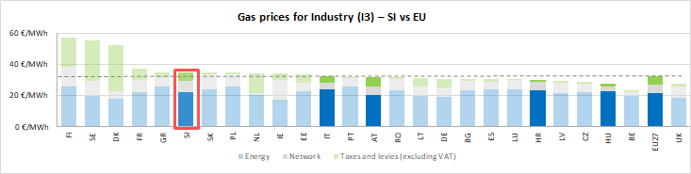

See footnote [32]

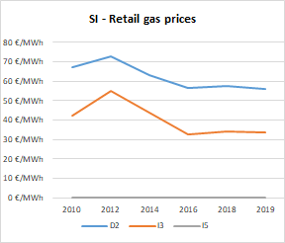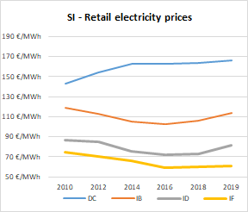

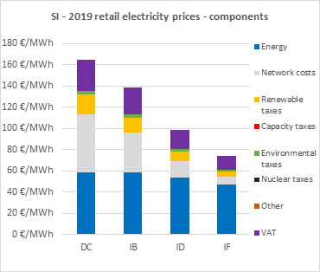

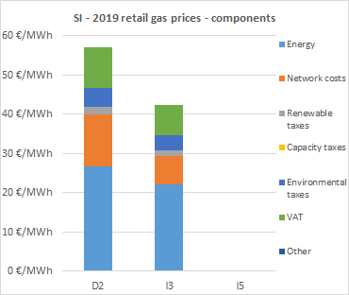

**Oil products prices**

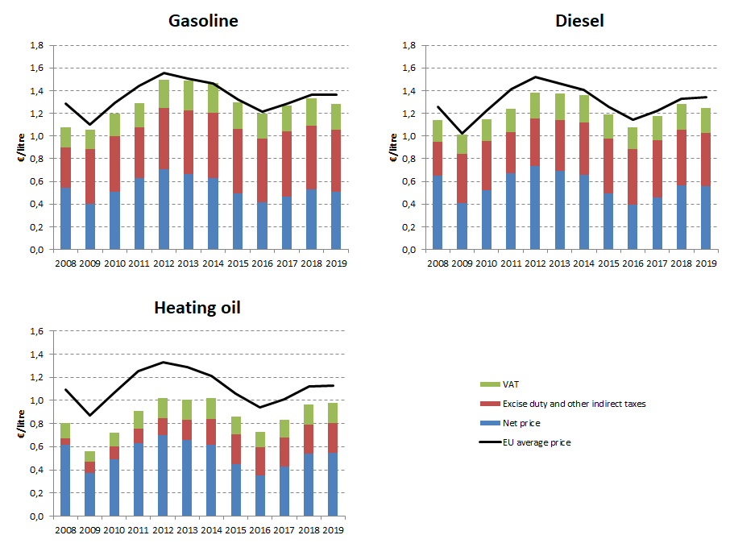

## Energy costs for households, industry and services

**Energy in Household budgets**

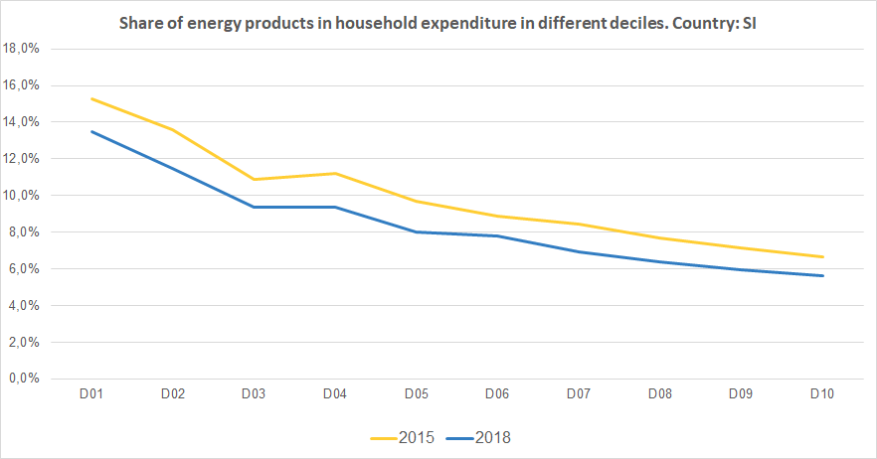

Notes: In 2015 in Slovenia (yellow line) the poorest households (Decile 1) had to spend 15.3% of their total expenditures on energy products. In 2018 (blue line) the share of energy decreased to 13.4%.In the case of middle income households (Decile 5), in 2015 they spent 10.0% of their total expenditure on energy, while in 2018 this value decreased to 8.0%. See footnote [33]

**Energy costs shares in total production costs**

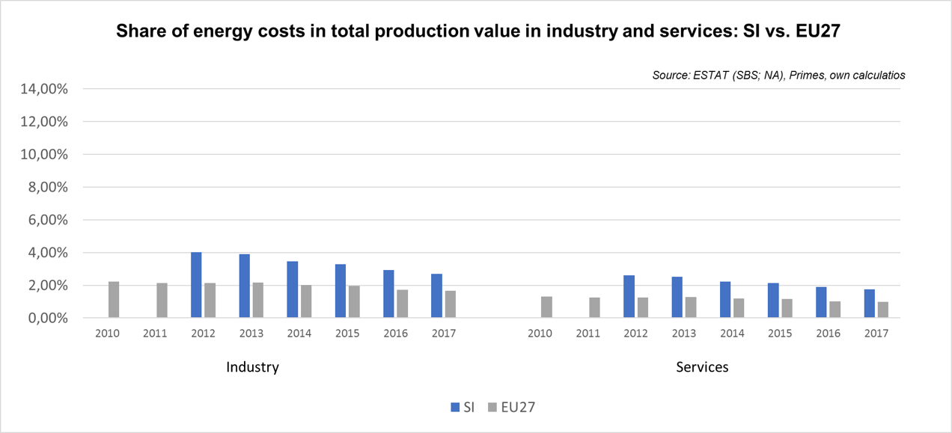

Notes: Data for Malta is only available for 2016. Data for Poland (prior to 2015), Slovenia (prior to 2012) and Greece (prior to 2008) is not available. At the time of extraction, the data for 2018 was not available.

**Spain** 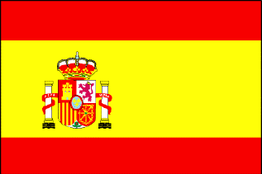

## Prices (2019 and recent evolution)

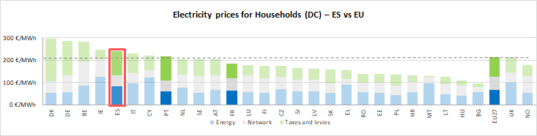see footnote[34]

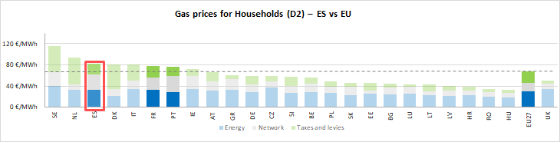

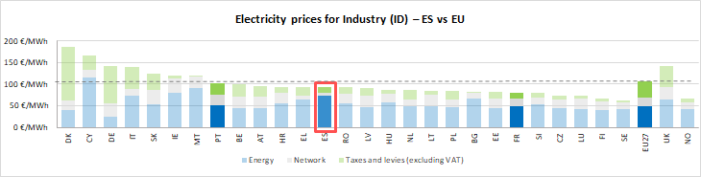

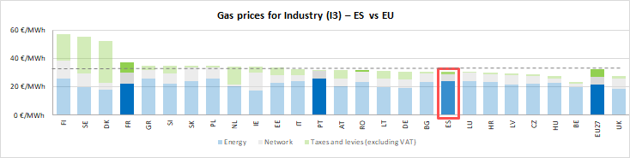



See footnote [35]

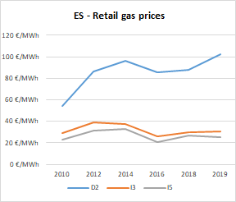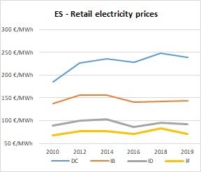

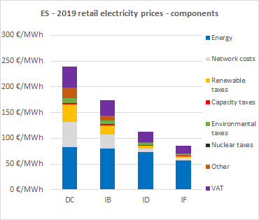

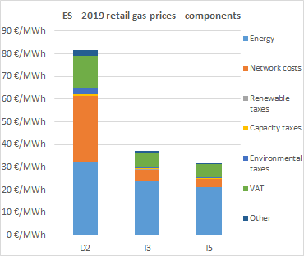

**Oil products prices**

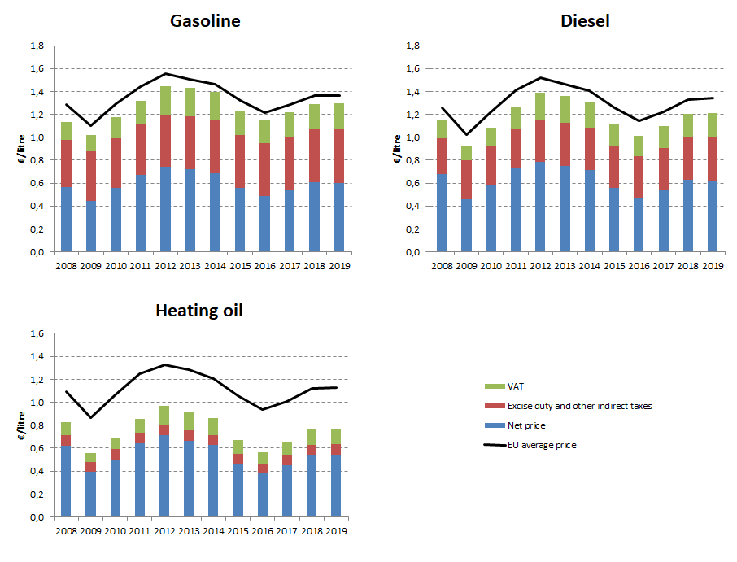

## Energy costs for households, industry and services

**Energy in Household budgets**

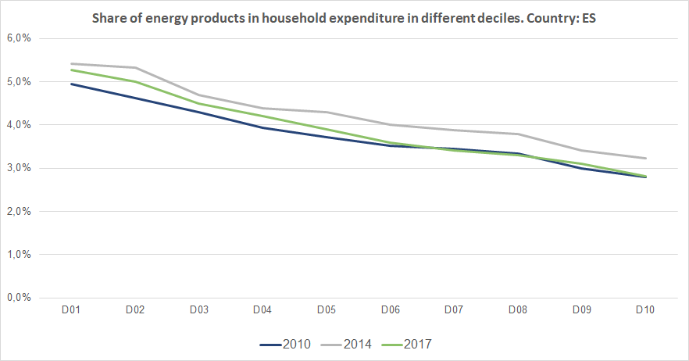

Notes: In 2010 in Spain (dark blue line) the poorest households (Decile 1) had to spend 5.0% of their total expenditures on energy products. In 2017 (grey line) the share of energy increased marginally to 5.3%.In the case of middle income households (Decile 5), in 2010 they spent 3.7% of their total expenditure on energy, while in 2017 this value remained almost unchanged. See footnote [36]

**Energy costs shares in total production costs**

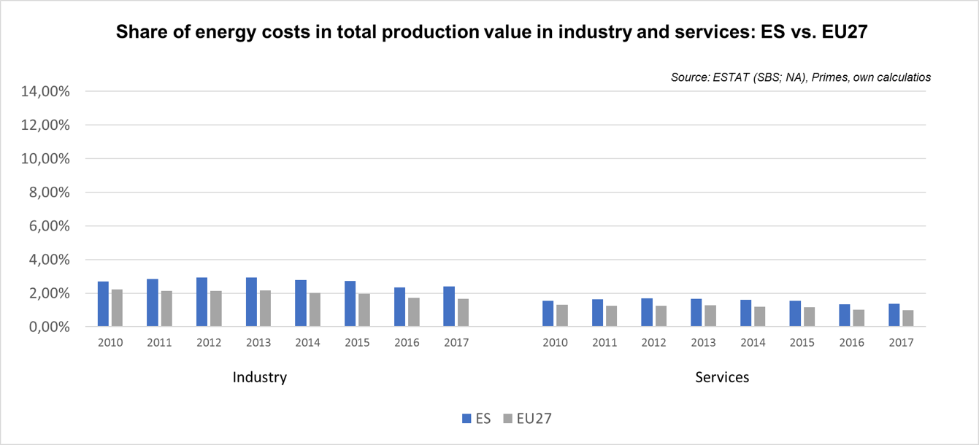

Notes: Data for Malta is only available for 2016. Data for Poland (prior to 2015), Slovenia (prior to 2012) and Greece (prior to 2008) is not available. At the time of extraction, the data for 2018 was not available.

Sweden 

## Prices (2019 and recent evolution)

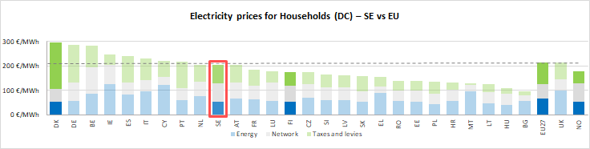see footnote[37]

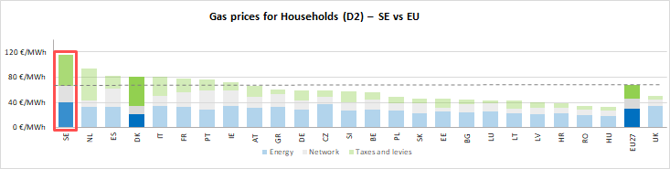

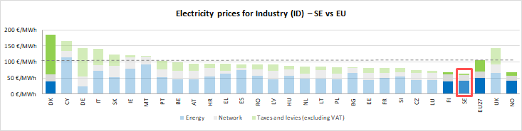

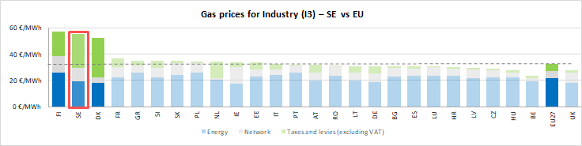

See footnote [38]

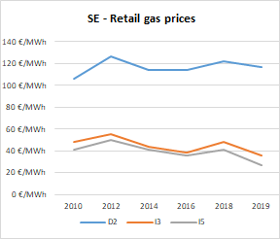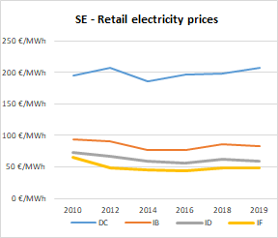

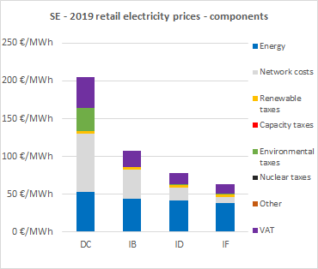

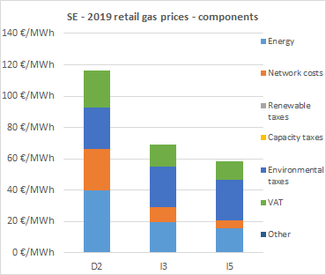

**Oil products prices**

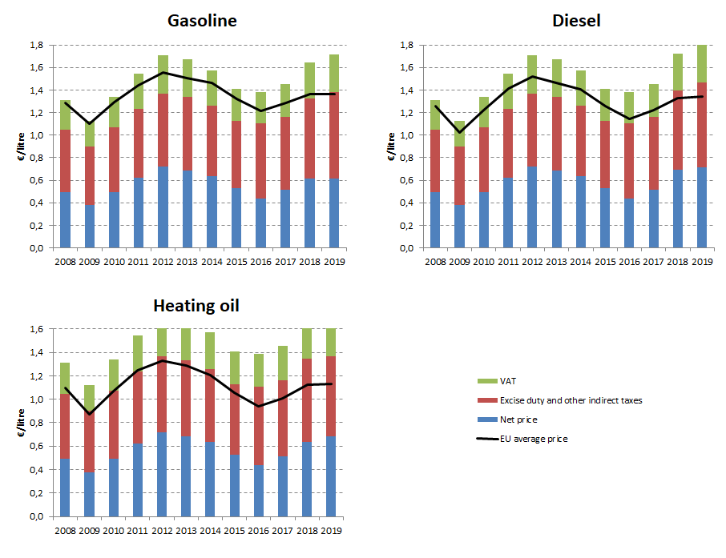

## Energy costs for households, industry and services

**Energy in Household budgets**

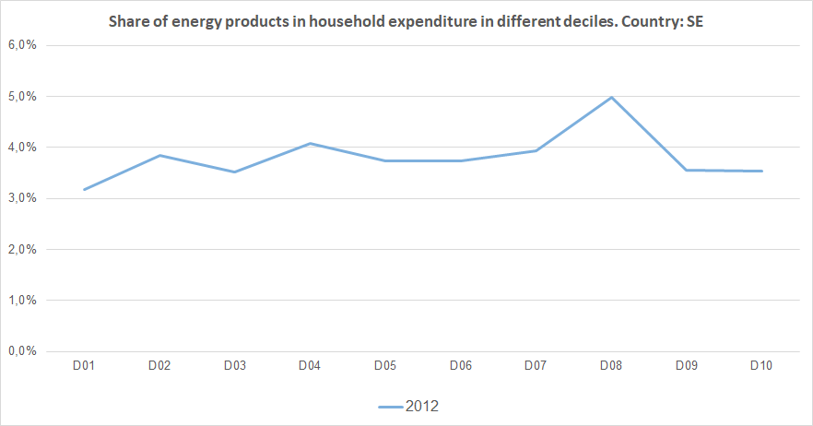

Notes: In 2012 in Sweden (blue line) the poorest households (Decile 1) had to spend 3.2% of their total expenditures on energy products. In the case of middle income households (Decile 5), in the same year they spent 3.7% of their total expenditure on energy. See footnote [39]

**Energy costs shares in total production costs**

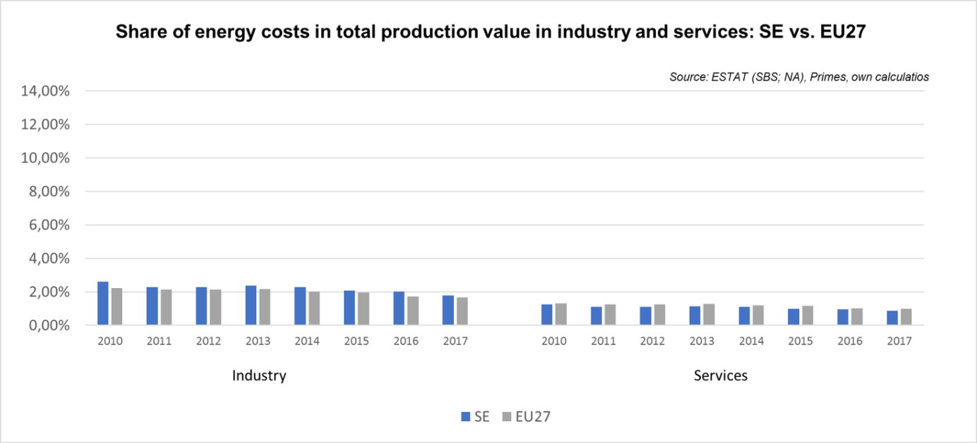

Notes: Data for Malta is only available for 2016. Data for Poland (prior to 2015), Slovenia (prior to 2012) and Greece (prior to 2008) is not available. At the time of extraction, the data for 2018 was not available.

United Kingdom 

## Prices (2019 and recent evolution)

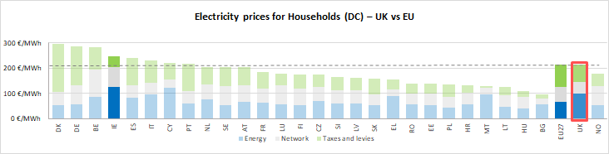 see footnote[40]

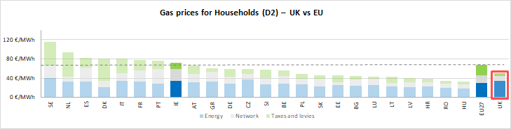

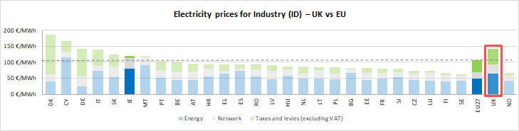

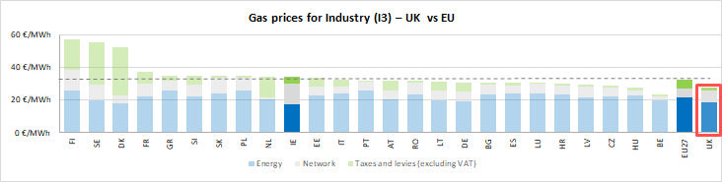



See footnote [41]

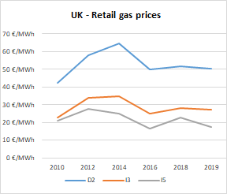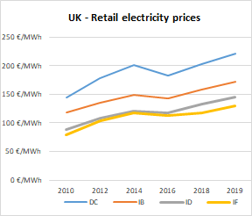

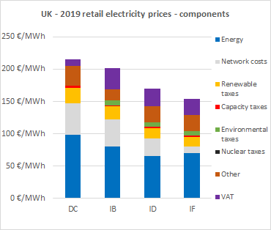

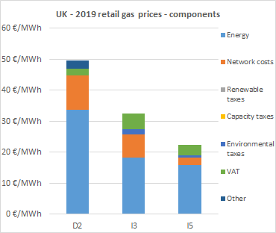

**Oil products prices**

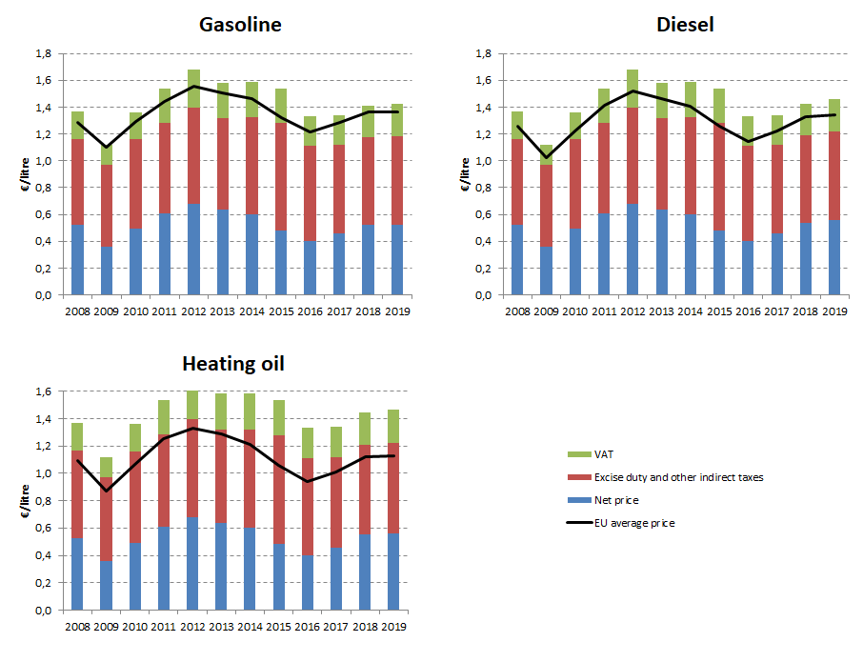

## Energy costs for households, industry and services

**Energy in Household budgets**

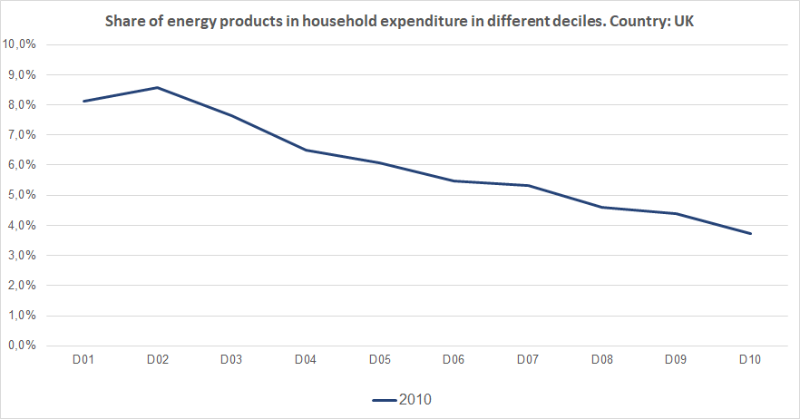

Notes: In 2010 in the United Kingdom (dark blue line) the poorest households (Decile 1) had to spend 8.1% of their total expenditures on energy products. In the case of middle income households (Decile 5), in the same year they spent 6.1% of their total expenditure on energy. See footnote [42]

**Energy costs shares in total production costs**

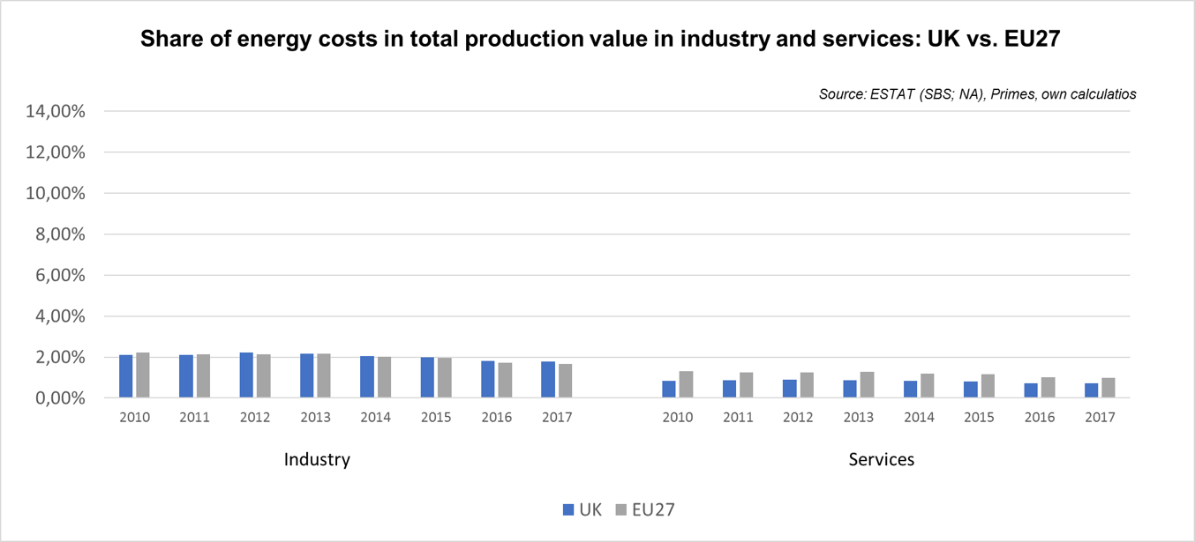

Notes: Data for Malta is only available for 2016. Data for Poland (prior to 2015), Slovenia (prior to 2012) and Greece (prior to 2008) is not available. At the time of extraction, the data for 2018 was not available.

**Norway** 

## Prices (2019 and recent evolution)

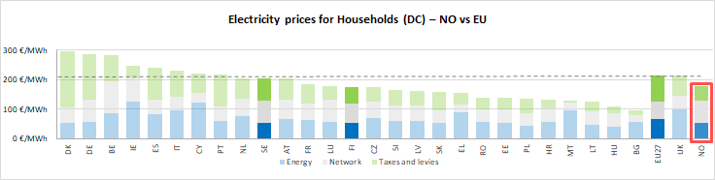 see footnote[43]

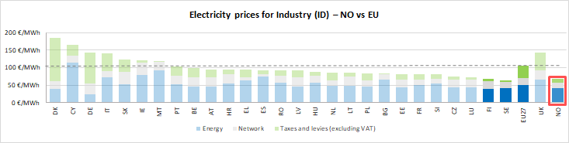



See footnote [44]

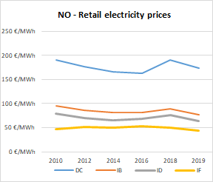

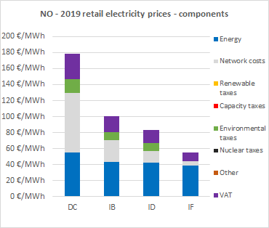

Oil product prices and Energy costs shares are not available for this country

1. The country of study, its neighbours and the EU average are highlighted with brighter colours in the figure.
2. Annual electricity consumption: DB 1 - 2.5 MWh, DC 2.5 - 5 MWh, DD 5 - 15 MWh, DE above 15 MWh, IB 20-500 MWh, ID 2000-20000 MWh, IF 70000-150000 MWh. Annual Gas consumption: D2 20-200 GJ, I3 10000-100000 GJ, I5 1 mil - 4 mil GJ.
3. This graphic includes energy expenditure per different household deciles, excluding transport energy expenditure (transport fuels).
4. The country of study, its neighbours and the EU average are highlighted with brighter colours in the figure.
5. Annual electricity consumption: DB 1 - 2.5 MWh, DC 2.5 - 5 MWh, DD 5 - 15 MWh, DE above 15 MWh, IB 20-500 MWh, ID 2000-20000 MWh, IF 70000-150000 MWh. Annual Gas consumption: D2 20-200 GJ, I3 10000-100000 GJ, I5 1 mil - 4 mil GJ.
6. This graphic includes energy expenditure per different household deciles, excluding transport energy expenditure (transport fuels).
7. The country of study, its neighbours and the EU average are highlighted with brighter colours in the figure.
8. Annual electricity consumption: DB 1 - 2.5 MWh, DC 2.5 - 5 MWh, DD 5 - 15 MWh, DE above 15 MWh, IB 20-500 MWh, ID 2000-20000 MWh, IF 70000-150000 MWh. Annual Gas consumption: D2 20-200 GJ, I3 10000-100000 GJ, I5 1 mil - 4 mil GJ.
9. This graphic includes energy expenditure per different household deciles, excluding transport energy expenditure (transport fuels). Data not available for Deciles 8 and 10.
10. The country of study, its neighbours and the EU average are highlighted with brighter colours in the figure.
11. Annual electricity consumption: DB 1 - 2.5 MWh, DC 2.5 - 5 MWh, DD 5 - 15 MWh, DE above 15 MWh, IB 20-500 MWh, ID 2000-20000 MWh, IF 70000-150000 MWh. Annual Gas consumption: D2 20-200 GJ, I3 10000-100000 GJ, I5 1 mil - 4 mil GJ.
12. This graphic includes energy expenditure per different household deciles, excluding transport energy expenditure (transport fuels).
13. The country of study, its neighbours and the EU average are highlighted with brighter colours in the figure.
14. Annual electricity consumption: DB 1 - 2.5 MWh, DC 2.5 - 5 MWh, DD 5 - 15 MWh, DE above 15 MWh, IB 20-500 MWh, ID 2000-20000 MWh, IF 70000-150000 MWh. Annual Gas consumption: D2 20-200 GJ, I3 10000-100000 GJ, I5 1 mil - 4 mil GJ.
15. This graphic includes energy expenditure per different household deciles, excluding transport energy expenditure (transport fuels).
16. The country of study, its neighbours and the EU average are highlighted with brighter colours in the figure.
17. Annual electricity consumption: DB 1 - 2.5 MWh, DC 2.5 - 5 MWh, DD 5 - 15 MWh, DE above 15 MWh, IB 20-500 MWh, ID 2000-20000 MWh, IF 70000-150000 MWh. Annual Gas consumption: D2 20-200 GJ, I3 10000-100000 GJ, I5 1 mil - 4 mil GJ.
18. This graphic includes energy expenditure per different household deciles, excluding transport energy expenditure (transport fuels).
19. The country of study, its neighbours and the EU average are highlighted with brighter colours in the figure.
20. Annual electricity consumption: DB 1 - 2.5 MWh, DC 2.5 - 5 MWh, DD 5 - 15 MWh, DE above 15 MWh, IB 20-500 MWh, ID 2000-20000 MWh, IF 70000-150000 MWh. Annual Gas consumption: D2 20-200 GJ, I3 10000-100000 GJ, I5 1 mil - 4 mil GJ.
21. This graphic includes energy expenditure per different household deciles, excluding transport energy expenditure (transport fuels).
22. The country of study, its neighbours and the EU average are highlighted with brighter colours in the figure.
23. Annual electricity consumption: DB 1 - 2.5 MWh, DC 2.5 - 5 MWh, DD 5 - 15 MWh, DE above 15 MWh, IB 20-500 MWh, ID 2000-20000 MWh, IF 70000-150000 MWh. Annual Gas consumption: D2 20-200 GJ, I3 10000-100000 GJ, I5 1 mil - 4 mil GJ.
24. This graphic includes energy expenditure per different household deciles, excluding transport energy expenditure (transport fuels).
25. The country of study, its neighbours and the EU average are highlighted with brighter colours in the figure.
26. Annual electricity consumption: DB 1 - 2.5 MWh, DC 2.5 - 5 MWh, DD 5 - 15 MWh, DE above 15 MWh, IB 20-500 MWh, ID 2000-20000 MWh, IF 70000-150000 MWh. Annual Gas consumption: D2 20-200 GJ, I3 10000-100000 GJ, I5 1 mil - 4 mil GJ.
27. This graphic includes energy expenditure per different household deciles, excluding transport energy expenditure (transport fuels).
28. The country of study, its neighbours and the EU average are highlighted with brighter colours in the figure.
29. Annual electricity consumption: DB 1 - 2.5 MWh, DC 2.5 - 5 MWh, DD 5 - 15 MWh, DE above 15 MWh, IB 20-500 MWh, ID 2000-20000 MWh, IF 70000-150000 MWh. Annual Gas consumption: D2 20-200 GJ, I3 10000-100000 GJ, I5 1 mil - 4 mil GJ.
30. This graphic includes energy expenditure per different household deciles, excluding transport energy expenditure (transport fuels).
31. The country of study, its neighbours and the EU average are highlighted with brighter colours in the figure.
32. Annual electricity consumption: DB 1 - 2.5 MWh, DC 2.5 - 5 MWh, DD 5 - 15 MWh, DE above 15 MWh, IB 20-500 MWh, ID 2000-20000 MWh, IF 70000-150000 MWh. Annual Gas consumption: D2 20-200 GJ, I3 10000-100000 GJ, I5 1 mil - 4 mil GJ.
33. This graphic includes energy expenditure per different household deciles, excluding transport energy expenditure (transport fuels).
34. The country of study, its neighbours and the EU average are highlighted with brighter colours in the figure.
35. Annual electricity consumption: DB 1 - 2.5 MWh, DC 2.5 - 5 MWh, DD 5 - 15 MWh, DE above 15 MWh, IB 20-500 MWh, ID 2000-20000 MWh, IF 70000-150000 MWh. Annual Gas consumption: D2 20-200 GJ, I3 10000-100000 GJ, I5 1 mil - 4 mil GJ.
36. This graphic includes energy expenditure per different household deciles, excluding transport energy expenditure (transport fuels).
37. The country of study, its neighbours and the EU average are highlighted with brighter colours in the figure.
38. Annual electricity consumption: DB 1 - 2.5 MWh, DC 2.5 - 5 MWh, DD 5 - 15 MWh, DE above 15 MWh, IB 20-500 MWh, ID 2000-20000 MWh, IF 70000-150000 MWh. Annual Gas consumption: D2 20-200 GJ, I3 10000-100000 GJ, I5 1 mil - 4 mil GJ.
39. This graphic includes energy expenditure per different household deciles, excluding transport energy expenditure (transport fuels).
40. The country of study, its neighbours and the EU average are highlighted with brighter colours in the figure.
41. Annual electricity consumption: DB 1 - 2.5 MWh, DC 2.5 - 5 MWh, DD 5 - 15 MWh, DE above 15 MWh, IB 20-500 MWh, ID 2000-20000 MWh, IF 70000-150000 MWh. Annual Gas consumption: D2 20-200 GJ, I3 10000-100000 GJ, I5 1 mil - 4 mil GJ.
42. This graphic includes energy expenditure per different household deciles, excluding transport energy expenditure (transport fuels).
43. The country of study, its neighbours and the EU average are highlighted with brighter colours in the figure.
44. Annual electricity consumption: DB 1 - 2.5 MWh, DC 2.5 - 5 MWh, DD 5 - 15 MWh, DE above 15 MWh, IB 20-500 MWh, ID 2000-20000 MWh, IF 70000-150000 MWh. Annual Gas consumption: D2 20-200 GJ, I3 10000-100000 GJ, I5 1 mil - 4 mil GJ.