

Content

This annex contains country *energy prices and costs* factsheets of the 27 EU Member States, Norway and the United Kingdom. Where available, each factsheet displays information about the level of electricity, gas and oil prices (2019 and recent evolution) as well as about the main components of such prices, including a detailed breakdown of the taxes and levies charged to gas and electricity prices. The factsheets also contain an account of the evolution of the importance of energy costs for households, industry and services in recent years.

**Details**

The purpose of this annex is to provide an overview of gas and electricity prices and costs for each country analysed.

In the first two pages, electricity and gas prices for each country are compared with neighbour countries and the EU average. We show the electricity and gas prices in 2019, first for households and subsequently for industry. At the bottom of the page the evolution of electricity and gas prices of the country from 2010 to 2019 is presented. The main data sources used are Eurostat latest data and DG ENER in-house data collection of the previous Energy Prices and Costs reports.

In the second page, the amount of the different taxes and levies included in electricity and natural gas prices across consumption bands in 2019 are also listed for each country analysed. The main data source is Eurostat latest data.

In the third page, oil prices (in €/litre) are presented, showing the evolution for gasoline, diesel and heating oil prices at national level from 2008 to 2019 and compared to the EU average. VAT and other indirect taxes affecting the country's total prices are also displayed. The main data source for this is the weekly oil bulletin published by the European Commission Directorate-General for Energy.

In the fourth page, the shares of energy in total household expenditure across income deciles are displayed for some specific years over the last decade according to the available data. This data comes from the European Commission Directorate-General for Energy ad hoc data collection on household consumption expenditures, voluntarily sent by mainly Member States National Institutes for Statistics (NIS). Then, energy costs shares in total production value costs for industry and services from 2010 to 2017 are shown and compared to the EU average. The main data sources for this own calculations made by European Commission Directorate-General for Energy were Eurostat SBS and Primes model data.

Methodology

*Prices*

In order to understand the price codes used for the graphs in the country sheets, please refer to the table below. Each code corresponds to a specific product (electricity or natural gas), which is related to the household or industry sectors and to a level of annual consumption.

|  |  |  |  |  |
| --- | --- | --- | --- | --- |
| Code | Product | Type | Annual consumption | Description |
| DC | Electricity | Household | 2.5 - 5 MWh | median |
| IB | Electricity | Industry | 20-500 MWh | small |
| ID | Electricity | Industry | 2000-20000 MWh | median |
| IF | Electricity | Industry | 70000-150000 MWh | large |
| D2 | Natural Gas | Household | 20-200 GJ | median |
| I3 | Natural Gas | Industry | 10000-100000 GJ | median |
| I5 | Natural Gas | Industry | 1 mil - 4 mil GJ | large |

*Share of energy costs in industry and services*

The shares of energy costs in industry and services were calculated by dividing the best available estimation of the energy costs (purchases of energy) by the best available estimation of the total production value (gross operating surplus *plus* personnel costs *plus* total purchases of goods and services) for industry and services, respectively. In the case of industry, the data is sourced only from SBS economic indicators. In the case of services, not all information is available in SBS. To calculate the share of energy costs in services, a combination of data from Primes Model and SBS data was used.

Besides, it is important in this methodological approach to bear in mind that:

* There is no one-on-one mapping between the economic indicators of SBS and the profit and loss account of real companies.
* Capital expenditure (CAPEX) is difficult to collect in SBS, forcing the estimation of the energy component to rely solely on operating expenditure (OPEX); as a result the provided estimation is not assessing the long term investment and cannot determine the relative share of investment in improved energy performance tools over the total stock of investment.
* The purchases of energy product data is available only for NACE Rev. 2 sections B (Mining and quarrying), C (Manufacturing), D (Electricity, gas, steam and air conditioning supply) and E (Water supply, sewerage, waste management and remediation activities). It is not available for important industrial such as Section F (Construction) and energy intensive sections such as H (Transportation and storage). More importantly, it is not available for all services sectors. According to the 2015 Commission report on single market integration and competitiveness, the relative share of the services sector in the 2014 Total Value Added in the EU 28 stood at almost 75%, as opposed to 15% for Manufacturing.
* Based on the definition of the Commission Regulation (EC) No 250/2009, the structural business statistics (SBS) code "20 11 0 Purchases of energy products" includes only energy products which are purchased to be used as a fuel. Energy products purchased as a raw material or for resale without transformation (such as crude oil) are excluded.

Austria 

## Prices (2019 and recent evolution)

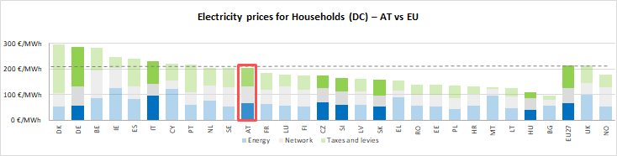

See footnote [1]

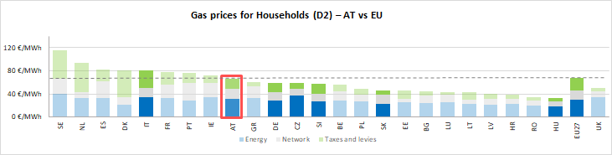

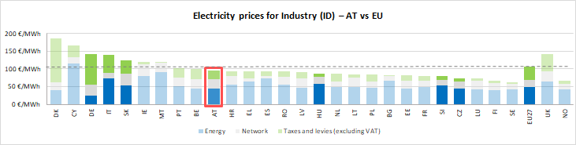

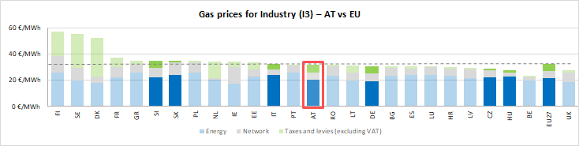

See footnote [2]

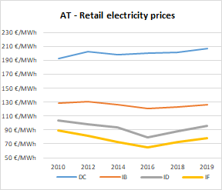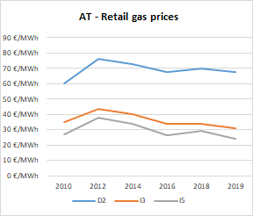

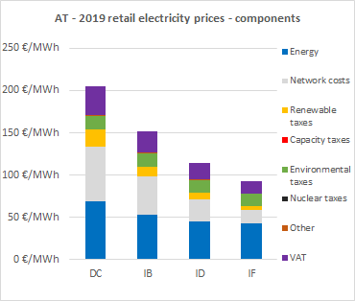

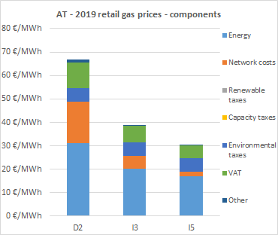

**Oil prices**

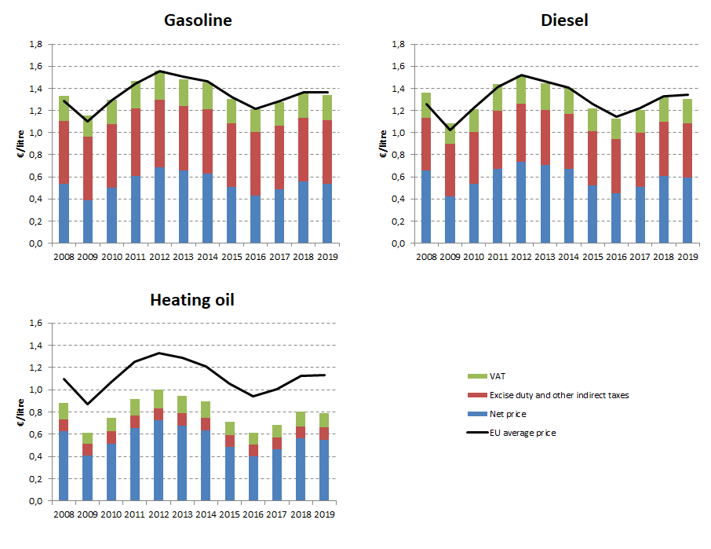

## Energy costs for households, industry and services

**Energy in Household budgets**

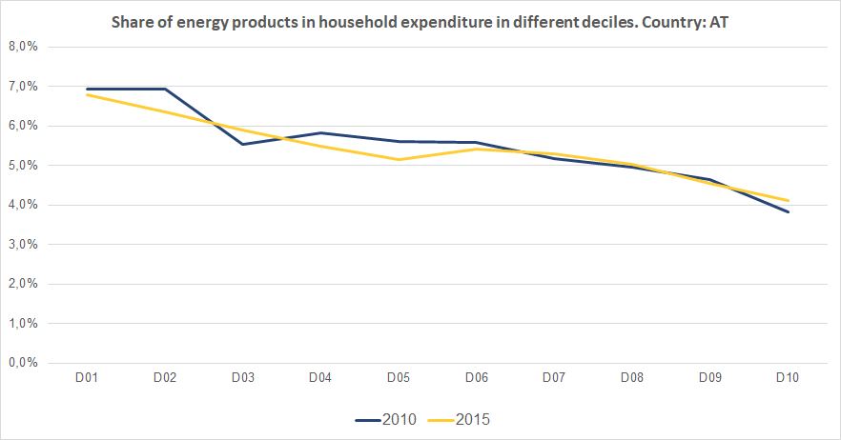

Notes: In 2010 in Austria (dark blue line) the poorest households (Decile 1) had to spend 6.9% of their total expenditures on energy products. In 2015 (yellow line) the share of energy remained practically unchanged.In the case of middle income households (Decile 5), in 2010 they spent 5.6% of their total expenditure on energy, while in 2015 this value decreased to 5.1%. See footnote [3]

**Energy costs shares in total production costs**

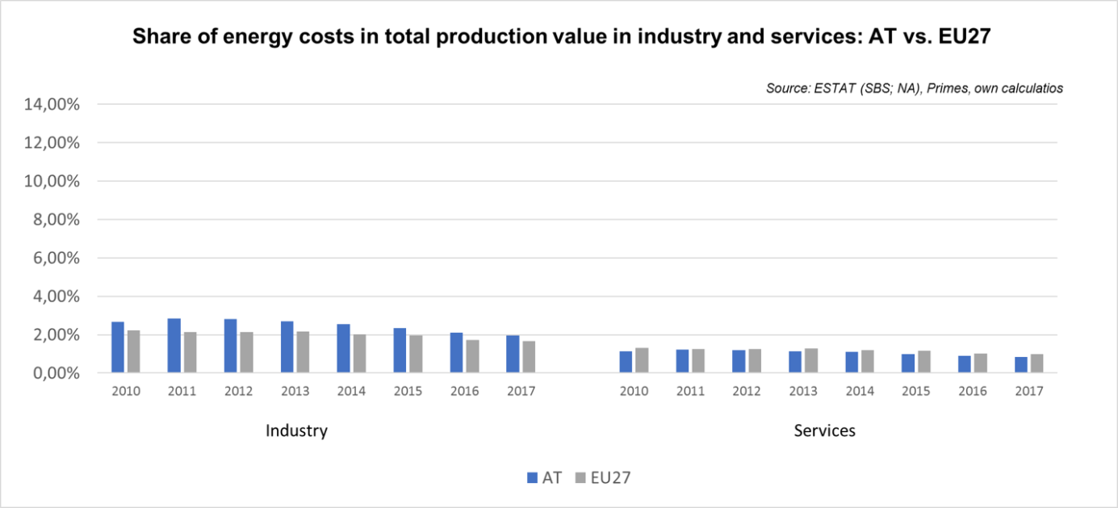

Notes: Data for Malta is only available for 2016. Data for Poland (prior to 2015), Slovenia (prior to 2012) and Greece (prior to 2008) is not available. At the time of extraction, the data for 2018 was not available.

Belgium 

## Prices (2019 and recent evolution)

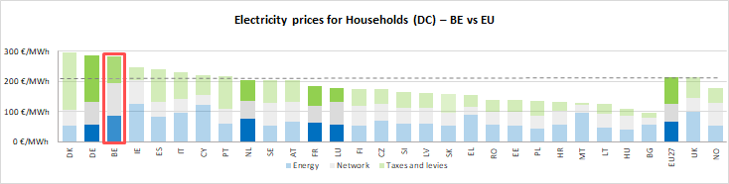

See footnote **[4]**

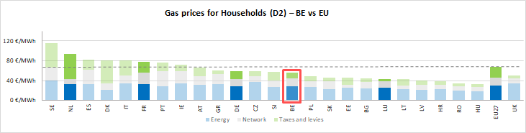

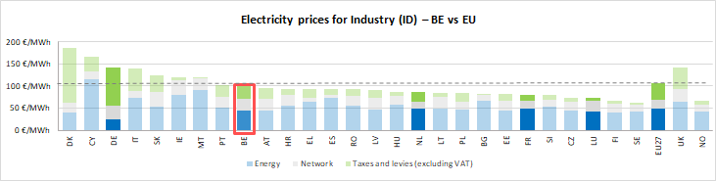

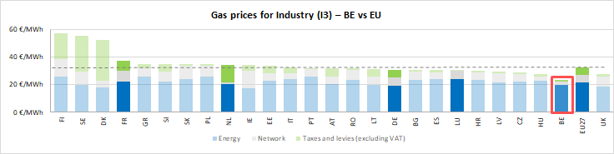



See footnote [5]

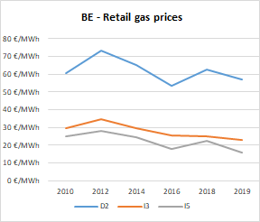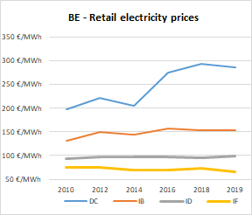

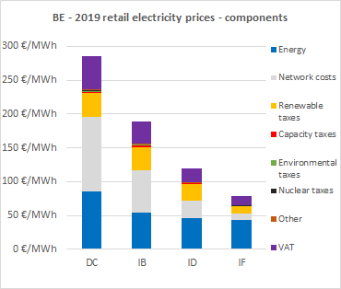

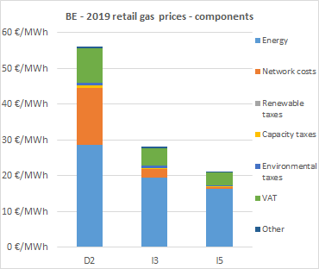

**Oil products prices**

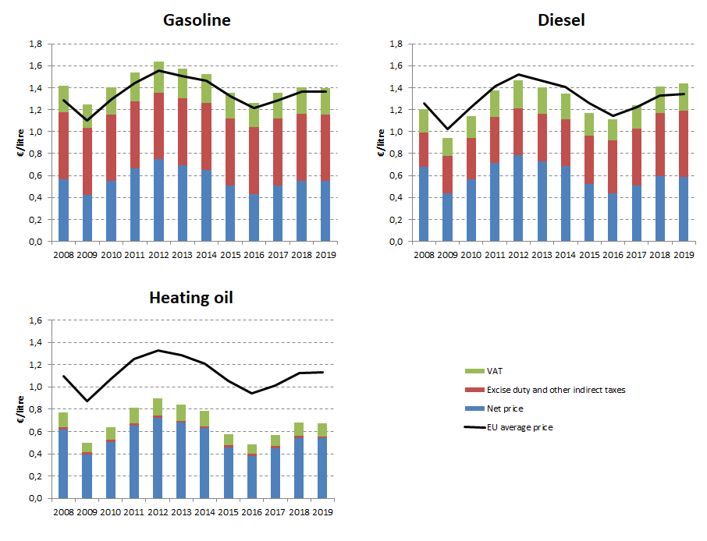

## Energy costs for households, industry and services

**Energy in Household budgets**

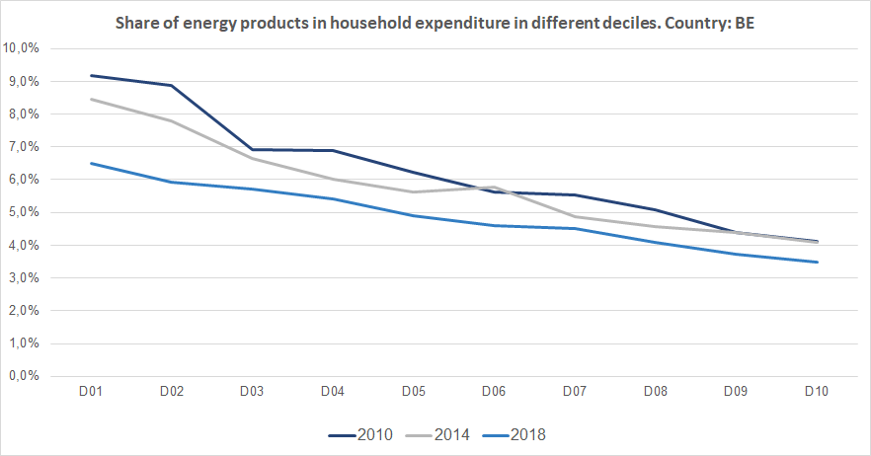

Notes: In 2010 in Belgium (dark blue line) the poorest households (Decile 1) had to spend 9.2% of their total expenditures on energy products. In 2018 (blue line) the share of energy decreased to 6.5%.In the case of middle income households (Decile 5), in 2010 they spent 6.2% of their total expenditure on energy, while in 2018 this value decreased to 4.9%. See footnote [6]

**Energy costs shares in total production costs**

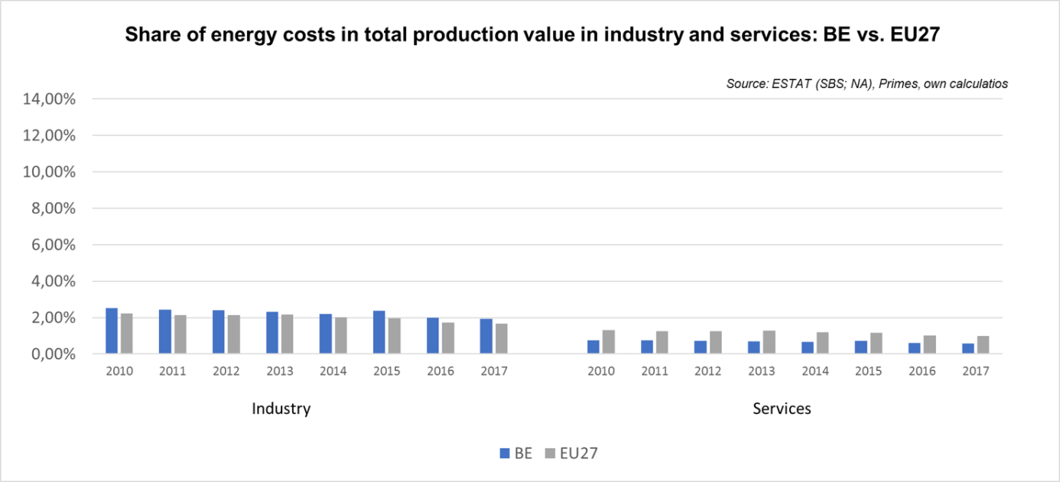

Notes: Data for Malta is only available for 2016. Data for Poland (prior to 2015), Slovenia (prior to 2012) and Greece (prior to 2008) is not available. At the time of extraction, the data for 2018 was not available.

Bulgaria 

## Prices (2019 and recent evolution)

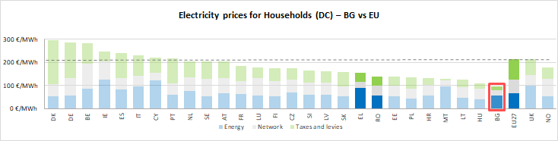

See footnote[7]

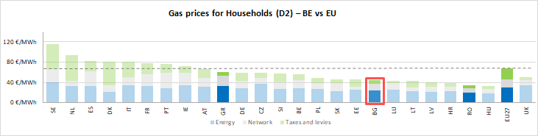

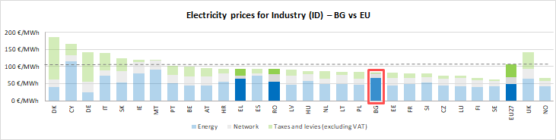

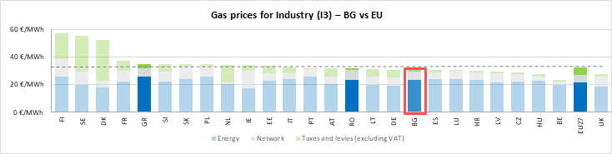



See footnote [8]

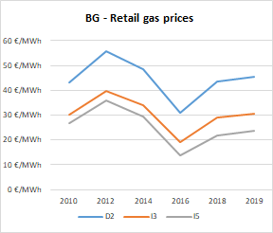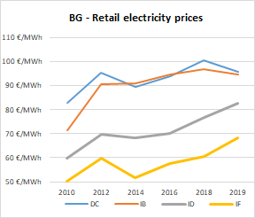

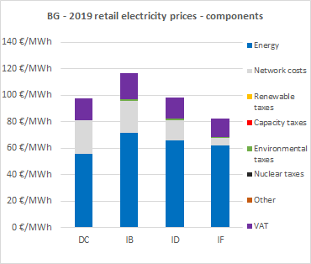

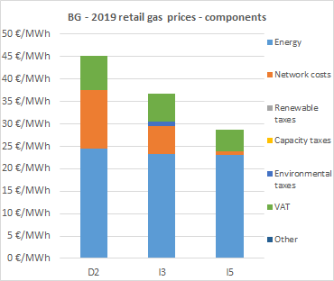

**Oil products prices**

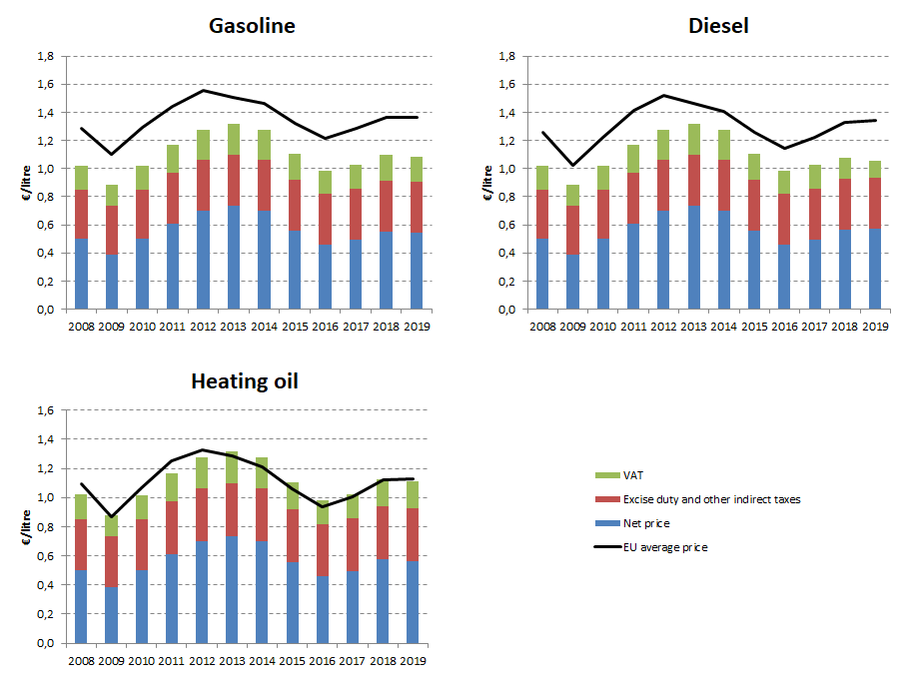

## Energy costs for households, industry and services

**Energy in Household budgets**

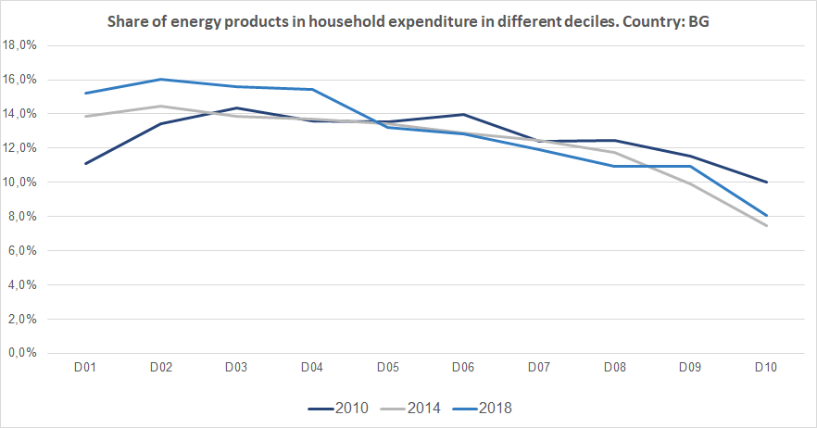

Notes: In 2010 in Bulgaria (dark blue line) the poorest households (Decile 1) had to spend 11.1% of their total expenditures on energy products. In 2018 (blue line) the share of energy increased to 15.2%.In the case of middle income households (Decile 5), in 2010 they spent 14.2% of their total expenditure on energy, while in 2018 this value remained almost unchanged. See footnote [9]

**Energy costs shares in total production costs**

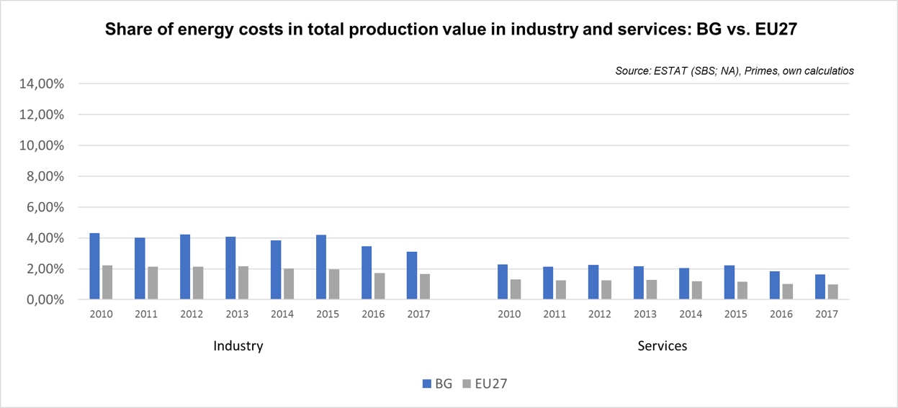

Notes: Data for Malta is only available for 2016. Data for Poland (prior to 2015), Slovenia (prior to 2012) and Greece (prior to 2008) is not available. At the time of extraction, the data for 2018 was not available

Croatia 

## Prices (2019 and recent evolution)

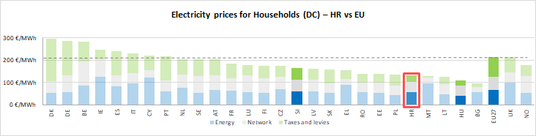

See footnote[10]

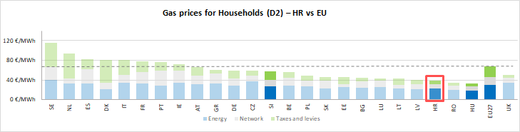

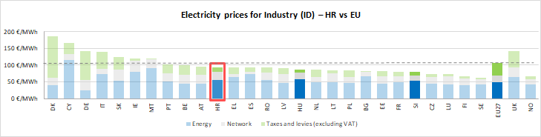

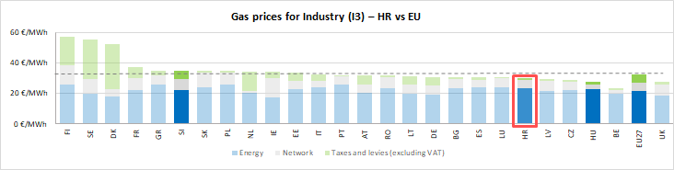



See footnote [11]

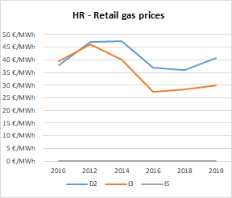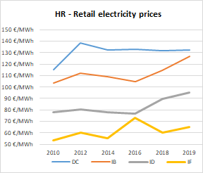

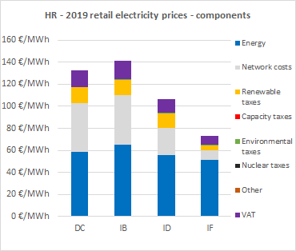

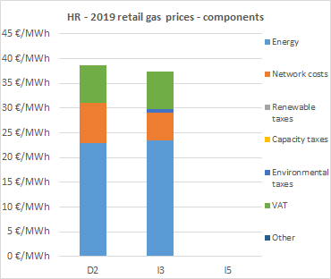

**Oil product prices**

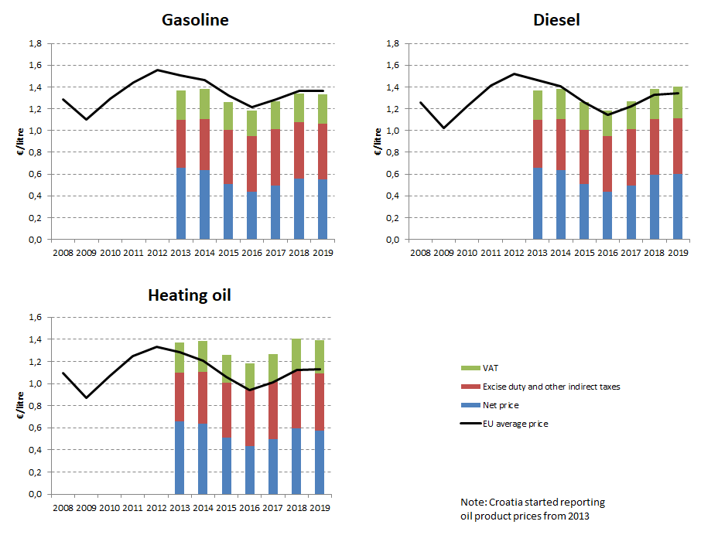

## Energy costs for households, industry and services

**Energy in Household budgets**

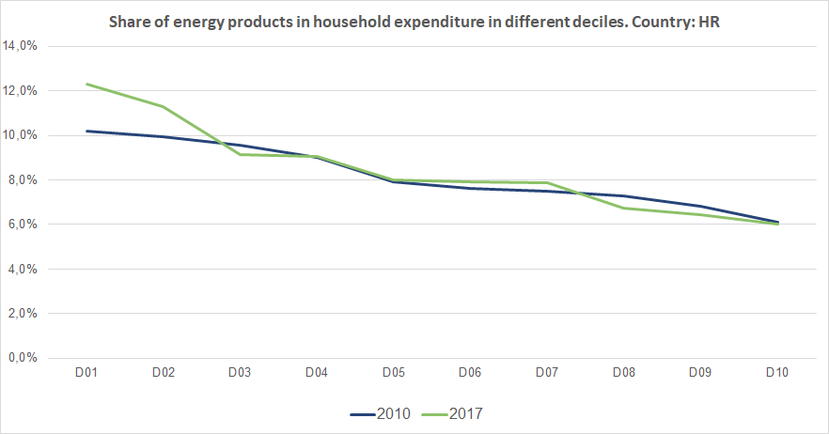

Notes: In 2010 in Croatia (dark blue line) the poorest households (Decile 1) had to spend 10.2% of their total expenditures on energy products. In 2017 (green line) the share of energy increased to 12.3%.In the case of middle income households (Decile 5), in 2010 they spent 7.9 % of their total expenditure on energy, while in 2017 this value remained almost unchanged. See footnote [12]

**Energy costs shares in total production costs**

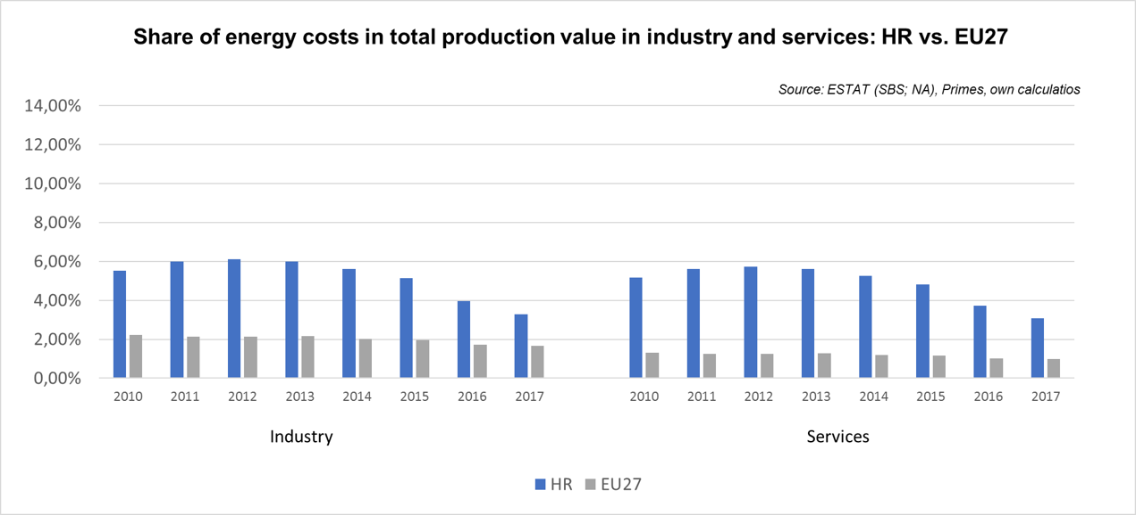

Notes: Data for Malta is only available for 2016. Data for Poland (prior to 2015), Slovenia (prior to 2012) and Greece (prior to 2008) is not available. At the time of extraction, the data for 2018 was not available

Cyprus 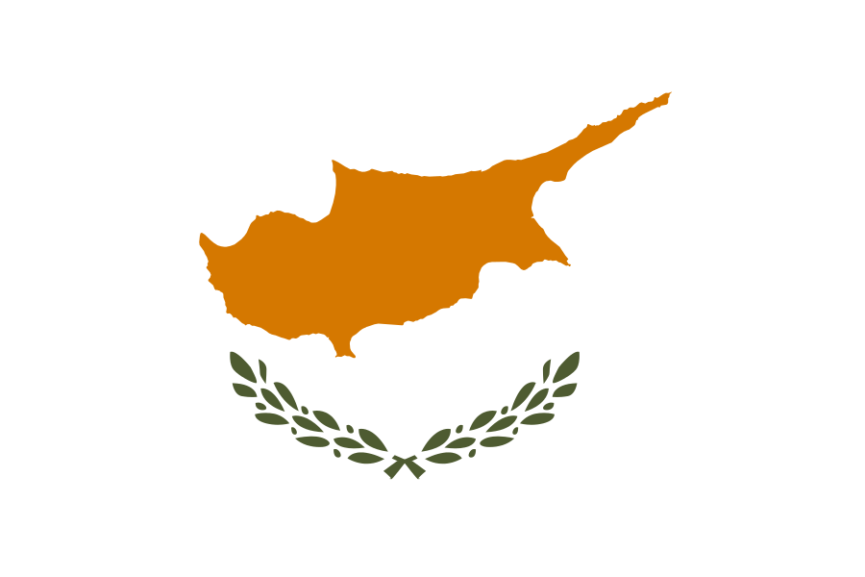

## Prices (2019 and recent evolution)

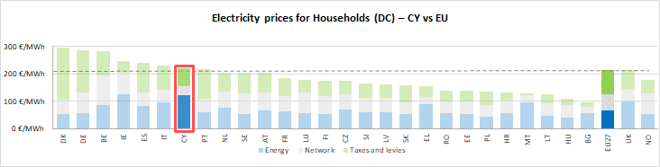 See footnote[13]

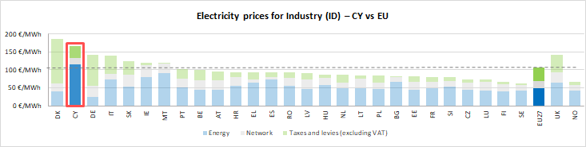



See footnote [14]

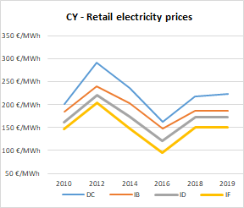

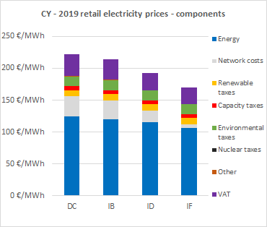

**Oil products prices**

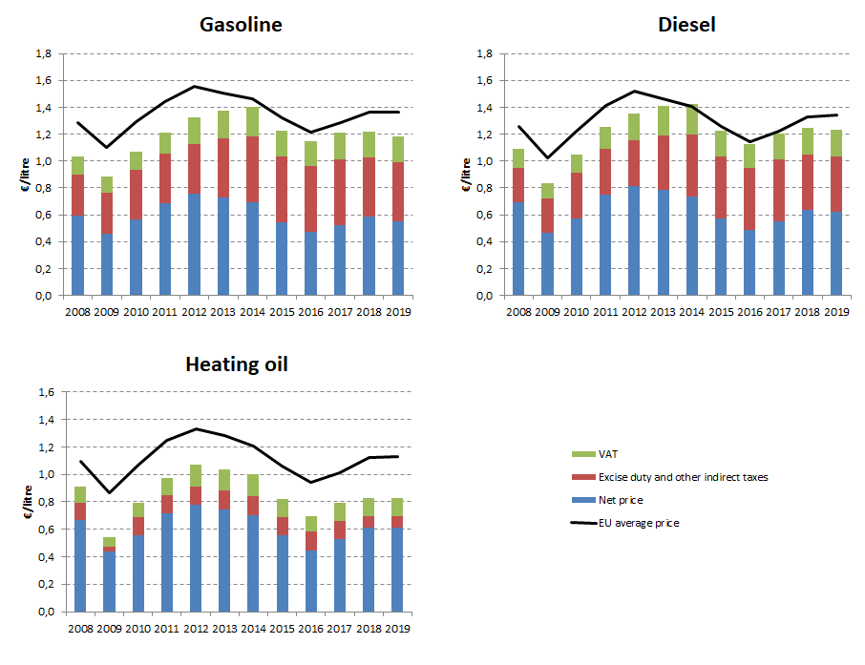

## Energy costs for households, industry and services

**Energy in Household budgets**

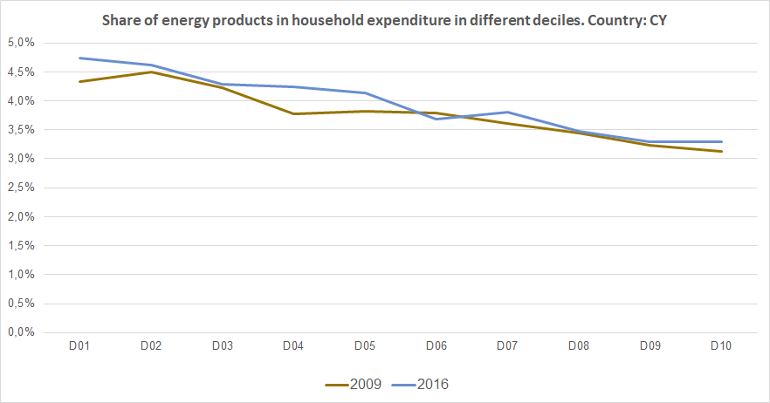

Notes: In 2009 in Cyprus (brown line) the poorest households (Decile 1) had to spend 4.3% of their total expenditures on energy products. In 2016 (blue line) the share of energy increased slightly to 4.7%.In the case of middle income households (Decile 5), in 2009 they spent 3.8 % of their total expenditure on energy, while in 2017 this value increased to 4.1%. See footnote [15]

**Energy costs shares in total production costs**

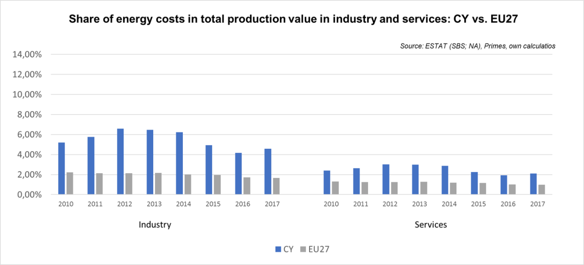

Notes: Data for Malta is only available for 2016. Data for Poland (prior to 2015), Slovenia (prior to 2012) and Greece (prior to 2008) is not available. At the time of extraction, the data for 2018 was not available

Czechia  

## Prices (2019 and recent evolution)

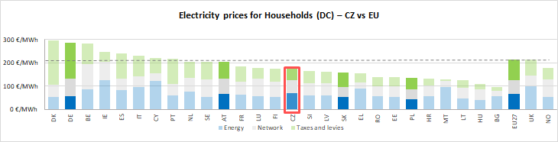

See footnote [16]

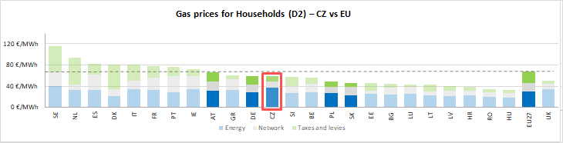

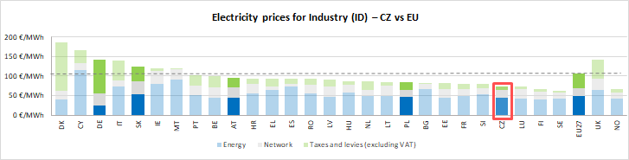

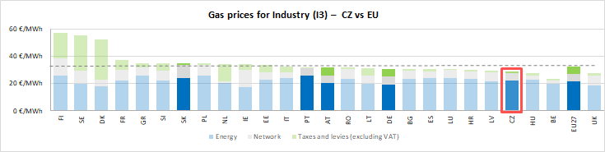

See footnote [17]

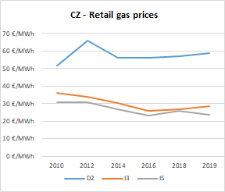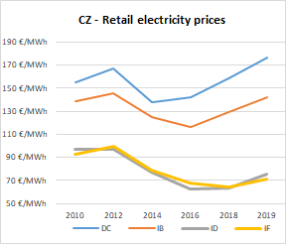

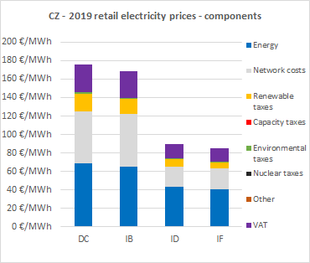

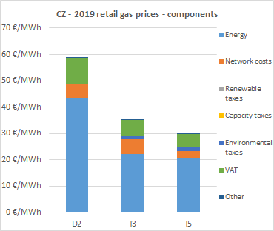

**Oil products prices**

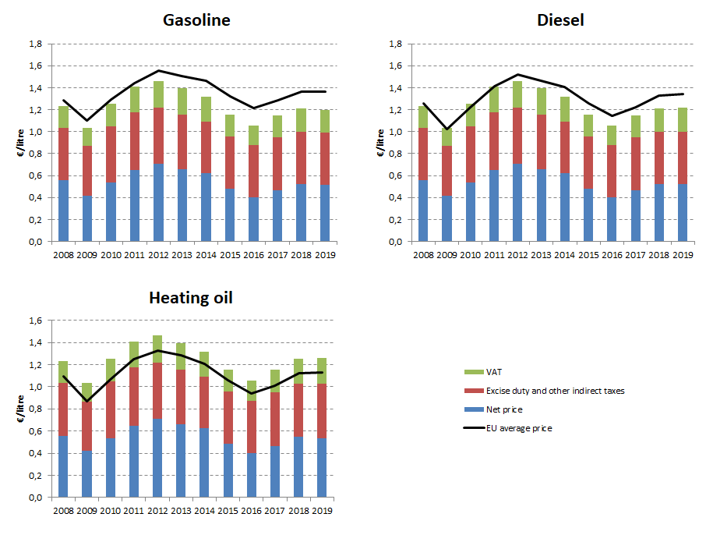

## Energy costs for households, industry and services

**Energy in Household budgets**

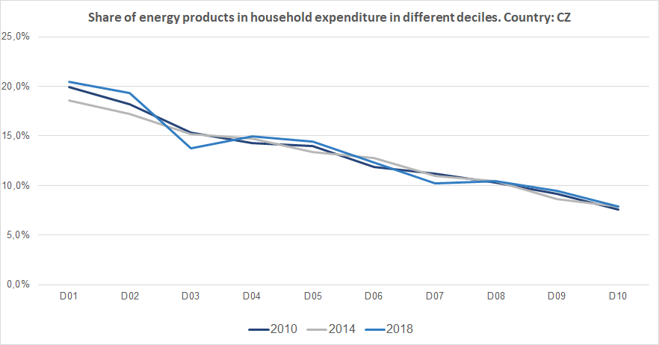

Notes: In 2010 in Czechia (dark blue line) the poorest households (Decile 1) had to spend 20.0% of their total expenditures on energy products. In 2018 (blue line) the share of energy increased marginally to 20.4%.In the case of middle income households (Decile 5), in 2010 they spent 13.9 % of their total expenditure on energy, while in 2018 this value increased to 14.4%. See footnote [18]

**Energy costs shares in total production costs**

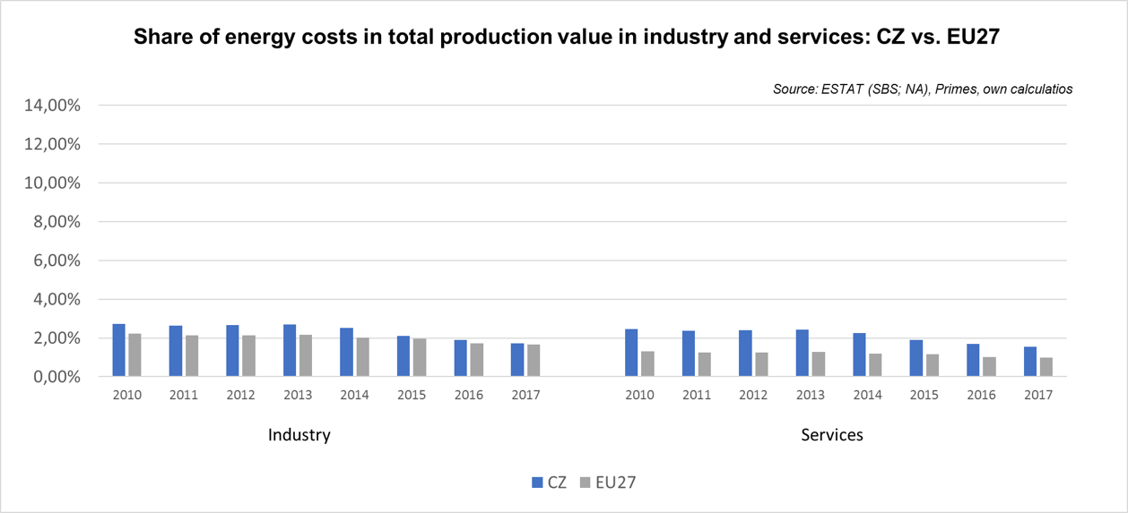

Notes: Data for Malta is only available for 2016. Data for Poland (prior to 2015), Slovenia (prior to 2012) and Greece (prior to 2008) is not available. At the time of extraction, the data for 2018 was not available

Denmark 

## Prices (2019 and recent evolution)

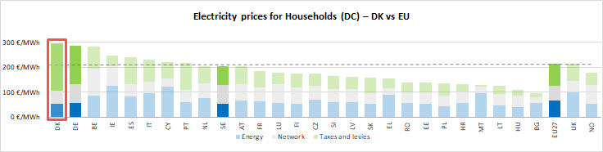

See footnote[19]

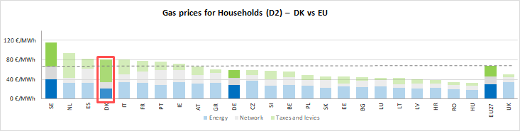

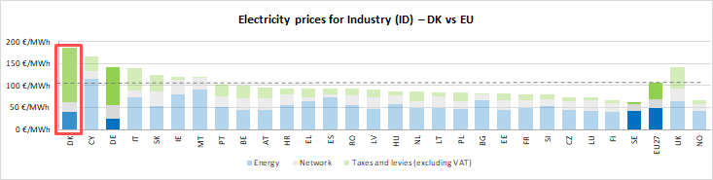

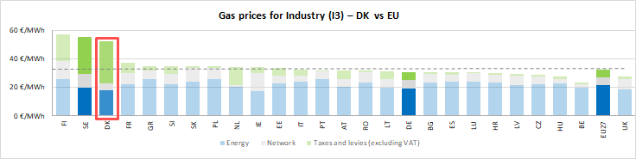



See footnote [20]

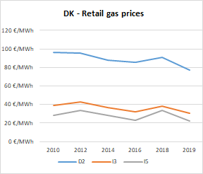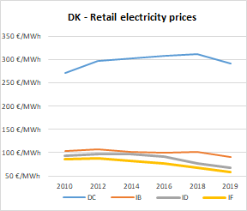

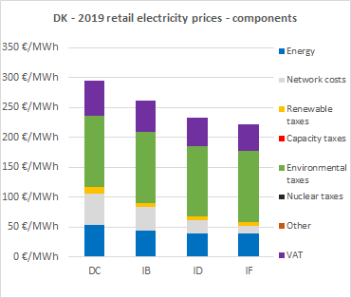

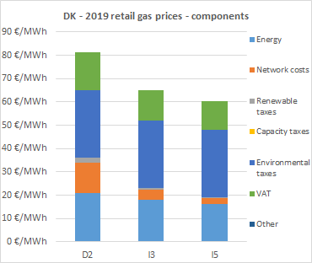

**Oil products prices**

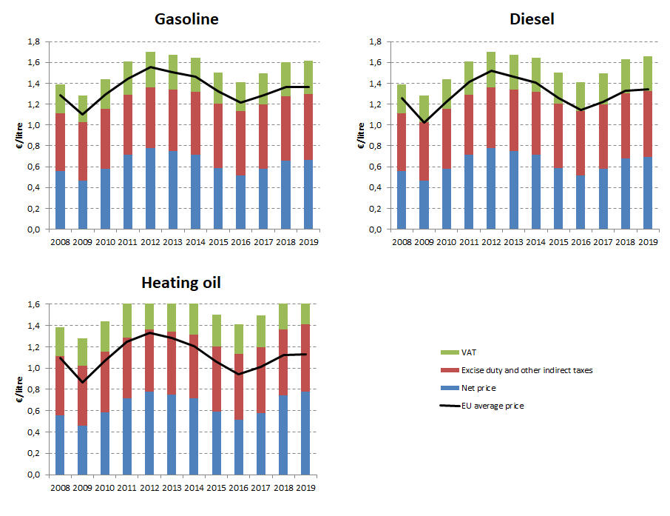

## Energy costs for households, industry and services

**Energy in Household budgets**

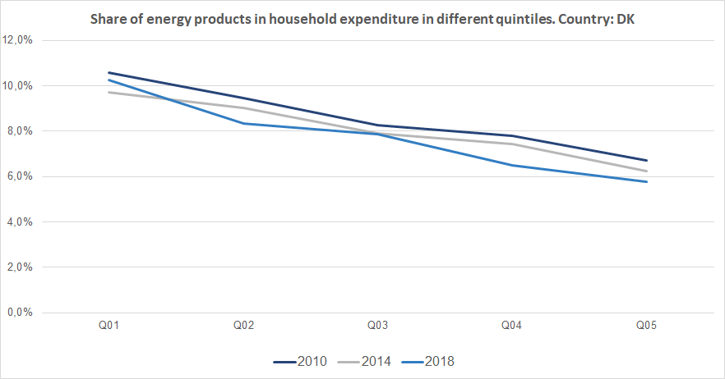

Notes: In 2010 in Denmark (dark blue line) the poorest households (Quintile 1) had to spend 10.6% of their total expenditures on energy products. In 2018 (blue line) the share of energy remained practically unchanged.In the case of middle income households (Quintile 3), in 2010 they spent 8.2 % of their total expenditure on energy, while in 2018 this value decreased slight to 7.9%. See footnote [21]

**Energy costs shares in total production costs**

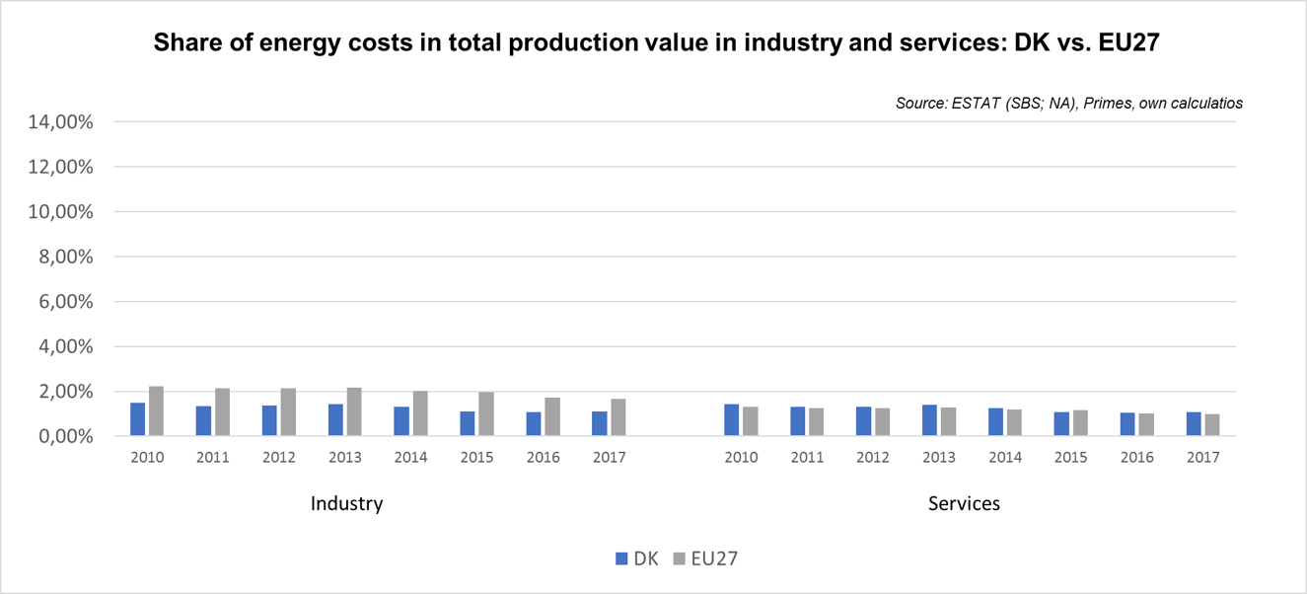

Notes: Data for Malta is only available for 2016. Data for Poland (prior to 2015), Slovenia (prior to 2012) and Greece (prior to 2008) is not available. At the time of extraction, the data for 2018 was not available

Estonia 

## Prices (2019 and recent evolution)

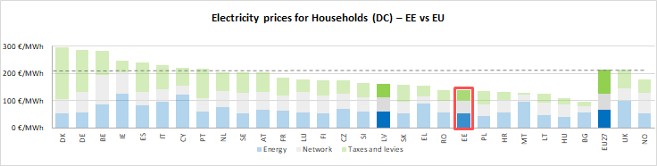 See footnote [22]

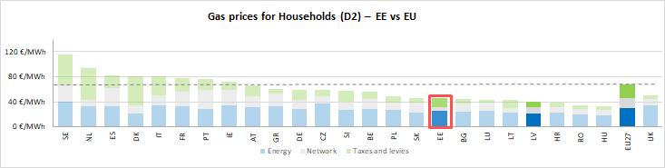

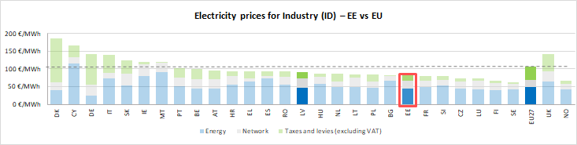

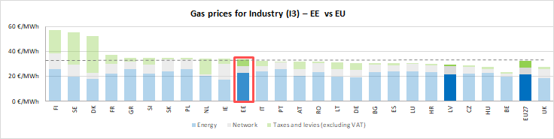



See footnote [23]

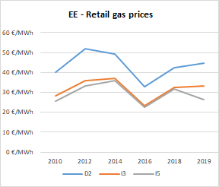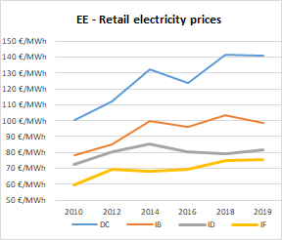

(DD)

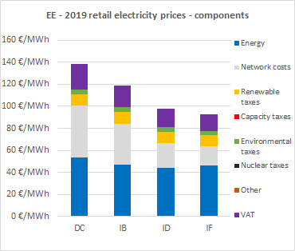

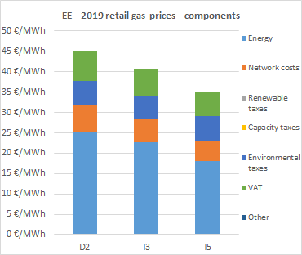

**Oil prices**

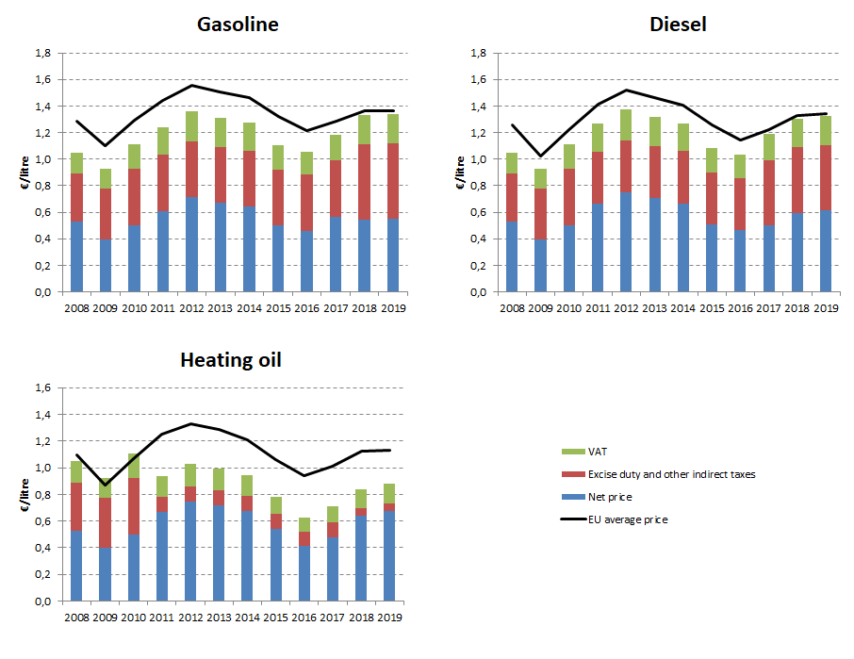

## Energy costs for households, industry and services

**Energy in Household budgets**

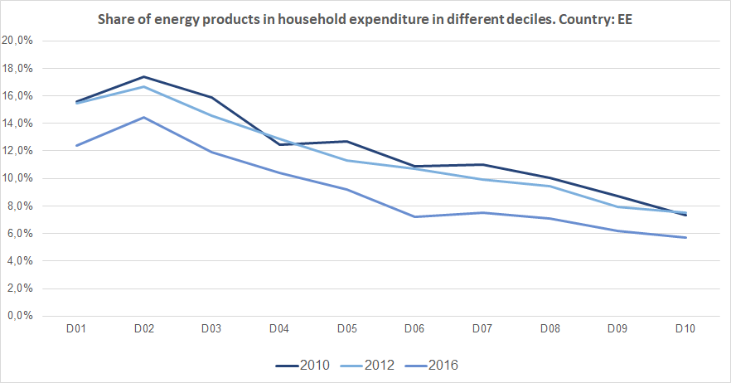

Notes: In 2010 in Estonia (dark blue line) the poorest households (Decile 1) had to spend 15.6% of their total expenditures on energy products. In 2016 (blue line) the share of energy decreased to 12.4%.In the case of middle income households (Decile 5), in 2010 they spent 12.7 % of their total expenditure on energy, while in 2018 this value decreased to 9.1%. See footnote [24]

**Energy costs shares in total production costs**

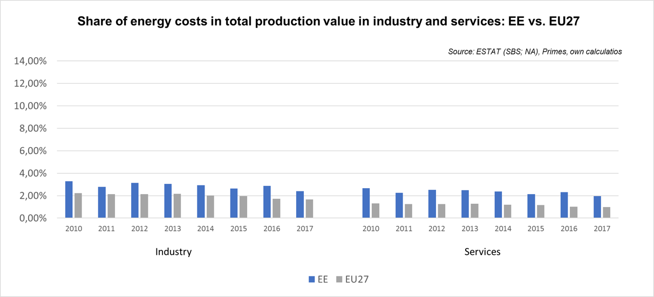

Notes: Data for Malta is only available for 2016. Data for Poland (prior to 2015), Slovenia (prior to 2012) and Greece (prior to 2008) is not available. At the time of extraction, the data for 2018 was not available

Finland 

## Prices (2019 and recent evolution)

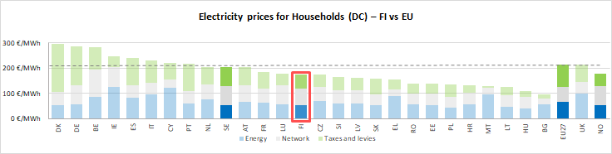 See footnote[25]

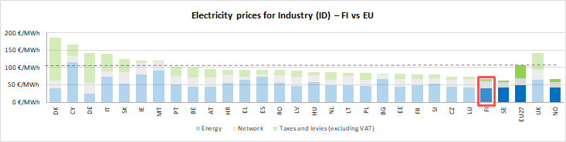

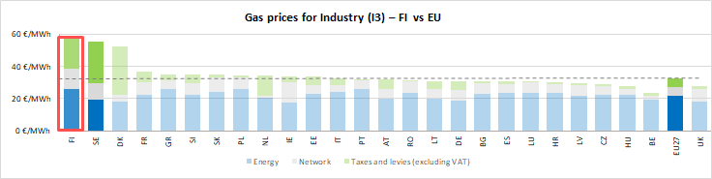



See footnote [26]

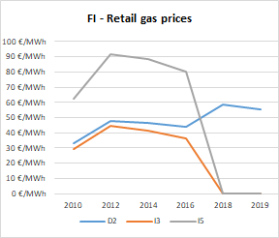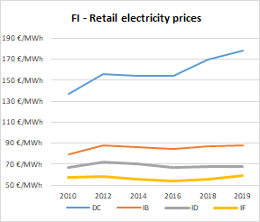

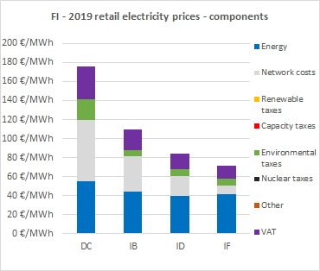

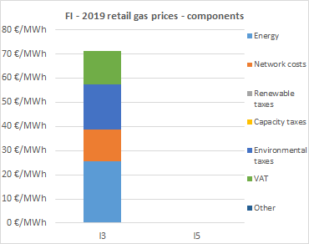

**Oil products prices**

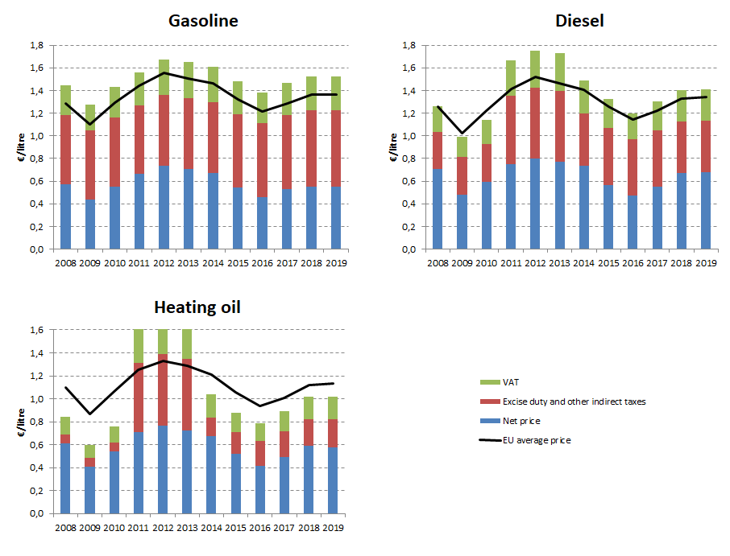

## Energy costs for households, industry and services

**Energy in Household budgets**

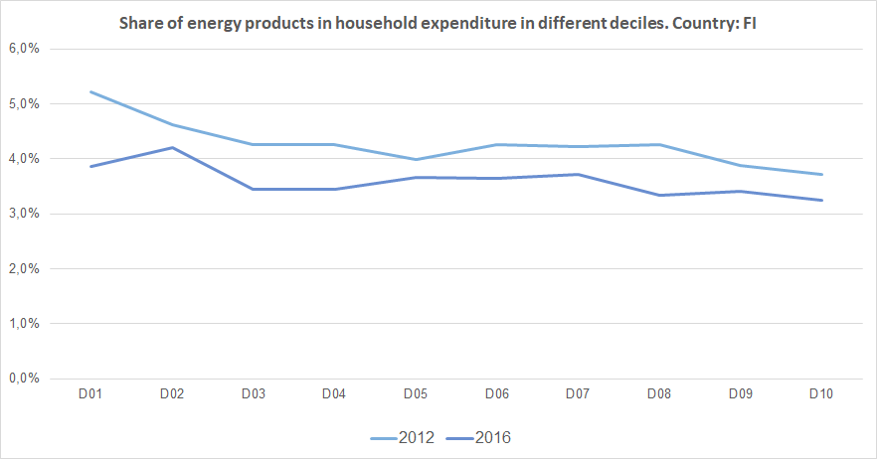

Notes: In 2012 in Finland (light blue line) the poorest households (Decile 1) had to spend 5.2% of their total expenditures on energy products. In 2016 (blue line) the share of energy decreased to 3.9%.In the case of middle income households (Decile 5), in 2012 they spent 4.0 % of their total expenditure on energy, while in 2016 this value decreased to 3.7%. See footnote [27]

**Energy costs shares in total production costs**

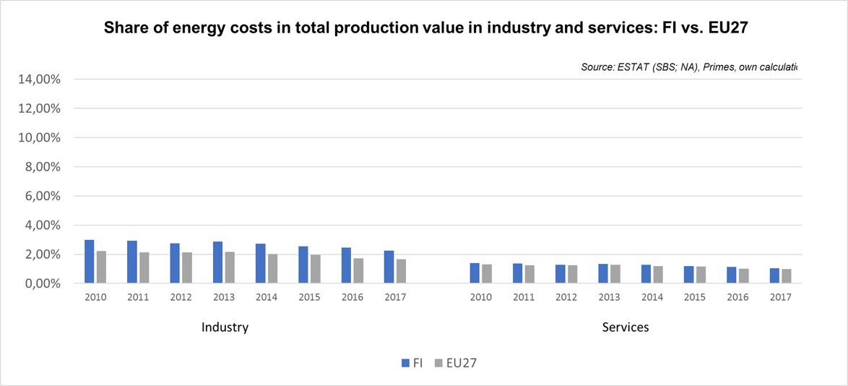

Notes: Data for Malta is only available for 2016. Data for Poland (prior to 2015), Slovenia (prior to 2012) and Greece (prior to 2008) is not available. At the time of extraction, the data for 2018 was not available.

**France** 

## Prices (2019 and recent evolution)

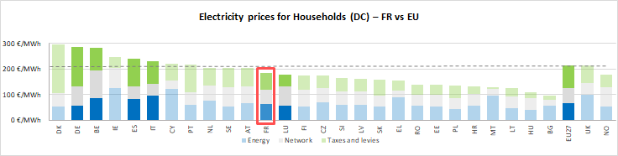See footnote [28]

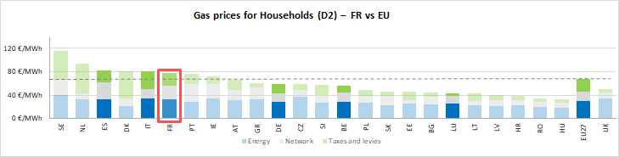

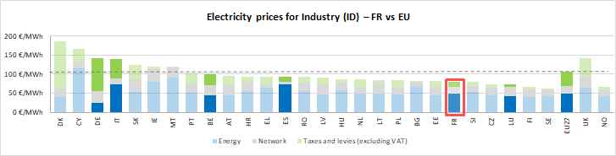

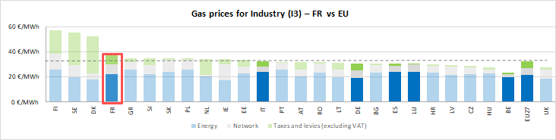

See footnote [29]

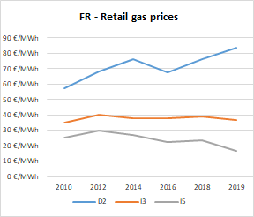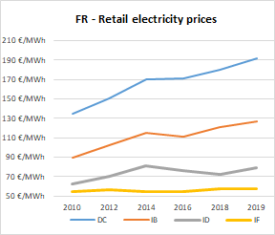

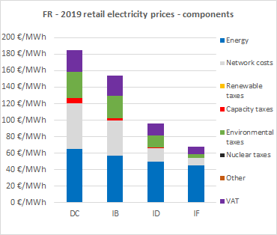

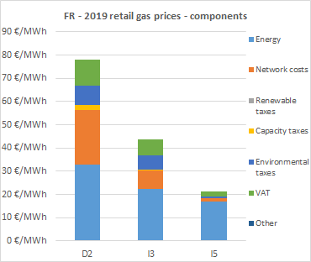

**Oil product prices**

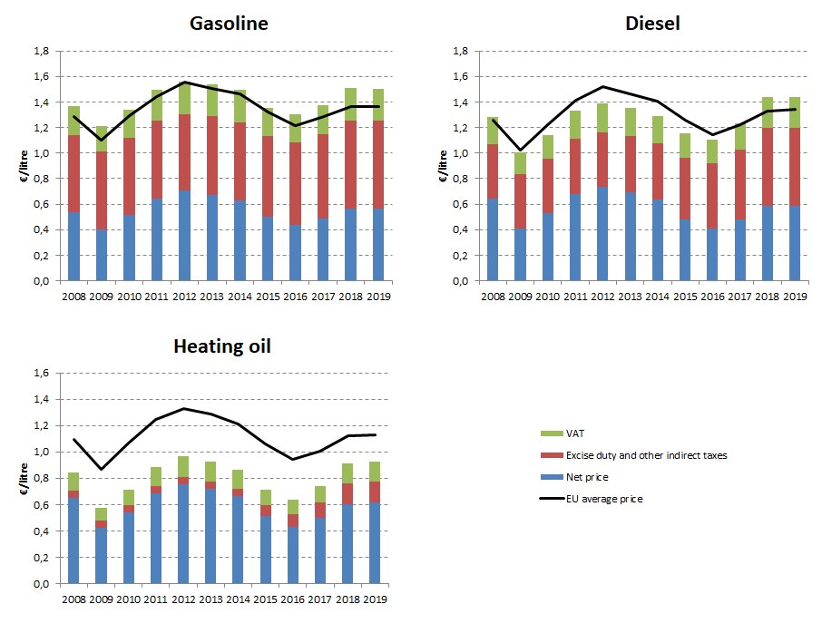

## Energy costs for households, industry and services

**Energy in Household budgets**

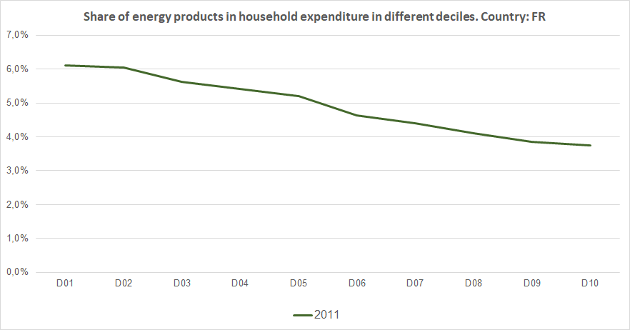

Notes: In 2011 in France (dark green line) the poorest households (Decile 1) had to spend 6.1% of their total expenditures on energy products.In the case of middle income households (Decile 5), in 2011 they spent 5.2 % of their total expenditure on energy. See footnote [30]

**Energy costs shares in total production costs**

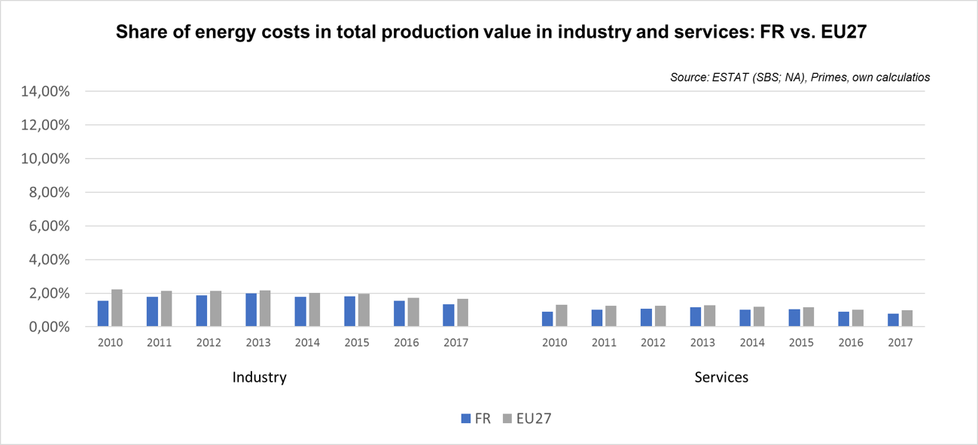

Notes: Data for Malta is only available for 2016. Data for Poland (prior to 2015), Slovenia (prior to 2012) and Greece (prior to 2008) is not available. At the time of extraction, the data for 2018 was not available

**Germany**  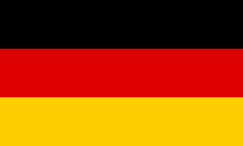

## Prices (2019 and recent evolution)

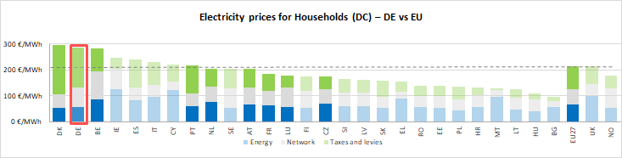 see footnote[31]

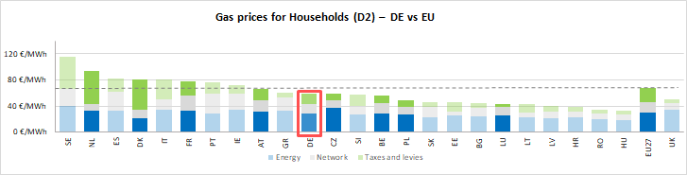

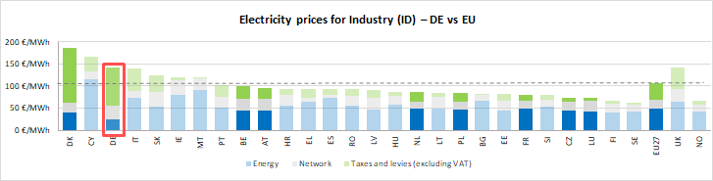

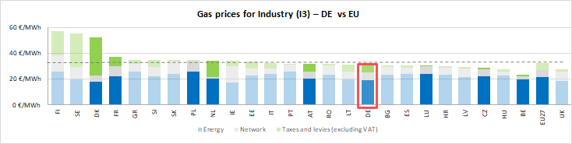



See footnote [32]

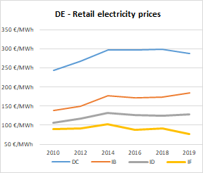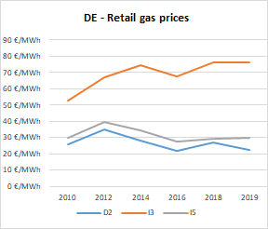

**P**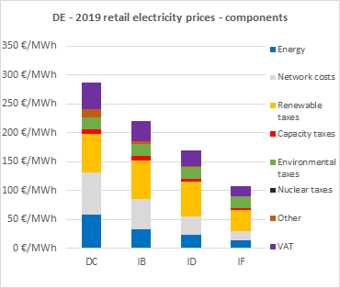

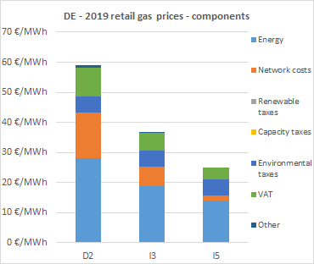

**Oil products prices**

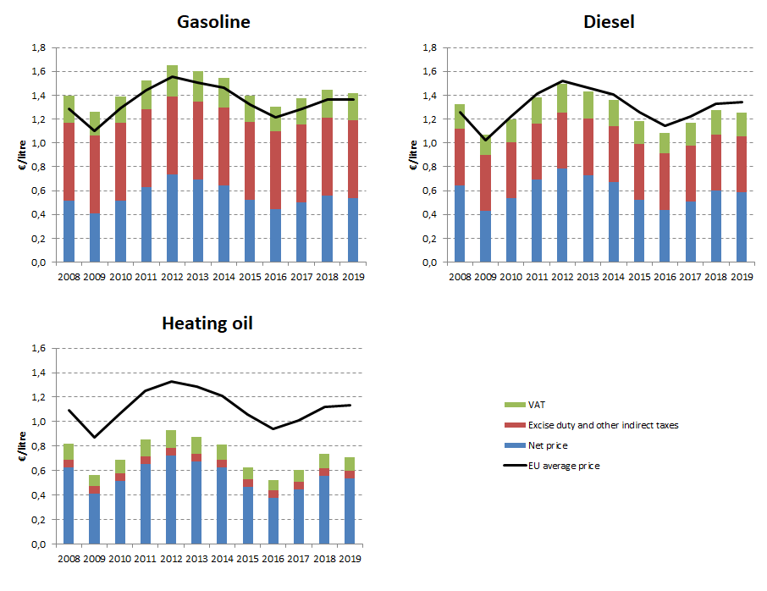

## Energy costs for households, industry and services

**Energy in Household budgets**

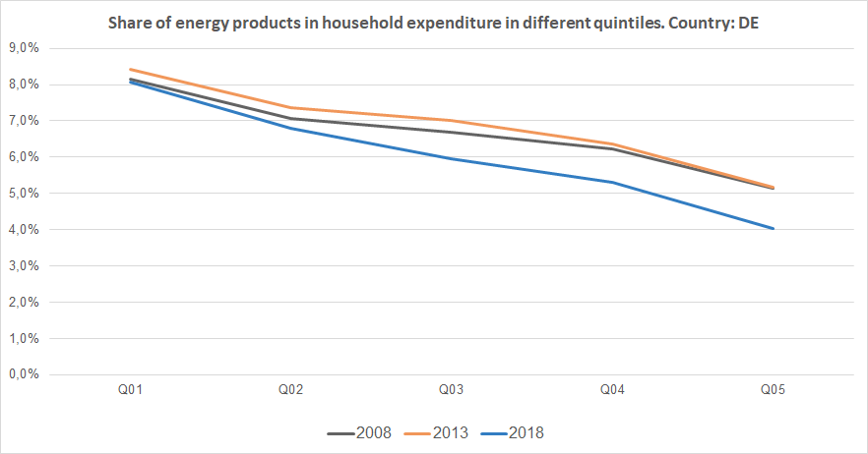

Notes: In 2008 in Germany (dark grey line) the poorest households (Quintile 1) had to spend 8.1% of their total expenditures on energy products. In 2018 (blue line) the share of energy remain almost unchanged.In the case of middle income households (Quintile 3), in 2008 they spent 6.7 % of their total expenditure on energy, while in 2018 this value decreased to 5.9%. See footnote [33]

**Energy costs shares in total production costs**

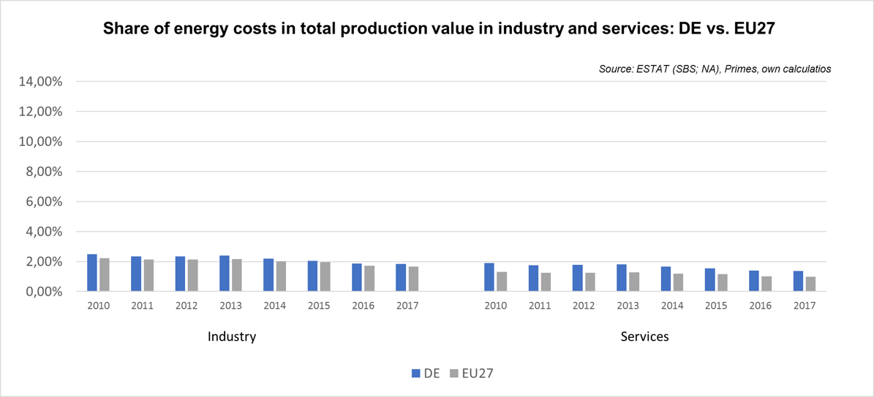

Notes: Data for Malta is only available for 2016. Data for Poland (prior to 2015), Slovenia (prior to 2012) and Greece (prior to 2008) is not available. At the time of extraction, the data for 2018 was not available.

Greece 

## Prices (2019 and recent evolution)

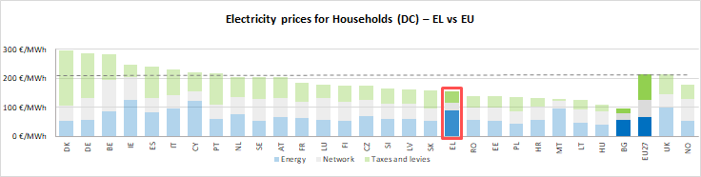 See footnote[34]

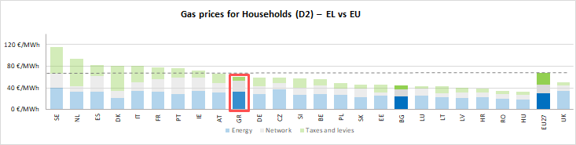

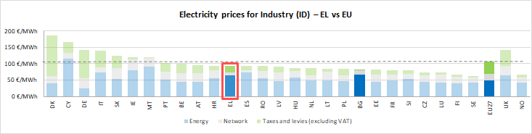

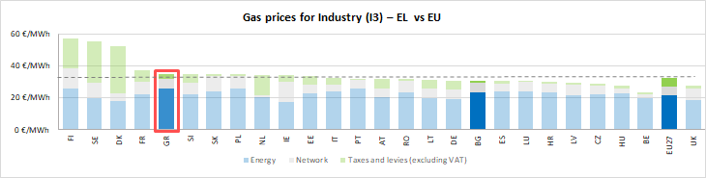



See footnote [35]

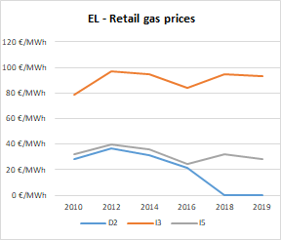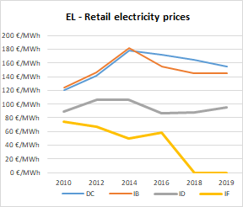

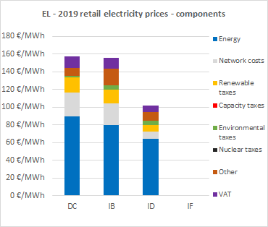

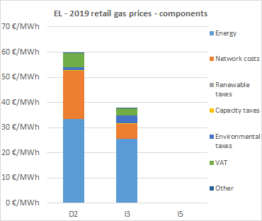

**Oil products prices**

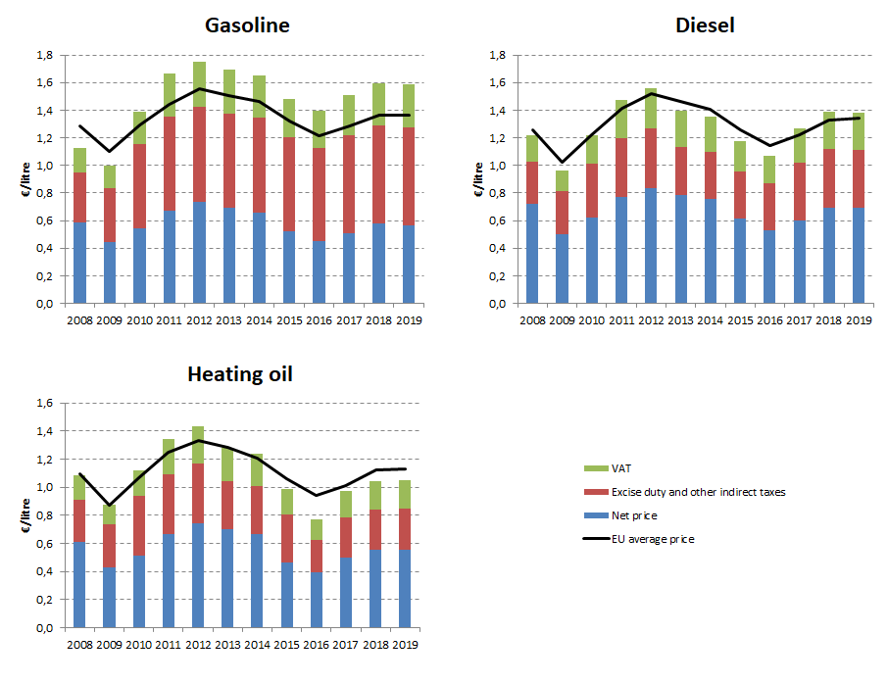

## Energy costs for households, industry and services

**Energy in Household budgets**

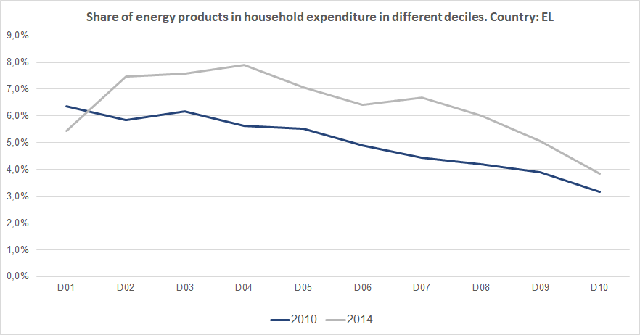

Notes: In 2010 in Greece (dark blue line) the poorest households (Decile 1) had to spend 6.3% of their total expenditures on energy products. In 2014 (grey line) the share of energy decreased to 5.4%.In the case of middle income households (Decile 5), in 2010 they spent 5.5 % of their total expenditure on energy, while in 2014 this value increased to 7.0%. See footnote [36]

**Energy costs shares in total production costs**

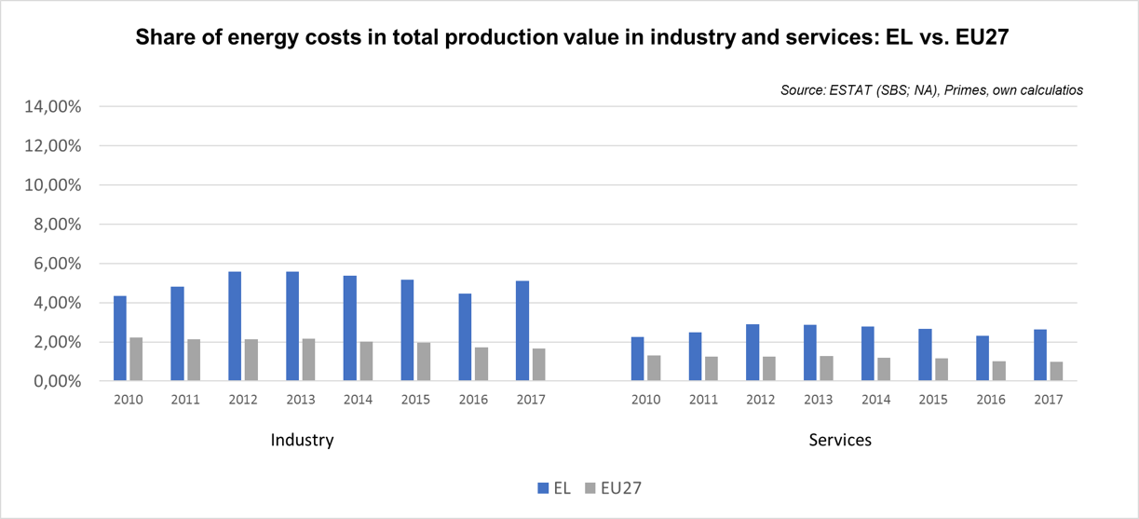

Notes: Data for Malta is only available for 2016. Data for Poland (prior to 2015), Slovenia (prior to 2012) and Greece (prior to 2008) is not available. At the time of extraction, the data for 2018 was not available.

Hungary 

## Prices (2019 and recent evolution)

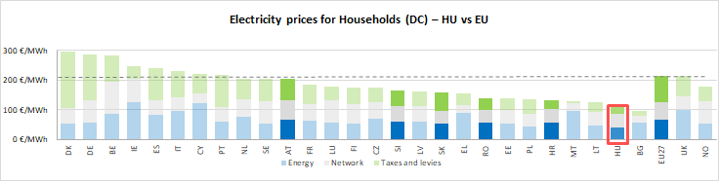

See footnote[37]

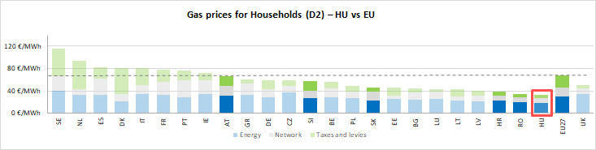

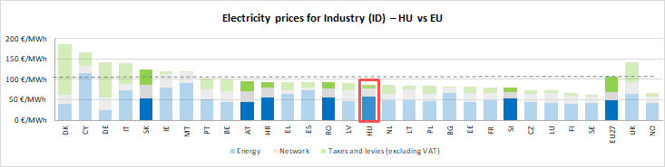

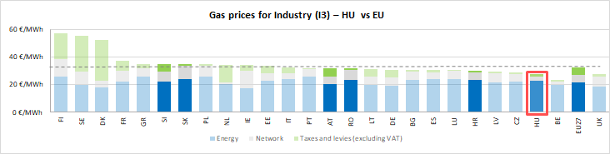

See footnote [38]

**Prices**

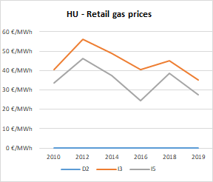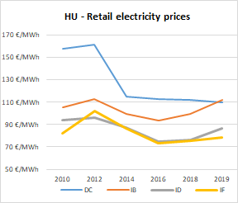

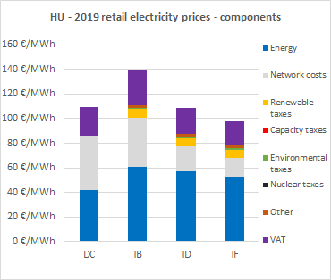

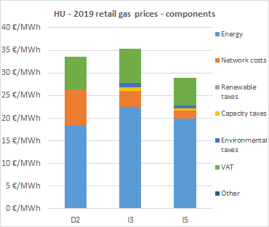

**Oil product prices**

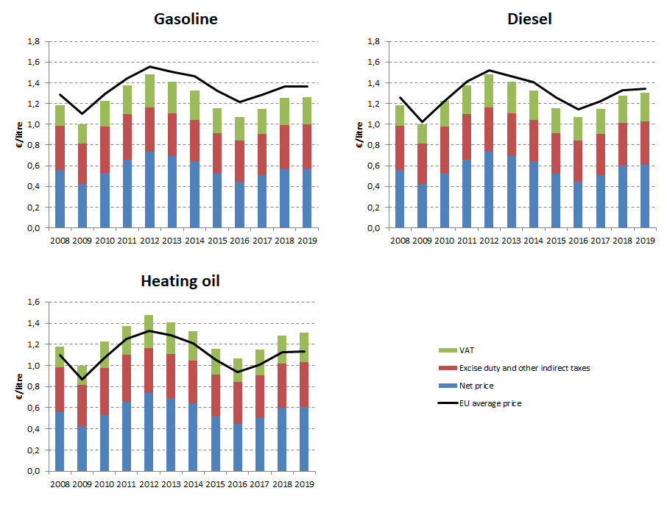

## Energy costs for households, industry and services

**Energy in Household budgets**

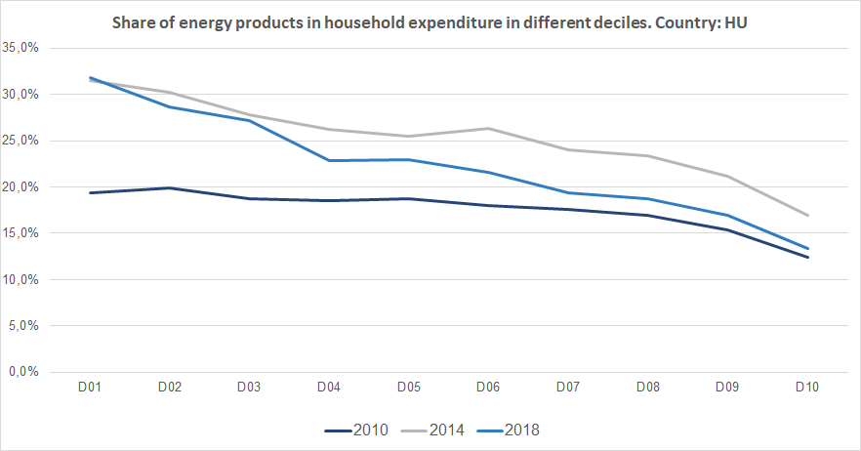

Notes: In 2010 in Hungary (dark blue line) the poorest households (Decile 1) had to spend 19.4% of their total expenditures on energy products. In 2018 (blue line) the share of energy increased to 31.2%.In the case of middle income households (Decile 5), in 2010 they spent 18.7 % of their total expenditure on energy, while in 2018 this value increased to 22.3%. See footnote [39]

**Energy costs shares in total production costs**

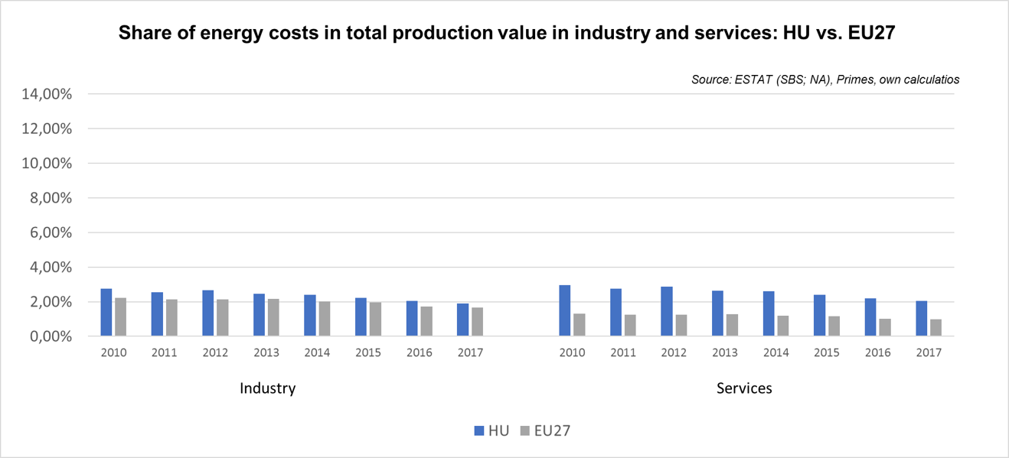

Notes: Data for Malta is only available for 2016. Data for Poland (prior to 2015), Slovenia (prior to 2012) and Greece (prior to 2008) is not available. At the time of extraction, the data for 2018 was not available.

70253E23-53F8-43A0-8E31-8F297C3D1C23

Ireland

## Prices (2019 and recent evolution)

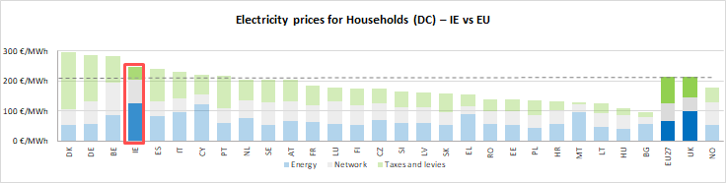

See footnote[40]

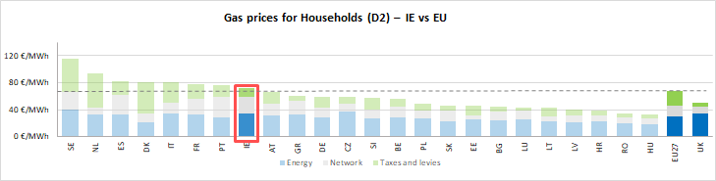

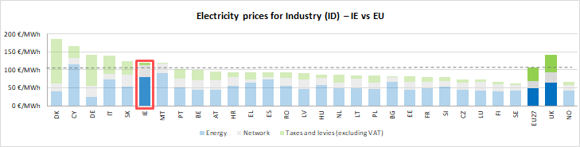

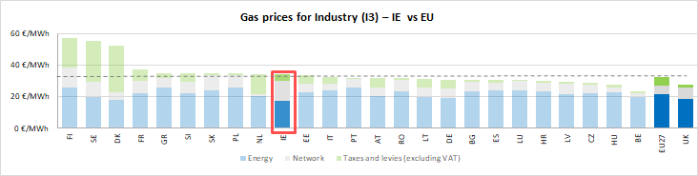



See footnote [41]

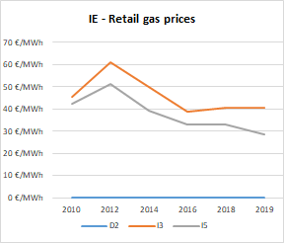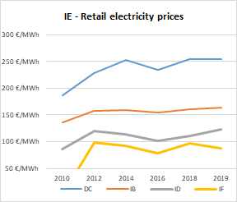

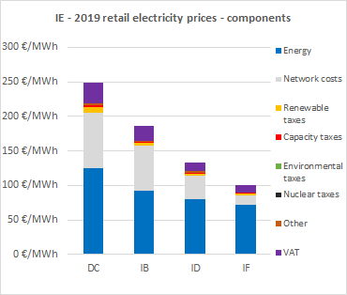



**Oil products prices**

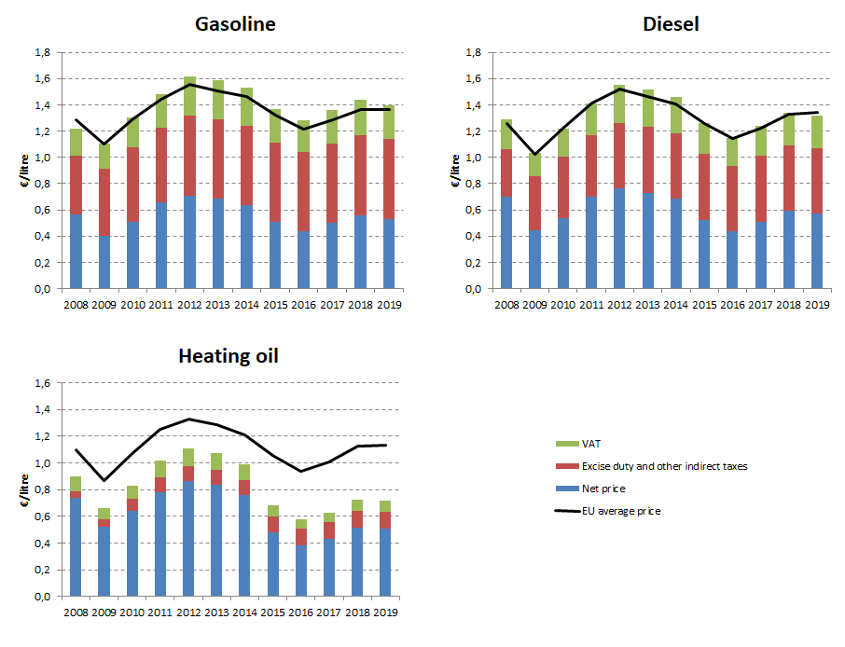

## Energy costs for households, industry and services

**Energy in Household budgets**

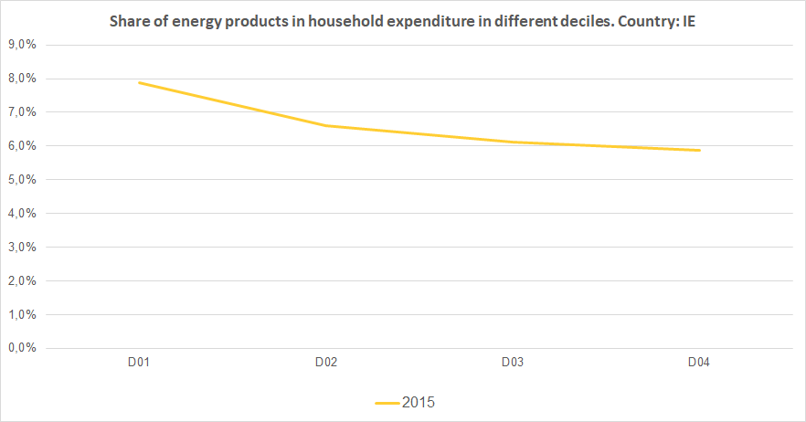

Notes: In 2015 in Ireland (yellow line) the poorest households (Decile 1) had to spend 7.9% of their total expenditures on energy products. In the case of lower-middle income households (Decile 3), in the same year they spent 6.12 % of their total expenditure on energy. See footnote [42]

**Energy costs shares in total production costs**

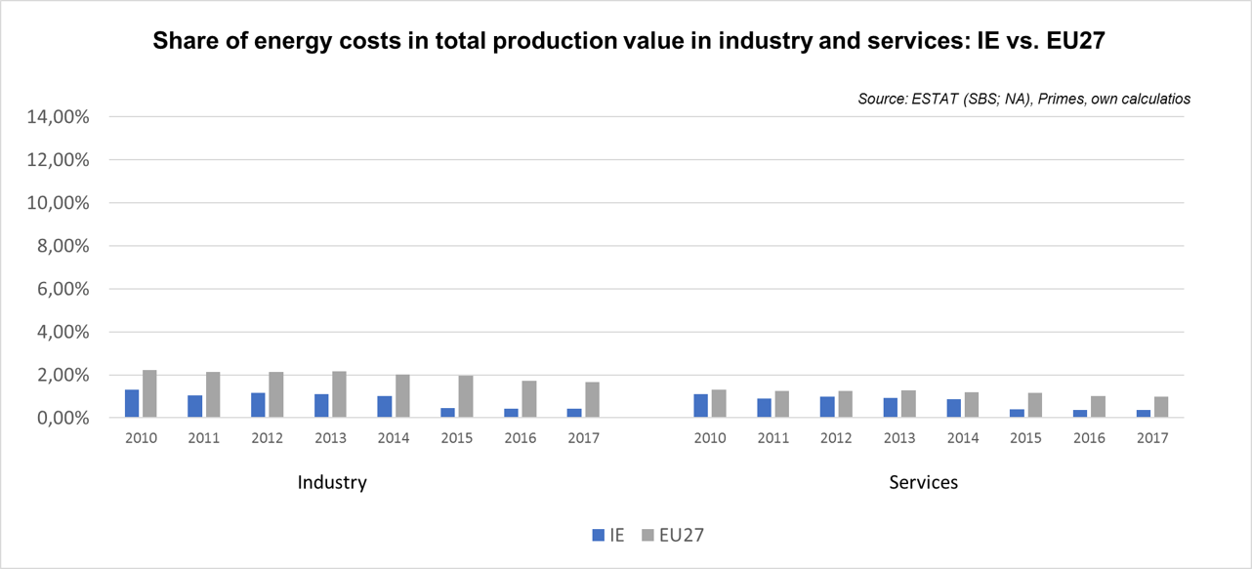

Notes: Data for Malta is only available for 2016. Data for Poland (prior to 2015), Slovenia (prior to 2012) and Greece (prior to 2008) is not available. At the time of extraction, the data for 2018 was not available.

1. The country of study, its neighbours and the EU average are highlighted with brighter colours in the figure.
2. Annual electricity consumption: DB 1 - 2.5 MWh, DC 2.5 - 5 MWh, DD 5 - 15 MWh, DE above 15 MWh, IB 20-500 MWh, ID 2000-20000 MWh, IF 70000-150000 MWh. Annual Gas consumption: D2 20-200 GJ, I3 10000-100000 GJ, I5 1 mil - 4 mil GJ.
3. This graphic includes energy expenditure per different household deciles, excluding transport energy expenditure (transport fuels).
4. The country of study, its neighbours and the EU average are highlighted with brighter colours in the figure.
5. Annual electricity consumption: DB 1 - 2.5 MWh, DC 2.5 - 5 MWh, DD 5 - 15 MWh, DE above 15 MWh, IB 20-500 MWh, ID 2000-20000 MWh, IF 70000-150000 MWh. Annual Gas consumption: D2 20-200 GJ, I3 10000-100000 GJ, I5 1 mil - 4 mil GJ.
6. This graphic includes energy expenditure per different household deciles, excluding transport energy expenditure (transport fuels).
7. The country of study, its neighbours and the EU average are highlighted with brighter colours in the figure.
8. Annual electricity consumption: DB 1 - 2.5 MWh, DC 2.5 - 5 MWh, DD 5 - 15 MWh, DE above 15 MWh, IB 20-500 MWh, ID 2000-20000 MWh, IF 70000-150000 MWh. Annual Gas consumption: D2 20-200 GJ, I3 10000-100000 GJ, I5 1 mil - 4 mil GJ.
9. This graphic includes energy expenditure per different household deciles, excluding transport energy expenditure (transport fuels).
10. The country of study, its neighbours and the EU average are highlighted with brighter colours in the figure.
11. Annual electricity consumption: DB 1 - 2.5 MWh, DC 2.5 - 5 MWh, DD 5 - 15 MWh, DE above 15 MWh, IB 20-500 MWh, ID 2000-20000 MWh, IF 70000-150000 MWh. Annual Gas consumption: D2 20-200 GJ, I3 10000-100000 GJ, I5 1 mil - 4 mil GJ.
12. This graphic includes energy expenditure per different household deciles, excluding transport energy expenditure (transport fuels).
13. The country of study, its neighbours and the EU average are highlighted with brighter colours in the figure.
14. Annual electricity consumption: DB 1 - 2.5 MWh, DC 2.5 - 5 MWh, DD 5 - 15 MWh, DE above 15 MWh, IB 20-500 MWh, ID 2000-20000 MWh, IF 70000-150000 MWh. Annual Gas consumption: D2 20-200 GJ, I3 10000-100000 GJ, I5 1 mil - 4 mil GJ.
15. This graphic includes energy expenditure per different household deciles, excluding transport energy expenditure (transport fuels).
16. The country of study, its neighbours and the EU average are highlighted with brighter colours in the figure.
17. Annual electricity consumption: DB 1 - 2.5 MWh, DC 2.5 - 5 MWh, DD 5 - 15 MWh, DE above 15 MWh, IB 20-500 MWh, ID 2000-20000 MWh, IF 70000-150000 MWh. Annual Gas consumption: D2 20-200 GJ, I3 10000-100000 GJ, I5 1 mil - 4 mil GJ.
18. This graphic includes energy expenditure per different household deciles, excluding transport energy expenditure (transport fuels).
19. The country of study, its neighbours and the EU average are highlighted with brighter colours in the figure.
20. Annual electricity consumption: DB 1 - 2.5 MWh, DC 2.5 - 5 MWh, DD 5 - 15 MWh, DE above 15 MWh, IB 20-500 MWh, ID 2000-20000 MWh, IF 70000-150000 MWh. Annual Gas consumption: D2 20-200 GJ, I3 10000-100000 GJ, I5 1 mil - 4 mil GJ.
21. This graphic includes energy expenditure per different household deciles, excluding transport energy expenditure (transport fuels).
22. The country of study, its neighbours and the EU average are highlighted with brighter colours in the figure.
23. Annual electricity consumption: DB 1 - 2.5 MWh, DC 2.5 - 5 MWh, DD 5 - 15 MWh, DE above 15 MWh, IB 20-500 MWh, ID 2000-20000 MWh, IF 70000-150000 MWh. Annual Gas consumption: D2 20-200 GJ, I3 10000-100000 GJ, I5 1 mil - 4 mil GJ.
24. This graphic includes energy expenditure per different household deciles, excluding transport energy expenditure (transport fuels).
25. The country of study, its neighbours and the EU average are highlighted with brighter colours in the figure.
26. Annual electricity consumption: DB 1 - 2.5 MWh, DC 2.5 - 5 MWh, DD 5 - 15 MWh, DE above 15 MWh, IB 20-500 MWh, ID 2000-20000 MWh, IF 70000-150000 MWh. Annual Gas consumption: D2 20-200 GJ, I3 10000-100000 GJ, I5 1 mil - 4 mil GJ.
27. This graphic includes energy expenditure per different household deciles, excluding transport energy expenditure (transport fuels).
28. The country of study, its neighbours and the EU average are highlighted with brighter colours in the figure.
29. Annual electricity consumption: DB 1 - 2.5 MWh, DC 2.5 - 5 MWh, DD 5 - 15 MWh, DE above 15 MWh, IB 20-500 MWh, ID 2000-20000 MWh, IF 70000-150000 MWh. Annual Gas consumption: D2 20-200 GJ, I3 10000-100000 GJ, I5 1 mil - 4 mil GJ.
30. This graphic includes energy expenditure per different household deciles, excluding transport energy expenditure (transport fuels).
31. The country of study, its neighbours and the EU average are highlighted with brighter colours in the figure.
32. Annual electricity consumption: DB 1 - 2.5 MWh, DC 2.5 - 5 MWh, DD 5 - 15 MWh, DE above 15 MWh, IB 20-500 MWh, ID 2000-20000 MWh, IF 70000-150000 MWh. Annual Gas consumption: D2 20-200 GJ, I3 10000-100000 GJ, I5 1 mil - 4 mil GJ.
33. This graphic includes energy expenditure per different household deciles, excluding transport energy expenditure (transport fuels).
34. The country of study, its neighbours and the EU average are highlighted with brighter colours in the figure.
35. Annual electricity consumption: DB 1 - 2.5 MWh, DC 2.5 - 5 MWh, DD 5 - 15 MWh, DE above 15 MWh, IB 20-500 MWh, ID 2000-20000 MWh, IF 70000-150000 MWh. Annual Gas consumption: D2 20-200 GJ, I3 10000-100000 GJ, I5 1 mil - 4 mil GJ.
36. This graphic includes energy expenditure per different household deciles, excluding transport energy expenditure (transport fuels).
37. The country of study, its neighbours and the EU average are highlighted with brighter colours in the figure..
38. Annual electricity consumption: DB 1 - 2.5 MWh, DC 2.5 - 5 MWh, DD 5 - 15 MWh, DE above 15 MWh, IB 20-500 MWh, ID 2000-20000 MWh, IF 70000-150000 MWh. Annual Gas consumption: D2 20-200 GJ, I3 10000-100000 GJ, I5 1 mil - 4 mil GJ.
39. This graphic includes energy expenditure per different household deciles, excluding transport energy expenditure (transport fuels).
40. The country of study, its neighbours and the EU average are highlighted with brighter colours in the figure.
41. Annual electricity consumption: DB 1 - 2.5 MWh, DC 2.5 - 5 MWh, DD 5 - 15 MWh, DE above 15 MWh, IB 20-500 MWh, ID 2000-20000 MWh, IF 70000-150000 MWh. Annual Gas consumption: D2 20-200 GJ, I3 10000-100000 GJ, I5 1 mil - 4 mil GJ.
42. This graphic includes energy expenditure per different household deciles, excluding transport energy expenditure (transport fuels).