

# Oil and oil product prices[1]

**Main findings**

* After the dramatic fall seen in 2014-2016, crude oil prices have broadly been rising since mid-2017 until late 2018, driven by robust global demand growth, Middle East tensions, concerns over the impact of a return to US sanctions on Iranian oil, sliding output in Venezuela and the continued OPEC-led output cuts. In 2019 there was settling of price between 60 and 70 USD per barrel due to signs of slowing of global economy and increased production of US shale oil.
* Due to COVID-19 crisis decreased demand and longer time needed for OPEC + to come to the agreement on adjusting production on supply side, the oil price fell to 20 USD per barrel.
* The crude oil price is the main driver for the development of the wholesale prices of oil products although other factors, like the supply-demand situation in the specific oil product market, refinery maintenance or seasonality can also influence the prices.
* In addition to the crude oil price, the retail price of oil products is also influenced by the costs of refining and distribution, variations in exchange rates (crude oil is traded in US dollar but the finished products are sold at the pump in euros or other national currencies) and tax rates. In fact, the share of crude oil in the final price can be as low as 25% and, therefore, variations in the price of crude oil have a limited impact on the price at the pump. In contrast, the tax component (excise duty plus VAT) can reach up to 70% of the retail price
* The high share of taxes and exchange rate developments moderate the pass-through of falling/rising crude oil prices to the retail prices of oil products in Europe.
* In 2018 and 2019, retail prices reached the highest levels since 2014-2015
* Due to COVID-19 crisis, retail prices in first half decreased of 2020 following movement of oil prices and wholesale prices.
* There has been some convergence of gasoline and diesel prices, helped by some convergence of the excise duty rates but in several Member States the tax advantage of diesel actually increased.
* International comparison of oil products reveals that differences in prices can be explained by differences in tax treatment amongst G20 countries. EU taxes on oil products are among the highest globally, resulting in a high retail price compared to most G20 countries.
* As regards to electricity prices for transport (alternative fuel to the conventional transport fuels) despite the limited available data, it can be observed that both home and public charging prices tend to be higher in Europe than in the main international G20 partners. However, superfast public charging prices in Europe tend to be comparable to the rest of G20 countries.

## Crude oil prices

Crude oil prices reached unprecedented levels in 2008, with Brent exceeding 140 USD/bbl at the height of the "commodity super cycle" which was driven by the rising demand from emerging markets, particularly China. The price increase was interrupted by the financial crisis, with a sharp downturn in the second half of 2008. However, as demand recovered, prices began to rise and crossed the 100 USD/bbl level again in early 2011. This was followed by three and a half years of remarkable price stability, with Brent rarely leaving the 100-120 USD/bbl range.

Crude oil prices started to decline in mid-2014, driven by weak demand and robust supply growth, resulting in an oversupplied market. Global oil demand growth has significantly weakened in 2014, mainly because of lower than expected global economic growth and mild winter temperatures.

On the supply side, non-OPEC output showed a robust growth, driven by increasing unconventional oil production in North America. US light tight oil production proved to be rather resilient to low prices: improving efficiency and cost reductions allowed output to continue increasing in spite of the plummeting crude oil prices.

In spite of the falling prices, OPEC countries chose not to cut production in an attempt to maintain market share and to squeeze out high-cost producers. Furthermore, the lifting of the Iranian sanctions in January 2016 allowed Iran to increase its oil exports, adding to an already high OPEC output and further delaying the market rebalancing. OPEC and a few key non-OPEC producers finally agreed in November 2016 to limit their production, in order to accelerate the drawdown of the stock overhang and bring the rebalancing forward.

From a 115 USD/bbl peak in June 2014, Brent dropped to 26 USD/bbl on 20 January 2016, its lowest level since 2003. This means the price decreased by 77% in 19 months.

Despite the November 2016 agreement of OPEC and non-OPEC producers to reduce output, oil prices decreased in the first half of 2017 reflecting increasing production in the US, as well as growing output in Libya and Nigeria which were exempted from the OPEC cut. The rollover of the cut in May 2017 failed to reverse the trend: in the second half of June 2017, the price of Brent dropped below 45 USD/bbl, the lowest level since November 2016.

From mid-2017, however, oil prices have broadly been on the rise, driven by a combination of factors, including the robust growth of global demand, growing tensions in the Middle East, a number of actual supply disruptions (Northern Iraq, hurricanes in North America, closure of the Forties pipeline system in the UK North Sea, a sustained plunge of Venezuelan supply), the weakening of the dollar and a further extension of the OPEC cut in November 2017. In late December and early January, the protests in Iran provided support to prices.

Prices receded in early February 2018 as the market remained well supplied, but the price rise resumed afterwards as growing tensions in Syria and the expectation of the US withdrawal from the Joint Comprehensive Plan of Action (the Iran nuclear deal) raised concerns about future oil supplies. In mid-May 2018, after President Trump announced the re-imposition of US sanctions on Iran, Brent reached 80 USD/bbl, the highest level in three and a half years. Compared to the 44 USD/bbl low on 20 June 2017, Brent increased by more than 75%. Prices continued to rise despite the strengthening of the US dollar which in general is conducive to lower oil prices.

Brent receded to around 75 USD/bbl in late May/early June after Russia and Saudi Arabia indicated they would increase production in the second half of the year. On 22 June, OPEC and non-OPEC producers agreed to do away with the over-compliance with the cuts agreed back in 2016, implying a theoretical output increase of around 1 million barrels per day (mb/d) in the second half of the year. Despite the agreement, prices rose again in late June and early July, supported by production outages in Libya and Canada.

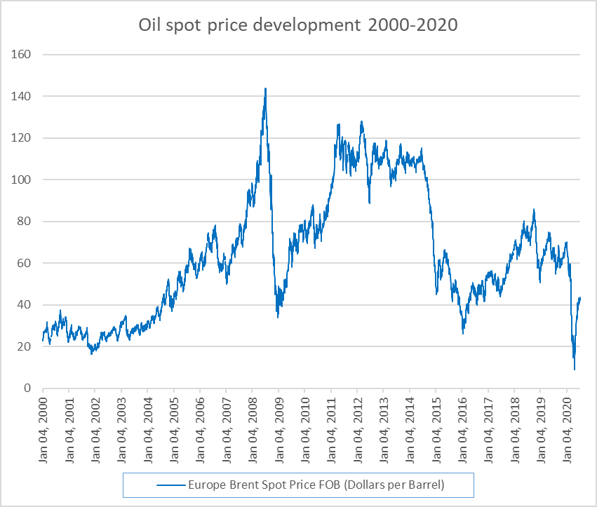

Figure 62 - The Brent crude oil price from 2000 to mid-2020

Source: Platts

The unilateral withdrawal of the US from the Iran nuclear deal cast a doubt about the future of Iranian crude exports, at a time when output in Libya and Venezuela was sliding, as well as geopolitical risks increasing in other parts of the world. This on one hand further tightened the global market, leading to additional price rise above 80 USD per barrel as OPEC and Russia could not fill this gap with their production.

Growth in energy markets slowed in 2019 due to weaker economic growth. Oil price dropped below 60 USD per barrel and fluctuated between 60 and 70 USD per barrel throughout 2019. However, in September 2019, due to an attack on key energy installations in Saudi Arabia, Brent oil prices increased by 9 USD per barrel, but only for a short while because of Saudi Arabia’s ability to bring production back online within weeks of the attack and global concerns about demand growth. Throughout 2019, increases in U.S. petroleum production put downward pressure on crude oil prices. In addition, the production increases likely limited the effect on prices from the attack on Saudi Arabia, production cut announcements from the Organization of the Petroleum Exporting Countries (OPEC), and U.S. sanctions on Iran and Venezuela that limited crude oil exports from those countries.

Since mid-January 2020 oil prices began to decrease based on slowing economic indicators, but dropped significantly to 20 USD per barrel (the lowest since 2002) as confinement measures for COVID-19 were imposed in China (and subsequently in other countries in the world) leading to immediate decrease for oil demand. Negotiations between OPEC members and non-OPEC members including Russia did not lead to production adjustment right away, but only in May after which oil price eased up a bit above 40 USD per barrel.

## Wholesale prices of oil products

Crude oil is the main feedstock to produce oil products and oil product prices closely follow the development of the crude oil price. This is clearly visible if we compare the Brent oil price with the representative wholesale prices of the main oil products in Western Europe.

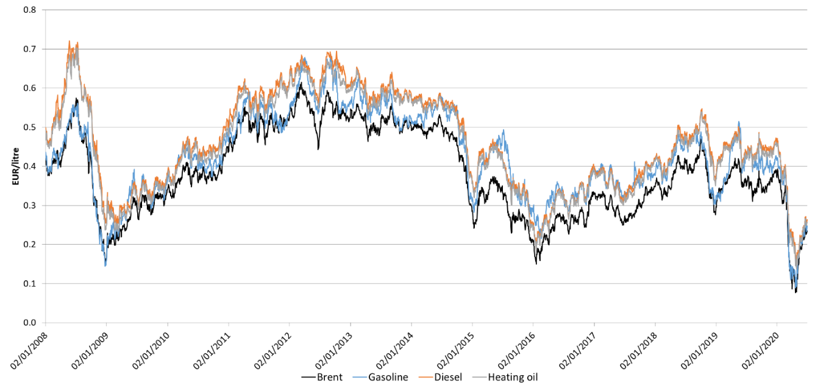

Figure 63 - Crude oil (Brent) and European wholesale gasoline, diesel and heating oil prices from 2008 to mid-2018

Source: Platts, ECB (for exchange rates).

The following oil product prices were used: Gasoline Prem Unleaded 10ppmS FOB AR Barge (gasoline), ULSD 10ppmS FOB ARA Barge (diesel) and Gasoil 0.1%S FOB ARA Barge (heating oil)

The following conversion rates were used: crude oil 159 litre/barrel, gasoline 1350 litre/ton, diesel and heating oil 1186 litre/ton.

Looking at the crack spreads (i.e. the differential between the wholesale price of oil products and crude oil), one can see that these spreads are however rather volatile and often follow different paths for different products.

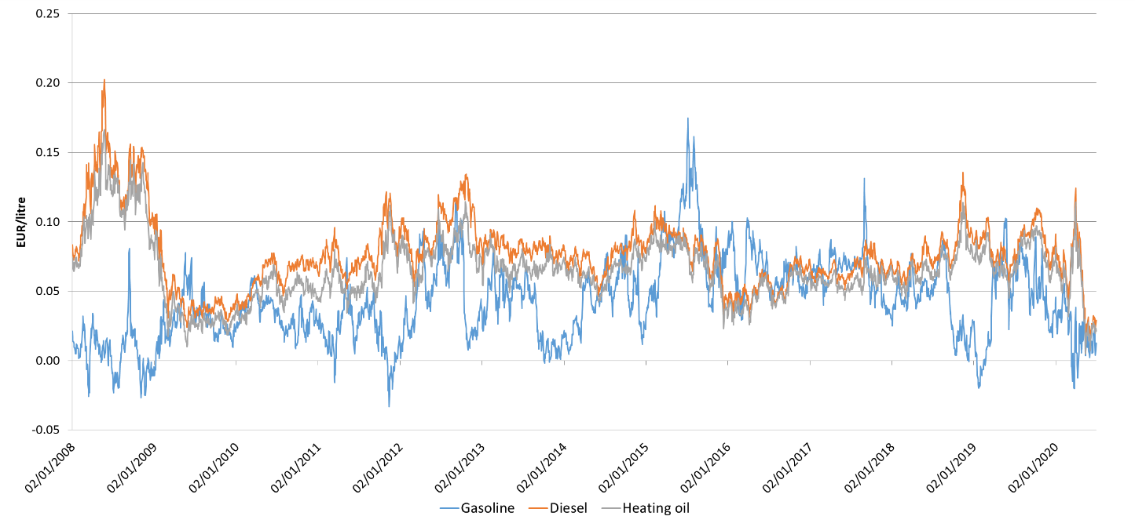

Figure 64 - Crack spreads of gasoline, diesel and heating oil from 2008 to mid-2018

Source: Platts, ECB (for exchange rates)

Crack spreads are calculated as the difference between the Brent crude oil price and the price of the following products: Gasoline Prem Unleaded 10ppmS FOB AR Barge (gasoline), ULSD 10ppmS FOB ARA Barge (diesel) and Gasoil 0.1%S FOB ARA Barge (heating oil)

The following conversion rates were used: crude oil 159 litre/barrel, gasoline 1350 litre/ton, diesel and heating oil 1186 litre/ton.

The supply-demand conditions of the different products are divergent (both from crude oil and from each other) which will affect their crack spreads. For example, the 2008 oil price rise was very much driven by industrial growth in China, leading to a big increase in the demand of middle distillates which is reflected in the high crack spreads of these products. There are also seasonal differences in demand, for example, gasoline demand is higher in the summer, typically resulting in a relatively high crack spread during that period while in times of low demand crack spreads can even turn negative (implying the gasoline is cheaper than crude oil). In the summer of 2015, gasoline crack spreads reached unusually high levels as low prices boosted gasoline demand.

Oil product supply can also fluctuate, for example as a result of refinery maintenance or natural disasters affecting refinery operations; this will also affect crack spreads. For example, Hurricane Harvey in the US triggered the spike of European gasoline crack spreads in late August 2017.

On Figure 64 one can see that European crack spreads have been relatively high in 2015, averaging 0.08 EUR/litre (around 13 EUR/barrel) for both gasoline and diesel. Afterwards, crack spreads diminished: in the period from the beginning of 2016 to mid-2018, both gasoline and diesel crack spreads averaged 0.06 EUR/litre (less than 10 EUR/barrel). There is divergence in gasoline in end of 2018 and in beginning of 2019, meaning gasoline being cheaper than oil due to US unilaterally getting out of the Iranian deal, reduction of production in Venezuela and Libya while at the same time growing indications of slowdown in economic activity and consumption especially in developing countries.

## Retail prices of oil products

In addition to electricity and gas, oil products constitute an important part of the energy costs of both households and industry. Oil products have a dominant role in transport where they have limited alternatives, particularly in road freight, maritime and air transport. In case of space heating, the share of oil products is on a declining trend but in certain Member States they still have an important role in this sector.

The retail price of oil products depends on several factors. Variations in the price of crude oil will obviously have an impact on retail prices but crude oil costs constitute just a part, often a relatively small part, of the final price paid by the consumer. Crude oil is traded in US dollar but the finished products are sold at the pump in euros or other national currencies. Therefore, variations in exchange rates will also influence the crude oil component.

Crude oil has to be refined to produce fuels which can be used in transportation, heating or other uses. After refining, the finished products have to be distributed and sold, typically at petrol stations. Refining and distribution costs are relatively stable and are not proportional to the crude oil price.

A significant part of the price goes to taxes: excise duties, other indirect taxes and VAT. These taxes make an important contribution to the tax revenue of Member States (see Chapter 7.1). In case of motor fuels (gasoline and diesel), taxes typically cover more than half of the final price.

Excise duties are generally a fixed amount per quantity (usually litre or kg), i.e. not influenced by the price of crude oil. VAT, on the other hand, is set as a percentage of the price of the product (including the excise duty) and, therefore, changes in the crude oil price will have an impact on the absolute value of the VAT component.

Rates of both the excise duty and VAT vary by product and by Member State, resulting in significant price differences across Europe. Nevertheless, Member States have no complete freedom when setting the tax rates. The Energy Tax Directive (2003/96/EC) sets minimum excise duty rates for gasoline, gasoil, kerosene, LPG and heavy fuel oil. New Member States were often granted a transition period to reach the minimum level; today, all Member States comply with minimum level.

In case of VAT, the VAT Directive (2006/112/EC) requires that the standard VAT rate must be at least 15%; currently the standard VAT rates applied by Member States range from 17% (in Luxembourg) to 27% (in Hungary). In case of oil products, Member States typically apply the standard VAT rate. Under certain conditions, however, Member States can set a lower VAT rate for specific products and services; for example, a few Member States apply a reduced rate for heating oil.

As the share of crude oil in the final price can be as low as 25%, variations in the price of crude oil will have a limited impact on the price at the pump. In fact, the high share of fixed taxes in the price acts as a buffer: fluctuations in the retail price of oil products (particularly motor fuels) are significantly lower than the fluctuation of the crude oil price. Variations in the exchange rate have a similar effect: the oil price and the value of the US dollar usually move in the opposite direction: a strengthening dollar typically coincides with decreasing oil prices and vice versa. This means that changes in the oil price, whether upwards or downwards, are mitigated by the exchange rate and the volatility of the oil price expressed in euros is smaller than the volatility of the price expressed in dollar.

During the decline of crude oil prices in 2014-2016, the above factors moderated the pass-through to oil product prices in the EU: while crude oil prices (expressed in USD) fell by 77% between mid-2014 and early 2016, in the same period[2] the average EU consumer price of gasoline and diesel decreased by 24% and 28%, respectively. In case of heating oil, the decrease was 45%.

Similarly, the comparably high taxes in the EU mitigated the feed-through of the recent oil price rise: between 2017 and 2018, retail prices of gasoline and diesel (including taxes and duties) increased between 4% and 14%, 4 and 18%, respectively, as compared to a more than 50% increase in international crude oil prices in the same period (measured in USD). In case of heating oil, where the tax component is smaller, the price increase was between 5 and 24%.

Finally, although their current use is limited, alternative fuels provide an increasing share of the energy mix in transport and their importance is expected to grow in the future. At the same time, as shown by Trinomics et al. (2018), data on retail prices for compressed natural gas (CNG), liquefied natural gas (LNG), liquefied petroleum gas (LPG) and biofuels is not widely available. The growing importance of the market for alternative fuels shows the need of further efforts in collecting such retail prices in the future.

### Methodology

The analysis in this section is based on the data of the weekly Oil Bulletin. Pursuant to the Council Decision on Crude Oil Supply Costs and the Consumer Prices of Petroleum Products (1999/280/EC), Member States have to report to the Commission the retail prices of the main petroleum products on a weekly basis. Member States also have to report any changes in the tax rates (VAT, excise duty, other indirect taxes) applicable to these products, allowing us to break down the final price to three main components: the net price, excise duty[3] and VAT. The reported data are published on the website of DG Energy.[4]

The analysis covers the three main petroleum products sold in the retail sector: gasoline (Euro-super 95), diesel (automotive gas oil) and heating oil (heating gas oil). The time horizon is from 2005 to 2019. All Member States are covered but data for Croatia is available only from 2013. In case of heating oil, Slovakia does not report prices since October 2011 while, from 2015, Greece does not report prices for the period from May to mid-October.

Prices reported in currencies other than the euro were converted into euro, using the ECB exchange rate of the day for which the price applies.

For each year and each Member State an average price was calculated as an arithmetic average of the weekly prices and an EU average price was calculated as the weighted average of these with weights in the previous year’s consumption.

### General findings

While the absolute level of the prices of the three oil products are different, their development over the last 15 years is very similar and basically reflects the evolution of the crude oil price in the same period. The price of all three products decreased significantly in 2009 when oil prices plummeted in the wake of the financial crisis. This was followed by years of gradual increase, with prices peaking in 2012. Prices decreased afterwards, with the decrease accelerating in 2015-2016. As crude oil prices recovered from 2016, oil product prices have been also rising and in 2018 and 2019 reached a level that was in 2011 and 2014.

For comparison, **Figure 65** also depicts the evolution of the Brent crude oil price (recalculated into EUR/litre).

Figure 65 - Average retail price of oil products in the EU

Source: Oil Bulletin, DG Energy, Platts

The difference in the absolute price of the three products can be mostly attributed to the diverging tax rates.

All countries but UK, Ireland, and Luxembourg have the same VAT tax rates for all the fuels. UK, Ireland, Luxembourg have the same VAT rates for gasoline and diesel, but lower for heating oil (Portugal had a similar pattern up to 2012).

So most of the difference comes from excise taxes. The Energy Tax Directive sets a higher minimum excise rate for gasoline (0.359 EUR/litre) compared to diesel (0.33 EUR/litre). Most of the countries have excise tax rate for gasoline the highest, followed by rate for diesel, followed by rate for heating oil.

The minimum rate established by the Energy Tax Directive (0.021 EUR/litre) is much lower than those for motor fuels. The UK has long been the only state where the two motor fuels (gasoline and diesel) are taxed at the same level, with heating oil taxed by excise tax less, but is joined recently in 2019 by Belgium (gasoline excise = diesel excise > heating oil excise). In practically all Member States, the excise duty rate of gasoline is higher than that of diesel, which is higher than that for heating oil (gasoline excise > diesel excise > heating oil excise). Few Member States (Bulgaria, the Czechia, Hungary, Netherlands and Romania) apply practically the same excise duty rates for diesel and heating oil, with excise for gasoline higher (gasoline excise > diesel excise = heating oil excise). In most Member States, however, heating oil is taxed at a lower level. Czechia is the only country that has subsidies for heating oil.

Although excise duty rates are set in absolute values, i.e. as a fixed amount per quantity of the product, several Member States increased the tax rates over the period, resulting in a gradually increasing (weighted) average tax rate. According to the Energy Tax Directive, the minimum excise duty rate for diesel increased from 0.302 EUR/litre to 0.33 EUR/litre on 1 January 2010, requiring some Member States to adjust their rates.

Contrary to the general trend, the weighted average excise duty rate for gasoline fluctuated slightly from 2104 to 2016. While a few Member States indeed reduced the excise duty rate for gasoline in this period, the decrease was driven mainly by exchange rate developments, in particular the depreciation of the pound sterling which made the UK excise duty (unchanged in the local currency) significantly lower when expressed in euros.

Austria is the only Member State that had other indirect taxes (mostly intended to curb pollution) on fuel throughout the period. Some Member States introduced them since 2010 or in last 5-6 years (CY, ES, GR, HU, IE, LV, NL, PT, SI, SK), but other member states did not. Since those are small compared to other taxes and are calculated per litre, we add them in our analysis to excise taxes.

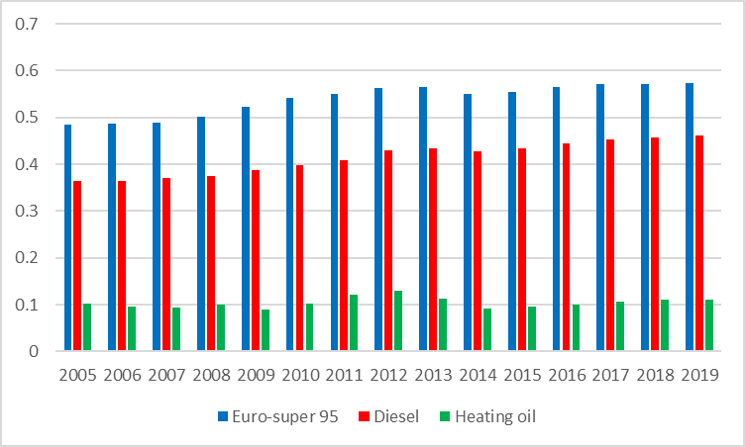

Figure 66 - Average excise duty rates for oil products in the EU (EUR/litre)

Source: Oil Bulletin, DG Energy

If the net price of the three products is compared, the difference is significantly lower. In fact, during the whole period the net price of diesel is slightly higher than that of gasoline.

**Figure 67** also depicts the evolution of the Brent crude oil price (recalculated into EUR/litre), showing that crude oil is clearly the main component of the net price. Over the period, crude oil price represented on average 65-70% of the net price of gasoline and diesel but in 2015-2016, as crude oil prices dropped significantly, this share dropped below 60%.

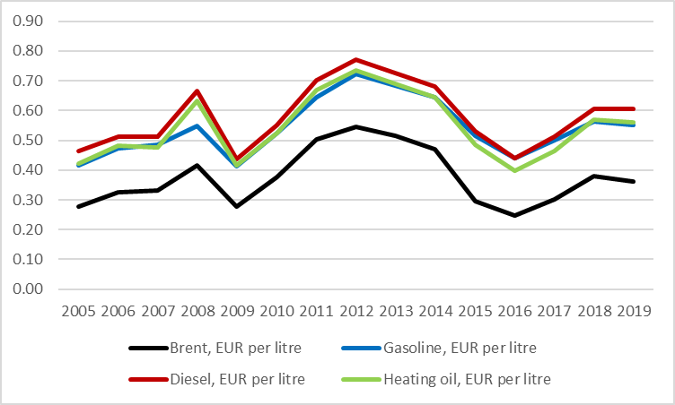

Figure 67 - Average retail price of oil products in the EU, without taxes

Source: Oil Bulletin, DG Energy

### Gasoline

In most Member States, the evolution of gasoline prices clearly followed the trend of the crude oil price but there have been considerable differences in the absolute level, mainly explained by the diverging excise duty and VAT rates. Average prices moved in a relatively wide range, with the difference between the highest and lowest price being about 0.5 EUR/litre. This range has slightly narrowed between 2013 and 2016, towards 0.45 EUR/litre, indicating some degree of price convergence. However, the range widened afterwards, exceeding 0.6 EUR/litre in 2019.

Greece showcased the biggest relative increase in gasoline prices: while in 2008-2009 Greek prices were well below the EU average, since 2011 they are among the highest, mainly as a result of the sharp increase of the excise duty rate. In the first half of 2018, the EU average gasoline price was 6% higher than in 2008; in case of Greece, the increase was 39%. At the other end of the spectrum, prices in Poland decreased by 8%, mainly because of the depreciation of the national currency in the second half of 2008 (measured in Polish zloty, the average price increased).

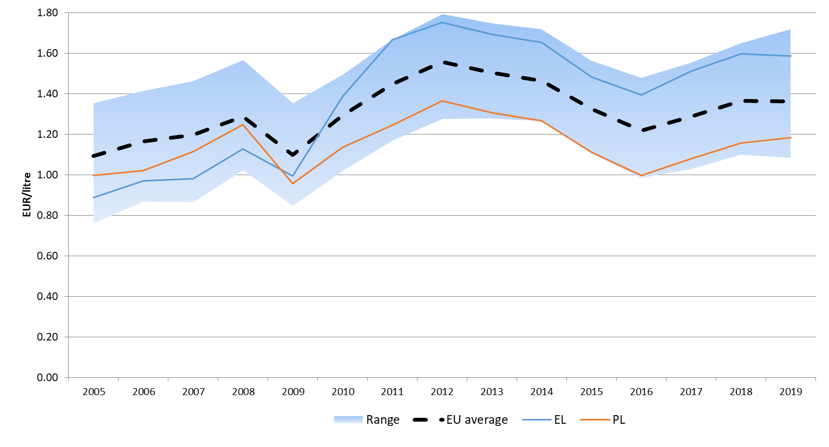

Figure 68 - The retail price of gasoline in the EU

Source: Oil Bulletin, DG Energy

Looking at net prices, the dispersion is smaller, the difference between the highest and the lowest price is typically between 0.10 and 0.15 EUR/litre. The net price depends on a number of factors, including the source of supply (local refinery or import), industry structure and competition. In 2019, the lowest net price was reported by Slovenia and Czechia, while the highest by the Denmark. Average net price follows the representative wholesale price (Platts Gasoline Prem Unleaded 10ppmS FOB AR Barge).

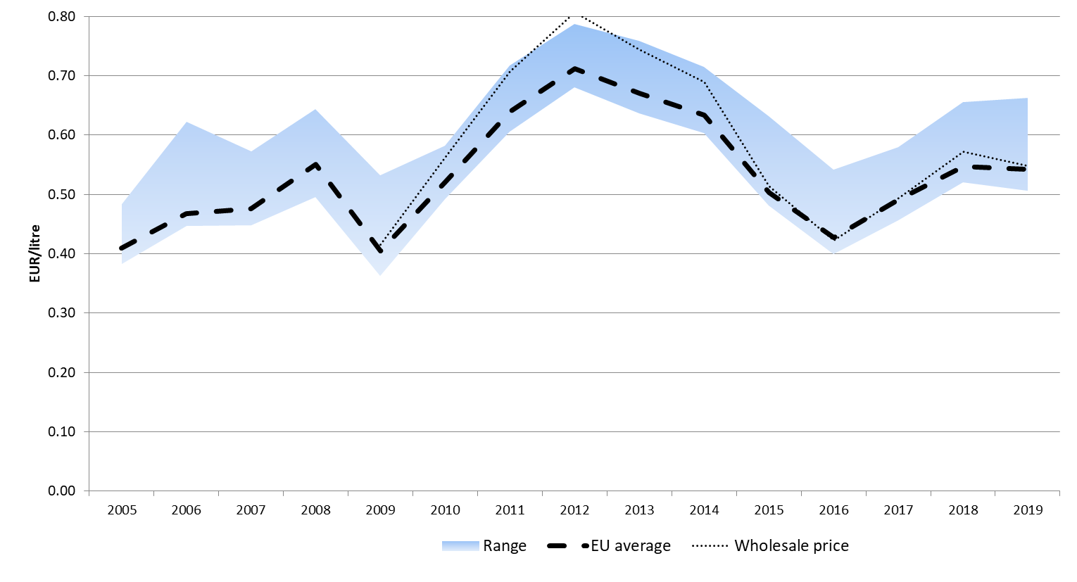

Figure 69 - The retail price of gasoline in the EU, without taxes

Source: Oil Bulletin, DG Energy, Platts

The wholesale price is Gasoline Prem Unleaded 10ppmS FOB AR Barge reported by Platts

Excise duty is an important component of the retail gasoline price; in 2019, in half of the Member States it actually exceeded the net price. Over the years, we see a gradual increase of the average excise duty rate, with a highest level in 2015 and then period of slight decreasing and rebounding again, from 0.50 EUR/litre in 2005, to 0.59 EUR/litre by 2015, and then falling back to 0.58 EUR/litre in 2018 and 2019.

In most Member States, excise duty rates increased between 2008 and 2019, with the biggest increases in Greece (98%), Latvia (63%) and Cyprus (58%). Germany and Luxembourg are notable exceptions: in these countries, the excise duty rate for gasoline has not changed since 2003 and 2007, respectively. In Hungary and Poland, the excise duty rate measured in euro was lower in 2018 than in 2008, mainly because of exchange rate developments (in national currencies, the excise duty rates increased over this period). In 2015, the UK had the highest excise duty in the EU but since then, due to the depreciation of the pound sterling, the excise duty measured in euro has significantly decreased.

For most of the study period, the Netherlands applied the highest excise duty rate for gasoline while Bulgaria had the lowest rate, just above the minimum level prescribed by the Energy Tax Directive.

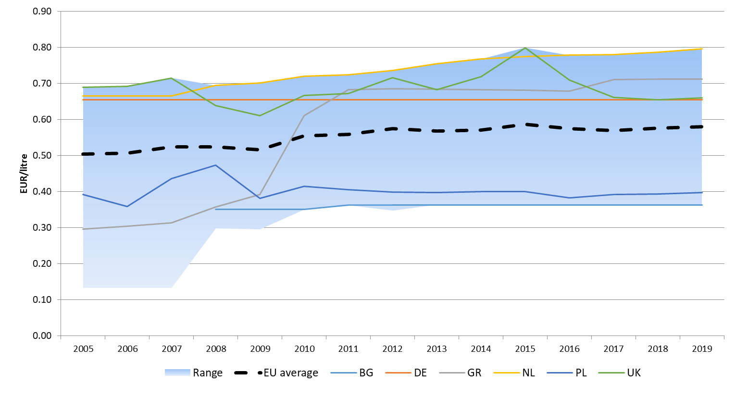

Figure 70 - The excise duty rate of gasoline in the EU

Source: Oil Bulletin, DG Energy.

The average VAT rate also increased during this period (as a part of the trend of fiscal policies of Member States of shifting more to consumption based taxation), from 19.3% in 2005 to 21.5% in 2014. Since then, the average VAT rate has not changed.

In 2014-2016, in line with the decreasing oil prices, the average retail price of gasoline decreased. However, because of the fixed (or, in case of several member States, increasing) excise duty rates, the share of the tax component gradually increased, from 54% in 2012 to 65% in 2016. Due to increases in the retail prices since 2017, the share of tax component decreased again towards 60%.

The average gasoline price increased in both 2017, 2018 and 2019, levelling the 2015 prices, while the 2012 remains the record high level. In 2019, the average price was 1.36 EUR/litre, composed of a 0.54 EUR/litre net price (40%), 0.58 EUR/litre excise duty (43%) and 0.24 EUR/litre (18%) VAT.

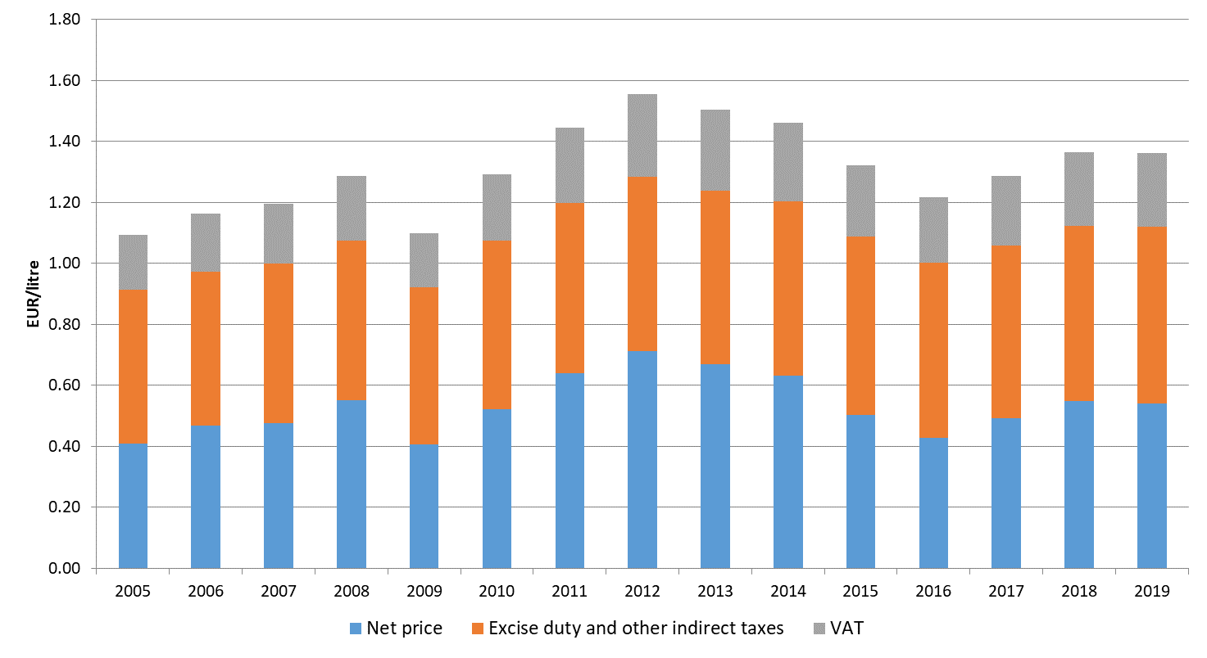

Figure 71 - Average retail price of gasoline in the EU by price component

Source: Oil Bulletin, DG Energy

The next graph shows the composition of the average gasoline price by Member State in 2019.

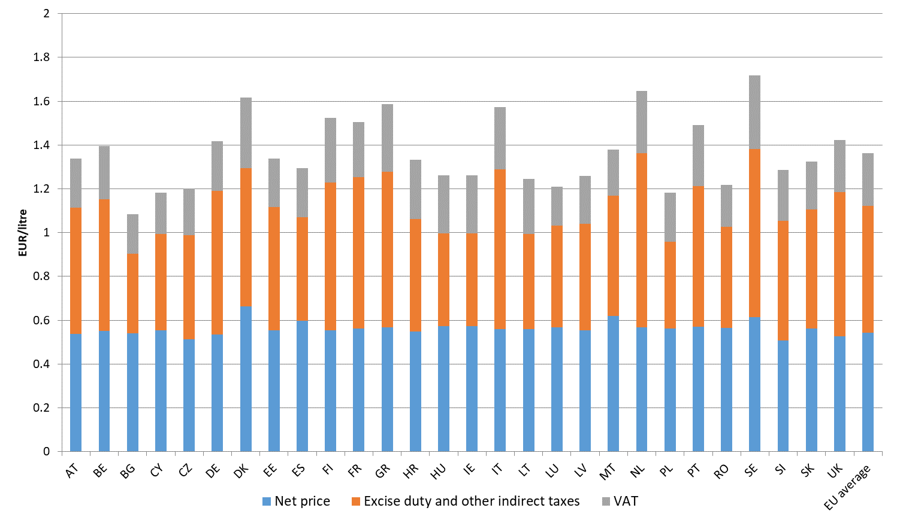

Figure 72 - Average retail price of gasoline in the first half of 2018 by Member State and price component

Source: Oil Bulletin, DG Energy

### Diesel

Similarly to gasoline, the evolution of diesel prices clearly followed the trend of the crude oil price, with considerable differences in the absolute level, mainly explained by the diverging excise duty and VAT rates. Average prices moved in a relatively wide range and, contrary to gasoline, this range has widened between 2008 and 2015: it was 0.37 EUR/litre in 2009 but grew to 0.50 EUR/litre in 2015 and was hovering around that level for much of the rest of the period with widening in 2018 and 2019 as most of the prices increased, but also situations in EU Member States economies started to diverge.

If the three most expensive countries (Italy, Sweden and the UK) were disregarded, the range would be considerably narrower. In 2015, the UK was by far the most expensive, 0.18 EUR/litre above the second most expensive country, Italy. However, the depreciation of the pound sterling in 2016-2017 had a negative impact on UK prices measured in euros and, as a result, it was "only" the third most expensive country in 2018 and 2019.

Cyprus experienced the biggest relative increase in diesel prices: in 2008 it had the lowest price in the EU but after significant increases in the excise duty rate the price reached the EU average by 2013. In 2018 and 2019, EU average diesel prices were 5% and 6% higher than in 2008; in case of Cyprus, the price increased by 15% and 13%.

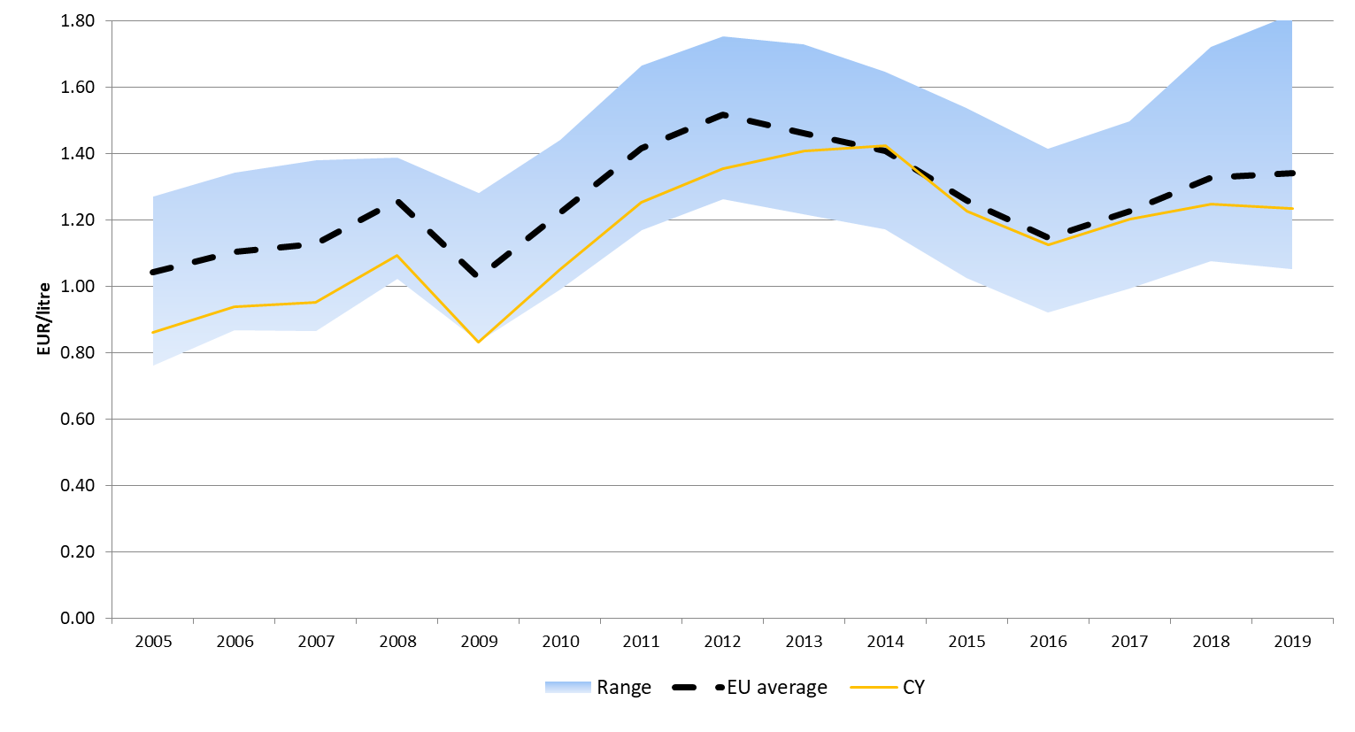

Figure 73 - The retail price of diesel in the EU

Source: Oil Bulletin, DG Energy

In case of net prices, the difference between the highest and the lowest price has been 0.23 in 2008 but the difference decreased to 0.13-0.16 EUR per litre. The widening of the range happened in 2018 and 2019 as prices grew. In 2019 Sweden was by far the most expensive country in terms of net prices, followed by other Scandinavian countries, while Czechia had the lowest net price. Looking at EU average net price with a representative wholesale price (Platts ULSD 10ppmS FOB ARA Barge), we find retail diesel prices followed the wholesale price.

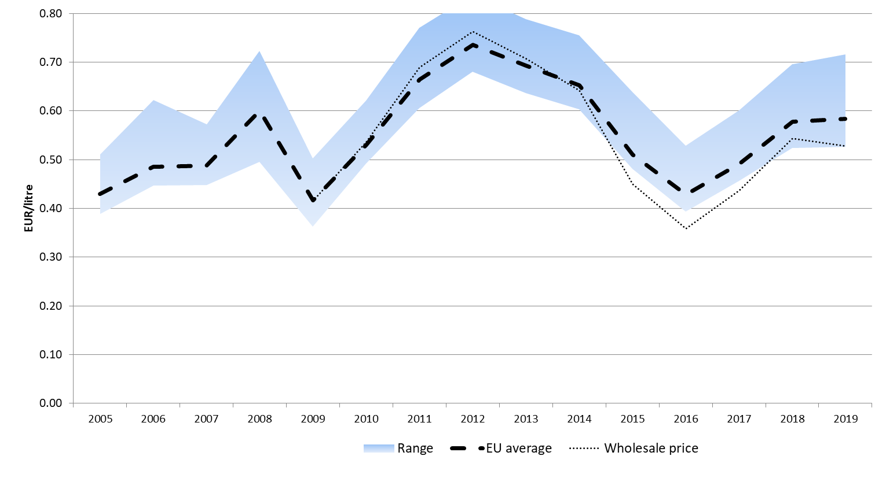

Figure 74 - The retail price of diesel in the EU, without taxes

Source: Oil Bulletin, DG Energy, Platts**.** The wholesale price is Gasoline Prem Unleaded 10ppmS FOB AR Barge reported by Platts

The average excise duty rate of diesel increased from 0.44 EUR/litre in 2005 to 0.52 EUR/litre in 2019, an increase of “only” 8% during the period. The excise on diesel has followed the movement on gasoline, trailing for the most time by 0.06 EUR per litre.

With two exceptions, excise duty rates increased in all Member States between 2005 and 2019, with the biggest increases in Cyprus (80%), Belgium (76%) and Slovenia (64%). In Germany, the excise duty rate for diesel has not changed since 2003 (similarly to the excise duty of gasoline). Slovakia is the only country where the excise duty was lower in 2019 than in 2008, as a result of a cut in the rate in 2010.

The excise duty rate applied by the UK, Sweden and other Scandinavian countries is significantly higher than in the rest of the countries. In contrast, Bulgaria and Luxembourg impose a rate at the minimum level prescribed by the Energy Tax Directive.

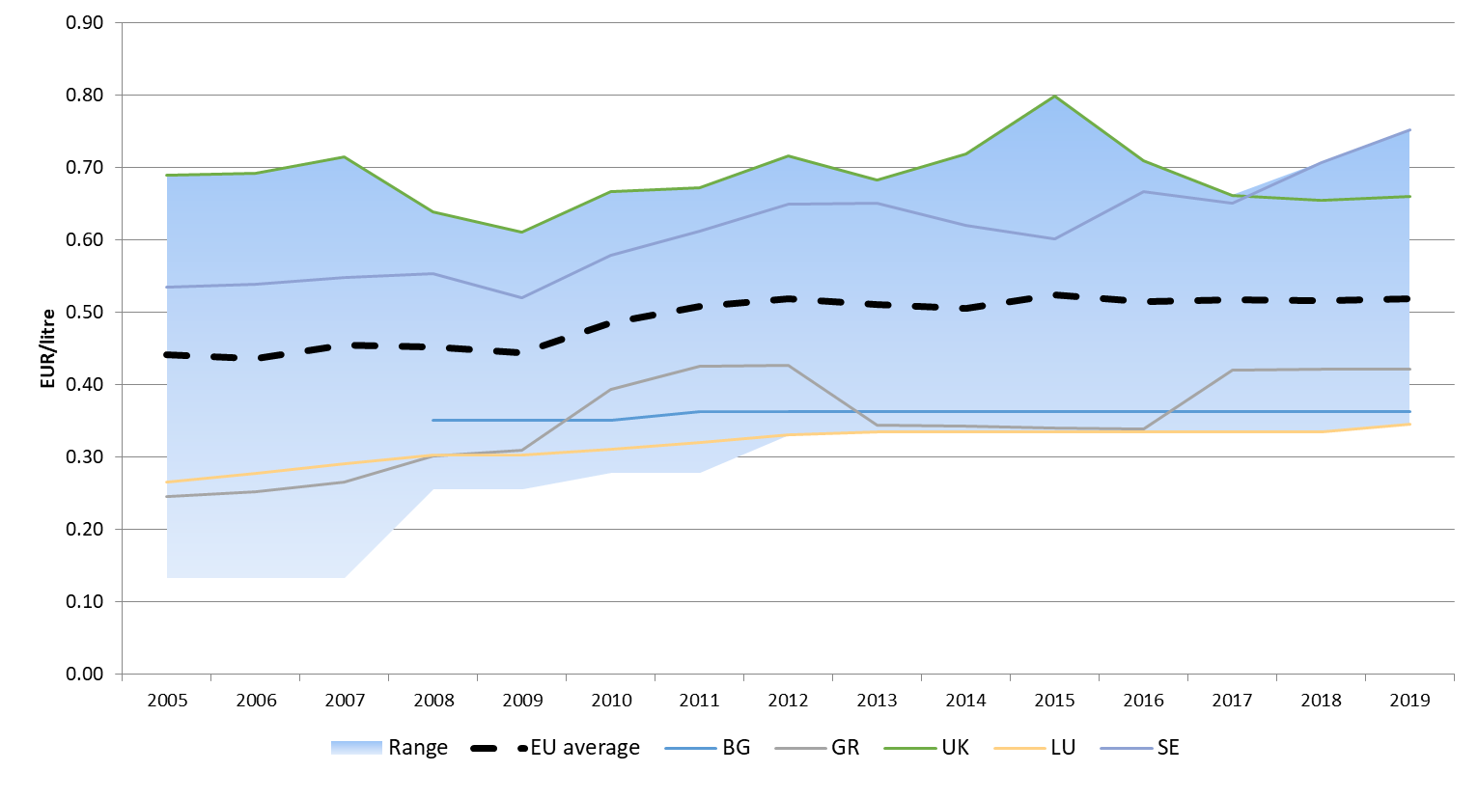

Figure 75 - The exercise duty rate of diesel in the EU

Source: Oil Bulletin, DG Energy

The average VAT rate of diesel also increased during the study period, from 19.6% in 2008 to 21.5% in 2013. Between 2014 and 2019, the average VAT rate for diesel has barely changed.

In 2012-2016, the average retail price of diesel decreased, with the share of the tax component increasing from 52% in 2013 to 63% in 2016. As prices rose again, tax component decreased again towards 56%.

Since 2016, the average retail price of diesel has been on the rise coming close to the record level reached in 2012. In 2019, the average price was 1.34 EUR/litre, composed of a 0.58 EUR/litre net price (43%), 0.52 EUR/litre excise duty (39%) and 0.24 EUR/litre (18%) VAT.

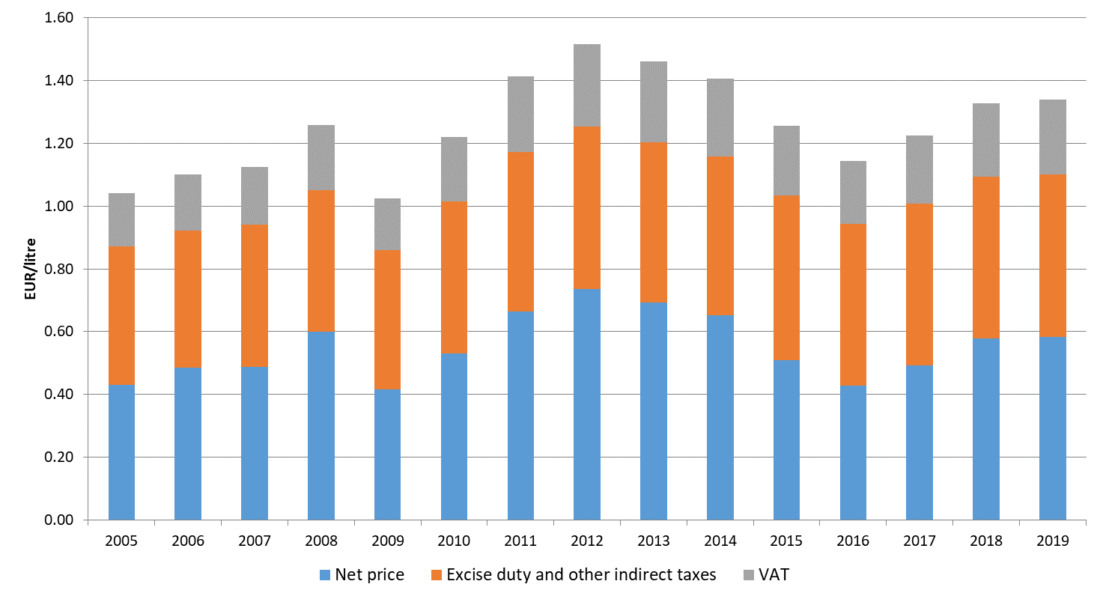

Figure 76 - Average retail price of diesel in the EU by price component

Source: Oil Bulletin, DG Energy

The next graph shows the composition of the average diesel price by Member State in 2019.

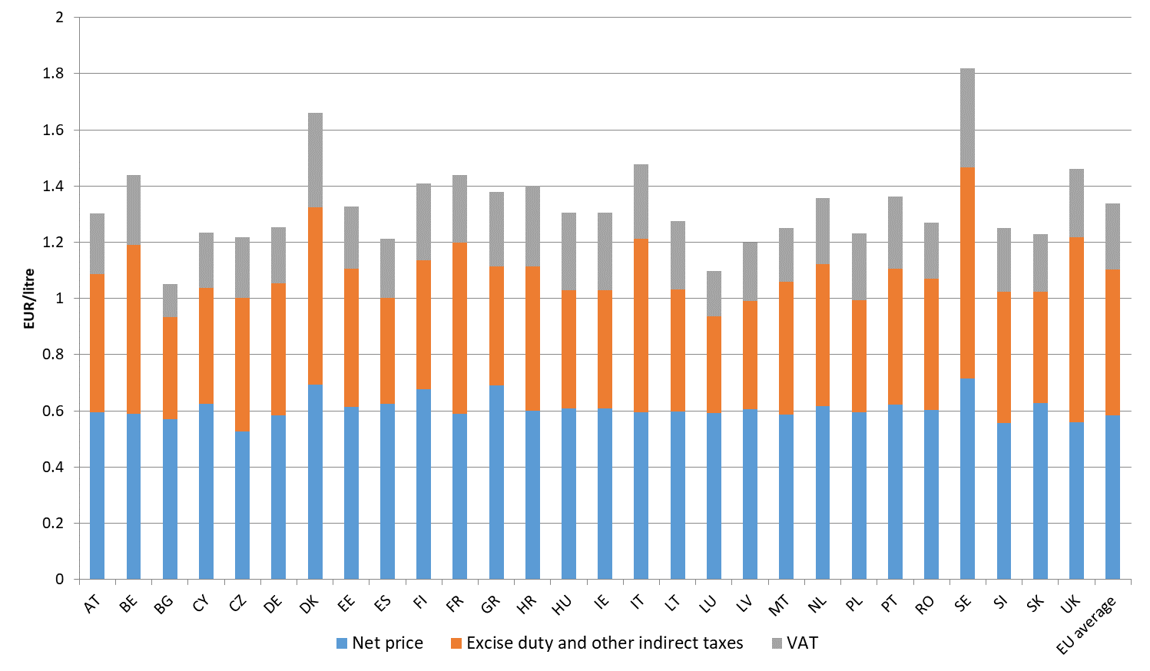

Figure 77 - Average retail price of diesel in the first half of 2018 by Member State and price component

Source: Oil Bulletin, DG Energy

### Heating oil

The large differences in the excise duty rates result in a wide dispersion of heating oil prices across the EU. The difference between the highest and lowest price increased from 0.79 EUR/litre in 2005 to 0.89 EUR/litre in 2012 and kept widening throughout the period beyond 1 EUR per litre. Slovakia ceased to report heating oil in 2011. In the most expensive Member State, Denmark, the price in 2019 was 109% higher than in the cheapest Member State, Luxembourg. Many of the most expensive countries have a rather low level of heating oil consumption. Germany is by far the biggest consumer of heating oil in the EU and its price has been consistently below the EU average.

Bulgaria experienced the biggest relative increase in heating oil prices: in 2008 its price was well below the EU average but today it is considerably higher. Ireland experienced the biggest price drop from the peak in 2012, 23%.

During most of the study period, Denmark had the highest heating oil prices in the EU, driven by a high excise duty.

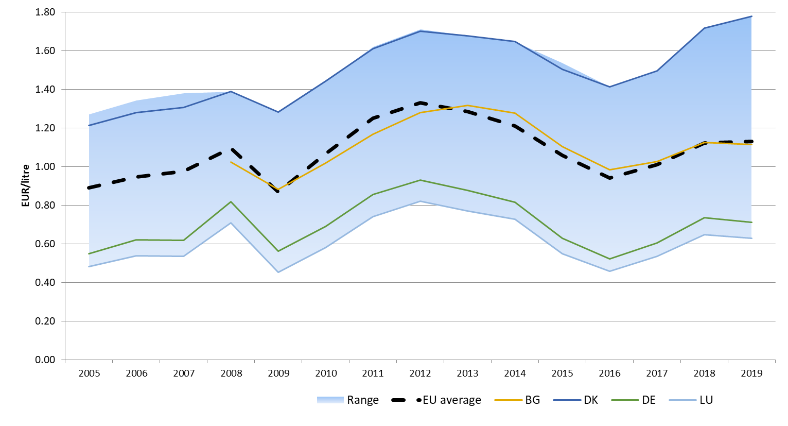

Figure 78 - The retail price of heating oil in the EU

Source: Oil Bulletin, DG Energy

The difference between the highest and the lowest price is rather high also in case of net prices (0.11-0.43 EUR/litre), significantly higher than for motor fuels. The gap significantly increased until 2013 but narrowed slightly back afterwards.

Denmark had the highest net price of heating oil in 2019; the lowest net price was reported in the Netherlands. Comparing the EU average net price with a representative wholesale price (Platts Gasoil 0.1%S FOB ARA Barge) shows that retail prices of heating oil have mimicked wholesale price.

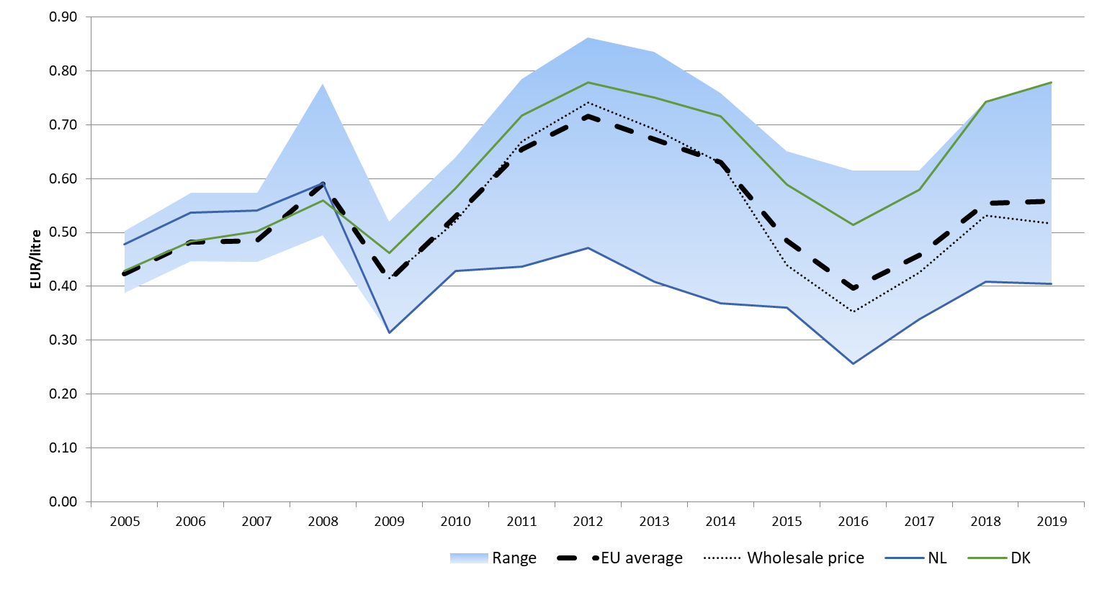

Figure 79 - The retail price of heating oil in the EU, without taxes

Source: Oil Bulletin, DG Energy, Platts

The wholesale price is Gasoline Prem Unleaded 10ppmS FOB AR Barge reported by Platts

The average excise duty rate of heating oil increased from 0.33 EUR/litre in 2005 to 0.39 EUR/litre in 2011-2013 and decreased slightly since towards 0.37 EUR/litre. Although most Member States apply a higher rate, the main consumer of heating oil, Germany, has an excise duty of only 0.06 EUR/litre.

Several Member States increased the excise duty rate between 2005 and 2019, but in a couple of countries (Austria, Germany, Italy, Lithuania and Luxembourg) it remained unchanged. Bulgaria significantly increased the excise duty rate in 2011 but returned to the previous, lower rate the following year; the rate was increased again in 2016. Sweden and other Scandinavian countries have the highest excise duty rate (0.71 and 0.69 EUR/litre in 2018 and 2019). Netherlands has also high excise rate and it is one of the few countries that apply the same rate for diesel and heating oil. Luxembourg reports the lowest excise duty rate, 0.01 EUR/litre. The rates applied by Belgium and Luxembourg are lower than the minimum level set by the Energy Tax Directive (0.021 EUR/litre); Lithuania uses the minimum level.

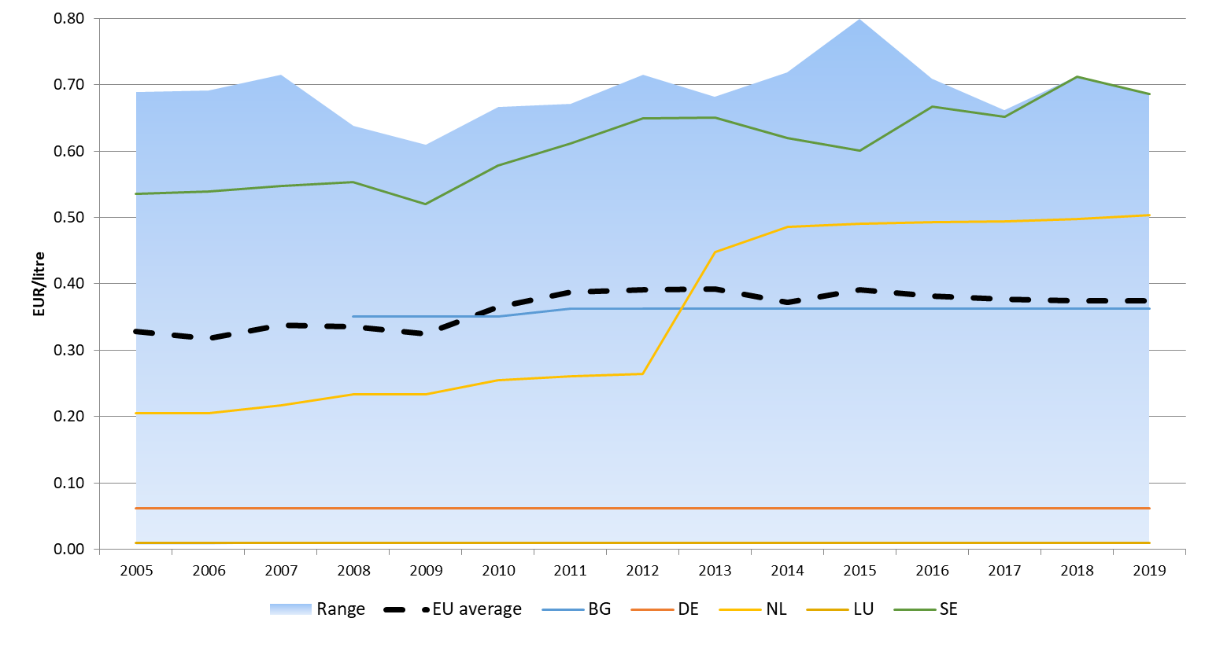

Figure 80 - The exercise duty rate of heating oil in the EU

Source: Oil Bulletin, DG Energy

The average VAT rate of heating oil also increased during this period, from 18.5% to 21.2%.

The average retail price of heating oil significantly decreased between 2012 and 2016, with the tax component increasing from 26% in 2012 to 46% in 2016. But with prices rising again since 2016, the tax component increased beyond 50%.

Prices have been rising since 2016 and in some cases (DK, SE) have surpassed the 2012 level. In 2019, the average price was 1.13 EUR/litre, composed of a 0.56 EUR/litre net price (50%), 0.37 EUR/litre excise duty (33%) and 0.20 EUR/litre (18%) VAT.

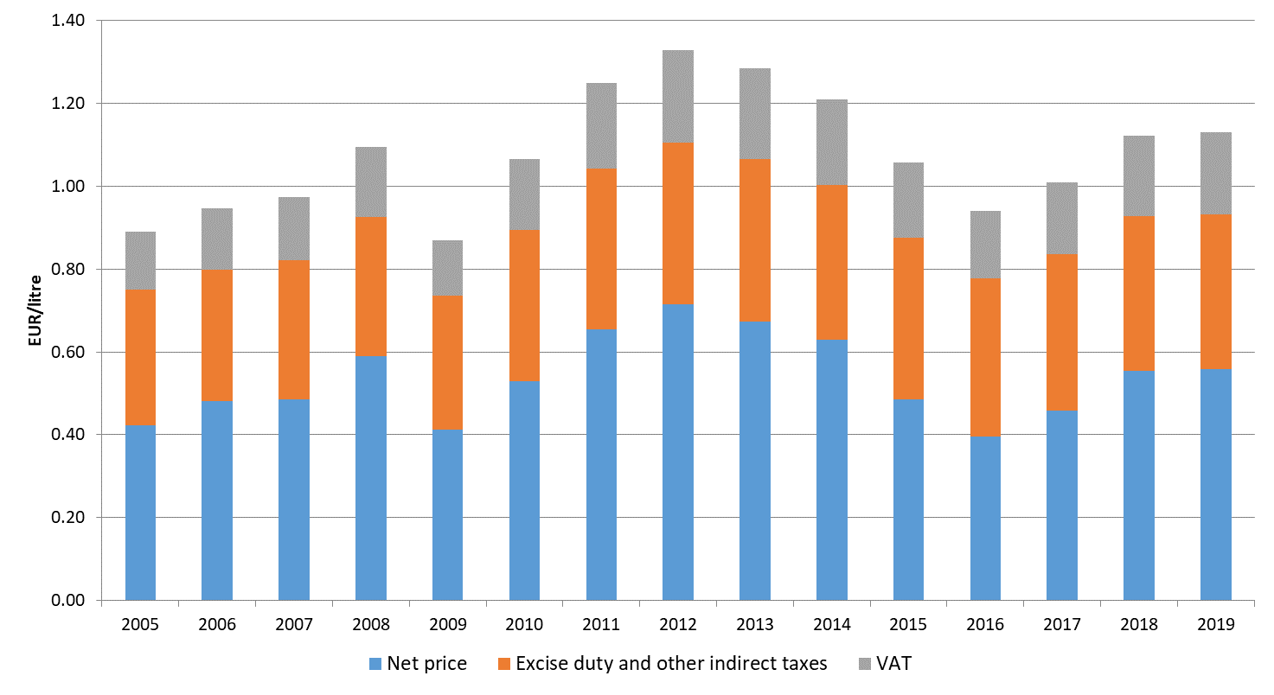

Figure 81 - Average retail price of heating oil in the EU by price component

Source: Oil Bulletin, DG Energy

The next graph shows the composition of the average heating oil price by Member State in the first half of 2019.

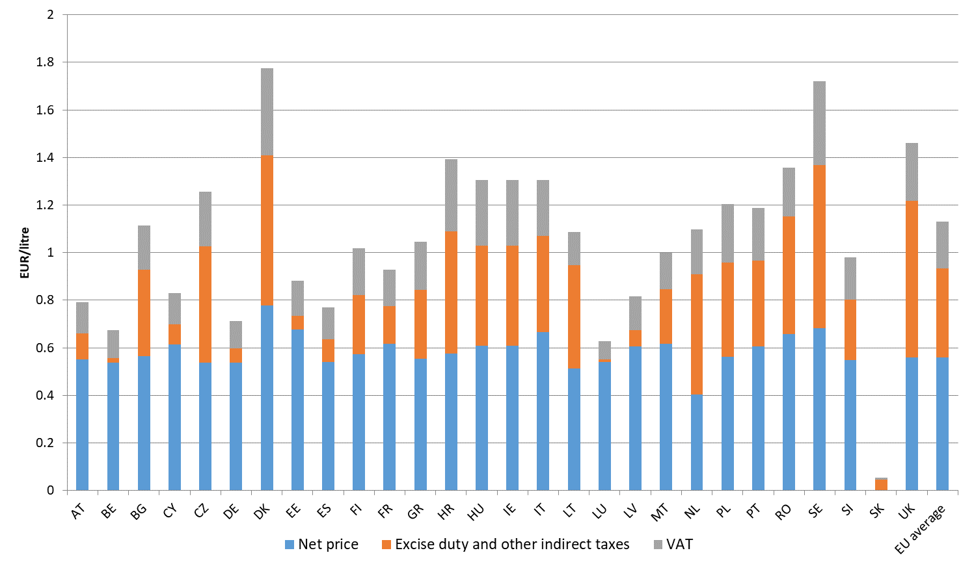

Figure 82 - Average retail price of heating oil in the first half of 2018 by Member State and price component

Source: Oil Bulletin, DG Energy

### Gasoline vs diesel

The unequal tax treatment of the main motor fuels, gasoline and diesel, has been a contentious policy issue and was often considered as the most like explanation for the "dieselisation" of the European vehicle fleet. Most Member States impose a lower level of excise duty for diesel than for gasoil, resulting in a lower retail price, in spite of the fact that the wholesale price of diesel is typically slightly higher than that of gasoline. The price advantage of diesel, coupled with the improving fuel economy of diesel engines, made diesel cars increasingly popular in the passenger car and light duty vehicle segments, with their share from new registration reaching up to 70-80% in certain Member States. In contrast, in other regions of the world gasoline-engine cars continued to have a dominant role in the passenger car fleet. The dieselisation significantly contributed to the gasoline/diesel imbalance: European refineries produce too much gasoline which has to be exported while diesel output is insufficient to meet demand as Europe has to rely on imports.

More recently, the emission scandal with diesel-engine cars which broke out in September 2015, raised renewed questions about the tax advantage of diesel.

Back in 2011, the Commission made an attempt to remove the distortive tax treatment of the two fuels in the proposed revision of the Energy Taxation Directive.[5] According to the proposal, the minimum tax rates of energy products would have been based on the energy content and the CO2 content of the fuel, resulting in a lower minimum rate for gasoline (diesel has a higher energy and CO2 content per litre). However, following the unsuccessful negotiations between Member States in the Council, the proposal was withdrawn.

In this section we compare the development gasoline and diesel prices in the EU and try to investigate whether there has been an approximation of excise duty rates imposed on the two fuels.

Over the last ten years, the average retail price of gasoline has been consistently above the price of diesel, with the difference between 0.02 and 0.07 EUR/litre in this period, widening when prices drop and coming close when prices increase. In 2019 average difference was 0.07 EUR/litre.

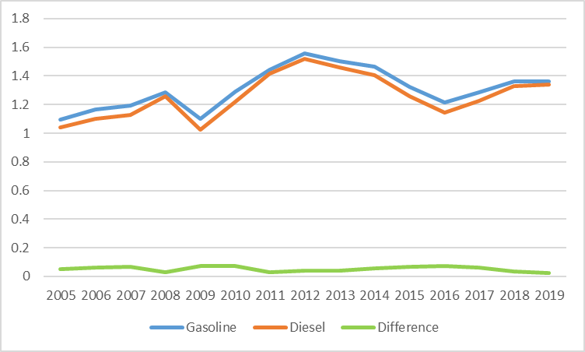

Figure 83 - Average retail price of gasoline and diesel in the EU, with taxes (EUR per litre)

Source: Oil Bulletin, DG Energy

When comparing the prices without taxes, it is striking that diesel prices are actually higher than gasoline prices. The only exception is 2016 when the average gasoline and diesel price was practically identical. In this year, global gasoline demand was supported by record-low oil prices, resulting in a relatively high gasoline price. Over the ten and half year period, the net price of diesel was on average 0.01 EUR/litre higher.

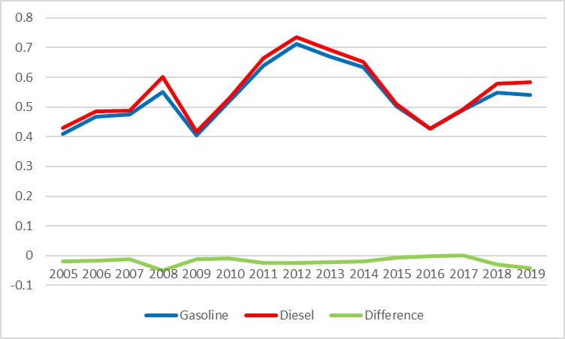

Figure 84 - Average retail price of gasoline and diesel in the EU, without taxes (EUR per litre)

Source: Oil Bulletin, DG Energy, Platts

The average excise duty rate for gasoline has been between 0.05 and 0.07 EUR/litre over the period, more than offsetting the lower net price of gasoline. The difference was largest in 2008 and 2009 (0.07 EUR/litre) but since then there has been declining a bit towards 0.05, with the average difference widening again in 2018 and 2019 as prices start rising again.

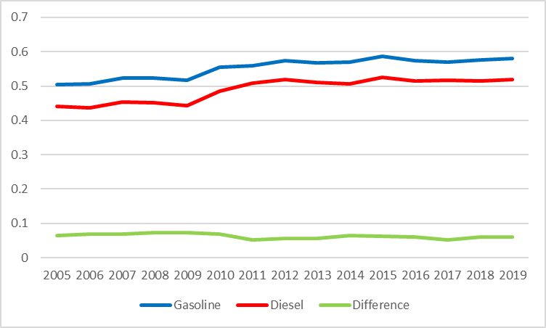

Figure 85 - Average excise duty rates for gasoline and diesel in the EU (EUR per litre)

Source: Oil Bulletin, DG Energy

In addition to the absolute difference, the relative (percentage) difference between gasoline and diesel excise duty rates also shows a decreasing trend: while in 2010 the excise duty on gasoline was on average 37% higher, by the first half of 2018 this difference decreased to 24%.

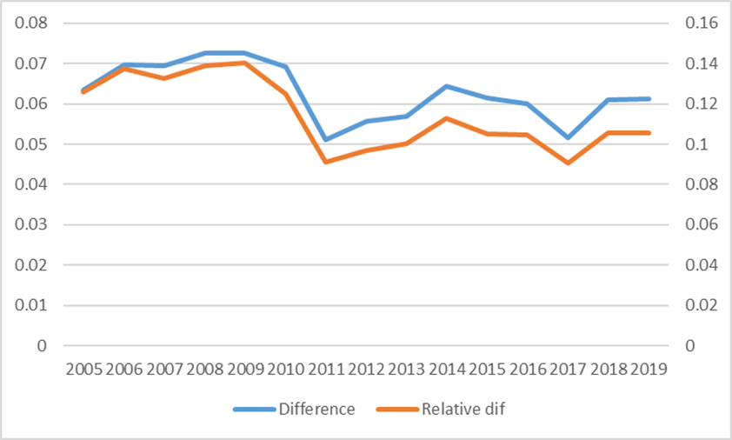

Figure 86 - The difference between the average excise duty rate on gasoline and diesel

Source: Oil Bulletin, DG Energy

In most Member States, excise duty rates increased for both gasoline and diesel in the last ten years. In case of gasoline, the average EU rate grew from 0.50 EUR/litre to 0.58 EUR/litre (+16%) while for diesel the average rate increased from 0.44 EUR/litre to 0.52 EUR/litre between 2005 and 2019. The faster growth of the diesel rate means that the difference has gradually diminished.

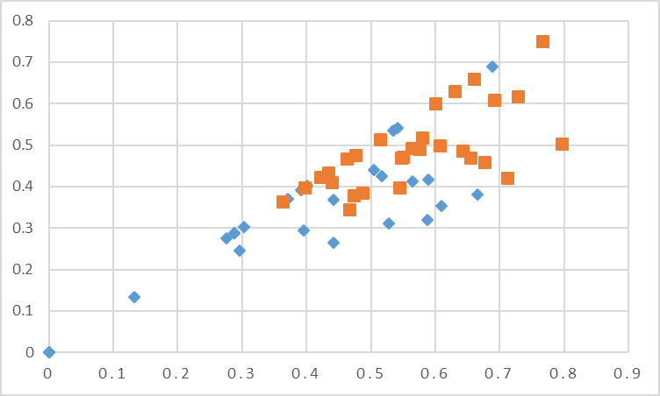

Figure 87 - Excise duty rates in individual Member States in 2005 (blue) and 2019 (red)

Source: Oil Bulletin, DG Energy

At EU level, the difference between the average gasoline and diesel excise duty rates decreased from 0.15 EUR/litre in 2005 to 0.10 EUR/litre in 2019. Looking at Member States, we can see that the difference decreased in only half of the Member States. In 12 Member States the absolute difference has actually increased, implying a growing tax advantage for diesel. For example, in Greece the gasoline excise duty rate has almost doubled (+98%) in this period while that of diesel grew by "only" 39%.

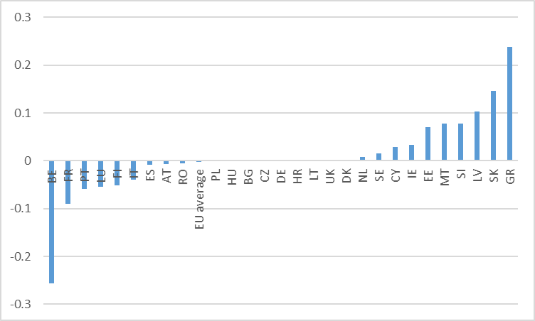

Figure 88 - the change of the difference between the gasoline and diesel excise duty rates between 2005 and the first half of 2019

Source: Oil Bulletin, DG Energy

In recent years, Belgium made the biggest step to remove the tax advantage of diesel: since 2016, the excise duty rate for diel has been gradually raised and by July 2018 the two excises were unified. As a result the difference between the retail prices of the two fuels has practically disappeared.

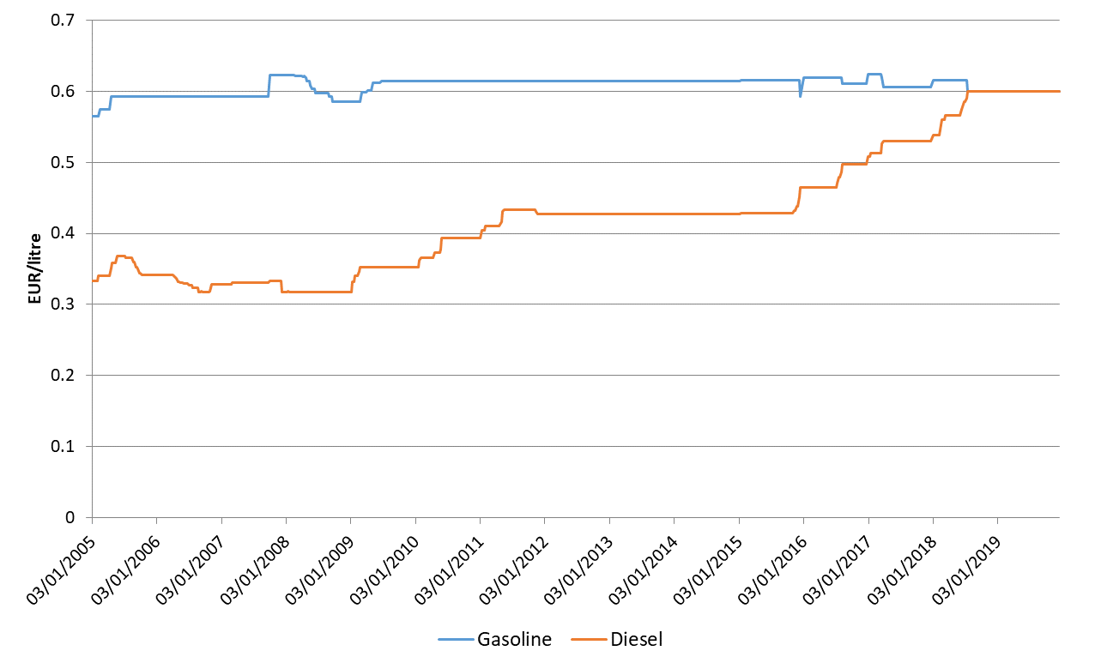

Figure 89 - Excise duty rates for motor fuels in Belgium

Source: Oil Bulletin, DG Energy

**Note on prices for selected alternative fuels: LPG, biofuels and electricity for transport**

In this note we are analysing the prices of some of the alternative fuels[6]: liquefied petroleum gases (LPG), biogasoline (pure or blended), biodiesel (pure or blended), other liquid biofuels, and biogases. Their use has been promoted in order to substitute non-renewable fossil fuels and their volume more than tripled since 2005. However, they still represent a small fraction of energy carriers- they represented together less than 1 percent in Gross Inland Consumption in 2005 and they are now more than 3%. The most important of alternative fuels are liquefied petroleum gases (LPG), pure biodiesels, and biogases, all representing around 30% of the total volume of alternative fuels.

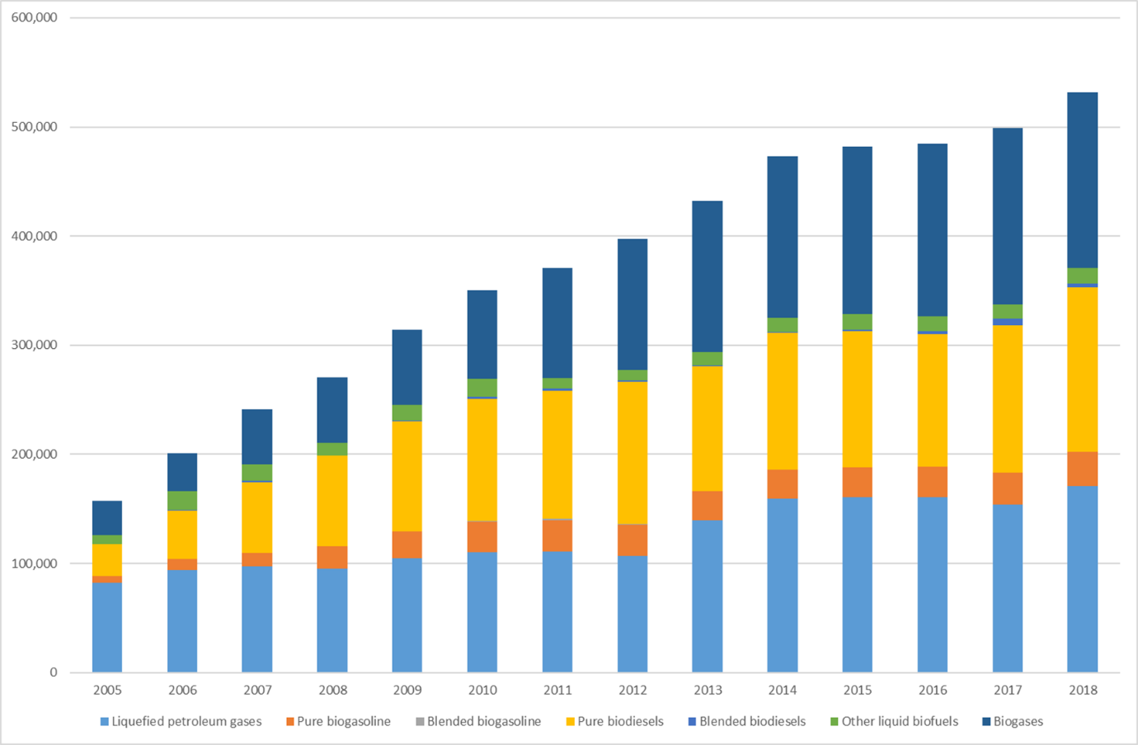

Figure 90 – Gross Inland Consumption of selected alternative fuels

Source: Eurostat, all figures in GWh.

In final energy consumption (energy use), alternative fuels have a little bit bigger share, starting around 2% in 2005 and almost doubling their share by 2018.

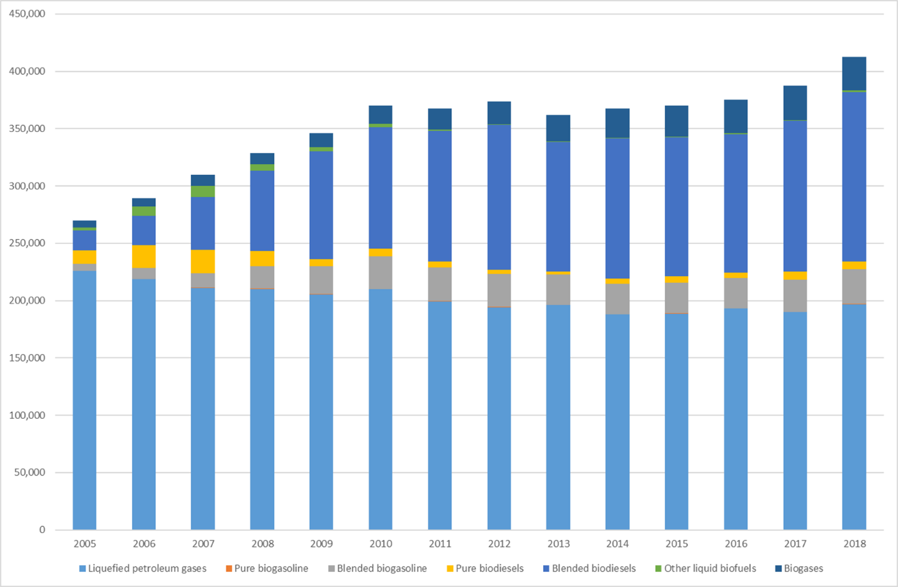

Figure 91 – Total (all sectors) Final Energy Consumption of selected alternative fuels

Source: Eurostat, all figures in GWh.

There are different preferences in different final energy consumption different activities. In industry on average liquefied petrol gas (LPG) dominates with rest taken almost by biogases:

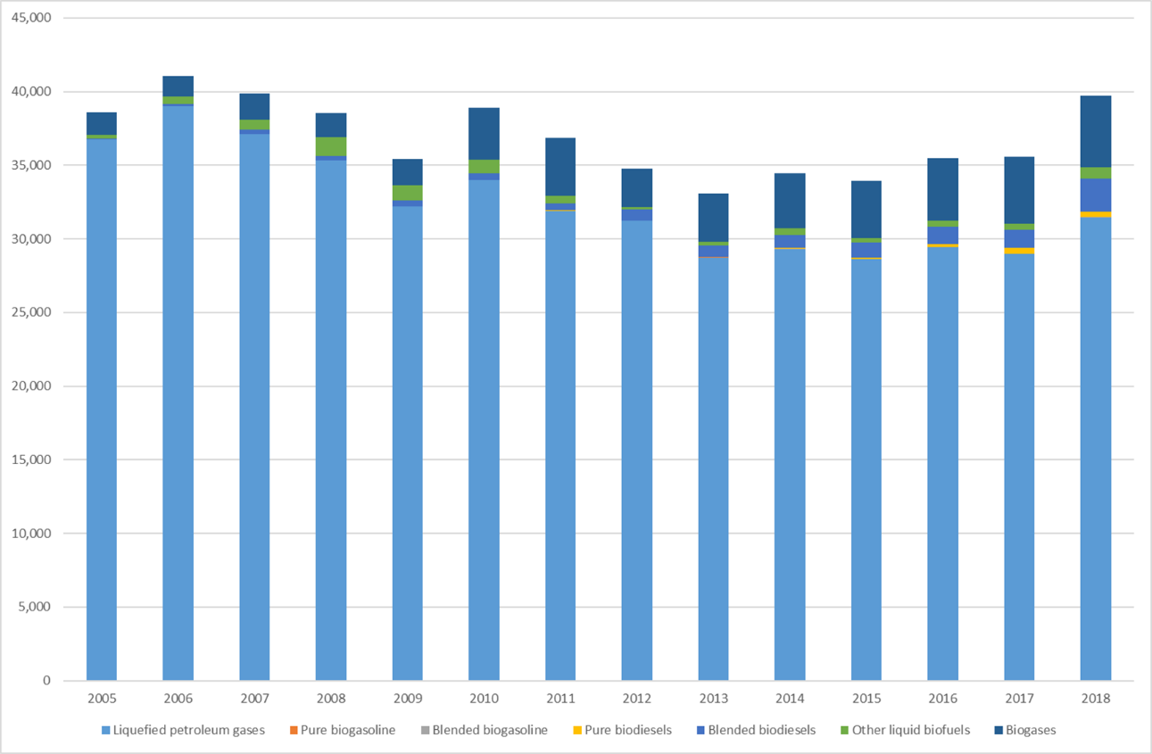

Figure 92 – Industry’s Final Energy Consumption of selected alternative fuels

Source: Eurostat, all figures in GWh.

Final energy consumption of alternative fuels in transport relies on biogases, blended biodiesel and blended biogasoline.

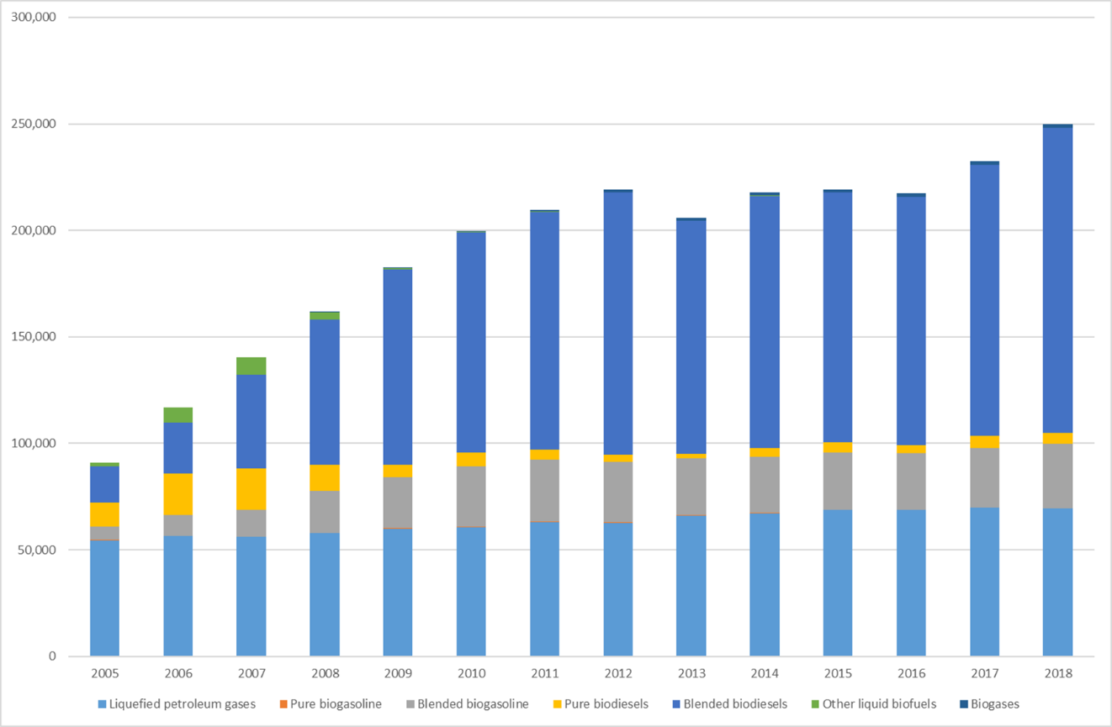

Figure 93 – Transport’s Final Energy Consumption of selected alternative fuels

Source: Eurostat, all figures in GWh.

Households rely almost entirely on blended biodiesel in their Final energy consumption of alternative fuels (for heating and mobility) and also recently a little on biogases.

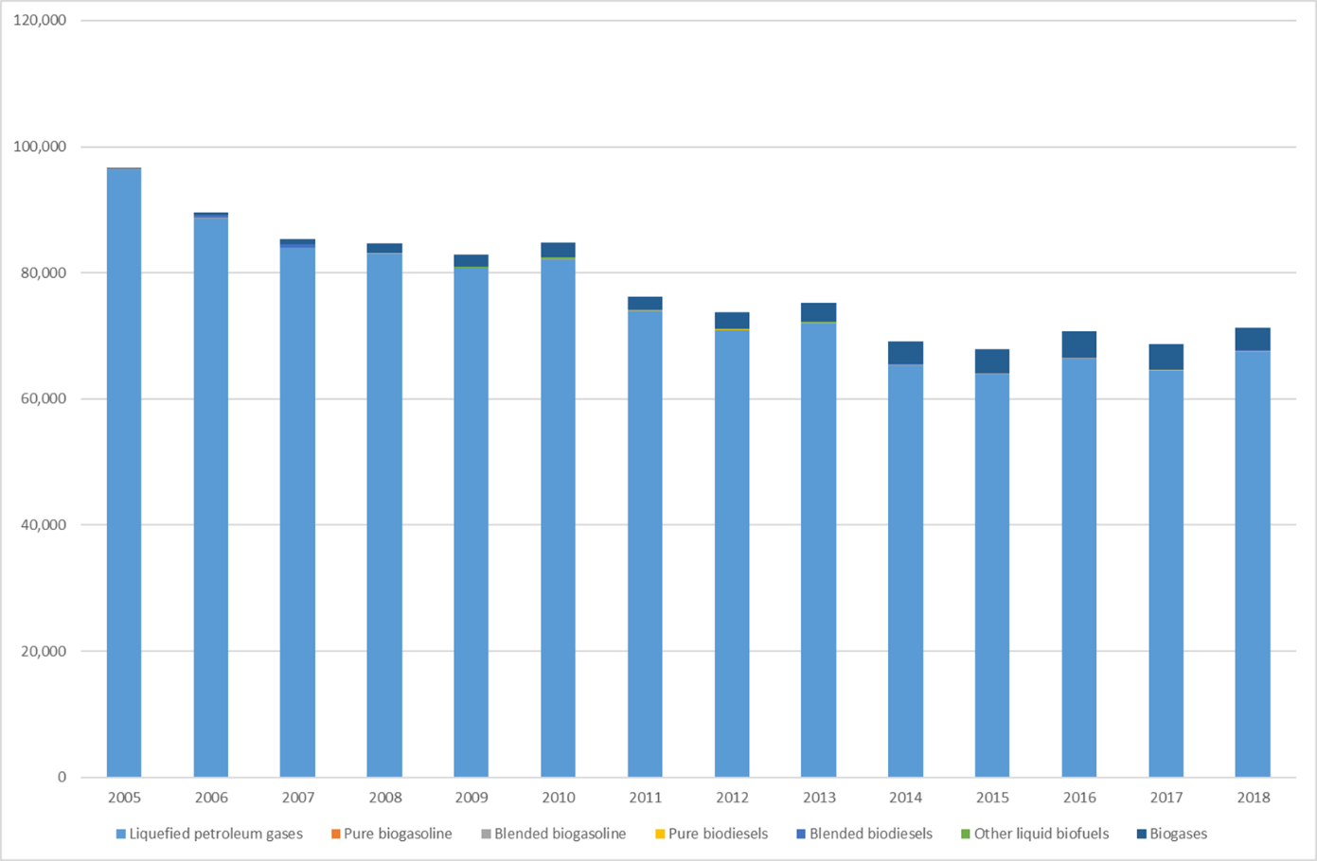

Figure 94 – Household’s (and other sectors) Final Energy Consumption of selected alternative fuels

Source: Eurostat, all figures in GWh.

***Prices of alternative fuels***

Alternative fuels have followed generally the dynamic of prices of fossil fuels.

For ethanol, prices in EU (Roterdam Barge) are highest due to the fact that EU does not produce enough of it and has to import it. The lowest price are those in Brasil, a global leader in production of ethanol.

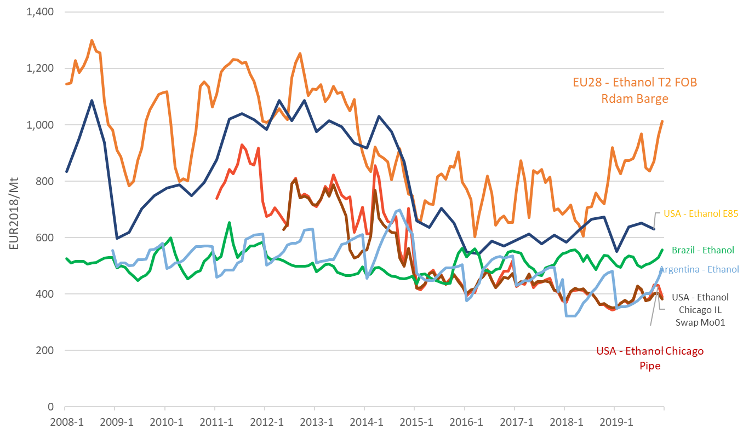

Figure 95 - International comparison of prices of ethanol

Source: Platts, Bloomberg, Trinomics (2020)

In biodiesel, wholesale prices in EU are similar to those in US, because both are importing than producing biodiesel, from countries like Argentina.

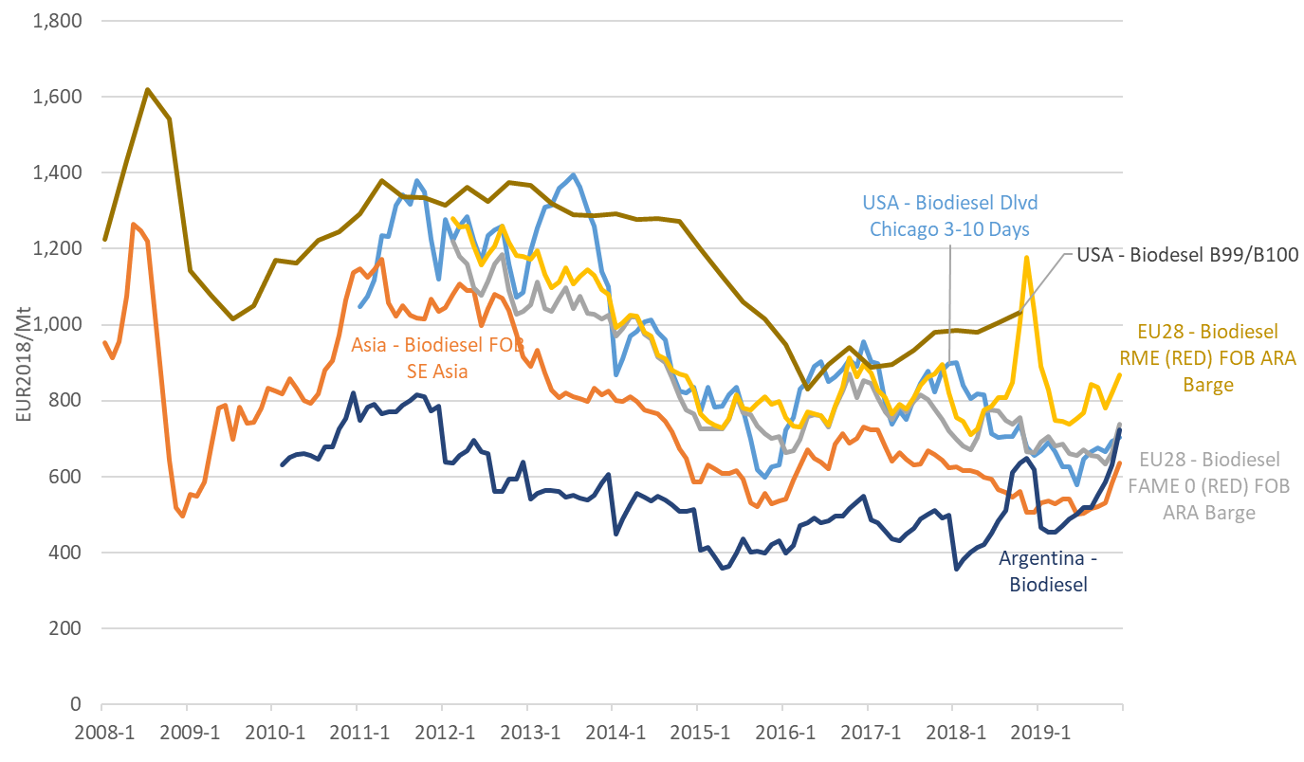

Figure 96 - International comparison of wholesale prices of biodiesel

Source: Platts, Bloomberg, Trinomics (2020)

For LPG, EU average retail prices including taxes have moved up and down within a relatively small range since 2008. Excluding taxes, it is possible to find that price trends mirror this price decline.

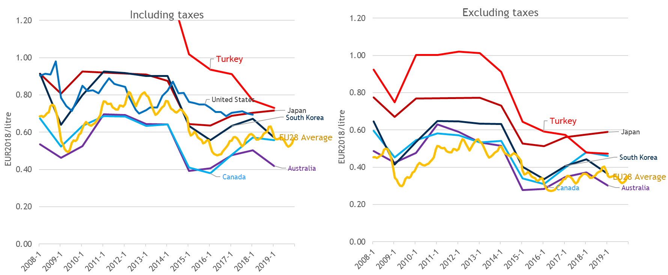

Figure 97 – International comparison of retail prices of LPG

Source: EU Oil Bulletin, IEA, US AFDA, Trinomics (2020)

***Biogases in electricity and heat generation and blending with natural gas***

In 2018 the total indigenous biogas production amounted to more than 580 thousand TJ (approximately 161 TWh). Out of this, the share of ‘other gases from anaerobic fermentation was 82%, amounting to 131 TWh. The share of landfilled gas was around 9% (15 TWh), while that of sewage sludge gas was 8% (13 TWh). The remaining 1% was represented by biogases from thermal processes, with less than 2 TWh volume. In 2019, according to preliminary Eurostat data, the total biogas production increased further and reached 590 thousand TJ (164 TWh). The biggest biogas producer in the EU was Germany (producing around 55% of the total EU production in 2018, around 90 TWh of biogas), followed by Italy (13%, around 21 TWh) and France (7%, 11 TWh).

As the next chart shows, over the last decade there was a dynamic increase in biogas production in the EU, reaching more than 160 TWh in 2018, whereas ten years earlier the total amount of produced biogas was barely 60 TWh. In 2018 around 81% of the biogas consumed were used for energy purposes, while 18% was used for other industrial purposes (and distribution losses accounted for 1%). Around 75% (121 TWh) was used in electricity and heat generation as fuel, while around 2.5% (4 TWh) was injected in the gas grids for blending natural gas.

Figure 98 - Biogas in electricity and heat generation and biogas blending for natural gas

Source: Eurostat, DG ENER Calculation

***Prices of electric mobility***

EV users’ preferences for charging location depends on a range of factors, such as access to a driveway at home, availability of public charging infrastructure, the pricing applied by operators, and driving habits. Charging at home is the most popular option. Prices paid for charging EVs essentially mirror regular electricity tariffs for private households. A survey of 12 European countries revealed that off-peak tariffs are available in most of them, although the uptake tends to be low in some cases. As of August 2020, dedicated EV tariffs were available only in Spain, France and the UK. In terms of the price differential between the average regular tariff and the average off-peak tariff, a substantial variation across markets can be observed. As shown in the Figure below, off-peak electricity prices for households (in €/MWh) could be over 40% lower compared to the average price. Countries with the highest difference include Australia, France, Spain and the UK.

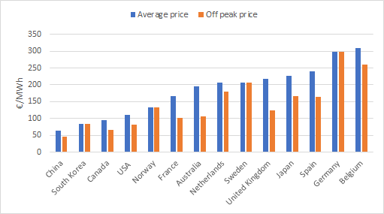

Figure 99: Electricity prices for households in €/MWh (2019)

Source: Trinomics (2020)

At public charging stations, tariffs vary according to charging capacity (which affects the speed of charge), type of batteries served, and loyalty programme discounts. Most of the time, charging prices vary between 200 and 450 €/MWh, while they can reach 800 €/MWh at the higher end. Public charging tends to be more expensive than home charging and the variation in prices between countries to a large extent mirrors the variation in home charging prices. Besides the price for the commodity, EV owners have also to subscribe (with a fee) to be able to use public charging stations. Recently announced investigations by Dutch and German competition authorities into the prices and practices of EV charging stations suggest a lack of transparency and fair treatment, which could hold back the uptake of green mobility solutions.[7] The available price data suggests public charging prices of €150-€250/MWh in China, the United States and Japan, which compares to €200-€500/MWh observed in the Austria, Spain, France, Germany and Netherlands. The differences are similar to that observed for household electricity prices. See Figure below.

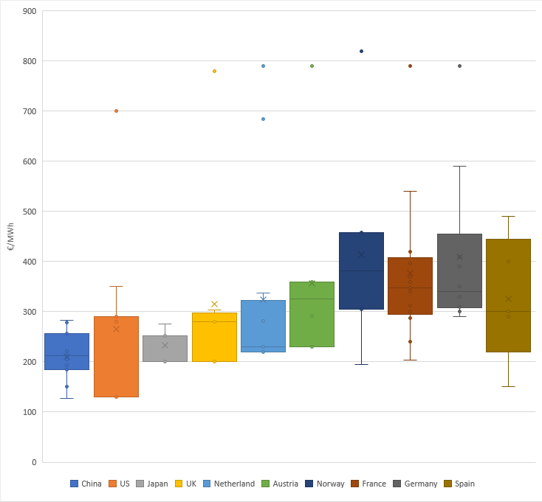

*Note: the dots represent outliers in the distribution*

Figure 100 - Representative sample of EV public charging prices in €/MWh

Source: Trinomics (2020)

The US-based EV maker Tesla has developed and operates its own charging network which includes fast and superfast charging points. The network currently counts around 13 000 charging points in more than 20 European countries. Given the homogenous charging specifications and conditions, it is possible to compare the charging prices to gauge differences between countries. **Figure 101** provides an overview of prices charged by Tesla in different countries. It is interesting to note that in most European countries, Tesla’s prices are at the lower end of the band of offers available to EV owners, which is visible especially in France and Norway.

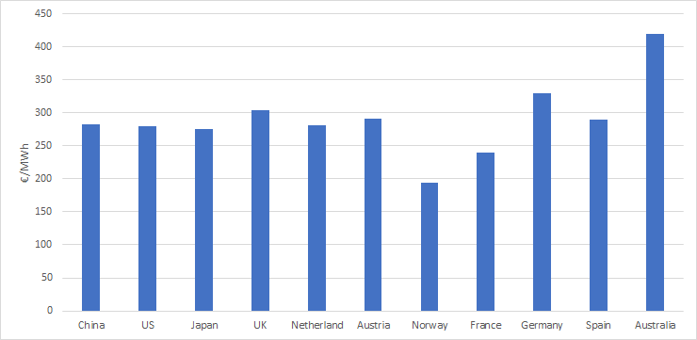

Figure 101 - EV fast and superfast public charging prices in Tesla network (€/MWh).

Source: Trinomics (2020)

* As a conclusion, it can be observed that both home and public charging prices tend to be higher in Europe (€200-€500/MWh) than in the main international G20 partners (€150-€250/MWh). However, superfast public charging prices in Europe tend to be comparable to the rest of G20 countries (€200-€400/MWh).

### International comparison

This section is relying on the price data collected by Trinomics and covering G20 economies.[8]

Comparing the average retail price of motor fuels in the EU with prices in other G20 countries reveals that the trajectory of prices is in general very similar, basically following the development of crude oil prices. However, there can be significant differences in the absolute level of prices which are largely affected by taxes.

In case of gasoline, retail prices in most G20 countries are lower than the EU average. The retail price in the US is typically less than half of the EU average level. While in the EU the tax component is on average about 60% of the final price, this share in the US is only around 25%. Excluding taxes, EU and US prices are comparable. A few G20 countries had higher prices than the EU average for most of the period, in particular Korea and Turkey, but even these have converged to the EU average level over the last decade.

To sum up, differences in tax treatment are instrumental in explaining the price differences across G20 countries. EU taxes on fuels are among the highest globally, resulting in a high retail price compared to most G20 countries.

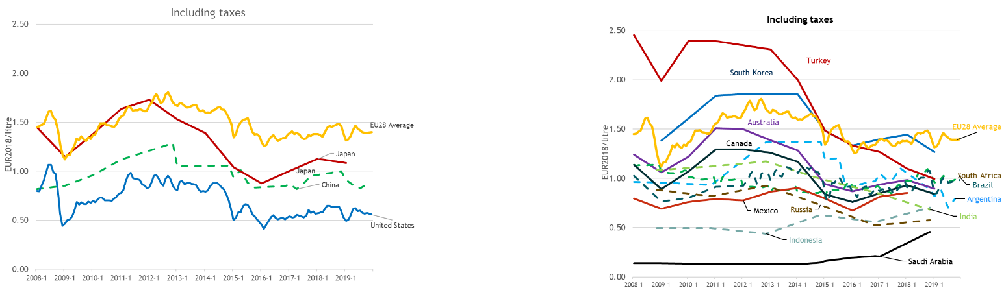

Figure 102 - International comparison of retail gasoline prices

Source: Oil Bulletin, DG Energy; IEA, GIZ

Note: prices are expressed in real (2018) euros; dotted line highlights that it is unclear if the excluding taxes price actually excludes relevant taxes

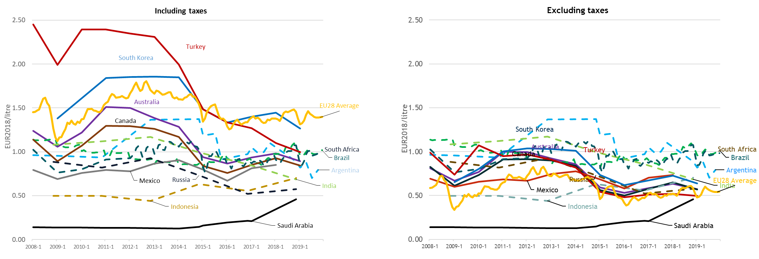

Figure 103 - International comparison of retail gasoline prices

Source: Oil Bulletin, DG Energy; IEA, GIZ

Note: prices are expressed in real (2018) euros; dotted line highlights that it is unclear if the excluding taxes price actually excludes relevant taxes

For diesel, the price is similar: the EU average price is one of the highest among the G20 countries. This is explained by a high tax component which on average constitutes about 50% of the final price. The retail price in the US, where the share of the tax component is only about 25%, is less than half of the EU average. Excluding taxes, EU prices are very similar to those in the US and lower than those in the majority of G20 countries. Turkey is the country which had a consistently higher price than the EU average for most of the period but the difference has largely disappeared by 2015-2016.

Similarly to gasoline, differences in tax treatment are instrumental in explaining the price differences across G20 countries. EU taxes on fuels are among the highest globally, resulting in a high retail price compared to most G20 countries, in spite of the relatively low net price.

The EU is not the only region with gasoline retail prices exceeding diesel prices. This is the case in practically all G20 economies.

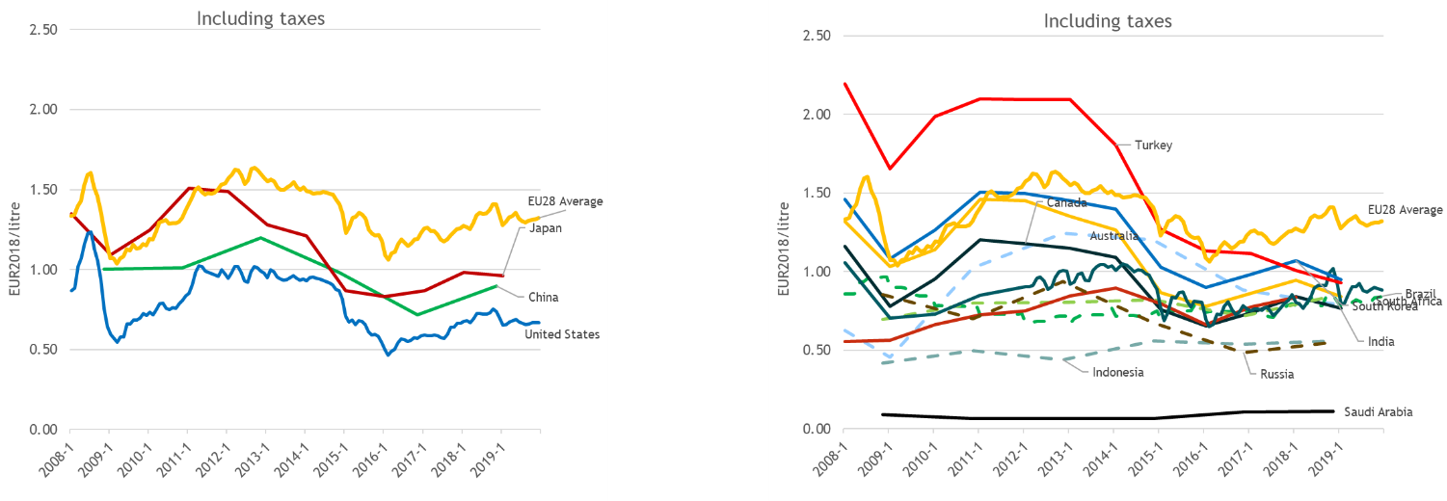

Figure 104 - International comparison of retail diesel prices

Source: Oil Bulletin, DG Energy; IEA, GIZ

Note: prices are expressed in real (2018) euros

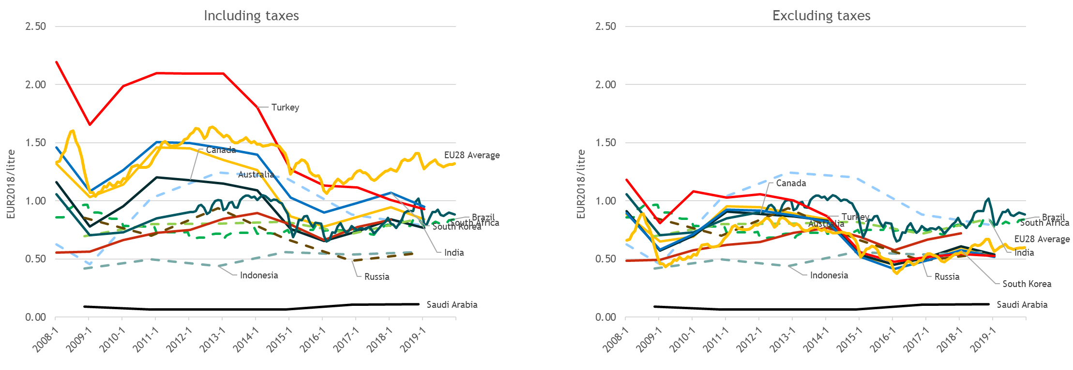

Figure 105 - International comparison of retail diesel prices

Source: Oil Bulletin, DG Energy; IEA, GIZ

Note: prices are expressed in real (2018) euros; dotted line highlights that it is unclear if the excluding taxes price actually excludes relevant taxes

1. This chapter analyses EU-28.
2. Between 30 June 2014 and 15 February 2016
3. In this section, other indirect taxes are reported in the excise duty component
4. https://ec.europa.eu/energy/en/statistics/weekly-oil-bulletin
5. http://europa.eu/rapid/press-release_IP-11-468_en.htm?locale=en
6. The full definition of the alternative fuels can be found in Art. 2 Directive 2014/94/EU as: ‘fuels or power sources which serve, at least partly, as a substitute for fossil oil sources in the energy supply to transport and which have the potential to contribute to its decarbonisation and enhance the environmental performance of the transport sector’. This definition includes: ‘electricity, hydrogen, biofuels as defined in point (i) of Article 2 of Directive 2009/28/EC, synthetic and paraffinic fuels, natural gas, including biomethane, in gaseous form (compressed natural gas (CNG)) and liquefied form (liquefied natural gas (LNG)), and liquefied petroleum gas (LPG)’.
7. <https://www.bundeskartellamt.de/SharedDocs/Meldung/EN/Pressemitteilungen/2020/09_07_2020_Ladesäulen.html>.
8. Trinomics et altri (2020)