

Contents

1. Introduction 2

2. Overall competitiveness of the EU clean energy sector 4

2.1 Energy and resource trends 4

2.2 Share of EU energy sector in EU GDP 6

2.3 Human capital 6

2.4 Research and innovation trends 9

2.5 Covid-19 Recovery 11

3. Focus on key clean energy technologies and solutions 12

3.1 Offshore renewables – wind 12

3.2 Offshore renewables – Ocean energy 16

3.3 Solar photovoltaics (PV) 18

3.4 Renewable hydrogen production through electrolysis 20

3.5 Batteries 23

3.6 Smart electricity grids 26

3.7 Further findings on other clean and low carbon energy technologies and solutions 30

Conclusions 31

# Introduction

The goal of the European Green Deal[1], Europe’s new growth strategy, is to transform the European Union (EU)[2] into a modern, resource-efficient and competitive economy, which is climate neutral by 2050. The EU’s economy will need to become sustainable, while making the transition just and inclusive for everyone. The Commission’s recent proposal[3] to cut greenhouse gas emissions by at least 55% by 2030 sets Europe on that responsible path. Today, energy production and use account for more than 75% of the EU’s greenhouse gas emissions. The delivery of the EU’s climate goals will require us to rethink our policies for clean energy supply across the economy. For the energy system, this means a steep decarbonisation and an integrated energy system largely based on renewable energy. By 2030 already, the EU renewable electricity production is set to at least double from today’s levels of 32% to around 65% or more[4] and by 2050, more than 80% of electricity will be coming from renewable energy sources[5].

Achieving these 2030 and 2050 targets requires a major transformation of the energy system. This however depends heavily on uptake of new clean technologies and increased investments in the needed solutions and infrastructure. However, as well as the business models, skills, and changes in behaviour to develop and use them. Industry lies at the heart of this social and economic change. The New Industrial Strategy for Europe[6] gives European industry a central role in the twin green and digital transitions. Considering the EU’s large domestic market, accelerating the transition will help modernise the whole EU economy and increasing the opportunities for the EU’s global clean technologies leadership.

This first annual progress report on competitiveness[7]aims to assess the state of the clean energy technologies and the EU clean energy industry’s competitiveness to see if their development is on track to deliver the green transition and the EU’s long-term climate goals. This competitiveness assessment is also particularly crucial for the economic recovery from the COVID-19 pandemic, as outlined in the *‘Next Generation EU’* communication[8]. Improved competitiveness has the potential to mitigate the short- and medium-term economic and social impact of the crisis, while also addressing the longer-term challenge of the green and digital transitions in a socially fair manner. Both in the context of the crisis, but also in the long run, improved competitiveness can address energy poverty concerns, reducing the cost of energy production and the cost of energy efficiency investments[9].

It is possible to ascertain the clean energy technology needs for achieving the 2030 and 2050 targets on the basis of the impact assessment referred to in the European Commission’s Climate Target Plan scenarios[10]. In particular, the EU is expected to invest in renewable electricity, notably offshore energy (in particular wind) and solar energy[11],[12]. This large increase in the share of variable renewables also implies an increase in storage[13] and in the ability to use electricity in transport and industry, especially through batteries and hydrogen, and requires major investments in smart grid technologies[14]. On this basis, the present report focuses on the six technologies mentioned above[15], most of which are at the heart of the EU flagship initiatives[16],[17] aimed at fostering reforms and investments to support a robust recovery based on twin green and digital transition. The remaining clean and low-carbon energy technologies included in the scenarios are analysed in the staff working document with the title ‘Clean Energy Transition – Technologies and Innovations Report’ (CETTIR) that accompanies this report[18].

For the purpose of this report, competitiveness in the clean energy sector[19] is defined as the capacity to produce and use affordable, reliable and accessible clean energy through clean energy technologies, and compete in energy technology markets, with the overall aim of bringing benefits to the EU economy and people*.*

Competitiveness cannot be captured by a single indicator[20]. Therefore, this report proposes a set of widely accepted indicators that may be used for this purpose (see table 1 below) capturing the entire energy system (generation, transmission and consumption) and analysed at three levels (technology, value chain and global market).

*Table 1 Grid of indicators to monitor progress in competitiveness*

|  |  |  |
| --- | --- | --- |
| Competitiveness of EU clean energy industry | | |
| 1. Technology analysis Current situation and outlook | 2. Value chain analysis of the energy technology sector | 3. Global market analysis |
| **Capacity installed, generation**  (today and in 2050) | **Turnover** | **Trade (imports, exports)** |
| **Cost / Levelised cost of energy (LCoE)**  (today and in 2050) | **Gross value added growth**  Annual, % change | **Global market leaders vs. EU market leaders**  (market share) |
| **Public R&I funding** | **Number of companies in the supply chain, incl. EU market leaders** | **Resource efficiency and dependence** |
| **Private R&I funding** | **Employment** | **Real Unit Energy Cost** |
| **Patenting trends** | **Energy intensity / labour**  **productivity** |  |
| **Level of scientific Publications** | **Community Production**[21]  Annual production values |  |

Analysis of competitiveness of the clean energy sector can be further developed and deepened over time, and future competitiveness reports may focus on different angles. For example by looking in more detail at policies and instruments to support R&I and competitiveness at the Member State level, how these contribute to the Energy Union and the Green Deal objectives, looking at competitiveness at subsector[22], national or regional level, or by analysing the synergies and trade-offs with environmental or social impacts, in line with the European Green Deal objectives.

Given the lack of data for a wide range of competitiveness indicators[23],[24], some approximations of a more indirect nature are used (e.g. the level of investment). The Commission calls on Member States and stakeholders to work together in the context of the National Energy and Climate Plans (NECPs)[25] and the Strategic Energy Technology plan to continue developing a common approach to assessing and boosting the competitiveness of the Energy Union. This is also important for the national recovery and resilience plans that will be prepared under the Recovery and Resilience Facility.

# Overall competitiveness of the EU clean energy sector

## 2.1 Energy and resource trends

Over 2005-2018, primary energy intensity in the EU decreased at an average annual rate of nearly 2%, demonstrating the decoupling of energy demand from economic growth. Final energy intensity in industry and construction followed the same trend, albeit at a slightly slower annual average rate of 1.8%, reflecting the sector’s efforts to reduce its energy footprint. Enabled by energy policy, the share of renewable energy in final energy consumption rose from 10% towards the 2020 target of 20%. The share of renewable energy in the electricity sector rose to just over 32%. It increased to just over 21% in the heating and cooling sector, while the figure for the transport sector was slightly over 8%. This shows that the energy system has been shifting gradually towards clean energy technologies (see Figure 1).

Figure 1 EU primary energy intensity, final energy intensity in industry, renewable energy share and targets, and net import dependency (fossil fuels)[26]

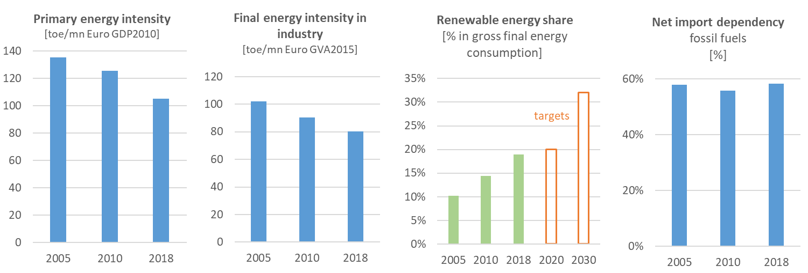

Source 1 EUROSTAT

During the last decade, industrial electricity prices in the EU[27] have remained relatively stable, and are currently lower than Japan’s, but double those of the US and higher than those of most non-EU G20 countries. Though industrial gas prices[28] have fallen, and are lower than those in Japan, China and Korea, they remain higher than those of most non-EU G20 countries. Relatively high non-recoverable taxes and levies in the EU and price regulation and/or subsidies in the non-EU G20 play an important role in this difference.

Despite a short-term improvement and reduction in energy import dependency between 2008 and 2013, the EU has since experienced an increase[29]. In 2018, net import dependency was 58.2%, just over the 2005 level, and almost equalling the highest values over the period. Resource efficiency and economic resilience are key in being competitive and enhancing the open strategic autonomy[30] of the EU in the clean energy technology market. While clean energy technologies reduce dependence on imports of fossil fuels, they risk replacing this dependence with on raw materials. This creates a new type of supply risk[31]. However, unlike fossil fuels, raw materials have the potential to stay in the economy through the implementation of circular economy approaches[32], like extended value chains, recycling, reuse and design for circularity, affecting the capital expenditures and decreasing the energy need for extraction and processing of virgin materials but not the operational expenditures of energy production. The EU is very dependent on third countries for raw and processed materials. For some technologies, however, it has a leading position in the manufacture of components and final products, or high technology components. Specific, often high-tech materials show high supply concentration in a handful of countries. (For instance, China produces over 80% of the available rare earths for permanent magnet generators)[33].

## 2.2 Share of EU energy sector in EU GDP

The turnover of the EU energy sector[34] was EUR 1.8 trillion in 2018, nearly the same level as in 2011 (EUR 1.9 trillion). The sector contributes 2% of total gross value added in the economy, a figure that has remained largely constant since 2011. The turnover of the fossil fuel sector shrank from 36% (EUR 702 billion) of the overall energy sector turnover in 2011 to 26% (EUR 475 billion) in 2018. At the same time, the turnover from renewables increased over the same period from EUR 127 billion to EUR 146 billion[35],[36]. The value added of the clean energy sector (EUR 112 billion in 2017) was more than double that of fossil fuel extraction and manufacturing activities (EUR 53 billion), having tripled since 2000. The clean energy sector thus generates more value added that stays within Europe than the fossil fuel sector.

Over 2000-2017, annual growth in the gross value added of renewable energy production averaged 9.4%, while that of energy efficiency activities averaged 22.3%, far outpacing the rest of the economy (1.6%). The labour productivity of the EU (gross value added per employee) has also improved significantly in the clean energy sector, especially in the renewable energy production sector, where it has risen by 70% since 2000.

Figure 2 Gross value added and value added per employee, 2000-2019, 2000=100

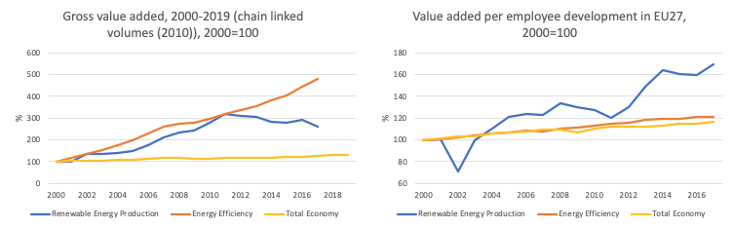

Source 2 JRC based on Eurostat data: [env_ac_egss1], [nama_10_a10_e], [env_ac_egss2], [nama_10_gdp.

## 2.3 Human capital

Clean energy technologies and solutions provide direct full-time employment for 1.5 million people in Europe[37], of which more than half million[38] in renewables (growing to 1.5 million when indirect jobs are also included) and almost 1 million in energy efficiency activities (in 2017)[39]. Direct jobs in renewable energy production for the EU grew from 327,000 in 2000 to 861,000 in 2011, falling to 502,000 in 2017. As Figure 3 shows, there was a decrease after 2011[40], probably explained by the effect of the financial crisis, including the subsequent relocation of manufacturing capacity, as well as by increased productivity and a decrease in job intensity. The number of direct jobs in energy efficiency increased steadily from 244,000 in 2000 to 964,000 in 2017. Direct jobs in these sectors (RES and EE) represent about 0.7% of total employment in EU,[41] but their growth has outpaced the rest of the economy, with average annual growth of 3.1% and 17.4% respectively[42].

Figure 3 Direct employment in the clean energy sector vs the rest of the economy over 2000-2018, 2000=100, and Renewable energy employment per technology, 2015-2018

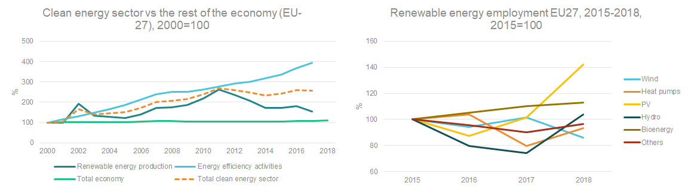*Source 3 (JRC based on Eurostat data [env_ac_egss1], [nama_10_a10_e][43] and EurObserv'ER)*

The growing trend of employment in the clean energy sector is global, although the technologies that offer more employment opportunities vary by region. In general, jobs have been created mainly in the solar PV and wind energy sectors. China, which has almost 40% of all global jobs in renewables, employs most in solar PV, solar heating and cooling, and wind energy; Brazil’s employment is in the bioenergy sector; and the EU employ most people in bioenergy (about half of all RES jobs) and wind energy (about a quarter), see Figure 4.

Figure 4 Global employment in renewable energy technology (2012-2018)[44]

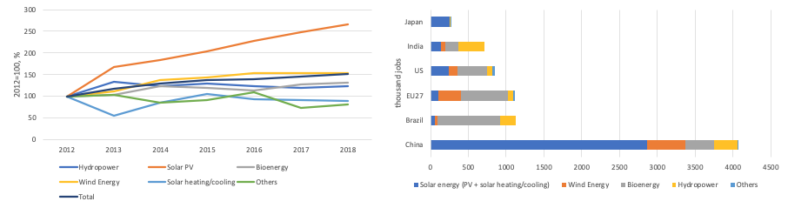

*Source 4 (JRC based on IRENA, 2019[45])*

The clean energy technology sector continues to face challenges, in particular availability of skilled workers at the locations where they are in demand.[46],[47]The skills concerned include, in particular, engineering and technical skills, IT literacy and ability to utilise new digital technologies, knowledge of health and safety aspects, specialised skills in carrying out work in extreme physical locations (for example at height or at depth), and soft skills like team work and communication, as well as knowledge of the English language.

As regards gender, women accounted for an average of 32% of the workforce in the renewables sector in 2019[48]. This figure is higher than in the traditional energy sector (25%[49]) but lower than the share across the economy (46.1%[50]) and furthermore gender balance differs to a higher extend for certain job profiles.

## 2.4 Research and innovation trends

In recent years, the EU has invested an average of nearly EUR 20 billion a year on clean energy R&I prioritised by the Energy Union[51],[52]. EU funds contribute 6%, public funding from national governments accounts for 17%, and business contributes an estimated 77%.

The R&I budget allocated to energy in the EU represents 4.7% of total spending on R&I[53]. In absolute terms, however, Member States have reduced their national R&I budgets for clean energy (Figure 5); in 2018 the EU spent half a billion less than in 2010. This trend is global. Public sector R&I spending on low-carbon energy technologies was lower in 2019 than in 2012, while countries continue to allocate large amounts of R&I funding to fossil fuels[54]. This is the opposite of what is needed: R&I investments in clean technologies need to increase if the EU and the world want to meet their decarbonisation commitments. Today the EU has the lowest investment rate of all major global economies measured as a share of GDP (Figure 5). EU research funds have been contributing a larger share of public funding and have been essential in maintaining research and innovationinvestment levels over the last four years.

Figure 5 Public R&I financing of Energy Union R&I priorities[55]

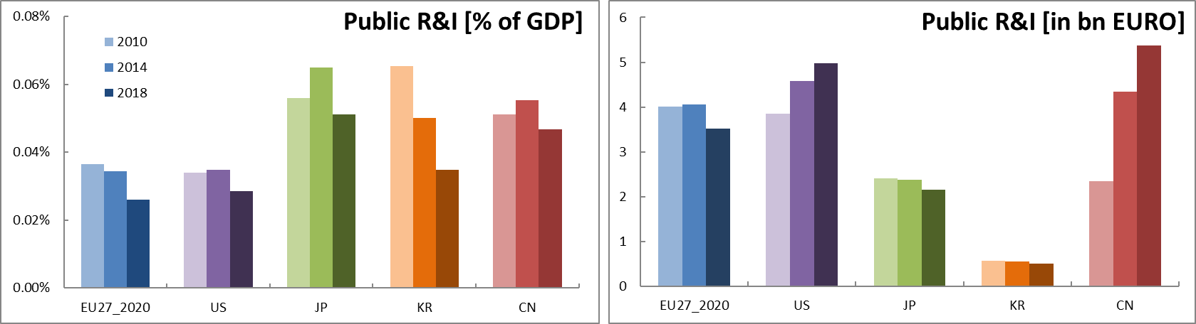

Source 5 JRC49 based on IEA[56], MI[57].

In the private sector, only a small share of revenue is currently being spent on R&I in the sectors most in need of large-scale adoption of low-carbon technologies51. The EU have estimated that private investment in Energy Union R&I priorities has been decreasing: it currently amounts to around 10% of businesses’ total expenditure on R&I[58]. This is higher than the US and comparable to Japan, but lower than China and Korea. A third of this investment goes on sustainable transport, while renewables, smart systems and energy efficiency receive about a fifth each. While the distribution of private R&I in the EU has changed only slightly in recent years, there has been a more significant shift globally towards industrial energy efficiency and smart consumer technologies[59].

Figure 6 Estimates of private R&I financing of Energy Union R&I priorities[60]

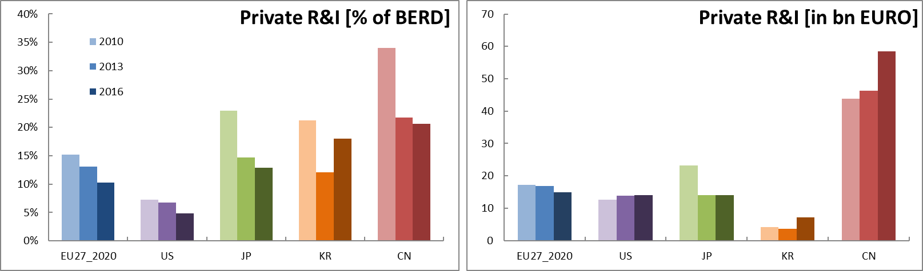

Source 6 JRC49, Eurostat/OECD55

On average, major listed companies and their subsidiaries make up 20-25% of the main investors, but account for 60-70% of patenting activity and investments. In the EU, the automotive sector is the biggest private R&I investor in absolute terms in the Energy Union R&I priorities[61], followed by biotechnology and pharmaceuticals. Figure 7 shows that among the energy industries, the oil and gas sector is the largest investor in R&I. Other energy sectors, such as electricity or alternative energy companies, have much lower budgets for R&I, although they spend more of it on clean energy. It is worrying that a major share of the private budget for R&I in the energy sector is not spent on clean energy technologies. According to the IEA, less than 1% of oil and gas companies’ total capital expenditure has been outside their core business areas, on average[62],[63], and only 8% of their patents are in clean energy[64].

Figure 7 EU R&I investment in Energy Union R&I priorities, by industrial sector[65]

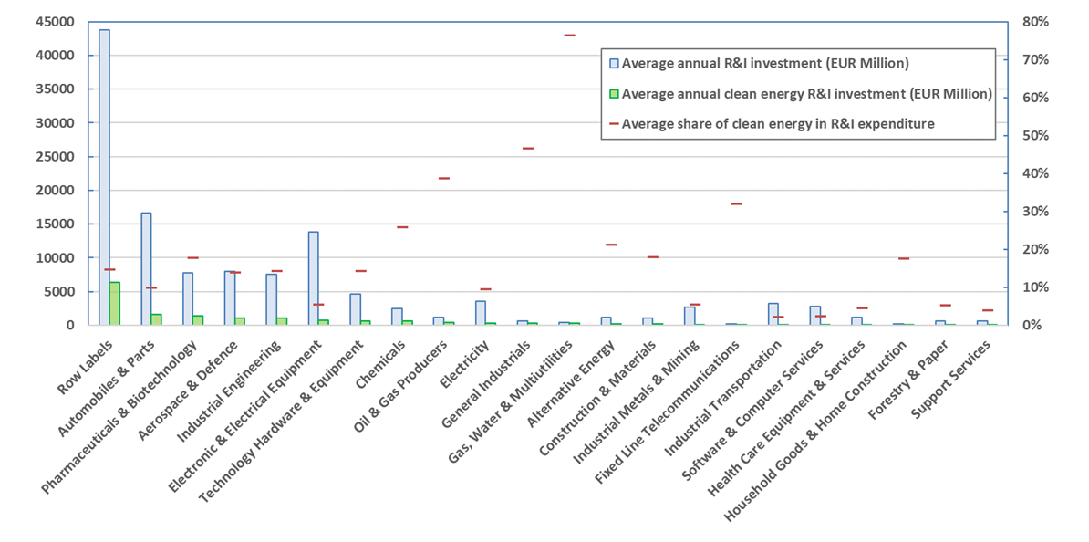 *Source 7 JRC*49

Venture capital (VC) investment in clean energy had been increasing in recent years, but remains low (just over 6-7%) compared with private-sector investment in R&I. So far, 2020 marks a significant global slowdown in VC investment in clean energy technologies[66].

Patenting activity in clean energy technologies[67] peaked in 2012, and has been in decline since.[68] Within this trend, however, certain technologies that are increasingly important for the clean energy transition (e.g. batteries) have maintained or even increased their levels of patenting activity.

The EU and Japan lead among international competitors in high-value[69] patents on clean energy technologies. Clean energy patents account for 6% of all high-value inventions in the EU. The EU’s share is similar to that of Japan, and higher than China (4%), the US and the rest of the world (5%), and second only to Korea (7%) in terms of competing economies. The EU host a quarter of the top 100 companies in terms of high-value patents in clean energy. The majority of inventions funded by multinational firms headquartered in the EU are produced in Europe and, for the most part, by subsidiaries located in the same country.[70] The US and China are the main IPO offices – and by extension markets – targeted for protection of EU inventions.

## 2.5 Covid-19 Recovery[71]

During the pandemic, the European energy system has proved to be resilient to shocks stemming from the pandemic[72] and a greener energy mix has emerged, with coal power generation in the EU falling by 34% and renewables providing 43% of power generation in Q2 2020, the highest share to date[73]. At the same time, the stock market performance of the clean energy sector has seemed less affected and recovered more quickly than fossil-fuel sectors. Digitalisation has helped companies and sectors respond successfully to the crisis, also boosting the emergence of new digital applications.

Although the EU energy value chains are recovering, the crisis has brought to the forefront the question of optimising and potentially regionalising supply chains, to reduce exposure to future disruptions and improve resilience. In response, the Commission aims to identify the critical supply chains for energy technologies, analyse potential vulnerabilities and improve their resilience[74]. The key energy priorities in recovery are energy efficiency in particular through the renovation wave, renewable energy sources, hydrogen and energy system integration. There is a further concern that the pandemic is affecting investments in and resources available for R&I, as has demonstrably happened in previous economic crises.

Recovery measures can take advantage of the job creation potential offered by energy efficiency and renewable energy[75], including that of the R&I sector, to boost employment while also moving towards sustainability. Support for R&I investment, including corporate R&I, has a greater positive impact on employment in medium- to high-technology sectors such as cleaner energy technology[76]. At the same time, breakthrough low-carbon technologies are needed, for instance in energy-intensive industries, which will require faster R&I investment for their demonstration and deployment.

# Focus on key clean energy technologies and solutions

In the section below, the most relevant competitiveness values for each of the six technologies analysed above, and *the status, value chain and global market* are analysed, based on the indicators outlined in Table 1. The EU's performance is compared as far as possible with other key regions (e.g. USA, Asia). A more detailed assessment of other important clean and low carbon energy technologies needed to reach climate neutrality is set out in the accompanying Clean Energy Transition – Technologies and Innovation Report[77].

## 3.1 Offshore renewables – wind

Technology: the EU cumulative installed capacity of offshore wind (OW) amounted to 12 GW in 2019[78]. At the 2050 time horizon, EU scenarios foresee approximately 300 GW of wind offshore capacity in the EU[79]. Globally, costs have fallen steeply in recent years, and demand has been stimulated by new tenders implemented worldwide and the building of subsidy-free wind parks. OW has benefited considerably from onshore wind developments, especially economies of scale (e.g. material developments and common components), thereby allowing efforts to focus on the technology’s most innovative segments (such as floating offshore wind, new materials and components). Recent offshore wind projects have observed much increased capacity factors. The average power capacity of the turbines has increased from 3.7 MW (2015) to 6.3 MW (2018), thanks to sustained R&I efforts.

R&I in offshore wind revolves mainly around increased turbine size, floating applications (particularly substructure design), infrastructure developments, and digitalisation. About 90% of EU R&I funding for wind comes from the private sector[80]. At EU level, offshore wind R&I has been supported since the 1990s. Offshore wind, in particular floating, have received substantial funding in recent years (*Figure 8*). These R&I patterns highlight that through the development of new market segments the EU could establish a competitive edge. For example, a fully-fledged EU OW supply chain (extended also to untapped EU sea basins), leadership in floating offshore industry targeting markets with deeper waters or new emerging concepts e.g. airborne wind systems or the development of a port infrastructure capable to deliver the ambitious targets (and synergies to other sectors e.g. hydrogen production in ports). Patenting trends confirm Europe’s competitiveness in wind energy. EU players are leading in high value inventions[81] and they protect their knowledge in other patent offices outside their home market.

*Figure 8 Evolution of EC R&I funding, categorised by R&I priorities for wind energy under FP7 and H2020 programmes and the number of projects funded over 2009-2019.*

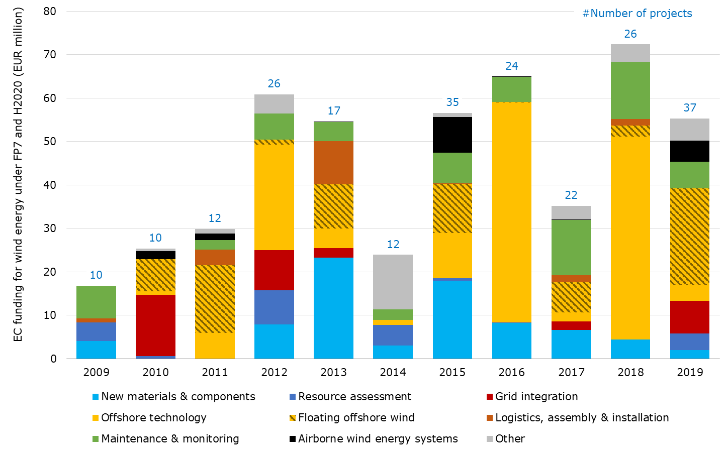

Source 8 JRC 2020[82]

Other recent innovations target the logistics/supply chain, e.g. the development of wind turbine gearboxes compact enough to fit into a standard shipping container[83] as well as applying circular economy approaches along the life-cycle of installations. Further innovations and trends expected to increase most over the next ten years include superconducting generators, advanced tower materials and the added value of offshore wind energy (system value of wind). The SET Plan Group on OW identified most of these areas as key for Europe to remain competitive in the future. Currently, Europe is leading in all parts of the value chain of sensing and monitoring systems for OW turbines, including research and production[84].

Value chain: On the market side, EU companies are ahead of their competitors in providing offshore generators of all power ranges, reflecting a well-established European offshore market and the increasing size of newly installed turbines[85]. Currently, about 93% of the total offshore capacity installed in Europe in 2019 is produced locally by European manufacturers (Siemens, Gamesa Renewable Energy, MHI Vestas and Senvion[86]).

Figure 9 Newly installed wind capacity (onshore & offshore) - local vs imported, assuming an European single market

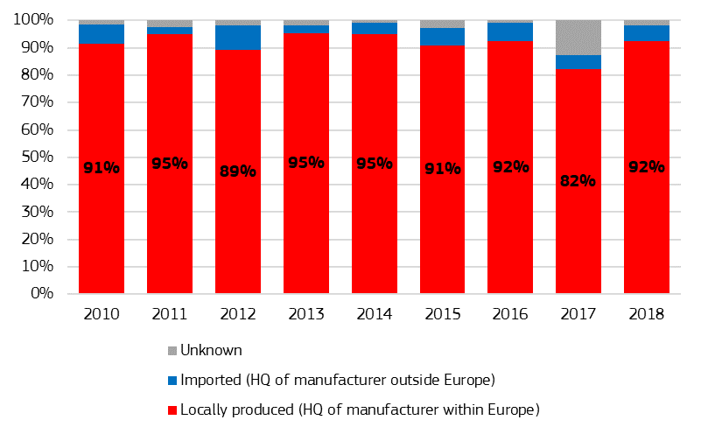

Source 9 JRC 2020[87]

Global market: the EU[88] share of global exports increased from 28% in 2016 to 47% in 2018, and 8 out of the top 10 global exporters were EU countries, with China and India being the key global competitors. Between 2009 and 2018, the EU[89] trade balance remained positive, showing a rising trend.

In terms of global markets projections, within Asia (including China), offshore wind capacity is expected to reach around 95 GW by 2030 (out of a projected global capacity of almost 233 GW by 2030)[90]. Nearly half of global offshore wind investment in 2018 took place in China[91]. At the same 2030 time horizon, the CTP-MIX scenario projects 73 GW of wind offshore capacity in the EU. Currently, the NECPs project 55 GW of offshore wind capacity by 2030.

Floating applications seem to become a viable option for EU countries and regions lacking shallower waters (floating OW farms for depths between 50 and 1000 metres) and could open up new markets based on areas such as the Atlantic Ocean, the Mediterranean and, potentially, the Black Sea. A number of projects are planned or underway that will lead to the installation of 350 MW of floating capacity in European waters by 2024. Moreover, the EU wind industry aims to install floating OW farms with 150 GW of capacity by 2050 in European waters with a view to achieving climate neutrality[92]. The global market for energy from floating OW farms represents a considerable commercial opportunity for EU companies. A total of about 6.6 GW from this source are expected by 2030, with significant capacities in certain Asian countries (South Korea and Japan), in addition to the European markets (France, Norway, Italy, Greece, Spain) between 2025 and 2030. Since China has abundant wind resources in shallow waters, it is not expected to build floating wind farms with significant capacity in the medium term[93]. Floating applications can also reduce under-water environmental impacts, notably during the construction phase.

Offshore wind is a competitive industry on the global market. Emerging global market demands, such as that for energy generated by floating wind farms, may become key to EU industry if it is to be competitive in the growing offshore wind industry, and remain so. A key consideration is whether Member States will commit to wind energy. The current mismatch between the 2030 NECP projection (55 GW of offshore wind) and the EU’s scenario (73 GW[94]) means that investment must be stepped up. The positive impact of offshore wind development on supply chains in sea basins is relevant to regional development (location of manufacturing, assembly of turbines close to the market, impact on port infrastructure). The offshore renewable energy strategy[95] will define a set of measures to overcome challenges and boost offshore prospects.

## 3.2 Offshore renewables – Ocean energy

Technology: tidal and wave energy technologies are the most advanced of the ocean energy technologies, with significant potential located in a number of Member States and regions[96]. Tidal technologies can be considered as being at the pre-commercial stage. Design convergence has helped the technology develop and generate a significant amount of electricity (over 30 GWh since 2016[97]). A number of projects and prototypes have been deployed across Europe and worldwide. Most of the wave energy technological approaches, however, are at technology readiness level (TRL) 6-7, with a strong focus on R&I. Most improvements in wave energy results stem from ongoing projects in the EU. Over the past five years, the sector has shown resilience[98] and significant technology progress has been achieved thanks to the successful deployment of demonstration and first-of-a-kind farms.[99]

The LTS scenarios foresee limited uptake of ocean energy technology. The high cost of wave and tidal energy converters and the limited information available on the performance limit the capture of ocean energy in the model[100]. At the same time, the European Green Deal emphasises the key role marine renewable energy will play in the transition to a climate-neutral economy, with a significant contribution expected under the right market and policy conditions (2.6 GW by 2030[101] and 100 GW in European waters by 2050[102]). Ongoing demonstrations show that costs can be reduced fast: data from Horizon 2020 projects indicate that the cost of tidal energy fell by over 40% between 2015 and 2018[103],[104].

Value chain: European leadership spans the whole ocean energy supply chain[105] and innovation system[106]. The European cluster formed by specialised research institutes, developers and the availability of research infrastructure has enabled Europe to develop and maintain its current competitive position.

Global market: the EU maintains global leadership despite the UK’s withdrawal from the bloc and changes in the market for wave and tidal energy technologies. 70% of global ocean energy capacity has been developed by EU-based companies[107]. Over the next decade it will be vital for EU developers to build on their competitiveness position. Global ocean energy capacity is expected to increase to 3.5 GW within the next five years, and an increase of up to 10 GW can be expected by 2030[108].

Figure 10 Installed capacity by origin of technology

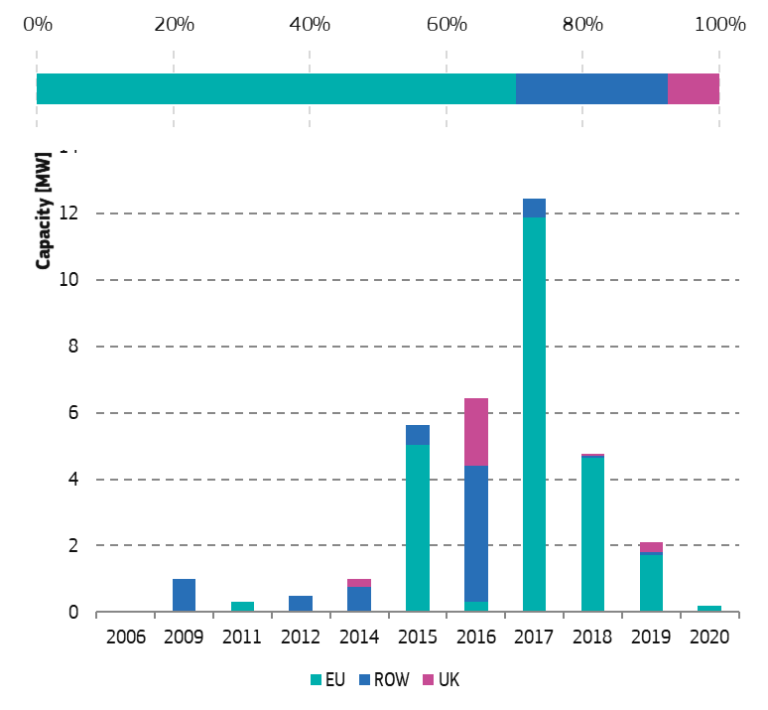

Source 10 JRC 2020[109]

Within the EU[110], 838 companies in 26 countries filed patents or were involved in the filing of patents to do with ocean energy between 2000 and 2015[111]. The EU has long maintained technological leadership in developing ocean energy technologies, thanks to the sustained support provided for R&I. Between 2007 and 2019, total R&I expenditure on wave and tidal energy amounted to EUR 3.84 billion, most of which (EUR 2.74 billion) came from private sources. In the same period, national R&I programmes contributed EUR 463 million to the development of wave and tidal energy, while EU funds supported R&I to the tune of almost EUR 650 million (including NER300 and Interreg projects (co-funded by the European Regional Development Fund))[112]. On average, EUR 1 billion of public funding (EU[113] and national) leveraged EUR 2.9 billion of private investments in the course of the reporting period.

Significant cost reduction is still needed for tidal and wave energy technologies to exploit their potential in the energy mix, for which intensified (i.e. increased rate of projects in the water) and continued (i.e. continuity of projects) demonstration activities are necessary. Despite advances in technology development and demonstration, the sector faces a struggle in creating a viable market. National support appears low, reflected by the limited commitment to ocean energy capacity in the NECPs compared to 2010 and the lack of clear dedicated support for demonstration projects or for the development of innovative remuneration schemes for emerging renewable technologies. This limits scope for developing a business case and for identifying viable ways to develop and deploy the technology. Specific business cases for ocean energy therefore need more focus, in particular when its predictability can enhance its value, as well its potential for decarbonising small communities and EU islands[114]. The upcoming offshore renewable energy strategy offers an opportunity to support the development of ocean energy and enable the EU to exploit its resources across the EU to the full.

## 3.3 Solar photovoltaics (PV)

Technology: solar PV has become the world’s fastest-growing energy technology, with demand for solar PV spreading and expanding as it becomes the most competitive option for electricity generation in a growing number of markets and applications. This growth is supported by the decreasing cost of PV systems (EUR/W) and increasingly competing cost of electricity generated (EUR/MWh).

The EU[115] cumulative PV installed capacity amounted to 134 GW in 2019, and it is projected to grow to 370 GW in 2030, and to 1051 GW in 2050[116]. Given the significant projected growth of PV capacity in the EU and globally, Europe should have a sizeable role in the whole value chain. At the moment, European companies perform differently across the various segments of the PV value chain (Figure 11).

*Figure 11 European players across the PV industry value chain*



Source 11 ASSET study on competitiveness

Value chain: EU companies are competitive mainly in the downstream part of the value chain. In particular, they have managed to remain competitive in the monitoring, control and balance of system (BoS) segments, hosting some of the leaders in inverter manufacturing and in solar trackers. EU companies have also maintained a leading position in the deployment segment, where established players like Enerparc, Engie, Enel Green Power or BayWa.re have been able to gain new market share worldwide[117]. Furthermore, equipment manufacturing still has a strong base in Europe (e.g. Meyer Burger, Centrotherm, Schmid).

Global market: the EU has lost its market share in some of the upstream parts of the value chain (e.g. solar PV cell and module manufacturing). The highest value added is located both a long way upstream (in basic and applied R&D, and design) and a long way downstream (in marketing, distribution, and brand management). Even though the lowest value-added activities occur in the middle of the value chain (manufacturing and assembly), companies have an interest in being well positioned in these segments, to reduce risks and financing costs. The EU still hosts one of the leading polysilicon manufacturers (Wacker Polysilicon AG), whose production alone is sufficient to manufacture 20 GW of solar cells, and which exports a significant part of its polysilicon output to China[118]. Currently, global production of PV panels is valued at about EUR 57.8 billion, with the EU accounting for EUR 7.4 billion (12.8%) of that amount. The EU still accounts for a relatively high share of the segment’s total value, thanks to the production of polysilicon ingots. However, it has fallen back dramatically in the manufacture of PV cells and modules. All the top 10 producers of PV cells and modules now produce most of their output in Asia[119].

Capital expenditure costs for polysilicon, solar cell and module manufacturing plants fell dramatically between 2010 and 2018. Together with innovations in manufacturing, this should offer an opportunity for the EU to take a fresh look at the PV manufacturing industry and reverse the situation[120].

The EU’s presence in the far upstream and far downstream parts of the value chain could well provide a basis for rebuilding the PV industry. This would require a focus on specialisation or high-performance/high-value products, such as equipment and inverter manufacturing and PV products tailored to the specific needs of the building sector, transport (vehicle integrated PV) and/or agriculture (dual land use with AgriPV), or to the demand for high-efficiency/high-quality solar power installations to optimize use of available surfaces and of resources. The modularity of the technology makes it easier to integrate PV in a number of applications, especially in the urban environment. These novel PV technologies, which are now reaching the commercial phase, could offer a new basis for rebuilding the industry[121]. The strong knowledge of the EU research institutions, the skilled labour force, and the existing and emerging industry players provide a basis for re-establishing a strong European photovoltaic supply chain[122]. To remain competitive, such industry needs to develop a global outreach. Building a sizeable EU PV manufacturing industry would also reduce the risk of supply disruptions and quality risks.

## 3.4 Renewable hydrogen production through electrolysis

This section focuses on renewable hydrogen production and on the competitiveness of this first segment of the hydrogen value chain[123]. Hydrogen is key to to store energy produced by renewable electricity and to decarbonise sectors that are hard to electrify. The aim of the EU hydrogen strategy is to integrate 40 GW of renewable hydrogen[124] electrolysers and the production of up to 10 Mt of renewable hydrogen in the EU energy system by 2030, with direct investment of between EUR 24 billion and EUR 42 billion[125],[126].

Technology: the capital cost of electrolysershas fallen by 60% in the last decade, and is expected to halve again by 2030, compared to the present day, thanks to economies of scale[127]. The cost of renewable hydrogen[128] currently lies between EUR 3 and EUR 5.5 per kilo, making it more expensive than non-renewable hydrogen (EUR 2 (2018) per kilo of hydrogen[129]).

Today, less than 1% of world hydrogen production comes from renewable sources[130]. Projections for 2030 locate the cost of renewable hydrogen in the range of EUR 1.1-2.4/kg[131], which is cheaper than low-carbon fossil-based hydrogen[132], and nearly competitive with fossil-based hydrogen[133].

Between 2008 and 2018, the Fuel Cells and Hydrogen Joint Undertaking (FCH JU) supported 246 projects across several hydrogen-related technological applications, reaching a total investment figure of EUR 916 million, complemented by EUR 939 million of private and national/regional investments. Under the Horizon 2020 programme (2014-2018), over EUR 90 million was allocated to developing electrolysers, complemented by EUR 33.5 million of private funds[134],[135]. At national level, Germany has deployed most resources, with EUR 39 million[136] allocated to projects devoted to electrolyser development between 2014 and 2018[137]. In Japan, Asahi Kasei received a multimillion dollar grant supporting the development of their alkaline electrolyser[138].

Asia (mostly China, Japan and South Korea) dominates the total number of patents filed between 2000 and 2016 for the hydrogen, electrolyser and fuel cell groupings. Nevertheless, the EU performs very well and has filed the largest number of ‘high-value’ patent families in the fields of hydrogen and electrolysers. Japan, however, has filed the largest number of ‘high-value’ patent families in the field of fuel cells.

Value chain: the main water electrolysis technologies are alkaline electrolysis (AEL), polymer electrolyte membrane electrolysis(PEMEL) and solid oxide electrolysis (SOEL)[139]:

* AEL is a mature technology with operational costs driven by electricity costs and high capital cost. The research challenges are high-pressure operation and the coupling with dynamic loads.
* PEMEL can reach signiﬁcantly higher current densities[140] than AEL and SOEL, with the potential to further reduce capital cost. In recent years, several large (MW-scale) plants have been installed in the EU (in Germany, France, Denmark, and the Netherlands), enabling the EU to catch up on AEL. It is a market-ready technology with research mainly focused on increasing aerial power density, while guaranteeing the simultaneous reduction of critical raw material use[141] and durability performance.
* SOEL exhibits greatest efficiency. However, plants are relatively smaller, usually still in the 100 kW capacity range, require steady operation, and need to be coupled to a heat source[142]. Overall, SOEL is still in the development phase, although it is possible to order products on the market.

In 2019, the EU had around 50 MW of water electrolysis capacity installed[143] (about 30% AEL and 70% PEMEL), of which about 30 MW were located in Germany in 2018[144].

AEL has no critical components in its supply chain. Thanks to technical similarities with the chlor-alkali electrolysis industry, which deploys much larger installations, it can exploit technology overlap and benefit from well-established value chains.[145]. PEMEL and SOEL share some cost and supply risks with the respective fuel cell value chains[146]. This applies in particular to critical raw materials[147] in the case of PEMEL, and to rare earths in the case of SOEL.

PEMEL has to withstand corrosive environments and therefore requires the use of more expensive materials, such as titanium for bipolar plates. The main system-cost contributors are the electrolyser stack[148] (40-60%), followed by the power electronics (15-21%). The core components driving up the stack cost are the layers of membrane electrode assemblies (MEA), which contain noble metals[149]. Cell components based on rare earths that are used for SOEL electrodes and electrolyte are the main contributors to stack cost. It is estimated that stacks account for about 35% of overall SOEL system cost[150].

Global market: European companies are well-placed to benefit from market growth. The EU has producers of all three main electrolyser technologies[151], and is the only region offering a well-defined market product for SOEL. The other players are located in the UK, Norway, Switzerland, the US, China, Canada, Russia and Japan.

The global turnover for water electrolyser systems is currently estimated to be in the range of EUR 100 to EUR 150 million per year. According to 2018 estimates, water electrolysis production could reach a capacity of 2 GW per year (globally), within a very short space of time (one to two years). European manufacturers could potentially supply about one third of this increased global capacity[152].

The aim of the EU’s hydrogen strategy is to achieve a significant renewable hydrogen production capacity by 2030. This will require a tremendous effort to scale up from the 50 MW of water electrolysis capacity currently installed to 40 GW by 2030, with the setting up of the capacity required for a sustainable value chain in the EU. This effort should build on the innovation potential offered by the whole spectrum of the electrolyser technologies and on the leading position EU companies have in electrolysis in all technology approaches, along the whole value chain, from component supply to final integration capability. Important cost reductions are expected as a result of scaling up industrial scale manufacturing of electrolysers.

## 3.5 Batteries

Batteries are a key enabler for the transition to the climate-neutral economy we aim to reach by 2050, for the roll-out of clean mobility, and for energy storage to enable the integration of increasing shares of variable renewables. This analysis focuses on lithium ion (Li-ion) battery technology. There are several reasons for this:

* the very advanced state of this technology and its market readiness;
* its high round trip efficiency;
* its considerable projected demand; and
* its expected broader use, be it in electric vehicles, future electric (maritime and airborne) vessels, or in stationary and other industrial applications, leading to considerable market opportunities.

Technology: global demand for Li-ion batteries is projected to increase from about 200 GWh in 2019 to about 800 GWh in 2025, and to exceed 2 000 GWh by 2030. Under the most optimistic scenario, it could reach 4 000 GWh by 2040[153].

*Figure 12 Historical and projected annual Li-ion battery demand, by use*



Source 12 Bloomberg Long-Term Energy Storage Outlook, 2019: Bloomberg NEF, Avicenne for consumer electronics

The projected growth, mainly based on electric vehicles (especially passenger vehicles), comes from the strong technological improvements that are expected and further decreases in cost. Lithium-ion battery prices, which were above USD 1 100/kWh in 2010, have fallen 87% in real terms to USD 156/kWh in 2020[154]. By 2025, average prices are expected to be close to USD 100/kWh[155]. As regards performance, lithium-ion energy density has increased significantly in recent years, tripling since their commercialisation in 1991151. Further potential for optimisation is expected with the new generation of Li-ion batteries[156].

Value chain: Figure 14 shows the value chain for batteries together with the EU’s position in the various segments. EU industry is investing in mining, raw and advanced materials production and processing (cathode, anode and electrolyte materials), and in modern cell, pack and battery production. The aim is to become more competitive through quality, scale and, in particular, sustainability.

Figure 13 Assessment of EU position along the battery value chain, 2019

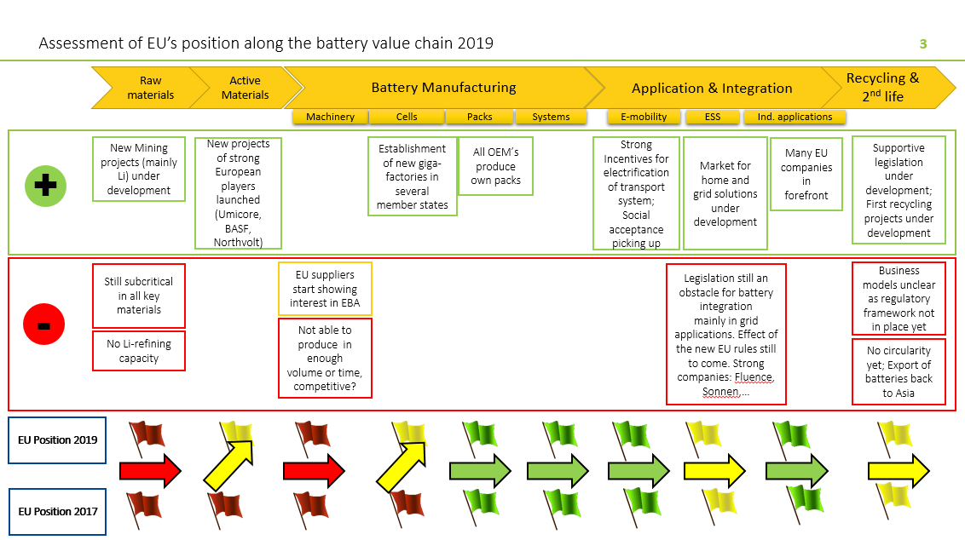*Source 13 InnoEnergy (2019).*

Global market: the global market for Li-ion batteries for electric cars is currently worth EUR 15 billion/year (of which the EU accounts for EUR 450 million/year (2017)[157]). A conservative estimate foresees that the market will be EUR 40-55 billion/year in 2025 and EUR 200 billion/year in 2040[158]. In 2018, the EU had only about 3% of the global production capacity of Li-ion cells, while China had about 66%[159]. European industry was perceived as being strong in the downstream, value-driven segments, such as battery pack manufacturing and integration and battery recycling, and generally weak in upstream, cost-driven segments such as materials, components and cell manufacturing[160],[161]. The marine battery market is growing and estimated to be worth more than €800 million/year by 2025, more than half within Europe and a technological sector where Europe currently leads[162].

Recognising the urgent need for the EU to recover competitiveness in the battery market, the Commission launched the European Battery Alliance in 2017 and adopted a strategic action plan for batteries in 2018[163]. This is a comprehensive policy framework with regulatory and financial instruments to support the establishment of a complete battery value chain ecosystem in Europe. At the same time, large-scale battery and battery cell manufacturers are starting to establish new production plants (e.g. Northvolt). Currently, there have been announcements for investments in up to 22 battery factories (some of which are under construction), with a projected capacity of 500 GWh by 2030[164].

Figure 14 Li-ion cell manufacturing capacity by region of plant location



Source 14 BloombergNEF, 2019

The EU has strengths which it can build on to catch up in the battery industry, particularly in advanced materials and battery chemistries, and in recycling, where EU pioneering legislation has made it possible to develop a well-structured industry. The Batteries Directive is currently under revision. However, to capture a significant market share of the new and fast-growing rechargeable battery market, sustained action is needed over an extended period to ensure more investment in production capacity. This needs to be supported by R&I to improve the performance of batteries, while also guaranteeing that they meet EU-level quality and safety standards, as well as to guarantee the availability of raw and processed materials and the reuse or recycling and sustainability of the whole battery value chain. There also needs to be a new comprehensive EU legislative framework that sets out robust standards for performance and sustainability for batteries placed on the EU market. This will help industry to plan investments and ensure high standards of sustainability in line with the objectives of the European Green Deal. A Commission proposal will be adopted shortly.

While improving the position on Li-ion technology is likely to be a core interest stream over the next few decades, there is also a need to look into other new and promising battery technologies (such as all-solid state, post Li-ion and redox flow technology). These are important for applications whose requirements cannot be met by Li-ion technology.

## 3.6 Smart electricity grids

Electrification increases in all scenarios for 2050[165], so a smart electricity system is essential if the EU is to achieve its Green Deal ambitions. A smart system enables a more efficient integration of increasing shares of renewable electricity production and of increasing electricity storage and/or consuming devices (e.g. electric vehicles) in the energy system. The same applies to the growing numbers of devices that run on electricity, such as electric vehicles. Through comprehensive control and monitoring of the grid, smart systems also create value by reducing the need for curtailment of renewables and enabling competitive and innovative energy services for consumers. According to the IEA, investment in enhanced digitalisation would reduce curtailment in Europe by 67 TWh by 2040[166]. In Germany alone, 6.48 TWh was curtailed in 2019, while grid stabilisation measures cost EUR 1.2 billion[167]. Such systems need to be cyber-secure, which requires sector-specific measures.[168]

Investments in digital grid infrastructure are dominated by hardware such as smart meters and electric vehicle chargers. In Europe, investments remained stable in 2019 at nearly EUR 42 billion[169], with a larger portion of spending allocated to upgrading and refurbishing the existing infrastructure.

Figure 15 (left) Global investment in smart grids by technology area, 2014-2019[170] (billion USD)

Figure 16 (right) Smart grid investment by European TSOs in recent years, by category (2018)[171]

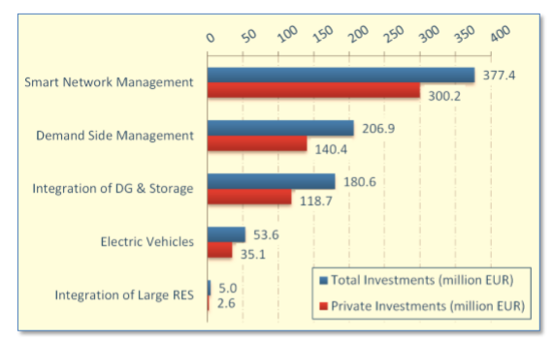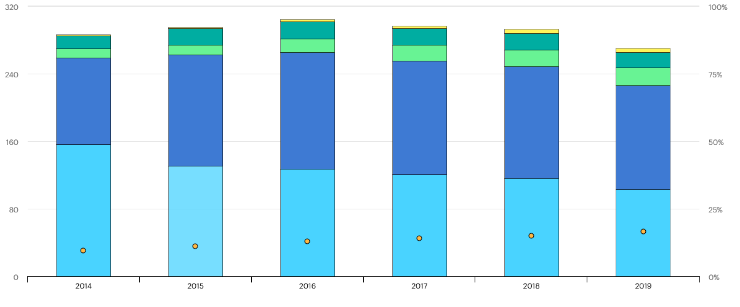



The main source of support for R&I investments in smart grids at EU level is Horizon 2020, which provided almost EUR 1 billion between 2014 and 2020. EUR 100 million was invested in dedicated digitalisation projects, and many other smart grid projects assign a considerable proportion of their budget to digitalisation.[172] Figure 16 shows that public investments in smart grids, including those made through Horizon 2020, account for a significant share of total investments by transmission system operations (TSOs). It is noteworthy that budgets for R&I by TSOs are low, at around 0.5% of their annual budget[173],[174].

The TEN-E Regulation also supports investments in smart electricity grids as one of the 12 priority areas, but investments in (cross-border) [smart](http://ec.europa.eu/energy/infrastructure/transparency_platform/map-viewer) grids could benefit from higher levels of support from regulatory authorities through inclusion in national network development plans and eligibility for EU financial assistance in the form of grants for studies and works as well as innovative financial instruments under the [Connecting Europe Facility](https://ec.europa.eu/inea/en/connecting-europe-facility) (CEF). From 2014 to 2019, CEF has provided up to EUR 134 million of financial assistance related to different smart electricity grids projects across the EU.

The following two key technologies are assessed in more detail: High-voltage direct current (HVDC) systems, and digital solutions for grid operations and for the integration of renewables.

#### High-voltage direct current (HVDC) systems

Technology: higher demand for cost-effective solutions to transport electricity over long distances, particularly, in the EU, to bring power generated by offshore wind to land, increases demand for HVDC technologies. According to Guidehouse Insights, the European market for HVDC systems will grow from EUR 1.54 billion in 2020 to EUR 2.74 billion in 2030, at a growth rate[175] of 6.1%[176],[177]. The global market is expected to be around EUR 12.5 billion (2020), with the main investments in HVDC taking place in Asia, where much of the market is taken up by Ultra-HVDC[178]. HVDC equipment is very costly, and projects to build HVDC connections are therefore very expensive. Given the technological complexity of HVDC systems, their installation is generally managed by manufacturers[179].

Value chain analysis: the value chain for HVDC grids can be segmented along the different hardware components needed to realise an HVDC connection[180].The cost of HVDC systems is accounted for largely by converters (about 32%) and cables (about 30%)[181]. In the converter stations’ value chain, power electronics[182] play a key role in determining the efficiency and the size of the equipment. Energy-specific applications represent only a small part of the global market in electronic components[183], but offshore grids and wind turbines depend on their functioning well under offshore conditions. R&I investments in HVDC technologies are mainly private. Public funding at EU level through Horizon 2020 is modest, but has been boosted by the recently finished Promotion project[184].

Global market: the global HVDC market is led primarily by three companies, namely Hitachi ABB Power Grids, Siemens, and GE[185]. Siemens and Hitachi ABB Power Grids have around 50% of the market in most market segments, whereas cable companies[186] make up around 70% of the market in the EU, and the main competitors are Japanese. In China, a further vendor, China XD Group, dominates the market.

So far, vendors have sold turnkey systems independently, as they were installed as point-to-point HVDC connections. In the more interconnected offshore grid of the future, HVDC systems from different manufacturers will need to be interconnected. This brings technological challenges to maintaining grid control[187] and, in particular, to ensuring the interoperability of HVDC equipment and systems. Moreover, as all components need to be installed on offshore platforms, it is important to reduce their size, and there is a need to develop power electronic solutions specifically for offshore energy applications.

#### Digital solutions for grid operations and for the integration of renewables

Technology & value chain: the market for grid management technologies is forecast to grow very rapidly. The IEA has estimated potential savings from these specific technologies at almost USD 20 billion globally in cost reduction of operation and maintenance (O&M) and almost USD 20 billion in avoided network investment[188]. The market consists of different technologies and services in a value chain that is difficult to separate clearly, which seem to be integrating as the need increases for integrated solutions to manage storage, demand response, distributed renewables and the grid itself. This reports highlights two aspects.

**Software- and data-based energy services,** which are key to optimising integration of renewables, including at local level, through remote control of different technologies, in particular renewables and virtual power plants (VPP)[189]. This is a fast-growing market, forecast to increase from EUR 200 million (globally[190]) in 2020 to EUR 1 billion in 2030[191],[192]. It forms the basis of a new industry that provides energy services to energy businesses (including network operators) as well as to business and household energy consumers. Thanks to a combination of increase in shares of renewables and market-supporting policies, Europe has been the driving force behind virtual power plant (VPP) markets, accounting for nearly 45% of global investments in 2020. Most of this in North-West Europe, including the Nordic countries. Within Europe, Germany is forecast to capture about one-third of the total VPP market’s annual capacity by 2028.

**Digital technologies for improved grid operation and maintenance** (O&M), which is a market focused particularly on network operators. This is also a growing market, expected to reach EUR 0.2 billion in the EU by 2030 for software platforms for predictive maintenance, and EUR 1.2 billion for Internet-of-Things (IoT) sensors. The IoT market is expected to grow at 8.8% between 2020 and 2030.

Global market: the EU holds a strong position in both parts. Many of the global companies are European (Schneider Electric SE and Siemens). Competition is strongest from US companies, including several innovative start-ups. The Internet-of-Things (IOT) sensor and monitoring device hardware market consists of several major players with broad portfolios, and dozens of medium and small companies in niche markets. A handful of global companies (Hitachi ABB[193], IBM, Schneider Electric SE, Oracle, GE, Siemens, and C3.ai) dominate the market for software solutions, which it is hard for new players to enter**.** The global market for digital services is shown in figure 17.

Figure 17: Top key market players and market share for digital services, Global, 2020



*Source 15 ASSET study on competitiveness*

Several oil and gas and other energy providers are making strategic investments in grid management technologies, in particular services, and have invested in or acquired smaller startups in the European and US markets. Shell and Eneco have invested in the German companies Sonnen[194] and Next Kraftwerke respectively[195] and Engie has invested in the UK’s Kiwi Power[196]. This trend seems to be confirmed by the fact that out of 200 recent ventures that oil and gas companies have invested in, 65 were in the area of digitalisation, being the third sector after upstream conventional ventures and renewables[197].

While software platforms are reaching maturity, the applications for digital technologies to provide grid services continue to push innovation in the market space. Data volumes are relatively small compared to other sectors, so the innovation challenge is not in the data volumes or the data analysis technologies[198]. It lies in the availability of and access to different and distributed sources of data for the software providers to be able to provide integrated solution to their customers. Market-wide interoperable platforms for easy data access and data exchange are therefore key.

## 3.7 Further findings on other clean and low carbon energy technologies and solutions

As described in the accompanying Staff Working Document, the EU holds a strong competitive position in **onshore wind** and **hydropower technologies**. For onshore wind, the large scale of the market[199] and increasing capacity outside Europe offer promising prospects to a relatively well positioned EU industry in the wind value chain[200]. Similarly, for **hydropower** the importance of the market[201] and the EUs weight in global exports (48%) are key elements for a competitive industry. Yet, for both technologies, a key challenge moving forward is focus research to seize the opportunity of repowering/refurbishment of the oldest installations for increasing their social acceptance and reduced footprint. For **renewable fuels,** the key issue is to shift from first[202] to second and third generation fuels to expand the feedstock sustainability and optimise its use. To do so, scale up and demonstration projects will be important moving forward.

In the **geothermal energy technologies** (market of approx. 1 EUR billion)and **solar thermal power technologies** (market of approx. EUR 3 billion) markets, in order to increase the EU’s market share, the challenge is to further deployment in existing and new heat applications for both buildings (especially for geothermal) and industry (especially for solar thermal power), and to further advance the innovation potential to integrate these technologies at scale. The development of **Carbon Capture and Storage** (CCS) technologies is currently hampered by the lack of viable business models and markets. With regard to **nuclear** energy technologies, EU companies are competitive across the whole value chain. Current competitiveness focus is set on developing and constructing on schedule, and on guaranteeing safety for the entire nuclear life cycle, with special regard to the disposal of the radioactive waste and the decommissioning of closing plants. Technological innovations such as Small Modular Reactors are being developed to maintain EU’s competitiveness in the nuclear domain.

A key sector when it comes to reducing energy consumption are **buildings**, representing 40% of the EU’s energy usage. The EU has a strong position in certain sectors[203] such as prefabricated building components[204], district heating systems, heat pump technologies and home/buildings energy management systems (HEMS/BEMS). In the energy efficient lighting industry[205] the EU has a long tradition in designing and supplying innovative and high efficient lighting systems. The competitiveness challenge lies in the large scale mass production which is possible for the solid state based lighting devices. Asian suppliers are in a more favourable position because they can scale up to much higher capacity (economies of scale). Whereas, high skills in innovative design and new approaches are traditionally part of the European industrial sector.

Lastly, the energy transition is not all about technologies, but also about fitting these technologies into the system. Succeeding in moving towards net-zero economies and societies requires placing **citizens** at the heart of all actions[206] by closely looking into main motivational factors and strategies to engage them and situating the energy consumer in a broader social context. The current legal framework at the EU level represents a clear opportunity for energy consumers and citizens taking the lead and clearly benefit from the energy transition. On the basis of the observed urbanization trends, **cities** can play a key role in developing a holistic and integrated approach[207] to the energy transition, and its link with other sectors, such as mobility, ICT, and waste or water management. This, in turn, requires research and innovation in technologies as well as in processes, knowledge and capacity growth involving city authorities, businesses and citizens.

# Conclusions

**First and foremost**, this report shows the economic potential of the clean energy sector. This outcome is also supported by the recent Impact Assessment of the 2030 Climate Target Plan[208]. It reinforces the argument how the European Green Deal has a clear potential to be the EU’s growth strategy through the energy sector. In this analysis, evidence shows that the clean energy technologies sector is outperforming conventional energy sources and in comparison is creating more value-added, employment and productive labour. The clean energy sector is gaining importance in the EU economy, in line with the increased demand for clean technologies.

At the same time, public and private investments in clean energy R&I are decreasing, putting at risk the development of key technologies needed to decarbonise the economy and reach the ambitious objectives of the European Green Deal. This decline would also have a negative impact on the economic and employment growth observed until now. Furthermore, the energy sector is not investing much in R&I compared to other sectors, and within the energy industry, those investing most in R&I are oil and gas companies. Although there are positive signs, with oil and gas companies increasingly investing in clean energy technologies (e.g. wind, PV, digital), such technologies are still a minor part of their activities.

This trajectory is not sufficient for the EU to become the first climate-neutral continent and lead the global clean energy transition. A considerable increase in R&I investment, both public and private, is needed to keep the EU on its decarbonisation path. The upcoming investments in economic recovery will provide a particularly good opportunity for this. At the national level, the Commission will encourage the Member States to consider setting national targets for investments in R&I to support clean energy technologies as part of the overall call for increased public R&I investments in climate ambition. The Commission will also work with private sector to step up their R&I investments.

**Second**, the EU’s targets for CO2 emission reduction, renewables and energy efficiency have triggered investments in new technologies and innovations that have led to globally competitive industries. This shows that a strong home market is a key factor in industrial competitiveness in clean energy technologies and that it will drive investments in R&I. However, key characteristics of the energy market (in particular the high capital intensity, long investment cycles, new market dynamics, coupled with a low rate of return on investment) make it difficult to attract sufficient levels of investment into this sector, which affects its ability to innovate.

Experience with solar PV manufacturing in the EU shows that a strong home market alone is not enough. In addition to setting targets to create demand for new technologies, there need to be policies to support EU industry’s ability to respond to this demand. This includes the development of industrial-based cooperative platforms for specific technologies (e.g. on batteries and on hydrogen). Further such actions may be needed for other technologies, in cooperation with Member States and industry.

**Third,** specific conclusions can be drawn from the six technologies analysed that are expected to play an increasing role in the EU’s 2030 and 2050 energy mix. In the solar photovoltaic industry, considerable market opportunities exist in the segments of the value chain where specialisation or high performance/high value products are key. Similarly, for batteries, the EU’s ongoing competitive recovery in the cell manufacturing segment through initiatives such as the European Batteries Alliance complements the more established European industry’s position in the downstream, value-driven segments such as battery pack manufacturing and integration, and battery recycling. Regaining a competitive edge in both technologies is essential, given their projected demand, modularity and spillover potential (e.g. integration of PV in buildings, vehicles or other infrastructure).

In the ocean energy, renewable hydrogen and wind industry, the EU currently holds a first mover advantage. Nevertheless, the expected, multi-fold increase in the capacity size of the markets suggests that the industry’s structure will inevitably change: expertise needs to be pooled across companies, and the Member States and the private sector have to re-structure and pool their value chains to realise the required economies of scale and positive spillovers. For instance, the EU’s current leading position on the electrolysers market, along the whole value chain from component supply to final integration capability, offers significant spillover potential between batteries, electrolysers and fuel cells. The announced European Clean Hydrogen Alliance will further strengthen Europe’s global leadership in this domain. As regards ocean energy, technologies have yet to become commercially viable, and financial support schemes need to be identified to maintain and expand the EU’s current leading position.

The offshore wind industry, with its established innovative capacity that pushes the boundaries of the technology (e.g. floating offshore wind farms), needs the perspective of a growing home market as well as sustained R&I funding to benefit from growth in global markets. The EU smart grid and HVDC industries are also doing well, and although a small market compared to wind or solar PV, it is important as it creates value for everything connected to the grid. Given its regulated nature, governments and regulators in the EU play a key role in exploiting the benefits of this industry.

**Fourth**, a move towards the clean technologies also shifts the EU import-dependency from fossil fuel to increasing use of critical raw materials in energy technologies. However, their dependency is less direct than it is for the fossil fuel as these materials have the potential to stay in the economy through re-using and recycling. This can improve the resilience of clean energy technology supply chains and therewith enhance EU’s open strategic autonomy. There is a clear need for R&I and investments to design the clean energy technology components to be more reusable and recyclable, in order for the materials to be kept in the economy for as long as possible at as a high value/performance as possible. Related to moving towards further circularity, the EU’s engagement in international fora such as G20, Clean Energy Ministerial and Mission Innovation will allow the EU to drive the creation of environmental standards for new technologies and further strengthen its global leadership, and will mitigate the risk of supply disruptions, technologies’ sustainability and quality.

**Fifth**, the European Commission will further develop the competitiveness assessment methodology in cooperation with the Member States and the stakeholders. The aim is to improve the macro-economic analysis of the clean energy sector, including the prerequisite of more data. An improved methodology will support designing an energy R&I policy helping to create a competitive, dynamic and resilient clean technology industry. The annual assessment of competitiveness of the clean energy sector will be complementary with the framework of the National Energy and Climate Plans, the Strategic Energy Technology Plan and the Clean Energy Industrial Forum. The aim of the continued and improved assessment is for the clean energy sector to play its full role in making the European Green Deal, an EU growth strategy in practice.

1. COM(2019) 640 final.
2. For the purpose of this report, EU is to be understood as EU27 (i.e. without the UK). Whenever the UK is included, this report will refer to EU28.
3. COM(2020) 562 final.
4. COM(2020) 562 final.
5. COM/2018/773 final.
6. COM (2020) 102 final.
7. Drawn up in accordance with the requirements of Article 35 (m) of Regulation (EU) 2018/1999 (Governance Regulation)
8. COM(2020) 456 final
9. See also A Renovation Wave for Europe – greening our buildings, creating jobs, improving lives COM(2020)662 accompanied by SWD(2020)550, and Energy Poverty Recommendation C(2020)9600
10. At time horizon 2050, the 1.5 TECH from the EU 2050 Long Term Strategy (COM (2018) 773) and the Climate Target plan (COM(2020) 562 final) scenarios display no significant differences and are therefore both referred to in this report. The CTP MIX scenario achieves around 55% GHG reductions, both expanding carbon pricing and moderately increasing the ambition of policies.
11. ASSET Study commissioned by DG ENERGY - Energy Outlook Analysis (Draft, 2020) covering LTS 1.5 Life and Tech, BNEF NEO, GP ER, IEA SDS, IRENA GET TES, JRC GECO 2C_M
12. Tsiropoulos I., Nijs W., Tarvydas D., Ruiz Castello P., Towards net-zero emissions in the EU energy system by 2050 – Insights from scenarios in line with the 2030 and 2050 ambitions of the European Green Deal, JRC118592
13. Study on energy storage - Contribution to the security of the electricity supply in Europe (2020): : <https://op.europa.eu/en/publication-detail/-/publication/a6eba083-932e-11ea-aac4-01aa75ed71a1>
14. Between EUR 71 and 110 billion/year of power grid investments between 2031 and 2050 under the different scenarios, ‘In-depth analysis in support of COM(2018) 773’, table 10, p. 202.
15. Offshore renewables (wind and ocean), solar photovoltaics, renewable hydrogen, batteries and grid technologies. This selection does not neglect the role of established renewables, in particular bioenergy and hydropower, within the EU portfolio of low-carbon energy technologies. These are covered in the CETTIR and may be covered in forthcoming annual reports on progress in competitiveness.
16. European flagship initiatives have been presented in the latest Annual Sustainable Growth Strategy 2021 (COM(2020) 575 final) – section iv.
17. Recent and upcoming initiatives include the upcoming offshore energy strategy and the hydrogen strategy (COM(2020) 301 final), including the Hydrogen Alliance, the European Batteries Alliance, and the energy system integration strategy (COM(2020) 299 final). These technologies are also described in a range of national energy and climate plans.
18. SWD(2020)953 – This includes buildings (incl. heating and cooling); CCS; citizens and communities engagement; geothermal; high voltage direct current and power electronics; hydropower; industrial heat recovery; nuclear; onshore wind; renewable fuels; smart cities and communities; smart grids – digital infrastructure; solar thermal power.
19. In this report and in the SWD, clean energy is considered as all energy technologies included in the EU Long-Term Strategy to achieve climate neutrality in 2050.
20. Based on the conclusions of the Competitiveness Council (28.07.20).
21. This abbreviation means Production Communautaire (PRODCOM dataset).
22. Eg. the scope and role of alternative business models, as well as the role of SMEs and local actors.
23. For an overall mapping of competitiveness definitions, refer to JRC116838, Asensio Bermejo, J.M., Georgakaki, A, Competitiveness indicators for the low-carbon energy industries - definitions, indices and data sources, 2020.
24. For an overview of missing data, see CETTIR (SWD(2020)953) chapter 5
25. This report builds on and complements the assessment and country-specific guidance of the NECPs (COM/2020/564 final), which include the topic of ‘research, innovation and competitiveness’.
26. Energy Union indicators EE1-A1, EE3, DE5-RES, and SoS1.
27. EU weighted average (see COM(2020)951).
28. EU weighted average (see COM(2020)951).
29. Plausible reasons include the exhaustion of EU gas sources, weather variability, the economic crises and fuel shift.
30. COM(2020) 562 final.
31. COM(2020) 474 final and Critical Raw Materials for Strategic Technologies and Sectors in the EU - A Foresight Study, <https://ec.europa.eu/docsroom/documents/42882>
32. The Circular Economy Action Plan puts in focus the creation of a secondary raw material market and design for circularity (COM/2015/0614 final and COM/2020/98 final)
33. D. T. Blagoeva, P. Alves Dias, A. Marmier, C.C. Pavel (2016) Assessment of potential bottlenecks along the materials supply chain for the future deployment of low-carbon energy and transport technologies in the EU. Wind power, photovoltaic and electric vehicles technologies, time frame: 2015-2030; EUR 28192 EN; doi:10.2790/08169
34. This is based on Eurostat’s Structural Business Statistics Survey. The following codes are included: B05 (mining of coal and lignite), B06 (extraction of crude petroleum and natural gas), B07.21 (mining uranium and thorium ores), B08.92 (extraction of peat), B09.1 (support activities for petroleum and natural gas extraction), C19 (manufacture of coke and refined petroleum products), and D35 (electricity, gas, steam and air conditioning supply).
35. Eurostat [sbs_na_ind_r2]
36. EurObserv'ER
37. To give some perspective, direct employment in fossil fuel extraction and manufacturing (NACE B05, B06, B08.92, B09.1, C19) was 328,000 in the EU27 in 2018, while it was 1.2 million in the electricity, gas, steam and air conditioning sector (NACE D35), which supplies electricity from both renewable and fossil energy sources. The total figure for the broad energy sector has remained largely stable, although employment has fallen by about 80,000 in the mining of coal and lignite and by about 30,000 in the extraction of crude petroleum and natural gas. See: JRC120302, Employment in the Energy Sector Status Report 2020, EUR 30186 EN, Publications Office of the European Union, Luxembourg, 2020.
38. If indirect jobs are also taken into account, the renewable energy sector employs nearly 1.4 million people in the EU27, according to EurObserv'ER. EurObserv'ER includes in its estimate both direct and indirect employment. Direct employment includes renewable equipment manufacturing, renewable plant construction, engineering and management, operation and maintenance, biomass supply and exploitation. Indirect employment refers to secondary activities, such as transport and other services. Induced employment is outside the scope of this analysis. EurObserv'ER uses a formalised model to assess employment and turnover.
39. Eurostat Environmental Goods and Services Sector (EGSS) data is estimated by combining data from different sources (SBS, PRODCOM, National Accounts). In EGSS, information is reported on the production of goods and services that have been specifically designed and produced for the purpose of environmental protection or resource management. The unit of analysis in EGSS is the establishment. The establishment is an enterprise or part of an enterprise that is situated in a single location and in which a single activity is carried out or in which the principal productive activity accounts for most of the value added. It is also tracked across all NACE codes. We use CREMA 13A Production of energy from renewable sources and CREMA 13B for Heat/energy saving and management.
40. This decrease can probably be explained by the effect of the financial crisis, including the subsequent relocation of manufacturing capacity, as well as by increased productivity and a decrease in job intensity (Sources: JRC120302 Employment in the Energy Sector Status Report, 2020). The decrease was led by solar PV and by geothermal energy to a lesser extent. The effect of the crisis was seen in the drop in solar PV installations and relocation of manufacturing to Asia. For the onshore and offshore wind energy sector, increased productivity and thus decreased job intensity can be particularly observed. Comparing direct employment with the cumulative installed capacity in the last decade unveils a decrease of 47% and 59% in specific employment for the onshore and offshore wind sector, respectively (sources: GWEC 2020, Global Offshore Wind Report, 2020; WindEurope 2020, Update of employment figures based on WindEurope, Local Impact Gl). Based on EurObserv’ER, job intensity (jobs/MW) fell by 19% in wind and by 14% in solar PV over 2015-2018. Dynamics in the energy efficiency sector are different (e.g. energy saving and efficiency has a direct positive impact through reduced costs), and the growth in EE jobs can partially be explained by strong growth of jobs in the heat pump sector since 2012 (EurObservER). Overall, we can see from EurObserv’ER, which accounts for direct and indirect jobs, an increasing trend for RES employment in the EU27.
41. Eurostat, EGSS.
42. In the rest of the economy, average annual growth has been 0.5%.
43. Renewable energy production refers to Eurostat EGSS code CREMA13A and energy efficiency activities to CREMA13B.
44. The employment figures per country are for 2017.
45. IRENA. 2019. Renewable Energy and Jobs – Annual Review 2019.
46. Strategy baseline to bridge the skills gap between training offers and industry demands of the Maritime Technologies value chain, September 2019 - MATES Project. <https://www.projectmates.eu/wp-content/uploads/2019/07/MATES-Strategy-Report-September-2019.pdf>
47. Alves Dias et al. 2018. EU coal regions: opportunities and challenges ahead. <https://ec.europa.eu/jrc/en/publi> cation/eur-scientific-and-technical-research-reports/eu-coal-regions-opportunities-and-challenges-ahead.
48. IRENA 2019: https://www.irena.org/publications/2019/Jan/Renewable-Energy-A-Gender-Perspective
49. Eurostat (2019), retrieved from <https://ec.europa.eu/eurostat/web/equality/overview>
50. Eurostat [lfsa_egan2], 2019.
51. COM(2015)80; renewables, smart system, efficient systems, sustainable transport, CCUS and nuclear safety.
52. JRC SETIS <https://setis.ec.europa.eu/publications/setis-research-innovation-data>;   
    JRC112127 Pasimeni, F.; Fiorini, A.; Georgakaki, A.; Marmier, A.; Jimenez Navarro, J. P.; Asensio Bermejo, J. M. (2018): SETIS Research & Innovation country dashboards. European Commission, Joint Research Centre (JRC) [Dataset] PID: <http://data.europa.eu/89h/jrc-10115-10001>, according to:

    JRC Fiorini, A., Georgakaki, A., Pasimeni, F. and Tzimas, E., Monitoring R&I in Low-Carbon Energy Technologies, EUR 28446 EN, Publications Office of the European Union, Luxembourg, 2017.

    JRC117092 Pasimeni, F., Letout, S., Fiorini, A., Georgakaki, A., Monitoring R&I in Low-Carbon Energy Technologies, Revised methodology and additional indicators, 2020 (forthcoming).
53. Eurostat, Total GBAORD by NABS 2007 socio-economic objectives [gba_nabsfin07]. The energy socioeconomic objective includes R&I in the field of conventional energy. The Energy Union R&I priorities would also fall under other socioeconomic objectives.
54. IEA ETP <https://www.iea.org/reports/clean-energy-innovation/global-status-of-clean-energy-innovation-in-2020#government-rd-funding>
55. Excludes EU funds.
56. Adapted from the 2020 edition of the IEA energy technology RD&D budgets database.
57. Mission Innovation Tracking Progress <http://mission-innovation.net/our-work/tracking-progress/>
58. Contrasted with BERD statistics: *Eurostat/OECD* business expenditure on R&D (BERD) by NACE Rev. 2 activity and source of funds [rd_e_berdfundr2]; The utilities sector includes water collection, treatment and supply services; data not available for all countries.
59. JRC118288 input to Mission Innovation (2019) ‘Mission Innovation Beyond 2020: challenges and opportunities’.
60. Estimates for China are particularly challenging and uncertain, given differences in intellectual property protection (see also <https://chinapower.csis.org/patents/>), and the difficulties faced in mapping company structures (e.g. state-backed companies) and financial reporting.
61. This is a wider definition of what clean energy technology includes than that used in this report. For example, this broader definition includes R&I in energy efficiency in industry.
62. With some leading individual companies spending around 5% on clean energy.
63. The oil and gas industry in energy transitions, world energy outlook special report, IEA, January 2020, https://www.iea.org/reports/the-oil-and-gas-industry-in-energy-transitions
64. The Energy Transition and Oil Companies’ Hard Choices – Oxford Institute for Energy Studies, July 2019; Rob West, Founder, Thundersaid Energy & Research Associate, OIES and Bassam Fattouh, Director, OIES, page 4.
65. Top contributing sectors. Five-year average (2012-2016) per sector; a third of companies (non-listed, smaller investors) cannot be allocated to a specific sector.
66. JRC46and JRC analysis based on Pitchbook, and IEA data on CleanTech VC investments.
67. Low-carbon energy technologies under the Energy Union’s R&I priorities.
68. With the exception of China, where local applications keep increasing, without seeking international protection. (See also: Are Patents Indicative of Chinese Innovation? <https://chinapower.csis.org/patents/>)
69. High-value patent families (inventions) are those containing applications to more than one office i.e. those seeking protection in more than one country / market.
70. Incentives, language and geographical proximity explain major exceptions.
71. Based on JRC work on the impacts of Covid-19 on the energy system and value chain.s
72. SWD(2020) 104 - Energy security: good practices to address pandemic risks
73. Quarterly Report on European Electricity Markets, Volume 13, Issue 2. https://ec.europa.eu/energy/data-analysis/market-analysis_en?redir=1
74. The analysis is supported by a study planned to deliver its conclusions in April 2021.
75. It is estimated that the same level of spending will generate nearly three times as many jobs as in fossil-fuelled industries Source: Heidi Garrett-Peltier, Green versus brown: Comparing the employment impacts of energy efficiency, renewable energy, and fossil fuels using an input-output model, Economic Modelling, Volume 61, 2017, 439-447
76. EC work for MI Tracking Progress: The Economic Impacts of R&D in the Clean Energy Sector and COVID-19, 2020, MI Webinar, May 6, 2020
77. SWD(2020)953
78. GWEC, Global Wind Energy Report 2019 (2020).
79. According to the CTP-MIX scenario from COM(2020) 562 final.
80. JRC Technology Market Report – Wind Energy (2019).
81. This means that the patents are protected in other patent offices outside the issuing country and refer to patent families that include patent applications in more than one patent office. About 60% of all EU wind-related inventions were protected in other countries (by way of a comparison, only 2% of Chinese inventions were protected in other patent offices outside China).
82. JRC 2020, Low Carbon Energy Observatory, Wind Energy Technology Development Report 2020, European Commission, 2020, JRC120709.
83. SET-Plan, Offshore Wind Implementation Plan (2018).
84. ICF, commissioned by DG Grow – Climate neutral market opportunities and EU competitiveness study (2020)
85. JRC Technology Market Report – Wind Energy (2019).
86. An even stronger market concentration can be expected following the insolvency of Senvion and the closure of its Bremerhaven turbine manufacturing plant at the end of 2019.
87. JRC 2020, Facts and figures on Offshore Renewable Energy Sources in Europe, JRC121366 (upcoming).
88. EU including UK.
89. EU including UK.
90. GWEC 2020, Global Offshore Wind Report, 2020.
91. IRENA – Future of wind (2019, p. 52).
92. ETIPWind, Floating Offshore Wind. Delivering climate neutrality (2020).
93. GWEC 2020, Global Offshore Wind Report, 2020.
94. The CTP-MIX scenario from COM(2020) 562 final.
95. It is anticipated that this will be published later in 2020.
96. There is significant potential to develop tidal energy in France, Ireland and Spain, and localised potential in other Member States. As regards wave energy, high potential is to be found in the Atlantic, localised potential in the North Sea, the Baltic, the Mediterranean, and the Black Sea.
97. Ofgem Renewable Energy Guarantees Origin Register. https://www.renewablesandchp.ofgem.gov.uk/
98. European Commission (2017) Study on Lessons for Ocean Energy Development, EUR 27984.
99. Magagna & Uihllein (2015) 2014 JRC Ocean Energy Status Report.
100. In the years to come, EU energy modelling results can be expected to reflect the validation and cost reduction of these technologies.
101. European Commission (2018) Market study on ocean energy.2.2GW of tidal stream and 423MW of wave energy.
102. European Commission (2017) Ocean energy strategic roadmap: building ocean energy for Europe.
103. JRC (2019) Technology Development Report LCEO: Ocean Energy.
104. In addition, R&I in the fields of advanced and hybrid materials, new manufacturing processes and additive manufacturing employing innovative 3D technologies could enable costs to be reduced further. It could also help reduce energy consumption, shorten lead times and improve quality associated with the production of large cast components.
105. JRC (2017) Supply chain of renewable energy technologies in Europe.
106. JRC (2014) Overview of European innovation activities in marine energy technology.
107. JRC (2020) - Facts and figures on Offshore Renewable Energy Sources in Europe, JRC121366 (upcoming).
108. EURActive (2020) <https://www.euractiv.com/section/energy/interview/irena-chief-europe-is-the-frontrunner-on-tidal-and-wave-energy/>
109. JRC (2020) - Facts and figures on Offshore Renewable Energy Sources in Europe, JRC121366 (upcoming).
110. EU including UK.
111. JRC (2020) Technology Development Report Ocean Energy 2020 Update.
112. JRC calculation, 2020.
113. EU funds awarded up to 2020 included UK recipients.
114. European Commission (2020), The EU Blue Economy Report, 2020.
115. EU including UK.
116. According to the projections in the Impact Assessment supporting the Climate Target Plan (COM(2020) 562 final.)
117. ASSET Study on Competitiveness, 2020.
118. JRC PV Status Report, 2011.
119. Izumi K., PV Industry in 2019 from IEA PVPS Trends Report, ETIP PV conference “Readying for the TW era, May 2019, Brussels
120. Arnulf Jäger-Waldau, Ioannis Kougias, Nigel Taylor, Christian Thiel, How photovoltaics can contribute to GHG emission reductions of 55% in the EU by 2030, Renewable and Sustainable Energy Reviews,

     Volume 126, 2020, 109836, ISSN 1364-0321
121. Here are a few examples of the most relevant PV manufacturing initiatives in Europe. i) The H2020 ‘Ampere’ project supporting the construction of a pilot line to produce heterojunction silicon solar cells and modules. The 3Sun Factory (Catania, Italy) produces one of the most efficient PV technologies based on this approach. ii) The Oxford PV initiative for manufacturing PV solar cells based on perovskite materials, receiving an EIB loan under the InnovFin EDP facility. iii) Meyer Burger’s patent-protected heterojunction/SmartWire technology, which is more efficient than the current standard mono-PERC, as well as other heterojunction technologies currently available.
122. Assessment of Photovoltaics (PV) Final Report, Trinomics (2017).
123. On-site hydrogen production for co-located consumption in industrial applications appears to be a promising pattern which could enable the scale for the wider introduction of the carrier in the energy system to be reached fast, in line with the ambition of a climate-neutral economy and the hydrogen strategy. The competitiveness of the other supply chain segments, such as the transport of hydrogen, its storage and its conversion in end-use applications (e.g. mobility, buildings) is not dealt with in this report. The Commission has set up the European Clean Hydrogen Alliance as a stakeholder platform to bring the relevant players together.
124. Renewable hydrogen (often referred to as ‘green hydrogen’) is hydrogen produced by electrolysers powered by renewable electricity, through a process in which water is dissociated into hydrogen and oxygen.
125. A hydrogen strategy for a climate-neutral Europe, <https://ec.europa.eu/energy/sites/ener/files/hydrogen_strategy.pdf>
126. In addition, from now to 2030, an amount between EUR 220bn and EUR 340bn would be required to scale up and connect 80-120 GW of solar and wind generators to the electrolysers to supply the necessary electricity.
127. From the hydrogen strategy: based on cost assessments by the IEA, IRENA and BNEF. Electrolyser costs to decline from EUR 900/kW to EUR 450/KW or less in the period after 2030, and EUR 180/kW after 2040. The costs of carbon capture and storage increase the costs of natural gas reforming from EUR 810/kWH2 to EUR 1512/kWH2. For 2050, the costs are estimated at EUR 1152/kWH2 (IEA, 2019).
128. State of art for alkaline electrolyser efficiency is around 50 kWh/kgH2 (about 67% based on hydrogen lower heating value (LHV)) and 55 kWh/kgH2 (about 60% based on hydrogen LHV) for PEM electrolysis. Energy consumption for SOE is lower (of the order of 40 kWh/kgH2), but a source of heat is required in order to provide the necessary high temperatures (>600°C). https://www.fch.europa.eu/sites/default/files/MAWP%20final%20version_endorsed%20GB%2015062018%20%28ID%203712421%29.pdf
129. <https://www.iea.org/data-and-statistics/charts/hydrogen-production-costs-using-natural-gas-in-selected-regions-2018-2> Original figure 1.7 USD - Conversation rate used: (EUR 1 = USD 1.18)
130. International Energy Agency, Hydrogen Outlook, June 2019, p. 32 – 2018 estimates.
131. COM(2020) 301 final
132. Refers to fossil-based hydrogen with carbon capture’ which is a subpart of fossil-based hydrogen, but where greenhouse gases emitted as part of the hydrogen production process are captured.
133. Refers to hydrogen produced through a variety of processes using fossil fuels as feedstock COM(2020) 301 final.
134. JRC 2020‚ Current status of Chemical Energy Storage Technologies’, p. 63. <https://publications.jrc.ec.europa.eu/repository/bitstream/JRC118776/current_status_of_chemical_energy_storage_technologies.pdf>
135. Compared with EUR 472 million for FCH JU funding overall and EUR 439 million for other sources of funding.
136. This includes both private and public funds.
137. JRC 2020 ‚Current status of Chemical Energy Storage Technologies’, p. 63 <https://publications.jrc.ec.europa.eu/repository/bitstream/JRC118776/current_status_of_chemical_energy_storage_technologies.pdf>
138. Yoko-moto, K., Country Update: Japan, in 6th International Workshop on Hydrogen Infrastructure and Transportation, 2018.
139. A novel type of high temperature electrolyser, at a very low TRL, is under development: proton ceramic Eeectrolysers (PCEL), with the potential advantage of producing pure dry pressurised hydrogen at the maximum pressure of the electrolyser, unlike other electrolyser technologies.
140. Electrolysis is a surface-based process. Therefore, upscaling an electrolyser stack cannot take advantage of a favourable surface/volume ratio as for volume-based processes. All other things remaining equal, doubling or tripling the size of an electrolysis stack will almost double or triple the investment cost, with limited direct economies coming from the scale-up. This is why the increased areal power density allowed in the PEMEL approach is relevant. Obtaining higher hydrogen production for a given surface area of the electrolyser reduces the capital cost and the overall footprint of the installation.
141. Mainly platinum group metals (PGMs), iridium in particular.
142. A recently started European project is currently aiming to install 2.5 MW in an industrial environment.
143. <https://iea.blob.core.windows.net/assets/a02a0c80-77b2-462e-a9d5-1099e0e572ce/IEA-Hydrogen-Project-Database.xlsx>
144. <https://www.dwv-info.de/wp-content/uploads/2015/06/DVGW-2955-Brosch%C3%BCre-Wasserstoff-RZ-Screen.pdf>
145. <https://www.fch.europa.eu/sites/default/files/Evidence%20Report%20v4.pdf>
146. <https://publications.jrc.ec.europa.eu/repository/handle/JRC118394>
147. Iridium is currently crucial for PEM electrolysis only, but not for fuel cell systems. Since it is one of the rarest elements in the earth’s crust, it is likely that any strain brought about by an increased additional demand will have strong repercussions on availability and price.
148. A stack is the sum of all the cells.
149. <https://www.fch.europa.eu/sites/default/files/Evidence%20Report%20v4.pdf>
150. <https://www.hydrogen.energy.gov/pdfs/16014_h2_production_cost_solid_oxide_electrolysis.pdf>
151. *AEL* **is** provided by nine EU producers (four in Germany, two in France, two in Italy and one in Denmark), two in Switzerland and one in Norway, two in the US, three in China, and three in other countries (Canada, Russia and Japan). *PEMEL* is provided by six EU suppliers (four in Germany, one in France and one in Denmark), one supplier from the UK and one from Norway, two suppliers from the US, and two suppliers from other countries. *SOEL* are provided by two suppliers from the EU (Germany and France).
152. <https://www.now-gmbh.de/content/service/3-publikationen/1-nip-wasserstoff-und-brennstoffzellentechnologie/181204_bro_a4_indwede-studie_kurzfassung_en_v03.pdf>
153. Source: JRC Science for Policy Report: Tsiropoulos I., Tarvydas D., Lebedeva N., Li-ion batteries for mobility and stationary storage applications – Scenarios for costs and market growth, EUR 29440 EN, Publications Office of the European Union, Luxembourg, 2018, doi:10.2760/87175.
154. L. Trahey, F.R. Brushetta, N.P. Balsara, G. Cedera, L. Chenga, Y.-M. Chianga, N.T. Hahn, B.J. Ingrama, S.D. Minteer, J.S. Moore, K.T. Mueller, L.F. Nazar, K.A. Persson, D.J. Siegel, K. Xu, K.R. Zavadil, V. Srinivasan, and G.W. Crabtree, ‘Energy storage emerging: A perspective from the Joint Center for Energy Storage Research’, PNAS, 117 (2020) 12550–12557.
155. BNEF 2019 Battery Price Survey
156. Forthcoming JRC (2020) Technology Development Report LCEO: Battery storage.
157. <https://ec.europa.eu/jrc/sites/jrcsh/files/jrc114616_li-ion_batteries_two-pager_final.pdf>
158. Bloomberg Long Term Energy Storage Outlook 2019, p55-56
159. Manufacturing capacity; Bloomberg Long-Term Energy Storage Outlook, 2019, pp. 55-56
160. JRC Science for Policy report: Steen M., Lebedeva N., Di Persio F., Boon-Brett L., EU Competitiveness in Advanced Li-ion Batteries for E-Mobility and Stationary Storage Applications – Opportunities and Actions, EUR 28837 EN, Publications Office of the European Union, Luxembourg, 2017 doi:10.2760/75757.
161. JRC Science for Policy report: Lebedeva, N., Di Persio, F., Boon-Brett, L., Lithium ion battery value chain and related opportunities for Europe, EUR 28534 EN, Publications Office of the European Union, Luxembourg, 2016, doi:10.2760/6060.
162. https://www.marketsandmarkets.com/Market-Reports/marine-battery-market-210222319.html
163. COM 2019 176 Report on the Implementation of the Strategic Action Plan on Batteries: Building a Strategic Battery Value Chain in Europe. <https://ec.europa.eu/transparency/regdoc/rep/1/2019/EN/COM-2019-176-F1-EN-MAIN-PART-1.PDF>

     Actions include a) strengthening the Horizon 2020 programme through additional battery research funding, b) creating a specific technology platform, the ETIP ‘Batteries Europe’ tasked with coordination of R&D&I efforts at regional, national and European levels, c) preparing specific instruments for the next Research Framework Programme Horizon Europe, d) preparing new sustainability regulation, and e) stimulating investment through Important Project of Common European Interest (IPCEI). Press release IP/19/6705, ‘State aid: Commission approves €3.2 billion public support by seven Member States for a pan-European research and innovation project in all segments of the battery value chain’, 9 December 2019. <https://ec.europa.eu/commission/presscorner/detail/en/ip_19_6705>.
164. EBA 2020.
165. ‘The share of electricity in final energy demand will at least double, bringing it up to 53%, and electricity production will increase substantially to achieve net-zero greenhouse gas emissions, up to 2.5 times of today's levels depending on the options selected for the energy transition’, Communication on ‘A Clean Planet for all - A European strategic long-term vision for a prosperous, modern, competitive and climate neutral economy’, p. 9.
166. with demand-response accounting for 22 TWh and storage accounting for 45 TWh - https://www.iea.org/reports/digitalisation-and-energy
167. including costs of curtailment, redispatch and procuring reserve power. These costs are higher in Germany than elsewhere in Europe, but nevertheless give a good indication of the cost of curtailment. Zahlen zu Netz- und Systemsicherheitsmaßnahmen - Gesamtjahr 2019, BNetzA, <https://www.bundesnetzagentur.de/DE/Sachgebiete/ElektrizitaetundGas/Unternehmen_Institutionen/Versorgungssicherheit/Netz_Systemsicherheit/Netz_Systemsicherheit_node.html>, p3
168. In particular, real-time requirements (e.g. a circuit breaker must react within a few milliseconds), cascading effects and the mix of legacy technologies with smart/state of the art technology. See the Commission’s Recommendation on cybersecurity in the energy sector, C(2019) 2400 final.
169. Source figure is US$ 50bn; https://www.iea.org/reports/tracking-power-2020
170. https://www.iea.org/reports/tracking-energy-integration-2020/smart-grids
171. https://ses.jrc.ec.europa.eu/sites/ses.jrc.ec.europa.eu/files/publications/dsoobservatory2018.pdf
172. Estimated to be at least half of that total Horizon 2020 support for smart grids.
173. This is further supported by figures on sub-markets dealt with in CETTIR (SWD(2020)953), see section 3.17.
174. ENTSO-E RDI Roadmap 2020-2030, July 2020, p. 25.
175. Growth rates in this chapter are reported as compounded annual growth rates (CAGR).
176. Guidehouse Insights (2020) Advanced Transmission & Distribution Technologies Overview. Retrieved at <https://guidehouseinsights.com/reports/advanced-transmission-and-distribution-technologies-overview>
177. EU energy models (e.g. Primes) do not model HVDC separately, so no longer-term figures are available. However, it is clear that the HVDC market is expected to grow consistently, especially given the growth of the offshore energy market.
178. UHVDC is not used in the EU. It is of particular use in transporting electricity over very long distances, which is less important in the EU. UHVDC is also less attractive in the EU as permitting is more difficult, for example because cable towers are higher than normal high-voltage transmission cable towers. The global market for UHVDC is estimated at EUR 6.5 billion, mostly in China.
179. By way of comparison, turnkey HVAC systems are often delivered by engineering, procurement, and construction firms.
180. Major converter station components include the transformers, converters, breakers, and power electronics used to convert power from AC to DC and back again. Line-commutated converters (LCCs), also known as current source converters (CSCs), and voltage-source converters (VSCs) are the primary commercial HVDC converter technologies. Both LCC and VSC stations, being more complex than HVAC substations, are also more expensive. Despite the integration of common technologies, HVDC transformers and converter stations are not standardised, and designs and costs are highly dependent on local project specifications.
181. In the EU the costs of cables are typically higher: Competitiveness report by ASSET for the European Commission.
182. Power electronics is an essential technology to integrate direct-current (DC) generation and consumption that is used in many parts of the (future) energy system, such as PV installations, windmills, batteries, and HVDC converters. Power electronics technology is based on semiconductor technology and allows control of voltage or current, for example, to manage the grid and convert electricity between AC and DC. It could, therefore, be addressed in many parts of this report, but because of a specific challenge to do with offshore wind and grids, it is dealt with here.
183. The total market for power electronics, i.e. passive, active, electromechanical components, was estimated at EUR 316 billion in 2019: Global active electronic components market share, by end user, 2018. [www.grandviewresearch.com](http://www.grandviewresearch.com)
184. https://www.promotion-offshore.net/
185. Guidehouse Insights (2020) *Advanced Transmission & Distribution Technologies Overview.* Retrieved at <https://guidehouseinsights.com/reports/advanced-transmission-and-distribution-technologies-overview>
186. Prysmian, Nexans, and NKT Cables are the three major European cable companies.
187. Key technologies in this area include grid forming converters and DC circuit breakers.
188. https://www.iea.org/reports/digitalisation-and-energy
189. This includes Distributed energy resources management system (DERMS), Virtual Power Plant (VPP) and DER Analytics. Please see section 3.17.4 in CETTIR (SWD(2020)953) for a more detailed description.
190. Figures for the EU are unfortunately not available.
191. Competitiveness report by ASSET for the European Commission - Chapter 10.3.2 Grid management (Digital Technologies)
192. These are considerable markets as is clear when comparing this to more established markets like the EU’s Building Energy Management System (BEMS) market that has a size of EUR 1.2 billion in 2020 (source: Competitiveness report by ASSET for the European Commission). In CETTIR (SWD(2020)953) section 3.17.4, this technology is described together with the Home Energy Management System (HEMS) and the market of energy aggregators. These markets could also be expected to slowly integrate with the markets described here.
193. The consequences of the divestment of ABB to Hitachi (https://new.abb.com/news/detail/64657/abb-completes-divestment-of-power-grids-to-hitachi) still need to be analysed further.
194. Shell owns 100% of the shares of Sonnen: <https://www.shell.com/media/news-and-media-releases/2019/smart-energy-storage-systems.html>, 15 February 2019.
195. Eneco owns a 34% minority share: <https://www.next-kraftwerke.com/news/eneco-group-invests-in-next-kraftwerke>, 8 May 2017.
196. Engie owns just under 50% of the shares, but is the largest shareholder: <https://theenergyst.com/engie-acquires-dsr-aggregator-kiwi-power/>, 26 November 2018.
197. The Energy Transition and Oil Companies’ Hard Choices – Oxford Institute for Energy Studies, July 2019; Rob West, Founder, Thundersaid Energy & Research Associate, OIES and Bassam Fattouh, Director, OIES, p. 6.
198. See CETTIR (SWD(2020)953) section 3.17 for more information.
199. EU wind industry revenues in 2019: EUR 86.1 billion
200. European manufacturers represent around 35%; Chinese manufacturers almost 50%
201. Current EU28 market: EUR 25 billion
202. The EU27 biofuels industry turnover was 14 billion EUR in 2017 – mostly first generation feedstocks.
203. Not all sectors have been covered in this first report due to data availability constraints. Further sectors top be analysed include the buildings enveloppe and construction techniques/modelling/design.
204. EU 28 production value increased from EUR 31.85 billion (in 2009) to EUR 44.38 billion (in 2018). Within the same period, EU28 exports to the rest of the world increased from EUR 0.83 billion to EUR 1.88 billion. On the other hand, imports have been relatively stable around EUR 0.18 billion in 2009 to EUR 0.26 billion in 2018 with a low of EUR 0.15 billion in 2012-13.
205. The European lighting market is expected to grow from EUR 16,3 billion in 2012 to EUR 19,8 billion in 2020 - CBI Ministry of Foreign Affairs, Electronic Lighting in the Netherlands, 2014
206. The engagement strategies have to be both individual and community-oriented, aiming not only at providing economic incentives, but also at changing individual behaviours tapping into non-economic factors, such as by providing energy consumption feedback appealing to social norms.
207. Including technologies, holistic urban planning, a combination of large-scale public and private investments, and co-creation between policy makers, economic actors and citizens
208. COM(2020) 562 final.