





## Geothermal

### State of play of the selected technology and outlook

Geothermal energy is derived from the thermal energy generated and stored in the Earth’s interior. The energy is accessible since groundwater transfers the heat from rocks to the surface either through bore holes or natural cracks and faults[1].

Deep geothermal energy is a commercially proven and renewable form of energy that can be used both for heat and power generation. Shallow geothermal energy is available everywhere. Shallow geothermal systems make use of the relatively low temperatures offered in the uppermost 100 m or more of the Earth´s crust[2].

The resource potential for geothermal heat and power is very large. The global annual recoverable geothermal energy is in the same order as the annual world final energy consumption of 363.5 EJ[3].The theoretical potential for geothermal power is very large and even exceeds the current electricity demand in many countries. For the EU28, the economic potential for geothermal power was estimated at 34 TWh in 2030 and 2 570 TWh in 2050[4].

Nevertheless, geothermal potential is still largely untapped, due to several technical and non-technical reasons. In fact, geothermal energy for both electricity and heat production is currently a marginal option in EU28’s energy mix accounting for 0.2% of electricity production and 0.4% of commercial heat production. Geothermal energy for both power and heat is expected to grow in the next decades, especially in the light of the ambitious climate change mitigation path set forth by the Green Deal[5]. However, estimates of future potential of geothermal power production are highly uncertain (although possibly very high) and technical challenges and costs can limit its attractiveness. Thus, although potentially contributing to a decarbonised energy system in the long run, this technology is not expected to experience a large-scale deployment in the coming decades[6]. In particular, in the power sector, other renewables (notably wind and solar PV) will likely have the main role in decarbonisation, while more room seems to exist in the heat sector (according to some assessments, around 45% of all heat demand could be covered by geothermal by 2050[7], [8]).

As a matter of fact, the EU’s LTS framework considers geothermal in the baseline scenario for primary energy production and gross electricity generation (projecting a marginal role), but then this technology is not explicitly considered in the other decarbonisation scenarios, falling in the “Other renewables” basket.

Capacity installed, generation

At the end of 2019 in Europe there were 130 geothermal electricity plants in operation, for a corresponding installed capacity of 3.3 GWe. The large majority of this capacity was located in countries outside the EU, i.e. Turkey (1.5 GWe) and Iceland (0.75 GWe). Within the EU, power capacity was almost entirely located in Italy (0.9 GWe)[9].

The yearly electricity generation from the geothermal source in the EU28 in 2018 amounted to about 7 TWhel, corresponding to 0.2% of the total electricity demand[10].

A similar share is found at global level, as the 14 GWe installed capacity in 2018 generated 90 TWhel, corresponding to 0.3% of the total electricity demand[11].

The planned electricity production in the EU28 Member States would be 11 TWhe according to their National Renewable Energy Action Plan (NREAP) for 2020. However, this target is highly unlikely to be met, given the 2018 generation level mentioned above. Unsurprisingly, the National Energy and Climate Plans (NECPs) reduces this target to 8 TWhe by 2030.

In its Sustainable Development Scenario, the IEA forecasts a growth in the global power capacity to 82 GWe in 2040, with a corresponding electricity generation of 552 TWhe[12].In the EU, geothermal energy is expected to grow more moderately, as the capacity is projected to be 3 GWel in 2040 (20 TWhe of electricity generation).

On the other hand, 36 projects are currently under development and 124 projects are in the planning phase. This allows predicting that the number of operating plants could double within the next decade [13].

In order to put these values in perspective, the current economic potential assuming a LCOE value lower than 150 EUR/MWhe is 21.2 TWhe[14], i.e. about twice as the NREAP planned production. In Europe, the economic potential of geothermal power including Enhanced Geothermal Systems (EGS) is estimated at 19 GWe in 2020, 22 GWe in 2030, and 522 GWe in 2050[15].

Geothermal heat can be used for a number of applications, such as district heating, agriculture, industrial processes. In 2019, 5.5 GWth of geothermal district heating and cooling capacity were installed in Europe, corresponding to 327 systems, see Figure 144. Again, most of this capacity is found in Iceland (2.2 GWth) and Turkey (1 GWth). Notable countries within the EU are France (0.65 GWth), Germany (0.35 GWth), Hungary (0.25 GWth), and the Netherlands (0.2 GWth), the latter being the most active market in recent years[16].

With 2 million systems installed, ground source heat pumps (GSHPs) are the most adopted technology for geothermal energy use in the EU. Half of these are found in Sweden and Germany (0.6 and 0.4 million, respectively)[17].

Figure 144 Map of geothermal district heating capacity in Europe

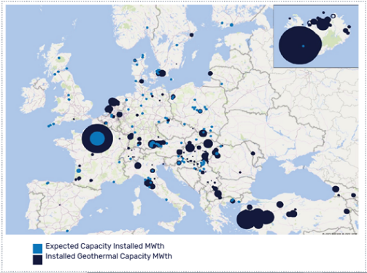

Source 148 EGEC, 2020

Cost, LCOE

According to the International Renewable Energy Agency (IRENA), geothermal in 2018 fell within the range of generation costs for fossil-based electricity. For new geothermal projects, the global weighted average LCOE was deemed to be 69 USD/MWh[18],[19].

A study by Bloomberg Finance[20] shows geothermal LCOE to be relatively stable over the period 2010-2016. Flash turbine technology continues to be the cheapest form, with somewhat declining costs due to favourable exchange rates and cheaper capital costs. As for binary technologies, an increase in competition in the turbine market is expected to produce a downward cost trend. The capital expenditure (CAPEX) has been estimated based on the international literature at 3 540 EUR/kW for flash plants, 6 970 EUR/kW for ORC binary plants and 11 790 EUR/kW for EGS plants[21]. Operating costs are in the range of 1.6-2.2% of CAPEX.

SET plan targets currently relate to reducing production costs, exploration costs and unit cost of drilling. With regard to production costs, SET plan targets require these to be reduced to below 10 ctEUR/kWhe for electricity and 5 ctEUR/kWhth for heat by 2025. Exploration costs include exploratory drilling and other exploration techniques. Exploration drilling alone can be up to 11% of CAPEX for geothermal project if accounting for all the activities needed to assess geological risk during the pre-development phase of the project (i.e. preliminary surveys and surface exploration)[22],[23]. The SET plan targets require reduction in exploration costs by 25% in 2025, and by 50% in 2050 compared to 2015.

In the scenario compatible with the SET plan targets, JRC-EU-TIMES projects that the CAPEX of EGS will fall below 6 000 EUR/kWe in 2050, compared to around 9-10 000 EUR/kWe in the other non-SET plan scenarios. EGEC[24] also reports the potential cost reduction as shown in Figure 145.

*Figure 145 Potential costs reduction for geothermal electricity production*

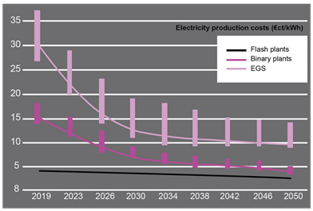

Source 149 EGEC, 2020

Concerning the heat sector, the selling price for heat in existing geothermal district heating systems is usually around 60 EUR/MWh, and within a range of 20 to 80 EUR/MWh[25].

R&I

Geothermal energy has significant untapped potential for both electrical and direct-use applications in the EU. Currently, 'traditional' hydrothermal applications are most common for electricity production, but if EGS technology is proven the technical potential increases significantly.

The technologies for hydrothermal applications, direct use (including GSHP) can be considered mature. R&I in those areas is needed to further lower the costs by e.g. developments in new materials, drilling techniques, higher efficiency, optimisation of maintenance and operation. The use of unconventional geothermal (EGS) is only now moving its first steps in the demonstration phase, thus R&I support in various areas (deep drilling, reservoir creation and enhancement, seismicity prediction and control) is still highly needed.

The Implementation Plan of the SET plan Temporary Working Group describes the current level of market or technical readiness of specific research areas in geothermal. The areas with the lowest TRL relate to the enhancement of reservoirs (4); advanced drilling (5); equipment and materials to improve operational availability (4-5); integration of geothermal heat and power into the energy system (4-5). These require specific attention.

Relevant R&I initiatives can be mentioned both on the public and the private sides, see the next sections.

Public R&I funding

Figure 146 shows the annual and cumulative EU contribution to co-funded projects focused on geothermal started between 2004 and 2019. This analysis includes the EU Framework Programmes FP6, FP7 and H2020, as well as the Intelligent Energy Europe (IEE) and NER 300 projects.

The total amount of funds granted by the EU to geothermal energy in the considered period is EUR 377 million, shared among 100 projects. It can be observed that more R&D funding has been allocated during H2020 (EUR 216 million, 49 projects) than in any other previous funding programme, although with a marked variability across the years[26].

Figure 146 EU contribution to co-funded projects since 2004: yearly detail and cumulative data

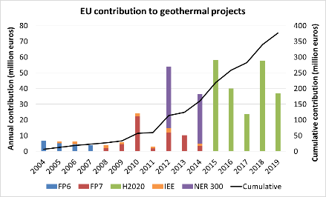

Source 150 JRC analysis based on CORDIS (2020)

Several R&I funding schemes or projects are implemented at national level. In the EU, notable countries are Germany and France. Outside the EU, Iceland and Switzerland are other two important European countries.

The SET plan working group for deep geothermal energy have identified a number of R&I activities as 'flagship':

* geothermal heat in urban areas;
* enhancement of conventional reservoirs and development of unconventional reservoirs;
* integration of geothermal heat and power into the energy system and grid flexibility
* zero emissions power plants.

Private R&I funding

EU private companies invested quite markedly in R&I for geothermal energy over the last some twenty years: as shown in Figure 147, the average yearly investment over the period 2003-2016 was EUR 100 million, more than in the other major countries globally, i.e. China, Japan, Republic of Korea, and US.

Within the EU, Germany had by far the lion’s share. France, Italy, Sweden, Finland, and The Czech Republic (as well as UK) are other remarkable countries.[27]

Figure 147 Average private R&I investment in the period 2003-2016

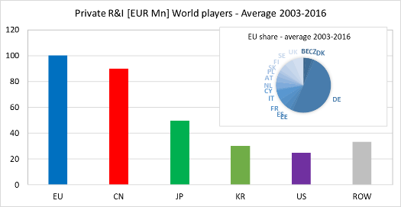

Source 151 JRC analysis (2020)

Patenting trends

The results reported in this section derive from a JRC analysis based on data from the European Patent Office (EPO)[28]. The methodology is described here [29],[30],[31].

The evolution of the number of patent families from 2000 to 2016 is shown in Figure 148, distinguishing the most important global regions. Patent families (or inventions) measure the inventive activity. If patent families regard more than one country or refer to more than one technology, the relevant fraction is accounted for.

The graph highlights a constant growing trend over the considered period, as the number of invention increased from less than 50 in 2000 to more than 350 in 2016.

Different regions alternated as global leader in such a short period of time. Japan was the clear leader in early 2000s, being replaced in 2007 for a couple of years by the EU. The second decade of the century has been characterised by a spectacular growth in the patent families produced in China and, to a lesser extent, in the Republic of Korea, while the number of inventions in the EU has progressively diminished. Marginal contributions came from the United States and the other countries of the world.

Figure 148 Global number of annual patent families for geothermal energy in 2000-2016 by country/region

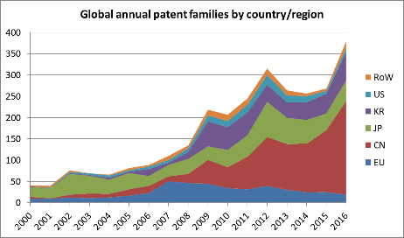

Source 152 JRC analysis (2020)

The cumulative patent families filed in the EU28 in the considered period are 439. About half (224) came from Germany, which is by far the leader in the region, followed by France (43) and by a group of countries with some 25 patent families each (Italy, Netherlands, Sweden, United Kingdom, and Poland).

Figure 149 tracks the flow of inventions, assessing where (i.e. in which national patent office) inventions are filed. This indicates where technology developers look for protection for their inventions and thus where they are likely to commercialise their products. In the period 2000-2016, China was poorly interested in exporting its R&D innovations. Conversely, the other countries intensively looked for protection in China, especially the Republic of Korea and Japan. The EU tends to be an exception, as European developers applied for few patents in China and in the other two Asian countries, mostly focusing on the United States and the Rest of the World.

Figure 149 Origin and destination of the geothermal energy inventions protected outside the domestic borders in 2000-2016)

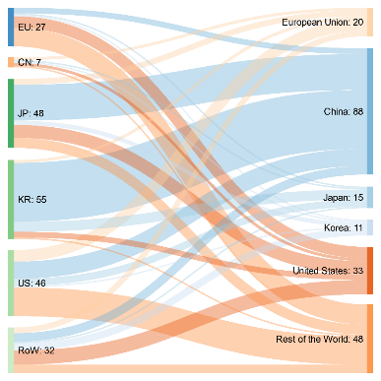

*Source: JRC analysis (2020)*

Publications / bibliometrics

The Clarivate / Web of Science search tool reports that 3 757 research documents were produced from 2010 to September 2020 in the field of geothermal energy. About 2 500 were articles, 750 proceeding papers, 300 reviews, 100 book chapters, while the remaining 100 were divided among other editorial products.

Figure 150 shows the most productive countries in the geothermal field at global level. China and US are at the top of the list. However, a remarkable production is also found in the EU, as the third and fourth most prolific countries were Germany and Italy, respectively. The most productive organisations are the Helmholtz Association, the China University of Petroleum, the United States Department of Energy, ETH Zurich and the Chinese Academy of Sciences.

Figure 150 Geographic distribution of the top-20 countries with organisations that published in the geothermal energy sector from 2010

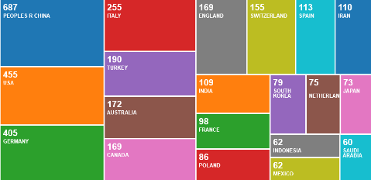

Source 153 JRC analysis using Clarivate Web of Science search tool (2020)

### Value chain analysis

Turnover

According to EurObserv’ER[32], the turnover generated by the geothermal sector in the EU27 in the latest years is in the range EUR 1-1.4 billion (Figure 151).

Figure 151 Turnover in the geothermal sector (million euros; period: 2015-2018)

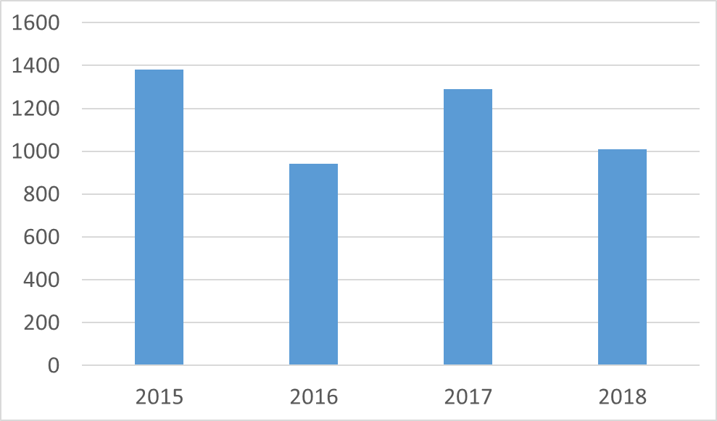

*Source: JRC analysis based on EurObserv’ER, 2019*

Gross value added growth

According to the EGEC market reports, equipment development and fabrication was characterised by a 10% growth rate in the gross value added in the last five years[33].

Number of companies in the supply chain, incl. EU market leaders

Globally, the EU28 has the second highest number of geothermal entities following the US, with around 181 entities (Figure 152). However, the majority of these parties globally are not involved in manufacturing components. The highest share of companies is in fact project developers, utilities or operators. Exploration & drilling companies and university or research institutes are also important. The suppliers of geothermal equipment for underground installations are from the oil and gas industry, and for above-ground installations (e.g. turbines) from the conventional energy sector.[34]

Figure 152 Entities in the geothermal power energy sector sorted by country/region.

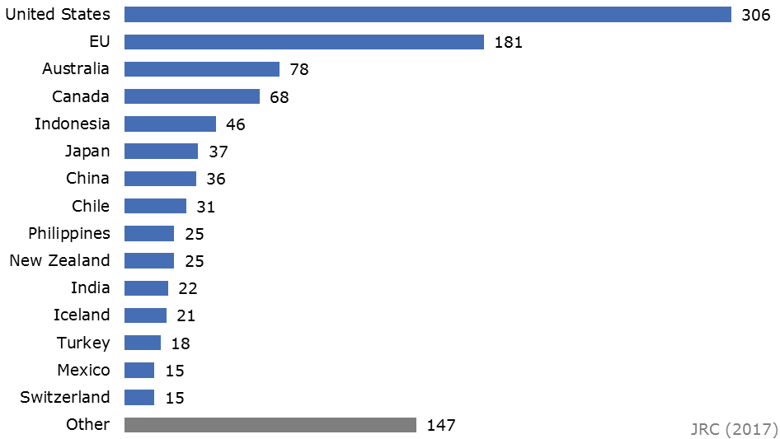

Source 154 JRC elaboration based on BNEF, 2016[35].

Production well drilling and facility construction are responsible for the majority of costs of a geothermal project. Globally, only a handful of companies are specialised in geothermal drilling only and about 20 more perform drilling in the oil, gas and geothermal sectors[36]. The EU is underrepresented in the exploration and drilling services. The market for facility construction is very competitive. Many geothermal field operators or power plant operators are national (public) companies such as KenGen in Kenya and CFE in Mexico. In addition, some large private operators exist, such as Calpine, Terra-Gen, Ormat (all from US) and ENEL (Italy).

Despite the existence of highly specialised smaller companies, the geothermal power plant turbine market is dominated by large industrial corporations that are also active in other energy sectors. The four major manufacturers account for about 80% of the installed capacity, which becomes 97% considering the first ten companies, see Table 10[37]. The first four companies are all from outside the EU (in particular, three from Japan and one from US): the first EU company is Ansaldo Energia (Italy) in fifth position.

*Table 10 Market share of geothermal turbine manufacturers (includes fully operational and grid connected geothermal projects until end 2017).*

|  |  |  |  |
| --- | --- | --- | --- |
| **Rank** | **Company** | **Installed Capacity (MW)** | **Market share (%)** |
| 1 | Toshiba Power System | 3 203.0 | 23.0 |
| 2 | Fuji Electric Co. | 3 012.1 | 21.6 |
| 3 | Mitsubishi Heavy Industries | 2 652.8 | 19.0 |
| 4 | Ormat Technologies | 2 092.6 | 15.0 |
| 5 | Ansaldo Energia | 1 092.5 | 7.8 |
| 6 | General Electric | 1 056.4 | 7.6 |
| 7 | Exergy | 312.9 | 2.2 |
| 8 | Atlas Copco | 102.6 | 0.7 |
| 9 | TAS Energy | 90.1 | 0.6 |
| 10 | Green Energy Group | 81.1 | 0.6 |
| 11 | Highstat | 80.2 | 0.6 |
| 12 | LA Turbine | 60.0 | 0.4 |
| 13 | Qingdao Jieneng Group | 21.0 | 0.2 |
| 14 | United Technologies | 20.5 | 0.1 |
| 15 | Kawasaki Heavy Industries | 15.0 | 0.1 |
| 16 | Harbin Electric | 11.3 | 0.1 |
| 17 | Enex HF | 9.4 | 0.0 |
| 18 | Parsons | 5.0 | 0.0 |
| 19 | Ebara | 4.5 | 0.0 |
| 20 | Barber Nichols | 3.7 | 0.0 |

Source 155 BNEF, 2018

From 2012-2016, the majority of total installed capacity in Europe was conventional flash/steam technology, however, since 2012 nearly 80% of newly installed capacity was binary technology, all ORC (Organic Rankine Cycle).[38]

The four major ORC manufacturers in the European market are Ormat (US), Turboden (Italy), Atlas Copco (Sweden) and Exergy (Italy), all currently most active in Turkey and Portugal. Toshiba is dominant in Turkey as a flash turbine supplier, as is Fuji in Iceland. Chinese turbine manufacturer Kaishan recently entered the European market supplying an ORC turbo-generator to a Hungarian power plant.

Moving to the heat sector, district heating and systems are the largest and fastest growing direct use application of geothermal energy in the EU. Direct-use technologies closely resemble geothermal electric systems, except the heat is used for another purpose. Data and information about players active in the direct use supply and value chain is scarce. Most suppliers of geothermal equipment for the underground part of the installations are from the oil & gas industry (e.g. exploration, drilling, pipes, and pumps).

Major providers for pumps, valves, and control systems include Schlumberger, Baker & Hughes, GE, ITT/Goulds, Halliburton, Weatherford International, Flowserve (all US), Canadian ESP (Canada), Borets (Russia)[39]. Heat exchangers are supplied mainly by Alfa Laval (Sweden), Danfoss (Denmark), Kelvion Holdings (Germany), SPX Corporation (US), Xylem (US), Hamon & Cie, Modine Manufacturing Company (US), SWEP International (Denmark).

Heat pumps are generally grouped into three main categories: i) ground source heat pumps, which extract heat from the ground; ii) hydrothermal heat pumps, that draw heat from water (the water table, rivers or lakes), and iii) air source heat pumps, whose heat source is air (outside, exhaust or indoor air). Heat pumps are available in different sizes, however, data is lacking for medium and large heat pumps. Smaller heat pumps that use ambient energy dominate the market. Air source heat pumps are the most prevalent, and made up 50% of total sales, followed by hot water heat pumps (6%) and air source heat pumps (30%) and geothermal systems (4%).

Ground source heat pumps make up the largest segment of the geothermal energy market in the EU28 (22.8 GWth installed)[40]. The geothermal heat pump market, in terms of end-users can be segmented into residential (53%) and non-residential (47%). The global geothermal heat pump market was valued at EUR 13 billion in 2016 and is expected to reach EUR 23 billion in 2021. EMEA dominated the global geothermal heat pump market with a 52% share in 2016.

The main vendors internationally are Carrier Corporation (US), Daikin (Japan), Mitsubishi (Japan), Danfoss (Denmark) and NIBE (Sweden). Other prominent vendors and collaborators are BDR Thermea (Netherlands), Bosch Thermotechnology (Germany), Bryant Heating & Cooling systems (US), CIAT (France), Hitachi Appliances (Japan), LSB Industries (US) and SIRAC (South Africa).

The global geothermal heat pump market is highly fragmented with the presence of many vendors. Vendors are highly diversified and operate at international, regional, and local levels.

Table 11 shows the major European GSHP manufacturers and brands. Heat pump markets and penetration rates in the EU vary considerably depending on climate. In north, central and eastern Europe, heat pumps are mostly used for heating, whereas in temperate to hot climates (western and southern Europe), more cooling is required and reversible heat pumps are more popular[41].

*Table 11 Overview of major European GSHP manufacturers and brands.*

|  |  |  |  |  |
| --- | --- | --- | --- | --- |
| **Company** | **Brand** | **Country** | **Capacity range (kW)** | **Comments** |
| BDR  Thermea (NL) | De Dietrich/ Remeha | France | 5.7-27.9 | 10 000 heat pumps sold in 2014 |
| Baxi | UK | 4-20 | GSHP offer discontinued |
| Brötje | Germany | 5.9-14.9 |  |
| Sofath | France | 2.8-29.5 | 50 000 GSHP units sold so far |
| Bosch Thermo­technik (DE) | Junkers | Germany | 5.8-54 |  |
| Buderus | Germany | 7-70 |  |
| IVT Industrier | Sweden | 6-16 | Swan-labelled GSHP |
| Danfoss (DK) | Thermia Värme | Sweden | 4-45 |  |
| Nibe (SE) | Alpha-InnoTec | Germany | 5-30 | Belongs to Schulthess (daughter of Nibe) |
| Nibe Energy Systems | Sweden | 5-17 | Largest EU manufacturer of dom. Heating |
| KNV | Austria | 4-78 | Acquired 2008. 13 000 heat pumps sold |
| Vaillant (DE) | Vaillant | Germany | 6-46 | Second largest HVAC manufacturer |
| Viessmann (DE) | Viessmann | Germany | 5-2000 |  |
| Satag Thermotechnik | Switzerland | 3-19 | Acquired in 2004 |
| KWT | Switzerland | 6-2000 | One of the pioneers in GSHP |
| Ochsner (AT) | Ochsner | Austria | 5-76 | 130 000 heat pumps sold so far |
| Stiebel  ­­Eltron (DE) | Stiebel Eltron | Germany | 4.8-56 | Acquired 35 % of share capital of Ochsner |

Source 156 JRC, 2017b

Employment figures

Some ten thousand people were employed in the geothermal sector in the EU27 in recent years: Figure 153 reports the detailed trend in the period 2015-2018. In particular, the sector supported 9 400 total jobs in 2018[42].

Leading European countries in geothermal energy employment are Italy, Romania, France, the Netherlands, and Hungary. Together they accounted for 60% of total jobs in the sector in the EU27 in 2018 (Figure 154).

Figure 153 Employment in the geothermal sector (number of employees; period: 2015-2018)

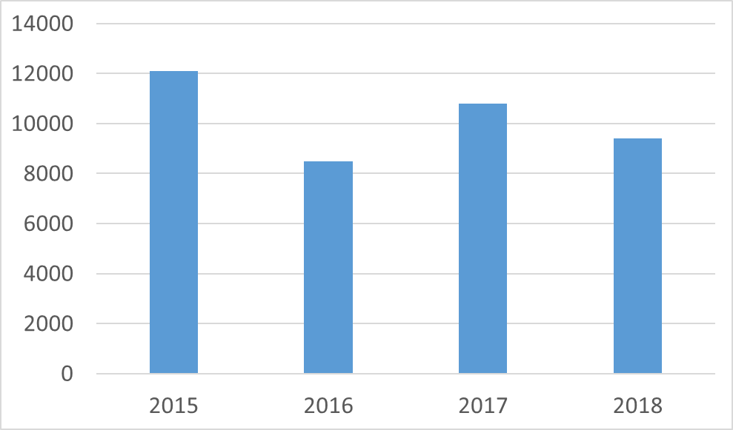

Source 157 JRC analysis based on EurObserv’ER, 2019

Figure 154 Geothermal energy employment in selected EU Member States, 2016-2018

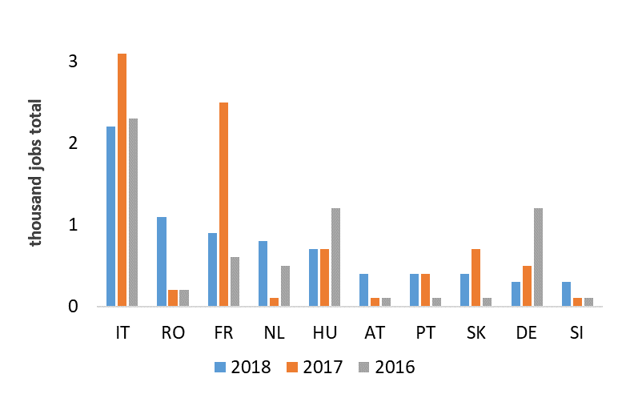

Source 158 JRC analysis based on EurObserv’ER, 2019

Productivity (labour and factor)

The previous data about turnover and employment allow calculating the turnover per employee, which can be used as a proxy for labour productivity. Figure 155 presents the average results for geothermal energy as well as for the other main renewable energy technologies in the period 2017-2018. The average turnover per employee for geothermal is around EUR 115 000, performing quite averagely across technologies. For the sake of completeness, wind is the technology showing the highest turnover per employee  
(EUR 155 000), whereas biofuels are characterised by the lowest value (EUR 60 000).

Figure 155 also shows the share that the different technologies have in the overall turnover of the renewable energy sector. Wind and biomass are the most significant technologies in this sense, while the geothermal contribute is around 1%.

Figure 155 Turnover per employee for different renewable energy sources (RES) and share of total RES turnover (average 2017-2018)

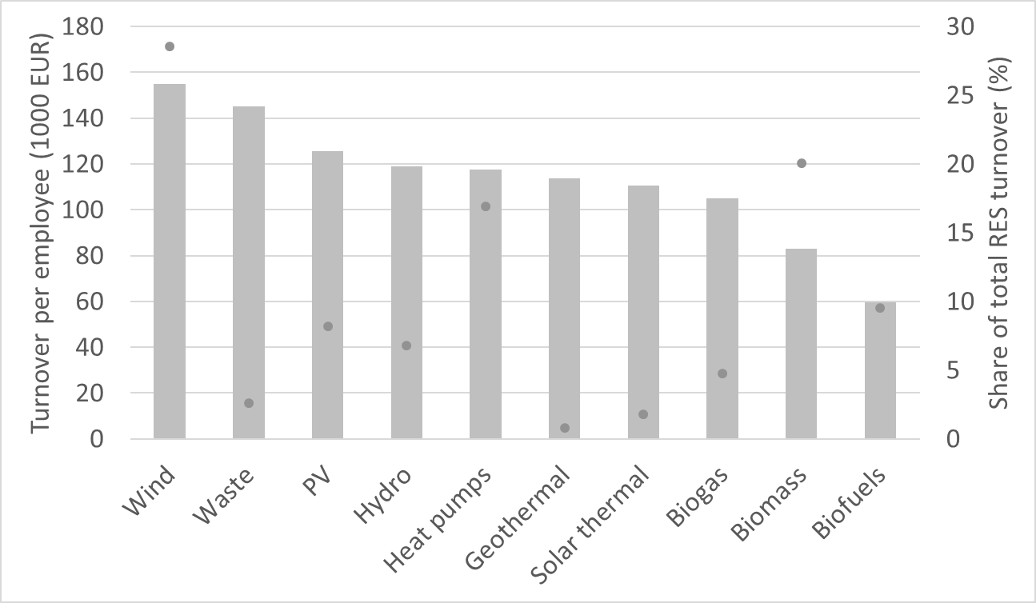

Source 159 JRC analysis based on EurObserv’ER, 2019

ProdCom statistics

EGEC[43] provides a detailed analysis on the deep geothermal industry supply chain. Assuming that 40 rigs were in operation for deep geothermal drilling in 2017, each rig drilling 3 wells in a year, around 120 deep wells were drilled in Europe that year. This generated a yearly turnover of about EUR 400 million. Pumps accounted for EUR 12.5 million. More than 150 heat exchangers are also sold per year for deep geothermal in Europe, generating an estimated turnover of EUR 20 million.

### Global market analysis

Trade (imports, exports)

In general, apart from the low presence in the exploration and drilling stage, the EU geothermal supply chain is quite robust[44]: in addition to the low dependency on critical raw materials (see the relevant section below), it is characterised by low dependency on imported manufactured equipment, robust domestic industry and know-how in project development. The EU27 is a net exporter of services for geothermal energy projects and equipment across all technologies.

However, as discussed in the previous sections, the main players in the power turbines sector are mostly located outside the EU27. Figure 156 shows global trade flows of geothermal power plant turbines from 2005 to 2015. In this period, most exports of binary cycle turbines came from Israel, United States, Italy, and Germany. The flash cycle and dry steam turbine market was dominated by Japan, Italy, and the United States. The biggest 'receiving' markets over the last ten years were the United States, Indonesia, New Zealand, Kenya, Iceland; of course reflecting the power capacity additions[45].

Figure 156 Geothermal power plants trade flows

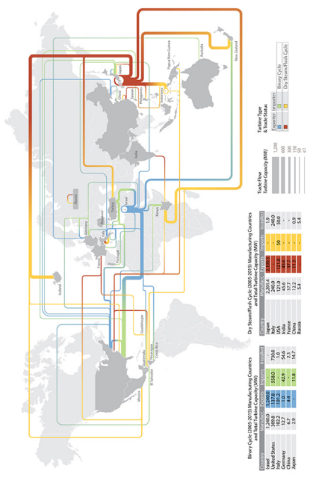

Source 160 CEMAC, 2016[46]

Global market leaders VS EU market leaders

As thoroughly described in the “Number of companies in the supply chain, incl. EU market leaders” section, the EU shows solid capability in ground source heat pumps and geothermal energy systems, although strong competition exists with extra-EU companies.

Concerning geothermal power turbines, the EU manufacturing capacity is limited for conventional technologies (where Japanese and American manufacturers lead), while it is stronger in the binary-ORC technology, which is used for low-temperature applications.

Critical raw material dependence

Critical raw materials are not a major issue for the geothermal sector. The two main raw materials of the supply chain are concrete and steel. Concrete is used in the casing of geothermal boreholes. Steel is used the pipes that carry the geothermal brine to the surface and the geothermal energy to the district heating network. It is a key component of turbines as well. Plastics is also used for pipes. Another important material is aluminium which is increasingly being used in plant construction[47]. On the other hand, projects exist that explore the possibility of extracting minerals from the geothermal brine.

### Future challenges to fill technology gap

The technical barriers to the uptake of geothermal energy are reflected in the SET plan priority areas. The urgency of each of these research areas may need to be clarified in the near future, since there appears to be some disparity between the attention given to each area although their relative importance is not clear.

Research areas that have received the most attention (in financial terms) under H2020 relate to drilling, EGS and district heating systems. The research areas 'Geothermal heat in urban areas' has already reached higher level of technological readiness, therefore progress should be reassessed in the near future. The areas 'Enhancement of reservoirs' (TRL 4) and 'Advanced drilling techniques' (TRL 3-5) are in greater need of support given their low TRLs. The research area 'Equipment / Materials and methods and equipment to improve operational availability' requires a significant jump to a higher TRL. Yet, this research area has not received much funding under H2020. The research areas 'Improvement of performance' and 'Exploration techniques' may require a more targeted focus in the future, since they are not specifically covered by particular projects at present.

It is difficult to assign levels of importance to each research area. The areas that are most urgently in need for funding should be identified to better focus the support. It should also be assessed whether cross-cutting issues which were highly funded in previous frameworks are still in need of similar funding now or in the future[48].

In addition to these technical points, other non-technical aspects exist which must be overcome in order to allow an uptake of geothermal energy.

Public acceptance is probably the main barrier, but further barriers have also been identified. In particular, other two relevant issues are the need for the development of a clear regulatory framework, notably in terms of administrative procedures for plant licensing, and the lack of geothermal engineers and trainers, as well as of non-technical experts such as accounting and finance staff, surveyors, auditors, and lawyers. Additionally, geothermal energy needs financial incentives similar to those received by other renewable energy sources, especially related to the high risk associated with the initial stages of projects[49].

## High Voltage Direct Current

High Voltage Direct Current (HVDC) is an efficient and economical option for long distance bulk transmission of electrical power compared to the High Voltage Alternate Current (HVAC) systems. An HVDC transmission system consists primarily of:

* a converter station where the HVAC from the existing transmission system is converted to HVDC;
* transmission cables that connect the converter stations and transmit the HVDC power;
* and a converter station on the other end of the transmission cables that converts the power from Direct Current (DC) to Alternating Current (AC) for delivery back into the grid.

HVDC systems can be integrated in the AC electric grid and allow the control of direction and amount of power to be transferred.

Figure 157 HVDC system integrated in the AC grid

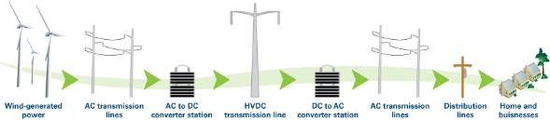

Source 161 Duke-American Transmission Co.

HVDC can offer several distinct advantages over a typical Alternating Current (AC) Transmission system. The key characteristic is that the power can be transmitted over very long distances without compensation for the reactive power.[50] Furthermore, HVDC stations can be connected to networks that are not synchronized or do not even operate at the same frequency. HVDC systems help preventing the transmission of faults between connected AC grids and can serve as a system “firewall” against cascading faults.

The key HVDC technologies are:

* **line Commutated Converter (**LCC-HVDC**).** Most of the HVDC systems in service today are of the LCC type (LCC HVDC), also referred as Current Source Converter CSC or HVDC Classic. It is a thyristor-based technology where the converter’s commutation is done by the AC system itself. The thyristor is a silicon semiconductor device with four layers of N and P type material acting as a bi-stable switch, which is triggered on with a gate pulse and remains in that on condition until the zero crossing of the Alternating Current. In order for LCC to commutate, the converters require a very high synchronous voltage source, thereby hindering its use for black start operation. With LCC current rating reaching up to 6250 A and blocking voltage of 10 kV, LCC has the highest voltage and power rating level of all the HVDC converter technologies;
* **ultra High Voltage Direct Current (**UHVDC**).** UHVDC is a DC power transmission technology utilising a higher voltage than HVDC to reduce the losses of the lines, increase the transmission capacity and extend the transmission distance. The Zhundong–Wannan UHVDC line in China completed in 2018 uses 1100 kV for 3400 km length and 12 GW capacity. Compared with the 800 kV UHVDC links currently in operation, the 1100 kV UHVDC link represents an increase of 50% in transmission capacity and from around 2.000 km to over 3.000 km of the transmission distance. UHVDC is typically used in areas of the world where the distance from generation to consumption is very high, such as in China, India and Brazil. As of 2020, no UHVDC line (≥ 800 kV) exists in Europe or North America. Another factor influencing the use of UHVDC is the vulnerability it creates when there is a loss of infeed from the UHVDC link;
* **voltage Source Converter (**VSC-HVDC**).** VSC HVDC, also known as self-commutated converter uses Insulated Gate Bipolar Transistor (IGBT) technology. The current in this technology can both be switched on and off at any time independently of the AC voltage, i.e. it creates its own AC voltages in case of black-start. Its converters operate at a high frequency with Pulse Width Modulation PWM, which allows simultaneous adjustment of the amplitude and phase angle of the converter while keeping the voltage constant. VSC has a high degree of flexibility with inbuilt capability to control both its active and reactive power, which makes it attractive for urban power network area and offshore applications.

This difference in construction of VSC HVDC offers many advantages over LCC HVDC, which can be summarised as follows:

* due to the usage of self-commutating devices, VSC will avert the system from commutation failures;
* VSC does not require reactive power compensators and have independent and full control over the active and reactive power. This will lead to a better system’s stability, enhance the market transactions, and power trading;
* harmonics level are at higher frequencies and as a result, the filter size, the losses and the cost are lower;
* VSC has the ability to support weak AC systems when there is no active power being transmitted;
* instantaneous power flow reversal without the need of reversing the voltage polarities, thus lowering the cables cross section. In addition, this makes easier to build multi terminal schemes;
* excellent response to AC faults and black start capability.

VSC-based HVDC systems are expected to attract greater demand because they require fewer conditions for connecting transmission lines. High penetration of DC systems in AC transmission and distribution networks can provide many benefits to the transition to a low carbon power system, for example in relation to offshore windfarms where undersea cables are required.

A **multi-terminal VSC-HVDC transmission system** is the interconnection of more than two VSC HVDC stations via DC cables in different topologies, e.g. radial, ring and meshed. It represents the evolution of the traditional two terminals (point-to-point) HVDC transmission system. MT HVDC provides the ability to connect multiple AC grids, remote power plants and remote loads together. This transmission system is considered a promising technology for the integration of massive generation from renewable sources into the power system. Furthermore, MT HVDC networks increase system reliability, the ability of smooth wind power fluctuations and it can be used to trade the electric power safely across national borders. The world’s first multi-terminal VSC-MTDC system was successfully commissioned on December, 2013 in Nan’ao island in the southern part of the Guangdong province of China. The key objectives of the project were to incorporate the existing and future wind power generated on Nan’ao island into the regional power grid, both to safeguard future energy supply and to support the transition from coal towards renewable energy sources.

**HVDC cables** are an important part of HVDC systems, and the different characteristics of dielectric materials typically lead to different electrical, mechanical, and thermal performances in cables. The main types of HVDC cables are briefly introduced below.

* oil-Filled DC Cable: Oil-filled cable (OF), usually filled with pressured oil in the oil channels. Due to obvious disadvantages, e.g. limited cable length, requirements of oil feed equipment and the risk of oil leakage, OF cables were gradually replaced by MI cables or extruded HVDC cables;
* mass-impregnated Cable: Similar to the OF cables, the main insulation of MI cables is also Kraft paper (or polypropylene laminated paper as in recent development) impregnated with high viscosity oil (the mass). However, MI cables usually can be defined as having “solid” insulation since there is no free oil contained in the cable;
* extruded DC Cable; In contrast to the paper insulated cables, extruded HVDC cables use an extruded polymeric material as the main insulation, which is a relatively new development in DC cables. The major insulation material is cross-linked polyethylene (XLPE). The process of cross-linking or vulcanisation makes the material heat resistant and does not soften at high temperatures. It develops resistance to stress cracking and ageing;
* gas Insulated Cable: Gas insulated cables are similar to oil-filled cables in that pressurized insulating gases are applied instead of oil. Another type of gas insulated power transmission cable technology is called Gas Insulated Line (GIL) system. In such a system, conductors with large cross-sectional areas are used to ensure high power ratings and low losses;
* superconducting Cable. Superconductors (SC) are materials that can conduct electric energy without losses below their critical threshold temperature. That distinguishes them from standard conductors like copper that have power losses dissipated as heat. A cryogenic envelope is needed to keep the superconductor cooled below its critical temperature.

Today, the more practical solution for HVDC superconductor cables is High Temperature Superconductor (HTS) DC cables. Liquid nitrogen is used as a cooling method. The refrigeration requirements for the DC superconductor cables are independent of the power flowing through the cable, since the cable itself generates no heat. The major length limitation of HTS cables is the requirements of refrigeration stations for cooling and liquid nitrogen flow.

Worldwide there are several on-going demonstration projects or installed superconducting cable operating live in grids. The US DoE supported the construction of an HTS cable which was installed in the Long Island Power Authority (LIPA) grid in 2007. The South Grid of China is developing a 1km long (High temperature Superconductor) HTS cable for urban deployment.

Costs for materials, components and systems that comprise a high-capacity, long-distance HTS transmission system are falling rapidly as EU-based technology companies continue to establish global leadership in advancing their development and demonstration.

### State of play of the selected technology and outlook

Capacity installed

HVDC projects for long-distance transmission have two (or rarely, more) converter stations and a transmission line interconnecting them. Generally, overhead lines are used for UHVDC interconnections, while LCC and VSC HVDC projects use submarine power cables. A back-to-back station has no transmission line and connects two AC grids at different frequencies or phase counts. HVDC systems evolved from mercury-arc valves to thyristors and IGBT power transistors. Table 12 below shows the main HVDC projects and that an increasing number of projects use VSC technologies.

Table 12 Selected HVDC Schemes using Line-Commutated Converters

|  |  |  |  |  |  |
| --- | --- | --- | --- | --- | --- |
| **Name** | **Year** | **Technology** | **Length** | **DC**  **Voltage** | **Power**  **Rating** |
|  |  |  | **Cable/OHL** | **(kV)** | **P (MW)** |
| Gotland 1 | 1954 | Mercury-arc | 98/0 | 200 | 20 |
| Cross-Channel | 1961 | Mercury-arc | 64/0 | +100 | 160 |
| NZ Inter-Island 1 | 1965 | Mercury-arc | 40/571 | +250 | 600 |
| SACOI[51] | 1965 | Mercury-arc | 365/118 | +200 | 200 |
| Konti-Skan 1 | 1965 | Mercury-arc | 87/89 | +250 | 250 |
| Zhoushan | 1987 | Mercury-arc | 54 | -100 | 50 |
| Vancouver Isl. 1 | 1968 | Mercury | 42/33 | 260 | 312 |
| Pacific DC Intertie | 1970 | Thyristor | 0/1362 | +500 | 3100 |
| Nelson River Bipole 1[52] | 1977 | Mercury-arc | 0/895 | +450 | 1620 |
| Skagerrak 1 | 1977 | Thyristor | 130/100 | +250 | 500 |
| Cahora Bassa[53] | 1979 | Thyristor | 0/1420 | +533 | 1920 |
| Hokkaido - Honshu | 1979 | Thyristor | 44/149 | +250 | 300 |
| Zhou Shan[54] | 1982 | Thyristor | 44/149 | +100 | 50 |
| Itaipu 1 | 1984 | Thyristor | 0/785 | +600 | 3150 |
| Nelson River Bipole 2 | 1985 | Thyristor | 0/940 | +500 | 1800 |
| Itaipu 2 | 1987 | Thyristor | 0/805 | +600 | 3150 |
| Fenno-Skan | 1989 | Thyristor | 200/33 | +400 | 500 |
| Rihand-Delhi | 1990 | Thyristor | 0/814 | +500 | 1500 |
| Quebec - New England | 1991 | Thyristor | 5/1100 | +450 | 2250 |
| NZ Inter-Island 2 | 1992 | Merc. & Thyr | 40/571 | +270/-350 | 1240 |
| Baltic Cable | 1994 | Thyristor | 250/12 | 450 | 600 |
| Garabi HVDC | 2002 | Merc. | 0/0 | +70 | 2200 |
| Three Gorges - Changzhou | 2003 | Thyristor | 0/ 890 | +500 | 3000 |
| Three Gorges - Guangdong 1 | 2004 | Thyristor | 0/980 | +500 | 3000 |
| Three Gorges - Guangdong | 2004 | Thyristor | 0/940 | +500 | 3000 |
| BassLink | 2006 | Thyristor | 298/72 | +400 | 500 |
| NorNed | 2008 | Thyristor | 580/0 | +450 | 700 |
| Yunnan-Guangdong | 2010 | Thyristor | 0/1418 | +800 | 5000 |
| XIangjiaba-Shanghai | 2010 | Thyristor | 0/1907 | +800 | 6400 |
| NZ Inter-Island 3 | 2013 | Thyristor | 40/571 | +350 | 1200 |
| Estlink 2 | 2014 | Thyristor | 157/14 | +450 | 650 |
| North-East Agra | 2017 | Thyristor | 0/1728 | +800 | 6000 |
| Nelson River Bipole 3 | 2018 | Thyristor | 0/1324 | +500 | 2000 |

Table 13 Selected HVDC Schemes using Voltage Source Converters

|  |  |  |  |  |  |  |  |
| --- | --- | --- | --- | --- | --- | --- | --- |
| **Name** | **Year** | **Topology** | **Length**  **(km)** | **Switching**  **Frequency** | **DC**  **Voltage** | **Power**  **Rating** |  |
|  |  |  | **Cable/OHL** | **(Hz)** | **(kV)** | **P (MW)** | **Q( MVAr)** |
| Gotland VSC | 1999 | 2-level | 70/0 | 1950 | +80 | 50 | -55 to 50 |
| Tjäreborg | 2000 | 2-level | 4.3/0 | 1950 | +9 | 7.2 | -3 to 4 |
| Directlink | 2000 | 2-level | 59/0 | 1950 | +80 | 180 | -165 to 90 |
| Eagle Pass | 2000 | 3-level BTB Diode NPC | 0/0 | 1500 | +15.9 | 36 | +36 |
| MurrayLink | 2002 | 3-level  ANPC | 176/0 | 1350 | +150 | 220 | -150 to 140 |
| CrossSound | 2002 | 3-level  ANPC | 40/0 | 1260 | +150 | 330 | +150 |
| Troll A | 2005 | 2-level | 70/0 |  | +60 | 84 | -20 to 24 |
| Estlink1 | 2006 | 2-level  OPWM | 105/0 | 1150 | +150 | 350 | +125 |
| BorWin1 | 2009 |  | 200/0 |  | +150 | 400 |  |
| Trans Bay  Cable | 2010 | MMC | 85/0 | <150 | +200 | 400 | +170 |
| Nanao Island[55] | 2013 | MMC  MTDC | 10/32 |  | +160 | 200/100/500 |  |
| Zhoushan  Islands[56] | 2014 | MMC | 134 ?141.5/ |  | +200 | 400 |  |
| INELFE | 2015 | MMC | 64.5/0 |  | +320 | 2x1000 | ? |
| BorWin2 | 2015 | MMC | 200/0 |  | +300 | 800 |  |
| HelWin1, | 2015 | MMC | 130/0 |  | +250 | 576 | ? |
| HelWin2, | 2015 | ? | 130/0 |  | +320 | 690 |  |
| Dolwin1 | 2015 | Casc. 2-L[57] | 165/0 |  | +320 | 800 |  |
| Dolwin2 | 2015 | MMC | 135/0 |  | +320 | 900 |  |
| Dolwin3 | 2018 | - | 162/0 |  | +320 | 900 |  |
| SylWin1 | 2015 |  | 205/0 |  | +300 | 864 |  |
| BorWin3 | 2019 | - | 160/0 |  | +320 | 900 |  |
| Zhangbei  HVDC | 2019 |  |  |  | +500 | 1500/4500 |  |
| Stage  1 | MMC |  |  |  |  |

Figure 158 shows a map of the medium to large HVDC interconnections that have been installed in Western Europe as of 2008.

Figure 158 Map of medium to large HVDC interconnections in Western Europe as of 2008

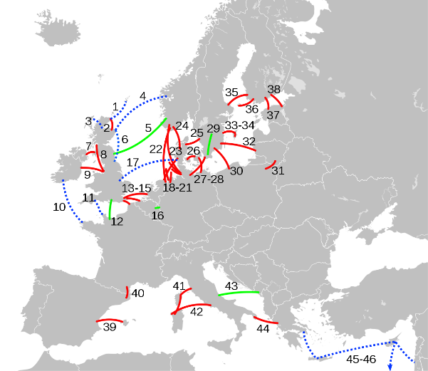

Source 162 Wikipedia

Existing

   Under construction

   Options under consideration

Cost, LCOE

When designing power transmission systems and opting for the different technologies, the break-even distance needs to be taken into account. The breakeven distance implies that the savings from HVDC power transmission system cost overweight the initial high cost of the converter stations compared to HVAC. For overhead lines, the break-even distance is in the range of 600-800 km while for underground cables it is around 50 Km. The variation of break-even distance is due to a number of other factors such as the voltage/power levels, elements cost, right of way cost, and operational costs. Figure 159 shows the comparison between AC and DC links costs where station costs, line costs, and the value of losses are considered.

Figure 159 Overview of HVDC Technology

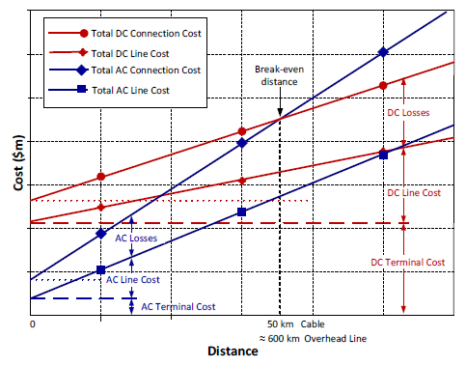

Source 163 N. Watson

Even when these are available, the options available for optimal design (different commutation techniques, variety of filters, transformers etc.) render difficult to give a cost figure for an HVDC system. Nevertheless, a typical cost structure for the converter stations could be as follows:

Figure 160 Cost structure of a converter station

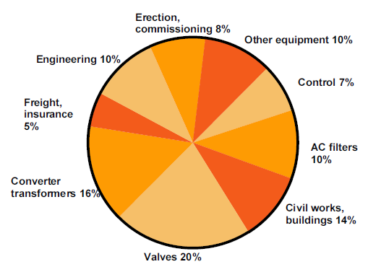

Source 164 R. Rudervall et al., 2000

Public R&I funding

Public funding by Member States for HVDC technologies is not available. At EU level, through Horizon 2020, funding is modest, but has been boosted by the recently finished Promotion project[58], which received close to 40 million Euros of funding. Other key projects that have supported HVDC technology development through Horizon 2020 are Migrate[59] and through the Clean Sky Joint Undertaking in relation to electrical aircrafts.

Private R&I funding

Figure 161 HVDC R&I investments by value chain[60], [61], [62]

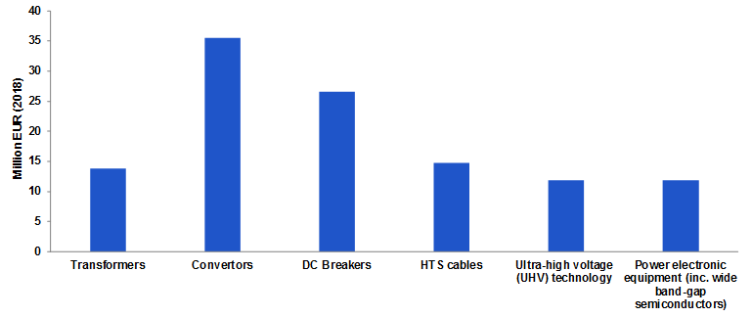

*Source: ASSET Study commissioned by DG ENERGY - Gathering data on EU competitiveness on selected clean energy technologies (Draft, 2020)*

According to the ICF[63], a lot of the current available research on the HVDC topic originates from Europe, where many HVDC projects are being proposed for renewables integration. Figure 162 shows the investments in the EU along the value chain. The sources used in their study are mostly peer-review journals, research reports, industry newsletters, or case studies published by industry vendors, research labs, and other reputed transmission industry stakeholders. Therefore, the research investments were only available from Europe. The Investments for Europe were obtained from ETIP SNET for 2018.

Patenting trends

Figure 162 HVDC Patents by Value Chain/HVDC patents by Region[64]

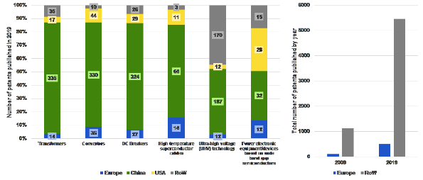

*Source: ASSET Study commissioned by DG ENERGY - Gathering data on EU competitiveness on selected clean energy technologies (Draft, 2020)*

As Figure 163 shows, in the value chain segmentation, the US and Europe have similar patent publications in 2019. However, China seems to be dominating the value chain in terms of the amounts of patents they have been publishing. Note that patents being published in China could belong to European companies. Overall, the trend has increased between 2009 and 2019 for both Europe and the rest of the world.

Publications / bibliometrics

Considering research publications and institutions, the US is the dominant player with about 110 research institutions active in this field, being responsible for 200 publications. Overall, there are about 140 research institutions from Horizon2020 participating countries active in research on transmission infrastructure, compared to 330 in the rest of the world. These institutions’ efforts resulted in about 240 (Horizon2020), respectively 670 (RoW) publications in a 5-year timeframe.[65]

### Value chain analysis

The value chain for HVDC grids can be segmented along the different hardware components needed to realize an HVDC connection . The main shares in the cost of HVDC systems are the converters (+/- 32%) and the cables (+/-30%) .

Figure 163 Value chain segmentation

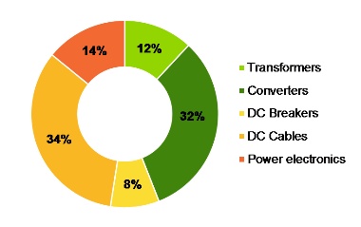

Source 165 Guidehouse Insights, 2020

Figure 164 Competitive intensity across each Value Chain Segment, global, 2020

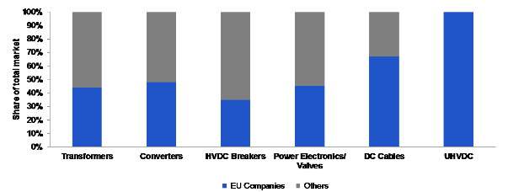

Source 166 Guidehouse Insights, 2020

European companies have a major market presence for HVDC across all value chain segments, as two of the major market players - ABB and Siemens are located in Europe. The majority of the non-European market for transformers, converters, breakers, and valves is made up of GE and several Chinese companies, while there are several major cable companies from Japan. Additionally, Prysmian, Nexans, and NKT Cables, three major cable providers are located in Europe as well, giving the EU a strong market presence across that value chain.

In the converter stations’ value chain, Power Electronics (PE) play a key role in determining the efficiency and the size of the equipment. Energy specific applications represent only a small part of the global electronic components market (passive, active, electromechanical components and others - EUR 316 billion in 2019).

Turnover

Higher demand for cost-effective solutions to transport electricity over long distances, particularly in the EU to bring offshore wind to land, increase the demand for HVDC technologies. According to Guidehouse Insights, the European market for HVDC systems will grow from EUR 1.43 billion in 2020 to EUR 2.6 billion in 2030, at a growth rate[66] of 6.1%[67],[68].

According to Global Industry Analysts[69], amid the COVID-19 crisis, the global market for HVDC Transmission estimated at EUR 7,1 billion in the year 2020, is projected to reach a revised size of EUR 10,6 billion by 2027, growing at a CAGR of 5.7% over the analysis period 2020-2027. The main investments in HVDC are taking place in Asia, where a big part of the market is taken up by Ultra-HVDC (EUR 6.5 billion – non existent in EU)[70]. Line Commutated Converter (LCC), one of the segments analysed in the report, is projected to record a 5.8% CAGR and reach EUR 4,2 billion by the end of the analysis period. After an early analysis of the business implications of the pandemic and its induced economic crisis, growth in the Voltage Source Converter (VSC) segment is readjusted to a revised 6.3% CAGR for the next 7-year period. HVDC equipment is very costly, and projects to build HVDC connections are therefore very expensive. Due to their technological complexity, installation of HVDC systems is generally managed by manufacturers[71].

Gross value added growth

The gross value added in general resembles the market sizes for the respective value chain segment and region, adjusted for a trade surplus/deficit and the value of input material. For the HVDC sector, the considered input material is used for cable manufacturing.

Figure 165 Breakdown of GVA throughout HVDC value chain

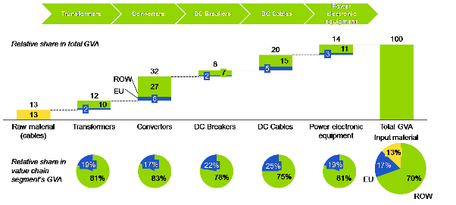

Source 167 Guidehouse Insights, 2020

Only a minor part of GVA is generated in the EU compared to the rest of the world, mostly Asia. However, as shown below, EU companies have an important global presence in this market. The largest share of the GVA is found in the converters segment, where the EU market captures a share in the GVA of about 17%. To be noted that the UHVDC market – which is not listed here since it is an intersection of all value chain segments – is only served by European companies. Therefore, within the UHVDC market almost all GVA can be assigned to the EU, even though the European market for UHVDC doesn’t exist.

Number of companies in the supply chain, incl. EU market leaders

The global HVDC market is led primarily by three companies, namely Hitachi ABB Power Grids, Siemens, and GE[72]. Siemens and Hitachi ABB Power Grids have around 50% of the market in most market segments, whereas in the EU cables companies[73] make up around 70% of the market and the main competitors are Japanese. Other market players include Mitsubishi, Toshiba, China XD Group, LS Industrial Systems and NR Electric company. These companies though, do not play in the HTS cable space. Major global HTS cable providers are Nexans, STI, American Superconductor, and Furakawa Electric. In China, an additional vendor, China XD Group, dominates the market. Prysmian and Nexans are two of the world’s largest cable providers, with headquarters in Italy and France, respectively.

Figure 166 Top key market players and market share, global, 2020

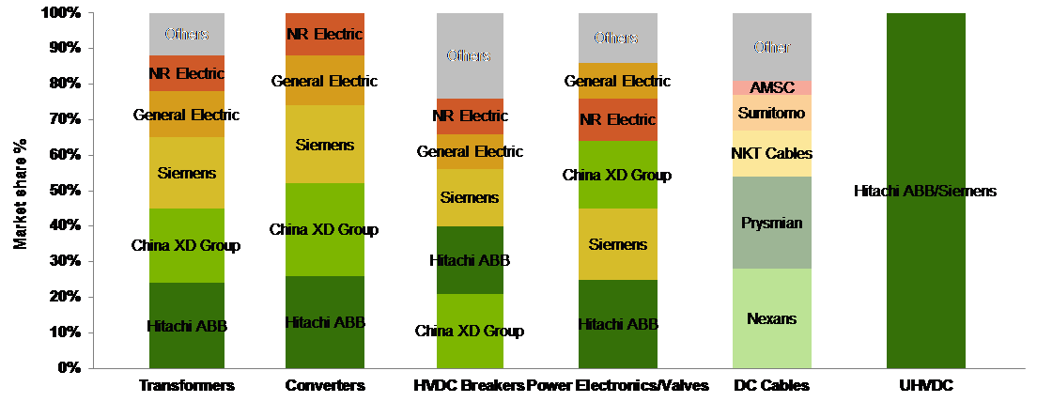

Source 168 Guidehouse Insights, 2020

So far, vendors sold turkney systems independently which were installed as a point-to-point HVDC connection. In a future more interconnected offshore grid, different HVDC systems need to be interconnected. This brings technological challenges to maintain grid control[74] and in particular to ensure interoperability of HVDC equipment and (future) systems. Furthermore, as all components need to be installed on (offshore) platforms, size reduction is key.

With respect to Power Electronics, there is a need to focus on the development of electronics in energy applications that are different from the main markets that drive R&I, in particular for offshore energy applications.

Employment figures

On the deployment and construction side, there are 200 HVDC projects around the world and of those, 40 are in the EU27[75]. Of those, 14 are under construction around the world and 12 are under construction in the EU27. A project under construction typically generates 4,000 jobs and a project in operation (described as deployment in the graph below) creates 400 jobs[76]. Therefore, an estimate of the employment numbers was generated as shown in Figure 167. Due to the nature of the HVDC market and how small it currently is, it is very difficult to segment these jobs into the value chain. It is also difficult to estimate the split between direct and indirect jobs. On the research side, the number of employees for Europe is likely to be much larger which will be explored in the next section.

Although there have been conversations with industry experts and market leaders in HVDC manufacturing such as ABB, the employment figures for manufacturing are still very unclear for both the EU27 and the rest of the world.

Figure 167 HVDC employment indicators

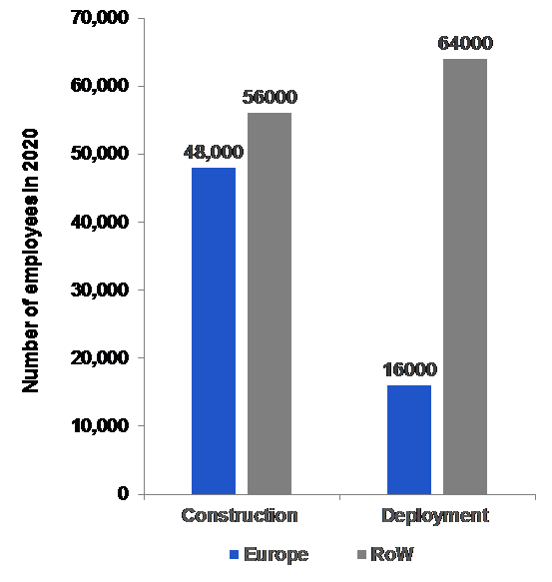

Source 169 The Brattle Croup, 2011

### Global market analysis

Trade (imports, exports)

The EU27 is a net exporter of transformers, converters, and breakers (HS Codes 850421, 850422, 850440, and 853529).[77] Though this is not specific to the HVDC equipment encompassed for HVDC applications is captured in these statistics. Most major companies in the HVDC market are located in Europe.

Global market leaders VS EU market leaders

European companies have a major market presence for HVDC across all value chain segments, as two of the major market players - ABB and Siemens are located in Europe. The majority of the non-European market for transformers, converters, breakers, and valves is made up of GE and several Chinese companies, while there are several major cable companies from Japan. Additionally, Prysmian, Nexans, and NKT Cables, three major cable providers are located in Europe as well, giving the EU a strong market presence across that value chain.

Figure 168 Competitive Intensity across each Value Chain Segment, Global, 2020



Source 170 Guidehouse Insights (2020)

Critical raw material dependence

The most significant use of raw materials in the HVDC value chain segment is the metal used to make steel, aluminium, and other metal alloys for major system components. Generally, these are not considered at-risk supply chains to Europe. However, superconducting materials used to construct the high temperature superconductor (HTS) cables may differ. These materials often require chemical compounds including the following[78]:

* Copper;
* Barium;
* Titanium;
* Sapphire;
* Bismuth;
* Strontium;
* Magnesium;
* Silver;
* Calcium.

Among these, Magnesium and Bismuth are considered high-risk for supply in Europe, as listed in the Commission’s Action Plan on Critical Raw Materials.[79]

Going one step down in the value chain, particular attention needs to be addressed to Power Electronics (PE), the key switching electronic component of the converter. Europe’s present position as a leader in Silicon (Si) technology, raw material and wafers needs to be maintained while trying to get access /develop NEW materials such as Silicon Carbide (SiC) and Gallium Nitride (GaN)[80].

### Future challenges to fill technology gap

The main gaps for the deployment of HVDC systems are related to the integration of multiple HVC systems into a Multi-Vendor Multi-Terminal VSC-HVDC system with Grid Forming Capability, in particular to enable the development of the EU’s ambitions in relation to offshore energy. This requires addressing standards, multivendor interoperability, industrial testing of equipment, procurement, wind/offshore planning and market models (the latter able to solve the windfarm-interconnector hybrid topology issue) across multiple technology vendors, transmission system operators, as well as offshore wind park developers, with the aim to have interoperability among all converter manufacturers.

As with AC system, the DC grid requires a number of **standards**. One of the most obvious ones being the voltage level used. Once a level is chosen, it sets the voltage for the entire system. As with the AC system, several levels might be possible from the transmission to the distribution and to the low voltage.

**Interoperability** is the capability of equipment, technologies and controls to operate in a robust way in the integrated power system. In order to evolve to large DC multi terminal systems step-by-step, TSO need to be confident for a reliable operation, when implementing new HVDC converters or new DC components to the existing infrastructure.

Up to now, a variety of HVDC technologies is already installed or planned in Europe. Currently, there is no common electrical interface among different vendors’ HVDC converters ensuring the correct interoperation between multiple converters. There was no need either due to point-to-point HVDC connections delivered by a single vendor. But to build the offshore energy production, and its connection to onshore consumption, an interconnected grid is needed. This requires interoperability among different vendors’ converters and technologies has become a need.

A distinction can be made between Technological interoperabilityon the one hand, that is about operation compatibility of different technologies (not mandatorily by different vendors). Assuring the correct operation of different technologies lies predominantly in the hand of the vendor. On the other hand, Vendor interoperabilityis about the operation compatibility of same technologies, but from different vendors and about the compatibility of different technologies, and from different vendors.

The main barrier currently regarding vendor interoperability is the analysis and tuning of controls with different proprietary developments.

Therefore, a standard interface would allow the TSO a detailed planning (for drawing specifications) and correct tuning for operation. In upcoming research projects, interoperability needs to be demonstrated in a real environment.

Regarding **HVDC cables**, recurring to superconductivity technologies and namely High Temperature Cables (HTC) may be technically and economically convenient when the increase of transmission capacity need over a corridor requests the addition of more cables in parallel. Therefore, it would be beneficial to develop HTC technologies for Superconducting Transmission Lines (STL) to explore its potential in situations where very high amounts of power need to be transmitted[81].

## Hydropower

### State of play of the selected technology and outlook

Hydropower has a history of providing clean electricity spanning more than 100 years in Europe. Between 1940 and 1970, significant hydropower developments took place in the EU27 and worldwide responding to increased electricity needs of growing population and economies. According to the IPCC special report[82], Europe had developed 53% of the available technical potential in 2009, the highest share, globally. Despite that, and the capacity additions between 2009 and 2020, there is still sufficient untapped technical potential in Europe and because of aging plants major refurbishments will be necessary in the future, if the existing fleet is intended to be retained.

Hydropower includes stations operating with large water quantities stored in artificial reservoirs behind dams, run-of-river projects utilising the natural flow of water bodies, and pumped hydropower storage (PHS) that is the main form of bulk electricity storage for power systems. Closed-loop PHS, also known as pure PHS, pumps water in an upper reservoir in periods of low demand and uses it to produce electricity by releasing it to the lower reservoir through the turbines. Closed-loop PHS stations are not connected to natural watercourses and do not utilise natural (river) inflows. Mixed PHS stations, also known as pump-back facilities, utilise natural river discharge when in production mode in addition to the released stored water[83]. An additional type of systems is conduit hydropower that utilises the available energy in the conduit systems of e.g. water distribution, irrigation, and sewage networks. In terms of size, hydropower stations are distinguished in large-scale and small-scale, with a typical threshold being an installed power capacity of 10 MW (variations exist).

Hydropower is a low-carbon energy technology with no direct emissions. Advantages are the reliability of supply, very high conversion factors, base-load capability and low cost. It is increasingly valuable for balancing load and generation, due to its flexible operation. It can very quickly adjust its generation to balance short-term variations in the intra-day market, and supports security of supply for seasonal variations. It also supports frequency regulation and provides power system black start in the case of disruption. Therefore, modern hydropower can fulfil essential energy system services.

On the downside, hydropower can be responsible (or in case of multipurpose installations co-responsible) for ecosystem deterioration, especially in cases dam construction obstructs the natural river flow. Since 2000, new hydropower development in the EU has to fulfil higher sustainability requirements due to strict standards and associated legislation in place to protect ecosystems and the environment. Hydropower is like other major energy technologies at important policy crossroads as new stations support low-carbon energy production and the climate targets, but their construction and operation need to be balanced with protection of ecosystem biodiversity. Sustainable hydropower needs to achieve a good balance between the different policies and multipurpose plants can have important additional functions for the society, often more important than hydropower generation per se. This includes irrigation and drinking water provision, flood risk management, river navigation, recreation, and others.

The EU28 long-term strategy (LTS) modelling exercise provides future projections of hydropower development grouped together with wave, tidal, and biomass power[84]. Projections indicate small additions and average hydroelectricity generation of 375 TWh/year. The dedicated projections for PHS show higher deployment rates and 4 GW of new PHS until 2030 (total 51 GW). The anticipated 2030-2050 PHS growth varies between scenarios from 8 GW (Baseline) to 19 GW (ELEC). Under the 1.5TECH and 1.5LIFE scenarios PHS additions are below 2 GW since hydrogen and power-to-gas technologies cover for the storage services.

In September 2020, the Commission presented the Communication “Stepping up Europe’s 2030 climate ambition” accompanied by a document that presents model projections of the EU27 power system[85]. The share of hydropower is expected to decrease from the current levels (12.5% on average) to 9-10%, depending on the scenario. In absolute terms, however, hydroelectric generation will increase by 35 TWh/year across all scenarios. PHS is expected to increase at much higher rates than those anticipated in the LTS. Until 2030, 18-20 GW of PHS will be added reaching up to 65 GW of total installed capacity. Between 2030 and 2050 lower deployment rates are expected, 5-10 GW of PHS additions, depending on the scenario.

Capacity installed, generation

In late 2019, approximately 151.4 GW of hydropower capacity was installed in the EU27. Out of that, 105.8 GW is “pure” hydropower stations, meaning hydroelectric facilities that solely serve electricity generation (including multipurpose services mentioned above). Another 22.7 GW refers to closed-loop pumped hydropower storage (PHS) stations that serve bulk electricity storage using a reverse, pump-back operation. Closed-loop PHS typically utilises the surplus of electricity generation of non-flexible stations (nuclear, thermal, variable renewable energy sources) by pumping water in a closed system of two artificial reservoirs[86]. In addition to that, nearly 23 GW of capacity relates to mixed hydropower stations, meaning typical facilities installed in natural rivers that have the additional feature of electricity storage[87],[88].

Investments in hydropower have been only limited in the recent past. Since 2010, when the EU Renewable Energy Directive was approved, 8.3 GW of new power capacity has been installed in the EU27 with a compound annual growth rate (CAGR) equal to 0.56%. The global CAGR over the same period was 2.47% showing the much greater investments in hydropower outside the EU. Between 2010 and 2019 the globally installed hydropower capacity increased from 1025 GW to nearly 1308 GW, mainly driven by investments in China, where 150 GW of new hydro was installed over the last decade[89].

In terms of generation, hydropower generates approximately 355 TWh in EU27, annually (Figure 169). This is –on average– 12.5% of EU’s total net electricity production and represents one-third of the annual renewable electricity generation. In the recent past, the highest EU27 generation was recorded in 2014 and it was 386.9 TWh. Obviously, hydro generation shows an interannual variability that depends on the specific climatological characteristics of each water year. Figure 169 shows the evolution of installed hydropower in the EU27 between 1990 and 2019 along with the annual generated electricity in the background.

Figure 169 Installed hydropower capacity by type of station (GW) and net annual electricity generation (TWh) in EU27

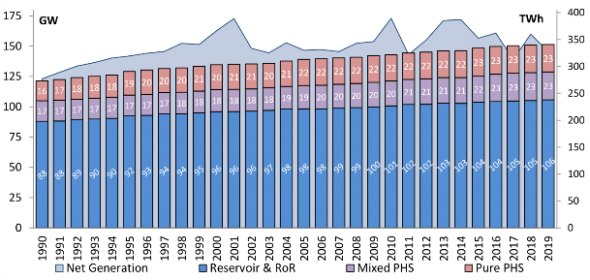

Source 171 Eurostat energy statistics, 2019 and IHA, 2020

Hydropower productivity is not uniform across the EU and reflects the climatology of each region. This variability is typically shown by the Capacity Factor (CF) i.e. the degree the available water resources utilise the hydro infrastructure. Figure 170 shows the average CF of the hydropower fleet of EU Member States and shows the degree of interannual variability of generation. It also shows that hydropower in the Northern Member States has generally higher productivity than that of countries in Southern Europe. The average CF in EU is 36.7%, lower than the global weighted-average of new projects commissioned between 2010 and 2019 that was 48%.

Figure 170 Capacity factors of hydropower stations operating in EU member states. Average, minimum and maximum values for 2000-2019.

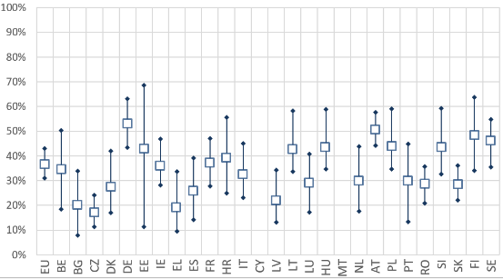

Source 172 Eurostat energy statistics, 2019

In the last five years (2015-2019), capacity additions in EU27 are mainly concentrated in Portugal, Austria, Italy, and France. This includes some large-scale PHS stations such as the Frades-II (780 MW) and the Foz Tua (270 MW) in Portugal and the Obervermuntwerk-II (360 MW) in Austria. Additions also refer to rehabilitation and upgrades of existing stations such as the La Bâthie, La Coche, and Romanche-Gavet projects in France.

Cost, LCOE

Hydropower is financially competitive with other electricity technologies achieving some of the lowest values of electricity generation costs. One of the main advantages of hydropower stations is that the low operation cost is generally very stable since it does not depend on fuel cost. Moreover, hydropower stations typically have a long service life typically assumed at 50 years, with the civil works even exceeding 80-100 years. In Europe the average age of the hydropower fleet is in many cases around 40 years, making it important not only to target additional capacity, but also to consider sustainable hydropower refurbishments in strategic energy planning. Hydropower is an exceptionally efficient renewable energy source and has a high conversion efficiency often exceeding 90%. On the downside, hydropower is capital intensive requiring large upfront investments. More importantly, licensing and construction periods can be long and complicated especially in large-scale projects (several years and in certain cases even exceeding 10 years).

In 2019, the global weighted-average LCOE for new hydropower stations was below EUR 0.04/kWh, 11.5% lower than the values reported for onshore wind and 30% lower than that for solar photovoltaics (PV)[90]. For Europe, the average 2015-2019 LCOE is higher – nearly EUR 0.10/KWh for large facilities and even higher for small-scale hydropower at EUR 0.12/KWh. The difference of hydropower with variable renewable energy sources (RES) such as wind and PV is that the deployment cost has a slightly increasing trend contrary to the decreasing costs of PV and wind. This is mainly due to the fact that the best sites for hydropower generation have already been exploited and the requirements in respect of sustainability and electricity market flexibility. Besides, almost half of the installation cost (45% on average) of a hydro project relates to civil works, the cost of which typically increases at rates subject to construction cost inflation.

Likewise, for large hydro, the 2019 installation cost in Europe was slightly higher than the global average (EUR 1450/kWh) value at EUR 1650/kW. This is lower than values recorded in North America, but clearly higher than the costs recorded in China. On the contrary, total installation costs for small hydro in the EU was the highest globally, approximately EUR 3800/kW. Hydropower stations are location-specific and each project has unique design characteristics. Accordingly, in regions where the best locations have already been developed such as the EU, the remaining technical potential usually refers to less advantageous sites and involves higher installation costs.

R&I

Despite hydropower’s technological maturity, research efforts are still ongoing and new concepts are emerging[91]. Recent hydropower research and development (R&D) efforts intend to improve the performance of sub-systems and components and to improve the sustainability and readiness of hydropower for modern power markets, including providing feasible business cases for the future. The aim is to further expand the range of capabilities and services hydro stations provide in light of the power system transformation. Accordingly, hydraulic design and mechanical equipment R&D focuses on expanding the flexibility of stations, to support a wide range of operation[92] and tackle specific interfaces of hydropower and the environment like sediment transport and fish protection. Such efforts relate to the operation and maintenance (O&M) and the lifespan of equipment of hydropower facilities, as well as the digitalisation of their operation and –importantly– decision-making at operational as well as strategic level. Equally importantly, while the GHG balance of hydropower is already very good, R&D explores options to minimise the further environmental impacts of hydropower.

Public R&I funding

In the recent past years (2009-2018), public spending for R&D in EU27 was at the range of EUR 16 million, annually[93],[94]. The main hubs of public spending are Austria, Germany, Finland, France, Italy, Poland and Sweden. Annual public spending in hydropower R&D is generally not stable as it follows the implementation of targeted actions, short-term national policies and specific EU calls. This is shown in Figure 171 that presents the annual public spending in hydro R&D in EU Member States. It appears that while in certain MS funding is somewhat stable (Germany, France, Sweden), in several MS it is irregular and dominated by targeted investments in specific years. Compared to variable RES, hydropower public spending is nearly 9-10 times lower than that for wind and 15 times lower than that for solar PV[95].

Figure 171 Public investments in hydropower R&D for the main EU member states over the period 2009-2018 (2019 data are only provisional).

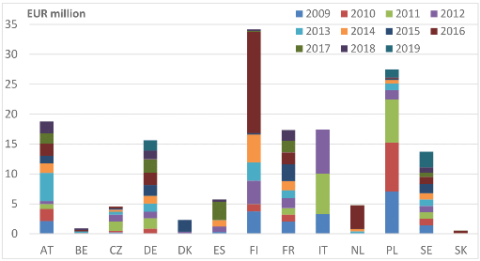

Source 173 Pasimeni, F et al., 2018

The average public spending is on annual basis slightly lower than the annual public spending in Canada (approximately EUR 18 million annually) and higher than that of Norway (about EUR 10 million) and Switzerland (about EUR 8 million). US public investment is coordinated by the Water Power Program of the US Department of Energy. The Water Program (hydropower branch) budget is typically higher than the EU and it is notewrthy that in the recent past (2018-2020), its annual budget was increased from USD 17 million to USD 35 million[96].

Concerning EU support to hydropower projects through the Horizon-2020 program, the latest analysis within the Low Carbon Energy Observatory[97] revealed that thirteen research and innovation projects will receive EUR 52.8 million from EU funds (their total budget is EUR 62.3 million). The duration of these projects ranges between 24 and 52 months.

Private R&I funding

Corporate R&D in the EU is generally the main driver of technological advances in hydropower (EUR 138.4 million in 2015) as it outbalances public investments[98]. Annual values between 2012 and 2015 range from EUR 88.0 million to EUR 146.1 million, while the annual average value is estimated at EUR 110.0 million. Compared to global spending, EU companies invest significantly higher amounts than companies in US, Japan, Korea, but Chinese companies are leading hydropower R&D[99].

Patenting trends

Patents on hydropower are identified by using the relevant Y code families of the Coordinated Patent Classification (CPC) for climate change. Relevant to hydropower are the following classes of patents:

* Y02E Hydro energy: Energy generation through RES10/20 Hydro energy;
  + 10/22 Conventional
  + 10/223 Turbines or waterwheels
  + 10/226 Other parts or details
  + 10/28 Tidal stream or damless hydropower
* Y02B Integration of RES in buildings
  + 10/50 Hydropower

The present patent analysis was based on data available from the European Patent Office (EPO). Details of the analysis are described in detail in dedicated JRC publications[100],[101],[102].

The number of patents for the main EU Member States and UK are provided in Figure 172 that covers the period 2010-2016.

Figure 172 Patent activity in selected EU Member States by number of inventions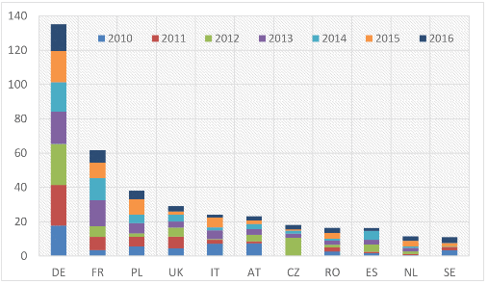

Source 174 Kougias I, 2019

Figure 173 shows the number of inventions in EU27 as compared with the leading countries globally. China, which is not included in the graph, appears to be by far the most active country in hydro R&D (number of inventions >3000), partially also due to the different patenting procedure in the country. The average annual number of inventions in the EU increased from ≈20 in the 2000-2009 period to ≈60 for 2010-2016.

Figure 173 Patent activity in EU and selected countries by number of inventions

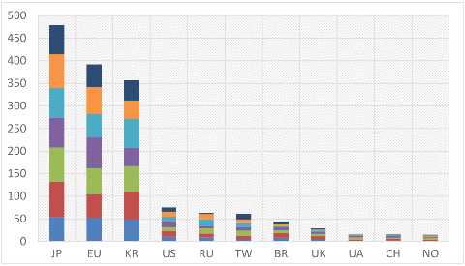

Source 175 Kougias I, 2019

Publications / bibliometrics

A bibliometric analysis using the ISI Web of Knowledge[103] shows that the number of records (research articles) concerning hydropower has been increasing in the past five years (from 1088 in 2016 to 1648 in 2019 and 1079 in 2020 until August). In terms of quantity, the hydropower knowledge production in EU27 is the highest, globally. Between 2016 and August 2020, EU institutions participated in the publication of more than 2100 articles (out of the total 6403) on the topic of hydropower, followed by China with 1681 records, and US with 618 records.

Figure 174 Bibliometric analysis: Number of records in EU and selected countries 01/2016 – 08/2020

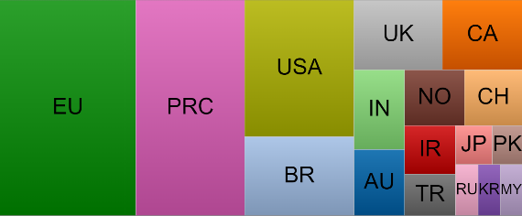

Source 176 ISI Web of Knowledge

Leading country in the EU27 is Germany with 306 records, followed by Italy (286) and Spain (215). Significant production took place also in France (177), Netherlands (176), Sweden (170), and Austria (135). It is important to note that hydropower research covers a wide range of scientific areas: energy engineering, but also environmental and water resource sciences, geology, fisheries and many others.

Out of the total 6403 records, 71 articles are considered as highly cited, with EU27-based institution participating in the publication of 50 of them (China in 24 and US in 20). This is an indication of EU’s important role in influential R&D activities. In order to draw safe conclusions, however, a dedicated and detailed bibliometric analysis is required.

Leading funding agencies of the 2016-2020 production are several National Foundations of China, the National Council for Scientific and Technological Development and the CAPES in Brazil, followed by EU (H2020 and ERC programmes) the NSERC in Canada and the NSF in US.

### Value chain analysis

Turnover

Estimations on the annual turnover of hydropower electricity generation in the EU27 place it at approximately EUR 12 billion in 2018[104]. Leading Member States in terms of turnover are Austria (EUR 2.85 billion in 2018), Italy (EUR 2.25 billion) followed by France (EUR 1.55 billion), Spain (EUR 1.18 billion) and Germany (EUR 1.06 billion).

Gross value added growth

Hydropower contributes EUR 25 billion to the EU28 (including the UK) gross domestic product (GDP), annually. The main part of this contribution is due to hydropower generation with about EUR 20 billion. Exports of hydropower equipment account for nearly EUR 1 billion and the remaining amount is tax. Hydropower’s contribution to EU28 GDP is expected to increase considerably by 2030 and exceed EUR 40 billion or even reach EUR 50 billion, depending on the scenario[105].

Number of companies in the supply chain, incl. EU market leaders

A recent JRC research developed a database of EU27 companies active in the hydropower sector that includes 524 entries. The large part of EU-based companies are commercial companies (85%). These companies are active in the design, manufacture and supply of hydropower equipment, including automation and control systems. They are also active in consultancy, R&D, and the construction of civil works. A smaller number of companies are national (≈10%) and international (≈5%) organisations active in hydropower.

Figure 175 shows the number of companies in EU Member States. It highlights the main hubs of hydropower activity in France, Germany and Italy, but also shows that certain countries such as Austria, Spain, Sweden, and Czech Republic host a significant number of hydro companies.

Figure 175 Number of EU-based hydropower companies per Member State.

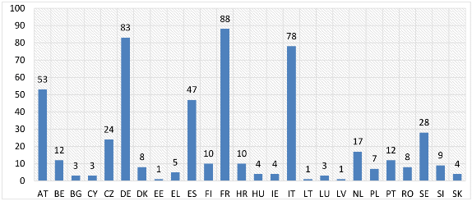

Source 177 Hydropower & Dams, 2020[106]

Employment figures

Employment in hydropower industry spans various value chain elements as project design, manufacturing, project construction and O&M. The sector employment generally includes engineers, technicians, and skilled workers. It also provides employment to scientists studying the interaction of hydro with the environment, as well as a wide range of scientists working in corporate and academic R&D activities.

In the EU27, the number of direct jobs of hydropower is estimated between 74,000 and 87,000, while direct and indirect jobs together are estimated at 102,100[107]. Future projections show that hydropower direct employment in EU will remain rather stable between 78,000 and 88,000. The number of jobs in Europe as a whole is estimated at 120,000. Despite its relatively low share in the global employment market (4%), the EU industry holds an important share in global exports (see section Trade, below). According to a different source559, hydropower provides 42,000 jobs in power generation and another 5,000 in manufacturing, with almost another 30,000 jobs created in external services of hydropower.

Globally, hydropower provides direct employment to 2.05 million people, representing almost 20% of the total direct jobs in the renewable sector. More than 70% of jobs are on O&M; construction and installation represent 23% of total jobs with the remaining 5% being on manufacturing[108].

Productivity (labour and factor)

Employees in the EU27 hydropower sector create on average an annual value of EUR 480 thousand in the generation sector and EUR 300 thousand in the manufacture[109]. This is 8 times higher than the average created value in the European manufacturing sector and ten times higher than the equivalent of the European construction sector.

ProdCom statistics

Eurostat regularly publishes data on “sold production, exports and imports”[110]. The main categories of goods associated with hydropower technology are: “hydraulic turbines and water wheels” (28112200) and “parts for hydraulic turbines and water wheels” (28113200).

Figure 176 shows the 2019 values (in EUR million) for the EU Member States. Overall, in 2019, the EU27 exported hydropower parts and turbines with a total value of EUR 322 million and EUR 99 million, respectively.

The cumulative EU27 imports accounted for EUR 142 million, which was the lowest recorded value since 2006. Imports refer mainly to parts for countries that are important exporters, indicating the presence of a processing market that uses parts to manufacture components or systems that can be exported. Notable is the exception of Sweden and Portugal, which are net importers of hydropower turbines and parts.

Figure 176 Value of hydropower exported/imported turbines and parts per Member State in 2019.

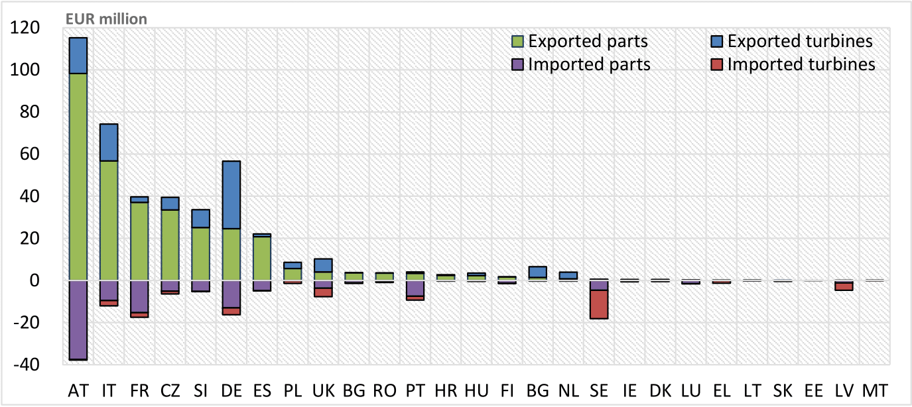

Source 178 Eurostat, 2020. Sold production, exports and imports by PRODCOM list

### Global market analysis

Trade (imports, exports)

The global exports in 2019 accounted for EUR 878 million with EU countries holding 48% of this. The remaining exports are mainly coming from China and account for EUR 210 million (24%). India EUR 52 million, Brazil EUR 45 million, US EUR 30 million are also important export countries[111].

The total value of imported turbines and parts in 2019, accounted for EUR 946 million[112]. This is the lowest value since 2007 and is significantly lower than the average of the previous 10-year period (2009-2018) that was EUR 1376 million, annually. EU imports accounted for 15% in 2019 (EUR 142 million). China moved from being the leading import country in 2007 to being almost independent from imports, as the country imported in 2019 equipment of a total value as low as EUR 2 million. Figure 177 shows the main import markets, globally and the total value of the 2019 imported equipment.

*Figure 177 Value of imported hydropower equipment in the leading global markets in 2019.*

*[113]*

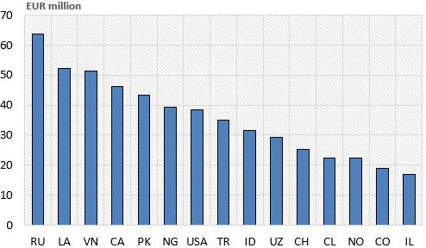

Global market leaders VS EU market leaders

The market performance of hydropower is usually connected to trade of hydropower turbines for large-scale projects. Hydraulic turbines are important components of a hydro station and a reliable proxy of the investment as it defines the power capacity of the station. As shown in the previous text (section *number of companies)* a large number of turbine manufacturers exists in the EU27 and globally, the majority of which focuses exclusively on small-scale turbines. The market of large-scale units –above 10 MW– is dominated by a rather small number of companies. This section focuses exclusively on the global market of large turbines which are typically hosted in projects worth several EUR hundred million (or even EUR multi-billion investments). In monetary terms, such investments represent a very large share of the global hydropower market. Besides, the small-scale market is not systematically monitored. An additional particularity of the hydropower market is that a significant part of investments is not monitored as it refers to the civil works and the associated consultancy services.

In the recent past, the leading hydropower turbine market has been China, followed by India, Brazil and Ethiopia. Accordingly, China-based technology companies received a large part of orders for hydro turbines. Between 2013 and 2017, Dongfang Electric and Harbin Electric sold approximately 40 GW of capacity in China. The penetration of EU-based companies in the Chinese market over the same period was significant with Voith Hydro providing 11.5 GW, GE 10.5 GW, and Andritz nearly 1 GW of capacity[114]. Accordingly, EU-based companies secured 35% of the total capacity orders in China over the analysed period.

Outside China, the three EU-based companies delivered 73.5% of the total orders in terms of capacity (2013-2017). Voith delivered 10.7 GW, Andritz 9.1 GW, and GE 6.6 GW. All Chinese manufacturers combined delivered 15.5% of total capacity. This shows that EU manufacturers have a leading role and are global leaders. The remaining share was almost equally divided between Japanese, Indian, and Norwegian companies.

In terms of number of sold units for large-scale stations worldwide, Andritz, Voith and GE held the leading positions in 2013-2017. In 2017 alone, the three EU companies sold 93 units (>10 MW) or 62% of the total number of sold units.

In EU, a large number of the existing stations is several decades old and will need to be refurbished. This is an opportunity for EU-based manufacturers and construction companies to provide parts and services and support economic growth.

Critical raw material dependence

Hydropower typically uses materials that are available in most parts of the world such as steel, concrete, and – to a lesser extent – copper. Indigenous materials are typically used and this explains the high added value of hydropower to the local economies. In terms of lifetime O&M, steel and copper is required for the replacement of runners, rotors and the windings of the generator, respectively.

Concrete is used for dam construction and the required civil works including the power station building. In large-scale stations, concrete may also be used in the construction of tunnels and caverns.

The manufacture of mechanical components for hydropower typically uses steel. The industry has optimized the production processes of hydraulic machinery with steel because of its mechanical strength and resistance to corrosion. In small-scale hydropower and hydrokinetic turbines, there is evidence of use of composite materials such as fibre-reinforced composites[115]. Copper is used at relatively lower quantities in the generator sets.

Hydropower development may involve substantial excavation and tunnelling. In such cases, significant amount for energy to run the appropriate machinery and explosives are also used. Naturally, some quantities of timber, aluminium, plastics are required for civil works – housing.

### Future challenges to fill technology gap

An important barrier to large-scale deployment is the effort to simultaneously pursue renewable energy, climate, and environmental goals. Measures to protect the environment hamper new dam construction in rivers. To date, targeted efforts to assess specific impacts and develop mitigation technologies produced significant results (e.g. fish ladders). However, future challenges lie on developing integrated approaches to achieve an environmental-friendly hydropower including the challenging aspects of implementation and monitoring after licensing.

In order to respond to the increasing needs for flexibility of operation, hydropower electro-mechanical equipment needs to reach higher levels of digitalisation, which is not a trivial exercise as wireless communication possibilities are limited within the dam constructions. This is also required to optimise operation, facilitate O&M, reduce costs, and –equally important– to increase resilience against physical and cyber threats. Existing hydro facilities were, in many cases, built decades ago. A future challenge lies on how to incorporate up-to-date advancements of the IT sector on existing and operating stations that currently use obsolete systems. Operational decision-making integrating lifetime and maintenance planning with operation at liberalised power markets is also an important challenge particularly concerning existing plants.

Developing low- and very low-head stations as well as hydrokinetic turbines has been the aim of numerous research and deployment activities. This is due to the considerably lower disruption and impacts compared to conventional reservoir hydropower. Also, the untapped low-head potential in the EU remains large. However, low-head technologies although they are technically feasible for a wide range of settings, they are often not economically viable and/or face major difficulties to scale successfully.

## Industrial heat recovery

### State of play of the selected technology and outlook

The European Green Deal aims to transform the EU into a modern, resource-efficient and competitive economy with an economic growth decoupled from resource use and aiming at zero net emissions of greenhouse gases by 2050. As its emissions account for about 21% of EU GHG emissions, the industry will play an important role in meeting this overall aim. According to scenarios formulated under the European Commission Long-Term Strategy[116], industry could reduce its emissions by up to 95% by 2050. The use of heating in industry is responsible for 60% of the total energy consumption in industry.

But the overall industry sector includes very diverse sectors, ranging from the very high temperature sectors of steel, cement glass and non-ferrous metals, where heat is supplied directly to process, through sectors which use direct heat and steam, such as chemicals, to lower temperature sectors where heat is predominately delivered to process via steam, such as pulp & paper and food & drink. This diversity of operations within industry means that deep emission reductions can only be achieved by deploying a multitude of solutions.

Figure 178 Heat Streams, origin, and their temperature by colour code – ultra-low-T-dark-blue<120°C, 120<low-T-light-blue-yellow<230°C, 230<medium-T-yellow<650°C, 650<high-T-brown<870°C, very-high-T-red>870°C

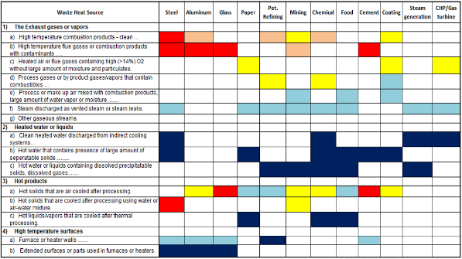

Source 179 Oak Ridge National Laboratory Report[117]

These various low-emission innovation pathways include inside factory processes, which are not directly related to energy consumption. Using excess heat that can’t be used inside the factory to supply energy in the form of heating or electricity to other consumers as a way to increase the energy efficiency of the system was one of the key elements of the Commission’s Energy System Integration Strategy of last July[118], and therefore this is the focus of this chapter.[119] This section focusses on the enhancement of industrial heat utilisation, namely on improving energy efficiency (including reduction of energy consumption) through the recovery of the industrial excess (waste) heat, including its upgrade and its conversion to power.

Industrial heat recovery is a process by which heat generated in or for an industrial process, that otherwise would be wasted, is recovered and utilised. It may involve the following operations: heat recovery, heat upgrade (to higher temperature or pressure), heat transport, heat storage, and finally heat use internally in the industrial plant or externally in another plant within an industrial cluster or in urban heating networks. Alternatively, heat can be converted to other energy vector, e.g. mechanical power or electricity.

Technology description and developments

**Heat recovery**

Often the most economically viable and less process-disturbing solution is to recycle excess heat in the process itself, using passive recovery technologies: either for combustion air preheating, for inlet products pre-heating, or for use in another (lower temperature) process of the same plant (cascading use of thermal energy). These heat recovery processes are based on well-established equipment, like recuperators, regenerators, economisers (types of heat-exchangers).

In cases where the excess heat from a process is utilized in another industrial plant or in district heating, the most common options are: heat transfer to water or other fluid (gas-to-water exchangers); air heating for process or space heating (gas to gas heat exchangers); steam generation (boilers), pressurized steam generation. Heat pipe heat exchangers allow for heat recovery under harsh conditions in a wide temperature range in industrial processes, where conventional heat exchangers may not be viable or operating costs are too high.

There is still room for **improvement of heat exchangers**, especially in harsh conditions, to avoid fouling, slagging, corrosion; including for example the development of new geometries, materials to reduce pressure drop and footprint area; automated multidisciplinary design in conjunction with innovative manufacturing techniques (e.g. 3D-printing), new probes, sensors and optimisation of maintenance intervals, etc. for reducing capex and opex costs

**Heat upgrade**

Heat upgrade refers to the increase of temperature (and pressure for gases) of a heat source which is accompanied by an input of energy, either heat or electricity. Technologies include heat pumps, and possibly some pressurisation device, like pumps, fans or compressors (e.g. mechanical vapour recompression MVR), among others.

**Heat pumps** are based on the inverse organic Rankine cycle principle and can upgrade lower temperature heat sources, including industrial excess (waste) heat, into higher temperature process (supply) heat. It is a cost-efficient way to electrify heat generation, and to greatly improve energy efficiency and hence to reduce GHG emissions. Concerning heat pumps with supply temperature up to 150°C, some products are commercially available but in general its performance and cost is not market-ready yet, and this technology is at TRL 6-7 today. The same goes for heat upgrade up to supply temperatures of 200°C - 250°C and for heat upgrade up to supply temperatures of 350°C (or even 400°C) that are not yet economically viable, being at TRL 3-4 today.

**Absorption heat transformers** (AHT)[120] are a type of absorption heat pumps that are primarily driven by low-grade heat and produce higher temperature heat. Depending on the quality of the waste source, AHT can convert up to 45% of the waste heat to useful energy. The main difference with other technologies is that AHT systems use a working fluid pair with a refrigerant and an absorbent, thermally activated, and therefore reduces dramatically electrical requirements.

**Heat-to-power conversion systems**

A technology that has been in use for many years for the conversion of thermal energy into mechanical or electrical energy is the steam Rankine cycle power plant. Aside from the conversion of primary energy, the steam power plant is also used for the conversion of industrial excess heat. Nevertheless it is suitable only for the conversion of relatively large thermal energy sources at temperatures around 300 °C or above, due to the constraints imposed by the thermo-physical properties of water as a working fluid and its impact on the feasibility and cost of the turbomachinery.

However, the Rankine cycle concept can be realized also with other working fluids, and the selection of the appropriate working fluid makes this technology very flexible when it comes to the conversion of any waste heat stream, both in terms of capacity and temperature level. Currently, Rankine cycle working fluids other than steam are made of organic molecules (i.e. containing one or more carbon atoms), therefore the resulting installations are called **Organic Rankine Cycle (ORC) power plants**. Simple molecules, like carbon dioxide (CO2) are suitable for large power capacity, while more complex molecules are better suited to lower temperature and lower capacity power plants. The maximum temperature of the cycle depends on the thermal stability of the fluid.

Emerging technologies for heat-to-power conversion include the Trilateral Flash Cycle (TFC), as well as Thermo-Electric power Generation, Piezo-electric power generation, thermionic generation, thermo photovoltaic generation. The advantage of direct thermal-to-electrical conversion systems is the absence of moving parts, but their efficiency and maturity are generally very low, hence they are not considered further in this report.

The appropriate technologies are displayed in Figure 179 as a function of the temperature and power output of the Rankine plant. Systems featuring carbon dioxide as working fluid are termed “supercritical” (sCO2) because they operate at pressures and temperatures which are beyond the critical point of the working fluid[121].

*Figure 179 Comparison of different operating range of heat to power conversion technologies*

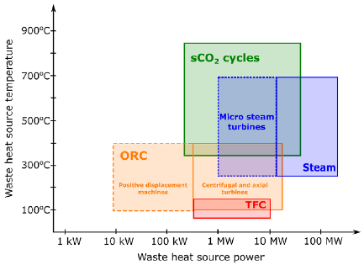

Source 180 Matteo Marchionni, Giuseppe Bianchi, Savvas A. Tassou1 (2020): Review of supercritical carbon dioxide (sCO2) technologies for high-grade waste heat to power conversion

**ORC systems for industrial heat recovery** are commercially available for temperatures of the waste heat source from approximately 100°C up to 5-600°C and power output of tens of kW up to few MW. Economic viability varies greatly and larger systems at higher temperatures are currently more successful, with exemplary installations in the cement, glass, and steel industry and as bottoming cycles of medium- and small-size gas turbines and stationary internal combustion engines. The efficiency of these systems is good considering the thermodynamic potential of the heat source,[122] as it goes from 12-15% for low-temperature system to 25-28% for high-temperature and larger systems. Concerning the specific case of supercritical CO2, so far, industrial heat recovery by sCO2 cycle power plant has been proven only at small laboratory scale in Europe.[123]

However, the potential is still large for improvements of the techno-economic performance, as well as for its wider application to the conversion of more types of waste heat streams, both in terms of capacity and temperature level, as described more in detail below:

* **innovative thermodynamic cycle configurations.** The theoretical exploration of innovative cycles, to tackle specific waste heat flow characteristics, and its experimentation can improve efficiency and reduce CAPEX and OPEX;
* **development of ad hoc working fluids and mixtures**. Fluids that are in line with the new regulations are currently accounting for 15-20% of the CAPEX, which is not acceptable for the sector, so in practice flammable fluids are still being used. Beside CO2, existing organic fluid are unstable above maximum 350°C and the existing fluids are explosive/flammable above 250°C, making it difficult to use even in an industrial environment. Developing new high T°, low cost, non-flammable organic fluid would raise the efficiency and application range of ORC. The performance of the thermodynamic cycle can also be improved by adopting an appropriate mixture as working fluid, due for example to the better thermodynamic coupling with the heat source and sink, or, as in the case of supercritical cycles, in order to avoid very high pressure;
* **direct evaporation**: Using direct evaporation will improve the overall efficiency of ORC system and should reduce their cost, by eliminating the indirect evaporation heat exchangers. One of the main issues will be to use a fluid capable to withstand high temperature, particularly alkanes fluids that are explosive or replace them with safe cost-effective engineered fluids like mixtures;
* Develop self-adaptive (machine learning) **control algorithms** for managing transient conditions and avoiding misbehaviour and instabilities of existing plants, due to impurities in working fluids, non-condensing gases in the cycle, temperature drifts (hot/cold side) and degradation of the working fluid. Thereby avoiding negative impact on lifetime;
* **expansion turbines (expanders), compressors and pumps**. In recent times, theoretical, numerical and experimental research has improved design methods and guidelines that are specific for ORC fluid machinery, (more specifically sCO2 compressors, given that the compression must occur close to the critical point of the working fluid). However, further experimentation would allow to validate these innovative methods, to devise and verify specific design tools over a large operation range and transfer them to industry. Pumps specifically designed for ORC applications are not commercially available, therefore substantial improvements would be possible, for example, by properly characterizing cavitation in organic fluids, or by using modern aeroacoustics methods to reduce the noise of ORC pumps and compressors;
* **turbomachine bearings, sealings and balancing**: Existing large ORC turbines technology remains traditional with hydrodynamic bearings or ball bearings and mechanical seals. Future ORC turbine solution could include hermetic turbines with self-lubricating or no-lubrication bearings (e.g. active magnetic bearings). For electricity generation, the generator could be included in the same hermetic casing providing increased compactness to the turbo-generator block and avoiding dynamic sealing on the shaft. These configurations, together with the balancing of plants, could increase the safety and reliability of these machines rotating at high speed;
* **integration and demonstration** in industrial environment in different processes, thermos-hydraulic coupling of supercritical ORC cycle with low temperature as well as high temperature heat storage.

Capacity installed, generation

The industrial heat needs can be categorised in very low temperature (<100°C), low temperature (100 - 200°C), medium temperature (100 – 500°C) and high temperature (>500°C), as depicted in Figure 180.

Figure 180 Breakdown of the recent energy demand in EU industry by application (left) and process heating demand by temperature level (centre) and energy source (right)

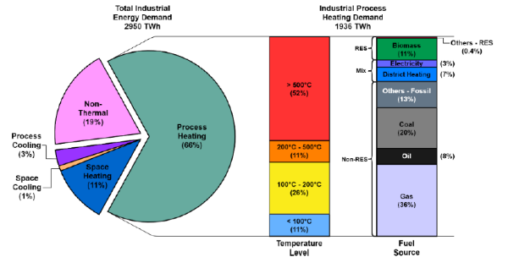

*Source[124]*

Within the EU industrial sectors, up to 1/3 of the energy utilized in industrial thermal processes is discharged to the environment (lost, wasted), yet it could be further converted into a useable form of energy (usable heat), thus greatly reducing emissions. The potential for utilisation of thermal energy that is currently discarded is estimated at 300-350 TWh/yr compared to the total industrial energy consumption of 3217 TWh in 2016[125].

Table 14 Excess heat potential in EU28 per sector complemented by calculations on conversion top electricity



Source 181 H2020 project RED-Heat-to-Power[126]

**Organic Rankine Cycle** (**ORC)** *(source[127])*

As of December 31st, 2016, the ORC technology represents a total installed capacity around 2701 MW, distributed over 705 projects and 1754 ORC units. Figure 181 depicts the total installed capacity and the total number of plants divided by application.

Power generation from **geothermal** brines[128] is the main field of application with 74.8% of all ORC installed capacity in the world; however the total number of plant is relatively low with 337 installations as these applications require large investments and multi-MW plants.

With 376 MW of installed capacity in the world, and 39 MW of new capacity in construction (16 projects), the **industrial** **heat recovery** market is still at an early stage but has long passed the demo/prototype phase. The main application is largely heat recovery from Diesel or gas engines and turbines, with 65% of the total installed capacity.

*Figure 181 ORC systems capacity and market share*

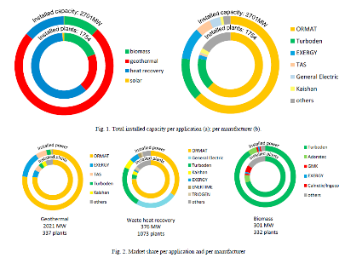

Source-?

Figure 182 ORC capacity per application

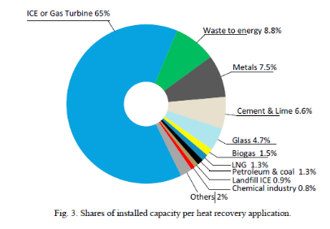

Source 182 Thomas Tartière et al. / Energy Procedia 129 (2017) 2–9

**Industrial heat pumps**

Heat pumps sales in Europe are dominated by space and domestic hot water heating applications. Small units account for the largest volumes, i.e. in buildings. This market is growing fast, as sales in 2018 were at 1,25 million units with was a 12% compared to 2017. The market is young though, with a total stock of installed capacity in the EU of 11,8 million units. Growth is expected mainly in air-water and air-air heat pumps, but there is also considerable growth expected in larger units. (source EHPA, Dec 2019). The industrial heat pumps market in the EU is growing, with 2813 units sold over the period 2009-2016, as depicted in Figure 184.

Figure 183 Origin of products sold in Europe 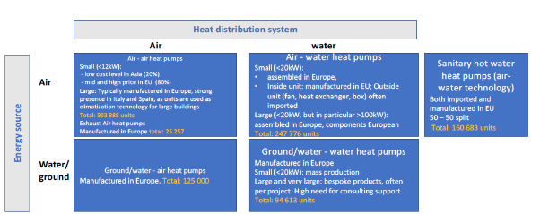

Source 183 EHPA, Dec 2019

Figure 184 Number of industrial heat pump sold in EU (showing only countries with reported sales)

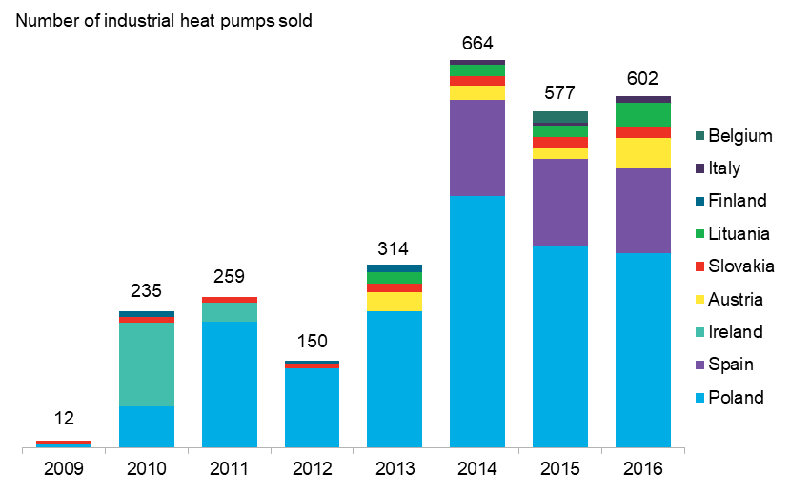

*Source[129]*

Cost, LCOE

**The cost of recovering thermal** energy from industrial processes is very dependent on each case: on the temperature and pressure, on the heat carrying fluid (solid, liquid, type of gas …) and its cleanliness (dusty, corrosive …), on its flow size and time variability. The value of the recovered heat then strongly depends on how and where the heat can be used (locally in the process/plant, in another plant, in a district heating network …), as well as on the cost of transferring the heat to another carrier (liquid water, steam …) and transporting the heat to the point of use. It is therefore very difficult to provide cost data for thermal energy recovery and proved not to be feasible for this report.

The **cost of electricity produced from industrial excess heat** is therefore also very case dependent. It can however be estimated in some specific examples, as follows:

* a typical 3 MW high temperature ORC power plant in a cement plant complete with waste heat recovery system on industrial fumes will cost around 7.5 MEUR or 2.5 EUR/W and will generate electricity at around 70 EUR/MWh without subsidies. A smaller ORC in a glass container factory will generate electricity without subsidies at around 100 EUR/MWh[130];
* even more favourable situations like recovering syngas from an industrial process which would otherwise be burnt in a flare and burning it in a syngas boiler would give room to large 8-10 MW high temperature ORC systems and could cost around 1,5 MEUR/MW producing electricity at 40-45 EUR/MWh without subsidies;
* electricity currently produced by ORC power plant at an LCOE between 30 and 50 EUR/MWh, based on depending on CapEx and assuming between 5000 and 7500 operating hours per year. Capex between 2 to 3.5 EUR/Wel depending on ORC size, type of application (clean gas or dirty gas), layout constrains, etc… Lifetime: more than 25 years. Operation & Maintenance cost: 1-2% of total CapEx per year;. ORC Conversion efficiency from heat to electricity (Wel/Wth input to ORC) between 18 to 28% depending on heat source temperature, ambient air temperature and ORC size. Efficiency increases with higher source temperature and with lower cold source temperature. (source: Turboden internal evaluation);
* based on literature data, the equipment unit cost for simple regenerative sCO2 power cycles ranges between 0.8-1.7 EUR/W installed, not taking into account the installation costs. Depending on the temperature level of the heat source a performance benefit of 2-4%-point (cycle efficiency) vs water/steam can be derived. Assuming that the heat is obtained at zero cost, the LCOE can be estimated to approx. 40 EUR/MWh. It is assumed that a further cost reduction economic can realized by future improvements and cost reduction measures (source: Siemens Energy AG internal evaluation).

The cost of producing heat by means of Heat Pumps can be compared with traditional gas boilers in a typical example of a heat pump of 217 kW operating in Germany. The operating cost depends on the relative costs of gas (for boilers) and electricity (for heat pumps), taking into account the efficiency of the boiler (e.g. 85%) and the COP of the heat pump (e.g. 3.95), as depicted in Figure 185. Because of higher upfront costs, the payback period of heat pump is longer, ranging from 2 to 10 years depending on the cases, with an average of 4.8 years[131]. Overall, the total cost of ownership over a 20-year period comes at an advantage for the heat pump in most EU countries, as depicted in Figure 186.

Figure 185 Example operating costs of heat pumps and gas boilers in Germany and Austria – fuel, for heat pump is for electricity, bi-annual fuel prices for 2019S1

|  |  |  |  |  |
| --- | --- | --- | --- | --- |
|  | Germany | | Austria | |
|  | Gas boiler | Heat pump | Gas boiler | Heat pump |
| Fuel price for industrial users Euro/kWh | 0.0278 | 0.0855 | 0.0264 | 0.0805 |
| Efficiency/ COP | 85% | 3.95 | 85% | 4.23 |
| Operating cost Euro/kWh | 0.033 | 0.022 | 0.031 | 0.019 |

Source 184 Bloomberg NEF, based on IEA, Eurostat

Figure 186 Total cost of ownership for a 20-year period, for a heat pump of 217kW, compared to a boiler, for different electricity and gas prices, assumed to operate at 90% capacity annually, no discount rate - Industrial retail electricity price (Euro per kWh)

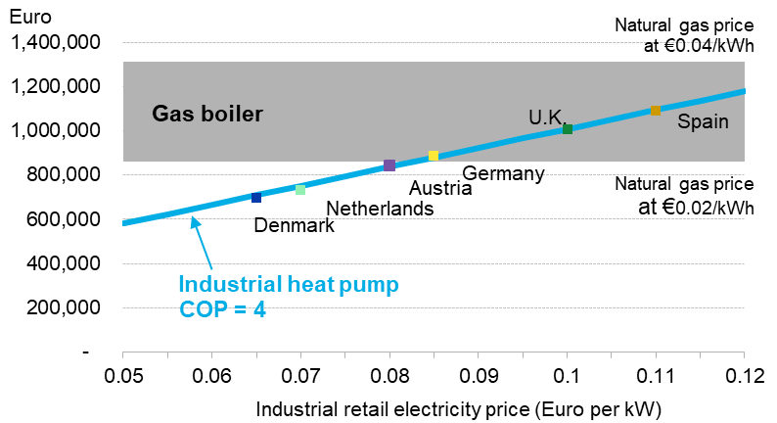

Source 185 Bloomberg NEF, McKinsey&Company, Eurostat, IEA annex 35

R&I

Public and private R&I funding

H2020 calls relevant for the industrial heat/cold recovery and upgrade[132]:

* LC-SC3-EE-6-2018-2019: Business case for industrial waste heat/cold recovery, 4 projects, total cost: EUR 12.5m, total public funding: EUR 11.4m, total private funding: EUR 1.1 million;
* LC-SC3-EE-13-2018-2019-2020: Enabling next-generation of smart energy services valorising energy efficiency and flexibility at demand-side as energy resource, 4 projects, total cost: EUR 14.0m, total public funding: EUR 11.7m, total private funding: EUR 2.3m for the 2018 and 2019 calls;
* LC-SC3-CC-9-2020 Industrial (Waste) Heat-to-Power conversion to be closed on 1st September 2020, expected one project, public funding EUR 14m, private funding not yet known;
* SPIRE-EE-17-2016-2017 - Valorisation of waste heat in industrial systems (including heat upgrade), 3 projects, total cost: EUR 16.7m, total public funding: EUR 13.3m, total private funding: EUR 3.4m for the 2018 and 2019 calls.

National projects on heat pumps:

* DK – project SuPrHeat - high-temperature heat pump technologies with supply temperatures of up to 200 °C, with a heat supply capacity of 500 kW. Public funding: DKK 34.2m; private funding: DKK 27.1 million[133];
* DK – project EUDP N°64010-0026 SteamHP - Utilisation of low grade industrial waste energy by means of new emerging high temperature heat pumps;
* FI – project SkaleUp – Heat pump, industrial pilot installation 300 kWh @115°C. Project budget: NOK 400 million[134];
* NL – project FUSE - Full Scale Industrial Heat Pump Using Natural Refrigerants. Public funding: EUR 0.93 million.

Patenting trends

Patents related to heat recovery are identified amongst the relevant Y02P code family (climate-change mitigation technologies in the production or processing of goods).

The following classes of patents were selected:

|  |  |
| --- | --- |
| Code | Description |
| Y02P 10/265 | Metal processing: process efficiency by heat recovery |
| Y02P 10/271 | Metal processing: process efficiency low temperature heat recovery |
| Y02P 10/274 | Metal processing: process efficiency medium temperature heat recovery |
| Y02P 10/277 | Metal processing: process efficiency high temperature heat recovery |
| Y02P 20/129 | Chemical industry: improvement of production processes by energy recovery |
| Y02P 40/53 | Glass production: Reusing waste heat during processing or shaping |
| Y02P 40/535 | Glass production: Regenerative heating |
| Y02P 70/129 | Improving processes for machines shaping products: heat recovery during rolling |
| Y02P 70/275 | Plastics: reusing heat |
| Y02P 70/405 | Drying: with heating arrangements using waste heat |
| Y02P 70/623 | Artificial filaments - Energy efficient measures, e.g. motor control or heat recovery |
| Y02P 70/639 | Textiles: Energy efficient measures, e.g. motor control or heat recovery |
| Y02P 70/649 | Wall covering: Energy efficient measures, e.g. motor control or heat recovery |
| Y02P 70/58 | Heat recovery or efficiency measures related to manufacturing vehicles |
| Y02P 70/60 | Heat recovery or efficiency measures related to electric components |
| Y02P 80/152 | Sector wide applications: heat recovery |

The present patent analysis was based on data available from the European Patent Office (EPO). Details of the analysis are described in detail in dedicated JRC publications [135] [136].

Figure 187 shows the patenting activity in the EU27, by Member State, between 2010-2017 (note that 2017 is not complete).

Figure 187 Heat recovery related patents by EU Member States

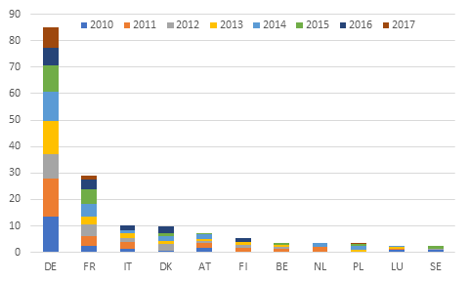

Source 186 EPO

The patenting activity in the EU-27 is dominated by Germany, which filed more patents than all other EU countries combined. France is the second most active country, but filed less than half as many patents and Germany. Both in France and Germany, patenting activity was relatively constant between 2010 and 2017.

Figure 188 below shows the patenting activity between the EU and other major economies. When selecting only patents that are protected in more than one country, a measure of high-value patents, the EU emerges as the most active patenting region in heat recovery. With more than twice as many patents filed as the second places countries, Japan and the US.

Figure 188 Global patenting activity in heat recovery technologies (high-value patents)

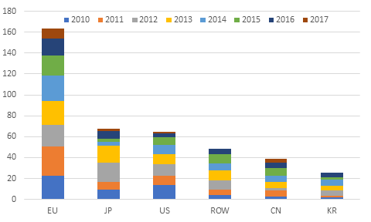

Source 187 EPO

Due to the different patenting procedures in China, when patents protected in only one country are included in the analysis, China is the dominant patenting actor with over 3500 patents filed, as shown in Figure 189. In this patenting measurement, the EU falls into third, but its activity remains similar to that of Korea and Japan, and ahead of the US.

Figure 189 Global patenting activity in heat recovery technologies (all patents)

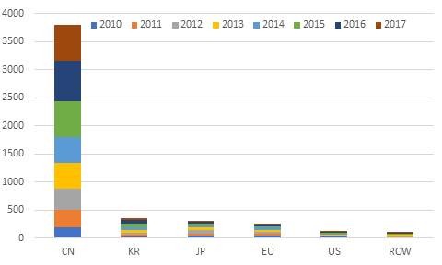

Source 188 EPO

Publications / bibliometrics

Using SCOPUS[137], a bibliometric analysis of the four heat recovery technologies – turbomachines, heat exchangers, heat recovery systems and heat upgrade systems, was performed to compare the research activity in this field.

Turbomachines:There seems to be active research on turbomachines, with 4024 published research papers between 2010 and 2016. Figure 190 shows that the EU-27 is the most active region in that field globally, with around 30% of all published papers linked to an EU research institution, followed closely by China and the US, with around 23% each.

Figure 190 Publications on turbomachines by country, 2010-2020

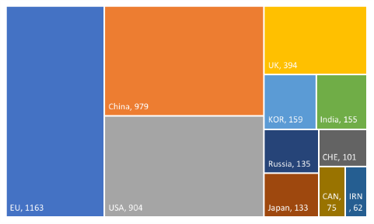

*Source: JRC, Scopus[138]*

Heat exchangers: Heat exchangers in industry have also been an active research area, with 4624 publications between 2010 and 2020. A similar regional pattern emerges, as shown in Figure 191. The gap between the EU and the other regions however is more pronounced. Authors from EU institutions appear on 30% of all published paper, while China and the US account for around 18% and 13% of publications respectively.

*Figure 191 Publications on heat exchangers by country, 2010-2020*



*Source: JRC, Scopus*[139]

*Industrial heat recovery systems*

A bibliometric search on industrial waste heat recovery systems yielded 1216 published papers between 2010 and 2020. As shown in the figure below, the EU and China are clear leaders in that field of research, with EU research institutions authoring 33% of the output and China 28%.

Figure 192 Publications on waste heat recovery and industry by country, 2010-2020



Source: JRC, Scopus[140]

*Heat upgrade systems*

Research activity on heat upgrade systems is evaluated based on the number of publications on heat pumps, the main heat upgrade technology described in section 1.4. Heat pumps are an extremely researched area, with 15762 published papers between 2010 and 2020. As shown in Figure 193, the EU and China are leading this research by a very wide margin, with each region affiliated to one third of the published output.

Figure 193 Publications on heat pumps by country, 2010-2020

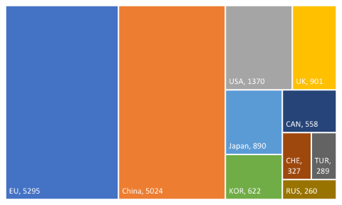

*Source: JRC, Scopus[141]*

Narrowing down the bibliometric analysis to research on heat pumps and industry, a much smaller number of publications (1449) remains. Figure 194 shows that in this more specific research field, the EU is clearly the most active region in terms of research output, with nearly twice as many publications more than China, the second most active contributor.

Figure 194 Publications on heat pumps and industry by country, 2010-2020



*Source: JRC, Scopus[142]*

Publications

*Publications by year*

Analysing the publication output on heat recovery technologies by year, there has been clear increase in the number of publications from 2015 onwards, mainly driven by the increase in papers on turbomachines (more than doubled between 2015 and 2017). In relative terms, research output on waste recovery in industry has seen the biggest increase in activity, with five times as many paper published in 2019 than in 2010.

Figure 195 Publications by heat recovery technology, 2010-2020



*Source: JRC, Scopus*

*Publications by EU MS*

Figure 196 shows the top ten EU countries by publications in all four technologies above. Germany is the most prolific knowledge producer overall, as well as in three out of the four technologies. The top three knowledge producing countries – Germany, Italy and France – participated in more publications (1743) than all other EU countries combined (1663).

Figure 196 Top ten EU countries by publications, 2010-2020



*Source: JRC, Scopus*

Considering the bibliometric analysis of all four technologies above, the EU and China seem to be the most active regions in the field of heat recovery by a considerable margin, and heat pumps in particular are an extremely researched technology. It must be noted however that a more detailed bibliometric analysis would need to be undertaken to draw more exhaustive and reliable conclusions.

### Value chain analysis

Turnover / Number of companies in the supply chain, incl. EU market leaders / Employment figures

Below an overview of the main companies, and where available their number of employees, their turnover (globally and/or in the EU) is presented, as well as the products that these companies produce. This has been split up as above, with a table on the industry involved in turbines, compressors and Heat-to-Power (H2P) systems, and a table focusing on industrial heat pumps.

There are many global companies active in this business for which EU-specific data were not available (NA) for this report. Considering that the market for turbomachines etcetera is much larger than the market for industrial heat pumps, with many more actors, a separate table for companies active in this area without EU operations is included.

For industrial heat pumps, considering it is an emerging market, the table specifies in what segment companies are active.

It also needs to be noted that the market for turbomachines includes much more than just systems used for heat recovery, but it was not possible to obtain specific heat recovery data for this market for this report. Gross value added growth figures were not available for this report.

**Turbomachines (Turbines, compressors), Heat-to-Power (H2P) system integration**

Table 15 Companies with operations in EU

|  |  |  |  |  |  |  |
| --- | --- | --- | --- | --- | --- | --- |
| Companies with operations in EU | Country | Nb of employees World | Nb of employees in EU | Turnover World | Turnover in EU | Products |
| Ansaldo Energia (acquired Alstom in 2016) | IT, FR | 3,451 (2019) |  | €984m (2019) |  | Turbomachines, H2P |
| Baker Hughes - BH | TPS[143] business headquarter in IT (+ FR, DE, UK), Company headquarter in US | 68000 | 25000 | $23.8bn | $6bn | Turbomachines, drilling, sensing, software, valves, etc |
| Doosan Škoda Power | CZ |  | 1,150 |  | CZK 4.3bn | Turbomachines, H2P |
| GE Power (part of GE Co.) | US, IT | 205,000 (GE Co., 2020) | NA | $95bn (GE Co., 2019) | NA | Turbomachines, H2P |
| MAN Energy Solutions (VW group) | DE | 14,400 (2013) | NA | €3.4 (2013) | NA | Turbomachines, H2P |
| Mitsubishi Power Europe (Mitsubishi Power, JAP) | UK, IT, JAP, 17 countries | 18,000 (world) | IT: 1100, other EU: NA | JPY 1.12tn[144] (2019) | NA | Turbomachines, H2P |
| Turboden (part of Mitsubishi Heavy Industries) | IT, JAP | NA | 250 | €64m (2019) | €50m | Turbomachines, H2P-ORC |
| Siemens Energy AG | DE, and 90+ countries world | 91,000 | NA | €28.8bn | NA | Turbomachines, H2P |
| Enertime | FR | 30 | 30 | €5m | NA | Turbomachines, H2P-ORC |
| Solar Turbines Europe (Caterpillar) | US, BE | 392 | NA | $453m | NA | Turbomachines, |
| Exergy (acquired by CN)[145] | IT | NA | NA | NA | NA | Turbomachines, H2P-ORC |

Other companies, active in excess/waste heat recovery, but without activities in the EU28, include:

* India – BHEL, Triveni Turbines;
* China – Dong Fang Turbine Works, Shanghai Turbine Co, Harbin Turbine, Hangzhou Turbine Co;
* Korea – Doosan Heavy Engineering Co;
* Brazil – TGM Turbinas, NG Turbine Co;
* Russia – Power Machines, Ural Turbine Works.

**Industrial Heat Pumps** (sink temperature > 100°C)

(NB: small size heat pumps and large heat pumps for district heating networks are covered by the CETTIR fiche on Heating and Cooling).

Table 16 Companies with operations in EU

|  |  |  |  |  |  |  |
| --- | --- | --- | --- | --- | --- | --- |
| Manufacturer | Country | Nb of employees | Turnover | Source temperature °C | Sink temperature °C | Thermal power kW |
| ECOP | AT | NA | NA | -20 - 110 | 150 | 400 - 700 |
| Enertime | FR | 30 | EUR 5m | 15-120 | 80-170 | 2000-10000 |
| ENGIE-Refrigeration | DE | NA | NA | 70 - 80 | 120 | 1000 |
| Epcon Evaporation Technoloyg | NO | 20 | NA | 60-110 | 100-150 | 1000-10000 |
| Hybrid Energy | NO | NA | NA | 15 - 75 | 75 - 110 | 800 - 1400 |
| Kobe steel | JAP | NA | NA | 25 - 65 | 120 | 370 |
| Mayekawa | BE, JP | NA | NA | 80-100 | 140 | NA |
| Ochsner Energietechnik GmbH | AT | NA | NA | NA | 130 | Up to 1500 |
| Olvondo Technology AS | NO | NA | NA | 80-100 | 130-180 | 200-400 |
| SPP | US | NA | NA | -20 - 110 | 200 (°F or °C tbc) | 400 - 500 |
| Turboden (Mitsubishi Heavy Industries) | IT | 250 | EUR 64m (2019)[146] | 10-75 | 90-120 | 5000 - 20000 |
| Viking Heat | NO | NA | NA | 30 - 100 | 80 - 150 | 28 - 188 |

Including also domestic, district and industrial heat pumps, there are 103 manufacturing sites in Europe[147]

**Industrial Heat Pumps** – market prospects[148]

There is a big untapped potential for industrial heat pumps, that can contribute in an important way to the reduction of emissions and the improvement of efficiency in industry. According to industry, Heat pumps for temperatures up to 100°C have the potential to cover 222 TWh/a or 11% of the process heating demand in European industry as depicted in Figure 180. This could lead to CO2 emission reductions in the order of 51 Mt/a.[149],[150] At present, there are a limited number of suppliers able to provide systems for temperatures higher than 100°C. In general, these systems are not considered to be mature technology.

In the case that heat pumps also become a mature technology for the supply of heat in the temperature range of 100°C to 200°C, an additional 508 TWh/a or 26% of the total process heat demand can potentially be emission free, with potential additional CO2 reductions in the order of 95 Mt/a.

Combining the two market segments, (i.e. applications up to 100°C and applications in the range of 100°C to 200°C) heat pumps could deliver 730 TWh/a or 37% of the process heat in industry, with a corresponding CO2 emission reduction potential in the order of 146 Mt/a. Being a cross-cutting technology, heat pumps will be applicable to multiple industrial subsectors. Assuming that heat pumps can reach temperatures of 200°C, they will have high potential for the pulp and paper (230 TWh/a), food and beverage (123 TWh/a), chemical (119 TWh/a), non-metallic minerals (43 TWh/a) and machinery (41 TWh/a) sectors[151].

The **European heat pump** sector (Including domestic, district and industrial heat pumps) employs a well-trained workforce in R&D, component and heat pump manufacturing, installers, and service and maintenance. A recent European Heat Pump Association report described the industry as an economic force and provider of local labour[152]. The expansion of the sector to establish products and solutions for industrial applications will further drive innovations, stimulating the creation of numerous jobs and contributing significantly to the European economy. Under the assumption that an industrial heat pump market can be established within Europe with a market rollout of 37 TWh/a per year, i.e. 5% of the total potential (730 TWh/a for applications up to 200°C), the total turnover for the entire value chain is estimated to be in order of EUR 2.3 billion/a, leading to the creation of 14,500 new jobs. Technology export will facilitate the creation of further revenue and jobs.

### Global market analysis

Global market leaders and EU market leaders

**Organic Rankine Cycle** (**ORC) – source[153]**

As of December 31st, 2016, the ORC technology represents a total installed capacity around 2701 MW, distributed over 705 projects and 1754 ORC units. Figure 197.1 (left part) depicts the total installed capacity and the total number of plants divided by application.

Power generation from **geothermal** brines is the main field of application with 74.8% of all ORC installed capacity in the world being in the EU; however the total number of plants is relatively low with 337 installations as these applications require large investments and multi-MW plants. As a result, only a few established companies (ORMAT, Turboden Exergy, Atlas Copco and TAS) have been active in this capital-intensive sector.

With 376 MW of installed capacity in the world, and 39 MW of new capacity in construction (16 projects), the **heat recovery** market is still at an early stage but has long passed the demo/prototype phase. The main application is largely heat recovery from Diesel or gas engines and turbines, with 65% of the total installed capacity. ORMAT (US) has been very active in this field with 24 plants around 3-8 MW installed along gas pipelines in the US and Canada. Turboden (IT) follows with 80 MW in 34 plants of average size around 2.5 MW. Using exhaust heat from combustion engines or turbines is easier than industrial heat recovery. Despite their apparently large heat recovery potential, Cement & Lime (9 projects) and Glass (8 projects) industries count for only a small share of the heat recovery market with approximately 100 units.

Table 17 List of ORC manufacturers/designers, with number of installed units and total installed capacity, before DEC 31st, 2016

|  |  |  |  |  |  |  |  |  |
| --- | --- | --- | --- | --- | --- | --- | --- | --- |
| Manufacturer | ORC units | Total MW | Manufacturer | ORC  units | Total MW | Manufacturer | ORC units | Total MW |
| ABB | 2 | 3.8 | Enogia | 11 | 0.26 | Orcan | 16 | 0.3 |
| Adoratec | 23 | 16.4 | Enreco | 1 | 0.15 | ORMAT | 1102 | 1701 |
| BEP - E-rational | 20 | 3.6 | Exergy | 34 | 300 | Rank | 5 | 0.07 |
| Calnetix CETY | 50 | 6.3 | General Electric | 6 | 101 | TAS | 17 | 143 |
| DürrCyplan | 6 | 1.2 | GMK | 18 | 5.3 | TMEIC | 1 | 1 |
| Electratherm | 55 | 3.14 | gT - Energy Tech | 2 | 0.7 | Triogen | 37 | 5.2 |
| Enerbasque | 3 | 0.13 | Johnson Control | 1 | 1.8 | Turboden | 267 | 363 |
| Enertime | 2 | 1.6 | Kaishan | 40 | 27.2 | UTC Power | 10 | 2.8 |
| Enex | 1 | 9.3 | Opcon | 3 | 2.0 | Zuccato | 21 | 1.7 |

Figure 197 Capacity, market share per manufacturer, per application

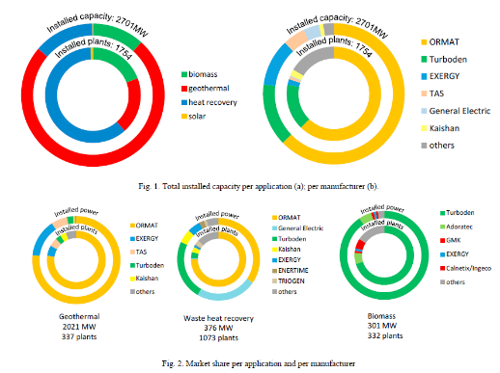

Source Thomas Tartière et al. / Energy Procedia 129 (2017) 2–9

**Supercritical CO2**

The table below shows the main companies active in the development of sCO2 technologies. One of the latest technology developments has been realised by ECHOGEN Power Systems (US), which offers a heat recovery system EPS100, rated at 8 MWel with an efficiency of 24% for waste heat supply at +532°C. But this is based on the use of a condensing cycle which inevitably requires a low temperature cooling water for the heat rejection, thus limiting its use.

Table 18 Technical feature of the first prototypes of sCO2 turbines and compressors commissioned and operating in the different academic and industrial organisations involved in research on sCO2 power cycle

|  |  |  |  |  |  |
| --- | --- | --- | --- | --- | --- |
| Institution | Type | Rotational speed (RPM) | Diameter (mm) | Power (kW) | Design point (°C/bar/kg/s) |
| Turbines |  |  |  |  |  |
| BMPC | Radial | 55,000 | 45 | 100 | 282/141/2.1 |
| SWRI/GE | Axial | n.a. | n.a. | 1000 | 700/250/8.4 |
| Echogen | Radial | 30,000 | n.a. | 8000 | 275/n.a./n.a. |
| KIER | Axial | 45,000 | 73 | 93 | 216/123/1.5 |
| KAIST | Radial | 80,000 | 325 | n.a. | 435/125/5.0 |
| Compressors |  |  |  |  |  |
| KAIST | Radial | 35,000 | 272 | 100 | 33/78/6.4 |

Source 189 Review of supercritical carbon dioxide (sCO2) technologies for high-grade waste heat to power conversion, Marchionni et al., SN Applied Sciences, 2020

Critical raw material dependence

This is not an issue, considering that industrial heat recovery typically uses materials that are available in most parts of the world and in the EU in particular, such as steel (for heat exchangers and turbomachines, special alloys for high temperature and corrosion resistance), minerals (for refractories of heat exchangers), and –to a lesser extent– copper and other silicon/germanium materials needed for the control electronics.

### Future challenges

**ORC systems** for industrial heat recoveryare commercially available for temperatures of the waste heat source from approximately 100°C up to 5-600°C and power output of tens of kW up to few MW. The major obstacle to the widespread adoption of ORC waste heat recovery technology is economic viability, which depends on the possibility of operating in a fair economic playing field, where the external costs of emissions would be accounted for.

Fortunately, the potential for improvements of the techno-economic performance is still large, thanks to the advancements in building-block sciences, technologies and design and operation methods. Key technology developments include designing innovative thermodynamic cycle configurations, finding alternative (non-flammable) fluids and mixtures that are able to withstand high temperatures, as well as developing specific turbines, compressors and pumps for ORC (including supercritical CO2) systems. Also, integrating and demonstrating their use in an industrial environment, and using advanced control algorithms to better manage irregularities in the process will contribute to the further development of the market for this technology.

**Heat pumps**

IEA HPP-IETS[154] identified barriers to the deployment of industrial heat pumps, which are still valid today, the main ones being:

* the integration of heat pumps in industry requires knowledge of both the capabilities of heat pumps as well as the underlying process in which they can be applied. Currently, there are limited installers and decision makers which possess this combined knowledge;
* many end-users have a lack of awareness of their heating requirements or consumption, meaning identifying heat pump integration opportunities is laborious or largely time consuming;
* in some cases, the technology is available, but high payback periods lead end-users to conclude that no feasible business case exists for installation of a heat pump. The high payback periods can be attributed to high initial capital costs, or to an unfavourable price of electricity relative to the alternative fossil source, as well as uncertainties in the boundary conditions (gas, electricity, CO2 price) which determine the business case for a heat pump;
* there have been limited cases to demonstrate and prove the reliability of novel heat pump technology in an industrial environment over short time periods but this is not sufficient to introduce a new technology to the market. To tackle this barrier, demonstration projects in various industrial sectors would demonstrate the benefits, reduce the risks and foster deployment of existing but novel heat pumps (today up to 150°C);
* in other cases, the technology for a specific application is not yet available. For instance, the process temperature level is higher than what can be delivered by commercially available heat pump technology. Indeed, the technologies capable of supplying process temperatures in the range 150-250°C and beyond 250°C are today at lower TRLs. R&I can help in identifying new cycles and refrigerants (compliant with F-gas regulation. Further R&I would increase the technological readiness, in order to cover more applications in more industrial sectors. The market potential in industry for such heat pumps needs to be better understood because their COP needs to be above 3 to be economically viable; this is limiting to applications where the excess heat temperature is not too far from the sink temperature[155].

## Nuclear energy

[*This report focuses on the energy technologies that are needed to achieve climate neutrality in 2050. Based on the modelling and scenarios of the European Commission[156], nuclear energy is included in this report. This inclusion is not to be considered as a view on the question on whether nuclear energy is a clean technology in the wider sense or not.*]

### State of play of the selected technology and outlook

Nuclear energy generation is called to play a key role during the next decades in achieving a decarbonized economy by 2050, mainly due to its contribution to ensuring security of supply. The expected increase of intermittent renewable generation, combined with the current lack of storage technologies, will cause the European power system to face a growing need for flexibility. As the COVID-19 crisis has shown, nuclear energy has proved itself to be both dispatchable and flexible, and will continue to be critical avoiding a significant increase in the energy dependency to imported fuel.

Another essential factor that places nuclear power as a crucial energy source is that it contributes to reducing the power system emissions. IPCC’s 2014 Climate Change Report[157] ranks nuclear energy amongst the lowest emitting energy sources considering its whole lifecycle. The probability to fully decarbonise the economy is higher if it features at least a stable nuclear share, as it grants reduced emissions in the transition phase and less cliff-edge effects in the long term.

On 2018, the European Commission adopted a long-term climate strategy – A Clean Planet for All[158]. According to its projections, by 2050 around a 15% of electricity will be coming from nuclear power, being considered as the backbone of a carbon-free European energy system. Also, within the framework of the Commission´s Taxonomy Regulation[159], the Technical Expert Group (TEG) on sustainable finance acknowledged that nuclear energy generation has near to zero greenhouse gas emissions in the energy generation phase, contributing to climate change mitigation, and that its potential role of nuclear energy in low carbon energy supply is well documented.

Capacity installed, generation

Nuclear energy has been used for civil purpose (energy production, both electricity and heat) since 1950s. Currently, 441 power reactors in 31 countries are in operation worldwide with 391 GW total electrical capacity[160]. The oldest reactors are still in safe operation over 50 years and the majority of the nuclear fleet is over 30 years. With the long-term operation (LTO) licensing processes, the power reactors can operate safely for 60 years and even up to 80 years[161]. These nuclear power plants are about the 6% of the total installed capacity and provide 11% of the produced electricity[162]. In 2019, the nuclear produced about 33% of low carbon electricity worldwide.

In the EU28, there were 126 power reactor units in operation with 14 Member States with 118 GW total electrical capacity[163]. After the UK’s withdrawal from the EU, the remaining fleet is 111 power reactor units with 109 GW total capacity. This capacity is more than 10% of the installed total capacity (1011 TW in 2017)[164]. In terms of the electricity production, the nuclear energy share in 2018 was about 28% in the EU27[165], which is about half of the low carbon electricity production. In terms of district heating and industrial process heat production, nuclear energy provided around 300 GWh of electric equivalent heat in several EU27 countries (Bulgaria, Czech Republic, Hungary, Slovakia and Romania) in 2018[166]. The average age of the nuclear fleet in EU28 is about 35 years[167][168].

Concerning the future of nuclear energy**,** the International Atomic Energy Agency (IAEA) foresees two scenarios. In the high-end scenario, the nuclear electrical capacity will increase up to 554 GW by 2030 (39% increase over current level) and 874 GW by 2050 (119% over current level). However, in the low case scenario, the nuclear energy capacity will decrease by 2030 a 14% of the current level (345 GW) but will slightly increase until 2050 up to 382 GW (96% of the current level). The global electrical generation capacity projected by the IAEA is up to 9.826 GW by 2030 and 12.908 GW by 2050, therefore nuclear energy contribution can vary between 3% and 6.8%. The share of the nuclear energy in the total electricity production can decrease from the current 11% level to 7.8% by 2030 and 6% by 2050 in the low case scenario, however can be slightly increase up to 12.4% by 2030 and 13.7% by 2050 in the high case scenario.

The future of the nuclear energy in the EU was examined in the Commission’s Nuclear Illustrative Programme PINC[169][170] at 15% (99-121 GW in 2050, including UK) and it was emphasised that nuclear energy will remain an important component in the energy mix in EU in 2050.

Nevertheless, a recent IEA report entitled ‘EU 2020 Energy Policy Review’[171] highlights the issue that “without new policy action at the national level, nuclear power capacity in the EU could fall to 5% by 2040.” It goes on to flag the negative implications of such a situation: “This may have implications not only for the cost of electricity but also the security of supply at a regional level, if not properly studied and addressed. To keep the nuclear energy option open for 2030 and beyond, the EU needs to maintain a level playing field for the financing of nuclear, to support lifetime extensions and new plants in countries where nuclear is accepted, and foster safety and waste disposal for the decommissioning of existing plants”.

Cost, LCOE

The cost of the nuclear energy is composed of capital cost, plant operating costs, external costs and other costs.[172] The capital costs include the site preparation, construction, manufacture, commissioning and financing a nuclear power plant. The overnight cost is the capital cost exclusive of financing charges accruing during the construction period. The overnight cost includes engineering, procurement and construction (EPC) costs, owners' costs (land, cooling infrastructure, associated buildings, site works, switchyards, project management, licences, etc.) and various contingencies. The overnight cost in EU28 is about USD 5,500/kW[173], and it varies between USD 2021/kW and USD 6215/kW worldwide (for instance USD 3500/kW in China and USD 4100/kW in US).[174]

Table 19 Overnight investment costs

|  |  |  |  |  |
| --- | --- | --- | --- | --- |
|  | Overnight investment Costs | | | |
|  | EUR'13/KWe | | | |
|  | 2020 | 2030 | 2040 | 2050 |
| Nuclear III gen. (incl. economies of scale) | 5300 | 4557 | 3873[175] | 3485 |
| Small Modular Reactors | 1800-4500 | | | |
| Refurbishment of existing nuclear reactors | 400-800 | | | |

Source 190 FORATOM, 2020

Lessons learnt in Europe are already allowing similar projects in other parts of the world to be delivered at lower costs and lead-times (e.g. the Taishan EPR projects). Nuclear cost reductions are therefore expected by nuclear experts across Europe (UK[176], France[177]) with the aim of a 30-35% cost reduction by 2030 compared to current projects. Cost reductions will also be achieved through a combination of technical (e.g. twin projects) and organisational factors (e.g. restructuring of the European nuclear supply chain).

In addition, beyond 2030, learning by doing and innovation should also allow for future cost reductions. This point was, for instance, noted by the European Commission in its PINC staff working document (pp 13, Box 2) based on a survey of the economic literature, which studied historical cost data. Overnight cost data for 2040 and 2050 are therefore be calibrated based on an experience curve as a function of cumulative nuclear new build in Europe between 2020 and 2039.

The 2016 edition of the World Nuclear Association's World Nuclear Supply Chain report considered capital costs by activity and in terms of labour, goods and materials:

Table 20 Capital Costs by Activity.

|  |  |
| --- | --- |
| Design, architecture, engineering and licensing | 5% |
| Project engineering, procurement and construction management | 7% |
| Construction and installation works: |  |
| Nuclear island | 28% |
| Conventional island | 15% |
| Balance of plant | 18% |
| Site development and civil works | 20% |
| Transportation | 2% |
| Commissioning and first fuel loading | 5% |
| Total | 100% |

Source 191 World Nuclear Association, 2016

Table 21 Capital Costs by Labour, Goods and Materials

|  |  |
| --- | --- |
| Equipment |  |
| Nuclear steam supply system | 12% |
| Electrical and generating equipment | 12% |
| Mechanical equipment | 16% |
| Instrumentation and control system (including software) | 8% |
| Construction materials | 12% |
| Labour onsite | 25% |
| Project management services | 10% |
| Other services | 2% |
| First fuel load | 3% |
| Total | 100% |

Source 192 World Nuclear Association, 2016

The plant operating costs include the cost of fuel and of operation and maintenance (O&M). Fuel cost figures include used fuel management and final waste disposal. The US Nuclear Energy Institute suggests that the cost of fuel for a coal-fired plant is 78% of total costs, for a gas-fired plant the figure is 87%, and for nuclear the uranium is about 14% (or 34% if all front end and back-end – waste management – costs are included). The front-end fuel cost is composed of mining and concentration (“yellow cake”) cost (43%), conversion cost (8%), enrichment cost (27%) and fuel fabrication cost (22%).

Figure 198 Breakdown of operating costs for nuclear, coal and gas generation

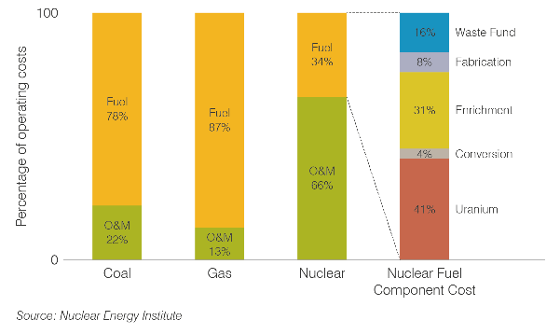

Source 193 Nuclear Energy Institute, 2017

Based on this model and calculation and assuming a burn-up rate of 45,000 MWd/tU, 1 kg uranium produces 360 000 kWh electricity, hence the fuel cost was 0.39¢/kWh in 2017. The 'back-end' of the fuel cycle, including used fuel storage or disposal in a waste repository, contributes up to 10% of the overall costs per kWh, or less if there is direct disposal of used fuel rather than reprocessing. The USD26 billion US[178] used fuel program is funded by a 0.1 cent/kWh levy.

Operation and maintenance (O&M) costs account for about 66% of the total operating cost. O&M may be divided into ‘fixed costs’, which are incurred whether or not the plant is generating electricity, and ‘variable costs’, which vary in relation to the output. Normally these costs are expressed relative to a unit of electricity (for example, cents per kilowatt hour) to allow a consistent comparison with other energy technologies.

Decommissioning costs are about 9-15% of the initial capital cost of a nuclear power plant. But when discounted over the lifetime of the plant, they contribute only a few per cent to the investment cost and even less to the generation cost. In the US they account for 0.1-0.2 cent/kWh, which is no more than 5% of the cost of the electricity produced.

In Europe, also several reports are saying that the costs of the back-end fuel cycle (radioactive waste management and decommissioning) is estimated at 1.75 – 2 EUR/MWh.

External costs are not included in the building and operation of any power plant, and are not paid by the electricity consumer, but by the community generally. The external costs are defined as those actually incurred in relation to health and the environment, and which are quantifiable but not built into the cost of the electricity. The European Commission launched a project, ExternE, in 1991 in collaboration with the US Department of Energy – the first research project of its kind "to put plausible financial figures against damage resulting from different forms of electricity production for the entire EU". The methodology considers emissions, dispersion and ultimate impact. With nuclear energy, the risk of accidents is factored in along with high estimates of radiological impacts from mine tailings (waste management and decommissioning being already within the cost to the consumer). Nuclear energy averages 0.15 euro cents/kWh, much the same as hydro; coal is over 4.0 c/kWh (4.1-7.3), gas ranges 1.3-2.3 c/kWh and only wind shows up better than nuclear, at 0.1-0.2 c/kWh average[179].

In the Nuclear Energy Technology Roadmap[180] (OECD NEA / IEA, 2015 edition), the total investment needs was calculated about 4.4 trillion USD[181] in the period of 2015 – 2050 to reach the estimated 930 GW nuclear capacity worldwide by 2050. In the EU according to PINC, for the same period to maintain the nuclear electrical production capacity between 95-105 GW, will require 660-770 billion EUR investment (including UK), where the long-term operations requires 45-50 billion EUR, the new built power reactor units contributes with 350-450 billion EUR investments and the decommissioning and spent fuel management needs 123 and 140 billion EUR.

R&I

The Research and Training Programs of the European Atomic Energy Community (2019–2020) and (2021-2025) focus on the safety of nuclear systems, radiation protection and radioactive waste management. These work programs give particular attention to innovations in the safety of reactors and in decommissioning by supporting technology transfer from the research community to industry.

For research infrastructure, the work programs launch actions aiming to maximise the safety of existing and future research reactors. The work programs also contain research topics and actions in nuclear fission to support the implementation of the Nuclear Safety Directive and other related legislation which concerns nuclear systems and safety, management of radioactive waste, spent nuclear fuel and radiation protection/low-dose risk, nuclear safeguards and security. Currently, the main areas for R&I are:

* **Harmonisation and development of common industrial standards for EU nuclear infrastructures** (conventional and future solutions) throughout their lifetime (construction, operation, decommissioning and waste management). This will allow to build a common framework for energy policies and win from economies of scale through the development of harmonised licensing processes and a competitive and sustainable nuclear supply chain. The scope to the Euratom R&I programme should be broadened in order to address future gaps between 2030-2050;
  + For example, R&I investment should be balanced between the existing fleet and new build enabling investments. Indeed, there are several refurbishment programmes in EU for LTO which require investment and innovative ways of use of supply chain. Furthermore, EU investment in SMRs R&I should be significantly increased as part of a clear strategic vision on supporting conditions for deployment in EU.
* **Safety and security of SMRs and advanced reactors (including Gen IV).** SMRs and advance reactors can play important role in the energy security, diversification and flexibility of the future low-carbon energy systems. This advanced technology would face to special challenges concerning to safety, physical protection and non-proliferation (nuclear safeguards) matters. Research activities in connection with this challenges would be very important to reach the ambitious climate goals of the EU;
* **Radioactive waste management**,including research activities on high-level waste disposal facilities, developing the appropriate model calculations to simulate the aging and its potential consequences of the waste disposal facilities and quantifying the risk and the potential harm can caused by the interim waste and spent fuel storage installations (in case of accident).

The majority of Member States operating nuclear power plants intend to dispose of their spent fuel in deep geological facilities without reprocessing. Currently, three countries have an established plan to develop geological disposal facilities. Finland is the first country in the world where the construction of a deep geological facility has begun, and is expected to be in operation in 2024. Sweden (2032) and France (2035) will also complete the construction of a deep geological facility during the next decade.

However, EU R&I in this field should not focus solely on Deep Geological Repositories (DGR). As highlighted in the latest NEA report[182], DGR projects are advancing in the EU. It would therefore be positive to broaden the scope of this research area to include options for reducing the radioactive life of the waste (e.g. transmutation), the development of new reactor technologies which generate less waste and options to recycle the waste in other industries (e.g. space applications).

Public R&I funding

In line with the Euratom Treaty, the Commission supports actions through the existing financing instruments that help improve the safe use of nuclear energy, namely nuclear decommissioning assistance programmes, research on safety and waste management and on the development of nuclear fusion energy technologies through the ITER project.

Research and innovation in nuclear energy is mainly promoted through the Euratom Research and Training Programme, which complements the EU research and innovation framework programme "Horizon Europe", providing funding to both established and new technologies. The financial support under the Euratom Research and Training Programme is dedicated only to the safety aspects of new nuclear technologies.

Nuclear safety receives the largest amount of public R&I investment among all SET Plan actions, in the order of EUR 1 billion per year. France is the major investor in nuclear safety R&I, contributing almost half of all public investment at EU level (47.5%).

Figure 199 Public R&I Investment in the EU

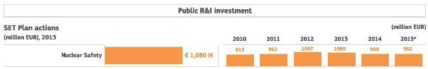

Source 194 Energy R&I financing and patenting trends in the EU, JRC, 2017

The EU also provides funding for the International Thermonuclear Experimental Reactor (ITER) project, located at Cadarache (France). It is aimed at demonstrating the feasibility of nuclear fusion as an unlimited and relatively clean source of energy. It is planned that first plasma, the point at which the ITER device is deemed operational, will be achieved by 2025. The completion of the project is foreseen for 2035.

The conclusions[183] adopted by the European Council on July 2020 secure funding for nuclear research and innovation in the instruments deployed by both the EU Recovery Plan and the Multiannual Financial Framework (MFF) 2021-2027.

Budget for Horizon Europe will be 80.9 billion euros (75.9 billion from MFF and 5 billion from the “Next Generation EU” recovery plan. The ITER project will receive funds directly from the 2021-2027 MFF, a total of 5 billion euros.

In order to support nuclear safety in Europe, a specific support coming from the MFF will be granted to the decommissioning of three nuclear power plants: 490M to Ignalina in Lithuania, 50M to Bohunice in Slovakia and 57M to Kozloduy in Bulgaria. In addition, EUR 448 million for nuclear safety and the decommissioning of the EU's own installations will be provided, for a total funding of 1045M.

Private R&I funding

In contrast, contributions to R&I from the private sector are very limited, just under 400 million euros in recent years. The majority of private R&I investment comes from the French private sector (UER 232.5 million), followed by Germany (109.5 million).

Figure 200 Private R&I Investment in the EU

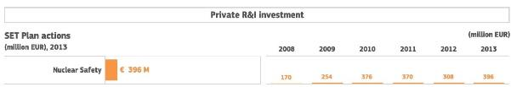

Source 195 Energy R&I financing and patenting trends in the EU, JRC, 2017

Patenting trends

In its 2017 study “Energy R&I financing and patenting trends in the EU”, the JRC assessed available patent data based on the European Patent Office PATSTAT database (EPO, 2017). This data show that patent numbers regarding nuclear safety have been increasing, from 19 in 2008 to 81 in 2013. However, they still only make up a small fraction (~1%) of the total patents in the SET Plan actions, which are 6,609. France is the EU country with a larger share of EU patents in the nuclear sector (58.7%), almost multiplying by five the number of patents in 2013 compared to 2008.

Figure 201 Trends in Patents in the EU

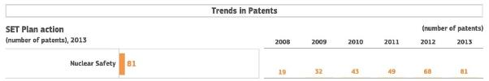

Source 196 Energy R&I financing and patenting trends in the EU, JRC, 2017

Globally, patent data should be compared using a specialisation index, based on the patenting intensity in each SET Plan action. For nuclear safety patents, it reveals that in the reference period 2007-2013 the EU is less specialised in nuclear safety and lags slightly behind the rest of the world, although the difference has reduced from -0.5 in 2007 to -0.2 in 2013.

Figure 202 Global Specialisation Index

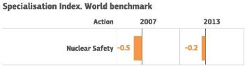

Source 197 Energy R&I financing and patenting trends in the EU, JRC, 2017

Publications / bibliometrics

The International Atomic Energy Agency (IAEA), the world's central intergovernmental forum for scientific and technical co-operation in the nuclear field, currently has available in its website 479 non-serial scientific and technical publications[184], ranging from 1960 to 2020. The most frequent topics are "nuclear power reactors", "legal affairs", "nuclear power and climate change" and "economic studies". There is also an extensive overview of nuclear accident reports.

Semantic Scholar[185] shows around 71,000 results for publications containing “nuclear energy”. There were 2,020 publications in 2019, an amount that has been stable every year for the past decade.

### Value chain analysis

Turnover

The annual turnover of the nuclear industry in the EU28 (its direct impact) is EUR 102.5 billion[186], and includes all the activities directly associated to nuclear power generation. The impact generated through suppliers in the nuclear supply chain, the expenses of the industry’s direct employees, together with the expenses of the suppliers’ employees in the EU28 economy (its indirect impact) is estimated in EUR 404.9 billion. As a result, the overall impact (direct and indirect impacts combined) of the nuclear sector on the European GDP totals 507.4 billion EUR in 2019, which represents a 3-3.5% of the EU28´s GDP. The multiplier effect of the nuclear industry in the EU28´s economy generates an indirect impact of 4 Euro and an overall impact of 5 Euro for every Euro of direct impact.

Gross value added growth

Currently, there are 13 EU countries with nuclear power generation (Belgium, Bulgaria, the Czech Republic, Germany, Spain, Finland, France, Hungary, the Netherlands, Romania, Sweden, Slovakia and Slovenia). The impact of nuclear power generation in these countries derives from both the direct contribution of the sector to GDP growth, job creation and paid taxes, and also from its indirect effects (the suppliers and employees’ contributions).

The other 14 EU countries lack nuclear power generation (Austria, Cyprus, Denmark, Estonia, Greece, Croatia, Ireland, Italy, Lithuania, Luxembourg, Latvia, Malta, Poland and Portugal). Nevertheless, there is also a positive impact deriving from nuclear power generation, due to the interconnectedness of the national economies and labour force markets. EU countries without nuclear capacities have qualified workforce and subcontractors which expertise and technologies for the nuclear industries in other member states with nuclear power, which generates both direct and indirect effects in the non-nuclear countries.

The nuclear industry has also a positive effect on the disposable household income, which is the amount of money that households have available for spending and saving after income taxes have been deduced. Currently, the nuclear industry generates a total disposable household income of 383.1 billion Euro. This amount is the sum of its direct impact in household income (employees directly working in nuclear power plants) and its indirect impact (both into the incomes of employees throughout the nuclear supply chain and the incomes of the industry’s direct employees’ and the suppliers’ employees), which amount to 106.2 billion Euro and 276.9 billion Euro respectively.

This implies that every Euro generated as direct impact of the EU28 nuclear sector generates an indirect impact of 2.6 Euro and a total of 3.6 Euro in disposable income among European households.

Finally, taxes deriving from the EU28 nuclear sector activity significantly contribute to the national budgets of EU member states. The total impact on public revenues generated through the nuclear industry amount 124.2 billion Euro, mainly composed by indirect taxes (VAT) and personal income and corporate income taxes.

The current direct impact that the nuclear industry has on state revenues through tax contributions amounts to 34.4 billion Euro, whereas the indirect impact amounts to 89.8 billion Euro. Here, for every Euro payed directly by the nuclear industry through taxes, 2.6 Euro are generated as indirect tax revenues and 3.6 Euro as total public revenues throughout the EU28.

Number of companies in the supply chain, incl. EU market leaders

At the EU level, FORATOM is the trade association for the nuclear energy industry. Its membership is made up of 15 national nuclear associations and the companies that they represent, and 3 Corporate Members, Fermi Energia (Estonia), CEZ (Czech Republic) and PGE EJ1 (Poland). Nearly 3,000 firms are represented, from large nuclear utilities and nuclear fuel cycle companies, to other companies engaged in the transport of nuclear materials and the management of radioactive waste.

Table 22 FORATOM´s Members,2020

|  |  |  |
| --- | --- | --- |
| Belgian Nuclear Forum  Bulgarian Atomic Forum  CEZ  Fermi Energia  Finnish Energy  French Nuclear Industry Association | Hungarian Nuclear Forum  Italian Nuclear Association  Nucleair Nederland  Nuclear Industry Association  PGE EJ1  Romanian Atomic Forum | Slovak Nuclear Forum  Slovenian Nuclear Forum  Spanish Nuclear Industry Forum  Swedish Atomic Forum  Swiss Nuclear Forum  Ukrainian Nuclear Forum Association |

EU market leaders in front-end nuclear activities are French companies Orano and Framatome (formerly both known as Areva). Orano processes nuclear materials and offers high value-added products and services for the entire nuclear fuel cycle, from raw materials to waste processing. Its activities, ranging from mining to decommissioning and including conversion, enrichment, recycling, logistics and engineering, contribute to the production of low-carbon electricity. Orano currently has 16,000 employees.

Framatome designs, services and installs components, fuel, and instrumentation and control systems for nuclear power plants. Its more than 14,000 employees work every day to help Framatome’s customers supply ever cleaner, safer and more economical low-carbon energy. Framatome is owned by the EDF Group (75.5%), Mitsubishi Heavy Industries (19.5%) and Assystem (5%).

Another major European company is Urenco, focused on the nuclear fuel supply chain, including mining, conversion, enrichment and fabrication. It owns and operates enrichment plants in Germany (Gronau), the Netherlands (Almelo) and the UK (Capenhurst).

During operation, most of EU´s electric utility companies operate and own nuclear facilities and play an active role in their national nuclear energy industry: For example, Electrabel (Belgium); CEZ (Chech Republic); TVO (Finland); EDF (France); MVM (Hungary); Slovenské Elektrárne (Slovakia); and Iberdrola, Endesa and Naturgy (Spain).

Regarding back-end activities, German companies GNS Gesellschaft für Nuklear-Service and Nukem Technologies are specialised in providing services in the field of radioactive waste disposal and decommissioning of nuclear facilities.

Employment figures

The nuclear industry directly creates 351,900 jobs through the industry’s performance. These jobs indirectly sustain other 777,900 jobs (suppliers in the nuclear sector and jobs created through the expenditures of both the industries’ employees and suppliers’ employees in other economic sectors). Overall, the nuclear industry accounts for 1,129,800 jobs. 47% of these jobs are considered highly skilled. In the electricity sector, the average share of highly skilled employees is considerably lower and varies between 25% and 36%.

The nuclear life cycle can be separated into three major phases. The construction phase takes approximately 10 years, and employs 9,600 workers in the EU28. The main activities during the this phase can be divided in field craft labour and field non-manual labour. The field craft labour category comprises civil, electrical, mechanical, piping and instrumentation personnel used during the installation and start-up of the units, and represents the 70-75% of the construction workforce (70-75%). The field non-manual labour comprises of field management, field supervision, field engineers, quality assurance/quality control, environmental-safety and health and administrative/clerical staff and accounts for approximately 25-30%.

Operation phase is estimated to last around 50 years and creates 258,600 jobs in the EU28 (including operation in power plants and nuclear fuel cycle). It implies engineering, materials and services, operations, maintenance, support services, training and management activities.

Finally, the decommissioning phase is usually expected to be completed after 10 years and generates 83,700 jobs. It involves project management and engineering activities that range from site restoration, environmental services and waste management services.

ProdCom statistics

Eurostat´s ProdCom database[187] includes the production value for parts of nuclear reactors (NACE code 2530). The EU27 produces a total of 102 billion euros in import value, the three leading countries being France (36 billion), Sweden (15 billion) and Finland (14 billion). On the export side, the EU27 produces a total of 68 billion euro value, led by Germany (35 billion), Czechia (9 billion) and Sweden and France (both 7 billion).

Table 23 Import and Export values of nuclear reactor parts (in thousand euros)[188]. Eurostat, 2019

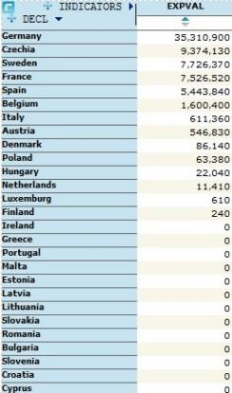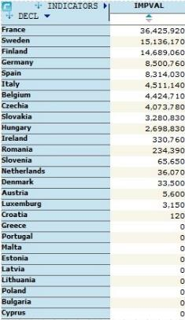

### Global market analysis

Trade (imports, exports)

Trade balance expresses the difference between the value of the exports and the imports from/in a country/region. Currently, the nuclear sector generates an annual trade surplus of 18.1 billion Euro in the EU28 (exports therefore being higher than imports), including both direct and indirect impact.

Imports include all the products and services required for the building and operation of the nuclear power plants, together with the acquisition of other goods and services for other indirect purposes (additional purchases of imported consumption products, resulting from increase in wages or additional salaries paid by the nuclear sector). Exports resulted from the nuclear activity are represented by the sales of electricity generated by the nuclear industry, but also by the indirect exports (increase of exports of manufacturing industry due to lower electricity prices).

Globally, international trade in nuclear goods is a small market. The payments for nuclear contracts include high amounts but are spread out over about many years and, above all, there are relatively very few large contracts. In 2000-10 the global export market amounted to orders for only two new reactors a year, some awarded following a call for tenders, others by mutual agreement.

A nuclear power plant comprises a pressure vessel, steam generators, piping and a control room, as well as other associated equipment to generate electricity with steam. As with any thermal power plant, it is necessary to install turbines, alternators, capacitors and such. The specifically nuclear part of a plant accounts for approximately half its cost, with the conventional part making up the rest. However, other activities must also be included, like trade in uranium, fuel, maintenance services, spare parts, reprocessing of spent fuel and waste management.

Nuclear markets are shifting from the United States and Western Europe to East Asia, the Middle East, South America, and Eastern and Central Europe. This has important implications for the global nuclear landscape after 2030. The U.S. Department of Commerce estimates the global civil nuclear market to be valued between $500 and $740 billion over the next 10 years[189].

Global market leaders VS EU market leaders

The major companies in the nuclear industry sector globally are part of the World Nuclear Association. WNA´s 181 members are responsible for virtually all of world uranium mining, conversion, enrichment and fuel fabrication; all reactor vendors; major nuclear engineering, construction, and waste management companies; and most of the world's nuclear generation. Other members also provide international services in nuclear transport, law, insurance, brokerage, industry analysis and finance.

One of the major nuclear industry companies is China General Nuclear Power Corporation (CGNPC), which operates four nuclear power plants in China, with five new nuclear power stations under construction and another two planned. With 39,000 employees worldwide, CGNPC is the largest nuclear power operator in China and the largest nuclear power constructor worldwide. It has also diversified its business to other energy sources such as wind energy, solar energy and hydropower.

Rosatom Nuclear Energy State Corporation. It is a state-owned holding company for all Russian nuclear sector, including nuclear power related companies, nuclear weapons companies, research institutes and nuclear and radiation safety agencies.

Other important nuclear companies are Tokyo Electric Power Co. (TEPCO), the largest nuclear operator in Japan, which operates three nuclear power plants; and Bruce Power (Canada), a partnership among Cameco Corporation, TransCanada Corporation, and BPC Generation Infrastructure Trust operating 8 nuclear reactors at the Bruce Nuclear Generating Station, the world's largest operating nuclear facility.

The world’s largest producer of uranium is Kazatoprom, in Kazakhstan. The company produced over 12,000 tons of uranium in 2017, 21% of the world’s uranium production. The company operates 26 deposits grouped into 13 mining assets all located in Kazakhstan.

Other main uranium mining companies are Cameco (Canada). In 2017, the company produced 9,155 tons of uranium, a 15% in the total world’s production; BHP Billiton, a British-Australian firm which owns the Olympic Dam mine which is the largest uranium deposit; and Energy Resources of Australia, a subsidiary of Rio Tinto Group, which provides 11% of the world's uranium production, operating the Ranger Uranium Mine.

When compared globally, the only main EU27 uranium producing company is Orano (France), which produced 8,031 tons of uranium, accounting for 13% of the world’s production, which mainly comes from the McArthur River and Cigar Lake mines in Canada.

For the operation phase, total energy production should be used to compare EU´s market globally. The EU27 currently has 111 active reactors out of 441 (25%), which generate 109GW out of 391GW globally (27%). However, nuclear energy in the EU27 energy mix stands at around 27% while is only 11% worldwide.

Critical raw material dependence

The main raw material dependence within the nuclear industry is uranium. In a nuclear reactor, uranium fuel is used to achieve a controlled fission chain reaction by splitting U-235 atoms. This generates heat which is used to make steam, which in turn spins a turbine to drive a generator, producing electricity.

Globally, the 441 active reactors require around 79,500 tonnes of uranium oxide concentrate which contain around 67,500 tonnes of uranium each year. Although there is an increasing fuel demand, it is balanced by an increase in efficiency. It is estimated that each GW of increased new capacity will require about 150 tU/yr of extra mine production routinely.

In 2019, mines supplied around 63,000 tonnes of uranium oxide concentrate containing 53,500 tU, an 80% of the annual needs. The rest is obtained from stockpiles of uranium. At the end of 2018, the stockpiled uranium was estimated at 280,000 tU (90,000 tU in Europe and the US, 120,000 tU in China, and 70,000 tU in the rest of Asia). As a result of the mine shutdowns caused by the COVID-19 crisis, the industry has been relying on these stockpiles, which have capped uranium prices for the last decade. However, as stockpiles are consumed, uranium price is rising from less than 24$/Lbs to current 32$/Lbs[190].

Uranium ore can be mined by several methods (underground, open-cut or in situ leaching), although before it can be used in a reactor for electricity generation it must undergo a series of processes to produce a useable fuel. It is necessary to first convert the uranium oxide into a gas (uranium hexafluoride, UF6), which enables it to be enriched. Enrichment is the process of increasing the proportion of the uranium-235 from its natural level (0.7%) to 4-5%.

After enrichment, the UF6 gas is converted to uranium dioxide (UO2) which is formed into fuel pellets. These fuel pellets are placed inside thin metal tubes, known as fuel rods, which are assembled in bundles to become the fuel elements or assemblies for the core of the reactor. In a typical large power reactor there might be 51,000 fuel rods with over 18 million pellets.

When the uranium fuel has been in the reactor for about three years, the used fuel is removed, stored, and then either reprocessed or disposed underground (see Nuclear Fuel Cycle or Radioactive Waste Management).

Uranium is present in many rocks and even in seawater, although it only constitutes an orebody when its concentration is sufficiently concentrated to be economically recoverable (considering the cost of mining and the market price of the metal). Therefore, uranium reserves are calculated as tonnes recoverable only up to a certain cost.

Kazakhstan produces the largest share of uranium from mines (43% of world supply from mines in 2019), followed by Canada (13%) and Australia (12%). Currently no EU27 country produces uranium from mines, although Spain has recently granted permission to start the building of a uranium mine in Retortillo. Other EU27 countries have plans to build uranium-mining facilities in their territories, like Finland (Rovaniemi), Slovakia (Kuriskova and Novoveska Huta) and Denmark (Greenland). Also, subsidiaries of EU27 companies operate mines in other parts of the world, like Orano Canada.

Table 24 Global production from mines (tonnes U) 2010-2019

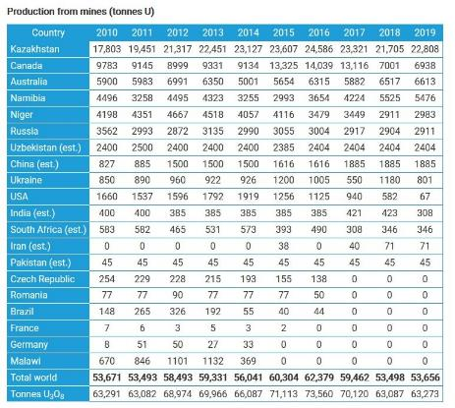

Source 198 World Nuclear Association, 2020

Australia has the largest known uranium resources (30% of the world´s resources), followed by Kazakhstan (14%) and Canada and Russia (8% each). No EU27 country has relevant uranium resources in their territory.

Finally, it should also be noted that the use of raw materials in the nuclear sector is broader than just the uranium fuel supply. Mechanical and electrical equipment make up the bulk of the nuclear island supply and will be where a lot of the R&D takes place, for example in new systems design.

Table 25 Global uranium resources (tonnes U) in 2017

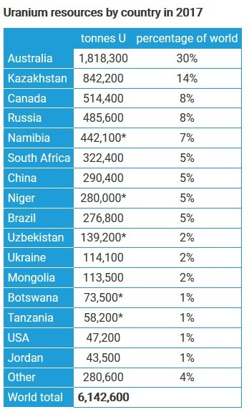

Source 199 World Nuclear Association, 2017

### Future challenges to fill technology gap

While the nuclear industry expects the overnight costs of current Gen III LWR to be reduced as series production is developed, additional innovations may be required for nuclear energy to maintain its role as a flexible, reliable and dispatchable source of energy and become the backbone of a carbon-free European energy system by 2050.

To reach the expectations by 2050, the industry has to face several challenges in the years to come. In its 2019 Technology Report[191], the IEA identified three types of innovations in which the nuclear industry is focusing to fill current technology gaps: The development of non-electric applications, the development of innovative fuels and the development of smaller reactors. Regarding each of these, the EU28 is lagging behind the rest of the world and investments and strategic planning are regarded as necessary.

Firstly, coupling reactors with non-electric applications can bring a new era to the nuclear energy industry. Nuclear energy provides low-carbon electricity, although its potential as a source of low-carbon heat is usually ignored, despite there is proven industrial experience of nuclear district heating. Coupling nuclear reactors with non-electric applications can provide policy makers with alternatives to decarbonise transport (for example, by producing hydrogen using nuclear heat and electricity), process heat applications and energy system storage.

Commercialising non-electric applications of nuclear energy faces several challenges, such as the lack of a business model that clearly defines the roles and responsibilities of nuclear plant operators and of users of nuclear heat, a lack of regulatory frameworks to oversee reactor operations and a lack of awareness among policy makers of the potential benefits of nuclear cogeneration.

Secondly, improvements in nuclear fuel design can offer additional benefits to the reactor´s performance and increased nuclear safety. These innovative fuels may incorporate new materials and designs, although further testing and validation are still needed before such fuels can be licensed. Several countries (US, Russia and China) are currently testing innovative Accident Tolerant Fuels (ATF) that could be used in all types of nuclear power plants.

Finally, small modular reactors and advanced reactors can be the perfect solution to meet future energy needs. To cope with the increasing power demand, the nuclear industry has focused in recent decades on constructing large reactors (usually 1400-1700 MW LWRs). However, smaller (300-600 MW) and more flexible reactors will be needed for certain niche markets (those with small grids, isolated communities, or large shares of renewables) to replace fossil fuel-based power plants, or even to provide low-carbon heat.

Most SMR designs of LWR technology use proven technologies, for which the supply chain can be easily adapted. The first examples of SMRs are expected to begin operating in the 2020s. Reactor technologies using other coolants (helium, sodium or molten salts), such as those developed within the Generation IV International Forum or by private companies, are also being demonstrated with prototypes in operation or under construction.

In order to tackle all these future challenges, public-private partnership and collaboration appears as the best solution. Governments should co-operate with the nuclear industry to promote the benefits of nuclear energy and its different applications, such as coupling a nuclear reactor with a non-electric application and stimulate its development.

Governments should also provide support to incentivise research in innovative fuel development and promote international R&I cooperation to facilitate prototype testing. In turn, vendors should complete this testing in both research and power reactors.

In essence, the administration and the nuclear industry should work together to promote the development of this technology, guaranteeing access to R&I financing and support, and developing efficient supply chains that can help cope with the challenges that will arise in the next decades.

## Onshore wind

### State of play of the selected technology and outlook

Onshore wind is a crucial part of the energy mix, as it is a highly cost-effective renewable technology, set to grow further as more sites are under development650. It is expected to deliver the main part of EUs renewable electricity by 2030[192]. EU onshore wind deployment in deep decarbonisation scenarios until 2050 range from about 370 GW (BNEF NEO) to 759 GW (LTS 1.5TECH)[193]. Deploying and integrating this amount of wind energy will bring about both environmental benefits and economic opportunities; stimulating research and innovation is key in this regard.

Capacity installed, generation

The cumulative installed capacity of wind energy globally grew from 198 GW in 2010 to about 591 GW in 2018. Since 2015, the majority of global installed capacity is located in China (36% in 2018), followed by the EU28 (30%) and the US (16%)[194]. The global wind power industry is expected to install more than 600 GW of new capacity over the next ten years, becoming a market worth EUR 77 billion in 2019 to EUR 1 trillion over the next decade[195].

In 2019, the EU28 installed 12.2 GW of wind power capacity, bringing its cumulative wind power capacity to 191.5 GW[196]. Based upon the ambitions set in European Member States’ National Energy and Climate Plans (NECPs), in 2030 the installed capacity of EU27 should be 268.4 GW.

Cost, LCOE

In the last five years, the costs of both onshore and offshore wind decreased by more than 50%, as a result of larger turbines which allow for better energy capture, better resiliency and reliability[197]; CAPEX/OPEX savings; global supply chain efficiencies; and competitive procurement mechanisms[198]. Until 2020, JRC shows onshore wind CAPEX values in a range between 1000 EUR/kW and 1800 EUR/kW depending on the region. With increasing competition such as for example the introduction of competitive auctions in Europe, a further drop in CAPEX values to about 960 EUR/kW to 1570 EUR/kW is expected until 2040[199].

According to WindEurope data, the LCOE of onshore wind will decrease from 40 EUR/MWh in 2019, to 26 EUR/MWh in 2030, to 19 EUR/MWh in 2050. BNEF estimates the LCOE of onshore wind in EU countries between 24 and 55 EUR/MWh, depending on for example location and financing conditions[200].

Cost assumptions on onshore wind within the PRIMES model see investment costs dropping to about 850 EUR/kW until 2050. According to WindEurope data, investment costs are expected to decrease from 1300 EUR/kW in 2019, to 1000 EUR/kW in 2030, to 850 EUR/kW in 2050[201].

R&I

There was around 3.5 times more investment in onshore wind than in offshore wind[202]. By far the largest investment area is turbines, in which Europe has a share of about 25%. There is a smaller split in private versus public investment in Europe when compared to the rest of the world[203].

Besides its offshore wind-related R&I priorities (Offshore BoP and Floating Offshore wind), ETIPWind sees the need to stimulate wind R&I in the areas of grid system integration (e.g. integrated forecasting, energy storage or hybrid solutions), operation and maintenance (e.g. digitalisation, condition monitoring, automated inspection methods), next generation technologies (e.g. recycling of components, sustainable materials and manufacturing processes) and skills & human resources. Similarly, IEA Wind Technology Collaboration programme defines the following main challenges in the science of wind energy which are applicable to both the onshore and offshore sector [204] [205] [206]: improved understanding of atmospheric and wind power plant flow physics; aerodynamics, structural dynamics, and offshore wind hydrodynamics of enlarged wind turbines; systems science for integration of wind power plants into the future electricity grid. According to WindEurope, R&I efforts in onshore wind should be directed towards cost reduction and to increasing the value of onshore wind energy. This involves scaling up wind turbine manufacturing, transportation and installation; innovation to reduce noise and visual impacts improving circularity and recyclability of components and materials; enhancing the digitalisation of wind and the energy sector; and increasing automation in operations and maintenance.

Public R&I funding

The share of European Public R&D support for wind energy has dropped from 58% in 1998 to 39% in 2018. In 2018, Member States funding for wind energy R&D totalled EUR 215 million, the European Commission contributed another EUR 70 million[207].

EU public investment has remained roughly constant around EUR 180-200 million per year over the past six years. Japan is by far the largest investor, followed by the US, Germany and the UK. Total EU investment over the past 3 years totalled EUR 583 million, which is slightly more than Japan’s figure. Seven out of the ten top countries where these investments occurred are in the EU[208].

Figure 203 EU Public RD&D investments in the Wind Value Chain

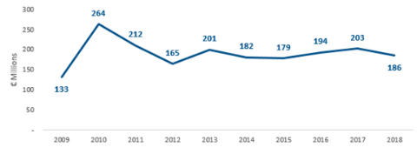

Source 200 ICF, commissioned by DG GROW - Climate neutral market opportunities and EU competitiveness study (Draft, 2020). Original source: IEA

Figure 204 Top 10 Countries – Public RD&D Investments (Total 2016-2018)

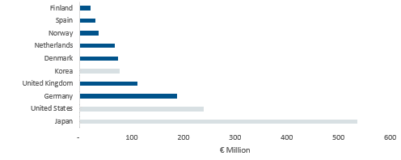

Source 201 Climate neutral market opportunities and EU competitiveness – wind rotors value chain analysis, commissioned by DG GROW. Original source: IEA

Private R&I funding

Generally, about 90% of R&D funding in wind energy comes from the corporate sector, which in Europe is concentrated in Germany, Denmark and Spain as leading OEMs concentrate their industry and value chain there[209]. In 2019 the European wind industry invested EUR 1.9 billion, the equivalent of 5.1% of its contribution to GDP (gross value added), on R&D[210].

Patenting trends

There were 1,176 wind energy patents registered in Europe in the year 2019. The amount of cumulative patents held by European companies is more than 12,000[211]. The largest amount of patent applications is being done in the onshore wind turbine segment, with a European share of 15%, which is slightly smaller than for offshore wind. Even though the EU has a lower patenting activity than China, patents by EU-based entities are filed in multiple patent offices worldwide, while Chinese entities aim for protection in China only. Thus, the EU has the highest specialisation index (indicating the patenting intensity) in wind energy compared to the rest of the world (see also Figure 29 in the offshore wind energy section)[212]. In 2016, Europe was still leading in the field of patent applications, especially in the wind rotor sector, which filed 67% of the high value patent applications between 2014 and 2016[213].

Publications / bibliometrics

At country level, bibliometric searches on wind turbine blades identified the United States and China leading in publishing activity in the area of blades, followed by the UK, Denmark and Germany. However, the entire EU28 top up the US and China in terms of publication counts in the period 1996-2016 by more than 40%[214] (see below)

Figure 205 EU28 and main competitors publishing on wind turbine blades, 1996-2016

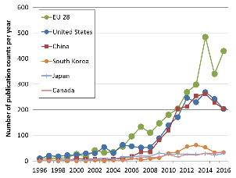

Source 202 JRC 2018, Monitoring scientific collaboration trends in wind energy components: Bibliometric analysis of scientific articles based on TIM, EUR 29305 EN, Luxembourg

Considering research publications and institutions, the US is a dominant player, followed by the EU[215].

### Value chain analysis

Since the value chains of onshore and offshore wind largely overlap, this section presents onshore wind-specific information. The value chainanalysis in the offshore wind energy chapter discusses the shared parts of the wind value chain.

The onshore wind value chain consists of various segments, including turbines (40%); support structures or foundations (2%); logistics/installations (7%); balance of systems (9%); engineering, procurement and construction (EPC) (7%); and deployment (35%)[216].

100% of onshore turbines with rated capacity of 4 MW and more are European[217].

For the onshore wind sector, the largest share of the Gross Value Added (GVA) is captured by the turbine manufacturing segment, where the EU relatively captures a higher share than in the other segments[218].

Figure 206 Breakdown of GVA throughout onshore wind value chain

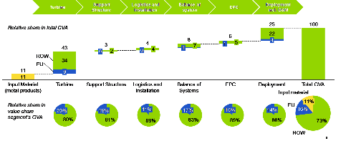

Source 203 Guidehouse Insights (2020)

Currently, many markets are recovering from the COVID-19 pandemic and adjusting to a new normal of intense price competition. The US and China for example, are experiencing rapid near-term increases of capacity additions. Despite the similarities in total shipments, turbine technology improvements have a direct impact on nacelle, blade and tower dimensions, therewith placing additional stress on turbine transport requirements. Similarly, turbine repowering activity further increases the number of large-scale components being transported during this peak demand period, placing additional stress on the transport industry. A more ‘distributed’ supply chain allows for some logistics optimisation as more suppliers usually means more sourcing locations[219].

Figure 207 Turbine fleet age structure in leading countries for land-based wind energy

|  |  |  |  |  |  |  |
| --- | --- | --- | --- | --- | --- | --- |
|  | Denmark | Germany | Spain | EU28 | US | China |
| Cumulative capacity installed in 2019 (GW) | 4.4 | 53.2 | 23.5 | 160.7 | 97.7 | 206.8 |
| Share of cumulative capacity |  |  |  |  |  |  |
| > 10 years | 55% | 43% | 73% | 39% | 34% | 7% |
| > 15 years | 53% | 26% | 27% | 17% | 6% | 0.4% |
| > 20 years | 23% | 4% | 3% | 3% | 1% | 0.2% |

Source 204 GWEC (Global Wind Council Energy). Global wind energy report 2018. 1–61 (2019); Uihlein, A., Telsnig, T. & Vazquez Hernandez, C. JRC Wind Energy Database, Joint Research Centre. (2019)

Turnover

Total revenues of the European wind industry amounted to EUR 86.1 billion in 2019. Direct revenues of the wind industry totalled EUR 59.6 billion in 2019. Of this at least EUR 30.5 billion is directly from onshore wind developers and onshore OEMs. In 2019 the revenue of onshore OEMs was EUR 16.3 billion. The combined revenue of the onshore/offshore component supply chain amounted to EUR 10 billion[220].

Figure 208 Turnover and Employees of large EU energy companies

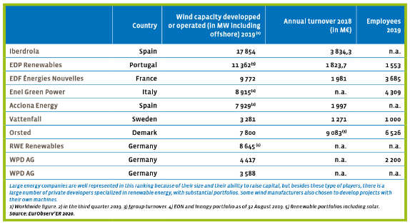

Source 205 Eurobserv’ER 2020

Gross value added growth

In 2019 the direct GVA of onshore OEMS was EUR 5.1 billion. The combined onshore/offshore component supply chain created another EUR 2.2 billion[221].

Total Gross Value Added of the European wind industry amounted to EUR 37.2 billion to EU GDP in 2019. Activity within the wind energy industry include onshore and offshore wind energy developers, turbine manufacturers, component manufacturers, service providers, and offshore wind energy substructures. Direct Gross Value Added by the wind industry was EUR 22.8 billion in 2019.

Of this at least EUR 13.8 billion is directly from onshore wind developers and OEMs (as compared to EUR 3.6 billion stemming from offshore wind developers, offshore OEMs and offshore wind energy substructures)[222].

Figure 209 Gross Value Added of the European wind energy industry, dark blue is direct, light blue is indirect

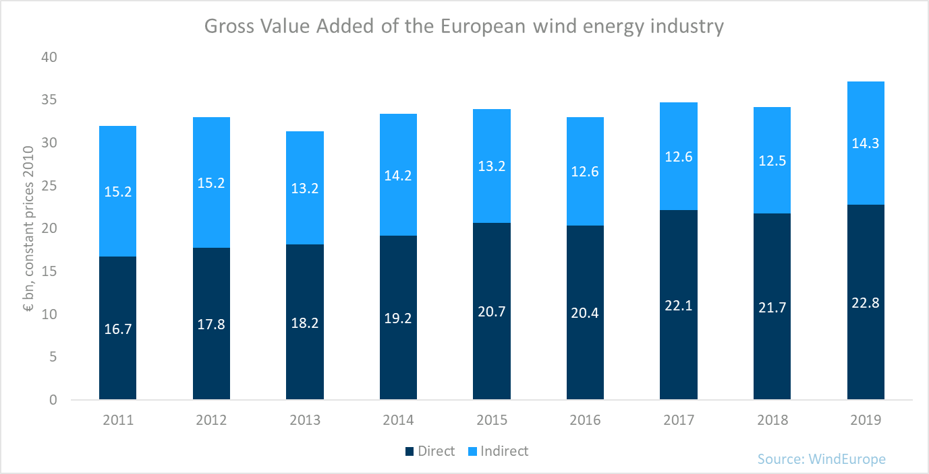

Source 206 WindEurope

Number of companies in the supply chain, incl. EU market leaders

There are 248 operational manufacturing facilities in Europe (30% of all facilities). 155 facilities are dedicated to onshore wind and a further 66 supply to both onshore and offshore wind. Onshore wind projects necessitate large investments with strong pricing competition, which drives down margins. As a consequence, economies of scale provide a competitive advantage, meaning that the incumbents of the established industry create an adverse environment for newcomers throughout the value chain: in 2019, only 15 start-ups received private funding. 40% of these companies were headquartered in the EU27[223].

Employment figures

The deployment value chain has the largest number of employees, both in Europe and the rest of the world. The share of jobs that Europe has in onshore wind energy is significant compared to the rest of the world: in 2019 the European onshore wind industry provided for 224,000 jobs, of which 122,500 direct FTEs. In 2019 onshore wind accounted for 75% of all jobs in the wind industry675. Member States that employ the most are Germany, Spain and Denmark[224].

Figure 210 Employment in Wind Energy, 2017

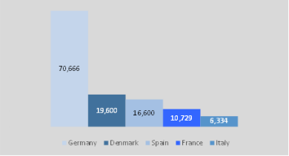

Source 207 EU Global Leadership in Renewables: Progress Report (2020)

Figure 211 Jobs in the European wind industry (in FTEs), dark blue is onshore, light blue is onshore

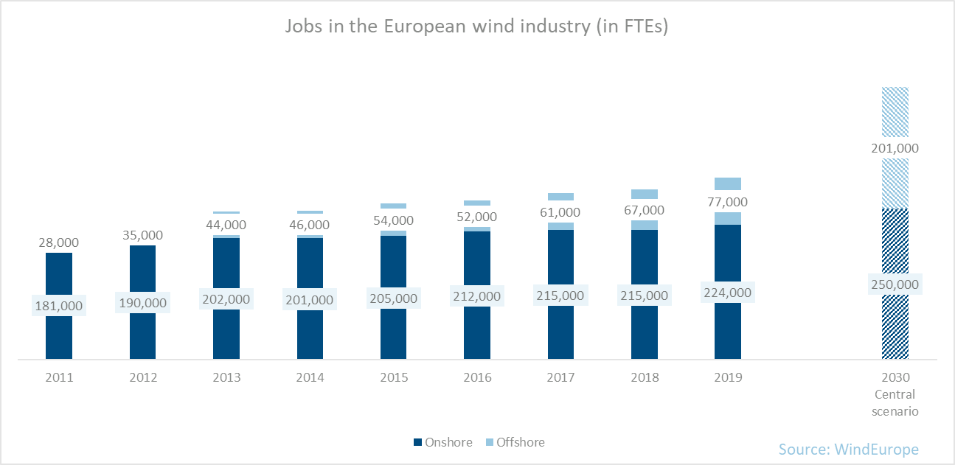

Source 208 WindEurope, Local Impact Global Leadership (2017) and updated information by WindEurope in August 2020

### Global market analysis

In 2019, the EU27 installed 10.8 GW of wind capacity (of which 8.9GW were installed onshore), China 26.2 GW (23.8 GW onshore), and the United States 9.1 GW (all onshore). The share of the EU-27 market size in 2019 in relation to the global market is 17.9% (onshore 16.5%)[225],[226]; its market for onshore wind is expected to grow from EUR 25.3 billion in 2002 to EUR 35.4 billion in 2030 at a CAGR of 3.4% during this period[227].

In emerging markets such as Asia, the market for wind energy is growing and therewith the outsourcing of blades to independent suppliers is becoming more popular among Original Equipment Manufacturers (OEMs) because it offers more flexibility in supply. Asian independent suppliers lead the global market for blades, power converters and towers, while the European independent suppliers lead in control systems685.

In 2019, the installed capacity in China grew with 12% to 236 GW[228],[229]. The Chinese government announced that as of 2021, onshore wind electricity feed-in tariffs could no longer exceed those of electricity produced in coal-fired plants because the Chinese wind energy sector would be mature enough[230].

Despite increasing globalisation of the onshore wind power business, some manufacturers are still mainly active in their home markets and a few neighbouring countries in the same region. Others are more broadly represented across many markets. This situation is most notable when examining the Chinese wind market and its domestic wind OEMs[231]. Chinese manufacturers are strongly consolidated in their home market, only allowing foreign manufacturers a penetration below 5% since 2013 of the new wind capacity installed in recent years, down from over 13% in 2010[232].

Figure 212 Market shares and origin of wind OEMs in the Chinese wind energy market

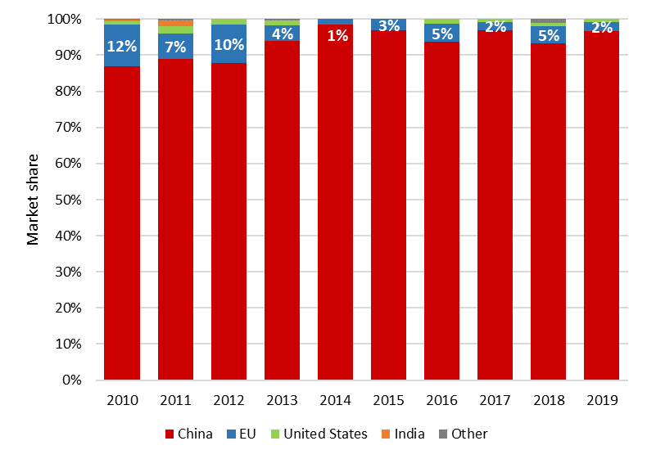

Figure 213 JRC analysis based on Chinese Wind Energy Association (CWEA) and BNEF

Due to adjustments to more competitive policy environments and reductions or eliminations of subsidies, some countries with mature wind markets are facing stagnating or declining growth. This slow market growth is being offset by increasing wind power development in emerging wind power markets, mostly countries in Asia Pacific, Latin America, the Middle East, Africa and non-traditional markets in Europe684.

Trade (imports, exports)

The European wind industry is a net exporter of wind turbine technology and equipment. In 2019, net exports of this equipment totalled €1.8 billion. In total, 2019 wind energy related gross exports amounted to EUR 8.25 billion[233].

Between 2009 and 2018, EU-28 exports increased steadily, reaching EUR 2.32 billion in 2018. Conversely, imports have remained constant between EUR 0.03 billion and EUR 0.17 billion over the same period. The EU28 share of global exports increased from 28% in 2016 to 47% in 2018. Top EU exporters are Denmark, Germany, and Spain. Between 2016 and 2018, 8 out of the top 10 global exporters were EU countries. Key rest of the world (RoW) competitors are China and India. Between 2016 and 2018, the largest RoW importers were Mexico, Turkey, Chile and Pakistan[234].

Global market leaders VS EU market leaders

Europe is a recognised market leader in the wind energy, with 48% of the companies headquartered here. Top EU exporters are Denmark, Germany and Spain. Key competitors for the EU as China and India. Between 2016 and 2018, the largest importers were Mexico, Turkey, Chile and Pakistan[235].

Critical raw material dependence

The section on offshore wind (3.2.1.4) addresses the critical raw materials dependence of onshore and offshore wind technologies.

### Future challenges to fill technology gap

Onshore wind investments are rising steadily, but deploying a total installed onshore wind capacity of 759 GW (LTS 1.5TECH scenario) in the EU by 2050, and more than 5000 GW globally, would require annual investments of more than twice the current investment level. Currently, the biggest part of investments is directed towards the installation on new wind power capacities, leaving a virtually insignificant share for the replacement of retired installed capacities. This highlights the need to direct a bigger part of investment to decommissioning and replacing wind capacities at the end of their life cycle. As of 2040, more than one third of total onshore wind investment will be needed to replace existing capacities with advanced technologies[236]. Besides, third party financing of wind turbines often requires developers to minimise risk with proven technologies, which limits flexibility and the amount of new technologies that become commercial[237].

1. Glassley W.E. (2018), ‘Geology and Hydrology of Geothermal Energy’. In: Bronicki LY (ed): ‘Power Stations Using Locally Available Energy Sources: A Volume in the Encyclopedia of Sustainability Science and Technology Series’, Second Edition. Springer New York, NY, US
2. JRC (2020). Low Carbon Energy Observatory: Geothermal Energy – Technology Development Report 2020, forthcoming.
3. Limberger J, Boxem T, Pluymaekers M, Bruhn D, Manzella A, Calcagno P, Beekman F, Cloetingh S and van Wees JD: Geothermal energy in deep aquifers: A global assessment of the resource base for direct heat utilization. Renewable and Sustainable Energy Reviews 82 (961–975).
4. van Wees J-D, Boxem T, Angelino L and Dumas P (2013): A prospective study on the geothermal potential in the EU. Geoelec.
5. JRC (2019). Low Carbon Energy Observatory: Geothermal Energy – Technology Market Report 2018
6. European Commission (2018). IN-DEPTH ANALYSIS IN SUPPORT OF THE COMMISSION COMMUNICATION COM(2018) 773 A Clean Planet for all A European long-term strategic vision for a prosperous, modern, competitive and climate neutral economy.
7. European Commission (2018). IN-DEPTH ANALYSIS IN SUPPORT OF THE COMMISSION COMMUNICATION COM(2018) 773 A Clean Planet for all A European long-term strategic vision for a prosperous, modern, competitive and climate neutral economy.
8. European Technology Platform on Renewable Heating, Common Vision for the Renewable Heating and Cooling Sector in Europe, 2011
9. EGEC (2020). Geothermal market report 2019, European Geothermal Energy Council.
10. IEA (2019). World Energy Outlook 2019. International Energy Agency
11. IEA (2019). World Energy Outlook 2019. International Energy Agency
12. IEA (2019). World Energy Outlook 2019. International Energy Agency
13. EGEC (2020). Geothermal market report 2019, European Geothermal Energy Council.
14. Miranda-Barbosa, E., Sigfússon, B., Carlsson, J. and Tzimas. E, (2017), ‘Advantages from Combining CCS with Geothermal Energy’, Energy Procedia, Vol. 114, pp. 6666–6676.
15. Limberger, J., Calcagno, P., Manzella, A., Trumpy, E., Boxem, T., Pluymaekers, M.P.D. and van Wees J.D. (2014), ‘Assessing the prospective resource base for enhanced geothermal systems in Europe’, Geothermal Energy Science, Vol. 2, No 1, pp. 55–71.
16. EGEC (2020). Geothermal market report 2019, European Geothermal Energy Council.
17. EGEC (2020). Geothermal market report 2019, European Geothermal Energy Council.
18. 58.5 EUR/MWh (1 USD = 0.85 EUR).
19. IRENA (2019), Global energy transformation: The REmap transition pathway (Background report to 2019 edition).
20. BNEF (2016). Annex, M., Robertson, D. H., Alves, L. C. R., Castro, L., Kawahara, T., and Taylor, M. 2016 Geothermal Market Outlook, Bloomberg New Energy Finance.
21. JRC (2018), Tsiropoulos, I., Tarvydas, D., Zucker, A., ‘Cost development of low carbon energy technologies’, Publications Office of the European Union, Luxembourg, EUR 29034 EN.
22. Micale, V, Oliver, P, and Messent, F, (2014), ‘The Role of Public Finance in Deploying Geothermal: Background Paper’, Climate Policy Initiative, San Giorgio Group Report.
23. Clauser, C. and Ewert, M. (2018), ‘The renewables cost challenge: Levelized cost of geothermal electric energy compared to other sources of primary energy – Review and case study’, Renewable and Sustainable Energy Reviews, Vol. 82, No 3, pp. 3683–3693.
24. EGEC (2020). EGEC contribution (DRAFT CERIO 30 June)
25. EGEC (2020). EGEC contribution (DRAFT CERIO 30 June)
26. JRC (2020). Low Carbon Energy Observatory: Geothermal Energy – Technology Development Report 2020, forthcoming.
27. Data source: Joint Research Centre (JRC) based on data from the European Patent Office (EPO). Private investments are estimated from patent data available through PATSTAT database 2019 autumn version (JRC update: December 2019) following methodology in Pasimeni, F., Fiorini, A., and Georgakaki, A. (2019), ‘Assessing private R&D spending in Europe for climate change mitigation technologies via patent data’, World Patent Information, Vol. 59, 101927
28. JRC (2020). Low Carbon Energy Observatory: Geothermal Energy – Technology Development Report 2020, forthcoming.
29. JRC (2017), Fiorini, A., Georgakaki, A., Pasimeni, F. and Tzimas, E., ‘Monitoring R&I in Low-Carbon Energy Technologies’, Publications Office of the European Union, Luxembourg, EUR 28446 EN.
30. Pasimeni, F. (2019), ‘SQL query to increase data accuracy and completeness in PATSTAT’, World Patent Information, Vol. 57, pp. 1-7.
31. Pasimeni, F., Fiorini, A., and Georgakaki, A. (2019b), ‘Assessing private R&D spending in Europe for climate change mitigation technologies via patent data’, World Patent Information, Vol. 59, 101927.
32. EurObserv’ER (2019). 19th annual overview barometer.
33. EGEC (2020). EGEC contribution (DRAFT CERIO 30 June)
34. JRC (2017) Magagna D, Telsnig T, Uihlein A, Shortall R and Vázquez Hernández C: Supply chain of renewable energy technologies in Europe: An analysis for wind, geothermal and ocean energy. Publications Office of the European Union, Luxembourg.
35. JRC (2017) Magagna D, Telsnig T, Uihlein A, Shortall R and Vázquez Hernández C: Supply chain of renewable energy technologies in Europe : An analysis for wind, geothermal and ocean energy. Publications Office of the European Union, Luxembourg.
36. Goldstein AH and Braccio R (2014): 2013 Market Trends Report. Geothermal Technologies Office. U.S. Department of Energy (DoE).
37. BNEF (2018). Company Ranking: Geothermal Turbine Makers 2017. Bloomberg New Energy Finance (BNEF), London.
38. EGEC (2018). 2017 Geothermal Market Report, European Geothermal Energy Council.
39. Angelino L, Spencer S and Gindre C (2016): Support schemes for geothermal heat pump technology: What key successful factors ? European Geothermal Congress 2016 (1–2).
40. JRC (2017) Magagna D, Telsnig T, Uihlein A, Shortall R and Vázquez Hernández C: Supply chain of renewable energy technologies in Europe: An analysis for wind, geothermal and ocean energy. Publications Office of the European Union, Luxembourg.
41. EurObserv’ER (2018). Heat pumps barometer. EURObserv’ER.
42. EurObserv’ER (2019). 19th annual overview barometer.
43. EGEC (2020b). EGEC contribution (DRAFT CERIO 30 June)
44. EGEC (2020b). EGEC contribution (DRAFT CERIO 30 June)
45. JRC (2019). Low Carbon Energy Observatory: Geothermal Energy – Technology Market Report 2018.
46. CEMAC (2016) Akar S: Geothermal Power Plant Turbines: First Look at the Manufacturing Value Chain. Accessed: 11/28/2016. URL: <http://www.manufacturingcleanenergy.org/blog-20160523.html>
47. EGEC (2020). EGEC contribution (DRAFT CERIO 30 June)
48. JRC (2020). Low Carbon Energy Observatory: Geothermal Energy – Technology Development Report 2020, forthcoming.
49. JRC (2020). Low Carbon Energy Observatory: Geothermal Energy – Technology Development Report 2020, forthcoming.
50. Reactive power is power that does not contribute to the effective real power transmitted (active power), but it is the extra power that needs to be spent (and lost) to transfer active power over the network due to the physical and electrical characteristics of AC transmission. Since in HVDC, the voltage is constant, reactive power is not generated (and lost). Only two conductors are needed (or even one conductor if the ground or the sea is used as return) for HVDC compared to the three conductors traditionally used for HVAC.
51. Later changed to be the first multiterminal link
52. Largest mercury-arc valves ever made. The mercury-arc valves since replaced by Thyristors.
53. First HVDC scheme order with thyristors, although operation was delayed. First to use a DC voltage greater than 500 kV. First HVDC link in Africa.
54. First HVDC Link in China
55. 3-terminal HVDC system in parallel to and AC interconnection. Switching devices IEGT/IGBT.
56. 5-terminal HVDC system. Provides voltage support to the existing ±50 kV 60 MW LCC-HVDC system on

    Sijiao island to prevent commutation failure.
57. Cascaded 2-Level converters
58. PROMOTioN (PROgress on Meshed HVDC Offshore Transmission Networks)
59. MIGRATE (**M**assive **I**nte**GRAT**ion of power **E**lectronic devices
60. ETIP SNET (2020). R&I Roadmap 2020-2030
61. IEA (2019). World energy investment <https://www.iea.org/reports/world-energy-investment-2019>
62. ETIP SNET (2018), Presentation of recent and ongoing R&I projects in the scope of the ETIP SNET. <https://www.etip-snet.eu/wp-content/uploads/2018/11/Project_monitoring_Part1-Final-1-1.pdf>
63. ICF (2018). Assessment of the Potential for High-Voltage Direct Current Transmission to Mitigate the Impacts of Non-Dispatchable Generation technologies. <https://www.eia.gov/analysis/studies/electricity/hvdctransmission/pdf/transmission.pdf>
64. Google patents (2020)
65. Navigant (2020) - International Strategic Partnerships in Energy
66. Growth rates in this chapter are reported as Compounded Annual Growth Rates (CAGR)
67. Guidehouse Insights (2020) Advanced Transmission & Distribution Technologies Ovierview. Retrieved at <https://guidehouseinsights.com/reports/advanced-transmission-and-distribution-technologies-overview>
68. EU energy models (e.g. Primes) do not model HVDC separately and therefore no longer-term figures are available, but it is clear that the HVDC market is expected to grow consistently in particular with the growth of the offshore energy market.
69. Global Industrial Analysts, Inc., retrieved at <https://www.strategyr.com/market-report-hvdc-transmission-forecasts-global-industry-analysts-inc.asp>
70. UHVDC is particularly interesting to transport electricity over very long distances, which is less important in the EU. UHVDC is also less attractive in the EU as permitting is more difficult, for example because cable towers are higher than normal high-voltage transmission cable towers.
71. In comparison: turnkey HVAC systems are often delivered by engineering, procurement, and construction firms.
72. Guidehouse Insights (2020) Advanced Transmission & Distribution Technologies Ovierview. Retrieved at <https://guidehouseinsights.com/reports/advanced-transmission-and-distribution-technologies-overview>
73. Prysmian, Nexans, and NKT Cables are the three major European cable companies
74. Key technologies in this area are for example grid forming converters and DC Circuit Breakers
75. T&D world (2018).
76. National Renewable Energy Laboratory (2013). Economic Development from New Generation. <https://www.nrel.gov/docs/fy13osti/57411.pdf>
77. Guidehouse analysis of UN COMTRADE
78. European Commission: JRC Report <https://rmis.jrc.ec.europa.eu/?page=crm-list-2017-09abb4>
79. Critical Raw Materials Resilience: Charting a Path towards greater Security and Sustainability, COM(2020)404, p3, https://ec.europa.eu/docsroom/documents/42849
80. R. Nagarajan, Infineon Technologies, DC-Hybrid grid round table, 2018 <https://ec.europa.eu/energy/sites/ener/files/documents/nagarajan_infineon_dc_grids_final.pdf>
81. Studies have proposed the very high continuous power capacity HTS DC cable system in the range of 5 to 20 GW at 200 kV
82. IPCC special report on renewable energy sources and climate change mitigation. Chapter 5, Hydropower. Intergovernmental Panel on Climate Change. 2011. Cambridge University Press, UK & New York NY, USA.
83. Kougias, I.. Low Carbon Eenegry Observatory, *Hydropower Technology Development Report 2018*, EUR 29912 EN, European Commission, Luxembourg, 2019, ISBN 978-92-76-12437-5, <https://doi.org/10.2760/49932>, JRC 118316.
84. European Commission (2018). IN-DEPTH ANALYSIS IN SUPPORT OF THE COMMISSION COMMUNICATION COM(2018) 773 A Clean Planet for all A European long-term strategic vision for a prosperous, modern, competitive and climate neutral economy.
85. European Commission. Communication *Stepping up Europe’s 2030 climate ambition.* 2020. Brussels. Accompanying document available [here](https://ec.europa.eu/transparency/regdoc/rep/10102/2020/EN/SWD-2020-176-F1-EN-MAIN-PART-2.PDF).
86. Kougias, I., & Szabó, S. Pumped hydroelectric storage utilization assessment: Forerunner of renewable energy integration or Trojan horse? *Energy*. 2017 140, 318-329.
87. IHA. Hydropower Status Report 2020. International Hydropower Association. London, United Kingdom: 2020.
88. Eurostat. Energy statistics - Supply, transformation and consumption of electricity - annual data 2019.
89. IRENA. Renewable Power Generation Costs in 2019. International Renewable Energy Agency. Abu Dhabi, UAE: 2020.
90. IRENA. Renewable Power Generation Costs in 2019. International Renewable Energy Agency. Abu Dhabi, UAE: 2020.
91. Kougias I et al.. Analysis of emerging technologies in the hydropower sector. *Renewable and Sustainable Energy Reviews.* 2019 Oct; 113, 109257. https://doi.org/10.1016/j.rser.2019.109257
92. Kougias, I.. Low Carbon Eenegry Observatory, *Hydropower Technology Development Report 2018*, EUR 29912 EN, European Commission, Luxembourg, 2019, ISBN 978-92-76-12437-5, <https://doi.org/10.2760/49932>, JRC 118316.
93. Pasimeni, F et al. (2018): SETIS Research & Innovation country dashboards. European Commission, Joint Research Centre (JRC), <http://data.europa.eu/89h/jrc-10115-10001>.
94. IEA. International Energy Agency RD&D Online Data Service. Available from: <http://www.iea.org/statistics/RDDonlinedataservice/>
95. This is equivalent to EUR 14.3 million and EUR 29.4 million, respectively (1 USD = 0.84 EUR).   
    Water Power Technologies Office Budget. Detailed information available [here](https://www.energy.gov/eere/water/water-power-technologies-office-budget#:~:text=Trump's%20FY%202021%20DOE%20Budget,and%20marine%20and%20hydrokinetic%20energy).
96. This is equivalent to EUR 14.3 million and EUR 29.4 million, respectively (1 USD = 0.84 EUR).   
    Water Power Technologies Office Budget. Detailed information available [here](https://www.energy.gov/eere/water/water-power-technologies-office-budget#:~:text=Trump's%20FY%202021%20DOE%20Budget,and%20marine%20and%20hydrokinetic%20energy).
97. Kougias I, Low carbon Eenergy Observatory, Hydropower Technology Development Report 2019, European Commission, Ispra, 2020, JRC120763.
98. EurObserv’ER. The State of Renewable Energies in Europe. 19th EurObserv’ER Rep 2019:153.
99. Kougias, I.. Low Carbon Eenegry Observatory, *Hydropower Technology Development Report 2018*, EUR 29912 EN, European Commission, Luxembourg, 2019, ISBN 978-92-76-12437-5, <https://doi.org/10.2760/49932>, JRC 118316.
100. Kougias I et al.. Analysis of emerging technologies in the hydropower sector. *Renewable and Sustainable Energy Reviews.* 2019 Oct; 113, 109257. https://doi.org/10.1016/j.rser.2019.109257
101. Pasimeni, F et al. Assessing private R&D spending in Europe for climate change mitigation technologies via patent data’, *World Patent Information*. 2019, 59, 101927. doi: 10.1016/j.wpi.2019.101927
102. Fiorini, A et al. *Monitoring R&I in Low-Carbon Energy Technologies*, EUR 28446 EN, European Commission, Luxembourg, 2017, ISBN 978-92-79-65591-3, doi: 10.2760/434051, JRC 105642.
103. ISI Web of Knowledge. Available at: jcr.clarivate.com. The search considered the topics (TS) of hydropower and hydroelectric technologies, covering the different possible spellings.
104. EurObserv’ER. The State of Renewable Energies in Europe. 19th EurObserv’ER Rep 2019:153.
105. DNV, GL. "The Hydropower sector’s Contribution to a sustainable and prosperous Europe." (2015).
106. Hydropower & Dams, 2020. Hydropower & Dams - World Atlas. Int. J. Hydropower Dams.
107. EurObserv’ER. The State of Renewable Energies in Europe. 19th EurObserv’ER Rep 2019:153.
108. IRENA. Renewable Energy and Jobs Annual Review 2019. International Renewable Energy Agency. Abu Dhabi, UAE: 2019.
109. DNV, GL. "The Hydropower sector’s Contribution to a sustainable and prosperous Europe." (2015).
110. Eurostat, 2020. Sold production, exports and imports by PRODCOM list (NACE Rev. 2) - annual data. Data is available online at: <https://ec.europa.eu/eurostat/web/prodcom/data/database>
111. International Trade Center (ITC). Trade statistics for international business development 2020.
112. International Trade Center (ITC). Trade statistics for international business development 2020.
113. International Trade Center (ITC). Trade statistics for international business development 2020.
114. McCoy power reports (2018). Hydro Turbines and generators 12M’17 Report. Available online at: https://www.mccoypower.net/products
115. Whitehead M and Albertani R. How Composite Materials Can be Used for Small Hydro Turbines (2015). Hydro Review, Vol 34(2).
116. Strategic long-term vision for a climate-neutral EU by 2050, European Commission, 28.11.2018, https://ec.europa.eu/clima/policies/strategies/2050_en
117. Industrial Waste Heat Recovery: Potential Applications, Available Technologies and Crosscutting R&D Opportunities”, Oak Ridge National Laboratory Report, ORNL/TM-2014/622 - https://info.ornl.gov/sites/publications/files/Pub52987.pdf
118. Powering a climate-neutral economy: An EU Strategy for Energy System Integration, 8 July 2020, COM(2020)299final, p8. https://ec.europa.eu/energy/sites/ener/files/energy_system_integration_strategy_.pdf
119. The Commission considers inside-factory processes very important for the Green Deal as is made clear in the New Industrial Strategy for Europe (COM(2020) 102 final, section 2.2 and 3.3), and support for R&I in this area is a priority for the European Commission. It is addressed by specific programmes under the Horizon 2020 programme (notably the Sustainable Process Industries through Resources and energy Efficiency (SPIRE) private public partnership, which is expected to continue under Horizon Europe) and Horizon Europe programme. But it is beyond the scope of this report that focuses on energy technologies.
120. <https://cordis.europa.eu/project/id/680738>
121. the critical point of CO2 is reached at 74 bar and 31.1 °.C, the critical point designates conditions under which a liquid and its vapour can coexist
122. It is roughly half of the Carnot efficiency calculated with the maximum and minimum thermodynamic equivalent temperatures. This so-called second-law efficiency is the correct way of evaluating a thermodynamic engine depending on the temperature of the heat source and sink. If their temperature difference is large the amount of thermal energy that can be converted into mechanical or electrical energy (first-law efficiency) is inherently larger.
123. H2020 project I-ThERM, Nb. 680599, Budget: €4.0m, start-end: 01-10-2015 - 31-03-2019
124. Heat Roadmap Europe, RES =renewable energy source, Eurostat Energy Balances 2019
125. Agathokleous et al. 2019
126. Source: H2020 project RED-Heat-to-Power [Michael Papapetrou et al., Applied Thermal Engineering, Volume 138, 25 June 2018, Pages 207-216](https://www.sciencedirect.com/science/article/pii/S1359431117347919), as well as internal calculations for electricity production
127. Thomas Tartière et al. / Energy Procedia 2017
128. Geothermal brine: hot, concentrated, saline solution that has circulated through crustal rocks
129. Bloomberg NEF, Industrial heat pump primer, Nov. 2019, based on EHPA data
130. source: Enertime internal evaluation; https://www.enertime.com/
131. Bloomberg NEF, Industrial heat pump primer, Nov. 2019
132. more information on Heat Pumps R&I at national and European level available in IHP white paper July 2020, not yet exploited here
133. Public funding: EUR 4.6m, private funding : EUR 3.6m (1 EUR = 7.44 DKK)
134. Budget : EUR 36m (1 EUR = 11.1 NOK)
135. Pasimeni, F et al. (2019) Assessing private R&D spending in Europe for climate change mitigation technologies via patent data’, World Patent Information. Pergamon, 59. doi: 10.1016/j.wpi.2019.101927
136. Fiorini, A et al. (2017) Monitoring R&I in Low-Carbon Energy Technologies Methodology for the R&I indicators in the State of the Energy Union Report, JRC Science for Policy report. doi: 10.2760/434051
137. Elsevier’s SCOPUS database. Available at www.scopus.com
138. Search keywords: (turbomachine AND heat) OR (turbomachinery AND heat)
139. Search keywords: ("heat exchanger" AND industry) OR ("heat exchanger" AND industrial)
140. Search keywords: (“waste heat recovery” AND industry) OR (“waste heat recovery” AND industrial)
141. Search keywords: “heat pump”
142. Search keywords: (“heat pump” AND industry) OR (“heat pumps” AND industrial)
143. Turbomachinery Process Solutions
144. EUR 9.1m (1 EUR = 122.8 JPY)
145. Acquired by the Chinese company Nanjing TICA Thermal Technology Co. Ltd on 25 Sept 2019. Products: ORC
146. New product developed: 2019 Turnover in IHP = 0€
147. EHPA, Dec 2019
148. Source: IHP white paper. These prospects need to be verified and assessed independently
149. Fleiter T, Elsland R, Rehfeldt M, Steinbach J, Reiter U, Catenazzi G, et al. Heat Roadmap Europe. Deliverable 3.1: Profile of heating and cooling demand in 2015. 2017.
150. Koffi B, Cerutti A, Duerr M, Iancu A, Kona A, Janssens-Maenhout G. JRC Technical Reports: Covenant of Mayors for Climate and Energy: Default emission factors for local emission inventories. 2017. https://doi.org/10.2760/290197.
151. Rehfeldt M, Fleiter T, Toro F. A bottom-up estimation of the heating and cooling demand in European industry.Energy Effciency 2018;11:1057–82. https://doi.org/10.1007/s12053-017-9571-y.
152. Nowak T, Westring P. European heat pump association, European heat pump market and statistics - Report 2019. 2019.
153. Thomas Tartière et al. / Energy Procedia 129 (2017) 2–9
154. IEA Heat Pump Centre. IEA Annex 35. Application of Industrial Heat Pumps. Final Report. Part 1 & 2. 2014.
155. as the COP depends on the Heat Pump max lift
156. Communication from the Commission, A Clean Planet for all - A European strategic long-term vision for a prosperous, modern, competitive and climate neutral economy. COM (2018) 773 final
157. Climate Change Report, IPCC (2014) https://www.ipcc.ch/site/assets/uploads/2018/02/ipcc_wg3_ar5_annex-iii.pdf
158. Communication from the Commission, A Clean Planet for all - A European strategic long-term vision for a prosperous, modern, competitive and climate neutral economy. COM (2018) 773 final
159. Taxonomy Report: Technical Annex (2020)

     https://ec.europa.eu/info/sites/info/files/business_economy_euro/banking_and_finance/documents/200309-sustainable-finance-teg-final-report-taxonomy-annexes_en.pdf
160. World Nuclear Association, (2020) https://www.world-nuclear.org/information-library/facts-and-figures/reactor-database.aspx
161. NRC Issues Subsequent Renewed Licenses for Turkey Point Reactors to 80 years (<https://www.nrc.gov/reading-rm/doc-collections/news/2019/19-062.pdf>)
162. IAEA Reference data series No. 1 – Energy, Electricity and Nuclear Power Estimates for the Period up to 2050 (2017 edition)
163. Country Nuclear Power Profiles, IAEA (2020) https://cnpp.iaea.org/pages/index.htm
164. EU energy in figures – Statistical pocket book 2019
165. <https://ec.europa.eu/eurostat/statistics-explained/index.php/Nuclear_energy_statistics#Nuclear_heat_and_gross_electricity_production>
166. Operating Experience with Nuclear Power Stations in Member States, IAEA, 2019 Edition, https://www.iaea.org/publications/13575/operating-experience-with-nuclear-power-stations-in-member-states
167. Optimising the European Supply Chain, Foratom (<https://www.foratom.org/downloads/report-optimising-the-european-nuclear-supply-chain/?wpdmdl=45050&refresh=5ee0a1469b1ff1591779654>)
168. IEA Report - Nuclear Power in a Clean Energy System, IEA Report, May 2019: <https://www.iea.org/reports/nuclear-power-in-a-clean-energy-system>
169. Nuclear Illustrative Programme presented under Article 40 of the Euratom Treaty – Communication from the Commission (COM(2017) 237
170. Communication from the Commission, A Clean Planet for all - A European strategic long-term vision for a prosperous, modern, competitive and climate neutral economy. COM (2018) 773 final
171. IAEA (2020) https://www.iea.org/reports/european-union-2020
172. World Nuclear Association (2020) https://www.world-nuclear.org/information-library/economic-aspects/economics-of-nuclear-power.aspx
173. EUR 4620 (1 USD = 0.84 EUR)
174. Nuclear Energy Technology Roadmap – 2015 edition (OECD NEA / IEA)
175. Similar figures (4500 $/KWe in 2040) can be also found in IEA [WEO 2019](https://www.iea.org/weo2019/)
176. Energy Technologies Institute (2018) http://www.eti.co.uk/library/the-eti-nuclear-cost-drivers-project-summary-report
177. SFEN (2020), [The cost of new nuclear power plants in France](https://new.sfen.org/wp-content/uploads/2020/04/EN-The-cost-of-new-nuclear-power-plants-in-France.pdf)
178. EUR 22 billion (1 USD = 0.84 EUR)
179. NB these are the external costs only. If these costs were in fact included, the EU price of electricity from coal would double and that from gas would increase 30%. These are without attempting to include the external costs of global warming.
180. OECD NEA / IEA, 2015 edition
181. EUR 3.7 trillion (1 USD = 0.84 EUR)
182. Management and Disposal of High-Level Radioactive Waste: Global Progress and Solutions, OECD (2020) <https://www.oecd-nea.org/rwm/pubs/2020/7532-dgr-geological-disposal-radioactive-waste.pdf>
183. EUCO 10/20 <https://www.consilium.europa.eu/media/45109/210720-euco-final-conclusions-en.pdf>
184. <https://www.iaea.org/publications/search/type/non-serial-publications>
185. <https://www.semanticscholar.org/search?q=%22nuclear%20energy%22&sort=relevance>
186. Eurostat (2019) <https://appsso.eurostat.ec.europa.eu/nui/submitViewTableAction.do>
187. <https://appsso.eurostat.ec.europa.eu/nui/submitViewTableAction.do>
188. Other NACE codes that may include production of goods within the nuclear industry are:

     * 24.46: Processing of nuclear fuel, which includes production of uranium metal from pitchblende or other ores, and smelting and refining of uranium.
     * 33.11: Repair of fabricated metal products, which includes repair and maintenance of nuclear reactors, except isotope separators.
     * 35.11: Production of electricity, operation of generation facilities that produce electric energy, including nuclear energy.
     * 38.12: Collection of hazardous waste, including nuclear waste.
     * 38.22: Treatment and disposal of hazardous waste, including the treatment and disposal of transition radioactive waste, and the encapsulation, preparation and other treatment of nuclear waste for storage.

    
189. Restoring America’s Competitive Nuclear Energy Advantage, U.S. Department of Energy, 2020
190. 20-27 EUR (1 USD = 0.84 EUR)
191. [IEA Technology Report – May 2019](https://www.iea.org/reports/innovation-gaps/other-power)
192. Wind Europe
193. JRC, Low carbon energy technologies in deep decarbonisation scenarios - Deliverable D 440 for the Low Carbon Energy Observatory, European Union, Petten, 2019, JRC118354.
194. JRC, Low Carbon Energy Observatory, Wind Energy Technology Market Report, European Commission, 2019, JRC118314.
195. Guidehouse Insights Estimates (from ASSET study, 2020)
196. Eurobserv’ER, Wind Energy Barometer, 2020.
197. ASSET Study commissioned by DG ENERGY - Gathering data on EU competitiveness on selected clean energy technologies (Draft, 2020)
198. GWEC, Global Wind Energy Report 2019, 2020.
199. JRC, Cost development of low carbon energy technologies - Scenario-based cost trajectories to 2050, 2017 Edition, 2018, JRC109894
200. BNEF, Interactive datasets - LCOE data, 2020.
201. WindEurope
202. ICF, commissioned by DG GROW - Climate neutral market opportunities and EU competitiveness study (Draft, 2020)
203. WindEurope
204. ETIPWind, ETIPWind Roadmap 2020, https://etipwind.eu/files/reports/ETIPWind-roadmap-2020.pdf, 2020.
205. Veers P, Dykes K, Lantz E, Barth S, Bottasso CL, Carlson O, Clifton A, Green J, Green P, Holttinen H, Laird D, Lehtomäki V, Lundquist JK, Manwell J, Marquis M, Meneveau C, Moriarty P, Munduate X, Muskulus M, Naughton J, Pao L, Paquette J, Peinke J, Robertson A, Sanz Rodrigo J, Sempreviva AM, Smith JC, Tuohy A and Wiser R: Grand challenges in the science of wind energy. Science 366 (eaau2027). DOI:10.1126/science.aau2027
206. JRC, Low Carbon Energy Observatory, Wind Energy Technology Development Report 2020, European Commission, 2020, JRC120709.
207. IEA, Energy Technology RD&D budget 2020, 2019.
208. ICF, commissioned by DG GROW - Climate neutral market opportunities and EU competitiveness study (Draft, 2020)
209. JRC, Low Carbon Energy Observatory, Wind Energy Technology Market Report, European Commission, 2019, JRC118314.
210. WindEurope
211. ASSET Study commissioned by DG ENERGY - Gathering data on EU competitiveness on selected clean energy technologies (Draft, 2020)
212. JRC, Low Carbon Energy Observatory, Wind Energy Technology Development Report 2020, European Commission, 2020, JRC120709.
213. ICF, commissioned by DG GROW - Climate neutral market opportunities and EU competitiveness study (Draft, 2020)
214. JRC, Monitoring scientific collaboration trends in wind energy components: Bibliometric analysis of scientific articles based on TIM, 2018, JRC111622.
215. Eurobserv’er Wind Energy Barometer, 2020
216. ASSET Study commissioned by DG ENERGY - Gathering data on EU competitiveness on selected clean energy technologies (Draft, 2020)
217. WindEurope
218. ASSET Study commissioned by DG ENERGY - Gathering data on EU competitiveness on selected clean energy technologies (Draft, 2020)
219. ASSET Study commissioned by DG ENERGY - Gathering data on EU competitiveness on selected clean energy technologies (Draft, 2020)
220. ICF, commissioned by DG GROW - Climate neutral market opportunities and EU competitiveness study (Draft, 2020)
221. JRC, Low Carbon Energy Observatory, Wind Energy Technology Market Report, European Commission, 2019, JRC118314.
222. WindEurope, Local Impact Global Leadership (2017) and updated information by WindEurope in August 2020
223. ASSET Study commissioned by DG ENERGY - Gathering data on EU competitiveness on selected clean energy technologies (Draft, 2020)
224. ICF, commissioned by DG GROW - Climate neutral market opportunities and EU competitiveness study (Draft, 2020)
225. JRC, Low Carbon Energy Observatory, Wind Energy Technology Development Report 2020, European Commission, 2020, JRC120709.
226. GWEC, Global Wind Energy Report 2019 (2020)
227. Guidehouse Insights Estimates
228. JRC, Low Carbon Energy Observatory, Wind Energy Technology Development Report 2020, European Commission, 2020, JRC120709.
229. GWEC, Global Wind Energy Report 2019, 2020.
230. Eurobserv’ER, Wind Energy Barometer, 2020.
231. ASSET Study commissioned by DG ENERGY - Gathering data on EU competitiveness on selected clean energy technologies (Draft, 2020)
232. JRC, JRC Analysis based on data from Chinese Wind Energy Association (CWEA) and BNEF, 2020.
233. WindEurope
234. ICF, commissioned by DG GROW - Climate neutral market opportunities and EU competitiveness study (Draft, 2020)
235. ICF, commissioned by DG GROW - Climate neutral market opportunities and EU competitiveness study (Draft, 2020)
236. IRENA, Future of wind: Deployment, investment, technology, grid integration and socio-economic aspects (A Global Energy Transformation paper), International Renewable Energy Agency, Abu Dhabi, 2019.
237. WindEurope