





## Offshore renewables – Ocean

### State of play of the selected technology and outlook

Ocean energy is a largely untapped renewable energy source, although it has significant potential to unlock further decarbonisation of the EU energy system. Tidal and wave energy technologies are the most advanced among the ocean energy technologies, with significant potential located in different Member States and regions. Tidal technologies can be considered at pre-commercial stage, benefitting from design convergence, significant electricity generation (over 30 GWh since 2016[1]) and a number of projects and prototypes deployed across Europe and worldwide. Instead, most of the wave energy technological approaches are at R&D stage. Many positive results on wave energy are stemming from ongoing European and national projects. Over the past 5 years significant technology progress has been achieved thanks to the successful deployment of demonstration and first-of-a-kind farms; with the sector showing particular resilience in overcoming the setbacks[2] that have hindered the industry in 2014/15[3].

The variety in ocean resource and location requires different technological concepts and solutions. Therefore, several methods exist to turn ocean energy into electricity:

* **Wave energy converters** have not reached yet the consensus on the optimal conceptual design of the converters. A range of full-scale prototypes, conceptually different, have been deployed. Further technology development, testing and demonstration are required prior to commercialisation and industrial roll-out. Most advanced technology can be considered at TRL 8-9, with Manufacturing Readiness Level of 1. Most of technology are at TRL 6-7. A convergence towards a common conceptual design to extract the energy from the waves and transform it into electricity, would help the industrialisation of the sector. The fact that the industry is not there yet means that a higher R&D effort is still necessary;
* **Tidal stream** turbines harness the flow of the currents to produce electricity. Tidal turbines can be fixed directly to and mounted on the seabed, or tethered/moored to the seabed and buoyant, floating on surface or in mid water. About 10 different converters designs are at an advantaged TRL stage [TRL 9], and are feeding electricity into the grid in real operational environments – both individually and as arrays. The Manufacturing Readiness Level is at 2, with some companies expanding manufacturing capabilities and consolidating supply chains;
* **Tidal range** is the more established ocean energy technology, with several projects generating power around the world, especially in France and in Korea. Such systems let the tide fill a natural or artificial basin, then blocking the “opening.” Once the tide has retreated, the barrage is opened and the resulting flow is used to drive a turbine. At low tide, the system works in reverse, with the flow running in the opposite direction; Environmental considerations and high upfront capital required have slowed the development of new projects in Europe. Most advanced technology can be considered at TRL8-9, with Manufacturing Readiness Level of 2 (supply chain forming);
* **Ocean Thermal Energy Conversion** (OTEC) exploits the temperature difference between deep cold ocean water and warmer surface waters to produce electricity via heat exchangers. OTEC is suited to oceans where high temperature differences will yield the most electricity. A number of demonstration plants are being developed in EU overseas territories opening up export opportunities. TRL is at 5;
* **Salinity gradient power generation**.Fresh water and salt water are channelled into different chambers, separated by a membrane. The salt draws the fresh water through the membrane by osmosis, causing the pressure on the seawater side to increase. This pressure can be used in a turbine to make electricity. Such systems have a significant deployment potential around Europe, (e.g., the estuary of the river Rhine alone is associated with a potential capacity of 1.75 GW[4]). However, a limited industrial involvement is observed. Further technology development is required to bring salinity gradient closer to maturity. More recently, the possibility of coupling salinity gradient with heat generation and hydrogen production. (TRL below 5 at this stage) has been considered.

Given the resources available in the EU, and the advancement of the technologies, it is expected that in the short-to-medium term (up to 2030), ocean energy development in the EU will be largely dependent on the deployment of tidal and wave energy converters. The deployment of OTEC in continental waters is very limited, whilst it is not clear how salinity gradient technologies could develop both in terms of technology and market. For tidal energy, there is significant potential in France, Ireland and Spain, and localised potential in other Member States. For wave energy, high potential is to be found in the Atlantic, localised potential in North Sea, Baltic, Mediterranean, and Black Sea.

Capacity installed, generation

At the beginning of 2020, the total installed capacity of ocean energy worldwide was of 528 MW, including 494 MW of tidal range projects (240 MW in France and 254 MWin the republic of Korea). Excluding tidal range, the total installed capacity of ocean energy worldwide[5] reached 34MW. 78% of the global capacity is installed in European waters, equally split between deployments in EU27 and in the UK (13.3 and 13.7 MW respectively), as shown in Figure 49[6],[7].

Figure 49 Global installed capacity post-Brexit (excluding tidal range)

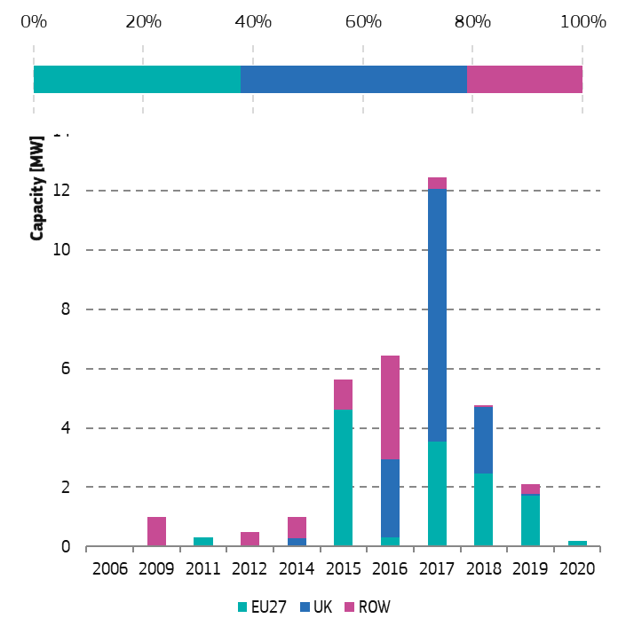

Source 49 JRC

**Wave.** At the start of 2020, the global installed capacity of wave energy was of 12 MW, with 8MW (66%) installed in EU27. In 2019, 600 kW of new wave energy capacity was deployed in the EU[8].

**Tidal.** At the start of 2020, the global installed capacity of tidal energy was of 22.4 MW, 76% of the installed capacity is deployed in Europe, of which 24% in EU waters. In the UK there are 12 MW of operational tidal energy capacity. EU developers have largely benefitted from successful collaboration and interlinkage between EU support and the availability of ad-hoc infrastructure especially in Scotland and in Northern Ireland. As a matter of fact, 65% of the global tidal energy installed capacity comes from EU developers.

The project pipeline of wave and tidal energy is of about 2.4 GW until for the next 7 years. This pipeline comprises projects currently under development, and of industrial ambitions stated by some technology developers[9]. This pipeline is in line with the market projections released by DG MARE[10] and with the IEA[11] modelling scenario in the most optimistic development scenarios for ocean energy. It shall be noted that in the pessimistic[12] scenario DG MARE and IEA expect between 0.25 GW and 0.6 GW of installed capacity by 2025 and around 1GW by 2030.

Future expectations on capacity installed based on different scenarios

Different energy system models have been used to model the future uptake of ocean energy in Europe and globally, providing a wide range spectrum of capacity that could be expected. The differences between models results is understandable and can be related to different assumptions such as:

* Global modelling assumptions: e.g. is the model designed to model a transition to zero-net emission or other policy ambitions;
* Role of R&I: is the model accounting for a strong role of R&I stimulating investments in new energy sources?
* Capacity of ocean energy to unlock cost-reductions: does the model foresee the availability for ocean energy to reduce its cost so that the technologies become cost-competitive?

Overall it can be expected that the continuous development of the *ocean energy* technologies and the reduction in technology costs are expected to lead to a significant increase of the deployed ocean energy capacity in the near future. On the other hand, when this assumption is not embedded in the model, the modelled contribution of ocean energy is minimised.

This is the case of the LTS: it indicates a low contribution of the technology in the total electricity generation with a maximum of 0.7 % in 2040 and 0.6% in 2050. Market scenario assessments from the International Energy Agency (IEA)[13] indicate that depending on the cost-reduction and policy design, by 2030 the total European ocean energy installed capacity could range between 0.5 GW and 2.6 GW by 2030, depending on the policy initiative. WEO expects a modest breakthrough of ocean energy technology, resulting in installed capacities of 20 GW worldwide and 12 GW in Europe by 2040. Higher ocean energy deployment is linked with policy accelerating the transition towards climate neutrality. JRC-EU-TIMES[14] simulations of the EU energy system indicate that a total capacity ranging from 28 GW to 46 GW could be expected by the sector by 2050, under the assumption of that wave and tidal energy devices meet the cost reduction of the SET plan. Tidal energy could be cost-competitive by 2030, accounting for most of the sector installed capacity (28 GW). Wave energy could reach 18 GW by 2050[15].

So far, all the modelling outputs are below the industrial target that the ocean energy sector has set itself. The ocean energy industry estimates that 100 GW of wave and tidal energy capacity can be deployed in Europe by 2050, meeting 10% of Europe’s current electricity needs; while IEA-OES estimates a global potential installed capacity of wave, tidal stream and range, OTEC and salinity gradient of 337 GW by 2050[16].

Meeting these targets requires that ocean energy costs are reduced through sustained R&D and the design of policies that recognise the potential and role of ocean energy in the transition to a climate-neutral economy and support large scale deployment of ocean energy possible like this has been done in the past for wind and PV.

Cost, LCOE

A critical aspect hindering the uptake of ocean energy technology is the high capital cost of the technology and the associated risk for project developers to deploy expensive technology. Thus, the development of ocean energy sector requires that significant cost reductions are achieved in order for wave and tidal energy technologies to become competitive with other renewable energy sources.

Data from the EU funded projects indicate that the LCOE of tidal energy technology ranges between 0.34 and 0.38 EUR/kWh (Figure 50), down from 0.60 EUR/kWh in 2015. This corresponds to reduction of more than 40% in three years. The current value is below the 2015 reference cost-reduction curve, which indicated that LCOE would reach 0.40 EUR/kWh with the cur-rent deployed capacity. In 2015, the LCOE of wave energy ranged between 0.47 EUR/kWh and 1.40 EUR/kWh, with a reference value of 0.72 EUR/kWh. In 2018, with addition of 8 MW of capacity, the LCOE is expect to have decreased to 0.56 EUR/kWh[17].

Figure 50 Cost-reduction curves for tidal energy and LCOE estimates from ongoing projects. Solid dots represent data from ongoing demo projects, while hollow dots indicate developers' estimates on the basis of technology improvements and increased deployment.

The SET plan targets set for wave and tidal energy technologies imply that the costs of generating electricity from the ocean need to be further reduced. According to the targets, the LCOE for tidal energy should reach 0.15 EUR/kWh by 2025 and 0.10EUR/kWh by 2030, while the LCOE for wave energy should reach 0.2 EUR/kWh by 2025 and 0.15 EUR/kWh by 2030, finally reaching 0.1 EUR/kWh in 2035.

For tidal energy, meeting the 2030 target of 0.1 EUR/kWh would require about deploying between 300 MW and 800 MW in the next 10 years, and a similar capacity would also be required for wave energy: albeit a step change in R&I and technology development[18].

R&I

Between 2007[19] and 2019, total EU R&D expenditure on wave and tidal energy amounted to EUR 3.84 billion with the majority of it (EUR 2.74 billion) coming from private sources (Figure 51)[20]. In the same period, national R&D programmes have contributed EUR 463 million to the development of wave and tidal energy. EU funds, including the European Regional Development Fund (ERDF) and Interreg projects, amounting to EUR 493 million. A further EUR 148 million had been made available through the NER300 Programme. On average, for the reporting period EUR 1 of public funding (EU[21]+National) has leveraged EUR 2.9 of private investments.

Figure 51 EU R&D expenditure on ocean energy, EUR million

Source 50 JRC

European, ERDF and National programmes have contributed to fund ocean energy projects for EUR 1.727 billion for a total worth of the projects equal to EUR 2.162 billion. It shall be noted however that the termination of a number of IA projects has a strong effect on the funds made available and used by the consortium. The total project costs leveraged by EU-awarded Horizon 2020 projects has fallen from EUR 328 million to EUR 108 million, with the EU contribution being reduced from EUR 163 to 90 million. This is a significant blow to the ambition of the sector, but also highlights the difficulties that project developers are having. A breakdown of the funds and project cost is provided in Table 2.

Table 2 Breakdown of funds for ocean energy through European, ERDF and national programmes 2017-2019.

|  |  |  |
| --- | --- | --- |
|  | **Funding Contribution** (**EUR )** | **Total Project Costs** (**EUR)** |
| **ERDF** | 253 190 108 | 358 746 847 |
| **EU** | 373 753 790 | 631 532 515 |
| **Ocean-ERANET** | 13 469 842 | 18 629 654 |
| **National** | 504 799 333 | 504 799 333 |
| **Regional** | 578 814 003 | 648 114 003 |
| **Total** | **1 726 870 711** | **2 161 822 352** |

Source 51 JRC

Patenting trends

Patents for ocean energy technologies are classified in 6 CPC classes as follows[22]:

* Y02E-10/28 - Tidal stream or damless hydropower, e.g. sea flood and ebb, river, stream;
* Y02E-10/30 - Tidal stream;
* Y02E-10/32 - Oscillating water column [OWC];
* Y02E-10/34 - Ocean thermal energy conversion [OTEC];
* Y02E-10/36 - Salinity gradient;
* Y02E-10/38 - Wave energy or tidal swell, e.g. Pelamis-type.

R&D activity in ocean energy involves over 838 EU companies and research institutions in 26 Member States[23]. In the EU28, 51% of the ocean energy inventions patented are for wave energy technology, 43% for tidal energy, 2.7% on Oscillating Water Column (OWC, this represent a subset of wave energy technology), and 3% for Ocean Thermal Energy Conversion (OTEC). The EU28 is a leader in the filing of patents in international markets, seeking protection in all key markets such as the United States, South Korea, and China as well as Canada and Australia (included in ROW). Nevertheless, the EU receives only a small number of incoming patents applications from outside, primarily from the United States (Figure 52). The patent filings indicate that the EU is a net exporter of *Ocean energy* technology and innovation, and that European *Ocean energy* developers are well positioned to exploit the growth of the sector globally.

Figure 52 Global patents flow, number of patents (for the years 2007-2016). The left side present the information of where invention have been generated, whilst the right side indicates where companies are seeking protection. (Intra-market patents are not included. 2016 is the latest full and validated year on Patstat).

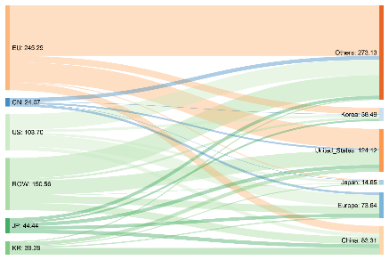

Source 52 JRC

The information presented in Figure 51 and Figure 52 indicate that companies in the EU are investing considerably in the development of ocean energy technology.

The EU has been the leader in ocean energy R&D in ocean energy until 2010. From 2010 Chinese patenting has increased significantly and has overtaken the EU (Figure 53). Nevertheless, only a limited part of the inventions patented in China have also sought international protection in other markets. High-value inventions (or high-value patent families) refer to patent families that include patent applications filed in more than one patent office, thus offering IP protection of the technology in multiple markets. Figure 54 presents the global patent trends for the period 2000-2016, taking into account those High-value inventions, highlighting the role of EU R&D in ocean sector.

Figure 53 Global ocean energy patents trend from 2000 to 2016

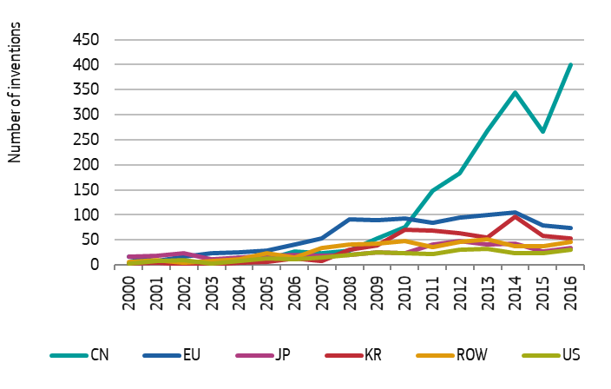

Source 53 JRC, Patstat

Figure 54 Global High-value inventions ocean energy patents trend, from 2000 to 2016

Source 54 JRC, Patstat

From Figure 54, one can see that only a few Chinese patents have sought international protection; whilst many EU inventors have sought protections in multiple potential markets.

Private R&I funding

Figure 55 presents the historical trend in private R&D Investments in the EU, showing a stead decrease from the period 2008-2010 where annual investments were estimated around EUR 300 million to about half of it in 2016 (EUR 158 million). In total since 2003 EUR 2.7 billion of private investments have been directed to ocean energy R&D. Companies based in the UK (EUR 900 million) and in Germany (EUR 475 million) have invested the most in R&D[24].

Figure 55 Private R&D Investment trend in the EU, based on patents information

Source 55 Source and Methodology JRC

In some countries, both national and private funds are used to support R&D in ocean energy technologies, while in other countries such as Germany, Finland, and the Netherlands the initiative is mainly private. The potential of ocean energy in these countries is limited, however the development of the ocean energy sector may have a positive effect on the countries’ manufacturing supply chain[25].

### Value chain analysis

The technology status of ocean energy converters has affected the consolidation of the supply and value chain of the sector. In fact, for technologies that are not yet market-ready, such as ocean energy technology, the consolidation of the supply chain is dependent on the ability or reliability of the technology and its progress to a higher TRL[26] (Figure 8), and is reflected in low Manufacturing Readiness Level for the sector.

Figure 56 Supply chain consolidation based on market development.

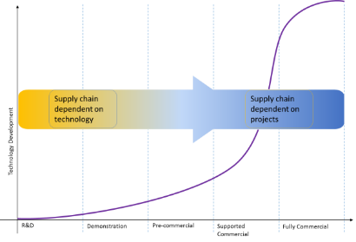

Source 56 JRC

Figure 57 shows the ocean energy supply chain, emphasising the manufacturing of ocean energy converters and key components.

Figure 57 Ocean energy supply chain accounting for component and subcomponents manufacturing

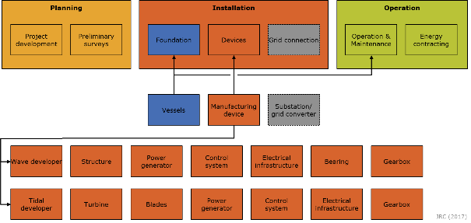

Source 57 JRC[27]

Given the localised nature of wave and tidal energy resources, it is expected that ancillary activities such as project development, operations and maintenance, will be carried out by local companies. The manufacturing of ocean energy converters, as in the case of wind, will then play a fundamental role in shaping the technology market and in defining the positioning of European companies in the global market. Technology developers are already investigating markets where to expand their business plans in location that offer growth both in terms of manufacturing capabilities and deployment of their technologies.

The supply chain spans[28] across 16 EU countries, with a significant presence also in landlocked countries and regions, who provide valuable expertise for the production of components and sub-components (Figure 58). The European ocean energy industry is making significant steps forward, and plans now to expand manufacturing facilities.

Figure 58 Ocean energy supply chain in Europe (to be updated)

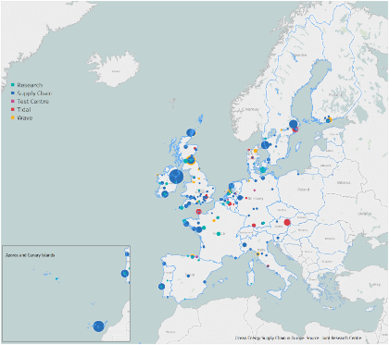

Source 58 JRC

Turnover

Given the current status of the sector, where very limited number of projects operates thanks to commercial revenues and to Power Purchase Agreements (PPAs) with utilities. Furthermore, with many companies still being SMEs and focussing on R&I it is not possible to estimate the turnover of the sector. The challenge facing the ocean energy sector is identifying ways to support the deployment of wave and tidal energy farms through innovative support schemes, until revenues are available most of the companies are going forwards thanks to a mix of grant, public funds, private equity and VC. An increasing number of developers are exploring the use of crowdfunding either for the fabrication of their new device, to support R&D activities, or to reach the required capital for deployment. Such efforts have mobilised over EUR 20.5 million (or about USD 23 million) over the past three years. The impact of crowdfunding is comparable with public funding for projects, and it is likely to have limited impact, especially in terms of deployment of projects[29]. Nevertheless it is telling of the difficulties being encountered by technology developers.

Gross value added growth

An indication of the Gross Value Added of ocean energy can be derived from the different deployment scenarios provided by DG MARE[30]. The cumulative GVA generated from deployed Ocean energy by 2030 would range between EUR 500 million and EUR 5.8 billion (Figure 59). The expected growth of the sector could lead to a significant increase in employment. It is projected that if under the optimistic deployment scenario, with the sector reaching 2.6 GW of installed capacity by 2030 up to 25000 yearly FTEs could be generated in Europe (EU27 and UK) and between 50 000 and 200 000 distributed in the next 10 years (Figure 59). Nevertheless, it shall be noted that the current development trajectory and current employment level is lower that modelled in the DG MARE pessimistic scenario.

Figure 59 Project GVA for ocean energy in the pessimistic and optimistic scenario.

Source 59 JRC, Innosea

Number of companies in the supply chain, incl. EU market leaders

At the end of 2019, over 590 (2020 updates) companies in the EU28 were in involved in the different steps of ocean energy supply chain, including wave and tidal energy developers; project developers, component manufactures, research centre and local authorities.

The landscape of the ocean energy supply chain is rapidly changing thanks to the technology validation projects currently ongoing in European test centres. The necessity of reducing the cost of ocean energy technology, also through economies of scale, implies that the presence of Original Equipment Manufacturers (OEMs) with access to large manufacturing facilities could be seen as an indicator of the consolidation of the supply chain.

In the period between 2012 and 2015 many OEMs have reduced their involvement in the sector, an inversion of tendency has been seen in the past years: new industrial players such as Enel Green Power, ENI, Fincantieri, Saipem, SBM Offshore, Total and Warstila have entered the market; bringing with them experience from the oil and gas and shipping sectors.

The increased presence of OEMs that adds on from the ones already presented in the sector such as AndritzHydro Hammerfest, Lockheed Martin, Engie, Schottel can be seen as a sign of the progress and confidence in the sector moving forward. Furthermore, the sector can also rely on the experience of key intermediate components and sub-components companies, such as Bosch Rexroth, AVV, SKF, Schaeffler and Siemens to mention a few that are actively supporting R&D and demonstration projects. These companies are currently engaged on at ad-hoc base, but their involvement in the sector could grow once the market and supply chain consolidated.

It is important to notice, that as witnessed in the wind energy sector, a strong project pipeline ensures that there is sufficient demand for OEMs, and as a result ensures demand for the manufacturing of components and subcomponents and for the supply of raw materials[31][32]. The landscape for ocean energy is rapidly changing thanks to the technology validation projects currently ongoing in European and international test centres.

The development of ocean energy has seen already almost 300 different concepts being proposed[33]. About half of them have progressed to higher TRL and even fewer tested in operational environment. 49.4% of the ocean energy developers in the EU27, when considering technology at TRL6 or higher[34]. 13.6% of ocean energy developers at TRL6 or more are located in the UK, with the remaining 37% located in the rest of the world.

In terms of tidal energy 41% of the tidal energy technology developers are based in the EU27, and 18% in the UK (Figure 60). The Members State with the highest number of developers are Netherlands and France. Major non-EU players are Canada, the US, the UK and Norway[35].

For wave energy, 52% of active wave energy developers at TRL6 or higher are located in the EU (Figure 60). The UK (14%) has the highest number of developers, followed by the US, Denmark, Italy and Sweden. Other key players in the sector are Australia, and Norway. A number of developers of technology at low TRL are not included in this analysis.

Whilst the highest concentration of wave and tidal energy developers occurs within the EU and Europe many developers are looking to deploy their technologies outside of Europe thanks availability of market instruments available elsewhere, such has the high feed-in-tariffs in Canada. Developing a strong internal market will be fundamental for the EU in order to build on and maintain its current leadership position in the market. As seen for other renewable energy sources first-mover advantage and strong internal markets are key to maintain a competitive position.

Figure 60 Distribution of tidal and wave energy developers

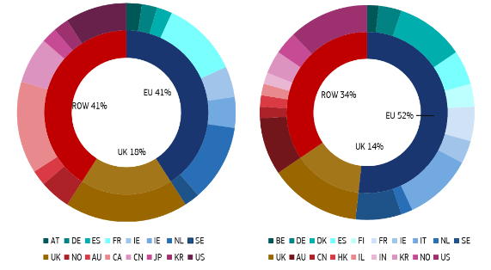

Tidal Wave

Source 60 JRC

Employment figures

At the end of 2019, it was estimated that the ocean energy sector generated 2 250[36] jobs generated across Europe, a significant increase from 2013 when ocean energy jobs were estimated to be between 800-1000[37]. The breakdown of jobs per country can be see in Figure 61.

Figure 61 Jobs in the ocean energy sector, thousand employees (Updated 2019)

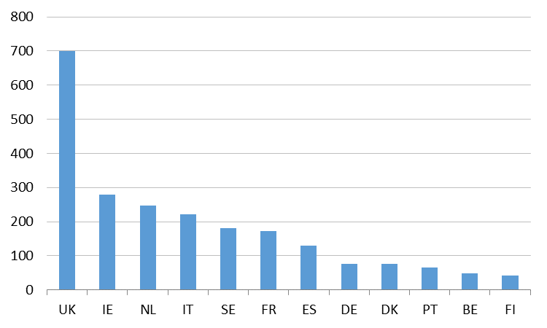

Source 61 JRC, Innosea

The expected growth of the sector could lead to a significant increase in employment. It it in fact projected that if under the optimistic deployment scenario, with the sector reaching 2.6 GW of installed capacity by 2030 up to 25 000 yearly FTEs could be generated in Europe (EU27 and UK).

Figure 62 Yearly jobs associated to the optimistic deployment scenario (2.6 GW)

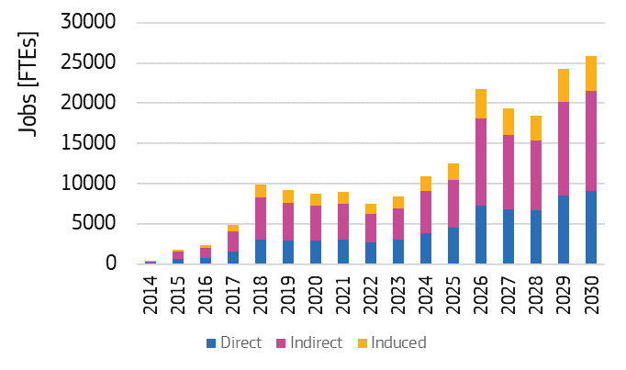

Source 62 JRC, Innosea

### Global market analysis

Global market leaders versus EU market leaders

European leadership spans across the whole ocean energy supply chain[38] and innovation system[39]. The European cluster formed by specialised research institutes, developers and the availability of research infrastructures has allowed Europe to develop and maintain its current competitive position.

The EU maintains global leadership despite the UK’s withdrawal from the EU and changes in the market for wave and tidal energy technologies. 70% of the global ocean energy capacity has been developed by EU27 based companies (Figure 63)[40].

Figure 63 Installed capacity by Origin of technology

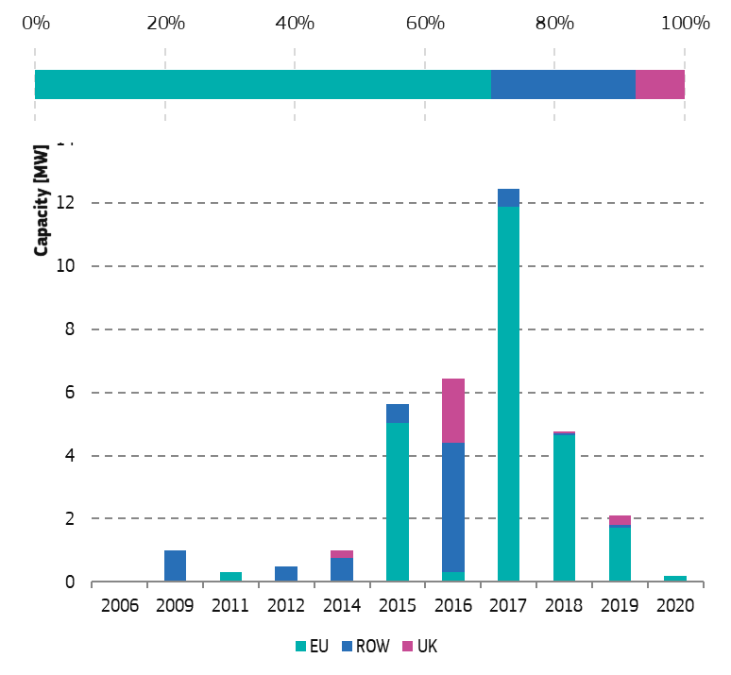

Source 63 JRC 2020[41]

The ocean energy market is slowly forming. The next decade will be fundamental for EU developers to maintain their competitiveness with the global ocean energy capacity of 3.5 expected to reach 2.5 GW by 2025 and to 10 GW by 2030[42]. With significant investments in ocean energy outside of Europe (Canada, US, Japan), dedicated support for is needed to ensure that a strong EU market can take off, allowing for the consolidation of the EU supply chain.

Critical raw material dependence

At the current stage, it is not possible to determine the extent of the dependency of the ocean energy sector on critical raw materials; however, it has to be noted that rare earth materials (REEs) are employed and likely to be employed in the production of power-take-off systems and for wave and tidal energy converters. The industry has an opportunity to already identify and act upon this potential bottlenecks by including aspects of circularity and sustainability in the design of the converters on the path to commercialisation.

### Future challenges to fill technology gap

Ocean energy technologies have the potential to contribute significantly to the decarbonisation of Europe’s energy system. Predictable and reliable production of wave and tidal energy would complement well wind and solar generation, supporting grid stability. With the sector having showing good progress in the past years, the next is to build and achieve further cost reduction and market consolidation.

2.2 GW of tidal stream and about 0.4 GW of wave energy could be already deployed in Europe by 2030[43],[44]. The sector has much higher ambitions for the time horizon 2050, aiming to install 100 GW in the European waters[45]. To get there and meet the expectations, significant cost reduction is still needed for tidal and wave energy technologies to exploit their potential in the energy mix. With a clear development and deployment strategy and by creating the right policy conditions, Europe can secure leadership in a market worth up to EUR 53 billion annually by 2050[46].

Despite the steps forwards in technology development and demonstration, the sector faces struggles in the creation of a viable market. National support appears low, reflected by the limited commitment to ocean energy capacity in the NECPs compared to 2010 and the lack of clear dedicated support for demonstration projects and the development of innovative remuneration schemes for emerging renewable technologies.

This limits the possibility of developing a business case, and of identifying viable ways to develop and deploy the technology. Therefore, investigating specific business cases for ocean energy should be given more focus, such as valorising its flexibility as a highly predictable source, and valorising its potential in the decarbonisation of small communities and EU islands[47].

The offshore renewable energy strategy[48] offers the opportunity to support the development of ocean energy and to help EU exploit fully the resources available across the EU.

In this overall context, R&I will play a key role in unlocking further reduction in ocean energy cost; and the further development of wave and tidal energy devices rests on demonstrating the reliability and survivability of the devices with relatively low maintenance cost for long operation periods and further advances such as foundation, connection, mooring, logistics and marine operation, integration in the energy system. In this sense R&I on advanced and hybrid materials such as advanced concrete and flexible blades[49] and on new manufacturing processes such as rotational moulding and additive manufacturing that employ innovative 3D technologies could enable further costs reduction, together with lower energy consumption, shortened lead times and improving quality associated with the production of large cast components.

Important lessons have been learnt from H2020 projects that should be shared as widely as possible among the developers, policy makers and other stakeholders to stimulate technology convergence and build on the knowledge and expertise already available in the EU.

## Solar Photovoltaics

### State of play of the selected technology and outlook

Solar photovoltaics (PV) has become the world’s fastest-growing energy technology, with demand spreading and expanding as it becomes the most competitive option for electricity generation in a growing number of markets and applications. The global compound annual growth rate of PV installations was about 37% between the years 2010 and 2019. This growth is supported by the declining cost of PV systems (EUR/W) and increasingly competing cost of electricity generated (EUR/MWh). All future scenarios for the energy system point to an ever-larger role of PV, with demand continuing and probably accelerating. According to the IEA sustainable development scenario, worldwide electricity generation from PV systems will increase from 720 TWh in 2019 to 3 268 TWh[50] in 2030. In terms of capacity, this would correspond to almost 2.9 TW, requiring of investments of USD 1.8 trillion[51] according to the BNEF NEO 2019[52]. More ambitious scenarios give even higher values. The Commission’s LTS analysis for 2050 shows wind and solar[53] (PV) power providing over 60% of electricity. The solar generation capacity values range from 770 GW (EC LTS1.5LIFE) to 1 030 GW[54] (EC LTS1.5TECH).

Amongst the renewables technologies, PV is unique in its scalability, with systems ranging from utility scale power plants of several hundred MW, to small kW-scale installations for buildings and other consumer uses. PV systems comprise the modules themselves, mounting structures, cabling and the power control and conversion equipment (inverters). This latter part is becoming increasingly digitized and sophisticated, capable of supporting a range of ancillary functions and grid services. Concerning the core PV technology, solar cells bases on silicon wafer is by far the dominant photovoltaic technology on the global market, with a share of over 95% in 2019. This has been by a major shift to passive emitter rear contact (PERC) architectures, bringing power conversion efficiency to the 20% level and above, together with an operational lifetime of 30 years. Passivated contact and heterojunction cells offer a further increases efficiency towards 25% and are already moving to mass production.

Other commercial PV technologies include the thin-film technologies of copper indium/gallium disulfide/diselenide (CIGS) and cadmium telluride (CdTe). Thin-film silicon (amorphous and microcrystalline silicon) and concentrating photovoltaics have lost market shares. Some organic and dye-sensitized solar PV devices have been commercialised, but for the most part this technology remains at niche or research level. Hybrid organic-inorganic perovskite materials recently emerged as a promising option, in particular combined with wafer-based silicon to offer high efficiency and attractive manufacturing costs, although long-term stability remains a challenge. Tandem devices with thin film layers on silicon wafers offer a concrete possibility to reach 30% and beyond for commercial products

The world average carbon footprint of PV electricity generation is approximately as 55 g CO2-eq/kWh. In the EU, treatment of end-of-life PV modules must comply the WEEE Directive since 2012. Several organisations have developed recycling processes, but so far waste volumes are too low for these to be economically viable.

Capacity installed, generation

The cumulative worldwide capacity was 635 GW at the end of 2019 and is expected to increase by more than one order of magnitude in 2030 and two orders of magnitude in 2050[55]. Figure 64 shows the development of the global market over the last ten years. In 2019 the EU28 accounted for 21%, while installations in China accounted for 36% of the total.

Figure 66 shows how the annual PV market in the EU28 has developed from 2020 to the present. From the introduction of the first Renewable Energy Directive in 2009, the PV power capacity in EU28 increased more than 10-fold from 11.3 GW at the end of 2008 to over 134 GW at the end of 2019. This capacity can generate approximately 150 TWh of electricity or about 5.2% of final demand.

The upturn of the EU market in 2018 and 2019 is very positive sign. However, achieving the European Green Deal targets will require considerable additional growth. The impact assessment[56] for the proposed European Climate Law implies a solar PV capacity of approximately 460 GWDC in 2030 (and over 1 000 GW by 2050) to achieve a 55% GHG emissions reduction. Previously a JRC study estimated that the cumulative PV capacity in the EU and the UK would need to rise to 455–605 GWDC by 2030, depending on strategic choices[57]. As things stand, the Member States’ National Energy and Climate Plans (NECPs) foresee PV capacity only in the range 260 to 341 GWDC by 2030.

PV deployment at a large scale may face certain obstacles related to land availability and policies on the use of land, in addition to those regarding the integration of variable power. However, the technical potential is large: over 2 000 GW for ground-mounted systems[58] and 540 GW for systems on buildings[59] in the EU27.

A large increase in module demand coupled with recent rapid cost reductions in PV manufacturing strengthens the case for bringing PV factories back to Europe. CAPEX costs for polysilicon, wafer, solar cell and module manufacturing plants have decreased by 75 to 90% between 2010 and 2018[60]. Economies of scale are critical, and a recent study has shown that a European manufacturing chain would be competitive with global PV factories, should an annual production volume between 5 and 10 GW be reached[61]. Chinese and American industrial experiences illustrate the benefits cutting-edge automation solutions (digital transformation) would bring, compensating the often-cited obstacle of EU high labour costs.

Figure 64 Cumulative Photovoltaic Installations from 2010 to 2020

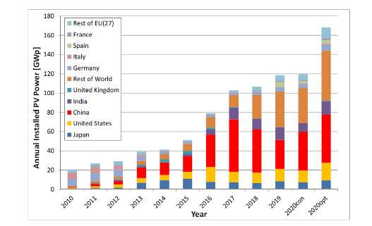

Source 64 Jaeger-Waldau et al, How photovoltaics can contribute to GHG emission reductions of 55% in the EU by 2030, Renewable and Sustainable Energy Reviews, Volume 126, 2020, 109836

Figure 65 Annual photovoltaic installations in EU and the UK from 2010 to 2020. Values for 2020 are based on pre-Covid estimations.

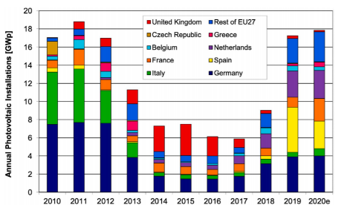

Source 65 Jäger-Waldau et al, How photovoltaics can contribute to GHG emission reductions of 55% in the EU by 2030, Renewable and Sustainable Energy Reviews, Volume 126, July 2020, 109836

Cost, LCOE

The cost of PV electricity depends on several elements: the capital investment for the system, its location and the associated solar resource, its design, permitting and installation, the operational costs, the useful operation lifetime, end of life management costs and, last but not least, financing costs. Here the focus is on the investment needed for a PV system and for the modules, as the main energy conversion component.

PV modules are the largest single cost component of a system, currently accounting for approximately 40% of the total capital investment needed for utility systems, and somewhat less for residential systems where economies of scale for installation are less and soft costs are higher. The cost of PV modules has decreased dramatically in recent years. The experience or learning curve shows that the price of the photovoltaic modules decreased by 24% with each doubling of the cumulative module production. The “learning rate” of 24% has been observed over the last 40 years[62]. This due to both economies of scale and technological improvements. Current spot market prices at the level of 0.20 EUR/W.

The total installation cost of solar PV will continue to decline in the future, making solar PV highly competitive in most markets and locations with adequate solar resource. Figure 66 shows projected CAPEX trends for utility PV systems from a study performed in the framework of the European Technology Innovation Platform for PV[63]. This foresees a halving by 2030 and a threefold reduction by 2050. IRENA indicates that the average cost for utility-scale PV will fall to at the range of 340 to 834 USD/kW by 2030 and to 165 to 481 USD/kW by 2050 (the average cost was 1 210 USD/kW in 2018[64]).

Rooftop systems for residential or small commercial buildings have traditionally been an important market segment, particularly in Europe. Prices have seen a significant decline, and are now approximately 1 000 EUR/kW (approximately 200 EUR/m2 ) in the well-developed and competitive German market. However, across Europe prices vary considerably and can be more than double this value. Building integrated roofing systems range from 200 to 500 EUR/m2 for standardised products and increase to 500 to 800 EUR/m2 for customised solution[65]. Costs for PV facades are in the upper part of this range.

In terms of cost per MWh, PV emerges as highly competitive for utility scale PV in favourable locations. In the first half of 2020 the global LCOE benchmarks for PV are reported with 39 to 50 USD/MWh[66]. In IRENA’s 2019 analysis, the LCOE for PV will decrease to 10 to 50 USD/MWh depending on location, due to continuing reduction of PV installation costs[67]. The previously mentioned study for ETIP-PV indicates an LCOE for utility scale systems (>10 MW) ranging from 24 EUR/MWh in Malaga to 42 EUR/MWh in Helsinki (see Figure 67) based on 2019 CAPEX and OPEX values, and with a weighted average cost of capital (WACC) of 7%. By 2030, this range would drop to 14‐24 EUR/MWh and by 2050 to 9‐15 EUR/MWh. Their sensitivity study showed that varying WACC from 2 to 10% doubles the LCOE.

Figure 66 Utility‐scale PV capital expenditure (CAPEX) in Europe for the years 2018 to 2050 in three different scenarios (EUR/W)

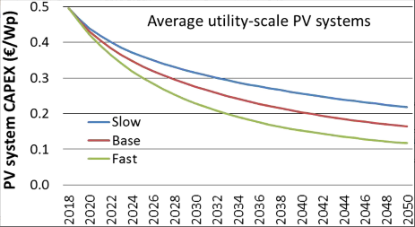

Source 66 E. Vartiainen et al, Impact of weighted average cost of capital, capital expenditure, and other parameters on future utility‐scale PV levelised cost of electricity, Prog Photovolt Res Appl. 2019; 1–15

Figure 67 PV LCOE for utility systems in six European locations, years 2019 to 2050 ( EUR 2019/MWh), taxes not included

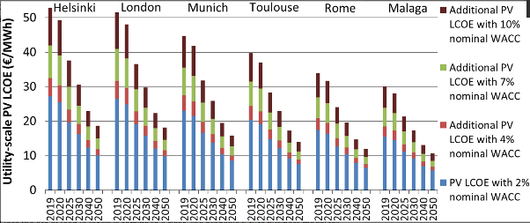

Source 67 E. Vartiainen et al, Impact of weighted average cost of capital, capital expenditure, and other parameters on future utility‐scale PV levelised cost of electricity, Prog Photovolt Res Appl. 2019; 1–15

Auctions for PV power supply provide a further indicator of cost level. Over the last few years, the number of EU Member States conducting such auctions has continuously increased. Prices have come down to the current average level of EUR 35 and 70/MWh. A Portuguese auction in August 2020 reached EUR 11.14/MWh, although this price is considered to reflect more the value of the grid connection to the bidder than the cost of PV electricity.

A recent Commission study[68] on the present and future competiveness of solar PV and wind power shows that both can be cost-competitive in almost all EU markets by 2030. It underlines the importance of flexibility in power systems, e.g. grid interconnections, storage and demand management, to mitigate negative price trends at peak production times, which could occur when variable renewables reach a high market share.

The rooftop PV market is of particular importance in view of its role in decarbonising energy consumption in the building sector and the socio-economic benefits to communities of small-scale installations. For PV rooftop systems there is still a wide spread in LCOE (61,9 to 321,5 EUR/MWh) across the EU[69]. This is due in part to geographic variations in the actual solar radiation reaching the system, and significantly to local regulations and market conditions. Depending on the actual retail prices, electricity generated from PV rooftop systems can be cheaper for a large part of the European population. Even in a less sunny locations, the electricity cost is only bettered by onshore wind, again providing the location has a favourable wind resource.

It should be said that very high penetration rates of variable renewable technologies (mostly PV and wind) will need storage, enforced grids and demand side management. The mix and intensity of renewables will determine the requirements of those elements and the total system costs.

R&I

Public R&I funding

IEA data has been analysed to assess public funding at EU level for PV, with the caveat that is subject to several limitations both in terms of coverage, disaggregation and completeness Figure 68 shows the data for R&D investment by EU28 member states. The annual total has fluctuated in a range of EUR 190 million to EUR 210 million. If the EU is to continue its role as a PV technology leader, it will need to maintain or increase this level going forward, together with R&D investments for closely related technologies (e.g. for power systems, grid integration and for battery storage).

The EU’s Strategic Energy Technology Plan (SET plan) aims to accelerate the development and deployment of low-carbon technologies. The implementation plan for PV identifies six main areas:

* PV for BIPV and similar applications;
* Technologies for silicon solar cells and modules with higher quality;
* New Technologies & Materials;
* Operation and diagnosis of photovoltaic plants;
* Manufacturing technologies;
* Cross-sectoral research at lower TRL.

At EU level, the Horizon 2020 supports the SET plan and PV technology development up to the technology readiness level 7 (system prototype demonstration in the operational environment). A total EU financial contribution of about EUR 196,8 million has been invested on activities related to PV[70]. This contribution has been mostly spent for research and innovation actions (30%), innovation actions (28%) and grants to researchers provided by the European Research Council (16%). Fellowships, under the Marie Skłodowska-Curie programme, absorb 5% while actions for SME are at 11% of the overall investment. Coordination actions, like ERA-NET, represent 10% of the budget.

Actions to support further development of PV technologies to commercialisation have been limited. A positive example is the AMPERE project (Automated photovoltaic cell and Module industrial Production to regain and secure European Renewable Energy market). This has lead an industrial scale (200 MW) production line for high efficiency heterojunction modules, representing the culmination of over ten years of R&D by a cluster of European labs. No PV projects were ultimately funded under the NER 300 demonstration programme. For the period 2021-2030 the Commission has launched a new programme called the ETS Innovation Fund.

The European Investment Bank provided EUR 20 million of quasi-equity under the InnovFin Mid Cap Growth Finance program to Heliatek (based in Germany) to help boost production capacity of its HeliaFilm product (an organic photovoltaic solar film for integration into building facades) and EUR 15 million to Oxford PV Germany GmbH under the InnovFin Energy Demonstration Projects scheme to support the transfer of its perovskite on silicon tandem solar cell technology.

Excellent technology and rapid innovation are essential for the EU industry to be and remain successful in the competitive global context[71]. The European research institutions are still amongst the leaders in the activities related to the photovoltaic field worldwide[72].

Figure 68 Public investment by EU28 member states in PV

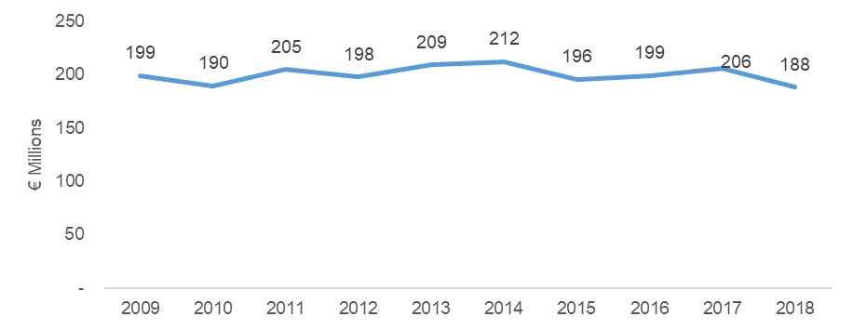

Source 68 ICF, Climate neutral market opportunities and EU competitiveness – Draft Final Report, September 2020

Private R&I funding

Global R&D spending in renewable energy edged up 1% to USD 13.4 billion in 2019. Half of that went to solar and a fifth to wind, and corporate R&D significantly outstripped government spending for the third year running[73].

Patenting Trends

The PATSTAT database 2019 autumn version has been analysed for the CPC classification codes relevant to PV modules and systems and considering for three categories: all patent families, the so-called "high-value" patent families[74] i.e. application made to two or more patent offices and lastly granted patent families. In terms of global regional breakdown for 2016, China took the largest share of all patent family applications, followed by Japan and Korea. However, there is a significant difference between US, Japanese and Chinese patents, where an idea can be patented, and European patents where proof of concept is required.

If just the "high-value" patent families are considered, a different picture emerges, with Japan as leader, and the EU second positon[75].

In the technology breakdown for European patents applications, the “energy generation” category is predominant, but there were also significant levels of activity for power conversion technologies, for PV with concentrators and PV in building. Encouragingly, the manufacturing category also maintained a 10% share, perhaps reflecting the continued market strength of the European PV manufacturing equipment sector.

Publications/Bibliometrics

In 2019 the scientific output on photovoltaics reached over 13 000 journal articles (Scopus, Clarivate) Figure 69 shows countries with the highest share number of author affiliations. China is clear leader, followed by the US and then England. Europe is well represented in the top-20 by Germany, UK, France, Italy and Switzerland. The EU28 as whole is second only to China, underlining the high-level scientific excellence in photovoltaics in Europe. Compared to a decade ago, Asian countries account for a very significant fraction of scientific output. The category of high cited articles can be used a measure of quality. In this case the overall ranking is relatively unchanged, although the leading countries or regions tend to have a larger share of these highly cited articles. A number of countries, in particular US, UK and Switzerland, appear to influence research much more than the simple volume of articles would suggest, whereas India had considerable output but with proportionally less impact up to now.

*Figure 69 Top countries/regions for author affiliations in 2019 journal articles on photovoltaics and/or solar cells*

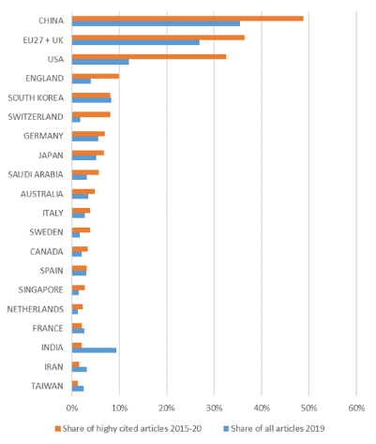

*Source: analysis of Clarivate data in N. Taylor, A. Jäger-Waldau, Photovoltaics technology development report 2020 - Deliverable D2.3.2 for the Low Carbon Energy Observatory, European Commission, Ispra, 2020, JRC120954.*

### Value chain analysis

Over the last 20 years, the PV industry has grown from a small group of companies and key players into a global business where information gathering is becoming increasingly complex. There is a long value chain from raw materials to PV system installation and maintenance (Figure 70). Often, there is a strong focus on solar cell and module manufacturers, but there are also the so-called upstream and downstream industries. The former include materials, polysilicon production, wafer production and equipment manufacturing, glass, laminate and contact material manufacturers, while the latter encompasses inverters, balance of system (BOS) components, system development, project development, financing, installations and integration into existing or future electricity infrastructure, plant operators, operation and maintenance, etc. In the near future, it will be necessary to add (super)-capacitor and battery manufacturers as well as power electronics and IT providers to manage supply and demand and meteorological forecasts.

Figure 70 The extended PV value chain

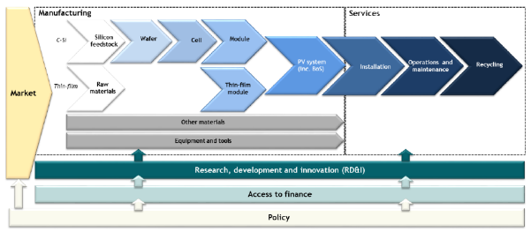

Source 69 Assessment of Photovoltaics (PV), Trinomics, 2017, European Commission EUR 27985 EN

The added value is generally distributed along the production process. This is described, in a simplified way by a “smile” curve (Figure 71). The highest value added is located in both the far upstream (basic and applied R&D, and design) and far downstream (marketing, distribution, and brand management) stages, while the lowest value-added activities occur in the middle of the value chain (manufacturing and assembly). However, an increasing number of installations are realized in harsh climates, e.g. high UV, high temperature differences between day and night, high humidity, floating. Therefore, companies are interested to control the manufacturing process to reduce risks and lower financing costs. Moreover, dominance of cell and module manufacturing, allows companies to move upstream in the PV value chain, towards more profitable segments. Therefore, looking at the added-value of a single segment of the value chain might not be sufficient to have the full insight of the industry and inform policy decision.

*Figure 71 “Smile Curve” of the PV Value Chain*

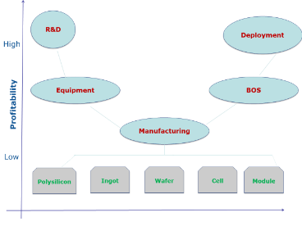

Source 70 Adapted from F. Zhang, K.S. Gallagher / Energy Policy 94 (2016) 191–203

Turnover

According to the Global Trends in Renewable Energy Investment 2020[76], global annual investments in solar PV were USD 126.5 billion in 2019. USD 52.1 billion were investments in small distributed solar capacity. Solar capacity investment in Europe was USD 24.6 billion. The EU28 share of new PV installations was 14% in 2019 with an estimated annual investment level (for installation in EU28) at about USD 18 billion.

A more recent analysis for the Commission puts the market size of the global PV industry at about EUR 132 billion[77], with the segments of value chain related to polysilicon ingots production, and cells and module manufacturing capturing the lion share (44%). The EU27 market size is about EUR 17,1 billion corresponding to about 13% of the global value.

Gross value added growth

The gross value added in general is similar to the market sizes for the respective value chain segment and region, when adjusted for a trade surplus/deficit and the value of input material. In the graph above, the available trade data on sector level had been disaggregated proportionally, according to market size of the different segments. Therein a potential source for inaccuracies in the GVA calculation may be found because it is likely that an export surplus exists in some segments (equipment for PV manufacturing) whilst a negative trade balance is likely for PV panels. For the solar PV sector, metal products and wafers are considered as input material, which are used mainly for cells and modules manufacturing. The largest share of the GVA is captured by the panel manufacturing.

Figure 72 Breakdown of GVA throughout solar PV value chain



Source 71 Guidehouse Insights (2019)

Number of companies in the supply chain, incl. EU market leaders

EU performs differently across the segments of the PV value chain (Figure 73). Europe, along with the US state of California and Japan, jump started the large-scale solar PV market in the mid-2000s. This early start positioned EU companies – mostly German, Spanish and Italian as the leaders in the industry. Since then, the market has moved to other regions and with that, some of the leaders in the industry. Nonetheless, European companies still maintain a strong presence in the industry (Figure 74) [78].

Figure 73 Competitive Intensity across Each Value Chain Segment, Global, 2020



Source 72 Guidehouse Insights (2019)

Figure 74 European players across the PV Industry Value Chain



Source 73 ASSET Study commissioned by DG ENERGY - Gathering data on EU competitiveness on selected clean energy technologies (Draft, 2020)

EU27 companies are most competitive in the downstream part of the value chain, and have in particular maintained key roles in i) the monitoring and control (with companies like GreenPower Monitoring, Meteo&Control and Solar-log), ii) balance of system (BOS) segments, hosting some of the leaders in inverter manufacturing, (like SMA, FIMER, Siemens, Gamesa Electric, Ingeteam and Power Electronics), and iii) solar trackers (like Soltec). European companies have also maintained a leading position in the deployment segment, where established players like Enerparc, Engie, Enel Green Power or BayWa.re have been able to move into new solar markets and gain new market share worldwide[79].

On the other hand, EU has lost its market share in some of the upstream part of the value chain (e.g. solar PV cell and module manufacturing). Figure 75 shows the situation in 2019. The EU still hosts one of the leading polysilicon manufacturers such as Wacker Polysilicon AG), which production alone is sufficient for manufacturing 20 GW of solar cells. However, a significant part of the polysilicon manufactured in Europe is currently exported to China.

Currently, the segment of the value chain which includes the polysilicon ingots production and the PV cells and modules manufacturing has a global value of about EUR 57.8 billion, of which the EU’s share corresponds to EUR 7.4 billion (12.8%). This still relatively high share captured by EU of the whole value of the segment is due to the polysilicon ingot production.

For PV cells and modules manufacturing, the EU positioning has dramatically fallen behind its Asia competitors. The limited access to fresh capital in Europe after the 2008 financial crisis, lead to the situation that European companies were not able to expand their manufacturing capacities in an expanding market. At the same time, China allocated substantial liquidity in the 12th Five-Year Plan to expand the renewable energy industry and renewable power installations. As of today, all the top 10 manufacturers of PV cells[80] and modules are mostly manufacturing in Asia (Table 3). CAPEX costs for polysilicon, solar cell and module manufacturing plants have diminished dramatically between 2010 and 2018. Together with innovations in manufacturing, this should offer an opportunity for the EU to have fresh look at the PV manufacturing industry and reverse the situation[81].

Figure 75 Companies and production sites in Europe for PV manufacturing



Source 74 J. Rentsch, Competitiveness Of European PV Manufacturers, Presentation to Interso-lar Europe 2019, Fraunhofer ISE web site

Table 3 Leading PV module manufacturers 2018

|  |  |  |  |
| --- | --- | --- | --- |
| rank | Company | Country | Volume  GW |
| 1 | JinkoSolar | Cjhina/Malaysia | 11.17 |
| 2 | JA Solar | China/Malaysia | 8.50 |
| 3 | Trina Solar | China/Thailand/Vietnam | 7.54 |
| 4 | Canadian Solar | Canada/China/Brazil/Vietnam | 6.82 |
| 5 | LONGi Solar | China | 6.58 |
| 6 | Hanwha Q CELLS | Korea/China/Malaysia | 5.60 |
| 7 | GCL System Integration Technology | China | 4.57 |
| 8 | Risen Eenrgy | China | 3.35 |
| 9 | Shunfeng Int. Clean Energy/Suntech | China | 3.30 |
| 10 | Chint Electrics | China | 3.15 |

Source 75 Izumi K., PV Industry in 2019 from IEA PVPS Trends Report, ETIP PV conference “Readying for the TW era, May 2019, Brussels

Example of EU companies now leading in PV technology innovation include:

**The 3Sun factory**, (Catania, Italy) produces heterojunction (HJT) bifacial cells, one of the most efficient PV technology that currently exists, based on the H2020 EU Ampere project. The HJT technology reaches higher efficiency and performance compared to other mainstream technologies and is suitable for applications in all the main industrial sectors. Based on the current 200 MW production line that started in 2019 (with an efficiency >22.4% for modules and up to 24.6% for cells) the 3SUN factory will ramp up its cell / module production capacity to 3.3 GW production of HJT solar modules in 2023-2024 (28% efficiency), and 3.8 GW in 2028. The 3SUN factory will progress to follow an industrial ecosystem approach, linked with the European PV components industry[82];

**Meyer Burger**, located in Europe, developed and patented the leading technology for next generation PV cells and modules. The company’s patent protected Heterojunction/SmartWire technology is more efficient than the current standard Mono-PERC, as well as other heterojunction technologies currently available. Meyer Burger is setting up a GW-scale European solar PV HJT cell and module manufacturing project[83];

**The Oxford PV plant** in Brandenburg is developing a production line for tandem crystalline silicon and perovskite cells, with the promise of creating a commercial breakthrough for very high efficiency devices.

Even though the EU industry has lost considerable market share in the past decade, there are opportunities for rebuilding the industry. These opportunities exist in parts of the value chain and market segments where differentiation plays a relatively large role, such as equipment and inverter manufacturing and tailored PV products, such as BIPV. Furthermore, the commercialisation of novel PV technologies could offer opportunities to rebuild the industry. The strong knowledge position of the EU research institutions, skilled labour force and industry players offer a sufficiently strong basis for such a strategy to succeed[84].

Employment figures

IRENA reports that, globally, the PV sector provided 3 265 million jobs in 2017, the largest of all the renewables. Figure 76 shows a breakdown of employment across the value chain, for the EU and the rest of the world. The deployment step had the largest number of employees. Indirect jobs also formed the majority of jobs in all segments. The relative size of the size of the European job count reflects the market share and current low level of manufacturing. The IEA has also noted that the solar PV sector is the most intensive job creator in the energy sector with 12 jobs for each million euro of investment. Similarly, IEA estimates that energy efficiency in buildings and industry together with solar PV create the most jobs per million euro of investment[85].

Figure 77 looks at the employment trends in Europe for the PV sector, together with the annual volume of installations. The decline from a peak of almost 300 000 in 2011 reflects both a decrease in installation and in manufacturing. The recent upswing is considered to be entirely due to the recovery of the installation market. In particular, the rooftop market can provide significant jobs, also at local level for installations and maintenance. At the end of 2018, about 19% of the installations in Europe were on in the residential sector, about 37% were commercial and industrial systems and about a third were ground-based and typically of utility-scale[86]. The additional PV capacity expected in EU by 2030 and 2050 would likewise be split between large-scale power plants and rooftop installations. Together with a revival of manufacturing of solar cells and modules, the sector could add 150 000 to 225 000 new jobs by 2030[87].

*Figure 76* *Solar Employment by value chain*



Source 76 ASSET Study commissioned by DG ENERGY - Gathering data on EU competitiveness on selected clean energy technologies (Draft, 2020)

Figure 77 Solar PV employment and annual capacity additions, EU28, 2009-2018

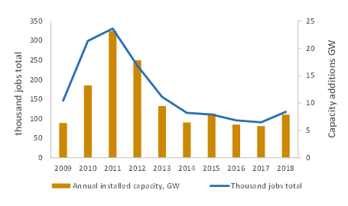

Source 77 JRC 120302 based on EurObserv’ER and IRENA.

### Global market analysis

Trade (imports, exports)

EU27 has experienced a negative trade balance in the solar PV sector[88]. The EU trade balance in the solar PV sector is negative, with a rapid decrease, starting from 2007. This imbalance reflects imports rather than exports, which are almost constant over the years. In particular, the total EU solar PV imports are strongly dependent on imports from Chinese and Asian companies.[89]

Figure 78 EU28 imports and exports for PV

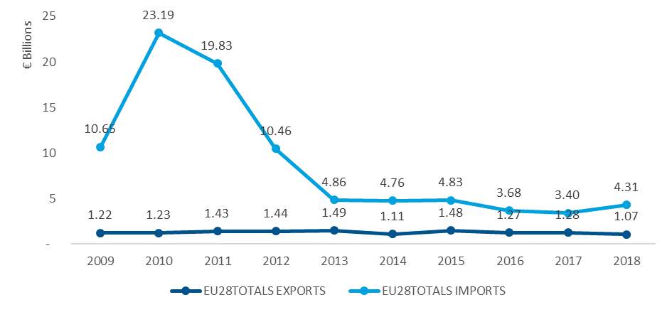

Source 78 Source 788 ICF, Climate neutral market opportunities and EU competitiveness – Draft Final Report to DG GROW, September 2020

Global market leaders VS EU market leaders

The global world market, dominated by Europe in the last decade, has rapidly changed into an Asia dominated market. The internationalisation of the production industry is mainly due to the rapidly growing PV solar cells and modules manufacturers from China and Taiwan, as well as new market entrants from companies located in India, Malaysia, the Philippines, Singapore, South Korea, UAE. However, the capital investment often comes from China, as well. At the moment, it is hard to predict how the market entrance of new players worldwide will influence future developments in the manufacturing industry and markets[90].

The downstream sector constitutes a very significant part of PV system investments. It includes project development, engineering, procurement & construction, operations and maintenance and decommissioning. Table 4 shows a listing of leading contractors for EPC and O&M, and includes a significant European presence. As for manufacturing, the majority are not pure solar players. Several EU companies are major international players for PV systems development and operation: EU companies are also at the forefront of PV module re-cycling technology, although the volume of decommissioned products is still insufficient for full commercial viability.

*Table 4 Wiki-Solar listing of inverter manufacturers, engineering, procurement and commissioning (EPC) and operation and maintenance (O&M) contractors for utility scale systems at end 2018.*

|  |  |  |
| --- | --- | --- |
| Inverters | EPC | O&M |
| SMA Solar Technology [DE]  Ingeteam [ES]  Asea Brown Boveri [CH] including Power-One [US]  Schneider Electric [FR]  TMEIC (Toshiba Mitsubishi-Electric Industrial Systems) [JP]  SunGrow [CN]  GE Energy [US]  TBEA (Tebian Electric Apparatus) [CN] including SunOasis  Fimer SpA [IT]  Siemens [DE]  Santerno [IT]  AE Advanced Energy [US]  Emerson [GB]  Bonfiglioli [IT]  Satcon [US]  Kaco [DE]  Fuji Electric [JP]  Huawei [CN]  GP Tech [ES]  Hitachi [JP]  Guanya [CN] | First Solar [US]Sterling & Wilson [IN]  Swinerton Renewable Energy [US]Abengoa Solar [ES] juwi AG [DE] Enerparc [DE]SunEdison [US]  Belectric [DE] (now part of: Innogy)Bharat Heavy Electricals [IN]  Mortenson Construction [US]  Acciona Energía [ES]  Elecnor [ES] McCarthy Building [US] Mahindra [IN]  SunPower Corporation [US]  Bechtel [US]  Canadian Solar [CA]  ACS Group [ES]  TSK Group [ES]  Kawa Capital (incl. ex. Conergy [DE]) Eiffage [FR]  Tata Power [IN]  Hanwha Q.Cells [KR]  RCR Tomlinson [AU] (in insolvency)  BayWa r.e. [DE] IB Vogt Solar [DE] | First Solar [US]SunEdison [US] (in insolvency)Enerparc [DE]juwi AG [DE] Bharat Heavy Electricals [IN]  Elecnor [ES] Cypress Creek Renewables [US] EDF Energies Nouvelles [FR] IB Vogt Solar [DE] Conergy [DE] (now part of: Kawa Capital) Signal Energy [US]  Martifer [PT] (now part of: Voltalia) TBEA SunOasis [CN]  BayWa r.e. [DE] Sterling & Wilson [IN]  SunPower Corporation [US] Canadian Solar [CA] Saferay [DE] Biosar Energy  SMA Solar Technology [DE] Grupo Ortiz [ES]  DEPCOM Power [US]  Vikram Solar  TSK Group [ES]  Metka-Egn [GR]  Kyudenko Corporation [JP]  Consolidated Edison Development [US]  RES Group [GB]  EDF Renewable Energy [US] |

Source 79 Wiki-Solar http://wiki-solar.org/index.html accessed March 2019

Critical raw material dependence

The EU’s list of critical raw materials contains boron, germanium, silicon, gallium and indium as PV relevant materials. To note that indium and gallium are only used in CIGS (and therefore not used in the 95% of the PV produced today). Silicon metal is included due to the current import dependence on Chinese PV products, although silicon oxide feedstock is abundant. Usage of silver for connections is sometimes cited as a cause for concern. The industry in any case works to decrease its use for cost reasons. R&D efforts concentrate on minimising silver use or on substitute materials like copper. The fact that PV offers a very broad range of options for materials and their sources can mitigate concerns that may arise from projections based on current device technologies.

### Future challenges to fill technology gap

Europe continues to be a leader in research on PV technologies, but also faces strong competition at global level. The innovation phase continues to pose significant challenges. Scale is a critical factor to achieving cost competiveness. This applies not just to the bulk market for free-standing or roof-applied systems, but also to building integrated products. Relatively few projects have sufficient resources to address this, particularly those requiring further technical development as well as pilot manufacturing. The new EU Green Deal and European Recovery funds could play a role in developing a new generation of PV manufacturing. Also very large-scale demonstration programmes are needed, and the new ETS Innovation Fund could be beneficial in creating such market-pull stimulus for advanced concepts.

Although the EU industry has lost considerable market share in the past decade, new opportunities are now emerging. These opportunities exist in parts of the value chain and market segments where differentiation plays a relatively large role, such as equipment and inverter manufacturing and PV products tailored to respond to the specific needs of the final sectors of use: buildings sector (BIPV), transportation (VIPV) and agriculture (AgriPV). The modularity of the technology in fact simplifies the integration of photovoltaics in a number of applications, especially in the urban environment. Furthermore, the novel PV technologies reaching the commercialization could offer new basis to rebuild the industry. The strong knowledge position of the EU research institutions, the skilled labour force and the existing and emerging industry players are the basis to rebuild a strong European photovoltaic supply chain[91].

Emerging approaches to solar photovoltaics (for instance heterojunction and perovskite materials) promise higher performances and lower cost together with a reduced use of materials and lower impact. European Institutes and companies are championing some of these new routes. Relevant manufacturing projects include Ampere, a Horizon 2020 project supporting the construction of a pilot line, to produce photovoltaic silicon solar cells and modules based on heterojunction technology[92]; Oxford PV, which is an initiative for manufacturing photovoltaic solar cells based on perovskite materials.[93]

All projections point to a large role for PV in the future energy system, which will result in a significant growth of the global PV manufacturing industry. If the EU manages to build a strong position in this industry, the benefits will not only include economic growth but also increased energy independence and leadership in innovative energy technologies. As such, it would clearly contribute to the goals set in the Energy Union strategy. Moreover, to maintain the competitiveness of the EU industry, extra-EU markets will need to be considered and developed. Building a sizeable EU PV manufacturing industry would then avoid the risk of supply disruptions’ and quality risks in extra-EU markets.

1. Ofgem Renewable Energy Guarantees Origin Register. https://www.renewablesandchp.ofgem.gov.uk/
2. European Commission (2017) Study on Lessons for Ocean Energy Development EUR 27984
3. Magagna & Uihllein (2015) 2014 JRC Ocean Energy Status Report (<https://publications.jrc.ec.europa.eu/repository/bitstream/JRC93521/jrc%20ocean%20energy%20report_v2.pdf>)
4. https://www.h2owaternetwerk.nl/h2o-actueel/redstack-bv-bedrijf-achter-blue-energy-wil-waterstof-op-gaan-wekken
5. JRC 2020, Facts and figures on Offshore Renewable Energy Sources in Europe, JRC121366 (upcoming)
6. JRC 2020, Facts and figures on Offshore Renewable Energy Sources in Europe, JRC121366 (upcoming)
7. These figures have been updated based on the JRC internal regisitry of projects and on the OES Annual Report. Given the R&D nature of some projects, it may contains small innacuracy in terms of status of a project such as operational/on pause.
8. Ocean Energy Europe (2020) Ocean energy key trends and statistics 2019
9. JRC 2020, Facts and figures on Offshore Renewable Energy Sources in Europe, JRC121366 (upcoming)
10. European Commission (2018) Market study on Ocean Energy
11. IEA (2019) World Energy Outlook 2019.
12. Current policy initiatve without specific support for emerging RES such as ocean
13. IEA (2019) World Energy Outlook 2019.
14. No support mechanisms are considered within the model.
15. JRC (2020) Technology Development Report Ocean Energy 2020 Update,
16. Seanergy 2016
17. JRC (2020) Technology Development Report Ocean Energy 2020 Update,
18. Corpower (2020) High Efficiency Wave Energy – Presentation at the Stakeholder event in support of the Offshore Renewable Energy Strategy 09/07/2020
19. Start of the SET plan initiative
20. Private investments areestimated from the patent data available through Patstat. Sources: Fiorini, A., Georgakaki, A., Pasimeni, F. and Tzimas, E., (2017) [Monitoring R&I in Low-Carbon Energy Technologies](https://setis.ec.europa.eu/related-jrc-activities/jrc-setis-reports/monitoring-ri-low-carbon-energy-technologies), JRC105642, EUR 28446 EN and Pasimeni, F., Fiorini, A., and Georgakaki, A. (2019). [Assessing private R&D spending in Europe for climate change mitigation technologies via patent data.](https://doi.org/10.1016/j.wpi.2019.101927) World Patent Information, 59, 101927.
21. EU funds awarded up to 2020 included UK recipients
22. Complete statistics on patent families are available up to 2014; filings in subsequent years are also considered if they belong to a patent family (or invention) that claims priority in this time period. Patent families are collections of documents referring to the same invention (e.g. filings to different IP offices)
23. JRC (2020) Technology Development Report Ocean Energy 2020 Update
24. Source and Methodology JRC
25. JRC and IEA [data updated Feb 2019X
26. JRC (2017) EU Low Carbon Energy Industry Report
27. <https://ec.europa.eu/jrc/en/publication/eur-scientific-and-technical-research-reports/supply-chain-renewable-energy-technologies-europe-analysis-wind-geothermal-and-ocean-energy>
28. The supply chain to which it is referred here does not reflect all the companies in the innovation
29. Hume (2018) The Rise of Crowdfunding for Marine Energy <https://www.maritime-executive.com/features/the-rise-of-crowdfunding-for-marine-energy>
30. European Commission (2018) Market study on Ocean Energy
31. FTI-Consulting. (2016). Global Wind Supply Chain Update 2016.
32. Magagna, D., Monfardini, R., & Uihlein, A. (2016). JRC Ocean Energy Status Report 2016
33. EMEC. (2020). Marine Energy. <http://www.emec.org.uk/marine-energy/>
34. TRL6 is used as cut-off point for developers receiving sufficient fuds to develop a small scale prototype of the device to be tested at sea.
35. JRC 2020, Facts and figures on Offshore Renewable Energy Sources in Europe, JRC121366 (upcoming)
36. European Commission (2020) 2020 Blue Economy Report
37. European Commission (2018) The 2018 Annual Economic Report on the EU Blue Economy
38. JRC (2017) Supply chain of renewable energy technologies in Europe.
39. JRC (2014) Overview of European innovation activities in marine energy technology.
40. JRC (2020) - Facts and figures on Offshore Renewable Energy Sources in Europe, JRC121366 (upcoming)
41. JRC (2020) - Facts and figures on Offshore Renewable Energy Sources in Europe, JRC121366 (upcoming)
42. EURActive (2020) <https://www.euractiv.com/section/energy/interview/irena-chief-europe-is-the-frontrunner-on-tidal-and-wave-energy/>
43. European Commission (2018) Market study on Ocean Energy
44. IEA (2019) World Energy Outlook
45. Ocean Energy Europe (2019) Powering Homes Today, Powering Nations Tomorrow
46. Ocean Energy Europe (2019) Powering Homes Today, Powering Nations Tomorrow
47. European Commission (2020) The EU Blue Economy Report 2020
48. European Commssion (2020) Offshore renewable energy strategy (upcoming)
49. D. Magagna et al (2018) Workshop on Future Emerging technologies for ocean energy
50. IEA data and statistics, https://www.iea.org/data-and-statistics/charts/solar-pv-power-generation-in-the-sustainable-development-scenario-2000-2030
51. EUR 1.5 trillion (1 USD = 0.84 EUR)
52. Bloomberg New Energy Finance (BNEF) New Energy Outlook (NEO)
53. The LTS study uses a single “solar” electricity generation category and is effectively PV for cost and deployment reasons.
54. The LTS results are for AC capacity, while PV systems sizes and market volumes are typically given as DC. For utility systems, the DC capacity is a factor of 1.25 higher than the AC value.
55. Jaeger-Waldau, A., Snapshot of Photovoltaics-February 2020, Energies, 13, 930
56. SWD(2020) 176, Accompanying the document “Stepping up Europe’s 2030 climate ambition Investing in a climate-neutral future for the benefit of our people”
57. Jaeger-Waldau, A, et al, How photovoltaics can contribute to GHG emission reductions of 55% in the EU by 2030, Renewable and Sustainable Energy Reviews, Volume 126, 2020, 109836,
58. Ruiz, P. et al, ENSPRESO - an open, EU-28 wide, transparent and coherent database of wind, solar and biomass energy potentials, Energy Strategy Reviews, Volume 26, November 2019, 100379
59. Bódis K, Kougias I, Jäger-Waldau A, Taylor N, Szabó S. A high-resolution geospatial assessment of the rooftop solar photovoltaic potential in the European Union. Renew Sustain Energy Rev 2019;114.
60. Woodhouse M, Smith B, Ramdas A, Margolis R. Crystalline silicon photovoltaic module manufacturing costs and sustainable pricing: 1H 2018 benchmark and cost reduction roadmap. 2019. Golden, CO
61. Fraunhofer ISE, Sustainable PV Manufacturing in Europe - An Initiative for a 10 GW GreenFab; 2019
62. According to the 2020 ITRPV update report, considering the shorter time interval 2006-2019, the learning rate shows a clear acceleration.
63. E. Vartiainen et al, Impact of weighted average cost of capital, capital expenditure, and other parameters on future utility‐scale PV levelised cost of electricity, Prog Photovolt Res Appl. 2019; 1–15.
64. With values in EUR: *“ 286 to 701 EUR/kW by 2030 and to 139 to 404 EUR/kW by 2050 (it is noted that the average cost was 1016 EUR/kW in 2018*” (1 USD = 0.84 EUR)
65. BIPVBoost H2020 Project, Competitiveness status of BIPV solutions in Europe, January 2020, available on project web site
66. 33 to 42 EUR/MWh, BNEF 1H LCOE update, 28 April 2020, (1 USD = 0.84 EUR)
67. 8 to 42 EUR/MWh, IRENA, Future of Solar Photovoltaic, November 2019, (1 USD = 0.84 EUR)
68. DG ECFIN Note on the Cost-Competitiveness of Renewable Energy in the EU - The Case of Onshore Wind and Solar Photovoltaic Electricity, Note to the Economic Policy Committee Energy and Climate Change Working Group, June 2020
69. Bódis K, Kougias I, Jäger-Waldau A, Taylor N, Szabó S. A high-resolution geospatial assessment of the rooftop solar photovoltaic potential in the European Union. Renew Sustain Energy Rev 2019;114.
70. As of 16 January 2020.
71. European Solar Manufacturing Accelerator, Solar Power Europe, ETIP PV, ESMC, and others (2020), see https://www.solarpowereurope.org/campaigns/manufacturing-accelerator/
72. CETP-SRIA Input Paper - Thematic Cluster: Renewable Technologies 1 & 2; Challenges 2 - Photovoltaics
73. Frankfurt School-UNEP Centre/BNEF. 2020, Global Trends in Renewable Energy Investment 2020, http://www.fs-unep-centre.org
74. Patent documents are grouped in families, with the assumption that one family equals one invention.
75. N. Taylor, A. Jäger-Waldau, Photovoltaics technology development report 2020 - Deliverable D2.3.2 for the Low Carbon Energy Observatory, European Commission, Ispra, 2020, JRC120954.
76. https://www.fs-unep-centre.org/wp-content/uploads/2020/06/GTR_2020.pdf
77. Asset Study Competitiveness (2020)
78. See also ICF, Climate neutral market opportunities and EU competitiveness – Draft Final Report to DG GROW, September 2020
79. Ongoing ASSET Study on Competitiveness, 2020
80. List will be provided soon
81. <https://www.sciencedirect.com/science/article/pii/S1364032120301301?via%3Dihub> (equal to 63)
82. https://www.solarpowereurope.org/wp-content/uploads/2020/07/3sunfactory_lr.pdf
83. https://www.solarpowereurope.org/wp-content/uploads/2020/07/meyer_burger_lr.pdf
84. Assessment of Photovoltaic (PV), Final Report, Trinomics B.V 2017 https://trinomics.eu/wp-content/uploads/2017/07/AssessmentofPV.pdf
85. (IEA, World Energy Outlook, Special Report Sustainable Recovery, June 2020) https://www.iea.org/reports/sustainable-recovery/evaluation-of-possible-recovery-measures
86. Ongoing ASSET Study on Competitiveness, 2020
87. Renewable and Sustainable Energy Reviews, Volume 126, July 2020, 109836, https://doi.org/10.1016/j.rser.2020.109836
88. Guidehouse Insights Estimates of UN COMTRADE data
89. JRC Report: EU energy technology trade - <https://publications.jrc.ec.europa.eu/repository/handle/JRC107048>
90. PV Status Report 2019

    <https://publications.jrc.ec.europa.eu/repository/bitstream/JRC118058/kjna29938enn_1.pdf>
91. Assessment of Photovoltaics (PV) Final Report, Trinomics (2017)
92. www.ampere-h2020.eu
93. <https://www.eib.org/en/products/blending/innovfin/products/energy-demo-projects.htm>