Renewable hydrogen through electrolysis

State of play of the selected technology and R&I landscape
Hydrogen offers the opportunity to be used as both an energy vector and a feedstock molecule, therefore having several potential uses across sectors (industry, transport, power and buildings sectors). Hydrogen does not emit CO₂ when used, and offers the option to decarbonise several hydrogen-based applications, provided its production is sustainable and hydrogen production is not associated to a considerable carbon footprint. Currently the most mature and promising hydrogen production technology, which can be coupled with renewable electricity, is electrolysis. Since any hydrogen-based technological chain has to rely on a hydrogen supply, it is sensible to focus first attention to technological solutions able to produce renewable hydrogen at scale and electrolysis is to be the most mature option.
In the strategic vision for a climate-neutral EU published in November 2018, the EC LTS foresees the share of hydrogen in Europe’s energy mix to grow from the current less than 2% to 13-14% by 2050, amounting to 60 to 80 million tonnes of oil equivalent (Mtoe) in 2050. In terms of installed capacity, the LTS foresees up to 511 GW (1.5 TECH scenario), whilst other studies suggest a 1 000 GW European market by 2050.
The objective of the hydrogen strategy is to install at least 6 GW of renewable hydrogen electrolysers in the EU by 2024 and 40 GW of renewable hydrogen electrolysers by 2030. The Hydrogen strategy sees industry and heavy-duty transport as applications with highest added value for the EU decarbonisation ambitions.
Figure 79 Differences in final energy consumption in Iron & Steel compared to Baseline in 2050 by fuel and scenario
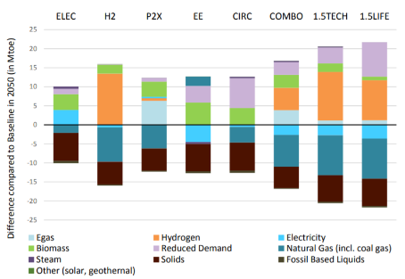
Source 80 EC PRIMES

Figure 80 Energy Content of feedstock demand for ethylene, ammonia and methanol production by type of feedstock and scenario in 2050
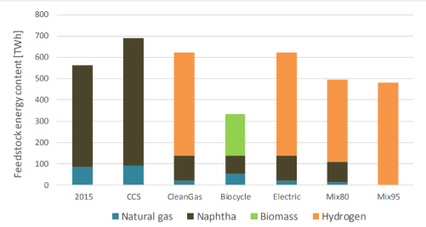
Source 81 FORECAST

Capacity installed, generation

The current hydrogen production is almost completely based on the use of fossil fuels and associated with large industrial processes. The dedicated world production of hydrogen (hydrogen as primary product) can be subdivided according to the following feedstock:

- ca. 71% from natural gas (steam methane reforming), accounting for 6% of global natural gas use, and emitting around 10 tonnes of carbon dioxide per tonne of hydrogen (tCO2/tH2);
- ca. 27% from coal (coal gasification), accounting for 2% of global coal use, emitting around 19 tCO2/tH2;
- about 0.7% from Oil (reforming and partial oxidation) (emitting around 6.12 tCO2/tH2);
- less than 0.7% from renewable sources (water electrolysis powered with renewable electricity in particular)
  - About 200 MJ (55 kWh) of electricity are needed to produce 1 kg of hydrogen from 9 kg of water by electrolysis. The required water feedstock consumption is always higher than the stoichiometric value and depends on the actual process efficiency.
The total worldwide hydrogen production is mainly associated with its use as chemical feedstock in oil refining (about 33%), ammonia production (about 27%) and methanol synthesis (about 10%); the remaining fractions are linked with other forms of pure hydrogen demand (e.g. chemicals, metals, electronics and glass-making industries) and use of mixtures of hydrogen with other gases (e.g. carbon monoxide) such as for heat generation.

9,9 Mt/y of hydrogen is produced today in the EU28 (9.4 Mt/y in EU27), out of about 70 Mt/y of pure hydrogen globally, producing around 830 Mt of CO₂ globally.

In this section, the focus is on renewable hydrogen production and on the competitiveness elements of this first segment of the whole hydrogen value chain. On-site hydrogen production for co-located consumption in industrial applications appears a promising option on the short-medium term to smoothly reach the scale for the larger introduction of the carrier in the energy system, in line with the ambition of a climate-neutral economy and the hydrogen strategy. The current use of hydrogen in the chemical and petrochemical industry is to be added to the future uses as fuel for the transportation sector (various modes), for cogeneration of electricity and heat or electricity alone, as a storage option for electricity and as a feedstock in the chemical industry, for direct use of hydrogen in small scale stationary end-uses. However, transport of hydrogen, its storage and its conversion in end-use applications (e.g. mobility, buildings) are not discussed here.
The recently launched “Hydrogen Strategy for a climate neutral Europe” aims at fostering a significant growth in European electrolyser capacity with the objective of an expected 6 GW (producing up to one million tonne of renewable hydrogen per year) of electrolysers powered by renewable electricity deployed by 2024 and 40 GW (producing up to ten million tonnes of renewable hydrogen) deployed by 2030.
Renewable hydrogen production is still at very low capacity, but a large number of demonstration projects have been announced and it is expected to grow significantly in the coming decade. In 2019, EU27 had around 50 MW of dedicated water electrolysis capacity installed (all technologies), of which around 30 MW were in Germany in 2018. There are an additional 34 concrete projects already in the pipeline for an additional 1 GW capacity, requiring EUR 1.6 billion of investments under construction or announced, and an additional 22 GW of electrolyser projects and would require further elaboration and confirmation. Between November 2019 and March 2020, market analysts increased the list from 3,2 GW to 8,2 GW of electrolysers by 2030 (of which 57% in Europe).

Figure 81 Hydrogen production
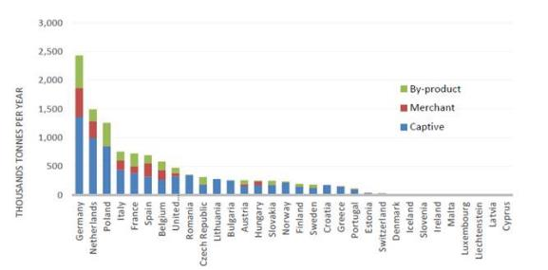
Source 82 Fuel Cell Hydrogen Joint Undertaking (2019 data)

The 2018 worldwide yearly hydrogen use was about 70 Mt as pure gas, in addition 45 Mt of hydrogen were used without prior separation from other gases. European hydrogen use in its pure form (both merchant and captive) accounted for about 9.7 Mt H₂ in 2015; around 47% of which was used in oil refining, 40% in ammonia production, 8% in methanol production and the remaining used mainly in other chemical productions and industrial processes.
Figure 82 Hydrogen Consumption
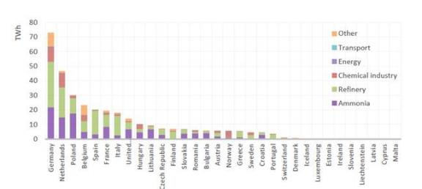
Source 83 Fuel Cell Hydrogen Joint Undertaking (2019 data)
Cost, LCOE
The cost of hydrogen depends on several factors: (i) capital investment (retrofitting or greenfield); (ii) operating costs, linked with the costs of natural gas or renewable power (50-60% of overall costs for both renewable and low-carbon hydrogen); (iii) load factor; and (iv) price of carbon emission (expected in the Emission Trading System), and other elements such as availability and cost of storage.
Estimated costs today for fossil-based hydrogen with carbon capture and storage are about 2 EUR/kg, and 2.5-5.5 EUR/kg for renewable hydrogen. Carbon prices in the range of EUR 55-99 per tonne of CO2 would be needed to make fossil-based hydrogen with carbon capture competitive with fossil-based hydrogen today (current cost of about 1.5 EUR/kg). Today’s price of 1 tonnes of CO₂ is around 25 EUR in the Emission Trading Scheme, and historically has not been higher. This means that CO₂ price will be a determining factor, together with low price of electricity, in making renewable hydrogen competitive against fossil based energy. The relative impact of these factors will be strongly influenced by the actual natural gas prices, which changes with location, depending on the world region considered, and temporality.
Costs for renewable hydrogen are going down quickly. Electrolyser costs have already been reduced by 60% in the last ten years, and are expected to halve in 2030 compared to today thanks to economies of scale. Other studies indicate that the price of renewable hydrogen will depend on the location of electrolyser (on site, or “centralised” electrolyser). In regions with cost of renewable electricity, electrolysers are expected to produce hydrogen that will compete with fossil-based hydrogen in 2030. These elements will be key drivers of the progressive development of hydrogen across the EU economy.
Based on current electricity prices, the associated cost estimates for EU production range (based on IEA, IRENA, BNEF) are:
- low-carbon fossil-based hydrogen: EUR 2.2/kg;
- Renewable hydrogen: EUR 3-5.5/kg.
For 2030, the cost estimates for EU production range (based on IEA, IRENA, BNEF) are:
- low-carbon fossil-based hydrogen: EUR 2.2-2.5/kg.
For the renewable hydrogen, the cost in the range EUR 1.1-2.4/kg. However, assumptions depend on a number of input factors. In countries relying on gas imports and characterised by good renewable resources, clean hydrogen production from renewable electricity can compete effectively with production that relies on natural gas.
Reducing the price of renewable hydrogen allows an increasing penetration of hydrogen into different sectors and applications. Usually system boundaries for hydrogen production calculations are defined by the production side, but actual competitiveness for hydrogen uses comes from the opportunity offered by business cases outside the production boundaries. Industrial competitiveness could allow certain industrial processes such as the use of hydrogen for clean steel production, to become affordable earlier than other uses which have to face more challenging competition against conventional fossil-based hydrogen (e.g. ammonia). As an additional advantage, renewable hydrogen has a lower price volatility against hydrogen produced from fossil fuels, which follow natural gas prices.
Table 5 State of art on Electrolysis
Low temp versus/ high temp membranes | Temp (°C) | Electrolyte | Efficiency (nominal stack and nominal system) | Maturity level () | Million EUR/tonne H2 out | Cost in EUR/MWel of production capacity/year
Alkaline Electrolysis (AEL) | 60-90 | Potassium hydroxide | 63-71%;  51-60% | Used in industry for last 100 years | 2020: 15-65  2030: 12-38  2050: 7-29 | 45 000
Polymer Exchange Membrane (PEMEL) | 50-80 | Solid state membrane | 60-68%; 46-60% | Commercially used for medium and small applications (less 300 kW) () | 2020: 42-120  2030: 26-82  2050: 8-55 | 69 000
Solid Oxide Electrolysis – high temperature (SOEL) | 700-900 | Oxide ceramic | 76-81% | Experiment, low TRL, pre-commercial status | 2020: 36-122  2030: 27-111  2050: 13-38
Anion Exchange Membrane (287 (AEMEL) | 60-80 | Polymer membrane | N/A | Commercially available for limited applications
Source 84 Alexander Buttlera, Hartmut Spliethoﬀ, Renewable and Sustainable Energy Reviews 82 (2018) 2440–245
Costs of electrolysers (2019): Capital expenditure (CAPEX) account for 50% to 60% of total costs of electrolyser.
AEL | USD 500–1400/kWe
PEM | USD 1 100–1800/kWe
SOEC | USD 2 800–5600/kWe

Figure 83 Specific Hydrogen Production per Cell Area
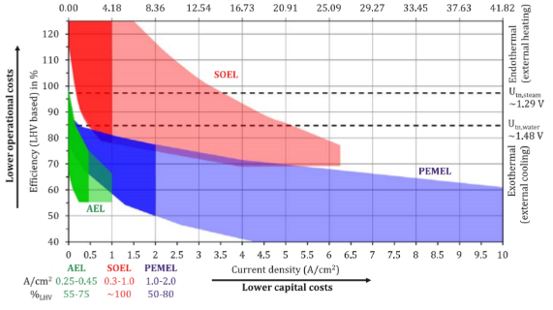
Source 85 A. Buttler, H. Spliethoﬀ Renewable and Sustainable Energy Reviews 82 (2018) 2440–2454
From now to 2030, investments in electrolysers could range from EUR 24 billion to EUR 42 billion to install 40 GW of electrolysers. In addition, over the same period, from EUR 220 billion to EUR 340 billion would be required to scale up and directly connect 80-120 GW of solar and wind energy production capacity to power them. From now to 2050, investments in production capacities would amount to EUR 180-470 billion in the EU.

Public R&I funding

An analysis of European projects financed under horizon 2020 (2014-2018) focussing on electrolyser’s development highlighted a public support of more than EUR 90 million, complemented by EUR 33.5 million of private money.

Figure 84 Cumulative EU funding contribution for electrolyser technology-related projects
Source 86 JRC 2020 Current status of Chemical Energy Storage Technologies
Between 2008 and 2018, the Fuel Cells and Hydrogen Joint Undertaking (FCH JU) supported 246 projects across several hydrogen-related technological applications, reaching a total investment of EUR 916 million, complemented by EUR 939 million of private and national/regional investments. Under the Horizon 2020 program (2014-2018 period), over EUR 90 million have been allocated to electrolyser’s development, complemented by EUR 33.5 million of private funds,. At national level, Germany has deployed the largest resources with EUR 39 million allocated to projects devoted to electrolyser development (2014-2018). In Japan, Asahi Kasei received a multimillion dollar grant supporting the development of their alkaline electrolyser.

Figure 85 The funding distribution across years for chemical energy storage projects subdivided according to the methodology as defined in the Technical Report “Current status of Chemical Energy Storage Technologies”, EU funding and private co-funding are separate
Source 87 JRC Technical Report Current status of Chemical Energy Storage Technologies

Patenting trends

Asia (mostly China, Japan and South Korea) dominates the total number of patents filed in the period from 2000 to 2016 for the hydrogen, electrolyser and fuel cell groupings. Nevertheless, the EU performs very well and has filed the most “high value” patent families in the fields of hydrogen and electrolysers. Japan, instead, filed the largest number of “high value” patent families on fuel cells.

Value chain analysis
Main companies
Whilst around 280 companies are active in the production and supply chain of electrolysers in Europe and more than 1 GW of electrolyser projects are in the pipeline, the total European production capacity for electrolysers is currently below 1 GW per year.
The electrolysis market is very dynamic with several fusions and acquisitions recorded in recent years. An overview of the manufacturers of medium to large scale electrolysis systems reports only manufacturers of commercial systems and does not consider manufacturers of laboratory-scale electrolysers. The market analysis shows that electrolysers based on alkaline electrolysis (AEL), are provided by nine EU producers (four in Germany, two in France, two in Italy and one in Denmark), two in Switzerland and one in Norway, two in US, three in China, and three in other countries (Canada, Russia and Japan). Electrolysers based on proton exchange membrane (PEM) electrolysis, are provided by six EU suppliers (four in Germany, one in France and one in Denmark), one supplier from UK and one from Norway, two suppliers from US, and two suppliers from other countries. Electrolysers based on solid oxide electrolysis, are manufactured by three suppliers from EU (two in DE and FR) and one from the US.
Figure 86 Location of the manufacturers of large electrolysers, by technology
Electrolyser technology | EU27 | CH, NO, UK | US | China | Others
Alkaline AEL | 9 | 3 | 2 | 3 | 3
Proton Exchange Membrane PEM | 6 | 2 | 3 |  | 2
Solid Oxide Electrolysis SOEL | 3 |  | 1
Source 88 A. Buttler, H. Spliethoﬀ, Renewable and Sustainable Energy Reviews 82 (2018) 2440–2454
Gross value added growth
Production equipment is a significant contributor of value added in electrolyser cell production.
Employment figures

Currently, the entire hydrogen industry has about 16 000 employees in Europe. There are 34 concrete electrolyser projects in the pipeline for an additional 1 GW, requiring EUR 1.6 billion of investments and creating 2 000 new additional jobs. Regarding future projections, the results below should be interpreted as the number of jobs that will be created for each billion EUR invested into the hydrogen value chain in that year. Job estimates for renewable hydrogen for 2050, are around 1 milllion, of which 50% of jobs would be in the renewables sector.
Figure 87 Number of jobs (000’s) created per billion EUR invested, breakdown by supply chain (left) and by sector (right)
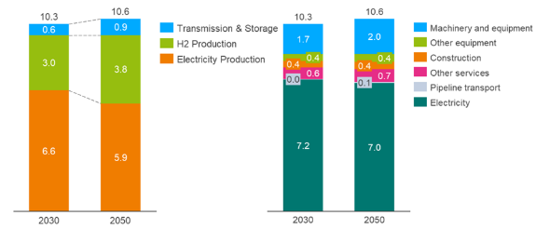
Source 89 ASSET Study commissioned by DG ENERGY - Hydrogen generation in Europe: Overview of costs and key benefits, 2020

Figure 88 Number of jobs created per billion EUR invested, breakdown by direct vs indirect jobs
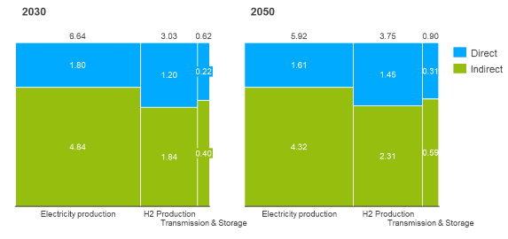
Source 90 ASSET Study commissioned by DG ENERGY - Hydrogen generation in Europe: Overview of costs and key benefits, 2020

Global market analysis
Raw materials
Europe is fully dependent on third countries for the supply of 19 of 29 raw materials relevant to fuel cells and electrolyser technologies. For the production of fuel cells alone, 13 critical raw materials namely cobalt, magnesium, REEs, platinum, palladium, borates, silicon metal, rhodium, ruthenium, graphite, lithium, titanium and vanadium are needed. The corrosive acidic regime employed by the proton exchange membrane electrolyser, for instance, requires the use of noble metal catalysts like iridium for the anode and platinum for the cathode, both of which are mainly sourced from South Africa (84%). Hydrogen production also relies on several critical raw materials for various renewable power generation technologies. The biggest supply bottleneck for fuel cells is however not the raw materials, but the final product, of which the EU only produces 1%.

Future challenges to fill technology gap
Even though renewable hydrogen is commercially available, its currently high costs provide limits to its broad uptake. To ensure a full hydrogen supply chain to serve the European economy, further research and innovation efforts are required.

As outlined in the Hydrogen Strategy, upscaling the generation side will entail developing to larger size, more efficient and cost-effective electrolysers in the range of gigawatts that, together with mass manufacturing capabilities and new materials, will be able to supply hydrogen to large consumers. The Green Deal call (under Horizon 2020) for a 100 MW electrolyser will be the first step. Moreover, research can play a role in increasing electrolyser’s performance and reducing its costs e.g.: increasing the durability of membranes for PEM, while reducing their critical raw materials content. Solutions for hydrogen production at lower technology readiness level need also to be incentivised and developed such as, for example, direct solar water splitting, or high-temperature pyrolysis processes, (cracking of methane into hydrogen, with solid carbon-black as side product). In the case of biomass based production (bio generation from bio-methane, bio-gas, vegetable oils) and from marine algae (biochemical conversion), a particular attention is to be paid to sustainability requirements.
In addition to considerations related to hydrogen production, subsequent new hydrogen technological chain should be developed. Infrastructure needs further development to distribute, store and dispense hydrogen in large volumes whether pure or mixed with natural gas should be developed. Points of production of large quantities of hydrogen and points of use (especially of large quantities) are likely not going to be close to each other. Hydrogen will have therefore to be transported over long distances.
Third, large scale end-use applications using renewable hydrogen need to be further developed, notably in industry (e.g. using hydrogen to replace coking coal in steel-making or upscaling renewable hydrogen use in chemical and petrochemical industry) and in transport (e.g. heavy duty road, rail, and waterborne transport and possibly aviation).
Finally, further research is needed to enable improved and harmonised (safety) standards and monitoring and assess social and labour market impacts. Reliable methodologies have to be developed for assessing the environmental impacts of hydrogen technologies and their associated value chains, including their full life-cycle greenhouse gas emissions and sustainability. Importantly, securing the supply of critical raw materials in parallel to their reduction, substitution, reuse, and recycling needs a thorough assessment in the light of the future expected increasing hydrogen technologies deployment, with due account being paid to ensuring security of supply and high levels of sustainability in Europe.

Batteries

State of play of the selected technology and R&I landscape
According to the LTS, by 2050, the share of electricity in final energy demand will double to at least 53 %. By 2030, it is expected that around 55 % of electricity consumed in the EU will be produced from renewables (up from the current level of 29 %) and by 2050, this figure is expected to be more than 80%.
In a world that is increasingly electrified, batteries will become one of the key technological components of a low-carbon economy as they enable the energy transition from a mostly centralised electricity generation network towards a distributed one with increased penetration of variable renewable energy sources and “intelligent” energy flow management with smart grids and prosumers. In particular, batteries cover close to half of the total need for storage within the EU energy system (more than 100 TWh), bypassing by far the currently dominating pumped hydro storage technology, and followed closely by hydrogen. Stationary batteries would play a larger role, growing from 29 GW in 2030 (from negligible amounts today) to between 54 GW (1.5 LIFE) and 178 GW (ELEC), in general having higher deployment in those scenarios without significant development of e-fuels.
Batteries are electrochemical energy storage technologies that can be found in four potential locations: associated to generation, transmission, distribution, and behind the meter (consumer, commercial and industrial). They can be divided into the categories of primary and secondary (rechargeable).
Batteries are based on a wide range of different chemistries. In the past lead acid based batteries were the main used technology, whereas nowadays Li-ion technology plays a central role. Other, more experimental, battery technologies are Lithium-air (Li-Air), Lithium-sulphur, Magnesium-ion, and Zinc-air. Li-Air technologies (also known as metal-air) have a much higher energy density than conventional lithium-ion batteries.
Figure 89 Overview of available battery technologies
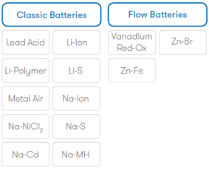
Source 91 European Association for Storage of Energy (EASE)
Secondary batteries, from an application point of view, can be broken down into:
- portable batteries (Li-based and primarily used in consumer devices);
- industrial batteries (mostly lead-based and used for industrial devices for stationery and mobile applications);
- starting-lighting ignition batteries (lead based, used in automobiles);
- “Clean Vehicles” batteries (mostly Li-based batteries, for e.g. Electric Vehicles, Plug-in Hybrid Vehicles);
- power grid batteries (different technologies, installed in residential, commercial & industrial, or grid-scale level facilities to provide a wide variety of services: balancing, system services, ancillary services).
Figure 90 Summary of services that can be provided by Energy Storage in the Power System
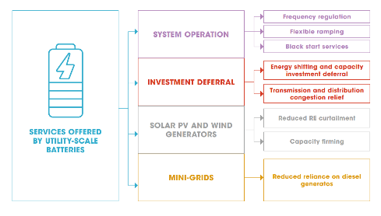
Source 92 IRENA Utility Scale Batteries 2019
Besides pumped hydro and compressed air with application for large power and long times , Li-ion Batteries currently dominate the rest of the market in Power System Applications. Li-ion batteries that have become a key option for electrifying transport and for lifting the penetration levels of intermittent renewable energy. Given the economies of scale, they are also increasingly used for stationary electricity storage.
Capacity installed
Battery development and production is largely driven by the roll out of electromobility. The future global annual market for batteries is expected to grow fast and be very substantial, increasing from about 90 GWh in 2016 to about 800 GWh in 2025, exceeding 2 000 GWh by 2030 and could reach up to 4 000 GWh by 2040 in the most optimistic scenario. As the global market size increases, the EU is forecasted to develop a capacity of 207 GWh by 2023, while European demand for electric vehicle batteries alone would be around 400 GWh by 2028.
With respect to performance, Li-ion energy density has increased significantly in the recent years, tripling since their commercialization in 1991. Further potential for optimization is given with new generation of Li-ion batteries.
Figure 91 Energy density of Li-ion batteries over recent years
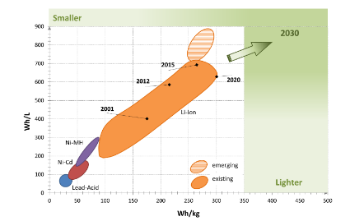
Source 93 JRC 2017315
EV demand has tripled global manufacturing capacity for Li-ion since 2013, given that batteries represent around 50% of the cost of an EV. By 2050, the share of battery electric and fuel cell drivetrains would reach 96% in 2050 (around 80% for battery electric and 16% for fuel cells). While only about 17 000 electric cars were on the road in 2010, there are today about 7.2 million electric cars globally. Of the 4.79 million battery electric vehicles worldwide, 1 million are in Europe. In particular, EVs could provide up to 20% of the flexibility to the grid required on a daily basis by 2050 given that appropriate interoperability solutions are in place and deployed.
Figure 92 Global Electric Vehicles and Plug in hybrid car stock, 2010-2019
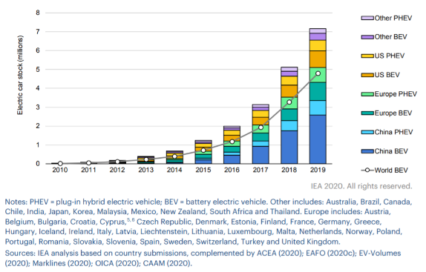
Source 94 IEA, Global electric car stock, 2010-2019, IEA, Paris https://www.iea.org/data-and-statistics/charts/global-electric-car-stock-2010-2019
Currently, there have been announcements for investments in up to 11 battery factories, with a projected capacity of 270 GWh by 2030. Whether these investments will materialise or not will depend on the establishment of a regulatory framework that will ensure fair competition for producers who take into account stricter sustainability standards.

Figure 93 Planned battery factories in EU27 + Norway and UK
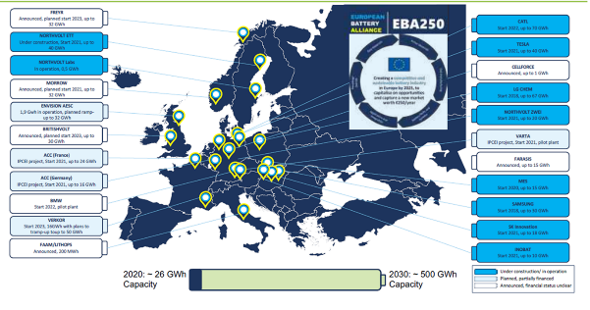
Source 95 European Battery Alliance
Cost, LCOE
For batteries, upscaling works differently than for other technologies - at least for Li technology, the cell size and form often change while its performance increases quickly. Li-ion technology is about to take over the leading role from lead-acid batteries, both for mobile and stationary applications. Li-ion batteries are viable in short-duration applications where services can be stacked and adapted to market pricing (e.g. hourly balancing, peak shaving and ancillary services) but are less cost effective for longer duration storage (> 4 hours, > 1 MW).

Electric vehicle (EV) demand is the main driver of cost reduction in Li-ion batteries. Li-ion battery prices, which were above USD 1 100/kWh in 2010, have fallen 87% in real terms to USD 156/kWh in 2020,. By 2025, average prices will be close to USD 100/kWh. The average battery pack size across electric light-duty vehicles sold (covering both battery electric vehicles and plug-in hybrid electric vehicles) continues to increase from 37 kWh in 2018 to 44 kWh in 2020, and battery electric cars in most countries are in the 50-70 kWh range.
Figure 94 Li-ion battery price survey results: volume-weighted average
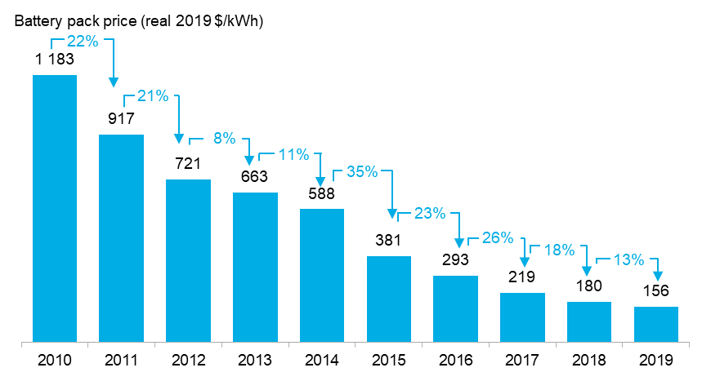
Source 96 BNEF

Figure 95 Li-ion battery pack price (real 2019 USD/kWh)
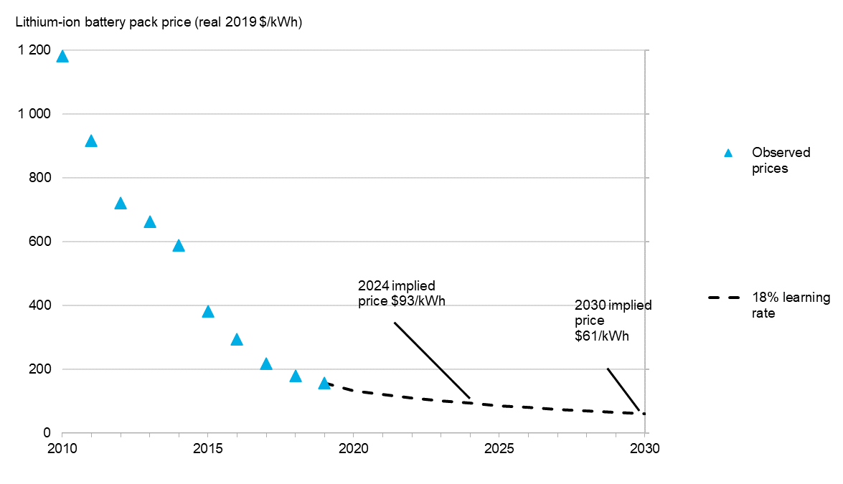
Source 97 BNEF
The prices for stationary Li-ion systems are also impressively coming down, though the cost is not the main factor for stationary systems, if compared to lifecycle. However, the cost reduction has been slower due to the contribution of other major cost components (e.g. inverters, balance of system hardware, soft costs such as engineering, procurement and construction), reduced economies of scale, and many use cases with different requirements. The benchmark costs of Li-ion stationary storage systems in 2017 were about EUR 500/kWh for energy-designed systems, about EUR 800/kWh for power-designed systems, and EUR 750/kWh for residential batteries. Lowering of balance of system and other soft costs can potentially help further cost reduction of stationary energy storage systems, lifting barriers for their widespread deployment. At the same time, alternative technologies, other than Li-ion, are most promising for stationary energy storage and most probably will gain most market share in the future.
R&I

The need for cost reduction leads to innovation around four performance characteristics: energy, power, lifespan and safety. Immediate innovation funding relates to succeeding with Li-ion cell mass production. In the short-term perspective this requires R&I at very high TRL level to bypass at least marginally current state of the art and start production (without waiting for break-through with solid-state technology).
While improving the performance of conventional lithium-ion batteries remains important, R&I efforts should also explore new chemistries for storing electricity at different scales329. The high differentiation of the market and the continuous interest in innovation are driven by multiple factors. Among the chemistries with a lower market share, currently lithium-sulphur and zinc-air batteries may be the most advanced but serious challenges will need to be overcome before commercialisation. Even though they both have significant potential, both Li-air and Mg-ion chemistries face difficulties and are dependent on technological breakthroughs for further development. Since the market for batteries is very competitive and prone to hypes, the long investment cycles, sometimes inflated expectations and reliance of some actors on government funding, can become problematic. Often, venture capital firms are reluctant to invest in projects that do not offer quick returns on investment. In addition, investors can be discouraged when innovations do not live up to the expectations. Consequently, some battery storage firms go bankrupt before reaching commercialisation329.
The wide range of applications of batteries and the various limitations of existing chemistries continue to drive innovation in the sector. Research and Innovation will benchmark the future specifications and characteristics for battery technology as such and, more important, will determine the speed and market uptake rates for mobility and energy sector electrification. The corresponding investments in research have to be substantially increased, following the trend of the last years. High performing batteries are an essential energy storage technology necessary for Europe to succeed in this transition, in particular to be competitive also in the largest Chinese market. Main technological challenges remain improving performances of batteries, at the same time guaranteeing the European-level quality and safety, as well as the availability of raw and processed materials. This can only happen through breakthrough innovations and disruptive inventions; increased digitalisation; pushing the boundaries of technological performance of battery materials and chemistries; increasing the effectiveness of manufacturing processes; ensuring smart integration in applications; interoperability with the rest of the smart energy system components at all levels; and guaranteeing reuse or recycling and sustainability of the whole battery value chain.
Materials play a very important part in the value chain, starting from the right choice of raw material that should be sustainable and easily available, over pre-processed materials, advanced value added materials and materials with low environmental and CO2 footprint up to materials that by nature or by design will be easily recyclable. Thus, EU should consider take up the chance to regain competitiveness by providing modern sustainable and cost competitive battery materials and basic battery components (as anode, cathode, electrolyte, separators, binders, etc.) made in Europe.
The current research trend is to develop advanced materials (e.g. silicon enriched anode, solid state electrolytes) for the currently dominant Li-ion technology rather than developing new chemistries beyond Li-ion, at least until 2025. On the battery’s technical innovation side, areas include use of graphene, silicon anodes, solid state electrolytes, room-temperature polymer electrolytes, and big-data-driven component recycling/repurposing techniques (e.g. Circunomics) paving the way for further efficiency increases. These improved technologies are speculated to transition by 2030 towards post Li-ion technologies (Li-air, Li-S, Na-ion) once their performance is proven in automotive applications. Li-ion technology is therefore expected to remain as the dominant deployed technology at least until 2025-2030.
The continuous pressure of improving Li-ion battery performance, especially in terms of extended life, cyclability and energy and power density as well as safety could affect the market uptake of emerging non-Li battery technology. Nevertheless, a broad range of applications requires a variety of fit-to-purpose batteries to satisfy the requirements for each application hence stimulating development of new types of batteries.

Despite only 3% of global production capacity currently being located within the EU, the sector is a very active investment space, with EU companies receiving around a third of deal volume and total investment over the 2014-2019 period. One should also mention the Business Investment Platform (BIP) set up by InnoEnergy to channel private funding around innovative manufacturing projects in all segments of the batteries value chain. More than EUR 20 billion is in the pipeline.
Innovators in the batteries chain have managed to attract considerable levels of early stage and late stage investments (with EU companies attracting about 40%) as new technology developments emerged. France and Sweden stand out in terms of total size of investments in early stage companies, while Sweden and Germany are the EU’s leading investors in late stage companies. Early and late stage investment peaked across the board in recent years as new technology developments emerged, with the EU holding a considerable share of these investments.

Public R&I funding
Figure 96 EU28 Public RD&D Investments in the Value Chain of grid-connected electrochemical batteries used for energy storage and digital control systems
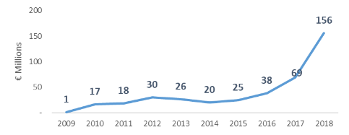
Source 98 ICF, commissioned by DG GROW - Climate neutral market opportunities and EU competitiveness study (Draft, 2020)
Figure 97 Top 10 Countries - Public RD&D Investments (Total 2016-2018) in grid-connected electrochemical batteries used for energy storage and digital control systems
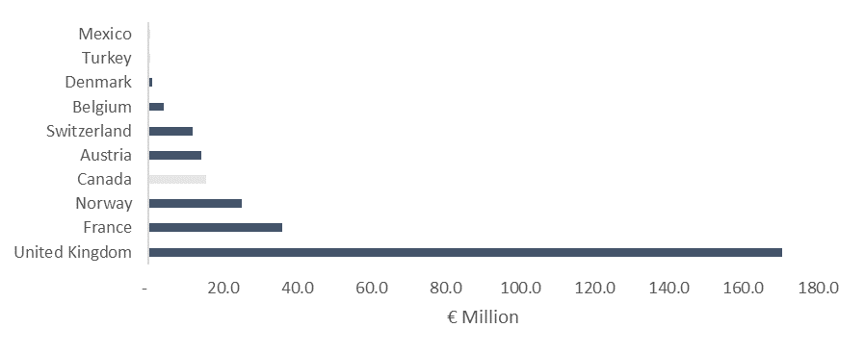
Source 99 ICF, commissioned by DG GROW - Climate neutral market opportunities and EU competitiveness study (Draft, 2020) (IEA data, does not include China)
A number of Member States are strengthening their R&I capacity. One prominent example includes the Frauenhofer (Germany) with its own “battery alliance”, the biggest research production facility consisting of a number of institutes. Other important R&I players include CEA (France), ENEA (Italy), CIC energiGUNE (Spain), etc.
In the UK, the Faraday battery challenge (part of the Industrial Strategy Challenge Fund of the UK) has an investment of EUR 280 million, which addresses the growing automotive battery technology market. There are opportunities for EU-UK cooperation in this sector worth an estimated EUR 57 billion across Europe by 2025.
Private R&I funding

Figure 98 Early Stage Private Investment in grid-connected electrochemical batteries used for energy storage and digital control systems
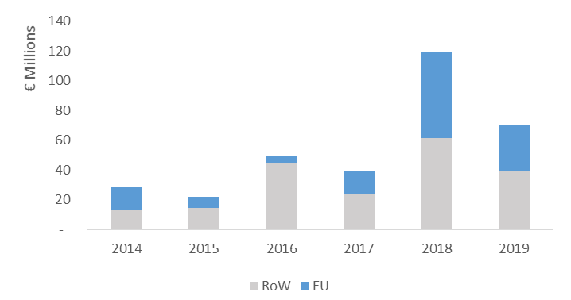
Source 100 ICF, commissioned by DG GROW - Climate neutral market opportunities and EU competitiveness study (Draft, 2020)
Figure 99 Total Early Stage Private Investment between 2014 and 2019 (top 10 countries) in grid-connected electrochemical batteries used for energy storage and digital control systems
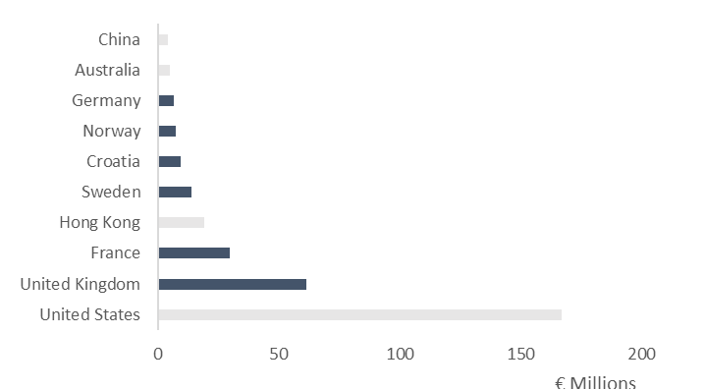
Source 101 ICF, commissioned by DG GROW - Climate neutral market opportunities and EU competitiveness study (Draft, 2020)

Figure 100 Late Stage Private Investment in grid-connected electrochemical batteries used for energy storage and digital control systems
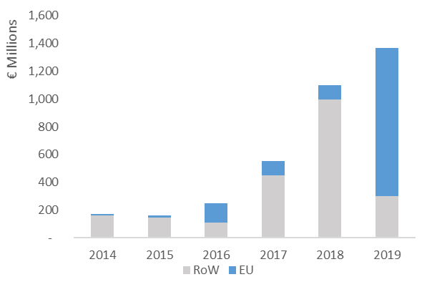
Source 102 ICF, commissioned by DG GROW - Climate neutral market opportunities and EU competitiveness study (Draft, 2020)
Figure 101 Total Late Stage Private Investment between 2014 and 2019 (top 9 countries) in grid-connected electrochemical batteries used for energy storage and digital control systems
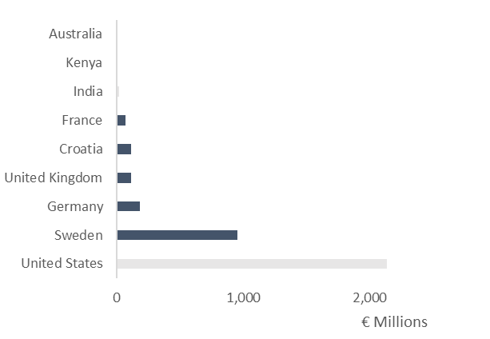
Source 103 ICF, commissioned by DG GROW - Climate neutral market opportunities and EU competitiveness study (Draft, 2020)

Patenting trends

Historically, more patent applications have been filed in the RoW than in the EU (EU share of high value patents is of about 18% between 2014 and 2016).
Figure 102 Patent Applications (2007-2016) – EU28 vs RoW in of grid-connected electrochemical batteries used for energy storage and digital control systems
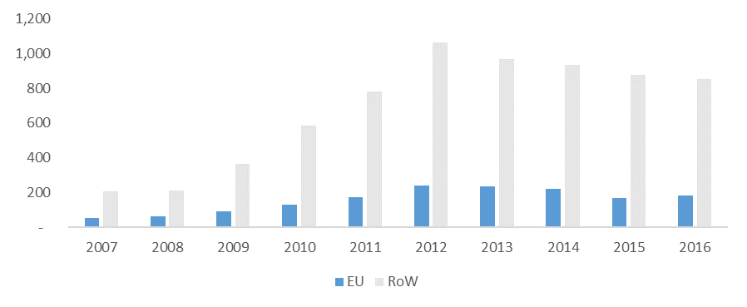
Source 104 ICF, commissioned by DG GROW - Climate neutral market opportunities and EU competitiveness study (Draft, 2020)
Figure 103 Patent Applications - Top 10 Countries (Total 2014-2016) in of grid-connected electrochemical batteries used for energy storage and digital control systems
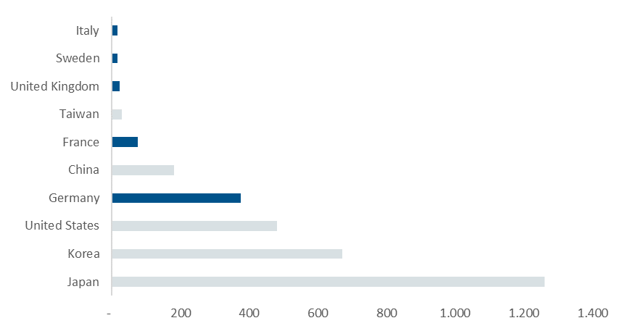
Source 105 ICF, commissioned by DG GROW - Climate neutral market opportunities and EU competitiveness study (Draft, 2020)

Five of the top ten countries where these patents originated were in the EU. More specifically, Germany and France stand out in terms of the number of high-value patent applications over the same period. Both patenting activity and public spending in R&I have increased over the last decade. However, when comparing with the rest of the world, the EU is still catching up.

Value chain analysis
Li-ion technology currently dominates the landscape as far as e-mobility and energy transition-related storage are concerned. Historically, the European battery segment has a large chemical industry cluster and a large ecosystem around batteries. However, when it comes to modern applications it could be considered a relatively new and growing economic sector.
Figure 104 Batteries value chain
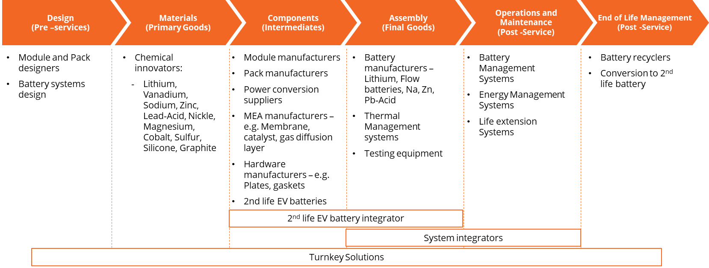
Source 106 ICF, commissioned by DG GROW - Climate neutral market opportunities and EU competitiveness study (Draft, 2020)
Turnover

The overall market size of Li-ion batteries is projected to increase.
Figure 105 Annual Li-ion battery market size
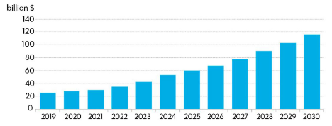
Source 107 BNEF
Figure 106 SWOT analysis for the EU on the central segments of the batteries value chain
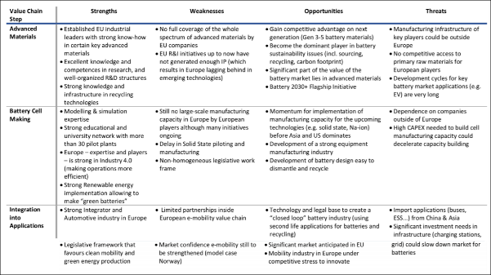
Source 108 EMIRI technology roadmap 2019
Number of companies in the supply chain, incl. EU market leaders

Around the world, a number of new companies/production installations are established along the whole battery value chain. For safety reasons it makes sense to produce battery cells close to consumer markets. This has led to numerous Li-ion cell and pack production facilities being started in the EU by European (NorthVolt, SAFT, VARTA), Asian (LG, Samsung CATL) and American producers (Tesla). 21% of active companies in the batteries sector are headquartered in the EU, with Germany and France standing out.
Figure 107 Top 10 Countries - # of companies in grid-connected electrochemical batteries used for energy storage and digital control systems
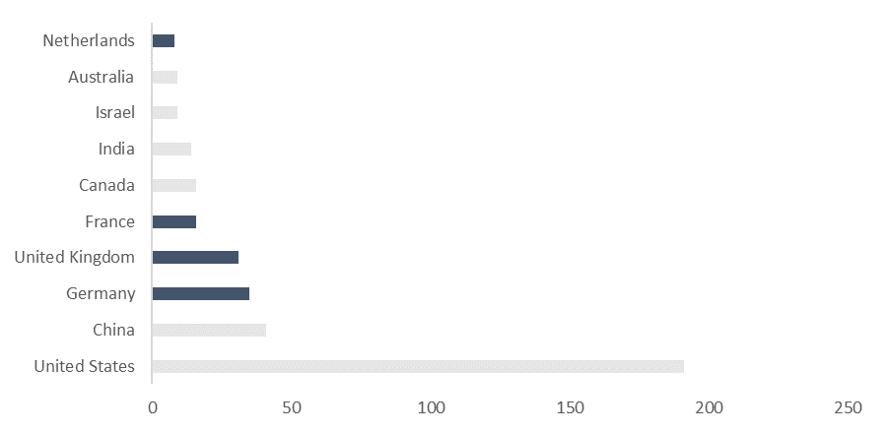
Source 109 ICF, commissioned by DG GROW - Climate neutral market opportunities and EU competitiveness study (Draft, 2020)
The EU industry has some production base in all segments of the battery value chain, but it is far from being self-sufficient. In the raw and processed materials, cell component and cell manufacturing value chain segments Europe holds a minor share of the market (3% in 2018), whereas in the pack and vehicle manufacturing and recycling segments Europe is among the market leaders. It is characterised by many actors, which represent a mix of corporates and innovators. There is a high potential for non-energy storage focused participants to enter the space.
Figure 108 EU’s position in the batteries value chain in 2016
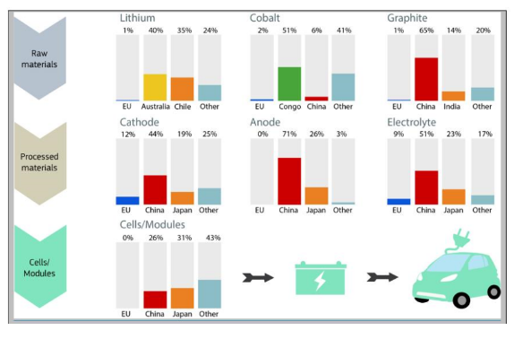
Source 110 JRC 2016
On the basis of the above, the EU recognised the needs and urgency to recover competitiveness in the battery value chain, and the Commission launched the European Battery Alliance in 2017 and in 2019 adopted a Strategic Action Plan for Batteries. It represents a comprehensive policy framework with regulatory and financial instruments to support the complete battery value chain eco-system. A range of actions have already been put in place, including:
- strengthening of the Horizon 2020 programme through additional battery research funding (more than EUR 250 million, for 2019-2020)
- creating a specific technology platform, the ETIP “Batteries Europe” tasked with coordination of R&D&I efforts at regional, national and European levels and following up on the work in the Key Action 7 on batteries of the SET-Plan,
- preparing of specific instruments for the next Research Framework Programme Horizon Europe,
- preparing of new specific regulation on sustainability and
- stimulation of investments, both national of the Member States and private, in creation of a modern and competitive EU battery value chain through Important Project of Common European Interest (IPCEI).
It is still to be seen how economies of scale in Li-ion battery sector will influence viability of other battery technologies and storage technologies in general. In principle, lead-acid battery producers, a well-established industry in the EU, should be able to keep certain role in automotive sector (12V batteries), in motive applications’ sector and re-orient e.g. to stationary storage sector. In stationary storage sector, weight and volume - main disadvantage of lead-acid batteries - do not matter as much as in e-mobility sector. However, it also has to be seen how lead-acid technology will be able to keep its competitiveness vis-à-vis emerging sector of flow batteries and other types of stationary technologies.
Figure 109 Battery production in MWh
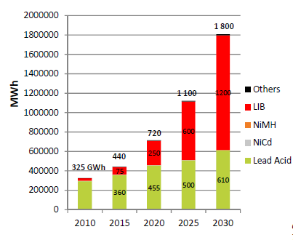
Source 111 (CBI) /Avicenne: Consortium for Battery Innovation “Advanced lead batteries the future of energy storage”
There are numerous European start-ups also in the field of flow-batteries focussed on stationary storage sector prompted by their long discharge (> 4 hours) possibilities. However, no big company seems to be entering this segment in the EU yet. Concerning sodium-ion: one FR start-up in this field (+1 in UK), however development may take some years before becoming a significant industrial actor. The EU was involved in the sodium-based (NaNiCl2) technology with FIAMM (Italy) in the past but it seems that there are no more activities. Concerning Lithium Sulphur: despite some start-up announcing it, the technology seems not to be ready for the market, except some niche application. Some development with alkaline rechargeable Zinc batteries is also observed, with at least two start-up in EU proposing this product for stationary applications.
Moreover, in the nascent stationary integration segment, the EU has companies, which advance convincingly: Sonnen (owned by Shell, and rolling out domestic battery storage systems), Fluence (joint venture between Siemens and American AEG is world’s number one as regards stationary storage systems), etc.
The market for Battery Management System currently growing faster than batteries themselves (from a lower baseline), this technology utilise analytical models and machine learning to predict, simulate and optimise battery operation.

ProdCom statistics
Between 2009 and 2018, the annual production value of batteries in the EU has grown steady at annual rate of 39% a year (2009 to 2018 period). Poland accounts for 21% of the EU production, followed by Germany (18%), France (16%) and Austria (15%).
Figure 110 Total Production Value in the EU28 and Top Producer Countries in grid-connected electrochemical batteries used for energy storage and digital control systems
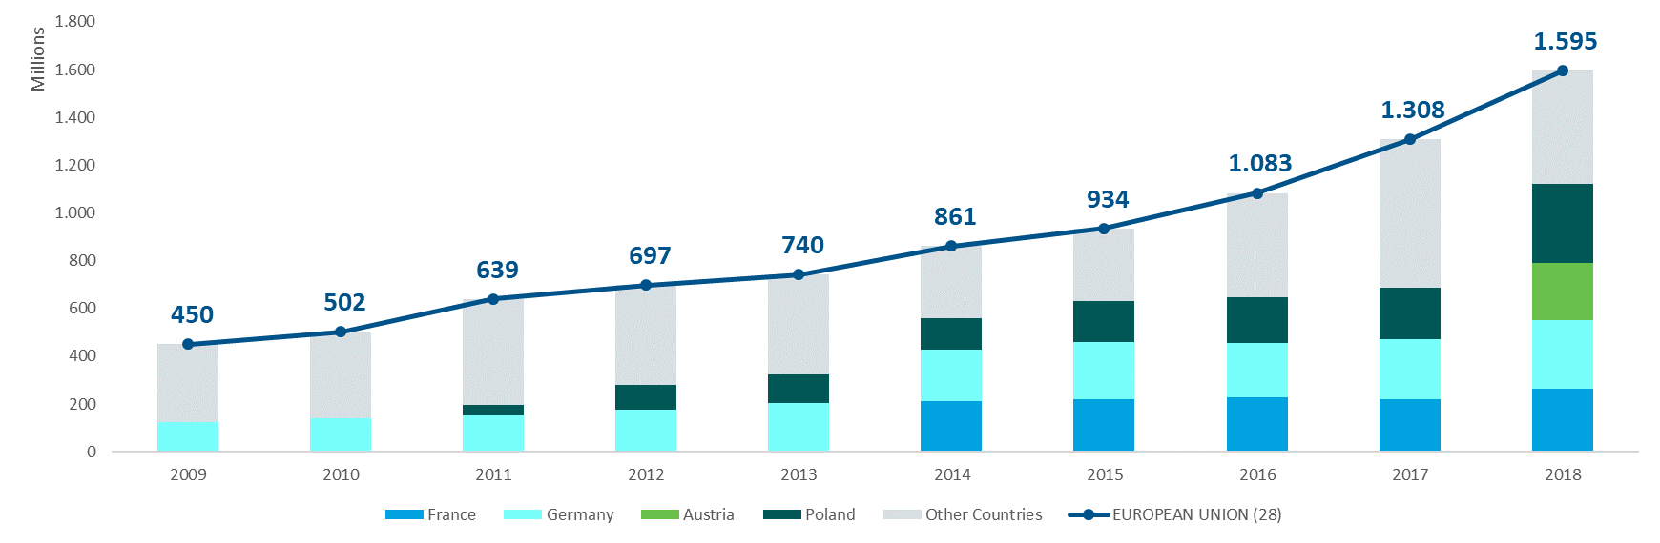
Source 112 ICF, commissioned by DG GROW - Climate neutral market opportunities and EU competitiveness study (Draft, 2020)

Global market analysis
Trade (imports, exports)

In Li-ion batteries sector, the EU’s share of global trade is currently limited, even if increasing with new battery factories being set up. Between 2009 and 2018, the EU28 trade balance is negative, even if trade in lead-acid batteries is added. The countries with the highest negative trends are Germany, France and the Netherlands.
Figure 111 Total EU28 Imports & Exports of grid-connected electrochemical batteries used for energy storage and digital control systems
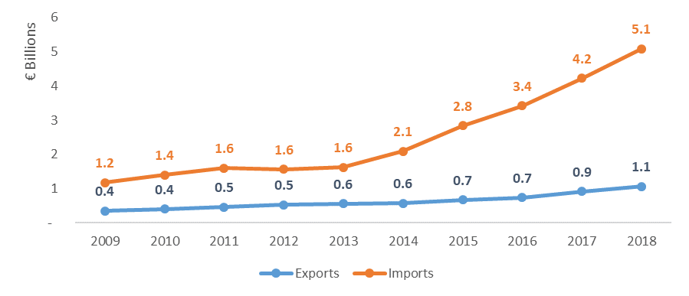
Source 113 ICF, commissioned by DG GROW - Climate neutral market opportunities and EU competitiveness study (Draft, 2020)
Most of the global manufacturing capacity for Li-ion batteries is located in Asia. Key RoW competitors are China, Korea, Japan, US and Hong Kong. Between 2016 and 2018, 3 out of the top 10 global exporters were EU countries (Germany, Poland and Czech Republic). However, not only the industrial capacity but also expertise, processes, skills and supply chain is concentrated around the regions dominating the market.
The manufacturing of electronic appliances in Asia has represented a significant advantage for the Asian battery industry, facilitating the supply of locally manufactured Li batteries. In addition, development and support of the battery industry have been considered a strategic objective for years in Japan, China and Korea, leading to strong support for local investment. China has played a predominant role in recent years.

Figure 112 EU28 Trade Balance in grid-connected electrochemical batteries used for energy storage and digital control systems
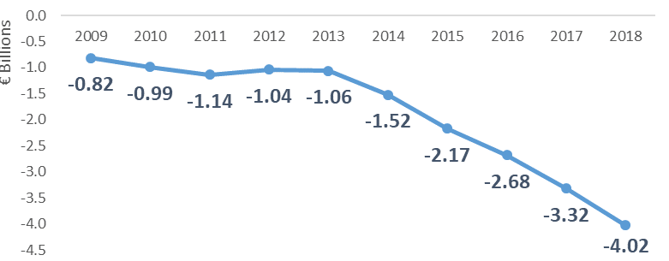
Source 114 ICF, commissioned by DG GROW - Climate neutral market opportunities and EU competitiveness study (Draft, 2020)
Between 2009 and 2018, EU28 exports to the RoW have been steadily increasing from EUR 0.4 billion (2009) to EUR 1.1 billion (2018). On the other hand, imports more than tripled from EUR 1.6 in 2013 to EUR 5.1 billion in 2018. This means that for the 2016-2018 period, the EU28 share of global exports was stable at roughly 2%. Top EU exporters were Germany, Netherlands, Hungary and Poland.
Figure 113 Top Countries - Negative Trade Balance in grid-connected electrochemical batteries used for energy storage and digital control systems
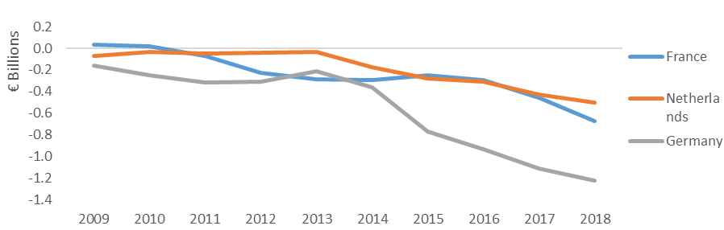
Source 115 ICF, commissioned by DG Grow – Climate neutral market opportunities and EU competitiveness study (2020)
However, the recent investments and investments in the pipeline should improve the trade balance. Increased investment in R&I, including through IPCEIs, H2020/HEU, etc. should improve technological leadership, including registered patents. Moreover, demand for new batteries has outpaced supply, creating an opportunity for new entrants as incumbents struggle to meet demand.

Global market leaders VS EU market leaders

Europe's position in the market is at risk, primarily from Asian competition. Although Asian participation in the market is largely around automotive electrochemical batteries for automotive use, their capacity ramp up will enable them to produce Li-ion batteries at lower cost than other participants, allowing them to enter the grid-scale energy markets. Key RoW competitors are China, Korea and Japan, with 70% of global planned manufacturing capacity is in China, but growth may stall when EV subsidies are reduced.

Critical raw material dependence

In the globalised economy, EU is mostly a price taker in this market segment dominated by the Asian producers. China is the major supplier of Critical Raw Materials (CRMs), with a share of ~40%, followed by South Africa, Russia, Democratic Republic of Congo (DRC) and Brazil. Li, nickel, manganese, cobalt and graphite mainly come from South America and Asia. Growth in material demand, such as cobalt, Li and lead, creating dramatic cost increases, supply shortages and efforts to find alternatives. Battery manufacturers accounted for 54% of all cobalt usage (2017).
Demand for materials to make batteries for electric vehicles will increase exponentially in the period to 2030; cobalt is the most uncertain reflecting various battery chemistries. Battery manufacturers accounted for 54% of all cobalt usage (2017). The demand for the materials used in electric vehicle batteries will depend on changing battery chemistries. Today, nickel cobalt aluminium oxide (NCA), nickel manganese cobalt oxide (NMC) and Li iron phosphate (LFP) cathodes for Li-ion batteries are the most widely used.
Figure 114 Global annual Li and cobalt demand for electric vehicle batteries, 2019-30
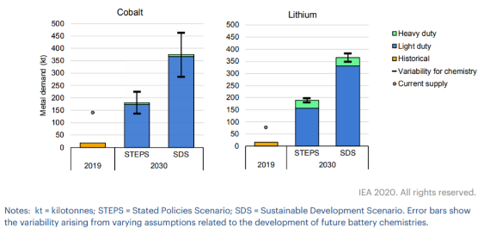
Source 116 IEA 2020357
A key challenge concerns the batteries end of life, which may represent a considerable environmental liability. The lifetime of batteries that are no longer suited for automotive applications can be extended via second use (e.g. for stationary storage applications for services to electricity network operators, electric utilities, and commercial or residential customers) and/or recycling. Challenges for this new market include the continuously decreasing cost of new batteries, and a lengthy refurbishing process requiring information exchange along the value chain. The current players in this market include OEMs, utilities and specialised start-ups.
Figure 115 Automotive battery capacity available for repurposing or recycling in the SDS, 2019-2030
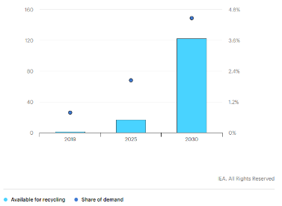
Source 117 IEA 2020357
The battery-recycling sector is currently struggling to prepare for increased volumes of battery waste expected from the automotive traction sector. Issues associated with access and use 64 of critical materials for cell production can be addressed by (i) tapping new sources of critical materials, (ii) substituting critical materials with less critical ones and (iii) recycling/reuse of critical materials. R&I on alternative Li-ion chemistries, made of more accessible raw materials, could cover development of alternative chemistries to alleviate the need for the critical materials, cobalt and natural graphite. R&I needs also to exist for improving the cost effectiveness of the recycling processes, development of more efficient processes, pre-normative research to develop standards and guidelines for collection and transportation of used batteries as well as standards and guidelines for battery second-use.
The EU Batteries Directive 2006/66/EC contributing to the protection, preservation and improvement of the quality of the environment by minimising the negative impact of batteries and accumulators and waste batteries and accumulators is currently under revision. The objective would be to start with disclosing to customers information on emissions during mining and production phase (before proceeding with introduction of limits), to facilitate re-use and impose new strict norms on collection and recycling. Stakeholder consultations are ongoing.

Future challenges to fill technology gaps
According to most technology pathways, the range of battery applications will significantly expand in the near future. The electrification of certain industrial sectors (vehicles and equipment, from automated loaders to mining or airports equipment) will be one of the drivers. This could represent about 100 GWH in the coming 10 years. The system-scale deployment of batteries faces various challenges: economic (price), technical (energy density, power density, long term quality, safety), as well as other challenges related to the availability of resources and raw material on the one hand and to sustainability, recycling and circular economy on the other hand.
The IT sector is expected to maintain a strong growth rate in EU. Despite a relative market saturation for cell phones and tablets, new consumer products (drones, domestic robots, etc.) are further growing the market (in the range of 5 to 10% per year) of small batteries during the next 10 years. In addition, digitalization remains important, involving computer-aided design of new chemistries, batteries with sensing capabilities and self-healing properties. See for example the Battery 2030+ initiative, which has recently issued a 2040 Roadmap targeting new scientific approaches that make use of technologies such as artificial intelligence, big data, sensors, and computing in order to advance knowledge in electro-chemistry and to explore new battery chemistries targeting in particular the needs of the mobility and energy sectors. Battery management system innovators are leveraging analytics and Artificial Intelligence to improve battery performance.
The global aircraft electrification market is projected to grow from USD 3.4 billion in 2022 to USD 8.6 billion by 2030, at a CAGR of 12.2%. Presence of key manufacturers of electric aircraft in Europe including Rolls-Royce (UK), Safran Group (France), GKN Aerospace (UK), Airbus (Netherlands), Thales Group (France), and Turbomeca (France), among others are driving the growth of the aircraft electrification.
On the waterborne side, greater widespread of pure battery powered solutions in the ferry and short-sea segment is the likely first step, with following greater use of hybrid applications in the deep-sea shipping market in Europe.
While improving the position on Li-ion technology may likely be a core interest stream for the next decades, at the longer term, other major progresses will come from new technologies (e.g. solid state) where the EU has a strong competitive position. It is therefore important to look into other new promising battery technologies (as e.g. all-solid state, post Li-ion and redox flow technology), which can potentially provide electricity storage for sectors whose needs cannot be met by the Li-ion technology. These technologies may surpass the performance of Li-ion batteries at the 2030 horizon in terms of cost, density, cycle life, and critical raw material needs (e.g. lithium-metal solid state battery, lithium-sulphur, sodium-ion or even lithium-air).
Table 6 Status of various Energy Storage Technologies
Status | Energy Storage Technology
Mature | Lead-acid, Ni-Cd (nickel cadmium), NiMH (Nickel–metal hydride)
Commercial | Li-ion, Lead-acid, NaS (sodium-sulphur) and NaNiCl2 (Zebra), Li-ion capacitors, ZnBr (zinc bromine), Va (vanadium) flow batteries, Zinc-air, Li-polymer, LiS
Demonstration | Advanced lead-acid, Li-ion, Na-ion, HBr (hydrogen bromine) flow batteries, LiS
Prototype | FeCr (iron chromium), Li-ion capacitors, Solid-state batteries
Laboratory | Advanced Li-ion, new electrochemical couples (other Li-based), liquid metal batteries, Mg-based batteries, Li-air and other Metal-air batteries, AI batteries, non-aqueous flow batteries, solid-state batteries, batteries with organic electrodes
Idea, concept | Solid electrolyte Li-ion batteries, rechargeable Metal-air batteries (Mg-air, Al-air and Li-air)

The scale-up of these new technologies will need time to compete with the well-established Li-ion technology (in terms of large-scale manufacture, investments already made and solid understanding of its long-term durability characteristics). Even though on the longer term other storage solutions such as renewable hydrogen may take a share of current battery applications, battery energy technology will maintain a large share in the next future due to its extremely high energy efficiency. The European economic competitiveness in this area will depend on the capability of Europe to react quickly to changing demand and to develop innovative technology solutions. EU programmes such as Horizon Europe and the Innovation Fund will strongly support these efforts.

Lastly, other efforts are to be focused on: (i) reducing to the maximum possible extent critical raw materials dependency in batteries production through further material substitution, providing local resources in a circular economy approach and substantial recycling of battery materials, both imported and local improving primary and secondary raw material processing; (ii) very high sustainability levels (approaching 100%) at production, use and the recycling stage, including improved end-of-life management – recycling and reuse, design for recycling; (iii) improvements in anode, cathode, separator, and electrolyte will enable further cost reductions in the near future, as well as improvements on non-battery pack system components (e.g. battery controller, structure around it) and improvements in manufacturing processes; (iii) ensuring safety.

Buildings (incl. heating and cooling)
With 40% of energy consumption and 36% of CO₂ emissions in the EU originating from buildings, the building sector is a key element in the EU climate and environmental policies and therefore technologies related to buildings and their energy consumption are key to achieve the Green Deal.

For example, the EU environmental obligations to reduce 80-95% greenhouse gas emissions, the Common European Sustainability Building Assessment (CESBA) initiative, the Roadmap to a Resource Efficient Europe and the new Circular Economy Action Plan all promote buildings sustainability, energy efficiency and aim to reduce waste, thus highlighting the efficiency gains of using prefabricated building components. The Renovation Wave initiative also examines and promotes energy efficiency in buildings, and aims to address the related issue of energy poverty.

This section analyses four elements of the buildings market that aim to capture the different dimensions, realising that this assessment is incomplete and needs to be expanded to give a complete picture. With respect to construction this SWD focuses on pre-fabrication, and with respect to energy consumption in buildings this document focuses on lighting as an important source of energy consumption in buildings, next to heating that is by far consuming most energy in buildings, and is therefore addressed in 2 parts, namely district heating and cooling (DHC) and heat pumps. Digital technologies to manage energy consumptions in homes and buildings (Home Energy Management Systems and Building Energy Management Systems) are also addressed in this SWD within the Smart Grids - Digital infrastructure part of this SWD. Considering that buildings solutions are often dependent on local circumstances, some data are difficult to aggregate and therefore not available, such as the cost or the productivity.

Prefabricated building components

State of play of the selected technology and outlook
The increasing demand for buildings due to increase in population and urbanisation opens markets for faster and efficient construction. Some of the trends in the building industry include an aging and dwindling construction workforce, increasing cost of labour and skills shortages, which in turn are causing low productivity. On the other hand, prefabrication is safer, often cheaper, and more productive and attracts different skilled workers. In addition, prefabricated buildings can be structurally stronger than traditional builds and so are resilient to natural disasters, especially earthquakes.
It is expected that property technology (the use of IT and data in real-estate, PropTech) and construction technologies are the markets that will drive innovation in modular or prefabricated construction, however, the two are very similar and often overlapping.
Innovation in component design is enabling faster and more efficient logistics and assembly. Recently foldable prefabricated homes have been developed for quick assembly and easy transportation. Design processes like building information modelling (BIM) and Digital Twins demonstrate that designs can be refined, monitored and improved by integrating on-site feedback. Technologies to improve circularity and re-use of materials are driving innovation in the buildings sector, including in pre-fab. This needs to be integrated from the design-phase. A landmark innovation was the creation of a building design utilising exclusively reusable materials and prefabricated methodology in showcasing how the built environment can implement the integration of circular economic thinking.
Capacity installed
From 2020 to 2025, the European prefabricated building market was projected (prior to the COVID-19 crisis) to expand at a 5% compound annual growth rate (CAGR) as a result of the maturation of digital tools, changing consumer perception, increased design complexity, quality, and sustainability, and demand for small to midsize housing units. By 2022, it is estimated that 70100 prefabricated units will be built in Northern Europe. However, these numbers could be impacted with a short-term decline due to the crisis and the expected market contraction in the building sector.
Public R&I funding
The data on public investment in R&D is available for a limited group of countries covered by the IEA. Starting from 2009, EU public R&I investment has increased to EUR 5 million by 2012, with a peak of EUR 10 million in 2016 and 2017 and a following downward trend to EUR 5 million in 2018. Out of the countries for which the IEA has data, France was by far the largest investor, followed by Denmark and Austria, while Canada was also very active when it comes to public investments. In addition, nine out of the top ten countries where these investments happened are in the EU.

Figure 116 EU28 Public R&D Investments in the Prefabricated Buildings Value Chain
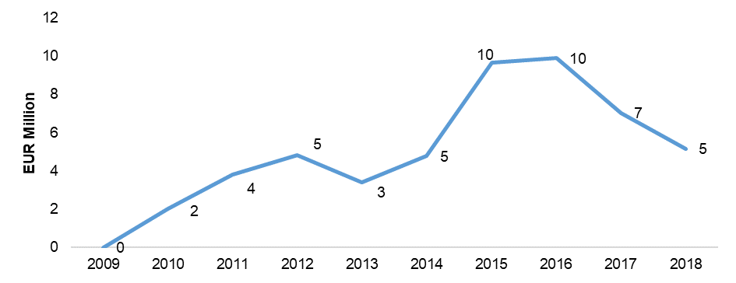
Source 118 ICF, 2020

Private R&I funding

Over the 2015-2019 period, 40% of the total value of global private investments in early stage companies was in European companies. When assessing the number of investments, this percentage decreases to 32%, suggesting that the average size of investments was higher in Europe. However, the availability of data for investments in European companies is limited. Available data shows that investments in European early stage companies in 2019 was around EUR 108 million. The investment in the selected countries in the rest of the world has increased at a slower pace, from EUR 67 million in 2015 to EUR 75 million in 2019. According to the analysed data, UK, Belgium and Germany stand out in terms of total size of investments in early stage companies over the 2015-2019 period.
Over the same period, 1% of the total value of global private investments was in late stage European companies. When assessing the number of investments, this percentage grows to 6%, suggesting that the average size of investments was larger outside of Europe. In addition, one out of the top three countries where these investments happened is in Europe. The UK stands out in terms of total size of investments in late stage companies over the studied period.
Late stage investments, both in Europe and in the rest of the world remained volatile. In 2018, there was growth in late stage private investments, which was followed by a dip in 2019, especially in Europe.

Private R&I funding

Over the 2015-2019 period, 40% of the total value of global private investments in early stage companies was in European companies. When assessing the number of investments, this percentage decreases to 32%, suggesting that the average size of investments was higher in Europe. However, the availability of data for investments in European companies is limited. Available data shows that investments in European early stage companies in 2019 was around EUR 108 million. The investment in the selected countries in the rest of the world has increased at a slower pace, from EUR 67 million in 2015 to EUR 75 million in 2019. According to the analysed data, UK, Belgium and Germany stand out in terms of total size of investments in early stage companies over the 2015-2019 period.
Over the same period, 1% of the total value of global private investments was in late stage European companies. When assessing the number of investments, this percentage grows to 6%, suggesting that the average size of investments was larger outside of Europe. In addition, one out of the top three countries where these investments happened is in Europe. The UK stands out in terms of total size of investments in late stage companies over the studied period.
Late stage investments, both in Europe and in the rest of the world remained volatile. In 2018, there was growth in late stage private investments, which was followed by a dip in 2019, especially in Europe.

Value chain analysis
The prefabricated value chain is represented amongst others by the European Federation of Premanufactured Buildings (EFV) and the European PropTech Association – PropTech House. They aim to create a legal framework in the EU that fosters innovation and adapts to new technologies across the European real estate industry. Other existing building associations also promote the use of prefabrication technologies.

Turnover
Between 2009 and 2018, the production value of prefabricated buildings in the EU increased steadily by 40% – from EUR 31.85 billion to EUR 44.38 billion. France and Italy accounted for around one third of the EU production value of prefabricated buildings.
Until 2018, the UK led the European PropTech market with USD 821 million raised between 771 companies. Germany, Austria and Switzerland, the three countries together, follows in second with 515 PropTech companies and USD 340 million raised so far. Among the top 15 most active investors, eight are based in Germany, with VitoOne (a part of Viessmann) being the most active investor in the region with 15 portfolio PropTech companies.
Some of the factors for growth in this sector included increasing acceptance of alternative methods and materials for prefabricated constructions, alongside environmental, efficiency and cost gains. Advanced assembly technologies like 3D printing reduce labour cost and increase replicability. In addition, 3D printing of concrete structures relies on prefabrication due to the logistics of sending a large and comparatively delicate printer to a construction site.

Number of companies, incl. EU market leaders

There are some prefabricated material such as wood, which make building very well insulated and low in carbon content.
Sweden is the European market leader in this sector with 80% of the housing integrating prefabricated components, 45% of houses and 35% of new build multi-resident structures using prefabricated modules. Other leading countries include Austria, Switzerland as well as Denmark and Norway.
Currently, Europe is home to 44% of the active companies of the industry on prefabricated building components. Considering the top 10 countries in the sector, US has 34 companies active in the prefabricated buildings sector, UK 15, France 6, Switzerland and Germany 5, the Netherlands 4, Canada and Norway 3, Italy and Spain 2.
Between 2009 and 2018, EU28 exports to the rest of the world increased from EUR 0.83 billion in 2009 to EUR 1.88 billion in 2018. On the other hand, imports have been relatively stable around EUR 0.18 billion in 2009 to EUR 0.26 billion in 2018 with a low of EUR 0.15 billion in 2012-13.

Global market analysis
The global modular construction market size is projected to grow from EUR 85.4 billion in 2020 to EUR 107.9 billion by 2025, at a CAGR of 5.7% from 2020 to 2025. Currently, the Asia-Pacific region has the largest share in the prefabricated building market. In 2018, it accounted for over 30%, which is due to a growing middle class and increasing urbanisation. North America is the second largest market, driven by factors such as consumer preference for green buildings and sustained investments in commercial real estate. Some of the countries around the world also implement policy measures to support this sector and to strengthen the active companies in this domain. For instance, China has a governmental target for 30% of new buildings to be prefabricated by 2026 and has implemented cash bonuses and tax exemptions for prefabricated buildings. The US International Code Council (ICC) building code was modernised to allow the increased height of mass timber building from 6 to 18 stories, enabling high-rise timber frame prefabricated buildings.

Trade (imports, exports) & Global market leaders vs. EU market leaders

The EU28 share of global exports has remained at 17.6% from 2016 to 2018. Top EU exporters are the Netherlands, Germany and the Czech Republic. For the same period, eight out of the top ten global exporters were European countries. For the studied period, key competitors to the EU in this VC were China and the US. For the same period, six out of the top ten global importers were EU countries. Germany was the largest importer followed by Norway, France and the Netherlands. However, some EU countries were importing mainly from within the EU.
Between 2009 and 2018, the EU28 trade balance has remained positive with an increasing trend. The countries with the highest positive trends were the Czech Republic, Estonia and the Netherlands, and the ones with the lowest negative trends were the UK, France and Germany. Poland, Estonia and Latvia had a trade balance with an upwards trend.
The Czech Republic exported mostly to Germany amongst the EU countries and the UK mainly imported from the Netherlands. These trends could be influenced by the ongoing Brexit negotiations.
Figure 117 Total EU28 Imports & Exports
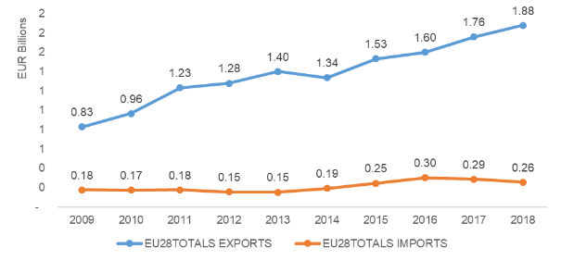
Source 119 ICF, 2020
Critical raw material dependence
Raw materials for buildings tend to be bulk materials sourced within limited distance. Critical raw materials come into play when the devices for the energy management systems for buildings and homes (HEMS and BEMS) are considered.

Future challenges to fill the technology gap
Competitiveness and sustainability. The prefabricated buildings technology addresses mostly the new buildings market, touching a limited fraction of the building stock. Moreover, traditional concrete prefabricated buildings recorded, in the past, poor energy performances. The challenge of this industry is the conjugate competitiveness and sustainability.
- High fragmentation. Both the market and its supply chains are fragmented with too many and small players which might represent a difficulty for manufacturing capacity and scalability. For instance, in Germany in 2018, the top five prefabricated housing developers (WeberHaus, SchwörerHaus, Danwood, Equistone, DFH) represented approximately 30% of the market, beyond these top five developers market shares are all below 3%. Mergers, acquisitions and corporate engagement with this market are expected to reduce fragmentation and improve efficiencies via economies of scale.
- Industry knowledge. The lack of familiarity and certainty with the different materials and techniques, difficulties with the planning systems and complying with building regulations can lead the industry to decisions against its use. In addition, the construction industry is notoriously conservative and slow in adapting to changes.
- Skill gap. New skills and expertise will need to be built up and invested in, particularly digital and design skills. As the industry is historically tech adverse this may be a concern. High levels of investment in training and education will be required.
- Lack of data and development of digital tools. There is limited available data on performance and durability of buildings constructed via modern methods of construction. In addition, due to competition and the use of new technologies, companies may be reluctant to share or publish information. At the same time, BIM and Digital Twin software are improving the replicability and learning capacity of prefabricated building design and assembly monitoring. The use of these are being encouraged by the EU via the EU BIM task group, whilst in Germany BIM will become mandatory for public infrastructure projects by 2021. By using these digital tools performance can be tracked throughout the entire lifecycle of the building in a continuous cycle that will provide info back to design, but it is important to share data to develop these tools.
- High capital costs. Upfront factory costs are high, requiring assemblers to benefit from economies of scale to ensure competitive costs. The small size of most construction companies is a further barrier both to technological development and adoption of new techniques.
- Access to finance and risk assurance. Due to lack of data and high market fragmentation, insurers and lenders may deem insolvency risk to be high and so can overprice or refuse support, slowing progress. Difficulties securing mortgages might occur. As the market scales up, insolvency risks are expected to be reduced. In 2012, the European Commission co-launched a digital library for prefabricated building designs as part of its Green Prefab project. This has helped to improve market confidence by aggregating data, and will also improve replicability, enabling economies of scale.
- Logistics. Restrictive transport regulation can increase project costs by 10%, paying for extras like road escorts for wide loads. Particularly difficult with big modules, wider 3D structures, a trade off exists between how much a structure is prefabricated and how easy it is to transport.
- Consumer perception. There are still some negative perceptions due to past failures rather than new technologies delivering quality and more cost-effective buildings from consumers, developers and wider industry. Difficulties related with durability, making adjustments and repairs to the properties also cause some apprehension from the consumers.

Energy efficient lighting

State of play of the selected technology and outlook
Technology development and capacity installed
Lighting is the second largest electricity consumer in the EU eco-design programme (after electric motors), responsible for about 12% of the gross electricity generation in the EU28. The 2017 data of the MELISA model scenario projected the electricity consumption of lighting products in scope of eco-design (with effect of current regulations, without any new measure) to 320 TWh in 2020. Technology for light sources keeps evolving, thereby improving energy efficiency. LED technology, has had a rapid uptake on the EU market. Almost absent in 2008, it reached 22% of the market in 2015. The average energy efficiency of LEDs quadrupled between 2009 and 2015, and prices dropped significantly. In 2017, a typical LED lamp for household was 75% cheaper and a typical LED lamp for offices 60% cheaper than in 2010.

During the last decade, Solid-State Lighting (SSL) based on components like OLEDs, LDs and particularly LEDs have challenged conventional technologies, displaying improved performance in most aspects. It is therefore anticipated that in the short-to-medium term, the new electric lighting installations will be based on SSL. However, this leaves the existing installations, which will be upgraded depending on use and maintenance. With equipment lifetime sometimes exceeding 15 or 20 years, inefficient systems are likely to remain in use unless change is triggered through incentives or requirements.
Figure 118 Variation of electricity savings/losses for lighting till 2030 following different scenarios
Source 120 Data from [SCO-17] modified by G. Zissis

Technological advances in 2019 concern both components and lighting systems. All these advances serve at least one of the following objectives: 1. Increasing the efficiency and reliability in all levels from the component to the global system. 2. Reducing the cost of the components and single lamps and using more sustainable materials. 3. Enhancing the quality of light associated to the comfort and more focusing on lighting application efficiency (LAE). 4. Implementing new functionalities and services beyond basic illumination for vision and visibility.
Since mid-2010’s a net increase of proposed technological advances at systems level can be observed, whereas innovations at component/device-level are less common.
Patenting Trends
Regarding the patents on solid-state lighting, as per data from Google Patents website, from 2010-01-01 to 2020-09-30, a number of 135,828 patents have been submitted at the European Patent Office, with Cree and Philips leading the pack in terms of patents filed in the period described.
Figure 119 Patents filed in the EPO since 2010
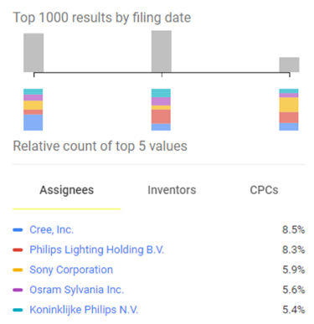
Source 121 Google Patents
As for the Worldwide submission of patents regarding solid-state lighting, as the figure below shows, Cree is still the leading company submitting patent requests, followed by Sony Corporation and Koninklijke Philips N.V.
Figure 120 Worldwide patents on Solid State Lighting
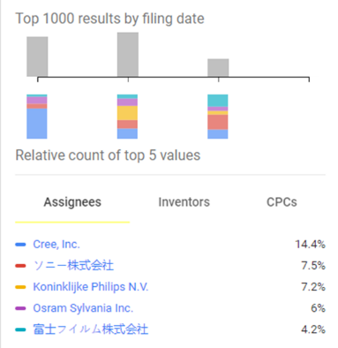
Source 122 Google Patents
Publications/Bibliometrics
In terms of scientific output, solid state lighting research has been steadily producing journal articles under Scopus publications (2123 articles in 2020, 2991 in 2019, 2902 in 2018 and 2949 in 2017), with China, the United States, Germany and Japan leading as the countries with most publications. As for Web of Science database, the same trend can be seen, with 1978 journal articles published already in 2020 with solid state light as a topic, 2815 in 2019, 2781 in 2018 and 2790 in 2017, with China, the USA, India and Germany being the countries with most publications during this period.
Figure 121Web of Science categories of solid state light publication
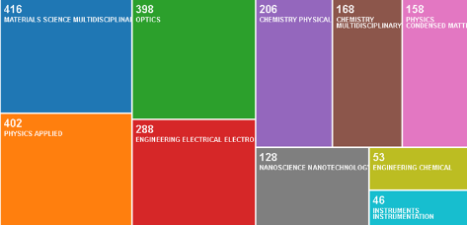
Source 123 Web of Science

Value chain analysis

Turnover & Gross-value added growth

The European lighting market is expected to grow from EUR 16.3 billion in 2012 to EUR 19.8 billion in 2020. Following the Geography - Global Forecast to 2022, Europe is expected to be the second largest LED lighting market by 2022. LEDs lighting is increasing its market share from 15% in 2012 (or even 9% in 2011) to 72% in 2020.
However, more recent data shown that Europe overall LED penetration rates are estimated in 2016 to be 8% of lamps and 9% of luminaires which lagging back previous predictions. This can be partially understood by the fact that Europe has a population that has a relatively high standard of living. The Ecodesign Law states that the maximum standby power of 0,5 W and a minimum efficacy requirement of 85 lm/W. In addition, the Energy Performance of Buildings’ (EPBD) minimum energy performance requirements at building level provide pressure to use efficient lighting.
CSIL analysts estimated that in 2019, the lighting market for the EU30 would reach around 21 billion (+1.6% increase) distributed as follows:
- Lighting fixtures EUR 18,1 billion (+0.9%)
- LED lamps EUR 1,9 billion (14%)
- Legacy lamps EUR 450 million (-17%)
- Lighting controls EUR 550 million (+4.8%)
The slight increase of consumption of lighting fixtures comes from a +2% for professional luminaires and around -1% for consumer lighting.
Number of companies, incl. EU market leaders

The LED lighting ecosystem comprises hardware component manufacturers, prototype designers, and original equipment manufacturers (OEMs) in the EU such as Signify (previously called and still operating under the brand Phillips from the High-Tech Campus in Eindhoven in the Netherlands), OSRAM Licht AG (Germany), Cooper Industries Inc. (Ireland) and the Zumtobel Group AG (Austria). Internationally, the key companies are General Electric Company (US), Cree, Inc. (US), Virtual Extension (Israel), Dialight plc (UK), Samsung (South Korea), and the Sharp Corporation (Japan).
Among the companies that are expanding in the European market during 2019 were Zumtobel, IKEA, Fagerhult, Yankon, Glamox, SLV, Flos, Xal. European leaders include Signify (on all the market segments), Ledvance (mainly on lamps), Eglo (consumer lighting), Flos (design), Trilux (industrial lighting), Glamox (office), Fagerhult (retail), Molto Luce (hospitality), Schréder, AEC (street lighting).

Global market analysis
Trade (imports, exports)
In 2019, the volume of lighting fixtures exports reached EUR 13,4 billion, registering an increase of 0,6% compared to the previous year. Imports of lighting fixtures in Europe reached EUR 17.1 billion in 2019, with an increase of 2,6% compared to 2018. In 2019, the European trade balance recorded a deficit of EUR 3.7 billion, (EUR 3.6 billion the previous year). As the internal EU market accounted for EUR 21 billion revenue in 2019, this means that the difference of EUR 4 billion is supplied by European production.
Global market leaders VS EU market leaders
Table 7 Ranking of the top 10 packaged LED manufacturers
Source 124 Amerlux Innovation Center, LED Energy Market Observer, Energy Observer, August 2018
According to the Amerlux Innovation Center, the Chinese LED package market scale had a size of US$ 10 billion in 2017, representing an increase of 12% year-on-year. Among the top ten manufacturers, four are international firms, two are Taiwanese companies and four are Chinese enterprises. Amongst the top 10 manufacturers, Lumileds and OSRAM are European companies, while 4 are Chinese enterprises and another 2 are Taiwanese companies. The top ten manufacturers took up market share of 48%.

Critical raw material dependence
Metals such as arsenic, gallium, indium, and the rare-earth elements (REEs) cerium, europium, gadolinium, lanthanum, terbium, and yttrium are used in LED semiconductor devices. Most of the world’s supply of these materials is produced as by-products of the production of aluminium, copper, lead, and zinc. Most of the rare-earth elements required for LED production in 2011 came from China, and most LED production facilities were located in Asia.

Future challenges to fill the technology gap
The lighting sector is evolving rapidly and changing quite fundamentally. Firstly, the market is moving towards solid state devices that consume a fraction of the energy of the older technology. These devise also create many more possibilities (colour, shape, size) to integrate lighting in the living and working environment that may change the way in which lighting markets are organised and where the added value in the lighting market may be (e.g. lighting as a service).
The high innovative capacity in manufacturing and design in the EU are based on a long tradition in designing and supplying innovative highly efficient lighting systems. But the drive towards large-scale mass production of solid-state lighting, and the fact that most LED manufacturing takes place in Asia, seems to favour Asian suppliers.

District heating and cooling industry

State of play of the selected technology and outlook
Technology development and capacity installed

District heating stands out as one of the most effective and economically viable options to reduce the heating and cooling sector’s dependence on fossil fuels and reduce CO₂ emissions. A smart energy system, comprising at least 50% district heating and relying on sector integration, is more efficient than a decentralised/conventional system and allows for higher shares of renewable energy at a lower cost. The most important characteristic is the use of an energy source that provides a significant cost differential in generating heat/cool compared with conventional heating/cooling systems (like boilers or direct electric heating).

It is this cost differential that finances the high capital investment in the heating/cooling network. For citywide schemes, such sources typically include combined heat and power production from major power stations or energy from waste incineration plants. For smaller communities, the heat source may be a small-scale Combined Heat-Power (CHP) plant, a biomass-fired boiler or waste heat from a local industry. Also city-wide schemes can be made up of multiple interconnected small-scale heat networks, running on locally available renewables. In both cases, thermal storage may be used to provide additional benefits. The heat is distributed using pre-insulated pipes buried directly into the ground and at each building, there will be a set of control valves and a heat meter to measure the heat supplied. A heat exchanger is typically used to separate the district heating system from the building heating system, although this is not always necessary.

In 2018, just under 6% of global heat consumption was supplied through District Heating and Cooling (DHC) networks, of which Russia and China each accounted for more than one-third. DHC currently meets about 8% of the total EU heating and cooling demand via 6000 DHC networks. The share of DHC varies significantly from one region to another. District heating is by far the most common heating solution in the Nordic and Baltic regions whereas it has historically played a minor role in Southern Europe and other Central and Western European countries (e.g. Netherlands, UK).

In urban areas, the heating and cooling demand assumes the highest density. At the same time, a high amount of low-grade waste heat is available within the urban landscape and could be captured as used a source for DHC systems. The industrial waste heat alone could meet the heat demand of the EU’s building stock.
Currently, approximately 60 million EU citizens are served by district heating, with an additional 140 million living in cities with at least one district heating system. If appropriate investments are made, almost half of Europe’s renewable heat demand could be met by district heating by 2050. The DHC sector has a significant green growth potential. Denmark is one of the front runners with a district heating share of about 50% and substantial exports of technology.
Figure 122 DH share in energy sources used to satisfy heat demand (2013-2017)
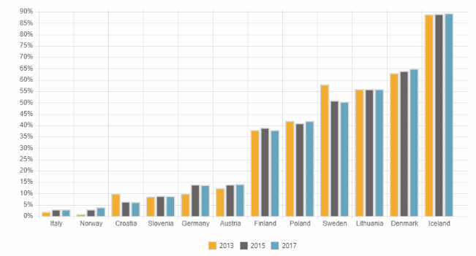
Source 125 Euroheat & Power Country by Country
Figure 123 The share of renewable energy in DH (2011-2017)
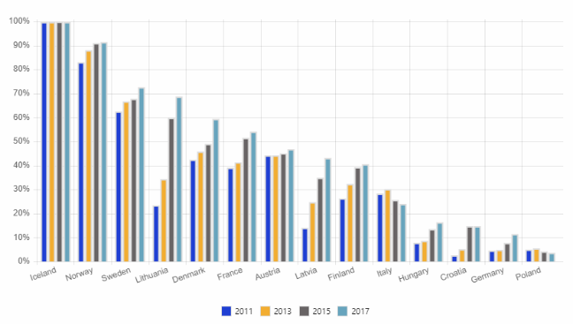
Source 126 Euroheat & Power Country by Country

Patenting trends

[This section also addresses the patenting trends for thermal storage, micro-generation and heat pumps – for further information on heat pumps see the next section.]

This chapter focuses on heat pumps and district heating but most buildings patents are in micro-generation and thermal energy storage.
Figure 124 Patents in the EU by heating and cooling technology category. ThSt = Thermal storage; micro-gen = Micro-generation; HP = Heat pumps; DH = District heating.
Source 127 Joint Research Centre (JRC) based on data from the European Patent Office (EPO)
The relative trends by technology are easier to discern and more robust. Patenting activity in district heating is extremely low, due to the maturity of core technologies and the small number of companies involved. The share of heat pump patents has been steadily rising however.
Figure 125 Share of patents in the EU by heating and cooling technology category. ThSt = Thermal storage; micro-gen = Micro-generation; HP = Heat pumps; DH = District heating
Source 128 Joint Research Centre (JRC) based on data from the European Patent Office (EPO)
Figure 126 Number of heating and cooling patents, by region. CN = China; JP = Japan; KR = Korea; ROW = Rest of the world; US = United States
Source 129 Joint Research Centre (JRC) based on data from the European Patent Office (EPO)
High-value inventions (or high-value patent families) refer to patent families that include patent applications filed in more than one patent office.
Figure 127 Number of high-value heating and cooling patents, by region. CN = China; JP = Japan; KR = Korea; ROW = Rest of the world; US = United States
Source 130 Joint Research Centre (JRC) based on data from the European Patent Office (EPO)

Global market analysis
Trade (imports, exports)

Today Europe has the highest standards in the world in terms of energy efficiency, strengthened recently by the introduction of Ecodesign criteria for the sale of heating products. The EU commitment to ambitious energy and climate goals has paved the way for the large presence of energy efficient technologies developed in Europe.
The European heating industry is world leader in highly efficient heating systems. Today the European heating industry covers 90% of the European market and is an important exporter of heating technologies. This includes countries such as Russia, where the European heating industry is market leader, Turkey where it represents half of the market, and even in China where it plays an important role in the development and deployment of efficient heating.
Danish and other European district heating technology is exported globally, especially to China, US and South Korea. Exports to the US have risen by 91% in the period between 2010-2018. Denmark exports of district heating technology and service amounted to DKK 6.77 billion in 2018, with the biggest exports to Germany (close to EUR 140 million), followed by Sweden (close to EUR 80 million) and China (EUR 65 million). In 2025, it is expected that the sector will achieve annual exports of DKK 11 billion. But Europe’s solar district heating industry suffered losses in 2019, leading to some bankruptcies and restructuring, among others because of high fluctuations in turnover and low margins in contracted projects.
Global market leaders VS EU market leaders

European companies are world leaders in the manufacture of DHC pipes, valves and related IT solutions. Danfoss is the leading pioneer in district heating and cooling equipment. In 2019, Danfoss’ sales amounted to EUR 6.3 billion.
Europe is home to world-leading DHC pipe manufacturers: Logstor is the leading manufacturer of pre-insulated pipe systems in the world, being active in 12 different countries and10 factories in Europe and China. German-based Aquatherm GmbH is the leading global manufacturer of polypropylene pipe systems for industrial applications and building services. Austrian company Austroflex is recognised within the industry as an expert supplier of flexible pre-insulated Pipe Systems, thermal Solar Pipe Systems and Technical Insulation solutions. Swedish company Cetetherm is a leading manufacturer of DHC substations and has manufacturing plants in 6 countries including China and US. Devcco (based in Sweden) offers consulting services across the district energy sector and has completed projects in countries in North and South America, the Middle East and South Asia.
The systems in operation in Europe, particularly in the Nordic countries, are at the forefront of the industry in terms of innovation, efficiency, reliability and environmental benefits, in the form of renewables integration, and a reduction in both local air pollution and primary energy demand, and developing the next generations of DHC systems that require smart components and IT solutions, such as demand-side controllers, sensors, AI platforms and automated systems for heat networks. There are a number of small-scale innovative players from Europe on the market leading the development, such as NODA Intelligent Systems, OPTIT, Gradyent and Leanheat.
Critical raw material dependence
Dependency on raw materials is not an issue for district heating. Pumps may use permanent magnets but alternative technologies exist hence this use should not lead to dependence on materials. Pipes are usually from non-critical raw materials like steel or plastic.

Future challenges to fill the technology gap
The key challenge for the DHC sector is to integrate low-grade waste heat into existing high temperature DH systems. New smart networks operate at lower temperatures and are capable of integrating locally available renewable and waste heat sources.
District heating projects, including expansion of existing systems, require a large initial infrastructure investment with long payback times that make the sector vulnerable to changes in the legislative framework and mean that new DHC technologies are slow to be taken up. Replacing existing systems by more climate-neutral DHC technologies can benefit from the minimum standard for a new heating installation that is represented by the very efficient boiler condensing technology, and further measures to support the renovation of the installed stock of heaters would accelerate the positive trend. Ensuring coordinated investments between suppliers of (waste) heat and demand require a strong coordination that is often considered a public responsibility. EU policies aim to overcome these barriers through support for local (holistic) planning and decision-making and to provide incentives to consider environmental and societal advantages.
Because of its large indoor appliances or installations and the need for house retrofitting consumer acceptance is key for market uptake of new DHC technologies.
Developing novel business models and capacity building may enable earlier and stronger market uptake. The challenge is to develop markets for services, rather than single technologies, as this can engage those end-users who cannot or will not interest themselves in using/maintaining technologies/measures most efficiently. This can prove to be a business opportunity for companies related to energy-savings measures, H&C supply units and district energy by overcoming a main economic barrier, namely the large up-front investment costs.

Heat pumps

State of play of the selected technology and outlook
Introduction
Heat pumps, mostly electricity-driven, are an increasingly important technology to meet heating and cooling demand in a sustainable way. They efficiently extract heat from a source at lower temperature and provide it at higher temperature. If coupled with a heat storage tank, heat pumps can store heat or cold when there is an abundance of renewable electricity in the grid and/or the electricity price is lower and provide it when needed. Heat pumps achieve higher performances than conventional boilers and electric heaters and can drastically reduce emissions of the delivered energy services. Heat pump (HP) technology is mature and reliable and can be integrated with other systems (e.g. photovoltaic electricity or other heat generators, such as gas boilers) and use a diverse set of (renewable) sources (e.g. as an air source, water source, ground source or waste source). It comes with capacities from a few kW to several MW, to be used in applications ranging from households to industrial applications and district heating systems. Furthermore, heat pumps work in a wide range of climatic conditions and can be used in energy storage and grid management.

Capacity installed, generation

The yearly market demand and the related growth in unit sales in Europe is growing rapidly, as shown in Figure 128. Industry experts expect this trend to continue and potentially accelerate. At the end of 2018, total installed heat pumps in Europe was 11.8 million. Air-to-air heat pumps are most commonly used, followed by air-to-water heat pumps.
Figure 129 Heat pump market development in Europe (annual sales, 2009–2018)
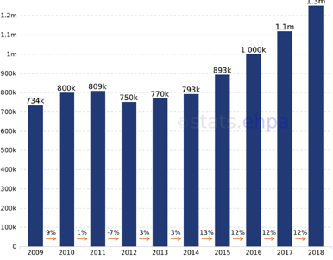

Source 131 European Heat Pump Association, 2020

The largest markets in terms of units sold are the Southern European countries where heat pumps are primarily used to deliver cooling. France, Italy, and Spain together account for almost 48% of sales. The largest growth in number of units in 2017 was in France, Spain and Denmark. The European Heat Pump Association foresees a doubling of the number of units sold in the period 2018 to 2025. According to the National Energy and Climate Plans (NECPs), significant contributions are foreseen from heat pumps in most Member States in order to increase the share of renewables in the heating and cooling sector. The total added annual final energy consumption from heat pumps is 7.7 Mtoe from 2020 to 2030 according to the NECPs. When compared to the rest of the world, the EU market has lagged behind China, Japan and the US but is now growing rapidly. The US demand is driven by installation incentives, while the development in the Asia-Pacific region is driven by construction sector growth.
The housing construction market is the largest market for heat pumps. New buildings are well insulated and thus suitable for heat pumps. However, there are increasing prospects in the housing renovation market, which accounts for high share of the building stock. Today's heat pumps can supply higher temperatures thus better meeting the energy needs of the older housing stock.

Cost

The operating costs of heat pumps are among the lowest in the heating and cooling sector. However, upfront investment cost is high, resulting in pay-back times of up to 20 years. According to recent studies, the average life time for air-to-air heat pumps would be 10 to 15 years (depending on the size) and for air-to-water heat pumps 15 to 20 years (depending on the size), meaning that capital cost reduction is a key issue for the sector.

Patenting trends

According to the Top 10 Innovators Report, the highest number of inventions originates from the Asia Pacific region (86%), with China at 58% of total inventions, followed by Europe at 9% and North America at 4%. The average IP strength score for inventions from Europe is more than that of Asia-Pacific (including China), but less than North America.
Stiebel Eltron and Robert Bosch are the most prominent innovators from the EU with the highest number of inventions. Siemens, Électricité de France, Robert Bosch, Vaillant, ATLANTIC Climatisation & Ventilation SAS and Viessmann Group remain active since 2010, and have high quality patent portfolios. Grundfos Management has been less active in Europe since 2010, despite having high-quality inventions. Worth noting, none of the prominent European innovators appear in the global top ten list.
[further details on patents for heat pumps are included in the section above on DHC]

Value chain analysis
Turnover

The turnover generated in Europe in 2017 was EUR 7.1 billion. The turnover is largest in France (EUR 1 474 million), followed by Germany (EUR 1 383 million), Italy (EUR 1 117 million) and Sweden (EUR 550 million).

Number of companies, incl. EU market leaders

In Europe there are about 180 heat pump manufacturers accounting for 70% of the global number of manufacturers. During the last few years, major European heat pump manufacturers have been consolidating. For instance, in 2016 and 2017, the Nibe Group (based at Markaryd) acquired many assets of the UK-based Enertech Group, including the highest value brand CTC, based at Ljungby in Sweden. The CTC product range includes ground source and air/water heat pumps. In 2017, Stiebel Eltron announced the acquisition of Thermia Heat Pumps, a brand that was previously owned by the Danfoss Group. Thermia was the third biggest heat pump supplier of the Scandinavian market, with annual sales close to EUR 70 million. With this acquisition, Stiebel Eltron becomes a major global electrical heating player.
Table 8 Non-exhaustive list of European heat pump manufacturers
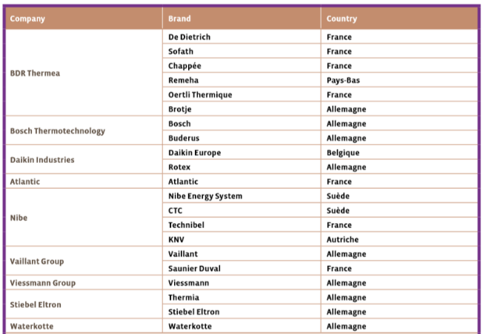
Source 132 Eurobserv'er Heat Pumps Barometer (2018)
Employment figures
In 2018 the sector employed more than 224 500 people, directly or indirectly, an increase from 191 000 in 2017. However, employment in the sector has declined by 20% between 2015 and 2017. The Member States that employ by far the most are Spain (68 700), France (41 200) and Italy (37 600).

Global market analysis
Trade (imports, exports)

Between 2009 and 2018, EU-28 exports to the rest of the world were relatively stable at about EUR 0.3 billion, with a peak in 2012/13 of EUR 0.4 billion. For the 2016-2018 period, the EU28 share of global exports was stable - roughly 1%. Top EU exporters were France, Germany and Italy. For the same period, four out of the top ten global exporters were EU countries. Key competitors were China, Mexico and the US. In addition, for the 2016-2018 period, three out of the top five global importers were European countries. The US was the largest importer followed by Germany, France and the UK.
Figure 130 EU28 Trade in the heat pump value chain (EUR million)
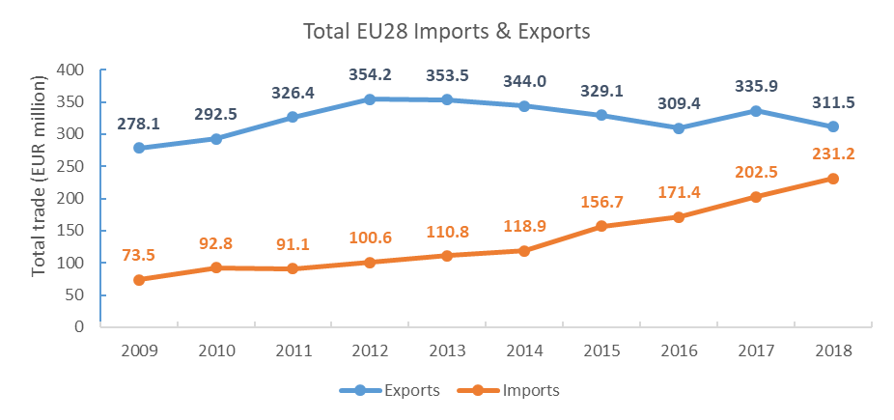
Source 133 ICF, 2020
Global market leaders VS EU market leaders

The European heating industry is a well-established economic sector and a world leader in highly efficient heating systems. The European heat pump sector is characterised by a few, mostly large corporations and a relatively small ecosystem with some innovative SMEs. The heat pump value chain is well represented through a number of industry associations – most notably the European Heat Pump Association (EHPA).
Globally, Japanese (Daikin, Mitsubishi, Toshiba, Fujitsu, Panasonic) and South-Korean (LG, Samsung) manufacturers mainly produce residential and commercial air-to-air and air-to-water heat pumps, while US manufacturers (Trane, Carrier/UTC, Johnson Controls, Honeywell, Lennox) produce mainly chillers for large commercial buildings.

Critical raw material dependence
Critical raw materials used are mainly copper in the heat exchanger and the gold in the printed circuit boards (PCBs).

Future challenges to fill the technology gap
The IEA has recently identified three gaps to fill: Enhance heat pump flexibility; raise heat pump attractiveness; and reduce costs of heat pump technologies. A stakeholder consultation in the framework of the Horizon Europe work programme highlighted as issues to address the high upfront prices and a lack of adaptability to multiple building contexts (e.g. multi-family residential buildings with limited outdoor space for exterior heat pump units) that needs to be addressed in particular by lowering device dimensions.
Reaching higher real life energy performances through the development of new texting methods that reflect real life usage behaviour better are important too.
Considering the growth potential of heat pumps in the EU, and the fact that it is a key technology for the decarbonisation of heating and cooling, it is important to keep on promoting innovative technological solutions in Europe, so manufacturers can distinguish themselves based on quality and innovation rather than on price. Improving existing (ecodesign and energy labelling) regulations and updating the requirements can contribute to innovation in the EU.

Carbon Capture and Storage

State of play of the selected technology and outlook
Reaching climate neutrality by 2050 requires strategic investment decisions. The pathway towards climate neutrality will bring about a major transformation of energy-intensive industries, such as cement, lime, steel and chemicals that are at the core of the European economy by producing basic industrial materials and products. For these sectors, carbon capture and storage (CCS) could represent the lowest-cost route to decarbonisation while maintaining industrial activity in Europe. CO2 capture in natural gas-based hydrogen plants could also enable the delivery of early, large-scale quantities of low-carbon hydrogen, which is a versatile energy vector that can be used across a number of sectors: energy intensive industries, transport, electricity production, and buildings, and it can also play an important role for zero-carbon domestic heating.
The Commission’s 2018 analysis of different CO2 reduction pathways showed a correlation between increasing climate ambition (i.e. pathways compatible with the 1,5ºC temperature target) and the need for deploying Carbon, Capture and Storage technologies. The Communication states that ‘CCS deployment is still necessary, especially in energy intensive industries and – in the transitional phase - for the production of carbon-free hydrogen. CCS will also be required if CO2 emissions from biomass-based energy and industrial plants are to be captured and stored to create negative emissions’.
The in-depth analysis further elaborates on the modelling: ‘For the 1.5°C scenarios, the higher carbon prices allow the appearance of CCS from 2040, with 54 / 58 MtCO2 captured (for 1.5LIFE / 1.5TECH respectively), increasing to 71 /80 MtCO2 in 2050 and further to 112 / 128 MtCO2 post-2050’.
Table 9 Carbon capture and stored underground (MtCO2) in different CO2 reduction scenarios
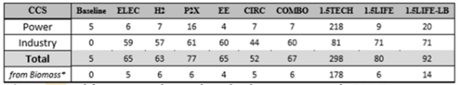
Source 134 PRIMES model; In-depth analysis in support to the “A Clean Planet for all” Communication, 2018
The Commission’s proposal for a European Green Deal confirmed that achieving climate neutrality by 2050 will be the European Union’s overarching climate goal, which will orient policies and investments. This development put the LTS 1,5 TECH and LIFE scenarios at the centre, and implied that the deployment of CCS at scale will be necessary. Correspondingly, the Green Deal Communication highlights CCS in two policy contexts:
- it recognizes that the regulatory framework for energy infrastructure, including the TEN-E Regulation, will need to be reviewed to ensure consistency with the climate neutrality objective. This framework should foster the deployment of innovative technologies and infrastructure, such as smart grids, hydrogen networks or carbon capture, storage and utilisation, energy storage (CCUS), also enabling sector integration;
- it calls for ‘climate and resource frontrunners’ in the European industrial sectors to develop the first commercial applications of breakthrough technologies in key industrial sectors by 2030. Priority areas include clean hydrogen, fuel cells and other alternative fuels, energy storage, and carbon capture, storage and utilisation.

Other European Commission Communications that followed the European Green Deal mentioned CCUS, including: the Industrial Strategy, the Circular Economy Action Plan, the Strategy for Energy System Integration, the Hydrogen strategy and, finally, the European Taxonomy on Sustainable Finance.

Capacity installed, generation

The 2019 report of the Global CCS Institute identified 51 large-scale CCS facilities worldwide. Of these: 19 are operating, 4 are under construction, 10 are in advanced development using a dedicated front-end engineering design (FEED) approach, and 18 are in early development. Right now, those in operation and construction have the capacity to capture and permanently store around 40 million tons of CO2 every year. This is expected to increase by about one million tons in the next 12-18 months. In addition, there are 39 pilot and demonstration scale CCS facilities (operating or about to be commissioned) and nine CCS technology test centres (including the Technology Centre Mongstad in Norway).
2 of the 19 operating CCS projects are in Norway and they store a combined 1,7 MtCO2 per year. In addition, Norway’s government-backed full-chain CCS project (Longship) is in Final Investment Decision phase, awaiting the Parliament’s approval.
In the EU, there are no large-scale CCS facilities in operation. However, the Netherlands’ flagship PORTHOS project in the Port of Rotterdam area is in advanced planning phase, closely followed by Amsterdam’s ATHOS project. In Ireland, Ervia is planning an off-shore CO2 storage project South of Cork. The total storage capacity of these sites, if implemented, together with six CCS projects in the UK, could add up to as much as 20,8 Mt of CO2 stored per annum, according to the Global CCS Institute.

Figure 131 Large scale CCS facilities in operation, under construction and in advanced development, by sector (status in 2019)
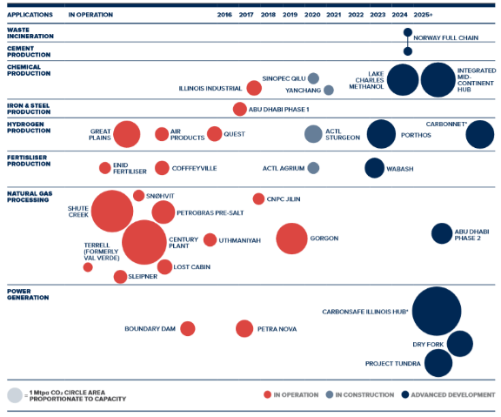
Source 135 Global status of CCS 2019, Report of the Global CCS Institute
In a global perspective, the IEA estimates that some 1030 MtCO2 will need to be captured and stored from industry by 2040, and an additional 1 320 MtCO2 from power to keep on track with the IEA’s Sustainable Development Scenario (compatible with the Paris Agreement).

A significant share of that may be deployed to produce “negative emissions” via biomass or biogenic waste combustion coupled with CCS (BECCS). The Fifth Assessment Report of the Intergovernmental Panel on Climate Change (IPCC) suggests a potential range of negative emissions from BECCS of 0 to 22 gigatonnes per year.

Considering the capacities of today (33 MtCO2/year captured globally, out of which 1,7 MtCO2/year in Norway), the CCS sector needs a huge global step change in all relevant sectors (power, industry, hydrogen) in order to fill in the significant role envisaged in some decarbonisation pathways.

Cost, LCOE

The upfront investment costs of CO2 transport and storage are considerable, however, not all needs to be built at once, the infrastructure can be progressively expanded. In some instances, investments to retrofit existing natural gas pipeline networks into CO2 pipeline networks can be advantageous and cut initial costs of infrastructure. Over time, the initial infrastructure will be progressively expanded to accommodate increasingly volumes of CO2.
At the same time CO2 emitters (power plants, industrial sites) can install CO2 capture solutions to trap their emissions and load them into the transport and storage infrastructure. This often comes not only with a higher CAPEX but also higher OPEX due to energy penalties and maintenance, which on their turn bear on the competitiveness of these clean products relative to unabated, high carbon products. In the same way as for every other low-carbon investment, in the absence of a “functional” (global) carbon price (min. EUR 50-60/tCO2), investment in CCS will have no business case today and will largely depend on public funding and policy and/or regulatory incentives (e.g. to purchasing zero-carbon products, such as clean steel or cement). It is thus crucial to fund R&I activities to develop an infrastructure backbone and reduce costs.
Figure 132 The Carbon price and CCS cost curves
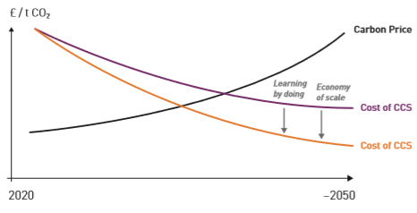
Source 136 Scaling up CCS in Europe, IOGP Fact sheet, September 2019
Costs of CO2 capture
CO2 capture is typically the largest cost component in the CCS and CCU (carbon capture and use) value chain, as a result of the technology costs and energy requirements. Costs of capture equipment are determined by the percentage volume of CO2 in the flue gas from which it is captured. As the Figure below shows, the higher the CO2 purity, the lower the cost in terms of CO2 avoided. In addition, the figure highlights that indicative carbon capture for many processes is currently more expensive than the EU ETS price and will need support in the near-term. Higher purity sources of CO2 include hydrogen production from reforming natural gas, and ethanol and ammonia production. Many current and emerging capture technologies are engineered to remove 80% - 90% of the CO2 from flue gas. Higher capture rates are possible, with the H21 North of England project having modelled 95% capture rates. Recent work by the IEAGHG suggest that 99% capture rates on combined cycle gas turbines (CCGT) are achievable with an increased cost below 10% compared to 90% capture rates.
Figure 133 Overview of median carbon capture costs in various industrial processes
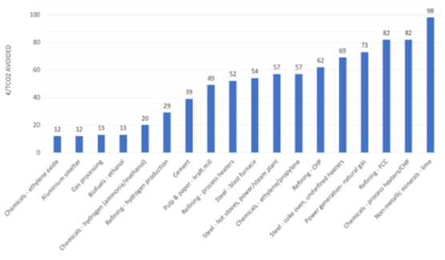
Source 137 (adapted by IOGP): Navigant (2019). Gas for Climate. The optimal role for gas in a net-zero emissions energy system, Appendix E

Costs of CO2 transport
On the basis of existing and planned CCS and CCU projects in Europe, the key options for CO2 transportation are pipeline transport using new or repurposed infrastructure, and shipping. CO2 transportation by ship will benefit from future standardization of the key ship components, including connection valves and flanges between ship and storage facilities, as well as optimization of the size and number of CO2 transport vessels to efficiently match the CO2 volumes. Equipment standardization will also increase the potential for cost reduction and will facilitate the construction and deployment of new CO2 transport ships relatively quickly using a “design one, build many” strategy.
Repurposing offshore oil and gas pipelines to transport CO2 to depleted oil and gas fields or saline aquifers suitable for CO2 storage can help to avoid installing new offshore infrastructure. The costs savings of reusing existing infrastructure, which would otherwise be decommissioned, depends on the condition of the existing pipelines, as well as any necessary technical interventions, e.g. installing additional concrete mattresses or repairing corrosion.
Reusing offshore oil and gas pipelines to transport CO2 may represent 1 – 10% of the cost of building a new CO2 pipeline. Offshore CO2 pipelines costs can vary between EUR 2–EUR 29/tCO2. Costs for ship transport range between EUR 10 – EUR 20/tCO2 and this option is usually preferable when smaller volumes need to be transported over longer distances. For onshore transportation of CO2 from industrial and power facilities to the storage location or port, gas infrastructure companies are exploring both the repurposing of existing gas pipelines, and also new-build CO2 pipelines.
Costs of CO2 storage
The cost of CO2 storage depends from location to location. The storage capacity in deep saline aquifers is much greater compared to onshore basins or offshore depleted oil and gas fields; these deep saline formations therefore have a better scaling-up and cost reduction potential. The upfront storage costs are lower in depleted oil and gas fields due to the presence of infrastructure that can be (re)used for CO2 injection. However, risks associated with securing legacy wells for storage operations may add additional risks and costs. Storage costs, while much lower than capture costs, are site dependent and require some upfront investment in mapping and understanding storage complexes (including, e.g. formation pressures, reservoir characteristics, cap rock efficiency, faults, trapping structures, mineralogy, salinity); estimating storage capacity; and designing infrastructure. Well costs are usually the highest component.
CO₂ geological storage is a safe and mature technology ready for broad implementation, as evidenced by over twenty years of successful storage offshore in Norway, combined with more recent onshore storage in Canada and the US. In the EU, CCS benefits from a clear set of regulations and requirements under the 2009 EU CO₂ Storage Directive that ensure the identification of appropriate storage sites and the safety of subsequent operation. In the U.S. the recent 45Q tax bill, which provided a 55 USD support for every tons of CO2 stored underground, and 35 USD/ton for enhanced oil recovery, proved to be a sufficient incentive for some industries. In Norway, two large-scale CCS projects are in operation: Sleipner (1996) and Snøhvit (2008). Both projects capture CO2 from natural gas processing. The business case is found in the otherwise payable CO2 tax (EUR ~40/t).
According to a paper of the the Zero Emissions Platform European Technology and Innovation Partnership (ZEP), in a mature CCS industry, the technical cost of storing CO2 in offshore storage reservoirs is expected to lie in the range EUR 2 – 20/tonne; adding transport and compression cost will bring this in the range of EUR 12 – 30/tonne.
Figure 134 Storage costs in the EU28 per formation type
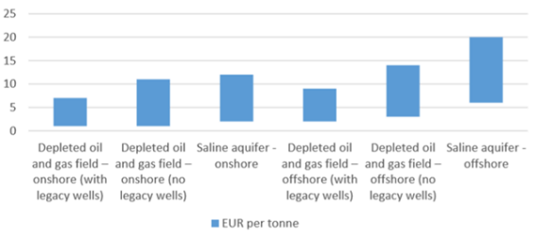
Source 138 IOGP from: ZEP (2011). The Costs of CO2 Capture, Transport and Storage
Learning curves
The cost reductions for CCS value chain are strongly connected to local and regional developments and to the introduction and adoption of EU policies and funding mechanisms. Shared CO2 transport and storage infrastructure - connecting industrial clusters and allowing numerous emitters to benefit from CCS applications – can deliver economies of scale and decrease the transport unit cost.

There is strong evidence that capture costs have already reduced in the U.S. The Figure below shows estimated costs from a range of feasibility and front end engineering and design (FEED) studies for coal combustion CCS facilities using mature amine-based capture systems. Two of the projects, Boundary Dam and Petra Nova are operating today. The cost of capture reduced from over USD100 per tonne CO2 at the Boundary Dam facility to below USD65 per tonne CO2 for the Petra Nova facility, some three years later. The most recent studies show capture costs (also using mature amine-based capture systems) for facilities that plan to commence operation in 2024-28, cluster around USD 43 per tonne of CO2. New technologies at pilot plant scale promise capture costs around USD 33 per tonne of CO2.
Figure 135 Levelised cost of CO2 capture for large-scale post-combustion facilities at coal-fired power plants, including previously studied facilities
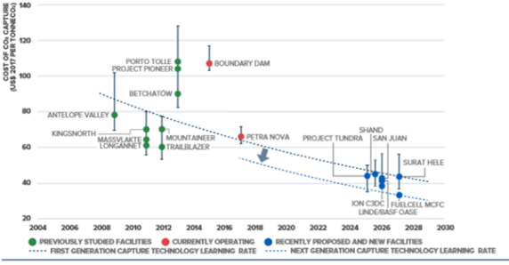
Source 139 Global status of CCS 2019, Report of the Global CCS Institute
In the EU, new industrial-scale CCS projects may become operational in this decade with sufficient support and coordination. Most importantly, the five Projects of Common Interest funded by the EU’s Connecting Europe Facility, all aiming to build cross-border CO2 pipelines as part of larger CCS infrastructures: Northern Lights (Norway), PORTHOS/CO2 TransPorts and ATHOS (both in the Netherlands), ERVIA CCUS (Ireland), Acorn/Sapling (UK).
Energy intensive sectors have also started putting up projects, which, once scaled up, can make these players part of the climate solution. Recent hydrogen projects include H2M (clean hydrogen), H2morrow (clean hydrogen for clean steel production), HyDemo (clean hydrogen for maritime sector) and H-Vision. Industrial CO2 capture projects include ViennaGreenCO₂ (solid sorbent capture technology pilot), Technology Centre Mongstad (post-combustion capture technologies), Norcem (capture from cement plant), LEILAC project (Pilot installation for breakthrough technology in cement production).
Knowledge sharing across these and other projects should help with improving CCS technologies while bringing down their costs. The Global CCS Report 2019 estimates that next-generation capture technologies have unique features – either through material innovation, process innovation and/or equipment innovation – which reduce capital and operating costs and improve capture performance.
Figure 136 Selected next-generation capture technologies being tested at 0,5MWe (10 T/D) scale or larger with actual flue gas
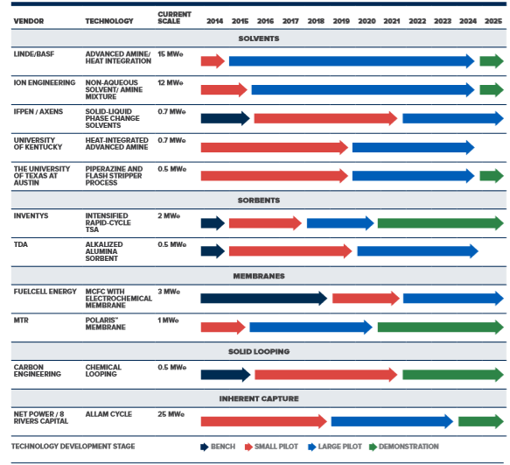
Source 140 Global status of CCS 2019, Report of the Global CCS Institute
The learning opportunities go beyond individual sectors. In fact, the development of the CCS infrastructure requires close cross-sectoral (and sometimes cross-border) cooperation among point sources of CO2 emissions (cement, steel, chemical, hydrogen, etc.) and the transport and storage providers. Integrated CCS infrastructure planning and development will hence be one of the major challenges of the decade.

R&I

The EU has been long-time supporting research and innovation in CO2 capture and storage through its successive R&I framework programmes (e.g. FP7: 2007-2013; Horizon 2020: 2014-2020). CO2 capture in industrial plants has become particular area under Horizon 2020, with focus on the cement sector (e.g. the CEMCAP, LEILAC and CLEANKER projects) and steel making (e.g. STEPWISE and C4U). CO2 storage research has also continued receiving support (e.g. STEMM-CCS, ENOS, SECURe and CarbFix2).

For joint R&I priority setting and funding, the Commission established stakeholder-driven platforms under the Strategic Energy Technology (SET) Plan, which typically include Member States, as well as industrial and R&I stakeholders. These platforms include the CCS Implementing Working Group of the SET Plan (which is Member State driven), the Zero Emissions Platform European Technology and Innovation Partnership (which is stakeholder driven) and the CCUS Project Network (which is project-driven).

In the 2020 decade, industrial scale CCS and CCU projects will generate many new challenges that can best be solved by undertaking R&I in parallel with large-scale activities. Therefore, under Horizon Europe, the EU’s now starting R&I programme, will have to focus on industrial clusters. An iterative process is needed where R&I projects address specific industrial challenges, including those related to negative emissions, with the results then implemented and published by large-scale projects. For example, pilot projects still have an important role to study the potential long-term impacts of varying flow rate and composition on CO2 pipeline, wellbore and reservoir integrity. Further knowledge will help large-scale projects establish the safe limits within which pipelines and wells can be operated.

Priority research topics (from laboratory to pilot scales) may include the following areas:
- CO2 capture in industrial clusters;
- CO2 capture in power applications;
- technological elements for capture and application;
- CCS and CCU transport systems;
- CO2 Storage;
- standardisation and legislation issues, and non-technological elements.

In view of longer-term CCS infrastructure development, a mapping of European CO2 storage assets and the implementation of a European storage development/appraisal programme is considered necessary. This is to optimise development and investment decisions against regional characteristics, resources and CO2 reduction pathways.

The revision of the CCS Implementation Plan of the SET Plan will reflect these needs.

Public R&I funding

National and EU public funding for CCS R&I continues being very important. The EU’s Horizon 2020 programme has provided close to EUR 240 million for carbon capture, use and storage projects during the 2014-2020 period. In the future, the Innovation Fund, which among other renewable and low-carbon energy technologies will also support CCS, will be instrumental for realising a new wave of CCS demonstrators and first-of-a-kind facilities in Europe. Horizon Europe, the EU’s new research and innovation framework programme will support not only the development of a new generation of CCS technologies, but also the necessary stakeholder engagement and knowledge sharing activities needed for the rollout of complex industrial CCS projects and infrastructure.

Government or public R&D investment can have a significant positive effect on the development and deployment of the CCS technology. It creates a positive environment for private initiatives, and affects among others the number of relevant publications and patent applications. Public R&D investment from 2004 to 2016 in the European Economic Area (EEA), is shown in the following figure. Since 2009, Norway is the largest investor in CCUS R&D in terms of public funds, except from 2014 when it was overtaken by the UK.
Figure 137 Public R&D investments in CCUS for the EEA (top countries)
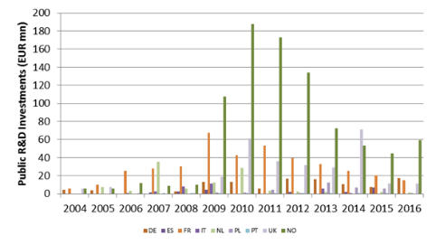
Source 141 JRC 2018 ‘Data collection and analysis on R&I investments and patenting trends in support of the State of the Energy Union Report’ based on 2018 IEA RD&D Statistics. Available at: https://www.iea.org/statistics/RDDonlinedataservice/

Private R&I funding

On private R&I funding, JRC analysis showed that amongst the countries most highly investing in CCUS, public to private R&D investments were mostly leveraged in Germany, followed by the Netherlands and France. This means that these countries noted significantly higher private investments compared to the public ones.

Figure 138 Private R&D investments in CCUS for the EEA (top countries, based on available data)
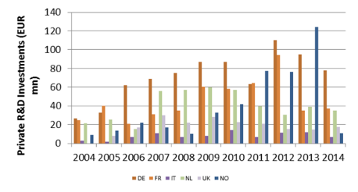
Source 142 JRC 2018 ‘Data collection and analysis on R&I investments and patenting trends in support of the State of the Energy Union Report’

Patenting trends

To identify trends, the JRC analysed the “inventive activity” of EU companies in certain technologies, i.e. the family of patents relevant to the technologies. The inventive activity from 2006 to 2016 showed that capture by absorption peaked in 2009 surpassing all the other technologies considered. In 2011 it was surpassed by capture with chemical separation and capture by adsorption has been the major trend ever since. According to the data, patent families related to CO₂ storage peaked in 2009 and 2015 but have been generally stable.

The following graphs indicate trends of inventive activity per year in different technologies as well as most active countries (hence no y-axis presented). The following figures show activity of companies of European Member States in each component of CCUS. Germany dominated activity in CO₂ capture technologies, followed by France and the Netherlands. These countries were also among the four countries with interest in CO₂ storage, together with Austria.

Figure 139 Activity by EU MS companies in CO2 capture.
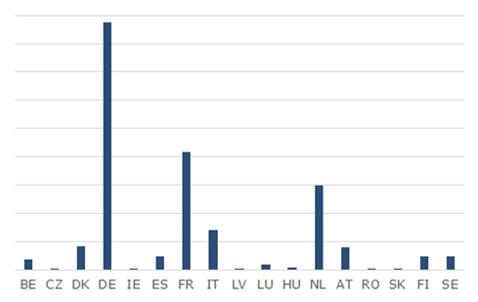
Source 143 JRC, 2018 based on data from the European Patent Office, “European Patent Office PATSTAT database, 2019 autumn version.” 2019

Figure 140 Activity by EU MS companies in CO2 storage
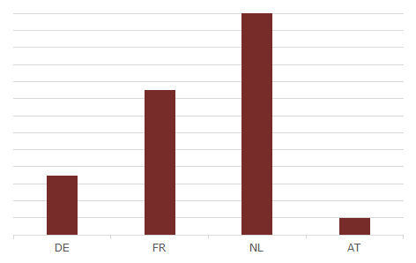
Source 144 JRC, 2018 based on data from the European Patent Office, “European Patent Office PATSTAT database, 2019 autumn version.” 2019

Value chain analysis

Number of companies in the supply chain, incl. EU market leaders

Analysing the patenting activity per priority year, from 2004 to 2014, the larger number of cumulative patents is found in the categories of capture by adsorption and capture by rectification and condensation. The third sub-class with more patenting is capture by chemical separation. Despite the current interest on membranes, patenting is still far from the three leading technologies. Big multinational companies such as Shell, Air Liquide, Siemens, BASF and Linde are amongst the companies with the highest activity in patenting. Regarding CO2 storage, since important investments on CCUS have been dependent on the oil and gas industry, the number of patents varies as a function of their interests for innovation or technology improvements. According to the data, patent families related to CO2 storage peaked in 2007 and have decreased ever since. The following graphs provide the relative patenting activity of company by country for CO2 capture and storage technologies.

Figure 141 Top companies and organisations patenting in CO2 capture technologies from 2004 to 2014 in Europe. a) capture by biological separation, b) capture by chemical separation, c) capture by absorption, d) capture by adsorption, e) capture by membranes, f) capture by rectification and condensation
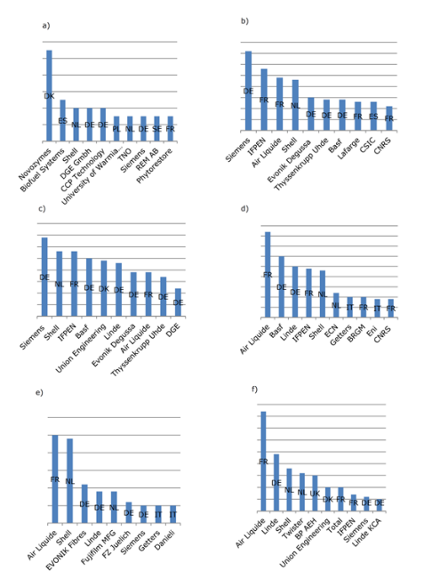
Source 145 JRC, 2018 based on the ‘European Patent Office PATSTAT database, 2018 spring version’

Figure 142 Top companies and institutions patenting in subterranean or submarine CO2 storage technologies in Europe from 2004 to 2014
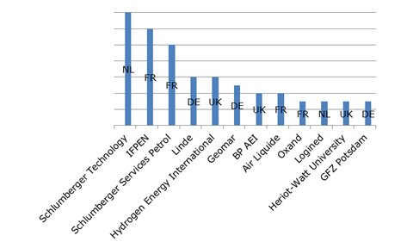
Source 146 JRC, 2018 based on the ‘European Patent Office PATSTAT database, 2018 spring version’

Large-scale CO2 transport and storage projects are typically driven by global gas and oil corporations, e.g. Shell, Total, Equinor, BP, which are often active in CCS projects outside of Europe, hence dispose of competitive knowledge and experience in the field. However, the development of a complex infrastructure like CCS requires the contribution of a large number of other stakeholders, including the users of the transport and storage infrastructure, public and licensing authorities, modellers, or those involved in site monitoring.
The picture is even more divers when it comes to CO2 capture, which potentially includes many different industrial sectors, processes and technology providers. The market of capture technologies may be relatively small today, but one can expect its rapid growth with higher price for carbon emissions, the development of CCS, as well as CCU solutions. Research and innovation policy has a very important role to support the development of a European CO2 capture industry that can compete on global markets. Recently, Gassnova, Equinor, Shell, and Total have renewed their commitment to research and testing of innovative capture technologies at the Technology Centre in Mongstad (Norway) until 2023, highlighting the momentum around CCS.

Global market analysis

Global market leaders vs EU market leaders

With no viable business model for CCS today, there is a limit to which terms of market economics (demand/supply, market leaders, competitive advantage, economy of scale, etc.) can be applied for CCS. Nevertheless, technology leaders (countries and companies) can be clearly distinguished.
Out of the 51 large-scale CCS facilities worldwide (in operation or development), most can be found in the U.S., which makes it a global CCS leader. Norway, thanks to its two CCS major facilities operated by Equinor (Sleipner since 1996 and Snøhvit since 2008), as well as to the Technology Centre Mongstad, is also a global technology leader and CCS promoter.
The adoption of the Paris Agreement, the growing scientific consensus on human-induced climate change, and government policies, which require CO2 reductions in all sectors (incl. cement, steel, chemicals, hydrogen production), are making a momentum for CCS. Today, ambitious CCS projects are planned and implemented in Europe (The Netherlands, UK, Ireland), Australia, Canada, China and the Middle East.
Analysis of the full CCUS value chain i.e. capture, transportation with pipelines and storage, presented in the following figure, indicates that Europe holds the second highest market share in all CCUS elements following North America. Asia Pacific, Middle East and South America are following. Asia Pacific and Middle East can be seen as emerging since it is these regions, which count the most projects in planning according to the Global CCS Institute projects database.
Figure 143 CCUS technologies market by region (2017)
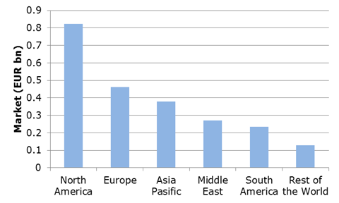
Source 147 Source: JRC, 2018 with data from Accuray Research (2018) Global Carbon Capture Utilization Storage Technologies Market Analysis Trends

Future challenges to fill technology gap
Many stakeholders and analysts, including the IEA, see CCS as a mature and readily available technology that will need to be deployed at scale for reaching climate neutrality by 2050. In Europe, this is particularly true for energy intensive industries (cement, steel, chemicals), for which no alternative routes exist to zero-emissions, or for which the alternative routes may be significantly more expensive. CCS may also be needed for stepping up clean hydrogen production, as well as for producing negative emissions via direct air capture or BECCS. Cross-border CO2 transport and storage infrastructure that connects industrial clusters with storage sites needs to be the backbone to which industrial emitters could plug in to get their CO2 emissions transported to permanent CO2 storage sites. This shared CO2 transport and storage infrastructure can help with safeguarding industrial jobs and activity in Europe while moving towards a climate-neutral economy.

However, the complexity of full-chain (i.e. CO2 capture-transport-storage) CCS infrastructure projects, their relatively high investment and operating costs, as well as regulatory and public acceptance issues have been hindering the rollout of CCS.

Credible energy and climate policies (e.g. strong CO2 price signal), as well as governments’ support to CCS projects (e.g. by including them in the National Energy and Climate Plans) are therefore deemed necessary. The European Green Deal legislative framework, including the TEN-E regulation and EU ETS directive, is expected to provide the necessary push for long-term public and private investments, helping to prepare for the rollout of CO₂ and clean hydrogen infrastructure. Public funding for CCS infrastructure, including the EU’s Innovation Fund and the Horizon Europe R&I programme, is highly important, also in view of mobilising and de-risking private investment.
The recent EC Communication on Stepping up Europe’s 2030 climate ambition defines clearly the task ahead: “hydrogen and carbon capture, utilisation and storage, will need to be developed and tested at scale in this decade”.

European Commission (2018). IN-DEPTH ANALYSIS IN SUPPORT OF THE COMMISSION COMMUNICATION COM(2018) 773 A Clean Planet for all A European long-term strategic vision for a prosperous, modern, competitive and climate neutral economy.
https://publications.jrc.ec.europa.eu/repository/bitstream/JRC115958/kjna29695enn.pdf
https://ec.europa.eu/energy/sites/ener/files/hydrogen_strategy.pdf
European Commission (2018). IN-DEPTH ANALYSIS IN SUPPORT OF THE COMMISSION COMMUNICATION COM(2018) 773 A Clean Planet for all A European long-term strategic vision for a prosperous, modern, competitive and climate neutral economy.
European Commission (2018). IN-DEPTH ANALYSIS IN SUPPORT OF THE COMMISSION COMMUNICATION COM(2018) 773 A Clean Planet for all A European long-term strategic vision for a prosperous, modern, competitive and climate neutral economy.
International Energy Agency, Hydrogen Outlook, June 2019, p.32 – 2018 estimates
In this case hydrogen is present as a component of syngas.
An additional 45 MtH₂/y are used mixed with other gases.
As a reference total European industrial emissions were estimated at 877 MtCO₂/y (around 10% of these can be associated with hydrogen production) in 2017 - https://www.eea.europa.eu/data-and-maps/indicators/greenhouse-gas-emission-trends-6/assessment-3. Industrial emissions are roughly 9% of total European emissions.
Renewable hydrogen refers to hydrogen produced by electrolysers powered by renewable electricity, through a process in which water is dissociated into hydrogen and oxygen (often referred to as “green hydrogen”).
https://ec.europa.eu/commission/presscorner/detail/en/QANDA_20_1257
https://iea.blob.core.windows.net/assets/a02a0c80-77b2-462e-a9d5-1099e0e572ce/IEA-Hydrogen-Project-Database.xlsx
https://www.dwv-info.de/wp-content/uploads/2015/06/DVGW-2955-Brosch%C3%BCre-Wasserstoff-RZ-Screen.pdf
Short-term projects collected from the TYNDP ENTSOs, the IEA hydrogen project database, and presented to the ETS Innovation Fund. Future project pipeline is based on industry estimates in Hydrogen Euro
International Energy Agency, Hydrogen Outlook, June 2019, p.18 and 32
https://www.fch.europa.eu/sites/default/files/Hydrogen%20Roadmap%20Europe_Report.pdf EXHIBIT 2
Amount of hours a production facility is able to run per year.
IEA 2019 Hydrogen report (page 42), and based on IEA assumed natural gas prices for the EU of 22 EUR/MWh, electricity prices between 35-87 EUR//MWh, and capacity costs of 600 EUR/kW.
However, at this stage, the costs can be only estimated given that no such project has started construction or operation in the EU today.
Clean steel could be competitive as compared to coking coal, if CO2 prices are raised to 50 USD/1t CO2; clean dispatchable power can be competitive with prices of natural gas on the condition of at least 32 USD/1t CO2; green ammonia could be competitive as compared to prices of natural gas, on the condition of at least 78 USD /1tCO2.
Based on cost assessments of IEA, IRENA and BNEF. Electrolyser costs to decline from 900 EUR/kW to 450 EUR/kW or less in the period after 2030, and 180 EUR/kW after 2040. Costs of CCS increases the costs of natural gas reforming from 810 EUR/kWH2 to 1512 EUR/kWH2. For 2050, the costs are estimated to be 1152 EUR/kWH2 (IEA, 2019).
Shell, Energy of the Future, 2017
Currently, the dissociation of the water molecule in its constituent parts requires large amount of energy to occur (about 200 MJ - or 55 kWh - of electricity are needed to produce 1 kg of hydrogen from 9 kg of water by electrolysis). The thermodynamic limit for dissociating water at room temperature through electrolysis is around 40 kWh/kgH₂.
Assuming current electricity and gas prices, low-carbon fossil-based hydrogen is projected to cost in 2030 between 2-2.5 EUR/kg in the EU, and renewable hydrogen are projected to cost between 1.1-2.4 EUR/kg (IEA, IRENA, BNEF).
https://ec.europa.eu/energy/sites/ener/files/hydrogen_strategy.pdf
IEA - The Future of Hydrogen, 2019, IRENA, Bloomberg BNEF, March 2020
IEA - The Future of Hydrogen, 2019, p.55
Shell, Energy of the Future, 2017.
The total investment costs includes the costs for the electrolyser but also the ‘balance of system’ costs and the system integration costs that could add an additional 50%.
Hydrogen generation in Europe: Overview of costs and key benefits (ASSET, 2020).
This corresponds with 57,300 EUR/MW H2out for ALK Electrolysers. ALK calculated using stack efficiency (LHV) of NEL A-series upper range 78.6% (LHV) (NEL Hydrogen, 2020).
The biggest PEM electrolyser in the world(10 MW - project REFHYNE) should be about to be commissioned.
This corresponds with 106 000 EUR/MW H2out for PEM electrolysers (LHV). PEM calculated using stack efficiency (LHV) of 65% (Guidehouse, 2020).
IEA - The Future of Hydrogen, 2019- Table 3
Asset study (2020). Hydrogen generation in Europe: Overview of costs and key benefits. Assuming a steel production plant of 400 000 tonnes/year.
JRC 2020 “Current status of Chemical Energy Storage Technologies” pag.63 https://publications.jrc.ec.europa.eu/repository/bitstream/JRC118776/current_status_of_chemical_energy_storage_technologies.pdf
JRC 2020 “Current status of Chemical Energy Storage Technologies” pag.63 https://publications.jrc.ec.europa.eu/repository/bitstream/JRC118776/current_status_of_chemical_energy_storage_technologies.pdf
vs EUR 472 million for FCH JU funding overall and EUR 439 million for other sources of funding
This includes both private and public funds.
JRC 2020 “Current status of Chemical Energy Storage Technologies” pag.63 https://publications.jrc.ec.europa.eu/repository/bitstream/JRC118776/current_status_of_chemical_energy_storage_technologies.pdf
Yoko-moto, K., Country Update: Japan, in 6th International Workshop on Hydrogen Infrastructure and Transportation 2018
60% of EU companies active are small- and medium-size enterprises
A. Buttler, H. Spliethoﬀ Renewable and Sustainable Energy Reviews 82 (2018) 2440–2454 and https://www.fch.europa.eu/sites/default/files/Evidence%20Report%20v4.pdf
The US company Proton on site was acquired by NEL (NO) in 2017.
Value Added of the Hydrogen and Fuel Cell Sector in Europe summary report, FCJU September 2019.
Gas for Climate study, assuming around 1500 TWh of renewable hydrogen by 2050.
https://ec.europa.eu/energy/sites/ener/files/hydrogen_strategy.pdf
https://ec.europa.eu/energy/sites/ener/files/hydrogen_strategy.pdf
Already today, the H2FUTURE project in Austria operates a 6MW electrolyser powered with renewable electricity that supplies hydrogen to a steel plant, while providing grid services at the same time. The HYBRIT project in Sweden is taking concrete action to become completely fossil-free steel plant by 2045, converting their production to use renewable hydrogen and electricity.
European bus companies have also acquired expertise in production of fuel cell busses, due to several JIVE projects funded from the Fuel Cell Joint Undertaking and from the Connecting Europe Facility (transport).
COM(2018) 773 final
https://ec.europa.eu/clima/sites/clima/files/docs/pages/com_2018_733_analysis_in_support_en_0.pdf
https://ec.europa.eu/clima/sites/clima/files/docs/pages/com_2018_733_analysis_in_support_en_0.pdf (page 79)
The above figures are focused only on grid scale storage and do not cover behind-the-meter storage (which might be operated differently than centralised units exposed to the wholesale electricity market), and vehicle-to-grid services. Nor do these figures cover intra-hour storage needs, but the market for this is not very big compared to the overall electricity market and will remain limited.
The possibility of storing e-fuels in conventional facilities (i.e. indirect storage of electricity) allows to reduce the storage needs of the system.
Next Generation Energy Storage Technologies (EST) Market Forecast 2020-2030, Visiongain
Batteries for stationary storage are used for a range of applications with some being more suited to store energy and others to supply power.
Source: JRC Science for Policy Report: Tsiropoulos I., Tarvydas D., Lebedeva N., Li-ion batteries for mobility and stationary storage applications – Scenarios for costs and market growth, EUR 29440 EN, Publications Office of the European Union, Luxembourg, 2018, doi:10.2760/87175.
COM (2019) 176 final
Forthcoming JRC (2020) Technology Development Report LCEO: Battery storage.
Both battery eletric vehicles and plug-in hybrid electric vehicles.
IEA (2020), Global EV Outlook 2020, IEA, Paris https://www.iea.org/reports/global-ev-outlook-2020
https://ec.europa.eu/energy/sites/ener/files/energy_system_integration_strategy_.pdf
ICF, commissioned by DG GROW - Climate neutral market opportunities and EU competitiveness study (Draft, 2020)
L. Trahey, F.R. Brushetta, N.P. Balsara, G. Cedera, L. Chenga, Y.-M. Chianga, N.T. Hahn, B.J. Ingrama, S.D. Minteer, J.S. Moore, K.T. Mueller, L.F. Nazar, K.A. Persson, D.J. Siegel, K. Xu, K.R. Zavadil, V. Srinivasan, and G.W. Crabtree, “Energy storage emerging: A perspective from the Joint Center for Energy Storage Research”, PNAS, 117 (2020) 12550–12557
https://www.iea.org/reports/global-ev-outlook-2020#batteries-an-essential-technology-to-electrify-road-transport
https://www.iea.org/reports/global-ev-outlook-2020#batteries-an-essential-technology-to-electrify-road-transport
https://publications.jrc.ec.europa.eu/repository/bitstream/JRC113360/kjna29440enn.pdf
ICF, commissioned by DG GROW - Climate neutral market opportunities and EU competitiveness study (Draft, 2020)
Next Generation Energy Storage Technologies (EST) Market Forecast 2020-2030, Visiongain
Graphene enabled silicon-based Li-ion battery boosts capacity by 30% - Graphene Flagship
ICF, commissioned by DG GROW - Climate neutral market opportunities and EU competitiveness study (Draft, 2020)
Lebedeva, N., Di Persio, F., Boon-Brett, L., Lithium ion battery value chain and related opportunities for Europe, EUR 28534 EN, Publications Office of the European Union, Luxembourg, 2017, ISBN 978-92-79-66948-4, doi:10.2760/6060, JRC105010
ICF, commissioned by DG GROW - Climate neutral market opportunities and EU competitiveness study (Draft, 2020)
ICF, commissioned by DG GROW - Climate neutral market opportunities and EU competitiveness study (Draft, 2020)
https://www.fraunhofer.de/en/research/key-strategic-initiatives/battery-cell-production.html
ICF, commissioned by DG GROW - Climate neutral market opportunities and EU competitiveness study (Draft, 2020)
https://about.bnef.com/blog/battery-pack-prices-fall-as-market-ramps-up-with-market-average-at-156-kwh-in-2019/#:~:text=Shanghai%20and%20London%2C%20December%203,research%20company%20BloombergNEF%20(BNEF).
Northvolt plans to have 32 GWh total facilities in Sweden in the coming years and 16 GWH in Germany (cooperation with VW is close). SAFT/TOTAL and Varta are part of first IPCEI on battery R&I. Northvolt will be involved in 2nd IPCEI on battery R&I.
ICF, commissioned by DG GROW - Climate neutral market opportunities and EU competitiveness study (Draft, 2020)
Lebedeva, N., Di Persio, F., Boon-Brett, L., Lithium ion battery value chain and related opportunities for Europe, EUR 28534 EN, Publications Office of the European Union, Luxembourg, 2017, ISBN 978-92-79-66948-4, doi:10.2760/6060, JRC105010
https://ec.europa.eu/jrc/sites/jrcsh/files/jrc105010_161214_li-ion_battery_value_chain_jrc105010.pdf
COM 2019 176 Report on the Implementation of the Strategic Action Plan on Batteries: Building a Strategic Battery Value Chain in Europe
Press release IP/19/6705, “State aid: Commission approves EUR 3.2 billion public support by seven Member States for a pan-European research and innovation project in all segments of the battery value chain”, December 9, 2019. https://ec.europa.eu/commission/presscorner/detail/en/ip_19_6705.
Here are some EU flow battery companies: VisBlue (DK 2014) commercialises a new battery technology using a vanadium redox flow battery system. BETTERY, an Italian Innovative Startup founded in January 2018 (flow batteries), NETTERGY, a start-up related to E.ON (2016) - developer of a scalable distributed flow battery system that economically serves multiple stationary energy storage applications Kemiwatt (FR) has made several world premieres since its creation in 2014, with the first organic Redox battery prototype in 2016 and the first industrial demonstrator in 2017. Jena batteries GmbH (2013 DE) innovative company in the field of stationary energy storage systems rated at 100 kW and up. It offers metal-free flow battery systems. Elestor (2014, NL) HBr flow batteries
Information received from RECHARGE
ICF, commissioned by DG GROW - Climate neutral market opportunities and EU competitiveness study (Draft, 2020)
ICF, commissioned by DG GROW - Climate neutral market opportunities and EU competitiveness study (Draft, 2020)
ICF, commissioned by DG GROW - Climate neutral market opportunities and EU competitiveness study (Draft, 2020)
C. Pillot, Nice batteries conference, Oct 23, 2019.
ICF, commissioned by DG GROW - Climate neutral market opportunities and EU competitiveness study (Draft, 2020)
ICF, commissioned by DG GROW - Climate neutral market opportunities and EU competitiveness study (Draft, 2020)
ICF, commissioned by DG GROW - Climate neutral market opportunities and EU competitiveness study (Draft, 2020)
ICF, commissioned by DG GROW - Climate neutral market opportunities and EU competitiveness study (Draft, 2020)
ICF, commissioned by DG GROW - Climate neutral market opportunities and EU competitiveness study (Draft, 2020)
IEA (2020), Global EV Outlook 2020, IEA, Paris https://www.iea.org/reports/global-ev-outlook-2020
IEA (2020), Global EV Outlook 2020, IEA, Paris https://www.iea.org/reports/global-ev-outlook-2020
Lebedeva, N., Di Persio, F., Boon-Brett, L., Lithium ion battery value chain and related opportunities for Europe, EUR 28534 EN, Publications Office of the European Union, Luxembourg, 2017, ISBN 978-92-79-66948-4, doi:10.2760/6060, JRC105010
Lebedeva, N., Di Persio, F., Boon-Brett, L., Lithium ion battery value chain and related opportunities for Europe, EUR 28534 EN, Publications Office of the European Union, Luxembourg, 2017, ISBN 978-92-79-66948-4, doi:10.2760/6060, JRC105010
Information provided by RECHARGE (2020)
Information provided by RECHARGE (2020)
https://battery2030.eu/
https://www.globenewswire.com/news-release/2020/02/07/1981726/0/en/Global-Aircraft-Electrification-Market-Forecast-to-2030-Low-Operational-Costs-Reduced-Emission-and-Aircraft-Noise.html
Nickel-based batteries have failsafe characteristics.
IEA (2020), Global EV Outlook 2020, IEA, Paris https://www.iea.org/reports/global-ev-outlook-2020
https://ec.europa.eu/info/news/focus-energy-efficiency-buildings-2020-feb-17_en
COM(2011) 571, Communication from the Commission to the European Parliament, the Council, the European Economic and Social Committee and the Committee of the Regions. Roadmap to a Resource Efficient Europe
COM(2020) 98, Communication from the Commission to the European Parliament, the Council, the European Economic and Social Committee and the Committee of the Regions. A new Circular Action Plan for a cleaner and more competitive Europe.
COM(2020)662 accompanied by SWD(2020)550, Communication from the Commission to the European Parliament, the Council, the European Economic and Social Committee and the Committee of the Regions. A Renovation Wave for Europe – greening our buildings, creating jobs, improving lives.
Developed in 2016 by ARUP with BAM Construction, Freiner & Reifer, and the Built Environment Trust
According to the analysed data from the CleanTech Group’s database. The Cleantech Group investment database is global. However, while there is confidence regarding the coverage of the investments in the US and the EU, data from emerging markets (notably China) can be underestimated due to this information not being made public.
According to the analysed data from the CleanTech Group’s database.
According to the analysed data from the CleanTech Group’s database. The Cleantech Group investment database is global. However, while there is confidence regarding the coverage of the investments in the US and the EU, data from emerging markets (notably China) can be underestimated due to this information not being made public.
According to the analysed data from the CleanTech Group’s database.
According to the analysed data from the CleanTech Group’s database. The Cleantech Group investment database is global. However, while there is confidence regarding the coverage of value chain investments in the US and the EU, data from emerging markets (notably China) can be underestimated due to this information not being made public.
http://www.greenprefab.com/ 3
European Commission Staff Working Document – Impact Assessment. SWD (2019) 357 final
European Commission Staff Working Document – Impact Assessment. SWD (2019) 357 final
The “Base” line is calculated extrapolating observed consumption values, the reference year is set to 2017; BAU scenario admits massive replacement of legacy light sources by LEDs; MEPS scenario suppose the adoption of Minimum Energy Performance Standards worldwide; BAT scenario supposes the use of the Best Available Technology in the market.
In this text a “component" means a single encapsulated small size electronic component whereas “device” corresponds to a larger encapsulated emitting element; both are drive-less but can include some reverse-current protection elements. “Component” applies better to LEDs and LDs when “device” is more appropriated for OLEDs and laser-systems.
https://patents.google.com/?q=(solid+state+light)&country=WO&before=priority:20200930&after=priority:20100101&type=PATENT&num=100
https://www.scopus.com/
https://www.webofknowledge.com/
CBI Ministry of Foreign Affairs, Electronic Lighting in the Netherlands, 2014
Geography - Global Forecast to 2022, online teaser, Report SE4912 published January 2017
Navigant, Let’s talk numbers – retail lighting: adoption rate of led lighting, presentation for US AATCC, October 2017
Center of Industrial Studies, The European market for lighting fixtures, press release, published online May 2020
Georges Zissis G., Bertoldi P., Update on the Status of LED-Lighting world market since 2018, JRC Technical Report (under publication)
Amerlux Innovation Center, LED Energy Market Observer, Energy Observer, August 2018
EHP Country by Country Study - https://www.euroheat.org/publications/country-by-country.
Towards a decarbonised heating and cooling sector in the EU – unlocking the potention of energy efficiency and district energy, Mathiesen, Brian Vad; Bertelsen, Nis; Schneider, Noémi Cécile Adèle; García, Luis Sánchez; Paardekooper, Susana; Thellufsen, Jakob Zinck; Djørup, Søren Roth, Aalborg University, 2019: https://heatroadmap.eu/decarbonised-hc-report/
www.iea.org/articles/how-can-district-heating-help-decarbonise-the-heat-sector-by-2024
Such as shopping malls, supermarkets, hospitals, metros, see www.reuseheat.eu/facts-figures/
Pan-European Thermal Atlas (PETA) prepared as part of the Heat Roadmap Europe project, 2019, https://heatroadmap.eu/peta4/
Towards a decarbonised heating and cooling sector in the EU – unlocking the potention of energy efficiency and district energy, Mathiesen, Brian Vad; Bertelsen, Nis; Schneider, Noémi Cécile Adèle; García, Luis Sánchez; Paardekooper, Susana; Thellufsen, Jakob Zinck; Djørup, Søren Roth, Aalborg University, 2019: https://heatroadmap.eu/decarbonised-hc-report/
It has a record 2019 year for new solar district heating installations, bringing online 10 new solar district heating plants and expanding 5 existing plants, for a total of 134 thermal MW added (compared to only 6 new plants and 4 expanded plants totalling 47 thermal MW added in 2018).
This section is based on the autumn 2019 version of the PATSTAT database (JRC update: December 2019). The methodology is provided by Fiorini, A., Georgakaki, A., Pasimeni, F. and E. Tzimas (2017) Monitoring R&I in Low-Carbon Energy Technologies, EUR 28446 EN, Publications Office of the European Union, Luxembourg. ISBN 978-92-79-65591-3, https://doi.org/10.2760/434051; Pasimeni, F., Fiorini, A. and A. Georgakaki (2019) Assessing private R&D spending in Europe for climate change mitigation technologies via patent data, World Patent Information, 59, 101927. https://doi.org/10.1016/j.wpi.2019.101927; Pasimeni, F. (2019) “SQL query to increase data accuracy and completeness in PATSTAT” in World Patent Information, 57, 1-7, https://doi.org/10.1016/j.wpi.2019.02.001.
Branchestatistik 2019 ''Fjernvarmesektorens samfundsbidrag', https://danskfjernvarme.dk/viden/statistik-subsection/branche-og-eksportstatistik/2019
Equal to 0.91 billion EUR and equal to 1.48 billion EUR at an exchange rate of 0.13 EUR/DKK, respectively: www.danskfjernvarme.dk/sitetools/english/eu-and-globally.
REN21 Global Status Report: https://www.ren21.net/wp-content/uploads/2019/05/gsr_2020_full_report_en.pdf
See also the final chapter on Smart Cities and Communities in this SWD
See also chapter 3.17 on smart grids & digital infrastructure for a further analysis of the energy services market based on digital technologies.
Business Cases and Business Strategies to Encourage Market Uptake - Addressing Barriers for the Market Uptake of Recommended Heating and Cooling Solutions, Heat Roadmap Europe 4, Trier, Daniel; Kowalska, Magdalena; Paardekooper, Susana; Volt, Jonathan; De Groote, Maarten ; Krasatsenka, Aksana ; Popp, Dana ; Beletti, Vincenzo; Nowak, Thomas; Rothballer, Carsten ; Stiff, George ; Terenzi, Alberto ; Mathiesen, Brian Vad, 2018: HRE4: http://vbn.aau.dk/files/290997081/HRE4_D7.16_vbn.pdf
This sections focuses on heat pumps for buildings and domestic use. Heat pumps for industrial use are discussed in the section on Industrial Heat Recovery (chapter 3.12). Heat pumps driven by gas will not be discussed here as their efficiency is still low.
In comparison, the minimum seasonal space heating energy efficiency for an air-to-water and water to water heat pump is 110 % in comparison to 86 % for a gas and oil boiler and 30 % for an electric boiler (source: Regulation (EU) 813/2013).
Transferring the heat demand (via HP) to the power system could increase peaks during winter season (for heating), and summer (for cooling), making the electricity demand profiles (load curves) steeper and more dependent on the weather conditions.
European Heat Pump Association, 2020, Sales, www.stats.ehpa.org/hp_sales/story_sales/
European Heat Pump Association, 2020, Forecast, www.stats.ehpa.org/hp_sales/forecast/
JRC Technical report, 2020, Assessment of heating and cooling related chapters of the National Energy and Climate Plans (NECPs), to be published.
Review study ecodesign and energy labelling for space heaters and combination heaters, task 5, final report, VHK, July 2019
Review of Regulation 206/2012 and 626/2011 air conditioners and comfort fans, task 3, final report, Armines and Viegand Maagøe, May 2018.
Top 10 Innovators Report - Heat pumps, Innoenergy, December 2018
Top 10 Innovators Report - Heat pumps, Innoenergy, December 2018
ENER/C2/2016-501, Study on the competitiveness of the renewable energy sector, 28 June 2019
Eurobserv'er Heat Pumps Barometer (2018): https://www.eurobserv-er.org/online-database/#
ICF study for DG GROW, to be published
Review study ecodesign and energy labelling for space heaters and combination heaters, task 2, final report, VHK, July 2019
Review of Regulation 206/2012 and 626/2011 air conditioners and comfort fans, task 5, final report, Armines and Viegand Maagøe, May 2018.
IEA Innovation Gaps, Key long-term technology challenges for research, development and demonstration, Technology report — May 2019
Input Paper for the SRIA for the CET, Stakeholder Cluster: Heating & cooling, to be published
Zero Emissions Platform, “Climate Solutions for EU industry”, 2017
For renewable hydrogen through electrolysis, see chapter 2.2.1.6.
European Commission (2018). IN-DEPTH ANALYSIS IN SUPPORT OF THE COMMISSION COMMUNICATION COM(2018) 773 A Clean Planet for all A European long-term strategic vision for a prosperous, modern, competitive and climate neutral economy.
Communication (COM(2019) 640)
Global Status of CCS, 2019 by the Global CCS Institute. https://www.globalccsinstitute.com/resources/global-status-report/
IEA (2020), CCUS in Industry and Transformation, IEA, Paris https://www.iea.org/reports/ccus-in-industry-and-transformation
IEA (2020), Large-scale CO2 capture projects in power generation in the Sustainable Development Scenario, 2000-2040, IEA, Paris https://www.iea.org/data-and-statistics/charts/large-scale-co2-capture-projects-in-power-generation-in-the-sustainable-development-scenario-2000-2040
The potential for CCS and CCU in Europe. Report to the thirty second meeting of the European Gas Regulatory Forum 5-6 June 2019, coordinated by IOGP. https://ec.europa.eu/info/sites/info/files/iogp_-_report_-_ccs_ccu.pdf
IEA Greenhouse Gas Programme: 2019-03 Review of Fuel Cell Technologies with CO2 Capture for the Power Sector. https://www.ieaghg.org/publications/technical-reports/reports-list/9-technical-reports/950-2019-03-review-of-fuel-cell-technologies-with-co2-capture-for-the-power-sector
The potential for CCS and CCU in Europe. Report to the thirty second meeting of the European Gas Regulatory Forum 5-6 June 2019, coordinated by IOGP. https://ec.europa.eu/info/sites/info/files/iogp_-_report_-_ccs_ccu.pdf
The potential for CCS and CCU in Europe. Report to the thirty second meeting of the European Gas Regulatory Forum 5-6 June 2019, coordinated by IOGP. https://ec.europa.eu/info/sites/info/files/iogp_-_report_-_ccs_ccu.pdf
ZEP paper from November 2019: CO2 Storage Safety in the North Sea: Implications of the CO2 Storage Directive (https://zeroemissionsplatform.eu/co2-storage-safety-in-the-north-sea-implications-of-the-co2-storage-directive/)
EUR 46,8 (1 USD = 0,85 Euro)
EUR 29,79 (1 USD = 0,85 Euro)
ZEP paper from January 2020 on cost of CO2 storage (https://zeroemissionsplatform.eu/wp-content/uploads/Cost-of-storage.pdf).
Global Status of CCS, 2019 by the Global CCS Institute. https://www.globalccsinstitute.com/resources/global-status-report/
EUR 85.1 (1 USD = 0.84 EUR)
EUR 55.3 (1 USD = 0.84 EUR)
EUR 36.6 (1 USD = 0.84 EUR)
EUR 28.1 (1 USD = 0.84 EUR)
See: Annex to the Delegated Regulation establishing the EU’s 4th PCI list. https://ec.europa.eu/energy/sites/ener/files/c_2019_7772_1_annex.pdf
ZEP (2020): A CCS industry to support a low-carbon European economic recovery and deliver sustainable growth, https://zeroemissionsplatform.eu/a-ccs-industry-to-support-a-low-carbon-european-economic-recovery-and-deliver-sustainable-growth/
For more details see the joint paper of ZEP and the European Energy Research Alliance (EERA): Priorities on CCUS R&I activities (https://zeroemissionsplatform.eu/wp-content/uploads/ZEP-input-CCUS-RI-priorities-1.pdf)
https://ec.europa.eu/energy/topics/technology-and-innovation/strategic-energy-technology-plan_en#key-action-areas
https://zeroemissionsplatform.eu/about-zep/zep-structure/
https://www.ccusnetwork.eu/
Briefing on Operational Flexibility for CO2 Transport and Storage, EU CCUS Project Network (2020) www.ccusnetwork.eu/
Kapetaki Z., Miranda Barbosa E., Carbon Capture Utilisation and Storage Market Development Report 2018, JRC118310
In-house JRC methodology (Fiorini et al., 2017; Pasimeni, Fiorini and Georgakaki, 2018), monitored Research Innovation and Competitiveness in the Energy Union R&I priorities.
Kapetaki Z., Miranda Barbosa E., Carbon Capture Utilisation and Storage Market Development Report 2018, JRC118310
Kapetaki, Z. Low Carbon Energy Observatory Carbon Capture Utilisation and Storage Technology Development Report, 2020, JRC120801
Kapetaki Z., Miranda Barbosa E., Carbon Capture Utilisation and Storage Market Development Report 2018, JRC118310
https://tcmda.com/three-more-years-of-testing-at-technology-centre-mongstad/
https://co2re.co/
COM(2020) 562 final, page 10

