





## Renewable fuels

### State of play of the selected technology and outlook

Renewable fuels in this document refer to liquid and gaseous advanced biofuels as well as synthetic fuels (or gas) produced from hydrogen from renewable electricity and CO2 from the atmosphere (renewable e-fuels and e-gas).

Renewable fuels are a cornerstone of the future EU energy system[1]. They are necessary where direct heating or electrification are not feasible or have higher costs. Renewable gases and hydrogen can offer solutions to store the energy produced from variable renewable sources, exploiting synergies between the electricity sector, gas sector and end-use sectors. Renewable liquids can provide high energy density where space and weight limit the viability of other solutions (e.g. long-haul aviation).

First generation biofuels have reached commercialisation, and increasing their deployment raises sustainability issues that constrain their growth potential. Therefore, where possible, this analysis sets focus on advanced biofuels. However, economic indicators are often only available for conventional biofuels or for all biofuels in general.

Carbon capture and use/storage (CCUS) technologies are relevant for both bioenergy (BECCS) and recycled carbon fuels but are addressed in another chapter. While renewable fuels also include hydrogen, which is also an important feedstock for production of e-fuels, they are not addressed in this section as there is a separate section on hydrogen production from electrolysers.

In all scenarios of the analysis in support of the EU’s long-term decarbonisation strategy (LTS)[2] (EU28), energy related consumption of biomass and waste increases from about 140 Mtoe in 2015 to about 200 Mtoe in 2030. Thereafter, demand diverges significantly to between about 170 and 250 Mtoe by 2050 in the 1.5°C scenarios. Displayed in Table 26 below are the developments of various fuel needs according to the LTS.

Table 26 Liquid and gaseous fuel needs identified by the LTS 1.5°C scenarios

|  |  |  |  |
| --- | --- | --- | --- |
| Fuel types | 2015 value | Needs in 2050 | Primary Sectors |
| Biogas | 16 Mtoe | 54-71 Mtoe | Power, Industry |
| E-gas | 0 | 40-50 Mtoe | Residential heating, industry, transport |
| Liquid Biofuels | 16 Mtoe | 40 Mtoe | Transport |
| Liquid E-fuels | 0 | 20-41 Mtoe | Transport |

The models used by the European Commission[3] show there is no single fuel solution, instead requiring multiple fuels and other energy vectors in parallel. The heavy industry relies increasingly on e-gas and biogas until 2050. In the transport sector specific nodes require different mixes of electrification and various types of fuels. Light road vehicles in 2050 might be powered by 80% electric and 16% hydrogen fuel cells. The priority for e-fuels and biofuels lies in road freight, aviation and maritime since alternative solutions (in particular electrification) are more difficult in these sub-sectors. While the models do not foresee full decarbonisation of the aviation sector by 2050, it reaches a use of 50% renewable fuels.

Similar to EU28 biomass consumption in the EU LTS 1.5C scenarios, the IEA B2DS scenario (a global sustainable development scenario aligned with 1.75°C warming), describes a global climate mitigation pathway in which bioenergy use doubles on a global scale by 2060. Because of global limits to sustainable biomass feedstock supply, the B2DS scenario also prioritises biomass use to those sectors that are otherwise hard to decarbonise (heavy industry and long-range transport).

Figure 214 Development of biofuels in IEA 2 °C (2DS) and 1.75°C (B2DS) scenarios. The primary bioenergy supply remains the same, while the distribution of the demand varies between the two scenarios.

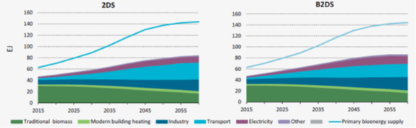

Source 209 IEA 2017[4]

Capacity installed

Current installed capacity of advanced biofuel production in the EU28 is 358,828 tons (230,000 – 309,000 toe)[5] per year while another 151,900 t/y (100,000 – 130,000 toe) are currently under construction, and 1.7 Mt/y (1.1 – 1.5 Mtoe) are planned (Figure 215)[6]. If waste fats and oils (FAME and HVO) are included, current capacity would be much higher (6.5 Mt/y).[7] However, feedstocks are still primarily conventional. Current installed production capacity of e-fuels are much smaller, around 150 toe (toe) of liquid e-fuels around 1400 toe of e-gas[8].

Figure 215 Existing and planned EU28 production capacity of advanced biofuels based on known plant construction and projects

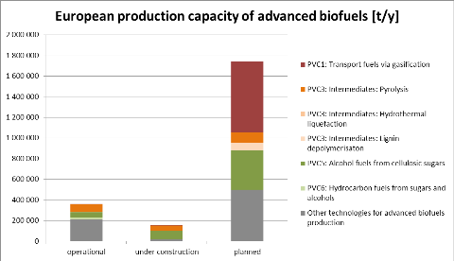

Source 210 ETIP Bioenergy Working Group 2[9]

Different fuel production processes are expected to grow at varying rates until 2030 as displayed in Figure 216 below. Particularly cellulosic ethanol (sometimes referred to as 2G alcohol) stands out as rapidly scaling up from current capacity, but this estimation may be overly optimistic.[10]

Figure 216 Anticipated EU28 production potential of different advanced biofuel production pathways towards 2030 in terms of annual kilo-tonnes produced

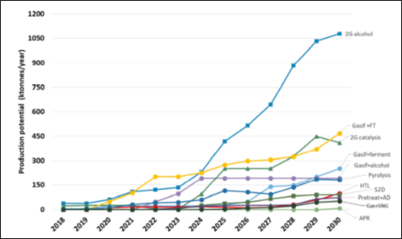

Source 211 JRC 2019[11] page 13

Figure 217 below displays the current global capacity for advanced biofuels (except FAME and HVO, which are already commercialised). Current installed capacity of advanced biofuels in the rest of the world is comparable to that of EU. However, planned production capacity is likely to scale up, particularly in co-processing of bio-oils in oil refineries, where current production is mostly in the EU. Production capacity outside the EU is expected to soon reach 5 times that of the EU28. Because co-processing has relatively low CAPEX costs, oil companies are expressing increased interest in adjusting refinery production to accommodate for it.

Figure 217 Existing and planned global production capacity of advanced bio-fuel plants excluding HVO and FAME

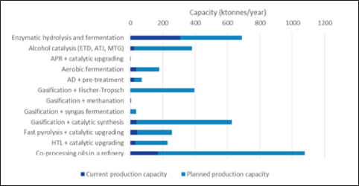

Source 212 JRC 2019[12], page 8

According to the JRC Low Carbon Energy Observatory[13], e-fuel capacity is currently very limited. Nearly all existing and projected power to gas (power to methane) plants as well as power to liquid (power to methanol) installations are in the EU28 with the exception of a few in Switzerland. There are 11 power to methane plants in the EU equalling a combined capacity of 7MW (1440 toe) of methane, but this could increase to 16MW (3300 toe) if all planned and announced plants become operational. Power to methanol capacity is nearly 800 kW (165 toe) and power to liquid plants (petrol, kerosene, diesel) in the EU currently amount to 150kW (31 toe)[14].

Cost, LCOE

By 2030 to 2035, production costs of advanced biofuels are expected to decrease as learning effects and innovation progress due to the expansion from a currently limited number of commercial plants as well as some upscaling of individual plants. Figure 218 below provides current costs ranges and estimates of expected cost reductions. Particularly ethanol produced from advanced (lignocellulosic) feedstock is expected to make large improvements. 80-120 EUR/MWh is roughly 22-33 EUR/GJ, which would be comparable to current costs of ethanol produced with conventional feedstock. On the other hand, bio-oil processing costs are expected to experience only very minor cost reductions, remaining one of the most costly processes.

Figure 218 Expected medium term (10-15 yr.) cost reductions of advanced biofuel production as successors to existing plants are built and plant size scales up

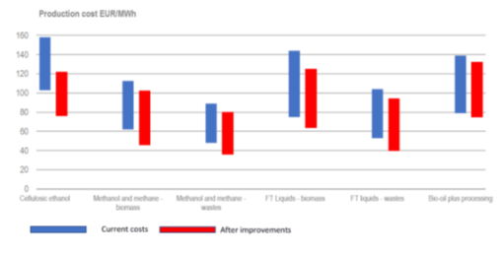

Source 213 IEA 2020[15]

The cost of liquid e-fuels are also expected to decrease significantly by 2030 to 44-58 EUR/GJ compared to current cost of 55-78 EUR/EJ [16]. IRENA and DENA estimate costs will reach 1-1.5 EUR/litre in 2030 compared to 3-5 EUR/litre today as scaling up of hydrogen production and CO2 capture technologies reduce overall costs[17]. Figure 219 below illustrates this development.

The most cost-efficient production of e-fuels is expected to be reached outside of the EU, in countries where hydrogen production and CO2 capture are expected to benefit from optimal solar and wind conditions. Thus, imports could possibly fall to 28 EUR/GJ by 2030.

Figure 219 Potential cost of e-fuels in 2030

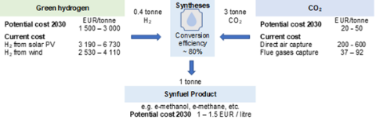

Source 214 Gielen et al. 2020[18]

R&I

Public & Private R&I funding

In the past private funding has been much higher than public funding of R&I. Figure 220 below compares the public and private investments in biofuels until 2014 within the EU28.

Figure 220 Current development of investments in biofuels in the EU

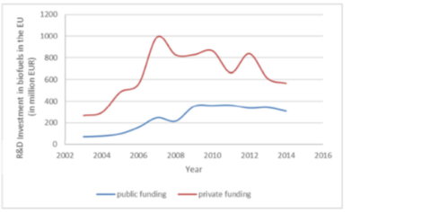

Source 215 JRC 2019[19], page 5

Recently EU investments in biofuels have decreased, falling in 2018 to below 2005 levels[20]. In 2018 the global R&I investments to biofuels were EUR 1.5 billion, approximately 80% from government funding[21]. The EEA describes this development as likely due to the saturation of 1st generation biofuel capacity as well as high cost of advanced biofuels and uncertainty in policy development. However, global investments in biofuel capacity have also dropped by 64% from 2017 to 2018, amounting to EUR 405 billion[22]. EU investments in biofuel capacity were EUR 84 million in 2018 compared to EUR 337 million in the US[23].

Patenting trends

From 2004 until 2014, the EU28 has been the leading patent developer in high value inventions related to advanced biofuels as can be seen in Figure 221 below. More recent figures were not available for this report.

Figure 221 Development of high value inventions related to advanced biofuels in leading countries

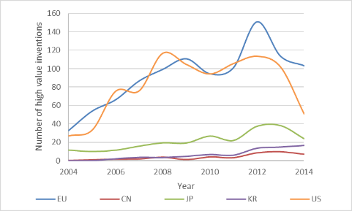

Source 216 JRC, 2019**[24]**

Publications / bibliometrics

EU28 institutions accounted for 1000 studies or roughly 35% of the scientific literature on advanced biofuels between 2016 and September 2020. Leading with 1098 studies (38%) was the US. China followed the EU with 316 studies. The total number of studies has been relatively constant during the nearly 5-year period, averaging roughly 340 studies annually, and Figure 222 shows the geographic distribution.[25]

Figure 222 Geographic distribution of the scientific literature on advanced biofuels from 2016 to 2020 based on “Web of Science” database.

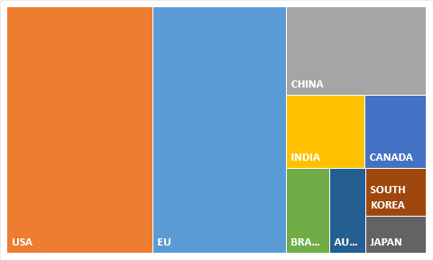

Source 217 Data compiled from Web of Science, 2020**[26]**

### Value chain analysis

The status of value chains depends on the conversion pathway considered to process various feedstocks into finished fuels. These conversion pathways and the associated finished fuels can be seen in the table below. There are often several potential pathways based on various feedstocks that can lead to the same finished fuels.

Table 27 Conversion pathways and advanced biofuels produced by them

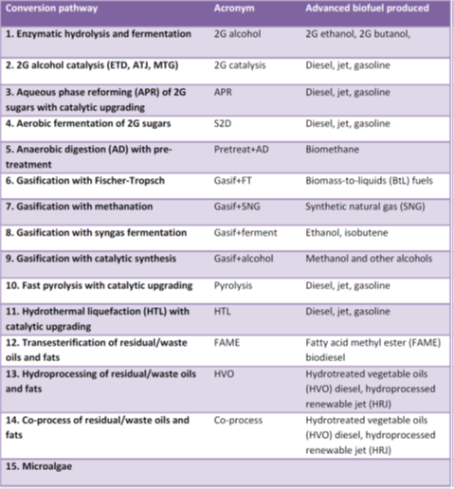

Source 218 JRC 2019[27], page 2

Turnover

The EU27 biofuels industry turnover was EUR 14 billion in 2017 as shown in Figure 223 below[28]. This includes only bioethanol and biodiesel, which currently rely mostly on 1st generation feedstocks. These are already fully commercialised as opposed to much of the advanced biofuel feedstock and production pathways. For most advanced biofuels, turnover estimates are not available. The JRC Low Carbon Energy Observatory[29] estimates an annual revenue of EUR 21 Million from pyrolysis oil-based diesel, jet-fuel and gasoline (using wood and straw-based feedstocks)[30].

Figure 223 Turnover of biofuels industry in the EU27

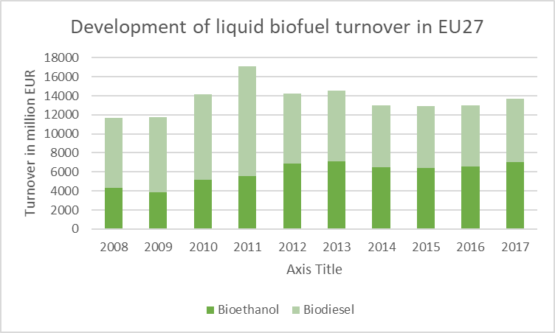

Source 219 COM, 2020[31]

Gross value-added and growth

In 2017 the EU27 bio-economy employed around 17.5 million people and generated approximately EUR 614 billion of value added, therefore representing around 8.9% of the EU27 labour force and generating 4.7% of the EU27 GDP. Biofuels (bioethanol and biodiesel) represented EUR 3 billion of the bioeconomy’s value added. Since 2008, the value added of biofuels has grown by 38%[32]. Figure 224 displays the development in gross value added by bioethanol and biodiesel since 2008.

Figure 224 Liquid Biofuel value added growth in the EU27

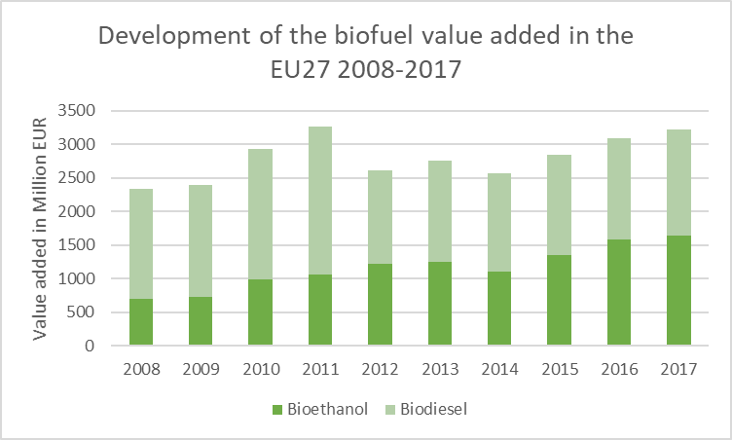

Source 220 COM Bioeconomy[33]

Number of companies in the supply chain, incl. EU market leaders

There are approximately 40 companies within the EU with advanced biofuel facilities in production, under construction or planned. Since current facilities are limited and future capacities of planned facilities are not always known it is difficult to estimate who market leaders are. Also, current conventional biofuel production is commercialised, largely outscaling current advanced biofuel capacity. Therefore, market leaders for advanced biofuels are not the same as for conventional biofuels, where companies such as Neste play a leading role.

The ETIP Bioenergy has surveyed the existing and planned demonstration projects for advanced biofuels including company, production capacity and production pathway. Figure 225 below displays the cumulative capacity data by company, published by ETIP Bioenergy[34].

Figure 225 Total existing and future output capacity of companies in the EU with existing or planned advanced biofuel plants

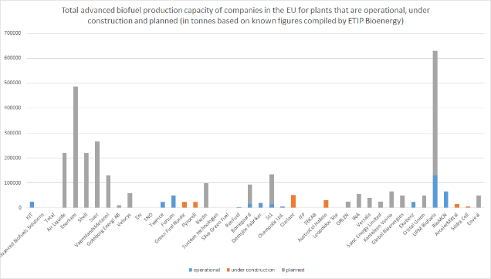

Source 221 Data compiled from ETIP Bioenergy, 2020[35]

From this survey it is possible to extract the following assessment:

* According to both current operational capacity and planned installations UPM Biofuels is the leading producer of advanced biofuels in the EU, currently producing 130,000 t/y of HVO from tall oil and planning to add a facility producing 500,000 t/y.
* BioMCN (65,000 t/y methanol from FAME) and Fortum (50,000 t/y pyrolisis oils) have the next highest operational capacities;
* Once construction is completed, Clariant will have the largest capacity for ethanol production in the EU (50,000t/y from agricultural residues);
* If planned facilities follow through, Enerkem could achieve the second largest advanced biofuels capacity in the EU with a potential capacity of 485000 t/y in gassication produced methanol. This includes a joint venture with Suez for 265,000 t/y as well as a joint venture with Air Liquide, Nouryon, Port of Rotterdam and Shell for 220,000 t/y;
* However information on other planned facilities such as from Total is unavailable so that it is not possible to predict potential market leaders in the near future;
* Also it is important to note that, while the total operational capacity of St1 is only 14,000 t/y and planned additional capacity is 120,000 t/y, St1 operates the most existing cellulosic ethanol plants in the EU. Five 1000t to 7000t plants are distributed throughout Finland and Sweden, while three more residue base ethanol plants are planned for Sweden and Norway, each with 40,000t/y capacity.

Employment figures

According to IRENA, liquid biofuels employs 208,000 people in the EU28 while biogas employs 67,000 people. Direct and indirect employment have grown in the past decade, reaching 248,000 jobs in 2018 as shown in Figure 226. Additional jobs occur in the upstream agricultural and forestry sectors. It is unclear how many of these jobs are linked to advanced as opposed to conventional biofuels. Likewise, no data is available for employment in the e-fuels sector.

Figure 226 Development of biofuel jobs in the EU28

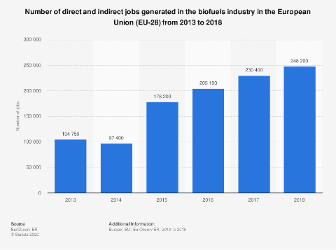

Source 222 Statistica 2020

Productivity (labour and factor)

Employees of the EU27 biofuels industry (bioethanol and biodiesel) generate an average annual value of EUR 157 thousand[36].

ProdCom statistics

Net-export values of the EU28 have been highly variable in recent years. The EU28 generated a net-export value of EUR 38 million for biofuels in 2018. By comparison, the EU28 had a net deficit of EUR -277 million in 2017 and EUR -118 million in 2016. In 2015 the net-export value was almost double that in 2018, with EUR 65 million. The US net-export values of biofuels far exceed the EU28 or any other country, having achieved an average net-value of EUR 1.5 billion for the period 2015-2018[37].

### Global market analysis

Trade (imports, exports)

The net consumption of bioethanol in the EU is slightly larger than the production, resulting in a net import (Figure 227). Domestic bioethanol production has levelled off and declined due to higher costs as advanced (cellulosic) feedstocks increasingly replace conventional feedstocks. Since the COVID-19 pandemic, the production has also declined due to reduced fuel demand.

Figure 227 EU28 Consumption, Production, Import and Export of Bioethanol

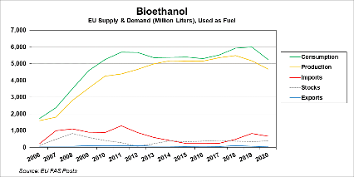

Source 223 USDA 2020 [38]

Although the EU28 is the largest producer of Biodiesel, FAME and HVO fuels, consumption exceeds this production slightly, requiring net imports (Figure 228). The demand is less impacted by the COVID-19 pandemic, since these fuels are more relevant for heavy duty vehicles as opposed to light weight passenger vehicles.

Figure 228 EU Consumption, Production, Import and Export of Biodiesel, FAME and HVO (here Biodiesel & HDRD)

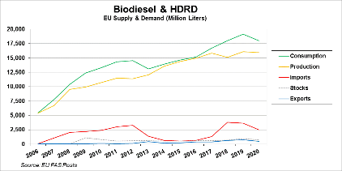

Source 224 USDA 2020[39]

Global market leaders VS EU market leaders

For several advanced biofuel pathways, a comparatively high percentage of companies and in some cases production facilities are located within the EU28 as Figure 229 below. For these technologies, this may be an indicator of technological and competitive advantage for further development within the EU.

Figure 229 Advanced biofuel companies and plants in the EU28 compared to rest of world as indicators of EU market share

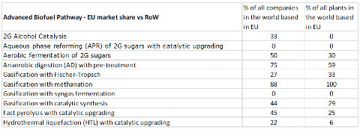

Source 225 JRC 2019[40]

However, comparing existing and planned capacity is a further indication of current and future market position. While advanced biofuel production pathways are at various stages of development, the following already produce more significant amounts of fuels:

* enzymatic hydrolysis and fermentation;
* co-processing;
* FAME and HVO from advanced feedstocks.

Currently, the EU28 is market leader in Biodiesel, FAME, HVO and Co-processing. However, these are dominated by conventional biomass feedstocks and relevant waste feedstock is limited, therefore a slight reduction in FAME capacity is expected in the EU, as can be seen Figure 230.

Figure 230 Installed and planned capacity of FAME and HVO biofuels in the EU compared to rest of the world

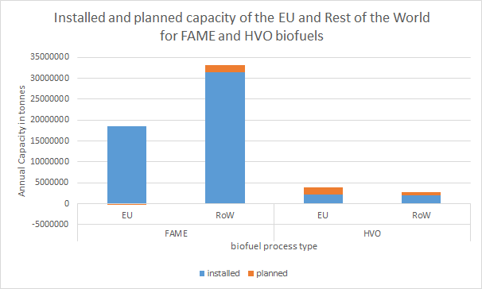

Source 226 data compiled from JRC 2019[41]

The EU may also lose market leadership in co-processing in the future as the rest of the world plans to add capacity. This is apparent below in Figure 231, which compares the installed and planned capacities for advanced biofuel processes in the EU28 and the rest of the world. The figure also displays that there is little to no existing capacity for several of the advanced biofuel processing technologies, since they are at early stages of demonstration.

Planned capacity for the EU28 indicates achieving a potential head start in hydrolysis as well as gasification with Fischer-Tropsch and gasification with catalytic synthesis.

Figure 231 Installed and planned capacity of advanced biofuels in the EU compared to rest of the world

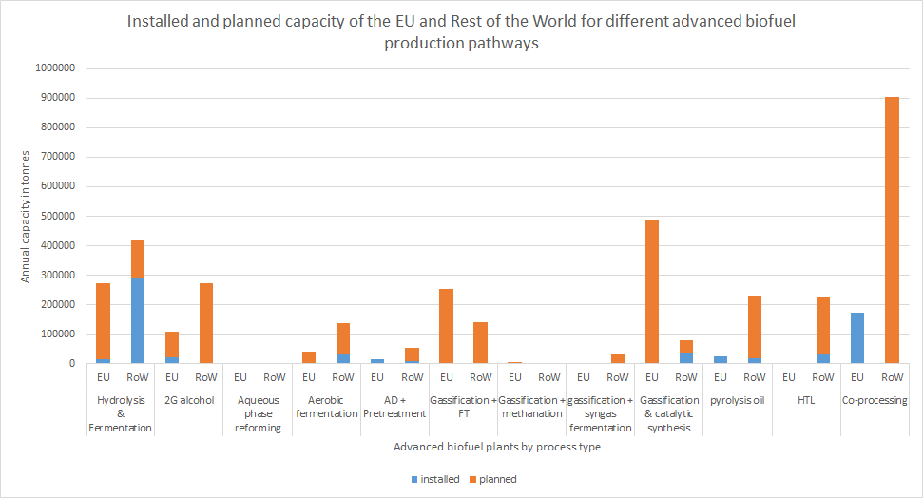

Source 227 data compiled from JRC 2019 [42]

Since e-fuels are less developed, a market does not yet really exist. However, most e-fuel companies and plants are in the EU as well as 88% of the e-fuel development projects. The EU is also a pioneer in the field of power to methanol, which typically uses CO2 from biogas[43].

Critical raw material dependence

E-fuel production depends on availability of renewable hydrogen and renewable electricity. Therefore, any critical raw material dependencies are in the technologies producing renewable electricity and hydrogen, which those sections of this report cover.

Advanced biofuels are not dependent on any of the critical raw materials presented in either the 2020 Commission communication or Foresight Study on critical raw materials. Particularly since they can also be produced throughout the EU and the rest of the world, this gives them a strategic advantage over other technologies. It is therefore possible to reduce foreign dependency through local and regional value chains.

### Future challenges to fill technology gap

Reaching the expectations of LTS 1.5°C scenarios by 2050, requires dramatic scaling up of renewable fuel production. Advanced biofuel capacity would have to expand from 1.8 Mt capacity today to roughly 40 Mt capacity by 2050 to reach amounts achieved in EU LTS scenarios. This requires large-scale demonstrations and commercialisation of several production pathways by 2030. Similarly, e-fuel production would need to rapidly advance from slightly over 1000 tons to nearly 40 Mt production capacity by 2050. To achieve this FOAK plants, demonstrations and commercial expansion are necessary within the next 30 years.

However, the production of advanced biofuels is limited by the availability of a sustainable feedstock. The Renewable Energy Directive aims to ensure that biomass is produced in a sustainable way, and therefore conventional biomass contribution is capped to avoid direct competition with food production and sustainability criteria are established to prevent land use changes or degradation and harm to biodiversity. Upholding these criteria also implies that there is a limit to the potential for scaling up biomass in a sustainable way. It has been highly debated what amount of sustainable biomass is available in the EU. On a global scale, the IEA considers this (including waste, residues and designated feedstocks) to be roughly 140 EJ (3,300 Mtoe). The EU-LTS implies an availability between 150 and 250 Mtoe within the EU28. Given the inconclusiveness regarding sustainable supply, the LTS prioritises the use of biomass for those areas where electrification is not feasible, and e-fuels are too expensive.

Sustainable feedstock supply will therefore be an increasing challenge. To help address this challenge, R&I can contribute to integration of advanced biofuel feedstock with other land uses (e.g. agroforestry systems) as well as using feedstock to improve soil conservation and remediate degraded land. In this way, it may be possible to increase sustainable feedstock supply while contributing to other sustainability goals, such as soil conservation and improved rural socio-economic conditions.

However, a foreseeable challenge might also be the potential supply chain competition between sectors as well as within the biofuels sector. The 2018 updated EU Bioeconomy Strategy suggests a potential increase in demand in biomass. One of the objectives of the EU Bioeconomy Strategy[44] is to increasingly replace fossil-based materials and chemicals with bio-based products. To reduce pressure on biomass resources, circularity is central to the Bioeconomy Strategy, as it is the renewable segment of the circular economy. The Bioeconomy Strategy also recognises ecological boundaries to bioeconomy and aims to improve understanding of these boundaries and optimise resource use.

E-fuels are also limited by the availability of electricity as well as hydrogen, both of which will face increasing demand from other sectors. To address this challenge, key measures include improvements in energy efficiency and scaling up of renewable energy resources as well as hydrogen electrolysers and transport infrastructure.

One of the greatest challenges is the speed with which renewable fuels must scale up to achieve 2030 and 2050 emission targets, particularly for aviation and shipping sectors. This means scaling liquid biofuels from 16 Mtoe up to 40 Mtoe within 30 years, while shifting from conventional to advanced feedstock and production pathways. More dramatically, the LTS implies scaling up e-fuels from a negligible amount today up to 20-40 Mtoe also within 30 years. Investments and reforms in Recovery and Resilience Plans of Member States, as well as stronger policy incentives may help give more speed to this transition.

Related to this are the challenge of reducing investment and operating costs. While various advanced biofuel production pathways have reached demonstration level, high investment and operating costs remain a barrier. Large-scale demonstrations can help address this challenge by increasing experience and reducing operating costs. Increased public financial support for R&D can also help to reduce private investment risks. Yet, even with these measures, costs will likely remain higher than conventional biofuels and fossil fuels. Levelling the playing field will likely require stronger policy incentives.

While production capacity developments indicate the EU will likely remain a market leader in specific fuel pathways, such as HVO, FAME as well as ethanol production from hydrolysis and fermentation, there are other key pathways where the EU risks falling behind the rest of the world. These include pyrolysis oil, aerobic fermentation and HTL, all of which are key pathways for jet-fuel. This could imply a further challenge to supply security as well as the speed at which it is possible for the aviation sector to decarbonise. To address this challenge, it may help to focus R&I priority on production pathways that yield fuels suited for such key sectors over those that primarily provide fuel to sectors with potential alternative solutions such as electrification or hydrogen.

## Solar thermal power

### State of play of the selected technology and outlook

Solar thermal electric or concentrating solar power (CSP[45]) plants generate electricity by converting solar energy to heat, which is then used to generate electricity in a thermal power block. When combined with a thermal storage system, CSP provides dispatchable, renewable electricity. CSP plants require high levels of steady, direct normal insolation (DNI > 1900 kWh/m2/year). This limits the range of potential locations in the first instance. Only southernmost Europe offers suitable (but not good) locations. European organisations are leaders in R&D and engineering for CSP systems. Growth of the sector worldwide can support EU jobs and promote economic growth.

Concerning the role of CSP in the EU energy transition, the Commission’s 2018 LTS scenarios uses a single solar technology category for electricity generation, covering both PV and CSP. The cost assumptions imply that the solar power capacity in the scenarios is almost entirely covered by PV. On the other hand, the potential additional market value of CSP’s capacity to use stored thermal energy to generate power after sundown has not been not taken into account up to now. In the Low Carbon Energy Observatory project the JRC used a more technology-rich model to look at the possible impact of individual technology and cost developments in Europe. Although the baseline scenario shows no CSP uptake, a pro-renewables scenario and a “SET-Plan” scenario, where all technologies meet their SET plan cost reduction targets, show the CSP capacity growing to over 100 GW by 2050.

The two major designs used today are parabolic trough power plants and central receiver or power tower systems. CSP systems comprise the following main elements: solar field (reflectors and receivers), a heat transfer and storage system, and thermal-to-electric power conversion unit. CSP plants are rated in terms of the maximum power output in MW (AC electricity output). The annual load capacity factor for a commercial plant without storage is approximately 27% but can be made much higher by increasing the size of the solar field and adding thermal storage to allow operation also after sundown. Indeed thermal storage is increasingly the key selling point for CSP technology. The current generation of plants with 150 MW rating and 10 hours storage offer a storage capacity an order of magnitude above large battery units, and at about 50% less cost per MWh. From an environmental perspective, water consumption is comparable to fossil thermal power plants, but dry-cooling CSP designs are under development. Life cycle analysis of GHG emissions leads to low values, typically below 40 gCO2eqv/kWh.

CSP can be combined with other power generation technologies, either for solar-assisted power generation or in hybrid configurations. There is interest for combining CSP with a PV field to support the ancillary power requirements in daytime. CSP can also provide heat for industrial processes. Fuel synthesis is a further option, as demonstrated by EU supported projects on thermochemical splitting of H2O and CO2 into hydrogen and carbon monoxide.

Capacity installed, generation

The current worldwide capacity of CSP power plants is approximately 5.6 GW, with only a marginal penetration in the global electricity market. There are 83 operational plants in 11 countries. The IEA envisages a modest role for CSP in the long-term, with installed capacity rising to 60 GW by 2030 and 267 GW by 2040 under its sustainable development scenario. The main markets are expected to be in the Middle East and Asia-Pacific regions, particular in China and India. The EU market is limited; by 2050 installed capacity would amount to 14 GW, providing about 1% (45 TWh) of its electricity[46]. The IRENA ReMAP analysis is more ambitious[47], with a 2050 scenario including 633 GW of CSP (contribution 3.7% of electricity generation).

In the EU27 current capacity is 2.4 GW. Spain has approximately 45 plants of 50 MW size, which were installed in the period 2009-2013 until a change in Spanish government policy halted further developments. The National Energy and Climate Plans (NECPs) indicate 6.2 GW of new capacity by 2030 (the total installed capacities would then be Spain, 7.3 GW, Italy 0.88 GW, Greece, 0.1 GW, Cyprus, 0.05 GW, Portugal, 0.3 GW).

Figure 232 Annual CSP capacity additions and country breakdown

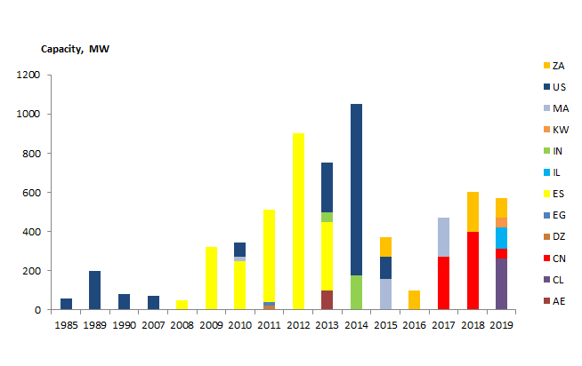

Source 228 NREL/SolarPACES data base and JRC analysis[48]

Cost, LCOE

CAPEX for CSP plants has fallen by over 50% in the last 10 years. The value for a large plant (100 MW or larger) with 8 hour storage is currently about 6 EUR million/MW. Both the SET Plan and US research programmes recognise that this needs to come down to the level of 3 EUR million/MW. CSP technology has significant scope for improvement in all areas: the solar field, the power block, high-temperature higher efficiency power cycles and thermal storage. However, with very modest global market growth, it remains a challenge to develop volume production processes to drive down costs, as has happened for other renewables. This is all the more critical as the deployment of a new generation of large battery storage units with capacity of hundreds of MWh is already underway in Australia and the US. Such plants may compete with CSP as providers of dispatchable electricity.

IRENA’s LCEO estimates for 2019 are approximately 180 USD/MWh, and recent auctions suggest that this can be halved for plants currently in construction in favourable locations. As mentioned above, LCOE may not however fully reflect the market value of dispatchable CSP electricity.

Figure 233 LCOE trend for CSP plants

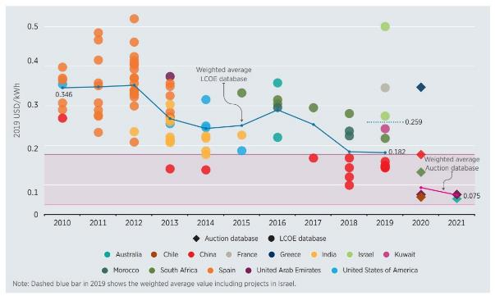

Source 229 IRENA[49]

R&I

Public R&I funding

Based on IEA data and JRC analysis, public funding is in the range EUR 70-100m (excluding China). The main declared contributors in 2016 were US, Australia, Germany, Switzerland, France and Denmark. In terms of time trends, funding saw a substantial increase around 2008-2010, followed by some levelling off and even a decreasing trend more recently.

Private R&I funding

Patent data provides an alternative route to assessing R&D investments made by public and private organisations (albeit with a 3 to 4 time lag given the process for processing applications). The JRC analysed data from Patstat (European Patent Office) for the period 2000 to 2016. For the EU28 this data indicates private/public innovation investments of approximately EUR 300 million in 2014. Compared to the values reported above for publicly funded R&D, the data suggests that EU private/industrial organisations are making investments of the order of EUR 200 million per year. It remains to be seen whether the declining trend is confirmed by more recent data, or whether it has stabilised, aided by the latest market developments. For China, the estimates are considered to contain substantial uncertainties, also in view of significant year-to-year fluctuations. Nonetheless they confirm that Chinese organisations are making substantial investments in STE technology, as in all forms of clean power generation, and can be expected to compete strongly with European and US firms in the international market in the coming years.

Patenting trends

This analysis looked at the Patstat (European Patent Office) data for the period to 2016. Overall filings grew strongly over the last decade and are at a level of about 2500 per year. The main application areas are the generic solar thermal energy category, heat exchange systems and mounting and tracking. In terms of the global regional breakdown for 2016, considering all patent family applications China is dominant with an 82% share. In contrast, the EU28 is leader with a 37% share for “high value” patents (applications in more than one patent office).

Publications / bibliometrics

Approximately 300 research articles (excluding reviews, books, conference proceedings etc) are published on CSP annually. Figure 235 shows the geographical breakdown in terms of author affiliation for the previous five years (2015 to the present) according to a search performed with the Clarivate Web of Science search tool. It identified 1811 articles, and organisations from EU28 countries are involved in 47%. The US is also a leader in this area and there is a significant (and increasing) contribution from China The most prolific organisations include the US DoE, DLR, the Helmholtz Association, CNRS, Chinese Academy of Sciences and the University of Seville. The most frequent topics include thermal heat transfer and thermal storage.

A separate analysis in Scopus of the 20 most cited articles for the same time period found that EU28 organisations were involved in 40%, the US in 15%, China in 10% and other countries in 50%.

Figure 234 Regional breakdown of patent families for 2016 for all patent family applications (2761) and high value applications (138) submitted to multiple patent offices.

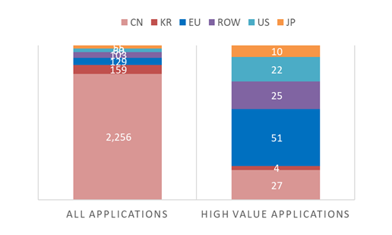

Source 230 JRC analysis of PATSTAT data

*Figure 235 Geographic distribution of the top-20 countries with organisations that published CSP research articles (excluding reviews) from 2015 to the present*

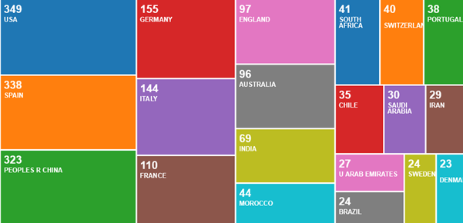

Source 231 JRC analysis using Clarivate Web of Science search tool

### Value chain analysis

Turnover

The JRC estimates the 2020 global market at : approximatley EUR 3 billion. This is consistent with the assessment of ResearchAndMarkets.com that : “the CSP power market is projected to grow from an estimated USD 3.5 billion in 2020 to USD 7.6 billion by 2025, at a CAGR of 16.4% from 2020 to 2025”

Number of companies in the supply chain, incl. EU market leaders

Leading CSP technology companies CSP include Abengoa (Spain), BrightSource Energy (US), Aalborg CSP (Denmark), Supcon Soalr (China), TSK Flagsol (Germany), , Cobra Energia (Spain), Torresol Energy (Spain), Acciona Energy (Spain), Siemens (Germany). Ener-T International (Israel), Flabeg FE (Germany), Ingeteam Power Technology (Spain), Rioglass (Belgium), Sener (Spain).

The European trade association ESTELA lists 49 organisations with activities are spread over 9 EU27 countries and a strong Spanish presence.

Table 28 Companies listed in in the ESTELA European solar thermal industry directory

|  |  |  |
| --- | --- | --- |
| Aalborq CSPA  Abengoa  ĄTEG  ATA Insļghts.  ATA Renewables  BASF ESPAÑOLA  CENER  CMI sa - BU SOLAR  CSP Services GmbH  DLR  Eastman Chemical - Theminol Products  ECILIMP TERMOSOLAR  Empresarios Agrupados  ENEA  Enel Green Power  ENGIE | Exera Enerqia Srl  Fichtner GmbH 8 Co. KG  Fraunhofer ISE  Grupo Cobra  IA Tech GmbH  IK4 TEKNIKER  IMDEA Energy  Innogy SE  Kraftanlagen München GmbH  LEITAT Technoloqical Center  Meteo  NEMATIA Technologies, SL  PROMES-CNRS  Protarget AG  PSA CIEMAT  Rioglass  ROBA Piping Projects | sbp sonne qmbl  JENER  SENIOR FIEXONICS  Seried Consultores S.l.  Solarlite CSP Technoloqy GmbH  SQM International N.V.  SUAVAL Group  Suntrace GmbH  Tecnalia Research & Innovation  The Cyprus Institute  The Dow Chemical Company  TSK Flagsol Engineering GmbH  Universidad Carlos III de Madrid  VIRTUALMECH  Wacker Chemie AG |

Employment figures

IRENA reports that the CSP provides 34,000 jobs, of which approximately 5000 in Europe[50].

ProdCom statistics

There is no Prodcom code that specifically addresses CSP plants. This probably reflects small size of the market and that it involves a mix of technologies and components: reflectors, solar absorbers/receivers, heat transfer & storage equipment, steam boilers and the steam turbine & generator sets[51].

### Global market analysis

Trade (imports, exports)

No detailed data on trade for CSP equipment and services has been located up to now. However, in terms of the global annual market it is likely that trade represents a sginifiant share (>50%) since most projects are developed in countries other than those of the main suppliers (EU, China)

In its input paper to the Strategic Research and Innovation Agenda of the Clean Energy Transition Partnership for Horizon Europe, the EU CSP industry foresees a conservative 50% share in the future developments up to 2030. Given the IEA estimate of 60 GW worldwide installed to that year, this could mean a business market of around EUR 100 billion.

Global market leaders VS EU market leaders

EU27 companies have traditionally been leaders in all aspects of CSP technology and project development. A recent trend is the emergence of Chinese organisations as international project developers (e.g. Shanghai Electric) and technology providers (e.g. Supcon Solar).

Critical raw material dependence

CSP plants do not use (or not significantly use) materials from the EU’s critical raw materials list 2020.

### Future challenges to fill technology gap

The EU is well positioned in the solar thermal power market. However, the market potential of the CSP technology appears still untapped, especially considering the high number of possible applications.

There are a wide range of options for decreasing costs and improving the performance of CSP plants. The solar field (comprising the reflecting systems themselves and the ground-works) accounts for approximately 40% of CAPEX and is an obvious target for cost reductions. Indeed a recent US analysis[52] sees potential for saving 44% of solar field costs, 14% of power block costs, 23% with a higher efficiency cycle and 19% with low cost thermal storage.

Ultimately, higher working fluid temperatures and heat storage density are needed to raise efficiency. CSP is uniquely placed to provide high input temperatures in the solar receiver, but use of molten salt-based systems may be limited by corrosion problems with high temperature ternary salts. Hence the interest in various air, supercritical CO2 or liquid metal concepts, coupled with high temperature and economic heat storage methods. The following H2020 projects are exploring such concepts[53].

* NEXTOWER (2017-2020) is working on a high temperature ceramic solar receivers with a maximum materials temperature of at least 800°C, to be exploited with a molten salt or liquid lead heat transfer and storage system;
* SCARABEUS (2019-2023) is working on supercritical CO2 cycles with a maximum temperature of up to 700°C;
* CAPTURE (2015-2020) studies an air receiver concept intended to operate at 1200oC,
* NEXT-CSP (2016-2020) aims to demonstrate a particle-in-tube heat transfer concept with a 4 MWth receiver on the Themis facility solar tower, capable to heat particles up to 800°C;
* POLYPHEM (2018-2022) studies a high temperature air receiver supplying a micro-gas turbine top cycle; recovered heat is stored in a thermocline and used in an ORC bottom cycle.

Bringing innovative concepts to a commercial level remains a major challenge. For instance, the solar thermal power sector uses different kind of turbines for producing electricity: steam turbines, gas turbines, and more recently, turbines working on supercritical CO2 cycles (having increased efficiency, compared to steam turbines). The main parameters to consider to orient the turbine choice are the expected maximum temperature which can be achieved by the working fluid in the plant and the required power capacity. Often these turbines are not “off-the-shelf” products but custom made turbines by specialized suppliers. Some turbines for the solar thermal power sector are still R&I target in the EU and USA (e.g. supercritical CO2 cycles).

The SET plan CSP implementation plan sees first-of-a-kind plants as essential to allow full-scale demonstration and create investor confidence. Such projects could apply to the new Innovation Fund or for Recovery Funds. Finally, standardisation is also important for critical components and for installation qualification. EU organisations should be encouraged to continue to support efforts at international level.

## Smart Grids[54] – Digital infrastructure[55]

### Smart Grids in the energy transition

Smart energy networks, especially a smart electricity grid, have a fundamental enabling role to play in the energy transition. Europe’s electricity networks have provided the vital links between electricity producers and consumers with great success for many decades. The fundamental architecture of these networks has been developed to meet the needs of large, generation technologies, located remotely from demand centres.

However, in recent times, environmental and energy challenges are changing the electricity generation landscape in Europe and beyond. The drive for lower-carbon technologies, renewable energy sources (RES), combined with greatly improved efficiency on the demand side, will enable consumers to become much more inter-active with the networks. More customer-centric networks are the way ahead, but these fundamental changes will impact significantly the network design and control.

The analysis which underpins the Commission Long Term Strategy “A Clean Planet for All”[56] shows that a very important single driver for a decarbonised energy system is the growing role of electricity which will be mostly generated by renewables[57].

A smart electricity grid opens the door to new capabilities and applications with far-reaching impacts:

* It provides the capacity to integrate safely more energy from renewable energy sources (RES), electric vehicles and distributed flexible generation into the network;
* Delivers power more reliably through comprehensive control and monitoring capabilities using automatic grid reconfiguration to prevent or restore outages (self-healing capabilities);
* Delivers power more efficiently and without compromising the needed reliability through demand response and by enabling consumers to have greater control over their electricity consumption and to participate actively in the electricity market.

The future energy system will have to rely on much higher balancing capacities such as better interconnections, more storage, deeper demand response, capability to integrate with other sectors and flexible generation units. Digitalisation, energy storage, power electronics components, HVDC, software platforms or demand-response to name some, are all key elements of a decarbonised energy system. While not all of them can be strictly classified as technologies, the combination of all elements into one system that is moving towards real time operations to accommodate higher shares of renewable energy generation aims to be a clean “technology”.

The following analysis will focus on elements like digitalisation in the O&M of the grids and the use of digitalisation to integrate Distributed Energy Resources (DER)[58].

The figure below[59] is already providing an overview of the status of emerging digital applications in the power sector that include the transmission and distribution grids.

Figure 236 Emerging digital applications in the power system

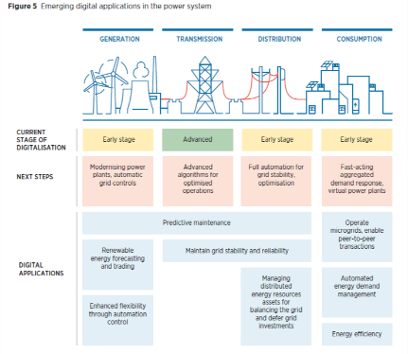

Source 232 https://www.irena.org/publications/2019/Sep/Enabling-Technologies

### Investment in Smart Grids & digital infrastructure

Investment in Smart Grids is mainly on hardware. At the same time, hardware dominates the investment in digital grid infrastructure. Elements of hardware in the digital grid infrastructure include smart meters and growing number of EV chargers. This leaves the investment in software in the order of a few percentage points of the total amount as shown in the figures below.

Figure 237 Global Investment in Smart Grids by technology area 2014-2019 (billion USD)

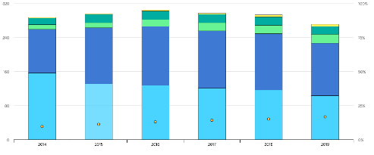

Source 233 https://www.iea.org/reports/tracking-energy-integration-2020/smart-grids

Figure 238 Smart Grid investment by category made by European TSO in recent years (2018)

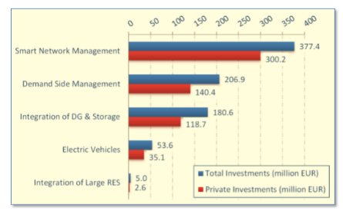

Source 234[60]

Public R&I investments in smart grids at EU level are mainly supported through Horizon 2020, at almost EUR 1 billion over the period 2014-2020, of which EUR 100 million was invested in dedicated digitalisation projects and many other smart grid projects that dedicate a considerable amount of their budget to digitalisation (at least EUR 400 million)[61]. Having said so, most of the investment in R&I for grid management software comes from the private sector[62].

Figure 239 R&I Investment in Grid management, 2018



Source 235[63]

Smart electricity grids are also one of the 12 priority areas under the TEN-E Regulation. Cross-border [smart](http://ec.europa.eu/energy/infrastructure/transparency_platform/map-viewer) grids could benefit from higher levels of support from regulatory authorities through inclusion in national network development plans, political recognition, and eligibility for EU financial assistance in the form of grants for studies and works as well as innovative financial instruments under the [Connecting Europe Facility](https://ec.europa.eu/inea/en/connecting-europe-facility) (CEF). From 2014 to 2019, CEF has provided up to EUR 134million of financial assistance related to different smart electricity grids projects across the EU.

IEA published in June 2020[64] the following analysis related to grid investment that shows different trends and reasons for grid investments in different regions of the world:

* in Europe, 2019 investments remained stable at nearly USD 50 billion[65], with a larger portion of spending allocated to upgrading and refurbishing the existing grid to accommodate more variable renewable energy and greater electrification;
* smart meters, utility automation and electric vehicle charging infrastructure now account for more than 15% of total grid spending (USD 40 billion[66]) globally;
* electricity grid investments declined for the third consecutive year, falling to less than USD 275 billion[67] (7% from 2018). The United States overtook China as the top grid investor for the first time in a decade;
* grid investment in the United States increased by 12%, following a continuous upward trend in the last decade to finance the considerable labour required to upgrade aging infrastructure, digitalise the system, electrify sectors such as transport and heat, and secure the grid against natural disasters and cyberattacks.

Because of some of the above mentioned grid investments, curtailment of renewable energy generation could be reduced. For Europe some estimations listed below include:

* enhanced digitalisation[68]: 67 TWh in 2040 (demand-response 22 TWh & storage technologies 45 TWh). Estimated in 2016 by the IEA;
* grid capacity increase of 128 GW[69] up to 2040: 110 TWh (45 billion Euro investment). Estimated in 2020 by ENTSO-E.

Related to the above, and as a word of caution on the potential to reduce curtailment, it is worth noting that the IEA in his report of June 2020 has indicated that “Experience from 2019 shows that new technology alternatives can avoid or defer investment in traditional transmission and other network infrastructure. The benefits demand response and storage technologies can offer to networks remain contentious. Regulations will need to evolve to reflect their new roles, including the leveraging of flexibility from consumer aggregation and grid congestion”.

In this context, the implementation of the Clean Energy Package appears to be crucial in reaching the expected curtailment reduction estimations. In Germany alone, 6.48 TWh were curtailed in 2019 and grid stabilisation measures costed EUR 1.2 billion[70].

Related to demand response, a handful of appliances could provide the required flexibility.

In 2016, in preparation of the CEP (Clean Energy Package), the theoretical Demand Response potential in 2030 in the EU was estimated[71] to be around 160 GW: Electric vehicles (around 30GW), Home electricity storage (around 30 GW), Ventilation (around 18GW), Refrigeration, households + retail (around 16 GW), Heat pumps (around 10 GW), Air conditioning (around 7 GW). These figures would have to be updated but it is expected that the message stays the same, focusing on some appliances might be enough to deliver the expected benefits.

What was indicated in 2016 as future possibilities[72] (Table 29) has already translated into commercial propositions in 2020[73] where owners of small-scale assets help balance the grid and ensure security of supply.

Table 29 Capabilities of DER to provide future ancillary services (2016)

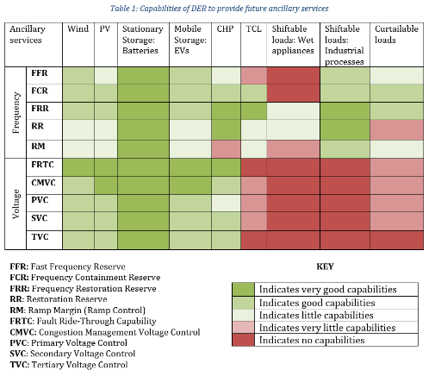

### Digital infrastructure for O&M of the Grid

During the last decades, the O&M strategies have transitioned towards what is today’s new target; predictive maintenance. In getting there, digitalisation plays a key role.

Figure 240 Evolution over the last decades of O&M approach

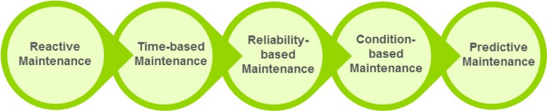

Source 236 Guidehouse Insights, 2018

In order to understand the status of network assets to successfully delivering predictive maintenance, utilities rely on additional sensors and measurement devices that collect data in real-time. This data is then communicated to a central analytics platform that can be used to analyse the data to generate insights about how the asset is likely to behave in future and react preventively. The central analytics platforms are known as Asset Performance Management (APM) platforms. They help reduce (O&M) costs, improve efficiency, reduce unplanned downtimes, and extend the lifetime of the asset.

The IEA estimated some of these benefits in 2016[74]:

Figure 241 Global Cumulative savings 2016-2040 IEA 2017

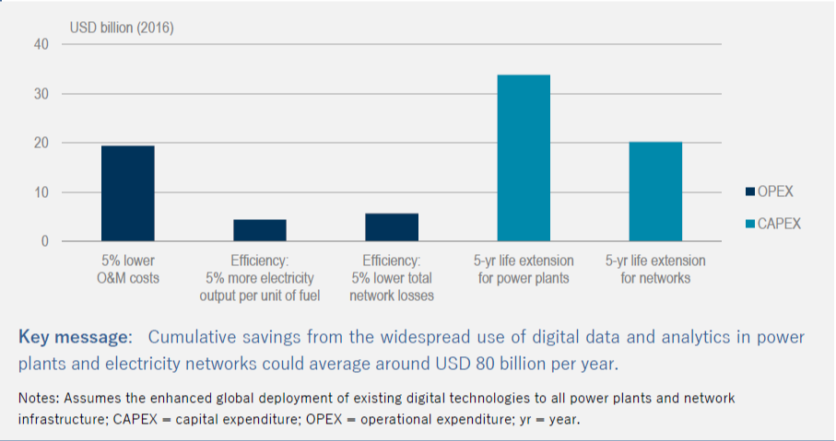

Source 237 IEA, 2017

In recent years, there has been an emergence of distributed intelligence (edge computing) that doesn’t rely on central analytics platforms and that is increasing the capabilities of IoT devices from sensing to actuating ( i.e. at substation level).

The next section will focus on two elements of the O&M. Namely, IoT devices and software platforms for predictive maintenance, APMs.

**IoT devices**

Broadly, the entire transmission and distribution infrastructure is transitioning away from modular or integrated analog sensors, and moving toward multifunctional digital sensors, often capable of decision-making in real time and onsite, and even further onto connected, interactive IoT devices. This represents significant technological advancements, and as the price of sensor devices themselves continues to fall, and communications and compatible IT systems become ubiquitous, market penetration will continue to grow in the European market.

Across the entire European markets for grid monitoring, sensors, and connected IoT devices, a recent study[75] estimates that more than 90% of overall new investment is occurring on the distribution networks.

Market size

Across the forecast period, the same study[76] expects the EU27 market for the sensors and monitors to grow from EUR 1.15 billion in 2020 to EUR 1.73 billion by 2030, at a compound annual growth rate (CAGR) of 4.6%. A few factors limit the market for standalone sensor equipment. Namely:

* the trend to fully integrate sensors and IoT equipment into major primary assets like transformers and protective equipment. Thus market size and growth for standalone metering devices is capped;
* devices can cost as little as EUR 50-100, so even large volumes do not necessarily lead to a very large market;
* the transmission side of the market is already well equipped with monitoring devices, lowering the necessity for new equipment in that part of the market.

Figure 242 Sensing and IOT Monitoring Devices Revenue, EU27, 2020-2030

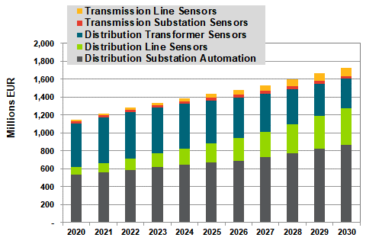

Source 238 ASSET Study commissioned by DG ENERGY - Gathering data on EU competitiveness on selected clean energy technologies (Draft, 2020)

Vendor overview

The study[77] estimates that the top players cover approximately 70-75% of the European market. The remainder of the market is made up of smaller, local players, and low-cost sensor and device providers from China. Major AMI (Advance Metering Infrastructure) providers are not necessarily included in this technology and use case, as the products are fundamentally different. Top players with a High Market share are: Hitachi ABB, Siemens, Itron, Schneider Electric.

**Software platforms for predictive maintenance[78]**

APM (Asset Performance Manager) can be seen as a platform that integrates multiple systems and sources of asset data, with dedicated asset analytics that sit on top to offer insights that cut costs and improve safety and reliability of the power grid.

In assessing the market for predictive analysis, APM builds a bridge between software such as enterprise asset management systems (AMSs), geographic information systems (GISs), meter data management systems (MDMSs), mobile workforce management systems (MWMSs), and other relevant sources of data that pertain to assets. Upon consolidating this information, analytics can translate data into meaningful insights that cut costs and improve safety and reliability of the power grid.

Looking at the software implementation itself, there is growing acceptance of software as a service (SaaS) purchase models for utilities even though some of the utilities are also developing in house solutions.

Market size

The study estimates that the APM revenue in EU27 market will grow at a CAGR of 6.4% between 2020-2030, to reach 160 Million Euro in 2020.

The scope of analysis includes APM software and deployment spending[79]. APM software consists of software license fees and SaaS spending, while deployment includes implementation and integration services as well as annual maintenance fees. While still nascent, the market for APM solutions can be viewed as relatively strong from a global perspective.

Figure 243 APM Market size, EU27, 2020-2030



Source 239 ASSET Study xxx, 2020

Vendor overview

APM is a relatively new sub-market of utility IT & analytics, and no vendors’ position is dominant. The competitive landscape for APM technologies is a relatively diverse mix of IT and OT (Operational Technology) system providers, data management solution providers, and analytics vendors. This includes companies such as Hitachi ABB, IBM, Schneider Electric SE, Oracle, GE, Siemens, and C3.ai.

Schneider Electric SE and Siemens are the key EU-based providers of APM technologies.

### Digital infrastructure for flexibility management in the grid[80]

In a system with a growing share of variable RES and distributed energy resources congestion starts appearing, creating demand for inter-TSO and TSO-DSO coordination across voltage levels.

The technologies like Distributed Energy Resources Management System (DERMS) and Advanced Distribution Management System (ADMS) have been deployed to address the issues of system imbalances, congestion and, commercial flexibility services. DERMS software offers control systems that enables optimized control of the grid and DER (to the extent that a utility may be able to dispatch and control DER).

ADMS (DMS, OMS and SCADA) unifies operational and engineering data for state analysis, switching, outage management, and planning. It maintains a single as-operated model of the distribution network based on the as-built model (typically from a geographic information system [GIS]). This consolidated suite of applications includes real-time monitoring, simulation, static engineering applications, and outage management.

In addition to DERMS and ADMS that support the flexibility market use case, there are other technologies that also play roles of varying degrees of significance in enabling the use of the flexibility such as:

* Advanced Metering Infrastructure (AMI) enables the flexibility market through provisioning of the end-consumer/prosumer data and communications to both behind-the-meter and front-of-the-meter DERs;
* Virtual Power Plants (VPPs) and aggregators are increasingly becoming popular where the markets have matured enough to allow the participation of aggregated energy services into the mainstream markets;
* DER analytics ;
* BEMS (Building Energy Management System) , HEMS ( Home Energy Management System);
* EV charging infrastructure & platforms.

While in this document some of them are analysed separately, there isn’t always a clear cut and there is a trend towards the merging of some of the software suites.

In order to understand the size of the flexibility market sw compared to others, see the table below where the use cases have been extracted from the EC study “Assessment and Roadmap for digital transformation of the energy sector towards an innovative Internal Energy Market”[81].

Table 30 Overview of market sizes, growth and lead vendors

H (High), M (Medium), L (Low) refer to market share

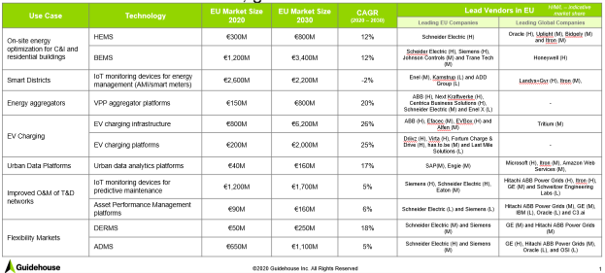

Source 240 ASSET Study commissioned by DG ENERGY  - Gathering data on EU competitiveness on selected clean energy technologies (Draft, 2020)

Complementing the market size information above, it can be seen that a handful of global companies, many of which are European, are active in different energy related software markets.

Table 31 Technology Vendor market share mapping (draft)

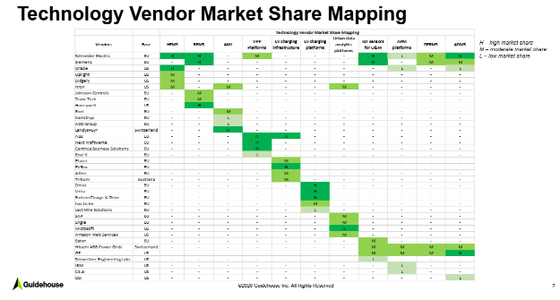

Source 241 ASSET Study commissioned by DG ENERGY  - Value & Supply Chain for Digital Technologies in some use cases in the Energy Sector (Draft, 2020)

Globally the situation is very similar with a small pool of companies dominating the landscape[82].

The figure below shows the respective global market shares of the top six providers across all value chain segments (DERMS, DER Analytics and VPP).

Figure 244 Grid management technologies Global market share of biggest providers



Source 242 ASSET Study commissioned by DG ENERGY - Gathering data on EU competitiveness on selected clean energy technologies (Draft, 2020)

Trying to enter the market, several oil and gas (O&G) and other energy providers are making strategic investments in grid management technologies by acquiring companies (Next Krafwerke (DE), Kiwi power (UK), Limejump (UK)) and have acquired or made strategic investments in smaller start-ups in European and US market[83].

**DERMS (Distributed Energy Resources Management System)**

EU growth will be driven by a number of market and technology factors, including the proliferation of DERs, network constraints, high levels of grid automation, carbon and energy efficiency requirements, and larger digital transformation initiatives.

Market Size

Figure 245 DERMS Revenue, EU Market[84]



Source 243 Guidehouse Insights

It is to be noted that the biggest share of the market is on deployment of solutions. This is valid for many grid related software solutions as will be shown below.

Vendor overview

The DERMS market is largely characterized by a small pool of global vendors having a moderate market share: Schneider Electric, Siemens, GE, Hitachi ABB.

**ADMS (Advanced Distribution Management System)**

EU growth will be driven by high rates of substation and feeder automation, carbon and energy efficiency targets, adoption of renewables, smart metering initiatives.

Because an ADMS conceptually includes many of the functions of the distribution SCADA, it is natural to consider it fundamental to the system. Many utilities’ SCADA systems are not yet at the end of their useful life. Therefore, desired ADMS upgrades may require integration with these systems (as opposed to replacement). Vendors typically offer an ADMS as a suite that includes a modular set of systems with multiple licenses that can be purchased over time to facilitate gradual installation.

As the need for multitude of IT systems grows, implementation and integration can become exponentially more challenging and expensive. Vendors are responding by making their suites of systems highly interoperable and adopting modular system architectures.

Market size

The ADMS revenue in EU27 market will grow at a CAGR of 5.4% between 2020-2030. The ADMS software revenue stems from the licensing costs and software customisations, whereas the deployment revenue is the annualized spending on the implementation and integration services and support and maintenance.

Figure 246 ADMS Revenue, EU Market



Source 244 Guidehouse Insights

Europe has the highest penetration of ADMS technologies globally. This is due to several factors, including high rates of substation and feeder automation, carbon and energy efficiency targets, adoption of renewables, smart metering initiatives, and more.

Most Western European utilities are expected to have one or more ADMS modules deployed while Eastern Europe shows lower rates of ADMS penetration regionally.

Vendor overview

The ADMS market is largely characterized by a small pool of global vendors.

The pool is made up of traditional, large OEMs (General Electric [GE], Schneider Electric SE, Oracle Corporation, Siemens AG, ABB, and Advanced Control Systems—Indra). It also includes a couple smaller vendors (ETAP, OSI, and Survalent Technology Corporation) making inroads around managed services and cooperative and public utility targeting.

**VPP (Virtual Power Plant)**

VPP aggregation platforms are software platforms that enable aggregators to manage a portfolio of distributed energy resources such as batteries, photovoltaics, flexible loads and electric vehicles in a manner that allows customers to access a greater number of energy markets.

VPPs can help to transform passive energy consumers into active prosumers through the integration and optimisation of technologies such as demand response (DR), solar PV systems, advanced batteries, and EV supply equipment (EVSE). At scale, VPPs represent the concept that intelligent aggregation and optimisation of DER can provide the same essential services as a traditional 24/7 centralized power plant.

Europe has been and continues to be (for the near future) the global VPP leader in terms of capacity. This is a function of several factors, including DER growth, market opening, valuation of non-traditional assets, and carbon reduction and efficiency goals. However, explicit demand response participation by residential loads through aggregators is not yet fully developed in all the EU MSs due to technical, market and regulatory barriers.

Germany is anticipated to capture about one-third of the total VPP market’s annual capacity by 2028[85].

Market size

Europe has also been the driving force behind VPP spending, accounting for nearly 45% of global spending in 2020.

Figure 247 VPP Revenue, EU Market

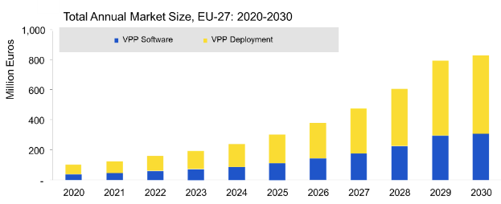

Source 245 Guidehouse Insight, 2020

While software cost is majorly attributed by the licensing, development and customisations, the deployment consists of implementation and integration services to enable VPP aggregation platform and provide ongoing maintenance activities

Vendor overview

Leaders are currently in the strongest position for long-term success in the VPP market.

Companies with High share include ABB and Next Kraftwerke followed with some with Moderate market share such as Schneider Electric or Centrica Business solutions.

**Building Energy Management Systems (BEMS) and Home Energy Management Systems (HEMS)**

While not part of the grid management these technologies are included here due to their increasing interaction with the grid and managing of flexibility loads.

HEMS and BEMS are hardware, software, and services platforms that facilitate monitoring and management of energy in residential and commercial buildings. HEMS are a key component of Smart Homes and are strictly related to Smart Appliance and Smart Lighting, where EU companies are among the world market leaders[86]. HEMS and BEMS have increased their capabilities with the advancement of technologies such as IoT, machine learning or AI and are aggregating increasing amount of data.

EU27 is a global leader in BEMS[87] Companies have successfully leveraged their leadership in building controls and related hardware, and moved into ever more advanced energy management systems.

This is not the case for HEMS where many key players are coming from North America. Same as for BEMS, during the last years, the HEMS market has been integrating new data streams coming from consumer smart home devices and energy appliances.

Figure 248 Overview EMS market & players



Source 246 ASSET Study commissioned by DG ENERGY - Gathering data on EU competitiveness on selected clean energy technologies (Draft, 2020)

Market size[88]

Figure 249 EU27 Market Size 2020-2030

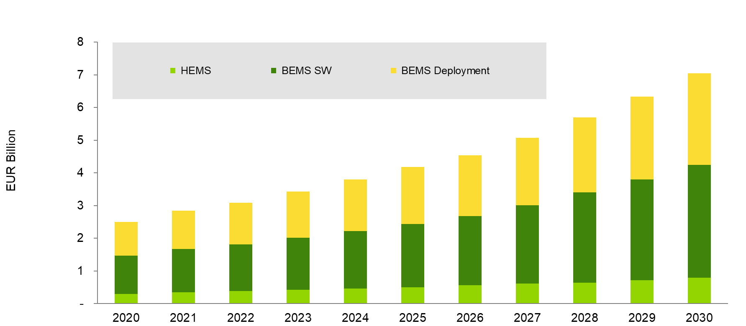

Source 247 Guidehouse Insights, 2020

**Barriers to rapid deployment of the solutions to manage grid flexibility** [89]

Barriers to a more rapid deployment of the solutions to manage flexibility in the grid include:

* energy market/system regulations not designed for the emerging applications and technological solutions;
* system Costs - Digital grid management technologies, particularly DERMSs, are naturally expensive due to their control system capabilities and number of integration points;
* communications Requirements - DER deployments have been sparse, making it difficult for utilities to justify the establishment of dedicated networks. Communications investments in the short term are likely to be small and incremental, using public cellular networks and past investments as much as possible;
* data Quality Remains a Concern - To adapt to the complex operating environment experienced today, utilities need to further invest in data integrity, most notably connectivity model correction and accuracy;
* availability of System Alternatives - Most major utilities do not require a DERMS at this time to enable granular control of DER.

### Future challenges

The following conclusions can be drawn based on the analysis of the different smart grid sub-sectors described in this section:

* investment in grid reinforcement and digital infrastructure is necessary to reduce the curtailment of renewable energy sources. The lion’s share of smart grid investments is in hardware, including in digital grid infrastructure (such as smart meters and eV chargers). The share of software investment is in the order of a few percentage points;
* a handful of global companies, many of which are European, dominate the market of software solutions for the management of the grid and the management of the flexibility provided by DER. In this context, European companies such as ABB, Siemens or Schneider Electric are very well positioned to maintain their existing European and global leading position in various grid and flexibility management software solutions market;
* new entrants have difficulties to enter the market, but oil & gas and energy providers are doing so through acquisitions of stablished players and investment in start-ups.

The digital technologies that underpin the solutions in this chapter are in different states of maturity when applied to the energy sector, as shown in the next figure.

Figure 250 This figure includes the maturity level in 2019 and also includes various technologies such as Block chain or Digital Twins from the 2018 figure

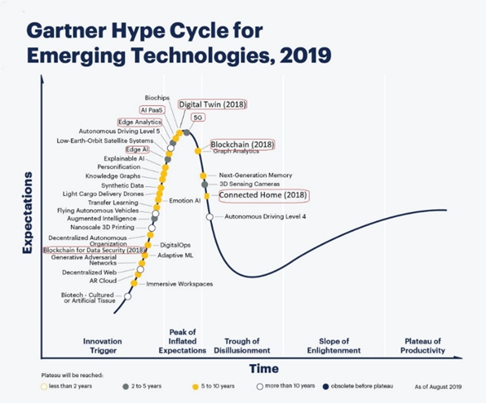

Source 248 Gartner, 2019

But it is important to note that in the development of smart grids, the volume of data generated by energy systems and the digital technologies used are not considered a barrier when moving towards real time operations.[90] There is no evidence that the data volumes being generated, transmitted and analysed is an issue today. Furthermore, developments in digital technologies such as edge computing, smarter IoT devices, AI, machine learning, big data etcetera, are able to handle the data amounts typically dealt with in the energy sector, also when moving towards real time data handling.

The challenge to promote competitiveness of the digital energy services is access to data, data interoperability and sharing of data among different stakeholders and of different parts of the energy value chain as well as in integrating different platforms and software solutions making use of data. Market-wide interoperable platforms for easy data access and data exchange are therefore key.

Interoperability is required at many levels (including technical & semantic interoperability). In this context, one of the challenges is the mix of legacy technologies/devices and state-of-the-art ones (in particular because of the long life duration of the components in the energy sector, often between 20 and 40 years).

Easy access to and sharing of data should allow all possible sources of flexibility to contribute, but the focus in promoting market participation could be on a handful of appliances that could provide the bulk of the required flexibility volumes[91] in the demand response side. The implementation of the Clean Energy Package is key in setting the conditions for data access and sharing to enable the development of the market for smart grids and energy services.

The role of citizens and communities is key when it comes to making the flexibility at appliance level available for the grid; therefore, this is addressed in the next section.

## Citizen and community engagement

Moving towards net-zero economies and societies can only be successful when citizens go along with the required changes. It is therefore important to understand the perspective and the role of citizens in the energy market and in the energy transition at large. More concretely, effective energy transition places citizens at the heart of its strategy by closely looking into main motivational factors and strategies to engage them and situating the energy consumer in a broader social context.

However, it is unrealistic to assume that all, or even a majority of citizens, will become active purely using economic incentives. As an example, citizens do not necessarily invest in energy efficiency, even when this would be economically beneficial for themselves. This suggests that other factors than pure economic self-interest motivate engagement in the energy transition. Engagement strategies can be both individual and community-oriented. The evidence shows an increasing trend of EU projects focusing on a more inclusive approach based on individual and community dynamics[92]. In other words, there is an emerging trend of engagement strategies based on changing community’s behaviours to reach goals that benefit the community at large, as well as an approach that aims at changing individual behaviours tapping into non-economic factors, such as by providing energy consumption feedback appealing to social norms[93].

*This section doesn’t follow the structure of other sections as citizen and communities engagement is not a competitive industry in itself, but it is a key dimension for successful policies that depend on citizen and community engagement, and for many companies that want to be competitive in the clean energy technology market. Therefore, this section addresses, in a brief way, the regulatory, technical social and behavioural, barriers and the state-of-play to address them. Future reporting can address how the EU performs in this sector compared to the rest of the world.*

### Citizen and community engagement in the Energy transition – status and outlook

To engage citizens in the energy transition, it is important to identify potential accelerators – such as social innovation – as well as social or behavioural barriers and levers to greater citizen engagement. This is recognised in the EU’s scenarios for 2050, as the scenarios that achieve higher GHG reductions are those that couple technological solutions with consumer choices that reduce or use energy demand in a more efficient way.

Estimates suggest that by 2030, energy communities could own some 17% of installed wind capacity and 21% of solar[94]. By 2050, almost half of EU households are expected to be producing renewable energy.

Public institutions, especially local authorities are often crucial to facilitate energy consumers engagement by building the sense of a community and to reach those that are the hardest to reach, e.g. vulnerable consumers[95] In addition, collective action enabled by citizen energy communities can empower energy consumers to not only become an active consumer but also an active market player by providing energy services to the grid and contributing towards more competitive and efficient energy markets. A collective approach to energy consumer engagement through citizen energy communities also facilitates the emergence of innovative energy services and new energy market players[96].

It is therefore encouraging to note that the number of energy community initiatives is growing rapidly in the EU and there are currently 3.500 Renewable Energy Cooperatives in Europe.[97]

Figure 251 Indicative number of energy community initiatives



Source 249 JRC based on various sources, 2019

The figure above[98] shows an indicative number of energy community initiatives such as cooperatives, eco-villages, small-scale heating organisations and other projects led by citizen groups in nine European countries. An analysis of 24 case studies of Community energy projects in nine countries[99] in Figure 252 shows the type of activities these initiatives are typically engaged in.

Figure 252 Indicative share of activities across energy community initiatives



Source 250 JRC based on the case student, 2019

### Technical and regulatory barriers & possible solutions

Technical barriers for renewable energy self-consumers as well as jointly acting renewable energy self-consumers are mainly associated with expensive and lengthy grid connections, which requires active management of distribution electricity grids and innovative commercial and connection arrangements[100]. This is particularly an issue for the increasing number of energy cooperatives in Europe. Another technological barrier is the use and availability of data and ICT (e.g. block chain) for effective control of the energy community.[101]

The main regulatory challenges for collective self-consumers are associated with self-consumers not being able to legally set up a renewable energy community or citizen energy community, with lack of incentives to set up jointly acting renewable self-consumer projects and, in some cases, with the reduction or removal of existent incentives, such as feed-in tariffs[102].

The Clean Energy Package (CEP) enables citizens to have a real influence over their energy footprint through specific market arrangements and reinforced consumer rights.[103] Moreover, the CEP acknowledges the central role that collectively acting consumers can play in the energy transition and have established a legislative framework where ’jointly-acting consumers’ and ’jointly-acting renewable self-consumers’ have more opportunities to get involved. Additionally, the CEP also introduces the concepts of “citizen energy communities” and “renewable energy communities” as a way to engage consumers and increase the acceptance of renewables. These concepts may also contribute to tackle energy poverty by transferring the extra energy produced to vulnerable households.

These recent policy developments have paved the way for development of favourable frameworks across Europe for jointly-acting energy consumers and energy self-consumers. Some Member States (France, Germany, UK, Netherlands, Belgium, Croatia, Italy, Spain and Portugal) have already put in place regulatory frameworks to facilitate the uptake of energy communities as a way to engage and empower the energy consumer/self-consumer. Some initial results in this respect indicate that the current legal framework at the EU level represents a clear opportunity for energy consumers and citizens taking the lead and clearly benefit from the energy transition[104].

### Social and behavioural barriers and key elements from science, research and innovation to address them

The choices to renovate one’s house or to self-produce renewable energy are exemplary ways for citizens to engage in the energy transition. However, the level of adoption of these behaviours is far less than the level required to achieve the ambitious environmental targets. At the same time, while some citizens are concerned with the protection of the environment, others do not perceive it as priority. The reason behind such a heterogeneous landscape lies in the fact that citizens face multiple barriers in making optimal choices for themselves and the society. In particular, in addition to structural factors (like the availability of capital), the choice to engage in the energy transition is influenced by several social and behavioural dimensions[105].

Using Social Sciences and Humanities (SSH) is critical in order to better understand public perceptions of energy policies, corresponding choices and forms of organisation and behaviour, as well as surrounding contexts and governance arrangements and how they could be adapted to the new challenges. In addition, factoring in Behavioural Sciences is key to both understand the factors that affect citizens’ participation in the energy transition, and to design more effective interventions enabling them to become actors of change[106].

In particular, in the last years, a plethora of empirical knowledge has given a more evidence-based understanding of human behaviour to inform the policy-making process[107]. The insights of these fields well serve the scope of engaging citizens, as they can be applied by different actors. As an example, these fields highlight that the decision structure is crucial for citizens to engage in decisions that are beneficial for themselves and society. In order for citizens to engage in pro-environmental behaviours, like the decision to become a prosumer, the decision should be structured in a way that citizens perceive it as easy. Changing behaviour requires effort but the cognitive capacities to make optimal decisions are limited[108].

Similarly, providing more information or more economic incentives does not necessarily translate in a change in behaviour, especially when this information is framed as too complex, or the associated benefits are perceived as too uncertain. Therefore, citizens should be provided with assistance to process that information, and it needs to be presented in a way that accounts for uncertainty aversion. As citizen engagement in the energy transition requires cross-sectoral and multi-level collaborations among different actors, this knowledge has to be accessible not only to a few expert actors. Therefore, a closer dialogue between social and behavioural scientists with key-decision stakeholders should be encouraged[109].

Evidence also shows the importance of leveraging on collective dynamics and on the specific social context to activate consumers’ response. A participatory approach that builds on a sense of community and of shared values and goals can be beneficial in mobilising consumers’ response[110]. A more participatory and inclusive approach offer also the possibility of reaching mainstream consumers as well as those that are the hardest to reach (e.g. vulnerable consumers) and to address energy poverty[111] .

Engaging consumers in a collective effort requires the implementation of well-thought engagement strategies. Figure 253 presents some engagement interventions used in collective action R&I projects to involve consumers at collective level to reach a common objective.

Figure 253 Consumer engagement interventions trialled in collective action projects

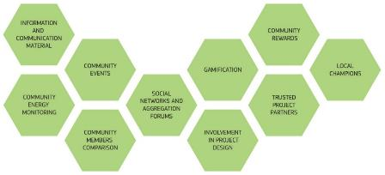

Source 251 JRC

These engagement strategies can be grouped in five main areas[112]:

* increased awareness;
* participatory approach;
* incentives and rewards;
* community trusted actors;
* behaviourally informed interventions.

Besides interventions, involvement of relevant stakeholders appears as one of the main enabling factors for effective consumer engagement.

### R&I to further develop citizen and community engagement

In practice, addressing the social and behavioural factors to promote citizen engagement in the energy transition means:

* analysing the nature of the problem (i.e. low uptake of energy efficiency measures or low adoption of storage systems), by assessing theory-driven hypotheses with qualitative and quantitative methods and identifying barriers (such as present-biased preferences, incorrect beliefs, status quo bias, and limited attention) and levers (such as pro-environmental preferences, personal and social norms, trust, autarky aspirations and status concerns);
* improving traditional instruments (i.e. financial, regulatory and information instruments) that are already addressing the problem, such as by using a framing that captures citizens’ attention, targeting financial instruments based on existing motivations, and providing information on the behaviour of a relevant group;
* trailing interventions on the decision structure, such as by decreasing the perceived financial effort (like enabling citizens to pay the energy efficiency measure with the generated energy savings), setting pro-environmental default options (like thermostat settings), providing options to publicly commit to save a certain amount of energy.

The benefits of integrating SSH and Behavioural Sciences were demonstrated in a range of H2020 projects that provided guidance, lessons and recommendations on how to increase citizen engagement[113]:

* engage and inform consumers/citizens in new ways through:
* education, awareness and dialogue - explaining technical aspects to consumers/citizens is helpful to implement a successful engagement strategy (e.g. H2020 project GAIA[114]);
* developing user-friendly interfaces (including apps) that turn energy management technologies into easy-to-use services (H2020 projects PeakApp[115], eTeacher[116], FEEdBACk[117]). The apps can also attract consumers/citizens by offering an added value, such as an overview of their energy consumption in real time;
* use of drivers such as social inclusion, quality of life and sharing benefits (e.g. in the H2020 project ECHOES[118]);
  + energy cooperatives/ energy communities that increase the acceptance for renewable energy projects and provides an opportunity to invest private capital in such projects (H2020 project ECHOES[119]).
* identify success factors that support citizen’s engagement:
* a pro-active public administration and participatory mechanisms: explore the dimension “working with” through experimentation, creativity, rather than “extracting data from”, knowledge-sharing and fostering a local identity (H2020 project SMARTEES[120]);
* applying a behavioural science approach to better understand individual behaviour in the domain of energy efficiency, (H2020 projects PENNY[121], BRISKEE[122]);
* better understand the decision making of consumers/citizens (H2020 project SHAPE ENERGY[123]);
* test behaviourally informed interventions to improve energy consumption (H2020 project NEWCOMERS[124]);
* recognising the segmentation of consumers’ profile: what is valuable for consumers/citizens depends on the situation. For a hospital, it is important not to have a blackout, while for residential buildings it could be to reduce CO2 output (H2020 project Energy-SHIFTS[125]).

### Challenges

Engaging consumers/citizens in the longer-term is a challenge that needs to be addressed in order to keep them as active as during the project. Easy-to-use IT tools such as apps can contribute to keep the continuity of consumer/citizen engagement.

Applying SSH knowledge on a large scale and replication best practices widely and rapidly is needed to achieve the levels of citizen engagement required to achieve climate neutrality in 2050. As demonstrated in the presented projects, energy-related projects and initaitives should take into account the social and behavioural dimension already at the stage of their design. This requires guiding the design of technological solutions, supporting local administrations in their dialogues with citizens and other key stakeholders, and strengthening communication about community energy projects. This should lead to more and long-term sustainable behaviour.

Moreover, engaging consumers/citizens in the longer-term is a challenge that needs to be addressed in order to keep them as active as during the project. Easy-to-use IT tools such as apps can contribute to keep the continuity of consumer/citizen engagement.

A more participatory approach that builds on a sense of community and of shared values and goals can be beneficial in mobilising consumers’ response and for reaching those that are the hardest to reach (e.g. vulnerable consumers) and to address energy poverty.

Last but not least, recent policy developments acknowledge the role of jointly acting renewable energy self-consumers and further encourages the active role consumers may have in the energy transition. This means that energy communities as a legal entity of jointly acting consumers should be able to compete on a level playing field with other market players, however, adequate regulatory frameworks need to prevent undue restoration in existing energy markets.[126]

## Smart cities & communities

### Introduction

Urbanisation is progressing quickly worldwide. Today, 55% of the global population is living in cities and it is expected to increase to 68% by 2050[127]. It is likely that soon 80% of the EU’s population will live in cities. As a consequence, cities are responsible for a high level of energy consumption and particularly vulnerable to the impacts of climate change. Cities as complex systems can holistically tackle the challenges and provide innovative solutions in different fields[128]. Moreover, the majority of energy and climate policies depend on local authorities for their implementation.

In this context, cities are key actors to realise the European Green Deal, and they can play a key role in developing a holistic and integrated approach to the energy transition, and its link with other sectors, such as mobility, ICT, and waste or water management. This challenges companies to innovate and provide solutions that look beyond individual technologies. In smart cities digital and telecommunication, technologies contribute to the efficiency of traditional networks and services increasing the benefit of its inhabitants and businesses.[129] When this works well, it provides for both better living standards in more sustainable cities and for innovative companies that provide technologies or services that have proven to work.

*This section does not follow the structure of other sections as smart cities and communities is not a competitive industry in itself, but it creates a market for systemic innovation that can contribute to the competitiveness of the EU clean technology industry. Therefore, this section addresses the 4 steps but not the individual indicators, as many smart city investments or companies are combining a range of technologies to provide a systemic innovation. This section therefore makes no cross-reference to the many other relevant sections.*

### Current situation and outlook

To support this interaction between cities and industry, the European Commission launched the H2020 Lighthouse Programme[130] in 2013, supporting cities and companies to cooperate to test and develop integrated solutions that include clean mobility, energy-efficient districts with a high share of renewables as well as ICT-enabled and smart integrated infrastructures. Cities applying to be a Lighthouse City have to have a Covenant of Mayors Sustainable Energy and Climate Action Plan or a similar plan, that is at least equally ambitious. Since then, the European Commission funded 17 projects of EUR 18-25 million each. Furthermore, in order to ensure replication and scaling-up afterwards, demonstrations in 2 to 3 lighthouse cities are closely followed by 3-5 fellow cities that plan to implement the integrated solutions at a later stage.

Currently, the programme now counts 46 lighthouse cities and 70 fellow cities. While only 3 out of the 17 projects are now finalised, the programme has nevertheless already achieved 53% energy savings, up to 88% CO2 reduction, more than 17.500 smart meters installed and over 1 million m2 floor space refurbished, more than 5.270 e-vehicles introduced, nearly 500 e-charging stations installed, and more than 260.000 citizens engaged in this transformation[131]. It is coordinated with Member States investments in smart cities and communities through the Strategic Energy Technology (SET) Plan’s action 3.2 on Smart Cities & Communities[132] and the Joint Programming Initiative Urban Europe[133].

In Horizon Europe, support for smart cities will continue, in particular through the Mission on Climate-Neutral and Smart Cities that aims to realise 100 climate-neutral cities by 2030. In addition, cooperation and exploitation of synergies are being developed with the 10 000+ cities of the Covenant of Mayors for Climate and Energy to i.a. replicate Smart City solutions across the Union. Last, but not least, the Smart Cities Marketplace[134] collaborates with both initiatives and will continue to support rolling out of Smart City solutions with its Explore-Shape-Deal[135] process and private investments facilitated by its Investor Network[136].

### Value chain analysis

Technologies

Providing solutions in the urban context requires addressing a complex, holistic, multi-actor, multi-sector and multi-level ecosystem[137]. Smart city solutions combine different technologies and innovations and integrate them, in particular:

* smart Cities & Communities drive investments in energy system integration[138] and combine energy efficiency technologies with citizens’ empowerment measures as well as renewable energy generation, such as (renewable) heating and cooling;
* to address GHG emissions from transport, urban mobility challenges and air pollution, smart cities invest in electric mobility and logistics, Hydrogen vehicles[139], as well as alternative Mobility schemes (e.g. smart booking, routing and information systems);
* digital technologies are key for smart cities, to make energy system integration happen, as well as integration with the transport system (for e-mobility) and for alternative mobility schemes. Furthermore, digital technologies provide the data and feed the models that cities need to manage this ever-more complex integration and optimisation of systems, in particular to plan and/or steer future investments. Many modelling tools are already available[140] to predict the impact of a technological solution applied to a real-world scenario and should be considered as effective planning aids. Urban (data) platforms, open digital marketplaces (ensuring security and respecting privacy) and AI are key for this, but also to enable innovative peer to peer collaborative schemes between citizens and/or visitors, allowing them to provide shared access to their flexible assets, such as locally generated energy, parking places, personal EV-charging facilities, to name a few. Open Source solutions are important since they avoid vendor lock-ins, ensure a level playing field and they help building user confidence.

System innovations and non-technical prerequisites

Beyond the pure integration of above-listed technologies and areas, the realisation of a Smart City depends to a much larger extent on system innovations and non-technical prerequisites. They are connected to “social innovation” and novel ways of capturing both economic and non-economic values. Below key factors are listed in a non-exhaustive way:

* **institutional Capacity and ownership**: city administrations – supported by their respective local leaders – need to understand and respect the needs of the city society and translate it into strategies, plans and measures. In order to be capable to do this, city administrations have to build the necessary know-how, both in terms of available technologies and solutions, but also in terms of interactions with the city society, planning skills, standards, business models, to name just a few;
* **experimenting, engaging and learning processes**: a culture of innovation based on experimenting and the possibility of learning from failures and successes need to be established. This includes regulatory experimenting (e.g. regulatory sandboxes, exemptions for living labs, pilot regulation), allowing administrations to grant exemptions from existing regulations to test and replicate promising (social) innovations. It also requires purposeful and sensible engagement of civil society in a multi-directional and inclusive way, with citizen-driven approaches and citizen-empowerment.[141] This needs to be followed up through learning processes for public and private actors;
* **standards**: standards for single technologies, integrated energy systems, and holistic comprehensive multi-sectorial standards such as the areas of integrated planning or city scale KPIs will help making Smart City approaches cost effective, lowering their (commercial) risks and facilitating the replication and scale-up of solutions, which is key for achieving the impact needed for the Clean Energy Transition.

### Global Market analysis

As the urbanisation trend is global, worldwide efforts have been drastically increased over the past decade in the field of making cities smarter and a driver for innovation, for example:

* the US Department of Transportation relaunched its smart city challenge[142] in 2016, encouraging cities across the country to submit innovative plans and compete for grants;
* China highlights smart city development as one of the major priorities in its 14th Five-Year Plan (covering 2021–2025)[143], and more than 500 cities across the country have already developed strategies or launched pilot projects;
* India has a 100 smart cities[144] programme well underway;
* the Smart Nation Singapore programme[145] combines a number of measures to transform Singapore into a “smart nation” across six core areas, most of which are also relevant for cities: strategic national projects, urban living, transport, health, digital government services, start-ups and businesses.

Furthermore, other countries in the world have national smart city programmes and market investment initiatives in development, such as Brazil, Russia, Korea, and Malaysia. These initiatives contribute to the global fight against climate change and at the same time present a market for EU companies that provide smart city solutions. Therefore the EU promotes international cooperation of cities, for example through the Global Covenant of Mayors.[146]

### Challenges

Enabling cities to drive climate neutral transformations require an integrated, coordinated approach in which technologies, holistic urban planning, a combination of large-scale public and private investments, effective communication and co-creation between policy makers, economic actors and citizens concur to achieve the goal. This, in turn, requires research and innovation in technologies as well as in processes, knowledge and capacity growth involving city authorities, businesses and citizens, in particular:

* to build capacity and tools to develop **integrated strategies and planning**: This should include tools and processes for strategy development (e.g. participatory foresight, horizon scanning, etc.) and for planning for participation, engagement and orchestration of public and private stakeholders as well as city society. Evidence shows that cities still lack the needed horizontal co-ordination, co-operation, and collaboration;
* **financing** the transition constitutes a critical gap for the transition to climate-neutral cities: cities often act individually and lack the capacity to develop and adequately present projects attractive for private or public investors. Credit rating is a further common barrier;
* **systematic screening of investments**: Investment decisions taken today are often irreversible and will impact urban sustainability for a long time to come, as the lifespan of buildings and infrastructures is at least several decades. Knowledge on low hanging fruits and upcoming opportunities for making cities low carbon is often lacking at city level, despite the availability of detailed geographical data.

Quite substantial research has been done on social innovation, co-creation, and co-realisation with citizens of climate-neutral and smart solutions. Citizen and communities engagement in the energy transition – behavioural and social dimension, communication), and there is a need to make this knowledge available and operational to local administrations, for example in the form of guidelines.

# Conclusions

The “*Clean Energy Transition – Technologies and Innovation Report*” (*CETTIR*) is the Staff Working Document (SWD) underpinning the first annual *Competitiveness Progress Report (CPR)[147]*.

This SWD first provides more details and data on the technologies that are addressed in the CPR, namely Offshore wind, Ocean energy, Solar photovoltaics, Renewable hydrogen, Batteries, and Smart grids[148].

The analysis is completed by the other clean and low carbon energy technologies and topics that are important to achieve climate-neutrality in 2050[149]. These are: Buildings, Carbon Capture and Storage (CCS), Geothermal, High Voltage Direct Current Systems, Hydropower, Industrial Heat Recovery, Nuclear Energy, Onshore Wind, Renewable Fuels, Solar Thermal Power, Smart Girds – Digital Infrastructure, Citizen and community engagement, and Smart Cities and communities.

Competitiveness is assessed, in this SWD as well as in the CPR, at macroeconomic level and at the level of specific technologies/topics, mapping a set of widely recognized competitiveness indicators and studying their evolution and use those as the basis to identify future challenges. The macroeconomic assessment shows that the clean energy technologies perform better as the rest of the economy, in terms of value-added, labour productivity and employment growth.

Concerning the technology and topic specific analysis, the following issues are worth highlighting:

On *solar photovoltaics* and *batteries*, the challenge for EU is to grasp the market opportunities that will arise from the growing demand, both in Europe and globally. For the solar photovoltaics EU industry, this would mean increasing the market share in the manufacturing segments of the value chain where specialization or high performance/high value products are key, building on the strong knowledge of the EU research institutions, the skilled labour force, and the existing and emerging industry players[150]. Similarly, in the batteries industry, Europe is currently devoting great efforts to both regaining a share of the cell manufacturing segment and at the same time developing the next generation of Li-ion batteries. Through the European Batteries Alliance, the EU works to enhance its future position in this market.

On *offshore* *wind energy*, *ocean energy* and *renewable hydrogen*, the EU currently holds a first-mover advantage. But this competitive position may change as the market grows and further competitors enter the market.

Given the prospect of a growing domestic market is important for the industry to strengthen its position and expand in the global market. However, the expected, multi-fold increase of the market capacity size for these technologies suggests that the industry’s structure will change. The challenge is to pool expertise along the value chains, within an innovative and competitive market, to reach the required economies of scale.

For this reason, the announced European Clean Hydrogen Alliance aims at further strengthening Europe’s global leadership of the electrolyser industrial sector. Furthermore, because of the similarities between the technologies, the EU’s current leading position in the market along the whole electrolysers value chain, from component supply to final integration capability, offers significant spill-over potential between batteries, electrolysers and fuel cells.

As regards *offshore wind* and *ocean energy*, a long-term vision will be set out in the upcoming offshore renewable energy strategy. Ocean energy technologies are yet to become commercially viable. In order to maintain and expand the EU’s current leading position, the challenge is to increase the scale and number of demonstrators, and at the same time accelerate the commercialization of the most advanced technological approaches. The *offshore wind* industry shows an impressive capacity to innovate, with a rapid cost decrease and remarkable performance improvements. This sector, which is now pushing the boundaries of the technology (e.g. floating offshore for countries/markets with steeper coastlines), will benefit by the projected expansion of the home market. This, together with sustained R&I funding would strengthen the current EU technology leadership and the EU competitive advantage in the global market.

The EU holds a strong competitive position in *onshore wind* and *hydropower technologies*. For onshore wind, the large scale of the market[151] and increasing capacity outside Europe offer promising prospects to a relatively well positioned EU industry in the wind value chain[152]. More specifically, EU researchers and companies are leading players in the *onshore wind* value chain developing digital technologies (sensing and monitoring systems) for onshore wind turbines. In this context, further innovations efforts in reducing visual impact and noise, and in increasing the turbines performances will contribute to further and fully exploit the EU competitive advantage.

Similarly, for *hydropower,* the importance of the market[153] and the EU’s share in global exports (the global exports in 2019 accounted for EUR 878 million in 2019 with EU countries holding 48% of it) are a good basis for a competitive industry, with European companies present in major value chain segments (e.g. design, manufacturing and supply of hydropower equipment, R&D and civil works).

The increasing need for a more flexible operation of both onshore wind parks and hydropower stations demands a higher level of digitalisation, which is therefore a key priority for the EU competitiveness.

Another key challenge for wind onshore and hydropower is to use repowering/refurbishment of older installations as an opportunity to radically reduce their environmental footprint and increase social acceptance.

For *renewable fuels* the key issue is to shift from first to second and third generation fuels so that the feedstock becomes sustainable, and to optimise its use. To do so, scale up to increase industrial production, via demonstration projects, will be important moving forward.

To increase the availability of sustainable biofuels beyond the limited waste and residue feed-stocks, it is important to lower costs and risks through large scale demonstration of the key production pathways (pyrolysis, gasification, fermentation). In parallel, large R&I investments could help to gain experience and push technology development in the currently limited e-fuel development, while maintaining the EU’s competitive edge through first of a kind plants, demonstrations and scaling up.

The EU is well positioned in the *geothermal* (market of approx. 1 EUR billion) and the *solar thermal power* (market of approx. EUR 3 billion) markets. These markets are comparatively small but there is untapped potential considering the high number of possible applications.

EU is a net exporter of services for *geothermal energy* projects and equipment, mainly as project developers, utilities and operators. To fully exploit the untapped geothermal potential, the areas that are most urgently in need for funding need to be identified to better target R&I funding. Past and current EU-funded projects have been and are advancing the state-of-the art, mainly for exploration (drilling), new materials/tools and the enhancement of reservoirs, among others. However, it is difficult to assign levels of importance to each research area. The areas that are most urgently in need for funding should be identified to better focus the support. This would also allow to fill the lack of high-skilled labour force (geothermal engineers and trainers) and non-technical experts so that to strengthen the position of the EU industry in the global market.

Similarly, EU companies have traditionally been leaders in all value chain segments of the *solar thermal power* technology. However, to face its US and emerging Chinese competitors and to maintain and expand its competiveness, it is important for the EU industry to improve the performance and the cost effectiveness of solar thermal power plants.

The development of *Carbon Capture and Storage* (CCS) technologies is currently hampered by the lack of viable business models and markets. The analysis of the whole value chain (capture, transportation with pipelines and storage) shows that the EU28 + Norway market size value is about EUR 450 million, second only to North America (with a size larger than EUR 800 million). The public sector can help in creating viable business models by supporting the development of CO2 transport infrastructure to create scale and lower the risk for private investors in CCS on both sides of the infrastructure.

As regards *nuclear energy technologies*, important EU companies are competitive across several segments of the value chain. The EU nuclear sector currently generates an annual trade surplus of EUR 18.1 billion. To maintain competitiveness, the sector focuses on developing and constructing on schedule, and guaranteeing safety and waste disposal for the decommissioning of existing plants.

*Smart grids* can open the door to new applications with far-reaching inter-disciplinary impacts, among which providing the capacity to safely integrate more renewable energy sources, smart buildings, electric vehicles and distributed generation into the network. The EU smart grid industry is expected to grow considerably over the next decade, and although it is a small market compared to wind or PV, it creates value for everything connected to the grid. Due to its regulated nature, governments and regulators in the EU play a key role in exploiting the benefits of this industry.

*HVDC systems* are key to transport electricity over larger distances, and are particularly important to develop EU’s offshore wind resources. So far, vendors have sold turnkey systems independently, as they were installed as point-to-point HVDC connections. In the more interconnected offshore grid of the future, HVDC systems from different manufacturers will need to be interconnected. This brings technological challenges to maintain grid control and to ensure the interoperability of HVDC equipment and systems. Moreover, as all components need to be installed on offshore platforms it is important to reduce their size.

In the converter stations’ value chain, *power electronics* play a key role in determining the efficiency and the size of the equipment. However, the energy system specific applications represent only a small share of the global electronic components market (passive, active, electromechanical components and others which was about EUR 316 billion in 2019), and there is a need to develop power electronic solutions specifically for offshore energy applications.

A key sector when it comes to the reduction of CO2 emissions is the *buildings* sector, representing 40% of the EU’s energy usage. The EU has a strong position in sectors[154] such as prefabricated building components, district heating systems, heat pump technologies and home/buildings energy management systems (HEMS/BEMS). In the specialized sector of prefabricated buildings, EU 28 production value increased from EUR 31.85 billion (in 2009) to EUR 44.38 billion (in 2018), and exports from the EU are growing as well, although at much smaller volumes (1.88 billion EUR in 2018). The *lighting* sector is experiencing a radical transformation, not only because solid state devices consume a fraction of the energy of the older technology, but also because of the broad spectrum of possibilities (colour, shape, size) to integrate lighting in the living and working environment. The EU has a long tradition in designing and supplying innovative and high efficient lighting systems but as this market will be driven by large scale mass production it seems to favour Asian suppliers, despite the high innovative capacity in manufacturing and design existing in Europe.

The EU is a world leader in *District Heating and Cooling* (DHC) technology and exports it globally, especially to China, USA and South Korea. The *industrial heat recovery* sector is important for its CO2 emission reduction potential in a hard-to-decarbonize sector and the current industry in the EU, for example in industrial heat pumps, would benefit if the sizable market potential for the recovery of industrial waste heat would be developed further.

But the energy transition is not all about technologies, it is also about fitting these technologies into the system.

On the basis of the observed urbanization trends, *cities* can play a key role in developing a holistic and integrated approach to the energy transition, as they integrate grids to transport people, goods, energy and water with ICT and digital solutions. The challenge for cities to drive climate neutral transformations is to combine technologies, holistic urban planning, large-scale public and private investments, and co-creation between policy makers, economic actors and citizens. Technology adaptation, process innovation, knowledge and capacity growth involving city authorities, businesses and citizens are the driver of the transformation.

Succeeding in moving towards net-zero economies and societies requires placing *citizens*at the heart of all actions by closely looking into main motivational factors and strategies to engage them and situating the energy consumer in a broader social context. The engagement strategies will have to be both individual and community-oriented, aiming not only at providing economic incentives, but also at changing individual behaviours tapping into non-economic factors, such as by providing energy consumption feedback appealing to social norms. The current legal framework at the EU level represents a clear opportunity for energy consumers and citizens taking the lead and clearly benefit from the energy transition.

The clean energy sector is gaining in importance in the EU economy, in line with the increased demand for clean technologies. The evidence collected in this report points at common challenges to enable a better exploitation of the economic potential of the clean and low carbon energy sector, namely:

1. The decrease of public and private investments in clean energy R&I together with a decrease in patenting activities;
2. Key characteristics of the energy market (in particular the high capital intensity, long investment cycles, new market dynamics, coupled with a low rate of return on investment) make it difficult to attract sufficient levels of investment into this sector, which affects its ability to innovate;
3. Use the increased resource efficiency and higher spill-over potential of the clean energy technologies (compared to the conventional ones) to catalyse their accelerated deployment and market uptake.

# List of missing indicators for specific technologies/topics

|  |  |  |  |
| --- | --- | --- | --- |
| **CETTIR Technologies and Sectors** | **Missing Indicators** | | |
| **Technology analysis** | **Value Chain analysis** | **Global Market Analysis** |
| **Batteries** | Private R&I funding (we have only figures, not text); Publications / bibliometrics | GVA growth; Employment figures; Productivity |  |
| **Buildings: Prefabricated building components** | Cost / LCOE; Patenting trends; Publications / bibliometrics | Employment figures; Productivity (labour and factor); ProdCom statistics |  |
| **Buildings: Energy efficient lighting** | Cost / LCOE; Public R&I funding ; Private R&I funding | Employment figures; Productivity (labour and factor); ProdCom statistics |  |
| **Buildings: district heating and cooling industry** | Cost / LCOE; Public R&I funding; Private R&I funding; Publications / bibliometrics | Turnover; Gross value added growth; Employment figures ; Productivity (labour and factor) ; ProdCom statistics |  |
| **Buildings: heat pumps** | Public R&I funding; Private R&I funding; Publications / bibliometrics | Productivity (labour and factor) ; ProdCom statistics |  |
| **CCS[155]** | Publications / bibliometrics | Turnover; GVA; employment figures; Productivity; ProdCom statistics | Trade |
| **Solar Thermal Power (CSP)** |  | GVA; Employment figures; Productivity (labour and factor) |  |
| **HVDC** |  | Productivity; ProdCom statistics |  |
| **Hydrogen** | Private R&I Funding, publications and bibliometrics | Turnover, GVA, productivity, ProdCom statistics | Trade; global market leaders vs EU market leaders |
| **Industrial Heat Recovery** |  | Turnover (available for heat pumps in general, not industrial heat pumps specific); GVA; Productivity; ProdCom statistics | Trade (no aggregated data available); |
| **Nuclear** |  | Employment; Productivity (labour and factor) |  |
| **Ocean** | Publications and Publiometrics | Productivity (labour and factor); ProdCom Statistics | Trade |
| **PV** | Private R&I Funding | Productivity (labour and factor); ProdCom Statistics |  |

# List of acronyms

|  |  |
| --- | --- |
| **AC** | Alternating Current |
| **ADMS** | Advanced Distribution Management System |
| **AEL** | Alkaline Electrolysis |
| **AEMEL** | Anion Exchange Membrane |
| **AHT** | Absorption heat transformers |
| **AMI** | Advance Metering Infrastructure |
| **AMPERE** | Automated photovoltaic cell and Module industrial Production to regain and secure European Renewable Energy market |
| **AMS** | Asset management systems |
| **APM** | Asset Performance Management |
| **ASSET** | Advanced System Studies for the Energy Transition |
| **BECCS** | Bioenergy with carbon capture and storage |
| **BEMS** | Building Energy Management System |
| **BIM** | Building information modelling |
| **BIPV** | Building Integrated Photovoltaics |
| **BNEF** | Bloomberg New Energy Finance |
| **BNEF NEO** | Bloomberg's New Energy Outlook scenario |
| **BOS** | Balance of System |
| **CAGR** | Compound Annual Growth Rate |
| **CAPEX** | Capital Expenditures |
| **CCGT** | Combined Cycle Gas Turbines |
| **CCS** | Carbon Capture and Storage |
| **CCU** | Carbon Capture and Utilisation |
| **CCUS** | Carbon Capture, Utilisation and Storage |
| **CdTe** | Thin-Film Technology of Cadmium Telluride used in PV |
| **CEMAC** | Clean Energy Manufacturing Analysis Center |
| **CEP** | Clean Energy Package |
| **CESBA** | Common European Sustainability Building Assessment |
| **CETTIR** | Clean Energy Transition – Technologies and Innovations Report |
| **CF** | Capacity Factor |
| **CHP** | Combined heat and power |
| **CIGS** | Thin-Film Technology of Copper Indium/Gallium Disulfide/Diselenide used in PV |
| **CIGS** | Copper indium gallium selenide solar cells |
| **CPC** | Compound Parabolic Concentrator |
| **CPR** | Competitiveness Progress Report |
| **CRMs** | Critical Raw Materials |
| **CSP** | Concentrating Solar Power |
| **DC** | Direct Current |
| **DER** | Distributed Energy Resources |
| **DERMS** | Distributed Energy Resources Management System |
| **DG ENER** | The Commission's Directorate-General for Energy |
| **DG MARE** | The Commission's Directorate-General for Maritime Affairs and Fisheries |
| **DGR** | Deep Geological Repositories |
| **DHC** | District Heating and Cooling system/technology |
| **DSO** | Distribution System Operators |
| **EEAG** | Guidelines for State Aid for Energy and Environmental Protection |
| **EERA** | European Energy Research Alliance |
| **EGEC** | European Geothermal Energy Council |
| **EGS** | Enhanced Geothermal Systems |
| **EIB** | European Investment Bank |
| **EPBD** | Energy Performance of Buildings Directive |
| **EPC** | Energy Performance Certificate |
| **EPC** | Engineering, Procurement and Commissioning |
| **EPO** | European Patent Office |
| **ERA-NET** | ERA-NET under Horizon 2020 is a funding instrument designed to support public-public partnerships |
| **ERDF** | European Regional Development Fund |
| **ETIPs** | European Technology and Innovation Platforms |
| **ETS** | Emissions Trading System |
| **EV** | Electric Vehicles |
| **EVSE** | EV supply equipment |
| **FAME** | Fatty Acid Methyl Ester |
| **FCH JU** | Fuel Cells and Hydrogen Joint Undertaking |
| **FEED** | Front-end Engineering Design |
| **FP6** | Sixth Framework Programme 2002-2006 |
| **FP7** | Seventh Framework programme 2007-2013 |
| **FTEs** | Full Time Equivalents |
| **GDP** | Gross Domestic Product |
| **GHG** | Greenhouse Gases |
| **GID** | Geographic Information Systems |
| **GIL** | Gas Insulated Line |
| **GP ER** | Greenpeace’s Energy Revolution scenario |
| **GSHP** | Ground Source Heat Pumps |
| **GSHPs** | Ground Source Heat Pumps |
| **GVA** | Gross Value Added |
| **H&C** | Heating and Cooling |
| **H2020** | Horizon 2020 |
| **H2P** | Heat-to-Power |
| **HEMS** | Home Energy Management System |
| **HJT** | Heterojunction |
| **HS Codes** | Harmonized System Codes |
| **HTL** | Hydrothermal Liquefaction |
| **HTS** | High Temperature Superconductor |
| **HVAC** | High Voltage Alternate Current |
| **HVDC** | High Voltage Direct Current |
| **HVO** | Hydrotreated Vegetable Oil |
| **ICC** | US International Code Council |
| **ICT** | Information and Communication Technology |
| **IEA** | International Energy Agency |
| **IEA TCP** | International Energy Agency - Technology Collaboration Programme |
| **IEA WEO SDS** | IEA's Sustainable Development Scenario in the World Energy Outlook |
| **IEE** | Intelligent Energy Europe |
| **IET** | Institute for Energy and Transport |
| **IGBTs** | Insulated-Gate Bipolar Transistors |
| **IoT** | Internet of Things |
| **IPCC** | Intergovernmental Panel on Climate Change |
| **IRENA** | International Renewable Energy Agency |
| **IRENA GRO TES** | IRENA's Global Energy Transformation, Transforming Energy Scenario |
| **ITER** | International Thermonuclear Experimental Reactor |
| **JRC** | Joint Research Centre |
| **JRC GECO 2C_M** | JRC Global Energy and Climate Outlook 2 °C medium scenario |
| **JRC-EU-TIMES** | Partial equilibrium energy system model maintained by the IET of the JRC |
| **LAE** | Lighting Application Efficiency |
| **LCC HVDC** | Line Commutated or Phase-commutated Converters |
| **LCEO** | Low Carbon Energy Observatory |
| **LCOE** | Levelised Cost of Electricity |
| **LED** | Light-emitting Diode |
| **LFP** | Li iron phosphate |
| **LHV** | Lower Heating Value |
| **Li-Ion** | Lithium-ion |
| **LIPA** | Long Island Power Authority |
| **LTO** | Long Term Operation |
| **LTS** | European Commission's Long Term Strategy for climate neutrality in 2050 |
| **LTS 1.5 LIFE** | Long Term Scenario Refers to the scenario in the Long Term Strategy which builds upon the 1.5 TECH scenario but assesses the impact of a highly circular economy and the potential beneficial role of a change in consumer choices that are less carbon intensive. It also explores how to strengthen the land use sink, to see by how much this reduces the need for negative emissions technologies. |
| **LTS 1.5 TECH** | Long Term Scenario Refers to the scenario in the Long Term Strategy which pushes all zero-carbon energy carriers as well as efficiency, and relies on a negative emissions technology in the form of bioenergy combined with carbon capture and storage to balance remaining emissions. |
| **LWR** | Light-water Reactor |
| **MDMS** | meter data management system |
| **MI** | Mass Impregnated cable systems |
| **MMC** | Modular Multilevel Converter |
| **MSP** | Maritime Spatial Planning |
| **MSs** | Member States |
| **MtCO2** | Million tonnes of CO2 |
| **Mtoe** | Million Tonnes of Oil Equivalent |
| **MWMS** | mobile workforce management systems |
| **NCA** | nickel cobalt aluminium oxide |
| **NECPs** | National Energy and Climate Plans |
| **NER300 Programme** | One of the world's largest funding programmes for innovative low-carbon energy demonstration projects |
| **NMC** | nickel manganese cobalt oxide |
| **NSERC** | The Natural Sciences and Engineering Research Council of Canada |
| **NSF** | National Science Foundation of US |
| **O&G** | Oil and Gas |
| **O&M** | Operation and Maintenance |
| **OECD** | Organisation for Economic Cooperation and Development |
| **OEE** | Ocean Energy Europe |
| **OEMs** | Original Equipment Manufacturers |
| **OF** | Oil-filled cable |
| **OLED** | Organic Light-Emitting Diode |
| **OPEX** | Operating Expense |
| **ORC** | Organic Rankine Cycle |
| **OT** | Operational Technology |
| **OTEC** | Ocean Thermal Energy Conversion |
| **OWC** | Oscillating Water Column |
| **Patstat** | European Patent Office |
| **PEM** | Proton Exchange Membrane |
| **PEMEL** | Polymer Exchange Membrane |
| **PERC** | Passive Emitter Rear Contact |
| **PHS** | Pumped Hydropower Storage |
| **PINC** | European Commission’s Nuclear Illustrative Programme |
| **PMSGs** | Permanent Magnet Synchronous Generators |
| **PPAs** | Power Purchase Agreements |
| **PV** | Solar Photovoltaic |
| **PWM** | Pulse Width Modulation |
| **R&D** | Research and Development |
| **R&I** | Research and Innovation |
| **RE** | Renewable Energy |
| **REEs** | Rare Earth Materials |
| **RES** | Renewable Energy Sources |
| **RoW** | Rest of the World |
| **SaaS** | Software as a Service |
| **SC** | Superconductors |
| **SCADA** | Supervisory Control and Data Acquisition |
| **SDG** | Sustainable Development Goals |
| **SET plan** | European Strategic Energy Technology Plan |
| **SMEs** | Small and Medium Enterprises |
| **SMRs** | Small Modular Reactors |
| **SOEL** | Solid Oxide Electrolysis – high temperature |
| **SSH** | Social Sciences and Humanities |
| **SSL** | Solid-State Lighting |
| **STEM** | Science, Technology, Engineering and Math |
| **STL** | Superconducting Transmission Lines |
| **TEN-E** | Trans-European Network for Energy |
| **TFC** | Trilateral Flash Cycle |
| **TRL** | Technology Readiness Level |
| **TSO** | Transmission System Operators |
| **UHVDC** | Ultra High Voltage Direct Current |
| **UV** | Ultraviolet |
| **VIPV** | Vehicle Integrated Photovoltaic |
| **VPP** | Virtual Power Plants |
| **VSC HVDC** | Voltage Source Converters |
| **WACC** | Weighted Average Cost of Capital |
| **WEEE** | Waste Electrical and Electronic Equipment |
| **WEO** | World Energy Outlook |
| **XLPE** | Cross-linked polyethylene |
| **ZEP** | Zero Emissions Platform ETIP |

1. Powering a climate-neutral economy: An EU Strategy for Energy System Integration, COM(2020), https://ec.europa.eu/energy/sites/ener/files/energy_system_integration_strategy_.pdf
2. Communication from the Commission, A Clean Planet for all - A European strategic long-term vision for a prosperous, modern, competitive and climate neutral economy. COM (2018) 773 final
3. Communication from the Commission, A Clean Planet for all - A European strategic long-term vision for a prosperous, modern, competitive and climate neutral economy. COM (2018) 773 final, p. 11
4. IEA Energy Technology Perspectives 2017, pg. 323
5. Tonnes of biofuels were given by ETIP Bioenergy. Conversion to toe depends on fuel type. Range of toe estimated by using conversion factors of bioethanol (0.64) and biodiesel (0.86) to toe.
6. ETIP Bioenergy Working Group 2 – Conversion Processes and ETIP-B-SABS2 project team, Current status of advanced biofuels demonstrations in Europe, 2020. <https://www.etipbioenergy.eu/images/ETIP-B-SABS2_WG2_Current_Status_of_Adv_Biofuels_Demonstrations_in_Europe_Mar2020_final.pdf>
7. A. O’Connell, M. Prussi, M. Padella, A. Konti, L. Lonza, Sustainable Advanced Biofuels Technology Market Report, 2019.
8. A. O’Connell, A. Konti, M. Padella, M. Prussi, L. Lonza, Advanced Alternative Fuels

   Technology Market Report, 2019.
9. ETIP Bioenergy Working Group 2 – Conversion Processes and ETIP-B-SABS2 project team, Current status of advanced biofuels demonstrations in Europe, 2020.
10. According to JRC experts
11. A. O’Connell, M. Prussi, M. Padella, A. Konti, L. Lonza, Sustainable Advanced Biofuels Technology Market Report, 2019, p. 13
12. A. O’Connell, M. Prussi, M. Padella, A. Konti, L. Lonza, Sustainable Advanced Biofuels Technology Market Report, 2019, p. 8.
13. JRC 2020, Low Carbon Energy Observatory, Wind Energy Technology Development Report 2020, European Commission, JRC120709
14. A. O’Connell, A. Konti, M. Padella, M. Prussi, L. Lonza, Advanced Alternative Fuels Technology Market Report 2018.
15. IEA Bioenergy, Advanced biofuels – potential for cost reduction, 2020
16. JRC, State of the Art on Alternative Fuels Transport Systems in the European Union Update 2020
17. Dolf Gielen, Gabriel Castellanos, Kilian Crone,The outlook for Powerfuels in aviation, shipping, 2020. https://energypost.eu/the-outlook-for-powerfuels-in-aviation-shipping/
18. Dolf Gielen, Gabriel Castellanos, Kilian Crone, The outlook for Powerfuels in aviation, shipping, 2020. https://energypost.eu/the-outlook-for-powerfuels-in-aviation-shipping/
19. A. O’Connell, M. Prussi, M. Padella, A. Konti, L. Lonza, Sustainable Advanced Biofuels Technology Market Report 2019, p.5.
20. Eionet Report - ETC/CME 2019/8
21. Eionet Report - ETC/CME 2019/8
22. Frankfurt School-UNEP, Global Trends in Renewable Energy Investment, 2019. <https://wedocs.unep.org/bitstream/handle/20.500.11822/29752/GTR2019.pdf?sequence=1&isAllowed=y>
23. Values converted from USD based on exchange rate of European Central Bank on 15/09/2020 (1EUR = 1.1876 USD)
24. A. O’Connell, M. Prussi, M. Padella, A. Konti, L. Lonza, Sustainable Advanced Biofuels Technology Market Report 2019, p.7.
25. Web of Science, 2020: https://wcs.webofknowledge.com/RA/analyze.do?product=WOS&SID=E6pWBx18Vuae7bU66PW&field=CU_CountryTerritory_CountryTerritory_en&yearSort=false
26. ibid
27. A. O’Connell, M. Prussi, M. Padella, A. Konti, L. Lonza, Sustainable Advanced Biofuels Technology Market Report, 2019, p.2.
28. Data compiled by Statistica 2020 based on the 14th to 19th European Observer Reports.
29. JRC 2020, Low Carbon Energy Observatory, Wind Energy Technology Development Report 2020, European Commission, JRC120709
30. A. O’Connell, M. Prussi, M. Padella, A. Konti, L. Lonza, Sustainable Advanced Biofuels Technology Market Report, 2019.
31. Data compiled from COM, Bioeconomy, 2020, https://ec.europa.eu/knowledge4policy/bioeconomy/topic/economy_en
32. Data compiled from COM, Bioeconomy, 2020, https://ec.europa.eu/knowledge4policy/bioeconomy/topic/economy_en
33. Data compiled from COM, Bioeconomy, 2020, https://ec.europa.eu/knowledge4policy/bioeconomy/topic/economy_en
34. ETIP Bioenergy Working Group 2 – Conversion Processes and ETIP-B-SABS2 project team, Current status of advanced biofuels demonstrations in Europe, 2020.
35. ETIP Bioenergy Working Group 2 – Conversion Processes and ETIP-B-SABS2 project team, Current status of advanced biofuels demonstrations in Europe, 2020.
36. Data compiled from COM, Bioeconomy, 2020, https://ec.europa.eu/knowledge4policy/bioeconomy/topic/economy_en
37. <https://www.eurobserv-er.org/online-database/>
38. Foreign Agriculture Service, United States Department of Agriculture (USDA), Biofuels Annual, 2020.
39. Foreign Agriculture Service, United States Department of Agriculture (USDA), Biofuels Annual, 2020.
40. A. O’Connell, M. Prussi, M. Padella, A. Konti, L. Lonza, Sustainable Advanced Biofuels Technology Market Report, 2019, p.10.
41. Data compiled from: A. O’Connell, M. Prussi, M. Padella, A. Konti, L. Lonza, Sustainable Advanced Biofuels Technology Market Report, 2019.
42. Data compiled from: A. O’Connell, M. Prussi, M. Padella, A. Konti, L. Lonza, Sustainable Advanced Biofuels Technology Market Report, 2019.
43. A. O’Connell, A. Konti, M. Padella, M. Prussi, L. Lonza, Advanced Alternative Fuels Technology Market Report, 2019.
44. <https://ec.europa.eu/research/bioeconomy/pdf/ec_bioeconomy_strategy_2018.pdf#view=fit&pagemode=none>
45. Solar thermal electricity (STE) is also known as concentrated of concentrating solar power (CSP). In principle STE also includes non-concentrating solar technologies, of which the solar chimney (the solar updraft tower concept is the main example). The term CSP also covers generation of solar heat for industrial processes.
46. IEA World energy Outlook 2018
47. IRENA (2018), Global energy Transformation: A Roadmap to 2050, IRENA, Abu Dhabi
48. Taylor, N., Solar Thermal Electricity Technology Development Report *- Deliverable D2.3.3 for the Low Carbon Energy Observatory*, European Commission, Ispra, 2020, JRC120955
49. IRENA (2020), Renewable Power Generation Costs in 2019, International Renewable Energy Agency, Abu Dhabi.
50. IRENA Renewable Energy and Jobs – Annual Review 2019
51. ProdCom item 841919 “Instantaneous or storage water heaters, non-electric (excl. instantaneous gas water heaters and boilers or water heaters for central heating)” refers to solar thermal heating for use in buildings.
52. 3A. Shultz, Concentrating Solar-Thermal Power Introduction, US DOE Solar Energy Technology Office 2020 Peer Review (available via https://www.energy.gov)
53. Taylor, N., Solar Thermal Electricity Technology Development Report - Deliverable D2.3.3 for the Low Carbon Energy Observatory, European Commission, Ispra, 2020, JRC120955
54. In this document Smart Grids is considering the traditional grid as part of it
55. In this document Digital infrastructure is considered as including both the hardware and software elements.
56. Communication from the Commission, A Clean Planet for all - A European strategic long-term vision for a prosperous, modern, competitive and climate neutral economy. COM (2018) 773 final
57. <https://ec.europa.eu/clima/policies/strategies/2050_en>
58. In this document DER include energy generating (i.e. wind, PV), energy storing (i.e. batteries) or energy using (i.e. freezers, air conditioning) resources
59. https://www.irena.org/publications/2019/Sep/Enabling-Technologies
60. https://ses.jrc.ec.europa.eu/sites/ses.jrc.ec.europa.eu/files/publications/dsoobservatory2018.pdf
61. https://www.h2020-bridge.eu
62. ASSET Study commissioned by DG ENERGY - Gathering data on EU competitiveness on selected clean energy technologies (Draft, 2020)
63. ASSET Study commissioned by DG ENERGY - Gathering data on EU competitiveness on selected clean energy technologies (Draft, 2020)
64. https://www.iea.org/reports/tracking-power-2020
65. EUR 42 billion (1 USD = 0.84 EUR)
66. EUR 33.7 billion (1 USD = 0.84 EUR)
67. EUR 328 billion (1 USD = 0.84 EUR)
68. <https://www.iea.org/reports/digitalisation-and-energy> **(2017)**
69. <https://www.entsoe.eu/news/2020/08/10/93gw-of-additional-solutions-for-cross-border-electricity-exchange-needed-by-2040-to-achieve-the-eu-green-deal/>

    ENTSO-E clarifies “The System Needs study expresses needs in terms of cross-border trans mission capacity increase and identifies the most cost-efficient combination of increases, but it does not mean that the identified set of increases are the only solution. The identified needs can be addressed in multiple ways such as increased transmission capacity, storage, hybrid offshore infrastructure, smart grids and power to gas”.
70. including costs of curtailment, redispatch and procuring reserve power. These costs are higher in Germany than elsewhere in Europe but nevertheless give a good indication of the cost of curtailment. Zahlen zu Netz- und Systemsicherheitsmaßnahmen - Gesamtjahr 2019, BNetzA, https://www.bundesnetzagentur.de/DE/Sachgebiete/ElektrizitaetundGas/Unternehmen_Institutionen/Versorgungssicherheit/Netz_Systemsicherheit/Netz_Systemsicherheit_node.html, p3
71. Ecodesign Preparatory study on Smart Appliances (Lot33) https://eco-smartappliances.eu/en
72. Ecodesign Preparatory study on Smart Appliances (Lot33) https://eco-smartappliances.eu/en
73. https://equigy.com/
74. https://www.**iea**.org/reports/digitalisation-**and-energy**
75. ASSET Study commissioned by DG ENERGY - Value & Supply Chain for Digital Technologies in some use cases in the Energy Sector (Draft, 2020)
76. ASSET Study commissioned by DG ENERGY - Value & Supply Chain for Digital Technologies in some use cases in the Energy Sector (Draft, 2020)
77. ASSET Study commissioned by DG ENERGY - Value & Supply Chain for Digital Technologies in some use cases in the Energy Sector (Draft, 2020)
78. ASSET Study commissioned by DG ENERGY - Value & Supply Chain for Digital Technologies in some use cases in the Energy Sector (Draft, 2020)
79. The market covers spending of transmission and distribution network operators. APM software related to generation is only included if owned by a T&D grid operator. UK is excluded (10-15% of APM market)
80. ASSET Study commissioned by DG ENERGY - Gathering data on EU competitiveness on selected clean energy technologies (Draft, 2020)
81. Assessment and Roadmap for digital transformation of the energy sector towards an innovative Internal Energy Market <https://data.europa.eu/doi/10.2833/36433>
82. ASSET Study commissioned by DG ENERGY - Gathering data on EU competitiveness on selected clean energy technologies (Draft, 2020)
83. ASSET Study commissioned by DG ENERGY - Gathering data on EU competitiveness on selected clean energy technologies (Draft, 2020)
84. ASSET Study commissioned by DG ENERGY - Value & Supply Chain for Digital Technologies in some use cases in the Energy Sector (Draft, 2020)
85. ASSET Study commissioned by DG ENERGY - Value & Supply Chain for Digital Technologies in some use cases in the Energy Sector (Draft, 2020)
86. Information on the trends in market development for Smart Appliances is available in the following report Smart Home and Appliances: State of the art available at <https://publications.jrc.ec.europa.eu/repository/handle/JRC113988>
87. Guidehouse Insights. (2020). *Guidehouse Insights Leaderboard: Intelligent Building Software*. Retrieved at <https://guidehouseinsights.com/reports/guidehouse-insights-leaderboard-intelligent-building-software>
88. SW include just the software revenue associated with HEMS and BEMS offerings. The forecasts do not capture hardware revenue. The BEMS Deployment forecast captures systems integration services for BEMS, including, HVAC, lighting, controls, and IoT integration
89. ASSET Study commissioned by DG ENERGY - Gathering data on EU competitiveness on selected clean energy technologies (Draft, 2020)
90. This is based on consultation with a broad range of experts through ETIP SNET WG4, BRIDGE R&I WG, JRC, as well as information from the ongoing ASSET Study commissioned by DG ENERGY - Value & Supply Chain for Digital Technologies in some use cases in the Energy Sector (Draft, 2020)
91. Data to be found with updated calculations for confirmation of collected expert feedback.
92. Mengolini, A., Gangale, F., Vasiljevska, J., “Exploring Community-Oriented Approaches in Demand Side Management Projects in Europe” Sustainability 2016, 8(12), 1266; [*https://doi.org/10.3390/su8121266*](https://doi.org/10.3390/su8121266)
93. Serrenho, T., P. Zangheri, and B. Bertoldi. "Energy Feedback Systems: Evaluation of Meta-Studies on Energy Savings through Feedback." Science for Policy Report by the Joint Research Centre (JRC), the European Commission’s Science and Knowledge service. Luxembourg: Office of the European Union (2015).
94. Clean energy for all Europeans

    (https://op.europa.eu/en/publication-detail/-/publication/b4e46873-7528-11e9-9f05-01aa75ed71a1/language-en?WT.mc_id=Searchresult&WT.ria_c=null&WT.ria_f=3608&WT.ria_ev=search)
95. Collective action in the energy sector: insights from EU research and innovation projects, JRC Science for Policy Report, EUR 30339, 2020 and Mengolini, A., Gangale, F., Vasiljevska, J., “Exploring Community-Oriented Approaches in Demand Side Management Projects in Europe” Sustainability 2016, 8(12), 1266; [*https://doi.org/10.3390/su8121266*](https://doi.org/10.3390/su8121266)
96. ASSET Study commissioned by DG ENERGY – Energy Communities in the European Union, 2019
97. REScoop.eu is the European federation for renewable energy cooperatives, a network of 1.500 European REScoops and their 1.000.000 citizens, <https://www.rescoop.eu/federation>
98. Energy communities: an overview of energy and social innovation, Aura Caramizaru, Andreas Uihlein, Science for Policy Report JRC, <https://ec.europa.eu/jrc/en/publication/eur-scientific-and-technical-research-reports/energy-communities-overview-energy-and-social-innovation>
99. Energy communities: an overview of energy and social innovation, Aura Caramizaru, Andreas Uihlein, Science for Policy Report JRC, <https://ec.europa.eu/jrc/en/publication/eur-scientific-and-technical-research-reports/energy-communities-overview-energy-and-social-innovation>
100. https://www.spenergynetworks.co.uk/userfiles/file/ARC_Closedown_Report.pdf
101. ASSET Study commissioned by DG ENERGY – Energy Communities in the European Union, 2019
102. Campos Ines et al. ’Regulatory challenges and opportunities for collective renewable energy prosumers in the EU’
103. For example, they can take control of household bills by using smart meters, or invest to produce their own renewable energy (e.g. solar panels) and consume, store or sell the energy they produce, see further: Article 15 of the Electricity Directive; Article 21 of the Renewable Energy Directive
104. Campos Ines et al. ’Regulatory challenges and opportunities for collective renewable energy prosumers in the EU’
105. Bertoldi, P. "Overview of the European Union policies to promote more sustainable behaviours in energy end-users." Energy and Behaviour. Academic Press, 2020. 451-477. https://doi.org/10.1016/B978-0-12-818567-4.00018-1
106. DellaValle, N, and Siddharth S. "Nudging and boosting for equity? Towards a behavioural economics of energy justice." Energy Research & Social Science, 2020, 68: 101589 https://doi.org/10.1016/j.erss.2020.101589
107. Lourenço, Joana Sousa, et al. "Behavioural insights applied to policy: European Report 2016." *Brussels: European Union* (2016).
108. Allcott, H., and Mullainathan, S.. "Behavior and energy policy." Science, 2010, 1204-1205., https://doi.org/10.1126/science.1180775
109. Sovacool, Benjamin K. "Diversity: energy studies need social science." Nature News, 2014, 529., https://doi.org/10.1038/511529a
110. Mengolini, A., Gangale, F., Vasiljevska, J., “Exploring Community-Oriented Approaches in Demand Side Management Projects in Europe” Sustainability 2016, 8(12), 1266; [*https://doi.org/10.3390/su8121266*](https://doi.org/10.3390/su8121266)
111. Energy poverty through the lens of research and innovation projects, JRC Science for Policy Report, EUR 29785, 2019
112. Collective action in the energy sector: insights from EU research and innovation projects, JRC Science for Policy Report, EUR 30339, 2020
113. From the Workshop report « Making the best use of Social Sciences and Humanities (SSH) in the clean energy transition », Brussels, 20.11.2019

     From the Workshop report « Making the best use of Social Sciences and Humanities (SSH) in the clean energy transition », Brussels, 20.11.2019
114. http://gaia-project.eu/index.php/en/homepage-3/
115. http://www.peakapp.eu/
116. http://eteacher-project.eu/
117. http://feedback-project.eu/
118. https://echoes-project.eu/
119. https://echoes-project.eu/
120. https://smartees.eu/
121. http://www.shapeenergy.eu/
122. https://www.briskee-cheetah.eu/briskee/
123. http://www.shapeenergy.eu/
124. https://www.newcomersh2020.eu/
125. https://energy-shifts.eu/
126. Regulatory Aspects of Self-Consumption and Energy Communities, CEER Report, 2019.
127. <https://ec.europa.eu/knowledge4policy/foresight/topic/continuing-urbanisation/urbanisation-worldwide_en>

     Based on previously accepted definitions of urbanised areas, the ratio of the world's urban population is expected to increase from 55% in 2018 (approximately 4.2 billion people) to 68% by 2050, meaning that the world's urban population will nearly double. By 2100, some 85% of the population will live in cities, with urban population increasing from less than 1 billion in 1950 to 9 billion by 2100.
128. See also https://urban.jrc.ec.europa.eu/thefutureofcities/
129. See also <https://ec.europa.eu/info/eu-regional-and-urban-development/topics/cities-and-urban-development/city-initiatives/smart-cities_en>
130. <https://smartcities-infosystem.eu/scc-lighthouse-projects>
131. Dinges, M., J. Borsboom, M. Gualdi, G. Haindlmaier and S. Heinonen (2020). Foresight on Demand: Climate-neutral and Smart Cities. Services to support the Mission Board “Climate-neutral and Smart Cities” under the framework contract 2018/RTD/A2/PP-07001-2018-LOT1. June 2020. Vienna: Austrian Institute of Technology
132. <https://setis.ec.europa.eu/system/files/setplan_smartcities_implementationplan.pdf>
133. <https://jpi-urbaneurope.eu/ped>
134. <https://eu-smartcities.eu>
135. <https://eu-smartcities.eu/news/welcome-smart-cities-marketplace>
136. <https://eu-smartcities.eu/page/eip-scc-marketplace-investor-network>
137. "Complexity, Cognition and the City" by Juval Portugali, ISBN 978-3-642-27087-1, published in 2011.
138. F1.1. OECD Policy paper for Smart Cities and Inclusive Growth
139. As well as ideas to invest in Urban Air Mobility (air taxis, drones, autonomous vehicles with AI) in the longer run
140. See also: “Living Labs” activity in JRC-Ispra and JRC-Petten and other JRC.C.3 activities such as resLoadSim, Interoperability Lab, etc.
141. e.g. with crowdfunding, social innovation, citizen-driven innovation
142. <https://www.transportation.gov/smartcity/what-comes-next>
143. <http://english.www.gov.cn/premier/news/201911/26/content_WS5ddd1626c6d0bcf8c4c17d87.html>
144. <http://smartcities.gov.in/content>
145. <https://www.smartnation.gov.sg/what-is-smart-nation/initiatives>
146. https://www.globalcovenantofmayors.org/
147. Report from the Commission to the European Parliament and the Council on progress of clean energy competitiveness (COM(2020)953)
148. Renewable hydrogen strategy, European Batteries Alliance, upcoming Renewable offshore strategy,
149. Based on the scenarios developed in the 2050 Long-term strategy
150. Assessment of Photovoltaics (PV) Final Report, Trinomics (2017).
151. EU wind industry revenues in 2019: EUR 86.1 billion
152. European manufacturers represent around 35%; Chinese manufacturers almost 50%
153. Current EU28 market: EUR 25 billion
154. The buildings sector is analysed only partially in this SWD. Important sub-sectors not analysed include the buildings envelope, insulation materials, construction techniques, modelling, design.
155. With only a relatively small number of projects worldwide and no viable business model for CCS, some terms of market economics and related statistical data (turnover, gross value-added growth, employment figures, trade, etc.) are not considered applicable for CCS today