Introduction
The EU’s Birds and Habitats Directives (the ‘nature directives’), which are the basis of the Natura 2000 network of protected areas, form a cornerstone of EU biodiversity policy. They seek to ensure the conservation of species and habitat types of EU importance, protecting all wild birds (over 460 species), representative and threatened habitats (233 types, from marine seagrass beds to alpine grasslands) and almost 1 400 additional species, from tiny plants to mammals, including many iconic wildlife species. They require the Member States to maintain and restore the favourable conservation status of these species and habitats.
To enable the Commission to gauge progress towards the nature directives’ goals, the Member States are required to report to it every 6 years as required under Article 12 of the Birds Directive and Article 17 of the Habitats Directive, in particular on the conservation status and trends of the habitats and species they protect. This composite report, the third EU conservation status assessment under the directives, is the result of the largest and most extensive data-gathering and reporting exercise carried out on the state of nature in Europe. It documents the status and trends of habitats and species in 2013-2018, as reported by the 28 Member States, providing an up-to-date overview of the health of the EU’s nature. It assesses changes over time, key pressures and the contribution of the Natura 2000 network to the conservation of protected species and habitats. The analysis is underpinned by a detailed technical assessment by the European Environment Agency.

Status and trends of habitats and species in the EU
Member States submit data in a harmonised format, so that they can be fed into databases used for aggregated EU-level assessments by the European Environment Agency.
For birds, the assessment is performed at the level of the EU. Protected species and habitat types covered by the Habitats Directive are assessed at the level of nine terrestrial ‘biogeographical’ regions and five marine regions. For clear and consistent communication, the results are presented using traffic-light colour coding (green-amber-red), to denote ‘good’, ‘poor’ and ‘bad’ status. All statistics on overall status and trends are based on the number of EU-level assessments for single habitats and species.
While this aggregation of national reporting data is necessary for assessments at the level of the EU and the biogeographical regions, it may conceal positive developments at lower (i.e. local, regional or national) levels.
2.1 Birds
The Birds Directive protects all naturally occurring wild bird species in the European territory of the Member States (over 460 species). In its Annex I, it lists 197 (sub)species that require special habitat conservation measures, including the designation of special protection areas (SPAs). Annex II lists 86 (sub)species that may be hunted under national legislation.

Birds — population status at EU level
Figure 1: EU population status of bird species
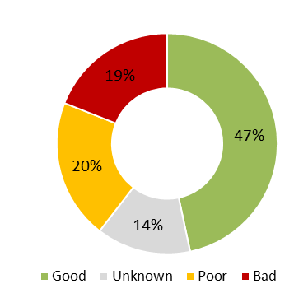
Note: The total number of assessments is 463 (one assessment per species).

The EU-level assessment indicates that 47% of all bird species have a good population status, down by 5 percentage points (pp) from 52% in 2015. The proportion of species with poor and bad status has increased from 32% to 39%, while the status of 14% is still unknown (compared with 16% in 2015) due to a lack of reliable data.

Birds — population trends at EU level
Figure 2a: Short-term (12-year) breeding bird population trends at EU level  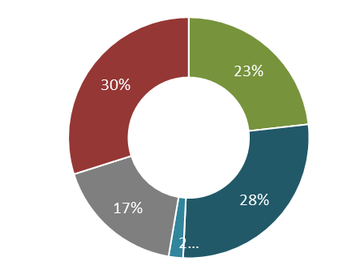 | Figure 2b: Long-term (38-year) breeding bird population trends at EU level  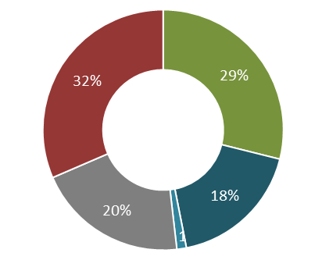
Note: Statistics based on 465 short-term and 467 long-term EU breeding population trends. Includes trends for a limited number of subspecies and biogeographical populations.

Member States reported population trends for both breeding and wintering bird populations for the short and the long term, i.e. for the past 12 years (2007-2018) and the past 38 years (1980-2018).
The data indicate that:
- almost a third (30%) of all assessed breeding bird species are on a downward short-term trend (the same percentage as in 2015);
- short-term breeding trends show 5% fewer species with increasing populations than in 2015 and a 7% increase in species with stable or fluctuating trends; ‘unknown’ assessments fell by 2%;
- slightly more long-term breeding trends are on the way down than on the rise (the opposite was true in 2008-2012); however, the proportion of ‘unknown’ long-term breeding trends dropped by 10 pp, from 30% to 20%; and
- for the 91 wintering population trends, the short-term situation is similar to that in 2015 (45% increasing, 29% decreasing); 54% of long-term trends are on the up and 13% going down (the proportion of the former has thus dropped by 9 pp, while that of the latter is almost the same).

Status and trends of birds according to their listing in the Birds Directive
Figure 3a: EU population status of Annex I and II, non-Annex I/II and all bird species | Figure 3b: EU short-term breeding population trends for Annex I and II, non-Annex I/II and all bird species
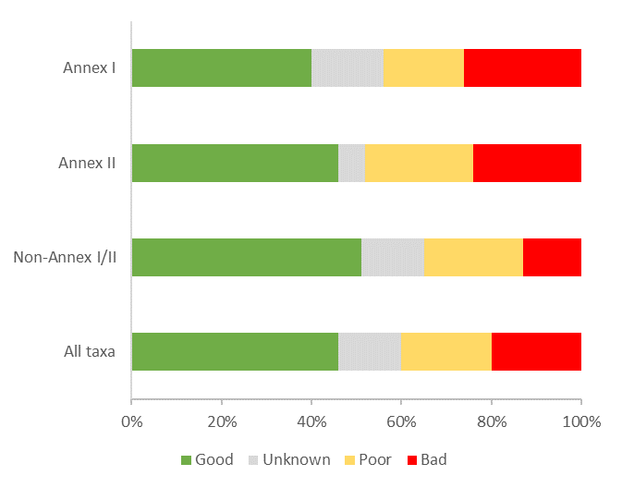 | 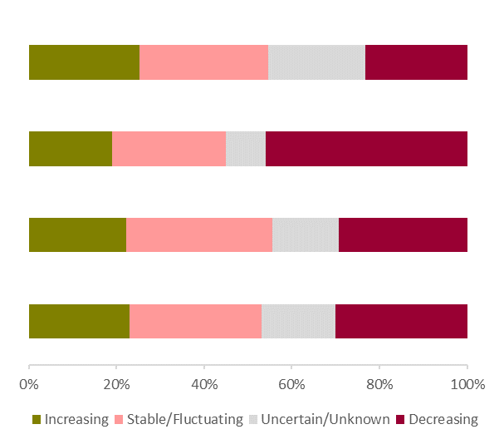
Note: The total number of assessments is 505. | Note: The total number of assessments is 465.

Analysis of the status and trends of species in Annexes I and II to the Birds Directive indicates that:
- the proportion of Annex I species with secure status decreased by 8 pp (from 48% to 40%) from 2015, while the proportion of those with poor and bad status increased by 6 pp (from 38% to 44%). This suggests that the status of several Annex I species has deteriorated, despite the special habitat conservation measures required under the Directive. The fact that the status of 16% of Annex I species is still unknown is of particular concern and underlines the need for improved monitoring systems for these species in the Member States;
- the proportion of Annex II (huntable) species with a good status was 9 pp lower (down from 55% to 46%) than in 2015, while the proportion with poor and bad status increased by 9 pp (from 39% to 48%); and
- as regards short-term population trends for breeding birds, Annex II species show by far the highest rate of downward trends – about 46%, i.e. twice the proportion for Annex I species (23%).
2.2 Habitat types
Of the 233 habitat types listed in Annex I to the Habitats Directive, 224 are terrestrial and nine are purely marine. The reported area for the former accounts for almost a third of the terrestrial area of the EU-28, equivalent to 1.3 million km². The area for the latter covers 0.4 million km² of EU waters.
The range of habitats is very wide. Some cover large areas, while others occur only in very small patches. Forest habitat types are the most numerous group in Annex I (35% of all types), followed by natural and semi-natural grasslands (14%). Groups such as temperate heath and scrub, sclerophyllous scrub, bogs, mires and fens, and rocky habitats each constitute only about 5% of the habitat types listed.
Conservation status of habitats
Figure 4a: Conservation status of habitats at EU level | Figure 4b: Conservation status per habitat group at EU level
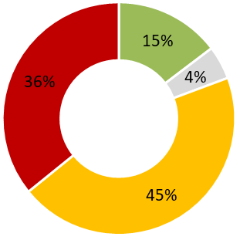 | 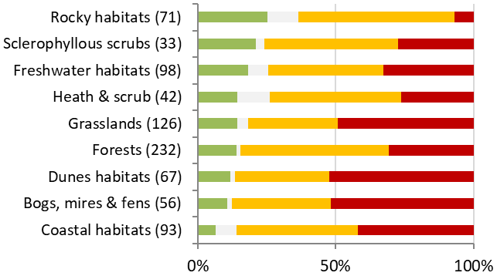
Note: Statistics based on number of EU habitat assessments (818). | Note: The number of assessments per group is indicated in parentheses. Marine habitats are part of the ‘coastal habitats’ group. The total number of assessments is 818.

The conservation status of habitats did not improve over the reporting period. Only 15% of the habitat assessments show good conservation status, compared with 16% in 2015. The vast majority indicate unfavourable status (45% poor and 36% bad, compared with 47% and 30% in 2015). While the level of poor status assessments has decreased by 2 pp and the level of bad ones increased by 6 pp, most of the changes do not reflect actual deterioration on the ground, but improvements in assessment methods at EU or Member State level.
Of the nine reported habitat groups, coastal habitats (which include marine habitat types) have the lowest proportion of ‘good status’ assessments. Dunes, bogs, mires and fens are most frequently assessed as having bad status (over 50%). Grasslands, which include some very species-rich habitats, are also among those with the highest proportion of ‘bad status’ assessments (49%). Grasslands that require active management are in a particularly bad state.
Gaps in knowledge for the nine marine habitats continue to be a problem. The conservation status of around 26% of Member States’ marine habitats remains unknown (compared with 4% for terrestrial habitats).

Trends in conservation status of habitats
Figure 5a: Conservation status trends of habitats with unfavourable (i.e. not good) or unknown status at EU level | Figure 5b: Conservation status trends of habitats with unfavourable (i.e. not good) or unknown status per habitat group at EU level
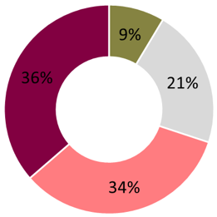 | 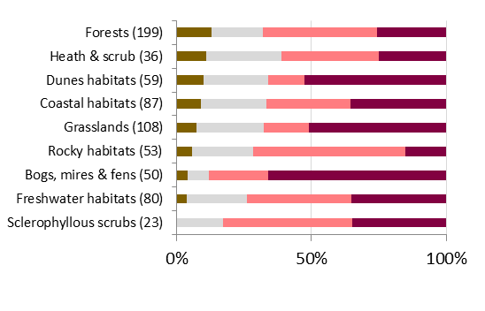
Note: Conservation status trends are based on EU habitat assessments (698). | Note: The number of assessments is indicated in parentheses. The total number of assessments is 698.

The status of 81% of the listed habitats is assessed as ‘poor’ or ‘bad’ at EU level. Only 9% of them show improving trends, while 36% show continuing deterioration. Deteriorating trends are observed in at least 25% of all assessments across habitat groups, except for rocky habitats (15%). Bogs, mires and fens, grasslands and dune habitats have the highest proportion of deteriorating trends (over 50% for each group). For grassland habitats, mainly hay meadows, Molinia meadows and several types of semi-natural dry grasslands show a deteriorating conservation status trend, illustrating their dependence on extensive farming practices that are still in decline across the EU. Forest habitats show the highest proportion of improving trends among the assessments (13%).
2.3 Species other than birds
Annexes II, IV and V to the Habitats Directive list 1 389 species of European interest. In some larger taxonomic groups such as molluscs, arthropods and vascular plants, the proportion of species covered by the annexes is very low. The best-represented groups are vertebrates, with 85% of amphibians, 70% of reptiles, 64% of mammals and 39% of freshwater fish species listed. Many unlisted species, including many of the more common species, benefit from measures under the Directive, including the protection of Annex I habitat types.
Conservation status of species
Figure 6a: Conservation status of species at EU level | Figure 6b: Conservation status per species group at EU level
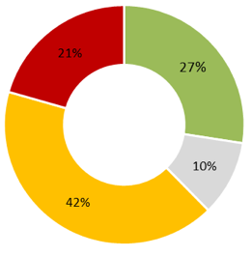 | 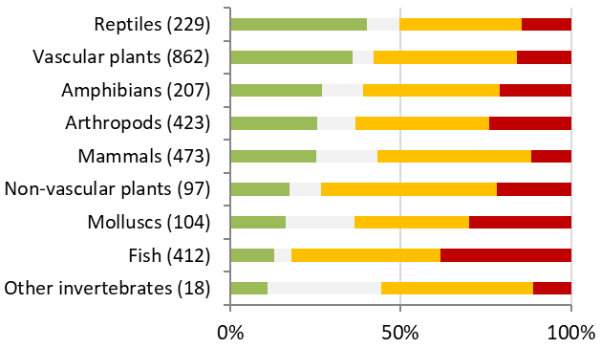
Note: Statistics based on number of EU species assessments (2 825). | Note: The number of assessments per group is indicated in parentheses. The total number of assessments is 2 825.

Over a quarter (27%) of species assessments indicate good conservation status, compared with 23% in 2015. 63% show poor or bad status, which is similar to the 2015 figure (60%). The number of ‘unknown’ assessments dropped from the last reporting period (from 17% to 10%), but remains significantly higher than for habitats (4%). At Member State level, the status of the majority of marine species (59%) is unknown, compared with only 8% of terrestrial species, suggesting that insufficient resources are devoted to monitoring them.
The species groups with the highest proportion in good status at EU level are reptiles and vascular plants (36% and 40% respectively). Around 30% of mollusc and fish species received a ‘bad status’ assessment.

Trends in conservation status of species
Figure 7a: Conservation status trends of species with unfavourable (i.e. not-good) or unknown status at EU level | Figure 7b: Conservation status trends of species with unfavourable (i.e. not-good) or unknown status at EU level, per group
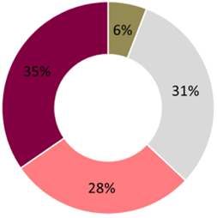 | 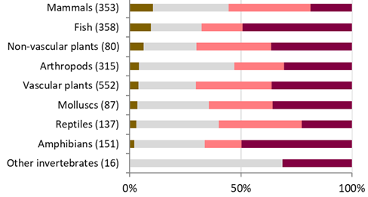
Note: Conservation status trends are based on EU species assessments (2 049). | Note: The number of assessments is indicated in parentheses. The total number of assessments is 2 049.

Of the 2 049 species assessed as having poor or bad conservation status at EU level, 35% are on a downward and 6% on an upward trend. The trend is unknown for another 31%. Except for mammals, fish and non-vascular plants (10%, 9% and 6% respectively), the proportion of species assessed as having poor or bad status, but with improving trends, remains below 5%. While fish show more upward trends than other species groups, they also show (together with amphibians) the highest proportion of deteriorating trends (close to 50%). Strong downward trends are reported for other species groups, e.g. grassland habitat specialists such as the marsh fritillary butterfly (Euphydryas aurinia) and the Jurinea cyanoides thistle.

Evolution in status and trends
3.1 Progress towards target 1 of the biodiversity strategy to 2020
On the basis of the information provided by Member States for this assessment, we determined the extent to which target 1 of the biodiversity strategy to 2020 had been achieved. The target was to halt the deterioration in the status of all species and habitats covered by EU nature legislation and achieve a significant and measurable improvement in their status, so that by 2020 (as compared with 2010 assessments) there would be:
- 100% more habitats assessments with a favourable or improving conservation status (i.e. 34% of the total);
- 50% more species assessments under the Habitats Directive with a favourable or improving conservation status (35%); and
- 50% more species assessments under the Birds Directive with a secure or improving population status (78%).

Figure 8: Progress towards target 1 (in % of assessments)
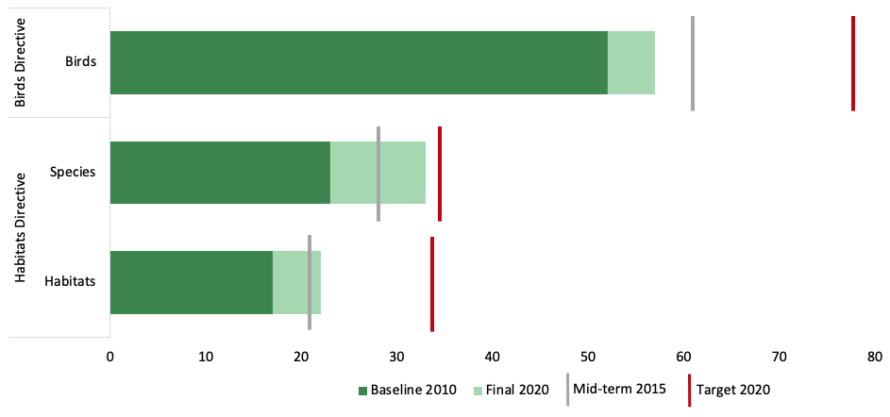
Note: Each bar represents the percentage of assessments with good status or improving.

There was limited progress from the 2010 baseline towards the 2020 targets, except in the case of non-bird species, where the target was almost reached. Continued deterioration for some habitats and species outweighs the improvements. The data reported in 2019 show that the proportion of species and habitats with deteriorating trends has even grown slightly: for birds from 20% to 23%, for non-bird species from 22% to 26% and for habitats from 30% to 32%.
The 2020 target of favourable or improving assessments for 34% of habitat assessments has not been met (the shortfall is 12 pp). However, the proportion of species other than birds whose status is assessed as favourable or improving almost reached the 2020 sub-target of 35% (shortfall 2 pp). Bird population trends present a mixed picture, with an increase in the number of secure and improving species between 2010 and 2015, but some deterioration (-3 pp) from 2015 to 2020, leaving a gap of over 20 pp from the 78% target. Target 1 of the biodiversity strategy to 2020 was therefore not reached.
3.2 Improvements in the Member States
‘Conservation status’ is known to change slowly and is therefore not a very sensitive short-term indicator for improvements. Also, EU-level assessments can hide improvements in individual Member States. Therefore, country-level positive and stabilising trends (where a trend genuinely changes from declining in the previous reporting period to stable in the current one) are positive developments that should be taken into account and analysed on top of positive changes in status.
On average, 6% of the Member States’ national/regional habitat assessments show improvements, most frequently for forests and freshwater habitats (10% of all assessments in the group), heath & scrubs (7%), bogs, mires and fens, and dune habitats (6%). An example of an improving coastal habitat are the Baltic coastal meadows in Finland.
Similarly, an average of 6% of all national/regional assessments for species other than birds show improvements. The largest number of improvements is for mammals (9% of all recorded mammal assessments show improvements), followed by fish (8%) and vascular plants (5%). Examples for mammals include beavers (Castor fiber), grey seals (Halichoerus grypus) and harbour seals (Phoca vitulina).
For birds, improvement at national level is defined differently, as there is no national assessment of conservation status and status trend. Therefore, a positive short-term population trend or a stabilisation after a negative long-term trend in the previous national report is considered an improvement. In total, there are 2 148 Member States’ reports showing improvements according to the criteria above. Globally this corresponds to 397 bird (sub)species which improve in at least one Member State in at least one reported season. Around 44% of all birds with improving trends are migratory waterbirds. Many of these species are also categorized as marine species according to the EU Marine Strategy Framework Directive and make up 33 % of all improvements. Farmland and forest bird species account for about 9% each. Examples of improving bird species are white-tailed eagle (Haliaeetus albicilla), crane (Grus grus), red kite (Milvus milvus) and great white egret (Ardea alba).
3.3 Progress on data quality
Assessing progress on conservation status requires appropriate monitoring systems to be in place in all Member States. In many cases, however, the reported information comes from partial surveys carried out for other purposes. In other cases, Member States do not have suitable data and rely on expert opinion. For Habitats Directive habitats and species, over 40% of the reported information comes from partial surveys and over 20% is based on expert judgment only. For bird data, over 30% of the information is from partial surveys and over 15% based on expert judgment. This reporting round shows that limitations due to poor or incomplete data still exist (albeit to widely varying degrees between Member States and on a smaller scale than in 2015). Nevertheless, the data presented here are a milestone in assessing the state of nature in the EU and provide a strong basis for improving reporting, assessment and implementation to be able to achieve the aims of the EU biodiversity strategy for 2030.

Pressures and responses
4.1 Pressures
Europe is one of the most densely populated regions in the world. Human activity has shaped its landscapes over centuries and contributed much to its biodiversity, e.g. semi-natural habitats such as extensive hay meadows and semi-natural dry grasslands. However, human activity has also caused deterioration and decline for many native species and habitat types — particularly (and much faster) in the past 100 years.
Member States reported on the main causes of species loss and habitat degradation for each species and habitat. Overall, they provided 67 000 records using a list of 203 individual pressures from 15 categories (from ’A-Agriculture’ to ‘X-Other’).

Figure 9: Distribution of level-1 pressure categories among habitats, non-bird species and birds
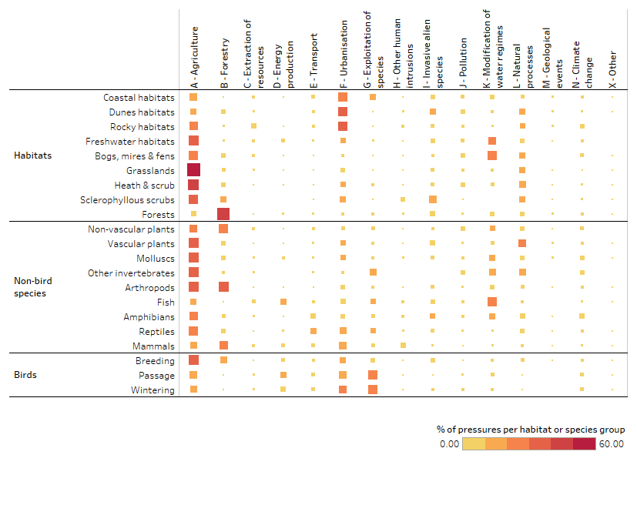
The most frequently reported pressures for both habitats and species stem from agriculture, which reflects the relative scale of agricultural land-use and changes in farming practices (intensification and abandonment of extensive agriculture). Extensive agricultural management creates and maintains semi-natural habitats with diverse fauna and flora. Since the 1950s, however, more intensive and specialised farming has contributed increasingly to ongoing biodiversity loss. Grasslands, freshwater habitats, heaths and scrubs, and bogs, mires and fens have been most severely affected. Semi-natural habitats depending on agriculture, such as grasslands, are particularly threatened and their conservation status is significantly worse than for other habitat types that do not depend on agriculture (45% are assessed as bad, as compared with 31% for other habitats). Compared to 2015, assessments of agricultural habitats show an overall deterioration in conservation status: good status decreased from 14% to 12% and bad status increased from 39% to 45%. Only 8% of agricultural habitats show an improving trend, whereas 45% are deteriorating. Many species of birds, reptiles, molluscs, amphibians, arthropods and vascular plants are also impacted and farmland biodiversity continuous to decline.
Overall, across categories, the modification of hydrological regimes (including multipurpose changes under category ‘K-Modification of water regimes’ and hydrological changes attributed to other categories, e.g. A-Agriculture) is the second most frequently reported type of pressure, followed by urbanisation and pollution:
- pressures relating to modifications of the water regime stem from multiple sources. For example, agricultural drainage activities and hydropower installations make up 14% and 13% of all hydrology-related pressures. Unsurprisingly, pressures in this category are particularly relevant for freshwater habitats and fish species, but also for carbon-rich ecosystems such as bogs, mires and fens;
- key pressures relating to urbanisation include sports, tourism and leisure activities, and particularly affect marine/coastal habitats. The conversion of natural and semi-natural land to housing, settlement or recreational areas mainly affects grassland habitats and forests; and
- pollution is a key pressure for many habitats and species, and agricultural activities account for almost half (48%) of the pressures relating to pollution, followed by mixed-source pollution (28%, as reported under category ‘J-Pollution’) and urbanisation (21%).
There are differences in the relative impact of pressure categories across habitats and species groups:
- forestry activities are the second largest pressure category reported for species, affecting in particular arthropods, mammals and non-vascular plants. Many forest-dependent species are reported to be affected by the removal of dead, dying and old trees (including salvage logging), forest management reducing old-growth forests and clear-cutting. Forestry is also the dominant group of pressures reported for most of the Annex I forest types which show a deterioration in conservation status compared to 2015: good status decreased from 16% to 14% and assessments revealing a bad status increased from 27% to 31%.
- species exploitation is the biggest pressure for wintering and passage birds; it involves illegal shooting or killing, hunting and incidental killing. Recent research in 26 European countries has calculated an annual hunting take of at least 52 million birds. Other species affected by exploitation include fish, mammals and reptiles. Fish are among the most affected groups due to marine and freshwater harvesting. The impact on mammals is twofold:
  - large terrestrial mammals such as the wolf (Canis lupus), Eurasian lynx (Lynx lynx) and Eurasian otter (Lutra lutra) are mostly exposed to illegal killing;
  - small cetaceans such as the short-beaked common dolphin (Delphinus delphis) and harbour porpoise (Phocoena phocoena) are mainly impacted by bycatch in fishing gear and other effects of marine harvesting activities such as reduction of prey populations and disturbance of species; marine mammals are also often impacted by pollution from various sources, the operation of shipping and ferry lanes (due to underwater noise and ship-strikes) as well as by military operations (through collisions with vessels, disturbance by military sonar).
- hydropower installations are the single most important source of energy-related pressures for migratory and freshwater fish. While pressures from wind, wave and tidal power present risks to many species, birds are also especially vulnerable to electricity and communication transmission infrastructures. The expansion of renewable energy is a key EU policy to help address climate change (which itself is putting significant and growing pressure on biodiversity), but inappropriately designed and located developments can lead to additional pressures on protected species and habitat types;
- invasive alien species (IAS) represent a major and growing threat to native European flora and fauna. Their impact has increased significantly since the last reporting period. ‘Invasive species of Union concern’ account for around 20% of the pressures reported in this category, while many more impacts are reported from IAS that are not yet listed as species of Union concern. IAS affect habitats more than species, but are also known to have a direct impact on certain bird, amphibian, fish and vascular plant species;
- even though climate change was not reported as a particularly relevant pressure in 2013-2018, future scenarios predict that it will have a dramatic effect on European plants and animals and lead to accelerated biodiversity loss and desertification in many areas. The most frequently reported pressures relating to climate change were droughts and decreases in precipitation; these accounted for 5% of all reported pressures affecting amphibians.
4.2 Responses (conservation measures)
In parallel to the reporting on pressures, Member States reported whether or not the majority of the measures needed for a species or a habitat of EU importance that require Natura 2000 site designation were taken. Such measures aim to maintain or to restore good status for species and habitats, and involve specific action on the ground to mitigate and remove the impact of past and present pressures. Member States are required to take the necessary conservation measures for Natura 2000 sites.
Their national reports indicate that:
- most measures are applied both within and outside the Natura 2000 network;
- for around 60% of Member States’ habitats the necessary measures were reported as being taken, mainly to maintain the current status or to restore the habitats’ structure and functions; only 4% of the reported measures taken are to increase the habitat area;
- conservation measures to keep agricultural areas in suitable ecological condition, thereby responding to pressures from farming, are by far the most common;

Figure 10: Implementation status of habitat conservation measures (in % of all habitat type assessment made by Member States)
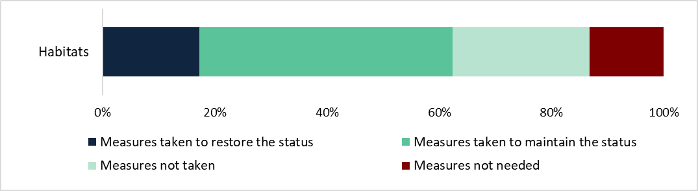

- the situation is similar for species. Around 40% of the reports for birds and 50% of those for species other than birds indicate that measures were taken. The biggest part of the measures taken for non-bird species aims to maintain their current status. Restoration measures play a less prominent role.

Figure 11: Implementation status of species conservation measures (in % of all species assessments made by Member States for species that require site designation)
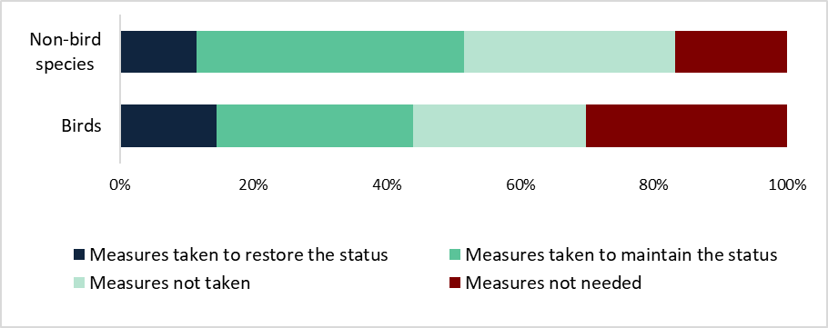
In spite of Member States’ measures, conservation status and trends did not improve over the reporting period; in fact, for many species and habitat types (including those for which Natura 2000 designation is a key conservation delivery mechanism) they deteriorated further. It is therefore clear (and confirmed by the reports) that Member States failed to take the necessary conservation measures (at least to the extent required) and in some cases even adequately to identify them.
Analysis of the effectiveness of measures shows a positive correlation between measures taken and good conservation status for most habitats and species groups. Furthermore, proactive restoration measures (e.g. to restore structure and functions) do lead to improvements.
4.3 Restoration needs for habitats
For a habitat type, ‘good conservation status’ means that its natural range, the extent of its area, and its structure and functions are all sufficiently large and in good condition; also, its future prospects are positive. In this context, ‘restoration’ refers to:
- improving the condition (i.e. quality) of existing areas of the habitat through targeted conservation measures; and
- ensuring sufficient surface area through habitat (re)creation (i.e. creating additional areas of a habitat, such as restoring wetland habitat from formerly drained agricultural land or extending the area of native protected woodland habitats).
An assessment of restoration requirements for Annex I habitat types shows that needs vary significantly between habitat groups and biogeographical regions.

Figure 12: Proportions of area covered by Annex I habitat groups that need to be improved, as reported by Member States
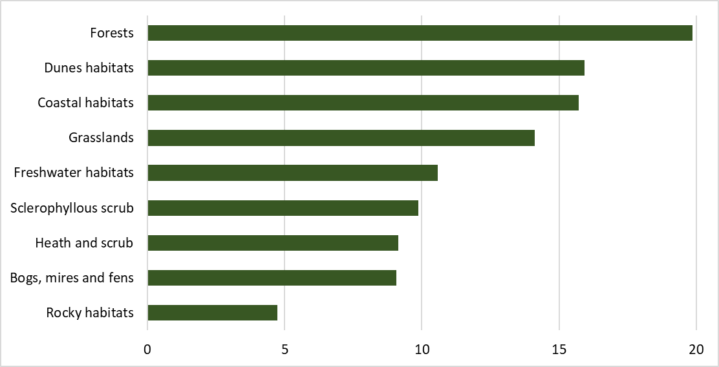
Note: The United Kingdom and habitat 8310 (natural caves) were excluded from the calculations.
Some key findings of the assessment are that:
- the area of protected habitats in need of improvement is estimated to be on average about 215 000 km² (or 5% of EU-27 territory). Forests have the greatest need, with about 19.5% (about 100 000 km²) requiring improvement, followed by coastal habitats with 16% (about 46 000 km²), grasslands with 13.5% (about 33 000 km²), freshwater habitats with 10.5% (about 13 500 km²) and bogs, mires and fens with 9% (about 10 900 km²);
- at least 11 000 km² of Annex I habitats need to be (re)created to add to the existing area in order to ensure the long-term viability of all habitat types. The habitat groups with the largest areas for (re)creation are forests (4 600 km²), grasslands (1 900 km²), bogs, mires and fens (1 700 km²), and coastal habitats (1 400 km²). Overall, this applies to 1-1.5% of the total existing area of these habitat groups;
- the biogeographical regions with the greatest need to improve the condition of existing habitat areas are the Continental, Mediterranean, Atlantic, marine Atlantic and Boreal regions;
- many of the Annex I habitats requiring restoration are particularly carbon-rich, offering significant potential to store and sequestrate carbon in the above- and below-ground biomass and in the soil. About 16% of these carbon-rich areas need to be improved (154 000 km²). Their restoration and maintenance could contribute significantly to climate change mitigation; and
- because the monitoring data are insufficient, the Annex I habitat areas in need of restoration are likely to be much greater than current estimates. Comprehensive mapping of carbon- and nature-rich areas, the effects of management, habitat condition and other factors is needed to inform decision-making on restoration priorities. Restoration needs for birds and other species should also be addressed, but data on these are currently not reported.

The role of the Natura 2000 network
The Natura 2000 network is made up of special protection areas (SPAs) classified under the Birds Directive and special areas of conservation (SACs) designated under the Habitats Directive. It represents the largest coordinated network of protected areas in the world and is the principal tool in the EU for maintaining/restoring the conservation status of protected habitats and species.
As of end-2019, Natura 2000 consisted of 27 852 sites with an area of 1 358 125 km². It covered 17.9% of the EU’s land territory and 9.7% of its marine waters. The coverage varies significantly between Member States: its terrestrial coverage ranges from 8% in Denmark to 38% in Slovenia and its marine coverage from 2% in Italy to 46% in Germany.
Since the last reporting period:
- the marine network has doubled in surface area;
- the number of designated SACs has more than doubled with 7262 new designations; and
- the number of sites reported to have comprehensive management plans has increased significantly.

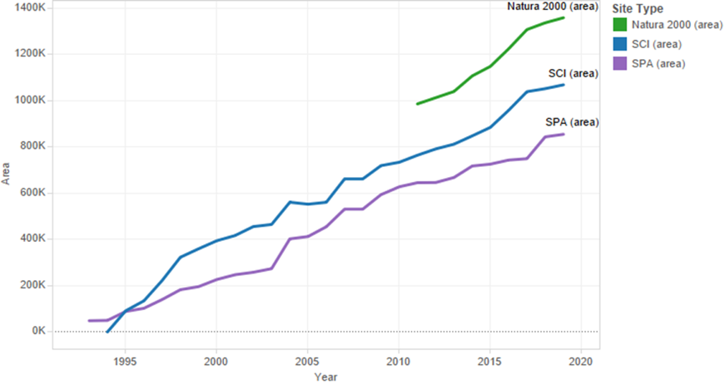
Figure 13: Cumulative surface area of Natura 2000 network in km², 1993-2019

Note: Numbers are for EU-28 and include SPAs, SCIs, SACs and proposed SCIs (together forming the blue SCI line). In many cases, Natura 2000 sites are (partially or totally) both a SPA and a SAC/SCI. Due to GIS data-handling limitations, the Natura 2000 area was only systematically calculated after 2010.
Source: Natura 2000 databases
5.1 Effectiveness of Natura 2000
Current reporting does not provide information that would allow a direct comparison of the conservation status of species and habitats inside and outside Natura 2000. Therefore, we have examined other potential indicators for effectiveness, such as the link between species’ and habitats’ representation in the network and the proportion of them showing good status or improving trends. The results, based on Member State assessments, show that:
- species and habitats are on average more likely to have good conservation status if their habitat area or population is well represented (> 75%) in the network compared to those that are less well represented. This is most obvious for dune habitats and forests, and for amphibians and fish; and
- habitat types with a high representation (>75%) in Natura 2000 sites show (slightly) more improvement and less deterioration than those that are less well represented. With reported improvement of over 8%, bogs, mires and fens appear to have particularly benefited from Natura 2000 coverage. The habitats that saw the most significant improvements, e.g. dry Atlantic coastal heaths with Erica vagans and coastal dunes with Juniperus species, are widely protected in the network.

Figure 14: Changes in conservation status and trends for Annex I habitats within different Natura 2000 coverage classes (<35 %, 35%-75%, >75%)

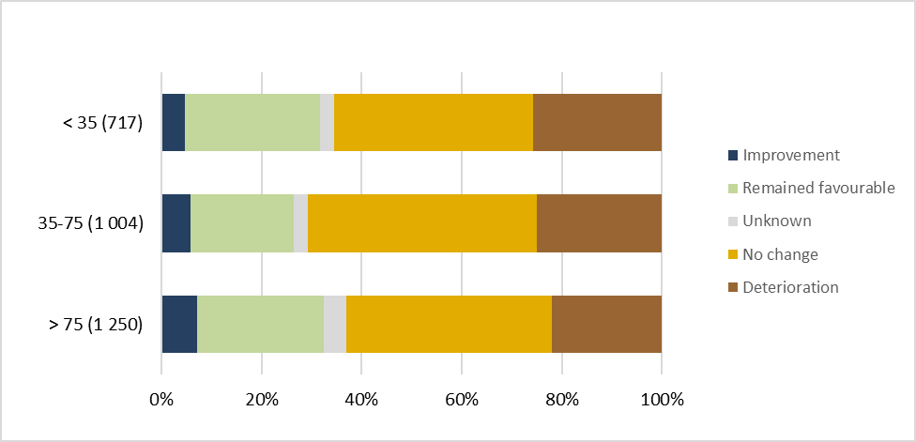
Note: ‘Improvement’ corresponds to poor or bad assessments that improved or became good, ‘remained favourable’ to assessments that kept their good status, ‘no change’ to poor or bad assessments that did not improve or deteriorate, ‘deterioration’ to poor or bad assessments that further deteriorated or changed from good to poor or bad, and ‘unknown’ to assessments without a trend. The number of assessments per group is indicated in parentheses. The total number of assessments is 2 970.

Overall, the reported information does not allow us to draw firm conclusions as to the effectiveness of the Natura 2000 network. This is due especially to limited monitoring, in particular the common practice of monitoring only a sample of Natura 2000 sites. For a satisfactory assessment of the effectiveness of Natura 2000-related measures, monitoring should involve collecting more data on areas inside and outside the network and on the quality of conservation management.
Despite some positive indications of the network’s contribution to conservation status, the available information strongly suggests that its full potential has still to be unlocked and that a significant implementation gap remains to be addressed.

Conclusions and outlook
This conservation status assessment constitutes the largest and most complete health check of nature ever undertaken in the EU. It provides a strong basis on which to evaluate implementation of the nature directives and a robust baseline for measuring progress under the new biodiversity strategy for 2030.
The assessment shows that the EU has not yet managed to stem the decline of protected habitat types and species of EU conservation concern. The key land- and water-use pressures that have led to the degradation of nature still persist, resulting in a significant shortfall from the 2020 target of halting and measurably reversing the deterioration in the status of species and habitats.
Inspiring success stories from across the Member States show what can be achieved through targeted action, often supported through initiatives under the EU LIFE programme or dedicated agri-environment schemes under the common agricultural policy. However, such success is not being achieved on a sufficient scale.
Progress in implementing both directives over the last 6 years (significant extension of the Natura 2000 network and more sites with management plans) has not been sufficient to improve conservation status. Establishment of a fully functional network of protected areas is still incomplete, especially in the marine environment. Furthermore, the necessary conservation measures, based on clearly defined conservation objectives, have yet to be put in place for many of the sites. The requisite investment in nature, inter alia as regards restoration within and beyond the protected area network, has not materialised. Nature requirements have not been sufficiently incorporated into key land- and water-use policies to overcome the negative pressures that can arise from sectors such as agriculture and forestry. Fisheries management measures have still to be agreed and put in place for many marine Natura 2000 sites. In addition, climate change is a growing threat, with predictions of a steep rise in pressures and both direct and indirect effects on species and habitats, such as from changes in land use and habitat location or quality.
This assessment underlines the need for a step-change in action if we are to have any serious chance of putting Europe’s biodiversity on a path to recovery by 2030, as envisaged in the new biodiversity strategy. Failure to do so will mean the continued erosion not only of our shared natural heritage, but also of the vital services it provides, which ultimately underpin human health and prosperity.
The new biodiversity strategy to 2030 provides the necessary framework for this transformative change. Together with other initiatives under the Green Deal, it sets out a highly ambitious and practical programme of action aimed, inter alia, at expanding the coverage of legally protected and effectively managed areas, while proposing a plan for restoring the EU’s nature.
This nature assessment underlines the significant potential for restoring protected habitats, as regards both their current condition and the additional surface area that is needed to achieve favourable conservation status. This includes restoring carbon-rich habitats that can deliver climate mitigation co-benefits. The assessment is also directly relevant to measuring the success of action under the strategy to address wider key land- and water-use pressures, particularly in relation to agriculture, which gave rise to the highest number of bad species and habitats assessments across the Member States. In combination with the ‘farm to fork’ strategy, action to promote organic farming, reduce the use and risk of pesticides, protect and restore soil ecosystems, and increase landscape features on farmland should support the recovery of species and habitats protected under the nature directives, including pollinators and their habitats.
The new biodiversity strategy emphasises that the fight against biodiversity loss must be based on sound science. Member States should continue to improve the quality and completeness of their monitoring systems to underpin future reporting. Earth observation / remote sensing, other technologies and tools (e.g. modelling), and the outcomes from research/innovation activities and citizen science could complement and support current monitoring and reporting. This potential should be tested and harnessed to facilitate the reporting bodies’ work.
The next assessment of the state of nature in the EU, planned for 2026, should make a significant contribution to gauging progress towards the nature targets under the new biodiversity strategy.

Directive 2009/147/EC of the European Parliament and of the Council of 30 November 2009 on the conservation of wild birds (OJ L 20, 26.1.2010, p. 7).
Council Directive 92/43/EEC of 21 May 1992 on the conservation of natural habitats and of wild fauna and flora (OJ L 206, 22.7.1992, p. 7).
This report still includes data from the United Kingdom, which left the EU in January 2020. For the first time, it includes data from Croatia, which joined the EU in July 2013. Romania was the only Member State that did not provide a report for birds.
4 State of nature in the EU — results from reporting under the nature directives 2013-2018, European Environmental Agency; available together with additional online materials, including summaries by Member State, at: https://www.eea.europa.eu/themes/biodiversity/state-of-nature-in-the-eu/state-of-nature-2020 https://ec.europa.eu/environment/nature/knowledge/rep_habitats/index_en.htm
Alpine, Boreal, Mediterranean, Atlantic, Continental, Pannonian, Black Sea, Macaronesian, Steppic.
Atlantic, Baltic, Black Sea, Macaronesian, Mediterranean.
See the EEA report for further details on the assessment methods under the Birds and Habitats Directives.
State of nature in the EU — results from reporting under the nature directives 2007–2012, EEA (2015), Technical report No 2/2015, ISSN 1725-2237, Publications Office of the European Union, 2015.
For details see EEA report; https://www.eea.europa.eu/themes/biodiversity/state-of-nature-in-the-eu/state-of-nature-2020
Habitat types of this group include lowland hay meadows (6510) and mountain hay meadows (6520)
Molinia meadows on calcareous, peaty or clayey-silt-laden soils (Molinion caeruleae) (6410)
Habitat types of this group include semi-natural dry grasslands and scrubland facies on calcareous substrates (Festuco-Brometalia) (6210) and Nordic alvar and precambrian calcareous flatrocks (6280)
Annex II: species requiring designation of SACs (Natura 2000 sites); Annex IV: strictly protected species; Annex V: species whose taking in the wild and exploitation may be subject to management measures.
Communication from the Commission to the European Parliament, the Council, the Economic and Social Committee and the Committee of the Regions, Our life insurance, our natural capital: an EU biodiversity strategy to 2020 (COM(2011) 244 final).
covered by the Agreement on the Conservation of African-Eurasian Migratory Waterbirds (AEWA )
Halada, L., Evans, D., Romão, C. and Petersen, J. E., 2011, 'Which habitats of European importance depend on agricultural practices?', Biodiversity and Conservation, 20(11) 2 365–2 378.
Hirschfeld, A. et al., 2019, ‘Bird-hunting in Europe: an analysis of bag figures and the potential impact on the conservation of threatened species’, British Birds: 153-166.
The Habitats Directive hardly covers marine fish (limited to several species of anadromous fish).
Regulation (EU) No 1143/2014 on the prevention and management of the introduction and spread of invasive alien species contains a list of IAS of Union concern (OJ L 317, 4.11.2014, p. 35).
See for example: IPBES (2018), The IPBES regional assessment report on biodiversity and ecosystem services for Europe and Central Asia, Rounsevell, M. et al. Secretariat of the Intergovernmental Science-Policy Platform on Biodiversity and Ecosystem Services, Bonn, Germany. 892 pages.
Calculations of restoration needs exclude the UK.
Under the Habitats Directive, Member States propose ‘sites of Community importance’ (SCIs) that the Commission then includes in biogeographical lists. Member States then have 6 years to designate the SCIs as SACs.
These are the figures for the marine areas within 200 nautical miles of the coastline; they do not include Natura 2000 sites on the extended continental shelf (relevant for Ireland, Portugal and the UK).
https://ec.europa.eu/easme/en/life
Communication from the Commission to the European Parliament, the Council, the European Economic and Social Committee and the Committee of the Regions, EU biodiversity strategy for 2030 — bringing nature back into our lives (COM/2020/380 final); https://eur-lex.europa.eu/legal-content/EN/TXT/?uri=CELEX:52020DC0380
Communication from the Commission to the European Parliament, the Council, the European Economic and Social Committee and the Committee of the Regions, A ‘farm to fork’ strategy for a fair, healthy and environmentally-friendly food system, (COM/2020/381 final); https://eur-lex.europa.eu/legal-content/EN/TXT/?uri=CELEX:52020DC0381

