

**Progress report on the internal energy market**

**1.** **Introduction** 3

**2.** **Electricity wholesale markets** 4

**2.1.** **Key indicators:** 4

**2.1.1.** **Wholesale prices - indications that markets deliver** 4

**2.1.2.** **Geographic scope of electricity markets - still work to do to overcome fragmentation** 6

**2.1.3.** **Market concentration - dominance of incumbents remains an issue in many countries** 7

**2.2.** **Key regulatory developments** 8

**2.2.1.** **A unique project: EU market coupling** 8

**2.2.2** **Comprehensive harmonisation of trade and system operation rules through network codes - a new form of collective EU-wide energy harmonisation** 9

**2.2.3.** **‘Clean Energy for all Europeans’ Package: Progress made putting in place new electricity market design** 10

**2.2.3.1.** **Unblocking electricity borders – the "70 % rule"** 11

**2.2.3.2.** **More coordinated and less harmful capacity mechanisms** 12

**2.2.3.3.** **Proper implementation of the unbundling rules for storage** 14

**3.** **Gas wholesale markets** 16

**3.1.** **Key indicators: Concentration, liquidity and convergence** 16

**3.2.** **Key regulatory developments** 19

**3.2.1.** **Market mergers** 19

**3.2.2.** **Gas Network codes** 19

**3.3.** **Decarbonisingthe gas sector** 20

**3.3.1.** **Integrating bio-methane and small scale producers** 20

**3.3.2.** **Gas quality issues** 21

**3.3.3.** **Preparing the market and infrastructure for hydrogen** 22

**4.** **Retail Markets** 24

**4.1.** **Market concentration** 24

**4.1.1.** **Electricity** 24

**4.1.2.** **Gas** 24

**4.2.** **Retail prices (including price components)** 26

**4.2.1.** **Electricity prices** 26

**4.2.2.** **Gas Prices** 27

**4.3.** **State interventions in retail electricity and gas prices** 28

**4.3.1.** **The household segment** 29

**4.3.2.** **The non-household segment** 30

**4.4.** **Consumer protection and empowerment** 31

## **Introduction**

While the internal market has often been considered as an instrument to keep prices for consumers in check and set efficient investment signals for investors, it has become clear in recent years that it is also of key importance for delivering on the EU’s ambitious climate targets. The integration of 27 national energy systems into one EU-wide market is crucial for efficient decarbonisation, as it will allow renewable energy to be traded across borders, benefiting from diversity and complementarity of the generation potential in the different EU regions. Cross-border markets can save significant CO2 emissions from fossil backup generation which would be necessary in fragmented national energy systems. Well-connected markets also improve security of supply.

Despite all efforts involving public spending, it alone will not be able to cover the enormous investments needed for the energy transition. Only well-organised and well-regulated markets will be able to mobilise the private investments needed to bring about a carbon-free economy. A fully integrated and well-functioning internal energy market is the most efficient means of ensuring i) the needed price signals for investments in green energy and technologies, ii) affordable energy prices, and iii) secure energy supplies on a least-cost path to climate neutrality[1].

The ‘Clean Energy for all Europeans’ Package, and in particular the new electricity market design rules adopted in 2019[2], paved the way to better cope with the new realities of energy markets increasingly dominated by renewable energy production, and to foster consumer participation in energy markets. It enables renewables to become the new backbone of the electricity system. The “Clean Energy for all Europeans” Package has also prepared the ground for better use of interconnectors between Member States (see section 2.2.3.1 for more detail). Clear rules to maximise usage of interconnection capacity will boost cross-border trade, allowing energy resources to be used more efficiently in the whole EU. The implementation of the comprehensive set of technical EU Regulations (network codes) is progressing with good results, as evidenced by the successful roll-out of EU market coupling in electricity, or the success in diversifying supplies and increasing liquidity in gas markets (see section 2.2.1 for more detail).

However, shortcomings still exist in the energy market, both at retail as at wholesale level, which unnecessarily increase costs for consumers and industry. Fixing these shortcomings is, therefore, a crucial aspect for a successful recovery and the foundation for the transition of the economy towards climate neutrality. The need to decarbonise the energy system also brought about new challenges, such as designing state interventions needed to support the energy transition in a manner that does not unduly hamper or fragment the internal market. Questions of market compatible support schemes for renewable energy or for traditional generation (‘capacity mechanisms’) have had a growing impact on the functioning of the market in recent years. The ‘Clean Energy for All Europeans’ Package addressed this problem and includes dedicated rules to optimise such state interventions.

The year 2020 brought great challenges due to the COVID crisis. Energy markets had to cope with the impact of social distancing measures which suddenly reduced energy demand and radically changed the behaviour of hundreds millions of Europeans. Despite increased volatility and fluctuating liquidity, the internal energy market withstood the shock and proved its resilience in the face of the crisis, while power systems successfully coped with record levels of renewable electricity.

In line with requirements in the Governance Regulation[3], and applicable sectoral legislation[4], this Report analyses the overall progress made in creating a complete and operational energy market and, particularly, in implementing the Gas and Electricity Directives.

## **Electricity wholesale markets**

### **2.1. Key indicators:**

### **2.1.1. Wholesale prices - indications that markets deliver**

Recent observations about prices at wholesale level decreasing in a mid-term view since 2009[5] have been found to be true for the last 2 years. While other factors, such as the rapid growth of renewable generation, contribute to this development, the steady decline of prices at wholesale level provides evidence that competition has tangible effects at wholesale level[6].

After increasing between 2016 and 2018, wholesale prices fell abruptly in 2019 as renewable penetration reached new records, coal and gas prices dropped and demand remained subdued. The decrease in prices across the continent was uneven, which resulted in growing price divergence among different regional markets. In the first half of 2020, as compared with the same period in 2019, prices fell between 30% in some southern European regional markets to up to 70% in some northern regions. The rising differences could be explained by insufficient interconnection capacities, renewable generation rising unevenly across markets, and a significantly strengthened CO2 price, which particularly affected Member States which have a stronger presence of fossil fuels in the generation mix. In 2020, all these trends were magnified due to the negative impact of COVID on economic activity that has caused a significant drop in the demand for electricity, which, together with rising renewable penetration and falling gas prices, has pushed wholesale prices to very low levels[7].

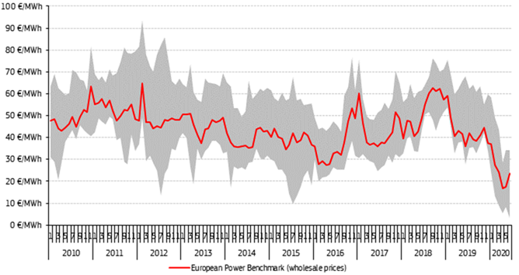

**Figure 1: Wholesale electricity prices lowest and highest regional prices**

Source: Platts, European Power Exchange

Note: The grey background represents the difference between maximum and minimum price

### **2.1.2. Geographic scope of electricity markets - still work to do to overcome fragmentation**

The further implementation of market coupling has brought tangible progress in improving supply opportunities across national borders (see section 2.2.1 below for more detail). There are indications that cross-border competition is increasing in certain regions, such as the Nordic region, and electricity imports and exports have been steadily increasing in recent years.

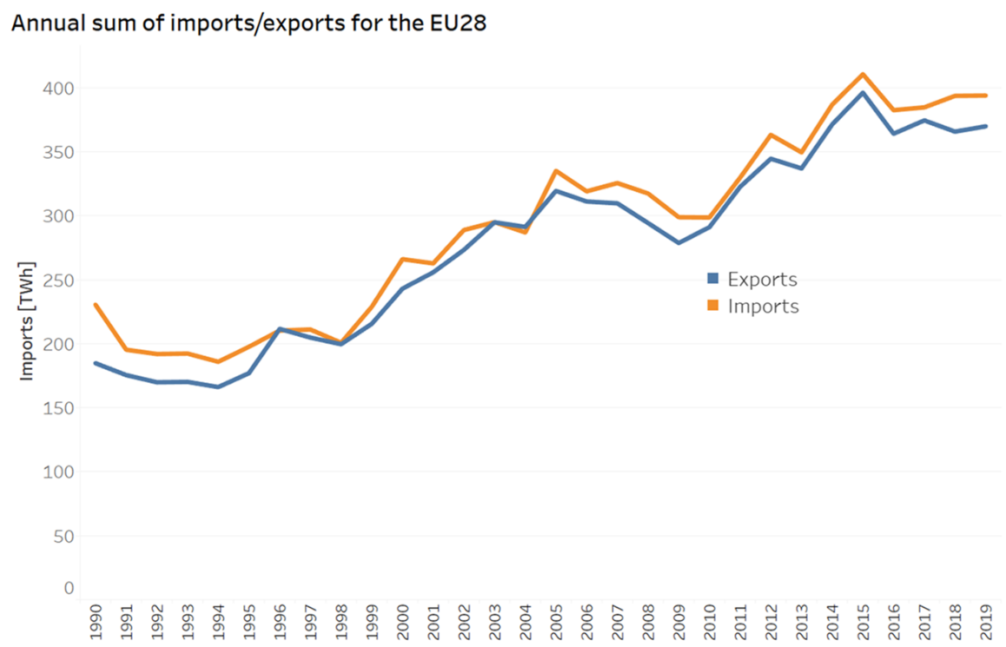

**Figure 2: Annual sum of imports/exports for the EU 28**

*Source: “*[*EUROSTAT*](https://appsso.eurostat.ec.europa.eu/nui/show.do?dataset=nrg_cb_e&lang=en) *[NRG_CB_E]”*

However, the analysis of the structure of EU electricity markets shows that conditions for supply and demand still differ significantly between most Member States, and that continued efforts to remove cross-border barriers are necessary[8]. Rolling out EU-wide market coupling and fully implementing the EU network codes and guidelines, which are meant to reduce existing technical barriers, will be crucial to overcoming the remaining fragmentation of EU markets.

### **2.1.3. Market concentration - dominance of incumbents remains an issue in many countries**

Functioning energy markets require a minimum degree of competition. The lower the market concentration, the higher the degree of potential competition is. In general, markets with higher levels of competition (i.e., lower concentration) show a lower price level than markets dominated by one or few players. An analysis of how competition developed in the European electricity wholesale market shows that more than 20 years after market liberalisation began, incumbents still hold a dominant position in a majority of Member States. In some countries, incumbents even hold market shares of over 80%, coming close to a monopoly. It should be noted that the size of a country will strongly influence the level of market concentration. Small and unconnected markets are not likely to support a large number of suppliers. Moreover, the tendency to regulate prices in these countries has often proven to be an additional barrier for entrants that wish to enter into competition with the established incumbents[9].

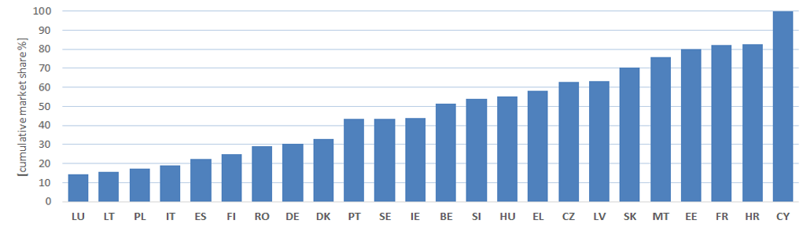

***Figure 3: Market share of largest electricity generation companies in 2018***

*Source: DG ENER country datasheets based on Eurostat surveys on* [*electricity*](https://ec.europa.eu/eurostat/statistics-explained/index.php/Electricity_market_indicators) *markets indicators*

Figure 3 shows that despite liberalisation, the share of the main generator in national production remains high in many countries. Therefore, enabling competition at generation and supply level needs to remain a priority for national and EU energy policy, including through competition law enforcement. Figure 3 also shows the benefits of linking markets across borders, as more physical interconnection and more efficient electricity trading systems like market coupling can at least partly substitute supply alternatives that are lacking at national level, to the benefit of consumers. Market-viable renewable electricity also has facilitated the entry of new market players and contributed to the decrease in market concentration.

### **2.2. Key regulatory developments**

### **2.2.1. A unique project: EU market coupling**

Important work was done on the EU project to connect national markets by way of market coupling. The project has advanced further in the last year, with significant progress notably with intraday market coupling.

The fact that EU electricity markets operated in a largely uncoordinated manner and electricity was not flowing to where it was most needed, led some Member States to start voluntary market coupling projects some 10 years ago. Market coupling allows electricity bids and offers to be aggregated across several Member States, in order to ensure that electricity flows to where it is most needed within the region in question.[10] The stepwise introduction of market coupling was made legally binding in 2015.

The introduction of market coupling across more than twenty countries, benefiting 380 million customers remains the only project of its kind worldwide. Despite its technical complexities, it was close to completion in 2019. The charts below show the evolution of the extension of the pan-EU intraday (i.e. short-term) and day-ahead (i.e. within 24 hours) market coupling project. 2018 and 2019 were particularly successful years, as they saw the launching and extension of the single intraday coupling to the majority of EU countries, and the extension of the day-ahead coupling project to new areas.

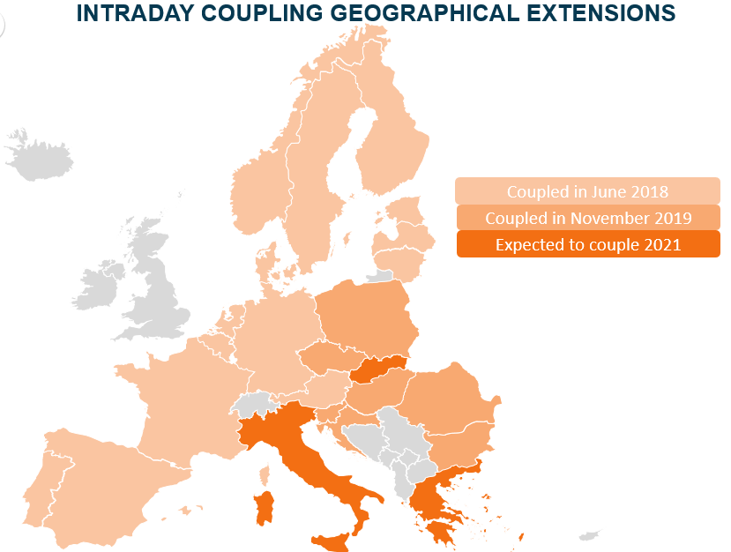

**Figure 4: Intraday coupling geographical extensions**

Source: DG ENER

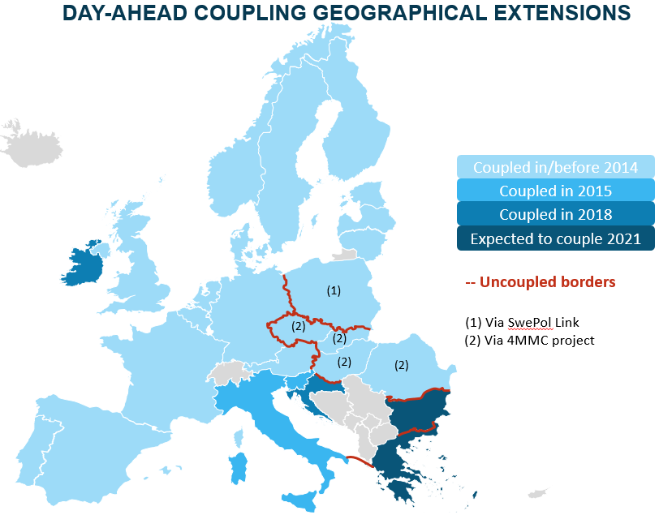

**Figure 5: Day-ahead coupling geographical extensions**

*Source: DG ENER*

With the extension of day-ahead and intraday market coupling, the European markets and electricity systems have become increasingly resilient, efficient and liquid, and are more able to integrate renewables at a lower cost.

### **2.2.2 Comprehensive harmonisation of trade and system operation rules through network codes - a new form of collective EU-wide energy harmonisation**

The roll-out of market coupling is the most visible evidence that the implementation of the *electricity network codes* began successfully. The eight electricity network codes were adopted between 2015 and 2018 to remove remaining technical barriers for electricity trade and coordinated grid operation by way of a stepwise harmonisation process[11]. For this purpose, the network codes provide a comprehensive framework for the joint development of common harmonisation methods[12]. Transmission system operators and power exchanges are obliged under the network codes to develop joint harmonisation proposals in a given field (e.g. market coupling or coordinated system operation). The national regulators then have to review and, if necessary, rewrite these common harmonisation methods, and jointly approve them. In the case of diverging views, they can decide by way of a qualified majority[13].

Experience with the implementation of the network codes and the development of the necessary methodologies has shown that the new instrument and the possibility to decide with qualified majority has brought *significant progress* to overcome the existing fragmentation in market and grid operation. Since 2015, more than 100 methods have already been jointly approved by regulators under the new collective harmonisation framework.

However, in some fields, the delivery of the required methods has been delayed. This is particularly the case in the field of joint capacity calculation, where some proposals for joint methods were not submitted within the required timeframe and where coordination among regulators proved to be particularly complex. As the benefits of removing the barriers resulting from uncoordinated capacity calculation are particularly significant for progress with the internal electricity market[14], the Commission, in close cooperation with national regulators and the Agency for the Cooperation of European Energy Regulation (ACER), will remain vigilant to use all available enforcement tools to ensure progress with the adoption of the required coordinated methods.

### **2.2.3. ‘Clean Energy for all Europeans’ Package: Progress made putting in place new electricity market design**

The new electricity market design, adopted as part of the ‘Clean Energy for all Europeans Package’, represents a significant step forward for the internal electricity market. However, now that the legislation has been adopted, its success will depend on it being implemented swiftly and effectively. Many of the market design rules are contained in the recast Electricity Regulation[15], which entered into force in January 2020. In particular, the provisions to make the market fit for larger shares of renewables, distributed generation and demand response (shorter term markets, full market participation for renewables and storage, etc.) and to make renewables fit for the market (phase-out of priority dispatch for new large installations and introduction of full balance responsibility) are now in force. In addition, the recast Electricity Regulation contains some important but complex elements regarding cross-border trade and capacity remuneration mechanisms.

### **2.2.3.1. Unblocking electricity borders – the "70 % rule"**

Over recent years, the single market for electricity has become increasingly integrated with more and more interconnection capacity being built between Member States. Interconnection improves competition, to the benefit of consumers, contributes to more secure electricity supply and supports decarbonisation, because their flexibility allows the complementarities between the differing generation mixes across Europe to be fully utilised, for example, between thermal and variable renewable generation, and enables different areas to share system services and backup generation.

However, as has been regularly reported by ACER in its Market Monitoring reports[16], capacities physically available at interconnectors are **regularly limited** in certain regions. Underutilised interconnectors prevent the full benefits of these projects from filtering down to consumers.

The main reason for these limitations relates to internal structural congestion. **Structural grid congestion** occurs when the internal grid of a bidding zone (or price zone) is not sufficient to flow electricity from where it is generated to where it is consumed. This can result in using the interconnectors and neighbours’ electricity grids instead to ensure that the electricity flows. When this happens, it effectively prioritises internal trades over cross-border trades which should not occur in the single market. Indeed, this runs counter to several EU Treaty articles, including, Article 18 TFEU which prohibits discrimination. Such behaviour by a transmission system operator, may also be found to violate Article 102 TFEU, which prohibits abuse of the dominant position. Until now, potential violations of these rules have been investigated primarily under antitrust cases by DG Competition, notably Case 39351 – Swedish Interconnectors from 2010[17] and Case 40461 DE/DK Interconnector from 2019[18].

The recast Electricity Regulation, negotiated as part of the ‘Clean Energy for all Europeans Package’, confirms the key principles on which, in line with the EU Treaty, the rules for electricity trading are based: maximisation and non-discrimination. These principles, which already existed both in Annex 1 of Regulation 714/2009[19] and the CACM Guideline[20], are maintained in Article 16 and complemented by certain additional elements. While recast Electricity Regulation reconfirms the importance of reducing internal structural congestion, it also introduces a **new minimum 70% target for interconnector capacities** to be made available for cross-border electricity trade[21], while giving Member States flexibility in how they choose to reach the target. Member States may be able to expand their grid, choose to reconfigure their bidding zones to better reflect structural congestion or to adopt an Action Plan with network investments in order to relieve this structural congestion by the end of 2025.

Although based on the EU Treaty and the sectorial electricity rules the transmission system operators already today have an obligation to fully maximise the interconnection capacities, the ‘Clean Energy for all Europeans” Package [22], is meant to guarantee that a minimum of 70% of the capacity is available at the latest by the end of 2025 on every single EU interconnector. This new legislation balances the objective of increasing trade through introducing a target, while ensuring that Transmission system operators (“TSOs”) have the tools they need to maintain the safe operation of the system.

### **2.2.3.2.** **More coordinated and less harmful capacity mechanisms**

Over recent years the European electricity market has quickly transformed with the rapid surge of variable power generation coupled with decreasing demand for electricity following the 2008-2009 financial and economic crisis. Variable renewable power generators with low marginal cost have displaced or significantly reduced the running hours of thermal power plants. At the same time, thermal plants, such as gas-fired power plants, can provide important flexibility to the system. This development has raised concerns with some stakeholders and governments over whether the power system will be able to meet demand in the long run. In response, many Member States have introduced capacity mechanisms in support of generation adequacy.

Capacity mechanisms support power plants to be available for generating electricity when needed. In exchange, the mechanisms provide payments to these power plants. These capacity payments are in addition to the earnings power plants gain by selling electricity on the power market. Inappropriately designed capacity mechanisms can severely distort the internal market[23]. The recast Electricity Regulation sets out a new framework for the introduction and design of capacity mechanisms to facilitate the European Commission's state aid enforcement work and complement existing rules governing capacity mechanisms.

The new rules require Member States with adequacy concerns, which were identified based on the adequacy assessment conducted in line with the EU-wide adequacy assessment methodology, to develop and execute an implementation plan (market reform plan), setting out how they intend to address the root causes of their adequacy problem with market reforms. They are required to submit this plan to the Commission for its Opinion on whether the proposed market reforms are fit for purpose[24]. A process was introduced to monitor how these reforms are being applied.[25]. The new rules ensure that the design choices for capacity mechanisms minimise their impact on market functioning. This means they should be:

* open to participation from generators across the border;
* be limited in time; and
* phased out when the underlying adequacy problems are resolved.

Capacity mechanisms should also be open to all technologies, including renewables. However, there is one important condition: power plants participating in capacity mechanisms cannot emit more than the emission limit of 550gr CO2/kWh.[26] This ensures that truly polluting power plants, such as coal fired generation facilities, are effectively excluded from the mechanisms.

By now, the Commission has issued opinions on six market reform plans[27]. Some of these measures are relatively concrete. For example, the rules suggest phasing out regulated end consumer price regimes (or at least relaxing price regulation), removing any price restrictions on wholesale markets, pricing in the value of system reserves in balancing energy prices (the ‘shortage pricing function’), and increasing interconnection with neighbours. Another group of measures are relatively open, such as removing all regulatory distortions or enabling demand side participation, self-generation, and energy efficiency.

There is currently additional work being carried out by ACER, the national regulatory authorities (NRAs) and TSOs to implement the new legislation. ACER has adopted methodologies for a state-of-the-art EU adequacy assessment, calculation of the Value of Lost Load, and the Reliability Standard. In addition ACER and the European Network of Transmission System Operators (ENTSO-E) are also developing a set of methodologies to enable cross-border participation in capacity mechanisms. Furthermore, ACER has issued guidance on how to calculate the CO2 emission limit[28].

The new legislation aims to bring a coordinated approach to capacity mechanisms, making sure they do not distort the EU's internal electricity market more than necessary and that they are not used to replace necessary reforms in Member States. The new legislation will also complement the European Commission's work on enforcing state aid that will continue to be the EU's chief tool to ensure individual capacity mechanisms are compliant with the internal market rules. Finally, it will help to reconcile security of supply objectives with the imperative of the clean energy transition.

### **2.2.3.3.** **Proper implementation of the unbundling rules for storage**

Storage of electrical energy using various technologies (such as pumped hydro storage, chemical storage in batteries or air pressure) is an important aspect of the electricity system. With growing shares of variable renewable energies in total electricity production, and advances in different storage technologies, storage is expected to play an increasingly important role in the internal market. Beyond traditional (pumped) hydro storage, which remains the main reservoir for storing electrical energy in the EU[29], chemical storage in batteries has expanded significantly, and become a relevant market factor notably for system services such as the provision of balancing capacity. The EU strongly supports the development of energy storage technologies so they become a key technology for the success of the energy transition. The comprehensive governance framework of the Energy Union and the strategic action plan on batteries[30], were important steps to help build a globally integrated, sustainable and competitive industrial base on batteries. The progress made was evaluated and summarised in a Commission report[31].

In order to allow energy storage to reach its full potential as regards a range of services and variety of technologies, it is important to ensure open and competitive markets for energy storage services. The ‘Clean Energy for All Europeans’ Package sets out important principles for the non-discrimination of storage, demand response and distributed generation, excluding e.g. market rules which would arbitrarily favour conventional electricity generation.

One important choice made in the recast Electricity Directive was to generally exclude transmission or distribution system operators from owning and operating electricity storage systems. Requiring full unbundling of storage assets aims to address systemic advantages of system operators which could otherwise discriminate in favour of their own assets compared to competitors, e.g. by procuring system services primarily from their own assets. This risk is even stronger than for most classical generation assets, as energy storage (due to its high flexibility but limited storage capacity) will often earn a higher share of revenues from system services rather than from the direct sale of electricity on the market. Furthermore, system operators could influence the system development and operation in a way so as to require, or reduce, the need for specific system services. Thus, creating own interests of system operators in the developing market for energy storage could become a significant barrier to developing this market and to achieving the objectives of the Energy Union.

Against the above background, Articles 36 and 54 of the recast Electricity Directive generally exclude distribution and transmission system operators from owning, developing, managing or operating energy storage facilities. However, the recast Electricity Directive recognises the possibility for derogations from this exclusion in two cases.

First, subject to regulatory approval, system operators may own and operate fully integrated network components. This derogation is aimed at system components which have been traditionally part of electricity transmission or distribution systems, such as capacitators integrated in substations.

Second, where an energy storage facility is recognised as necessary to ensure that the system operation is efficient, reliable and secure, but this facility is not used to buy or sell electricity, a tendering procedure may be conducted. If in an open, transparent and non-discriminatory tendering procedure, other parties are shown not to be willing or able to deliver those services at a reasonable cost and in a timely manner, the national regulatory authority may grant approval to the system operator to own and operate an energy storage facility. Where a derogation has been granted, the capability of the market to provide those services will be subject to regular review, with a view to phasing out the system operator’s activity in that field.

This derogation option gives the NRAs a strong role, requiring them to closely assess any requests for granting derogations. It is important that derogations do not become the norm and remain limited to exceptional circumstances, in order to allow for innovative and efficient energy storage services to be developed in a competitive market. The Commission will support the regulatory authorities in this task and closely monitor implementation.

## **Gas wholesale market****s**

Currently, around 5000 TWh of natural gas are consumed in the EU each year, which constitutes around 95% of today’s total gaseous fuel demand. It accounts for roughly 25% of total EU energy consumption, including around 20% of EU electricity production, and 39% of heat production. Gaseous fuels are a key input for industrial processes, both as energy carrier and feedstock. Gases are one source of flexibility for an energy system increasingly based on variable renewable energy systems generation, and are, together with renewables, progressively replacing both coal and oil.

Well-functioning and liquid markets for gaseous fuels play a crucial role in achieving the environmental ambitions of the European Green Deal[32], which envisages the decarbonisation of the gas sector via a forward-looking design for competitive decarbonised gas markets. Well-functioning markets are also a prerequisite for ensuring affordable energy for consumers, competitiveness of industries, and security of supply.

### **3.1. Key indicators: Concentration, liquidity and convergence**

Gas wholesale markets have become well developed in recent years. Traded volumes on natural gas hubs rose to an all-time high in 2019. This trend continued into 2020, with traded volumes on the European gas hubs recording a 32% year-on-year increase in Q1 2020 (up to 5 010 TWh). The increase in 2020 can be principally attributed to increasing hedging activity on the markets as prices became more volatile and contract price differences widened also as result of the COVID-19 crisis. The Dutch Title Transfer Facility (TTF) is developing into a benchmark also for internationally traded liquified natural gas (LNG)[33].

Connectivity and access to different sources of gas continue to improve as well. Only three markets had access to less than three sources of supply. However, two out of these (Ireland, Denmark-Sweden) are connected to a diversified hub and also score well on the market concentration index (HHI) and the residual supply index (RSI). This leaves only the Latvian-Estonian and Finnish markets below the minimum gas target model indicator.

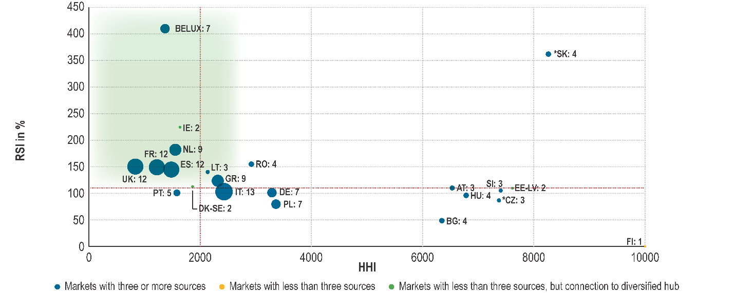

***Figure 6 Overview of MSs according to AGTM market health metrics (Upstream company RSI, HHI and number of supply sources) – 2019***

*Source: ACER calculation based on European Network of Transmission System Operators for Gas (ENTSOG) capacity data, Eurostat and NRAs.*

Price convergence had improved over recent years and was highest in north west Europe. However, on a European level it declined in 2019, showing higher price differences between markets on more days during the year. This could be attributed to overall high gas price dynamics in 2019[34].

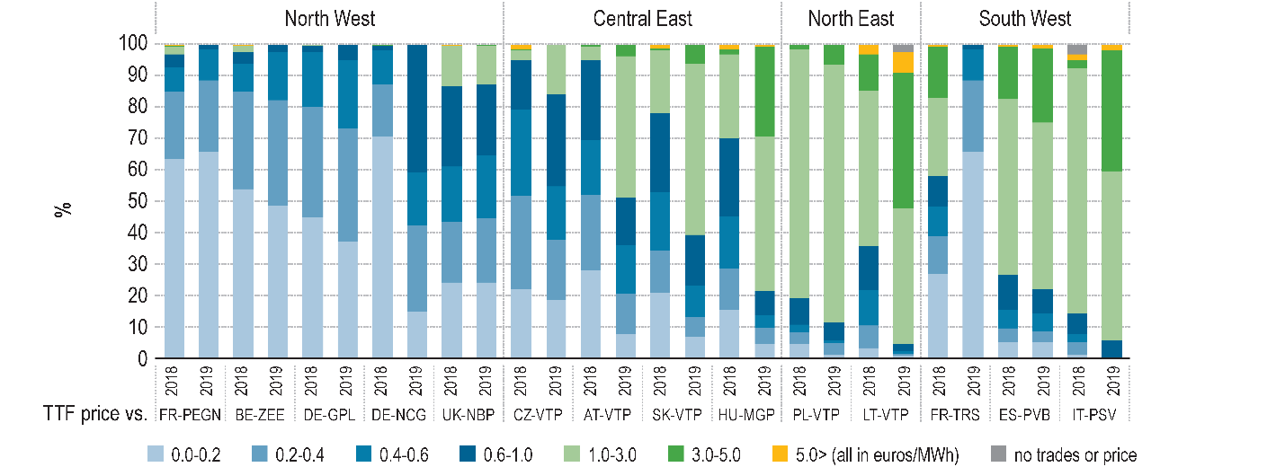

***Figure 7: DA price convergence between TTF and selected EU hubs – 2017–2019 - % of trading days within given price spread range***

*Source: ACER calculation based on Platts and ICIS Heren prices data.*

*Notes: Spreads in euros/MWh are calculated as the absolute price differential between pairs of hubs, independent of discount or premium.*

The sourcing costs for gas supply fell significantly in 2019 in most Member States. This resulted in a substantially lower gas import bill for the EU. Estimates for 2019 indicate an EU gas import bill totalling EUR 69 bn, an almost 30% reduction reflecting the impact of falling import prices.

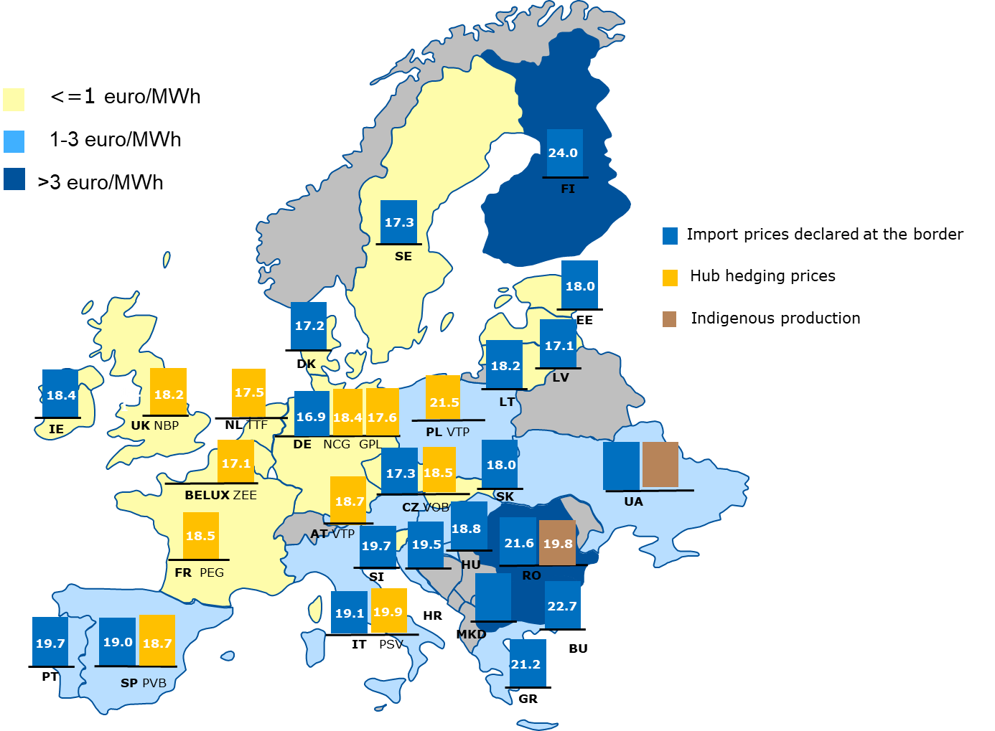

**Figure 8: 2019 estimated average suppliers’ gas sourcing costs by EU Member States and Energy Community contracting parties and delta with TTF hub hedging prices – euros/MWh**

*Source: ACER calculation based on Eurostat Comext, ICIS and NRAs from both EU MSs and EnC CPs.*

*Note: Import prices for AT, NL, FR and PL could not be assessed.*

### **3.2. Key regulatory developments**

### **3.2.1. Market mergers**

The Gas Target Model proposes to overcome the segmentation of the internal market, caused, among other things, by the applied entry/exit tariffs and related pancaking[35], by gradual, voluntary and bottom-up market area mergers. Experience shows that cross-border market mergers do not materialise easily. The deeper the integration, the higher the need to agree on a harmonized set of rules, which makes a full market merger a complex undertaking. Up until now, there is no single example of a full cross-country merger in the EU. There are, however, a few ongoing attempts. The regulatory framework for the regional cooperation and integration in the gas market is relatively weak in comparison to the electricity market. At present, there are no provisions that systematically guide or require the process of market mergers and facilitate regional market integration.

### **3.2.2. Gas Network codes**

The Third Energy Package sets the legal basis for establishing more detailed common European rules in the form of gas Network Codes and Framework Guidelines, with the aim to harmonise and coordinate the different processes of energy markets and systems. Since the entry into force of Regulation 715/2009[36] in 2011, five Network Codes and Guidelines have been adopted, covering capacity allocation mechanisms (CAM NC[37]), gas balancing rules (BAL NC[38]), congestion management procedures (CMP Guideline[39]), interoperability between gas systems (IO NC[40]), and transmission tariff structures (TAR NC[41]). The harmonisation of these technical rules has both enhanced the market functioning at national level (in particular BAL NC) and further advanced the interconnection of national gas markets. Notably, CAM NC has fully harmonised the procedure and the calendar for the booking of transmission capacity, which fosters competition and accessibility of national markets. The most recently adopted TAR NC has introduced extensive publication requirements on gas tariff parameters and calculations, which provides additional transparency and tariff predictability for network users across the EU, while highlighting potential tariff outliers. Whereas the implementation of Network Codes is far advanced across Member States[42], the continued enforcement of these rules by the Commission remains crucial for the completion of the internal energy market.

### **3.3. Decarbonisingthe gas sector**

The EU Strategy for Energy System Integration[43] and the Hydrogen Strategy[44] adopted by the Commission in summer 2020 set out how the energy markets could contribute to achieving the goals of the European Green Deal, including the decarbonisation of gas production and consumption required in the transition towards climate neutrality.

To enable cost-effective decarbonisation, the Energy System Integration Strategy announces to “*re-examine the gas market regulatory framework so as to facilitate the uptake of renewable gases and customer empowerment, whilst ensuring an integrated, liquid and interoperable EU internal gas market.”*

While renewable and low-carbon hydrogen is currently the headline topic of energy system integration, other renewable and low-carbon gases, such as biomethane, are already today playing an important role in the energy sector.

### **3.3.1. Integrating bio-methane and small scale producers**

Currently, the most significant production of renewable gases in the EU are biogas and biomethane[45] with around 17 bcm annually. There were more than 17000 biogas installations in 2015[46] and some 500 biomethane plants in the EU are connected to the gas grid. Biogas is mainly used for producing electricity and heat, often under support schemes[47]. Once support schemes end, existing biogas plants may decide to invest into upgrading biogas to biomethane to inject it into the gas grid.[48] Investments in new plants are expected to increase biogas and biomethane production significantly.

The vast majority of today’s 500 biomethane plants are connected at the distribution level. In practice, the injection at the distribution level requires consumption by consumers connected to that local grid. In cases of over-supply at distribution level and without possibility to inject gas from the distribution to the transmission level biomethane producers are deprived from access to wholesale markets and cross-border trade. This could distort the level playing field vis-à-vis other gas producers and can be a barrier to scaling up renewable gas production in the future.

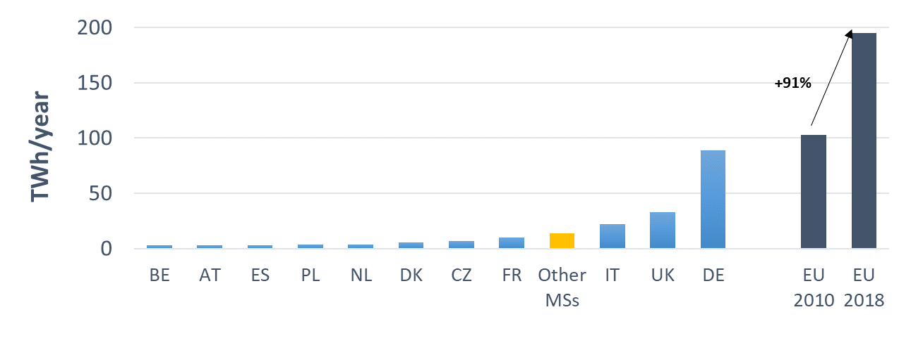

**Figure 9: Evolution of biogas and biomethane production in the EU – 2010-2018 – TWh/year**

*Source: ACER calculation based on Eurostat.*

### **3.3.2. Gas quality issues**

The integration of growing volumes of biomethane, LNG and some interest in Member States to blend hydrogen into the natural gas grid poses new challenges for the operation of the gas networks. Issues arise regarding the gas quality, both at transmission and distribution levels, which can affect the design of gas infrastructure, end-user applications and cross-border system interoperability.

Rules on gas quality, i.e. on the chemical and physical properties of gases, ensure the integrity and safety of both the gas infrastructure and of end-appliances (e.g. gas turbines in electricity production, furnaces in industrial process). At the same time, it is essential that gas quality specifications do not hinder the production and transport of renewable and decarbonised gases to consumers. In the past, Member States developed national gas quality standards[49] based on the relatively stable quality of their historical gas sources[50]. For the case that cross-border trade issues arise due to differences in the gas quality or its specification across Member States, the Interoperability and Data Exchange Network Code[51] defines a dispute resolution procedure. This procedure is however, limited to cross-border interconnection points, and is based on general, high level principles of ACER dispute resolution. Beyond divergent national gas quality standards, a European Committee for Standardization (“CEN”) standard exists for H-gas quality (EN 16726:2015[52]) defining the acceptable bandwidth for a number of relevant parameters. However, this CEN gas quality standard is not binding and does not include the Wobbe Index, which is a key indicator of the interchangeability of different gases. To ensure that this important parameter is included in the H-gas standard the Commission invited CEN to propose an acceptable range and rate of change for the Wobbe Index in the EU[53]. This CEN process is still ongoing.

### **3.3.3. Preparing the market and infrastructure for hydrogen**

Hydrogen is enjoying renewed and rapidly growing attention as it offers a solution to decarbonise industrial processes and economic sectors where reducing carbon emissions is both urgent and hard to achieve. Whilst the Third Energy Package applies to all gases that can safely be injected into the gas network, it does not apply to networks transporting pure hydrogen. The Hydrogen Strategy sets out the Commission’s vision to support the progressive development of a more hydrogen based EU economy and, *inter alia*, foresees a revision of the current EU legislation for the gas markets.

Infrastructure use has increased especially for LNG Terminals. Higher utilization of LNG Terminals reflects the competitive position of LNG against pipeline gas.

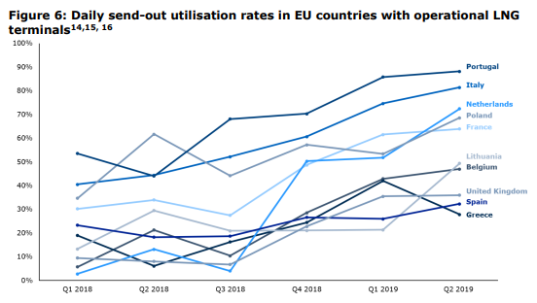

**Figure 10: Daily send-out utlilisation rates in EU countries with operational LNG terminals**

*Source: Figure 6 of* [*Trinomics Study on Gas market upgrading and modernisation – Regulatory framework for LNG terminals, May 2020*](https://op.europa.eu/en/publication-detail/-/publication/efa4d335-a155-11ea-9d2d-01aa75ed71a1/language-en)

Regulation (EU) 347/2013 (TEN-E)[54] obliges the ENTSOs for gas and electricity to use joint scenarios for their respective Ten-Year Network Development Plans (TYNDPs). The ENTSOs have worked together to develop these scenarios jointly for the TYNDP 2020. Scenario work is not only undertaken to test future electricity and gas infrastructure needs and projects but also captures the interactions between the gas and electricity systems to assess the infrastructure of a hybrid energy system.

The Energy System Integration Strategy identified the review of the scope and governance of the TYNDP to ensure full consistency with the EU’s decarbonisation objectives and cross-sectoral infrastructure planning as part of the revision of the TEN-E Regulation (2020) and other relevant legislation (2021).

## **Retail Markets**

### **4.1. Market concentration**

### **4.1.1. Electricity**

Regarding electricity market, the main retailers across the EU have been losing market shares. In 2018, the share of the largest retailers dropped in 16 Member States in comparison to 2017. On the other hand, the number of retailers dropped in 13 Member States and increased only in nine of them, and market concentration increased in six Member States.

In Czechia, Greece, Portugal, Slovakia and Spain the number of retailers grew, while the main market players lost market shares. This is an indication for increased consumer choice and competition. On the other hand, in Belgium, Estonia, Finland, Lithuania and Sweden the number of retailers dropped and the market share of main players increased. In Cyprus, Greece and Malta, there is still only one retailer on the market. In Croatia, two main players cumulate 88 per cent of the market between them.

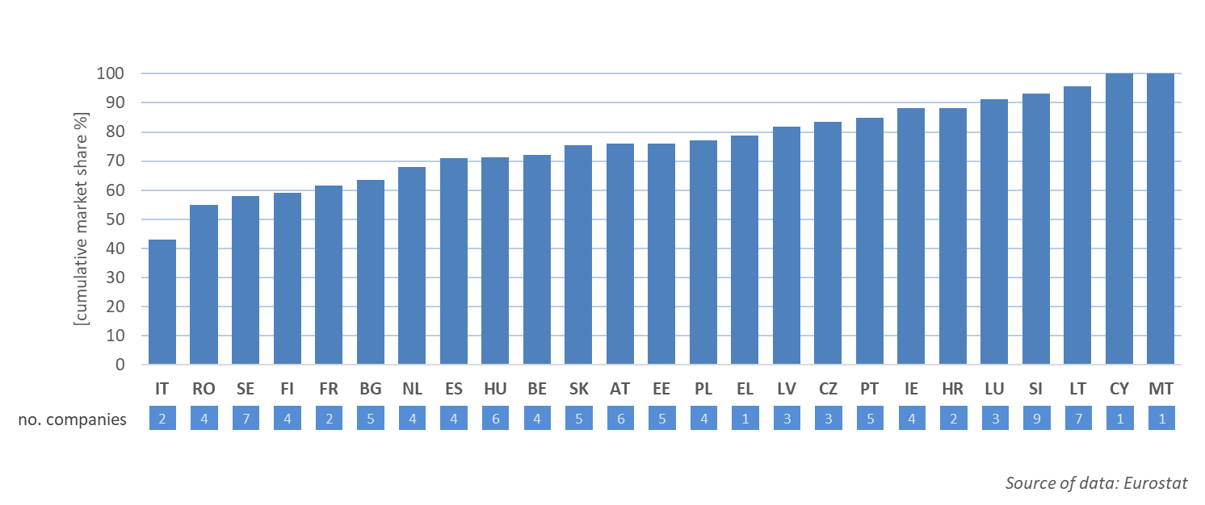

**Figure 11: Main electricity retailers and their cumulative market shares in 2018**

*Source: DG ENER country datasheets based on Eurostat surveys on* [*electricity markets indicators.*](https://ec.europa.eu/eurostat/statistics-explained/index.php/Electricity_market_indicators)

### **4.1.2. Gas**

Regarding gas markets, in 2018 the main retailers have lost market shares in 13 Member States and gained ground only in nine. On the other hand, the number of retailers dropped in 14 Member States and increased only in six of them.

In Austria, Latvia and Lithuania the number of retailers grew, while the main market players lost market shares. In Hungary dominant players also lost market shares, but the number of players remained unchanged. In Estonia the main retailer still held 90 per cent of the market. In Italy, Poland and the UK the market concentration increased as the number of retailers dropped while the main players gained market shares.

In Bulgaria, Latvia, Lithuania and Poland only two companies share most of the retail market. Conversely, there are at least six main retailers in Austria, Belgium, Czechia, Greece, Ireland, Portugal, Romania and Slovenia.

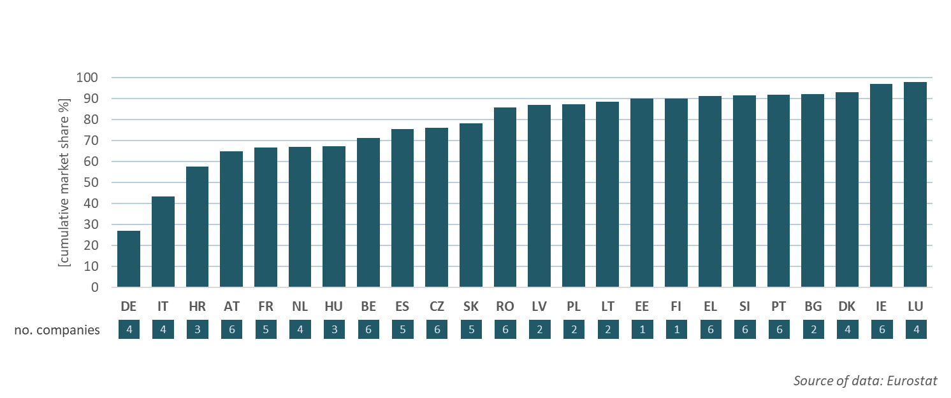

***Figure 12: Main gas retailers and their cumulative market shares in 2018***

*Source: DG ENER country datasheets based on Eurostat surveys on* [*natural gas markets indicators*](https://ec.europa.eu/eurostat/statistics-explained/index.php/Natural_gas_market_indicators)*.*

In Estonia and in the isolated Finnish market, there is still just one retailer dominating the market. The biggest retailers also hold majority of the market in Latvia and Lithuania. On the other hand, the biggest company does not hold more than 30 per cent of the market in Belgium, Czechia, Italy and Romania.

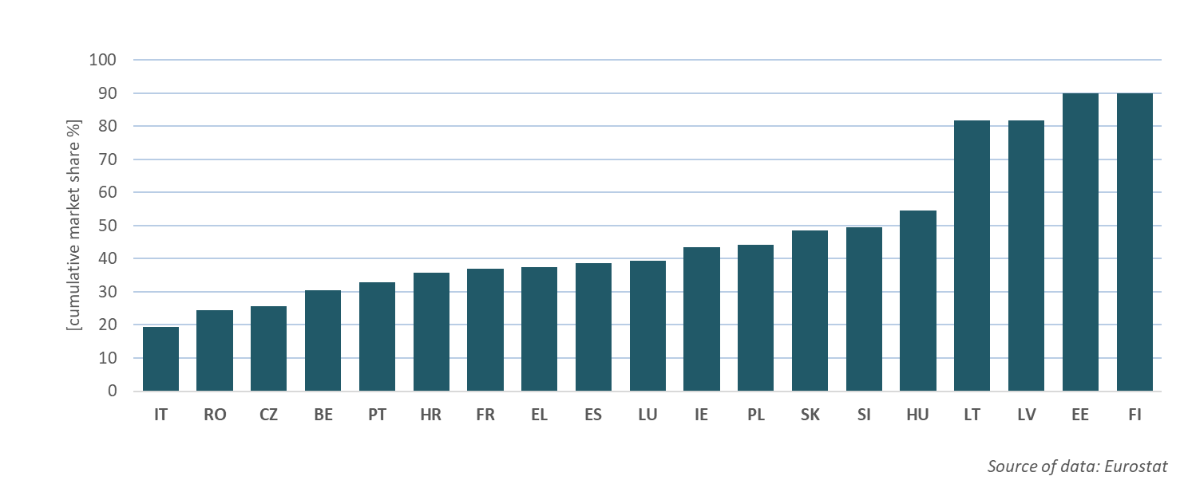

**Figure 13: Market share of largest natural gas retailer in 2018**

*Source: DG ENER country datasheets based on Eurostat surveys on* [*natural gas markets indicators*](https://ec.europa.eu/eurostat/statistics-explained/index.php/Natural_gas_market_indicators)*.*

### **4.2. Retail prices (including price components)**

### **4.2.1. Electricity prices**

Progress with the single energy market continued insofar as differences between energy components in individual Member States become smaller than before. They became 14% and 9% less spread out since 2010 for households and industrial consumers respectively[55]. This contributed to rising convergence in total retail prices which can be observed since 2016. The convergence however was accompanied by a long-term retail electricity price increase. Between 2017 and 2019 the average EU 27 retail price for households went up by 4 per cent continuing its upward trend since 2010[56].

Electricity prices for household consumers ranged from EUR 98/MWh in Bulgaria to EUR 295/ MWh in Denmark. The average price for EU28 was EUR 217/MWh[57]. Denmark and Germany reported the highest tax components of almost EUR 190 and 156/MWh respectively, which accounted for more than half of the total retail price in 2019. On average, price components which are not the result of competition but set by regulators (e.g. regulated network charges, taxes and levies) still dominate the retail price. This hampers the efforts to empower consumers to actively participate in the electricity market, e.g. by adjusting their demand or activating self-generation, benefiting from the differences in demand and supply[58]. The lowest taxes on electricity, both in absolute and relative terms, were assessed in Malta (EUR 8/MWh)[59]. Belgium recorded the highest network component of EUR 109/MWh in 2019. On the opposite side of the spectrum, Malta and Bulgaria had the lowest network charges (EUR 25/MWh)[60]. The largest energy components were reported in the island systems of Ireland (EUR 125/MWh), Cyprus (EUR 124/MWh) and Malta (EUR 97/MWh). The lowest values of the energy component were recorded in Hungary (EUR 42/MWh) and Poland (EUR 43/MWh), markets with stronger forms of price regulation[61].

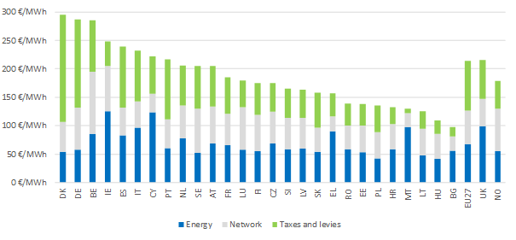

**Figure 14 Household electricity prices in the EU in 2019 (DC band)**

Source: Report on Energy prices and costs in Europe COM(2020)951.

### **4.2.2. Gas Prices**

The evolution of prices in the gas market also proves there is a progress with the Internal Market implementation. Retail gas prices for household customers increased by 2.1% annually between 2010 and 2019, whereas for medium level industrial customers prices rose only slightly, by 0.1% and for large industrials prices decreased by 1.3%[62].

Gas prices for household consumers ranged from EUR 33/MWh in Hungary to EUR 116/MWh in Sweden[63]. In Denmark the share of the energy component was the lowest (barely 26% in 2019), whereas the taxation share was the highest (EUR 41/MWh)[64]. Consumers in Luxembourg had to spend the least for taxes and levies. The highest network components for household natural gas prices were reported in Portugal in 2019[65].

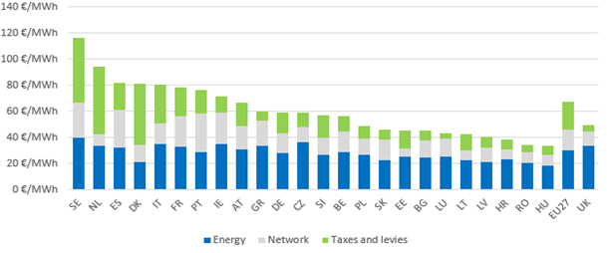

***Figure 15: Household gas prices in 2019 (DC band)***

Source: Report on Energy prices and costs in Europe COM(2020)951.

*.*

**4.3. State interventions in retail electricity and gas prices**

In 2018, 14 countries reported a direct intervention in the retail electricity price setting mechanism in the household segment. For the non-household segment, 8 reported such mechanisms. For gas prices, 11 countries reported intervention in the household segment and 5 in the non-house segment[66].There was clear progress in the non-household segment of the energy market, as the volume of both gas and electricity effected by regulated prices has decreased. On the other hand, progress in the household segment was very limited.

### **4.3.1. The household segment**

End-user price regulation of electricity applied to households in nine countries (Bulgaria, Cyprus, France, Hungary, Lithuania, Malta, Spain, Poland and Portugal)[67] and of gas in eight (Bulgaria, Croatia, France, Hungary, Latvia, Poland, Portugal and Spain). In the UK and Belgium, the price intervention concerned only the special price mechanisms for vulnerable customers.

In Bulgaria, Lithuania and Malta in electricity and Bulgaria and Poland in gas, 100 per cent of the households are supplied under a price intervention mechanism. In Hungary and Poland, the percentage of households in the country affected by price intervention is above 90 per cent in electricity, and for Croatia and Hungary in gas.

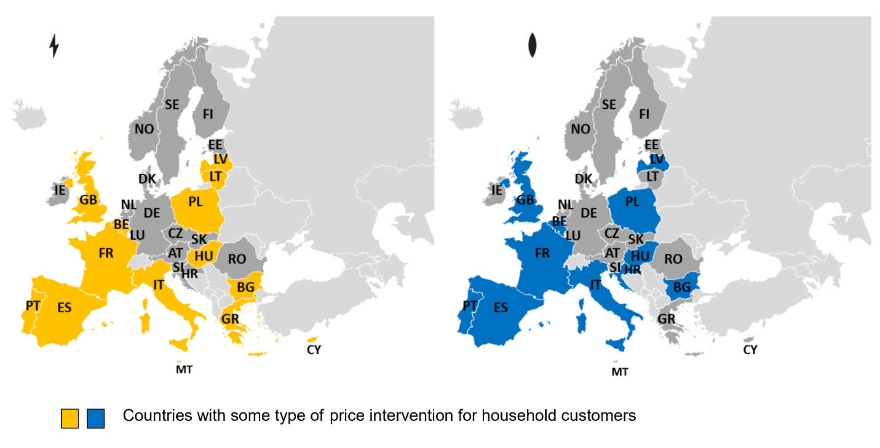

***Figure 16: Existence of price intervention in electricity and gas in 2018 (household)***

*Source: Monitoring Report on the Performance of European Retail Markets in 2018, CEER Report.*

### **4.3.2. The non-household segment**

End-user price regulation of electricity existed in six countries (Bulgaria, Cyprus, France, Hungary, Malta and Portugal) and in four countries of gas (Bulgaria, France, Hungary and Portugal)[68]. In Cyprus and in Malta all of the non-household electricity consumers were supplied under regulated prices. In the other four countries, in terms of consumption, less than 10 per cent of non-households paid regulated prices[69]. In all countries the share of non-household customers under regulated prices has recorded a drop.

As regards gas prices, in Bulgaria, all non-household consumers were supplied under regulated prices. On the other hand, regulated consumption was negligible in Portugal and France[70]. As for electricity, the share of gas consumed under regulated prices in the non-household tariff group has decreased.

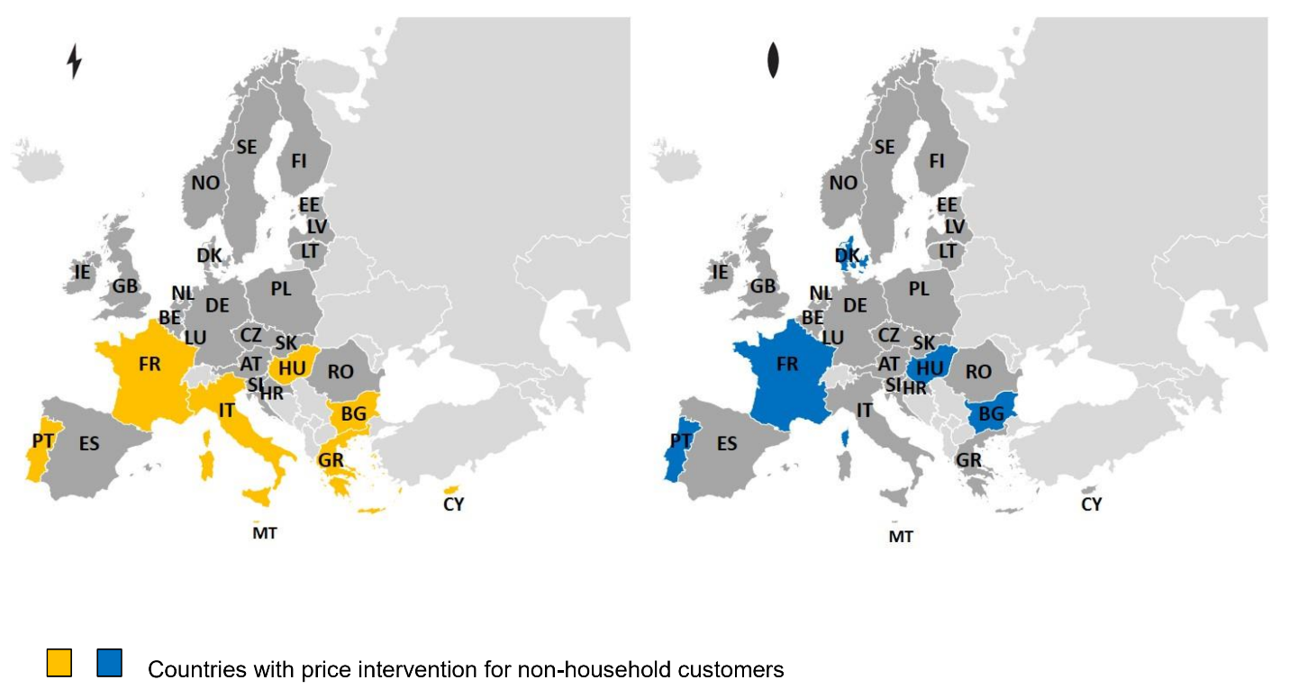

***Figure 17: Existence of price intervention in electricity and gas in 2018 (non-household)***

*Source: Monitoring Report on the Performance of European Retail Markets in 2018, CEER Report.*

### **4.4. Consumer protection and empowerment**

The recast Electricity Directive, adopted in 2019 as part of the ‘Clean Energy for all Europeans Package’, aims to ensure a competitive, consumer-centred, flexible and non-discriminatory EU electricity market. It places the consumer at the centre of the clean energy transition and further strengthens consumer rights, including active participation in the energy market, shorter switching times, access to price comparison tools and smart meters, and clearer and more frequent energy bills.

The recast Electricity Directive also enables consumers to participate actively in the energy market, by producing their own energy at home and selling it. This may dramatically change the electricity system, although residential consumers who produce and consume electricity in their homes – mainly through photovoltaic (PV) panels - have already existed in some Member States[71]. However, despite the increased use of PV panels, consumer participation in the energy market remained low prior to the adoption of the recast Electricity Directive[72].

The recast Electricity Directive aims to facilitate and speed up switching of suppliers. It enables consumers to switch electricity suppliers within three weeks. By 2026, this will be possible within 24 hours. Changing suppliers is free of charge, except for early termination of fixed-term contracts. In most Member States, the legal maximum duration of an electricity and gas switch was 3 weeks or 15/18 working days (according to data from 2018). However, actual switching times were still longer in some countries[73]. Switching within 24 hours was only possible in Italy[74]. Overall, household switching rates have increased for gas and electricity in most Member States in 2018. For electricity, no or almost no switching was reported in three countries, while two only had one supplier and switching was not possible[75].

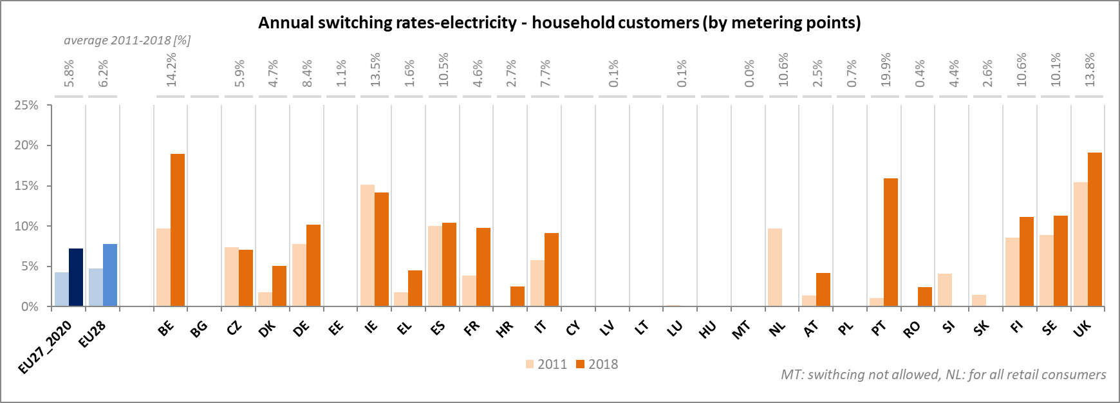

***Figure 18: Annual switching rates – electricity - household customers (by metering points)***

*Source: CEER Monitoring Reports on the Performance of European Retail Markets[76]*

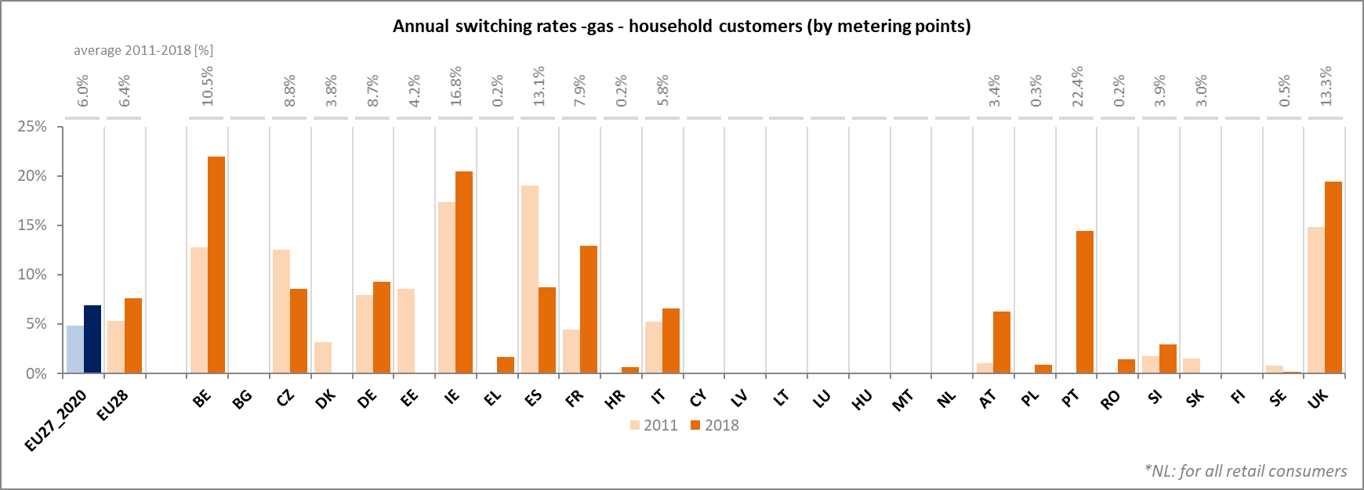

***Figure 19: Annual switching rates – gas - household customers (by metering points)***

*Source: CEER Monitoring Reports on the Performance of European Retail Markets*

According to a 2018 survey, consumers’ main concerns with utility markets were choice and comparability[77]. Consumers faced difficulties with comparing gas and electricity offers, especially what regards the main features of the offer and conditions for terminating the contract[78]. When asked about options to increase comparability some customers expressed a preference for a standardised format for offers. The new rules require suppliers to present information about energy consumption and costs on every bill in a clear and easily understandable way. Information should be presented in a way to facilitate comparison by customers. In addition, the recast Electricity Directive helps consumers make more informed choices by introducing the requirement to put in place reliable comparison tools. Consumers have a right to access at least one price comparison tool that is free of charge and meets minimum quality standards.

The recast Electricity Directive grants consumers the right to request a smart meter that shows energy consumption and the cost in real time and that can be read remotely. Consumers can also opt for dynamic price contracts. Smart meters and dynamic pricing would be underpinned by the foreseen implementing acts on data interoperability. They will be instrumental in assisting customers as well as new service providers to get actively involved in the market and navigate it with more confidence.

In 2018, there were around 99 million smart electricity meters across the EU or 34 per cent of all electricity metering points, compared to around 12 million smart meters for gas[79].

In the same year, 12 countries reached at least 50 per cent roll-out of electricity smart meters. At the same time, seven states decided not to implement the roll-out of smart meters[80]. By the end of 2019, more than 80 per cent of consumers in Luxembourg should have received electricity smart meters, followed by Denmark, Austria, France and Great Britain in 2020.

The roll-out of gas smart meters remains limited, with only 5 countries having commenced it by 2018.

Among the important issues facing some energy consumers on the internal market is energy poverty. To support Member States in their efforts to tackle it, the Commission has issued guidance on energy poverty along this document[81]. It also continues to support the European Energy Poverty Observatory that collects data, develops indicators and disseminates best practices for tackling energy poverty.

1. European Council conclusions, 12-13 December 2019 EUCO 29/19.
2. Regulation (EU) 2019/943 of the European Parliament and of the Council of 5 June 2019 on the internal market for electricity OJ L 158, 14.6.201.

   Directive (EU) 2019/944 of the European Parliament and of the Council of 5 June 2019 on common rules for the internal market for electricity and amending Directive 2012/27/EU.

   Regulation (EU) 2019/942 of the European Parliament and of the Council of 5 June 2019 establishing a European Union Agency for the Cooperation of Energy Regulators OJ L 158, 14.6.2019, p. 22–53.
3. This report fulfils the obligations as outlined in Article 35 (2) (f) (g) and (k) of Regulation (EU) 2018/1999 of the European Parliament and of the Council of 11 December 2018 on the Governance of the Energy Union and Climate Action, OJ L 328, 21.12.2018, p. 1–77.
4. Article 52 (1) of Directive 2009/73/EC of the European Parliament and of the Council of 13 July 2009 concerning the common rules for the internal market in natural gas, OJL 211, 14.8.2009, pp. 94-136 (“Gas Directive”) and Article 47 (1) of Directive 2009/72/EC of the European Parliament and of the Council of 13 July 2009 concerning common rules for the internal market in electricity and repealing Directive 2003/54/EC, OJ L 211, 14.8.2009, p. 55–93 (“Electricity Directive”). Together both the Gas and Electricity Directives are also referred in the Report as the Third Energy Package. Article 47 (1) of has been recast by Article 69 (1) of Directive (EU) 2019/944 of the European Parliament and of the Council of 5 June 2019 on common rules for the internal market for electricity OJ L 158, 14.6.2019, p. 125–199 (“recast Electricity Directive”).
5. See previous progress reports, e.g. Communication from the Commission to the European Parliament, the Council, the European Economic and Social Committee and the Committee of the Regions ‘Progress towards completing the Internal Energy Market’ of 13.10.2014, COM(2014) 634 final, p.2 - <https://eur-lex.europa.eu/legal-content/EN/TXT/PDF/?uri=CELEX:52014DC0634&qid=1558357809501&from=EN>.
6. See also ACER/CEER Annual Report on the Results of Monitoring the Internal Electricity and Natural Gas Markets in 2018, Electricity Wholesale Markets Volume, November 2019.
7. Report from the Commission to the European Parliament, the Council, the European Economic and Social Committee and the Committee of the Regions on Energy prices and costs, Section trends in energy prices COM(2020)951.

  
8. In most competition decisions of the Commission, electricity wholesale markets (e.g. generation and supply of electricity, ancillary services markets) are still defined as national in scope in most cases, see e.g. COMP/M.8660 - Fortum/Uniper; see previously e.g. COMP/M.5979 – KGHM/TAURON Wytwarzanie/JV, para. 24; COMP/M.5711 – RWE/Ensys, para. 21; COMP/M.4180 – GDF/Suez, para. 726.
9. End-user electricity price regulation is still applied to households in nine Member States, and end-user gas price regulation in eight. In the non-household sector, end-user electricity price regulation existed in six Member States and gas price regulation in four Member States.
10. Of final electricity trades, market coupling contributed to an increase from 60% in 2010 to 87% in 2018 of the amount of trades going in the right direction i.e. from lower to higher priced areas. This delivers an affordable model for the energy transition ensuring that least-cost electricity can be dispatched around Europe for the benefit of consumers.
11. Commission Regulation (EU) 2015/1222 of 24 July 2015 establishing a guideline on capacity allocation and congestion management, OJ L 197, 25.7.2015, p. 24–72.

    Commission Regulation (EU) 2016/1719 of 26 September 2016 establishing a guideline on forward capacity allocation, OJ L 259, 27.9.2016, p. 42–68.

    Commission Regulation (EU) 2017/2195 of 23 November 2017 establishing a guideline on electricity balancing, OJ L 312, 28.11.2017, p. 6–53.

    Commission Regulation (EU) 2017/2196 of 24 November 2017 establishing a network code on electricity emergency and restoration, OJ L 312, 28.11.2017, p. 54–85.

    Commission Regulation (EU) 2016/1388 of 17 August 2016 establishing a Network Code on Demand Connection, OJ L 223, 18.8.2016, p. 10–54.

    Commission Regulation (EU) 2016/631 of 14 April 2016 establishing a network code on requirements for grid connection of generators, OJ L 112, 27.4.2016, p. 1–68.

    Commission Regulation (EU) 2016/1447 of 26 August 2016 establishing a network code on requirements for grid connection of high voltage direct current systems and direct current-connected power park modules, OJ L 241, 8.9.2016, p. 1–65.

    Commission Regulation (EU) 2017/1485 of 2 August 2017 establishing a guideline on electricity transmission system operation, OJ L 220, 25.8.2017, p. 1–120.
12. The network codes use speak about ‘terms, conditions or methodologies’ to be developed by grid operators or power exchanges.
13. In case of disagreement about a method, national regulators decide within with the help of ACER with a 2/3 majority.
14. See e.g. ACER, Monitoring report on the implementation of the CACM Regulation and the FCA Regulation of 31 January 2019, page 61 & Annual Report on the Results of Monitoring the Internal Electricity and Natural Gas Markets in 2017-Electricity Wholesale Markets Volume, 18 October 2018, page 46.
15. Regulation (EU) 2019/943 of the European Parliament and of the Council of 5 June 2019 on the internal market for electricity, OJ L 158, 14.6.2019, p. 54–124 (“recast Electricity Regulation”)
16. See references to ACER monitoring reports in the footnote 14
17. <https://ec.europa.eu/competition/elojade/isef/case_details.cfm?proc_code=1_39351>
18. <https://ec.europa.eu/competition/elojade/isef/case_details.cfm?proc_code=1_40461>
19. Regulation (EC) No 714/2009 of the European Parliament and of the Council of 13 July 2009 on conditions for access to the network for cross-border exchanges in electricity, OJ L 211, 14.8.2009, p. 15–35.
20. Commission Regulation (EU) 2015/1222 of 24 July 2015 establishing a guideline on capacity allocation and congestion management, OJ L 197, 25.7.2015, p. 24–72.
21. The 70% are calculated respecting so-called operational security limits (generally understood as the maximum flow on an interconnector). The most straightforward way to understand the target is to consider what the 30% covers; this is a maximum limit for the deductions that TSOs can make for loop flows, internal flows and reliability margins. The rest should be made available to the regional capacity calculator for trade and security deductions at regional level where needed (e.g. to meet the N-1 security standard in the flow-based process). It is important to note that, under this framework, TSOs always retain control of the system and have the ability to take any action needed to maintain operational security of the system.
22. ACER has issued a recommendation on how to monitor the new 70% target, see Recommendation 01/2019: <https://www.acer.europa.eu/Official_documents/Acts_of_the_Agency/Recommendations/ACER%20Recommendation%2001-2019.pdf>; three Member States have so far opted to implement an Action Plan to reduce internal congestion, while several more are considering a reconfiguration of their bidding zones through the current bidding zone review, see: 2019 BZR methodology and assumptions as submitted to NRAs: <https://www.entsoe.eu/news/2019/10/07/bidding-zone-review-methodology-assumptions-and-configurations-submitted-to-nras/>
23. See in more detail the Communication from the Commission ‘Delivering the internal electricity market and making the most of public intervention’ of 5.11.2013, C(2013) 7243 final.
24. Article 20 (4) recast Electricity Regulation.
25. Article 20 (6) recast Electricity Regulation.
26. Article 22 recast Electricity Regulation.
27. Those can be found under the following link: [https://ec.europa.eu/energy/topics/markets-and-consumers/capacity-mechanisms_en#commission-opinions-and-consultations](https://ec.europa.eu/energy/topics/markets-and-consumers/capacity-mechanisms_en)
28. [OPINION No 22/2019 OF ACER of 17 December 2019 on the calculation of the values of CO2 emission limits referred to in the first subparagraph of Article 22(4) of Regulation (EU) 2019/943 of 5 June 2019 on the internal market for electricity (recast).](https://www.acer.europa.eu/Official_documents/Acts_of_the_Agency/Opinions/Opinions/ACER%20Opinion%2022-2019%20on%20the%20calculation%20values%20of%20CO2%20emission%20limits.pdf)
29. Study on energy storage – Contribution to the security of the electricity supply in Europe, see <https://op.europa.eu/en/publication-detail/-/publication/a6eba083-932e-11ea-aac4-01aa75ed71a1/language-en?WT.mc_id=Searchresult&WT.ria_c=37085&WT.ria_f=3608&WT.ria_ev=search>
30. Annex 2 to the Communication Europe on the move Sustainable Mobility for Europe: safe, connected, and clean

    COM/2018/293 final.
31. Commission report on the Implementation of the Strategic Action Plan on Batteries: Building a Strategic

    Battery Value Chain in Europe, COM(2019) 176 final.
32. Communication from the Commission – The European Green Deal, COM(2019) 640 final (“European Green Deal”).
33. [European Commission Quarterly Report on European Gas Markets Q1/2020](https://ec.europa.eu/energy/sites/ener/files/quarterly_report_on_european_gas_markets_q1_2020.pdf).
34. See the [European Commission quarterly gas market monitoring report for more details](https://ec.europa.eu/energy/data-analysis/market-analysis_en).
35. Accumulation of tariffs to be paid by traders when shipping gas through several borders.
36. Regulation (EC) No 715/2009 of the European Parliament and of the Council of 13 July 2009 on conditions for access to the natural gas transmission networks, OJ L 211, 14.8.2009, p. 36–54.
37. Regulation 2017/459/EU establishing a network code on capacity allocation mechanisms in gas transmission systems, OJ L 72, 17.3.2017, p. 1–28.
38. Regulation 2014/312/EU establishing a network code on gas balancing and transmission networks, OJ L 91, 27.3.2014, p. 15–35.
39. Guidance on best practices for congestion management procedures in natural gas transmission networks [SWD(2014) 250].
40. Regulation 2015/703/EU establishing a network code on interoperability and data exchange rules, OJ L 113, 1.5.2015, p. 13–26
41. Regulation 2017/460/EU establishing a network code on harmonised transmission tariff structures for gas, OJ L 72, 17.3.2017, p. 29–56.
42. Cf. ACER Implementation Reports on individual Network Codes at <https://acer.europa.eu/Official_documents/Publications/Pages/Publication.aspx>.
43. Communication from the Commission - Powering a climate-neutral economy: An EU Strategy for Energy System Integration COM(2020) 299 final (“Energy System Integration Strategy”).
44. Communication from the Commission - A hydrogen strategy for a climate-neutral Europe, COM(2020) 301 final (“Hydrogen Strategy”).
45. Biogas is about 60% methane, 40% CO2 + some impurities. Upgrading biogas to biomethane level requires removal of CO2 and impurities. If used and, more importantly, stored the CO2 obtained in production of biomethane from biogas is sometimes argued to create ‘negative’ emissions.
46. In-depth analysis in support on the COM(2018) 773: A Clean Planet for all - A European strategic long-term vision for a prosperous, modern, competitive and climate neutral economy. Chapter 4.2.
47. This is due to subsidy schemes as well as additional cost in case of upgrading it to biomethane for grid injection.
48. According to ÖSTERREICHISCHE VEREINIGUNG FÜR DAS GAS- UND WASSERFACH (2019) and its report Kostenbetrachtung der Einbindung existierender Biogasanlagen in das österreichische Gasnetz 74 out of 301 biogas plants in Austria could be connected with an expected EUR 100m investment, injecting 16.813 Nm3/h.
49. A gas quality specification describes acceptable limits for various characteristics of a gas in order to ensure safety and the integrity of the infrastructure, and to prevent a negative impact on particular applications. Standards imply establishing the width of boundaries of main gas quality parameters. Wide boundaries give flexibility to the sourcing of gases (i.e. from different production sites, renewable gases, hydrogen) while narrow boundaries ensure that the properties of the gas consumed by an end-user are fully defined and allow safe operation and process optimization.
50. The sources of natural gas are stable for each Member States but differ when comparing across the EU, including indigenous gas production (main producers are the UK, the Netherlands, Romania, Germany and Denmark), pipeline gas from Russia and Norway as well as from North Africa, LNG from Qatar, Russia and the US. The variety of different sources of gas flowing into Europe means also a corresponding variety of gas qualities. For recent detail data see DG Energy Quarterly Report on European Gas Markets, Volume 14, Q4 2019.
51. Commission Regulation (EU) 2015/703 of 30 April 2015 establishing a network code on interoperability and data exchange rules, OJ L 113, 1.5.2015, p. 13–26.
52. This standard was developed based on European Commission Mandate M/400 for H-gas quality.
53. Via extension of the standardisation Mandate M/400.
54. Regulation (EU) No 347/2013 of the European Parliament and of the Council of 17 April 2013 on guidelines for trans-European energy infrastructure, OJ L 115, 25.4.2013, p. 39–75.
55. Commission Staff Working Document accompanying the document Report from the Commission to the European Parliament, the Council, the European Economic and Social Committee and the Committee of the Regions, Energy prices and costs in Europe, SWD (2020)951(“SWD, Energy Prices and Costs in Europe”).
56. SWD, Energy Prices and Costs in Europe.
57. SWD, Energy Prices and Costs in Europe.
58. See in this context also recital 38 of the Electricity Directive 2019/944: *“In order to maximise the benefits and effectiveness of dynamic electricity pricing, Member States should assess the potential for making more dynamic or reducing the share of fixed components in electricity bills, and where such potential exists, should take appropriate action.”*
59. SWD, Energy Prices and Costs in Europe.
60. SWD, Energy Prices and Costs in Europe.
61. SWD, Energy Prices and Costs in Europe.
62. SWD, Energy Prices and Costs in Europe.
63. SWD, Energy Prices and Costs in Europe.
64. SWD, Energy Prices and Costs in Europe.
65. SWD, Energy Prices and Costs in Europe.
66. Monitoring Report on the Performance of European Retail Markets in 2018, CEER Report, Ref: C19-MRM-99-02

    04 November 2019, p. 53. [CEER 2018 Monitoring Report].
67. CEER 2018 Monitoring Report, p. 55.
68. CEER 2018 Monitoring Report, p. 60.
69. CEER 2018 Monitoring Report, p. 60.
70. CEER 2018 Monitoring Report, p. 61.
71. [ACER Market Monitoring Report 2018 – Consumer Empowerment, Volume, 2019](https://www.acer.europa.eu/Official_documents/Acts_of_the_Agency/Publication/ACER%20Market%20Monitoring%20Report%202018%20-%20Consumer%20Protection%20and%20Empowerment%20Volume.pdf), p. 30.
72. According to a 2018 report, only 13 NRAs reported the use of PV panels among household consumers; ACER Market Monitoring Report 2018 –Consumer Empowerment, Volume, 2019, p. 31.
73. ACER Market Monitoring Report 2018 –Consumer Empowerment Volume, 2019, p. 28-29.
74. ACER Market Monitoring Report 2018 –Consumer Empowerment Volume, 2019, p. 29.
75. CEER 2018 Monitoring Report, p. 29-30.
76. Available at: <https://www.ceer.eu/1765>
77. European Commission, DG Justice and Consumers, [Consumer Markets Scoreboard: Making markets work for consumers](https://ec.europa.eu/info/sites/info/files/consumer-markets-scoreboard-2018_en_0.pdf), 2018 edition, p. 38.
78. European Commission, DG Justice and Consumers, [Consumer study on “Pre-contractual information and billing in the energy market - improved clarity and comparability ”](https://ec.europa.eu/info/sites/info/files/final_report_2_july_2018.pdf), 2018, p. 208.
79. ACER Market Monitoring Report 2018 –Consumer Empowerment Volume, 2019, p. 23.
80. ACER Market Monitoring Report 2018 –Consumer Empowerment Volume, 2019, p. 24.
81. Recommendation on energy poverty C(2020)9600.