

**Annex – Energy subsidies in the EU**

**1. Introduction**

The Regulation on the Governance of the Energy Union and Climate Action (‘the Governance Regulation’) requires the Commission to report each year on ‘Member States' progress towards phasing out **energy subsidies**, in particular **fossil fuel subsidies**’[1].

This Annex responds to the requirement by reporting on the EU’s efforts to phase out these subsidies. This in line with the commitments in the Paris Agreement[2], the G7[3] and G20[4] conclusions/commitments and as reflected in the European Green Deal communication principle of ”do no harm” recalled in Next Generation EU.

Monitoring and analysing subsidies is important as the subsidy measures can influence the uptake of new technologies in the energy sector and consumption of different energy sources, and can imply a significant burden on households and businesses. Depending on how subsidies are structured, they can be a barrier to or an enabling factor for promoting energy system integration and, more broadly, the decarbonisation of the energy system. Energy prices are also affected as subsidies can impact the income of energy consumers and the supply of energy products.

Fossil fuel subsidies are costly for the public budgets and undermine the green transition. In many cases they go against incentives for investments in green technologies, and do not contribute to levelling the playing field of all energy sources, including renewable energy. In order to support efforts to phase out fossil fuel subsidies, the Commission and Member States have stepped up the monitoring process for energy subsidies in recent years, and fossil fuel subsidies in particular. This report is therefore based on two sources. First, a comprehensive study prepared for the Commission (‘the study’)[5] that covers the EU Member States and all major energy sources across different economic sectors. Second, information from the Member States included in the national energy and climate plans (NECPs) to report on energy subsidies, particularly on fossil fuels and progress made on phasing them out.

This Annex looks into various types of subsidies, including measures related to energy production, demand, energy efficiency, infrastructure and R&D. It sheds light on subsidies across energy, transport, households and industries. However, the subsidies reported by Member States in their NECPs only cover a narrower range. This stems from the fact that there is currently no standard definition of energy subsidies across the EU, leaving the Member States with considerable freedom in reporting practices. In a number of NECPs, the information on subsidies is also fragmented or not included at all.

This year’s report confirms that in spite of positive developments in some Member States, the overall amount of energy subsidies, especially fossil fuel subsidies, that adversely impact the attainment of climate neutrality and broader Green Deal objectives, such as air quality and health, continues to increase slightly. However, some Member States - Austria, Denmark, Estonia and Hungary - went against this overall trend reducing their fossil fuel subsidies significantly.

The COVID-19 pandemic has called for adequate measures to ensure a resilient recovery in the EU Member States. Currently, no solid evidence-based data are available to assess the impact of COVID-19 on subsidies. Initial estimations suggest however that the crisis might have led to additional energy subsidies, including those for fossil fuels.

This issue will be addressed in more details in next year’s report.

**2. Energy subsidies and fossil fuel subsidies in the EU**

**2.1. Energy subsidies in the EU**

In this report, energy subsidies are deemed to exist if there is a financial contribution by a government or any public body within the territory of a Member State[6], following the same concept used in the Commission study. Energy subsidies can be provided in various forms, such as the direct transfer of funds (e.g. grants, loans), government revenue foregone (e.g. tax incentives and credits), the provision of goods and services, payments to funding mechanisms and income or price support.

Overall, **total energy subsidies** in the EU were estimated at EUR159 billion in 2018[7].They have been increasing in the last decade, although the increase has slowed down, growing only by 5% since 2015. Although in the last decade increase in subsidies was largely driven by support for renewable energy, this grew only by 4% since 2015. Energy efficiency subsidies have increased by 21% since 2015, contributing to investments in moderating energy demand. Energy demand subsidies, which incentivise energy consumption (e.g. in the form of tax breaks or income support), grew by 8% during the same period.

Figure 1 – Evolution of energy subsidies in the EU by purpose

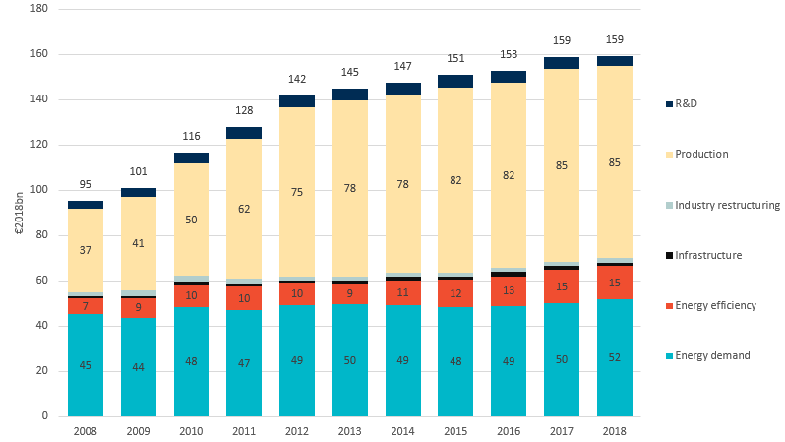 Source: Study on energy costs, taxes and the impact of government interventions on investments

In 2018, the ratio of energy subsidies to GDP varied between 3.3% in Latvia to 0.2% in Luxembourg, with the EU average was 1.2%. However, the major subsidy types also varied. For instance, in Latvia, subsidies primarily supported energy efficiency measures, while in Germany, almost two-thirds of the total volume of subsidies supported renewables. In France, Belgium, Poland, Greece, Ireland and Finland, the highest shares were spent on fossil fuels (although in absolute terms, the fossil fuel subsidies in France were slightly lower than in Germany).

Figure 2 – Energy subsidies in absolute amounts and as percentage of the GDP in the EU Member States in 2018

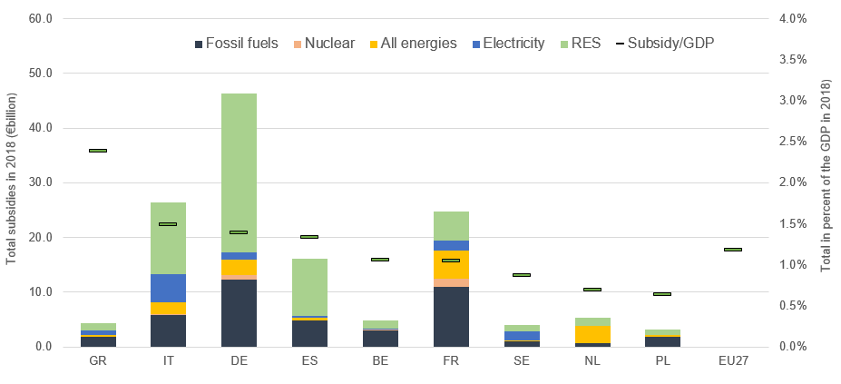

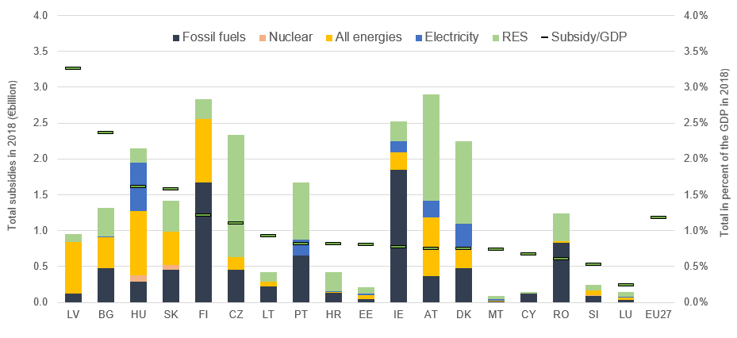 Source: Study on energy costs, taxes and the impact of government interventions on investments Electricity refers to general non-technology specific support for electricity, while all energies refers to measures that cannot be assigned to a single technology (or multiple technology support).

**Most of the subsidies in 2018 occurred[8]** in the **energy sector** (EUR92 billion), followed by industry (EUR20 billion), households (EUR17 billion), transport (EUR13 billion), and agriculture (EUR5 billion) in 2018.

Renewable energy received almost three-quarters of the subsidies in the energy sector, showing the continued importance of renewable subsidies in supporting their deployment in the energy sector. In recent years, the importance of subsidy instruments has decreased for new projects primarily due to the falling investment costs of wind and solar generation, leading to lower renewable subsidy growth in the EU. The three most important renewable technologies (solar, wind and biomass) received 30%, 22% and 16% of the total energy sector subsidies respectively.

The three most important subsidy instruments to promote **renewable energy** were feed-in tariffs (which still account for 70% of total renewable subsidies[9]), feed-in premiums and renewable quotas with tradable certificates. Besides the energy sector, renewables also play a role in transport, with around 10% of the sector’s subsidies related to biofuels.

**Energy efficiency** received around 9% of the total EU energy subsidies in 2018 in the EU. The biggest recipients of these subsidies were households. At EU level energy efficiency subsidies amounted to only 0.1% of GDP, while in Latvia they reached 2.4% and in Hungary and Bulgaria 0.7%. Energy efficiency, especially in the residential and industrial sectors, contributes to achieving climate change objectives, as opposed to subsidising energy demand and consumption of fossil fuels.

Among specific subsidies, **capacity payment mechanisms[10]** received around EUR2.2 billion subsidies in 2018, and were stable at an average level around EUR2 billion over the last few years.

Looking at the key recipients of the subsidies, **households** received around 11% of total subsidies in 2018, mainly in the form of energy demand or energy efficiency subsidies and electricity consumption support.

The picture presented by the **NECPs** on subsidiesis quite diverse.In eight NECPs, subsidies were not quantified and another four NECPs provided no information at all on subsidies. Four Member States provided only partial information. Only six Member States (Austria, Germany, France, Spain, Latvia and Lithuania) included a timeline to phase out (at least a part of the) existing subsidies. Four Member States (Croatia, Czechia, Finland and Malta) explicitly stated that they have no plans to phase out subsidies which help energy transition.

Energy subsidies identified in the NECPs provided relevant information add up to EUR55 billion – a third of the amount identified by the study. The number of measures identified in the study is far higher than that suggested by the NECPs. Member States may have embraced different interpretations on how to report energy subsidies. While a few Member States reported data for 2018 or 2019, some of them referred to earlier periods, and some did not specify the reporting year.

To make the reporting on progress in phasing out the energy subsidies comprehensive and meaningful, in particular those related to fossil fuels, the incompleteness and lack of coherence in the reporting practice needs to be addressed in future progress reports and updated plans, with clearer guidelines given to the Member States on how to report on subsidies.

**2.2. Fossil fuel subsidies in the EU**

F**ossil fuel subsidies**, amounting to EUR50 billion in 2018[11], were relatively stable over the past decade, peaking at EUR53 billion in 2012. They have started to increase again since 2015, growing by 6% until 2018.

As a share of GDP, they ranged from 1% in Greece to less than 0.1% in Luxembourg (amounting to 0.4% on average[12]). Whereas petroleum product subsidies were larger in France and Italy, in Germany coal and gas subsidies played a bigger role in Germany.

Figure 3 – Fossil fuel subsidies in total amount and *as a percent of GDP in* the EU Member States in 2018

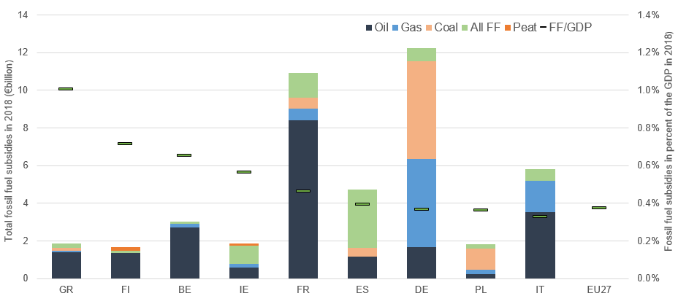

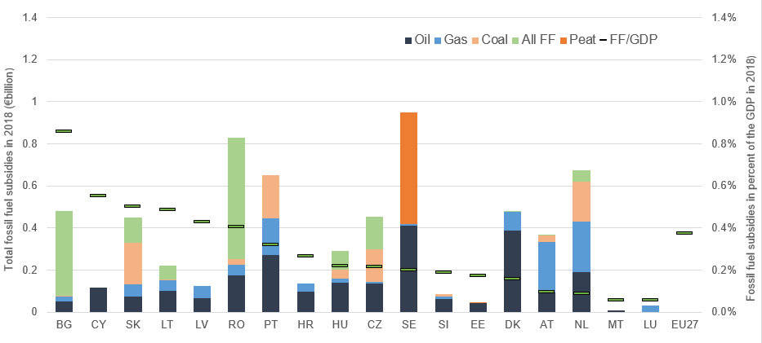 Source: Study on energy costs, taxes and the impact of government interventions on investments

To put this fossil fuel subsidy amount of EUR50 billion into context, investments in new wind power generation capacities[13] amounted to EUR16 billion in 2018 in the EU, whereas investments in solar power generation were around EUR8 billion in the same period. Investments in electricity transmission and distribution systems (including new capacities and refurbishments) in the same year amounted to EUR31 billion.

Between 2015 and 2018, fossil fuel subsidies increased the most in France (adding more than EUR2 billion, or 27%, largely owing to measures supporting fuel consumption in freight transport). However, at the same time they fell slightly in some countries such as Italy (by EUR0.4 billion, or 6%, largely owing to a decrease in excise tax exemptions in transport and feed in tariff reductions in power generation) and Germany (by EUR0.3 billion, or 2%, owing among others to a reduction in subsidies to the coal sector).

More than 60% of fossil fuel subsidies could be linked to energy demand support measures in 2018, implying that this support increased the consumption of fossil fuels. Support to electricity generation from fossil fuels is also important, amounting to 30%, while only 5% was spent on industry restructuring to help reduce reliance on fossil fuels. This suggests the need to, shift measures towards the objective of decreasing consumption of fossil fuels.

Subsidies on **oil and petroleum products,** which accounted for almost half of the total, grew by 18% between 2015 and 2018, while other types of fossil-fuel subsidies stagnated or decreased. Rising crude oil prices in this period might also have had an impact on petroleum products subsidies.

Coal, natural gas and other multiple fuel subsidies (e.g. combined heat and power generation) each accounted for around 17-18% of the total in 2018.

Compared to 2015, subsidies on **coa**l decreased by 9%, reflecting the decreasing share of coal in power generation. At the same time, **natural gas** subsidies went up by 4%. These data do not reflect the shift from coal to gas in the EU power generation mix that occurred in 2019, but it can be assumed that alongside lower consumption, coal subsidies have fallen further since 2018 and gas subsidies might have risen in the energy sector.

Fossil fuel subsidies in the **energy sector** remained stable between 2015 and 2018, with coal subsidies amounting to 30%. The **transport** sector received 20% more fossil fuel subsidies in 2018 than 3 years earlier, overwhelmingly in the form of subsidies to petroleum products.Fossil fuel subsidies in **agriculture** went up by 6% in the same period and were almost exclusively related to petroleum product subsidies.Fossil fuel subsidies in the **industrial sectors** and **households** increased only by 3-4%. While fossil fuels received 10% of the total subsidies going to households, this share was more than half in industry.

Looking at the financing sources, fossil fuel subsidies were provided mainly in the form of tax expenditures[14] (around 70% of the total, including consumption tax and excise duty exemptions, reductions, refunds, etc.). Price and income supports were three times lower. Direct transfers, mainly in the form of grants, played a smaller role.

Figure 4 – Fossil fuel subsidies in different sectors of the economy

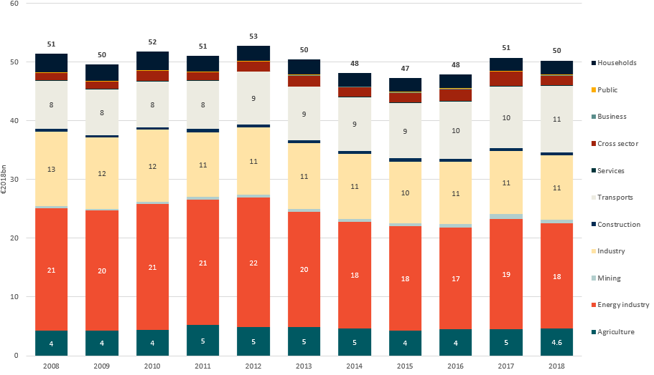

Source: Study on energy costs, taxes and the impact of government interventions on investments

Aggregated data from the **NECPs report only on EUR30 billion of fossil fuel subsidies**, which is 60% of the Commission study results. Three Member States (Croatia, Estonia and Malta) have explicitly stated that they do not plan to phase out (a number of specific) fossil fuel subsidies, referring mostly to protecting the competitiveness or economic viability of various sectors.

Thirteen Member States (Austria, Belgium, Bulgaria, Germany, Denmark, Greece, Finland, France, Italy, Lithuania, Latvia, Portugal and Spain) have indicated that they intend to work on setting up plans to phase out fossil fuel subsidies, although not all of them have fully developed their plans. Incomplete data does not allow us to paint a comprehensive picture of the situation and calls for significant improvement in reporting.

Member States will have to set out their national objectives on phasing out energy subsidies, in particular for fossil fuels, as part of their progress reports under the Governance Regulation.

**3. International comparison of fossil fuel subsidies**

G20 countries outside the EU spend more on fossil fuel subsidies compared to their GDP than the EU average of 0.4%, (with some exceptions, namely China, USA, Canada, Korea and Japan). Big fossil energy producer countries tend to spend proportionally more on related subsidies. Saudi Arabia spent more than 8% of its GDP on fossil fuel subsidies in 2018. This alone amounted to more than the total fossil fuel subsidies spent in the EU, principally supporting the domestic consumption of petroleum products. Russia has spent three times as much on fossil fuel subsidies as a percentage of GDP compared to the EU.

Figure 5 – Fossil fuel subsidies in absolute amounts and in the percent of GDP in the EU Member States and non-EU G20 countries

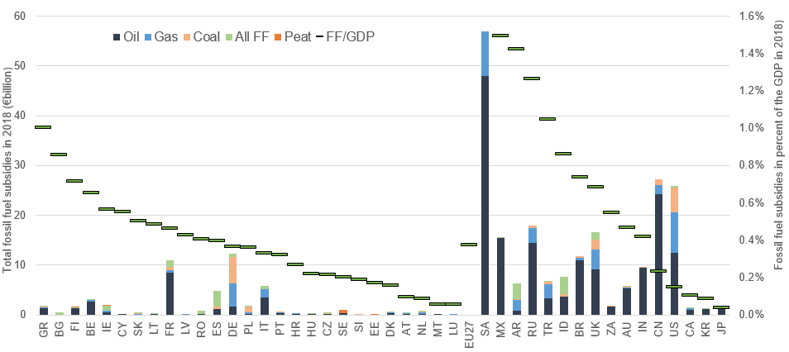 Source: Study on energy costs, taxes and the impact of government interventions on investments and own computations. For non- EU countries, given the limited comparability in subsidy classification and methodology, coupled with difficulties in data collection, results should be interpreted cautiously. The chart cannot show clearly, but Saudi Arabia spent more than 8% of its GDP on fossil fuel subsidies.

**4. Conclusions**

This findings of this report is largely based on the study on subsidies carried out for the Commission. This provides more comprehensive information on subsidies compared to the information on energy and fossil fuel subsidies provided by the NECPs.

Fossil fuel subsidies did not decrease substantially in the past decade; in some instances they even increased.

In addition, the completeness and coherence of different Member States’ NECPs needs to be improved. The Comparison with the Commission study shows that the Member States, underreported subsidies in their national plans. Only a few Member States presented detailed plans on phasing out subsidies. This shows the need for further action.

Commission guidance on the definition, coverage and methodology for Member States’ reporting on energy subsidies, including those on fossil fuels, in a more coherent and comparable manner could be one way to improve the situation and make future progress reports more comprehensive and accurate. The Commission will also publish the detailed results of its study on subsidies to provide a comprehensive picture of the situation[15].

.

1. Article 35, point n of the Regulation on the Governance of the Energy Union (2018/1999/EU)
2. <https://unfccc.int/files/essential_background/convention/application/pdf/english_paris_agreement.pdf>
3. G7 leaders declaration: <https://www.mofa.go.jp/files/000160266.pdf>
4. G20 Pittsburgh summit declaration: <http://www.g20.utoronto.ca/2009/2009communique0925.html#energy>
5. Study on energy costs, taxes and the impact of government interventions on investments <https://ec.europa.eu/energy/studies_main/final_studies/study-energy-costs-taxes-and-impact-government-interventions-investments_en> Hereinafter referred as ‘Commission study’
6. Following the concepts set forth by the World Trade Organization (WTO) Agreement on

   Subsidies and Countervailing Measures (<https://www.wto.org/english/tratop_e/scm_e/scm_e.htm>)
7. Source: Commission study
8. Subsidies with different purposes have different importance across the economic sectors. Subsidies that aim to support energy production (e.g. feed-in tariffs) and energy infrastructure were almost exclusively observed in the energy sector, whereas subsidies given to consumption (energy demand, e.g.: tax exemptions for fuels) were characteristic in energy consuming sectors such as industry, transport, households and agriculture. Energy efficiency subsidies were more evenly spread across the sectors.
9. High subsidies in the form of feed-in tariffs reflect the legacy of previous mechanisms as this form of support is no longer applied, with the exception of small producers
10. A significant part of these capacity payments can be associated with fossil fuel power plants, with renewables or demand side response (DSM) representing only a smaller share
11. Source: Commission study
12. In absolute amounts, ranging from EUR10 million in Malta to EUR12.2 billion in Germany. Given the different size of the EU economies, subsidies expressed as a percentage of GDP make more sense for cross-country comparisons
13. Source: Commission study. Including new onshore and offshore installations, which amounted to 6.8 GW and 0.6 GW respectively in 2018. New solar installations include photovoltaics and solar thermal heating, respectively amounting to 7.1 GW and 1.4 GW in the same period.
14. It is important to note here that in the case of tax reliefs, only the tax rate differences within the same fuel are taken into account for calculating subsidies. Cross-fuel subsidies are not computed, as it would be extremely complicated to consistently do so in all sectors and across all fuel types. However, based on partial country data, the study gives estimates on the cross-subsidisation of diesel and petrol fuels. These numbers are not included in the total amount of subsidies in the EU as there is only partial information available. Potential fuel subsidies in the international maritime and aviation sectors are also estimated, but not included in the total EU subsidy number. For more information, seen the Study on energy costs, taxes and the impact of government interventions on investments [link].
15. See Study on energy costs, taxes and the impact of government interventions on investments (with country fact sheets) https://ec.europa.eu/energy/studies_main/final_studies/study-energy-costs-taxes-and-impact-government-interventions-investments_en