

ANNEX 1  
Data collection framework – graphic presentation

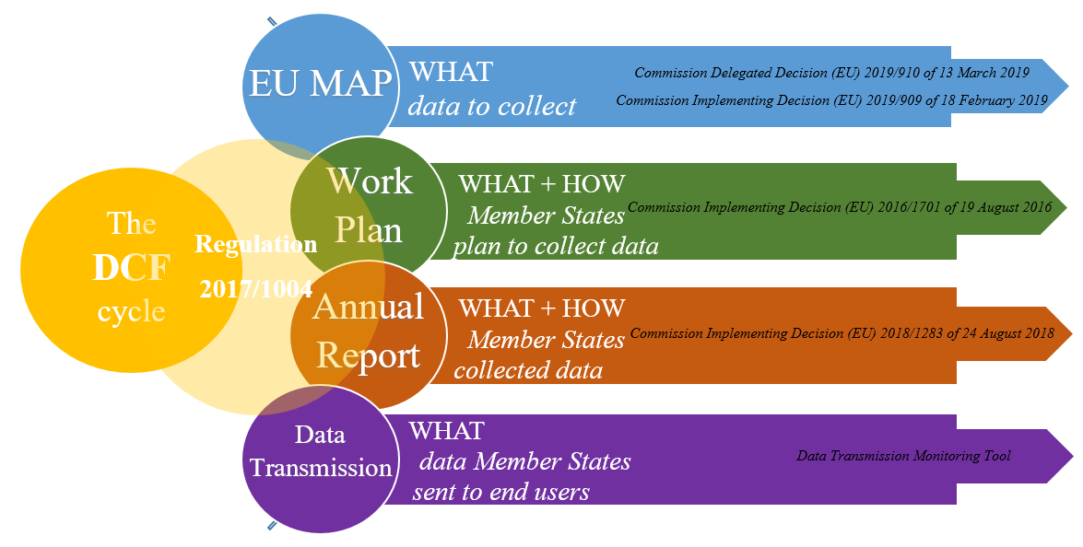

ANNEX 2  
 Regional coordination groups 2017-2019

This table lists the regional coordination groups (RCGs), which cover most fishing fleets subject to DCF activities. All RCGs have now developed and agreed their rules of procedures (RoP), which are made publicly available on the DCF website. In 2019, an agreement was reached on the merging of RCG North Sea and Eastern Arctic (NS&EA) and RCG North Atlantic (NA). The newly formed RCG NANS&EA adopted the RCG NS&EA RoP. The table also lists the RCG composition, in terms of EU Member States and end users involvement. (Mediterranean and Black Seas (Med&BS), Large Pelagic (LP), Long Distance Fisheries (LDF))

|  |  |  |  |  |  |  |  |
| --- | --- | --- | --- | --- | --- | --- | --- |
|  |  | Baltic | NA | NS&EA | Med & BS | LP | LDF |
|  |  | ICES 3b-d | ICES 5-10, excl 5a&7d * | ICES 1, 2, 3a, 7d, 5a, 12, 14, NAFO * | ICCAT, STECF. GFCM GSA 1-29 or FAO 37 | ICCAT, IOTC, WCPFC, IATTC | RFMO other than tuna |
| Member States’ composition | * = merged in 2019 | DK DE EE FI LV LT PL SE | BE DK FR DE IE EE FI NL PT ES UK LV LT SE PL | | BG HR CY FR EL IT MT RO SI ES | HR CY FR EL IT PT ES | DE IT LV LT NL PL ES |
| 2017 | annual meeting | X | X | X | X | X | X |
|  | end users present | X | X | X | X |  |  |
|  | RCG created | X | X | X | X | X | X |
|  | rules of procedure |  |  |  |  |  |  |
| 2018 | annual meeting | X | X | X | X | X | X |
|  | end users present | X | X | X | X | X (ICES) |  |
|  | rules of procedure | X | X | X | X | X | X |
| 2019 | annual meeting | X | X | X | X | X | X |
|  | end users present | X | X | X | X | X |  |
|  | RCG created |  | X* | |  |  |  |
|  | rules of procedure |  | X* | |  |  |  |

ANNEX 3  
Data calls and reporting obligations by end-users in 2017-2019

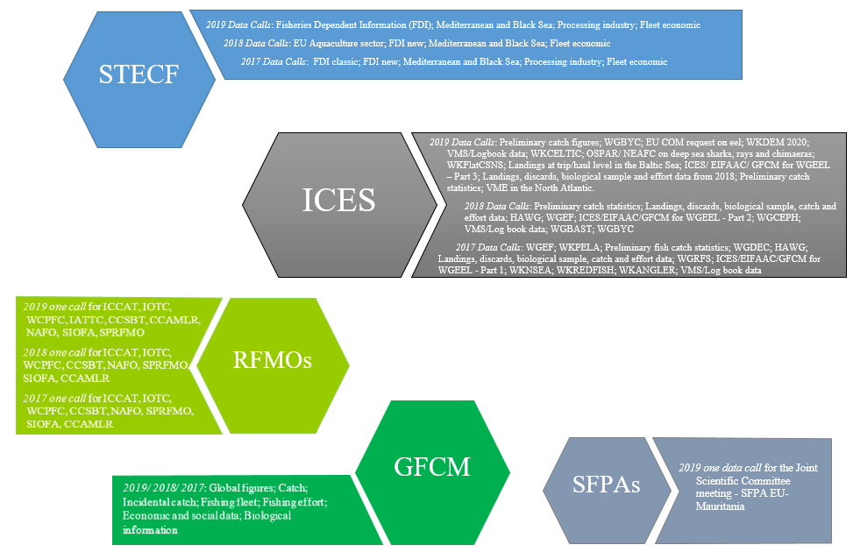

Data calls and reporting obligations by end-users in 2017-2019. The main and recurrent data calls and reporting obligations are listed here.

ANNEX 4   
Commission participation in DCF meetings 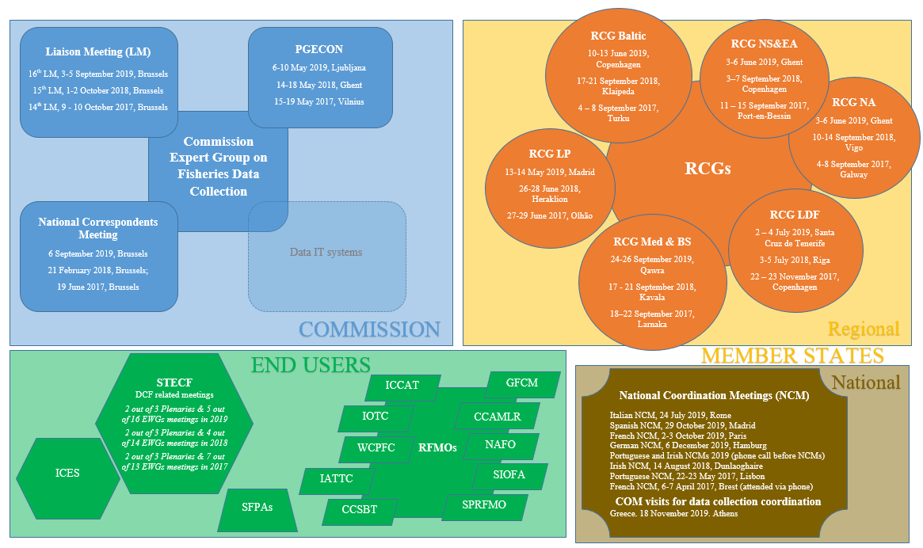

Mapping of DCF-related meetings, grouped by the responsible organising body (Commission, Member States and end users), that were attended by DG MARE, Unit C3. The group ‘Data IT system’ is inactive for the moment. The RCG NS & EA and the RCG NA merged in 2019. For the abbreviations, please refer to the main text.

ANNEX 5   
STECF activities 2017–2019 on data collection   
(Plenaries and Expert Working Groups meetings)

**2019** <https://stecf.jrc.ec.europa.eu/meetings/2019>

1. EWG 19-05, Evaluation of mandatory surveys under the DCF, 13-17 May, Brussels
2. EWG 19-09, Evaluation of annual reports for data collection, 24-28 June, Gothenburg;
3. PLEN 19-02, Summer plenary meeting, 01-06 July, Brussels (scrutiny of EWG work on the evaluation of the annual reports for data collection results)
4. EWG 19-11, FDI: Fisheries Dependent Information, 16-20 September, JRC-Ispra
5. EWG 19-12, Revision of the EU multiannual programme for data collection (EU-MAP) after 2020, 16-20 Sept, Brussels
6. EWG 19-18, Evaluation of work plans for data collection, 4-8 Nov, Bremerhaven
7. PLEN 19-03, Winter plenary meeting, 11-16 Nov, Brussels (scrutiny of EWG work on the EU-MAP revision after 2020 and results of EWG on work plans for data collection evaluation)

**2018**<https://stecf.jrc.ec.europa.eu/meetings/2018>

1. EWG 18-04, Preparation for the evaluation of the list of mandatory research surveys at sea, 14-18 May, Varese
2. EWG 18-10, Evaluation of annual reports, 25-29 June, Brussels
3. PLEN 18-02, Summer plenary meeting, 02-07 July, Brussels (scrutiny of EWG work on annual reports)
4. EWG 18-11, New FDI, 10-14 Sept, JRC-Ispra
5. EWG 18-18, Evaluation of work plans and data transmission failures, 05-09 November, Bremerhaven
6. PLEN 18-03, Winter plenary meeting, 12-17 November, Brussels (scrutiny of EWG work on evaluation of work plans and data transmission failures)

**2017** <https://stecf.jrc.ec.europa.eu/meetings/2017>

1. EWG 17-05, Fisheries Dependent Information – Classic, 19-23 June, JRC-Ispra
2. EWG 17-07, DCF 2016 annual reports evaluation and data transmission to end users in 2016, 26-30 June, Gavirate
3. EWG 17-04, Quality assurance for DCF data, 03-7 July, Copenhagen
4. PLEN 17-02, Summer plenary meeting, 10-14 July, Brussels (scrutiny of EWG work on annual reports evaluation and data transmission)
5. EWG 17-17 (1), Compilation of the new DCF annual report template - part 1, 16-20 October, Brussels
6. EWG 17-17 (2), Compilation of the new DCF annual report template - part 2, 23-27 October, Brussels
7. EWG 17-12, Fisheries Dependent Information - new FDI, 23-28 Oct, JRC-Ispra
8. PLEN 17-03, Winter plenary meeting, 06-11 November, Brussels (scrutiny of EWG work on new DCF annual report template)
9. EWG 17-13, Evaluation of DCF national work plans amendments for 2018/19, 13-18 November, Hamburg

ANNEX 6  
Data collected under the EU-MAP

**Delegated decision**

BIOLOGICAL DATA

Table 1A Stocks in Union waters

Table 1B Stocks of outermost regions of the Union

Table 1C Stocks in marine regions under regional fisheries management organisations (RFMOs) and sustainable fishing partnership agreements (SFPAs)

Table 1D Species to be monitored under protection programmes in the Union or under international obligation

Table 1E Freshwater anadromous and catadromous species

Table 2 Fishing activity (metier) by region

Table 3 Species to be collected for recreational fisheries

Table 4 Fishing activity variable

SOCIO-ECONOMIC DATA for fish, aquaculture and processing sector

Table 5A Economic variables for the fleet

Table 5B Fleet segmentation

Table 5C Geographical stratification by region

Table 6 Social variables for the fishing and aquaculture sectors

Table 7 Economic variables for the aquaculture sector

Table 8 Environmental variables for the aquaculture sector

Table 9 Segmentation to be applied for the collection of aquaculture data

Table 10 Economic and social variables for the processing industry sector that may be collected on a voluntary basis

**Implementing decision**

SURVEYS

List of research surveys at sea:

Baltic Sea: 5 surveys

North Sea and Eastern Arctic (ICES areas I and II): 15 surveys

North Atlantic (ICES Areas V-XIV and NAFO areas): 19 surveys

Mediterranean waters and Black sea: 4 surveys

THRESHOLDS

Thresholds on biological data collection

Provision of catch estimates from existing recreational fisheries

Thresholds on social and economic data on aquaculture

Thresholds on environmental data on aquaculture

Thresholds on Member State's participation (physical or financial) in research surveys at sea

ANNEX 7  
EU MAP beyond 2021- consultation activities

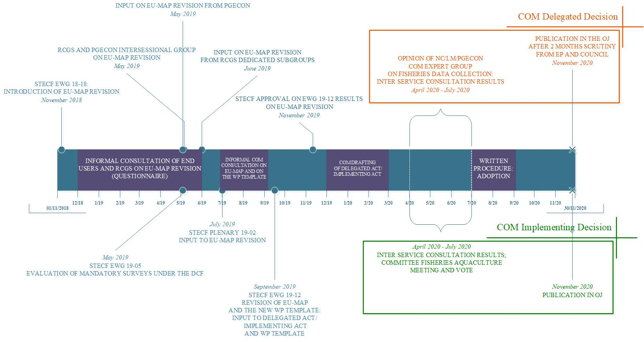

*Timeline of EU MAP consultation (indicative from July 2020)*

ANNEX 8  
 Templates for work plans and annual reports

Example of how the EU MAP requirements (upper left-hand box) are translated into the work plan template (middle box) and the annual report template (bottom right box): the sampling of commercial fisheries in the EU MAP includes details on the sampling fractions and the biological variables to be collected for the stocks listed in Tables 1A, 1B and 1C. These requirements are described in the work plan template in a series of tables – here we present Table 1C, that depicts the sampling intensity of the stocks and the biological variables to be collected. The annual report includes the above planning of the work plan table (white part) and the achieved sampled levels (grey part).

ANNEX 9  
Summary of MS pilot studies 2017 – 2019

This table marks the pilot studies undertaken by the Member States during the period 2017–2019, based on the EU MAP.

|  |  |  |  |  |
| --- | --- | --- | --- | --- |
| **MS** | **Pilot study 1:  Share of catches of recreational fisheries** | **Pilot study 2:  Level of fishing and impact on resources/ecosystems** | **Pilot study 3:  Employment data by education/nationality** | **Pilot study 4:  Environmental data on aquaculture** |
| AT | X |  | X | X |
| BE | X | X | X | X |
| BG |  | X |  |  |
| HR | X | X | X |  |
| CY | X | X | X |  |
| CZ |  |  |  | X |
| DK | X | X | X | X |
| EE | X | X | X |  |
| FI | X | X | X | X |
| FR | X | X |  | X |
| DE | X | X | X |  |
| GR | X | X | X | X |
| HU |  |  | X | X |
| IE | X | X | X | X |
| IT | X. | X | X | X |
| LT |  | X | X |  |
| LV | X |  | X |  |
| MT | X | X | X | X |
| NL |  |  | X | X |
| PL | X | X | X |  |
| PT | X | X | X |  |
| RO |  | X | X | X |
| SK |  |  | X |  |
| SI | X | X. | X | X |
| ES | X | X | X |  |
| SV | X | X |  | X |
| UK | X | X | X | X |

ANNEX 10  
Regional coordination groups’ recommendations

This table briefly describes the recommendations put forward by the regional coordination groups (RCG) of the Baltic (RCG BALTIC), North Sea and Eastern Arctic (RCG NS&EA), North Atlantic (RCG NA), Mediterranean and Black Sea (RCG MED&BS), long distance fisheries (RCG LDF) and large pelagics (RCG LP) for the period 2017-2019. The information was collated from the respective liaison meeting reports.

|  |  |  |  |
| --- | --- | --- | --- |
|  | **2019** | **2018** | **2017** |
| *Internal matters* | | | |
| Governance |  |  |  |
| Rules of Procedures (RoP) | RCG NA & RCG NS&EA: to establish RCG NS&EA RoP as the RoP for the merged group | RCG MED&BS: amendment of RoP | RCG MED&BS: RoP  RCG LP: future status |
| RCG secretariat | RCG NANS&EA, RCG BALTIC: need for central resources to support RCG work | RCG NS&EA, RCG BALTIC: finance a secretariat for supporting RCG work |  |
| Meetings | RCG NA NS&EA, RCG BALTIC back-to-back meeting in 2020 |  |  |
| *Inter-sessional work (sub-groups)* | | | |
|  | Cooperation between RCG LDF with RCG NANS&EA, RCG BALTIC |  | RCG NA:  - Establish and maintain a pan regional RCG data end user subgroup  - Pan-regional subgroup on regional sampling plans  - Workshop to standardise methods of determining metiers from transversal data  RCG LP: Establish in 2018 a workshop for launching a permanent group for temperate tuna |
| *Outcomes* | | | |
| Regional sampling plans | RCG BALTIC: small pelagic in the Baltic  RCG MED&BS: small pelagic fish in the Adriatic Sea |  |  |
| Fisheries overviews | RCG NA NS&EA: to approve  RCG NA NS&EA, RCG BALTIC: to make publically available |  |  |
| *Surveys at sea* | | | |
| Survey data | RCG NANS&EA, RCG BALTIC: all data from mandatory surveys to be made publicly available  RCG NA NS&EA: to develop an inventory list from the survey databases | RCG MED&BS: mesozooplankton sampling in MEDIAS (acoustic) surveys | RCG NS&EA:  - Common naming of surveys  - Review of survey tables  RCG NA: collate survey information from MS for evaluation of EU‐MAP  RCG MED&BS:  - Implementation of research surveys at sea  - Introduction of new research surveys at sea |
| Cost sharing | RCG NA NS&EA: cost‐sharing agreements for surveys in 2020-2021 |  | RCG NA: cost‐sharing agreements for surveys in 2018 – 2019  RCG MED&BS: procedures for cost sharing under the EMFF |
| *Regional databases* | | | |
| RDB data | RCG NA NS&EA: update stock information  RCG BALTIC: carry out data checks  RCG LDF:  - Update data  - Facilitate future uploads for combined areas | RCG NS&EA: finalize the work done on the population of the stock database table  RCG MED&BS: setting up of a Regional Database | RCG BALTIC:  - Request ICES to improve the RDB towards the data needs of WGEEL/ WGBAST  - Request ICES to align the master stock database with data used in stock assessments  RCG NA: Explore current RDB structure and data in simulations to test regional sampling designs |
| Data policy and confidentiality | RCG NA NS&EA:  - SCRDB to review the RDB/RDBES Data Policy  - SCRDB and ICES to create an RDB/RDBES Data confidentiality agreement |  | RCG NA: RCG to re‐establish representation at the SC‐RDB |
| Funding | RCG LDF: to fund work a through COM-ICES agreement  RCG NA NS&EA, RCG BALTIC: need for long term funding of the RDBES development | RCG NA, RCG NS&EA, RCG BALTIC: funding of RDBES development |  |
| Applications/ uses |  | RCG NA:  - Use of the RDBES to populate DCF National Report tables  - Storage and maintenance of metiers variables | RCG NA: utilisation of RDB for completion and evaluation of MS national plans |
| *Data Quality* | | | |
|  | RCG MED&BS: to apply STREAM data quality checks, before submitting data to the relevant data calls |  | RCG NS&EA: development of quality evaluation tools based on InterCatch |
| *Scientific Advice* | | | |
| ICES |  | RCG NS&EA:  - Set guidelines for all WKs and WGs for writing recommendations to others  - Recommendations addressed to WGNAS and WGBAST on Atlantic salmon  RCG NA: need for further inclusion of recreational caught fish in stock assessments | RCG NS&EA: update of advice sheet  Diadromous subgroup: recommendations to WGBAST, WGNAS, WGEEL |
| DG MARE/STECF |  |  | RCG MED&BS:  - Proposed Changes to FDI data call and new data calls  - Improve communication between end users and MS before reporting DT failures to COM  - Data availability and official data calls  - Shorten the data‐handling procedures |
| *Per Theme* | | | |
| Recreational fisheries (RF) | RCG MED&BS: workshop for RF  RCG NA NS&EA:  - ICES to consider inclusion RF data in the RDBES  - STECF to consider a workshop on the outcomes from pilot studies of RF | RCG NA:  - Need for multispecies data collection for marine RF pilot surveys  - To consider inclusion of marine RF data into the RDBES  - To review the role of regional cooperation for surveys of marine RF in 2019 |  |
| sampling | RCG MED&BS: establishment of a scientific network for sampling optimization | RCG NS&EA: Endorsement of outcomes from metier workshop 2018 | RCG MED&BS: merging of length classes  RCG LP:  - shark sampling  - Compatibility of shark sampling activities with CITES  RCG LDF: suspension of EU sampling of small pelagics in CECAF area (From Morocco to Guinea‐Bissau) |
| Age reading | RCG BALTIC: to finalise age readings for dab, flounder, brill and turbot  RCG MED & BS: MSs to harmonize age reading protocols for all target species | RCG LP: promote regular workshops for Bluefin Tuna age reading and calibration in ICCAT | RCG MED&BS: biological parameters – ageing protocols |
| Fish stomach contents | RCG MED & BS: use of STREAM protocols for monitoring |  |  |
| Data requirements |  | RCG NA, RCG NS&EA, RCG BALTIC: review and amendment of proposed Control Regulation to ensure DCF data requirements are met  RCG Baltic: availability of last haul data | RCG NA: implications of the Landing obligation  RCG MED&BS: pilot studies on incidental catch of vulnerable species  RCG LDF: data requirements small pelagics CECAF area (from Morocco to Guinea‐Bissau) |
| Index rivers (diadromous species) | RCG BALTIC: potential cost-sharing |  |  |

Annex 11

Data collection – Member States EMFF allocation, commitments, spending – by end 2018

|  |  |  |  |  |  |  |
| --- | --- | --- | --- | --- | --- | --- |
| MS | EMFF – allocated | **Average annual EMFF allocation** | EMFF committed (Euro) | **EMFF committed spending / EMFF allocation (%)** | EMFF spent (Euro) | **EMFF spending / EMFF allocation (%)** |
| 2014-2020 | **(Euro)** | (2014-2018) | (2014-2018) |
| (Euro) |  |  |  |
| AT | 700,000 | **100,000** | 698,689 | 99.8% | 257,408 | 36.8% |
| BE | 8,696,680 | **1,242,383** | 8,756,490 | 100.7% | 3,420,655 | 39.3% |
| BG | 3,983,120 | **569,017** | 1,370,570 | 34.4% | 935,331 | 23.5% |
| CY | 3,541,528 | **505,933** | 3,872,695 | 109.4% | 1,625,782 | 45.9% |
| CZ | 1,953,015 | **279,002** | 299,624 | 15.3% | 66,084 | 3.4% |
| DE | 37,195,778 | **5,313,683** | 37,195,778 | 100.0% | 19,663,775 | 52.9% |
| DK | 40,095,077 | **5,727,868** | 27,424,872 | 68.4% | 21,609,095 | 53.9% |
| EE | 5,628,408 | **804,058** | 3,736,000 | 66.4% | 2,869,377 | 51.0% |
| GR | 16,368,547 | **2,338,364** | 15,342,220 | 93.7% | 6,410,771 | 39.2% |
| ES | 79,041,351 | **11,291,622** | 35,161,405 | 44.5% | 35,092,020 | 44.4% |
| FI | 14,332,894 | **2,047,556** | 10,132,560 | 70.7% | 8,408,569 | 58.7% |
| FR | 66,146,872 | **9,449,553** | 33,425,613 | 50.5% | 26,600,570 | 40.2% |
| HR | 4,876,000 | **696,571** | 4,224,704 | 86.6% |  | 0.0% |
| HU | 1,751,293 | **250,185** | 1,688,617 | 96.4% | 859,088 | 49.1% |
| IE | 32,557,058 | **4,651,008** | 36,923,391 | 113.4% | 27,687,992 | 85.0% |
| IT | 46,985,079 | **6,712,154** | 46,585,393 | 99.1% | 22,179,921 | 47.2% |
| LT | 2,757,954 | **393,993** | 1,869,761 | 67.8% | 915,262 | 33.2% |
| LV | 5,280,929 | **754,418** | 2,339,075 | 44.3% | 1,969,892 | 37.3% |
| MT | 3,541,528 | **505,933** | 3,541,528 | 100.0% | 1,754,836 | 49.6% |
| NL | 26,675,264 | **3,810,752** | 25,600,000 | 96.0% | 10,056,900 | 37.7% |
| PL | 7,434,311 | **1,062,044** | 6,673,578 | 89.8% | 3,853,923 | 51.8% |
| PT | 24,004,679 | **3,429,240** | 15,699,554 | 65.4% | 5,149,221 | 21.5% |
| RO | 3,555,675 | **507,954** | 2,021,328 | 56.8% | 2,019,595 | 56.8% |
| SE | 27,412,172 | **3,916,025** | 11,384,821 | 41.5% | 7,075,020 | 25.8% |
| SK | 700,000 | **100,000** | 0 | 0.0% | 0 | 0.0% |
| SI | 2,343,474 | **334,782** | 1,171,737 | 50.0% | 602,937 | 25.7% |
| UK | 52,441,314 | **7,491,616** | 25,217,017 | 48.1% | 14,988,460 | 28.6% |
| Total | 520,000,000 | **74,285,714** | 362,357,020 | 69.7% | 226,072,483 | 43.5% |

*Source: Infosys, 31.12.2018*

Annex 12  
Summary of regional grants

1. *Strengthening regional cooperation in the area of large pelagic fishery data collection (RECOLAPE)*

This report refers to the framework contract MARE/2016/22 and, specifically, to the Annex III “Biological data collection for fisheries on highly migratory species”. The overall objective of the project is to strengthen the regional cooperation in the area of biological data collection for highly migratory species in the current context where, regional cooperation will evolve from a single meeting (RCM – Regional coordination meeting) to a continuous process that will have greater responsibilities (RCG – Regional coordination group). The project has been involved in several developments: the design of Regional Sampling Plans (RSPs) for large pelagic stocks, creation of tools and protocols for collecting new data around FADs (Fish Aggregating Devices), testing the alternative on-board data collection methods and the design of an appropriate regional framework to assess the data quality. The objective of this final report is to explain the work undertaken, giving details of the implementation and results of the specific work packages. The final section in each work package report also lists recommendations for the future work to improve the coordination in the collection of data on highly migratory species

**WP1** made a proposal for the future organisation of the Large Pelagic RCG (RCG-LP). This proposal includes meetings/subgroups, which are organized in three stages. The first stage has the objective of identifying data gaps and data needs, based on the research priorities for data collection identified by the end-users (stock assessment groups within the tuna RFMOs). It is expected that this group will serve to improve the coordination between data collection scientists and stock assessment scientists. The second stage is in charge of designing Regional Sampling Plans (RSP) both for the target and bycatch species, by coordinating both dockside and on-board sampling for the different stocks. Ideally, this coordination should be achieved by methodological groups dealing with specific fisheries. The proposal includes four parallel groups based on stocks/gears; tropical tunas (focused on purse seine fleet), longline fisheries outside the Mediterranean Sea, longline fisheries inside the Mediterranean Sea and bluefin tuna fisheries. Finally, the third stage would evaluate the results of the two preceding stages, and it would make the final decisions of greater importance and approve the RSPs.

The **WP2** explores all the elements needed for the design of a European Regional Work Plan that may replace the relevant parts of the MS National Work Plans. This WP includes two case studies: one for the Mediterranean swordfish and another for the tropical tunas in the Atlantic Ocean. In both cases, data needs and priorities were defined, current port sampling protocols were reviewed, and specific variations to current sampling design are recommended to increase the sampling efficiency.

**WP3** includes two independent pilot studies. **WP3.1** proposes best standards for data collection and data transmission around fish aggregating devices (FADs), which are presented as valid to fulfil minimum requirements in all tuna Regional Fisheries Management Organizations (RFMO). The use of FADs has continuously increased in tropical tuna purse seine fishery, with FAD-associated catches now exceeding those on free schools in the case of the European Fleet. Despite the importance of this fishery, little information is available on FAD use worldwide which is crucial for the understanding, monitoring and management of FADs use and the impacts on pelagic ecosystems. As a result, tuna RFMOs have called for FAD management plans, including data collection and reporting on deployment and use of FADs by purse seiners and support vessels[1].

On the other hand, during this WP3.1 standards for data submission on FOBs to RFMOs were defined. This WP recommends that RFMOs templates should be adjusted to the data sources (FOB logbook and data coming from buoys attached to the FADs, which permit their constant tracking).

The second pilot study, **WP3.2**, compares the data collected using Electronic Monitoring Systems (EMS) to the data collected by observers and self-reporting programs, to determine if EMS can be used to reliably collect unbiased data on-board longline fleet. This pilot study, which was conducted in the longline fleet targeting large pelagic species around La Reunion Island (Indian Ocean), demonstrates that using the EMS is a viable complement or alternative to collecting the data using human observers, even if there are still some weaknesses.

**WP4** developed a data collection strategy for some variables not collected under the Data Collection Framework (DCF). These variables should be provided by the fishing industry and buoy providers and will be used, in combination with traditional DCF data, for Catch per unit effort (CPUE) standardisation, as well as in the estimation of alternative abundance indices in tropical tuna fisheries. The introduction of FADs in conjunctions with the satellite linked echo-sounder buoys was one of the most significant innovation introduced in the industrial tropical tuna purse seine fishery. These buoys provide information on the accurate geo-location of the floating object and estimation of fish biomass aggregated underneath the FAD along its trajectory, which increases the efficiency of the fishing operations. Alternative indicators of tuna biomass and fishing effort can be derived from echosounder buoys, which could help to assess natural variations on target species abundance and improved scientific advice for stock assessment. As such, the objectives of the WP4 are to develop a data collection strategy on FADs to provide indicators of the total number of operational buoys at sea to improve the CPUE standardization procedure, to define dedicated algorithms to improve estimates of biomass signal from echo-sounders, and to develop alternative abundance indices in tuna fisheries, which requires the efforts from all the stakeholders.

On the other hand, the WP4 is devoted to developing and test methods for the estimation of reliable estimates of tuna presence and abundance underneath the FADs. The algorithm developed for one specific brand of buoys has shown a very good efficiency in pattern recognition of presence and absence of tuna aggregation under FADs, regardless of the ocean.

**WP5** developed an R package[2], named “dqassess”, which could improve the procedures assessing the quality of biological data on large pelagic stocks, at the national and regional levels. The introduction of the R package “dqassess” has to be seen as the first step in a larger dynamic process. Several projects on data quality assessment have been started by different initiatives (e.g. COST[3]); the package needs to be linked to these projects. Furthermore, this kind of quality control and checks have to be tested by the community and all contributions, and feedback experiences should be considered to improve the methodology and, especially, to follow-up the specific user needs. In addition, Mediterranean swordfish age-reading coordination exercise was conducted under WP5, which could be understood as an example of cooperation under the DCF between the institutes from several MS and which could be extended to the rest of the LP species. This cooperation has resulted in common and agreed procedures (age scheme, age criteria) and methods (preparation of the spines) used for swordfish age reading. Moreover, it is recommended that the coordination on the swordfish ageing should continue, organising new exchange exercise and workshop after three years to assess any improvements that might be ascribed to the agreed-on procedures and common ageing protocol.

Finally, **WP6** has focused on a consultation process about the results obtained in the present project among MS involved in LP fisheries. The participation rate exceeded 50% including some of the most relevant countries with large pelagic captures. There is a broad consensus among MS on the general proposal to structure the RCG-LP in 3 stages, on the recommendations done for the development of a RSP for tropical tunas and Mediterranean swordfish, and for the procedures to assess the biological data quality.

1. *Strengthening Regional cooperation in the Area of fisheries biological data collection in the Mediterranean and Black Sea (STREAM)*

The STREAM project “Strengthening Regional cooperation in the area of fisheries biological data collection in the Mediterranean and Black Sea” aimed at providing support to the Commission and MSs to build up experience in new areas of regional cooperation in the Mediterranean and Black Sea for the realization of Multiannual Regional Work Programme (MRWP).

The **Work Package 1** performed a regional consultation to obtain views, determine the degree of consensus on possible future developments of regional coordination in the collection of biological data, on the implementation of common methodologies, the establishment of regional sampling plans as well as the development of *ad hoc* working groups, and note any outstanding areas of disagreement that need to be addressed. The results of the consultation pointed out the urgent need to progress towards common regional methodological approaches for the collection of biological data on commercial fisheries, recreational fisheries, and the marine ecosystem in general. The necessity to better develop statistical and quality check aspects related to the collection of all biological data at regional level, and strengthen the cooperation between MSs sharing the same marine resources in the region also emerged. WP1 also analysed the rules of procedures (RoPs) already developed during the RCG Med&BS (RCG Med&BS Report, 2017), identifying gaps and suggesting further actions.

Under **Work Package 2**, we performed an analysis aimed at identifying stocks and fisheries (métiers) suitable for regional sampling. The analyses performed under WP2 of the project STREAM provided new insights on the identification of stocks and métiers driving the fisheries in the EU Mediterranean and Black Sea GSAs. On the basis of the 2013-2015 data, and taking into account a 75 % threshold of the cumulative value and volume of landings, it was possible to identify the most important target species for all the demersal and small pelagic fisheries. The outputs of WP2 provided the elements to identify the case studies for the training workshops on the sampling optimization tools and the analyses performed under WP3.

Under **Work package 3,** a data sharing agreement (DSA) was finalized specifying the type of data to be shared, the common data format and rules for the usage of these data. The DSA was shared through the project sharepoint with National Correspondents for their feedback and agreement. Under Task 3.2, some modifications were made to the RCG Med&BS Data Call format to allow the recording of individual measures (e.g., weight, sex, maturity and age) useful for analyses on biological variables, and information related to the fishing area and (port) that can be used in the analyses performed by the Sampling Design tool (under Task 3.3) in order to perform the analyses in different areas. The introduction of these additional fields implied necessary modifications to the scripts for the conversion of the simplified format (RCG Med&BS Data Call) to the SDEF (Standard Data Exchange Format) used in COST.

A regional data storage system for Mediterranean and Black Sea is not available, though requests for establishing a RDB have been proposed in past occasions. Besides the revision of the reference lists and data format also contributes to examine solutions related to the storage, processing and analysis of the data at regional level, taking into account the current situation, ongoing studies and developments. A list of expectations of the various stakeholders from the RDB (requirement specifications), the potential users (actors) and the list of actions defining the interactions between a user and the system to achieve a goal (use cases) is described.

Auxiliary tools to standardize and ease the procedures for data processing and management are made available through *ad hoc* scripts for the conversion of primary data into the formats for data transmission to specific data call (e.g. EU-JRC DCF, GFCM DCRF) and use of existing tools (e.g. COST) for data analyses.

The work done in Task 3.3 included the development of tools for the sampling optimization, and the application of the developed tools to specific case studies. The initial plan was to cover and analysed at least four case studies, while it was finally decided to provide the results of five case studies in order to have a wider overview on the potentialities of the developed tools and their applications.

The methodology and the R tools developed in Task 3.3 of the project have been applied to 15 case studies during the 2 training workshops organized under WP7. Data for the case studies were obtained after a data call of RCG Med&BS, following a Data Sharing Agreement.

R scripts to implement rules on how to allocate tasks or costs between Member States and assessing results from simulations under the economic perspective were developed. Cost implications if Member States will implement the regional sampling plan proposed under Task 3.3 were evaluated and compared to the "business as usual" approach that consists of national sampling plans.

The work of **Work package 4** was organized into two Tasks.

The main objective of Task 4.1 was to develop a RSP adapted to the characteristics of the stock/fisheries object of regional monitoring, which were identified by the WP2 of this project.

In addition to the main stock proposed by MARE/2017/19 for stomach content data collection, e.g. European hake in Mediterranean GSAs and turbot in the Black Sea, some additional stocks were proposed for this data collection in the new sampling program: anglerfish, *Lopius piscatorius* and *L. budegassa*, in the Mediterranean, Mediterranean horse mackerel, *Trachurus mediterraneus*, and sprat, *Sprattus sprattus*, in the Black Sea. As main criteria followed for the selection of the new species, we considered the species importance in terms of landings and commercial value, the trophic relationships (e.g. predator, prey) with European hake in the Mediterranean, and turbot in the Black Sea. On this basis a new sampling scheme was proposed, taking into account, for each species, factors such as size class, season (quarter), and type of sampling (e.g. experimental fishing and biological sampling on commercial fishery).

A common procedure of analysis to estimate the structure of the exploited fish and shellfish assemblages (in terms of species occurrence and relative abundance) was designed using the MEDITS trawl survey data. The proposed methodology was tested on a case study represented by the GSA9, using MEDITS data from 2015 to 2017.

Under Sub-Task 4.1.3 “Data on incidental catch of non-target species, such as protected, endangered or threatened species”, the methodological approach developed under the project MARE/2014/19 Med&BS was reviewed and updated. An analysis of pros and cons of the approach was performed, also taking advantage of the preliminary results that came from the pilot studies carried out under the MSs work plans. A cooperation started with experts from GFCM working on the implementation of a monitoring program on the incidental catch of vulnerable species, and the colleagues involved in the WP4 of the FishPi2 project.

The new programme on data collection of incidental by catch was designed taking into consideration three case studies, two in the Mediterranean (trawl fisheries in the Gulf of Lions and the Adriatic Sea), one in the Black Sea (beam trawl fishery targeting Rapana whelk). The monitoring programmes are based on a combined approach coupling the fleet observer monitoring scheme already foreseen for the collection of biological data on commercial fisheries and discards with a self-sampling programme (log-books filled in by fishermen) through the proactive involvement of the fishing industry.

The **Work Package 5** performed athorough review of the knowledge on SSF and RF in terms of characterization of the fisheries, data collection approaches and needs, data quality and existing gaps has been performed. Furthermore, WP5 formulated guidelines for the collection of data in SSF and RF, and provided a list of recommendations for the implementation of monitoring programs on RFs. WP5 proposed a roadmap listing the steps that shall be taken by MSs to implement pilot studies on RFs in the new EU MAP.

The work of **WP6** has been organized and performed in three tasks. Task 6.1 developed a series of a priori and a posteriori data quality checks to be performed at national level. Two different R scripts were developed: a priori QC: quality checks carried out on the sampling data in RCG CS format; a posteriori QC: quality checks on the Med&BS Data Call tables. The a priori QC script is aimed at detecting the errors or inconsistencies on the sampling data, before the raising procedures were applied. Once the warnings have been addressed, the conversion tools developed within STREAM Task 3.2 can be used to obtain the COST objects and the SDEF tables (RCG_to_COST script); subsequently, the SDEF tables can be used to obtain the Med&BS Data Call tables applying the SDEF_to_DGMARE_Med_BS script. Then, the a posteriori quality checks can be carried out to get a report containing information on the spatial and temporal coverage of all the relevant tables, as well as to detect records with discrepancies..

The work performed under Task 6.2 has been implemented taking into consideration two case study species: red mullet, *Mullus barbatus*, and common pandora, *Pagellus erythrinus*. The analyses performed on the age variability in red mullet and the procedures set up for the implementation of an exchange exercise and a workshop on the ageing of common Pandora will represent common procedures to be extended to other species with the aim checking the quality of age data.

Task 6.3 developed a detailed calendar for national and regional checks by means of the a priori and a posteriori data quality check scripts developed by Task 6.1. A first draft of the calendar was presented and discussed with Member State National Correspondents and stakeholders during the STREAM Knowledge Exchange Workshop (Rome, 11-12 April 2019), and the proposed final version of the calendar took into account their comments and suggestions.

The **Work Package 7** performed an analysis aimed at mapping the training needs and the expertise in the various fields of biological data collection. This analysis was performed through an *ad hoc* questionnaire. The results of the answers received from the questionnaire were presented at the RCG Med&BS meeting in Kavala (September 2018).

In cooperation with WP3, two workshops were organized for the experts in the region. The two workshops involved training on use of regional tools developed for optimising sampling intensity, and took place in Kavala (in parallel with the RCG Med&BS meeting, September 2018) and in Bari (1-4 October 2018). A third workshop (Workshop on age reading of common pandora) was organized in cooperation with Task 6.2, and took place in Livorno (26-28 March 2019).

For **Work Package 8**, a written consultation was carried out with NCs after the STREAM Knowledge Exchange Workshop (11-12 April 2019), asking them to evaluate the main points tackled in the WPs 1-6, and express their level of agreement/disagreement on a scale of semantic scores ranging from -3 to +3, with the value 1 representing a judgement of indifference and the value ±3 representing highest agreement/disagreement. The feedback from the National Correspondents was generally positive.

1. *Strengthening regional cooperation in the area of fisheries data collection – Socio-economic data collection for fisheries, aquaculture and the processing industry at EU level (SECFISH)*

The final report of the SECFISH project provides an overview of the achievements/results in the project between August 2018 and the End of the project (May 15th 2019) and problems encountered during that period.

For **WP 1** was finalised shortly after the first reporting period (Month 9).

The Handbook is finalized as product from **WP 2**. It gives a comprehensive overview on sampling design and estimation methods. Participants in **WP 3** on the disaggregation of economic data have developed the R-Script and have tested this script with country data. During the PGECON meeting 2019 a training session was organised to allow participants from outside the SECFISH project to test the methodology with their own data.

The results of **WP 4** include an overview on the situation of fishing rights in the EU Member States, methods to assess the value of these intangible assets and a description of some applications of the proposed methods. The participants in **WP 5** have done a feasibility study on a possible data collection of raw material in the EU. Finland, Denmark and Germany were used as case studies where Finland is already collecting the data and it was assessed how a data collection could look like in Denmark and Germany.

The report for **WP 6** gives an overview on the availability of socioeconomic data and a methodology for socioeconomic data collection for EU fisheries, aquaculture, and the fisheries processing industry. In **WP 7** the participants summarized the main outputs of the ICES WGRFS on recreational fisheries and developed suggestions for a quality assurance framework including data formats for the use in RDBs, socioeconomic data collection requirements and future coordination activities.

**Background and project objectives**

The project coordinator has organized for **WP** 8 since the delivery of the interim report a Web-Meeting in December 2018 and a physical meeting in The Hague in March 2019. He presented an overview on the SECFISH project and coordinated the presentation of the project participants at the PGECON meeting.

This project was funded under the Call for Proposals Mare 2016/22: Strengthening regional cooperation in the area of fisheries data collection. It addressed the TOR regarding social and economic data collection issues. As stated in the project proposal the project especially addresses the following overall and specific objectives:

* Improves completeness and reliability of the social and economic data collection.
* Improves the availability of data to scientists to provide advice to end-users.
* Address aspects raised by the Scientific, Technical and Economic Committee for Fisheries (STECF) and other relevant scientific committees to improve the social and economic data collection (e.g. data on raw material for the processing industry to be able to form a link to the sustainable exploitation of fish stocks in the regional seas).
* Improves the regional coordination between MS of different regions regarding sampling design and end-user needs.
* With new approaches to disaggregation of data this data can be used to define different fleet segments, which could be, for example, a group of vessels in a certain fishery or if possible a metier. Metiers are applied by the fisheries biologists in stock assessment exercises and management strategy evaluations to describe a group of vessels.
* Addressing coordination of methodologies for socio-economic data collection going beyond the coordination through PGECON.

The consortium covered the main sea basins of the European Union (Baltic Sea, North Sea, Western Waters, Celtic Sea and Mediterranean Sea) and a wide variety of fleet segments, aquaculture production systems and sectors of the fish processing industry.

The project was organised in 7 Work packages which were in line with the objectives for socio-economic data collection outlined in the call text. The consortium consisted of institutes with a long-lasting experience in economic data collection and research activities regarding application of the DCF data for end-users needs in the advisory process. The institutes participate regularly in PGECON work and provide an overview on what has been achieved in 2016-17 (**WP 1**).

In **WP 2** the consortium addressed the methodologies for sampling designs and estimation methods by providing a handbook including the relevant information. The handbook will be available on the DCF website.

The disaggregation of economic variables is one of the main problems we face analysing economic effects of management decisions. The consortium developed a methodology (R-code) for a standardised routine to disaggregate the economic data.

In more and more countries tradable fishing rights are introduced. It is, therefore, important to estimate the intangible assets like fishing rights in EU fisheries. This was addressed in **WP 4**.

**WP 5** elaborated on the possibilities to collect data on raw material in the fish processing industry. The STECF has repeatedly argued that without information on the origin of raw material it is impossible to draw a link between the processing sector and the fishing fleets.

As it is important to improve the collection on social variables (e.g. included in the new DCF), **WP 6** addressed possibilities for improvements of the data collection.

**WP 7** elaborated on the possibilities for the economic data collection on recreational fisheries. The main reason is that there are some regions where recreational fisheries are very important for the regional economy.

The project ended May 14th 2019. This draft final report includes a description of the WP with objectives and achieved results. In addition, a description of encountered difficulties is added. All deliverables are available on the SECFISH Webinterface.

1. *Strengthening regional cooperation in the area of fisheries data collection - biological data collection in EU waters (fishPi2 )*

FishPi2 stands for the region of North Atlantic, North Sea and Eastern Arctic. The final report was sent in May 2019 and the time-series data used in the study are mainly from 2015 and 2016.

The project has built on the work achieved in the fishPi project, further strengthening regional cooperation, and has provided some clear guidance on the implementation phase of regional sampling.

Work packages (WP) have specifically addressed:

(WP1) **prerequisites for the functioning of Regional Coordination Groups** (RCGs). Comparing the tasks and objectives today and the desired future situation, including the analysis of the absence of RCGs. The outcomes are recommendations such as, among others, to set up a better organization and recognition of the experts work; create a specific website and a secretary to help with the administrative tasks; or the establishment of permanent subgroups, including pan-regional subgroups (9 are mentioned, and include topics such as the landing obligation, the quality of data, catadromous species or the revision of the EU MAP).

(WP2) **sets out scoping of regional fisheries**. Three case studies were chosen based on agreed criteria for a regional sampling plan (stock fished by fleets from more than one nation fleet or landed in more than one nation; and for which landings are not dominated by a single nation).

* Celtic Sea: anglerfish, megrim, whiting, pilchard, pollack, where no country have more than 60% of the landings.
* Wider North Sea: otter trawl, seine and beam trawl fisheries, which are mixed fisheries including cod, haddock, plaice and sole. Several MS have vessels in more than one area and some MS land into other MS.
* Iberian Waters: demersal trawl fisheries from Portugal and Spain, including anglerfish, black-bellied anglerfish, hake, megrim, four spot megrim, horse mackerel, blue whiting, Nephrops, mackerel and deep rose shrimp.

(WP3) **proposes regional sampling plans for commercial fisheries**, based in two cases studies: North Sea demersal fisheries and Iberian trawl fisheries. Both cases confirm that regionally stratified sampling designs with proportional effort allocation perform better than the status-quo. Moving from theory to implementation should be taken forward through the RCGs.

(WP4) **stomach and incidental bycatch sampling.** Ecosystem components and species for which information would be particularly important to obtain, an overview of available data for bycatch of protected species and detailed methods to identify priority species has been collected. Prey mortality and prey-predator dependency have been analysed in six different ecosystems. Outcomes show that 26 predatory species affect 22 prey species in Baltic Sea, Bay of Biscay, Irish Sea, Kattegat and the North Sea including Skagerrak; while in Celtic Sea, Eastern English Channel and the North Sea, 10 predatory species affected by seven commercially exploited prey species. On Bycatch of protected species, 74 cases studies, covering six types of cases were analysed from Germany, Greece, Iceland, Ireland, Netherlands, Spain, Sweden and the UK.

(WP5) **small scale fisheries and marine recreational fisheries sampling.** Despite the differences, SSF and MRF have things in common: low mobility, dependency on local and regional ecosystems and impact on coastal fish and shellfish resources and habitat (nursery for many species). Therefore, similar approaches to data collection and management may be considered. Census using landing declarations on-shore and sampling on-board and on-shore have been considered; 15 different providers of electronic systems (recording, reporting, monitoring) and the experience of 14 scientist using them have been contacted. Case studies come from ES, FR, PT and UK, with special mention to the recreational European seabass Northern stock case study.

(WP6) **national and regional data quality**. This WP compared Fisheries Dependent Information (FDI) data call from different end-users (EC, ICES, GFCM, ICCAT, IOTC, FAO). Translating national data to data call is a translation work in time and space plus renaming the information properties of the object (the same vessel is code differently in different data calls).This WP facilitates guidance to address data quality at national level (conformity, stability, consistency, accuracy) while mentioning data quality at end-user level (timeliness, completeness, adequacy). The outcome of this WP is the CLEFRDB, a library of the free software for statistical computing called R.

The **project outcomes have been disseminated** to the North Sea and Eastern Arctic, North Atlantic, and Baltic RCGs in September 2018 (WP7). The feedback from these interactions led to a **dissemination workshop** with National Correspondents and DG MARE representatives in February 2019 (WP8).

The project team established close links with other successful consortia and the STREAM project (which stands for the Mediterranean and Black Sea) in particular, thus building both within region expertise and facilitating pan-regional cooperation.

So far, many of the outputs from fishPi2 are already being implemented and some of the key recommendations noted in the report are under active considered by RCGs.

1. Vessels fishing in cooperation with tropical tuna purse seine vessels. They do not fish but are devoted to supporting the activities with FADs.
2. R Packages are the fundamental units of reproducible R code. They include reusable R functions, the documentation that describes how to use them, and sample data. R is a programming language and free software environment for statistical computing and graphics supported by the R Foundation for Statistical Computing, which is commonly used by fisheries researchers.
3. https://wwz.ifremer.fr/cost/content/download/15319/file/COSTcore.pdf