

Table of Contents

1. **Introduction** 2

2. **Overview of capital loan operations covered by the EU guarantee** 2

2.1. Loan operations covered by the EU budget guarantee 4

2.1.1. EU loan operations to Member States 4

2.1.2. EU loan operations to non-Member States 5

2.1.3. Guarantees given to the EIB 6

2.2. Cumulative and annual EU budget guarantee exposures 8

2.3. Evolution of risk 9

2.3.1. EU loan operations to Member States 10

2.3.2. EU loan operations to non-Member States 11

2.3.3. Guarantes given to the EIB 12

2.4. Payments under the EU budget guarantees 13

2.4.1. EU loan operations 13

2.4.2. Guarantees given to EIB 14

2.4.3. Default interest penalties for late payment 14

1. Introduction

This working document is published in parallel with the report of the Commission to the European Parliament and the Council on guarantees covered by the EU budget at 31 December 2019. It provides further information on the risk borne by the EU budget related to Member States and third countries. An overview of the outstanding amount of loans covered by the EU budget under each programme is presented in section 2. Data concerning EU loans are processed by the Commission whereas EIB (“the Bank”) figures have been provided by the Bank.

2. Overview of capital loan operations covered by the EU guarantee

The graph hereunder shows the breakdown of outstanding amounts by financial instrument. Each financing facility is detailed in the sections below.

Table A1 shows the outstanding amount of capital in respect of borrowing and lending operations for which the risk is covered by the EU budget. The figures show the maximum possible risk for the EU for these operations and must not be read as meaning that these amounts will actually be drawn from the Guarantee Fund for external actions ("the Fund") or the EU budget. Accordingly, the relevant amounts are not registered as expenditure in the EU budget; rather they are formally recorded pro memoria only.



2.1. Loan operations covered by the EU budget guarantee

The EU budget covers three types of operations. These are:

2.1.1. EU loan operations to Member States

The outstanding risk of these operations is covered by the EU Budget. They relate to BOP, EFSM and to borrowing and lending granted to certain Member States prior to their EU accession under Euratom (table A2a) and EIB guaranteed financing operations (table A3).

2.1.2. EU loan operations to non-Member States

These operations are covered by the Fund. They relate to MFA, Euratom (Table A2b) and EIB guaranteed lending operations to third countries or Member States before accession to the EU (table A3).



2.1.3. Guarantees given to the EIB

The EU provides a guarantee in respect of financing granted by the EIB under the external lending mandates (ELM).

The guarantee given to the EIB depends on the Mandate under which the loans are granted.

The EU guarantee is limited as detailled below[1]:

- 75% of the total amounts of loans signed in the Mediterranean countries based on the Mediterranean protocols of 1977 and Council Regulations 1762/92/EEC and 1763/92/EEC;

- 70% of the total amounts of loans signed as part of lending operations with certain non‑Member States authorised by Council Decisions 96/723/EC, 97/256/EC, 98/348/EC and 98/729/EC;

- the 65% guarantee rate covers three different mandates:

* regarding the 2000/2007 Mandate, the EU budget guarantee is restricted to 65% of the aggregate amount of credits opened (i.e. loans signed and not cancelled) plus all related sums authorised by Council Decisions 1999/786/EC[2] and 2008/580/EC (codified version)[3];
* for the last two Mandates (2007-2013 and 2014-2020), the EU budget guarantee is restricted to 65% of the aggregate amount of credits disbursed and guarantees provided under EIB financing operations, less amounts reimbursed, plus all related amounts authorised by Decisions No 1080/2011/EU[4]and No 466/2014/ EU[5].





2.2. Cumulative and annual EU budget guarantee exposures

With the amortization profile based on the existing loans disbursed, it is possible to calculate the total capital exposure of the EU budget and the total capital and interest payments due to be received each year. The following table A4 includes the estimated amount of principal and interest due each financial year by each country according to disbursements made until 31 December 2019[6]. Data related to Member States are highlighted in yellow in the following table.

2.3. Evolution of risk

The evolution of risk corresponds to the schedule of the total annual repayments (amount in capital including interests due) under all financial instruments covered by the EU budget. In case of loans to Member States, the risk is *directly* covered by the EU budget. Regarding loans to third countries, the risk is covered in the first instance by the Guarantee Fund for external Actions.

The weight of EFSM (58.5% of the total oustanding including accrued interest) clearly highlights that most of the risk is nowadays directly borne by the EU budget, whereas before the financial crisis, EIB loans to non-Member States made up the highest exposure via the Guarantee Fund for external Actions.



2.3.1. EU loan operations to Member States

In 2019, Member States represented 60.1% of the EU budget exposure (cumulated total risk borne by the EU budget, see table 1 above) with the following breakdown between the financial instruments:

**Graph A1:** Total annual risk borne by the EU budget (EUR million) related to Member States at 31.12.2019 for the period 2020-2026 (based on amortization plans of existing loans)

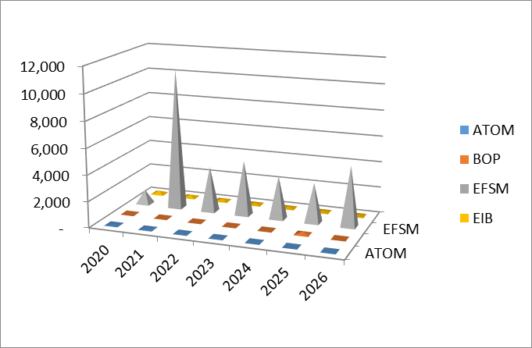

As Graph 1 illustrates, the main risk for the EU budget is linked to EFSM loans, which represent 97.6% of the total outstanding of Member States.

2.3.2. EU loan operations to non-Member States

In 2019, non-Member States represented 39.9% of the EU budget exposure (cumulated total risk borne by the EU budget, see table 1 above) with the following breakdown between the financial instruments:

**Graph A2:** Total annual risk borne by the EU budget (EUR million) related to non-Member States at 31.12.2019 for the period 2020-2026 (based on amortization plans of existing loans)

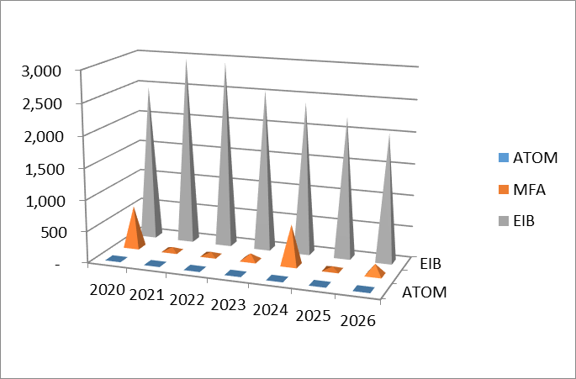

As graph A2 illustrates that the weight of MFA and Euratom loans are marginal in the total annual risk in comparison with the EIB loans granted (these amounts include loans signed and disbursed under all EIB mandates).

2.3.3. Guarantes given to the EIB

90% of the 2007-2013 EIB external Mandate has been signed but an amount of EUR 3,184 million still remains to be disbursed within 10 years from the end of the Mandate.



The 2014-2020 Mandate covers EIB financing operations to be signed during the period from 1 January 2014 to 31 December 2020.



Risk factors:

a) Factors increasing the risk:

* the interest on the loans must be added to the authorised ceiling;
* an additional factor to be considered is that some loans are disbursed in currencies other than the EUR. Due to exchange rate fluctuations, the ceiling may be exceeded when the amounts disbursed are converted into EUR at the year end.

b) Factors reducing the risk:

* the limitation of the guarantee given to the EIB;
* operations already repaid;
* the ceilings are not necessarily taken up in full;
* in some cases, notably private sector operations, the EU budget guarantee covers only well defined political risk events, with the EIB (or a third party guarantee) covering other risks (e.g. commercial).

2.4. Payments under the EU budget guarantees

The EU borrows on the financial markets and on‑lends the proceeds to Member States (BOP, EFSM) and to third countries (MFA) or nuclear sector companies (Euratom).

Procedures have been set up to guarantee the repayments of the borrowings due by the EU and also the guarantees given in connection with the EIB financing operations.

2.4.1. EU loan operations

The loan repayments are scheduled to match the repayments of the borrowings due by the EU. If the recipient of the loan is in default, the Commission will first draw on the budget cash resources to ensure a timely repayment of the EU borrowing on the contractual due date. Therefore, the Commission would draws on its cash resources in order to avoid delays and any resulting costs in servicing its borrowing operations . Furthermore, being mindful of most expenditures taking place during the first quarter of each year, debt redemption is structured for the months thereafter as well as for the beginning of each month when cash balances are highest.

Should the amounts needed for the necessary cash coverage exceed, for a certain period or date, the available treasury funds of the Commission, the Commission would, in accordance with Article 14 of Council Regulation 609/2014[7], draw on additional cash resources from the Member States in order to fulfil its legal obligations towards its lenders.

In the case of BOP loans, where amounts to be reimbursed can be very high, the beneficiary Member States are required to transfer the amounts due to the European Central Bank seven business days in advance of the contractual due date. This gives enough time for the Commission and Member States to provide for the cash advance to ensure timely repayment in case of default. The same process applies for the EFSM loans with 14 days lead time.

In a second step, the treasury situation would be regularised as follows:

BOP and EFSM loans

* 1. The Commission may need to propose a transfer or an Amending Budget to budget the cash advance under the corresponding budget line "01 02 02 European Union guarantee for Union borrowings for balance-of-payments support" or "01 02 03 European Union guarantee for Union borrowings for financial assistance under the European financial stabilisation mechanism".
  2. The recovered funds will be re-paid to the EU budget.

Euratom and MFA loans

1. If the payment delay reaches three months after the due date and if the borrower is a third country, the Commission draws on the Guarantee Fund for external action to cover the default[8] and to replenish its treasury.
2. The Commission might also need to draw on the EU budget, most likely by means of a transfer, to provide the corresponding budget lines under articles "01 03 04 Guarantee for Euratom borrowings to improve the degre of efficiency and safety of nuclear power stations in third countries" or "01 04 03 Guarantee for Euratom borrowings" or "01 03 03 European Union Guarantee for Union borrowings for macro-financial assistance to third countries" with the necessary appropriations needed to cover the default. This method is used when there are insufficient appropriations in the Fund or if the borrower is a Member State and the transfers are likely to require advance authorisation by the budgetary authority.
3. The recovered funds may either be kept on the Fund account (the next annual provisioning from the EU budget being reduced accordingly) or re-paid to the EU budget.

2.4.2. Guarantees given to EIB

The EU provides a guarantee in respect of financing granted by the EIB under the external lending mandates. When the recipient of a guaranteed financing fails to make a payment on the due date, the EIB asks the Commission to pay via the Fund the amounts owed by the defaulting entity in accordance with the relevant guarantee agreement.

The guarantee call must be paid within three months of receiving the EIB's request, either from the Fund[9] or directly from the EU budget should the resources of the Fund be insufficient[10].

The EIB administers the loan with all the care required by good banking practice and is obliged to seek the recovery of the payments due after the guarantee has been activated.

2.4.3. Default interest penalties for late payment

a) EU loans

For loans granted by the EU, default interest is owed by loan beneficiaries for the time between the date at which cash resources are made available by the EU budget and the date of repayment to the EU.

b) EIB loans

For EIB loans, EIB is entitled to default interest which is calculated during the period between the due date of a defaulted loan instalment and the date of receipt of the cash resources by the EIB from the Commission. From the latter date, default interest is due to the Commission.

1. Within each portfolio individual EIB loans are, de facto, guaranteed at 100% until the global ceiling is reached.
2. OJ L 308, 3.12.1999, p. 35.
3. OJ L 186, 15.7.2008, p. 30.
4. Decision No 1080/2011/EU of the European Parliament and of the Council of 25 October 2011 granting an EU guarantee to the European Investment Bank against losses under loans and loan guarantees for projects outside the Union and repealing Decision No 633/2009/EC (OJ L 280, 27.10.2011, p. 1).
5. Decision No 466/2014/EU of the European Parliament and of the Council of 16 April 2014 granting an EU guarantee to the European Investment Bank against losses under financing operations supporting investment projects outside the Union (OJ L135 of 8.5.2014, p.1).
6. For the purpose of this calculation, it is assumed that defaulting loans are not accelerated, i.e. only due payments are taken into account.
7. See Article 14 of Council Regulation (EU, Euratom) No 609/2014 of 26 May 2014 on the methods and procedure for making available the traditional, VAT and GNI-based own resources and on the measures to meet cash requirements (OJ L 168, 7.6.2014, p. 39).
8. Except for Bulgaria and Romania which were granted Euratom loans before joining the Union. The loans (and loans guarantees) to accession countries were covered by the Fund until the date of accession. From that date, those that remained outstanding ceased to be external actions of the Union and are therefore covered directly by the EU budget.
9. Since the entry into force of Council Regulation (EC, Euratom) No 480/2009 of 25 May 2009 establishing a Guarantee Fund for external actions (codified version), the "Guarantee Fund Regulation" (OJ L 145, 10.6.2009, p.10), the agreement between the EU and the EIB on the management of the Fund foresees that the Commission must authorise the Bank to withdraw the corresponding amounts from the Fund within three months from the date the EIB calls on the guarantee.
10. If there are insufficient resources in the Fund, the procedure for activating the guarantee is the same as for borrowing/lending operations, see point 2.4.1 above and footnote 7.