

ANNEX 1

TEN-T network rail border crossing points*

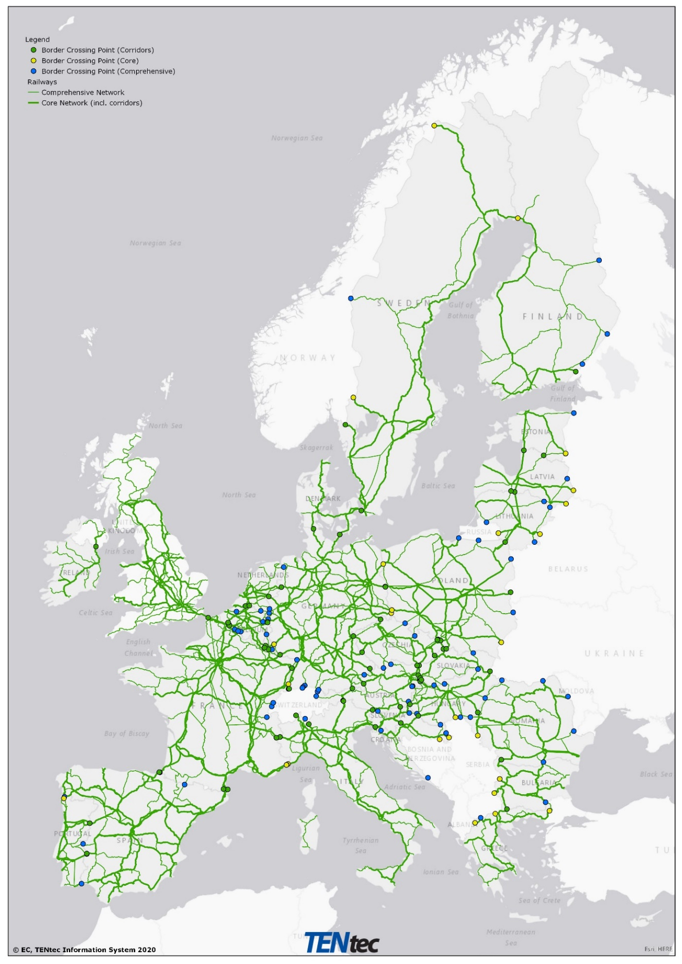

*Legend: Green dot for Border crossing points (Corridors), yellow dot for Border crossing points (Core), blue dot for Border crossing points (Comprehensive), regular green line for Comprehensive railway network, bold green line for Core railway network (incl. corridors)

ANNEX 2

**TEN-T network road border crossing points\***

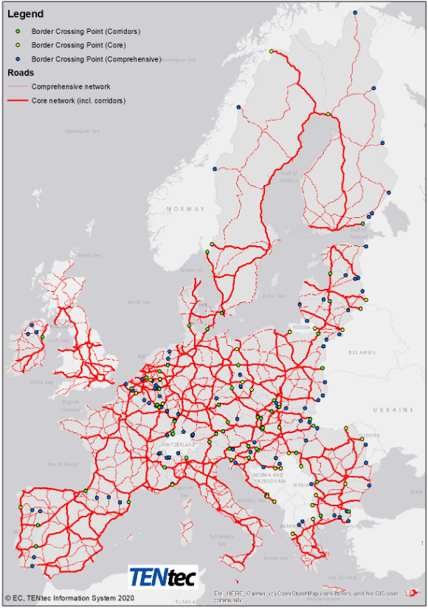

*Legend: Green for Border Crossing Point (Corridors); Yellow for Border Crossing Point (Core); Blue for Border Crossing Point (Comprehensive); Thin red line for Comprehensive network; Thick red line for Core network (incl. corridors)