

**TABLE OF CONTENTS**

FOREWORD 2

KEY MESSAGES 3

1. OVERVIEW OF LABOUR MARKET AND SOCIAL TRENDS AND CHALLENGES IN THE EUROPEAN UNION 21

1.1 Labour market trends 21

1.2 Social trends 28

2. SNAPSHOTS FROM THE SOCIAL SCOREBOARD 31

2.1 The scoreboard explained 31

2.2 Evidence from the social scoreboard 33

3. EMPLOYMENT AND SOCIAL REFORMS – MEMBER STATES PERFORMANCE AND ACTION 37

3.1 Guideline 5: Boosting the demand for labour 37

*3.1.1* *Key indicators* 37

*3.1.2* *Measures taken by Member States* 50

3.2 Guideline 6: Enhancing labour supply and improving access to employment, skills and competences 56

*3.2.1* *Key indicators* 56

*3.2.2* *Measures taken by Member States* 84

3.3 Guideline 7: Enhancing the functioning of labour markets and the effectiveness of social dialogue 98

*3.3.1*  *Key indicators* 98

*3.3.2*  *Measures taken by Member States* 121

3.4 Guideline 8: Promoting equal opportunities for all, fostering social inclusion and fighting poverty 127

*3.4.1* *Key indicators* 127

*3.4.2* *Measures taken by Member States* 144

# **FOREWORD**

The Joint Employment Report by the European Commission and the Council is mandated by Article 148 of the Treaty on the Functioning of the European Union. The European Commission’s proposal for this report is part of the Autumn package. The Joint Employment Report provides an annual overview of key employment and social developments in the European Union as well as Member States’ reform actions, in line with the Guidelines for the Employment Policies of the Member States[1]. The report follows the structure of the Guidelines: boosting the demand for labour (Guideline 5), enhancing labour supply and improving access to employment, skills and competences (Guideline 6), enhancing the functioning of labour markets and the effectiveness of social dialogue (Guideline 7), and promoting equal opportunities for all, fostering social inclusion and fighting poverty (Guideline 8).

In addition, the Joint Employment Report monitors Member States’ performance in relation to the Social Scoreboard set up in the context of the European Pillar of Social Rights. The Pillar was proclaimed jointly by the European Parliament, the Council and the Commission on 17 November 2017. It identifies principles and rights in three areas: i) equal opportunities and access to the labour market, ii) fair working conditions, and iii) social protection and inclusion. Monitoring of progress in these areas is underpinned by a detailed analysis of the Social Scoreboard accompanying the Pillar.

The Joint Employment Report is structured as follows: an introductory chapter (Chapter 1) reports on main labour market and social trends in the European Union, to set the scene. Chapter 2 presents the main results from the analysis of the social scoreboard associated with the European Pillar of Social Rights. Chapter 3 provides a detailed cross-country description of key indicators (including from the social scoreboard), looking at Member States’ performance, challenges and policies implemented to address the Guidelines for Employment Policies.

# **KEY MESSAGES**

**Before the COVID-19 crisis hit, the EU was experiencing a steady though decelerating employment growth.** Continuing the positive performance in the labour markets that started in 2013, employment further expanded in 2019, reaching a record level at the end of the year. Reform efforts by Member States in the aftermath of the financial crisis contributed to this job-rich economic growth, though challenges persisted in some Member States and regions, including with regard to the labour market integration of vulnerable groups.

**The COVID-19 pandemic reversed this trend, suddenly changing our ways of working and living.** It has taken a significant toll in terms of human lives and caused an unprecedented economic shock. The response by European and national authorities has been swift. Safeguarding citizens’ health and jobs has become the top policy priority. Member States have provided support notably to the groups and sectors that have been particularly affected. The implementation of these measures has, so far, avoided the emergence of a massive employment and social crisis across the EU. Yet, many uncertainties remain, notably about how long the pandemic will last, when a sustainable economic recovery will materialise, and the consequences for the most vulnerable. The situation differs across countries, also due to the legacy of the past. Member States that already experienced serious socio-economic challenges before the pandemic are now even more exposed to vulnerabilities.

**Implementing the European Pillar of Social Rights is key to ensuring that the recovery is fair and inclusive.** The Pillar principles, along the three dimensions of equal opportunities and access to the labour market, fair working conditions and social protection, health and inclusion, need to guide the design of policy measures in support of workers and households. Fighting the impact of the pandemic, as well as preparing the recovery, requires fostering social resilience and upward convergence by putting people at the centre. The recently adopted Employment Guidelines integrate specific guidance aimed at mitigating the employment and social impact of COVID-19 and provide Member States with concrete guidance on how to modernise labour market institutions, education and training as well as social protection and health systems, with a view to making them more inclusive and fair. They also incorporate new elements reflecting the Union’s priorities, notably with regard to socially just green and digital transitions. Turning climate and environmental challenges into opportunities, and making the transition just and inclusive for all, is a key goal of the European Green Deal.

**The EU’s reaction to the crisis has been swift and strong.** Member States have been offered unprecedented financial support to mitigate the economic, social and health impact of the crisis and enhance the recovery, including through the new SURE instrument, the Emergency Support Instrument and the increased flexibility in the use of the cohesion policy funds under the Coronavirus Response Investment Initiative. Furthermore, the Recovery and Resilience Facility – which is at the centrepiece of Next Generation EU – will provide large-scale financial support for reforms and investments aimed to support job creation and make the EU economies, societies and health systems more resilient and better prepared for the twin transition. This represents a unique opportunity to boost investment in people and accelerate the economic recovery. This swift response fits within a long-term strategy and contributes to the capacity of the Union to achieve its long-term objectives.

**The Joint Employment Report aims at helping Member States identify priority areas for reforms and investment.** Mandated by Article 148 of the Treaty on the Functioning of the European Union, the Joint Employment Report provides an overview of key employment and social developments in Europe and of the implementation of the Employment Guidelines. It has been an integral part of the European Semester from the onset, highlighting the key employment and social challenges to be tackled in the yearly cycle, as part of the Autumn Package. In the exceptional 2021 European Semester[2], the Joint Employment Report will additionally help Member States identify priority areas for reforms and investment to be included in their recovery and resilience plans, against the background of the Employment Guidelines. The results from the Social Scoreboard accompanying the European Pillar of Social Rights are presented in the Joint Employment Report and can serve developing the national plans. Moreover, also against the background of the Joint Employment Report, the Commission will assess the substance of the plans in analytical documents accompanying the proposals for the Council implementing acts. In cooperation with the Employment Committee and the Social Protection Committee, the Commission will also keep monitoring closely all labour market and social developments with the regular update of the corresponding Employment Performance Monitor and Social Protection Performance Monitor.

*********

**The COVID-19 crisis has strongly affected labour market outcomes in the EU.** Though signs of slowdown in employment figures were already evident in the second half of 2019, most labour market indicators have interrupted their positive trend at the outbreak of the pandemic.Total employment (that had increased by 15 million since mid-2013) went down by 6.1 million persons between the fourth quarter of 2019 and the second quarter of 2020, the sharpest decline observed over two successive quarters. After six years of positive developments towards the Europe 2020 employment target, the employment rate got farther from it in 2020. The swift adoption of short-time work schemes and other labour market retention measures, together with a decline in activity rates, led so far to an only moderate increase in the unemployment rate, of 1 percentage point (pp) by September 2020. Youth unemployment (15-24) nevertheless increased more markedly than unemployment for other age cohorts, and the share of young people not in employment nor in education or training (NEET) soared. Non-EU born workers have also been severely affected. These outcomes vary significantly across countries, regions and sectors and require close monitoring and policy efforts to avoid a more negative impact in the short run.

**Massive use of short-time work schemes helped mitigate the consequences of the shock on the labour market.** The hours worked per worker fell abruptly, by 11.3% in Q2-2020 compared to the last quarter of 2019; at the same time, absences from work buoyed, from 9.7% in Q4-2019 to 21.8% in Q2-2020 (around half of this increase being due to temporary lay-offs). Since the onset of the crisis, Member States have extended (or introduced when not previously available) short-time work schemes and/or other job preservation schemes, with the aim to limit job losses, avoid the dispersion of human capital and sustain aggregate demand. The European Union is supporting this effort with the temporary instrument ***S****upport to mitigate* ***U****nemployment* ***R****isks in an* ***E****mergency* (SURE). The extraordinary and synchronised use of short-time work schemes helped addressing the immediate consequences of the crisis and prevented a surge in unemployment. However, the longer the crisis lasts, the higher the risk of subsidising jobs in firms that are no longer viable. Therefore, when considering the phasing out of short-time work schemes, it is important to carefully weigh, on the one hand, the need to protect firms and employees as long as the economic conditions require and, on the other hand, the introduction of policies to promote structural change and the reallocation of workers (e.g. via well-designed hiring incentives and reskilling measures).

|  |  |  |
| --- | --- | --- |
| **The COVID-19 crisis is breaking a 6-years long**  **positive trend on the labour market** | |  |
| **6.1 million**  **fewer people in employment** in Q2-2020 compared to  Q4-2019  **72%** **employment rate** in Q2‑2020 (1.1 pps lower than one year earlier)  **7.5%** **unemployment rate** in September 2020 (1 pp higher than in March)  **-11.3%** **hours worked per worker** in Q2-2020 compared to  Q4-2019 | **Activity, unemployment and NEET rates in the EU-27, %**    **Hours worked per worker and absences from work in the EU-27** | Source: Eurostat, LFS. Seasonally adjusted, not calendar adjusted data. |

**The economic shock is experienced differently across sectors and categories of workers.** All economic activities except construction reduced their employment numbers in the year to Q2-2020, but the sharpest declines were observed in the hospitality sector, in the cultural and entertainment sector as well as among professional activities. The employment fall has affected to a greater extent workers in non-standard forms of employment, though with strong differences across countries. Temporary employees have been severely impacted, with a 16.7% decrease year-on-year in Q2-2020, while permanent employment has remained stable, also thanks to the policy response. This has translated into a significant decrease in the share of temporary employees over total employees, again with wide differences across countries.

|  |  |  |
| --- | --- | --- |
| **The pandemic has impacted differently across jobs and sectors** | |  |
| **4.2 million**  **fewer workers on temporary contracts** in the year to Q2-2020  **Employment growth** in construction, public administration and ICT activities  **Largest declines in relative terms** in trade, arts and entertainment and agriculture | **Employment (15-64) by type of contract: percentage change between Q2-2019 and Q2-2020** | Source: Eurostat, LFS. Note: *NACE Rev.2 activities. |

**Due to COVID-19, Member States risk facing a sharp increase in youth unemployment, which calls for reforms and reinforced support.** After a continued decline in 2019, EU-wide youth unemployment jumped from a low of 14.9% in March 2020 to 17.1% in September, increasing at a faster rate than overall unemployment. The crisis also led to the largest increase between two consecutive quarters in the rates of 15 to 24 year-olds not in employment, education or training since the start of Eurostat series in 2006 (from 10.4% to 11.6% between Q1-2020 and Q2-2020). In 2019, one in ten young people aged 18-24 left education or training with a qualification below upper secondary education, and more than a quarter of people aged 30 to 34 did not have a qualification with direct labour market access (secondary vocational education and training or tertiary education qualification). The Commission proposals for the VET Recommendation and the European Education Area put forward targets to improve attainment in both VET and tertiary education. Since the increases in the NEET rates largely stem from the drop in labour demand, reforms to support job creation, education and skills will be essential. A successful implementation of the reinforced Youth Guarantee, relying on well-functioning Public Employment Services and education and training systems, will be crucial. For young NEET women, among whom inactivity plays a stronger role than for men, reforms should also include measures to remove fiscal disincentives to work and help reconcile work and care responsibilities (see also further below).

|  |  |  |
| --- | --- | --- |
| **The COVID-19 crisis led to a substantial rise in NEET rates** | |  |
| |  |  | | --- | --- | |  |  |   **11.6%**  **young NEETs (15-24)** in Q2-2020 (1.2 pps more than in the previous quarter)  **-12%**  **low-skilled young people in employment** between end-2019 and second quarter of 2020  **26%**  **of young people** (30-34) hold qualifications that do not grant direct access to the labour market (secondary VET or tertiary education) | **Young people aged 15-24 neither in employment nor in education and training (NEET),** (Q2-2020) | Source: Eurostat, LFS |

**The gender gap in employment stagnated and the one in pay narrowed over the past five years, but the crisis has created new risks and underlined the need for reforms and investments.** Although female employment rates increased, the gender gap in pay has only improved slightly since 2013, in spite of the higher average educational attainment of women. Women’s over-representation in lower paid sectors and occupations make them particularly vulnerable in the labour markets struck by the COVID-19 crisis. Gender gaps are larger for women with young children: in 2019, they faced a negative employment gap of 14.3 pps in contrast to women without children, whereas men in the same situation saw a positive gap of 9.6 pps. Employment outcomes are poorer in particular for older, non-EU born, low-skilled and women with disabilities. Women’s participation in the labour market could be strengthened by reforms and investments in early childhood education and care as well as long-term care services, and work-life balance policies, such as gender balanced parental and care leaves. Other reforms and investments could include measures ensuring equal career progression, pay transparency measures, and adjustments to the tax and benefit system, such as inividual, rather than household, levied taxation, and family-based, dependent spouse and transferable deductions.

|  |  |  |
| --- | --- | --- |
| **Gender gaps for employment and pay remain substantial**  **in several Member States** | |  |
| **11.4 pps**  **employment gender gap** in Q2-2020, almost stable since 2013  **14.3 pps** **employment impact of parenthood** (lower employment rate for women with young children compared to those with no children) | **Unadjusted gender pay gap in 2014 and 2018**  (percentage points) | Source: Eurostat. |

**The crisis is likely to have a disproportionate impact on non-EU migrants, with additional efforts needed to ensure their labour market integration.** Non-EU migrants had seen an improvement in their average employment rate between 2017 and 2019 (from 61.5% to 64.2%). Yet, since the crisis started the employment rate dropped significantly (down to 60.8% in Q2-2020), due to their over-representation among temporary workers and in sectors impacted strongly by the crisis, though they played a crucial role in key frontline occupations during the pandemic. In addition, first-generation migrant workers are more likely to be found in lower skilled occupations, even when holding tertiary education. Member State policy responses related to the provision of language courses, access to education and training, labour market guidance and recognition of skills and qualifications helped improving their labour market integration. Maintaining and strengthening these policies would help make the recovery more inclusive and build on the skills and potential of migrants including refugees.

**Addressing the causes of labour market segmentation, including by adapting legislation and ensuring that the right incentives are in place to hiring on stable contracts, is key to improve social resilience.** The incidence of temporary employment differs significantly across countries, with young people and women relatively more represented in this category. Member States with a substantial share of fixed-term workers have experienced the largest fluctuations in employment during the crisis. In this perspective, ensuring that fixed-term contracts support labour market entry, while serving as a ‘stepping stone’ to regular employment is key to increase social resilience and to support a fair and inclusive recovery. Reforms to modernise employment protection legislation are important in this context, inter alia by setting clear conditions for using temporary contracts, preventing employment relationships that lead to precarious working conditions, and providing the right incentives for hiring on permanent contracts. At the same time, Member States should ensure that job-seekers with precarious work histories have adequate access to social protection and notably unemployment benefits through adaptable eligibility requirements and enjoy opportunities to train and reskill.

**Many workers are still not protected by adequate minimum wages.** Often statutory minimum wages are low compared to other wages in the economy, despite recent increases in many Member States. The minimum wage is generally not sufficient to protect workers against the risk of poverty. In addition, gaps in coverage occur both in countries with a statutory minimum wage (because of exemptions for specific categories) and in countries where wages are exclusively set through collective bargaining (for workers who are not covered by collective agreements). Following a consultation with social partners, the Commission proposed a Directive to ensure that the workers in the Union are protected by adequate minimum wages. The proposal aims to promote collective bargaining on wages in all Member States. In this regard, countries with statutory minimum wages should put in place the conditions for minimum wages to be set at adequate levels, including clear and stable criteria for minimum wage setting, indicative reference values to guide the assessment of adequacy, and regular and timely updates. These countries are also asked to ensure the proportionate and justified use of variations in and deductions from statutory minimum wages, and the effective involvement of social partners in statutory minimum wage setting and updating. Finally, the proposal provides for improved enforcement and monitoring of the minimum wage protection established in each country.

**The adaptation of working conditions has become central during the pandemic and will remain key afterwards, requiring investment in the workplace and reforms to enhance the availability of flexible working arrangements.** Many Member States have adapted their working terms and conditions, including by extending the use of telework, with a particular focus on protecting vulnerable workers. During the health emergency, teleworking has proven very important for ensuring business continuity, while providing wider options for coping with additional care needs. However, it may also carry risks, including those related with occupational, physical and mental well-being of home-based teleworkers. In perspective, the pandemic will lead to rethinking the organisation of workplaces and work-life balance. Differences exist in the content and coverage of national regulations related to telework, including as regards the promotion of information and communication technologies (ICT) for this purpose. Building on existing national practices regarding collective bargaining, Member States should ensure that working environments are safe and well adapted, and that flexible working arrangements are widely available, in order to balance work, family and private life. More attention is also needed to improve working conditions for workers in vulnerable situations and to attract those in undeclared work into formal employment. The pandemic has also cast light on shortages in certain health professions and the need to adapt or improve their working conditions and skills.

|  |  |  |
| --- | --- | --- |
| **The incidence of teleworking during the crisis**  **varies considerably among profiles and sectors** | |  |
| **60 pps**  **gap in access to teleworking** between high-skilled and low-skilled workers  **61%**  **of those living in cities had access to telework,** compared to 41% of those living in small towns  **Workers in education and administrative services used teleworking to a larger extent** | Work-at-home during COVID-19, main characteristics of the participating workers (EU-27, in %). | Source: Eurofound (2020) Living, working and COVID-19 e-survey. |

**Active labour market policies are key to support labour market adjustments following the COVID-19 shock.** Member States entered the jobs crisis with different rates of coverage of active labour market policies (ALMPs). Supporting smooth labour market transitions, while preventing the risks of further skills polarisation is essential to inclusive growth. This is particularly important for Member States with still high rates of long-term unemployment, which are likely to be aggravated as a consequence of the COVID-19 shock. Member States have amended existing frameworks or introduced new ALMP systems to better respond to the labour market conditions, promote employment as well as up- and reskilling, often with the support of the European Social Fund. They could now have the possibility to combine cohesion policy funds with funding from the Recovery and Resilience Facility to further promote targeted ALMPs including upskilling and reskilling measures.

**Access to unemployment benefit schemes with adequate benefit levels and duration is key to mitigate the negative impact of the crisis, and support the transition of the unemployed towards new jobs.** The provision of adequate unemployment benefits of reasonable duration accessible to all workers, including those in non-standard contracts, is key to support jobseekers during transitions. Particular attention is required towards individuals with short or discontinuous work histories, as they are often less covered by these schemes. In response to the pandemic, several Member States have reinforced their unemployment protection schemes. These schemes may need to be further reviewed following changes in economic conditions in order to maintain adequate incomes and support the effective labour market activation of those affected.

**Public Employment Services will need to go beyond traditional ways of working to tackle a surge in the number of job-seekers and support their reallocation across occupations or sectors**. The share of unemployed people using public employment services (PES) for job search has been on a decreasing trend over the past years, albeit with strong differences across Member States. Young people, the low-skilled and older job seekers continue to be overrepresented among those seeking assistance from the PES. In the current context, ensuring an adequate and effective response to jobseekers’ and employers’ needs may require scaling up the capacity in relation to strengthening profiling systems, furthering guidance and mentoring capacities for job-seekers. Investment in up-to date information and communication technology (ICT) solutions and reskilling of PES staff will be important for reinforcing their capacity. A stronger support based on individual action plans could help those affected by the crisis get jobs in the context of a future recovery.

|  |  |  |
| --- | --- | --- |
| **PES can play a crucial role in facilitating smooth transitions and in promoting a fast recovery** | |  |
| **45 pps**  **gap between the highest and the lowest level of PES usage for job search** in 2019  **Low-skilled and older job seekers are largely represented** among those seeking assistance from the PES  **High long-term unemployment rates** prior to the pandemic may add challenges to make the recovery work for all | **Share of unemployed people using a given job search method (2019)** | Source: Eurostat, LFS. |

**Social dialogue and social partners’ involvement in policy-making are key to foster a fair and sustainable recovery and support inclusive growth.** In several Member States, collective agreements and social dialogue have helped in designing and implementing the immediate socio-economic response to the COVID-19 crisis, including measures to swiftly adapt working patterns, such as the promotion of teleworking, and to protect the health, incomes and jobs of front-line and essential workers. Social partners’ consultation in the crisis response remained strong in those Member States with already well-developed social dialogue structures. In other Member States, the crisis has aggravated the already limited involvement of social partners prior to the health emergency. To ensure effective and smooth design and implementation of their reform and investment agendas under the new Recovery and Resilience Facility over the 2021-23 period, it is crucial that Member States engage with social partners in the preparation of their national recovery and resilience plans.

**Inequalities in education put at risk social cohesion and inclusive growth, calling for reforms to make education systems more inclusive and deliver better outcomes, support the most vulnerable and invest in educational infrastructure, including digital education.** Children from lower socioeconomic groups often face significant challenges in educational attainment. They show considerably lower participation in early childhood education and care and more often fail to achieve basic reading skills in secondary school. They are also underrepresented in tertiary education, alongside students from rural areas, with disabilities and non-EU migrants. Distance learning introduced during lockdowns put the spotlight on these disadvantages: pupils from a lower socioeconomic background typically started with lower digital skills, and more often lacked access to computers and internet connections. A gender gap is also growing in basic skills and tertiary education attainment, where boys perform worse than girls. There is a risk that the combination of these factors translates into disadvantages throughout the working life, also in light of the already large employment gap between the low and the high skilled (29.1 pps in 2019). There is a strong link between education performance, success on the labour market and participation in society, which underlines the importance of inclusive education to ensure a fair recovery and strengthen social resilience. Reforms could cover, among others, preventing early educational tracking, introducing support services and targeted financial schemes and services for disadvantaged schools, families and young people, fostering improved access to education for children in need, including the integration of learners with special educational needs in mainstream settings, and investing in infrastructure and equipment.

|  |  |  |
| --- | --- | --- |
| **Socio-economic disadvantages still impact strongly on participation and educational outcomes** | |  |
| **36.4% pupils**  with lower conomic, social and cultural background **fail to achieve basic reading skills**  **11.3 pps**  gap in ECEC participation **for children at risk of poverty or social exclusion** in 2016  **22.5%**  **of young people born outside the EU** leave education and training early (compared to 10.2% EU-wide) | **Rate of underachievement in reading skills by economic, social and cultural status** (in percentage points of 15-year-olds, 2018)    Note: ESCS stands for economic, social and cultural status. | Source: PISA 2018, OECD. |

**Upskilling and reskilling are a top priority to foster an inclusive recovery and support the digital and green transitions.** Before the crisis, EU companies cited the scarcity of skilled staff as the first obstacle to investment. 20 Member States missed the EU-wide adult learning target of 15% by 2020. Adults with lower qualifications participate significantly less in learning, although they need it the most. A quarter of young adults do not have a qualification that gives direct access to the labour market. Some sectors, like the ICT, report a wide gap between vacancies and graduates. In many Member States it is still too difficult to access further education and training after leaving formal education, and validation of skills remains underdeveloped. Together with the new skills challenges emerging in relation to the digital and green transitions, this points to the need to support the transformation of vocational- and tertiary education. The European Skills Agenda and the European Education Area lay out policies for lifelong learning, upskiling and reskilling, including a Pact for Skills and the implementation of skills strategies, forecasting, guidance and validation. Under the ‘Reskill and Upskill’ flagship, Member States are strongly encouraged to put forward reforms and investment on skills, in particular digital, for financing under the new Recovery and Resilience Facility, on top of and in complementarity with the financing traditionally provided by the European Social Fund.

|  |  |  |
| --- | --- | --- |
| **There is scope for strengthening participation in adult learning as key to support career development and successful job transitions** | |  |
| **28.3 pps**  gap in employment rates between **low- and high-skilled workers**    **6.5 pps**  gap in adult learning participation for **low-skilled workers**  **In 20 Member States**  **fewer than 15% of adults** took part in adult learning  **Half of adults**  should take part in **adult learning over one year** by 2025, according to the European Skills Agenda (compared to 38% in 2016) | **Employment rates by educational attainment level**  (% persons aged 25 – 64 in 2019)    **Share of adults and low-qualified adults participating in learning** (% persons aged 20-64 in 2019) | Source: Eurostat. |

**The COVID-19 crisis further highlighted the importance of strengthening digital skills.** During the pandemic, digital skills proved essential for the continuity of business, education and training activities, as well as to ensure access to services, including healthcare, to a large share of EU citizens. Digital skills will be increasingly important for full participation in the labour market and in the societies of the future, as well as to support the green and digital transitions. Yet progress in basic digital skills has been slow: in spite of a modest improvement, in 2019 more than four people out of ten in the EU did not have basic digital skills, notably older people and those with low qualifications. In addition, there is a systematic shortage of digital experts and people with advanced digital skills, a challenge driven to a significant extent by the under-representation of women among STEM tertiary graduates and ICT sector jobs. Even though girls do better than boys in digital skills at a young age, they choose the respective study- or career-tracks at a significantly lower rate than boys. Reforms to strengthen digital skills include curricula updates, introducing ICT courses in primary schools, teaching ICT as a discipline in secondary education, support to teachers and trainers (including how to encourage girls’ interest and aspirations), adult learning opportunities in digital skills, measures aimed at increasing the attractiveness of studies in STEM and ICT fields (particularly for girls), strengthened cooperation between businesses, research centres and academia, as well as investment in digital infrastructure and equipment.

|  |  |  |
| --- | --- | --- |
| **The digital skills gap remains significant** | |  |
| |  |  | | --- | --- | |  |  |   **46% of people**  aged 16-74 **did not have basic digital skills** in 2019  **13.5 million**  **vacancies sought ICT-related skills** in 2018 and 2019  **57%**  **of companies reported difficulties**  recruiting ICT specialists in 2019   |  |  | | --- | --- | |  |  |   **50.9%** **of teachers** did not receive ICT training in their formal education | **Individuals who have basic or above basic overall digital skills** (2019, percentage points, persons aged 16 – 74) | Source: Eurostat |

**Overall income inequality slightly decreased over recent years before the COVID-19 pandemic, but it increased at the lower end of the income distribution over the last decade, raising concerns about the inclusiveness of economic growth.** On average across the EU, the richest 20% of households have an income that exceeds by about five times that of the poorest 20%. In past years, income inequality increased more in the lower part of the income distribution (S50/S20) than in the upper part (S80/S50). According to preliminary estimates, automatic stabilisers and policy measures adopted to face the emergency have so far muted the effect of COVID-19 on inequality. Tackling income inequalities requires reforms by Member States in different policy areas, including the design of their tax and benefit systems, wage setting mechanisms, inclusiveness and equal opportunities in education and training (starting from early age), and access to affordable and quality services for all. The assessment of the distributional impacts of policies should be ensured, notably with regard to policies supporting the twin green and digital transition.

|  |  |  |
| --- | --- | --- |
| **Though decreasing recently, inequality has**  **increased at the bottom of the income distribution** | |  |
| |  |  | | --- | --- | |  |  |   **5 times**  is the ratio of the **income share of the top 20% incomes to the bottom** **20%** in 2019  **21.4%**  is the **share of income gained by the bottom 40%** of the population, on the rise since 2015 | **Income quintile share ratio (S80/S20) and breakdown**  **by high and low part of the distribtion** | Source: computation on Eurostat data |

**Before the COVID-19 crisis, the number of people at risk of poverty or social exclusion was declining for the seventh consecutive year, though slow progress in countries with higher poverty rates hints at challenges for social protection systems.** In 2019, around 92.4 million were at risk of poverty or social exclusion (AROPE), which is 2.3 million fewer people compared to the previous year. Since the peak of 2012, severe material deprivation has been the component that improved most, followed by the share of people living in households with very low work intensity, owing to the robust labour market performance before the crisis, while the at-risk-of-poverty rate reductions were less marked. These positive developments were nonetheless showing some deceleration in many Member States. In-work poverty and the depth of poverty were slowly declining, including for people in very low work intensity households. The COVID-19 crisis, with the associated increase in unemployment and inactivity, makes the achievement of the Europe 2020 target of 20 million fewer people in poverty or social exclusion (compared to 2008) highly unlikely. The current situation poses challenges for social protection systems, in particular in relation to sustainably ensuring adequate incomes and the provision of quality services especially for all those who need them most.

**Poverty remained high for most vulnerable groups, in particular for families with children,** **people with disabilities and non-EU born, all disproportionally hit by the COVID-19 crisis.** Health, education and social protection systems, in particular social services, have been put under unprecedented pressure, further exacerbating challenges for people in most vulnerable situations. While decreasing in the past few years, the risk of poverty or social exclusion for children (aged below 18) remained 1 pp higher than that for the working-age population, and was very high in some Member States. Beside adequate income levels, access to services, including education, healthcare and housing, plays a key role in supporting families with children, and ensures equal opportunities in life. The Commission will propose in 2021 a European Child Guarantee to provide a framework for action at EU level. People with disabilities and non-EU born, both exposed to higher risks of poverty and social exclusion, also require strengthened support. The new Strategy on the rights of persons with disabilities to be launched by the Commission in 2021 will aim to promote the economic and social inclusion of persons with disabilities. It is expected to focus on a wide range of areas, including education, employment, adequate social protection, accessibility and non-discrimination. The European Pillar of Social Rights reiterates people’s right to access to quality services. Enhancing access to services, including to social services and community and home-based services for independent living and inclusion in the community, will be reflected in a number of the Commission’s upcoming initiatives and work-streams, such as the mentioned strategies and the new Action Plan on Integration and Inclusion for people with a migrant background.

|  |  |  |
| --- | --- | --- |
| **The AROPE rate was on the decline before the**  **COVID-19 crisis, though at a slow pace** | |  |
| |  |  | | --- | --- | |  |  |   **92.4 million**  **people at risk of poverty or social exclusion** in EU-27 in 2019, 2.3 million fewer than in 2018  **22.5% of children** are **at risk of poverty or social exclusion**  **9% of workers** are **at risk of poverty** | **At-risk-of-poverty or social exclusion rate**  **and its sub-components in the EU** | Source: Eurostat |

**While housing costs remain very high for a large share of households, the crisis requires action to protect the most vulnerable.** One European in ten is affected by housing cost overburden. Lowest income households and people living in cities are most affected. Homelessness, the most extreme form of housing exclusion, increased over the last decade in most Member States. The health crisis has put further in evidence these housing difficulties. Many Member States undertook emergency measures to protect the most vulnerable, including by providing emergency accommodation for the homeless. Member States’ reforms should put a particular focus on investing in the renovation of residential and social housing and on increasing access to the latter.

**The COVID-19 crisis is a powerful reminder of the importance of social protection systems and their role in mitigating the economic and social effects of reduced economic activity.** The COVID-19 crisis is likely to increase the number of people falling on unemployment benefits and other income support, stress-testing the capacity of our social protection systems. Countries have extended and scaled up existing schemes, and expanded their eligibility conditions on a temporary basis. In a recovery phase, sustained efforts are needed to maintain and reinforce social protection for all in a sustainable manner. Building on the crisis response, protection of the self-employed and non-standard workers should be further improved on a structural basis, in line with the Recommendation on Access to social protection. Reforms should address, among others, coverage, adequacy, transferability of social protection rights, and support for the labour market integration of those who are able to work.

|  |  |  |
| --- | --- | --- |
| **In most Member States, the minimum income level**  **falls below the poverty threshold** | |  |
| |  |  | | --- | --- | |  |  |   On average, **social transferes (excluding pensions)** reduce poverty by **32.7%**  **63.9%**  of the EU population **at risk of poverty** **received any kind of benefits** in 2018 | **Net income of minimum income recipients (income year: 2018)** | Source: computation on OECD and Eurostat data |

**COVID-19 has put Member States’ health and long-term care systems under unprecedented stress.** The crisis response capability of our healthcare systems has often been put under strain and existing structural challenges related to the effectiveness, accessibility and resilience of healthcare have been exacerbated. These relate for instance to insufficient financing for health investments (including crisis preparedness and response), limited coordination and integration of care, weak primary care and persisting obstacles to access to healthcare and unmet needs for medical care. Such difficulties affected strongly the most vulnerable. As mentioned above, the pandemic also highlighted shortages in certain health professions and the importance to adapt or improve their working conditions and skills. Reforms should cover in particular the strengthening of health care capacities in Member States (in particular surge and crisis management capacity), a better coordination between inpatient, outpatient and primary care, up-skilling and reskilling of health workers and improvements to their working conditions, digital health and reduced out-of-pocket payments. Long-term care systems have been also strongly affected by the pandemic, in relation to their users’ and staff’s high vulnerability to COVID-19. Challenges for long-term care systems – ranging from difficult situations for workers and informal carers, discontinuity of services and capacity issues – have come to the fore. Reforms should cover, among others, preventive measures such as active and healthy ageing, and reactive measures such as setting–up properly integrated health and social care services, expanding access and coverage, in particular to home care and community-based services, upskilling and reskilling of the workforce and supporting integrated care services and independent living.

|  |  |  |
| --- | --- | --- |
| **In several Member States, income levels affect access to healthcare** | |  |
| |  |  | | --- | --- | |  |  |   **1.8%**  of the EU population reported **unmet medical needs** in 2019, before the COVID-19 crisis  in **11 MS**  **out-of-pocket payments** are more than **20%** **of health expenditure** | **Self-reported unmet needs for medical**  **examination by income level, 2019** | Source: computation on Eurostat data |

**Demographic change continues to pose long-term challenges to pension systems.** Pension adequacy remained generallystable in 2019. Pension incomes slightly deteriorated relative to labour incomes, while the share of older people suffering from severe material deprivation continued to decrease. The gender gap in pensions remains large, despite a gradual decrease over the last ten years.The impact of the crisis on employment and labour incomes, in particular for non-standard workers and the self-employed,adds to the risks for pension adequacy over the longer term. Reformsshouldaim at building inclusive and sustainable pension systems, providing adequate access and saving opportunities for men and women alike and for people in different types of contracts and economic activities, while ensuring adequate minimum income in old age.

**Member States should take action to address the employment, skills and social policy challenges identified in this Joint Employment Report.** The analysis presented in the report highlights a number of priority areas for reforms and investments. These should aim to foster job creation, ease transitions from unemployment into employment and across sectors, improve economic and social resilience and mitigate the employment and social impact of the crisis. EU funding, including via the European Social Fund Plus (with the additional resources made available by REACT-EU) and the new Recovery and Resilience Facility, provides support to Member States to speed up the implementation of policy action in these domains. In line with the Employment Guidelines, Member States are invited to:

* Keep short-time work schemes in place as long as necessary and couple them with upskilling/reskilling schemes; as soon as conditions allow, introduce support for the reallocation of labour (e.g. via well-designed hiring incentives) notably towards green and digital economy, while protecting workers during the transition;
* Ensure that working environments are safe and well adapted to the new social distancing requirements, and that flexible working arrangements are widely available;
* Enhance labour market support and upskilling opportunities to address the increase in youth unemployment, notably through support for apprenticeships (in particular in SMEs), hiring subsidies, learning infrastructure, technology and equipment;
* Invest in Public Employment Services, notably to increase their capacity, modernise their ICT infrastructure, strengthen profiling systems, and provide staff with adequate skills;
* Promote collective bargaining and social dialogue; if statutory minimum wages are in place, ensure conditions for them to be set at adequate levels, through clear and stable criteria, and regular and timely updates, and with effective involvement of the social partners;
* Reform labour market regulation, as well as tax and benefit systems, to ensure that labour market segmentation is reduced and the recovery will boost quality jobs; make sure that workers on non-standards forms of work and the self-employed gain access to social protection;
* Invest in reskilling and upskillsing, notably in digital skills, by reinforcing VET systems, supporting large-scale public private multi-stakeholder partnerships under the Pact for Skills, providing greater incentives to businesses and workers to engage in upskilling and reskilling, investing in infrastructure and equipment, including digital, supporting teachers and trainers; ensure equal access to education and training;
* Invest in sustainable social protection for all, supporting reforms to maintain and reinforce levels of protection, and improving the protection of those who are not covered; ensure adequate benefits, transferability of rights, access to services and support for the labour market integration of those who are able to work; invest in quality and accessibility of early childhood education and care (ECEC) and long-term care services; assess distributional impacts of policies;
* Invest in the renovation of residential and social housing; ease access to social and affordable housing where appropriate;
* Invest in healthcare system capacity including surge capacity, primary care, coordination of care, healthcare staff and eHealth. Reduce out-of-pocket payments, improve healthcare coverage and promote up-skilling and reskilling of health workers.

# **OVERVIEW OF LABOUR MARKET AND SOCIAL TRENDS AND CHALLENGES IN THE EUROPEAN UNION**

This section presents an overview of labour market and social trends and challenges in the European Union[3] at the aggregate level.

## **1.1 Labour market trends**

**Economic growth continued to uphold job creation in 2019, though at a slower pace than in past years.** In the fourth quarter of 2019, 209.3 million of people were in employment in the EU-27 (1.9 million more than in Q4-2018), the highest level ever reached. Older and high-skilled workers continued to be the main drivers of employment growth in this period, supporting the rise in the overall employment rate of people aged 20-64 to 73% in 2019. Unemployment reached a record low at 6.5% in the fourth quarter of 2019. Youth and long-term unemployment were declining too, though they were still high in some Member States.

**The COVID-19 crisis has reversed the positive employment trend of the last six years in the EU-27**. The economic recession sparked by the pandemic has had a strong impact on the labour market. Total employment has decreased at an accelerated pace during the first two quarters of 2020, down to 203.1 million in the second quarter of 2020. With about 6.1 million (or 2.9%) fewer persons employed, this was the sharpest decline ever observed over two successive quarters since 1995.[4] In annual terms, after increasing by 1% in 2019, total employment is projected to decrease by 4.5% in 2020 and then to rebound 1.8% in 2021,[5] with large downside risks to the forecast conditional on how the pandemic will evolve.

**The employment rate of people aged 20-64 decreased despite the swift policy response and measures taken to contain job losses.** In 2019, the employment rate in EU-27 continued increasing up to 73.1% on average (72.7% in the euro area), 0.7 pps more than in 2018 (for both EU and euro area; Figure 1). Nonetheless, after a peak of 73.3% in Q2-2019, it started slowly declining in the second part of the year. As the COVID-19 crisis erupted, the employment rate dropped to 72% in Q2‑2020, which is 1.1 percentage point (pp) lower than in Q4-2019 and 1.3 pp below the level observed in Q2‑2019. In the euro area, the decrease was more marked, with the employment rate reaching 71.4% in Q2-2020, respectively 1.2 pps and 1.5 pps lower than in Q4-2019 and Q2-2019. The employment rate of women decreased less markedly (by 0.9 pps in the EU-27 and by 1 pps in the euro area) than that of men (by 1.1 pps and by 1.3 pps, respectively), albeit the gap remains broadly at pre-pandemic levels (it was 11.7 pps in 2019 and remains close at 11.4 pps in Q2-2020). After six years of positive developments towards the Europe 2020 75% target,[6] the employment rate started moving away from it, while high uncertainty persists with regard to further developments in economic activity and related repercussions on employment.[7]

Figure 1: The pandemic has produced a major shock in the labour market, breaking a 6 year-long spell of positive performance

Employment and unemployment rates in the EU and euro area



*average of Q1-2020 and Q2-2020, seasonally adjusted.

Source: Eurostat, LFS.

**The crisis has resulted in a moderate impact on unemployment rates across Europe, compared to the magnitude of the shock on GDP.**[8] The unemployment rate kept decreasing in the course of 2019 both in the EU and in the euro area (Figure 1). In Q2-2020, 6.7% of the active population was unemployed, which is 0.2 pps below Q4-2019 (the lowest level ever recorded in the EU-27) and at the same level as in Q2-2019. In the euro area, the unemployment rate was higher, at 7.3% in Q2-2020, the same as in Q4-2019, but 0.2 pps lower than in Q2-2019. Differences are nonetheless marked when looking at the breakdown by age groups. The unemployment rate has increased in particular for the youth (15-24 years old), following a decrease in 2019 compared to the previous year. Between Q4-2019 and Q2-2020 it rose by 1.2 pps in the EU-27 and by 1.1 pps in the euro area. Conversely, unemployment actually decreased for those aged 55-74 (-0.4 pps and -0.5 pps, respectively). Looking at monthly data, the overall unemployment rate has followed a steady increase since the outbreak of the pandemic, reaching 7.5% in the EU-27 (8.3% in the euro area) last September. As a result, 16 million people were unemployed in the EU-27 at that point, about 1.8 million more than in the same month of 2019 (13.6 million and 1.4 million more respectively in the euro area). Two main reasons could explain this sluggish response of unemployment. First, the significant reduction in the hours worked per person employed (mostly thanks to the swift adoption of short-time work measures) and the dismissal restrictions imposed in several Member States helped to contain labour shedding. Second, the severity of the economic shock pushed many unemployed people into inactivity (‘discouraged worker’ effect). However, there is a significant heterogeneity across Member States (see Figure 2 and Section 3.1.1). At 2% of the active population in Q2-2020, long-term unemployment has reached the lowest level ever in the EU-27 (2.4% in the Euro area). The potential impact of the crisis on this indicator will only be visible with a delay.

**Total hours worked have seen a sharp decline largely related to the adoption of containment measures to fight the pandemic.** COVID-19 broke a positive trend that had started with the recovery in 2013. The total number of hours worked in the economy increased up to a peak of around 85 billion in the fourth quarter of 2019. It then dropped abruptly (quarter on quarter) by 3.1% in Q1-2020 and 10.7% in Q2-2020. The number of hours worked per person employed in the EU-27, which was already on a decreasing trend (Figure 2), dropped by 2.7% in Q1-2020 and by 10.1% in Q2-2020 (quarter on quarter changes). This sharp decline is largely due to the extensive use of short-time work or temporary lay-off schemes, together with firing restrictions imposed by several Member States to help preserve employment. However, the employment disruption generated by the pandemic may also have a sustained impact on hours worked. Long-term trends such as high part-time work, on-demand work on digital platforms and a more structural occupational shift towards less labour-intensive sectors could exacerbate this trend.

Figure 2: Trends in employment and hours worked have been severely affected by the pandemic

Growth in employment (15-64) and hours worked per employed person in the EU-27 and Euro area (cumulative change, quarterly data – index Q4-2008 = 100)



Source: Eurostat, National accounts, seasonally and calendar adjusted data (DG EMPL calculations).

**Labour market participation dropped sharply during the pandemic.** After increasing up to a peak of 78.4% in the EU-27 and 78.8% in the euro area in Q2-2019, the activity rate for the age group 20-64 dropped respectively to 77% and 76.9% in Q2-2020, with significant differences across countries. Activity rates have declined, together with employment rates, in most Member States (see Figure 3 and Chapter 3.1). This decrease has not seen substantial differences by gender (-1.4 pps in the EU-27 and -1.9 pps in the euro area for men, compared to -1.5 pps and -1.8 pps respectively for women). It has nevertheless affected to a greater extent the young cohorts (15-24) compared to older workers (55-64).

Figure 3: The impact of the pandemic was felt differently across Member States

Employment, unemployment and activity rates in the EU-27: cumulative change (in pps) between Q4-2019 and Q2-2020



Source: Eurostat, LFS. Seasonally adjusted data, not calendar adjusted.

**The job vacancy rate dropped significantly, having started to decrease already before the COVID-19 crisis.**[9] The Beveridge curve[10] (Figure 4) shows a strong decrease in the number of vacancies along with a slight increase in unemployment (15-74 years old). In the EU-27, the job vacancy rate was 1.6% in the second quarter of 2020, down from 1.9% in the first quarter of 2020 and from 2.3% in the second quarter of 2019. These latest developments break the moderate albeit constant increases in the vacancy rate observed between 2014 and the beginning of 2019 (from 1.3% in Q1-2014 to 2.3% in Q1-2019), prior to the crisis. In this new context, a better matching of workers and jobs is expected to play a key role in creating resilient and competitive labour markets (see Section 3.3). While the situation differs substantially across Member States in terms of labour demand, the capacity to identify and prepare for changes in skills needs will importantly affect the evolution of the vacancy rate in the post-crisis period.[11]

Figure 4: Job vacancies fall while unemployment rises moderately

Beveridge curve for the EU, 2008-2020, quarterly data



Source: Eurostat, LFS and job vacancy statistics.

Note: Seasonally adjusted data (except job vacancy rate for 2008 and 2009).

**The economic shock has affected employment in all sectors, although with important differences across economic activities.** All economic activities except construction (NACE classification) have seen a reduction in employment between Q2-2019 and Q2-2020. In absolute terms, ‘wholesale and retail trade, accommodation and transport’ have been the most affected activities in the EU-27 (2.8 million fewer employed people compared to Q2-2019; a reduction by 5.5%), followed by ‘professional, scientific and technical activities’ (i.e. administrative and support services), with one million fewer persons employed compared to Q2-2019 (a reduction by 3.6%). In relative terms, ‘arts, entertainment and recreation’ and ‘agriculture, forestry and fishing’ activities have seen the greatest reductions (by 5% and 4.3%, respectively). In the case of agriculture, the impact of the pandemic on employment may have accelerated its long-term downward trend. The number of people employed in construction nonetheless showed a slight increase compared to Q2-2019 (by 0.4%).

**Young people are among the most affected by the labour market deterioration, though with strong differences across Member States.** In 2019 the youth employment rate (15-24) increased up to 33.5% in the EU-27, 0.6 pps more than in 2018 (34% and 0.6 pps in the euro area). As the COVID-19 crisis started, it decreased by 1.6 pps in the year to Q2-2020, down to 31.2% (-1.5 pps in the euro area, down to 31.8% in Q2-2020). The youth unemployment rate (15-24), which previously reached a minimum in 2019, increased by 1.4 pps in the EU-27 (by 1.2 pps in the euro area) between Q4-2019 and Q2-2020. Overall, 2.8 million young people were unemployed in the EU in Q2-2020, and this number expands to 5.4 million when all those neither in employment, nor in education or training (NEET) are considered. The quarterly NEET rate increased up to 11.6% in the EU and 12% in the euro area in Q2-2020 (from a minimum of 9.8% and 9.9%, respectively, in Q2-2019).

**Older workers have better weathered the impact of the pandemic in terms of labour market outcomes.** The activity rate of older workers (aged 55-64) continued increasing in the course of 2019. It stood at 62.2% in Q2-2020, with only a slight reduction (0.2 pps) compared to Q2-2019, but still 9.3 pps higher than in Q2-2013, when the previous recovery started. The unemployment rate (55-74) has remained at low levels and with a steady decreasing trend (4.4% in Q2-2020 compared to 4.8% one year before), possibly indicating a discouragement effect among older job-seekers. On the contrary, the employment rate (55-64), at 59.2% in Q2-2020 (after a steady increase by 10.6 pps since Q2-2013), has held up relatively better than for other age groups, with no change for instance compared to Q2-2019 (while the number of young people aged 15-24 in employment decreased by 2.5 pps over the same period). The employment rate of prime age adults (25-54) decreased by 1.1 pps, resulting in a 79.4% employment rate in Q2-2020.

**The employment rate of women has been affected by the COVID-19 shock slightly less than that of men, but gender differences persist and need monitoring going forward.** In 2019, the employment rate of women has increased to 67.3%, 0.8 pps more than in the previous year. In Q2-2020, the employment rate of women has shown a more moderate decrease (‑1 pps compared to Q1-2020 and -1.2 pps compared to Q2-2019) than for men (-1.3 pps and -1.5 pps, respectively). However, these recent developments did not significantly reduce the gender employment gap, which stood at 11.4 pps in Q2-2020 (slightly lower than the 11.7 pps recorded in Q2-2019. The impact of the crisis on employment outcomes by gender requires close monitoring, as the reduction in the gap may be due to a more significant, and temporary, impact of the pandemic on male employment rather than an increased labour market attachment of women. The employment gap decreased to 11.5 pps for women aged 25-49 in Q2-2020, while standing at 13 pps for those aged 55-64. The gap was 22.1 pps for low-skilled women in 2019, significantly higher than that for medium-skilled (12.1 pps) and high-skilled women (6.4 pps).

**The employment rate of non-EU born people has been strongly affected by the pandemic.** Before the crisis, this indicator (in the age group 20-64) rose steadily until 2019. It then dropped to 60.8% in Q2-2020 (3.6 pps less than in Q2-2019), corresponding to a decrease in absolute terms of 1.4 million persons (from 16.2 million in Q2-2019 to 14.8 million in Q2-2020) and almost 9% in relative terms.

**Albeit decreasing, the number of workers in non-standard employment still remains sizeable, which entails individual and social vulnerability to labour market adjustments.** Over the total number of employees (aged 15-64) in the EU-27 in 2019 (167 million), almost 85% were employed under a permanent contract (+1.3% compared to 2018), while the remaining 25.2 million were under a contract of limited duration (-1.3% compared to 2018). The drop in the number of temporary workers has been accentuated by the pandemic. Some 21.2 million workers (aged 15-64, seasonally adjusted) were on temporary contracts in the EU-27 in Q2-2020, a decrease by 4.1 million compared to one year before. As a consequence, the share of temporary contracts in total employment went down to 11.1% in Q2-2020 (a decrease of 2.9 pps compared to one year before). This share remains slightly higher in the euro area, at 11.7%. The proportion of part-time workers (15-64) in total employment dropped by 1.4 pps (to 17% in Q2-2020), and more significantly so in the euro area (by 1.8 pps). Out of this, the share of *involuntary* part-time workers decreased by 1.5 pps between 2018 and 2019 and it is now 6.2 pps lower than at its 2014 peak (32.7%), with a slightly higher figure in the euro area (26.9% in 2019). The number of employed persons having a second job continued to steadily increase in 2019 (8.2 million people in 2019, compared to 7.8 in 2014).

Figure 5: Differences in the impact of the crisis by gender and age

Employment rates (domestic concept) across gender and age groups in the EU, seasonally adjusted data

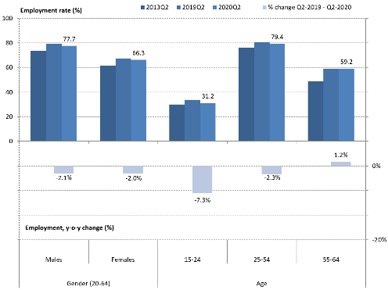

Source: Eurostat, LFS.

**Educational attainment remains key to improve employability and labour market outcomes.** Prior to the pandemic, the number of employed people (aged 25-64) with higher education continued to grow steadily (by 0.5 pps between 2018 and 2019), resulting in a corresponding employment rate of 86.2%. The employment rate of medium-skilled workers (i.e. those with upper secondary education) stood at 76.5% in 2019. This is an increase of 0.5 pps compared to the previous year and 4.7 pps higher than in 2014. These changes reflect that fact that labour demand has progressively shifted towards higher skills levels, including digital skills. This trend has often corresponded with a higher average level of skills among the new cohorts entering the labour market.[12] The share of low-skilled workers (i.e. those with lower secondary education or below) increased by 0.7 pps during the last year (and by 1 pps between 2017 and 2018). In 2019, the employment rate of this group stood at 56.3%. The employment gap between the low- and high-skilled stood at 30 pps in 2019, highlighting the need for further upskilling and reskilling.

## **1.2 Social trends**

**Before the onset of the COVID-19 crisis the number of people at risk of poverty or social exclusion continued to decline in the EU-27.[13],[14]** This downward trend continued for seven consecutive years until 2019 (Figure 6), when the number of people at risk of poverty or social exclusion fell to 92.4 million (21.1% of the total population), about 2.3 million fewer than in 2018 (3.8 pps less than the 2012 peak value). The overall trend was decreasing for all three sub-indicators, the severe material deprivation rate (‑0.5pps), the very low work intensity rate (‑0.3pps) and also the at-risk-of-poverty rate (‑0.3pps). These developments are in line with increases in employment and disposable incomes experienced in 2019 (see Section 3.4). However, all these indicators still do not capture the effects of the COVID-19 crisis. Given the relevance of labour income for households’ livelihoods and the drop in both employment rates and hours worked, the income situation and work intensity of households are likely to worsen in 2020. As a result, the positive trend in AROPE may be broken and the Europe 2020 target of 20 million fewer people at risk of poverty or social exclusion may become more distant.

**The percentage of people at risk of poverty after social transfers decreased in 2019, but was still high; it is difficult to estimate the impact of the crisis.** The at-risk-of-poverty indicator remained broadly stable, decreasing marginally to 16.5% in 2019 (from 16.8% in 2018, based on incomes from one year earlier). The number of people living in households with a disposable equivalised income below 60% of the national median was slightly above 84.5 million, one and a half million people less than in the previous year. Eurostat flash estimates for the income year 2019 point to a rather stable scenario.[15] At the moment of drafting, the flash estimates referring to 2020 incomes (thus reflecting the impact of the crisis) are not yet available. Changes in 2020 are rather difficult to foresee, also due to the likely impact of the crisis on median incomes. Simulation results[16] show that, thanks to the policy measures adopted in response to the crisis, the AROP rate may only increase by 0.1pp on average in the EU. The anchored AROP rate (i.e. the rate computed against a poverty threshold fixed on a base year) would instead increase by 1.7 pps, reflecting the substantial expected drop of income levels against a fixed poverty line.[17]

**The sharp fall in the number of people suffering from severe material deprivation before the pandemic contributed to upwards social convergence.** More than 2 million people were relieved of severe material deprivation in 2019, bringing the overall number down to 24.4 million, or 5.6% of the EU population. This decline represented a significant improvement for the seventh year in a row. It was driven by the good performance recorded by the Member States for which severe material deprivation was the highest (see Section 3.4), thus contributing to continued upwards social convergence (though at a slower pace in 2019 than in previous years).

Figure 6: The share of people at risk of poverty or social exclusion was on the decline before COVID-19, but the share of those at risk of poverty remained broadly stable

Percentage of population at risk of poverty or social exclusion (AROPE) and its sub-indicators (2010-2019)

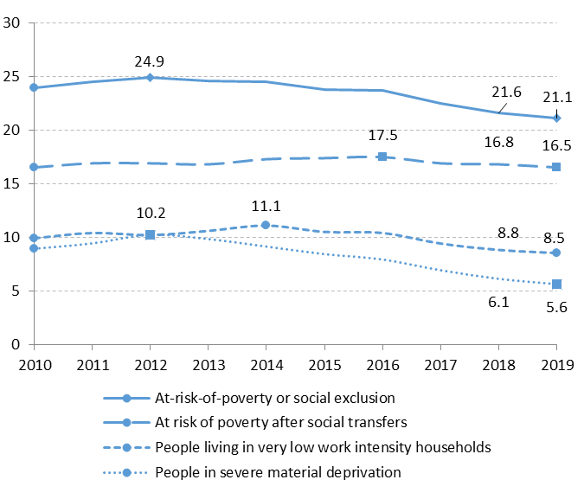

Source: Eurostat, indicators t2020_50, t2020_51, t2020_52, t2020_53. Data refer to Member States of the EU-27 from 2020 February on.

**At the same time, the good labour market performance prior to the pandemic has helped further reducing the number of persons living in quasi-jobless households**. The number of people living in households with very low work intensity decreased by more than 1 million people in 2019. This represented 8.5% of the overall population, further decreasing from the 2014 peak. Given that the COVID-19 shock affected relatively more workers in less stable jobs (see Section 3.3), this indicator may deteriorate heavily in 2020.

**Although the risk of poverty or social exclusion decreased substantially in 2019, it remained higher for children.** Between 2018 and 2019, the number of children (aged less than 18) at risk of poverty or social exclusion decreased in the EU-27 by 674 000, or 3.6%. As a result, the related AROPE rate was 22.5% for children, down from 23.4% in 2018. Compared to an AROPE rate of 21.5% for the working-age population (18-64) and 18.6% for older people (65 years or more), this rate remains still high.

**The in-work poverty risk slightly decreased in 2019 but remained at a high level, while the depth of poverty was high for people in very low work intensity households.** In 2019, the percentage of people at risk of in-work poverty decreased by 0.3 pps, down to 9%, further below the peak of 9.8% reached in 2016, but still 0.5 pps above the minimum achieved in 2010. People working part-time and under temporary contracts remain more exposed to such risk, with in-work poverty rates respectively at 15.1% and 16.2% (see also sections 3.1.1 and 3.4.1). At the same time, the relative median income poverty gap[18], which measures how far income levels of those at poverty risk are from the poverty line (i.e. how severe poverty is), was 24.4% in 2019, almost unchanged from 2018. Member States show different dynamics (see Section 3.4.1 for details). At aggregate level, the poverty gap for the working-age population (18-64) living in (quasi-)jobless households[19] was stable at 36.2% in 2019, suggesting low adequacy and coverage of benefits.

**Income inequality remained at a high level in 2019 and convergence decelerated.** On average, income levels of the richest 20% of households in Member States were five times higher than that of the poorest 20%. Evidence suggests that over the last decade the overall increase in income inequality has been driven by an increase of inequalities in the lower end of the distribution (see Section 3.4). Limited improvements, especially in countries with higher levels of inequality, suggest a slowing pace in convergence. The income share of households in the bottom 40% of the income distribution was increasing until 2019, in line with moderate improvements in other income inequality indicators. The EU-27 average reached 21.4% in 2019, compared to 21.2% in 2018 and in 2017 (and a minimum of 20.9% in 2014 and 2015). In view of the long-term nature of these issues, it is important to develop an in-depth understanding of the possible ways forward through systemic foresight analyses and strengthen the resilience of the EU.

# **SNAPSHOTS FROM THE SOCIAL SCOREBOARD**

The European Pillar of Social Rights was proclaimed jointly by the European Parliament, the Council and the Commission on 17 November 2017. It sets out twenty principles and rights to support equal opportunities and access to the labour market, fair working conditions and social protection and inclusion. It is designed as a compass for a process of convergence among Member States towards better socio-economic conditions. Especially in the current crisis situation, implementing the European Pillar of Social Rights is a priority. The Commission will put forward an ambitious action plan in the first quarter of 2021 to ensure its full implementation. The action plan will be this Commission’s key instrument to contribute to socio-economic recovery and resilience in the medium and long-term, with a view to enhance social fairness of the digital and green transitions.

The European Pillar of Social Rights is accompanied by a social scoreboard to monitor performances and track trends across Member States[20]. The scoreboard provides a number of indicators (headline and secondary) to screen the employment and social performance of Member States along three broad dimensions, identified in the context of the Pillar: (i) equal opportunities and access to the labour market, (ii) dynamic labour markets and fair working conditions, and (iii) public support / social protection and inclusion. Since the 2018 edition, the Joint Employment Report includes the social scoreboard, the results of which are summarised in this Chapter as concerns headline indicators. The analysis is placed in the broader reform context presented in Chapter 3.

## **2.1 The scoreboard explained**

**The social scoreboard is a central tool for monitoring performance in the employment and social domains, and convergence towards better living and working conditions.** In particular, it helps monitoring the situation of Member States on measurable dimensions of the Pillar, complementing the existing monitoring tools, in particular the Employment Performance Monitor and the Social Protection Performance Monitor[21]. The social scoreboard notably includes 14 headline indicators that assess employment and social trends at large:

* *Equal opportunities and access to the labour market:*
  + Share of early leavers from education and training, age 18-24
  + Gender gap in employment rate, age 20-64
  + Income inequality measured as quintile share ratio - S80/S20
  + At-risk-of-poverty or social exclusion rate (AROPE)
  + Young people neither in employment nor in education or training (NEET rate), age 15-24
* *Dynamic labour markets and fair working conditions:*
  + Employment rate, age 20-64
  + Unemployment rate, age 15-74
  + Long-term unemployment rate, age 15-74
  + Gross disposable income of households in real terms, per capita[22]
  + Net earnings of a full-time single worker without children earning an average wage[23]
* *Public support / Social protection and inclusion:*
* Impact of social transfers (other than pensions) on poverty reduction[24]
* Children aged less than 3 years in formal childcare
* Self-reported unmet needs for medical care[25]
* Share of population with basic overall digital skills or above.

**Headline indicators are analysed using a common methodology agreed by the Employment Committee and the Social Protection Committee** (see Annex 3 for details). This methodology evaluates the situation and developments in Member States by looking at levels and yearly changes[26] of each of the headline indicators included in the social scoreboard. Levels and changes are classified according to their distance from the respective (unweighted) EU averages. Member States' performances on levels and changes are then combined (by using a predefined matrix) so that each Member State is assigned to one out of seven categories (‘best performers’, ‘better than average’, ‘good but to monitor’, ‘on average/neutral’, ‘weak but improving’, ‘to watch’ and ‘critical situations’). On this basis, Table 1 provides a summary of the readings of the scoreboard according to the latest figures available for each indicator. A detailed analysis of the fourteen indicators, including longer-term trends and additional indicators, when relevant, is presented in Chapter 3.

**The reading from the social scoreboard helps identifying employment and social challenges in Member States.** In the context of the European Semester, evidence from the social scoreboard has been regularly used in the country reports to inform the analysis of country-specific challenges. At Member States’ level, it also fed into the preparation of National Reform Programmes and Stability and Convergence Programmes. Together with further analysis included in the Employment Performance Monitor and the Social Protection Performance Monitor, this has provided an analytical basis for the subsequent Commission’s proposals for Country Specific Recommendations, where appropriate. During this process, a careful and non-mechanical reading of the table is warranted, and further elements – of qualitative and quantitative nature – are considered.

**The social scoreboard will support the preparation of national reform plans and recovery and resilience plans, the main reference documents under the Recovery and Resilience Facility.** As indicated in the Annual Sustainable Growth Strategy 2021[27], the Recovery and Resilience Facility will entail changes in the 2021 European Semester cycle. Given the complementarities with the Europen Semester, Member States are encouraged to submit their National Reform Programme and recovery and resilience plan in a single integrated document. Moreover, as highlighted in the guidance to Member States on Recovery and Resilience Plans[28], Member States are invited to explain in broad terms how the plans are coherent with, and effectively contribute to, implementing the European Pillar of Social Rights. In addition, they are invited to provide a picture of the overall economic and social impact of the plan (together with an assessment of the macroeconomic outlook), presenting relevant indicators, including from the social scoreboard. For the Member States submitting their plans in 2021, the Commission will assess their substance in analytical documents accompanying the proposals for the Council implementing acts[29].

**The 2021 Joint Employment Report integrates a regional dimension to the Social Scoreboard**. The evolution of the indicators at the national level may mask important differences at regional level (while, in many Member States, a number of policies and funding are often decided at this level). Against this background, for the second year, the Joint Employment Report features evidence on the regional situation, on the basis of the social scoreboard. In particular, a series of maps showing regional breakdowns by Member State are presented in Annex 4 for some Social Scoreboard headline indicators[30]. Furthermore, the analysis in Chapter 3 reports, where relevant, findings at the regional level for the Member States where large disparities[31] exist between NUTS 2 regions. The data and findings make it possible to better understand how different regions in a country fare as regards some key dimensions of the Pillar and helps monitor convergence within countries, assess the impact of regional policies and shape regional policy-making.

## **2.2 Evidence from the social scoreboard**

**The social scoreboard reflects the employment conditions following the COVID-19 crisis while showing social and skills conditions before the pandemic, due to data availability.** Since the scoreboard was presented, the assessment of Member States’ situation on its headline indicators (through the methodology described in the previous section) has been based on the latest available annual data, both for levels and for changes. At the current juncture, this approach would mean looking at 2019 data (and changes with respect to 2018) for most indicators. However, using yearly data would not allow observing the latest labour market developments in a context of crisis, and their reversal compared to past (pre-pandemic) trends. In this context, the EMCO Indicators Group agreed to temporarily depart from the use of yearly figures for the Social Scoreboard assessment, and use the latest quarterly figures instead, for the following five labour market headline indicators[32] for which they are actually available (based on the Labour Force Survey):

* Employment rate, age 20-64
* Gender gap in employment rate, age 20-64
* Unemployment rate, age 15-74
* Long-term unemployment rate, age 15-74
* Young people neither in employment nor in education or training (NEET rate), 15-24

**Headline indicators point to some deterioration in labour market conditions in the first half of 2020.** Of the five above-mentioned labour market indicators, the emploment rate and NEET rate have worsened in the EU-27[33] in Q2-2020 compared to the same quarter of 2019, while the unemployment rate has remained constant; the gender employment gap and the long-term unemployment rate, conversely, showed some improvement (more details on recent trends in Chapter 1).

**Social and skills indicators, for which only pre-COVID-19 data is available, continued to improve in 2019[34].** The remaining nine headline indicators show a positive or broadly stable trend on yearly basis (i.e. either in 2019 or 2018 depending on data availability). In particular, an improvement was observed on average for poverty, inequality and related indicators (i.e. share of people at risk of poverty or social exclusion, income quintile share ratio, gross disposable household income per capita, net earnings of a full-time single worker earning the average wage) as well as for education, childcare and skills indicators (early leavers from education and training, participation of children aged less than three in childcare, share of population with basic or above basic digital skills). A broadly stable trend was observed for the impact of social transfers on poverty reduction and self-reported unmet need for medical care.

**As highlighted by the scatterplot graphs in Chapter 3, a divergent trend across Member States can be observed for most labour market indicators** (except the long-term unemployment rate). This means that, on average, Member States with a worse initial situation have experienced a stronger deterioration in the year to Q2-2020. Nevertheless, some degree of convergence can generally be observed for the other headline indicators (in some cases, the trend is not clearly defined).

**Almost all Member States face challenges on at least one headline indicator**. Considering the three most problematic classifications altogether (i.e. ‘critical situation’, ‘to watch’ and ‘weak but improving’), all Member States are flagged at least once, with the exception of Germany. Looking at ‘critical situations’ only (i.e. indicators for which the level is much worse than average, and either not improving sufficiently fast or deteriorating further over the last year), 15 Member States were flagged, one more than in the 2020 Joint Employment Report[35]. Austria, Hungary and Portugal joined this group of countries (the two latter ‘re-joined’ it, after having left it in the previous year), while Estonia and Lithuania left it. Across the 14 domains assessed, overall 116 ‘critical situation’, ‘to watch’ or ‘weak but improving’ cases are identified, i.e. about 33% of the total number of assessments (one percentage point more than in the 2020 Joint Employment Report). Of these, 41 are ‘critical situations’ (corresponding to 11.1% of all assessments), compared to 40 in the 2019 Joint Employment Report (corresponding to 10.3% of all assessments).

**As in previous years, the situation of Member States and the severity of their challenges vary widely – also reflecting the impact of the crisis, as far as labour market indicators are concerned.** Romania and Spain present ‘critical’, ‘to watch’, or ‘weak but improving’ assessments on ten or more indicators, followed by Bulgaria and Greece with nine challenges each (see Table 1). Of these countries, Bulgaria, Romania and Spain present the highest number of ‘critical situations’ (6 each) followed by Greece (4). Yet, Greece, Romania and Spain also report a number of positive assessments each (recorded before the start of the pandemic): Greece is among the ‘best performers’ on early school leaving and ‘better than average’ on income inequality and individuals’ level of digital skills; Spain is among the ‘best performers’ on participation to childcare and ‘better than average’ on self-reported unmet needs for medical care; Romania is among the ‘best performers’ on household disposable income per capita growth. In terms of overall count of challenges, Italy (seven challenges), Cyprus, Hungaria and Latvia (six challenges each) follow[36]. By contrast, Czechia and the Netherlands are ‘best performers’ or ‘better than average’ on ten headline indicators, followed by the Denmark and Sweden (nine indicators each), and Germany (eight indicators).

**Table 1.** **Summary of headline indicators of the Social Scoreboard**



Note: update of 28 October 2020. Income quintile share ratio not available for IE, FR, IT, LV and SK. At-risk-of-poverty or social exclusion rate not available for IE, IT. NEET rate and long-term unemploymennt rate not available for DE. GDHI per capita growth not available for BG, EL, LU, MT and PL. Net earnings of a full-time single worker without children earning the average wage unreliable (and not reported) for DK. Impact of social transfers on poverty reduction not available for IE, IT and SK. Self-reported unmet needs for medical care not available for IE, FR, IT and SK. Participation of children aged less than 3 in childcare not available for FR, IE, IT and SK. Individuals' level of digital skills not available for IT (2017 missing). Breaks in series and other statistical flags are reported in Annexes 1 and 2.

# **3. EMPLOYMENT AND SOCIAL REFORMS – MEMBER STATES PERFORMANCE AND ACTION**

This section presents an overview of recent key employment and social indicators and measures taken by the Member States in priority areas identified by the EU employment guidelines, as adopted by the Council in 2020[37]. It draws on Member States’ National Reform Programmes 2020 and European Commission sources[38]. If not specified otherwise, only policy measures implemented after June 2019 are presented in the report. An in-depth analysis of recent labour market developments can be found in the Labour Market and Wage Developments Annual Review 2020[39] and the Employment and Social Developments in Europe Annual Review 2020.[40]

## **3.1 Guideline 5: Boosting the demand for labour**

This section looks at the implementation of the employment guideline no. 5, which recommends Member States to create conditions promoting labour demand and job creation. It first presents an overview of unemployment and employment rates by Member State, complementing the analysis at EU level presented in Chapter 1. It then looks at self-employment trends, wage dynamics, minimum wage and tax wedge developments. Section 3.1.2 reports on policy measures implemented by Member States in these areas, with a special focus on the policy responses to preserve employment and support job creation in the context of the pandemic.

### *3.1.1 Key indicators*

**The number of employed people dropped in the second quarter of 2020, reflecting the impact of the COVID‑19 crisis.** During 2019, total employment increased or remained stable in all Member States compared to 2018 (except for small declines in Poland and Romania). Employment growth decelerated or turned negative in several Member States in the first quarter of 2020 (with an average of -0.2% in the EU quarter-on-quarter). Subsequently, all Member States (with the exception of Malta) recorded a fall in the second quarter (with an average of ‑2.7% in the EU). Compared to the employment peak in Q4-2019, this drop exceeded six million people. The largest decreases were recorded by Spain (-8.4%, corresponding to 1.7 million people), Ireland (-6.1%), Estonia and Hungary (‑5.6%). Employment growth was below -2% in other thirteen Member States (Figure 7). On the contrary, the fall was more moderate in Cyprus (-0.9%), Poland (-0.4%) and Luxembourg (‑0.3%). Malta was the only country to record an increase in employment, by 1.7%.

Figure 7: Substantial fall in employment across the EU

Percentage change in total employment and hours worked between Q4-2019 and Q2-2020

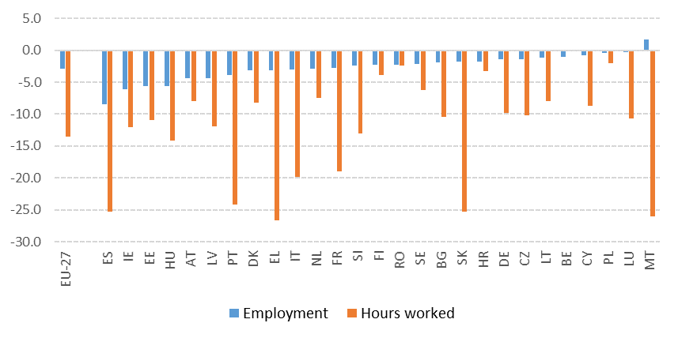

Source: Eurostat, National accounts.

Note: seasonally and calendar adjusted data, except only seasonally adjusted for CZ, EL, FR, MT, PL, PT, SK (employment) and MT, SK (hours worked). Data on hours worked for BE is not available.

Figure 8: Absences from work increased abruptly across the EU

Absences from work as a share of total employment (20-64)

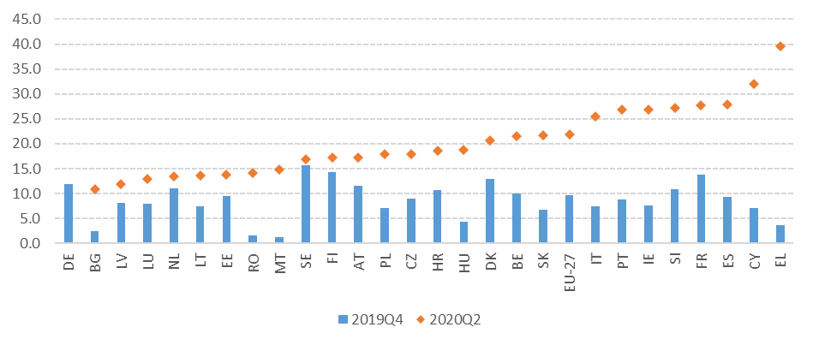Source: Eurostat, LFS. Note: seasonally adjusted data. Data for DE are not available for Q2-2020.

**Short-time work schemes helped contain job destruction.** Since the onset of the crisis, Member States have extensively implemented and/or strengthened short-time work schemes or other job preservation schemes, with the aim to limit job losses, avoid the dispersion of human capital at firm level, and sustain aggregate demand in a phase of substantial economic slump. At the same time, employers have also adjusted their labour demand autonomously to ensure the sustainability of their operations. As already shown in Section 1 and evident from Figure 7, the fall in hours worked has been substantially larger than the fall in employment (‑13.5% vs ‑2.9% in the EU in Q2-2020 compared to Q4-2019) which can be largely ascribed to the functioning of short-time work schemes. Across countries, the largest discrepancies between the two indicators[41] could be observed in Luxembourg, Slovakia, Cyprus, Greece, Czechia, Germany, France and Italy. At the same time, as evident in Figure 8, the number of workers absent from employment (as a proportion of total employment) rose abruptly, with an increase of 12.1 pps for the EU (from 9.7% in Q4-2019, following a stable trend over the last decade, to 21.8% in Q2-2020). Temporary lay-offs alone accounted for almost half of all absences (a sudden increase from 0.2% in Q4-2019 to 10.3% in Q2-2020). The largest increases in the share of absences were recorded in Greece (+35.9 pps), Cyprus (+25 pps), Ireland (+19 pps), Spain (+18.7 pps), Italy and Portugal (+18 pps).

**The use of short-time work schemes has reached unprecedented levels during the COVID-19 crisis in all countries** (for which data are publicly available)[42]. The use of short-time work was particularly widespread in the services sector (mainly hotels and restaurants) and in retail trade. The take-up was comparatively lower in Member States with newly established schemes.This could have been in part due to the design of their schemes, slow adaptation to the new administrative procedures, or implementation delays. In some of the newly established schemes (for example in Bulgaria, Czechia, Croatia and Hungary), the requirement for firms to share part of the costs could have curtailed take up. In Poland, initial take-up was lowered by a requirement to maintain employment after the expiry of support.

**A limited drop in the overall employment rate hides major differences across Member States.** Over 2019, the employment rate (age group 20-64) increased on average and in all Member States (except for a small decline in Sweden, still from the highest level across the EU). As shown in Section 1, in Q2-2020 the employment rate decreased by 1.3 pps, down to 72% from the peak of 73.3% reached in Q2-2019 (bringing back the indicator to the level seen in the first quarter of 2018). As mentioned, the overall modest fall can be ascribed to the extraordinary measures taken in the context of the crisis. Yet, the situation hides substantial heterogeneity across Member States. As shown in Figure 9, Spain experienced the largest fall (by 3.8 pps) followed by Bulgaria (3.2 pps), Austria (2.4 pps) and Ireland (2.4 pps). On the contrary, Croatia recorded an increase (by 0.7 pps) while Malta, Latvia and Poland recorded a stable or marginally decreasing rate.

**Looking at the assessment based on the methodology for headline social scoreboard indicators, the situation does not change significantly compared to previous years**, with Greece, Italy and Spain still marked as ‘critical situations’ (with rates close to or below 65%) while Sweden, Germany, Czechia and the Netherlands are ‘best performers’ (with rates close to or above 80%). In between, the sudden drop in employment rates explains the classification of Bulgaria, Ireland and Austria as ‘to watch’ countries (though the respective levels are still close to average). Belgium and Romania, with an employment rate falling to below 70% over the last year, are also ‘to watch’. Croatia, which still presents a low employment rate at 66.8% in Q2-2020 is marked as ‘weak but improving’ in view of the recent increase (in spite of the crisis). The positive slope of the regression line suggests that Member States are experiencing a diverging trend (i.e. employment rates have decreased faster in countries starting from a lower level). Whether this trend will be sustained over time, as it happened in the financial crisis, remains to be seen. A number of Member States present significant regional disparities in employment rates (see Annex 4).

Figure 9: The employment rate dropped in almost all Member States

Employment rate (20-64) and its yearly change (Social Scoreboard headline indicator)

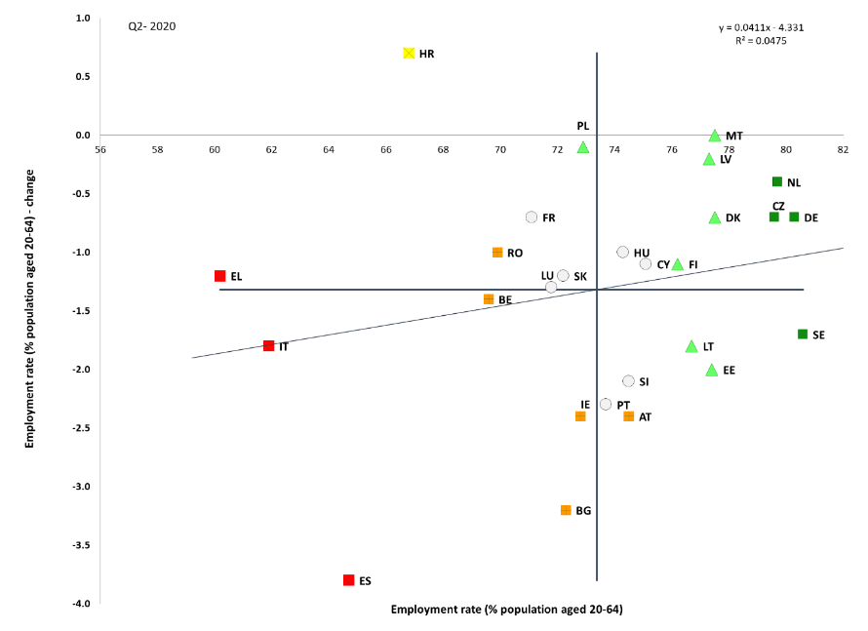

Source: Eurostat, LFS. Period: Q2-2020 levels and yearly changes with respect to Q2-2019. Note: Axes are centred on the unweighted EU average. The legend is presented in the Annex.

In most Member States, the increase in unemployment has been moderate so far. As shown in Section 1, the average unemployment rate for the EU has increased to 7.5% in September 2020, i.e. by only 1 pp compared to the lowest pre-crisis level recorded in February 2020. This follows a continuous decline in the majority of Member States in 2019. Such a moderate increase can be seen as the effect of the functioning of short-time work schemes, though inactivity could also explain part of it (in several Member States a sizeable share of workers gave up active job search, especially during the lockdown phases). Figure 10, showing the level of unemployment rate in Q2-2020 and the change compared to Q2-2019, indicates that to such a moderate average increase correspond very different national trends. For 20 out of 27 Member States the unemployment rate actually rose over this period, with increases close or above 2 pps in Lithuania, Latvia, Estonia and Sweden (all marked ‘to watch’ according to the social scoreboard methodology). On the contrary, the unemployment rate has actually decreased in Italy, France, Portugal, Belgium, Ireland, Poland and Greece (in the case of Italy, by more than 2 pps). The falling activity rate (by 3.1 pps in Ireland and Portugal, 2.9 pps in Italy, 2.1 pps in France, 1.7 pps in Belgium, 1.5 pps in Greece) can help explain this behaviour. Monthly figures for September 2020 point indeed to an actual increase in unemployment compared to one year before for all those countries except Belgium and France. In comparative terms, Spain and Greece are still classified as ‘critical situations’ (with unemployment rates above 15%) while Czechia and Poland are ‘best performers’ (with unemployment rates below 4%). Large disparities persist at regional level (see Annex 4) with some regions of Greece, Italy and Spain recording unemployment rates above 20%.

Figure 10: Unemployment has risen in most Member States, with a moderate overall increase

Unemployment rate (15-74) and yearly change (Social Scoreboard headline indicator)

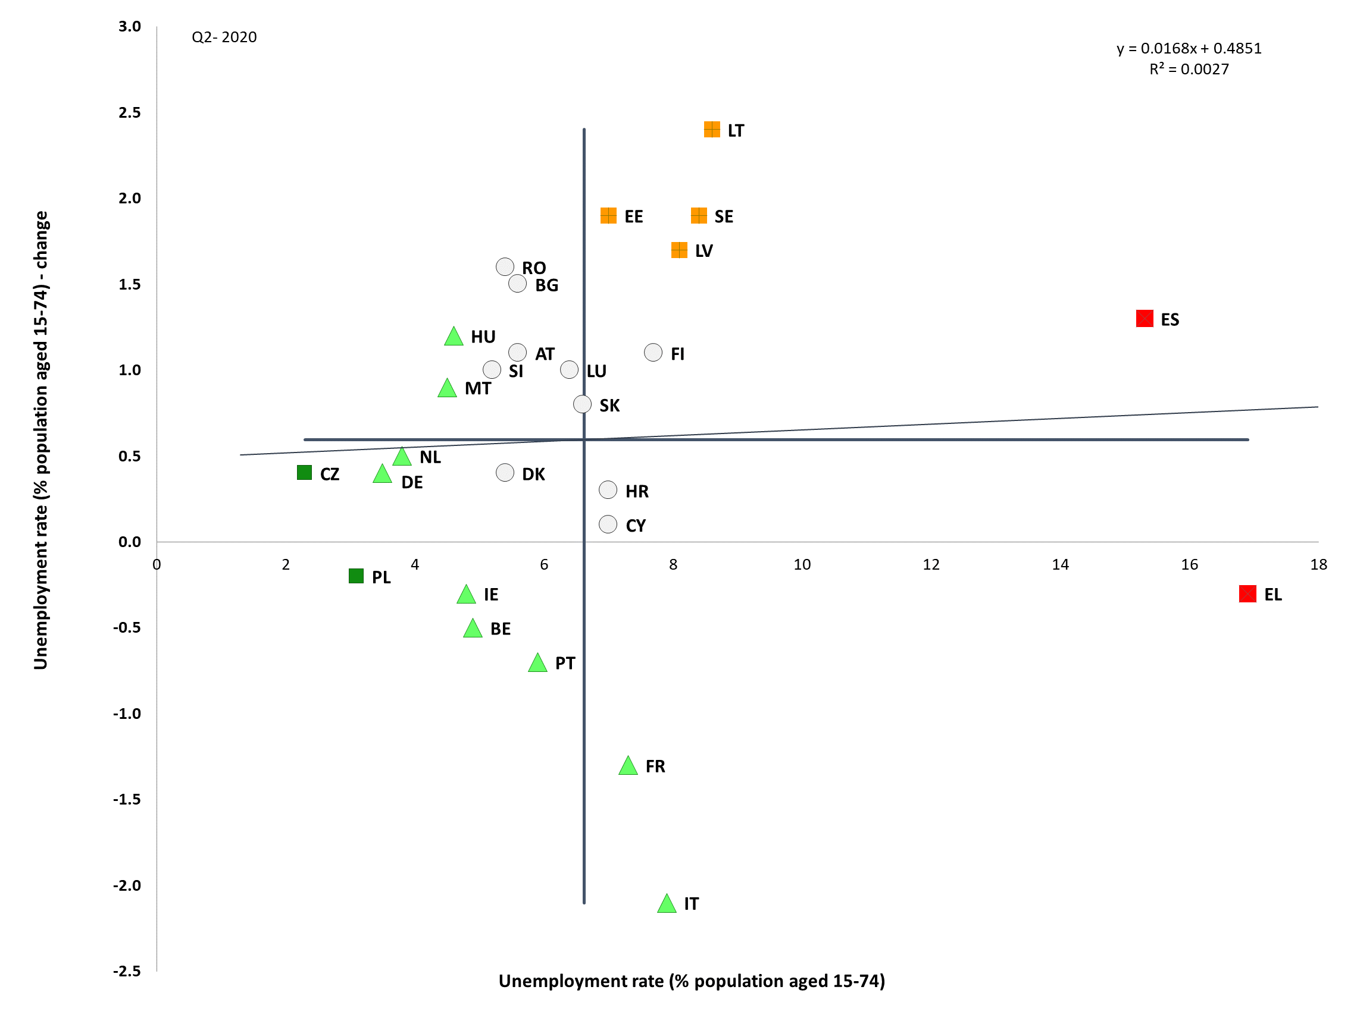

Source: Eurostat, LFS. Period: Q2-2020 levels and yearly changes with respect to Q2-2019. Note: Axes are centred on the unweighted EU average. The legend is presented in the Annex.

**Self-employment was, on average, less affected by the crisis than total employment – but with a higher heterogeneity across Member States.** Between Q4-2019 and Q2-2020, the number of self-employed workers dropped by 1.8% (or 530 000), compared to 2.9% for total employment (National Accounts figures, seasonally adjusted[43]). While this fall is sizeable, the comparison with total employment suggests that a large share of the self-employed managed to keep their activity running in spite of the collapse in economic activity, either by (temporarily) reducing the size of their business or switching to remote forms of working. Still, the self-employed represent one of the categories most at risk if the recession is protracted, not least because of limited access to social protection schemes in many Member States. Only in seven Member States did self-employment drop faster than total employment between Q4-2019 and Q2-2020 (Bulgaria, Germany, Estonia, Malta, Romania, Slovakia and Finland). Overall, the largest drop was recorded in Romania (-10.5%), followed by Estonia (‑6%), Ireland (-5.7%) and Spain (-4.6%). Interestingly, the number of the self-employed increased in eleven Member States during the crisis, the largest increases recorded in Latvia, Poland and Luxembourg.

**In recent years, self-employment slowly declined as a share of total employment.** Overall, the share of self-employed on total employment has been slowly decreasing, from 14.3% in 2008 to 13.4% in 2019[44]. Such a decrease was evident in particular during the phase of economic expansion between 2013 and 2019, when job creation occurred more than proportionally among employees. As shown in detail in the Joint Employment Report 2020, this decrease over time hides a continuous shift in the composition of self-employment away from traditional activities towards services and higher value-added sectors – notably away from agriculture, trade and transport, towards information and communication, professional, scientific and technical activities, human health and social work activities. This structural change is accompanied by a faster increase in the average level of educational attainment among self-employed than among employees: the share of tertiary educated workers among the former increased from 26% in 2008 to 36.1% in 2019, against a more limited increase (from 26.1% to 34.5%) among employees. The crisis is likely to accelerate the shift towards services sectors and a higher educational level among the self-employed, as low-skilled workers in traditional sectors (that cannot be performed digitally) are among the most affected.

**Nominal wage growth accelerated in 2019 to then react to the economic slump.** The EU‑27 average growth of nominal compensation of employees was above 3% and it reached more than 4% in the Baltics, Central and Eastern Europe and Ireland (Figure 11). For Hungary, Lithuania and Ireland, the changes in 2019 substantially outpaced those of the previous year, whereas signs of deceleration from high growth trend were recorded for Romania, Bulgaria, Estonia and Czechia. Wages decelerated also in Sweden and especially in Italy and France (in the latter, they remained at the same level of 2018).In 2020, with several Member States entering into recession, growth of compensation per employee started to slow down in most of them. This response mainly reflects the shortfall of hours worked (and, often, of associated wage costs) related to the widespread use of short-time work schemes. Depending on the design of national schemes, the share of employees involved and the intensity of the drop in hours worked, wage decreases varied considerably. By Q2-2020, a large number (18) of Member States recorded negative changes (y-o-y), with substantial decreases in France (-8.5%), Belgium (-9.5%) and Italy (-10.3%). In some of the remaing ones, positive developments were higher than 3.5% in Romania, the Netherlands and Poland, and especially significant in Bulgaria (+8.3%), Hungary (+6.6%) and Lithuania (+5.1%). Furthermore, as firms reducing the hours worked attempt to save labour costs, compensation per employee has also been affected by the freezing of the variable components of pay or the postponement of labour contracts renewals.

Figure 11: Nominal wage growth turned negative during the crisis in most Member States

Nominal compensation per employee, 2018-2019 and Q2-2020, annual% change

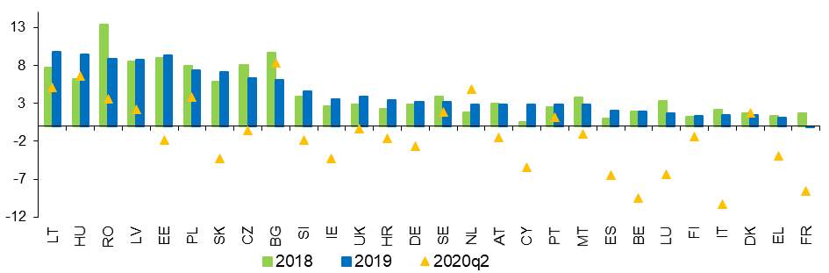

(1) Wages are measured by the indicator ‘Nominal compensation per employee’, which is calculated as a total compensation of employees divided by total number of employees. The total compensation is defined as the total remuneration, in cash or in kind, payable by an employer to an employee in return for work done by the latter during the accounting period and it has two components: i) Wages and salaries payable in cash or in kind; and ii) Social contributions payable by employers. (2) All the data used are national accounts data. The indicators are based on national currency values. Aggregates are weighted averages.

Source: European Commission, AMECO database.

**While the compensation per employee dropped, the reduction of hours worked triggered an increase in hourly wages**. While in few countries (Cyprus, Czechia, Croatia, Poland and Romania), hourly wages actually decreased in the second quarter of 2020 (quarter on quarter), they generally outpaced compensation per employee. In seven countries, the gap is above 10 pps, with the highest values for France and Portugal (14% and 19.6%, repectively).

**Real wages increased in almost all Member States in 2019 to then drop in the first half of 2020.[45]** In real terms (deflated with consumer price inflation), 2019 wage growth was particularly strong – above 5% – in Central and Eastern European (Poland, Hungary, Romania, Slovakia) and Baltic countries (Estonia, Latvia and Lithuania). The robust real wage dynamics in countries with GDP per capita catching up to the EU average therefore led to a decline in the dispersion of real wages within the EU. Increases of less than 1% were observed in nine countries, including Sweden, France, Greece, and of almost negligible size in Italy and the Netherlands (see Figure 12). Luxembourg recorded negative real wage growth. A spike in heterogeneity of real wage dynamic is recorded in the second quarter of 2020. In several Member States, aggregate real wages are severely falling, especially in Czechia, Spain, France, Belgium and Italy; in the latter two countries, real wages fell by more than 10 per cent. This reduction is (at least) partly explained by the impact of short-time work schemes, depending on the design of national measures (in countries where benefits are paid directly to the employees and recorded as social transfers, short-time work schemes lead to an observed drop of wage costs)[46]. Elsewhere, positive developments continued along the most recent trend, especially in Lithuania, Latvia, Hungary and Bulgaria.

Figure 12: Real wage growth was strong in Eastern and Baltic Member States in 2019

Real wages per employee, 2018, 2019 and 2020Q2, annual % change

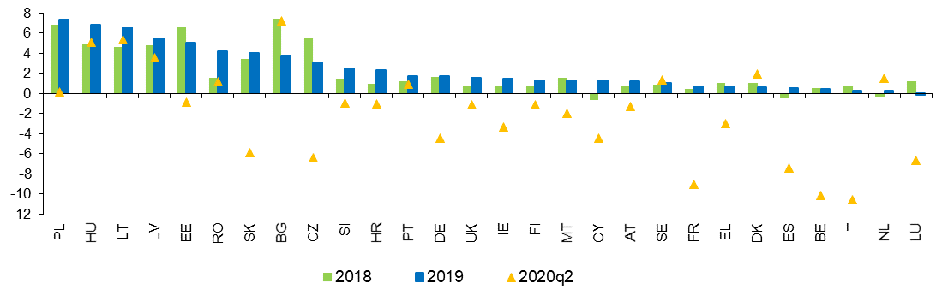

(1) Real gross wages and salaries per employee; deflator: private consumption. (2) Countries are ranked in descending order of real wage growth in 2019. Source: European Commission, AMECO database.

**After dropping in the aftermath of the previous financial crisis, the wage share increased moderately on average in 2018 and 2019.** In 2019, the wage share in the EU-27 inched up at 55.4% (from a bottom level of 55% between 2015 and 2017),with increases higher than 1 pp in Cyprus, Slovenia, Slovakia, Lithuania and Latvia. At the same time, the wage share decreased in seven countries and by at least 1 pp in France, Romania and Bulgaria. Over the period 2013-2019, the wage share increased in Member states whose starting levels were comparatively low, and most notably in Latvia, Lithuania, Romania and Slovakia, showing some degree of convergence. Among the largest EU countries, the wage share only increased in Germany (1.7 pps), slightly decreased in Italy (-0.3 pps), while France, Spain and the Netherlands recorded contractions larger than 1 pp.

**Over the last three years, net earnings growth continued to be faster in Central and Eastern Europe, contributing to convergence in labour income levels**. This trend appears clearly from the distribution of countries in Figure 13, which takes as a reference a single earner without children earning the average wage level, over a three-year period (2016-2019)[47]. Upwards convergence in living standards is in line with the goals of the European Pillar of Social Rights. On the lower end of the net earnings distribution, Bulgaria, Romania, Latvia, Lithuania, Hungary and Poland, where net earnings in purchasing power standards (PPS) stand below or around EUR 15 000, all presented an average increase above 5% over the past three years, and are classified as ‘weak but improving’[48]. Other countries showing similarly low levels did not experience such a fast growth, and are classified as ‘to watch’ (Croatia, Slovenia, Portugal, Czechia and Estonia) or ‘critical’ (Slovakia). Among the ‘best performers’, net earnings in purchasing power standards are close or above EUR 30 000 in Germany, Netherlands, Ireland and Luxembourg. In these Member States, net earnings have been growing faster than in countries with similar levels. Spain, Greece and Italy, with net earnings levels close to average, showed a negative or stagnant development over the last three years (consistently with high unemployment rates). Importantly, those countries experiencing higher than average net earnings growth also highlight a fast increase in unit labour cost, whose long-term implications for competitiveness need to be monitored.

Figure 13: Net earnings have been increasing rapidly in Central and Eastern Europe, thus supporting upwards convergence

Net earnings and yearly change – average over three years (Social Scoreboard headline indicator)

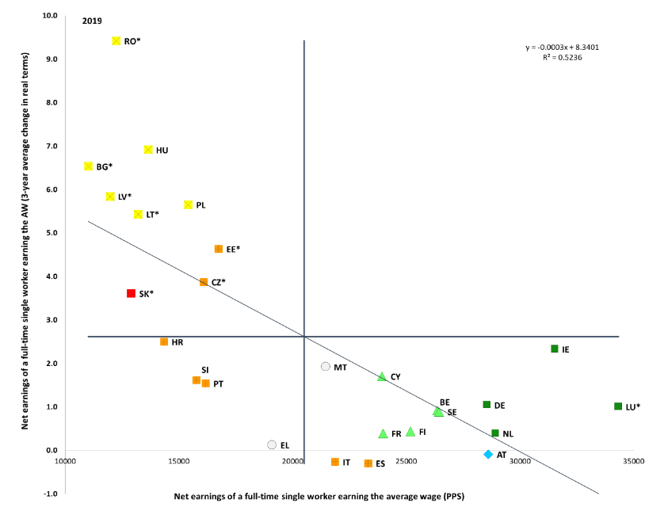

Source: Tax and benefits database (own calculations). Period: 2019 levels (3-year average) and average yearly changes 2016-2019. Note: Axes are centred on the unweighted EU average. The legend is presented in the Annex. Member States marked with an asterisk are those where nominal unit labour cost (NULC) exceeded the threshold set by the Macroeconomic Imbalances Procedure (MIP). The MIP scoreboard indicator is the percentage change over three years of NULC. The threshold is 9% for the euro area countries and 12% for the non-euro area countries. DK is not reported as its value is unreliable.

**A job does not always provide for a decent living.** In recent years, the situation of low-wage workers deteriorated in many countries. In-work poverty has increased in the last decade, from 8.5% in 2007 to 9.8% in 2016 in the EU-27, to then decline to 9% in 2019.[49] Structural trends reshaping labour markets, such as digitalisation and the rise in non-standard forms of work, are resulting in more job polarization, a decline of employment in medium-paid occupations and a simultaneous increase of low- and high-paid occupations.[50] Workers on temporary contracts face a higher risk of in-work poverty than those on permanent contracts (16.3% vs 5.7%); as do low-skilled workers compared to high-skilled ones (19.3% vs 4.5%). In addition, non-EU born workers are much more likely (20.9%) to experience in-work poverty than natives (7.9%). Figure 14 shows that more than 10% of workers are at risk of poverty in Romania, Spain, Italy, Luxembourg, Portugal and Greece. Among this group, the in-work poverty rate has actually increased compared to 2010 in Spain, Italy, Luxembourg and Portugal.

Figure 14: In-work poverty has increased in the majority of Member States over the last decade.

In-work at-risk-of-poverty rate, multiannual comparison

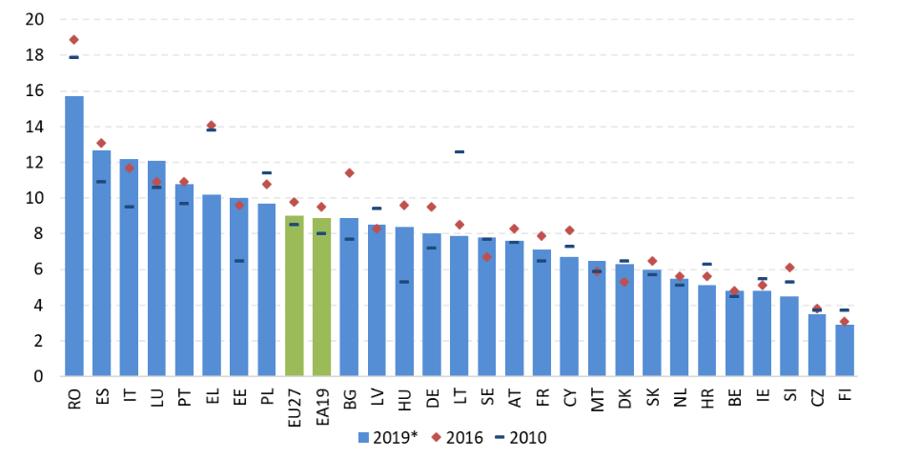

Source: Eurostat, SILC.

Note: 2019 data are not available (2018 is shown instead) for FR, IE, IT and SK.

**Women, young and low-skilled workers, as well as those with non-standard jobs have a higher probability of earning the minimum wage than other workers[51].** In particular, young workers are three times more likely to earn the minimum wage than adult workers, while women are almost twice more likely. Similarly, temporary work increases the probability of earning the minimum wage by a factor of three while part-time work by a factor of two. Nevertheless, the ‘typical’ minimum wage earner in most Member States is older than 25, has upper secondary education and is living in a couple. This is because the share of young, low-skilled workers and lone parents is relatively small in the overall workforce, which weighs down their higher chance of earning the minimum wage.

**Despite recent minimum wage increases in many Member States[52], statutory minimum wages remain, in many cases, low compared to other wages in the economy.** In almost all Member States, the statutory minimum wage is below 60% of the median wage and 50% of the average wage. In 2019, only the statutory minimum wage of Portugal reached both values, while that of Bulgaria reached 60% of the median. Further, in the same year, the minimum wage was below 50% of the median wage in nine EU countries (Estonia, Malta, Ireland, Czechia, Latvia, Germany, the Netherlands, Croatia and Greece, see Figure 15). In the same year, seven countries (Estonia, Malta, Ireland, Czechia, Latvia, Hungary and Romania) had minimum wages below 40% of the average wage. There are also instances where the minimum wage was not sufficient to protect workers against the risk of poverty. There are gaps in the coverage of minimum wages in several Member States. In countries with a statutory minimum wage, specific categories of workers are not protected by minimum wages because exemptions apply. In countries where wages are exclusively set through collective bargaining, there are gaps in coverage for workers who are not covered by collective agreements.

Figure 15: In almost all Member States, the statutory minimum wage is below 60% of the median wage and 50% of the average wage

Minimum wages as a percentage of the gross median and average wage of full-time workers, 2019

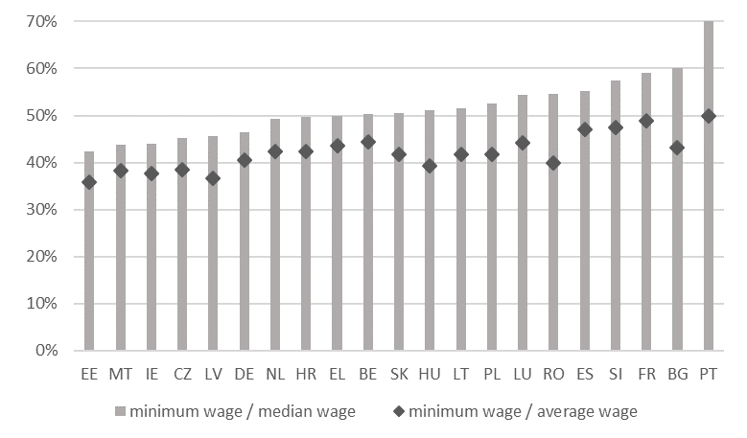

Source:Commission calculations based on Eurostat data.

Note: Member States with a statutory minimum wage are depicted.

**That is why, on 28 October 2020, the Commission has proposed an EU Directive to ensure that the workers in the Union are protected by adequate minimum wages allowing for a decent living wherever they work.** The Commission proposal aims at promoting collective bargaining on wages in all Member States. Countries with statutory minimum wages should put in place the conditions for minimum wages to be set at adequate levels. These conditions include clear and stable criteria for minimum wage setting, indicative reference values to guide the assessment of adequacy and regular and timely updates of minimum wages. These Member States are also asked to ensure the proportionate and justified use of variations in and deductions from statutory minimum wages and the effective involvement of social partners in statutory minimum wage setting and updating. At the same time, the proposal is designed in such a way as to take into account the effects on employment and competitiveness. It thus provides sufficient flexibility to take into consideration social and economic developments, including productivity and employment trends. Finally, the proposal provides for improved enforcement and monitoring of the minimum wage protection established in each country. In accordance with Article 154(3) TFEU, a two-stage consultation of social partners has been carried out.

Figure 16: In spite of an overall decrease, the tax wedge on labour remains high in several Member States

Tax wedge on labour on low and average wages, level and change 2014-2019

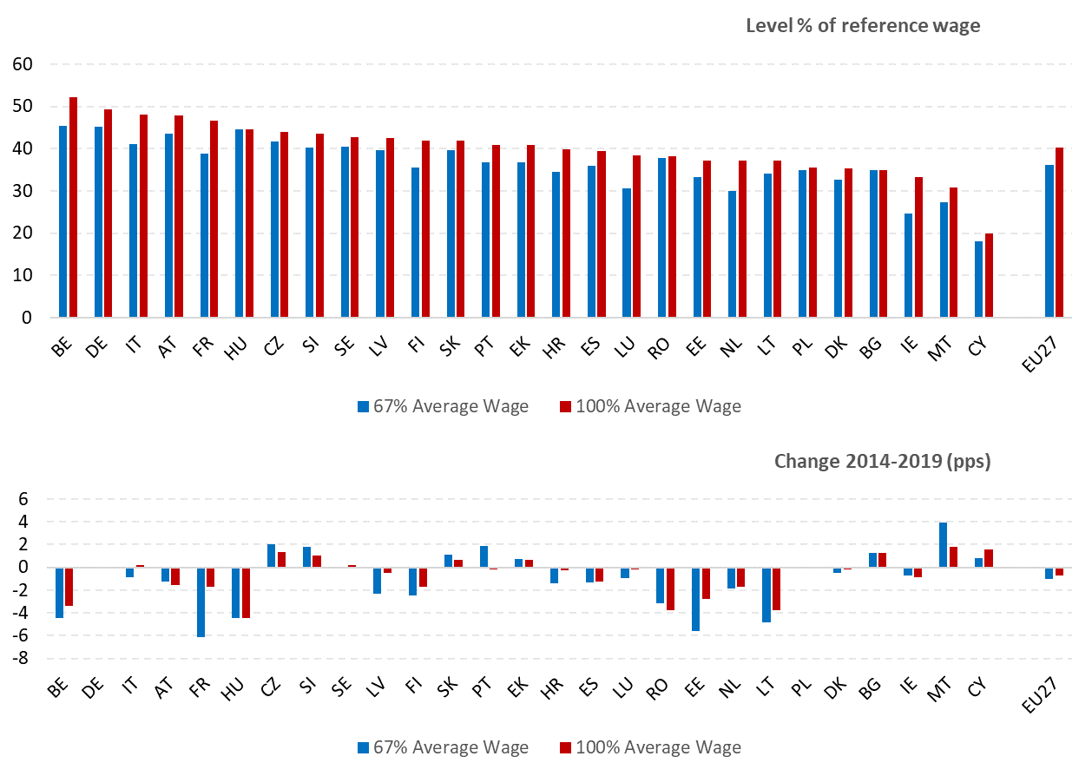

Source: Tax and benefits database, European Commission/OECD.

Note: Data are for single earners without children.

**The average tax burden on labour in the EU-27 continues a slight downward trend, with relatively small changes in most Member States.** In 2019, the reduction in the tax wedge for single workers earning the average wage was most significant in Lithuania (-3.4 pp), while reductions elsewhere were more limited (less than one pp). The highest increases were seen in Cyprus (1.2 pps) and Estonia (1.1 pps). Differences across Member States remain large (see Figure 16), with the tax wedge ranging from around 20% in Cyprus to more than 45% in Belgium, Germany, Italy, Austria and France. Similarly, the tax wedge for lower income workers (defined as those earning 67% of the average wage) varies significantly across Member States. In a longer-term perspective, the tax wedge has declined both at the average wage and for lower income workers, with the reduction for the latter being on average more pronounced. Between 2014 and 2019, the non-weighted average tax wedge in the EU decreased 0.7 pps (and by 1.1 pps for low-income workers). Lithuania, Hungary, Romania, Belgium and Estonia saw large reductions for both income groups (though for Belgium both levels remain among the highest), while substantial reductions for lower income workers were also recorded for France, Latvia and Finland. The most significant increase at both wage levels was recorded in Malta, although the tax wedge remains relatively low.

**In a number of Member States there is scope for shifting taxation away from labour towards other sources less detrimental to growth and more supportive to environmental goals.** Environmental taxes (i.e. energy, transport, pollution and resource taxes) contributed around 6% of total tax revenue in the EU-27 in 2018, with a share ranging from 10.9% in Latvia to 4.4% in Luxembourg (Figure 17). Energy taxes made the largest contribution, comprising around 77% of environmental tax revenue in the EU-27, in 2018. For the EU-27 as a whole the share of environmental taxes in total tax revenue remained relatively steady between 2008 and 2018. Changes at national level were more pronounced, with the largest increases in Latvia and Greece and the largest reductions in Luxembourg. However, it should be noted that the share of environmental taxation alone is not sufficient to conclude whether the tax system of a Member State is well-designed to support environmental objectives.[53]

Figure 17: The share of environmental taxes has not increased on average in the EU over the last decade

Environmental taxes as % of total taxation, 2008-2018

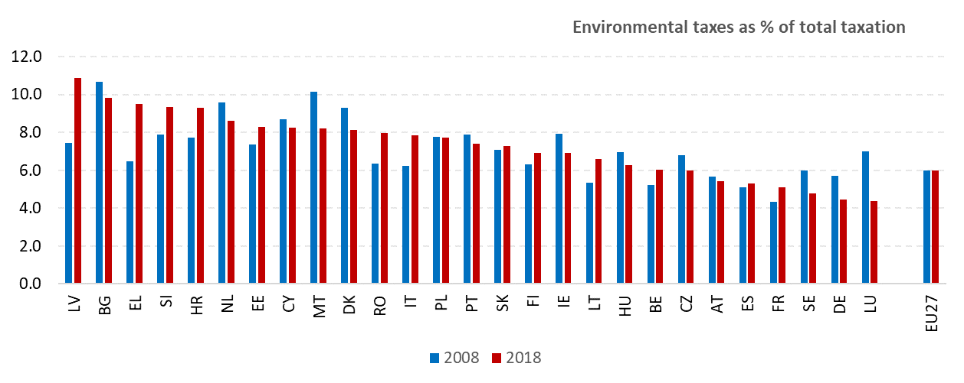

Source: European Commission, DG Taxation and Customs Union, based on Eurostat data

**If not designed properly, environmental taxes may have adverse distributional effects, by putting a comparatively higher burden on lower-income households.** Compensation mechanisms need therefore to ensure adequate revenue recycling or investments in public goods, such as public transport, to offer alternatives. In the context of climate action to reduce greenhouse gas emissions (in accordance with the increased targets and ambition levels that are proposed in the Climate Target Plan and draft European Climate Law) carbon prices and energy costs are set to increase, including through carbon taxes and possible extensions of the Emission Trading System. From a consumer point of view, the impacts of the two are similar. Evidence shows that taxes on fuels and other energy products put the highest burden, as a proportion of disposable income, on the lowest-income households.[54] The impact asssessment accompaying the 2030 Climate Target Plan[55] also shows a higher proportionate expenditure on electricity, gas and solid fuels by lower-income households. Therefore, from an equity point of view, compensatory fiscal instruments are called for in order to mitigate such regressivity impacts. Moreover, the unaffordability of energy products can exacerbate energy poverty[56]. In order to ensure accesss to essential services, enshrined as a principle in the European Pillar of Social Rights, support through further dedicated fiscal instruments may be envisaged.

**Compensatory labour tax cuts have been shown to lead to gains in terms of employment and economic growth.** Lowering taxes on labour improves work incentives in general, particularly for low-wage earners, and other target groups such as young and old workers. A compensating measure that accompanies raising carbon prices can be thought of as a way to enhance employers’ incentives to retain their workforce while production costs increase (triggering labour demand). In addition, labour tax cuts may be used to increase workers’ take-home pay (at given labour costs), increasing their incentive to be active on the labour market (triggering labour supply). Most recently, the above-mentioned impact assessment accompaying the 2030 Climate Target Plan has shown positive growth and employment effects of carbon ‘revenue recycling’ taking the form of income or labour tax cuts.[57]

**Revenues from environmental taxation can be used to support *all* incomes.** Equity-driven revenue recycling has been implemented for instance in the form of lump-sum transfers or ‘carbon dividend’ handouts, so that houselholds without work income can benefit as well. The Employment and Social Developments in Europe Annual Review 2020, based on a modelling exercise, presents the example of a revenue-neutral fiscal reform, consisting of an energy tax and a lump-sum benefit granted to all households. It is shown that such transfer can fully cushion the negative effect of the tax on both poverty and inequality. This is because the benefit, albeit granted across the board, provides relatively more support to poorer than to richer households.[58]

### *3.1.2 Measures taken by Member States*

**In the aftermath of the COVID-19 outbreak, all Member States turned to short-time work (STW) schemes to mitigate the consequences of the economic shock on the labour market.** Due to the pandemic,businesses throughout the EU have been suddenly forced to reduce or suspend their activities due to disruptions in supply chains, the enforcement of strict containment measures and the consequent fall in demand for a broad range of products and services. In response to these developments, all EU Member States have strengthened existing short-time work schemes or introduced new ones with the objective of preserving employment through the most acute phase of the health emergency. The European Union is supporting this effort with the temporary instrument ***S****upport to mitigate* ***U****nemployment* ***R****isks in an* ***E****mergency (SURE)*.

**Short-time work schemes are public programmes aimed at avoiding excessive job destruction during downturns**. They allow firms experiencing economic difficulties to temporarily reduce the working hours of their employees, who in turn receive income support for the hours not worked. The main purpose of these schemes is to protect employees and the job match, thereby limiting the long-term consequences of a transitory shock. Generally, they are used in case of external events hampering business activities (e.g. technical accidents, bad weather conditions affecting works in construction or agriculture, causes of *force majeure*), and transitory business downturns (e.g. reduction in turnover or decline in orders, which is expected to be temporary). A key characteristic is that the employment relationship is maintained during the period of short-time work, even in cases when working hours are reduced to zero (i.e. a full suspension of work).

**Short-time work schemes can be beneficial for employers, workers, and the economy at large**. They allow companies to adjust their labour costs when economic activity weakens, preserving jobs and human capital, while avoiding incurring long and costly dismissal procedures as well as re-hiring costs once activities resume in full. From the perspective of the workers, these schemes provide (partial) replacement income while preventing dismissals, allowing the burden of the adjustment to be shared more equally across employees. By limiting job losses, short-time work schemes reduce the volatility of employment and incomes, and enhance labour market resilience, alleviating the burden on the unemployment benefit systems and the likelihood of long-term unemployment.

**Before the outbreak of the COVID-19 pandemic, 17 EU Member States had a scheme** **or a framework in place for the provision of short-time work support**. However, these schemes differed considerably in the way they were established and administered, e.g. via dedicated schemes, via the unemployment benefits system, or via active labour market policies.

**Belgium, Germany, France, Italy, Luxembourg, Austria and Portugal had dedicated and well-established schemes before the crisis**. In these countries, companies submit a request to the authorities responsible for the management of the scheme. Once the authorisation is granted, the company can adjust the working hours of its employees, paying them the regular salary for the amount of hours worked, and an indemnity for the hours not worked (generally lower than the normal wage). The company is then reimbursed (fully or partially) through the public short-time work scheme.[59] Sweden legislated a similar scheme in 2014, to be ‘activated’ in case of a severe and deep economic recession. Bulgaria established the legal framework following the 2009 crisis, but its scheme was ‘inactive’ as it has not been funded in recent years before the COVID-19 crisis. Hungary also had such a permanent short-time work scheme in place, which was relatively small and was used and funded only intermittently before COVID-19.

**In Denmark, Ireland, the Netherlands, Spain and Finland, support for short-time work has been typically (before the crisis) provided through the unemployment benefit system.** In these systems, firms have the possibility to reduce temporarily the working time of their employees (in some cases, e.g. Finland, also temporarily lay-off employees, while the employment relationship remains otherwise in force). In turn, the workers affected can register as jobseekers and claim unemployment benefits for an amount proportional to the days not worked (so-called ‘*partial unemployment benefits*’). The conditions for receipt of such ‘partial’ unemployment benefit are defined at the level of the individual workers, and are the same as for the standard (‘full’) unemployment benefit. In particular (with some exceptions, e.g. Spain) workers can claim the partial unemployment benefit if they have the necessary contribution record, and have to comply with the standard job-search and availability to work requirements (meaning that they are expected to accept possible offers for full-time jobs).

**In Croatia and Slovakia, support for short-time work has been administered as a form of active labour market policy.** Initially, these schemes had a limited budget, a low number of firms and workers covered and they included job-retention requirements (an obligation for employers to preserve employment levels for a certain period following the receipt of support). These schemes were strengthened considerably in response to the COVID-19 crisis, with sizable budget allocations and a wide coverage of businesses and workers.

**Following the outbreak of the COVID-19,** **all** **Member States have adapted their national short-time work (STW) schemes** **with a view to facilitating their use and enlarging the scope of potential beneficiaries**. For instance, they streamlined the administrative procedures for the authorisation of STW support, e.g. by shortening notification periods, introducing a new ‘COVID-19 emergency’ justification (automatically considered a cause of ‘force majeure’) and/or softening the requirements of prior consultation of workers’ representatives and shortening the time period for claiming benefits. They also broadened the coverage of schemes to companies and sectors that were previously not eligible. For example, Germany, Spain, France, Italy, Luxembourg, Austria, Portugal and Finland have amended the rules of their STW schemes in order to streamline procedures, ease access and/or broaden their coverage (e.g. include self-employed and also workers who have just been employed). Spain and Finland streamlined administrative procedures and substantially relaxed the eligibility criteria, to allow all employees to receive STW support regardless of their contribution record, and without prejudice of their accrued entitlements for ‘standard’ unemployment benefits. Member States reduced the costs for employers to zero in some countries. The duration of STW use has also been increased in view of the exceptional nature of the crisis and the uncertainty around its duration. Moreover, some Member States (among them Belgium and France) have temporarily increased the level of the indemnity granted to the workers for the hours not worked. France also created sectoral derogations from common rules, for specific sectors more impacted by COVID-19-related emergency measures (aviation, tourism).

**Some Member States opted for introducing new programmes specifically aimed at preserving employment levels in companies affected by the COVID-19 pandemic.** For example, Denmark, Ireland and the Netherlands introduced new emergency (short-time work) schemes in which support is channelled directly through the employer, rather than through the unemployment benefit system. For instance, in the Netherlands the previous short-time work scheme was replaced with a more generous arrangement. Employers who expect a loss of revenue (at least 20%) can apply for an allowance of labour costs of maximum 90% for a period of 3 months provided that they do not lay off workers.

**All Member States that did not have short-time work schemes already in place have taken emergency measures to prevent lay-offs in the spirit of short-time work.** This meant granting temporary support to workers employed by companies whose activities are suspended or substantially reduced. In particular, some countries (e.g. Malta, Greece, Lithuania and Romania), in which the legislation already allowed employers to reduce the working time or suspend the contracts of their employees in duly justified cases, introduced public subsidies to finance the income support for the affected workers. For instance, since June 2020, the SYN-ERGASIA scheme in Greece allows for up to 50% reduction in the weekly working time of full-time workers in companies experiencing at least a 20% decrease in their turnover. The State covers 60% of the employees' net wage and 100% of social security contributions corresponding to the hours not worked.

**While in the short term STWs are suited to address the immediate consequences of an external economic shock,** **its prolonged use may hinder structural change.** The preservation of existing jobs has been the main concern in the labour market at the onset of the COVID-19 crisis. As the pandemic drags on, the economic impact of the crisis on the structure of demand and on the activity of firms becomes increasingly apparent and with it, the need for structural change comes more to the forefront. The longer the crisis lasts, the more likely it may become that STW schemes subsidise jobs in firms that are no longer viable. STW schemes can also reduce the probability that those without a secure job find work and hence it may slow down job growth during the recovery. Hence, policies to promote structural change and reallocation of workers across sectors (e.g. via well-designed hiring incentives and reskilling measures) could be promoted upon signs of an economic recovery, tailored to the particular economic situation in each country.

**Some Member States have already started scaling back short-time work schemes and other emergency measures, while others have adapted or prolonged them**. For example, in Denmark and Estonia the emergency measures taken in response to the pandemic have expired during the summer and (at the moment of drafting) have not been renewed. Other Member States have started restricting access to the emergency schemes only to businesses still directly affected by restrictions linked to the sanitary crisis (e.g. in Belgium, Greece and Cyprus). Finally, a number of Member States have already extended the validity of some emergency measures until the end of 2020 (e.g. France, Italy and Greece) or 2021 (e.g. Germany, Malta, Sweden, Cyprus, Spain).

**Several Member States have adopted measures to increase employee retention and support labour demand through hiring incentives[60].** For instance, in Greece, the existing hiring subsidy schemes run by the public employment service have been boosted with new places, extended duration (up to 2 years) and increased subsidy rate (75% of wage costs with a EUR 750 ceilling). In addition, a new scheme was launched in October to incentivise the creation of 100 000 jobs in the private sector through the coverage of social security contributions for 6 months by the state. In Croatia, a temporary wage support scheme (equal to 50% of the minimum wage) has been extended to support workers affected by the sanitary restrictions, most of them seasonal workers in tourism and services sector. In Romania, a number of measures (in addition to the existing employment subsidies schemes) were taken in order to address the latest labour market challenges, including support to young and older workers, and self-employed. The Belgian region of Flanders has conducted a revision of the existing hiring incentives for the long-term unemployed, while Wallonia is assessing its overall framework of hiring incentives to improve its effectiveness. In May 2020, Hungary adopted an Action Plan to preserve jobs and create additional ones in sectors defined as priority, including healthcare, construction, agriculture, transport and tourism. The latter action counts with a total budget of HUF 674 billion (EUR 1.85 billion) for the period 2020-2022, through, among others, wage subsidy schemes and other arrangements to make work more flexible. Spain has introduced hiring incentives targeting negatively affected workers in the tourism sector of the Balearic and Canary Islands. In Latvia, a new wage subsidy has been set for three months for a period until end of 2020. The employer will receive the equivalent of up to 50% of the employee’s monthly wage (maximum of EUR 430 per month) conditional to employing the previously unemployed person not less than three months after the end of the subsidy. Cyprus intends to implement subsidy schemes to encourage the recruitment of unemployed, former prisoners and young people after the end of October. As part of a broad reform, Finland aims to simplify the current system of recruitment and pay subsidies to increase their use by firms, especially small- and medium-sized enterprises. In particular, plans are made to reduce the administrative burden for employers and to speed up the payment process, which will be closely linked to the identification of future skills needs of the employee.

**Statutory minimum wages were increased in most Member States in 2020 as compared to the previous year.[61]** In some of them, they were raised substantially (for example, Poland 17%, Slovakia 12%, Czechia 11%). The minimum wage in Romania was increased by 7%, amounting to around 40% of the average wage in the country. In Belgium, the statutory minimum wage remained frozen (apart from indexation), as social partners could not reach an agreement. In Spain, the latest minimum wage increase (by 5.5%, following a 22.3% hike in 2019) has been negotiated and agreed with the social partners, differently from the previous one. Latvia’s minimum wage will be raised by 16% as of January 2021, according to a Government decision. In Germany, the Minimum Wage Commission proposed a 10% increase in the minimum wage in four steps over the next 2 years. Germany is currently reviewing its minimum-wage setting in view of the experience gained with the introduction of a statutory minimum wage. Some governments (such as Poland and Spain) have announced or are considering plans to increase the statutory minimum wages to 60% of median or average wages. In Slovakia, a new mechanism for setting the national minimum wage was adopted in 2019, establishing that if social partners do not agree on the level for the next year by the required deadline (15 July of each year), it will be set automatically at 60% of the average nominal gross wage in the economy from the previous year. The new mechanism should have been applied for the first time for the 2021 minimum wage, but another amendment adopted by the Parliament in October 2020 provides for an ad-hoc increase in 2021 (lower than based on the preceding calculation) and lowers the automatic formula to 57% of the average nominal gross wage in the past two years. Many countries are debating a further substantial increase to minimum wages beyond 2020, partially in relation to a relative target, partially in absolute terms.

**Only limited changes in wage setting rules and frameworks were recorded over the past year.** One exception is Greece, where the possibility of opting out from sectoral agreements was introduced in October 2019, in particular for businesses facing economic problems (bankruptcy, restructuring, liquidation, non-performing loans), or operating in areas with high unemployment rates, start-ups and social economy firms. Moreover, the extension of sectoral agreements is no longer automatic, but the decision is now at the discretion of the Minister of Labour, following an explicit request introduced by one of the signatory parties. This request needs to be accompanied by an analysis of the estimated economic and labour market impact, in addition to the existing criterion of representativeness (50% of labour force already covered by the agreement). A public registry for, respectively, employers’ associations and trade unions is created, in order to verify their representativeness to conclude collective labour agreements. It remains to be seen how these changes will affect collective bargaining in practice. Across the EU, some wage setting measures (either collectively agreed or on government’s initiative) were targeted to health and assimilated workers, in the context of the COVID-19 response. A number of Member States, including Bulgaria, Latvia and Lithuania introduced measures to temporarily top up wages of healthcare staff and/or other categories of workers directly involved in the fight against the pandemic. Collective agreements related to the health sector were recently concluded, for instance, in Austria, Belgium (federal level), France and Germany (nurses).

**Most measures taken in the field of labour taxation in the past months have been designed as a response to the COVID-19 pandemic**. An analysis of Member States’ initial tax response to the outbreak highlights that this was done to prevent a sharp rise in unemployment and to alleviate the pressure on companies, Member States protected business cash flows, with the most common measure being tax deferrals. Such deferrals have been introduced for the following tax categories: corporate income tax (CIT), personal income tax (PIT), property tax, VAT, and social security contributions (SSCs). Some Member States have also introduced broader tax reliefs, including discounts on tax and/or social contributions for on-time payments, tax cuts for companies severely affected, temporary suspensions of certain tax and SSC payments and tax credits.

**Many Member States designed tax measures aimed at protecting fragile workers, sectors of the economy or categories of the population** **with targeted temporary measures.** For example, Belgium has introduced the possibility to defer the payment of social security contributions for 2020. Self-employed persons can also benefit from a reduction or abolishment of social security contributions, depending on specific conditions. In Spain the self-employed could defer the payment of taxes and social security contributions for six months if activities were suspended by the declaration of the state of emergency. Poland implemented a temporary exemption (or, depending on firm size, a reduction) of social security contributions for small enterprises and social cooperatives. Portugal introduced a partial exemption from the payment of employers' social security contributions for up to three months for workers covered by extraordinary support measures. Slovakia postponed the deadline for compulsory payments of employers and self-employed to social security funds. According to this framework, any employer and self-employed paying compulsory contributions to health and pension funds, and whose revenue from business decreased by at least 40%, have been entitled to defer the payment. In Finland, to support private sector employers to maintain as many jobs as possible, employers’ social security contributions have been reduced by 2.6 pps between May and December 2020. To cover for the additional costs, contributions will be increased by 0.4 pps between 2022 and 2025. This measure was designed in coordination with the social partners. Moreover, the state co-finances part of the social security contributions for entrepreneurs who recorded a decrease in turnover for a period of 3 months (with the possibility of extension).

**In other cases, measures were taken on a more stable or permanent basis, with the aim of reducing the tax wedge on labour with potentially beneficial effects on labour demand and supply.** For example, Greece reduced the social security contributions for full-time employees by 0.9 pps with effect from June 2020. The government has announced a further reduction by 3 pps in 2021. In Poland, on top of a tax exemption for younger workers, since October 2019 the first income tax rate was reduced from 18% to 17%. The tax deductible costs for employees were also increased. Lithuania increased the income tax allowance from EUR 350/month to EUR 400/month, effective from July 2020. Italy reduced the tax wedge for dependent workers: for incomes up to EUR 28 000 per year, an allowance of EUR 600 is given for the last six months of 2020, which becomes EUR 1 200 from 2021. Lower allowances are envisaged for higher incomes, up to EUR 40 000. This measure replaces a previous rebate (‘bonus Renzi’) on incomes between EUR 8 000 and 26 600. In Flanders (Belgium), from 2021 an ‘employment bonus’ will increase the net salaries of workers whose gross monthly salary does not exceed EUR 1 700 by at least 50 euros per month. The bonus gradually decreases to zero for people with a gross monthly salary of EUR 2 500. Such a measure is expected to address unemployment and inactivity traps.

## 

## **3.2 Guideline 6: Enhancing labour supply and improving access to employment, skills and competences**

This section looks at the implementation of the employment guideline no. 6, which recommends Member States to create conditions to promote labour supply, skills and competences. Section 3.2.2 reports on policy measures undertaken by Member States in these policy areas.

*3.2.1 Key indicators*

**In the last ten years, the share of early leavers from education and training[62] decreased significantly at EU level, but the COVID-19 crisis highlights the need for continued efforts**. Early school leaving stood at 10.2% in 2019, only 0.2 pps above the Europe 2020 Strategy headline target, following a considerable improvement (of almost 4 pps) since 2009. The progress at the EU level was led mainly by a number of Member States that saw very significant improvements: Portugal (-20.3 pps), Spain (-13.6 pps), Greece (-10.1 pps) and Malta (-8.5 pps).[63] Only Slovakia and Czechia experienced an increase in their respective early school leaving rates over the last decade (+3.4 and +1.3 pps respectively) (

Figure 18 and Figure 19). Nevertheless, no major improvements have been recorded at EU level over the last four years, when the share of early school leavers has stagnated on average. For a few Member States that score poorly on this account in the Social Scoreboard – notably Spain, Malta, Romania, Bulgaria and Italy - early school leaving remains a key challenge with little improvement recorded since the previous year. A number of countries show large regional disparities in early school leaving rates (see Annex 4). Protracted periods of school closure due to the COVID-19 crisis could increase early school leaving rates, calling for continued efforts to tackle the challenge.

**Early school leaving affects mostly young people who need additional support to remain in education.** In 2019, more young men (11.9%) than young women were early leavers (8.4%) on average in the EU. Only Romania and Czechia show a different picture (in Romania, 14.9% of boys versus 15.8% of girls; in Czechia, 6.6% of boys vs. 6.8% of girls). Overall, the socio-economic background of students has a strong impact on early school leaving, with parental education playing a key role. Migrant background also plays a role with, on average in the EU, native-born people showing significantly lower shares of early leavers (8.9%) than those born in another EU country (21.4%) and those born outside the EU (22.5%). In four Member states (Italy, Malta, Spain and Greece) more than 25% of non-EU born young people were early school leavers in 2019.

**Figure 18: Early school leaving rates differ considerably amongst Member States**

Early leavers from education and training (% of population aged 18-24) and yearly change (Social Scoreboard headline indicator)

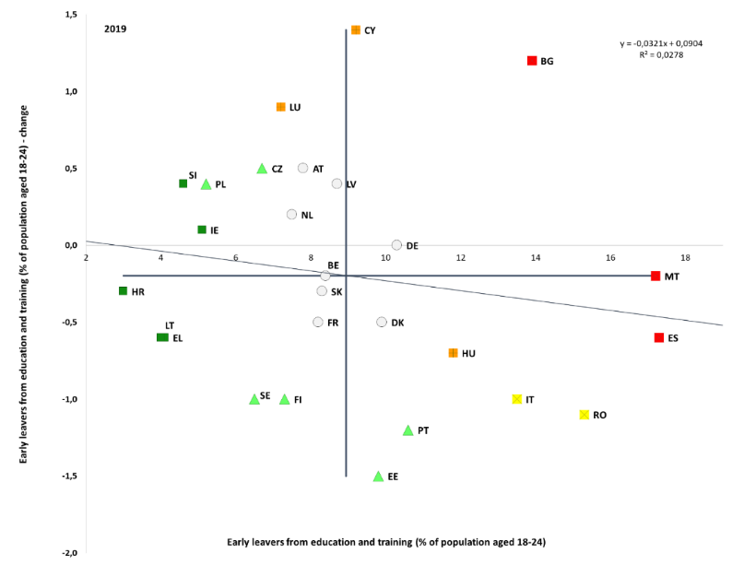

Source: Eurostat, LFS, online data code: [[edat_lfse_14](https://appsso.eurostat.ec.europa.eu/nui/show.do?dataset=edat_lfse_14&lang=en)]. Period: 2019 levels and yearly changes with respect to 2018. Note: Axes are centred on the unweighted EU average. The legend is presented in the Annex. Data are unreliable for HR. Breaks in series for NL.

**Figure 19: The Europe 2020 early school-leaving target has nearly been reached**

Early leavers from education and training, 2009-2019 and EU 2020 target (%)

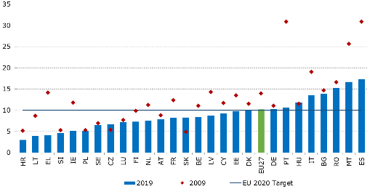

Source: Eurostat, LFS, online data code: [[edat_lfse_14](https://appsso.eurostat.ec.europa.eu/nui/show.do?dataset=edat_lfse_14&lang=en)].

Note: All countries: break in time series in 2014 (switch from ISCED 1997 to ISCED 2011). 2019 data are unreliable for HR.

**Across the EU, more than one in five pupils fail to reach the minimum proficiency level in reading, mathematics and science, with only very limited progress being registered over time.** The StrategicFramework for European Cooperation in Education and Training (ET 2020) benchmark on the reduction (to below 15% in the EU by 2020) of the rate of underachievers in reading, mathematics and science among 15 year-olds has not been reached in any of the three domains tested by the OECD’s Programme for International Student Assessment (PISA). In 2018 in EU-27, 22.5% of pupils were considered as underachievers in reading, 22.9% in mathematics, and 22.3% in science. Since 2009, the share has deteriorated for the EU in both science and reading, and has remained stable in mathematics – see Figure 20[64]. Gender differences in underachievement were rather small in mathematics and science, but recorded a large gap in reading (the rate of underachievement was 17.4% for girls compared to 27.3% for boys). To spur action on this fundamental issue, the Communication on Achieving the European Education Area relaunches the commitment for the EU as a whole to reduce the share of low achievers in reading, mathematics and science below 15% by 2030[65].

**Figure 20: Reading performance shows a large variation across EU Member States**

Long-term change in underachievement rate in reading, 2009 – 2018 [%]

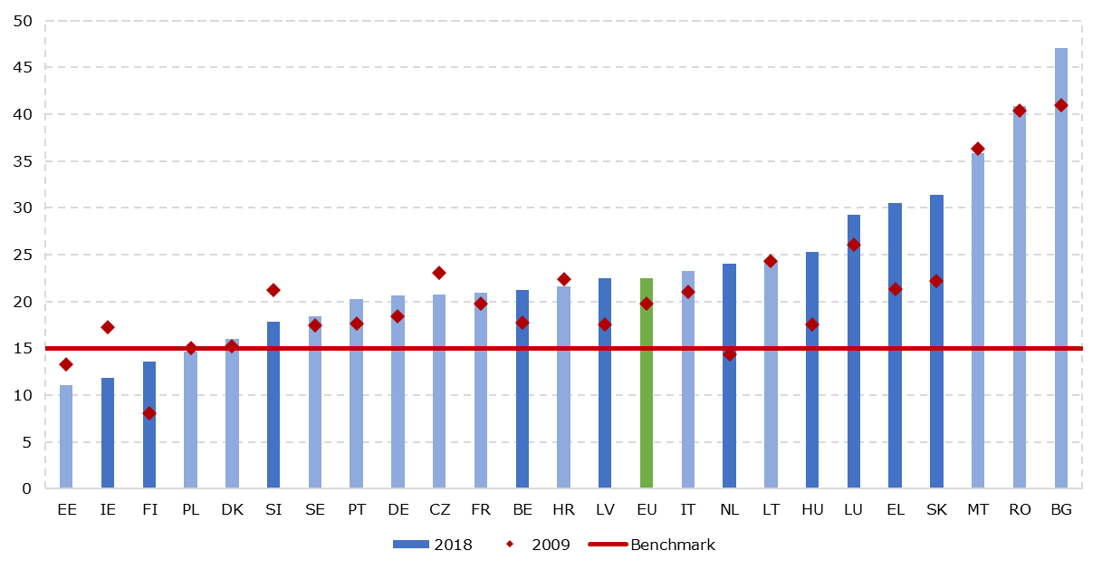

Source: PISA 2018, OECD. Note: Note: Darker vertical bars denote statistically significant changes between 2009 and 2018. Data not available for AT, CY and ES.

**The COVID-19 crisis has underlined the challenge of skills and educational divides, making it even more pressing to set up adequate policy responses**. The COVID-19 crisis, with its sudden acceleration of the digitalisation of learning, could amplify the persistently strong correlation between socio-economic background and educational outcomes. Preliminary analysis[66] suggests that the lockdowns had a disproportionately negative effect on the vulnerable or those from the less developed regions. For example, distance learning presupposes that each child has at least a computer or a tablet, combined with a fast internet connection, the skills to use it and adequate parents’ support in doing so. This is not always the case for pupils living in poorer areas or families. In the EU in 2018, 3.9% of households could not afford a computer. For households with income below 60% of median equalised income, the figure was 12.8%, and 8% for households of those not born in the EU[67]. This may be even more severe for pupils who are asylum seekers and refugees whose access to education is often difficult. The real effects of the crisis on learning outcomes cannot be assessed at this stage but they deserve close monitoring in the years to come.

**Participation in early childhood education and care (ECEC) has been on a steady rise in the last decade but children from a lower socio-economic background persistently participate to a lesser extent.** In 2009, the StrategicFramework for European Cooperation in Education and Training (ET 2020) set the ambition to have at least 95% of children between four years and the age for starting compulsory primary education in ECEC by 2020[68]. In 2018, the EU-27 almost reached this target, with an average of 94.8% (a 4.5 pps increase since 2009). In 2018, France, Denmark and Ireland provided universal access to ECEC in this age group. Moreover, considerable improvements have been registered in Ireland (+26.4 pps), Poland (+22.1 pps) and Finland (+17.4 pps) in the last ten years. On the contrary, participation rates have slightly deteriorated in Italy (-4.9 pps), Estonia (-3.3 pps), the Netherlands (-2.6 pps), Bulgaria (-1.8 pps), Romania (-1.7 pps), Belgium (-0.8 pps) and Spain (-0.4 pps). In spite of this overall positive picture, important inclusion and equality challenges persist. Analysis of survey data shows considerably lower ECEC attendance rates for children from a lower socio-economic background or socially disadvantaged groups[69]. Such inequalities so early in life are likely to be reflected later on in lower educational outcomes, educational attainments and labour market prospects.

**Socio-economic and migrant backgrounds remain strong predictors of educational performance, while wide performance gaps exist between urban and rural areas in many Member States.** Figure 21 shows that in all Member States the proportion of underachievers in reading is much larger in the bottom quarter of the economic, social and cultural status (ESCS) index[70] than in the top quarter. Bulgaria (44.9 pps), Romania (43.1 pps), Hungary (38.6 pps), Slovakia (37.8 pps) and Luxembourg (37.5pps) have the highest performance gaps between pupils belonging to the top and the bottom quartiles. Nevertheless, countries such as Estonia, Finland, Ireland, Poland, Croatia and Latvia have been able to reduce the impact of socio-economic background on educational outcomes. Moreover, Member States with a low share of underachievers in reading tend to also have a smaller divergence between the top and bottom of the ESCS scale. This suggests that good education systems can promote both quality and equity at the same time. In 2018, the proportion of underachievers in reading among pupils with a migrant background was still much higher than among those with a non-migrant background in many EU Member States[71]. Language barriers seem to play an essential role in this, which underlines the importance of language training. Finally, the difference in reading performance between pupils attending schools in cities and in rural areas is statistically significant and rather large in many Member States. In Hungary, Bulgaria, Romania, Slovakia and Portugal it even exceeded 100 PISA score points, corresponding to approximately 2-3 years of schooling.

**Figure 21: Socio-economic background of students affects their reading proficiency**

Underachievers in reading (%) by economic, social and cultural status, 2018

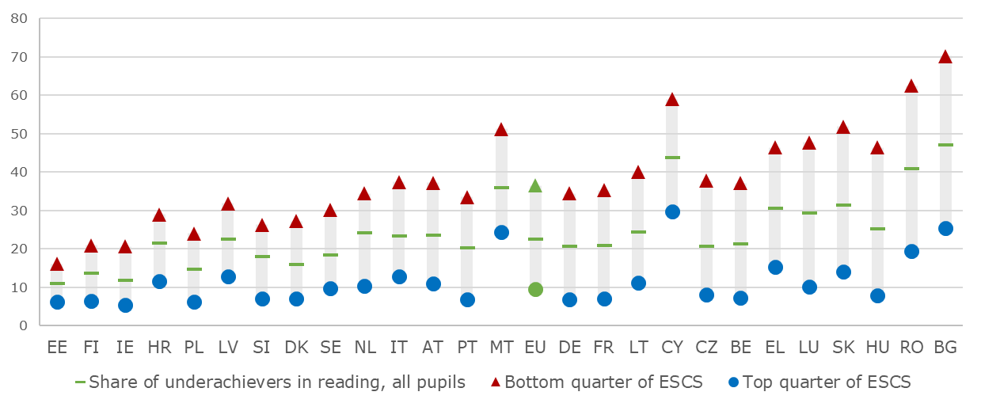

Source: PISA 2018, OECD. Note: Countries are sorted in ascending order according to the underachievement gap between the bottom and top quarter of the socio-economic index. Data not available for ES.

**Roma inclusion in education is a challenge that could become more prominent as a result of the COVID-19 crisis.** This is due to several factors, including school segregation, non-inclusive teaching, barriers induced by severe poverty or housing segregation and lacking access to distance learning. Despite efforts to increase participation and reduce drop-out in compulsory school age, less than a third of Roma young people (20-24) complete upper secondary education[72], while the gap in participation in early childhood education (age 3 to compulsory school age) relative to the general population is particularly high, at 53 ppt. Early school leaving, although decreasing between 2011 and 2016, remains much higher than among the general population (68% as compared to 10.2%). The share of young people not in education, employment or training has increased among the Roma between 2011 and 2016 from 56% to 62%[73]. During the COVID-19 induced lockdowns, a large number of Roma children faced challenges to participate in distance learning, and initial findings suggest a widening gap with the general population[74]. Distance learning is often not accessible and/or affordable for Roma and Travellers children at risk-of-poverty lacking adequate IT equipment, internet access or even electricity access in their homes, camps or irregular sites[75].

**High early school leaving and low levels of tertiary education attainment among people with disabilities negatively affect their employment.** In the EU-27 in 2018[76], early school leaving of young persons (18-24) with disabilities was 20.3% compared to 9.8% of those without disabilities (a gap of about 10.5 pps). This gap was the smallest in Denmark (0.4 pps) and Slovenia (2.8 pps), while relatively high in Malta (19.4 pps), Croatia (18.2 pps), Germany (17.3 pps) and Romania (15.5 pps). At the same time, only 29.4% of persons with disabilities completed a tertiary or equivalent education as compared to 43.8% for those without disabilities. The gap was smallest in Italy (4.3 pps), Slovenia (4.4 pps) and Portugal (4.5 pps), while the highest in Sweden (27.9 pps), Germany (27.2 pps), Bulgaria (25.8 pps) and Ireland (21.8 pps).

**Figure 22: Many pupils still lack basic digital skills**

Distribution of computer and information literacy scores across achievement scale levels 2018, 2013

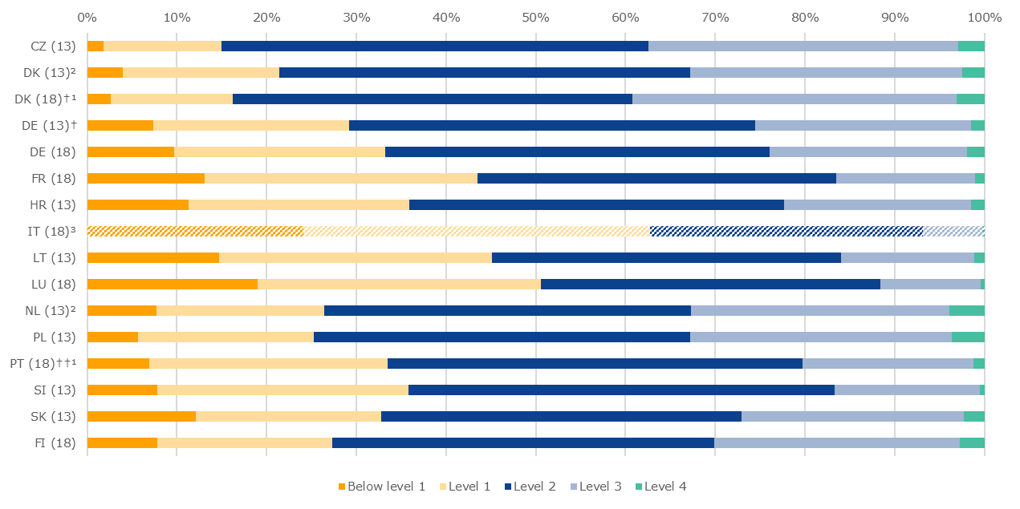

Source: IEA, ICILS 2018 & ICILS 2013. Pupils below level 2 are only able to demonstrate a functional working knowledge of computers as tools and a basic understanding of the consequences of computers being accessed by multiple users. †Met guidelines for sampling participation rates only after replacement schools were included. ††Nearly met guidelines for sampling participation rates after replacement schools were included. ¹National defined population covers 90% to 95% of the national target population. ²Did not meet the sample participation rate. ³Testing took place at the beginning of the school year. The results are thus not comparable to the other Member States.

**Twenty-first century’s pupils are “digital natives” but they still lack digital skills.** The International Computer and Information Literacy Study (ICILS)[77], which assesses the capacity of grade eight pupils (13 or 14 year-olds) to use information and communication technologies (ICT), suggests that many pupils are not able to understand and perform even the most basic ICT operations. Figure 22 shows that the share of pupils failing to reach level 2 of the computer and information literacy achievement scale exceeded 30% in 9 out of 14 Member States participating in the 2013 and 2018 ICILS. In 2018, as many as 62.7% of Italian pupils have not passed the underachievement threshold. Neither have 50.6% of pupils in Luxembourg, 43.5% in France, 33.5% in Portugal, 33.2% in Germany, and 27.3% in Finland. Girls show higher levels of performance in Information and Computer Literacy and in Science, Technology, Engineering and Mathematics (STEM)[78]. On average, pupils from lower socio-economic background and/or with a migrant background perform worse in computer and information literacy than their peers from more privileged or non-migrant families. The Communication on Achieving the European Education Area has now proposed the target of reducing the share of low-achieving eight-graders in computer and information literacy below 15% by 2030.

**Figure 23: There are significant gaps between Member States in basic digital skills**

Share of population with basic overall digital skills or above and yearly change (Social Scoreboard headline indicator)

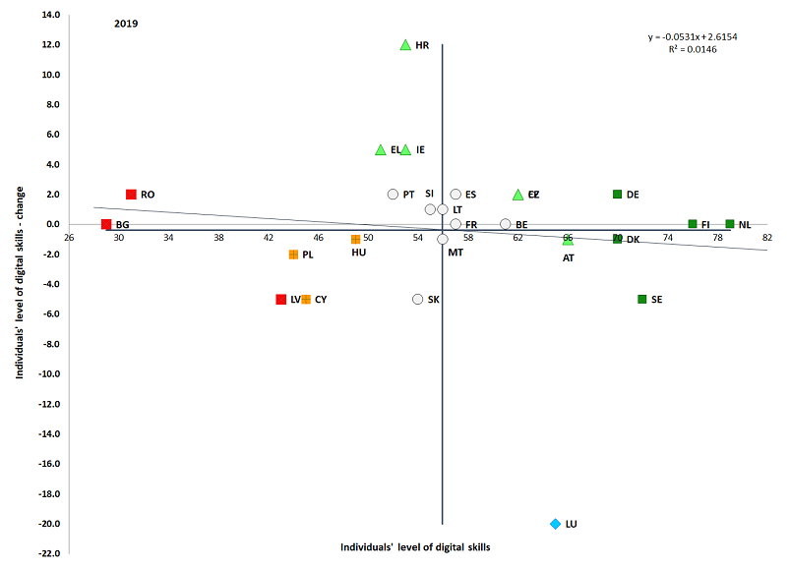

Source: Eurostat, online data code [[TEPSR_SP410](https://ec.europa.eu/eurostat/databrowser/view/tepsr_sp410/default/table?lang=en)]. Period: 2019 levels and changes with respect to 2017. Note: Axes are centred on the unweighted EU average. The legend is presented in the Annex. Break in series for Czechia, Italy, Latvia, Luxembourg in 2019. 2017 data not available for IT (2019: 42%).

**The COVID-19 crisis has highlighted the insufficient levels of digital skills of adults and the wide gaps between countries**. The lockdown measures taken in most Member States in the first half of 2020 underlined the importance of digital skills for business continuity, education and training, healthcare, as well as for ordinary social interaction. Low digital skills limit innovation as well as full participation in society. Progress is very slow: on average in 2019 in the EU-27 56% of the population aged 16-74 had at least basic digital skills (1 pp more than in 2017[79]), with still four people out of ten without basic digital skills (Figure 23). At the EU level, men have slightly higher digital skills than women (58% compared to 54% in 2019), but the gap has narrowed by 2 pps since 2015. Since 2015, only Czechia, Ireland, Greece, Lithuania, Netherlands and Romania achieved improvements of 5 pps or more. There is wide divergence across the EU: in five countries (in ascending order Denmark, Germany, Sweden, Finland and the Netherlands) the share was between 70 and 80%, but in seven, it remained below 50% (below 40% in Bulgaria and Romania). Socio-demographic aspects are crucial, as less than one quarter of the elderly (65-74) has basic digital skills, compared with eight in ten young people (16-24); this share reaches 32% for those with low educational attainment in contrast to 84% for people with a high level of education. Recent EU initiatives aim to increase the basic digital skills of adults and young people in the EU: the Skills Agenda sets a 70% target for adults by 2025, and the European Education Area a 85% target for 14-year-olds by 2030.

**Figure 24: Around one in five teachers report a high level of need for ICT training**

Percentage of teachers reporting a high level of need for professional development in ICT skills for teaching

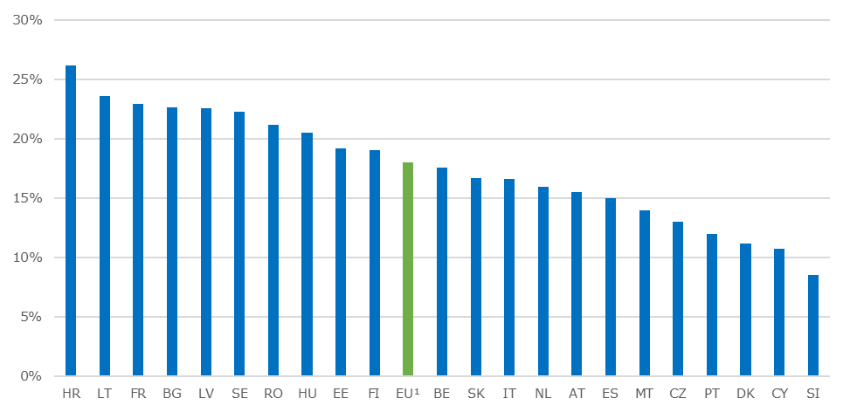

Source: OECD, TALIS 2018 Database. Note: Results based on responses of lower secondary teachers. Data not available for DE, EL, PL, LU and IE.

¹ Weighted EU average based on the 22 participating Member States in TALIS 2018.

**The transition towards online and distance learning triggered by the COVID-19 crisis poses new challenges to the teaching profession.** Teachers need to be equipped with the necessary competences to take advantage of the potential of digital technologies for enhancing teaching and learning and preparing their pupils for life in a digital society.[80] According to TALIS 2018, the percentage of lower secondary teachers who felt ‘well prepared’ or ‘very well prepared’ to use ICT for teaching varies significantly among Member States. In Romania (69.5%), Slovenia (67%), Hungary (65.7%) and Cyprus (61.8%), larger shares of teachers feel adequately prepared to use ICT for teaching than in Austria (19.9%) or Finland (21.5%). When asked about their level of need for training in ICT skills, 18% of teachers on average across the EU reported a “high level of need”. In 2018, needs were the highest in Croatia (26.2%), Lithuania (23.6%) and France (22.9%), while in Slovenia less than one in ten teachers reported a high need for training in ICT skills (Figure 24).

**The EU as a whole has reached its 40% tertiary education attainment headline target for 2020 though large disparities among Member States and different population groups persist[81].** In 2019, 40.3% of people aged 30-34 held a tertiary education degree in the EU. Progress has been particularly significant in Slovakia (+22.5 pps), Austria (+19 pps), Czechia (+17.6 pps), Lithuania (+17.4 pps) and Greece (+16.5 pps). The Member States with the highest tertiary attainment levels among 30-34 year olds are Cyprus (58.8%), Lithuania (57.8%), Luxembourg (56.2%), and Ireland (55.4%), while Romania (25.8%), Italy (27.6%), Bulgaria (32.5%) and Croatia (33.1%) score the lowest. In the EU, the urban-rural divide in tertiary education attainment was 22.1 pps. The biggest gaps were registered in Luxembourg (41.2 pps), Romania (38.4 pps), Slovakia (35.5 pps), and Bulgaria (35.4 pps) (Figure 25). Considerable disparities in attainment rates persist on average in the EU between women and men (45.6% vs. 35.1%). Only about 29.4% of persons with disabilities (age group 30-34) have completed tertiary education or equivalent, compared to 43.8% for persons without disabilities in 2018.

**Figure 25: Substantial disparities in tertiary attainment between rural areas and cities**

Urban-rural divide in tertiary educational attainment by country, 2019 (%)

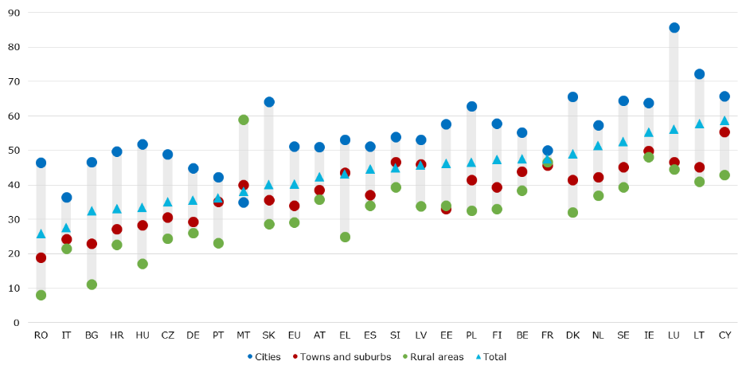

Source: Eurostat, EU Labour Force Survey. Online data code: [[edat_lfs_9913](https://appsso.eurostat.ec.europa.eu/nui/show.do?query=BOOKMARK_DS-417497_QID_-74B04886_UID_-3F171EB0&layout=TIME,C,X,0;GEO,L,Y,0;UNIT,L,Z,0;ISCED11,L,Z,1;SEX,L,Z,2;DEG_URB,L,Z,3;AGE,L,Z,4;INDICATORS,C,Z,5;&zSelection=DS-417497AGE,Y15-64;DS-417497SEX,T;DS-417497UNIT,PC;DS-417497DEG_URB,TOTAL;DS-417497INDICATORS,OBS_FLAG;DS-417497ISCED11,ED0-2;&rankName1=TIME_1_0_0_0&rankName2=ISCED11_1_2_-1_2&rankName3=UNIT_1_2_-1_2&rankName4=GEO_1_2_0_1&rankName5=AGE_1_2_-1_2&rankName6=INDICATORS_1_2_-1_2&rankName7=SEX_1_2_-1_2&rankName8=DEG-URB_1_2_-1_2&sortC=ASC_-1_FIRST&rStp=&cStp=&rDCh=&cDCh=&rDM=true&cDM=true&footnes=false&empty=false&wai=false&time_mode=NONE&time_most_recent=false&lang=EN&cfo=%23%23%23%2C%23%23%23.%23%23%23)] Note: The indicator covers the share of the total population aged 30-34 having successfully completed tertiary education (ISCED 5-8).

**Public spending on education remained relatively constant at EU level in the past five years, although investment needs are increasing**. In 2018, Member States invested 4.6% of total GDP on education and training, and the EU average share of public expenditure on education stood at 9.9%. Nevertheless, significant differences exist among Member States, with certain countries facing difficulties in ensuring adequate resources to cover their investment needs in terms of education and training. The European Investment Bank (EIB) estimates the education infrastructure investment gap for the EU-27 until 2030 at roughly EUR 8 billion per year[82]. At the same time,pedagogical use of digital technologies also depends on the availability, accessibility and quality of ICT resources[83]. Shortage of resources is to a varying degree affecting schools across EU countries. TALIS 2018 reports that, on average, 35.9% of lower secondary teachers in the EU identify investing in ICT to be of high importance. In Cyprus (66.3%) and Hungary (56.3%) more than 50% of teachers see this as a priority. A recent teachers’ survey further emphasised the relative importance of ICT equipment and highlighted how teachers perceived the equipment related obstacles as most important in adversely affecting the use of digital technologies.[84]

**Before the COVID-19 crisis, the gap between the demand and supply of skills had been narrowing across the EU**. This trend has been mainly driven by the decline in the share of the low-skilled and the general rise in educational attainment[85]. Rising employment rates of the low- and medium skilled related to the favourable macroeconomic context has also contributed to this trend. Yet, large gaps in employment rates by educational attainment remain in several countries. In 2019, on average in the EU-27, the employment rate has been 55.7% for those who have not completed the equivalent of upper secondary school, 73.4% for those with medium-level qualifications and 84.8% for those with high-level qualifications (Figure 26). Depending on sectoral trends and policies to preserve employment and prevent or tackle unemployment in the current COVID-19 crisis, the decline in macroeconomic skills mismatch may slow down or even reverse in some countries.

**Figure 26: Higher education is correlated with higher employment rates in all Member States**

Employment rates by educational attainment, age group 20-64 (2019)

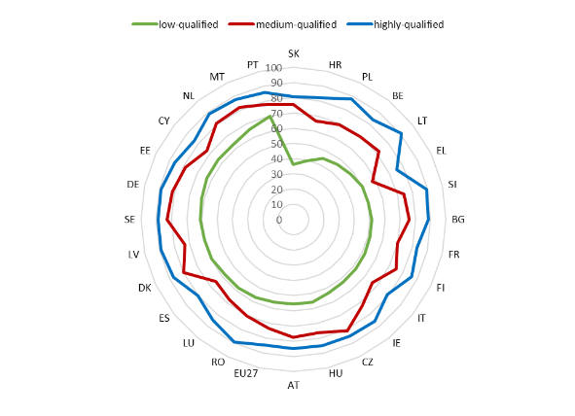

Source: Eurostat, online data code [[lfsa_ergaed](http://appsso.eurostat.ec.europa.eu/nui/show.do?dataset=lfsa_ergaed&lang=en)]. Note: break in time series for NL.

**Educational attainment among the adult population has been on the rise since 2009 across the EU**. Analysis in the EU benchmarking framework on adult skills and learning policies showed that, in 2019, more than two-thirds of the EU population (78.7%) in the age group 25-64 had at least upper secondary educational attainment. This is an improvement compared to the value of 72% in 2009 (Figure 27). While both genders recorded increases between 2009 and 2019, there was markedly more progress for women than for men: among people aged 25-64, women were 1.8 pps behind in 2009, and 1 pps ahead in 2019. Member States with the highest share of population with at least upper secondary education attainment include Lithuania, Czechia, Poland and Slovakia. Conversely, Portugal, Malta, Spain and Italy are among the countries with the highest shares of low-qualified, despite marked improvement during the last decade among some of them (notably Malta and Portugal). This rise in skills supply has been matched by a rise in the demand for medium and high skills, reflected in the higher employment rates of medium and highly qualified adults.

**Figure 27: More than two-thirds of adults had at least upper secondary educational attainment in 2019**

Population with at least upper secondary education attainment, age group 25-64 (2009 and 2019)

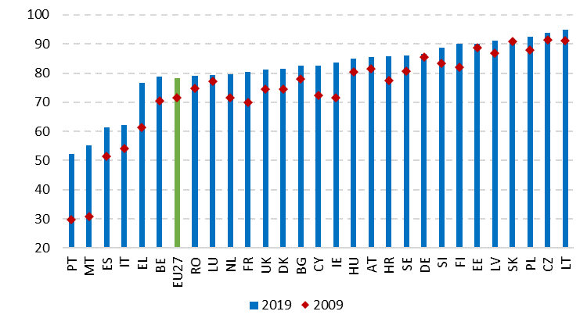

Source: Eurostat, online data code [[edat_lfs_9903](http://appsso.eurostat.ec.europa.eu/nui/show.do?dataset=edat_lfs_9903&lang=en)]. Note: break in time series for EL, CY and LU in 2009; BG, DE, HR, NL, PL, RO, UK in 2010; CZ, MT, NL, PT, SK, UK in 2011; FR, NL in 2013; all countries in 2014; LU in 2015; DK in 2016; BE, IE in 2017, NL in 2019.

**However, more than a quarter of young adults (aged 30 to 34) only have a low qualification or a general upper secondary qualification.** This means that they did not acquire labour market-relevant skills either through vocational education and training (VET) or tertiary education (Figure 28). There are large differences across Member States, with 40 to 50 percent of young adults (aged 30-34) falling into this category in Malta, Portugal, Spain, Bulgaria and Luxembourg, as compared to less than 20 percent in 9 EU Member States (Croatia, Czechia, Slovakia, Slovenia, Poland, Germany, Finland, Austria and the Netherlands). On average, recent graduates from VET (79.1%) and tertiary education (85.0%) had better employment outcomes than recent upper-secondary education graduates from general orientation programmes (62.8%) as well as the low-qualified (53.9%). In Member States with a large share of low-qualified young adults and a significant gap in their employment rates (cf. Figure 28 and Figure 29), guidance and suitable (work-based) learning offers can help the transition from lower secondary education to a quality vocational upper secondary pathway and reduce existing skills mismatches. In Member States with a large share of general upper secondary graduates who did not acquire tertiary education, this may be achieved by improving the permeability of education pathways and extending the provision of post-secondary non-tertiary, short-cycle tertiary VET or tertiary education.

**Figure 28: More than a quarter of young adults do not have a qualification that provides direct labour market access**

Educational attainment level and orientation of young adults aged 30-34, 2019

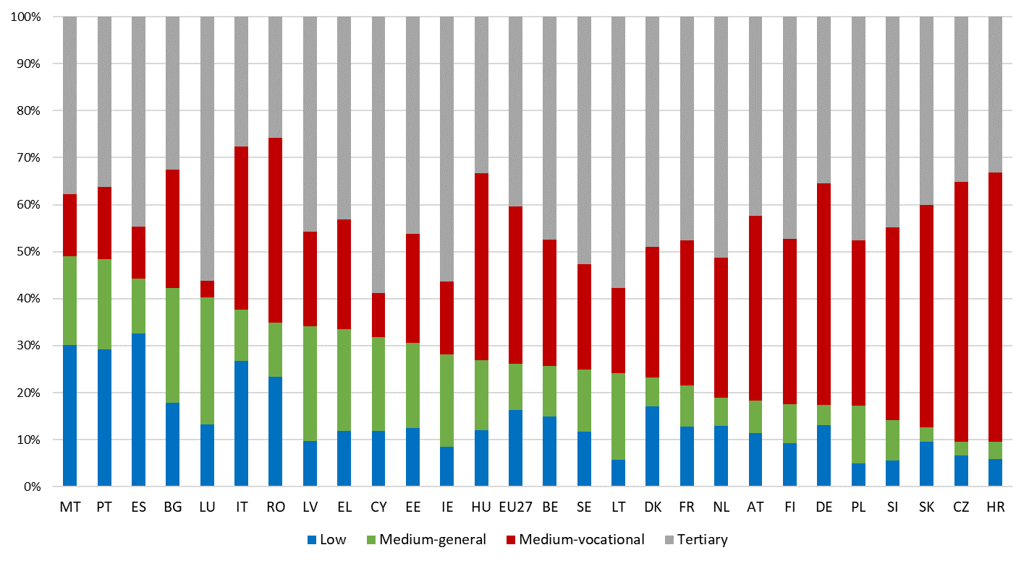

Source: Eurostat, LFS, online data source [[edat_lfs_9914](https://appsso.eurostat.ec.europa.eu/nui/show.do?dataset=edat_lfs_9914&lang=en)].

**Figure 29: Young graduates with higher education or vocational medium-level qualifications have better labour market perspectives**

Employment rates of recent graduates aged 20-34 by educational attainment level, 2019 (%)

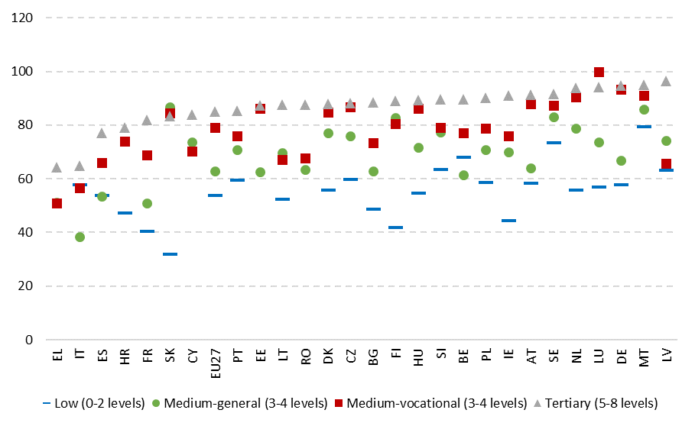

Source: Eurostat (EU-LFS, 2019, online data code [edat_lfse]. Note: The data exclude those still enrolled in education or training. Where available, data include only individuals who have graduated 1-3 years before the survey. In BG, CZ, EE, IE, EL, HR, CY, LV, LT, HU, MT, AT, RO, SI, SK, and FI, data on the employment rate of low-qualified recent graduates is not available, and the figure shows the employment rate of all low-qualified graduates aged 20-34 instead for these countries.

**Despite labour market needs, the demand for ICT specialists in the EU is broader than the supply**. Science, technology, engineering and mathematics (STEM) skills, including ICT skills, play a key role in driving innovation, and delivering knowledge-driven growth and productivity gains[86]. A CEDEFOP analysis of job vacancies shows that computer skills for quality control, data management and communication are the third most requested skill, appearing in about 13.5 million online vacancies between July 2018 and December 2019, coming after the ability to adapt to change and the use of English[87]. The same analysis identified software developers as the second top occupation in that period (1.6 million vacancies) and system analysts as the third one (1.3 million vacancies). Together, ICT professionals (2-digit ISCO) were the second most requested group of occupations, with 8.2% of all vacancies. However, ICT specialists make up less than 4% of the EU workforce, with a small increase from 2016 (3.7%) to 2018 (3.9%)[88]. The increase in ICT graduates is even slower, from 3.5% in 2017 to 3.6% in 2019. There is a clear gap between demand and supply: more than half of the EU companies (57%) found it difficult in 2019 to recruit ICT specialists (Figure 30). Gender differences are a significant part of the challenge: even though women complete tertiary education at a significantly higher rate than men, only one in three STEM graduates is a woman[89]. In addition, women hold only 17% of positions in tech sector (although there is wide divergence between countries)[90]. To address this challenge, the Commission proposed new actions on gender in STEM and digital fields in the Communication on Achieving the European Education Area by 2025.

**Figure 30: The lack of ICT specialists can hamper the digital transition**

Companies finding it difficult to recruit ICT specialists (%)

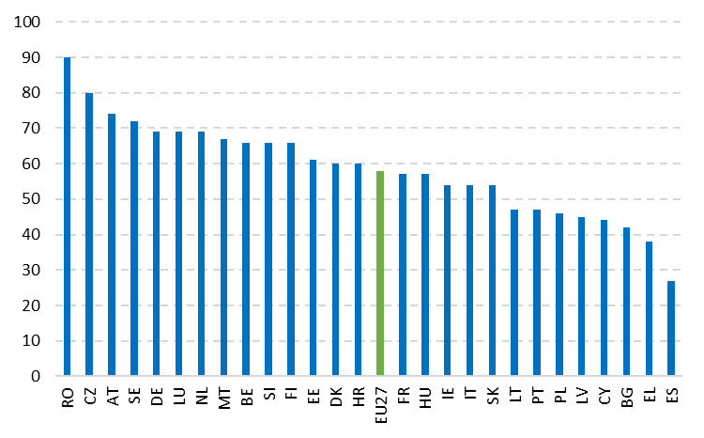

Source: Eurostat community survey on ICT usage and e-commerce in entreprises [[isoc_ske_itrcrn2](http://appsso.eurostat.ec.europa.eu/nui/show.do?dataset=isoc_ske_itrcrn2&lang=en)]

**The skills challenge for companies goes beyond digital, extending to skills for the green transition and transversal skills, and sustained efforts are needed to ensure the identification of evolving needs**. In 2019, scarcity of skilled staff remained the most frequent reason to limit long-term investments, cited by 77% of companies[91]. All companies will need to adapt their economic activity and in-house skills in light of the shift towards a climate neutral Europe. There is however little quantitative information on the skills needed or available in relation to ‘green jobs’, mostly because there is no agreed definition of the relevant concepts yet[92]. The anticipation and analysis of skills needs are not possible without establishing foresight scenarios with industry in specific industrial ecosystems and until these concepts are properly defined, which would also facilitate appropriate identification and validation of skills related to green jobs, activities and processes. To be useful, skills anticipation should be conducted at industrial ecosystems level, not merely at macro level. There is some evidence that the reorganisation of workplaces brought about by the digital and green transitions increases the importance of transferable skills such as self-organisation, communication, management, creativity and conscientiousness. Labour productivity is positively associated with these traits, even after accounting for differences in cognitive skills[93]. There is also some evidence of an interaction effect, so that possessing non-cognitive skills is a pre-requisite for using cognitive skills to their full potential. This highlights that the green and digital transitions will increase the demand for a broad range of skills, and calls for promoting adult learning more generally.

**There has been limited progress on overall participation in adult learning between 2009 and 2019.** Participation in adult learning in the EU-27 increased by 3 pps over the decade, from 7.8% to 10.8%, which falls significantly short of the ET 2020 target of 15% of the EU population in the age group 25-64 participating in formal or non-formal education and training in the last four weeks (Figure 31). The lowest adult learning rates are observed in Romania, Bulgaria, Croatia, Slovakia, Greece and Poland (below 5% of the adult population), while the highest rates are observed in Sweden, Finland and Denmark (above 25%). Some Member States (Denmark, Slovenia and Cyprus) saw a deterioration in this area during the last decade, while countries with the most remarkable improvements (above 5 pps) included Estonia, Finland and Sweden[94]. Moreover, participation in adult learning is less frequent for certain sub-groups. For instance, as regards non-EU born persons (aged 25-64), on EU average they were equally likely to participate in education and training (in the last 4 weeks) (11.1%) in 2019 than native-born (10.8%). However, the situation differs across countries. In France, Estonia, Slovenia, Italy and Latvia, native-born people are substantially more likely than non-EU born to have access to adult education. The gaps in those countries are even more pronounced among migrant women. Only 2.4% of persons with disabilities participated in learning in the age group 25-64 as compared to 4.1% of those without disabilities in 2016. The Skills Agenda of 2020 proposes an improvement in the indicator for adult learning by changing the measurement window from the past four weeks to the past year[95]. The ambition is to achieve significant increases in the participation of adults in learning as measured over this time period, from 38% in 2016 to 50% in 2025.

**Figure 31: Participation of adults in learning is low and varies significantly among Member States**

Share of adults (aged 25-64) participating in education and training, 2009 and 2019

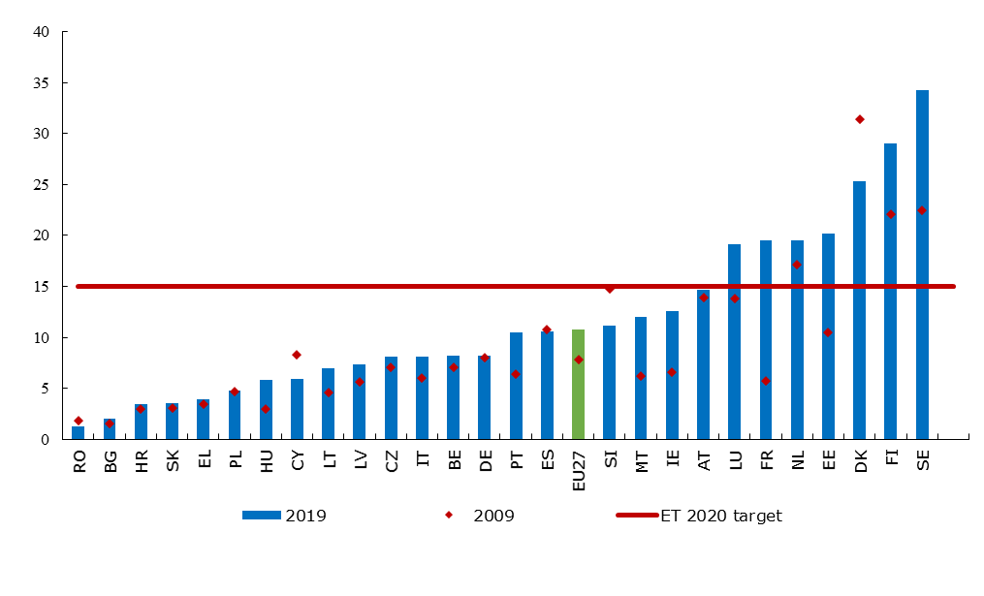

Source: Eurostat, LFS, 2019, online data code [[trng_lfs_01](http://appsso.eurostat.ec.europa.eu/nui/show.do?dataset=trng_lfs_01&lang=en)]. Note: break in time series in DK, IE, LU, SE, UK in 2007; DE, EL, PL, SE, UK in 2008; EE, IE, EL, CY, LU in 2009; DE, NL, PL, RO in 2010; CZ, NL, PT, SK in 2011; CZ, FR, NL, PL in 2013; ES, FR in 2014; LU, HU in 2015; DK in 2016 and BE, IE and MT in 2017; PL and SE in 2018.

**The low qualified and jobseekers are priority target groups for policies to improve overall participation in adult learning**. The low qualified are in particular need of upskilling to fully participate in society and on the labour market. In 2019, their share of participation in learning during the last four weeks before the survey ranged from 0.5% in Croatia to nearly 23.7% in Sweden (EU-27 average: 4.3%, Figure 32). In most countries, less than 10% of low qualified adults participate in learning. On the other hand, in Finland, Denmark and Sweden 16.8%, 17.7% and 23.7% participate respectively, highlighting that it is possible to achieve high learning participation rates also among the low qualified. A second priority target group for learning are jobseekers, for whom training can be very effective at increasing labour market prospects and preventing long-term unemployment[96]. There are large gaps across Member States in the share of unemployed adults who participated in any training activity during the last four weeks before the survey, with values ranging from 2.4% in Croatia to nearly 46% in Sweden in 2019 (EU-27 average: 10.7%). In Slovenia, Germany, Latvia, Italy, Cyprus, Czechia, Greece, Poland, Lithuania, Croatia, Romania, Slovakia and Hungary, less than 10% of unemployed adults participate in learning. On the other hand, their participation is high, above 25%, in Denmark, Luxembourg and Finland. The 2020 European Skills Agenda aims to ensure significant improvement in the participation of low qualified and jobseekers in learning and in particular it proposed to nearly double the EU-27 share of jobseekers with a recent learning experience to 20% by 2025.

**Figure 32: Despite significant differences amongst Member States, low-qualified and unemployed adults face challenges in terms of participation in learning activities**

Share of adults aged 25-64 who are low-qualified (as part of all low-qualified adults) and unemployed (as a share of all unemployed adults, right axis) participating in learning, 2019

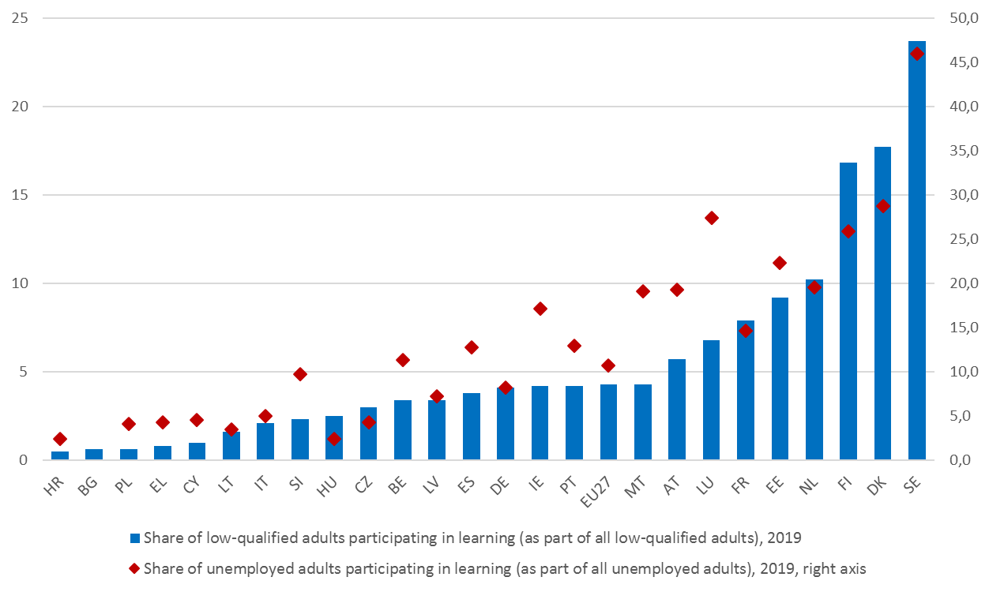

Source: Eurostat, LFS, 2019, online data code [[trng_lfse_03](https://appsso.eurostat.ec.europa.eu/nui/show.do?dataset=trng_lfse_03&lang=en)]. Note: Data for RO and SK are not available, reflecting that the number of learners in these groups is too low to publish a reliable indicator. However, this reflects very low participation rates for this group. For Croatia, the 2018 figure is used because of missing data for 2019. Data for BG, HR, CY, LT, PL, and SI are unreliable for the same reason.

Source (right axis): Eurostat, LFS, 2019, online data code [[trng_lfse_02](https://appsso.eurostat.ec.europa.eu/nui/show.do?dataset=trng_lfse_02&lang=en)]. Note: Data for BG, RO and SK are not available, reflecting a number of learners in this groups that is too low to publish a reliable indicator. However, this reflects very low participation rates for this group. Data are unreliable for HR, CY, LT, HU and SI for the same reason.

**A large part of adult learning takes place in non-formal or informal settings, and there is wide consensus about the relevance of skills validation to respond to skill needs and reduce skill gaps**[97]. The Commission Staff Working Document evaluating the 2012 Council Recommendation on the validation of non-formal and informal learning, published on 1 July 2020[98], found that, in spite of clear progress since the adoption of the Recommendation, many people do not have access to validation opportunities. Validation arrangements are now in place in all Member States. However, most arrangements have some restrictions (e.g. only people with work experience can apply), many are not comprehensive (e.g. only for vocational training qualifications) and different arrangements may coexist in the same country without coordination. Quantitative information on take-up remains limited and fragmented. The updates of the European inventory of validation[99] show that validation is broadly present in the national policy agendas and its provision has improved since 2012, with some exceptions (Figure 33). There is some evidence of an ‘evaporation effect’ in which some people who engage in a validation procedure fail to complete it[100]. In fact, engaging in validation processes requires a serious commitment by individuals[101] and the availability of active support, such as paid time by the employer or financial aid. These forms of active support are not common: responses to a specific public consultation show that only one in ten validation beneficiaries had received some form of support to participate in validation[102].

**Figure 33: Many people do not have access to validation opportunities with significant differences amongst Member States**

Trend in the number of people using validation (2018 compared to 2016)



↑ increased numbers; ↓ decreased numbers; ↔ stable numbers; ↕ variation of numbers in different sectors

Source: Cedefop, European Inventory of validation 2016 and 2018. No data available for Austria, Croatia, Estonia, Hungary, Lithuania, Slovenia.

**The COVID-19 pandemic increases the need for upskilling and reskilling, but could lead to lower levels of provision without a policy response.** The COVID-19 downturn will have a disproportionate effect on some economic sectors and, together with the digital and green transitions, create need for new or adjusted skills. It will also lower the opportunity cost of investing time in training. However, recent analyses[103] found that in the EU-27 between 2005 and 2019, adult learning participation did not increase in downturns. In Central and Eastern European countries, that already tend to have low participation rates, adult learning decreased even further in downturns. The same is true for people who are not in employment, which may reflect pressures on public training budgets in times of rising unemployment. Conversely, the analyses suggest that higher public expenditure on training is associated with a more counter-cyclical behaviour of adult learning. This underlines the importance of reforms and public investments in adult learning systems to strengthen their resilience in downturns.

**Due to COVID-19, Member States may be facing a possible protracted youth employment crisis that calls for new policy responses.** Before the crisis, youth unemployment figures reached record lows of 14.9% in March 2020 in the EU-27 on average, a 0.5 pps improvement from 15.4% in March 2019. The figure however jumped to 17.1% after the lockdown in September 2020. The respective figures for the total population were 6.5% in March and 7.5% in September. Five Member States experienced sharp increases in youth unemployment between the first and second quarter of 2020 (Estonia 8.2 pps, Lithuania 6.1 pps, Luxembourg 5.5 pps, Croatia 5.3 pps, Bulgaria 5.2 pps). Experience from the previous economic crisis creates cause for concern. While the EU average youth unemployment rate continued to improve considerably before the COVID-19 crisis (see Figure 34), it has always remained more than double the unemployment rate observed for the adult population (6.7% in 2019), pointing to a structural challenge even in the absence of further shocks. Before the crisis, dispersion in youth unemployment rates – although decreasing over time – remained high and youth unemployment was still above 30% in some Member States (Greece: 35.2%; Spain: 32.5%). The recovery did not in all cases lead to quality job creation for young people: in 2019, 14.6% of employees aged 15 to 24 were on temporary contracts because they could not find a permanent job (compared to 7.2% of workers aged 25-64); the proportion was more than one out of three in Spain, Portugal, Croatia and Italy[104]. In order to address the COVID-19 and structural challenges, the Commission proposed, in July 2020, to reinforce the Youth Guarantee. The new initiative will expand the age range for eligibility to 29 years of age, strengthen focus on vulnerable groups, support skills for the green and digital transitions and upgrade counselling, guidance and mentoring services.

**Figure 34: Youth unemployment rates rose during the COVID-19 crisis, but remain lower than in 2014**

Youth unemployment rate (15-24), multiannual comparison Q2 of 2014, 2019 and 2020

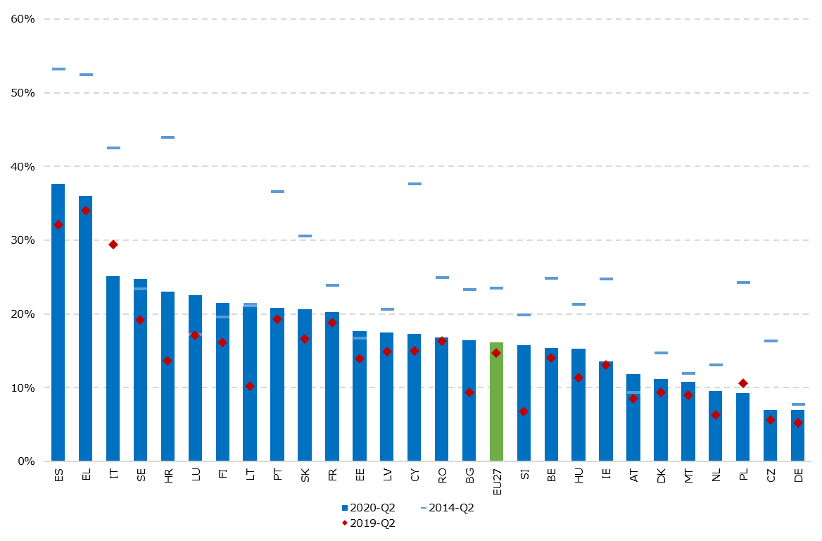

Source: Eurostat, LFS, online data code: [[une_rt_q](https://appsso.eurostat.ec.europa.eu/nui/show.do?dataset=une_rt_q&lang=en)].

**The COVID-19 shock reversed the improvement of NEET rates in all but two Member States.** Before the crisis, Member States were making steady progress in reducing the rates of 15 to 24 year-olds not in employment, education or training (NEET): between the second quarters of 2013 and 2019, the rates shrank from the record high of 13.1% to a record low of 9.8%. The crisis reversed the trend sharply: between the second quarters of 2019 and 2020 the EU-27 NEET rates increased by 1.8 pps (from 9.8% to 11.6%). The Social Scoreboard headline indicator (Figure 35) shows that NEET rates increased year-on-year in all but three Member States (Latvia and Malta: -0.8 pps; Romania: -0.4 pps). Five Member States showed a much higher than average increase in NEET rates (Austria, Ireland, Spain, Italy and France), although Austrian NEET rates remained below the EU-27 average. The Netherlands, Czechia and Sweden performed best on this measure. On the whole, the effect of COVID-19 has been unprecedented: the first and second quarters of 2020 recorded the largest quarterly jump in NEET rates since Eurostat started collecting the data in 2006[105] (from 10.4% to 11.6%). This makes it crucial to monitor the situation closely and introduce targeted measures for NEETs, such as those proposed in the July 2020 reinforced Youth Guarantee.

**Figure 35: NEET rates have increased in most Member States and levels create concerns in several countries**

NEET rate (15-24) and change between Q2-2019 and Q2-2020 (Social Scoreboard headline indicator).

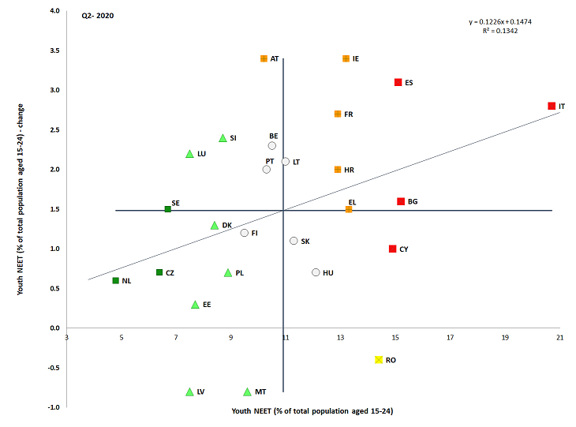

Source: Eurostat. Period: Q2-2020 levels and yearly changes with respect to Q2-2019. Note: Axes are centred on the unweighted EU average. The legend is presented in the Annex. Missing data for DE for Q2-2020.

**Changes in the NEET rate during an economic downturn are largely due to increases in unemployment rather than in inactivity, with the latter posing a challenge that remains more stable over time.** Until the COVID-19 crisis, the trend was that decreasing youth unemployment matched an increase in the share of inactive NEETs[106] (they formed 46.9% of the group in 2013, and 59.4% in 2019). As of 2019, the share of inactive NEETs was particularly high in Bulgaria (85.4%), Czechia (75.4%), the Netherlands (74.4%) and Denmark (72.7%). It was particularly low in Spain (43.8%), Greece (44.0%), Portugal (47.5%) and Luxembourg (48.2%). Among female NEETs, inactivity is more frequent than unemployment, while the two shares are almost on a par for men. Drawing a lesson from the previous economic crisis, the share of unemployed NEETs is likely to increase quite rapidly. After the recovery, inactivity rates are likely to again become the predominant challenge related to NEETs.

**Figure 36: The majority of NEETs are inactive, but with substantial differences among Member States**

Profile of NEETS (15-24 years old)° in EU Member States in 2019 (%)

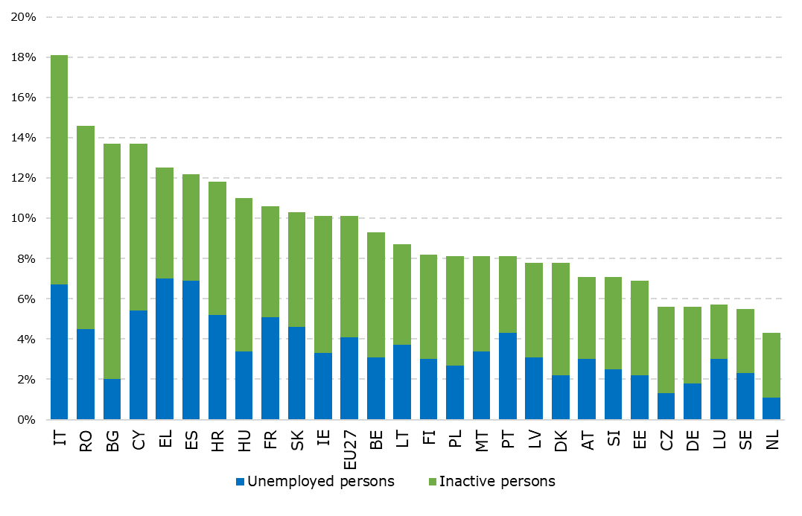

Source: Eurostat, LFS, online data code: [[edat_lfse_20](https://appsso.eurostat.ec.europa.eu/nui/show.do?query=BOOKMARK_DS-142917_QID_-30D60F49_UID_-3F171EB0&layout=TIME,C,X,0;GEO,L,Y,0;SEX,L,Z,0;AGE,L,Z,1;WSTATUS,L,Z,2;UNIT,L,Z,3;TRAINING,L,Z,4;INDICATORS,C,Z,5;&zSelection=DS-142917WSTATUS,NEMP;DS-142917SEX,T;DS-142917AGE,Y15-34;DS-142917INDICATORS,OBS_FLAG;DS-142917TRAINING,NO_FE_NO_NFE;DS-142917UNIT,PC;&rankName1=WSTATUS_1_2_-1_2&rankName2=TIME_1_0_0_0&rankName3=UNIT_1_2_-1_2&rankName4=TRAINING_1_2_-1_2&rankName5=GEO_1_2_0_1&rankName6=AGE_1_2_-1_2&rankName7=INDICATORS_1_2_-1_2&rankName8=SEX_1_2_-1_2&sortC=ASC_-1_FIRST&rStp=&cStp=&rDCh=&cDCh=&rDM=true&cDM=true&footnes=false&empty=false&wai=false&time_mode=NONE&time_most_recent=false&lang=EN&cfo=%23%23%23%2C%23%23%23.%23%23%23)].

**Young people with a migrant background are more likely to be NEETs.** The NEET rate of non-EU born young people (aged 15-24) was 17.1% in 2019 compared to 9.9% among native-born[107]. The gap was higher than 10 pps in several Member States such as Greece, Slovenia, Belgium, Germany, Austria, France, Malta and Spain. Moreover, the situation was on average more adverse for young migrant women (NEET rate of 25.9%, 13.2 pps higher than among their native peers). In addition to non-EU born persons, native-born with a migrant background are also likely to be affected: in the majority of EU Member States, they were more likely to be neither in employment nor in education and training than those with native-born parents. The gap was especially large (rate more than 8 pps higher) in six Member States (Belgium, Czechia, France, Luxembourg, Netherlands, Slovenia)[108]. Young people combining migrant background and low level of education were particularly at risk. The NEET rate of Roma is much higher than that of the general population (gap of 52pps) [109].

**The employment rate of older workers (aged 55-64) remained robust despite a dip caused by the COVID-19 crisis.** The share of employed people in this age group stood at 59.2% in the second quarter 2020, with a slight decline of 0.4% from the previous quarter and unchanged from the same period in 2019. The strong labour market activity rate[110] of people aged 55-64 underpinned the EU’s performance over recent years: between the second quarters of 2013 and 2020, the activity rate of 55-64-year-olds increased by 8.9 pps, compared to the 0.6 pps increase for the population aged 20-64. There is nonetheless a need to continue monitoring the labour market situation of older workers. In a 2019 EU-wide survey[111], 47% of respondents reported that age was a factor that could put job applicants at a disadvantage. This may lead to an adverse effect for older workers who lose their jobs due to the COVID-19 crisis, potentially also leading to involuntary early retirement. Monitoring is needed in particular in the seven Member States that saw a drop in the older workers’ employment rates of one percentage point or more between the first and second quarter of 2020 (Estonia 2.8 pp, Malta 1.8 pp, Lithuania 1.6 pp, Ireland 1.5 pp, Spain 1.5 pp, Luxembourg 1.4 pp and Finland 1 pp). Employment rates among older people could also help sustain employment growth for a few more years even as the working age population is decreasing. Older women, in particular, still have a significant potential to increase their employment (the employment rate of women aged 55-64 stood at 52.9% in Q2-2020 compared to 65.9% for men in the same age group).

**After years of steady increase, the crisis caused a dip in the employment rate of women, although at a slower pace than for men.** Between the second quarters of 2019 and 2020, the employment rate of women (aged 20-64) decreased by 1.2 pps and stood at 66.3% at the EU-27 level in Q2-2020. Due to a slightly larger decline in the employment rates of men during the period (of 1.5 pps), the Social Scoreboard headline indicator of gender employment gap recorded a small improvement (Figure 37). All but three Member States experienced a reduction in women’s employment rates between the second quarters of 2019 and 2020 (the exceptions were Croatia, Germany and Luxembourg). Notably, decreases over 3 pps were registered in Bulgaria and Spain. Despite a 2 pps decline, Sweden remains the top performer with 77.9% female employment closely followed by Lithuania, Germany, Netherlands and Latvia, all with female employment rates above 75%. The lowest gender employment gaps in Q2-2020 can be found in Lithuania (1.4 pps), Finland (3.2 pps), Latvia (4 pps) and Sweden (5.2 pps). At the other side of the spectrum stand Italy (19.9 pps), Malta (19.7 pps), Greece (18.9 pps), and Romania (18.4 pps). All the latter countries are assessed as ‘critical situations’ in the Social Scoreboard with the exception of Greece, which is ‘weak but improving’ thanks to a sharp decrease by 1.5 pps year-on-year. From Figure 37 it emerges that convergence is not occurring on this indicator, as several Member States with high – or close to average – gender employment gaps recorded a deterioration in 2020.

**Figure 37: The gender employment gap remains large, with significant differences amongst Member States**

Gender employment gap and yearly change (Social Scoreboard headline indicator)

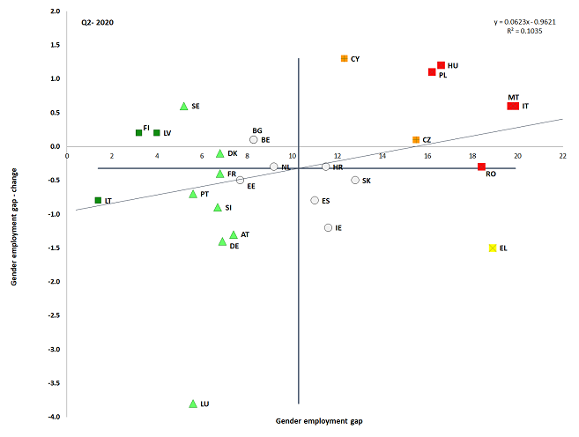

Source: Eurostat, LFS. Period: Q2-2020 levels and yearly changes with respect to Q2-2019. Note: Axes are centred on the unweighted EU average. The legend is presented in the Annex.

**In full-time equivalents (FTE), the gender employment gap widened further.** Fewer women aged 20-64 in the EU worked full-time in 2019 than men (58.7% compared to 76.1%). In 2019, the FTE gender gaps were lowest in Lithuania, Finland and Latvia, and highest in Malta (24.3 pps), Italy (24.2 pps) and the Netherlands (24.1 pps). These outcomes are linked to shares in part-time work. Of those employed, 29.4% of women worked part-time compared to 7.8% of men in 2019, with women experiencing lower rates of involuntary part-time work than men (23.5% vs 33% respectively). In most Central and Eastern European Member States, the share of women working part-time is traditionally below 10% (Bulgaria, Romania, Slovakia, Croatia, Hungary, Lithuania, and Poland). Conversely, though slowly decreasing for the fourth consecutive year, it remained the highest in the Netherlands (73.4%). Flexible work-life balance policies can have a positive impact on parents’ and carers’ labour market attachment, but can also contribute to wider FTE employment gaps. This is particularly evident in Member States with significant shares of women working part-time (e.g. Netherlands, Austria and Germany), of which the Netherlands also experienced large FTE gender gaps. The unbalanced share of care responsibilities borne by women fosters labour market biases manifested in gender gaps such as in unemployment, pay and pensions. This shows, for instance, in the fact that the gender gap in the share of unemployed people is widest at women’s prime childbearing age group 30-44[112].

**EU-27 employment gaps are wider for women with children.** Parenthood widens the gender employment gap in all Member States. In 2019, for parents (25-49 years) with at least one child less-than six years, employment rates increased for men in all Member States (by 9.6 pps at EU level) whereas it decreased in most Member States for women (by 14.3 pps at EU level). Exceptions are Sweden, Portugal, Slovenia, Croatia and Denmark where the impact of having at least one child less than six years on female employment rates is either positive or neutral. In Czechia, Hungary and Slovakia, the negative impact of parenthood for women with at one child less than six years is particularly high (over 40 pps) (Figure 38)[113]. Education levels are an important factor in explaining the impact of motherhood on work: the employment rate of low-skilled women with at least one child less than six years was just 36.3%.

**Figure 38: Employment impacts for men and women with a child under six diverge strongly; the impact is positive for men in all Member States**

Employment impact of parenthood for men and women (age 20-49) in 2019

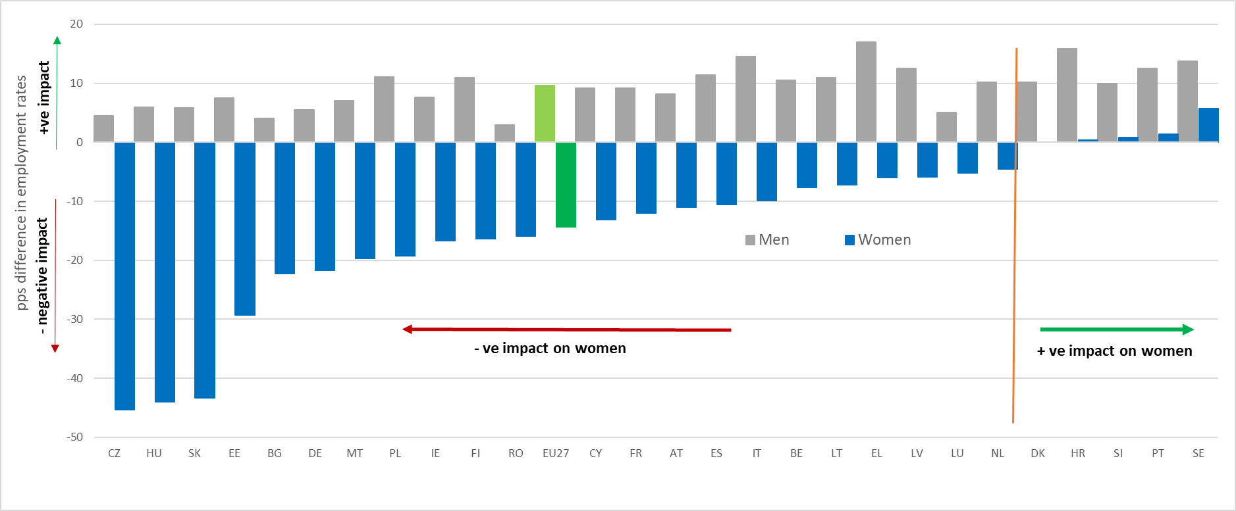Source: Eurostat [[lfst_hheredch](http://appsso.eurostat.ec.europa.eu/nui/show.do?dataset=lfst_hheredch)]. Note: the employment impact of parenthood is the pps difference in the employment rate for mothers and fathers with at least one child under the age of six.

**The persistent employment gap is also mirrored in the significant gender pay gap.** The unadjusted pay gap was broadly unchanged in EU-27, 14.1% in 2018 with a 0.4 pps decline since 2017. This is against an increasing education attainment gap in favour of women aged 30-34 years compared to men (45.6% vs 35.1% respectively), in 2019. The COVID-19 pandemic further highlighted how women continue to be over-represented in lower paid sectors and occupations, and experience constraints in their professional choices linked to family care obligations. Moreover, research[114] shows that factors such as differences in experience, level of education and the type of contract, accounted for less than a third of the gender pay gap. The part of the gap that can be explained was largely due to economic activity and working time.

**Differences across countries in the unadjusted gender pay gap are considerable; pay gaps can lead to pension gaps.** The gender pay gap remains above 20% in Estonia, Austria, Czechia and Germany, with the smallest values (between 1 and 4%) registered in Romania, Luxembourg and Italy. Since 2014, the situation has considerably improved in Estonia, Portugal, Greece and Luxembourg (by 6.3 pps, 6 pps, 4.6 pps and 4 pps respectively), while the gender pay gap has increased by more than 2 pps in Latvia, Malta and Slovenia. The gender pay gap frequently translates into a pension gap in favour of men, which stood at 29.1% on EU-27 average for pensioners aged 65-74 in 2018. The difference in pensions was bigger in the Member States with the wider pay gap.

**Figure 39: There is still a significant gender pay gap between women and men**

Unadjusted gender pay gap in 2014 and 2018

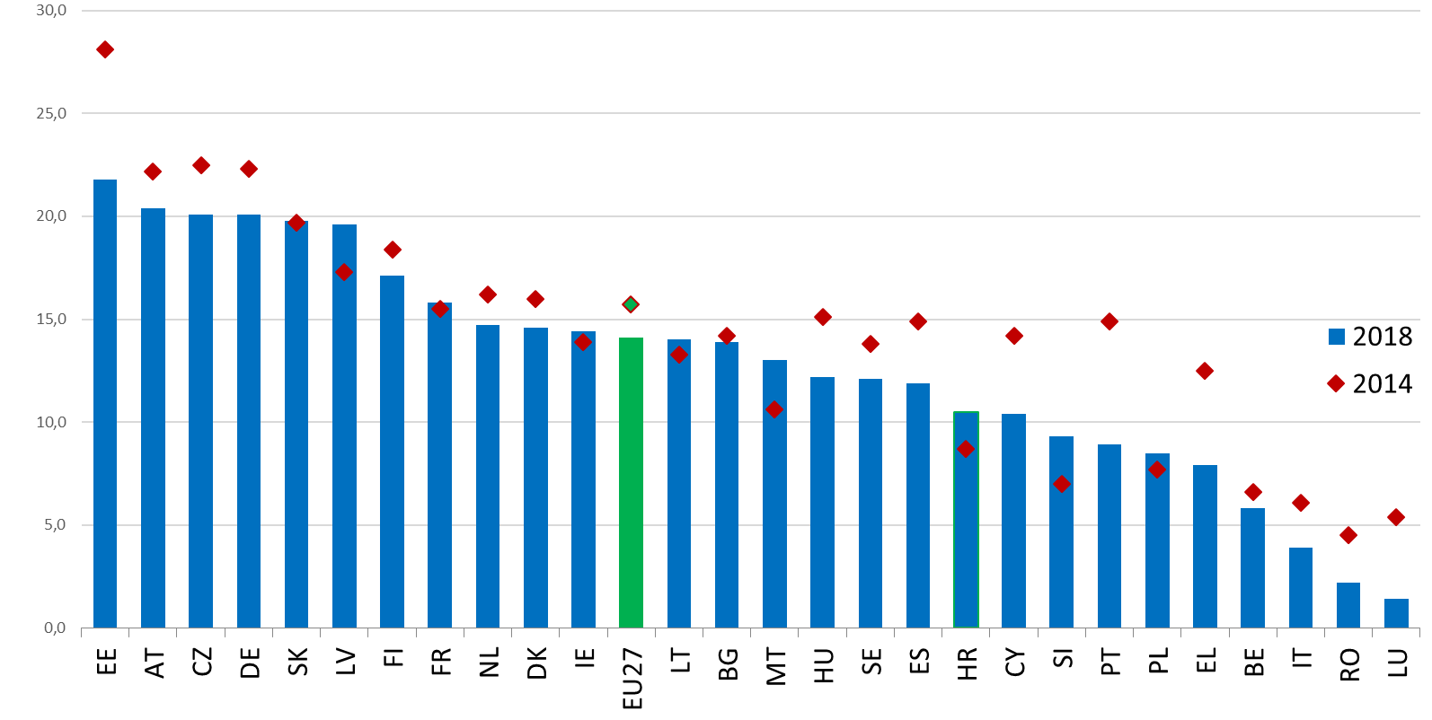

Source: Eurostat, online data code: [[SDG_05_20](http://appsso.eurostat.ec.europa.eu/nui/show.do?dataset=sdg_05_20&lang=en)]. Note: the unadjusted Gender Pay Gap (GPG) is measured as the difference between average gross hourly earnings of male and female paid employees as a percentage of average gross hourly earnings of male paid employees. 2018 data is replaced by 2017 data for IE. The calculation for EL and IT, and therefore for EU-27, is provisional.

**Women’s employment is strongly affected by access to quality and affordable early childhood education and care and long-term care services.** The Social Scoreboard headline indicator on childcare estimates the participation of children below the age of 3 in formal early childhood education and care (ECEC) to be 35.5% at EU-27 level in 2019, and thereby exceeding the 33% Barcelona target (Figure 40). However, differences persist among countries with 15 Member States yet to reach it. While the participation rate in formal ECEC for children under age 3 reaches 60% and above in Denmark, Luxembourg and Spain, five countries report ‘critical’ in the Social Scoreboard analysis (Romania, Hungary, Poland, Czechia, Croatia[115]). Much higher than average rates of improvement were recorded in the Netherlands, Spain, Malta and Lithuania. The lack or insufficient ECEC provision, including in terms of opening hours, is associated with the negative impact of parenthood on women’s employment (Figure 38). While even a few hours per week spent in ECEC have a beneficial effect on children in terms of their socialisation and future educational achievements, to narrow the gender employment gap it is crucial that formal childcare is provided for more than 30 hours per week. This prevents that one parent, usually the mother, is compelled to work part-time, with negative consequences on career advancement and lifetime earnings. Work-life balance policies, such as flexible working arrangements or family leaves, also play an important role in reducing obstacles to the labour market participation of people with caring responsibilities. If used in a balanced way by women and men, they can also contribute to reducing gender gaps in employment.

**Figure 40: Large differences in terms of participation in childcare services persist among Member States**

Children less than 3 years in formal childcare and yearly change (Social Scoreboard headline indicator)

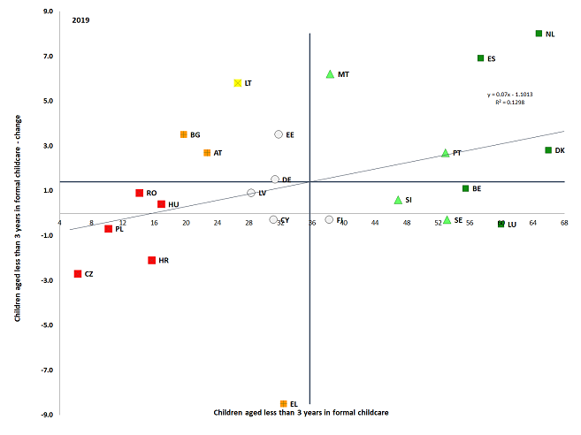

Source: Eurostat, EU-SILC. Period: 2019 levels and yearly changes with respect to 2018. Note: Axes are centred on the unweighted EU average. Breaks in series for BE. Data not available for IE, FR, IT and SK on 28 October 2020. The legend is presented in the Annex.

**Financial disincentives from the tax and benefit system worsen women’s labour market participation**. If income tax is levied on household income rather than on individual income it may create a disincentive for the second earners (predominantly women) to engage in paid work (inactivity trap). Other features of the tax and benefit system may discourage labour supply, including family-based, dependent spouse and transferable deductions. Costly care facilities also increase inactivity traps particularly for second earners and low-income families. In 2019, the highest second earner inactivity traps were seen in France, Germany, Slovenia and Belgium. The low wage trap was highest in Belgium, the Netherlands, Italy and Germany[116].

**Despite persistent challenges, prior to the COVID-19 crisis the employment situation of non-EU born people had continuously improved over the last three years.** In 2019, 64.2% of non-EU born people of working-age (20-64) were in employment, a rate almost 3 pps higher than two years before (2017). However, it remains 10 pps lower than the employment rates among the native-born (73.9%). In some Member States (Sweden, Belgium, the Netherlands, Denmark, Finland, France and Germany) the gap exceeded 15 pps in 2019. The larger share of low-educated among non-EU-born versus native-born (respectively 38.5% and 19.6% at EU-27 level among those aged 25-64) explains partly the lower employment rate of the former. However, even non-EU born individuals with a high level of educational attainment do not reach the same employment levels as the native-born and this therefore remains a significant under-use of migrants' skills and qualifications[117]. The situation remains particularly unfavorable for non-EU born women with an employment rate around 54.6% in 2019, 14 pps below the level recorded among native-born women[118]. This suggests that with appropriate integration and activation measures, the EU could benefit better from the talent and potential of non-EU born individuals. The improvement in recent years is due notably to higher employment rates among “recent arrivals” (non-EU born residents since less than 5 years).

**There is evidence that the projected decrease in employment due to the COVID-19 crisis will affect non-EU migrants more severely than natives**[119]**.** Preliminary data point to a stronger impact of the COVID-driven lockdown and recession on the employment rate of non-EU migrants (decrease from 64.4 to 60.8% between the second quarters of 2019 and 2020) than on natives. As a result the gap increased by more than 2 pps and by around 4 pps or more in countries such as Spain, Belgium and Austria[120]. This is due to a higher share of temporary workers among migrants, shorter job tenure, lower shares of workers employed in tele-workable and/or public sectors jobs as well as higher shares in sectors likely to be impacted more strongly by the recession (accommodation and food services activities, tourism, services sector, construction etc).

**Low employment and activity rates of persons with disabilities indicate an untapped talent potential.** In the EU-27 in 2018, the employment rate of people with disabilities was 50.8% versus 75% for those without[121]. The employment gap varies substantially across Member States[122], from 15.2 pps in Italy to 40.3 pps in Ireland. Despite a slight increase, only 62.4% of persons with disabilities in the EU-27 were economically active, compared to 82.2% of those without disabilities, suggesting little change in the significant barriers that persons with disabilities face in accessing the labour market. The employment rate of women with disabilities (47.8%) remained lower than that of men with disabilities (54.3%). In 2019 persons with disabilities were more likely to face in-work poverty risks than those without (10.5% versus 8.9% on average in the EU)[123].

*3.2.2 Measures taken by Member States*

**Targeted support to vulnerable groups is fundamental to reduce early school leaving and educational inequalities as well as to promote participation in mainstream education.** Many Member States are considering these aspects in their policy design. In Ireland, the National Council for Special Education (NCSE) launched the *School Inclusion Model* for supporting inclusive education in mainstream primary and secondary school settings, and building schools’ capacity to include students with additional needs. Latvia made significant steps towards inclusive education by legislating the obligation for general education institutions to admit students with special needs in their educational programmes from September 2020. The range of support measures to be provided in the education process has been extended in line with the specific needs of each child. In Poland the government launched a scheme to support the purchase of textbooks and educational/training materials for students with disabilities, active until 2023. School authorities in Sweden have been working on national targets and indicators for monitoring school’s activities to improve equity and better understand schools’ success factors, which will then be used both at local and national level as a basis for the allocation of funding.

**The COVID-19 crisis has revealed disparities in digital readiness of schools and different segments of society, which risk widening educational inequalities linked to socio-economic disadvantage.** Across the Member States, some 58 million children transitioned to distance learning, putting vulnerable children clearly at a disadvantage. Member States have taken different actions in order to mitigate the impact of school closures. Countries like Bulgaria, Cyprus, France, Lithuania, Malta, Austria, Poland, Belgium, Romania and Spain have provided disadvantaged learners with equipment needed for remote learning (computers/tablets, internet access, sim cards, etc.), although to a different extent. Member States distributed IT equipment to vulnerable pupils (Croatia, Germany, Greece, Ireland, Lithuania, Malta, Poland), incentivised private donations of computers (Belgium, Estonia, Greece, Spain) or made classrooms available so that pupils had the peace of mind to do their homework or visio-conferences (Luxembourg). In addition, 11 Member States (Bulgaria, Estonia, Finland, Hungary, Ireland, Latvia, Lithuania, Malta, Portugal, Slovakia, and Spain) continued, in one form or another, provision of free meals for disadvantaged pupils. In some Member States (e.g. France, Latvia, Luxembourg, Portugal) municipalities or individual schools were responsible for tackling the challenge. Generally, those emergency measures did not meet the demand (e.g. in the remote areas of Hungary 1/3 of children could not participate in distance learning).

**Member States adopted different strategies to ensure access to learning under lockdown.** Greece passed emergency legislation enabling municipalities to use savings from operational costs during school closures for procuring ICT equipment and lending it to students in need. Moreover, in Greece, with the support of private companies, over 17 000 tablets and laptops were lent to students (mostly from disadvantaged groups) and to teachers for distance learning. Similarly, in Ireland, a special EUR 10 million fund was announced in April 2020 for the purchase of technology and devices for disadvantaged students at primary and post-primary level, in particular for the ‘Delivering Equality of Opportunity in Schools’ (DEIS) initiative. In Italy, EUR 85 million have been allocated to support distance learning, including the acquisition of digital devices. The Netherlands introduced support of around EUR 244 million aimed at preventing educational disadvantage and delay in learning. Romania approved a National Programme ‘*Home School*’ and allocated funding from the Budget Reserve Fund at the disposal of the government. In Poland, the government allocated around EUR 81 million to local governments for purchasing ICT equipment for disadvantaged pupils and for schools and teachers under the ERDF Operational Programme ‘*Digital Poland*’. In Slovakia, the Ministry of Education, in cooperation with non-governmental organisations, launched a website supporting online learning. The IT sector has supported schools and teachers with software and digital solutions free of charge. A number of Member States have also organised national language courses over the summer for disadvantaged children in order to limit the impact on the language learning process. For instance, Austria initiated a two-week summer school programme that helped 24 000 vulnerable pupils catch up on linguistic skills before schools reopened in September. Likewise, in Bulgaria, students that could not take part in remote learning were included in remedial classes, through the ‘*Support for Success*’ project, co-funded by the European Social Fund. In Slovakia, the Ministry has allocated EUR 500 000 for the organisation of summer schools to compensate for the temporary school closure. In France, a *‘Learning Holidays’* programme targeting one million children aged 6-16 was set up last summer (EUR 200 million).

**Ensuring that each pupil reaches a certain level of proficiency in basic skills such as reading, mathematics and science, as well as digital competences, has become a key priority for the EU**. Sloveniahas adopted a *National strategy for the development of Reading Literacy until 2030*, setting up goals for different age and target groups (90% of 15 year-olds with at least basic skills in PISA and 10% at highest levels by 2030). In January 2020, the Italian national authorities presented an action plan to reduce regional divides in competence achievement (*Piano di intervento per la riduzione dei divari territoriali in istruzione)*. It will identify ‘troubled’ schools in five southern regions (Campania, Calabria, Sicily, Sardinia and Apulia), and create a task force in each region to propose targeted interventions, initially for the last year of lower secondary school (grade 8). In Lithuania, a new competence-based curriculum will be piloted in 2021 and implemented as of 2022, accompanied by new formative assessment practices. It aims to introduce new pedagogies to better address students’ learning needs and enhance digital competences already at primary level. Malta implemented a new national initiative in the lower-secondary school, the ‘My Journey: Achieving through different paths’, with the aim of building a more inclusive and equity-oriented curriculum. In June 2020,Greeceadopteda new school legislation that provides for curricula and textbook revisions across all levels (including ECEC) to shift away from a content-heavy focus towards skills development around four thematic pillars: environment, well-being, creativity and citizenship education. It also strengthens digital education and introduces foreign language learning (English) already in pre-primary education. In Luxembourg, coding will be embedded in mathematics classes in cycle 4 (age 10-11) as of 2020-21, and across all subjects in cycles 1 to 3 (age 4-9) as from 2021-22. Teachers will receive training and support from specialised teachers to be recruited in 2020. In secondary education, computer science will appear as a new subject in 2021-22, including coding and computational thinking.

**Supporting teachers and trainers in developing their digital skills and pedagogical competences, as well as tackling the digital divide, are fundamental steps towards a digital education that benefits everybody.** Many Member States have already introduced effective policy measures in this regard. France announced in 2019 that ITC will be taught in high school as a discipline with dedicated teachers to make sure that all pupils are digitally literate and increase the number of ICT students (especially girls) in higher education. Austria announced a *8-Point Plan for digital learning*, which aims at introducing as of 2020-21 a single portal for applications and communication between students, teachers and parents *(‘Digital Schule’*), preparing all teachers for blended and distance learning through intensified continuing professional development, providing access to harmonized learning and teaching material, and upgrading IT infrastructure so that all students have access to devices. In Poland, ‘*Lesson: Enter’* is the largest nationwide digital education project for teachers and schools, supported by the ERDF Operational Programme ‘*Digital Poland*’. Its main goal is to train and encourage teachers to more often use digital content and tools. Around 15% of the teaching workforce (i.e. 75 000 teachers) are to be trained between 2019 and 2023. InCroatia, in primary schools, all pupils in 5th and 7th grade have received tablets, and schools have also received 1 tablet per 4 pupils for classwork in lower grades. In secondary schools, tablets were distributed to disadvantaged pupils. Schools have also received equipment for classrooms (smart boards, projectors, lab equipment) and laptops for teachers from the *e-Schools project*.

**Broadening participation in tertiary education with more inclusive and flexible learning, and equipping students with labour market relevant skills and competences remain priorities.** In Finland, over 10 000 additional places will be allocated to universities over the period 2020-22 to raise the level of education and respond to labour shortages of experts in different fields and regions. As from the academic year 2020-21, Bulgaria has eliminated university fees for new entrants into eight professional study fields in the areas of pedagogical and natural sciences and eight protected specialities. According to a legislation passed in January 2020, in Greece universities’ funding will be partly based on performance criteria (20%), including internationalisation, absorption of graduates in the labour market and the ratio of new entrants to graduates. In Poland, the new Council of Scientific Excellence established in June 2019 has changed the formula of doctorate studies: they can now be conducted only on full-time basis and all PhD students receive scholarships. Finally, Ireland has launched the *Action Plan for increasing Traveller Participation in Higher Education* to promote access to higher education for marginalised students.

**Member States adopted measures to improve the participation and educational attainment of third-country nationals, children with a migrant background and other disadvantaged pupils.** The Slovak Ministry of Culture, Science, Research and Sport [allocated](https://www.minedu.sk/podpora-regionalnej-a-multikulturnej-vychovy-ziakov-patriacich-k-narodnostnym-mensinam-2020/) EUR 48 000 for projects supporting students of minority backgrounds. Slovenia has increased the number of hours of Slovenian language lessons available to students with a migrant background in the first year of entering the education system, from 35 to a minimum of 120 hours per pupil. In upper secondary education, Sweden has further institutionalised the right of all students to have a mentor. Czechia developed the ‘Support for Educating Foreigners in Schools’ programme for 2020, a subsidy meant to adapt the teaching of Czech to the needs of foreign children and adjusting the conditions for their education. Within the Belgian ‘*Pact for Excellence in Education*’, extending to 2030, new approaches to French language learning for newly arrived and vulnerable pupils have been widely taken up by schools. Malta set up induction programmes for newly arrived children who cannot speak Maltese or English, with public schools required to implement the 2019 inclusive framework. A number of Member States aimed specifically at increasing the participation of children from third-country nationals in early childhood education and care. For instance, Bulgaria and France have lowered compulsory schooling age to four and three years old respectively, aiming at a better integration of children from vulnerable families. Greece is gradually extending mandatory pre-school attendance to the 4-years old (for the upcoming school year 2020-21 the remaining 40 municipalities will be included).

**Some Member States have increased the financial resources to support education, which may also benefit children with a migrant background.** In France, strengthening pre-primary and primary education and tackling inequalities are budget priorities in 2020, with a EUR 991 million budget increase for compulsory education. In Ireland, efforts have been continued to improve access to higher education for vulnerable groups and EUR 27 million were devoted to support 30 000 higher education students from such groups. Sweden placed EUR 460 million in 2020 in the equality grant to municipalities for increasing the quality of schools with a higher share of children with a migrant background. Moreover, Sweden introduced in July 2019 a new guarantee which intervenes earlier in the learner’s educational journey, enabling them to receive support early in their schooling. Denmark invested DKK 2 billion (EUR 268 million) for more pedagogical staff in areas with children from vulnerable backgrounds and for the respective upskilling of pedagogical staff. In December 2019, Italy increased the yearly voucher for preschool attendance, the so-called *Bonus Nido,* by an additional EUR 1 500 for lower income families.

**Effective enforcement of legislative changes for Roma inclusion in mainstream education remains important.** Several Member States have recently introduced reforms lowering the compulsory pre-school education age that may benefit disadvantaged pupils. Although affirmative action[124] has helped to improve Roma participation in education, it is important to avoid dedicating specific places for Roma who would have in any case qualified for regular admittance. Active measures to fight school and class segregation need to be accompanied by additional financial and professional support to promote the integration of Roma children in mainstream schools. Bulgaria has recently lowered the compulsory pre-school age to 4 years. Measures currently in place beneficial to Roma students include educational mediators, scholarships, extracurricular activities, additional Bulgarian language courses and free transportation in some localities. Since 2018, the Bulgarian Ministry of Education and Science has started allocating additional funding to schools[125] working with vulnerable children and/or in rural areas. Different rules, autonomy, size of school districts limit the potential impact of measures on effective desegregation in education in Hungary. Following the 2017 amendment of the *Hungarian Equal Treatment* and *Public Education Acts*, since 2018 anti-segregation officers and working groups have been set up in educational districts. However, significant differences remain in the composition of students between state and church schools. Moreover the July 2020 modification of the *Public Education Acts* risks decreasing the dissuasive effects of sanctions against discrimination in education. Although several programmes and measures have been implemented to improve the education system in Romania, Roma students still face numerous challenges, with significant differences between rural and urban areas. In 2016, the National Education Ministry issued a new Framework Order banning segregation in pre-university schools but in 2020 its implementation is still pending. However, the methodology for monitoring school segregation in secondary education was approved only at the beginning of 2020 by ministerial order. The monitoring methodology will be piloted in the first phase in a limited number of primary and secondary schools in three counties. In Slovakia, where a disproportionate share of Roma children are still placed in special schools or classes for children with mental disabilities, the revised *Action Plan for integrating Roma* is being implemented but results remain to be seen. In addition, Slovakia adopted a 10-year National Education Development Plan which should also try to address the aspects of inclusiveness and quality of education[126], also for Roma children. The planned introduction of compulsory kindergarten from age 5 as of 2021, accompanied by an abolishment of the zero-grade mostly attended by Roma children, may have some positive impact in this regard, but active desegregation measures remain lacking.

**The size of the current skills challenge calls for a paradigm shift in skills policies to ensure an inclusive and sustainable recovery and growth going forward.** National skills strategies based on effective skills forecasts need to become mainstream to help put in practice a holistic, whole-of-government approach to skills development. To date, ten Member States have engaged in preparing a national skills strategy with the OECD’s technical assistance.[127] Lithuania has also recently started preparing a Skills Strategy. Portugal, Slovenia and Latvia have moved from the diagnostic to the action phase, focusing on upskilling of adults.[128] Germany presented its national skills strategy in 2019.[129] The 2020 European Skills Agenda proposes a Pact for Skills (Action 1) to mobilise and incentivise investment in up- and reskilling, support to all Member States for the establishment of comprehensive national skills strategies (Action 3), among others by strengthening skills intelligence (Action 2). Depending on national priorities, Member States may put a particular focus on challenges such as closing particular skills gaps, promoting life-long learning, or designing and implementing policies specifically tailored to the needs of low-skilled adults, in line with the 2016 Council Recommendation on Upskilling Pathways.

**The green and digital transitions provide challenges but also opportunities that Europe needs to be ready to grasp**. Achieving this requires appropriate skills development at all levels: everybody needs a basic level of ability to carry out daily activities in an environmentally sustainable way and to live and work in an increasingly digital society. At the same time, companies and institutions need people with the right skills to address needs related to the green and digital transitions. Many actions of the European Skills Agenda, from the Pact for Skills to enhanced skills intelligence and the development of standards for micro-credentials, will contribute to the development of skills for the twin transition. To address the lack of clarity of the term ‘green skills’, the Skills Agenda envisages to produce an agreed taxonomy of skills for the green transition, and to define a set of core skills relevant to the labour market. Together with actions related to the European Education Area, the aim is to develop a set of indicators and a European competence framework on education for climate change and sustainable development. There is a clearer understanding of digital skills and related labour market needs. In addition to the urgent need to increase the talent pool of ICT specialists and strengthen the recognition of the ICT profession, the Skills Agenda envisages in particular two activities: responding to the needs of SMEs through Digital Crash Courses that bring their staff to an appropriate level of digital competence, and supporting workers to upskill in digital through ICT Jump Start trainings. In addition, the new Digital Europe Programme will support the development of excellent training opportunities in digital areas, such as artificial intelligence, cybersecurity, to train and attract the best talents in the EU.

**The development of labour market relevant skills needs to be matched by their appropriate recognition and use.** Properly awarded, trusted qualifications remain the main means to recognise people’s skills. Their transparency is crucial to support the free movement of learners and workers in the internal market. All Member States except Spain have referenced their national qualification frameworks to the [European Qualifications Framework](https://ec.europa.eu/ploteus/content/how-does-eqf-work) (EQF) and most (Bulgaria and Croatia are the exceptions) indicate the EQF level on their qualifications or supplements, making them clearer and more comparable. Besides, the focus on learning outcomes makes it easier to link formal qualifications with the validation of skills acquired outside formal programmes as well as with emerging innovative forms of skills recognition. Among the latter, micro-credentials can play a significant role in making initial and continuing education and training more flexible and responsive to emerging needs. They can help people to engage in short, targeted upskilling and reskilling, especially valuable for people who need to move to another occupation or sector. To support coherent developments, the 2020 Skills Agenda and the European Education Area envisage work towards a European approach to micro-credentials (action 10), ensuring minimum agreed standards for quality and transparency.

**Micro-credentials can also be valuable to recognise and validate skills developed outside formal education and training, following a proper validation process as laid out in the 2012 Council Recommendation on validation.[130]** The evaluation of the implementation of the Recommendation[131] confirms that all Member States have taken action to apply its principles. In 23 Member States, validation can lead to many (in 13 countries, all) qualifications included in the National Qualifications Framework, in 22 it leads to formal credit towards a qualification and in 17 it enables people to access formal education programmes and exemption from parts of them. However, most validation arrangements are not comprehensive and not open to everybody. The main lesson from the evaluation is that developments should focus on extending access to validation to all people and actively supporting individuals to engage in validation pathways. In eight Member States (Belgium-Flanders, Denmark, Finland, France, Italy, Portugal, Luxembourg and Sweden), validation arrangements already cover all areas of education and training and labour market, though some access restrictions still persist. A promising approach to widen access, if appropriately coordinated, is given by the increasing provision of validation opportunities without a direct relation to formal education and training. In 2018, validation was provided in relation to labour market reforms in 17 countries (Austria, Belgium, Croatia, Cyprus, Czechia, Denmark, France, Germany, Ireland, Italy, Luxembourg, Malta, Netherlands, Poland, Portugal, Slovakia, Sweden), often with a role for public employment systems, while validation opportunities were provided by third-sector organisations in 19 countries (Austria, Belgium, Croatia, Cyprus, Czechia, Denmark, Finland, Germany, Hungary, Ireland, Italy, Latvia, Luxembourg, Netherlands, Poland, Portugal, Slovenia, Spain, Sweden).

**The COVID-19 crisis has further highlighted the importance of lifelong guidance services for the lifelong management of one’s career,** including the need for a stronger role of public employment services (PES) and social partners and better validation arrangements. The response to the crisis will accelerate the experimentation and mainstreaming of innovative guidance practices and tools, including by taking advantage of information and communication technologies and by involving a wider set of actors.[132] PES have a major role in an Italian initiative providing individuals with skills profiling and documentation and tailored career guidance support. In Belgium, the Flemish PES provides workers with career guidance vouchers that they can use at different steps of their career. Validation of prior learning and career guidance are integrated in personalised learning plans offered to adults in Finland. The French system of individual training accounts support adults in accessing guidance opportunities and upskilling programmes – one of the national practices that the 2020 Skills Agenda proposes to explore for wider mainstreaming (Action 9). The Czech PES introduced the Outplacement project which strengthened training activities to increase the employability of the workers at risk of dismissal due to the COVID-19 crisis (CZK 3.6 billion, EUR 130 million)

**Vocational education and training is key to labour market relevant skills development, but needs to adapt to the green and digital transitions and to the challenges posed by COVID-19**. To meet the rapidly evolving labour market needs, skills development requires successful cooperation among the many actors involved. The Pact for Skills (Action 1 of the European Skills Agenda) will encourage large-scale public and private multi-stakeholder partnerships in major industrial ecosystems to pool expertise and resources such as training facilities and funding, towards concrete up- and reskilling actions with clear commitments. Work-based learning and apprenticeship schemes can ensure the closest links between education and the world of work. The reinforced European Alliance for Apprenticeships[133] will hence further promote national coalitions, support SMEs and increase the involvement of social partners. To facilitate Member State reforms, the proposal for a Council Recommendation on Vocational Education and Training (Action 4) proposes principles for effective VET governance, stronger linkages to forward-looking economic strategies, flexible progression opportunities, equal opportunities and quality assurance. Member States are actively modernising their VET systems and apprenticeship schemes, and 25 of them participate in the Benchlearning pillar of the Apprenticeship Support Services. In addition, as a response to the COVID-19 crisis, several have invested financial resources to safeguard the supply of apprenticeships: Germany launched a EUR 500 million programme to support SMEs through a one-time premium of EUR 2 000 for each newly concluded training contract and EUR 3 000 for new additional training contracts. Austrian companies receive a EUR 2 000 bonus per new apprentice in order to save about 10 000 apprenticeship places at risk. In Denmark a tripartite agreement reallocates a surplus from the Employers’ Education Grant (AUB) to provide a wage subsidy scheme for apprenticeships. France launched a EUR 1 billion State support programme for hiring apprentices.

**Member States are committed to work towards common policy objectives defined in the Council Resolution on the** **European Agenda for Adult Learning** (2011), which is part of the broader framework for cooperation in education and training (ET 2020). The European Commission’s working group on adult learning took stock of progress in the four priority-areas (governance, supply and take-up, access and quality) of the European Agenda for Adult Learning in 2019.[134] On the positive side, adult learning is receiving increased attention from policy-makers – a trend further accelerated by challenges linked to the changing nature of work, automation and demographic developments. Several Member States adopted measures to strengthen the governance of adult learning, notably by updating and improving legislation and establishing better coordination mechanisms. European funding plays an important role in supporting adult learning in many countries, particularly in relation to the measures implementing Upskilling Pathways.[135] Evidence from the working group indicates two interrelated challenges, namely ensuring equal access to adult learning for all and supporting vulnerable groups hardly hit by COVID-19. Moreover, opportunities for the professionalisation of adult learning staff are still limited.

**Member States, recognising challenges faced by their adult learning systems, undertook a number of initiatives during the second half of 2019 and 2020**. The European Pillar of Social Rights acknowledges the adults’ right to lifelong learning, as a way to acquire the skills necessary to participate fully in society and successfully manage work transitions. A number of Member States have adopted measures to support the upskilling of low-qualified or unemployed adults. Since September 2019 Finland has engaged in a parliamentary continuous learning reform to prepare a comprehensive policy that focuses on professional development and education throughout working life. The *Upskilling CZ project* supports the network of authorised NQF bodies to organise and conduct exams that lead to what is called the complete professional qualification at the NQF level 3 and 4. In Bulgaria, the ‘*operation Skills’* was designed to enable employers to train both employed and newly recruited unemployed in their enterprises. With a budget of EUR 17 million, it should deliver training for professional qualification, key competences and specific training to at least 5,500 people. Denmark reached political agreement on earmarking DKK 102 million (EUR 13.7 million) to upskill low-skilled workers, providing them with the necessary competences to shift to skilled jobs. Cyprus, Italy and Latvia recently introduced measures to support unemployed persons. Latvia scaled up its adult learning offer, including distance learning, study modules and courses at universities and colleges. Support for employees has also been extended to cover their travel expenses to the training site.

**Member States have also supported individuals’ choice of trainings that meet their individual learning preferences and needs.** In 2019, France passed decrees to implement the 2018 law on the freedom to choose one’s future career, which gives employees and job seekers access to training and the use of the personal training account. The Netherlands launched, as of 2020, the *SLIM scheme*, an Incentive Scheme for Learning and Development in SMEs. In addition the new STAP funding mechanism to stimulate labour market participation is expected to enter into force in 2022. It will enable anyone with a link to the Dutch labour market to train for their own development and employability. Austria plans to introduce a learning account (‘*Bildungskonto*’) on the basis of a social partner agreement to fund vocational reorientation, training and further education. In Sweden, investment in regional vocational education for adults will be increased by SEK 700 million (EUR 68.2 million). The state removed the requirement for co-financing by municipalities for 2020 and will in addition finance an additional 1,500 places and related study support.

**The 2013 Youth Guarantee has created opportunities for young people and acted as a powerful driver for structural reforms and innovation.** As a result, the majority of public employment services (PES) have improved and expanded their services for young people.[136] Over the seven years before the COVID-19 pandemic, there were approximately 1.7 million fewer young people neither in employment nor in education or training (NEETs) across the EU.[137] Though an improving macro-economic context certainly played a role, evidence suggests that the Youth Guarantee had a major transformative effect. Over 24 million young people who were once registered in Youth Guarantee schemes received an offer of employment, continued education, apprenticeships and traineeships. However, in many Member States the estimated proportion of NEETs registered with these schemes throughout the year is still below 50%.[138] Prior to the COVID-19 pandemic, policy measures underpinning the Youth Guarantee were targeted more to specific vulnerable groups. In July 2020, the Commission proposed to reinforce the Youth Guarantee by expanding the coverage to people aged 15-29 (up from 25), becoming more inclusive, strengthening the link to the green and digital transitions and providing counselling, guidance and mentoring.

**Before the pandemic, Member States started to improve the outreach and activation of the hardest-to-reach young people, while strengthening the gender dimension of initiatives.** Greece adopted a pilot programme that provides temporary entrepreneurship support to 3 000 unemployed young people (aged 18-29). The support comprises the evaluation and coaching of business plans, followed by a subsidy programme for 2 500 young entrepreneurs. The latter focuses in particular on young women (at least 60% of placements), and amounts to either EUR 10 000 for 12 months or EUR 17 000 for 18 months. Austria planned to reform its *Arbeitsmarktservice*, aiming for a more sustainable reduction of unemployment. Envisaged measures target in particular gender stereotyping, people with disabilities and long-term unemployed and aim to strengthen efficiency with the introduction of one-stop shops for job-seekers. Austria also planned to introduce a comprehensive overhaul of its apprenticeship system in order to modernise it, and strengthen its capacity to benefit vulnerable groups, such as young people with special needs, early leavers from education and training, and asylum seekers. The German PES has an instrument for people working in educational and vocational guidance to more quickly identify young people who are likely to drop out and offer them effective counselling and support measures. The College (*Hochschule*) of the Federal Employment Agency is responsible for an instrument for the prevention of early terminations of apprenticeships. The Flemish Government and the social partners signed a declaration of intent to improve activation of inactive people, especially young NEETs, to be implemented in close collaboration with the federal social security system (e.g. RIZIV) and social integration services (OCMW).

**The economic crisis generated by COVID-19 has hit young people hard and made them a priority group for support across Member States.** France announced the creation of 300 000 additional *contrats d'insertion professionnelle* (subsidised jobs) to support the labour market integration of young people. Also, a tax exemption targeting young low-skilled people on jobs with salary up to 1.6 times the minimum wage is planned to improve their access to the labour market. Belgium has extended the duration of the unemployment allowance for job-seeking school-leavers (*inschakelingsuitkering*) by five months. In Latvia, unemployed full-time students have the opportunity to participate in digital upskilling at their university or college. Students participating in the measure will be paid a scholarship of EUR 10 for each day of participation (approximately EUR 200 per month). Latvia also introduced a temporary unemployment support benefit for young graduates for a total period of four months, but not longer than 31 December 2020, of EUR 500 per month for the first two months and EUR 375 per month for the last two months.

**Member States adopted measures to broaden participation in early childhood education and care and improve its quality provision, as key to prepare children to succeed throughout life**. Bulgariaand Belgium have lowered the compulsory pre-school age, from five to four and from six to five respectively. In Croatia,almost 500 kindergartens are being constructed or renovated, many of which in towns with fewer than 5 000 inhabitants. Moreover, a grant of EUR 1.8 million is at the disposal of local government units to improve availability and quality of ECEC. Ireland launched the *National Childcare Scheme* in November 2019, which makes income-based subsidies available to families with reckonable household incomes of up to EUR 60 000 per annum to cover the costs of childcare outside pre-school or school hours. The aim isto deliver quality, accessible, affordable ECEC and afterschool care to all families, projected to register 70-80,000 children per year in its early phases. At the same time, the Irish national authorities have adopted the *Workforce Development Plan (2020-2028)*, which aims to raise the profile of careers in ECEC by establishing qualification requirements, a career framework and leadership development opportunities. Italy doubled the EUR 1 500 yearly preschool voucher (*Bonus Nido*) for lower income families to EUR 3 000. The Netherlands will increase the ECEC allowance and the child-related budget to support parents by close to EUR 500 million for middle-income couples from 2020. Families with more than two children will receive an extra EUR 617 per child per year from the third child onwards as of 2021, which presents a substantial increase to the current figure. They are also expanding ECEC allowance entitlement to households where one partner works and the other requires long-term care. Malta’s 2019 *Education Act* has raised the minimum entry requirement for ECEC staff to Bachelor’s degree level to boost quality in the sector.

**Many Member State introduced temporary measures for parents and carers in response to the COVID-19 crisis.** Such temporary measures were taken, for example, in Czechia to support parents through a homecare allowance for children younger than 13 or whose caregiver had a disability, while schools were closed. Self-employed workers needing to stay home with children aged 6–13 also received a CZK 424/day (EUR 16/day) contribution. Lithuania introduced new social security provisions for working parents and carers of elderly or disabled people (mainly women) following the suspension of schools and care provision, paying 65.9% of declared income in sickness benefit. France ensured ECEC services for essential workers and increased individual services’ capacity, to up to six children at the same time, during the emergency sanitary state period. Italy offered a voucher of EUR 1 200 to families, which increased up to EUR 2 000 if they were health workers.

**Family leave was used as a key work–life balance measure in the COVID emergency**. In response to the crisis, Belgium introduced a special COVID-19 parental leave scheme (full- or part-time) to enable working parents (with a child less than 12) to combine work and care during the pandemic. Operating from May to September 2020, employees with at least one month service could reduce their working time partially or fully[139]. Requiring just one-month’s service for eligibility, with a 25% higher benefit than the previous model, it also encouraged take-up by fathers. In Italy, workers with children less than 12 years old could take up to 30 days parental leave at half pay until end-July. Families whose equivalised income does not exceed EUR 40 000 receive a holiday tax credit. Cyprus granted paid special leave for parents (children less than 15 years) unable to telework due to ECEC and school closures, based on salaries. Luxembourg introduced paid family leave for the private sector and self-employed workers obliged to stop work to care for a disabled or dependent elderly person in their household due to closures of approved facilities. Parents who had to care for children (less than 13 years old) because of ECEC and school closures, could benefit from leave on family grounds, subject to certain conditions. Romania granted free paid days to parents during educational establishment closures, due to unfavourable meteorological conditions or “other extreme situations”, such as the COVID-19 pandemic. The allowance is 75% of base salary up to 75% of the average gross national salary (i.e. RON 5 429, or EUR 1 115). Parents or legal representatives of children or adults with a disability, not in school or requiring care, also receive free paid days. In Spain, flexibility is given to employees to adapt or reduce their working hours (up to 100%), with equivalent reduction of salary, in case of caring responsibilities related to the pandemic. In Bulgaria, the allowed unpaid leave was increased from 30 to 60 days to minimize the negative impact of the pandemic.

**Permanent family leave measures are increasingly adopted in Member States.** This could partly reflect the Directive on work-life balance for parents and carers adopted in 2019[140]. Czechia increased parental allowance to CZK 300 000 (EUR 11 300, increased by 50% for twins or multiple births). The monthly limit for a child under 2 enrolled in ECEC was increased from 46 to 92 hours and parental allowance limit increased to CZK 10 000 (EUR 376) for parents without sickness insurance. Italy increased paternity leave from five to seven days, moving its policy closer to the Directive on work-life balance for parents and carers, which stipulates a 14-day paid paternity leave. Lithuania extended the right to use the parental 30-day leave from three months to a year after birth. In the Netherlands, fathers or second parents can, as of 1 July 2020, take additional leave for up to five weeks within the first six months after birth. Employers can apply to the employee insurance agency for a leave benefit for their employees of up to 70% of daily wage (to no more than 70% of maximum daily wage).

**Flexible work measures were introduced by some Member States in response to the COVID-19 crisis**. Malta introduced a scheme to support employers and self-employed people covering 45% of the eligible costs up to EUR 500 for each teleworking agreement and EUR 4 000 per undertaking for teleworking technology. Slovakia introduced measures to allow employers and employees to enter a mutually agreed work-from-home scheme. Czechia proposed job-sharing in the Labour Code to help employees better reconcile work and family life. The job-sharing should support employers in offering shorter work hours providing for some employees an alternative to leaving the labour market, particularly due to family care. The amendment went through its first reading in the Chamber of Deputies and is proposed to become effective from January 2021.

**Measures to address the gender pay gap were adopted in few Member States.** In Czechia, an Action Plan for Equal Pay is being developed that will propose specific measures to reduce the gender pay gap. Key actors such as the State Labour Inspection Office (SLIO), the Office of the Public Defender of Rights, the labour office, social partners and specific employers from the public and private sector are involved. Estonia is piloting nudge measures to increase the share of female ICT students and employees. France has introduced an index that will increase the visibility of multi-dimensional wage inequalities for all firms with more than 50 employees. In Spain, two decrees in October have made it mandatory for all employers to keep records of the average wages of men and women, while companies with more than 50 employees have to negotiate equality plans with workers’ representatives. The Commission plans to propose a Directive on pay transparency measures with a view of improving workers’ access to information on pay, raising awareness of discrimination and making it easier to enforce equal pay.

**Active labour market policies and targeted services have been put in place to support female employment.** Austria plans to increase opportunities for women in rural areas through digitisation, education and training opportunities. Greece is planning several programmes to support women’s employment such as ‘*Advanced Skills 4 Women’* - an ICT training programme for unemployed women; ‘*Counselling support, Training and Certification for unemployed women in the Creative Industry Sector’*; and a skills acquisition programme for unemployed women up to 29 years old. Spain introduced new legislation to protect women affected by job losses in female-dominated precarious sectors. An extraordinary subsidy (70% of wages) was introduced in the Special System of Household Employees of the General Social Security Regime for domestic workers who totally or partially lose jobs during the pandemic and do not receive unemployment benefit.

**Member States launched several measures to promote the employment of people with disabilities,** including temporary measures to mitigate the negative impact of the COVID-19 crisis. Based on the new Persons with Disabilities Act, Bulgaria is implementing the new National Programme for the employment of persons with disabilities aiming at creating employment conditions for them. Luxembourg introduced a law to improve access to the regular labour market (private sector) and continued employment for persons with disabilities or in external reclassification. This is achieved through accompanying measures (up to 150 hours for a contract or ALMP of at least 12 months and 300 hours above 24 months) under the guidance of an “inclusion in employment assistant”. Malta provided temporary support from 8 March until 5 July 2020 to people with disabilities working in the private sector that were registered with Jobsplus (PES) and wanted to stay home for health and safety reasons during the COVID-19 crisis. Already prior to the COVID-19 pandemic, Finland launched the Work ability programme for persons with partial work capacity with 33 million euros allocated for 2020–22. The programme includes measures to identify the individual’s working capacity and measures to guide jobseekers to the support services they need. It is closely linked to the ongoing Future Health and Social Services Centres 2020–2022 programme. The programme also foresees that PES services will recruit more work capacity coordinators to improve the available services.

**A number of Member States launched actions to support the labour market integration of third-country nationals, often combined with language training.** Several Member States introduced or revised action plans/strategies as a response to the need to intensify efforts on labour market integration. Some also broadened their offer of integration measures and increased mandatory participation in language courses and integration training. Portugal published an ordinance launching a new programme of language courses in Portuguese adjusted to the learning needs of migrants as a way to promote social inclusion and cohesion. Germany developed guidelines to support companies in the operational integration of refugees by welcome pilots, to offer a comprehensive individual support for refugees’ integration. In Austria, the ‘*supraregional apprenticeship placement-project*’ was implemented nationwide in 2019, after several years of piloting. It targets the mismatch of vacant apprenticeship places and unemployed young people with a particular focus on refugees. Czechia adopted in December 2019 a new action plan on integration. Cyprus also presented in mid-2019 a new Action Plan for the Integration of Migrants 2020-2022, while Slovenia adopted a new Strategy on Migration (July 2019).

**Some Member States took measures to upskill and reskill adults, often benefiting third-country nationals as one of the target groups.** For instance, Sweden planned new investment (SEK 150 million, i.e. approximately EUR 14.6 million) aside for ‘green jobs’ for people who are far from the labour market, including immigrants. In Belgium, the Walloon Government proposed a new scheme to support and guide workers wishing to improve their skills or to redirect to a job facing labour shortages, with a focus on older workers and workers losing their jobs, while Flanders plans to increasingly address literacy and numeracy skills and to install a new Platform of Lifelong Learning. Finally, Austria continued implementing its Adult Education Initiative (*Initiative Erwachsenenbildung*), which aims to improve access to adult learning for socioeconomically disadvantaged persons and to increase their level of education, with a predominant participation of adults with a migrant background.

**Member States also undertook reforms aimed at the recognition and/or validation of qualifications or skills of third-country nationals**. For instance, in February 2020, Germany established the new Central Service Center for Recognition of Professions at the Federal Employment Agency.[141] This new service acts as the nationwide office to those who are abroad seeking recognition of qualifications or skills. Germany’s Act on Temporary Suspension of Deportation for Training and Employment also gives the possibility to receive a residence permit for two years after successfully completing vocational education or training or being employed for 30 months. Finland prepared new guidelines to assess skills and work abilities, and additionally, the Ministry for Economic Affairs and Employment is proposing a general increase of EUR 3 million in the budget for migrant integration (including skills identification).

**A number of Member States have taken measures to facilitate the admission of migrant workers from third countries, in particular highly skilled workers and those filling shortage occupations**. Following the Employment Permits (Amendment) Regulations 2018, Ireland published the latest version of the Critical Skills and Ineligible Lists of Occupations, which became effective as of January 2020, with the objective of addressing immediate labour shortages in key sectors such as hospitality, construction, health and road haulage.[142] In 2019, the French government announced that it would implement a professional immigration policy by sector of activity, based on the first revision (since 2008) of regional shortage occupation lists. In order to manage the increased labour migration inflows, Lithuania introduced quotas for third-country workers coming to work in shortage occupations in July 2019, with the first list of occupations to be established in 2021. In September 2019, Czechia introduced new annual quotas for the intake of applications for Employee Cards and long-term business visas, along with three new labour migration programmes. In Latvia, amendments to the Immigration Law entered into force 1 July 2019, providing the possibility for employers to hire third-country nationals on the basis of a long-term visa, with the minimum period for applying for a vacancy and the requirement to publish a vacancy abolished for certain cases. Finland has expanded its horizontal ‘*Talent Boost’* programme for labour migration on a larger scale, with a stronger focus on immigration and integration of international students and researchers. As part of the programme, measures will be taken to accelerate the work-based residence permit process, to make it easier for students and researchers to enter and remain in Finland.

**The COVID-19 crisis has led many Member States to restrict the freedom of movement from outside and within the EU borders, resulting in workforce shortages in some fields such as agriculture and healthcare.** In order to fulfil these labour needs, countries such as Belgium, Austria, Germany, Greece, Spain, Finland, France, Italy and Slovenia speeded up the release and/or extended the validity of (seasonal) work visas for specific agricultural workers and/or healthcare professionals[143]. More specifically for the healthcare sector, in Ireland legally resident third-country nationals without access to the labour market had the possibility to respond to the national call for healthcare workers and apply for change of status to work as healthcare staff. In France, a specific and simplified procedure was implemented for third-country doctors with a non-EU diploma who assisted in addressing the health emergency. Greece applied flexibility in residence permits for undocumented third-country nationals for their exclusive employment in agriculture. In Spain, regular migrants with a residence permits expiring between 14 March and 30 September could be also regularly employed by farmers. Additionally, Spain also ensured seasonal workers a strengthened protection, both in terms of access to temporary unemployment schemes (ERTEs) and to unemployment benefits. Czechia developed measures to connect available third-country nationals in danger of losing their employment with employers who were looking for new workers, particularly in agriculture. Finland and Belgium implemented temporary derogations for the right to work for asylum seekers. Additionally, Finland amended the Aliens Act and the Seasonal Workers Act, thus allowing third-country nationals already residing in the country to change employer or sector without applying for an extended or new permit. Some countries exceptionally lifted the entry ban for specific categories, like Luxembourg, which did not apply the ban to researchers and experts who provided advice in the context of the COVID-19 pandemic, and seasonal workers.

## **3.3 Guideline 7: Enhancing the functioning of labour markets and the effectiveness of social dialogue**

This section looks at the implementation of the employment guideline no. 7, which recommends Member States to enhance the functioning of the labour market and the effectiveness of social dialogue. It includes balancing flexibility and security in labour market policies, preventing labour market segmentation, fighting undeclared work and fostering the transition towards open-ended contracts, ensuring coverage of public employment services and the effectiveness of active labour market policies, providing adequate unemployment benefits, and promoting the mobility of workers and learners. Building up on existing national practices, the promotion of social dialogue and the engagement with civil society are also discussed. Section 3.3.2 reports on policy measures from Member States in these areas.

### *3.3.1 Key indicators*

**The COVID-19 crisis has emphasized differences in working conditions between individuals, and highlighted the negative consequences of labour market segmentation.** While decreasing overall, involuntary temporary and part-time jobs remain high in some Member States. Duality in the labour market has negative consequences on affected workers, in particular young people and those in vulnerable situations. This has become evident in the current context: while the segment of the workforce enjoying better job prospects and security has been more protected in the COVID-19 crisis, those with more precarious or less adaptable working conditions, and/or lower access to social protection, have been more heavily impacted[144]. Groups at the lower end of the income distribution from work have been more likely to experience further income and job losses, in particular temporary workers, the young employed and those in low-skill occupations. In perspective, it is important that Member States avoid ill-designed regulations that act as a barrier to job creation, and ensure that temporary jobs are a springboard to more protected contractual forms of work. Two principles of the European Pillar of Social Rights support efforts in this direction. In particular, Principle 5 (‘*Secure and adaptable employment’*) and Principle 7 (‘*Information about employment conditions and protection in case of dismissals’*) aim at ensuring equal treatment between workers, irrespective of the type of employment relationship.

**Information and communications technology (ICT)-flexible work, and particularly telework, has become a key element of the changing work patterns and practices.** The health emergency has sparked the debate about extending flexible working conditions by relying on ICTs. This can have clear benefits for people’s work-life balance, enabling them to adapt working time and location to their needs. It may nonetheless also lead to an intensification of work, even in the presence of high levels of flexibility and autonomy. These aspects have fostered the debate on the regulation of working time in remote working arrangements in a number of Member States and at the EU level.[145] In addition, work environments characterised by high ICT use may pose health risks for workers. Aspects linked to job quality are also relevant in the context of ICT-based work. While some workers manage to use the greater flexibility and higher level of autonomy inherent in ICT-based work to their own benefit, about a quarter of workers (24%) in an ICT-based working environment experience precarious employment conditions (e.g. they are more likely to have a fixed-term contract, earn a low income, experience job insecurity and lack training opportunities). Self-employed doing ICT-based flexible work are also more likely to be in such a situation.

**Figure 41: The pandemic has boosted remote working**

Employees’ place of work during the COVID-19 restrictions on individual mobility (by Member State, in %)



Source: Eurofound (2020), *Living, working and COVID-19,* COVID-19 series, Publications Office of the European Union, Luxembourg. Note:Low reliability (*) in October 2020 for CY, LV, MT and PL. EU-27 refers to the weighted average of the 27 Member States. Caution is needed in interpreting these results as the sectoral distribution of workers in the sample affects the distribution of teleworking by country*.*

**Teleworking has become the customary mode of working for many people with previously limited or no experience of remote working.** According to LFS data,[146] only 5.5% of the total employed persons (aged 20-64) in the EU-27 were working from home on a regular basis in 2019. The highest shares were recorded in the Netherlands (15%), Finland (14.5%), Luxembourg (11.5%) and Austria (10.2%). While on a slightly increasing trend in past years, working from home was almost an exception in Bulgaria, Romania, Hungary, Cyprus, Croatia and Greece, with percentages below 2% of total employment in 2019. This has all changed in 2020, with the restrictions on individual mobility and social distancing measures that were taken to fight the pandemic. A recent Eurofound’s e-survey provides relevant insights about this change on people’s work patterns.[147] Figure 41 shows significant differences across Member States regarding the self-reported place of work during the pandemic. The share of respondents that indicated to be working exclusively from home during the COVID-19 pandemic varies from around 20% in Bulgaria, Croatia, Hungary, Poland and Slovakia to more than 40% in France, Spain, Italy and Ireland, and above 50% in Belgium. A detailed analysis of vulnerable occupations in the EU Member States (i.e. those that include contact-intensive tasks and tasks that cannot be completed remotely) can be found in the Labour Market and Wage Developments Annual Review 2020[148].

**Figure 42: The incidence of teleworking has been greater in certain profiles and sectors**

Work-at-home during COVID-19, main characteristics of the participating workers (EU-27, in %)

Source: Eurofound (2020) ‘Living, working and COVID-19’ e-survey.

**Based on survey evidence, people working from home were predominantly urban-based, white-collar workers in the services sector and with tertiary education attainment.** As many as 74% of employees with tertiary education worked from home, compared to 34% of those with secondary education and 14% among those with primary education. As could be expected, there are also important differences in homeworking incidence by sector with highest incidence in most services sectors (notably, in education, finance and public administration) and lowest in “frontline” sectors such as health, transport and agriculture, as well as in sectors subject to specific restrictions, such as retail trade and hospitality. Employees living in cities are also more likely to be working from home than those living in the countryside or in less populated areas. A relatively higher share of women indicated working from home compared to men. Younger employees were finally more likely to telework than other age cohorts. These findings are in line with the data from the EU survey on ICT usage[149].

**Evidence from the latest COLLEEM II online survey, collected before the pandemic, shows that platform work is still a limited but growing phenomenon.**[150] Only a small proportion (around 1.4%) of the working-age population in the Member States surveyed in 2018 provided services via digital labour platforms as their main activity (a decrease of 0.9 pps compared to 2017). However, the percentage is more significant for those declaring to provide these services as a secondary activity (4.1% of total respondents; an increase of 0.5 pps compared to 2017), with substantial differences between Member States. Platform work remains a heterogeneous activity with working conditions, status and income of platform workers strongly dependent on the type of tasks performed, the business model and the governance mechanisms applied by the platform. Yet, the estimates obtained are important to analyse the relevance of platform work in Member States, and related job quality considerations.[151]

**The COVID-19 pandemic has affected the platform economy in several Member States.** Some platforms have swiftly adapted their business models to expand their deliveries and include additional products or services, including health care. This may have contributed to facilitate supply of essential goods, minimise the risk of supply chain disruptions and support job retention. However, risks related to health and safety and concerns related to high work intensity have become more apparent during the pandemic. Other platforms, often providing mobility and household services, were confronted with a sudden drop in activity following the imposed restrictions on mobility and social distancing measures. According to Eurofound,[152] demand for platform work has increased since the outbreak of the pandemic in Belgium, Croatia, Czechia, Estonia, France, Greece, Lithuania, Malta, the Netherlands, Portugal, Slovenia and Spain. In these and other Member States, platforms have taken measures to provide workers with guidance regarding health and safety at work, income support and contract guarantees to compensate for the periods of absence and work stoppage. However, the impact in terms of coverage and adequacy of these measures on platform workers is likely to require close monitoring.

**Labour market segmentation,**[153] **as proxied by the share of temporary employees, could be an additional source of vulnerability in the current crisis context.[154]** As highlighted in the 2020 Joint Employment Report, labour market segmentation may have important economic and social consequences, such as limited efficiency in resource allocation, lower income, weak productivity growth and human capital development, higher poverty risks, inequality or reduced social mobility. The share of temporary contracts over total employees has hovered around 15% on average in the EU-27 over the last ten years, though with significant differences across Member States. The gap between the Member States with the highest and the lowest shares stood at 25 pps in 2019, following a decreasing trend since the 31 pps peak in 2005, and lies at 21.4 pps based on latest data for Q2-2020. A substantial decrease in the share of temporary employees has been observed in the second quarter of 2020 in the EU-27 (by 3.3 pps), compared to Q2-2019. This suggests that job losses due to the economic shock occurred mostly via non-renewal of fixed-term contracts, while short-time work schemes and firing restrictions may have prevented job destruction to a larger extent among permanent workers. Some Member States such as Spain, Croatia, Poland, Portugal and Slovenia recorded reductions in their shares of temporary employees greater than 3.5 pps between Q2-2020 and Q2-2019, while their overall share remains at high levels (above 15%). Other seven Member States (Sweden, France, Italy, Croatia, Cyprus, Denmark and Greece) have still shares in a range between 15% and 10%, while the lowest shares are recorded in Lithuania, Romania, Latvia, Estonia and Bulgaria, with figures below 5%. Some of these countries have recorded reductions in their shares of temporary employees below 1 pp.

**Figure 43: Temporary employment remains a challenge in several Member States**

Share of temporary employees over total number of employees (15-64), quarterly data, seasonally adjusted.



Source: Eurostat, LFS. Note: Most recent quarterly data not available for DE.

**Women, younger employees and non-EU born workers are more likely to be in temporary employment than other population groups.** In Q2-2020, the share of female employees (aged 15-64) in temporary contracts in the EU-27 was 13.6%, compared to 12.4% for men, with a drop by 2.2 pps for both men and women between Q2-2019 and Q2-2020 (the yearly figures for 2019 were 15.5% for men and 14.4% for women, with a broadly stable gap over recent years). The largest shares of female temporary employment were observed in Spain (24.2% in 2019; 24% for Q2-2020), Poland (19.4% and 19.8%, respectively), Portugal (18.8% and 17.2%, respectively) and the Netherlands (18.5% and 18.4%, respectively). In 2019 the share of temporary employment among young employed people (aged 15 to 24) was much higher, at 49.8% (45.2% in Q2-2020), compared with 14% (12.1% in Q2-2020) for those aged 25 to 49 and 6.8% (5.8% in Q2-2020) for those aged 55 to 64. The share of temporary employment was also much larger among non-EU born employees (22%) than among natives (13%), with the gap being especially large (more than 20 pps difference) in Poland and Cyprus and relatively large (around 10-15 pps) in Sweden, Spain and Greece.

**Figure 44: Ensuring the ‘springboard effect’ of temporary contracts contributes to inclusive growth**

Transition rate to permanent jobs (average for 2018 and 2019) and share of temporary workers over total employees 15-64 (2019).



Source: Eurostat, LFS, SILC.

Note: Labour transitions for BE, IE, FR, IT and LU refer to 2018; figure from 2017 for LV; value for SK refers to 2016.

**Ensuring that temporary contracts are a "springboard" towards permanent jobs and do not become career dead ends is key for inclusive growth.** A high share of temporary employees coupled with low transition rates from temporary to permanent jobs may be a sign of labour market duality. Figure 44 shows the transition rates from temporary to permanent contracts (averaged for 2018 and 2019), plotted against the most recent annual data regarding temporary employees as a percentage of total employment (15-64 years old). Three Member States (Spain, France, Italy) show high rates of temporary employment (above the EU average of 12.8% in 2019) coupled with low transition rates from fixed-term to open-ended contracts (below 20%). Other countries such as Poland, the Netherlands or Portugal show sizeable rates of temporary employment, but with higher transition rates (above 30%). Conversely, low rates of temporary employment and relatively high transition rates to open-ended contracts (above 30%) were observed in Romania, Estonia, Czechia, Slovakia and Austria.

**Involuntary temporary employment remains sizeable in some Member States.** In some Member States, the main reason for having a temporary contract remains the impossibility to find a permanent job. The share of involuntary temporary employees in the total number of employees in the EU-27 has decreased slowly but steadily in recent years, from 56.2% in 2016 to 52.1% in 2019, although with strong differences across Member States (see Figure 45). In countries like Croatia, Portugal, Romania, Spain and Italy, around 80% or more of the temporary employees (aged 15-64) report being in this situation because they could not find a permanent job. In Cyprus, despite the share of temporary employees (13.9% in Q2-2020) is close to the EU average, 93.4% of them are considered as involuntary temporary employees, compared to an EU average of 53%. The lowest rates of involuntary temporary workers are recorded in Luxembourg, Austria and Germany, with figures below 15%.

**Figure 45: The share of people considered to be in temporary employment involuntarily remains significant in some Member States**

Involuntary temporary workers as a share of total temporary employees (2019) and share of temporary workers in the total number of employees (2019).



Source: Eurostat, LFS, SILC.

Note: Involuntary temporary employment for EE refers to 2018.

**The share of part-time employment has decreased recently, but involuntary part-time work continues to affect a significant number of employees.** The share of part-time workers (15-64, seasonally adjusted) in the EU-27 reached 17% in Q2-2020, 1.4 pps lower than in Q2-2019. In terms of quarterly variation, Hungary, Estonia and the Netherlands have recorded a recent increase in part-time employment (between 1.1 pps and 0.5 pps in Q2-2020, compared to the same quarter in 2020), while in Portugal, Slovenia, Spain, Finland and Ireland this share has decreased significantly (between -2.3 and -1 pps) (see Figure 46). In Q2-2020, the part-time workers share is equal to or above 20% in five Member States (the Netherlands, Austria, Belgium, Denmark and Sweden), while below 5% in other three (Bulgaria, Slovakia and Croatia). Before the pandemic, the share of involuntary part-time work in total employment (aged 15-64) has been on a decreasing trend, from 32% in 2014 to 25.8% in 2019. However, shares differ strongly across Member States (some 62 pps between the lowest and the highest rates in 2019), with Greece, Italy, Cyprus and Romania reporting figures above 55%, while others (Belgium, Czechia, Estonia, Malta, the Netherlands, Austria and Slovenia) showing figures below 5%. It is too early to see in the data whether the current crisis will cause a rebound in the share of involuntary part-time workers.

**Figure 46: The share of part-time work has remained broadly stable over time, albeit with important variations in some Member States**

Share of part-time employment over total employment (15-64), quarterly data, seasonally adjusted.



Source: Eurostat, LFS. Note: Most recent quarterly data not available for DE.

**The solo self-employment status (so-called own-account workers) remains widespread.** Prior to the pandemic, the share of self-employed workers aged 20-64 in total employment was relatively stable or slightly decreasing in most Member States, albeit with significant differences across countries and sectors (see Section 3.1). The self-employment status is normally voluntary and a positive sign of entrepreneurial spirit. However, it may also conceal dependent employment relationships (there are nonetheless limitations to assess the economic and organisational dependency with comparable Eurostat statistics).[155] In 2019, the self-employed workers without employees accounted for 9.4% of the total employment in the EU. Greece, Italy and Romania showed the highest rates (above 14%), followed by Poland, Czechia, the Netherlands and Slovakia, with rates between 13.6% and 12% (see Figure 47). On the contrary, Member States such as Luxembourg, Denmark, Germany, Sweden, Croatia and Hungary showed rates below or close to 5%. In Malta, the Netherlands, Cyprus and Portugal the share of self-employed workers without employees has increased (by 0.5 pps or more) in 2019 compared to one year before; while in Greece and Bulgaria it has decreased by at least 0.5 pps over the same period. In the current context, ensuring that access to social protection is ensured to all, including to the self-employed, could reduce uncertainty and improve labour market conditions.

**Figure 47: While decreasing, the number of own-account workers remains high in some Member States and needs close monitoring to prevent ‘bogus’ self-employment**

Self-employed without employees as percentage of total employment.



Source: Eurostat, LFS (DG EMPL calculations).

**COVID-19 has had a strong impact on individuals engaged in undeclared work.** Undeclared work remains a significant challenge for the EU and takes many different forms, from a lack of documentation to under-reporting of hours, envelope wages and bogus self-employment. According to a special Eurobarometer survey, 33% of Europeans know someone who works undeclared, and 10% report acquiring goods or services involving undeclared work in the past year. The pandemic has had a major impact on most economic sectors across the EU, including those with traditionally high proportions of undeclared workers with often limited access to social protection and higher risks of income and job loss. This raises new challenges for labour inspectorates, which had to adapt their work practices and priorities in light of the pandemic. In line with the European Pillar of Social Rights, the European Platform tackling undeclared work has responded to the immediate challenges with actions to encourage the transition from undeclared to declared work (see Section 3.3.2 for more details).

**A well-designed employment protection legislation can facilitate labour market adaptation and structural change** by cushioning workers against the effects of economic shocks and fostering smooth labour market transitions. With the involvement of social partners, this also supports a stable environment in which people and businesses consume and invest with confidence. Figure 48 presents the main results of the 2020 update of the employment protection indicators by the OECD for the participating Member States.[156] While these indicators have limited normative value, they highlight the heterogeneity of models across countries (as indicated by differences both on the overall indicator and for each of the sub-indicators) and allow to observe their evolution over time. On average, participating Member States score around 2 in the overall OECD Employment Protection Legislation (EPL) indicator, in a ranking of 0 to 6. Some Member States, such as Denmark, Estonia, Hungary, Ireland and Austria, have an overall score of the EPL indicator below 2, pointing to a more flexible regulation of labour markets; while others, such as Belgium, Czechia, Italy, Latvia, the Netherlands and Portugal, show an EPL indicator between 2.5 and 3, pointing to more tightly regulated labour markets. The rest of the eleven Member States analysed score in the middle with indicator values between 2 and 2.5. In general terms, for the period 2008-2020, some Member States such as the Netherlands, Czechia and Ireland have moved towards higher values of the indicator, meaning more tight regulation (with scores increasing by 0.4 points or more) (see Figure 49). Conversely, in countries such as Austria, Greece, Slovenia, Germany and Luxembourg, there has been a reduction in the value of the global indicator by some 0.8 points or more, signalling a move to a more flexible regulation.

**Figure 48: Member States have shaped differently their employment protection legislation**

OECD indicators: Strictness of regulation of individual dismissals of regular workers, 2019



(*) EU-22 refers to the average score of the 22 Member States analysed in the OECD EPL database.

Source: 2020 OECD indicators of employment protection legislation.

**Differences between contracts in procedural requirements, hiring and firing costs and regulations on unfair dismissals can influence the employers’ hiring preferences and the job security for employees.** The average score[157] of the 22 EU countries analysed in terms of procedural requirements is 2, with six Member States (Austria, Hungary, Denmark, Greece, Ireland and Slovenia) showing figures below 1.3, and three others (Slovakia, Czechia and Netherlands) scoring above 2.8. The length of notice and amount of severance pay show a relatively low average score (1.9), with a 2.5 pps gap between the highest value (3.4 in Lithuania) and the lowest (0.9 in Austria). The differences in the regulatory framework for unfair dismissals or compensations in case of dispute (i.e. cost of enforcement of the unfair dismissal through the severance payment if it is judged ‘unfair’ in court) may also affect employers’ hiring patterns. The average score in the EU-22 for the enforcement of unfair dismissals is 3.1, with a 2.8 pps gap between the lowest scores (in Austria, Slovakia, Hungary and Lithuania) and the highest (observed in Finland, Belgium, Luxembourg, Italy and Greece).

**Figure 49: In some Member States, the employment protection legislation has changed substantially over time**

OECD indicators: Strictness of employment protection, individual and collective dismissals (regular contracts), 2020, 2013 and 2008 values



(*) EU-22 refers to the average score of the 22 Member States analysed in the OECD EPL database.

Source: 2020 OECD indicators of employment protection legislation published in 2009, 2013 and 2020. Note: 2008 EPL values (published in 2009) not available for LV and LT.

**The strictness of employment protection legislation for temporary contracts has been also adapted over time.** In general terms, the indicator of strictness of employment protection legislation (i.e. strictness of hiring regulation) for workers on temporary contracts has decreased from a score of 1.85 in 2000 to 1.78 in 2009 (i.e. meaning conditions for hiring on temporary contracts softened over that period), to later increase (from 1.78 in 2009 to 1.84 in 2019), going almost back to the 2000 level. However, there are significant differences across Member States regarding the strictness of employment protection of temporary contracts, with scores ranging from less than 1 in Ireland, Sweden and Latvia, to scores greater than 3 in Estonia, France, Italy and Luxembourg. As regards the 2000-2019 period, there has been a progressive reduction in the overall score (meaning lower strictness) in Sweden, Germany, Portugal, Greece and Spain. Conversely, the score increased slightly (meaning higher strictness) in Slovakia, Poland, Czechia and Hungary.

Figure 50: While decreasing, long-term unemployment remains high in some southern and eastern European countries

Long-term unemployment (aged 15-74) as a percentage of active population, quarterly data, seasonally adjusted



Source: Eurostat, LFS. Note: Most recent quarterly data not available for DE.

**Despite significant improvements in recent years, the incidence of long-term unemployment remains high in some Member States.** Figure 50 shows, for the second quarter of selected years, the long-term unemployment rate (i.e. the ratio between the number of people unemployed for more than one year and the active population, seasonally adjusted, considered as a good proxy for the effectiveness of ALMPs).[158] On average in the EU-27, there has been a steady reduction in long-term unemployment rates in recent years, from 5.4% in Q2-2013 to 2% in Q2-2020 (or from 5.5% in 2014 to 2.8% in 2019 in yearly figures). However, the incidence of long-term unemployment still differs significantly between Member States, with rates in Q2-2020 ranging from 0.5% in Czechia, 0.6% in Poland or 0.8% in the Netherlands, to 3.7% in Italy and 4.3% in Spain. High levels are also recorded in Slovakia, Latvia, Lithuania, Bulgaria and France, with figures above 2%. Notwithstanding this, the improvement in Q2-2020 with respect to one year before has been substantial (by more than 1.2 pps) in Italy, Spain and Portugal. Conversely, in Lithuania and Luxembourg, the long-term unemployment rate increased in a noticeable way (by more than 0.5 pps) compared to Q2-2019 (Figure 51). The long-term unemployment rate presents large regional disparities (Annex 4). In six Member States, there is at least one region with a long-term unemployment rate above 5%.

**The 2016 Council recommendation on the integration of the long-term unemployed remains relevant to policies needed to mitigate the scarring effects of the crisis**. The increase in unemployment due to the COVID-19 pandemic is expected to aggravate long-term unemployment after a lag (i.e. one year), while the quality of support to this group still varies significantly across Member States. Among the existing active labour market policies, there is room to increase targeted outreach, to improve the quality of assessments done by the Public Employment Services and to strengthen cooperation with employers. The coordination between public employment and social services is also a challenge in some countries, often due to limited capacity, lack of strategic approach and political commitment to ensure institutional or legislative change.

**Figure 51: The challenges faced by long-term unemployed people to get back into work may be exacerbated by the pandemic**

Long-term unemployment rate (Social Scoreboard headline indicator)

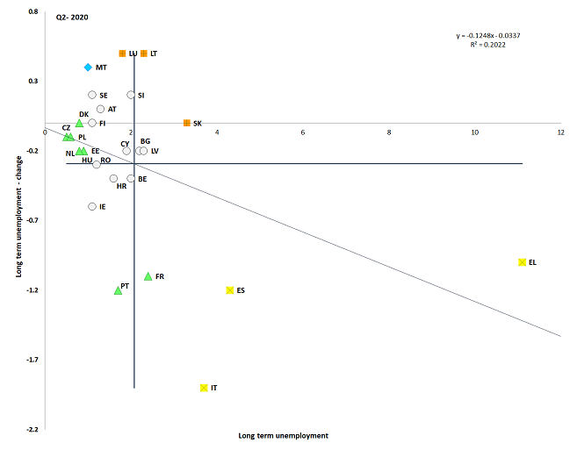

Source: Eurostat, LFS. Period: 2020 levels and quarterly changes with respect to 2019. Note: Axes are centred on the unweighted EU average. The legend is presented in the Annex.

**Member States entered the crisis with different rates of participation in active labour market policies**. There are high disparities in terms of participation in activation measures, including in relation to the share of long-term unemployed in the countries (see Figure 52).[159] Since 2014, several Member States (such as Lithuania, Slovenia, Malta, Slovakia, Italy and Poland) have recorded participation rates below 30%, albeit with positive developments in recent years. For several countries, including Greece, Romania, Cyprus, Latvia, Bulgaria and Croatia, both investments in and participation to active labour market policies (ALMPs) remain low compared to the average (at or below 10% in terms of participation and below 0.2% of GDP in terms of expenditure). In Member States with low participation rates prior to the health crisis, additional and more targeted investments in ALMPs could bring everyone closer to the labour market and ensure a recovery that is inclusive.

Figure 52: Strong differences exist in terms of participation in ALMPs

Participation in active labour market policies (per 100 persons wanting to work)



Source: Eurostat, LMP database.

Note: For BG and EL, data for 2017 instead of 2018.

**By strengthening the links between active labour market policies (ALMPs) and skills provision, Member States can make labour market reforms more effective and promote an inclusive and sustainable recovery.** Ensuring sustainable job creation that is of high-quality requires a successful provision of targeted and adaptable ALMPs, with particular focus on investments in reskilling and upskilling for all ages. This will support a more inclusive recovery, in particular for those in vulnerable situations. The European Structural and Investment Funds (ESIF) have been playing an important role in promoting partnerships involving a wide range of actors and more exchanges of information and best practices regarding ALMPs. Member States will now be able to use various instruments, including the new Recovery and Resilience Facility,[160] to promote skills development at all levels, notably under the flagship initiative ‘Reskill and Upskill’. Strong coordination and a clear definition of the envisaged objectives, the reforms, investments and measures to reach these, and the various funding contributions will be key for an effective delivery.[161]

Figure 53: Spending on labour market services and measures differs significantly between Member States, often with no direct link with unemployment levels

Spending on labour market services and measures (2018) and share of long-term unemployed (2019)



Source: LMP database and LFS.

Figure 54: Spending on labour market services and measures has changed significantly over time in many Member States

Spending on active labour market policies in pps per person wanting to work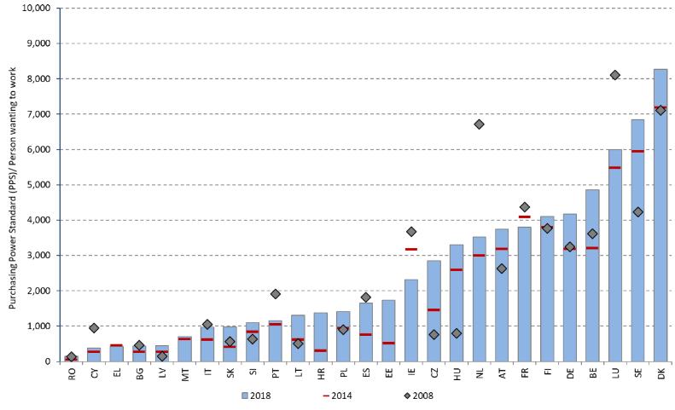

Source: LMP database. Note: For BG, DK and IT, the expenditure on ALMP refers to 2017.

**Public Employment Services (PES) are playing an important role in containing the impact of the crisis and supporting people facing barriers to employment.** Figure 55 shows the share of unemployed people using PES for job search. There are significant differences between Member States in 2019, with figures ranging from 30% in Italy, Spain, the Netherlands and Romania, to 75% in Lithuania, Greece, Czechia, Austria, Slovakia, Slovenia and Germany. On average in the EU-27, the use of PES by the unemployed has been on a decreasing trend, dropping from 50.8% in 2013 to 44.2% in 2019, although some Member States record notable increases in this period (Greece by 10.7pps; Estonia by 8.4 pps; Cyprus by 5 pps; Denmark by 3.3pps). Young people, the low-skilled and older job-seekers continue to be overrepresented among those seeking assistance from the PES, and are likely to continue being so under the effects of the crisis.

Figure 55: The use of PES in the Member States has varied over time

Share of unemployed people using public employment services for job search, figures for 2013, 2017 and 2019



Source: Eurostat, LFS.

**Public Employment Services are going beyond traditional ways of working to tackle a surge in the number of job-seekers and to support them in their transitions across occupations or sectors**.[162] [163] The need to provide support in an increasingly remote context calls for further investments in up-to-date technology and online platforms, coupled with the development of ICT skills for the staff. Also, ensuring an adequate and effective response to jobseekers’ and employers’ needs may require scaling up capacity in certain services to make them more individualised and effective. Together with job-search assistance and counselling, enhanced profiling tools for job-seekers could support job placements by better targeting services to specific groups and individual needs.

**Job search behaviour differs across Member States.** On average in the EU-27, 68.1% of the respondents claim to use social connections (e.g. friends, relatives and trade unions) in their job search, followed by direct applications to employers (56.6%), assistance from public employment services (44.2%) and contact with private employment offices (21%) (see Figure 56). At the national level, there are no clear substitution patterns between job-search methods. However, Member States where the use of public employment services (PES) is low tend to also show higher use of informal methods such as social connections or direct applications to employers. On average, 21% of job-seekers contact private employment agencies to look for a job, with shares across Member States ranging from 2.3% to 42.2%. All things equal, the effectiveness of the assistance provided to job-seekers by the PES has traditionally been measured taking into account factors such as capacity (in terms of expenditure and of staff), degree of digital and technological integration, and level and extent of partnerships. These same factors are now instrumental in supporting the rapid adaptation of PES to cope with the disruptions associated with the pandemic and the need for enhanced matching services (ILO, 2020[164]).

Figure 56: The use of PES in job searches varies widely between Member States

Share of unemployed people using selected job search methods (2019)



Source: Eurostat, LFS.

**Benefit duration, level and eligibility are features of unemployment benefit schemes that are key to mitigate the socio-economic impact of the crisis.** The provision of adequate unemployment benefits of reasonable duration, accessible to all workers and accompanied by effective active labour market measures is key to support jobseekers during transitions. In the current context, individuals with short or less continuous work histories require particular attention, as they are often less covered by unemployment benefit schemes. Several Member States have reinforced these schemes in the current crisis. The comparative analysis presented in the Joint Employment Report is based on the benchmarking framework of unemployment benefits and ALMPs agreed by the Employment Committee (EMCO). This analysis remains overall valid. This section provides an update of the exercise, notably on policy lever indicators.[165]

**On average, before the COVID-19 crisis, around one third of the short-term unemployed were covered by unemployment benefits in the EU.** The share of short-term unemployed (i.e. those who have been unemployed for less than 12 months) receiving unemployment benefits has remained stable in recent years, with little variation in the ranking of countries (see Figure 56). The highest coverage rates (over 50%) are shown by Germany, Austria and Finland, followed by Belgium, Denmark and France. On the opposite end, the lowest coverage can be observed in Poland (12%), followed by Italy and Croatia, with around 20%. These cross-country differences can be explained by differences in the design of the unemployment benefit schemes, notably on eligibility conditions, maximum duration, strictness of job-search requirements and overlaps with other social protection schemes.

Figure 57: The share of short-term unemployed covered by unemployment benefits differs significantly across Member States

Coverage of unemployment benefits for the short-term unemployed (15-64)



Source: Eurostat, LFS. Note: data not available for IE and NL. Data for BG and RO refers to 2018.

**In all but one Member State, one year of employment is sufficient to qualify for unemployment insurance benefits, but this corresponds to very different entitlement periods.** A key parameter to determine eligibility is the required minimum contribution period for workers to be entitled to unemployment benefits. In about half of the Member States, a one-year employment record is needed to qualify for benefits (Figure 58). Only in Slovakia, the requirement is higher (two years of employment over the previous three years). In the remaining countries, the minimum required period is either of six or nine months. It is lowest in Italy, where 13 weeks of work insurance are sufficient to qualify for benefits. To such a short insurance record, however, corresponds an entitlement of 6.5 weeks (since the duration of benefits corresponds to 50% of the insurance record, capped at two years). Shorter entitlement periods allow easier access to unemployment benefits for workers with short or discontinuous careers, although they might in turn promote unnecessary turnover of workers (i.e. churning). As shown in Figure 59, workers being dismissed after one year of employment are entitled to benefits for very different durations, depending on the country. In a majority of Member States, benefits can be claimed for at most six months. In Greece and Luxembourg the duration is exactly 12 months, while in Belgium, Denmark and France it is more than one year. Beside Slovakia (where a person with an employment record of one year is not entitled to benefits), the shortest duration (of just five weeks) is found in Hungary.

Figure 58: In about half of the Member States the contribution period to qualify for unemployment benefits is one year (52 weeks)

Length of the required qualifying period, 2020 (in weeks)



Source: MISSOC (Mutual Information System on Social Protection) database, January 2015 and January 2020. Note: In MT, the minimum qualifying criteria are 50 weeks of paid contributions of which at least 20 paid or credited in the previous 2 calendar years; in Ireland, at least 104 weekly contributions must have been paid since the person first started work.

**The adequacy of unemployment benefits varies significantly across Member States.** Net replacement rates at the beginning of the unemployment spell [166] for low-wage individuals (i.e. with previous earnings at 67% of the average wage), who are generally among the main beneficiaries of unemployment benefits, range from below 20% in Hungary to 90% in Belgium, with most countries ranging between 60% and 80% (see Figure 60). Income support received (during different unemployment spells) generally decreases over time due to the reduction in benefit generosity over time or the transition from unemployment insurance to unemployment assistance schemes. For this reason, net replacement rates are generally higher at the 2nd month of unemployment compared to the 12th month.[167] Five Member States (Cyprus, the Netherlands, Italy, Portugal and Bulgaria) show the largest differences between the net replacement rates at the 2nd and the 12th month.

Figure 59: The duration of unemployment benefits (for a worker with a contribution record of one year) varies significantly across the EU

Maximum duration of benefits in number of weeks with a one-year work record, 2015 and 2020



Source: MISSOC database, January 2015 and January 2020. Note: In BE, there is no limit on the duration of benefits. In CY, weeks are calculated on the basis of 6 working days per week. In IE, benefit is paid for 39 weeks (234 days) only for people with 260 or more weekly PRSI contributions paid. In SK, a person with a one-year record cannot qualify for unemployment benefits (at least 2 years of unemployment insurance contributions during the last 4 years are required. In PL, duration varies depending on the level of the unemployment rate of the region relative to the national average.

Figure 60: Large disparities in terms of benefit levels emerge across the EU

Net replacement rate at 67% of the average wage, at the 2nd and 12th month of unemployment (2019)



Source: European Commission based on OECD Tax-Benefit Model.

Note: The indicator is calculated for the case of a single person without children with a short work history (1 year) and aged 20. Different income componnts, unemployment benefits and other benefits (such as social assistance and housing benefits) are included.

**Prior to the pandemic, intra-EU mobility continued on an upward trend.** In 2019, 7.3 million EU citizens (excluding the UK) aged 20-64 were active in a different Member State than their country of citizenship. In addition to these, there were around 7 million people in the EU-27 who had moved to another country without being active (e.g. inactive family members, students and pensioners). About 1.9 million (with EFTA countries) were crossing borders to go to work and around 3 million postings of workers were registered in 2019. 17 million non-EU nationals who had taken their residence in the EU complemented this intra-EU mobility. All these together accounted for about 10% of the EU population. With the outbreak of the COVID-19 pandemic, a number of issues have emerged linked to the exercise of the free movement of workers. Cross-border workers and short-term mobile workers such as seasonal workers and posted workers have been among the most affected. The European Commission has provided guidance and practical advice to ensure that mobile workers within the EU, and in particular those in critical occupations, could reach their workplace.[168] Member States should exchange information to and establish specific procedures for ensuring a smooth passage of short-term mobile workers (e.g. seasonal workers), in order to better respond to labour shortages and needs arising from the crisis. Furthermore, information provision in the areas of labour law and social security to cross-border workers and short-term mobile workers should be improved; in addition, legal and administrative obstacles should be reduced by Member States and regional authorities.

**A significant share of learners in the EU is mobile.** Borderless learning contributes to the personal and educational development of both individual learners and the educational contexts in which learning takes place. In 2018, 13.5% of higher education graduates in the EU were mobile (i.e. they studied abroad, partly or entirely). Cyprus, Germany, Finland, Luxembourg and the Netherlands have the highest shares of outward mobility of tertiary graduates in the EU. In 2018, the highest shares of inward mobile graduates were recorded in Luxembourg (24.2%), the Netherlands (18.8%), Austria (16.0%) and Denmark (15.1%).

**Social dialogue is a key feature of industrial relations and an important element to foster the recovery and social resilience.** It comprises all negotiations and consultations between employers’ and workers’ associations and representatives of the government, supporting safe working environments, fair working conditions and resilient labour markets. Timely and effective social dialogue is central to build national ownership of reforms and ensure their lasting success. Both the Employment Guideline 7 and the European Pillar of Social Rights highlight the importance of ensuring sufficient involvement of social partners in the design and implementation of relevant reforms and policies.

**In line with national practices, Member States can further support social dialogue through an increased operational capacity of the social partners.** As indicated in the last Joint Employment Report, unions’ membership figures have, on average, decreased across Europe in recent years. However, unions’ density is not the only indication of the unions’ capacity to mobilise workers. Aspects such as collective bargaining coverage[169] (i.e. the share of employees covered by collective wage bargaining agreements, excluding sectors or occupations that do not have the right to bargain) and level in the trade union landscape may also play a role. While collective bargaining coverage has decreased over the last decades,[170] it remains a key labour market institution for wage setting at all levels in some Member States. The Commission proposal for adequate minimum wages (2020/0310 (COD)) aims at promoting collective bargaining on wages in all Member States.

Figure 61: Collective bargaining coverage and level differ across Member States

Collective bargaining coverage and level (most updated year available)



Source: Database on Institutional Characteristics of Trade Unions, Wage Setting, State Intervention and Social Pacts (ICTWSS). The source containing more recent data per MS was used. Note: data years: 2018 for AT, DE, FR, IT, LT, NL; 2017 for ES, HR, HU, IE, LU; 2016 for BE, BG, CY,CZ, DK, EL, FI, MT, PT, RO, SE, SI. 2015 for EE, PL. Dominant level of bargaining: 5 = predominantly at central or cross industry level and there are centrally determined binding norms or callings to be respected by agreements negotiated at lower levels; 4 = intermediate or alternating between central and industry bargaining; 3 = predominantly at the sector or industry level; 2 = intermediate or alternating between sector or company bargaining; 1 = predominantly at the local or company level. Data years 2018 except: 2017 for DE, SE, SI, SK.

**Social partners can provide important input to initiatives planned by governments to mitigate a sudden stop in economic activity or accommodate new technological developments.** They play a key role in the governance of the employment relationships and can contribute to support a labour market in transition that is sustainable and fair. Social dialogue has been an important framework for negotiating the immediate socio-economic response to the COVID-19 crisis, including measures to protect the health, incomes and jobs of front-line and essential workers. Social partners can also negotiate fast adaptations to existing agreements, such as the extension of short-time work schemes or the simplification of procedures to promote teleworking and, more broadly, ICT-based mobile work. According to Eurofound,[171] in around 40% of the recorded cases where the government passed legislation or made other non-binding texts in response to the COVID-19 crisis between April and October 2020, social partners were ‘involved’ (i.e. either consulted, had negotiated or ultimately agreed with the measure). Figure 62 shows how this involvement varies by thematic area. Social partners have been mostly involved in actions related to employment protection and retention, which include mainly short-time work schemes and other income protection schemes. They were also involved to a large extent in measures promoting the recovery, including income protection beyond short-time work and support to businesses. The lowest degree of involvement was reported for measures supporting business continuity and preventing social hardship.

Figure 62: The involvement of social partners differs depending on the thematic area

Form of involvement of social partners in the design of policy measures as a response to the crisis



Source: Eurofound (2020), COVID-19 EU Policy Watch database.

**Despite recent progress across the EU, there is still room for greater involvement of the social partners in developing and implementing policies and reforms.** The COVID-19 crisis put the political and legislative decision-making procedures under stress in the majority of Member States. In an unprecedented context, many Member States adopted extraordinary emergency measures or approved fast track legislation procedures which not always included the participation of the social partners. In some Member States, namely Hungary, Poland and Romania, the crisis has aggravated an already limited involvement of social partners prior to the pandemic. The overall progress and the existing challenges were analysed and assessed by the Employment Committee in autumn 2018 and 2019. The 2020 Country-Specific Recommendations highlighted a lack of social partners’ involvement in the three aforementioned Member States. To ensure that the recovery promotes high-quality jobs as well as secure and adaptable working conditions, it is crucial that Member States engage in a broad policy dialogue with social partners, including for the preparation and implementation of their recovery and resilience plans.[172]

**Consultation with civil society organisations can provide valuable insights and support for policy design and implementation.** Civil society organisations (CSOs) have been at the forefront of mitigating the impact of the pandemic in Europe. For instance, they have often acted as a support network for the provision of social and care services in the Member States. As highlighted in the revised Employment Guidelines adopted in October 2020,[173] where relevant and building on existing national practices, Member States should take into account the experience on employment and social issues of relevant civil society organisations. CSOs can play a key role in the prompt and responsible implementation of exceptional measures, reforms and investments to support the recovery and social resilience. Efforts to make the recovery more inclusive and sustainable also depend on the engagement of and cooperation between the national authorities and the CSOs.

### *3.3.2 Measures taken by Member States*

**Recent labour market developments have prompted some Member States to adapt working conditions, with a particular focus on protecting vulnerable workers.** In March 2020, Spain introduced a temporary ban on objective dismissals and the suspension of temporary contracts affected by a short-time work (STW) scheme, so that the employees affected would not see their contracts expire during the work restrictions. Italy adopted a measure to ban the dismissal of workers during a period of 5 months starting on 23 February 2020. Belgium introduced a temporary measure allowing for short consecutive fixed-term contracts in critical sectors for a maximum period of 3 months. Further, to address labour shortages in sectors with a significant share of student work, the Belgian government introduced a temporary derogation of the maximum number of student work hours (475 per year) until the end of 2020. Following the Emergency Act issued in March 2020, Finland extended the period of notice for individual dismissals to all workers in health care and social service sectors, including rescue and emergency services, to respond to the possible labour shortages in critical and life-saving sectors. As part of a broad reform to address structural challenges, in 2019 Portugal adopted measures to ensure temporary workers’ rights to compensation for contract termination and actions targeting the very short-term contracts (e.g. extension of the maximum duration from 15 to 35 days) and intermittent contracts (e.g. reduction from 6 to 5 months of the minimum period). An additional measure, ‘CONVERTE +’ supports the conversion of fixed-term contracts into permanent ones by providing financial assistance to employers (equal to 4 times the net salary of the open-ended contract, up to a limit of EUR 439). A 10% top-up is included if the conversion takes place in economically disadvantaged territories or targets persons in vulnerable situations, including people with disabilities.

**Other Member States are proposing new or amended working time regulations to respond to existing, new and emerging labour market challenges.** In Finland, a temporary derogation was adopted between March and June 2020 to obtain employees’ consent to work overtime, ensure regular rest periods and observe annual leave entitlements for all workers in the health care and social service sectors, including those in emergency response centres. In March 2020, Spain adopted a temporary measure prioritising teleworking arrangements and the right to adapt or reduce working hours following the impact of the pandemic. In April 2020, France adopted a set of amendments to the labour law for civil servants (excluding teachers), with the aim of aligning working arrangements (i.e. working hours, home working, paid leave and rest days) to those set for private sector employees. Hungary adopted a decree to provide more flexibility in terms of working time and organisation. Belgium has temporarily updated its employment protection legislation to increase the number of days of seasonal labour and facilitate the temporary secondment of permanent workers from other companies to employers in sectors considered critical. Finland adopted a new law setting the framework for regulating working hours in all sectors. In force since January 2020, the law includes provisions on working hours banks, which will allow employees to save working hours, earn annual leave entitlements or monetary benefits in exchange for leave. In Portugal, on the contrary, the elimination of the counting of working hours based on individual agreement between the employer and the employee since October 2020 could make the regulation of working hours more stringent.

**Differences exist as regards content and coverage of the national-level regulations related to telework and ICT-based mobile work.** A general approach has been adopted in some Member States by regulating telework, without making a direct link to work-life balance (e.g. Germany). Other countries have regulated telework to promote work-life balance, but without including provisions about the potential negative effects of working flexibly with ICTs (e.g. Lithuania, Malta, Poland, Portugal and Romania). In Spain, a new law was passed in September 2020 to regulate structural teleworking (i.e. when at least 30% of the working time is in remote). The employers are obliged to compensate workers for the costs incurred and to guarantee equal treatment and opportunities for all. A few other Member States have adopted legislation that promotes the use of ICT to support flexible working patters, while setting a clear-cut division between working and non-working time. In other countries, issues related to work-life balance are regulated through collective bargaining at company or sectoral level, building up on existing national practices.

**In the current context, several Member States have updated and strengthened their regulations to ensure adequate occupational health and safety at work**. Together with social partners, in April 2020 Italy adopted a joint protocol defining measures to ensure adequate levels of health protection for all workers. The measure includes a budget of EUR 50 million for the purchase of personal protective equipment and tools. In addition, a tax credit is available for companies to finance up to 60% (or EUR 60 000) of their health and safety measures in 2020. In April, Lithuania updated its law on prevention and control of communicable diseases to extend the scope of the persons insured by the State budget and better cover the risks associated with the pandemic and other serious diseases. In May 2020, Romania adopted guidelines and measures to regulate the return to activity of employers and employees. This is expected to be translated into more specific protocols at sector or firm level to identify and eliminate or control work-related hazards. In June, Estonia amended the Occupational Health and Safety Act to establish fines for those firms failing to meet the occupational health and safety standards, including in terms of work equipment and prevention of risk factors. As part of a broader package, in July 2020 Portugal adopted guidance and temporary measures supporting the acquisition of health control devices for employees.

**The process of modernisation of employment protection legislation continued in various ways in several Member States to combat labour market segmentation.** As part of a broader reform in October 2019, Greece introduced a measure to strengthen the protection of part-time workers, additional requirements on written contracts and regulation of over-time work to prevent the abuse of this type of contract (often considered to mask undeclared full-time work). The ‘ERGANI’ registration system has also been enhanced to cover all forms of non-standard employment. This comes with the introduction of a new digital platform for efficient working time recording. In October 2019, Portugal revised its labour code to set more restrictive conditions for the use of fixed-term contracts, ensure social protection and discourage undeclared work. More specifically, the measures seek to reduce the maximum duration of fixed-term contracts (from 3 to 2 years), restrict fixed-term hiring for permanent posts and renewals of temporary contracts (e.g. maximum limit of 6 renewals). In January 2020, a new measure entered into force in the Netherlands to improve the balance between permanent and fixed-term contracts by making it easier to hire employees on a permanent basis and by reducing the attractiveness of fixed-term hiring. Estonia has increased the strictness of measures for better protecting the rights of posted workers and those with similar conditions providing services through temporary agencies.

**Some Member States followed past efforts to tackle undeclared work and strengthen labour inspectorates with additional measures and resources.** In Greece, a follow-up to the 2017-19 action plan for tackling undeclared work was launched in October 2019. The Greek authorities have also established a new e-registry of firms previously fined for employing undeclared workers and an e-list of compliant firms will follow. Plans are also to define a new code of ethics for the labour inspectorates, to upgrade the existing risk analysis system and to provide enhanced training for labour inspectorates inspired by the EU’s best practices. In Italy, the government increased the resources dedicated to tackle irregular work and exploitation in the agriculture sector with a total of EUR 31 million, partly supported by the Asylum, Migration and Integration Fund. In addition, in May 2020, Italy took steps to regularise the employment status and issue temporary residence permits for foreign citizens. This measure targets specific economic sectors with a strong prevalence of undeclared work, such as agriculture, personal and household services. In Spain, data mining and matching have been used to better detect fraudulent claims linked to employment support schemes. Increasing prevention is another important feature, with countries such as Bulgaria, Portugal and Slovakia, developing new outreach services towards workers and companies in the context of the PAN Europe campaign #EU4FairWork.

**Member States are amending existing frameworks or introducing new ALMP systems to better respond to the new labour market conditions, with particular focus on the long-term unemployed and other vulnerable groups.** With the support of the European Social Fund (ESF), the Bulgarian public employment services (PES) are completing the ‘Job Project’ targeting the long-term unemployed and inactive people, started in 2018. The Belgian region of Wallonia is implementing a new support scheme especially geared to meet job seekers’ needs. The scheme puts a special focus on vulnerable groups (e.g. the low-skilled, long-term unemployed and people with a migrant background). In the Czechia, measures adopted in March 2020 seek to improve the accessibility to the labour office by allowing for an on-line registration to job search assistance and by removing the obligation for job seekers to register at their place of the permanent residence. In Estonia, a new measure adopted in April 2020 has increased the options of the unemployed persons to consult the PES virtually, including through IT tools such as Skype. In France, as part of a broad reform, the tripartite agreement signed between the government, the PES and the National Professional Union for Employment in Industry and Trade ‘UNEDIC’ in December 2019 aims at reinforcing the guidance provided to the registered unemployed and, in particular, to those in vulnerable situations. Germany adopted several measures between March and June to assist vulnerable groups. These groups also benefited from general labour market measures including counselling services and training to better match the labour market needs. Poland introduced in April 2020 a temporary support for unemployed persons or those at risk of losing their job. The scheme co-finances actions to boost the employability of the beneficiaries and fostering their labour market transition, including job-to-job transitions.

**Member States are taking further steps to provide more individualised support and better integrate services for the long-term unemployed.** In the context of a broader reform, France has adopted measures to strengthen the cooperation with employers, better assess the different needs of the public employment services and improve guidance to job-seekers, in particular to those being long-term unemployed. Plans are now to adopt legislative changes to protect employees from risks linked to unemployment through early detection mechanisms. As part of a broad response to the crisis, in June 2020 Greece approved 36 500 places for an 8-month employment contract in the public sector, including 150 hours of training and certification of the skills acquired. Finland is taking measures to provide more individualised and tailor-made assistance to job-seekers and job changers in the PES. Cyprus has introduced various incentives for in-company training for newly recruited LTU. In 2019, 92 previous long-term unemployed people benefitted from this targeted scheme and plans are to reach 300 participants by the end of 2020.

**In the current context, Member States have adopted measures (mostly of temporary nature) to reinforce their unemployment benefit systems.** In March, Denmark extended the duration of unemployment benefits and sick pay until June 2020 and relaxed the access conditions for those already on unemployment and sickness benefits. In June 2020, Estonia adopted measures to increase the unemployment benefits and strengthen its social protection measures. This includes, from September 2020 onwards, an increase in the unemployment insurance benefit (from 50% to 60% of the newly unemployed person’s previous wage), and from January 2021 onwards, an increase in the unemployment allowance (from 35% to 50% of this year's minimum monthly wage, or EUR 292). These measures follow the adoption in December 2019 of the annual increase in the unemployment insurance benefit. The new minimal monthly rate for 2020 increased to EUR 279 (for 31 days), compared to EUR 258 in 2019. In March, Malta adopted a temporary unemployment benefit (amounting to EUR 800) for all persons who lost their job due to the health crisis. As part of a broader reform, in April 2020 Sweden adopted a number of measures to temporarily reinforce its unemployment benefit system, including a relaxation of the requirements concerning access and amounts (i.e. increase in the minimum amounts) of the unemployment insurance fund. As of October 2020, Bulgaria has increased by 30% the minimum daily benefit and has extended its duration from 4 to 7 months. Luxembourg approved an automatic extension of the unemployment benefits for the duration of the state of crisis, supporting recipients whose benefits were expiring during the health crisis. As a response to the COVID-19 outbreak, Greece and France extended the eligibility period of the unemployment benefits. Slovakia did the same for those recipients whose support period was ending during the health crisis. In July 2020, Portugal extended the unemployment social benefit until the end of the year. In consultation with the social partners, Cyprus adopted in April a special temporary scheme to support unemployed persons who had exhausted the regular unemployment benefits. It is set at EUR 360-500 per month and it will remain valid until October 2020. In April, Latvia introduced an unemployment assistance benefit (set at EUR 180 per month) for a period of 4 months for those who exhausted their unemployment benefits. It will remain in force until the end of 2020. In March, France introduced emergency income replacement measures to support job-seekers reaching the end of their entitlement. Italy set aside in March some EUR 10 billion to strengthen its social safety net system (‘Cassa Integrazione’) and support employment and income levels of those most affected by the crisis. In case the unemployed person is not eligible for the social allowance mentioned previously (amounting EUR 600 per month), they will benefit from an automatic extension of the unemployment benefits (if terminating before 1st May 2020) for a period up to 2 months. In coordination with social partners, Finland introduced temporary amendments to the ‘Unemployment Security Act’ in April 2020 to shorten the work requirement period for eligibility to earnings-related unemployment allowance (EUR 65 per work day), rather than the basic unemployment allowance (EUR 34 per workday). Further temporary derogations aim to provide broader temporary support for acceptance of work, in particular for workers in the agriculture and forestry sector.

**Some of the measures adopted to reinforce the unemployment benefit systems are designed to improve the specific situation of certain groups.** In March 2020, Belgium extended the duration of the unemployment allowance for job-seeking school leavers by three months. This temporary measure was followed by a temporary freeze of the degressivity of the unemployment benefits (i.e. gradual decline in the amount of benefits) starting in April 2020 and valid for the duration of the crisis. France has extended the eligibility period of the unemployment benefits and associated rights to new categories of workers (seasonal employees and employees employed by a self-employed, among others). As part of a broad reform, the ‘partial unemployment’ scheme has also been modified in France to adapt for the negative consequences of the pandemic on specific groups (e.g. childcare workers, home workers, temporary and intermittent workers, freelancers and seasonal workers) and certain sectors. In April, Latvia has extended the unemployment benefit coverage to the self-employed and owners of micro-enterprises affected by the pandemic until the end of 2020. In March, Spain adopted extraordinary measures to ensure temporary income support for specific groups affected by the pandemic. In particular, the measures target temporary workers or those working in the domestic sector whose job has been totally or partially interrupted (including job termination) and lack access to regular unemployment benefits. Finland has also adopted a targeted measure to ensure that unemployment benefits are paid without decision, as an advance payment, for a period of six months instead of the normal period of two months.

**In recent years, Member States reviewed the qualifying periods for unemployment benefits to find the right balance between activation and conditionality.** In Lithuania, the required period to qualify for unemployment benefits was reduced from 18 to 12 months in 2017, while it increased from 9 to 12 months in Bulgaria and Latvia since 2018 and 2020, respectively. As of 2020, Latvia has also reduced the amounts and the duration of the unemployment benefits from 9 to 8 months In Austria, an insurance record of 52 weeks (within the last 24 months) is required for first-time applications, but this is reduced to 28 weeks for subsequent applications, and to 26 weeks (within the last 12 months) for workers under the age of 25. Finally, in the context of a broad reform of its unemployment benefit system, France increased the minimum required length of employment from 4 to 6 months as of November 2019, increasing at the same time the entitlement duration.

**In many Member States, social partners provided their most important contribution to policy-makers in the realm of employment protection and retention.** [174] The involvement of social partners following the outbreak of the pandemic has been the strongest in those Member States with well-developed social dialogue structures. In March 2020, the Danish government and the social partners reached a tripartite agreement to support job retention. Similar agreements for protecting employment and supporting incomes were reached in Austria, together with the implementation of teleworking measures following the health-related restrictions. In Spain, tripartite agreements have led to the extension of job retention schemes at least until January 2021, and to the approval of a new law on teleworking. In Germany, several sectors, such as the chemical and the public sector, reached bipartite agreements for employment and income protection. In France and Italy, the social partners developed safety protocols to ensure the health and safety of all employees at the workplace. In Cyprus, a new pilot-type consultation was introduced in 2020 to improve the effectiveness of the process and facilitate the provision of input at the initial stage of the National Reform Programme (NRP) preparation. In Lithuania, a new bipartite body was created to foster social partners’ capacity building and to improve their involvement in the European Semester. It is also worth mentioning the valuable input provided by the social partners to recent EU initiatives such as, for instance, the new Skills Agenda and the Minimum Wage initiative.[175]

**Support to social partners’ engagement has evolved in a number of ways in Member States.** In France, the legal requirement to set up a Social and Economic Committee in every firm above eleven employees is in force since January 2020. The measure aims at replacing the three pre-existing bodies for social dialogue and decentralising the negotiation at firm level. In Portugal, a measure sets certain requests prior to the termination of collective agreements, including motivation and reasons behind. Any of the parties involved can request arbitration from the Employment Tribunal. In June 2020, Estonia modified the Trade Union Act to introduce fines in case of actions hindering participation in trade union’s related activities. In Spain, the national government, trade unions’ and employers’ associations signed an agreement in July 2020 to relaunch the tripartite roundtables negotiating key employment and social reforms. The work on these roundtables has been on hold since March 2019. In Poland, new provisions adopted in March 2020 empowered the government to dismiss members of the Social Dialogue Council under certain circumstances. This implies a potential weakening of the autonomy of social partners and a departure from Principle 8 of the European Pillar of Social Rights.

**The reactions to the health emergency have shown the potential for closer cooperation between national authorities and social partners in developing and implementing policies and reforms.** In a survey run by Eurofound,[176] social partners assessed the quality of the national procedures and governance structures in place to discuss the National Reform Programme (NRP) as similar to those in place in previous years. Findings show specific procedures aiming to discuss the NRPs were only modified in some countries (e.g. Belgium). However, they also suggest that the involvement of the social partners in 2020 has been overall below usual quality standards, noticeably due to the limited consultations and exchanges in a number of Member States. The same findings show that social partners are overall satisfied with the policy content of the NRPs, even in Member States where their involvement in the European Semester process is not fully institutionalised. Only in a few countries, trade unions reported a rather negative assessment of the content in these documents. Overall, this positive feedback could be partly explained by the fact that social partners in some Member States have been involved in the design of some of the key policy responses at national level.

## **3.4 Guideline 8: Promoting equal opportunities for all, fostering social inclusion and fighting poverty**

This section looks at the implementation of the employment guideline no. 8, which recommends Member States to promote equal opportunities, fight poverty and social exclusion. Section 3.4.2 reports on policy measures from Member States in the areas of social protection systems, including minimum income schemes, family benefits, housing policies, pensions, long-term care, healthcare and inclusion of people with disabilities.

### *3.4.1 Key indicators*

**The positive dynamics of the economy seen in earlier years was steady before the burst of the COVID-19 crisis, with aggregate household incomes (GDHI) on the rise in all EU-27 Member States.** Households’ income grew everywhere in Europe in 2019, buoyed by higher income from work and in line with the general progress of the gross disposable income per capita. Nonetheless, the range of real GDHI growth rate was wide across Member States. Most Central and Eastern European countries continued the convergence process, showing GDHI increases higher than average. On the other hand, in countries where households’ incomes had declined the most since the 2008 crisis, growth continued to be subdued. GDHI per capita in five Member States (Cyprus, Italy, Spain, Austria and Greece[177]) was still below the levels reached before the 2008-2009 recession.

**Figure 63: Real household incomes were still on the rise before the COVID-19 crisis, but growth rates vary widely across Member States**

Real GDHI per capita, index 2008 = 100 and yearly change (Social Scoreboard headline indicator)

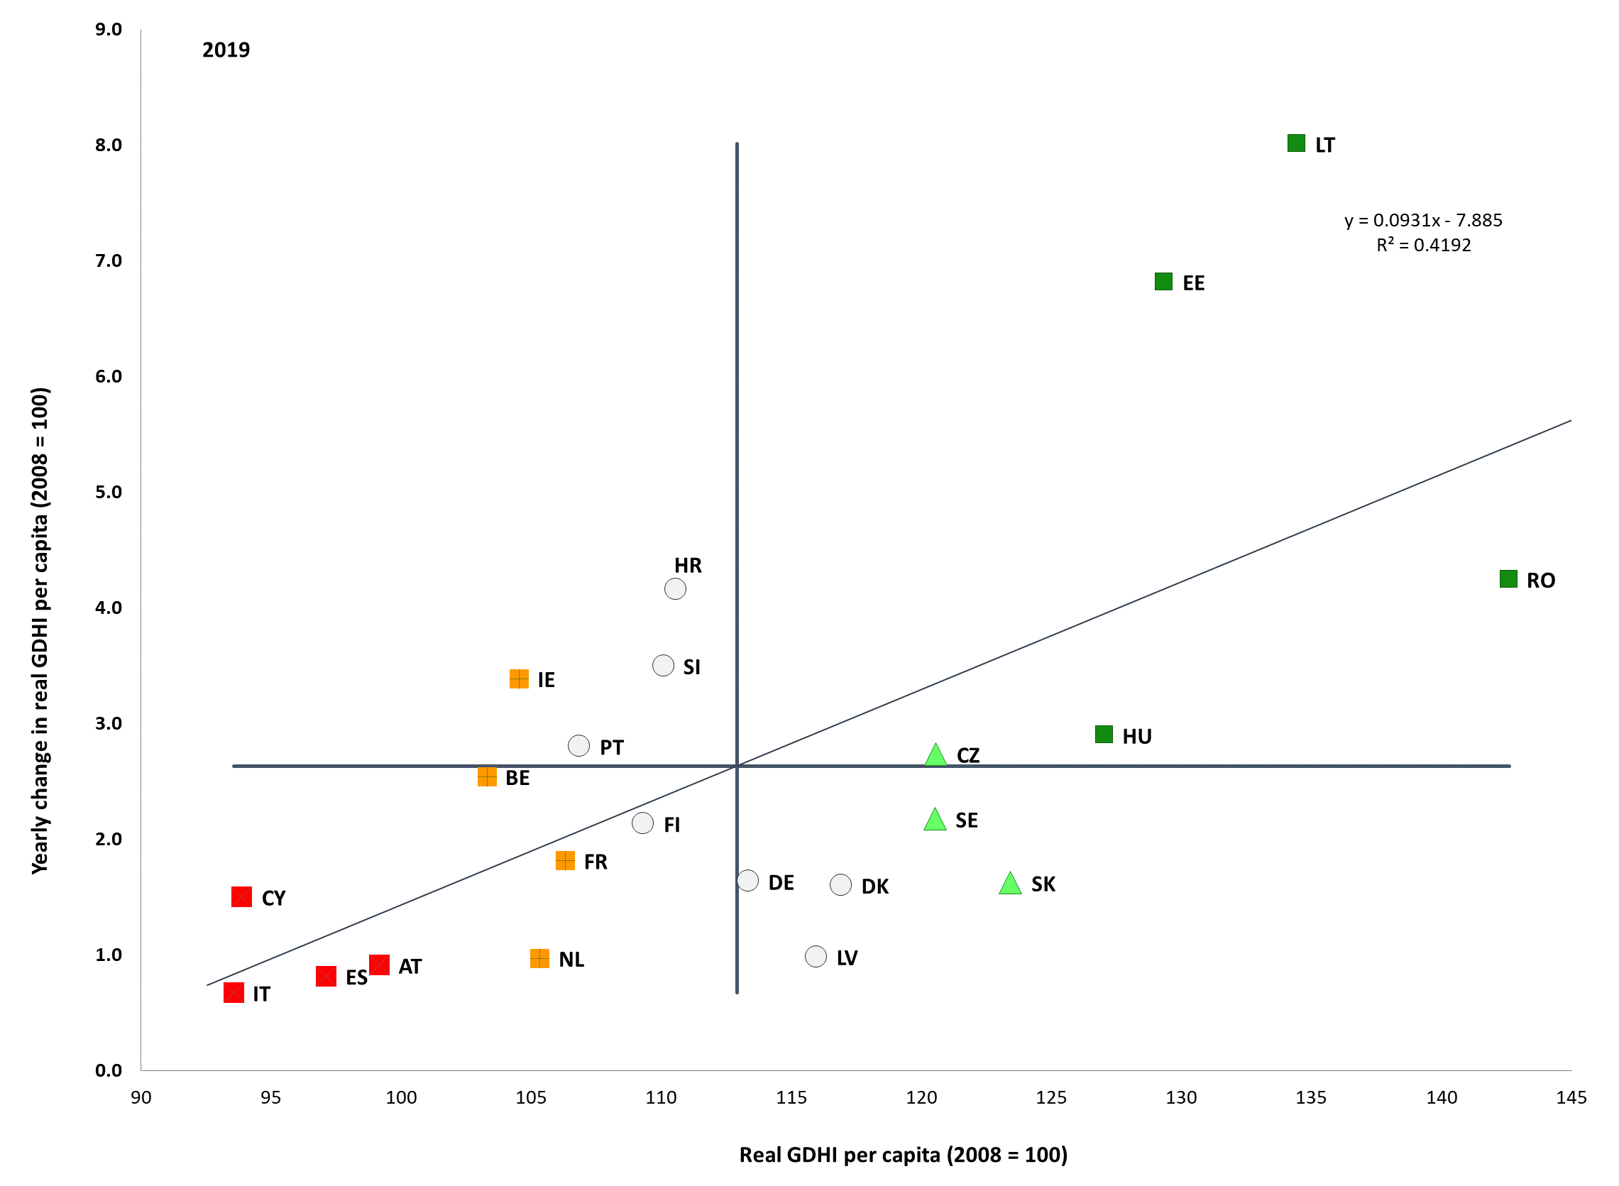

Source: Eurostat, National Accounts [nasq_10_nf_tr and namq_10_gdp], own calculations. Real GDHI per capita index 2008=100’Period: 2019 levels and yearly changes with respect to 2018. Note: Axes are centred on the unweighted EU average. The legend is presented in the Annex. Data for BG, EL, LU, MT and PL not available on 28 October 2020.

**The share of people at risk of poverty or social exclusion (AROPE) was declining for the seventh year in a row before the COVID-19 crisis hit, but progress was slowing down in countries with higher rates.** In 2019 the share of people at risk of poverty or social exclusion (AROPE) in EU-27 declined by another 0.5 percentage points compared to 2018, down to 21.1% (or 2.3 million people fewer than in 2018). A certain degree of convergence was ongoing across the EU (see Figure 64), though at a slower pace, as the improvement in some countries with the highest levels decelerated compared to the previous year. In particular, in Bulgaria the AROPE rate was only 0.5pps lower than in 2018, compared to much larger reductions in previous years (yielding a cumulative drop of 16.8 pps since the 2012 peak). Similarly, in Romania the AROPE rate decreased by 1.3 pps from 2018 (-12 pps since 2012), in Latvia by 1.1 pps (-8.9 pps since 2012) and in Hungary only by 0.7 pps, versus a decline of 6 pps in 2018. The most noticeable improvements can be observed in Lithuania (-2 pps), Greece (-1.8 pps), Cyprus (-1.6 pps) and Croatia (-1.5 pps). Despite of the improvements, these Member States remain all above the EU average. Among countries below the EU average, Slovenia (-1.8 pps) and Germany (-1.3 pps) improved, while Malta (+1.1 pps) and France (+0.5 pps) showed some deterioration[178]. A number of Member States present large regional disparities in AROPE rates (Annex 4).

**Figure 64: The share of people at risk of poverty or social exclusion has decreased in most Member States**

Percentage of the population at risk of poverty or social exclusion, 2019 levels and changes from previous year (Social Scoreboard headline indicator)

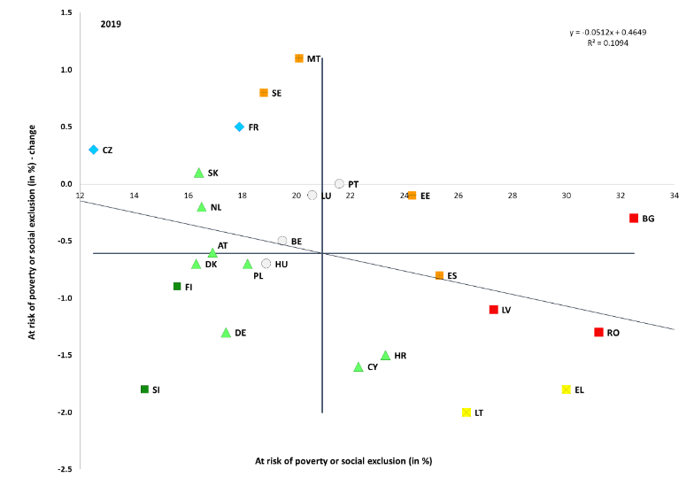

Source: Eurostat, SILC. Period: 2019 levels and yearly changes with respect to 2018. Note: axes are centred on the unweighted EU average. The legend is presented in the Annex. Breaks in series for BE. Data for IE and IT not available on 28 October 2020.

**The share of children at risk of poverty or social exclusion (AROPE) had been falling in the past few years before the COVID-19 crisis**. In 2019, the overall AROPE rate in EU-27 was 22.5% for children, compared to 21.5% for the working age population (18-64) and 18.6% for the elderly (65 years or more). Overall, the highest rates are recorded in Romania (35.8%), Bulgaria (33.9%), Greece (30.5%) and Spain (30.3%). Between 2018 and 2019, the number of children at risk of poverty or social exclusion in the EU-27 decreased by 674 000, i.e. by 3.6%. In relative terms, the reduction was largest in Latvia (15.0%), Croatia (14.7%), and Denmark (14.2%). On the other end of the spectrum, the number of children at risk of poverty or social exclusion increased by 14.5% in Sweden (adding 2.5 pps to the AROPE rate), and by 1.9% in Spain (adding 0.8 pps to the AROPE rate). In the most affluent countries (e.g. Luxembourg, Sweden or Finland), living below the poverty line does not always entail being in a condition of material and social deprivation. On the other hand, many children in poorer countries suffer from material deprivation even if incomes of their families are above the AROP poverty line. Children growing up in poverty or social exclusion are less likely than their better-off peers to do well in school, enjoy good health and realise their full potential later in life. The main driver of child poverty is the labour market position of the parents, which is in turn strongly linked to their level of education, and the composition of the household. In all Member States, the poverty risk for children raised by a single parent or in families with more than 3 children or with a migrant or Roma background is two to three times higher than that of other children. Such disadvantages often go together.

**Non-EU born people face a higher risk of poverty or social exclusion.** In 2019, the AROPE rate of non-EU born people (aged 18 or over) was close to double that of the native born people (39% vs. 19.5%), implying a gap of almost 20 pps. In recent years, this gap has remained stable, fluctuating around 19.5 pps. In some Member States, it is particularly wide: almost 30 pps in Sweden, Belgium and Greece. Non-EU born persons also frequently experience in-work poverty. In 2019, the respective rate stood at 21.2% compared to 7.9% for the native born. At EU level, the gap between the two groups is stable, but remains high for some Member States, in particular for Spain, Luxembourg and Sweden.

**The share of the population at risk of poverty (AROP) remained broadly stable before the COVID-19 crisis.** With 1.4 million fewer people at risk of poverty in the EU-27, this share slightly declined to 16.5% in 2019 (from 16.8% in 2018) – see the top panel of Figure 3. The situation remained significantly worse than average in Romania, Latvia, Bulgaria, Estonia, Spain, Lithuania and Italy[179], all above 20%. The AROP rate declined in Lithuania (‑2.3 pps), Belgium (-1.6 pps), Slovenia (-1.3 pps), Germany (-1.2 pps) and Croatia (-1 pps). Overall, after years of increases and recent improvements, the average AROP rate is stable, back at the level of 2010. However, this overall stability is a result of compound changes that are rather wide-ranging at the level of Member States. One observes significant deterioration in some Member States (by above 2 pps or more in Estonia, Luxembourg, the Netherlands, Sweden and Romania) but also some improvements (by more than 2 pps in Croatia, Greece and Poland). Latest estimates based on Eurostat Flash Estimates indicate that for 2019, most countries will see little change.[180] In particular, one can expect an increase of the AROP rate in Slovenia and Sweden, and a decrease in Cyprus, Germany, Greece, Spain and Romania. At the moment of drafting, Eurostat flash estimates referring to 2020 incomes (thus reflecting the impact of the crisis) are not yet available.

**The COVID-19 crisis is likely to exacerbate existing challenges in poverty.** A recent study by the Joint Research Centre[181] has explored the impact of the pandemic on household incomes and the cushioning effect of fiscal policy measures adopted in response to the crisis. Reflecting the automatic stabilisation effect of social protection and inclusion systems, as well as of additional measures taken, the AROP rate would only increase by 0.1 pps on average in the EU. The anchored AROP rate[182] would increase by 1.7 pps, reflecting the substantial drop in the poverty line due to the COVID-19 crisis. Countries with an increase in poverty rates would include Hungary, Slovakia, Spain, Sweden, Lithuania and Czechia. The increase in poverty would be spread over a similar range as the one experienced between 2008 and 2009, due to the financial crisis.

**Figure 65: The situation continues to improve in particular with respect to severe material deprivation and people living in quasi-jobless households.**

Sub-indicators of the at-risk-of-poverty or social exclusion rate, EU-27

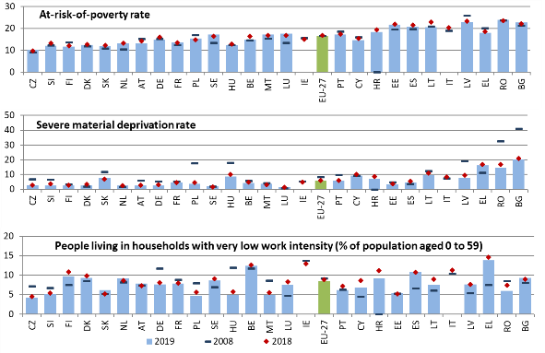

Source: Eurostat, SILC. Note: Indicators are ranked by AROPE in 2019 (2018 for IE and IT). 2019 data not available for IE and IT on 28 October 2020. Due to data availability, the EU aggregate for 2008 includes UK and excludes HR.

**Material deprivation further improved in almost all countries before the pandemic.** In 2019, more than 2.2 million people were relieved of severe material deprivation (SMD) in the EU-27 compared to the previous year, and the share of the population in this condition was 5.6%, half percentage point less than in 2018 – see the middle panel of Figure 65. Material deprivation improvements further drove the improvement of AROPE, especially thanks to decreases in Romania, Poland, Germany and Spain. This results into more than 20 million fewer people in severe material deprivation than in 2012, when the indicator reached its peak. However, the positive trend seems to be weakening in some of the countries with highest rates (Bulgaria, Latvia, Lithuania and Greece). Still, material and social deprivation[183] (i.e. the enhanced indicator where more and socially related items are considered), was quickly declining in these countries, with the exception of Bulgaria where the improvement was modest.

**Positive labour market dynamics were supporting further declines in the share of people living in quasi-jobless households before the COVID-19 crisis.** The share of people living in quasi-jobless households was 8.5% overall in EU-27 countries in 2019, moderately decreasing from the previous year – see the bottom panel of Figure 65. While the overall trend was positive or stable in almost all Member States (with some exception as in Slovakia, the Netherlands and Austria) , this trend is likely to be reversed due to the COVID-19 crisis, reflecting increases in unemployment and declines in the number of hours worked, as highlighted in chapter 3.1.

**In-work poverty remained stable at high levels in 2019 despite a few noticeable reductions.** After its 9.8% peak in 2016 for the EU-27, in-work poverty remained high at 9% (slightly below its 2018 level of 9.3%; see also Chapter 3.1.1). In-work poverty remains particularly high in Romania (15.4%), Spain (12.8%), Italy (12.8%, based on 2018 data) and Luxembourg (12%). Over the last year, improvements can be observed in some Member States (-1.5 pps in Slovenia, -1.1 pps in Bulgaria and Germany, -0.8 pps in Greece). People with part-time work contracts are more exposed to in-work poverty (15.1% overall in EU-27), but in some countries, also people in full-time work face a high related risk. This is the case in particular in Romania at 12.3%, in Spain at 10.7% and in Luxembourg at 10%.

**The depth of poverty remained unchanged in 2019 in spite of the overall improvement in income levels.** The poverty gap shows the distance of the median income of people at risk of poverty from the poverty threshold. This gap was 24.4% in the EU-27 in 2019, almost unchanged compared to 2018. Among countries with the widest poverty gap (above 25% in Romania, Spain, Hungary, Latvia, Bulgaria, Greece, Croatia and Lithuania[184]) the indicator improved only in Romania, Lithuania and Greece in 2019. In Hungary, the poverty gap increased by 4.8 pps. It also increased in countries with lower than average levels (Austria +2.2 pps, Sweden +1.8 pps and Germany +1.2 pps). In many cases, the depth of poverty did not significantly decrease in spite of the overall improvements in the socio-economic situation before the pandemic.

**Figure 66: Relative median at-risk-of-poverty gap from quasi-jobless households**

Relative median at-risk-of-poverty-gap for quasi-jobless households, 2017-2019

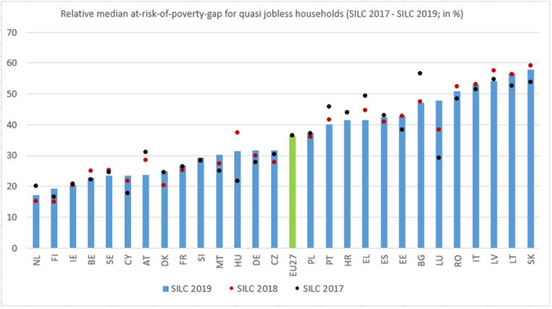

Source: Own computation on Eurostat, SILC microdata.

**Poverty among low work intensity households is deeper than for other groups.** In the EU-27, the poverty gap for the working age population (18-64) living in (quasi-)jobless households[185] remained stable at 36.2% in 2019 (36.5% in 2018). Slovakia, Lithuania, Latvia, Italy and Romania still register the widest poverty gaps, despite some improvements (Figure 66). The indicator is lower than 20% in the Netherlands and Finland. The biggest increase is observed in Luxembourg (+9.4 pps). High rates suggest low adequacy and coverage of benefits, as they do not perform well in filling this gap.

**People with disabilities are significantly more likely to be at risk of poverty or social exclusion than those without disabilities**. In 2019, 28.5% of persons with disabilities in the EU-27 were at risk of poverty or social exclusion, compared to 18.6% of people without disabilities, showing a gap of 9.9 pps. The severity of disability is a very important explanatory factor, with 34.7% of those with a severe disability aged 16 or over being at risk of poverty or social exclusion, compared to 26% of those with a moderate disability.[186]

**Figure 67: Income inequality slightly decreased overall, with moderate increases in some Member States.**

Income quintile share ratio and yearly change (Social Scoreboard headline indicator).

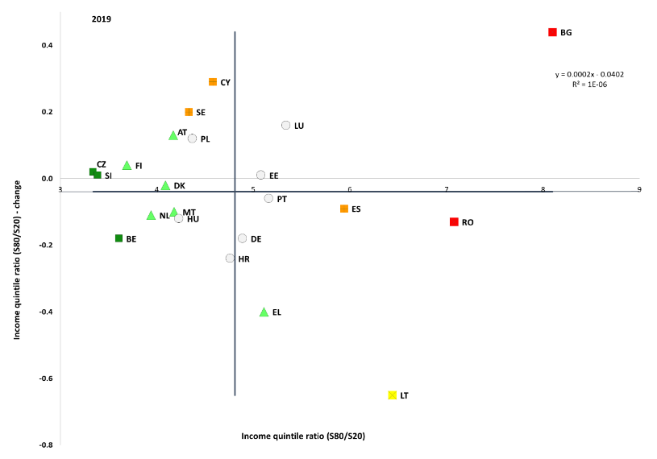

Source: Eurostat, SILC. Period: 2019 levels and yearly changes with respect to 2018. Note: Axes are centred on the unweighted EU average. The legend is presented in the Annex. Breaks in series for BE. Data for IE, FR, IT, LV and SK not available on 28 October 2020.

**While overall income inequality further slightly decreased on average, its dynamics suggest a weakening of convergence across Member States before the COVID-19 crisis.** In 2019 in EU-27 the income share of the top 20% of the income distribution was 5 times the share of the 20% bottom of the income distribution, slightly below the ratio of the previous year (5.05). This indicator of income inequality remained high, well above 7, in particular in Bulgaria and Romania (both ‘critical situations’ according to the social scoreboard methodology – see Figure 67). Improvements were limited, especially among countries with the highest levels of income inequalities. Nonetheless, inequalities decreased significantly in Lithuania (‘weak but improving’) and Greece (‘better than average’ because of the recent improvement). Other reductions can be observed in Germany and Belgium. Overall, there is limited convergence across the countries, excluding Bulgaria being an outlier with a significant increase in the income quintile share ratio (+0.44). According to preliminary estimates by the Joint Research Centre[187], policy measures would be able to broadly counteract the inequality increasing effect of the COVID-19 pandemic in 2020. While the COVID-19 crisis would cause, alone, a substantial rise in inequality (+3.3% in the Gini index), policy measures would reduce inequalities by 1%. By comparison, the 2008/2009 crisis led to a small decrease in income inequality.

**The overall increase in income inequality over the last decade was driven by an increase in inequalities at the lower end of the income distribution.** Inequality over the whole of the income distribution can be decomposed to that in the upper and that in the lower part of it. The income quintile share ratio, S50/S20, measures the relationship between the shares of income at the median and at the bottom 20% of the income distribution. This measure was 2.29 in 2019, stable compared to 2018 (2.3). The recovery allowed a further decrease since the peak of 2016 (2.36), but could not fully offset the overall increase observed since 2010 (from 2.21) – see Figure 68, which explains the overall increase in income inequalities over the decade. In a similar fashion, the S80/S50 measures inequality at the upper part of the income distribution. This indicator actually remained broadly stable and even slightly declined over the decade (from 2.2 to 2.17).

**Figure 68. Over the last decade, inequality increased at the bottom of the income distribution**

Decomposition of income inequality trends over the last decade.

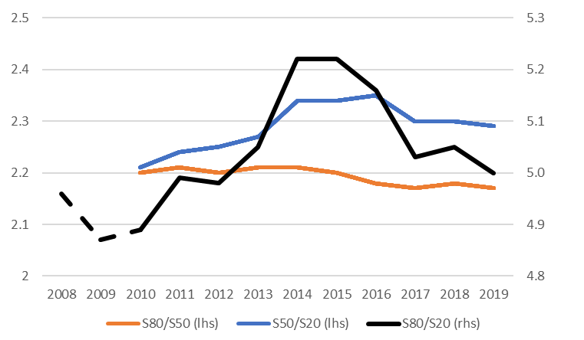

Source: own computation on Eurostat, SILC data.

**The income of the bottom 40% of the population continued to increase slightly more quickly than the average.** The income share of households in the bottom 40% of the income distribution was slowing increasing until 2019, in line with moderate improvements in other income inequality. The EU average reached 21.33% in 2019, compared to 21.19% in 2018 (from a minimum of 20.9% in 2014 and 2015). Households at the bottom 40% of the distribution gained in income share mostly in Germany, Greece, Lithuania and Hungary, while their income share declined in Bulgaria, Luxembourg, Poland and Sweden.

**By 2017 (the year of the latest available data), social protection expenditure in the EU continued to increase in nearly all Member States and went towards old-age pensions and health needs[188].** The increases in social expenditure in the years 2012 to 2017 were mainly due to further increases in spending on old age (driven partly by demographic factors), except for Greece, and on healthcare. By contrast, expenditure on unemployment stabilised after 2010 and has declined since 2014, as the economic environment improved. Expenditure on families, housing and combating social exclusion has increased slightly since 2013.Sickness and disability expenses contributed significantly to the overall expenditure growth in most Member States, except in Greece and Poland where it declined.

**Figure 69: The poverty reducing impact of social benefits is weakening in some Member States.**

Impact of social transfers (other than pensions) on poverty reduction and yearly change (Social Scoreboard headline indicator).

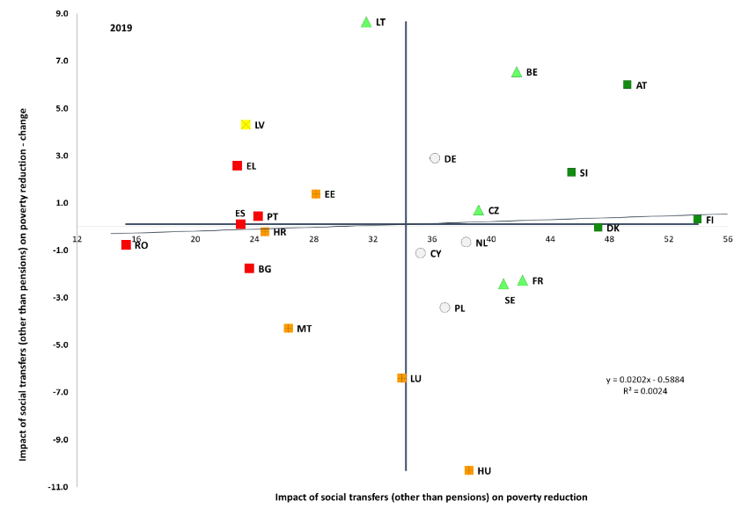

Source: Eurostat, SILC. Period: 2019 levels and yearly changes with respect to 2018. Note: Axes are centred on the unweighted EU average. The legend is presented in the Annex. Breaks in series for BE. Data for IE, IT and SK not available on 28 October 2020.

**While the impact of social transfers (excluding pensions) on poverty is stable, substantial differences between Member States remain in terms of levels and dynamics.** Overall, this indicator remained stable in 2019 for EU-27 compared to the previous year (32.65% vs 32.8% in 2018). However, performance and dynamics vary greatly – see Figure 69. Best performers countries are Finland, Austria, Denmark and Slovenia above 45%, while the worst remain Romania, Greece, Spain, Bulgaria and Portugal with figures below or close to 24%. Lithuania and Latvia, respectively below and close to the EU average, show substantial improvements (+8.7 pps and +4.3 pps), while Luxembourg, Malta and in particular in Hungary significantly drop (by 6.4 pps, 4.3 pps and 10.3 pps respectively). The graph does not show a clear relation between levels and changes.

**The COVID-19 crisis is a powerful reminder of the importance of social protection.** Social insurance mechanisms can help to ‘flatten’ the pandemic curve by allowing workers to stay at home when needed. They can also mitigate the economic and social effects of reduced economic activity, while supporting workers through the green and digital transitions. However, these mechanisms are not always available to non-standard workers and to the self- employed. Also, they may not be sufficient or adequate for pandemic times.

**In spite of government measures adopted to protect jobs (e.g. short-time work schemes), up to the summer of 2020 there were signs of a notable increase in the number of unemployment benefit recipients** (see also chapter 3.3)**.** Among those countries for which recent data are available, the relative rise in unemployment benefit recipients since February 2020 has been especially strong (more than 50%) in Austria, Estonia, Spain, Hungary, Malta and Slovakia.[189] In contrast, there was not much to signal at this stage in terms of changing trends in the number of recipients of social assistance benefits and disability benefits, with generally no immediate, clear signs of a rise in recipient levels based on the available figures.

**The monitoring framework on access to social protection shows that there remain significant gaps in the protection of the self-employed and non-standard workers.** Some groups of self-employed do not have access to sickness benefits in four Member States, to unemployment insurance in eleven, and to insurance against accidents at work and occupational diseases in nine. The monitoring report shows that access to social protection may also be more limited for some forms of non-standard workers. These gaps can concern casual, on-demand work, short-term fixed contracts, seasonal work, apprenticeships or traineeships. Country-specific examples of non-standard forms of work are mini-jobs in Germany, civil law contracts in Poland, agreements to perform a job in Czechia, work agreements with irregular income in Slovakia, domestic workers in Spain, simplified contracts in Hungary. Such contracts can represent a sizeable proportion of the labour market.

**Even though they are formally covered, some non-standard workers and the self-employed may de facto have limited access to social protection.** Limited access means that workers are not able to build up and take up adequate entitlements they can draw on if needed. Barriers include minimum qualifying periods, waiting times and lack of transferability of social protection rights. Social protection rights are not always preserved, accumulated and/or transferred when individuals transition between different labour market statuses. As the world of work changes, this flexibility is becoming more important and a lack of transferability may impede labour market dynamism and matching. A lack of regulation, high cost and different rules governing different schemes can be a barrier to transitions between sectors or employment forms in several Member States. Finally, the lack of transparent information about social security rights stops people from taking informed decisions in many countries.

**Temporary measures do not substitute the need to expand social protection for those who are not covered on a more permanent basis.** Most measures taken at the beginning of the COVID-19 crisis were presented as temporary in nature. In a recovery phase, sustained efforts are needed to maintain and reinforce social protection for all, including the self-employed. Building on the crisis response, protection of the self-employed and non-standard workers should be further improved on a structural basis, in line with the Recommendation on Access to social protection.

**Minimum income schemes’ adequacy has been eroding in almost all Member States when comparing it with poverty thresholds and incomes of low wage earners.** The adequacy of minimum income benefits can be monitored[190], both by comparing the income of beneficiaries with the national poverty threshold and with the income of a low-wage earner[191]. These references provide an indication of the income poverty alleviation impact, as well as the activation dimension and potential disincentive effects of the schemes, respectively. For the latest available income year (2018), the adequacy of minimum income schemes eroded overall in the EU-27, reflecting that the income of minimum income beneficiaries has been lagging behind overall income developments in the economic expansion preceding the COVID-19 crisis. While such erosion on adequacy is general, the decline is more substantial in some countries, when comparing to the income of a low wage earner (Estonia -18.2 pps, Czechia ‑7 pps, Luxembourg -5.8 pps). In only two countries, the minimum income adequacy is close to the poverty threshold (Ireland and the Netherlands), while it remained below one third of the poverty threshold in Romania, Bulgaria, Hungary, Italy[192], Czechia and Slovakia.

**Figure 70: The adequacy of minimum income support in different Member States varies strongly**

Net income of minimum income recipients as% of at-risk-of-poverty threshold (smoothed over three years) and of the income of a low wage earner (income year 2018)

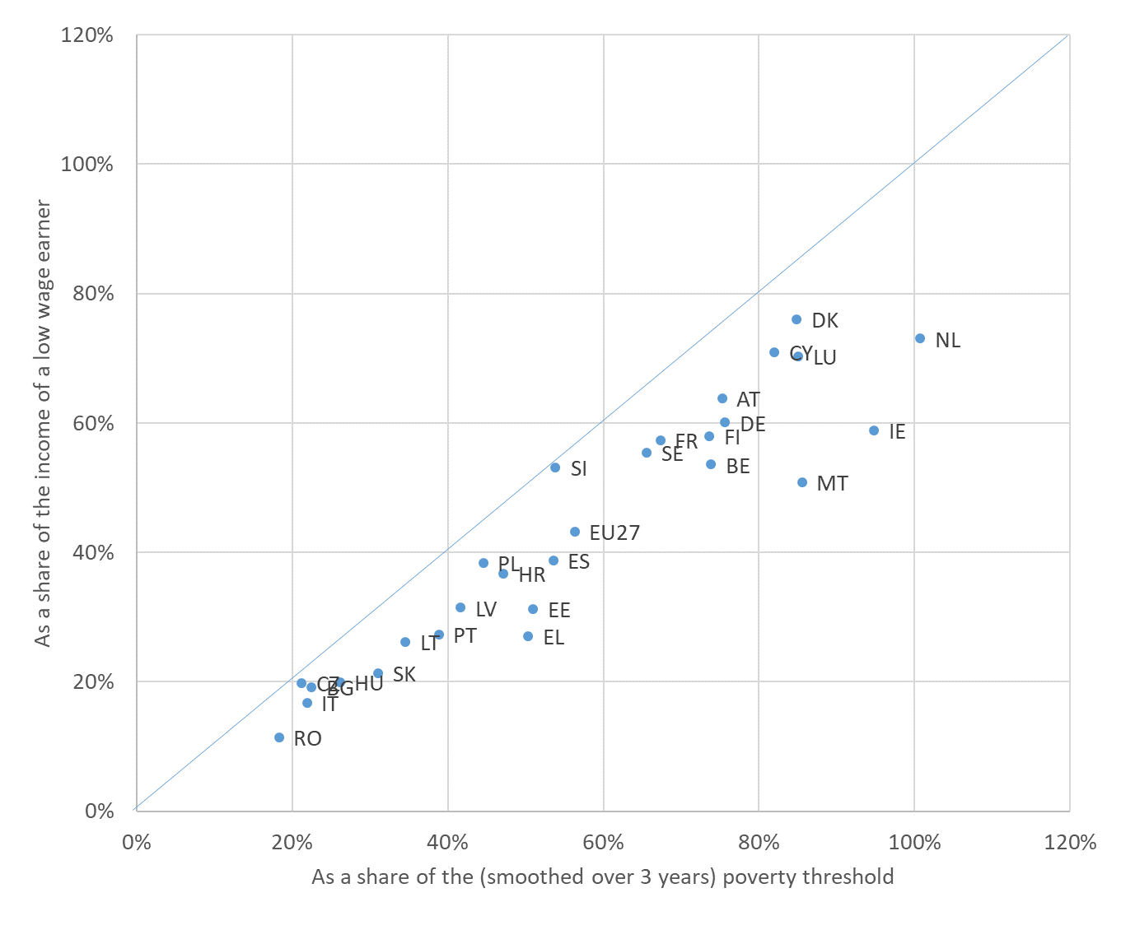

Source: Eurostat, OECD.

Notes: The charts concerns single childless persons. Net income of a minimum income recipient may also include other types of benefits (e.g. housing benefits) than minimum income. The low wage earner considered earns 50% of the average wage and works full time. For some MS (IE, IT and SK), due to SILC 2019 AROP threshold data not being yet available, the AROP threshold used for comparison in the chart is only smoothed over the two latest years for which data is available, instead of being smoothed over the three latest years as done for the other MS.

**Before the burst of the pandemic, the coverage of social benefits for poorer people was broadly stable.** The benefit recipient rate measures the share of working age individuals (aged 18-59) receiving any benefits (other than old age benefits) among the population at-risk-of poverty. This indicator shows a range from 42.1% in Spain to 96.1% in Denmark with an EU-27 average of 63.9%, slightly decreasing (-2 pps) from the previous year.

Error! No sequence specified. **Figure 71: In several Member States a large share of the population at risk of poverty does not receive any benefits**

Benefit recipient rate (share of individuals aged 18-59 receiving any social benefits other than old-age) among the population at-risk-of-poverty, 2018

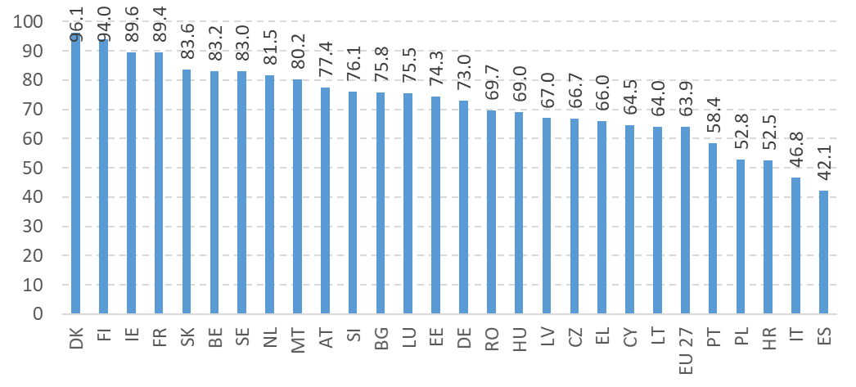

Source: own computation on SILC data from ESTAT.

**The inability to keep one’s home warm has been declining and varies a lot across countries.** This dimension of energy poverty has declined on average between a 11.2% peak in 2012 to 7.3% in 2019. The percentage of the population not able to satisfy heating needs has been falling sharply (by 5 pps or more) in Malta, Bulgaria, Latvia, Lithuania, Hungary, Cyprus, Greece, Poland, Portugal, Italy, and Romania, while increasing by 2.3 pps in Slovakia and 1.8 pps in Luxembourg. In the EU-27, 18.8% of people at risk of poverty were affected (compared to 5% for people living in households with 60% or more of the median equivalised income). Single people aged 65 or above (10.2%), or lone parents (10.5%) were more at risk than the average population. The recently adopted Commission Recommendation on Energy Poverty[193] provides guidance and a further understanding of energy poverty in the EU, together with Member States’ National Energy and Climate Plans – and their assessments by the Commission.

**Pension adequacy has slightly worsened in 2019.** The AROPE rate among those aged 65 and above slightly increased in the EU-27 from 18.7% in 2018 to 18.9 in 2019, although still a good measure down from 2008 (23.3%). Differences between genders persist (16.1% among older men, 21% among older women). The rate varies widely across Member States, from 9.6% in Luxembourg to 47.1% in Bulgaria. The increase in the AROPE rate is mainly due to relative poverty, the poverty threshold having increased in all 27 countries except Sweden. On the contrary, the severe material deprivation rate has continued on its downward path: after having decreased from 7.5% in 2008 to 4.7% in 2018, it was down again to 4.4% in 2019. The aggregate replacement ratio[194] also decreased slightly, from 58% in 2018 to 57% in 2019, indicating a relative deterioration of pension benefits in relation to late work income; it is still higher than in 2008 (52%). The gender difference (with women having a lower replacement ratio on average) decreased from 5 to 4 pps and it had remained substantially constant since 2008, in spite of relative gains in women employment.

**The gender pension gap continues its slow decrease.** The gender pension gap[195] has been decreasing by about 1 pp per year since 2010 and was at 29.1% in 2018 (age group 65-74). Recent figures from 2019 show that the gender pension gap was the highest in Luxembourg, Malta, the Netherlands (above 40%), Austria, Cyprus (just above 35%) while the smallest gaps (below 10%) were registered in Estonia (0.2%), Denmark (6.7%) and Slovenia (9.4%).

**The COVID-19 pandemic further highlighted care needs of elderly people.** Since the COVID-19 outbreak, a fifth of people aged 50 and above who needed care found that it had become more difficult to receive the care they needed[196]; this was either because carers could not reach them, or because they could no longer afford it.

**Overall, housing affordability for European households continued to improve in 2019, although with important disparities across Member States**. In 2019, 9.3% of the EU-27 population lived in households that spent 40% or more of their equivalised disposable income on housing (a measure of housing cost overburden). This rate was highest in Greece (36.2%), followed by Bulgaria and Denmark (more than 15%) and lowest in Finland, Malta and Cyprus (less than 4% of the population). Within the population at risk of poverty, the rate of housing cost overburden was significantly higher (35% in 2019), with important disparities among Member States. In Greece, 88% of the population at risk of poverty was overburdened by housing costs, 74% in Denmark and 48% in Bulgaria and in Germany. At the same time in Lithuania, Latvia, Finland, Estonia, Cyprus and Malta less than 20% of the population at risk of poverty spent 40% or more of the disposable income on housing costs. In general, tenants, either in the private rental market or in the reduced price market, are more affected by housing affordability than owners with a mortgage. The housing cost overburden rate was highest in cities (11.9%) compared to rural areas (6.8%).

**Housing quality has improved over the last decade, but still 4% of the EU-27 population lived in dwellings that were overcrowded or suffered from important quality issues**. Such issues included the lack of a bath or a toilet, a leaking roof in the dwelling, or a dwelling considered to be too dark. Overcrowding or poor quality dwellings affect disproportionately people at-risk-of-poverty and tenants, in particular those in the subsidized rental market. Non-EU born people also faced more difficulties in accessing decent housing with higher rate of overcrowding (27.6% versus 14.2% for natives) and housing cost overburden (19.1% versus 8.8% for natives) in 2019.

**Homelessness has been on the rise in the European Union with numbers increasing consistently in most Member States over the past decade.** Studies estimate that at least 700 000 people are sleeping rough or in emergency or temporary accommodation any given night in the EU, 70% more than a decade ago[197]. In addition, the risk of homelessness is expanding to different groups in society. For example, in Ireland, 1 in 3 homeless people in temporary accommodation last year was a child. In Sweden, between 1993 and 2017, the share of women amongst the homeless population increased from 17% to 38%. In the Netherlands, the number of homeless young people has more than tripled between 2009 and 2018, from 4 000 to 12 600. Also, refugees and asylum seekers are overrepresented among the homeless population. In Germany, families with children account for 27.2% of homeless refugees, compared to 13% of the rest of the homeless population. In the city of Barcelona, 52.3% of homeless people are third country nationals. And in Greece, 51% of the 3 774 unaccompanied minors are homeless. People experiencing homelessness also face health inequalities: high rates of chronic mental and physical health conditions, substance abuse problems and reduced life expectancy.

**The COVID-19 crisis has put Member States’ health systems under unprecedented stress.** In addition to challenging the crisis response capabilities of Member States, it has exacerbated existing structural challenges related to effectiveness, accessibility and resilience of health systems. These relate for instance to insufficient financing for health investments (including for crisis preparedness and response), limited coordination and integration of care, weak primary care, persisting obstacles to access to healthcare and unmet needs for medical care. Such difficulties affected strongly the most vulnerable, notably because of high out-of-pocket payments.

**The share of the population reporting perceived unmet needs for medical care still shows large variation among Member States, both in levels and changes.** Contrary to the previous year, in 2019 a negative correlation appears between level and changes in unmet needs for medical care, meaning that the countries where perceived unmet needs are highest have seen a relatively stronger decrease over the last period (Figure 72). In some Member States, costs and waiting time remain important barriers for the accessibility of healthcare. The proportion of the EU population facing self-reported unmet needs for medical care due to either too high costs, too long waiting times or travelling distance, was stable on average at 1.8% in 2019 (same rate as in 2018). This proportion still exceeded 5% in Estonia and Greece, with Romania and Finland close to this threshold. The most visible increase in 2019 was recorded for Denmark. People with disabilities face higher level of self-reported unmet needs for medical examination and care at 4.2% in 2019, as compared to those without disabilities at 1%. Particularly disadvantaged are those with severe disabilities (5.6%).[198]

**In some countries the income level or activity status play an important role in explaining problematic access to medical care.** Although the majority of countries do not show significant differences according to activity status (Figure 73), in some of them unemployed people (Estonia and Greece) and retired persons (Estonia, Greece and Romania) have important difficulties in accessing healthcare, with unmet medical needs above 10%. In most EU countries people from the lowest income quintile face higher unmet needs for healthcare (see Figure in the Key Messages). The burden for low-income households is particularly high in Greece (+10 pps compared to the total population) and Latvia (more than 4.5 pps compared to the total population).

**Figure 72: Large variation in self-reported unmet needs for medical care were recorded across Member States before the COVID-19 crisis**

Self-reported unmet needs for medical care (Social Scoreboard headline indicator)

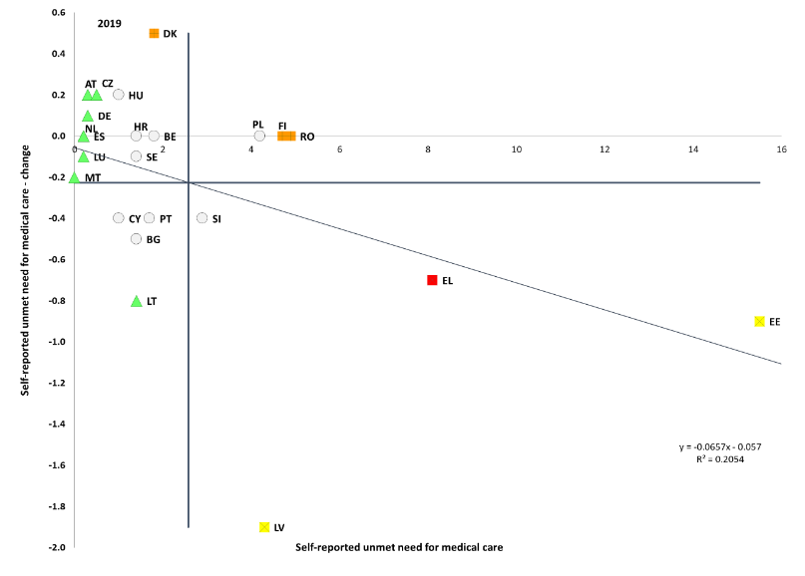

Source: Eurostat, SILC. Period: 2019 levels and yearly changes with respect to 2018. Note: Axes are centred on the unweighted EU average. The legend is presented in the Annex. Data not available for IE, FR, IT and SK on 28 October 2020.

**Figure 73: In some countries, unemployed or retired people report higher unmet needs for medical care**

Self-reported unmet needs for medical examination according to activity status (2019)

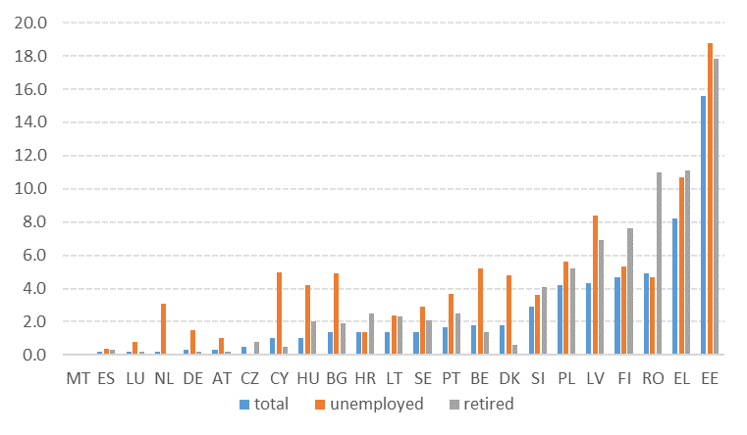

Source: Eurostat [hlth_silc_13]. Data not available for FR, IE, IT and SK.

**When adjusting by age composition, unmet medical needs were more likely among non-EU born (compared to native-born)** **population.** This was evident especially in Estonia and Greece and to smaller extent in Sweden, Italy, Denmark and Latvia.[199] Such a trend may be related to various factors such as lack of access due to residence status or limited health insurance (in some countries), lack of knowledge on how to access services, financial resources, concentration of migrants in disadvantaged areas with lower access to health services, and national systems not adapted to specific needs of migrants.[200] These factors, combined with housing situation and exposure at work, explain why migrants have been more affected by the COVID-19 pandemic.[201] Among migrants residing in the EU, refugees (and asylum seekers) may be particularly at risk.

**The average number of healthy life years that can be expected at the age of 65 has remained stable in 2018).** This is now 9.8 years for men and 10.0 years for women. While the highest number of healthy life years at 65 can be expected in Sweden, Malta, Ireland and Spain (above 12 years for both genders), healthy life expectancy is particularly low in Latvia, Slovakia and Croatia (around 5 years).

**Healthcare is financed through different schemes, while the relative importance of each scheme varies among Member States.** In 2018, out-of-pocket payments, i.e. household expenditure for health (including medical goods) not reimbursed by any scheme or paid as cost-sharing with an organized scheme, was above 30% of current health expenditure in Bulgaria, Greece, Cyprus, Latvia and Lithuania (Figure 74).

**Long-term care (LTC) systems have been strongly affected by the pandemic, due to their users’ high vulnerability to the disease** (due to old age, having comorbidities, or disabilities). Several COVID-related challenges for LTC, ranging from limited availability of data, difficult situations for workers and informal carers, discontinuity of services, capacity issues for testing and personal protective equipment to violations of human rights of older people and persons with disabilities, especially those with intellectual and severe disabilities have come to the fore during the last weeks. Some of them represent new crisis-related challenges (e.g. testing capacity), while in other cases the COVID-19 pandemic has laid bare and exacerbated existing structural challenges (e.g. in relation to access to care and the workforce).

**The need for long-term care (LTC) is growing as the population in the EU ages**. Over the next six decades (by 2070), the number of Europeans aged 80+ is set to double and the old-age dependency ratio (people aged 65+ relative to those aged 15-64) is projected to jump from 29.6% in 2016 to 51.2% in 2070.[202] In the EU there will be only 2 working-age people for every person aged 65+) against 3.3 people in 2016. The risk of becoming dependent is higher towards older age, when people are more likely to become frail (27.3% people aged 65+ and 41.5% aged 75+ report severe difficulties in personal care or household activities).

**Figure 74: In some Member States, out-of-pocket payments represent a large share of total healthcare expenditure**

Healthcare expenditure by financing source, 2018

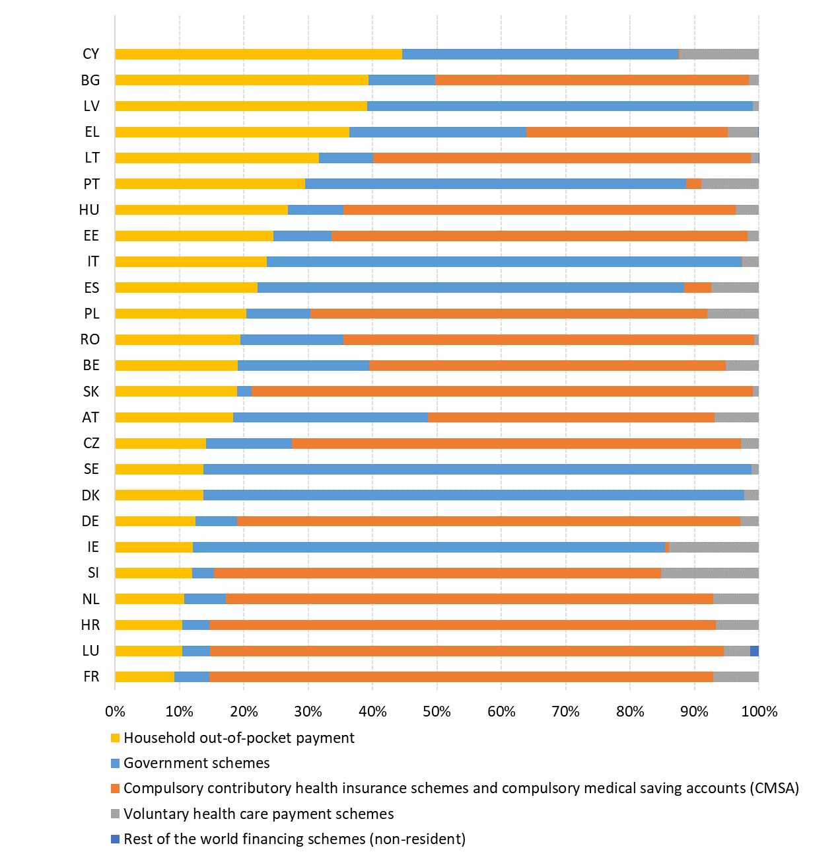

Source: Eurostat [hlth_sha11_hf]. Notes: data are collected according to Commission Regulation (EC) 2015/359 as regards statistics on healthcare expenditure and financing (System of Health Accounts 2011 manual). Data not available for FI and MT.

**A large share of those with needs do not have access to personal care services.** On average in the EU-27 in 2014 (latest available data point)[203], 52% of those with severe difficulties in personal care or household activities lacked help with those activities, 37% had enough assistance and 11% did not need assistance. For many households, it is difficult to access professional homecare services, and the main inhibiting factors for not using home care were financial reasons (35.7%), unavailability (9.7%), refused by person in need (5%) and unsatisfactory quality (2.1%). Across the EU-27, 6.3% of the adult population provided informal care to family or friends.

**A significant rise in long-term care needs is projected.** LTC is the fastest-rising social expenditure compared to health and pensions. The EU public expenditure on LTC is projected to increase from 1.6% to 2.7% of GDP between 2016 and 2070, with marked variations across the EU (see Figure 72).

**The changing role of women in society interacts with the demographic changes and the provision of long-term care in the EU.** Though gender gaps persist (see Chapter 3.2) women are increasingly participating in the labour market – a positive development in a context of ageing societies and a decreasing working-age population. Given their increased mobility and participation in the labour market, women are less able to provide long-term care to someone in their social environment. The need for adequate and affordable long-term care services is thus even more pressing.

### *3.4.2 Measures taken by Member States*

**Member States took emergency measures to respond to the social impacts of the COVID-19 crisis, often in addition to ongoing reforms to improve social protection for people at risk of poverty.** Many Member States introduced measures to support the income of households in very fragile situations. Measures included increasing existing benefits or providing additional in kind services, relaxing eligibility rules and easing administrative burdens, or introducing new temporary benefits. These temporary measures were especially meant to support people not entitled to unemployment benefits and with very low incomes. For example, Italy introduced an ‘emergency income’ (*Reddito di emergenza*) to support low-income families (potentially one million people) not covered by the minimum income scheme or by other measures implemented in the context of the crisis (such as wage supplement schemes or benefits for regulated professions). A lump sum of almost EUR 200 has been paid to families with children under 14 years who were on unpaid leave during the confinement in Bulgaria, where the government continued to grant social assistance benefits by easing requirements linked to regular education attendance. Finland supported the most economically vulnerable families entitled to minimum income, where the limitation measures resulting from the pandemic have entailed additional costs. As for permanent measures, Spain adopted a nationwide minimum income scheme, which sets a minimum floor across the territory, with common rules in terms of eligibility, duration and amount. It is expected to extend the coverage of the existing regional schemes, as well as to reduce regional disparities. The national scheme is compatible with low labour income, although the specific rules concerning this point, as well as other activation measures, are under preparation. Some smaller scale permanent changes were made in other MSs. In Latvia, from 1 January 2021, the guaranteed minimum income level (GMI) will be increased from current 64 EUR to 109 EUR per month per person in a household. In Bulgaria a new ‘Basic Heating Income’ was introduced by widening access criteria and raising the amounts (24.5% increase in the amounts, and 21% more people covered compared to 2018).

**The COVID-19 crisis has put unprecedented pressure on targeted social services.** Many targeted social services were not considered essential and could not continue their operations during the lockdowns. This disproportionately affected people in most vulnerable situations who relied on the continuous provision of these services, in particular homeless people, persons with disabilities, indebted households, children, persons suffering from domestic violence, addiction and households relying on the visits of social workers. The negative effect concerned in particular the services provided by NGOs or social economy enterprises. The provision of services and outreach to beneficiaries was affected by staff shortages, lack of business continuity plans, limited implementation of ICT technologies, communication issues, and difficulties in coordination with other stakeholders, such as public administration, services providers and NGOs. In this difficult context, Member States undertook positive planned and emergency measures. As an example of the latter, in Spain additional resources were transferred from the national budget to social services of regions and municipalities, with the aim of assisting vulnerable people, particularly the elderly and dependent persons. In addition, local governments were authorised to invest the 2019 budget surpluses in addressing the consequences of the pandemic (around EUR 300 million). As for planned measures, Estonia adopted a mentoring programme to support municipalities in their performance of social welfare tasks, support the development of social welfare organisations and improve the quality of welfare measures at the local level. Another measure provided social rehabilitation measures without waiting list in the case of first time psychological disorders to ensure timely and un-interrupted support. Romania updated the standard costs of social services for vulnerable categories of beneficiaries: children, adults with disabilities, dependent elderly people, victims of domestic violence, or social services for aggressors. The increase in expenditure ranges between 44% and 98% by different types of services. Respective actions were also undertook at the local level and include: postponement of payments for certain paid services, staff redeployment, allocation of additional facilities (including for homeless people), launching teleservices and shifting services online.

**Member States have taken measures to support access to essential services and address energy poverty, also in response to the COVID-19 crisis.** Measures to support access for people in need to essential services – such as water, sanitation, energy, transport, digital communications and financial services – vary considerably across Member States. They include general social policy measures targeting low-income or poor households, such as income support to afford services or help them pay their bills, vouchers, credit lines and subsidies, tax exemptions, direct interventions in reducing the price of services and consumer protection measures, such as minimum provision of services and protection from disconnections.[204] Some Member States have been adapting their policy frameworks to broaden support and facilitate access over the past years. For example, in Romania, new cash benefits on the provision of potable water and sewage were introduced for the low-income population. In Italy, from 2021, bonuses for water and energy will be automatically applied to bills, in an attempt to increase take-up rates of benefits. While essential services have been ensured throughout the COVID-19 crisis, vulnerable groups might face increasing challenges to access and afford them. In the emergency packages Member States adopted measures to address this risk. For example, Spain enlarged the pool of customers eligible for the electricity social tariff to some self-employed. Finally, renewed attention has been put on energy poverty thanks to the national energy and climate plans (NECPs)[205] and the Renovation Wave Strategy.[206] The NECPs also address affordability often in the context of the energy and climate transition. This is the case in Austria, Belgium, France, the Netherlands or Denmark.

**The COVID-19 crisis is likely to have an especially heavy impact on low-income families with children.** Under normal circumstances, increasing the labour market participation of parents is one the most efficient way of addressing the root causes of child poverty, with active labour market policies and expansion of affordable high-quality childcare with long working hours as the main intervention measures. However, this has become difficult in the COVID-19 context. Not only new job openings became scarcer in result of the economic downturn, but also many childcare facilities restricted their capacity or working hours – or closed altogether – in order to mitigate the epidemic risk. Only one Member State (Sweden) kept the preschools and schools for children aged up to 15 years open[207], thus providing care and quality education for children and allowing parents to maintain working patterns as close to normal as possible. Member State responses to these key educational challenges are discussed in detail in section 3.2.2.

**Most of the new measures in the area of family policies were part of the reaction to the COVID-19 challenge.** Those usually took the form of additional and temporary financial benefits, targeted on the most vulnerable children and families (Belgium-Flanders, Bulgaria, Latvia, Portugal, Romania), or of extension of eligibility for previously existing benefits (Poland, Slovakia). In addition, Lithuania, Malta, Slovenia and Slovakia permanently raised family benefits, and Poland extended eligibility to the existing child benefit. With a new Family Act, Italy plans to establish a monthly universal allowance for all dependent children, reform various types of family leave, provide incentives for women with care responsibilities to enter the workforce, and develop policies that will support families with educational and school expenses.

**Given that the COVID-19 pandemic is likely to increase inequalities in Europe, both income and educational, corrective actions are necessary.** Among them the Child Guarantee figures prominently, aiming to secure for children in need access to services such as healthcare and education, and including also adequate nutrition (which is key to healthy development), early childhood education and care, extracurricular activities in the areas of culture, sport and leisure (which complement the social integration aspect of education), and to the extent possible – housing. The European Child Guarantee will help mitigate the negative effects of the post-COVID-19 economic crisis: it will work towards closing the gaps at national level in terms of access to services and promote equality of opportunity.

**Whereas Member States expanded the coverage of social protection systems in previous years on a permanent basis, the focus in 2020 was to adopt temporary measures to address emergency situations.** COVID-19 put the spotlight on people who are not or not adequately covered by social protection, such as non-standard workers or the self-employed. During the first months of the crisis (March/April 2020), countries therefore extended and scaled up existing schemes, and loosened their eligibility conditions (for instance, unemployment benefits or sickness benefits schemes). Unemployment benefits were prolonged (e.g. Denmark, Greece, Bulgaria or Luxembourg), increased (Bulgaria) or their degressivity was frozen, like in Belgium. Self-employed received more possibilities to benefit from income support schemes, mostly for a limited period or through one-off payments (e.g. Belgium, Cyprus, Czechia, Portugal). For instance, in Czechia the Government compensated the income loss of the self-employed affected by decreasing sales, by a flat-rate payment amounting to CZK 25 000 (approx. EUR 915), for the period from 12 March to 30 April. Recently, the support has been extended for the whole period of shops/trades closure, the self-employed affected will receive CZK 500 per day (approx. EUR 18). In Cyprus, a subsidization scheme would cover part of the operating expenses of small businesses and self-employed. Sickness benefits were broadened to cover from the second day of illness (Estonia) or (Cyprus) to cover both employees and self-employed with underlying health conditions that need to be absent from work for health safety reasons, and to cases of compulsory absenteeism on the instructions or orders of the authorities (compulsory confinement/quarantine). In Latvia, the State takes over the responsibility for the sickness period previously paid by the employer (from the 2nd day of leave), in cases related to COVID-19 (sickness and mandatory quarantine) until end of 2020.

**The COVID-19 crisis created the need for additional measures to address a disproportionately negative impact on people with disabilities.** Therefore, in addition to planned permanent measures, several Member States took temporary measures to ease the situation of people with disabilities. Both permanent and COVID-19 temporary measures are listed in this section. Belgium put in place an additional income support of EUR 50 per month for 6 months for the beneficiaries of a minimum income, a disability benefit and the income guarantee of pensioners. Because of COVID-19 Estonia extended children’s validity of disability rights until the end of August 2020, with additional funding of EUR 0.34 million. At the same time, it increased the disabled children’s benefits that were last raised in 2006. During the emergency situation (until 18 May 2020), extraordinary allowance payments were provided to the parents of children with special needs, with a budget of EUR 10 million. Estonia has also prolonged the validity of the level of disability of children until reaching working age in case of unchanged or progressive severe or profound disability. Previously, the disability was established for one to three years. France extended certain social rights by three or six months, when these rights would expire between 12 March 2020 and 31 July 2020, including allowance for people with disabilities, allowance for the education of a disabled child, and disability compensation benefit. As for permanent measure, in Bulgaria health and social workers provided the elderly and people with disabilities with patronage care services including home visits, food packages and hot lunch, medicines and essential goods. Latvia planned to increase income support for persons with disabilities and introduce an assistant for persons with disabilities in higher education (prior, only students with visual impairments were entitled to services of assistants). Lithuania is making efforts to close all institutional orphanages until the end of 2020 (see section 3.2). Malta increased disability pensions and Slovakia increased disability benefits. Portugal established the legal statute of the informal caregiver, simplified the process of verification of disability in the status of informal caregivers, and is working on the pilot projects to improve the situation of informal caregivers. Romania updated the cost standards of social services for vulnerable groups, including people with disabilities that has not been updated since 2015 (see also above).

**During the COVID-19 crisis, many Member States undertook emergency measures to protect the housing situation of the most vulnerable**.[208] For instance, emergency accommodation was provided for the homeless during the lockdown, including through hostels and emergency shelters. This was the case for example in France, Spain and main cities in Ireland, Austria. Moratoria on rent payments for tenants severily affected were implemented in Spain, Austria, Germany or Portugal, while Ireland and Luxembourg deployed financial support to tenants unable to honour rent payments as a result of the crisis.[209] In Greece, the government authorised a temporary reduction (of up to 60%) of rent payments for tenants that lost their job during the crisis.[210] Similar measures were taken by local governments and in some cities, such as in Lisbon and Sintra (Portugal), where social housing rents have been suspended for several months.[211] Italy and the Netherlands implemented measures to protect mortgage holders against the risk of losing their homes, such as the suspension of foreclosure procedures during the period of confinement.[212] These measures have been for the most part temporary, however, and are unlikely to match the duration of the effects of the global pandemic on households’ capacity to afford housing costs, especially for those who suffered from loss of employment or income during the crisis. On the supply side, a major housing policy challenge is the decrease in public investment in housing supply over the last decade.[213] Some Member States have taken steps to raise the supply of social housing and support the post-crisis recovery of the construction sector. For instance, Austria, Ireland and the Netherlands have put in place additional funding and/or easing of lending conditions, in order to provide liquidity to developers. In Portugal, tax exemptions were granted over real estate capital gains to incentivise the lettings on the affordable rental market for homeowners operating in the short-term holiday rental market.

**Pensions are the main source of income for one in four Europeans and play a major role in ensuring the resilience of the economy during the COVID-19 economic crisis.** Over the last year, before the outbreak of the COVID-19 crisis, in the context of continued growth in EU employment that reached the highest level ever recorded, Member States continued efforts to safeguard pension adequacy. Several Member States continued efforts to promote longer working lives and later retirement, mainly through incentives and other ‘soft’ measures such as facilitating the combination of pensions and employment (Slovenia), facilitating deferred retirement work beyond pensionable age (Estonia, Sweden) and extending the qualifying period (Denmark, Lithuania). Other countries aimed to strengthen the income maintenance capacity and inclusiveness of pension systems, for instance, by revising the rules of pension accrual (Estonia, Lithuania) or indexation (Croatia), raising tax exemptions (Malta), introducing pension credits for child-care (Slovenia) or strengthening occupational pension saving (the Netherlands, Poland). A number of Member States adopted measures aimed at poverty reduction, mostly by introducing or increasing basic or minimum pension (e.g. Italy, Slovenia, Bulgaria) or adding a small supplement to all pensions during the COVID-19 crisis and proposing provisions for permanent increases (Bulgaria). Some Member States reformed how their pension systems are financed; e.g., Lithuania shifted part of the financing from social security to the general budget and made transfers to the statutory funded pillar voluntary. At the same time, since the beginning of the crisis, most Member States have not introduced substantial crisis-related reforms to their pension systems, while some previously planned reforms have been put on hold (e.g. the comprehensive pension reform in France).

**All Member States have adopted various temporary measures to reinforce their healthcare systems in response to the pandemic and to improve resilience.** The measures include additional funds allocated to cover health care costs incurred due to the coronavirus pandemic (for example for reorganising care provision in hospitals or for critical medical products, such as personal protective equipment, pharmaceuticals or ventilators) and to raise the research and innovation capacity (in particular on vaccines and crisis response measures). Measures also aimed to strengthen health systems by increasing the number of intensive care beds, providing territorial assistance to regions most affected, increasing numbers of health care staff (e.g. by recruiting additional staff, up- or re-skilling staff, deploying medical students or the medical reserve), financing overtime work of healthcare staff working in the containment of the COVID-19, and/or granting a risk incentive bonus for social and community assistance personnel, healthcare and staff providing community care. Member States have increased and improved their testing and laboratory capacity and they are continuously adapting the rules on testing, physical distancing, travelling, personal protection and quarantine to the respective epidemiological situations.

**The crisis uncovered the structural underlying weaknesses of the health systems in many Member States and underlined the need for reform and modernisation.** It has already prompted reforms for improving accessibility of health systems, such as the removal of user charges for primary care in Ireland, covering COVID-19 related care also for the non-insured in Bulgaria, extending coverage for migrants in Portugal or covering for contributions for those out of work to some extent in Hungary, Slovenia, Greece and Croatia. In Germany and France, limitations to the use of teleconsultations were further reduced in the wake of the crisis.

**Member States continue to modernise their health systems, e.g. by increasing access and availability of healthcare services.** Some Member states provide incentives or grants to family doctors or medical students to work in underserved areas (e.g. Estonia, Latvia, France, Germany) or increased the salaries of (certain professions of) healthcare workers (Bulgaria, Estonia, Latvia, Lithuania, Romania). Primary care is being strengthened with the establishment of community health centres, local health care units, or general practitioner group practises (Austria, Czechia, Estonia, Greece, Luxembourg, Romania). Lithuania is reporting progress in shortening waiting lists and reducing co-payment to prescriptions.Cyprus implemented the first phase of out-patient care in 2019, which is expected to reduce significantly out of pocket payments and further increase access to healthcare. The final phase of the general health system reform was launched on 1 June 2020, with the introduction of hospital care coverage as part of the benefits package. Some specialties originally planned to be included in phase 2 (clinical dieticians, occupational therapists, speech therapists, physiotherapists, psychiatrists, dentists, medical rehabilitation and palliative care) have been delayed to the autumn. A number of Member States are planning or implementing improved health workforce planning and/or training (Sweden, Germany, France, Estonia, Spain, Lithuania, Luxembourg, Latvia).

**Efforts to improve the resilience, effectiveness and efficiency of care provision are continuing.** In Finland, the new government relaunched the social and healthcare (SOTE) reform with some modifications, while maintaining the focus on improved access to care. Austria reduced the number of insurance funds from 21 to 5 as of 1 January 2020 for greater efficiency. A new system for performance assessment is being developed in Czechia and Latvia, and Portugal has created a formal structure to evaluate the management of public hospitals. Luxembourg established a national health data observatory to improve the availability and quality of health data. In Greece, a new central purchasing authority for the health sector (EKAPY) will operationalize central procurement. France is continuing with the consolidation of hospital networks for better coordination of inpatient care. Diagnosis-related group (DRG) systems are being implemented in Czechia and Greece, and are planned in Luxembourg. In the area of digital healthcare, Estonia’s e-consultation system allows family doctors to consult specialists digitally about their difficult cases. The country launched in July 2019 a central digital registration system for booking hospital care. Czechia and Poland have fully implemented e-prescriptions, and Lithuania is testing a model for the provision of remote healthcare services. Germany is preparing to have electronic patient records available for all patients as from 2021. Romania is planning to present a new multiannual Health Strategy in 2021. France announced in the summer of 2020 new investments in health and elderly care, including in infrastructure, staff and digital services.

**Due to the impact of the pandemic, many Member States have taken action to protect their long-term care systems** **and recipients, and** **some have improved the situation in the formal and in the informal sector.** Finland has adopted amendments to the Act on Care Services for Older Persons to increase the minimum staffing level and quality of care for 24-hour care and for long-term institutional care for older people gradually, from 0.5 employees per client in October 2020 to 0.7 employees per client by April 2023. Portugal established the legal statute of the informal caregivers. To protect care recipients during the pandemic, several Member States (e.g. Austria, Belgium, France, Germany, Ireland, Italy, Slovenia) have introduced measures to isolate residents from other care recipients within the care home. Such measures include confinement of persons newly arriving in a nursing home for a certain number of days, separation of institutions into COVID-areas and COVID-free areas and isolation of residents in single rooms. Member States (e.g. Belgium (Wallonia), Estonia, France, Ireland, Italy, Spain) have also introduced measures to fight increased loneliness resulting from the pandemic and containment measures. Such initiatives include allowing visits of relatives in care homes under regulated conditions, using video tools to enable communication between care home residents and their relatives and psychological support via telephone counselling. As labour shortages in the long-term care (LTC) sector have worsened during the crisis, Member States (e.g. Austria, Italy, Luxembourg, the Netherlands, Slovenia, Sweden) have introduced or extended measures to increase the pool of LTC workers, including temporarily reducing qualification requirements to allow quickly recruiting new staff, recruiting volunteers, medical students and retirees, relaxing rules on maximum working time, redeploying staff from other sectors, increase up- and reskilling and life-long learning within the sector and allowing cross-border care workers to enter the country despite border closures. Member States (e.g. Lithuania, Luxembourg, Slovakia, Spain) also introduced measures to support informal carers during the pandemic, e.g. through benefits, allowing to reduce working time or introducing special leave schemes.

1. The last update of the Employment Guidelines was adopted by the Council of the European Union in October 2020 (OJ L 344, 19.10.2020, p. 22–28).
2. As indicated in the Annual Sustainable Growth Strategy 2021, the 2021 European Semester cycle will be adapted to reflect the introduction of the Recovery and Resilience Facility. For the Member States submitting a recovery and resilience plan, the Commission will assess their substance in analytical documents accompanying the proposals for the Council implementing acts. These analytical documents will replace the usual country reports. Given the comprehensive and forward-looking policy nature of the recovery and resilience plans, there will be no need for the Commission to propose country-specific recommendations in 2021 for those Member States that will have submitted such a plan. The Commission will nevertheless propose recommendations on the budgetary situation of the Member States in 2021 as envisaged under the Stability and Growth Pact.
3. EU-27 is considered throughout the report unless differently indicated.
4. Total employment figures come from National Accounts (domestic concept), other figures from Labour Force Survey data. Seasonally adjusted quarterly figures are used throughout this section.
5. European Commission (2020), *European Economic Forecast, Autumn 2020*, Institutional Paper 136.
6. Note that the 75% target for employment rate (age of 20-64) was set for a different EU composition (including the United Kingdom and excluding Croatia) under the Europe 2020 strategy.
7. The 2020 Annual Employment Performance Report and the Employment Performance Monitor by the Employment Committee (EMCO) estimate that the number of employed people in the EU-27 will rise by 4.4% in 2020 before it falls again in 2021 (based on Commission’s 2020 Spring Economic forecast).
8. For details, see Employment and Social Developments in Europe, Annual Review 2020 (available at: <https://europa.eu/!MM76mf>) and Labour Market and Wage Developments in Europe, Annual Review 2020 (forthcoming).
9. The job vacancy rate is the percentage of total posts that are vacant expressed as a percentage of occupied and vacant posts.
10. The Beveridge curve is a graphical representation of the relationship between unemployment and a measure of job vacancies (either the vacancy rate or, as in this case, an indicator of labour shortages).
11. See European Commission (2020), *Labour Market and Wage Developments in Europe Annual Review* (forthcoming).
12. European Commission (2020). Employment and Social Developments in Europe*.* Annual review 2020. Luxembourg: Publications Office of the European Union. Available at: <https://europa.eu/!MM76mf>
13. People at risk of poverty or social exclusion (AROPE) are people who are at risk of poverty (AROP) or experiencing severe material deprivation (SMD) or living in (quasi-)jobless households, i.e. households with very low work intensity (VLWI), or any combination of these.

    People at risk of poverty are people living in a household whose equivalised disposable income is below 60% of the national equivalised median income (this is therefore an income poverty indicator).

    People are severely materially deprived if they live in a household unable to afford at least four of the following items: 1) pay rent/mortgage/ utility bills on time; 2) keep home adequately warm; 3) meet unexpected expenses; 4) eat meat, fish or a protein equivalent every second day; 5) one week annual holiday away from home; 6) have access to a car for private use; 7) have a washing machine; 8) have a colour TV; and 9) have a telephone.

    People living in (quasi-) jobless households are people aged 0-59 living in a household where working-age adults (18-59) worked less than 20% of their total work potential during the past year (i.e. during the income reference year).
14. The income statistics of EU SILC refer to the previous income year, with the exception of Ireland (income of 12 months preceding the survey).
15. EU-SILC data refer in most Member States to incomes recorded in the previous year (i.e. 2018 incomes for SILC 2019). Eurostat published flash estimates for income 2019 (i.e. EU-SILC indicators published in 2020), but not for 2020 yet. See methodological note and results by Eurostat at: <https://europa.eu/!qv46uJ>
16. See Almeida et al. (2020), *Households´ income and the cushioning effect of fiscal policy measures during the Great Lockdown*, JRC Working Papers on Taxation and Structural Reforms No 06/2020. Available at: https://europa.eu/!Vj39hX and the accompanying policy brief at <https://europa.eu/!JU66Gc>
17. In this case, the poverty line is anchored to the value of the 2019 EUROMOD baseline simulations, instead of using the estimated poverty line for 2020.
18. The relative median at-risk-of-poverty gap is calculated as the difference between the median equivalised total net income of persons below the at-risk-of-poverty threshold and the at-risk-of-poverty threshold, expressed as a percentage of the at-risk-of-poverty threshold (cut-off point: 60% of median equivalised income).
19. The indicator is calculated as the distance between the median equivalised total net income of persons below the at-risk-of-poverty threshold and in very low work intensity. and the at-risk-of-poverty threshold itself, expressed as a percentage of the at-risk-of-poverty threshold. This threshold is set at 60% of the national median equivalised disposable income of all people in a country and not for the EU as a whole.
20. SWD(2017) 200 final, accompanying the Communication COM(2017) 250 final of 26 April 2017.
21. The Employment Performance Monitor (EPM) and the Social Protection Performance Monitor (SPPM) are yearly reports prepared respectively by the Employment Committee and the Social Protection Committee. They identify trends to watch, key employment and social challenges in Member States, and monitor progress towards the Europe 2020 employment and poverty reduction targets.
22. As demanded by the Social Protection Committee, this indicator is measured using ‘unadjusted income’ (i.e. without including social transfers in kind) and dropping reference to the use of purchasing power standards (PPS) units.
23. Levels of this indicator are expressed in purchasing power standards (PPS) while changes are expressed in national currency in real terms. To smooth out short-term fluctuations, 3-year averages are used for both levels and changes. This indicator should be read and interpreted in conjunction with other indicators, such as the in-work poverty rate, the ratio between the fifth and the first decile of the wage distribution (D5/D1) and other relevant EPM/SPPM and JAF indicators.
24. This is measured as the difference, among total population, between the share of people at risk of (income) poverty before and after social transfers.
25. Self-reported unmet needs for medical care concern a person’s subjective assessment of whether he or she needed examination or treatment for a specific type of health care, but did not have it or did not seek it because of the following three reasons: ‘Financial reasons’, ‘Waiting list’ and ‘Too far to travel’. Medical care refers to individual healthcare services (medical examination or treatment excluding dental care) provided by or under direct supervision of medical doctors or equivalent professions according to national healthcare systems (Eurostat definition). The problems that people report in obtaining care when they are ill can reflect barriers to care.
26. With the exception of the Gross Disposable Household Income, which is measured as an index number (2008=100, thus reflecting a change compared to pre-crisis) and changes in the latest year; and net earnings of a full-time single worker without children earning an average wage, for which three-years averages are used, in agreement with the Employment Committee and the Social Protection Committee.
27. COM(2020) 575 final.
28. SWD(2020) 205 final.
29. These documents will replace the country reports in 2021. Moreover, for those Member States the Commission will not propose country-specific recommendations in 2021, except for recommendations on the budgetary situation as envisaged under the Stability and Growth Pact.
30. For which data at a regional level (NUTS 2) is available (early school leaving, gender employment gap, NEET rate, employment rate, unemployment rate, long-term unemployment rate, at-risk of poverty or social exclusion rate, impact of social transfers (excluding pensions) on poverty reduction, self-reported unmet needs for medical care and income quintile share ratio).
31. Based on the population-weighted coefficient of variation.
32. For these five indicators, Q2-2020 values (seasonally adjusted) are used as ‘levels’ of the indicators, and differences between Q2-2020 and Q2-2019 (seasonally adjusted) as ‘changes’. The relevant yearly scatterplots and data tables for 2019 are reported in Annex for information.
33. This evidence refers to weighted EU averages, except for the indicator ‘Net earnings of a full-time single worker without children earning an average wage’ for which unweighted average is used.
34. The cut-off date for the extraction of social scoreboard headline indicators is 28 October 2020.
35. Figures are not directly comparable since the exercise was conducted on EU-28 in the 2020 report, and on EU-27 in the current one; the computation of average values and standard deviations is affected by the composition of countries. The UK did not have ‘critical situations’ in the 2020 report.
36. To be noted that Italy counted more than 10 challenges in the Joint Employment Report 2020 exercise. At the moment of drafting, data for Italy are missing for four, and for Latvia for one headline indicator.
37. OJ L 344, 19.10.2020, p. 22–28.
38. Including LABREF database, available at <https://europa.eu/!NR68Bw>
39. European Commission (2020). Labour Market and Wage Developments in Europe. Annual review 2020. Luxembourg: Publications Office of the European Union, forthcoming.
40. European Commission (2020). Employment and Social Developments in Europe. Annual Review 2020. Luxembourg: Publications Office of the European Union. Available at: <https://europa.eu/!MM76mf>
41. Taking the ratio of the fall in hours worked to the fall in employment.
42. For details, see Labour Market and Wage Developments Annual Review 2020, forthcoming.
43. Eurostat LFS figures (age group 15-64, not seasonally adjusted) point to a drop by 1.5% in the same period.
44. Eurostat LFS data, age group 15-64.
45. From workers’ perspective, the most relevant measure of wages is gross wages and salaries, thus excluding the contributions paid by the employers.
46. Dias da Silva et al. (2020), Short-time work schemes and their effects on wages and disposable income, ECB Economic Bulletin, Issue 4/2020.
47. Net earnings levels are measured in purchasing power standards (PPS) to allow a meaningful comparison across Member States. The changes are measured in national currency and in real terms. This indicator should be read and interpreted in conjunction with other indicators, such as the in-work poverty risk rate, the ratio between the fifth and the first decile of the wage distribution (D5/D1) and other relevant EPM/SPPM and JAF indicators.
48. Interestingly, several of these countries also present high wage inequalities as measures by the ratio between the fifth and the first decile of the wage distribution (D5/D1). According to OECD, the EU countries presenting the largest D5/D1 ratios in 2017 were Romania (2.9), Latvia (2.6), Lithuania (2.5) and Bulgaria (2.5). On the other side of the scale, the lowest ratios were recorded in Finland (1.8), Slovakia (1.8) and Czechia (1.7).
49. The data refer to the EU aggregate including the UK but excluding Croatia, the only comparable one between 2007 and 2016. In the average of the current 27 Member States (i.e. including Croatia and excluding the UK), in-work poverty increased from 8.5% in 2010 (earliest available data) to 9.3% in 2018. In-work poverty is the share of persons who are at work and have an equivalised disposable income below the at risk-of-poverty threshold, which is set at 60% of the national median equivalised disposable income (after social transfers).
50. European Commission (2019): Labour Market and Wage Developments in Europe: Annual Review 2019 Report, Directorate-General for Employment, Social Affairs and Inclusion.
51. For details, see the impact assessment accompanying the Proposal for a Directive of the European Parliament and of the Council on adequate minimum wages in the European Union, SWD(2020) 245 final.
52. See Section 3.1.2 for details.
53. The same level of environmental taxation may result from a low tax rate on a large tax base (i.e. a high level of polluting activity) or a high tax rate on a small tax base.
54. European Commission (2020). Employment and Social Developments in Europe. Annual Review 2020. Luxembourg: Publications Office of the European Union. Available at: <https://europa.eu/!MM76mf>
55. SWD(2020) 178 final, p. 115.
56. Commission Recommendation on Energy Poverty (C(2020) 9600 final) and its accompanying SWD containing EU Guidance on Energy Poverty (SWD(2020) 960 final).
57. See other other similar results in the Employment and Social Developments in Europe, Annual Review.
58. Employment and Social Development in Europe, Annual Review 2020, Chapter 3, Section 4.2.
59. Belgium is an exception, as the workers receive the indemnity directly from the federal agency responsible for the payment of unemployment insurance benefits.
60. This paragraph is about untargeted hiring subsidies. More details on measures targeted at specific groups or taken more generally as part of ALMPs can be found in sections 3.2 and 3.3.
61. See Eurofound (2020): Minimum wages in 2020: Annual Report. Available at: <https://europa.eu/!hR69mk>
62. The share of early leavers from education and training is defined as the share of 18- to 24-year-olds with at most lower secondary education (i.e. ISCED 0-2 levels) and not in further education and training during the four weeks preceding the EU Labour Force Survey (LFS).
63. Member States used a variety of interventions, including support from the EU funds, to achieve these improvements. An analysis is presented in the European Commission (2020), Assessment of the implementation of the 2011 Council recommendation on policies to reduce early school leaving.
64. The challenge is presented in more detail in the 2019 Education and Training Monitor, p. 60. Available: <https://europa.eu/!GK66PF>
65. Commission Communication on ‘Achieving the European Education Area by 2025’*,* COM(2020) 625 final
66. European Commission Employment and Social Developments in Europe, Annual Review 2020, p. 32.
67. European Commission Education and Training Monitor 2020, based on Eurostat ‘Persons who cannot afford a computer’ EU-SILC survey, online data code: [ilc_mddu03].
68. Council conclusions of 12 May 2009 on a strategic framework for European cooperation in education and training (ET 2020). The European Education Area has now set the ambition to have at least 98% of children between 3 years old and the starting age for compulsory primary education participating in early childhood education and care by 2030.
69. Flisi, S. and Blasko, Zs. *A note on early childhood education and care participation by socio-economicbackground*, 2019.
70. OECD measures the ESCS index taking into consideration multiple variables related to pupils’ family background, namely: parents’ education, parents’ occupation, home possessions, number of books and educational resources available at home.
71. To avoid calculations based on very small sample sizes, this report shows results only for EU Member States where the percentage of pupils with a migrant background is at least 5%.
72. Annex 2 of SWD(2020) 530 final accompanying the Communication on Union of Equality: EU Roma strategic framework for equality, inclusion and participation, COM(2020) 620 final, based on FRA, EU-MIDIS II 2016; FRA, RTS 2019; Eurostat [edat_lfse_03] 2019 (General population)
73. The 2019 Roma and Travellers Survey covering Roma in Belgium, France, Ireland, the Netherlands and Sweden, presented a similar result. FRA (2020), [Roma and travellers in six countries](https://fra.europa.eu/en/publication/2020/roma-travellers-survey)
74. FRA (2020) [Coronavirus pandemic in the EU – impact on Roma and Travellers - Bulletin #5](https://fra.europa.eu/en/publication/2020/covid19-rights-impact-september-1#TabPubKeyfindings1).
75. [Overview of the impact of coronavirus measures on marginalised Roma communities in the EU, April 2020, European Commission](https://ec.europa.eu/info/sites/info/files/overview_of_covid19_and_roma_-_impact_-_measures_-_priorities_for_funding_-_23_04_2020.docx.pdf).
76. Data come from EU-SILC 2018 analysed by the European Disability Expertise (EDE).
77. ICILS measures pupils’ achievement through computer-based assessment in two domains of digital competences: computer and information literacy and computational thinking. Two cycles have been completed so far in 2013 and 2018. A total of 14 Member States took part, nine in the first cycle and seven in the second cycle (only Denmark and Germany participated in both). ICILS results are presented in Fraillon, J. Ainley, J., Schulz, W., Friedman, T., Duckworth, D. (2019). [Preparing for Life in a Digital World: IEA International Computer and Information Literacy Study 2018 International Report](https://www.iea.nl/publications/study-reports/preparing-life-digital-world). Amsterdam: International Association for the Evaluation of Educational Achievement (IEA); and Fraillon, J. Ainley, J., Schulz, W., Friedman, T., Gebhardt, E. (2014). [Preparing for Life in a Digital Age: the IEA International Computer and Information Literacy Study International Report](https://www.iea.nl/publications/study-reports/international-reports-iea-studies/preparing-life-digital-age). Cham: Springer.
78. European Commission (2020) Staff Working Document Accompanying the Communication on the Digital Education action Plan 2021-2027 Resetting education and training for the digital age
79. Data not available for 2018.
80. Redecker, C. (2017). [European Framework for the Digital Competence of Educators: DigCompEdu](https://ec.europa.eu/jrc/en/publication/eur-scientific-and-technical-research-reports/european-framework-digital-competence-educators-digcompedu).
81. The European Education Area has proposed as a target that the share of 30-34 year-olds with tertiary educational attainment should be at least 50% by 2030.
82. European Investment Bank (EIB), *Investment Report 2018/2019 – Retooling Europe’s Economy*, 2018
83. OECD (2019). [PISA 2021 ICT Framework](https://www.oecd.org/pisa/sitedocument/PISA-2021-ICT-framework.pdf) (April 2019). Page 6.
84. European Commission (2019). [2nd Survey of Schools: ICT in Education. Objective 1: Benchmark progress in ICT in schools](https://ec.europa.eu/newsroom/dae/document.cfm?doc_id=57894).
85. The analysis presented in this and the following paragraphs builds on an update of the EU benchmarking framework on adult skills and learning.
86. Shapiro et al., 2015; Peri et al., 2015; Deming and Noray, 2018
87. CEDEFOP’s [Skills-OVATE](https://www.cedefop.europa.eu/en/data-visualisations/skills-online-vacancies) (Online vacancy analysis tool for Europe).
88. This and other data in this paragraph are from the Digital Economy and Society index 2020, [Human capital and digital skills](https://ec.europa.eu/digital-single-market/en/human-capital).
89. Eurostat data code [educ_uoe_grad04].
90. European Parliament (2020). Education and employment of women in science, technology and the digital economy, including AI and its influence on gender equality.
91. European Investment Bank Group [Investment Survey 2019](https://www.eib.org/en/publications/econ-eibis-2019-eu), p. 19.
92. Cf. Cedefop, Skills for green jobs: [2018 update](https://www.cedefop.europa.eu/en/publications-and-resources/publications/3078), p. 47 and European Commission, Employment and Social Developments in Europe, Annual Review 2020
93. Maria Chiara Morandini, Anna Thum-Thysen and Anneleen Vandeplas (2020). [Facing the Digital Transformation: are Digital Skills Enough](https://ec.europa.eu/info/sites/info/files/economy-finance/eb054_en.pdf)? Economic Brief 054, Publications Office of the European Union.
94. MT, LU, IE and FR also recorded large increase in participation, however breaks in the time series for these countries make it difficult to interpret them.
95. Data for adult learning participation during the last 12 months will be available from 2022 in the Labour Force Survey every two years. For the time being, information from the 2016 Adult Education can be used to gauge participation rates over this longer observation period. See the 2020 Education and Training Monitor for a discussion of the advantages of using a longer reference period to measure participation in adult learning.
96. For instance, see Card, Kluve and Weber (2018), ‘[*What Works? A Meta Analysis of Recent Active Labor Market Program Evaluations*](https://academic.oup.com/jeea/article/16/3/894/4430618)*’*, Journal of the European Economic Association.
97. ‘There has been increasing awareness among policy makers that learning outside classroom and other formal settings is a rich source of human capital’, OECD (2018), Education Working Paper No 180, Making skills transparent: recognising vocational skills acquired through work-based learning, p. 11. Available at: <https://doi.org/10.1787/5830c400-en>
98. Commission Staff Working Document SWD(2020)121, Evaluation of the Council Recommendation of 20 December 2012 on the validation of non-formal and informal learning. Available at: <https://europa.eu/!Uk64Pk>
99. European inventory of validation of non-formal and informal learning, available on the website of Cedefop, in particular updates 2016 and 2018 (released in 2020).
100. [Study supporting the evaluation](https://ec.europa.eu/social/main.jsp?catId=738&langId=en&pubId=8306&furtherPubs=yes) of the Council Recommendation of 20 December 2012 on the validation of non-formal and informal learning, section 4.1.1.3, p. 40.
101. Cf. OECD 2018, quoted above, p. 59.
102. Cf. Annex 2 to the Staff Working Document, Question 17.
103. Giorgio Di Pietro, Zbigniew Karpiński and Federico Biagi (2020), “*Adult learning participation and the business cycle*”, report prepared by the Joint Research Centre for DG EMPL (unpublished). Marco Bertoni and Giorgio Brunello (2020), *“Skills Investment and the Business Cycle in Europe”,* preliminary draft report for the European Expert Network on Economics of Education.
104. Source: Eurostat (online data code: LFSA_ETGAR)
105. [Eurostat analysis](https://ec.europa.eu/eurostat/statistics-explained/index.php?title=File:Risk_of_losing_job_in_Q2_2020_for_young_workers_(aged_16-24)_(measured_as_probability_from_0_to_1)_.png) showed that young people (15-24) were more likely than average to lose jobs at the start of the COVID-19 crisis in all the EU Member States for which data was available (missing data for Germany, Estonia, Croatia, Malta).
106. Inactive NEETs are not seeking employment because of, for instance, their own illness or disability, their caring responsibilities for children or incapacitated adults or other personal or family responsibilities.
107. Eurostat, [[edat_lfse_28](https://appsso.eurostat.ec.europa.eu/nui/show.do?query=BOOKMARK_DS-383436_QID_77DDF420_UID_-3F171EB0&layout=C_BIRTH,C,X,0;TIME,C,X,1;GEO,C,Y,0;SEX,C,Z,0;AGE,C,Z,1;WSTATUS,C,Z,2;TRAINING,C,Z,3;UNIT,C,Z,4;INDICATORS,C,Z,5;&zSelection=DS-383436INDICATORS,OBS_FLAG;DS-383436C_BIRTH,NAT;DS-383436TRAINING,NO_FE_NO_NFE;DS-383436WSTATUS,NEMP;DS-383436SEX,T;DS-383436UNIT,PC;DS-383436AGE,Y18-24;&rankName1=WSTATUS_1_2_-1_2&rankName2=UNIT_1_2_-1_2&rankName3=TRAINING_1_2_-1_2&rankName4=AGE_1_2_-1_2&rankName5=INDICATORS_1_2_-1_2&rankName6=SEX_1_2_-1_2&rankName7=C-BIRTH_1_2_0_0&rankName8=TIME_1_0_1_0&rankName9=GEO_1_2_0_1&rStp=&cStp=&rDCh=&cDCh=&rDM=true&cDM=true&footnes=false&empty=false&wai=false&time_mode=NONE&time_most_recent=false&lang=EN&cfo=%23%23%23%2C%23%23%23.%23%23%23)]
108. OECD/EU (2018), Settling In 2018: Indicators of immigrant integration (figure 7.19). Available at: <https://www.oecd.org/publications/indicators-of-immigrant-integration-2018-9789264307216-en.htm>
109. Annex 2 of SWD (2020) 530 final accompanying the Communication on the EU Roma strategic framework for equality, inclusion and participation COM (2020) 621 final, based on FRA, EU-MIDIS II 2016; FRA, RTS 2019.
110. The activity rate is the measure of the participation of population, whether employed or unemployed, in the labour market.
111. Eurobarometer survey 2019, Discrimination in the EU.
112. The share of unemployed as a proportion of the active population (those working and looking for work).
113. The issue was discussed in detail in the European Commission, Employment and Social Developments in Europe, Annual Review 2019, p. 130. Available at: <https://europa.eu/!tN33hy>
114. Leythienne, D., Ronkowski, P., (2018) A decomposition of the unadjusted gender pay gap using Structure of Earnings Survey data, Statistical Working Papers, Eurostat. Available at: <https://europa.eu/!pu34qq>
115. Slovakia also presents a very low participation rate (1.4%) based on 2018 data (data for 2019 not available at the moment of drafting).
116. The inactivity trap for the second earner measures the marginal effective tax rate on labour income from a second member of a couple moving from social assistance to work. The low wage trap is calculated for couple without children where a second earner increases earnings from 33% to 67% of the average wage and where the principal earner earns 100% of the average wage (European Commission Tax and Benefits Database).
117. Eurofound (2019) How your birthplace affects your workplace, Publications Office of the European Union, Luxembourg
118. This gender difference could be partially explained by the much lower activity rates among non-EU born women especially in Belgium, Croatia, France and Italy (with levels recorded below 60%, Eurostat [lfsa_argacob]). See also JRC (2020) [Gaps in the EU Labour Market Participation Rates: an intersectional assessment of the role of gender and migrant status](https://publications.jrc.ec.europa.eu/repository/bitstream/JRC121425/kcmd_gender_gaps-pdf.pdf).
119. See OECD What is the impact of the Covid 19 pandemic on immigrants and their children, [http://www.oecd.org/coronavirus/policy-responses/what-is-the-impact-of-the-covid-19-pandemic-on-immigrants-and-their-children-e7cbb7de/](https://urldefense.com/v3/__http:/www.oecd.org/coronavirus/policy-responses/what-is-the-impact-of-the-covid-19-pandemic-on-immigrants-and-their-children-e7cbb7de/__;!!DOxrgLBm!WmVCoIfpdCFX5msseV0ZQz_KOxR9oDzwSW_CSmxJDLgK2M-dAI-A_21e1usIzsS_o29Xttk$)
120. Eurostat, [lfsq_ergacob]
121. Data come from EU-SILC 2018 analysed by the European Disability Expertise (EDE).
122. The prevalence of disability also differs among Member States to a considerable extent. It is comparatively low in the case of Malta at 12%, Ireland at 15.9%, Bulgaria at 16.8%, compared to the EU-27 average (24.7%) in 2018 (age group 16-64).
123. EU-SILC (2019) In-work at-risk-of-poverty rate [hlth_dpe050]
124. European Commission (2020) Staff Working Document: analytical document accompanying the EU Roma strategic framework for equality, inclusion and participation
125. The additional funding is allocated for primary and lower-secondary degree students.
126. Despite partial improvements on Roma equality in education, owing largely to ESF/ERDF investments into inclusive education as reported by stakeholders, progress has been limited. The European Commission therefore issued a reasoned opinion in 2019 in the context of the ongoing infringement proceedings against Slovakia.
127. Spain, Portugal, Italy, Slovenia, Slovak Republic, Belgium (Flanders), Latvia and Poland with financial EU support, as well as Austria and the Netherlands without EU support.
128. See the OECD page on national skills strategies at <http://www.oecd.org/skills/buildingeffectiveskillsstrategiesatnationalandlocallevels.htm>
129. Cf. the [specific page](https://www.bmas.de/SharedDocs/Downloads/EN/Topics/Initial-and-Continuing-Training/national-skills-strategy.pdf;jsessionid=7C2B9E3C9EC77A6118338B23CBB2F6C9?__blob=publicationFile&v=7) on the website of the Federal Ministry for Labour and Social Affairs.
130. See the Council Recommendation of 22.12.2012 on the validation of non-formal and informal learning. Available at: <https://europa.eu/!jk88yN>
131. Commission Staff Working Document SWD(2020)121 of 1.7.2020.
132. See the *Lifelong guidance policy and practice in the EU: trends, challenges and opportunities*, European Commission 2020. Available at: <https://europa.eu/!VY66fv>
133. The reinforced EAfA is one of the Pillars of the Commission Communication Youth Employment Support: a Bridge to Jobs for the Next Generation*”,* COM(2020) 276 final. Available at <https://europa.eu/!VK79Vc>
134. European Commission (2019), Achievements under the Renewed European Agenda for Adult Learning*,* Publications Office of the European Union. Available at: <https://europa.eu/!Up64bh>
135. European Commission (2019), Council Recommendation on Upskilling Pathways: New Opportunities for Adults- Taking stock of implementation measures, SWD(2019) 89. Available at <https://europa.eu/!Wh39md>
136. While the overall management of national or regional Youth Guarantee schemes can be the responsibility of a particular Ministry, another level of government or the public employment service (PES), the latter usually runs the Youth Guarantee schemes on the ground, registering young people and providing specific employment services. See the 2019 Report on PES Implementation of the Youth Guarantee (available at <https://europa.eu/!rR34MQ>) and the 2018 Assessment Report on PES Capacity (available at <https://europa.eu/!Xg73Ux>).
137. Data from Eurostat for the 15-24 age bracket, 2013-2019, using the EU-27 average. With a wider 15-29 age bracket, adopted in many Member States (see Section 2.2), the absolute decrease is an approximate 3.2 million.
138. Limited coverage in many countries is likely to be linked to the shifting composition of the NEET population (lower share of unemployed NEETs) and reductions in the overall number of NEETs.
139. Parents can reduce their working time by 20% (for those working full-time) or 50% (for those working full-time and those working 75%). Furthermore, since July 2020 single parents and parents of children with disabilities can reduce their working time fully.
140. Directive (EU) 2019/1158 of the European Parliament and of the Council of 20 June 2019 on work-life balance for parents and carers and repealing Council Directive 2010/18/EU.
141. Zentrale Servicestelle Berufsanerkennung (ZSBA): <https://www.anerkennung-in-deutschland.de/html/de/pro/zsba.php>
142. See the list at <https://dbei.gov.ie/en/What-We-Do/Workplace-and-Skills/Employment-Permits/Employment-Permit-Eligibility/Ineligible-Categories-of-Employment/>
143. See also EMN/OECD (2020). Maintaining labour migration in essential sectors in times of pandemic. EMN-OECD Inform. Brussels: European Migration Network. <https://ec.europa.eu/home-affairs/sites/homeaffairs/files/00_eu_inform3_labour_migration_2020_en.pdf>
144. European Commission Joint Research Centre (2020), *The impact of COVID confinement measures on EU labour market*, Science for Policy Briefs, available at <https://europa.eu/!QK78dV>; Eurostat’s experimental analysis (2020), *COVID-19 labour effects across the income distribution*, available at <https://europa.eu/!nV98vQ>
145. For more details see Eurofound (2020), *Telework and ICT-based mobile work: Flexible working in the digital age*, New forms of employment series, Publications Office of the European Union, Luxembourg.
146. European Commission (2020), *EU Labour Force Survey ad hoc module 2019 on work organisation and working time arrangement*s, Eurostat, Quality Assessment Report. Available at: <https://europa.eu/!Fq97qU>
147. Note: The Eurofound ‘*Living, working and COVID-19*’ e-survey is an online tool designed to quickly gather information from people above 18 years old with access to Internet using a non-probabilistic sampling method. The e-survey was conducted in two rounds, in April and July 2020. In total, 91,753 questionnaires were completed, 87,477 from people living in the EU-27.
148. European Commission (2020), *Labour Market and Wage Developments in Europe,* Annual review 2020 (forthcoming). Luxembourg: Publications Office of the European Union.
149. Sostero M., *et al*. (2020), *Teleworkability and the COVID-19 crisis: a new digital divide?*, European Commission, 2020, JRC121193. Available at <https://europa.eu/!PR73qN>
150. Urzi Brancati, C., *et al*. (2019), *New evidence on platform workers in Europe. Results from the second COLLEEM survey*. Available at <https://europa.eu/!qQ33cP> Note: COLLEEM II continues and extends the work done in the previous COLLEEM (‘Collaborative Economy and Employment’) survey. It is an online panel survey on digital platforms commissioned by DG EMPL and coordinated by the JRC. It was conducted in 15 Member States: CZ, DE, ES, FI, FR, HR, HU, IE, IT, LT, NL, PT, RO, SE, SK and in the UK.
151. For more details on platform work, see the 2020 Joint Employment Report and underlying data sources.
152. Eurofound (2020), *Platform economy: Developments in the COVID-19 crisis*.
153. According to the International Labour Organisation (ILO), it is the division of the labour market into separate submarkets or segments, distinguished by different characteristics and behavioural rules such as contractual arrangements, level of enforcement or types of workers concerned. Research on the topic aims at identifying key labour market segments, the degree of transitions between them and the consequences for equity and efficiency of the labour market, to address the negative consequences of this phenomenon.
154. The 2020 Joint Employment Report presented an extensive analysis of issues related to labour market segmentation with insights from Eurofound (2019), *Labour market segmentation: Piloting new empirical and policy analyses*, Publications Office of the European Union, Luxembourg.
155. For more information, see the 2020 Joint Employment Report and the 2017 ad-hoc module on self-employment from Eurostat.
156. The OECD employment protection legislation (EPL) indicators for dismissing regular workers scores from 0 to 6. It evaluates national provisions for dismissing regular workers based on four broad categories: i) Procedural requirements; ii) Notice and severance pay; iii) Regulatory framework for unfair dismissals; iv) Enforcement of unfair dismissal regulation. The OECD EPL indicator is the average of the four scores. It was conducted in 22 Member States: BE, CZ, DK, DE, EE, IE, EL, ES, FR, IT, LU, HU, LV, LT, NL, AT, PL, PT, SI, SK, FI and SE. Source: <http://oe.cd/epl>
157. The score is the unweighted average of the values reported for the 22 EU Member States participating in the OECD indicators of employment protection. For each year, indicators refer to regulation in force on the 1st of January. For more information, see [www.oecd.org/employment/protectionanalysis](http://www.oecd.org/employment/protectionanalysis)
158. The long-term unemployment rate has been agreed by the Employment Committee as a headline social scoreboard indicator to monitor active support to employment.
159. Nonetheless, this indicator should be interpreted with caution, as it only measures participation to (and not effectiveness of) labour market policies, and for a number of countries it presents statistical reliability issues, related to the data collection process.
160. COM(2020) 408 final. *Proposal for a Regulation of the European Parliament and of the Council establishing a Recovery and Resilience Facility*. Available at <https://europa.eu/!fp38Ng>
161. COM(2020) 575 final. *Annual Sustainable Growth Strategy 2021*. Available at: <https://europa.eu/!DY66vx>
162. OECD (2020). *Public employment services in the frontline for employees, jobseekers and employers*.
163. European Commission (2020). *PES measures and activities responding to COVID-19*, European Network of Public Employment Services, Survey-based study, June 2020.
164. Avila, Z., & Mattozzi, G. (2020), *COVID-19: public employment services and labour market policy responses*. International Labour Organisation, ILO Policy Brief.
165. For more details see European Commission (2020). *Employment and Social developments in Europe. Quarterly review*, June 2020. Luxembourg: Publications Office of the European Union.
166. Net replacement rates (NRR) provide an indication of the adequacy of the income replacement function of unemployment insurance benefits. The NRR is usually defined as the ratio of net income while out of work (mainly unemployment benefits if unemployed or means-tested benefits if on social assistance) divided by net income while in work.
167. Malta is the only case where net replacement rates are higher at the 12th month of unemployment than at the 2nd and this is due to the fact that the unemployment assistance (the only to which individuals have access to after 12 months of unemployment) is higher than the unemployment insurance.
168. C/2020/2051. Communication from the Commission Guidelines concerning the exercise of the free movement of workers during COVID-19 outbreak (2020/C 102 I/03).
169. Collective bargaining coverage is among the indicators that could best describe the prevalence of collective bargaining in a Member State. Yet, it has a number of important statistical and conceptual drawbacks that limit its representativeness and comparability, in particular when it comes to analysing its functionality. The various dimensions present in collective bargaining require a precise study of the functional framework and the existing indicators to assess their economic and social outcomes.
170. European Commission (2020), *Employment and Social developments in Europe, Annual review*, September 2020. Luxembourg: Publications Office of the European Union.
171. Eurofound’s COVID-19 EU Policy Watch database maps policy measures, collective agreements and company practices by governments, social partners and other actors, to cushion the socio-economic effects of the crisis. By 8 October 2020, the database contained a total of 564 cases related to legislation or non-binding texts which were considered as being in the social partners’ domain.
172. COM(2020) 575 final. *Annual Sustainable Growth Strategy 2021*.
173. Council Decision (EU) 2020/1512 of 13 October 2020 on guidelines for the employment policies of the Member States.
174. Eurofound (2020), *Involvement of national social partners in policymaking – 2019*, Publications Office of the European Union, Luxembourg.
175. Further consultation meetings were planned by the end of the deadline of drafting this report on other policy initiatives such as the child guarantee and platformsu work.
176. Source: Eurofound (2020), *National social partners and policymaking during the health crisis*, Publications Office of the European Union, Luxembourg.
177. Based on 2018 data, as figures for 2019 were not available at the moment of drafting.
178. At the moment of drafting, flags for statistical significance of yearly changes are not available.
179. Based on 2018 data, as figures for 2019 were not available at the moment of drafting.
180. Eurostat Flash Estimates on 2019 incomes. Available at: <https://europa.eu/!px93hB>
181. Almeida et al. (2020), *Households´ income and the cushioning effect of fiscal policy measures during the Great Lockdown*, JRC Working Papers on Taxation and Structural Reforms No 06/2020. Available at: https://europa.eu/!Vj39hX and the accompanying policy brief at <https://europa.eu/!JU66Gc>
182. In this case, the poverty line is anchored to the value of the 2019 EUROMOD baseline simulations, instead of using the estimated poverty line for 2020.
183. A person is considered as materially and socially deprived when he/she experiences an enforced lack of 5 or more of 13 deprivation items (instead of 9 of the SMD). These include items related to social activities (leisure, internet, get together with friends/family, pocket money). From 2014, 7 new items are collected, 1 at household level and 6 at individual level, i.e. for each of the persons aged 16 or more within the household.
184. This group also includes Italy and Slovakia based on 2018 data.
185. The indicator is calculated as the distance between the median equivalised total net income of persons below the at-risk-of-poverty threshold and in very low work intensity. and the at-risk-of-poverty threshold itself, expressed as a percentage of the at-risk-of-poverty threshold. This threshold is set at 60% of the national median equivalised disposable income of all people in a country and not for the EU as a whole.
186. EU-SILC (2019), people at risk of poverty or social exclusion by level of activity limitation, sex and age [hlth_dpe010].
187. See Almeida et al. (2020), as mentioned above.
188. See p. 33 in European Commission (2020). Employment and Social Developments in Europe*.* Annual review 2020. Luxembourg: Publications Office of the European Union. Available at: <https://europa.eu/!MM76mf>
189. See the *2020 SPC Annual Review of the Social Protection Performance Monitor (SPPM) and developments in social protection policies*. Available at: <https://europa.eu/!FN69gB>
190. According to the methodology agreed in the benchmarking framework on minimum income, see the 2019 and 2020 Joint Employment Reports.
191. A ‘low-wage earner’ is defined in the benchmarking framework as somebody earning 50% of the average national gross wage.
192. The scheme considered is the Inclusion income in place, before the adoption of the current scheme Citizenship Income (Reddito di cittadinanza) adopted in 2019.
193. C(2020) 9600 final.
194. The aggregate replacement ratio is gross median individual pension income of the population aged 65–74 relative to gross median individual earnings from work of the population aged 50–59, excluding other social benefits.
195. The gender pension gap is defined as the percentage difference in the average individual retirement pension of all women covered in the study compared with the average indivi- dual retirement pension of the comparable group of men.
196. SHARE survey wave 8, preliminary results.
197. FEANTSA (2020), Fifth overview of Housing Exclusion in Europe.
198. EU-SILC 2019 table [HLTH_DH030]
199. EU-OECD (2019), Settling In, Indicators of Immigrant Integration, ‘Figure 4.11. Unmet medical needs’
200. EC (2020) EWSI analysis on availability of services for long-term integration of migarnts and refugees in Europe. Available at <https://europa.eu/!Xq69WR>
201. See OECD What is the impact of the Coivd 19 pandemic on immigrants and their children, [http://www.oecd.org/coronavirus/policy-responses/what-is-the-impact-of-the-covid-19-pandemic-on-immigrants-and-their-children-e7cbb7de/](https://urldefense.com/v3/__http:/www.oecd.org/coronavirus/policy-responses/what-is-the-impact-of-the-covid-19-pandemic-on-immigrants-and-their-children-e7cbb7de/__;!!DOxrgLBm!WmVCoIfpdCFX5msseV0ZQz_KOxR9oDzwSW_CSmxJDLgK2M-dAI-A_21e1usIzsS_o29Xttk$)
202. European Commission, Ageing Report 2018. Available at: <https://ec.europa.eu/info/publications/economy-finance/2018-ageing-report-economic-and-budgetary-projections-eu-member-states-2016-2070_en>
203. The results for 2020 are expected in 2021 [hlth_ehis_tae]
204. ESPN(2020), Access to essential services for people on low incomes in Europe. An analysis of policies in 35 countries, Brussels: European Commission. Available at: <https://europa.eu/!rp96Kc>
205. Member States were required to elaborate NECPs in the framework of Energy Union and the Clean energy for all Europeans package which was adopted in 2019. Available at: <https://europa.eu/!WR76jF>
206. COM/2020/662 final.
207. With a clause allowing for a temporary closure.
208. <https://www.oecd.org/coronavirus/policy-responses/housing-amid-covid-19-policy-responses-and-challenges-cfdc08a8/>
209. OECD (2020), Housing amid COVID-19: Policy responses and challenges
210. Ibid.
211. OECD (2020), Policy responses to the COVID-19 crisis in cities,
212. OECD (2020), Housing amid COVID-19: Policy responses and challenges
213. See page 13 in OECD (2020), *Housing and Inclusive Growth*, OECD Publishing, Paris. Available at: <https://doi.org/10.1787/6ef36f4b-en>