

**REPORT FROM THE COMMISSION TO THE EUROPEAN PARLIAMENT AND THE COUNCIL**

**Quality of petrol and diesel fuel used for road transport in the European Union  
(Reporting year 2018)**

**1. Introduction**

Pursuant to Article 7a of Directive 98/70/EC[1] relating to the quality of petrol and diesel fuels (henceforth the "Fuel Quality Directive") and Article 5 of Council Directive (EU) 2015/652 laying down calculation methods and reporting requirements pursuant to Directive 98/70/EC[2], Member States are required to report annually on the greenhouse gas (GHG) intensity of fuels and energy supplied in their territories. This reporting obligation applied for the first time for the reporting year 2017, following the application and transposition of Council Directive (EU) 2015/652. This annual report comprises the data reported for the year 2018.

Furthermore, pursuant to Article 8(3) of Directive 98/70/EC Member States are required to report on national fuel quality data for the preceding calendar year.

This annual report summarises the information provided by Member States in relation to the above-mentioned reporting requirements. It is based on the data submitted by Member States to the European Environment Agency (EEA) for the year 2018.

**2. Volumes and life cycle greenhouse gas intensity of fuel and energy types**

Article 7a of the Fuel Quality Directive, in conjunction with the Council Directive (EU) 2015/652, sets out reporting requirements concerning the following:

* the total volume of each type of fuel or energy supplied for road transport and non-road mobile machinery (including inland waterway vessels when not at sea), agricultural and forestry tractors, and recreational craft when not at sea;
* the life cycle GHG emissions per unit of energy, including the provisional mean values of the estimated indirect land use change (ILUC) emissions from biofuels[3];
* the feedstock and the biofuel production pathway used for each of the biofuels supplied on the territories of Member States.

The Fuel Quality Directive obliges Member States to require fuel suppliers to reduce the life cycle GHG intensity of transport fuels, i.e. the life cycle GHG emissions per unit of energy from fuel and energy supplied, by a minimum of 6 % by 31 December 2020 compared with the fuel baseline standard for 2010 of 94,1 gCO2eq/MJ[4]. ILUC GHG emissions are not taken into account in assessing compliance with the minimum 6% reduction target.

In year 2018, all 28 Member States (as well as Norway and Iceland) provided data on greenhouse gas emmission reductions in the appropriate format.

2.1 Greenhouse gas emissions and distance to 2020 target

According to the data provided, the average GHG intensity of the fuels and energy supplied in the 28 reporting Member States in 2018 was 90.6 gCO2eq/MJ, which is 3.7 % lower than the 2010 baseline of 94,1 gCO2eq/MJ. This corresponds to a saving of 51 Mt carbon dioxide equivalent (CO2eq) during the year 2018. The progress achieved by fuel suppliers has been limited between the years 2017 and 2018 with an improvement of 0.3 percentage point of the reported average GHG intensity of the fuels.

Reported data for 2018 confirms that EU fuel suppliers in the 28 reporting Member States were on average behind their objective of reducing the GHG intensity of transport fuels by 6 % by 2020, compared with 2010 (see *Figure 1*). It is to be noted that in 2018 no upstream emission reductions (UER)[5] were reported. These are expected to contribute to the reduction target in the year 2020.

Furthermore, progress varies greatly across Member States. In 23 Member States, the reductions in 2018 still remain lower than the optional intermediate target of 4% that Member States could require fuel suppliers to comply with already for the year 2017. Sweden and Finland are the only Member States having already exceeded the 6 % reduction target for 2020 (further information can be found in the EEA Technical Report No 2/2020 on ‘Greenhouse gas intensities of transport fuels in the EU in 2018). Therefore, almost all Member States need to take swiftly further action to ensure that the 2020 target is met.

**Figure 1: Reductions in GHG intensity of fuels achieved by EU fuel suppliers in Member States, 2010-2018 *(Source: EEA)***

Taking ILUC emissions into account[6], the average GHG intensity of the fuels consumed in 2018 was 2.1 % lower than in 2010. This corresponds to a saving of 29 Mt CO2eq during the year 2018. ILUC emissions are not taken into account in assessing compliance with the minimum 6% reduction target.

2.2 Fuel supply

This section provides the data submitted by Member States on all fossil fuels, biofuels and fuels of non-biological origin within the scope of the Fuel Quality Directive for road transport and non-road mobile machinery.

Total fuel supply reported was 14 028 petajoules (PJ), of which 94.8 % was from fossil fuels, and 5.2 % was from biofuels. No renewable fuels of non-biological origin were reported in 2018.

The fossil fuel supply in 2018 was dominated by diesel (59.8 %; 8 386 PJ), followed by petrol (23.3 %; 3 271 PJ) and gas oil (9.7 %; 1 363 PJ). Liquefied petroleum gas and compressed natural gas had a total share of 2 % (275 PJ) (see *Figure 2*).

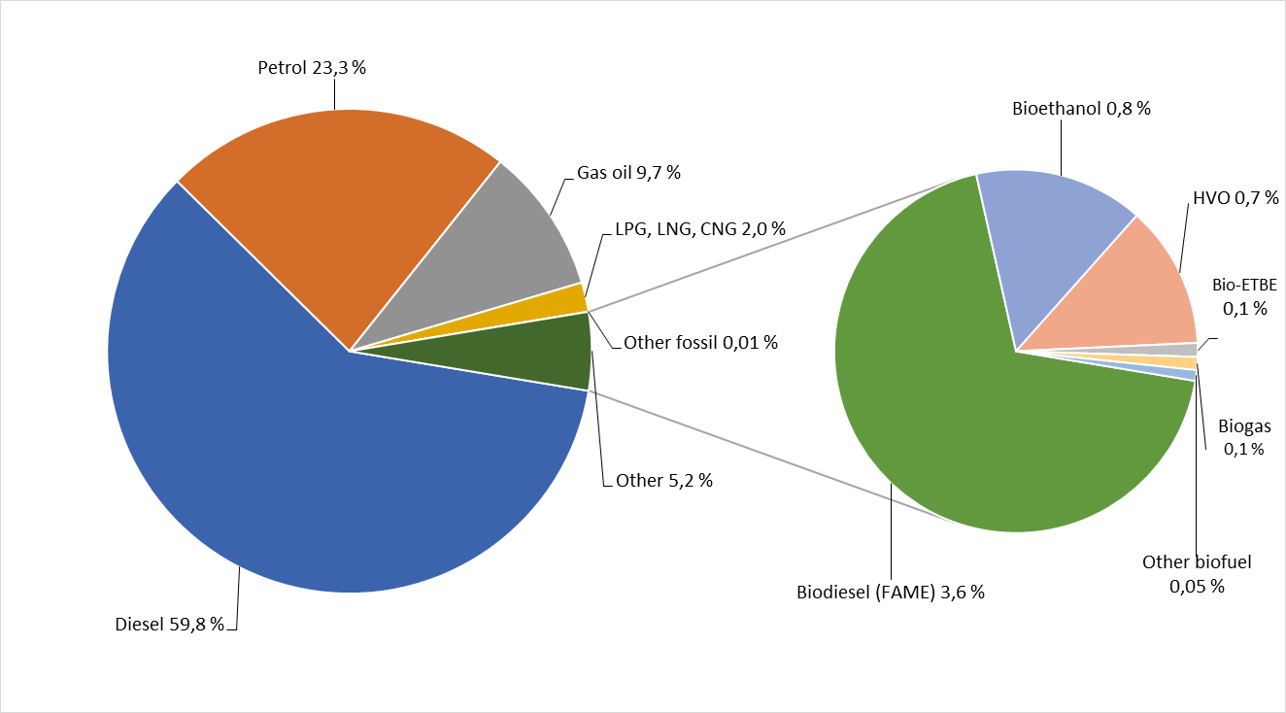

**Figure 2: Fuel energy supply shares per fuel type in 2018 *(Source: EEA)***

2.3 Biofuel consumption

The biofuel consumption in the 28 Member States continues to be dominated by biodiesel (fatty acid methyl ester, FAME) (68.9 % of the total biofuel consumption; 504 PJ), followed by bioethanol (15.1 %; 111 PJ) and hydrotreated vegetable oil (HVO; 13.1 %; 93 PJ). Bio-ethyl tert-butyl ether (bio-ETBE) and biogas account for almost 0.1 % of the total biofuel consumption (18 PJ). All other biofuels represented a much smaller share (see *Figure 3*).

Detailed information for all biofuels and pathways can be found in the EEA Technical Report No 2/2020 on ‘Greenhouse gas intensities of transport fuels in the EU in 2018.

**Figure 3: Biofuel energy supply shares per fuel type in 2018 *(Source: EEA)***

2.4 Electricity consumption

The reporting of electricity consumption by fuel suppliers is voluntary and ten Member States, compared to seven in 2017, reported data on electricity consumed by electric vehicles and motorcycles (see *Table 1*).

|  |  |  |  |  |  |
| --- | --- | --- | --- | --- | --- |
| **Member State** | **Quantity of energy excluding powertrain efficiency (GJ)** | **Quantity of energy including powertrain efficiency (GJ)** | **GHG intensity reported by Member State (g CO2e/MJ)** | | **GHG intensity**  **reported by Member State (g CO2e/kWh)** |
| Bulgaria | 189 652 | 75 861 | - | - | |
| France | 1 122 448 | 448 979 | 20.4 | 73 | |
| Germany | 774 000 | 309 600 | 153 | 551 | |
| Italy | 1 444 681 | 577 872 | 110.3 | 397 | |
| Netherlands | 236 081 | 94 432 | 165 | 594 | |
| Portugal | 19 224 | 7 690 | 74.7 | 269 | |
| Slovakia | 1 407 | 563 | 46.4 | 167 | |
| Slovenia | 318 | 127 | - | - | |
| Sweden | 52 | 21 | 169.2 | 609 | |
| United Kingdom | 867 996 | 347 198 | 85.3 | 307 | |

**Table 1: Electricity consumed by electric vehicles and motorcycles in 2018 as a reported contribution by fuel suppliers to their GHG reduction target (*Source: EEA*)**

**3. Overview of the 2018 fuel quality data in the EU**

According to Article 8 of the Fuel Quality Directive, all Member States, as well as Iceland, submitted reports on national fuel quality data for the year 2018.

This section provides the data for petrol and diesel sales, and the bio-components included therein, for road transport reported by all EU Member States. It excludes other fossil fuels, other biofuels and fuels of non-biological origin, as well as fuels used for non-road mobile machinery.

3.1 Petrol and diesel and biocomponent content

Diesel continues to dominate fuel sales in the EU: 72.3 % of fuel sold in 2018 was diesel and 27.7 % was petrol, as in 2017 (see *Table 2*).

|  |  |  |
| --- | --- | --- |
|  | **2017** | **2018** |
| **Diesel fuel sales** | 270 668 (72.3%) | 271 018 (72.3%) |
| **Petrol fuel sales** | 103 766 (27.7%) | 103 856 (27.7%) |

**Table 2: Diesel and petrol fuel sales (in million litres and their respective shares) in 2017 and 2018*.***

The share of diesel as compared with petrol sales has increased over the years, from 55.6 % of total sales in 2001 to 72.3 % in 2018. This reflects to a large degree the increasing dieselisation of Europe’s vehicle fleet during that period.

Diesel fuel consumption is dominant in most EU Member States (representing more than 60 % of total fuel sales) except for Cyprus, Greece and the Netherlands.

The majority of petrol sales in 2018 comprised fuels with a petrol grade research octane number (RON) of 95, the share of which slightly decreased compared to 2017. The share of 95 ≤ RON < 98 sales increased, while the share of RON ≥ 98 sales decreased since 2017 (see *Table 3*).

|  |  |  |
| --- | --- | --- |
|  | **2017** | **2018** |
| **RON 95** | 85.7% | 82% |
| **95 ≤ RON < 98** | 8.3% | 13.7% |
| **RON ≥ 98** | 5.8% | 4.2% |
| **RON = 91** | 0.1% | 0.1% |

**Table 3: Share of petrol sales according to RON numbers**

All diesel sold in the EU is marketed as containing biodiesel, whereas nearly 96 % of petrol is marketed as containing bioethanol. In 2018, 84.3 % of petrol fuel sold in the EU had up to 5 % ethanol content by volume, and 11.4% had up to 10 % ethanol content. Of the diesel fuel sold, 99.2 % contained up to 7 % FAME and 0.8 % contained more.

3.2 Compliance of sold fuels with quality limits

Overall in the EU, a high compliance with the quality limits is observed. The very large majority of key fuel parameters in the samples taken in 2018 were reported within the tolerance limits.

Lithuania, Slovenia and Sweden verified and reported full compliance for both petrol and diesel fuels. Six Member States verified and reported full compliance for petrol (Bulgaria, Greece, Latvia, Lithuania, Slovenia and Sweden), and twelve for diesel (Austria, Croatia, Greece, Finland, Germany, Hungary, Ireland, Lithuania, Poland, Romania, Slovenia and Sweden). One Member State (Belgium) reported more than 100 non-compliances for petrol and 30 for diesel in 2018, yet this represents a small fraction of the overall number of samples taken in Belgium.

Member States reported a total of 410 cases of non-compliance for petrol and 114 for diesel for 2018. For petrol, the most common parameters falling outside the specifications were summer vapour pressure (in nineteen Member States), research octane number (RON) (in ten Member States), motor octane number (MON) (in eight Member States) and sulphur content (in five Member States). For diesel, the most common parameters falling outside the specifications were the FAME content (in seven Member States) and the sulphur content (in eight Member States).

All Member States described the actions taken when non-compliant samples were identified. These included informing the competent authorities, initiating investigations, imposing penalties and fines, and resampling. In a small number of cases, no action has been taken where the non-compliant parameters were found to be very close to the tolerance limits.

There was therefore no need for the Commission to launch any new investigation in this area.

1. Directive 98/70/EC of the European Parliament and of the Council relating to the quality of petrol and diesel fuels and amending Council Directive 93/12/EEC, OJ L 350 of 28.12.1998, p. 58.
2. Council Directive (EU) 2015/652 of 20 April 2015 laying down calculation methods and reporting requirements pursuant to Directive 98/70/EC of the European Parliament and of the Council relating to the quality of petrol and diesel fuels, OJ L 107 of 25.4.2015, p. 26.
3. Directive (EU) 2015/1513 of the European Parliament and of the Council of 9 September 2015 amending Directive 98/70/EC relating to the quality of petrol and diesel fuels and amending Directive 2009/28/EC on the promotion of the use of energy from renewable sources, OJ L239 of 15.9.2015, p. 8.
4. Council Directive (EU) 2015/652 of 20 April 2015 laying down calculation methods and reporting requirements pursuant to Directive 98/70/EC of the European Parliament and of the Council relating to the quality of petrol and diesel fuels, OJ L 107 of 25.4.2015, p. 26.
5. ‘Upstream emissions’ means all greenhouse gas emissions occurring prior to the raw material entering a refinery or a processing plant where the fuel is produced.
6. For this calculation, the provisional estimated indirect land-use change emissions from biofuels were taken into account as listed in Annex V of the Fuel Quality Directive.