

**APPENDIX 4 – Task 3 Workshop on 12 March 2020**

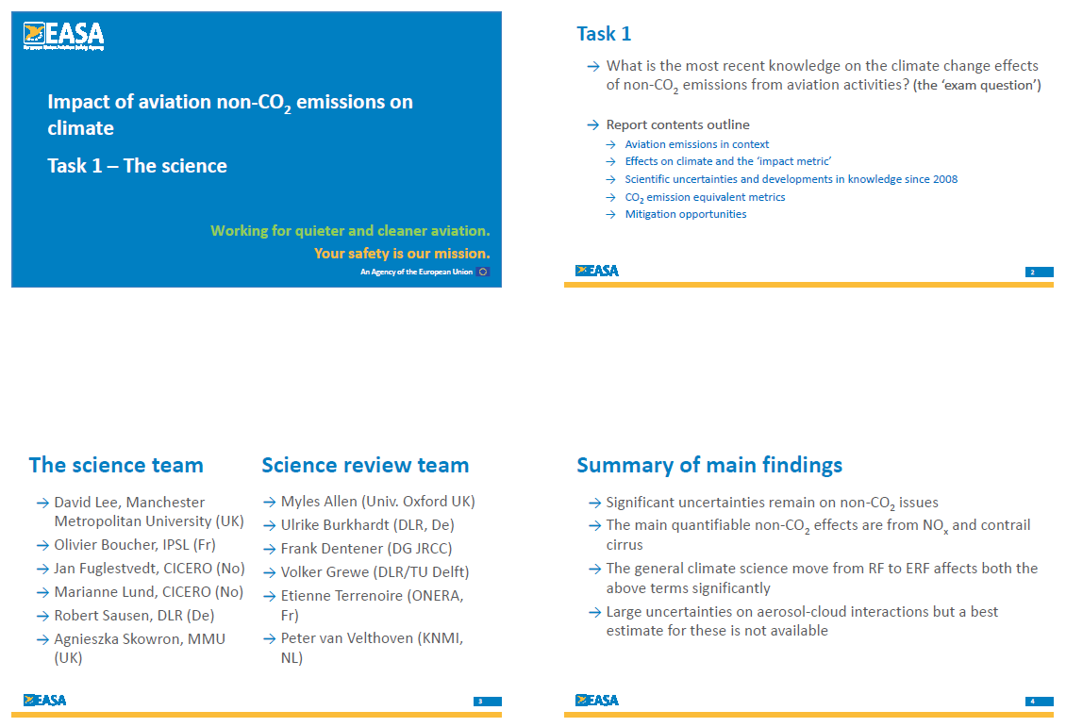

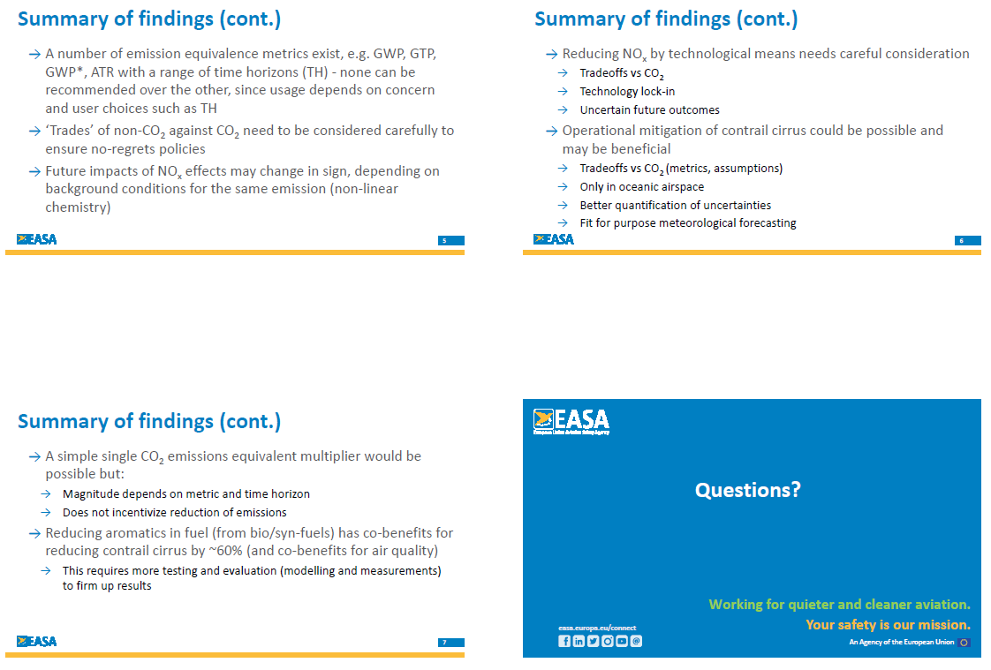

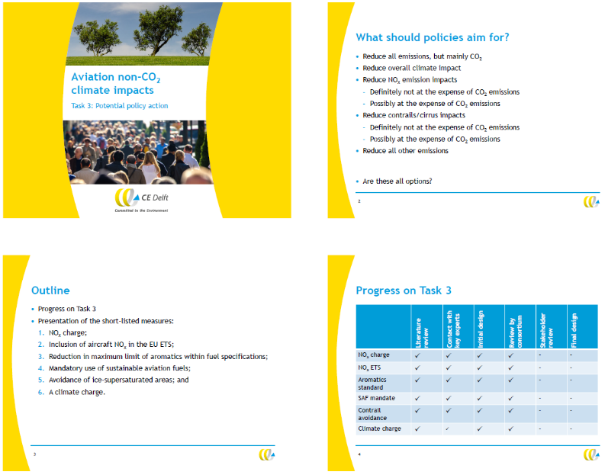

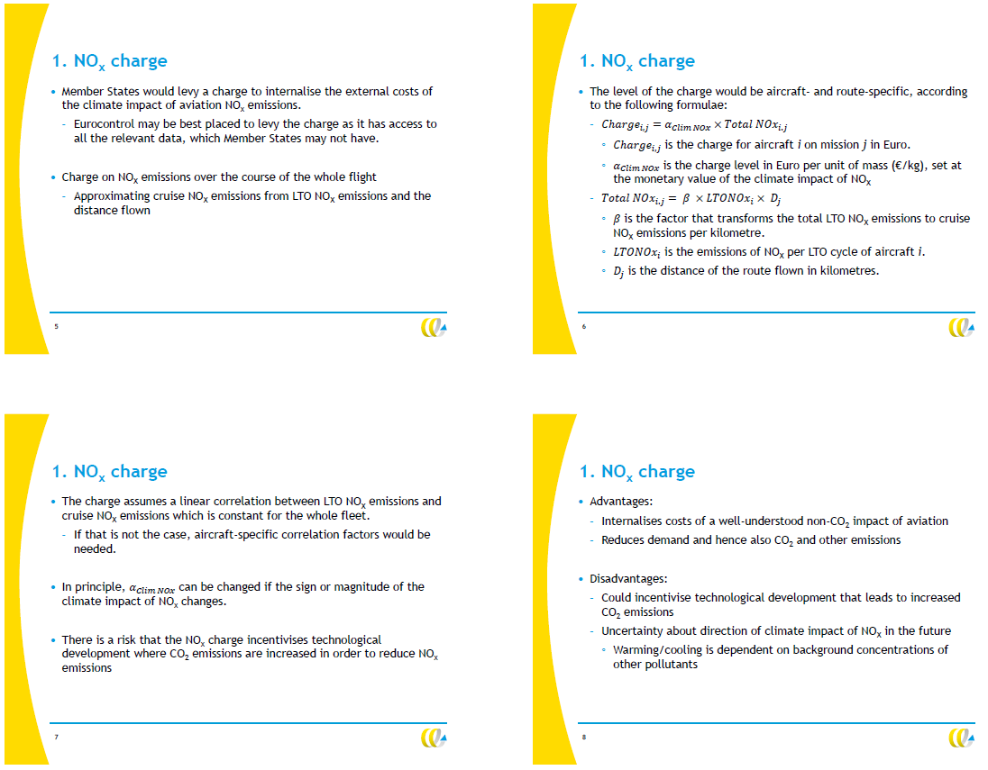

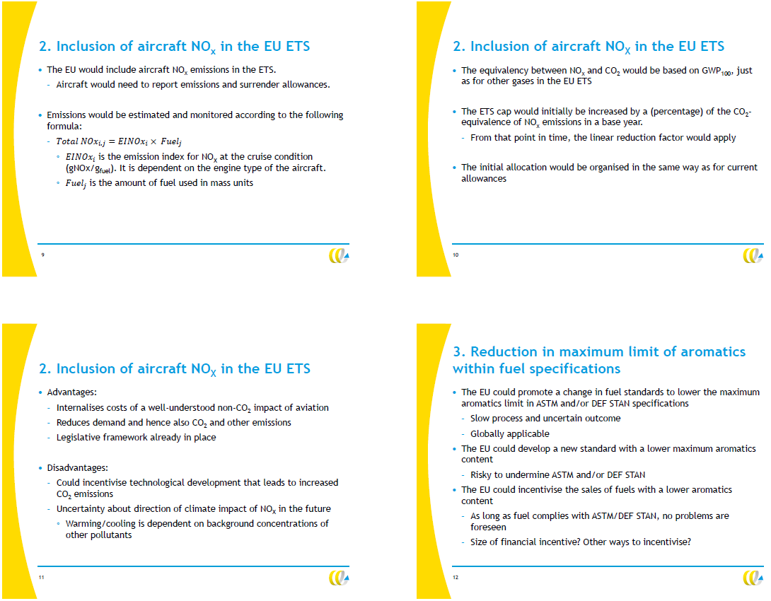

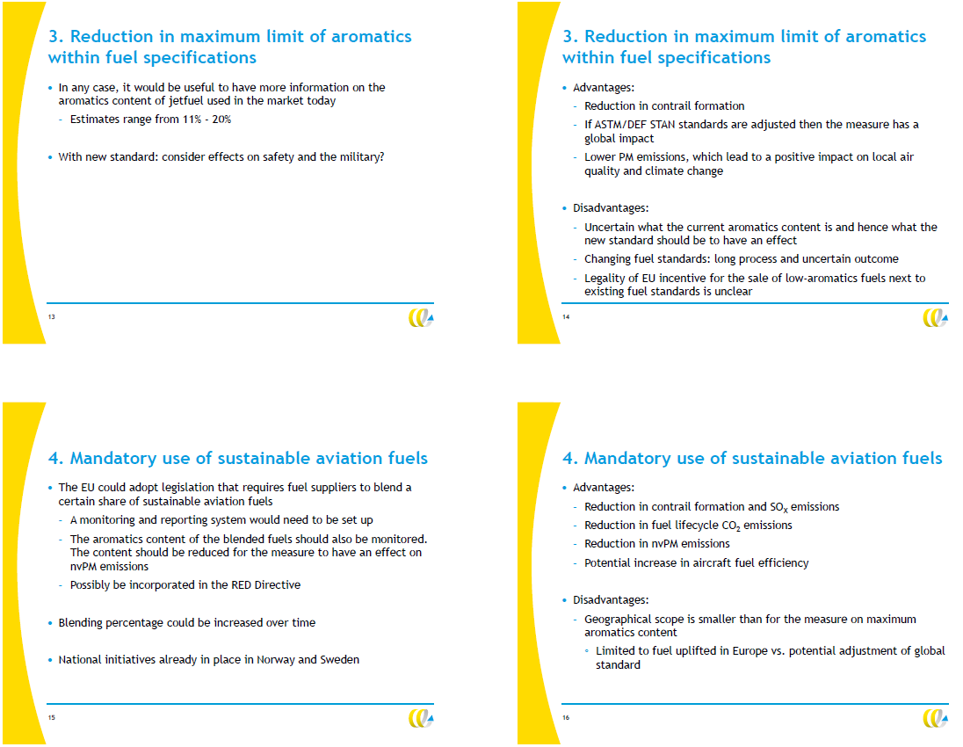

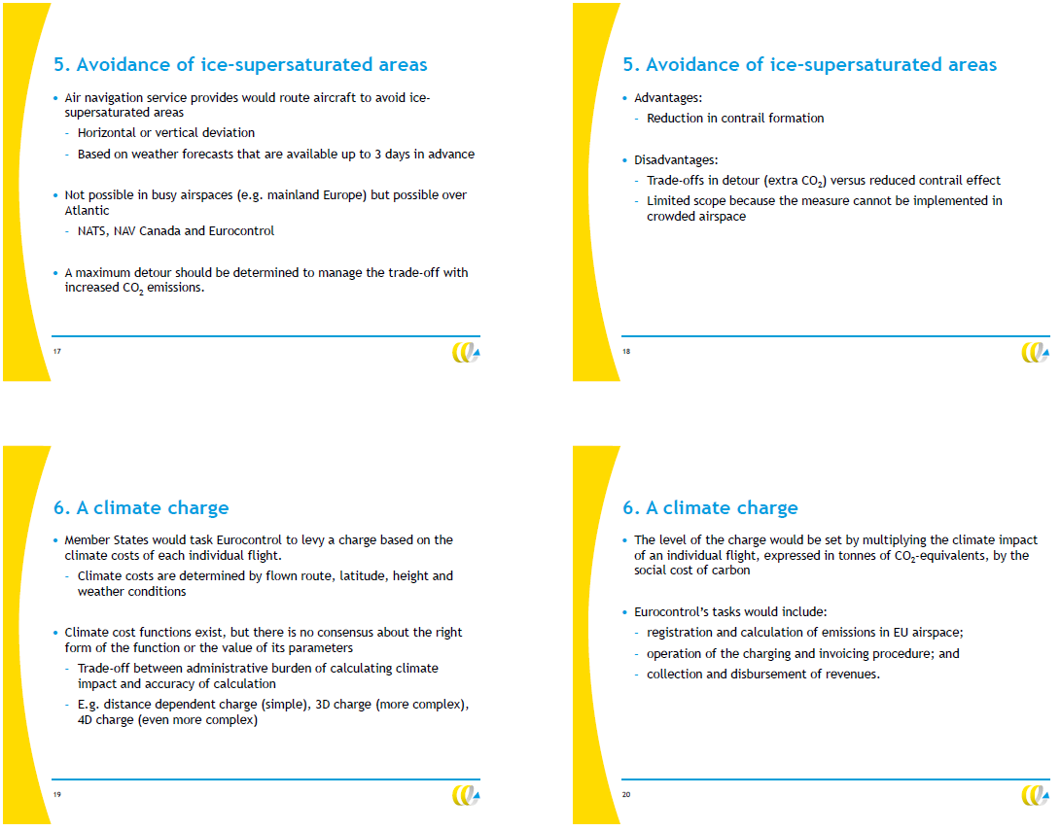

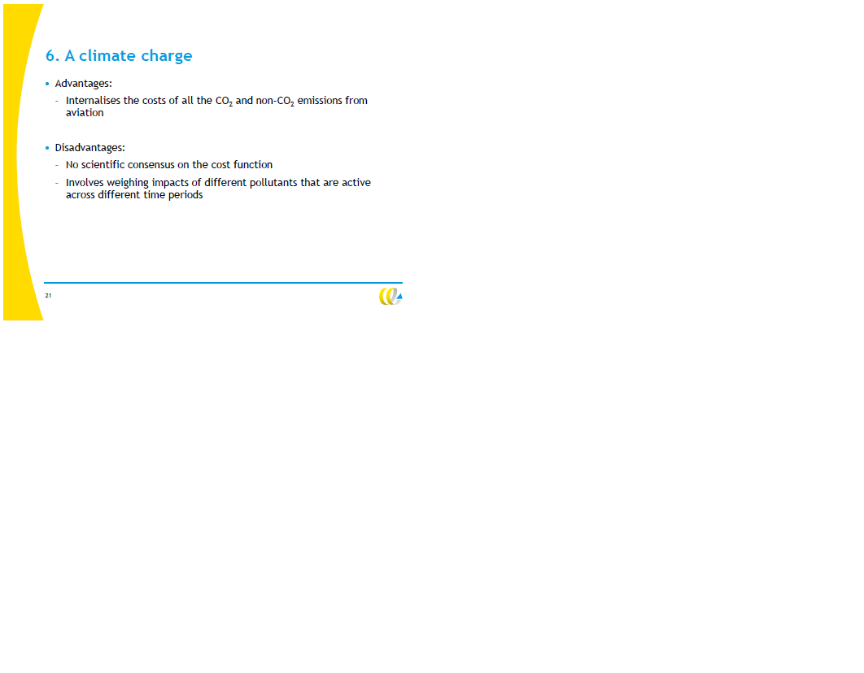

**DG MOVE-DG CLIMA study on the effects of**

**non-CO2 aviation emissions on climate change**

**EASA, Brussels**

**12 March 2020**

**Summary Record of Meeting**

**1. Welcome and Introductions**

Participation: Rob Gemmill, Jarlath Molloy, Lisanne van Wijngaarden, Jasper Faber, Philippe Lenne, Rik Brouwer, Peter Vis, Chris Lewis, Stephen Arrowsmith, Joonas Laukia.

Remotely: David Lee, Andreas Busa, Stefan Ebert, Cheryl Micallef-Borg.

**2. Summary of study ToR and confidentiality**

Stephen provided some background to the project, and the meeting objectives. EASA is currently managing the project on behalf of the European Commission to examine the most recent knowledge on the climate change effects of non-CO2 emissions from aviation, and potential policy options to reduce these impacts. The project arises from the EU ETS Directive Article 30(4), which requests for an analysis on the effects of non-CO2 aviation emissions on climate change.

The project team contains task focal points for science, existing mitigation measures and trade-offs, and further potential policy action. Stephen clarified that the purpose of the workshop was to discuss the initial findings on the potential policy options to reduce the impact of non-CO2 emissions. He also highlighted that the report, and recommendations included therein, is still work in progress, and should be treated on a confidential basis.

**3. Summary of most recent knowledge on the climate change effects of non-CO2 from aviation activities**

David presented the summary of most recent knowledge on the climate change effects of non-CO2 from aviation activities. He summarised that:

* Significant uncertainties still remain on non-CO2 issues;
* The main quantifiable non-CO2 effects are from NOx and contrail cirrus;
* The general climate science move from RF to ERF affects both the above terms significantly
* There are large uncertainties on aerosol-cloud interactions, and a best estimate[1] for these is not available;
* A number of emission equivalence metrics exist, e.g. GWP, GTP, GWP*, ATR with a range of time horizons (TH) - none can be recommended over the other, since usage depends on concern and user choices such as TH;
* ‘Trades’ of non-CO2 against CO2 need to be considered carefully to ensure no-regrets policies;
* Future impacts of NOx effects may change in sign, depending on background conditions for the same emission (non-linear chemistry);
* Reducing NOx by technological means needs careful consideration:
  + Tradeoffs vs CO2
  + Technology lock-in
  + Uncertain future outcomes
* Operational mitigation of contrail cirrus could be possible and may be beneficial;
* Tradeoffs vs CO2 (metrics, assumptions):
  + Only in oceanic airspace
  + Better quantification of uncertainties
  + Fit for purpose meteorological forecasting

The presentation was welcomed by the group. Questions were raised on the relationship between NOx emissions and formation of ice crystals. It was noted that the reduction of aromatics contained in jet fuel is a potential mitigation measure as it would reduce nvPM (mass and number) leading to a reduction in the formation of ice-crystals. On the other hand, it was noted that producing cleaner fuels would incur additional costs (including increased use of energy, hydrogen and consequential impact on price/yield of final fuel) for the fuel producer and operators.

**4. Overview of potential policy options to reduce non-CO2 emissions and their feasibility of implementation**

Jasper presented the potential policy options to reduce non-CO2 emissions and their feasibility of implementation as included in the initial draft report. Regarding the scope of the study, it was noted that this study was limited to subsonic aircraft only.

The group reviewed each policy option contained in the draft report, and concluded the following:

1. *NOx charge*

* A question was raised on the impact of N2O emissions from aviation. *Post Meeting Note: Aviation emissions contain NO and NO2 , and it is these species that are regulated within ICAO Annex 16 Volume II engine emissions certification requirements.* *N2O is a potent long-lived GHG with GWP100 of around 300 arising principally from agricultural emissions, but also from fossil fuel combustion and industrial processes. However, the emission factor is very small for aviation and usually ignored.*
* Regarding Article 24 of the Chicago Convention, it was noted that previous research and experience suggests that internalization of environmental cost would be allowed under ICAO rules.
* The geographical scope could be a sensitive issue in a similar manner to the EU ETS.
* Eurocontrol access to accurate engine type data on a tailnumber basis still needs to be clarified.
* The roles and responsibilities between airlines, member states, ANSPs and international organizations was identified as important for the implementation of the NOx charge. We must also be careful with regard to the language used to describe these roles (e.g. MS mandate ECTL to collect charges in line with an agreed charging scheme).
* A legal review would be needed to identify the legislative process through which a NOx charge would be proposed.
* ANSPs highly likely not to favour adding a NOx charge to ATC fees for airlines (passengers) as it would add complexity to a relatively simple cost recovery mechanism, as well as blur the objectives of the CRCO.
* CRCO scheme now based on actual flightpath rather than filed flightpath. Need to ensure policy options do not create perverse incentives.

1. *Inclusion of aircraft NOx into the EU ETS*

* It was noted that there is greater uncertainty in the climate impact and quantification of NOx compared to CO2, and therefore the CO2eq metric that would permit trading of 1 tonne of CO2 for an equivalent tonnage of NOx could undermine the confidence of the EU ETS.
* The uncertainty, and potential unintended consequences, has a higher political risk in the ETS option compared to the NOx charge option. People pay real money for real emissions reductions, and a potential repeat of the issues with CDM offsets should be avoided in order to ensure the credibility of the ETS.

1. *Reduction in maximum limit of aromatics within fuel specifications*

* It was noted that, if taken forward, this option would need to include a robust study to look at the benefits and costs (including environmental impact of increased refinery processing etc.) of changes to the DEF STAN/ASTM fuel specifications.
* Data on the current specifications of fuel being used in the aviation sector is being collected (e.g. PQIS, JET SCREEN project, US Military), but access to this data is unclear due to there being several different sources.
* Regarding the governance of the option, it was noted that the existing standardisation schemes use a consensus-driven, technical approach, and it could be challenging to impose actual legal requirements for the specifications of jet fuel which operate in a global commodity regime.
* A holistic approach (e.g. use of SAF) to justifying proposed changes in fuel specs is likely to be more successful than focusing on a single species (more likely to have a favourable benefit vs cost balance). For example, car Denox catalytic convertors were introduced to reduce NOx emissions, but needed lower sulphur fuel to work properly leading to changes in fuel specs.

1. *Mandatory use of SAF*

* In general, the group saw this measure as very promising. It was highlighted that, if taken forward, the SAF mandate would need to take into account the level of current SAF production, and that a gradual increase in the mandate could be considered as production increases. The current major challenge is availability of SAF at commercially viable volume and cost.
* Regarding the sustainability criteria for the SAF, it was agreed that this would need to refer to the existing criteria included in the EU Renewable Energy Directive (RED) in order to be consistent across EU policies.
* Chris and Rik to provide a reference study investigating the benefits of SAF (approx. 1%) in terms of aircraft fuel efficiency due to lower mass with same energy content.
* It was noted that an impact assessment on implementing this measure should consider its potential impact of penalizing regional operators compared to long-haul operators.

1. *Avoidance of ice-supersaturated areas (ISSR)*

* NATS confirmed that implementation over mainland Europe would be difficult due to congestion
* NATS was supporting a feasibility study led by the UK Royal Aeronautical Society and including Imperial College London, DLR and IATA on contrail avoidance over the North Atlantic.
* Further information was also provided on route-planning. The Air Navigation Service Provider (ANSP) provide a pre-designed route track structure for the Airline Operators to choose from, based on where the Operators indicate they wish to fly and the most recent met forecast. Adjusting the track structure pre-tactically to avoid ISSRs would be possible, subject to various conditions and assumptions.
* Despite the challenges in practical application, it was recognized that there could be some value in a pilot project investigating risks, opportunities, benefits and unintended consequences from avoiding ISSRs.
* Regarding air navigation charges, it was noted that currently a flat charge is collected for crossing the Atlantic. Compensation may be needed if an airline was asked to detour an ISSR leading to a fuel burn penalty.
* The additional complexity of contrails having a warming or cooling effect during day and a warming effect during the night would also need to be taken into account.

1. *A Climate Charge*

* Similar considerations were raised to that of the NOx charge, especially related to the geographical scope, roles and responsibilities, legal issues involved in applying a climate charge and use of revenue raised.
* The complexity of such an option would only be justified if it was also considered more accurate. This is not the case at the moment, and so a more workable and defendable option may be optimum.

**5. Summary of key points from discussions**

The Project Team will consider the key points per agenda item captured above when finalizing the draft report.

**6. AOB**

Stephen presented the timeline for finalising the report. Final draft needs to be completed by Friday 4 April. A quick review of the meeting notes would be appreciated to help integrate feedback from the workshop in the report.

**APPENDIX 5 – Updated aviation radiative forcing components in 2020**

Selected content from Lee et al. (2020, in press), Figure and Table numbers refer to this paper and the legends are reproduced verbatim.

Lee D. S., Fahey D. W., Skowron A., Allen M. R., Burkhardt U., Chen Q., Doherty S. J., Freeman S., Forster P. M., Fuglestvedt J., Gettelman A., DeLeon R. R., Lim L. L., Lund M. T., Millar R. J., Owen B., Penner J. E., Pitari G., Prather M. J., Sausen R. and Wilcox L. J. (2020) The contribution of global aviation to anthropogenic climate forcing in 2018. *Atmospheric Environment* (<https://doi.org/10.1016/j.atmosenv.2020.117834>).

**Abstract**

Global aviation operations contribute to anthropogenic climate change via a complex set of processes that lead to a net surface warming. Of importance are aviation emissions of carbon dioxide (CO2), nitrogen oxides (NOx), water vapor, soot and sulfate aerosols, and increased cloudiness due to contrail formation. Aviation grew strongly over the past decades (1960–2018) in terms of activity, with revenue passenger kilometers increasing from 109 to 8269 billion km yr-1, and in terms of climate change impacts, with CO2 emissions increasing by a factor of 6.8 to 1034 Tg CO2 yr-1. Over the period 2013–2018, the growth rates in both terms show a marked increase. Here, we present a new comprehensive and quantitative approach for evaluating aviation climate forcing terms. Both radiative forcing (RF) and effective radiative forcing (ERF) terms and their sums are calculated for the years 2000–2018. Contrail cirrus, consisting of linear contrails and the cirrus cloudiness arising from them, yields the largest positive net (warming) ERF term followed by CO2 and NOx emissions. The formation and emission of sulfate aerosol yields a negative (cooling) term. The mean contrail cirrus ERF/RF ratio of 0.42 indicates that contrail cirrus is less effective in surface warming than other terms. For 2018 the net aviation ERF is +100.9 milliwatts (mW) m-2 (5–95% likelihood range of (55, 145)) with major contributions from contrail cirrus (57.4 mW m-2), CO2 (34.3 mW m-2), and NOx (17.5 mW m‑2). Non-CO2 terms sum to yield a net positive (warming) ERF that accounts for more than half (66%) of the aviation net ERF in 2018. Using normalization to aviation fuel use, the contribution of global aviation in 2011 was calculated to be 3.5 (4.0, 3.4) % of the net anthropogenic ERF of 2290 (1130, 3330) mW m-2. Uncertainty distributions (5%, 95%) show that non-CO2 forcing terms contribute about 8 times more than CO2 to the uncertainty in the aviation net ERF in 2018. The best estimates of the ERFs from aviation aerosol-cloud interactions for soot and sulfate remain undetermined. CO2-warming-equivalent emissions based on global warming potentials (GWP* method) indicate that aviation emissions are currently warming the climate at approximately three times the rate of that associated with aviation CO2 emissions alone. CO2 and NOx aviation emissions and cloud effects remain a continued focus of anthropogenic climate change research and policy discussions.



**Figure 6**. Timeseries of calculated ERF values and confidence intervals for annual aviation forcing terms from 2000 to 2018. The top panel shows all ERF terms and the bottom panel shows only the NOx terms and net NOx ERF. All values are available in the SD spreadsheet, in Tables 2 and 3, and in Figure 3 for 2018 values. The net values are not arithmetic sums of the annual values because the net ERF, as shown in Figure 3 for 2018, requires a Monte Carlo analysis that properly includes uncertainty distributions and correlations.

**Figure 7.** Probability distribution functions (PDFs) for aviation ERFs in 2018 based on the results in Figure 3 and Table 2. PDFs are shown for separately for CO2, the sum of non-CO2 terms, and the net aviation ERF. Since the area of each distribution is normalized to the same value, relative probabilities can be intercompared. Uncertainties are expressed by a distribution about the best-estimate value that is normal for CO2 and contrail cirrus, and lognormal for all other components. A one-million-point Monte Carlo simulation run was used to calculate all PDFs.

**Table 2.** Best estimates and high/low limits of the 90% likelihood ranges for aviation ERF components derived in this study

|  |  |  |  |  |  |
| --- | --- | --- | --- | --- | --- |
| **ERF (mW m-2)** | **2018** a | **2011** a | **2005** a | **Sensitivity to emissions** | **ERF/RF** |
| Contrail cirrus | 57.4 (17, 98) | 44.1 (13, 75) | 34.8 (10, 59) | 9.36 x 10-10 mW m-2 km-1 | 0.42 |
| CO2 | 34.3 (28, 40) | 29.0 (24, 34) | 25.0 (21, 29) |  | 1.0 |
| Short-term O3 increase | 49.3 (32, 76) | 37.3 (24, 58) | 33.0 (21, 51) | 34.4 ± 9.9 mW m-2 (Tg (N) yr-1)-1 | 1.37 |
| Long-term O3 decrease | -10.6 (-20, -7.4) | -7.9 (-15, -5.5) | -6.7 (-13, -4.7) | -9.3 ± 3.4 mW m-2 (Tg (N) yr-1)-1 | 1.18 |
| CH4 decrease | -21.2 (-40, -15) | -15.8 (-30, -11) | -13.4 (-25, -9.4) | -18.7 ± 6.9 mW m-2 (Tg (N) yr‑1)-1 | 1.18 |
| Stratospheric water vapor decrease | -3.2 (-6.0 -2.2) | -2.4 (-4.4, -1.7) | -2.0 (-3.8, -1.4) | -2.8 ± 1.0 mW m-2 (Tg (N) yr-1)-1 | 1.18 |
| Net NOx | 17.5 (0.6, 29) | 13.6 (0.9, 22) | 12.9 (1.9, 20) | 5.5 ± 8.1 mW m-2 (Tg (N) yr-1)-1 |  |
| Stratospheric H2O increase | 2.0 (0.8, 3.2) | 1.5 (0.6, 2.4) | 1.4 (0.6, 2.3) | 0.0052 ± 0.0026 mW m-2  (Tg (H2O) yr-1)-1 | --- |
| Soot (aerosol-radiation) | 0.94 (0.1, 4.0) | 0.71 (0.1, 3.0) | 0.67 (0.1, 2.8) | 100.7 ± 165.5 mW m-2 (Tg (BC) yr-1)-1 | --- |
| Sulfate (aerosol-radiation) | -7.4 (-19, -2.6) | -5.6 (-14, -1.9) | -5.3 (-13, -1.8) | -19.9 ± 16.0 mW m-2 (Tg (SO2) yr-1)-1 | --- |
| Sulfate and soot (aerosol-cloud) | ---- | ---- | ---- | ---- | --- |
| Net ERF (only non-CO2 terms) | 66.6 (21, 111) | 51.4 (16, 85) | 41.9 (14, 69) | ---- | --- |
| Net aviation ERF | 100.9 (55, 145) | 80.4 (45, 114) | 66.9 (38, 95) | ---- | --- |
| Net anthropogenic ERF in 2011 | ---- | 2290 (1130, 3330) b | ---- | ---- | --- |

a The uncertainty distributions for all forcing terms are lognormal except for CO2 and contrail cirrus (normal) and Net NOx (discrete pdf).

b Boucher et al., 2013. IPCC also separately estimated the contrail cirrus term for 2011 as 50 (20, 150) mW m-2.

**Table 5.** Emission metrics and corresponding CO2-equivalent emissions for the ERF components of 2018 aviation emissions and cloudiness

**Metrics**

|  |  |  |  |  |  |  |
| --- | --- | --- | --- | --- | --- | --- |
| **ERF term** | **GWP20** | **GWP50** | **GWP100** | **GTP20** | **GTP50** | **GTP100** |
| CO2 | 1 | 1 | 1 | 1 | 1 | 1 |
| Contrail cirrus  (Tg CO2 basis) | 2.32 | 1.09 | 0.63 | 0.67 | 0.11 | 0.09 |
| Contrail cirrus  (km basis) | 39 | 18 | 11 | 11 | 1.8 | 1.5 |
| Net NOx | 619 | 205 | 114 | -222 | -69 | 13 |
| Aerosol-radiation |  |  |  |  |  |  |
| Soot emissions | 4288 | 2018 | 1166 | 1245 | 195 | 161 |
| SO2 emissions | -832 | -392 | -226 | -241 | -38 | -31 |
| Water vapor emissions | 0.22 | 0.10 | 0.06 | 0.07 | 0.01 | 0.008 |

**CO2-eq emissions (Tg CO2 yr-1) for 2018**

|  |  |  |  |  |  |  |  |
| --- | --- | --- | --- | --- | --- | --- | --- |
| **ERF term** | **GWP20** | **GWP50** | **GWP100** | **GTP20** | **GTP50** | **GTP100** | **GWP*100**  (E*CO2e) |
| CO2 | 1034 | 1034 | 1034 | 1034 | 1034 | 1034 | 1034 |
| Contrail cirrus  (Tg CO2 basis) | 2399 | 1129 | 652 | 695 | 109 | 90 | 1834 |
| Contrail cirrus  (km basis) | 2395 | 1127 | 651 | 694 | 109 | 90 | 1834 |
| Net NOx | 887 | 293 | 163 | -318 | -99 | 19 | 339 |
| Aerosol-radiation |  |  |  |  |  |  |  |
| Soot emissions | 40 | 19 | 11 | 12 | 2 | 2 | 20 |
| SO2 emissions | -310 | -146 | -84 | -90 | -14 | -12 | -158 |
| Water vapor emissions | 83 | 39 | 23 | 27 | 4 | 3 | 42 |
| Total CO2-eq  (using km basis) | 4128 | 2366 | 1797 | 1358 | 1035 | 1135 | 3111 |
| Total CO2-eq / CO2 | 4.0 | 2.3 | 1.7 | 1.3 | 1.0 | 1.1 | 3.0 |



**Figure 5.** Summary of RF estimates for aerosol-cloud interactions for aviation aerosol as calculated in the SD spreadsheet for a variety of published results normalized to 2018 air traffic and 600 ppm fuel sulfur. The results are shown for soot; total particulate organic matter (POM), sulfate and ammonia (NH3); and sulfate aerosol from the indicated studies. The color shading gradient in the symbols indicates increasing positive or negative magnitudes. No best estimate was derived in the present study for any aerosol-cloud effect due to the large uncertainties. In previous studies, the estimates for the soot aerosol-cloud effect are associated with particularly large uncertainty in magnitude and uncertainty in the sign of the effect (Penner et al., 2009; Zhou and Penner, 2014; Penner et al., 2018). As part of the present study, an author (JEP) re-evaluated these earlier studies and concluded that the Penner et al. (2018) results supersede the earlier Penner et al. (2009) and Zhou and Penner (2014) results because of assumptions regarding updraft velocities during cloud formation. In addition, a bounding sensitivity case in which all aviation soot acts as an IN in Penner et al. (2018) is not included here.

**Table 4a.** Confidence levels for the ERF estimates in **Figure 3**

|  |  |  |  |  |  |
| --- | --- | --- | --- | --- | --- |
| **Terms** | **Evidence** | **Agree-ment** | **Conf.**  **level** | **Basis for uncertainty estimates** | **Understanding change since L09** |
| **Contrail cirrus formation in high-humidity regions** | Limited | Medium | Low* | Robust evidence for the phenomenon. Large remaining uncertainties in magnitude in part due to incomplete representation of key processes | The inclusion of contrail cirrus processes in global climate models. |
| **Carbon dioxide (CO2) emissions** | Robust | Medium | High** | Trends in aviation CO2 emissions and differences between simplified C-cycle models | Better assessment of uncertainties from multiple models |
|  |  |  |  |  |  |
| Short-term ozone increase | Medium | Medium | Medium* | Observed trends of tropospheric ozone and laboratory studies of chemical kinetics, reliance on a large number of model results for aviation emissions | Elevated owing to many more studies |
| Long-term ozone decrease | Limited | Medium | Low* | Reliance on chemical modelling studies | Not provided previously |
| Methane decrease | Medium | Medium | Medium* | Observed trends of tropospheric methane and laboratory studies of chemical kinetics, reliance on a large number of model results for aviation emissions | Elevated owing to many more studies |
| Stratospheric water vapour decrease | Limited | Medium | Low* | Reliance on chemical modelling studies | Not provided previously |
| **Net NOx** | Medium | Limited | Low* | Associated uncertainties with combining above effects | Elevated owing to more studies but lowered in total owing to additional terms and methodological constraints |
| **Water vapor emissions in the stratosphere** | Medium | Medium | Medium | Limited studies of perturbation of water vapor budget of UT/LS | Elevated owing to more studies |
| **Aerosol-radiation interactions** |  |  |  |  |  |
| From soot emissions | Limited | Medium | Low | Limited studies and uncertain emission index | More studies |
| From sulfur emissions | Limited | Medium | Low | Limited studies and uncertain emission index | More studies |
| **Aerosol-cloud interactions** |  |  |  |  |  |
| From sulfur emissions | Limited | Low | Very  low | None available; few studies, probably a negative ERF | Not provided previously |
| From soot emissions | Limited | Low | Very  low | None available; few studies, varying in sign and magnitude of ERF constrained by poor understanding of processes | Not provided previously |

* This term has the additional uncertainty of the derivation of an effective radiative forcing from a radiative forcing.

** This term differs from ‘Very High’ level in IPCC (2013) because additional uncertainties are introduced by the assessment of marginal aviation CO2 emissions and their resultant concentrations in the atmosphere from simplified carbon cycle models.

**Table 3.** Best estimates and low/high limits of the 95% likelihood ranges for aviation RF components derived in this study a

|  |  |  |  |  |  |
| --- | --- | --- | --- | --- | --- |
| **RF (mW m-2)** | **2018** b | **2011** b | **2005** b | **L09 2005 values** | **Sensitivity to emissions (this work)** |
| Contrail cirrus | 111.4 (33, 189) | 85.6 (25, 146) | 67.5 (20, 115) | (11.8 c) | 1.82 x 10-9 mW m-2 km-1 |
| CO2 | 34.3 (31, 38) | 29.0 (26, 32) | 25.0 (23, 27) | 28.0 |  |
| Short-term O3 increase | 36.0 (23, 56) | 27.3 (17, 42) | 24.0 (15, 37) | 26.3 | 25.1 ± 7.3 mW m-2 (Tg (N) yr-1)-1 |
| Long-term O3 decrease | -9.0 (-17, -6.3) | -6.7 (-13, -4.7) | -5.7 (-11, -4.0) | ---- | -7.9 ± 2.9 mW m-2 (Tg (N) yr-1)-1 |
| CH4 decrease | -17.9 (-34, -13) | -13.4 (-25, -9.3) | -11.4 (-21, -7.9) | -12.5 | -15.8 ± 5.9 mW m-2 (Tg (N) yr‑1)-1 |
| Stratospheric water vapor decrease | -2.7 (-5.0 -1.9) | -2.0 (-3.8, -1.4) | -1.7 (-3.2, -1.2) | ---- | -2.4 ± 0.9 mW m-2 (Tg (N) yr-1)-1 |
| Net NOx | 8.2 (-4.8, 16) | 6.5 (-3.3, 12) | 6.6 (1.9, 12) | 13.8 d | 1.0 ± 6.6 mW m-2 (Tg (N) yr-1)-1 |
| Stratospheric H2O increase | 2.0 (0.8, 3.2) | 1.5 (0.6, 2.4) | 1.4 (0.6, 2.3) | 2.8 | 0.0052 ± 0.0026 mW m-2  (Tg (H2O) yr-1)-1 |
| Soot (aerosol-radiation) | 0.94 (0.1, 4.0) | 0.71 (0.1, 3.0) | 0.67 (0.1, 2.8) | 3.4 | 100.7 ± 165.5 mW m-2 (Tg (BC) yr-1)-1 |
| Sulfate (aerosol-radiation) | -7.4 (-19, -2.6) | -5.6 (-14, -1.9) | -5.3 (-13, -1.8) | -4.8 | -19.9 ± 16.0 mW m-2 (Tg (SO2) yr-1)-1 |
| Sulfate and soot (aerosol-cloud) | ---- | ---- | ---- | ---- | ---- |
| Net RF (only non-CO2 terms) | 114.8 (35, 194) | 88.4 (27, 149) | 70.3 (22, 119) | ---- | ---- |
| Net aviation RF | 149.1 (70, 229) | 117.4 (56, 179) | 95.2 (47, 144) | 78.0 | ---- |

a ERF values are shown in **Table 2**.

b The uncertainty distributions for all forcing terms are lognormal except for CO2 and contrail cirrus (normal) and Net NOx (discrete pdf).

c Linear contrails only; excludes the increase in cirrus cloudiness due to aged spreading contrails.

d Excludes updated CH4 RF evaluation of Etminan et al. (2016) and equilibrium-to-transient correction.

**APPENDIX 6 – List of Resources**

Agarwal A., Speth R. L., Fritz T. M., Jacob S. D., Rindlisbacher T., Iovinelli R., Owen B., Miake-Lye R. C., Sabnis J. S. and Barrett S. R. H. (2019) SCOPE11 method for estimating aircraft black carbon mass and particle number emissions. *Environ. Sci. Technol.* 53, 1364 – 1373.

AINonline, (2019). Sweden makes a sustainability leap. [www.ainonline.com/aviation-news/air-transport/2019-06-13/sweden-makes-sustainability-leap](http://www.ainonline.com/aviation-news/air-transport/2019-06-13/sweden-makes-sustainability-leap) [Accessed February 2020].

Allen M. R., J. S. Fuglestvedt, K. P. Shine, A. Reisinger, R. T. Pierrehumbert, and P. M. Forster (2016) New use of global warming potentials to compare cumulative and short­lived climate pollutants. *Nature Climate Change*, 6 (8). pp. 773–776, <https://doi.org/10.1038/nclimate2998>.

Allen M. R. Shine K. P., Fuglestvedt J. S., Millar R. J., Cain M., Frame D. J. and Macey A. H. (2018) A solution to the misrepresentations of CO2-equivalent emissions of short-lived climate pollutants under ambitious mitigation. *Npj Climate and Atmos. Sci.* **1**:16.

Anderson, S., (2015). Would a minimum limit on aromatics (>0) impact the manufacture/supply of jet fuel? London, Aviation Fuel Committee Meeting.

ASTM, (2007). Synthetic fuels for aviation. [www.astm.org/SNEWS/APRIL_2007/hemighaus_apr07.html](http://www.astm.org/SNEWS/APRIL_2007/hemighaus_apr07.html) [Accessed February 2020].

Beyersdorf, A.J., Timko M.T., Ziemba, L.D., Bulzan, D., Corporan, E., Herndon, S. C., Howard, R. Miake-Lye, R., Thornhill, K. L., Winstead, E., Wey, C., Yu, Z. and Anderson B. E. (2014) Reductions in aircraft particulate emissions due to the use of Fischer–Tropsch fuels, A. J., Atmos. Chem. Phys., 14, 11-23, (2014)

BioEnergy International, (2018). *Norway to introduce 0.5% sustainable aviation fuel quota from 2020.* [www.bioenergyinternational.com/policy/norway-to-introduce-0-5-sustainable-aviation-fuel-quota-from-2020](http://www.bioenergyinternational.com/policy/norway-to-introduce-0-5-sustainable-aviation-fuel-quota-from-2020) [Accessed February 2020].

Biofuels Flight Path, (2019). *Swedish proposal for a sustainable aviation fuel mandate in Sweden.* [www.biofuelsflightpath.eu/news/60-swedish-proposal-for-an-alternative-aviation-fuel-mandate-in-sweden](http://www.biofuelsflightpath.eu/news/60-swedish-proposal-for-an-alternative-aviation-fuel-mandate-in-sweden) [Accessed February 2020].

Bock L. and Burkhardt U. (2016) Reassessing properties and radiative forcing of contrail cirrus using a climate model. *J. Geophys. Res. Atmos.* **121**, 9717 – 9736.

Bond, T.C., et al., (2013). Bounding the role of black carbon in the climate system: A scientific assessment. *J. Geophys. Res.* **118**, 5380-5552.

Botzen & van den Bergh. (2012). How sensitive is Nordhaus to Weitzman? Climate policy in DICE with an alternative damage function. *Economic Letters*, 372-374.

Boucher O., Randall D., Artaxo P., Bretherton C., Feingold G., Forster P., Kerminen V-M., Kondo Y., Liao H., Lohmann U., Rasch P., Sateesh S. K., Sherwood S., Stevens B and Zhang X-Y. (2013) Clouds and aerosols. In ‘*Climate Change 2013: The Physical Science Basis*’. Contribution of Working Group I to the Fifth Assessment Report of the Intergovernmental Panel on Climate Change. Cambridge University Press, Cambridge, United Kingdom and New York, NY, USA.

Bowman C. T. (1992) Control of combustion-generated nitrogen oxide emissions: technology driven by regulation, Twenty-Fourth Symposium (International) on Combustion, The Combustion Institute, Pittsburgh, pp. 859–878.

Brem et al., (2015). Effects of fuel aromatic content on nonvolatile particulate emissions of an in-production aircraft gas turbine. *Environmental Science Technology,* 49(22), pp. 13149-13159.

Brown, R.C., Anderson, M.R., Miake-Lye, R.C., Kolb, C.E., Sorokin, A.A., Buriko, Y.Y., 1996. Aircraft exhaust sulfur emissions. *Geophys. Res. Lett*. **23** (24), 3603–3606.

Burke et al. (2016). Opportunities for advances in climate change economics. *Science*, 292-293.

Burkhardt U. and Kärcher B. (2011) Global radiative forcing from contrail cirrus. *Nature Climate Change* **1**, 54 – 58.

Burkhardt, U., Bock, L. & Bier, A., (2018). Mitigating the contrail cirrus climate impact by reducing aircraft soot number emission. *Climate and Atmospheric Science,* Volume 37.

Cain M., J. Lynch, M. R. Allen, J. S. Fuglestvedt, D. J. Frame, A. H. Macey (2019) Improved calculation of warming-equivalent emissions for short-lived climate pollutants. *npj Climate and Atmospheric Science,* 2:29, <https://doi.org/10.1038/s41612-019-0086-4>.

CE Delft et al., (2008). *Lower NOx at higher altitudes,* Delft: CE Delft.

CE Delft et al., (2019). *Handbook on the external costs of transport,* Delft: CE Delft.

CE Delft, (2002). *Economic incentives to mitigate greenhouse gas emissions from air transport in Europe,* Delft: CE Delft.

CE Delft, (2007). *Allocation of allowances for aviation in the EU ETS,* Delft: CE Delft.

CE Delft, (2008). *Competitiveness issues for Dutch aviation from EU ETS,* Delft: CE Delft.

CE Delft, Forthcoming. *Social costs and benefits of advanced aviation fuels,* Delft: CE Delft.

CE Delft et al. (2019). *Handbook on the external costs of transport.* Delft: CE Delft.

Chen C.-C., Gettelman A., Craig C., Minnis P., and Duda D. P. (2012), Global contrail coverage simulated by CAM5 with the inventory of 2006 global aircraft emissions. *J. Adv. Model. Earth Syst.* **4**, M04003, doi:10.1029/2011MS000105.

Chan, T. W., Chishty, W., Davison, C. & Buote, D., (2015). Characterization of the Ultrafine and Black Carbon Emissions from Different Aviation Alternative Fuels. *SAE International Journal of Fuels and Lubricants,* 8(3), pp. 515-526.

Chen, J. T., Abdullah, L. C. & Tahir, P. M., (2019). Biomass valorization for better aviation environmental impact through biocomposites and aviation biofuel. In: *Structureal health monitoring of biocomposites, fibre-reinforced composites and hybrid composites.* s.l.:Woodhead Publishing, pp. 19-31.

Chevron, (2006). *Alternative Jet Fuels,* Houston: Chevron.

Civil Aviation Authority, (2017). *Environmental charging - Review of impact of noise and NOx landing charges: Updat 2017,* West Sussex: Civil Aviation Authority.

Copenhagen Airport, (2010). *Conditions relating to calculation of emissions charge in Copenhagen Airport.* [www.cph.dk/en/cph-business/aviation/charges-and-slot/calculation-of-emission-charges](http://www.cph.dk/en/cph-business/aviation/charges-and-slot/calculation-of-emission-charges) [Accessed January 2020].

Dahlmann, K., Grewe, V. & Niklaß, M., (2019). *Suitable climate metrics for assessing the relation of non-CO2 and CO2 climate effects,* Bonn: German Federal Ministry for the Environment, Nature Conservation and Nuclear Safety.

Dallara E., Kroo I.M. and Waitz I. A. (2011) Metric for Comparing Lifetime Average Climate Impact of Aircraft. *AIAA Journal* **49**, 1600–1613

De León R. R., Lim L. L., Lee D. S., Bennet M., Krämer M. (2018) Simple versus complex physical representation of the radiative forcing from linear contrails, an uncertainty analysis. *J Geophys. Res.* **123**, 2831 – 2840. DOI: 10.1002/2017JD027861

DLA Energy, (2013). PQIS 2013 Annual Report, Belvoir, Virginia: Defence Logistics Agency Energy.

DLR, (2019). Verifiability of Reporting Aviation's non-CO2 Effects in EU ETS and CORSIA, Bonn: Bundesministerium für Umwelt, Naturschutz und nukleare Sicherheit.EASA (2014) SAMPLE III: Contribution to aircraft engine PM certification requirement and standard Fifth Specific Contract– Final Report.

EASA (2019) European Aviation Environmental Report.

EASA, (2020). *ICAO Aircraft Engine Emissions Databank.* [www.easa.europa.eu/easa-and-you/environment/icao-aircraft-engine-emissions-databank](http://www.easa.europa.eu/easa-and-you/environment/icao-aircraft-engine-emissions-databank) [Accessed February 2020].

EASA, (2020). *Sustainable Aviation Fuels.* [www.easa.europa.eu/eaer/climate-change/sustainable-aviation-fuels](http://www.easa.europa.eu/eaer/climate-change/sustainable-aviation-fuels) [Accessed February 2020].

Edwards, T., (2017). *Reference Jet Fuels for Combustion Testing,* Reston, Virginia: American Institute of Aeronautics and Astronautics.

EEA, (2019). *The EU Emission Trading System in 2019: Trends and projections,* Copenhagen: European Environment Agency.

European Commission, (2000). *Communication (COM(2000) 1final) on the precautionary principle*, Brussels: European Commission.

European Parliament, (2009). *Directive 2009/12/EC of the European Parliament and of the Council of 11 March 2009 on airport charges,* Strasbourg: European Parliament .

European Parliament, (2018). *Regulation (EU) 2018/1139 of the European Parliament and of the Council on common rules in the field of civil aviation and establishing a European Union Aviation Safety Agency,* Strasbourg: European Parliament.European Commission, (2020). *Reducing emissions from aviation.* [www.ec.europa.eu/clima/policies/transport/aviation_en](http://www.ec.europa.eu/clima/policies/transport/aviation_en) [Accessed February 2020].

ExternE. (2005). *Externalities of Energy, Methodology 2005 update.* Luxembourg: European Commission.

Fahey D. and Lee D. S. (2016) Aviation and climate change: a scientific perspective. *Carbon and Climate Law Review (CCLR)* 10,97–104.

Forster, P. M. d. F. and Shine, K. P. (1997) Radiative forcing and temperature trends from stratospheric ozone changes. *J. Geophys. Res.* **102** (D9), 10841–10855.

Forster, P., Ramaswamy, V., Artaxo, P., Berntsen, T., Betts, R., Fahey, D.W., Haywood, J., Lean, J., Lowe, D.C., Myhre, G., Nganga, J., Prinn, R., Raga, G., Schulz, M., Van Dorland, R. , 2007a. Changes in atmospheric constituents and in radiative forcing. Climate Change 2007: The Physical Science Basis. Contribution of Working Group I to the Fourth Assessment Report of the Intergovernmental Panel on Climate Change (Solomon, S., Qin, D., Manning, M., Chen, Z., Marquis, M., Avery, K.B., Tignor, M., Miller, H.L. (Eds.)), Cambridge University Press, Cambridge, United Kingdom and New York, NY, USA.

Freeman S., Lee D. S., Lim L. L., Skowron A. and De León R. R. (2018) Trading off aircraft fuel burn and NOx emissions for optimal climate policy. *Environ. Sci. Technol.* DOI: 10.1021/acs.est.7b05719.

Frömming C., Ponater M., Dahlmann K., Grewe V., Lee D. S. and Sausen R. (2012) Aviation-induced radiative forcing and surface temperature change in dependency of the emission altitude. *J. Geophys. Res.* **117**, 9717–9736.

Frontier Economics, (2018). *Aviation and carbon markets,* London: Frontier Economics.

Fuglestvedt, J. S., Berntsen, T.K., Godal, O., Sausen, R, Shine, K.P. and Skodvin, T. (2003), Metrics of Climate Change: assessing radiative forcing and emission indices, Climatic Change, **58**, 267-331.

Fuglestvedt, J. S., Shine, K. P., Cook, J., Berntsen, T., Lee, D. S., Stenke, A., Skeie, R. B., Velders, G. J. M. and Waitz, I. A. (2010) Transport impacts on atmosphere and climate: Metrics. *Atmos. Environ.* **44**, 4648–4677.

Fuglestvedt J.S., Berntsen T.K., Isaksen I.S.A., Mao H.T. and Liang X.Z. (1999) Climatic forcing of nitrogen oxides through changes in tropospheric ozone and methane; global 3D model studies. *Atmos. Environ.* **33**, 961-977.

Gettelman A. and Chen C. (2013) The climate impact of aviation aerosols. *Geophys. Res. Lett.* **40**, 2785–2789.

Gettelman A., Fetzer E. J., Eldering A., and Irion F. W. (2006) The global distribution of supersaturation in the upper troposphere from the atmospheric infrared sounder. *J. Clim.* **19**, 6089 – 6103.

Gierens K., Sausen R. and Schumann U. (1999) A diagnostic study of the global distribution of contrails part II. Future air traffic scenarios. *Theor. Appl. Climatol.* **63**, 1–9.

Gierens K. and Spichtinger P. (2000) On the size distribution of ice-supersaturated regions in the upper troposphere and lowermost stratosphere. *Ann. Geophysicae* **18**, 499 – 504.

Gierens K., Matthes S. and Rohs S. (2020) How well can persistent contrails be predicted? In ‘3rd ECATS Conference, Making Aviation Environmentally Sustainable’ Book of Abstracts Matthes S. and Blum A. (eds).

Grewe , V., Champougny, T., Matthes, S., Frömming, C., Brinkop, S., Søvde, O., Irvine, E., Halscheidt, L. (2014) Reduction of the air traffic's contribution to climate change: A REACT4C case study. Atmospheric Environment 94 616-625

Grewe V., Matthes S., Frömming C., Brinkop S., Jöckel P., Gierens K., Champougny T., Fuglestvedt J., Haslerud A., Irvine E. and Shine K. (2017) Feasibility of climate-optimized air traffic routing for trans-Atlantic flights. *Environ. Res. Lett.* **12**. 034003. ISSN 1748-9326 doi: <https://doi.org/10.1088/1748-9326/aa5ba0>.

Grewe et al., (2017). Mitigating the climate impact from aviation: Achievements and Results of the DLR WeCare Project. *Aerospace Science and Technology,* 4(3).

Hansen J., Sato M., Ruedy R., Nazarenko L., Lacis A., Schmidt G. A., Russell G., Aleinov I., Bauer M., Bauer S., Bell N., Cairns B., Canuto V., Chandler M., Cheng Y., Del Genio A., Faluvegi G., Fleming E., Friend A., Hall T., Jackman C., Kelley M., Kiang N., Koch D., Lean J., Lerner J., Lo K., Menon S., Miller R., Minnis P., Novakov T., Oinas V., Perlwitz Ja., Perlwitz Ju., Rind D., Romanou A., Shindell D., Stone P., Sun S., Tausnev N., Thresher D., Wielicki B., Wong T., Yao M., Zhang S. (2005) Efficacy of climate forcings. *J. Geophys. Res.* **110**, D18104. DOI: 10.1029/2005JD005776.

Holmes C. D., Tang Q., and Prather M. J. (2011) Uncertainties in climate assessment for the case of aviation NOx, *Proc. Nat. Acad. Sci.* **108**, 10997 – 11002.

IATA, (2015). *Sustainable Aviation Fuel Roadmap,* Montreal: IATA.

IATA, (2015). *IATA Guidance Materal for Sustainable Aviation Fuel Management,* Montreal: IATA.

ICAO, (2000). *ICAO's Policies on Taxation in the Field of International Air Transport: DOC 8632.* s.l.:s.n.

ICAO, (2012). *Policies on Charges for Airports and Air Navigation Services - Doc 9082.* s.l.:s.n.

ICAO (2016) Environmental Report. [www.icao.int/environmental-protection/Pages/env2016](http://www.icao.int/environmental-protection/Pages/env2016)

ICAO, UNDP & GEF, (2017). *Sustainable Aviation Fuels Guide,* Montreal: ICAO.

ICAO, (2017). *Annex 16 to the Convention on International Civil Aviation - Environmental protection - Volume II: Aircraft Engine Emissions,* Montreal: s.n.

ICAO (2019) Environmental Report Environmental Trends in Aviation to 2050, Montreal, Canada

ICCT, (2019). *Long-term aviation fuel decarbonization: Progress, roadblocks, and policy opportunities,* Washington: ICCT.

Infras, CE Delft & TAKS, (2016). *The EU Emission Trading Schemes' effects on the competitive situation within national and international aviation,* Dessau-Roßlau: Umweltbundesamt.

IPCC (1999) *Aviation and the Global Atmosphere*. Intergovernmental Panel on Climate Change Special Report, eds Penner J. E., Lister D. H., Griggs D. J., Dokken D. J., McFarland M. Cambridge University Press, Cambridge, UK.

IPCC (2006) Guidelines for National Greenhouse Gas Inventories Volume 2, Energy. Cambridge University Press, Cambridge, UK.

IPCC (2007) *Climate Change 2007. The Physical Science Basis*. S. Solomon, D. Qin, M. Manning, M. Marquis, K. Averyt, M. M. B. Tignor, H. L. Miller and Z. Chen (eds). Contribution of Working Group I to the Fourth Assessment Report of the Intergovernmental Panel on Climate Change. Cambridge University Press, UK.

IPCC (2013) *Climate Change 2013: The Physical Science Basis*. In: Contribution of Working Group I to the Fifth Assessment Report of the Intergovernmental Panel on Climate Change. Cambridge University Press, Cambridge, United Kingdom and New York, NY, USA.

Johansson D. J. A. (2012) Economics- and physical-based metrics for comparing greenhouse gases. Climatic Change 110, 123 – 141.

Kapadia, Z. Z., Spracklen D. V., Arnold S. R., Borman D. J., Mann G. W., Pringle K. J., Monks S. A., Reddington C. L., Benduhn F., Rap A., Scott C. E., Butt E.W. and Yoshioka M. (2016) Impacts of aviation fuel sulfur content on climate and human health. *Atmos. Chem. Phys.* **16**, 10521–10541, doi:10.5194/acp-16-10521-2016.

Kärcher B. (2017) Cirrus clouds and their response to anthropogenic activities. *Curr. Clim. Change Rep.* **3**, 45 – 57.

Kärcher, B., (2018). Formation and radiative forcing of contrail cirrus. *Nature Communications,* Volume 9, p. 1824.

Lee D. S., Fahey D., Forster P., Newton P. J., Wit R. C. N., Lim L. L., Owen B., Sausen R. (2009) Aviation and global climate change in the 21st century. *Atmos. Environ.* **43,** 3520–3537.

Lee D. S., Pitari G., Grewe, V., Gierens K., Penner J. E., Petzold A., Prather M., Schumann U., Bais A., Berntsen T., Iachetti D., Lim L. L. and Sausen R. (2010) Transport impacts on atmosphere and climate: Aviation. *Atmos. Environ.* **44**, 4678–4734.

Lee D. S., Fahey D. W., Skowron A., Allen M. R., Burkhardt U., Chen Q., Doherty S. J., Freeman S., Forster P. M., Fuglestvedt J., Gettelman A., DeLeon R. R., Lim L. L., Lund M. T., Millar R. J., Owen B., Penner J. E., Pitari G., Prather M. J., Sausen R. and Wilcox L. J. (2020) The contribution of global aviation to anthropogenic climate forcing in 2018. Atmospheric Environment

Lim, Y., Gardi, A. & Sabatini, R., (2017). Optimal aircraft trajectories to minimise the radiative impact of contrails and CO2. *Energy Procedia,* Volume 110, pp. 446-452.

Lobo P., Rye L., Williams P.I., Christie S., Uryga-Bugajska I., Wilson C.W., Hagen D.E., Whitefield P.D., Blakey S., Coe H., Raper D., Pourkashanian M. (2012) Impact of Alternative Fuels on Emissions Characteristics of a Gas Turbine Engine - Part I: Gaseous and PM Emissions. Environ. Sci. Technol. 46, 10805–10811.

Manne A. S. and Richels R. G. (2001). An alternative approach to establishing trade-offs among greenhouse gases. Nature 410, 675 – 677.Joshi M., Shine K., Ponater M., Stuber N., Sausen R. and Li L. (2003) A comparison of climate response to different radiative forcings in three general circulation models: towards an improved metric of climate change. *Clim. Dynam.* **20**, 843–854. DOI: 10.1007/s00382-003-0305-9.

Matthes S., Grewe V., Dahlmann K., Frömming C., Irvine E., Lim L., Linke F., Lührs B., Owen B., Shine K., Stromatas S., Yamashita H. and Yin F. (2017) A concept for multi-criteria environmental assessment of aircraft trajectories. *Aerospace* **4**, 42. ISSN 2226-4310 doi: <https://doi.org/10.3390/aerospace4030042>

Matthes, S., Grewe, V., Linke, F., Shine, K. Lim, L. and Stromatas, S. (2018) Final Project Results Report ATM4E H2020-SESAR-2015-1

Meerkötter, R. Schumann, U., Dölling D.R., Minnis P., Nakajima T. & Tsushima Y. (1999). Radiative Forcing by Contrails. Annales Geophysicae. 17. 1080-1094. 10.1007/s00585-999-1080-7.

Miller M., Brook P. and Eyers C. (2010) Sulphur reduction in aviation fuel. EASA research project EASA.2008/C11, European Aviation Safety Agency.

Myhre G., Nilsen J. S., Gulstad L., Shine K. P., Rognerud B. and Isaksen I. S. A. (2007) Radiative forcing due to stratospheric water vapor from CH4 oxidation. *Geophys. Res. Lett.* **34**, L01807.

Myhre G., Kvalevåg M., Rädel G., Cook J., Shine K. P., Clark H., Karcher F., Markowicz K., Kardas A., Wolkenberg P., Balkanski Y., Ponater M., Forster P., Rap A., de Leon R. R. (2009) Intercomparison of radiative forcing calculations of stratospheric water vapour and contrails. *Meteorol. Z.* 18, 585–596.

Myhre G., Shindell D., Breon F.-M., Collins W., Fuglestvedt J., Huang J., Koch D., Lamarque J.-F., Lee D., Mendoza B., Nakajima T., Robock A., Stephens G., Takemura T. and Zhang H. (2013) Anthropogenic and Natural Radiative Forcing. In ‘*Climate Change 2013: The Physical Science Basis*’. Contribution of Working Group I to the Fifth Assessment Report of the Intergovernmental Panel on Climate Change. Cambridge University Press, Cambridge, United Kingdom and New York, NY, USA.

Niklaß, M. et al., (2019). *Integration of Non-CO2 effects of aviation in the EU ETS and under CORSIA,* Dessau-Roßlau: Umweltbundesamt.

Norwegian Government, (2018). *Luftfarten skal bruke 0,5 prosent avansert biodrivstoff fra 2020.* [www.regjeringen.no/no/aktuelt/biodrivstoff-i-luftfarten/id2613122/](http://www.regjeringen.no/no/aktuelt/biodrivstoff-i-luftfarten/id2613122/) [Accessed February 2020].

Olsen S. C., Brasseur G. P., Wuebbles D. W., Barratt S. R. H., Dang H., Eastham S. D., Jacobson M. Z., Khodayari A., Selkirk H., Sokolov A. and Unger N. (2013) Comparison of model estimates of the effects of aviation emissions on atmospheric ozone and methane. Geophys. Res. Lett. 40, 6004 – 6009.

Petzold A., and 17 others (2015) Global-scale atmosphere monitoring by in-service aircraft -current achievements and future prospects of the European Research Infrastructure IAGOS. Tellus B, 67, 28452.

Petzold A., Gysel M., Vancassel X., Hitzenberger R., Puxbaum H., Vrochticky S., Weingartner E., Baltensperger U. and Mirabel, P. (2005) On the effects of organic matter and sulphur-containing compounds on the CCN activation of combustion particles. *Atmos. Chem. Phys.* **5**, 3187–3203.

Pitari G., Iachetti D., Genova G., De Luca N., Søvde O. A., Hodnebrog Ø., Lee D. S. & Lim, L. L. (2015) Impact of coupled NOx/aerosol aircraft emissions on ozone photochemistry and radiative forcing. *Atmosphere* **6**, 751-782, doi:10.3390/atmos60x000x

Plohr, M. et al., (2019). *Determination of data required for consideration of non-CO2 effects of aviation in EU ETS and under CORSIA,* Dessau-Roßlau: Umweltbundesamt.

Ponater M., Pechtl S., Sausen R., Schumann U., Hüttig G. (2006) Potential of the cryoplane technology to reduce aircraft climate impact: A state-of-the-art assessment. *Atmos. Environ.* **40**, 6928–6944.

Le Quéré et al. (2018) Global carbon budget 2018. *Earth Syst. Sci. Data* 10, 2141–2194, 2018.

Rädel, G. & Shine, K. P., (2010). Validating ECMWF forecasts for the occurrence of ice supersaturation using visual observations of persistent contrails and radiosonde measurements over England. *Quarterly Journal of the Royal Meteorological Society,* Volume 136, pp. 1723-1732.

Rap A. Forster P. M., Haywood J. M., Jones A., Boucher O. (2010) Estimating the climate impact of linear contrails using the UK Met Office climate model. *Geophys. Res. Lett.* **37**, doi:10.1029/2010GL045161.

Righi M., Hendricks J. and Sausen R. (2013) The global impact of the transport sectors on atmospheric aerosol: simulations for year 2000 emissions. *Atmos. Chem. Phys.* **13**, 9939 – 9970.

Rosenow et al., (2017). *Impact of multi-criteria optimized trajectories on European air traffic density, efficiency and the environment.* Seattle, 12th USA/Europe Air Traffic Management Research and Development Seminar.

Rosenow, J., Fricke, H., Luchkova, T. & Schultz, M., (2018). Minimizing contrail formation by rerouting around dynamic ice-supersaturated regions. *Aeronautics and Aerospace Open Access Journal,* 2(3).

Sausen R., Isaksen I., Grewe V., Hauglustaine D., Lee D. S., Myhre G., Köhler M. O., Pitari G., Schumann U., Stordal F., Zerefos C. (2005) Aviation radiative forcing in 2000: An update on IPCC (1999). *Meteorol. Z.* **14,** 555–561.

Sausen R. and Schumann U. (2000) Estimates of the climate response to aircraft CO2 and NOx emissions scenarios. *Clim. Change* **44**, 27–58.

Scheelhaase, J. D., (2019). How to regulate aviation's full climate impact as intented by the EU council from 2020 onwards. *Journal of Air Transport Management,* Volume 75, pp. 68-74.

Schumann U. (1996) On conditions for contrail formation from aircraft exhausts. *Meteorol. Z.* **5**, 4–23.

Schumann U. (2002) Contrail cirrus. In: Lynch, D.K., Sassen, K., Starr, D.O’C, Stephens, G. (Eds), Cirrus. Oxford University Press, pp. 231–255.

Schumann U. and Graf K. (2013) Aviation-induced cirrus and radiation changes at diurnal timescales. *J. Geophys. Res.* **118**, 2404-2421.

Schumann U. and Mayer B. (2017) Sensitivity of surface temperature to radiative forcing by contrail cirrus in a radiative-mixing model. Atmos. Chem. Phys., 17, 13833-13848

Schumann U., Penner J. E., Chen Y., Zhou C. and Graf K. (2015) Dehydration effects from contrails in a coupled contrail-climate model, *Atmos. Chem. Phys.* **15**, 11179–11199.

Sehra A. K. and Whiltlow, W. (2004) Propulsion and power for 21st century aviation. *Prog. Aerospace Sci.* **40**, 199–235.

Shell, 2020. *Civil Jet Fuel.* [www.shell.com/business-customers/aviation/aviation-fuel/civil-jet-fuel-grades.html](http://www.shell.com/business-customers/aviation/aviation-fuel/civil-jet-fuel-grades.html) [Accessed February 2020].

Shine K. P. (2009) The global warming potential—the need for an interdisciplinary retrial: an editorial comment. *Clim. Change* **96** (4). pp. 467-472.

Shine K. P., Fuglestvedt J. S., Hailemariam K., Stuber N. (2005) Alternatives to the global warming potential for comparing climate impacts of emissions of greenhouse gases. *Clim. Change* **68,** 281–302.

Simos, (2015). *Piano.* [www.piano.aero/](http://www.piano.aero/)

Skowron A., Lee D. S., de Léon, R. R. (2015) Variation of radiative forcings and global warming potentials from regional aviation NO­x emissions. *Atmos. Environ.* **104**, 69–78.

SkyNRG, (2020). *Technology.* [www.skynrg.com/sustainable-aviation-fuel/technology/](http://www.skynrg.com/sustainable-aviation-fuel/technology/) [Accessed February 2020].

Spichtinger, P., Gierens, K., Leiterer, U., and Dier, H.: Ice supersaturation in the tropopause region over Lindenberg, Germany, Meteorol. Z. (2005) 12, 143-156, doi: 10.1127/0941-2948/2003/0012-0143, 2003

Stordal F., Myhre G., Stordal E. J. G., Rossow W. B., Lee D. S., Arlander D. W. and Svenby T. (2005) Is there a trend in cirrus cloud cover due to aircraft traffic? *Atmos. Chem. Phys.* **5**, 2155 – 2162.

Swedavia, (2018). *Swedavia's Airport Charges 2019,* s.l.: Swedavia Airports.

Teoh, R., Schumann, U., Majumdar, A. & Stettler, M. E. J., (2020). Mitigating the climate forcing of aircraft contrails by small-scale diversions and technology adoption. *Environmental Science and Technology,* 54(5), pp. 2941-2950.

Tesche M., Achtert P., Glantz P., Noone K. J. (2016) Aviation effects on alredy-existing cirrus clouds. Nature Comms. 7: 12016.

Transport & Environment, (2018). *Why is palm oil biodiesel bad?* [www.transportenvironment.org/what-we-do/biofuels/why-palm-oil-biodiesel-bad?gclid=EAIaIQobChMIxoqsjrHR5wIV0ed3Ch0VoQRxEAAYASAAEgKXgfD_BwE](http://www.transportenvironment.org/what-we-do/biofuels/why-palm-oil-biodiesel-bad?gclid=EAIaIQobChMIxoqsjrHR5wIV0ed3Ch0VoQRxEAAYASAAEgKXgfD_BwE)   
[Accessed February 2020].

Tremmel, H.G. and Schumann, U. (1999) Model simulations of fuel sulfur conversion efficiencies in an aircraft engine: Dependence on reaction rate constants and initial species mixing ratios. *Aerosp. Sci. Technol.* **3**, 417–430.

UKCCC (2009) Meeting the UK aviation target – options for reducing emissions to 2050. London, UK: Committee on Climate Change (CCC). Available at: <http://downloads.theccc.org.uk/Aviation%20Report%2009/21667B%20CCC%20Aviation%20AW%20COMP%20v8.pdf>

UK Ministry of Defence, (2015). *Defence Standard 91-91,* London: UK Ministry of Defence.Wilcox L. J., Shine K. P., Hoskins B. J. (2012) Radiative forcing due to aviation water vapour emissions. *Atmos. Environ.* **63**, 1-13.

Vázquez-Navarro M., Mannstein H. and Kox S., 2015: Contrail life cycle and properties from 1 year of MSG/SEVIRI rapid-scan images. Atmos. Chem. Phys., 15, 8739–8749.

Watkiss et al. (2005a). *The impacts and costs of climate change.* Harwell: AEA Technology Environment.

Wuebbles D., Forster P., Rogers H. and HermanR (2010). Issues and Uncertainties Affecting Metrics for Aviation Impacts on *Climate. Bull. Amer. Meteorol. Soc.* **91,** 491-496. 10.1175/2009BAMS2840.1.

Yin, F., Grewe, V., Frömming, C. & Yamashita, H., (2018). Impact on flight trajectory characteristics when avoiding the formation of persistent contrails for transatlantic flights. *Transportation Research Part D,* Volume 65, pp. 466-484.

Zschocke, A., Scheuermann, S. & Ortner, J., (2012). *High Biofuel Blends in Aviation (HBBA),* Cologne: Lufthansa.

Zhou C., and Penner J. E. (2014) Aircraft soot indirect effect on large-scale cirrus clouds: Is the indirect forcing by aircraft soot positive or negative? *J. Geophys. Res. Atmos.* **119**, doi:10.1002/2014JD021914.

Zhou C., Penner J. E., Lin G., Liu X., and Wang M. (2016) What controls the low ice number concentration in the upper troposphere? *Atmos. Chem. Phys.* **16**, 12411-12424, <https://doi.org/10.5194/acp-16-12411-2016>.

Zurich Airport, (2010). *Aircraft Emission Charges Zurich Airport,* Zurich: Zurich Airport.



**SAFE AND SUSTAINABLE AVIATION**

European Union Aviation Safety Agency

Konrad-Adenauer-Ufer 3

50668 Cologne

Germany

EASA and Environment

Web: [www.easa.europa.eu/environment](http://www.easa.europa.eu/environment) E-mail: [environment@easa.europa.eu](mailto:environment@easa.europa.eu)

Tel.: +49 221 89990 000

|  |  |
| --- | --- |
| An Agency of the European Union |  |

1. IPCC terminology: Estimates are available, but they cannot be synthesised because of uncertainties to give a mean/median number (with uncertainty range). The uncertainties may arise because of wildly disparate results (as is the case of aviation aerosol-ice-cloud interactions of soot), or there are considered to be too few results to give it a ‘reliable’ mean number (as is the case for aviation aerosol-cloud interactions of S with low-level warm clouds).