

**APPENDIX 1 – Task Specifications**

|  |  |
| --- | --- |
|  | EUROPEAN COMMISSION  DIRECTORATE-GENERAL FOR MOBILITY AND TRANSPORT  Directorate E Unit E1 |

**CALL FOR TENDERS**

N° MOVE/E1/2019-475

**" EU ETS Directive Article 30(4) Analysis on the Effects of**

**Non-CO2 Aviation Emissions on Climate Change "**

**TENDER SPECIFICATIONS**

**TABLE OF CONTENTS**

TABLE OF CONTENTS

1. INFORMATION ON TENDERING

1.1. Participation

1.2. Contractual conditions

1.3. Compliance with applicable law

1.4. Joint tenders

1.5. Subcontracting

1.6. Structure and content of the tender

1.7. Identification of the tenderer

2. TECHNICAL SPECIFICATIONS

3. CONTENT, STRUCTURE AND GRAPHIC REQUIREMENTS OF THE DELIVERABLES

3.1. Content

3.2. Graphic requirements

**Information on tendering**

**Participation**

The invitation is based on Article 164 and Annex I Point 11.1(b)(ii) and (iii) of Regulation 2018/1046 of 18 July 2018 on the financial rules applicable to the general budget of Union that provides for a negotiated procedure with 1 candidate due to a monopoly situation, as competition is absent for technical reasons. Director General of DG MOVE has authorised the use of the said procedure given that the contract can only be awarded to the European Union Aviation Safety Agency (EASA).

**Contractual conditions**

The tenderer should bear in mind the provisions of the draft contract which specifies the rights and obligations of the contractor, particularly those on payments, performance of the contract, confidentiality, and checks and audits.

**Compliance with applicable law**

The tender must comply with applicable environmental, social and labour law obligations established by Union law, national legislation, collective agreements or the international environmental, social and labour conventions listed in Annex X to Directive 2014/24/EU[[1]](#footnote-1).

**Joint tenders**

A joint tender is a situation where a tender is submitted by a group of economic operators (natural or legal persons). Joint tenders may include subcontractors in addition to the members of the group.

In case of joint tender, all members of the group assume joint and several liabilitytowards the Contracting Authority for the performance of the contract as a whole, i.e. both financial and operational liability. Nevertheless, tenderers must designate one of the economic operators as a single point of contact (the leader) for the Contracting Authority for administrative and financial aspects as well as operational management of the contract.

After the award, the Contracting Authority will sign the contract either with all members of the group, or with the leader on behalf of all members of the group, authorised by the other members via powers of attorney.

**Subcontracting**

Subcontracting is permitted but the contractor will retain full liability towards the Contracting Authority for performance of the contract as a whole.

Tenderers are required to identify subcontractors whose share of the contract is above 20% and those whose capacity is necessary to fulfil the selection criteria.

During contract performance, the change of any subcontractor identified in the tender or additional subcontracting will be subject to prior written approval of the Contracting Authority.

**Structure and content of the tender**

The tenders must be presented as follows:

Part A: Identification of the tenderer (see section 1.7)

Part B: Non-exclusion (see section 4.1)

Part C: Selection (see section 4.2)

Part D: Technical offer

The technical offer must cover all aspects and tasks required in the technical specifications and provide all the information needed to apply the award criteria. Offers deviating from the requirements or not covering all requirements may be rejected on the basis of non-compliance with the tender specifications and will not be evaluated.

Part E: Financial offer

The maximum contract price is EUR 250.000 (two hundred and fifty thousands).

The price for the tender must be quoted in euro. Tenderers from countries outside the euro zone have to quote their prices in euro. The price quoted may not be revised in line with exchange rate movements. It is for the tenderer to bear the risks or the benefits deriving from any variation.

Prices must be quoted free of all duties, taxes and other charges, including VAT, as the European Union is exempt from such charges under Articles 3 and 4 of the Protocol on the privileges and immunities of the European Union. The amount of VAT may be shown separately.

The quoted price must be a fixed amount which includes all charges (including travel and subsistence). Travel and subsistence expenses are not refundable separately.

**Identification of the tenderer**

The tender must include a **cover letter** signed by an authorised representative presenting the name of the tenderer (including all entities in case of joint tender) and identified subcontractors if applicable, and the name of the single contact point (leader) in relation to this procedure.

In case of joint tender, the cover letter must be signed either by an authorised representative for each member, or by the leader authorised by the other members with powers of attorney. The signed powers of attorney must be included in the tender as well. Subcontractors that are identified in the tender must provide a letter of intent signed by an authorised representative stating their willingness to provide the services presented in the tender and in line with the present tender specifications.

In addition the tenderer must fill and sign Annex I (identification of the Tenderer) and join it to the tender.

**Technical specifications**

**Problem Statement**

Alongside all other emitting sectors, aviation will need to reduce its GHG emissions so as to provide its fair contribution to the achievement of the temperature goals agreed under the Paris Agreement. Despite major efforts in global technology improvement and facing constant traffic growth, aviation is one of the fastest-growing sources of greenhouse gas (GHG) emissions. As part of GHG emissions, CO2 emissions from aviation presently account for more than 2% of global CO2 emissions, featuring among the top 10 global emitters. By 2020, international aviation CO2 emissions are projected to be around 70% higher than in 2005, and the International Civil Aviation Organisation (ICAO) forecasts that by 2050 they will grow by a further 300-700%.[[2]](#footnote-2) CO2 emissions from aviation account for 3.3% of the EU’s total CO2 emissions, and 13.3% CO2e of the EU's total transport GHG emissions.[[3]](#footnote-3)

The impact of aviation on climate change goes beyond CO2 emissions alone, which are the main target of current policies.[[4]](#footnote-4) Flights i.a. also emit NOx, SO2, sulphate aerosols, soot and water vapour which have complex effects on the climate, and when emitted at high altitudes the impacts are estimated to be 2 to 5 times higher than CO2 emissions. There have been several requests by the co-legislators, particularly the European Parliament, for aviation’s non-CO2 emissions to be scrutinised and possibly addressed through policy/legislative means. In fact the 2006 Impact Assessment to the EU ETS Directive[[5]](#footnote-5) analysed the possibility of also regulating NOx, while DG MOVE had also commissioned a study, published in 2008,[[6]](#footnote-6) to explore ways in which policy might capture NOx. Science in this field was not however sufficiently developed to enable a clear determination of a course of action. Since, there have been many scientific developments over the last few years. Nonetheless, the level of scientific understanding of the magnitude of non-CO2 impacts is medium to very low.[[7]](#footnote-7) The individual emissions and effects have differing warming or cooling impacts, however the overall balance is a warming effect. Moreover, new secondary effects have been identified with potentially large impacts. So far the non-CO2 effects of aviation on climate change remain largely unaddressed.[[8]](#footnote-8),[[9]](#footnote-9) The co-legislators recently reiterated in the EU ETS Directive as last revised (2017),[[10]](#footnote-10) a request to report on and possibly address these effects.

Article 30(4) of the revised EU ETS Directive provides for the following mandate:

*‘Before 1 January 2020, the Commission shall present an updated analysis of the non-CO2 effects of aviation, accompanied, where appropriate, by a proposal on how best to address those effects.*’

**Objectives**

Given the mandate, the main questions to be answered and as such tasks to be executed by the contractor are the following:

What is the most recent knowledge on the climate change effects of non-CO2 emissions from aviation activities?

1A. Which metric and time horizon may be used to measure these effects?

1B. What is the level of scientific understanding of these effects and what are the related uncertainties?

What factors/variables (possibly) have had an impact on these effects? What is the level of that impact? Do these factors/variables exhibit trade-offs or interdependencies between different emissions?

What research has been undertaken on potential policy action to reduce non-CO2 climate impacts?

**Tasks:**

**What is the most recent knowledge on the climate change effects of non-CO2 from aviation activities?**

The legal mandate requires an ‘*updated analysis’.* As a basis therefore, the study should take the following indicative documentation as a point of departure (with the highlighted being the most relevant from a legal perspective), to then be complemented as appropriate by any existing and/or new relevant report or research analysis:

[Aviation and the Global Atmosphere, IPCC 1999](https://www.ipcc.ch/report/aviation-and-the-global-atmosphere-2/)[[11]](#footnote-11)

[Study on air quality impacts of non-LTO emissions from aviation](http://ec.europa.eu/environment/air/pdf/air_quality_impacts_finalreport.pdf)[[12]](#footnote-12) (ENV 2004 Study)

[Giving wings to emission trading - Inclusion of aviation under the European emission trading system (ETS): design and impacts](https://ec.europa.eu/clima/sites/clima/files/transport/aviation/docs/aviation_et_study_en.pdf) [[13]](#footnote-13) (07/2005 ETS Study)

[Commission Staff Working Document, SEC(2005) 1184, Annex to the Communication from the Commission ”Reducing the Climate Change Impact of Aviation” Impact Assessment {COM(2005) 459 final}](https://ec.europa.eu/clima/sites/clima/files/transport/aviation/docs/ia_aviation_en.pdf) (09/2005 Prelim ETS IA)

[Commission Staff Working Document, SEC(2006) 1684, Impact Assessment of the inclusion of aviation activities in the scheme for greenhouse gas emissions allowance trading within the Community](https://ec.europa.eu/clima/sites/clima/files/transport/aviation/docs/sec_2006_1684_en.pdf) (12/2006 Full ETS IA)

[Commission Staff Working Document, SEC(2006) 1685, Summary of the Impact Assessment: Inclusion of Aviation in the EU Greenhouse Gas Emissions Trading Scheme (EU ETS)](https://ec.europa.eu/clima/sites/clima/files/transport/aviation/docs/sec_2006_1685_en.pdf) (12/2006 Summary ETS IA)

IPCC, 2007. Climate Change 2007. The Physical Science Basis. Contribution of Working Group I to the Fourth Assessment Report

[Lower NOx at Higher Altitudes Policies to Reduce the Climate Impact of Aviation NOx Emission](https://ec.europa.eu/transport/sites/transport/files/modes/air/studies/doc/environment/oct_2008_nox_final_report.pdf) [[14]](#footnote-14) (2008 DG MOVE Commissioned Study)

Aviation and global climate change in the 21st century (2009)[[15]](#footnote-15)

IPCC, 2013. Climate Change 2013: The Physical Science Basis. Contribution of Working Group I to the Fifth Assessment Report

IPCC, 2014. Climate Change 2014: Impacts, Adaptation, and Vulnerability Part A: Global and Sectoral Aspects. Working Group II Contribution to the Fifth Assessment Report.

IPCC, 2014. Climate Change 2014 Mitigation of Climate Change. Working Group III Contribution to the Fifth Assessment Report.

Aircraft soot indirect effect on large-scale cirrus clouds: Is the indirect forcing by aircraft soot positive or negative? (2014)[[16]](#footnote-16)

Impact of Coupled NOx/Aerosol Aircraft Emissions on Ozone Photochemistry and Radiative Forcing. (2015)[[17]](#footnote-17)

The global impact of the transport sectors on atmospheric aerosol in 2030 – Part 2: Aviation. (2016)[[18]](#footnote-18)

Impacts of aviation fuel sulphur content on climate and human health. (2016)[[19]](#footnote-19)

Annex 16 to the Convention on International Civil Aviation, Environmental Protection Volume II - Aircraft Engine Emissions, as last amended

[Global Warming of 1.5°C. An IPCC Special Report on the impacts of global warming of 1.5°C above pre-industrial levels and related global greenhouse gas emission pathways, in the context of strengthening the global response to the threat of climate change, sustainable development, and efforts to eradicate poverty](https://www.ipcc.ch/sr15/) (1.5°CReport)[[20]](#footnote-20)

[A Clean Planet for all - A European strategic long-term vision for a prosperous, modern, competitive and climate neutral economy COM(2018) 773 final](https://ec.europa.eu/clima/sites/clima/files/docs/pages/com_2018_733_en.pdf) (2050 LTS)

[In-depth analysis in support of the Commission Communication COM(2018) 773](https://ec.europa.eu/clima/sites/clima/files/docs/pages/com_2018_733_analysis_in_support_en_0.pdf) (Add. 2050 LTS)

Trading Off Aircraft Fuel Burn and NOx Emissions for Optimal Climate Policy. (2018)[[21]](#footnote-21)

Simple Versus Complex Physical Representation of the Radiative Forcing From Linear Contrails: A Sensitivity Analysis. Journal of Geophysical Research: Atmospheres. (2018)[[22]](#footnote-22)

[European Aviation Environmental Report 2019](https://www.easa.europa.eu/eaer/system/files/usr_uploaded/219473_EASA_EAER_2019_WEB_HI-RES.pdf) (EAER 2019)

[The current state of scientific understanding of the non-CO2 effects of aviation on climate](https://assets.publishing.service.gov.uk/government/uploads/system/uploads/attachment_data/file/763262/non-CO2-effects-report.pdf)[[23]](#footnote-23)

The following non-exhaustive list of non-CO2 in-flight[[24]](#footnote-24) emissions and effects on climate change ought to be covered by the assessment:

- Emissions of NOx (nitric oxide – NO, and nitrogen dioxide – NO2), PMs (particulate matter) and nvPMs (non-volatile particulate matter), sulphate aerosols, soot aerosols, SOx (sulphur oxides), and water vapour;

- Effects on ozone chemistry including on the concentration of atmospheric greenhouse gases, including carbon dioxide (CO2), ozone (O3), and methane (CH4); (indirect) effects on cloud formation; and the effects of the formation of linear contrails and contrail-cirrus.[[25]](#footnote-25)

The researcher shall take stock of and analyse the most relevant and up to date studies, statistics, reports, research and materials issued, endorsed or funded by the EU and its institutions, International, European or national stakeholder associations, Eurocontrol, as well as independent research institutes and individual stakeholders – particularly academia (e.g. MMU/DLR). To this end, the researcher is requested to liaise with DG RTD to determine the most relevant deliverables from EU funded projects.

This should be accompanied by an identification of whom the potential (academic) interlocutors may be, to engage them in the process of the study. It is expected that an experts/stakeholder meeting/conference is convened at this stage of the study, to set the scene of the study.

This initial phase of the study should provide an updated overview in terms of scientific research and understanding of these emissions and their effects on climate change, with initial results to be made available around 2nd week of October 2019. It should delineate whether indeed there has been anything ‘new’ in this field since 2005-2008. It is acknowledged that much will depend on the parameters applied to determine the emissions and their effects on climate change, as such this should be highlighted. This initial phase should also enable an assessment in order to provide replies particularly to Questions 1A and 1B, as well as provide inclinations towards the possible results of the study.

**Which metric and time horizon may be used to measure these effects?**

As the study is set to examine different non-CO2 emissions, the determination of how climate impacts may be assessed in a comparative manner, possibly also in relation to CO2, for policy/legislative purposes, is rather relevant. It appears from the 2008 DG MOVE commissioned Study that RF (Radiative Forcing) and RFI (Radiative Forcing Index) are not suitable metrics to determine climate impact for policy purposes, given that these are backward looking (i.e. they analyse past impact). The Study also examines whether GWP (Global Warming Potential) may be used, concluding however that not enough research exists to enable this, albeit it does speculate that given 2-5 years and provided GWP may be used, policy/legislative responses would be possible. This given, and provided the legal mandate looks for an 'updated' analysis, it may be warranted that the study looks into the question of metric.

There are physical metrics - e.g. GWP, (I)GTP ((Integrated) Global Temperature Potential), SGTP (Sustained GTP); and there are economic metrics – e.g. RDC (Relative Damage Cost), CETO (Cost-Effective Trade-Off). The researcher is encouraged to examine both types of metrics, albeit given the ‘update’ nature of the legal mandate it is presumed that a focus on the physical metrics may be more opportune, including in relation to time constraints. Prima facie, it appears that no matter whether physical or economic metrics are used, both provide for several permutations depending on the parameters applied. It is expected that the researcher will take into account the metrics used in both International and EU relevant Climate Change law and policy.

The study should also seek to determine the appropriate timeframe to measure and compare non-CO2 effects, possibly also with CO2 effects. Comparing CO2 vs non-CO2 RF is effectively a comparison of a long-lived greenhouse gas with short-lived climate forcers and such comparison depends to a large extent on the choice of time horizons and metrics.

The reply/replies to Question 1A should provide more clarity on the research and scientific knowledge status quo in relation with the climate metric and time horizon/s best utilised for policy/legislative purposes. Again it should delineate whether indeed there has been anything ‘new’ in this field since 2005-2008. The uncertainties, ambiguities and data variability (also depending on the parameters applied), as well as whether there are issues of equivalence,[[26]](#footnote-26) should be highlighted.

**What is the level of scientific understanding of these effects and what are the related uncertainties?**

Taking account of work undertaken in relation with Questions 1 and 1A, the level of scientific understanding about the climate change effects of the non-CO2 in-flight emissions should be established here, either emission by emission or effect by effect. This section should enable an understanding of whether the level of scientific understanding has changed since 2005-2008 and to what extent. Uncertainties and knowledge gaps are to be identified and reasons there-for should be highlighted.

N.B. This study’s prime concern is non-CO2 in-flight emissions from aviation. Should uncertainties/knowledge gaps emerge on whether non-CO2 emissions and their effects are directly or indirectly attributable to aviation, such are to be acknowledged, without however deterring or deviating from the main focus of the study.

**What factors/variables (possibly) have had an impact on these effects? What is the level of that impact? Do these factors/variables exhibit trade-offs or interdependencies between different emissions?**

In determination of the reply to this question, the following non-exhaustive list of measures is to be considered. All measures are to be examined to the extent they are relevant to non-CO2 in-flight emissions and addressing their climate change effects.

The level of impact of the various relevant measures on the climate change effects should also be assessed, at the very least in qualitative terms.

Should the various relevant measures exhibit trade-offs (in tackling one emission over another[[27]](#footnote-27) and/or in the choice of action undertaken[[28]](#footnote-28)), and/or interdependencies/incentives (one measure would target 2 or more emissions),[[29]](#footnote-29) such should be identified and described.

Fuel Efficiency including engine design, engine specification standards, and fleet upgrading;

Alternative Fuel use: sustainable bio-fuels/synthetic fuels and e-fuels[[30]](#footnote-30)

Flight Path Alteration including Free Route Airspace; avoidance of sensitive climatic zones; alteration of altitude and speed of flights; and time when the flight occurs

Network Flight Efficiency/Capacity constraints and/or Optimisation

Airplane Electrification/Battery-powered aircraft

Innovative/One-off Solutions e.g. electric taxi-ing; winglets/scimitars (United); nano coating to reduce drag (Easyjet); lighter internal components (Lufthansa)

Measures implemented by some EU/EEA/ECAC Member States e.g. charges/taxes/levies

A slight foray into LTO emissions standards, as well as implementation of the NEC Directive/Ambient Air Quality Directives/UNECE CLRTAP may here be warranted. This simply to continue to illustrate the scope of the study (i.e. in-flight emissions), being that LTO emissions are those occurring from all aircraft activities that take place at altitudes under 914 meters (3.000 feet), including taxi-in and -out, take-off, climb-out and approach-landing; and to show coverage of LTO emissions as well as the possible impact of such on in-flight emissions.

The purpose of this section is to determine actions currently undertaken to address, even if indirectly, non-CO2 in-flight emissions and their effects on climate change, as well as the level of impact/adequacy or otherwise of such actions on the subject at issue. It is not the intent of the study to enter into extensive detail of each measure, as such clear focus and scope should be maintained.

**What research has been undertaken on potential policy action to reduce non-CO2 climate impacts?**

This section should seek to determine the research already undertaken which explores potential policy action to address non-CO2 in-flight emissions and their effects on climate change. Here the researcher may explore i.a. studies such as ‘[*Feasibility of climate-optimized air traffic routing for trans-Atlantic flights*](https://iopscience.iop.org/article/10.1088/1748-9326/aa5ba0/pdf)’[[31]](#footnote-31) and ‘[*Potential to reduce the climate impact of aviation by climate restricted airspaces*](https://www.sciencedirect.com/science/article/pii/S0967070X16303663/pdfft?md5=91bf37621c5588d83c4107ab86a7b4e4&pid=1-s2.0-S0967070X16303663-main.pdf)’.[[32]](#footnote-32) The policy options identified in said studies are to be described, with pros and cons, particularly in relation with implementation, clearly identified. A means to compare these policy options is welcomed. Conclusions of said studies are to be viewed taking the answer/s to Q2 into account. Knowledge gaps identified should be delineated. This section may also consider the international context and issues of competitiveness.

**Deliverables**

**Timeline for delivery of tasks**

|  |  |  |  |  |  |  |  |  |  |  |  |  |  |  |  |  |  |  |  |  |  |  |  |  |  |  |  |  |  |
| --- | --- | --- | --- | --- | --- | --- | --- | --- | --- | --- | --- | --- | --- | --- | --- | --- | --- | --- | --- | --- | --- | --- | --- | --- | --- | --- | --- | --- | --- |
| **week** | **40** | **41** | **42** | **43** | **44** | **45** | **46** | **47** | **48** | **49** | **50** | **51** | **52** | **1** | **2** | **3** | **4** | **5** | **6** | **7** | **8** | **9** | **10** | **11** | **12** | **13** | **14** | **15** | **16** |
| **Key deliverables meetings** |  |  | **Conf. call** |  |  | **workshop** |  |  | **Conf. call** | **Report** |  | **conf call** |  |  |  | **conf call** |  |  |  | **conf call** |  |  |  | **conf call** |  |  |  | **final report** | |

**2nd week of October 2019:** Initial results to be made available, as described in Question 1 above.

**2 December 2019:** Delivery of a robust interim report, covering all aspects referred to above, and a significant indication of the direction of travel of (the results) of the final report. This interim report is also expected to showcase the proceedings of the experts meeting mandated in Question 1, also above.

**30 March 2020 and no later than 13 April 2020:** Delivery of the final completed report as per the above.

In principle, the deadlines set out below cannot be extended. The Contractor is deemed solely responsible for delays occasioned by subcontractors or other third parties (except for rare cases of *force majeure*). Adequate resources and appropriate organisation of the work including management of potential delays should be put in place.

**Content, Structure and graphic requirements of the deliverables**

The contractor must deliver the study and other deliverables as indicated below.

**Content**

**Final study report**

The final study report must include:

an abstract of no more than 200 words and an executive summary of maximum 6 pages, both in English and French;

specific identifiers which must be incorporated on the cover page provided by the Contracting Authority;

the following disclaimer:

*“The information and views set out in this [report/study/article/publication…] are those of the author(s) and do not necessarily reflect the official opinion of the Commission. The Commission does not guarantee the accuracy of the data included in this study. Neither the Commission nor any person acting on the Commission’s behalf may be held responsible for the use which may be made of the information contained therein.”*

**Publishable executive summary**

The publishable executive summary must be provided in both in English and French and must include:

specific identifiers which must be incorporated on the cover page provided by the Contracting Authority;

the following disclaimer:

*“The information and views set out in this [report/study/article/publication…] are those of the author(s) and do not necessarily reflect the official opinion of the Commission. The Commission does not guarantee the accuracy of the data included in this study. Neither the Commission nor any person acting on the Commission’s behalf may be held responsible for the use which may be made of the information contained therein.”*

**Requirements for publication on Internet**

The Commission is committed to making online information as accessible as possible to the largest possible number of users including those with visual, auditory, cognitive or physical disabilities, and those not having the latest technologies. The Commission supports the [Web Content Accessibility Guidelines 2.0](http://www.w3.org/TR/WCAG20/) of the W3C.

For full details on the Commission policy on accessibility for information providers, see: <http://ec.europa.eu/ipg/standards/accessibility/index_en.htm>.

For the publishable versions of the study, abstract and executive summary, the contractor must respect the W3C guidelines for accessible pdf documents as provided at: <http://www.w3.org/WAI/>.

**Graphic requirements**

The contractor must deliver the study and all publishable deliverables in full compliance with the corporate visual identity of the European Commission, by applying the graphic rules set out in the European Commission's Visual Identity Manual, including its logo. The graphic rules, the Manual and further information are available at:

<http://ec.europa.eu/dgs/communication/services/visual_identity/index_en.htm>

A simple Word template will be provided to the contractor after contract signature.The contractor must fill in the cover page in accordance with the instructions provided in the template. The use of templates for studies is exclusive to European Commission's contractors. No template will be provided to tenderers while preparing their tenders.

**APPENDIX 2 – Study Telecon / Meeting Schedule**

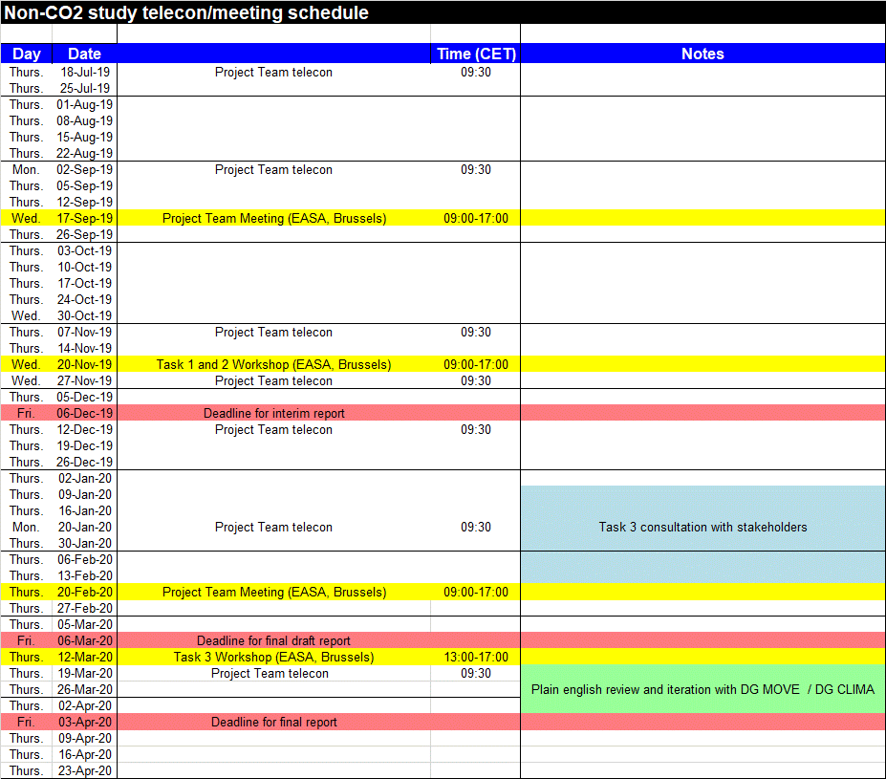

**APPENDIX 3 – Task 1 and 2 Workshop on 20 November 2019**

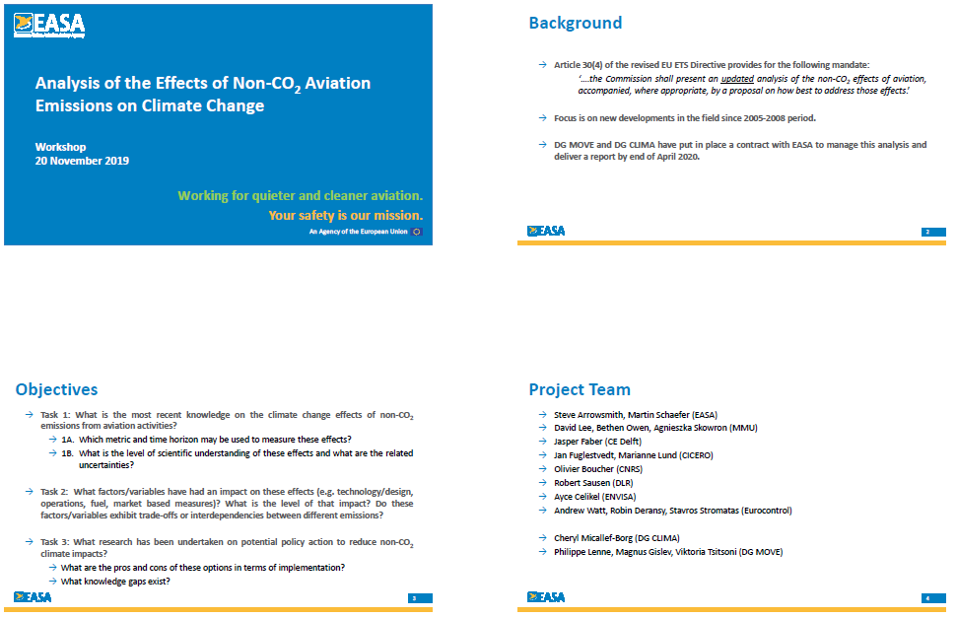

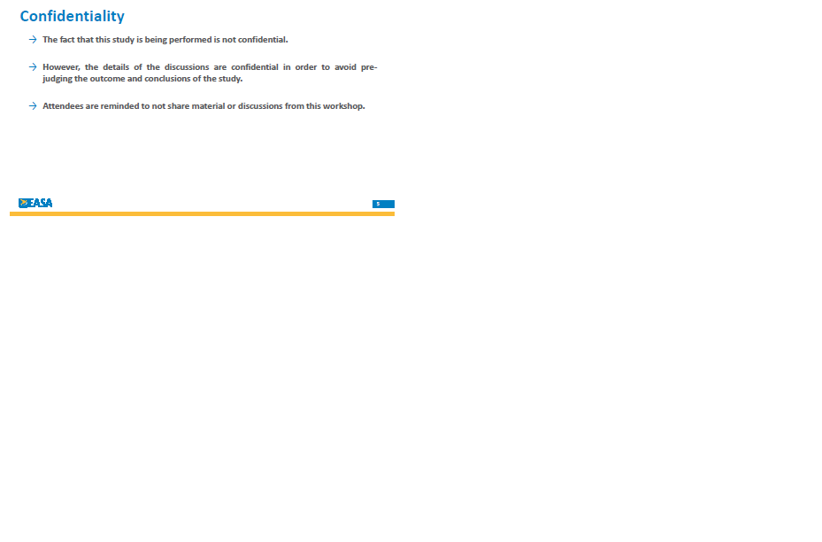

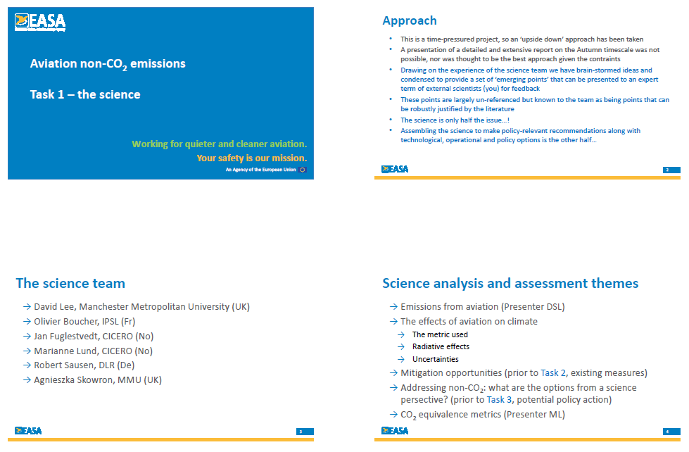

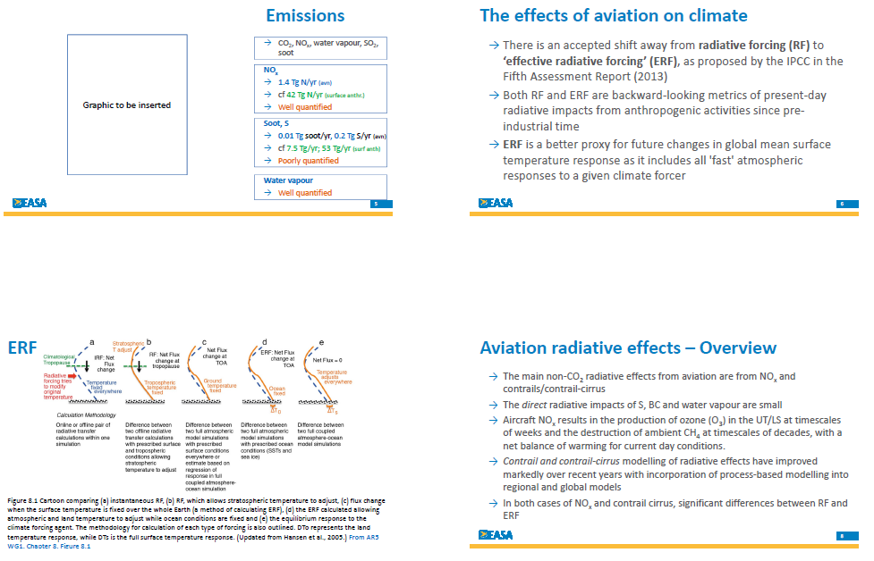

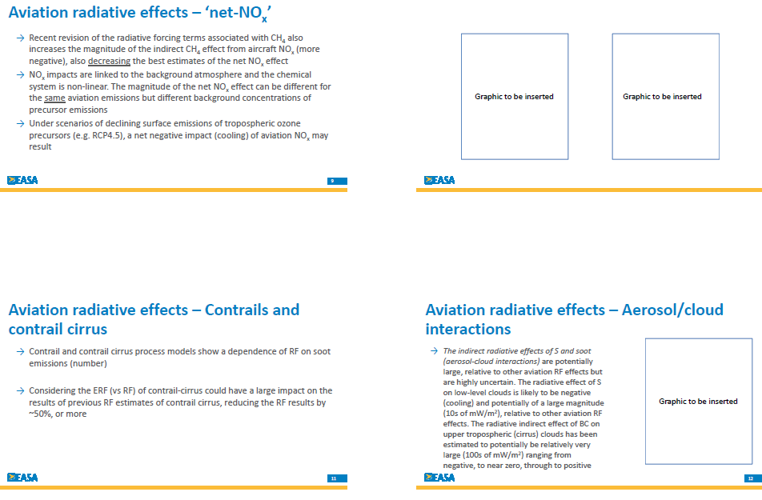

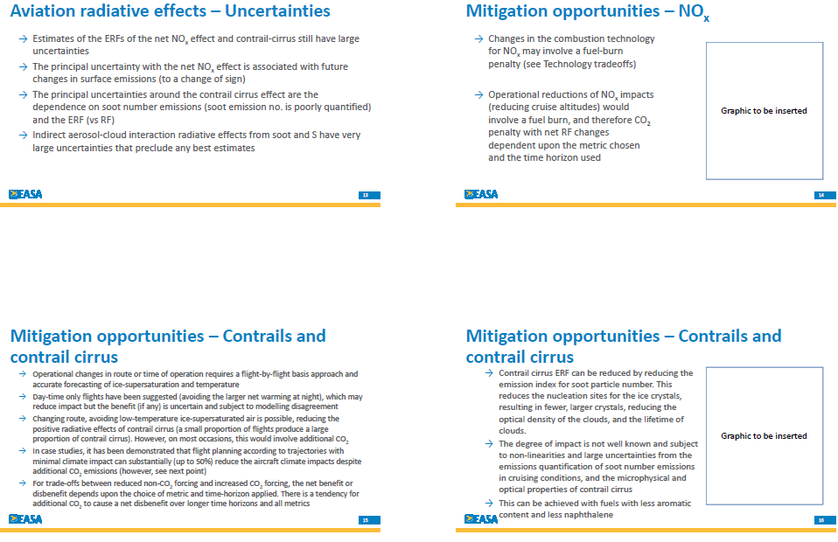

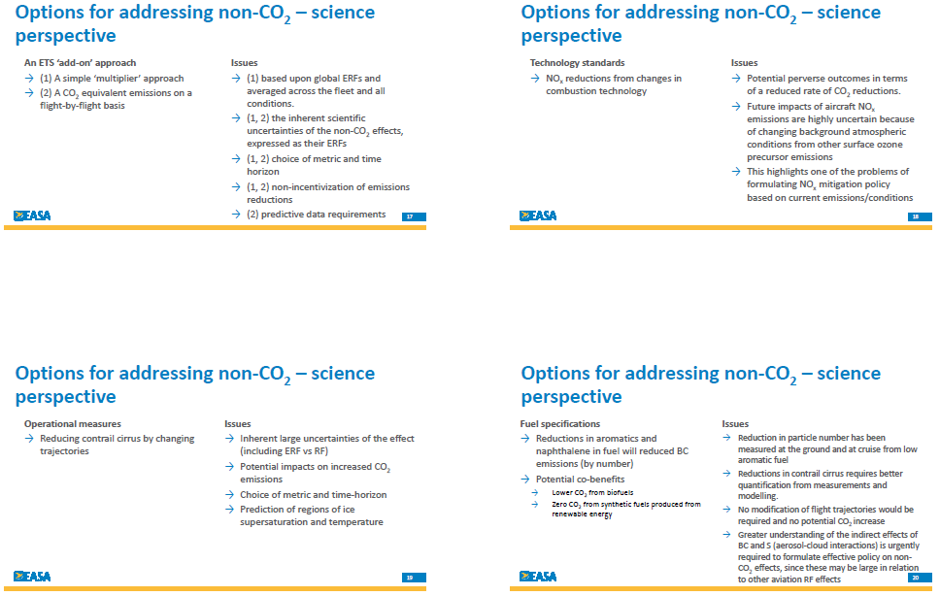

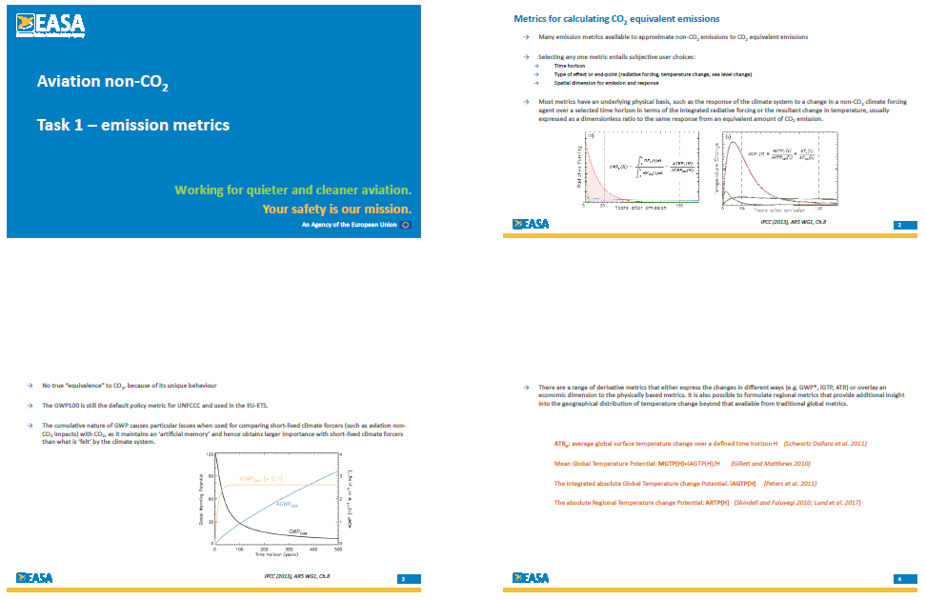

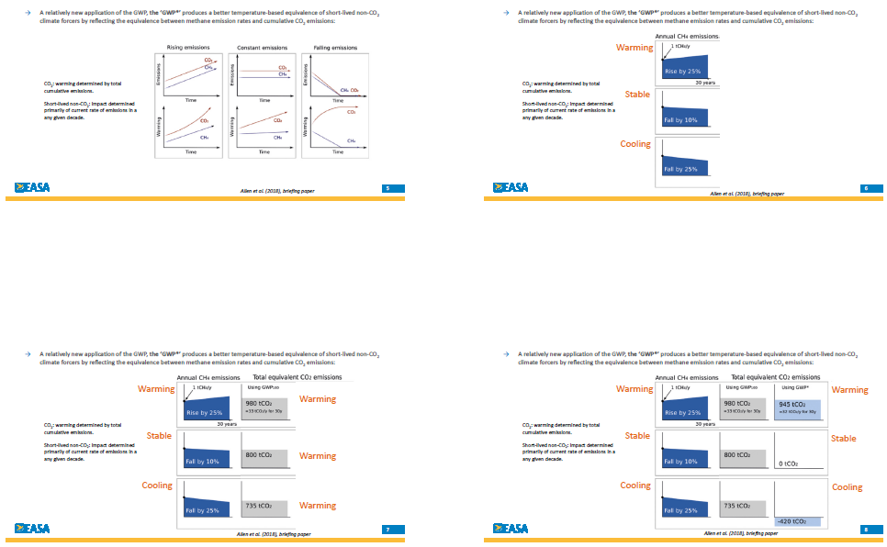



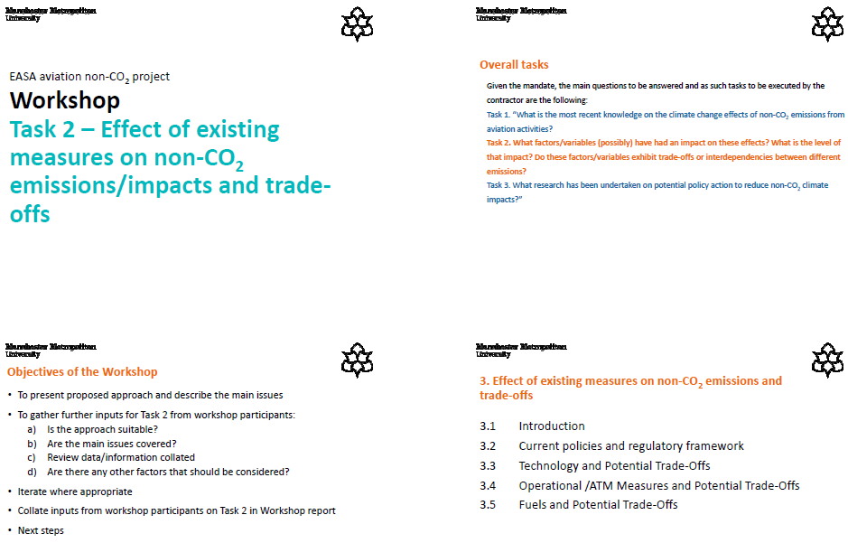

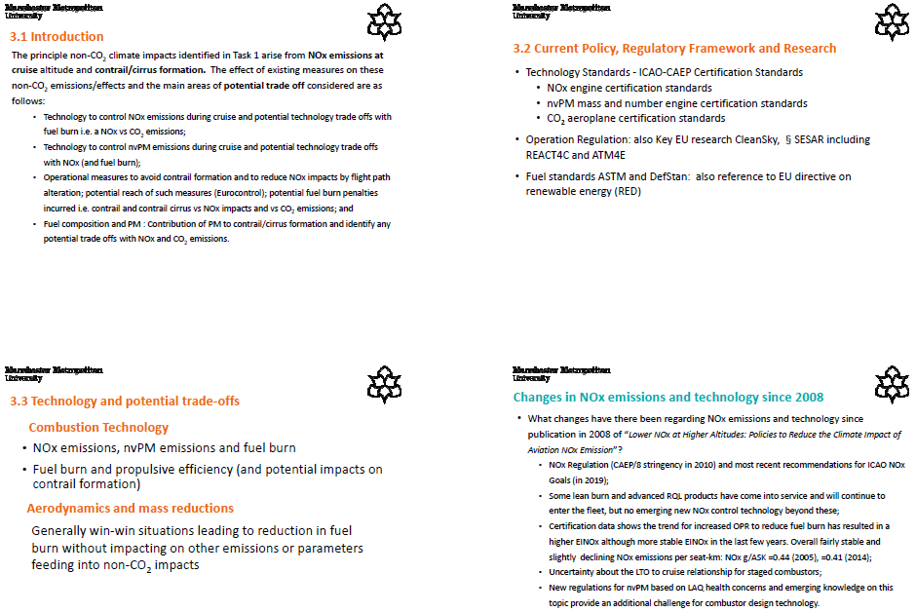

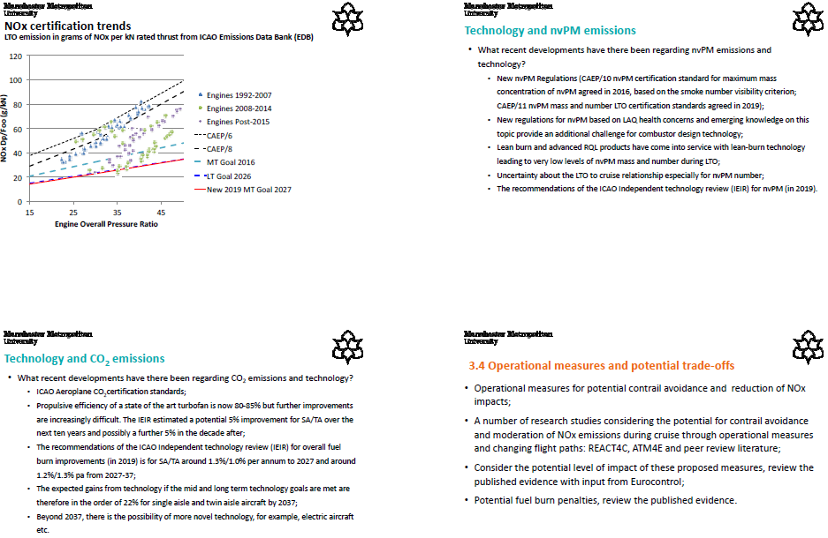

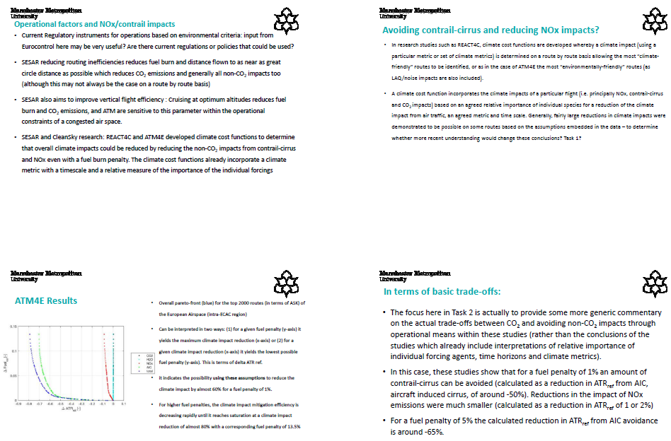

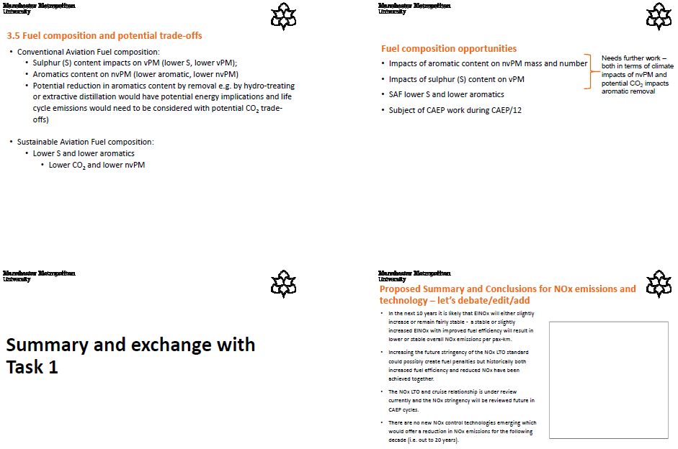

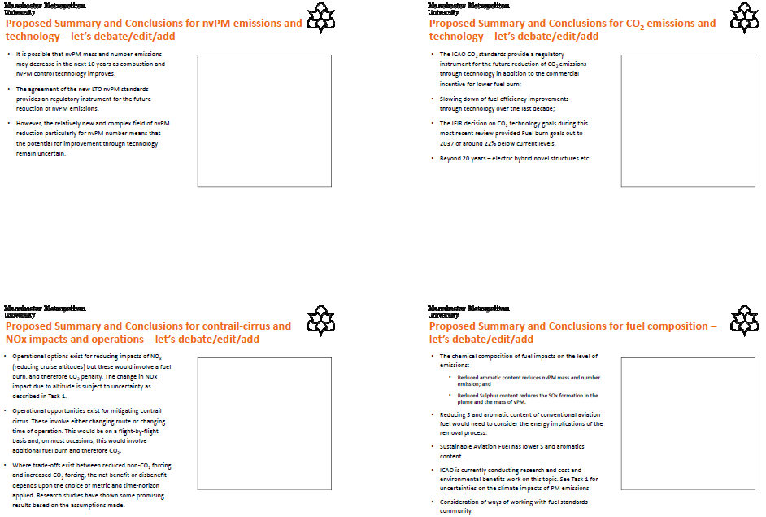

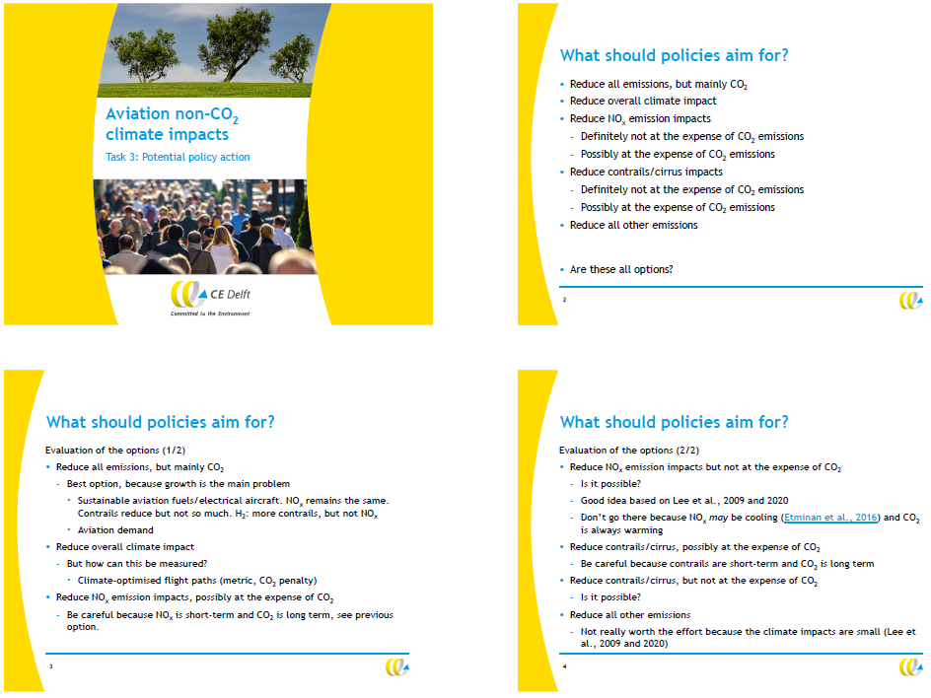

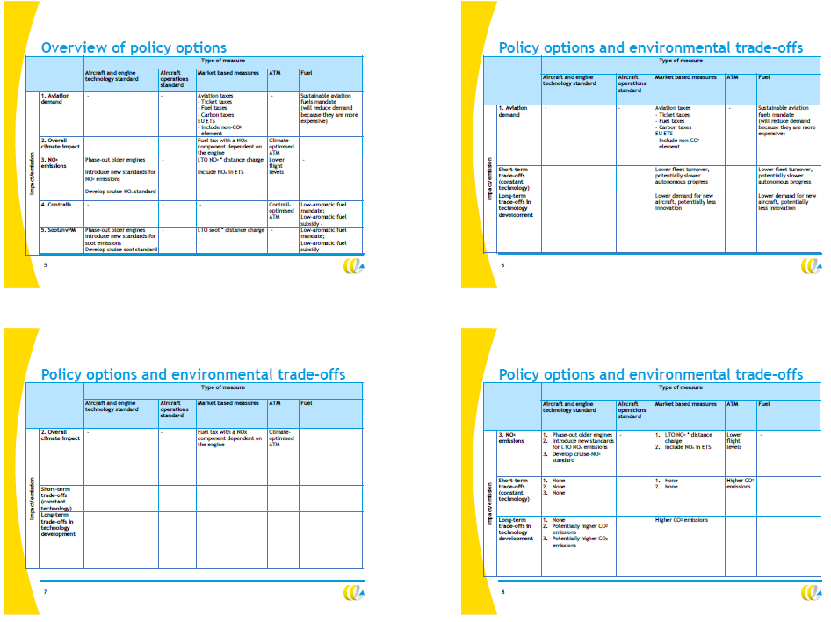

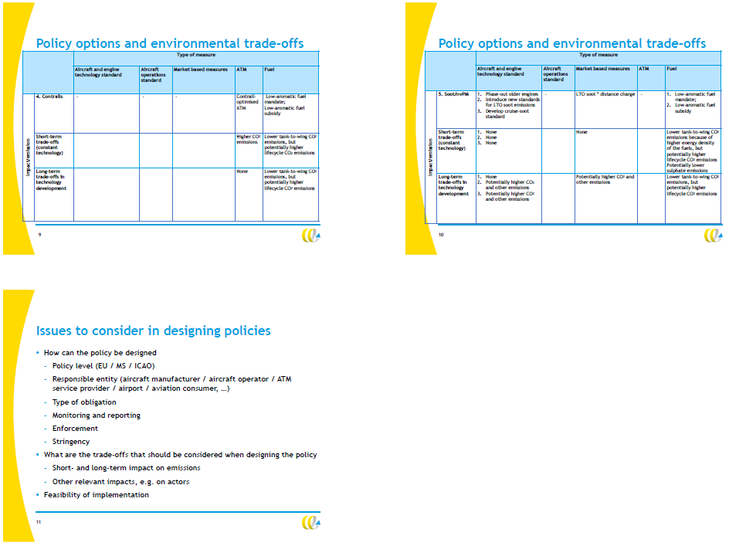

|  |  |  |  |  |
| --- | --- | --- | --- | --- |
| C:\Users\zaratma\Desktop\NEW EASA-logo_RGB_positive_300dpi 2019 - Copy.png | | **MINUTES OF MEETING** | | |
| **Subject** | | Workshop on the effects of non-CO2 aviation emissions on climate change |
| **Date** | | 20.11.2019 |
| **Location**  **Organised by** | | EASA Office, Brussels  Steve Arrowsmith, EASA Certification Directorate |
|  | |  | | |

**List of Participants**

|  |  |
| --- | --- |
| **Attendees** | Project Team:  Steve ARROWSMITH, EASA  Martin SCHAEFER, EASA  Philippe LENNE, DG MOVE  Viktoria TSITSONI, DG MOVE  Cheryl MICALLEF-BORG, DG CLIMA  Andrew WATT, EUROCONTROL  Stavros STROMATAS, EUROCONTROL  David LEE, MMU  Bethan OWEN, MMU  Agnieszka SKOWRON, MMU  Jasper FABER, CE Delft  Lisanne VAN WIJNGAARDEN, CE Delft  Jan FUGLESTVEDT, CICERO  Marianne LUND, CICERO  Robert SAUSEN, DLR  Olivier BOUCHER, CNRS  Ayce CELIKEL, ENVISA *(via WebEx)*  External Experts:  Myles ALLEN, University of Oxford *(via WebEx)*  Volker GREWE, TU Delft *(via WebEx)*  Ulrike BURKHARDT, DLR  Etienne TERRENOIRE, ONERA  Frank DENTENER, DG JRC *(via WebEx)*  Matteo PRUSSI, DG JRC *(via WebEx)*  Peter VAN VELTHOVEN, KNMI  Andre VAN VELZEN, TAKS  Chris EYERS, LimitedSkies  Martin PLOHR, DLR  Stephanie SCHILLING, EEA *(via WebEx)* |

**AGENDA**

Welcome and Introduction

Summary of study ToR and confidentiality

Task 1: Most recent knowledge on the climate change effects of non-CO2 from aviation

Task 2: Effect of existing measures on non-CO2 emissions/impacts and trade-offs

Task 3: Policy options to reduce non-CO2 emissions

Summary of key points from discussions

AOB

|  |
| --- |
| **Welcome and Introduction** |
| Steve ARROWSMITH welcomed the project team and external experts to the workshop, which was organised in the context of the planned study about non-CO2 effects of aviation. |

|  |  |
| --- | --- |
| **Summary of study ToR and confidentiality**  *Pre*s*ented by:* Steve, Philippe, Cheryl | |
| Steve ARROWSMITH gave an introduction into the planned study, which is triggered by Article 30(4) of the revised EU ETS Directive. The project is funded by the European Commission and managed by EASA. The study assesses non-CO2 climate impacts of aviation and policy measures to mitigate such impacts, with a focus on new findings since 2005-2008. The goal of the meeting was to discuss preliminary key messages, in particular but not limited to atmospheric science, in order to ensure that those represent a consensus amongst the experts.  Philippe LENNE and Cheryl MICALLEF-BORG highlighted the confidentiality of the study contents. While we can communicate that this project is ongoing, any results and contents shall not be disclosed. Attendees are reminded to not share material or discussions from the workshop. | |
|  |  |

|  |  |
| --- | --- |
| **Task 1: Most recent knowledge on the climate change effects of non-CO2 from aviation**  *Presented by:* David, Agnieszka, Marianne, Jan | |
| David LEE gave a presentation about ‘emerging points’ from the study, covering emissions, effects, and metrics.  Regarding **aviation emission quantities**, the discussion focused on knowledge gaps:while emissions of CO2, water vapour and – to a lower degree – NOx are comparably well quantified, sulphur and soot emissions can be regarded as poorly quantified. Sulphur emissions depend on fuel properties, which are not well known on a worldwide basis, while only limited number of measurements exist for soot emissions. Bethan OWEN added that ICAO initiatives to collect fuel properties via State Letters has not delivered good results. Cruise emissions of NOx and particles are an additional source of uncertainty, particularly for unconventional engine combustor configurations. Robert SAUSEN mentioned that insights into actual cruise emissions have been gathered from in-flight measurements, but further work is required.  **Effects of aviation on climate** were suggested by David to be quantified by means of the effective radiative forcing (ERF), as proposed by IPCC in the 5th Assessment Report (2013). ERF would be a better proxy than RF for future changes in global mean surface temperature response as it takes into account the non-CO2 ‘fast’ atmospheric forcing effects. Myles ALLEN agreed with this view and stressed the importance of context, plain English and, as far as possible, ‘simplicity’ when communicating to policymakers (e.g. 1000 billion tonnes of CO2 emissions results in an increase in RF of 1W/m2). Ulrike BURKHARDT and Volker GREWE mentioned that both RF and ERF are backward looking and could be useful depending on the goal of an assessment and emissions scenario. Olivier BOUCHER stated that he saw RF and ERF as more overlapping then complementary and that, while ERF is potentially a better predictor of GMST, it is also more uncertain.  Main non-CO2 radiative effects from aviation are from **NOx and contrail/contrail-cirrus**. Quantification of the contrail/contrail-cirrus effects in cloud free air have improved recently, but further research is needed to consider effects within clouds. Robert SAUSEN mentioned that water vapour effects become important should supersonic aircraft witih higher cruise altitudes be reintroduced. Volker GREWE mentioned that the altitude-dependency for water vapour effects are already important for recent subsonic aircraft designs cruising at flight levels 410-430. Peter VAN VELTHOVEN mentioned that an evolution of knowledge for NOxhas taken place, but, as a result, its warming effects must be regarded as less certain than it appeared in the past.  Agnieszka SKOWRON explained in her presentation that the **net NOx effect** may be lower than previsouly assumed or – in certain future scenarios – even negative. Recent studies show that the climate impact of aviation NOx depends on surface emissions from other sources. A cleaner background environment mitigates some of the aviation NOx radiative forcing on a non-linear basis. David pointed out that short-lived climate forcers should be reduced, but care should be taken regarding aircraft NOx policies given current uncertainties. Peter suggested that priorisation regarding the reduction of different short-lived forcers should be discussed. Myles highlighted the ‘big picture’ objectives in the Paris Agreement and IPCC 1.5degC report which refers to net zero CO2 emissions and a reduction in RF from other non-CO2 climate forcers.  Marianne LUND presented information on **metrics for calculating CO2 equivalent emissions**. Temperature-based metrics and the GWP\* are potentially more useful for temperature-based policy objectives. GWP and GTP are common metrics used by IPCC. GWP100 is the default metric for UNFCCC and EU-ETS, but GWP may not be suitable to assess short-lived climate forcers. Derivative metrics (GWP\*, iGTP, ATR) express the changes in different ways or overlay an economic dimension to the physically based metrics. Main discussion item was GWP\*: Myles ALLEN clarified that the scientific integrity of GWP\* is undisputed, while its application to policy measures can be discussed. Marianne added that the AGTP concept has also been used frequently in recent literature. Stephanie SCHILLING added that no shift from GWP to GWP\* had been observed in terms of the UNFCCC submissions. Myles confirmed that the use of GWP\* instead of GWP100 makes no difference to CO2 effects, and mitigates the issue that GWP100 undervalues any increase in short-lived climate species’ emission rates, but overvalues ongoing emissions.  Olivier and Myles initiated a discussion about **whether long-lived climate forcers and short-lived forcers should be tradable against each other** in a policy measure (“stock” CO2 against “flow” non-CO2 pollutants”). Olivier argued that, although scientifically sound, GWP\* does not provide a practical actionable metric for trading. Miles also cautioned that there is not true equivalent, that trading may not be sensible, and suggested that both aspects should be treated separately. This was captured in the IPCC AR5, Chapter 8:  “*Ideally, the climate effects of the calculated CO2 equivalent emissions should be the same regardless of the mix of components emitted. However, different components have different physical properties, and a metric that establishes equivalence with regard to one effect cannot guarantee equivalence with regard to other effects and over extended time periods*.”  Robert SAUSEN noted that in the aviation world, CO2 and non-CO2 emissions are interrelated, and should be accounted for accordingly in order to set the right incentives to minimize the total aviation effect on climate in the most efficient way. It was agreed that reducing only CO2, while not addressing non-CO2 emissions, would be neither enough nor optimal to reach climate goals. Myles also noted that the GWP\* was a more appropriate metric if future scenarios included serious plans to mitigate total emissions.  David LEE continued his presentation about **contrail and contrail cirrus effects**. A dependence of contrail/contrail-cirrus formation on soot emissions is shown by the models, and climate effects are potentially large. Uncertainties regarding the magnitude of these effects are high. The use of ERF, instead of RF, to assess contrail-cirrus could have a large impact on the previous results with a reduction of approx. 50%. Ulrike pointed out that when reducing the number of particles from aircraft engines by 50% (e.g. by use of sustainable fuels), their impact on climate could be reduced in the order of 15-20%. The interrelation between soot emissions and contrail/cirrus formation is non-linear, ranging from a small reduction in RF when decreasing soot slightly, a larger reduction of effects with further soot decrease, and an increase in RF should soot emissions be reduced by more than 90%. Indirect aerosol-cloud interaction radiative effects from sulphur also has very large uncertainties that preclude any best estimates.  Etienne TERRENOIRE underlined the fact that reducing strongly the soot emissions at the engines exits could modify the microphysics processes that were up to now identified as crucial. For example, poorly quantified organics matter from the aircraft engines, as well as background ice nuclei, could see their roles in contrails formation (and thus contrails properties) leading to the need for a specific detailed microphysics study dedicated to contrails formation in the plane near-field.  David and Jan FUGLESTVEDT presented a still unpublished **updated ERF chart** intended to summarize the climate effects of aviation. Contrail-cirrus effects are larger than CO2 efffects when using ERF as a backward-looking metric, but with greater uncertainty and lower confidence level. Net NOx effects are estimated to be positive for now. Non-CO2 effects in total represent more than half of the aviation effects on climate. Steve ARROWSMITH asked for more information regarding the confidence levels shown in the chart. David explaind that a qualitative IPCC approach is applied to estimate confidence levels, unlike the level of scientific understanding shown in previous chart from Lee et al. 2009. Ulrike mentioned that the uncertainty bars in the chart do not include the uncertainty related to the conversion of RF to ERF. | |
|  |  |

|  |  |
| --- | --- |
| **Task 2: Effect of existing measures on non-CO2 emissions/impacts and trade-offs**  *Presented by:* Bethan, David | |
| David shortly introduced **mitigation opportunities** for aviation’s climate impacts. Contrail impacts can be mitigated by operational measures, but at the cost of a fuel-burn penalty. Net benefits of such avoidance measures depend on time horizons and metrics, and the uncertainties regarding certain input assumptions (e.g. particle number emissions in cruise) affect the quality of results.  Bethan OWEN gave a presentation on technology and operational measures to reduce aviation emissions. Various technology trade-offs between engine emissions and fuel burn or between different emissions exist and need to be considered. Discussions focused on **certification standards** for NOx and nvPM emissions of aircraft engines, and the aeroplane CO2 standard. NOx standards have been tightened several times in the past, resulting in the development of advanced RQL and staged/lean-burn combustor technology with lower NOx emissions. Lean-burn combustion has co-benefits in terms of low NOX and nvPM emissions. No step-change technologies are expected at the aircraft or engine level in the next 20 years. Cruise NOx emissions and nvPM emissions (by mass and number), in particular for staged/lean-burn combustors, were identified as knowledge gaps that needed to be addressed. Chris EYERS suggested to consider obligatory reporting of cruise NOx and cruise nvPM emissions by the manufacturers on their aircraft engines. Robert SAUSEN mentioned that the size distribution of particle emissions is of interest to the atmospheric science community, and that hybrid aircraft with hydrogen powered engines could be feasible in the short term. Martin SCHAEFER raised a concern regarding the observation that conventional combustors replace newly developed lean-burn combustors on some engines for reasons of cost, reduced complexity and a minimal fuel-burn benefit (<0.5%), but at the cost of significantly higher NOx and nvPM emissions. Chris explained the tradeoff between the nvPM and NOx emissions during combustor design. It was noted that there may be potential to motivate manufacturers to focus more on nvPM rather than on NOx by communicating policy preferences on this matter based on the lateast scientific understanding.  Research in the REACT4C and ATM4E projects have combined CO2 and non-CO2 effects of aviation for assessing operational mitigation measures (**climate-optimized flight trajectories**). REACT4C and ATM4E use climate cost functions to determine that overall climate impact of flights can be reduced by reducing non-CO2 impacts (even with a fuel burn penalty). Under a set of specific assumptions, Volker GREWE explained that the contrail impact is typically larger than the NOx impact when optimising flight profiles for minimum climate impact (e.g. in terms of ATR). In ATM4E, different metrics and time horizons were explored, and those lead to similar results. Intermediate-stop operations and formation flight are **other operational concepts** mentioned by Robert SAUSEN. Andrew WATT added that an element linked to the environmental efficiency of a flight could be added to the route-charging concept.  **Fuel composition** (sulphur and aromatics) influence nvPM emissions, according to Bethan’s presentation, with potential consequences for contrail formation, at least in a situation where formation criteria are met by a high margin. **Synthetic fuels (biofuels or PtL)** also have benefits through the formation of a lower amount of the smaller particles, leading to a reduction in the climate effect of contrail/contrail cirrus. | |
|  |  |

|  |  |
| --- | --- |
| **Task 3: Policy options to reduce non-CO2 emissions**  *Presented by:* Jasper, David | |
| David LEE introduced options for addressing non-CO2 from a science perspective. **Multiplier approaches** for use with the ETS (constant multiplier vs. CO2-equivalent emissions on a flight-by-flight basis) can be discussed, but have disadvantages in terms of data requirements, scientific uncertainty and/or would not set the right incentives. Robert SAUSEN suggested an additional option in between the aforementioned two approaches, i.e. height- and latitude-dependent climate cost functions. Other policy options resulting from Task 2 discussions included more stringent engine emissions technology standards, and reducing contrail cirrus by operational measures. Both options have pros and cons. Fuel-related options include the promotion of sustainable aviation fuels (biofuels, PtL fuels), in order to reduce lifecycle CO2 emissions with co-benefits for nvPM and reduced aromatics. PtL fuels with zero net CO2 emissions could be produced using renewable energy. Robert SAUSEN cautioned that CO2 provision for PtL production is an open issue, at least for large-scale production.  Jasper FABER iniatiated a discussion about **policy aims**. Should policies aim to reduce all emissions (but mainly CO2), reduce the overall climate impact of aviation, or any other option? Cheryl mentioned the Paris objectives, which need to be considered at a higher level. Volker asked whether the policy aims mentioned by Jasper are for an individual flight or for the whole sector? Jan suggested to focus on temperature goals rather than all climate impacts. In terms of emissions, the net-zero CO2 emissions goal could play a key role. Robert highlighted that non-CO2 emissions are important, and temperature goals will not be reached without reducing them.  Jasper initially focused on the aim to **reduce all emissions, but mainly CO2**. Fuel-based measures and technology measures (electrical or hydrogen-powered aircraft) could be seen as appropriate examples to address such a goal. Ulrike questioned whether H2-powered aircraft would produce more contrails, as mentioned on Jasper’s slides, due to the H2O growing and dropping out quickly. Chris clarified that for H2-powered aircraft with conventional combustion, also NOx would be produced. An alternative policy aim would be to **reduce the overall climate impact**, e.g. by means of promoting climate-optimised flight trajectories, at the risk of drawbacks in terms of accuracy. Robert SAUSEN mentioned that the accuracy would not have to be high for every individual flight as along as the climate cost function has good results on average. The metrics chosen for such an approach should ensure that effects go in the right direction. Ulrike cautioned to keep such simplified cost functions under review in order to ensure that they correspond to results of climate models, and latest scientific understanding, thereby meeting environmental protection objectives. Olivier shared his thought that long-lived and short-lived species had different “status”: the climate effect of CO2 has a high level of certainty and is already considered by airlines because of fuel cost (rather than taxation) while the climate effects of short-lived species is more uncertain and unaccounted for. In a first approach, short-lived species could initially be given a lower weight, which may be increased later as science develops. Olivier also suggested that more importance should be given to contrail/contrail-cirrus than to NOx because i) the magnitude of the NOx effect is being revised downwards, ii) it may be less in a hypothetical future cleaner atmosphere, iii) it has already been addressed to some extent by legislation. @:Volker suggested to define in more detail the time horizons that are of interest for the policy side, and develop an appropriate (combined) metric from there. **Reducing NOx emissions** and **reducing contrails/cirrus** were presented as further policy aims by Jasper. Andrew WATT pointed out that any policy measure should be easy to communicate and be based on sound science without high levels of uncertainty. Resistance from airlines and the public can be expected otherwise.  Jasper ended his presentation by giving an **overview of different policy options**. A sustainable fuel mandate or aviation taxes would indirectly impact aviation demand. Lower fleet turnover and less innovation could be negative consequences. Steve asked whether a positive short-term impact for market-based measures could be the early retirement of old aircraft, which was confirmed by Jasper. Robert raised doubts whether a negative impact in terms of innovation will be the result, as any such policy could be regarded as incentivising technologies. Climate-optimised ATM and a fuel tax with a NOx (or nvPM) component were presented as further example measures. NOx (or nvPM) reduction policies could consider more stringent emission standards, or inclusion of these emissions into market-based systems. Robert mentioned that avoiding only the most important contrails by incentives or penalties to avoid airspace with the biggest effects from supersaturated air, could be an option to discuss. Etienne TERRENOIRE mentioned that the quality of weather forecast information could be a risk for any such measure. | |
|  |  |

|  |  |
| --- | --- |
| **Summary of key points from discussions** | |
| Steve ARROWSMITH thanked the participants for attending the workshop and for their expert input into the discussions. Meeting minutes that include a summary of discussions will be distributed for review and comments after the meeting. Any further input by participants would be most welcome and can be provided by email.  Cheryl MICALLEF-BORG thanked the external participants on behalf of the European Commission for their valuable contribution to this workshop. | |
|  |  |

|  |  |
| --- | --- |
| **AOB** | |
| - |  |

|  |  |  |  |
| --- | --- | --- | --- |
| **MoM prepared by** | Martin SCHAEFER | **21.11.2019** |  |
| **MoM reviewed by** | Steve ARROWSMITH | **22.11.2019** |  |

1. Directive 2014/24/EU of the European Parliament and of the Council of 26 February 2014 on public procurement and repealing Directive 2004/18/EC (OJ L 94, 28.3.2014, p. 65). [↑](#footnote-ref-1)
2. (European Commission - DG CLIMA) [↑](#footnote-ref-2)
3. (European Environment Agency , 2018) [↑](#footnote-ref-3)
4. Vide i.a. (Emission Reduction Targets for International Aviation and Shipping, 2015); (Grewe, 2018); and (CE Delft, May 2017) [↑](#footnote-ref-4)
5. Commission Staff Working Document, SEC(2006) 1684, Impact Assessment of the inclusion of aviation activities in the scheme for greenhouse gas emissions allowance trading within the Community [↑](#footnote-ref-5)
6. Lower NOx at Higher Altitudes - Policies to Reduce the Climate Impact of Aviation NOx Emission; Jasper Faber, Dan Greenwood, David Lee, Michael Mann, Pablo Mendes de Leon, Dagmar Nelissen, Bethan Owen, Malcolm Ralph, John Tilston, André van Velzen, Gerdien van de Vreede; Delft, CE Delft, October 2008 [↑](#footnote-ref-6)
7. European Aviation Environmental Report 2019, Chap. 7.3 [↑](#footnote-ref-7)
8. Certain Landing and Take-Off (LTO) emissions are captured by Annex 16 to the Convention on International Civil Aviation, Environmental Protection Volume II - Aircraft Engine Emissions, 4th Edition July 2017. The ICAO Standards for Engine Emissions are implemented through Article 6 of the Regulation (EU) 2018/1139 of the European Parliament and of the Council of 4 July 2018 on common rules in the field of civil aviation and establishing a European Union Aviation Safety Agency, and amending Regulations (EC) No 2111/2005, (EC) No 1008/2008, (EU) No 996/2010, (EU) No 376/2014 and Directives 2014/30/EU and 2014/53/EU of the European Parliament and of the Council, and repealing Regulations (EC) No 552/2004 and (EC) No 216/2008 of the European Parliament and of the Council and Council Regulation (EEC) No 3922/91; Annex I (Part-21) of the Implementing Regulation, and the Certification Specifications of CS-34 (emissions) and CS-36 (noise). [↑](#footnote-ref-8)
9. It should be noted that the cruise emissions of certain air pollutants that are relevant in this context are reported as ‘memo items’ (i.e. reported but not added to national totals) under the UNECE Convention on Long-range Transboundary Air Pollution (CLRTAP) – i.e. NOX, NMVOCs, SOX, NH3, CO, HMs, POPs and PM; and the National Emissions Ceilings (NEC) Directive (2016/2284/EU) – i.e. NOX, NMVOCs, SO2 and NH. Guidance on estimating these emissions is provided in the aviation chapter of the EMEP/EEA Guidebook: <<https://www.eea.europa.eu/publications/emep-eea-guidebook-2016/part-b-sectoral-guidance-chapters/1-energy/1-a-combustion/1-a-3-a-aviation-2016/view>> [↑](#footnote-ref-9)
10. Directive (EU) 2018/410 of the European Parliament and of the Council of 14 March 2018 amending Directive 2003/87/EC to enhance cost-effective emission reductions and low-carbon investments, and Decision (EU) 2915/1814 [↑](#footnote-ref-10)
11. J.E.Penner, D.H.Lister, D.J.Griggs, D.J.Dokken, M.McFarland (Eds.); Prepared in collaboration with the Scientific Assessment Panel to the Montreal Protocol on Substances that Deplete the Ozone Layer; Cambridge University Press, UK. [↑](#footnote-ref-11)
12. Leonor Tarrasón and Jan Eiof Jonson (met.no), Terje K. Berntsen and Kristin Rypdal (CICERO); Norwegian Meteorological Institute, 09 January 2004 [↑](#footnote-ref-12)
13. R.C.N. (Ron) Wit, B.H. (Bart) Boon and A. (André) van Velzen (CE Delft), M. (Martin) Cames and O. (Odette) Deuber (Oeko-Institut), D.S. (David) Lee (Manchester Metropolitan University); Delft, CE, July 2005. [↑](#footnote-ref-13)
14. op.cit. fn.5 [↑](#footnote-ref-14)
15. Lee D. S., Fahey D., Forster P., Newton P.J., Wit R.C.N., Lim L.L., Owen B., Sausen R. [↑](#footnote-ref-15)
16. Zhou C. and Penner J. [↑](#footnote-ref-16)
17. Pitari G., Iachetti D., Di Genova G., De Luca N., Amund Søvde O., Hodnebrog Ø., Lee D.S. and Lim L. [↑](#footnote-ref-17)
18. Righi M., Hendricks J., and Sausen R. [↑](#footnote-ref-18)
19. Kapadia Z. et al. [↑](#footnote-ref-19)
20. Masson-Delmotte, V., P. Zhai, H.-O. Pörtner, D. Roberts, J. Skea, P.R. Shukla, A. Pirani, Moufouma-Okia, C. Péan, R. Pidcock, S. Connors, J.B.R. Matthews, Y. Chen, X. Zhou, M.I. Gomis, E. Lonnoy, Maycock, M. Tignor, and T. Waterfield (eds.). World Meteorological Organization, Geneva, Switzerland [↑](#footnote-ref-20)
21. Sarah Freeman, David S Lee, Ling L. Lim, Agnieszka Skowron and Ruben Rodriguez De León [↑](#footnote-ref-21)
22. Rodriguez De Leon, Ruben & L. Lim, Ling & Lee, David & Bennett, Michael & Krämer, Martina. [↑](#footnote-ref-22)
23. D. Lee, Manchester Metropolitan University; published online on 17 December 2018 UK Government Dept. for Transport [↑](#footnote-ref-23)
24. So excluding all aircraft activities that take place at altitudes under 914 meters (3.000 feet), including taxi-in and -out, take-off, climb-out and approach-landing. [↑](#footnote-ref-24)
25. Vide op.cit fn.6 and fn. 10, for reasons as to why these emissions are to be assessed. [↑](#footnote-ref-25)
26. In treating non-CO2 emissions in an equivalent manner to CO2 emissions. [↑](#footnote-ref-26)
27. E.g. the 2006 Impact Assessment is based on the premise that CO2 and NOx do not have trade-offs, however the Standards for Fuel Efficiency in new engine design have resulted in higher NOx output. [↑](#footnote-ref-27)
28. E.g. With contrails, there seems to be a basic tension between flying the most efficient route to minimise fuel burn/CO2, and flying a sub-optimal route to minimise contrail formation. [↑](#footnote-ref-28)
29. E.g. there is already large commercial incentive in reducing fuel burn. Reducing fuel burn reduces both CO2 and NOx emissions. [↑](#footnote-ref-29)
30. Given Alternative Fuels also produce non-CO2 emissions, and one is to take account of an LCA analysis, it may be warranted that this measure is not included in the Study’s parameters. Should this be the route taken, it is however argued that a justification should be provided within the Study’s report. [↑](#footnote-ref-30)
31. Grewe et al., 2017 [↑](#footnote-ref-31)
32. Niklaß et al., 2017 [↑](#footnote-ref-32)