

***Annex 1:***

***Number of reported export authorisations issued by Member States pursuant to Article 20(2) of Regulation (EU) 2019/125 by Annex entry***

***Annex 2:***

***Number of reported export authorisations issued by Member States over the period 2017– 2019***

***Annex 3:***

***Reported destinations[1] of authorised exports in 2019[2]***

***Annex 4:***

***Overview of reported authorised exports of Annex III goods in 2019***

|  |  |  |  |  |
| --- | --- | --- | --- | --- |
| **Code** | **Product Annex III** | **Destination** | **End use** | **Competent authority** |
| 1.1 | Shackles and gang chains | Bahrain (2), Serbia (1), Argentina (1) | Law enforcement | CZ |
|
|
| Montenegro (1), North Macedonia (4), Oman (1), Switzerland (1), United States (1) | End use not stipulated | DE |
| Hong Kong (1), Australia (2), New Zealand (1) | Law enforcement | UK |
| 1.2 | Individual cuffs or rings fitted with a locking mechanism | Barbados (1) | Law enforcement | UK |
| 2.1 | Portable electric discharge weapons, including but not limited to electric shock batons, electric shock shields, stun guns and electric shock dart guns | Aruba (1), Moldova (1), Montenegro (1), Ukraine (1), UAE (1), Switzerland (1) | Law enforcement (Aruba), Traders | CZ |
| New Caledonia (2), Central African Republic (1) | End use not stipulated | DE |
| Andorra (1) | Law enforcement | ES |
| Andorra (1), Senegal (1) | Private security firm | FR |
| United States (1) | Other | UK |
| 3.1 | Portable weapons and equipment for administration or dissemination of a dose of an incapacitating or irritating chemical substance. | Aruba (1), Moldova (1), Montenegro (1), Ukraine (1), UAE (1), Switzerland (1) | Law enforcement (Aruba), Traders | CZ |
| Andorra (9), Bosnia and Herzegovina (4), Chile (1), Democratic Republic of the Congo (1), French Polynesia (1), Japan (4), Kosovo (1), Cuba (1), Mali (1), Montenegro (2), Namibia (1), New Caledonia (2), North Macedonia (1), Pakistan (1), Moldova (1), Switzerland (11) Serbia (1), Somalia (3), South Africa (7), Tunisia (1), Uruguay (1), United States (1), China (2). | End use not stipulated | DE |
| Andorra (2) | Law enforcement | ES |
| Senegal (1), Andorra (2), Niger (1) | Private security firm, law enforcement (customs) (Niger) | FR |
| United Arab Emirates (2) | Private security firm | PL |
| Andorra, Australia, Switzerland, South Africa, United States (total 6) | Other | SE |
| Australia (1) | Law enforcement | UK |
| 3.2 | Pelargonic acid vanillylamide (PAVA) | Brazil (4), India (13), Japan (1), South Korea (3), Singapore (1), Sri Lanka (1), South Africa (1), Thailand (1), Turkey (2), China (3)  (30) | End use not stipulated | DE |
| Costa Rica (1), Gibraltar (1), United States (1) | Clinical and laboratory use (Costa Rica and US), law enforcement (Gibraltar) | UK |
| 3.3 | Oleoresin capsicum (OC) | Egypt (1), Argentine (2), Australia (1), Japan (1), Kenya (1), Russia (2), Switzerland (5), South Africa (1), Tunisia (1), Ukraine (4), China (1) | End-use not stipulated | DE |
| Aruba (1), BES Islands (3), Curaçao (2), Sint Marteen (1) and global licence to referred destinations | Law enforcement | NL |
| 3.4 | 3.4 Mixtures containing at least 0.3 % of PAVA by weight or OC and a solvent (pepper spray) | Brazil (1), Japan (1), Russia (1), Switzerland (4), Ukraine (5), United States (1), China (1). | End-use not stipulated | DE |
| Saint Helena (1) | Law enforcement | UK |
| 3.6 | Fixed or mountable equipment for the dissemination of incapacitating or irritating agents covering a wide area | Switzerland (2), United Arab Emirates (1). | End use not stipulated | DE |

***Annex 5:***

***Detailed overview of reported authorised exports of Annex IV goods in 2019***

|  |  |  |  |  |
| --- | --- | --- | --- | --- |
| **Code** | **Product Annex IV** | **Destination** | **End use** | **Competent authority** |
| 1.1 (a) | Amobarbital | Norway (1)  (Same authorisation is used for all listed goods exported from the UK destined for Norway). | Clinical and laboratory use | UK |
| 1.1 ( c) | Pentobarbital | Norway | Clinical and laboratory use | UK |
| 1.1 (d) | Pentobarbital sodium salt | Aruba (1), Canada (2), Curaçao (2), Hong Kong (2), Malaysia (1), Switzerland (2) | Veterinary use | NL |
| United States (1) | Clinical and laboratory use | UK |
| 1.1 ( e) | Secobarbital | Jordan (1), Norway, United States (1) | Clinical and laboratory use | UK |
| 1.1 (g) | Thiopental | Saudi Arabia (1), Iran (1), Albania (1), Iraq (1) | Medical use | CZ |
| Bosnia and Herzegovina (5), Serbia (1) | Medical use | AT |
| Angola (3) | Medical/pharmaceutical use | PT |
| Norway | Clinical and laboratory use | UK |
| 1.1 (h) | Thiopental sodium salt | Lebanon (1) | Medical use | FR |
| Argentina (2) | Medical/pharmaceutical use | IT |
| Brazil (2) | Medical/pharmaceutical use | IT |
| Mexico (2) | Medical/pharmaceutical use | IT |
| Moldova (1) | Medical/pharmaceutical use | IT |
| Turkey (4) | Medical/pharmaceutical use | IT |
| Ghana (2), Malaysia (1), Sierra Leone (2), Singapore (3) | Medical use | NL |
| Nigeria (3) | Medical/pharmaceutical use | PT |
| Sierra Leone (1), Australia (3), Falkland Islands (1), Singapore (1), Zimbabwe (1) | Health care/medical use | UK |
| 1.1 | Other short and intermediate acting barbiturate anaesthetic agents | Egypt (2),Antarctic (1), Argentina (2), Australia (2), Chile (3), Iran (1), Israel (2), Japan (1), Jordan (1), Canada (1), Kenya (1), Colombia (3), Malaysia (1), Mexico (3), Namibia (1), Norway (2), New Zealand (1), Oman (2), Peru (2), Russia (1), Switzerland (2), Zimbabwe (1), South Africa (2), Turkey (3). | End use not stipulated | DE |
| Norway, United States (2), Belize (1), Switzerland (1) | Clinical and laboratory use (Norway, United States, Switzerland), veterinary use (Belize) | UK |

***Annex 6:***

***Reported end-use of authorised exports to third countries in 2019[3]***

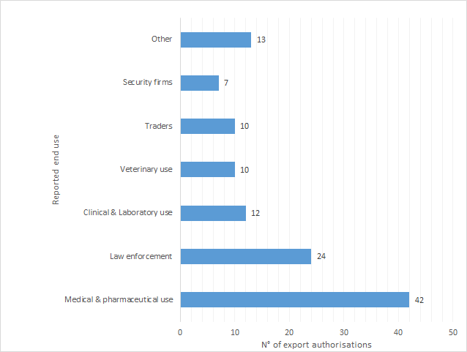

1. If a particular name is used in the list of destinations, it should not be construed as going beyond referring to a (customs) territory commonly known by that name.
2. ‘*Other destinations’* include those to which one export authorisation only was reported, namely: Albania, Antarctic, Barbados, Belize, Central African Republic, Costa Rica, Cuba, Democratic Republic of the Congo, Falklands Islands, French Polynesia, Gibraltar, Iraq, Kosovo, Lebanon, Mali, Niger, Pakistan, Saudi Arabia, Saint Helena (UK), Sint Marteen, Sri Lanka, Thailand and Uruguay. One reported authorisation to one of the Channel Islands has not been accounted for the purposes of this report, as it does not qualify as an export within the meaning of Article 2(d) of Regulation (EU) 2019/125.
3. The number of export authorisation does not match the number referred to in in previous Annexes, as not all authorities in the Member States stipulate the end-use.