

**Table of Contents**

**1.** **Introduction** 2

**2.** **Background** 2

**3.** **Project Methodology for the UCC electronic systems** 3

**4.** **Global Overview of progress with the UCC electronic systems** 4

**5** **management summary and Conclusions** 15

1. **Introduction**

The first Annual Progress Report[1] from the Commission on the implementation of the electronic systems of the Union Customs Code (UCC) and its accompanying Staff Working Document[2] were published on 13 December 2019. This year’s annual report will elaborate on the continuing progress in developing the electronic systems and describe the developments towards a fully digital customs environment since the UCC entered into force. For this purpose, it draws on the UCC Work Programme (UCC WP)[3], which is considered as the baseline for reporting progress.

The projects listed in the UCC WP can be divided into three system categories:

1. eleven central trans-European systems to be developed or upgraded by the Commission (often also requiring developments or upgrades by the Member States of national systems);
2. three decentralised trans-European systems that have to be developed or upgraded by the Commission but have a major national component to be implemented by the Member States; and
3. three national systems that have to be developed or upgraded exclusively by the Member States.

This report analyses the tangible progress made for all three system types, outlining the objectives to be met by each project, the project architecture and the planning approach. On that basis, it highlights potential delays, where identified, as well as envisaged mitigating measures. The overall assessment of the progress of the implementation of the UCC WP is summarised in the conclusion section of this report and demonstrates that the remaining projects are mostly on track for completion in line with the planning schedule. More details of the planning and status of each project are provided in a Commission Staff Working Document[4] published alongside this report.

1. **Background**

The UCC entered into force on 1 May 2016 and, following its amendment in 2019,[5] establishes the deadlines of 2020, 2022 and 2025 for the progressive completion of the work in terms of IT transition and implementation. Article 278 of the UCC provides that existing electronic and paper-based systems can continue to be used for the completion of customs formalities (the so-called ‘transitional measures’) until the relevant new or upgraded electronic systems envisaged under the UCC are operational. The transitional measures must cease once the relevant electronic systems are in place.

To support this complex electronic transition process towards a full digital customs environment, the UCC WP sets deadlines for each electronic system (and its possible phases) during the period 2020 to 2025.

Article 278(a) requires the Commission to provide an annual report on the deployment progress of the outstanding electronic systems. For this purpose, the Commission collected information on progress **based on (1) national plans that Member States are required to provide twice a year (January and June) and (2) a survey circulated among its services and among the Member States to capture the progress.**

The planning and progress information collected from the Member States and the Commission and incorporated into this report reflects the actual situation at the end of June and provides an estimation of progress achieved by the end of 2020. As announced in the 2019 report, the 2020 report also contains an analysis based on more detailed information reported by the Member States in the framework of the **national coordination programmes** in place since 2020 for the core decentralized trans-European systems in the area of transit and export.

The data collected was also compared with the 2019 data in order to detect major shifts. The survey asked the project managers to indicate any known delays in the planning schedules for the electronic systems, the reasons for any such delays and the measures taken. The data yielded from the survey are both quantitative in the form of deadlines and milestones met or missed, and qualitative in the form of detailed descriptions regarding the challenges faced, the anticipated risks and the estimated complexity of the projects.

1. **Project Methodology for the UCC electronic systems**

The work of developing electronic systems involves several steps:

* First, a business case is prepared, which provides the project justification and defines budgetary requirements. Typically, the business case includes the business context, problem description, project description/scope, alternative solutions, costs and a timescale.
* Next, a vision document is created, which provides more detailed information regarding the project definition in terms of architecture, cost, time, and risks, as well as information such as milestones, deliverables and project organization.
* Subsequently, business process modelling takes place, whereby the business processes from the legislation are visually represented in process flows or process models to help develop the functional specifications for the systems. The benefit of visually depicting process models is to ensure a common understanding and analysis.
* In this context, the technical specifications are developed, to detail how the system will be constructed, the architecture to be used, the messages to be submitted by economic operators and customs offices, the interfaces to other systems, test plans, etc.

In recent developments of UCC projects, the project methodology has been **optimised** and the business process modelling, data modelling and technical specifications have been developed more **in parallel** and through **close collaboration** from the start with experts from the legal, business and IT side, both on the side of the Commission and of the National Administrations, and in consultation with trade representatives. Moreover, **iterative development and deployment models** have been gradually rolled out over several projects.

The Commission and the Member States meet regularly to define and agree these project documents for each trans-European system. In addition, the Commission systematically consults the trade community through the Trade Contact Group. A major challenge is to ensure that existing systems continue to function smoothly while the new systems are being developed. Once ready, it is then of utmost importance to ensure a smooth transition from the existing systems to the upgraded ones. This is vital to ensure that trade and customs operations are not impacted.

1. **Global Overview of progress with the UCC electronic systems**

**The UCC WP contains seventeen projects leading to the deployment of the required electronic systems** including fourteen trans-European systems for which the Commission, together with the Member States, is responsible and three falling under the sole responsibility of the Member States.

**4.1** As of the end of 2020, the Commission can report the **successful upgrade or deployment of eight systems out of the seventeen.**

Notably, the succesfull deployment of the **UCC Information Sheets for Special Procedures (INF SP) system** on 1 June 2020 is to be highlighted in this year’s report. This new system harmonises the approach for the efficient management of inward and outward processing procedures and improves the monitoring and control amongst customs offices.

The eight completed trans-European systems (new systems and upgrades) are as follows:

* **UCC Registered Exporter System** – *REX* (new): Deployed in **2017**.
* **UCC Customs Decisions** –*CDS*(new): Deployed in **2017**.
* **UCC Direct Trader Access to the European Information Systems** – *UUM&DS* (Uniform User Management & Digital Signature) (new): Deployed in **2017**.
* **UCC Economic Operator Registration and Identification System Upgrade** – *EORI2*(upgrade): Deployed in **2018**.
* **UCC Surveillance 3** – *SURV3*(upgrade): Deployed in **2018**.
* **UCC Binding Tariff Information –** *BTI*(upgrade): aims to align the long-standing database that contains all binding tariff information issued by customs authorities of Member States with the UCC rules. Better control mechanisms will ensure that all customs duties and related VAT that are legally due are properly collected and fraud can be more effectively detected. Steps 1 and 2 of the first phase were completed by October 2017. The second phase faced a delay of two quarters during the elaboration phase. Nevertheless, the overall planning remained on target and the UCC aligned eBTI system **was deployed in October 2019**. This also entailed the construction of the access to this system through the EU Customs Trader Portal.
* **UCC Authorised Economic Operators –** *AEO*(upgrade): aims to improve the business processes related to AEO applications and authorisations taking account of the legislative changes in the UCC. Phase 1 was completed on 5 March 2018 and phase 2, part 1 was completed on 1 October 2019, including the new UCC requirements in terms of electronic submission through the EU Customs Trader Portal and the changes in relation to the decision-taking process. Phase 2, part 2 (subsequent processes) **was deployed in December 2019**.
* **UCC Information Sheets for Special Procedures** –*INF*(new): develops a new system to support and streamline the processes of data management and the electronic handling of data required in connection with the customs formality known as Special Procedures. Having taken into account the experience of the pilot, some further adjustments were made and the full INF system **was deployed in time on 1 June 2020.**

**4.2 For the nine still ongoing projects**, this report aims to highlight the 2020 achievements and prove the continuous collaboration between the Commission and the Member States.

* + 1. **The six trans-European projects**

A series of IT project documents were prepared and agreed upon in 2020 as the basis for the systems’ development work – see below the progress per project.

The six trans-European projects with their specific architecture, sometimes requiring a combination of central and national components and one or more project phases, due by 31 December 2025 pursuant to Article 278(3) UCC, are described and progressing as follows:

* **UCC Guarantee Management –** *GUM*(new): aims to assure real time allocation and management of the different types of guarantees across the EU. The improved processing speed, traceability and monitoring of guarantees electronically between customs offices is expected to lead to a faster identification of cases where guarantees are deemed invalid or insufficient to cover the incurred or potential debt.

**Progress:** In view of the legal milestones in the UCC WP, the technical specifications are to be completed by 30 September 2022 for Component 1 related to the *trans-European GUM* and 30 November 2024 for Component 2 related to the *National Guarantee Management system*. The business case for the *trans-European GUM* was subject to several rounds of discussions around the scope and implementation options. Finally, the Commission agreed with the Member States in 2020 on the re-use of an existing system with the addition of specific requirements for GUM. As regards the *National Guarantee Management system,* four Member States reported the deployment of the national system and three other Member States are progressing on the technical specifications. However, the scope re-orientation of the trans-European GUM might require some further adjustments.

* **UCC Import Control System Upgrade –** *ICS2*(upgrade): aims to strengthen the safety and security of the supply chain by means of improving data quality, data filing, data availability and data sharing in regard to pre-arrival notifications (“Entry Summary Declarations”) and related risk and control information. In particular, the project will facilitate collaboration amongst Member States in the process of risk analysis. The project will be delivered in three releases to allow a feasible transition per mode of transport.

**Progress:** The technical specifications *for ICS2 - Releases 1 and 2* were completed on 30 June 2018. *ICS2 - Release 1* is planned for 15 March 2021 and will cover the obligation on the relevant economic operators (postal operators and express carriers in air transport) to provide the minimum data i.e. ENS pre-loading dataset. Work is on track in view of the timely deployment of the central ICS2 repository and Shared Trader Interface. however, some risks of delays have been highlighted by a few Member States because of the ambitious conformance testing period.

* **UCC Proof of Union Status –** *PoUS* (new): will store, manage and retrieve all proofs that traders provide to prove the Union status of their goods. This project can be deployed either centrally or nationally but many Member States have explicitly conveyed their intention to use the central system developed by the European Commission. In view of the dependency between the implementation of the UCC customs goods manifest as a proof of Union status and of the European Maritime Single Window, the project will be completed in two phases to avoid inconsistency and reduce risks.

**Progress:** As in last year’s report, those Member States that prefer to deploy a system component nationally reported having difficulty in predicting if their implementation will follow the timeline indicated in the Work Programme due to the early stage of the project. The business processes and functional specifications for *PoUS - Phase 1* were approved by the Member States in Q1 2020 and the vision document was completed in Q3 2020.

* **UCC Centralised Clearance for Import –** *CCI*(new): aims to allow goods to be placed under a customs procedure using centralised clearance, allowing economic operators to centralise their business from a customs viewpoint. The processing of the customs declaration and the physical release of the goods will be coordinated between the related customs offices. The system will be based on the new national import systems and enable an automated functioning of the centralised clearance process at the European level.

**Progress:** The technical specifications for *CCI - Phase 1* were completed and approved in 2020 in view of the planned deployment date of 1 March 2022 with forerunner Member States. Two Member States have reported the completion of their Phase 1 technical specifications while five others are in progress.

The business case for *CCI - Phase 2* was finalised in October 2019. The business processes and functional specifications for Phase 2 were completed in 2020 and the technical specifications are expected by 30 June 2022 in view of the planned deployment date of 2 October 2023.

* **UCC New Computerised Transit System –** *NCTS*(upgrade): The New Computerised Transit System aligns the existing Union and common transit system to the new UCC legal provisions including the alignment of information exchanges to UCC data requirements and the upgrade and development of interfaces with other systems.

**Progress:** No delays have materialised for *NCTS - Phase 5*: the technical specifications were completed and approved as was the IT transition strategy. The project is currently on track and is due by 1 December 2023 pursuant to the UCC WP, with first deployments by forerunner Member States envisaged as of March and December 2021. Four Member States have reported completing their technical specifications for Phase 5 while nine others are in progress.

For *NCTS - Phase 6* (interconnection with other systems), a feasibility study was carried out in 2020 which will provide input for the business case due to be completed in early 2021.

* **UCC Automated Export System –** *AES*(upgrade of both the existing *trans-European system* (project Component 1) and the existing *National Export Systems* (project Component 2)): aims to implement the UCC requirements for export and exit of goods. The project related to the *trans-European AES* entails implementing the UCC simplifications offered to trade to facilitate export of goods for European companies, such as centralised clearance for export, and the UCC obligations to better monitor goods that exit the EU customs territory, in order to prevent fraud.

**Progress:** The technical specifications for the *trans-European AES* were completed and approved as was the IT transition strategy. The project is currently on track and is due by 1 December 2023 pursuant to the UCC WP, with first deployments by forerunner Member States envisaged as of March 2021. Regarding Component 2, the *National Export Systems upgrade*, the technical specifications should be completed by 1 September 2022. Member States should complete the Export Component of their Special Procedures systems at the same time as the AES. Four Member States have reported completing their technical specifications for Component 1 while eight others are in progress.

To summarise, for **the six remaining trans-European projects**, **the Commission and the Member States are** **on track to meet the legal deadlines** agreed in the context of the UCC and UCC WP, and the project milestones set out in the Multi-Annual Strategic Plan for Customs (MASP-C) of 2019.

**In view of upcoming deployments in 2021 and 2022, it is important to point to some key progress achievements:**

First, decisive progress was achieved in the preparation for and testing of the first release of the Import Control System 2 (ICS2) and the project is on track to be implemented by March 2021.

Second, the technical specifications have been completed for the core decentralised trans-European systems on import, transit and export, being Centralised Clearance at Import (CCI) – Phase 1, the New Computerised Transit System (NCTS) Phase 5 and the Automated Export System (AES) and the development work on the side of the Member States and the Commission is on track. In addition the business case has been approved for Guarantee Management (GUM).

For NCTS – Phase 5 and AES, the UCC WP foresees a deployment window starting as of March 2021. Forerunner Member States are joining in March and December 2021, with more Member States gradually joining in till the end of 2023.

All National Administrations confirmed their planning to start operations for AES and NCTS-Phase 5 during the deployment window from Q1 2021 until Q4 2023, in full alignment with the UCC WP. This is illustrated in Figure 1 and Figure 2. The yellow bar indicates the time-limit for the Member States to prepare the closure of the existing export and transit systems and start operating the new ones in order to be ready for the legal deadline indicated by the red bar.

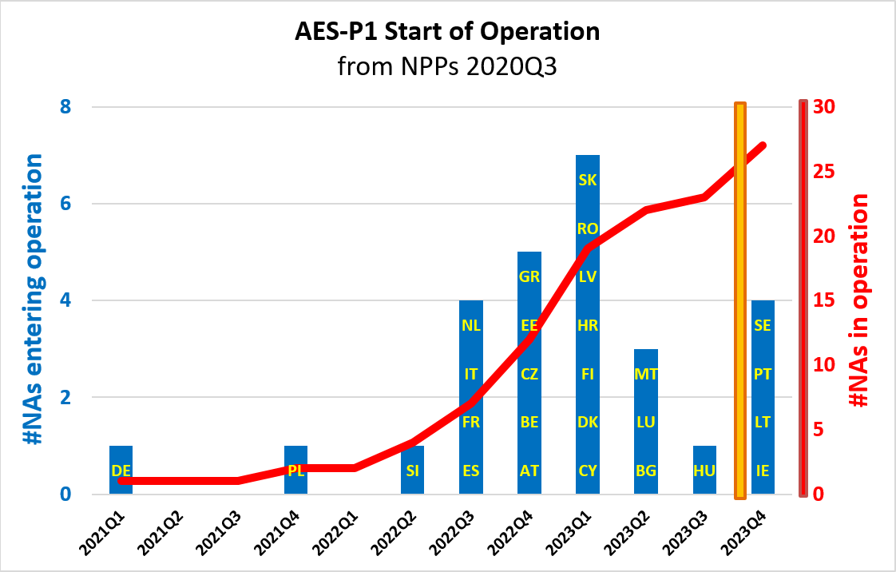

*Figure 1 - AES National Administrations entry into operations*

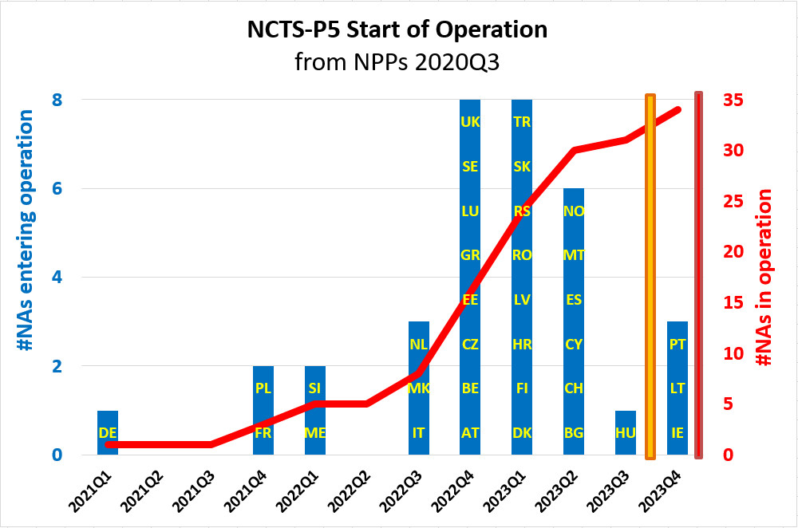

*Figure 2 – NCTS - Phase 5 National Administrations entry into operations*

The Commission also submitted to the Member States an updated package of documentation on the Terms of Collaboration and Service Level Agreements for the operation of the service desks and for the availability and continuity management of the systems. This is an important body of work which underpins the proper functioning and availability of the trans-European Systems.

Finally, it is important to highlight that in view of the implementation of the UCC WP, the **activities performed by the Commission represent approximately 79% by December 2020** (in last year’s report it represented 66%) of the totality of its development work due by 2025. This percentage is based on key performance indicators for the activities assigned to the Commission only and does not reflect the activities required by the Member States. In the overview below you can find the prospects in view of the progress and planning provided by the services of DG TAXUD.

|  |  |
| --- | --- |
|  | % completed |
| By end 2020 | 79% |
| By end 2021 | 85% |
| By end 2022 | 90% |
| By end 2023 | 95% |
| By end 2024 | 97% |
| By end 2025 | 100% |

*Figure 3 – Approximation of % of the Commission’s development activities completed*

* + 1. **The three national projects**

**Member States are due to complete the upgrade of their three national systems by 2022.** However, this excludes the export component of the national Special Procedures system, for which the activity and planning is interlinked to the Automated Export System (AES).

The three Member States’ systems that are due by 31 December 2022 pursuant to Article 278(2) UCC are as follows:

* **UCC Notification of Arrival, Presentation Notification and Temporary Storage** (*NA, PN and TS*)– (upgrade): define the automation of processes at the national level in relation to Notifications of Arrival of means of transport, Presentation of goods and declarations for Temporary Storage, as described in the UCC. This project supports harmonisation across the Member States in regards to the data exchange between trade and customs.

**Progress:** Belgium has established a collaboration initiative with 12 other interested Member States in order to prepare specifications. An expert team, co-funded by the Customs 2020 Programme, will continue collaborating to deliver the appropriate functional and technical documentation and test packages. ***NA, PN and TS* have been completed by one, four and three Member States, respectively.** In comparison to the planning provided last year, some Member States have chosen to integrate this project into ICS2. Because of this, some Member States have reported deployment dates which are later than the deadline in the UCC WP.

* **UCC National Import Systems – NIS (upgrade)**: aims to implement all process and data requirements deriving from the UCC which relate to imports. Member States must develop technical specifications at their level as a first step towards the completion of the systems.

**Progress:** All Member States have reported to the Commission that these specifications are in progress and will be completed by 1 July 2021. Nine Member States have completed their technical specifications and seven others are in progress. In comparison to last year’s report, some re-planning of intermediate milestones have been reported but **all the Member States are still on track to achieve the 2022 deployment milestone.**

* **UCC Special Procedures**– *SP* (upgrade):aims to harmonise and facilitate special procedures (customs warehousing, end-use, temporary admission and inward and outward processing). Member States will have to implement all the required UCC changes for these special procedures in their national systems. The first (export) component of the SP will be implemented in-line with and as part of the national UCC Automated Export System (AES) project (with a 2025 deployment deadline), while the second (import) component will be part of the upgrade of the UCC National Import Systems project (with a 2022 deployment deadline).

**Progress**: One Member State has completed their technical specifications for SP Components 1 while nine have completed them for Component 2. Interdependencies exist with AES and the National Import Systems Upgrade. So far, no delays have been reported by the Member States and **all the Member States are on track** with the first deadline being 2022.

To summarise: For the national systems, Member States are making strong efforts, sometimes through intense collaboration, to progress the implementation of the requirements for NA/PN/TS, the adjustments to the National Import Systems, and the interrelated Special Procedures. As the deployment deadlines are approaching (31 December 2022 for all three), Member States should pay carefull attention to this matter, in particular the ten Member States that could not confirm a timely deployment for AN, the four Member States for PN, and the three Member States for TS as displayed in table 9, 10 and 11 of the Staff Working Document accompanying this report.

**4.3 Risks for delays**

The Commission presented the first UCC Annual Progress Report 2019 to the Council on 12 February 2020. The main feedback received was as follows:

* The report seemed overly optimistic;
* The report was missing the financial sustainability of the UCC implementation (in particular the viability of ICS2);
* The stability of Annex B (common data requirements) of the UCC is paramount.

In response to the feedback from the Council, the Commission is confident that the **current reporting presents a correct overview of the situation**, as it is based, on the one hand, on its own activities leading to progress for the trans-European central systems, and, on the other hand, on the activities of the Member States, as communicated to the Commission. In their reporting on the decentralised elements of the trans-European systems and on their national systems, Member States were requested to provide a realistic view of project progress and identified risks.

Regarding the **financial situation and sustainability**, in the Council Conclusions on the Multi-Annual Financial Framework, the budget allocation for the Customs Programme was approved at €950 m. This represents a significant commitment to deliver and financially support the work of customs and in particular the development of electronic systems during the period up to 2027. With these developments, the Commission is no longer seeing a risk of lack of EU budget for developing the system components for which it is responsible. It is noted that at the time of writing this report the budget negotiations are ongoing with the European Parliament so this figure may not be final.

The instability of the Annex B of the UCC-DA[6] and UCC-IA[7] and the upcoming amendments were raised by the Council and the Member States’ customs administrations as an important risk in the context of last year’s report.The common data requirements of Annex B are used for the trans-European and national systems and the applicability of the different columns of Annex B to the UCC-DA is linked to the deployment dates of the electronic systems defined in the UCC WP. **The Commission is pleased to report that thanks to the progress made in 2020 the risk has been diminished**. The work on the harmonisation of the common data requirements for declarations, notifications and proof of the customs status of Union goods was finalised and reflected in the amendments to the UCC-DA and the UCC-IA which will be adopted by the Commission early 2020. The amendments were necessary to ensure full alignment between the legal provisions and the functional and technical specifications for the trans-European systems and to ensure the necessary stability.

Turning to the survey of progress in 2020, **the Commission is progressing well on the developments under its responsibility and no delays beyond the legal deadlines have been identified or materialised. Moreover, no major risks have been reported** **which would lead to late deployment.**

The **Member States are also advancing significantly** with the developments under their responsibility. However, as stated in section 4.2, there is **one project for which a delay beyond the legal deadline (in this case 31/12/2022) has been reported, being the project NA, PN and TS, categorised as a purely national project.** The delays reported by the Member States are depicted in table 9, 10 and 11 of the Staff Working Dopcument accompanying this Report and can be summarised as follows:

* For the implementation of the Notification of Arrival, the following Member States have a planned deployment date which is later than the deadline in the UCC Work Programme: BE, BG, DE, EE, ES, FI, FR, NL and RO. No planned date was provided by DK for the deployment of the NA.

More specifically, four Member States have reported that they will use the NA integrated in ICS2 – Release 2 (planned deployment 01/03/2023). For 8 Member States, the delay is limited to two-three months.

* For the implementation of the Presentation Notification and the Temporary Storage, the following Member States have indicated a planned deployment date for PN, which is later than the deadline in the Work Programme: BE, FR and NL. No planned date was provided by DK for the deployment of the PN.

More specifically, for two Member States the estimated delay is limited to two months.

As regards the project National Import Sytems, the risk for delays mentioned by a few Member States in last year’s report seem to be under control and no longer translate into a non-timely completion, potentially impacting the trans-European CCI project.

As regards the national project on Special Procedures, all Member States indicated to be on time, except for the Export component for which 1 Member State (DK) did not provide a date.

On the side of the **Member States**, a number of overall risks have been repeated since last year, potentially impacting the progress of their activities. A key source of difficulties and risks of delays indicatedby the Member States is their lack of resources and the need for further integration of the UCC projects. In comparision to last year’s report, only a few cases remain where tenders have not yet been awarded, for others the risk related to procurements has disappeared. As regards the lack of financial resources, the **Commission**’s adoption of the UCC WP and of the Annual Progress Report at the end of 2019 helped Member States to receive additional budget. A Member State explicitly reported on the succesfull outcome. Concerning the human resources, the Member States have reiterated the lack of human resources as a particular risk for the successful and timely implementation of the projects. Human resources are often working on other IT projects in parallel. In addition, there are many contributing factors to the **complexity** of the UCC projects (in terms of project dependencies, transition and testing with the economic operators, system integrations).

In the 2019 Annual Progress Report, the Member States already pointed at the difficulties in meeting the **obligations on customs systems imposed by the VAT eCommerce package** adopted on 5 December 2017[8]. The Member States mentioned that the parallel implementations would risk leading to a delay in the completion of the UCC electronic systems by the relevant deadlines. The **Commission** has further monitored the situation this year. On 8 May 2020, the Commission proposed to postpone the introduction of the new rules by six months (1 January 2021 to 1 July 2021 or later). On 20 July 2020 the Council accepted this proposal and adopted the necessary legislation[9]. With this postponement, the Member States have more time to meet the legal deadlines for the national developments, and fewer Member States reported in 2020 the risk of collateral impact of the VAT eCommerce initiative on the UCC implementation. Primarly 2 Member States reported the need for replanning of some UCC activities and for upscaling platforms and supporting IT systems. However, they also stated considering mitigating measures to avoid a real delay in the start of deployment. It is to be noted that the risk by Member States was considered in combination with other external factors as COVID-19 and Brexit (see p 29, p 35, p 41 of the Staff Working Document accompanying this report).

**As regards the challenges brought about due to the COVID-19 pandemic and the withdrawal of the United Kingdom from the EU**, the Commission reported that for its own activities no impact is to be noted from COVID-19 and that mitigating actions were taken to counter the impact from the Withdrawal Agreement. The Member States reported that the effects were unclear at the moment but that additional pressure on their national planning and on the number of human resources available internally and externally (IT contractors, economic operators) were to be expected.

**In conclusion, the assessment of the main risks for the timely implementation of the UCC systems revealed that the risks are situated mostly on the side of the Member States and linked to the complexity of the projects, procurement and contractual issues, resource constraints, the transformation process, and some external factors as COVID-19 and Brexit. The Commission will continue to support the Member States with applying mitigating actions to avoid the risks materialise into late deployments of electronic systems as described in the section 4.4 below.**

**4.4 Mitigation actions**

As regards **the national projects**, the planning and progress provided by the Member States shows on the one hand a better situation than last year for the national import systems with no longer an indication of delays, but on the other hand, for the national project on AN/PN/TS, the situation is slightly deteriorating**. In view of the risks assessed, the Commission intends to scale up the support to the Member States** by means of several actions. As a number of Member States link their national activities to those planned in the context of ICS2 Release 2, the Commission will study this misalignment of 2 months in the planning in more details. It will monitor the progress more regularly, take bilateral contacts to understand the problems and issue formal letters to the Member States concerned to mitigate the risks of delays. Meanwhile, the Member States are advised to continue and accelerate further their intense collaboration work for the implementation of the project AN/PN/TS and to join forces in the expert team. The Commission continues with the co-funding from the Customs Programme for the Expert Team on new approaches to develop and operate Customs IT systems (ETCIT). Ultimately, the timely implementation of the national components remains the responsibility of the Member States.

As announced in last year’s report, the **Commission** has intensified its support to the Member States for the development of **the trans-European systems** by establishing innovative development and deployment mechanisms, by refining the governance approach and by providing trans-European coordination and monitoring programmes. This is described in more details below.

The Commission continues to utilise **an agile approach concerning the development and deployment of the UCC electronic systems** in order to deliver and review project documentation and application software in more manageable iterations or packages. This allows for quicker fixes and a more balanced workload for the Commission and the Member States. This method has been pioneered in the AES, NCTS – Phase 5 and ICS2 projects and has been welcomed by the Member States and traders. Following the request to generalise the approach, it was utilised for other UCC projects such as PoUS and CCI. Furthermore, the Commission has established a **mechanism for enhanced collaboration between all stakeholders** from the outset of the projects, to improve the quality of the preparatory activities and to avoid difficulty in decision-taking and additional requirements at later stages in the projects.

**A Multi-Annual Strategic Plan for Customs (MASP-C) dashboard** is used for progress tracking and as an information tool from the Commission side on its progress. The baseline for the dashboard milestones is the MASP-C 2019 and the UCC WP 2019. The dashboard is presented on a quarterly basis to the Member States (Electronic Customs Coordination Group) and the trade community (Trade Contact Group) for information and steering purposes.

**The Commission is now not only monitoring progress against the main project milestones, as indicated in the UCC WP and MASP-C, but is also setting specific interim milestones per project** (e.g. milestones by which all Member States should have completed the conformance testing). Such close monitoring is needed in order to make the deployment of the decentralised trans-European systems manageable and to avoid additional costs for operating old and new systems in case of an extended deployment window.

As regards implementation of the **ICS2 programme,** the Commission continued with ICS2 **“trans-European coordination activities”** throughout the years 2019 and 2020[10]. Work focused on ICS2 - Release 1 implementation with a view to facilitating operational preparedness by Member States customs authorities, express carriers and EU postal operators as from 15 March 2021.

The Commission provided support to the national administrations and economic operators in their development activities via a set of activities which included:

* Creation of a dedicated forum and organisation of dedicated webinars, support via frequently asked questions and organisation of regular ICS2 trans-European coordination plenary meetings with participation of all Member States national ICS2 project management and risk management representatives, individual economic operators, trade associations and international organisations;
* Close and continuous monitoring, planning of national and trade project plans to ensure their alignment with the Commission’s central planning across relevant IT delivery milestones (conformance testing campaigns, end-to-end testing, dry run testing). This ranged from continuous support to coordination of conformance test activities and stimulating national administrations and economic operators to co-ordinate their individual projects;
* Preparation for the launch of communication campaigns, with different activities which were implemented in year 2020 and throughout the ICS2 programme implementation, including creation of ICS2 programme specific content on DG TAXUD webpage;
* Preparation of the training material that will be based on the compendium of ICS2 Release 1 common operational guidance.

Furthermore, the Commission launched at the end of 2019 a **“National Administration quarterly monitoring programme”** **for the trans-European systems NCTS – Phase 5** **and AES** with Key Performance Indicators to regularly assess progress and raise alerts well in advance where problems might occur.

As a complementary instrument, the Commission also established for these projects a **“National Administration coordination programme”** to support the Member States in the development and deployment of their national components for the trans-European systems. These programmes will help to steer the IT transition process as of 2020 with a dedicated helpdesk, webinars, bilateral visits (where possible), training, conformance testing follow-up, quarterly progress reporting, service delivery management, etc.

During the programme’s first six months of application, the following results can be reported:

* All national administrations have complied with the provisions of the Coordination Programme for NCTS - Phase 5 and AES, providing detailed National Project Plans using the proposed templates and reporting any deviations to their baseline plan;
* The overall Coordination Programme was discussed with all national administrations in four virtual and physical meetings and was accepted by the Electronic Customs Coordination Group (ECCG);
* Three bilateral missions took place and six bilateral webinars were held with national administrations;
* The Commission reported, to the ECCG and Customs Policy Group (CPG), the current report providing the Key Performance Indicators overview of the aggregated national plans.

The output of both programmes is considered to bring valuable progress information and will continue to be used for the future Annual Progress Reports. It will provide for detailed progress information per project and per Member State.

1. **management summary and Conclusions**

In conclusion, it is evident that the Commission and Member States **face challenges** in ensuring the full deployment of the UCC electronic systems by the relevant deadlines. The assessment of the progress and risks reveal that these challenges are situated **primarly on the side of the Member States**. The Member States refer to uncertainty regarding the impact of the COVID-19 pandemic, to many other obligations to be implemented via customs systems, to resource issues in Member States, to the complexity and interconnectivity of systems, and to the need for a smooth transition from the existing systems to the upgraded ones so that the impact on trade is minimised. The Commission engages to support, coordinate and monitor the progress on the side of the Member States more carefully and profoundly during the coming years and to undertake some specific actions to ensure a timely implementation of the national as well as trans-European systems.

Nevertheless, it is also clear that **tangible progress is being made**. **A sizable number of electronic systems have already been deployed and are now fully operational.**

The INF SP project was successfully deployed this year and significant progress has been made on finalising technical and functional specifications for four and two projects respectively, completing two business cases and preparing for major upcoming releases.

**As mentioned above, the remaining projects are mostly on track and planned to be completed** in line with the planning of the projects defined in the UCC WP. A summarised overview of the planning and progress can be found in Figure 4 below.

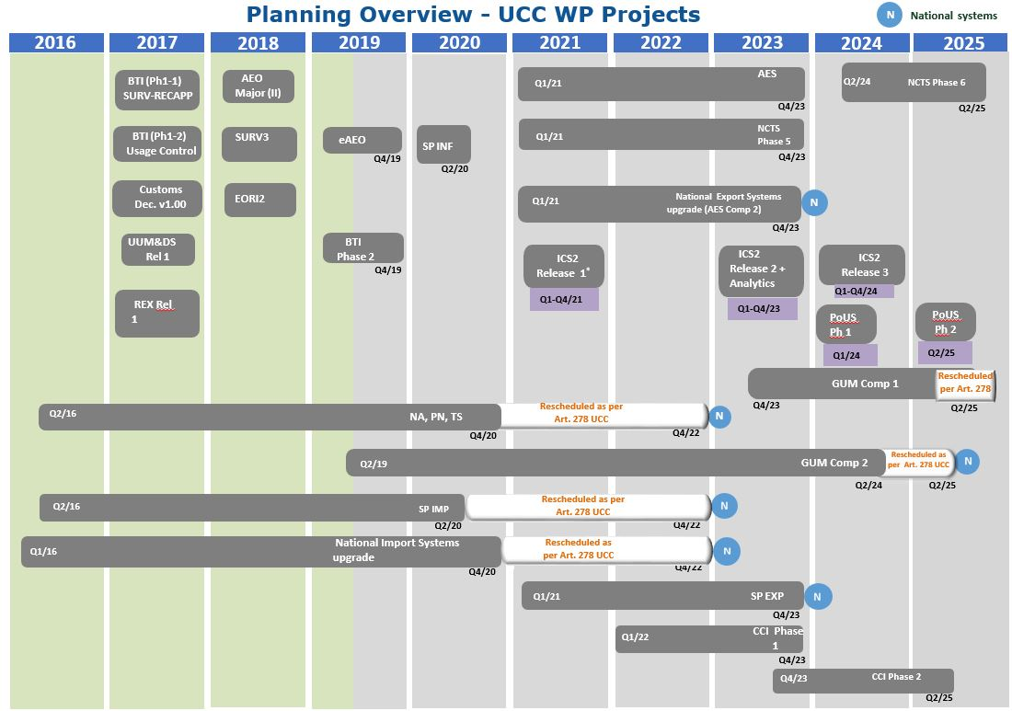

*Figure 4: Planning for UCC WP projects*

The Commission and the Member States will continue their regular meetings **to steer and monitor the projects** via the MASP-C dashboards and via the reinforced planning and progress reporting requirements for the UCC WP implementation. The Commission and the Member States will also continue the elaboration and development work for the remaining trans-European systems in terms of business cases and vision documents, as well as to prepare the functional and technical specifications (including transitional technical specifications in some cases) as the basis for the systems rollouts and deployments.

The Commission will continue with the **National Administration quarterly monitoring and coordination programmes**. With these managerial instruments, the Commission is confident that it has the appropriate mechanisms in place to face the upcoming challenges.

All Member States have expressed their willingness to define and undertake mitigating actions to ensure that they respect the planning deadlines set out in the UCC WP.

More details of the planning and status of each project are provided in a **Commission staff working document published alongside this report.**

1. Report from the Commission to the European Parliament and the Council pursuant to Article 278a of the Union Customs Code, on progress in developing the electronic systems provided for under the Code, COM(2019) 629 final.
2. Commission Staff Working Document Accompanying the Report from the Commission to the European Parliament and the Council pursuant to Article 278a of the Union Customs Code, on progress in developing the electronic systems provided for under the Code, SWD(2019) 434 final.
3. Commission Implementing Decision (EU) 2019/2151 of 13 December 2019 establishing the work programme relating to the development and deployment of the electronic systems provided for in the Union Customs Code (OJ L 325, 16.12.2019, p. 168–182).
4. Commission Staff Working Document Accompanying the Report from the Commission to the European Parliament and the Council pursuant to Article 278a of the Union Customs Code, on progress in developing the electronic systems provided for under the Code, SWD(2020) XXX final.
5. Regulation (EU) 2019/632 of the European Parliament and of the Council of 17 April 2019 amending Regulation (EU) No 952/2013 to prolong the transitional use of means other than the electronic data-processing techniques provided for in the Union Customs Code (OJ L 111, 25.4.2019, p. 54–58).
6. Commission Delegated Regulation (EU) 2015/2446 of 28 July 2015 supplementing Regulation (EU) No 952/2013 of the European Parliament and of the Council as regards detailed rules concerning certain provisions of the Union Customs Code (OJ L 343, 29.12.2015, p. 1-557).
7. Commission Implementing Regulation (EU) 2015/2447 of 24 November 2015 laying down detailed rules for implementing certain provisions of Regulation (EU) No 952/2013 of the European Parliament and of the Council laying down the Union Customs Code (OJ L 343, 29.12.2015, p. 1-558-893).
8. [Council Implementing Regulation (EU) 2017/2459 of 5 December 2017](https://eur-lex.europa.eu/legal-content/EN/TXT/?uri=CELEX%3A32017R2459) (OJ L 348, 29.12.2017, p. 32–33)
9. [Council Decision (EU) 2020/1109 of 20 July 2020](https://eur-lex.europa.eu/legal-content/EN/TXT/?qid=1596024145125&uri=CELEX:32020D1109) amending Directives (EU) 2017/2455 and (EU) 2019/1995 as regards the dates of transposition and application in response to the COVID-19 pandemic (OJ L 244, 29.7.2020, p. 3–5), [Council Regulation (EU) 2020/1108 of 20 July 2020](https://eur-lex.europa.eu/legal-content/EN/TXT/?qid=1596024422615&uri=CELEX:32020R1108) amending Regulation (EU) 2017/2454 as regards the dates of application in response to the COVID-19 pandemic (OJ L 244, 29.7.2020, p. 1–2) and [Council Implementing Regulation (EU) 2020/112 of 20 July 2020](https://eur-lex.europa.eu/legal-content/EN/TXT/?qid=1596024540124&uri=CELEX:32020R1112) amending Implementing Regulation (EU) 2019/2026 as regards the dates of application in response to the COVID-19 pandemic (OJ L 244, 29.7.2020, p. 9–10).
10. ICS2 trans-European coordination activity strand, as integral element of the ICS2 programme, was launched in year 2018.