

**The Second Clean Air Outlook**

1. **Introduction**

As mentioned in the European Green Deal[1], creating a toxic-free environment requires more action to prevent pollution from being generated as well as measures to clean and remedy it. To protect Europe’s citizens and natural ecosystems, the EU needs to better monitor, report, prevent and remedy pollution in the air, water, soil and consumer products. This will also contribute to achieving the Sustainable Development Goals.

The EEA ‘Air quality in Europe - 2020 report' published in November 2020 shows that, although emissions of most air pollutants have declined in the EU in recent decades (see figure 1), air pollution continues to be a significant problem. Air pollution overall is responsible for about 400 000 premature deaths in the EU every year and for about two-thirds of ecosystem area in the EU being exposed to eutrophication[2]. Air pollution also entails considerable economic costs by inducing increased medical expenses, reduced productivity, for example through lost working days, and reduced agricultural yields.

The EU has been working for decades to improve air quality by controlling emissions of harmful substances into the atmosphere and by integrating environmental protection requirements into transport, industry, energy, agriculture and the building sector. The aim is to reduce air pollution to levels which minimise harmful effects on human health and the environment across the EU.

The EU’s approach to improving air quality rests on three pillars. The first pillar comprises the ambient air quality standards set out in the Ambient Air Quality Directives for ground-level ozone, particulate matter, nitrogen oxides, dangerous heavy metals and a number of other pollutants[3]. If the set limit values are exceeded, Member States are required to adopt air quality plans detailing measures to keep the exceedance period as short as possible.

The second pillar consists of national emission reduction obligations set by the National Emission reduction Commitments Directive (NEC Directive)[4] for the most important transboundary air pollutants: sulphur dioxides, nitrogen oxides, ammonia, non-methane volatile organic compounds and particulate matter. Member States had to develop national air pollution control programmes (NAPCPs) by 2019 presenting the measures they will put in place to comply with their emission reduction commitments.

The third pillar comprises emission standards for key sources of pollution, from vehicle and ship emissions to energy and industry. These standards are set out at EU level in dedicated legislation.

This second edition of the Clean Air Outlook assesses the prospects for achieving the objectives of the NEC Directive for 2030 and beyond, bearing in mind the zero pollution ambition of the European Green Deal and the objective from the Clean Air Programme[5] of halving the impact of air pollution on health by 2030 compared to 2005. This Second Clean Air Outlook updates the analysis and the conclusions of the first outlook published in 2018[6], taking into account the numerous developments resulting from the NEC Directive and other relevant legislation and policies. This edition also shows the impact of climate change policy on attaining these objectives and notes that meeting the 2030 climate target will make a decisive contribution to halving health impacts of air pollution by 2030.

The Second Clean Air Outlook complements the first Commission report on the implementation of the NEC Directive published in June 2020[7], by providing a forward-looking assessment of the likely evolution of air pollution and how distant this is likely to be from the 2030 air pollution reduction obligations. The findings will inform the upcoming 2021 zero pollution action plan[8], which aims to put the EU on a path towards zero pollution and a toxic-free environment, as announced in the European Green Deal[9]. Finally, this edition assesses the impact of air pollution on ecosystems; together with the monitoring of ecosystems required by the NEC Directive, this will provide input for the analysis underpinning the implementation of the biodiversity strategy[10], since air pollution is an important driver of biodiversity loss.

The analysis undertaken for this Clean Air Outlook could not yet incorporate the impact on air pollutants from a projected slowdown in economic activity due to the COVID-19 pandemic. It should be noted that impacts on reduction of emissions of certain pollutants were unequal during the lockdown periods and that overall emissions might return to previous levels when the economy recovers[11].

1. **State of air pollutant emissions and air quality and progress towards compliance**
   1. Current air pollutant emissions and air quality situation

Since 2005 (the base year for emission reductions under the NEC Directive) and even before, emissions of air pollutants in the EU have decreased significantly thanks to EU and national legislation[12]. In fact, since 2000 the EU’s GDP has grown by about 30% while emissions of the main air pollutants have decreased by 10% to 70%, depending on the pollutant[13].

**Figure 1: Development of EU-28 emissions, 2000-2018 (% of 2005 levels) (Source: EEA)**

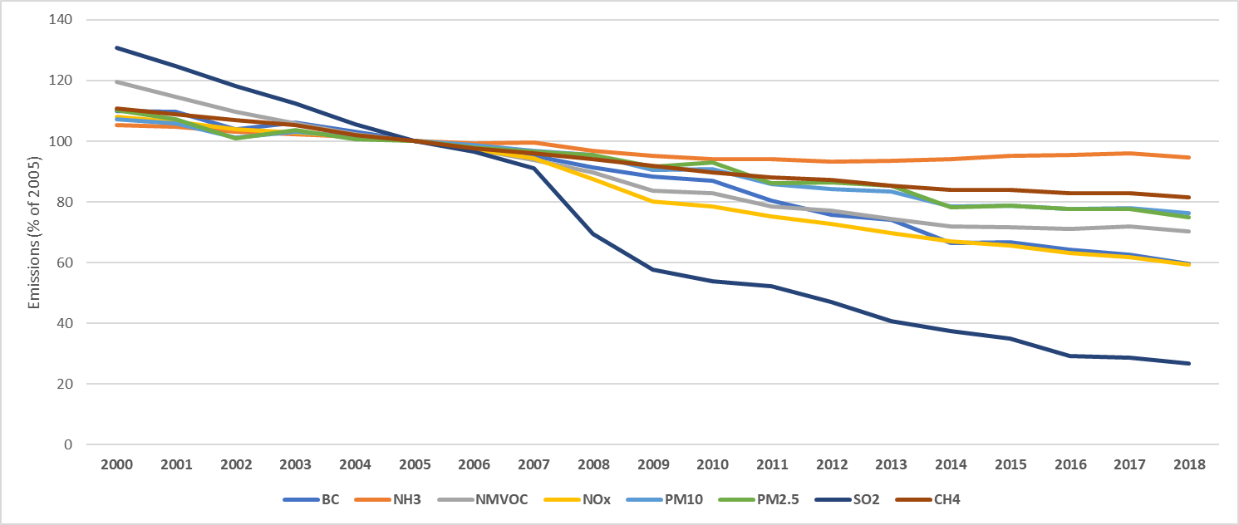

This decreasing trend needs to be sustained through continued efforts, particularly for those pollutants that have shown a smaller reduction. For instance, ammonia emissions have plateaued since 2005 and even increased in recent years in some Member States.

Despite this overall decrease in air pollutant emissions, in most Member States the quality of life in certain hotspots remains impaired, as air quality standards are still not met. The situation is especially severe in urban areas, where a majority of Europeans live. Too many EU citizens are still exposed to concentrations of certain air pollutants above the limit or target values set in the Ambient Air Quality Directives, and even more of them are exposed to levels above those recommended by the World Health Organization (WHO) Air Quality Guidelines. In 2018, about 4% of the EU-28’s urban population was exposed to PM2.5 levels above the EU annual limit value, while more than 70% was exposed to concentrations exceeding the WHO Air Quality Guidelines values[14].

Air pollution is still the number one environmental health risk in the EU[15], a cause of both chronic and serious diseases such as asthma, cardiovascular problems and lung cancer[16], and a major health and environmental concern for EU citizens[17]. Groups of lower socio-economic status, elderly, children, and those in poor health tend to be more adversely affected by air pollution than the general population[18].

* 1. Progress towards compliance

While the national emission reduction commitments under the NEC Directive started to apply in 2020, the Commission NEC implementation report showed that almost all Member States need immediately and substantially to reduce emissions of at least some pollutants to comply with their obligations. This is particularly so for ammonia. This is also demonstrated in the analysis of the gap between the latest reported emissions (corresponding to the year 2018) and the level of emissions allowed by the NEC Directive for the period 2020-29[19], which shows that many Member States need to reduce their emissions by up to 10% in less than 2 years[20]. For PM2.5 and NOx, six[21] and five[22] Member States respectively will need to reduce their emissions by up to 30% or more.

Member States will have to increase their efforts even further to comply with the more ambitious emission reduction obligations for 2030 under the NEC Directive. Compared to their 2018 emission levels, five Member States[23] will have to halve their PM2.5 emissions and 15[24] will need to reduce their NOx emissions by more than 30% compared to 2018; in addition, respectively 15 and 13 Member States will need to reduce their NMVOC[25] and ammonia[26] emissions by up to 30% or more. The Commission will closely monitor the next steps of the NEC Directive implementation and will continue to support Member States’ implementation efforts, but will also make use of its legal powers to ensure the legislation is enforced.

When it comes to air quality, there have been significant improvements over the past decade, yet there are still major problems with exceedances of the EU’s air quality limit values under the Ambient Air Quality Directives. For 2019, 23 Member States reported exceedances above at least one air quality standard, for at least one pollutant, in at least one location – this includes 17 Member States with exceedances of EU air quality standards for NO2, 14 with exceedances for PM10, four with exceedances for PM2.5 and one for SO2.

As of 1 December 2020, a total of 31 infringement cases against 18 Member States are ongoing for exceedances of PM10, PM2.5, NO2 or SO2 concentration levels or flawed monitoring. Ten of these cases have been referred to the Court of Justice of the European Union, of which five cases have received a ruling. In its Communication on ‘Cleaner Air For All’ in May 2018, the Commission underlined the importance of continued enforcement[27].

* 1. Follow-up to the fitness check of the Ambient Air Quality Directives

In November 2019, the Commission published the results of a fitness check of the two EU Ambient Air Quality Directives[28]. It concluded that, even though EU air quality standards have been instrumental in driving a downward trend in exceedances and exposure of the population to exceedances, the remaining gap to achieve air quality standards is too wide in certain cases. It further concluded that for several pollutants the current air quality standards are not as ambitious as the WHO recommendations[29], especially for fine particulate matter (PM2.5). Subsequently, the European Green Deal announced that the Commission will draw on the lessons learnt from the fitness check and will notably propose to revise air quality standards to align them more closely with the WHO recommendations. The Commission will also propose to strengthen provisions on monitoring, modelling and air quality plans to help local authorities achieve cleaner air[30].

1. **Implementation of the NEC Directive and supportive EU legislation**
   1. Changes in legislation contributing to clean air

Several changes to policy and legislation have occurred since the First Clean Air Outlook was published. In particular, the level of ambition in fighting climate change increased with the entry into force of higher objectives in December 2018[31]. One of the conclusions of the First Clean Air Outlook, according to which synergies between air and climate policies make the achievement of the objectives of both policies easier, applies even more so now. However, to actually see these benefits materialise, legislation has to be implemented in a timely manner. Additional EU legislation limiting air pollutants at their source has also been adopted, such as Euro 6 standards for diesel vehicles.

Furthermore, in April 2019 Member States had to submit their NAPCPs for the first time, describing the policies and measures they intend to put in place to fulfil their emission reduction commitments under the NEC Directive. The modelling framework underpinning the analysis in this Clean Air Outlook incorporates these policies and measures as much as possible; however, their level of detail varies greatly between Member States, and in some cases prevents their inclusion in the quantitative analysis[32].

The increased climate ambition towards reducing greenhouse gases by 55% by 2030[33] presented by the Commission in 2020, which is still subject to interinstitutional negotiations, is not part of the baseline in the analysis for the Second Clean Air Outlook but is reflected as a policy scenario.

* 1. Prospects for achieving the emission reduction commitments in the NEC Directive for 2030 and beyond

Member States committed in December 2018 to climate and energy targets for 2030[34], which require appropriate policies and measures to be put in place. With those measures and the application of existing legislation tackling air pollution at its source, the reductions in all air pollutant emissions required by the NEC Directive across the EU would be fulfilled for the period from 2030 onwards, except for ammonia. This hides, however, differences between Member States in achieving their national commitments.

The SO2 reduction commitment for 2030 would be achieved by all Member States but one[35] if all existing legislation is fully implemented. The measures announced in the NAPCPs would facilitate this achievement. For NOx, PM2.5 and NMVOC, two Member States[36] would fail to fulfil their obligations even with the measures announced in their NAPCPs and would therefore need to introduce further measures. There would be a major issue with ammonia, where existing legislation would be insufficient to reach the 2030 reduction commitments for 22 Member States[37]. Even though Member States have announced in their NAPCPs that they would put in place additional measures to reduce ammonia emissions, those would still be insufficient for 15 Member States[38] to achieve their 2030 commitments on ammonia.

Overall, Member States must fully implement all existing legislation and the measures that they have announced as soon as possible. For the 15 Member States for which the ammonia commitment will pose problems even if they introduce the measures planned in their NAPCPs, further measures need to be developed as a matter of urgency. This is also required by the NEC Directive if a Member State is projected to miss one of its emission reduction commitments.

The modelling exercise under this Clean Air Outlook has identified the most cost-effective air pollution control measures that would allow all Member States to fulfil their commitments under the NEC Directive, even without taking into account possible synergies with climate measures. For SO2, PM2.5 and NOx, they mostly relate to measures in industrial processes and industrial combustion. To reduce NMVOC, the large majority of the cost-efficient measures would tackle emissions from the burning of biomass for domestic heating and, to a lesser extent, from the use of solvents. The measures that would cut ammonia emissions in the most cost-efficient manner all relate to agriculture and are, to a large extent, related to animal feeding practices, manure management and use of fertilisers[39].

1. **Prospects for attaining long-term objectives**

In relation to the aim of halving the impacts of air pollution on health by 2030 compared to 2005, the First Clean Air Outlook concluded that this impact (expressed in number of premature deaths due to air pollution) would indeed be reduced by more than 50% by 2030 if Member States implemented all the legislation adopted between 2014 and 2017 to reduce air pollutant emissions; this analysis also took into account the effects of measures able to tackle multiple pollutants simultaneously. However, the First Clean Air Outlook was less positive about impacts on ecosystems, as none of the new measures put in place between 2014 and 2017 addressed ammonia emissions from agriculture, the primary source of air pollution affecting ecosystems[40].

The methodology used for the Second Clean Air Outlook takes into account policy and legislative developments since 2018 (on EU climate policy and additional pollution control) and information (such as better emission inventories, and a better understanding of the impact of emissions on health and their economic value) that were not included in the First Clean Air Outlook[41]. As a consequence, it is not possible to make a direct comparison between the results of the two Outlook reports. However, it is still useful to assess the latest results in achieving the objectives of the clean air programme and inferring the progress that has been made on that basis.

* 1. Pollutant background concentration

If Member Sates implemented all existing sectoral legislation regulating air pollution and measures needed to reach the 2030 climate and energy targets as agreed in December 2018, air pollutant emissions would be reduced sufficiently to meet the requirements of the NEC Directive at EU level in 2030 for all pollutants except ammonia. In addition, no air quality management zone would exceed 25 microgram/m3 of PM2.5 in background concentration[42]; in 2019, there were 14 such zones in four Member States.

The number of zones for which computed background concentration levels of PM2.5 would comply with the current WHO Guidelines value of 10 µg/m³ is expected to increase from 41% of all zones in 2015 to 90% in 2030, again assuming all existing legislation is fully implemented. If all technically feasible air pollution control measures were put in place, this proportion would increase to 98%. The most ambitious situation in terms of both air and climate policies (involving lifestyle changes to mitigate climate change and the introduction of all technically possible measures to mitigate air pollution) would bring the background concentrations in all zones below the current WHO Guidelines value in 2050.

This trend can also be seen in the evolving exposure of the EU population to air pollution. The proportion of the EU population living in areas with background PM2.5 concentration below the WHO Guidelines value of 10 µg/m³ would more than double between 2015 and 2030 if all adopted clean air and climate laws were implemented (figure 2). However, this would still leave 12% of the EU population in 2030 exposed to levels of fine particulate matter above the WHO Guidelines value. With the most ambitious clean air policy (with all technically feasible mitigation measures in place), this share would be reduced to 4%. This remaining share is due to air pollution originating from outside the EU (neighbouring countries and international shipping) and of natural origin. However, these positive trends only relate to background concentration and do not include possible pollution hotspots, including those where pollution is above the WHO’s recommended values, that would still need to be addressed.

**Figure 2: Distribution of population exposure to PM2.5 for key scenarios, EU-27 (Source: IIASA)**

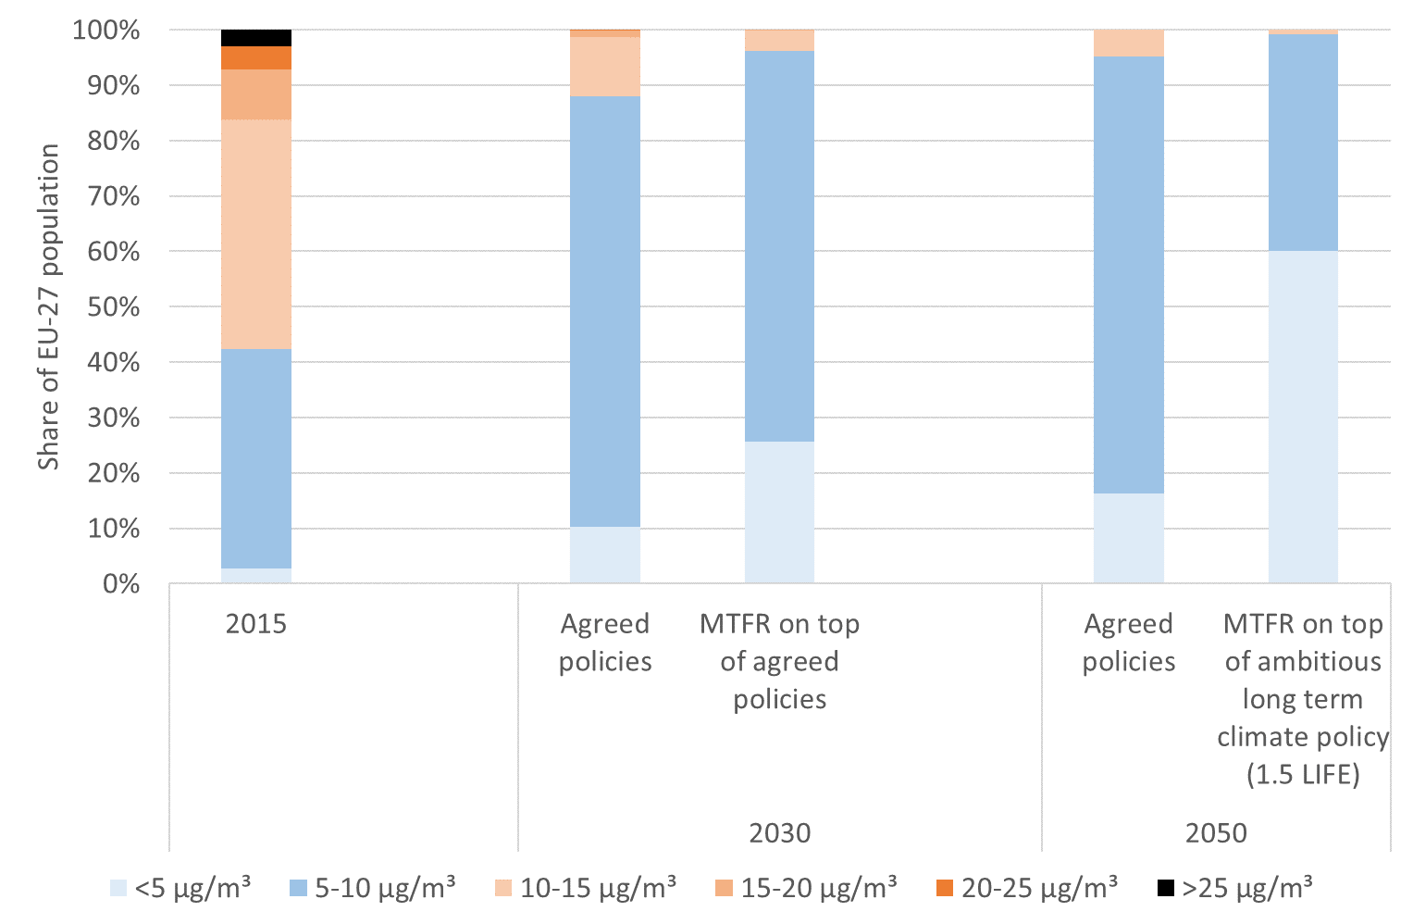

Note: MTFR stands for ‘Maximum Technically Feasible air pollution Reduction measures’.

* 1. Health impacts

Premature deaths due to PM2.5 are projected to decrease by about 55% between 2005 and 2030 if all policies that Member States have already agreed to are fully implemented[43]; this would imply a fall of 28% in the estimated number of these premature deaths between 2020 and 2030. The measures announced in the NAPCPs would accelerate this decrease between 2020 and 2030, achieving a 31% reduction. If maximal air pollution control measures were put in place[44], premature deaths would drop by 44% between 2020 and 2030. However, this would still leave more than 130 000 premature deaths per year in the EU due to PM2.5 pollution alone.

Looking at the issue from the perspective of the number of years of life lost due to PM2.5 pollution, the overall picture remains the same (see figure 3). Beyond important co-benefits from climate measures, significant benefits are also expected from additional clean air measures.

**Figure 3: Years of life lost due to exposure to PM2.5 in the EU-27 (Source: IIASA)[45]**

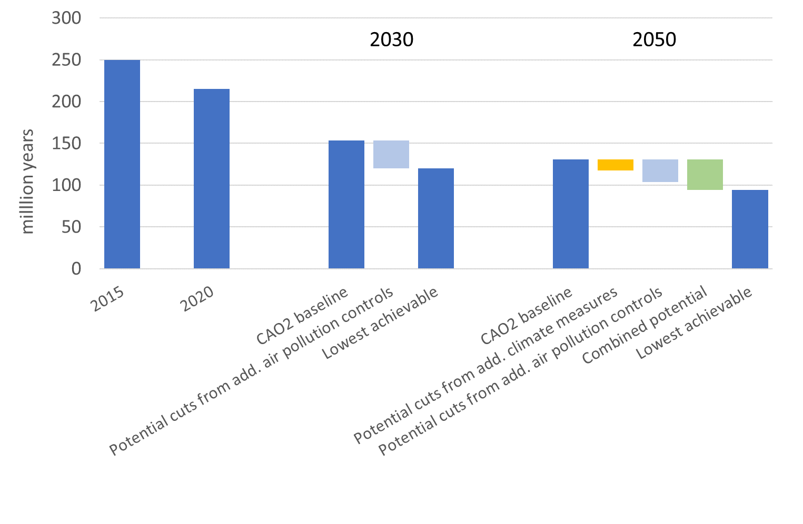

Implementing the policies and measures announced by Member States in their NAPCPs generates costs estimated at about EUR 1.4 billion per year in the EU (for measures presented with enough detail in the NAPCPs and to which a cost could therefore be attributed). However, the increased health benefits (both in terms of reduced mortality and morbidity) exceed the increased costs in all of the cases that have been analysed (see Section 4.4 for more details on the economic impacts). The health benefits brought by the NAPCP measures[46] amount to between EUR 8 billion and EUR 43 billion per year for the EU[47]; there is thus an overall gain for society in putting these measures in place.

***Box 1: Methodology for assessing and valuing the impact of air pollution on health***

*This analysis draws on research into the impact of air pollution on health by the WHO (Health Risks of Air Pollution In Europe - HRAPIE). These are conservative estimates, since findings from new epidemiological literature have become available since HRAPIE was published (in 2013), showing the effects of a wider range of health impacts caused by air pollution (wider effects of ultra-fine particles for instance). The methodology used to assess health impacts in this report differs to some extent from the one used by the EEA; this primarily concerns the granularity of the underlying air quality data and the level at which concentrations of pollutants start to have an impact on health. In terms of putting a value on health impacts, the data used here have been updated since the First Clean Air Outlook as regards the year in which prices are expressed (2015, instead of 2005 in the First Clean Air Outlook). This analysis also provides a more up-to-date valuation of life, life years lost and morbidity, using OECD and other sources. Therefore, the numbers presented here cannot be directly compared to those reported by the EEA, nor to those presented in the First Clean Air Outlook, for all these methodological reasons. However, the numbers provide useful orders of magnitude and are informative when comparing the various situations using the same methodology.*

*For full information on the methodology, see IIASA report.*

* 1. Ecosystem impacts

The recent improvements in terms of the impact of air pollution on ecosystems[48] are projected to continue in the future in all scenarios. However, in spite of these positive developments, the situation is still worrying, as levels of nitrogen deposits remain significantly above critical loads[49] and threaten biodiversity, especially in Natura 2000 areas. With all adopted legislation implemented, Natura 2000 areas that exceed critical loads for eutrophication would decrease by 8% between 2020 and 2030; with all measures announced by Member States in their NAPCPs also implemented, the reduction would be 15%. However, this would still leave more than half (58%) of the Natura 2000 areas under the threat of eutrophication. If all technically feasible air pollution control measures were put in place, this proportion would fall to 46% in 2030, which shows the considerable potential for improvement (see figure 4).

Air pollution impacts all ecosystems, including agricultural crops and forests, and they would all benefit greatly from reduced air pollution, through reduction of eutrophication, acidification and excess ozone flux. For all these threats, the combination of clean air and energy and climate measures would provide the largest benefits in 2050.

**Figure 4: Area of terrestrial ecosystems (1 000 km2) where nitrogen deposits exceed the critical loads for eutrophication, EU-27 (Source: IIASA)[50]**

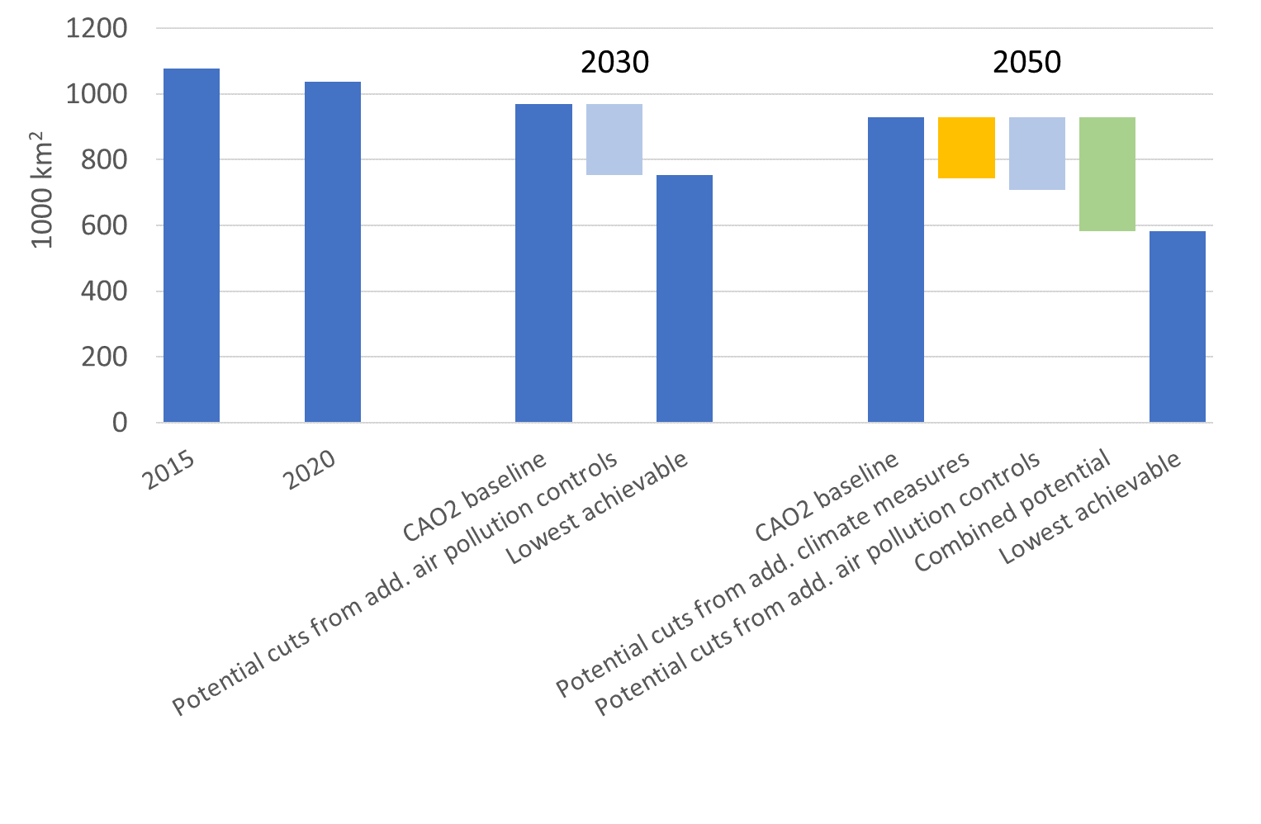

* 1. Economic impacts

While air pollution directly damages human health and has a negative impact on agricultural crops, forest yields, ecosystems and buildings, it also has an indirect impact on the economy, e.g. through loss of working days due to poorer health. In all the cases that have been analysed, additional measures to reduce pollution always bring a net gain to society, with the benefits of cleaner air always overriding the costs of these measures. Figure 5 shows that the implementation of the NAPCP measures alone would deliver about EUR 7 billion per year in 2030 of additional net benefits[51] to the EU. If all the measures that are technically possible were implemented, these net benefits could be about EUR 21 billion a year by 2030. Avoided mortality (estimated here through reduced PM2.5 impacts) is by far the most important benefit of clean air measures, followed by avoided morbidity. In general, the health benefits are higher in the earlier years of implementation but remain steady after 2030, while the costs of the measures decrease after 2030.

More ambitious clean air and climate measures would increase the net benefits to society in all the cases analysed. If more ambitious climate policy were implemented (achieving climate neutrality in 2050), air pollution abatement measures would come at no cost compared to the baseline[52]. These induced cost savings, combined with market benefits of clean air measures, would boost EU GDP by 0.15% in 2050 in the most beneficial case. In such a case[53], if recent empirical work on the productivity gains obtained through cleaner air[54] is taken into account, GDP would even raise by up to 1.3% in 2050 compared to the baseline.

**Figure 5: Change in net benefits of clean air measures under various air and climate policy scenarios compared to baseline, in EUR billion per year (EU-27), based on a conservative valuation of all impacts[55] (Source: JRC, in IIASA report)**

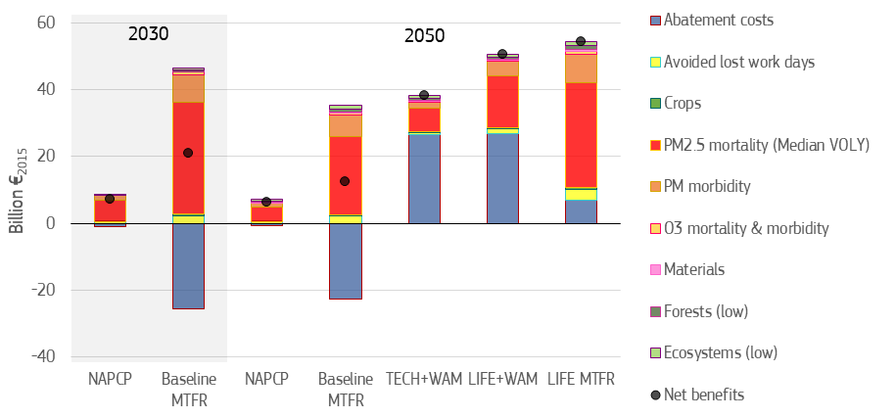

1. **Interactions with climate change and climate policy**
   1. Prospects for emissions of short-lived climate forcers (methane and black carbon)

Methane and black carbon contribute to both air pollution and global warming. Methane is not only a very powerful greenhouse gas but also an important precursor to ground-level ozone, which is very detrimental to health. Black carbon is a component of particulate matter but also a potent contributor to climate warming.

With currently adopted air, climate and energy objectives and legislation (the baseline), the computed methane emissions would decrease by about 20% between 2020 and 2050, while only very small benefits would be brought on this matter by the measures announced by Member States in their NAPCPs. However, with the increased climate ambition proposed by the Commission in 2020[56], the decrease would reach 44% over the same period. These reductions do not factor in the effect of the actions set out in the recently adopted methane strategy[57], which would further reinforce this decreasing trend.

For black carbon, existing policies and, to a much lower extent the ones announced in the NAPCPs, could reduce overall EU emissions by about 80% between 2020 and 2050. The largest reductions of black carbon would be achieved when air emissions control measures are combined with more ambitious climate policies, showing how synergies can be achieved through the measures to tackle black carbon.

* 1. Co-benefits and trade-offs between policies

Several climate scenarios have been analysed with regard to their effects on air pollution in the modelling work underpinning this Clean Air Outlook. Some of these scenarios are based on the cases developed for the Commission’s ‘Long-term strategic vision for a prosperous, modern, competitive and climate neutral economy’[58]; this aims to achieve a carbon-neutral economy by 2050 through various routes, with one scenario relying on the circular economy and lifestyle changes[59] and another relying on technological solutions[60]. A further scenario corresponds to the new proposal for a 55% reduction in greenhouse gases by 2030[61]. This allows to identify the effects of various actions at EU level on air pollutant emissions for 2030 and 2050.

Figure 6 shows that, in the long term (2050), actions to fight climate change always help to reduce air pollutant emissions (the smallest contribution relates to PM2.5 – see Box 2 below for some possible explanations). The climate scenario reflecting a move towards a circular economy and lifestyle change is the one that contributes most to reducing air pollutant emissions.

**Figure 6: Projections for emissions of the main air pollutants in the EU-27 under various scenarios and the maximum potential reductions provided by air pollution control measures and climate policies (Source: IIASA)[62]**



As shown in Section 4.4, air pollution control measures are more costly when they are introduced in isolation than when they are implemented together with climate change mitigation measures. There are clearly measures that benefit both policies, and these need to be promoted, while measures leading to trade-offs should be avoided. Measures to increase the share of non-combustible renewables in energy consumption, to improve the energy performance of buildings and promote more sustainable heating and cooling solutions and to boost energy efficiency overall, as well as measures in support of clean transport, are particularly beneficial. On the other hand, measures that increase bioenergy use in devices without adequate emissions abatement technologies[63] are detrimental to clean air and need to be avoided.

***Box 2:*** *EEA analysis of the effects of increased renewable energy sources on air pollution*

*The EEA has estimated the impact of gross final consumption of renewable energy sources on air pollutant emissions at EU level and in Member States. The situation in 2017 is compared to a hypothetical situation where renewable energy consumption would have remained at its 2005 level. Against that baseline, the EEA concludes that the additional consumption of renewable energy across the EU led to a decrease of SO2 and NOx emissions by 6% and 1% respectively in 2017. In contrast, it led to an increase of PM2.5 and NMVOC emissions of 13% and 4% respectively, which is estimated to have occurred in all Member States except one (Portugal). The EEA explains this relative increase by the increase in bioenergy use over the period (the use of which has actually decreased considerably in Portugal since 2005). Since, in most cases, biomass is used for domestic heating, the EEA concludes that this is likely to have led to increases in PM2.5 concentrations.*

Source: EEA, Renewable energy in Europe 2019 - Recent growth and knock-on effects (<https://www.eionet.europa.eu/etcs/etc-cme/products/etc-cme-reports/renewable-energy-in-europe-2019-recent-growth-and-knock-on-effects>).

1. **Transboundary and international dimension**

The analysis undertaken to support this Clean Air Outlook shows that, in most Member States, a significant contribution to PM2.5background concentration comes from other Member States, in addition to already significant domestic contributions. This reflects the transboundary nature of air pollution, which justifies EU action in this field. It reinforces the idea that Member States all need to reduce their air pollutant emissions according to their obligations under the NEC Directive, so that their combined efforts at national level deliver benefits to all. National cost-benefit analyses of clean air measures should take into account their positive spill-over effects in neighbouring countries.

In addition, the analysis shows that contributions to air pollutant background concentration also come from non-EU countries, at varying levels depending on the geographical situation of the Member States. This underlines the need for the EU to take stronger action bilaterally (notably in the context of accession and neighbourhood policies[64] but also by building stronger international partnerships) and in international fora such as the UNECE Air Convention[65]. Ratification and implementation of the Air Convention by all parties, notably by countries in the Eastern Neighbourhood that have not already done so, is a key priority. A major step towards achieving this objective is the ratification by all Member States of the amended Gothenburg Protocol to the Air Convention[66], as well as the amended Heavy Metals and Persistent Organic Pollutants Protocols.

However, in most cases, the main share of the effort to reduce air pollutant background concentration would come from each Member State’s domestic action by cutting their own emissions. This share is often higher in the largest Member States, where at least half of the effort has to come from reducing domestic emissions. Smaller and more isolated Member States can benefit to a larger extent from respectively reductions in neighbouring countries and in international shipping (especially in the case of islands)[67].

1. **Conclusion**

This report demonstrates that, if all legislation adopted up to 2018 delivered its full benefits and if Member States implemented the measures announced in their NAPCPs, the EU as a whole would achieve the reductions of air pollutant emissions that correspond to the obligations under the NEC Directive for 2030. For all pollutants except ammonia, this would even be achieved with some margin[68]. However, there are wide differences across Member States and the report makes it clear that this remains a distant prospect, as most Member States still need to make a significant effort to fulfil their obligations for 2020-29 under the NEC Directive (although these obligations are less stringent than the 2030 ones).

The report makes a strong case for Member States to continue, intensify and broaden their efforts, and to implement measures to cut air pollution and greenhouse gases in a mutually supportive way; the priorities and actions announced in the European Green Deal and the opportunities provided in the long-term budget for 2021-2027 and NextGenerationEU[69] will help deliver such synergies. Initiatives such as the Renovation Wave[70], more stringent air pollutant emission standards for vehicles[71], the revision of the Industrial Emissions Directive[72] and all actions that contribute to a climate neutral and resource-decoupled economy by 2050 will help to mainstream the reduction of air pollution in all sectors. New initiatives such as Europe’s Beating Cancer Plan[73] and the EU4Health programme[74] will provide the opportunity to better address the links between environment and health. The new financial instruments supporting NextGenerationEU, together with the cohesion policy funds, will support national, regional and local efforts to deliver cleaner air.

The new Common Agricultural Policy (CAP), still subject to interinstitutional negotiations, will also have a crucial role to play in incentivising Member States to reduce air pollution in the agricultural sector.

Ammonia emissions from agriculture remain an outstanding issue in all the cases analysed in this report, and the additional measures announced by Member States in their NAPCPs need to be implemented without delay to reduce these emissions, and even more measures need to be introduced in many Member States. More than 90% of ammonia emissions in the EU come from agriculture, notably from livestock farming and from the storage and use of organic and inorganic fertilisers. The new CAP needs to play its part in supporting and contributing to the reduction of air pollution and Member States must harness the new opportunities provided by e.g. the proposed eco-schemes in the national strategic plans and the proposed strategic objectives (including management of natural resources such as air and water). A CAP with strong environmental and climate ambitions should be pursued in order to reflect the priorities under the European Green Deal, in line with the farm to fork and biodiversity strategies[75].

In parallel, the Commission will continue to help Member States by developing more guidance and technical support for farmers and national institutions on how to implement well-known and cost-effective measures to reduce air pollution and by exploring innovative ways to reduce air pollutant emissions in agriculture. This should be done in an integrated way, taking into account pollution to air, water and soil, as well as climate impacts, in line with what will be endeavoured for all sectors through the European Green Deal’s zero pollution ambition.

All the above measures will nevertheless not be sufficient to eliminate all the effects of air pollution, and worrying levels of pollution concentration in cities will remain, as well as air pollution-related threats to ecosystems, including protected ones. Even though pollution concentration levels could come much closer to the current WHO Air Quality Guidelines values if there is full implementation of agreed climate and energy policies and of the clean air measures announced by Member States in their NAPCPs, there will continue to be premature deaths in the EU due to air pollution. As even relatively low levels of pollution exposure are harmful, there is a need to reinforce efforts at all levels to reduce air pollution. In addition to strengthening domestic measures, stronger international and inter-regional cooperation is also needed; particularly through the Air Convention but also beyond that, including promoting and supporting implementation of the UNEA resolution on reduction of air pollution at a global level[76]. This also underlines the need to continue working on reducing emissions of air pollutant precursors, particularly methane (methane is an important precursor to ground-level ozone, which is harmful to human health and the environment). The methane strategy has announced that the review of the NEC Directive (due by 2025) will explore the possible inclusion of methane among its regulated pollutants.

This Second Clean Air Outlook and its supporting analysis provide elements for a more informed implementation of the NEC Directive by Member States. It will be updated in around 2 years with the publication of the Third Clean Air Outlook, as part of the wider zero pollution activities.

1. COM (2019) 640
2. European Environment Agency (EEA) Air Quality Report 2020: the EEA uses a slightly different methodology to the one used for this Clean Air Outlook to estimate numbers of premature deaths. The main differences are explained in Box 1. The impact of air pollution on ecosystems through eutrophication is estimated according to ‘critical load’. For more information, see also Section 4.3 below.
3. Directives 2004/107/EC and 2008/50/EC.
4. Directive (EU) 2016/2284 on the reduction of national emissions of certain atmospheric pollutants (‘NEC Directive’).
5. COM (2013) 918
6. COM (2018) 446
7. COM (2020) 266
8. See ‘Roadmap for an EU Action Plan Towards a Zero Pollution Ambition for air, water and soil’ (https://ec.europa.eu/info/law/better-regulation/have-your-say/initiatives/12588-EU-Action-Plan-Towards-a-Zero-Pollution-Ambition-for-air-water-and-soil).
9. The European Green Deal announced the overall objective to ‘protect, conserve and enhance the EU's natural capital, and protect the health and well-being of citizens from environment-related risks and impacts’. The Second Clean Air Outlook also provides input towards this objective.
10. COM/2020/380
11. See for instance OECD/European Union (2020), Health at a Glance: Europe 2020: State of Health in the EU Cycle, OECD Publishing, Paris, <https://doi.org/10.1787/82129230-en>; European Environment Agency (EEA) Air Quality Report 2020
12. See EEA NEC Directive emissions data viewer 1990-2018 (<https://www.eea.europa.eu/data-and-maps/dashboards/necd-directive-data-viewer-3>).
13. EEA Air Quality Report 2020.
14. EEA Air Quality Report 2020.
15. ‘Healthy Environment, Healthy Lives’, EEA Report 21/2019.
16. See for instance: OECD/European Union (2020), Health at a Glance: Europe 2020: State of Health in the EU Cycle, OECD Publishing, Paris, <https://doi.org/10.1787/82129230-en>.
17. European Commission (2017). Special Eurobarometer 468: ‘Attitudes of European citizens towards the environment’.
18. ‘Unequal exposure and unequal impacts: social vulnerability to air pollution, noise and extreme temperatures in Europe’, EEA Report No 22/2018; ‘Employment and Social Developments in Europe 2019’
19. EEA National Emission reduction Commitments Directive reporting status 2020 (<https://www.eea.europa.eu/publications/national-emission-reduction-commitments-directive>).
20. 10 Member States for ammonia (Austria, Cyprus, Finland, France, Germany, Hungary, Ireland, Latvia, Spain, Sweden), six for NOx (Denmark, France, Ireland, Latvia, Malta, Sweden), four for PM2.5 (Finland, Poland, Slovenia, Spain), four for NMVOC (Bulgaria, Cyprus, Czechia, Lithuania) and two for SO2 (Lithuania, Poland).
21. Bułgaria, Cyprus, Czechia, Denmark, Hungary, Romania.
22. Cyprus, Germany, Lithuania, Poland, Romania.
23. Cyprus, Czechia, Hungary, Poland, Romania.
24. Austria, Cyprus, Czechia, Denmark, France, Germany, Hungary, Ireland, Italy, Lithuania, Malta, Portugal, Romania, Slovenia, Sweden.
25. Bulgaria, Croatia, Cyprus, Czechia, Hungary, Ireland, Italy, Latvia, Lithuania, Malta, Poland, Portugal, Romania, Slovenia, Spain.
26. Austria, Cyprus, Czechia, Denmark, France, Germany, Hungary, Lithuania, Luxembourg, Poland, Romania, Slovakia, Spain.
27. COM (2018) 330 final
28. SWD (2019) 427 final
29. The WHO Guidelines are currently being reviewed and the Commission is following this closely.
30. For more information, see: https://ec.europa.eu/info/law/better-regulation/have-your-say/initiatives/12677-Revision-of-EU-Ambient-Air-Quality-legislation
31. In December 2018, the Energy Efficiency Directive (EU) 2018/2002 and the recast Renewable Energy Directive 2018/2001/EU both entered into force, respectively setting EU 2030 targets of at least 32.5% for energy efficiency (compared to projections of expected energy use in 2030) and at least 32% for renewable energy; these targets were part of the climate scenario in the First Clean Air Outlook and are now part of the baseline in the Second Clean Air Outlook, which also therefore includes a reduction of greenhouse gases of about 40% in 2030 compare to 2005.
32. For details, see IIASA report: “Support to the development of the Second Clean Air Outlook”: https://ec.europa.eu/environment/air/clean_air/outlook.htm
33. COM/2020/562 final
34. See footnote 24.
35. Slovenia.
36. Czechia and Luxembourg for NOx; Germany and the Netherlands for PM2.5; Ireland and Luxembourg for NMVOC.
37. All Member States but Greece, Malta, the Netherlands, Slovakia and Slovenia.
38. Austria, Bulgaria, Cyprus, Denmark, Estonia, Finland, Germany, Ireland, Latvia, Lithuania, Luxembourg, Poland, Portugal, Romania, Sweden.
39. See IIASA report for more details.
40. Ammonia is also a precursor to secondary PM2.5, which is detrimental to health.
41. See IIASA report for details
42. 25 microgram/m3 corresponds to the Ambient Air Quality Directive limit value, which refers to overall concentration, while results presented here refer only to background concentration and do not include emissions in local hotspots.
43. To preserve consistency with previous calculations for such change, these calculations are performed keeping population constant at its 2010 level. However, this is not done when estimating the economic and health benefits, which uses projections of future population data for Member States for better accuracy.
44. Maximum technically feasible scenario.
45. “CAO2 baseline” corresponds to the implementation of all legislation adopted until 2018; “Potential cuts from additional climate measures” correspond to the situation with the lowest air pollutant emissions among the long term climate scenarios reaching a decarbonized economy by 2050; “Potential cuts from additional air pollution controls” corresponds to the maximum technically feasible air pollutant emission reductions (MTFR).
46. Again, with the caveat that not all measures could be modelled due to lack of details in some NAPCPs.
47. The range is due to the various valuation methods and the extent of the health impacts that were included.
48. Only terrestrial ecosystems are included in this analysis due to the model features.
49. This term describes the ecosystem’s ability to absorb eutrophying nitrogen pollutants (or acidifying pollutants, in the case of acidification) deposited from the atmosphere without causing negative effects to the natural environment (EEA, Air Quality Report 2020).
50. See footnote 47 for graph legend.
51. Net benefits correspond to the benefits minus costs.
52. Note that the cost of climate change mitigation measures are not included in this graph.
53. When all technically feasible air pollution abatement measures are implemented and climate change is kept below 1.5° C.
54. Dechezleprêtre et al. (2019), The economic cost of air pollution: Evidence from Europe, OECD Economics Department Working Papers.
55. Benefits are shown above the x-axis, costs are below. ‘NAPCP’ represents a situation where all measures selected for adoption in the NAPCPs deliver benefits on top of already agreed policies; ‘Baseline MTFR’ represents a situation where Maximum Technically Feasible air pollution Reduction measures deliver benefits on top of already agreed policies; ‘TECH+WAM’ represents a situation where NAPCP measures come on top of ambitious climate mitigation based on technological options; ‘LIFE+WAM’ represents a situation where NAPCP measures come on top of ambitious climate mitigation based on the circular economy; ‘LIFE MTFR’ represents a situation where Maximum Technically Feasible air pollution Reduction measures deliver benefits on top of ambitious climate mitigation based on the circular economy. These various climate situations are described in more detail in Section 5.2.
56. COM(2020) 562 final
57. COM(2020) 663 final; examples of sectoral actions cover agriculture, energy, waste and waste water.
58. COM(2018)773 final
59. The ‘1.5 LIFE’ scenario achieves the 1.5°C ambition through a more circular economy, less carbon-intensive diets, a sharing economy, etc.
60. The ‘1.5 TECH’ scenario achieves the 1.5°C ambition through technological options. Remaining emissions that cannot be abated by 2050 are balanced by negative emissions through the deployment of bioenergy associated with carbon capture and storage and LULUCF sinks.
61. COM(2020) 562 final
62. For legend, see footnote 47
63. However, Commission Regulations on Eco-design requirements for solid fuel boilers and for solid fuel local space heaters set air pollution limits for biomass devices.
64. Particularly by encouraging enlargement countries to step up their transposition and implementation of EU legislation and countries which have signed agreements with the EU to align their laws more closely with those of the EU.
65. UNECE Convention on Long-Range Transport of Air Pollution (https://www.unece.org/env/lrtap/welcome.html.html).
66. As amended in 2012.
67. Results for all Member States available in IIASA report.
68. For ammonia, the NAPCP measures would be just sufficient to achieve, for the EU as a whole, the emissions reduction corresponding to the NEC Directive commitments.
69. https://ec.europa.eu/info/strategy/recovery-plan-europe_en
70. https://ec.europa.eu/energy/topics/energy-efficiency/energy-efficient-buildings/renovation-wave_en
71. Such as the Proposal for more stringent air pollutant emissions standards for combustion-engine vehicles announced in the European Green Deal.
72. See Inception Impact Assessment (https://ec.europa.eu/info/law/better-regulation/have-your-say/initiatives/12306-EU-rules-on-industrial-emissions-revision).
73. https://ec.europa.eu/health/non_communicable_diseases/cancer_en
74. https://ec.europa.eu/health/funding/eu4health_en
75. COM/2020/381
76. United Nations Environment Assembly Resolution 3/8.