

ANNEX

**Annex 1, VERSION 1, Page 2 of cover: Model of the TIR Carnet, No. 5 of the “règles relatives à l’utilisation du carnet TIR”**

*For* quatre *substitute* huit

**Annex 1, VERSION 1, Page 3 of cover: Model of the TIR Carnet Version 1, No. 5 of the rules regarding the use of the TIR Carnet**

*For* four *substitute* eight

**Annex 1, VERSION 1, Page 5 (white) of the model of the TIR Carnet, Voucher No. 1**

*For* the existing Voucher No. 1 *substitute[1]*

**Annex 1, VERSION 1, Page 6 (green) of the model of the TIR Carnet Version 1, Voucher No. 2**

*For* the existing Voucher No. 2 *substitute[2]*

**Annex 1, VERSION 2, Page 2 of cover: Model of the TIR Carnet, No. 5 of the “règles relatives à l’utilisation du carnet TIR”**

*For* quatre *substitute* huit

**Annex 1, VERSION 2, Page 3 of cover: Model of the TIR Carnet Version 1, No. 5 of the rules regarding the use of the TIR Carnet**

*For* four *substitute* eight

**Annex 1, VERSION 2, Page 12 (white) of the model of the TIR Carnet, Voucher No. 1**

*For* the existing Voucher No. 1 *substitute[3]*

**Annex 1, VERSION 2, Page 13 (green) of the model of the TIR Carnet, Voucher No. 2**

*For* the existing Voucher No. 2 *substitute[4]*

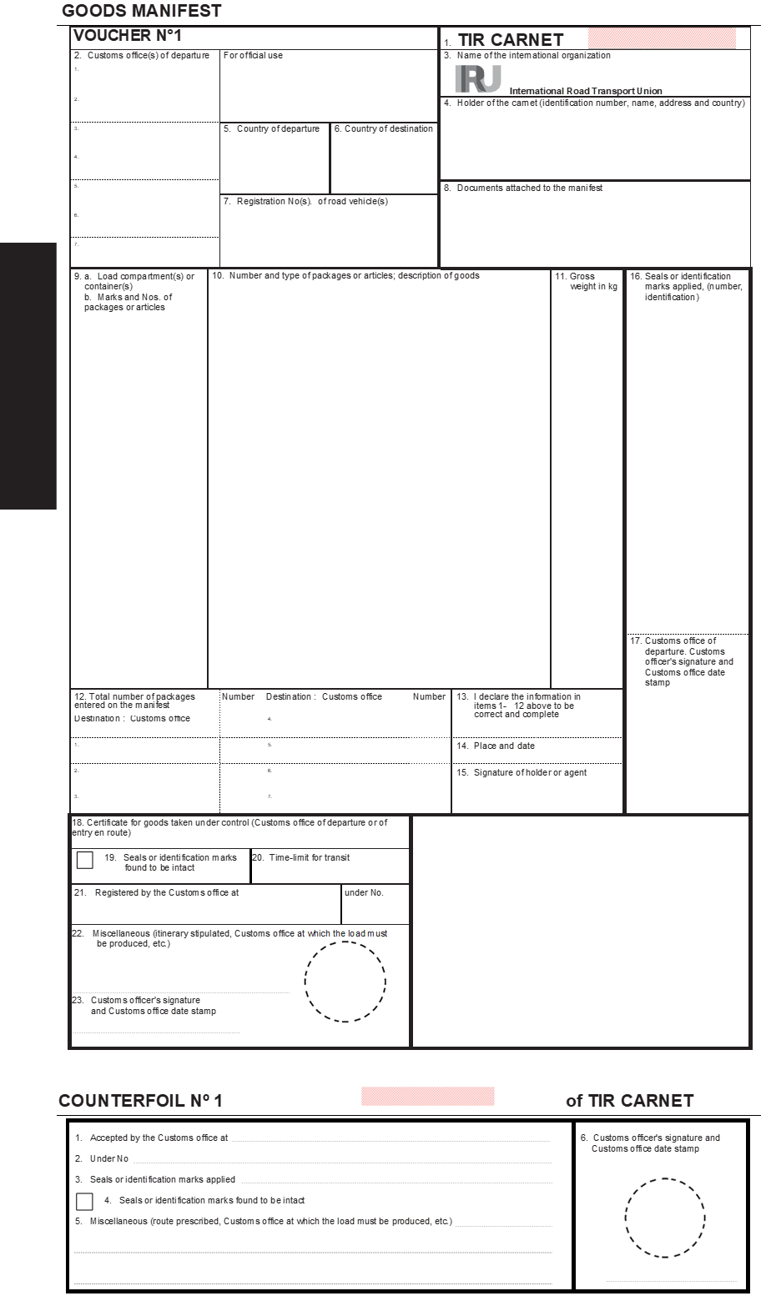

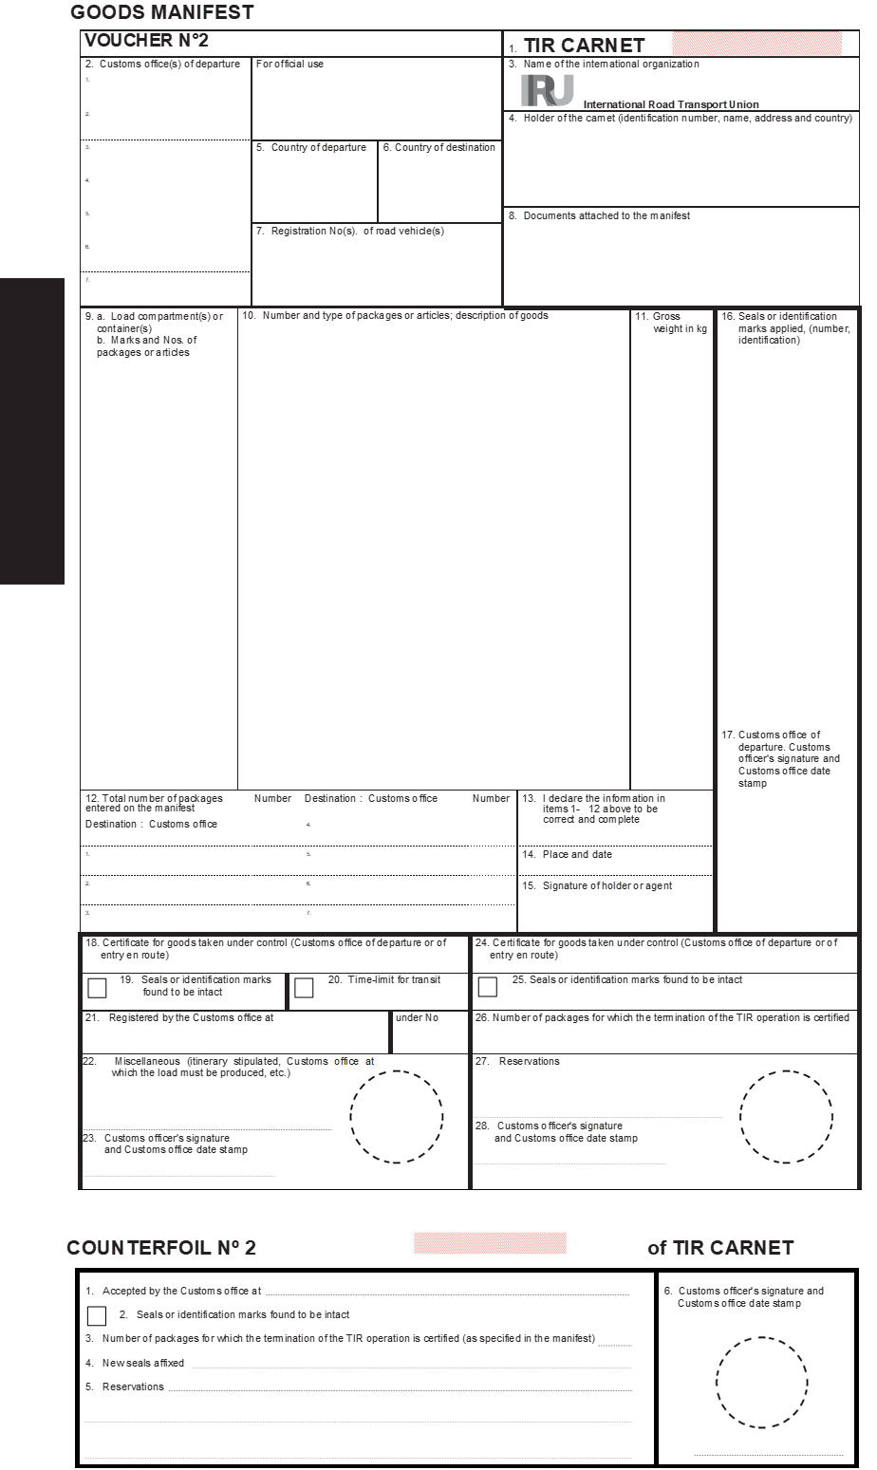

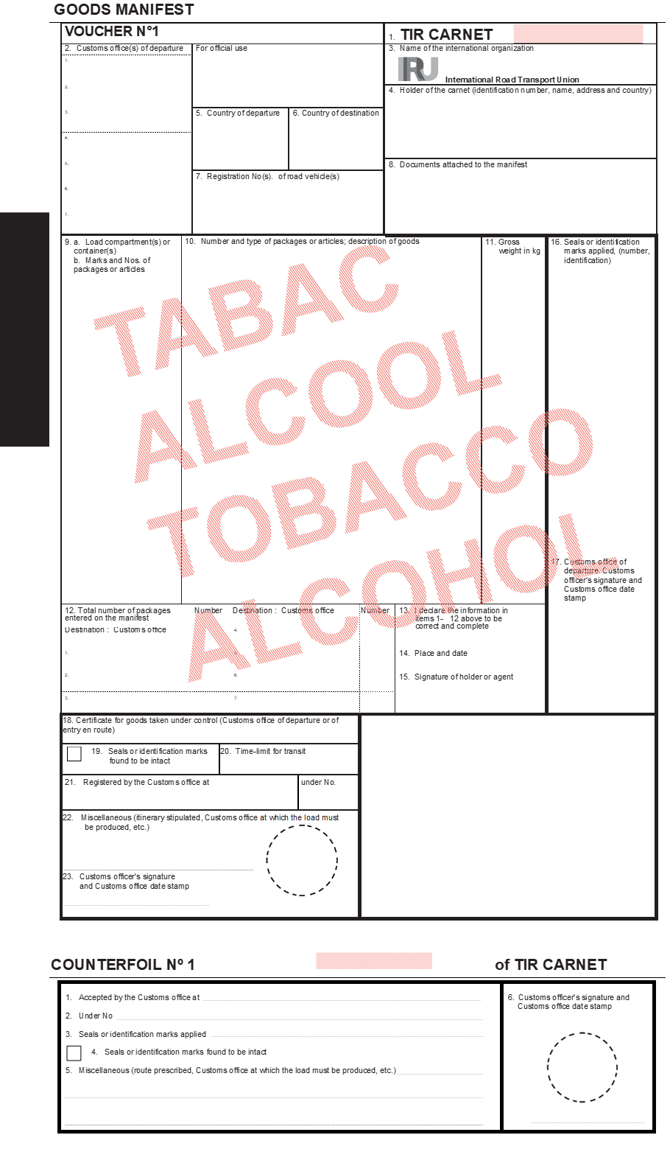

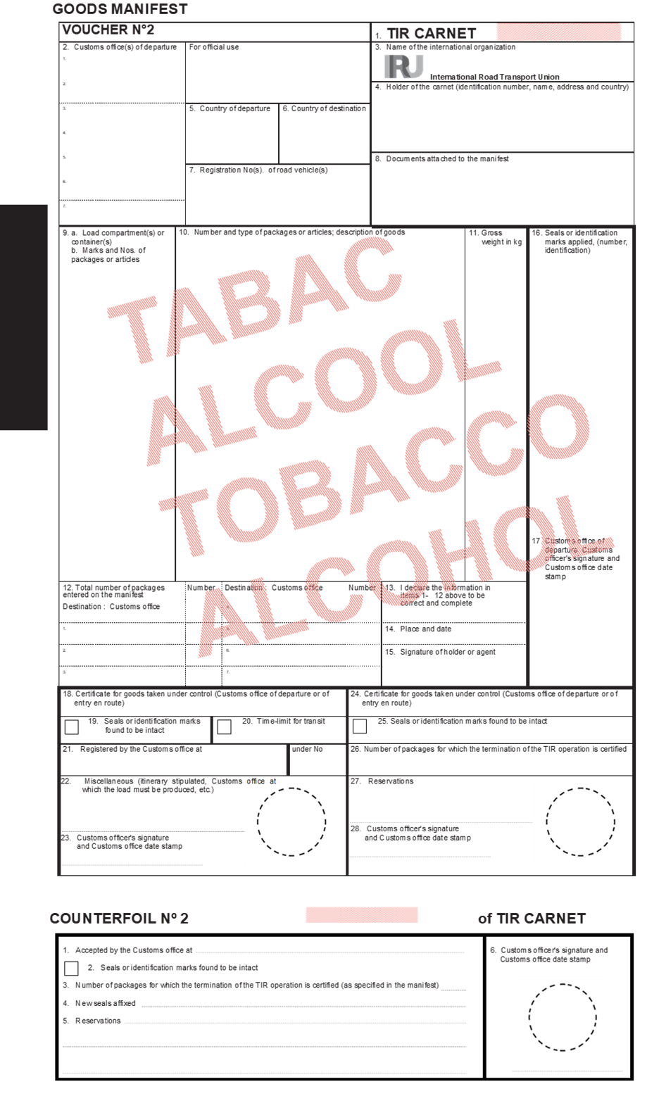

1. See page 3 of this document.
2. See page 4 of this document.
3. See page 5 of this document
4. See page 6 of this document.