

**REPORT FROM THE COMMISSION TO THE EUROPEAN PARLIAMENT AND THE COUNCIL**

**on the implementation of Regulation (EC) No 428/2009 setting up a Community regime for the control of exports, transfer, brokering and transit of dual-use items**

**1. Introduction**

Article 23(3) of Regulation (EC) No 428/2009 ("the Regulation") requires the Commission to submit an annual report to the European Parliament on "the activities, examinations and consultations of the Dual-Use Coordination Group (DUCG)". Article 25(2) of Regulation (EC) 428/2009 further requires the Commission to present, every three years a “comprehensive implementation and impact assessment report” to the Council and Parliament. Article 25(3) stipulates that special sections of the report shall deal with the activities of the Dual-Use Coordination Group (DUCG), the introduction of a secure and encrypted system for the exchange of information between Member States and the Commission, as well as the implementation of Article 15(1) and (2) regarding updates to the control lists and Article 24 regarding national penalties in case of infringement to the Regulation. In light of this, the Commission started publishing annual export control reports in 2013 and recognised, in its 2014 Communication on "The review of export control policy"[1], that the publication of reports and of non-sensitive control information, beyond the specific requirements of Articles 15, 23(3), 25(3) and 24, are critical steps to enhance transparency and improve operators' compliance and their capacity to implement controls.

This report, prepared by the Commission with input from Member States[2] in the DUCG, provides information on the implementation of the Regulation in 2019, and includes aggregated export control data for 2018.

**2. Evolution of the policy & regulatory framework**

**2.1 Export control policy review**

The legislative process for a modernisation of EU export controls, that started in 2016[3], advanced significantly in 2019 with the adoption by the Council of a mandate for negotiations with the European Parliament in June 2019, and the start of trilogue negotiations between the co-legislators in the autumn. Two trilogue negotiations were held by the Council, the European Parliament and the Commission in October and November 2019.

The Commission conducted a series of targeted consultations and outreach to key industry and civil society stakeholders in the course of 2019. In particular, an Export Control Forum was organised on 13 December 2019, jointly with the Finnish Presidency of the Council of the EU, to exchange views with industry and civil society stakeholders[4].

**2.2 Amendments to Regulation (EC) No 428/2009**

2019 Update to the EU control list

The EU Control List in Annex I to the Regulation was amended once during the reporting period, in order to update the list of dual-use items subject to control. This amendment[5] incorporated over 300 modifications agreed at the multilateral export control regimes in 2018 (mostly from amendments agreed at the 2018 Plenary of the Wassenaar Arrangement, many of them editorial). Annexes II and IV of the Regulation were also updated in line with the amendments to Annex I.

The 2019 EU control list in particular introduced new controls on certain discrete microwave transistors (3A001b3f), signal generators with specified 'Radio Frequency modulation bandwidths’ (3A002d5), software designed to restore operation of microcomputers/ microprocessors after Electromagnetic Pulse (EMP) or Electrostatic Discharge Disruption (ESD) (3D005), for masks and reticles designed for optical sensors (6B002), and for air-launch platforms for space launch vehicles (9A004g). On the other hand, it removes control on technology for diffusion bonding for gas turbine engine components (9E003a7) and introduces new decontrol notes for 'open-cell foam' electromagnetic wave absorbing materials (1C001) as well as for "Information security" items specially designed for a 'connected civil industry application’ (5A002). The 2019 EU control list also incorporates changes to the controls on gear machine tools (2B003), Digital-to-Analogue Converter (3A001a5b) and multi-layer mask control (3B001h) as well as for hydrophones operating over 1000m (6A001a2a6), underwater submersible vehicles (8A001c) and for detonation engines (9A111).

A "Comprehensive Change Note" was published as guidance providing an overview of all technical changes to the 2019 EU Dual-Use Control List[6]. The updated and consolidated EU Control List became applicable on 31 December 2019, thereby allowing the EU to comply with its international commitments with regard to export controls, and supporting the competitiveness of EU exporters where control parameters were adjusted to technological developments.

Brexit contingency plans

The Council and the European Parliament adopted, on 25 March 2019, Regulation (EU) 2019/496 amending Council Regulation (EC) No 428/2009 by granting a Union general export authorisation for the export of certain dual-use items from the Union to the United Kingdom[7]. This amendment formed part of a package of measures under a "no deal contingency plan" for certain sectors to mitigate risks of the United Kingdom’s withdrawal from the European Union. It has, however, become without object as a result of the ratification of the Withdrawal Agreement.

**2.3 National implemention and enforcement measures**

Implementation measures

The Regulation is binding in its entirety and directly applicable in all Member States, but provides that Member States take certain measures for the implementation of specific provisions, and that information on those measures should be published in the Official Journal of the European Union. An Information Note of 2016[8] provides an overview of measures taken by Member States including, inter alia, the extension of brokering and transit controls, the extension of controls to non-listed items for reasons of public security and human rights considerations, the introduction of national general export authorisations, the application of intra-EU transfer controls for non-listed items, as well as information relating to competent authorities.

New measures were reported by Member States in 2019: France introduced a national general license for the export of dual-use goods for the repair of civil aircraft, while the United Kingdom updated seven open general export licences and one open general transshipment licence to reflect changes to the EU dual-use export control list. In addition, the United Kingdom published on 24 September 2019 guidance on export controls: dual-use items, software and technology, goods for torture and radioactive sources.

Enforcement measures

Article 24 of the Regulation stipulates that "Each Member State shall take appropriate measures to ensure proper enforcement of all the provisions of this Regulation. In particular, it shall lay down the penalties applicable to infringements of the provisions of this Regulation or of those adopted for its implementation. Those penalties must be effective, proportionate and dissuasive". Article 25(3)(e) requires that the Commission's report includes a special section dealing with "the measures taken by the Member States pursuant to Article 24 and notified to the Commission under paragraph 1 of this Article". A list of national enforcement measures was published together with the 2019 Annual Export Control Report[9] and remains valid.

**3. Activities of the Dual-Use Coordination Group**

Article 23(3) of the Regulation requires that the “Commission shall submit an annual report to the European Parliament on the activities, examinations and consultations of the Dual-Use Coordination Group (DUCG)" that brings together experts from the Commission and Member States to examine any issue concerning the application of export controls with a view to practically improving their consistency and effectiveness throughout the EU. Furthermore, Article 25(3)(a) adds that "special sections of the report shall deal with the Dual-Use Coordination Group and its activities".

The DUCG held seven meetings during the reporting period, confirming its function as a forum for consultations on a number of topical issues described herein.

**3.1 Consultations on implementation issues - general information exchange**

The DUCG conducted ***general information exchanges on export control issues***, including in support of the modernisation of EU export controls. The DUCG conducted an information exchange on penalties and sanctions in 2019, and, as a result, published an "*Overview of national enforcement measures*" as an annex to the 2019 Annual Export Control Report.

The DUCG exchanged information regarding ***national implementing measures*** and advanced preparations for updating the relevant Information Note in the Official Journal of the European Union.

The DUCG reviewed the methodology and approach for data exchange, and conducted a ***licensing data collection exercise*** on 2018 data in order to enhance information exchange between Member States - especially regarding the collection of data under global and general export authoritisations - and to increase public transparency on EU dual-use export controls (EU 2018 aggregated data was used in the preparation of this annual report).

In consideration of the debate regarding the control of cyber-surveillance items, the DUCG conducted an ***exchange of information on the application of controls on cyber-surveillance technologies*** in 2018. The "Surveillance Technology Expert Group" ("STEG") continued to provide a forum for *ad hoc* information exchange but did not hold any meeting in 2019. The data collected from Member States shows a decrease in the number of licences (131 licences in 2018 as shown on the table below). In the same period, 27 denials were issued for cyber-surveillance items[10].

**3.2 Technical exchange of information – implementation issues**

* ***Support to the preparation of updates to the EU control list***

The DUCG was consulted on the revised EU Control List mentioned above. National experts, as well as observers from the European Parliament, attended a special session of the DUCG on 16 May 2019 and gave presentations highlighting the most important changes to the EU Control List.

* ***Technical information exchange on specific implementation issues***

The DUCG discussed a number of specific implementation issues in light of reports from competent authorities e.g. regarding consignee and end user data on export licenses and customs declarations, the information exchange under EU General Export Authorisations (EUGEAs), approaches to the identification of sanctioned persons involved in controlled exports, and the identification of third parties - consignees and intermediaries - on the standard licence form.

**3.3 EU Guidelines on Dual-Use Export Controls**

The DUCG set up a "Technical Expert Group on the development of compliance guidelines for academia" ("TEG-DUR"). The TEG-DUR held two meetings - on 13 June and 16 October 2019 – and presented the progress of its work to stakeholders at the Export Control Forum on 13 December 2019.

**3.4 Electronic exchange of information between competent authorities**

Article 25(3)(b) requires the Commission to report on "the implementation of Article 19(4)" and "the stage reached in the set-up of the secure and encrypted system for the exchange of information between Member States and the Commission". The Commission, supported by the DUCG, continued to develop the Dual-use e-System (DUeS), a secure and encrypted electronic system hosted by the Commission, to support the enhanced exchange of information between export control authorities and the Commission. In the course of 2019, the DUCG agreed on specific improvements to DUeS and developed functionalities supporting *denials notifications under Article 13(5) of the Regulation* and *bilateral consultations between competent authorities under Article 11 and Article 13(5) of the Regulation*. Other minor updates were made to the DUeS e.g. in December 2019, the list of items in the DUeS was updated to reflect the *2019 update of the EU control list* under Commission Delegated Regulation (EU) 2019/2199*.*

The DUCG also continued to support, through a dedicated Technical Expert Group, the development of an "electronic licensing platform" to be used by competent authorities on a voluntary basis. The TEG on e-licensing met twice – on 18 March and 14 October 2019 - and provided continued support to the "eLicensing pilot project". At the end of 2019, the "Front Office prototype" and the "Back Office prototype" were ready for testing by competent authorities, while discussions have started under the “Certex” project regarding the integration of dual-use eLicensing systems with the customs’ Single Window initiative. The Belgian Walloon competent authority became the 5th authority to join the pilot project (together with the competent authorities of Italy, Latvia, Romania and Greece). The project was presented to stakeholders on the occasion of the Export Control Forum on 13 December 2019. E-licensing platforms are scheduled to become operational in those competent authorities in the course of 2020.

**3.5 EU Dual-use Pool of Experts**

In 2019, the EU Dual-use Pool of Experts operated by Commission’s Joint Research Centre (JRC) and experts made available by Member States continued to provide support to competent authorities requesting technical advice to support the assessment of specific licensing cases. In total, 9 technical advices on commodity classification were provided to 6 competent authorities over the reporting period.

**3.6 Implementation and enforcement**

The DUCG exchanged information on the implementation and enforcement of controls. According to available data, in 2019 the EU export control network – comprising staff in Member States’ licensing competent authorities and the Commission - consisted of over 450 staff. With respect to enforcement, 218 breaches of export control regulations were recorded in 2018, while 85 administrative penalties and 19 criminal penalties were applied by national law enforcement authorities.

**3.7 Capacity building**

In 2019, the DUCG supported the organisation by the Commission's JRC in collaboration with the US Department of Energy of an event in Ispra (Italy) on 17-19 September 2019 combining the *12th JRC-NNSA[11] technical seminar* for licensing authorities and the *8th Commodity Identification Training Progress Review Meeting* for customs including also a joint customs-licensing exercise.

The Commission's JRC presented an "Export Control Handbook for Chemicals" that identifies correlation codes for chemicals (Export control classification number, Customs code, CAS[12] chemical number and name) under various EU trade regulations.

**3.8 Transparency and dialogue with industry and academia**

The DUCG supported the organisation of an "Export Control Forum" on 13 December 2019 in Brussels with industry associations, dual-use companies, academia and civil society organisations to discuss the implementation of EU export controls and the legislative process for a modernisation of EU export controls. Altogether, the Commission and competent authorities organised or participated in over 205 industry outreach events in 2019.

The DUCG also prepared documentation to support exporters' implementation of the regulations. In particular, a "Comprehensive Change Note Summarry 2019" summarises, for information purposes, the control text changes to the EU control list introduced under Commission Delegated Regulation (EU) 2019/2199[13].

**4 EU export controls – Key Data**

It is difficult to obtain reliable information on overall dual-use exports (including non-listed dual-use items) as there is no correspondingly defined economic sector. However, the Commission and Member States collect data that allow for approximate estimates of exports of dual-use goods based, on the one hand, on specific licensing data collected by competent authorities and, on the other hand, on statistics for customs commodities which include dual-use goods. 2018 export data estimates are presented below. It should be noted that the estimates presented hereafter do not include services and intangible technology transfers associated with the trade in dual-use goods.

**4.1 EU dual-use trade: items and destinations**

In 2019, the Regulation primarily applied to the export of about 1858 dual-use items listed in Annex I (the "EU Control List") and classified in 10 categories (Figure 1). These dual-use items relate to circa 1000 customs commodities, including chemicals, metals and non-metallic mineral products, computers, electronic and optical products, electrical equipment, machinery, vehicles and transport equipment etc. and typically fall at the high–tech end of this large, mixed commodity area.

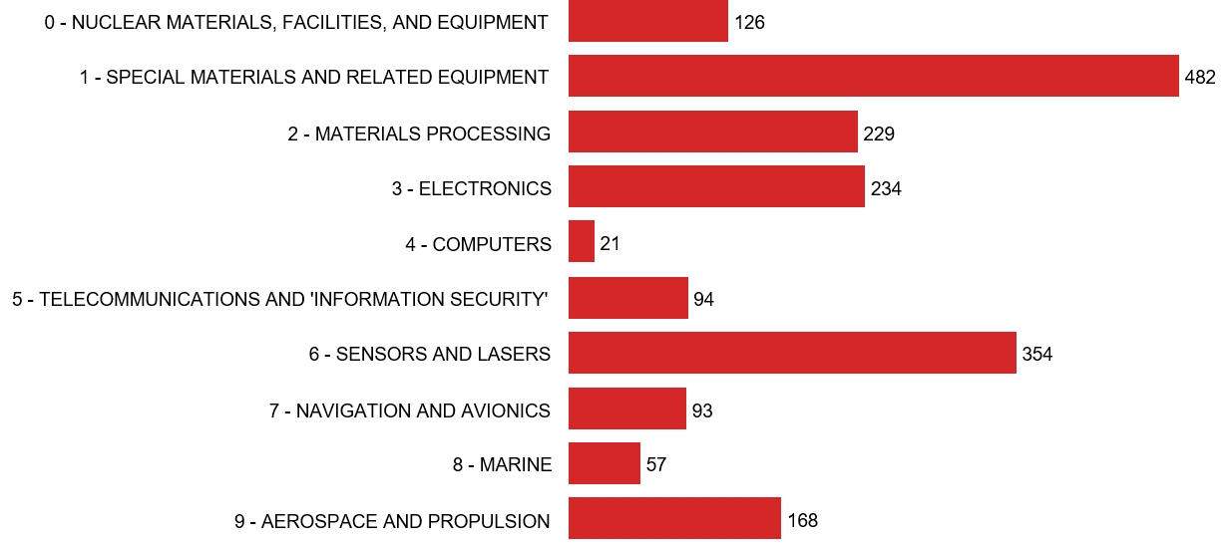

*Figure 1: Number of dual-use entries listed in the 10 Categories of Annex I further to the adoption of Regulation (EU) 2019/2199.*

Statistical estimates of the relative importance of dual-use trade indicate that dual-use exports represent about 3% of EU total exports (intra and extra-EU), within a broad ‘dual-use export domain’[14] of customs commodities that may include, to varying degrees, certain dual-use items (Figure 2).

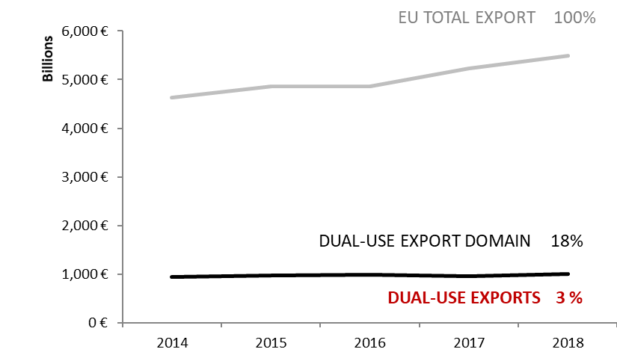

*Figure 2: Statistical estimates of dual-use intra and extra-EU exports.*

Statistical estimates also show the main export destinations and indicate that a large part of the dual-use exports are directed towards countries listed on Union General Export Authorisations (EUGEAs). The destination countries reflect the EU export market structure in the relevant commodities as well as trade facilitation under EUGEAs (Figure 3 and 4)[15].

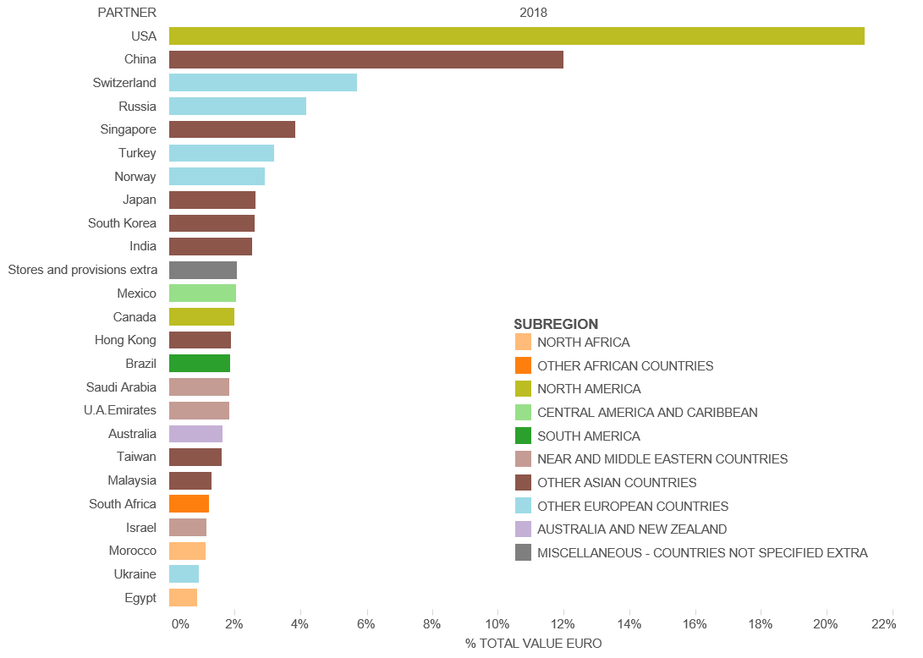

*Figure 3: EU dual-use export estimates: top 25 export destination countries and their sub-regions in 2018.*

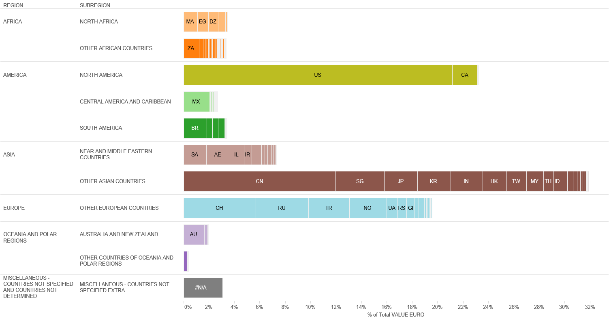

*Figure 4: EU dual-use export estimates: destination countries by regions and sub-regions in 2018.*

**4.2. EU dual-use trade control: Applications, licences, denials**

In light of Article 19(2) of the Regulation, which stipulates that "Member States shall take all appropriate measures to establish direct cooperation and exchange of information between competent authorities with a view to enhance the efficiency of the Community export control regime", the DUCG has exchanged licensing data and information in order to improve the understanding of export controls and their economic effect. Some data collected for the reporting period is reported below; it should be noted however that not all Member States collect all data. The information provided below thus represents approximate estimates of aggregate quantities and values within the limits of the data made available by Member States.

The total value[16] of applications reached EUR 50.7 billion and controlled dual-use exports thus represented 2.6% of total extra-EU exports. Authorised dual-use trade amounted to EUR 41.5 billion, representing 2.1% of total extra-EU exports, with a majority of transactions authorised under individual licenses (approx. 25349 single licenses issued in 2018) and global licenses (by their value). Only a small portion of exports were actually denied: 791 denials were issued in 2018, representing about 0.69% of the value of controlled dual-use exports in that year, and 0.02% of total extra-EU exports.

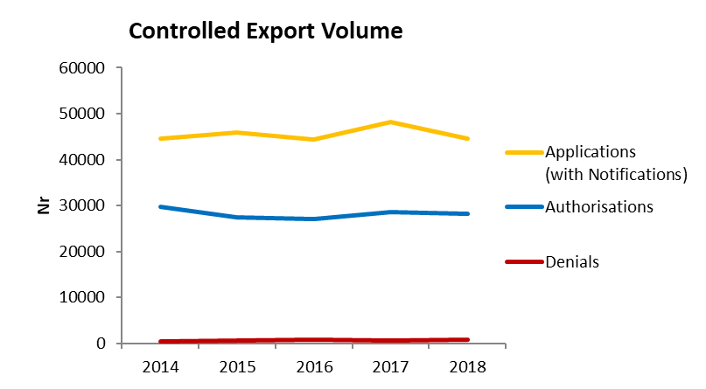

*Figure 5: Volume (number) of authorisations and denials in 2014-2018[17].*

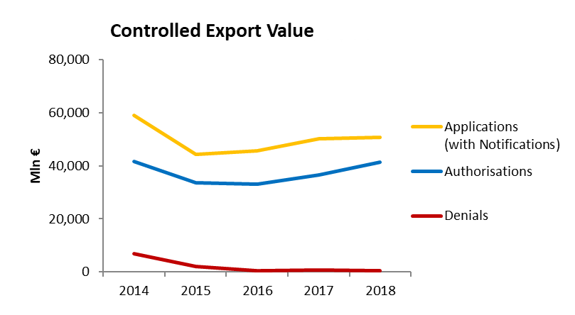

*Figure 6: Value (mln EUR) of authorisations and denials in 2014-2018.*

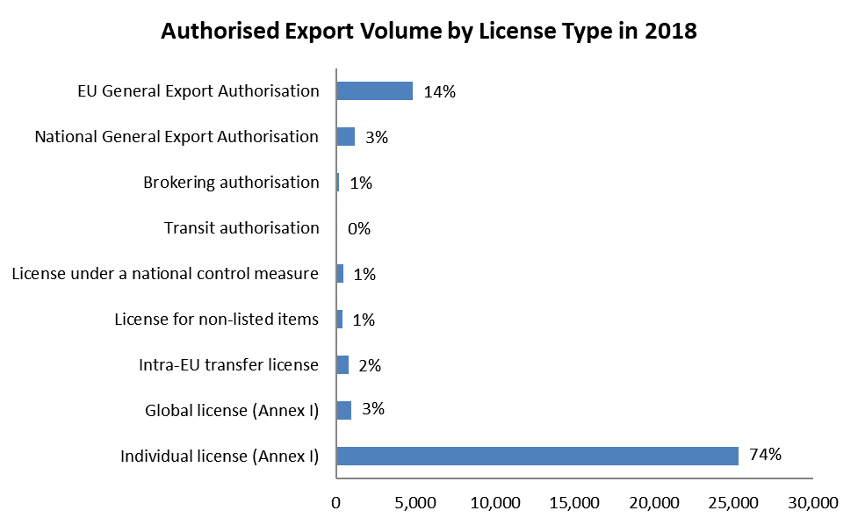

*Figure 7: Volume (number) of authorisations per type of licence in 2018.*

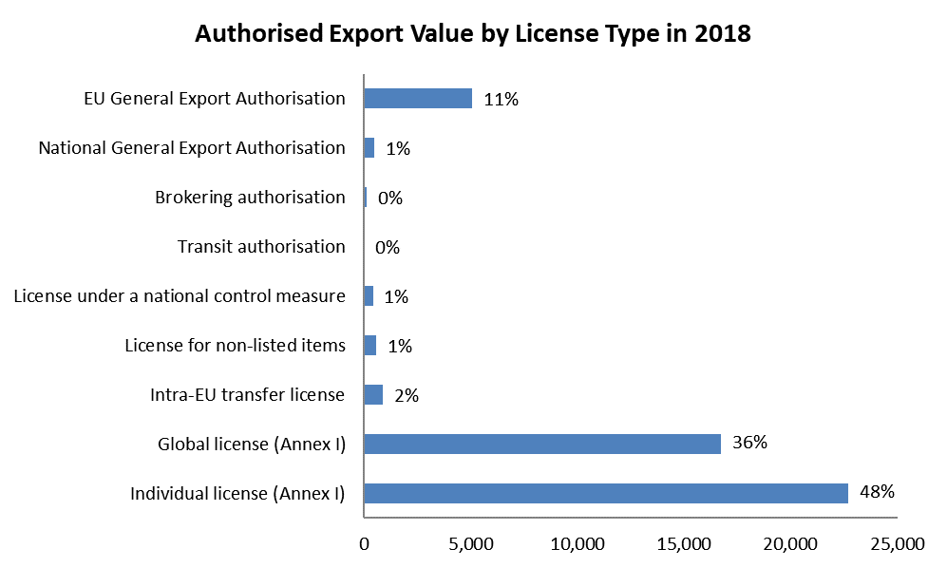

*Figure 8: Value (mln EUR) of authorisations per type in 2018.*

**5. Conclusions**

The Commission invites the European Parliament and the Council to take note of this report in the context of the proper exercise by the Commission of the powers delegated by the Regulation.

1. COM(2014)244 final of 24.4.2014.
2. Some Member States’ competent authorities also publicly report on trade in dual-use items.
3. The Commission proposal for a regulation COM(2016)616 is available at <http://eur-lex.europa.eu/legal-content/EN/TXT/?qid=1476175365847&uri=CELEX:52016PC0616>
4. <https://trade.ec.europa.eu/doclib/docs/2019/december/tradoc_158495.pdf>
5. Commission Delegated Regulation (EU) 2019/2199 of 17 October 2019, OJ L 338, 30.12.2019, p. 1.
6. The Summary Note is available at: https://trade.ec.europa.eu/doclib/docs/2019/october/tradoc_158393.pdf
7. OJ L 85, 27.03.2019, p. 1
8. OJ C 304, 20.8.2016, p. 3.
9. https://ec.europa.eu/transparency/regdoc/index.cfm?fuseaction=list&n=10&adv=0&coteId=1&year=2019&number=562&version=F&dateFrom=&dateTo=&serviceId=&documentType=&title=&titleLanguage=&titleSearch=EXACT&sortBy=NUMBER&sortOrder=DESC#
10. 23 denials were issued in 2018 for mobile telecommunications interception or jamming equipment (5A001.f), 2 for Internet Protocol (IP) network communications surveillance systems (5A001.j) and 2 for intrusion software (4A005 et al).
11. The National Nuclear Security Administration (NNSA) is part of the US Department of Energy.
12. The CAS number is a unique number applied to a specific chemical by the Chemical Abstract Service (CAS).
13. [https://trade.ec.europa.eu/doclib/docs/2019/october/tradoc_158392.pdf](https://trade.ec.europa.eu/doclib/docs/2019/october/tradoc_158392.pdf%20)
14. The statistical methodology developed by the Commission's Joint Research Centre makes use of a correlation table, developed by DG TAXUD, between dual-use classification numbers and customs codes and of Eurostat’s COMEXT data, as well as of licensing data. The notion of *dual-use export domain* refers to a large mixed commodity area, which includes dual-use items. Trade in dual-use items takes place *within* this commodity area, but is not identical to it, since by far, not all of the commodities within the *dual-use export domain* are really dual-use.
15. "Stores and provisions extra" are defined as delivery of ships' and aircraft's stores. ”Miscellaneous –countries not specified extra” includes countries and territories not specified within the framework of trade with third countries (i.e., these codes are usually used for goods delivered for offshore installations).
16. This figure includes value for licence applications and notifications under General Export Authorisations.
17. In Figures 5 and 6, "Applications" data include all applications for licenses, including notifications under general authorisations, thus providing an indication of "controlled exports", i.e. the value of extra-EU exports subject to an authorisation process. In cases where no application data is available, the charts make use of authorisation data as estimate for application data. "Authorisations" data refers to dual-use exports authorised under individual and global licences. It should be noted that applications do not necessarily correspond to the sum of authorisations and denials, as a number of applications may be cancelled and some applications may not be finalised within the same year. "Denial" refers to the volume and value of denied exports.