

**ANNEXES**

TABLE OF Contents

**Annex 6 Additional background information 2**

**1. Background information for all initiatives 2**

**1.1. Selection criteria of European Partnerships 2**

**1.2. Overview of potential functions for a common back office among Joint Undertakings 3**

**2. Background information for this specific initiative 5**

**2.1. Health status in the EU and related main challenges 5**

**2.2. Information about IMI JU & lessons learnt 16**

**2.2.1. IMI JU Interim & Final evaluations 18**

**2.3. Information about IMI2 JU & lessons learnt 19**

**2.3.1. IMI2 JU Interim evaluation and recommendations for a future partnership 25**

**2.4. IMI Success stories 28**

Annex 6 Additional background information

# Background information for all initiatives

## Selection criteria of European Partnerships

Partnerships based on Article 185 and 187 TFEU *shall be implemented only where other parts of the Horizon Europe programme, including other forms of European Partnerships would not achieve the objectives or would not generate the necessary expected impacts, and if justified by a long-term perspective and high degree of integration.* At the core of this impact assessment is therefore the need to demonstrate that the impacts generated through a Partnership approach go beyond what could be achieved with traditional calls under the Framework Programme – the Baseline Option. Secondly, it needs to assess if using the Institutionalised form of a Partnership is justified for addressing the priority.

The necessity test for a European Partnership (as set out in the Horizon Europe regulation) has two levels:

1. **The justification for implementing a priority with a European Partnership** to address Horizon Europe and EU priorities. This is linked to demonstrating that a European Partnership can produce added value beyond what can be achieved through other Framework Programme modalities, notably traditional calls in the work programmes (Option 0 – Baseline).
2. **The justification for the use of the form of Institutionalised Partnership**: Once it has been demonstrated that a partnerships approach is justified, co-programmed and/or co-funded forms are considered for addressing the priorities as they are administratively lighter, more agile and easier to set-up (Options 1 and/or 2). As Institutionalised Partnerships require setting up a legal framework and the creation of a dedicated implementation structure, they have to justify higher set-up efforts by demonstrating that it will deliver the expected impacts in a more effective and efficient way, and that a long-term perspective and high degree of integration is required (Option 3).

The outcomes of the ‘necessity test’ is presented together with the preferred option.

Figure 1. Horizon Europe selection criteria for the European Partnerships

| **Common selection criteria & principles** | **Specifications** |
| --- | --- |
| 1. **More effective** (Union added value) clear impacts for the EU and its citizens | Delivering on global challenges and research and innovation objectives |
| Securing EU competitiveness |
| Securing sustainability |
| Contributing to the strengthening of the European Research and Innovation Area |
| Where relevant, contributing to international commitments |
| 1. **Coherence and synergies** | Within the EU research and innovation landscape |
| Coordination and complementarity with Union, local, regional, national and, where relevant, international initiatives or other partnerships and missions |
| 1. **Transparency and openness** | Identification of priorities and objectives in terms of expected results and impacts |
| Involvement of partners and stakeholders from across the entire value chain, from different sectors, backgrounds and disciplines, including international ones when relevant and not interfering with European competitiveness |
| Clear modalities for promoting participation of SMEs and for disseminating and exploiting results, notably by SMEs, including through intermediary organisations |
| 1. **Additionality and directionality** | Common strategic vision of the purpose of the European Partnership |
| Approaches to ensure flexibility of implementation and to adjust to changing policy, societal and/or market needs, or scientific advances, to increase policy coherence between regional, national and EU level |
| Demonstration of expected qualitative and significant quantitative leverage effects, including a method for the measurement of key performance indicators |
| Exit-strategy and measures for phasing-out from the Programme |
| 1. **Long-term commitment** of all the involved parties | A minimum share of public and/or private investments |
| In the case of Institutionalised European Partnerships, established in accordance with article 185 or 187 TFEU, the financial and/or in-kind, contributions from partners other than the Union, will at least be equal to 50% and may reach up to 75% of the aggregated European Partnership budgetary commitments |

## Overview of potential functions for a common back office among Joint Undertakings

|  |  |  |  |
| --- | --- | --- | --- |
| **Functions** | **Current situation** | **Option of joint back- office** | **Comments** |
| **Organising calls for grant and proposal evaluations** | Each JU organises this independently. | A central organisation of evaluation, logistics, contracting evaluators, managing the data of the evaluation results  Central database of potential evaluators with domain expertise in thematic areas of partnerships | The evaluations would still need to be supervised by the Scientific staff of the individual Joint Undertakings (consensus meetings of expert evaluators etc) |
| **Human Resources related matters** | Each JU has own HR policy and resources  Quite some resources spent on recruitment in some JUs  Some HR facilities are procured from external contractors  Some JUs have a Service Level Agreement with COM for HR | More generic resources and expertise for HR matters  More consistency in HR policy  Shared HR investment for specialised expertise (IP and legal) | Ensuring consistency with EC HR policies is already in place |
| **Financial management** | Each JU conducts own financial contract management; differences between JUs  Each JU is audited separately.  Auditing at project level more frequent than in other Horizon 2020 parts and outsourced by JUs thus differences  ECA: too many audits on JUs | Financial management by one core team of financial staff  Would reduce the number of interfaces for audits and simplifies the auditing of the all JUs  Harmonisation of project auditing | Simplifies the harmonisation of financial management across JUs in line with Horizon Europe |
| **Communication (internal and external)** | Each JU has a separate communication strategies, teams and resources | A common back-office can support activities such as event organisation, dissemination of results, setting up website communication  Can help create a more visible Partnership brand | A considerable share of communication activity is partnership specific (addressing particular target groups, synthesising project results) however there are generic communication activities that can be shared  Needs to avoid duplication of efforts |
| **Data management on calls, project portfolios, information on project results** | Most JUs but not all use e-Corda for project data  Overall IT integration of JUs still difficult | Harmonised data management  Reduction of IT systems and support that is procured | This will need to happen regardless of the common back office but will likely be more smooth if managed centrally |

# Background information for this specific initiative

## Health status in the EU and related main challenges

This Annex describes the health status of EU citizens based on the analysis provided in the most recent “Health at a Glance: Europe” report (2018)[1] developed by the Organisation for Economic Co-operation and Development (OECD) in cooperation with the European Commission. It includes recent trends in life expectancy, the main causes of death, health inequalities by gender and socioeconomic status, the occurrence of communicable and chronic diseases as well as the main challenges to improving the health of EU citizens.

**Health status**

**Trends in life expectancy**

Life expectancy[2] reaches 81 years on average across EU countries, exceeding 80 years in two-thirds of EU countries (Figure 1). Women live nearly 5 ½ longer than men although this gap has narrowed by one year since 2000. This gender gap is partly due to greater exposure to risk factors among men (tobacco consumption, excessive alcohol consumption and less healthy diet) resulting in higher death rates from heart diseases, various types of cancer and other diseases.

Figure 1. Life expectancy at birth, by gender, 2016

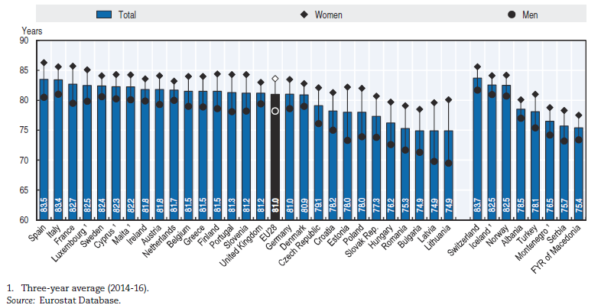

Until recently, life expectancy was rising fairly rapidly and steadily across EU countries, but since 2011, the gains in life expectancy have slowed down markedly in several Western European countries, with even some reductions in certain years. This appears to have been driven by a slowdown in the rate of reduction of deaths from circulatory diseases and periodical increases in mortality rates among elderly people, due partly to bad flu seasons in some years. More than 80% of all deaths in the EU occur after the age of 65. The main cause of death for people under 65 is cancer, particularly among women (Eurostat, 2018).

**Inequalities in life expectancy**

Large inequalities in life expectancy persist not only by gender but also by socioeconomic status. On average across EU countries, 30-year-old men with a low education level can expect to live about 8 years less than those with a university degree or the equivalent. The “education gap” among women is smaller, of about 4 years. This education gap in life expectancy is due to higher mortality rates among the least educated at different ages (Figure 2). A substantial part of the education gap in mortality is due to higher smoking rates, a very important risk factor for both circulatory diseases and different types of cancer.

Figure 2. Mortality rates by education level and causes, 10 European countries, 2011 (or nearest year)

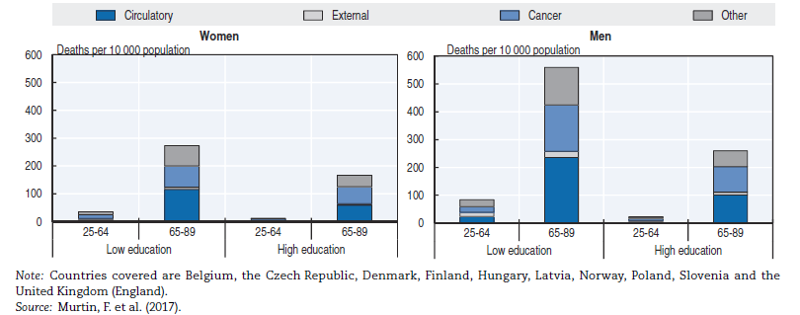

**Healthy life expectancy**

Healthy life expectancy indicates whether any gains in life expectancy are lived in good health or with some health problems and disabilities. The main indicator of healthy life years used in the European Union is the number of years lived free of activity limitations due to health problems. On average across EU countries, people can expect to live about 80% of their lives free of disability (Figure 3). Whereas the gender gap in life expectancy at birth is about 5,5 years on average across EU countries, there is virtually no gender gap in healthy life expectancy (64,2 years for women compared with 63,5 years for men). Women in EU countries can expect to live over 19 years of their lives with some disabilities compared with less than 15 years for men. This is explained by the fact that women report more activity limitations due to health problems at any given age and also because women live longer.

*Figure 3. Life expectancy and healthy life years at birth, by gender, 2016 (or nearest year)*

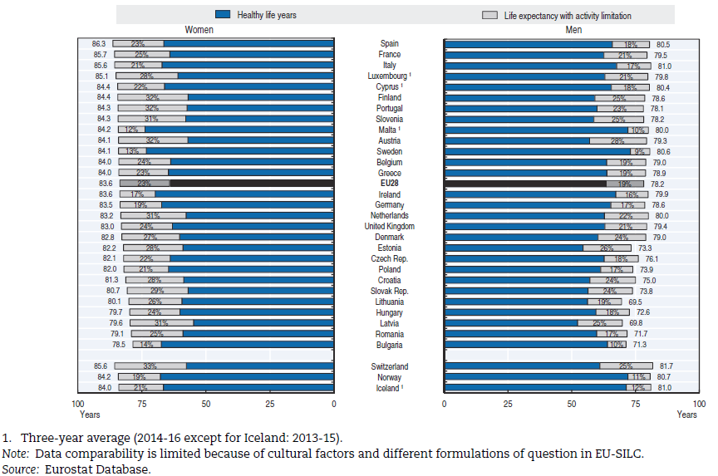

**Main causes of mortality**

The main causes of deaths across EU countries remain circulatory diseases, mainly heart attacks and strokes (over 1.8 million deaths in 2016) and cancers (1.3 million deaths), which together account for over 60% of all deaths (Figure 4). Indeed, diseases of the cardiovascular system were the main cause of deaths in all EU Member States, except in Denmark, France, the Netherlands and the United Kingdom where cancer was the main killer.[3]

also shows that the third main cause of death in the EU was diseases of the respiratory system, killing 422 000 (8% of all deaths in the EU). A significant share of deaths happened due to other external causes which include accidents, suicides, homicides and other violent causes of death (237 000 deaths, 5% of all deaths in the EU), diseases of the digestive system (222 000 deaths, 4%), mental and behavioural diseases such as dementia (220 000 deaths, 4%) and diseases of the nervous system including Alzheimer’s (219 000 deaths, 4%)36.

Figure 4. Causes of death in the EU by type, 2016 (as % of all deaths)

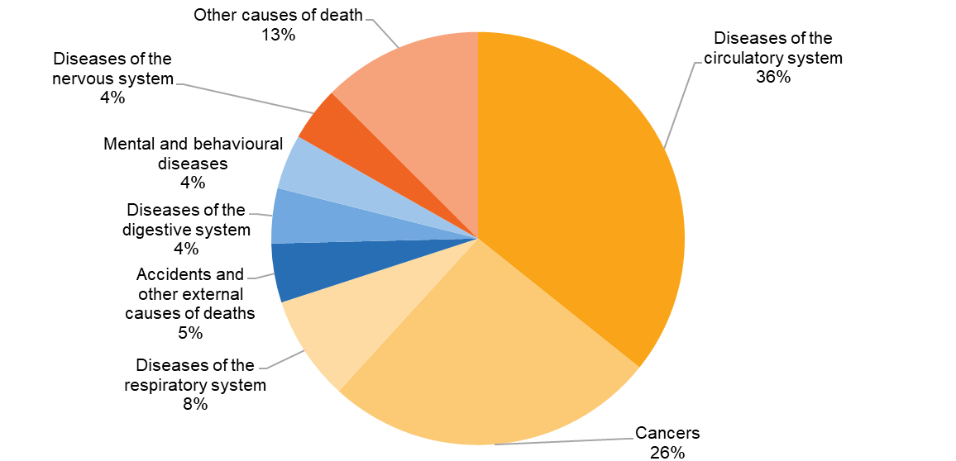

*SOURCE EUROSTAT ICD10 2016 all deaths of residents in or outside their home country*

**Burden of diseases in the EU**

Circulatory diseases

Circulatory diseases comprise a range of illnesses related to the circulatory system, including ischaemic heart diseases (notably heart attacks) and cerebrovascular diseases (such as strokes). Ischaemic heart diseases (IHD) and strokes caused more than one-fifth of all deaths in EU Member States in 2015.

Death rates for IHD are over 80% higher for men than for women across EU countries, because of a greater prevalence of risk factors among men, such as smoking, hypertension and high cholesterol. Since 2000, mortality rates from IHD have declined in all countries, with an overall reduction of over 40% on average across the EU, although the reduction has slowed down in recent years. Reductions in risk factors such as tobacco consumption have contributed to reducing the incidence of IHD and consequently mortality rates. Improvements in medical care have also played an important role.

Strokes were responsible for some 430 000 deaths across the EU in 2015, accounting for about 8% of all deaths. In addition to being an important cause of mortality, the disability burden from stroke is substantial. The gender gap in mortality rates from stroke is not as large as for IHD (less than 20%). As with IHD, there are wide variations in stroke mortality rates across countries. Since 2000, stroke mortality rates have decreased by nearly 50% across the EU, although the gains have slowed down over the past five years. Again, as with IHD, the reduction in stroke mortality can be attributed at least partly to both a reduction in risk factors and improvements in medical treatments. Looking ahead, further progress in reducing mortality rates from IHD, strokes and other circulatory diseases may be hampered by a rise in certain risk factors such as obesity and diabetes (OECD, 2015).

Cancer

Cancer is the second leading cause of mortality after cardiovascular diseases, accounting for 25% of all deaths in 2015. Figure shows the main causes of cancer mortality among men and women.

Figure 5. Main causes of cancer mortality among men and women in EU countries, 2015

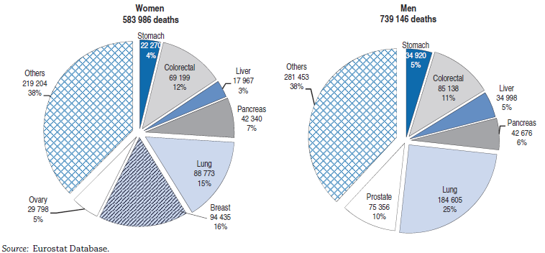

In all countries, mortality rates from cancer are greater among men than women.Death rates from all types of cancer combined among men and women have declined at least slightly in most EU Member States since 2000, although the decline has been more modest than for circulatory diseases, explaining why cancer now accounts for a larger share of all deaths. In 2018, 3 million new cases of cancer were expected to be diagnosed in the EU (actual figures not yet available).[4]. Large variations in cancer incidence exist across EU countries, with Hungary, Ireland, Denmark, Belgium and France with the highest expected age-standardised incidence rate in 2018. Such variations in incidence rates mirror the variations in the real number of new cancers each year, but also variability in national screening policies to detect different types of cancer as soon as possible.

Respiratory diseases

Mortality from respiratory diseases is the third main cause of death in EU countries, accounting for 8% of all deaths in 2015. Most of these deaths (90%) were among people aged 65 and over. The main causes of death from respiratory diseases are chronic obstructive pulmonary disease (COPD), pneumonia, asthma and influenza. Death rates from respiratory diseases are on average 85% higher among men than among women in all EU countries. This is partly due to higher smoking rates among men. The prevalence and mortality from respiratory diseases are likely to increase in the coming years as the population ages and presently unreported cases of COPD begin to manifest, whether alone or in co-morbidity with other chronic diseases.

Diabetes

About 32.7 million adults were diabetics in the EU in 2017, up from an estimated 18.3 million adults in 2000 (Figure). In addition, some 12.8 million people were estimated to have undiagnosed diabetes in 2017. Diabetes is more common among older people. These upward trends are partly due to the rise in obesity and physical inactivity, and their interactions with population ageing.

Figure 6. Number of people with diabetes in EU28, 2000 and 2017.

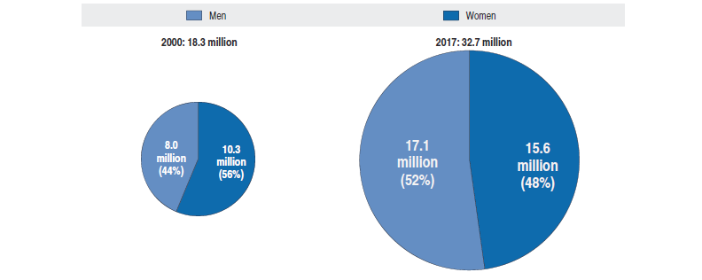

Note: Data include people aged 20-79 with Type1 or Type 2 diagnosed diabetes. The number of peoples with diabetes in 2000 has been estimated for some countries do to data gaps. Source IDF Atlas, 8th edition, 2017 and OECD estimates.

The economic burden of diabetes is substantial. People with diabetes are at greater risk of developing cardiovascular diseases such as heart attack and stroke if the disease is left undiagnosed or poorly controlled. They also have higher risks of sight loss, foot and leg amputation, and renal failure. The health expenditure allocated to treat diabetes and prevent complications are estimated at about EUR 150 billion in 2017 in the European Union. Type 2 diabetes is largely preventable. A number of risk factors, such as overweight and obesity, nutrition and physical inactivity, are modifiable. However, the prevalence of overweight and obesity is increasing in most countries.

Dementia

In 2017, Alzheimer’s disease and other dementia represented 9.6% of all deaths in the EU, expressing an increase of 2.2% in annual change in comparison with 2016.[5] In 2018 alone, an estimated 9.1 million people aged over 60 (around 7%) were living with dementia in the EU Member States, a significant increase from 5.9 million in 2000. Ageing populations mean that this number will continue to substantially grow in the future.[6] Estimations indicate that in 2040, 14.3 million people aged over 60 could be living with dementia (Figure 7).

Figure 7. Estimated number of people with dementia in EU countries by age group, 2000, 2018, and 2040

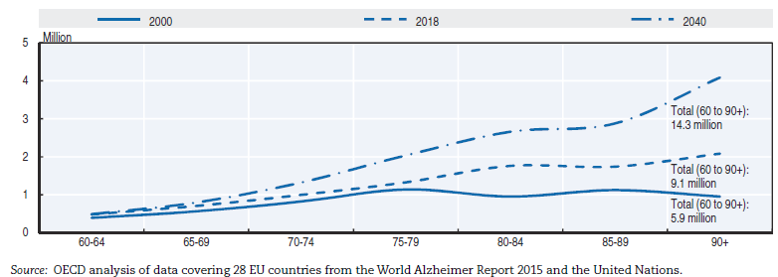

However, there is some evidence that the risk of dementia could be reduced through healthier lifestyles and preventive interventions. If such efforts are successful, the rise in prevalence may be less dramatic than these numbers suggest. Nonetheless, dementia will undoubtedly pose a growing challenge to all EU countries.

Communicable diseases

Communicable diseases, such as measles, hepatitis B and many others, pose major threats to the health of European citizens, although vaccination can efficiently prevent these diseases. 13 475 cases of measles were reported across the 30 EU/EEA countries from May 2017 to May 2018, up by nearly 60% over the preceding 12-month period. In most countries where vaccination coverage is high, very few cases of measles were reported.

**Current and future challenges to improving the health of EU citizens**

**Ageing of the EU population**

Population projections (Figure 8) suggest that there will be 66.1 million very old persons — defined here as those aged 80 years and over — in the EU-28 by 2080. This means the more than double the 2016 figure, which was 27.3 million very old persons. More so, the latest projections indicate that age dependency ratios (indicator which gives insight into the number of people of nonworking age) are likely to continue increasing. This highlights challenges for public expenditure in relation to pensions, health care and long-term care costs[7].

Figure 8. Population pyramides (% of population), EU-28, 2016 (estimates) and 2080 (projections)

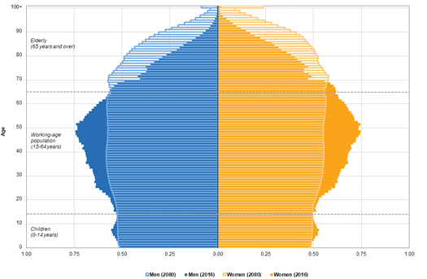

*Source: Eurostat*

In a context of an ageing society, non-communicable diseases are an active threat to public health. Even more so timely access to health care, prevention interventions and curative measures are of critical importance. Overall, the ageing process in the EU, allied with a substantial demand for health care, has been estimated to result in a significant increase in health care spending of 1–2 % of GDP in the EU Member States in total by 2050. On average, this would amount to an increase of 25% in health care spending[8].

**Health care spending in the EU**

Increasing numbers of people living with dementia, as well as other chronic diseases, will bring new challenges to the national, regional and local health systems. This will impact the organisation of services, fiscal sustainability of the systems and financial protection of the populations they serve.

Across the EU as a whole, health spending per capita increased by around 1.9% each year between 2013 and 2017, compared with an annual growth rate of only 0.6% between 2009 and 2013. In 2017, spending in health care in the EU stood at 9.6% of gross domestic product (GDP) ranging from over 11% in France and Germany to less than 6% in Romania (Figure 9).

Figure 9**.** Health expenditure as a share of GDP, 2017 (or nearest year)

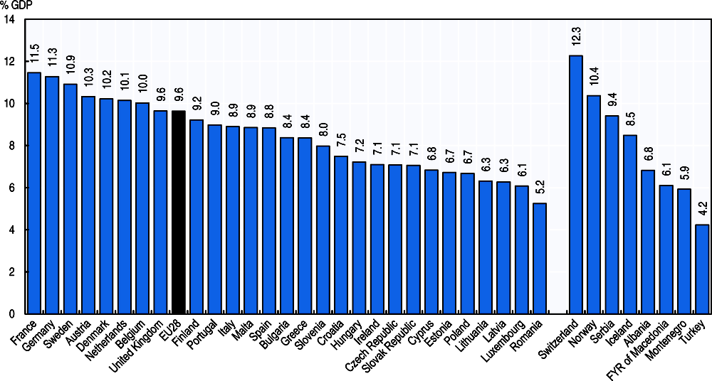

*Source: OECD Health Statistics 2018,* https://doi.org/10.1787/health-data-en*; Eurostat Database; WHO Global Health Expenditure Database*

In 2016, EU Member States spent 60% of their health expenditure on curative and rehabilitative care services (inpatient[9] and outpatient care), 20% on medical goods (mainly pharmaceuticals) while 13% were spent on health-related long-term care and the remaining 7% on collective services, such as prevention and public health (Figure 10).

Figure 10. Health expenditure by function, 2016 (or nearest year)

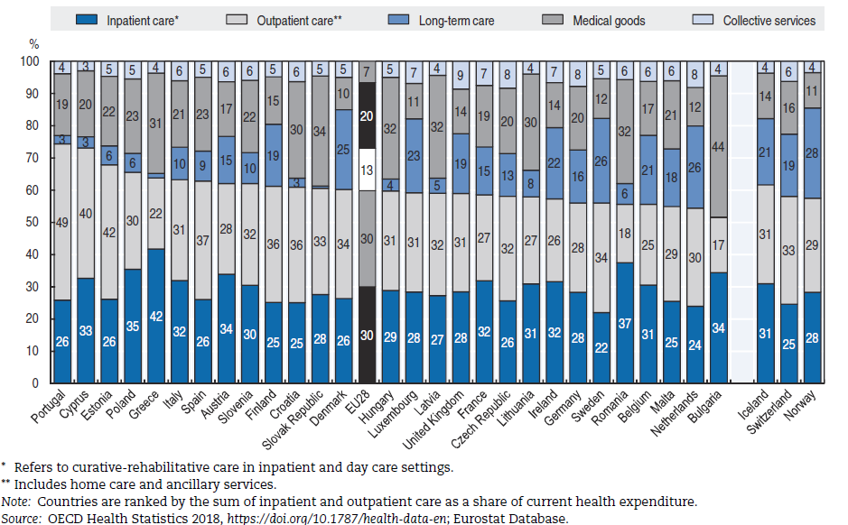

Pharmaceuticals (excluding those used in hospitals) represented the third largest item of health care spending, accounting for a sixth of health expenditure in 2016. Differences in distribution channels, prevalence of generic drugs, as well as relative prices in different countries, can highly influence spending in this category. The total retail pharmaceutical bill across the EU was more than EUR 210 billion in 2016 and an increase of around 5% since 2010. Spending on pharmaceuticals used during hospital care can typically add another 20% to a country’s pharmaceutical bill. The cost of pharmaceuticals is predominantly covered by government or compulsory insurance schemes. These schemes cover around 64% of all retail pharmaceutical spending, with out-of-pocket payments (34%) and voluntary private insurance (1%) financing the remaining part.

**The challenge of unmet needs for medical care.** Unmet needs for medical care demonstrate issues in health care accessibility for a number of reasons including cost, distance to the closest health facility and waiting times[10]. Unmet care needs may result in poorer health for people forgoing care and may increase health inequalities if such unmet needs are concentrated among poor people. There is significant variation in the EU regarding the percentage of people reporting unmet medical needs both across countries and income levels with the burden falling mostly in low-income groups (Figure 11).

Figure 11. Unmet needs vary across countries and income groups.

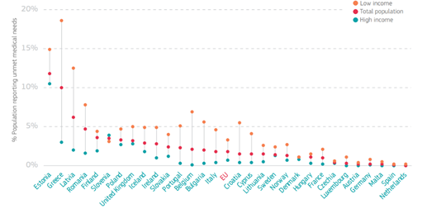

Source: Adapted from OECD/European Observatory on Health Systems and Policies (2019), Country Health Profiles 2019, State of Health in the EU (data refer to 2017).

Out of the fourteen EU Member States with a reported level of unmet medical needs above the EU average, half revealed costs as the prominent reason.[11] Across the EU, about 1.7% of citizens self-reported to have forgone treatment primarily for financial reasons.44 Of note, out-of-pocket spending[12] varies across the EU, reaching more than twice the EU average in Bulgaria, Cyprus, Latvia, Greece, Malta and Lithuania (Figure 12)**.**.

Figure 12. Out-of-pocket payments by expenditure type

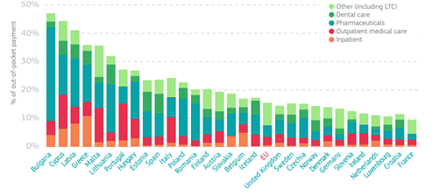

*Source: Adapted from OECD/European Observatory on Health Systems and Policies (2019), Country Health Profiles 2019, State of Health in the EU (data refer to 2017). NOTE: Indicator captures how the out-of-pocket expenditure as a share of current expenditure on health is broken down by particular services and goods.*

Figure also shows that out-of-pocket spending is highly driven by pharmaceutical expenditure, being the largest single cost component in the majority of the EU Member States. More so, the emergence of new medical technologies is having an important impact on the determinants for access to these pharmaceuticals in national contexts.

## Information about IMI JU & lessons learnt

In 2007, the European Commission released a proposal for the creation of the Innovative Medicines Initiative[13] Joint Undertaking (IMI JU), a public-private partnership (PPP) between the European Community, represented by the European Commission, and the European Federation of Pharmaceutical Industries and Associations, EFPIA. The proposal was based on an article in the EU treaties (now Article 187 TFEU) allowing the EU to set up joint undertakings ‘for the efficient execution of Union research, technological development and demonstration programmes’.

Under the Seventh Framework Programme (FP7), IMI JU had a budget of EUR 2 billion. Half of it came from the EU and the rest came in the form of in-kind contributions from EFPIA and its member companies who did not receive any EU funding. The overall goal of the IMI JU programme was to ‘significantly improve the efficiency and effectiveness of the drug development process with the long-term aim that the pharmaceutical sector produce more effective and safer innovative medicines’.

IMI delivered 59 projects of approx. EUR 1.919 million total budget[14] (cut-off date of the analysis: December 2019). The three most funded health areas were: ‘infectious diseases’ (EUR 719 million), ‘drug discovery’ (EUR 232 million) and ‘other’ (EUR 221 million) as shown in Figure 1.

**Stakeholder analysis**

Based on the analysis of IMI JU funded projects, overall 29.6% of the participants were private companies while 51.9% were academia, secondary and higher education establishments, and non-profit research organisations. 11.2% of beneficiaries receiving EU funding were SMEs, 5.7% came from an entity categorised as other and 1.6% represented patient organisations (see Table 1 below for types of organisations and the budget distribution for the 59 projects).[15] It should be noted again in this context that EFPIA members did not receive EU funding.

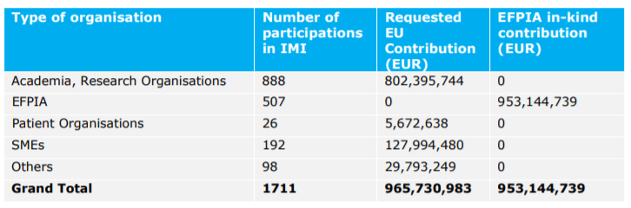Table 1. Types of organisations and the budget distribution for the 59 IMI JU projects

Figure 1. Total amounts (in million EUR) invested by IMI JU per scientific area

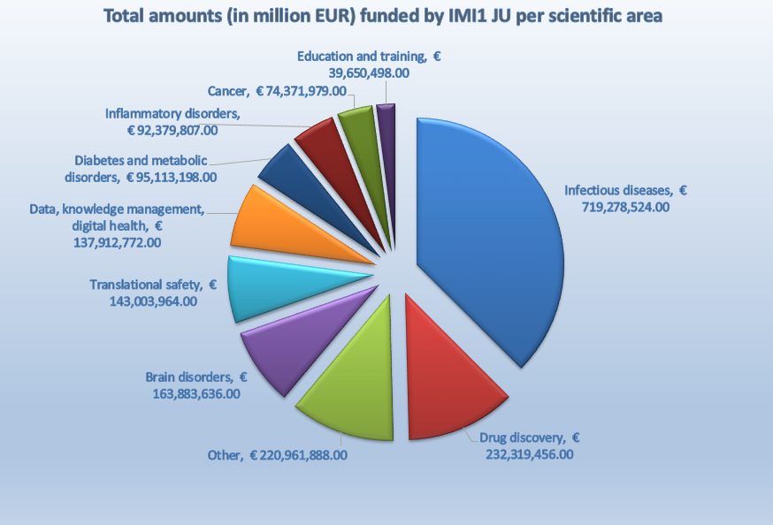

The total EU contribution (% share) to participations distributed over the different country categories was:

* EUR 907.3 million (93.9%) for EU-15;
* EUR 45.6 million (1.3 %) for Associated Countries;
* EUR 12.1 million (1.3%) for EU-13; and
* EUR 0.7 million (0.1%) for third countries.

An experts’ analysis of IMI’s first projects revealed that they were generating socio-economic impacts on a number of fronts: making concrete improvements to pharmaceutical R&D; leveraging funding; creating new knowledge and tools; and making Europe an attractive place to carry out research. The report noted that many of the projects’ achievements would not have been possible without IMI. Feedback from project participants has also highlighted the benefits of taking part in IMI projects for all participants, including large pharmaceutical companies, universities, SMEs, and patient organisations[16].

IMI JU projects in general contributed to novel scientific insights. The number of publications was impressive with 1,678 unique Web of Science publications linked to the Thomson Reuters citation databases (published between 2009 and 2015). There were 1,661 papers (articles and reviews; 99%); 17 other document types (13 editorials, two meeting abstracts, one letter and one news-item; 1%). Between 2009 and 2015, the citation impact for IMI project papers (1.93) was nearly twice the EU’s citation impact (1.1) in similar journal categories.[17]

### **IMI JU Interim & Final evaluations**

The Final Evaluation of the IMI JU50 (published in June 2017) set out to address specific evaluation questions under the individual criteria of effectiveness, efficiency, relevance, coherence and added value. The expert group concluded that the IMI JU programme was relevant and justified and positive contributions on the drug development process have been realised. According to the final evaluation (similarly to IMI2 JU), “the main achievement of IMI JU on which there was general consensus, was that under IMI JU **collaborations between different competing global companies, SME’s and academia became possible**. These collaborations created trust and new partnerships, including partners from different areas of expertise, such as with regulatory bodies, or with patient’s representatives groups. Together with the available budget and long term strategy, this was considered an important asset for European pharmaceutical research”. The evaluation recognised that since its origin in 2008, ‘IMI may have contributed to **resilience of the European pharmaceutical industry** at the time of the crisis, as the number of clinical trials and research remained stable across Europe in the period following the crisis of 2008’. IMI actions have also contributed to access to research infrastructure. A major success was the development of an **antimicrobial resistance infrastructure** that provided access to external companies or the European Lead Factory (ELF) project, providing access to libraries of medicinal compounds.

One of the main criticisms, found both in the interim[18] and final evaluations of IMI JU50 was the lack of a performance measuring system with SMART (Specific, Measurable, Achievable, Relevant, Time-phased) Key Performance Indicators (KPIs) to measure not only scientific output, but also socio-economic impacts. A finally agreed set of KPIs was introduced in 2017, during the lifetime of IMI2 JU.

The second interim evaluation of IMI JU (published in July 2013) also provided recommendations for the future initiative, i.e. the IMI2 JU:

**Recommendation** **1**: Baseline data should be obtained in parallel with the launch of IMI2 in order to allow for better benchmarking and assessment of IMI2 performance.

**Recommendation 2**: Industrial participants from other healthcare related sectors should be involved in IMI2. An integrated approach to healthcare will be required including prevention and diagnosis.

**Recommendation 3**: The Commission should ensure that IMI2 is transparent and has increased flexibility in terms of governance. It should be ensured that the roles and mandates of the governance and advisory bodies (in particular the Scientific Committee and the States Representatives Group) are clearly defined and the membership configured with the appropriate expertise to execute their mandate.

These recommendations have resulted, among others, in the following developments:

Ad 1) A set of ten SMART KPIs was introduced for IMI2 JU in December 2017[19].

Ad 2) A small improvement has been achieved in involving other health care related sectors, mainly in diagnostics and medical technology companies (e.g. IMI2 JU Call 20 topic on ‘Proton therapy’). However, under IMI2 JU, only the pharmaceutical sector was represented as the founding member and therefore, sizeable involvement of non-pharmaceutical entities under the current IMI2 JU structure and rules is unlikely to be achieved by the end of the IMI2 JU programme. The main reasons seem to consist in difficulties to attract big non-pharma industries to IMI2 topics because of the various current rules in place, including the intellectual property rules not responding to the needs of these industries. IHI is going to address this recommendation as it is designed to involve five health care industry sectors (pharma, medtech, biotech, imaging, vaccines) from the start.

Ad 3) IMI2 JU has generally improved definitions of its governance structures and advisory bodies and its communication between them. The governance structure was enshrined in the Regulation establishing IMI JU and as such, it was not modified during the lifetime of the initiative. The composition of the Scientific Committee and the States Representatives Groups was considered adequate for the tasks performed.

## Information about IMI2 JU & lessons learnt

Under Horizon 2020, the overall budget for the Societal Challenge “Health, demographic change and wellbeing” was EUR 7.5 billion which included Joint Undertakings (JUs). The Innovative Medicine Initiative was one such JU that supported R&I in the health field, named as IMI2 JU for the period 2014-2020 to distinguish it from its predecessor, IMI JU, operating under FP7.

IMI2 JU’s total budget of up to EUR 3.276 billion makes it the world’s largest public-private partnership in life sciences. IMI has become a renowned brand, recognised globally. Half of its budget comes from Horizon 2020 and most of the rest comes from the European Federation of Pharmaceutical Industries and Associations (EFPIA) and its member companies in the form of in-kind contributions, for example time of staff working on joint projects (other minor contributors include technology providers, diagnostics companies, charities or data handlers). It is important to emphasise that EFPIA companies do not receive any EU funding via IMI; the EU funding goes to universities, research centres, small and medium-sized enterprises (SMEs), mid-sized companies, patient groups, and regulators[20].

In each IMI project, a number of big industry players (EFPIA members) participate and collaborate with public sector partners and smaller companies. The IMI office coordinates the selection of the most suitable public consortium (including mostly public research organisation and SMEs) for the projects through open, competitive calls. These partners are funded by the EU, while EFPIA members use their own resources.

A novelty of IMI2 JU compared to its predecessor was the introduction of Associated Partners (AP) that can support and contribute to (both financially and in-kind) the objectives of IMI. The AP category was created with the goal of expanding IMI2 JU activities to a wider range of stakeholders to address the entire life science research and innovation value chain and to actively involve organisations other than pharmaceutical companies (therefore also following the recommendations of the predecessor IMI JU evaluation). Examples of organisations that have become AP include philanthropic organisations and charities that run their own health research programmes, as well as organisations working in sectors related to health care such as ICT, imaging, diagnostics, etc. IMI2 JU already attracted several global players as APs, such as the Bill and Melinda Gates Foundation, the Wellcome Trust and the Coalition for Epidemic Preparedness Innovations (CEPI)[21]. In fact, the category of AP has been so successful in leveraging contributions to IMI2 JU, that the reserved maximum amount of EUR 213 million as set out in the regulation is expected to be fully used. The category of AP is expected to continue in the future IHI.

Calls under IMI2 JU resulted in more than 84 projects (figure based on the number of grant agreements signed by end December 2019). Some of these projects focus on specific health issues such as neurological conditions, diabetes, oncology, Ebola vaccine development and antimicrobial resistance. Others focus on broader challenges in drug development such as drug and vaccine safety, knowledge management, drug behaviour in the body, and research and clinical data sharing platforms. In addition to research projects, IMI2 JU supported a number of education and training projects.

IMI projects delivered scientific breakthroughs that would not have been possible without IMI’s public-private partnership model (see success stories below). Thomson Reuters is tracking the research papers coming out of IMI, revealing a rapid growth of scientific output (Figure 1), matched with high quality: the citation impact of IMI papers is twice the world average and significantly higher than the EU average. Articles accounted for the majority of publications (73.2%), followed by reviews (14%) and other (12.7%) in 2018. IMI projects produced more publications in Pharmacology & Pharmacy than in other journal categories, followed by Neurosciences and Biochemistry & Molecular Biology[22].

*Figure 1. Number of Web of Science publications stemming from IMI.*

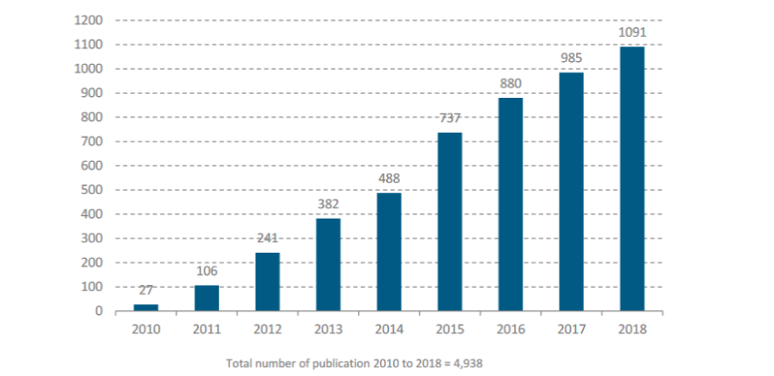

**IMI2 project participant analysis**

In terms of number and total budget of projects, the following data are available (up to December 2019):

* 84 projects of approx. EUR 1,832 million total budget[23]

The three most funded health areas for IMI2 are: ‘infectious diseases’ (EUR 708 million), ‘data, knowledge management, digital health’ (EUR 386 million) and ‘brain disorders’ (EUR 232 million), as shown in Figure 2.

Figure 2. Total amounts (in million EUR) invested by IMI2 JU per scientific area

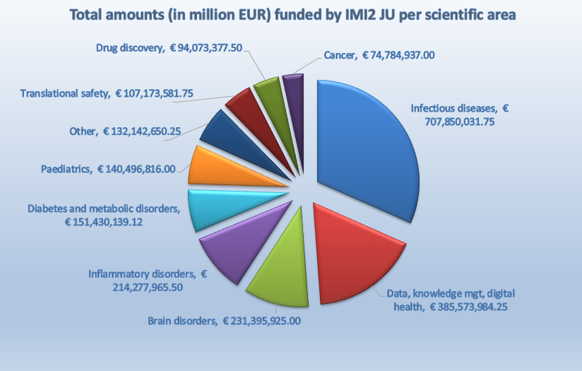

**Stakeholder analysis**

IMI2 JU project participants spanned a wide range of organisations including private companies (including SMEs), higher education institutions, public-funded research centres, public bodies and others (e.g. non-profit organisations, patient associations, etc.). Based on the analysis of IMI2 JU funded projects (until 2018), overall 39.20% of the participants were private companies while 33.65% were higher education institutions, 17.25% were research performing organisations and 3.53% were public bodies (see Figure 3). 15.4% of beneficiaries receiving EU funding are SMEs[24]. It should be noted that EFPIA members do not receive EU funding.

Figure 3. Overview of participants and participations per organisation type in IMI2 (2014-2018)

In terms of the size of funding, higher education institutions accounted for most of the received funding, totalling around EUR 447 million or 55% of the total net requested EU contributions between 2014 and 2018[25]. This was followed by EUR 222 million (27%) for research centres, EUR 87 million (11%) for private companies, EUR 23 million (3%) for public bodies and EUR 40 million (5%) for other types of organisations. Since constituent and affiliated entities of EFPIA that participated in projects did not receive any reimbursement from the JU, their costs are not represented among these figures.

The highest number of participants (including all public and private sector participants and non-EU participants) were from the UK (19.95%, n=339) followed by Germany (13.83%, n=235), France (11.77%, n=200), the Netherlands (9.95%, n=169) and Belgium (8.18%, n=139) (see Figure 4). The EU15 Member States dominated the participation, accounting for 87% of participations and 90% of the total net requested EU contributions. In turn, EU13 accounted for only 2% of the participations and 1% of the total EU contributions. There was also participation from associated Member States (7% of participations, receiving 3% of contributions) and other international partners (4% of participations, receiving 5% of contributions).

Figure 4: Overview of participants per EU MS in IMI2 JU (2014-2018) by organisation type

Based on IMI2 JU participation data, the level of participation of individual organisations was mapped. Figure 5 outlines a preliminary mapping of the IMI2 JU network according to organisations’ NACE[26] industry sector (classified according to colour) with the bubble size indicating the frequency of participation (the bigger the bubble, the more frequent participation). The lines (‘ties’) between two organisations display the frequency of collaboration among the concerned organisations. The private companies, Janssen Pharmaceutica NV, Novartis Pharma AG, Eli Lilly and Company and Pfizer participated in the highest number of IMI2 JU projects (see JPNV, NOV, ELI LILLY and PFIZER in Figure 5 below). Again, it should be noted that as EFPIA members, these companies did not receive EU funding.

Figure 5: Preliminary mapping of the network structure of IMI2 JU by NACE sector

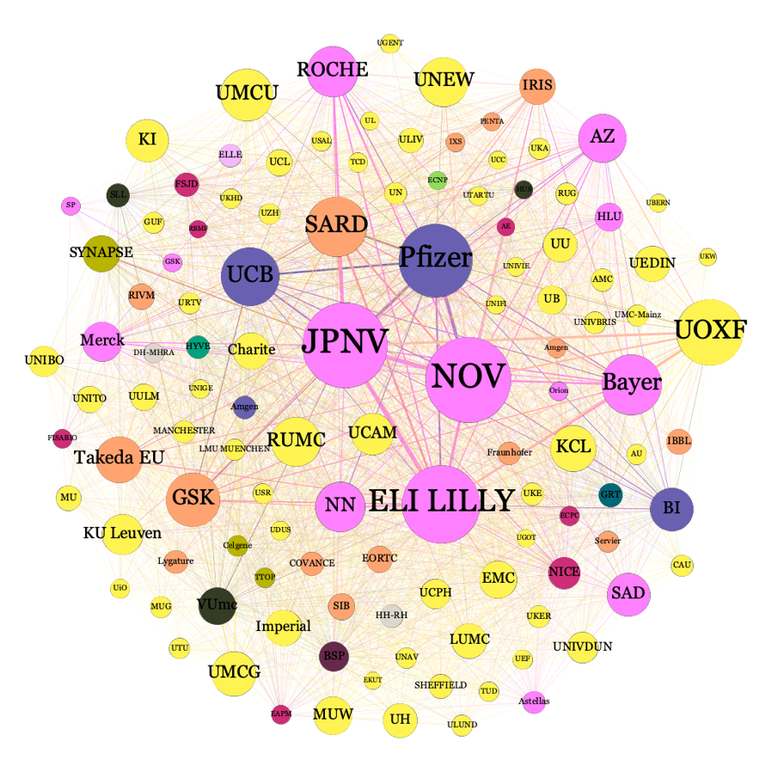

Source: Technopolis Group

### **IMI2 JU Interim evaluation and recommendations for a future partnership**

The interim evaluation of the IMI2 JU[27] (published in September 2017) came to the following main findings:

* The main achievement of IMI2 JU on which there was general consensus, was that since the joint undertaking started, collaborations between different competing global companies, SME’s and academia became possible. These collaborations created trust and new partnerships, including partners from a number of expertise areas, such as patient representative groups or regulatory bodies, which are essential stakeholders for medicines to enter the market with quality, safety and efficacy guarantees and in the shortest possible time. Together with the available budget and long term strategy, these collaborations were considered an important asset for European pharmaceutical research.
* The large scale and ambition of the IMI2 JU projects, their long-term vision and strategy were viewed positively.
* The reasons to create a public-private partnership to strengthen the European pharma industry were valid and the goals were justified.
* Thanks to the joint undertaking, for the first time competing companies were collaborating in precompetitive research and deciding together, which call topics should be launched to address challenges that a single company could not tackle.
* IMI2 JU was considered to be a unique initiative that has no counterpart elsewhere.
* The process of developing the SRA and call topics was considered by many stakeholders to lack transparency and to be dominated by EFPIA partners.
* The added value for patients or society in general was hard to demonstrate at the time of mid-term evaluation, because of the early stage of IMI2[28].

Therefore, the experts drafting the evaluation identified several recommendations for a potential future partnership that were taken into consideration in the design of IHI (Table 2).

*Table 2. Recommendations of IMI2 JU interim evaluation for a future initiative and how they were used to design IHI*

|  |  |
| --- | --- |
| **Recommendation** | **How it was taken into consideration in the design of IHI** |
| **Recommendation 1**: Make a substantial adaptation to the collaborative and funding model to enable the active engagement of other industry sectors with the pharmaceutical industry to capitalise on their expertise in the development of new health care interventions. | IHI is designed as a cross-sectoral partnership between EU and five industry sectors (pharma, medtech, biotech, imaging, vaccines), rather than only pharmaceuticals as in IMI2 JU. The respective industry associations have indicated a strong preliminary interest in becoming members of such an Institutionalised Partnership. |
| **Recommendation 2**: Increase the transparency of in-kind contributions as well as the Strategic Research Agenda (SRA) and call topics generation to reflect European interest and interests of stakeholders other than EFPIA. Transparency on these issues will open up the programme for more creative and innovative thinking and trust amongst the potential participants and stakeholders. | Transparency of the initiative was maintained from the design phase, including via several public consultations (detailed in Annex 2).  To address the request for broader involvement of stakeholders in IHI governance and for more openness, a separate body is planned to be created in its governance (‘Innovation Panel’). It would be tentatively composed of the representatives of EU and member industry associations, as well as of various other stakeholders such as representatives of patients, health care professionals, patients, health care providers, academia, research and technology organisations, research infrastructures, other partnerships and ad-hoc members as necessary.  The reporting of in-kind contribution will be handled according to the conditions laid down in the relevant legal texts. |
| **Recommendation 3**: Change the rules on the calculation of the in-kind contributions from non-European entities. To be consistent with the goal of increasing investments in Europe, in–kind contributions from activities that occur outside of the EU should not be accepted to match with the public funding, but may be accounted as additional contributions or leveraging effects. | During consultations on IHI, EU Member States expressed a strong wish to strengthen the competitiveness of Europe’s health technology industry (more information in Annex 2 section 1.3.2). At the same time, the necessary global dimension of the partnership should be ensured. Therefore, the partnership should strive to attract and partially match investments from outside Europe to increase its international footprint, capture resources and expertise of global companies, benefit from other previous international investments or address a specific scope (such as e.g. disease prevalence in non-EU countries, with relevance for EU population), while maintaining a majority of activities in the EU. |

The experts also identified a number of recommendations to improve effectiveness, efficiency, coherence and added value of the existing partnership. Even though these recommendations were meant to help in the final phase of IMI2 JU execution, they were also used as lessons learned to better design the Innovative Health Initiative (Table 3).

*Table 3. Findings of IMI2 JU interim evaluation that could be implemented towards the end of IMI2 JU, and how they were used to design the Innovative Health Initiative.*

|  |  |
| --- | --- |
| **Recommendation** | **How it was taken into consideration in the design of IHI** |
| **Recommendation 1**: A renewed and stronger effort should be made to attract and integrate other industries than the pharmaceutical industry in the collaborative projects. | IHI will involve several industry sectors as founding members. |
| **Recommendation 2**: Create a better eco-system to attract more SMEs.   * Expand the scope of projects to attract SMEs developing innovative technologies to capture novel trends in the development of healthcare of the future; * Make topic description less prescriptive and allow more flexibility for SMEs to come with creative ideas. | Associations of medtech, biotech, imaging and vaccine industry sectors have indicated a strong preliminary interest in becoming members of such an Institutionalised Partnership, along with EFPIA’s continued interest. The new associations have a larger number of SME partners, across various geographies.  It is expected that a majority of topic will be less prescriptive single-stage, allowing a more bottom-up approach with more space for ideas coming from applicants. |
| **Recommendation 3**: An accountable Performance Measurement Framework, using SMART KPIs should be developed to assess the impacts and socio-economic benefits of the joint undertaking. | A set of KPIs aligned with the specific objectives of IHI is going to be in place from the start of the initiative. |
| **Recommendation 4**: Review the IP policy and make it more flexible to respond to the needs allowing negotiations on exclusive rights. | As a default, general Horizon Europe provisions will apply. |
| **Recommendation 5**: Improve and broaden access to project outcomes and assure their sustainability to increase impact.   * Develop a platform for open dialogue with and between the different groups in the governance structure of the joint undertaking; * Develop a brokerage platform to stimulate that results from IMI2 projects and from other programmes are leading to applications. * Ensure communication to a wider audience to increase awareness of the programme results and outputs. | The measures to enssure the sustainability of project outcomes remain to be discussed. The initiative will strive to consider recommendations from IMI2 JU Scientific Committee on this matter[29].  The process of future topic generation is foreseen to be made more transparent by revised governance structure with the Innovation Panel that will better incorporate the voice of various stakeholders, as explained above (Table 2, recommendation 2).  The details of communication activities will be discussed later in the partnership preparation process. |

The recommendations referred to above have resulted, among others, in a set of ten SMART KPIs introduced in December 2017[30]. The KPIs focus on the following elements:

* 1. the coverage of the research portfolio, showing adequate implementation of the annual scientific priorities;
  2. the achievements of the assets during the course of the IMI programmes;
  3. the impact of the IMI programmes on the regulatory framework;
  4. the ability of the IMI programs to set new standards (i.e. new taxonomies, new stratifications)
  5. the rate of contribution of non-pharma actors to the IMI programmes (e.g. non-pharma industries, foundations, charities, professional organisations);
  6. the accessibility of the resources/outputs beyond the IMI consortia partners;
  7. the level of co-authorships and cross-sector publications between European researchers;
  8. the adoption of the novelty generated by the IMI programmes by the industrial partners;
  9. the level of involvement of patients groups or healthcare professional association;
  10. the level of collaboration and SME participation.

Data from IMI2 JU Annual Activity Report 2019[31] demonstrate that IMI2 JU has already reached or almost reached the desired targets in more than half of the KPIs.

## IMI Success stories

IMI has resulted in a range of outcomes and impacts on health care, health systems and patient wellbeing[32]. A selection of these success stories is presented below, followed by a case example from an SME.

**Empowering patients**

IMI2 made a significant step towards patient empowerment: the Patient Expert Training Course trained almost 100 patients from 32 countries across 58 disease areas, and the R&D toolbox has been used by more than 500,000 people worldwide. These were outputs of the European Patients' Academy on Therapeutic Innovation[33] project (EUPATI, budget EUR 10.9 million) that has helped address a key gap in patient and public knowledge by providing information on how medical R&D is conducted. Other outputs include guidance documents for the engagement of patient organisations, and annual conferences and workshops.

**Responding to emerging health threats**

In November 2014, IMI responded to the West Africa outbreak of Ebola by launching a comprehensive Ebola+ programme[34] to tackle a wide range of challenges in Ebola research, including vaccines development, clinical trials, storage and transport, as well as diagnostics. Today, the Ebola+ programme has 12 projects with a total budget (joint EU and EFPIA / Associated Partner contributions) of close to EUR 300 million. In July 2020, the European Commission granted marketing authorisations to Janssen, a Johnson & Johnson company, for their vaccine against Ebola virus disease, whose development was supported by IMI’s Ebola+ programme.

**Better use of big data**

20 years of clinical research on knee replacement were reviewed and analysed in just 5 days. It demonstrated the power of using electronic health data in replicating clinical trials, to generate information that could help patients and doctors make better decisions about their care (EHDEN project, budget EUR 28.9 million)[35]. This was done as part of IMI’s Big Data for Better Outcomes programme aiming to integrate detailed personal and biological data to uncover insights that will improve outcomes for patients.

Years of clinical research data on Alzheimer’s earliest stages were made securely available to the scientific community – a move that can help go further with knowledge sharing and discovery of treatments. This was done through the ‘European prevention of Alzheimer’s dementia consortium’, looking into innovative designs of clinical trials to deliver better results, faster and at lower cost[36] (EPAD project, budget EUR 59.9 million).

**Faster diagnostics**

Lengthy diagnostic was a major problem during the 2014-15 West Africa Ebola outbreak. To remedy this, a compact, easy-to-use diagnostic device was developed that deliver results in a little over an hour[37]. The device is now validated and commercially available. The test can be used to diagnose Ebola and other *Filoviridae* such as Marburg virus. In the future, it may be expanded to other WHO priority pathogens such as dengue and Lassa fever. This was done under IMI’s Mofina project (EUR 4.4 million), where partners reported that the collaboration between public and private stakeholders was key to their success.

**Greener pharmaceuticals**

A new tool was designed to embed ‘green chemistry’ in chemical development, for use in the early stages of drug development[38]. The toolkit assesses how green a chemical reaction is by using a combination of qualitative and quantitative criteria. A range of new, cleaner catalysts were also delivered, now used by several pharmaceutical companies. This was done thanks to CHEM21 project (budget EUR 26.7 million) that addresses inefficiencies and sustainability in the manufacturing processes of pharmaceuticals.

**Accelerating the development of new drugs and new treatments**

Using patient reported outcomes and tools, the impact of chronic obstructive respiratory disease (COPD) on how patients experience physical activity was measured, achieving a qualification of European Medicines Agency (EMA) for novel methodologies. This opens the way for the development of more effective treatments (PRO-active project, budget EUR 15.6 million).

Pharmaceutical companies – who are market competitors – started to share their data on the toxicity of drug-like compounds, for the first time on a large scale. This happened through the creation of a large database, which can be mined, e.g. to try to predict whether or not a particular candidate drug is likely to have an adverse effect on patients. This data sharing can lower the failure rate in later phases of pharmaceutical development, significantly reduce the number of animal tests needed, and accelerate the development of new drugs[39] (eTOX project, budget EUR 18.7 million).

**Stakeholder opinion**

Pharmacoidea Ltd. is a Hungarian biotech SME specialising in preclinical drug discovery, founded in the 2000s’ by a handful of talented scientists. The early years were characterized by struggling at a little domestic market until the company got into an IMI project as part of an international consortium. IMI was a game-changer for Pharmacoidea, it gained hands-on knowledge of the pharmaceutical R&D process, partnering with leading industry players and academic institutes. By understanding the industrial requirements of pharmaceutical drug discovery, the company acquired the skills for world-class pharmaceutical innovation. As a result, Pharmacoidea’s drug discovery platform was advanced, innovative target-specific bioassays and analytical methods were developed and Pharmacoidea established an advanced informatics platform and filed several novel patents. All strengthening the company’s industrial capacities, business perspectives and improving its competitiveness within the biotech and pharmaceutical industry. IMI also opened up a vast network of potential clients, and the IMI participation put a quality stamp on the company. Pharmacoidea’s revenues increased almost ten-fold from EUR 114,600 in 2012 (before joining IMI) to EUR 961,366 in 2018 and created several highly skilled jobs.

Dr Tamas Letoha, CEO   
Pharmacoidea Ltd

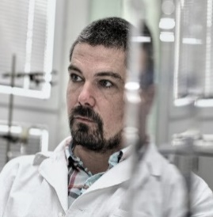

1. https://ec.europa.eu/health/sites/health/files/state/docs/2018_healthatglance_rep_en.pdf
2. Life expectancy measures the average number of remaining years of life for people at a specific age based on current mortality conditions
3. EUROSTAT News 2019 <https://ec.europa.eu/eurostat/web/products-eurostat-news/-/DDN-20190716-1>
4. Joint Research Centre (2018), Dataset Collection: European Cancer Information System, <https://ec.europa.eu/jrc/en/publication/dataset-collection-european-cancer-information-system>.
5. GHB Compare <https://vizhub.healthdata.org/gbd-compare/>
6. OECD (2018), Care needed: Improving the lives of people with dementia, OECD Health Policy studies, OECD publishing, Paris, <https://doi.org/10.1787/9789264085107-en>
7. Eurostat: People in the EU: who are we and how do we live? 2015 edition
8. Eurostat: Morbidity statistics – methodology – statistics explained 2015
9. Inpatient care refers to care for a patient who is formally admitted (or ‘hospitalised’) to an institution for treatment and/or care and stays for a minimum of one night in the hospital or other institution providing in-patient care [Source: OECD Health Data 2001: A Comparative Analysis of 30 Countries, OECD, Paris, 2001, data sources, definitions and methods]
10. The share of persons declaring an unmet need for medical examination is also a core indicator for accessibility in the “[social scoreboard](https://ec.europa.eu/social/main.jsp?langId=en&catId=1196&furtherNews=yes&newsId=9163)” underpinning the European Pillar of Social Rights.
11. State of Health in the EU: Companion report 2019 <https://ec.europa.eu/health/sites/health/files/state/docs/2019_companion_en.pdf>
12. Out-of-pocket payments are expenditures borne directly by a patient where neither public nor private insurance cover the full cost of the health good or service. At an aggregate level, the share of out-of-pocket spending in total health spending reflects the degree of financial protection in a country.
13. For clarity, the term ‘IMI JU’ is used when referring to Innovative Medicines Initiative JU that started in 2007 under FP7, and the term ‘IMI2 JU’ is used to denote its successor initiative, operating under Horizon 2020. The term ‘IMI’ is used when the two predecessors initiative are meant jointly.
14. Jointly, for the EU financial contribution and the contribution of private JU Member, i.e. members of EFPIA or its constituent entities or their affiliated entities.
15. The Final Evaluation of the Innovative Medicines Initiative Joint Undertaking (2008-2016) operating under the 7th Framework Programme Experts Group Report.
16. [IMI Socio-economic Impact Assessment Expert Group Final Report](https://www.imi.europa.eu/sites/default/files/archive/uploads/documents/Publications/SocioeconomicImpactAssessment_FINALMay2016.pdf) (May 2016).
17. The Final Evaluation of the Innovative Medicines Initiative Joint Undertaking (2008-2016) operating under the 7th Framework Programme. <https://ec.europa.eu/research/health/pdf/imi_final_evaluation.pdf>.
18. Second Interim Evaluation IMI - Innovative Medicines Initiative Joint Undertaking. <https://www.imi.europa.eu/sites/default/files/uploads/documents/reference-documents/2ndInterimEvaluationIMI.pdf>
19. IMI2 JU Key Performance Indicators. <https://www.imi.europa.eu/sites/default/files/uploads/documents/About-IMI/mission-objectives/IMI2_KPIs_approved_14_DEC_2017.pdf>.
20. Council of the European Union (2014), Council regulation (EU) No 557/2014 of 6 May 2014 establishing the Innovative Medicines Initiative 2 Joint Undertaking. Official Journal of the European Union 169, p. 54-76.
21. [IMI2 JU full list of Associated Partners.](https://www.imi.europa.eu/get-involved/associated-partners) 
22. [Bibliometric analysis of ongoing IMI projects](https://www.imi.europa.eu/sites/default/files/uploads/documents/reference-documents/IMI_Bibliometrics_Report_2019_v4%20FINAL.pdf) (September 2019).
23. Corresponding to IMI2 JU calls up to Call 14 (with further eight calls remaining to be signed/launched).
24. IMI (2019) Annual Activity Report 2018. Available at: <https://www.imi.europa.eu/sites/default/files/uploads/documents/reference-documents/AAR2018_final.pdf>
25. Technopolis analysis of IMI2 JU data
26. NACE (Nomenclature of Economic Activities) is the European statistical classification of economic activities. NACE groups organisations according to their business activities. Statistics produced on the basis of NACE are comparable at European level and, in general, at world level in line with the United Nations' [International Standard Industrial Classification (ISIC](https://siccode.com/page/what-is-an-isic-code)).
27. European Commission (2017) [The Interim Evaluation of the Innovative Medicines Initiative 2 Joint Undertaking (2014-2016) operating under Horizon 2020](https://ec.europa.eu/research/health/pdf/imi2_interim_evaluation.pdf). Experts Group Report. Luxembourg: Publications Office of the European Union.
28. This finding could be attributed to the fact that mid-term evaluation report was published in 2017, only three years after the launch of the initiative in 2014.
29. IMI Scientific Committee Recommendation. Sustainability solutions are important criteria determining project quality and output in IMI (2018).

    <https://www.imi.europa.eu/sites/default/files/uploads/documents/About-IMI/Governance/sc/SC_Sustainability_June2018.pdf>.
30. IMI2 JU Key Performance Indicators. <https://www.imi.europa.eu/sites/default/files/uploads/documents/About-IMI/mission-objectives/IMI2_KPIs_approved_14_DEC_2017.pdf>.
31. IMI (2020) Annual Activity Report 2019. Available at: <https://www.imi.europa.eu/sites/default/files/events/IMI%20AAR%202019_FINAL.pdf>.
32. An up-to-date list of success stories can be found at <https://www.imi.europa.eu/projects-results/success-stories-projects>.
33. <https://www.imi.europa.eu/projects-results/project-factsheets/eupati>.
34. <https://www.imi.europa.eu/projects-results/project-factsheets/ebola>.
35. <https://www.ehden.eu/ehden-knee-replacement-study-results-published-in-lancet-rheumatology-truly-elevating-observational-data/>.
36. <https://www.imi.europa.eu/projects-results/project-factsheets/epad>.
37. <https://www.imi.europa.eu/projects-results/project-factsheets/mofina>.
38. <https://www.imi.europa.eu/projects-results/project-factsheets/chem21>.
39. <https://www.imi.europa.eu/projects-results/project-factsheets/etox>.