

**ANNEXES**

TABLE OF Contents

Annex 1 Procedural information 3

Annex 2 Stakeholder Consultation 11

1. Overview for all candidate institutionalised European Partnerships 11

1.1. Introduction 11

1.2. Horizontal results of the Open Public Consultation 11

1.2.1. Profile of respondents 11

1.2.2. Characteristics of future candidate European Partnerships 15

1.2.3. Main advantages and disadvantages of Institutionalised European Partnerships 17

1.2.4. Relevance of EU level to address problems in Partnerships’ areas 17

1.2.5. Horizon Europe mode of intervention to address problems 18

1.2.6. Relevance of a set of elements and activities to ensure that the proposed European Partnership would meet its objectives 18

1.2.7. Relevance of setting up a legal structure (funding body) for the candidate European Partnerships to achieve improvements 21

1.2.8. Scope and coverage of the candidate European Partnerships based on their inception impact assessments 22

1.2.9. Scope for rationalisation and alignment of candidate European Partnerships with other initiatives 23

1.2.10. Relevance of European Partnerships to deliver targeted scientific, economic/technological and societal impacts 23

1.3. Stakeholder consultation results for the Clean Hydrogen Initiative 24

1.3.1. Feedback to the inception impact assessment on candidate initiatives for Institutionalised Partnerships 24

1.3.2. Structured consultation of the Member States on European partnerships 25

1.4. Targeted consultation of stakeholders 28

1.4.1. Approach to the targeted consultation 28

1.4.2. Overview of respondents to the targeted consultation 28

1.4.3. Key results/messages from the targeted consultation 29

1.5. Open Public Consultation 33

1.5.1. Characteristics of respondents 33

1.5.2. Results on general questions 33

1.5.3. Results on candidate European Partnership specific questions 34

1.5.4. Summary of campaigns results 41

Annex 3 Who Is Affected And How? 44

1. Practical implications of the initiative 44

Annex 4 Analytical Methods 47

1. Overview of the methodologies employed 47

2. Method for assessing the effectiveness, efficiency and coherence of each option - The use of functionalities 48

3. Method for identifying the preferred option – The scorecard analysis 52

Annex 5 Subsidiarity Grid 55

Annex 6 Additional background information 63

1. Background information for all initiatives 63

1.1. Selection criteria of European Partnerships 63

1.2. Overview of potential functions for a common back office among Joint Undertakings 64

2. Background information for this specific initiative 66

2.1. General information on the hydrogen sector 66

2.1.1. Hydrogen Roadmap. 66

2.1.2. Deployment of Hydrogen 67

2.1.3. Specific objectives and targets 68

Annex 1 Procedural information

1. **LEAD DG, DECIDE PLANNING REFERENCES**

Lead DG: Directorate General Research and Innovation (RTD)

Decide number: PLAN/2019/5306

1. **ORGANISATION AND TIMING**

Institutionalised partnerships are foreseen in Articles 185 and 187 of the Treaty on the Functioning of the European Union (TFEU). The preliminary agreement on Horizon Europe contained a list of possible areas for institutionalised partnerships based on Article 185 and 187. For each of these areas the Commission considered 12 potential institutionalised partnerships. Their set up involves new EU legislation and the establishment of dedicated implementing structures and therefore an impact assessment for each of these initiatives.

Following political validation in June 2019, the impact assessment process started with the publication of inception impact assessments for each initiative in August 2019.

An inter-service steering group (ISSG) on research and innovation partnerships under Horizon Europe was set up in May 2019 and held 4 meetings before submission of the Staff Working Document to the Regulatory Scrutiny Board (7 May 2019, 19 June 2019, 5 December 2019, 20 January 2020). The ISSG consisted of representatives of the Secretariat-General, Directorate-General for Budget, Directorate-General for Research and Innovation, Directorate-General for Communications Networks, Content and Technology, Directorate-General for Mobility and Transport, Directorate-General for Internal Market, Industry, Entrepreneurship and SMEs, Directorate-General for Energy, Directorate-General for Environment, Directorate-General for Climate Action, and the Legal Service.

An online public stakeholder consultation was launched between September and November 2019, gathering 1635 replies for all 12 initiatives.

1. **CONSULTATION OF THE RSB**

Two upstream meetings with the Regulatory Scrutiny Board were held on 10 July 2019 and 30 September 2019.

In accordance with the feedback received from the Regulatory Scrutiny Board on 27.03.2020 the Staff Working Document has been revised as presented in Figure 1. The impact assessment was endorsed by the Inter Service Steering Group on 20.01.2020.

1. **EVIDENCE, SOURCES AND QUALITY**

To ensure a high level of coherence and comparability of analysis for all candidate initiatives, an external study was procured to feed into the impact assessments of the 12 candidate institutionalised partnerships[1]. It consisted of an horizontal analysis and individual thematic analyses for each of the initiatives under review.

For all initiatives, the evidence used includes desk research partly covering the main impacts and lessons learned from previous partnerships. A range of quantitative and qualitative data sources complement the evidence base, including evaluations; foresight studies; statistical analyses of Framework Programmes application and participation data and Community Innovation Survey data; analyses of science, technology and innovation indicators; reviews of academic literature; sectoral competitiveness studies and expert hearings. The analyses included a portfolio analysis, a stakeholder and social network analysis in order to profile the actors involved as well as their co-operation patterns, and an assessment of the partnerships’ outputs (bibliometrics and patent analysis). A cost modelling exercise was performed in order to feed into the efficiency assessments of the partnership options. Public consultations (open and targeted) supported the comparative assessment of the policy options. For each initiative up to 50 relevant stakeholders were interviewed by the external contractor (policymakers, business including SMEs and business associations, research institutes and universities, and civil organisations, among others). In addition, the analysis was informed by the results of the Open Public Consultation (Sep – Nov 2019), the consultation of the Member States through the Strategic Programme Committee and the online feedback received on the Inception Impact Assessments of the set of candidate Institutionalised European Partnerships.

A more detailed description of the methodology and evidence base used, completed by thematic specific methodologies, is provided in Annexes 4 and 6.

Figure 1 Modifications to the draft Staff Working Document based on comments received from the Regulatory Scrutiny Board

|  |  |
| --- | --- |
| **Comments from the Regulatory Scrutiny Board** | **Actions taken for the Staff Working Document** |
| (1) The report does not adequately explain how greater flexibility in implementation of research projects relates to the desire to focus research. It does not sufficiently describe the competition aspects of the partnership. | For hydrogen, we are talking today about a very dynamic sector and community. Responsiveness to new technological developments is essential, meaning that it should be ensured that the partnership would be able to react quickly and efficiently and that the Clean Hydrogen initiative is empowered enough to deliver.  Explanations are provided in p.44 and p.45. A number of activities have been mentioned in the IA to ensure flexibility of implementation and create the expected impacts such as (i) Seek synergies with R&I programmes of other sectors and initiatives (ii) Coordinate R&I actions ranging from concept to demonstration and validation activities (covering all Technology Readiness Levels), ensuring inclusion of new actors and integration of extended value chains (iii) Develop deployment and piloting activities to ensure flexibility over time across the range of applications implemented and (IV) Co-create solutions with end-users, emphasising the importance of flexibility in addressing different target groups over time, including industrial end users for which low carbon alternatives are not evident.  The request of flexibility or responsiveness in terms of implementation of the Clean Hydrogen Partnership is fully aligned with the call for an enlarged research agenda, addressing production, distribution and storage as indicated in p.40.  The calls for research and innovation proposals in the partnership will be open to all and not restricted to just members of the associations Hydrogen Europe and Hydrogen Europe Research. The partnership will fund and manage cooperative research projects where different industrial and research entities will conclude a consortium agreement on how they will share foreground and background IPR. |
| (2) The report should explain in more detail the current partnership, its objectives and its structure. | Additional information is provided on p.26.  The objectives of FCH 2 JU, organised around the energy and transport pillars were the following:   * Clean Transport : reduce fuel cell system costs for transport applications * Green hydrogen production: increase efficiency and reduce costs of hydrogen production, mainly from water electrolysis and renewables * Heat & electricity production: increase fuel cell efficiency and lifetime * Hydrogen storage for grid balancing: demonstrate on a large-scale hydrogen’s capacity to harness power from renewables and support its integration into the energy system * Minimal use of critical raw materials: reduce platinum loading   FCH 2 JU is a public-private partnership with 3 members: the industry grouping Hydrogen Europe, the research grouping Hydrogen Europe Research and the European Commission. |
| (3) The report does not adequately describe the existing partnership, including its strengths and weaknesses.  The report should use the findings of the evaluation of the existing Joint Undertaking to explain the need for change. It should justify the shift of focus to hydrogen production, distribution and storage in the new partnership. | Information is provided on p.26 and p.27. Strengths under the new headings “What has or is being achieved so far” and weaknesses under “What are the key areas for improvement & unmet challenges”.  Explanation is provided on p.40. The shift of focus to hydrogen production, distribution and storage in the new partnership is justified by the evolution of the political context with the role of hydrogen likely to become more prominent in a fully decarbonised energy system and the European Green Deal, the new growth strategy that aims to transform the EU into a fair and prosperous society, with a modern, resource-efficient and competitive economy, where there are no net emissions of greenhouse gases in 2050 and where economic growth is decoupled from resource use.  Reaching this long term vision means capacity to supply hydrogen at scale and simultaneously boosting demand. |
| (4) The report does not clearly identify which problems and problem drivers the initiative would address.  The report should limit the problems and problem drivers to what research and innovation actions can address. It could clarify how wider problems are addressed by other initiatives. | On Figure 8 p. 30 “Problem tree behind an initiative for European research and innovation on Clean Hydrogen”, issues relevant to research and innovation actions are highlighted in boxes in blue.  Chapter 2 of the report, in particular sections 2.1 and 2.2 now better define what research and innovation actions will address.  Inadequate or not fit for purpose regulatory, policy and financial framework for clean hydrogen are addressed in the Hydrogen Strategy and the global framework for enabling hydrogen rollout will be central to the Clean hydrogen Alliance to be launched as announced in the New Industrial Strategy. |
| (5) In this framework, the report should justify why continuation of the current partnership is not the baseline. The report should use its selected baseline (Horizon Europe calls) consistently throughout the report, notably in the impact analysis and in the comparison of the policy options. The report sometimes takes the absence of any research programme as a baseline. The selected baseline should consistently be scored as zero, while the scoring of the other options should be adjusted to reflect their impacts as compared to the baseline. | See p.14, In line with the Better Regulation Framework, the assessment of the effectiveness, efficiency and coherence of each option is made compared to the baseline. Therefore, for each of these aspects the performance of using traditional calls under Horizon Europe is first estimated and scored 0 to serve as a reference point.  A new Table 5: Overview of the options’ effectiveness compared to the baseline is provided on p.53. |
| (6) The report should clarify how the flexibility of a partnership, in particular via changes to its membership, is compatible with the narrower focus on research areas and with potential risks of excluding competitors. It should reflect on the consequences of partners not being willing to accept newcomers to avoid that competitors take advantage of their earlier investments. The report should clarify the changes in the substance of cooperation by moving from research to production and distribution. It should reflect on how to avoid anti-competitive behaviour in product markets. | See point (1) above and paragraphs 4.3.1 and 4.3.2 on p.44 and p.45  Despite the potential of hydrogen to contribute to the decarbonisation of many different sectors, one has to acknowledge that the deployment of hydrogen and fuel cells is only marginal today (see Annex 6). As a consequence, there is no evidence of anti-competitive behaviour from the side of partners or in product markets. To accelerate the commercial readiness of hydrogen technologies, the proposed Clean Hydrogen Partnership is building on the work of FCH 2 JU which made the start of commercialisation of a first series of applications possible. It will aim at bringing a second series of applications to commercial level in particular in industry heat and feedstock, power generation and hard to abate transport sectors.  Considering the substance of cooperation, the partnership seek to address **research and innovation aspects related to production, distribution, infrastructure and storage of hydrogen**. As such, it is open to newcomers as mentioned in p.44, paragraph 4.3.1 “Type and composition of actors to be involved”. Clean hydrogen partnership is the R&I pillar of the overall hydrogen strategy. |
| (7) The report should provide – as far as possible – quantified estimates of the cost of the different partnership types. This would provide evidence for the assessment that cost differences between policy options matter less than differences in benefits. The report should also take into account savings or costs stemming from the continuation or discontinuation of various elements of the already existing partnership in the baseline and policy options. | See revised paragraph 6.2 Efficiency in p.53 and p.54.  A common approach was taken to assess the costs of the various policy options in general terms. The main purpose of this common approach was to show – in relative terms - how the costs of e.g. traditional calls compare with those of an institutionalised partnership in general.  Further refinements in these costs are made in the individual assessment, for instance if one would have to hypothesize discontinuation costs for an existing Partnership. Conversely, the benefits are specific to each case and reflect the expected impacts of the Partnership. Where some monetised figures were available, these have been included in Annex 3.  The overall message however, is that the costs difference are not the driving factors for choosing between the various options, but it is rather the type of benefits that the different forms of implementation could bring about that justify the choice. |
| (8) The report should explain the choice of the specific objectives (in particular the origin of the quantified targets) and clarify the relation between the objectives, the “expected impacts” and the “functionalities”. Impacts should be assessed with respect to the specific objectives. | Due to the flexibility and versatility of hydrogen and multitude of hydrogen end-use applications, defining overall time-bound targets was not straightforward. In order to achieve the general objectives, seven specific objectives were defined in the IA from which three “time-bound targets” were mentioned on p.40 and p.41:   * Deliver hydrogen based solutions at a price equivalent to the alternatives by 2030. * Produce clean hydrogen at a cost of ~€1.5-3/kg by 2030, allowing penetration into mass markets. * Reduce the distribution costs to less than €1/kg of hydrogen at scale by 2030   These time-bound targets can already be considered as operational objectives.  These objectives in terms of costs are very ambitious considering in particular that the actual cost of clean hydrogen delivered today at Hydrogen refuelling station is on average close to € 9-12/kg. Similar comments could be made for fuel cells components and stacks which are today still very expensive - meaning that efforts should be made to reduce costs by funding R&I activities seeking for example to reduce the amount of critical elements (Platinum group metals) while improving energy density, efficiency and durability.  Production costs of clean hydrogen are linked to Electrolyser costs. Those have already been reduced by 60% in the last ten years, and are expected to halve by 2030 compared to today with economies of scale.[2] In areas with low-cost renewable electricity, electrolysers are expected to be able to compete with fossil-fuel hydrogen in 2030.  On distribution costs, transport costs can vary dramatically between transport means (e.g. pipeline (15 cents/kg) versus trucks versus liquid carriers, etc….) and context of usage. The figure of “less than 1 euro” is for the specific case of transport by truck for mobility application.  Given the focus of the impact assessment on comparing different forms of implementation, the identification of “**key** **functionalities needed**” allows making the transition between the definition of the objectives and what would be crucial to achieve them *in terms of implementation*. These functionalities relate to the type and composition of actors that have to be involved, the type of range of activities that should be performed, the degree of directionality needed and the linkages needed with the external environment. A paragraph is inserted in 4.4. |
| (9) The report should be more transparent about what issues remain open after the impact assessment and will be decided at a later stage, because of the particularities of this exercise where some contextual elements, such as the budget, remain undecided. For example, the report refers to certain selection criteria that will be addressed later.  The Board notes the estimated costs and benefits of the preferred option in this initiative, as summarised in the attached quantification tables. | Issues that remain open after the impact assessment are now listed on p. 60.  These are the followings:   * Finalisation of Strategic Research and Innovation agenda which will provide a detailed description of activities to be performed in the partnership. * Governance of the proposed partnership * Partners signing up to final, commonly agreed objectives and committing the resources and investments needed from their side to achieve them, e.g. partners’ financial contribution. * Finalisation of the Basic Legal Act. |

Annex 2 Stakeholder Consultation

# Overview for all candidate institutionalised European Partnerships

## Introduction

In line with the Better Regulation Guidelines,[3] the stakeholders were widely consulted as part of the impact assessment process of the 12 candidates for institutionalised partnerships, including national authorities, the EU research community, industry, EU institutions and bodies, and others. These inputs were collected through different channels:

* A feedback phase on the inception impact assessments of the candidate initiatives in August 2019, gathering 350 replies for all 12 initiatives on the “Have your say” web portal during a period of 3 weeks;
* A structured consultation of Member States performed by the EC services over 2019 through the Shadow Strategic Configuration of the Programme Committee of Horizon Europe (in line with the Article 4a of the Specific Programme of Horizon Europe). This resulted in 44 possible candidates for European Partnerships identified as part of the first draft Orientations Document towards the Strategic Plan for Horizon Europe (2021-2024), taking into account the areas for possible institutionalised partnerships defined in the Regulation.
* An online public stakeholder consultation administered by the EC, based on a structured questionnaire, open between September and November 2019, gathering 1635 replies for all 12 initiatives;
* A targeted consultation run by the external study contractors with a total of 608 interviews performed as part of the thematic studies by the different study teams between August 2019 and January 2020.

## Horizontal results of the Open Public Consultation

The consultation was open to everyone via the EU Survey online system.[4] The survey contained two main parts to collect views on general issues related to European partnerships (in Part 1) and specific responses related to one or more of the 12 candidate initiatives (as selected by a participant). The survey was open from 11 September till 12 November 2019. The consultation was available in English, German and French and advertised widely through the European Commission’s online channels as well as via various stakeholder organisations.

### Profile of respondents

In total, 1635 respondents filled in the questionnaire of the open public consultation. Among them, 272 respondents (16.64%) were identified to have responded to the consultation as part of a campaign (coordinated responses). Based on the Better Regulation Guidelines, the groups of respondents where at least 10 respondents provided coordinated answers were labelled as *‘campaigns’,* segregated and analysed separately and from other responses. In total 11 campaigns were identified, the largest of them includes 57 respondents[5]. In addition, 162 respondents in the consultation also display similarities in responses but in groups smaller than 10 respondents. Hence, these respondents were not labelled as campaigns and therefore were not excluded from the general analysis.

***Table 1: Country of origin of respondents (N=1635)***

|  |  |  |
| --- | --- | --- |
| Country | Number of respondents | Percentage of respondents |
| Germany | 254 | 15.54% |
| Italy | 221 | 13.52% |
| France | 175 | 10.70% |
| Spain | 173 | 10.58% |
| Belgium | 140 | 8.56% |
| The Netherlands | 86 | 5.26% |
| Austria; United Kingdom | 61 | 3.73% |
| Finland | 49 | 3.00% |
| Sweden | 48 | 2.94% |
| Poland | 45 | 2.75% |
| Portugal | 32 | 1.96% |
| Switzerland | 28 | 1.71% |
| Czechia | 24 | 1.47% |
| Greece | 23 | 1.41% |
| Norway; Romania | 22 | 1.35% |
| Denmark | 20 | 1.22% |
| Turkey | 19 | 1.16% |
| Hungary | 14 | 0.86% |
| Ireland | 12 | 0.73% |
| United States | 11 | 0.67% |
| Estonia; Slovakia; Slovenia | 10 | 0.61% |
| Bulgaria; Latvia | 9 | 0.55% |
| Bosnia and Herzegovina | 7 | 0.43% |
| Lithuania | 4 | 0.24% |
| Canada; Croatia; Israel | 3 | 0.18% |
| China; Ghana; Iceland; Japan; Luxembourg; Morocco | 2 | 0.12% |
| Bhutan; Botswana; Cyprus; Iran; Malta; Mexico; Moldova; Mongolia; Palestine; Russia; Serbia; South Africa; Tunisia; Ukraine; Uruguay | 1 | 0.06% |

As shown in Figure 2, the three biggest **categories of** **respondents** are representatives of companies and business organisations (522 respondents or 31.9%), academic and research institutions (486 respondents or 29.7%) and EU citizens (283 respondents or 17.3%). Among the group of respondents that are part of campaigns, most respondents are provided by the same groups of stakeholders, namely company and business organisations (121 respondents or 44.5%), academic and research institutions (54 respondents or 19.8%) and EU citizens (42 respondents or 15.4%).

**Figure 2 Type of respondents (N=1635) - For all candidate initiatives**

Among all consultation respondents, 1303 (79.69%) have been **involved in the on-going research and innovation framework programme** Horizon 2020 or the preceding Framework Programme 7, while 332 respondents (20.31%) were not. In the group of campaign respondents, the share of those who were involved in these programmes is higher (245 respondents out of 272 or 90.07%) than in the group of non-campaign respondents (1058 out of 1363 or 77.62%). When respondents that participated in the Horizon 2020 or in the preceding Framework Programme 7 were asked to indicate in which capacity they were involved in these programmes, the majority stated they were a beneficiary (1033 respondents) or applicant (852 respondents). The main stakeholder categories, e.g. companies/business organisation, academic/research institutions, etc., show a similar distribution across the capacities in which they ‘have been involved in Horizon 2020 or in the Framework Programme 7’ as the overall population of consultation respondents.

Among those who have been involved in Horizon 2020 or the preceding Framework Programme 7, 1035 respondents (79.43%) are/were **involved in a partnership**. The share of respondents from campaigns that are/were involved in a partnership is higher than for non-campaign respondents, 89.80% versus 77.03% respectively. The list of partnerships under Horizon 2020 or its predecessor Framework Programme 7 together with the numbers, percentages of participants is presented in Table 4**Error! Reference source not found.**, the table also show the key stakeholder categories for each partnership. Most consultation respondents participated in the following partnerships: Fuel Cells and Hydrogen 2 (FCH2) Joint Undertaking, Clean Sky 2 Joint Undertaking, European Metrology Programme for Innovation and Research (EMPIR) and in Bio-Based Industries Joint Undertaking. The comparison between the non-campaign and campaign groups of respondents shows that the overall distribution is quite similar. However, there are some differences. For the campaign group almost a half of respondents is/was involved in the Fuel Cells and Hydrogen 2 (FCH2) Joint Undertaking, a higher share of campaign respondents is/was participating in Clean Sky 2 Joint Undertaking and in Single European Sky Air Traffic Management Research (SESAR) Joint Undertaking.

When respondents were asked in which **role**(s**) they participate(d) in a** **partnership**(s), over 40% indicated that they act(ed) as partner/member/beneficiary in a partnership. The second largest group of respondents stated that they applied for funding under a partnership. The roles selected by non-campaign and campaign respondents are similar.

Table 4: Partnerships in which consultation respondents participated (N=1035)

| **Name of the partnership** | **Number and % of respondents from both groups**  **(n=1035)** | **Number and % of respondents from a non-campaign group**  **(n=815)** | **Academic/research institutions** | **Business associations** | **Company/business organisations (<250)** | **Company/business organisations (250+)** | **EU citizens** | **NGOs** | **Public authority** |
| --- | --- | --- | --- | --- | --- | --- | --- | --- | --- |
| Fuel Cells and Hydrogen 2 (FCH2) Joint Undertaking | 354 (33.33%) | 247 (30.31%) | 97 | 9 | 37 | 43 | 41 | 8 | 5 |
| Clean Sky 2 Joint Undertaking | 195 (18.84%) | 145 (17.79%) | 57 | 2 | 10 | 27 | 37 | 1 | 7 |
| European Metrology Programme for Innovation and Research (EMPIR) | 150 (14.49%) | 124 (15.21%) | 64 | 0 | 13 | 9 | 14 | 2 | 19 |
| Bio-Based Industries Joint Undertaking | 142 (13.72%) | 122 (14.97%) | 39 | 8 | 20 | 27 | 14 | 1 | 6 |
| Shift2Rail Joint Undertaking | 124 (11.98%) | 101 (12.40%) | 31 | 7 | 5 | 31 | 14 | 3 | 7 |
| Electronic Components and Systems for European Leadership (ECSEL) Joint Undertaking | 111 (10.72%) | 88 (10.80%) | 42 | 2 | 7 | 20 | 12 | 0 | 5 |
| Single European Sky Air Traffic Management Research (SESAR) Joint Undertaking | 66 (6.38%) | 46 (5.64%) | 10 | 3 | 3 | 20 | 3 | 2 | 3 |
| 5G (5G PPP) | 53 (5.12%) | 47 (5.77%) | 20 | 1 | 6 | 14 | 5 | 0 | 1 |
| Eurostrars-2 (supporting research-performing small and medium-sized enterprises) | 44 (4.25%) | 40 (4.91%) | 17 | 0 | 6 | 1 | 7 | 0 | 6 |
| Innovative Medicines Initiative 2 (IMI2) Joint Undertaking | 37 (3.57%) | 35 (4.29%) | 18 | 2 | 3 | 3 | 2 | 4 | 3 |
| Partnership for Research and Innovation in the Mediterranean Area (PRIMA) | 28 (2.71%) | 26 (3.19%) | 15 | 0 | 3 | 1 | 2 | 0 | 2 |
| European and Developing Countries Clinical Trials Partnership | 25 (2.42%) | 24 (2.94%) | 12 | 0 | 1 | 2 | 3 | 3 | 2 |
| Ambient Assisted Living (AAL 2) | 22 (2.13%) | 21 (2.58%) | 11 | 2 | 1 | 1 | 3 | 0 | 3 |
| European High-Performance Computing Joint Undertaking (EuroHPC) | 22 (2.13%) | 18 (2.21%) | 6 | 0 | 2 | 3 | 5 | 0 | 2 |

For the remaining of the consultation, respondents could provide their views on each/several of the candidate initiatives. The majority of respondents (31.4%) provided their views on the Clean Hydrogen candidate partnership. More than 45% of respondents from the campaigns selected this partnership. Around 15% provided their views for European Metrology, Clean Aviation and Circular Bio-based Europe. The share of respondents in the campaign group that chose to provide views on the Clean Aviation candidate partnership is of 20%. The smallest number of respondents provided opinions on the candidate initiative ‘EU-Africa research partnership on health security to tackle infectious diseases – Global Health’.

Table 5: Candidate Institutionalised Partnerships for which consultation respondents provide responses (N=1613)

|  |  |  |
| --- | --- | --- |
| **Name of the candidate Institutionalised European partnership** | **Number and % of respondents from both groups**  **(n=1613)** | **Number and % of respondents from a non-campaign group**  **(n=1341)** |
| Clean Hydrogen | 506 (31.37%) | 382 (28.49%) |
| European Metrology | 265 (16.43%) | 225 (16.78%) |
| Clean Aviation | 246 (15.25%) | 191 (14.24%) |
| Circular bio-based Europe | 242 (15%) | 215 (16.03%) |
| Transforming Europe’s rail system | 184 (11.41%) | 151 (11.26%) |
| Key Digital Technologies | 182 (11.28%) | 162 (12.08%) |
| Innovative SMEs | 111 (6.88%) | 110 (8.20%) |
| Innovative Health Initiative | 110 (6.82%) | 108 (8.05%) |
| Smart Networks and Services | 109 (6.76%) | 107 (7.98%) |
| Safe and Automated Road Transport | 108 (6.70%) | 102 (7.61%) |
| Integrated Air Traffic Management | 93 (5.77%) | 66 (4.92%) |
| EU-Africa research partnership on health security to tackle infectious diseases – Global Health | 49 (3.04%) | 47 (3.50%) |

### Characteristics of future candidate European Partnerships

Respondents were asked to assess what areas, objectives, aspects need to be in the **focus of the future European Partnerships** under Horizon Europe and to what extent. According to Figure 6, a great number of respondents consider that a significant contribution by the future European Partnerships is ‘fully needed’ to achieve climate-related goals, to the development and effective deployment of technology and to EU global competitiveness in specific sectors/domains. Overall, respondents’ views reflect that many aspects require attention of the Partnerships. The least attention should be paid to responding towards priorities of national, regional R&D strategies, including smart specialisation strategies, according to respondents.

Overall, only minor differences can be found between the main stakeholder categories. Academic/research institutions value the responsiveness towards EU policy objectives and focus on development and effective deployment of technology a little less than other respondents. Business associations, however, find that the future European Partnerships under Horizon Europe should focus a little bit more on the development and effective deployment of technology than other respondents. Furthermore, business associations, large companies as well as SMEs value the role of the future European Partnerships for significant contributions to EU global competitiveness in specific sectors domains a little higher than other respondents. Finally, both NGOs and Public authorities put a little more emphasis on the role of the future European Partnerships for significant contributions to achieving the UN SDGs. The views of citizens (249, or 18.3%) do not reflect significant differences with other types of respondents. However, respondents that are/were directly involved in a partnership under Horizon 2020 or its predecessor Framework Programme 7 assign a higher importance of the future European Partnerships to be more responsive towards EU policy objectives and to make a significant contribution to achieving the UN’s Sustainable Development Goals.

A qualitative analysis of the “other” answers highlights the importance of collaboration and integration of relevant stakeholders to tackle main societal challenges and to contribute to policy goals against which fragmentation of funding and research efforts across Europe should be avoided. Additionally, several respondents suggested that faster development and testing of technologies, acceleration of industrial innovation projects, science transfer and market uptake are needed. Next to that, many respondents provided answers related to the hydrogen and the energy transition, which corresponds to the high number of respondents that provided answers to the candidate initiative on this topic.

***Figure 6: To what extent do you think that the future European Partnerships under Horizon Europe need to (N=1363) (non-campaign replies) For all candidate initiatives***

### Main advantages and disadvantages of Institutionalised European Partnerships

An open question asked to outline the main advantages and disadvantages of participation in an Institutionalised European Partnership (as a partner) under Horizon Europe (1551 respondents). The advantages mentioned focus on the development of technology, overall collaboration between industry and research institutions, and the long-term commitment. Disadvantages mentioned are mainly administrative burdens. An overview is provided below.

**Advantages mentioned:** Long term commitment, stability, and visibility in financial, legal, and strategic terms; Participation of wide range of relevant stakeholders in an ecosystem (large/small business, academics, researchers, experts, etc.); Complementarity with other (policy) initiatives at all levels EU, national, regional; Efficient and effective coordination and management; High leverage of (public) funds; Some innovative field require high levels of international coordination/standardisation (at EU/global level); Ability to scale up technology (in terms of TRL) through collaboration; Networking between members; Direct communication with EU and national authorities

**Disadvantages mentioned:** Slow processes; System complexity; Continuous openness to new players should be better supported as new participants often bring in new ideas/technologies that are important for innovation; Lower funding percentage compared to regular Horizon Europe projects; Cash contributions; Administrative burdens; Potential for IPR constraints.

### Relevance of EU level to address problems in Partnerships’ areas

Respondents were asked to rate the **relevance of research and innovation efforts at EU level efforts to address specific problems in the area of partnerships**. Research and innovation related problems were rated as most relevant across all candidate initiatives, followed by structural and resources problems and problems in the uptake of innovations. Overall, all three areas were deemed (very) relevant across the partnerships, as more than 80% of respondents found these challenges (very) relevant. Only minor differences were found between stakeholder categories. Research and innovation problems were found slightly more relevant by academic/research institutions, yet slight less relevant by large companies and SMEs. Structural and resource problems were indicated as slightly more relevant by NGOs, but slightly less by academic/research institutions. While both NGOs and public authorities find slightly more relevant to address problems in uptake of innovation than other respondents. The views of citizens are not differing significantly. Respondents that are/were directly involved in a current/preceding partnership find, however, the need to address problems related to the uptake of innovations slightly more relevant than other respondents.

***Figure 9: To what extent do you think this is relevant for research and innovation efforts at EU level to address the following problems in relation to the candidate partnership in question? (non-campaign replies) Aggregation of responses of all candidate initiatives***

### Horizon Europe mode of intervention to address problems

Respondents were asked to indicate how these challenges could be addressed through **Horizon Europe intervention**. Just over 50% of all respondents indicated that institutionalised partnerships were the best fitting intervention, with relatively strong differences between stakeholder categories. The use of Institutionalised Partnership was indicated more by business associations and large companies, but less by academic/research institutions and SMEs. While academic/research institutions valued traditional calls more often, this was not the case for business associations, large companies and public authorities. Public authorities indicated a co-programmed intervention more often than other respondents. Citizens indicated slightly less often that institutionalised partnerships were the best fitting intervention. Respondents that are/were directly involved in a current/preceding partnership, selected the institutionalised partnership intervention in far higher numbers (nearly 70%).

***Figure 10: In your view, how should the specific challenges described above be addressed through Horizon Europe intervention? (non-campaign replies) For all candidate initiatives***

When asked to reflect on their answers, respondents that pointed to the need for using institutionalised partnership mentioned the long-term commitment of collaboration, a common and ambitious R&I strategy as well as the overall collaboration between industry and research institutions. Others shared positive experiences with other modes of interventions:

* Traditional calls, because of their flexibility and integration of a wide range of actors, as long as the evaluation panels do not deviate from the policy focus. This was mentioned by 94 participants, including companies (25), academics (26) and EU citizens (25).
* Co-funded partnership, as a mechanism to ensure that all participants take the effort seriously, while allowing business partnerships to develop. This approach was deemed suitable based on previous experiences with ERANETs. This was raised by 84 participants, 36 of them academic respondents, 18 companies and 16 EU citizens.
* Co-programmed partnerships, to tackle the need to promote and engage more intensively with the private sector. This was mentioned by 97 participants, most of them companies (34), followed by academics (22), business associations (15) and EU citizens (11).

### Relevance of a set of elements and activities to ensure that the proposed European Partnership would meet its objectives

**Setting joint long-term agendas**

Respondents were asked how relevant it is for the proposed European Partnerships to meet their objectives to have a strong involvement of specific stakeholder groups in setting joint long-term agenda. All respondents see stakeholders from industry as the most relevant, followed by academia and governments. The involvement of foundations and NGOs as well as other societal stakeholders were, however, still found to be (very) relevant by more than 50% of the respondents. Most respondents indicated the stakeholder group they belong to themselves or that represent them as relevant to involve.

***Figure 11: In your view, how relevant are the following elements and activities to ensure that the proposed European Partnership would meet its objectives - Setting joint long-term agenda with strong involvement of: (non-campaign replies) For all candidate initiatives***

**Pooling and leveraging resources through coordination, alignment and integration with stakeholders**

Respondents were asked how relevant it is for the proposed European Partnership to meet its objectives to pool and leverage resources (financial, infrastructure, in-kind expertise, etc.) through coordination, alignment and integration with specific groups of stakeholders. Respondents see stakeholders from industry as the most relevant, followed by academia and governments (Member States and Associated Countries). The involvement of foundations and NGOs as well as other societal stakeholders are also still found to be (very) relevant for more than 50% of the respondents. Similarly as described for the question on setting joint long-term agendas, most stakeholder categories valued their own involvement higher than other respondents – although also here differences between stakeholder categories were minor.

***Figure 12: In your view, how relevant are the following elements and activities to ensure that the proposed European Partnership would meet its objectives – Pooling and leveraging resources (financial, infrastructure, in-kind expertise, etc.) through coordination, alignment and integration with: (non-campaign replies) For all candidate initiatives***

**Composition of the partnerships**

Regarding the composition of the partnership most respondents indicated that for the proposed European Partnership to meet its objectives the composition of partners needs to be flexible over time and that a broad range of partners, including across disciplines and sectors, should be involved (see Figure 13). When comparing stakeholder groups only minor differences were found. Academic/research institutions and public authorities found the involvement of a broad range of partners and flexibility in the composition of partners over time slightly more relevant than other respondents, while large companies found both less relevant. SMEs mainly found the flexibility in the composition of partners over time less relevant than other respondents, while no significant differences were found regarding the involvement of a broad range of partners. Citizens provided a similar response to non-citizens. Respondents that are/were directly involved in a current/preceding partnership, when compared to respondents not involved in a current/preceding partnership, indicated a slightly lower relevance of the involvement of a broad range of partners and flexibility in the composition of partners over time.

***Figure 13: In your view, how relevant are the following elements and activities to ensure that the proposed European Partnership would meet its objectives – Partnership composition (non-campaign replies) Aggregation of responses of all candidate initiatives***

**Implementation of activities**

Most respondents indicated that implementing activities like a joint R&I programme, collaborative R&I projects, deployment and piloting activities, providing input to regulatory aspects and the co-creation of solutions with end-users are all (very) relevant for the partnerships to be able to meet its objectives. Minor differences were found between the main stakeholder categories, the differences found were in line with their profile. As such, academic/research institutions found joint R&I programme & collaborative R&I projects slightly more relevant and deployment and piloting activities, input to regulatory aspects and co-creation with end-users slightly less relevant than other respondents. For SMEs an opposite pattern is shown. Large companies, however, also found collaborative R&I projects slightly more relevant than other respondents, as well as input to regulatory aspects. The views of citizens are similar to non-citizens. Respondents that are/were directly involved in a current/preceding partnership, when compared to respondents not involved in a current/preceding partnership, show a slightly higher relevance across all activities.

***Figure 14: In your view, how relevant are the following elements and activities to ensure that the proposed European Partnership would meet its objectives – Implementing the following activities (non-campaign replies) For all candidate initiatives***

### Relevance of setting up a legal structure (funding body) for the candidate European Partnerships to achieve improvements

Respondents were asked to reflect on the relevance of setting up a legal structure (funding body) for achieving a set of improvements, as shown in the Figure below. In general, 70%-80% of respondents find a legal structure (very) relevant for these activities. It was found most relevant for implementing activities in a more effective way and least relevant for ensuring a better link to practitioners on the ground, however differences are small.

***Figure 15: In your view, how relevant is to set up a specific legal structure (funding body) for the candidate European Partnership to achieve the following? (non-campaign replies) Aggregation of responses of all candidate initiatives***

When comparing stakeholder categories there are only minor differences. Academic/research institutions indicated a slightly lower relevance for transparency, better links to regulators as well as obtaining the buy-in and long-term commitment of other partners. SMEs also indicated a lower relevance regarding obtaining the buy-in and long-term commitment of other partners. Large companies showed a slightly higher relevance for implementing activities effectively, ensure better links to regulators, obtaining the buy-in and long-term commitment of other partners, synergies with other EU/MS programmes and collaboration with other EU partnerships. NGOs find it slightly more relevant to implement activities faster for sudden market or policy needs. Public authorities, however, find it slightly less relevant to facilitate collaboration with other European Partnerships than other respondents. The views of citizens show a slightly lower relevance for a legal structure in relation to implementing activities in an effective way. Respondents that are/were directly involved in a current/preceding partnership indicated a higher relevance across all elements presented.

### Scope and coverage of the candidate European Partnerships based on their inception impact assessments

Consulted on the scope and coverage for the partnerships, based on their inception impact assessments, the large majority feels like the scope and coverage initially proposed in the inception impact assessments is correct. However, about 11% to 15% of the respondents indicated the scope and coverage to be too narrow. About 11%-17% of respondents answered “Don’t know”. Overall, differences between the main stakeholder categories were found to be minor. Academic/research institutions indicated slightly more often that the research area was “too narrow” then other respondents. SMEs on the other hand indicated slightly more often that the research area and the geographical coverage were “too broad”. NGOs and public authorities, however, found the geographical coverage slightly more often “too narrow”. Large companies found the range of activities slightly more often “too broad” and the sectoral focus slightly more often “too narrow” when compared to other respondents. The views of citizens are the same as for other respondents. Respondents that are/were directly involved in a current/preceding partnership more often indicated that the candidate institutionalised European Partnership have the “right scope & coverage”.

***Figure 16: What is your view on the scope and coverage proposed for this candidate institutionalised European Partnership, based on its inception impact assessment? (non-campaign replies) Aggregation of responses of all candidate initiatives***

### Scope for rationalisation and alignment of candidate European Partnerships with other initiatives

When asked whether it would be possible to rationalise a specific candidate European Institutionalised Partnership and its activities, and/or to better link with other comparable initiatives, nearly two thirds of respondents answered “Yes” (1000, or 62%), while over one third answered “No” (609, or 39%). Nearly no differences were found between stakeholder categories, only large companies and SMEs indicated slightly more often “Yes” in comparison to other respondents. The views of citizens are the same as for other respondents. Respondents that are/were directly involved in a current/preceding partnership, indicated “No” more often, the balance is about 50/50 between “Yes” and “No” for this group.

### Relevance of European Partnerships to deliver targeted scientific, economic/technological and societal impacts

Finally, respondents were asked to rate the relevance of partnership specific impacts in three main areas: Societal; Economic/technological; and Scientific impacts. All three areas were deemed (very) relevant across the candidate partnerships. Scientific impact was indicated as the most relevant impact, more than 90% of respondents indicated that this as (very) relevant. Only minor difference between stakeholder groups were found. Academic/research institutions found scientific impacts slightly more relevant, while large companies found economic and technological impacts slightly more relevant than other respondents. NGOs found societal impact slightly more relevant, while SMEs found this slightly less important. Citizens did not a significantly different view when compared to other respondents. Respondents that are/were directly involved in a current/preceding partnership find all impacts slightly more relevant than other respondents.

***Figure 17: In your view, how relevant is it for the candidate European Institutionalised Partnership to deliver on the following impacts? (non-campaign replies) Aggregation of responses of all candidate initiatives***

## Stakeholder consultation results for the Clean Hydrogen Initiative

### Feedback to the inception impact assessment on candidate initiatives for Institutionalised Partnerships

Following the publication of the inception impact assessment, a feedback phase of 3 weeks allowed any citizen to provide input on the proposed initiatives on the “Have your say” web portal. In total 350 feedbacks were collected for all initiatives.

For the initiative “Clean Hydrogen” 38 individual feedbacks were collected, mainly from company/business organisations (15) and business associations (12).[6] Among the elements mentioned were:

* This new partnership should build on the progress made by the FCH 2 JU (“Fuel Cells and Hydrogen 2 Joint Undertaking) during the last decade which has demonstrated effectiveness especially for the coordination of the programme and alignment of priorities between the various stakeholders;
* 14 respondents clearly wrote that the institutionalised European Partnership based on Article 187 TFEU (option 2) offers the most effective way of delivering the objectives of the initiative;
* Uptake of the production and consumption of renewable or decarbonised hydrogen is slowed down by a lack of political commitment, perfectible market design, important costs and varying technology readiness levels (TRL);
* Coordination between economic actors and between sectors, such as mobility, energy, heating and industry, is key and can be better achieved within an iPPP;
* Openness to EU-13 MS is essential and needs to be improved;
* Key components: gas infrastructure & underground storage (to transport and store renewable hydrogen) to meet demand from the power, industry, land and marine transportation and heating sectors;
* The overall leverage achieved in the FCH JU (i.e. level of private investment compared with EU finding) to date stands at 1.96, compared to 1.09 during the FP7 programme. This leverage effect is forecasted to rise to 3.0.

Beyond the cooperation expected from an R&D programme, the creation of an Institutionalised Partnership has led to many additional coordination efforts: MoUs with 90+ regions and cities; various hydrogen mobility initiatives across MS; better synergies with other European programmes (CEF, ETS Innovation Fund, etc.); co-funding with national and regional programmes; and more.

Whilst this Institutionalised Partnership would support and enable cooperation between the actors of the wider Hydrogen Value Chain, it needs to be complemented: first, by sector-specific Hydrogen activities; secondly, by activities focusing specifically on aspects of industrial cross-sectoral nature; third, by Hydrogen-related infrastructural investment; as well as, fourth, the regulatory environment, which would provide access to the CO2-lean electricity (needed to operate the Hydrogen Value Chain) at costs, which do not undermine the global economic feasibility of this value chain.

### Structured consultation of the Member States on European partnerships

A structured consultation of Member States through the Shadow Strategic Configuration of the Programme Committee Horizon Europe in May/June 2019 provided early input into the preparatory work for the candidate initiatives (in line with the Article 4a of the Specific Programme of Horizon Europe). This resulted in 44 possible candidates for European Partnerships identified as part of the first draft Orientations Document towards the Strategic Plan for Horizon Europe (2021-2024), taking into account the areas for possible institutionalised partnerships defined in the Regulation.

The feedback provided by 30 countries (all Member States, Iceland and Norway) has been analysed and summarised in a report, with critical issues being discussed at the Shadow Strategic Programme Committee meetings.

For the initiative “Clean Hydrogen” the following overall feedback was received from Member States: *“countries support the proposed partnership, and its objectives. Key issues raised by delegations and that may need further discussion include the need to ensure systems aspects and sectoral coupling for the use of hydrogen technologies, and agreeing on the areas for applications”.*

“Overall there is a good agreement on the use of a partnership approach in addressing energy transition through clean hydrogen technologies (64% consider it very and 11% somewhat relevant). There is broad agreement (71%) that the partnership is more effective in achieving the objectives and delivering clear impacts for the EU and its citizens, but to a lesser degree (43%) that it would contribute to improving the coherence and synergies within the EU R&I landscape. ”

Delegations identified further of aspects that could be reinforced in the proposal a partnership *“that would increase its relevance for national priorities, e.g.[7] ensure synergies with other related partnerships (e.g. Clean Hydrogen)”…* Other comments were related to *“avoiding duplications with other Partnerships (notably on Integrated Air Traffic Management and Hydrogen), and clarifying objectives”.*

**Section on “clean hydrogen”**

*“Overall the results of the consultation confirm the relevance of the proposed European Partnership on Clean Hydrogen, with 82% considering it very or somewhat relevant for their research organisations, including universities, 79% for their national policies and priorities, and 72% of respondents found the proposed partnership to be relevant for their industry”.*

***Figure 1: Relevance of the European Partnership for Clean Hydrogen in the national context***

On the question of existing national/regional R&I strategies, plans and/ or programmes in support of the proposed Partnership for Clean Hydrogen, 25 countries report to have relevant elements in place. National economic sectoral strategies and/or plans with a strong emphasis on research and innovation (54%, AT, CZ, DE, DK, EE, FR, HR, IT, LUC, LV, NL, SE, SI, SK, NO) and regional R&I and/or smart specialisation strategies (54%, AT, BE, DE, DK, EL, ES, FR, HR, NL, PL, PT, SE, SI, SK, UK) were identified most frequently, followed by national R&I strategies or plans (50%, DE, DK, EE, FR, HR, LV, NL, PT, RO, SE, SI, SK, IS, NO), dedicated R&I funding programmes or instruments (46%, AT, DE, DK, ES, FR, HR, NL, RO, SE, SI, SK, UK, NO). Eight countries (FR, HR, HU, IE, NL, PT, SE, SK) reported other policies/ programmes, such as national /state support plans and cross-sectoral roadmaps.

Delegations identified a number of aspects that could be reinforced in the proposal for this partnership that would increase its relevance for their national priorities. Several delegations emphasise the need to ensure systems aspects and sectoral coupling, notably by developing demonstrators for the use of hydrogen technologies in energy, transport and industry. In a similar manner, several countries indicated specific areas of interest for applications, e.g.: all types of road transport (not just heavy-duty transport), the maritime sector, small-scale hydrogen usage, transportation and storage. Various comments also pointed out the need to ensure alignment with national activities, as well as the complementarity and synergies with other related partnerships/initiatives/programmes to cover the entire Hydrogen value chain. Other individual comments suggest to, e.g.:

* Include infrastructure for heavy-duty and FCEVs
* Ensure R&I activities among the whole value chain
* Extend the scope to the development of fuels with high energy density
* Include hydrogen sensor as an important field of application
* Assess the role of Carbon Capture & Storage as a means of achieving the scale required both for volume and cost
* Include technologies for distribution of hydrogen through pipelines
* Focus on near-zero carbon hydrogen production pathways

Many countries (64%) are undecided concerning their interest to participate in an initiative. At this stage 9 countries (BE, DE, EE, ES, FR, IT, MT, RO, NO) expressed interest to join as a partner, and only one country (CY) indicated that there is no national interest to participate. Governmental research organisations (61%), research infrastructures (50%), and planned national R&I programmes (50%) are most frequently identified as potential partners or contributors.

While many are undecided concerning their participation, all countries show interest in having access to results produced in the context of the partnership.

**Feedback on objectives and impacts**

Overall there is a good agreement on the use of a partnership approach in addressing energy transition through clean hydrogen technologies (64% consider it to be very relevant and 11% see it as somewhat relevant). There is broad agreement (71%) that the partnership is more effective in achieving the objectives and delivering clear impacts for the EU and its citizens, but to a lesser degree (43%) that it would contribute to improving the coherence and synergies within the EU R&I landscape.

Countries indicate strong agreement with the proposed short, medium and long term objectives, as well as with the expected scientific, economic and societal impacts at the European level (79%). Slightly fewer MS (75%) consider the impacts to be relevant in the national context. Three-quarters (75%) of the countries find the envisaged duration of the proposed partnership to be adequate, although some delegations point out that there is insufficient information to assess the appropriate timeframe. In additional comments, delegations reiterated some of the points made regarding elements to be reinforced, notably sector coupling and inclusion of all transport modes. Additional individual comments highlighted the need to allow technology-neutral solutions (in this context, one delegation suggested a merger with 2ZERO), to consider international initiatives in the field, and to include H2 production from renewables through water electrolysis, water thermochemical splitting and biomass gasification, and photochemical water splitting.

**Views on partners, contributions and implementation**

Around two-thirds (64%) of the countries agree on the type and composition of partners, whilst 18% remain neutral and 7% disagree. In additional comments, several countries’ delegates emphasised the need to ensure stronger involvement of Member States and local authorities in the partnership to guarantee alignment with national activities. Other comments stressed the need to ensure a more balanced participation from other countries, stakeholders and actors compared to the current set-up of the Fuel Cells and Hydrogen Joint Undertaking, notably by ensuring increased involvement of smaller suppliers for the hydrogen industry.

At this stage, the majority of the countries’ respondents (79%) indicated that they would need more information on the contributions and level of commitments expected from partners.

More than half (61%) of the countries needed more information to assess the proposed mode of implementation based on Article 187 TFEU, while 8 countries are in favour and 3 against. In the additional comments, three countries favour explicitly implementation through a co-programmed model, and two countries stress the need for comprehensive assessments as to whether a co-programmed or institutionalised model is more effective. One country supported implementation through competitive calls in Horizon Work Programmes.”

## Targeted consultation of stakeholders

In addition to the consultation exercises coordinated by EC services, the external study thematic teams performed targeted consultations with businesses, research organisations and other partners on different aspects of potential European Partnerships.

### Approach to the targeted consultation

Few actors have experience with different types of initiatives (usually actors involved in H2 funding have only experience with either standard EU programme calls or with the FCH JU, but not with a co-programmed or co-funded scheme). Therefore, it was difficult to ask them for their opinions on the “best option.” With each topic, the main objective for the interviewers was to collect data that would allow for distinguishing between the options to determine which was best, given their characteristics. The co-funded initiative and Article 185 were quickly deemed out of scope, so that interviewers focused on the baseline, the co-programmed and the existing Article 187 options. It was obvious that all interviewees – even the five actors that were not currently involved in FCH JU calls – favoured an IP (some strongly, others with some nuances). These actors favoured an IP due to the increasing scope of applications in the hydrogen field, and the growing need for coordination and a strong community within the sector.

The partnership in Clean Hydrogen would require engagement not only with stakeholders from across the European Hydrogen community, but also from across new non-H2 sectors, in order to fulfil low carbon objectives. An outline of stakeholders targeted for interviews is presented in the table below; it was drafted by taking into account current trends in the field of H2.

### Overview of respondents to the targeted consultation

The table below shows that targeted interviewees were well-distributed across categories, with strong representation from Research and Academia, End-use industry and Manufacturing industry. The subsequent figure illustrates how interviewees were primarily based in areas with strong national hydrogen programmes, including Germany, France, the Netherlands and Spain. Efforts were also made to reach out to relevant Eastern and Southern European countries in order to collect a diversity of perspectives.

Table 1 – Number of interviews per stakeholder category

| **Stakeholder category** | **Number** | **Share (%)** |
| --- | --- | --- |
| Manufacturing industry | 7 | 15% |
| Association | 4 | 8% |
| Grid operator | 2 | 4% |
| Research & academia | 13 | 27% |
| Civil society | 1 | 2% |
| National associations | 3 | 6% |
| End use industry | 8 | 17% |
| MS and EU Commission | 6 | 13% |
| Industry (utilities) | 2 | 4% |
| Local authority representatives | 1 | 2% |
| Integrators / developers | 1 | 2% |
| TOTAL | 48 | 100% |

### Key results/messages from the targeted consultation

**Scope of the initiative**

* Focus on Clean Hydrogen complete chains: the focus of a partnership should be on hydrogen generation, delivery (transport, distribution and storage) and end-use, covering all relevant sectors and applications.

The partnership should only support the scale-up of clean hydrogen applications, i.e., technologies that produce and use hydrogen from low carbon sources (like renewable or other low carbon electricity, or SMR combined with CCUS).

* Technology neutral: the initiative should not focus on specific technologies or applications but should remain open to all potential developments.
* Sector coupling & infrastructure development: the coupling of renewable electricity production and hydrogen generation is seen as a key technology route for propagating clean hydrogen and a key enabler for the deployment of renewables. The FCH JU has been instrumental in reaching out to renewables companies and other potential end-users to increase their interest in hydrogen applications – many new organisations across several different sectors have incorporated hydrogen into their long-term strategies (e.g., power companies, gas distributors) largely due to FCH JU outreach.

The development of infrastructure (gas pipelines and refuelling stations) is considered as a key enabler to deploy clean hydrogen at scale. There is also a need to define the form in which hydrogen will be transported (e.g., compressed, liquid). The initiative should provide support to ensure that infrastructure investments are encouraged, even if they must be realised by the industry with private capitals (connections to receive support from the CEF could help).

* Continuous improvement: through further RD&I, there is need to spur further cost decreases, quality improvements and performance enhancements of all technologies, applications and stacks. There is still room for improvement in all sectors and for all applications, even for applications that are ready-to-market. The JU has demonstrated its ability to develop technologies to expected maturity levels in the direction of market uptake, and has proven its ability to strengthen the hydrogen community and encourage shared practices and knowledge at all TRLs.
* Coordination with other sectors and/or initiatives: the initiative will have to ensure coordination with other initiatives in concerned sectors. The need for strong coordination can be better handled with an IP than with any other option. For example, the gas sector will play a key role in hydrogen’s rollout, but there is no existing initiative on decarbonising gas grids, so it will be important for the partnership to involve gas sector stakeholders. This is true for several “end use” sectors.

Collaboration between all sectors relevant to clean hydrogen is of paramount importance, as they complement one another while sharing a broad low-carbon vision and the scientific knowledge and skills necessary to adapt existing technologies appropriately.

**Policy and regulatory vacuum**

* No market conditions: there is a need for market uptake of several technologies considered ready-to-market (including FC buses, FC forklifts, stationary FCs, microgrids, and certain types of electrolysers). Further improvement of these applications could prompted by industry deploying technologies at scale. However, necessary market conditions are missing, jeopardising their deployment. The risk of losing the benefits of past years’ RD&I efforts is high, if market uptake does not increase within the EU. While it is no longer the role of RD&I to support market uptake, an IP could provide vital support to foster requisite market conditions (both regulatory and policy).
* Absence of regulation: as H2 applications are maturing within all sectors, the need for regulation is increasing. An optimal first space for addressing regulatory requirements is within the RD&I sphere, as it contains actors with the required knowledge (both industry- and research-based actors) and with views on market constraints (industry actors).

In addition, the dominance of a strong hydrogen community at an EU level would make discourse with other global regions more efficient, as the EU could address international norms and standards with a single voice. A strong community would also support the leading position of EU organisations.

* Missing vision: the lack of a cohesive European hydrogen policy is a big issue. Without a long-term vision on hydrogen rollout, stakeholders are confident there will be insufficient commitment to launch new markets and secure investors.

The JU is the most appropriate framework for proposing and implementing a clear vision on sequential next steps for hydrogen uptake: design, develop, improve, integrate and deploy at scale.

**Coordination and cooperation**

* There is a need for strong coordination between Research and Industry as the former has knowledge/views on fundamental R&D and emerging technologies and the latter is well-versed in market needs and trends. A community that gathers both types of stakeholders is very important and should be strengthened to ensure complementarity along the entire hydrogen value chain. An IP is the most appropriate option for maintaining and reinforcing the strong, existing European hydrogen community.
* A community addressing all related topics: community coordination is essential in order to help establish a clear agenda that identifies priorities and necessary activities in the clean hydrogen space. This community can most effectively be hosted by an IP.

**Involving authorities**

* MS involvement: for some stakeholders, sharing best practices will bring MS on board “naturally.” But for others, outreach is still needed in order to increase interest. At the MS-level, the European HyENet initiative has made a very good start in engaging with authorities, as it plans to support exchanges on market trends, to present best practices and leverage downstream development.
* Local authorities involvement: local authorities have an important role to play in enabling clean hydrogen uptake; they are involved with public awareness, permitting, coordination, setting low carbon roadmaps, creating early market conditions, responding to local needs, and bringing funds for projects. Therefore, depending on the specific needs of a project or an application that can be deployed at the local level, their involvement in a partnership could become essential. An IP would be the most appropriate structure to support knowledge-sharing and to liaise with important local actors and develop local hydrogen communities.

**Awareness**

* Specific vs general: awareness must be properly fostered. Outreach on hydrogen should correctly explain the technical, economic and environmental characteristics of different hydrogen applications.
* Extensive diffusion: established best practices should be encouraged and propagated in all concerned industries.

**EU positioning**

* Relevant for all applications: the supply chain for clean hydrogen applications is dispersed across sectors and industries; knowledge management encourages collaboration and linkages between potential partners. An appropriate IP provides such effective knowledge management.

Targeted areas for R&D should be determined based on identified needs (among end-users) rather than on established practices (what EU industry is doing). Therefore, even in segments and with technologies where other regions are gaining prominence (e.g., Asia, which leads in FCEV rollout), it is still important to support R&I, given the need for building blocks and considering that assemblers play a role within hydrogen value chains as well.

* Vital for SMEs: FCH JU plays a **vital role in supporting SMEs**. Within national governments, there is a feeling that larger industrial players dominate the conversations on the strategies for hydrogen, and that they steer national funding towards their own organisations. But the FCH JU provides a forum for SMEs to substantially contribute to/engage in strategic discussions, and there is more of a sense that funding is allocated to projects which really merit it.

**Market uptake**

* Demonstration: there is a consensus among stakeholders that hydrogen applications are entering a phase of real demonstration. Many demonstration projects will be managed at the MS level, with important industry leverage. EU level intervention and monitoring will remain important to ensure that coordination addresses cross-border projects and linkages between different actors throughout Europe.
* Industrialisation: There is still a strong need for R&D efforts in developing hydrogen applications; whereas in the past R&D mainly focused on scientific and technological development, there is now a much stronger need for research focused on production processes and commercial deployment. The industrialisation phase of hydrogen applications will depend on market uptake. R&D funds can go into validating the applications (as the phase of industrialisation remains outside the R&D sphere). Complementarity could be developed with the Innovation Fund (from ETS) to support this phase of industrialisation. This is where an IP, with good knowledge management, could also provide some support (in preparing calls or screening projects).
* Financing: where competitiveness of end use applications is market volume-dependent, an effective market launch will be possible only with policy incentives. Decision makers should therefore seize all opportunities of an H2 economy by setting up adequate support frameworks. An IP, with deep expertise, can provide support in developing and deploying incentives.

**Strategic Research & Innovation Agenda**

* As H2 is versatile and can be integrated into various sectors using many different applications, it is vital to prepare a coherent SRIA, which is able to draw from current efforts and results to develop a longer term vision. The SRIA should ideally ensure that there is a proper articulation between the long-term CO2 strategy objectives AND the applications where we can expect cost decreases. Coupling the SRIA and H2 strategy is essential and could be best managed by an IP.
* Balance between low and high TRLs. It is important to address all levels of technological readiness in the RD&I agenda. Most stakeholders agree that over the next ten years, RD&I should be concentrated on technologies at high, nearly market-ready levels and at low, potentially innovative levels. EU contributions should decrease when addressing higher TRL projects, to ensure higher private contributions for demonstration projects. An IP is the most appropriate structure through which to prompt increasing industry leverage.

**Openness**

* The initiative should work at a global level, or at least be connected to all relevant counterparts to ensure compliance with international standards, to secure the role of EU industry in different hydrogen spaces, and to make sure that regulatory issues are addressed properly. An IP is probably the most appropriate initiative to foster collaboration at international levels, given its expertise and knowledge management.
* Open calls: there is a consensus among the interviewees that calls for funding should remain open, but it is considered important (strategically and financially) to ensure that there are incentives that keep members of the IP community consistently interested in its efforts.

**Long term commitment**

* Public / private collaboration on long term is key. An IP is considered the most appropriate structure for ensuring follow-up and engaging both public and private players in the long run.

Fundamental R&D could be facilitated and reinforced by providing structural funding to centres and academia in a more programmatic ways, avoiding the need to regularly submit new project proposals. With clear and strict monitoring, programming could ensure a longer-term and coherent vision of the R&D agenda, and alleviate the process of launching new calls.

* Long-term application selection: for some applications (e.g. in the maritime or aviation sectors), there is need to test out different technologies and alternatives in order to be able to later see which is the most appropriate for deployment at scale. It takes years to test applications and requires long-term commitments to carbon emission reduction at large scales.

## Open Public Consultation

### Characteristics of respondents

There are 382 respondents who have answered (part of) the consultation for the Clean Hydrogen Partnership. Of these respondents, 76 (19.90%) were citizens. The largest group of respondents were businesses and academic and research institutions both with 123 respondents (32.20%). There were 21 respondents from business associations (5.50%). The other respondents were representatives of public authorities (13, 3.4%), non-governmental organisations (8, 2.09%) or other (17, 4.45%). Over 3/4s of respondents, namely 293 (76.70%), have been involved in the on-going research and innovation framework programme, of which 245 respondents (83.62%) were directly involved in a partnership under Horizon 2020 or its predecessor Framework Programme 7.

### Results on general questions

**Relevance of efforts of the candidate European Partnership to address problems**

At the beginning of the consultation, the respondents of this partnership were asked to indicate their views on the needs of the future European Partnerships under Horizon Europe. All 382 respondents answered these questions. Overall, the respondents indicated that many of the options presented were very relevant. The option where most respondents indicated this, was making a significant contribution to the EU efforts to achieve climate-related goals (320, 83.77%), which is not surprising considering the focus of this partnership. The option where the least amount of respondents indicated that improvements were very relevant, being more responsive towards priorities in national and/or regional R&I strategies (114, 29.84%).

No statistical differences were found between the views of citizens and other respondents.

Figure 1: Views of the respondents in regard to the needs of future European Partnerships under Horizon Europe (N=382)



The respondents also had the option to indicate other needs. The results show that respondents have indicated needs around international policy and industrial competition as well as the development of technology for clean hydrogen fuels and cells.

**Main advantages and disadvantages of participation in the Institutionalised European Partnership**

The respondents were asked what they perceived to be the main advantages and disadvantages of participation in an Institutionalised European Partnership (as a partner) under Horizon Europe. This analysis showed the respondents mentioned long term commitment and collaboration in relation to advantages and efficient management and higher visibility in relation to disadvantages.

### Results on candidate European Partnership specific questions

**Relevance of research and innovation efforts at the EU level to address problems**

In the consultation, respondents were asked to provide their view on the relevance of research and innovation efforts at EU level to address the following problems in relation to hydrogen and fuel cells, specifically on three types of problems: problems in uptake of hydrogen and fuel cells innovations (UI-P), structural and resource problems (SR-P) and research and innovations problems (RI-P). In Figure 2 the responses to these answers are presented.

Figure 2: Views of respondents on relevance of research and innovation efforts at the EU level to address problems in relation to hydrogen and fuel cells

With regard to the uptake in innovation problems, 278 respondents have indicated that it is very relevant for research and innovation efforts at EU level to address the problem of high costs of clean hydrogen and fuel cells solutions that hinder mass commercialisation until serial production is achieved, factoring-in economies of scale (73.74%). Of the uptake in innovation problems, market failures due to inadequate industry investment has the least amount of very relevant answers (45.50%), while most respondents still have indicated that they view this issue as very relevant.

There were only two structural and resource problems that the respondents were asked to reflect on. Of these the limited role of current industrial policy in framing the market perspectives related to hydrogen and fuel cells innovation, received more 5 (very relevant) answers, namely 60.53% of responses.

The research and innovation problem that most people have indicated as very relevant is the innovation gap in the EU in translating the results of hydrogen and fuel cells research into new products, with 267 respondents choosing this answer (70.82%). The problem that was least often indicated as very relevant, is also a research and innovation problem, namely: lack of interest of major market players to engage in hydrogen and fuel cells research (121, 32.01%).

No statistical differences were found between the views of citizens and other respondents. Respondents that are/were involved in a current/preceding partnership (Horizon 2020 or Framework Programme 7) found all uptake in innovation problems more relevant than other respondents.

**Horizon Europe interventions to address problems**

After providing their views on the relevance of problems, respondents were asked to indicate how these challenges could be addressed through Horizon Europe intervention. As shown in Figure 3, just over 65% of respondents indicated that institutionalised partnerships were the best fitting intervention.

No statistical differences were found between the views of citizens and other respondents.

Figure 3: Assessment of Horizon Europe intervention

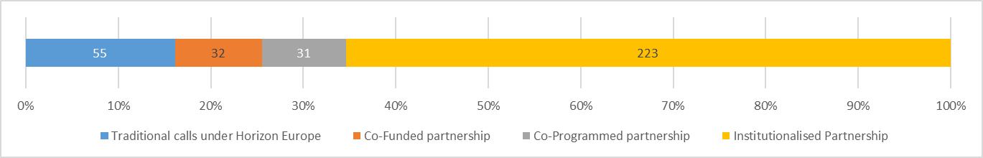

The respondents were asked to briefly explain their answers to the question above. People who stated that an institutionalised partnerships was the best fitting answer, mentioned long term, research and innovation and private funding.

**Relevance of involvement of actors in setting joint long-term agenda**

Respondents were asked how relevant the involvement of actors is in setting a joint long-term agenda to ensure that the proposed European Partnership would meet its objectives (see Figure 4). The highest amount of respondents indicated that the involvement of Industry is very relevant (323 respondents or 86.13%). A large part of respondents also indicated that the involvement of Academia (215, 58.58%) and Member States and Associated Countries (201, 53.46%) is very relevant. With regard to Foundations and NGO’s, respondents indicate that their involvement is seen as less relevant, with only 70 (19.23%) respondents indicating that their involvement is very relevant and a 135 respondents (37.09%) indicating that their involvement is a 3 on the relevance scale.

No statistical differences were found between the views of citizens and other respondents.

Figure 4: Views of respondents on relevance of actors in setting joint long-term agenda

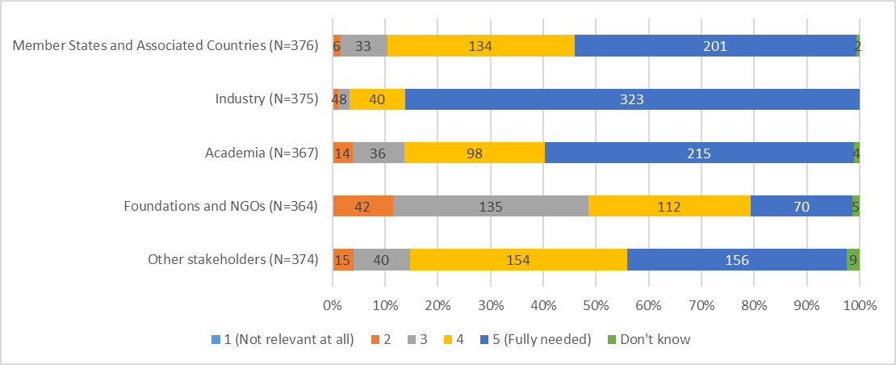



**Relevance of elements and activities in pooling and leveraging resources**

With respect to the relevance of actors in pooling and leveraging resources, such as financial, infrastructure, in-kind expertise etc.), to meet Partnership objectives, the patterns are similar. First, 301 respondents (80.05%) indicated that industry was very relevant, which is much larger than for any of the other stakeholders. 205 (54.14%) respondents felt that Member States and Associated Countries were very relevant and 188 (51.37%) of respondents indicated that Academia were very relevant. Foundations and other stakeholders were deemed less relevant, since only 68 (18.68%) and 89 (24.31%) respondents respectively indicated that these stakeholders were very relevant. No respondents indicated that any of the categories was not relevant at all.

No statistical differences were found between the views of citizens and other respondents.

Figure 5: Views of respondents on relevance of actors for pooling and leveraging resources

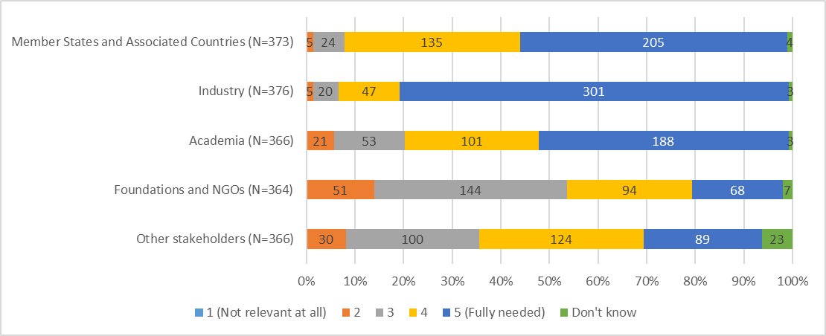



**Relevance of elements and activities for the partnership composition**

Respondents were asked about the relevance of the Partnership composition, such as flexibility in the composition of partners over time and involvement of a broad range of partners (including across disciplines and sectors), to reach Partnership objectives. As it is visible in Figure 6, ensuring involvement of a broad range of partners has more ‘very relevant’ answers (143, 38.96%) than the flexibility in the composition of partners (112, 30.60%). Almost 17% (16.94%) of respondents has indicated that flexibility in composition is worth a 2 on the relevancy scale, for ensuring involvement of a broad range of partners, this is the case for 47 respondents (12.81).

No statistical differences were found between the views of citizens and other respondents. Respondents that are/were directly involved in a current/preceding partnership found flexibility in the composition of partners less relevant.

Figure 6: Views of respondents on relevance of partnership composition elements

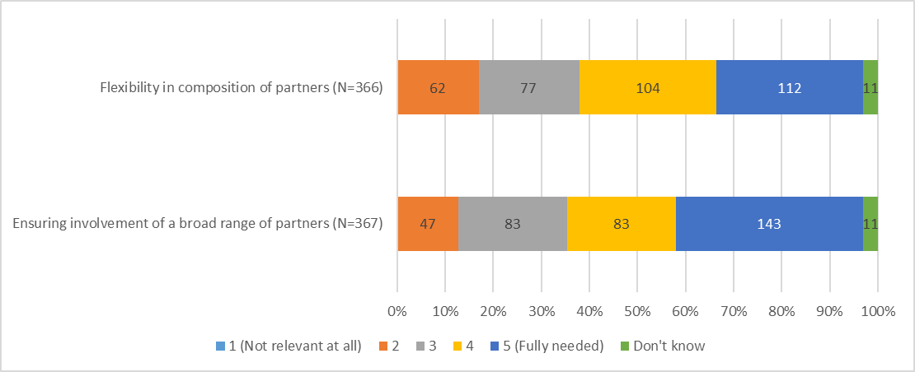



**Relevance of implementation of activities**

Respondents were asked to provide opinions on the relevance of implementation of several activities for meeting objectives of the Clean Hydrogen Partnership. Among activities were listed – joint R&D programme, collaborative R&D projects, deployment and piloting activities, input to regulatory aspects and co-creation of solutions with end-users. Out of 375 respondents, 292 (77.86%) indicated that deployment and piloting activities are very relevant to ensure that the Partnership would meet its objectives. For all the other options, the majority (over 60%) of all respondents have indicated that these are very relevant. See Figure 7.

No statistical differences were found between the views of citizens and other respondents. Respondents that are/were directly involved in a current/preceding partnership found most activities slightly more relevant than other respondents.

Figure 7: Views of respondents on relevance of implementation of the following activities

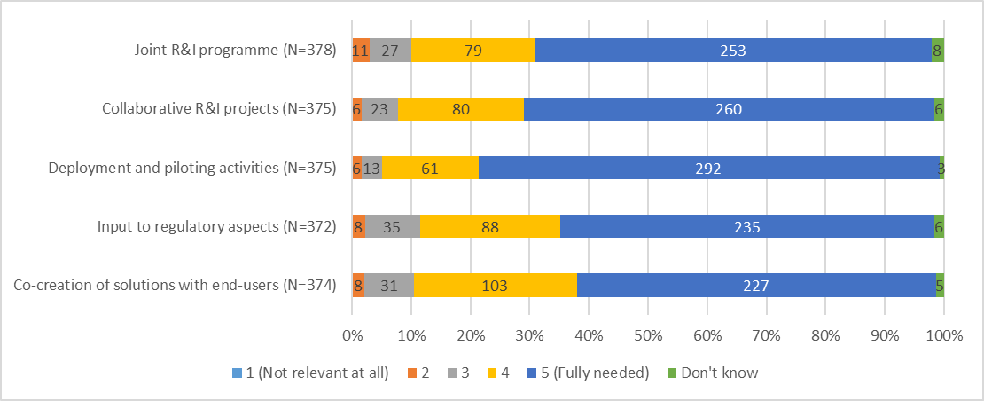



**Relevance of a legal structure (funding body) to achieve specific objectives**

Respondents were also asked to assess the relevance of a specific legal structure (funding body) for the candidate European Partnership to achieve several activities. According to Figure 8, respondents indicated that it was very relevant to set up a specific legal structure for the partnership to achieve a more effective implementation of activities (235, 62.67%) and to increase financial leverage (229, 60.90%). Although ‘to ensure better links to practitioners on the ground’ and ‘to obtain more buy-in and long term commitment from other partners, have received the least 5 (very relevant) answers (106 and 123 respectively), they have received the most 4 answers. Which could indicate that they are still seen as important, just slightly less important than the other options.

No statistical differences were found between the views of citizens and other respondents. Respondents that are/were directly involved in a current/preceding partnership found a legal structure slightly more relevant for most objectives.

Figure 8: Views of respondents on relevance of a specific legal structure

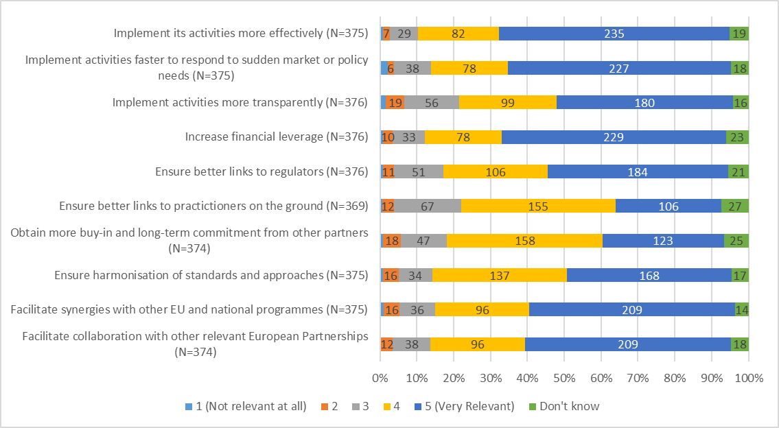

**Scope and coverage of the candidate European Partnership**

Respondents were asked to assess the scope and coverage of the proposed Clean Hydrogen Partnership, based on its inception impact assessment. The clear majority of the respondents have indicated that the partnership has the right scope and coverage across all areas. The respondents have been the most positive with regard to technologies covered, where 261 respondents (70.54%) have indicated the partnership has the right scope and coverage. The respondents who have indicated that the scope and coverage are not right, have indicated that it was too narrow more often than they viewed it as too broad.

No statistical differences were found between the views of citizens and other respondents.

Figure 9: Views of respondents on the scope and coverage proposed for the Clean Hydrogen partnership

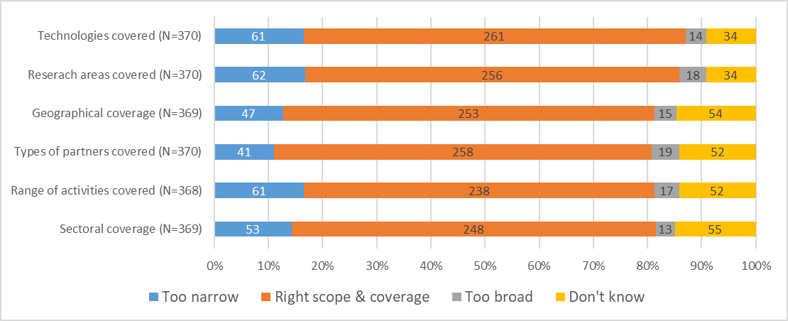

Aside from this multiple choice question, the respondents were also asked to provide any comment that they may have on the proposed scope and coverage for this candidate Institutionalised Partnership. This analysis showed the respondents used this question to talk about low TRL levels, flagship projects and the production and distribution of hydrogen technology.

**Alignment of the European Partnership with other initiatives**

The respondents were also asked if it they thought it would be possible to rationalise the candidate European Institutionalised Partnership and its activities, and/or to better link it with other comparable initiatives. 165 respondents (48.53%) have indicated that they think this is the case.

No statistical differences were found between views of citizens and other respondents.

The respondents who answered affirmative, where asked which other comparable initiatives it could be linked with. The results show that respondents think the initiative could be linked with other comparable initiatives related to hydrogen, renewable energy and the application of hydrogen as well as clean aviation and rail systems.

For the respondents who answered negatively on the previous question, The results show that respondents mention key success factors, other initiatives, other partnerships and the energy system and energy transport.

**Relevance of the Candidate European Partnership to deliver impacts**

Based on Figure10, among presented societal impacts, only the category “improved working conditions” has a relatively low number of respondents that consider that the Partnership would be ‘very relevant’ for this impact category. In other categories, around 80% of respondents consider that the Partnership would be ‘very relevant’ to deliver on those impacts. Similarly, among listed economic/technological impacts, around 80% of respondents suggest that the Partnership would have a significant effect on/be ‘very relevant’ for increasing industrial leadership in hydrogen technologies and uptake of new technologies, for provision of a solution for storing renewable energy for later use, and for provision of low-carbon and competitive solutions for heavy duty and long-distance transport. In contrast, the least number of respondents, namely 197 out of 376 (52.39%), expect a significant impact of the candidate Partnership on better cross-fertilisation of innovative ideas from SMEs to large companies. Around 70% of respondents indicated that the Partnership will have a significant impact on all listed categories in the area of science.

No statistical differences were found between the views of citizens and other respondents. Respondents that are/were involved in a current/preceding partnership found most economic/technological and scientific impacts more relevant than other respondents.

Figure10: Views of respondents on the relevance of the candidate European Institutionalised Partnership to various impacts

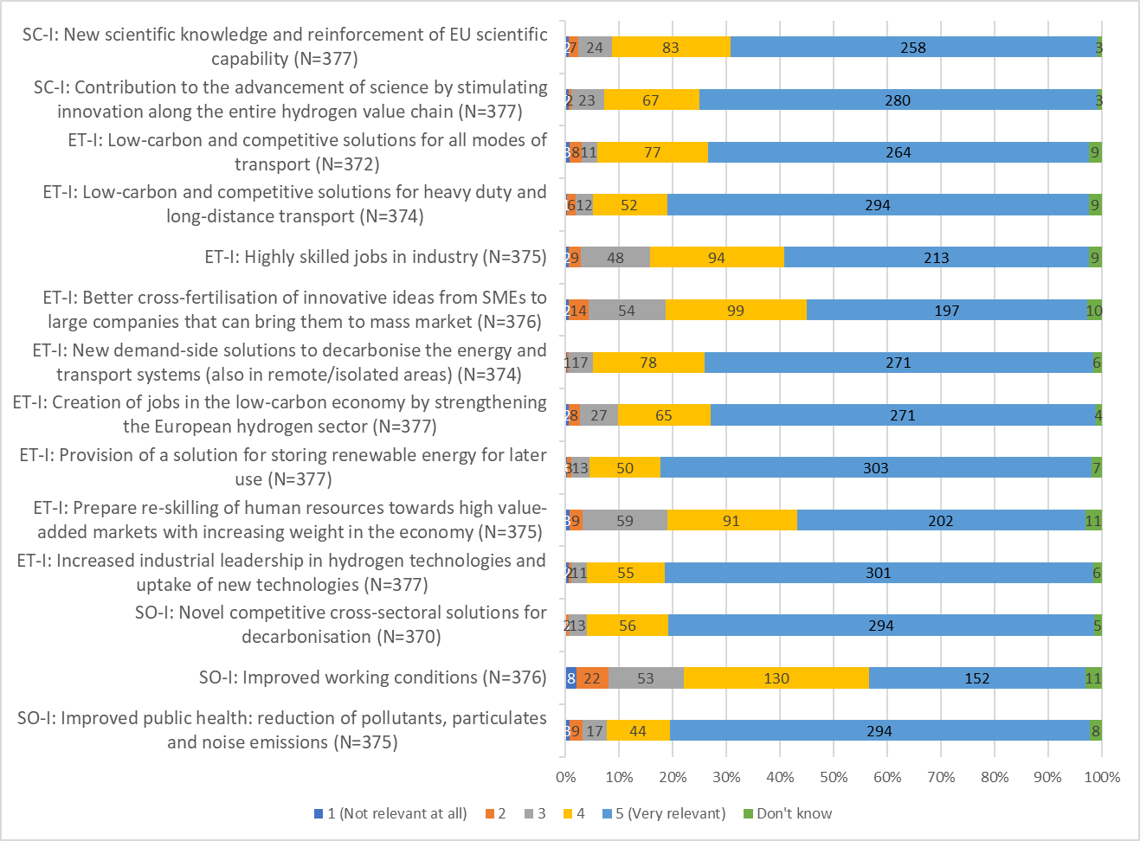

### Summary of campaigns results

Five campaigns were identified among respondents that provided answers for the current candidate Partnership:

1. campaign #1 includes 57 respondents
2. campaign #2 includes 25 respondents
3. campaign #7 includes 18 respondents
4. campaign #9 includes 13 respondents
5. campaign #11 includes 9 respondents

Only the overview for campaign #1 is presented.

Table 1: Overview of responses of the first campaign (campaign #1) (N=57)

|  |  |
| --- | --- |
| Question category | Summary of responses |
| Research and innovation problems | The answer category “Innovation gap in the EU in translating the results of hydrogen and fuel cells research into new products” was assessed as ‘very relevant’ by all respondents. Other categories have mixed and lower scores, on average. |
| Structural and resource problems | With exception of three respondents, all respondents gave a high score (5 ‘very relevant’) for both answer categories. |
| Problems in uptake of digital innovations | Across all answer categories, most respondents selected the option 5 ‘very relevant’. |
| Preferred Horizon Europe intervention | Institutionalised Partnership was selected by all respondents.  When respondents were asked to explain their choice, all of them used the following quote: *“IPPP with its specific governance and 7 years budget enables the sector to define and implement a common ambitious R&I strategy. IPPP unique in coordinating innovation effort beyond industry and research with regions, end-users, members states, other industrial sectors, other EU programmes. IPPP superior in leveraging EU funding with private contributions and other funding sources”*. |
| Relevance of actors for setting join long-term agenda | A higher number of respondents consider that the involvement of industry and academia is ‘very relevant’. Foundation and NGOs received the lowest score (3.21), on average. |
| Relevance of actors for pooling and leveraging resources | A higher number of respondents consider that the involvement of industry and academia is ‘very relevant’. Foundation and NGOs received the lowest score (3.30), on average. |
| Partnership composition | Both categories received a relatively low score (between 2 and 3), on average. |
| Implementation of activities | Across all categories, the majority of respondents indicated that listed activities are ‘very relevant’. |
| Relevance of the legal structure | On average, across all categories, respondents indicated that the legal structure would be ‘very relevant’. The exceptions include the following categories “ensure better links to practitioners on the ground”, “obtain more buy-in and long-term commitment from other partners” and “ensure harmonisation of standards and approaches”. In these categories, on average, respondents gave a score of 4 ‘relevant’. |
| Scope and coverage of the candidate Partnership | Across all answer categories, most respondents consider that the elements are of right scope and coverage.  Respondents were offered an opportunity to provide comments on the proposed scope and coverage of the Institutionalised Partnership. Most of them included the following quote: *“Inception impact assessment says little. PPP infosheet for member states included excellent description with three pillars: 1. Near-zero carbon hydrogen production + 2. Technologies distribution and storage + 3. Demand side technologies for (a) power and/or heat in industry, (b) and building and the (c) In the transport sector with focus on heavy duty road freight, rail, and water-borne. Programme to include adapted instruments to support low TRL, flagship projects and EU supply chain”*. |
| Rationalisation of the candidate Partnership and linking to other initiatives | Out of 57 respondents, 53 (92.98%) consider that it would not be possible to rationalise the candidate Partnership and its activities, and/or to better link it with other comparable initiatives.  Respondents were asked to explain their answer. Regardless of the answer option, all of them inserted a following quote: *“We believe that Hydrogen should have its proper partnership and there is no value in merging it with another partnership. It would increase complexity and lose the focus which is key success factor of an IPPP. Nevertheless we value focussed cooperation with a number of partnerships in particular Clean Aviation, Transforming EU Rail, Waterborne, Built Environment, Clean and Low Carbon Steel, Clean and Circular Industry, Batteries and 2Zero”*. |
| Societal impact | Almost all respondents consider that the Partnership would be ‘very relevant’ to deliver on the following results: “improved public health, reduction of pollutants etc.” and “novel competitive cross-solutions for decarbonisation”. The other suggested impact is considered ‘relevant’, on average, by respondents. |
| Economic/technological impact | Across all listed categories, majority of respondents indicated that impacts are ‘very relevant’. |
| Scientific impact | Across all listed categories, majority of respondents indicated that impacts are ‘very relevant’. |

Annex 3 Who Is Affected And How?

# Practical implications of the initiative

The proposed Clean Hydrogen Partnership focuses on areas where there is a demonstrable advantage in acting at the EU-level due to the scale, speed and scope of the efforts needed for the EU. It will produce quantifiable contributions towards the achievement of climate targets in 2030 and for climate neutrality by 2050. The following stakeholder groups are affected by the proposed initiative, as explained below:

* Academia and the scientific community play a pivotal role in strengthening and integrating scientific capacity to accelerate the development and improvement of advanced clean hydrogen applications ready for market, across energy, transport, building and industrial end-uses;
* The private sector, by having a central role in the proposed Clean Hydrogen Partnership, will benefit from the long-term vision and financial certainty required for its businesses and industries to grow and to strengthen the competitiveness of the EU clean hydrogen value chain (notably SMEs);
* Civil society as a whole is mainly affected by the climate change issue. The proposed Clean Hydrogen Partnership provides the right framework to increase public awareness, acceptance and trust of Hydrogen solutions and services. Having civil society on board is a prerequisite for the clean energy transition to happen, in particular for the development of a highly transformative sector such as Hydrogen;
* Finally, in an increasingly globalized and interlinked world, governments are required to enhance their role in the fight against climate change. New evidence on this issue should be incorporated in every level of policy-making and in every sector. Governments are responsible for the development, implementation and enforcement of environmental clean energy and climate change regulation that addresses current and future problems. The proposed Clean Hydrogen Partnership will be instrumental in providing a relevant scientific and technology evidence base.

**For the preferred option**

|  |  |  |
| --- | --- | --- |
| ***I. Overview of Benefits (total for all provisions) – Preferred Option*** | | |
| ***Description*** | ***Estimation (quantitative or qualitative)*** | ***Comments*** |
| ***Direct benefits*** | | |
| More competitive hydrogen industry | Hydrogen applications are more competitive, efficient and reliable. |  |
| Clean Hydrogen scale up | EU validates its ability to scale-up clean economical hydrogen end-use applications in heavy-duty transport and energy-intensive industries – maintaining global competitiveness. |  |
| Economic growth particularly for SMEs | EU growth in hydrogen economy, especially for SMEs. | When the clean hydrogen value chain develops, it will be possible to monitor the number of SMEs operating in the sector. |
| ***Indirect benefits*** | | |
| Decarbonisation of heavy industry | The EU’s maritime, aviation, rail and heavy-duty transport sectors, as well as their gas grid, can progressively decarbonize so the EU can meet its climate targets. |  |
| Reduction in pollution and CO2 emissions | Outdoor pollution can progressively decrease while reducing carbon emissions at the same time. |  |
| Incorporation of larger shares of renewable energy in European electricity grids. | The European electricity grid can accommodate larger shares of renewable energy, thanks to flexibility services provided by power to gas installations. |  |

*(1) Estimates are relative to the baseline for the preferred option as a whole (i.e. the impact of individual actions/obligations of the preferred option are aggregated together); (2) Please indicate which stakeholder group is the main recipient of the benefit in the comment section;(3) For reductions in regulatory costs, please describe details as to how the saving arises (e.g. reductions in compliance costs, administrative costs, regulatory charges, enforcement costs, etc.; see section 6 of the attached guidance).*

|  |  |  |  |  |  |  |  |  |  |  |
| --- | --- | --- | --- | --- | --- | --- | --- | --- | --- | --- |
| ***II. Overview of direct and indirect costs – Preferred option*** | | | | | | | | | | |
|  | | | Citizens/Consumers | | Businesses | | Administrations | | |
| One-off | Recurrent | One-off | Recurrent | One-off | Recurrent | |
| **Management/ Administrative costs** | Direct costs |  | |  |  |  |  | Other cost €2.1 million[8]. |
| Indirect costs |  | |  |  |  |  |  |
| **Personnel costs** | Direct costs |  | |  |  |  |  | € 2.9 million corresponding to 27 full time equivalent staff [9] |
| Indirect costs |  | |  |  |  |  |  |
| **Coordination costs (or transaction costs)** |  |  | |  |  |  |  |  |
| **Budget expenditure/ investment costs** |  |  | |  |  |  |  |  |

*(1) Estimates to be provided with respect to the baseline; (2) costs are provided for each identifiable action/obligation of the preferred option otherwise for all retained options when no preferred option is specified; (3) If relevant and available, please present information on costs according to the standard typology of costs (compliance costs, regulatory charges, hassle costs, administrative costs, enforcement costs, indirect costs; see section 6 of the attached guidance).*

**REFIT Cost savings table**

Not applicable for the proposed Clean Hydrogen Partnership. The initiative will benefit from the existing organisation/structure (e.g. the Programme Office) already in place for the FCH 2 JU. There are no additional regulatory costs associated, and no specific simplification measures apply in this case.

Annex 4 Analytical Methods

The methodology for each impact assessment is based on the Commission Better Regulation Guidelines[10] to evaluate and compare options with regards to their **efficiency, effectiveness and coherence**. This is complemented by integrating the **conditions and** **selection criteria for European Partnerships**, as well as requirements for setting up Institutionalised Partnerships.[11]

# Overview of the methodologies employed

In terms of **methods and evidence used**, the set of impact assessments for all candidate Institutionalised European Partnerships draw on an external study covering all initiatives in parallel to ensure a high level of coherence and comparability of analysis[12].

All impact assessments mobilised a mix of qualitative and quantitative data collection and analysis methods. These methods range from desk research and interviews to the analysis of the responses to the Open Consultation, stakeholder analysis and composition/portfolio analysis, bibliometric/patent analysis and social network analysis, and a cost-effectiveness analysis.

The first step in the impact assessment studies consisted in the definition of the context and the problems that the candidate partnerships are expected to solve in the medium term or long run. The main data source in this respect was desk research. This includes grey and academic literature to identify the main challenges in the scientific and technologic fields and in the economic sectors relevant for the candidate partnerships, as well as the review of official documentations on the policy context for each initiative.

In the assessment of the problems to address, the lessons to be learned from past and ongoing partnerships were taken into account, especially from relevant midterm or ex-post evaluations.

The description of the context of the candidate institutionalised European Partnerships required a good understanding of the corresponding research and innovation systems and their outputs already measured. Data on past and ongoing Horizon 2020 projects, including the ones implemented through Partnerships, served as basis for descriptive statistic of the numbers of projects and their respective levels of funding, the type of organisations participating (e.g. universities, RTOs, large enterprises, SMEs, public administrations, NGOs, etc.) and how the funding was distributed across them. Special attention was given to analysing the participating countries (and groups of countries, such as EU, Associated Countries, EU13 or EU15) and industrial sectors, where relevant. The sectoral analysis required enriching the eCORDA data received from the European Commission services with sector information extracted from ORBIS, using the NACE codification up to level 2. These data enabled the identification of the main and, where possible, emerging actors in the relevant systems, i.e. the organisations, countries and sectors that would need to be involved (further) in a new initiative.

A Social Network Analysis was performed by the contractors using the same data. It consisted in mapping the collaboration between the participants in the projects funded under the ongoing R&I partnerships. This analysis revealed which actors – broken down per type of stakeholders or per industrial sector – collaborate the most often together, and those that are therefore the most central to the relevant research and innovation systems.

The data provided finally served a bibliometric analysis run by the contractor aimed at measuring the outputs (patents and scientific publications) of the currently EU-funded research and innovation projects. A complementary analysis of the Scopus data enabled to determine the position and excellence of the European Union on the international scene, and identify who its main competitors are, and whether the European research and innovation is leading, following or lagging behind.

A cost modelling exercise was performed in order to feed into the efficiency assessments of the partnership options.

The conclusions drawn from the data analysis were confronted to the views of experts and stakeholders collected via three means:

* The comments to the inception impact assessments of the individual candidate institutionalised European Partnerships;
* The open public consultation organised by the European Commission from September to November 2019;
* The interviews (up to 50) conducted by each impact assessment study team conducted between August 2019 and January 2020 (policymakers, business including SMEs and business associations, research institutes and universities, and civil organisations, among others).

The views of stakeholders (and experts) were particularly important for determining the basic functionalities (see further below) that the future partnerships need to demonstrate to achieve their objectives as well as their most anticipated scientific, economic and technological, and societal impacts. The interviews allowed more flexibility to ask the respondents to reflect about the different types of European Partnerships. Furthermore, as a method for targeted consultation, it was used to get insights from the actors that both the Study Teams and the European Commission were deemed the most relevant. For the comparative assessment of impacts, the external contractors confronted the outcomes of the different stakeholder consultation exercises to each other with a view of increasing the validity of their conclusions, in line with the principles of triangulation.

Annex 2 includes also the main outcomes of the stakeholder consultation exercises.

# Method for assessing the effectiveness, efficiency and coherence of each option - The use of functionalities

Given the focus of the impact assessment on comparing different forms of implementation, the Better Regulation framework has been adapted to introduce “**key** **functionalities needed**” – so as to link the intended objectives of the candidate European Partnerships and what would be crucial to achieve them *in terms of implementation*. The identification of “key functionalities needed” for each initiative as an additional step in the impact assessment is based on the distinguishing factors between the different options (see Section 2.2.1 in the main body of the impact assessment). In practical terms, each option is assessed on the basis of the degree to which it would allow for the key needed functionalities to be covered, as regards e.g. the type and composition of actors that can be involved (‘openness’), the range of activities that can be performed (including additionality and level of integration), the level of directionality and integration of R&I strategies; the possibilities offered for coherence and synergies with other components of Horizon Europe, including other Partnerships (internal coherence), and the coherence with the wider policy environments, including with the relevant regulatory and standardisation framework (external coherence). This approach guides the identification of discarded options. It also allows for a structured comparison of the options as regards their effectiveness, efficiency and coherence, and also against a set of other key selection criteria for European Partnerships (openness, transparency, directionality)[13].

Figure 3 Overview of key functionalities of each form of implementation of European Partnerships

| **Baseline: Horizon Europe calls** | **Option 1: Co-programmed** | **Option 2: Co-funded** | **Option 3.1: Institutionalised Article 185** | **Option 3.2: Institutionalised Article 187** |
| --- | --- | --- | --- | --- |
| **Type and composition of actors (including openness and roles)** | | | | | |
| Partners: N.A.,  no common set of actors that engage in planning and implementation  Priority setting: open to all, part of Horizon Europe Strategic planning  Participation in R&I activities: fully open in line with standard Horizon Europe rules | Partners: Suitable for all types: private and/or public partners, foundations  Priority setting: Driven by partners, open stakeholder consultation, MS in comitology  Participation in R&I activities: fully open in line with standard Horizon Europe rules | Partners: core of national funding bodies or govern-mental research organisations  Priority setting: Driven by partners, open stakeholder consultation  Participation in R&I activities: limited, according to national rules of partner countries | Partners: National funding bodies or governmental research organisation  Priority setting: Driven by partners, open stakeholder consultation  Participation in R&I activities: fully open in line with standard Horizon Europe rules, but possible derogations | Partners: Suitable for all types: private and/or public partners, foundations  Priority setting: Driven by partners, open stakeholder consultation  Participation in R&I activities: fully open in line with standard Horizon Europe rules, but possible derogations |
| **Type and range of activities (including additionality and level of integration)** | | | | | |
| Activities: Horizon Europe standards that allow broad range of individual actions  Additionality: no additional activities and investments outside the funded projects  Limitations: No systemic approach beyond individual actions | Activities: Horizon Europe standard actions that allow broad range of individual actions, support to market, regulatory or policy/ societal uptake  Additionality: Activities/investments of partners, National funding  Limitations: Limited systemic approach beyond individual actions. | Activities: Broad, according to rules/programmes of participating States, State-aid rules, support to regulatory or policy/ societal uptake  Additionality: National funding  Limitations: Scale and scope depend on the participating programmes, often smaller in scale | Activities: Horizon Europe standards that allow broad range of individual actions, support to regulatory or policy/societal uptake, possibility to systemic approach  Additionality: National funding | Activities: Horizon Europe standards that allow broad range of individual actions, support to regulatory or policy/societal uptake, possibility to systemic approach (portfolios of projects, scaling up of results, synergies with other funds.  Additionality: Activities/investments of partners/ national funding |
| **Directionality** | | | | | |
| Priority setting: Strategic Plan and annual work programmes, covering max. 4 years.  Limitations: Fully taking into account existing or to be developed SRIA/ roadmap | Priority setting: Strategic R&I agenda/ roadmap agreed between partners and COM, covering usually 7 years, including allocation of Union contribution  Input to FP annual work programme drafted by partners, finalised by COM (comitology)  Objectives and commitments are set in the contractual arrangement. | Priority setting: Strategic R&I agenda/ roadmap agreed between partners and COM, covering usually 7 years, including allocation of Union contribution  Annual work programme drafted by partners, approved by COM  Objectives and commitments are set in the Grant Agreement. | Priority setting: Strategic R&I agenda/ roadmap agreed between partners and COM, covering usually 7 years, including allocation of Union contribution  Annual work programme drafted by partners, approved by COM  Objectives and commitments are set in the legal base. | Priority setting: Strategic R&I agenda/ roadmap agreed between partners and COM, covering usually 7 years, including allocation of Union contribution  Annual work programme drafted by partners, approved by COM (veto-right in governance)  Objectives and commitments are set in the legal base. |
| **Coherence: internal (Horizon Europe) and external (other Union programmes, national programmes, industrial strategies)** | | | | | |
| Internal: Between different parts of the Annual Work programme can be ensured by COM  External: Limited for other Union programmes, no synergies with national/regional programmes and activities | Internal: Coherence among partnerships and with different parts of the Annual Work programme of the FP can be ensured by partners and COM  External: Limited synergies with other Union programmes and industrial strategies  If MS participate, with national/ regional programmes and activities | Internal: Coherence among partnerships and with different parts of the Annual Work programme of the FP can be ensured by partners and COM  External: Synergies with national/ regional programmes and activities | Internal: Coherence among partnerships and with different parts of the Annual Work programme of the FP can be ensured by partners and COM  External: Synergies with national/ regional programmes and activities | Internal: Coherence among partnerships and with different parts of the Annual Work programme of the FP can be ensured by partners and COM  External: Synergies with other Union programmes and industrial strategies  If MS participate, with national/ regional programmes and activities |

In line with the Better Regulation Framework, the assessment of the effectiveness, efficiency and coherence of each option is made in comparison to the baseline. Therefore, for each of the above criteria, the performance of using traditional calls under Horizon Europe is first estimated and scored 0 to serve as a reference point. When relevant, this estimation also includes the costs/benefits of discontinuing existing implementation structures. The policy options are then scored compared to the baseline with a + and – system along a two-point scale, to indicate limited (+ or -) or high (++ or --) additional/lower performance compared to the baseline. When a policy option is scored 0, this means that its impact is expected to be roughly equal to the baseline option.

On the basis of the evidence collected, the intervention logic of each initiative and the key functionalities needed, the impact assessments first evaluate the **effectiveness** of the various policy options to deliver on their objectives. To be in line with the Horizon Europe impact framework, the fulfilment of the specific objectives of the initiative is translated into ‘expected impacts’ - how success would look like -, differentiating between scientific, economic/ technological, and societal (including environmental) impacts. Each impact assessment considers to which extent the different policy options provides the ‘key functionalities needed’ to achieve the intended objectives. The effectiveness assessment does not use a compound score but shows how the options would deliver on the different types of expected impacts. This is done to increase transparency and accuracy in the assessment of options[14].

A similar approach is followed to evaluate the coherence of options with the overarching objectives of the EU’s R&I policy, and distinguishes between **internal** and **external coherence**. Specifically, internal coherence covers the consistency of the activities that could be implemented with the rest of Horizon Europe, including European Partnerships (any type). External coherence refers to the potential for synergies and/or complementarities (including risks of overlaps/gaps) of the initiative with its external environment, including with other programmes under the MFF 2021-27, but also the framework conditions at European, national or regional level (incl. regulatory aspects, standardisation).

To compare the expected costs and benefits of each option (**efficiency**), the thematic impact assessments broadly follow a cost-effectiveness approach[15] to establish to which extent the intended objectives can be achieved for a given cost. A preliminary step in this process is to obtain a measure of the expected costs of the policy options, to be used in the thematic assessments. As the options correspond to different implementation modes, relevant cost categories generally include the costs of setting-up and running an initiative. For instance, set-up costs includes items such as the preparation of a European Partnership proposal and the preparation of an implementation structure. The running costs include the annual work programme preparation costs. Where a Partnership already exists, discontinuation costs are also taken into account[16]. The table below provides an overview of the cost categories used in the impact assessment and a qualitative scoring of their intensity when compared to the baseline option (traditional calls). Providing a monetised value for these average static costs would have been misleading, because of the different features and needs of each candidate initiative.[17] Where possible however, Annex 3 to the thematic impact assessments provides additional quantification and details. The cost categories are then used to develop a scorecard analysis and further refine the assessment of options for each of the 12 candidate Institutionalised Partnerships. Specifically, the scores related to the set-up and implementation costs are used in the thematic impact assessments to consider the scale of the expected benefits and thereby allow a simple “value for money” analysis(**cost-effectiveness**)[18]. In carrying out the scoring of options, the results of fieldwork, desk research and stakeholder consultation undertaken and taken into account.

Figure 4 - Intensity of additional costs compared with Horizon Europe Calls (for Partners, stakeholders, public and EU)

| Cost items | Baseline: traditional calls | Option 1: Co-programmed | Option 2 Co-funded | Option 3a -Art. 185 | Option 3b -Art. 187 |
| --- | --- | --- | --- | --- | --- |
| **Preparation and set-up costs** | | | | | |
| Preparation of a partnership proposal (partners and EC) | 0 | ↑↑ | | | |
| Set-up of a dedicated implementation structure | 0 | | | Existing: ↑ New: ↑↑ | Existing: ↑↑ New: ↑↑↑ |
| Preparation of the SRIA / roadmap | 0 | ↑↑ | | | |
| Ex-ante Impact Assessment for partnership | 0 | | | ↑↑↑ | |
| Preparation of EC proposal and negotiation | 0 | | | ↑↑↑ | |
| **Running costs (Annual cycle of implementation)** | | | | | |
| Annual Work Programme (AWP) preparation | 0 | ↑ | | | |
| Call and project implementation | 0 | 0 In case of MS contributions: ↑ | ↑ | ↑ | ↑ |
| Cost to applicants | Comparable, unless there are strong arguments of major differences in oversubscription | | | | |
| Partners costs not covered by the above | 0 | ↑ | 0 | ↑ | ↑ |
| Additional EC costs (e.g. supervision) | 0 | ↑ | ↑ | ↑ | ↑↑ |
| **Winding down costs** | | | | | |
| EC | 0 | | | | ↑↑↑ |
| Partners | 0 | ↑ | 0 | ↑ | ↑ |

Notes: 0: no additional costs, as compared with the baseline; ↑: minor additional costs, as compared with the baseline; ↑↑: medium additional costs, as compared with the baseline; ↑↑↑: higher costs, as compared with the baseline.

# Method for identifying the preferred option – The scorecard analysis

For the **identification of the preferred option,** a scorecard analysis is used to build a hierarchy of the options by individual criterion and overall in order to identify a single preferred policy option or in case of an inconclusive comparison of options, a number of ‘retained’ options or hybrid. This exercise supports the systematic appraisal of alternative options across multiple types of monetary, non-monetary and qualitative dimensions. It also allows for easy visualisation of the pros and cons of each option. Each option is attributed a score of the adjudged performance against each criterion with the three broad appraisal dimensions of effectiveness, efficiency and coherence.

This scorecard approach also relies on a standard cost model developed for the external study supporting the impact assessment, as illustrated in **Error! Reference source not found.**. These costs essentially refer to the administrative, operational and coordination costs of the various options. The figure shows how the scoring of costs range from a value of 0, in case an option does not entail any additional costs compared to the baseline (traditional calls), to a score of (-) for options introducing limited additional costs relative to the baseline and a score of (- -) when substantial additional costs are expected in comparison with the baseline. Should the costs of a policy option be lower than those of the baseline, (+) and (+ +) are used.

**Figure 5: Matrix on ‘overall costs’ and ‘adjusted cost scoring’**

|  | Baseline: Horizon Europe calls | Option 1: Co-programmed | Option 2: Co-funded | Option 3: Institutionalised |
| --- | --- | --- | --- | --- |
| **Administrative, operational and coordination costs** | 0 | (-) | (- -) | ( - -) |
| **Administrative, operational and coordination costs adjusted per expected co-funding (i.e. *cost-efficiency*)** | 0 | 0 | (-) | (-) |

Notes: Score 0 = same costs as for the baseline; score (-) = limited additional costs compared to baseline; score (- -) = substantial additional costs compared to baseline.

The **baseline (regular calls)** has the lowest administrative, operational and coordination costs. This is based on two facts: firstly, that Horizon Europe traditional calls will not entail any additional one-off costs to be set up or discontinued at the end, where each of the other policy options will require at least some additional set-up and phasing out costs; and secondly, that Horizon Europe will not require any additional running costs, where each of the other policy options will involve additional efforts by the Commission and partners in the carrying out of necessary additional tasks (e.g. preparing annual work programmes).

A **co-programmed partnership** (Option 1 -CPP) will entail slightly higher overall costs as compared with the baseline. There will be some additional set-up costs linked for example with the creation of a strategic research and innovation agenda (SRIA) and additional running costs linked with the partners role in the creation of the annual work programmes and the Commission’s additional supervisory responsibilities. A CPP will have lower overall costs than each of the other types of European Partnership, as it will function with a smaller governance and implementation structure than will be required for a Co-Funded Partnership or an Institutionalised Partnership and – related to this – its calls will be operated through the existing HEU agencies and RDI infrastructure and systems.

The **Co-Funded Partnership (**Option 2 – CFP)has been **scored (- -)** on overall cost. This reflects the additional set-up costs of this policy option and the substantial additional running costs for partners, and the Commission, of the distributed, multi-agency implementation model.

The **Institutionalised Partnership** (Option 3 - IP) has been **scored (- -)** on overall cost. This reflects the substantial additional set-up costs of this policy option – and in particular the high costs associated with preparing the Commission proposal and negotiating that through to a legal document – and the substantial additional running costs for the Commission associated with the supervision of this dedicated implementation model.

It is considered that while there is a clear gradation in the overall costs of the policy options, the cost differentials are less marked when one takes into account the expected co-financing rates and the total budget available for each of the policy options, assuming a common Union contribution. From this perspective, there are only one or two percentage points that split the most cost-efficient policy options – the baseline (traditional calls) and the Co-Programmed policy options – and the least cost-efficient – the Institutionalised Partnership option. A score of 0 is therefore assigned for **cost-efficiency** to the Co-Programmed option and a score of (-) for the Co-Funded and the Institutionalised Partnership policy options[19].

Annex 5 Subsidiarity Grid

|  |
| --- |
| 1. **Can the Union act? What is the legal basis and competence of the Unions’ intended action?** |
| **1.1 Which article(s) of the Treaty are used to support the legislative proposal or policy initiative?** |
| This proposal is based on (1) Article 185 TFEU which stipulates that in implementing the multiannual framework programme, the Union may make provision, in agreement with the Member States concerned, for participation in research and development programmes undertaken by several Member States, including participation in the structures created for the execution of those programmes; and (2) Article 187 TFEU according to which the Union may set up joint undertakings or any other structure necessary for the efficient execution of Union research, technological development and demonstration programmes (both Articles are under Title XIX of the TFEU - Research and Technological Development and Space).  The proposal aims to implement Article 8 of the Commission proposal for Horizon Europe - the future EU research and innovation (R&I) programme for 2021-2027, according to which, “*European Partnerships shall be established for addressing European or global challenges only in cases where they will more effectively achieve objectives of Horizon Europe than the Union alone and when compared to other forms of support of the Framework programme*”. The Horizon Europe proposal has received the political agreement of the Council and the European Parliament. |
| **1.2 Is the Union competence represented by this Treaty article exclusive, shared or supporting in nature?** |
| Research is a shared competence between the EU and its Member States according to the TFEU. Article 4 (3) specifies that in the areas of research, technological development and space, the European Union can carry out specific activities, including defining and implementing programmes, without prejudice to the Member States’ freedom to act in the same areas. |
| *Subsidiarity does not apply for policy areas where the Union has* ***exclusive*** *competence as defined in Article 3 TFEU[20]. It is the specific legal basis which determines whether the proposal falls under the subsidiarity control mechanism. Article 4 TFEU[21] sets out the areas where competence is shared between the Union and the Member States. Article 6 TFEU[22] sets out the areas for which the Unions has competence only to support the actions of the Member States.* |
| 1. **Subsidiarity Principle: Why should the EU act?** |
| * 1. **Does the proposal fulfil the procedural requirements of Protocol No. 2[23]:** * Has there been a wide consultation before proposing the act? * Is there a detailed statement with qualitative and, where possible, quantitative indicators allowing an appraisal of whether the action can best be achieved at Union level? |
| This proposal and the accompanying impact assessment were supported by a wide consultation of stakeholders, both during the preparation of the Horizon Europe proposal and - later on, all the candidates for European Partnerships. Member States were consulted via the Shadow Strategic configuration of the Horizon Europe Programme Committee. On candidates for institutionalised Partnerships based on Article 185/187 of the TFEU, an Open Public Consultation (OPC) was held between 11 September and 6 November 2019. Over 1 600 replies were received. In addition, targeted consultation activities were undertaken to prepare the present impact assessment. In particular, for each of the candidate partnerships, an external consultant interviewed a representative sample of stakeholders. The need for EU action as well as its added value were covered in those interviews.  The explanatory memorandum and the impact assessment (horizontal part, Section 3) contain a dedicated section on the principle of subsidiarity, as explained in question 2.2 below. |
| * 1. **Does the explanatory memorandum (and any impact assessment) accompanying the Commission’s proposal contain an adequate justification regarding the conformity with the principle of subsidiarity?** |
| The impact assessment accompanying the proposal features a horizontal part on relevant common elements to all the candidate partnerships, including the conformity of the proposed initiative with the principle of subsidiarity (Section 3). Moreover, the individual assessments of each candidate partnership include additional details on subsidiarity, touching in particular on the specificities of a candidate partnership that could not be adequately reflected in the horizontal part of the impact assessment. This will also be reflected in the explanatory memorandum. |
| * 1. **Based on the answers to the questions below, can the objectives of the proposed action be achieved sufficiently by the Member States acting alone (necessity for EU action)?** |
| National action alone cannot achieve the scale, speed and scope of support to R&I needed for the EU to meet its long-term Treaty objectives, to deliver on the EU’s strategic policy priorities (including the climate and energy goals set out in the Paris Agreement, and the European Green Deal), and to contribute to tackling global challenges and meeting the Sustainable Development Goals (SDGs). |
| 1. Are there significant/appreciable transnational/cross-border aspects to the problems being tackled? Have these been quantified? |
| The thematic areas covered by the candidate partnerships feature a series of challenges in terms of cross-border/transnational aspects, need to pool resources, need for a critical mass to meet intended policy objectives, need to coordinate different types of actors (e.g. academia, industry, national and regional authorities) across different sectors of the economy and society, which cannot be tackled to the same degree by Member States alone. This is particularly true for the research and innovation (R&I) dimension of the proposed initiative: the importance of a multi-centre and interdisciplinary approach, cross-country data collection and research, and the need to develop and share new knowledge in a timely and coordinated manner to avoid duplication of efforts are key to achieve high quality results and impact. The Interim Evaluation of Horizon 2020 and the impact assessment of Horizon Europe provide extensive qualitative and quantitative evidence on the above points. In addition, Sections 1 and 2 of the individual impact assessments on the candidate partnerships include more detail on the necessity to act at EU-level in specific thematic areas. Finally, it is worth noting that not all Member States have the same capacity or R&I intensity to act on these challenges. As the desired policy objectives can be fully achieved only if the intended benefits are widespread across the Member States, this requires action at the EU-level. |
| 1. Would national action or the absence of the EU level action conflict with core objectives of the Treaty[24] or significantly damage the interests of other Member States? |
| As per Article 4(3) TFEU, national action does not conflict with core objectives of the Treaty in the area of R&I. The absence of EU level action in this area would however prevent the achievement of core objectives of the Treaty. Indeed, national action alone cannot achieve the scale, speed and scope of support to R&I needed for the EU to meet its long-term Treaty objectives on e.g. competitiveness, to deliver on the EU’s strategic policy priorities, and to contribute to tackling global challenges and meet the Sustainable Development Goals (SDGs). |
| 1. To what extent do Member States have the ability or possibility to enact appropriate measures? |
| As foreseen by Article 4(3) TFEU, this proposal does not hamper Member States’ ability to enact appropriate measures in the field of R&I. However, the scale and complexity of the policy objectives pursued by the present initiative cannot be fully addressed by acting at national level alone. |
| 1. How does the problem and its causes (e.g. negative externalities, spill-over effects) vary across the national, regional and local levels of the EU? |
| As described in the horizontal part of the impact assessment accompanying the present proposal, several problems (e.g. on competitiveness, global challenges, demographic change) and their underlying causes affect the EU as a whole rather than individual Member States. Where important differences between Member States are present, these are described in Sections 1 and 2 of the individual impact assessments. |
| 1. Is the problem widespread across the EU or limited to a few Member States? |
| The problem of coordinating R&I efforts in the thematic areas covered by the candidate partnerships affects all Member States, albeit to different degrees. However, from a general EU perspective, available evidence shows that the EU as a whole needs to step up efforts and investments in thematic areas that are crucial to tackle present and future policy challenges on several fronts, e.g. ageing population, global technological trends, and climate change to name a few. The way these problems affect the EU and its Member States is described in the horizontal part of the impact assessment and in Sections 1 and 2 of the individual impact assessments. |
| 1. Are Member States overstretched in achieving the objectives of the planned measure? |
| As indicated in the horizontal part of the impact assessment and in Sections 1 and 2 of the individual assessments, the sheer scale, speed and scope of the needed support to R&I would overstretch national resources, without guaranteeing the achievement of the intended objectives. Acting at EU-level would achieve greater impact in a more effective and efficient manner. |
| 1. How do the views/preferred courses of action of national, regional and local authorities differ across the EU? |
| No specific differences between the views of national, regional and local authorities emerged from the stakeholder consultation. |
| * 1. **Based on the answer to the questions below, can the objectives of the proposed action be better achieved at Union level by reason of scale or effects of that action (EU added value)?** |
| EU funded R&I activities, including those covered by the present proposal, produce demonstrable benefits compared to the corresponding national and regional initiatives, due to the scale, speed and scope achievable by acting at the EU level. In addition, the proposed initiatives should be seen as complementary and reinforcing national and sub-national initiatives in the same area. |
| 1. Are there clear benefits from EU level action? |
| Quantitative and qualitative evidence of the benefits of EU level action are available in the interim evaluation of Horizon 2020 and in the impact assessment of Horizon Europe, among others. An analysis of the emerging challenges in each thematic areas, of the EU’s competitive positioning, as well as feedback gathered from different types of stakeholders for the present impact assessment indicate that EU level action remains appropriate also for the present proposal. In addition, the benefits of acting at EU-level have been illustrated by the success and the impact achieved by the predecessors to the proposed initiative. |
| 1. Are there economies of scale? Can the objectives be met more efficiently at EU level (larger benefits per unit cost)? Will the functioning of the internal market be improved? |
| EU funded R&I activities, including those covered by the present proposal, produce demonstrable benefits compared to the corresponding national and regional initiatives, due to the scale, speed and scope achievable by acting at the EU level. This is the case both in terms of effectiveness in achieving intended policy objectives, but also in terms of efficiency. Positive impact is also visible in terms of competitiveness: recent data on EU funded R&I activities indicate that EU-funded teams grow 11.8% faster and are around 40% more likely to be granted patents or produce patents applications than non-EU funded teams. Efficiency gains are also visible in terms of dissemination of results to users beyond national borders, including SMEs and citizens. EU funded R&I is more effective in leveraging private investment. Finally, there are clear additionality benefits (i.e. EU R&I funding does not displace or replace national funding), as the EU focuses on projects that are unlikely to be funded at national or regional level. Overall, this is beneficial to the functioning of the internal market in several respects, including human capital reinforcement through mobility and training, the removal of barriers to cross-border activity for economic players including SMEs, easier access to finance and to relevant knowledge and research, and increased competition in the area of R&I. |
| 1. What are the benefits in replacing different national policies and rules with a more homogenous policy approach? |
| A homogeneous policy approach in the various thematic areas covered by the present proposal would reduce fragmentation and increase efficiency and effectiveness in meeting the intended policy objectives. Indeed fragmentation, persisting barriers in the internal market and differences in the resources available to Member States are some of the key problems that stand in the way of fully achieving the intended policy objectives and reaching the required critical mass to obtain tangible results. Specific detail on how these issues differ in each thematic area are illustrated in Sections 1 and 2 of the individual impact assessments, so as to reflect the specificities of each case. |
| 1. Do the benefits of EU-level action outweigh the loss of competence of the Member States and the local and regional authorities (beyond the costs and benefits of acting at national, regional and local levels)? |
| The proposed initiative does not lead to a loss of competence of the Member States. In fact, the proposed initiative should be seen as complementary and reinforcing national and sub-national initiatives in the same area. Previous quantitative and qualitative assessments of Horizon Europe and Horizon 2020 have shown that the proposed EU-level action do not displace national ones and tend to concentrate on initiatives that would not have been funded by the Member States themselves, or would not have reached the same scale and ambition without EU-level intervention, due to their complexity and trans-national nature. |
| 1. Will there be improved legal clarity for those having to implement the legislation? |
| Yes. The proposed initiatives will be implemented in line with the Horizon Europe single set of rules for participation; this will ensure increased clarity and legal certainty for end beneficiaries, other stakeholders and programme administrators. It will also reduce the administrative burden for beneficiaries, and for the Commission services. In addition, the accessibility and attractiveness of the broader Horizon Europe programme, in particular for applicants with limited resources, would be sustained. |
| **3. Proportionality: How the EU should act** |
| * 1. **Does the explanatory memorandum (and any impact assessment) accompanying the Commission’s proposal contain an adequate justification regarding the proportionality of the proposal and a statement allowing appraisal of the compliance of the proposal with the principle of proportionality?** |
| The principle of proportionality underpins the entire analysis of the candidate partnerships. Specifically, the analysis included in the accompanying impact assessment is structured along the following logic: 1. Justification of the use of a partnership approach in a given area (including considerations on additionality, directionality, link with strategic priorities) instead of other forms of intervention available under Horizon Europe; 2. If the partnership approach is deemed appropriate, proportionality considerations guide the assessment of which type of partnership intervention (collaborative calls, co-programmed, co-funded or institutionalised partnership) is most effective in achieving the objectives. This will also be reflected in the explanatory memorandum. |
| * 1. **Based on the answers to the questions below and information available from any impact assessment, the explanatory memorandum or other sources, is the proposed action an appropriate way to achieve the intended objectives?** |
| The proposed initiative only focuses on areas where there is a demonstrable advantage in acting at the EU-level due to the scale, speed and scope of the efforts needed for the EU to meet its long-term Treaty objectives and deliver on its strategic policy priorities and commitments. In addition, the present proposal leaves full freedom to the Member States to pursue their own actions in the policy areas concerned. This will also be reflected in the explanatory memorandum. |
| 1. Is the initiative limited to those aspects that Member States cannot achieve satisfactorily on their own, and where the Union can do better? |
| The proposed initiative only focuses on areas where there is a demonstrable advantage in acting at the EU-level due to the scale, speed and scope of the efforts needed for the EU to meet its long-term Treaty objectives and deliver on its strategic policy priorities and commitments. |
| 1. Is the form of Union action (choice of instrument) justified, as simple as possible, and coherent with the satisfactory achievement of, and ensuring compliance with the objectives pursued (e.g. choice between regulation, (framework) directive, recommendation, or alternative regulatory methods such as co-legislation, etc.)? |
| For each of the candidate partnerships, the analysis carried out in the accompanying impact assessment has explored several options for implementation. A comparative assessment of the merits of each option also included an analysis of the simplicity of the intervention, its proportionality and effectiveness in achieving the intended objectives. This is reflected in the fact that a tailored approach has been suggested for each candidate partnership, ranging from looser forms of cooperation to more institutionalised ones, depending on the intended policy objectives, specific challenges, and desired outcome identified in each case. |
| 1. Does the Union action leave as much scope for national decision as possible while achieving satisfactorily the objectives set? (e.g. is it possible to limit the European action to minimum standards or use a less stringent policy instrument or approach?) |
| The proposed approach leaves full freedom to the Member States to pursue their own actions in the policy areas covered by the present proposal. |
| 1. Does the initiative create financial or administrative cost for the Union, national governments, regional or local authorities, economic operators or citizens? Are these costs commensurate with the objective to be achieved? |
| The proposed initiatives do create financial and administrative costs for the Union, national governments and, depending on the chosen mode of implementation, for regional and local authorities. In addition, economic operators and other stakeholders potentially involved in the candidate partnerships will also incur some costs linked to implementation. The financial cost of the proposed initiative is covered under the Horizon Europe programme. Its exact amount is still subject to political decision. As regards the candidate partnerships and the different modes of implementation (co-programmed, co-funded, institutionalised), the relevant costs and benefits are assessed in the individual impact assessments covering each candidate partnership. The additional administrative costs of implementation via partnerships are limited, when compared to the administrative costs of implementation through traditional calls. As indicated by comparable experience with previous initiatives and in feedback provided by a variety of stakeholders, these costs are expected to be fully justified by the benefits expected from the proposed initiative. Where available, additional details on costs are provided in Annex 3 of the impact assessment. |
| 1. While respecting the Union law, have special circumstances applying in individual Member States been taken into account? |
| Where relevant, differences between Member States in capacity and stage of advancement of R&I in specific thematic areas have been taken into account in the individual impact assessments. |

Annex 6 Additional background information

# Background information for all initiatives

## Selection criteria of European Partnerships

Partnerships based on Article 185 and 187 TFEU *shall be implemented only where other parts of the Horizon Europe programme, including other forms of European Partnerships would not achieve the objectives or would not generate the necessary expected impacts, and if justified by a long-term perspective and high degree of integration.* At the core of this impact assessment is therefore the need to demonstrate that the impacts generated through a Partnership approach go beyond what could be achieved with traditional calls under the Framework Programme – the Baseline Option. Secondly, it needs to assess if using the Institutionalised form of a Partnership is justified for addressing the priority.

The necessity test for a European Partnership (as set out in the Horizon Europe regulation) has two levels:

1. **The justification for implementing a priority with a European Partnership** to address Horizon Europe and EU priorities. This is linked to demonstrating that a European Partnership can produce added value beyond what can be achieved through other Framework Programme modalities, notably traditional calls in the work programmes (Option 0 – Baseline).
2. **The justification for the use of the form of Institutionalised Partnership**: Once it has been demonstrated that a partnerships approach is justified, co-programmed and/or co-funded forms are considered for addressing the priorities as they are administratively lighter, more agile and easier to set-up (Options 1 and/or 2). As Institutionalised Partnerships require setting up a legal framework and the creation of a dedicated implementation structure, they have to justify higher set-up efforts by demonstrating that it will deliver the expected impacts in a more effective and efficient way, and that a long-term perspective and high degree of integration is required (Option 3).

The outcomes of the ‘necessity test’ is presented together with the preferred option.

Figure 5 Horizon Europe selection criteria for the European Partnerships

| **Common selection criteria & principles** | **Specifications** |
| --- | --- |
| 1. **More effective** (Union added value) clear impacts for the EU and its citizens | Delivering on global challenges and research and innovation objectives |
| Securing EU competitiveness |
| Securing sustainability |
| Contributing to the strengthening of the European Research and Innovation Area |
| Where relevant, contributing to international commitments |
| 1. **Coherence and synergies** | Within the EU research and innovation landscape |
| Coordination and complementarity with Union, local, regional, national and, where relevant, international initiatives or other partnerships and missions |
| 1. **Transparency and openness** | Identification of priorities and objectives in terms of expected results and impacts |
| Involvement of partners and stakeholders from across the entire value chain, from different sectors, backgrounds and disciplines, including international ones when relevant and not interfering with European competitiveness |
| Clear modalities for promoting participation of smes and for disseminating and exploiting results, notably by smes, including through intermediary organisations |
| 1. **Additionality and directionality** | Common strategic vision of the purpose of the European Partnership |
| Approaches to ensure flexibility of implementation and to adjust to changing policy, societal and/or market needs, or scientific advances, to increase policy coherence between regional, national and EU level |
| Demonstration of expected qualitative and significant quantitative leverage effects, including a method for the measurement of key performance indicators |
| Exit-strategy and measures for phasing-out from the Programme |
| 1. **Long-term commitment** of all the involved parties | A minimum share of public and/or private investments |
| In the case of institutionalised European Partnerships, established in accordance with article 185 or 187 TFEU, the financial and/or in-kind, contributions from partners other than the Union, will at least be equal to 50% and may reach up to 75% of the aggregated European Partnership budgetary commitments |

## Overview of potential functions for a common back office among Joint Undertakings

|  |  |  |  |
| --- | --- | --- | --- |
| **Functions** | **Current situation** | **Option of joint back- office** | **Comments** |
| **Organising calls for grant and proposal evaluations** | Each JU organises this independently. | A central organisation of evaluation, logistics, contracting evaluators, managing the data of the evaluation results  Central database of potential evaluators with domain expertise in thematic areas of partnerships | The evaluations would still need to be supervised by the Scientific staff of the individual Joint Undertakings (consensus meetings of expert evaluators etc) |
| **Human Resources related matters** | Each JU has own HR policy and resources  Quite some resources spent on recruitment in some JUs  Some HR facilities are procured from external contractors  Some JUs have a Service Level Agreement with COM for HR | More generic resources and expertise for HR matters  More consistency in HR policy  Shared HR investment for specialised expertise (IP and legal) | Ensuring consistency with EC HR policies is already in place |
| **Financial management** | Each JU conducts own financial contract management; differences between JUs  Each JU is audited separately.  Auditing at project level more frequent than in other Horizon 2020 parts and outsourced by JUs thus differences  ECA: too many audits on JUs | Financial management by one core team of financial staff  Would reduce the number of interfaces for audits and simplifies the auditing of the all JUs  Harmonisation of project auditing | Simplifies the harmonisation of financial management across JUs in line with Horizon Europe |
| **Communication (internal and external)** | Each JU has a separate communication strategies, teams and resources | A common back-office can support activities such as event organisation, dissemination of results, setting up website communication  Can help create a more visible Partnership brand | A considerable share of communication activity is partnership specific (addressing particular target groups, synthesising project results) however there are generic communication activities that can be shared  Needs to avoid duplication of efforts |
| **Data management on calls, project portfolios, information on project results** | Most JUs but not all use e-Corda for project data  Overall IT integration of JUs still difficult | Harmonised data management  Reduction of IT systems and support that is procured | This will need to happen regardless of the common back office but will likely be more smooth if managed centrally |

# Background information for this specific initiative

## General information on the hydrogen sector

### Hydrogen Roadmap.

The scope of hydrogen applications is expanding from its present focus on transport, fuel cells and electrolysers, and to include the energy sector (power, heating and gas), industry and new transport applications (maritime, aviation, rail, heavy transport).

The objectives of the proposed Clean Hydrogen Partnership are to address hydrogen production (1), hydrogen distribution (2) and storage (3) in order to supply hydrogen (at scale) to the different sectors (4 to 7) and help them to decarbonise.

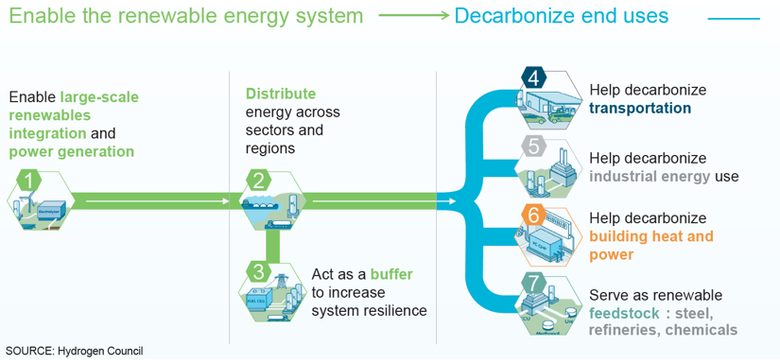

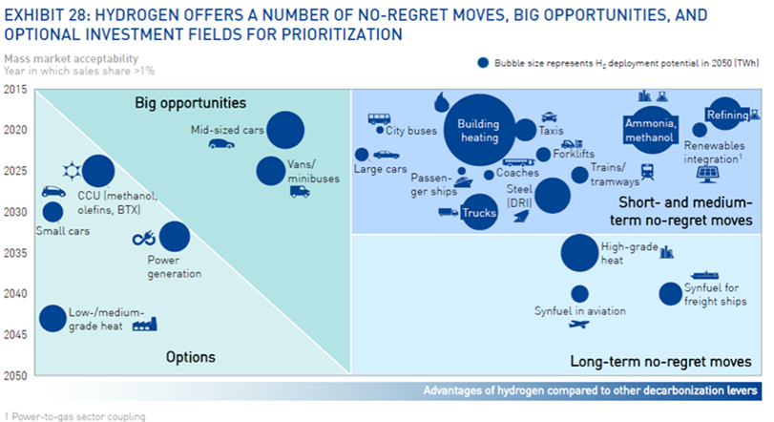

The Figure above highlights the enabling role of hydrogen and the important role it could potentially play in the decarbonisation of a large number of sectors.

### Deployment of Hydrogen

IPHE, the intergovernmental partnership for hydrogen and fuel cells in the economy comprises 20 member countries representing 2/3 of the world’s GDP and investing nearly $1 billion annually in hydrogen and fuel cells. IPHE collects every 6 months information provided by Government officials (Country Reports) on hydrogen deployment.

**Today worldwide**, there are >14,000 fuel cell electric vehicles (FCEVs), >300 hydrogen refueling stations (HRSs), >1/3 million stationary fuel cells in operation, and 600 MW of electrolyser’s installed capacity1.

**Figures for Europe:** 1730 FCEVs; 78 fuel cell buses, 15 garbage trucks; 185 HRSs deployed for road transport, 34 Water Electrolysers (PEM, Alkaline, SOEC) 34 deployed within the cutrrent FCH 2 JU (incl. 24 at HRSs, 4 at Telecom, 2 for grid autonomy and 4 for grid services) - 9 more planned, excl. HRSs (2 for H2 storage, 1 for refinery, 4 Power to Gas applications, 2 for other industrial purposes).

Regarding the production of hydrogen, it is important to note that today hydrogen represents 1% of the energy mix and only 1% of this 1% corresponds to green hydrogen (produced from renewable energy sources). It is clear that the EU has to push for the production of clean hydrogen at scale. This activity will be supported under hydrogen production in the proposed clean hydrogen partnership. There will be no deployment of hydrogen and fuel cell applications without developing the hydrogen supply chain.

In conclusion, despite the potential of hydrogen to contribute to the decarbonisation of many different sectors, one has to acknowledge that the deployment of hydrogen and fuel cells is only marginal today. To accelerate the commercial readiness of hydrogen technologies, the proposed Partnership is building on the work of FCH 2 JU which made the start of commercialisation of a first series of applications possible. It will aim at bringing a second series of applications to commercial level as outlined in the figure below.

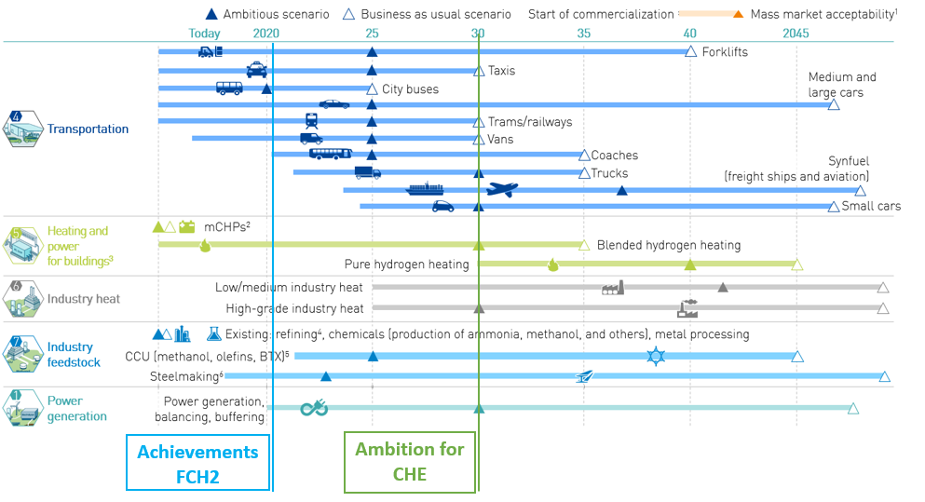

It is also expected that the proposed Clean Hydrogen Partnership will improve through research and innovation the cost-effectiveness, reliability and quality of clean hydrogen applications developed in the EU and therefore accelerate and boost the market entry of these innovative competitive clean hydrogen solutions to support the decarbonisation of the EU economy

### Specific objectives and targets

In order to have a good understanding of the hydrogen and fuel cells sector, it is worth looking at the KPIs listed in the Multi-Annual Work Plan of FCH 2 JU. One can see that a large number of KPIs are on track (in green in the table below) but that for a few applications technology developments are behind schedule. The case of PEM electrolysers is of concern with current capital costs far from reaching the targets. This fact could delay large scale deployment of this technology with a direct consequence on clean hydrogen production.

It is also clear from this analysis that achieving the 2030 targets will be very challenging. However, there are reasons to remain optimistic if one looks for example at the capital costs of fuel cell buses. Continuous support from a series of FCH JU projects has allowed a drastic reduction of the costs of fuel cell buses, 400% in 15 years. A similar evolution could be expected for other hydrogen and fuel cell technologies.

KPIs FCH 2 JU Programme 2014-20202

|  |  |  |  |  |  |  |  |  |  |  |  |  |  |  |  |  |  |  |  |  |  |  |  |  |
| --- | --- | --- | --- | --- | --- | --- | --- | --- | --- | --- | --- | --- | --- | --- | --- | --- | --- | --- | --- | --- | --- | --- | --- | --- |
| **Transport – Demo (MAWP - SoA/Targets)** | | | | | | | | | | | | | | | | | | | | | | | | |
| **Application** | | | **KPI** | | | **unit** | **SoA  2012** | | | | | **SoA 2017** | **FCH 2 JU Projects Results Average values 2018** | | | | **2020** | | | **2024** | | **2030** | | |
| **Light Duty Vehicles (LDV)**  **Storage tanks**  **Bus** | | | Fuel cell system durability | | | h | 2,500 | | | | | 4,000 | 5,000 | | | | 5,000 | | | 6,000 | | 7,000 | | |
| Fuel cell system cost | | | EUR/kW | 500 | | | | | 100 | Work in progress | | | | 60 | | | 50 | | 40 | | |
| CAPEX - Storage tank | | | EUR/kg H2 | 3,000 | | | | | 1,000 | 875 | | | | 500 | | | 400 | | 300 | | |
| Bus price | | | thousand EUR | 1300 | | | | | 650 | ≈550. Latest figures from JIVE report | | | | 625 (150 units) | | | 600 (250 units) | | 500 (300 units) | | |
| **HRS** | | | CAPEX for the HRS | | | Thousand EUR/  (kg/day) | 7,5 | | | | | 7 | 2,978.53  (HRS bus) | | | | 4-2,1 | | | 3-1,6 | | 2,4-1,3 | | |
| **Energy – Demo Stationary Applications (MAWP - SoA/Targets)** | | | | | | | | | | | | | | | | | | | | | | | | |
| **Application** | **KPI** | | | **unit** | | | | | **SoA  2012** | | **SoA 2017** | | | **FCH 2 JU Projects Results Average values 2018** | | **2020** | | | **2024** | | | | | **2030** |
| mCHPs  Medium Scale applications | CAPEX | | | EUR/kW | | | | | 16000 | | 13000 | | | 16,000  (range 6,000-23,000) | | 10000 | | | 5500 | | | | | 3500 |
| Lifetime | | | |  | | --- | | years of  appliance  operation | | | | | | 10 | | 12 | | | 12.25 | | 13 | | | 14 | | | | | 15 |
| Durability | | | h | | | | | 25,000 | | 40,000 | | | 55,450 | | 50,000 | | | 60,000 | | | | | 80,000 |
| Electrical Efficiency | | | % LHV | | | | | 30-60 | | 33-60 | | | 47.4 (between 37 and 60%) | | 35-60 | | | 37-63 | | | | | 39-65 |
| CAPEX | | | EUR/kW | | | | | 6,000 - 10,000 | | 5,000 - 8,500 | | | Work in progress  for commercial applications | | 4.500  - 7.500 | | | 3.500  - 6.500 | | | | | 1,500 - 4,000 |
| Large Scale Applications | Electrical efficiency | | | % LHV | | | | | 45 | | 45 | | | 48.3 | | 45 | | | 45 | | | | | 50 |
| Lifetime | | | years of plant operation | | | | | 2-20 | | 6-20 | | | 15 | | 8-20 | | | 8-20 | | | | | 15-20 |
| Availability | | | % of the plant | | | | | 97 | | 97 | | | 95 | | 97 | | | 97 | | | | | 98 |
| Electrical efficiency | | | % LHV | | | | | 40-45 | | 41-55 | | | 50 | | 42-60 | | | 42-62 | | | | | 50-65 |
|  | | |  | | | | |  | |  | | |  | |  | | |  | | | | |  |
| **Energy – H2 Production, Storage & Distribution** **(MAWP - SoA/Targets)** | | | | | | | | | | | | | | | | | | | | | | | | |
| **Application** | | **KPI** | | | **unit** | | | **SoA  2012** | | **SoA 2017** | | | | | **FCH 2 JU Projects Results Average values 2018** | | | **2020** | | | **2024** | | **2030** | |
| PEM electrolysers | | Electricity consumption @ nominal capacity | | | kWh/kg | | | 60 | | 58 | | | | | 58 | | | 55 | | | 52 | | 50 | |
| Capital cost | | | €/(kg/d) | | | 8,000 | | 2,900 | | | | | ≈ 8000 EUR/(kg/d) | | | 2,000 | | | 1,500 | | 1,000 | |
| (€/kW) | | | (~3,000) | | (1,200) | | | | | (900) | | | (700) | | (500) | |
| O&M cost | | | €/(kg/d)/yr | | | 160 | | 58 | | | | | No data | | | 41 | | | 30 | | 21 | |
| Alkaline Electrolysers | | Electricity consumption @ nominal capacity | | | kWh/kg | | | 57 | | - | | | | | 59 (minimum value 46)  @System Level | | | 50 | | | 49 | | 48 | |
| Capital cost | | | €/(kg/d)  (€/kW) | | | 8,000  (~3,000) | | 1,600  (750) | | | | | Work in Progress | | | 1,250  (600) | | | 1,000  (480) | | 800  (400) | |
| O&M cost | | | €/(kg/d)/yr | | | 160 | | 32 | | | | | No data | | | 26 | | | 20 | | 16 | |
| Solid Oxide Electrolysers | | Electricity consumption | | | kWh/kg | | | na | | 41 | | | | | 2020 Target achieved | | | 40 | | | 39 | | 37 | |
| Availability | | | % | | | na | | na | | | | | ≈66%  Targets have not been achieved  (79 @ Stack level) | | | 95% | | | 98% | | 99% | |
| Capital cost | | | €/(kg/d) | | | na | | 12,000 | | | | | 11,000  1,500 at mass production | | | 4,500 | | | 2,400 | | 1,500 | |
| O&M cost | | | €/(kg/d)/yr | | | na | | 600 | | | | | No data | | | 225 | | | 120 | | 75 | |
| Compressed gas tube trailers | | Capacity | | | kg | | | 400 | | 850 | | | | | No data | | | 1000 | | | 1000 | | 1000 | |
| Capital cost | | | €/kg | | | 550 | | 400 | | | | | No data | | | 350 | | | 350 | | 350 | |
| Large scale H2 storage | | €/kg | | | 1.2 | | | 1.1 | | 1.0 | | | | | No data | | |  | | | 0.8 | | 0.6 | |

1 There is no data available on installed electrolyser’s capacity. The overall figure sums up the figures reported in the press.

2 The complete list of KPIs is available at:

https://www.fch.europa.eu/sites/default/files/MAWP%20final%20version_endorsed%20GB%2015062018%20%28ID%203712421%29.pdf

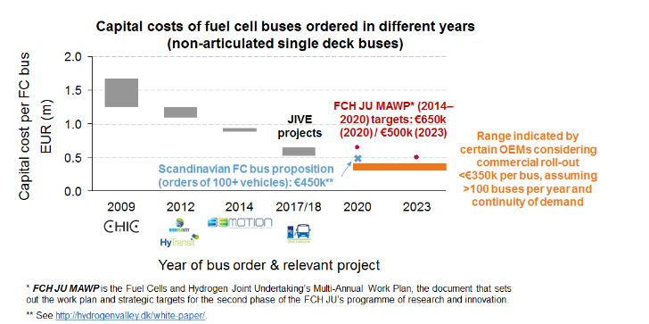

Source:https://www.fch.europa.eu/sites/default/files/Strategies_%20for_joint_procurement_of_FCbuses_final_report.pdf

1. Technopolis Group, 2020, forthcoming.
2. Based on cost assessments of IEA, IRENA and BNEF. Electrolyser costs to decline from EUR 900/kW to EUR 450/KW or less in the period after 2030, and EUR 180/kW after 2040. Costs of CCS increases the costs of natural gas reforming from EUR 810/kWh2 to EUR 1512/kWh2. For 2050, the costs are estimated to be EUR 1152/kWh2.
3. <https://ec.europa.eu/info/files/better-regulation-guidelines-stakeholder-consultation_en>
4. <https://ec.europa.eu/eusurvey/runner/ConsultationPartnershipsHorizonEurope>
5. The candidate Institutionalised Partnership Clean Hydrogen has the highest number of campaigns, namely 5. A few initiatives, such as Innovative SMEs, Smart Networks and Systems, were not targeted by campaigns. Some campaign respondents decided to provide opinions about several partnerships.
6.
7. Comments on scope and content have to be assessed in the context of the overall priority setting to ensure coherence.
8. These are the costs of running the FCH JU from the 2018 Annual report.
9. These are the costs of running the FCH JU from the 2018 Annual report.
10. European Commission (2017), Better Regulation Guidelines (SWD (2017) 350)
11. A pivotal element of the present analysis is the so-called two-step ‘necessity test’ for European Partnerships, used to establish: step 1) the need for a partnership approach in the first place, followed by step 2) a justification for the form of Institutionalised Partnership. The necessity test is described in Annex 6. This impact assessment focuses on the second step of the test.
12. Technopolis Group (2020), Impact Assessment Study for Institutionalised European Partnerships under Horizon Europe.
13. The criterion on the ex-ante demonstration of partners’ long term commitment depends on a series of factors that are unknown at this stage, and thus fall outside the scope of the analysis.
14. In the thematic impact assessments, scores are justified in a detailed manner to avoid arbitrariness and spurious accuracy. A qualitative or even quantitative explanation is provided of why certain scores were given to specific impacts, and why one option scores better or worse than others.
15. For further details, see Better Regulation Toolbox # 57.
16. While monetised cost figures are available for existing European Partnerships, they widely differ between each case, thus limiting meaningful comparability. Moreover, they are not readily applicable for new candidate initiatives. Instead, the analysis uses a static, common model of average real costs as a means to show the order of magnitude of efforts and reveal the principal differences between the options.
17. A complete presentation of the methodology developed to assess costs as well as the sources used is described in the external study supporting this impact assessment (Technopolis Group, 2020).
18. More details on the methodology can be found in Annex 4.
19. The baseline (traditional calls) is scored 0, as explained above.
20. <https://eur-lex.europa.eu/legal-content/EN/TXT/HTML/?uri=CELEX:12008E003&from=EN>
21. <https://eur-lex.europa.eu/legal-content/EN/TXT/HTML/?uri=CELEX:12008E004&from=EN>
22. <https://eur-lex.europa.eu/LexUriServ/LexUriServ.do?uri=CELEX:12008E006:EN:HTML>
23. <https://eur-lex.europa.eu/legal-content/EN/TXT/HTML/?uri=CELEX:12016E/PRO/02&from=EN>
24. <https://europa.eu/european-union/about-eu/eu-in-brief_en>