Union of Equality: Strategy for the Rights of Persons with Disabilities 2021-2030
“Persons with disabilities have the right to have good conditions in the workplace, to live independently, to equal opportunities, to participate fully in the life of their community. All have a right to a life without barriers. And it is our obligation, as a community, to ensure their full participation in society, on an equal basis with others.”
Commission President von der Leyen
- Vision and need for Action
The European Union is anchored in values of equality, social fairness, freedom, democracy and human rights. The Treaty on the Functioning of the European Union (TFEU) and the Charter of Fundamental Rights of the European Union provide the basis to combat all forms of discrimination, establishing equality as a cornerstone of EU policies. President von der Leyen announced as one of the priorities of her Commission to build a Union of Equality in all of its senses.
The adoption of the United Nations Convention on the Rights of Persons with Disabilities (UNCRPD or Convention) in 2006 marked a breakthrough in setting minimum standards for rights of persons with disabilities. The EU and its Member States are parties to the UNCRPD and are progressing with its implementation.
The European Pillar of Social Rights serves as compass for employment and social policies, jointly proclaimed in 2017 by the European Parliament, the Council, and the European Commission. Principle 17 of the Pillar underlines that persons with disabilities have the right to income support that ensures their living in dignity, services that enable them to participate in the labour market and in society and a work environment adapted to their needs.
The European Disability Strategy 2010-2020 paved the way to a barrier-free Europe, fostering actions supported also by EU funds to make a difference for the life of approximately 87 million persons having some form of disability in the EU. The evaluation shows that it contributed to improving the situation in a number of areas, in particular accessibility for persons with disabilities and promoting their rights by putting disability high on the EU agenda.
However, persons with disabilities still face considerable barriers in access to healthcare, education, employment, recreation activities, as well as in participation in political life. They have a higher risk of poverty or social exclusion (28.4%) compared to persons without disabilities (18.4%). Over half of persons with disabilities say they personally felt discriminated against in 2019.
The Covid-19 pandemic and its economic consequences makes it even more pressing to tackle this issue, as it amplified obstacles and inequalities. Persons with disabilities living in residential care experience higher infection rates and at the same time they suffer from isolation due to social distancing rules. Those living in the community and at home are affected by restricted personal service delivery, which can put independent living in jeopardy. Limited accessibility of ICT tools necessary for teleconferencing, telework arrangements, distance learning, online shopping, and access to COVID-19 related information make even the small tasks challenging. The EU has taken rapid action to mitigate the socio-economic consequences of the pandemic to ensure a fair and inclusive recovery addressing the disparities and inequalities. The Commission promoted emergency measures already in early spring 2020 and in May it proposed a major recovery plan for Europe. The EU’s next long-term budget, coupled with NextGenerationEU, represents the largest stimulus package ever adopted. This will support a disability-inclusive COVID-19 response and recovery.
It is time to scale up European action. The European Parliament called for a renewed disability strategy covering all areas of the Convention, and the Council is committed to continue work on its implementation. The European Economic and Social Committee and the European Committee of Regions highlighted the role of accessibility and independent living as well as the importance of governance and monitoring.
This Strategy aims to improve the lives of persons with disabilities in the coming decade, in the EU and beyond. The objectives of this Strategy can only be reached through coordinated action at both national and EU level, with a strong commitment from Member States and regional and local authorities to deliver on the actions proposed by the Commission.
In some areas, the EU shares competence with Member States, such as transport or the internal market. In other relevant areas, such as health, education and culture, the main competence remains with the Member States and the EU has a supportive role. Therefore, it remains the primary responsibility of Member States to design their national disability policies in line with their obligations to implement the UNCRPD and in line with applicable EU rules. This Strategy will also ensure that the Commission leads by example in its implementation of the UNCRPD and that it intensifies its work with the other EU institutions to that end.
This Strategy takes account of the diversity of disability, resulting from the interaction between long-term physical, mental, intellectual or sensory impairments, which are often invisible, with barriers in the environment, as well as the increased prevalence of disabilities with age, with almost half of persons aged above 65 reporting some form of disability. It promotes an intersectional perspective, addressing specific barriers faced by persons with disabilities who are at the intersection of identities (gender, racial, ethnic, sexual, religious), or in a difficult socioeconomic or other vulnerable situation. Among persons with disabilities, women, children, older persons, homeless persons, refugees, migrants, Roma and other ethnic minorities need particular attention.
The Strategy supports the green and digital transitions and a healthy Europe, thus contributing to a sustainable, resilient, innovative, and fair Union. It is part of the European Pillar of Social Right Action plan adopted by the Commission. Complementing the equality strategies adopted to combat discrimination in all its forms, this Strategy will help to achieve a Union of Equality and to strengthen Europe’s role as a global partner in combatting inequalities, achieving the UN Sustainable Development Goals and promoting human rights.
- Accessibility – an enabler of rights, autonomy and equality
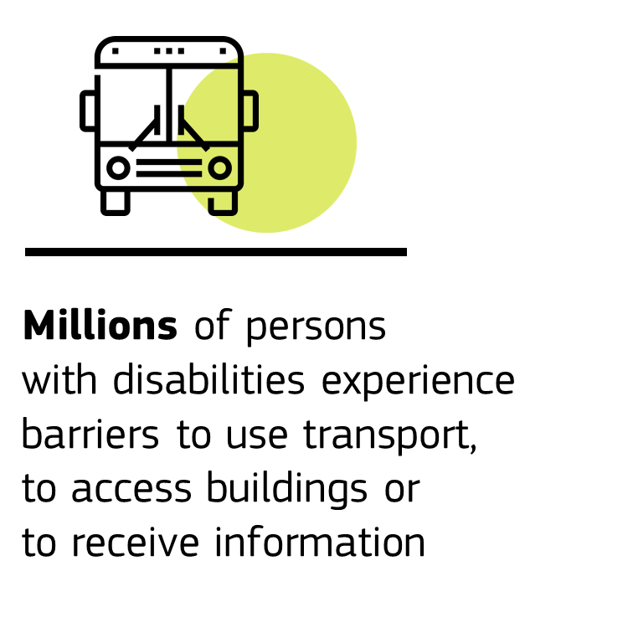
Accessibility to the built and virtual environments, to information and communication technologies (ICT), goods and services, including transport and infrastructure, is an enabler of rights and a prerequisite for the full participation of persons with disabilities on an equal basis with others.
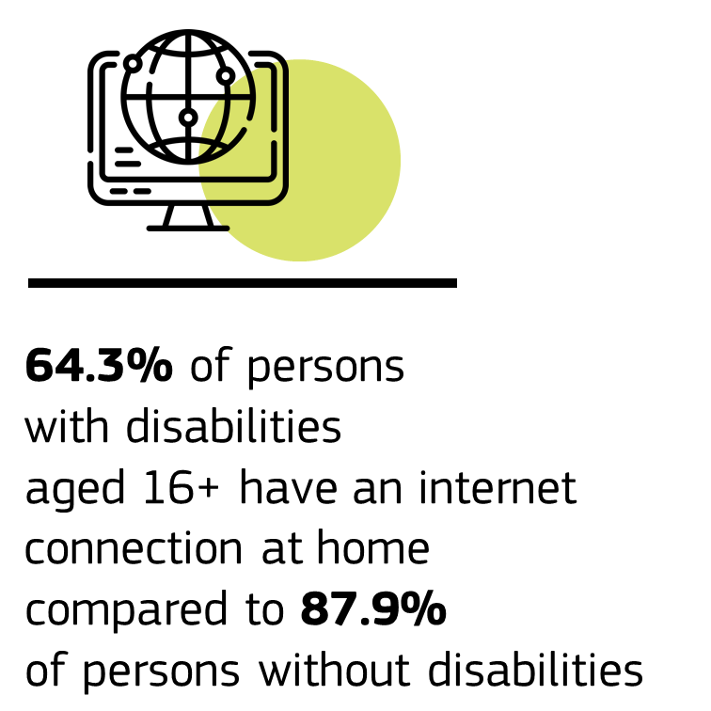
During the last decade, a number of EU rules have been adopted in different areas to make the EU more accessible for persons with disabilities: the European Accessibility Act covering products and services, the Web Accessibility Directive, the Electronic Communications Code, the Audiovisual Media Services Directive and copyright legislation. European accessibility standards have been put in place to support implementation in the built environment and ICT and for organisations to adopt a Design for All approach. European policies promote a digital transformation and digital public services that are inclusive of and accessible for persons with disabilities. In the recent proposal for the review of roaming legislation the Commission included specific measures aiming to facilitate access to emergency services for end-users with disabilities.
Passenger rights guarantee the right to non-discrimination in access to transport and to receive assistance free of charge for passengers with disabilities and reduced mobility travelling by air, rail, maritime means of transport, or bus and coach. The Access City Award has stimulated a coherent, cross-sectoral approach going beyond the minimum standards set by law. Further, the Commission has recommended that in the context of building renovations to improve energy efficiency, the removal of accessibility barriers should be ensured.
EU rules make accessibility requirements compulsory for the Member States to benefit from shared management funds, and buying accessible goods, services and infrastructure is an obligation in public procurement. Member States are also encouraged to mainstream accessibility funding under the Recovery and Resilience Plans.
Still, barriers for persons with disabilities remain, hindering mobility within countries and across Europe, and preventing access to information, products, services and housing.
To make Europe barrier-free, Member States should mainstream accessibility into all relevant policies and actions, notably those related to the European Green Deal, the Renovation Wave and the New European Bauhaus, and professionals should receive training in accessibility.
At EU level, the Commission will pay close attention to the correct implementation and evaluation of all EU rules regulating accessibility and identify gaps and the need for further legislative actions. EU-level action will also include further work on standardisation and technical specifications. The Commission will examine by 2023 the functioning of the internal market for assistive technologies to identify need for further action as diverse rules in the Members States on product eligibility and certification may harm the competitiveness of prices. In 2021, as a follow-up of the Renovation Wave Communication, the Commission will revise the legislative framework related to the energy performance of buildings, which also has an impact on accessibility improvements as a result of renovation requirements.
Flagship initiative:
In 2022 the Commission will launch a European resource centre AccessibleEU to increase coherence in accessibility policies and facilitate access to relevant knowledge. This cooperation framework will bring together national authorities responsible for implementing and enforcing accessibility rules with experts and professionals from all areas of accessibility, to share good practices across sectors, to inspire policy development at national and EU level, as well as to develop tools and standards aiming to facilitate implementation of EU law. The Commission will start preparations for AccessibleEU within the newly established Disability Platform.
The Commission will also:
- provide, in 2021, practical guidance to Member States to support the implementation of the accessibility obligations under the public procurement Directives, and promote training for public procurers to buy accessible;
- include, in 2021, accessibility and inclusiveness in the reinforced EU digital government strategy, focusing on human-centric and user-friendly digital public services across Europe that respond to the needs and preferences of European citizens, including the needs of persons with disabilities;
- evaluate, in 2022, the application of the Web Accessibility Directive and assess whether the Directive should be revised to address any gaps identified, such as scope, technological advances, and coherence with other relevant EU legislation;
- review, in 2021, and in line with the Sustainable and Smart Mobility Strategy, the passenger rights regulatory framework including rights for persons with disabilities and reduced mobility in transport by air, water, bus and coach;
- launch, by 2022, an Inventory of Assets on rail infrastructure, i.e. of accessible parts of train stations, aiming at identifying the existing obstacles and barriers to accessibility;
- review, in 2021, the Regulation on Union Guidelines for the development of the trans-European transport network to strengthen the provision on accessibility;
- revise, in 2021, its Urban Mobility Package to strengthen Sustainable Mobility Planning which requires Member States to adopt local mobility plans taking into consideration the needs of different groups, including persons with disabilities.
- Enjoying EU Rights
Persons with disabilities should enjoy all rights on an equal basis with others, notably when moving to another Member State or participating in political life.
  - Moving and residing freely
When moving to another Member State for work, studies, or other reasons, persons with disabilities may experience difficulties to have their disability status recognised. This means that they may face barriers to access services, including sign language interpreting, and benefits for persons with disabilities in that country. Services across borders may equally pose challenges. The Commission will work with Member States to expand the scope of the mutual recognition of disability status in areas such as labour mobility and benefits related to conditions of service provision.
Flagship initiative:
The Commission will propose creating a European Disability Card by end of 2023 with a view to be recognised in all Member States. It will build on the experience of the ongoing EU Disability Card pilot project in eight Member States and upon the European parking card for persons with disabilities.
  - Fostering participation in the democratic process
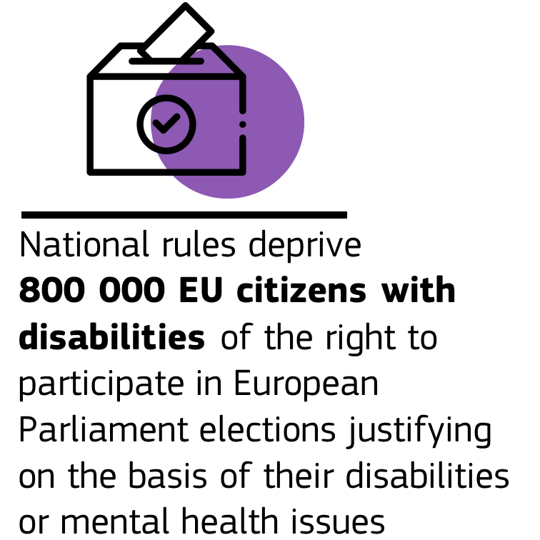
Full political participation, as required by the UNCRPD, means that persons with disabilities participate in elections as well as in political and decision-making processes on an equal basis with others.
In practice, persons with disabilities often face difficulties in exercising their rights due to limited accessibility (including a lack of information and communication in sign language), or due to restrictions in their legal capacity.
In its Recommendation for the 2019 elections to the European Parliament, the Commission called upon Member States to promote the exercise of electoral rights of underrepresented groups, including persons with disabilities. A number of Member States have already adopted targeted legal adjustments and the European democracy action plan promotes this process. The Commission’s report on the implementation of the 2019 European Parliament elections noted that there is still progress to be made. The European Parliament called on Member States to step up exchanges of best practice to improve the conditions for political participation of persons with disabilities including accessibility of information and polling stations.
As announced in the 2020 Citizenship Report, the Commission will work with Member States, including through dedicated discussions in the European Cooperation Network on Elections and the European Parliament to guarantee political rights of persons with disabilities on equal basis with others. Persons with disabilities should participate fully in the Conference on the Future of Europe.
The Commission will also:
- work with Member States in the European Cooperation Network on Elections to support full electoral participation and accessibility of the European elections (both as voter and as candidate), addressing underrepresented citizens, including citizens with a disability in order to guarantee the exercise of political rights of persons with disabilities on equal basis with others;
- discuss, in 2022, in the framework of the high-level event on elections announced in the Democracy Action Plan, practices on inclusive democracy with the aim that candidate lists reflect the diversity of our societies;
- establish, in 2023, on this basis and in close cooperation with Member States in the framework of the European Cooperation Network on Elections a guide of good electoral practice addressing participation of citizens with disabilities in the electoral process;
- seek to address the needs of citizens with a disability in the compendium on e-voting envisaged under the European Democracy Action Plan;
- support inclusive democratic participation, including for persons with a disability, through the new Citizenship, Equalities, Rights and Values programme (CERV).
- Decent quality of life and living independently
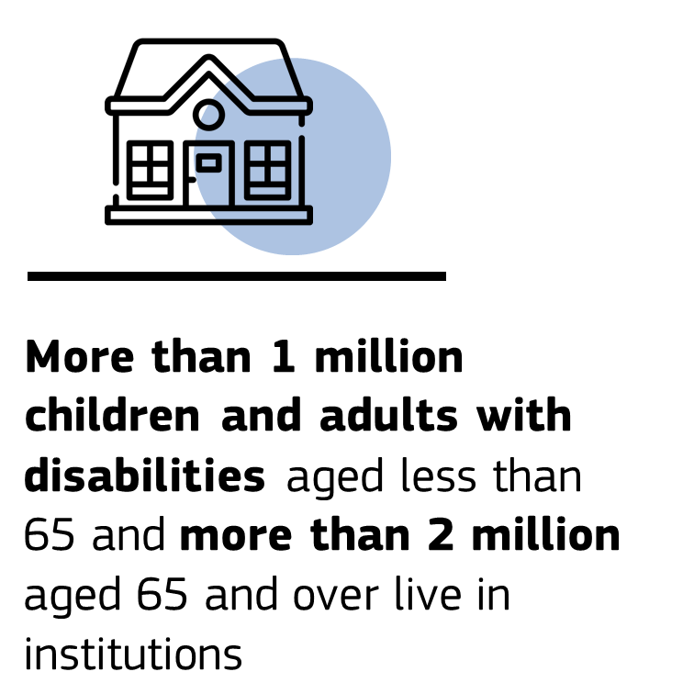
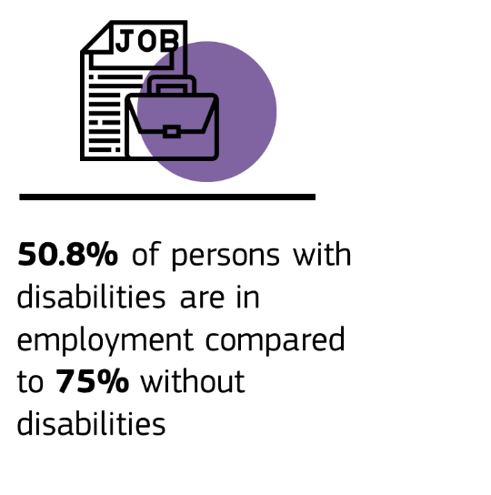
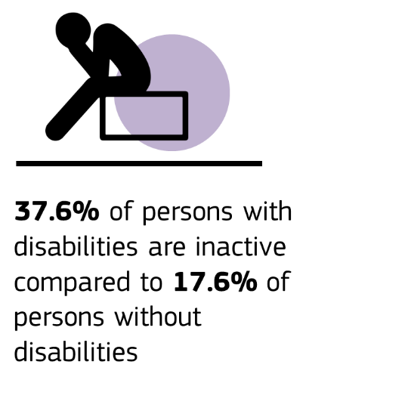
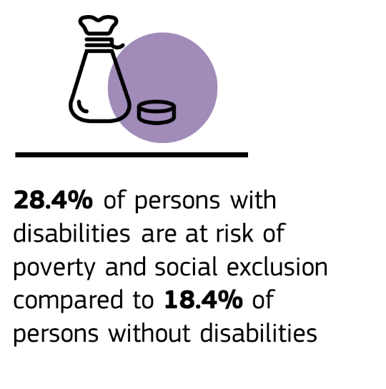
Independent living, quality social and employment services, accessible and inclusive housing, participation in lifelong learning, adequate social protection and a strengthened social economy are indispensable for decent living for all persons with disabilities.
  - Developing independent living and reinforcing community-based services
Persons with disabilities, old and young, have an equal right to live independently and be included in the community, with choices equal to those of others about their place of residence and with whom and how they live. In the last decade EU funding has made an important contribution to the independent living and inclusion in the community for persons with disabilities. Independent living requires a differentiated landscape of quality, accessible, person-centred and affordable, community- and family-based services comprising personal assistance, medical care and interventions by social workers, thereby facilitating everyday activities and providing choice to persons with disabilities and their families.
Mainstream support services need to be inclusive of and accessible for children with disabilities and older persons, while being gender- and culture-sensitive.
Still, many persons with disabilities, adults and children, are segregated from community life and do not have control over their daily lives, in particular those living in institutions. This is mainly due to the insufficient provision of appropriate community-based services, housing and technical aids, as well as to the limited availability of support for families and of personal assistance, including in the area of mental health. The situation is particularly difficult in remote and rural areas. The COVID-19 pandemic highlighted and intensified the challenges faced by persons living in institutions.
The quality of the services provided across and within Member States varies. Moreover, the sector is affected by workforce shortages and challenging working conditions. Older persons with disabilities living in rural areas are more prone to the insufficient provision of social and health services. Ensuring access to such services in areas with low population density has been raised by the Green Paper on Ageing and will be further addressed under the upcoming Long-term Vision for Rural Areas.
All this requires reinforced action by the Member States and the Commission will support national, regional and local authorities in their efforts for deinstitutionalisation and independent living, including through the 2021-2027 shared management funds, the Renovation Wave, the Renovation Component of the Recovery and Resilience Plans, and the Technical Support Instrument.
Accelerated digital transformation and the green transition offer opportunities, using information and communication technology (ICT), artificial intelligence and robotics to design on-site and remote services tailored to the needs of persons with disabilities. Effective use of these technologies requires the removal of accessibility barriers for persons with disabilities and investing in their digital skills.
Flagship initiatives:
The Commission will, by 2023, issue guidance recommending to Member States improvements on independent living and inclusion in the community, in order to enable persons with disabilities to live in accessible, supported housing in the community, or to continue living at home (including personal assistance schemes).
Building on the existing voluntary European Quality Framework for Social Services, the Commission will present, by 2024, a specific framework for Social Services of Excellence for persons with disabilities, to improve service delivery for persons with disabilities and to enhance the attractiveness of jobs in this area including through upskilling and reskilling of service providers.
The Commission calls on Member States to:
- implement good practices of deinstitutionalisation in the area of mental health and in respect of all persons with disabilities, including children, to strengthen the transition from institutional care to services providing support in the community;
- promote and secure financing for accessible and disability-inclusive social housing, including for older persons with disabilities, and address challenges of homeless persons with disabilities.
  - Developing new skills for new jobs
Having the right skills and qualifications is a prerequisite for accessing and succeeding in the labour market. As set in the European Skills Agenda, this requires national skills strategies that should also cover the specific needs of persons with disabilities. Equal access to education and labour-market oriented training at all levels has to be ensured. Member States are responsible to adapt education and training policies to the needs of persons with disabilities in a manner consistent with the UNCRPD.
Despite the right to access mainstream vocational education and training, the proportion of young persons with disabilities being referred to special vocational schools is high. This is often due to the general lack of accessibility and reasonable accommodation, and insufficient support provided to learners with disabilities in mainstream vocational training settings. The transition to the open labour market is more difficult than from mainstream educational settings. Moreover, participation of persons with disabilities in adult learning is lower compared to persons without disabilities.
The Council Recommendation on vocational education and training (VET) for sustainable competitiveness, social fairness and resilience invites Member States to design vocational programmes so they are inclusive and accessible for vulnerable groups, such as persons with disabilities. The renewed European Alliance for Apprenticeships will contribute to sharing knowledge on how apprenticeships can be used as a tool for social inclusion, and will encourage pledges on quality apprenticeships providing support for learners with disabilities. Through the reinforced Youth Guarantee, the Commission supports the outreach to and activation of young persons with disabilities.
For efforts on education and training provision to translate into participation in the labour market, guidance counsellors and in particular public employment services have an important role to play. In the Skills Agenda, the Commission commits to join forces with the European Network of Public Employment Services to develop peer learning to shed light on skills needed on the labour market and to step up the provision of guidance services, also for people in employment and for vulnerable groups, and on closing skills gaps, notably digital skills gaps, often in cooperation with social enterprises for labour market inclusion. As announced in the Digital Education Action Plan 2021-2027, Member States will be supported in securing assistive technologies and in providing an accessible digital learning environment and content.
The Commission calls on Member States to:
- set targets for the participation of adults with disabilities in learning with a view to increasing their participation, and ensure that national skills strategies cover the specific needs of persons with disabilities to help achieve the target in the Skills Agenda and in the action plan implementing the Pillar of Social Rights;
- adopt targeted measures and flexible training formats to ensure inclusive and accessible VET programmes including for persons with disabilities;
- building on the results of the Blueprint for sectoral cooperation on skills under the Pact for Skills, further support the cooperation between relevant stakeholders of the social economy, including identifying digital skills needs and applying assistive technology for better employability.
  - Fostering access to quality and sustainable jobs
Participation in employment is the best way to ensure economic autonomy and social inclusion. The employment gap between persons with and without disabilities remains high: persons with disabilities have a lower employment rate, are disproportionately affected by unemployment, and leave labour markets earlier. A large number of persons with severe disabilities do not work in the open labour market, but in facilities offering so-called sheltered employment. Such schemes are diverse and not all ensure adequate working conditions or labour-related rights for persons with disabilities, nor pathways to the open labour market. Deprivation of legal capacity can limit the ability of persons with intellectual or mental disabilities to conclude contracts or start a business, thus making self-employment and entrepreneurship impossible.
The evaluation of the Disability Strategy 2010-2020 identified employment as one of the five top policy priorities for future actions. To ensure better labour market outcomes for persons with disabilities, the Commission will continue to support Member States in the implementation of the relevant Employment Guidelines through the European Semester, in developing statistical tools as well as promoting the exchange of best practices in the context of the Social Open Method of Coordination. Unlocking the potential and talents of persons with disabilities will be for the benefit of the individuals, the economy and for the cohesion of the society as a whole. While the EU Employment Equality Directive is contributing significantly to promoting equal rights of persons with disabilities in employment including as regards reasonable accommodation at work, more needs to be done to ensure better labour market outcomes for persons with disabilities.
The Commission will continue to ensure rigorous application by Member States of the rights covered by the Employment Equality Directive and will report on the Directive’s application in 2021. The report will also examine whether Member States have followed the Commission’s recommendation to consider designating an equality body to address discrimination on the grounds of religion or belief, disability, age and sexual orientation within the scope of application of the Directive.
Member States can make use of the reinforced Youth Guarantee to support young persons with disabilities. Other groups requiring particular attention are women and persons with psychosocial disabilities.
The Commission will also support employment policies in the Member States through fostering the social economy which provides services for persons with disabilities, helps to build bridges for persons with disabilities to employment in the open labour market and offers employment opportunities. The situation of this sector varies considerably across the EU. To support Member States in strengthening social inclusion of disadvantaged groups, EU public procurement legislation provides for reserved contracts and EU competition law allows specific State aid for the recruitment of workers with disabilities. In parallel, Member States also develop ‘inclusive entrepreneurship’ policies targeted at under-represented groups such as women, youth and migrants, including also persons with disabilities.
Flagship initiative:
In 2022, the Commission will present a package to improve labour market outcomes of persons with disabilities, seeking cooperation with the European Network of Public Employment Services, social partners and organisations of persons with disabilities. The package will support Member States in the implementation of the relevant Employment Guidelines through the European Semester. It will provide guidance and support mutual learning on strengthening capacities of employment and integration services, promoting hiring perspectives through affirmative action and combating stereotypes, ensuring reasonable accommodation, securing health and safety at work and vocational rehabilitation schemes in case of chronic diseases or accidents, exploring quality jobs in sheltered employment, and pathways to the open labour market.
The Commission will also:
- publish, in 2021, an implementation report on the EU Employment Equality Directive and, if appropriate, follow up with a legal proposal in particular to strengthen the role of equality bodies;
- issue, in 2021, an Action Plan on Social Economy to improve the enabling environment for the social economy, including opportunities related to persons with disabilities, through social enterprises with a focus on integration, into the open labour market.
The Commission calls on Member States to:
- establish, by 2024, targets for increasing the employment rate of persons with disabilities and reducing employment rate gaps between persons with and without disabilities to help achieve the 2030 headline employment target proposed in the Action Plan to implement the European Pillar of Social Rights for endorsement by the European Council;
- strengthen the capacities of employment services for persons with disabilities and enhance work with social partners and organisations of persons with disabilities to that end;
- facilitate self-employment and entrepreneurship, including for persons with intellectual and psychosocial disabilities, through providing support on legal and business matters, including by using the EU funds.
  - Consolidating social protection systems
Alongside fair employment, adequate social protection, including retirement schemes, is an essential prerequisite to ensure an adequate income for a decent standard of living of persons with disabilities and their families.
In accordance with the European Pillar of Social Rights and the UNCRPD, Member States have intensified reforms of their social protection systems including of their disability assessment frameworks and benefits. All countries have measures in place to provide a replacement income for persons with disabilities. Personal budgets and financial support, including for carers, are becoming a common practice. A considerable number of Member States have received support for reforms of their social protection systems from the Commission through the Structural Reform Support Programme.
However, the objective of an adequate living standard for all has not yet been achieved. Insufficient labour market participation in combination with insufficient social protection and extra costs related to disability, including family care, are the main reasons why persons with disabilities and their families are at a higher risk of financial poverty. The eligibility criteria for disability benefits sometimes act as a barrier to employment.
The Commission will:
- launch, in 2022, a study on social protection and services for persons with disabilities to examine good practices on disability benefits, old-age income, health insurance, cash and non-cash benefits as well as on extra-costs due to disability;
- provide guidance to support Member States in further reforms of social protection focusing on persons with disabilities and disability assessment frameworks, including upon requests through the Technical Support Instrument.
The Commission calls on Member States to:
- define measures to further tackle gaps in social protection for persons with disabilities to reduce inequalities, including by compensating extra costs related to disability and eligibility for disability benefits.
- Equal Access and non-discrimination
Persons with disabilities have the right to protection from any form of discrimination and violence, equal opportunities in and access to justice, education, culture, housing, recreation, leisure, sport and tourism, and equal access to all health services.
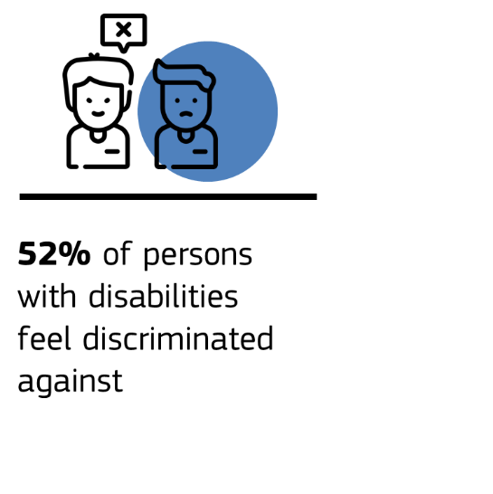
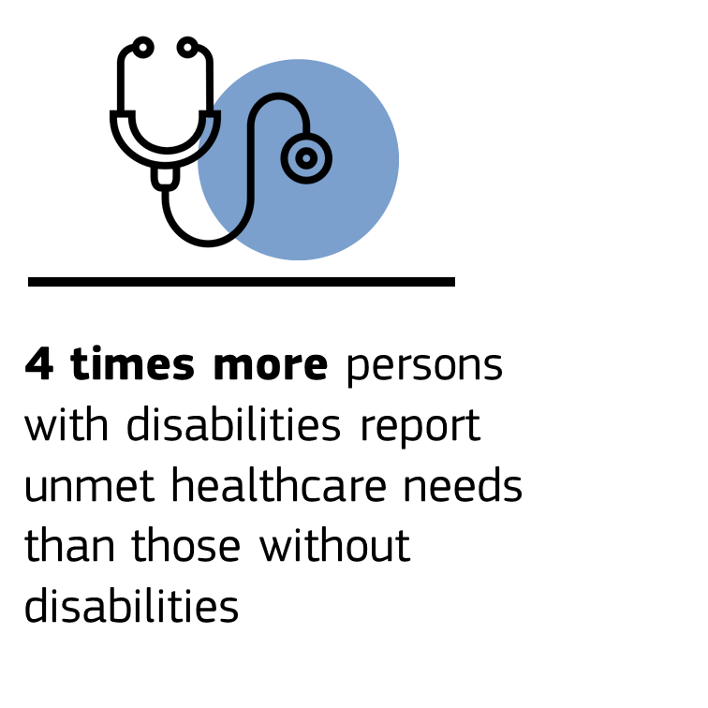
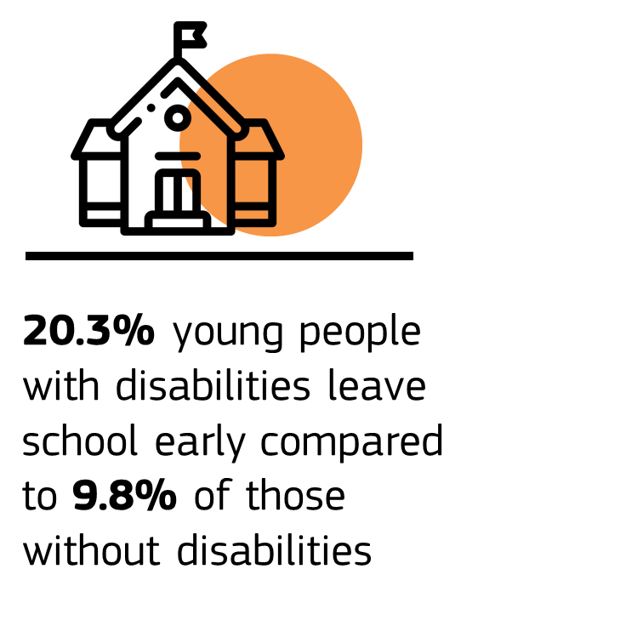
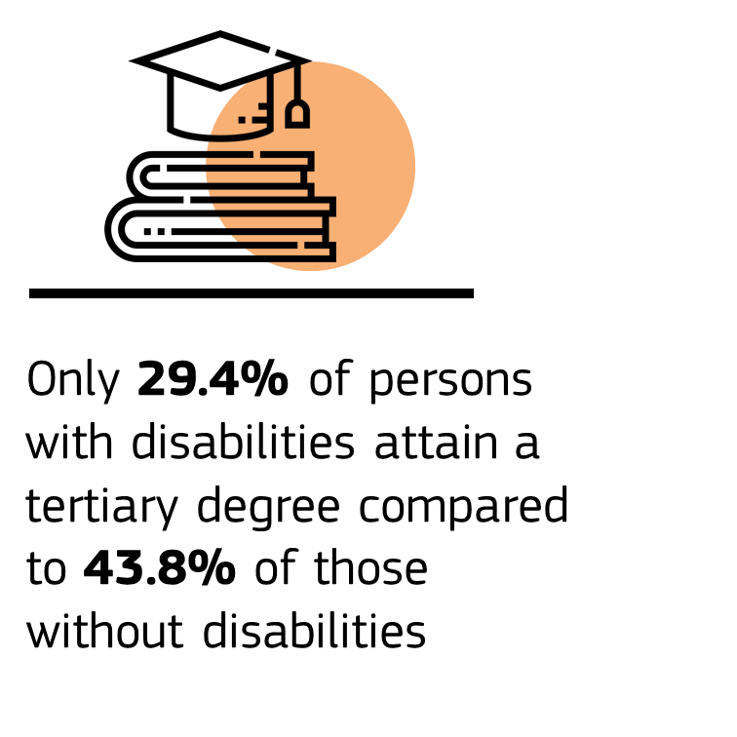
  - Improving access to justice, legal protection, freedom and security
Persons with disabilities should have effective access to justice, including through the provision of adequate accommodations. In practice, this involves practical and legal barriers which hinder persons with disabilities in criminal and civil proceedings from acting as witnesses, defending their rights as victims, suspects or accused persons, and also from participating in professional roles such as judges, lawyers and prosecutors. Legal barriers exist in particular for persons with intellectual disabilities, psychosocial disabilities or with mental health problems as they are often restricted in or deprived of their legal capacity.
In its initiatives for digitalisation of justice systems, protection of victims’ rights and training for professionals the Commission takes account of disability in line with the UNCRPD. Digitalisation of judicial systems is essential for improving access to justice, including for persons with disabilities when accessibility is provided. The Commission will pay particular attention to women with disabilities who are two to five times more likely to face violence than other women, and also to persons with disabilities living in institutions. Within its training strategy for justice professionals, the Commission will focus on the protection of individuals’ rights in the digital space and to upscale training of legal professionals on EU disability legislation including the UNCRPD.
The Commission will:
- work with Member States to implement the 2000 Hague Convention on the international protection of vulnerable adults in line with the UNCRPD, including by way of a study on the protection of vulnerable adults in cross-border situations, notably those with intellectual disabilities, to pave the way for its ratification by all Member States;
- launch a study on procedural safeguards for vulnerable adults in criminal proceedings, and assess the need for legislative proposals strengthening the support and protection of vulnerable adults who fall victims of crime, in line with the EU Victims’ Rights Strategy (2020-2025);
- provide guidance to Member States on access to justice for persons with disabilities in the EU, building on international guidance provided by the United Nations;
- develop measures to support Member States in boosting the participation of persons with disabilities as professionals in the justice system and collect good practices on supported decision-making.
  - Equal access to social protection, healthcare, education and goods and services including housing
Combating all forms of discrimination against persons with disabilities is at the heart of the UNCRPD. The EU has put a comprehensive body of EU anti-discrimination legislation in place to ensure equal treatment regardless of sex, sexual orientation, racial or ethnic origin, age, religion or belief. The Employment Equality Directive provides for specific measures to ensure equal treatment of persons with disabilities.
A gap exists in EU law to ensure equal treatment of persons with disabilities outside the field of employment, such as social protection, healthcare, education and access to goods and services, including housing. Pending the adoption of a Commission proposal for a Council Directive on Equal Treatment, persistent inequalities and discrimination underline the need for further progress in EU legislation.
The Commission calls on Member States to:
- enable the adoption of the Commission proposal for a horizontal directive on implementing the principle of equal treatment outside the field of employment including disability;
- support cooperation between the EU and the national UNCRPD frameworks and members of European networks of rights defenders.
  - Inclusive and accessible education
Education creates the foundations for combating poverty and for creating fully inclusive societies. Persons with disabilities have the right to participate in all educational levels and forms including early childhood education and care on an equal basis with others. Education institutions and the relevant legislation must provide the conditions for an inclusive approach.
There is still a considerable need for action as demonstrated by the gaps in educational outcomes between learners with and without disabilities. More young persons with disabilities leave school early and fewer learners with disabilities complete a university degree (gap of 14.4pps). Many children and young persons with disabilities are enrolled in special schools which do not always offer effective bridges to the mainstream education system, continued training, or to the labour market. No sufficient systematic research has been carried out so far on the conditions necessary for learners with disabilities to succeed, including learners with invisible disabilities such as autism, dyslexia, or hyperactivity. Confinement measures during the COVID-19 pandemic added urgency to develop measures making inclusive and accessible remote learning an option for all.
At EU level, inclusive education has been put high on the education agenda. One of the six axes of the European Education Area is dedicated to inclusive education and lifelong learning for all, starting with early childhood education and care. Related initiatives such as the Pathways to School Success initiative have a special focus on groups at risk such as pupils with disabilities and special educational needs. The European approach to micro-credentials, through flexible and modular learning pathways, can positively impact employability and the lifelong learning process of persons with disabilities.
Education policies will continue to be supported by the European Agency for Special Needs and Inclusive Education. The Commission will collect policies and practices promoting educational achievements of persons with disabilities in the Member States to feed into policymaking. Synergies with a view to access and quality of education including early childhood and care will be exploited with the forthcoming EU Strategy on the Rights of the Child and the European Child Guarantee.
In response to the recommendations issued to the EU by the UNCRPD Committee in 2015, the European Schools System (the ESS) established a sub-Working Group “UN Convention” and adopted an Action Plan on Educational Support and Inclusive Education. A dedicated monitoring system for the plan has been set up.
To promote disability-inclusive education, Member States can use the opportunities offered by EU funding including the Erasmus+ and the European Solidarity Corps programmes, setting out dedicated inclusion measures. The Cohesion policy and the Recovery and Resilience Facility to mitigate the impact of the COVID-19 pandemic will continue to support national reforms for inclusive education in the light of digital and green transitions. Furthermore, for schools and educational buildings, Member States can address accessibility through the Renovation Wave.
This Strategy will enhance cooperation for national reforms for inclusive education and exploit opportunities for synergies between the European Education Area, the European Skills Agenda, the Digital Education Action Plan and the European Research Area, and also between the Erasmus+ and other EU funding instruments.
The Commission will:
- issue in 2021 a toolkit for inclusion in early childhood education and care, which includes a specific chapter on children with disabilities;
- support Member States to further develop their teacher education systems to address shortages of teachers in Special Needs Education and competences of all education professionals to manage diversity in the classroom and develop inclusive education;
- as a member of the Board of Governors of the European Schools, support increased efforts to implement the Action Plan Educational Support and Inclusive Education focusing on accessibility and reasonable accommodation, adaptation of their curricula to the needs of learners with disabilities (e.g. alternative leaving certificates allowing for continuation of education at national level) and on providing training courses for teachers in the area of inclusive education.
The Commission calls on Member States:
- to support the development of inclusive schools that can become a reference in inclusive and innovative teaching and learning across the EU along the objectives of the European Education Area and the Digital Education Action Plan;
- to ensure that their education systems at all levels comply with the UNCRPD to advance on supported learning in inclusive mainstream settings, as announced in the Communication on the European Education Area;
- to support the implementation of Article 24 UNCRPD in the European Schools.
  - Sustainable and equal access to healthcare
Persons with disabilities have the right to high-quality healthcare, including health-related rehabilitation and prevention.
Further action is needed as persons with disabilities report unmet needs for medical examination four times more often than persons without disabilities. Healthcare is often too expensive, too far to travel to, not accessible, or subject to long waiting lists. As the prevalence of disabilities increases with age, older persons living in rural areas face particular challenges due to a lack of availability of appropriate healthcare and persistent staff shortages. Persons with invisible disabilities (such as chronic pain or intellectual disabilities), with rare diseases or with cancer, that often lead to impairments, do not always receive the tailored support needed, nor do women or refugees with disabilities. The COVID-19 crisis revealed weak spots in health systems, in particular regarding persons with disabilities living in institutions with limited access to emergency and intensive care.
The European Health Union launched by the Commission in November 2020 will support Member States in policies to improve the resilience of their health systems including for persons with disabilities.
Reforms by the Member States should address country-specific challenges with a view to groups facing particular barriers in accessing health services, taking account of the Commission initiative on Digital Transformation of Health and Care.
The Commission will step up its fight against cancer through the Europe’s Beating Cancer Plan. To strengthen patient rights, the Commission will carry out an evaluation of Directive 2011/24/EU on patients’ rights in cross-border healthcare. As part of this evaluation, it will identify where Member States have opted to reimburse accommodation and travel costs or extra costs which persons with disabilities might have incurred to assess cross-border healthcare. The Commission will also assess to what extent the National Contact Points on cross-border healthcare have made information available in a format accessible to persons with disabilities.
The Commission will:
- address issues related to health and disability through the Steering Group on Promotion and Prevention (SGPP) for the sharing of validated health-related good practices to support Member States in their health reforms;
- support stakeholders to address and alleviate the burden that the COVID-19 pandemic imposes on the mental health of European citizens;
- address specific inequalities for persons with disabilities in accessing cancer prevention, early detection and care through specific actions identified through the inequalities registry in the Europe’s beating cancer plan.
The Commission calls on Member States to:
- improve access for persons with disabilities to the entire healthcare portfolio including sexual and reproductive healthcare and prevention services, including by way of Commission guidance on access to healthcare for persons with disabilities based on inclusive, accessible, person-centred healthcare, and free and informed consent;
- raise awareness and develop support strategies for patients with disabilities related to rare diseases and identify and examine ways of facilitating access to state-of-the-art treatment including making use of digital innovations across Member States.
  - Improving access to art and culture, recreation, leisure, sport, and tourism
Accessible and inclusive art and culture, sport, leisure, recreational activities, and tourism are essential for full participation in society. They increase wellbeing and give everyone, including persons with disabilities, the opportunity to develop and utilise their potential. The Council highlighted the importance in its conclusions on access to sport for persons with disabilities. Accessible tourism for persons with disabilities is key to support participation as well as socio-economic development. The UNCRPD calls for a twin-track policy, promoting both mainstream and disability-specific activities for children and adults.
The Commission will strengthen participation of persons with disabilities in all these areas by pursuing cooperation with mainstream and disability-specific sports organisations at all levels. It will promote and raise visibility of the art works by persons with disabilities and strive to make cultural heritage and all art accessible and disability inclusive with support from EU funding such as the Creative Europe Programme. The Commission will also address disability stereotypes, for example in media and film in line with the Audiovisual Media Services Directive which requires that commercial communications respect human dignity and do not include any discrimination, including that based on disability. Moreover, the Commission will assess the availability of printed works for persons with disabilities taking account of the existing EU law.
The Commission will also:
- launch a study evaluating the implementation of Article 30 of the UNCRPD to support Member States in policies to increase the participation of and support to persons with disabilities in sport, culture and leisure activities;
- partner with the International Paralympic Committee to foster inclusion in sport and combat stereotypes;
- further promote the development of accessible tourism notably by cities via the European Capital of Smart Tourism award.
The Commission calls on Member States to
- promote and encourage arts of persons with disabilities and raise awareness making them visible through exhibitions and performances; and make more art collections and museums accessible to persons with disabilities.
  - Ensuring safety and protection
Persons with disabilities have a higher risk of becoming victims of violence and abuse both in their home environment and in institutions, in particular women, older persons and children with disabilities. Persons with disabilities are also targeted by hate speech and bullying, including in education institutions. Persons with disabilities or with health problems experience a higher prevalence rate of violence (17% compared to 8% of people without) and experience harassment at a higher rate (50% compared to 37% of people without disabilities).
Human traffickers exploit the particular vulnerabilities of persons with disabilities for the purpose of sexual exploitation, forced begging and sham marriages. The safety and wellbeing of migrants, applicants for and beneficiaries of international protection, including of children with disabilities, is not always protected in reception centres or other facilities hosting them. Disaster events such as floods and earthquakes exacerbate existing vulnerabilities, thus making disaster recovery more difficult for disadvantaged groups. Issues related to equality and accessibility in case of disasters are often neglected in existing emergency plans and in civil protection assistance.
Moreover, climate change can also have a more significant impact on persons with disabilities who may be at risk when key services and infrastructure are affected; it is therefore particularly important to ensure that the green transition to a climate neutral and resilient society is just and inclusive and involves persons with disabilities.
Multi-faceted policies are needed to better support and protect the safety of persons with disabilities in all situations. To ensure better protection against violence and crime, the EU has put in place a strong legal mechanism, and the Commission will carry out targeted actions within the Gender Equality Strategy 2020-2025 and the EU Strategy on the Rights of the Child, comprising capacity building of professionals and awareness raising campaigns. Furthermore, the Commission will ensure mainstreaming of disability-related aspects of violence and abuse into relevant future EU policies. Policies should include monitoring of institutions and systematic identification and investigation in case violence, crimes or abuse occurs.
The Common European Asylum System (CEAS) sets out common protection standards and co-operation mechanisms to address the specific situation and needs of vulnerable applicants for and beneficiaries of international protection, including persons with disabilities. The Commission has made proposals to reform the Common European Asylum System by making it more resilient and effective while reinforcing also the applicable protection standards. In the same vein, the Commission will ensure support for persons with disabilities under the Asylum Migration and Integration Funds (AMIF) and the European Asylum Support Office will facilitate training for protection officers and interpreters dealing with asylum claims by vulnerable persons, including persons with disabilities. Furthermore, the Commission will ensure synergies in the implementation of this Strategy with the Action Plan on Integration and Inclusion (2021-2027). One of the core principles of the new action plan is “inclusion for all”, taking account the challenges of multiple and intersecting risks that can represent specific challenges for migrants.
Moving towards common European standards in Civil Protection operations, the Commission will include awareness raising to improve the safety for vulnerable groups. EU funding will be used to raise awareness for the needs of persons with disabilities using civil protection meetings with the Civil Protection Forum and the Union Civil Protection Knowledge Network. The Commission will continue to finance training programmes for disaster situations, including preparedness projects and exercises, taking account of the needs of persons with disabilities and strengthen dedicated monitoring in prevention actions.
The Commission will also:
- provide by 2024 guidance to Member States and practitioners, including police officers, on improving support for victims of violence who are persons with disabilities;
- invite the Fundamental Rights Agency to examine the situation of persons with disabilities living in institutions in relation to violence, abuse and torture.
The Commission calls on Member States:
- to implement the CEAS acquis taking into account the specific needs of vulnerable applicants for and beneficiaries of international protection, including persons with disabilities, with a view to ensure adequate protection in practice;
- to facilitate the training of protection officers and interpreters dealing with asylum claims by vulnerable persons, including persons with disabilities, working very closely with the European Asylum Support Office in that respect.
- Promoting the rights of persons with disabilities globally
The EU will continue to uphold the human rights of persons with disabilities and support their social inclusion in all international relations, and as part of all external action, policy planning, funding programmes and activities. Attention must also be paid to children and young people with disabilities, especially in conflict and post-conflict societies or developing countries, where protection, access to school and basic services are often lacking.
This implies paying particular attention to the engagement with third countries in the framework of the EU’s enlargement and neighbourhood policies and its broader development cooperation agenda.
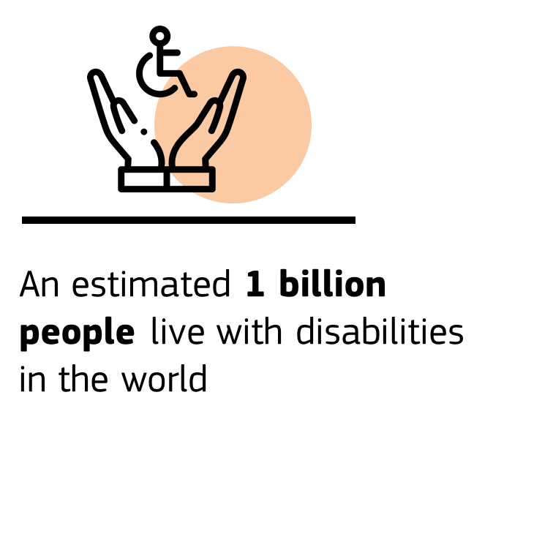
About 15% of the world’s population lives with some form of disability, and about 2-4% experience serious difficulties in functioning and of which about 80% live in developing countries. In large parts of the world, persons with disabilities have poor access to inclusive basic services, protection, assistive technologies, information, justice and legal identity. This comes in addition to discrimination and a lack of job opportunities. Among the most pressing issues are continued institutionalised care and segregation. Education systems are often not inclusive of the needs of children with disabilities. Furthermore, persons with disabilities are often among the most vulnerable in humanitarian crises. In disasters, their mortality rate is two to four times higher than that of persons without disabilities.
With this Strategy, the EU will reinforce its role globally as an advocate for rights of persons with disabilities through cooperation, humanitarian action and dialogue with the international UNCRPD community. While recognising the different challenges partner countries face and the variety of cooperation frameworks in place with the EU, this Strategy will serve as inspiration to guide reform efforts and planning of assistance with partner countries and relevant stakeholders. Moreover, the EU will continue to deliver humanitarian aid and protection based on needs, in accordance with the humanitarian principles.
The EU calls on all states to respect, protect and fulfil the rights of persons with disabilities as reflected in all policy initiatives shaping the next decade. It is essential that external action respects and implements the UNCRPD principles alongside the Agenda 2030, mainstreaming the Universal Design approach for better accessibility and provision of reasonable accommodation for persons with disabilities into all actions. The EU will do this using all its tools ranging from political, human rights and trade dialogues, to cooperation with third countries in the EU’s neighbourhood, enlargement and international partnership policies covering also humanitarian action and cooperation with multinational organisations. The EU supports reforms of public policies globally to make these more inclusive and strives to ensure that all human rights, including the rights of persons with disabilities, remain at the core of the response to the COVID-19 pandemic and the global recovery. EU delegations provide support to advance the rights of persons with disabilities, guidance to implement accessibility and ensure meaningful consultation of persons with disabilities, including through their representative organisations based on existing good practices. The EU strives for targeted action on disability as well as disability mainstreaming in its external action. The EU’s Action Plan on Human Rights and Democracy 2020-2024 and the EU Gender Action Plan III 2021-2025 lay out the EU’s ambitions to step up action to combat all forms of discrimination that persons with disabilities face, with a specific attention to multiple and intersecting forms of discrimination, in accordance with its human rights guidelines on non-discrimination in external action.
The EU will also aim to ensure that the needs of persons with disabilities are adequately addressed in EU-funded humanitarian aid, through strengthening the involvement of persons with disabilities and cooperation with civil society, as well as supporting capacity building. In addition, the EU will strengthen its data collection on persons with disabilities in EU-funded humanitarian aid, for example by means of promoting the use of the Washington Short Set of Questions. Furthermore, a reference to the UNCRPD will be included in the revision of the EU’s Generalised Scheme of Preferences regulation GSP+ incentivising its compliance by the related trade partners.
The EU will also step up and consolidate its cooperation with other State Parties and signatories to advance the ratification and implementation of the UNCRPD, and to increase leadership especially in the context of the annual UNCRPD Conference of State Parties. The EU continues to support civil society organisations to ensure that representatives of persons with disabilities can participate in all relevant processes through specific and inclusive structured dialogues, at EU, partner countries’ and global level. These trigger exchanges on strategic initiatives and best practices in combination with a wider dissemination of results.
The EU will share its strategies and practices on the implementation of the UNCRPD in UN multilateral fora, such as the Human Rights Council, the Commission on the Status of Women, or the Commission of Social Development and with regional integration organisations, such as the African Union, ASEAN or USAN. The aim of this exchange would be to stimulate transparent and ambitious implementation of the UNCRPD across the world while the EU would also benefit from the global exchange of practices. A stronger involvement of the EU in the UNCRPD Committee could trigger more effective implementation of the UNCRPD both in the EU and beyond. The Commission will propose to the Member States that the EU puts forward a candidate for the elections of the UNCRPD Committee in line with the Joint Communication on Multilateralism.
The Commission and the High Representative for Foreign Affairs and Security Policy / Vice-President of the Commission (HRVP) will:
- in 2021, update the Toolbox on the “Rights Based Approach, encompassing all human rights for EU development cooperation” to address all inequalities, including discrimination against persons with disabilities, in external actions;
- ensure that the EU delegations play a more active role in supporting the implementation of the UNCRPD and fostering global ratification;
- systematically use the OECD Development Assistance Committee (DAC) disability marker to track disability inclusive investments for a targeted monitoring of EU funding;
- provide technical assistance together with Member States to partner countries’ administrations through their programmes and facilities;
- organise regular structured dialogues during the annual UNCRPD Conference of State Parties, and in the context of other existing multilateral fora, and enhance cooperation with a focus on accessibility and employment.
- Efficiently delivering the strategy
The Commission calls on Member States and all EU institutions and agencies to take needs of persons with disabilities into consideration when designing, implementing and monitoring policies, legislation and funding programmes through targeted action and mainstreaming. The Commission encourages cooperation on disability between EU institutions, Member States, and other stakeholders, supported by the use of EU funding and the provision of training.
  - Better Regulation - UNCRPD compliance in policymaking
Better Regulation aims at providing the best possible basis for timely and sound policymaking. Article 10 TFEU underlines that the Union should combat discrimination, including that based on disability, when defining and implementing its policies.
Effective policy making implies consultation and participation of persons with disabilities and their representative organisations throughout the process and the provision of information about relevant policy initiatives and consultations in accessible formats.
As part of its activities towards promoting equality for all and equality in all its senses, the Commission’s Task Force on Equality strives to ensure the mainstreaming of disability throughout all policy areas.
The Commission will also:
- reinforce the Better Regulation toolbox to enhance disability-inclusiveness for ensuring UNCRPD consistency;
- ensure the coherent inclusion and assessment of disability matters in impact assessments and evaluations where relevant, including through training of staff preparing initiatives on the UNCRPD.
  - Stepping up cooperation of EU institutions and Member States
In order to reinforce UNCRPD implementation and to better reflect the commitment taken by the EU as a party to the Convention, the Commission will invest in strengthening coordination at EU level in line with the recommendations by the UN Committee on the Rights of Persons with Disabilities. The Commission will work with the European Parliament and the Council to ensure that disability matters are adequately taken into account in inter-institutional negotiations and will work together to identify gaps in existing legislation.
The Commission will:
- call on all EU institutions and bodies, agencies and delegations to designate disability coordinators for their institutions and for their disability strategies;
- organise regular high-level meetings between the European Parliament, the Council, the Commission and the EEAS, involving representative organisations of persons with disabilities;
- arrange an annual exchange of views with the European Economic and Social Committee and the Committee of Regions.
The Commission calls on Member States:
- to take account of specific needs of persons with disabilities in all policies to be dealt with at Council level and in Council conclusions (disability mainstreaming).
  - Working with Member States, regional and local authorities
Member States as parties to the UNCRPD are key actors to implement the UNCRPD involving governments, parliaments and other stakeholders at various levels. They have to regularly report to the UN Committee on their measures to implement the UNCRPD including national strategies for persons with disabilities. The Commission will reinforce the governance mechanism for cooperation at EU level.
Flagship initiative:
The Commission will in 2021 establish the Disability Platform. It will replace the existing High Level Group on Disability and support the implementation of this Strategy as well as national disability strategies. It will bring together national UNCRPD focal points, organisations of persons with disabilities and the Commission. The Platform could be used as a forum to exchange on the UN’s assessments of Member States’ implementation of the UNCRPD. The online presence of the Disability Platform will contain information on its meetings, activities, analysis, and country information, including promotion of accessible and inclusive good practices.
The Commission will also:
- establish a dialogue on disability with existing networks of local and regional authorities.
The Commission calls on Member States:
- to adopt ambitious national strategies to foster the implementation of the UNCRPD and of this Strategy at national, regional and local level.
  - Supporting implementation through EU funding
To support the implementation of this Strategy and of the UNCRPD, the EU will continue to promote the use of EU funding by the Member States as provided for in the Multiannual financial framework 2021-2027 and by new funding opportunities under NextGenerationEU, the Recovery Plan which will lead the way out of the current crisis and lay the foundations for a modern and more sustainable Europe. The Technical Support Instrument may support Member States with tailor-made technical expertise.
The Common Provisions Regulation for shared management funds provides the policy framework for, among others, the Cohesion policy funds, including the European Social Fund+ (ESF+), the European Regional Development Fund (ERDF) and the new Just Transition Fund (JTF). It sets out that Member States must meet so-called ‘enabling conditions’ to ensure that the investment environment for EU support is well prepared upfront. One enabling condition requires that a national framework to ensure implementation of the UNCRPD is in place. One of the criteria for its fulfilment relates to having in place arrangements to ensure accessibility. EU funding supports areas such as deinstitutionalisation, socio-economic inclusion of persons with disabilities, access to services, inclusive education and healthcare, making cultural heritage more inclusive and ensuring accessibility. UNCRPD Member State focal points can play an important role in supporting the fulfilment of the relevant enabling conditions through the programming period. The Common Provisions Regulation also requires that accessibility for persons with disabilities be taken into account throughout the preparation and implementation of Member States’ operational programmes.
Other funds can play a role in achieving the objectives of this Strategy.
The Erasmus+ programme will foster financial support and other inclusion measures for participants with disabilities. The Citizenship, Equality, Rights and Values Programme (CERV) will support the implementation and governance of this Strategy. The Commission will foster a disability-inclusive implementation of other financial instruments and programmes such as InvestEU, Horizon Europe.
To align the management of the relevant funds under the Multi-annual financial framework for 2021-2027 with regards to the rights of persons with disabilities, the Commission will support Member States through stronger cooperation, awareness raising activities, and targeted guidance.
The Neighbourhood, Development and International Cooperation Instrument 2021-2027 will contribute to the implementation of the external objectives of the strategy. Funds such as SOCIEUX+, the technical cooperation programme focusing on short-term missions, the Technical Assistance and Information Exchange instrument (TAIEX) and TWINNING programmes will help to implement EU disability policies worldwide.
The Commission will also:
- explore funding opportunities through the new Citizenship, Rights, Equalities and Values Programme (CERV) to foster engagement of citizens with disabilities on equal basis with others;
- support Member States to use EU Funds in compliance with the UNCRPD and respecting accessibility ensuring that EU funds do not support actions that contribute to segregation or exclusion.
The Commission calls on the Member States to:
- ensure partnership with regional, local authorities, representative organisations of persons with disabilities, civil society, fundamental rights bodies and other stakeholders in the design and implementation of EU funds;
- encourage the UNCRPD focal points to support the fulfilment of the relevant enabling conditions throughout the programming period.
- Leading by example
The Commission aims to lead by example and calls on other EU institutions, bodies and agencies to do likewise.
  - Making selection, recruitment, employment and retention processes disability-inclusive
Diversity and inclusion enrich and strengthen organisations. In this spirit, the Commission will include in its renewed Human Resources (HR) strategy actions to boost the recruitment, effective employment and career perspectives of staff with disabilities and to create inclusive work environments, reinforcing its commitment as an employer to foster diversity and equality while also ensuring that accessibility and reasonable accommodation are provided for. The recently created ‘Diversity and Inclusion Office’ will oversee the development and implementation of relevant actions and contribute to advancing diversity, equality and inclusion across all Commission departments.
The selection and recruitment process is merit-based and follows an equal opportunities policy. However, a proactive approach and steps to promote greater diversity need to be implemented.
As regards recruitment, equality and diversity screenings of recruitment processes, procedures and tools will be carried out in order to identify any potential risk of bias or discrimination and the remedial actions needed. Appropriate actions will be taken to ensure effective remedy of the issues identified by the equality and diversity screenings.
This will be supported by an internal Commission communication campaign and training for staff, including to managers and HR professionals (for whom training will be mandatory), to ensure a respectful working environment and act against bias and discrimination, including against persons with disabilities.
As regards staff selection, the inter-institutional European Personnel Selection Office (EPSO) will continue to apply its equality, diversity and inclusion policy to its competitions and selections by gathering data on disability at the application stage. In this manner EPSO is able to guarantee reasonable accommodation, better identify gaps in its outreach, and increase possibilities for candidates with disabilities to participate in the tests. It will also update its targeted communication and outreach strategy, further develop its network of disability partner organisations, its expertise in reasonable accommodations, as well as its training and service catalogue.
In all its recruitment channels and different programmes, the Commission applies an equal opportunities policy. In order for this to materialise in practice, it will explicitly encourage applications from persons with a disability and will provide candidates with targeted support and assistance throughout the process.
The European External Action Service (EEAS) will continue the implementation of its Action Plan on disability.
Flagship initiative:
The Commission will adopt a renewed HR strategy that will include actions to promote diversity and inclusion of persons with disabilities, and invites EPSO to complement these efforts in collaboration with other recruiting EU institutions.
The Commission will also:
- ensure the continuous removal and prevention of barriers by all services for staff and public with disabilities (e.g. accessible ICT equipment and tools for online meetings);
- strengthen reporting by the management of all Commission services on diversity, including reasonable accommodation for staff with disabilities.
  - Accessibility of buildings and communication
The Commission has been continuously improving the accessibility of its buildings, digital environments and communications and will scale up efforts to ensure accessibility, including innovative projects, increasing the accessibility of publications, notably of EU law and policies, providing training for staff and supporting learning of interpretation in International Sign Language.
The Commission will:
- adopt, in 2021, an Action Plan on web accessibility, to be shared and promoted in all EU institutions, bodies and agencies in view of ensuring compliance of EU websites, documents published on these websites and online platforms, with European accessibility standards;
- improve by 2023 accessibility across its audiovisual communications and graphic design services as well as of its publications and events, including where relevant sign language interpretation and documents in ‘easy-to-read’ format;
- ensure accessibility for all newly occupied buildings of the Commission, subject to possible urban planning requirements of the host countries;
- ensure the accessibility of venues where Commission events are organised;
- ensure that by 2030 all Commission buildings follow European accessibility standards, subject to urban planning requirements of the host countries.
- Awareness, governance and measuring progress
The Commission will work with Member States to complement and support national campaigns, to strengthen awareness-raising and to combat stereotypes around disability. It will continue organising dedicated events, notably the European Day of Persons with Disabilities celebrating the UN International Day of Persons with Disabilities on 3rd of December.
The Commission will reinforce structured dialogues with persons with disabilities and their representative organisations, ensure their representation in relevant political processes and their consultation on relevant Commission proposals. It will continue to finance work by organisations of persons with disabilities contributing to implement the UNCRPD through the Citizenship, Equality, Rights and Values programme.
The Optional Protocol of the UNCRPD allows persons with disabilities to address the related Committee when they claim to be victims of a violation by that State Party of the provisions of the UNCRPD. Not all Member States have acceded the Protocol, and a proposal for a Council Decision for EU accession to the Optional Protocol of the UNCRPD has been pending since 2008. The Commission will closely follow the progress of accession by Member States to the Optional Protocol and re-examine the EU’s ratification of the UNCRPD Optional Protocol in that light.
The Commission will initiate work with the Council to update the EU declaration concerning the competence of the EU with regards to matters governed by the UNCRPD as recommended by the UNCRPD Committee in 2015. The number of relevant EU legal acts has considerably increased from about 40 listed in the declaration in 2008 to over 130.
  - Strengthening the EU Framework under the UNCRPD
As party to the UNCRPD the EU had to set up a framework in order to promote, protect and monitor implementation of the Convention.
In this respect, a specific EU framework has been put in place consisting of the European Ombudsman, the Committee on Petitions of the European Parliament, the Fundamental Rights Agency and the European Disability Forum, each performing their tasks in an independent manner but in coordination. The EU framework oversees areas in the UNCRPD where the Member States have transferred competences to the EU as well as the implementation of the UNCRPD by the EU institutions.
To increase the effectiveness of this mechanism at EU level, the Commission will:
- examine in 2022 the functioning of the EU framework and propose actions on this basis;
- organise an annual dialogue between the Commission as EU Focal Point and the EU framework.
  - Ensuring sound monitoring and reporting
Building upon the experience from the European Disability Strategy 2010-2020, the Commission will set up a framework to monitor the implementation of this Strategy, which will also provide input for the European Semester, the Social Scoreboard and the implementation of the Sustainable Development Goals.
Monitoring the progress in Member States will rely on improved statistical data collection on the situation of persons with disabilities, and information on national policies and practices complementing reporting by the Member States to the dedicated UN Committee. A new dashboard will present progress made in implementing the activities at EU level under this Strategy as well as those in which the Commission calls on Member States for action. The Commission will continue monitoring the implementation of EU disability legislation. Further, it will consider whether to fine-tune actions on the basis of a mid-term report of this Strategy.
On behalf of the EU, the European Commission as EU focal point regularly reports to the UNCRPD Committee on the EU implementation of the Convention. To that end, the Commission will collect information, including from the European Parliament and the Council as well as from within the Commission services.
In order to make effective monitoring possible, quality data together with long-term research are an indispensable prerequisite. This includes insights into what the green and digital transitions mean for persons with disabilities. Though Eurostat provides survey data for key areas, existing data collection does not cover all relevant areas yet and is not always frequent enough to identify trends.
The Commission will reinforce data collection in all areas where gaps have been identified, including data on those living in institutions and research on disability under the EU Research and Innovation Framework Programme Horizon Europe (2021-2027) integrating an intersectional approach. Based on more comprehensive data collection, the Commission will strengthen monitoring of disabilities in the context of the European Semester.
The Commission will also:
- develop and publish, in 2021, a monitoring framework for the objectives and actions of this strategy;
- develop, at the latest by 2023, new disability indicators with a clear roadmap for implementation. These should include indicators for children and the situation of persons with disabilities in employment, education, social protection, poverty and social exclusion, living conditions, health, use of new communication technologies, supporting the indicators for the EU Social Scoreboard, the European Semester Sustainable Development Goals;
- prepare a report in 2024 of this Strategy assessing the progress of its implementation and, if deemed necessary, update its objectives and actions;
- develop a strategy for data collection, steer Member States accordingly and provide an analysis of existing data sources and indicators including administrative data.
- Conclusion
With this Strategy, the Commission aims to deliver further significant improvements to all areas of the lives of persons with disabilities within the EU and beyond. Over the coming decade, this Strategy will support both Member States and EU institutions in their endeavour to implement the UNCRPD. Accomplishing the initiatives envisaged in this strategy will contribute to reducing discrimination, inequalities and supporting persons with disabilities to fully enjoy their human rights, fundamental freedoms and EU rights on an equal basis with others, by 2030, to maximize their independence, participation and decent living conditions.
The objectives of this Strategy will need to be achieved through a strong commitment by the Member States, by promoting policies and actions that will bring about accessible environments, inclusive education systems as well as health care systems of high quality and effective pathways to fair employment for persons with disabilities.
Empowering persons with disabilities to fully participate and contribute to the transition to an inclusive, green and digital economy and society as well as to our democracy will reaffirm the EU values enshrined in the Treaties. It will bring a strong contribution to the Union of Equality, and strengthen the rights of persons with disabilities globally.
The Commission invites the European Parliament and the Council to work together and to lead by example in achieving implementation of the UNCRPD both at EU and national levels. It invites the Council to adopt Conclusions on this Strategy.

President of the European Commission, von der Leyen, European Day of Persons with Disabilities 2020.
UNCRPD.
Implementation at EU level.
Interinstitutional Proclamation on the European Pillar of Social Rights (2017/C 428/09).
Commission Communication (COM (2010) 636 final): European Disability Strategy 2010-2020.
Data: EU SILC (Statistics on Income and Living Conditions) and EU LFS (Labour Force Survey). 24.7% of EU population > 16 years are limited in their activities, 17.7% having moderate, 7% severe limitations; S. Grammenos/M. Priestley, 2020: Europe 2020 data and people with disabilities.
Commission (SWD(2020) 291 final): Evaluation of the European Disability Strategy 2010-2020.
Special Eurobarometer 493, Discrimination in the EU, May 2019.
UN Resources on Persons with Disabilities and COVID-19.
Cohesion policy action against Coronavirus: European Solidarity Fund; Corona Response Investment Initiative; REACT-EU (Recovery Assistance for Cohesion and the Territories of Europe) Package.
Commission Communication (COM/2020/456 final): Europe's moment: Repair and Prepare for the Next Generation.
Commission Communication COM/2020/442 final): The EU budget powering the recovery plan for Europe.
As called for in the Joint Statement by the High Representative of the Union for Foreign Affairs and Security Policy and Vice-President Borrell, Vice-President Jourova and Commissioner Dalli.
European Parliament resolution of 18 June 2020 on the European Disability Strategy post‑2020.
Council conclusions, 2019: Improving the employment of people in a vulnerable position in the labour market; Council conclusions on Access to sport for persons with disabilities.
European Economic and Social Committee (EESC), 2019: Shaping the EU agenda for disability rights 2020-2030; European Committee of the Regions, 2017: Deinstitutionalisation in care systems at local and regional level.
European Green Deal (COM/2019/640 final); European Climate Pact (COM(2020) 788 final); Shaping Europe´s Digital Future (COM/2020/67 final); Building a European Health Union (COM/2020/724 final); A New Circular Economy Action Plan (COM(2020) 98 final); A Renovation Wave for Europe (COM(2020) 662); Digital Education Action Plan 2021-202 (COM(2020)624 final).
United Nations: The 2030 Agenda for Sustainable Development.
Directive 2019/882/EU European Accessibility Act; Directive 2016/2102/EU Web Accessibility Directive; Directive 2018/1972 European Electronic Communications Code; Directive 2018/1808 Audiovisual Media Services Directive and the copyright legislation adopted under the Marrakesh Treaty (2013) to Facilitate Access to Published Works for Persons Who Are Blind, Visually Impaired or Otherwise Print Disabled.
Accessibility standards resulting from Commission Mandates 376, 554, 420 and 473.
Tallinn Declaration on eGovernment, 2017; Berlin Declaration on Digital Society and Value-Based Digital Government. The EU space programme also supports eGovernment policies with data, information and services.
Commission (COM/2021/85 final): Proposal for a Regulation of the European Parliament and of the Council on roaming on public mobile communications networks within the Union (recast).
EU Passenger rights; Interoperability: Commission Regulation (EU) No 1300/2014.
Commission initiative: Access City Award.
Commission Recommendation (EU) 2019/786 of 8 May 2019 on building renovation.
Commission Proposal for a Common Provisions Regulation for shared management funds (COM(2018)375 final) as amended by COM(2020) 450 final; Directive 2014/24/EU on public procurement.
Evaluation of air, waterborne, bus and coach passenger rights for persons with disabilities and reduced mobility (2021), with the view of reviewing passenger rights in the regulatory framework (2021-2022); evaluation of the Web Accessibility Directive (2022); review of the European Electronic Communications Code (2025).
Reports on the outcome of monitoring and the use of the enforcement procedure that Member States shall submit to the Commission for the first time in December 2021 and every three years thereafter will show progress in the practical implementation of the Directive and in the accessibility of public sector website and mobile applications over time.
Whereas the obligation to renovate a percentage of public buildings annually currently applies only to central governments, it will be extended to buildings at all public administration levels, including the Commission.
See section 7.3.
Commission Communication (COM(2020)789 final): Sustainable and Smart Mobility Strategy, points 91 and 92, and Annex, actions 63 and 64. The evaluations of the Regulations on air passenger rights for persons with disabilities and reduced mobility and on waterborne and bus and coach passenger rights (2021) are ongoing and should be finalised in the first semester of 2021.
Commission implementing regulation (EU) 2019/772.
Regulation (EU) No 1315/2013: Union guidelines for the development of the trans-European transport network; Commission Communication (COM(2020)789 final): Sustainable and Smart Mobility Strategy, point 23 and Annex, action 55.
Commission Communication (COM(2020)789 final): point 37, and Annex, action 20.
EU Disability card: pilot project in 8 MS (Belgium, Cyprus, Estonia, Finland, Italy, Malta, Romania, Slovenia).
Infographic: EESC Information Report (SOC/554), 2019: Real rights of persons with disabilities to vote in European Parliament elections. The organisation of elections in the EU is largely regulated at Member State level, and there are a variety of national laws affecting political advertising and communications, including on their transparency. There is also a significant body of EU law relevant in this context. This includes in the context of European parliamentary elections, the 1976 European Electoral Act and the regulation on the statute and financing of European Political Parties and Foundations. The Commission does not have a general power to intervene in electoral matters. Subject to the respect of certain basic principles, such as those laid down in Articles 2 and 14 of the Treaty on European Union, it is the competence and the responsibility of the Member States to lay down the specific conditions for the conduct of elections, and of the competent national administrative and judicial authorities to ensure compliance with applicable law and relevant standards.
Commission Recommendation (EU) 2018/234: Enhancing the European nature and efficient conduct of the 2019 elections to the European Parliament.
Commission Communication (COM(2020) 790 final): European democracy action plan.
The Commission will work with Member States to improve indicators and data collection taking account of gaps identified in this report.
European Parliament resolution of 26 November 2020: Stocktaking of European elections.
Commission, 2020: EU Citizenship Report 2020: Empowering citizens and protecting their rights.
European Cooperation Network on elections.
EU funding and deinstutionalisation; long-stay residential institutions were excluded from EU funding.
N. Crowther (ANED), 2019: The right to live independently and to be included in the community in European States.
Coface – FamiliesEurope, 2020: Disability and the Family.
Academic Network of European Disability Experts (ANED), 2018: Mainstreaming Disability Rights in the European Pillar of Social Rights – a compendium, p. 94ff.
OECD, 2020. Policies for present and future service delivery across territories.
Commission (COM(2021) 50 final): Green Paper on Ageing.
Regulation (EU) 2021/240 of the European Parliament and of the Council of 10 February 2021 establishing a Technical Support Instrument, OJ L 57, 18.2.2021, p. 1.
Commission Communication (COM(2020)274 fin): European Skills Agenda for sustainable competitiveness, social fairness and resilience.
See ANED, 2018, p.103f.; Reasonable accommodation means necessary and appropriate modification and adjustments not imposing a disproportionate or undue burden, where needed in a particular case (Article 2 UNCRPD).
EU SILC (2018).
Council Recommendation (2020/C 417/01).
Council Recommendation (2020/C 372/01): Reinforcing the Youth Guarantee.
Commission Communication (COM/2018/022): Digital Education Action Plan.
ANED, 2018, p. 184ff.
Council Directive (2000/78/EC): Establishing a general framework for equal treatment in employment and occupation.
Commission Recommendation (EU) 2018/951: Standards for equality bodies.
Social economy in the EU. The social economy includes cooperatives, mutual societies, non-profit associations, foundations, and social enterprises.
This report will be presented jointly with the report on Council Directive 2000/43/EC of 29 June 2000 implementing the principle of equal treatment between persons irrespective of racial or ethnic origin.
ANED, 2018, p. 12, 62ff.; see also: ILO: Disability-inclusive social protection.
For 2021-2027, this programme has been replaced by the Technical Support Instrument, with a broader mandate and an increased budget of €864.4 million.
Commission Communication (COM(2020) 710 final): Digitalisation of justice in the European Union; Commission Communication (COM/2020/258 final): EU Strategy on Victim´s rights 2020-2025; Commission Communication (COM(2020) 713 final): Ensuring justice in the EU — a European judicial training strategy for 2021-2024.
In its Resolution on the situation of women with disabilities (2018/26855RSP), the European Parliament also stresses that 34% of women with a health problem or a disability have experienced physical or sexual violence by a partner in their lifetime.
United Nations, 2020: International Principles and Guidelines on Access to Justice for Persons with Disabilities.
Racial Equality Directive (2000/43/EC); Employment Equality Directive (2000/78/EC); Equal Treatment Directive (2006/54/EC).
Gaps: see infographics in chapters 4 and 5 on discrimination, education, employment, poverty and healthcare.
Proposal COM/2008/0426 for a Council Directive on implementing the principle of equal treatment between persons irrespective of religion or belief, disability, age or sexual orientation.
Such as the European Network of National Human Rights Institutions (ENNHRI), the European Network of Equality Bodies (Equinet) and the European Network of Ombudsmen (ENO).
Commission Communication (COM(2020) 625 final): Achieving the European Education Area by 2025.
European Agency for Special Needs and Inclusive Education an independent organisation that acts as a platform for collaboration for the ministries of education in its member countries.
The forthcoming European Child Guarantee, Erasmus Plus, European Solidarity Corps.
As approved by the Board of Governors on its meeting in April 2019 in Athens.
EU-SILC 2019: table (hlth_dh030).
EU-SILC 2018; Cedefop 2016: Skill shortage and surplus occupations in Europe; Eurostat, 2020: Handbook Ageing Europe; Eurostat Regional Yearbook 2020.
Commission Communication (COM/2020/724 final): Building a European Health Union.
Commission Communication (COM(2018) 233 final): Enabling the digital transformation of health and care in the Digital Single Market.
Several Member States have received support through the Commission´s Structural Reform Programme to improve cancer screening programmes with a view to its early detection.
Council Conclusions, 2019: Access to sport for persons with disabilities.
Directive (EU) 2018/1808: Audiovisual Media Services Directive.
Directive (EU) 2017/1564: Certain permitted uses of certain works and other subject matter protected by copyright and related rights for the benefit of persons who are blind, visually impaired or otherwise print-disabled.
European Capital of Smart Tourism for sustainability, accessibility, digitalisation, cultural heritage/creativity.
Reports European Agency for Fundamental Rights: https://fra.europa.eu/en/publication/2015/children-disabilities-violence; https://fra.europa.eu/en/publication/2014/violence-against-women-eu-wide-survey-main-results-report.
Fundamental Rights Agency, 2021: Fundamental Rights Survey - Crime, Safety and Victims’ Rights.
Commission (COM(2020) 661 final): Third Report on the progress made in the fight against trafficking in human beings and its Staff Working Document, SWD(2020) 226 final).
S. Jodoin, N. Ananthamoorthy, K. Lofts, 2020: A Disability Rights Approach to Climate Governance, in: Ecology Law Quarterly, Vol. 47, No. 1.
Commission Communication (COM(2020) 152 final): A Union of Equality: Gender Equality Strategy 2020-2025.
Commission Communication (COM/2020/609 final): A New Pact on Migration and Asylum.
Commission Communication (COM(2020) 758 final): Action Plan on Integration and Inclusion (2021-2027).
World Health Organization/World Bank, 2011: World report on disability see page 27.
Inter-Agency Standing Committee, 2019: Inclusion of Persons with Disabilities in Humanitarian Action, p. 2.
1) Joint communication (JOIN (2020) 5 final): EU Action Plan on Human Rights and Democracy 2020-2024; 2) Joint Communication (JOIN (2020) 17 final): EU Gender Action Plan (GAP) III – an Ambitious Agenda for Gender Equality and Women's Empowerment in External Action 2021–2025; 3) The EU’s Generalised Scheme of Preferences (GSP).
Council, 6337/19, 2019: EU human rights guidelines on non-discrimination in external action.
Washington Group on Disability Statistics: Short Set on Functioning.
In particular in other regional integration organisations, such as the African Union, ASEAN or USAN.
Joint Communication (JOIN (2021) 3): Strengthening the EU’s contribution to rules-based multilateralism.
OECD, 2019: Handbook for the marker for the inclusion and empowerment of persons with disabilities.
This internal Task Force on Equality is composed of representatives of all Commission services and the European External Action Service. It is supported by a Secretariat based in the Secretariat General of the European Commission.
UN Committee, 2015: Concluding observations on the initial report of the European Union, points 75, 77.
Networks include for example Eurocities or the Council of European Municipalities and Regions – CCRE.
Council Regulation (2020/2093): Multiannual financial framework 2021-2027.
NextGenerationEU is a €750 billion temporary recovery instrument to help repair the economic and social damage brought about by the coronavirus pandemic. Its centre piece is the Recovery and Resilience Facility, which will provide loans and grants to support reforms and investments by Member States: Council Regulation (EU) 2020/2094 establishing a European Union Recovery Instrument to support the recovery in the aftermath of the COVID-19 crisis.
The co-legislators reached on 1 December 2020 a political agreement on the Commission Proposal (COM(2018)375 final) for a Common Provisions Regulation for shared management funds.
Erasmus Plus; InvestEU; Horizon Europe.
Multiannual financial framework for 2021-2027.
The European Personnel Selection Office EPSO will continue improving accessibility of its tests and its web site in order to become compliant with the Web Content Accessibility Guidelines.
Optional Protocol; State of ratification: 21 Member States.
UN Committee, 2015: Concluding observations on the initial report of the European Union.
Commission (SWD(2017) 29 final): Progress Report on the implementation of the European Disability Strategy (2010 - 2020).
Revised EU-level Framework to comply with Article 33.2 of the UNCRPD.
Reporting: further information is collected on EU institutions, agencies and bodies.
For example, persons with disabilities living in institutions, health, humanitarian aid, employment.

