

Table of Contents

5.19 Netherlands (NL) 442

5.19.1 Main messages from the Commission assessment of the NPF 442

5.19.2 Overview of requirements’ fulfilment from Annex I of the Directive 443

5.19.3 Quantitative assessment: Vehicles and infrastructure 445

5.19.4 Measures assessment 454

5.19.5 Additional information on alternative fuels infrastructure developments 460

5.19.6 Summary of the assessment 462

5.19.7 Final remarks 466

5.19.8 ANNEX - Description of the Member State 468

5.20 Austria (AT) 469

5.20.1 Main messages from the Commission assessment of the NPF 469

5.20.2 Overview of requirements’ fulfilment from Annex I of the Directive 471

5.20.3 Quantitative assessment: Vehicles and infrastructure 472

5.20.4 Measures assessment 479

5.20.5 Additional information on alternative fuels infrastructure developments 483

5.20.6 Summary of the assessment 484

5.20.7 Final remarks 486

5.20.8 ANNEX - Description of the Member State 488

5.21 Poland (PL) 490

5.21.1 Main messages from the Commission assessment of the NPF 490

5.21.2 Overview of requirements’ fulfilment from Annex I of the Directive 491

5.21.3 Quantitative assessment: Vehicles and infrastructure 492

5.21.4 Measures assessment 497

5.21.5 Additional information on alternative fuels infrastructure developments 502

5.21.6 Summary of the assessment 503

5.21.7 Final remarks 505

5.21.8 ANNEX - Description of the Member State 507

5.22 Portugal (PT) 508

5.23 Romania (RO) 509

5.23.1 Main messages from the Commission assessment of the NPF 509

5.23.2 Overview of requirements’ fulfilment from Annex I of the Directive 511

5.23.3 Quantitative assessment: Vehicles and infrastructure 512

5.23.4 Measures assessment 520

5.23.5 Additional information on alternative fuels infrastructure developments 526

5.23.6 Summary of the assessment 527

5.23.7 Final remarks 530

5.23.8 ANNEX - Description of the Member State 532

5.24 Slovenia (SI) 533

5.24.1 Main messages from the Commission assessment of the NPF 533

5.24.2 Overview of requirements’ fulfilment from Annex I of the Directive 535

5.24.3 Quantitative assessment: Vehicles and infrastructure 536

5.24.4 Measures assessment 542

5.24.5 Additional information on alternative fuels infrastructure developments 545

5.24.6 Summary of the assessment 546

5.24.7 Final remarks 548

5.24.8 ANNEX - Description of the Member State 550

5.25 Slovakia (SK) 551

5.25.1 Main messages from the Commission assessment of the NPF 551

5.25.2 Overview of requirements’ fulfilment from Annex I of the Directive 553

5.25.3 Quantitative assessment: Vehicles and infrastructure 555

5.25.4 Measures assessment 561

5.25.5 Additional information on alternative fuels infrastructure developments 564

5.25.6 Summary of the assessment 565

5.25.7 Final remarks 567

5.25.8 ANNEX - Description of the Member State 569

5.26 Finland (FI) 570

5.26.1 Main messages from the Commission assessment of the NPF 570

5.26.2 Overview of requirements’ fulfilment from Annex I of the Directive 571

5.26.3 Quantitative assessment: Vehicles and infrastructure 572

5.26.4 Measures assessment 582

5.26.5 Additional information on alternative fuels infrastructure developments 587

5.26.6 Summary of the assessment 589

5.26.7 Final remarks 593

5.26.8 ANNEX - Description of the Member State 595

5.27 Sweden (SE) 596

5.27.1 Main messages from the Commission assessment of the NPF 596

5.27.2 Overview of requirements’ fulfilment from Annex I of the Directive 597

5.27.3 Quantitative assessment: Vehicles and infrastructure 598

5.27.4 Measures assessment 607

5.27.5 Additional information on alternative fuels infrastructure developments 611

5.27.6 Summary of the assessment 612

5.27.7 Final remarks 614

5.27.8 ANNEX - Description of the Member State 616

5.28 United Kingdom (UK) 617

6 Abbreviations 618

7 References 621



## Netherlands (NL)

### Main messages from the Commission assessment of the NPF

In its original assessment of the Dutch NPF the Commission concluded:

*The Dutch NPF fully addresses the requirements of Article 3, except for the definition of future targets for CNG refuelling points. It contains an extensive discussion of the current state and future scenarios for alternative fuels in the transport sector. For all fuels and modes, it establishes targets as required by Article 3 of the Directive, except for CNG refuelling points.*

*The Dutch NPF puts a lot of emphasis on electric vehicles, although the future estimated share of 1.5% EV seems low in comparison to the current share of EVs on the road, which is already above 1%. The Netherlands already today has a considerable number of recharging points. Their spatial distribution and especially the increasing number of high power recharging points along main roads seems to appropriately cover the needs of electric vehicles in terms of distance requirements. The ratio of one public recharging point per 8 electric vehicles estimated for 2020 indicates that the Netherlands has defined appropriate targets for recharging infrastructure in line with the requirements of the Directive. No targets are foreseen for increasing the availability of electricity supply for stationary airplanes. The Dutch NPF contains targets for further increasing shore-side electricity in its ports.*

*The same is true for CNG refuelling points. However, the Dutch NPF considers CNG is likely to have a limited market share and does not foresee an increase in CNG refuelling infrastructure. It does not commit to keep the current level of CNG refuelling infrastructure.*

*Targets for LNG refuelling for vessels and heavy-duty trucks are defined in the NPF. Dual LNG refuelling points for waterborne and road transport is the preferred option. If the planned LNG bunkering points in the Dutch ports were realised, this would guarantee that the requirement for LNG refuelling points on the maritime and inland ports of the TEN-T Core Network would be fulfilled in the Netherlands. The same is true for the targeted LNG refuelling points for heavy-duty trucks.*

*The Dutch NPF displays a strong commitment towards hydrogen. The deployment of 20 publicly accessible hydrogen refuelling points is planned by 2020.*

*The Dutch NPF contains a well-balanced portfolio of measures, mostly based on Administrative Agreements and public private cooperation. These instruments, coupled with fiscal incentives, have proven to be effective for the deployment of electric vehicles and the related recharging infrastructure. They are comprehensive and seem to have a high impact on fostering deployment. Hence, similar measures proposed for other AF can be considered having at least a medium impact on market actor's decisions. Most of the measures are already in effect, and have an average duration of four years, so that continuity through that period is assured, increasing the likelihood that targets and objectives of the NPF can be reached.*

*The consideration of the interests of regional and local authorities, as well as stakeholders is part of the Dutch policy, e.g. put into practice via the "Green Deals", and can be considered exemplary.*

*The Netherlands is actively involved in coordinating its plans on alternative fuels infrastructure with other Member States as well as collaborating with them in this field.*

### Overview of requirements’ fulfilment from Annex I of the Directive

*Table 5.19.2‑1 Checklist Table*

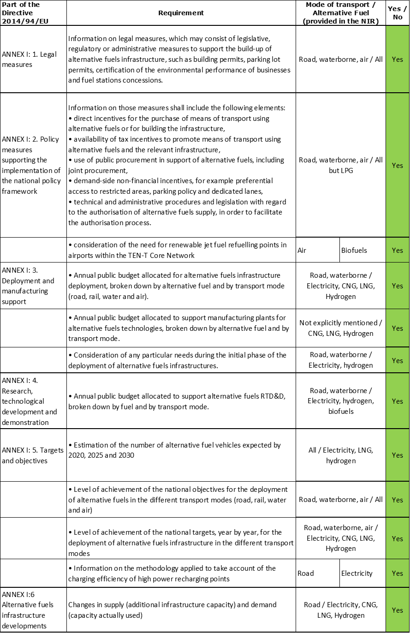

The checklist shows that all the requirements of Annex I from the Directive have been covered in the NL NIR.

Regarding the combination of AF/AFV/AFI with transport mode, electricity is partially covered for all modes; CNG, LNG, hydrogen and LPG are partially covered for road transport, LNG also for waterborne transport, while all the other combinations are either absent or not applicable.

The Dutch NIR reports 58 measures. Under the Policy and Deployment & Manufacturing sections it was possible to identify eight AF/transport mode clusters of measures, of which five were assessable.

### Quantitative assessment: Vehicles and infrastructure

*Table 5.19.3‑1 National AFV estimates and AFI targets established in the NIR at the horizon 2020, 2025 and 2030 and their comparison with the NPF situation*



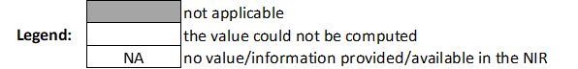

* Number of ports with at least one SSE supply point; ** Number of SSE supply points; ***Public and private hydrogen refuelling stations

#### Road transport

##### Electricity

###### Vehicles

The Netherlands recorded a total of 146,447 EVs in 2018 (in Table 5.19.3‑1 they are indicated separately as BEV and PHEV because the estimates for the next decade are only BEV), of which the majority were passenger cars (44,977 BEV and 97,750 PHEV), followed by 3,194 BEV light commercial vehicles, 118 BEV heavy commercial vehicles and 408 BEV buses and coaches. In addition, the number of electric powered two wheelers in 2018 was 49,029. The NIR affirms that the number of BEV cars has almost doubled annually in the recent years while the number of PHEV has decreased by over 2% per year.

The NL NIR’s estimates for the number of electric vehicles are based on the Dutch *Climate Agreement’s* targets for mobility. It is expected to reach around 1.5 million zero-emission vehicles (with an assumed proportion of 90% BEV and 10% FCEV) by 2030. It is especially remarkable the ambition of selling only zero-emission passenger cars in the Netherlands by then. Hence, the NIR does not provide estimates for the number of PHEV, while the estimates for BEV vehicles are 63,936 (50,000 cars, 13,000 LCVs, 120 HCVs and 816 buses and coaches) in 2020; 741,058 (700,000 cars, 37,000 LCVs, 2,000 HCVs and 2,058 buses and coaches) in 2025 and 1,453,000 (1,350,000 cars, 85,000 LCVs, 15,000 HCVs and 3,300 buses and coaches) in 2030. These estimates represent a confirmation of the NPF for 2020 and reflects a high policy ambition for 2025 and 2030 (no estimates were provided in the NPF for 2025 and 2030).

The 2018 ***attainment*** of future BEV estimates is 70.35% for 2020 and 3.09% for 2030. According to the assessment methodology described in Section 2.1, the 2018 situation corresponds to an ***adequate progress*** towards reaching the envisaged BEV estimates. The calculated ***average*** ***annual growth rate*** corresponding to the period 2016-2030 for BEV fleet evolution planned by Netherlands is equal to 41%.

###### Infrastructure

The Netherlands recorded 38,977 publicly[1] accessible recharging points in 2018 (Table 5.19.3‑1), of which 35,502 were normal charging points and 3,475 high-power charging points. The NIR mentions that the number of recharging points for road transport is rising rapidly and has doubled in the period 2016-2019. The Netherlands had only provided a target for 2020 in its NPF, which was already achieved before 2018 and the NIR provides a revised target (50,000) that is 180.21% higher than the one in the NPF. The Dutch NIR indicates that although there are not hard targets for the number of recharging points in 2030, the *National Agenda for Charging Infrastructure* considers a number of 1.7 million. On this basis, the NIR presents now targets for recharging points (public/semi-public and private) which are 925,500 in 2025 and 1,826,000 in 2030, however it declares that there are not accurate data regarding the share of private recharging points and thus information to derive the expected number of public recharging points in 2025 and 2030 is not available.

For this reason, the 2018 ***attainment*** of future public recharging infrastructure targets could be computed only for 2020 and is 77.95%. According to the assessment methodology described in Section 2.1, the 2018 situation corresponds to a ***fast progress*** towards reaching these envisaged targets. The calculated ***average annual growth rate*** corresponding to the period 2016-2020 for publicly accessible recharging infrastructure evolution planned by Netherlands is equal to 17%.

###### Ratio

Based on the NL NIR, the following table shows the ratio between vehicles and publicly accessible recharging points (i.e. sufficiency index) for the pair electricity/road. It can be seen that in 2020 the foreseen sufficiency index is 3.16, which is regarded as adequate. Because the NIR does not clearly distinct publicly accessible recharging points, the sufficiency index cannot be calculated for 2025 and 2030.



###### Information on charging efficiency

The NL NIR states that the Dutch public authorities do not use a fixed methodology to determine the charging efficiency of high power (>22kW) recharging points, although the developments concerning the network of fast recharging points will be monitored. The *National Agenda for Charging Infrastructure* contains the assumption that recharging using fast-chargers accounts for 15% of the total energy demand. Consideration on future actions and most suitable locations will be provided in the *National Charging infrastructure Action Plan*.

##### CNG

###### Vehicles

The total number of CNG vehicles recorded by the Netherlands in 2018 was 7,870 (Table 5.19.3‑1), of which 4,055 (51.52%) were passenger cars, 2,507 (31.86%) LCVs, 630 (8.01%) HCVs and 678 (8.61%) buses and coaches. The Dutch NPF did not contain any estimate for CNG vehicles in 2020, 2025 and 2030 and, likewise, no estimates are provided in the NIR. For this reason the 2018 ***attainment*** and ***progress*** could not be computed.

###### Infrastructure

The Netherlands recorded 150 CNG publicly accessible refuelling points in 2018, see Table 5.19.3‑1. The NPF had only provided a target of 145 public refuelling points for 2020. Instead the NL NIR presents a revised target for 2020 (170 points), which is 17.24% higher than the NPF, and states that for CNG the aim is to maintain the network of public refuelling stations, hence the target for 2025 and 2030 remains at 170 refuelling points.

The 2018 ***attainment*** of future public CNG refuelling infrastructure targets is constant and equal to 88.24% for 2020, 2025 and 2030. According to the assessment methodology described in Section 2.1, the 2018 situation corresponds to a ***slow progress*** towards reaching these envisaged targets. The calculated ***average annual growth rate*** corresponding to the period 2016-2030 for publicly accessible CNG refuelling infrastructure evolution planned by Netherlands is equal to 1%.

###### Ratio

Based on the NL NIR, the following table shows the ratio between vehicles and publicly accessible refuelling points (i.e. sufficiency index) for the pair CNG/road. Due to the lack of data, the sufficiency index could be calculated only for 2018, resulting well below the indicative value of 600 (see Section 2.1.5).



##### LNG

###### Vehicles

The Netherlands recorded a fleet of 457 LNG vehicles in use in 2018, composed entirely by heavy commercial vehicles (Table 5.19.3‑1). The NIR recognises that LNG has not taken off as hoped for years ago, although the fleet is growing by around 100 vehicles per year. The Dutch NPF did not contain any estimate for LNG vehicles. The NIR estimates for the number of LNG vehicles is 600 in 2020, 2,925 in 2025 and 5,250 in 2030, presumably all heavy-duty vehicles. This is showing an increased ambition.

The 2018 ***attainment*** of future LNG vehicles estimates is 76.17% for 2020 and 8.70% for 2030. According to the assessment methodology described in Section 2.1, the ***progress*** obtained by Netherlands from 2016 until 2018 for LNG vehicles deployment is 8.70% of the overall planned deployment during the period 2016-2030.

###### Infrastructure

Table 5.19.3‑1 shows that in 2018 there were already 27 publicly accessible LNG refuelling points in the Netherlands. The NL NIR declares that the aim is to have a network of LNG refuelling points where there is demand. The Dutch NPF had only provided a target for 2025. The NIR presents now a revised target of 30 LNG refuelling points in 2025, which is 7.14% higher than in the NPF.

The 2018 ***attainment*** of future public LNG refuelling infrastructure targets is 90% for 2025. According to the assessment methodology described in Section 2.1, the ***progress*** obtained by Netherlands could not be computed because the 2030 target is not provided.

###### Ratio

Based on the NL NIR, the following table shows the ratio between vehicles and publicly accessible refuelling points (i.e. sufficiency index) for the pair LNG/road.



* Value calculated from NL NPF.

##### Hydrogen

###### Vehicles

The NL NIR indicates that there were 69 hydrogen-powered vehicles (50 passenger cars, 10 LCVs, 1 HCV and 6 buses) in the Netherlands in 2018. The NIR notes that the number of hydrogen vehicles is still very low but rising, expecting a growth from 2025. As mentioned for electric vehicles, estimates for hydrogen vehicles are based on the Dutch *Climate Agreement’s* targets for zero-emission vehicles in 2030. The NIR estimates are 2,203 vehicles (1,750 cars, 400 LCVs, 3 HCVs and 50 buses and coaches) in 2020; 33,875 (15,000 cars, 15,000 LCVs, 3,000 HCVs and 875 buses and coaches) in 2025 and 189,400 (150,000 cars, 30,000 LCVs, 7,700 HCVs and 1,700 buses and coaches) in 2030. The NL NPF had only provided an estimate of 2,000 hydrogen vehicles in 2020, compared to which the NIR estimate is 3.92% higher. The estimates for 2025 and 2030 show a high ambition.

The 2018 ***attainment*** of future hydrogen vehicles estimates is 3.13% for 2020 and 0.04% for 2030. According to the assessment methodology described in Section 2.1, the ***progress*** obtained by Netherlands from 2016 until 2018 for hydrogen vehicles deployment is 0.02% of the overall planned deployment during the period 2016-2030.

###### Infrastructure

Table 5.19.3‑1 shows that in 2018 there were 15 hydrogen refuelling points in the Netherland, of which 7 publicly accessible, located in 4 public refuelling stations, and the other 8 in 4 private stations. The NIR indicates that there are 6 hydrogen refuelling stations in construction and another 12 under planning. It has to be pointed out that the NL NIR (similarly to the NPF) is not very clear concerning the number of hydrogen refuelling points versus the number of refuelling stations and concerning the share of publicly accessible stations.

The NL NPF had provided a target of 20 publicly accessible refuelling points for 2020. The NIR states that the objective is to increase the number of hydrogen refuelling stations to 20 in 2020 and that *the Dutch Climate Agreement* aim is to reach 50 stations by the end of 2025. This is showing an increase in ambition, however it is not possible for the assessors to deduct if the entire infrastructure would be publicly available.

The 2018 ***attainment*** of future public and private hydrogen refuelling stations targets is 40% for 2020 and 16% for 2025. According to the assessment methodology described in Section 2.1, the ***progress*** obtained by Netherlands could not be computed because the 2030 target is not provided.

###### Ratio

Based on the NL NIR, the following table shows the ratio between vehicles and total (both public and private) refuelling stations for the pair hydrogen/road until 2025. This is not exactly the definition of sufficiency index (which is related to the public refuelling points), however the numbers reported in the table represent a conservative estimate, as the number of refuelling points has to be equal or bigger that the number of refuelling stations.



##### Biofuels

###### Vehicles

Information in not available in the Dutch NIR.

###### Infrastructure

The NL NIR indicates that the European Fuel Quality Directive and the European Renewable Energy Directive govern the use of biofuels in the Netherlands. Provision has been made in the Dutch legislation for the blending obligation since 2007. The proportion of renewable fuels has increased to 4% for petrol and 11% for diesel in the recent years.

##### LPG

###### Vehicles

The Netherlands had a fleet of 154,448 LPG vehicles in use in 2018 (see Table 5.19.3‑1), of which 132,956 were passenger cars, 20,753 LCVs, 730 HCVs and 9 buses and coaches. The Dutch NIR notes that the popularity of LPG has been declining in the recent years, with a decrease in the number of LPG vehicles. The NIR does not contain any estimates for the next decade. For this reason, the 2018 ***attainment*** and ***progress*** could not be computed.

###### Infrastructure

Table 5.19.3‑1 shows that in 2018 there were 1,351 LPG publicly accessible refuelling points in the Netherlands. This, according to the NIR, represents a broad nationwide network. The NIR indicates that the number of stations accessible to the public is decreasing although it does not provide any information on the situation in 2016 and 2017. The NPF had not provided targets for LPG refuelling points and likewise the NIR does not contain any targets. For this reason, the 2018 ***attainment*** and ***progress*** could not be computed.

###### Ratio

Based on the NL NIR, the following table shows the ratio between vehicles and publicly accessible refuelling points (i.e. sufficiency index) for the pair LPG/road, which could be calculated only for 2018.



#### Rail transport

##### Hydrogen

###### Vehicles

The Dutch NIR contains the estimate of one hydrogen locomotive in 2020.

###### Infrastructure

Information is not available in the Dutch NIR.

#### Waterborne transport (maritime)

##### Electricity

###### Vessels

The Dutch NIR indicates that, as agreed in the *Green deal for shipping, inland shipping and harbours,* the ambition is to realize at least one zero-emission seagoing vessel in 2030, either battery-electric or hydrogen-electric. Since it is unclear which the solution will be, the NIR has allocated this ambition to battery electric. Thus, while the NL NPF had not considered estimates for electric seagoing ships and ferries, the revised NIR estimate is one vessel in 2030.

###### Infrastructure

Table 5.19.3‑1 shows that in 2018 the Netherlands had four (high-voltage) shore-side electricity supply points for ships and ferries in the ports of Den Helder (defence), Ijmuiden (fishing trawlers), Hook of Holland (ferries) and Scheveningen (trawlers and government shipping). The NIR indicates that in 2019 a mobile shore-side installation was opened in Rotterdam; that in Amsterdam cruise ships will be connected to shore-side electricity in the near future, and that plans are well advanced to establish shore-side electricity at the large wharf on the Rotterdam’s Calandkanaal. The Dutch NIR target for the number of shore-side electricity supply points for maritime vessels in 2025 is 10, thus confirming the NPF targets for 2025 (and 2030).

The 2018 ***attainment*** of shore-side electricity supply points in maritime ports is 40% for 2025. According to the assessment methodology described in Section 2.1, the ***progress*** obtained by Netherlands could not be computed because the 2030 target is not provided.

##### LNG

###### Vessels

In 2018, the Netherlands had 11 LNG seagoing vessels. The Dutch NIR declares that the fleet of seagoing ships powered by LNG is growing slowly but steadily. The NL NPF had not provided estimates for the number of LNG seagoing ships, whereas the NIR estimates are 11 ships in 2020, 30 in 2025 and 48 in 2030 (Table 5.19.3‑1). This indicates an increase in ambition, aimed to achieve a CO2 reduction by 2030 in line with the IMO goals.

The 2018 ***attainment*** of future LNG seagoing ships and ferries estimates is 100% for 2020 and 22.92% for 2030. According to the assessment methodology described in Section 2.1, the ***progress*** obtained by Netherlands could not be computed because the 2016 value is not provided.

###### Infrastructure

The NL NIR indicates that one LNG bunkering vessel, commissioned in 2018, is serving the ports of Amsterdam and Rotterdam. One bunkering pontoon can be deployed flexibly to serve both seagoing ships and inland waterway vessels in Amsterdam and Rotterdam and a second pontoon is ordered. The Dutch NPF had provided a target of six LNG refuelling points for seagoing vessels in 2025, now the NIR presents a revised target of four refuelling points, which is 33.33% lower than the NPF.

The 2018 ***attainment*** for LNG supply points to seagoing ships and ferries is 25% for 2025. According to the assessment methodology described in Section 2.1, the ***progress*** obtained by Netherlands could not be computed because the 2030 target is not provided.

#### Waterborne transport (inland)

##### Electricity

###### Vessels

In 2018 there were no fully electric inland waterway vessels in the Netherlands. While the Dutch NPF had not provided estimates of electric inland waterway vessels, the NL NIR presents now an ambitious plan: the *Climate Agreement* is aiming for a minimum of 150 zero-emission inland waterway vessels by 2030 (it is not defined which proportion of these vessels will be battery-electric or fuel cell). The NIR assumption is that 66% of the inland waterway vessels will be battery electric and hence estimates for electric vessels are 2 for 2020, 30 for 2025 and 100 for 2030.

###### Infrastructure

The NL NIR states that shore-side electricity supply is available in almost all major inland waterway ports in the Netherlands. In 2018, more than 280 points have been recorded. The Dutch NPF target was to have shore-side electricity supply in 75 inland ports by 2025, but the total number of shore-side electricity supply points was not specified. The NIR indicates that there is not a specific target for shore-side electricity supply points in inland ports but shifts the target of covering 75 ports to 2030.

Due to data inconsistency, the 2018 ***attainment*** and ***progress*** of shore-side electricity supply deployment in maritime ports cannot be calculated.

##### LNG/CNG

###### Vessels

In 2018 there were seven LNG inland waterway vessels in the Netherlands. In addition the NL NIR indicates that in 2017 the first CNG inland waterway ferry of Europe was commissioned. The Dutch NIR specifies that inland waterway vessels use LNG as fuel on a very limit scale and that LNG is regarded as a transitional fuel towards zero emission, hence the trend in the use of LNG for inland waterborne in uncertain. The NPF had provided an estimate of 40 LNG inland waterway vessels in 2020, whereas the NIR provides a revised estimate 72.5% lower than the NPF (11 vessels) and new targets for 2025 and 2030 which are, respectively, 86 and 160 inland waterway vessels (Table 5.19.3‑1).

The 2018 ***attainment*** of future LNG vessels estimates is 63.64% for 2020 and 4.38% for 2030. According to the assessment methodology described in Section 2.1, the ***progress*** obtained by Netherlands from 2016 until 2018 for LNG vessels deployment in the inland ports is 1.29% of the overall planned deployment during the period 2016-2030.

###### Infrastructure

The Dutch NIR indicates that in 2018 there were six inland port locations where LNG could be bunkered (Table 5.19.3‑1). The NL NPF had only provided a target for 2030 (13 LNG bunkering points for inland waterborne transport). The NL NIR presents a target of seven bunkering points (six mobile and one fix) in 2020 and confirms the NPF target of 13 in 2030 (six fix and seven mobile).

The 2018 ***attainment*** for LNG supply points in the inland ports is 85.71% 2020 and 46.15% for 2030. According to the assessment methodology described in Section 2.1, the ***progress*** obtained by Netherlands from 2016 until 2018 for the deployment of LNG refuelling infrastructure in the inland ports is 12.50% of the overall planned deployment during the period 2016-2030.

##### Hydrogen

###### Vessels

As mentioned earlier, the *Climate Agreement* is aiming for a minimum of 150 zero-emission inland waterway vessels by 2030. The NIR presents estimates for hydrogen inland ships based on the assumption that 34% of the inland waterway vessels will be fuel cell powered (the remaining 63% being battery-electric vessels) and hence estimates are of 15 hydrogen vessels for 2025 and 50 for 2030.

###### Infrastructure

The Dutch NIR does not provide any further information on infrastructure for refuelling inland waterway vessels.

#### Air transport

##### Electricity

###### Airplanes

The NL NIR indicates that, in line with the CO2 emission targets agreed with the ICAO, the *draft Agreement on Sustainable Aviation* contains the objective that all NL domestic flights will be zero-emission in 2050.

###### Infrastructure (for stationary airplanes)

According to the Dutch NIR, in 2018, there were 73 aircraft stands at the main airport in the Netherlands (Schiphol) equipped with fixed installations for electrical ground power and pre-conditioned air units. The target provided in the NPF for electric supply for stationary airplanes in 2020 is already attained. The NPF had not provided targets for 2025 and 2030. Likewise the NL NIR does not provide any specific target for the future number of power supply points for stationary aircraft in the Dutch Airports.

The NIR mentions the ambition in the Dutch *Climate Agreement* that all ground-related activities at the Dutch airports should be zero-emission from 2030.

The 2018 ***attainment*** for electricity supply for stationary airplanes is 100% for 2020. According to the assessment methodology described in Section 2.1, the ***progress*** obtained by Netherlands could not be computed because the 2030 target is not provided.

##### Biofuels

###### Airplanes

Information is not available in the NL NIR.

###### Infrastructure

The Dutch NIR declares that, in principle, there is infrastructure at the main airport in the Netherlands (Schiphol) that could be used for the delivery of renewable fuels. However, the current use of renewable jet fuels is limited and the target for 2030 is 4 Petajoule (PJ), about 2% of the total use. At present, the scale-up of biofuels use is not yet viable.

Moreover, the NIR mentions that according to the Dutch Cabinet, bio-kerosene is seen as the most promising way of flying. The Cabinet wishes to promote developments in the field of sustainable alternative fuels where possible. In this respect, the Ministry of Infrastructure and Environment commissioned in 2017 a research on the possibilities of stimulating the demand for bio-kerosene and the effects on aviation and the economy.

### Measures assessment

The Dutch Implementation Report contains a well-balanced portfolio of measures that, as described in the NPF, is based on administrative agreements and public-private cooperation as well as on fiscal incentives. The main driver for the measures presented in the NL NIR are the Dutch *Climate Act* and the *Climate Agreement,* which are setting out ambitious goals for the Netherlands such as the aim for reaching 1.5 million zero-emission vehicles by 2030 and the ambition of selling only zero-emission passenger cars in the Netherlands by then. Accordingly, a significant number of measures in the NIR are oriented to foster deployment of both electric and hydrogen vehicles and the respective recharging and refuelling infrastructure.

#### Legal measures

The Dutch NIR contains 20 legal measures, which represent an increase compared to the 15 measures identified in the NPF. Legal measures are implemented at national level and all the legal measures described in the NIR are existing or adopted. Some of these measures, as the *Green Deals*, are agreements between the Dutch Government and the different sectors, companies and lower level of government (provinces and municipalities) to achieve the national goals and have a duration of around four years.

Considering all the legal measures together, they appear to be designed as the necessary tools to allow the realisation of the AFV/AFI plans as presented in the NPF and revised in the NIR. On the basis of the available information, it can be considered that the level of ambition of the legal measures has increased in the NIR, compared to the NPF, for electricity and hydrogen for road and electricity for air transport.

##### Legislative & Regulatory

Of all the legal measures described in the Dutch NIR, 16 can be categorised as legislative and regulatory measures. Three measures are applicable to several transport modes, 10 measures are dedicated to road transport, two to waterborne, while one is addressing airborne transport. The following can be highlighted:

* The partnerships among municipalities and metropolitan regions, as the *Amsterdam Metropolitan Area Electric MRA-E*, to streamline installation of recharging points using only one permit for several potential locations or by providing legal advice for infrastructure on private properties.
* The *Green Deal Autodelen II* (car sharing), which is ensuring the roll-out of 100,000 zero-emission electric or fuel cell shared cars in the period 2018-2021.
* The publication of the *Hazardous Substances Factsheet 35 – PGS 35* on hydrogen installations for the delivery of hydrogen to vehicles and equipment and the working group to establish uniform permits for hydrogen refuelling stations and assist public authorities and businesses in granting permits.
* The *Green Deal on Maritime, Inland Shipping and Ports*, established in 2019, involving all relevant stakeholders to make more sustainable maritime and inland shipping and their ports. It aims to achieve reductions in carbon emissions and pollutants by deploying zero-emissions inland ships and at least one seagoing vessel, and ultimately achieving a climate-neutral maritime shipping as soon as possible after 2050.
* The 2019 *Draft Agreement on Sustainable Aviation*, with the objective of reducing CO2 emissions from aviation to 2005 level by 2030; to 50% less than in 2005 by 2050 and achieving zero emissions by 2070. Notably it contains the ambition of all domestic aviation no longer emitting CO2 by 2050.

##### Administrative

Four legal measures described in the Dutch NIR can be categorised as administrative measures. One measure is applicable to all transport modes and three measures are specific for road transport. The most relevant are:

The *BREEAM certification scheme* for sustainable buildings, in which points are awarded for the installation of recharging points and solar panels to achieve the quality mark.

The *Lean and Green Personal Mobility*, that encourages and facilitates organisations to raise their sustainability level by taking efficient measures in the field of the mobility of their employees and operational activities. This includes the use of greener or zero-emission transport.

#### Policy measures

The Dutch NIR contains 23 policy measures, which represents an increase compared to the 12 policy measures identified in the NPF. Five of the policy measures described in the NIR refer to both road and waterborne transport, 16 only to road and two refer only to waterborne transport. The Dutch Government has put in place a significant number of direct incentives to foster the deployment of alternative fuel vehicles and related infrastructure. The majority of them are of financial nature, applicable at national level and complemented with public procurement initiatives at regional and local level. Approximately one third of the policy measures are targeting zero-emission transport, in particular electro-mobility. The measures reported in the NIR are existing, with three of them entering into force in 2020. Some measures, such as subsidies, are intended for several alternative fuels, but are applied in practice for only one fuel.

##### Measures to ensure national targets and objectives

Of all the policy measures described in the NIR, 21 can be considered as measures to ensure national targets and objectives. The large majority of these measures are of a financial nature.

###### Road transport

There is a significant number of direct incentives in the Netherlands, which are supporting the deployment of alternative infrastructure and the use of alternative fuel vehicles for road transport. The following could be highlighted:

* The *Autobrief II*, setting the fiscal arrangements, in place since 2017 and prolonged to 2025. It contains incentives to promote zero-emission vehicles by providing exemption from registration tax, reduced income tax liability for business users and exemption from annual vehicle tax. In addition, the 50% reduced rate in the annual vehicle tax for vehicles emitting between 0 and 51 g CO2/km will be extended up until 2024. In 2025, a 25% reduced rate applies.
* Exemption from excise duty on hydrogen, favourable tax rate for CNG and temporarily refund of excise duty for LNG fuel (for 2020 and 2021, this has been converted into a subsidy scheme with a discount per 1000 kg of LNG sold). Tax rate for electricity is halved in public recharging points; sot that charging station operators will temporarily have to pay less tax for each kWh supplied thus improving the business case for a public charging station. In addition, the excise duty on diesel will be increased by 0.01 €/l in 2021 and 2023.
* The *Environmental Investment Deduction Allowance, MIA/VAMIL*, providing additional tax deduction on taxes on profits. It applies for investments in environmentally vehicles (for example for all zero-emission cars and vans) and charging infrastructure. MIA can be applied by businesses and for private recharging points for lease cars. This amounts to up to 36% of the investment, which can be deducted from corporate income tax.

Regarding public procurement, the following can be highlighted:

* The Dutch Government’s commitment to renew its vehicle fleet, aiming to have 20% to 25% electric vehicles by 2020.
* Provinces, municipalities or metropolitan regions use of joint procurement for the installation of recharging points. Under large-scale procurement, the recharging point operator pays for the right of use. In this way, public authorities and market participants both invest in public charging infrastructure. This holds out the prospect that the public authorities will need to invest less as the market for electric vehicles grows.

There are also measures at local level, for example, purchase subsidies for electric cars have been introduced in Amsterdam, Den Haag, Rotterdam and Utrecht municipalities, for both private individuals and companies. In addition, various provinces and municipalities have established a purchase subsidy for CNG cars. Moreover, non-financial incentives are applied in the Netherlands, notably at local level. For example, electric cars have priority for obtaining a parking permit in Amsterdam and municipalities have a growing number of parking spaces with recharging points where only electric cars may park.

###### Waterborne transport

In addition to the *Environmental Investment Deduction Allowance, MIA/VAMIL*, the Dutch NIR mentions that the Port Authority in Rotterdam and Amsterdam provide discounts on inland harbour dues or sea harbour dues for vessels using alternative fuels (such as LNG), but does not provide further details. In addition, some municipalities have made it mandatory for inland vessels to use shore-side electricity at berths.

##### Measures that can promote AFI in public transport services

The Dutch NIR contains two agreements that can be considered as measures to promote alternative fuels use and infrastructure in public transport, namely:

* The *Administrative Agreement on Zero-Emission Regional Public Transport*, with the aim that all public transport concessions must have the best possible score for well-to-wheel CO2 emissions per passenger/kilometre. It is also agreed that, from 2025 all public transport concessions will be zero-emission.
* The *Administrative Agreement on Zero Emission for Target Groups Transport* (special transport services for people unable to travel independently). Signed on 31 May 2018 by 32 municipalities and the Ministry of Infrastructure and Water Management. The parties involved agreed that the target group transport they provide will be completely zero-emission from 2025.

##### Measures that can promote the deployment of private electro-mobility infrastructure

Information is not available in the Dutch NIR.

#### Deployment and manufacturing support

##### AFI deployment

The Dutch NIR contains nine deployment support measures for AFI at national level, which compared to the four measures identified in the NPF, represents an increase in ambition. All these measures are existing. Three AFI deployment support measures refer to a combination of transport modes while six measures are targeting road transport. Four of them regard recharging infrastructure, three are related to hydrogen and two to LNG refuelling points.

The NIR mentions that in the Dutch approach, consisting on green deals, covenants and partnerships with stakeholders and regional and local authorities, a large share of co-financing comes from other parties than the Central Government. For example, public recharging points are being deployed as part of the *Green Deal for Zero Emission in Urban Logistics,* and the *Green Deal Publicly Accessible Electric Charging Infrastructure* adds to the Government financial contribution to support municipalities in installing public recharging points.

In addition, the NL NIR mentions several European co-funded programmes that are used for AFI deployment as the BENEFIC Action, Connect2LNG and INTERREG NWE, the FCH JU and TEN-T CEF for hydrogen.

##### Support of manufacturing plants for AF technologies

The Dutch NIR indicates that government support for manufacturing plants for AF technologies is not available on large scale. The Top Sector Energy distributes the main subsidies regarding manufacturing of alternative fuels through network of business, knowledge institutions and public authorities. For example, since 2017 innovative projects are supported for manufacturing of renewable gases and climate-neutral hydrogen.

For hydrogen production, support is available via the *Demonstration scheme for climate technologies and innovation in transport (DKTI)* in the form of co-financing for infrastructure with local energy production.

##### Consideration of any particular needs during the initial phase of the deployment of alternative fuels infrastructures

The Dutch NIR mentions the following needs to be considered during deployment of alternative fuel infrastructure:

* For electricity recharging points for road transport, the process from application to materialisation is long. Municipalities are examining how this can be expedited, for example granting a single permit that authorises the installation of recharging points in specific locations in a town.
* With the increasing number of recharging points and with higher power, timely investment in reinforcement of grid connections is important.
* For shore-side electricity for vessels in maritime ports, the high costs of shore-side electricity supply points requires attention. On the one hand, good financing is essential and requires cooperation of banks, ports and electricity suppliers. On the other hand, the costs for the use of shore-side electricity must be more financially attractive than the use of other fuels. This is not currently the case; tax is imposed to electricity while marine fuels are not subjected to tax.
* Hydrogen infrastructure is expensive. Good financing is important at initial stage and it is also important to ensure a fleet that will use the infrastructure. Without users, there is no business case. The first group of buyers can be sought in public transport vehicles. It is also important that local authorities issuing permits become familiar with hydrogen refuelling stations.

#### Quantitative assessment of Policy and Deployment & Manufacturing measures

Table 5.19.4‑1 presents an analysis of all the Policy and Deployment & Manufacturing measures, carried out according to the assessment methodology described in Section 2.2. As it can be seen, eight clusters of measures are identified, of which five were assessable, for the pairs electricity/road, electricity/water (inland), CNG/road, LNG/road and hydrogen/road. The clusters for the pairs LNG/water and electricity/water (maritime) were not sufficiently detailed for an assessment.

Four out of the five assessable clusters score medium; only the cluster electricity/road scores high. Most of the measures are in effect, and have an average duration of four years, so that continuity through that period is assured. The clusters for the pairs electricity/road, LNG/road, hydrogen/road and electricity/water-inland can be considered comprehensive. The cluster for the pair CNG/road results not comprehensive. In terms of expected impact of these measures to support the realisation of the AFV/AFI objectives as presented in the NPF and revised in the NIR, the measures for the pairs electricity/road have a high impact, those for the pair CNG/road score low, while all the other three assessable clusters have a medium impact.

As it can be seen in Table 5.19.4‑1, compared to the NPF, the level of ambition has increased in the NIR for electricity/road, hydrogen/road and electricity/water while it remains the same for CNG/road and LNG/road.

*Table 5.19.4‑1 Quantitative assessment of Policy and Deployment & Manufacturing support measures*

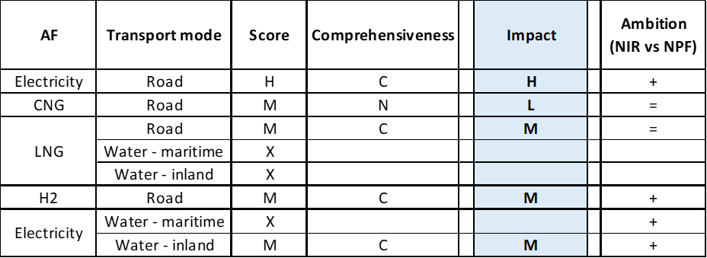

**Legend:** Score and Impact: H = high; M = medium; L = low; X = not assessable. Comprehensiveness: C = comprehensive; N = Not comprehensive. Ambition level: ‘+’ means ‘higher’; ‘=’ means ‘comparable’; ‘-‘ means ‘lower’.

#### Research, Technological Development & Demonstration

The Dutch NIR presents six measures for RTD&D and innovation activities, which represent a significant increase compared to the one measure identified in the NPF. National financing and support for RTD&D and innovation projects target mainly electricity and hydrogen. In particular, the NIR highlights:

* The *Demonstration scheme for climate technologies and innovation (DKTI)* in transport energy subsidies for transport solutions with low or zero CO2 emission (31 million € in 2017/2018). DKTI subsidies are as well provided for co-funding European FCH JU hydrogen projects.
* The *Hydrogen for pilot scheme,* with 1.5 million € budget in 2020 and the subsidy for hydrogen Tender with 2.3 million € in 2018 and 2.2 million € in 2019.
* The *Sustainable Inland Shipping subsidy*, with 1.75 million € budget for 2017-2018, funding for example a project dedicated to develop a electricity and hydrogen fuel cell based propulsion configuration for regional shipping suitable for class type approval. This will be tested and validated in a new Zero-Emission-Laboratory.

On the basis of the available information, it can be considered that, compared to the NPF, the level of ambition in the NIR has increased for RTD&D actions for electricity and hydrogen for the different transport modes.

### Additional information on alternative fuels infrastructure developments

The Dutch NIR contains information on the changes in fuels use in the transport sector (see Table 5.19.5‑1). As it can be noticed, LPG use is foreseen to still increase compared to 2018, remaining the most significant alternative fuel in road transport (however slightly decreasing from 2020 until 2030). Electricity share is rather small (the NIR does not take into account PHEVs), reaching 2.61% in 2030. A decrease of diesel use is expected from 2025 and the increase of the excise duty on diesel in 2021 and 2023 could have an influence in this direction. Natural gas and hydrogen will continue to play a minor role. In addition, synthetic and paraffinic fuels will not vary from the current 1% share.

For inland waterway transport, it is expected that in 2030 part of the diesel fuel will be replaced by 8.87% LNG use, 3.74% electricity and 2.65% hydrogen.

A slight increase in LNG use in maritime transport is noticed from 2018 but marine fuel oil will continue to be the main fuel used in maritime transport, with just a 0.61% of LNG use in 2030.

*Table 5.19.5‑1 Changes in fuel use in transport sector (2016-2030)*



### Summary of the assessment

**Tabular overview**

*Table 5.19.6‑1 Overview of the NIR assessment*





* Value taken or calculated from NL NPF. ** Public and private hydrogen refuelling stations

The NL NIR considers many combinations of alternative fuels and transport modes, with particular focus on zero emission vehicles (electricity and hydrogen) and, to a lesser extent, LNG. The *National Climate Act* and the *Climate Agreement*, which were issued in 2019 as part of the Dutch National and Energy Climate Plan, influence the Dutch policy for alternative fuel transport. The *Climate Agreement* is setting out ambitious goals for the Netherlands such as the aim for reaching 1.5 million zero emission vehicles by 2030 and the ambition of selling only zero-emission passenger cars in the Netherlands by then. Therefore, Dutch targets for alternative fuels have been adjusted in the NIR compared to the NPF and measures in the NIR are oriented to zero-emission transport.

The NL NIR does not establish infrastructure targets/vehicle estimates for all fuels and modes for each of the years of reference (2020, 2025 and 2030). Specifically no targets are provided for recharging infrastructure in 2025 and 2030, for LNG refuelling points for both road and maritime in 2030 and for hydrogen refuelling points in 2030. Therefore, it cannot be stated that the Dutch NIR covers the whole AFID period (2016-2030). The Dutch NPF had addressed most of the requirements of Article 3 of the Directive and, likewise, the NIR almost fully addresses the requirements of Annex I of the Directive.

The main outcomes of the technical assessment of the Dutch NIR on vehicles/vessels estimates and infrastructure targets can be summarised as follows:

###### Road transport

* **Electricity** – Concerning EVs, the Netherlands recorded a total of 146,447 electric vehicles in 2018 (of which 142,727 were passenger cars, 3,194 LCVs, 118 HCVs and 408 buses and coaches). The Dutch NIR estimates for the number of electric vehicles are established considering the Climate Agreement target of 1.5 million zero emission vehicles by 2030. Hence the NIR only provide estimates for BEVs, which are 63,936 in 2020, 741,058 in 2025 and 1,453,000 in 2030. These estimates represent a confirmation of the NPF for 2020 and reflects a remarkable high policy ambition for 2025 and 2030. The Netherlands had only provided a target for 2020 in its NPF, which was already surpassed in 2018 with 38,977 publicly accessible recharging points. The NIR provides a revised target (50,000) that for publicly accessible recharging points is 180.21% higher than the NPF. The 2018 progress results to be adequate for the vehicles and fast for infrastructure, while the sufficiency index remains adequate until 2020.
* **CNG** – the Netherlands recorded a total of 7,820 CNG vehicles in 2018 (of which 4,055 cars, 2,507 LCVs, 630 HCVs and 678 buses and coaches). Neither the NPF nor the NIR provide estimates for the number of vehicles in 2020, 2025 and 2030. The Netherlands counted 150 CNG publicly accessible refuelling points in 2018. The NPF had only provided a target for CNG refuelling infrastructure in 2020. The NL NIR presents a revised target for 2020 (170 points), which is 17.24% higher than the NPF. The NIR states that for CNG the aim is to maintain the network of public refuelling stations and hence the target for 2025 and 2030 remains at 170 refuelling points. The 2018 progress results to be not computable for vehicles and slow for infrastructure.
* **LNG** – the Netherlands recorded 457 LNG vehicles in use in 2018, composed entirely by heavy commercial vehicles. The Dutch NPF did not contain estimates for LNG vehicles; the NIR estimate for LNG vehicles is 600 in 2020, 2,925 in 2025 and 5,250 in 2030, presumably all heavy-duty vehicles. This is showing an increased ambition. In 2018, there were 27 LNG refuelling points in the Netherlands. The Dutch NPF had only provided a target for 2025. The NIR presents now revised targets of 30 LNG refuelling points in 2025, which is 7.14% higher than in the NPF.
* **Hydrogen** - there were 69 hydrogen-powered vehicles (50 passenger cars, 10 LCVs, 1 HCV and 6 buses) in the Netherlands in 2018. The Netherlands had included hydrogen in its NPF and had only provided an estimate for hydrogen vehicles in 2020. The NIR estimates for hydrogen vehicles are 2,203 vehicles in 2020 (3.92% higher than in the NPF); 33,875 in 2025 and 189,400 in 2030. These estimates show an increase of ambition. Concerning hydrogen infrastructure, in 2018 there were 15 refuelling points, of which 7 publicly accessible located in 4 public refuelling stations and the other 8 in 4 private stations. The NL NPF had provided a target of 20 publicly available refuelling points for 2020. Now the NIR provides targets of 20 (public and private) refuelling stations in 2020 and 50 in 2025.
* **Biofuels** – The Dutch NIR does not contain data or estimates on the number of vehicles running on high concentrations of biofuels.
* **LPG** - The Netherlands had a fleet of 154,448 LPG vehicles in use in 2018 (of which 132,956 were passenger cars, 20,753 LCVs, 730 HCVs and 9 buses and coaches). Neither the NPF nor the NIR contain estimates for LPG vehicles. In 2018 there were 1,351 LPG publicly accessible refuelling points in the Netherlands that, according to the NIR, represent a broad nationwide network.

###### Rail transport

The Dutch NIR contains the estimate of having one hydrogen locomotive in 2020.

###### Waterborne transport (maritime)

* **Electricity** - Shore-side electricity supply points were available in four Dutch maritime ports in 2018. The Dutch NIR target for the number of shore-side electricity supply points for maritime vessels in 2025 is 10, which is confirming the NPF targets for 2025 and 2030.
* **LNG** - In 2018, the Netherlands had 11 LNG seagoing vessels. The NL NPF had not provided estimates for the number of LNG seagoing ships, whereas the NIR estimates are 11 vessels in 2020, 30 in 2025 and 48 in 2030. This indicates an increase in ambition, aimed to achieve a CO2 reduction by 2030 in line with the IMO goals. Concerning LNG infrastructure, one LNG bunkering vessel is serving the ports of Amsterdam and Rotterdam and one bunkering pontoon can be deployed flexibly to serve both seagoing ships and inland waterway vessels in Amsterdam and Rotterdam. The Dutch NPF had provided a target of six LNG refuelling points for seagoing vessels in 2025, now the NIR presents a revised target of four refuelling points, which is 33.33% lower than the NPF.

###### Waterborne transport (inland)

* **Electricity** - In 2018, there were no fully electric inland waterway vessels in the Netherlands. While the Dutch NPF had not provided targets of electric inland waterway vessels, the Netherlands have now increased ambitions: the *Climate Agreement* is aiming for a minimum of 150 zero-emission (i.e. BEV or fuel cell) inland waterway vessels by 2030 and thus estimates for electric vessels are 2 for 2020, 30 for 2025 and 100 for 2030. The NL NIR states that shore-side electricity supply for auxiliary power is available in almost all major inland waterway ports in the Netherlands. The Dutch NPF target was to have shore-side electricity supply in the main 75 inland ports by 2025 and the NIR has shifted this target of 75 ports to 2030.
* **LNG** - In 2018, there were seven LNG inland waterway vessels in the Netherlands. The NPF had provided an estimate of 40 LNG inland waterway vessels in 2020, whereas the NIR provides a revised estimate 72.5% lower than the NPF for 2020 (11 vessels) and new targets for 2025 and 2030 which are, respectively, 86 and 160 inland waterway vessels. Concerning infrastructure, the Dutch NIR indicates that in 2018 for inland shipping there were 6 locations LNG could be bunkered. The NL NIR targets for LNG supply for inland waterway is seven bunkering points (six mobile and one fixed) in 2020 and 13 in 2030, so the NL NPF target of for 2030 is confirmed in the NIR.
* **Hydrogen** - The Dutch NIR presents estimates for hydrogen-powered inland ships derived from the *Climate Agreement* target of a minimum of 150 zero-emission inland waterway vessels by 2030. Therefore, estimates for hydrogen inland ships are 15 for 2025 and 50 for 2030.

###### Air transport

* **Electricity** (for stationary airplanes) - According to the NL NIR, in 2018 there were 73 aircraft stands at the main airport in the Netherlands (Schiphol) equipped with fixed installations for electrical ground power and pre-conditioned air units. The target provided in the NPF for electric supply for stationary airplanes in 2020 is already attained. Neither the NPF nor the NIR provide targets for the number of power supply points for stationary aircraft in the Dutch Airports in 2025 and 2030. The NIR mentions the ambition in the Dutch Climate Agreement of all ground-related activities at the Dutch airports to be zero-emission from 2030.

The Dutch Implementation Report contains a well-balanced portfolio of 58 **measures** that is based on administrative agreements and public-private cooperation as well as on fiscal incentives. The main driver for the measures presented in the NL NIR are the Dutch *Climate Act* and the *Climate Agreement.* The measures cover various alternative fuels and transport modes*,* mostly targeting electricity and hydrogen for road transport and electricity for inland waterborne, and to a lesser extent CNG and LNG for road. Some measures, such as subsidies, are intended for several alternative fuels, but are applied in practice for only one fuel. The Dutch NIR contains 20 legal measures that are implemented at national level. Considering all the legal measures together, they appear to be designed as the necessary tools to allow the realisation of the AFV/AFI plans as presented in the NPF and revised in the NIR.

The Dutch NIR contains 23 policy measures; the majority of them are of financial nature applicable at national level and complemented with public procurement initiatives at regional and local level. The Dutch Government has put in place a significant number of direct incentives to foster the deployment of alternative fuel vehicles and related infrastructure. Approximately one third of the policy measures are targeting zero-emission transport, in particular electro-mobility. As for deployment and manufacturing support, nine measures have been identified in the NIR. Eight clusters of measures were identified, of which only five were assessable, for the pairs electricity/road, electricity/water (inland), CNG/road, LNG/road and hydrogen/road. The clusters for the pairs LNG/water and electricity/water (maritime) were not sufficiently detailed for an assessment. In terms of expected impact of these measures to support the realisation of the AFV/AFI objectives as presented in the NPF and revised in the NIR, the measures for the pairs electricity/road have a high impact, while all the other (assessable) measures have a medium impact. The level of ambition for policy and deployment & manufacture support measures between the NPF and the NIR has increased in the NIR for electricity/road, hydrogen/road and electricity/water while it remains the same for CNG/road and LNG/road.

The Dutch NIR presents six measures for RTD&D and innovation activities. National financing and support for RTD&D and innovation projects target mainly electricity and hydrogen, showing that for these AFs the level of ambition has increased at RTD&D level.

### Final remarks

The NIR of the Netherlands provides a comprehensive report on the efforts to implement the Directive. The NIR complies largely with the requirements of Annex I to the Directive with the exception that it does not include targets of electric vehicles’ recharging points by 2025 and 2030. The NIR announces a minimum of 150 zero-emission inland waterway vessels by 2030 and a target for all Dutch domestic flights to be zero-emission by 2050. A significant number of measures are being implemented to promote alternative fuels in all modes, but with a special focus on electro-mobility and on hydrogen.

With regard to electricity, the NIR plans for approximately 1,500,000 vehicles on the roads by 2030, representing about 14% of the fleet by that time. Taking into account the current situation and expected trends, this level of ambition appears to be broadly consistent with the pace of deployment of electric vehicles considered necessary for a full transition to carbon neutrality by 2050. The NIR targets a network of 50,000 recharging points in the Netherlands by 2020, but it does not provide additional targets for recharging infrastructure for 2025 and 2030. This is a shortcoming, as the 2020 target is not sufficient to take into account the estimated number of electric vehicles in 2030. Future reporting should indicate the planning for 2025 and 2030. Information on charging efficiency is provided. Four out of the five maritime ports in the Netherlands’ TEN-T Core Network were already equipped with shore-side electricity supply in 2018. The NIR estimates that the number of shore-side electricity supply points for maritime vessels will be 10 in 2025. In addition, all major inland ports had already shore side electricity supply facilities in 2018 and the plan is to have shore-side electricity supply in 75 inland ports by 2025. Moreover, 73 airplane stands at the main airport in the Netherlands (Schiphol) are equipped with fixed installations for electrical land power and pre-conditioned air unit. However, further information should be given for the airport of Rotterdam-The Hague that is also included in the TEN-T Core Network. Further information should be provided on the future share of the electrified rail network.

Regarding hydrogen for transport, the NIR reports the target of 50 public and private hydrogen refuelling stations by 2025. It does not set a target for hydrogen refuelling points for 2030. The Dutch NIR estimates a significant fleet of 189,400 FCHVs by 2030 (150,000 cars, 30,000 light commercial vehicles, 7,700 heavy commercial vehicles and 1,700 buses and coaches).

In terms of natural gas for transport, the Netherlands already has a network of CNG refuelling stations, which is sufficient for the current and future CNG vehicle fleet. The NIR does not provide any estimates on the future growth of CNG vehicles. There are already 27 LNG refuelling stations for vehicles, which should grow to 30 by 2025 according to the NIR. This number seems appropriate considering the total length of the Dutch TEN-T Core Network, provided that the refuelling stations are widely distributed along the network. There is already one LNG refuelling point for maritime vessels. The NIR presents a target that four out of five ports in the TEN-T Core Network will be equipped with LNG refuelling points by 2025. As regards inland ports, 6 out of 11 ports in the TEN-T Core Network already have LNG refuelling points. The NIR targets 13 refuelling points by 2030, thus complying largely with the requirements of the Directive. The number of maritime and inland LNG vessels is growing steadily.

In 2018, there were 154,448 registered LPG vehicles and 1,351 refuelling points. The NIR does not provide information on the estimated future number of LPG vehicles and refuelling points.

The NIR states that the proportion of renewable fuels has increased in the last years. A limited use of renewable fuels in aviation is foreseen by 2030. The NIR mentions that bio-kerosene is considered as the most promising way of flying. In this respect, The Netherlands should provide more information in future reporting on efforts to promote the use of renewable fuels in transport, and particularly in aviation.

### ANNEX - Description of the Member State

On a surface area of 41,500 km², the Netherlands has a population of 17.181 million people in 2018, which makes up for a population density of 414 inhabitants/km².

*Number of main urban agglomerations*

* 47 urban agglomerations > 50,000 inhabitants

In 2018, Netherlands achieves a per capita gross domestic product at market prices of €44,920, which represents a per capita gross domestic product in purchasing power standards of 129 if expressed in relation to the EU-28 average set to equal 100.

*Length of the road networks*

The length of the road TEN-T Core Network in the Netherlands is 671 km. The total road network length is 13,165 km, of which 2,756 km are motorways.

The following lengths of the TEN-T Road Corridors are present in the Netherlands: 8% (334 km) of the North Sea - Baltic Corridor, 20% (282 km) of the Rhine - Alpine Corridor, 6% (254 km) of the North Sea - Mediterranean Corridor.

Through the TEN-T Road Corridors, the Netherlands is connected with the following Member States:   
- Belgium (through the North Sea - Baltic and the North Sea - Mediterranean Corridor),  
- Germany (through the North Sea - Baltic and the Rhine - Alpine Corridor Corridor)

*Number of registered road vehicles*

At the end of 2018, the Netherlands accounts for 11,471,308 registered road vehicles of which 8,530,584 are categorised as passenger cars, 914,766 as light goods vehicles, 143,041 as heavy goods vehicles and 9,717 as buses and coaches. The motorisation rate is 497 passenger cars per 1,000 inhabitants.

*Number of ports in the TEN-T Core Network*

* 5 maritime ports in the TEN-T Core Network (Amsterdam, Moerdijk, Rotterdam, Terneuzen, Vlissingen)
* 8 maritime ports in the TEN-T Comprehensive Network
* 11 inland ports in the TEN-T Core Network (Almelo, Amsterdam, Bergen op Zoom, Deventer, Hengelo, Moerdijk, Nijmegen, Rotterdam, Terneuzen, Utrecht, Vlissingen)
* 44 inland ports in the TEN-T Comprehensive Network

Through the 1,370 km inland waterways TEN-T Core Network, the Netherlands is connected with Germany by the North Sea - Baltic and Rhine - Alpine Corridors and with Belgium by the North Sea - Baltic and North - Sea Mediterranean Corridor.

*Number of airports in the TEN-T Core Network*

* 2 airports in the TEN-T Core Network (Amsterdam-Schiphol, Rotterdam-The Hague)
* 4 airports in the TEN-T Comprehensive Network

## Austria (AT)

### Main messages from the Commission assessment of the NPF

In its original assessment of the Austrian NPF the Commission concluded:

*The Austrian NPF fully addresses the requirements of Article 3. It contains an extensive discussion of the current state and future scenarios for alternative fuels in the transport sector. For all fuels and modes, it establishes targets as required by Article 3 of the Directive.*

*The Austrian NPF puts a lot of emphasis on electric vehicles and contains, with more than 1.3% share by 2020, high estimates for the future deployment of EV, when compared with its current EV shares (0.3%). Austria has already today a relatively dense network of public recharging points. Eligibility for several support measures for EV is contingent on 100% renewable electricity contracts. This ensures zero emission electro-mobility also under a well-to-wheel perspective. Austria, already today, has a significant number of electric buses, some powered via overhead lines. Bicycles and electric bikes as well as their infrastructure also receive support. Regarding electricity supply for stationary airplanes, the Austrian NPF commits to maintaining the current infrastructure. For shore-side electricity, the NPF mentions ongoing studies to investigate the possible extension of the basic existing network.*

*Today, the spatial distribution of recharging points and especially high power recharging infrastructure seems to appropriately cover the needs of electric vehicles in terms of distance requirements in Austria. For the future, the targeted ratio of only one public recharging point per 18-37 electric vehicles estimated for 2020 could evolve to become a barrier for the further market deployment of electric vehicles. This could also lead to market fragmentation within the EU. It will be important to closely monitor this development and correct infrastructure targets in line with the market developments.*

*Austria currently has a sufficient network of CNG refuelling points. However, the Austrian NPF displays a sceptical view on the future prospects of CNG vehicles and does not foresee additional investments in CNG refuelling infrastructure.*

*Depending on market demand, 1-2 dual use LNG refuelling points for vessels and heavy-duty trucks are proposed in the NPF. If both LNG refuelling points were realised, this would guarantee that the maximum distance requirement for LNG refuelling points along the TEN-T Core Network would be fulfilled on Austrian territory.*

*The Austrian NPF considers hydrogen for transport and targets a slight increase of hydrogen refuelling points.*

*The Austrian NPF contains a very comprehensive list of measures, most already in place and their prolongation foreseen. Most of them can be considered having a medium impact on market actor's decisions. Longer periods for their validity could provide certainty for market actors and hence increase the likelihood that the national targets and objectives of the NPF can be reached. The NPF contains a comprehensive list of support measures that can promote the deployment of alternative fuels infrastructure in public transport services.*

*The consideration of the interests of regional and local authorities, as well as stakeholders during the drafting of the Austrian NPF can be considered exemplary. Further coordination is planned in order to ensure follow-up of the implementation actions, collaboration among authorities and advice from stakeholders.*

*Austria is actively involved in coordinating its plans on alternative fuels infrastructure with other Member States as well as collaborating with them in this field.*

### Overview of requirements’ fulfilment from Annex I of the Directive

*Table 5.20.2‑1 Checklist Table*

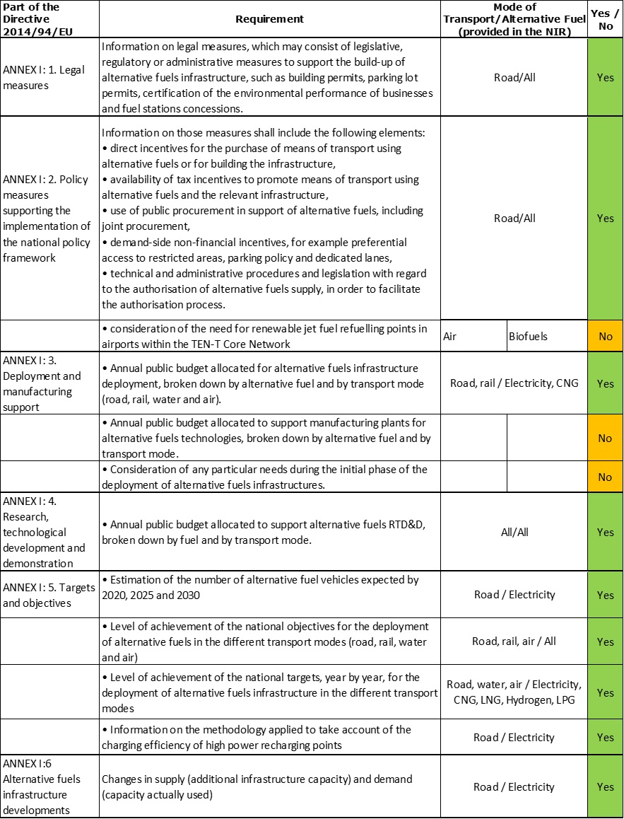

The checklist shows the requirements of Annex I from the Directive covered in the AT NIR.

Regarding the combination of AF/AFV/AFI with transport mode, electricity is partially covered for all modes; CNG, hydrogen and LPG are partially covered for road transport; LNG is partially covered for road and inland waterborne transport; all the other combinations are either absent or not applicable.

The Austrian NIR reports 159 measures. Under the Policy and Deployment & Manufacturing sections it was possible to identify five AF/transport mode clusters of measures, all assessable.

### Quantitative assessment: Vehicles and infrastructure

*Table 5.20.3‑1 National AFV estimates and AFI targets established in the NIR at the horizon 2020, 2025 and 2030 and their comparison with the NPF situation*

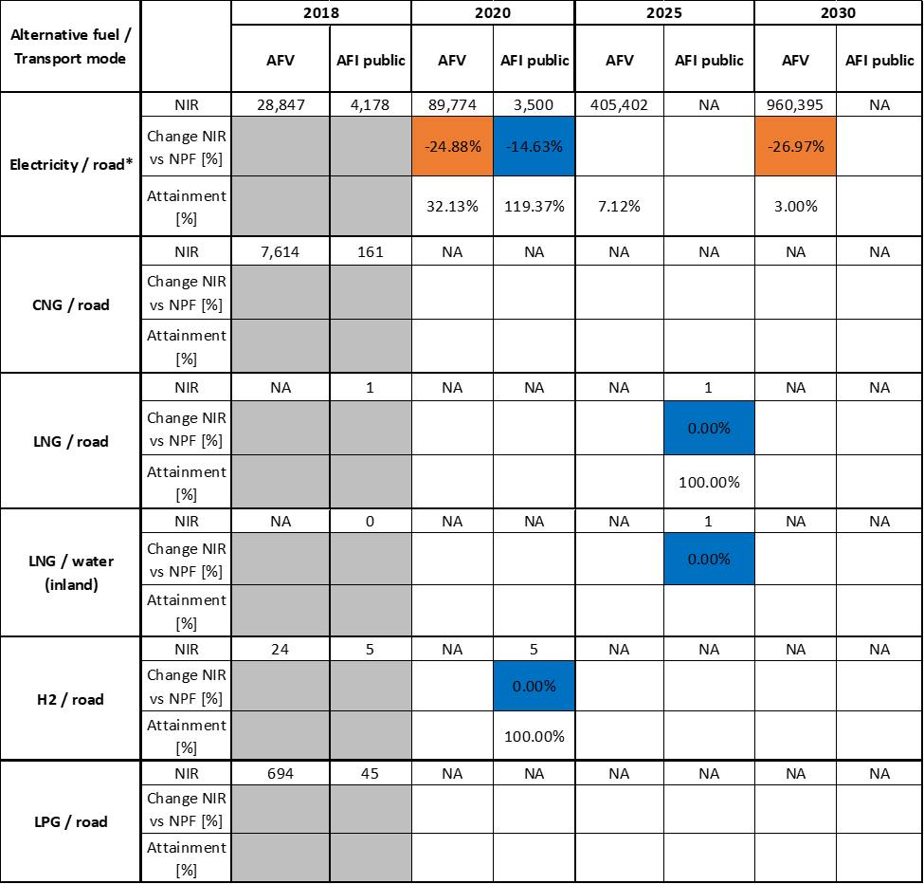



* The NPF value used for the calculation is based on an average of values reported in the Austrian NPF.

#### Road transport

##### Electricity

###### Vehicles

Austria recorded 28,847 battery-electric and plug-in hybrid electric vehicles in use in 2018, of which 26,541 were passenger cars, 2,141 battery-electric LCVs, 11 battery-electric HCVs and 154 battery-electric buses and coaches (see Table 5.20.3‑1). The Austrian NIR EV estimates are 89,774 for 2020 and 960,395 for 2030. These figures are respectively 24.88% and 26.97% lower than those reported in the NPF. This reflects a lower policy ambition, with a caveat: while the underlying NPF numbers used to calculate these percentages are based on an average value, the actual future EV estimates provided in the NPF were a range (low and high). This is shown for 2020 and 2030 in Figure 5.20.3‑1. As it can be seen, the 2030 estimate provided in the NIR is close to the NPF low estimate. The figure also shows that Austria did not provide 2025 EV estimates in the NPF but the NIR presents an estimate (405,402 EVs). No future estimates are provided for the stock of electric HCVs. In addition, the Austrian NIR provides an estimate of 85,161 electric PTW in 2030, compared to 8,614 in 2018.

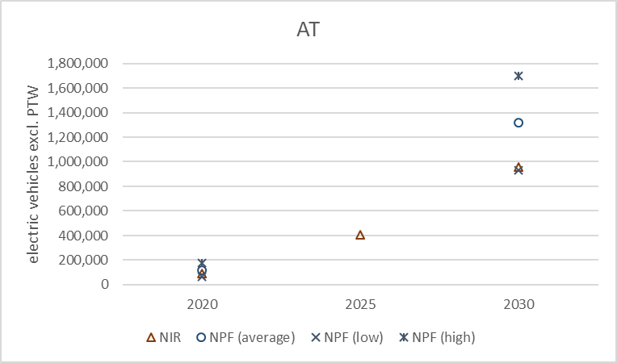

*Figure 5.20.3‑1 Future EV estimates in the Austrian NPF versus NIR*

The 2018 ***attainment*** of future EV estimates is 32.13% for 2020 to 3.00% for 2030. According to the assessment methodology described in Section 2.1, the 2018 situation corresponds to an ***adequate progress*** towards reaching the envisaged EV estimates. The calculated ***average annual growth rate*** corresponding to the period 2016-2030 for EV fleet evolution planned by Austria is equal to 35%.

###### Infrastructure

Austria recorded 4,178 publicly accessible recharging points in 2018 (Table 5.20.3‑1). The NIR target for the publicly accessible electric recharging points for 2020 is 3,500, of which 500 would be high power (>22kW). This is 14.63% lower than the target set in the NPF, with a caveat: while the underlying NPF number used to calculate this percentage is based on an average value, the actual target provided in the NPF was a range (low and high). As Figure 5.20.3‑2 shows, the 2020 target provided in the NIR is close to the NPF low target. The figure also indicates that neither the Austrian NPF nor the NIR provide publicly accessible electric recharging points targets for 2025 and 2030.

The Austrian NIR does not provide information on the number of private recharging points but assumes that one private recharging point will be available for each passenger car.

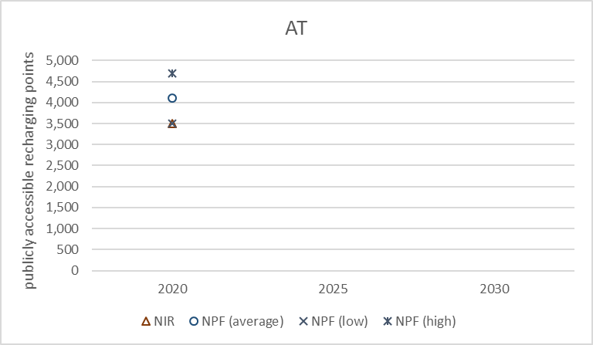

*Figure 5.20.3‑2 AFI targets in the Austrian NPF versus NIR: publicly accessible electric recharging points*

The 2018 ***attainment*** of future publicly accessible recharging infrastructure target is 119.37% for 2020. The attainment >100% represents an early over-achievement of the target. According to the assessment methodology described in Section 2.1, the 2018 situation corresponds to a ***fast progress*** towards reaching the envisaged target. The calculated ***average annual growth rate*** corresponding to the period 2016-2030 for publicly accessible recharging infrastructure evolution planned by Austria is equal to 10%.

###### Ratio

Based on the AT NIR, the following table shows the ratio between vehicles and publicly accessible recharging points (i.e. sufficiency index) for the pair electricity/road. In 2020 the foreseen sufficiency index exceeds a value of 10 that, even considering the 14% high power share, can be regarded as inadequate. The lack of 2025 and 2030 targets precluded the calculation of the sufficiency index.



###### Information on charging efficiency

In line with the information provided by the Commission (Frequently-Asked Questions document issued to the Member States on 16 September 2019), the Austrian NIR reported the following average data based on 86 high power (>22kW) recharging points along the ASFiNAG network, concluding that the utilisation rate is low: 0.4 charges/day, 7.5 kW delivered/day and 11 minutes/day. Although this data collection is part of Austria’s assessment of the efficiency of high power recharging infrastructure, the NIR[2] does not disclose any detail on the methodology applied.

##### CNG

###### Vehicles

Austria recorded 7,614 CNG vehicles in use in 2018, of which 5,542 were passenger cars, 1,846 LCVs, 55 HCVs and 171 buses and coaches (Table 5.20.3‑1). The Austrian NIR does not provide future estimates of CNG vehicles because it considers them currently unfeasible. As a result, the future values in Table 5.20.3‑1 are shown as NA and the 2018 ***attainment*** and ***progress*** could not be computed.

###### Infrastructure

The Austrian NIR provides information on the number of CNG refuelling points that have been declining over the past years (171 in 2016, 166 in 2017, 161 in 2018 and 156 in September 2019). The NIR does not provide future targets, thus the relevant values in Table 5.20.3‑1 are shown as NA. As in the NPF, the Austrian NIR confirms the intention of preserving the existing CNG refuelling infrastructure. The NPF had reported that five refuelling points for pure biomethane were available in Austria in 2016, whereas the NIR asserts that three such refuelling points were available in 2019.

Due to the absence of future CNG refuelling points targets, the 2018 ***attainment*** and ***progress*** could not be computed.

###### Ratio

Based on the AT NIR, the following table shows the ratio between vehicles and publicly accessible refuelling points (i.e. sufficiency index) for the pair CNG/road. The sufficiency index is well below the indicative value of 600 (see Section 2.1.5) for the period 2016-2018. Since there are no future CNG vehicle estimates and no refuelling points targets in the AT NIR, it is not possible to compute the sufficiency index for the period 2020-2030.



##### LNG

The Austrian NIR acknowledges that the deployment of LNG infrastructure has not been a priority so far, because LNG does not play a role in Austria’s heavy goods transport.

###### Vehicles

Information is not available in the Austrian NIR.

###### Infrastructure

The Austrian NIR indicates the presence of one publicly accessible LNG refuelling point for road vehicles in 2018 and two in 2019. The NIR also provides a target of one public LNG refuelling point in 2025, which is in line with the value reported in the NPF (Table 5.20.3‑1). The Austrian NIR states that future target setting of LNG infrastructure will depend on the market development along the TEN-T Network.

The 2018 ***attainment*** of future LNG refuelling infrastructure target could only be calculated with respect to 2025 and is equal to 100%, while the ***progress*** could not be computed.

###### Ratio

Due to the lack of LNG vehicle estimates in the AT NIR it was not possible to compute the sufficiency index.

##### Hydrogen

Since the Austrian government considered hydrogen for transport in its NPF, it became mandatory for Austria to include hydrogen-related information in its NIR. The Austrian NIR states that concrete future estimates and targets for 2020, 2025 and 2030 are excluded from the NIR because the country’s Hydrogen Strategy was being drafted at the time of notification of the NIR.

###### Vehicles

The Austrian NIR indicates that 24 hydrogen-powered vehicles (all of them passenger cars) were in use in 2018 (Table 5.20.3‑1), but it does not provide future estimates. As a result, the future values in Table 5.20.3‑1 are shown as NA and the 2018 ***attainment*** and ***progress*** could not be computed.

###### Infrastructure

The Austrian NIR reports that hydrogen refuelling points are slowly increasing (3 in 2016, 4 in 2017 and 5 in 2018 and 2019; they are all publicly accessible 700 bar infrastructure). The NIR also presents a target of five hydrogen refuelling points for 2020 that is in line with the one indicated in the NPF (Table 5.20.3‑1). In contrast to the NPF, the NIR no longer provides a target for 2025 and states that the 2025 and 2030 targets would be set only if market developments require them.

The 2018 ***attainment*** of future hydrogen refuelling infrastructure target could only be calculated with respect to for 2020 and is equal to 100%, while the ***progress*** could not be computed.

###### Ratio

Based on the AT NIR, the following table shows the ratio between vehicles and publicly accessible refuelling points (i.e. sufficiency index) for the pair hydrogen/road. The sufficiency index (see Section 2.1.5) remains below five for the period 2016-2018. Since there are no future vehicle estimates and refuelling points targets in the AT NIR, it is not possible to compute the sufficiency index for the period 2020-2030.



##### Biofuels

###### Vehicles

Information is not available in the Austrian NIR.

###### Infrastructure

Information is not available in the Austrian NIR.

##### LPG

The Austrian government does not mention LPG in its main report but provides historical data in the Annex.

###### Vehicles

Austria recorded 694 LPG vehicles in use in 2018 (of which 329 were passenger cars, 173 LCVs, 1 HCV and 191 buses and coaches) (see Table 5.20.3‑1). Most of these vehicles are bi-fuel (petrol-LPG), with the exception of buses and coaches. The Austrian NIR does not provide any justification for the lack of future estimates of LPG vehicles. As a result, the 2018 ***attainment*** and ***progress*** could not be computed.

###### Infrastructure

The Austrian NIR provides information on the number of publicly accessible LPG refuelling points for the period 2016-2018 (50 points in 2016 and 45 in 2017 and 2018) but does not provide future targets. As a result, the 2018 ***attainment*** and ***progress*** could not be computed.

###### Ratio

Based on the AT NIR, the following table shows the ratio between vehicles and publicly accessible LPG refuelling points (i.e. sufficiency index) for the pair LPG/road. Since there are no future LPG vehicle estimates and no refuelling points targets in the AT NIR, it was not possible to compute the sufficiency index for the period 2020-2030.



*Note: The 2016 and 2017 values are calculated without taking into account the stock of buses and coaches, for which the NIR provided no information.

#### Rail transport

##### Electricity

###### Vehicles

Austria recorded 824 electric and 9 hybrid electric locomotives in 2018.

###### Infrastructure

According to the Austrian NIR, around 70% of the rail network is electrified and further progress is ongoing on rail electrification, with a focus on high-traffic passenger and freight routes.

#### Waterborne transport (maritime)

Not applicable since Austria has no maritime ports in the TEN-T Core Network.

#### Waterborne transport (inland)

##### Electricity

###### Vessels

Information is not available in the Austrian NIR.

###### Infrastructure

As in the NPF, the Austrian NIR does not provide specific values on the number of shore-side electricity recharging points. The NIR states that a basic level of shore-side electricity supply for inland waterway vessels is available at Austria’s TEN-T ports. As for the future, the Austrian NIR indicates that the aim is to maintain the existing basic infrastructure and to analyse additional needs in the context of the ‘Action Programme Danube 2022’.

##### LNG

Similarly to the heavy goods transport, the Austrian NIR acknowledges that LNG does not play a role in Austria’s inland waterborne transport.

###### Vessels

Information is not available in the Austrian NIR.

###### Infrastructure

Austria recorded zero LNG refuelling points in inland ports for the period 2016-2018 (Table 5.20.3‑1). Both the NPF and the NIR are consistent in indicating one refuelling point for 2025 (at Enns or Linz); however, in the main body of the NIR, the Austrian government considers the possibility of a second LNG refuelling point in the port of Vienna), but its deployment by 2030 will depend on the market development along the TEN-T Network.

Since there was no LNG refuelling infrastructure in 2018, the **attainment** and **progress** have not been computed.

#### Air transport

##### Electricity

According to the NIR, electro-mobility deployment at all airports has a high priority for Austria.

###### Airplanes

Information is not available in the Austrian NIR.

###### Infrastructure (for stationary airplanes)

The Austrian NIR provides a figure of 42 recharging points at airports for use by stationary planes over the period 2016-2018. This number is the same as the one provided in the NPF for the period 2020-2030. In addition, the Austrian NIR states that around 50 mobile GPUs are available. Austria considers that the current electricity supply at commercial airports for use by stationary airplanes is adequate. For the future, the Austrian NIR indicates that the aim is to maintain the existing electricity supply for stationary aircraft at Austrian airports until further evidence of additional needs.

##### Biofuels

###### Airplanes

Information on flights / airplanes powered by biofuels is unavailable in the Austrian NIR.

###### Infrastructure

Information is not available in the Austrian NIR.

### Measures assessment

As in the NPF, the Austrian NIR contains a very comprehensive list of measures that covers various fuels and modes, with particular emphasis on electricity for road transport. The Austrian NPF had proposed the extension of existing measures and this has been reflected in the NIR.

#### Legal measures

The Austrian NIR contains 52 legal measures, which represents a strong increase compared to the 16 legal measures identified in the NPF. Slightly less than half of them corresponds to measures at national level (most of the rest are regional measures). Some of the new legal measures update the measures provided in the NPF (e.g. related to the Passenger Car Consumer Information Act). The majority of the legal measures described in the NIR are existing (around 12% are under consideration). Some of these measures relate to the implementation of the provisions stipulated in the Energy Performance of Buildings Directive (2018/844/EU).

All together, the legal measures appear to address relevant needs for the realisation of the AFV/AFI ambition as described in the NPF. On the basis of the available information, it is considered that the level of ambition of the legal measures has generally increased in the NIR, compared to the NPF**.**

##### Legislative & Regulatory

Of all the legal measures described in the Austrian NIR, 37 can be categorised as legislative and regulatory measures. The following new measures can be highlighted:

* National targets: exemptions for zero-emission lorries (BEV and FCEV) from the driving bans applicable on a section of the A12 Inntal motorway as well as the obligation to register all publicly accessible recharging points in Austria, so that information on the geographical location is available to users in a non-discriminatory and open manner.
* Norms & requirements: the NIR mentions the adoption of two relevant federal acts on technical standards since the notification of the NPF. The first one is “the Federal Act laying down uniform standards for the deployment of alternative fuels infrastructure was adopted on 12 July 2018 (Federal Law Gazette I No 38/2018)”. The second one is the Federal Act laying down “uniform standards for normal-power and high-power recharging points for electric vehicles that are accessible to the public, hydrogen refuelling points for vehicles that are accessible to the public and CNG refuelling points for vehicles that are accessible to the public” adopted on 23 September 2019 (Federal Law Gazette II No 280/2019).
* Permits: a measure stipulating that recharging stations should be regarded as installations that require approval only in exceptional cases.

##### Administrative

Of all the legal measures described in the Austrian NIR, 15 can be categorised as administrative (basically regional) measures. The following new measures can be highlighted:

* AFV classification on environmental performance: possibility to switch all public bus routes to alternative drive technologies in Vorarlberg.
* Certification of the environmental performance of businesses: commercial recharging stations for EVs do not require approval under plant permit law in Upper Austria.
* EU & international standards implementation: all the electricity delivered by publicly accessible recharging stations in Vienna must be ‘green’.
* Other: prioritisation of EVs in the procurement of company cars in Vorarlberg (‘Mission ZeroV’); (ii) cross-border electro-mobility strategy for the area Burgenland-West Hungary (INTERREG ‘Low Carb Mobility’ project); and (iii) international cooperation on electro-mobility in the Lake Constance area (E-Charter).

#### Policy measures

The Austrian NIR contains 56 policy measures that represent a strong increase compared to the 14 policy measures identified in the NPF. Almost 40% of them corresponds to measures at national level (most of the rest are regional measures). Some of the new policy measures update those provided in the NPF. Most of the policy measures are in place. Almost 30% of them have expired by 2019 and around 2% were under consideration. The vast majority of the policy measures described in the NIR refer to road transport.

##### Measures to ensure national targets and objectives

Of all the policy measures described in the Austrian NIR, 46 can be categorised as measures to ensure national targets and objectives. Around 70% of these measures provide financial support.

###### Road transport

As the Austrian NIR states, financial incentives for the acquisition of vehicles powered by the following alternative fuels continue to be available:

* Electricity: federal subsidies are available for enterprises (a maximum funding rate of 30% applies) and private individuals. For M1 vehicles, the subsidy ranges from €1,500 for PHEVs to €3,000 for BEV and FCEVs. Funding is also available for freight vehicles (€1,500-€10,000 for N1; €20,000 for N2; €50,000 for N3) and for public vehicles (taxis and buses (up to €100,000)). Subsidies in some regions complement the federal subsidies for one or more vehicle categories. Moreover, funding is available for motorcycles as well as for electric bikes (including electric cargo bikes), as in the NPF.
* CNG: tax concessions continue to be available and several regions offer subsidies for new CNG vehicles.
* Hydrogen: certain tax concessions are available for FCEVs.

Financial incentives are also available for the deployment of private recharging infrastructure, including for multi-family dwellings, both at the federal level and in certain regions.

Among the non-financial incentives, it is worth mentioning exemptions for BEVs and FCEVs from the speed limit (100 km/h under the Ambient Air Quality Act) on motorways and dual carriageways.

In terms of measures at local level, the number of Austrian cities and towns with parking fee exemptions for EVs and hydrogen-powered vehicles rose from 14 in mid-2016 to 33 in late 2019. This exemplifies an increased level of ambition in support measures for zero-emission vehicles at local level.

###### Rail transport

The Austrian NIR lists two policy measures in Burgenland Upper Austria on rail transport: both are existing public procurement incentives targeting electricity, though their budgets vary greatly. Besides, the Austrian NIR indicates that the Zillertal Railway in Tyrol is scheduled to switch from diesel to hydrogen.

###### Waterborne transport

In addition to the aforementioned ‘Action Programme Danube 2022’, the Austrian NIR mentions the ‘LNG Master Plan Rhine-Main-Danube’ project (but without providing details).

##### Measures that can promote AFI in public transport services

The main report of the Austrian NIR highlights three examples of best practice at sub-national level that concern public transport: electric bus tests in Carinthia; the promotion of multimodal transport (including electric taxis) in Styria; and funding for zero-emission taxis in Upper Austria.

Of all the policy measures described in the Annex of the Austrian NIR, two can be categorised as measures to promote AFI in public transport services (both of them in Vorarlberg).

##### Measures that can promote the deployment of private electro-mobility infrastructure

The main report of the Austrian NIR highlights funding for the deployment of recharging infrastructure in multi-family dwellings in Vorarlberg as an example of best practice at sub-national level.

Of all the policy measures described in the Annex of the Austrian NIR, eight can be categorised as measures to promote the deployment of private electro-mobility infrastructure. All of these are regional measures. In addition, the main report of the NIR indicates that funding is available for wall boxes for multi-family dwellings at the federal level.

#### Deployment and manufacturing support

##### AFI deployment

The Austrian NIR contains 19 deployment support measures, which represents a significant increase compared to the three measures identified in the NPF. Twelve of the measures were in place. Most of the support concerns electricity for road. The total estimated budget for AFI deployment reported in the NIR amounts to around 36.7 million € for the period 2016-2030 (though most of it reflects the period 2016-2020 and information on the budget is incomplete).

##### Support of manufacturing plants for AF technologies

Although the Austrian NIR states that the Province of Lower Austria has collaborated with recharging stations manufacturers and will be offering support for the development of recharging stations, no concrete measure regarding support of manufacturing plants for AF technologies is presented in the Annex of the Austrian NIR.

##### Consideration of any particular needs during the initial phase of the deployment of alternative fuels infrastructures

Information is not available in the Austrian NIR.

#### Quantitative assessment of Policy and Deployment & Manufacturing measures

Table 5.20.4‑1 presents an analysis of all the Policy and Deployment & Manufacturing measures, carried out according to the assessment methodology described in Section 2.2. As it can be seen, in addition to electricity for various transport modes, clusters of measures for the pairs CNG/road and hydrogen/road could also be identified in the Austrian NIR. Similarly to the NPF, nothing assessable could be defined for LNG and for the other AFs. All the assessable measures mentioned in the NIR score low or medium. Only the clusters of measures for the pairs electricity/road and electricity/bicycles are comprehensive. In terms of expected impact of these measures to support the realisation of the AFV/AFI objectives as presented in the NPF and revised in the NIR, the lack of a complete plan regarding future targets and estimates does not facilitate the task of putting this assessment into perspective. Based on the impact seen during the implementation period, for the future it can be said that the measures for the pairs electricity/road and electricity/bicycles have a medium impact, those for the pairs CNG/road, hydrogen/road and electricity/rail have a low impact.

Compared to the NPF, the level of ambition increases only for the electricity-related measures.

*Table 5.20.4‑1 Quantitative assessment of Policy and Deployment & Manufacturing support measures*

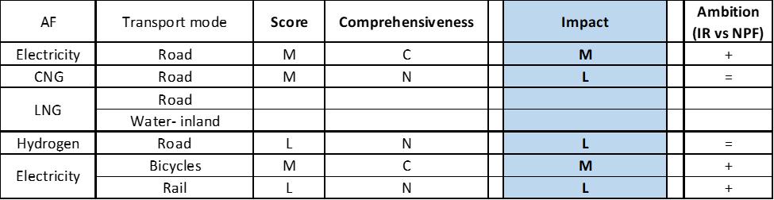

**Legend:** Score: H = high; M = medium; L = low; X = not assessable. Comprehensiveness: C = comprehensive; N = Not comprehensive. Ambition level: ‘+’ means ‘higher’; ‘=’ means ‘comparable’; ‘-‘ means ‘lower’.

#### Research, Technological Development & Demonstration

The Austrian NIR contains 32 RTD&D projects, which represents a significant increase compared to the 17 RTD&D projects identified in the NPF. Some of the new projects are follow-ups or expansions of the projects listed in the NPF (e.g. the ‘Zero-Emission Mobility’ project). A significant proportion of the RTD&D projects described in the NIR are probably concluded at the time of writing this assessment. The vast majority of the RTD&D projects described in the NIR refer to road transport. Electricity features prominently in these projects, but hydrogen, LNG and combinations of alternative fuels are also addressed. The total estimated budget for RTD&D projects reported in the NIR amounts to 148 million € for the period 2016-2025 (though most of it reflects the period 2016-2020 and information on the budget is not complete). The reported budget includes sub-national, national and supra-national funding.

On the basis of the available information, it can be considered that, compared to the NPF, the level of ambition in the NIR has increased only for the clusters electricity / road and hydrogen / road.

### Additional information on alternative fuels infrastructure developments

The Austrian NIR does not provide information on the changes in fuel use.

### Summary of the assessment

**Tabular overview**

*Table 5.20.6‑1 Overview of the NIR assessment*

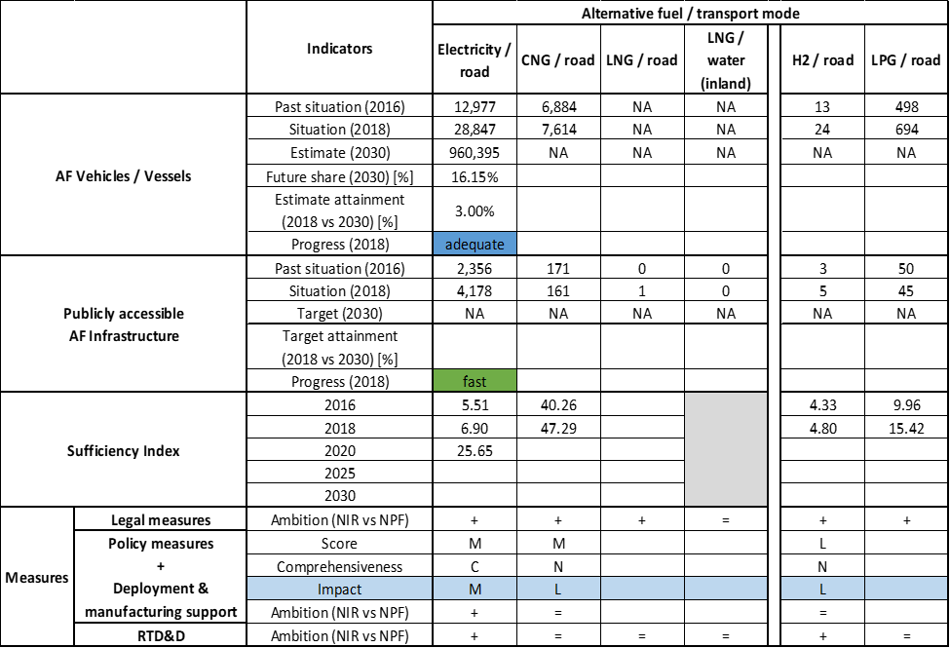



As stated in the NIR, the Austrian government aims at limiting transport GHG emissions to 15.7 million tCO2 by 2030. As road transport currently accounts for most of Austria’s GHG emissions in the transport sector, road transport decarbonisation is crucial. Moreover, the Austrian NIR asserts that the country is well positioned to make the transition to a transport sector powered by electricity, thanks to its high share of renewables in electricity generation. Since the notification of the NIR, Austria has published its National Energy and Climate Plan. The NIR indicates that Austria is drafting its Hydrogen Strategy.

The NIR does not establish infrastructure targets / vehicle estimates for all fuels and modes for each of the years of reference (2020, 2025 and 2030). Therefore, it cannot be stated that the Austrian NIR covers the whole AFID period (2016-2030). Compared to the Austrian NPF that had fully addressed the requirements of Article 3 of the Directive, the Austrian NIR almost fully addresses the requirements of Annex I of the Directive, with the exception of: a) information on the need for renewable jet fuel refuelling points in airports within the TEN-T Core Network; b) information on the annual public budget allocated to support manufacturing plants for alternative fuels technologies; c) information on any particular needs during the initial phase of AFI deployment.

The main outcomes of the technical assessment of the Austrian NIR on vehicles/vessels estimates and infrastructure targets can be summarised as follows:

###### Road transport

* **Electricity** – With 28,847 electric vehicles registered in 2018, the Austrian NIR puts a lot of emphasis on road electrification, to be led by the passenger car market, though electric LCVs, HCVs and buses and coaches are also indicated for 2018 (2,141 battery-electric LCVs, 11 battery-electric HCVs and 154 battery-electric buses and coaches). With regards to future EV estimates and publicly accessible recharging points targets, the Austrian government updates its policy goals by indicating values in the NIR that are closer to the least ambitious scenario of the two reported in its NPF and does not provide details on the heavy-duty vehicles. As for recharging infrastructure, the NIR only reports a target for 2020, which was already exceeded by the 2018 value, meaning a fast progress. The 2018 progress for EVs is adequate, but when the estimated number of EVs in 2020 is compared to the corresponding infrastructure, the result is a rather deteriorated sufficiency index in 2020.
* **CNG** – Austria recorded 7,614 CNG vehicles in use in 2018, of which 55 HCVs and 171 buses and coaches. Biomethane was available in three out of the 156 Austrian CNG refuelling points in use in 2019. The NIR signals the intention to maintain the existing CNG infrastructure. As in the NPF, the Austrian NIR exhibits a sceptical view on the future prospects of CNG vehicles. Due to the lack data, the attainment, progress and sufficiency index could not be calculated.
* **LNG** – Due to the high focus on the national electricity generation based on renewable energy, the Austrian NIR is cautious also about the development of LNG for transport. The Austrian NIR only notes the intention to maintain one LNG refuelling point for 2025, and keep future target development open.
* **Hydrogen** – As in the NPF, the Austrian NIR considers hydrogen for transport. However, the information contained in the NIR is rather limited. It is expected that the upcoming Austrian Hydrogen Strategy will shed more light into the future developments Austria envisages for this alternative fuel in transport.
* **Biofuels** – The Austrian NIR provides no relevant information on biofuels for transport.
* **LPG** – The Austrian NIR provides only past information on LPG vehicles and refuelling infrastructure.

###### Rail transport

* **Electricity** – According to the NIR, electrification efforts have taken place, although the information provided is rather scarce.
* **Hydrogen** – The Austrian NIR indicates the promotion of hydrogen trains in Tyrol.

###### Waterborne transport (inland)

* **Electricity** – The Austrian NIR indicates that shore-side electricity supply is available at Austria’s TEN-T inland ports but provides no information on battery-powered vessels as well as on specific future developments in this sector.
* **LNG** – None of the Austrian inland ports had LNG supply available in 2018. Following the Austrian NIR, at least one inland port is expected to supply LNG by 2025. No information on LNG vessels could be found in the NIR.

###### Air transport

* **Biofuels** – The Austrian government did not consider the need for renewable jet fuel refuelling points in airports within the TEN-T Core Network in its NIR.

The Austrian NIR contains a lengthy list of **measures**, of which: 108 are legal and policy measures, 19 are deployment support measures and 32 RTD&D projects. Overall, the Austrian NIR contains a very comprehensive list of measures to support the AF infrastructure and vehicles, many of them still in place and financially supported. Concerning the Policy and Deployment & Manufacturing support measures, the Austrian NIR continues to provide a large amount of measures to support the uptake of alternative fuels for transport but the vast majority of them focuses on electricity for road. As in the NPF, nothing assessable could be defined for LNG. In terms of expected impact of these measures to support the realisation of the AFV/AFI objectives as presented in the NPF and revised in the NIR, the lack of a complete plan regarding future targets and estimates does not facilitate the task of putting this assessment into perspective. Based on the impact seen during the implementation period, for the future it can be said that the measures for the pairs electricity/road and electricity/bicycles have a medium impact, those for the pairs CNG/road, hydrogen/road and electricity/rail have a low impact. Compared to the NPF, the NIR features an increased level of ambition for support actions to the electrification, in particular, of road transport. The key to success may lie in the measures supporting private recharging infrastructure, but at the moment, the effectiveness of the measures in place remains to be seen.

The Austrian NIR contains 32 RTD&D projects, which represents a significant increase compared to the 17 RTD&D projects identified in the NPF.

### Final remarks

The Austrian NIR provides a rather comprehensive report on the efforts made to implement the Directive. The NIR is, to a certain extent, in line with most of the provisions of Annex I of the Directive with the main exception that the Austrian NIR does not provide estimates for CNG vehicles and LNG vehicles and inland navigation vessels. Furthermore, concerning the infrastructure, targets for road recharging points are provided only for 2020 but not for 2025 and 2030, and for road and inland navigation LNG refuelling points for 2025; no information is provided for CNG, and LNG refuelling point targets for road and inland navigation are provided only for 2025. The NIR includes a very comprehensive list of measures which support particularly the electrification of transport (including bicycles), but also research and innovation and support for deployment and manufacturing.

Regarding electricity, the NIR estimates that there will be some 960,000 electric vehicles on the roads by 2030, representing about 16% of the fleet by that time. Taking into account the current situation and expected trend development, this level of ambition appears to be broadly consistent with the pace of deployment of electric vehicles estimated as necessary for the transition to carbon neutrality by 2050. However, the Austrian NIR does not provide targets for publicly accessible recharging points for 2025 and 2030. It would be beneficial to provide further information. Information on charging efficiency is provided. A basic level of shore side electricity is already supplied in the inland navigation ports of the TEN-T Core Network; however, no numbers are provided. Electricity to stationary aircraft is supplied in most Austrian airports. The Austrian NIR reports 42 recharging points at airports in 2018. Around 50 mobile ground power units are available. The NIR indicates that Austria aims at maintaining the existing electricity supply for stationary aircraft. Approximately 70% of the Austrian rail network is electrified. Further progress on rail electrification is ongoing, with a focus on high-traffic passenger and freight routes.

Regarding hydrogen for road transport, the NIR shows Austria's interest in developing hydrogen as a fuel for road transport. There are currently five hydrogen refuelling points and a small number of hydrogen fuel cell vehicles. However, no estimates are provided on vehicles and infrastructure for 2025 and 2030. Nevertheless, the NIR announces that a “Hydrogen Strategy” was in process of elaboration.

With regard to natural gas for transport, there is already a small number of CNG vehicles and a significant number of CNG refuelling points in Austria. Only one road LNG refuelling point is foreseen until 2025; this number seems insufficient taking into account the length of the Austrian TEN-T Core Network. Furthermore, only one of the two Austrian inland ports in the TEN-T Core Network will have a LNG refuelling point by 2025. Finally, the NIR considers no need for additional measures to support the development of the market for LNG vehicles and inland waterway vessels and their necessary infrastructure. Austria should corroborate its position in this respect.

Concerning LPG, the NIR shows that Austria already had a small LPG vehicle fleet and infrastructure in 2018, but the NIR does not provide any estimates of vehicles and targets for infrastructure by 2020, 2025 and 2030.

Further information should be provided on the consumption of biofuels in road transport and particularly aviation transport, where the promotion of such fuels is essential to contribute to emission reduction.

### ANNEX - Description of the Member State

On a surface area of 83,900 km², Austria has a population of 8.822 million people in 2018, which makes up for a population density of 105 inhabitants/km².

*Number of main urban agglomerations*

* 6 urban agglomerations > 50,000 inhabitants

In 2018, Austria achieves a per capita gross domestic product at market prices of €43,640, which represents a per capita gross domestic product in purchasing power standards of 127 if expressed in relation to the EU-28 average set to equal 100.

*Length of the road networks*

The length of the road TEN-T Core Network in Austria is 1,084 km. The total road network length is 36,242 km, of which 1,743 km are motorways.

The following lengths of the TEN-T Road Corridors are present in Austria: 15% (559 km) of the Baltic - Adriatic Corridor, 3% (142 km) of the Orient / East Mediterranean Corridor, 2% (110 km) of the Scandinavian - Mediterranean Corridor and 11% (485 km) of the Rhine - Danube Corridor.

Through the TEN-T Road Corridors, Austria is connected with the following Member States:  
- Czechia (through the Baltic - Adriatic and the Orient / East Mediterranean Corridor),   
- Slovakia (through the Baltic - Adriatic and the Rhine - Danube Corridor),   
- Slovenia (through the Baltic - Adriatic Corridor),   
- Italy (through the Baltic - Adriatic and the Scandinavian - Mediterranean Corridor),  
- Germany (through the Scandinavian - Mediterranean and the Rhine - Danube Corridor) and   
- Hungary (through the Orient / East Mediterranean and the Rhine - Danube Corridor)

*Number of registered road vehicles*

At the end of 2018, Austria accounts for 6,316,320 registered road vehicles of which 4,978,852 are categorized as passenger cars, 422,745 as light goods vehicles, 72,486 as heavy goods vehicles and 10,037 as buses and coaches. The motorisation rate is 564 passenger cars per 1,000 inhabitants.

*Number of ports in the TEN-T Core Network*

* No maritime ports
* 2 inland ports in the TEN-T Core Network (Enns, Vienna)
* 2 inland ports in the TEN-T Comprehensive Network (Krems, Linz)

Through the 343 km inland waterways TEN-T Core Network, Austria is connected with Germany and Slovakia by the Rhine - Danube Corridor.

*Number of airports in the TEN-T Core Network*

* 1 airport in the TEN-T Core Network (Vienna/Schwechat)
* 5 airports in the TEN-T Comprehensive Network

## Poland (PL)

### Main messages from the Commission assessment of the NPF

In its original assessment of the Polish NPF the Commission concluded:

*The Polish NPF addresses most of the requirements of Article 3. It contains a description of the current state and future estimates for alternative fuels vehicles in the transport sector and establishes targets as required by Article 3 of the Directive. The analysis of agglomerations/densely populated areas and TEN-T network needs regarding AFI, including the calculation of market needs can be considered exemplary. The Polish NPF does not contain any measures that could encourage and facilitate the deployment of recharging points not accessible to the public.*

*The Polish NPF puts a lot of emphasis on the development of the market for electric and CNG cars; however, it is currently at a very early stage of its development. In view of the low numbers of EV and CNG cars on the road today, Poland has at the moment a sufficient network of public recharging and CNG refuelling points and this situation is going to be maintained in the time frame mentioned in the NPF. Beyond 2020, Poland, in its NPF, defined a very ambitious target of reaching more than 1 million of EVs on the road by 2025. The support measures defined in the NPF may not be sufficient to ensure target achievement, considering that the EV share in Poland is very low today. The spatial distribution of recharging points seems to appropriately cover the needs of electric vehicles in terms of distance requirements. No targets are foreseen for increasing the availability of electricity supply for stationary airplanes. Also for shore-side electricity the Polish NPF does not contain concrete targets. However, it envisages a pilot project to better assess the cost and benefits.*

*The planned LNG refuelling points for heavy-duty vehicles could guarantee that the maximum distance requirement for LNG refuelling points along the road TEN-T Core Network would be fulfilled on Polish territory.*

*LNG refuelling is planned for all maritime and inland ports in the TEN-T Core Network.*

*The Polish NPF displays no commitment towards hydrogen in the next future.*

*The Polish NPF contains a comprehensive list of measures; however, most of them are still only under consideration or in an early stage of the adoption process. Very few are already in place. Some of the measures, especially the ones targeting to improve the economics of AF, can be considered having a medium impact on market actor's decisions. Poland has also defined ambitious targets for low emitting vehicles in fleets of companies performing public services and fleets of public institutions. Direct incentives are foreseen aiming in increasing the AFV market share. The Polish NPF also contains targets for increasing shore-side electricity supply in its maritime ports.*

*The consideration of the interests of regional and local authorities, as well as stakeholders during the drafting of the Polish NPF is not evident throughout the text of the NPF. This issue should be strengthened.*

*Poland did not present any evidence of coordinating its plans on alternative fuels infrastructure with other countries, especially neighbouring. It is advised to provide evidence of existing collaborations and planning or to engage in such cooperation.*

### Overview of requirements’ fulfilment from Annex I of the Directive

*Table 5.21.2‑1 Checklist Table*

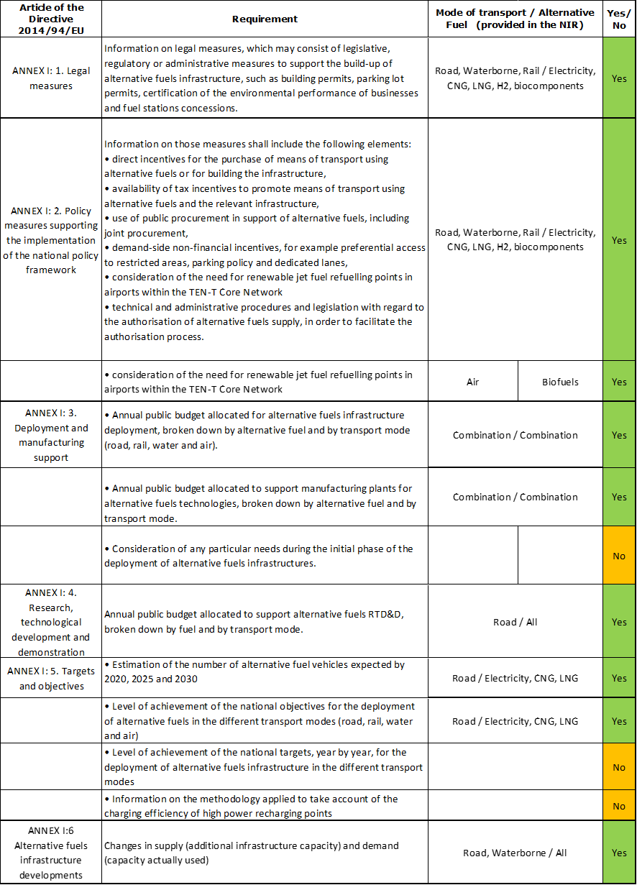

The checklist shows the requirements of Annex I from the Directive that are covered in the PL NIR.

Regarding the combinations of AF and transport mode, electricity/road, CNG/road and LNG/road are partially covered for AFV and AFI. LPG for road is mentioned. About the remaining combinations, the Polish NIR does not offer exhaustive quantitative future AFI targets or AFV estimates.

The Polish NIR reports 26 measures. Under the Policy and Deployment & Manufacturing sections it was possible to identify eight AF/transport mode clusters of measures, all assessable.

### Quantitative assessment: Vehicles and infrastructure

*Table 5.21.3‑1 National AFV estimates and AFI targets established in the NIR at the horizon 2020, 2025 and 2030 and their comparison with the NPF situation*

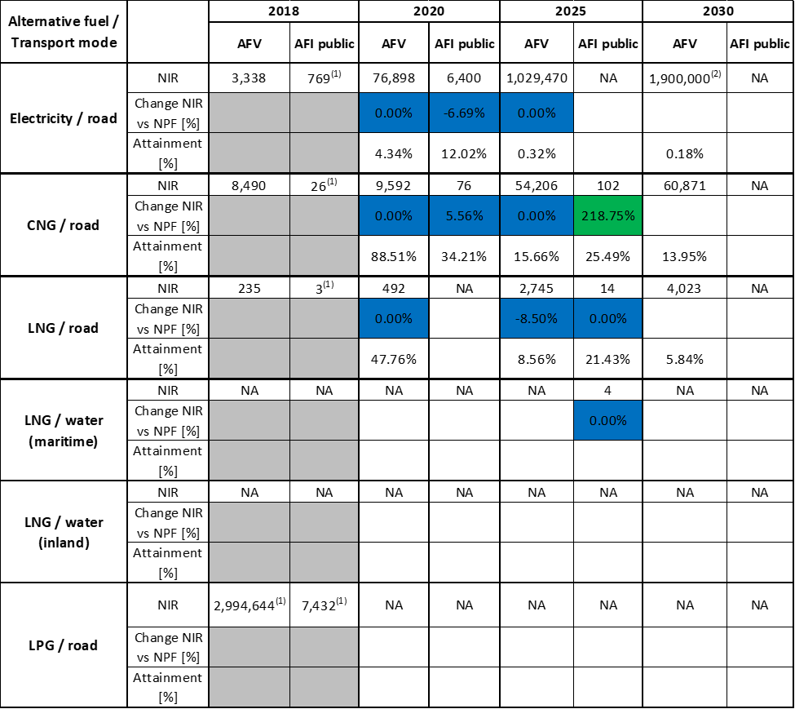



(1) Value taken from EAFO 2018 (absent in NIR)

(2) This value is mentioned in the PL NIR but not officially reported in the accompanying excel file

#### Road transport

##### Electricity

###### Vehicles

Poland recorded a total of 3,338 electric vehicles in use in 2018 (of which 3,018 were passenger cars and 320 buses and coaches). The Polish NIR confirms the EV estimates presented in the NPF for the years 2020 and 2025 (76,898 and 1,029,470 EVs, respectively) and adds a new estimate for 2030 (1,900,00 EVs) that was not present in the NPF. The level of ambition in the PL NIR remains the same as in the NPF. Concerning the heavy-duty sector, the Polish NIR does not provide specific information for the years 2020-2030.

The 2018 ***attainment*** of future EV estimates is 4.34% for 2020 and 0.18% for 2030. According to the assessment methodology described in Section 2.1, the 2018 situation corresponds to an ***adequate progress*** towards reaching the envisaged EV estimates. The calculated ***average*** ***annual growth rate*** corresponding to the period 2016-2030 for EV fleet evolution planned by Poland is equal to 69%.

###### Infrastructure

The PL NIR does not provide information on the number of publicly accessible recharging points in Poland in 2018. The value of 769 reported in Table 5.21.3‑1 is taken from EAFO 2018 database. The target for publicly accessible recharging points in 2020 provided in the PL NIR is 6,400, almost 7% lower than in the NPF, of which 6,000 are normal power (≤22kW) points and 400 high power (>22kW) points. Similarly to the NPF, no targets for 2025 and 2030 are provided in the PL NIR. Similarly to the vehicles, the level of ambition for infrastructure in the PL NIR appears the same as in the NPF.

The 2018 ***attainment*** of future public recharging infrastructure targets is 12.02% for 2020. According to the assessment methodology described in Section 2.1, the 2018 situation corresponds to a ***slow progress*** towards reaching these envisaged targets. The calculated ***average annual growth rate*** corresponding to the period 2016-2020 for publicly accessible recharging infrastructure evolution planned by Poland is equal to 111%.

###### Ratio

Based on the PL NIR, the following table shows the ratio between vehicles and publicly accessible recharging points (i.e. sufficiency index) for the pair electricity/road. For 2025 and 2030 the sufficiency index could not be computed, while for 2020 it exceeds the value of 10. It can be considered still adequate but the trend from the previous years raises some doubts about it adequacy also after 2020.



###### Information on charging efficiency

Information is not available in the Polish NIR.

##### CNG

###### Vehicles

Poland reported 8,490 CNG vehicles in use in 2018, of which 5,339 were passenger cars, 2,405 LCVs, 177 HCVs and 569 buses and coaches. Concerning the years 2020 and 2025, the PL NIR confirms the NPF estimates (respectively 9,592 and 54,206 CNG vehicles). In addition, the PL NIR presents an estimate of 60,871 CNG vehicles in 2030, which was absent in the NPF. This new estimate is not accompanied by details on the heavy-duty vehicles.

The 2018 ***attainment*** of future CNG vehicles estimates is 88.51% for 2020 and 13.95% for 2030. According to the assessment methodology described in Section 2.1, the 2018 situation corresponds to an ***adequate progress*** towards reaching the envisaged CNG vehicles estimates. The calculated ***average annual growth rate*** corresponding to the period 2016-2030 for the CNG vehicle fleet evolution planned by Poland is equal to 30%.

###### Infrastructure

The PL NIR does not provide information on the number of CNG refuelling points in Poland in 2018. The value of 26 reported in Table 5.21.3‑1 is taken from EAFO 2018 database. However, the PL NIR does report that 28 CNG refuelling points were in place at the end of August 2019. The PL NIR also reports that Poland aims to achieve 76 CNG refuelling points in 2020 and 102 in 2025. No target for 2030 was indicated. The value for 2020 is in line with the NPF (5.56% higher) while the value for 2025 is remarkably higher (+218.75%) but this could be due to an incorrect reporting of the original value in the PL NPF.

The 2018 ***attainment*** of future public CNG refuelling infrastructure targets is 34.21% for 2020 and 25.49% for 2025. According to the assessment methodology described in Section 2.1, the 2018 situation corresponds to a ***slow progress*** towards reaching these envisaged targets. The calculated ***average annual growth rate*** corresponding to the period 2016-2025 for publicly accessible CNG refuelling infrastructure evolution planned by Poland is equal to 16%.

###### Ratio

Based on the PL NIR, the following table shows the ratio between vehicles and publicly accessible refuelling points (i.e. sufficiency index) for the pair CNG/road. The values not shown could not be computed as vehicle estimates and/or targets for infrastructure were not given. According to the available data, the sufficiency index is always below the indicative value of 600 (see Section 2.1.5).



##### LNG

###### Vehicles

Poland recorded 235 LNG vehicles in 2018, all in the heavy-duty sector (200 HCVs and 35 buses and coaches). Regarding next years, the PL NIR confirms the NPF estimate for 2020 (492 LNG vehicles) and decreases the estimate for 2025 (2,745 compared to 3,000 in the NPF). The PL NIR reports also that in 2030 the number of LNG vehicles is expected to increase to 4023 (this value was not present in the NPF). This estimated growth is planned mainly for the heavy-duty sector.

The 2018 ***attainment*** of future LNG vehicles estimates is 47.76% for 2020 and 5.84% for 2030. According to the assessment methodology described in Section 2.1, the ***progress*** obtained by Poland from 2016 until 2018 for LNG vehicles deployment is 4.49% of the overall planned deployment during the period 2016-2030.

###### Infrastructure

The PL NIR does not provide information on the number of LNG refuelling points in Poland in 2018. The value of three reported in Table 5.21.3‑1 is taken from EAFO 2018 database. As for the next decade, the PL NIR only confirms for 2025 the NPF target of 14 publicly accessible LNG refuelling points, to be developed on the TEN-T network.

The 2018 ***attainment*** of future LNG refuelling infrastructure target could only be calculated with respect to 2025 and is equal to 21.43%, while the ***progress*** could not be computed.

###### Ratio

Based on the PL NIR, the following table shows the ratio between vehicles and publicly accessible refuelling points (i.e. sufficiency index) for the pair LNG/road. Obviously, the sufficiency indexes for 2020 and 2030 could not be computed as targets for infrastructure were not indicated.



##### Hydrogen

###### Vehicles

Information is not available in the PL NIR.

###### Infrastructure

Information is not available in the PL NIR on the hydrogen infrastructure development, but financial support for such projects is foreseen within the Polish Low-Emission Transport Fund.

###### Ratio

As no information has been provided for vehicles and infrastructure, the sufficiency index could not be computed.

##### Biofuels

###### Vehicles

Information is not available in the Polish NIR.

###### Infrastructure

The PL NIR reports that there is no obligation to obtain a licence for the production of bio-components used for the production of liquid fuels or liquid biofuels. Producers of bio-components are only obliged to register with the Producer Register, kept by the National Support Centre for Agriculture.

##### LPG

###### Vehicles

Information is not available in the Polish NIR. The value shown in Table 5.21.3‑1 (2,994,644 LPG vehicles in 2018) is taken from EAFO.

###### Infrastructure

The Polish NIR, similarly to the NPF, does not report any past of future data on LPG infrastructure. The 2018 value of 7,432 publicly accessible LPG refuelling points, shown in Table 5.21.3‑1, is taken from EAFO.

###### Ratio

Based on the PL NPF and EAFO data, the following table shows the ratio between vehicles and publicly accessible refuelling points (i.e. sufficiency index) for the pair LPG/road. Only the ratios for 2016 and 2018 could be computed.



* computed with values taken from NPF and EAFO

#### Rail transport

##### Electricity

###### Vehicles

Information is not available in the Polish NIR.

###### Infrastructure

Information is not available in the Polish NIR.

#### Waterborne transport (maritime)

##### Electricity

###### Vessels

Information is not available in the Polish NIR.

###### Infrastructure

Information is not available in the Polish NIR.

##### LNG

###### Vessels

Information is not available in the Polish NIR.

###### Infrastructure

The PL NPF had claimed that “*Because of insufficient demand, there is currently no need to build fixed LNG bunkering installations in Polish ports. It is enough to use tank trucks or bunker vessels for this purpose”.* Despite that, the NPF had provided a provisional plan to develop by 2025 infrastructure for provision of LNG bunkering services in the ports of Gdańsk, Gdynia, Szczecin, and Świnoujście, within the TEN-T Core Network. The PL NIR confirms this plan.

Since the current LNG refuelling infrastructure situation in the maritime ports was not provided, the 2018 ***attainment*** and ***progress*** could not be computed.

#### Waterborne transport (inland)

Information is not available in the Polish NIR.

#### Air transport

##### Electricity

###### Airplanes

Information is not available in the Polish NIR.

###### Infrastructure (for stationary airplanes)

Information is not available in the Polish NIR.

##### Biofuels

###### Airplanes

Information on flights / airplanes powered by biofuels is unavailable in the Polish NIR.

###### Infrastructure

The Polish NIR makes only some general considerations of the need for renewable jet fuel refuelling points in airports within the TEN-T Core Network.

### Measures assessment

The measures listed in the Polish NIR are not differentiated at regional level. As the NPF, the Polish NIR contains an extensive and detailed description of measures. They cover a wide variety of AFs and transport modes, however the vast majority focuses on electricity and natural gas as AF and on road as transport mode. In comparison to the NPF, the measures in the PL NIR include hydrogen, which is an additional value to the program. For example, there is the possibility for financing projects for hydrogen use in maritime transport. Shore-side electricity supply and LNG refuelling infrastructure for ships were in some way addressed in the NPF but after transposition of the legal acts they are not further reported in the NIR. The focus on CNG development is strong in Poland and measures continue to support further development.

#### Legal measures

The Polish NIR contains 10 legal measures (versus 18 in the NPF) to promote AF, with detailed descriptions. Measures focusing on defining the legislative framework for AF deployment were not reported in the NIR, while the law is now developed and functioning. Most of the NIR measures are covered by the *Act of 11 January 2018 on electromobility and alternative fuels* that addresses entirely or partly the topic of alternative fuels and by national legal acts transposing EU Directives. The Low-Emission Transport Fund to finance the measures implementation has been established, scheduled for release on the second half of 2019 and planned to be functional until the end of 2027. This is a main implementation tool providing financial support.

In line with the overall focus on electrification in the NIR, the most numerous cluster concerns electricity/road containing 9 measures out of which three are specifically dedicated to this pair of AF/transport mode while the other six cover also other AFs. Four measures target AFI and information tools development, one addresses production of bio-components for liquid fuels or liquid biofuels, three refer to AFV and involve obligation to involve AFVs in the fleets of administrative bodies, and one refers to the Low-Emission Fund that is presented as main financing tool.

Overall, the legal measures in the PL NIR show an increased ambition level compared to that in the NPF.

##### Legislative & Regulatory

Poland lists seven legal measures in its NIR that are implemented directly on the basis of by the *Act of 11 January 2018 on electromobility and alternative fuels* to allow for the implementation of principles for deployment of alternative fuels infrastructure, fuel quality and clean vehicles:

* recharging points and CNG/LNG stations development within the TEN-T Core Network,
* obligation to have electric vehicles in supreme or central state administration bodies and local self-government units
* no requirement to obtain a permit for the construction of a charging station
* no obligation to obtain a license for the production of bio-components used to produce liquid fuels or liquid biofuels
* establishing vehicle charging service as new type of business activity that does not require concession
* electronic application to provide information on the availability of infrastructure for charging electric vehicles.

##### Administrative

The Polish NIR only reports one administrative measure, on rules and standards for the construction of alternative fuels infrastructure. Also this measure is implemented in the *Act of 11 January 2018 on electromobility and alternative fuels* with statutory definitions created in line with Directive 2014/94/EU.

The updated *National policy framework for alternative fuels infrastructure development*, adopted by the Council of Ministers on 17 October 2018[3], assumes the introduction into the National Framework of technical specifications for hydrogen refuelling points, in accordance with the content of AFI Directive 2014/94/EU. Technical specifications are specified in the following standards:

- ISO / TS 20100, concerning the filling of hydrogen gas[4],

- ISO 17268, concerning connection devices for filling hydrogen in gaseous state in motor vehicles,

- ISO 14687-2, concerning the purity of hydrogen issued by hydrogen refuelling points.

The national framework will also be updated with information on consumer rights to choose an electricity seller to charge electric vehicles other than the household electricity supplier.

#### Policy measures

The PL NIR states that the policy direction in Poland is to encourage the introduction of alternative fuels vehicles and other sustainable transport modes. The main focus in the Polish NIR is on electric and CNG vehicles, where financial instruments are introduced for different vehicle categories. In comparison to the NPF, hydrogen is also acknowledged and supported in the NIR.

##### Measures to ensure national targets and objectives

###### Road transport

Most of the policy measures described in the Polish NIR can be categorised as measures to ensure national targets and objectives.

The implementation report lists a series of twelve (of which six financial, and six non-financial) policy measures, all related mainly to road transport, but not excluding other modes if the potential project would pass the eligibility criteria.Two of them involve taxation: tax reductions or exemptions for alternative fuels or for vehicle registration. Although both of them were present also in the NPF, changes have been implemented. Since then new caps are proposed for excise duty on all vehicles, starting from 1 January 2020 (50% lower than in the NPF), which could stimulate the economy, but at the same time the incentives to buy electric or hydrogen car dropped by 50% in comparison to the NPF level. The support for plug-in hybrid electric vehicles will be stopped in 2021.

The second tax incentive is a more favourable tax depreciation for electric vehicles purchased by companies and put into service after 18 December 2018. From January 2019, the tax-deductible costs have been increased by 70% for all types of vehicles. This change incentivises the purchase of the more expensive cars in general.

The draft implementing act to operationalise the Low-Emission Transport Fund foresees support through competitive and non-competitive procedures for all transport modes and AF. It covers projects indicated in the Electro-mobility Development Plan in Poland, in the NPF and in the Act on electro-mobility and alternative fuels. The values and types of support for investments linked to alternative fuels infrastructure and the purchase of vehicles are simply tabularised. Substantial support is available for purchase of EV, CNG/LNG and hydrogen vehicles (types M1, M2, N1-N3, L up to 30% of the purchase cost).

###### Other transport modes

The PL NIR does not report measures specifically addressing other transport modes (waterborne, air, railway). However, other modes are not excluded if the potential project would pass the eligibility criteria. The main instrument for financing the projects remains the Low-Emission Transport Fund.

##### Measures that can promote AFI in public transport services

Five of the policy measures described in the Polish NIR, can be categorised also as measures that can promote AFI in public transport services. All of them are existing measures: one is dealing with research on alternative fuels, and the remaining four provide financial support for buses and trolley buses at national level.

###### Buses

The draft implementing act to operationalise the Low-Emission Transport Fund foresees support through competitive and non-competitive procedures for all transport modes and AFs. The values and types of support for investments linked to alternative fuels infrastructure and the purchase of vehicles are simply tabularised. Substantial support is available for EV (55% of the purchase cost), CNG/LNG (15%) and hydrogen (55%) fuelled buses and electric trolley buses (45%).

Also research aimed at developing new types of bio-components, liquid biofuels, other renewable fuels, or the use of CNG or LNG, including that derived from biomethane, or hydrogen, or electricity is subsidised. Transport projects or research towards new design-related solutions in this area, up to PLN 5,000,000, can obtain financing up to 25%, 50% or even 100% of eligible costs per project.

###### Other transport modes

Transport modes other than those indicated directly in Directive 2014/94/EU (inter alia, railway transport) may be taken into account under that Directive, but these measures are not a mandatory part of Directive. As railway transport is not a transport mode for which limited alternatives to fossil fuels are available in Poland, it is not considered necessary to set targets for railway transport in the NIR.

##### Measures that can promote the deployment of private electro-mobility infrastructure

Support for private electro-mobility infrastructure is provided as the possibility of financial support for normal power (≤22kW) recharging stations, up to 50% of eligible costs, but with a cap of PLN 25,500 per station. The main instrument for financing the projects remains the Low-Emission Transport Fund, but no allocations/denominations have been indicated.

#### Deployment and manufacturing support

##### AFI deployment

Both categories, AFI deployment and support of manufacturing plants for AF technologies, fall under funding from the Low-Emission Transport Fund with no denominations given. As no allocations have been given, the quantitative assessment is not possible.

##### Support of manufacturing plants for AF technologies

Both categories, AFI deployment and support of manufacturing plants for AF technologies, fall under funding from the Low-Emission Transport Fund with no denominations given. As no allocations have been given, the quantitative assessment is not possible.

##### Consideration of any particular needs during the initial phase of the deployment of alternativefuels infrastructure

Information is not available in the Polish NIR.

#### Quantitative assessment of Policy and Deployment & Manufacturing measures

Table 5.21.4‑1 presents an analysis of all the Policy and Deployment & Manufacturing measures, carried out according to the assessment methodology described in Section 2.2. As it can be seen, all the identified clusters can be considered comprehensive, however all get a low overall score with the exception of the electricity/road cluster that obtains a medium score. The reason for this overall situation is that, although in principle the measures look quite promising and with a wide scope, they cannot be properly assessed, as the specific allocations to support the attainment of the declared targets and objectives were not given. In terms of expected impact of these measures to support the realisation of the AFV/AFI objectives as presented in the NPF and revised in the NIR, the partial lack of objectives (especially regarding future infrastructure) and information related to budget allocations, does not allow to put this assessment in the right perspective. However, on the basis of a comparison of the Polish measures with those provided by other Member States, it can be said that the measures for the pair electricity/road might have a medium impact while all the other might have a low impact.

Compared to the NPF, the level of ambition of the Policy and Deployment & Manufacturing support measures has increased for all pairs.

*Table 5.21.4‑1 Quantitative assessment of Policy and Deployment & Manufacturing support measures*

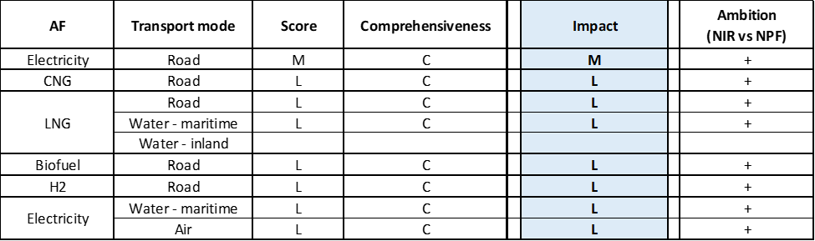

**Legend:** Score and Impact: H = high; M = medium; L = low; X = not assessable. Comprehensiveness: C = comprehensive; N = Not comprehensive. Ambition level: ‘+’ means ‘higher’; ‘=’ means ‘comparable’; ‘-‘ means ‘lower’.

#### Research, Technological Development & Demonstration

Four measures for financing the RTD&D activities are given for Poland. The first one is the Low-Emission Transport Fund, where by the end of 2027, the resources available to the Fund will have amounted to more than PLN 6.7 billion. All projects indicated in the *Electromobility Development Plan in Poland*, NPF and *Act on electromobility and alternative fuels* are supposed to be financed from the Low-Emission Transport Fund.

On top of that, financial support for R&D is granted by the National Centre for Research and Development. Funding amounting to:

a) PLN 1,579,000 has been established to co-fund R&D related to road transport based on natural gas,

b) PLN 11,030,800 has been established to co-fund R&D related to road transport based on hydrogen,

c) PLN 14,069,404 has been established to co-fund R&D related to road transport based on electricity.

Compared to the NPF, the PL NIR shows that the financing instruments for RTD&D projects have been established.

### Additional information on alternative fuels infrastructure developments

The Polish NIR provides information on the changes in fuel use but only until 2018 (see Table 5.21.5‑1). As no future estimates were provided, one can only comment on the slight decrease of gasoline and LPG use for road transport, accompanied with a growing use of biofuels and, to a much lesser extent, of CNG. The use of electricity as a fuel for transport is still marginal.

No noticeable LNG use in maritime transport is reported. Marine gas oil is the dominant fuel for maritime and inland waterways.

*Table 5.21.5‑1 Changes in fuel use in transport sector (2016-2018)*



### Summary of the assessment

###### **Tabular overview**

*Table 5.21.6‑1 Overview of the NIR assessment*

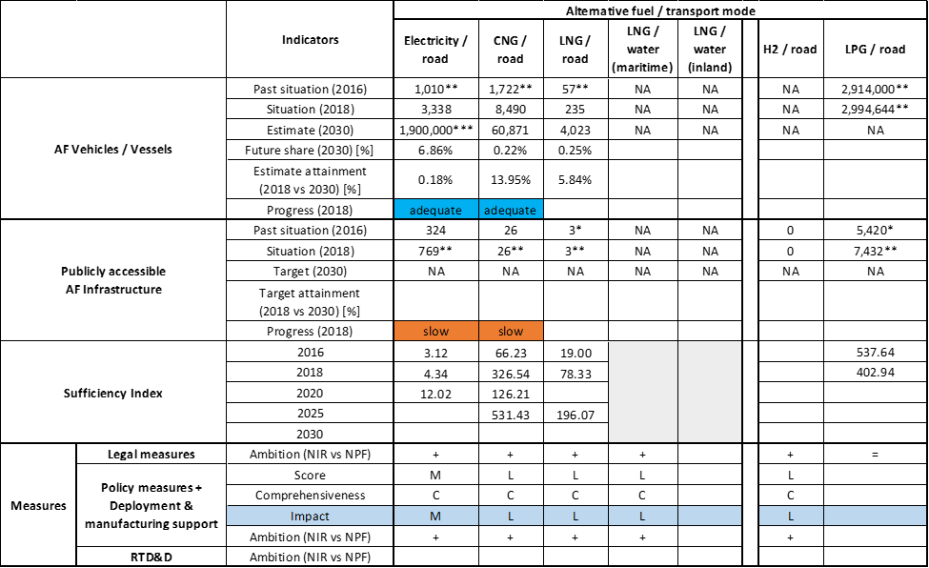



* Value taken or calculated from PL NPF; ** Value taken from EAFO (absent in both NPF and NIR); ***Value mentioned in the PL NIR but not officially reported in the accompanying excel file.

The Polish NIR only partially covers the whole AFID period (2016-2030). The Polish government took actions to fulfil its NPF, specifically implementing legal changes announced in the NPF, as well as by constituting the Low-Emission Transport Fund. The Polish NIR addresses several requirements of Annex I of the Directive, but it does not provide information on the methodology applied to take account of the charging efficiency of high power recharging points and it does not provide considerations on any particular needs during the initial phase of AFI deployment.

The main outcomes of the technical assessment of the Polish NIR on vehicles/vessels estimates and infrastructure targets can be summarised as follows:

###### Road transport

* **Electricity** - Poland recorded a total of 3,338 electric vehicles in use in 2018 (of which 3,018 were passenger cars and 320 buses and coaches). Poland is progressing adequately towards reaching the envisaged EV estimates but slowly in terms of recharging infrastructure. With regards to the latter, the targeted number of publicly accessible recharging points in 2020 is slightly less ambitious in the NIR than in the NPF (-6.69%). The sufficiency index deteriorates slightly over time. In 2020 it can still be considered adequate, but the trend raises some doubts about it adequacy also after 2020. The Polish NIR does not give information on the foreseen electric heavy-duty vehicles by 2030.
* **CNG** - The second fastest growing alternative fuel in Poland is CNG. According to the Polish NIR, the number of CNG vehicles will be growing from 8,490 reported for 2018, up to 60,871 in 2030, which corresponds to adequate progress. While the number of heavy-duty vehicles is reported for 2018 (177 HCVs and 569 buses and coaches) no information is given for 2030. As for CNG infrastructure, the targeted number of CNG refuelling points for 2020 is higher (5.56%) in the NIR than in NPF. Also, the target value for 2025 in the NIR is remarkably higher (+218.75%) but this could be due to an incorrect reporting of the original value in the PL NPF. The 2018 situation corresponds to a slow progress towards reaching these envisaged targets. The sufficiency index is always below 600.
* **LNG** - The Polish NIR foresees a development of LNG for road transport. It is worth noting that the whole LNG/road pair is reported mainly for the heavy-duty sector (200 HCVs and 35 buses and coaches were recorded in 2018). The progress obtained from 2016 till 2018 by Poland for LNG vehicles deployment is 4.49% of the overall planned deployment during the period 2016-2030. By 2025, the construction and deployment of 14 public LNG refuelling points is planned on the TEN-T network.
* **Hydrogen** – Similarly to the NPF, the NIR does not report any vehicle estimate or infrastructure target until 2030, but foresees the possibility of financial support for eligible projects on hydrogen vehicles and refuelling infrastructure within the Low-Emission Transport Fund.
* **Biofuels** – The PL NIR only reports on the lack of obligation to obtain a licence for the production of bio-components used for the production of liquid fuels or liquid biofuels.
* **LPG** – LPG is not taken into consideration in the Polish NIR, even if in practice it plays a considerable role in the Polish transport system.

###### Rail transport

Information is not available in the Polish NIR.

###### Waterborne transport (maritime)

* **Electricity –** Information is not available in the Polish NIR.
* **LNG** - While in the NPF Poland claimed that “*Because of insufficient demand, there is currently no need to build fixed LNG bunkering installations in Polish ports. It is enough to use tank trucks or bunker vessels for this purpose.”,* the PL NIR provides some new elements, as Poland plans to develop 4 LNG refuelling points in the TEN-T Core maritime ports by 2025. At the same time, no plans for LNG vessels are revealed.

###### Waterborne transport (inland)

Information is not available in the Polish NIR.

###### Air transport

Information is not available in the Polish NIR.

The Polish NIR contains an extensive and detailed description of **measures**. They cover a wide variety of AFs and transport modes, however the vast majority focuses on electricity and natural gas as AF and on road as transport mode. An overall assessment of the legal measures is that the PL NIR shows an increased ambition level compared to the NPF.

With reference to the Policy and Deployment & Manufacturing support measures, financial instruments are introduced for different vehicle categories. In comparison to NPF, hydrogen is also acknowledged and supported in the NIR. In terms of expected impact of the measures to support the realisation of the AFV/AFI objectives as presented in the NPF and revised in the NIR, the partial lack of objectives (especially regarding future infrastructure) and information related to budget allocations, does not allow to put this assessment in the right perspective. However, on the basis of a comparison of the Polish measures with those provided by other Member States, it can be said that the measures for the pair electricity/road might have a medium impact while all the other might have a low impact. Compared to the NPF, the level of ambition of the Policy and Deployment & Manufacturing measures support measures has increased for all pairs.

The financial support for the measures implementation will be provided mainly from the national Low-Emission Transport Fund, but some support from EU funds is also taken into consideration, mainly in case of RTD&D. Although the government of Poland officially excludes hydrogen from its plans, the prominence of this alternative fuel in support measures, particularly RTD&D funding, is noteworthy.

### Final remarks

The Polish NIR provides a rather comprehensive report on the efforts to implement the Directive. The NIR complies, to a certain extent, with the requirements of Annex I to the Directive. However, the NIR does not set targets for electricity recharging points for 2025 and 2030 as well as for CNG and LNG refuelling points for road and maritime transport in 2030. Information is not available on the LNG planning for inland water transport. Furthermore, the NIR does not provide information on existing and future plans for the supply of electricity in ports and airports. The NIR includes an elaborated list of measures; however, they are mainly focused on road transport and, in particular, on its electrification.

For electricity, the NIR estimates that approximately more than one million electric vehicles could be on the road in Poland by 2025 and almost two million by 2030, representing about 7% of the fleet by that time. Taking into account the current situation, fleet and existing trends, this level of ambition does not appear to be fully compatible with the pace of deployment of electric vehicles considered necessary for a full transition to carbon neutrality by 2050. Furthermore, Poland should provide further information on its targets for recharging points by 2025 and 2030. No information on charging efficiency is provided. Further information should be given on shore side electricity, electricity supply for stationary aircraft and rail transport. Poland should also report on its plans for further electrification of these modes of transport.

Regarding hydrogen for transport, the NIR does not report any vehicle estimates or infrastructure target until 2030, merely indicating that Poland provides financial support to vehicles and refuelling infrastructure as part of its Low-Emission Transport Fund. It would be relevant that Poland provides more information on how to ensure EU-wide connectivity for HCEV.

Concerning natural gas, the NIR shows a target of 60,871 CNG vehicles in 2030. Although the number of CNG vehicles is considered to increase in Poland until 2030, they would only represent 0.22% of the future fleet in 2030 according to the NIR. For 2025, 102 CNG refuelling points are planned, which seems sufficient for the estimated CNG fleet. For LNG, only a moderate increase of heavy-duty vehicles is expected in the next years. Furthermore, the NIR estimates 14 LNG refuelling stations by 2025. The number of LNG refuelling points seem sufficient considering the length of Poland’s TEN-T Core Network, provided that the refuelling points are widely distributed along the network. The current target is that LNG refuelling points will be installed in the four Polish ports in the TEN-T Core Network by 2025, thus complying with the requirements of the Directive. However, Poland should provide information on estimates for LNG vessels in its fleet. Nevertheless, no information is provided to ensure LNG refuelling in the two inland ports of the TEN-T Core Network by 2030.

Future LPG development is not taken into consideration in the Polish NIR, even if in practice it plays a considerable role in the Polish transport system (three million LPG vehicles and around 7,400 refuelling points). Future reporting should provide more information on LPG development.

Poland should provide more information in future reporting on efforts to promote the use of renewable fuels in transport, and particularly in aviation.

### ANNEX - Description of the Member State

On a surface area of 312,700 km², Poland has a population of 37.977 million people in 2018, which makes up for a population density of 121 inhabitants/km².

*Number of main urban agglomerations*

* 69 urban agglomerations > 50,000 inhabitants

In 2018, Poland achieves a per capita gross domestic product at market prices of €12,920, which represents a per capita gross domestic product in purchasing power standards of 70 if expressed in relation to the EU-28 average set to equal 100.

*Length of the road networks*

The length of the road TEN-T Core Network in Poland is 3,834 km. The total road network length is 156,822 km, of which 1,637 km are motorways.

The following lengths of TEN-T Road Corridors are present in Poland: 1,832 km (51%) of the Baltic - Adriatic Corridor and 975 km (24%) of the North Sea - Baltic Corridor.

Through the TEN-T Road Corridors, Poland is connected with the following Member States:   
- Germany (through the North Sea - Baltic Corridor)   
- Lithuania (through the North Sea - Baltic Corridor)   
- Slovakia (through the Baltic - Adriatic Corridor)  
- Czechia (through the Baltic - Adriatic Corridor)

*Number of registered road vehicles*

At the end of 2018, Poland accounts for 30,061,644 registered road vehicles of which 23,429,016 are categorized as passenger cars, 2,649,198 as light goods vehicles, 1,108,075 as heavy goods vehicles and 119,471 as buses and coaches. The motorisation rate is 617 passenger cars per 1,000 inhabitants.

*Number of ports in the TEN-T Core Network*

* 4 maritime ports in the TEN-T Core Network (Gdánsk, Gdynia, Świnoujście, Szczecin)
* 1 maritime port in the TEN-T Comprehensive Network
* 2 inland ports in the TEN-T Core Network (Świnoujście, Szczecin)
* 1 inland port in the TEN-T Comprehensive Network

Through the 65 km inland waterways TEN-T Core Network, Poland is connected with Germany through the North Sea – Baltic Corridor.

*Number of airports in the TEN-T Core Network*

* 8 airports in the TEN-T Core Network (Gdánsk, Katowice-Pyrzowice, Kraków, Łódź, Poznań, Szczecin, Warszawa, Wrocław)
* 2 airports in the TEN-T Comprehensive Network

## Portugal (PT)

The Portuguese NIR was not notified to the Commission on time and was thus not assessed.

## Romania (RO)

### Main messages from the Commission assessment of the NPF

In its original assessment of the Romanian NPF, the Commission concluded:

*The Romanian NPF addresses partly the requirements of Article 3 of the Directive. For most mandatory fuels and modes, it establishes targets but it does not contain a target for LNG refuelling points to be put in place along the road TEN-T Core Network for heavy-duty vehicles. It contains a discussion of the current state and future scenarios for alternative fuels in the transport sector. The Romanian NPF indicates global AF targets for infrastructure in 2020 and vague targets for electricity and CNG in road transport related only to urban agglomerations and the TEN-T Core Network. The NPF contains only general estimates of percentage increase for AFV in the future.*

*The Romanian NPF lacks concrete targets for EV infrastructure and information about the future EV vehicle market development. It only mentions a target for urban agglomerations in 2020 and one for the TEN-T Core Network in 2030. According to the Romanian NPF, the distance between two directly neighbouring high power-recharging points along the TEN-T Core Network will be approximately 70 km in 2030, which seems insufficient. If implemented, the proposed set of measures could support electro-mobility since it was evaluated as being comprehensive and having a medium assessment score. There are plans for the public procurement of 107 electric buses for public transport in three main urban agglomerations.*

*For shore-side electricity, the NPF does not contain concrete targets but mentions ongoing studies for Bucharest Airport "Henri Coandă" to investigate the possible extension of the existing network. The Romanian NPF provides targets for supplying shore-side electricity in its TEN-T Core Network ports.*

*The NPF shows the ambition of increasing the number of CNG refuelling stations with 23 new ones in selected urban agglomerations and 30 new ones along the TEN-T Core Network before the end of 2020. The targeted number of CNG refuelling stations can be considered sufficient, although the NPF does not provide future estimates for CNG vehicles. Since the average distance between them is foreseen to be 150 km along the TEN-T Core Network, it seems that the 2025 minimum coverage requirements will be fulfilled even though their precise spatial distribution information is not provided.*

*No infrastructure targets are given in terms of LNG for road transport, for 2025, the NPF is only mentioning as objective the assessment of the feasibility of deploying such an infrastructure.*

*The Romanian NPF does not provide targets for hydrogen refuelling infrastructure but mentions that research and development in this field will be encouraged since Romania is part of the group of countries who traditionally produce hydrogen.*

*The Romanian NPF, intending to accelerate the AF deployment in transport, contains a large portfolio of measures with more than half of the presented measures being of administrative, legislative and regulatory type. In the case of the assessed measures, most of them are under consideration and only few are already in place while the lack of concrete information makes it difficult to evaluate the scope according to our methodology. A medium overall assessment score is derived for electric vehicles as well as for alternative fuels in public transport services. Electro-mobility is promoted through substantial direct incentives for purchase of vehicles that are in place since 2016. However, these incentives are only approved for one year at a time and this could be perceived by market actors as a lack of predictability in terms of stability of support measures.*

*The NPF provides a detailed current situation and assessment of the need for investment in public transport services. Measures and plans to increase to more than 30 % the share of electricity-powered vehicles (including tramways, trolleybuses, buses and microbuses) in the urban public transport fleet in 2020 are presented.*

*Five ministries and a series of relevant central public institutions were involved in the drafting of the Romanian NPF. It has been established respecting the interests of regional and local authorities. An inter-ministerial coordination council has been set up in order to ensure the monitoring of the implementation actions and cooperation between the relevant authorities.*

*Evidence of Romania’s collaboration with other MSs has been found mainly in the frame of EU projects regarding the inland navigation sector (INNOVATIVE DANUBE VESSEL, PROMINENT, the LNG Master Plan for Rhine-Main-Danube). Beyond these projects, the NPF does not mention any cooperation or coordination with the neighbour MSs in the field of alternative fuels. It is advised to provide evidence of existing collaborations and planning or to engage in such cooperation to ensure AFI cross-border continuity.*

### Overview of requirements’ fulfilment from Annex I of the Directive

*Table 5.23.2‑1 Checklist Table*



The checklist shows that not all the requirements of Annex I from the Directive are covered.

The Romanian NIR does not offer quantitative future AFI targets. Regarding the combination of AF/AFV/AFI with transport mode, electricity is partially covered for road, rail and air; CNG, hydrogen, biofuels and LPG are partially covered for road transport; LNG is partially covered for waterborne transport; other combinations being either absent or not applicable.

The Romanian NIR reports 28 measures. Under the Policy and Deployment & Manufacturing sections it was possible to identify six AF/transport mode clusters of measures, all assessable.

### Quantitative assessment: Vehicles and infrastructure

The Romanian NPF had AFV estimations only as total number, and not discriminated by AF, while the RO NIR provides estimates for EVs and CNG vehicles. Instead, the RO NPF contained targets for electricity/road, electricity/water (maritime and inland), CNG/road and LNG/water (maritime and inland), while the NIR does not contain any AFI targets (with exception of the pair electricity/air).

Therefore, in order to be able to carry out the assessment of the Romanian NIR, the targets presented in the NPF have been considered.

*Table 5.23.3‑1 National AFV estimates and AFI targets established in the NIR at the horizon 2020, 2025 and 2030 and their comparison with the NPF situation*





(1) value provided in the RO NIR (in this assessment it is assumed this value corresponds to BEV+PHEV+HEV); (2) values from EAFO (BEV+PHEV); (3) values from RO NPF; (4) mono-fuel CNG vehicles; (5) total CNG vehicles (sum of mono-fuel and bi-fuel vehicles) (6) values from EAFO.

#### Road transport

##### Electricity

###### Vehicles

Romania reported a total of 18,067 electric vehicles in use in 2018 (Table 5.23.3‑1), of which 17,352 were passenger cars (1,802 BEV and 15,550 PHEV - but this number probably includes also HEVs, which do not fall under the scope of this assessment), 71 LCVs, 5 HCVs and 639 buses and coaches (but this number probably includes also trolleybuses, which do not fall under the scope of this assessment). On top of that, the RO NIR reports also 107 electric PTWs in use in 2018. According to EAFO, there were 1,448 EVs (excluding PTWs) in use in Romania at the end of 2018. In contrast to the NPF that did not include any EV estimates, the RO NIR contains EV estimates for the next decade (21,074 in 2020, 31,611 in 2025 and 42,148 in 2030)[5].

The 2018 ***attainment*** of future EV (probably including also HEVs) estimates is 85.73% for 2020 and 42.87% for 2030. According to the assessment methodology described in Section 2.1, the 2018 situation corresponds to a ***fast progress*** towards reaching the envisaged EV estimates. The calculated ***average*** ***annual growth rate*** corresponding to the period 2016-2030 for EV fleet evolution planned by Romania is equal to 13%.

###### Infrastructure

Romania recorded 335 publicly accessible recharging points in 2018, of which 207 were normal power (≤22kW) and 128 high power (>22kW) recharging points (38.21%). The RO NIR does not contain any information on targets for the next decade. The NPF had presented two targets: at least 292 recharging points by 2020 (achieved already in 2018) and at least 362 by 2030.

The 2018 ***attainment*** of future public recharging infrastructure targets is 114.73% for 2020 and 92.54% for 2030. According to the assessment methodology described in Section 2.1, the 2018 situation corresponds to a ***fast progress*** towards reaching these envisaged targets. The calculated ***average annual growth rate*** corresponding to the period 2016-2020 for publicly accessible recharging infrastructure evolution planned by Romania is equal to 6%.

###### Ratio

Based on RO NIR[6] and EAFO data, the following table shows the ratio between the number of electric vehicles and number of publicly accessible recharging points (i.e. sufficiency index) for the pair electricity/road. The sufficiency index is well below 10 for the computable years 2016 and 2018, thus it can be considered adequate[7].



* based on AFV and AFI data from EAFO; ** based on AFV data from EAFO and AFI data from RO NIR

###### Information on charging efficiency

Information is not available in the Romanian NIR.

##### CNG

###### Vehicles

The Romanian NIR reports 295 mono-fuel CNG vehicles in 2018, of which 167 were passenger cars, 78 LCVs, 11 HCVs and 39 buses and coaches. Additionally, the RO NIR states that at the end of 2018 there were 1,888 bi-fuel (CNG+gasoline) vehicles in use (1,755 passenger cars and 133 LCVs). In contrast to the NPF that did not include any estimates, the RO NIR contains estimates for mono-fuel CNG vehicles for the next decade (406 in 2020, 609 in 2025 and 812 in 2030).

The 2018 ***attainment*** of future estimates of mono-fuel CNG vehicles is 72.66% for 2020 and 36.33% for 2030. According to the assessment methodology described in Section 2.1, the 2018 situation corresponds to a ***fast progress*** towards reaching the envisaged estimates of mono-fuel CNG vehicles. The calculated ***average annual growth rate*** corresponding to the period 2016-2030 for the evolution of the fleet of mono-fuel CNG vehicles planned by Romania is equal to 12%.

###### Infrastructure

In 2018, Romania recorded three publicly accessible CNG refuelling points (Table 5.23.3‑1). The RO NIR does not provide targets for the next decade but mentions that there is “*a potential of extension in the near future with nine CNG fuelling stations throughout the TEN-T corridor*”, including a series of cities from Arad, via Bucharest, up to Constanța. The RO NPF had presented a target of 55 publicly accessible CNG refuelling points by 2020.

The 2018 ***attainment*** of future public CNG refuelling infrastructure targets is 5.45% for 2020. According to the assessment methodology described in Section 2.1, the 2018 situation corresponds to a ***slow progress*** towards reaching these envisaged targets. The calculated ***average annual growth rate*** corresponding to the period 2016-2030 for publicly accessible CNG refuelling infrastructure evolution planned by Romania is equal to 129%.

###### Ratio

Based on the Romanian NIR and NPF, the following table shows the ratio between total CNG vehicles (mono-fuel and bi-fuel) and publicly accessible refuelling points (i.e. sufficiency index) for the pair CNG/road. The sufficiency index is below the indicative value of 600 for 2016 and thus can be considered adequate (see Section 2.1.5). In 2018, the index is above this indicative value and in the future the index should be monitored in order not to become a barrier for the further market deployment of CNG vehicles.



* calculated using AFV data from EAFO and AFI data from RO NPF

##### LNG

###### Vehicles

Similarly to the NPF, the Romanian NIR does not contain any information about the past or future situation of LNG vehicles. According to EAFO, there were no LNG vehicles deployed in 2018 in Romania. Therefore, the 2018 ***attainment*** and ***progress*** could not be computed.

###### Infrastructure

Similarly to the NPF, the Romanian NIR does not contain any information about past or future situation of LNG refuelling points for road transport. According to EAFO, there were no LNG refuelling points for road transport deployed in 2018 in Romania. Therefore, the 2018 ***attainment*** and ***progress*** could not be computed.

###### Ratio

Since there are no LNG vehicle or infrastructure data provided in the Romanian NIR, it is not possible to calculate the sufficiency index.

##### Hydrogen

The Romanian NIR considers that hydrogen used as alternative fuel is at the research-development stage, and no specific regulations have been implemented in Romania for hydrogen refuelling of vehicles, despite the fact that the transport of hydrogen by road from the place of production to the refuelling station is regulated.

###### Vehicles

Similarly to the NPF, the Romanian NIR does not contain any quantitative information about the past or future situation of hydrogen vehicles. According to EAFO, there were no hydrogen vehicles deployed in 2018 in Romania. Therefore, the 2018 ***attainment*** and ***progress*** could not be computed.

###### Infrastructure

Similarly to the NPF, the Romanian NIR does not contain any quantitative information about past or future situation of hydrogen refuelling points for road transport. According to EAFO, there were no hydrogen refuelling points deployed in 2018 in Romania. Therefore, the 2018 ***attainment*** and ***progress*** could not be computed.

The RO NIR mentions an existing policy measure that was announced in the NPF on establishing the technical characteristics for defining and possibly facilitating the authorisation of hydrogen refuelling stations, and for the authorisation of supply with this type of alternative fuel. The Ministry of Energy initiated consultations with the national natural gas transmission operator, which proposed to establish a research topic regarding the technical reliability of hydrogen injection in the natural gas network.

###### Ratio

Since there are no quantitative hydrogen vehicle or infrastructure data provided in the Romanian NIR, it is not possible to calculate the sufficiency index.

##### Biofuels

###### Vehicles

Similarly to the NPF, the Romanian NIR does not contain any quantitative information about past or future situation of vehicles fuelled by biofuels. Therefore, the 2018 ***attainment*** and ***progress*** could not be computed.

###### Infrastructure

Similarly to the NPF, the Romanian NIR does not contain any quantitative information about past or future situation of refuelling points dedicated to biofuels. Therefore, the 2018 ***attainment*** and ***progress*** could not be computed.

###### Ratio

Since there are no quantitative biofuels vehicle or infrastructure data provided in the Romanian NIR, it is not possible to calculate the sufficiency index.

##### LPG

###### Vehicles

The RO NIR only reports that, according to the Periodic Roadworthiness Test results, the total numberofvehicles equipped with LPG systems in use in 2018 was 261,504, of which 254,275 vehicles equipped with retrofitted LPG fuelling units and 7,229 vehicles equipped with petrol + LPG fuelling units by the vehicle manufacturer. Due to the lack of data, the 2018 ***attainment*** and ***progress*** could not be computed.

###### Infrastructure

The Romanian NIR reported approximately 1,990 public LPG refuelling points in 2018 and, similarly to the NPF, no information regarding future targets. Because there are no LPG refuelling points targets provided in the RO NIR, the 2018 ***attainment*** and ***progress*** could not be computed.

###### Ratio

Based on the RO NIR and EAFO data, the following table shows the ratio between vehicles and publicly accessible refuelling points (i.e. sufficiency index) for the pair LPG/road.



* calculated using AFV and AFI data from EAFO

#### Rail transport

##### Electricity

###### Vehicles

Based on data from the Ministry of Transport, Infrastructure and Communications, the Romanian NIR indicates that the stock of electric locomotives has a descending trend, from 542 in 2016 to 526 in 2018, with 210 being estimated for 2020. For 2025 and 2030, it is stated that no predictions can be made because the active fleet of locomotives will depend on the rail traffic chart of that year.

###### Infrastructure

Information is not available in the Romanian NIR.

#### Waterborne transport (maritime)

##### Electricity

###### Vessels

Similarly to the NPF, information is not available in the Romanian NIR related to electric seagoing ships.

###### Infrastructure

The Romanian NIR does not contain any information about past or future situation of shore-side electricity supply for maritime ports. The RO NPF had provided two targets for maritime and inland ports together: one port for 2025 and six ports by 2030. Since the situation in 2018 is not described in the RO NIR, the 2018 ***attainment*** and ***progress*** could not be computed.

##### LNG

###### Vessels

Similarly to the NPF, no quantitative data are provided regarding LNG seagoing ships in the Romanian NIR. However, two studies are mentioned: one on the “*possibility of adapting the Navrom Galati fleet to using LNG*” (under the LNG MASTER PLAN project) and an opportunity study for the construction and refurbishment of ships using LNG. The NIR mentions that “*the opportunity of refurbishing Diesel propelled ships for the use of LNG is considered not a feasible solution for the time being, constituting a potential option only for newly built ships, in particular ships designed for such type of fuel*”.

###### Infrastructure

No quantitative data are provided in the Romanian NIR regarding LNG supply in the maritime ports, while the NPF contained two targets (1 port in 2025 and 2 ports in 2030). Under the LNG MASTER PLAN project, a pre-feasibility study was prepared on the construction of a small capacity LNG terminal in Constanţa Port (maritime and inland) and a study on the construction of an LNG terminal in Galaţi Port (maritime and inland). The Romanian NIR considers as priority the identification of investors to concession the management of LNG terminals to port operators.

#### Waterborne transport (inland)

##### Electricity

###### Vessels

Similarly to the NPF, information is not provided in the Romanian NIR related to electric inland waterways vessels.

###### Infrastructure

The Romanian NIR does not contain any information about past or future situation of shore-side electricity supply for inland ports. The RO NPF had provided two targets for maritime and inland ports together: 1 port for 2025 and 6 ports by 2030. Since the situation in 2018 is not described in the RO NIR, the 2018 ***attainment*** and ***progress*** could not be computed.

##### *LNG*

###### Vessels

Similarly to the NPF, no quantitative data are provided regarding LNG inland waterways in the Romanian NIR. However, a study is mentioned on the “*possibility of adapting the Navrom[8] Galati fleet to using LNG*” (under the LNG MASTER PLAN project). In Section 5.23.3.3.2 more details are provided on another developed study regarding LNG use in waterborne transport.

###### Infrastructure

No quantitative data are provided in the Romanian NIR regarding LNG supply in the inland ports, while the NPF contained two targets (one port in 2025 and two ports in 2030). In Section 5.23.3.3.2, some details on two studies regarding LNG terminals construction are presented. Since the situation in 2018 is not described in the RO NIR, the 2018 ***attainment*** and ***progress*** could not be computed.

#### Air transport

##### Electricity

###### Airplanes

The only information found in the Romanian NIR relates exclusively to unmanned aircraft equipped with an electric motor – drones. Their number presents an increasing trend for the period 2016 – 2030 (from 542 in 2016 and 379 in 2018 to 800 foreseen in 2020, 1,200 in 2025 and 2,000 in 2030).

###### Infrastructure (for stationary airplanes)

The Romanian NIR reports that 28 electricity supply points for stationary airports were in use in 2018. Targets for the next decade are provided as well: 31 in 2020, 78 in 2025 and 131 in 2030. The Romanian NIR provides also detailed information from the National Company of Airports that at the TEN-T Core “International Henri Coandă Airport” in Bucharest, which performs more than 50,000 aircraft movement per year, there are 16 electricity generators for parked aircraft at the 14 air bridges. The 16 electricity generators have an installed capacity of 90 kVA and, depending on the load, the average power demand is approximately 45 kW. As regards energy consumption, approximately 170 parking operations per air bridge per month are estimated and the electricity consumption is approximately 33.75 kWh per operation.

The 2018 ***attainment*** of future targets of electricity supply points for stationary airports is 90.32% for 2020 and 21.37% for 2030. According to the assessment methodology described in Section the ***progress*** obtained by Romania from 2016 until 2018 for the deployment of electricity supply points for stationary airports is 3.74% of the overall planned deployment during the period 2016-2030.

##### Biofuels

###### Airplanes

Information on flights / airplanes powered by biofuels is not available in the RO NIR. It is mentioned that no aircraft using alternative fuels is recorded in the Romanian air transport sector.

###### Infrastructure

Information is not available in the Romanian NIR on the need for renewable jet fuel refuelling points in airports within the TEN-T Core Network.

### Measures assessment

The Romanian NIR contains a medium size portfolio of measures, most of them focusing on electricity/road. This situation results from the fact that the Romanian NIR presents only new measures in place after 2017 and none of the measures presented in the NPF as in place at that time is mentioned anymore. The NIR mentions that the presented measures are listed in the Annex to Government Decision No 87 of 7 March 2018 approving the “*NPF strategy for developing the alternative fuels market in the transport sector and deploying the relevant infrastructure in Romania and establishing the Inter-ministerial Coordination Council for developing the Alternative Fuels Market*”.

Around half of all the measures in the NIR are Legal measures, mainly of legislative and regulatory category, presenting either current or under discussion legislation.

#### Legal measures

The Romanian NIR contains the description of 11 legal measures in place, a subset from the 19 measures that were listed as future intentions in the Romanian NPF. The remaining 10 measures presented in the NPF as in place at that time are not mentioned anymore in the NIR.

Nine NIR legal measures concern AFI deployment. For AFV and AF, there is one measure for each thematic. All AF types are relatively uniformly covered (two for electricity, one for CNG, one for LNG, three for LPG, two for hydrogen, one for biofuels and one for AF combinations). As transport mode, road is the most frequently mentioned. All measures have 2018 as starting year and are applied at national level.

Considering all the legal measures, they appear to be fit, if fully implemented, to support the realisation of the AFV/AFI objectives as described in the NPF and revised in the NIR. Taking into account that all the legal measures presented in the NIR were announced in the NPF (and proposed for the future), it is considered that the level of policy ambition of the legal measures is similar in the NIR compared to the NPF.

##### Legislative & Regulatory

From the nine measures of this category described in the Romanian NIR, three are of type norms and requirement while six regard national targets. The measures concern developing, revising, supplementing and streamlining the legal framework for alternative fuels deployment in transport, including:

* establishing a common method and/or measurement unit for the public recharging service,
* ensuring the installation of normal power (≤22kW) recharging points in classical fuel stations,
* revising the authorisation procedure of refuelling stations (CNG, LPG),
* conditions of safety and environmental protection for the refuelling process (CNG, LNG, Hydrogen),
* compulsory percentages of biofuels in fossil fuels (in accordance with national and EU legislation),
* revising the concession of spaces designated for the deployment of refuelling/recharging stations/points.

All AF types are present, and from the transport mode point of view, road is covered in all the measures (5 times expressly mentioned). Seven measures concern AFI and cover the following AFs: electricity, CNG, LNG, biofuels, hydrogen and LPG.

##### Administrative

Of all the measures described in the Romanian NIR, six can be categorised as administrative measures. Two of them[9] regard AFI deployment and AFV purchase. One refers to an assessment of the development of LNG infrastructure, covering economic feasibility and cost-benefit proportionality, including environmental aspects. The other concerns the assessment of the opportunity to establish financial instruments (such as guarantee funds, bonds, public-private partnerships) for legal persons intending to develop recharging/refuelling points/stations, and to purchase alternative fuels vehicle fleets.

The Romanian NIR lists as well two measures[10] regarding the establishment of information points and a monitoring system to provide the geographical locations and information on real-time accessibility, historical and real-time information on recharging/refuelling for alternative fuels infrastructure[11]. Other two measures concern local authorities: preparation of guidelines by adapting and integrating good practices tested in other European cities and promotion of funding lines available under the 2014-2020 Regional Operational Programme and intended for the development of local projects, with focus on the development of the alternative fuels infrastructure.

#### Policy measures

The Romanian NIR contains ten policy measures in place, the majority of which were announced as future measures in the NPF. Taking into account that some of them have been revised or have become more concrete, their overall level of ambition is considered increased. Some measures lack details in their description (e.g. budget) that are needed to perform an accurate assessment according to the methodology described in Section 2.2. From the transport mode point of view, nine regard specifically road and one the combination of all modes. Regarding the AF covered, six measures concern different combinations of fuels, three electricity, and one biofuels. They are in majority financial measures and in seven cases they apply at a national level, while in three cases they apply at local level.

##### Measures to ensure national targets and objectives

###### Road transport

The RO NIR presents seven policy measures meant to support the achievement of the Romanian AF objectives in road transport (one measure appears only in the NIR, 6 are common to the NIR and NPF). They are all in place and the majority of them are financial incentives.

Within the measures in place targeting electricity/road pair, which is the focus of the Romanian strategy, the NIR lists:

* purchase subsidies (“Rabla Plus” programme - grants of €10,000 for the private purchase of a new BEV and of €4,250 for the private purchase of a new PHEV),
* scrappage schemes (“Rabla” programme - €1,250 for scrapping an old vehicle at national level and additionally around €2,000 in Bucharest)
* tax reductions/exemptions
  + Ownership tax exemption

The NIR also mentions that the Administration Office of the Environmental Fund is reviewing the possibility of including vehicles using CNG, LNG and hydrogen in the “Rabla Plus” purchase incentive programme in the following years and encouraging the purchase by freight and passenger transport operators of vehicles that can operate on E10 fuel.

A favourable regime for the parking of vehicles using alternative fuels in the main urban areas is mentioned as being under preparation. From the total number of approximately 481,036 parking spaces registered in the administrative territorial units[12], approximately 400 of these are intended exclusively for vehicles using alternative fuels (150 additional under consideration). The NIR mentions that in 12 of the 41 administrative territorial units, including Bucharest Municipality, a series of benefits were granted to natural and legal persons owning alternative fuels vehicles, which consisted in reduction of payment or gratuity for use of parking spaces.

###### Other transport modes

The Romanian NIR presents as an education/information measure the organisation of events to promote mobility based on alternative fuels.

##### Measures that can promote AFI in public transport services

In accordance with Law No 37/2018 on the promotion of green transport, local public authorities, autonomous administrations and companies subordinated to administrative territorial units will purchase AF (electricity – HEV, PHEV and BEV; CNG; LNG; hydrogen) vehicles for passenger transport in a minimum rate of 30% of the demand for future procurements. Privately owned companies providing public local and metropolitan transport services or those in an inter-community development association, including taxi companies, will purchase, as from 2020, AF vehicles (electricity – HEV, PHEV and BEV; CNG; LNG; hydrogen) for passenger transport in a rate of 30% of the demand for future procurements. Annual procurements of vehicles by public authorities to supply their own fleet must include AF passenger cars (electricity – HEV, PHEV and BEV; hydrogen) at a minimum rate of 20%.

##### Measures that can promote the deployment of private electro-mobility infrastructure

Information is not available in the Romanian NIR.

#### Deployment and manufacturing support

Within the Romanian NIR, four measures have been identified to relate to deployment and manufacturing support in the area of alternative fuels in transport, however, the absence of the necessary financial data makes impossible an appropriated assessment.

##### AFI deployment

Since 2018, there is in place a support scheme for deployment of recharging stations for electrical vehicle in the county capital cities. The maximum amount financed by the Authority for the installation of a recharging station (2 high power recharging points – one AC with power >22 kW and one DC with power ≥50 kW) is approximately €40,000, representing 90% of the eligible expenditure.

The Romanian NIR reports one measure regarding the improvement of the methodology for replacing and recycling EV and HEV batteries in order to mitigate any potential negative impact on the environment and public health.

Another measure concerns the identification of funding solutions for power supply infrastructure deployment programmes for stationary aircraft. The administration office of the International Henri Coandă Airport in Bucharest that performs more than 50,000 aircraft movements/year will review the opportunity and the need to deploy power supply sources without using fossil fuel-based supply sources.

##### Support of manufacturing plants for AF technologies

The Romanian NIR contains only one measure in this direction. It regards the assessment of the possibility of allocating an annual budget to support the units developing alternative fuels technologies and reviewing any special needs concerning the use of such technologies by public institutions, the accessing of European funds and communication of any potential benefits for the environment and the economic efficiency of these technologies for the final user.

##### Consideration of any particular needs during the initial phase of the deployment of alternative fuels infrastructures

Information is not available in the Romanian NIR, except the mention that “*special needs at the initial stage of deployment of the alternative fuels infrastructure were also considered*” while preparing the deployment and manufacturing support measures.

#### Quantitative assessment of Policy and Deployment & Manufacturing measures

Table 5.23.4‑1 presents an analysis of all the Policy and Deployment & Manufacturing measures, carried out according to the assessment methodology described in Section 2.2. Five clusters of measures were identified for road transport and one for air transport. Three clusters contain dedicated measures (electricity/road, electricity/air, and biofuels/road) while the other three contain general measures addressing combinations of several alternative fuels. No measure could be identified for the pairs LNG/water (maritime and inland). Five clusters can be considered comprehensive because they cover different categories of measures and different directions of alternative fuels deployment.

In line with the overall focus on road electrification reported in the NIR, the most numerous cluster concerns electricity/road containing a comprehensive set of 10 measures, of which 3 are new measures, displaying a high overall score. In terms of expected impact of these measures to support the realisation of the AFV/AFI objectives as presented in the NPF and revised in the NIR, the measures for the pair electricity/road result to have a high impact and the measures for the pair hydrogen/road to have a medium impact. For all the other identified clusters of measures, the overall low score results in a low impact.

Compared to the NPF, the level of ambition of the Policy and Deployment & Manufacturing support measures has increased for electricity/road, CNG/road, LNG/road and hydrogen/road, and has remained the same for biofuels/road and electricity/air.

*Table 5.23.4‑1 Quantitative assessment of Policy and Deployment & Manufacturing support measures*



**Legend:** Score and Impact: H = high; M = medium; L = low; X = not assessable. Comprehensiveness: C = comprehensive; N = Not comprehensive. Ambition level: ‘+’ means ‘higher’; ‘=’ means ‘comparable’; ‘-‘ means ‘lower’.

#### Research, Technological Development & Demonstration

The Romanian NIR presents a list of eight RTD&D measures[13], however only three of them have been considered as actual RTD&D measures. They represent activities appearing in the NPF as future plans, while the three EU projects on waterborne transport that were presented in the NPF are not mentioned anymore. All three measures are in force but no budget information is presented. As transport mode, two measures address road and one addresses combinations of modes. Regarding the targeted AF, one measure is specific for hydrogen and two for combinations of fuels.

The activities covering specifically hydrogen relate to the assessment of the possibilities of using it as alternative fuel in transport (including by a re-profiling of the current industrial potential of production) and of supporting research activities (including by facilitating access to European funding mechanisms like FCH JU), to develop the required refuelling and propelling systems. The NIR mentions that a technical possibility was identified as regards production of hydrogen in the three refineries within the Romanian territory, through the units producing hydrogen in the petrochemical industry and in the agro-chemical industry as a by-product. In this situation, the NIR level of ambition is consider increased in comparison with the NPF.

One measure is represented by the assessment of the possibility of supporting research activities concerning alternative fuels in general, including by accessing European financing mechanisms (main identified financing means listed are Horizon 2020, Innovation Fund, Connecting Europe Facility (CEF)).

Another RTD&D activity mentioned is the organisation of events to enable testing of buses using alternative fuels for the purpose of procurement for public transport.

### Additional information on alternative fuels infrastructure developments

The Romanian NIR contains information on the fuels use in the transport sector only for the period 2016-2018 (see Table 5.23.5‑1). Electricity presents a stable trend while LPG a slightly increasing one in the three years covered. The other AFs (presumably biofuels) are around 5%.

*Table 5.23.5‑1 Changes in fuel use in transport sector (2016-2030)*



### Summary of the assessment

**Tabular overview**

*Table 5.23.6‑1 Overview of the NIR assessment*

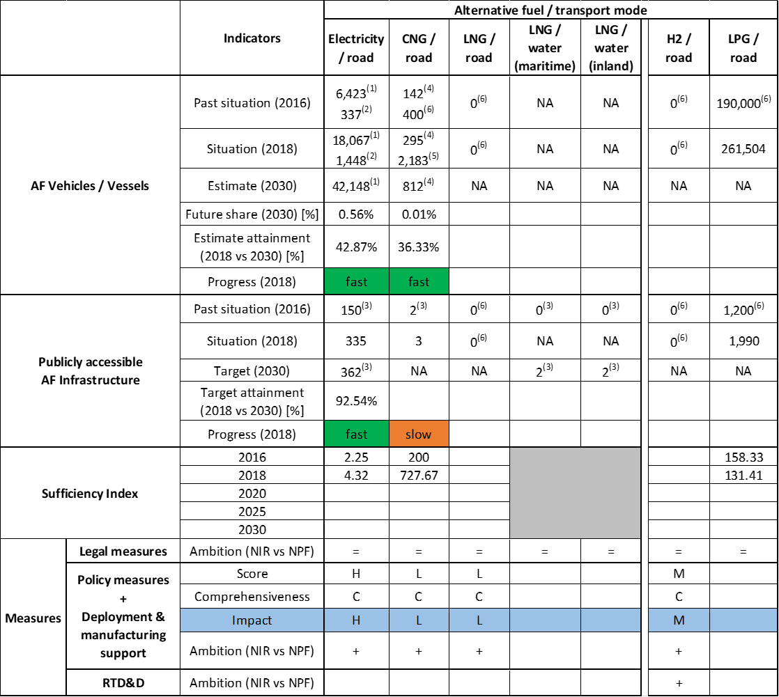



(1) value provided in the RO NIR (in this assessment it is assumed this value corresponds to BEV+PHEV+HEV); (2) values from EAFO (BEV+PHEV); (3) values from RO NPF; (4) mono-fuel CNG vehicles; (5) total CNG vehicles (sum of mono-fuel and bi-fuel vehicles) (6) values from EAFO.

The Romanian NIR does not cover all the requirements of Annex I from the Directive and does not offer any quantitative future AFI targets.

Regarding the combination of AF/AFV/AFI with transport mode, electricity is covered for road, rail and air; CNG and LPG for road transport; hydrogen and biofuels are partially covered for road transport; LNG is partially covered for waterborne transport; other combinations being either absent or not applicable.

The main outcomes of the technical assessment of the Romanian NIR on vehicles/vessels estimates and infrastructure targets can be summarised as follows:

###### Road transport

* **Electricity** – Romania reported a total of 18,067 electric vehicles in use in 2018 (but this number probably includes also HEVs that do not fall under the scope of this assessment). According to EAFO, there were 1,448 EVs (excluding PTWs) in use in Romania in 2018. In contrast to the NPF that did not include any EV estimates, the RO NIR contains EV estimates for the next decade (21,074 in 2020, 31,611 in 2025 and 42,148 in 2030)[14]. Romania recorded 335 publicly accessible recharging points in 2018, of which 38.21% were high power (>22kW) recharging points. The RO NIR does not contain any information on targets for the next decade, but the NPF had included two targets: at least 292 recharging points by 2020 (achieved already in 2018) and at least 362 by 2030. The progress in 2018 results to be fast both for EVs and for infrastructure. The ratio AFV to AFI is below 10 for the computable years 2016 and 2018, thus is considered adequate.
* **CNG** – The RO NIR reports 295 mono-fuel CNG vehicles and 1,888 bi-fuel (CNG+gasoline) vehicles in use in 2018. In contrast to the NPF that did not include any estimates, the RO NIR contains estimates for mono-fuel CNG vehicles for the next decade (406 in 2020, 609 in 2025 and 812 in 2030). In 2018, Romania recorded three publicly accessible CNG refuelling points. The RO NIR does not provide targets for the next decade but the RO NPF had included a target of 55 publicly accessible CNG refuelling points by 2020. The progress in 2018 is fast for CNG vehicles and slow for the infrastructure. The sufficiency index is below the indicative value of 600 for 2016 and above it in 2018, and should therefore be monitored in order not to become a barrier for the further market deployment of CNG vehicles.
* **LNG** – Similarly to the NPF, the Romanian NIR does not contain any information about past or future situation of LNG vehicles and infrastructure.
* **Hydrogen** – The Romanian NIR considers that hydrogen used as alternative fuel is at the research-development stage, thus no specific regulations have been implemented yet in Romania for hydrogen refuelling of vehicles, but some are in planning phase. Similarly to the NPF, the Romanian NIR does not contain any quantitative information about past or future situation of hydrogen vehicles and infrastructure.
* **Biofuels** – No specific information regarding vehicles and/or biofuels refuelling points was found in the RO NIR.
* **LPG** – The RO NIR reports that, according to the Periodic Roadworthiness Test results, the total numberofvehicles equipped with LPG systems in use in 2018 is 261,504, mainly with retrofitted LPG fuelling units. The Romanian NIR reported approximately 1,990 public LPG refuelling points in 2018 and, similarly to the NPF, no information regarding future targets.

###### Rail transport

* **Electricity** – The Romanian NIR indicates that the stock of electric locomotives has a descending trend, from 542 in 2016 to 526 in 2018, and 210 are estimated for 2020 (while for 2025 and 2030 no predictions can be made because the active fleet of locomotives will depend on the rail traffic chart of those years).

###### Waterborne transport (maritime)

* **Electricity** - Similarly to the NPF, information is not available in the Romanian NIR related to electric seagoing ships. The Romanian NIR does not contain any information about past or future situation of shore-side electricity supply for maritime ports, but the RO NPF had provided two targets for maritime and inland ports together: one port for 2025 and six ports by 2030.
* **LNG** – Similarly to the RO NPF, no quantitative data are provided in the Romanian NIR regarding LNG seagoing ships. However, an opportunity study for the construction and refurbishment of ships using LNG is mentioned. No quantitative data are provided in the Romanian NIR regarding LNG supply in the maritime ports, while the NPF contained two targets (one port in 2025 and two ports in 2030). Under the LNG MASTER PLAN project, a pre-feasibility study was prepared on the construction of a small capacity LNG terminal in Constanţa Port (maritime and inland) and a study on the construction of an LNG terminal in Galaţi Port (maritime and inland).

###### Waterborne transport (inland)

* **Electricity** – Similarly to the NPF, no information is provided in the Romanian NIR related to electric inland waterways vessels. The Romanian NIR does not contain any information about past or future shore-side electricity supply points for inland ports, whilst the RO NPF had provided two targets for maritime and inland ports together: 1 port for 2025 and 6 ports by 2030.
* **LNG** – Similarly to the RO NPF, no quantitative data are provided regarding LNG inland waterways in the Romanian NIR. However, a study is mentioned on the “*possibility of adapting the Navrom[15] Galati fleet to using LNG*” (under the LNG MASTER PLAN project). No quantitative data are provided in the Romanian NIR regarding LNG supply in the inland ports, while the NPF contained two targets (1 port in 2025 and 2 ports in 2030).

###### Air transport

* **Electricity** – The Romanian NIR relates exclusively to unmanned aircraft equipped with an electric motor (drones), and foresees and an increasing trend for them. The Romanian NIR reports that 28 electricity supply points for stationary airports were in use in 2018, mentioning that there are 16 electricity generators for parked aircraft at 14 air bridges “International Henri Coandă Airport” in Bucharest. Targets for the next decade are provided: 31 in 2020, 78 in 2025 and 131 in 2030.
* **Biofuels** – No aircraft using alternative fuels are recorded in the Romanian air transport sector. Information is not available in the Romanian NIR on the need for renewable jet fuel refuelling points in airports within the TEN-T Core Network.

The Romanian NIR contains around 30 **measures**, a medium size portfolio of measures. The NIR presents only measures in place after 2017 and none of the measures presented in the NPF as in place at that time is mentioned anymore. The NIR mentions that the presented measures are listed in the Annex to Government Decision No 87 of 7 March 2018 approving the “*NPF strategy for developing the alternative fuels market in the transport sector and deploying the relevant infrastructure in Romania”.*

The majority of the measures address road transport and focus on the development of electro-mobility. Around half of the presented measures are Legal measures, mainly of legislative and regulatory category presenting current or under discussion legislation.

Concerning the policy measures, most of the presented measures in the RO NIR were announced as future plans in the NPF. Since some measures have been revised or have become more concrete, their overall level of ambition is considered increased. They cover financial aspects (e.g. purchase and scrappage subsidies, tax incentives) but also non-financial (e.g. favourable parking regimes) and information ones (organisation of events to promote mobility based on alternative fuels).

The AFI deployment measures address the electricity/road and electricity/air pairs.

Concerning the Policy and Deployment & Manufacturing support measures, in the NIR compared with the NPF, the level of ambition has increased for electricity/road, CNG/road, LNG/road and hydrogen/road pairs, and has remained the same for biofuels/road and electricity/air pairs. The most complete and numerous cluster of measures is for the pair electricity/road. The expected impact of the measures to support the realisation of the AFV/AFI objectives as presented in the NPF and revised in the NIR is high for the electricity/road pair, medium for hydrogen/road while for the other pairs (CNG/road, LNG/road, biofuels/road and electricity/air) it results to be low.

Three measures have been identified as RTD&D, all being in place but none containing budget information. One of them covers specifically hydrogen and relates to the assessment of the possibilities of using it as alternative fuel in transport (including by a re-profiling of the current industrial potential of production) and of supporting research activities to develop the required refuelling and propelling systems. Another RTD&D activity mentioned is the organisation of events to enable testing of buses using alternative fuels for the purpose of procurement for public transport.

### Final remarks

The Romanian NIR provides a rather limited report on the efforts to implement the Directive. The NIR meets, to a certain extent, the requirements of Annex I to the Directive, but it lacks information on the targets for CNG refuelling points by 2025 and 2030 and for LNG refuelling points for vehicles by 2020, 2025 and 2030. It also lacks information on estimates LNG vehicles and vessels in 2020, 2025 and 2030. Future reporting should provide further information on measures to support alternative fuels ramp up in other modes of transport than road and with special attention for waterborne transport.

Regarding electricity, the NIR does not provide detailed information. This assessment has been based on information provided already in the NPF. On this basis, it is estimated that by 2030 there could be about 42,000 electric vehicles on the roads, representing about 0.6% of the future vehicle fleet. Taking into account the current situation expected trends, this level of ambition appears too low compared to the pace of deployment of electric vehicles considered necessary for a full transition to carbon neutrality by 2050. The targets for publicly accessible recharging infrastructure correspond to the low estimated number of vehicles. Higher ambition would contribute to better meeting the objective of realising a dense, wide-spread and easy to use network of recharging and refuelling infrastructure throughout the EU. No information on charging efficiency is provided. The NIR does not provide estimates on shore-side electricity supply in maritime and inland ports. Following the NPF, one port should be equipped accordingly by 2025 and six ports by 2030. Romania should provide updated information in this regard in future reporting. In 2018, 28 electricity supply points for stationary airplanes were already in use; 131 are expected by 2030. The number of electric locomotives has been decreasing, from 542 in 2016 to 526 in 2018, while 210 are expected for 2020. Further information as regards the current electrification of railways and future planning should be provided in future reporting.

Concerning hydrogen for road transport, the Romanian NIR does not contain any quantitative targets for hydrogen vehicles and refuelling points. It would be relevant that Romania provides more information on how to ensure EU-wide connectivity for HCEV.

Regarding natural gas for transport, there was a negligible fleet of CNG vehicles (295 mono-fuel and 2,183 bi-fuel, CNG-petrol) in Romania in 2018. By 2030, Romania expects 812 mono-fuel CNG vehicles. The NIR does not provide information on future targets for CNG refuelling points for vehicles. The NPF had provided the target of 55 refuelling points by 2020. Moreover, the NIR neither provides targets for LNG vehicles and vessels by 2020, 2025 and 2030, nor for road and port LNG infrastructure in the same years. In comparison. The NPF had indicated that one port should be equipped with a LNG refuelling point by 2025 and two ports by 2030.

As regards LPG in road transport, there was already a significant fleet of 261,504 and 1,990 refuelling points in 2018. However, the Romanian NIR does not contain any further targets for vehicles and infrastructure by 2020, 2025 and 2030.

As far as biofuels are concerned, the NIR does not provide quantitative information on the use of biofuels in road transport. Romania should provide more information in future reporting on efforts to promote the use of renewable fuels in transport, and particularly in aviation.

### ANNEX - Description of the Member State

On a surface area of 238,400km², Romania has a population of 19.531 million people in 2018, which makes up for a population density of 82 inhabitants/km².

*Number of main urban agglomerations*

* 35 urban agglomerations > 50,000 inhabitants

In 2018, Romania achieves a per capita gross domestic product at market prices of €10,510, which represents a per capita gross domestic product in purchasing power standards of 63 if expressed in relation to the EU-28 average set to equal 100.

*Length of the road networks*

The length of the road TEN-T Core Network in Romania is 2.564 km. The total road network length is 52.787 km, of which 823 km are motorways. The length of the total road network in Romania is 52,787 km.

The following lengths of the TEN-T Road Corridor network are present in Romania: 8 % (418 km) of the Orient / East - Mediterranean Corridor and 32 % (1,435 km) of the Rhine - Danube Corridor.

Through the TEN-T Road Corridors, Romania is connected with the following member states:

- Hungary (through the Orient / East Mediterranean and the Rhine - Danube Corridor)

- Bulgaria (through the Orient / East Mediterranean Corridor)

*Number of registered road vehicles*

At the end of 2017, Romania accounts for 7,665,962 registered road vehicles of which 6,452,536 are categorized as passenger cars, 753,029 as light goods vehicles, 281,295 as heavy goods vehicles and 51,802 as buses, coaches or trolley-buses. The motorisation rate is 330 passenger cars per 1,000 inhabitants.

*Number of ports in the TEN-T Core Network*

* 2 maritime ports in the TEN-T Core Network (Constanța, Galați)
* 3 maritime ports in the TEN-T Comprehensive Network (Brăila, Sulina, Tulcea)
* 6 inland ports in the TEN-T Core Network (Calafat, Cernavodă, Constanța, Drobeta Turnu Severin, Galați, Giurgiu)

The inland waterways TEN-T Core Network in Romania is 1,294 km long.

*Number of airports in the TEN-T Core Network*

* 2 airports in the TEN-T Core Network (Bucureşti-Henri Coandă, Timişoara)
* 10 airports in the TEN-T Comprehensive Network (Bacău, Baia Mare, Cluj-Napoca, Constanța, Craiova, Iași, Oradea, Sibiu, Suceava, Tulcea)

## Slovenia (SI)

### Main messages from the Commission assessment of the NPF

In its original assessment of the Slovenian NPF the Commission concluded:

*The Slovenian NPF addresses most of the requirements of Article 3. For most fuels and modes, it establishes infrastructure targets and vehicle estimates for 2020, 2025 and 2030.*

*The Slovenian NPF puts emphasis on the development of the market for electric vehicles. It estimates a share of roughly 1% electric passenger cars on the road in 2020 and 16.9% in 2030. The 2030 estimations are also optimistic for electric light commercial vehicles (12.4%) and electric buses (6.3%). Measures are already in place or planned to reach these estimated shares (several tax exemptions and benefits, attractive incentives for purchase and for use of electric vehicles). Slovenia already today has a well-developed recharging infrastructure, with a ratio of one public recharging point per only 1.64 electric vehicles. It plans to further increase the number of recharging points, its targets being in line with the requirements of the Directive and they seem sufficient to cover appropriately the needs of electric vehicles in terms of distance requirements. The Slovenian NPF mentions that electricity supply will be in place in all 3 airports of the TEN-T network by the end of 2025. Regarding shore-side electricity, studies are ongoing and measures are planned to build new power lines for the needs of the Port of Koper.*

*CNG is considered to be the key alternative fuel for buses in the future with estimated shares of CNG buses in the total buses fleet of around 9.3% (2020), 19.7% (2025) and 33.9% (2030) and measures are planned to ensure that these objectives are realised. The NPF mentions that CNG recharging infrastructure will be deployed in all municipalities and their targets for 2020 and 2025 are considered appropriate since they pass the sufficiency threshold.*

*A target of 3 LNG refuelling points for heavy-duty vehicles is foreseen for 2020 that will also ensure the fulfilment of the distance requirement on the TEN-T Core Network in Slovenia. The LNG road infrastructure will be built in the framework of two European projects, namely SiLNGT (2015-EU-TM-0104-S Mediterranean Corridor) and cHAMeleon.*

*LNG refuelling is planned for the only maritime port in the TEN-T Core Network, the port of Koper. Two studies were performed within the projects POSEIDON MED II and GAINN4MOS to find appropriate solutions for supplying ships with LNG in the port of Koper.*

*A target of 5 to 9 hydrogen refuelling points is established for 2025 for which full subsidies for installation are considered necessary by the NPF (in particular, grants from EU funds are mentioned).*

*The Slovenian NPF contains a wide range of measures, but the majority of the measures are under consideration whilst a reduced amount is already in place. The presented measures cover a wide variety of types, addressing many deployment barriers. However, information concerning their implementation status, validity periods, or appropriated budget is often lacking.*

*A medium overall assessment score is derived for electric road transport where the mentioned existing and planned measures seem to have the potential to contribute towards reaching the committed targets and objectives.*

*The NPF mentions that incentives will be available to replace public transport vehicles of EURO IV or lower standards with less polluting vehicles powered by alternative fuels, in particular in areas with poor air quality. With regard to buses, CNG is stated to be the key alternative and subsidies are being considered for the purchase of CNG buses for a period of two to five years.*

*The Slovenian government established an inter-ministerial working group for drafting the NPF. The Slovenian NPF considers that the local communities and other stakeholders will have an important role in implementing the planned measures.*

*Slovenia shows intentions to cooperate with the neighbouring countries to ensure EU-wide circulation of AF vehicles and vessels. For setting up infrastructure for the supply of ships with LNG, Slovenia cooperates with neighbouring Member States within the European projects POSEIDON MED II and GAINN4MOS.*

### Overview of requirements’ fulfilment from Annex I of the Directive

*Table 5.24.2‑1 Checklist Table*

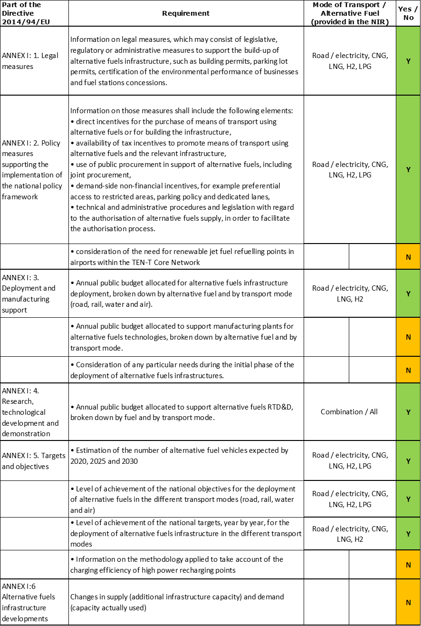

The checklist shows the requirements of Annex I from the Directive that are covered in the SI NIR.

Regarding the combination of AF/AFV/AFI with transport mode, electricity, CNG, LNG, hydrogen and LPG are covered for road transport; all the other combinations are either absent or not applicable.

The Slovenian NIR reports 37 measures. Under the Policy and Deployment & Manufacturing sections it was possible to identify five AF/transport mode clusters of measures, all assessable.

### Quantitative assessment: Vehicles and infrastructure

*Table 5.24.3‑1 National AFV estimates and AFI targets established in the NIR at the horizon 2020, 2025 and 2030 and their comparison with the NPF situation*

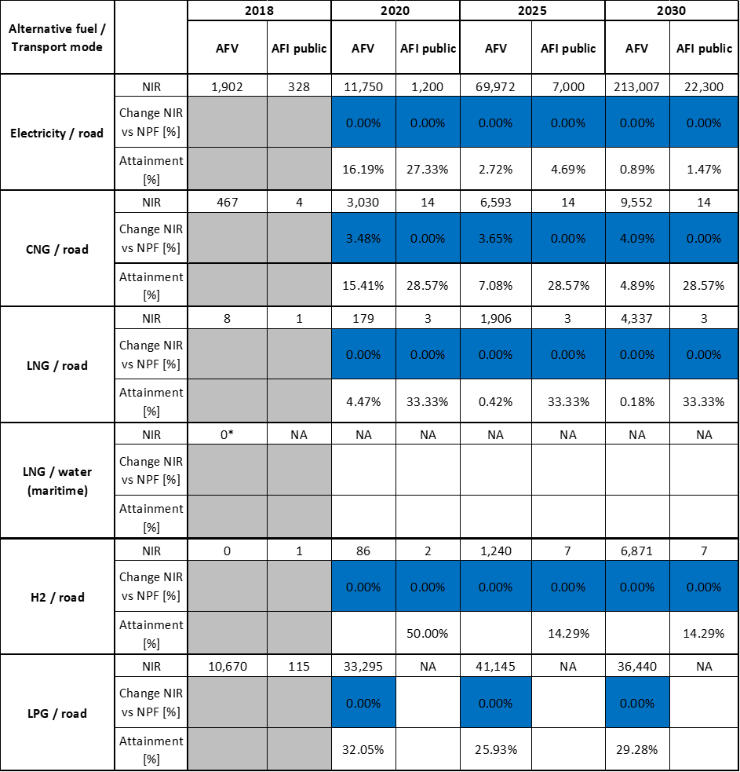



* From EAFO (absent in the NIR)

#### Road transport

##### Electricity

###### Vehicles

Slovenia recorded 1,902 electric vehicles in 2018 (Table 5.24.3‑1), of which 1,834 were passenger cars, 64 LCVs and 4 buses and coaches. For the period 2020-2030, the SI NIR confirms the NPF estimates (11,750 EVs in 2020, 69,972 in 2025 and 213,007 in 2030). The NPF plan is fully confirmed also in terms of vehicle categories and relative share of BEV vs. PHEV. For example, in 2030 the SI NIR confirms the estimates of 129,690 (BEV) and 71,664 (PHEV) passenger cars, of 11,020 LCVs (all BEV), of 258 (BEV) and 160 (PHEV) HCVs and of 215 buses and coaches (all BEV).

The 2018 ***attainment*** of future EV estimates is 16.19% for 2020 and 0.89% for 2030. According to the assessment methodology described in Section 2.1, the 2018 situation corresponds to an ***adequate progress*** towards reaching the envisaged EV estimates. The calculated ***average*** ***annual growth rate*** corresponding to the period 2016-2030 for EV fleet evolution planned by Slovenia is equal to 50%.

###### Infrastructure

Slovenia recorded 328 publicly accessible recharging points in 2018, of which 297 were normal power (≤22kW) and 31 high power (>22 kW) recharging points (the latter being all deployed on the TEN-T Core road network). For the next decade, in line with the EVs estimates, the SI NIR confirms the NPF targets (1,200 recharging points in 2020, 7,000 in 2025 and 22,300 in 2030). It is worth mentioning that the share of high power recharging points will remain quite low (300 foreseen in 2030).

The 2018 ***attainment*** of future public recharging infrastructure targets is 27.33% for 2020 to 1.47% for 2030. According to the assessment methodology described in Section 2.1, the 2018 situation corresponds to a ***slow progress*** towards reaching these envisaged targets. The calculated ***average annual growth rate*** corresponding to the period 2016-2020 for publicly accessible recharging infrastructure evolution planned by Slovenia is equal to 39%.

###### Ratio

Based on the SI NIR, the following table shows the ratio between vehicles and publicly accessible recharging points (i.e. sufficiency index) for the pair electricity/road. It can be seen that the foreseen sufficiency index is always below or equal to 10, thus it can be considered adequate for the next decade.



###### Information on charging efficiency

Information is not available in the Slovenian NIR.

##### CNG

###### Vehicles

Slovenia recorded 467 CNG vehicles in 2018, of which 244 were passenger cars, 74 LCVs, 60 HCVs and 89 buses and coaches. For the next decade, the SI NIR presents a slightly upward revision of the CNG vehicles estimate compared to the NPF, with 9,552 vehicles in 2030 (of which 355 LCVs, 355 HCVs and 1,154 buses and coaches). This represents an increase of 4.09% compared to the NPF.

The 2018 ***attainment*** of future CNG vehicles estimates is 15.41% for 2020 and 4.89% for 2030. According to the assessment methodology described in Section 2.1, the 2018 situation corresponds to a ***slow progress*** towards reaching the envisaged CNG vehicles estimates. The calculated ***average annual growth rate*** corresponding to the period 2016-2030 for the CNG vehicle fleet evolution planned by Slovenia is equal to 25%.

###### Infrastructure

In 2018, Slovenia recorded 4 publicly accessible CNG refuelling points (Table 5.24.3‑1). The SI NIR confirms the NPF targets over the period 2020-2030, which consisted in 14 refuelling stations from 2020 onward.

The 2018 ***attainment*** of future public CNG refuelling infrastructure targets is constant and equal to 28.57% for 2020, 2025 and 2030. According to the assessment methodology described in Section 2.1, the 2018 situation corresponds to a ***slow progress*** towards reaching these envisaged targets. The calculated ***average annual growth rate*** corresponding to the period 2016-2030 for publicly accessible CNG refuelling infrastructure evolution planned by Slovenia is equal to 8%.

###### Ratio

Based on the SI NIR, the following table shows the ratio between vehicles and publicly accessible refuelling points (i.e. sufficiency index) for the pair CNG/road. It can be seen that sufficiency index is well below the indicative value of 600 until 2025 and can be considered adequate also until 2030 (see Section 2.1.5).



##### LNG

###### Vehicles

Slovenia recorded eight LNG HCVs in 2018 (Table 5.24.3‑1). For the next decade, once again the SI NIR fully confirms the NPF estimates (179 HCVs in 2020, 1,906 HCVs in 2025 and 4,337 HCVs in 2030).

The 2018 ***attainment*** of future LNG vehicles estimates is 4.47% for 2020 and 0.18% for 2030. According to the assessment methodology described in Section, the ***progress*** obtained by Slovenia from 2016 until 2018 for LNG vehicles deployment is 0% of the overall planned deployment during the period 2016-2030 because there has been no increase between 2016 and 2018.

###### Infrastructure

The Slovenian NIR reports one publicly accessible LNG refuelling point in 2018 and confirms the NPF target for the next decade (three refuelling points from 2020 until 2030) (Table 5.24.3‑1).

The 2018 ***attainment*** of future public LNG refuelling infrastructure targets is constant and equal to 33.33% for 2020, 2025 and 2030. According to the assessment methodology described in Section 2.1, the ***progress*** obtained by Slovenia from 2016 until 2018 for public LNG refuelling infrastructure deployment is 33.33% of the overall planned deployment during the period 2016-2030.

###### Ratio

Based on the SI NIR, the following table shows the ratio between vehicles and publicly accessible refuelling points (i.e. sufficiency index) for the pair LNG/road.



##### Hydrogen

###### Vehicles

There were no hydrogen vehicles recorded in Slovenia in 2018 (Table 5.24.3‑1). Similarly to the other AFs, the SI NIR confirms the NPF estimates for the next decade (86 in 2020, 1,240 in 2025 and 6,871 in 2030). The majority of these vehicles will be light-duty vehicles (i.e. passenger cars and light commercial vehicles) but 800 HCVs and 57 buses and coaches are also foreseen in 2030.

Since at the end of 2018 there are no hydrogen vehicles deployed, the 2018 ***attainment*** and ***progress*** have not been computed.

###### Infrastructure

Slovenia had one publicly accessible hydrogen refuelling point in 2018 and for the future the SI NIR confirms the NPF targets (two refuelling points in 2020 and seven refuelling points from 2025 until 2030). The SI NIR also mentions a project (RESHUB), headed by the Ministry of Defence and dedicated to the establishment of 15 hydrogen refuelling points in Slovenia for strategic independence. This is linked to a project of zero emission corridors in Slovenia and will allow civilian hydrogen-powered mobility to make use of the hydrogen refuelling points of the Slovenian army. It is not clear how these 15 refuelling points relate to the seven public refuelling points mentioned above.

The 2018 ***attainment*** of future public hydrogen refuelling infrastructure targets is 50% for 2020 and 14.29% for 2030. According to the assessment methodology described in Section 2.1, the ***progress*** obtained by Slovenia from 2016 until 2018 for the deployment of public hydrogen refuelling infrastructure is 0% of the overall planned deployment during the period 2016-2030.

###### Ratio

Based on the SI NIR, the following table shows the ratio between vehicles and publicly accessible refuelling points (i.e. sufficiency index) for the pair hydrogen/road.



##### Biofuels

###### Vehicles

Information is not available in the Slovenian NIR.

###### Infrastructure

Information is not available in the Slovenian NIR.

##### LPG

###### Vehicles

Slovenia recorded 10,670 LPG vehicles in 2018 (of which 10,246 passenger cars, 410 LCVs and 14 HCVs). The SI NIR confirms the NPF estimates for the next decade, which include a peak of 41,145 LPG vehicles in 2025 (Table 5.24.3‑1). In 2030, the total LPG fleet of 36,440 vehicles will be composed by 31,374 passenger cars, 224 LCVs and 4,842 HCVs.

The 2018 ***attainment*** of future LPG vehicles estimates is 32.05% for 2020 and 29.28% for 2030. According to the assessment methodology described in Section 2.1, the ***progress*** obtained by Slovenia from 2016 until 2018 for LPG vehicles deployment is 3.08% of the overall planned deployment during the period 2016-2030.

###### Infrastructure

The Slovenian NIR reported 115 public LPG refuelling points in 2018 and, similarly to the NPF, no information regarding future targets. The NIR declares that “*Refuelling infrastructure has been deployed to a satisfactory extent; users trust it and are using it….That is why there is no provision in the Strategy for the development of refuelling infrastructure using public funds*”. This would imply that the LPG infrastructure should remain roughly the same also for the next decade.

In the absence of detailed targets, the 2018 ***attainment*** and ***progress*** have not been computed.

###### Ratio

Based on the SI NIR, the following table shows the ratio between vehicles and publicly accessible refuelling points (i.e. sufficiency index) for the pair LPG/road. Of course, only the sufficiency index until 2018 could be computed.



#### Rail transport

##### Electricity

###### Vehicles

Information is not available in the Slovenian NIR.

###### Infrastructure

Information is not available in the Slovenian NIR.

#### Waterborne transport (maritime)

##### Electricity

###### Vessels

Information is not available in the Slovenian NIR.

###### Infrastructure

The SI NIR explains that the Port of Koper is connected to the electricity network through the 20 kV distribution network. This is sufficient for the current electricity needs at the port. For the future, an increased request of electric energy is foreseen, which might not be satisfied by the existing electricity network. For this reason, the SI NIR refers that, as part of the European project POSEIDON-MED, a document was prepared (*Feasibility of connecting the Port of Koper to the 110 kV network*). On this basis the NIR concludes that “*Measures are planned to build new power lines to connect to the 110 kV transmission network in order to realise objectives linked to supplying ships with electricity from the shore-side for the needs of the Port of Koper and to assess how much to charge for electricity to supply ships from the shore-side*.”

##### LNG

###### Vessels

Information is not available in the Slovenian NIR.

###### Infrastructure

The SI NIR makes reference to the obligation set in the Directive to deploy, by 31 December 2025, an adequate number of LNG refuelling points at maritime ports in the TEN-T Core Network, which for Slovenia relates to the Port of Koper. The NPF that had set a target of one LNG refuelling point in 2025, however the SI NIR does not provide any confirmation/modification of this plan.

#### Waterborne transport (inland)

Not applicable since Slovenia has no inland ports in the TEN-T Core Network.

#### Air transport

##### Electricity

###### Airplanes

Information is not available in the Slovenian NIR.

###### Infrastructure (for stationary airplanes)

The Slovenian NIR refers that at the TEN-T Core “Jože Pučnik” airport of Ljubljana-Brnik, all stationary aircraft already have a supply of electric power. At Maribor and Portorož airports from the TEN-T Comprehensive Network, the supply will be in place by the planned deadline (i.e. 31 December 2025).

### Measures assessment

With reference to the measures to support the uptake of AF vehicles and infrastructures, the SI NIR shows an effort to select and tailor them according to Slovenia’s objectives for 2030. However, at the moment this effort is totally concentrated on road transport only, while rail, waterborne and air transport are either just mentioned or not considered. The NPF had presented a large number of measures of all types, but most of them were only under consideration. The SI NIR presents a lower number of Legal and Policy/Deployment measures compared to the NPF, but the majority of these measures are in place or are being adopted. It is also worth mentioning that Slovenia had some measures to support the uptake of AF vehicles and infrastructure even before the introduction of the Directive. These measures have become part of the NPF and are included also in the NIR. Finally, it is noteworthy the remarkable increase in the number of RDT&D projects/measures presented in the NIR, compared to the NPF.

#### Legal measures

The SI NIR presents a list of five Legislative & Regulatory measures and no Administrative measures. Three of them were in place before the publication of the Directive. The other two are a consequence of the Directive. The level of ambition has generally increased compared to the NPF.

##### Legislative & Regulatory

The five Legislative & Regulatory measures are quite different in the scope and some of them contain also elements that could be considered as direct policy actions. In particular, there are:

* The Decree on the deployment of infrastructure for alternative transport, which transposes Directive 2014/94/EU into Slovenian law, entered into force on 12 August 2017;
* The Motor Vehicle Duties Act (2017), which updates the previous Annual Fee for Use of Motor Vehicles Act (in place since 2008) whereby motor vehicles with only an electric propulsion engine are exempt from annual vehicle duty;
* The Act amending the Motor Vehicles Tax Act, allowing a minimum tax rate (0.5%) for all vehicles emitting CO2 up to and equal to 110 g/km, including alternatively powered vehicles (in place since 2010);
* The Personal Income Tax Act (that applies from 1 January 2020), where an employer provides an employee with an electric vehicle for private use, regardless of whether the vehicle is actually used for private purposes, the employee's taxable base has to include 0.3% of the purchase value of the vehicle per month, instead of 1.5% that applies to normal vehicles;
* The Corporate Income Tax Act, allowing a reduction of the tax base up to 40% of the purchase value of electric vehicles (BEV and PHEV) or of electric buses (BEV and PHEV).

##### Administrative

No Legal measure is present under this heading in the SI NIR.

#### Policy measures

With regards to the Policy measures, the SI NIR contains a total of 14 measures versus the 20 measures in the NPF. However, as mentioned earlier, these 14 measures are all in place or in the process of adoption, while the NPF included several measures under consideration (thus with low impact by default). Two things shall be highlighted here: first, all the measures are related to road transport only; second, the SI NIR has listed Policy and Deployment measures all together under the Policy heading, but this is not a problem for their assessment.

##### Measures to ensure national targets and objectives

###### Road transport

Ten out of the 14 Policy measures are dedicated to ensure national targets and objectives. Nine of these are financial incentives (either non-repayable, or favourable loans). The most relevant is the incentive scheme for the purchase of AF vehicles:

* €7,500 for a new electric vehicle without CO2 emissions or an electrically processed vehicle, category M1;
* €4,500 for a new electric vehicle without CO2 emissions or a power-driven vehicle, category N1 or L7e;
* €4,500 for a new plug-in hybrid vehicle or a new electric vehicle with a range extender, with CO2 emissions at a discharge of less than 50g/km, category M1 or N1;
* €3,000 for a new electric vehicle without CO2 emissions or a power-driven vehicle, category L6e.
* €1,000 for a new electric vehicle without CO2 emissions of category L3e or L4e or L5e;
* €500 for a new electric vehicle without CO2 emissions of category L1e-B or L2e;
* €200 for a new electric vehicle without CO2 emissions of category L1e-A.

Other measures are related to providing incentives to municipalities for deploying publicly accessible recharging infrastructure; incentives to municipalities to support the purchase of AF vehicles for public transport and relative recharging/refuelling points; incentives to support public administration to purchase AF vehicles.

###### Other transport modes

The SI NIR does not provide measure addressing other transport modes (rail, waterborne, air).

##### Measures that can promote AFI in public transport services

The Slovenian NIR lists four measures to promote AFI in public transport services. They are related to providing direct incentives for the purchase of AF vehicles (BEV, PHEV and CNG) and for building recharging/refuelling infrastructure for these vehicles. A measure is under adoption for the construction of a hydrogen refuelling station in the municipality of Velenje.

##### Measures that can promote the deployment of private electro-mobility infrastructure

The SI NIR explains that at the moment it does not provide measures to promote private infrastructure for electro-mobility, because the State aid scheme for the private sector has not been set up yet. The plan is to have this scheme in 2020 on the basis of an amendment to the Energy Act.

#### Deployment and manufacturing support

##### AFI deployment

As mentioned earlier, the SI NIR has not distinguished between Policy and Deployment measures, listing all of them under the Policy measures heading.

##### Support of manufacturing plants for AF technologies

Information is not available in the SI NIR.

##### Consideration of any particular needs during the initial phase of the deployment of alternative fuels infrastructures

Information is not available in the SI NIR.

#### Quantitative assessment of Policy and Deployment & Manufacturing measures

Table 5.24.4‑1 presents an analysis of all the Policy and Deployment & Manufacturing measures, carried out according to the assessment methodology described in Section 2.2. As it can be seen, five clusters of measures could be identified in the Slovenian NIR on electricity, CNG, LNG, hydrogen and LPG, all for road transport. No measure was found regarding LNG for waterborne transport, nor for rail or air. All the clusters obtained a medium or a low score and only the ones for the pair electricity/road and CNG/road resulted to be comprehensive. In terms of expected impact of these measures to support the realisation of the AFV/AFI objectives as presented in the NPF and revised in the NIR, the measures for the pairs electricity/road and CNG/road have a medium impact, while those for the pairs LNG/road, hydrogen/road and LPG/road have a low impact.

Compared to the NPF, the level of ambition of the Policy and Deployment & Manufacturing support measures has generally increased for all the assessed pairs.

*Table 5.24.4‑1 Quantitative assessment of Policy and Deployment & Manufacturing support measures*



**Legend:** Score and Impact: H = high; M = medium; L = low; X = not assessable. Comprehensiveness: C = comprehensive; N = Not comprehensive. Ambition level: ‘+’ means ‘higher’; ‘=’ means ‘comparable’; ‘-‘ means ‘lower’.

#### Research, Technological Development & Demonstration

The SI NIR shows a remarkable increase of RTD&D projects compared to the NPF. In the latter, only two projects were listed, while the NIR presents 18 projects that, for the period 2016 to 2019, received a total funding of 2.95 million €. These projects cover all the alternative fuels indicated in the Directive, except LPG. In particular, five RTD&D projects address electricity, one is related to the direct conversion of natural gas to higher hydrocarbons, two projects are focused on hydrogen, five projects on biofuels and five on synthetic & paraffinic fuels.

This clearly is assessed as showing a higher level of ambition compared to the NPF.

### Additional information on alternative fuels infrastructure developments

Information is not available in the Slovenian NIR.

### Summary of the assessment

**Tabular overview**

*Table 5.24.6‑1 Overview of the NIR assessment*

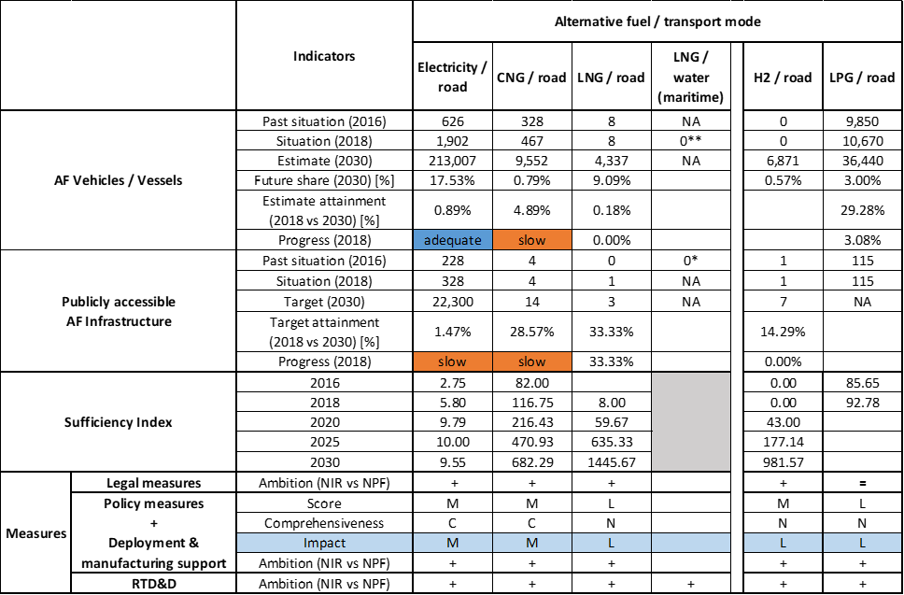



* Value taken or calculated from SI NPF. ** Value taken from EAFO (absent in NIR).

The Slovenian NIR addresses several requirements of Annex I from the Directive but only for road transport. The level of attainment in terms of AFV and AFI is reported for electricity, CNG, LNG, hydrogen and LPG. Vehicle estimates and infrastructure targets are provided for electricity, CNG, LNG and hydrogen.

For LPG, only vehicle estimates are provided. For all the other transport modes, the SI NIR does not report assessable information.

The main outcomes of the technical assessment of the Slovenian NIR on vehicles/vessels estimates and infrastructure targets can be summarised as follows:

###### Road transport

* **Electricity** – Slovenia recorded 1,902 electric vehicles in 2018 (Table 5.24.3‑1), of which 1,834 were passenger cars, 64 LCVs and 4 buses and coaches. The SI NIR confirms the NPF estimates for the next decade, also in terms of vehicle categories and ratio BEV/PHEV. For example, for 2030 the SI NIR confirms the estimate of 129,690 (BEV) and 71,664 (PHEV) passenger cars, of 11,020 LCVs (all BEV), of 258 (BEV) and 160 (PHEV) HCVs and of 215 buses and coaches (all BEV). The 2018 progress is adequate. As for the infrastructure, Slovenia recorded 328 publicly accessible recharging points in 2018. In line with the EVs estimates, the SI NIR confirms the NPF targets (1,200 recharging points in 2020, 7,000 in 2025 and 22,300 in 2030). In this case the progress is assessed as slow, but the sufficiency index is adequate for the whole period.
* **CNG** – Slovenia recorded 467 CNG vehicles in 2018, of which 244 were passenger cars, 74 LCVs, 60 HCVs and 89 buses and coaches. For the next decade, the SI NIR presents a slightly upward revision of the CNG vehicles estimate compared to the NPF, with 9,552 vehicles in 2030 (of which 355 HCVs and 1,154 buses and coaches). The 2018 progress is slow. The Slovenian NIR presents 4 publicly accessible CNG refuelling points in 2018 and a confirmation of the NPF targets over the period 2020-2030, which consisted in 14 refuelling stations from 2020 onward. The 2018 progress is slow also for CNG infrastructure, but the sufficiency index is adequate until 2030.
* **LNG** – The SI NIR lists eight LNG HCVs in 2018 and fully confirms the NPF estimates (179 HCVs in 2020, 1,906 HCVs in 2025 and 4,337 HCVs in 2030). On the infrastructure side, the Slovenian NIR reports one publicly accessible LNG refuelling point in 2018 and confirms the NPF target for the next decade (three refuelling points from 2020 until 2030).
* **Hydrogen** – In 2018, there were no hydrogen vehicles in Slovenia. The SI NIR confirms the NPF estimate (86 in 2020, 1,240 in 2025 and 6,871 in 2030). The majority of these vehicles will be light-duty vehicles, but 800 HCVs and 57 buses and coaches are also foreseen in 2030. Slovenia had one publicly accessible hydrogen refuelling point in 2018 and the SI NIR confirms the NPF targets (two refuelling points in 2020 and seven refuelling points from 2025 until 2030).
* **Biofuels** – Information is not available in the SI NIR.
* **LPG** – Slovenia recorded 10,670 LPG vehicles in 2018 (of which 10,246 passenger cars, 410 LCVs and 14 HCVs). For the next decade, the NPF vehicle estimates are confirmed. Concerning infrastructure, the SI NIR declares that the 115 public refuelling points in 2018 are sufficient also for the next decade, thus no further investment is foreseen.

###### Rail transport

Information is not available in the Slovenian NIR.

###### Waterborne transport (maritime)

* **Electricity** – The SI NIR explains that the Port of Koper is connected to the electricity network through the 20 kV distribution network. This is sufficient at the moment but in the future the request of shore-side electricity should increase. There is a plan to connect the Port of Koper to the 110kV transmission network, but no details concerning timetable and budget are provided.
* **LNG** – Contrary to the NPF that had set a target of one LNG refuelling point in 2025, the SI NIR does not provide any confirmation/modification of this plan.

###### Air transport

* **Electricity** - The Slovenian NIR refers that at the Jože Pučnik airport of Ljubljana-Brnik, all stationary aircraft already have a supply of electric power. At Maribor and Portorož airports the supply will be in place by the planned deadline (i.e. 31 December 2025).

With reference to the **measures** to support the uptake of AF vehicles and infrastructures, the SI NIR shows an effort to move from the wide list of measures under discussion in the NPF to a more limited but focussed set of measures. However, at the moment this effort is totally concentrated on road transport only, while rail, waterborne and air transport are either just mentioned or not considered.

The SI NIR presents a list of five Legislative & Regulatory measures and no Administrative measures. Three of them were in place before the publication of the Directive. The other two are a consequence of the Directive. The level of ambition has generally increased compared to the NPF.

As for the Policy and Deployment & Manufacturing measures, the SI NIR contains a total of 14 measures versus the 20 measures in the NPF. However, these 14 measures are all in place or in the process of adoption, while the NPF included several measures under consideration. The SI NIR has listed Policy and Deployment measures all together under the Policy heading. In terms of expected impact of these measures to support the realisation of the AFV/AFI objectives as presented in the NPF and revised in the NIR, the measures for the pairs electricity/road and CNG/road have a medium impact, while those for the pairs LNG/road, hydrogen/road and LPG/road have a low impact. The level of ambition has generally increased for all the assessed pairs.

The SI NIR shows a remarkable increase of RTD&D projects compared to the NPF, with 18 projects (versus two in the NPF) that cover all the AFs (including biofuels and synthetic & paraffinic fuels) and all transport modes.

### Final remarks

The Slovenian's NIR provides a rather comprehensive report on efforts to implement the Directive. It complies with most of the provisions of Annex I to the Directive, with the main exception being the lack of information on LNG infrastructure at the port of Koper, the only Slovenian port in the TEN-T Core Network. The measures provided by Slovenia target all fuels with varying scopes and impacts; but with a clear focus on road transport. Future reporting should better describe measures for other modes of transport, particularly for LNG in maritime transport.

With regard to electricity, the NIR estimates that by 2030 there could be 213,007 electric vehicles on the roads, representing about 17.5% of the fleet by that time, as well as 22,300 recharging points in the same year. Taking into account the current situation and expected trends, this level of ambition appears to be broadly consistent with the pace of deployment of electric vehicles considered necessary for the full transition to carbon neutrality by 2050. No information on charging efficiency is provided. The Port of Koper is connected to the electricity network. Electricity supply is provided to stationary airplanes in Ljubljana-Brnik airport "Jože Pučnik" and is planned to be made available in the Maribor and Portorož airports by 2025. The Slovenian NIR does not provide information on the share of the electrified rail network. More information on Slovenia's future plans for further electrification of this mode of transport should be provided.

Regarding hydrogen for transport, there is already one hydrogen refuelling point in Slovenia. The NIR estimates a small fleet of about 6,900 FCHVs for 2030. Further, it estimates seven hydrogen refuelling points by 2030. This number seems sufficient, taking into account the length of the TEN-T Core Network, provided that the refuelling stations are equally distributed along the network.

Concerning natural gas, 14 CNG refuelling points are planned for 2020 for a small fleet that is estimated to increase from 467 CNG vehicles in 2018 to about 9,552 in 2030. The number of CNG refuelling points is not expected to increase, as it is considered sufficient given the estimated size of the CNG fleet by 2030. One LNG refuelling point for road transport was recorded in Slovenia in 2018, three LNG refuelling points are planned in Slovenia for 2020. This seems sufficient considering the length of the TEN-T Core Network, provided that the refuelling points are widely distributed along the network. A significant increase in the number of LNG heavy-duty vehicles is foreseen (4,337 LNG HDVs by 2030). No information is provided on the LNG infrastructure at the port of Koper. To this end, Slovenia should clarify how it intends to ensure the supply of LNG in the port of Koper by 2025.

There are already 115 LPG refuelling points in Slovenia. It is not foreseen to build additional infrastructure, but an increase of the LPG fleet from 10,670 vehicles in 2018 to 36,440 in 2030 is estimated.

Slovenia should provide more information in future reporting on efforts to promote the use of renewable fuels in transport, and particularly in aviation.

### ANNEX - Description of the Member State

On a surface area of 20,300 km², Slovenia has a population of 2.067 million people in 2018, which makes up for a population density of 102 inhabitants/km².

*Number of main urban agglomerations*

* 2 urban agglomerations > 50,000 inhabitants

In 2018, Slovenia achieves a per capita gross domestic product at market prices of €22,080, which represents a per capita gross domestic product in purchasing power standards of 87 if expressed in relation to the EU-28 average set to equal 100.

*Length of the road networks*

The length of the road TEN-T Core Network in Slovenia is 446 km. The total road network length is 20,051 km, of which 623 km are motorways.

The following lengths of the TEN-T Road Corridors are present in Slovenia: 8% (433 km) of the Mediterranean Corridor and 7% (262 km) of the Baltic - Adriatic Corridor.

Through the TEN-T Road Corridors, Slovenia is connected with the following Member States:  
- Austria (through the Baltic – Adriatic Corridor),   
- Italy (through the Baltic – Adriatic and the Mediterranean Corridor),   
- Hungary (through the Mediterranean Corridor),   
- Croatia (through the Mediterranean Corridor).

*Number of registered road vehicles*

At the end of 2018, Slovenia accounts for 1,376,012 registered road vehicles of which 1,143,150 are categorised as passenger cars, 89,000 as light goods vehicles, 15,928 as heavy goods vehicles and 2,834 as buses and coaches. The motorisation rate is 553 passenger cars per 1,000 inhabitants.

*Number of ports in the TEN-T Core Network*

* 1 maritime port in the TEN-T Core Network (Koper)
* No maritime ports in the TEN-T Comprehensive Network
* No inland ports

*Number of airports in the TEN-T Core Network*

* 1 airport in the TEN-T Core Network (Ljubljana)
* 2 airports in the TEN-T Comprehensive Network

## Slovakia (SK)

### Main messages from the Commission assessment of the NPF

In its original assessment of the Slovak NPF the Commission concluded:

*The Slovak NPF addresses partly the requirements of Article 3. It contains a discussion of the current state and future scenarios for alternative fuels in the transport sector. For all the mandatory fuels and modes (electricity and natural gas), it establishes targets as required by Article 3 of the Directive. No measures have been taken or proposed to promote alternative fuels infrastructure in public transport services or to facilitate the deployment of recharging points not accessible to the public.*

*The Slovak NPF puts a comparably low emphasis on electric vehicles and estimates only 0.5% electric vehicles on the road in 2020. The number of electric recharging points foreseen for 2020 and 2025 seems not sufficient to cover the needs of Slovakia in terms of number of the estimated number of vehicles and distance requirements. This could evolve to become a barrier for the further deployment of electric vehicles in Slovakia and could also lead to market fragmentation within the EU. The spatial distribution of the recharging points is not given. According to the Slovak NPF, the greatest distance between any two directly neighbouring high power recharging points is at the moment approximately 80 km which seems insufficient. Also according to the Slovak NPF, South Slovakia is at the moment poorly – perhaps even inadequately – covered in terms of all types of recharging. It will be important to closely monitor this development and correct the infrastructure targets in line with the market developments. Purchase incentives have been defined to increase the number of electric vehicles in Slovakia. The Slovak NPF discusses electricity for stationary airplanes at the Bratislava TEN-T Core Network airport. It does not specify any quantitative targets for this. The Slovakian NPF does not include concrete plans for shore-side electricity supply for inland ports. However, it mentions that this will be further investigated in the future.*

*Regarding CNG, the NPF shows that the available number of CNG refuelling points and the ones planned for 2020 and 2025 are sufficient to pass the threshold value of one CNG refuelling point per 600 vehicles today and in the future. The distance requirement of at least one refuelling point every 150 km is met already today. The NPF shows also the ambition of increasing the number of CNG refuelling points with a specific plan on selected urban/suburban agglomerations. Some lower impact financial measures have been defined to promote the use of CNG vehicles on the roads.*

*The Slovak NPF considers that at least two LNG refuelling points for heavy-duty vehicles will be required and mentions that the ideal situation appears to be 3-5 public LNG refuelling points for road transport by 2025. If at least two LNG refuelling points were realised (one on each TEN-T Corridor; Bratislava area, Žilina area and/or Košice/Prešov area) this could guarantee that the maximum distance requirement for LNG refuelling points along the TEN-T Core Network would be fulfilled on Slovak territory.*

*The construction of LNG bunkering facilities in the two TEN-T Core Network inland ports (Bratislava and Komárno) is planned and measures are proposed to support the construction of these LNG facilities on the Slovak section of the River Danube.*

*The Slovak NPF does not include hydrogen but will analyse opportunities to further the advancement of hydrogen infrastructure.*

*According to the Slovak NPF, LPG is actually covered by a relatively large nationwide network of refuelling points (fulfilling the needs of vehicle operators) and the infrastructure of LPG refuelling points is constantly expanding. However, one of the main barriers preventing the development of LPG vehicles seems to be the restriction on parking in underground parking facilities.*

*The Slovak NPF contains a comprehensive list of support measures for electricity for vehicles, most already in place and for some a prolongation is foreseen. They can be considered having a low to medium impact on market actor's decisions. Longer periods for their validity could provide certainty for market actors and hence increase the likelihood that the national targets and objectives of the NPF can be reached. For other modes and fuels, the measures in the Slovak NPF seem to have a rather low impact and are not comprehensive. No measures are discussed to promote AFI in public transport services or to promote the deployment of private electro-mobility infrastructure.*

*The Slovak NPF has taken into consideration the interests of regional and local authorities, as well as other stakeholders during its drafting.*

*Slovakia has not listed specific cooperation programmes; however, some collaboration examples are given. Slovakia has cooperated with the Czech Republic within the Connecting Europe Facility programme and, since 2013, has also assisted in the implementation of the TEN-T project LNG Masterplan for the Rhine - Main - Danube Corridor.*

### Overview of requirements’ fulfilment from Annex I of the Directive

*Table 5.25.2‑1 Checklist Table*

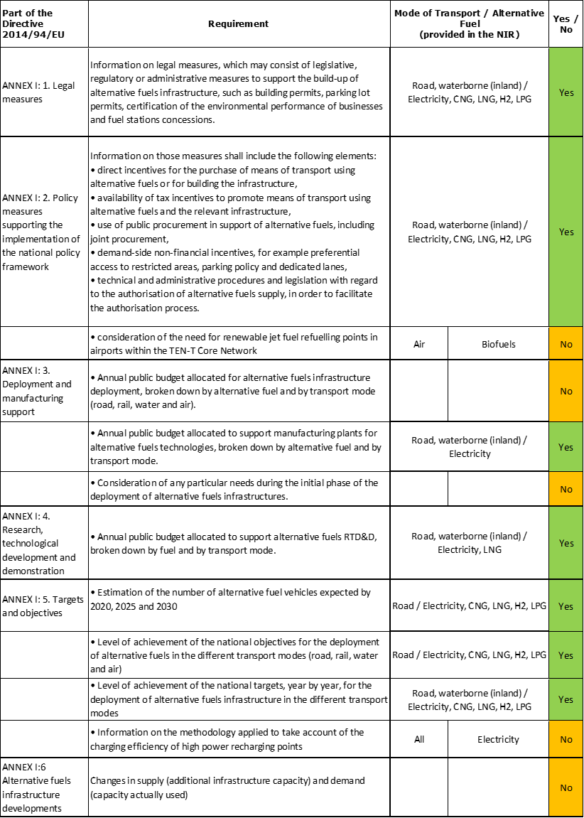

The checklist shows the requirements of Annex I from the Directive that are covered in the SK NIR.

Regarding the combination of AF/AFV/AFI with transport mode, electricity, CNG, LNG, hydrogen and LPG are covered for road transport; LNG is just mentioned for inland water transport; hydrogen in mentioned for rail and inland water transport; all the other combinations are either absent or not applicable.

The Slovak NIR reports 17 measures. Under the Policy and Deployment & Manufacturing sections it was possible to identify six AF/transport mode clusters of measures, of which four were assessable.

### Quantitative assessment: Vehicles and infrastructure

*Table 5.25.3‑1 National AFV estimates and AFI targets established in the NIR at the horizon 2020, 2025 and 2030 and their comparison with the NPF situation*

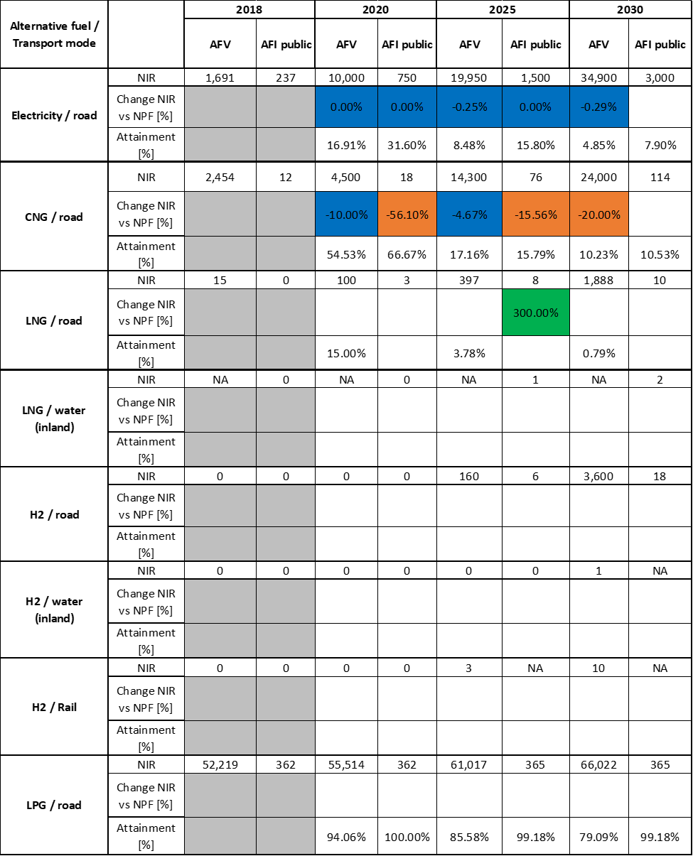



#### Road transport

##### Electricity

###### Vehicles

Slovakia recorded 1,691 battery-electric and plug-in hybrid electric vehicles in use in 2018 (see Table 5.25.3‑1), of which 1,570 were passenger cars, 74 LCVs and 47 buses and coaches. Regarding EV estimates for 2020, 2025 and 2030, the SK NIR substantially confirms the estimates made in the NPF (10,000; 19,950 and 34,900 EVs in the NIR, versus 10,000; 20,000 and 35,000 in the NPF). The NIR also provides estimates for electric two-wheelers, which were not reported in the NPF (500, 1,000 and 2,000 two-wheelers respectively for 2020, 2025 and 2030). Concerning heavy-duty vehicles, the SK NIR estimates 200 electrified buses and coaches on the road by 2030 but no HCV.

The 2018 ***attainment*** of future EV estimates is 16.91% for 2020 and 4.85% for 2030. According to the assessment methodology described in Section 2.1, the state of play in 2018 corresponds to an ***adequate progress*** towards reaching the envisaged EV estimates. The calculated ***average*** ***annual growth rate*** corresponding to the period 2016-2030 for EV fleet evolution planned by Slovakia is equal to 31%.

###### Infrastructure

Slovakia recorded 237 publicly accessible recharging points in 2018 (Table 5.25.3‑1). Concerning the targets for 2020 and 2025, the SK NIR confirms the NPF targets (750 and 1,500, respectively). For 2030 the NIR presents a new target (3,000). The SK NIR also shows for 2020 and 2025 a progressive shift from normal power (≤ 22 kW) to high power (>22 kW) recharging points compared to the NPF. For 2030, the new target of 3,000 recharging points should consist of 50% normal power and 50% high power.

The 2018 ***attainment*** of future publicly accessible recharging infrastructure targets is 31.60% for 2020 and 7.90% for 2030. According to the assessment methodology described in Section 2.1, the state of play in 2018 corresponds to an ***adequate progress*** towards reaching these envisaged targets. The calculated ***average annual growth rate*** corresponding to the period 2016-2030 for publicly accessible recharging infrastructure evolution planned by Slovakia is equal to 24%.

###### Ratio

Based on the SK NIR, the following table shows the ratio between vehicles and publicly accessible recharging points (i.e. sufficiency index) for the pair electricity/road. For the next decade the foreseen sufficiency index is not far from a value of 10 that, considering the planned 50% share of high power recharging points in 2030, can be regarded as adequate.



###### Information on charging efficiency

Information is not available in the Slovak NIR.

##### CNG

###### Vehicles

Slovakia recorded 2,454 CNG vehicles in use in 2018, of which 1,856 were passenger cars, 334 LCVs, 24 HCVs and 240 buses and coaches. As shown in Table 5.25.3‑1, the NIR presents lower estimates of CNG vehicles for 2025 and 2030 than the NPF. In the latter, a total number of 30,000 CNG vehicles were estimated by 2030, while in the NIR this number has been revised to 24,000 CNG vehicles. With regard to the heavy-duty sector, the SK NIR estimates 800 HCVs and 200 buses and coaches by 2030.

The 2018 ***attainment*** of future CNG vehicles estimates is 54.53% for 2020 and 10.23% for 2030. According to the assessment methodology described in Section 2.1, the 2018 situation corresponds to a ***slow progress*** towards reaching the envisaged CNG vehicles estimates. The calculated ***average annual growth rate*** corresponding to the period 2016-2030 for the CNG vehicle fleet evolution planned by Slovakia is equal to 20%.

###### Infrastructure

Slovakia recorded 12 publicly accessible CNG refuelling points in 2018 (see Table 5.25.3‑1). For the next decade, the SK NIR shows a general reduction of the targets for publicly accessible CNG refuelling points over the period 2020-2025 compared to the NPF (-56.10% in 2020 and -15.56% in 2025). For 2030, the SK NIR presents a new CNG infrastructure target of 114 publicly accessible refuelling points that was absent in the NPF. According to the SK NIR “*the number of (CNG) refuelling points (in 2018) appears to be inadequate. The target situation, as defined in the National Policy Framework, is to achieve a critical mass of CNG refuelling point infrastructure that will trigger the spontaneous development of CNG use*”.

The 2018 ***attainment*** of future publicly accessible CNG refuelling infrastructure targets is 66.67% for 2020 and 10.53% for 2030. According to the assessment methodology described in Section 2.1, the 2018 situation corresponds to a ***slow progress*** towards reaching these envisaged targets. The calculated ***average annual growth rate*** corresponding to the period 2016-2030 for publicly accessible CNG refuelling infrastructure evolution planned by Slovakia is equal to 20%.

###### Ratio

Based on the SK NIR, the following table shows the ratio between vehicles and publicly accessible refuelling points (i.e. sufficiency index) for the pair CNG/road. The sufficiency index is well below the indicative value of 600 (see Section 2.1.5) for the whole implementation period.



##### LNG

###### Vehicles

Slovakia recorded 15 LNG vehicles in 2018 (all HCVs). For the next decade, the SK NIR shows a series of LNG vehicles estimates (100, 397 and 1,888 vehicles, respectively for 2020, 2025 and 2030), all in the heavy-duty sector, which was completely absent in the NPF*.* Estimates for 2030 point to 1850 HCVs and 38 buses and coaches are estimated.

The 2018 ***attainment*** of future LNG vehicles estimates is 15.00% for 2020 and 0.79% for 2030. According to the assessment methodology described in Section 2.1, the ***progress*** obtained by Slovakia from 2016 until 2018 for LNG vehicles deployment is 0.79% of the overall planned deployment during the period 2016-2030.

###### Infrastructure

The SK NIR does not report any LNG refuelling point in 2018, however it shows a new strategy on LNG infrastructure (similar to that for LNG vehicles). While in the NPF there was only a target of two refuelling points for 2025, the SK NIR shows a new set of targets for 2020, 2025 and 2030 (three, eight and ten refuelling points, respectively). The reason for this new approach is due to the need to provide the heavy-duty sector with a more CO2 friendly solution (compared to diesel fuel) “*in connection with the adoption of the Regulation of the European Parliament and of the Council setting CO2 emission performance standards for new heavy-duty vehicles*”.

Since at the end of 2018 there are no LNG refuelling points deployed, the 2018 ***attainment*** and ***progress*** have not been computed.

###### Ratio

Based on the SK NIR, the following table shows the ratio between vehicles and publicly accessible refuelling points (i.e. sufficiency index) for the pair LNG/road.



##### Hydrogen

###### Vehicles

The SK NIR reports zero hydrogen vehicles in 2018, but shows estimates for 2025 and 2030 (160, and 3,600 vehicles, respectively), which were absent in the NPF. The plan for 2030 is to have 3,000 passenger cars, 250 LCVs, 150 HCVs and 200 buses and coaches.

Since at the end of 2018 there were no hydrogen vehicles deployed, the 2018 ***attainment*** and ***progress*** have not been computed.

###### Infrastructure

The SK NIR does not report any hydrogen refuelling point in 2018, but presents new targets for hydrogen infrastructure, which were not present in the NPF. The targeted hydrogen publicly accessible refuelling points for 2025 and 2030 are six and eighteen, respectively.

Since at the end of 2018 there were no hydrogen refuelling points deployed, the 2018 ***attainment*** and ***progress*** have not been computed.

###### Ratio

Based on the SK NIR, the following table shows the ratio between vehicles and publicly accessible refuelling points (i.e. sufficiency index) for the pair hydrogen/road.



##### Biofuels

###### Vehicles

Information is not available in the Slovak NIR.

###### Infrastructure

The Slovak NIR reports that, while the content of biofuel in diesel fuel is at the upper limit of the technical standard (7% by volume), for petrol there is scope to increase the share of biofuels from the present 7.4% to 9% by volume. Also, the introduction of high-biofuel blends in the form of E20, E85 and, if appropriate, B30 is expected to be considered in the near future in parallel to the development of electro-mobility. There is, however, no description of concrete planning into this direction and no indication of infrastructure implication.

##### LPG

###### Vehicles

The SK NIR recorded 52,219 LPG vehicles in 2018 (of which 49,083 were passenger cars, 3,125 were LCVs, 10 HCVs and 1 bus) and confirms the LPG vehicle estimates for 2020, 2025 and 2030 that were already in the NPF (see Table 5.25.3‑1). Such estimate appears as an incremental increase from 55,514 vehicles in 2020 to the 66,022 vehicles in 2030, with an overall growth of 26% compared to 2018.

The 2018 ***attainment*** of future LPG vehicles estimates is 94.06% for 2020 and 79.09% for 2030. According to the assessment methodology described in Section 2.1, the ***progress*** obtained by Slovakia from 2016 until 2018 for LPG vehicles deployment is 21.71% of the overall planned deployment during the period 2016-2030.

###### Infrastructure

The SK NIR reports 362 LPG refuelling points in 2018. In the NPF there was no mention of a targets for 2020, 2025 and 2030, while in the NIR (see Table 5.25.3‑1) such plan appears as a substantial confirmation of the current situation regarding LPG refuelling points in Slovakia also for the period up to 2030 (365 LPG refuelling points).

The 2018 ***attainment*** of future publicly accessible LPG refuelling infrastructure targets is 100% for 2020 and 99.18% for 2030, reflecting a mature and stable situation. According to the assessment methodology described in Section 2.1, the ***progress*** obtained by Slovakia from 2016 until 2018 for LPG refuelling infrastructure deployment is already 95.38% of the overall planned deployment during the period 2016-2030.

###### Ratio

Based on the SK NIR, the following table shows the ratio between vehicles and publicly accessible refuelling points (i.e. sufficiency index) for the pair LPG/road.



#### Rail transport

##### Hydrogen

###### Vehicles

The SK NIR shows the plan to have three and ten hydrogen-fuelled locomotives by 2025 and 2030, respectively. This is new compared to the NPF.

###### Infrastructure

Information is not available in the Slovak NIR.

#### Waterborne transport (maritime)

Not applicable since Slovakia has no maritime ports in the TEN-T Core Network.

#### Waterborne transport (inland)

##### LNG

###### Vessels

Information is not available in the Slovak NIR.

###### Infrastructure

The SK NIR presents the target (absent in the NPF) to provide one LNG refuelling point for each port in the TEN-T Core Network (i.e. Blatislava and Komárno) by 2030.

Since at the end of 2018 there were no LNG refuelling points deployed, the 2018 ***attainment*** and ***progress*** have not been computed.

##### Hydrogen

###### Vessels

The Slovak NIR reports the plan to have one hydrogen-fuelled vessel by 2030.

###### Infrastructure

Information is not available in the Slovak NIR.

#### Air transport

##### Electricity

###### Airplanes

Information is not available in the SK NIR.

###### Infrastructure (for stationary airplanes)

Information is not available in the Slovak NIR.

##### Biofuels

###### Airplanes

Information on flights / airplanes powered by biofuels is unavailable in the SK NIR.

###### Infrastructure

The Slovak NIR provides no information on the need for renewable jet fuel refuelling points in airports within the TEN-T Core Network.

### Measures assessment

The SK NIR presents a set of measures covering all the four categories (legal, policy, deployment & manufacturing and RTD&D) however they mostly focus on the development of electro-mobility. To a lower extent, also measures for CNG, LNG, and hydrogen refuelling infrastructure for road transport are present.

#### Legal measures

The most prominent legislative and regulatory initiatives taken by Slovakia are the approval of the Action Plan (the ‘Action Plan’) for the Development of Electro-mobility in the Slovak Republic (Resolution No 110/2019) and the revision of two legislative acts. The implementation report submitted by SK does not list all the initiatives taken in the Action Plan. Below is a summary of the initiatives mentioned in the SK NIR and those mentioned in the Action Plan only.

Considering all the legal measures, they appear, if fully implemented, to be fit to support the realisation of the AFV/AFI objectives as presented in the NPF and revised in the NIR. On the basis of the available information, it can be considered that the level of ambition remains constant between NPF and implementation report.

##### Legislative & Regulatory

SK NIR lists three legal measures: i) the Action Plan for the Development of Electro-mobility in the Slovak Republic (Resolution No 110/2019); ii) the Act No 162/2018, establishing terms and conditions for the operation of publicly accessible recharging points and refuelling points for AF; iii) the Amendment of Act No 71/2013 Coll., to allow subsidies and state aid to support the construction of AF infrastructure and subsidies for the purchase of AF vehicles.

##### Administrative

Although there is no mention of them in the SK NIR (probably because they were still under discussion), the Action Plan lists two administrative measures that, if approved, can provide a positive contribution to the development of AFV and AFI in Slovakia: i) simplification of the administrative process for the construction of recharging infrastructure; ii) legislative obligation to build recharging infrastructure in the construction of new parking spaces.

#### Policy measures

##### Measures to ensure national targets and objectives

###### Road transport

The implementation report lists a series of eight policy measures (six of which are financial, two non-financial), all related to road transport. One of these eight measures has expired in 2019, while the other seven are either in force or have been adopted for entry into force from 2020 onward. The six financial policy measures entail: subsidies for the purchase of BEV and PHEV (€5,000 and €3,000 respectively); subsidies (expired in 2019) for the purchase of EV by municipalities; subsidies for building EV recharging infrastructure by municipalities (up to €5,000 per each recharging point); reduction of 50% in the annual tax rate for hybrid, CNG, LNG and hydrogen vehicles; reduction of 50% in the registration fee for these same vehicles; reduced excise duty for CNG. The two non-financial policy measures involve the introduction of terms and conditions for establishing low-emission zones and the introduction of emission plaques for marking vehicles.

In addition to these eight measures, the Action Plan lists seven other policy measures that are either in force, in process of adoption, or under discussion.

###### Other transport modes

The SK NIR presents no measure concerning other transport modes (waterborne, air, rail).

##### Measures that can promote AFI in public transport services

The SK NIR presents no measure regarding the promotion of AFI in public transport.

##### Measures that can promote the deployment of private electro-mobility infrastructure

The SK NIR presents no measure regarding the promotion of the deployment of private electro-mobility infrastructure.

#### Deployment and manufacturing support

##### AFI deployment

As part of the measures for the deployment of alternative fuels infrastructure, the SK NIR lists the state subsidies allocated to the municipalities for the build-up of publicly accessible recharging points, as set forth in Act No 71/2013 and the approved Scheme for the Build-up of Alternative Fuels Infrastructure (a de minimis aid scheme) – DM 6/2019. This measure is also listed as one of the financial policy measures.

In addition to the above initiative, SK NIR also mentions the update of the Operational Programme Integrated Infrastructure to incorporate alternative fuels into Priority Axis 6 – as a potential means of using financial instruments (as part of the National Development Fund II, which accounts for 3% of each operational programme).

##### Support of manufacturing plants for AF technologies

Concerning the support to manufacturing plants related to AFV/AFI, SK NIR reports the granting of investment aid in the form of tax concessions for two companies that manufacture electric vehicle components.

##### Consideration of any particular needs during the initial phase of the deployment of alternative fuels infrastructures

Information is not available in the Slovak NIR.

#### Quantitative assessment of Policy and Deployment & Manufacturing measures

Table5.25.4‑1 presents an analysis of all the Policy and Deployment & Manufacturing measures, carried out according to the assessment methodology described in Section 2.2. As it can be seen, the pair electricity/road obtains an overall medium score and is considered comprehensive. None of the other pairs identified can be considered comprehensive. Support measures have a medium score for the pair CNG/road and low score for LNG/road and for hydrogen/road. For all the other pairs the measures are either absent or not assessable. In terms of expected impact of the assessable measures to support the realisation of the AFV/AFI objectives as presented in the NPF and revised in the NIR, the measures for the pair electricity/road have a medium impact, those for the pairs CNG/road, LNG/road and hydrogen/road have a low impact.

Compared to the NPF, the level of ambition of the Policy and Deployment & Manufacturing support measures has increased for the pairs CNG/road and hydrogen/road, although this does not appear to correlate with the vehicle estimates and infrastructure targets described in the previous Section 5.25.3.

*Table 5.25.4‑1 Quantitative assessment of Policy and Deployment & Manufacturing support measures*

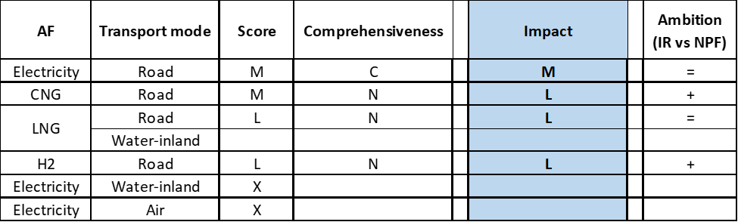

**Legend:** Score: H = high; M = medium; L = low; X = not assessable. Comprehensiveness: C = comprehensive; N = Not comprehensive. Ambition level: ‘+’ means ‘higher’; ‘=’ means ‘comparable’; ‘-‘ means ‘lower’.

#### Research, Technological Development & Demonstration

Compared to the NPF, which only reported one RTD&D measure, the implementation report shows an increased effort to channel financial resources into the support of research, development and demonstration in the form of grant calls by the Slovak Research and Development Agency and via the Operational Programme Research and Innovation and the Operational Programme Integrated Infrastructure. Three RTD&D programmes have been launched concerning AFV for a total budget of €550,000, one programme is related to recharging points for EVs with a budget of €200,000, two programmes deal with the design of the LNG terminal at the public port of Bratislava for a total budget of €953,000.

The Action Plan mentions that a seventh RTD&D programme regarding battery manufacturing is under discussion.

### Additional information on alternative fuels infrastructure developments

The Slovak NIR does not provide information on the changes in fuel use.

### Summary of the assessment

**Tabular overview**

*Table 5.25.6‑1 Overview of the NIR assessment*





The SK NIR addresses several but not all the requirements of Annex I from the Directive.

Regarding the combination of AF/AFV/AFI with transport mode, electricity for road transport is the most comprehensively covered; CNG, LNG and hydrogen are also partially covered for road transport; LNG is just mentioned for inland water transport; all the other combinations are either absent or not applicable. As for LPG, Slovakia has already a quite developed combination of refuelling infrastructure and vehicles. The Slovak NIR does not provide information on the methodology applied to take account of the charging efficiency of high power recharging points nor any particular needs during the initial phase of AFI deployment.

The main outcomes of the technical assessment of the Slovak NIR on vehicles/vessels estimates and infrastructure targets can be summarised as follows:

###### Road transport

* **Electricity** - The SK NIR confirms the NPF vehicles estimates and infrastructure targets for the period 2020-2030, thus showing the same level of ambition of the NPF. According to our methodology, the progress achieved between 2016 and 2018 to meet the 2030 objectives is adequate. The sufficiency index indicating the ratio between number of EVs and number of recharging points also remains adequate until 2030. With regards to heavy-duty vehicles, the SK NIR estimates 200 electrified buses and coaches on the road by 2030 but no HCV.
* **CNG** - The SK NIR reports an important revision of both the vehicle estimates and infrastructure targets for the period 2020-2030 compared to the NPF. The new objectives are both lowered (for example 24,000 CNG vehicles are now foreseen in the NIR for 2030, compared to 30,000 CNG vehicles in the NPF), representing a clear decrease of ambition. This is further confirmed by the progress for the period 2016-2018, assessed as slow for both vehicle and infrastructure deployment. However, the decrease in vehicle estimates and infrastructure targets for CNG/road is partially mitigated by a comparable increase of LNG/road and hydrogen/road objectives, combined. For the heavy-duty sector the SK NIR estimates 800 HCVs and 200 buses and coaches by 2030.
* **LNG** – Unlike the NPF, the SK NIR presents a strategy for LNG/road, which plans to have 1,888 heavy-duty vehicles and 10 LNG refuelling points by 2030.
* **Hydrogen** - Similarly to LNG, the SK NIR presents a strategy for the pair hydrogen/road that was not present in the NPF. In this case, 3,600 vehicles and 18 hydrogen refuelling points are foreseen by 2030. Most of the hydrogen-fuelled vehicles should be light-duty vehicles (3,250), but 150 HCVs and 200 buses and coaches are estimated too.
* **Biofuels** – The SK NIR reports that for petrol there is scope to increase the share of biofuels from 7.4% to 9% by volume. It also includes the possibility in the near future to introduce high-biofuel blends in the form of E20, E85 and, if appropriate, B30.
* **LPG** - The SK NIR presents a plan for the LPG/road, however this cannot be regarded as a consequence of the AFI Directive, because the LPG vehicles and infrastructure were already present on the Slovak territory before 2016 and the outlook presented in the NIR until 2030 shows a substantial confirmation of the present situation.

###### Rail transport

* **Hydrogen** - The SK NIR plans to have three and ten hydrogen-fuelled locomotives by 2025 and 2030, respectively. This is new compared to the NPF.

###### Waterborne transport (inland)

* **LNG** - The SK NIR presents the target (absent in the NPF) to provide by 2030 one LNG refuelling point for each port in the TEN-T Core Network (i.e. Blatislava and Komárno).

###### Air transport

* **Biofuels** – The Slovak NIR does not provide information related to the need of renewable jet fuel refuelling points in airports within the TEN-T Core Network.

With reference to the **measures**, the SK NIR shows a focus on the development of electro-mobility. To a lower extent, also measures addressing CNG, LNG, and hydrogen refuelling infrastructure are present.

The Legal measures are mainly dedicated to allowing the development of electro-mobility, in terms of both electric vehicles and recharging infrastructure. If fully implemented, these measures appear to be fit to support the realisation of the AFV/AFI objectives, as presented in the NPF and revised in the NIR. Based on the available information, the level of ambition remains constant between the NPF and the NIR.

The Policy and Deployment & Manufacturing measures, taken singularly, score low or medium, with the majority showing the same or higher level of ambition compared to the NPF. The most complete and comprehensive cluster of measures applies the pair electricity/road, followed by the pair CNG/road, while the LNG/road pair obtains the same overall score as in the NPF. As for hydrogen, there were no measures in the NPF, thus those in the NIR, although overall low scoring and not-comprehensive, represent an increase of ambition compared to the NPF. In terms of expected impact of the assessable measures to support the realisation of the AFV/AFI objectives as presented in the NPF and revised in the NIR, the measures for the pair electricity/road have a medium impact, those for the pairs CNG/road, LNG/road and hydrogen/road have a low impact.

With regards to the RTD&D measures, the implementation report shows an increased effort to channel financial resources into the support of research, development and demonstration, with focus on electro-mobility projects. This qualitatively scores as showing a higher ambition compared to the NPF.

### Final remarks

The Slovak NIR provides a rather comprehensive report on the efforts to implement the Directive. The NIR meets many requirements of Annex I to the Directive, with some exceptions like the missing information on the use of shore-side electricity supply in inland ports and electricity supply for stationary aircraft in airports. There is also a lack of information on the measures to be implemented to promote other modes of transport than road.

The Slovak NIR plans for approximately 34,900 electric vehicles on the roads by 2030, representing about 1.4% of the fleet by that time. Taking into account the current situation and expected trends, this level of ambition appears quite low compared to the pace of deployment of electric vehicles considered necessary for a full transition to carbon neutrality by 2050. Furthermore, the targets for publicly accessible recharging infrastructure correspond to the low estimated number of vehicles and will hence not lead to an appropriate recharging network. An increase in ambition will contribute to better meeting the needs of a dense, wide-spread and easy to use network of recharging and refuelling infrastructure throughout the EU. No information on charging efficiency is provided. Further information should be provided on the electrification of waterborne, air and rail transport.

For hydrogen infrastructure, the NIR includes a strategy for developing hydrogen infrastructure for road transport. Such strategy was not considered in the NPF. The NIR targets around 3,600 FCHVs by 2030. A number of 18 hydrogen refuelling points is estimated for 2030. This number seems sufficient subject to future fleet development. The NIR also includes the plans of Slovakia to use hydrogen as a fuel for rail.

With regard to CNG vehicles and infrastructure, the NIR shows a slightly reduced level of ambition in comparison with the figures reported in the NPF. In any case, the estimated uptake of CNG is expected to result in about 24,000 vehicles by 2030, which will represent about 1% of the fleet by that time. The estimated number of CNG refuelling points by 2030 seems to be sufficient taking into account the estimated size of the CNG fleet in that year. Concerning LNG for road transport, the NIR includes a strategy to develop the LNG infrastructure for road transport, which had not been included in the NPF. The NIR estimates eight LNG refuelling points by 2025 and ten LNG refuelling points by 2030. The number of refuelling points seems sufficient, considering the length of the TEN-T Road Core Network, provided that the refuelling points are widely distributed along the network. Concerning the LNG infrastructure for inland ports, the NIR estimates one refuelling point for each port of the TEN-T Core Network, which is in line with the requirements of the Directive.

With regard to LPG infrastructure, the NIR reports a fleet of 52,219 LPG vehicles and a sufficient number of 362 refuelling points in Slovakia in 2018. According to the NIR, a slight increase of LPG vehicles and a constant number of LPG refuelling points is estimated by 2025 and 2030 compared to 2018. The estimated number of around 66,000 LPG vehicles will only make up approximately 2-3% of the fleet by 2030.

Regarding biofuels, Slovakia is also considering the use of higher blends of biofuels in road transport. The NIR expresses that there is scope to increase the share of biofuels in petrol from 7.4% to 9% by volume. Biodiesel is blended by 7%. The NIR does not provide information on the use of biofuels in aviation. Slovakia should provide more information in future reporting on efforts to promote the use of renewable fuels in transport, and particularly in aviation.

### ANNEX - Description of the Member State

On a surface area of 49,000 km², Slovakia has a population of 5.443 million people in 2018, which makes up for a population density of 111 inhabitants/km².

*Number of main urban agglomerations*

* 8 urban agglomerations > 50,000 inhabitants

In 2018, Slovakia achieves a per capita gross domestic product at market prices of €16,470, which represents a per capita gross domestic product in purchasing power standards of 73 if expressed in relation to the EU-28 average set to equal 100.

*Length of the road networks*

The length of the road TEN-T Core Network in Slovakia is 832 km. The total road network length is 18,023 km, of which 413 km are motorways.

The following lengths of the TEN-T Road Corridors are present in Slovakia: 7% (256 km) of the Baltic - Adriatic Corridor, 1% (81 km) of the Orient / East - Mediterranean Corridor and 9% (395 km) of the Rhine - Danube Corridor.

Through the TEN- T Road Corridors, Slovakia is connected with the following Member States:   
- Austria (through the Baltic - Adriatic and the Rhine - Danube Corridor)   
- Poland (through the Baltic - Adriatic Corridor)   
- Czechia (through the Orient / East Mediterranean and the Rhine - Danube Corridor)   
- Hungary (through the Orient / East Mediterranean and the Rhine - Danube Corridor)

*Number of registered road vehicles*

At the end of 2018, Slovakia accounts for 3,141,103 registered road vehicles of which 2,321,608 are categorized as passenger cars, 318,000 as light goods vehicles, 358,832 as heavy goods vehicles and 9,363 as buses and coaches. The motorisation rate is 427 passenger cars per 1,000 inhabitants.

*Number of ports in the TEN-T Core Network*

* No maritime ports
* 2 inland ports in the TEN-T Core Network (Bratislava, Komárno)
* No inland ports in the TEN-T Comprehensive Network

Through the 413 km inland waterways TEN-T Core Network, Slovakia is connected with Austria and Hungary by the Rhine - Danube Corridor.

*Number of airports in the TEN-T Core Network*

* 1 airport in the TEN-T Core Network (Bratislava)
* 2 airports in the TEN-T Comprehensive Network

## Finland (FI)

### Main messages from the Commission assessment of the NPF

In its original assessment of the Finnish NPF the Commission concluded:

*The Finnish NPF fully addresses the requirements of Article 3. It contains an extensive discussion of the current state and future scenarios for alternative fuels in the transport sector. For all fuels and modes, it establishes targets as required by Article 3 of the Directive. The Finnish NPF focuses on biofuels to meet the near-zero emission transport target by 2050, and states ambitious measures to achieve them. Low and high blends are planned to be used in different modes of transports, ensuring less fossil oil dependency and less GHG emissions.*

*The NPF states high recharging point targets and vehicle estimates, and contains some measures to deploy electricity in transport, such as tax reductions and direct investments for private and public electro-mobility. The given recharging points target and its spatial distribution seems to cover the needs of electric vehicles in terms of number of publicly accessible recharging points as well as distance requirements in Finland. The ratio of recharging points per estimated number of electric vehicles is on the borderline to sufficiency until 2030, and close monitoring may be needed to ensure sufficiency. In Finland, 22 electric buses have been procured for public transport for demonstration projects in 4 cities. The Finnish NPF contains targets to further promote and increase shore-side electricity in ports and ground power for stationary airplanes is already offered in the major airports.*

*Finland currently has a sufficient CNG infrastructure in terms of vehicles per refuelling point and will continue to have in 2025. The NPF provides a map of spatial CNG distribution where minimum coverage criteria does not hold on the TEN-T Core Network in 2020, and no information about CNG infrastructure until 2025 is provided. Thus, additional revision could be necessary to secure the minimum coverage criteria until 2025.*

*LNG with gradual increase of renewable share is foreseen as the main shipping and long-haul transport fuel. Six LNG refuelling points in maritime ports and one mobile inland waterway bunker are planned until 2030. Nine road LNG refuelling points on the TEN-T Core Network will ensure the minimum coverage criteria of one LNG refuelling point at least every 400 km for heavy-duty motor vehicles, already by 2020.*

*Furthermore, the Finnish NPF displays a strong commitment towards hydrogen. The deployment of 19 publicly accessible hydrogen refuelling points in addition to two existing is planned, ensuring the distance of 300 km between two points.*

*The Finnish NPF contains a comprehensive list of measures, with most already in place and foreseen to stay. Most of them could have a medium impact on electricity, CNG and LNG in the road transport, and high impact on LNG in shipping. However, some measures could not be assessed due to the limited information contained in the NPF. The NPF contains a comprehensive list of support measures that can promote the deployment of alternative fuels infrastructure in public transport services.*

*Finland considered regional and local authorities, stakeholders’ interests and cooperation with other Member States in some instances.*

### Overview of requirements’ fulfilment from Annex I of the Directive

*Table 5.26.2‑1 Checklist Table*

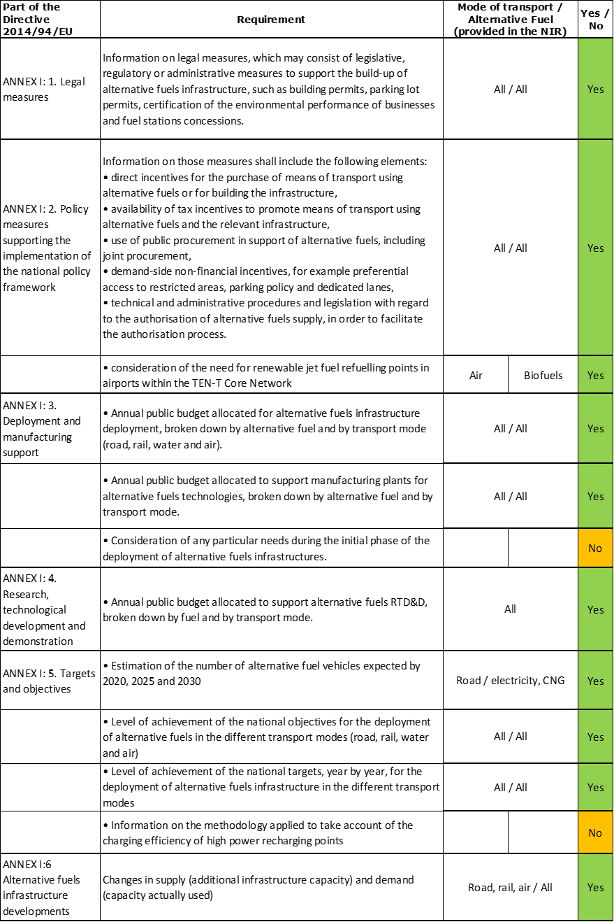

The checklist shows that most of the requirements of Annex I from the Directive are covered in the Finnish NIR.

Regarding the combination of AF/AFV/AFI with transport mode, electricity is partially covered for all modes. CNG, hydrogen and synthetic fuels are partially covered for road transport, LNG for road and waterborne transport. Biofuels are partially covered for road, waterborne and air transport, while all the other combinations are either absent or not applicable.

The Finnish NIR reports 52 measures. Under the Policy and Deployment & Manufacturing sections it was possible to identify 11 AF/transport mode clusters of measures, of which seven were assessable.

### Quantitative assessment: Vehicles and infrastructure

In its accompanying Excel table, the FI NIR states that “the targets for public recharging points will need to be revised. However, no decisions have yet been made regarding new targets”. For natural gas infrastructure, it indicates that “targets will be set in the near future, but no formal decisions have yet been made”. For hydrogen refuelling points, the following can be read: “targets will need to be revised. However, no decisions have yet been made regarding new targets”. Thus it was not entirely clear at the time of writing this assessment whether the government of Finland will endorse the NPF infrastructure targets for road electricity, CNG and hydrogen. For information purposes, when considered still relevant, these will be shown in Table 5.26.3‑1.

*Table 5.26.3‑1 National AFV estimates and AFI targets established in the NIR at the horizon 2020, 2025 and 2030 and their comparison with the NPF situation*



* Target from the FI NPF.

** Values taken from EAFO 2018 (absent in both NPF and NIR).



#### Road transport

The FI NIR states that the National Distribution Infrastructure Programme for Alternative Propulsion Systems in Transport has the goal that all new passenger cars and vans sold in Finland shall be compatible with an alternative propulsion system by 2030.

##### Electricity

###### Vehicles

Finland reported 15,807 battery-electric and plug-in hybrid electric vehicles in use in 2018 (see Table 5.26.3‑1), of which 15,499 were passenger cars, 285 LCVs, 2 HCVs and 21 buses and coaches. Additionally, Finland also recorded 1,248 electric PTWs in 2018. The Finnish NIR estimates 160,738 EVs for 2025 and 382,790 for 2030, which are respectively 51.64% and 45.55% higher than in the NPF. In particular for 2030, the FI NIR foresees 364,346 passenger cars, 15,398 LCVs, 2,046 HCVs and 1,000 buses and coaches. This reflects a considerably higher policy ambition than in NPF. In contrast to the NPF, estimates for 2020 were not reported in the NIR.

The 2018 ***attainment*** of future EV estimates is 9.83% for 2025 and 4.13% for 2030. According to the assessment methodology described in Section 2.1, the 2018 situation corresponds to an ***adequate progress*** towards reaching the envisaged EV estimates. The calculated ***average*** ***annual growth rate*** corresponding to the period 2016-2030 for EV fleet evolution planned by Finland is equal to 41%.

###### Infrastructure

Finland reported 2,399 publicly accessible recharging points in 2018 (Table 5.26.3‑1), of which 413 were high power (>22kW) recharging points. For the next decade, the FI NIR does not provide targets and mentions that those in the NPF need to be revised. The 2020 target provided in the NPF of 2,000 points has been clearly achieved and exceeded already in 2018. Considering the NPF targets for 2020 and 2030 (25,000 points), the share of publicly accessible high power recharging infrastructure is foreseen to remain constant at a value of 10%.

The 2018 ***attainment*** of the future public recharging infrastructure targets (provided in the NPF) is higher than 100% for 2020 and 9.60% for 2030. According to the assessment methodology described in Section 2.1, the 2018 situation corresponds to an ***adequate progress*** towards reaching these envisaged targets. The calculated ***average annual growth rate*** corresponding to the period 2016-2030 for publicly accessible recharging infrastructure evolution planned by Finland in its NPF is equal to 29%.

###### Ratio

The following table shows the ratio between vehicles and publicly accessible recharging points (i.e. sufficiency index) for the pair electricity/road. For the next decade only the 2030 value can be computed and results higher than 10, which can be regarded as potentially inadequate considering the foreseen low share of high power recharging points (10%).



* Value computed with AFI target from the FI NPF.

###### Information on charging efficiency

Information is not available in Finnish NIR.

##### CNG

###### Vehicles

Finland reported 6,307 CNG vehicles in use in 2018 (Table 5.26.3‑1), of which 5,599 were cars, 528 LCVs, 133 HCVs and 47 buses and coaches. In contrast to the NPF, the 2020 estimate is not reported in the NIR. The NPF estimate of 5,800 CNG vehicles in 2020 has been already achieved. The NIR presents a new estimate for 2025 (25,337 vehicles), which is 49.04% higher than in the NPF, while there is practically no change for 2030. For this latter year, the Finnish NIR expects a fleet of 52,788 CNG vehicles, composed by 43,745 passenger cars (82.9%), 7,177 LCVs (13.6%), 1,719 HCVs (3.25%) and 147 buses and coaches (0.28%).

The 2018 ***attainment*** of future CNG vehicles estimates is 24.89% for 2025 and 11.95% for 2030. According to the assessment methodology described in Section 2.1, the 2018 situation corresponds to an ***adequate progress*** towards reaching the envisaged CNG vehicles estimates. The calculated ***average annual growth rate*** corresponding to the period 2016-2030 for the CNG vehicle fleet evolution planned by Finland is equal to 26%.

###### Infrastructure

As Table 5.26.3‑1 shows, Finland reported 40 publicly accessible refuelling points in 2018. The FI NIR provides only a new target of 50 CNG refuelling points for 2020, which means five refuelling points less in comparison to the NPF (i.e. 9.09% lower), and no target for 2025 and 2030. The NPF included also a target of 55 refuelling points for 2025 (similar to 2020), but this has not been confirmed in the NIR.

The 2018 ***attainment*** of future public CNG refuelling infrastructure targets is 80% for 2020. According to the assessment methodology described in Section 2.1, the 2018 situation corresponds to a ***fast progress*** towards reaching these envisaged targets. The calculated ***average annual growth rate*** corresponding to the period 2016-2020 for publicly accessible CNG refuelling infrastructure evolution planned by Finland is equal to 20%.

###### Ratio

Based on the FI NIR, the following table shows the ratio between vehicles and publicly accessible refuelling points (i.e. sufficiency index) for the pair CNG/road. It can be seen that the sufficiency index is always below the indicative value of 600 (see Section 2.1.5), even in 2025. The values for 2020 and 2030 could not be computed due to the lack of data.



* Value computed with AFI target from the FI NPF.

##### LNG

###### Vehicles

The Finnish NIR does not report any information on LNG vehicles, either past data nor future estimates. Also the NPF had not reported any vehicle estimate for 2020-2030. The value shown in Table 5.26.3‑1 of 25 LNG vehicles in 2018 is from EAFO. The FI NIR only briefly mentions about long-distance lorries using LNG and LBG (Liquid BioGas), but does not provide specific numbers.

Because there are no LNG vehicle estimates provided in the Finnish NIR, the 2018 ***attainment*** and ***progress*** could not be computed.

###### Infrastructure

The Finnish NIR does not report any figure for road LNG refuelling points in 2018 (the value shown in Table 5.26.3‑1 of 6 refuelling points is from EAFO), but declares that in autumn 2019 there were seven LNG refuelling points in use. The NPF had a target of 9 LNG refuelling points for 2020 and 11 for 2025. The FI NIR does not confirm them numerically, but states that for liquefied natural gas and biogas (LNG, LBG) the objective for Finland is to have by 2030 a nationwide network of LNG refuelling stations on the highway for heavy-duty vehicles.

Because there are no LNG refuelling point targets provided in the Finnish NIR, the 2018 ***attainment*** and ***progress*** could not be computed.

###### Ratio

As no information has been provided for LNG vehicles/infrastructure in the FI NIR, the sufficiency index could not be computed. Using the EAFO numbers for 2018 the sufficiency index is equal to 4.17.

##### Hydrogen

###### Vehicles

In 2018, there was just one hydrogen passenger car on the road in Finland, since 2016. The FI NIR does not provide estimates for the next decade, thus the 2018 ***attainment*** and ***progress*** could not be computed.

###### Infrastructure

The Finnish NIR did not include hydrogen infrastructure provisions. According to the NPF, an objective for Finland was to have 21 hydrogen refuelling stations in main urban centres by 2030, with a distance between them of approximately 300 kilometres and a radius of influence of 150 kilometres each. Back in 2016, in Finland there were two hydrogen filling stations. By 2019, there was no longer any publicly accessible hydrogen refuelling station in Finland. The FI NIR states that it is unlikely that the network of hydrogen stations will grow in line with the targets set in 2016 (see also Section 5.26.4.2).

Because of the lack of hydrogen data in the Finnish NIR, the 2018 ***attainment*** and ***progress*** have been computed.

###### Ratio

As no information has been provided for vehicles and infrastructure, the sufficiency index could not be computed.

##### Biofuels

###### Vehicles

The Excel file accompanying the FI NIR shows 4,132 vehicles powered by other alternative fuels in 2018, of which 94 were HCVs, 6 LCVs and the rest passenger cars. It is, however, unclear whether they refer to E85 vehicles only. The NIR states that around 4,300 E85 fuelled vehicles were in use in autumn 2019 (see Section 5.26.4.2.1 for information on vehicle conversions) but it also explains that not all the E85 vehicles are included in this statistics because there are conventional vehicles that are later converted to E85 and are not immediately ri-registered as such. The FI NIR also mentions that there are a few trucks used for refuse collection and freight distribution, as well as some buses used in public transport in Helsinki running on ED95.

The FI NIR indicates the following objectives for the share of vehicles being able to use some alternative mode of propulsion, including E85 and ED95 (see also Section 5.26.3.1.7):

* For new passenger cars and vans: the target is to have 20% of the vehicles in 2020, 50% in 2025 and 100% in 2030.
* For new heavy-duty vehicles (HCV and buses): 40% in 2020, 60% in 2025 and 100% in 2030.

The FI NIR also explains that, due to the absence of new E85 vehicle models on the market, the only way for E85 to contribute to the above objectives is through the conversion to E85 of the existing conventional vehicles, for which Finland provides subsidies.

Because there are no numerical E85 vehicle estimates in the Finnish NIR, the 2018 ***attainment*** and ***progress*** could not be computed.

###### Infrastructure

The FI NIR reports a network of 140 E85 refuelling stations (a map was also included in the NIR) and one ED95 refuelling point (with another one under construction)[16]. While for 2020 and 2025, both the NPF and the NIR indicate no targets, for 2030 the FI NIR has a new target of 1,800 refuelling points offering biofuels, which constitutes an increase of 620% compared to the NPF target of 250 refuelling points. In fact, the FI NIR states that “*An objective in the national distribution infrastructure programme for alternative propulsion systems in transport was that by 2030 all filling stations would include in their range of products a high blend fuel (such as 100% renewable diesel, high blend ethanol E85 or ethanol diesel ED95). The dominant grade would be, for example, E20/25 petrol*” (see also Section 5.26.3.1.7).

Ultimately, the FI NIR mentions that the trend in the availability of, E85 and ED95 fuel will depend on the demand. It also states that the network can grow quickly and in response to market demand at any given time, reaching, if necessary, several hundred stations.

Considering the publicly accessible E85 refuelling infrastructure, the 2018 ***attainment*** of the future targets is 7.78% for 2030. According to the assessment methodology described in Section 2.1, the ***progress*** obtained by Finland from 2016 until 2018 for the deployment of publicly accessible biofuels (E85) refuelling infrastructure is 2.35% of the overall planned deployment during the period 2016-2030[17].

###### Ratio

Based on the Finnish NIR, the following table shows the ratio between vehicles and publicly accessible refuelling points (i.e. sufficiency index) for the pair E85/road. It is worth reminding that the number of vehicles used to calculate these ratios might be underestimated, due to the uncertain number of E85 converted vehicles in the official statistics.



* Value computed with 2016 AFI number from the FI NPF

##### LPG

###### Vehicles

Information is not available in the Finnish NIR.

###### Infrastructure

Information is not available in the Finnish NIR.

##### Synthetic and paraffinic fuels

###### Vehicles

The FI NIR indicates that the use of renewable diesel, by bus operators, taxis and other transport firms as well as for non-road mobile machinery, is increasing. For instance, the NIR expected that all the vehicles operating at Finavia’s regional airports would be using renewable diesel by the end of 2019.

The FI NIR objectives indicated in Section 5.26.3.1.5 also apply to vehicles running on 100% renewable diesel that do not rely on any special technology to do so.

###### Infrastructure

Information on the number of publicly accessible synthetic and paraffinic refuelling points in use between 2016 and 2018 is not available in the Finnish NIR. Finland recorded 20 renewable paraffinic diesel (HVO) refuelling points for heavy-duty vehicles (a map was also included in the NIR) and 34 for all vehicles in summer 2019.

The FI NIR identifies the limited network of refuelling stations as a bottleneck to greater renewable diesel use. The objective mentioned in Section 5.26.3.1.5, related to the national distribution infrastructure programme for alternative propulsion systems in transport also applies to 100% renewable diesel HVO100. The NIR again specifies that future HVO100 availability is conditional to market demand.

#### Rail transport

##### Electricity

###### Vehicles

Information is not available in the Finnish NIR.

###### Infrastructure

The FI NIR states that “*an objective of the national distribution infrastructure programme for alternative propulsion systems in transport was that rail would be nearly 100% electrified by 2050*”, therefore the electrification of the state rail network will continue for 2020/2025/2030.

#### Waterborne transport (maritime)

##### Electricity

###### Vessels

The NIR mentions two electric vessels in operation since 2018: the ‘Aranda’ marine research vessel, capable of relying on its battery for short journeys, and a cable reel ferry operating between Nauvo and Högsar. According to the NIR, there were a few electric vessels in use in Finland in autumn 2019. The NIR expects new electric cable ferries to be deployed in the future as well as a new electric ferry to be sailing in the archipelago off Turku. In addition, the NIR reports hybrid (electric) vessels: the ‘Elektra’, in service between Parainen and Nauvo since mid-2017, and three new ones (fitted with batteries to be charged by diesel electric generators, whose power will be used at ports) commissioned by Finnlines and expected to be ready between 2020 and 2021.

Because there are no numerical estimates of electric vessels to be deployed in the maritime ports provided in the Finnish NIR, the 2018 ***attainment*** and ***progress*** could not be computed.

###### Infrastructure

Similarly to the NPF, the Finnish NIR did not provide numerical data regarding the shore-side electricity supply points in 2018. However, the NIR reports that in autumn 2019 shore-side power was available at the ports of Helsinki, Oulu and Kemi.

For shore-side electricity, the development plans over the next years vary from port to port. The FI NIR mentioned the objective that the largest ports should have a shore-side electricity facility by 2030. To this end, several projects have started during the implementation period and are currently continuing at the ports of Helsinki, Oulu and Kemi, but also at the ports of Turku and Långnäs. The Finnish NIR indicates technical and economic challenges with the supply of shore-side electric power, as individual cruisers need about 15 MW each.

Because there are no numerical targets for shore-side electricity supply in the maritime ports provided in the Finnish NIR, the 2018 ***attainment*** and ***progress*** could not be computed.

##### LNG

###### Vessels

In 2018, LNG was the fuel used by four vessels under Finnish flag. LNG consumption data on one of them (the Viking Grace) accounted for 94% of all the fuel used in 2018. The NPF had indicated 17 LNG seagoing ships in 2016.

The number of LNG-fuelled vessels is expected to increase in the next years, but no numerical data for 2020/2025/2030 were provided in the NIR. The only exception being the indication that five new vessels powered by LNG were in the order book in September 2019, although it is not certain whether all will be registered with the Finnish flag.

Because there were no numerical estimates in the Finnish NIR of LNG vessels to be deployed in the maritime ports, the 2018 ***attainment*** and ***progress*** could not be computed.

###### Infrastructure

The Finnish NIR mentions that LNG bunkering operations are currently carried out in the TEN-T Core port of Helsinki. On the west coast of Finland, an LNG terminal is available since September 2016 in Pori, while another one was completed in June 2019 in Tornio. The FI NIR confirms the 2025 target of 6 refuelling points provided in the NPF. More specifically, it mentions that the Finnish national distribution infrastructure programme for alternative propulsion systems in transport aimed at having bunkering facilities (LNG or LBG) at all TEN-T Core Network ports (Hamina-Kotka, Helsinki, Naantali and Turku) and in the ports of Pori and Tornio by 2025.

The FI NIR states that the increase in the number of LNG-fuelled ships used for domestic and international transport will be a factor that supports the development of the LNG infrastructure in the longer term and that low oil prices might slow down the investments.

The 2018 ***attainment*** of future LNG refuelling infrastructure targets for seagoing ships is 33.33% for 2025. The ***progress*** could not be computed due to the lack of necessary data.

##### Biofuels

Finland reports the intention to increase the use of VG Marine EcoFuel, produced in Finland, by four or five times the current volume of 450 tonnes a year by the end of 2021.

###### Vessels

The FI NIR does not provide numerical data on the number of vessels using biofuels in 2018, but gives information indicating that at least four vessels that fly the Finnish flag can use biofuels. On two of them, the fuel consumption in 2018 included approximately 25% bio-oil, manufactured in Finland from vegetable fat and fish gut waste.

The number of biofuesl vessels is expected to increase in the next years, but no numerical data for 2020/2025/2030 were provided. The Act on the Promotion of Biofuels in Transport aims at increasing the use of biofuels on boats that use the same fuels as road transport. At the same time, the stock of boats and boat engines in Finland is replaced slowly.

#### Waterborne transport (inland)

##### Electricity

Information is not available in the Finnish NIR.

##### LNG

###### Vessels

Information is not available in the Finnish NIR.

###### Infrastructure

The FI NIR confirms the target of one LNG refuelling facility for inland waterways provided in the NPF for 2030. More specifically, it is stated that the potential needs for LNG/LBG of vessels navigating in the Saimaa lake deep-water routes will be covered by a mobile bunkering point or similar solution located in Mustola, near Lappeenranta, by 2030.

#### Air transport

The FI NIR does not give any numerical data on airplanes and infrastructure, but the objective for air transport is to reach a 40% share of renewables or of other solutions to cut emissions by 2050, and airport terminals traffic emission-free by 2050.

##### Electricity

###### Airplanes

Information is not available in the Finnish NIR. Finavia predicts that Finland will have pure electric passenger aircraft on domestic routes by the end of the 2030s at the earliest.

###### Infrastructure (for stationary airplanes)

It is not fully clear from the NIR whether electricity for stationary airplanes continues to be available at the major Finnish airports, as indicated in the NPF, and what the current situation for smaller airports is. The number of electric recharging infrastructure for stationary airplanes is expected to increase in the next years, but no numerical data for 2020/2025/2030 were provided.

Electricity is used by about 30% of non-road machinery of ground handling companies at Helsinki-Vantaa Airport, and the replacement rate for rechargeable equipment is 5-15% per year.

##### Biofuels

Finland reports an objective on blending obligation, which would allow for sustainable biofuels to achieve a 30% share in aviation fuels by 2030, but no measures have yet been put in place to achieve it.

###### Airplanes

Information on flights / airplanes powered by biofuels is not provided in the FI NIR.

###### Infrastructure

Finland did not provide data on the biofuels refuelling infrastructure for airplanes in its NIR.

### Measures assessment

As in the NPF, the Finnish NIR contains an extensive and detailed description of measures, most of them in place during the implementation period. They cover a wide variety of AFs and transport modes. The majority focuses on electricity, natural gas and biofuels as AF and on road as transport mode, however measures for waterborne maritime, rail and air are also present.

#### Legal measures

The Finnish NIR contains 7 legal measures (versus 12 in the NPF) to promote AF. One of them focuses exclusively on biofuels, while the rest target a combination of AFs.

An overall assessment of the legal measures is that the Finnish NIR shows an increased ambition level compared to the NPF.

##### Legislative & Regulatory

Almost all the legal measures listed in the NIR can be categorised as legislative and regulatory measures. They tend to target a combination of AFs in road transport, such as:

* Act on Transport Services (320/2017);
* Act on Consideration for the Energy and Environmental Impact of Vehicles in Public Procurement;
* Act on the Distribution of Alternative Fuels for Transport.

In addition, the Act on the Promotion of Biofuels in Transport entered into force in 2019 and set a mandatory target for 2030 of 30% biofuels share (10% share of advanced biofuels). Biogas is also being considered.

Traficom, the Finnish Transport and Communications Agency, and many other Finnish actors have established collaborations. In November 2018, the Finnish government and the automotive industry concluded a climate agreement known as the ‘green deal’, to be in effect until the end of 2025. Among its goals there are: increasing the registration share of new vehicles with alternative propulsion systems to at least 25% by 2025, reducing average CO2 emissions from new light-duty vehicles by at least 4% a year as well as promoting biofuels use in heavy-duty vehicles.

The FI NIR reports as well contribution to targets and measures agreed upon at international level, as Finland has actively participated in the work of the ICAO and IMO to promote the use of alternative means of propulsion.

##### Administrative

The Finnish NIR provides information on one administrative measure regarding the contribution to EU objectives and measures, targeting a combination of AFs and transport modes.

#### Policy measures

The Finnish NIR contains 29 policy measures at national level, a strong increase compared to the 12 policy measures identified in the NPF. Of all the policy measures reported in the NIR, 83% have a financial nature, 55% can be characterised as targeting a combination of alternative fuels, 31% a combination of transport modes and 28% as targeting a combination of both.

Finland based their policy measures and financial incentives on the emissions level to encourage introduction of alternative fuels vehicles and other sustainable transport modes. The main focus in the Finnish NIR is on electric, biofuels and CNG/LNG vehicles, where financial instruments are introduced for different vehicle categories.

The NIR reports at least one policy measure that targets exclusively each of the AFs as defined in the Directive, with the exception of hydrogen and synthetic and paraffinic fuels. As a matter of fact, hydrogen seems to have lost (part of) its relevance in Finnish plans and the NIR reports a decrease of ambition justified with different directions of market development. Nevertheless, some subsidising possibilities for hydrogen are still possible under the ‘Energy support programme’ and the taxation system.

##### Measures to ensure national targets and objectives

Of all the national policy measures described in the Finnish NIR, 19 can be categorised as measures to ensure national targets and objectives.

###### Road transport

Among the policy measures that focus on road transport, the following can be highlighted:

* BEV purchase subsidy: granting €2,000 to private persons (applicable also to long-term leases);
* Financial aid for ethanol[18] and gas-powered vehicle conversions: €200 and €1,000 respectively;
* Scrapping premium: €2,000 for the purchase of vehicles powered by high blend ethanol, electricity or methane, topped up with an industry discount of €500. The measure was in place in 2018 and resulted in 6,677 new vehicle purchases, mostly petrol vehicles. Of the total budget of 8 million €, circa 90% was used. The NIR compares the share of total vehicle purchases AFVs held both with and without the premium in the same period: in both cases, AFVs accounted for around 6% of the total vehicle purchases. However, the share of gas-powered vehicles was much higher with the premium (4.4% compared to ca. 1% without the premium).
* Differential fuel and vehicle registration taxation: four measures aim at taxation of the road vehicles, either privately owned or company cars;
* Information measures: All cars registered in Finland after 2001/2002 have an energy label developed for all new and used vehicles for which there is type approval information on emissions.

It seems that the BEV purchase subsidy and conversion aid have together an annual estimated budget of 6 million € over 2018-22, of which only 15.16% of the 2018-2019 budget was taken up.

Eight policy measures in the Finnish NIR are financial incentives to support the deployment of electric recharging infrastructure.

###### Waterborne transport

The FI NIR reports the plan to pursue the implementation of the LNG operational programme prepared in 2016, which consists of: i) addressing issues for the refuelling of ships with gas in Finland; ii) financial incentives for the construction of LNG infrastructure and the procurement of LNG-powered ships; iii) active role of Finland at international level.

The number of LNG-fuelled vessels in Finland is supposed to increase in the next few years, due to more stringent emission controls. Liquefied natural gas is now an attractive option to help achieve the emissions limits for coming years, as availability of other alternative fuels is not sufficient to meet the needs of maritime transport. Finland notices recent international developments in the LNG distribution infrastructure, which supports the transition to LNG vessels.

The Finnish NIR speculates that the use of shore-side electricity supply could be promoted through lower taxation on shore-side electricity in accordance with Article 19 of Council Directive 2003/96/EC, which would result in its wider use.

###### Air transport

The Finnish NIR also presents policy measures on promotion of the use of biofuels in air transport and on promotion of alternative propulsion systems at ports and airports. The main goal is to explore and promptly adopt various financing models and/or other approaches to guarantee the availability of biofuels at Helsinki-Vantaa Airport. The FI NIR explains that the various actors have discussed possible models in 2016-2019, but no actual measures have been put in place yet. Progress is expected in the coming years and the target is to reach a 30% share for sustainable biofuels in air transport by 2030, by means of blending obligation.

##### Measures that can promote AFI in public transport services

Many of the policy measures described in the Finnish NIR, can be considered also as measures that can promote AFI in public transport services. These measures are such that they can impact also public transport on road, rail, air and waterborne. All these measures address a wide spectrum of uses (different alternative fuel/mode of transport combinations).

The measure addressing rail in the Finnish NIR consists of financial incentives to achieve the goal of 100% rail electrification. The state provided financial assistance for the following urban rail projects:

Western extension of the Helsinki metro, phase 1 (entire project 1,186 million €, state contribution 200 million €);

Western extension of the Helsinki metro, phase 2 (entire project 801 million €, state contribution 240 million €);

Jokeri light rail (entire project 275 million €, state contribution 84 million €);

Tampere tramway (entire project 245 million €, state contribution 30%)

For the future, the government of Finland plans an increase in rail investments, although it is unclear to what extent this covers alternative fuels.

##### Measures that can promote the deployment of private electro-mobility infrastructure

A measure for private recharging points reported in the Finnish NIR regards a grant for building recharging infrastructure in housing cooperatives, with a budget of 1.5 million € per annum for 2018-2021. The grant, which is available also for acquiring recharging equipment, is for 35% of actual costs, with a ceiling of €90,000. It requires the provision of at least five recharging points. It has been proposed that the budget for this grant is increased by 4 million € per annum as from 2020.

#### Deployment and manufacturing support

##### AFI deployment

The Finnish NIR contains seven AFI deployment support measures, which represents an increase compared to the three measures identified in the NPF. While all of them include budget information, four of them focus on electricity and the rest target a combination of alternative fuels.

In addition to the urban rail projects highlighted in Section 5.26.4.2.2 (thus dealing with passenger transport), the following development projects were in progress or have just been completed in Finland in 2016-2019, including electrification projects:

The Seinäjoki-Oulu upgrade project (entire project 674 million €)

The western rail track at Pasila (49 million €)

The Riihimäki triangular junction (12 million €)

Increased capacity between Helsinki and Riihimäki (150 million €)

Improvements to the Helsinki rail yard (55 million €)

The Luumäki-Imatra project (189 million €)

The Pori-Mäntyluoto electrification project (7 million €)

The electrification of the line at Uusikaupunki (21 million €)

The Pännäinen-Pietarsaari electrification project (4 million €)

Besides electricity for rail, electricity for road features among the AFI deployment measures indicated in the NIR. Concerning publicly accessible recharging infrastructure, the NIR reports 4.8 million € in aid over 2017-2019, with an aid rate of 35% for fast recharging and 30% for normal recharging points, granted only for smart charging systems. With regards to private AFI deployment, the policy measure mentioned in Section 5.26.4.2.3 resulted in 1,200 recharging points in 75 housing cooperatives in 2018, at an expense of 0.7 million €.

TEN-T grants are reported to be used where possible, in building the distribution network in Finland. In 2016-2019 multiple LNG/CNG large scale projects have been implemented in Finland and have received TEN-T financial support in 2016-2019 of almost 33 million €. In comparison to the NPF, the budget is lower (30 million € vs. 90 million € in NPF), but the projects seem to continuously run and this decrease is probably due to the market saturation.

In addition to the aforementioned budgets, the Finnish NIR reports an estimated budget of 41.5 million € for AFI deployment for the period 2018-2021. This includes infrastructure support programme for electric transport and the use of biogas in transport, and the aid for the construction of recharging points in apartment buildings.

##### Support of manufacturing plants for AF technologies

The Finnish NIR indicates slightly over 30 million € of aid between 2017 and 2019 to support the construction of a biogas production plant and/or the production of biogas.

##### Consideration of any particular needs during the initial phase of the deployment of alternative fuels infrastructures

Information is not available in the Finnish NIR.

#### Quantitative assessment of Policy and Deployment & Manufacturing measures

Table 5.26.4‑1 presents an analysis of all the Policy and Deployment & Manufacturing measures, carried out according to the assessment methodology described in Section 2.2. As it can be seen, eleven clusters of measures have been identified, for as many pairs AF/transport mode, of which seven were assessable. The electricity/road, CNG/road, LNG/water (both maritime and inland) and electricity/rail pairs are the ones having a high score; the LNG/road and biofuels/road pairs get a medium score. All the others pairs score low or are not assessable. Five of the seven assessable clusters identified can be considered to be comprehensive. In terms of expected impact of these measures to support the realisation of the AFV/AFI objectives as presented in the NPF and revised in the NIR, the lack of future targets and estimates for several pairs does not facilitate the task of putting this assessment into perspective. Based on the impact seen during the implementation period, for the future it can be said that the measures for the pairs electricity/road, CNG/road and LNG/water have a high impact. Electricity/rail, LNG/road and biofuels/road result to have a medium impact. Hydrogen/road has a low impact. Finally, electricity/water, electricity/air, biofuels/water and biofuels/air could not be assessed as limited information and no allocation were given in relation to the ‘Energy support programme’. Moreover, concerning this particular measure, aimed at “*(exploring) the possibility of promoting the use of alternative propulsion systems at Finnish ports and airports*”, the Finnish NIR and NFP explain that only the most promising options could be adopted by the beginning of the 2020s at the latest.

Compared to the NPF, the level of ambition of the Policy and Deployment & Manufacturing support measures has increased for all pairs.

*Table 5.26.4‑1 Quantitative assessment of Policy and Deployment & Manufacturing support measures*



**Legend:** Score: H = high; M = medium; L = low; X = not assessable. Comprehensiveness: C = comprehensive; N = Not comprehensive. Ambition level: ‘+’ means ‘higher’; ‘=’ means ‘comparable’; ‘-‘ means ‘lower’.

*For some of the measures, it is unclear which ones correspond to maritime transport, which to inland and which cover both.

**For road transport, this includes renewable diesel.

#### Research, Technological Development & Demonstration

The Finnish NIR lists nine RTD&D research and pilot projects relating to alternative propulsion systems for transport carried out between 2016 and 2019: three addressing the field of biofuels, two on emissions measurements and financial mechanisms, and three on electric vehicles. In addition, an Action Plan for the Future of Mobility in Europe Mobility4EU, as well as the involvement in a project initiated by the European Commission to explore best practices for providing consumers with price comparison information on different propulsion systems were mentioned. The NIR does not provide specific details about each of these projects and this does not allow to either make direct comparisons with the projects listed in the NPF or to further analyse them. According to the information given in NIR, the majority of these projects focus on electricity and biofuels, to increase their cost-effectiveness. The indicated budget for RTD&D projects reported in the NIR amounts to 3.9 million € for the period 2016-2020. It includes both national funds and EU financial support to RTD&D activities on alternative fuels.

### Additional information on alternative fuels infrastructure developments

The FI NIR provides information on the fuel use in road transport only with reference to 2017 (see Table 5.26.5‑1). No other past data, nor future expectations have been shared.

Concerning rail transport, the NIR reports that electric traction systems account for 95% of passenger transport and 78.3% of freight transport.

The FI NIR states that the main fuel used in aviation in Finland is kerosene. Total sales of kerosene in 2018 reached around 77,000 tonnes. More than 80% of kerosene was used in international transport.

*Table 5.26.5‑1 Changes in fuel use in transport sector (2016-2030)*



### Summary of the assessment

**Tabular overview**

*Table 5.26.6‑1 Overview of the NIR assessment*

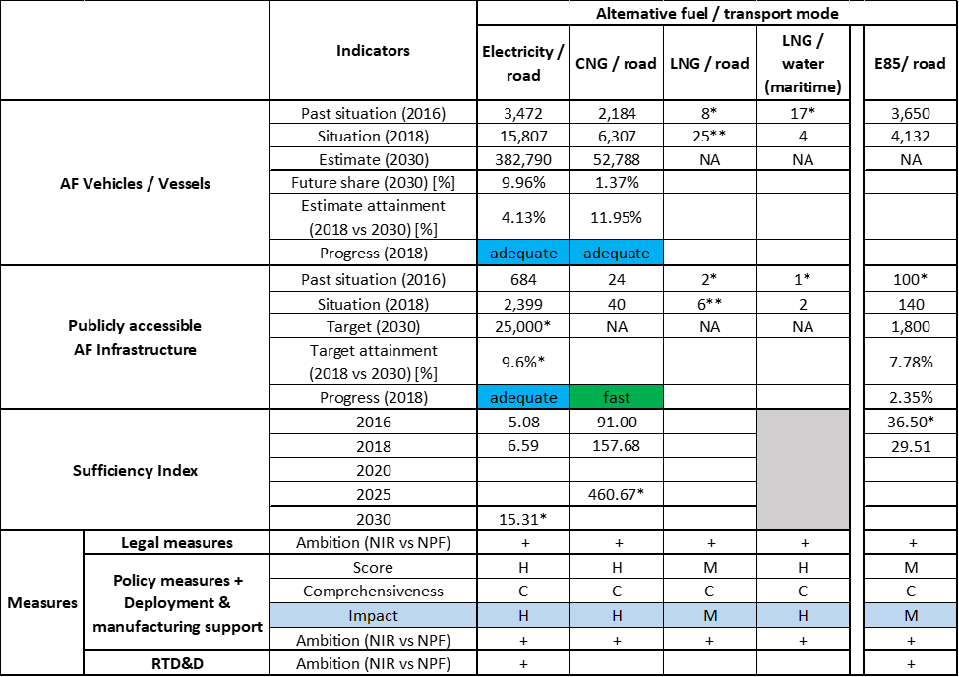



* Value taken or calculated from FI NPF. ** Value taken from EAFO (absent in NIR).

The NIR describes Finland’s efforts to increase the use of alternative fuels in transport, including waterborne transport. For instance, the information provided in the Finnish NIR is that Finland is committed to an ambitious (climate) target under the IMO’s provisional Greenhouse Gas Strategy for reducing emissions from shipping, and is aiming at similar emission cuts both in international navigation and for maritime transport in Finnish waters. An objective for boating activities is that they should become virtually emission-free in Finland by 2050, and all new boats should be able to be used with an alternative propulsion system by 2030.

In principle, the Finnish NIR covers the whole AFID period (2016-2030), but the quantitative analysis is not always possible. It almost fully addresses the requirements of Annex I of the Directive. In particular, the FI NIR offers quantitative objectives for electric vehicles and infrastructure, for E85 infrastructure and for CNG vehicles. The FI NIR does not provide information on the methodology applied to take account of the charging efficiency of high power recharging points and does not provide considerations on any particular needs during the initial phase of AFI deployment.

The main outcomes of the technical assessment of the Finnish NIR on vehicles/vessels estimates and infrastructure targets can be summarised as follows:

###### Road transport

* **Electricity** – With 15,807 electric vehicles and 2,399 publicly accessible recharging points in 2018, Finland is progressing adequately towards reaching both the envisaged EV estimate and AFI target for 2030. The targeted numbers of publicly accessible recharging points in 2020 and 2030 remain the same as in the NPF, but since the number of electric vehicles in Finland has grown more rapidly than expected, this might need to be revised. The infrastructure target for 2020 has been reached already in 2018. Electric HCVs constitute the smallest share in the Finnish EV market (two in 2018), but are foreseen to increase up to 2,046 by 2030. Also the number given for buses and coaches is expected to increase to 1,000 in 2030. The targeted number of electric vehicles in 2025 and 2030 is more ambitious in the NIR than in the NPF (+51.64% for 2025 and +45.55% for 2030). As for the sufficiency index, it is currently adequate, but according to the available data it might become inadequate in 2030.
* **CNG** – According to the Finnish NIR, the number of CNG vehicles will be growing from 6,307 reported for 2018 up to 52,788 in 2030. The number of HDVs reported in 2018 is of 133 HCVs and 47 buses and coaches. The expected number of HCVs and buses and coaches in 2030 is respectively 1,719 and 147. The estimated number of LCVs in 2030 is 7,177. The 2018 progress for CNG vehicles is adequate. Regarding CNG infrastructure, 40 publicly accessible refuelling points have been recorded in 2018 and no targets for 2025 and 2030 are given. The 2020 target provided in the NIR (50 refuelling points) is 9.09% lower than in the NPF. The 2018 state of play corresponds to a fast progress towards reaching the envisaged targets, while the sufficiency index is always below the reference value of 600.
* **LNG** – The FI NIR only briefly mentions long-distance lorries using LNG and LBG, but no quantitative information is provided on LNG vehicles market. Data on 25 LNG vehicles and 6 publicly accessible refuelling points in 2018 come from EAFO. For Finland the objective is to have a network of LNG refuelling stations nationwide for heavy-duty vehicles on the highway by 2030. The NPF had reported a target of 9 LNG stations in 2020 and 11 in 2025, but this has not been confirmed in the FI NIR.
* **Hydrogen** – The Finnish NIR does not include hydrogen infrastructure provisions. Despite a target in the NPF to have 21 hydrogen refuelling stations in the main urban centres by 2030, the number of hydrogen refuelling stations in Finland dropped from two in 2016, to zero in 2019. In 2018, there was just one hydrogen passenger car on the road in Finland and this number did not change between 2016 and 2018. The FI NIR states that it is unlikely that the network of hydrogen stations will grow in line with the targets set in 2016. Anyway, financial support for hydrogen vehicles, infrastructure and other hydrogen projects is foreseen within the ‘Energy support programme’, as well as within the taxation system.
* **Biofuels** – The fastest growing alternative fuels in Finland are biofuels. Liquid biofuels (including high blend ethanol E85 or ethanol diesel ED95) are planned to account for 30% of the total road fuels in 2030 (the share was 10% in 2018), the objective being laid down in legislation[19]. The NIR indicates that new flex-fuel vehicles (E85), no longer being commercially available in Finland, resulted in zero registrations in 2019. The country instead relies on conversions of conventional vehicles. Finland recorded 140 E85 refuelling stations in 2018. While for 2020 and 2025, both the NPF and the NIR indicate no targets, for 2030 the FI NIR has a new target of 1,800 refuelling points offering biofuels (and synthetic fuels, see next), which constitutes an increase of 620% compared to the NPF target of 250 refuelling points.
* **LPG** – LPG is not taken into consideration in the Finnish NIR.
* **Synthetic and paraffinic fuels** – Finland recorded 20 renewable paraffinic diesel (HVO) refuelling points for heavy-duty vehicles and 34 for all vehicles in mid-2019. In the infrastructure targets mentioned above for liquid biofuels (1,800 in 2030), the NIR also includes the availability of 100% renewable diesel, similarly to E85 and ED95.

###### Rail transport

* **Electricity** – One objective of the Finnish national distribution infrastructure programme for alternative propulsion systems in transport is that rail should be nearly 100% electrified by 2050.

###### Waterborne transport (maritime)

* **Electricity** – Finland did not provide numerical objectives in their NIR, instead the situation up to 2019 was described. Traficom’s register of boats reports 184 vessels[20] in Finland with an electric motor, which accounts for 0.09% of all boats in September 2019. According to the FI NIR, development plans for shore-side electric supply over the next years vary from port to port, and no numerical data has been provided. The Finnish NIR indicates challenges with the supply of shore-side electricity, as individual cruisers need up to 15 MW for large vessels.
* **LNG** – In 2018, LNG was the fuel used by four vessels under Finnish flag. The NPF had indicated 17 LNG seagoing ships in 2016. Sixteen vessels with a gas motor were reported for September 2019 in Finland. Although 2025 and 2030 estimates are not provided, the NIR expects the number of LNG-fuelled vessels to increase in the next years. Bunkering operations are reported in the ports of Helsinki and Pori. The FI NIR confirms the 2025 target of 6 refuelling points provided in the NPF. In its NIR, Finland states that the increase of LNG-fuelled ships used for domestic and international transport will support the development of the LNG infrastructure and that low oil prices might slow down the investments.
* **Biofuels** – Biofuels accounted for around 10% of MDO (marine diesel oil) or MGO (marine gas oil) fuels in 2018. The FI NIR does not provide numerical estimates for the future, but informs about four vessels flying under Finnish flag using biofuels. Bio-oil manufactured in Finland from vegetable fat and fish gut waste is explicitly mentioned here. Finland reports the intention to increase the ship use of VG Marine EcoFuel, produced in Finland, by four or five times the current volume of 450 tonnes a year by the end of 2021. The Act on the Promotion of Biofuels in Transport implies that the use of biofuels will increase on boats that use the same fuels as road transport.

Air transport

The FI NIR does not give any numerical data on airplanes and infrastructure, but the objective for air transport is to reach a 40% share of renewables or of other solutions to cut emissions by 2050, and airport terminals traffic emission-free by 2050.

* **Electricity** – Finavia predicts that Finland will have pure electric passenger aircraft on domestic routes by the end of the 2030s at the earliest. The FI NIR speculates that it is more probable that hybrid aircraft (combustion engine plus electric power) will come onto the market first. There are at present dynamic efforts to develop hybrid and electric aircraft by start-ups and the world’s largest aircraft manufacturers. The number of electricity recharging infrastructure for stationary airplanes is expected to increase in the next years, but no numerical data for 2020/2025/2030 were provided.
* **Biofuels** – The NIR provides very limited information on biofuels use in air transport. The objective is that the blending obligation would allow for sustainable biofuels to reach a 30% share of aviation fuels by 2030. No measures have yet been put in place to achieve the objective.

As in the NPF, the Finnish NIR contains an extensive and detailed description of **measures**. They cover a wide variety of AFs and transport modes.

Considering all the legal measures, they show an overall increase in ambition compared to the NPF and appear, if fully implemented, to be fit to support the realisation of the AFV/AFI objectives as described in the NPF and revised in the NIR.

With reference to the Policy and Deployment & Manufacturing measures, although the lack of future targets and estimates for several pairs does not facilitate the task of putting this assessment into perspective, the applied assessment methodology provides very positive scores, which are based on the results obtained during the implementation period. The measures for the pairs electricity/road, CNG/road and LNG/water (both maritime and inland) have a high impact. Electricity/rail, LNG/road and biofuels/road pairs result to have a medium impact. In addition, shore-side electricity supply infrastructure for ships was addressed in the NIR and LNG refuelling infrastructure constitutes a strong point in both the Finnish NPF and NIR. Concerning rail transport, the NIR indicates that 3.7 billion € were spent in Finland on rail development projects, including electrification, in 2016-2019 and reports on planned further increase in rail investments. The focus on biofuels development for aviation, road and maritime transport is strong in Finland and measures continue to support further development. In particular, a biofuels quota obligation is being planned for air transport. The level of ambition for all support measures has increased from the NPF to the NIR. Only for hydrogen there is lower ambition in the NIR compared to the NPF, explained as the result of an actual market request lower than foreseen when designing the NPF. Nonetheless, financial support for hydrogen is still possible, even if the market does not seem to follow yet. Noteworthy is the successful implementation of the measures supporting ambitious climate targets and provision of sufficient financial means to implement the Directive.

As for RTD&D measures, they are focused principally on biofuels and electricity.

### Final remarks

The Finnish NIR provides a comprehensive report on the efforts made to implement the Directive, which is largely in line with the provisions of Annex I to the Directive. However, no information is provided on targets for recharging points in 2025, and for CNG and LNG refuelling points for vehicles for 2030. Furthermore, no estimates are provided for LNG vehicles and vessels by 2020, 2025 and 2030. Nevertheless, the NIR reports that there is a small fleet of LNG vessels in Finland and their number is expected to increase in the next years. Biofuels and electricity will play a major role in the decarbonisation of transport in Finland. The Finnish NIR contains an extensive and detailed description of measures covering all fuels and transport modes.

As regards electricity, the NIR estimates that about 380,000 electric vehicles could be on the roads by 2030, representing about 10% of the future fleet. Taking into account the current situation and expected trends, this level of ambition does not appear to be fully compatible with the pace of deployment of electric vehicles considered necessary for a full transition to carbon neutrality by 2050. While current infrastructure deployment is in line with the current vehicle uptake, Finland should provide information on estimated targets for 2025 and 2030 that will be in line with the expected vehicle uptake. No information on charging efficiency is provided. In 2019, shore-side electricity supply was available in three ports and projects are ongoing in the remaining two ports of the TEN-T Core Network. In addition, several electric powered vessels are already in operation, but further information on fleet development would be helpful. Finland should provide clarifications on the installation of electricity supply to stationary aircraft in its airports. The NIR predicts to have some electric passenger aircraft by 2030. No information is provided on the current share of electrified rail network. However, Finland aims to electrify nearly 100% of its railways by 2050.

Concerning hydrogen for road transport, the NIR does not include targets for the number of future hydrogen refuelling stations. While some financial support for FCHVs and infrastructure is foreseen, further effort is needed to address the uptake of FCHVs and infrastructure in Finland. It would be relevant that Finland provides more information on how to ensure EU-wide connectivity for HCEV.

Regarding natural gas, according to the Finnish estimates, CNG vehicles will represent about 1.5% of the vehicle fleet by 2030. No targets are provided in the NIR for CNG refuelling points in 2025 and 2030, while the NPF foresaw 55 refuelling points for 2025. The NPF had presented a target of 11 LNG refuelling points by 2025. This seems to be sufficient considering the length of the Finnish TEN-T Core Network, provided that the refuelling stations are distributed widely along the network. The NIR does not provide any information on the current number of LNG vehicles or any future estimates. LNG bunkering operations are currently carried out in the TEN-T Core port of Helsinki and it is planned that six ports (there are five ports in the TEN-T Core Network) will supply LNG for vessels by 2025. Although future estimates are not provided, the NIR expects the number of LNG-fuelled vessels to increase in the next years compared to the 16 existing in 2019.

No information is provided on LPG vehicles or infrastructure.

While the ambition for zero emission fuels and natural gas are relatively low, Finland’s transport decarbonisation strategy focusses on biofuels and to a lesser extent on synthetic fuels. Legislation is in place that foresees that Liquid biofuels (including high blend ethanol E85 or ethanol diesel ED95) will account for 30% of the total road fuels in 2030. Finland recorded 140 E85 refuelling stations in 2018 and plans to have 1,800 refuelling points offering biofuels and synthetic fuels. In order to create demand for such fuels, Finland provides financial incentives to retrofit existing vehicles for the use of high biofuel blends. In waterborne transport, biofuels accounted for around 10% of MDO (marine diesel oil) or MGO (marine gas oil) fuels in 2018. Finland reports the intention to increase the ship use of VG Marine EcoFuel, produced in Finland, by four or five times the current volume of 450 tonnes a year by the end of 2021. As for the use of renewable fuels in aviation, Finland sets itself the very ambitious target to have a biofuel blending obligation of 30% in aviation fuels by 2030.

### ANNEX - Description of the Member State

On a surface area of 338,400 km², Finland has a population of 5.513 million people in 2018, which makes up for a population density of 16 inhabitants/km².

*Number of main urban agglomerations*

* 9 urban agglomerations > 50,000 inhabitants

In 2018, Finland achieves a per capita gross domestic product at market prices of €42,490, which represents a per capita gross domestic product in purchasing power standards of 111 if expressed in relation to the EU-28 average set to equal 100.

*Length of the road networks*

The length of the road TEN-T Core Network in Finland is 1,071 km. The total road network length is 26,952 km, of which 926 km are motorways.

The following lengths of the TEN-T Road Corridors are present in Finland: 5% (348 km) of the Scandinavian – Mediterranean Corridor.

Through the TEN-T Road Corridors, Finland is connected with the following Member States:  
- Sweden (through the Scandinavian – Mediterranean Corridor)

*Number of registered road vehicles*

At the end of 2018, Finland accounts for 4,728,980 registered road vehicles of which 3,470,507 are categorized as passenger cars, 465,024 as light goods vehicles, 171,182 as heavy goods vehicles and 18,467 as buses and coaches. The motorisation rate is 629 passenger cars per 1,000 inhabitants.

*Number of ports in the TEN-T Core Network*

* 5 maritime ports in the TEN-T Core Network (Hamina, Helsinki, Kotka, Naantali, Turku)
* 12 maritime ports in the TEN-T Comprehensive Network
* No inland ports

*Number of airports in the TEN-T Core Network*

* 2 airports in the TEN-T Core Network (Helsinki-Vantaa, Turku)
* 18 airports in the TEN-T Comprehensive Network

## Sweden (SE)

### Main messages from the Commission assessment of the NPF

In its original assessment of the Swedish NPF the Commission concluded:

*The Swedish NPF addresses only very few of the requirements of Article 3. According to the Swedish NPF, climate change is ‘one of the top priority issues for the government’. The expression ‘fossil-free’ is emphasised throughout the NPF. Sweden clusters national policy objectives of interest to the Directive into 6 groups: climate, energy, transport, regional, industry and consumer. Numerical targets are shown only for the first two. The Swedish NPF contains neither future estimates for alternative fuels vehicles nor any targets for alternative fuels recharging or refuelling infrastructure. This violates a basic requirement of the Directive. It can pose a serious risk to cross-border continuity and a functioning internal market for alternative fuels vehicles.*

*Concerning future estimates of electric vehicle stock, the Swedish NPF is rather vague. The lack of clear targets for future electric vehicle market deployment jeopardises the assessment and may represent an obstacle to policy efforts towards electro-mobility. It will be important to establish appropriate infrastructure targets in line with the market developments.*

*The Swedish NPF indicates regional discrepancies with regards to the share of natural gas use. No natural gas refuelling points can be found in large inland areas in Northern Sweden (see Figures 7-8 of the NPF). CNG refuelling infrastructure halfway the Skellefteå - Härnösand route (around southern Umeå) as well as halfway the Sundsvall - Gävle route (around Hudiksvall) would appear sufficient to meet the requirement of one refuelling point at least every 150 km.*

*The use of alternative fuels for public transport activity is concisely addressed. Rail is briefly mentioned. Additional details would be desirable.*

*The Swedish NPF highlights the role of biofuels in the country’s transport sector and the fact that Sweden has already met the sectoral 2020 target set by the Renewable Energy Directive. The Swedish NPF stresses that no special infrastructure is required for biofuels and regards this as a cost-effective solution for road vehicles. At the same time, the NPF indicates that new flex-fuel car registrations have decreased dramatically in recent years (0.4% share in 2015).*

*The Swedish NPF contains a relatively comprehensive portfolio of measures. Overall, Sweden appears to be implementing a solid policy package, beneficial to the deployment of alternative fuels vehicles, also visible in the current high shares of newly registered EV; but, as the Swedish NPF does not contain future quantitative targets for AFI, it is difficult to judge how the support measures can support reaching the objectives.*

*Further elaboration on the possibility of Member State cooperation to establish a harmonised fairway and port recharging system in the Baltic Sea Area would be advantageous.*

*Information on AFI targets related to inland waterways, airports and private electro-mobility is inadequate. Information on these is essential in view of the requirements stipulated in the Directive.*

### Overview of requirements’ fulfilment from Annex I of the Directive

*Table 5.27.2‑1 Checklist Table*

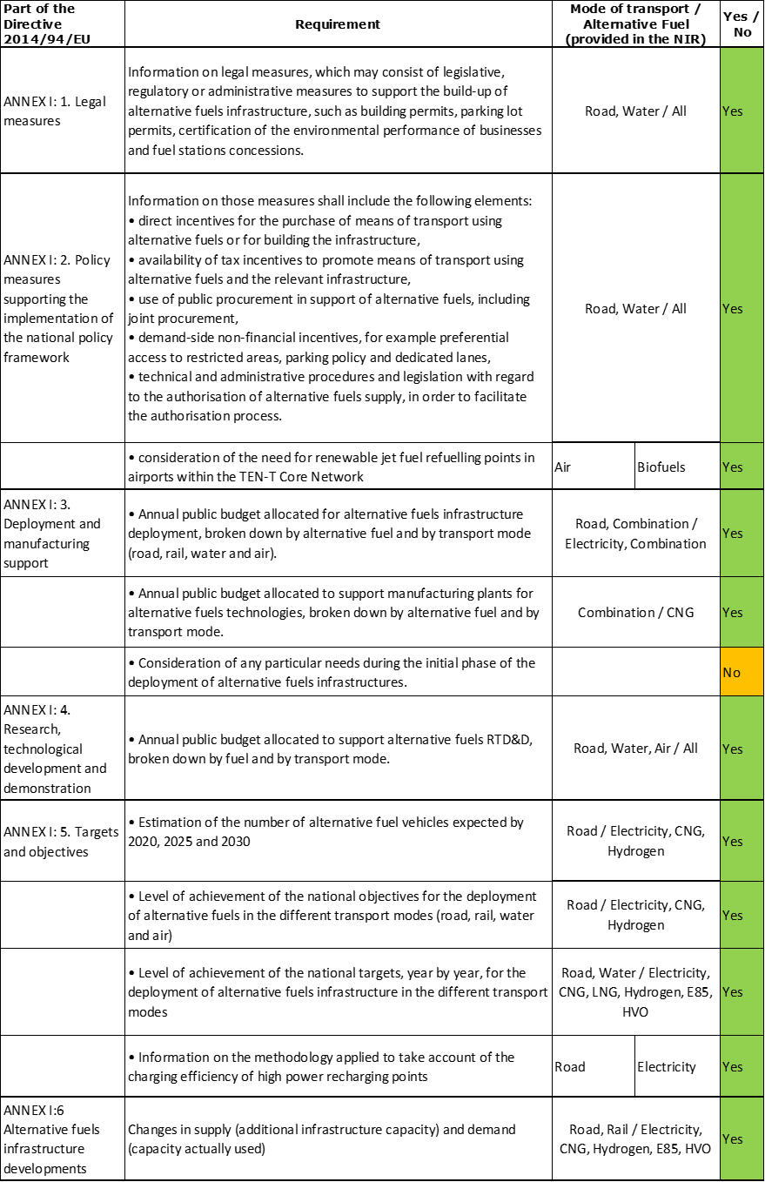

The checklist shows that almost all the requirements of Annex I from the Directive are covered in the Swedish NIR.

Regarding the combination of AF/AFV/AFI with transport mode, electricity is partially covered for all modes; CNG, hydrogen and HVO are partially covered for road transport; LNG for road and maritime transport; biofuels are partially covered for road and air transport; all the other combinations are either absent or not applicable.

The Swedish NIR reports 67 measures. Under the Policy and Deployment & Manufacturing sections it was possible to identify six AF/transport mode clusters of measures, all assessable.

### Quantitative assessment: Vehicles and infrastructure

It is important to note, when interpreting the values shown in Table 5.27.3‑1, that the original Swedish NPF notified to the Commission did not specify relevant AFI targets and AFV estimates. The government of Sweden later provided this information officially to the Commission (document ‘Information supplementing the Swedish policy framework for alternative fuels infrastructure in accordance with Directive 2014/94/EU’ (Annex to minutes II 20 of government meeting of 30 August 2018, N2018/04594/MRT)). This fact is acknowledged in the Swedish NIR, which also indicates that those AFI targets and AFV estimates differ from the ones provided in the NIR. For the purpose of this assessment, the relevant AFI targets and AFV estimates communicated by the Swedish government in its NIR and in the document supplementary to its NPF will be considered and the latter will be referred to as “NPF”.

*Table 5.27.3‑1 National AFV estimates and AFI targets established in the NIR at the horizon 2020, 2025 and 2030 and their comparison with the NPF situation*





*The Swedish NIR indicates that its AFV estimates are based on the ‘Reference EU’ scenario reported by Swedish Energy Agency, which takes into account instruments introduced by 1 July 2018. For electric LCVs and buses and coaches, the Swedish NIR reports the estimates only as percentage values, presumably of the total stock of respectively LCVs and buses and coaches. The same occurs with HDVs powered by CNG. Without information on the absolute numbers of these, it is not possible to apply our methodology to these vehicle types. As a result, the 2020 percentage change NIR vs NPF reflects electric passenger cars (NIR) relative to the sum of electric passenger cars and electric LCVs (NPF).

#### Road transport

##### Electricity

###### Vehicles

Sweden recorded 68,728 battery-electric and plug-in hybrid electric vehicles in use in 2018[21] (Table 5.27.3‑1). Of these, 66,058 were passenger cars (one-fourth were battery-electric) and 2,670 were LCVs (of which 2,661 battery-electric). The Swedish NIR provides information on neither past electric buses and coaches (it only provides percent estimates for 2020, 2025 and 2030) nor, as in the NPF, past and future electric HCVs (the NIR considers that the use of electricity to power lorries is still relatively uncommon). Compared to the NPF, the Swedish NIR reflects a lower policy ambition – the 2020 estimate is almost 10.95% lower (with caveats concerning the heavy-duty sector, as noted) than the original estimate in the NPF. Sweden did not provide 2025 and 2030 EV estimates in the NPF, but the NIR presents estimates: by 2030, the Swedish NIR expects a stock of 644,148 electric cars (of which battery-electric account for only 17%). In addition, the Swedish NIR expects that, by 2030, the share of electric LCVs reaches 1.4% of, presumably, the future total stock of LCVs (up from 0.6% in 2020) and that the share of electric buses and coaches reaches 14% of, presumably, the future total stock of buses and coaches (up from 4% in 2020). Information is not available on electric PTW. Finally, the possibility of converting mining trucks to electric operation is being explored in an RTD&D project (see Section 5.27.4).

The 2018 ***attainment*** of future EV estimates is 48.33% for 2020 and 10.67% for 2030. According to the assessment methodology described in Section 2.1, the 2018 situation corresponds to an ***adequate progress*** towards reaching the envisaged EV estimates. The calculated ***average*** ***annual growth rate*** corresponding to the period 2016-2030 for EV fleet evolution planned by Sweden is equal to 24%.

###### Infrastructure

Sweden recorded 6,700 publicly accessible recharging points in 2018 (Table 5.27.3‑1). The NIR target for the public AFI (electricity /road) for 2020 is 9,000, with no information provided on the share of normal (≤22kW) versus high power (>22kW) recharging points. In addition, Sweden reports a value of 20,000 private recharging points for 2020. In both cases, the NIR values for 2020 are the same as in the NPF. Sweden did not provide targets for publicly accessible electric recharging points for 2025 and 2030 in its NPF. In the NIR, these are not provided either.

The 2018 ***attainment*** of future publicly accessible recharging infrastructure targets is 74.44% for 2020. According to the assessment methodology described in Section 2.1, the 2018 situation corresponds to a ***fast progress*** towards reaching these envisaged targets. The calculated ***average annual growth rate*** corresponding to the period 2016-2020 for publicly accessible recharging infrastructure evolution planned by Sweden is equal to 36%.

###### Ratio

Based on the SE NIR, the following table shows the ratio between vehicles and publicly accessible recharging points (i.e. sufficiency index) for the pair electricity/road. The foreseen sufficiency index deviates from the value of 10 in 2018 to almost 16 in 2020. Considering the lack of information regarding the share of normal power and high power recharging points, this can be regarded as potentially inadequate.



###### Information on charging efficiency

Although the Swedish NIR devotes a section to this aspect, the information provided refers to an assumption on the usage of publicly accessible high power (>22kW) recharging infrastructure, rather than on the methodology applied to take account of the charging efficiency of high power recharging points or observed data on usage (which was the minimum requirement set by the Commission (Frequently-Asked Questions document notified to the Member States on 16 September 2019)).

##### CNG

###### Vehicles

The Swedish NIR indicates that natural gas is the most common alternative fuel to power LCVs, HCVs and buses (where it accounted for 18% of the bus fleet in 2018) but acknowledges that data disaggregated by type of fuel (either CNG or LNG) are not available in the road traffic register. As a result, the NIR provides values only for passenger cars: Sweden recorded 42,463 CNG passenger cars in use in 2018 (Table 5.27.3‑1). This represents a slight decline relative to 2016. Compared to the NPF, the Swedish NIR reflects a lower policy ambition in the near-term but higher in the mid-term, in fact the 2020 and 2025 estimates are 10.16% lower and 15.12% higher respectively than the original estimates in the NPF. Sweden did not provide 2030 CNG estimates in the NPF, but the NIR presents estimates: the CNG stock is planned to increase to 76,898 CNG passenger cars. In addition, the Swedish NIR expects that, by 2030, the share of CNG HCVs reaches 1.9% of, presumably, the future total stock of HCVs (up from 1.2% in 2020) and that the share of CNG buses and coaches reaches 15.4% of, presumably, the future total stock of buses and coaches (down from 16.6% in 2020).

The 2018 ***attainment*** of future CNG vehicles estimates is superior to 100% for 2020 and 55.22% for 2030. According to the assessment methodology described in Section 2.1, the 2018 situation corresponds to a ***slow progress*** towards reaching the envisaged CNG vehicles estimates. The calculated ***average annual growth rate*** corresponding to the period 2016-2030 for the CNG vehicle fleet evolution planned by Sweden is equal to 4%.

###### Infrastructure

The Swedish NIR indicates that 185 publicly accessible CNG refuelling points were available in 2018 (Table 5.27.3‑1)[22]. The NIR does not modify the 2020 and 2025 targets of respectively 230 points and at least 230 points indicated in the NPF. Both the NPF and NIR lacked 2030 targets for publicly accessible CNG refuelling points. Concerning non-publicly accessible infrastructure, the Swedish NIR indicates that there were 60 private and municipal CNG refuelling points in 2018. The NIR also indicates that the share of biogas in natural gas use in road transport grew significantly from 55% in 2013 to 93% in 2018.

The 2018 ***attainment*** of future publicly accessible CNG refuelling infrastructure targets is constant and equal to 80.43% for 2020 and 2025. According to the assessment methodology described in Section 2.1, the 2018 situation corresponds to a ***fast progress*** towards reaching these envisaged targets. The calculated ***average annual growth rate*** corresponding to the period 2016-2025 for publicly accessible CNG refuelling infrastructure evolution planned by Sweden is equal to 3%.

###### Ratio

Based on the SE NIR, the following table shows the ratio between vehicles and publicly accessible refuelling points (i.e. sufficiency index) for the pair CNG/road. The sufficiency index is well below the indicative value of 600 (see Section 2.1.5) for the whole 2016-2025 period.



##### LNG

###### Vehicles

The Swedish NIR indicates that natural gas is the most common alternative fuel to power LCVs and HCVs but provides no information on the number of heavy-duty vehicles powered by LNG, indicating that the figures for the period 2016-2018 are not available in the road traffic register. It is also unclear whether a fraction of the buses powered by natural gas (Section 5.27.3.1.2) is LNG-fuelled. The NIR acknowledges that interest in LNG-fuelled heavy-duty vehicles is increasing among manufacturers. It also mentions, in the context of an innovation cluster for liquefied biogas, the demonstration of 159 bio-LNG lorries, 10 bio-LNG coaches and one port tow vehicle in 2019.

Because there were no future LNG vehicle estimates in the Swedish NIR, the 2018 ***attainment*** and ***progress*** could not be computed.

###### Infrastructure

The Swedish NIR indicates that six publicly accessible LNG refuelling points were available in 2018 (Table 5.27.3‑1). The NIR does not modify the 2020 and 2025 targets of respectively 22 points and at least 22 points indicated in the NPF. Both the NPF and NIR lacked 2030 targets for publicly accessible LNG refuelling points. The NIR also mentions, in the context of the aforementioned innovation cluster for liquefied biogas, the demonstration of five (bio-)LNG refuelling points and two bunkering depots in 2019.

The 2018 ***attainment*** of future LNG road refuelling infrastructure targets is constant and equal to 27.27% for 2020 and 2025, while the ***progress*** could not be computed.

###### Ratio

Since there are no vehicle estimates in the SE NIR, it is not possible to calculate the sufficiency index.

##### Hydrogen

###### Vehicles

The Swedish NIR indicates that 42 hydrogen-powered vehicles were in use in 2018 (Table 5.27.3‑1), without providing information on the type of vehicle[23]. The Swedish NIR expects a future stock of at least 36 hydrogen-powered vehicles.

Because the Swedish government expects a decrease of the hydrogen-powered vehicles fleet in the future, no ***attainment*** and ***progress*** values have been computed.

###### Infrastructure

The Swedish NIR indicates that six publicly accessible hydrogen refuelling points were available in 2018 (Table 5.27.3‑1) and that additional ones were under construction in 2019. By 2020, both the Swedish NPF and NIR indicated a target of 13 points. The Swedish NPF had also provided a 2025 target of at least 13 points.

The 2018 ***attainment*** of future hydrogen refuelling infrastructure targets is constant and equal to 46.15% for 2020 and 2025, while the ***progress*** could not be computed.

###### Ratio

Based on the SE NIR, the following table shows the ratio between vehicles and infrastructure (i.e. sufficiency index) for the pair hydrogen/road (see Section 2.1.5) for the 2016-2025 period.



##### Biofuels

###### Vehicles

The Swedish NIR recorded about 215,600 ethanol-powered passenger cars in use in 2018, making E85 still the most common alternative fuel for passenger cars. However, it also reports a declining stock of passenger cars powered by E85 in the past three years (following the trend highlighted in the NPF) and indicates that new sales in 2019 were limited by model availability (five models from one manufacturer). The NIR considers that the use of ethanol to power lorries is still relatively uncommon and indicates that 9% of the bus fleet in 2018 was powered by biodiesel. The Swedish NIR acknowledges the difficulty of indicating the number of diesel vehicles running on FAME (including B100) because those vehicles are not registered as such. Finally, the NIR mentions an innovation cluster for ethanol, particularly to power HCVs (see Section 5.27.4).

Because there were no future biofuels vehicle estimates provided in the Swedish NIR, the 2018 ***attainment*** and ***progress*** could not be computed.

###### Infrastructure

The Swedish NIR reports information on infrastructure for E85 and FAME (mainly RME). The number of E85 and RME sales points decreased between 2016 and 2018: from 1,828 to 1,723 and from 38 to 9, respectively. Further information on energy use can be found in Section 5.27.5.

Because there were no future biofuels refuelling infrastructure targets provided in the Swedish NIR, the 2018 ***attainment*** and ***progress*** could not be computed.

###### Ratio

The sufficiency index for E85 was 125.13 in 2018, the only year for which it could be computed with the information provided in the SE NIR.

##### LPG

Apart from mentioning that this alternative fuel is part of the Directive, the Swedish NIR does not cover LPG.

###### Vehicles

Information is not available in the Swedish NIR.

###### Infrastructure

Information is not available in the Swedish NIR.

###### Ratio

Since no information is provided in the Swedish NIR, it is not possible to compute the sufficiency index.

##### Synthetic and paraffinic fuels

###### Vehicles

As in the case of FAME (Section 5.27.3.1.5), the Swedish NIR acknowledges the difficulty of indicating the number of vehicles powered by HVO100, which can be used in approved diesel engines of buses and lorries. The NIR confirms that just a few manufacturers have approved their car models to run on pure HVO, which currently limits its use.

###### Infrastructure

The Swedish NIR reports that the number of HVO100 sales points grew from zero in 2016 to 162 points in 2018.

#### Rail transport

##### Electricity

###### Vehicles

The Swedish NIR indicates that the stock of railway vehicles was 2,699 at the end of 2017, of which 641 were locomotives and shunters and the rest railcars. Between 2016 and 2017, the number of railway vehicles went up by 141 units (mainly electric).

###### Infrastructure

The length of the Swedish railway lines was 10,874 km in 2017, of which 75% was electrified. Further information on energy use can be found in Section 5.27.5.

#### Waterborne transport (maritime)

##### Electricity

###### Vessels

The Swedish NIR mentions that several ferries powered by electricity are in operation (see also Section 5.27.3.3.3). In addition, the NIR indicates that interest in alternative fuels by shipping companies is growing and claims to be providing government support to R&D and innovation in the field of electrified vessels (see Section 5.27.4).

###### Infrastructure

The Swedish NIR indicates that the number of ports with access to shore-side electricity supply (defined in the NIR as ‘quay-side electric connection’) went up from nine in 2015 to 20 in 2017[24]. According to the NIR, there were at least 20 ports with such connections also in 2018. Unfortunately, neither the NPF nor the NIR distinguished between maritime and inland port electricity supply.

In terms of future targets, the Swedish NIR indicates that values were provided in the supplement document to the NPF. That document indicates a target of 23 ports with access to shore-side electricity in 2025 and at least 23 in 2030. Furthermore, the NIR acknowledges that no official data exists on vessel access to shore-side electricity supply and that information on shore-side electrical connections use is not available.

##### LNG

###### Vessels

The Swedish NIR mentions that several vessels powered by LNG are in operation and on order but provides no LNG vessel estimates. Therefore, the 2018 ***attainment*** and ***progress*** could not be computed.

###### Infrastructure

The Swedish NPF indicated that the number of (maritime) ports in the TEN-T Core Network with access to LNG was two in 2017 and expected to be five in 2025 and 2030. In addition, the NPF indicated that the number of other (maritime) ports with access to LNG was five in 2017 and expected to be 12 in 2025 and 2030. The Swedish NIR indicates that the number of ports with access to LNG was 11 in 2018 (of which three in ports that are part of the TEN-T Core Network). It also states that seven ports gained access to LNG in early 2019. Information is not available for 2020.

The 2018 ***attainment*** of future LNG refuelling infrastructure targets in maritime ports is constant and equal to 64.71% in 2025 and 2030. According to the assessment methodology described in Section 2.1, the ***progress*** obtained by Sweden from 2016 until 2018 for LNG refuelling infrastructure deployment in maritime ports is 60.00% of the overall planned deployment during the period 2016-2030.

##### Synthetic and paraffinic

###### Vessels

The Swedish NIR reports that a hybrid electric vessel capable of running also on synthetic diesel was commissioned by the Swedish Transport Administration’s shipping company in March 2019. In addition, it can be understood from the NIR that the Stena Germanica ferry powered by methanol continues to be in operation.

###### Infrastructure

Information is not available in the Swedish NIR.

#### Waterborne transport (inland)

##### Electricity

###### Vessels

Information on battery-powered inland vessels in unavailable in the Swedish NIR.

###### Infrastructure

For shore-side electricity supply, see Section 5.27.3.3.1.

##### LNG

###### Vessels

Information on inland waterborne vessels powered by LNG in unavailable in the Swedish NIR.

###### Infrastructure

The Swedish NPF had indicated that the number of inland ports with access to LNG was zero in 2017 and was expected to be zero also in 2025 and 2030. The Swedish NIR confirms that the number of inland ports with access to LNG was zero in 2018 and provides no information for 2020.

#### Air transport

##### *Electricity*

###### Airplanes

The only information found on this in the Swedish NIR relates to government support to R&D and innovation in the field of electrified airplanes (see Section 5.27.4).

###### Infrastructure (for stationary airplanes)

As in the NPF, the Swedish NIR provides information on the ten airports owned by Swedavia AB and confirms that GPUs are available at all aprons in seven of them. In two others, 20% of the moorings have electrical connections. According to the NIR, the number of moorings providing electricity supply for stationary aircraft has risen and demand from airlines for such connections is high.

##### *Biofuels*

###### Airplanes

The only piece of information found in the Swedish NIR relates to a programme by an airline targeting greater use of bio-jet fuel.

###### Infrastructure

The Swedish NIR reports that one of the world’s first initiatives to showcase bio-jet fuel use in existing refuelling infrastructure took place in Karlstad airport in 2014. The NIR also mentions a central refuelling point in Arlanda airport. However, it also indicates that the amount of bio-jet fuel supplied in Sweden is very low and remains unreported in the official statistics.

### Measures assessment

As in the NPF, the Swedish NIR contains a rather comprehensive portfolio of measures. They tend to target either a combination of alternative fuels, or of transport modes or both.

#### Legal measures

The Swedish NIR contains 16 legal measures. This represents a significant increase compared to the seven legal measures identified in the NPF. All presented measures are in place, with the exception of one related to the Energy Performance of Buildings Directive (2018/844/EU). While three legal measures target specifically electricity, 63% of the legal measures target a combination of alternative fuels and transport modes.

Considering all the legal measures, they appear, if fully implemented, to be fit to support the realisation of the AFV/AFI objectives as described in the NPF and revised in the NIR. The level of ambition of the legal measures has increased in the NIR, compared to the NPF.

##### Legislative & Regulatory

Of all the legal measures described in the Swedish NIR, six can be categorised as legislative and regulatory measures (most of them targeting road transport) and include the following ones:

* Norms & requirements: Act (2016:915) and Ordinance (2016:917) on requirements for installations for alternative fuels.
* National targets: Pumps Act (2005:1248) entailing the obligation for refuelling stations and sales outlets to supply renewable fuels.

##### Administrative

Of all the legal measures described in the Swedish NIR, ten can be categorised as administrative measures. The following new ones can be highlighted:

* AFV classification on environmental performance: fairway and port charges disaggregated by environmental class. The Swedish NPF had indicated the intention to introduce in 2018 a more environmentally ambitious charging model. The Swedish NIR confirms that the new system was introduced on 1 January 2018. The fairway charge is differentiated into four environmental classes. Environmentally differentiated port levy charges are also in use in around 20 ports. According to the NIR, the system incentivises vessel performance and the use of electricity, LNG and methanol.
* Another measure targeting waterborne transport concerns national guidelines for liquid methane bunkering at ports, which have since 2018 clarified the requirements for (bio)LNG.

Other measures concern CEF applications, a national freight strategy and coordination assignments at regional level. Finally, the number of actors involved in the ‘Fossil-Free Sweden’ initiative grew from more than 170 reported in the NPF to over 400 in the NIR. In this context, industry roadmaps on automotive, aviation, haulage and shipping have been or will be presented.

#### Policy measures

The Swedish NIR contains 18 policy measures, compared to 14 policy measures identified in the NPF. Of all the policy measures, 67% can be characterised as targeting a combination of alternative fuels (most of them are road-related measures), 17% a combination of transport modes and 11% as targeting a combination of both. The majority of these measures have a financial nature.

##### Measures to ensure national targets and objectives

Of all the policy measures described in the Swedish NIR, twelve can be categorised as measures to ensure national targets and objectives. With one exception, these measures featured in the NPF. However, for some of them the level of ambition has increased. This is prominently the case of the bonus-malus/feebate system, which covers new passenger cars, LCVs and light buses. The budget allocation has increased from 1.24 billion SEK in 2019 to 1.63 billion SEK in 2020. As a consequence of implementing the bonus-malus system, two measures (vehicle tax exemption for green cars and super green car premium) were abolished.

Other policy measures to ensure national targets and objectives include CO2 and energy tax exemptions for high-blend sustainable biofuels and aid for the procurement of vehicles (including heavy lorries) that can run on alternative fuels. For the latter, 63.8 million SEK were granted over 2016-2018 for 495 vehicles (with around 400 of them powered by bio-LNG). It is, however, unclear what proportion of this budget was for heavy commercial vehicles.

##### Measures that can promote AFI in public transport services

Of all the policy measures described in the Swedish NIR, four can be categorised as measures that can promote AFI in public transport services (of which three were mentioned in the NPF). They deal with public procurement and lower vehicle taxation for AFVs, aid for municipalities and country councils for measures that promote public transport solutions via the so-called ‘urban environment agreements’ as well as an electric bus premium (applicable also to fuel cell and trolley buses) endowed with 750 million SEK for the period 2016-2023.

##### Measures that can promote the deployment of private electro-mobility infrastructure

While no measures promoting the deployment of private electro-mobility infrastructure were identified in the NPF, two were found in the NIR. Both of them focus on electricity for road: the so-called ‘BeBo’ and ‘Belok’ networks to promote recharging infrastructure deployment in apartment and commercial buildings as well as aid for home recharging for private individuals. The latter entails aid to cover 50% of the acquisition and installation cost of a charging box, with a limit to SEK 10,000 per property. A status report released in April 2019 indicates that 3,300 people have received aid.

#### Deployment and manufacturing support

##### AFI deployment

The Swedish NIR reports three AFI deployment measures, of which two are related to the Climate Leap initiative and one is new: investment aid for recharging stations used by companies and other organisations, which is provided through a grant that covers up to 50% of the costs, with a maximum of SEK 15,000 per recharging point. Concerning the Climate Leap and according to the NIR, aid amounted to 276.1 million SEK for the period 2016-2018 and had been granted for over 30,000 recharging points by the end of 2018. It is unclear how this figure relates to the AFI targets provided in the NIR. In addition, 533.9 million SEK of Climate Leap aid was given for biofuels/liquefied biogas (mainly publicly accessible) refuelling points between 2016 and 2018.

##### Support of manufacturing plants for AF technologies

The Swedish NIR lists four measures to support manufacturing plants for AF technologies, all of them targeting mainly biogas production. In total, 1,209 million SEK have been earmarked for manufacturing support for the period 2014-2023, of which over 250 million SEK for two projects focusing on production of biofuels from waste products from forestry.

##### Consideration of any particular needs during the initial phase of the deployment of alternative fuels infrastructures

Information is not available in the Swedish NIR.

#### Quantitative assessment of Policy and Deployment & Manufacturing measures

Table 5.27.4‑1 presents an analysis of all the Policy and Deployment & Manufacturing measures, carried out according to the assessment methodology described in Section 2.2. As it can be seen, clusters of measures on electricity, CNG, hydrogen and biofuels for road transport as well as LNG for road and waterborne transport could be identified in the Swedish NIR. The electricity/road cluster is the only having a high score; the other clusters receive a medium score. Half of the clusters (on electricity, CNG and biofuels) can be considered comprehensive. In terms of expected impact of these measures to support the realisation of the AFV/AFI objectives as presented in the NPF and revised in the NIR, the measures for the pair electricity/road result to have a high impact, those for the pairs CNG/road and biofuels/road have a medium impact while all the other measures have a low impact. Compared to the NPF, the level of ambition of the Policy and Deployment & Manufacturing support measures has increased for all the identified clusters.

*Table 5.27.4‑1 Quantitative assessment of Policy and Deployment & Manufacturing support measures*

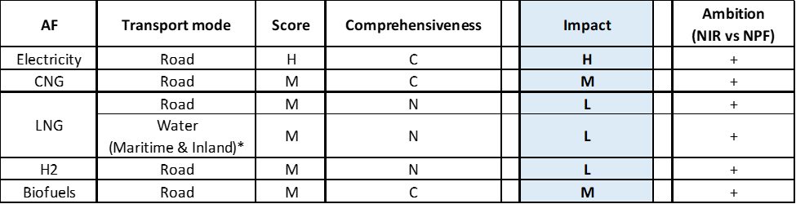

**Legend:** Score and Impact: H = high; M = medium; L = low; X = not assessable. Comprehensiveness: C = comprehensive; N = Not comprehensive. Ambition level: ‘+’ means ‘higher’; ‘=’ means ‘comparable’; ‘-‘ means ‘lower’.

*It is unclear which measures correspond to maritime transport, which to inland and which cover both.

#### Research, Technological Development & Demonstration

The Swedish NIR lists 26 RTD&D projects. Because the number and a detailed description of them were not available in the NPF, it is not possible to make a proper comparison of the amount and nature of the projects reported in the NPF and NIR. Nonetheless and based on the corresponding start and stop years reported in the NIR, it can be deduced that a substantial proportion of the projects can be considered new. The majority of the funding is national, with instances of co-funding with industry.

As the Swedish NIR indicates, many of the RTD&D projects cannot be attributed to a single alternative fuel or transport mode, and are thus reported as a combination thereof. Specifically, 38% of the RTD&D projects can be characterised as targeting a combination of alternative fuels and 62% target a single alternative fuel; 65% focus on a combination of transport modes and 35% on a specific one; overall, 27% of the RTD&D projects target a combination of both alternative fuels and transport modes. Regarding transport modes, road, water and air transport are individually represented. For those projects that focus on a single fuel, electricity and biofuels can be highlighted. Two RTD&D projects worth mentioning are the Northvolt Pilot Production Line for lithium-ion battery cell manufacturing (up to 146 million SEK of aid) and the ‘Electrified roads’. Following the tests initiated in 2016 and an evaluation in 2018, the Swedish authorities decided to support with 175 million SEK the construction of two stretches of electrified roads with the expectation that they will become operational during 2019-2022: one demonstrating conductive ground rail and one inductive technologies. Concerning biofuels, two innovation clusters (one demonstrating ED95 for road freight and one for sustainable biofuels for aviation) were being established and biofuels production from lignocellulosic or residual products funded with 180 million SEK for the period 2017-2021. A project on lignin, which can be refined into HVO, is also listed. Hydrogen or fuel cell technology is not explicitly mentioned in the section of the NIR that covers RTD&D.

The NIR acknowledges that, in some cases, annual budget values (shown in the corresponding tables of the NIR only for the period 2016-2019) could not be reported, so total budget figures are provided in their place (this is the case of e.g. SamspEL and TripleF projects). For some projects, the total budget does not match the sum of the corresponding annual budgets, so that it can be presumed that the difference is due to the budget being used before 2016 or after 2019. Overall, for the period 2016-2030[25], it is calculated that the total estimated budget for RTD&D projects reported in the NIR amounts to around 4.4 billion SEK (ca. 425 million €).

### Additional information on alternative fuels infrastructure developments

Based on input from the Swedish Energy Agency, the Swedish NIR provides information on past (1990-2016) energy use, by type of fuel, for domestic transport and four scenarios for the period 2017-2050[26].

The Swedish NIR indicates that no official statistics on electricity use in road transport are available. Based on the information provided in the NIR, HVO100 and E85 accounted for respectively 4.6% and ca. 1% of road transport fuel consumption in 2018. In the same year, 1.65 TWh of road fuel gas were used.

For rail transport, the NIR provides the split between diesel and electricity use, disaggregated into tram, underground and rail (passenger, freight) operations. Overall, the share of electricity use in the Swedish railways remained stable at 94% over the period 2016-2018.

### Summary of the assessment

**Tabular overview**

*Table 5.27.6‑1 Overview of the NIR assessment*

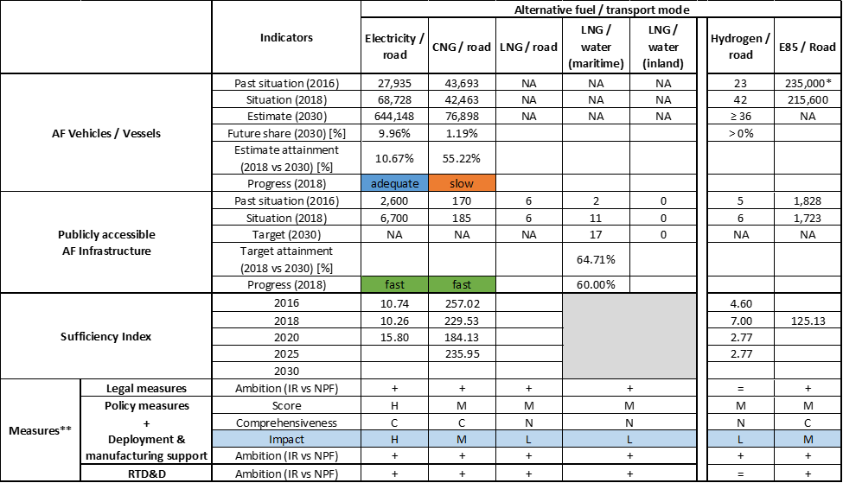



* Value taken or calculated from SE NPF; **It is not possible to disentangle the inland from the maritime-related measures.

The Swedish NIR reiterates its ambition “to become one of the first fossil-free developed nations in the world” and seeks to achieve zero net GHG emissions by 2045 and negative emissions thereafter. At the same time, the NIR acknowledges that, despite the increasing renewable energy use in transport, “Sweden’s emissions are falling too slowly to be in line with climate policy targets”. Concerning the passenger car fleet, the Swedish NIR highlights that a switch from conventional to alternative technologies powered by alternative fuels is taking place.

The Swedish NIR does not cover the whole AFID period (2016-2030). Compared to the Swedish NPF that had addressed only very few of the requirements of Article 3 of the Directive, the NIR almost fully addresses the requirements of Annex I of the Directive, with the exception of information on any particular needs during the initial phase of AFI deployment. Moreover, Sweden should provide data (rather than assumed values) on the usage of high power recharging infrastructure, as per the Commission’s Frequently-Asked Questions document notified to the Member States on 16 September 2019.

The main outcomes of the technical assessment of the Swedish NIR on vehicles/vessels estimates and infrastructure targets can be summarised as follows:

###### Road transport

* **Electricity** – In 2018, Sweden recorded 68,728 light-duty EVs and 6,700 publicly accessible recharging points. No details were provided on heavy-duty vehicles. With reference to the objectives of the SE NPF as updated by the NIR, Sweden’s progress is fast in terms of infrastructure and adequate in terms of EV deployment. The NIR lowers the level of ambition on the number of EVs for 2020 compared to the NPF. The calculated Swedish sufficiency index is becoming potentially inadequate in 2020. The NIR does not provide recharging points targets for 2025 and 2030.
* **CNG** – The SE NIR provides values only for passenger cars: Sweden recorded 42,463 CNG passenger cars in use in 2018. The NIR also shows a substantial growth in the share of biogas use relative to natural gas use in road transport over the period 2013-2018, but records a declining stock of CNG passenger cars and conveys a future declining share of buses powered by natural gas. With regards to CNG road vehicle deployment, Sweden is progressing slowly and the level of ambition is lower for 2020 but higher for 2025, compared to the NPF. Around 75% of the CNG refuelling points in use in Sweden in 2018 was publicly accessible. It is worth mentioning that 93% of road fuel gas used in Sweden in 2018 was biogas. The progress of infrastructure deployment is fast.
* **LNG** – The NIR provides insufficient information on LNG vehicles. One of the limitations faced when analysing the stock of CNG versus LNG vehicles is the impossibility of a clear disaggregation in Sweden’s road traffic register. The NIR states that this hurdle is to be removed in December 2019. So, this should no longer be a limitation in future NIR assessments.
* **Hydrogen** – In 2018, 42 hydrogen-powered vehicles were circulating on Swedish roads, supported by six publicly accessible hydrogen refuelling points. Further deployment of refuelling infrastructure can be expected in the future.
* **Biofuels** – FAME100 remains one of the most common alternative fuels used for Sweden’s road transport. However, the number of RME sales points significantly decreased between 2016 and 2018.
* **LPG** – No assessment on LPG can be made using the information provided in the Swedish NIR.
* **Synthetic and paraffinic** – The NIR indicates that HVO100 refuelling infrastructure for road transport became available in recent years.

###### Rail transport

* **Electricity** – The length of the Swedish railway lines was 10,874 km in 2017, of which 75% was electrified, with an average share of electricity use above 90%. Further rail electrification does not seem to play an important role in the NIR.

###### Waterborne transport (maritime)

* **Electricity** – It is expected that electricity supply will be available in 23 Swedish ports by 2025, compared to 20 in recent years. Future NIR assessments would benefit from a clear distinction between maritime and inland port electricity supply.
* **LNG** – The NIR restates the target of having all maritime ports in the TEN-T Core Network with LNG supply by 2025.
* **Synthetic and paraffinic** – The NIR indicates that a few vessels powered by synthetic diesel and methanol are in use.

###### Waterborne transport (inland)

* **Electricity** – A proper understanding on the use of electricity for inland waterborne transport cannot be derived from the information provided in the NIR. Future NIR assessments would benefit from a clear distinction between maritime and inland port electricity supply.
* **LNG** – Based on the figures provided by Sweden, it seems that LNG availability in inland ports will remain inexistent until 2030, which jeopardises uptake of inland vessels powered by LNG.

###### Air transport

* **Biofuels** – Bio-jet fuel for aviation is available in Sweden but currently supplied in small quantities. The NIR mentions a study, presented on 4 March 2019, containing a series of proposals to promote sustainable biofuels in aviation. It also indicates that investments in this area have been made.

With regards to the **measures**, similarly to the NPF, the Swedish NIR reports a rather solid package, consisting in 67 measures. A significant number of them targets a combination of alternative fuels and/or transport modes. There were two potentially effective measures in road and waterborne transport that were envisaged in the NPF and have become a reality in the NIR: the bonus-malus system for light-duty road vehicles and an upgraded version of differentiated port and fairway charges for vessels.

With regards to the Policy and Deployment & Manufacturing measures, six clusters on electricity, CNG, hydrogen and biofuels for road transport as well as LNG for road and waterborne transport could be identified in the Swedish NIR. In terms of expected impact of these measures to support the realisation of the AFV/AFI objectives as presented in the NPF and revised in the NIR, the measures for the pair electricity/road result to have a high impact, those for the pairs CNG/road and biofuels/road have a medium impact while all the other measures have a low impact. Compared to the NPF, the level of ambition has increased for all the identified clusters.

The Swedish NIR lists 26 RTD&D projects where all transport modes and alternative fuels are represented.

### Final remarks

The Swedish NIR provides a comprehensive report on the efforts made to implement the Directive, which is largely in line with the provisions of Annex I to the Directive. However, no information is provided on targets for recharging points by 2025 and 2030 and for CNG and LNG refuelling points for vehicles in 2030. Nor are estimates provided for LNG vehicles and vessels by 2020, 2025 and 2030. The Swedish NIR contains a rather comprehensive portfolio of measures. They tend to target either a combination of alternative fuels, or of transport modes or both. In general, the Swedish NIR states the ambition to promote the large-scale electrification of road and rail transport, airports and ports.

As regards electricity, the NIR estimates that about 645,000 electric vehicles could be on the roads by 2030, representing about 10% of the future fleet by that time. Taking into account the current situation, fleet and existing trends, this level of ambition does not appear to be fully compatible with the pace of deployment of electric vehicles considered necessary for a full transition to carbon neutrality by 2050. The current infrastructure deployment is lower than the current vehicle uptake. Sweden should provide information on targets for 2025 and 2030 with a view to the expected vehicle uptake. Limited information on charging efficiency is provided. In 2017, shore-side electricity supply was available in 20 ports. This number should increase to 23 ports by 2025. However, no differentiation is made for maritime and inland ports. In addition, several electrically powered ferries are already in operation. Electricity supply to stationary airplanes is largely installed at Sweden’s airports and 75% of Sweden's railways lines are already electrified.

Concerning hydrogen for road transport, the target is to have at least 13 hydrogen refuelling points available from 2025 onwards, which is an ambitious target that will need to be matched by adequate vehicle uptake.

According to Sweden’s estimates, CNG vehicles will represent about 2% the vehicle fleet by 2030. The NIR presents a target to have at least 22 LNG refuelling points available from 2020. This seems sufficient considering the length of the Swedish TEN-T Core Network, provided that the refuelling points are equally distributed along the network. The NIR does not provide any information on the current number of LNG vehicles or any future estimates. Eleven maritime ports, three of which are part of the TEN-T Core Network, supplied LNG to vessels already in 2018. However, there is no estimate on LNG infrastructure in inland ports. Sweden should also provide estimates of the number of LNG vessels in its fleet by 2020, 2025 and 2030.

The Swedish NIR does not cover LPG.

Regarding biomethane, the number of vehicles running with biomethane represent a large share of the natural gas fleet. Concerning the use of E85 in vehicles, the NIR shows that by 2018 there was already a large fleet of 215,600 E85 vehicles and a significant number of refuelling points in Sweden. However, the use of E85 in flex-fuel vehicles seems to decrease due to the lack of vehicle models. ED95 use in heavy-duty vehicles is today an emerging market. As for the use of renewable fuels in aviation, very limited quantities of bio-jet are currently supplied to airplane fleets. Sweden should provide more information in future reporting on efforts to promote the use of renewable fuels in transport, and particularly in aviation.

### ANNEX - Description of the Member State

On a surface area of 450,300 km², Sweden has a population of 10.120 million people in 2018, which makes up for a population density of 22 inhabitants/km².

*Number of main urban agglomerations*

* 13 urban agglomerations > 50,000 inhabitants

In 2018, Sweden achieves a per capita gross domestic product at market prices of €46,310, which represents a per capita gross domestic product in purchasing power standards of 121 if expressed in relation to the EU-28 average set to equal 100.

*Length of the road networks*

The length of the road TEN-T Core Network in Sweden is 3,034 km. The total road network length is 172,891 km, of which 2,132 km are motorways.

The following lengths of the TEN-T Road Corridors are present in Sweden: 16% (1,039 km) of the Scandinavian - Mediterranean Corridor.

Through the TEN-T Road Corridors, Sweden is connected with the following Member States:  
- Denmark (through the Scandinavian – Mediterranean Corridor),   
- Finland (through the Scandinavian – Mediterranean Corridor)

*Number of registered road vehicles*

At the end of 2018, Sweden accounts for 6,145,560 registered road vehicles of which 4,869,979 are categorized as passenger cars, 570,252 as light goods vehicles, 79,652 as heavy goods vehicles and 14,377 as buses and coaches. The motorisation rate is 481 passenger cars per 1,000 inhabitants.

*Number of ports in the TEN-T Core Network*

* 5 maritime ports in the TEN-T Core Network (Göteborg, Luleå, Malmö, Stockholm, Trelleborg)
* 20 maritime ports in the TEN-T Comprehensive Network
* 2 inland ports in the TEN-T Core Network (Göteborg, Stockholm)
* 2 inland ports in the TEN-T Comprehensive Network

The inland waterways TEN-T Core Network in Sweden is 667 km long.

*Number of airports in the TEN-T Core Network*

* 3 airports in the TEN-T Core Network (Göteborg-Landvetter, Malmö-Sturup, Stockholm-Arlanda)
* 23 airports in the TEN-T Comprehensive Network

## United Kingdom (UK)

The UK NIR was not notified to the Commission on time and was thus not assessed.

# Abbreviations

AC Alternative Current

AF Alternative Fuels

AFI Alternative Fuels Infrastructure

AFID Alternative Fuels Infrastructure Directive

AFV Alternative Fuels Vehicle

B100 100% biodiesel for diesel engines

B7 Blend of 7% ethanol and 93% diesel fuel

BEV Battery Electric Vehicle

CBG Compressed BioGas

CEF Connecting Europe Facility

CNG Compressed Natural Gas

CO2 Carbon Dioxide

DC Direct Current

DIONE Fleet Impact model, (DIONE is a name not an acronym)

E10 Blend of 10% ethanol fuel and 90% gasoline by volume

E20 Blend of 20% ethanol fuel and 80% gasoline by volume

E3MLab Energy-Economy-Environment Modelling Laboratory

E5 Blend of 5% ethanol fuel and 95% gasoline by volume

E85 Blend of 85% ethanol fuel and 15% gasoline by volume

EAFO European Alternative Fuels Observatory

EC European Commission

ED95 Blend of 95% ethanol and 5% ignition improver

EE Employment Effect

ERDF European Regional Development Fund

ESF European Social Fund

EU European Union

EV Electric Vehicle

FC Fuel Cell

FCEV Fuel Cell Electric Vehicle

FCH JU Fuel Cells and Hydrogen Joint Undertaking

GHG Greenhouse Gas

GVA Gross Value of production Added

GVP Gross Value of Production

H2 Hydrogen

HCV Heavy Commercial Vehicle

HDV Heavy-Duty Vehicle (category including HCVs, buses and coaches)

HEV Hybrid Electric Vehicle

HVO Hydro-treated Vegetable Oil

ICAO International Civil Aviation Organisation

ICE Internal Combustion Engine

IDACS Data collection related to recharging/refuelling points for alternative fuels and the unique identification codes related to electro-mobility actors

IMO International Maritime Organisation

JRC Joint Research Centre

LBG Liquid BioGas

LCV Light Commercial Vehicle

LNG Liquefied Natural Gas

LPG Liquefied Petroleum Gas

MS Member State[27]



NACE Nomenclature statistique des activités économiques dans la Communauté européenne

NDI Normalised Difference Index

NIR National Implementation Reports

NOx Nitrogen Oxides

NPE Nationale Plattform Elektromobilität

NPF National Policy Framework

PHEV Plug-in Hybrid Electric Vehicle

PM Particulate Matter (PM2.5 is PM with a diameter of 2.5 μm or less)

PRIMES-TREMOVE Price-Induced Market Equilibrium System – linked with transport model

PSA Programme Support Action

PTW Powered Two Wheeler

PWA Population Weighted Average

REEV Range Extended Electric Vehicles

REF Reference Scenario

RP Recharging Point

SME Small and Medium Enterprise

SSE Shore-Side Electricity

SWD Staff Working Document

TCO Total Cost of Ownership or Total Cost of Operation

TEN-T Trans-European Transport Network

TM Transport Mode

UWA Un-Weighted Average

WtW Well-to-Wheel

# References

European Commission. (2017). *Staff Working Document SWD/2017/0365 “Detailed Assessment of the National Policy Frameworks”.* accompanying the document Communication “Towards the broadest use of alternative fuels - an Action Plan for Alternative Fuels Infrastructure under Article 10(6) of Directive 201/94/EU".

European Commission. (2018). *Support guidance concerning the reporting by the Member States in the context of Directive 2014/94/EU.*

European Commission. (2019). *Staff Working Document SWD/2019/0029 “Report on the Assessment of the Member States National Policy Frameworks.* for the development of the market as regards alternative fuels in the transport sector and the deployment of the relevant infrastructure pursuant to Article 10 (2) of Directive 2014/94/EU”.

European Commission. (2020). *State of the Art on Alternative Fuels Transport Systems in the European Union - Update 2020.* Joint Research Centre and DG Mobility and Transport. Luxembourg: Publications Office of the European Union. doi:10.2771/29117

European Commission. (n.d.). *Better regulation toolbox - Tool #18 The choice of policy instruments*. Retrieved from https://ec.europa.eu/info/sites/info/files/file_import/better-regulation-toolbox-18_en_0.pdf

European Parliament. (2013). Regulation (EU) No 1315/2013 of the European Parliament and of the Council. Luxembourg: Official Journal of the European Union. Retrieved from http://publications.europa.eu/resource/cellar/f277232a-699e-11e3-8e4e-01aa75ed71a1.0006.01/DOC_1

Eurostat. (2020a). Population on 1 January by age groups and sex - cities and greater cities. Retrieved from https://appsso.eurostat.ec.europa.eu/nui/show.do?dataset=urb_cpop1&lang=en

Eurostat. (2020b). Main GDP aggregates per capita. Retrieved from https://appsso.eurostat.ec.europa.eu/nui/show.do?dataset=nama_10_pc&lang=en

Eurostat. (2020c). Length of motorways and e-roads. Retrieved from https://appsso.eurostat.ec.europa.eu/nui/show.do?dataset=road_if_motorwa&lang=en

Eurostat. (2020d). Passenger cars, by age. Retrieved from https://appsso.eurostat.ec.europa.eu/nui/show.do?dataset=road_eqs_carage&lang=en

Eurostat. (2020e). Lorries, by type of motor energy (Goods vehicles <= 3.5 tonnes). Retrieved from https://appsso.eurostat.ec.europa.eu/nui/show.do?dataset=road_eqs_lormot&lang=en

Eurostat. (2020f). Lorries and road tractors, by age . Retrieved from https://appsso.eurostat.ec.europa.eu/nui/show.do?dataset=road_eqs_lorroa&lang=en.

Eurostat. (2020g). Lorries (excluding light goods road vehicles), by permissible maximum gross weight. Retrieved from https://appsso.eurostat.ec.europa.eu/nui/show.do?dataset=road_eqs_lornum&lang=en

Eurostat. (2020h). Motor coaches, buses and trolley buses, by age. Retrieved from https://appsso.eurostat.ec.europa.eu/nui/show.do?dataset=road_eqs_busage&lang=en

Ludwig-Bölkow-Systemtechnik. (2016). *Vergleich von CNG und LNG zum Einsatz in Lkw im Fernverkehr, Abschlussbericht.*

Mobility and Transport - European Commission. (2020). TENtec Interactive Map Viewer. Retrieved from TENtec Public Portal: https://ec.europa.eu/transport/infrastructure/tentec/tentec-portal/map/maps.html

Nationale Plattform Elektromobilität (NPE). (2015). *Ladeinfrastruktur für Elektrofahrzeuge in Deutschland - Statusbericht und Handlungsempfehlungen 2015.* AG 3 – Ladeinfrastruktur und Netzintegration, Berlin. Retrieved from http://nationale-plattform-elektromobilitaet.de/fileadmin/user_upload/Redaktion/NPE_AG3_Statusbericht_LIS_2015_barr_bf.pdf

Steer Davies Gleave. (2016). *Clean Power for Transport Infrastructure Deployment.* Final Report, Study on behalf of European Commission, DGMOVE/2015 VIGIENo 495.

1. The Dutch NIR notes that differentiation between public and semi-public charging infrastructure is not possible (e.g. Tesla superchargers with limited availability).
2. See Section 5.20.4.1 for two Federal Acts on technical standards for recharging infrastructure.
3. <https://bip.kprm.gov.pl/kpr/form/r54402924429635,Krajowe-ramy-polityki-rozwoju-infrastruktury-paliw-alternatywnych.html>
4. Hydrogen standards have been amended by the Commission Delegated Regulation (EU) 2019/1745.
5. However, it is not clear whether this number includes also HEVs.
6. The values reported in the RO NIR for EVs have not been used since it is not clear whether they include also HEVs, which do not require recharging infrastructure.
7. The values of the ratio have been computed using AFV data representing EV+PHEV (available only for 2016 and 2018).
8. Romanian River Shipping Company Navrom that has most of its fleet on the Rhine River, where many LNG terminals are operable, whereas only a small number of ships are on the Danube River.
9. Included by the RO NIR in the category Legal measures - Administrative
10. In order to comply with the classification used in this assessment, four of the measures presented by the RO NIR as RTD&D measures are reclassified and assessed as Legal measures (Administrative).
11. Data on 258 recharging points were inputted in the records of the Ministry of Energy at the date of drafting the NIR.
12. Source: data taken from the letters received from the 41 administrative territorial units (ATU) included in the National Policy Framework Strategy for developing the alternative fuels market;
13. In order to comply with the classification used in this assessment, four of these measures are assessed as Legal measures (Administrative) and one as Policy measure.
14. However, it is not clear whether these numbers include also HEVs which do not fall under the scope of this assessment.
15. Romanian River Shipping Company Navrom that has most of its fleet on the Rhine River, where many LNG terminals are operable, whereas only a small number of ships are on the Danube River.
16. However, from the information provided in the FI NIR it is not clear which is the total number of refuelling stations providing at least one type of biofuels in 2018.
17. Calculation performed using the value of 100 E85 refuelling stations existing in 2016 as indicated in the FI NPF.
18. As the NIR states, the conversion of old vehicles into ethanol-powered flex-fuel cars is motivated by the lack of new model availability, the slow rate of replacement of the vehicle stock and its age.
19. The rest is planned to be achieved through the increased use of (hydrogen), electricity and gas.
20. Register includes watercraft over 5.5 metres long or with motors in excess of 15kW.
21. The 2017 EV values reported in the Swedish NIR match those reported in the document supplementary to the Swedish NPF.
22. The Swedish NIR updates the 2017 value provided in the supplement document to the NPF from 170 to 175 points. Note also that the NIR refers to natural gas vehicles and infrastructure as CNG/CBG (compressed biogas) or LNG/LBG (liquefied biogas).
23. The Swedish NIR updates the 2017 value provided in the supplement document to the NPF from 36 to 37 vehicles.
24. The Swedish NIR updates the 2017 value provided in the supplement document to the NPF from 16 to 20 ports.
25. Budget information pre-dating 2016 is also available in the NIR for some projects.
26. With the information provided in the NIR, it is not possible to compile the corresponding table of the Excel template provided to Member States. Further details can be found in sections 8.2.1 and 8.3 of the Swedish NIR.
27. https://ec.europa.eu/eurostat/statistics-explained/index.php/Glossary:Country_codes