

Table of Contents

1 Introduction 2

2 Methodology for the assessment of National Implementation Reports 4

2.1 Member state level assessment methodology 4

2.1.1 AFV-estimates / AFI-targets assessment 4

2.1.2 Assessment of AFV-estimates / AFI-targets changes 5

2.1.3 Progress assessment method for AFV-estimates / AFI-targets deployment 6

2.1.4 Level of AFV-estimates / AFI-targets attainment 15

2.1.5 Adequacy between alternative fuels vehicles and infrastructure 15

2.2 Measure assessment method 17

2.2.1 Overview of measure assessment activities 17

2.2.2 Legal measures 18

2.2.3 Policy measures 19

2.2.4 Deployment and manufacturing support measures 20

2.2.5 Research, technological development and demonstration (RTD&D) activities 20

2.2.6 Assessment methodology at individual measure level 21

2.2.7 Assessment methodology at alternative fuel / transport mode pairs level 24

3 Overview of the main results of the assessment of all NIRs 26

3.1 Road transport 27

3.1.1 Electricity (alternative fuels vehicles and infrastructure) 27

3.1.2 CNG (alternative fuels vehicles and infrastructure) 29

3.1.3 Measures (Electricity and CNG) 31

3.1.4 LNG (alternative fuels vehicles and infrastructure) 32

3.1.5 Hydrogen (alternative fuels vehicles and infrastructure) 33

3.1.6 Measures (LNG and Hydrogen) 34

3.2 Waterborne transport 35

3.2.1 Inland waterborne transport 35

3.2.2 Maritime waterborne transport 37

4 Overall contribution of NIRs to EU policy targets 40

4.1 Deployment of alternative fuels infrastructure and transport systems 40

4.1.1 Road transport 41

# Introduction

To minimise transport dependence on oil and to reduce the environmental impact of transport, Directive 2014/94/EU of the European Parliament and of the Council on the deployment of alternative fuels infrastructure (hereinafter the "Directive”), of 22 October 2014, provides a common approach for the development of alternative fuel infrastructure as well as common technical specifications.

The Directive requires Member States to set up long-term National Policy Frameworks (NPFs) for the development of the alternative fuels market and the planning of the deployment of relevant alternative fuels infrastructure. The Directive also sets requirements for rollout of alternative fuels infrastructure along the core network of the Trans-European Transport Network (TEN-T) and its urban areas - with different milestones for 2020, 2025 and 2030 for different alternative fuels. Finally, the Directive prescribes common technical specifications for recharging and refuelling points and for consumer information.

In accordance with the requirements of the Directive, Member States shall:

* by 31 December 2020, establish an adequate number of publicly accessible recharging points to ensure that electric vehicles (hereinafter “EV”) can circulate at least in urban/suburban agglomerations and other densely populated areas;
* by 31 December 2025, establish additional EV recharging points at least on the TEN-T Core Network, urban/suburban agglomerations and other densely populated areas;
* assess shore power supplies for inland waterway vessels and seagoing vessels in sea and inland ports;
* by 31 December 2020, establish an adequate number of publicly accessible refuelling points to ensure that CNG vehicles can circulate in urban/suburban agglomerations and other densely populated areas and, where appropriate, on networks designated by Member States;
* by 31 December 2025, establish an adequate number of publicly accessible CNG fuelling points at least in the existing TEN-T Core Network in order to ensure that CNG vehicles can circulate throughout the European Union (hereinafter "EU”);
* by 31 December 2025, establish an adequate number of LNG refuelling points in ports to ensure the circulation of LNG inland waterway vessels or seagoing vessels throughout the TEN-T Core Network;
* By 31 December 2025, establish an adequate number of publicly accessible LNG refuelling points in the existing TEN-T Core Network at least to ensure that LNG-powered heavy-duty vehicles can circulate throughout the EU on demand unless costs are disproportionate in relation to the benefits, including environmental benefits.

Under Article 10 of the Directive, Member States have to submit a report on the implementation of their national policy framework to the Commission by 18 November 2019, and every three years thereafter. The national implementation report (hereinafter “NIR”) has to cover the information listed in Annex I of the Directive and, where appropriate, to include a relevant justification regarding the level of attainment of the national targets and objectives referred to in Article (3)(1).

Point 3 of Article 10 of the Directive prescribes also that “*The Commission shall submit a report on the application of this Directive to the European Parliament and to the Council every three years with effect from 18 November 2020*”.

The present Commission Staff Working Document (hereinafter “SWD”) responds to the above request of the Directive. It covers 25 Member States instead of 28, because Italy, Portugal and UK did not deliver their NIRs within the latest possible deadline agreed between the Commission and the Member States to have their NIRs included in this SWD[1].

The SWD is structured as follows: after the introduction, Chapter 2 describes the methodology adopted for the assessment of the NIRs and presents the new parameters and calculations carried out in this SWD, which were not present in the Commission SWD on the National Policy Frameworks.

Chapter 3 provides for all the MSs a tabularised synthesis of the most relevant assessment results, both concerning the numerical values provided in the NIRs in relation to alternative fuels vehicles and related infrastructure, and concerning the outcome of the analysis and assessment of the measures.

Chapter 4 is divided in two sections. The first section provides some considerations and additional information on the results shown in Chapter 3, but from an EU-wide perspective. Where possible, the results from the individual NIRs and MSs are combined to provide EU averages that, although with some limitations related to the availability of data and the number of Member States assessed, give an indication of the EU-wide state of play in 2018 and of the outlook until 2030.

The second section of Chapter 4 presents an update of the simplified analysis regarding the economic and social impact of the Directive, based on the NIRs[2].

Chapter 5 contains the detailed assessment reports of the 25 Member States that have delivered their NIRs within the latest deadline granted by the Commission. These 25 assessment reports are preceded by a section that explains the structure and content of each part of the assessment.

When considering the individual assessment reports and the EU-wide analysis it is important to keep in mind that the information provided in the NIRs and assessed by the Commission constitutes a snapshot of the situation in 2018. Almost two years have passed since then and in several cases the position and strategies of the MSs concerning alternative fuels might have changed quite considerably. Nevertheless, this SWD provides an impressive amount of data, information and analysis on the level of implementation of the Directive three years after the submission of the NPFs by the MSs.

# Methodology for the assessment of National Implementation Reports

The analysis of the national implementation reports (NIR) has been carried out in two stages: first, an assessment at member state level according to the methodology described in the following sections. After that, an analysis at EU level has been performed on the basis of the 25 NIRs received (out of 28), which also includes some considerations on the economic and social impact of the implementation of the Directive.

## Member state level assessment methodology

The assessment of the Implementation Reports at Member State level is performed along two main directions: on the one hand, it evaluates the AFV estimates and AFI targets, on the other hand, the support measures. Concerning the former, the assessment analyses the MSs situation in 2018 towards reaching the AFV-estimates / AFI-targets and characterises the modifications reported in the NIR versus the NPF. As for the latter, by applying the assessment methodology, it examines whether the existing or planned support actions or measures from the NIR are coherent with the AFV-estimates / AFI-targets set in the NIR, and provides an evaluation of the possible impact of such measures to achieve the objectives[3].

### AFV-estimates / AFI-targets assessment

The flowchart in Figure 2.1.1‑1 gives an overview of the AFV estimates and AFI targets assessment by presenting the main activities (rectangles) that are performed and their different inputs and outputs (parallelograms). The following sections present in detail the methodology employed to perform the listed activities:

* level of change assessment - see subsection 2.1.2
* progress assessment (including annual growth rate determination in the case of electricity/road and CNG/road pairs) - see subsection 0
* determination of the AFV-estimates / AFI-targets attainment - see subsection 2.1.4
* analysis of the adequacy between alternative fuels vehicles and infrastructure - see subsection 2.1.5

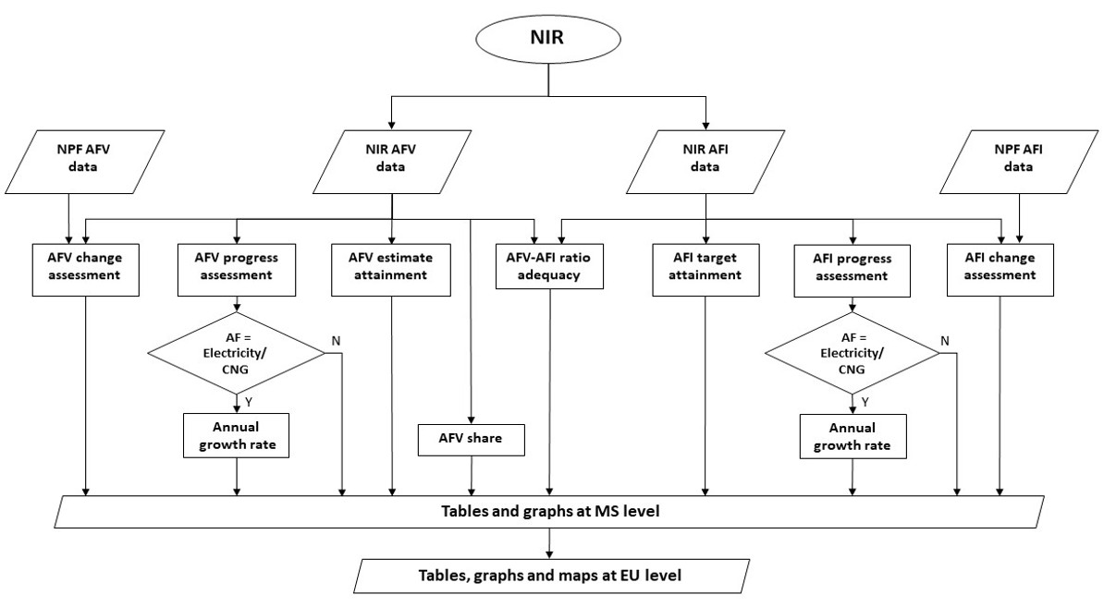

Figure 2.1.1‑1 Overview of the AFV estimates and AFI targets assessment

### Assessment of AFV-estimates / AFI-targets changes

The changes presented in the NIR in comparison with the NPF concerning AFV-estimates / AFI-targets are computed for a given year according to this formula:

$$change\left[\%\right]= \frac{\text{NIR value – NPF }\text{value}}{\text{NPF value}}*100$$

They are characterized as follows:

* Increased ambition (change > 15%)
* Similar ambition (-15% <= change < = 15%)
* Decreased ambition (change < -15%)

In the assessment of each MS’ NIR, these changes are computed for all the pairs alternative fuel/transport mode for which data are available and are displayed under tabular format using the colour coding described above. Table 2.1.2‑1 presents an example from one MS’ NIR.

Table 2.1.2‑1 National AFV-estimates and AFI-targets established in one NIR at the horizon 2020, 2025 and 2030 and their comparison with the NPF situation

|  |  |  |  |  |  |  |  |  |  |  |
| --- | --- | --- | --- | --- | --- | --- | --- | --- | --- | --- |
| **Alternative fuel / transport mode** | |  | **2018** | | **2020** | | **2025** | | **2030** | |
| **AFV** | **AFI public** | **AFV** | **AFI public** | **AFV** | **AFI public** | **AFV** | **AFI public** |
| **Electricity / road** | | NIR | 68,728 | 6,700 | 142,211 | 9,000 | 370,617 | NA | 644,148 | NA |
| Change NIR vs NPF [%] |  |  | -10.95% | 0.00% |  |  |  |  |
| Attainment [%] |  |  | 48.33% | 74.44% | 18.54% |  | 10.67% |  |
| **CNG / road** | | NIR | 42,463 | 185 | 42,351 | 230 | 54,268 | ≥ 230 | 76,898 | NA |
| Change NIR vs NPF [%] |  |  | -10.16% | 0.00% | 15.12% | 0.00% |  |  |
| Attainment [%] |  |  | 100.26% | 80.43% | 78.25% |  | 55.22% |  |
| **LNG / road** | | NIR | NA | 6 | NA | 22 | NA | ≥ 22 | NA | NA |
| Change NIR vs NPF [%] |  |  |  | 0.00% |  | 0.00% |  |  |
| Attainment [%] |  |  |  | 27.27% |  |  |  |  |
| **LNG / water (maritime)** | | NIR | NA | 11 | NA | NA | NA | 17 | NA | 17 |
| Change NIR vs NPF [%] |  |  |  |  |  | 0.00% |  | 0.00% |
| Attainment [%] |  |  |  |  |  | 64.71% |  | 64.71% |
| **LNG / water (inland)** | | NIR | NA | 0 | NA | NA | NA | 0 | NA | 0 |
| Change NIR vs NPF [%] |  |  |  |  |  |  |  |  |
| Attainment [%] |  |  |  |  |  |  |  |  |
| **H2 / road** | | NIR | 42 | 6 | ≥ 36 | 13 | ≥ 36 | ≥ 13 | ≥ 36 | NA |
| Change NIR vs NPF [%] |  |  | 0.00% | 0.00% | 0.00% | 0.00% |  |  |
| Attainment [%] |  |  |  | 46.15% |  |  |  |  |
|  | |  |  |  |  |  |  |  |  |  |
|  |  | Not applicable | | |  |  |  |  |  |  |
| **Legend:** |  | The value could not be computed | | | |  |  |  |  |  |
|  | NA | No value/information provided/available in the NIR | | | | | |  |  |  |

It should be noted that the values shown in Table 2.1.2‑1 are those in the NIR, however the corresponding values in the NPF can be easily calculated from the NIR values and the percentage changes versus NPF:

$$NPF value= \frac{NIR value}{\left(1+\frac{change\left[\%\right]}{100}\right)}$$

When for a given column in Table 2.1.2-1 the NIR value is present and the corresponding cell “Change NIR vs NPF [%]” is empty, it means that the NPF did not contain the AFV estimates or AFI targets.

### Progress assessment method for AFV-estimates / AFI-targets deployment

The progress assessment evaluates what has been achieved at MS level between 2016 and 2018 regarding alternative fuels transport systems and infrastructure compared to the overall planned evolution in the NPF/NIR for the period 2016-2030. Therefore, the progress is not influenced by the initial situation in 2016. Due to the different level of development of the various AF/AFV/AFI, both at MS level and at EU level, two separate cases have been identified and are treated differently.

1. For the electricity/road and CNG/roadpairs, where a clear evolution type could be identified in many MSs and at EU level, the progress is assessed following the next steps, which are described in detail in the mentioned subsections:
   * Determination of the type of evolution at EU level for each of the two AFs from past available data until 2018, and 2020 foreseen situation in the NPF (see subsection 2.1.3.1);
   * Determination of the areas of slow progress, adequate progress and fast progress (see subsection 2.1.3.2);
   * Characterisation of the 2018 progress at MS level for AFV-estimates / AFI-targets deployment as ***fast***, ***adequate*** or ***slow*** progress (see subsection 2.1.3.2).

For these two AF/transport mode pairs, the progress type information is complemented by an evaluation of the AFV-estimates / AFI-targets growth rate of the foreseen evolution (see subsection 2.1.3.4).

1. For all the other AF/transport mode pairs, for which a clear evolution type could not be identified, the 2018 progress of a MS for the corresponding transport systems or infrastructure deployment is obtained by dividing the achievement in the period 2016-2018 by the overall planned deployment during the period 2016-2030. Thus, the progress determination in these cases is based on the formula:

*progress [%] = $\frac{\text{NIR} \text{value (2018) - NIR} \text{value (2016)}}{\text{NIR value (2030) - NIR value (2016)}}$*100*

#### EU level analysis – evolution type determination

For the electricity/road and CNG/road pairs, the type of evolution at EU level was determined from available past data from the European Alternative Fuels Observatory (EAFO)[4] and future 2020 AFV-estimates / AFI-targets provided by the MSs in their NPFs. The highest coefficient of determination R2 that described the goodness of the fit was used as criterion to establish the best fitting curve to these data (exponential, linear, logarithmic or power). This identified curve type provided the type of evolution at EU level that was then considered to perform the MS level progress assessment.

##### Electricity/road example

Using past data (2008–2018) regarding electric vehicles (EVs) from EAFO and 2020 EV estimates from the NPFs, the results depicted in Figure 2.1.3‑1 are obtained at EU level:

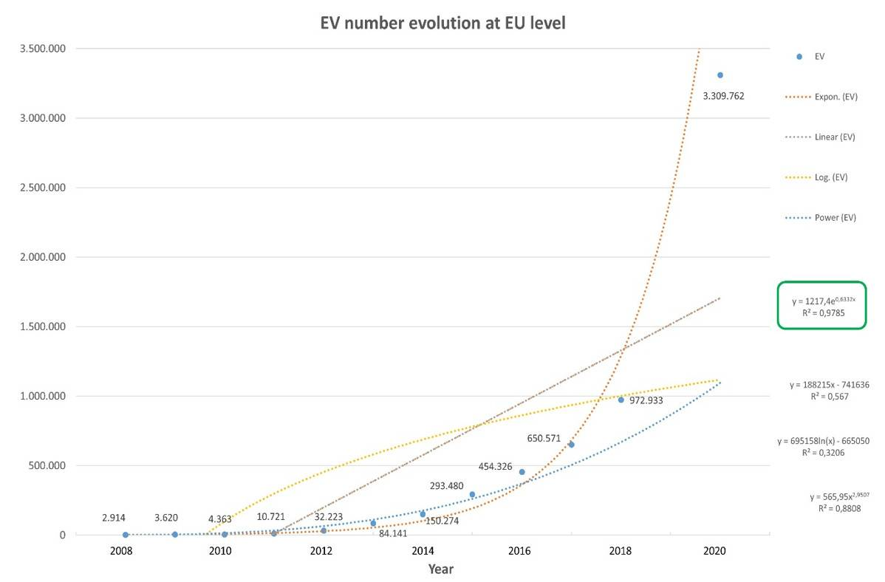

Figure 2.1.3‑1 Evolution of EV number at EU level (source of data – EAFO for 2008-2018, NPFs – 2020 estimates)

Considering the highest coefficient of determination R2 as criterion to establish the best fitting curve, the result is that **best_fit = exponential** (R2 = 0.9785).

For recharging points, **best_fit = exponential** is also chosen for the following reasons:

- it is assumed that vehicles are the driving force for the uptake of AF transport systems and infrastructure will follow;

- the AFI Directive foresees the electric vehicles and infrastructure having a synchronised development, meaning the same evolution type as it recommends a ratio of 10 between electric vehicles and infrastructure.

##### CNG/road example

Using past CNG vehicle data (2008–2018) from EAFO and 2020 CNG vehicle estimates from the NPFs, the results depicted in Figure 2.1.3‑2 are obtained at EU level:

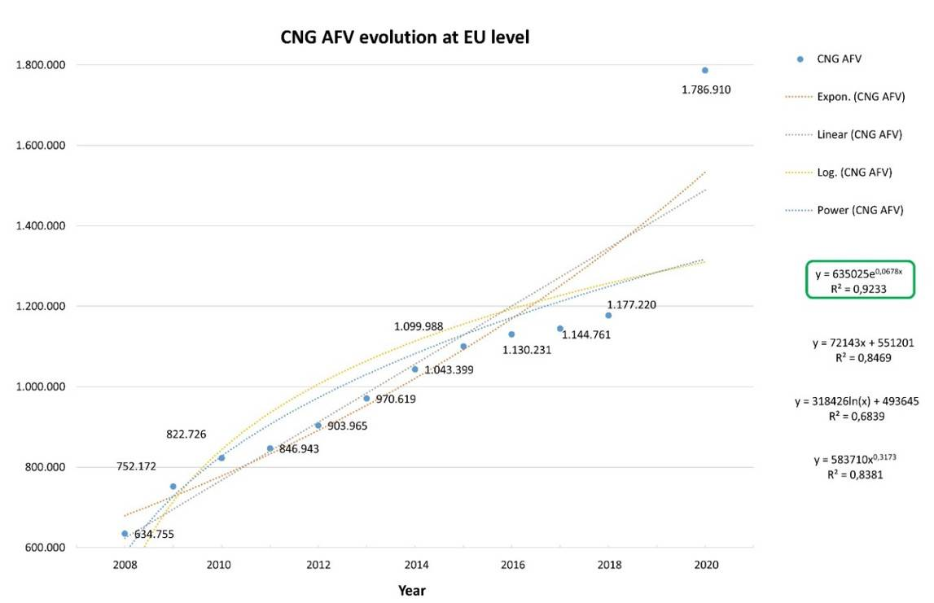

Figure 2.1.3‑2 Evolution of CNG vehicle number at EU level (source of data – EAFO for 2008-2018, NPFs – 2020 estimates)

Considering the highest coefficient of determination R2 as criterion to establish the best fit curve, also in this case the result is that **best_fit = exponential** (R2 = 0.9233).

Following the same approach adopted for the electric vehicles and recharging infrastructure, **best_fit = exponential** is also chosen for CNG refuelling points.

#### Determination of the areas of slow progress, adequate progress and fast progress

Before characterising the progress of a MS, it is necessary to define the areas of slow progress, adequate progress and fast progress. This is obtained as follows:

* First, a curve of exponential type is applied to the AFV-estimates / AFI-targets values of the MS from 2016 and 2030[5]; this curve is called “best_fit_2016_2030(x)” and constitutes the lower boundary of the area of adequate progress.
* Next, a linear function connecting the AFV-estimates / AFI-targets values for 2016 and 2030[6] is added to the diagram; this straight line is called “lin_2016_2030(x)” and constitutes the upper boundary of the area of adequate progress.
* The area above the linear function is considered as area of fast progress; the area below the exponential curve is considered as area of slow progress (see figures Figure 2.1.3‑3 and Figure 2.1.3‑4)

#### Characterisation of AFV-estimates / AFI-targets progress at MS level in 2018

To characterise the progress in 2018 of a certain MS, the position of 2018 AFV-estimates / AFI-targets value (called “MS_situation_2018”), as reported by the MS in its implementation report, is considered with respect to the three areas described above.

Thus, it is proposed to classify the 2018 progress of the MSs for AFV-estimates / AFI-targets depending on its position with respect to one of the three areas:

* + - **fast progress**

MS_situation_2018 > lin_2016_2030(2018)

* + - **adequate progress**

lin_2016_2030(2018) <= MS_situation_2018 <= best_fit_2016_2030(2018)

* + - **slow progress**

MS_situation_2018 < best_fit_2016_2030(2018)

In other words, when the 2018 data point of the MS is in between the exponential curve and the straight line, this is considered as an **adequate progress**. If the 2018 data point is below the exponential curve, this is considered as a **slow progress**. If the 2018 data point is above the straight line, this is considered as a **fast progress**. This is further explained in the examples in the following subsection.

##### Examples of the methodology application for the evaluation of progress for AFV-estimates / AFI-targets

In this subsection, three detailed examples of the computation of 2018 progress are provided for AFV and AFI, different pairs AF/transport mode and different Member States.

###### AFV CNG/road

Figure 2.1.3‑3 displays the determination of the progress type for the case of CNG vehicles in one MS. The recorded EV value of fleet in 2018 is:

MS_situation_2018 = 578 (in yellow in the figure)

The best_fit is an exponential curve with the formula:

best_fit_2016_2030(x) = 319.66e0.1272x

which gives: best_fit_2016_2030(2018) = 468 (in black in the figure)

Concerning the straight line connecting the 2016 data point to the 2030 (or latest available) data point, we obtain:

lin_2016_2030(x) = 127.868x + 235.14

which gives: lin_2016_2030(2018) = 619 (in red in the figure)

In this case of CNG/road, **adequate progress** is obtained because

best_fit_2016_2030(2018) <= MS_situation_2018 <= lin_2016_2030(2018)

i.e. 468 <= 578 <= 619 (the 2018 data point is in the blue zone of adequate progress).

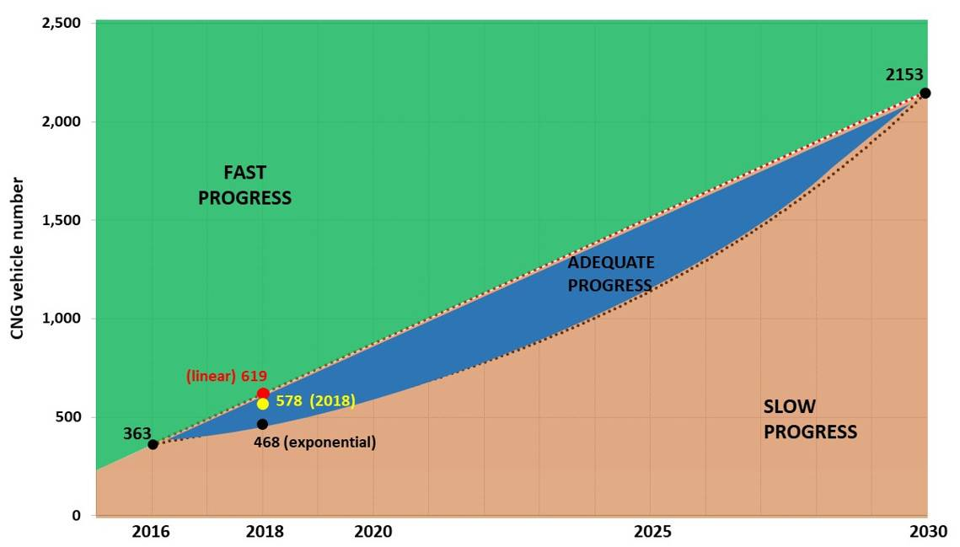

Figure 2.1.3‑3 Example of 2018 progress determination for AFV CNG/road 2016 - 2030 evolution in one MS.

###### AFI electricity/road

Figure 2.1.3‑4 displays the determination of the progress type for the case of recharging points in another MS. The recorded value of recharging points in 2018 communicated by this MS is:

MS_situation_2018 = 231 (in yellow in the figure)

The best_fit is an exponential curve with the formula:

best_fit_2016_2030(x) = 14.267e0.2324x

which gives: best_fit_2016_2030(2018) = 29 (in black in the figure)

Concerning the straight line connecting the 2016 data point to the 2030 (or latest available) data point, we obtain:

lin_2016_2030(x) = 32x - 14

which gives: lin_2016_2030(2018) = 82 (in red in the figure)

In this case, **fast progress** is obtained because

MS_situation_2018 > lin_2016_2030(2018)

i.e. 231 > 82 (the 2018 data point is in the green zone of fast progress).

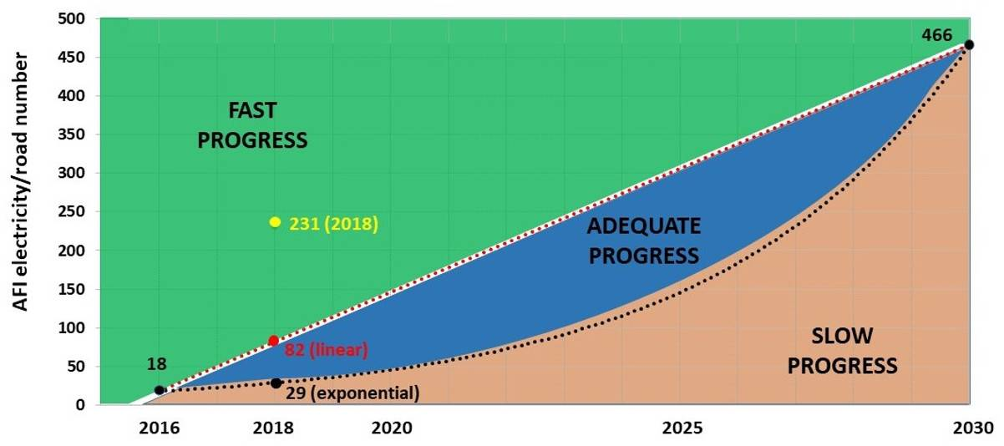

Figure 2.1.3‑4 Example of 2018 progress determination for AFI electricity/road 2016 - 2030 evolution in one MS.

###### AFV LNG/road

As described in subsection 0 B of the assessment methodology, for all the other pairs than electricity/road and CNG road, the progress is obtained in a different way. In the following example the progress obtained from 2016 until 2018 by a MS for LNG vehicles deployment is 0.79% of the overall planned deployment during the period 2016-2030. The AFV LNG/road estimates used in the calculations are presented below:

|  |  |  |  |  |  |
| --- | --- | --- | --- | --- | --- |
| **Year** | **2016** | **2018** | **2020** | **2025** | **2030** |
| **LNG AFV existent/estimated value** | **0** | 15 | 100 | 397 | 1,888 |

and the Progress result, in this case, is obtained by the formula shown in section 2.1.3 B):

progress [%] = $\frac{\text{NIR} \text{value (2018) - NIR} \text{value (2016)}}{\text{NIR value (2030) - NIR value (2016)}}$*100 = $\frac{\left(15 – 0\right)}{\left(1,888-0\right)}*100=0.79$%

#### Characterisation of the AFV-estimates / AFI-targets growth rate of the foreseen evolution at MS level

Having selected the exponential curve as best fit for the electricity and CNG AFV-estimates / AFI-targets values both at MS and at EU level, for each MS a specific exponential curve is obtained, which fits all its provided data as reported in the NIR. In order to characterise mathematically the exponential evolution for AFV-estimates / AFI-targets, a calculation of its growth rate is carried out as explained below.

Since the best fitting curve is an exponential curve, the normal exponential function under its form **f(x) = aekx** (which is employed in situations of continuous growth or decay) is used. If a quantity grows continuously by a fixed percentage (growth rate), the pattern can be depicted by this type of function.

f(x) = abx = **aekx** = a(1+r)x

where the parameters have the following meanings:

a=initial value

b=base (if b > 1 - exponential growth, if 0 < b < 1 - exponential decrease)

x=exponent (in this case, it is the year)

k=constant of proportionality (if k > 0 - the amount is increasing (growing); if k < 0 - the amount is decreasing (decaying))

r=growth rate, where r=ek-1.

For each MS, the fitted exponential curve will have different parameters (a, k and r).

In order to better understand the influence of the parameters constant of proportionality (k) and growth rate (r), Figure 2.1.3‑5 provides a graph containing 10 exponential functions (k=0.1, 0.2…1 and a=1) with corresponding growth rates displayed.

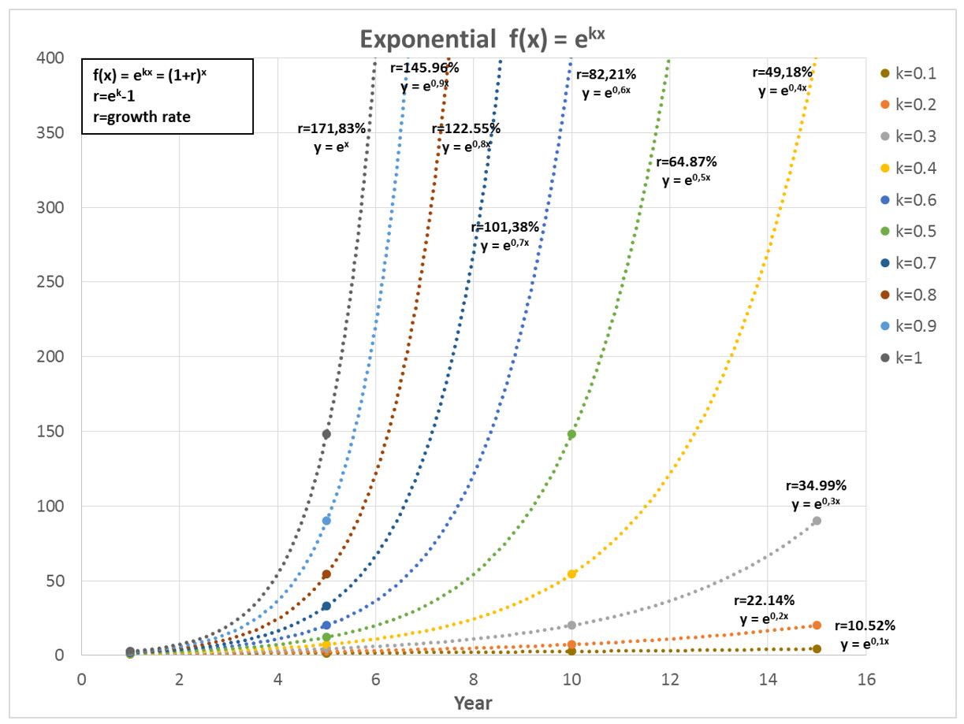

Figure 2.1.3‑5 Exponential function f(x) = aekx graphical representation (k=0.1, 0.2…1 and a=1)

Thus, the characterisation of the AFV-estimates / AFI-targets of the foreseen evolution at MS level can be performed by providing a parameter given by the best fitting exponential function, namely the growth rate (r). This parameter describes how quickly the MS envisioned its development of the corresponding AFV/AFI for the AF/transport mode pair under analysis between 2016 and 2030 by showing the corresponding annual percentage of growth.

##### Examples of the methodology application for the evaluation of the annual growth rate for AFV-estimates / AFI-targets

Two examples for the determination of the average annual growth rate from the exponential function fitting the four points corresponding to the foreseen AFV-estimates / AFI-targets evolutions are illustrated in Figure 2.1.3‑6 and Figure 2.1.3‑7 in the cases of EVs for one MS and of CNG AFI for another MS.

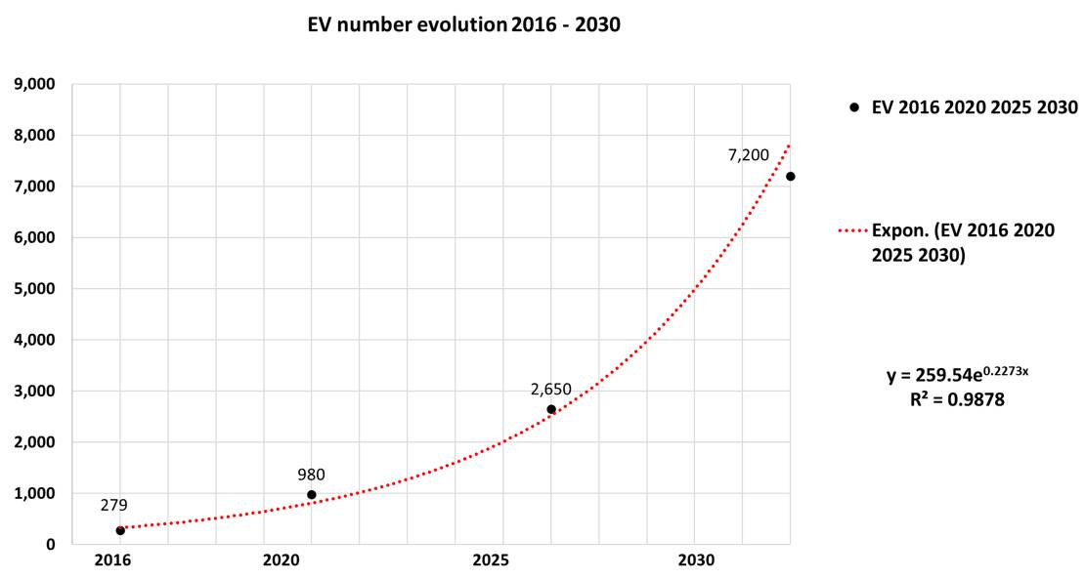

Figure 2.1.3‑6 Example of EV number 2016 – 2020 – 2025 – 2030 evolution

In the case of foreseen EV evolution, the exponential function fitting the 2016, 2020, 2025 and 2030 data has a good R2 and an annual growth rate of 25.52% is obtained.

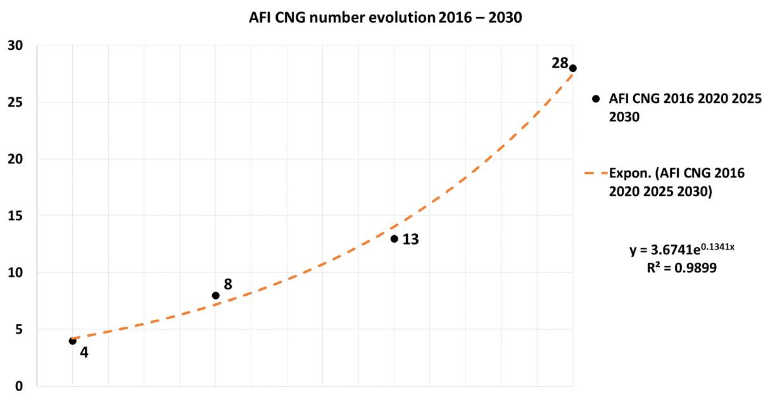

Figure 2.1.3‑7 Example of CNG AFI 2016 – 2020 – 2025 – 2030 evolution

In the case of foreseen CNG AFI evolution, the good exponential fitting (R2 = 0.9899) leads to an annual growth rate of 14.35%.

### Level of AFV-estimates / AFI-targets attainment

The level of AFV-estimates / AFI-targets attainment can be expressed by the percentage represented by the number of AFI/AFV existent in 2018 over the total number of AFV/AFI foreseen to exist in 2020/2025/2030. The level of attainment corresponding to a certain future year (2020/2025/2030) is calculated according to the formula:

*level of attainment [%] = $\frac{\text{NIR} \text{value (2018)}}{\text{NIR} \text{value (2020/2025/2030)}}$* *100

As an example, the results for AFV electricity/road for one MS are presented in the table below:

|  |  |  |  |  |
| --- | --- | --- | --- | --- |
| **Year** | **2018** | **2020** | **2025** | **2030** |
| **EV existent/estimated value** | 7,464 | 59,219 | 181,263 | 936,363 |
| **Level of attainment (2018 vs 2020/2025/2030)** |  | 12.60% | 4.12% | 0.80% |

Because of the significant increase of the EV fleet foreseen by this MS during the period 2016-2030, the corresponding 2018 ***attainment*** of future estimates has reduced values and varies moderately, from 12.60% for 2020 to 0.80% for 2030.

We mention that attainment can be > 100% if the 2018 value is higher than the 2020 one, illustrating a foreseen descending tendency. This is shown in the table below for the CNG AFV evolution in one MS.

|  |  |  |  |  |
| --- | --- | --- | --- | --- |
| **Year** | **2018** | **2020** | **2025** | **2030** |
| **CNG AFV existent/estimated value** | 314 | 180 | 125 | 100 |
| **Level of attainment (2018 vs 2020/2025/2030)** |  | 174.44% | 251.20% | 314.00% |

### Adequacy between alternative fuels vehicles and infrastructure

For road transport, where the number of AFV and AFI can be relevant in almost all the MSs, the adequacy between AFV and publicly accessible AFI at MS level is monitored by calculating the sufficiency index that is the ratio between AFV estimates and AFI targets for each of the reference years for which the MSs provided values in their NIR[7]. When an AFV estimate or an AFI target is not provided for a certain year, the corresponding ratio cannot be calculated. An example of this is shown in the table below:



Where applicable, the evolution trend of the sufficiency index will be analysed and considerations will be made on the value of the index. In particular, for the electricity/road pair, an assessment is provided concerning the adequacy of the ratio between the number of vehicles and the number of recharging points. The adequacy assessment is based mainly on the indicative threshold value of 10, as mentioned by the Directive[8], however, the share of high power (>22kW) recharging points in the total number of recharging points is also taken in consideration.

For the CNG/road pair, the adequacy assessment is based on the indicative value of 600 as considered in (European Commission, 2019)[9]. For all the other AFs/road pairs, only the sufficiency index is shown, without any comment.

## Measure assessment method

A key aspect of the Directive is that the Member States are asked to plan and adopt measures to support the achievement of the alternative fuels infrastructure and transport system targets and objectives of their NPF. The Annex I of the Directive mentions that the implementation report of the NPF of each MS required by Article 10(1) of the Directive “*shall include at least the following elements:*

1. *Legal measures [...]*
2. *Policy measures supporting he implementation of the national policy framework [...]*
3. *Deployment and manufacturing support [...]*
4. *Research, technological development and demonstration (RTD&D) [...]”*

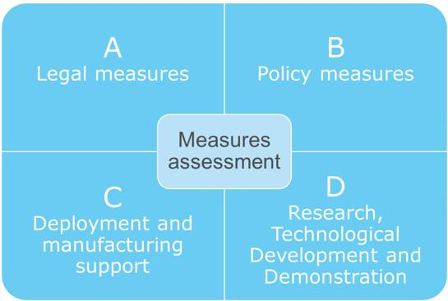

### Overview of measure assessment activities

The flowchart in Figure 2.2.1‑1 delivers an overview of the assessment performed for the measures present in the NIR by presenting the main activities (rectangles) that are performed and their different inputs and outputs (parallelograms). In the following sections, the methodology employed to perform the listed activities on the four types of measures included in the NIR is presented.

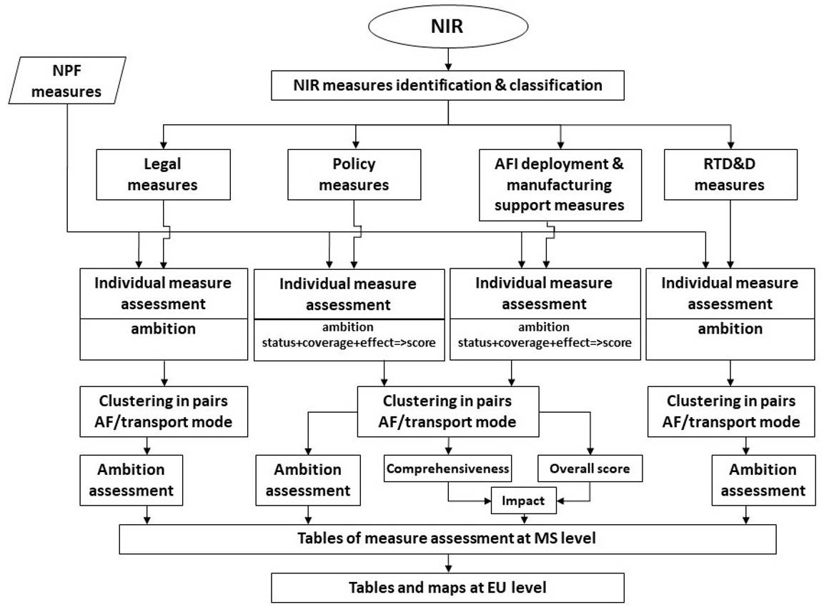

Figure 2.2.1‑1 Overview of the NIR measures assessment

The first step of the measure assessment is the identification and classification of the measures as presented by the MSs in their NIRs. In doing so, it can happen that a measure placed by a MS in a category (ex. Legal measures) is moved to another category (ex. Deployment & Manufacturing) because it fits better with the classification presented in the support guidance (European Commission, 2018) and the assessment methodology. However, all the NIR measures, either confirmed or moved, are analysed and assessed.

### Legal measures

According to the support guidance (European Commission, 2018) concerning the NIR content, it is possible to classify the legal measures in two categories which are disaggregated by type[10] as it can be observed in   
Figure 2.2.2‑1.

Therefore, the legal measures provided by a MS in their NIR are identified and classified using these proposed categories.

Category

Type

Legend

Figure 2.2.2‑1 Types of legal measures

### Policy measures

The policy measures are supporting the implementation of the national policy framework. The proposed categorisation[11] of policy measures derives from Article 3(1) and Article 4(3) of the Directive. Three categories are available for policy measures:

• Measures to ensure that the national targets and estimates are reached (Art. 3 (1) 3rd indent)

• Measures that can promote AFI deployment in public transport services (Art. 3 (1) 4th indent)

• Measures to encourage and facilitate the deployment of recharging points not accessible to the public (Art. 4 (3))

According to the support guidance (European Commission, 2018) concerning the NIR content, it is possible to classify the policy measures in these three categories which are further disaggregated by type and indicator as it can be observed in Figure 2.2.3‑1. Therefore, the policy measures provided by MSs in their NIRs are identified and classified using these proposed parameters.

Category

Type

Legend

Indicator/group of indicators

Figure 2.2.3‑1 Types of policy measures

### Deployment and manufacturing support measures

According to the support guidance (European Commission, 2018) concerning the NIR content prepared for the MSs, it is possible to classify the deployment and manufacturing support in two categories: a) AFI deployment and b) support of manufacturing plants for alternative fuels technologies. Manufacturing plants for AF technologies include both production sites and research facilities for any of the key components of AF technologies such as connectors of charging systems, batteries, fuel cell systems or hydrogen storage tanks.

Therefore, the deployment and manufacturing support measures provided by MSs in their NIRs are identified and classified using these proposed categories.

### Research, technological development and demonstration (RTD&D) activities

Annex I of the Directive requires the reporting of “annual public budget allocated to support alternative fuels RTD&D, broken down by fuel and by transport mode”.

The activities of research, technological development and demonstration (RTD&D) are identified and classified according to the alternative fuel, transport mode and to the application field (AF, AFI, AFV or combination).

### Assessment methodology at individual measure level

Once the identification and classification of all the measures contained in the NIR is concluded, the assessment continues with the analysis of all the measures, one by one. The methodology employed to assess each individual measure involves several activities that are described in detail in the following subsections. Some assessment activities are common to all four types of measures while others are dedicated only to some types of measures.

#### NIR and NPF measure correspondence identification

An assessment activity that is common to all four types of measures in the NIR is represented by the verification of the existence in the NPF of a similar measure. In a positive case, a comparative analysis of the two measures from the NIR and NPF is performed to determine if their descriptions coincide or contain differences. This activity has four possible results:

* the measure appears only in the NIR
* the measure appeared only in the NPF
* the measure appears in both NIR and NPF with the same characteristics
* the measure appears in both NIR and NPF with different characteristics

#### Adoption status determination

The adoption status determination of a measure represents another common activity to all four types of measures. This parameter can be assigned to one of the following five categories:

* Existed [2016-2018]
* Existing [2019]
* Adopted (but not yet in effect)
* In process of adoption
* Under consideration

#### Ambition level determination

Another common activity to all four types of measures regards the determination of the level of ambition of each measure in the NIR compared to the NPF. The level of ambition is a parameter that describes qualitatively the characteristics of the measure in the NIR compared to NPF from the perspective of the influence to reaching the MS alternative fuels related targets and objectives. The determination of this parameter takes into account whether there is a new measure in the NIR that was not in the NPF, or the opposite, or any change in the measure’s characteristics (e.g. the degree of coverage, the duration of application, the amount of a subsidy/tax, the funding level, etc.). For each measure, the comparative analysis of its ambition in the NIR versus NPF can have three types of results expressed by the following symbols:

• “+” describes an increased level of ambition in the NIR vs NPF

• “=” describes a similar level of ambition in the NIR and NPF

• “-“ describes a decreased level of ambition in the NIR vs NPF

In general, the level of ambition is assessed to be decreasing when a measure appeared only in the NPF and to be increasing when a new measure appears only in the NIR.

#### Type of funding determination

When the assessment involves research, technological development and demonstration (RTD&D) measures, the determination of the funding available is carried out.

The options for this parameter include the following nature of funding categories:

* national
* EU
* international
* co-funding
* other

#### Measure score determination

As explained earlier, the four groups of measures are not assessed in the same way. Legal measures and RTD&D measures are analysed and described qualitatively. In addition, the three characterisations presented in paragraphs 2.2.6.1, 2.2.6.2 and 2.2.6.3 are carried out and, where possible, some considerations on the ambition level are provided.

For the individual measures belonging to the Policy and AFI Deployment & Manufacturing support categories, the assessment methodology includes more steps and the introduction of a scoring for some parameters (similarly to the NPF assessment [EC17]). This is explained below.

###### **Status**

For Policy and AFI Deployment & Manufacturing support measures the status is characterised as in paragraph 2.2.5.2, but depending on the status level identified a score is assigned:

* Low (L): if the measure is under consideration,
* Medium (M): if the measure is adopted or in process of adoption,
* High (H): if the measure existed [2016-2018] or is existing in 2019.

###### **Scope**

The scope of a measure is evaluated against two dimensions, coverage and effect, as summarised in Table 2.2.6‑1.

Table 2.2.6‑1 Criteria for determining the scope of a measure

|  |  |  |
| --- | --- | --- |
|  | **Alternative Fuels Infrastructure** | **Alternative Fuels Vehicles** |
| **Coverage** | Number of eligible recharging/refuelling points versus the total AFI target foreseen in the period of the application of the measure | Number/share of eligible vehicles versus the total AFV estimate foreseen in the period of the application of the measure |
| **Effect (Financial Measures)** | Investment Cost Difference versus no-measure case | Purchase Price Difference or Total Cost of Ownership (TCO) versus no-measure case |
| **Effect (Non-financial Measures)** | Qualitative | Qualitative |

###### Coverage

Coverage is an indicator of the number or share of vehicles or refuelling/recharging points eligible to benefit from the measure. For coverage, the assessment is performed based on the ratio between the maximum number of vehicles or refuelling/recharging points that can benefit from the measure versus the total number of vehicles or AFI points that are foreseen by the Member States’ NIR AFV estimates or AFI targets during the period when the measure is applied. Depending on this ratio of vehicles or refuelling/recharging points in scope for a measure, three categories for coverage have been defined as follows:

* Low (L): share covered by the measure is < 10%,
* Medium (M): share covered by the measure is in between 10% and 50%,
* High (H): share covered by the measure is > 50%.

###### Effect

Effect is an indicator of how much a measure could influence the purchase or investment decision for a given alternative fuels vehicle or refuelling/recharging point. Effect is calculated in quantitative terms for financial measures only and is assessed qualitatively for non-financial measures. In the case of financial measures, two different calculations are made for AF vehicles and for recharging/refuelling infrastructure. For AF vehicles, the effect level is assessed by calculating the amount covered by the measure with respect to the price difference (or TCO difference, depending on the availability of data) between conventional and AF vehicles. In the second case, the effect level is assessed by calculating the amount of the investment cost of each single recharging/refuelling point covered by the measure.

The likely effect on deployment or development decisions by market actors has been classified in three categories depending on the amount covered by the measure:

* Low (L): amount covered by the measure is < 10%,
* Medium (M): amount covered by the measure is in between 10% and 50%,
* High (H): amount covered by the measure is > 50%.

###### **Overall Score of a single measure**

For each measure where a score could be assigned to status, coverage and effect, its overall score is assessed based on these three evaluations, as shown in Table 2.2.6‑2. Following the precautionary principle, the overall measure score is determined by the lowest evaluation the measure has received regarding its three attributes of status, coverage and effect. For example, if the measure has a high (H) coverage and effect but is only under consideration (thus low (L) adoption status), the overall measure assessment score will be low (L) because it cannot be guaranteed that it will ever come into effect. Likewise, if its status is H (measure in effect) but the measure covers only few infrastructure items or has a low effect, its overall assessment score will also be low. The overall measure assessment score will be H only if all three attributes are evaluated as high.

Table 2.2.6‑2 Assessment of Overall Measure Score

|  |  |  |  |  |
| --- | --- | --- | --- | --- |
| **Measure** | **Status** | **Scope** | | **Overall Measure Score** |
| **Coverage** | **Effect** |
| Measure x | H | H | H | H |
| Measure x | M | H or M | H or M | M |
| Measure x | H or M | M | H or M | M |
| Measure x | H or M | H or M | M | M |
| Measure x | L | any | any | L |
| Measure x | any | L | any | L |
| Measure x | any | any | L | L |

### Assessment methodology at alternative fuel / transport mode pairs level

The assessment of the policy measures and AFI deployment and manufacturing support measures includes also an analysis of whether these existing or planned support actions or measures seem sufficient and are coherent with the vehicle estimates and infrastructure targets.

These measures, defined by a Member State in its NIR, are assessed individually in terms of their adoption status, coverage and effect and they receive a score (as described in subsection 2.2.6.5).

For a given fuel/transport mode pair, all the relevant measures are clustered and the resulting cluster receives an overall assessment regarding its score, comprehensiveness, and on its impact to support the uptake of the AFV-estimates / AFI-targets as presented in the NPF and revised in the NIR. The cluster’s impact can be low, medium or high based on the score and comprehensiveness, as explained below.

#### Cluster’s score

For each cluster, the general rule is that the maximum score from all individual measure scores is taken as the cluster score. Consequently, if a Member State has defined for a given fuel/transport mode cluster at least one measure with a high adoption status, high coverage, and high effect, the total score for the cluster would also be high.

#### Comprehensiveness

Comprehensiveness indicates to which extent the totality of measures for a given fuel and transport mode addresses various deployment barriers. It will take into account whether both infrastructure and vehicles are addressed or just one of them, what part of the vehicle population is addressed (e.g. for vehicles, whether private cars, company cars, light commercial vehicles or several groups are subject to measures), and if financial as well as nonfinancial incentives are provided within a cluster. The score for comprehensiveness is binary: comprehensive/not comprehensive. The comprehensiveness assessment is independent of the measure score.

#### Impact

Once the cluster’s score and comprehensiveness have been assigned, the expected impact to support the uptake of the AFV-estimates / AFI-targets as presented in the NPF and revised in the NIR is calculated. If the cluster of measures for a given pair has a high score and is comprehensive, then the impact is considered high. In all other cases, the impact is considered either medium or low, as shown in Table 2.2.7‑1.

Table 2.2.7‑1 Assessment of the impact of the measures from an AF/transport mode pair

|  |  |  |  |
| --- | --- | --- | --- |
|  | **Score** | **Comprehensiveness** | **Impact** |
| AF/TM 1 | H | C | **H** |
| AF/TM 2 | M | C | **M** |
| AF/TM 3 | H | N |
| AF/TM 4 | M | N | **L** |
| AF/TM 5 | L | C |
| AF/TM 6 | L | N |

**Legend:** Score and Impact: H = high; M = medium; L = low. Comprehensiveness: C = comprehensive; N = Not comprehensive.

For example, it is possible that a Member State defines a very comprehensive package of measures for a certain pair alternative fuel/transport mode, but this cluster has a low total score. In this case the resulting impact of the measures for this pair is assessed as low.

# Overview of the main results of the assessment of all NIRs

This section presents an overview of the outcome of the assessment of the 25 NIRs. When considering all these results together, it is necessary to keep in mind two important points. First, the amount and quality of data and information provided by the Member States for each alternative fuel/transport mode combination differ quite considerably. Second, for a given combination of alternative fuel/transport mode, there can be important differences among MS in terms of details and type of data (for example recharging/refuelling points versus recharging/refuelling stations). Therefore, although the results of the NIR assessments are shown here all together for the 25 MSs, they should not be read and interpreted on a comparative basis, but more by single MS. The opposite could lead to wrong conclusions.

For the most complete alternative fuel/transport mode pairs (i.e. electricity/road and CNG/road) there are tables showing the results by AFV and AFI. In particular, for AFV:

* Changes between NIR and NPF for 2020, 2025 and 2030;
* Level of Attainment in 2018 with respect to the vehicle estimates for the years 2020, 2025 and 2030;
* Progress in 2018;
* Average annual growth rate (2016-2030);
* AFVs shares in 2018, 2020, 2025 and 2030.

For AFI:

* Changes between NIR and NPF for 2020, 2025 and 2030;
* Level of Attainment in 2018 with respect to the infrastructure targets for the years 2020, 2025 and 2030;
* Progress in 2018;
* Average annual growth rate (2016-2030);
* Ratio between AFV and AFI (i.e. sufficiency index).

After that, there is a table showing the summary of the measure assessments, i.e.:

* Change of ambition between NIR and NPF for the Legal measures;
* For the Policy and Deployment & Manufacturing support measures:
  + Overall score of the clusters of measures
  + Comprehensiveness
  + Impact
  + Change of ambition between NIR and NPF
* Change of ambition between NIR and NPF for the RTD&D measures.

For the other combinations of alternative fuel/transport mode, only some of the above results could be computed and are shown.

## Road transport

### Electricity (alternative fuels vehicles and infrastructure)

Table 3.1.1‑1 gives an overview of the results for electric vehicles in each country. When a cell is empty in the columns under Changes, it means that the NPF had not provided any estimate for that year. However, if the cell is highlighted in yellow, it indicates that the NIR has provided an estimate (but the Change could not be calculated). Overall, a good coverage in terms of assessable information can be seen for the large majority of the NIRs. Only for two of the assessed NIRs, due to the limited information provided, it was possible to compute only one parameter.

*Table 3.1.1‑1 Overview of electricity / road AFV*

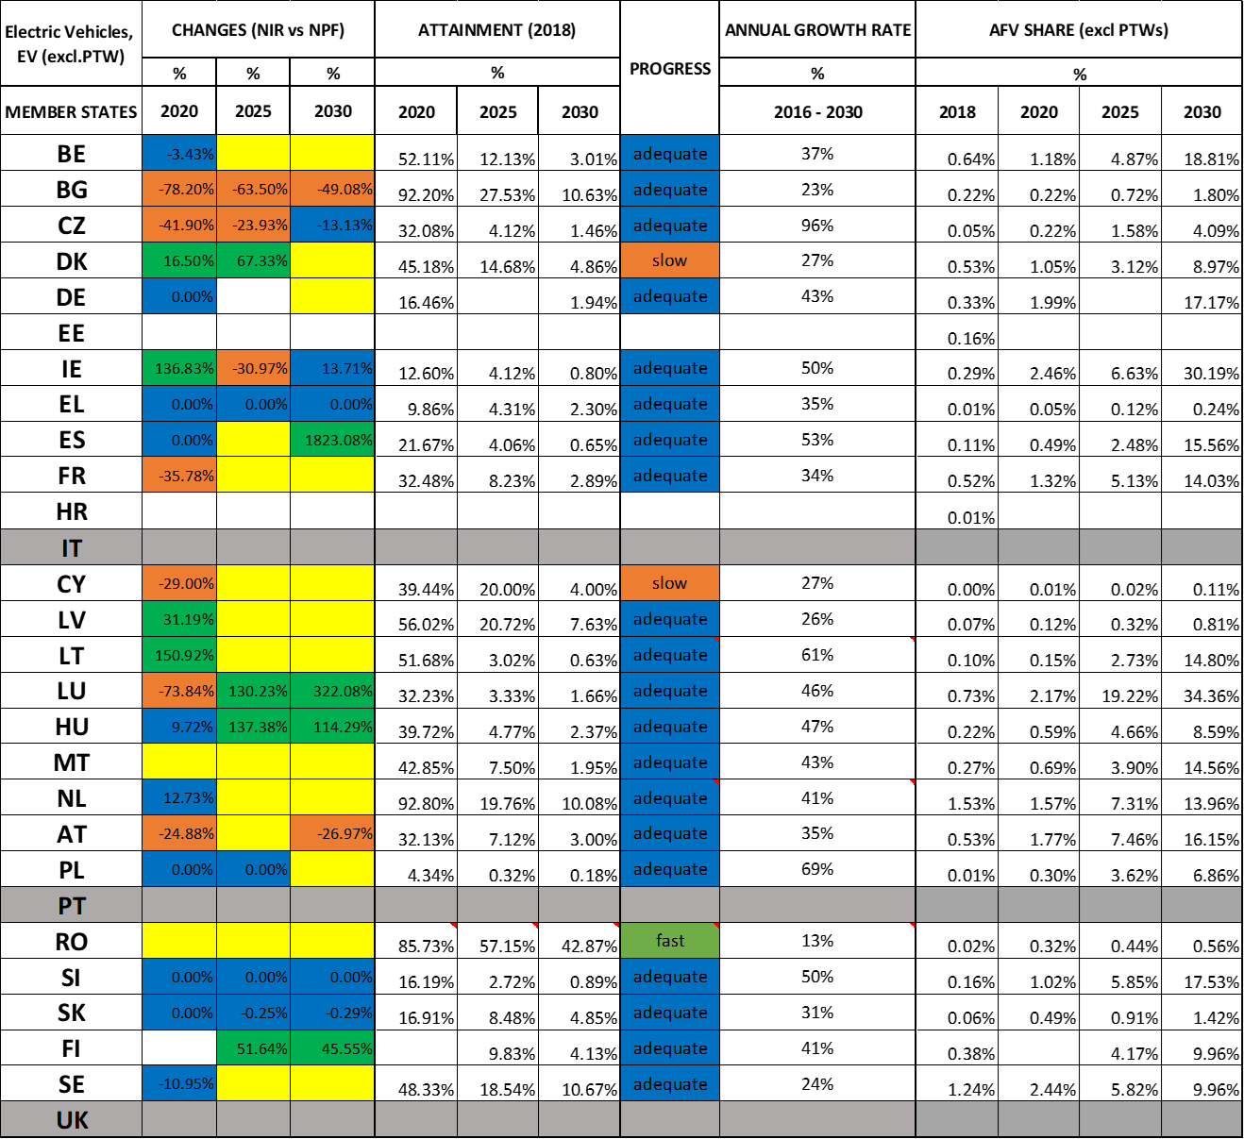



Table 3.1.1‑2 gives an overview of the results for publicly accessible recharging points[12] in each country. Due to the limited information provided, for one of the assessed NIRs it was possible to compute only one parameter.

*Table 3.1.1‑2 Overview of electricity / road AFI*

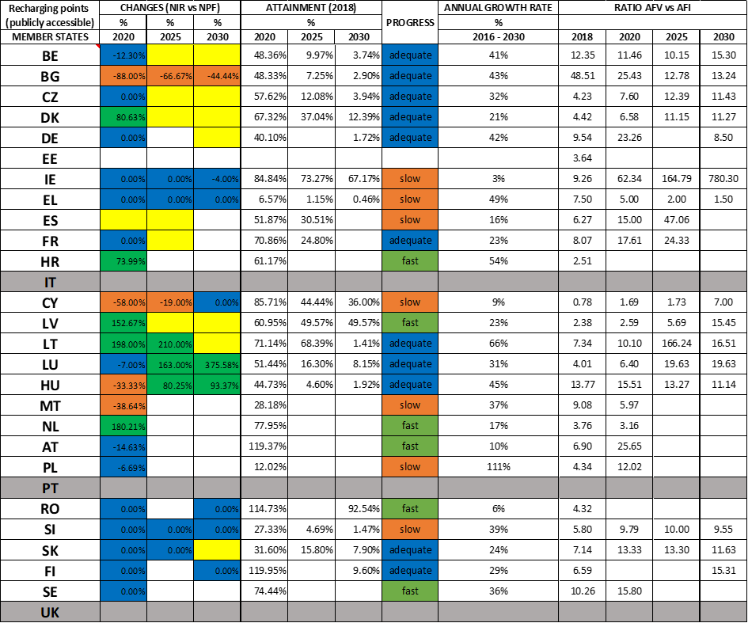



### CNG (alternative fuels vehicles and infrastructure)

Table 3.1.2‑1 gives an overview of the results for CNG vehicles in each country. Due to the limited information provided, for nine of the assessed NIRs it was possible to compute only one parameter.

*Table 3.1.2‑1 Overview of CNG / road AFV*





Table 3.1.2‑2 gives an overview of the results for publicly accessible CNG refuelling points[13] in each country. Due to the limited information provided, it was not possible to compute several parameters for six of the assessed NIRs.

*Table 3.1.2‑2 Overview of CNG / road AFI*





### Measures (Electricity and CNG)

Table 3.1.3‑1 provides an overview of the measure assessment results for the pairs electricity/road and CNG/road for each country. As it can be seen, for the latter pair it was not possible to compute the impact for three of the assessed NIRs, due to the limited information provided.

*Table 3.1.3‑1 Overview of the measure assessment results for electricity / road and CNG / road*



**Legend:** Score and Impact: H = high; M = medium; L = low; X = not assessable. Comprehensiveness: C = comprehensive; N = Not comprehensive. Ambition level: ‘+’ means ‘higher’; ‘=’ means ‘comparable’; ‘-‘ means ‘lower’.

### LNG (alternative fuels vehicles and infrastructure)

Table 3.1.4‑1 gives an overview of the results for LNG vehicles and the corresponding publicly accessible refuelling points[14] in each country. As it can be seen, the level of coverage in terms of assessable information is quite sparse.

*Table 3.1.4‑1 Overview of LNG / road*





### Hydrogen (alternative fuels vehicles and infrastructure)

Table 3.1.5‑1 gives an overview of the results for hydrogen vehicles and the corresponding publicly accessible refuelling points[15] in each country. Also in this case the level of coverage is quite scarce, although it is worth reminding that, according to the Directive, it was not compulsory to include hydrogen in the NPF (hence in the NIR).

*Table 3.1.5‑1 Overview of hydrogen / road*





### Measures (LNG and Hydrogen)

Table 3.1.6‑1 provides an overview of the measure assessment results for the pairs LNG/road and hydrogen/road for each country. As it can be seen and due to the limited information provided, it was not possible to compute the impact for eight of the assessed NIRs in the case of LNG/road and for four in the case of hydrogen/road.

*Table 3.1.6‑1 Overview of the measure assessment results for LNG / road and hydrogen / road*



**Legend:** Score and Impact: H = high; M = medium; L = low; X = not assessable. Comprehensiveness: C = comprehensive; N = Not comprehensive. Ambition level: ‘+’ means ‘higher’; ‘=’ means ‘comparable’; ‘-‘ means ‘lower’.

## Waterborne transport

### Inland waterborne transport

The following tables give an overview of shore-side electricity (Table 3.2.1‑1) and LNG supply[16] (Table 3.2.1‑2) for vessels in TEN-T Core inland ports in each country. For nine of the Member States, this requirement was not applicable since they have no TEN-T Core inland ports[17]. The tables show the results of the assessable data provided in the NIRs in terms of Changes, Attainment, Progress and measures.

Table 3.2.1‑1 displays that some information on shore-side electricity for vessels in inland ports to compute at least one of these metrics was available in only eight of the assessed NIRs. Due to the limited information provided, it was possible to compute the impact only for four of the assessed NIRs in the case of electricity/water (inland).

*Table 3.2.1‑1 Overview of electricity / water (inland)*





Table 3.2.1‑2 displays that some information on LNG supply for vessels in inland ports to compute at least one of these metrics was available in only ten of the assessed NIRs. Due to the limited information provided, it was possible to compute the impact only for five NIRs in the case of LNG/water (inland).

*Table 3.2.1‑2 Overview of LNG / water (inland) AFI*





Score and Impact: H = high; M = medium; L = low; X = not assessable. Comprehensiveness: C = comprehensive; N = Not comprehensive. Ambition level: ‘+’ means ‘higher’; ‘=’ means ‘comparable’; ‘-‘ means ‘lower’.

### Maritime waterborne transport

The following tables give an overview of shore-side electricity (Table 3.2.2‑1) and LNG supply[18] (Table 3.2.2‑2) for vessels in TEN-T Core maritime ports in each country. For five of the Member States, this requirement was not applicable since they have no TEN-T Core maritime ports. The tables show the results of the assessable data provided in the NIRs in terms of Changes, Attainment, Progress and measures.

Table 3.2.2‑1 displays that some information on shore-side electricity for vessels in maritime ports to compute at least one of these metrics was available in fourteen of the assessed NIRs. Due to the limited information provided, it was possible to compute the impact only for seven of the assessed NIRs.

*Table 3.2.2‑1 Overview of electricity / water (maritime)*





Table 3.2.2‑2 displays that some information on LNG supply[19] for vessels in maritime ports to compute at least one of these metrics was available in sixteen of the assessed NIRs. Due to the limited information provided, it was possible to compute the impact only for nine of the assessed NIRs.

*Table 3.2.2‑2 Overview of LNG / water (maritime)*





Score and Impact: H = high; M = medium; L = low; X = not assessable. Comprehensiveness: C = comprehensive; N = Not comprehensive. Ambition level: ‘+’ means ‘higher’; ‘=’ means ‘comparable’; ‘-‘ means ‘lower’.

# Overall contribution of NIRs to EU policy targets

## Deployment of alternative fuels infrastructure and transport systems

This section provides an EU-wide overview of the AFV-estimates / AFI-targets and the results of the measure assessment for the most relevant alternative fuels and transport modes.

**AFV-estimates / AFI-targets**

For the two best-covered pairs, namely electricity/road and CNG/road, the results will be presented from two points of view. First, the numerical values of AFV/AFI in 2016 and 2018, and the objectives for 2020, 2025 and 2030 will be shown on diagrams including all the 25 Member States. Then, in addition to the summary tables presented in Chapter 3, some considerations regarding “coverage”, “change NIR vs. NPF”, “attainment”, “progress”, “average growth rate” and “sufficiency index” will be provided, according to the results of the assessment methodology described in Chapter 2. Finally, the calculated shares of electric vehicles and CNG vehicles in 2018, and the estimated shares in 2020, 2025 and 2030, will be shown in EU maps with the use of different colours.

Secondly, an analysis and interpretation of data from an EU-wide perspective will be presented. Concerning numerical values that can be summed up, this will simply consist in adding the individual values from the MS to the total sum to represent the EU value (for example the total number of electric vehicles in 2018, 2020, 2025 and 2030, or the total number of recharging points). Instead, for those parameters that cannot be summed up (for example the “change NIR vs. NPF”), two averaged European values will be shown:

* an unweighted average, where each MS counts one (UWA)
* a weighted average, based on the population of each MS (PWA)

It is considered that both averages are important and indicative. The first gives a better vision of the average strategy of all the MSs and provides a more balanced geographical representation of the situation. The second average provides holistic EU numbers, which are closer to the real situation from an EU-citizens point of view. The PWA can be used for example to check the current or foreseen EU state of play versus the objectives of the Green Deal, or when comparing Europe to the other major actors in the field. There is however an important caveat when considering the PWA as representative of the whole EU situation. The sum of the populations of the 25 assessed MSs is about 75% of the total EU-28 population. Thus, a PWA calculated from 25 MSs represents an approximation of the real EU population weighted average. This approximation deteriorates as the number of MSs becomes lower than 25. When the number of MSs was lower than 10, the EU-wide averages were not even calculated.

For the other road-related fuels (LNG, hydrogen, LPG), only the diagrams with the individual numerical values of the MSs will be shown (both AFV and AFI), because the amount of available data does not allow to calculate representative EU average results.

For waterborne transport, only individual AFI data (shore-side supply points and LNG refuelling points) will be shown in diagrams, while for rail and air transport only a mention of the number of MSs that have delivered data will be provided.

**Measure assessment**

In addition to the analysis and assessment provided in each assessment report in Chapter 5 (where the measures for all the pairs AF/transport mode are presented), a paragraph summarising the total EU-wide number of measures and their impact is also presented for road transport.

### Road transport

#### Electricity

Of all the alternative fuel and transport mode combinations, the pair electricity/road is the best covered as electro-mobility seems to be a priority for most Member States.

Figure 4.1.1-1 summarises the information for the EV estimates and targeted publicly accessible recharging points as provided in the NIRs for the next decade as well as the 2016 and 2018 situation. It is worth noting that a logarithmic scale is used for these diagrams, in order to have readable data for all MSs, however there are big absolute differences among them.

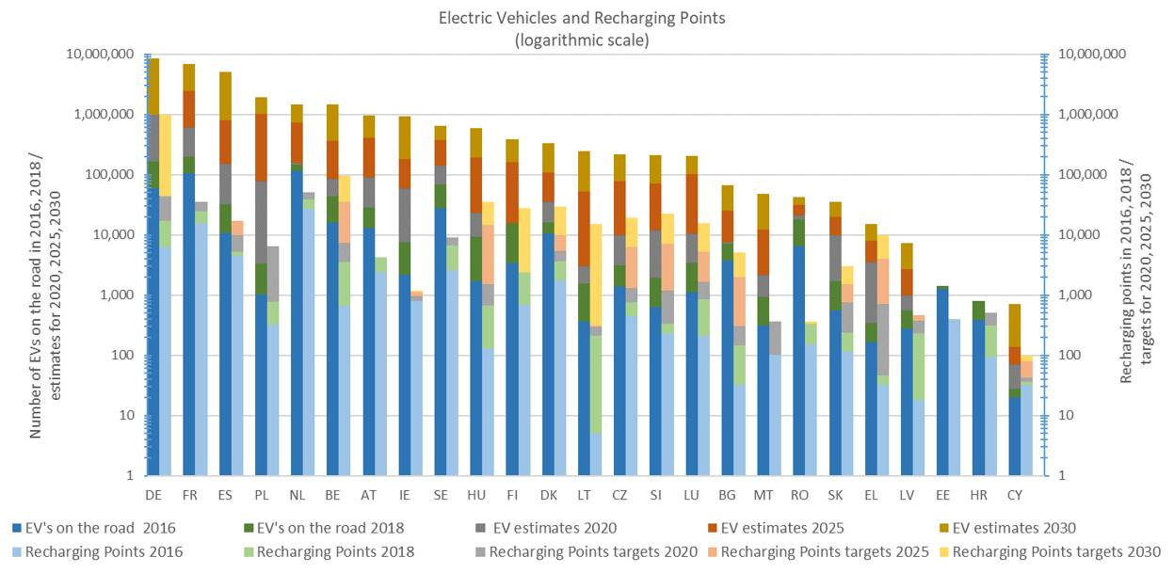

*Figure 4.1.1‑1 EV estimates and recharging points targets for 2020, 2025 and 2030*

**Electric Vehicles**

* **(Coverage)** Twenty-three MSs NIRs out of the total 25 assessed (92%) have provided at least some historical data (2016-2018)[20] and at least one estimate for the decade 2020-2030[21]. For the three years of the next decade when estimates were requested, the NIRs contained globally 24 more inputs than the NPFs, showing the improving MSs’ strategies regarding electro-mobility (in particular, one more estimate in 2020, 11 more estimates in 2025 and 12 more estimates in 2030 compared to the NPF).
* **(Change NIR vs NPF)** Considering the 42 cases where a change could be computed (EV estimates provided both in the NPF and NIR), a decrease of ambition is noticeable in 11 cases, a similar ambition in 19 cases and an increase of ambition in 12 cases. The changes range from -78.20% (Bulgaria) to +150.92% (Lithuania) in 2020; from -63.50% (Bulgaria) to +137.38 (Hungary) in 2025; from -49.08% (Bulgaria) to +1,823.08% (Spain) in 2030. In other 25 cases, an estimate was provided only in the NIR and the changes could not be computed.

Considering the changes from a EU-wide point of view, the unweighted average (UWA) and the population weighted average (PWA) are reported in the following table. As mentioned earlier, the values shown for 2025 and 2030 should be considered with more caution (especially the latter), due to the limited numbers of MSs available to calculate the EU averages. To be noted that the 2020 change is small, even negative (estimates are decreasing in value in NIR vs NPF), and for 2025 and 2030, the estimations are increasing. The very high values for the EU-wide 2030 change are influenced by Spain’s significant change (1,823%), due to its EV estimation of 5,000,000 for 2030, and by the relevance of Spain population compared to the other ten MSs concurring to the 2030 averages.



* **(Attainment)** The 2018 attainment of the foreseen EV estimates ranges significantly across EU, from 4.34% (Poland) to 92.80% (Netherlands) for 2020, from 0.32% (Poland) to 57.15% (Romania) for 2025, and from 0.18% (Poland) to 42.87% (Romania) for 2030. It is worth reminding that a low 2018 attainment could be due to either a slow uptake of EVs in 2018 and/or to a very ambitious estimate for the target year compared to 2018.

The average situation from a EU-wide perspective is reported in the following table:



* **(Progress)** Considering the 23 MSs that provided at least one estimate for the decade 2020-2030, and comparing the 2018 situation with their foreseen EV fleet evolution, 1 MS results to progress fast, 20 adequately and 2 slowly.
* **(Growth rate)** The average annual growth rate characterising the foreseen evolution of electric vehicles for the next decade ranges from 13% (Romania) to 96% (Czechia). Out of the 23 computed annual growth rates, 1 is below 20%, 10 are in between 20% and 40%, 9 are in between 40% and 60% while 3 are above 60%.

The average situation from a EU-wide perspective is reported in the following table:



* **(EV share)** The maps in Figure 4.1.1-2 and Figure 4.1.1-3 show the evolution of the shares of electric vehicles in 2018, 2020, 2025 and 2030 (according to the estimates provided in the NIRs), allowing a comparison among MSs since the absolute numbers shown in Figure 4.1.1‑1 are normalised by the existing (2018) or estimated (2020, 2025 and 2030) total fleet[22] of each MS in the reference year. The share of electric vehicles in the total vehicle fleet (excluding PTWs) varies significantly across MSs ranging:
  + from less than 0.01% (Cyprus) to 1.53% (Netherlands) with 7 MSs above 0.5% share in 2018,

and is foreseen to vary also in the future

* + from 0.01% (Cyprus) to 2.46% (Ireland) with 9 MSs above 1% share in 2020,
  + from 0.02% (Cyprus) to 19.22% (Luxembourg) with 6 MSs above 5% share in 2025, and
  + from 0.11% (Cyprus) to 34.36% (Luxembourg) with 11 MSs above 10% share in 2030.

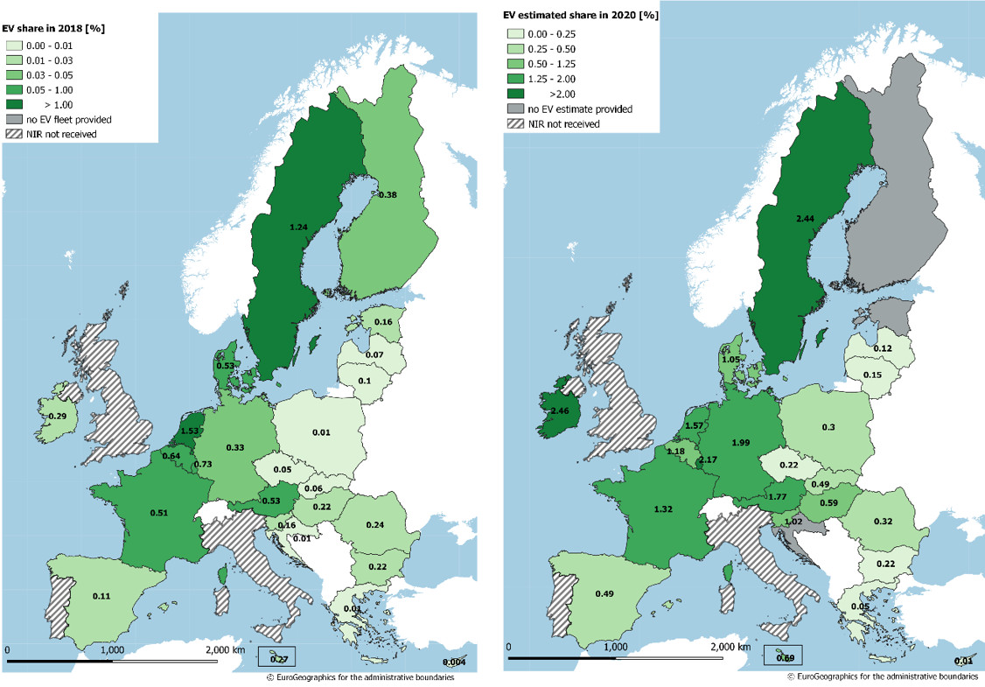

*Figure 4.1.1‑2 Shares of electric vehicles in use in 2018 (left map) and estimated for 2020 (from the NIRs) (right map)*

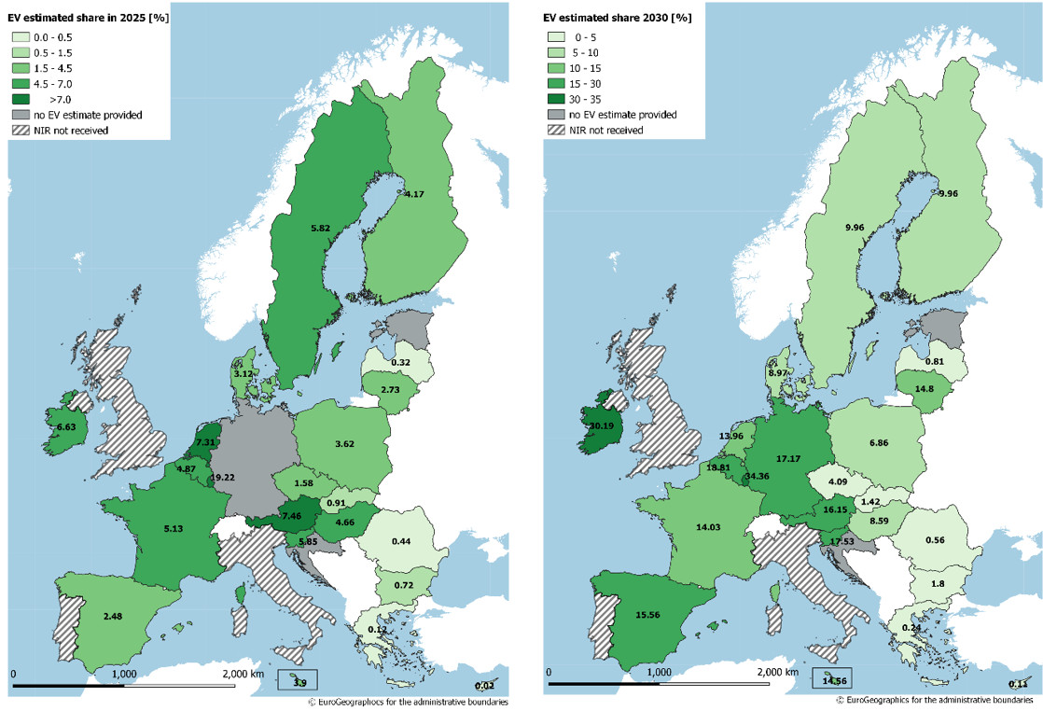

*Figure 4.1.1‑3 Shares of estimated electric vehicles (from the NIRs) in 2025 (left map) and in 2030 (right map)*

Also for the EV share, the EU-wide average situation is shown in the following table:



The maps in Figure 4.1.1‑4 and Figure 4.1.1‑5 show the evolution of the shares of alternative fuels vehicles normalized by population (that can be named as AFV motorisation) per Member State in 2018, 2020, 2025 and 2030 (according to the estimates provided in the NIRs) for the pair electricity/road. In 2018, there were 5 MSs having more than 3 EVs per 1,000 inhabitants, and the leader is Netherlands with the value of 8.52 for this parameter. In 2020, there are 5 MSs foreseen to have more than 10 EVs per 1,000 inhabitants. In 2025, there are 8 MSs foreseen to have values above 30 EVs per 1,000 inhabitants, while in 2030, there are 8 MSs foreseen to exceed the value of 100 for this parameter. In all estimated future cases, Luxembourg leads with the values of 17 in 2020, 168 in 2025, and 337 in 2030.

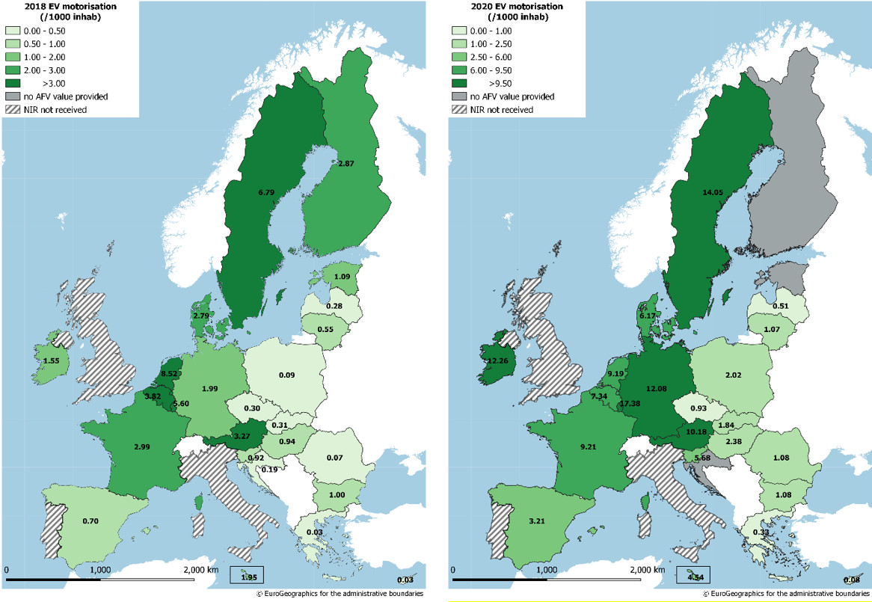

*Figure 4.1.1‑4 Shares of electric vehicles normalized by population (EV motorisation) in 2018 (left map) and estimated for 2020 (from the NIRs) (right map)*

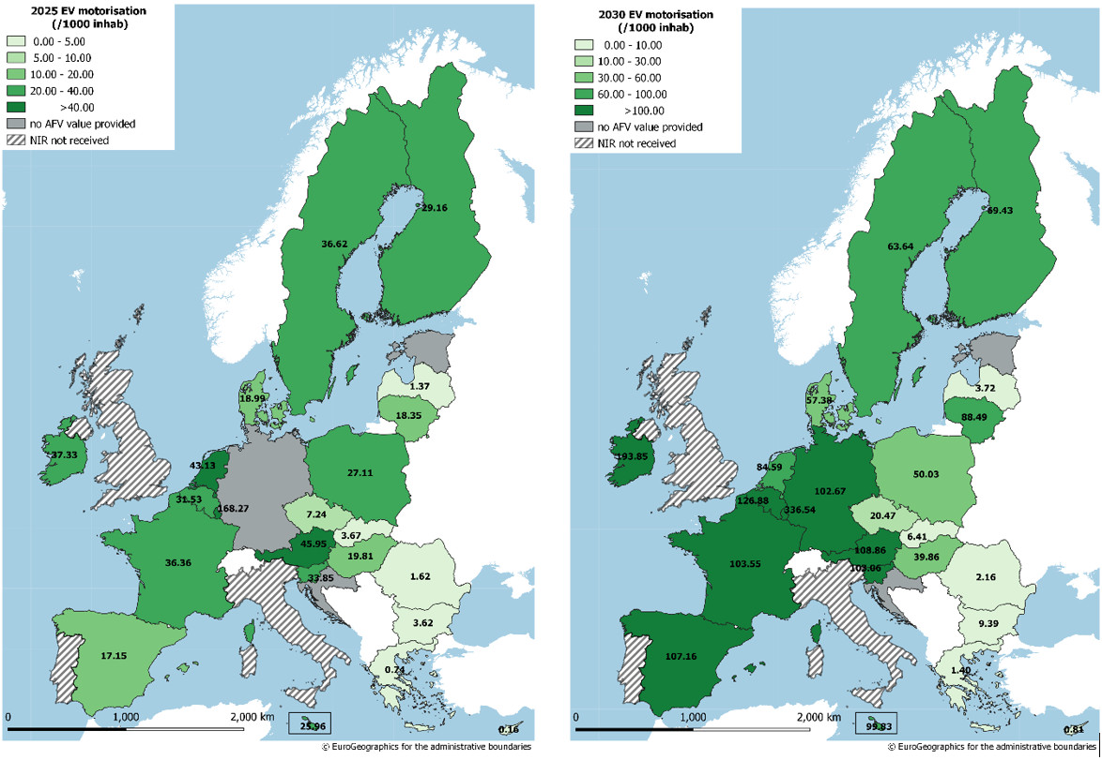

*Figure 4.1.1‑5 Shares of estimated electric vehicles (from the NIRs) normalized by population (EV motorisation) in 2025 (left map) and in 2030 (right map)*

**Recharging points (publicly accessible)**

* **(Coverage)** Twenty-four MSs NIRs out of the total 25 assessed (96%) have provided at least some historical data (2016-2018)[23] and 22 at least one target for the decade 2020-2030. For the three years of the next decade when targets were requested, the number of provided targets is higher in the NIRs than in the NPFs (49 vs 45).
* **(Change NIR vs NPF)** Considering the 35 cases where a change could be computed (recharging infrastructure targets provided both in the NPF and NIR), a decrease of ambition is noticeable in 7 cases, a similar ambition in 18 cases and an increase of ambition in 10 cases. The changes range from -88.00% (Bulgaria) to +198.00% (Lithuania) in 2020; from -66.67% (Bulgaria) to +210.00% (Lithuania) in 2025; from -44.44% (Bulgaria) to +375.58% (Lithuania) in 2030. In other 14 cases, a target was provided only in the NIR and the changes could not be computed.

The average situation from a EU-wide perspective is reported in the following table. In this case, only the 2020 averages have been computed as EU-wide representative.



* **(Attainment)** The 2018 attainment of the MSs foreseen recharging points targets ranges significantly across EU, from 6.57% (Greece) to 119.37% (Austria) for 2020, from 1.15% (Greece) to 73.27% (Ireland) for 2025, and from 0.46% (Greece) to 92.54% (Romania) for 2030.

The average situation from a EU-wide perspective is reported in the following table:



The values shown for 2025 and 2030 should be considered with more caution, due to the limited numbers of NIRs available to calculate the EU averages.

* **(Progress)** Considering the 24 MSs that provided at least one target for the 2020-2030 decade in their NIR or NPF, and comparing the 2018 situation with their foreseen recharging points infrastructure evolution, 6 MSs result to progress fast, 11 adequately and 7 slowly.
* **(Growth rate)** The average annual growth rate characterising the foreseen evolution of recharging points for the next decade ranges from 3% (Ireland) to 111% (Poland). Out of the 24 computed annual growth rates, 6 are below 20%, 10 are in between 20% and 40%, 6 are in between 40% and 60% while 2 are above 60% (Lithuania and Poland).

The average situation from a EU-wide perspective is reported in the following table:



The maps in Figure 4.1.1‑6 and Figure 4.1.1‑7 show the evolution of the density of publicly accessible recharging points (number of recharging points normalized by the total length of roads[24]) per Member State in 2018, 2020, 2025 and in 2030 (according to the estimates provided in the NIRs). Also in this case, very big differences can be seen among MSs. To be noted is the group of central European MSs (Belgium, Netherlands, Luxembourg and Germany). In 2018, their densities exceeded the value of 5 recharging points per 100 km. In 2020, their densities are foreseen to exceed the value of 10 for this parameter, while in 2030, their densities are foreseen to be well above 100 recharging points per 100 km (or more than 1 recharging point per km).

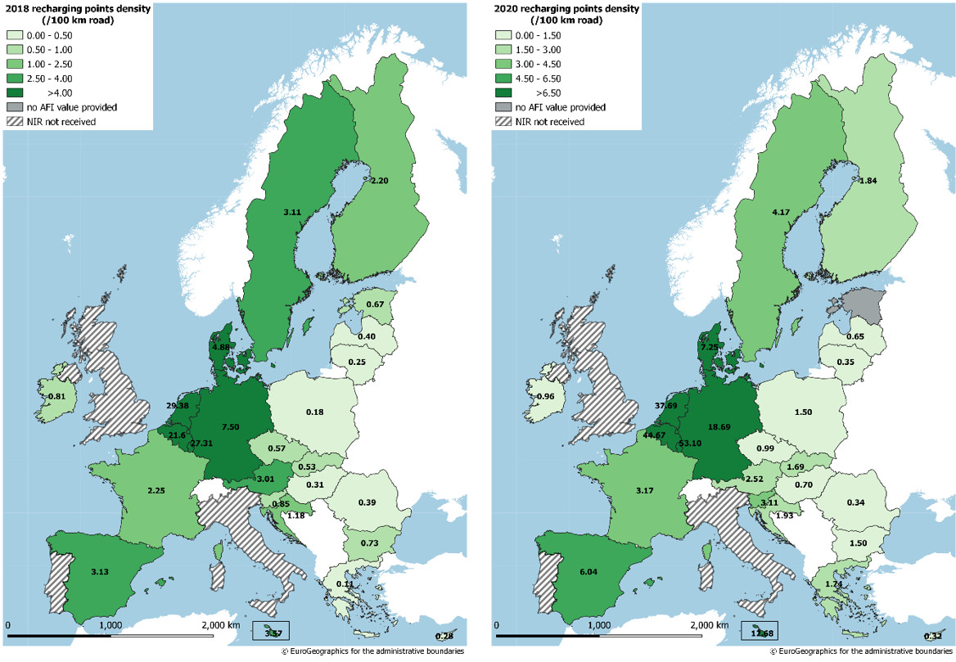

*Figure 4.1.1‑6 Density of publicly accessible recharging points in 2018 (left map) and estimated for 2020 (from the NIRs) (right map)*

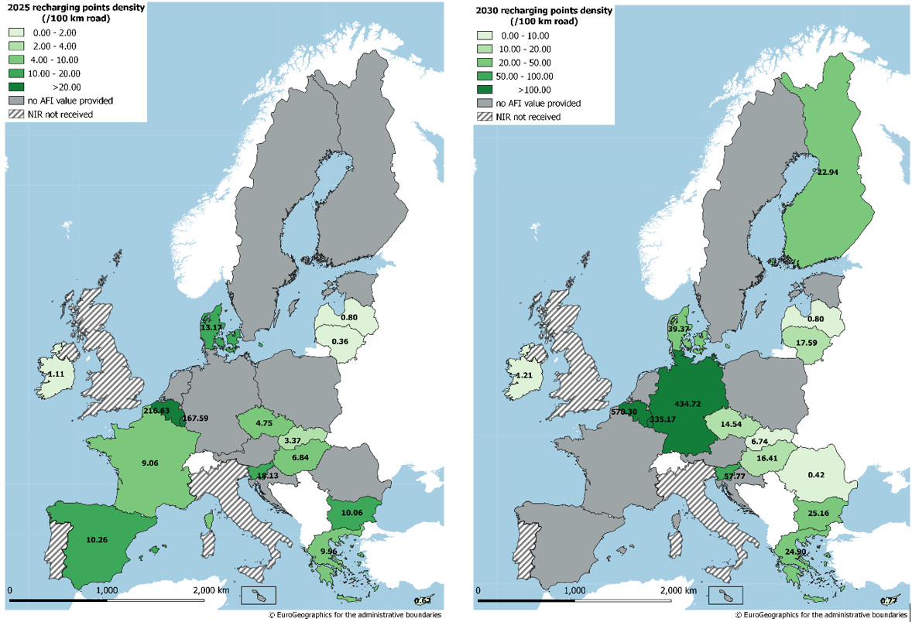

*Figure 4.1.1‑7 Estimated density of publicly accessible recharging points (from the NIRs) in 2025 (left map) and in 2030 (right map)*

**Sufficiency Index (Ratio AFV/AFI)**

From NIR data, it is possible to compute the ratio (sufficiency index) of electric vehicles and publicly accessible recharging points for 23 MSs (with the exception of Estonia and Croatia). Concerning the adequacy of this ratio (the Directive has indicated a value of 10), it has to be considered that there are other elements influencing it, which were not included when setting the value of 10 (e.g. the share of high power (>22kW) publicly accessible recharging points and the number of private recharging points).

The maps in Figure 4.1.1-8 and Figure 4.1.1‑9 show the evolution of the sufficiency index for electricity/road in 2018, 2020, 2025 and 2030 (according to the estimates provided in the NIRs). For the 2020-2030 decade, NIR data allows computing 53 ratios while NPF data had allowed computing only 30. For 2020, the ratio can be computed for 21 MSs and ranges from 1.69 (Cyprus) to 62.34 (Ireland), with 4 MSs situated below 5, 10 MSs in between 5 and 15, and 7 MSs above 15. For 2025, the ratio can be computed for 15 MSs and ranges from 1.73 (Cyprus) to 166.24 (Lithuania), with 2 MSs situated below 5, 8 MSs in between 5 and 15, and 5 MSs above 15. For 2030, the 15 computable ratios range from 1.50 (Greece) to 780.30 (Ireland), with 1 MS situated below 5, 8 MSs in between 5 and 15, and 6 MSs above 15.

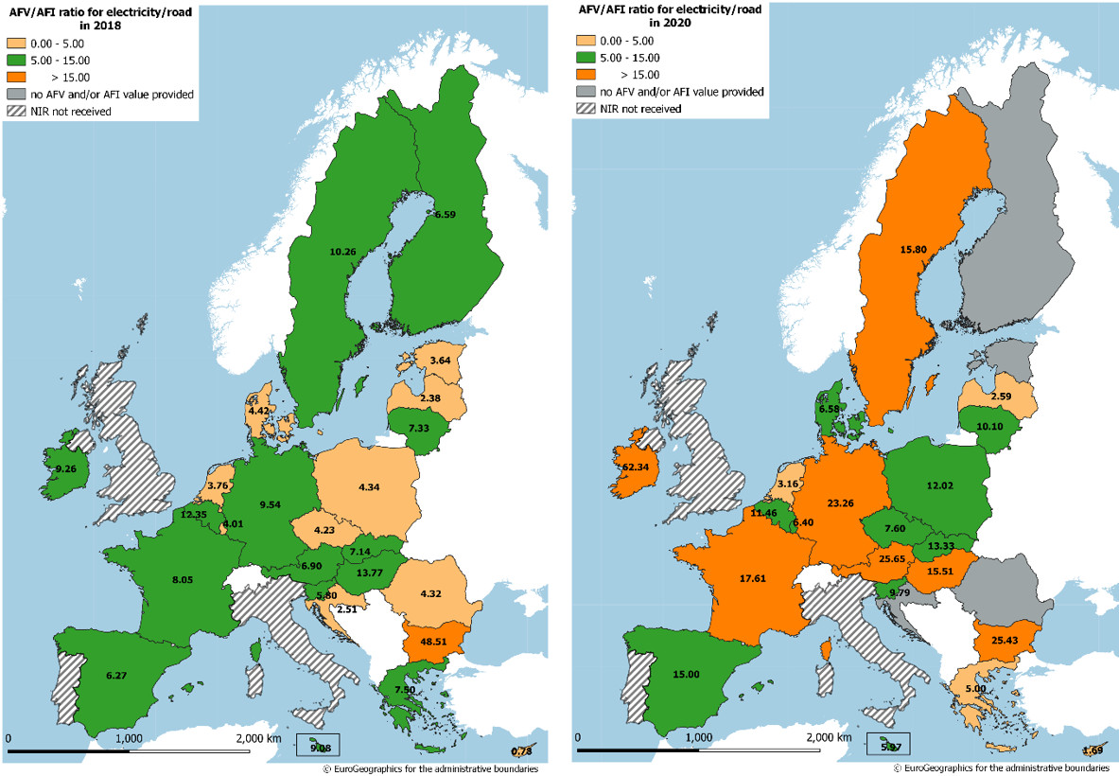

*Figure 4.1.1‑8 Ratio AFV/AFI (sufficiency index) for electricity/road in 2018 (left map) and estimated for 2020 (from the NIRs) (right map)*

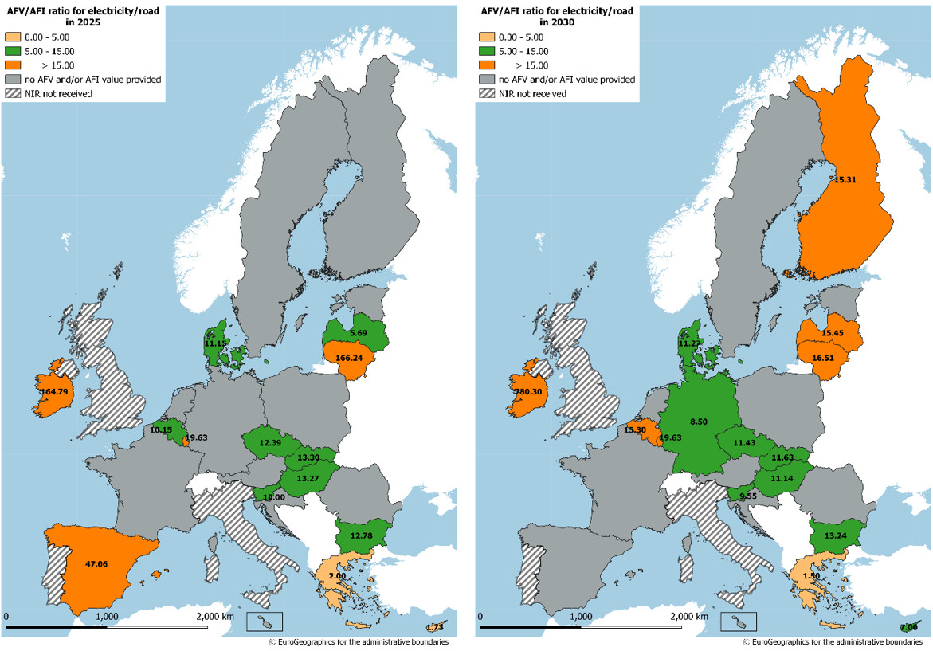

*Figure 4.1.1‑9 Estimated ratio AFV/AFI (sufficiency index) for electricity/road (from the NIRs) for 2025 (left map) and for 2030 (right map)*

Looking at these data from an EU-wide point of view, the obtained results are shown in the following table:



From these average sufficiency indexes one would deduct that EU is clearly moving from an adequate balance between EV and recharging points in 2018 to a progressively increasing inadequate balance in 2030. However, it is worth to note that, if the extreme MS (IE) is excluded, the EU averages are both below 12, which can be considered as an adequate sufficiency index.

**Measures**

The pair electricity/road is the most numerous in terms of dedicated measures by the majority of MSs.

* The **legal measures**’ level of ambition in the NIRs vs. NPFs has increased for 21 MSs out of the 24 NIRs assessed[25].
* The importance given to this pair is revealed also by its presence in all the 25 MSs NIRs assessed and the good score obtained for the assessment of the **policy and deployment & manufacturing support measures** in relation to reaching the MSs electro-mobility objectives (13 MSs sets of measures obtained a high score and the rest a medium score). Among the MSs with a high score, there are front-running countries in the field (e.g. DE, FR and LU, which are distinguished by the consistency of their policies in electro-mobility development) but also late-starting countries (e.g. HU and LT). An expression of the serious commitment in the deployment of electro-mobility is represented by the fact that 23 MSs have measure sets for this field that were assessed to be comprehensive. In terms of expected impact of these measures to support the realisation of the AFV/AFI objectives as presented in the NPF and revised in the NIR, 12 MSs are assessed having a high level impact (of which one medium/high) and 13 a medium level. Regarding the ambition in the NIR vs. NPF, the measure sets of 21 MSs have an increased level and none a decreasing one.
* In twenty cases, the ambition of **RTD&D measures** targeting electro-mobility in the NIRs could be determined, and among these 18 measure sets show an increased ambition compared to the NPF situation.

1. The official date for the submission of the NIRs to the Commission was 18 November 2019. By that date only nine NIRs were delivered, by Belgium, Czechia, Germany, Ireland, Greece, Spain, Austria, Poland and Slovakia. Thus, it was decided to allow some additional time to the remaining MS to submit their NIRs (i.e. 1 May 2020).
2. The previous simplified analysis and modeling of the economic and social impact of the Directive was carried out on the basis of the inputs provided by the MS in their NPFs.
3. Disclaimer: the evaluation of the impact is related only to the objectives set by the MS in the NIR/NPF, not to the absolute values of these objectives, nor to a comparison among member states.
4. EAFO. (2020). European Alternative Fuels Observatory (EAFO). European Commission (EC). Retrieved from https://www.eafo.eu on 01/02/2020.
5. If a MS did not provide a value for 2030, the exponential curve is built using the 2016 and the farthest available value (2020/2025).
6. If a MS did not provide a value for 2030, the straight line is built using the 2016 and the farthest available value (2020/2025).
7. The sufficiency index is also shown when the values of AFV and/or AFI are not available in the NIR but are available either in the NPF or in EAFO.
8. “As an indication, the appropriate average number of recharging points should be equivalent to at least one recharging point per 10 cars”.
9. The average ratio in Member States between conventional vehicles and gasoline/diesel refuelling points is 600 to one (one fuel station typically has several refuelling points).
10. The proposed categorisation of legal measures is an adaptation of the “Better regulation toolbox” (European Commission, n.d.)
11. This categorisation of policy measures was used in (European Commission, 2017) and (European Commission, 2019).
12. The meaning of publicly accessible recharging point, as reported in the NIR, may differ by country.
13. The meaning of publicly accessible refuelling point, as reported in the NIR, may differ by country.
14. The meaning of publicly accessible refuelling point, as reported in the NIR, may differ by country.
15. The meaning of publicly accessible refuelling point, as reported in the NIR, may differ by country.
16. The meaning of alternative fuel supply in waterborne transport, as reported in the NIR, may differ by country. It is not always clear whether the value reported refers to maritime or inland, to a port or another location along the waterway/shore, to a station or a refuelling point.
17. Finland has not TEN-T Core inland ports but included an AFI target and measures for LNG supply in inland ports.
18. The meaning of alternative fuel supply in waterborne transport, as reported in the NIR, may differ by country. It is not always clear whether the value reported refers to maritime or inland, to a port or another location along the waterway/shore, to a station or a refuelling point.
19. The meaning of alternative fuel supply in waterborne transport, as reported in the NIR, may differ by country. It is not always clear whether the value reported refers to maritime or inland, to a port or another location along the waterway/shore, to a station or a refuelling point.
20. With the exception of Czechia and Estonia
21. With the exception of Estonia and Croatia
22. Similarly to the NPF assessment, the future total vehicle fleets are based on the Baseline scenario of the Impact Assessment accompanying the Proposal for a Directive amending Directive 1999/62/EC on the charging of heavy goods vehicles for the use of certain infrastructures (SWD (2017) 180), and thus on the EU Reference scenario 2016, but excluding the incentives for alternative fuels provided at the Member State level. It has been developed with the PRIMES-TREMOVE model (i.e. the same model used for the EU Reference scenario 2016) by ICCS-E3MLab.
23. With the exception of Estonia
24. Including motorways, main/national and secondary/regional roads
25. For Czechia this assessment was not possible.