

Table of Contents

4.1.1.2 CNG 52

4.1.2 Rail transport 67

4.1.3 Waterborne transport (maritime and inland) 67

4.1.4 Air transport 69

4.2 Strengthening EU competitiveness and jobs 69

4.2.1 Method to assess the strengthening of the EU's competitiveness and jobs 69

4.2.2 Assessment of the strengthening of the EU's competitiveness and jobs 72

1. * + 1. CNG

Of all the alternative fuel and transport mode combinations, the pair CNG/road is the second best covered. Figure 4.1.1‑10 summarises the information for the CNG vehicle estimates and targeted publicly accessible refuelling points as provided in the NIRs for the next decade as well as the 2016 and 2018 situation.

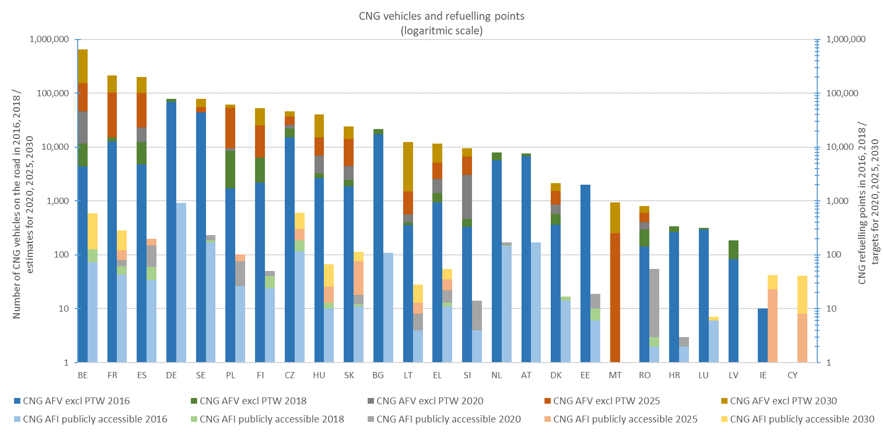

*Figure 4.1.1‑10 CNG vehicle estimates and refuelling points targets for 2020, 2025 and 2030*

**CNG vehicles**

* **(Coverage)** In the NIRs,23 MSs (out of 25) have provided at least some historical data (2016-2018) (92%), and 16 MSs have provided at least one estimate for the decade 2020-2030 (64%). In the NPF, only 12 MSs had provided at least one estimate for this decade.
* **(Change NIR vs NPF)** Considering the 26 cases where a change could be computed (CNG estimates provided both in the NPF and NIR), a decrease of ambition is noticeable in 10 cases (3 in 2020), a similar ambition in 12 cases (6 in 2020) and an increase of ambition in 4 cases (1 in 2020). In other 20 cases, an estimate was provided only in the NIR and the changes could not be computed.

The average situation from an EU-wide perspective is reported in the following table. Contrary to the case of EVs where 20 MSs concurred to the calculation of the EU averages for 2020, for CNG vehicles the number of MSs is insufficient to be considered representative. The result is shown with this caveat. The two 2020 average changes show the decreasing tendency of CNG vehicles estimates in NIR vs NPF.



* **(Attainment)** The 2018 attainment of the foreseen CNG vehicle estimates ranges significantly across MSs from 15.41% (Slovenia) to more than 100% (France, Luxembourg and Sweden) for 2020, from 7.08% (Slovenia) to 78.25% (Sweden) for 2025, and from 1.82% (Belgium) to 55.22% (Sweden) for 2030. One Member State (Luxembourg) foresees a decreasing trend of its CNG vehicle fleet in the future.

The average situation from an EU-wide perspective is reported in the following table:



* **(Progress)** Considering the 14 MSs for which progress could be calculated, comparing the 2018 situation with their foreseen CNG vehicle fleet evolution, 2 MSs result to progress fast, 6 adequately and 6 slowly.
* **(Growth rate)** The average annual growth rate characterising the foreseen evolution of CNG vehicles for the next decade ranges from 4% (Sweden) to 41% (Belgium). Out of the 14 computed annual growth rates, 2 are below 10%, 3 are in between 10% and 20%, 7 are in between 20% and 30% while 2 are above 30% (Belgium and Spain).

The average situation from an EU-wide perspective is reported in the following table (also in this case, it is acknowledged that the number of MSs is not sufficient for a robust estimation):



* **(CNG vehicle share)** Themaps in Figure 4.1.1‑11 and Figure 4.1.1‑12 show the evolution of the shares of CNG vehicles in 2018, 2020, 2025 and in 2030 (according to the estimates provided in the NIRs). The share of CNG vehicles in the total vehicle fleet (excluding PTWs) ranges from 0% (Cyprus and Malta) to 0.77% (Sweden) in 2018. This share is also foreseen to vary in the future in the 18 MSs providing CNG vehicle estimates
  + from 0% (Malta) to 0.73% (Sweden) with 3 MSs above 0.5% share (Belgium, Czechia and Sweden) in 2020,
  + from 0.01% (Romania) to 0.85% (Sweden) in 2025, and
  + from 0.01% (Romania) to 8.38% (Belgium) with 3 MSs above 1% share (Belgium, Finland and Sweden) in 2030.

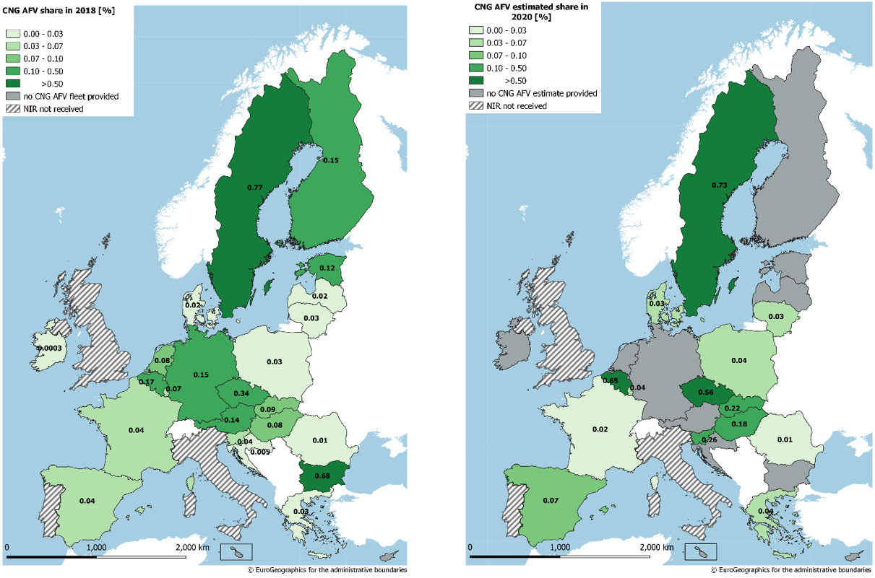

*Figure 4.1.1‑11 Shares of CNG vehicles in use in 2018 (left map) and estimated in 2020 (from in the NIRs) (right map)*

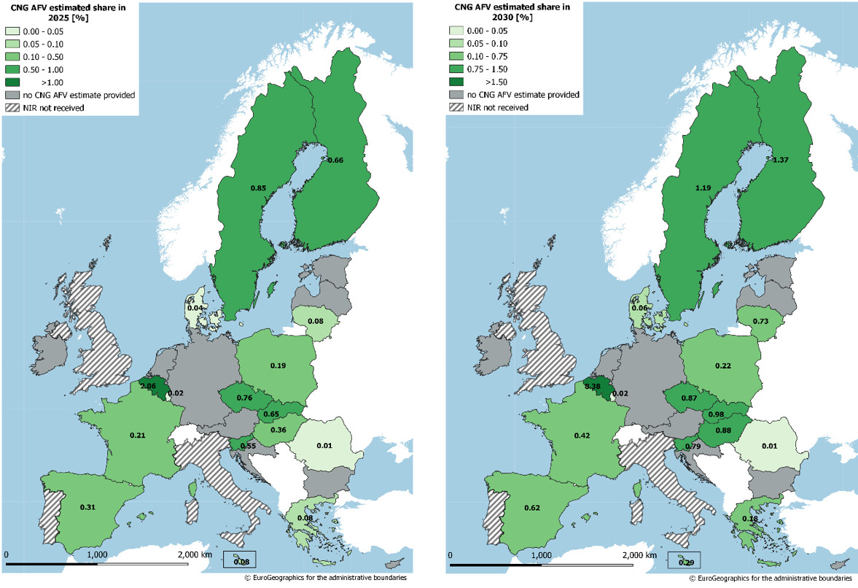

*Figure 4.1.1‑12 Shares of estimated CNG vehicles (from the NIRs) in 2025 (left map) and in 2030 (right map)*

The EU-wide average situation concerning CNG vehicle shares is shown in the following table (the results for 2020, 2025 and 2030 are less statistically representative than the 2018 result, due to the lower number of MSs concurring to the calculation of the averages):



The maps in Figure 4.1.1‑13 and Figure 4.1.1‑14 show the evolution of the shares of alternative fuels vehicles normalized by population (that can be named as AFV motorisation) per Member State in 2018, 2020, 2025 and in 2030 (according to the estimates provided in the NIRs) for the pair CNG/road. In 2018, there were 5 MSs having more than 1 CNG vehicle per 1,000 inhabitants. In 2020, there are 3 MSs foreseen to have more than 2 CNG vehicles per 1,000 inhabitants. In 2025, there are 5 MSs foreseen to have values above 3 CNG vehicles per 1,000 inhabitants. In 2030, there are 9 MSs foreseen to exceed the value of 4 CNG vehicles per 1,000 inhabitants. In 2018 and 2020, Sweden presents the highest values of CNG vehicles per 1,000 inhabitants: 4.20 in 2018 and 4.18 in 2020. In 2025 and 2030, Belgium presents the highest values of CNG vehicles per 1,000 inhabitants: 13.31 in 2025 and 56.53 in 2030.

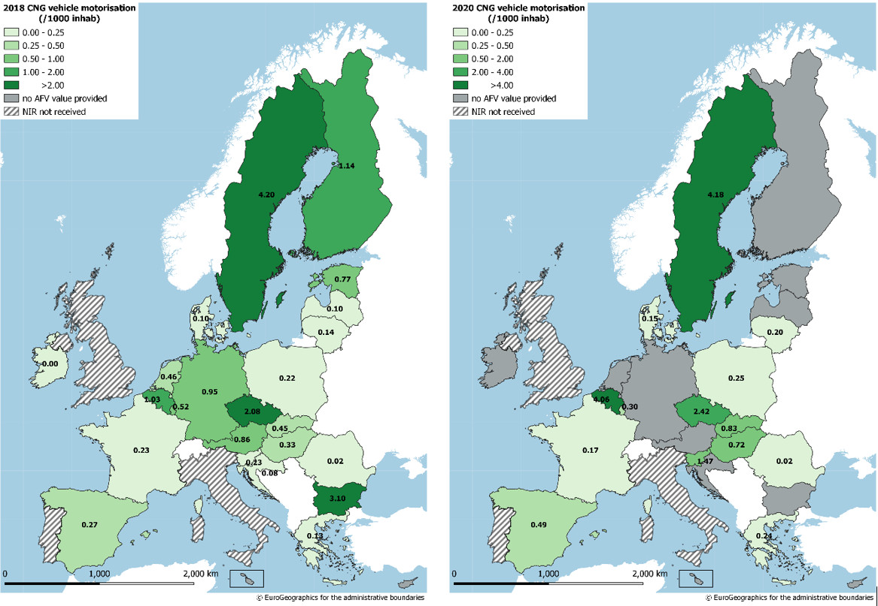

*Figure 4.1.1‑13 Shares of CNG vehicles normalized by population (CNG vehicle motorisation) in 2018 (left map) and estimated for 2020 (from the NIRs) (right map)*

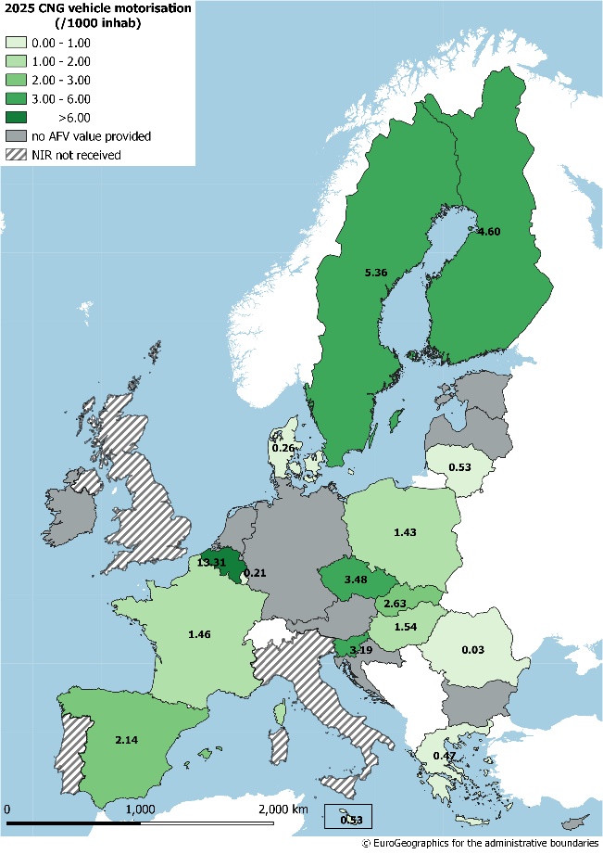 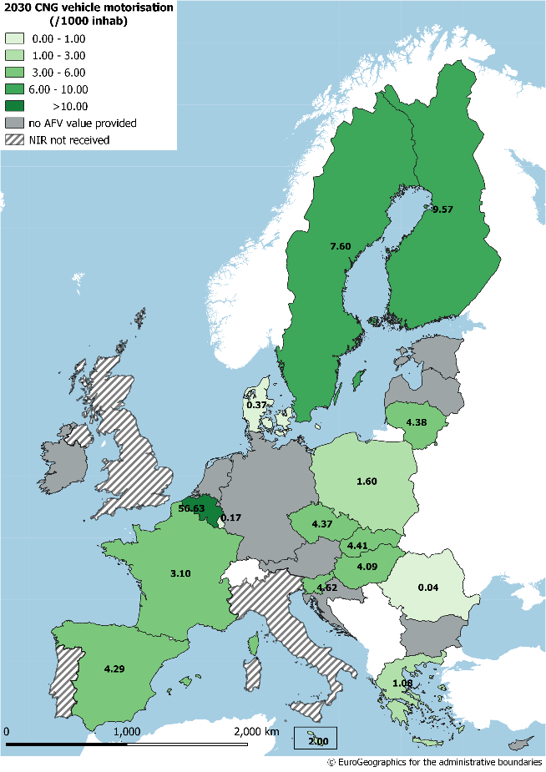

*Figure 4.1.1‑14 Shares of estimated CNG vehicles (from the NIRs) normalized by population (CNG vehicle motorisation) in 2025 (left map) and in 2030 (right map)*

**CNG AFI** **(publicly accessible)**

* **(Coverage)** In their NIRs, 20 MSs out of the total 25 assessed (80%) have provided at least some historical data (2016-2018) and 19 MSs (76%) at least one target for the decade 2020-2030. For the three years of the next decade when targets were requested, the number of provided targets is higher in the NIRs than in the NPFs (45 vs 41).
* **(Change NIR vs NPF)** Considering the 36 situations where a change could be computed (CNG AFI targets provided both in the NPF and NIR), a decrease of ambition is noticeable in 9 cases (6 for 2020), a similar ambition in 20 cases (9 for 2020) and an increase of ambition in 7 cases (4 for 2020). In other 14 cases, a target was provided only in the NIR and the changes could not be computed.

Looking at these data from an EU-wide point of view, the results shown in the following table are obtained. In this case, only the 2020 and 2025 averages have been computed as EU-wide representative, it should be kept in mind that the 2025 values are less representative.

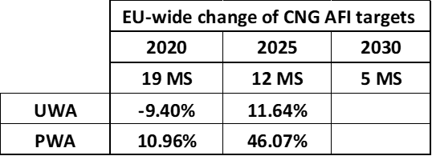

* **(Attainment)** The 2018 attainment of the foreseen CNG AFI targets ranges significantly across MSs from 5.45% (Romania) to 100% or more (Denmark, Ireland, Hungary) for 2020, from 0.00% (Cyprus) to 100% (Denmark) for 2025 and 2030. One Member State (Luxembourg) foresees a decreasing trend of its CNG refuelling points in the future. Four Member States (Denmark, Estonia, Netherlands and Slovenia) foresee a constant number of refuelling stations in the next decade (2020-2030).

Looking at these data from an EU-wide point of view, we obtain the results shown in the following table:

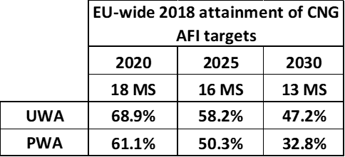

* **(Progress)** From the 20 MSs that provided at least one target for the 2020-2030 decade in their NIR or NPF, comparing the 2018 situation with their foreseen CNG refuelling infrastructure evolution, 4 MSs results to progress fast, 7 adequately and 8 slowly (in the case of Luxembourg the progress was not computed).
* **(Growth rate)** The average annual growth rate characterising the foreseen evolution of CNG refuelling points for the next decade ranges from 1% (Ireland) to 129% (Romania). Out of the 17 computed annual growth rates, 5 are below 10%, 9 are in between 10% and 20%, 2 are in between 20% and 30% while 1 is above 60% (Romania).

Looking at these data from an EU-wide point of view, the results shown in the following table are obtained.



The maps in Figure 4.1.1‑15 and Figure 4.1.1‑16 show the evolution of the density of publicly accessible CNG refuelling points (number of refuelling points normalized by the total length of roads) per Member State in 2018, 2020, 2025 and in 2030 (according to the estimates provided in the NIRs). In 2018, a group of 6 MSs in Central Europe had a density superior to 0.1 CNG refuelling points per 100 km of road and Belgium had the highest value for this parameter (0.77). Because of the absence of several CNG AFI targets for the decade 2020-2030, the number of MSs foreseen to have a density above 0.1 CNG refuelling points per 100 km of road is 3 for 2020, 5 for 2025 and 6 for 2030.

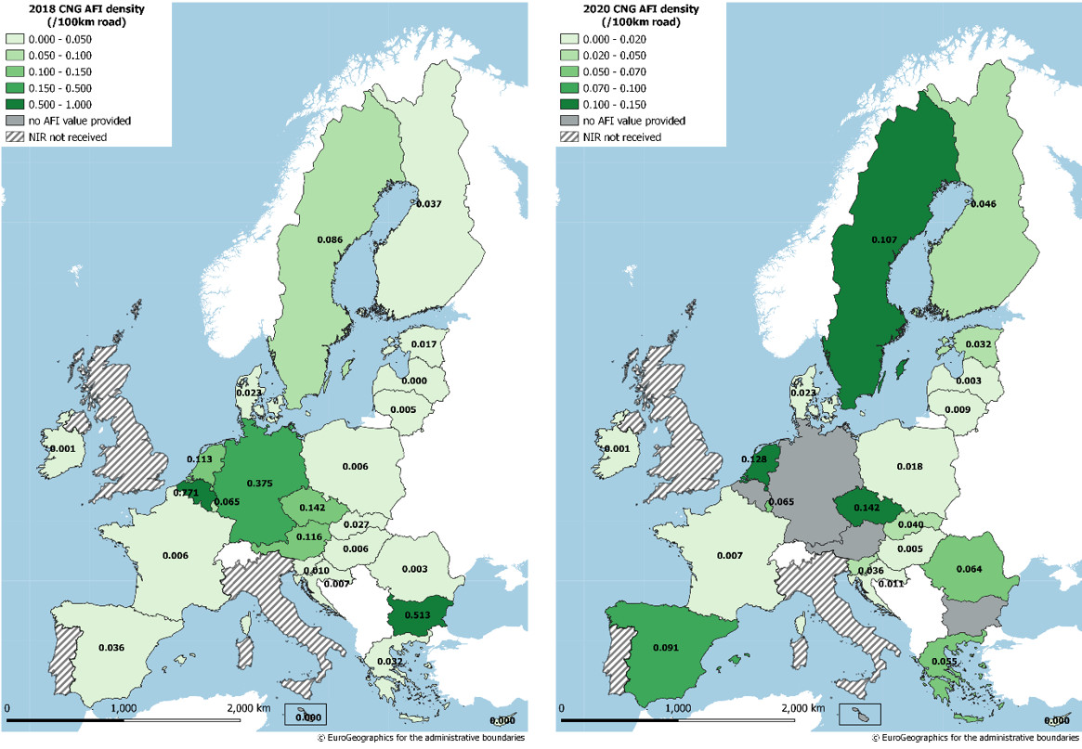

*Figure 4.1.1‑15 Density of publicly accessible CNG refuelling points in 2018 (left map) and estimated for 2020 (from the NIRs) (right map)*

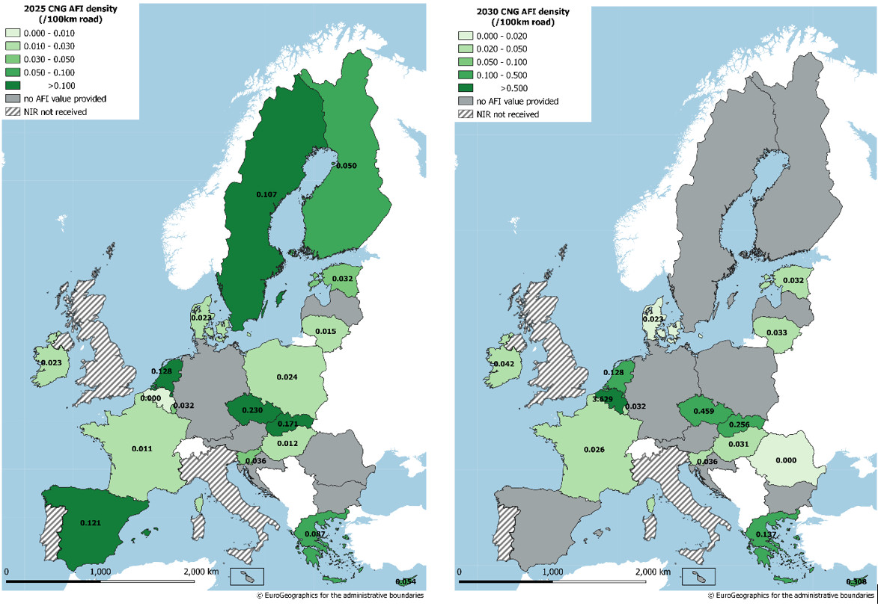

*Figure 4.1.1‑16 Estimated density of publicly accessible CNG refuelling points (from the NIRs) in 2025 (left map) and in 2030 (right map)*

**Sufficiency Index (Ratio AFV/AFI)**

From NIR data, it is possible to compute the ratio of CNG vehicles and publicly accessible CNG refuelling points for 13 MSs for the 2020-2030 decade, overall in 32 cases compared with the NPF that allowed 27. For 2020, the ratio can be computed for 11 MSs and ranges from 50.71 (Denmark) to 597.69 (Hungary), with 10 MSs situated below 400 and 1 MS in between 400 and 800. For 2025, the ratio can be computed for 12 MSs and ranges from 89.53 (Denmark) to 612.37 (Hungary), with 7 MSs situated below 400 and 5 MSs in between 400 and 800. For 2030, the 9 computable ratios range from 77.23 (Czechia) to 1,086.67 (Belgium), with 5 MSs situated below 400, 3 MSs in between 400 and 800, and 1 MS above 800.

The maps in Figure 4.1.1‑17 and Figure 4.1.1‑18 show the evolution of the sufficiency index for CNG/road in 2018, 2020, 2025 and in 2030 (according to the estimates and targets provided in the NIRs).

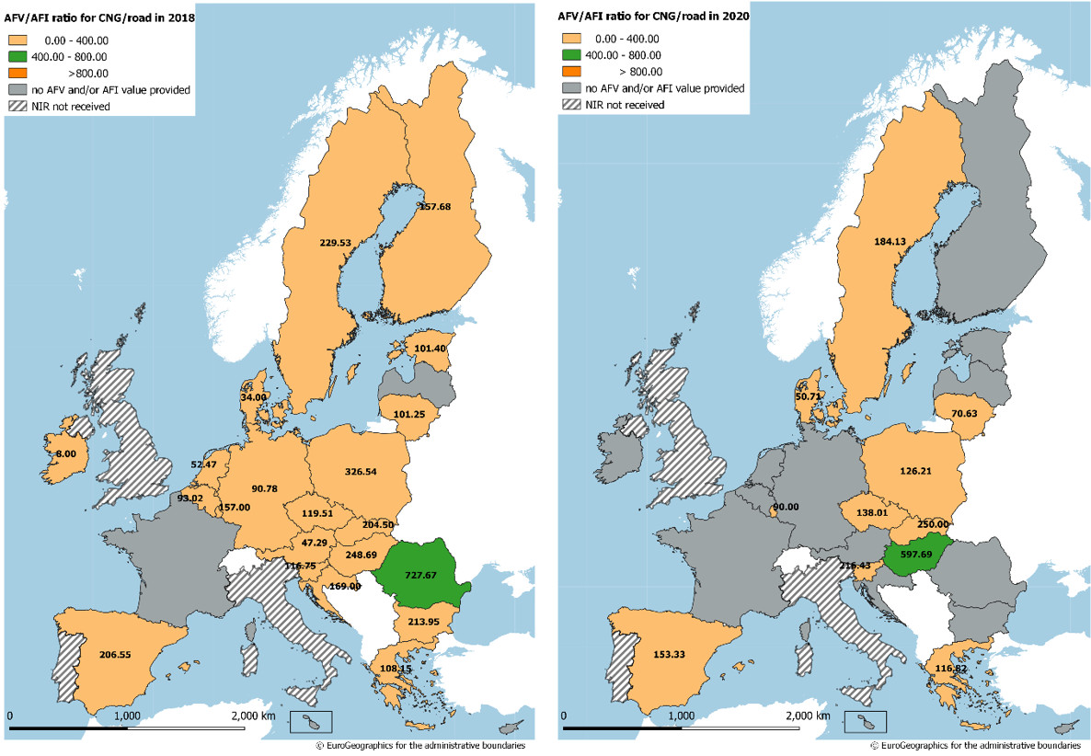

*Figure 4.1.1‑17 Ratio AFV/AFI (sufficiency index) for CNG/road in 2018 (left map) and estimated for 2020 (from the NIRs) (right map)*

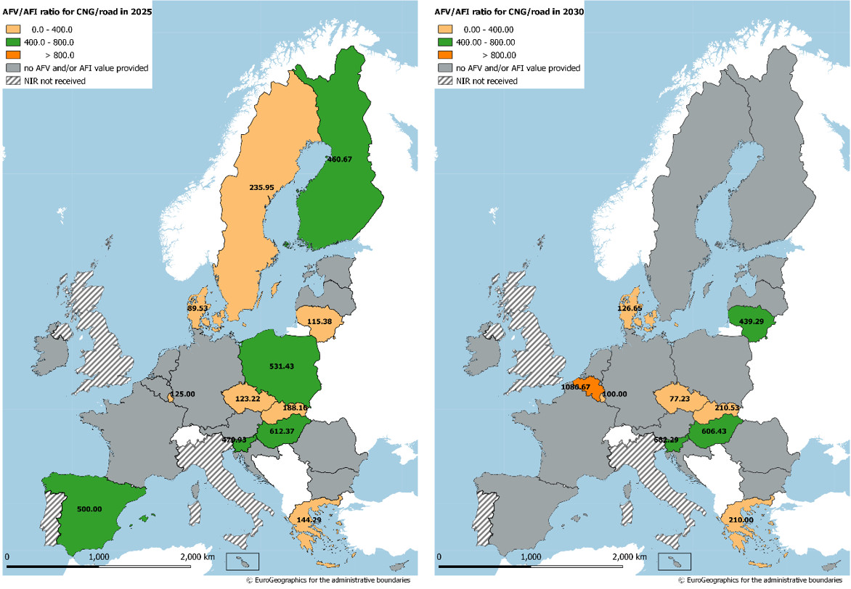

*Figure 4.1.1‑18 Estimated ratio AFV/AFI (sufficiency index) for CNG/road (from the NIRs) for 2025 (left map) and for 2030 (right map)*

Looking at these data from an EU-wide point of view, the results shown in the following table are obtained (the results for 2020 and 2025 are clearly less representative than for 2018):

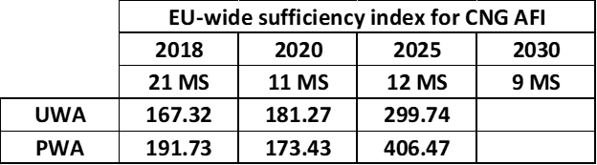

**Measures**

The pair CNG/road is the second most covered in terms of dedicated measures by the majority of MSs. Compared to the electricity/road pair, for which a full commitment and positive outlook are shown by almost all MSs (although with important differences in absolute terms), the pair CNG/road presents a more articulated and MS-differentiated scenario:

* The **legal measures**’ level of ambition in the NIR vs. NPF has increased for 12 MSs out of the 25 NIRs assessed.
* Concerning the **policy and deployment & manufacturing support measures**, 22 MSs have reported assessable clusters of measures. Of these, only 4 clusters have obtained a high overall score, 14 clusters have obtained a medium score, 2 clusters a low/medium score and 2 a low score. Ten clusters are comprehensive, while the others are not comprehensive. In terms of expected impact of these measures to support the realisation of the AFV/AFI objectives as presented in the NPF and revised in the NIR, only 2 clusters are assessed as having a high level impact (Finland and Ireland), 8 a medium level and 12 a low impact. Regarding the ambition in the NIR vs. NPF, an increased level has been found in 17 cases.
* In seventeen cases, the ambition of **RTD&D measures** targeting CNG/road in the NIRs could be determined, and among these 10 measure sets show an increased ambition compared to the NPF situation.

#### LNG

Figure 4.1.1‑19 summarises the information for the LNG vehicle estimates and targeted publicly accessible refuelling points as provided in the NIRs for the next decade as well as the 2016 and 2018 situation.

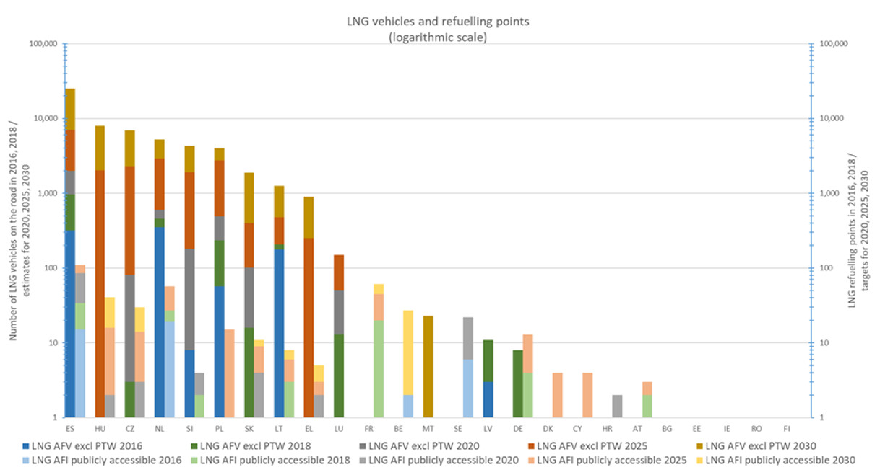

*Figure 4.1.1‑19 LNG vehicle estimates and refuelling points targets for 2020, 2025 and 2030*

With LNG, the level of coverage by the MSs starts to decrease and does not allow to provide averages at EU-wide level.

**LNG vehicles**

* **(Coverage)** Thirteen MSs (out of 25) have provided at least some historical data (2016-2018). Among these, three MSs have declared zero LNG vehicles up to 2018. This means that 10 out of 25 MSs have declared LNG vehicles in 2018 (40%). Eleven MSs have declared at least one target for the decade 2020-2030 (44%).
* **(Change)** In the NPFs, there were only 7 MSs having at least one target. Comparing with NIR data, it results that the change is computable for 7 MSs and only 14 changes can be determined. Out of these 14 computable changes, 3 have provided less ambitious LNG vehicle estimates in the NIR compared to the NPF (1 MS in 2020). Seven changes indicate the same ambition as NPF (2 MSs in 2020) and 4 changes show increased ambition (2 MSs in 2020). In other 15 cases, an estimate was provided only in the NIR and the changes could not be computed.
* **(Attainment)** The 2018 attainment of the foreseen LNG vehicle estimates is computable for eight MSs, with 24 attainment values as result. They range significantly across MSs from 2.5% (Czechia) to 100% (Lithuania) for 2020, from 0.09% (Czechia) to 42.95% (Lithuania) for 2025, and from 0.03% (Czechia) to 16.53% (Lithuania) for 2030.
* **(Progress)** Comparing the 2016-2018 LNG vehicle fleet evolution with their 2016-2030 foreseen evolution, the progress was computed for 11 MSs and it ranges from 0.00% (Slovenia) to 8.05% (Luxembourg).

**LNG refuelling points**

* **(Coverage)** Fifteen MSs (out of 25) have provided at least some historical data (2016-2018). Among these, six MSs have declared zero LNG infrastructure in 2018. This means that 9 out of 25 MSs have declared LNG infrastructure by 2018 (36%). Nineteen MSs have declared at least one target for the decade 2020-2030 (76%).
* **(Change)** The NIR and NPF data allows computing 24 changes corresponding to 2020-2030 period, for 13 MSs. There are 3 decreasing changes (1 in 2020), 14 situations with the same ambition (4 in 2020) and 7 with increased ambition (2 in 2020). In other 11 cases, a target was provided only in the NIR and the changes could not be computed.
* **(Attainment)** The 2018 attainment of the foreseen LNG AFI targets is computed for 11 MSs and 20 determined attainment values result. They range across MSs from 27.27% (Sweden) to 66.67% (Finland) For 2020, from 7.14% (Czechia) to 100% (Austria) for 2025, and from 3.33% (Czechia) to 48.78% (France) for 2030.
* **(Progress)** Comparing the 2016-2018 LNG AFI evolution with their 2016-2030 foreseen evolution, four progress values are determined. They range from 3.33% (Czechia) to 47.50% (France).

**Measures**

* The level of NIR’s ambition vs NPF for legal and RTD&D measures is assessed for 21 and 17 MSs respectively, and for the majority of them the level is increased (14 and, 9 respectively).
* From the 17 NIRs offering assessable data regarding policy and deployment measures, only two have a high score and none of them displays a high impact. The ambition level is predominantly increased (13 MS).

#### Hydrogen

Figure 4.1.1‑20 summarises the information for the hydrogen vehicle estimates and targeted publicly accessible refuelling points as provided in the NIRs for the next decade as well as the 2016 and 2018 situation.

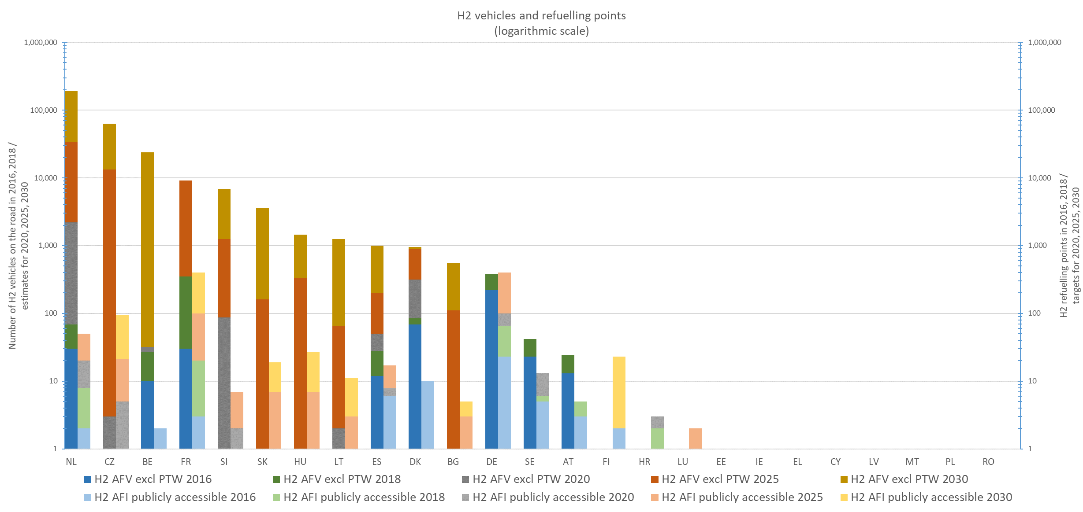

*Figure 4.1.1‑20 Hydrogen vehicle estimates and refuelling points targets for 2020, 2025 and 2030*

**Hydrogen vehicles**

* **(Coverage)** Ten MSs (out of 25) have provided positive values for hydrogen vehicles in 2018 (40%). The other 13 MSs have declared zero hydrogen vehicles and 2 have not reported anything. Twelve MSs have declared at least one positive estimate for the decade 2020-2030 (48%).
* **(Change)** The NPF and NIR data allow change computing for only 6 MSs. Two MSs have provided less ambitious AFI estimates in their NIR compared to the NPF (Bulgaria and Spain). Other three MSs have practically confirmed their initial NPF plans, while Hungary increased its ambition for 2025 and 2030. In other 20 cases, an estimate was provided only in the NIR and the changes could not be computed.
* **Attainment** The 2018 attainment of the foreseen hydrogen vehicle estimates are computed for 6 MSs and 17 attainment values result. For 2020, they range significantly across MSs from 3.13% (Netherlands) to more than 100% (France), from 0.01% (Czechia) to 14% (Spain) for 2025 and from less than 0.01% (Czechia) to 8.91% (Denmark) for 2030. For one Member State (Sweden), the attainment is not computed since all the future estimates are below the 2018 value.
* **Progress** Comparing the 2016-2018 hydrogen vehicles evolution with the 2016-2030 foreseen evolution, five progress values are determined. They range from 0.00% (Czechia) to 1.81% (Denmark). For one Member State (Sweden), the progress is not computed since the 2030 estimated value is below the 2018 existing one.

**Hydrogen refuelling points**

* **(Coverage)** Seventeen MSs (out of 25) have provided at least some historical data (2016-2018) in their NIRs. Among these, nine MSs have declared zero hydrogen infrastructure in 2018. This means that 8 out of 25 MSs have declared hydrogen infrastructure by 2018 (32%). Seventeen MSs have declared at least one target for the decade 2020-2030, but two of them have declared only targets of zero. This means that 15 out of 25 MSs have set hydrogen infrastructure targets above zero by 2030 (60%).
* **(Change)** Ten MSsallow the change computing. Two MSs have decreased their targets (Bulgaria and Spain). Four of them preserve the NPF target values and therefore the change values are zero. The remaining four have shown an increase of their ambition, significant in three cases: Netherlands (in 2020) and Czechia (in 2025), both with 400% change values, and France with 233% in 2025. In other 15 cases, a target was provided only in the NIR and the changes could not be computed.
* **(Attainment)** The 2018 attainment of the foreseen hydrogen refuelling points are computed for 8 MSs and 15 attainment values. For 2020, they range across MSs from 46.15% (Sweden) to 100% (Austria), from 14.29% (Slovenia) to 46.15% (Sweden) for 2025 and from 5.00% (France) to 14.29% (Slovenia) for 2030. One Member State (Denmark) foresees a decreasing trend of its hydrogen refuelling points in the future.
* **(Progress)** Only two progress values are calculated (France and Slovenia).

**Measures**

The pair hydrogen/road shows an increased interest from the MSs.

* The level of NIR’s ambition vs NPF for legal and RTD&D measures is assessed for 13 MSs and for the majority of them the level is increased (10 and 11 respectively).
* For this pair, 21 NIRs contain data regarding policy, and deployment and manufacturing support measures. Three measure packages are assessed with high score (Czechia, Germany and Croatia), nine are comprehensive but only one receives a high level impact (Germany). An indicator of the increased interest is the fact that 18 NIRs from 21 have an increased ambition level in the comparison with the NPF.

#### LPG

Figure 4.1.1‑21 summarises the information for the LPG vehicle estimates and targeted publicly accessible refuelling points as provided in the NIRs for the next decade as well as the 2016 and 2018 situation.

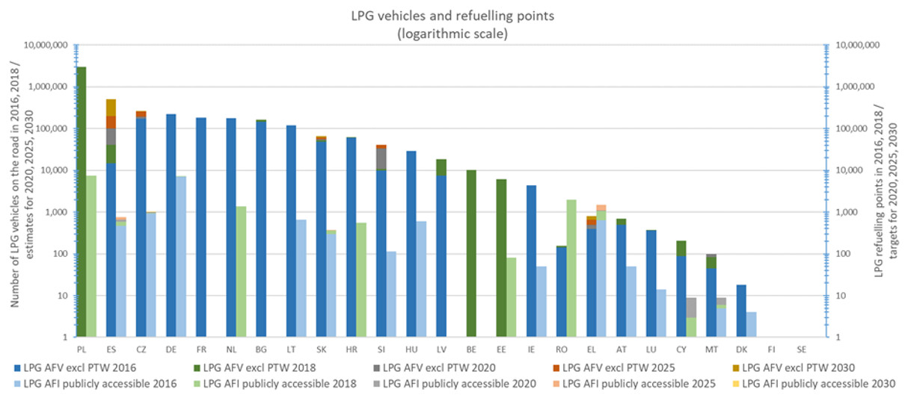

*Figure 4.1.1‑21 LPG vehicle estimates and refuelling points targets for 2020, 2025 and 2030*

**LPG vehicles**

- **(Coverage)** Twenty MSs out of 25 (80%) have provided at least some historical data (2016-2018). Nine MSs (44%) have declared at least one vehicle estimate for the decade 2020-2030.

- **(Change)** Because only 4 MSs had estimates for the future in the NPF, only these MSs allow change computing. Slovenia preserves its estimates while Greece and Estonia are decreasing their ambition. Malta shows a slight increase in 2020 followed by decreases in 2025 and 2030. In other 16 cases, an estimate was provided only in the NIR and the changes could not be computed.

- **(Attainment)** The 2018 attainment of the foreseen LPG vehicle estimates is computed for 6 MSs, resulting 18 attainment values. They range across EU from 32.05% (Slovenia) to 94.06% (Slovakia) for 2020, from 20.54% (Spain) to 85.58% (Slovakia) for 2025, and from 8.22% (Estonia) to 83.00% (Malta) for 2030. Two Member States (Denmark and France) foresee a decreasing trend of their LPG vehicle fleets in the future.

- **(Progress)** Comparing the 2016-2018 LPG vehicles evolution with the 2016-2030 foreseen evolution, six progress values are determined. They range from -14.33% (Greece)[1] to 69.09% (Malta). For two Member States (Denmark and France), the progress is not computed since they foresee a decreasing trend of their LPG vehicle fleets in the future.

**LPG refuelling points**

- **(Coverage)** Seventeen MSs out of 25 (68%) have provided at least some historical data (2016-2018). Nine MSs (44%) have declared at least one target for the decade 2020-2030.

- **(Change)** Because only four MSs had provided targets for the future in the NPF, only these MSs allow change computing.Excepting Greece that preserved in NIR the NPF targets, Spain, Cyprus and Hungary have decreased their targets. In other 13 cases, a target was provided only in the NIR and the changes could not be computed.

- (**Attainment)** The 2018 attainment of the foreseen LPG refuelling points targets is computed for 6 MSs, resulting 12 attainment values. They range across EU from 25.00% (Cyprus) to 100% (Slovakia) for 2020, from 70.00% (Greece) to 99.18% (Slovakia) for 2025, and from 94.53% (Czechia) to 99.18% (Slovakia) for 2030. Three Member States (Denmark, Lithuania and Hungary) foresee a decreasing trend of their LPG refuelling infrastructure in the future decade.

- **(Progress)** Only two progress values are calculated (Czechia and Slovakia).

**Measures**

* The level of NIR’s ambition vs NPF for legal measures is assessed for 5 MSs, and for two of them the level is increased.
* From the seven NIRs containing assessable policy and deployment & manufacturing support measures for this cluster, only ES had a medium score and a medium level of impact, the rest have low level impact. The level of ambition is similar to the one in the NPF for four NIRs.
* The level of NIR’s ambition vs NPF for RTD&D measures is assessed for 3 MSs, and for two of them the level is considered increased.

### Rail transport

#### Electricity

**AFV**

Six MSs[2] have provided in their NIRs the existing numbers of locomotives in the period 2016-2018 and at least one estimate for the next decade.

Four MSs[3] have provided only the existing numbers of locomotives.

#### Hydrogen

**AFV**

Germany has reported the existence of two hydrogen locomotives in 2018, while France, the Netherlands and Slovakia have announced plans for 15, 1 and 10 hydrogen locomotives, respectively within the next decade.

### Waterborne transport (maritime and inland)

#### Electricity

**AFI**

Around 50% of the MSs that should have reported about the shore-side electricity supply infrastructure for their maritime ships have actually done so. This percentage becomes 60% for the waterborne inland transport. The data provided by the MSs in their NIRs are summarised in the following diagram.

Figure 4.1.3‑1 summarises the information for the shore-side electricity supply for waterborne transport (maritime and inland) as provided in the NIRs for the next decade as well as the 2016 and 2018 situation.

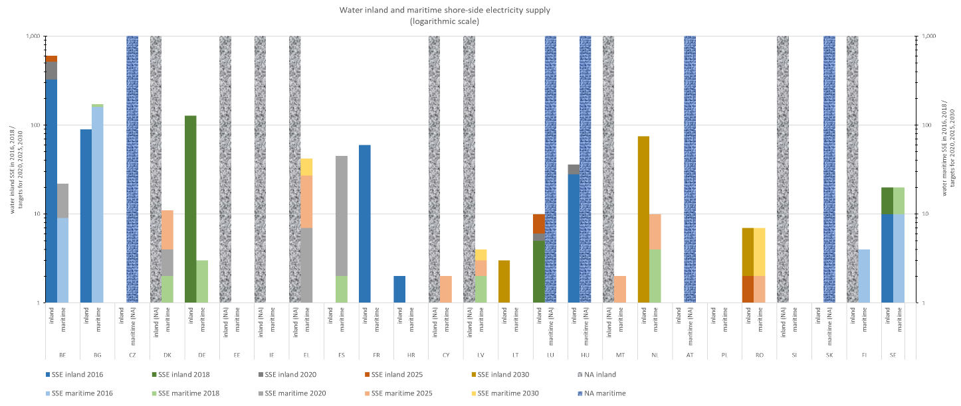

*Figure 4.1.3‑1 Shore-side electricity supply targets for 2020, 2025 and 2030 (maritime and inland waterborne transport)*

#### LNG

**AFI**

Around 50% of the MSs that should have reported about the LNG supply infrastructure for their maritime ships have actually done so. This percentage becomes 60% for the waterborne inland transport. The data provided by the MSs in their NIRs are summarised in the following diagram.

Figure 4.1.3‑2 summarises the information for the LNG refuelling supply for waterborne transport (maritime and inland) as provided in the NIRs for the next decade as well as the 2016 and 2018 situation.

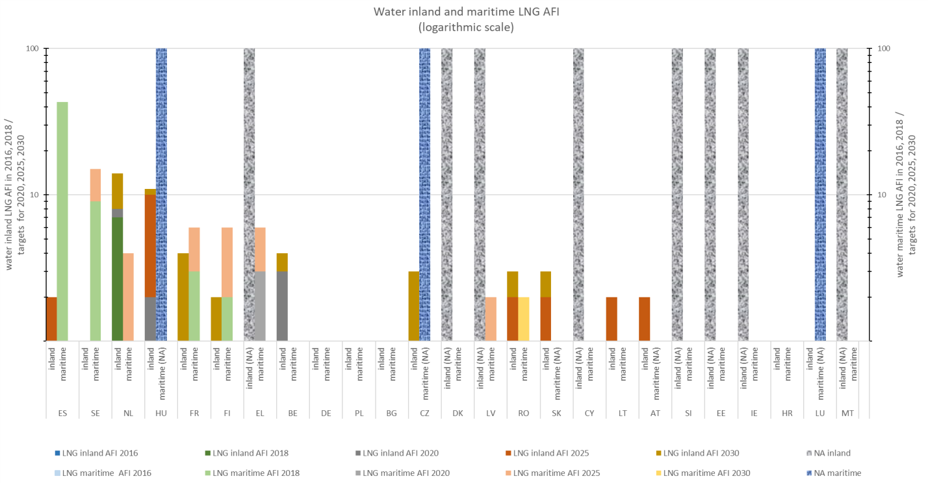

*Figure 4.1.3‑2 LNG refuelling supply targets for 2020, 2025 and 2030 (maritime and inland waterborne transport)*

### Air transport

#### Electricity

**AFI (electricity supply for stationary airplanes)**

Eight MSs[4] have provided in their NIRs the existing numbers of electricity supply for stationary airplanes in the period 2016-2018 and at least one estimate for the next decade.

Two MSs[5] have provided only the existing numbers of electricity supply for stationary airplanes.

Changes could be computed for only three MSs: Luxembourg has increased its targets and Netherlands and Austria have similar targets as in the NPF.

## Strengthening EU competitiveness and jobs

### Method to assess the strengthening of the EU's competitiveness and jobs

A computational model was developed for calculating the value creation and employment effects resulting from AFI build-up as described in the NPFs and revised in the NIRs. It outputs Member States' domestic as well as the EU-wide effects resulting from infrastructure production and installation. Types of infrastructure covered by the model include electricity recharging points and CNG, LNG and hydrogen refuelling points for road transport.

* + - 1. Calculating the Gross Value Added (GVA) through AFI build-up

Figure 4.2.1‑1 shows a model flowchart for the calculation of the domestic economic effects of recharging point build-up in a Member State. The calculations are intended to cover the period 2019-2030 by considering three sub-periods dictated by the years for which targets were requested by the Directive (i.e. 2019-2020, 2021-2025 and 2026-2030) and they are adapted to the AFI targets provided by the Member States. For each infrastructure type, Member State and sub-period, AFI build-up targets are derived in a first step, calculated as the target number of recharging or refuelling points for each requested year (2020, 2025 and 2030) minus the previously built or targeted number as given in the NIR[6] (for example 2020-2018, or 2025-2020, or 2030-2025). Summed over Member States, the number of total planned AFI of each type in the EU is obtained. AFI build-up is assumed to be linear for each sub-period in the model.

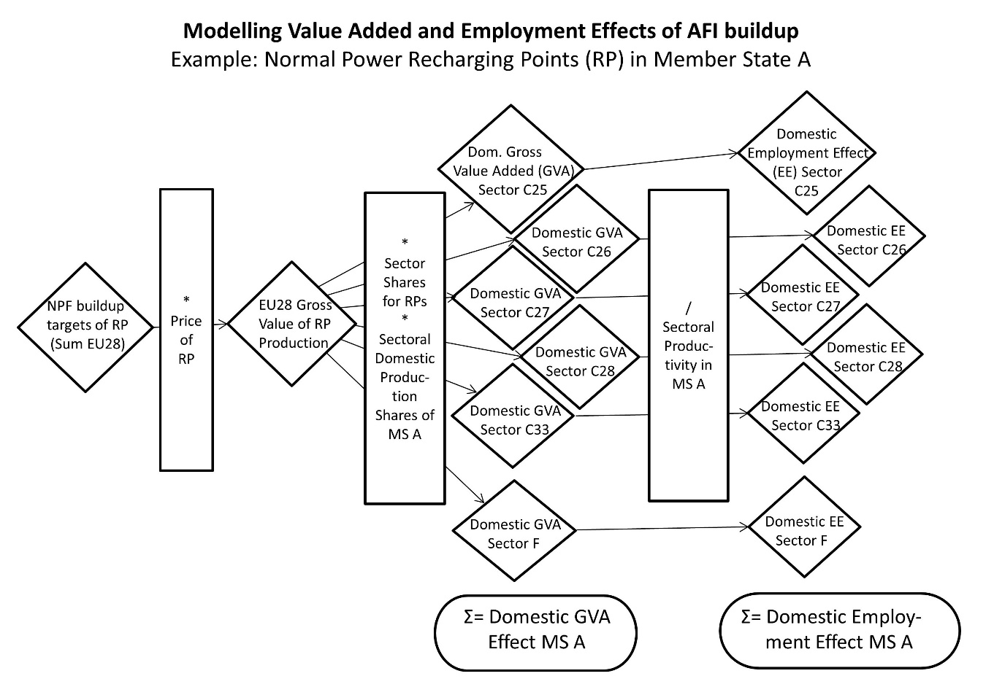

*Figure 4.2.1‑1 Flowchart of Added Value and Employment Calculation*

Annual numbers of new AFI installed are multiplied by their net market prices to derive the Gross Value of Production (GVP). As the market price of a technology includes all value added along the value chain, it is a reasonable proxy for the calculation of gross value of production added.

In a next step, the share of each Member State in the production and installation of AFI needs to be determined, and imports from outside the EU need to be deducted. As the share of imported preliminary products differs among economic sectors, the GVP is sub-split. This is done by assigning the different technological components of an AFI installation (and thus their costs) to different economic sectors, on the basis of data on the composition and prices of the different AFI types. Price information was taken from studies and industry sources (Steer Davies Gleave, 2016), (Ludwig-Bölkow-Systemtechnik, 2016), (Nationale Plattform Elektromobilität (NPE), 2015), (European Commission, 2020). AFI GVP is assigned to the following sectors (in line with Eurostat NACE Rev. 2):

**Table 4.2.1‑1 Economic Sectors Considered**

|  |  |  |  |  |  |  |
| --- | --- | --- | --- | --- | --- | --- |
| Sector | Fabricated metal products, except machinery and equipment | Computer, electronic and optical products | Electrical equipment | Machinery and equipment n.e.c. | Repair and installation services of machinery and equipment | Constructions and construction works |
| Eurostat Sector Number | C25 | C26 | C27 | C28 | C33 | F |

For each of these sectors, the sectoral GVP is multiplied by the sectoral domestic production share, yielding the sectoral domestic GVA for each of the six sectors for the AFI type and Member State under consideration. By default, the sectoral domestic share in AFI production in each Member State is assumed to be equal to the Member State's present sectoral share of production value within the EU, which is derived from Eurostat data[7]. The model allows reallocating domestic production shares as well as import shares from outside the EU for scenario analysis.

The national GVA effect resulting in the sectors C25, C26, C27 and C28 from the production is allocated completely (adjusted by preliminary imports) to the producing country. The costs of installing a recharging or refuelling point, occurring in sectors C33 and F, is divided into a GVA effect in the producing country and the country that installs the infrastructure.

Summing over the sectors, the Member States' domestic GVA effect from the particular infrastructure type results. For each Member State, total sectoral GVA effect includes the domestic effect of own AFI installation and the Member States exports of preliminary products for AFI installation to other EU countries. The sum over all AFI types per Member State is the total national GVA effect from the EU-wide implementation of AFI targets as envisaged in the NPFs and revised in the NIRs, and the sum over all Member States yields the EU-wide effect. AFI maintenance costs are included via a multiplier representing annual costs as percentage of total investment per facility.

* + - 1. Calculating the employment effect of AFI build-up

As shown in Figure 4.2.1‑1, the employment effect of building a given type of infrastructure in each Member State is derived from domestic GVA per sector, dividing it by productivity. This yields the amount of person-years required to build the AFI envisaged in the NPF and revised in the NIR, which is assumed to translate into employment.

As labour productivity varies for each Member State and sector, this calculation is done on sectoral level. Data on the number of persons employed in the production of AFI is not available, thus productivities in the sectors contributing to AFI build-up (see Table 4.2.1‑1) were used. These were derived by dividing each Member State's sectoral gross value added by the number of employed persons, both taken from Eurostat[8].

The domestic employment effect is derived by aggregating over all sectors, and the EU-wide effect by then aggregating over all Member States.

* + - 1. Sensitivities and scenario analysis

The model allows for running scenarios on a wide number of parameters. These include, for example:

* The allocation of AFI production and installation, intra-EU and international,
* Technology costs and sectoral shares,
* Technology types, e.g. normal power (≤22kW) vs. high power (>22kW) recharging points, number of points per recharging or refuelling station, etc.,
* The time frame of AFI build-up, and
* Labour productivity.

### Assessment of the strengthening of the EU's competitiveness and jobs

The effects of AFI infrastructure build-up were calculated using the model described above (subsection 4.2.1). The model was run using AFI build-up targets for the different road transport AFI types (recharging points, CNG, LNG and hydrogen refuelling points) for the periods 2019-2020, 2021-2025 and 2026-2030. Table 4.2.2‑1 shows the EU-wide value added and additional labour demand that can be achieved by fulfilling the targets for publicly accessible recharging points and CNG, LNG and hydrogen refuelling points for the next decade provided by the Member States in their NPF and revised in the NIR[9]. The total value-added until 2030 sums up to more than 16 billion € with annual effects ranging from roughly 360 to 2,800 million €. The economic effect is strongest for the period 2026-2030, as the Member States foresee a significant increase of the number of AFI towards the end of the decade. The annual effects for the 2021-2025 period are smaller since several MSs did not provide targets for the year 2025 (in this case, if a target is provided for 2030, the model considers that all infrastructure build-up and the associated economic benefits related to the 2030 target take place in the period 2026-2030).

Table 4.2.2‑1 Gross Value Added (GVA) and Employment Effects of Implementing the AFI targets for each year between 2019 and 2030



The total effect on labour demand amounts to roughly 247,000 person-years until 2030, again with higher effects of around 40,000 persons per year during the last period 2026-2030. Additional employment effects could be triggered by the substantial deployment of private recharging points that several MSs refer to in their NPF/NIR, but are not considered in this analysis. In conclusion, a consistent EU-wide build-up of alternative fuels infrastructure could trigger a sustained positive employment effect, and could contribute to translating the temporary extra labour demand resulting from NPFs and NIRs into permanent jobs. Moreover, the respective qualification of workforce, which is more likely to occur in the presence of longer-term targets, can support the maintenance or increase of domestic shares in AFI production and installation. This again can have a positive impact on the EU sector's competitiveness.

1. The negative value of progress for Greece means that a decreased number of LPG vehicles was recorded between 2016 and 2018, however an increase of LPG vehicles above the value recorded in 2016 is estimated for the next decade.
2. Belgium, Czechia, Denmark, Lithuania, Hungary and Romania
3. Germany, Greece, Austria and Sweden
4. Bulgaria, Greece, Spain, Lithuania, Luxembourg, Netherlands, Austria and Romania
5. Ireland and Hungary
6. Or in the NPF or EAFO, if absent in the NIR
7. Total imports and EU-internal imports for each Member State are available from Eurostat at <http://appsso.eurostat.ec.europa.eu/nui/show.do?wai=true&dataset=nama_10_exi>, input-output tables for all member states based on <http://ec.europa.eu/eurostat/de/web/esa-supply-use-input-tables/data/workbooks>.
8. Annual enterprise statistics for special aggregates, http://ec.europa.eu/eurostat/data/database.
9. A comparison with the results obtained in the NPF assessment is not performed since those results correspond to 28 MSs while the current analysis addresses 25 MSs.