

Table of Contents

5 Full assessment of Member States' NIRs 78

5.0 Assessment of the Member States National Implementation Reports (NIR) 78

5.0.1 Structure of the assessment report 78

5.0.2 Main messages from the Commission assessment of the NPF 79

5.0.3 Overview of requirements’ fulfilment from Annex I of the Directive 79

5.0.4 Quantitative assessment: Vehicles and infrastructure 81

5.0.5 Measures assessment 84

5.0.6 Additional information on alternative fuels infrastructure developments 85

5.0.7 Summary of the assessment 85

5.0.8 Final remarks 87

5.0.9 ANNEX: Description of the Member State 87

5.1 Belgium (BE) 88

5.1.1 Main messages from the Commission assessment of the NPF 88

5.1.2 Overview of requirements’ fulfilment from Annex I of the Directive 89

5.1.3 Quantitative assessment: Vehicles and infrastructure 90

5.1.4 Measures assessment 97

5.1.5 Additional information on alternative fuels infrastructure developments 101

5.1.6 Summary of the assessment 102

5.1.7 Final remarks 105

5.1.8 ANNEX - Description of the Member State 106

5.2 Bulgaria (BG) 108

5.2.1 Main messages from the Commission assessment of the NPF 108

5.2.2 Overview of requirements’ fulfilment from Annex I of the Directive 110

5.2.3 Quantitative assessment: Vehicles and infrastructure 112

5.2.4 Measures assessment 119

5.2.5 Additional information on alternative fuels infrastructure developments 123

5.2.6 Summary of the assessment 124

5.2.7 Final remarks 126

5.2.8 ANNEX - Description of the Member State 128

5.3 Czechia (CZ) 130

5.3.1 Main messages from the Commission assessment of the NPF 130

5.3.2 Overview of requirements’ fulfilment from Annex I of the Directive 131

5.3.3 Quantitative assessment: Vehicles and infrastructure 132

5.3.4 Measures assessment 139

5.3.5 Additional information on alternative fuels infrastructure developments 142

5.3.6 Summary of the assessment 143

5.3.7 Final remarks 146

5.3.8 ANNEX - Description of the Member State 148

5.4 Denmark (DK) 150

5.4.1 Main messages from the Commission assessment of the NPF 150

5.4.2 Overview of requirements’ fulfilment from Annex I of the Directive 151

5.4.3 Quantitative assessment: Vehicles and infrastructure 153

5.4.4 Measures assessment 160

5.4.5 Additional information on alternative fuels infrastructure developments 163

5.4.6 Summary of the assessment 164

5.4.7 Final remarks 167

5.4.8 ANNEX - Description of the Member State 168

5.5 Germany (DE) 169

5.5.1 Main messages from the Commission assessment of the NPF 169

5.5.2 Overview of requirements’ fulfilment from Annex I of the Directive 170

5.5.3 Quantitative assessment: Vehicles and infrastructure 173

5.5.4 Measures assessment 181

5.5.5 Additional information on alternative fuels infrastructure developments 186

5.5.6 Summary of the assessment 187

5.5.7 Final remarks 190

5.5.8 ANNEX - Description of the Member State 192

5.6 Estonia (EE) 194

5.6.1 Main messages from the Commission assessment of the NPF 194

5.6.2 Overview of requirements’ fulfilment from Annex I of the Directive 195

5.6.3 Quantitative assessment: Vehicles and infrastructure 196

5.6.4 Measures assessment 202

5.6.5 Additional information on alternative fuels infrastructure developments 205

5.6.6 Summary of the assessment 206

5.6.7 Final remarks 208

5.6.8 ANNEX - Description of the Member State 210

5.7 Ireland (IE) 211

5.7.1 Main messages from the Commission assessment of the NPF 211

5.7.2 Overview of requirements’ fulfilment from Annex I of the Directive 213

5.7.3 Quantitative assessment: Vehicles and infrastructure 214

5.7.4 Measures assessment 221

5.7.5 Additional information on alternative fuels infrastructure developments 227

5.7.6 Summary of the assessment 228

5.7.7 Final remarks 231

5.7.8 ANNEX - Description of the Member State 232

5.8 Greece (EL) 233

5.8.1 Main messages from the Commission assessment of the NPF 233

5.8.2 Overview of requirements’ fulfilment from Annex I of the Directive 235

5.8.3 Quantitative assessment: Vehicles and infrastructure 237

5.8.4 Measures assessment 243

5.8.5 Additional information on alternative fuels infrastructure developments 246

5.8.6 Summary of the assessment 246

5.8.7 Final remarks 249

5.8.8 ANNEX - Description of the Member State 251

5.9 Spain (ES) 252

5.9.1 Main messages from the Commission assessment of the NPF 252

5.9.2 Overview of requirements’ fulfilment from Annex I of the Directive 253

5.9.3 Quantitative assessment: Vehicles and infrastructure 255

5.9.4 Measures assessment 264

5.9.5 Additional information on alternative fuels infrastructure developments 270

5.9.6 Summary of the assessment 271

5.9.7 Final remarks 274

5.9.8 ANNEX - Description of the Member State 276

5.10 France (FR) 277

5.10.1 Main messages from the Commission assessment of the NPF 277

5.10.2 Overview of requirements’ fulfilment from Annex I of the Directive 279

5.10.3 Quantitative assessment: Vehicles and infrastructure 280

5.10.4 Measures assessment 289

5.10.5 Additional information on alternative fuels infrastructure developments 296

5.10.6 Summary of the assessment 297

5.10.7 Final remarks 300

5.10.8 ANNEX - Description of the Member State 302

5.11 Croatia (HR) 303

5.11.1 Main messages from the Commission assessment of the NPF 303

5.11.2 Overview of requirements’ fulfilment from Annex I of the Directive 304

5.11.3 Quantitative assessment: Vehicles and infrastructure 306

5.11.4 Measures assessment 312

5.11.5 Additional information on alternative fuels infrastructure developments 316

5.11.6 Summary of the assessment 316

5.11.7 Final remarks 319

5.11.8 ANNEX - Description of the Member State 321

5.12 Italy (IT) 322

5.13 Cyprus (CY) 323

5.13.1 Main messages from the Commission assessment of the NPF 323

5.13.2 Overview of requirements’ fulfilment from Annex I of the Directive 325

5.13.3 Quantitative assessment: Vehicles and infrastructure 326

5.13.4 Measures assessment 331

5.13.5 Additional information on alternative fuels infrastructure developments 334

5.13.6 Summary of the assessment 335

5.13.7 Final remarks 337

5.13.8 ANNEX - Description of the Member State 339

5.14 Latvia (LV) 340

5.14.1 Main messages from the Commission assessment of the NPF 340

5.14.2 Overview of requirements’ fulfilment from Annex I of the Directive 341

5.14.3 Quantitative assessment: Vehicles and infrastructure 342

5.14.4 Measures assessment 348

5.14.5 Additional information on alternative fuels infrastructure developments 351

5.14.6 Summary of the assessment 352

5.14.7 Final remarks 354

5.14.8 ANNEX - Description of the Member State 356

5.15 Lithuania (LT) 357

5.15.1 Main messages from the Commission assessment of the NPF 357

5.15.2 Overview of requirements’ fulfilment from Annex I of the Directive 358

5.15.3 Quantitative assessment: Vehicles and infrastructure 359

5.15.4 Measures assessment 368

5.15.5 Additional information on alternative fuels infrastructure developments 374

5.15.6 Summary of the assessment 374

5.15.7 Final remarks 378

5.15.8 ANNEX - Description of the Member State 380

5.16 Luxembourg (LU) 381

5.16.1 Main messages from the Commission assessment of the NPF 381

5.16.2 Overview of requirements’ fulfilment from Annex I of the Directive 383

5.16.3 Quantitative assessment: Vehicles and infrastructure 385

5.16.4 Measures assessment 391

5.16.5 Additional information on alternative fuels infrastructure developments 394

5.16.6 Summary of the assessment 395

5.16.7 Final remarks 397

5.16.8 ANNEX - Description of the Member State 399

5.17 Hungary (HU) 400

5.17.1 Main messages from the Commission assessment of the NPF 400

5.17.2 Overview of requirements’ fulfilment from Annex I of the Directive 401

5.17.3 Quantitative assessment: Vehicles and infrastructure 402

5.17.4 Measures assessment 410

5.17.5 Additional information on alternative fuels infrastructure developments 413

5.17.6 Summary of the assessment 415

5.17.7 Final remarks 418

5.17.8 ANNEX - Description of the Member State 420

5.18 Malta (MT) 421

5.18.1 Main messages from the Commission assessment of the NPF 421

5.18.2 Overview of requirements’ fulfilment from Annex I of the Directive 423

5.18.3 Quantitative assessment: Vehicles and infrastructure 424

5.18.4 Measures assessment 430

5.18.5 Additional information on alternative fuels infrastructure developments 435

5.18.6 Summary of the assessment 436

5.18.7 Final remarks 439

5.18.8 ANNEX - Description of the Member State 440

# Full assessment of Member States' NIRs

## Assessment of the Member States National Implementation Reports (NIRs)

The following sections present the assessments of each individual NIR[1]. The official date for the submission of the NIRs to the Commission was 18 November 2019. By that date only nine of the expected 28 NIRs had been delivered (by Belgium, Czechia, Germany, Ireland, Greece, Spain, Austria, Poland and Slovakia). Thus, an extension was granted to the remaining MSs to submit their NIRs. By the 1st of May 2020, which was the ultimate date for submitting the missing NIRs, as agreed between the Commission and the Member States, 3 NIRs were still outstanding.

Later, the United Kingdom delivered its NIR in the beginning of September, followed by Portugal. Italy, despite announcing the submission of its NIR by 30 September, had not yet delivered it by the time this document was finalised.

Similarly to the NPF reports, the 25 NIRs received and assessed vary in terms of length (from a minimum of 3 pages to a maximum of 205 pages) and level of detail provided for each of the subsections. However, there is an overall improvement in the consistency of the reports among MSs compared to the NPFs. Several MSs followed more closely the structure of the requirements listed in Annex I of the Directive and the guidance documents provided by the Commission for the reporting. The remaining countries structured their reports differently, with some substantial deviations from both Annex 1 and the guidance documents.

Although the completion and delivery of the Excel® reporting template provided by the Commission was not a mandatory requirement of the Directive, 19 MSs have submitted the template as an annex separate to the report. From the remaining 6 MSs that have not submitted a separate Excel® template, 4 MSs included some tables into the main body of the report.

In conclusion, although there has been an overall improvement in the quality and consistency of the NIRs when compared to the NPFs, there are still several important gaps and flaws in the information reported by the MSs. When there was the suspicion that a NIR presented mistakes, the MS was asked to provide clarification. Unfortunately this was not always feasible and the assessment of some NIRs would not have been possible without filling some gaps, or retrieving additional information. In such circumstances, the assessor would collect the necessary data (for example from the NPF, when such value was not reported in the NIR, or using a value from EAFO[2], when both the NIR and NPF were lacking information), and highlight it in the assessment report. However, this has shifted the burden of the reporting (and the assumptions that underpin such process) onto the Commission.

### Structure of the assessment report

The assessment of the individual NIR is based on the assessment methodology described in Chapter 2 and follows a fixed structure, which consists of:

1. Main messages from the Commission assessment of the NPF
2. Overview of the fulfilment of the requirements in Annex I of the Directive
3. Quantitative assessment: Vehicles and infrastructure
4. Measures assessment
5. Additional information on alternative fuels infrastructure developments
6. Summary of the assessment
7. Final remarks
8. ANNEX: Description of the Member State

Before explaining each point in more detail, it is important to stress that the assessment of the MS NIRs is carried out principally with reference to the Directive and to the respective NPF. This is particularly important when looking at the comparison of the ambition level between NIR and NPF concerning the AFV estimates and AFI targets, and concerning the measures. These assessments are “internal”, in the sense that they refer to what has been presented in the NIR compared to what had been presented in the NPF by the same MS. It would be wrong to make a comparison among Member States based on such considerations. Furthermore, point seven (Final remarks) contains the concluding remarks from the Commission, based on the assessment of the national implementation reports of each Member State. In this section, the Commission might provide some additional comments on the latest development of the European policies on alternative fuels transport systems and infrastructure (for example the Green Deal).

### Main messages from the Commission assessment of the NPF

The NIR assessment reports start with an excerpt from the Commission assessment of the NPFs (European Commission, 2019). This excerpt is the summary of the NPF assessment for each MS and provides the background for a better understanding of how the NIRs relate to the initial plans of the MS, as reported in the NPF.

### Overview of requirements’ fulfilment from Annex I of the Directive

The Directive requested the MSs to prepare and submit their NIRs in accordance with the requirements listed in Annex I. In this second section of the assessment report, a table (the Check List) that looks like Table 5.0.3‑1 shows how each MS complied with this request.

*Table 5.0.3‑1 Checklist Table*

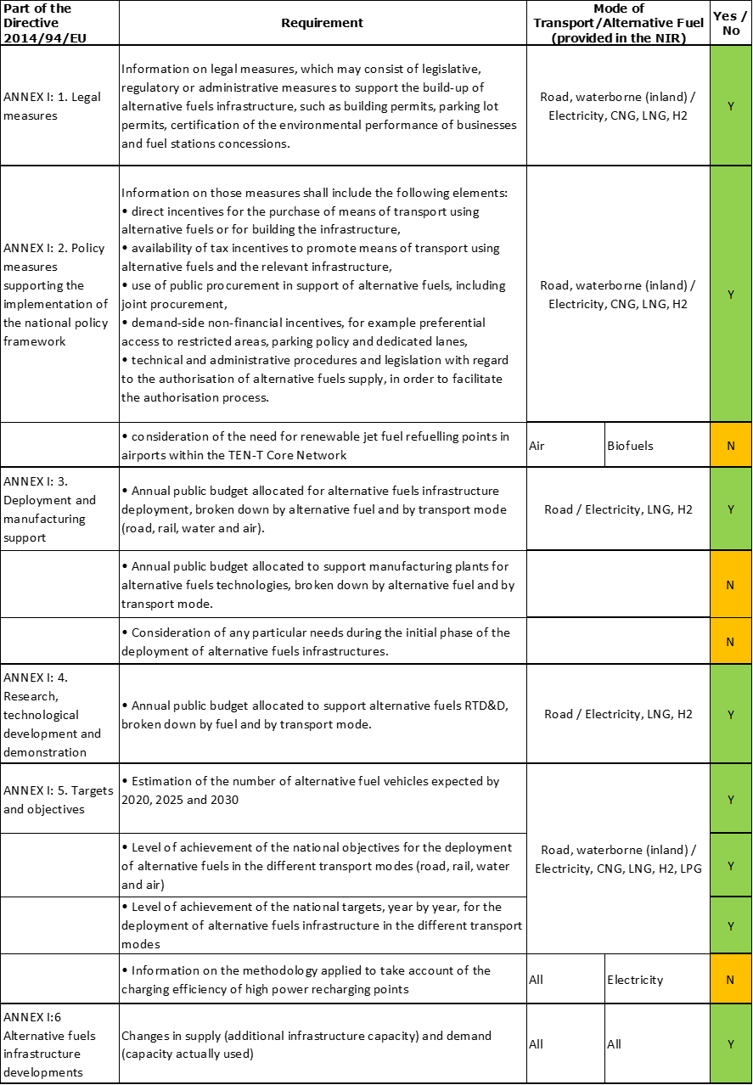

The first two columns report the content of Annex I to the Directive. The third column shows for which transport mode and alternative fuels the MS provided the required information in its NIR. When an alternative fuel or a transport mode is explicitly mentioned in the NIR, then it is mentioned also in column three; when all alternative fuels and/or transport modes are mentioned, this is indicated by the word “All”. If instead in the NIR there was just a generic mention of the AF/transport mode, this is indicated by using the word “Combination” or “AF (in general)”.

Because there was no agreed methodology to assign a score to the level of quality and detail of the information provided, no score is provided here, but only a flag. When at least some information is reported in the third column, in the fourth column there is a “Y or Yes” (on a green background), otherwise there is an “N or No” (on an orange background) [3].

### Quantitative assessment: Vehicles and infrastructure

This section starts with a table that looks like the following:

*Table 5.0.4‑1 National AFV estimates and AFI targets established in one NIR at the horizon 2020, 2025 and 2030 and their comparison with the NPF situation*



For each AF/transport mode pair, the table shows three rows. The first row displays the state of play reported by the MS in the NIR in 2018 for AF vehicles/vessels/locomotives/airplanes (AFV) and for their respective infrastructure (AFI). If the NIR did not report any data but the NPF did, then the latter is shown[4]. Then, the AFV estimates and AFI targets for the years 2020, 2025 and 2030 are also reported as given in the NIR. The second and third rows present the results of the calculations regarding changes between NIR and NPF, and attainment. These calculations follow the procedure explained in subsection 2.1.2 and subsection 2.1.4 of the assessment methodology.

As a general rule, the table shows the following AF/transport mode pairs for which the AFI Directive included specific infrastructure deployment requirements in its articles:

* Electricity/road (Article 4(1))
* CNG/road (Article 6(7))
* LNG/road (Article 6(4))
* LNG/waterborne maritime (if applicable to the MS) (Article 6(1))
* LNG/waterborne inland (if applicable to the MS) (Article 6(2))

If the MS has provided additional information in its NIR regarding other AF/transport mode pairs, these are also shown in the table. For example, the Table 5.0.4‑1 also includes data on hydrogen/road because they were in the NIR of that MS.

The assessment report continues with the presentation and analysis of the most important points from Table 5.0.4‑1. The order of such presentation is the following:

1. **Road**
   1. Electricity
      * Vehicles
      * Infrastructure
      * Ratio
      * Information on charging efficiency
   2. CNG
      * Vehicles
      * Infrastructure
      * Ratio
   3. LNG
      * Vehicles
      * Infrastructure
      * Ratio
   4. Hydrogen
      * Vehicles
      * Infrastructure
      * Ratio
   5. Biofuels
      * Vehicles
      * Infrastructure
      * Ratio
   6. LPG
      * Vehicles
      * Infrastructure
      * Ratio
   7. Other AF (if applicable)
      * Vehicles
      * Infrastructure
      * Ratio
2. **Rail**
   1. Electricity (if applicable)
      * Vehicles
      * Infrastructure
   2. LNG (if applicable)
      * Vehicles
      * Infrastructure
   3. Hydrogen (if applicable)
      * Vehicles
      * Infrastructure
   4. Biofuels (if applicable)
      * Vehicles
      * Infrastructure
3. **Waterborne maritime (if applicable to the MS)**
   1. Electricity (if applicable)
      * Vessels
      * Infrastructure (shore-side electricity supply)
   2. LNG (if applicable)
      * Vessels
      * Infrastructure
   3. Hydrogen (if applicable)
      * Vessels
      * Infrastructure
   4. Biofuels (if applicable)
      * Vessels
      * Infrastructure
4. **Waterborne inland (if applicable to the MS)**

Same scheme as for waterborne maritime

1. **Air** 
   1. Electricity (if applicable)
      * Airplanes
      * Infrastructure (electricity supply for stationary airplanes)
   2. Biofuels (if applicable)
      * Airplanes
      * Infrastructure (renewable jet fuel refuelling points in airports within the TEN-T Core Network)

It shall be noted that only for the pairs of alternative fuels and road, in addition to the analysis of vehicles and infrastructure, there is a point called “Ratio”, which is also indicated as “Sufficiency index”, representing the proportional relation between alternative fuels vehicles and infrastructure (see subsection 2.1.5 of the assessment methodology and (European Commission, 2019)). In particular, for the electricity/road pair, an assessment is provided concerning the adequacy of the ratio between the number of vehicles and the number of recharging points, either for the period 2016 - 2018, or estimated for 2020, 2025 and 2030. The adequacy assessment is based mainly on the indicative threshold value of 10, as mentioned by the Directive[5]. However, the share of high power (>22kW) recharging points in the total recharging points is also taken in consideration.

For the CNG/road pair, the adequacy assessment is based on the indicative value of 600 as considered in (European Commission, 2019)[6]. For all the other AFs/road pairs, only the sufficiency index is shown, without any comment.

The electricity/road pair has also an additional point on “Information on charging efficiency”, which is a specific requirement of Annex I to the Directive[7]. When available in the NIR, this information is summarised in the assessment report.

### Measures assessment

This part of the assessment report is carried out as described in the assessment methodology (Section 2.2). It contains five headings. Headings 1, 2, 3 and 5 are dedicated to the description and analysis of the main points related to the four different classes of measures required by Annex I of the Directive; heading 4 shows the result of a more detailed assessment of the Policy and Deployment & Manufacturing measures, as described in Section 2.2.

1. Legal measures
   * Legislative & Regulatory
   * Administrative
2. Policy measures

* Measures to ensure national targets and objectives
* Measures that can promote AFI in public transport services
* Measures that can promote the deployment of private electro-mobility infrastructure

1. Deployment and manufacturing support
   * AFI deployment
   * Support of manufacturing plants for AF technologies
   * Consideration of any particular needs during the initial phase of the deployment of alternative fuels infrastructures
2. Quantitative assessment of Policy and Deployment & Manufacturing support measures
3. Research, Technological Development & Demonstration

Concerning heading 4, the results of the quantitative assessment of Policy and Deployment & Manufacturing support measures are presented in a table like the following (see also Section 2.2.6):

*Table 5.0.5‑1 Quantitative assessment of Policy and Deployment & Manufacturing support measures*

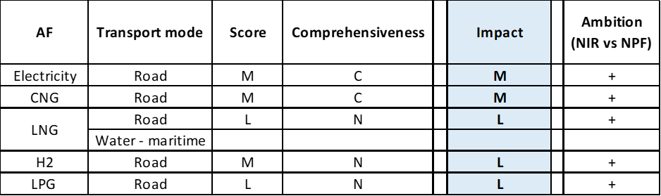

**Legend:** Score and Impact: H = high; M = medium; L = low; X = not assessable. Comprehensiveness: C = comprehensive; N = Not comprehensive. Ambition level: ‘+’ means ‘higher’; ‘=’ means ‘comparable’; ‘-‘ means ‘lower’.

Similarly to the quantitative assessment of vehicles and infrastructure, the table presents always the results for the five pairs, regardless of whether a cluster of measures was found or not: electricity/road, CNG/road, LNG/road, LNG/waterborne maritime (if applicable to the MS) and LNG/waterborne inland (if applicable to the MS). In addition to that, if the NIR has provided evidence of Policy and Deployment & Manufacturing support measures for other AF/transport mode pairs, they are shown in the table. In the example above, the MS has not presented any measure regarding LNG/water-maritime transport, while the pair LNG/water-inland transport was not applicable to that MS (thus it is not shown).

### Additional information on alternative fuels infrastructure developments

Annex I to the Directive also offered Member States the possibility to provide additional information in their NIR on AF consumption data, past and projected, plus any other comment or data not included in the list of the requirements for the compilation of the NIR.

Any information provided by the MS in its NIR is presented and commented in this section.

### Summary of the assessment

This section starts with a table providing an overview as follows:

*Table 5.0.7‑1 Overview of the NIR assessment*

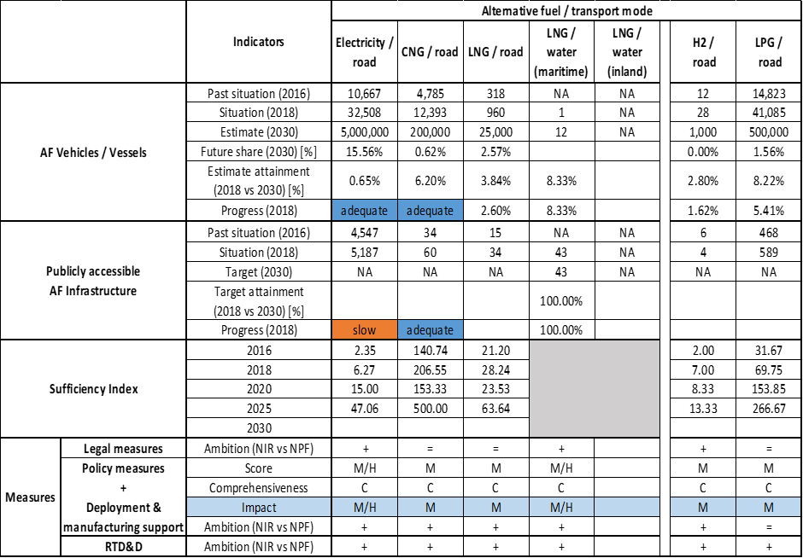



Table 5.0.7‑1 provides a synthesis of the following elements:

* + AFV/AFI state of play in 2016
  + Main elements of Table 5.0.4‑1 presented in point 5.0.3 (i.e. the situation at the end of 2018 and the objectives for 2030)
  + Sufficiency indexes for the pairs AF/road
  + Main outcome of the measure assessment

In addition to the above, for the vehicle and the infrastructure parts of the table, information on the progress in 2018 is provided, calculated according to the procedure described in the assessment methodology (Section 2.1.3). For the vehicle part, the future share in 2030 of AF vehicles is also provided for each alternative fuel. This share is calculated by dividing the 2030 vehicle estimate provided in the NIR by the total vehicle fleet in the same year[8]. For all alternative fuels (excepting LNG) corresponding to road transport mode, the total number of relevant vehicles was considered as the number of all vehicles excluding powered two wheelers (i.e. sum of light and heavy-duty categories of vehicles). For LNG vehicles, only the heavy-duty category was considered.

After the table, this section of the assessment report presents a summary of all the preceding sections, in the same order.

### Final remarks

This section provides final remarks addressing the following common elements:

* to what extent the Member State has fulfilled the requirements of Annex I to Directive
* to what extent the Member State is aligned with the overall objectives of the Directive
* how do the Member State planning, presented in the NPF and revised in the NIR, fits with the new objectives set in the Green Deal
* observations on benefits of additional action in specific areas

### ANNEX: Description of the Member State

This section provides a general description of the Member State with special focus on the transport sector. This is similar to what had been presented in the NPF assessment report (European Commission, 2019), with the only difference that now all the data are updated to reflect the situation in 2018. A brief explanation on the data sources used is provided below.

Data on surface area and population is retrieved from the European Commission’s Statistical Pocketbook 2019 (European Commission, 2019). Information on the number of main urban agglomerations (Eurostat, 2020a) and on the per capita gross domestic product at market prices and in purchasing power standards expressed in relation to the EU-28 average (Eurostat, 2020b) is retrieved from Eurostat.

Regarding information on the TEN-T Core Network two sources exist. The lengths of roads and inland waterways of the TEN-T Core Network are obtained from the TENtec portal (Mobility and Transport - European Commission, 2020) and complemented by general country-specific road network length data retrieved from the Statistical Pocketbook (European Commission, 2019) and (Eurostat, 2020c). Other specific information on the TEN-T Network, such as number of ports and airports, is in accordance with Regulation (EU) No 1315/2013 (European Parliament, 2013)

Information on the number of registered road vehicles for all vehicle categories is obtained from Eurostat (passenger cars (Eurostat, 2020d), light goods vehicles (Eurostat, 2020e), heavy goods vehicles (Eurostat, 2020f) and (Eurostat, 2020g), buses and coaches (Eurostat, 2020h)) or the Statistical Pocketbook (European Commission, 2019). When available and relevant, information from the Member State’s NPF and/or NIR has also been considered.

## Belgium (BE)

### Main messages from the Commission assessment of the NPF

In its original assessment of the Belgian NPF the Commission concluded:

*The Belgian NPF fully addresses the requirements of Article 3. It contains tables of the current state and future estimates for alternative fuels vehicles in the transport sector. For all fuels and modes, it establishes targets as required by Article 3 of the Directive.*

*The Belgian NPF puts a lot of emphasis on electric cars. It contains high estimates for the future deployment of EV with an estimated roughly 1.3% electric vehicles on the road in 2020. Today, the spatial distribution of recharging points seems to appropriately cover the needs of electric vehicles in terms of distance requirements in Belgium. For the future, the targeted ratio of less than one public recharging point per 10 electric vehicles estimated for 2020 could evolve to become a barrier for the further market deployment of electric vehicles, especially in the Walloon and Brussels-Capital Region. This could also lead to market fragmentation within the EU. It will be important to closely monitor this development and correct infrastructure targets in line with the market developments. Belgium has also defined ambitious targets for electric buses, especially in the Brussels-Capital Region. Other initiatives for electrifying public transport, such as taxi fleets and carpooling are presented in the Belgian NPF. Electric bikes as well as their infrastructure also receive support. The Belgian NPF contains targets for further increasing shore-side electricity in its ports but no plans to increase the electricity supply for stationary airplanes.*

*The Belgian NPF sees a growing role for CNG cars. It contains modest estimates for the further evolution of CNG cars, with an estimated share of 0.6% on the road in 2020. Belgium has today a sufficient network of public recharging and CNG refuelling points.*

*LNG refuelling is planned for all maritime ports in the TEN-T Core Network and several inland ports. Furthermore, at least 2 LNG refuelling points for heavy-duty vehicles are targeted in the ports of Antwerp and Oostende. According to the results of a sector survey, that is mentioned in the NPF, these targets could be significantly exceeded. Altogether, the planned LNG refuelling points could guarantee that the maximum distance requirement for LNG refuelling points along the TEN-T Core Network would be fulfilled on Belgian territory.*

*The Belgian NPF displays a strong commitment towards hydrogen. The deployment of 19 publicly accessible hydrogen refuelling points in addition to the three existing is planned.*

*The Belgian NPF contains a comprehensive list of measures, most already in place and foreseen to stay. Most of them can be considered having a medium impact on market actor's decisions, especially for electric and CNG cars as well as electrification of public transport. The measures listed in the Belgian NPF differ for the three different regions (Flemish Region, Walloon Region, and Brussels Capital Region). A number of measures are defined at the federal level and apply for all three regions. The level of support varies greatly across the three regions. This could lead to a certain market fragmentation within the country.*

*The consideration of the interests of regional and local authorities, as well as stakeholders during the drafting of the Belgian NPF is evident throughout the text of the NPF.*

*Belgium is actively involved in coordinating its plans on alternative fuels infrastructure with the Benelux countries and is collaborating with them in this field. It may be advisable to extend this cooperation effort also towards other neighbouring countries such as France and Germany.*

### Overview of requirements’ fulfilment from Annex I of the Directive

*Table 5.1.2‑1 Checklist Table*

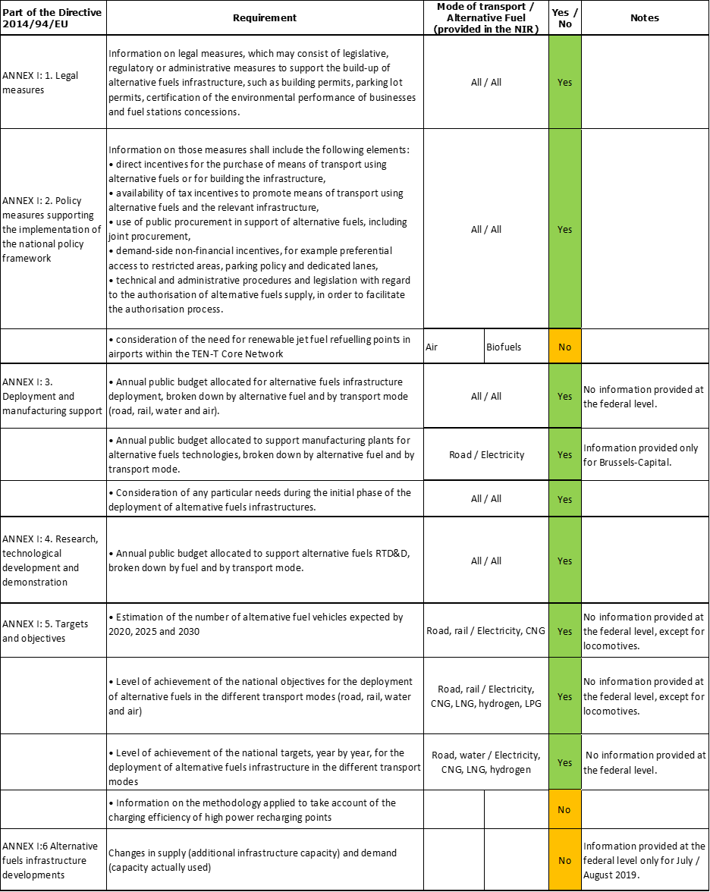

The checklist shows that almost all the requirements of Annex I from the Directive are covered, though not necessarily at federal level (see Section 5.1.3).

Regarding the combination of AF/AFV/AFI with transport mode, electricity is covered for all modes; LNG for road and waterborne (inland and maritime) transport; CNG, hydrogen and LPG are partially covered for road transport; all the other combinations are either absent or not applicable.

The Belgian NIR reports 119 measures, most of them regional ones. Under the Policy and Deployment & Manufacturing sections it was possible to identify eight AF/transport mode clusters of measures, of which six were assessable.

### Quantitative assessment: Vehicles and infrastructure

The Belgian NIR reports historical data and future vehicle estimates and infrastructure targets by region, without providing an aggregation at national level. Information on the number of locomotives is the only exception of figures being reported at federal level. Maritime-related data, which concerns only the region of Flanders, can also be considered an exception (i.e. representing the national level). To address this issue, we summed up the relevant values reported by the NIR for Flanders, Walloon and Brussels-Capital. Since there are differences in the type of information available in the NIR for each region, the values aggregated and used in this assessment sometimes reflect the values of two or even just one region. In the exceptional cases that this posed a clear distortion in comparison with the NPF, as in Table 5.1.3‑1, we ignored the regional value(s) and indicated that the aggregate value was not available (NA). For simplicity, we do not indicate in this written assessment which value refers to which region(s) and we do not report values for specific regions, with the exception of LNG and hydrogen infrastructure. Thus, the reader should refer to the Belgian NIR for further details and be mindful that the Walloon data on infrastructure targets and vehicle estimates is, as the NIR states, “*for information only, as the Walloon Energy and Climate Plan is being amended in response to the Commission’s comments*”. It is recommended that for the next exercise the Belgian NIR is compiled at federal level only.

*Table 5.1.3‑1 National AFV estimates and AFI targets established in the NIR at the horizon 2020, 2025 and 2030 and their comparison with the NPF situation*





* Value taken from EAFO 2018; **See Sections 5.1.3.3.2 and 5.1.3.4.2

Note: The **bold** values reflect the fact that the information was available for all the regions. AFI 2020 and 2025 values for CNG are reported in the NIR for the regions of Brussels-Capital and Flanders. However, they are not reported in this assessment due to the fact that this would have led to a strong reduction in percentage change NIR vs. NPF, which may not reflect the actual (unreported) country-wide target. Consequently, the 2020 and 2025 values are not shown in the ratio table of Section 5.1.3.1.2 either.

#### Road transport

##### Electricity

###### Vehicles

It is estimated that Belgium recorded around 43,599 battery-electric and plug-in hybrid electric vehicles in use in 2018 (Table 5.1.3‑1), of which 43,181 were passenger cars (75% were plug-in hybrids). The estimate of 83,669 EVs for 2020 is 3.43% lower than the NPF estimate, signalling a slight decline in the level of ambition. The NPF lacked 2025 and 2030 estimates. The NIR reports an estimated value of 359,402 EVs in 2025 and 1,446,286 EVs in 2030. Specific data on the heavy-duty sector were not available.

The 2018 ***attainment*** of future EV estimates is 52.11% for 2020 and 3.01% for 2030. According to the assessment methodology described in Section 2.1, the 2018 situation corresponds to an ***adequate progress*** towards reaching the envisaged EV estimates. The calculated ***average*** ***annual growth rate*** corresponding to the period 2016-2030 for EV fleet evolution planned by Belgium is equal to 37%.

###### Infrastructure

It is estimated that Belgium recorded around 3,530 publicly accessible recharging points in 2018 (Table 5.1.3‑1). Limited information on the split between normal and high-power points is available in the NIR at regional level only. The estimated target of 7,300 points for 2020 is 12.30% lower than the NPF target, signalling a slight decline in the level of ambition. The NPF lacked 2025 and 2030 target. The NIR reports a target of 35,400 points in 2025 and 94,500 points in 2030.

Limited information on the number of private recharging points is available in the NIR at regional level only.

The 2018 ***attainment*** of future public recharging infrastructure targets is 48.36% for 2020 and 3.74% for 2030. According to the assessment methodology described in Section 2.1, the 2018 situation corresponds to an ***adequate progress*** towards reaching these envisaged targets. The calculated ***average annual growth rate*** corresponding to the period 2016-2030 for publicly accessible recharging infrastructure evolution planned by Belgium is equal to 41%.

###### Ratio

Based on the BE NIR, the following table shows the ratio between vehicles and publicly accessible recharging points (i.e. sufficiency index) for the pair electricity/road. It can be seen that the sufficiency index was 12.35 in 2018. The foreseen sufficiency index is 11.46 in 2020, 10.15 in 2025 and 15.30 in 2030. Without specific information on the share of high power (>22kW) recharging points, it is not possible to assess the adequacy of the sufficiency index in 2030.



###### Information on charging efficiency

The only information found in the Belgian NIR relates to a project for the development of an AFI data collection methodology.

##### CNG

###### Vehicles

It is estimated that Belgium recorded around 11,721 CNG vehicles in use in 2018 (Table 5.1.3‑1), of which 11,184 were passenger cars. The estimate of 46,305 CNG vehicles for 2020 is 8.75% higher than the NPF estimate, signalling a slight increase in the level of ambition. The NPF lacked 2025 and 2030 estimates. The NIR reports an estimated value of 151,744 CNG vehicles in 2025 and CNG vehicles 644,393 in 2030. Also in this case it was not possible to extract specific information on the heavy-duty sector.

The 2018 ***attainment*** of future CNG vehicles estimates is 25.31% for 2020 and 1.82% for 2030. According to the assessment methodology described in Section 2.1, the 2018 situation corresponds to an ***adequate progress*** towards reaching the envisaged CNG vehicles estimates. The calculated ***average annual growth rate*** corresponding to the period 2016-2030 for the CNG vehicle fleet evolution planned by Belgium is equal to 41%.

###### Infrastructure

It is estimated that Belgium recorded around 126 publicly accessible CNG refuelling points in 2018 (Table 5.1.3‑1), an increase compared to the 98 points available in the three regions in the previous year. Concerning the 2020 and 2025 targets, the limited regional values reported in the NIR are well below the target of 333 points indicated in the NPF for 2020. The NPF lacked 2025 and 2030 targets. The NIR reports a target of 593 points in 2030.

The 2018 ***attainment*** of future public CNG refuelling infrastructure targets is 21.25% for 2030. According to the assessment methodology described in Section 2.1, the 2018 situation corresponds to an ***adequate progress*** towards reaching these envisaged targets. The calculated ***average annual growth rate*** corresponding to the period 2016-2030 for publicly accessible CNG refuelling infrastructure evolution planned by Belgium is equal to 18%.

###### Ratio

Based on the BE NIR, the following table shows the ratio between vehicles and publicly accessible refuelling points (i.e. sufficiency index) for the pair CNG/road. It can be seen that the sufficiency index was well below the indicative value of 600 (see Section 2.1.5) in 2018 and was thus adequate to support CNG vehicle uptake. The foreseen sufficiency index instead exceeds this value by a large margin in 2030. As indicated above, the 2020 and 2025 values can only be computed at regional level.



##### LNG

###### Vehicles

The Belgian NIR does not provide information on the number of LNG vehicles in use between 2016 and 2018 (Table 5.1.3‑1). Both the NPF and NIR lacked future LNG vehicle estimates. For this reason the 2018 ***attainment*** and ***progress*** could not be computed.

###### Infrastructure

The Belgian NIR does not provide information on the number of publicly accessible LNG refuelling points in 2018. EAFO provides a value of four refuelling points in 2018. Whereas the NPF lacked targets for 2025 and 2030, the NIR provides only one regional target for 2030: 25 refuelling points in Walloon.

Based on the EAFO value, the 2018 ***attainment*** of future public LNG refuelling infrastructure targets is 16.00% for 2030. Due to the lack of data, the ***progress*** could not be computed.

###### Ratio

Due to the lack of information in the BE NIR, the ratio between vehicles and publicly accessible refuelling points (i.e. sufficiency index) could not be computed for the pair LNG/road.

##### Hydrogen

###### Vehicles

It is estimated that Belgium recorded around 27 hydrogen vehicles in use in 2018 (Table 5.1.3‑1), all of them being passenger cars. The NPF lacked future estimates. The NIR lacks 2025 estimates but provides the following ones for the Walloon region: 32 hydrogen vehicles in 2020 and 23,719 vehicles in 2030.

The 2018 ***attainment*** of future hydrogen vehicles estimates is 84.38% for 2020 and 0.11% for 2030. According to the assessment methodology described in Section 2.1, the ***progress*** obtained by Belgium from 2016 until 2018 for hydrogen vehicles deployment is 0.07% of the overall planned deployment during the period 2016-2030.

###### Infrastructure

The NIR does not provide information on the state of play at end of 2018, but reports that two publicly accessible hydrogen refuelling points were available in Belgium in 2019, both in Flanders. Concerning the 2020 target, the only value reported in the NIR is for Walloon, with two points, thereby remaining well below the target of 22 points indicated in the NPF for 2020. The NIR also reports two private refuelling points for this region. Whereas the NPF lacked targets for 2025 and 2030, the NIR provides only the following two targets for Walloon: 10 refuelling points in 2025 and 20 in 2030.

As the 2018 value of hydrogen refuelling points was not provided, the 2018 ***attainment*** and ***progress*** could not be computed.

###### Ratio

Based on the BE NIR, the ratio between vehicles and publicly accessible refuelling points (i.e. sufficiency index) for the pair hydrogen/road could be computed only on a regional basis. The sufficiency index was equal to 5.00 in 2016 in Flanders, and is expected to be equal to of 16.00 in 2020 in Walloon and equal to 1,185.95 in 2030 again in Walloon.

##### Biofuels

###### Vehicles

Information is not available in the Belgian NIR.

###### Infrastructure

Information is not available in the Belgian NIR.

##### LPG

###### Vehicles

Based on the limited information provided in the NIR, Belgium recorded at least 10,219 LPG vehicles in use in 2018, all of them being cars. See also Section 5.1.4.1.1 for a relevant regional measure related to LPG vehicles.

Because there are no LPG vehicles estimates in the Belgian NIR, the 2018 ***attainment*** and ***progress*** could not be computed.

###### Infrastructure

Information is not available in the Belgian NIR.

###### Ratio

Due to the lack of information in the BE NIR, the ratio between vehicles and publicly accessible refuelling points (i.e. sufficiency index) could not be computed for the pair LPG/road.

#### Rail transport

##### Electricity

###### Vehicles

The Belgian NIR indicates that the stock of electric railway vehicles was 1,036 in 2018, compared to 1,090 in 2016. The NIR provides the following estimates: 982 in 2020, 937 in 2025 and 950 in 2030.

###### Infrastructure

Information is not available in the Belgian NIR.

##### Hydrogen

###### Vehicles

The Belgian NIR indicates that “there are no plans to purchase any hydrogen locomotives”.

###### Infrastructure

Information is not available in the Belgian NIR.

#### Waterborne transport (maritime)

##### Electricity

###### Vessels

Information is not available in the Belgian NIR.

###### Infrastructure

The Belgian NIR does not present data for 2018, but reports 11 shore-side electricity supply points in maritime ports in 2019, compared to 9 in 2016. The NIR target of 13 for 2020 is 18.18% higher than the NPF target, signalling an increase in the level of ambition. In contrast to the NPF, the NIR does not report 2025 and 2030 targets for shore-side electricity supply in maritime ports.

Because the 2018 value of shore-side electricity supply points was not provided, the 2018 ***attainment*** and ***progress*** could not be computed.

##### LNG

###### Vessels

The only information found in the Belgian NIR relates to the statement that LNG maritime vessels are under construction.

###### Infrastructure

The Belgian NIR indicates only that the availability of LNG in maritime ports went up from zero refuelling points to five between 2016 and 2019. The latter value can be compared with the NPF targets of at least four points in 2020, 2025 and 2030.

Because the Belgian NIR does not report data on LNG refuelling points in 2018, the ***attainment*** and ***progress*** for that year could not be computed.

#### Waterborne transport (inland)

##### Electricity

###### Vessels

Information is not available in the Belgian NIR.

###### Infrastructure

Due to lack of data, it is not possible to report the state of play in 2018 in Belgium. The BE NIR indicates a value of 327 shore-side electricity supply in inland ports in 2016. The NIR target values of 516 for 2020 and 606 for 2025 are respectively 0.58% and 1.85% higher than the corresponding NPF targets, signalling a slight increase in the level of ambition. Both the NPF and NIR lacked 2030 targets.

Due to the lack of data, the ***attainment*** and ***progress*** figures for 2018 could not be computed.

##### LNG

###### Vessels

Information is not available in the Belgian NIR.

###### Infrastructure

The Belgian NIR indicates only that the availability of LNG in inland ports went up from zero refuelling points to two between 2016 and 2019. A regional value of one point in 2030 is also reported. These values can be compared with the NPF targets of two points in 2020 and three points in 2030.

Because the Belgian NIR does not report data on LNG refuelling points in 2018, the ***attainment*** and ***progress*** for that year could not be computed.

#### Air transport

##### Electricity

###### Airplanes

Information is not available in the BE NIR.

###### Infrastructure (for stationary airplanes)

Limited information on electricity supply for stationary airplanes is available in the NIR at regional level only.

##### Biofuels

###### Airplanes

Information is not available in the BE NIR.

###### Infrastructure

Information is not available in the BE NIR.

### Measures assessment

The Belgian NIR reports the information related to the measures at both federal and regional level. In some cases, the same type of measure (e.g. low-emission zones) is reported separately for more than one region. Furthermore, a few of the measures listed in the NIR as Legal and AFI deployment measures can be linked to Policy measures reported in a different section of NIR. To be in line with our assessment methodology, these are assessed only once. However, it shall be highlighted that this way of reporting increases the risk of double counting a given measure, with implications for the assessment of the measures’ impacts. Finally, the Belgian NIR reports road vehicle data at regional level, thus, when possible, the assessment of the scope of a regional measure is assessed taking that into account. It is recommended that for the next exercise the Belgian NIR is compiled at federal level only.

The Belgian NIR reports 119 measures, most of them regional ones. As in the NPF, the measures listed in the NIR continue to differ for the three regions. Almost all the measures were in place during the implementation period. It is possible to identify six assessable AF/transport mode clusters for the quantitative assessment: electricity/road, electricity/water (maritime), electricity/water (inland), CNG/road, LNG/road and hydrogen/road (Table 5.1.4‑1).

#### Legal measures

The Belgian NIR contains 38 legal measures, which represents a strong increase compared to the 15 measures identified in the NPF. The application level of these measures is as follows: 13% are federal (i.e. apply to the three regions), 34% to Flanders, 18% to Walloon and 34% to Brussels-Capital. Electricity for road features prominently, but other alternative fuels and transport modes are also considered.

##### Legislative & Regulatory

Of all the legal measures described in the Belgian NIR, 19 can be categorised as legislative and regulatory measures and include among others:

* Norms & requirements: the three federal measures identified deal with standards and fuel labelling and one in Walloon facilitates the development of renewable energy communities.
* Permits: Gradual tightening-up of the environmental criteria for licensed taxis in Flanders.
* Other: Brussels-Capital Region proposes the phasing-out of diesel vehicles in 2030, and petrol and LPG vehicles in 2035 at the latest as well as increased EV quotas for public authorities from 2020.

##### Administrative

Of all the legal measures described in the Belgian NIR, 19 can be categorised as administrative measures and include among others:

* AFV classification on environmental performance: Environmental criteria for car-sharing in Brussels-Capital.
* EU & international standards implementation: Decree establishing the electrical standards for shore-side recharging of vessels in Walloon.
* Other: Green Deal for Sustainable Urban Logistics in Flanders.

#### Policy measures

The Belgian NIR contains 35 policy measures, which also represents a strong increase compared to the 16 measures identified in the NPF. All the measures listed in the NIR, with one exception, were in place during the implementation period. The application level of these measures is as follows: 17% are federal (i.e. apply to the three regions), 34% to Flanders, 14% to Walloon and 34% to Brussels-Capital. Almost half of the policy measures target a combination of alternative fuels. Among the measures targeting a single AF, electricity features again prominently. Most of the measures focus on road transport. The majority of these measures have a financial nature (though information on the budget is very limited).

##### Measures to ensure national targets and objectives

Of all the national policy measures described in the Belgian NIR, 27 can be categorised as measures to ensure national targets and objectives. Among these, the following can be highlighted:

* Financial incentives: road tax exemption, zero-emission premium and ecology premium in Flanders; investment premium for new or converted LNG HCV in Walloon as well as for the replacement of polluting N1 vehicles in Brussels-Capital.
* Low-emission zones in Walloon and Brussels-Capital.
* Ecological investments, including shore-side electricity supply for seagoing vessels.

##### Measures that can promote AFI in public transport services

Of all the policy measures described in the Belgian NIR, six can be categorised as measures that can promote AFI in public transport services, of which four were present already in the NPF. Only one of them is a national measure. They tend to focus on the greening of the fleet, including procurement for buses and incentives for taxis fleets. None of them targets rail transport.

##### Measures that can promote the deployment of private electro-mobility infrastructure

Of all the policy measures described in the Belgian NIR, two can be categorised as measures that can promote the deployment of private electro-mobility infrastructure.

#### Deployment and manufacturing support

The NIR provides information on deployment and manufacturing support only at regional level.

##### AFI deployment

The Belgian NIR lists 17 AFI deployment measures, of which 6 were found also in the NPF. With one exception, all the AFI deployment measures target road transport. Almost 60% of the measures target electricity and 29% a combination of AFs. There is also one measure targeting LNG only and another one CNG only. Several measures related to the CEF project known as BENEFIC are listed by different regions. All the AFI deployment measures were in place during the implementation period. Their total budget, with one exception for which the budget is not reported, is about 37.5 million € for the period 2014-2022 (though most of it refers to 2016-2020). A significant proportion of this budget (17 million €) comes from loan support for electricity, CNG and LNG infrastructure in Walloon. Most of the rest of the budget is sourced from Flanders.

##### Support of manufacturing plants for AF technologies

The Belgian NIR reports four measures to support manufacturing plants for AF technologies, all of which related to MIVB-STIB (Maatschappij voor het Intercommunaal Vervoer te Brussel - Société des Transports Intercommunaux Bruxellois) and focusing on electricity for road in the Brussels-Capital region. For one of them, which was identified in the NPF, budget data is reported. For the rest, no information on budget is provided.

##### Consideration of any particular needs during the initial phase of the deployment of alternative fuels infrastructures

The Belgian government not only highlights cooperation with neighbouring countries but also reiterates in its NIR the need for interoperability and common standards for alternative fuels infrastructures.

#### Quantitative assessment of Policy and Deployment & Manufacturing measures

Bearing in mind the fact that most of the measures reported in the NIR are of a regional nature, Table 5.1.4‑1 presents an analysis of all the Policy and Deployment & Manufacturing measures, carried out according to the assessment methodology described in Section 2.2. As it can be seen, six[9] assessable clusters of measures on electricity, CNG, LNG and hydrogen for road transport and electricity for waterborne transport could be identified in the Belgian NIR. The measures for the pairs LNG/water maritime and LNG/water inland were not assessable.

None of the clusters have a high score. The cluster with the best rank, and the only one considered to be comprehensive, is electricity/road. In terms of expected impact of these measures to support the realisation of the AFV/AFI objectives as presented in the NPF and revised in the NIR, the partial or total lack of future targets and estimates and the regional nature of most of the measures does not allow a proper assessment. With this caveat, using the available information and applying the same criteria used for the other MS assessments, it can be suggested that the measures for the pair electricity/road might have a medium impact, while all the others appear to have a low impact.

Concerning the level of ambition, it has increased for the four clusters related to road transport.

*Table 5.1.4‑1 Quantitative assessment of Policy and Deployment & Manufacturing support measures*

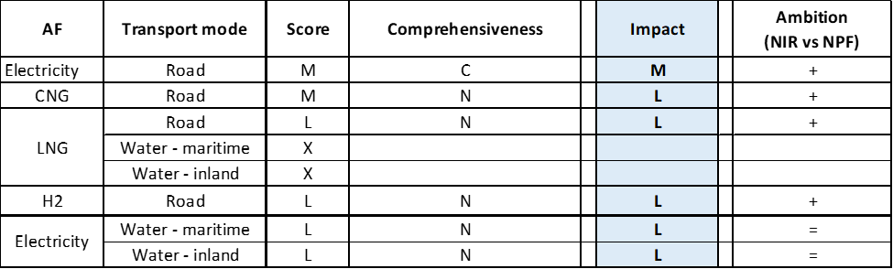

**Legend:** Score and Impact: H = high; M = medium; L = low; X = not assessable. Comprehensiveness: C = comprehensive; N = Not comprehensive. Ambition level: ‘+’ means ‘higher’; ‘=’ means ‘comparable’; ‘-‘ means ‘lower’.

#### Research, Technological Development & Demonstration

The NIR provides information on RTD&D at regional level, with the exception of the federal energy transition fund which has an annual budget of 25 million € and covers, among others, batteries and EVs (the total budget and duration are however not detailed).

The Belgian NIR contains 25 RTD&D projects, which represents a significant increase compared to the 6 RTD&D projects identified in the NPF. All the RTD&D projects were in place during the implementation period, with one-third of them having expired by 2019. The vast majority of these projects target road transport. Electricity dominates the list, hydrogen is also well-represented and combinations of AFs are also reported. Among the list of regional RTD&D projects, the following can be highlighted:

* Implementation of Ship Hybridisation project in Flanders, targeting hydrogen and with a total budget of ca. 6.8 million € for the period 2019-2022.
* Hydrogen call for Power-to-X projects targeting road transport in Walloon, with an indicative budget of 15 million € in 2019.
* Green approaches towards full solid-state batteries for EVs in Brussels-Capital, with a total budget of 0.8 million € for the period 2019-2022.

Budget information is provided for all the RTD&D projects listed in the NIR, often with information on annual values. In total, the budget of these projects exceeds 55 million € for the period 2016-2022. Information on the type of funding is not always provided.

### Additional information on alternative fuels infrastructure developments

AFI developments (i.e. demand/supply) are available in the BE NIR at regional level. In addition, changes in fuel use between 2016 and 2018 are reported only for Walloon as follows: gasoline, diesel, electricity and CNG respectively accounted for 45.34%, 54.41%, 0.30% and 0.05% of fuel use in road transport in 2018. This can be correspondingly compared with 39.61%, 59.51%, 0.11% and 0.02% in 2016.

### Summary of the assessment

**Tabular overview**

*Table 5.1.6‑1 Overview of the NIR assessment*





(1) Value taken from the NPF; (2) Value taken from EAFO; (3) See sections 5.1.3.3.2 and 5.1.3.4.2; (4) Values not necessarily representative at national level.

Note: The **bold** values reflect the fact that the information was available for all the regions.

The Directive stresses the need for coordinated policy frameworks and the Belgian NIR highlights Benelux cooperation (examples of this includes the Benelux Talanoa Declaration adopted in 2018, the Benelux study on freight transport and the BENEFIC project) and policy coordination within Belgium. It is thus somewhat paradoxical that the Belgian NIR does not report the relevant AFV estimates and AFI targets at Member State level (Table 3 of the NIR provides figures only for 2019, of limited usefulness both as historical data and as future targets/estimates). As a result, the lack of aggregated input data has seriously jeopardised the assessment of the Belgian NIR. According to the NIR, “*the implementation of alternative fuels infrastructure is a regional competence*”. However, by not aggregating the regional values reported in the NIR, the Belgian government delivered an inconsistent NIR and placed the burden of aggregation (and the assumptions that underpin such process) onto the Commission. The Belgian government is strongly encouraged to improve on this by notifying to the Commission in future implementation reports the information required in the Directive in an aggregated manner (i.e. at Member State level).

A clear statement of commitment to alternative fuels deployment in transport is found in the NIR for one region: “*the Flemish Region remains firmly committed to alternative fuels for transport*”. Interoperability of recharging infrastructure is also mentioned as an important criterion in one of the reported measures (a map of recharging stations in Flanders was also included in the NIR). In the case of Walloon, infrastructure targets for publicly accessible LNG and hydrogen refuelling points are provided. Brussels-Capital continues to support alternative fuels in public transport.

Compared to the Belgian NPF that fulfilled all of the requirements of Article 3 of the Directive, the NIR addresses almost all the requirements of Annex I of the Directive. However, it cannot be stated that the Belgian NIR covers the whole AFID period (2016-2030), for it lacks infrastructure targets and vehicle estimates at Member State level for several years.

The main outcomes of the technical assessment of the Belgian NIR on vehicles/vessels estimates and infrastructure targets can be summarised as follows:

###### Road transport

* **Electricity** – It is estimated that Belgium recorded around 43,599 battery-electric and plug-in hybrid electric vehicles in use in 2018, of which 43,181 were passenger cars (75% were plug-in hybrids). The NIR reports an estimated value of 1,446,286 EVs in 2030. Specific data on the heavy-duty sector were not available. With reference to the objectives of the BE NPF as updated by the NIR, Belgium is progressing adequately. Concerning infrastructure, it is estimated that Belgium recorded around 3,530 publicly accessible recharging points in 2018. The NIR reports a target of 94,500 points in 2030. The 2018 progress is adequate also in this case, as the sufficiency index for the whole next decade.
* **CNG** – It is estimated that Belgium recorded around 11,721 CNG vehicles in use in 2018, of which 11,184 were passenger cars. The NIR reports an estimated value of 644,393 CNG vehicles in 2030. Also in this case it was not possible to extract specific information on the heavy-duty sector. The 2018 progress is adequate. It is estimated that Belgium recorded in 2018 around 126 publicly accessible CNG refuelling points. The NIR reports a target of 593 points in 2030. Belgium is progressing adequately also concerning the infrastructure uptake, however it has to be signalled a quite high sufficiency index (i.e. potentially inadequate) in 2030.
* **LNG** – The NIR does not report federal level data on LNG vehicles. Both the NPF and NIR lacked future LNG vehicle estimates. The BE NIR also lacks information on public LNG refuelling points. EAFO provides a value of four refuelling points in 2018. The expected number of publicly accessible LNG refuelling points in 2030 is at least 25.
* **Hydrogen** – It is estimated that Belgium recorded around 27 hydrogen vehicles in use in 2018 (all of them being passenger cars) and 2 publicly accessible hydrogen refuelling points in 2019. The NPF lacked future estimates but the NIR indicates at least 23,719 vehicles in 2030. The expected number of publicly accessible hydrogen refuelling points in 2030 is at least 20.
* **Biofuels** – Information is not available in the NIR.
* **LPG** – LPG plays a minor role in the NIR.

###### Rail transport

* **Electricity** – The number of electric railway vehicles in use in Belgium is expected to slightly decrease from 1,036 locomotives in 2018 to 950 in 2030.
* **Hydrogen** – The deployment of locomotives powered by hydrogen is currently not a priority.

###### Waterborne transport (maritime)

* **Electricity** – While no vessel estimates were found, the NIR expects shore-side electricity supply in maritime ports to increase from 11 units in 2019 to 13 in 2020. In contrast to the NPF, the NIR does not report 2025 and 2030 targets for shore-side electricity supply in maritime ports.
* **LNG** – The NIR signals future deployment of LNG maritime vessels. As of July 2019, Belgium recorded availability of LNG in five maritime ports, a value that exceeds the future targets (not reported in the NIR) indicated in the NPF.

###### Waterborne transport (inland)

* **Electricity** – While no vessel estimates were found, the NIR expects shore-side electricity supply in inland ports to increase from 327 units in 2016 to 516 in 2020 and 606 in 2025. Both the NPF and NIR lacked 2030 targets.
* **LNG** – While no vessel estimates were found, LNG was available in two inland ports in 2019. No federal level targets are provided in the NIR. As a reference, the NPF had indicated targets of two points in 2020 and three points in 2030.

###### Air transport

Information on alternative fuels related to air transport is very scarce in the NIR (see Section 5.1.3.5).

Concerning the **measures**, the Belgian NIR reports a long list of mainly regional measures. As in the NPF, the Belgian government continues to put a lot of emphasis on electric cars. Contrariwise, biofuels, LPG and synthetic and paraffinic fuels receive virtually no support. Between these two extremes lie various clusters of AFs for road and waterborne transport. Measures to support greater AF use in the Belgian railways and aviation sector are not reported. Considering all the legal measures, they appear to be fit to support the realisation of the AFV/AFI objectives as described in the NPF and revised in the NIR, provided that the ones not yet in place are fully implemented. Concerning the Policy and Deployment & Manufacturing measures, in none of the identified clusters is the score high (this might in part be due to the regional nature of most of the reported measures, which might prevent the exploitation of synergies for certain clusters) and only the electricity/road pair results comprehensive. In terms of expected impact of these measures to support the realisation of the AFV/AFI objectives as presented in the NPF and revised in the NIR, the partial or total lack of future targets and estimates and the regional nature of most of the measures does not allow a proper assessment. With this caveat, using the available information and applying the same criteria used for the other NIR assessments, it can be suggested that the measures for the pair electricity/road might have a medium impact, while all the others appear to have a low impact.

On the basis of the available information, it can be considered that, compared to the NPF, the level of ambition for RTD&D projects in the NIR has increased for most of the clusters.

### Final remarks

The Belgium NIR is generally in line with the provisions of Annex I to that Directive with the main exception that the NIR does not include estimates for future numbers of LNG vehicles and vessels and related targets for LNG infrastructures for inland and maritime transport. The NIR estimates that a significant number of inland and maritime ports are already equipped with shore-side electricity supply facilities. A significant number of measures are being implemented to promote alternative fuels at federal and regional level, but with a special focus on electro-mobility and CNG for road transport. The Belgium NIR consists of three regional reports on the efforts to implement the Directive, however, accessibility of data of future reporting will improve by aggregation of data in one overall NIR.

With regard to electricity, the NIR plans for approximately 1.5 million electric vehicles on the roads by 2030, representing about 19% of the fleet at that point in time as well as 35,400 recharging points by 2025 and 94,500 recharging points by 2030. Taking into account the current situation and expected trends, this level of ambition appears to be broadly consistent with the pace of deployment of electric vehicles that is considered necessary for the transition to carbon neutrality by 2050. The only information provided on charging efficiency relates to a project on data collection methodology. The number of shore-side electricity supply facilities in inland ports is expected to rise to 516 by end of 2020 and to 606 by 2025. There were 11 shore-side electricity supply facilities in maritime ports in 2018. This figure will increase to 13 in 2020. Only limited information is provided on electricity supply for stationary aircraft. More information should be provided for the further development of electricity supply for stationary aircraft in the two Belgian airports in the TEN-T Core Network as well regards the further electrification of the rail network.

Regarding hydrogen for transport, the NIR estimates around 24,000 FCHVs by 2030. However, no targets are provided for H2 infrastructure. Further information on both light- and heavy-duty vehicles and related infrastructure developments should be provided in future reporting.

In terms of natural gas for road transport, the Belgium vehicle fleet comprised about 11,700 CNG vehicles, which were served by 126 refuelling points in 2018. The NIR presents a target of 644,393 CNG vehicles and 593 CNG refuelling points until 2030. The NIR does not provide estimates of the future growth of LNG vehicles and vessels nor for LNG infrastructures for inland and maritime ports by 2025 and 2030. The NIR only provides the target of 25 refuelling points for LNG vehicles by 2030, whereas no targets are reported for 2025.

Information is not available on the LPG vehicles and infrastructure in the NIR.

The NIR does not provide information on the consumption of biofuels, neither with regard to road transport nor to aviation. Belgium should provide more information on efforts to promote the use of renewable fuels in transport, and particularly in aviation.

### ANNEX - Description of the Member State

On a surface area of 30,500 km², Belgium has a population of 11.399 million people in 2018, which makes up for a population density of 374 inhabitants/km².

*Number of main urban agglomerations*

* 11 urban agglomerations > 50,000 inhabitants

In 2018, Belgium achieves a per capita gross domestic product at market prices of €40,240, which represents a per capita gross domestic product in purchasing power standards of 117 if expressed in relation to the EU-28 average set to equal 100.

*Length of the road networks*

The length of the road TEN-T Core Network in Belgium is 828 km. The total road network length is 16,341 km, of which 1,763 km are motorways.

The following lengths of the TEN-T Road Corridors are present in Belgium: 5% (214 km) of the North Sea - Baltic Corridor, 18% (253 km) of the Rhine - Alpine Corridor and 12% (508 km) of the North Sea - Mediterranean Corridor.

Through the TEN-T Road Corridors, Belgium is connected with the following Member States:  
- Germany (through the North Sea - Baltic and the Rhine - Alpine Corridor)  
- the Netherlands (through the North Sea - Baltic and the North Sea - Mediterranean Corridor)  
- Luxembourg (through the North Sea - Mediterranean Corridor)  
- France (through the North Sea - Mediterranean Corridor)

*Number of registered road vehicles*

At the end of 2018, Belgium accounts for 7,406,933 registered road vehicles of which 5,853,782 are categorized as passenger cars, 759,406 as light goods vehicles, 146,920 as heavy goods vehicles and 16,125 as buses and coaches. The motorisation rate is 514 passenger cars per 1,000 inhabitants.

*Number of ports in the TEN-T Core Network*

* 4 maritime ports in the TEN-T Core Network (Antwerpen, Gent, Oosende, Zeebrugge)
* No maritime ports in the TEN-T Comprehensive Network
* 8 inland ports in the TEN-T Core Network (Albertkanaal, Antwerpen, Brussels, Gent, Kortrijk-Bossuit, Liege-Can. Albert, Liege-Meuse, Namur-Meuse)
* 10 inland ports in the TEN-T Comprehensive Network

Through the 1,071 km inland waterways TEN-T Core Network, Belgium is connected with France through the North Sea - Mediterranean Corridor, and with the Netherlands through the North Sea - Baltic and the North - Sea Mediterranean Corridor.

*Number of airports in the TEN-T Core Network*

* 2 airports in the TEN-T Core Network (Brussels, Liège)
* 2 airports in the TEN-T Comprehensive Network

## Bulgaria (BG)

### Main messages from the Commission assessment of the NPF

In its original assessment of the Bulgarian NPF the Commission concluded:

*The Bulgarian NPF addresses only part of the requirements of Article 3 of the Directive. It contains an extensive discussion of the current state and future scenarios for alternative fuels in the transport sector. However the NPF does not contain any designation of urban/suburban agglomerations to be equipped with recharging points and with CNG refuelling points. In the Bulgarian NPF the number of refuelling points for CNG and for LNG to be put in place along the TEN-T Core Network is not defined.*

*In the Bulgarian NPF estimates for deployment of alternative fuel vehicles are only provided for electric and for hydrogen fuel cell cars. No estimate has been provided for LNG heavy duty vehicles or vessels.*

*The Bulgarian NPF recognises that electrification of the propulsion of vehicles could contribute to the development of environmentally friendly road transport in Bulgaria however in a long term perspective. Bulgaria expects a rather rapid deployment of electric vehicles, mainly PHEV. Moreover Bulgaria considers hydrogen technologies as a way of integrating renewable energy sources in transport and has included hydrogen in its national policy framework. Accordingly, Bulgaria intends to develop an alternative fuel infrastructure network that it is considerate of the Bulgarian economic conditions with lower initial investments and minimised risks in the first years.*

*For electric recharging infrastructure the current situation, with 22 publicly accessible recharging points, is sufficient. The Bulgarian targets for the recharging network in 2020, 2025 and 2030 might not be enough if the estimates for electric vehicles in Bulgaria are met. It may be important to closely monitor this development and correct infrastructure targets in line with the market developments.*

*Bulgaria has already today a relatively dense network of CNG refuelling stations in parts of the country and the NPF foresees that this will further grow to cover the complete Bulgarian territory and the Bulgarian part of the TEN-T corridors. It has a target of 4 LNG refuelling points for heavy duty motor vehicles.*

*The Bulgarian NPF contains some targets for LNG bunkering infrastructure for inland and sea going vessels. Building of the bunkering infrastructure is to a certain extent dependent on the availability of European funds.*

*The Bulgarian NPF is based on a well-defined legislative framework and on investment support that to some extent relies on European Union co-funding instruments and Cohesion Funds. The NPF contains large number of possible initiatives to enhance the deployment of electro mobility, hydrogen and natural gas vehicles and alternative infrastructure which, if implemented, could help overcome deployment barriers. Since most of these measures are still only under consideration, there is a certain risk that the national targets and objectives of the NPF may not be reached.*

*The Republic of Bulgaria, in its NPF, declares interest to cooperate with the neighbouring countries to ensure EU wide circulation of vehicles and vessels, especially for natural gas. It may be advisable to extend this cooperation also for the other fuels and modes.*

### Overview of requirements’ fulfilment from Annex I of the Directive

*Table 5.2.2‑1 Checklist Table*

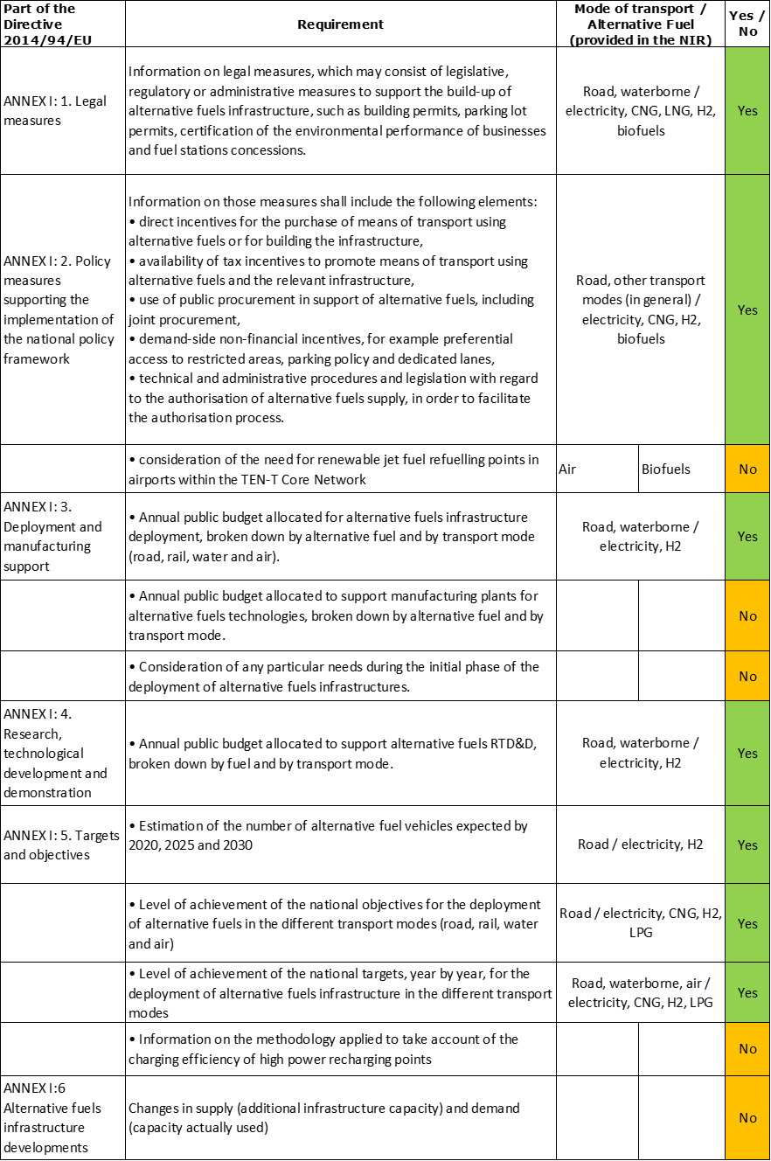

The checklist shows the requirements of Annex I from the Directive that are covered in the BG NIR.

Regarding the combination of AF/AFV/AFI with transport mode, electricity is covered for all modes; CNG, hydrogen and LPG are partially covered for road transport; all the other combinations are either absent or not applicable.

The Bulgarian NIR reports more than 30 measures. Under the Policy and Deployment & Manufacturing sections it was possible to identify four AF/transport mode clusters of measures, of which three were assessable.

### Quantitative assessment: Vehicles and infrastructure

*Table 5.2.3‑1 National AFV estimates and AFI targets established in the NIR at the horizon 2020, 2025 and 2030 and their comparison with the NPF situation*

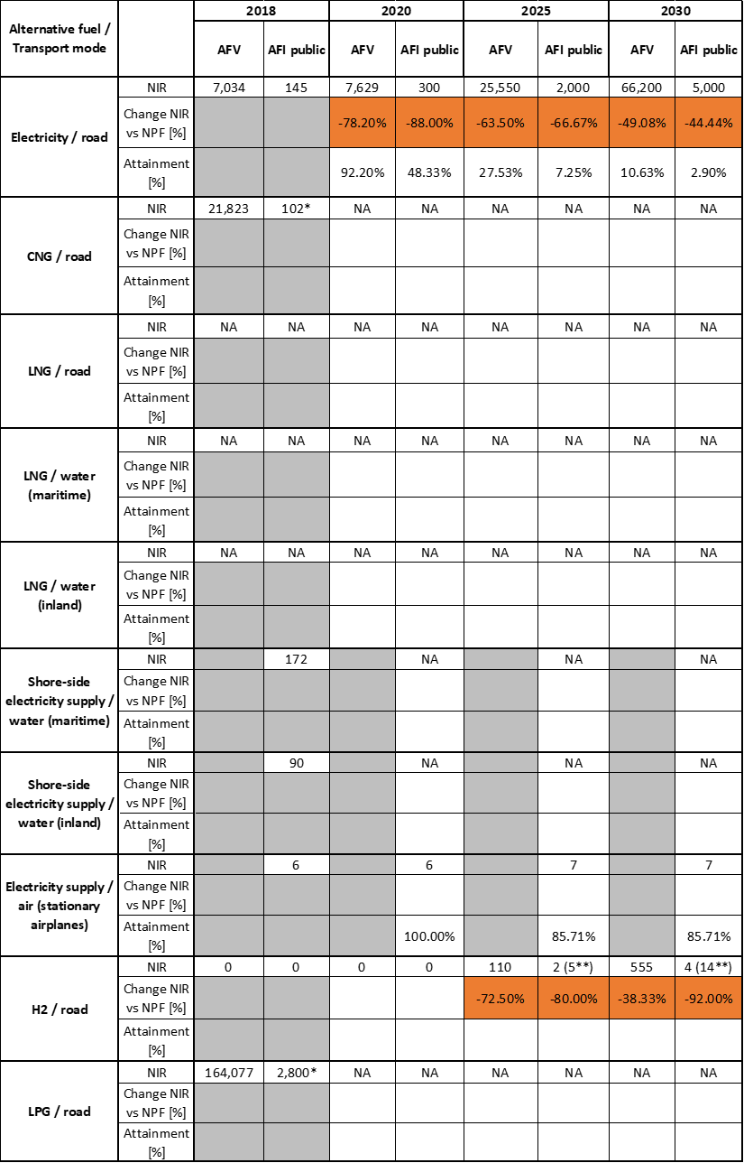

* Value taken from EAFO 2018 (absent in NIR)

** For Hydrogen, total number of AFI (public + private)

#### Road transport

##### Electricity

###### Vehicles

Bulgaria recorded 7,034 electric vehicles in 2018 (of which 6,288 were passenger cars, 721 LCVs and 25 buses and coaches). In addition, the number of electric PTW recorded in 2018 was 788. Even if the growth rate of battery electric and plug-in hybrid electric vehicles is slow in Bulgaria, the numbers are rising. For the period 2012-2018, the NIR outlines a 4.4 times increase in the number of BEVs and nearly 10 times increase for the number of PHEV.

As Table 5.2.3‑1 shows, the NIR provides revised estimates for EVs expected to be registered in 2020, 2025 and 2030. The EV estimates in the NIR are 7,629 for 2020, 25,550 for 2025 and 66,200 for 2030, which are respectively 78.20%, 63.50% and 49.08% lower than in the NPF.

The 2018 ***attainment*** of future EV estimates is 92.20% for 2020 and 10.63% for 2030. According to the assessment methodology described in Section 2.1, the 2018 state of play corresponds to an ***adequate progress*** towards reaching the envisaged EV estimates. The calculated ***average*** ***annual growth rate*** corresponding to the period 2016-2030 for EV fleet evolution planned by Bulgaria is equal to23%.

###### Infrastructure

As it can be seen in Table 5.2.3‑1, there were 145 publicly accessible recharging points in Bulgaria in 2018. The Bulgarian NIR mentions the positive trend in building-up the infrastructure for electric vehicle charging, which is implemented mainly at municipality level by private investors. High power (>22kW) recharging points have been built, at key locations, along the international routes from Sofia to the borders with Greece and Turkey.

The Bulgarian NIR presents revised targets for publicly accessible recharging points for 2020, 2025 and 2030 with respective values 88.00%, 66.67% and 44.44% lower than those provided in the NPF. The target number of publicly accessible recharging points in Bulgaria is 300 for 2020, 2,000 for 2025 and 5,000 for 2030. The NIR does not provide estimates for private recharging points.

The Bulgarian NIR states that “*having regard to the differences in functionality and price levels, the electric vehicles charging infrastructure to be deployed will include fast charging (of minimum capacity of 50 kW DC) stations along the TEN-T Core Network and a massive number of standard charging points (of at least 22 kW AC per point) at publicly accessible locations as shopping malls, entertainment and recreation centres, office buildings, industrial plants, hotels and restaurants.*”

The 2018 ***attainment*** of future public recharging infrastructure targets is 48.33% for 2020 and 2.90% for 2030. According to the assessment methodology described in Section 2.1, the 2018 state of play corresponds to an ***adequate progress*** towards reaching these envisaged targets. The calculated ***average annual growth rate*** corresponding to the period 2016-2020 for publicly accessible recharging infrastructure evolution planned by Bulgaria is equal to 43%.

###### Ratio

Based on the BG NIR, the following table shows the ratio between vehicles and publicly accessible recharging points (i.e. sufficiency index) for the pair electricity/road. It can be seen that current values are quite high, but in 2025 and 2030 the foreseen sufficiency index decreases towards values slightly above 10. Considering that in 2030 the share of high power charging points is planned to be 40%, the sufficiency index can be regarded as becoming adequate, although currently it is not.



###### Information on charging efficiency

Information is not available in the Bulgarian NIR.

##### CNG

###### Vehicles

Bulgaria reported 21,823 CNG vehicles in 2018, mostly dual engines, (of which 17,829 were passenger cars, 3,376 LCVs, 116 HCVs and 502 buses and coaches). The Government of Bulgaria did not provide CNG vehicles estimates in the NPF for the years 2020, 2025 and 2030 and, likewise, the NIR does not contain any estimate for these vehicles.

Since there are no CNG vehicle estimates, the 2018 ***attainment*** and ***progress*** could not be computed.

###### Infrastructure

The BG NIR does not provide the state of play in the period 2016-2018, but the NPF had indicated 108 publicly accessible CNG refuelling points in 2016 and for 2018 EAFO has reported a number of 102. The Bulgarian NIR does not contain targets for CNG refuelling points, similarly to the NPF, which presented only the statement that in the period 2020-2025 emphasis should be placed on building infrastructure in regions with lower coverage of the distribution network.

Since there are no CNG refuelling points targets, the 2018 ***attainment*** and ***progress*** could not be computed.

###### Ratio

Based on the BG NIR, the following table shows the ratio between vehicles and publicly accessible refuelling points (i.e. sufficiency index) for the pair CNG/road. It can be seen that the sufficiency index (where computable) is well below the indicative value of 600 (see Section 2.1.5).



* Values of CNG AFI taken from EAFO (absent in NIR)

##### LNG

###### Vehicles

Information is not available in the Bulgarian NIR.

###### Infrastructure

The Bulgarian NIR does not provides information on LNG refuelling points for road vehicles. Since the NPF declared that in the period 2025-2030 activities should be aimed at increasing the density of the distribution network for LNG refuelling points, it can only be assumed that the assessment of the NPF continues to apply here.

Since there are no LNG refuelling points targets, the 2018 ***attainment*** and ***progress*** could not be computed.

###### Ratio

The lack of information on vehicles and infrastructure precluded the calculation of the sufficiency index.

##### Hydrogen

###### Vehicles

While there are no hydrogen fuelled vehicles recorded in Bulgaria in 2018, the NIR estimates the registration of 110 vehicles in 2025 and 555 in 2030. These values are, respectively, 72.5% and 38.33% smaller than the estimates provided in the NPF.

Notably, according to the BG NIR, the majority of the hydrogen vehicles will be hybrid electric/fuel cell buses and coaches. Bulgaria expects to have 80 of them in 2025 and 400 in 2030.

Since at the end of 2018 there was no deployment of hydrogen vehicles, the 2018 ***attainment*** and ***progress*** have not been computed.

###### Infrastructure

Bulgaria included hydrogen in its NPF and presented two scenarios regarding hydrogen refuelling stations deployment. The NIR provides a revision of the NPF projections and envisages 2 and 4 public refuelling points by 2025 and 2030, respectively, which correspond to the less ambitious NPF scenario. Compared with the most optimistic NPF scenario, this represents an 80% decrease for 2025 and a 92% for 2030 targets. It should be also mentioned that the BG NIR foresees 3 and 10 private fuelling stations by 2025 and 2030, respectively.

Since at the end of 2018 there was no deployment of hydrogen refuelling points, the 2018 ***attainment*** and ***progress*** have not been computed.

###### Ratio

Based on the BG NIR, the following table shows the ratio between vehicles and publicly accessible refuelling points (i.e. sufficiency index) for the pair hydrogen/road. Due to the lack of data, only the 2025 and 2030 sufficiency indexes could be computed.



##### Biofuels

###### Vehicles

Information is not available in the BG NIR.

###### Infrastructure

Information is not available in the BG NIR.

##### LPG

###### Vehicles

The BG NIR reported 164,077 LPG vehicles in 2018. The majority of those are passenger cars (157,440), but 6,603 LCVs and 34 buses and coaches were also recorded. This represents a 17% increase compared to the data provided in the NPF for 2016. The NIR does not contain any future estimates for LPG vehicles.

Since there are no LPG vehicle estimates, the 2018 ***attainment*** and ***progress*** could not be computed.

###### Infrastructure

The BG NIR does not provide any past or future information concerning LPG infrastructure, thus the past total numbers of LPG refuelling points have been taken from EAFO.

Since there are no LPG refuelling points targets, the 2018 ***attainment*** and ***progress*** could not be computed.

###### Ratio

Based on the BG NIR, the following table shows the ratio between vehicles and publicly accessible refuelling points (i.e. sufficiency index) for the pair LPG/road.



* Values of CNG AFI taken from EAFO (absent in NIR)

#### Rail transport

Information is not available in the Bulgarian NIR.

#### Waterborne transport (maritime)

##### Electricity

###### Vessels

Information is not available in the Bulgarian NIR.

###### Infrastructure

According to the BG NIR, shore-side electricity supply and the relevant infrastructure are available for public transport in the maritime ports that are part of the TEN-T Core and Comprehensive Networks. A slight increase in the provision of service is observed in maritime ports in the period 2016-2018.

Table 5.2.3‑1 shows that the number of recharging points providing shore-side electricity supply at the Bulgarian maritime ports is 172 in 2018 albeit it is not evident from the NIR which kind of ships can be supplied with these supply points. Neither the NIR nor the NPF provided targets for the period 2020-2030.

The Bulgarian NIR mentions that Bulgarian ports have an obsolete infrastructure for shore-side electricity supply that needs modernising. The state-owned Bulgarian Ports Infrastructure Company has taken steps to examine the condition of the electricity supply network for seagoing vessels at the ports of Varna and Burgas.

Since there are no targets for shore-side electricity supply for seagoing ships in maritime ports, the 2018 ***attainment*** and ***progress*** could not be computed.

##### LNG

###### Vessels

Information is not available in the BG NIR.

###### Infrastructure

Information is not available in the BG NIR.

##### Hydrogen

###### Vessels

Information is not available in the BG NIR.

###### Infrastructure

The NIR mentions that the state-owned company “*Bulgarian Ports Infrastructure*” continues to explore possibilities for securing funding, using various EU programmes, for the construction of a hydrogen refuelling station at the port of Burgas.

#### Waterborne transport (inland)

##### Electricity

###### Vessels

The Bulgarian NIR does not provide any details on this matter.

###### Infrastructure

According to the NIR, shore-side electricity supply and the relevant infrastructure are available in inland waterway ports that are part of the TEN-T Core and Comprehensive Networks.

As Table 5.2.3‑1 shows, the number of recharging points providing shore-side electricity supply at the Bulgarian inland ports is 90 albeit it is not evident from the NIR which kind of ships can be supplied with these supply points. Neither the NIR nor in the NPF provided targets.

Since there are no targets for shore-side electricity supply for inland waterway vessels in inland ports, the 2018 ***attainment*** and ***progress*** could not be computed.

#### Air transport

##### Electricity

###### Airplanes

The Bulgarian NIR does not provide any details on the deployment of hybrid-electric or fully-electric airplanes.

###### Infrastructure (for stationary airplanes)

In the period 2016-2018, Sofia airport in the TEN-T Core Network provided power supply and air-conditioned from stationary facilities installed at 6 passenger sleeves at Terminal 2. The NIR mentions that a new boarding sleeve will be delivered in 2021. For airplanes serviced at Terminal 1 and for those not using Fixed Ground Power supply at Terminal 2, ground service operators provide upon request diesel-powered Ground Power Units. Sofia Airport has three recharging stations for electric vehicles (<22 kW) near Terminal 2.

The Bulgarian NIR provides information about electric vehicles and recharging infrastructure in the airports in the TEN-T Comprehensive Network (Plovdiv, Varna and Burgas), although it does not contain information about electricity supply for stationary airplanes in these airports.

##### Biofuels

###### Airplanes

Information on flights / airplanes powered by biofuels is unavailable in the Bulgarian NIR.

###### Infrastructure

There is no reference to the need for renewable jet fuel refuelling points in airports within the TEN-T Core Network in the Bulgarian NIR.

### Measures assessment

The Bulgarian NIR presents the measures put in place, adopted and under consideration in the period 2016 – 2018. The majority of these measures focus on electro-mobility and hydrogen for road transport.

#### Legal measures

The Bulgarian NIR contains seven[10] legal measures, which have been implemented at national level during the reporting period. These measures are required for the transposition of European Directives to the Bulgarian legislation. The level of ambition of the legal measures remains constant between NPF and the implementation report.

##### Legislative & Regulatory

The NIR shows that Bulgaria has progressed with the transposition of Directive 2014/94/EU, regarding the legal framework for electric vehicles recharging points. The requirement that shore-side electricity supply for maritime transport, deployed or updated after 18 November 2017, should comply with the technical specifications laid out in the Directive 2014/94/EU is transposed in Bulgarian law by its inclusion in “*Ordinance No 9 on the requirements for operability of ports and specialised port facilities*”. In addition, an “*Ordinance on the conditions and procedures for designing, construction and commissioning into operation of hydrogen refuelling stations*” was in the process of being adopted.

The Bulgarian NIR does not contain any information on legislative and regulatory measures for LNG.

##### Administrative

In 2019, the Bulgarian “*Ordinance on sustainability criteria for biofuels and bio liquids*” was amended and a calculation methodology for greenhouse gas emission reduction throughout the whole life cycle of biofuels was set out, transposing Directive 2015/1513/EU.

#### Policy measures

The policy measures listed in the Bulgarian national implementation report comprise both strategic plans in support of the implementation of the NPF and supporting measures for development of electro-mobility. Although the level of ambition of AF vehicle estimates and infrastructure targets has decreased between NPF and NIR, in terms of measures it has instead increased in the NIR compared to the NPF, in particular for electricity and hydrogen.

##### Measures to ensure national targets and objectives

The Bulgarian NIR mentions two strategic documents, supporting the use of alternative fuels in transport. The first one is the “*Integrated Transport Strategy until 2030*”, approved in 2017, which includes a measure on the ‘*Promotion of the use of biofuels and other renewable fuels in transport*’ in order to achieve the strategic priority ‘*Reduction of the fuel consumption and increasing the energy efficiency of transport*’. The second document is the “*draft Integrated National Energy and Climate Plan of the Republic of Bulgaria until 2030*”, developed in 2019.

Although not specifically mentioned in the NIR, it is understood that these documents are generally applicable to all transport modes.

###### Road transport

For electric vehicles, the “*draft Integrated National Energy and Climate Plan of the Republic of Bulgaria*” envisages that: ‘*in view of promoting the development and deployment of electric mobility, obligations will be imposed on the local authorities to introduce within their programmes measured to make the use of electric transport mode more attractive. Good practices, as tax reliefs, simplified access, reserved parking spaces for electric vehicles, will be promoted in view of their widespread implementation*.’

In 2018, the “*Ordinance setting out the procedure and the rate of product charges for motor vehicles*” was amended, including a reduction of the product charge for new hybrid motor vehicles as well as for plug-in hybrid electric and fully electric cars and light commercial vehicles. The product charge for the latter shall be payable from 1 January 2022.

The “*Climate Investment Programme of the National Trust Eco Fund*” started in 2016 and provides funding support to public institutions in purchasing electric and plug-in hybrid vehicles. This measure was also present in the NPF. The programme runs on annual calls for project proposals and the BG NIR declares that, as of 2018, 16 projects have been completed, 10 are being implemented and another three have signed the contract.

###### Other transport modes

There are no measures concerning other transport modes (water, air and railway) in the Bulgarian implementation report.

##### Measures that can promote AFI in public transport services

Of all the policy measures described in the Bulgarian NIR, two can be categorised as measures aimed at promoting AFI in public transport services.

Within the Priority Axis “*Improvement of Ambient Air Quality of the Operational Programme Environment 2014 – 2020*”, also described in the NPF, a new procedure on ‘*Measures for addressing transport as a source of ambient air pollution*’ was announced in 2019. The procedure comprises two components: electric road buses and trolleybuses and electric rail tramways. With a budget of 500 million BGN, 11 Bulgarian municipalities were selected as beneficiaries of grant-projects for the provision of vehicles and infrastructure.

The other measure deals with the procurement of hydrogen buses for public transport. An overall budget of 150 million € is planned for the purchase of 50 hydrogen buses by three municipalities between 2020 and 2030.

The Bulgarian NIR also reports about the investment programme of the ‘*Sofia Public Electrical Transport Company EAD*’ that envisages the acquisition of 30 fast-charging standard low-floor buses, out of which 20 buses are already into operation. Moreover, in the period August 2017-August 2018 Sofia airport used a -leased from manufacturer- electric bus for passenger’s transfer between terminals and one electric bus is expected to be purchased and delivered at the airport at the end of 2020.

##### Measures that can promote the deployment of private electro-mobility infrastructure

The Bulgarian NIR does not contain information on this matter

#### Deployment and manufacturing support

The Bulgarian NIR contains six AFI deployment support measures, which represents an increase compared to the four measures identified in the NPF. Three of the six measures are exiting, two are adopted and one is under consideration. The measures cover recharging points, shore-side electricity supply and hydrogen infrastructure.

##### AFI deployment

In 2017, the “*Central European Ultra Charging project*” was funded under the CEF[11]. In Bulgaria, four ultra-fast recharging points are planned to ensure cross-border connection to the main urban nodes of the TEN-T Core road Network.

At the end of 2017, Sofia’s public electrical transport company “*Stolichen Electrotransport EAD*” adopted a plan for setting up six new electric bus lines, using fast charging technologies. Its investment programme envisages the installation of 12 recharging points at depots as well as at the start and end stops of the bus lines.

According to the Bulgarian NIR, deployment and manufacturing support is planned to help the take up of hydrogen technologies in transport. The implementation, between 2020 and 2030, will start by the purchase of buses (see above) and the construction of the related infrastructure for hydrogen production and dispensing. The NIR contains the planned budget for the construction in Sofia of one hydrogen refuelling station amounting 9.5 million € and €800,000 for one mobile refuelling station.

The state-owned “*Bulgarian Ports Infrastructure Company*” is considering the need of modernising the shore-side electricity supply to waterborne vessels and has taken steps to examine the condition of the electricity supply network at Varna and Burgas ports.

The NIR indicates that the “*Bulgarian Ports Infrastructure*” company continues to explore possibilities for securing funding, under various EU programmes, for the construction of a hydrogen refuelling station at Burgas Port.

##### Support of manufacturing plants for AF technologies

One measure that can support the manufacturing plants for alternative fuel technologies could be identified in the NIR, namely for the production of green hydrogen from renewables. At present, the total cost of ownership is being evaluated in order to determine the most suitable locations and to prepare funding mechanisms, which are counting on EIB support. The overall planned budget for the production of green hydrogen, reported in the NIR, amounts to 35 million €.

##### Consideration of any particular needs during the initial phase of the deployment of alternative fuels infrastructures

Information is not available in the Bulgarian NIR.

#### Quantitative assessment of Policy and Deployment & Manufacturing measures

Table 5.2.4‑1**Error! Reference source not found.** presents an analysis of all the Policy and Deployment & Manufacturing measures, carried out according to the assessment methodology described in Section 2.2. As it can be seen, only four clusters have been identified, of which one is not assessable. The assessable clusters have all a medium score, but only electricity/road and hydrogen/road result to be comprehensive. For all other combinations of AF and transport mode, there are no measures. In terms of expected impact of the measures to support the realisation of the AFV/AFI objectives as presented in the NPF and revised in the NIR, those for the pairs electricity/road and hydrogen/road result to have a medium impact, while those for biofuels/road have a low impact.

Concerning the level of ambition, this has increased for the pairs electricity/road and hydrogen/road.

*Table 5.2.4‑1 Quantitative assessment of Policy and Deployment & Manufacturing support measures*

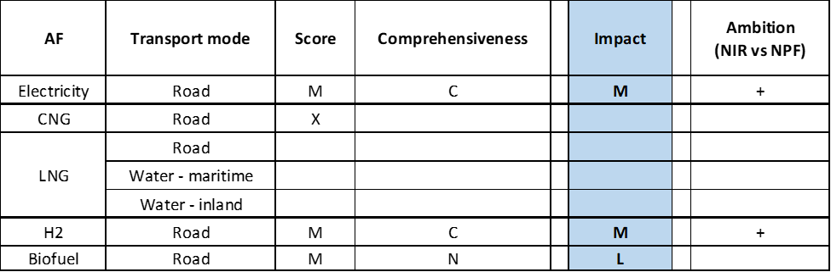

**Legend:** Score and Impact: H = high; M = medium; L = low; X = not assessable. Comprehensiveness: C = comprehensive; N = Not comprehensive. Ambition level: ‘+’ means ‘higher’; ‘=’ means ‘comparable’; ‘-‘ means ‘lower’.

#### Research, Technological Development & Demonstration

The Bulgarian NIR contains a list of 12 RTD&D programmes, which represents a significant increase compared to the six RTD&D actions identified in the NPF. The majority of these RTD&D programmes focus on electric vehicles and notably on hydrogen.

The continuation of the “*Operational Programme Innovation and Competitiveness 2014-2020*” for the period 2021-2027 will speed up the development of alternative fuels and the deployment of the relevant infrastructure. Funds are mainly channelled through the ESF+, the ERDF and the Cohesion Fund.

The “*National Research Programme Low Carbon and Energy for Transport and Households (EPLUS)*”, approved in 2018, contains a component on ‘*Electric Vehicles and Hydrogen Mobility’*. The NIR report showcases the activities towards Bulgaria’s specialisation in battery/fuel cell based hybrid electric mobility: namely a cyber-physical platform for development and demonstration of battery/fuel cell hybrid vehicles and the retrofitting of trolleybuses with a battery/fuel cell range extender. The total budgets for these projects are €450,000 and €650,000 respectively.

In addition, the “*Energy Storage and Hydrogen Energy project*”, funded by the Bulgarian Ministry of Education and Science, foresees 1.5 million € to be used for the development of the relevant hydrogen infrastructure for transport application and the “*Clean Energy Production Storage and Application Technologies Competence Centre – HITMOBIL*” has allocated 2 million €, out of 8 million € total budget, to transport. Highlighted in the Bulgarian NIR report are the €750,000 for the demonstration of a mobile hydrogen refuelling station and €700,000 for an electrolysis system for hydrogen production from RES.

### Additional information on alternative fuels infrastructure developments

The Bulgarian NIR does not provide information on the changes in fuel use.

### Summary of the assessment

**Tabular overview**

*Table 5.2.6‑1 Overview of the NIR assessment*



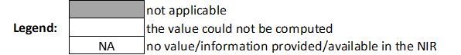

* Value taken from BG NPF

** Value taken from EAFO (absent in NIR)

In its NPF, the Republic of Bulgaria indicated that their long-term goal, after 2030, was to deploy electro-mobility, use natural gas widely as a standard fuel and advance hydrogen technology out of the research and development phase. The Bulgarian NIR is fully consistent with the NPF and focuses on road transport electrification and on the potential for the use of hydrogen in transport. The Bulgarian NIR covers mostly the 1st part of the AFID period (2016-2020).

The Bulgarian NIR almost fully addresses the requirements of Annex I of the Directive, but limitedly to electro-mobility and, to a lesser extent, hydrogen/road. To have fully complied with the requirements of Annex I of the Directive, the Bulgarian government should have considered the need for renewable jet fuel refuelling points in airports within the TEN-T Core Network and it should have provided information on the methodology applied to take account of the charging efficiency of high power recharging points.

The main outcomes of the technical assessment of the Bulgarian NIR on vehicles/vessels estimates and infrastructure targets can be summarised as follows:

###### Road transport

* **Electricity** – Concerning EVs, Bulgaria recorded a total of 7,034 electric vehicles in 2018 (of which 6,288 were passenger cars, 721 LCVs and 25 buses and coaches). The Bulgarian NIR reports a revised set of vehicle estimates for 2020, 2025 and 2030, which are respectively 78.2%, 63.5% and 49.08% lower than in the NPF. Passenger cars have the highest share, but in 2030, 10,000 LCVs, 200 HCVs and 1,000 buses and coaches are also foreseen. Similarly, the infrastructure targets in the BG NIR have been reduced compared to the NPF by 88%, 66.67% and 44.44% respectively for 2020, 2025 and 2030. The 2018 progress towards the significantly reduced objectives is considered to be adequate both for the vehicles and for infrastructure, but the sufficiency index becomes adequate only in 2025 and 2030 while until then infrastructure deployment cannot be considered sufficient with respect to the expected vehicle uptake.
* **CNG** – The Bulgarian NIR shows only the state of play of CNG vehicles in 2018 (21,823 vehicles, mostly dual engines, of which 17,829 were passenger cars, 3,376 LCVs, 116 HCVs and 502 buses and coaches), but does not report any vehicle estimate or infrastructure target for 2020, 2025 and 2030.
* **LNG** – Information is not available in the Bulgarian NIR.
* **Hydrogen** – The Republic of Bulgaria had included hydrogen in its NPF. Accordingly, the Bulgarian NIR shows that emphasis is put on hydrogen road transport, however it presents reduced ambition for vehicles and infrastructure. Although there are no hydrogen vehicles on the Bulgarian roads as of 2018, 110 vehicles are expected to be deployed by 2025 and 555 in 2030, mainly buses. Two publicly accessible hydrogen refuelling points will be deployed by 2025 and four refuelling points are foreseen for 2030. These will be accompanied by three and ten private refuelling points in 2025 and 2030 respectively.
* **Biofuels** – Information is not available in the Bulgarian NIR.
* **LPG** – Other than reporting a total number of 164,077 LPG vehicles in 2018 (of which 157,440 passenger cars, 6,603 LCVs and 34 buses and coaches), the BG NIR does not show any further information or objectives for vehicles and infrastructure.

###### Rail transport

Information is not available in the Bulgarian NIR.

###### Waterborne transport (maritime)

* **Electricity** – The number of shore-side electricity supply points at the Bulgarian maritime ports was 172 in 2018. There are no targets for the period 2020-2030 in either the NIR or the NPF.
* **LNG** – Information is not available in the Bulgarian NIR.
* **Hydrogen** – The BG NIR mentions that the state-owned company “*Bulgarian Ports Infrastructure*” continues to explore possibilities for the construction of a hydrogen refuelling station at the port of Burgas.

###### Waterborne transport (inland)

* **Electricity** – The number of shore-side electricity supply points at the Bulgarian inland ports was 90 in 2018. There are no targets for the period 2020-2030 in either the NIR or the NPF.
* **LNG** –Information is not available in the Bulgarian NIR.

###### Air transport

* **Electricity** (for stationary airplanes) - In the period 2016-2018, Sofia airport in the TEN-T Core Network provided power supply and air-conditioning from stationary facilities installed at six passenger sleeves at the Terminal 2. The NIR mentions that a new boarding sleeve will be delivered in 2021.

The **measures** presented in the Bulgarian Implementation Report mainly focus on electro-mobility and hydrogen. The legal, regulatory and administrative measures detailed in the NIR mainly concern the requirements for the transposition of European Directives to the Bulgarian legislation. In the period 2016-2018, most legal measures were in place or in the process of being adopted. Based on the available information, the level of ambition can be considered to remain constant between NPF and NIR.

As for the policy measures, the BG NIR contains measures oriented to enhance the deployment of electro-mobility, with particular reference to electrification of urban public transport and the acquisition of hydrogen buses. The number of deployment and manufacturing support initiatives portrayed in the Bulgarian NIR has increased in comparison to the NPF. Measures in the NIR target recharging points for electricity supply and hydrogen refuelling infrastructure. Bulgaria relies on the European Union co-funding instruments and Cohesion Funds to finance support initiatives for the production of alternative fuels, as for example the 35 million € foreseen for the production of green hydrogen.

In terms of expected impact of the measures to support the realisation of the AFV/AFI objectives as presented in the NPF and revised in the NIR, those for the pairs electricity/road and hydrogen/road result to have a medium impact, those for the pair biofuels/road have a low impact, while all the others are not assessable.

With regard to RTD&D measures, the Bulgarian implementation report shows an increased effort to channel financial resources, counting on the European Union co-funding instruments and Cohesion funds. Research, development and demonstration activities mainly concern electro-mobility and hydrogen related projects. From the information provided in the NIR for RTD&D, the level of support, compared to the NPF, can be considered to have increased for electro-mobility and hydrogen road transport.

### Final remarks

The Bulgarian NIR reports on a range of efforts to implement the Directive but with a focus on electro-mobility and, to a lesser extent, on hydrogen for road transport. In particular, it does not provide future estimates for CNG and LNG vehicles and vessels for the years 2020, 2025 and 2030. It also lacks information, for the same years, on the targets for CNG refuelling points for vehicles and LNG refuelling points for vehicles and vessels. There are no estimates on the future shore-side electricity supply in ports. Most of the measures referenced in the NIR focus on electro-mobility and hydrogen for road transport.

Regarding electricity, the NIR estimates for 2030 a fleet of 66,200 electric vehicles, representing about 1.8% of the future vehicle fleet. Taking into account the current situation and expected trends, this level of ambition appears quite low compared to the pace of deployment of electric vehicles considered necessary for a full transition to carbon neutrality by 2050. The targets for publicly accessible recharging infrastructure correspond to those low vehicle estimates. An increase in ambition would contribute to better meeting the needs for a dense, wide-spread and easy to use network of recharging and refuelling infrastructure in the EU. No information on charging efficiency is provided. The NIR states that shore-side electricity supply is available in a significant number of maritime and inland ports. However, it remains unclear which vessels can actually connect to the infrastructure and whether this infrastructure is suitable for all seagoing ships and inland waterway vessels as requested by the Directive. The NIR notes the intention to develop measures to modernise the existing infrastructure for shore-side electricity supply in ports and ensure that seagoing ships and inland waterway vessels can be connected. Electricity to stationary aircraft is supplied at the TEN-T Core airport of Sofia. Future reporting could usefully include more information as regards the current and planned electrification of railways.

Concerning hydrogen for road transport, the NIR expresses Bulgaria's interest in developing hydrogen as a fuel for road transport. It estimates 555 FCHVs by 2030. The NIR envisages four public refuelling points by 2030. Further detail on infrastructure needs and planning should be provided, particularly for buses and heavy-duty vehicles.

Regarding natural gas for transport, there was already a limited fleet of 21,823 CNG vehicles in Bulgaria in 2018. The NIR does not provide information on estimates and targets for CNG vehicles and refuelling points for 2020, 2025 and 2030. It further does not provide information on LNG for road and inland and maritime waterway transport.

As regards LPG in road transport, there was already a fleet of 164,077 LPG vehicles in 2018, but the Bulgarian NIR does not bring any further information or objectives for vehicles and infrastructure.

As far as biofuels are concerned, no quantitative information on the use of biofuels in road transport is provided. However, the measure “Promotion of the use of biofuels and other renewable fuels in transport” has been included in the NIR. Bulgaria should provide more information on efforts to promote the use of renewable fuels in transport, and particularly in aviation.

### ANNEX - Description of the Member State

On a surface area of 111,000 km², Bulgaria has a population of 7.050 million people in 2018, which makes up for a population density of 64 inhabitants/km².

*Number of main urban agglomerations*

* 17 urban agglomerations > 50,000 inhabitants

In 2018, Bulgaria achieves a per capita gross domestic product at market prices of €7,980, which represents a per capita gross domestic product in purchasing power standards of 51 if expressed in relation to the EU-28 average set to equal 100.

*Length of the road networks*

The length of the road TEN-T Core Network in Bulgaria is 1,507 km. The total road network length is 7,690 km, of which 757 km are motorways.

The following lengths of the TEN-T Road Corridors are present in Bulgaria: 18% (960 km) of the Orient – East Mediterranean Corridor.

Through the TEN-T Road Corridors, Bulgaria is connected with the following Member States:  
- Greece (through the Orient – East Mediterranean Corridor),   
- Romania (through the Orient – East Mediterranean Corridor)

*Number of registered road vehicles*

At the end of 2018, Bulgaria accounts for 3,413,371 registered road vehicles[12] of which 2,773,325 are categorized as passenger cars, 438,328 as heavy goods vehicles and 20,818 as buses and coaches. The motorisation rate is 393 passenger cars per 1,000 inhabitants. The Bulgarian NIR describes the age distribution of the vehicle fleet: in 2017 around 86% of vehicles were over 10 years old (with 69% of passenger cars being over 15 years old), while only 5% of the vehicles have less than 5 years and 9% are in the range of 60 to 10 years. The matter of the renewal of the country’s vehicle is regarded by Bulgaria as needing to be considered.

*Number of ports in the TEN-T Core Network*

* 1 maritime port in the TEN-T Core Network (Burgas)
* 1 maritime port in the TEN-T Comprehensive Network (Varna)
* 2 inland ports in the TEN-T Core Network (Ruse, Vidin)
* 4 inland ports in the TEN-T Comprehensive Network

Through the 478 km inland waterways TEN-T Core Network, Bulgaria is connected with Romania through the Rhine-Danube Corridor.

*Number of airports in the TEN-T Core Network*

* 1 airport in the TEN-T Core Network (Sofia)
* 4 airports in the TEN-T Comprehensive Network

## Czechia (CZ)

### Main messages from the Commission assessment of the NPF

In its original assessment of the Czech NPF the Commission concluded:

*The Czech NPF broadly addresses the requirements of Article 3. It contains an extensive discussion of the current state and future scenarios for alternative fuels in the transport sector. For most fuels and modes, it establishes sufficient targets as required by Article 3 of the Directive. It does not contain a target for LNG refuelling points at inland ports.*

*The Czech NPF puts a comparably low emphasis on electric vehicles and estimates only 0.35% electric vehicles on the road in 2020. Today, the spatial distribution of recharging points and specifically high power recharging infrastructure seems to appropriately cover the needs of electric vehicles in terms of distance requirements in the Czech Republic. For the future, the targeted ratio of only one public recharging point per 13 electric vehicles estimated for 2020 could evolve to become a barrier for the further market deployment of electric vehicles. This could also lead to market fragmentation within the EU, especially in the context of the rather low estimated EV shares in the Czech NPF. It will be important to closely monitor this development and correct infrastructure targets in line with the market developments. Regarding electricity supply for stationary airplanes, the NPF only mentions that further installations for the Prague airport are under consideration. The NPF does not provide any targets for shore-side electricity.*

*The Czech Republic already today has a relatively dense network of CNG refuelling points and the NPF foresees that this will further grow in line with the expected market needs, which are comparably high in the NPF, with estimates of 1% CNG cars on the road in 2020.*

*The NPF has established targets for LNG refuelling points for heavy-duty vehicles that will likely ensure appropriate coverage of the road TEN-T Core Network on Czech territory.*

*The Czech NPF does not contain targets for LNG refuelling at inland ports. This omission could have a negative impact on the circulation of LNG inland waterway vessels throughout the TEN-T Core Network. The decision not to include LNG refuelling at inland ports in the Czech NPF would have merited a more detailed discussion of market needs. This may need to be revisited also in light of estimated market needs from other Member States.*

*The NPF establishes targets for hydrogen refuelling points.*

*The Czech NPF contains a very comprehensive list of measures, which, if implemented, could help overcome deployment barriers. Since the adoption status of most of these measures is low, there is a certain risk that the national targets and objectives of the NPF may not be reached. The NPF also contains a list of considered support measures to promote the deployment of alternative fuels infrastructure in public transport services.*

*The Czech Republic, in its NPF, declares interest to cooperate with the neighbouring countries to ensure EU-wide circulation, especially for LNG and hydrogen for road transport. It may be advisable to extend this cooperation also for the other fuels and modes.*

### Overview of requirements’ fulfilment from Annex I of the Directive

*Table 5.3.2‑1 Checklist Table*



The checklist shows the requirements of Annex I from the Directive that are covered in the CZ NIR.

Regarding the combination of AF/AFV/AFI with transport mode, electricity is covered for road transport; CNG, LNG, hydrogen and LPG are also covered for road transport; inland water transport is just mentioned; all the other combinations are either absent or not applicable.

The Czech NIR reports around 30 measures. Under the Policy and Deployment & Manufacturing sections it was possible to identify four AF/transport mode clusters of measures, all assessable.

### Quantitative assessment: Vehicles and infrastructure

*Table 5.3.3‑1 National AFV estimates and AFI targets established in the NIR at the horizon 2020, 2025 and 2030 and their comparison with the NPF situation*

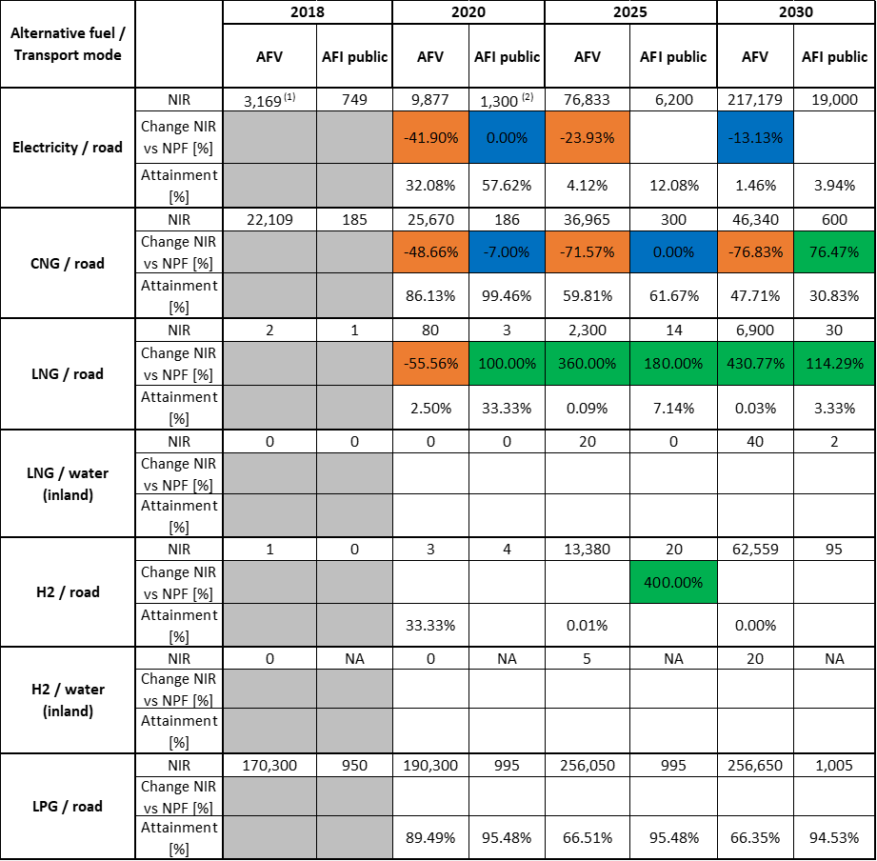

1. value taken from EAFO (absent in both NIR and NPF)
2. this value is mentioned in the CZ NIR but not officially reported in the accompanying excel file

#### Road transport

##### Electricity

###### Vehicles

Czechia recorded 44 LCVs and 55 buses and coaches in 2018 (all battery-electric) but did not provide the number of electric passenger cars. As the NPF also did not have this detail, the total number of EVs in 2018 has been taken from EAFO. For the period 2020-2030 the CZ NIR presents a new curve related to the estimated growth of electric vehicles up to 2030 compared to the NPF. While for 2020 and 2025 there is a sensible decrease in the estimated numbers (-41.90% and -23.93% respectively, compared to the NPF values), for 2030 the NPF estimate is substantially confirmed in the NIR and some expectations to overpass such number are also expressed. In fact, the CZ NIR report says: “*even though the uptake of electro-mobility in the Czech Republic has not been as fast as originally expected or in line with developments in certain western European countries in particular, the Czech Republic is still on course for just over 200,000 vehicles by 2030, as predicted in the National Action Plan for Clean Mobility. If the optimistic scenario worked out, this number could be more than doubled”*. The current estimate for 2030 is 217,179 EVs, of which 200,647 are passenger cars, 15,949 LCVs and 583 buses and coaches. The CZ NIR reveals also the presence of 756 trolleybuses in 2018, which are expected to remain in the same number until 2030.

The 2018 ***attainment*** of future EV estimates is 32.08% for 2020 and 1.46% for 2030. According to the assessment methodology described in Section 2.1, the 2018 situation corresponds to an ***adequate progress*** towards reaching the envisaged EV estimates. The calculated ***average*** ***annual growth rate*** corresponding to the period 2016-2030 for EV fleet evolution planned by Czechia is equal to 96%.

###### Infrastructure

Czechia recorded 749 publicly accessible recharging points in 2018, of which 253 were normal power (≤22kW) and 496 high power (>22kW) recharging points. Concerning the next decade, the CZ NIR confirms the NPF targets for 2020. For 2025 and 2030 there are new targets, not present in the NPF, that appear to be coherently designed to maintain a constant ratio with respect to the estimated EVs for the target years. It is worth mentioning that the share of high power recharging infrastructure decreases from 67% in 2018 to 18% in 2025 and 11% in 2030.

The 2018 ***attainment*** of future public recharging infrastructure targets is 57.62% for 2020 and 3.94% for 2030. According to the assessment methodology described in Section 2.1, the 2018 situation corresponds to an ***adequate progress*** towards reaching these envisaged targets. The calculated ***average annual growth rate*** corresponding to the period 2016-2020 for publicly accessible recharging infrastructure evolution planned by Czechia is equal to 32%.

###### Ratio

Based on the CZ NIR, the following table shows the ratio between vehicles and publicly accessible recharging points (i.e. sufficiency index) for the pair electricity/road. It can be seen that the foreseen sufficiency index remains below 10 until 2020, raising slightly above 10 in 2025 and 2030. Overall the sufficiency index can be considered adequate for the next decade.



###### Information on charging efficiency

Information is not available in the Czech NIR.

##### *CNG*

###### Vehicles

Czechia recorded 22,109 CNG vehicles in 2018, of which 20,660 were passenger cars, 215 HCVs and 1,234 buses and coaches. For the next decade, the CZ NIR presents an important revision of the CNG vehicles estimate compared to the NPF, with a decrease in the total number of CNG vehicles going down from 50,000 to 25,670 vehicles in 2020 and from 200,000 to 46,340 vehicles in 2030. This is justified in the NIR as: “*mainly due to the reduced offering of these vehicles resulting from the transition to the new Worldwide Harmonized Light Vehicle Test cycles*”. On the other hand, a partial compensation in terms of AF vehicles is foreseen by the increased estimates of LNG and mostly of hydrogen vehicles in the CZ NIR compared to the NPF (see next sections).

The 2018 ***attainment*** of the significantly reduced future CNG vehicles estimates is 86.13% for 2020 and 47.71% for 2030. According to the assessment methodology described in Section 2.1, the 2018 situation corresponds to a ***fast progress*** towards reaching the envisaged CNG vehicles estimates. The calculated ***average annual growth rate*** corresponding to the period 2016-2030 for the CNG vehicle fleet evolution planned by Czechia is equal to 8%.

###### Infrastructure

In 2018, Czechia recorded 185 CNG refuelling points. Table 5.3.3‑1 shows a confirmation of the NPF targets for publicly accessible CNG refuelling points over the period 2020-2025, and a remarkable increase for 2030 (+76.47%), which however seems in contrast with the corresponding decrease in CNG vehicle estimate for 2030 (-76.83%) compared to the NPF estimate. This is not explained in the CZ NIR.

The 2018 ***attainment*** of future public CNG refuelling infrastructure targets is 99.46% for 2020 and 30.83% for 2030. According to the assessment methodology described in Section 2.1, the 2018 situation corresponds to an ***adequate progress*** towards reaching these envisaged targets. The calculated ***average annual growth rate*** corresponding to the period 2016-2025 for publicly accessible CNG refuelling infrastructure evolution planned by Czechia is equal to 12%.

###### Ratio

Based on the CZ NIR, the following table shows the ratio between vehicles and publicly accessible refuelling points (i.e. sufficiency index) for the pair CNG/road. It can be seen that sufficiency index is well below the indicative value of 600 (see Section 2.1.5) for the whole period.



##### *LNG*

###### Vehicles

Czechia recorded two LNG HCVs in 2018. For the next decade, the CZ NIR presents a revised plan compared to the NPF. Although for 2020 there is a lower estimate of LNG vehicles than in the NPF, the CZ NIR presents overall a considerably more ambitious plan for 2025 and 2030, with respectively 2,300 and 6,900 heavy commercial LNG vehicles on the market.

The 2018 ***attainment*** of future LNG vehicles estimates is 2.50% for 2020 and 0.03% for 2030. According to the assessment methodology described in Section 2.1, the ***progress*** obtained by Czechia from 2016 until 2018 for LNG vehicles deployment is 0.03% of the overall planned deployment during the period 2016-2030.

###### Infrastructure

With only one LNG refuelling point recorded on 2018, the CZ NIR presents a new and more ambitious set of targets for LNG infrastructures in 2020, 2025 and 2030 (30 in the NIR versus 14 in the NPF), which is in line with the corresponding increased estimation of LNG vehicles compared to the NPF for the next decade.

The 2018 ***attainment*** of future public LNG refuelling infrastructure targets is 33.33% for 2020 and 3.33% for 2030. According to the assessment methodology described in Section 2.1, the ***progress*** obtained by Czechia from 2016 until 2018 for public LNG refuelling infrastructure deployment is 3.33% of the overall planned deployment during the period 2016-2030.

###### Ratio

Based on the CZ NIR, the following table shows the ratio between vehicles and publicly accessible refuelling points (i.e. sufficiency index) for the pair LNG/road.



##### *Hydrogen*

###### Vehicles

While in 2018 there was just one hydrogen vehicle recorded in Czechia, the CZ NIR presents quite an ambitious estimate of hydrogen vehicles for 2025 and 2030, with a total number of 62,559 in 2030. The vast majority of these vehicles is foreseen to be light-duty vehicles (i.e. passenger cars and light commercial vehicles) but 100 heavy commercial vehicles and 870 buses and coaches are also foreseen in 2030.

The 2018 ***attainment*** of future hydrogen vehicles estimates is 33.33% for 2020 and less than 0.01% for 2030. According to the assessment methodology described in Section 2.1, the ***progress*** Czechia obtained from 2016 until 2018 for hydrogen vehicles deployment is 0% of the overall planned deployment during the period 2016-2030 since the situation remained the same.

###### Infrastructure

The new set of targets for hydrogen infrastructures (and vehicles) reported in the CZ NIR represents the most relevant change with respect to the NPF. In the latter, there was only one target for 2025 of four hydrogen publicly accessible refuelling stations. In the CZ NIR, these targets are: four for 2020 (the construction of which has already been contracted), 20 for 2025 and 95 for 2030.

Since at the end of 2018 there are no hydrogen refuelling points deployed, the 2018 ***attainment*** and ***progress*** have not been computed.

###### Ratio

Based on the CZ NIR, the following table shows the ratio between vehicles and publicly accessible refuelling points (i.e. sufficiency index) for the pair hydrogen/road.



##### *Biofuels*

###### Vehicles

Information is not available in the Czech NIR.

###### Infrastructure

Information is not available in the Czech NIR.

##### *LPG*

###### Vehicles

Czechia recorded 170,300 LPG vehicles in 2018 (of which 170,000 were passenger cars and 300 LCVs). In the CZ NPF, there was no mention of LPG vehicle estimates for 2020, 2025 and 2030, while in the NIR (see Table 5.3.3‑1) such estimate appears, with an increase from 190,300 vehicles in 2020 to 256,650 vehicles in 2030.

The 2018 ***attainment*** of future LPG vehicles estimates is 89.49% for 2020 and 66.35% for 2030. According to the assessment methodology described in Section 2.1, the ***progress*** Czechia obtained from 2016 until 2018 for LPG vehicles deployment is 0.00% of the overall planned deployment during the period 2016-2030 because the CZ NIR shows a constant value of 170,300 LPG vehicles for the period 2016-2018.

###### Infrastructure

As for LPG vehicles, the CZ NIR presents a strategy for LPG infrastructures, which was not present in the NPF. However this cannot be considered as a real novelty or a change of ambition on this fuel, as a substantial network of LPG refuelling points (and corresponding LPG vehicles) was already present in Czechia even before the AFI Directive. Furthermore, looking at the infrastructure target for 2030 it can be seen that the level of attainment in 2018 is already around 95%, meaning a very limited growth compared to the current situation.

The 2018 ***attainment*** of future public LPG refuelling infrastructure targets is 95.48% for 2020 and 94.53% for 2030. According to the assessment methodology described in Section 2.1, the ***progress*** Czechia obtained from 2016 until 2018 for LPG refuelling infrastructure deployment is 42.71% of the overall planned deployment during the period 2016-2030.

###### Ratio

Based on the CZ NIR, the following table shows the ratio between vehicles and publicly accessible refuelling points (i.e. sufficiency index) for the pair LPG/road.



#### Rail transport

##### *Electricity*

###### Vehicles

The CZ NIR recorded 814 locomotives/railcars and 317 passenger vehicles in 2018. A slight increase in these numbers is expected until 2030 (900 locomotives/railcars and 370 passenger vehicles).

###### Infrastructure

Information is not available in the Czech NIR.

#### Waterborne transport (maritime)

Not applicable since Czechia has no maritime ports in the TEN-T Core Network.

#### Waterborne transport (inland)

##### LNG

###### Vessels

The CZ NIR provides an estimate of 20 and 40 LNG vessels for inland waterborne transport, respectively by 2025 and 2030 (NOTE: these estimates have been presented as CNG vessels in the CZ NIR but it is considered that in reality the numbers refer to LNG vessels and as such they have been treated).

Since at the end of 2018 there are no LNG vessels deployed in the inland ports, the 2018 ***attainment*** and ***progress*** have not been computed.

###### Infrastructure

Following the Commission assessment of the CZ NPF, the CZ NIR shows a change of strategy, with a target of two LNG refuelling stations for 2030. In fact, in relation to Article 6(3) of the Directive, the CZ NPF had not set any target for the construction of LNG fillings stations at inland ports. The justification had been that the construction of filling stations for LNG-powered vessels in public ports in Czechia did not look effective for the immediate future.

Since at the end of 2018 there are no LNG refuelling points deployed, the 2018 ***attainment*** and ***progress*** have not been computed.

##### *Hydrogen*

###### Vessels

The CZ NIR also presents an estimate of hydrogen-fuelled vessels for 2025 and 2030 (5 and 20 vessels, respectively), however this is not accompanied by any announced plan of corresponding hydrogen infrastructures at the Czech inland ports. The CZ NIR provides no explanation.

Since at the end of 2018 there are no hydrogen vessels deployed in the inland ports, the 2018 ***attainment*** and ***progress*** have not been computed.

###### Infrastructure

Information is not available in the Czech NIR.

#### Air transport

##### Electricity

###### Airplanes

Information is not available in the Czech NIR.

###### Infrastructure (for stationary airplanes)

CZ NIR reports the following: “*At present, the (Prague’s Václav Havel) airport is equipped with power connections (400 Hz) at all 31 contact stands (stands served by boarding bridges), and every new contact stand will also be fitted with one. Remote stands are not provided with permanent connections and there are no plans to fit these. However, the handling companies have mobile ground power units (GPUs), which can be used for aircraft at remote stands…. Within five minutes of an aircraft stopping at a stand, it must be connected to an external power source and the auxiliary power unit must be disconnected. Auxiliary power units cannot be started up until 20 minutes prior to the expected time of departure (ETD). The other international airports included in the TEN-T core or global network, i.e. Ostrava/Mošnov airport and Brno/Tuřany airport, and equipped with permanent power connections do not have contact stands, but even here the same requirement applies concerning restrictions on auxiliary power units and the use of mobile ground power units instead.”*

### Measures assessment

Concerning the measures to support the uptake of AF vehicles and infrastructures, the CZ NPF had listed a large number (around 70 overall) that was presented as a collection of the most common measures also taken into consideration by other Member States. Of this large list of measures, the NPF reported that only a limited number was actually implemented, while the majority was still at discussion stage. In the CZ NIR, the situation has evolved as to include a selection of measures that have been either confirmed/modified (if already in place), or implemented/dropped (if under discussion).

#### Legal measures

The CZ NIR presents a list of six Legislative & Regulatory measures and seven Administrative measures. Ten of these measures are in place and three are in the process of being adopted. This compares with a list of 24 Legal measures presented in the NPF, of which seven were adopted and 17 were under discussion. In this case it was not possible to provide an assessment of the change of ambition level between NIR and NPF.

##### Legislative & Regulatory

The six Legislative & Regulatory measures are quite differentiated and cover a series of elements:

* allowing public contracting authorities to apply a methodology to calculate operating costs using lifetime costs when purchasing vehicles;
* setting specification of the requirements for electrical engineering qualifications for staff working on electric vehicles;
* updating the legislation dealing with LNG-powered vehicles;
* addressing the issue of removing barriers to the garaging of gas-powered vehicles;
* no payment of motorway vignettes/tolls for vehicles powered by alternative fuels;
* introduction of special registration plate for electric vehicles.

##### Administrative

Similarly, the seven Administrative measures address different aspects (both of financial and non-financial nature) like, for example:

* maintaining the reduced rate on excise duty for CNG and LNG;
* allowing free parking for vehicles powered by alternative fuels;
* promoting targeted specialised teaching in the area of clean mobility both at secondary schools and at university level;
* strengthening cooperation between universities, research organisations and industry in the development of alternative fuels in Czechia.

Overall, the list of Legal measures presented in the CZ NIR shows the development of a strategy that was not evident in the NPF.

#### Policy measures

In terms the Policy measures, the first considerations relate to the comparison between NPF and NIR.

The NPF contained 26 measures that could be considered as Policy measures. Of these, only four were implemented, while the other 22 were under discussion. The NIR only addresses eight Policy measures, but all are in place. Six measures are related to ensure national targets and objectives, one measure can be associated to the promotion of AFI in public transport services and one measure to the promotion of deployment of private electro-mobility infrastructure.

##### Measures to ensure national targets and objectives

###### Road transport

Two out of the six measures in this section concern incentives to support the purchase of AF vehicles. The first has supported the purchase of 69 electric buses, 98 trolleybuses and 100 CNG buses. The second measure has supported the purchase of 508 electric vehicles by private business. It is noted here that, contrary to several other MSs, no incentives are foreseen for the purchase of EV by private citizens.

The remaining four measures are related to providing financial support to the construction of recharging stations (375 fast recharging points and 444 normal recharging points), CNG refuelling stations (2 CNG refuelling stations are already supported, others are planned), LNG refuelling stations (13 LNG refuelling stations are supported, others are planned), and hydrogen refuelling stations (4 hydrogen refuelling stations are supported, others are planned).

###### Other transport modes

The CZ NIR does not present measures for other transport modes (rail, water, air).

##### Measures that can promote AFI in public transport services

The above-mentioned measure, concerning the purchase of 69 electric buses, 98 trolley-buses and 100 CNG buses, can be considered as an indirect measure to promote AFI in public transport service and as such it has been assessed.

##### Measures that can promote the deployment of private electro-mobility infrastructure

The CZ NIR also presents a Policy measure to promote the deployment of private electro-mobility infrastructure. According to the NIR, this measure has supported 256 recharging stations within premises of private companies.

#### Deployment and manufacturing support

##### AFI deployment

Considering, that in the CZ NPF there were four Deployment measures mentioned, all under discussion, it is evident that actions have been taken and some progress has been made towards the uptake of AF infrastructures in the CZ Republic. The CZ NIR reports that, in the implementation period 2017-2020, 375 rapid recharging stations, 444 normal recharging stations, 13 LNG and 4 hydrogen refuelling stations have either been built, or are under construction or have been assigned for construction.

The CZ NIR also reports that “*some businesses have also responded to the calls announced by the European Commission under the Connecting Europe Facility. In 2020, support from this source should lead to the construction of 149 rapid charging stations and 10 ultra-rapid charging stations on the corridors of the TEN-T Core Network”.*

##### Support of manufacturing plants for AF technologies

The CZ NIR mentions a measure to support manufacturing plants for AF technologies in the form of investment incentive (reduced corporation tax), foreseen for the period 2021-2025 with a total budget of around 53 million €. However, no other information is given that could allow any assessment of this measure.

##### Consideration of any particular needs during the initial phase of the deployment of alternative fuels infrastructures

Information is not available in the Czech NIR.

#### Quantitative assessment of Policy and Deployment & Manufacturing measures

Table 5.3.4‑1 presents an analysis of all the Policy and Deployment & Manufacturing measures carried out according to the assessment methodology described in Section 2.2. As it can be seen, only clusters of measures on electricity, CNG, LNG and hydrogen, all for road transport, could be identified in the Czech NIR but none resulted to be comprehensive. The electricity/road, LNG/road and hydrogen/road clusters have at least one measure that scores high, thus the overall score is H. In terms of expected impact of these measures to support the realisation of the AFV/AFI objectives as presented in the NPF and revised in the NIR, the measures for the pairs electricity/road, LNG/road and hydrogen/road result to have a medium impact, while those for the pair CNG/road have a low impact. Compared to the NPF, the level of ambition of the Policy and Deployment & Manufacturing support measures has increased for LNG/road and hydrogen/road, has remained the same for electricity/road and has decreased for CNG/road, coherently with the vehicle estimates and infrastructure targets presented in Section 5.3.3.

*Table 5.3.4‑1* *Quantitative assessment of Policy and Deployment & Manufacturing support measures*

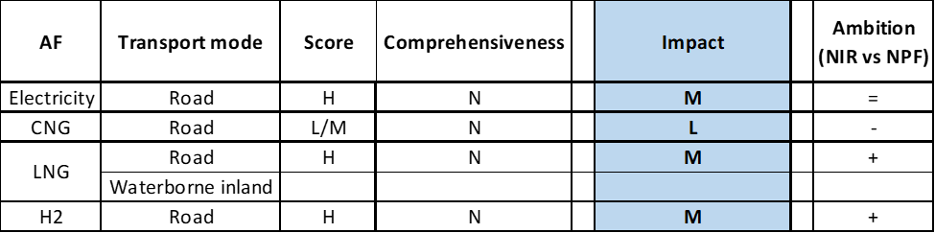

**Legend:** Score and Impact: H = high; M = medium; L = low; X = not assessable. Comprehensiveness: C = comprehensive; N = Not comprehensive. Ambition level: ‘+’ means ‘higher’; ‘=’ means ‘comparable’; ‘-‘ means ‘lower’.

#### Research, Technological Development & Demonstration

In terms of RTD&D measures, the CZ NIR shows a substantial continuity in the approach taken in the NPF, with the participation in several EU RTD&D projects (Alpha, Beta, Gamma, Delta, etc.). In particular, the CZ NIR reports a project on electro-mobility and links with the distribution system/Smart Grids. Two projects focus on the development of hydrogen for road transport. A fourth project is dedicated to the analysis of the potential for the use of CNG/LNG in inland water transport. Overall, the approach shown in the CZ NIR appears to have a similar level of ambition to that of the NPF.

### Additional information on alternative fuels infrastructure developments

The CZ NIR provides information on the changes in fuel use (see Table 5.3.5‑1). As it can be seen, CNG is expected to remain the dominating alternative fuel in road transport throughout the period (despite the important downward revision of the CNG vehicle estimate for next decade), followed by LPG and electricity. Hydrogen is also expected to start playing a little role in 2030. No increase in AF use in inland waterway transport is expected.

*Table 5.3.5‑1 Changes in fuels use in transport sector (2016-2030)*



### Summary of the assessment

**Tabular overview**

*Table 5.3.6‑1 Overview of the NIR assessment*

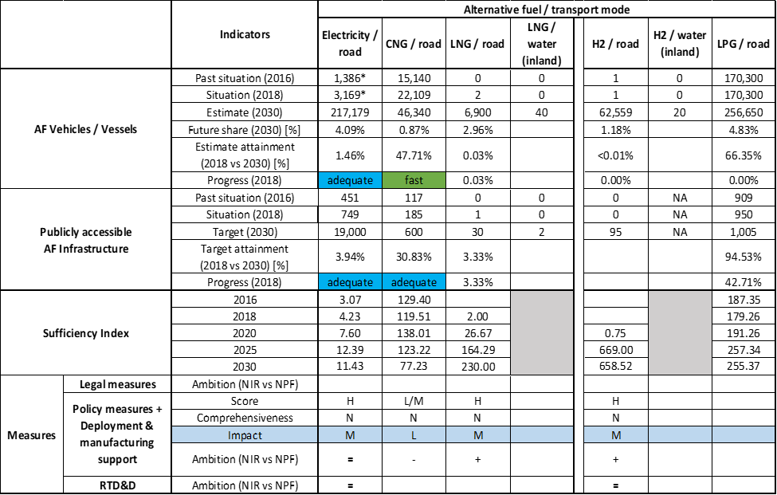



* Value taken from EAFO (absent in both NIR and NPF).

The CZ NIR addresses all the requirements of Annex I from the Directive, although not with the same level of detail.

Regarding the combination of AF/AFV/AFI with transport mode, electricity is well covered for road transport; CNG, LNG and hydrogen are also covered for road transport; inland water transport is just mentioned (refuelling infrastructures are foreseen in 2025 and 2030 for LNG, while inland waterway vessels are estimated for CNG and hydrogen. In this assessment the CNG vessels have been considered instead as LNG vessels, while for hydrogen the discrepancy remains that no infrastructure is foreseen up to 2030); all the other combinations are either absent or not applicable. As for LPG, Czechia has already quite a developed combination of refuelling infrastructure and vehicles.

The main outcomes of the technical assessment of the Czech NIR on vehicles/vessels estimates and infrastructure targets can be summarised as follows:

###### Road transport

* **Electricity** – With 749 recharging points recorded in 2018, the CZ NIR confirms the infrastructure target for the end of 2020, thus showing the same level of ambition of the NPF. Targets have been introduced for the years 2025 and 2030 that were not included in the NPF. These appear to be coherently designed to maintain a constant and adequate ratio with the estimated EV for the target years. Concerning EV vehicles, the CZ NIR presents a new growth curve, with a lower number of vehicles in 2020 and 2025 compared to the NPF, but a similar number of vehicles in 2030 (i.e. > 200,000). According to our methodology, the progress between 2016 and 2018 to achieve their objectives in 2030 is considered adequate for both EV infrastructure and EV vehicles. As for heavy-duty vehicles, the CZ NIR estimates 583 battery-electric buses and coaches on the road by 2030 but no HCV.
* **CNG** – In 2018, Czechia recorded 185 CNG refuelling points and 22,109 vehicles. For the next decade, the CZ NIR shows a substantial reduction in CNG vehicle estimate for 2030, from 200,000 to less than 50,000 (-76.83%), coupled to an increase for the CNG infrastructure. This discrepancy is not explained in the NIR. It should be noted that the decrease in vehicle estimates for CNG/road is partially compensated by an increase of LNG/road and hydrogen/road vehicles, however this does not seem sufficient compared to the NPF plan. Thus, it can be considered that on non-EV vehicles there is an overall decrease of ambition compared to the NPF. According to our methodology, the progress between 2016 and 2018 to achieve their objectives in 2030 is considered adequate for CNG infrastructure and fast for CNG vehicles. Obviously, the substantial reduction in vehicle estimates for 2030 plays a role here. In the heavy-duty sector, the CZ NIR estimates 600 HCVs and 1,740 buses and coaches on the road by 2030.
* **LNG** – The CZ NIR presents a plan to double the number of LNG refuelling infrastructure in 2030 compared to the NPF (30 in the NIR versus 14 in the NPF) and to have 6,900 LNG heavy commercial vehicles on the road by 2030.
* **Hydrogen** – The CZ NIR provides objectives that were not present in the NPF (with the exception of the hydrogen infrastructure target for 2025). In the CZ NIR, 62,559 hydrogen vehicles and 95 hydrogen publicly accessible refuelling stations are foreseen by 2030. Most of these hydrogen vehicles should be light-duty vehicles (>60,000) but 100 heavy commercial vehicles and 870 buses and coaches are estimated too.
* **Biofuels** – Information is not available in the CZ NIR.
* **LPG** – The CZ NIR also presents a plan for the pair LPG/road, which was not included in the NPF. However, this cannot be considered as a consequence of the AFI Directive, because the LPG vehicles and infrastructure were already present on the Czech territory before 2016 and the outlook presented in the NIR until 2030 only shows a moderate increase compared to the current situation.

###### Rail transport

* **Electricity** – The CZ NIR recorded 814 locomotives/railcars and 317 passenger transport vehicles in 2018 and these numbers are expected to slightly increase until 2030 (900 locomotives/railcars and 370 passenger vehicles).

###### Waterborne transport (inland)

* **LNG** – The CZ NIR presents the intention to have 40 LNG waterborne vessels and 2 LNG inland port refuelling stations by 2030.
* **Hydrogen** – The CZ NIR also estimates 20 hydrogen-fuelled waterborne vessels for 2030, but no infrastructure is planned at the moment.

###### Air transport

Information is not available in the Czech NIR.

Concerning the **measures** to support the uptake of AF vehicles and infrastructures, the CZ NIR shows an effort to move from the wide list of measures under discussion in the NPF, to a more limited but focussed set of measures. As a general statement, such effort seems to have been more successful for what concerns the deployment of infrastructure (in particular charging points), less for the AF vehicles.

The Legislative & Regulatory measures are quite differentiated and cover a series of elements: from allowing public contracting authorities to apply a methodology to calculate operating costs using lifetime costs when purchasing vehicles, to setting specification of the requirements for electrical engineering qualifications for staff working on electric vehicles; from updating the legislation dealing with LNG-powered vehicles, to addressing the issue of removing barriers to the garaging of gas-powered vehicles. Similarly, the Administrative measures address different aspects (both of financial and non-financial nature) like, for example, maintaining the reduced rate on excise duty for CNG and LNG; allowing free parking for vehicles powered by alternative fuels; strengthening cooperation between universities, research organisations and industry in the development of alternative fuels in Czechia.

With reference to Policy and Deployment & Manufacturing measures, the effort to focus on implementing a few initiatives is evident. The NPF contained 26 measures that could be considered as Policy measures. Of these, only four were implemented, while the other 22 were under discussion. In the NIR, only eight Policy measures have been counted, but all are in place. Six measures are related to ensure national targets and objectives, one measure can be associated to the promotion of AFI in public transport services and one measure is related to the promotion of deployment of private electro-mobility infrastructure. All of them are only related to road transport. The implementation of these measures has produced some tangible results in terms of deployment of recharging points and refuelling infrastructures in the implementation period 2016-2018. In terms of the expected impact of these measures to support the realisation of the AFV/AFI objectives as presented in the NPF and revised in the NIR for the next decade, the measures for the pairs electricity/road, LNG/road and hydrogen/road result to have a medium impact, while those for the pair CNG/road have a low impact.

With RTD&D measures, the CZ NIR shows continuity with the approach taken in the NPF, i.e. participation in several EU RTD&D projects (Alpha, Beta, Gamma, Delta, etc.). In particular, the CZ NIR reports a project on electro-mobility and links with the distribution system/Smart Grids. Two projects focus on the development of hydrogen for road transport. A fourth project is dedicated to the analysis of the potential use of CNG/LNG in inland water transport. Overall, the approach shown in the CZ NIR appears to have a similar level of ambition to that of the NPF.

### Final remarks

The Czech NIR presents a quite comprehensive report on the efforts to implement the Directive. It largely complies with the provisions of Annex I to the Directive, with only a few exceptions. The NIR provides estimates for vehicles and vessels, and targets for recharging and refuelling points for all alternative fuels with the exception of shore-side electricity supply in inland ports. The report also sets targets for hydrogen, which is not mandatory under the Directive. The NIR presents a large array of measures, in particular in the field of road transport. However, its level of ambition falls short regarding zero emission vehicles and their infrastructure needs. Range and ambition of measures could also be increased as regards the use of alternative fuels in modes of transport other than road.

With regard to electricity, the NIR estimates a fleet of 217,179 electric vehicles on the roads by 2030, representing about 4% of the fleet by that time. Taking into account the current situation and expected trend development, this level of ambition appears quite low compared to the pace of deployment of electric vehicles considered necessary for a full transition to carbon neutrality by 2050. The targets for publicly accessible recharging infrastructure correspond to the estimated number of vehicles. Because of the low vehicles estimate, infrastructure planning is likely to not result in a necessary comprehensive network of recharging points throughout the country. An increase in ambition would contribute to better meeting the needs of a dense, wide-spread and easy to use network of recharging and refuelling infrastructure throughout the EU. No information on charging efficiency is provided. Further, there is no information on shore-side electricity supply in inland ports. Only Prague’s Václav Havel airport is equipped with power connections for stationary aircraft. The NIR does not provide information on the share of electrification of the rail network. However, the use of electricity in rail is expected to slightly increase until 2030.

Regarding hydrogen for transport, the NIR shows Czechia's interest in promoting hydrogen in road and inland waterway transport. The NIR estimates a number of 62,559 FCHVs and around 95 refuelling stations by 2030. The number of hydrogen refuelling points for 2030 seems sufficient taking into account the length of Czechia’s TEN-T Core Network, provided that the refuelling points are widely distributed along the network.

Concerning natural gas for transport, the estimates for vehicle uptake have been significantly reduced compared to those presented in the NPF. The NIR accounts for a share of CNG vehicles in 2030 below 1% of the fleet. In comparison to the fleet estimate, the deployment targets for CNG refuelling infrastructure remain rather high. A significant increase in LNG heavy-duty vehicles is expected in the coming years. In addition, the number of 30 LNG refuelling points planned for 2030 seems sufficient taking into account the length of Czechia’s TEN-T Core Network, provided that the refuelling points are widely distributed along the network. Only two inland ports of the TEN-T Core Network are planned to supply LNG to ships. Czechia should ensure that the other two ports are also equipped with LNG infrastructure to ensure that LNG vessels can circulate throughout the TEN-T Core Network.

A fleet of 170,300 LPG vehicles already exists and their number is expected to increase to 256,050 vehicles until 2025. However, similarly to electric and CNG vehicles, the share in the total fleet is expected to remain very limited.

Further information should be provided on the use of biofuels in road and air transport. Czechia should provide more information on efforts to promote the use of renewable fuels in transport, and particularly in aviation.

### ANNEX - Description of the Member State

On a surface area of 78,900 km², Czechia has a population of 10.610 million people in 2010, which makes up for a population density of 134 inhabitants/km².

*Number of main urban agglomerations*

* 17 urban agglomerations > 50,000 inhabitants

In 2018, Czechia achieves a per capita gross domestic product at market prices of €19,530, which represents a per capita gross domestic product in purchasing power standards of 92 if expressed in relation to the EU-28 average set to equal 100.

*Length of the road networks*

The length of the road TEN-T Core Network in Czechia is 1,017 km. The total road network length is 55,740 km, of which 1,252 km are motorways.

The following lengths of TEN-T Road Corridors are present in Czechia: 6% (230 km) of the Baltic - Adriatic Corridor, 9% (473 km) of the Orient/East - Mediterranean Corridor and 11 % (495 km) of the Rhine - Danube Corridor.

Through the TEN-T Road Corridors, Czechia is connected with the following Member States:  
- Austria (through the Baltic - Adriatic and the Orient/East - Mediterranean Corridor)  
- Poland (through the Baltic - Adriatic Corridor)  
- Germany (through the Orient/East Mediterranean Corridor and the Rhine - Danube Corridor)  
- Slovakia (through the Orient/East Mediterranean Corridor and the Rhine - Danube Corridor)

*Number of registered road vehicles*

At the end of 2018, Czechia accounts for 7,582,962 registered road vehicles of which 5,747,913 are categorized as passenger cars, 441,303 as light goods vehicles, 269,319 as heavy goods vehicles and 22,027 as buses and coaches. The motorisation rate is 542 passenger cars per 1,000 inhabitants.

*Number of ports in the TEN-T Core Network*

* No maritime ports
* 4 inland ports in the TEN-T Core Network (Děčín, Mělník, Pardubice, Praha-Holešovice)
* 5 inland ports in the TEN-T Comprehensive Network

Through the 333 km inland waterways TEN-T Core Network, Czechia is connected with Germany by the Orient – East Mediterranean Corridor.

*Number of airports in the TEN-T Core Network*

* 2 airports in the TEN-T Core Network (Ostrava, Praha-Václav Havel)
* 1 airport in the TEN-T Comprehensive Network

## Denmark (DK)

### Main messages from the Commission assessment of the NPF

In its original assessment of the Danish NPF, the Commission concluded:

*The Danish NPF addresses most of the requirements of Article 3. It presents the current state of alternative vehicle uptake and infrastructure and derives targets for future recharging points and CNG refuelling points (road). It discusses LNG refuelling in maritime ports and H2 refuelling points (road). It does not establish targets for LNG refuelling points for heavy-duty vehicles. The government in Denmark is committed to achieve the goal of becoming a low-emission society, independent of fossil fuels by 2050. The Danish government seeks to promote a market-driven (i.e. determined by market players) development of infrastructure deployment and to limit public financial aid, so that greater pressure on public finances can be avoided. Technology neutrality is emphasised in the NPF.*

*For electricity, the Danish NPF is relatively well-balanced in terms of future targets and the description of policy measures. Notwithstanding, the latter is fundamentally based on current rather than planned measures. The NPF estimates that the EV share (of all vehicles on the road) will remain below 1% until 2020. The prospects of shore-side electricity supply in Danish maritime ports are not good. The only policy measure mentioned in the NPF is tax relief for electricity. However, this incentive was not sufficient to make the investment in shore-side electricity supply attractive in the context of the Nordhavn expansion of the Port of Copenhagen. At the opposite extreme lies the status of electricity supply for stationary airplanes. Denmark considers itself a leader in this matter. Notwithstanding, communication f the number of ground power units installed in the three largest airports would facilitate the assessment.*

*For other alternative fuels, the NPF is not comprehensive.*

*The NPF highlights the lack of market momentum for private ownership of CNG cars. The NPF does not contain any future estimates for CNG vehicles. Although the sufficiency index for CNG refuelling points is adequate, it seems that Aarhus, in particular, could benefit from CNG infrastructure deployment for two reasons: it is the second-largest city in the country and it is located along the TEN-T Network between Aalborg and Vejle.*

*In terms of LNG for road transport, no infrastructure targets are given.*

*There appears to be a lack of policy measures targeting LNG in the Danish maritime ports.*

*At present, Denmark foresees insignificant market uptake for hydrogen vehicles before 2025.*

*The support measures defined in the Danish NPF are unlikely to have a high impact on removing market barriers.*

*The NPF does not provide any information on stakeholder engagement and cooperation with other Member States.*

### Overview of requirements’ fulfilment from Annex I of the Directive

*Table 5.4.2‑1 Checklist Table*

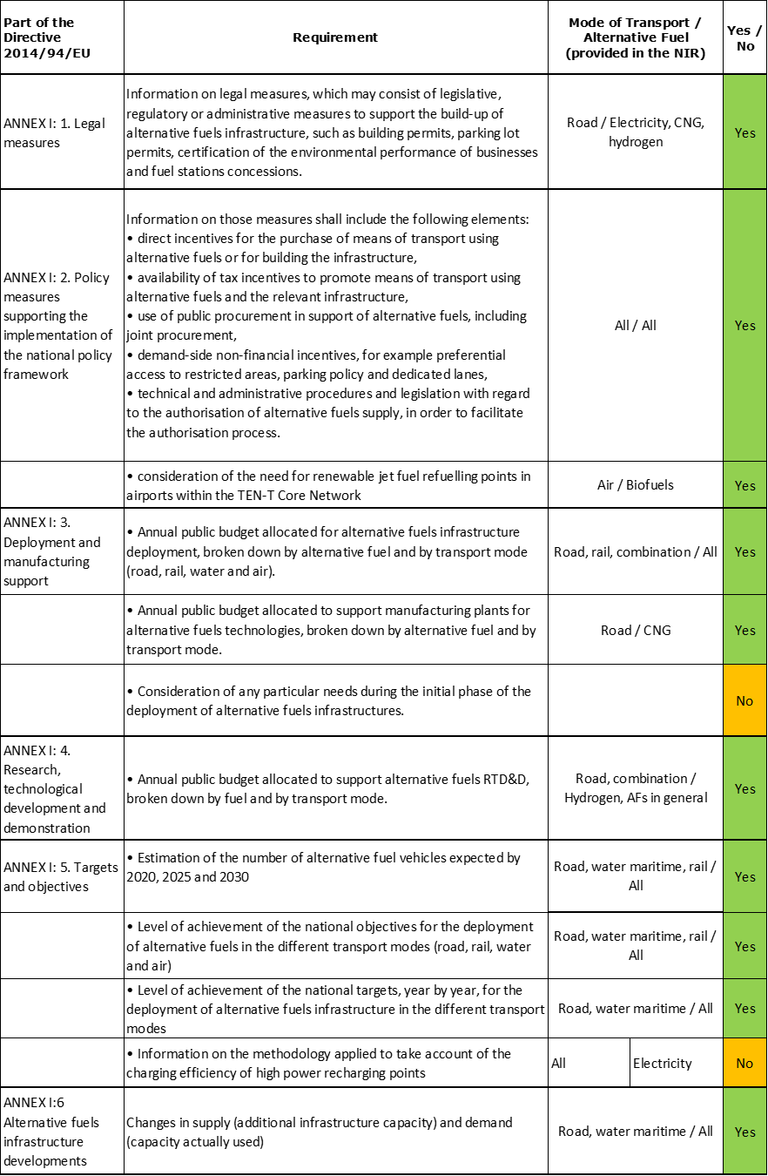

The checklist shows that almost all the requirements of Annex I from the Directive are covered.

Regarding the combination of AF/AFV/AFI with transport mode, electricity is covered for all modes; CNG, hydrogen and LPG for road transport; LNG for road and maritime transport; biofuels for air transport; all the other combinations are either absent or not applicable.

The Danish NIR reports around 50 measures. Under the Policy and Deployment & Manufacturing sections it was possible to identify six AF/transport mode clusters of measures, of which five were assessable.

### Quantitative assessment: Vehicles and infrastructure

*Table 5.4.3‑1 National AFV estimates and AFI targets established in the NIR at the horizon 2020, 2025 and 2030 and their comparison with the NPF situation*

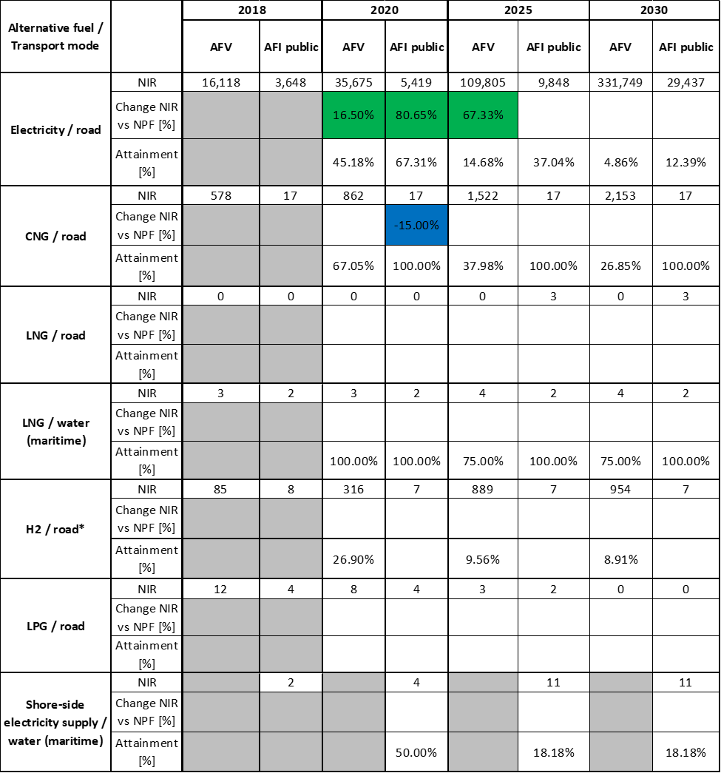



*The values for hydrogen refuelling points are shown for informational purposes only and should not be interpreted as Denmark’s targets, for the Danish government officially excluded hydrogen from its NPF and NIR.

#### Road transport

##### Electricity

###### Vehicles

Denmark recorded 16,118 battery-electric and plug-in hybrid electric vehicles in use in 2018 (of which 15,205 were passenger cars, 905 were LCVs and 8 were buses and coaches) (see Table 5.4.3‑1). The Danish NIR EV estimates are 35,675 for 2020 and 109,805 for 2025, which are respectively 16.50% and 67.33% higher than in the NPF. This reflects a higher policy ambition. Denmark had not provided 2030 EV estimates in the NPF but the NIR presents estimates: by 2030, the Danish NIR expects that 88.7% of the 331,749 EVs in use will be passenger cars, 10.7% LCVs, 0.1% HCVs and 0.5% buses and coaches. In addition, the Danish NIR provides an estimate of 2,510 electric PTW in 2030, compared to 1,386 in 2018.

The 2018 ***attainment*** of future EV estimates is 45.18% for 2020 and 4.86% for 2030. According to the assessment methodology described in Section 2.1, the 2018 situation corresponds to a ***slow progress*** towards reaching the envisaged EV estimates. The calculated ***average*** ***annual growth rate*** corresponding to the period 2016-2030 for EV fleet evolution planned by Denmark is equal to 27%.

###### Infrastructure

Denmark recorded 3,648 publicly accessible recharging points in 2018 (Table 5.4.3‑1). The NIR target for the publicly accessible recharging points for 2020 is 5,419. This is 80.65% higher than the target in the NPF. Denmark had not provided targets for publicly accessible recharging points for 2025 and 2030 in its NPF. This has now been modified in the NIR: 9,848 and 29,437 points respectively in 2025 and in 2030. Over the period 2020-2030, the share of publicly accessible high power (>22kW) recharging infrastructure is targeted to remain constant at a value of 62%.

The Danish NIR indicates that information on the number of private recharging points is unavailable.

The 2018 ***attainment*** of future publicly accessible recharging infrastructure targets is 67.31% for 2020 and 12.39% for 2030. According to the assessment methodology described in Section 2.1, the 2018 situation corresponds to an ***adequate progress*** towards reaching these envisaged targets. The calculated ***average annual growth rate*** corresponding to the period 2016-2030 for publicly accessible recharging infrastructure evolution planned by Denmark is equal to 21%.

###### Ratio

Based on the DK NIR, the following table shows the ratio between vehicles and publicly accessible recharging points (i.e. sufficiency index) for the pair electricity/road. It can be seen that in 2030 the foreseen sufficiency index is not far from a value of 10 that, considering the planned 62% high power share, can be regarded as adequate.



###### Information on charging efficiency

Information is not available in the Danish NIR.

##### CNG

###### Vehicles

Denmark recorded 578 CNG vehicles in use in 2018, of which 130 were passenger cars, 138 LCVs, 156 HCVs (including refuse collection vehicles in many cities) and 154 buses and coaches (Table 5.4.3‑1). By 2030, the Danish NIR expects that 37% of the 2,153 CNG vehicles in use will be passenger cars, 17% LCVs, 4% HCVs and 42% buses and coaches.

The 2018 ***attainment*** of future CNG vehicles estimates is 67.05% for 2020 and 26.85% for 2030. According to the assessment methodology described in Section 2.1, the 2018 situation corresponds to an ***adequate progress*** towards reaching the envisaged CNG vehicles estimates. The calculated ***average annual growth rate*** corresponding to the period 2016-2030 for the CNG vehicle fleet evolution planned by Denmark is equal to 13%.

###### Infrastructure

As Table 5.4.3‑1 shows, the Danish government plans that the 17 publicly accessible CNG refuelling points in 2018 remain in use until 2030. The AFI (CNG/road) public target for 2020 provided in the NIR is 15.00% lower than in the NPF.

The 2018 ***attainment*** of future publicly accessible CNG refuelling infrastructure targets is constant and equal to 100% for 2020, 2025 and 2030. According to the assessment methodology described in Section 2.1, the 2018 situation corresponds to a ***fast progress*** towards reaching these envisaged targets. The calculated ***average annual growth rate*** corresponding to the period 2016-2030 for publicly accessible CNG refuelling infrastructure evolution planned by Denmark is equal to 1%.

###### Ratio

Based on the DK NIR, the following table shows the ratio between vehicles and publicly accessible refuelling points (i.e. sufficiency index) for the pair CNG/road. It can be seen that the sufficiency index is well below the indicative value of 600 (see Section 2.1.5) for the whole implementation period.



##### LNG

###### Vehicles

Three years after the notification of the Danish NPF, LNG road vehicles had not been deployed in Denmark yet. The Danish NIR provides a value of zero for the future estimates of LNG road vehicles. However, since the notification of its NPF, Denmark has been observing LNG developments in neighbouring countries and expects future transit traffic of LNG vehicles.

###### Infrastructure

The Danish NIR notes that refuelling a LNG vehicle on Denmark’s part of the TEN-T network is currently not possible. As it can be seen in Table 5.4.3‑1, Denmark plans for the possibility of three LNG refuelling points to be deployed by 2025 (probably around Aalborg, the Triangle Region and Copenhagen). According to the NIR, such deployment will be facilitated by market-driven developments.

Because there were no LNG refuelling points in Denmark at the end of 2018, this assessment did not compute 2018 ***attainment*** and ***progress*** values.

###### Ratio

Since there are no LNG vehicle estimates in the DK NIR it is not possible to compute the sufficiency index.

##### Hydrogen

###### Vehicles

The Danish NIR indicates that 85 hydrogen-powered vehicles (all of them passenger cars) were in use in 2018. This number is expected to reach almost 1,000 units by 2030, of which 21 would be HCVs, 276 buses and coaches and the rest passenger cars.

The 2018 ***attainment*** of future hydrogen vehicle estimates is 26.90% for 2020 and 8.91% for 2030. According to the assessment methodology described in Section 2.1, the ***progress*** obtained by Denmark from 2016 until 2018 for hydrogen vehicles deployment is 1.81% of the overall planned deployment during the period 2016-2030.

###### Infrastructure

The Danish NPF did not include hydrogen infrastructure provisions. Data reported on hydrogen in the NPF and the NIR are presented here for informational purposes though.

The Danish NIR indicates that eight hydrogen refuelling points (all of them 700 bar and publicly accessible) were available in 2018, of which seven remained at the time the NIR was notified.

Because the Danish government officially excluded hydrogen for its NPF and NIR, no ***attainment*** and ***progress*** values have been computed.

###### Ratio

Because the Danish government officially excluded hydrogen for its NPF and NIR, no sufficiency index has been computed.

##### Biofuels

###### Vehicles

Information is not available in the Danish NIR.

###### Infrastructure

As in the Danish NPF, the Danish NIR does not provide further information on infrastructure requirements for biofuels, as these are expected to be distributed through existing conventional fuels infrastructure.

##### LPG

###### Vehicles

The Danish government expects that LPG for transport is fully phased out by 2030. Thus, the future number of LPG vehicles in use declines and is expected to reach zero by 2030.

Because the Danish government expects the phase-out of LPG, no ***attainment*** and ***progress*** values have been computed.

###### Infrastructure

Given the expectation of an LPG phase-out by 2030, the number of publicly accessible LPG refuelling points halves by 2025 and further reduces to zero by 2030, according to the NIR.

Because the Danish government expects the phase-out of LPG, no ***attainment*** and ***progress*** values have been computed.

###### Ratio

Based on the DK NIR, the following table shows the ratio between vehicles and publicly accessible refuelling points (i.e. sufficiency index) for the pair LPG/road (see Section 2.1.5). The 2030 value could not be computed since LPG will be phased out.



#### Rail transport

##### Electricity

###### Vehicles

The Danish NIR expects the number of electric locomotives to increase from 253 units in 2018 to 353 by 2030. This number is however similar to the 345 figure reported for 2016.

###### Infrastructure

According to the NIR, the full electrification of the 57 km Esbjerg-Lunderskov route in 2017 and the 45 km Køge-Næstved route in 2019 allows electric trains to circulate on these electrified routes. In addition, the 60 km high-speed Copenhagen–Ringsted line inaugurated in 2019 was also built as an electrified railway.

#### Waterborne transport (maritime)

##### Electricity

###### Vessels

The Danish NIR expects the number of electric seagoing ships to increase from 3 units in 2018 to 5 by 2030.

###### Infrastructure

According to the NIR, shore-side electricity supply installations are available for use in all the Danish ports by vessels requiring a rather limited power supply. However, the availability of shore-side electricity supply installations for use by vessels requiring substantial power supply is uncertain and remains, on economic grounds, not widespread yet. The Danish NIR does not provide specific information on the threshold between ‘limited and substantial’ power supply. The NIR mentions that shore-side electricity supply will become available in the ports of Skagen, Hirtshals and Frederikshavn in next three years. As it can be seen in Table 5.4.3‑1, the number of recharging points providing shore-side electricity supply in the Danish maritime ports is expected to increase from two in 2018 to eleven by 2030. Denmark is likely to reach its 2020 target given that shore-side electricity supply became available also in the Port of Faaborg and the Port of Grenå in 2019 (in the latter, with a 2 MW capacity).

The 2018 ***attainment*** of future targets for shore-side electricity supply for seagoing ships in maritime ports is 50% for 2020 and 18.18% for 2030. According to the assessment methodology described in Section 2.1, the ***progress*** Denmark obtained from 2016 until 2018 for shore-side electricity supply deployment in maritime ports is 60% of the overall planned deployment during the period 2016-2030.

##### LNG

###### Vessels

The Danish NIR expects the number of LNG seagoing ships to increase from three units in 2018 to four by 2030.

The 2018 ***attainment*** of future LNG seagoing ships estimates is 100% in 2020 and 75% in 2030. According to the assessment methodology described in Section 2.1, the ***progress*** obtained by Denmark from 2016 until 2018 for LNG seagoing ships deployment is 0% of the overall planned deployment during the period 2016-2030.

###### Infrastructure

As it can be seen in Table 5.4.3‑1, there were two LNG refuelling points in Danish maritime ports in 2018. This entails that Denmark’s second LNG facility has become operational in the port of Hou since the notification of the NPF (and while Frederikshavn was mentioned in the NPF, no update on LNG availability in this port is provided in the NIR). According to the NIR, the future number of LNG refuelling points in Danish maritime ports is expected to remain unchanged. Accordingly, no LNG supply targets before 2030 are given for the two maritime ports that are part of the TEN-T Core Network (Aarhus and Copenhagen). Notwithstanding this, the Danish NIR reports the expectation that the Directive’s minimum requirements will either be met by market-based developments or by regulatory initiatives, if necessary.

The 2018 ***attainment*** of future LNG refuelling infrastructure targets in maritime ports is 100% in 2020, 2025 and 2030. According to the assessment methodology described in Section 2.1, the ***progress*** obtained by Denmark from 2016 until 2018 for LNG refuelling infrastructure deployment in maritime ports is 100% of the overall planned deployment during the period 2016-2030.

#### Waterborne transport (inland)

Not applicable since Denmark has no inland ports in the TEN-T Core Network.

#### Air transport

##### Electricity

###### Airplanes

The Danish NIR considers that the deployment of hybrid-electric or fully-electric airplanes by 2030 remains highly uncertain.

###### Infrastructure (for stationary airplanes)

As in the NPF, the Danish NIR indicates that the airports that account for more than 97% of passenger flights are equipped with devices that enable electricity supply for stationary airplanes.

##### Biofuels

###### Airplanes

Information on flights / airplanes powered by biofuels is not provided in the Danish NIR.

###### Infrastructure

The Danish NIR gives some consideration to the need for renewable jet fuel refuelling points in airports within the TEN-T Core Network. In Denmark, there was no sustainable aviation fuel production in late 2019. The NIR does not quantify sustainable aviation fuel production by 2030, though it expects it to increase towards 2030.

### Measures assessment

As in the NPF, a relevant series of measures is mentioned in the Danish NIR. For the Policy and Deployment & Manufacturing support measures, this results in five assessable AF/transport mode clusters.

#### Legal measures

The Danish NPF had only mentioned one legal measure on advanced biofuels blending, which is no longer mentioned in the NIR. The Danish NIR contains now seven legal measures, representing a significant increase.

Whereas two of the legal measures described in the NIR have already expired, another one refers to the presentation of a proposal for an Act amendment (related to the implementation of the provisions stipulated in the Energy Performance of Buildings Directive (2018/844/EU)). The rest are existing measures (all of them affecting road transport).

Considering all the legal measures, they appear, if fully implemented, to be fit to support the realisation of the AFV/AFI objectives as presented in the NPF and revised in the NIR. The level of ambition of the legal measures has generally increased in the NIR compared to the NPF.

##### Legislative & Regulatory

All the legal measures described in the Danish NIR can be categorised as legislative and regulatory measures and include the following ones:

* Norms & requirements: zero- and low-emission parking benefits and stricter energy requirements for the taxi fleet.
* Permits: quotas of permits for zero-emission taxis and access to bus lanes for low-emission vehicles.

##### Administrative

The Danish NIR does not provide specific information on administrative measures.

#### Policy measures

In its NPF, the Danish government had signalled the willingness to re-examine public support if conditions varied considerably on various policy issues. The Danish NIR contains nine policy measures, which represents no change in the number of measures compared to the ones identified in the NPF (adopted or existing at the time). In contrast to the NPF, the abolition of the public service obligation tax and public procurement for alternative fuel vehicles are no longer mentioned.

##### Measures to ensure national targets and objectives

###### Road transport

Of all the policy measures described in the Danish NIR, six can be categorised as measures to ensure national targets and objectives. None of these target AFI. All of them, with one exception, involve taxation: tax reductions or exemptions for alternative fuels or for vehicle registration. Although most of them were present also in the NPF, changes on two relevant acts have taken place since then: Act No. 687 in 2017 and Act No. 1730 in 2018. According to the Danish NIR, the energy tax benefits electricity and hydrogen while the CO2 tax favours in addition biofuels and natural gas (including biogas). Moreover, reductions in the ordinary electricity tax can be expected until 2025 from the 89.2 øre/kWh level in 2020.

Regarding taxation for vehicle registration, the Danish NIR distinguishes between the registration and the motor vehicle tax. Fuel cell-powered vehicles will be exempted from both until 2021, fully subject to the motor vehicle tax from 2022 and gradually subject to the registration tax between 2022 and 2025. For BEVs[13], the NIR further distinguishes between a special battery allowance and a tax-free allowance. The Danish NIR considers that in practice BEVs valued at DKK 400,000 (around €60,000), or less, paid no registration taxes in 2019 and 2020. The registration tax will be gradually phased in for BEVs, PHEVs and CNG vehicles. Under current policy, BEVs will be subject to the full registration tax in 2023 (and not in 2020 as the NPF had stated).

###### Waterborne transport

The Danish NPF mentioned the reduction of the electricity tax for shore-side electricity supply. Although a few of the policy measures target alternative fuels and can be considered to potentially affect water transport, no concrete policy measures targeting water transport are listed in the Danish NIR.

##### Measures that can promote AFI in public transport services

Of all the policy measures described in the Annex of the Danish NIR, two can be categorised as measures that can promote AFI in public transport services. Both of them are existing measures: one dealing with electric buses at local level and the other with electric railway vehicles at regional level.

###### Buses

The Danish NIR mentions that electric buses have been trialled in many routes in Copenhagen and Frederiksberg since 2016. Moreover, over 40 new electric buses were expected to be introduced in Denmark in the year in which the NIR was notified (2019).

###### Rail transport

According to the Danish NIR, further electrification of the railways is pursued, including the Fredericia-Aarhus, Aarhus-Lindholm and Roskilde-Kalundborg routes. To this end, the Banedanmark’s Electrification Programme is being implemented with the objective of electrifying much of the country’s railway network, according to the NIR.

##### Measures that can promote the deployment of private electro-mobility infrastructure

The NIR lists a measure to support the deployment of private electro-mobility infrastructure, namely the low rate of industry process electricity tax (0.4 øre/kWh) for commercially recharged EVs. It seems that this measure was expected to expire at the end of 2019 but has been extended until 2021.

#### Deployment and manufacturing support

##### AFI deployment

The Danish NIR contains 11 AFI deployment support measures[14], which represents a significant increase compared to the four measures identified in the NPF. Nine of the eleven can be considered measures that have already expired. The measures cover various alternative fuels and transport modes, including for instance funds to support e-bike use and to supply harbour buses with green biodiesel. The total estimated budget for AFI deployment reported in the NIR amounts to 140 million € for the period 2016-2025.

##### Support of manufacturing plants for AF technologies

The Danish NIR contains one measure that had been mentioned in the NPF to support manufacturing plants for AF technologies. The measure, to be implemented between 2021 and 2030, is backed by a ca. 286 million € fund with the aim of supporting the use of biogas in transport and industrial processes.

##### Consideration of any particular needs during the initial phase of the deployment of alternative fuels infrastructures

Information is not available in the Danish NIR.

#### Quantitative assessment of Policy and Deployment & Manufacturing measures

Table 5.4.4‑1 presents an analysis of all the Policy and Deployment & Manufacturing measures, carried out according to the assessment methodology described in Section 2.2. As it can be seen, the electricity/road cluster is the only having a high score. None of the clusters identified can be considered comprehensive. Support measures continue to be irrelevant or not assessable for LNG/road and for LNG/water (maritime) (for instance, it seems that the Danish NIR does not consider LNG retrofit for vessels to be an option).

In terms of expected impact of these measures to support the realisation of the AFV/AFI objectives as presented in the NPF and revised in the NIR, the measures for the pair electricity/road have a medium impact, those for the pairs CNG/road, biofuels/road, hydrogen/road and electricity/rail result to have a low impact.

Compared to the NPF, the level of ambition of the Policy and Deployment & Manufacturing measures has increased for all the assessable pairs.

*Table 5.4.4‑1* *Quantitative assessment of Policy and Deployment & Manufacturing support measures*

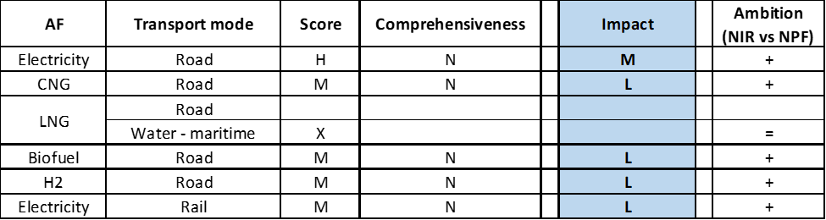

**Legend:** Score: H = high; M = medium; L = low; X = not assessable. Comprehensiveness: C = comprehensive; N = Not comprehensive. Ambition level: ‘+’ means ‘higher’; ‘=’ means ‘comparable’; ‘-‘ means ‘lower’.

#### Research, Technological Development & Demonstration

The Danish NIR contains 19 RTD&D projects of relevance: 3 supported in 2019, 8 in 2018, 4 in 2017 and 4 in 2016. This represents a significant increase compared to the six RTD&D projects identified in the NPF. The NIR does not provide specific details[15] about each of these projects, which does not allows us to either make direct comparisons with the projects listed in the NPF or to cluster them. The NIR states that the vast majority of these projects focus on hydrogen, with a couple of them dealing with electricity for maritime transport and bioethanol. The total estimated budget for RTD&D projects reported in the NIR amounts to 36 million € for the period 2016-2019, mainly channelled through the Energy Technology Development and Demonstration Programme, the Innovation Fund and the EU framework schemes.

### Additional information on alternative fuels infrastructure developments

The Danish NIR provides information on the changes in fuel use (see Table 5.4.5‑1[16]). As it can be seen, biofuels are expected to remain the dominating alternative fuel in road transport throughout the period, followed by electricity. No real increase in LNG use in maritime transport is expected.

*Table 5.4.5‑1 Changes in fuels use in transport sector (2016-2030)*



*Note: Since the values for ‘other AF’ provided in the NIR are zero and CNG use in Denmark is dominated by biomethane, it is unclear whether the biofuels figures include biomethane.

### Summary of the assessment

**Tabular overview**

*Table 5.4.6‑1 Overview of the NIR assessment*

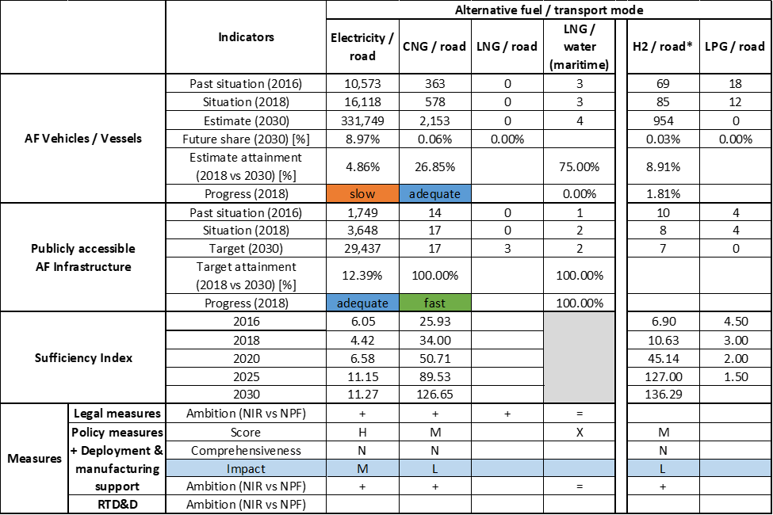



*The values for hydrogen are shown for informational purposes only and should not be interpreted as Denmark’s policy goals, for the Danish government officially excluded hydrogen for her NPF and NIR. For this reason, we do not report our assessment on the measures for hydrogen.

The Danish NIR covers the whole AFID period (2016-2030). Compared to the NPF that did not meet several of the requirements of Article 3 of the Directive, the Danish NIR almost fully addresses the requirements of Annex I of the Directive, with the exception of: a) information on the methodology applied to take account of the charging efficiency of high power recharging points; b) information on any particular needs during the initial phase of AFI deployment.

The main outcomes of the technical assessment of the Danish NIR on vehicles/vessels estimates and infrastructure targets can be summarised as follows:

###### Road transport

* **Electricity** – Denmark recorded 16,118 electric vehicles and 3,648 publicly accessible recharging points in 2018. With reference to the objectives of the DK NPF as updated by the NIR, Denmark is progressing adequately in terms of infrastructure and slowly in terms of EV deployment. The NIR increases the level of ambition compared to the existing objectives in the NPF and provides a new set of vehicle estimates and infrastructure targets until 2030. The calculated Danish sufficiency index deteriorates slightly over time but is considered still adequate[17]. The Danish NIR expects that, by 2030, the stock of electric HCVs will reach 208 units and two-thirds of the electric buses in use will be fully electric.
* **CNG** –The Danish NIR does not foresee a further expansion of the 17 CNG refuelling infrastructure recorded in 2018, while CNG vehicle stock is expected to grow from 578 units in 2018 to 2,153 units in 2030 (an increasing stock of CNG passenger cars, LCVs and buses/coaches and a declining number of HCVs), which would lead to greater utilisation of the existing CNG refuelling points. By 2025, the Danish NIR expects the stock of CNG buses to be overtaken by electric buses. With regards to CNG road vehicle deployment, Denmark is progressing adequately. Concerning the progress of infrastructure deployment, this is obviously fast, as the new 2030 target declared in the DK NIR has been already achieved in 2018.
* **LNG** – In contrast to the NPF, the Danish NIR provides future targets for LNG refuelling infrastructure deployment (three by 2025). The NIR does not foresee deployment of road vehicles powered by LNG.
* **Hydrogen** –The NIR reports future values for the stock of vehicles but does not include official hydrogen infrastructure provisions. Furthermore, the NIR mentions measures for supporting the market and expects some market-driven uptake of vehicles and refuelling points.
* **Biofuels** – The Danish NIR expects the share of biofuels use in road transport to remain constant at 6% until 2030.
* **LPG** –The NIR notes that LPG will essentially play no role in the future Danish transport system.

###### Rail transport

* **Electricity** – The Danish NIR reports recent railway electrification. It also expects the strong decline in electric locomotive stock that took place between 2016 and 2017 to be reversed by 2030.

###### Waterborne transport (maritime)

* **Electricity** – The Danish NIR expects the number of battery-powered seagoing vessels to increase from three units in 2018 and 2020 to five in 2025 and 2030. The number of maritime ports providing access to shore-side electricity supply is expected to grow from two in 2018 to eleven in 2025 and 2030.
* **LNG** – Concerning LNG vessels, no real uptake is expected in the Danish NIR. The number of maritime ports providing access to LNG is reported by the NIR as remaining stable with two ports, making it uncertain whether LNG will be available in the two ports that are part of the TEN-T Core Network.

###### Air transport

* **Biofuels** – The Danish NIR expects sustainable aviation fuel production to start in the future.

As in the NPF, the Danish NIR continues to provide a reasonable amount of **measures** to support the uptake of alternative fuels for transport. The number of legal measures and deployment & manufacturing support measures has increased in the NIR compared to those reported in the NPF, while the number of policy measures has not. Regarding the combination of Policy and Deployment & Manufacturing measures, six clusters were identified for as many AF/transport mode pairs. Five clusters were assessable, with the pair electricity/road obtaining a high score and the other four a low score. No cluster could be considered comprehensive. Support measures continue to be irrelevant or not assessable for LNG/road and for LNG/water (maritime). In terms of expected impact of these measures to support the realisation of the AFV/AFI objectives as presented in the NPF and revised in the NIR, the measures for the pair electricity/road have a medium impact, those for the pairs CNG/road, biofuels/road, hydrogen/road and electricity/rail result to have a low impact. The level of ambition of Policy and Deployment & Manufacturing support measures has increased in the NIR for all the assessable pairs, however the NIR does not report support measures for publicly accessible recharging infrastructure, increasing the uncertainty on how the future targets will be attained. In the absence of LNG support measures, the Danish NIR seems to rely on developments in the private sector and other neighbouring markets. Although the government of Denmark officially excluded hydrogen from its plans, the prominence of this alternative fuel in support measures, particularly RTD&D funding, is noteworthy.

### Final remarks

The Danish NIR provides a comprehensive report on the efforts to implement the Directive. These efforts are mostly in line with the provisions of Annex I to the Directive. All alternative fuels are addressed in the Danish NIR. Denmark has a clear ambition to foster the large-scale electrification of road transport, railways, maritime transport and airports. The estimated extension of shore-side electricity supply in ports should support the greening of the waterborne sector. The Danish NIR includes a significant amount of measures to promote the uptake of zero- and low-emission vehicles, including a significant number of R&I projects on hydrogen and fuel cell technologies. Denmark should provide further information on some of those measures in future reporting to be able to fully assess their impact.

With regard to electricity for road transport, the NIR estimates approximately 332,000 electric vehicles on the road in 2030, representing about 9% of the fleet by that time. However, taking into account the current situation and expected trend development, this level of ambition does not appear to be fully compatible with the pace of deployment of electric vehicles considered necessary for a full transition to carbon neutrality by 2050. Moreover, attention needs to be paid also to infrastructure deployment. No information on charging efficiency is provided. The NIR estimates around 11 shore-side electricity supply facilities by 2030. Five electric seagoing ships are estimated to be in operation by 2030. The NIR indicates that the airports accounting for more than 97% of passenger traffic provide electricity supply for stationary airplanes. The NIR lacks sufficient information on the share of the electrified rail network.

Regarding hydrogen for road transport, there was already a small fleet of FCHVs and eight hydrogen-refuelling stations in Denmark in 2018. No targets are set for future deployment by 2025 and 2030. More information in future reporting on further development of vehicles and infrastructure uptake would be beneficial.

Regarding natural gas for transport, Denmark plans to keep the number of CNG refuelling points at a constant number of 17 until 2030. It estimates 1,522 CNG vehicles by 2025 and 2,153 CNG vehicles by 2030. The NIR does not provide estimates for LNG vehicles. However, the number of three LNG refuelling points planned for 2025 and 2030 seems sufficient taking into account the extensiveness of the Danish TEN-T Core road Network, provided that the refuelling points are widely distributed along the network. On the other hand, LNG refuelling points are already installed in the two Danish ports, although they are not part of the TEN-T Core Network.

As regards LPG, there were 12 LPG vehicles in 2018. The number is to decrease to zero by 2030.

Denmark should provide more information in future reporting on efforts to promote the use of renewable fuels in transport, and particularly in aviation.

### ANNEX - Description of the Member State

On a surface area of 43,100 km², Denmark has a population of 5.781 million people in 2018, which makes up for a population density of 134 inhabitants/km².

*Number of main urban agglomerations*

* 4 urban agglomerations > 50,000 inhabitants

In 2018, Denmark achieves a per capita gross domestic product at market prices of €52,010, which represents a per capita gross domestic product in purchasing power standards of 128 if expressed in relation to the EU-28 average set to equal 100.

*Length of the road networks*

The length of the road TEN-T Core Network in Denmark is 813 km. The total road network length is 74,674 km, of which 1,329 km are motorways.

The following lengths of the TEN-T Road Corridors are present in Denmark: 7% (456 km) of the Scandinavian – Mediterranean Corridor.

Through the TEN-T Road Corridors, Denmark is connected with the following Member States:  
- Germany (through the Scandinavian – Mediterranean Corridor),   
- Sweden (through the Scandinavian – Mediterranean Corridor)

*Number of registered road vehicles*

At the end of 2018, Denmark accounts for 3,237,751 registered road vehicles of which 2,594,469 are categorized as passenger cars, 389,461 as light goods vehicles, 42,663 as heavy goods vehicles and 13,158 as buses and coaches. The motorisation rate is 449 passenger cars per 1,000 inhabitants.

*Number of ports in the TEN-T Core Network*

* 2 maritime ports in the TEN-T Core Network (Aarhus, Copenhagen)
* No maritime ports in the TEN-T Comprehensive Network
* No inland ports

*Number of airports in the TEN-T Core Network*

* 1 airport in the TEN-T Core Network (Copenhagen – Kastrup)
* 3 airports in the TEN-T Comprehensive Network

## Germany (DE)

### Main messages from the Commission assessment of the NPF

In its original assessment of the German NPF the Commission concluded:

*The German NPF addresses most of the requirements of Article 3. It presents the current state of alternative vehicle uptake and infrastructure and derives targets for future recharging points, LNG refuelling points (road), and H2 refuelling points (road). It does not establish targets for LNG refuelling points in ports beyond the already existing facilities.*

*A main focus of the German NPF is on electric vehicles. It estimates a share of roughly 2% electric vehicles on the road in 2020. This is a comparably high estimate and will require a rapid growth of EV deployment in Germany in the coming years. While the targeted number of recharging points seems adequate to cover the needs of electric vehicles in terms of distance requirements in Germany, the ratio of only one public recharging point per 23 electric vehicles estimated for 2020 could evolve to become a barrier for the further market deployment of electric vehicles. This could also lead to market fragmentation within the EU. It will be important to closely monitor this development and correct infrastructure targets in line with the market developments. The NPF does not provide any targets for further deployment of electricity supply for stationary airplanes. For shore-side electricity, it does not contain targets. Instead, it refers to pilot projects with a focus on inland ports.*

*The NPF enables for potentially significant further market uptake of CNG vehicles. Germany has already today a relatively dense network of CNG refuelling points, offering a good coverage in most regions and in all urban agglomerations. Available infrastructure could probably support more than five times the CNG vehicles on the road in Germany today. No CNG infrastructure build-up beyond present levels is intended.*

*The German NPF defines a network of nine road LNG refuelling points that could guarantee fulfilment of the maximum distance requirement for LNG refuelling points for heavy-duty vehicles along the TEN-T Core Network on German territory. However, LNG propelled heavy-duty vehicles may have to deviate from the shortest route in order to refuel when travelling on the TEN-T Core Network.*

*The NPF does not establish target numbers for LNG refuelling points for ports, nor does it define an LNG distribution system as required by the Directive. According to the NPF, LNG infrastructure build-up will be pursued depending on market needs.*

*The German plan allows for potentially ambitious market uptake of H2 vehicles, where infrastructure sufficiency is planned to be achieved in the near future.*

*The German NPF contains a comprehensive list of measures which are already existing or adopted. Measures are focussed on electric vehicles and infrastructure for road, but measures are proposed also for other road AFI/AFV types as well as for waterborne transport. Most of them can be considered having a medium or low impact on market actor's decisions. Some measures attain a low overall measure score due to scarce information on planned budget and boundaries which allows for qualitative evaluation only. Measures presented seem sufficient to contribute to the achievement of the targets set in the NPF. The NPF also contains several support measures to promote the deployment of alternative fuels infrastructure in public transport services.*

*Interests of regional and local authorities as well as stakeholders have been considered during the drafting of the German NPF. Germany is actively involved in coordinating its plans on alternative fuels infrastructure with other Member States as well as collaborating with them in this field.*

### Overview of requirements’ fulfilment from Annex I of the Directive

*Table 5.5.2‑1 Checklist Table*



The checklist shows that almost all the requirements of Annex I from the Directive are covered.

Regarding the combination of AF/AFV/AFI with transport mode, electricity is covered for all modes; all the other pairs are partially covered, in particular: CNG and LPG for road transport; LNG for road and waterborne transport; hydrogen for road and rail transport; biofuels for air transport; synthetic and paraffinic fuels for road, inland waterway transport and air transport. All the other combinations are either absent or not applicable.

The German NIR reports a list of 180 measures. Under the Policy and Deployment & Manufacturing sections it was possible to identify 12 AF/transport mode clusters of measures, all assessable.

### Quantitative assessment: Vehicles and infrastructure

*Table 5.5.3‑1 National AFV estimates and AFI targets established in the NIR at the horizon 2020, 2025 and 2030 and their comparison with the NPF situation*





*In this particular case, the value includes L-category vehicles. **The values refer to stationary shore-to-ship facilities (i.e. bunkering stations) (see Section 5.5.3.3.2). ***The NIR states that two new LNG vessels are planned but no indicative year of deployment is provided.

#### Road transport

##### Electricity

###### Vehicles

Germany recorded 164,566 battery-electric and plug-in hybrid electric vehicles in use in 2018 (Table 5.5.3‑1). Of these, 148,845 were passenger cars (55% were battery-electric), 15,423 were LCVs (almost all of them battery-electric), 165 were HCVs (all battery-electric) and 133 were buses and coaches (all battery-electric). In addition, the NIR reported a stock of 62 trolleybuses (operating in the municipalities of Eberswalde, Esslingen and Solingen) and 9,684 L-category vehicles. Although not sufficiently explicitly, the NIR seems to retain the 2020 target of 1 million EVs. Both the NPF and NIR lack estimates for the EV fleet in 2025. The NIR expects that, by 2030, between 7 and 10 million electric passenger cars will be in use; electric buses will account for up to 50% of the city bus stock and around 33% of vehicle mileage in heavy road haulage will be undertaken by means of electricity.

The 2018 ***attainment*** of future EV estimates is 16.46% in 2020 and 1.94% for 2030. According to the assessment methodology described in Section 2.1, the 2018 situation corresponds to an ***adequate progress*** towards reaching the envisaged EV estimates. The calculated ***average*** ***annual growth rate*** corresponding to the period 2016-2030 for EV fleet evolution planned by Germany is equal to 43%.

###### Infrastructure

Germany recorded 17,245 publicly accessible recharging points in 2018 (Table 5.5.3‑1), of which 2,562 were high power (>22kW) points (of these 40.1% were AC fast charging, 53.6% DC fast and 6.3% DC ultrafast). The NIR seems to endorse the 2020 targets reported in the NPF and indicates that one million recharging points can be expected by 2030 (without details on the share of high power recharging points). Both the NPF and NIR lacked 2025 targets. The DE NIR provides no information on private recharging points on the grounds that the available information is not robust.

The 2018 ***attainment*** of future publicly accessible recharging infrastructure targets is 40.10% for 2020 and 1.72% for 2030. According to the assessment methodology described in Section 2.1, the 2018 situation corresponds to an ***adequate progress*** towards reaching these envisaged targets. The calculated ***average annual growth rate*** corresponding to the period 2016-2020 for publicly accessible recharging infrastructure evolution planned by Germany is 42%.

###### Ratio

Based on the DE NIR, the following table shows the ratio between vehicles and publicly accessible recharging points (i.e. sufficiency index) for the pair electricity/road. It can be seen that the sufficiency index fluctuated around the value of 10 between 2016 and 2018 and was thus adequate to support EV uptake. The foreseen sufficiency index is 23.26 for 2020 (potentially not adequate) and 8.50 for 2030.



*In this particular case, the vehicle estimate includes L-category vehicles.

###### Information on charging efficiency

The German NIR fulfils the requirements on charging efficiency reporting by providing comprehensive information, based on representative samples, on actual capacity usage by type of recharging point. For instance, for high power recharging points (43 < P < 100 kW): a) the average number of charging processes/day/point is 0.5; b) the average energy delivered/day/point is 6.8 kWh; c) the average occupancy time/point/day is 18 minutes. Additional data related to the charging process, the sample and for other types of recharging points are reported in Table 12 of the German NIR.

##### CNG

###### Vehicles

Germany recorded 78,251 CNG vehicles in use in 2018 (Table 5.5.3‑1). Of these, 71,122 were passenger cars, 6,316 LCVs, 369 HCVs and 444 buses and coaches. Both the NPF and NIR lack estimates on future CNG vehicles, therefore the 2018 ***attainment*** and ***progress*** could not be computed.

###### Infrastructure

The German NIR indicates that 862 publicly accessible CNG refuelling points were available in 2018 (Table 5.5.3‑1), a decline compared to the 913 points available in 2016. Both the NPF and NIR lack targets for future publicly accessible CNG refuelling points.

Because there were no future CNG road refuelling infrastructure targets provided in the German NIR, the 2018 ***attainment*** and ***progress*** could not be computed.

###### Ratio

Based on the DE NIR, the following table shows the ratio between vehicles and publicly accessible refuelling points (i.e. sufficiency index) for the pair CNG/road. It can be seen that the sufficiency index was well below the indicative value of 600 (see Section 2.1.5) between 2016 and 2018. However, the foreseen sufficiency index cannot be computed.



##### LNG

###### Vehicles

Germany recorded seven LNG vehicles in use in 2018: one LCV and six HCVs (Table 5.5.3‑1)[18]. Both the NPF and NIR lacked future LNG vehicle estimates, therefore the 2018 ***attainment*** and ***progress*** could not be computed.

###### Infrastructure

The German NIR indicates that four publicly accessible LNG refuelling points were available in 2018 (Table 5.5.3‑1), of which three are on the TEN-T Core Network. The NIR states that “*at least 9 LNG refuelling points for heavy goods vehicles are to be in operation on the TEN-T Core Network by 2025*”, which is in line with the target provided in the NPF.

The 2018 ***attainment*** of future publicly accessible LNG refuelling infrastructure targets is 44.44% for 2025. According to the assessment methodology described in Section 2.1, the ***progress*** obtained by Germany for publicly accessible LNG refuelling infrastructure deployment from 2016 until 2018 versus the period 2016-2030 could not be computed because the 2030 target is not provided.

###### Ratio

Based on the DE NIR, the following table shows the ratio between vehicles and publicly accessible refuelling points (i.e. sufficiency index) for the pair LNG/road, computable only for 2018.



##### Hydrogen

###### Vehicles

The German NIR indicates that 378 hydrogen-powered vehicles[19] were in use in 2018 (Table 5.5.3‑1), of which 367 were passenger cars and 11 were buses and coaches. In addition, the NIR reports one L-category vehicle powered by hydrogen. Both the NPF and NIR lacked future hydrogen vehicle estimates, therefore the 2018 ***attainment*** and ***progress*** could not be computed.

###### Infrastructure

The German NIR indicates that 66 publicly accessible hydrogen refuelling points were available in 2018 (Table 5.5.3‑1), of which 4 were 350-bar points and the rest 700-bar. This represents a strong increase compared to the 23 points available in 2016. According to the NIR, “the Federal Government is supporting the objective of 100 public refuelling stations in 2020 which was formulated by the industry and – subject to the condition of an appropriate vehicle ramp-up – the objective of 400 public refuelling stations in 2025”. No infrastructure target for 2030 is provided.

The 2018 ***attainment*** of future publicly accessible hydrogen refuelling infrastructure targets is 66.00% for 2020 and 16.50% for 2025. According to the assessment methodology described in Section 2.1, the ***progress*** obtained by Germany for publicly accessible hydrogen refuelling infrastructure deployment from 2016 until 2018 versus the period 2016-2030 could not be computed because the 2030 target is not provided.

###### Ratio

Based on the DE NIR, the following table shows the ratio between vehicles and infrastructure (i.e. sufficiency index) for the pair hydrogen/road (see Section 2.1.5).



##### Biofuels

Information is not available in the German NIR.

##### LPG

###### Vehicles

The German NIR indicates that 213,718 LPG vehicles were in use in 2018 (Table 5.5.3‑1), which represents a 3% decline compared to 2016. Of these, 206,786 were passenger cars, 6,907 were LCVs, 20 were HCVs and 5 were buses and coaches. In addition, the NIR reports 34 L-category vehicles powered by LPG. Both the NPF and NIR lacked future LPG vehicle estimates, therefore the 2018 ***attainment*** and ***progress*** could not be computed.

###### Infrastructure

The German NIR indicates that 7,128 publicly accessible LPG refuelling points were available in 2018 (Table 5.5.3‑1), compared to 7,061 points in 2016 (no data is provided for 2017). Both the NPF and NIR lacked future targets for publicly accessible LPG refuelling points, therefore the 2018 ***attainment*** and ***progress*** could not be computed.

###### Ratio

Based on the DE NIR, the following table shows the ratio between vehicles and infrastructure (i.e. sufficiency index) for the pair LPG/road (see Section 2.1.5).



##### Synthetic and paraffinic fuels

###### Vehicles

The NIR mentions two passenger cars powered by methanol.

###### Infrastructure

Information is not available in the DE NIR.

#### Rail transport

##### Electricity

###### Vehicles

The German NIR indicates that the stock of electric railway vehicles in use was 6,173 in March 2019, compared to 5,572 in 2016 (no disaggregation between locomotives and railcars is reported). The NIR also mentions that diesel-electric hybrid locomotives have been deployed for shunting operations and have been presented for long-distance freight transport (see also Section 5.5.4).

###### Infrastructure

According to the DE NIR, overhead contact lines are presently not available in around 40% of the rail network, most of it affecting low traffic passenger services. Germany’s ambition is to deploy alternative fuels or, when economically feasible, to pursue further electrification of those lines.

##### Hydrogen

###### Vehicles

The German NIR indicates that two hydrogen-powered railway vehicles were in use in March 2019. It is expected that by 2022 there will be 26 hydrogen trains in regular operation in Hessen and 14 hydrogen trains in Niedersachsen.

###### Infrastructure

The German NIR indicates that one hydrogen refuelling point (350-bar) was available for rail services in 2018.

#### Waterborne transport (maritime)

##### Electricity

###### Vessels

The German NIR indicates that there were no electric maritime vessels in use in 2018 and it does not provide future estimates.

###### Infrastructure

The German NIR indicates that there were three maritime ports providing shore-side electricity supply in 2018. Both the NPF and NIR lack targets for future deployment of shore-side electricity supply in maritime ports, therefore the 2018 ***attainment*** and ***progress*** could not be computed.

##### LNG

###### Vessels

The German NIR indicates that two LNG maritime vessels were in use in 2018. Both the NPF and NIR lacked future LNG maritime vessel estimates, therefore the 2018 ***attainment*** and ***progress*** could not be computed. The NIR, however, states that two new state-owned LNG maritime vessels are planned, though no tentative year of deployment is indicated.

###### Infrastructure

The German NIR reports that there were no maritime ports supplying LNG in stationary bunkering stations in 2018. Both the NPF and NIR lacked future targets for publicly accessible LNG refuelling points in maritime ports, therefore the 2018 ***attainment*** and ***progress*** could not be computed. The NIR, however, mentions that “truck-to-ship” supply is available and that “ship-to-ship” supply will be available in the future. Four ports (Brunsbüttel, Rostock, Stade and Wilhelmshaven) are being considered by private investors as suitable locations for the deployment of LNG import/distribution terminals.

#### Waterborne transport (inland)

##### Electricity

###### Vessels

The German NIR indicates the use of 14 inland vessels powered by electricity in 2018, including two plug-in hybrid vessels. Both the NPF and NIR lacked future electric inland vessel estimates, therefore the 2018 ***attainment*** and ***progress*** could not be computed.

###### Infrastructure

The German NIR indicates that there were 128 inland ports providing shore-side electricity supply in 2018[20]. In addition, the NIR specifies that there were 279 facilities providing electricity along inland waterways, thus the total number of ‘shore-side electricity facilities’ for inland vessels amounted to 407 in 2018. Both the NPF and NIR lacked future targets for shore-side electricity supply in inland ports, therefore the 2018 ***attainment*** and ***progress*** could not be computed.

##### LNG

###### Vessels

The German NIR indicates that there were no LNG inland vessels in use in 2018. Both the NPF and NIR lacked future LNG inland vessel estimates, therefore the 2018 ***attainment*** and ***progress*** could not be computed.

###### Infrastructure

The German NIR reports that there were no inland ports supplying LNG in stationary bunkering in 2018. Both the NPF and NIR lacked future targets for publicly accessible LNG refuelling points in inland ports and the 2018 ***attainment*** and ***progress*** could not be computed. The NIR, however, indicates that “truck-to-ship” supply is available and that “ship-to-ship” supply will be available in the future. The NIR mentions plans to deploy 14 stations and the interest from the private sector to set up an LNG distribution network along the German section of the Rhine River.

##### Synthetic and paraffinic

###### Vessels

The NIR indicates that one passenger vessel, powered by renewable methanol, is operating on the Baldeneysee.

###### Infrastructure

Information is not available in the DE NIR.

#### Air transport

##### Electricity

###### Airplanes

The NIR indicates that all-electric and hybrid-electric engines for commercial air taxis as well as hybrid-electric propulsion for small commercial aircraft are being developed. The NIR considers that electric engines are still at an early stage of development for use in air transport.

###### Infrastructure (for stationary airplanes)

The German NIR provides information on two sources of electricity supply to stationary airplanes at airports (at the terminal and on the tarmac) based on the responses to a 2016 survey covering fourteen airports (all part of the *Flughafenverband ADV*). With regards to supply at the terminal, almost all of the 270 terminal positions are equipped with stationary ground power connections. In contrast, the NIR acknowledges that supply on the tarmac is less developed: around 40% of ca. 580 positions on the tarmac are equipped.

##### Hydrogen

###### Airplanes

The NIR indicates that hydrogen-powered fuel cell engines are being developed for commercial air taxis, but are still at an early stage.

###### Infrastructure

The NIR mentions an existing research project focusing on on-board power supply via hydrogen fuel cell auxiliary power units (see Section 5.5.4).

##### Biofuels

###### Airplanes

Information is not available in the DE NIR.

###### Infrastructure

The NIR considers that there is no need for renewable jet fuel refuelling points in German airports within the TEN-T Core Network.

##### Synthetic and paraffinic

###### Airplanes

Information is not available in the DE NIR.

###### Infrastructure

The NIR mentions that research and demonstrations projects targeting synthetic kerosene production for use in aviation have been initiated (see Section 5.5.4) however, no further information is provided on the expected growth path.

### Measures assessment

The German NIR assigns each measure to one or more of the following categories: strategies and framework programmes, legislative measures, administrative measures, R&D, procurement of vehicles, establishment of infrastructure, public transport, funding of production facilities and other policy measures. For the purpose of this assessment, the following two preliminary steps were executed: (i) each category appearing in the NIR was mapped into a category used for the assessment (refer to the Guidance document provided to the Member States); (ii) for those measures listed by the NIR as belonging to more than one category, the most appropriate category used for the assessment was chosen. Due to the limited information on budget provided and to the large number of measures listed, the clustering of the measures was performed only for the national ones. However, the most salient regional measures (typically those with a reported budget exceeding 10 million €) were taken into account in the final assessment. Finally, the NIR indicates when a given measure is reported twice (in separate sections) and when an individual measure is part of a package / programme listed separately. In these cases and for the purpose of assigning the overall cluster score and to avoid double counting, the measure in question was considered once.

The German NIR reports a long list of 180 measures. A few of the measures reported in the NIR can be considered packages or programmes consisting of individual measures that are also listed separately with specific budgets. An example of this is the “*Marktanreizpaket Elektromobilität*” (Market Incentive Programme for Electric Mobility). The German NIR reports the measures in two lists: national and regional measures[21]. Although the budget for the regional measures is incomplete, the indicated sum amounts to at least 1 billion €. The following regional measures can be highlighted (with the figure within the square brackets indicating the number of measures listed in the NIR for each region):

* Baden-Württemberg [15]: Electro-mobility federal state initiatives II and III, with a budget of 50 million € and 83.7 million € respectively;
* Bayern [4]: public transport grants;
* Berlin [6]: taxi programme;
* Brandenburg [10]: public transport grants, including for procurement and for tram and trolleybus infrastructure, with a budget of 65 million €;
* Bremen [3]: public transport electrification;
* Hamburg [10]: public recharging infrastructure deployment and ‘ELectrify Buildings for EVs’ (ELBE) project, with respectively a budget of 27 million € and 16 million €;
* Hessen [7]: two electro-mobility support programmes, with a combined budget of 24.3 million €, and electric bus procurement with a budget of 15 million €;
* Mecklenburg-Vorpommern [2]: municipal and business climate support guidelines, including for electricity and hydrogen in road transport, with a budget of 47 million €;
* Niedersachsen [11]: 125 million € for local public transport bus procurement, ca. 278.4 million € for electric railway vehicle procurement and 89 million € for fuel cell railway vehicle procurement and the provision of related refuelling infrastructure;
* Nordrhein-Westfalen [15]: two R&D projects covering fuel cell and battery technology and synthetic and biofuels, with a combined budget of 91.1 million €, and funding in the amount of 40 million € for fuel cell vehicle and EV procurement and recharging infrastructure;
* Rheinland-Pfalz [2]: training and information measures;
* Saarland [1]: measure under preparation to convert trains to battery-electric railcars;
* Sachsen [4]: vehicle procurement and retrofitting and grants for alternative fuels infrastructure at inland ports;
* Sachsen-Anhalt [5]: financial support amounting to 35.7 million € for EV procurement and deployment of recharging infrastructure;
* Schleswig-Holstein [4]: R&D projects for sustainable logistics;
* Thüringen [6]: 14 million € for the procurement of public road transport vehicles powered by electricity and the construction of recharging infrastructure.

As in the NPF, the German NIR contains a comprehensive list of measures already existing or adopted. Information on the budget implications is limited and not available on an annual basis. The reported measures tend to target a combination of alternative fuels, or of transport modes or both. For those measures listed as targeting all the alternative fuels, the NIR points out that LPG is generally excluded. Nonetheless, it is possible to identify twelve AF/transport mode clusters for the quantitative assessment: electricity/road, electricity/rail, electricity/water (maritime), electricity/water (inland), electricity/air[22], CNG/road, LNG/road, LNG/water (maritime), LNG/water (inland), hydrogen/road, hydrogen/rail and hydrogen/water (maritime)[23] (see Table 5.5.4‑1).

#### Legal measures

The German NIR contains 15 national legal measures, which is almost twice the number of measures identified in the NPF (most of which focused on cooperation with other Member States and consideration of stakeholders’ interests). Eight of the measures target electricity, six target a combination of alternative fuels and one hydrogen. All the measures were in place during the implementation period and all the transport modes are covered.

##### Legislative & Regulatory

Of all the national legal measures described in the German NIR, six can be categorised as legislative and regulatory measures (most of them targeting road transport) and include among others:

* Norms & requirements: Charging Point Regulation with a focus on public recharging points; Product Safety Act, transposing technical standards for hydrogen refuelling; amendment to the 10th Federal Emissions Control Regulation, transposing labelling requirements; and Amendment to the Energy Industry Act, which also covers technical standards for shore-side electricity facilities.
* Other: Federal Rail Network Expansion Act, which may include measures for railway electrification.

##### Administrative

Of all the national legal measures described in the German NIR, nine can be categorised as administrative measures (sub-type “other”). Of these, four were found in the NPF. Taken together, these measures cover road, rail, waterborne transport (particularly inland) or combinations thereof. Four of these measures target electricity and the rest a combination of alternative fuels.

#### Policy measures

The German NIR contains 14 policy measures at national level, a similar number as identified in the NPF. Four measures no longer explicitly found in the NIR are: fast recharging for highway resting areas, tax incentive for company cars that excludes the battery price, minimum tax rate for shore-side electricity and tax exemption for electricity generated on board of vessels and airplanes. All of the measures reported in the NIR were in place during the implementation period. The majority of these measures have a financial nature (though information on the budget is rather limited) and focus on road transport. Half of the measures target a combination of alternative fuels.

##### Measures to ensure national targets and objectives

Of all the national policy measures described in the German NIR, eleven can be categorised as measures to ensure national targets and objectives (of which five were found in the NPF). Among these, the following can be highlighted:

* Purchase incentives: environmental premium with a budget of 600 million € for the period 2016-2019 to subsidise EV sales;
* Road toll exemptions: Amendment to the Federal Trunk Road Toll Act to exempt electric, fuel cell and natural gas powered HCVs from the “*LKW-Maut*” (HCV toll) scheme.
* Retrofitting: Subsidies for the use of LNG by retrofitting and equipping new seagoing vessels.
* Preferential lanes/access to restricted areas: Electro-mobility Act establishing preferential treatment for electric vehicles, including fuel cell electric vehicles. At municipal level, the NIR reports that 110 municipalities had lowered parking charges for electric road vehicles by May 2018, 3 municipalities had allowed their partial circulation on bus lanes and 2 municipalities had lifted access restrictions.

##### Measures that can promote AFI in public transport services

Of all the national policy measures described in the German NIR, three can be categorised as measures that can promote AFI in public transport services. All of them are new measures targeting electricity. The NIR lists a national measure on electric bus procurement, including public, and recharging infrastructure in the public road transport network, with a budget of 292 million €. In addition, half of the Federal States are listed to provide financial support for public transport vehicle procurement (for some examples, see the list above). The NIR also lists a national measure to support public transport by rail, to which a budget of 500 million € was allocated. At regional level, in addition to the measures listed above for several regions and information on future hydrogen train deployment in Hessen (see Section 5.5.3.2.2), the DE NIR indicates that 55 battery-powered railcars will replace diesel railcars in Schleswig-Holstein.

##### Measures that can promote the deployment of private electro-mobility infrastructure

No national measure devoted to this aspect was identified in the DE NIR[24]. However, the NIR mentions in the context of the “standortTOOL” the possibility of funding in the future jointly used private and commercial recharging infrastructure. At regional level, five measures explicitly mention the deployment of private electro-mobility infrastructure in Bremen, Hamburg, Hessen and Nordrhein-Westfalen.

#### Deployment and manufacturing support

##### AFI deployment

The German NIR reports eight AFI deployment measures, half of which were found in the NPF. They target hydrogen, electricity for road and waterborne transport and combinations of alternative fuels and/or transport modes. All of them were in place during the implementation period. Among the measures for which budget information is provided, the following can be highlighted: 300 million € (2017-2020) to install public recharging infrastructure; 250 million € (2016-2019) to inter alia construct hydrogen refuelling infrastructure and electrolysis units (though it is unclear what fraction of the budget was devoted to AFI deployment only); and 217.5 million € (2015-2019) for investments in alternative fuels infrastructure development.

##### Support of manufacturing plants for AF technologies

The German NIR lists five measures to support manufacturing plants for AF technologies, of which one focusing on waterborne transport was found in the NPF. The remaining four deal with electricity for all modes of transport. One of them, with an estimated budget of 1 billion € for the period 2019-2022, targets battery cell production and the rest are part of the “battery research factory” support scheme, which has a total budget of 500 million € for the same period. All the measures were in place during the implementation period.

##### Consideration of any particular needs during the initial phase of the deployment of alternative fuels infrastructures

The German NIR indicates the following: “*The initial phase of the market introduction of alternative drivetrain technologies is a special challenge because sufficiently dense supply infrastructure is a necessary condition for alternative fuels to be broadly accepted by the users. The objective of the measures taken by the Federal Government and the federal states is to overcome this barrier while ensuring European interoperability through uniform standards*”.

#### Quantitative assessment of Policy and Deployment & Manufacturing measures

Table 5.5.4‑1 presents an analysis of all the national Policy and Deployment & Manufacturing measures, carried out according to the assessment methodology described in Section 2.2. As it can be seen, clusters of measures could be identified in the German NIR on electricity, CNG, LNG and hydrogen for road transport, electricity and hydrogen for rail transport, electricity and LNG for inland waterborne transport, electricity, LNG and hydrogen for maritime waterborne transport and electricity for air transport.

The electricity/road and hydrogen/road clusters are the only ones with a high score; the rest of the clusters involving road and rail receive a medium score; the clusters related to waterborne and air transport have a low score. All the clusters, with the exception of electricity/air and hydrogen/water (maritime), can be considered comprehensive. In terms of expected impact of these measures to support the realisation of the AFV/AFI objectives as presented in the NPF and revised in the NIR, the lack of future targets and estimates does not facilitate the task of putting this assessment into perspective. Based on the impact seen during the implementation period, it can be said that in the future the measures for the pairs electricity/road and hydrogen/road are expected to have a high impact, those for the pairs electricity/rail, CNG/road, LNG/road and hydrogen/rail might have a medium impact while all the other measures should have a low impact. However, a caveat is due: because most of these clusters are the result of adding measures that target a combination of alternative fuels and/or transport modes and information on budget is limited, the possibility cannot be ruled out that budget competition in practice might constrain the overall impact of certain clusters.

Compared to the NPF, the level of ambition of the Policy and Deployment & Manufacturing support measures has increased for all the identified clusters.

*Table 5.5.4‑1* *Quantitative assessment of Policy and Deployment & Manufacturing support measures*

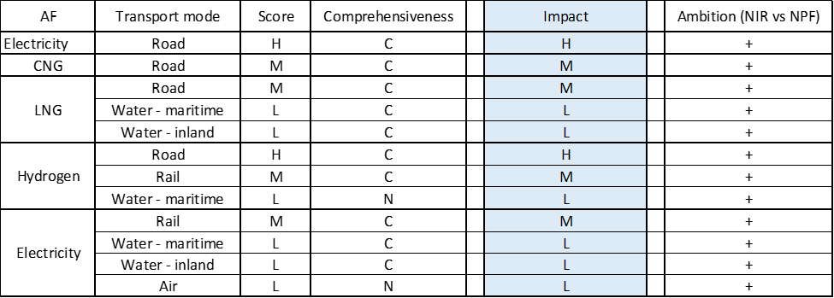

**Legend:** Score and Impact: H = high; M = medium; L = low; X = not assessable. Comprehensiveness: C = comprehensive; N = Not comprehensive. Ambition level: ‘+’ means ‘higher’; ‘=’ means ‘comparable’; ‘-‘ means ‘lower’.

#### Research, Technological Development & Demonstration

The German NIR contains 67 RTD&D projects, which represents a significant increase compared to the 17 RTD&D projects identified in the NPF. Of those, 33 are national RTD&D projects and 34 regional ones. All the national RTD&D projects were in place during the implementation period, with 15% of them having expired by 2019. Over half of the national RTD&D projects described in the NIR are applicable to more than one transport mode. Almost 40% of the national RTD&D projects refer to road transport only, with the vast majority of these targeting electricity. The NIR also lists national projects dedicated to waterborne and air transport, targeting a combination of fuels. RTD&D projects are also reported for biofuels and synthetic and paraffinic fuels, including synthetic kerosene.

Among the list of national RTD&D projects, the National Hydrogen and Fuel Cell Technology Innovation Programme (NIP; phases I and II), with a budget of over 1 billion €, and funding for R&D in the field of electro-mobility, with a budget of up to 380.5 million € (2017-2020), can be singled out. For the “battery research factory”, see Section 5.5.4.3.2.

The NIR acknowledges that annual budget values could not be reported on the ground that some projects go beyond alternative fuels, so total budget figures are provided in their stead, though not for all the projects listed (in fact, budget information is not available for 27% of the reported national RTD&D projects). For projects where budget is reported, the total estimated budget amounts to 2.8 billion € for the period 2006-2023 (for those projects that started in 2017 or later, the estimated value is 1 billion €). Information on the type of funding and, for some projects, the length of the project, is not provided.

### Additional information on alternative fuels infrastructure developments

Information is not available in the DE NIR.

### Summary of the assessment

**Tabular overview**

*Table 5.5.6‑1 Overview of the NIR assessment*

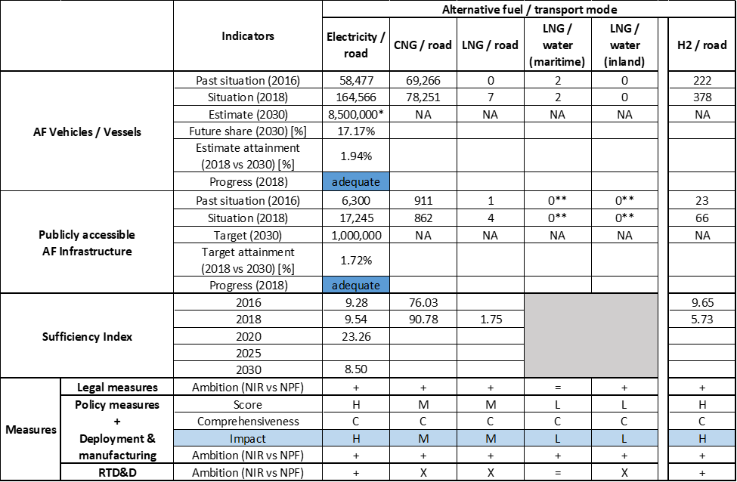



*The NIR expects that between 7 and 10 million electric passenger cars will be in use by 2030 (see Section 5.5.3.1.1 for information on other vehicle types). **The values refer to stationary shore-to-ship facilities (i.e. bunkering stations) (see Section 5.5.3.3.2).

After the adoption of the “*Klimaschutzgesetz*” (Climate Change Act), the German government is committed to reducing 95 million tonnes of CO2 transport emissions by 2030 and achieving GHG neutrality by 2050. The government of Germany stresses that it is pursuing a technology-neutral approach for the uptake of alternative fuel technology, while it considers that the most energy-efficient and climate-friendly option should prevail. Furthermore, the German government has introduced the following initiatives in recent years: “*Klimaschutzprogramm 2030*” (2030 Climate Change Programme), “*Mobilitäts- und Kraftstoffstrategie* (MKS)” (Mobility and Fuels Strategy), “*Marktanreizpaket Elektromobilität*” (Market Incentive Programme for Electric Mobility), “*Sofortprogramm Saubere Luft 2017-2020*” (2017-2020 Immediate Action Programme for Clean Air) and the research agenda “Sustainable urban mobility”.

Compared to the German NPF that fulfilled many but not all of the requirements of Article 3 of the Directive, the NIR fully addresses the requirements of Annex I of the Directive. However, it cannot be stated that the German NIR covers the whole AFID period (2016-2030), for it lacks infrastructure targets and vehicle estimates for several alternative fuels.

The main outcomes of the technical assessment of the German NIR on vehicles/vessels estimates and infrastructure targets can be summarised as follows:

###### Road transport

* **Electricity** – In 2018, Germany recorded 164,268 light-duty EVs, 298 heavy-duty vehicles and 17,245 publicly accessible recharging points. With reference to the objectives of the DE NPF as updated by the NIR, Germany is progressing adequately in both vehicles and infrastructure uptake. The NIR expects one million publicly accessible recharging points to provide electricity to 8.5 million EVs in 2030. The NIR does not provide recharging points targets / EV estimates for 2025.
* **CNG** – In 2018, Germany recorded 78,251 CNG vehicles, the majority of which were passenger cars, and 862 publicly accessible CNG refuelling points. Both the NPF and NIR lacked future targets for publicly accessible CNG refuelling points and CNG vehicle estimates. Due to this, the progress could not be computed. Notwithstanding, the DE NIR expects CNG technology to play an important role for HCVs.
* **LNG** – In 2018, Germany recorded seven LNG vehicles and four publicly accessible LNG refuelling points. Both the NPF and NIR lacked future LNG vehicle estimates. Nonetheless, the NIR expects LNG technology to play a more prominent role for HCVs. In line with the NPF, the NIR expects that a minimum of 9 LNG refuelling points will be available for HCVs by 2025.
* **Hydrogen** – In 2018, Germany recorded 378 fuel cell vehicles, of which 11 were buses and the rest passenger cars, and 66 publicly accessible hydrogen refuelling points. Both the NPF and NIR lacked future hydrogen vehicle estimates, but in terms of infrastructure the DE NIR expects that 400 publicly accessible hydrogen refuelling points will be in operation in 2025.
* **Biofuels** – There was no information on road vehicles powered by biofuels and related infrastructure in the NIR.
* **LPG** – In 2018, Germany recorded 213,718 LPG vehicles, most of which were passenger cars, and 7,128 publicly accessible LPG refuelling points. Apart from this, LPG plays a minor role in the NIR.
* **Synthetic and paraffinic** –The NIR mentions a project with two methanol-powered passenger cars.

###### Rail transport

* **Electricity** – In 2018, Germany recorded 6,173 electric railway locomotives. The NIR expects the deployment of alternative fuels in Germany on the non-electrified railways, or further network electrification.
* **Hydrogen** – In 2018, Germany recorded two fuel cell locomotives powered by hydrogen and one point to refuel them. The NIR expects a stock of at least 40 hydrogen trains in two Federal States in 2022.

###### Waterborne transport (maritime)

* **Electricity** – The NIR indicates that there were three maritime ports providing shore-side electricity supply but no German maritime vessels powered by electricity in 2018. Both the NPF and NIR lacked future targets for shore-side electricity supply in maritime ports and electric maritime vessel estimates.
* **LNG** – The NIR indicates that there were two LNG maritime vessels in operation in 2018. In the same year, LNG supply was not available in stationary bunkering stations at maritime ports but “truck-to-ship” supply was. Both the NPF and NIR lacked future targets for publicly accessible LNG refuelling points in maritime ports and estimates of maritime vessels powered by LNG. However, the NIR expects “ship-to-ship” LNG supply to become available and new LNG maritime vessels to be deployed.

###### Waterborne transport (inland)

* **Electricity** – In 2018, Germany recorded 14 electric inland vessels and a total of 407 facilities supplying electricity in inland ports and along waterways. Both the NPF and NIR lacked future targets for shore-side electricity supply in inland ports and electric inland vessel estimates.
* **LNG** – In 2018, there was no use of LNG in Germany’s inland waterborne transport system (i.e. no LNG supply in inland ports and no stock of LNG inland vessels). Both the NPF and NIR lacked future targets for LNG supply in inland ports and LNG inland vessel estimates. Notwithstanding, the NIR expects 14 LNG stations to become available in the future, seemingly along the German Rhine.
* **Synthetic and paraffinic** – The NIR mentions one methanol-powered passenger vessel in operation.

###### Air transport

* **Biofuels** – The NIR sees no need to nurture this market on the grounds that blend limits currently exist.
* **Synthetic and paraffinic** – The NIR indicates that R&D projects are targeting synthetic kerosene production and use for aviation.

As for the **measures**, the German NIR reports a long list of 75 national measures and 105 regional measures. Only two of them cover LPG. For the rest of the alternative fuels, the set of measures reported by the German government is wide-ranging, as the emergence of twelve clusters shows. Given the emphasis on electrification, the bundle of measures focusing on battery research and production can be highlighted. Considering all the legal measures, they appear, if fully implemented, to be fit to support the realisation of the AFV/AFI objectives as described in the NPF and revised in the NIR. Compared to the NPF, the level of ambition of the legal measures has increased in the NIR, except of the cluster LNG/water (maritime). No legal measures were identified for the clusters hydrogen/rail and hydrogen/water (maritime). With reference to the Policy and Deployment & Manufacturing measures, the level of ambition has increased for all the clusters, with the ones on road for electricity and hydrogen receiving the highest score. In terms of expected impact of these measures to support the realisation of the AFV/AFI objectives as presented in the NPF and revised in the NIR, the lack of future targets and estimates does not facilitate the task of putting this assessment into perspective. Based on the impact seen during the implementation period, it can be said that in the future the measures for the pairs electricity/road and hydrogen/road are expected to have a high impact, those for the pairs electricity/rail, CNG/road, LNG/road and hydrogen/rail a medium impact while all the other measures are expected to have a low impact. As for RTD&D measures, on the basis of the available information and in comparison to the NPF, the level of ambition for RTD&D projects in the NIR can be considered to have increased for the five clusters targeting electricity and the three clusters focusing on hydrogen, while it has remained similar for the pair LNG/water (maritime). No RTD&D projects were identified for the clusters CNG/road, LNG/road and LNG/water (inland).

### Final remarks

The German NIR provides a comprehensive report on the efforts to implement the Directive. The NIR is largely in line with the provisions of Annex I to the Directive, with the main exception that it does not include estimates for future market uptake of natural gas vehicles and vessels and related targets for natural gas infrastructures, except for LNG vehicle refuelling points in 2025. A significant number of measures are being implemented to promote a wide range of alternative fuels, with a strong focus on electro-mobility and hydrogen for the different transport modes. A significant budget is devoted to research and innovation projects focusing mainly on the development of batteries and fuel cell technologies. Research and demonstrations projects targeting synthetic kerosene production for use in aviation are funded too.

With regard to electricity, the NIR estimates that approximately 8,500,000 vehicles could be on the roads by 2030, representing about 17% of the fleet by that time. One million charging points should serve that fleet in the same year. Taking into account the current situation and expected trend development, this level of ambition appears to be broadly consistent with the pace of deployment of electric vehicles considered necessary for a full transition to carbon neutrality by 2050. The number of shore-side electricity supply facilities for inland vessels amounted to 407 in 2018. However, only 3 out of 6 maritime ports of the TEN-T Core Network in Germany are equipped with such facilities. Germany should provide information on its plans to supply shore-side electricity supply in the remaining three maritime ports of the TEN-T Core Network. Fourteen electric inland waterways vessels are already in use in Germany. Moreover, almost all of the 270 airport terminals are equipped with stationary ground power connections. Around 60% of Germany’s rail network is electrified. Information on charging efficiency is provided.

Regarding hydrogen for transport, the NIR presents the ambitious target of 400 hydrogen refuelling stations in place by 2025, but it does not provide estimates for FCHVs. The number of refuelling stations seems sufficient taking into account the length of Germany’s TEN-T Core network, provided that the refuelling points are widely distributed along the network. Further, the NIR foresees the use of hydrogen in rail transport as well in aviation in the longer term.

In terms of natural gas for transport, Germany has the second largest network of CNG refuelling stations in the EU. It seems sufficient for serving a larger fleet of CNG vehicles compared to the current one. Germany does not provide any estimates for the future growth of such vehicles. The NIR does not provide estimates for LNG vehicles either. The NIR foresees at least nine LNG refuelling points by 2025 in the TEN-T Core Network. This number seems rather low compared to the overall extensiveness of the German TEN-T Core Network. Although the NIR reports that two LNG maritime vessels were in use in 2018, it does not provide any target for LNG refuelling points in maritime and inland ports. Germany should provide further detail in future reporting.

In 2018, there were 213,718 LPG vehicles (less than those registered in 2016) and 7,128 refuelling points registered. The NIR does not provide information on the estimated future number of LPG vehicles and refuelling points.

With regards to renewable fuels, Germany should provide more information in future reporting on efforts to promote the use of renewable fuels in transport, and particularly in aviation.

### ANNEX - Description of the Member State

On a surface area of 357,100 km², Germany has a population of 82.792 million people in 2018, which makes up for a population density of 232 inhabitants/km².

*Number of main urban agglomerations*

* 126 urban agglomerations > 50,000 inhabitants

In 2018, Germany achieves a per capita gross domestic product at market prices of €40,340, which represents a per capita gross domestic product in purchasing power standards of 122 if expressed in relation to the EU-28 average set to equal 100.

*Length of the road networks*

The length of the road TEN-T Core Network in Germany is 6,363 km. The total road network length is 230,035 km, of which 13,141 km are motorways.

The following lengths of the TEN-T Road Corridors are present in Germany: 35% (1,393 km) of the North Sea - Baltic Corridor, 26% (1,398 km) of the Orient / East - Mediterranean Corridor, 30% (1,895 km) of the Scandinavian - Mediterranean Corridor, 50% (707 km) of Rhine - Alpine Corridor and 27% (1,191 km) of the Rhine - Danube Corridor.

Through the TEN-T Road Corridors, Germany is connected with the following Member States:  
- Poland (through the North Sea - Baltic Corridor)  
- the Netherlands (through the North Sea - Baltic and the Rhine - Alpine Corridor)  
- Belgium (through the North Sea - Baltic and the Rhine - Alpine Corridor)  
- Czechia (through the Orient/ East Mediterranean and the Rhine - Danube Corridor)  
- Austria (through the Scandinavian - Mediterranean and the Rhine - Danube Corridor)  
- Denmark (through the Scandinavian - Mediterranean Corridor)  
- France (through the Rhine - Danube Corridor)

*Number of registered road vehicles*

At the end of 2018, Germany accounts for 54,915,724 registered road vehicles of which 47,095,784 are categorized as passenger cars, 2,616,118 as light goods vehicles, 750,303 as heavy goods vehicles and 80,519 as buses and coaches. The motorisation rate is 569 passenger cars per 1,000 inhabitants.

*Number of ports in the TEN-T Core Network*

* 6 maritime ports in the TEN-T Core Network (Bremen, Bremerhaven, Hamburg, Lübeck, Rostock, Wilhelmshaven)
* 15 maritime ports in the TEN-T Comprehensive Network
* 21 inland ports in the TEN-T Core Network (Berlin, Braunschweig, Bremen, Bremerhaven, Dortmund, Duisburg, Düsseldorf- Neuss, Frankfurt am Main, Hamburg, Hamm, Hannover, Karlsruhe, Koblenz, Köln, Lübeck, Magdeburg, Mainz, Mannheim-Ludwigshafen, Nürnberg, Regensburg, Stuttgart)
* 68 inland ports in the TEN-T Comprehensive Network

Through the 4,248 km inland waterways TEN-T Core Network, Germany is connected with the Netherlands through the North Sea - Baltic and Rhine - Alpine Corridors, with Austria through the Rhine - Danube Corridor, with France through the Rhine-Alpine and the North Sea - Mediterranean Corridor, with Czechia through the Orient/East-Mediterranean Corridor, with Luxembourg through the Rhine-Alpine Corridor and with Poland through the core network.

*Number of airports in the TEN-T Core Network*

* 11 airports in the TEN-T Core Network (Berlin-Brandenburg Intl., Bremen, Düsseldorf, Frankfurt am Main, Hamburg, Hannover, Köln-Bonn, Leipzig-Halle, München, Nürnberg, Stuttgart)
* 13 airports in the TEN-T Comprehensive Network

## Estonia (EE)

### Main messages from the Commission assessment of the NPF

In its original assessment of the Estonian NPF the Commission concluded:

*The Estonian NPF addresses partially the requirements of Directive’s Article 3. For many aspects more details would have been needed for an accurate assessment. The NPF does not contain any future estimates for alternative fuels vehicles. Vague targets are provided concerning AFI for 2020 (>100 for high power recharging points and >10 for biomethane refuelling points). Spatial distribution details or references to urban areas and the TEN-T network are not presented. Estonia is focusing on increasing the proportion of alternative fuels use in road transport and is seeking to increase the use of renewable energy sources in road transport to 10% of the amount of fuel consumed. The objective is to be achieved through three types of fuel – liquid biofuels, biomethane and electricity.*

*The Estonian NPF lacks concrete targets for EV infrastructure and information about the future EV vehicle market development. It neither contains targets for further deployment of electricity supply for stationary airplanes nor shore-side electricity.*

*One of the Estonian NPF's main objectives is the introduction of methane-based fuels in transport. Longer term preference is biomethane because of its environmental and energy security benefits. Promoting the creation of a comprehensive network of natural gas refuelling points is considered to be the main challenge in the period leading up to 2020.*

*Regarding LNG, the NPF mentions that an LNG terminal including an LNG bunkering terminal is due to be completed in 2017, at the Harbour of Muuga (part of the Tallinn port) where a distribution system will also be developed, including loading facilities for LNG tank vehicles.*

*For hydrogen, a first pilot project is pointed out, in which the University of Tartu and the private sector plan to jointly create a hydrogen refuelling point, a production facility in Pärnu.*

*The Estonian NPF contains a reduced and vaguely described portfolio of existing and proposed measures covering road transport and shore-side electricity supply. All the measures concerning the use of electricity for road transport (private or public infrastructure) have expired and no future ones are proposed. Support measures for natural gas infrastructure and the promotion of biomethane are vaguely mentioned and lack concrete information (e.g. start year, budget). Biofuels are promoted in the short term and Estonia’s energy policy regulates the blending shares of biofuels in petrol and diesel (gradually increasing up to at least 10% as of 2020). For LNG, no measures are proposed at this moment but the degree of interest and need will be further investigated after the completion of the first terminal in 2017. The NPF presents two measures regarding public transport that relate to public procurement of CNG and hydrogen public buses.*

*The NPF mentions cross-border cooperation focussing on shore-side electricity supply.*

### Overview of requirements’ fulfilment from Annex I of the Directive

*Table 5.6.2‑1 Checklist Table*

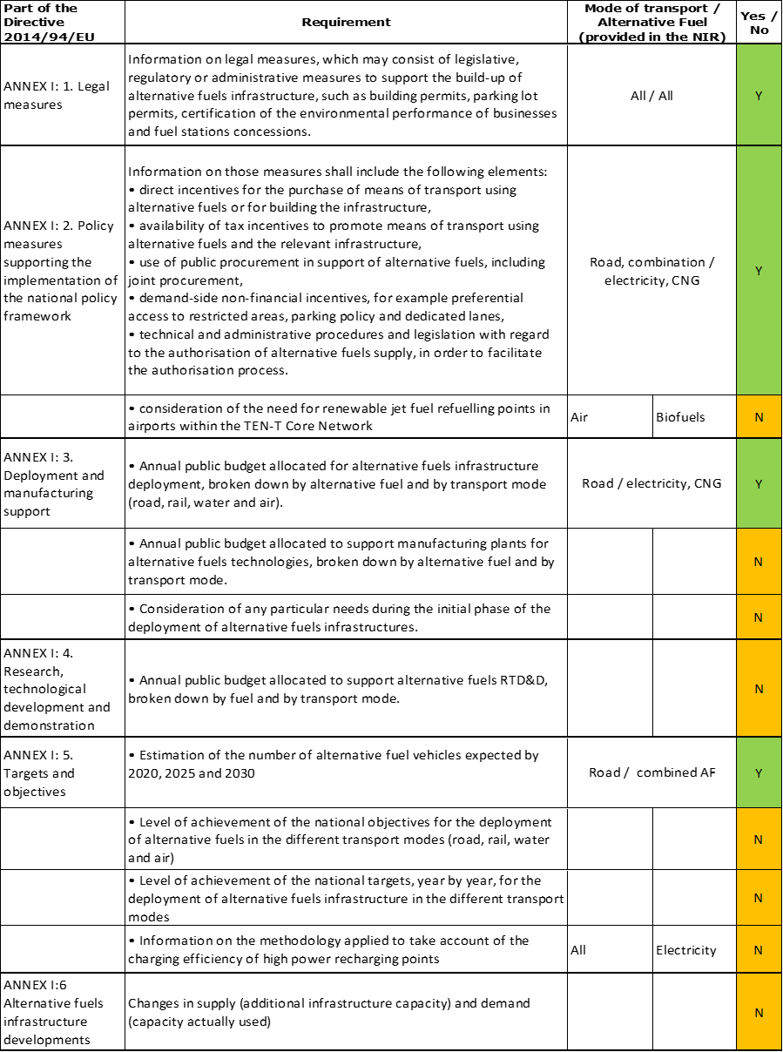

The checklist shows that the requirements of Annex I from the Directive are scarcely covered in the Estonian NIR.

The Estonian NIR does not offer any quantitative future AFI targets and provides only AFV estimates on a cumulative all-AFs level.

The EE NIR reports 13 measures in total. Under the Policy and Deployment & Manufacturing sections it was possible to identify three AF/transport mode clusters of measures, all assessable.

### Quantitative assessment: Vehicles and infrastructure

*Table 5.6.3‑1 National AFV estimates and AFI targets established in the NIR at the horizon 2020, 2025 and 2030 and their comparison with the NPF situation*

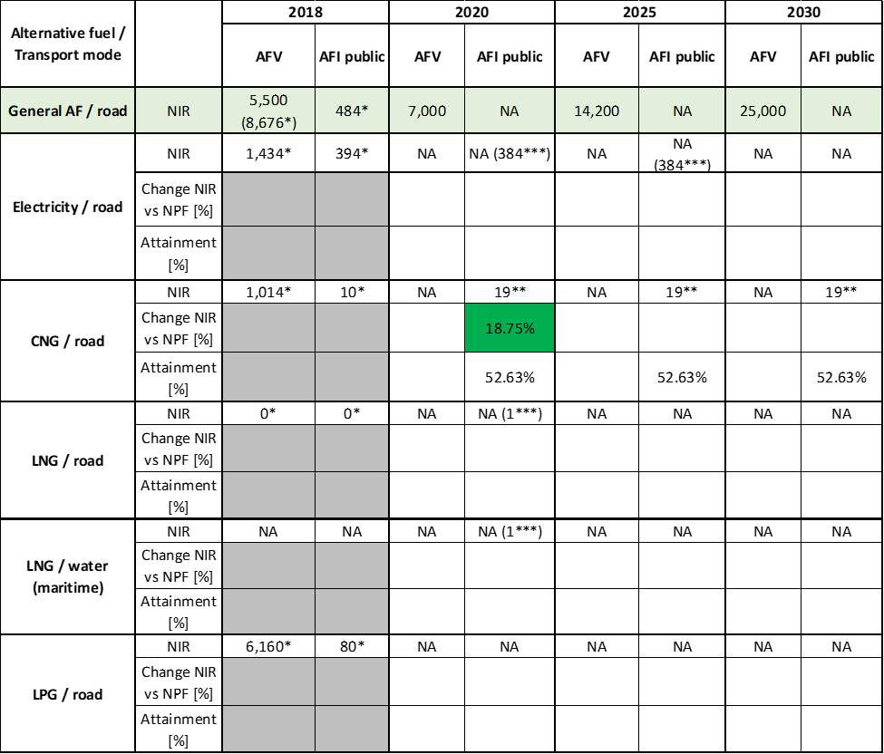



* Data from EAFO since the EE NIR did not provide detailed information, ** Values corresponding to 2019 from EAFO (the NIR mentions that the CNG infrastructure was established in 2019 and no further plans are presented), *** Targets from the EE NPF.

#### Road transport

NOTE: Similarly to the NPF, there are no fuel-specific AFV estimates presented in the Estonian NIR. Instead, an overall projection of AFV on Estonian roads is provided. Total AFV fleet is foreseen to develop from 5,500 vehicles in 2018 to 7,000 in 2020, 14,200 in 2025 and 25,000 in 2030.

The Estonian NIR provides no quantitative future AFI targets for any alternative fuel.

The NIR mentions that Estonia will complete its National Transport and Mobility Development Plan 2021+ by the end of 2020 in order to set new national objectives for the deployment of alternative fuels and their infrastructure.

##### Electricity

###### Vehicles

The Estonian NIR does not provide the 2016-2018 quantitative situation regarding electric vehicles. According to EAFO, Estonia recorded 1,434 battery-electric and plug-in hybrid electric vehicles in use in 2018, of which 1,377 were passenger cars, 31 LCVs and 26 buses and coaches (Table 5.6.3‑1).

Similarly to the Estonian NPF, the NIR did not provide future electric vehicle estimates and the 2018 ***attainment*** and ***progress*** could not be computed.

###### Infrastructure

The Estonian NIR does not provide the 2016-2018 quantitative situation regarding publicly accessible recharging infrastructure. According to EAFO, Estonia recorded 384 publicly accessible recharging points in 2016 and 2017, and 394 in 2018 (Table 5.6.3‑1).

In the Estonian NIR, no specific future targets are listed concerning the development of electric recharging points. Instead, the long-term vision is loosely described as planned to achieve recharging infrastructure that would be convenient for all users.

The Estonian NIR mentions that, during the process of privatising the national recharging infrastructure, obligations derived from the AFI Directive were put on the new owners (e.g. adding ‘Combo 2’ sockets to the existing/future high-power recharging points, distance between recharging points). Developing the national recharging infrastructure is considered to depend on the business plan of the new owners.

The targets for 2020 and 2025 considered in the Estonian NPF assessment were both equal to 384 publicly accessible recharging points.

Because the Estonian NIR did not provide any future targets for publicly accessible recharging points, the 2018 ***attainment*** and ***progress*** could not be computed.

###### Ratio

Based on the EE NIR, the following table shows the ratio between vehicles and publicly accessible recharging points (i.e. sufficiency index) for the pair electricity/road. Because the Estonian NIR did not provide present values and future targets, the sufficiency index could only be computed for 2016 and 2018 by using data from EAFO. The 2016 - 2018 situation is considered adequate since the sufficiency index is inferior to the indicative value of 10.



* data from EAFO

###### Information on charging efficiency

The NIR mentions that, due to Estonia’s privatization process of the recharging infrastructure, the specific methodology to take account of the charging efficiency of high power (>22kW) recharging points is subject to the developer’s business plan.

##### CNG

###### Vehicles

The Estonian NIR does not provide the 2016-2018 quantitative situation regarding CNG vehicles. The report only mentions that public transport in Estonia is largely based on natural gas buses and some support vehicles at airports use biogas.

According to EAFO, Estonia recorded 1,014 CNG vehicles in use in 2018, of which 651 were passenger cars, 170 LCVs, 82 HCVs and 111 buses and coaches (Table 5.6.3‑1).

There are no future CNG vehicle estimates provided in the Estonian NIR, thus the 2018 ***attainment*** and ***progress*** could not be computed.

###### Infrastructure

The Estonian NIR does not provide the 2016-2018 quantitative situation regarding publicly accessible CNG refuelling infrastructure. According to EAFO, Estonia recorded 6 CNG refuelling points in 2016 and 2017, 10 in 2018 (and 19 in 2019).

The Estonian NIR provides no specific quantitative future targets for publicly accessible CNG refuelling points but reports that the nationwide CNG and biogas refuelling infrastructure has already been established in 2019, funded by the government and the private sector that contributed each with 2.78 million €. In the case of biogas, it is added that the refuelling infrastructure is developing on demand.

In accordance with the statement of the EE NIR, the current assessment considers the future number of CNG refuelling points to remain the same as in 2019 (Table 5.6.3‑1). This considered target for 2020 is 18.75% higher than the NPF target of 16 CNG refuelling points.

The 2018 ***attainment*** of future publicly accessible CNG refuelling infrastructure targets is constant and equal to 52.63% for 2020, 2025 and 2030. According to the assessment methodology described in Section 2.1, the 2018 situation corresponds to a ***fast progress*** towards reaching these envisaged targets. The calculated ***average annual growth rate*** corresponding to the period 2016-2030 for publicly accessible CNG refuelling infrastructure evolution planned by Estonia is equal to 7%.

###### Ratio

The following table shows the ratio between vehicles and publicly accessible CNG refuelling points (i.e. sufficiency index) for the pair CNG/road. As is the case for electricity/road, the sufficiency index could only be computed for the 2016 - 2018 period by using data from the Estonian NPF and from EAFO, respectively. The 2016 - 2018 situation is considered adequate since the sufficiency index is inferior to the indicative value of 600 (see Section 2.1.5).



* data from EE NPF; ** data from EAFO

##### LNG

###### Vehicles

Similarly to the Estonian NPF, there is no information provided about LNG vehicles in the Estonian NIR. Therefore, the 2018 ***attainment*** and ***progress*** could not be computed.

###### Infrastructure

There is no information provided about road LNG refuelling points in the Estonian NIR. According to EAFO, Estonia did not record any road LNG refuelling points in 2018.

The NPF target for 2020 was equal to one road LNG refuelling point.

Since there are no road LNG refuelling points targets provided in the Estonian NIR, the 2018 ***attainment*** and ***progress*** could not be computed.

###### Ratio

Since there is no current LNG infrastructure available and no targets were provided in the Estonian NIR, it is not possible to compute the sufficiency index.

##### Hydrogen

###### Vehicles

The Estonian NIR mentions that hydrogen vehicles are only slowly entering the Estonian market. On the basis of this observation, the Estonian NIR stipulates that no concrete actions have thus been taken.

Similarly to the Estonian NPF, there are no future hydrogen vehicle estimates provided in the Estonian NIR. Therefore, the 2018 ***attainment*** and ***progress*** could not be computed.

###### Infrastructure

The Estonian NIR provides no quantitative information for hydrogen refuelling points. According to the Estonian NIR, different ideas have been put forward on the hydrogen refuelling infrastructure, but no concrete targets or actions have yet been declared.

According to EAFO, Estonia did not record any hydrogen refuelling points in 2018.

Since there are no hydrogen refuelling points targets provided in the EE NIR, the 2018 ***attainment*** and ***progress*** could not be computed.

###### Ratio

Since there is no current hydrogen refuelling infrastructure available and no targets were provided in the Estonian NIR, it is not possible to compute the sufficiency index.

##### Biofuels

###### Vehicles

Information is not available in the Estonian NIR.

###### Infrastructure

Information is not available in the Estonian NIR.

##### LPG

###### Vehicles

The Estonian NIR does not provide information on the number of LPG vehicles. According to EAFO, Estonia recorded 6,160 LPG vehicles in use in 2018, all of them being passenger cars (Table 5.6.3‑1).

###### Infrastructure

The Estonian NIR does not provide information on the number of LPG refuelling points. According to EAFO, Estonia recorded 55 LPG refuelling points in 2016, 60 in 2017, and 80 in 2018.

###### Ratio

The following table shows the ratio between vehicles and publicly accessible LPG refuelling points (i.e. sufficiency index) for the pair LPG/road. The sufficiency index could only be computed for the 2016 – 2018 period by using data from EAFO.



* data from EAFO

#### Rail transport

##### Electricity

###### Vehicles

The Estonian Cabinet of Ministers has approved the acquisition of six electric trains by the public transport company ELRON (see also Section 5.6.4.2.2).

###### Infrastructure

The Estonian Cabinet of Ministers decided to fully electrify Estonia’s railway system by 2028. Design work begins in 2020 and construction work will commence in 2022 (see also Section 5.6.4.2.2).

#### Waterborne transport (maritime)

##### Electricity

###### Vessels

Information is not available in the Estonian NIR.

###### Infrastructure

According to the previously evaluated Estonian NPF, there was one maritime port equipped with shore-side electricity supply in 2016. The target set out in the NPF for 2020 and 2025 accumulated to 11 maritime ports with shore-side electricity supply available. It is not clear if this target is still meant to be achieved as the Estonian NIR does not provide any information on shore-side electricity supply.

##### LNG

###### Vessels

Information is not available in the Estonian NIR. However, one LNG vessel was mentioned in the Estonian NPF that began sailing the Tallinn–Helsinki line in 2017.

###### Infrastructure

No information was provided regarding LNG refuelling infrastructure in maritime ports along the TEN-T Core Network in the Estonian NIR. The NPF target for 2020 was one LNG terminal in the TEN-T Core maritime port of Tallinn.

#### Waterborne transport (inland)

Not applicable since Estonia has no inland ports in the TEN-T Core Network.

#### Air transport

##### Electricity

###### Airplanes

No specific information was found in the Estonian NIR.

###### Infrastructure (for stationary airplanes)

The Estonian NIR does not provide any information on electricity supply for stationary airplanes. According to the EE NPF, there was electricity supply available for stationary airplanes at the five Estonian airports with international flights in 2016. However, the NPF did not contain information on future plans.

##### *Biofuels*

###### Airplanes

The Estonian NIR reports that the aviation sector has signalled openness to introduce machinery powered by alternative fuels. There are, however, no big investments expected due to low volumes.

###### Infrastructure

The Estonian NIR does not provide information on the introduction of renewable jet fuel refuelling points.

### Measures assessment

The Estonian NIR mentions a series of measures that cumulate in three AF/transport mode clusters. Unfortunately, the Estonian NIR falls short of providing detailed information needed to perform the assessment. Many measures are vaguely defined or lack concrete information. The need to report this information has already been emphasized in the previous assessment of the Estonian NPF.

#### Legal measures

The Estonian NIR contains three legal measures to promote AFs. The previous NPF contained three measures as well, but different ones.

##### Legislative & Regulatory

The legislative & regulatory category of the Estonian NIR contains two measures. The planned measures are the above-mentioned National Transport and Mobility Development Plan 2021+ setting national deployment and AFI targets as well as a new regulation for 2021 requiring new building projects to install electric recharging points relative to the availability of parking spaces. Two different legislative and regulatory measures have been featured in the Estonian NPF. These concerned a memorandum of cooperation for the implementation of shore-side electricity supply in Estonia’s Baltic maritime ports as well as the Estonia-Latvia cross-border cooperation programme for a joint network of small ports. The current Estonian NIR does not indicate whether these measures have been successfully implemented or not.

##### Administrative

The Estonian NIR reports solely one administrative measure. The member state mentions the EU Clean Vehicles Directive which stipulates that 31% and 43% of public buses procured by 2025 and 2030, respectively, must be clean vehicles with half of those operating with zero emissions. The past Estonian NPF also reported only one administrative measure, which concerned biofuels blending mandates for petrol and diesel fuel. This measure was mentioned as adopted and has not been reported again in the Estonian NIR.

#### Policy measures

The Estonian NIR reports eight policy measures intended to foster alternative fuels in Estonia. Only one measure is featured in both NPF and NIR, seven have been newly introduced. This is an improvement compared to the NPF, which contained only three policy measures. Most policy measures in the Estonian NIR are financial incentives. The modes of transport covered are road or a combination of modes where fuels as such have been subject of the measures. The policy measures target exclusively electricity and CNG (including biomethane).

##### Measures to ensure national targets and objectives

###### Road transport

Six of the eight policy measures in the Estonian NIR are measures to ensure national targets and objectives. All six measures exclusively focus on electricity/road as well as CNG/combination of modes.

The three measures concerning electricity/road are all new measures that did not appear in the NPF. The most substantial among them is a purchase incentive with an allocated budget of 1.2 million € for the purchase of electric vehicles announced to begin at the end of 2019. The maximum grant per EV is €5,000. The other measures include discounts and free parking for electric vehicles in various cities as well as the possibility for EVs to use bus lanes.

As a fuel-specific measure, biomethane is exempt from excise duty in Estonia. Additionally, no excise warehouse permit is required for production and sale of biomethane. Information campaigns have been conducted to educate the population on biomethane, with a budget of €120,000 for the last two years, which included, among others, creating the Biomethane Advisory Council, advertising, launching a biomethane website and seminars.

##### Measures that can promote AFI in public transport services

The Estonian NIR lists two new measures that can promote AFI in public transport services. They are both related to rail transport (see next paragraph). The previous NPF offered a measure concerning the introduction of natural gas-powered public buses. The Estonian NIR does not refer to this past measure again.

###### Rail transport

The Estonian Cabinet of Ministers decided to fully electrify Estonia’s railway system by 2028 for an estimated total cost of 300 million €. It is foreseen that design work begins in 2020 and construction work in 2022. The Cabinet of Ministers additionally aims to purchase six new electric trains for an estimated cost of 60 million €.

##### Measures that can promote the deployment of private electro-mobility infrastructure

The Estonian NIR does not list any measure that can promote the deployment of private electro-mobility infrastructure.

#### Deployment and manufacturing support

##### AFI deployment

The Estonian NIR lists two measures fostering the deployment and manufacturing support of alternative fuels. The first measure was due to expire at the end of 2019. It supported the maintenance of the electric recharging infrastructure for an amount of €50,000 per month. The Estonian NIR argues, however, that due to the privatisation of the recharging infrastructure no financial support is needed anymore. The second measure concerns the deployment of the nation-wide CNG refuelling infrastructure and has also been listed in the NPF but updated since. The Estonian NIR argues that no further action is needed as the complete CNG infrastructure has been established in 2019. Public and private investors contributed 2.78 million € each.

The Estonian NIR does not consider any other transport modes or other alternative fuels other than CNG and electricity in this section.

##### Support of manufacturing plants for AF technologies

No measures regarding the support of manufacturing plants for AF technologies are presented in the Estonian NIR.

##### Consideration of any particular needs during the initial phase of the deployment of alternative fuels infrastructures

The Estonian NIR provides no information on this subject.

#### Quantitative assessment of Policy and Deployment & Manufacturing measures

Table 5.6.4‑1 presents an overview of the analysis of all the Policy and Deployment & Manufacturing measures, carried out according to the assessment methodology described in Section 2.2. No clusters of measures have emerged for hydrogen, LNG and LPG nor for waterborne and air transport modes.

Electricity/road is a new cluster appearing only in the NIR. While it results comprehensive since it concerns both vehicles and infrastructure (with financial and non-financial measures), it obtained a medium overall score influenced by the lack of specific details that made the assessment very difficult. Electricity/rail is also a cluster newly introduced in the NIR. It is comprehensive and has a medium overall score.

CNG/road cluster was already present in the NPF, where it was assessed with an overall medium score and as comprehensive. In the EE NIR, the result of the assessment is different (high overall score but not comprehensive).

In terms of expected impact of these measures to support the realisation of the AFV/AFI objectives as presented in the NPF and revised in the NIR, the lack of objectives and information related to budget allocations, does not allow to put this assessment into the right perspective. However, on the basis of a comparison of the Estonian measures with those provided by other Member States, it can be said that the measures for the pairs electricity/road, electricity/rail and CNG/road could have a medium impact. The three identified clusters of measures show a higher level of ambition compared to the NPF.

*Table 5.6.4‑1* *Quantitative assessment of Policy and Deployment & Manufacturing support measures*



**Legend:** Score and Impact: H = high; M = medium; L = low; X = not assessable. Comprehensiveness: C = comprehensive; N = Not comprehensive. Ambition level: ‘+’ means ‘higher’; ‘=’ means ‘comparable’; ‘-‘ means ‘lower’.

#### Research, Technological Development & Demonstration

The Estonian NIR does not list any measures that can be assessed as supporting research, technological development and demonstration (RTD&D). Two measures presented only in the NPF concerned a pilot project at the University of Tartu, which at the time of 2017 planned to acquire the first hydrogen powered public buses and to build a hydrogen refuelling point. These measures were under consideration in the NPF and their current status is unclear as the Estonian NIR does not mention them anymore.

### Additional information on alternative fuels infrastructure developments

The Estonian NIR does not provide information on the changes in fuel use.

### Summary of the assessment

**Tabular overview**

*Table 5.6.6‑1 Overview of the NIR assessment*





* Value taken or calculated from EE NPF. ** Value taken from EAFO (absent in the NIR). *** Values corresponding to 2019 from EAFO (the NIR mentions that the CNG infrastructure was established in 2019 and no further plans are presented).

The requirements of Annex I from the Directive are only partly covered in the Estonian NIR. The NIR does not contain a sufficient description of the policy direction towards the introduction of alternative fuels in Estonia. It does not establish AFI targets nor does it present AFV estimates differentiating between the different kinds of fuels. The EE NIR only provides an overall projection of AFV on Estonian roads. However, it mentions that a National Transport and Mobility Development Plan 2021+ will be completed by the end of 2020. The plan will set new national targets for the deployment of alternative fuels and their infrastructure.

The main outcomes of the technical assessment of the Estonian NIR on vehicles/vessels estimates and infrastructure targets can be summarised as follows:

###### Road transport

* **Electricity** – According to EAFO, Estonia recorded 1,434 electric vehicles in 2018 (1,377 passenger cars, 31 LCVs, 0 HCVs and 26 buses and coaches). There are no quantitative infrastructure targets or vehicle estimates outlined in the Estonian NIR. It is only mentioned that their vision is to achieve recharging infrastructure that would be convenient for all users. The recharging infrastructure was privatised and its further development is considered to depend on the business plan of the new owners. Due to the lack of reported values, the sufficiency index, progress and target attainment could not be calculated.
* **CNG** – According to EAFO, Estonia recorded 1,014 CNG vehicles in use in 2018 (651 passenger cars, 170 LCVs, 82 HCVs and 111 buses and coaches). As in the NPF, the Estonian NIR does not provide estimates for CNG vehicles. The NIR signals that the CNG infrastructure was completely established in 2019 so that the value of 19 CNG refuelling points was considered as the target for the future years. With reference to the objectives of the EE NPF as updated by the NIR, in 2018 Estonia was progressing fast in terms of CNG infrastructure deployment.
* **LNG** – According to EAFO, Estonia did not record any road LNG refuelling points or vehicles in 2018. Similarly to the NPF, the EE NIR does not include quantitative estimates for road vehicles powered by LNG. Regarding LNG refuelling infrastructure, the EE NIR does not provide any future target while the NPF had presented a target of one LNG refuelling point for 2020.
* **Hydrogen** – The Estonian NIR mentions that, because hydrogen vehicles are only slowly entering the Estonian market, no concrete objectives or actions have yet been declared.
* **Biofuels** – Information is not available in the Estonian NIR.
* **LPG** – According to EAFO, Estonia recorded 6,160 LPG vehicles on the road and 80 LPG refuelling points in 2018. Similarly to the NPF, the Estonian NIR does not provide estimates for LPG vehicles or targets for LPG refuelling infrastructure.

###### Rail transport

* **Electricity** – The electrification process of Estonia’s railway system is set to be completed by 2028.

###### Waterborne transport (maritime)

* **Electricity** – The Estonian NIR does not provide any information on shore-side electricity supply. The NPF had mentioned one port was equipped with shore-side electricity supply in 2016 and included a target of 11 maritime ports with shore-side electricity supply available in 2020 and 2025.
* **LNG** – Regarding LNG refuelling infrastructure in maritime ports along the TEN-T Core Network, the EE NIR does not provide any future target while the NPF had presented a target of one LNG terminal in the port of Tallinn for 2020.

###### Air transport

* **Biofuels** – According to the Estonian NIR, the aviation sector has signalled openness to introduce machinery powered by alternative fuels but no big investments are expected due to low volumes.

The Estonian NIR contains a modest list of **measures** to support the substitution of conventional fuels with alternative fuels. Most of the presented measures lack concrete information needed for a proper assessment. The number of legal measures remained the same in the NIR as in the NPF, but they are totally different. Concerning the Policy and Deployment & Manufacturing support measures, compared with the NPF, the level of ambition has increased for all the three existing clusters in the NIR: electricity/road, electricity/rail and CNG/road. The first two clusters are totally new in the NIR, while the CNG/road cluster was already present in the NPF.

On the basis of the assessment methodology described in Section 2.2, the new electricity/road and electricity/rail clusters were assessed to have medium impact towards reaching the electro-mobility objectives of Estonia. The CNG/road cluster was assessed as well to have a medium impact towards reaching the CNG objectives of Estonia.

The Estonian NIR does not provide information about measures that can be assessed as supporting RTD&D of AFI and AFV.

### Final remarks

The Estonian NIR provides a rather limited report on the efforts to implement the Directive. It does not provide information on several requirements of Annex I to the Directive: it does not offer any quantitative targets for alternative fuels infrastructure deployment and provides generic alternative fuels vehicles estimates without differentiation per fuel. It should be noted that the information on shore-side electricity supply at ports and airports, included in the NPF, is not included in the NIR. Nor is there any mention of LNG vessels, while, according to the NPF, these should have started sailing on the Tallinn-Helsinki line in 2017. The NIR focuses on measures promoting electricity for road and rail transport and CNG for vehicles. Future reporting should include information on measures to support ramp up of other alternative fuels in other modes of transport. This could contain particularly more information on promotion of zero-emission vehicles up to 2030. Following the requirements under the Directive, targets for the coverage of publicly accessible infrastructure need to be established and the numbers of specific alternative fuel vehicles and infrastructure need to be adequately quantified and reported.

With regard to electricity, the lack of specific data prevents an assessment of the ambition for 2030. Taking into account the current situation and expected trends, which have been derived either from the NPF or from EAFO, Estonia’s level of ambition appears quite low compared to the pace of deployment of electric vehicles considered necessary for a full transition to carbon neutrality by 2050. In this context, increased deployment of the relevant recharging infrastructure is also crucial to meet the objective of realising a dense, wide-spread and easy to use network of recharging and refuelling infrastructure throughout the EU. No information on charging efficiency is provided. The supply of shore-side electricity supply in ports and of electricity supply to stationary aircraft in airports needs to be clarified due to discrepancies between the information given in the NPF and the lack of information in the NIR. The railway network is expected to be fully electrified by 2028.

Regarding hydrogen, the NIR does not provide any plan for the development of an infrastructure for HCEV and does not provide information on fleet development. Although hydrogen is not binding under the Directive, it would be relevant that Estonia provides information on how to ensure EU-wide connectivity for HCEV.

As to natural gas, according to the information provided in the NIR, 19 CNG refuelling points were in place in 2019. The NIR expects no additional deployment of CNG refuelling infrastructure until 2030. Furthermore, the NIR does not report estimates for LNG vehicles and vessels nor targets for the relevant infrastructure. Estonia should provide further information in future reporting..

With regard to LPG infrastructure, the NIR does not provide information. However, EAFO shows that Estonia already had fleet of 6,160 LPG vehicles and around 80 refuelling stations in 2018, with decreasing registrations, but the Estonian NIR does not provide any estimates of vehicles and infrastructure by 2020, 2025 and 2030.

Estonia should provide more information in future reporting on efforts to promote the use of renewable fuels in transport, and particularly in aviation.

### ANNEX - Description of the Member State

On a surface area of 45,200 km², Estonia has a population of 1.319 million people in 2018, which makes up for a population density of 29 inhabitants/km².

*Number of main urban agglomerations*

* 3 urban agglomerations > 50,000 inhabitants

In 2018, Estonia achieves a per capita gross domestic product at market prices of €19,740, which represents a per capita gross domestic product in purchasing power standards of 82 if expressed in relation to the EU-28 average set to equal 100.

*Length of the road networks*

The length of the road TEN-T Core Network in Estonia is 481 km. The total road network length is 16,604 km, of which 154 km are motorways.

The following lengths of the TEN-T Road Corridors are present in Estonia: 5% (192 km) of the North Sea - Baltic Corridor.

Through the TEN-T Road Corridors, Estonia is connected with the following Member States:  
- Latvia (through the North Sea - Baltic Corridor)

*Number of registered road vehicles*

At the end of 2017, Estonia accounts for 924,802 registered road vehicles of which 746,464 are categorized as passenger cars, 83,313 as light goods vehicles, 38,229 as heavy goods vehicles and 5,026 as buses and coaches. The motorisation rate is 566 passenger cars per 1,000 inhabitants.

*Number of ports in the TEN-T Core Network*

* 1 maritime port in the TEN-T Core Network (Tallinn)
* 7 maritime ports in the TEN-T Comprehensive Network
* No inland ports

*Number of airports in the TEN-T Core Network*

* 1 airport in the TEN-T Core Network (Tallinn)
* 4 airports in the TEN-T Comprehensive Network

## Ireland (IE)

### Main messages from the Commission assessment of the NPF

In its original assessment of the Irish NPF the Commission concluded:

*The Irish NPF addresses partly the requirements of Article 3. It contains a discussion of the current state and future scenarios for alternative fuels in the transport sector. For all the mandatory fuels and modes except for LNG it establishes targets as required by Article 3 of the Directive.*

*The spatial distribution of the available recharging points fulfils the requirement of having chargers available every 60 km on Ireland’s main intercity roads, including the TEN-T Core Network. The actual number of public recharging points is also sufficient to cover the requirement of one recharging point every 10 electric vehicles. However, the numbers of electric recharging points foreseen for 2020, 2025 and 2030 seem to be insufficient for the foreseen number of electric vehicles in Ireland if only the public recharging points are taken into account. Ireland supports the deployment of private electro-mobility infrastructure. To increase the number of electric vehicles in Ireland, vehicle purchase and registration tax incentives exist since 2011. Company tax incentives exist since 2008. The registration tax relief for battery electric vehicles will be extended until 2021 and for plug in hybrid vehicles until 2018.*

*The Dublin Airport in the TEN-T Core Network is currently using mobile ground power units for use by stationary airplanes. However, the Irish NPF does not include targets for electricity supply for stationary airplanes only a life-cycle cost analysis of rolling out Fixed Electrical Grown Power units at airports is considered for 2018.*

*The Irish NPF does not include concrete plans for shore-side electricity supply for maritime ports. The development of a feasibility study of shore-side electricity supply for seagoing ships in TEN-T ports (Dublin, Cork and Shannon Foynes) is considered for 2018. Based on the results of the study, targets for shore-side electricity supply should be established.*

*Regarding CNG, the current number of vehicles in Ireland is insignificant. The current number of refuelling points is also insufficient to cover the Irish territory, not fulfilling the requirement of refuelling points every 150 km. In order to improve this situation, the Ireland has established direct incentives for the installation of 5 public CNG points in 2017. For 2020, the targeted number of public refuelling points would be sufficient to have one for every 600 vehicles. For 2025 and 2030, the number of public points seems to be insufficient to cover all the foreseen CNG vehicles in Ireland. The inclusion of biomethane as transport fuel in the biofuel obligation scheme since 2010 assists the promotion of the vehicles running with natural gas.*

*The Irish NPF does not consider any LNG refuelling points in Ireland (neither for road nor for maritime ports). Ireland has committed to setting targets for the LNG facilities at the three TEN-T Core Network maritime ports in 2019.*

*The Irish NPF does not include hydrogen. It has already identified measures to be considered by 2020 and plans to analyse opportunities to further the advancement of hydrogen infrastructure.*

*In Ireland, since 2013 tax incentives like lower fuel excise duty for LPG vehicles exist. They are foreseen to be active at least until 2023. These measures together with the already existing infrastructure for LPG have led to substantial LPG vehicle shares in Ireland.*

*The Irish NPF contains a comprehensive list of financial support measures already in place for the support of electricity, CNG (biofuels included) and LPG vehicles and infrastructure. They can be considered having a medium impact on market actor's decisions. Longer periods for their validity could provide certainty for market actors and hence increase the likelihood that the national targets and objectives of the NPF can be reached. For other modes and fuels the measures in the Irish NPF seem to have a rather low impact because they are only in planning phase. The Irish NPF has included a group of measures to be implemented in the coming years 2017 and 2018 (e.g. establishment of the green bus fund and scrappage scheme for taxis) which have been considered to have a medium impact on the promotion of alternative fuels in public services. Finally, the tax incentives for the installation of free home recharging points have had an important impact on the deployment of private electro-mobility infrastructure in Ireland.*

*The NPF states that the development of alternative fuels use has benefitted from close cooperation between the Republic of Ireland and Northern Ireland.*

### Overview of requirements’ fulfilment from Annex I of the Directive

*Table 5.7.2‑1 Checklist Table*

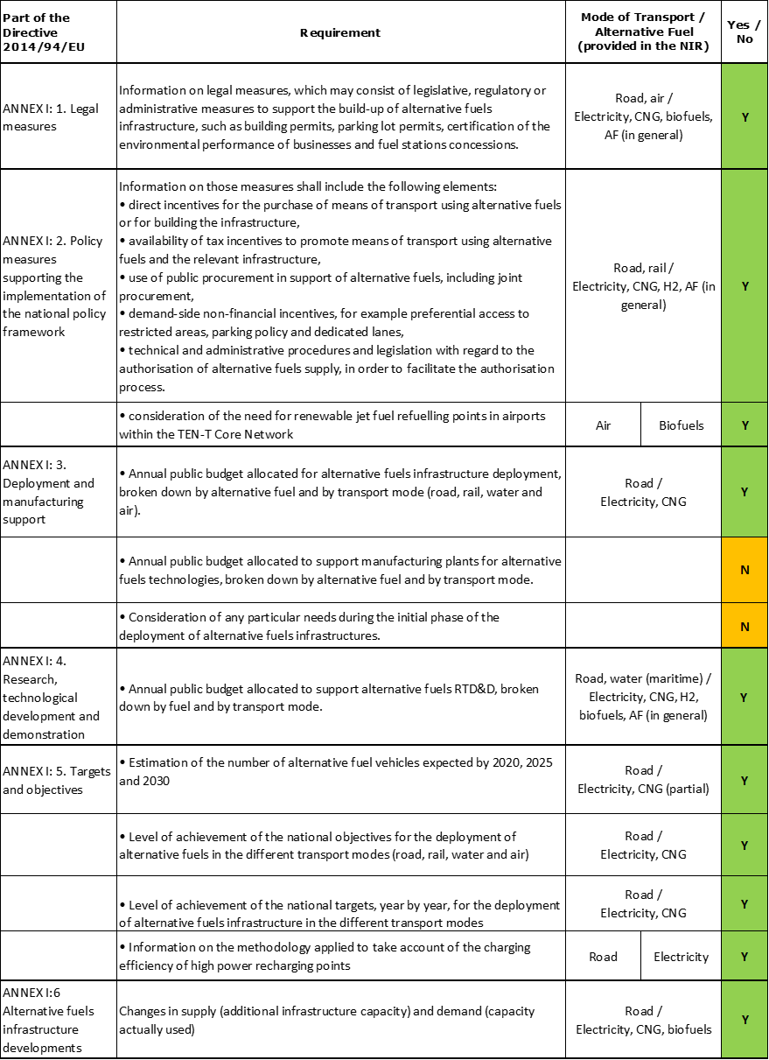

The checklist shows that most of the requirements of Annex I from the Directive are covered.

Regarding the combination of AF/AFV/AFI with transport mode, electricity and CNG are covered for road transport; LNG, hydrogen and biofuels are partially covered for road transport; electricity is partially covered for rail transport; shore-side electricity supply and LNG are partially covered for maritime water transport; electricity supply for stationary airplanes is partially covered for air transport; all the other combinations are either absent or not applicable.

The Irish NIR reports more than 50 measures. Under the Policy and Deployment & Manufacturing sections it was possible to identify 11 AF/transport mode clusters of measures, all assessable.

### Quantitative assessment: Vehicles and infrastructure

*Table 5.7.3‑1 National AFV estimates and AFI targets established in the NIR at the horizon 2020, 2025 and 2030 and their comparison with the NPF situation*

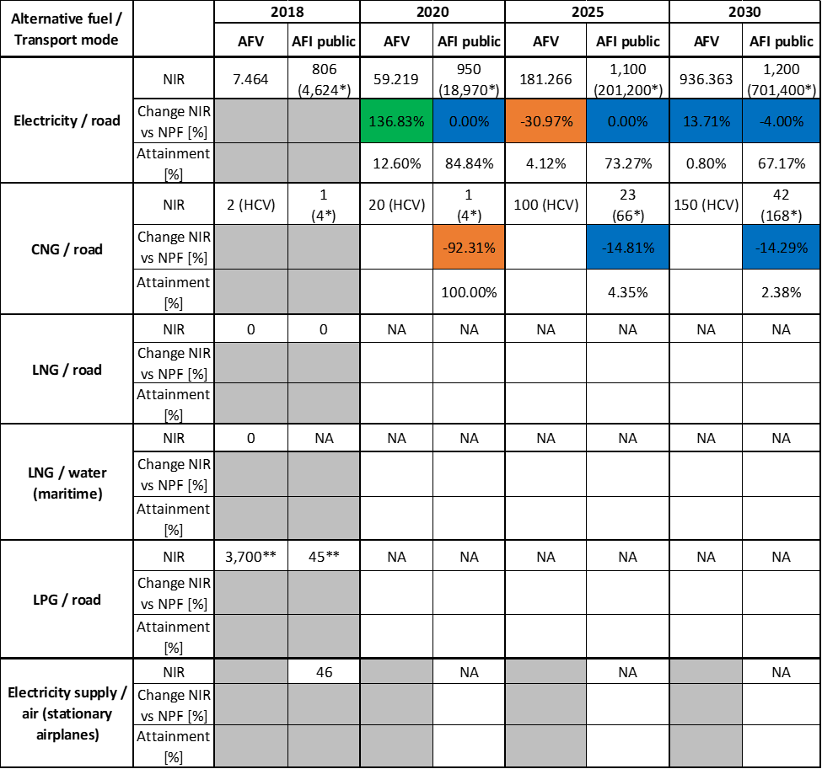

* Total number of AFI (public + private). ** Data from EAFO (absent in the IE NIR)

#### Road transport

##### Electricity

###### Vehicles

Ireland recorded 7,464 battery-electric and plug-in hybrid electric vehicles in use in 2018 (see Table 5.7.3‑1), of which 7,287 were passenger cars and 177 were LCVs. The Irish NIR EV estimates are 59,219 for 2020, 181,266 for 2025 and 936,363 for 2030, reflecting a revised curve compared to the NPF related to the estimated growth of electric vehicles for the next decade. Compared to the NPF values, the IE NIR forecasts an earlier and higher EV market uptake for 2020 (+136.83%) and an increased estimated number for 2030 (+13.71%), while for 2025 the NIR estimates a decrease (-30.97%) compared to the NPF. The Irish NIR expects that of the total 936,363 EVs foreseen in use in 2030, 89.72% will be passenger cars, 10.14% LCVs and 0.13% buses and coaches. The interest in electrifying the light commercial vehicles deserves to be highlighted since a progressive increase of their number compared with NPF is foreseen (7% in 2020, 140% in 2025 and 313% in 2030).

The 2018 ***attainment*** of future EV estimates is 12.60% for 2020 and 0.80% for 2030. According to the assessment methodology described in Section 2.1, the 2018 situation corresponds to an ***adequate progress*** towards reaching the envisaged EV estimates. The calculated ***average*** ***annual growth rate*** corresponding to the period 2016-2030 for EV fleet evolution planned by Ireland is equal to 50%.

###### Infrastructure

Ireland recorded 806 publicly accessible recharging points in 2018 (see Table 5.7.3‑1), of which 666 were normal power (≤22kW) and 140 high power (>22kW) recharging points. Concerning the next decade, the IE NIR shows a confirmation of the NPF targets for 2020 and 2025 (950 and 1,100, respectively). For 2030, the revised target of 1,200 represents a slight decrease compared with the NPF (-4%) that originates from a reduction of the targeted number of high power recharging points. In the NIR, the percentage of planned high power recharging points in the total publicly accessible recharging infrastructure increases from 12% or 100 (2020) to 16% or 150 (2025) and 20% or 200 (2030) but it has to be highlighted that the 2020 target was already overpassed in 2018. The Irish NIR confirms the targets for private recharging points provided in the NPF: 18,020 in 2020, 200,100 in 2025 and 700,200 in 2030. This confirms a clear strategy of Ireland to support the uptake of electro-mobility primarily on private recharging infrastructure, while keeping publicly accessible infrastructure at a bare minimum. It can be noticed in fact that the percentage of publicly accessible infrastructure from the total infrastructure is 17.43% in 2018 and foreseen to decrease to 5% (2020), 0.55% (2025) and 0.17% (2030).

The 2018 ***attainment*** of future public recharging infrastructure targets is 84.84% for 2020 to 67.17% for 2030. According to the assessment methodology described in Section 2.1, the 2018 situation corresponds to a ***slow progress*** towards reaching these envisaged targets. The calculated ***average annual growth rate*** corresponding to the period 2016-2020 for publicly accessible recharging infrastructure evolution planned by Ireland is equal to 3%.

###### Ratio

Based on the IE NIR and NPF, the following table shows the ratio between vehicles and publicly accessible recharging points (i.e. sufficiency index) for the pair electricity/road. It can be seen that for the next decade the foreseen sufficiency index is expected to progressively increase to values that are considerably above 10 and thus inadequate. The fact that Ireland has a clear strategy regarding private recharging infrastructure does not seem to solve the problem fully.



* Value calculated from IE NPF

###### Information on charging efficiency

The Irish NIR provides an example of usage for the high power (>22kW) recharging infrastructure. It mentions that the average overall number of transactions per day in 2018 was 840 corresponding to all the existing 140 high power recharging points, while the average duration of a stay was of 47 minutes. It is worth noting that in 2018 there were no recharging and no overstay fees at this infrastructure.

##### CNG

###### Vehicles

Compared to the NPF, the Irish NIR does not include any more estimates for CNG light-duty vehicles, reflecting a modification in the policy direction where the support focuses principally on electrification in the light vehicle sector. Since the IE NIR mentions that “*in the heavy-duty sector there is a recognition that electrification is not currently a viable alternative*” and other solutions must be considered, the report contains only future estimates for CNG HCV but their values are significantly reduced in comparison with the NPF ones (20 vs 150 for 2020, 100 vs 1,050 for 2025 and 150 vs 1,550 for 2030).

Because there are no total CNG vehicle estimates, the 2018 ***attainment*** and ***progress*** could not be computed.

###### Infrastructure

In 2018, Ireland recorded one public CNG refuelling point and three private fleet operators’ ones. Table 5.7.3‑1 shows an overall reduction of the targets for public CNG refuelling points provided in the NIR compared to the NPF over the next decade (1 vs 13 for 2020, 23 vs 27 for 2025 and 42 vs 49 for 2030). The Irish NIR also provides revised targets for private CNG refuelling points in comparison to the NPF (3 vs 5 for 2020, the same number of 43 for 2025 and 126 vs 53 for 2030), reflecting the forecast that during the next decade the share of private CNG refuelling infrastructure will progressively increase and become dominant.

A map with the locations of the 14 public CNG refuelling stations to be rolled out as part of Causeway Project is provided (for more information on the project, see Section 5.7.4.3). The Irish NIR mentions the objective of the Gas Network Ireland that 20% of the gas in the network will be renewable by 2030.

The 2018 ***attainment*** of future public CNG refuelling infrastructure targets is 100% for 2020 and 2.38% for 2030. According to the assessment methodology described in Section 2.1, the 2018 situation corresponds to an ***adequate progress*** towards reaching these envisaged targets. The ***average annual growth rate*** corresponding to the period 2016-2030 for public CNG refuelling infrastructure evolution planned by Ireland could not be calculated since in 2016 there were no public CNG refuelling points deployed.

###### Ratio

Since there are no total CNG vehicle estimates provided in the Irish NIR, it is not possible to compute the sufficiency index.

##### LNG

###### Vehicles

At the end of 2018, there were no LNG vehicles in use. Similarly to the NPF, the Irish NIR provides no LNG vehicle estimates for the future and therefore the 2018 ***attainment*** and ***progress*** could not be computed.

###### Infrastructure

At the end of 2018, there were no LNG road refuelling points deployed. Similarly to the NPF, the Irish NIR does not commit to any targets for LNG road refuelling infrastructure and therefore the 2018 ***attainment*** and ***progress*** could not be computed.

###### Ratio

For the same reason, it is not possible to compute the sufficiency index.

##### Hydrogen

###### Vehicles

Estimates for hydrogen vehicles are absent in the Irish NIR as they were lacking also in the NPF. The NIR mentions there are currently no hydrogen vehicles in use in Ireland and no real suppressed demand for hydrogen vehicles at current market prices. However, it states that a potential deployment of around 100 vehicles in 2022/23 is under consideration by a range of engaged stakeholders possibly with government support.

Because no clear quantitative hydrogen vehicle estimates were provided, the 2018 ***attainment*** and ***progress*** could not be computed.

###### Infrastructure

In line with the strategy regarding the hydrogen vehicles, the Irish NIR as the NPF does not commit to targets for hydrogen refuelling infrastructure and justifies this by the lack of demand at this stage. However, it mentions that there is under consideration by a range of engaged stakeholders, potentially with government support, a deployment of a sustainable hydrogen production and three clustered refuelling points in 2022/23.

Because no clear quantitative hydrogen refuelling infrastructure targets were provided, the 2018 ***attainment*** and ***progress*** could not be computed.

###### Ratio

For the same reason, it is not possible to compute the sufficiency index.

##### Biofuels

###### Vehicles

No quantitative information regarding vehicles fuelled by biofuels is provided in the Irish NIR. However, the IE NIR contains some details on the biofuels consumption in transport (see Section Additional information on alternative fuels infrastructure developments) and about the Biofuels Obligation Scheme (see Section Legislative & Regulatory).

###### Infrastructure

Information is not available in the Irish NIR.

###### Ratio

Information is not available in the Irish NIR.

##### LPG

###### Vehicles

The Irish NIR does not provide information on the number of LPG vehicles. However, according to EAFO, Ireland recorded 3,700 LPG vehicles in use in 2018, all of which were passenger cars (Table 5.7.3‑1).

###### Infrastructure

The Irish NIR does not provide information on the number of LPG refuelling points. According to EAFO, Ireland recorded 50 LPG refuelling points in 2016, 47 in 2017, and 45 in 2018.

###### Ratio

Based on EAFO data for Ireland, the following table shows the ratio between vehicles and publicly accessible refuelling points (i.e. sufficiency index) for the pair LPG/road. The sufficiency index could only be computed for the 2016 – 2018 period.



* data from EAFO

#### Rail transport

##### Electricity

###### Vehicles

The IE NIR recorded 144 locomotives in 2018 and this number is expected to increase in the next decade (196 in 2025 and 600 in 2030). However, the IE NIR mentions that “*these figures include hybrid trains which are expected to come into service in the coming years*”.

###### Infrastructure

Information is not available in the Irish NIR.

#### Waterborne transport (maritime)

##### Electricity

###### Vessels

Information is not available in the Irish NIR.

###### Infrastructure

The feasibility study on the development of AFI in Irish ports foreseen in the NPF has been carried out and was included as an annex of the IE NIR[25]. Favourable economic (e.g. price of electricity below European average) and geographic conditions, a stringent regulatory environment and scale of operations were identified to have a common influence in the successful deployment of AFI in general, and shore-side electricity (SSE) in particular. Taking these drivers into account, the study considered the demand for, and feasibility of, AFI in Irish ports. The study found that many of the characteristics evident at current ports providing AFI are not present at Irish ports as “*Ireland does not gain from geographic conditions* *favourable to … renewable energy production*” and the scale of operations in Irish ports and the number of ships calling to them does not generate sufficient demand to justify the capital investment that AFI requires. As a result, forecasted demand for SSE in Irish ports was considered low. The same view resulted from stakeholder consultations highlighting concerns that forecasted demand does not justify large scale capital investment in AFI. Based on these findings from the market demand analysis, the Irish NIR is not setting targets for SSE at maritime ports on the TEN-T network at this time but commits however to a continued monitoring of markets trends.

##### LNG

###### Vessels

Information is not available in the Irish NIR.

###### Infrastructure

Similarly to the NPF, the Irish NIR does not commit to any targets for LNG refuelling infrastructure at maritime ports on the TEN-T network.

The feasibility study on the development of AFI in Irish maritime ports (see Section 5.7.3.3.1) covered also LNG refuelling infrastructure. As already mentioned in the section dedicated to SSE, the study found that many of the characteristics common to ports with successful AFI deployment are not present at Irish ports: Ireland does not gain from favourable economic (e.g. price of natural gas below European average) and geographic conditions (e.g. large natural gas resources), the scale of operations in Irish ports does not generate sufficient demand and Ireland falls outside the Emission Control Areas with stringent regulatory standards. Therefore, the demand for LNG refuelling infrastructure in Irish ports was considered low. The innate conservatism and risk aversion of the shipping industry was also mentioned as a reason to consider investment in LNG unlikely because of the potential obsolescence of LNG technologies through the development of alternative fuels such as hydrogen and ammonia. The Irish NIR mentions that, based on these arguments, it did not provide targets for LNG refuelling infrastructure at maritime ports on the TEN-T network at this time. However, it commits to facilitate discussions between the maritime industry and other industries currently using LNG and to monitor annually the use of alternative fuels use.

#### Waterborne transport (inland)

Not applicable since Ireland has no inland ports in the TEN-T Core Network.

#### Air transport

The NIR mentions that “*Ireland’s policy to reduce the climate impact of aviation emissions is aligned with the strategies being pursued at EU level and globally*” by the International Civil Aviation Organisation (ICAO). Regarding aircraft technology, the two major Irish airlines have invested recently in newer fuel efficient aircraft.

It is mentioned that the Irish state airports Dublin, Cork and Shannon are reducing their year-to-year carbon footprint being accredited by Airport Council International (ACI) at “Level 2 Reduction” status. Several examples of existing or foreseen sustainability activities are provided:

* “*Dublin is committed, and Cork Airports also intends, to become carbon neutral under the Airport Carbon Accreditation Scheme of the ACI by 2020*” through initiatives such as the use and generation of green electricity and various other renewable energy projects.
* Dublin and Cork Airports, as part of ACI EUROPE, “*have committed to achieving net zero emissions by 2050 at the latest*”, as part of a collective pledge of 194 airports in 24 countries.

##### Electricity

###### Airplanes

Information is not available in the Irish NIR.

###### Infrastructure (for stationary airplanes)

The Irish NIR, similarly to the NPF, does not include quantitative future targets for electricity supply at Irish airports for use by stationary airplanes. However, it mentions that Dublin Airport from the TEN-T Core Network is replacing diesel-powered ground power units with fixed electrical ground power (FEGP) units. An amount of 46 FEGP units are currently available at most of the aircraft contact stands on three out of the four piers at this airport and the Dublin Airport Authority has committed to introduce FEGP on all future new contact stands.

##### Biofuels

###### Airplanes

The Irish NIR mentions that there are no sustainable aviation fuel (SAF) stocks in any Irish airport, as no flights to/from Ireland have requested the use of such fuel. The report states that despite most commercial aircraft in use in Ireland are capable of using a blend of conventional and SAF, all aircraft still use conventional fuel.

###### Infrastructure

Information is not available in the Irish NIR.

### Measures assessment

The Irish NIR, as the NPF, contains an extensive and detailed description of measures. They cover a wide variety of types and several AFs and modes, however the vast majority focuses on electricity/road and, to a lesser extent, CNG/road. The policy direction in Ireland is to encourage the move away from fossil fuelled vehicles to AFV and other sustainable transport modes in order to reduce national emissions. Electro-mobility and EVs are a prominent mitigation in the Irish Climate Action Plan, foreseen to rely mostly on private recharging infrastructure.

#### Legal measures

The Irish NIR contains 18 legal measures (versus 10 in the NPF) to promote AF, with detailed descriptions (12 measures appear only in the NIR, 6 are common to the NIR and NPF while 4 were only present in the NPF). Most of the NIR measures are represented by national plans that address entirely or partly the topic of alternative fuels and by national legal acts transposing EU Directives.

In line with the overall focus on electrification of the NIR, the most numerous cluster concerns electricity/road containing 15 measures, of which 6 are specifically dedicated to this pair of AF/transport mode, and was assessed to display an increased ambition level compared to the NPF (see Table 5.7.6‑1 for the ambition levels of other clusters).

##### Legislative & Regulatory

There are 12 measures identified in this category out of which 8 appear only in the NIR.

A ban to sale new fossil fuel cars from 2030 and to stop the granting of national car tests from 2045 is under consideration.

Several national plans that concern alternative fuels are mentioned:

* the Climate Action Plan together with its planned Amendment Bill and its predecessor the National Mitigation Plan,
* the National Planning Framework for land use,
* the Development Plan Guidelines for planning authorities,
* the National Energy and Climate Plan and
* the National Aviation Policy.

Listed as well are the Biofuels Obligation Scheme with stricter future requirements[26] and the transposition of the EU Energy Performance of Buildings Directive in the national Building Regulations. As part of AFI Legislations, the Irish NIR presents the Electrical Wiring Standards to which the recharging points’ installation must comply and the CNG Installation Legislation regarding the corresponding licences.

##### Administrative

The Irish NIR describes six administrative measures, of which two were also present in the NPF. The Low-Emission Vehicle Taskforce foreseen in the NPF was established in December 2016 focusing exclusively on EVs in a first phase and covering other low-emission fuels, including CNG, LNG and hydrogen, in a second phase. The two Statutory Instruments from 2018 that served to transpose the AFI Directive provisions not addressed through the NPF are presented. There are also mentioned the Clean Vehicles Directive transposition and the National Adaptation Framework including mitigation and climate adaptation measures and sectoral sub-plans for transport infrastructure and for gas and electricity networks. Concerning electricity, an Electric Vehicle Deployment Roadmap is under development and guidance will be issued to planning authorities to ensure a consistent and future proofed approach to the rollout of recharging infrastructure.

#### Policy measures

The Irish NIR reports 21 policy measures intended to foster alternative fuels in Ireland, most of them represent financial incentives. The modes of transport covered are road, rail or a combination of modes where fuels have been subject of the measures.

##### Measures to ensure national targets and objectives

###### Road transport

A set of 15 policy measures meant to support the achievement of the Irish AF objectives have been identified in the Irish NIR (9 measures appear only in the NIR, 6 are common to the NIR and NPF). Nine measures present in the NPF are not part of the NIR anymore. They are all in place or planned for the future with one exception (the free public recharging of EVs which was discontinued in 2019/2020). The majority is represented by financial incentives (sometimes with different conditions depending on the AF) for road as transport mode.

Within the measures in place targeting specifically electricity, the Irish NIR lists:

* purchase subsidies (grants of up to €5,000 for the private purchase of a new BEV or PHEV and of €3,800 for companies purchasing electric LCVs),
* tax reductions/exemptions
  + Vehicle Registration Tax relief of up to €5,000 for BEVs – until the end of 2021, up to €2,500 for PHEVs - until the end of 2020;
  + BEVs qualify for a 0% Benefit-in-Kind rate up to €50,000 without mileage conditions - until the end of 2022;
  + toll incentive scheme (BEVs qualify for 50% and PHEVs for 25% toll reductions up to a maximum of €500 per year).

As general measures targeting several AFs, the IE NIR includes:

* different tax related incentives
  + annual motor tax based on CO2 emission band;
  + punitive measures related to fossil fuels
    - tax based on a vehicle’s nitrogen oxide emissions applied to new car purchases and used imports
    - increasing carbon tax (at least €80 per tonne by 2030 is foreseen)
  + Accelerated Capital Allowance support scheme regarding corporation tax for vehicles and infrastructure purchase – existing for electricity and CNG, under consideration for hydrogen;
  + minimum excise duty rate – existing for natural gas and biogas as a propellant set at the current EU minimum rate of €2.60 per GJ, under consideration for hydrogen.

Two measures targeting HCV fuelled on AFs (electricity, CNG, LNG, hydrogen) are in the process of adoption:

* purchase subsidies (grants of up to 30% of the cost differential between a traditional fossil fuelled HCV and an AF equivalent)
* toll incentive scheme.

Of the measures that were presented in the NPF but not in the NIR, three concerned LPG, two synthetic and paraffinic fuels and one biofuels.

###### Other transport modes

No measure specifically dedicated to the other transport modes (water, air and rail) is listed in the Irish NIR.

##### Measures that can promote AFI in public transport services

In the Irish NIR, six policy measures related to the public transport are presented (one measure is only part of the NIR, five are common to the NIR and NPF, while three were only present in the NPF).

Three measures correspond to rail as mode of transport and concern the electrification of public transport in the Dublin area. The DART (Dublin Area Rapid Transit) Expansion Programme is expected to create a full metropolitan area DART network and to transition current diesel commuter lines to electricity from the city centre to Drogheda, Co. Louth, to Celbridge/Hazelhatch and Maynooth, Co. Kildare. In 2022 is expected the delivery of Ireland’s first diesel-electric trains enlarging the rail fleet by approximately 300 new rail carriages. A new metro system, MetroLink, will be also funded and will stretch from Swords, north Co. Dublin, to Dublin’s south city centre serving critical destinations including Dublin Airport and Dublin City University. Light rail projects will also receive investments including the Green Line Capacity Enhancement Project which will add capacity to the light rail network in Dublin through additional and longer trams.

Two measures regard the public urban bus fleet. The National Development Plan committed Ireland to no longer purchase diesel-only buses for the urban public bus fleet from July 2019 and a decision was made to purchase hybrid-electric buses in the short term (nine hybrid buses have entered into service in Dublin city centre). To inform the long term approach, a low-emission bus trial was launched in December 2018 to assess full electric, diesel-electric hybrids and CNG buses. A major project to be funded is BusConnects which commits to the uptake of low-emission technologies and which will be rolled out across all major cities in Ireland. It is anticipated that by 2023, half of the bus fleet (approximately 500 buses) will be converted to low-emission vehicles, with plans for full conversion by 2030.

The Electric Small Public Service Vehicle (eSPSV) Grant Scheme currently offers purchase subsidies for new BEVs (up to €7,000) or PHEVs (€3,500) for taxis, hackneys and limousines. Plans are mentioned to increase the level of the grants for BEVs to up to €10,000 from 1 January 2020. In order to encourage an increase in electric wheelchair accessible vehicles (WAV) in the taxi fleet, from 2020 further support will be given to through an extra €2,500 grant for the conversion of an eSPSV to a WAV.

##### Measures that can promote the deployment of private electro-mobility infrastructure

A group of two measures from the Irish NIR have been identified as helping the deployment of private electro-mobility infrastructure. These measures are included and assessed in the measures on AFI deployment and only mentioned here. They are the EV Home Charger Grant and the Accelerated Capital Allowance tax incentive scheme (companies allowed to write off 100% of recharging points purchase value against profit of same year).

#### Deployment and manufacturing support

##### AFI deployment

A set of 10 measures related to AFI deployment has been included in the Irish NIR (five measures appear only in the NIR, five are common to the NIR and NPF, while three were only present in the NPF). All NIR measures correspond to road as transport mode, with five targeting electricity, four CNG and one hydrogen.

Concerning electricity/road, the listed measures are promising and include:

* the EV Home Charger Grant (subsidy in place of up to €600 for the purchase and installation of a home recharging point but no indication of future allocated budget is given),
* the EV High Power Charging Infrastructure Development Project (government supported project to install >100 high power points (150kW) at key locations on the national road network, to replace 100 high power points (50kW) and also to refurbish up to 200 high power points (22kW) in 2020-2022),
* the planned support for installing EV Fast Chargers for taxis at Transport Hubs,
* the support for local authorities to rollout up to 2,000 on-street public recharging points over the next 5 years (which would mean the over achievement of the committed publicly accessible target for 2025 which is 1,100).

For CNG/road, the measures presented regard:

* two installation projects receiving funding from the CEF
  + Causeway project – 14 public refuelling points and 1 large scale renewable gas injection point by 2021 and
  + its follow up Green Connect project – 21 public refuelling points and 4 renewable gas injection points
* a national funded project at validation stage named GRAZE (Mitchelstown Central Grid Injection Point) to create the first large scale central injection point on the gas network.

The Accelerated Capital Allowance incentive scheme mentioned within policy measures section also applies to infrastructure purchase and is in place for electricity and CNG and under consideration for hydrogen.

The NPF measures not present anymore in the NIR concerned the Accelerated Capital Allowance scheme related to LPG, renewable jet fuel refuelling points in airports and the reduction of electricity tax for SSE.

##### Support of manufacturing plants for AF technologies

No measure regarding the support of manufacturing plants for AF technologies is presented in the Irish NIR.

##### Consideration of any particular needs during the initial phase of the deployment of alternative fuels infrastructures

No information is presented in the Irish NIR.

#### Quantitative assessment of Policy and Deployment & Manufacturing measures

Table 5.7.4‑1 presents an analysis of all the Policy and Deployment & Manufacturing measures, carried out according to the assessment methodology described in Section 2.2. Among the clusters of measures identified in the Irish NIR, four clusters contain dedicated measures (electricity/road, electricity/rail, CNG/road and hydrogen/road) while the other six contain general measures addressing combinations of several alternative fuels[27]. For all other pairs of AF and transport mode, there are either no measures or the pair is not applicable to Ireland.

*Table 5.7.4‑1* *Quantitative assessment of Policy and Deployment & Manufacturing support measures*



**Legend:** Score and Impact: H = high; M = medium; L = low; X = not assessable. Comprehensiveness: C = comprehensive; N = Not comprehensive. Ambition level: ‘+’ means ‘higher’; ‘=’ means ‘comparable’; ‘-‘ means ‘lower’.

In line with the overall focus on road electrification reported in the NIR, the most numerous cluster concerns electricity/road containing a comprehensive set of 19 NIR measures out of which 12 are new measures, displaying a high overall score and showing an increased level of ambition compared with the NPF.

Even though the CNG related infrastructure targets and vehicle estimates have been reduced in the NIR, the corresponding CNG/road cluster containing 14 measures has been assessed to have a high score, to be comprehensive and to show an increased level of ambition.

The Irish NIR did not commit to hydrogen AFI targets or AFV estimates but includes a set of support measures assessed to be comprehensive and having a low score but a similar level of ambition compared to the NPF.

The electricity/road and CNG/road clusters have at least one measure that scores high, thus the overall score is H. In terms of expected impact of these measures to support the realisation of the AFV/AFI objectives as presented in the NPF and revised in the NIR, the measures for the pairs electricity/road and CNG/road result to have a high impact, the measures for the pair electricity/rail have a medium impact. For all the other assessable clusters of measures, the partial or total lack of future targets and estimates does not allow putting this assessment into perspective. However, as all these other pairs have an overall low score, they have therefore a low impact. Compared to the NPF, the level of ambition of the Policy and Deployment & Manufacturing support measures has increased for electricity/road, electricity/rail, CNG/road and LNG/road, has remained the same for hydrogen/road and LNG water-maritime and has decreased[28] for biofuels/road, LPG/road, synthetic&paraffinic fuels/road, electricity/water-maritime and electricity/air.

#### Research, Technological Development & Demonstration

The Irish NIR contains 10 RTD&D activities, nine are only present the NIR, one is common to the NIR and NPF while other eight were only present in the NPF. For most activities, the financial details are given, with the overall budget surpassing 1.5 million €. The RTD&D activities from the NIR cover more uniformly the transport modes, the AFs and their related technologies. Compared with the NPF measures, they are more concrete, diversified and documented and the clusters electricity/road and CNG/road have an increased level of ambition.

Two research projects related to biofuels are mentioned (one on the production of oxygenated hydrocarbons from lignocellulosic waste by acid hydrolysis and the other on large scale algal biofuel production). Another project presented is a European project with Interreg funding aiming to accelerate the transition to renewable energy in agricultural transport in North-West Europe by making clean hydrogen technology for field operations ready for practice. Three projects listed in the NIR concern potential emission savings from the HCV segment.

### Additional information on alternative fuels infrastructure developments

The Irish NIR contains information on the changes in fuels use in the transport sector (see Table 5.7.5‑1). As it can be noticed, biofuels use is foreseen to increase progressively, remaining the most significant alternative fuel[29] in road transport until 2025 but in 2030 electricity is expected to take the lead. A decrease of diesel use is expected in the next years and the tax based on a vehicle’s nitrogen oxide emissions applied to new car purchases and used imports could have an influence in this direction. No increase in LNG use in maritime transport is expected as marine diesel oil will continue to be the only fuel used in water transport.

*Table 5.7.5‑1 Changes in fuels use in transport sector (2016-2030)*



### Summary of the assessment

**Tabular overview**

*Table 5.7.6‑1 Overview of the NIR assessment*





* Value taken or calculated from IE NPF; ** HCV; *** Value taken from EAFO (absent in both NPF and NIR).

The Irish NIR addresses most of the requirements of Annex I from the Directive, although not with the same level of detail for all the alternative fuels and transport modes.

Regarding the combination of AF/AFV/AFI with transport mode, electricity and CNG are covered for road transport; LNG, hydrogen and biofuels are partially covered for road transport; electricity is partially covered for rail transport; shore-side electricity supply and LNG are partially covered for maritime water transport; electricity supply for stationary airplanes is partially covered for air transport; all the other combinations are either absent or not applicable.

The main outcomes of the technical assessment of the Irish NIR on vehicles/vessels estimates and infrastructure targets can be summarised as follows:

###### Road transport

* **Electricity** – Ireland recorded a total of 7,464 electric vehicles and 806 publicly accessible recharging points in 2018. Compared to the NPF the IE NIR presents a new scenario concerning EV estimates for the next decade, i.e. an earlier and higher EV market uptake for 2020 (+136.83%), a decrease in 2025 (-30.97%) and an increased number for 2030 (936,363 vs. 823,455 EVs, of which 89.72% passenger cars, 10.14% LCVs and 0.13% buses and coaches). Instead, NPF targets of public recharging infrastructure are kept in the NIR, with minor differences. The progress in 2018, calculated according to the assessment technology described in Section 2.1, is adequate for EVs and is slow for the infrastructure. Indeed Ireland seems to largely rely on private recharging infrastructure for which an accelerated increase is foreseen. For this same reason, the ratio AFV to AFI considering only the public recharging infrastructure situation is progressively degrading as its value is expected to increase considerably over time.
* **CNG** – Compared to the NPF, the Irish NIR does not include any more estimates for CNG light-duty vehicles, reflecting a modification in the policy direction where the support focuses principally on electrification in the light vehicle sector. The IE NIR only records two HCVs in 2018 and provides estimates in 2020, 2025 and 2030 again only for HCVs. This fact makes impossible to calculate of the 2018 progress and attainment or of the infrastructure sufficiency index. Against this situation, the strategy for refuelling infrastructure is reported as evolving toward an increasing share of private CNG refuelling points. In 2030, the total number of CNG refuelling points planned is 168, of which only 42 are publicly accessible refuelling points. With respect to the latter, the progress in 2018 is adequate.
* **LNG** – The Irish NIR, as the NPF, does not propose vehicle estimates nor targets for LNG refuelling infrastructure.
* **Hydrogen** – Similarly to the NPF, the Irish NIR does not commit to targets for hydrogen refuelling infrastructure or to estimates for hydrogen vehicles. However, the possibility for a deployment is under consideration.
* **Biofuels** – No specific information is provided in the Irish NIR.
* **LPG** – The Irish NIR does not provide information on the number of LPG vehicles nor on the existing or future infrastructure.

###### Rail transport

* **Electricity** – The IE NIR recorded 144 locomotives in 2018 and this number is expected to increase in the next decade (196 in 2025 and 600 in 2030). However, the IE NIR mentions that “*these figures include hybrid trains which are expected to come into service in the coming years*”.

###### Waterborne transport (maritime)

* **Electricity** - The feasibility study on the development of AFI in Irish ports foreseen in the NPF has been carried out and was included as an annex of the IE NIR. The study found that many of the characteristics evident at current ports providing AFI are not present at Irish ports as “*Ireland does not gain from geographic conditions* *favourable to … renewable energy production*” and the scale of operations in Irish ports and the number of ships calling to them does not generate sufficient demand to justify the capital investment that AFI requires. Based on these findings, the Irish NIR did not set targets for shore-side electricity supply at maritime ports on the TEN-T network at this time but commits to a continued monitoring of markets trends.
* **LNG** – The feasibility study mentioned above reported for LNG infrastructure at ports the same conclusions as for shore-side electricity. For this reason, the IE NIR did not provide targets for LNG refuelling infrastructure at maritime ports on the TEN-T network at this time. However, it commits to facilitate discussions between the maritime industry and other industries currently using LNG and to monitor annually the use of alternative fuels use.

###### Air transport

* **Electricity** – The Irish NIR, similarly to the NPF, does not include quantitative future targets for electricity supply at Irish airports for use by stationary airplanes. However, it mentions that the Dublin Airport from the TEN-T Core Network is replacing diesel-powered ground power units with fixed electrical ground power (FEGP) units. FEGP units are currently available at most of the aircraft contact stands on three of the four piers at this airport, and the Dublin Airport Authority has committed to introduce FEGP on all future new contact stands.

The Irish NIR contains a rather comprehensive list of **measures** to support the envisaged AFI targets and AFV estimates. The legal measures to promote AFs are represented mainly by national plans that address entirely or partly the topic of alternative fuels and by national legal acts transposing EU Directives.

Concerning Policy and Deployment & Manufacturing support measures, the majority of support measures including the most prominent ones relate to electricity/road and CNG/road, noting that Ireland does not intend to foster publicly accessible recharging infrastructure. The two clusters have been quantitatively assessed with similar results: high overall score and comprehensiveness, and thus high impact. They however correspond to different envisaged AFI targets and AFV estimates, increased in the case of electro-mobility and decreased for the CNG in comparison with the NPF situation. For all the other assessable clusters of measures, the partial or total lack of future targets and estimates does not allow putting this assessment into perspective. However, with the only exception of the pair electricity/rail, which has a medium impact, all the other pairs have an overall low score, and therefore have a low impact.

The increased emphasis of the policy direction on electro-mobility has also influenced changes in the Irish NIR compared to the NPF with regards to the disappearing of some measures dedicated to LPG and synthetic & paraffinic fuels.

Compared to the NPF, the level of ambition of the Policy and Deployment & Manufacturing support measures has increased for electricity/road, electricity/rail, CNG/road and LNG/road, has remained the same for hydrogen/road and LNG water-maritime and has decreased[30] for biofuels/road, LPG/road, synthetic & paraffinic fuels/road, electricity/water-maritime and electricity/air. The RTD&D activities included in the NIR have changed compared to those in the NPF. They currently cover more uniformly the transport modes, the AFs and their related technologies. Compared with the NPF, they are more concrete, diversified and documented.

### Final remarks

The Irish NIR provides a rather comprehensive report on the efforts to implement the Directive. The NIR is largely in line with the provisions of Annex I to the Directive, with the exception of missing estimates for LNG vehicles, vessels and related infrastructure targets for the years 2020, 2025 and 2030. The Irish NIR includes a significant number of measures to promote the uptake of electric vehicles and some measures on the use of electricity in the rail sector as well as for the possible promotion of CNG (heavy-duty vehicles). Future reporting should include information on further measures to promote other alternative fuels and modes of transport.

The Irish NIR estimates that approximately 940,000 electric vehicles could be on the roads by 2030, representing about 30% of the fleet by that time. Taking into account the current situation, fleet and existing trends, this level of ambition appears to be consistent with the pace of deployment of electric vehicles considered be necessary for a full transition to carbon neutrality by 2050. Nevertheless, the number of public recharging points for 2025 and 2030 seems far too low against the estimated fleet of electric vehicles. Ireland would be encouraged to explain in greater detail how it intends to ensure sufficient public infrastructure for a vehicle fleet that is expected to grow rapidly. Information on charging efficiency is provided. The NIR does not include information on plans for shore-side electricity supply in ports in the short term. Ireland should update planning and reporting on this matter. Furthermore, the Irish NIR does not include quantitative future targets for electricity supply to stationary aircraft at Irish airports. However, it mentions that Dublin Airport, which forms part of the TEN-T Core Network, is replacing diesel-powered ground power units with fixed electrical ground power units. It would be beneficial to provide further detail on the possible extension of these facilities to other airports. Further information should be provided on the share of the electrified rail network.

Hydrogen for road transport is not considered in the NIR.

The NIR reports that by 2030, Ireland expects no more than 150 CNG heavy-duty vehicles, a significant drop compared to the estimates number in the NPF (1,550), which demonstrates Ireland’s reduction of ambition towards CNG. Information is not available on CNG fuelled passenger cars. The NIR does not provide estimates for LNG vehicles, vessels and the relevant infrastructure by 2020, 2025 and 2030.

The NIR does not include information on the number of LPG vehicles, nor does it provide information on the LPG infrastructure.

The share of biofuel blends with conventional fuels in road vehicles is estimated at 6% in 2020 and is expected to be 9% by 2030, thus contributing to the objectives of the recast Renewable Energy Directive. Ireland should provide more information in future reporting on efforts to promote the use of renewable fuels in transport, and particularly in aviation.

### ANNEX - Description of the Member State

On a surface area of 70,300 km², Ireland has a population of 4.830 million people in 2018, which makes up for a population density of 69 inhabitants/km².

*Number of main urban agglomerations*

* 4 urban agglomerations > 50,000 inhabitants

In 2018, Ireland achieves a per capita gross domestic product at market prices of €66,670, which represents a per capita gross domestic product in purchasing power standards of 191 if expressed in relation to the EU-28 average set to equal 100.

*Length of the road networks*

The length of the road TEN-T Core Network in Ireland is 478 km. The total road network length is 18,426 km, of which 916 km are motorways.

The following lengths of the TEN-T Road Corridors are present in Ireland: 8% (353 km) of the North Sea – Mediterranean Corridor.

Through the TEN-T Road Corridors, Ireland is connected with the following Member States:  
- the United Kingdom (through the North Sea - Mediterranean Corridor)

*Number of registered road vehicles*

At the end of 2018, Ireland accounts for 2,590,989 registered road vehicles of which 2,182,920 are categorized as passenger cars, 317,798 as light goods vehicles, 37,871 as heavy goods vehicles and 12,500 as buses and coaches. The motorisation rate is 452 passenger cars per 1,000 inhabitants.

*Number of ports in the TEN-T Core Network*

* 3 maritime ports in the TEN-T Core Network (Cork, Dublin, Limerick)
* 2 maritime ports in the TEN-T Comprehensive Network
* No inland ports

*Number of airports in the TEN-T Core Network*

* 2 airports in the TEN-T Core Network (Cork, Dublin)
* 6 airports in the TEN-T Comprehensive Network

## Greece (EL)

### Main messages from the Commission assessment of the NPF

In its original assessment of the Greece NPF the Commission concluded:

*The Greek NPF addresses many of the requirements of Article 3. It contains a detailed description of the current state and some future estimates for alternative fuels vehicles in the transport sector and establishes targets required by Article 3 of the Directive. However, the NPF does not contain any designation of urban/suburban agglomerations to be equipped with recharging points and the number and location of recharging points and LNG refuelling points to be put in place along the TEN-T Core Network is not defined.*

*The Greek NPF estimates a very modest share of below 0.1% electric vehicles on the road in 2020. The proposed set of measures based mainly on tax reliefs could support reaching the declared objectives since it was evaluated as being comprehensive and having a medium assessment score. The ratio of one public recharging point per 5 electric vehicles estimated for 2020 indicates that Greece has defined appropriate targets for recharging infrastructure in line with the requirements of the Directive. The spatial distribution of the future recharging points is not provided in the NPF.*

*The Athens central airport in the TEN-T Core Network has currently fixed electricity supply points and mobile ground power units for use by stationary airplanes. Other airports are using mobile ground power units. However, the Greek NPF does not include targets for electricity supply for stationary airplanes and it only mentions the possibility of pilot deployment for evaluating the feasibility and viability of such electricity supply points at specific airports.*

*In Greece, existing shore-side infrastructure for supplying electricity to ships primarily relates to tourist ports whereas at major maritime ports infrastructure is limited and mainly relates to pilot applications (such as the ELEMED project). The Greek NPF contains targets for further increasing shore-side electricity in its ports, concrete values being provided for different categories of ports (tourist ports, maritime ports of the TEN-T Core Network and outside of it). The NPF mentions that adopting a maritime electricity tariff category will be examined coupled with tax breaks for ships that use shore-side electricity supply.*

*For CNG vehicles, the estimated shares are slightly higher than for EVs (0.23% in 2020 and 0.5% in 2025). Due to high estimates for CNG vehicles and non-proportional expansion of refuelling points, the number of publicly accessible CNG refuelling points in the future will likely be insufficient. The NPF shows the ambition of increasing the number of CNG refuelling points with 13 new ones by 2020 on selected urban agglomerations along the TEN-T Core Network in the framework of a project partially funded by the Connecting Europe Facility. The NPF also presents different projects to significantly extend the existing natural gas distribution network.*

*The NPF has established a target of 2 LNG refuelling points for heavy-duty vehicles in 2025, which is insufficient to ensure appropriate coverage of the TEN-T Core Network on Greek territory. The NPF mentions also a project entailing the design and development of LNG tanker truck transhipment facilities at the Revythousa LNG terminal.*

*Currently, only the Port of Piraeus has the potential to provide ships berthed with LNG by transporting it from Revythousa facilities, using specially fitted ships. The Public Gas Corporation of Greece is currently examining the potential for developing LNG facilities at the other 4 maritime ports of the TEN-T Core Network.*

*The Greek NPF presents the situation of LPG for which the current number of vehicles, corresponding to a share of 3.04% from all the vehicles in circulation, is expected to grow to shares higher than 4.5% in 2020, than 5.5% in 2025 and than 7.5% in 2030. It also establishes appropriate refuelling infrastructure targets consistent with the vehicle projections.*

*The Greek NPF does not examine the potential for using hydrogen in the transport sector.*

*The Greek NPF, intending to accelerate the AF deployment in transport, contains a relatively wide portfolio of measures. More than half of the presented measures are of administrative, legislative and regulatory type targeting transposition provisions of the Directive and laying down terms and conditions for the installation and operation of the AFI. A high amount of the measures is under consideration whilst only a reduced amount is already in place. Some of the mentioned measures seem to have the potential to contribute towards reaching the national targets and objectives. In many cases, the lack of concrete information (for example budget ceiling or quantification of future incentives) for the measures makes it difficult to evaluate the scope according to our methodology. Electro-mobility is promoted mostly with financial measures in the form of taxation exemptions while direct incentives for purchase of vehicles are lacking. For natural gas, the Greek NPF focuses in a first stage to extend and improve the existing natural gas distribution network. The NPF also contains several support measures to promote the deployment of alternative fuels infrastructure in public transport services and of private electro-mobility infrastructure.*

*Greece is interested to cooperate with the neighbouring countries in the context of the deployment of alternative fuels infrastructure on the TEN-T Core Network to ensure EU-wide circulation. The NPF states that Greece cooperates with Cyprus and Italy in the frame of the EU funded POSEIDON-MED ΙΙ project that aims to have LNG adopted as a marine fuel in the Eastern Mediterranean. Greece also cooperates with Cyprus and Slovenia in the frame of the ELEMED project regarding the introduction of shore-side electricity supply to the East Mediterranean Corridor (Adriatic and Ionian seas)*.

### Overview of requirements’ fulfilment from Annex I of the Directive

*Table 5.8.2‑1 Checklist Table*

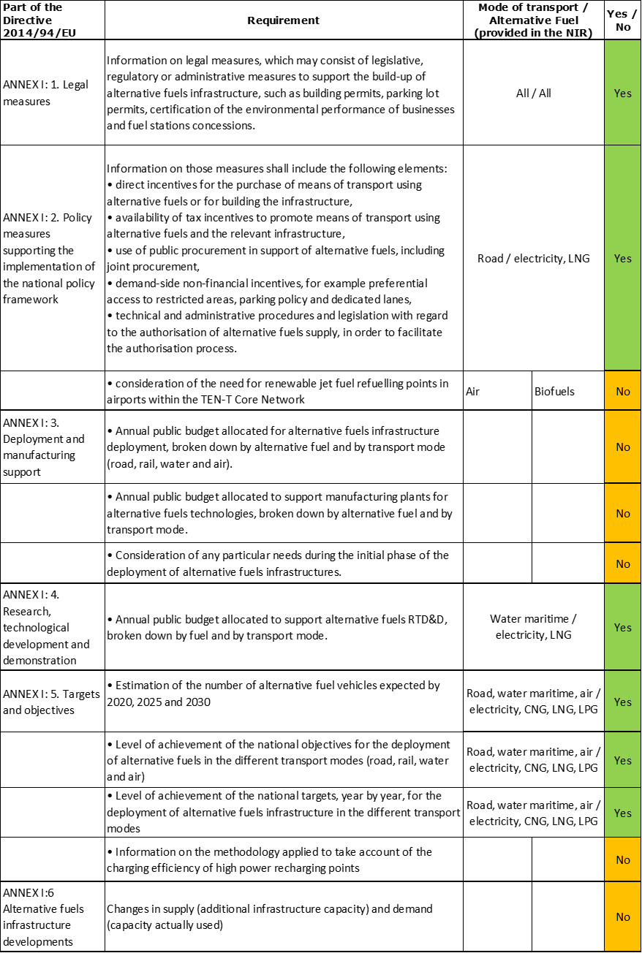

The checklist shows the requirements of Annex I from the Directive that are covered in the EL NIR.

Regarding the combination of AF/AFV/AFI with transport mode, electricity is covered for all modes; CNG, LNG, and LPG for road transport; LNG also for waterborne maritime transport; all the other combinations are either absent or not applicable.

The Greek NIR reports 83 measures in total (of which 70 are Legal measures). Under the Policy and Deployment & Manufacturing sections it was possible to identify three AF/transport mode clusters of measures, all assessable.

### Quantitative assessment: Vehicles and infrastructure

*Table 5.8.3‑1 National AFV estimates and AFI targets established in the NIR at the horizon 2020, 2025 and 2030 and their comparison with the NPF situation*

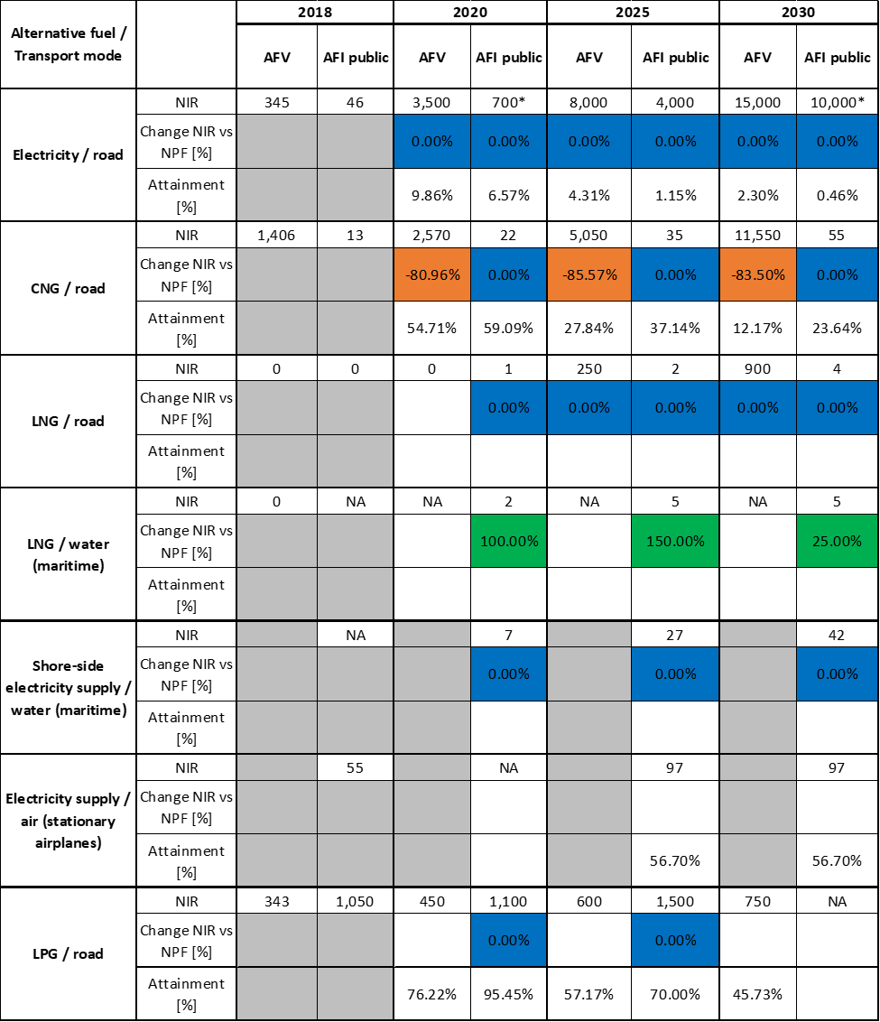



* Values taken from the Greek NPF since the NIR only provided total recharging infrastructure targets and no breakdown for publicly accessible and private infrastructure.

#### Road transport

##### Electricity

###### Vehicles

Greece recorded 345 electric vehicles in use in 2018 (see Table 5.8.3‑1), of which 322 were passenger cars (308 BEV and 14 PHEV), 21 LCVs (all BEV) and 2 BEV buses and coaches. The Greek NIR also reports 387 PTWs in 2018. For the next decade, the EL NIR provides estimates that seem to also include PWTs. These are 3,500 for 2020, 8,000 for 2025 and 15,000 for 2030 and are identical to the NPF. As for the heavy-duty sector, the EL NIR only estimates 40 BEV buses and coaches for 2025 and 90 for 2030.

The 2018 ***attainment*** of EV future estimates is 10% for 2020 and 2.3% for 2030. According to the assessment methodology described in Section 2.1, the 2018 situation corresponds to an ***adequate progress*** towards reaching the envisaged EV estimates. The calculated ***average annual growth rate*** corresponding to the period 2016-2030 for EV fleet evolution planned by Greece is equal to 35%.

###### Infrastructure

Greece recorded 46 publicly accessible recharging points in 2018 (Table 5.8.3‑1), of which 40 normal power (≤22kW) and 6 high power (>22kW) recharging points. For the next decade the EL NIR presents combined targets for the number of recharging points (public + private) for 2020 and 2030 (and they are identical to those in the NPF). Only for the year 2025, the EL NIR provides the breakdown between public and private recharging points (again identical to the NPF). The NPF however had provided targets for publicly accessible recharging points also for 2020 and 2030. On this basis, the NPF targets have been assumed still valid also for the NIR. Thus 700 publicly accessible recharging points for 2020, 4,000 for 2025 and 10,000 for 2030, are indicated in Table 5.8.3‑1. No information is available on the future share of high power recharging points in the total number or public recharging points.

The 2018 ***attainment*** of future publicly accessible recharging infrastructure target is 6.57% for 2020 and 0.46% for 2030. According to the assessment methodology described in Section 2.1, the 2018 situation corresponds to a ***slow progress*** towards reaching these envisaged targets. The calculated ***average annual growth rate*** corresponding to the period 2016-2030 for publicly accessible recharging infrastructure evolution planned by Greece is equal to 49%.

###### Ratio

Based on the EL NIR, the following table shows the ratio between vehicles and publicly accessible recharging points (i.e. sufficiency index) for the pair electricity/road. Because the Greek NIR has not clearly indicated the 2020 and 2030 targets for public recharging points, the sufficiency index is not reported in the table. When using the numbers from the NPF, the sufficiency index would be 5 for 2020 and 1.5 for 2030. This represents an adequate sufficiency index for the whole period.



###### Information on charging efficiency

Information is not available in the EL NIR.

##### CNG

###### Vehicles

Greece recorded 1,406 CNG vehicles in use in 2018 (Table 5.8.3‑1**Error! Reference source not found.**), of which 920 were passenger cars, 130 LCVs, 109 HCVs and 247 buses and coaches. In addition, the EL NIR presents an estimate of 2,570 vehicles for 2020, of 5,050 vehicles for 2025, and of 11,550 vehicles for 2030 (made by 10,000 passenger cars, 250 HDVs and 1,200 buses and coaches). The estimated numbers in the NPF were however considerably higher (13,500, 35,000, and 70,000 in 2020, 2025, and 2030, respectively), indicating that the ambition has decreased from the NPF to NIR.

The 2018 ***attainment*** of future CNG vehicles estimates is around 55% for 2020 and around 12% for 2030. According to the assessment methodology described in Section 2.1, the 2018 situation corresponds to an ***adequate progress*** towards reaching the envisaged CNG vehicles estimates. The calculated ***average annual growth rate*** corresponding to the period 2016-2030 for the CNG vehicle fleet evolution planned by Greece is equal to 19%.

###### Infrastructure

The Greek NIR reports 11 CNG refuelling points in 2016 and 2017, 13 in 2018, and targets 22 refuelling points in 2020, 35 in 2025, and 55 in 2030 (Table 5.8.3‑1). These numbers are identical to the NPF.

The 2018 ***attainment*** of future publicly accessible CNG refuelling infrastructure targets is close to 59% for 2020 and close to 24% for 2030. According to the assessment methodology described in Section 2.1, the 2018 situation corresponds to a ***slow progress*** towards reaching these envisaged targets. The calculated ***average annual growth rate*** corresponding to the period 2016-2025 for publicly accessible CNG refuelling infrastructure evolution planned by Greece is equal to 12%.

###### Ratio

Based on the EL NIR, the following table shows the ratio between vehicles and publicly accessible refuelling points (i.e. sufficiency index) for the pair CNG/road. It can be seen that the sufficiency index is well below the indicative value of 600 (see Section 2.1.5) for the whole period 2016-2030.



##### LNG

###### Vehicles

Greece recorded no LNG vehicles in 2018. For next years, the EL NIR confirms the NPF estimate of zero, 250 and 900 LNG vehicles (all of them heavy commercial vehicles) for the years 2020, 2025 and 2030, respectively.

Since at the end of 2018 there are no LNG vehicles deployed, the 2018 ***attainment*** and ***progress*** have not been computed.

###### Infrastructure

Greece reported no LNG refuelling points in use for road vehicles in 2018, and has set a target of one public LNG refuelling point in 2020, two in 2025, and four in 2030, as it can be seen in Table 5.8.3‑1 (in line with the values reported in the NPF).

Since at the end of 2018 there are no LNG refuelling points deployed, the 2018 ***attainment*** and ***progress*** have not been computed.

###### Ratio

Based on the EL NIR, the following table shows the ratio between vehicles and publicly accessible refuelling points (i.e. sufficiency index) for the pair LNG/road.



##### Hydrogen

###### Vehicles

Similarly to the NPF, the Greek NIR reports no hydrogen in 2018 and does not foresee any development in the future.

###### Infrastructure

The Greek NIR reports no hydrogen refuelling point in 2018 and, similarly to the NPF, does not foresee any development in the future.

##### Biofuels

###### Vehicles

The Greek NIR reports a long list of norms and regulations setting the specifications of biofuels (ethanol and biodiesel) and allowing the possibility to sell biofuels either mixed with conventional fuels, or neat. However there is no information on number of vehicles or on consumption of biofuels in Greece.

###### Infrastructure

The Greek NPF had stated that there is no infrastructure to provide biofuels or synthetic and paraffinic fuels. Biofuels are available in liquid or gaseous form and are sold on the Greek market mixed with diesel (biodiesel) or gasoline (ethanol) directly from existing refineries. No future targets are given in the Greek NIR.

##### LPG

###### Vehicles

Greece recorded 343 pure LPG vehicles in use in 2018 (see Table 5.8.3‑1), of which 248 were passenger cars, 80 LCVs, 11 HCVs and 4 buses and coaches). In the NPF, the reported situation was very different, with 264,053 LPG vehicles (for the year 2016) because the bi-fuel (petrol-LPG) vehicles were included. Now the EL NIR presents the future estimates of pure LPG vehicles, which are 450, 600, and 750, for 2020, 2025, and 2030, respectively. Because the NPF had provided future estimates regarding bi-fuel vehicles, it is not possible to assess the change between the NIR and NPF.

The 2018 ***attainment*** of future LPG vehicles estimates is 76.22% for 2020 and 45.73% for 2030. According to the assessment methodology described in Section 2.1, the ***progress*** obtained by Greece from 2016 until 2018 for LPG vehicles deployment is -14.33% of the overall planned deployment during the period 2016-2030, because a decrease has been reported between 2016 and 2018.

###### Infrastructure

The Greek NIR provides information on the number of publicly accessible LPG refuelling points for the period 2016-2018 (634 points in 2016, 811 in 2017, and 1,050 in 2018) and the future targets (1,100 in 2020, and 1,500 in 2025). The target for 2030 is missing in the NIR.

The 2018 ***attainment*** of future publicly accessible LPG refuelling infrastructure targets is 95.45% for 2020 and 70% for 2025. The ***progress*** could not be computed due the lack of the 2030 target.

###### Ratio

Based on the EL NIR, it is not possible to calculate the ratio between vehicles and publicly accessible refuelling points (i.e. sufficiency index) for the pair LPG/road, because the LPG infrastructure is clearly dimensioned and used by the bi-fuel vehicles too.

#### Rail transport

##### Electricity

###### Vehicles

Greece recorded 30 (presumably new) electric locomotives in 2018, but no future estimates.

###### Infrastructure

Information is not available in the Greek NIR.

#### Waterborne transport (maritime)

##### Electricity

###### Vessels

Greece has no electric vessels and does not give future estimates.

###### Infrastructure

The EL NIR does not provide any information regarding shore-side electricity supply for seagoing ships in 2018. The NPF had reported that the port of Piraeus accepted a large number of cruise liners and other passenger and vehicle ferries, which remained berthed for several hours in some cases, burning conventional fuels, and emitting large quantities of polluting gases. A proposal on electricity supply at the port of Piraeus has been submitted as part of the 2014-2020 Competitiveness, Entrepreneurship and Innovation Operational Programme, in order to conduct a feasibility study into the investment.

The Greek NIR confirms the NPF plan to have 7, 27, and 42 shore-side electricity supply points for seagoing ships in 2020, 2025, and 2030, respectively.

##### LNG

###### Vessels

The Greek NIR does not provide information on the past nor on the estimated number of LNG vessels.

###### Infrastructure

The Greek NIR does not report any LNG infrastructure in 2018, but presents a revised and slightly more ambitious plan for the next decade compared to the NPF, consisting of two LNG refuelling points in maritime ports for 2020, and five in 2025 and 2030 (in the NPF they were one, two and four, respectively for 2020, 2025 and 2030).

Since at the end of 2018 there were no LNG refuelling points deployed, the 2018 ***attainment*** and ***progress*** have not been computed.

#### Waterborne transport (inland)

Not applicable since Greece has no inland ports in the TEN-T Core Network.

#### Air transport

##### Electricity

###### Airplanes

No information provided.

###### Infrastructure (for stationary airplanes)

The Greek NIR lists 55 recharging points at airports over the period 2016-2018. No target is reported for 2020, while from 2025 to 2030 there is a target of 97 recharging points for stationary airplanes. The NPF had stated that only the Athens central airport (Eleftherios Venizelos Airport) had fixed electricity-recharging supply points to meet the recharging needs of stationary airplanes. Stationary airplanes could recharge from 76 fixed recharging points and there were in addition 33 portable power generators owned by private ground handlers. The other central and regional airports in Greece had no fixed recharging points, just portable generators.

##### Biofuels

###### Airplanes

No information on flights / airplanes powered by biofuels is provided in the EL NIR.

###### Infrastructure

Information is not available in the Greek NIR.

### Measures assessment

The Greek NIR presents a very long list of measures (70 Legal, 9 Policy, 2 Deployment & Manufacturing support and 2 RTD&D). The Legal measures cover all transport modes and generally contain the minimum level of information necessary for their comprehension and for the qualitative assessment of their ambition compared to the NPF. One of the Policy measures is in reality a Legal measure too, while the Deployment & Manufacturing measures lack any information/data needed to perform a quantitative assessment.

#### Legal measures

The Greek NIR contains 70 legal measures, divided in 39 Legislative & Regulatory and 31 Administrative measures. Eleven out of the 39 Legislative & Regulatory measures are envisaged, which means that they are in process of adoption or under consideration. Considering all the legal measures together, they appear to be designed as the necessary tools to allow the realisation of the AFV/AFI plans as presented in the NPF and revised in the NIR. On the basis of the available information, it can be considered that the level of ambition of the legal measures has increased in the NIR, compared to the NPF, because there are many new measures listed in the NIR. Several new Ministerial Decisions, Laws, or Presidential Decrees have been adopted in 2019.

##### Legislative & Regulatory

The Greek NIR contains 39 Legislative and Regulatory measures (11 are “envisaged”). The following new ones are highlighted:

* Joint Ministerial Decision No 42863/438/2019: Laying down the terms, conditions and technical specifications for installing charging devices for electric vehicle batteries (recharging points) at vehicle service facilities, at publicly accessible recharging points throughout the urban, intra-urban and national road network, and at parking facilities in public and private buildings.
* Joint Ministerial Decision No 33180/351/2019: Laying down the terms and conditions for establishing and operating liquid fuel, liquid petroleum gas (LPG) and natural gas filling stations (refuelling points) within port zones and tourist ports (marinas) for fuel to be sold exclusively to ships.
* Presidential Decree 64/2019: Implementation of a Regulation on safe bunkering of liquefied natural gas fuelled vessels.
* Ministerial Decision No 7135/81/2019 and Ministerial Decision No 44464/452/2019: Laying down the terms and conditions for the creation, development, operation and maintenance of a digital register of operating ‘*fuel and energy supply stations, liquid and gaseous fuel filling stations, indoor car parks with fuel pumps and all kinds of stations supplying fuels for public and private use*’, and all other necessary details.
* Ministerial Decision No 29122/314/2019: Laying down the procedure, other conditions and all other technical details for sealing filling stations that supply LPG only, CNG only, and mixed stations that supply any combination of liquid fuels, LPG and CNG.
* Joint Ministerial Decision No 93067/1083/2018: Laying down the technical specifications, competent bodies and terms and conditions for establishing and operating filling stations with devices (refuelling points) for the supply of CNG to wheeled vehicles, such as (1) filling stations that supply CNG only; or (2) mixed filling stations that supply (a) liquid fuels, LPG and CNG; or (b) LPG and CNG; or (c) liquid fuels and CNG.
* Law 4067/2012 (start year 2018): New building regulation - Establishment licence for electric vehicle charging stations in public areas.

##### Administrative

The Greek NIR lists 31 Administrative Legal measures. Most of them are international EN ISO standards. The following new ones can be highlighted:

ΕLΟΤ ΕΝ 62196-1 (2019): Plugs, socket-outlets, vehicle connectors and vehicle inlets — Conductive charging of electric vehicles — Part 1: General requirements.

ΕLΟΤ ΕΝ 62196-3 (2019): Plugs, socket-outlets, vehicle connectors and vehicle inlets - Conductive charging of electric vehicles - Part 3: Dimensional compatibility and interchangeability requirements for AC/DC pin and contact-tube vehicle couplers.

#### Policy measures

The Greek NIR lists nine Policy Measures (of which one is a Legal measure and is not included in the quantitative assessment), which refer mainly to road transport and are all existing or adopted. In the NPF, there were 21 policy measures, but only 5 of them were existing, while all the others were under discussion.

##### Measures to ensure national targets and objectives

The policy measures described in the Greek NIR are all presented as measure that should ensure national targets and objectives are reached. Some of the measures are quite general and others are of financial nature.

###### Road

* Establishment and composition of an Interministerial Committee for implementation of the project ‘*Promoting electro-mobility in Greece*’.
* Exemption of electric cars from the luxury tax.
* Electric, hybrid, and hydrogen-fuelled passenger motor vehicles for private or public use, registered in Greece for the first time up to 31 October 2010, are exempt from the circulation tax.
* Hybrid cars are exempt from 50% of the registration tax, and electric vehicles are not subject to the registration tax.
* Measures to limit vehicle traffic in the centre of Athens: All hybrid cars are exempt from the restrictions on circulation.
* Measures to combat smog, and town planning arrangements: Electric or hybrid cars … are not subject to an excise duty, a supplementary single-payment tax and a registration tax.

###### Other transport modes

No specific measures listed in the EL NIR.

##### Measures that can promote AFI in public transport services

Information is not available in the Greek NIR, however one of the measures listed under the previous heading is related to the purchase of 90 electric and natural gas buses and coaches, which can be considered as an indirect measure to promote AFI in public transport services.

##### Measures that can promote the deployment of private electro-mobility infrastructure

Information is not available in the Greek NIR.

#### Deployment and manufacturing support

##### AFI deployment

The Greek NIR mentions one generic deployment measure but does not provide any information for a possible assessment.

##### Support of manufacturing plants for AF technologies

The Greek NIR mentions one generic manufacturing support measure but does not provide any information for a possible assessment.

##### Consideration of any particular needs during the initial phase of the deployment of alternative fuels infrastructures

Information is not available in the EL NIR.

#### Quantitative assessment of Policy and Deployment & Manufacturing measures

Table 5.8.4‑1 presents an analysis of all the Policy and Deployment & Manufacturing measures, carried out according to the assessment methodology described in Section 2.2. As it can be seen, only three clusters of measures could be identified in the Greek NIR, on electricity, CNG and hydrogen, all for road transport. No measure was found regarding LNG (contrary to the NPF), nor for waterborne, rail, or air transport. All the clusters obtained a medium or a low score and only the one for the pair electricity/road resulted to be comprehensive. In terms of expected impact of these measures to support the realisation of the AFV/AFI objectives as presented in the NPF and revised in the NIR, the measures for the pair electricity/road has a medium impact, while those for the other two pairs have a low impact.

Compared to the NPF, the level of ambition of the Policy and Deployment & Manufacturing support measures has increased only for electricity/road, while it has decreased for CNG and LNG.

*Table 5.8.4‑1* *Quantitative assessment of Policy and Deployment & Manufacturing support measures*



**Legend:** Score: H = high; M = medium; L = low; X = not assessable. Comprehensiveness: C = comprehensive; N = Not comprehensive. Ambition level: ‘+’ means ‘higher’; ‘=’ means ‘comparable’; ‘-‘ means ‘lower’.

#### Research, Technological Development & Demonstration

The Greek NIR lists only two RTD&D projects. Both projects, “POSEIDON MED II” and “ELEMED”, were already included in the NPF.

The POSEIDON MED II project is an EU co-funded project with a total budget of 33.4 million € for the period 2015-2020. It aims at the preparation of all final studies for the creation of a full chain of supply of LNG as fuel for shipping in the Southeast Mediterranean. The project is expected to make Greece an international hub for the bunkering and distribution of LNG in Southeast Europe.

ELEMED was an EU funded project with a budget of €860,000, for the period 2015-2018. It aims at the preparation of technical studies and plans regarding electricity supply and electrification of ships, analysis of the regulatory framework, a model-based financial analysis and the construction of facilities on a pilot basis to supply electricity to ships at the port of Kyllini, to implement environmentally-friendly maritime transport in the Adriatic and the Ionian Sea.

### Additional information on alternative fuels infrastructure developments

The Greek NIR does not provide information on the changes in fuel use.

### Summary of the assessment

**Tabular overview**

*Table 5.8.6‑1 Overview of the NIR assessment*

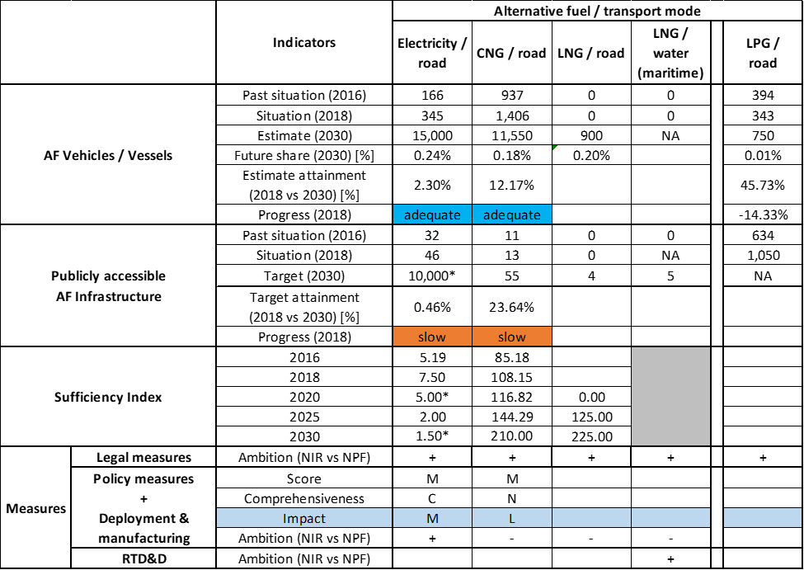



* Values based on the Greek NPF since the NIR only provided total recharging infrastructure targets and no breakdown for publicly accessible and private infrastructure.

The Greek NIR provides an incomplete coverage of the requirements of Annex I from the Directive. Regarding the combination of AF/AFV/AFI with transport mode, electricity is covered for all modes; CNG, LNG, and LPG for road transport; LNG also for waterborne maritime transport; all the other combinations are either absent or not applicable. The Greek NIR has not provided considerations on the need of renewable jet fuel refuelling points in airports and has not reported any particular needs during the initial phase of the deployment of AF infrastructure.

The EL NIR contains a long lists of Legal measures addressing all transport modes and alternative fuels, but when it comes to policy measures, these are only related to road transport and to electro-mobility in particular.

The main outcomes of the technical assessment of the Greek NIR on vehicles/vessels estimates and infrastructure targets can be summarised as follows:

###### Road transport

* **Electricity** - Greece recorded 345 electric and plug-in hybrid electric vehicles in use in 2018 (of which 322 were passenger cars, 21 LCVs and 2 buses/coaches). The EL NIR confirms the estimates made in the NPF, but does not distinguish EVs from PTWs and provide total numbers. For 2030 a total number of 15,000 EVs+PTWs is foreseen, with zero HCVs and 90 buses and coaches. The 2018 progress is adequate. As for recharging infrastructure, Greece recorded 46 publicly accessible recharging points in 2018. The number of public recharging points for 2020 and 2030 is missing in the NIR, but was given in the NPF (700 and 10,000, respectively). For the year 2025 instead, the EL NIR specifies that 4,000 public and 8,000 private recharging points (in total 12,000) are envisaged. In this case, the 2018 progress is slow, but the current and foreseen sufficiency index is adequate.
* **CNG** – Greece recorded 1,406 CNG vehicles in use in 2018, of which 920 were passenger cars, 130 LCVs, 109 HCVs and 247 buses and coaches. The NIR estimates for the years 2020, 2025, and 2030 are 2,570, 5,050, and 11,550 CNG vehicles (10,000 passenger cars, 250 HDVs and 1,200 buses and coaches), respectively. This represents a decrease of ambition of around 80% compared to the NPF. The 2018 progress for vehicles uptake is adequate. On the other hand, the EL NIR registers 13 public CNG refuelling points in 2018 and confirms the NPF plan for the next decade, i.e. 22 CNG public refuelling points for 2020, 35 in 2025, and 55 in 2030, respectively. The 2018 progress for infrastructure is slow, while the sufficiency index is adequate for the whole period.
* **LNG** – Greece did not record any road LNG vehicles or refuelling points in 2018. A development is foreseen, but only after 2020, since the NIR confirms the NPF estimate of 250 and 900 LNG vehicles (all of them HCVs) for the years 2025 and 2030, respectively. The LNG refuelling points targets for the years 2020, 2025, and 2030 are 1, 2, and 4, respectively.
* **Hydrogen** – The Greek NPF had declared that the use of hydrogen in the transport sector was not expected in the near future. The EL NIR follows on this line and does not report any vehicle estimate or infrastructure target until 2030. It is however worth mentioning that some measures of financial nature reported in the Greek NIR also cover hydrogen.
* **Biofuels** – The Greek NIR provides no relevant information on biofuels for transport.
* **LPG** – Greece recorded 343 pure LPG vehicles in use in 2018 (of which 248 were passenger cars, 80 LCVs, 11 HCVs and 4 buses and coaches). The future estimates of LPG vehicles for 2020, 2025, and 2030 are 450, 600, and 750, respectively. The NPF has provided much higher numbers that included bi-fuel LPG-gasoline vehicles. The number of publicly accessible LPG refuelling points in 2018 was 1,050, and the future targets are 1,100 in 2020, and 1,500 in 2025.

###### Rail transport

* **Electricity** – Greece recorded 30 electric locomotives in 2018, but the Greek NIR provides no future estimates.

###### Waterborne transport (maritime)

* **Electricity** – The EL NIR does not provide any information regarding shore-side electricity supply for seagoing ships in 2018. For the next decade, the Greek NIR confirms the NPF targets of 7, 27, and 42 shore-side electricity supply points for seagoing ships by 2020, 2025, and 2030, respectively. No battery-powered vessels are reported, nor any specific future development in this sector.
* **LNG** – In none of Greece’s maritime ports was LNG supply available in 2018. The NIR estimates two LNG refuelling points in maritime ports for 2020, and five in 2025 and 2030, which is slightly more ambitious than the NPF. No information on LNG vessels could be found in the NIR.

###### Air transport

* **Electricity** - The Greek NIR lists 55 recharging points for stationary airplanes over the period 2016-2018. No target is reported for 2020, while from 2025 to 2030 there is a target of 97 recharging points for stationary airplanes.
* **Biofuels** – Information is not available in the Greek NIR on renewable jet fuel refuelling points in airports.

The Greek NIR contains a long list of mainly Legislative & Regulatory and Administrative **measures**. They address all transport modes and alternative fuels and provide a solid legal background to progress with the uptake of alternative fuels vehicles and infrastructure.

However, the level of implementation of these measures, which can be derived by the number and information provided in the list of Policy and Deployment & Manufacturing support measures, is still quite at an early stage. In fact, only three clusters of Policy measures could be identified in the Greek NIR, on electricity, CNG and hydrogen, all for road transport. No measure was found regarding LNG, nor for waterborne, rail or air transport. In terms of expected impact of these measures to support the realisation of the AFV/AFI objectives as presented in the NPF and revised in the NIR, the measures for the pair electricity/road has a medium impact, while those for the other two pairs have a low impact. Compared to the NPF, the level of ambition of the Policy and Deployment & Manufacturing support measures has increased only for electricity/road.

The Greek NIR lists only two RTD&D projects, one on the preparation of the necessary studies for the creation of a full chain of supply of LNG as fuel for shipping in the Southeast Mediterranean, the other to support electrification of waterborne maritime transport in the Adriatic and Ionian seas.

### Final remarks

The Greek NIR provides a sufficiently comprehensive report on the efforts to implement the Directive, although it does not report on some important provisions of Annex I to the Directive. Overall, the level of ambition for the development of alternative fuel vehicles and vessels and the relevant infrastructures seems to be rather limited. The Greek NIR presents a very long list of legal measures, but only a limited number seems to address concretely the uptake of alternative fuel vehicles and infrastructure, with a focus on road transport, while it does not mention measures for waterborne, rail, or air transport.

With regard to electricity, the NIR expects some 15,000 electric vehicles on the roads by 2030, representing less than 0.3% of the vehicle fleet by that time. Furthermore, deployment of only 10,000 recharging points is foreseen by 2030. Taking into account the current situation and expected trends, this level of ambition appears quite low compared to the pace of deployment of electric vehicles considered necessary for a full transition to carbon neutrality by 2050. No information on charging efficiency is provided. The NIR estimates that there will be 27 shore-side electricity supply facilities in 2025 and 42 in 2030, aiming to cover the needs of the five ports in the TEN-T Core Network. There were 55 electricity supply points for stationary aircraft in 2018. The NIR expects an increase to 97 points by 2025, which will remain constant in number for 2030. The electricity supply points for stationary aircraft are and will mainly be located at the Eleftherios Venizelos Airport. Portable power generators will be installed in other airports. There was a small number of electric locomotives in 2018. Further information on the electrification of the rail network should be provided in future reporting.

The NIR does not include any information on future development of hydrogen as a transport fuel in Greece. Although hydrogen is not binding under the Alternative Fuels Infrastructure Directive, it would be relevant that Greece provides information on how to ensure EU-wide connectivity for HCEV.

The NIR also shows a limited level of ambition with the use of natural gas in road transport. There were 13 CNG refuelling points in 2018 for a small fleet of 1,406 CNG vehicles. It is estimated that in 2030 the number of CNG refuelling points will be 55 and the number of vehicles will be 11,550, representing 0.18% of the future vehicle fleet. Two LNG refuelling points are planned in Greece for 2025 and four for 2030. This seems insufficient taking into account the extensiveness of the TEN-T Road Core Network. A limited number of LNG heavy-duty vehicles is also foreseen (250 and 900 LNG heavy-duty vehicles by 2025 and 2030 respectively). All five ports of the Greek TEN-T Core Network are expected to have LNG refuelling points by 2025, as required by the Directive.

Regarding LPG, the NPF had reported a figure of 264,053 LPG vehicles by 2016. This figure included bi-fuel (petrol-LPG) vehicles. The NIR, on the other hand, only reports pure LPG vehicles e.g. 343 in 2018, 600 by 2025 and 750 by 2030) which does not allow a comparison between the NIR and the NPF. The number of LPG filling stations will increase from 1,050 in 2018 to 1,500 in 2025. Bi-fuel LPG vehicles are the main alternative fuel vehicle fleet in Greece.

Greece should provide more information in future reporting on efforts to promote the use of renewable fuels in transport, and particularly in aviation.

### ANNEX - Description of the Member State

On a surface area of 132,000 km², Greece has a population of 10.741 million people in 2018, which makes up for a population density of 81 inhabitants/km².

*Number of main urban agglomerations*

* 9 urban agglomerations > 50,000 inhabitants

In 2018, Greece achieves a per capita gross domestic product at market prices of €17,210, which represents a per capita gross domestic product in purchasing power standards of 68 if expressed in relation to the EU-28 average set to equal 100.

*Length of the road networks*

The length of the road TEN-T Core Network in Greece is 1,815 km. The total road network length is 40,163 km, of which 1,843 km are motorways.

The following lengths of the TEN-T Road Corridors are present in Greece: 25% (1,346 km) of the Orient – East Mediterranean Corridor.

Through the TEN-T Road Corridors, Greece is connected with the following Member States:  
- Bulgaria (through the Orient – East Mediterranean Corridor)

*Number of registered road vehicles*

At the end of 2017[31], Greece accounts for 8,236,900 registered road vehicles of which 5,236,000 are categorized as passenger cars, 1,344,100 as goods vehicles[32] and 26,300 as buses and coaches. The motorisation rate is 492 passenger cars per 1,000 inhabitants.

The present situation of few AFV/electric vehicles (1749/345) on Greek roads, with for example less than 0.022% of AFV/0.0042% electric vehicle/passenger cars, *is regarded by Greece as insufficient and in need of improvement.* In the NPF was written that there are 3.5% AFV on Greek roads, with less than 0.01% of electric passenger cars. The higher amount of AFV in the NPF is due to the LPG bi-fuel vehicles that were counted in the NPF.

*Number of ports in the TEN-T Core Network*

* 5 maritime ports in the TEN-T Core Network (Athina-Piraeus, Heraklion, Igoumenitsa, Patras, Thessaloniki)
* 20 maritime ports in the TEN-T Comprehensive Network
* No inland ports

*Number of airports in the TEN-T Core Network*

* 3 airports in the TEN-T Core Network (Athina, Heraklion, Thessaloniki)
* 35 airports in the TEN-T Comprehensive Network

## Spain (ES)

### Main messages from the Commission assessment of the NPF

In its original assessment of the Spanish NPF the Commission concluded:

*The Spanish NPF focusses on LPG and natural gas, for which substantial infrastructure is already in place. The Spanish NPF contains modest targets and measures for increasing shore side electricity in its ports. Coverage of electricity supply for stationary airplanes at the major airports is already good and no increase is foreseen.*

*The Spanish NPF strongly emphasizes LNG. LNG refuelling is available for all maritime ports in the TEN-T core network and in several ports of the comprehensive network, and additional bunkering terminals and ship-to-ship refuelling are planned. There are already 15 publicly accessible LNG refuelling points for heavy duty vehicles present in the Spanish territory and it is foreseen to add 20 more by 2020. Altogether, the planned LNG refuelling points could guarantee that the maximum distance requirement for LNG refuelling points along the TEN-T core road network would be fulfilled on the Spanish territory.*

*Spain has considered hydrogen in its NPF. The deployment of 20 publicly accessible hydrogen refuelling points and 500 hydrogen fuel cell vehicles by 2020 is foreseen.*

*The Spanish NPF contains an extensive list of measures, most already in place. Most of them can be considered having a low to medium impact on market actor's decisions. Regulatory measures have been put in place to facilitate infrastructure deployment. Longer durations for the validity of financial support measures could provide certainty for market actors and hence increase the likelihood that the national targets and objectives of the NPF can be reached.*

*The consideration of the interests of regional and local authorities, as well as stakeholders during the drafting of the Spanish NPF can be viewed as exemplary. Further co-operation will continue in the follow up phase of the NPF.*

*Spain is actively involved in coordinating its plans on alternative fuels infrastructure with other member states as well as collaborating with them in this field, in particular for the deployment of alternative fuel infrastructure for electricity, natural gas and LPG. Spain and France collaborate for the establishment of a hydrogen refuelling station corridor connecting the two countries.*

### Overview of requirements’ fulfilment from Annex I of the Directive

*Table 5.9.2‑1 Checklist Table*

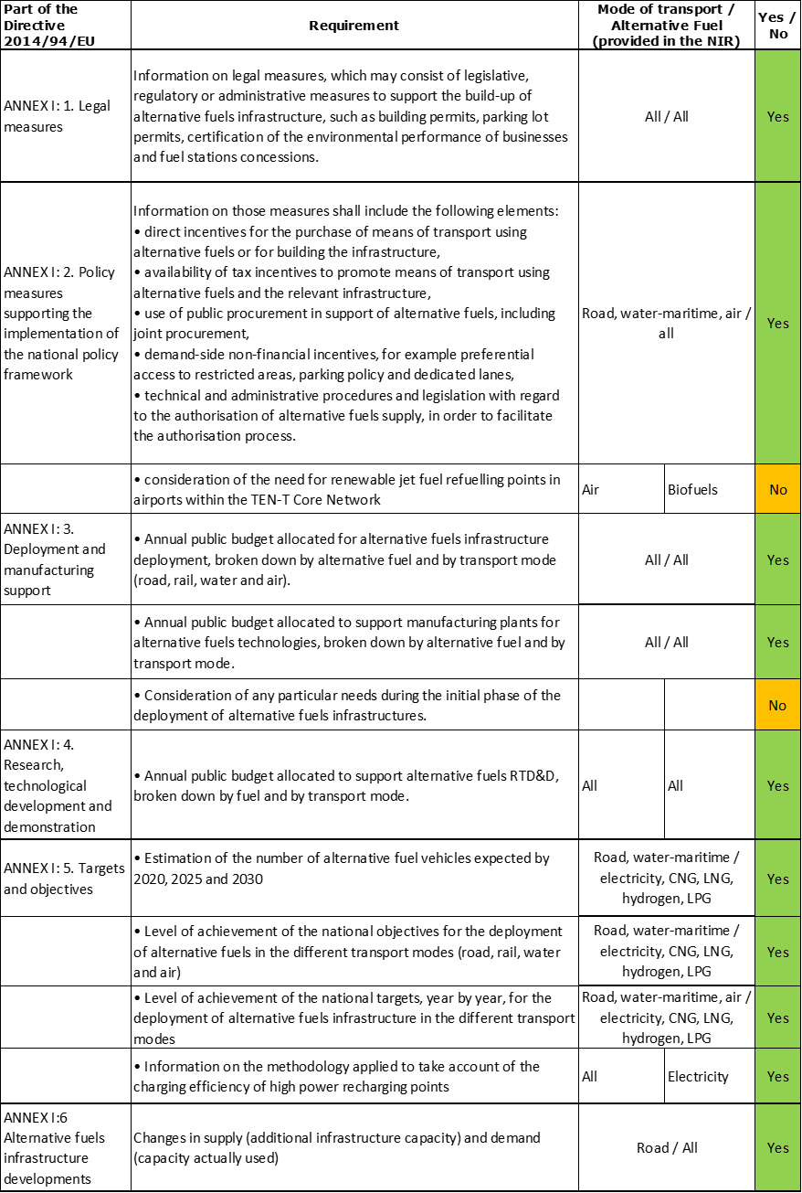

The checklist shows that almost all the requirements of Annex I from the Directive are covered.

Regarding the combination of AF/AFV/AFI with transport mode, electricity is covered for all modes; CNG, hydrogen and LPG for road transport; LNG for road and maritime transport; all the other combinations are either absent or not applicable.

The Spanish NIR reports almost 100 measures. Under the Policy and Deployment & Manufacturing sections it was possible to identify eight AF/transport mode clusters of measures, of which seven were assessable.

### Quantitative assessment: Vehicles and infrastructure

*Table 5.9.3‑1 National AFV estimates and AFI targets established in the NIR at the horizon 2020, 2025 and 2030 and their comparison with the NPF situation*





#### Road transport

##### Electricity

###### Vehicles

As shown in Table 5.9.3‑1, Spain recorded a total of 32,508 EVs in 2018. The majority of them are passenger cars (15,855 BEV and 12,707 PHEV), followed by 3,788 electric light commercial vehicles and 158 electric buses and coaches. In addition, the number of electric powered two wheelers in 2018 was 22,111. The Spanish NIR’s estimates for electric vehicles are 150,000 in 2020, 800,000 in 2025 and 5,000,000 in 2030. These estimates are provided without details on vehicle classes and represent a confirmation of the NPF for 2020 and a remarkable jump of 1,823% for 2030 (no estimate was provided in the NPF for 2025). This reflects a higher policy ambition.

The 2018 ***attainment*** of future EV estimates is 21.67% for 2020 and 0.65% for 2030. According to the assessment methodology described in Section 2.1, the 2018 situation corresponds to an ***adequate progress*** towards reaching the envisaged EV estimates. The calculated ***average*** ***annual growth rate*** corresponding to the period 2016-2030 for EV fleet evolution planned by Spain is equal to 53%.

###### Infrastructure

Spain recorded 5,187 publicly accessible recharging points in 2018 (Table 5.9.3‑1), of which 4,665 were normal power (≤22kW) recharging points and 522 high power (>22kW) recharging points. While Spain had not provided targets for publicly accessible recharging points for 2020, 2025 and 2030 in its NPF, this has been modified in the NIR: 10,000 publicly accessible recharging points are now foreseen for 2020 and 17,000 for 2025. The NIR does not provide estimates for private recharging points.

The ES NIR indicates that full information on the number of recharging points is unavailable and that the Spanish Government is participating in the European project (PSA-IDACS) promoted by the European Commission to gather all the relevant data.

The 2018 ***attainment*** of future publicly accessible recharging infrastructure targets is 51.87% for 2020 and 30.51% for 2025. According to the assessment methodology described in Section 2.1, the 2018 situation corresponds to a ***slow progress*** towards reaching these envisaged targets. The calculated ***average annual growth rate*** corresponding to the period 2016-2025 for publicly accessible recharging infrastructure evolution planned by Spain is equal to 16%.

###### Ratio

Based on the ES NIR, the following table shows the ratio between vehicles and publicly accessible recharging points (i.e. sufficiency index) for the pair electricity/road. As it can be seen, in 2020 the foreseen sufficiency index is higher than 10, which, considering the low share of high power recharging points in 2018 (10%), has to be regarded as probably inadequate. The sufficiency index further deteriorates in 2025 when it becomes 47.06.



###### Information on charging efficiency

The Spanish NIR contains two tables providing information about the charging efficiency of high power (>22kW) recharging points. Namely, the averaged data by high power recharging point per day (on average, a recharging point provides 1.85 recharges, is used 2.3 hours and supplies 33.985 kWh per day) and the daily data regarding the average number of recharges and duration. The total energy supplied is also provided. Every day, around 198 recharging operations take place at high power recharging points, representing a total average energy of 1,904.610 kWh for a total average duration of 129.51 hours.

##### CNG

###### Vehicles

The total number of CNG vehicles recorded by Spain in 2018 was 12,393 of which 6,452 (52%) were passenger cars, 1,438 (12%) LCVs, 2,108 (17%) HCVs and 2,395 (19%) buses and coaches (Table 5.9.3‑1). The Spanish NIR estimates 23,000 CNG vehicles for 2020, 100,000 for 2025 and 200,000 for 2030. These estimates are provided without details on vehicle classes. The Spanish NPF had only provided estimates for the number of CNG vehicles in 2020; the NIR revised estimate is 33.72% higher than that of the NPF, reflecting a greater policy ambition.

The 2018 ***attainment*** of future CNG vehicles estimates is 53.88% for 2020 and 6.20% for 2030. According to the assessment methodology described in Section 2.1, the 2018 situation corresponds to an ***adequate progress*** towards reaching the envisaged CNG vehicles estimates. The calculated ***average annual growth rate*** corresponding to the period 2016-2030 for the CNG vehicle fleet evolution planned by Spain is equal to 31%.

###### Infrastructure

Spain recorded 60 CNG publicly accessible refuelling points in 2018, see Table 5.9.3‑1. The NPF had only provided a target for CNG refuelling infrastructure in 2020. The ES NIR presents a revised target for 2020 (150 points), which is 97.37% higher than in the NPF and a new target of 200 CNG refuelling points in 2025. This shows an increase of ambition for CNG.

The 2018 ***attainment*** of future publicly accessible CNG refuelling infrastructure targets is 40.00% for 2020 and 30.00% for 2025. According to the assessment methodology described in Section 2.1, the 2018 situation corresponds to an ***adequate progress*** towards reaching these envisaged targets. The calculated ***average annual growth rate*** corresponding to the period 2016-2025 for publicly accessible CNG refuelling infrastructure evolution planned by Spain is equal to 21%.

###### Ratio

Based on the ES NIR, the following table shows the ratio between vehicles and publicly accessible refuelling points (i.e. sufficiency index) for the pair CNG/road. It can be seen that sufficiency index is well below the indicative value of 600 (see Section 2.1.5) for the implementation period until 2025.



##### LNG

###### Vehicles

Spain recorded 960 LNG vehicles in use in 2018, composed entirely by heavy commercial vehicles (Table 5.9.3‑1). Such LNG fleet has increased remarkably since 2012 when there were just 12 vehicles. The Spanish NPF had estimated to have 800 LNG vehicles registered in 2020 and according to the NIR that value had been surpassed already in 2018. The NIR revised estimate for the number of LNG vehicles in 2020 is 2,000 that is 150% higher than in the NPF. In addition, new estimates for LNG vehicles in 2025 and 2030 are 7,000 and 25,000 respectively, presumably all heavy-duty vehicles.

The 2018 ***attainment*** of future LNG vehicles estimates is 48.00% for 2020 and 3.84% for 2030. According to the assessment methodology described in Section 2.1, the ***progress*** obtained by Spain from 2016 until 2018 for LNG vehicles deployment is 2.60% of the overall planned deployment during the period 2016-2030.

###### Infrastructure

Table 5.9.3‑1 shows that in 2018 there were already 34 publicly accessible LNG refuelling points in Spain. The ES NIR declares that there were 24 combined CNG/LNG stations under construction in 2019. The Spanish NPF had only provided targets for 2020 and 2025. The NIR now presents revised targets for LNG refuelling points: 85 in 2020 and 110 in 2025, which are respectively 93.18% and 150% higher than in the NPF.

The 2018 ***attainment*** of future publicly accessible LNG refuelling infrastructure targets is 40% for 2020 and 30.91% for 2025. According to the assessment methodology described in Section 2.1, the ***progress*** obtained by Spain for publicly accessible LNG refuelling infrastructure deployment from 2016 until 2018 versus the period 2016-2030 could not be computed because of the lack of the 2030 target.

###### Ratio

Based on the ES NIR, the following table shows the ratio between vehicles and publicly accessible refuelling points (i.e. sufficiency index) for the pair LNG/road.



##### Hydrogen

###### Vehicles

The ES NIR indicates that there are 28 hydrogen-powered vehicles (20 passenger cars and 8 buses) in Spain in 2018. There were also 4 PTW & other vehicles. According to the NIR, the fleet of hydrogen-powered cars is limited to demonstration projects and 38 of these vehicles were authorised to circulate on public roads in 2019. It is expected to reach 50 hydrogen-powered vehicles by 2020, 200 by 2025 and 1,000 by 2030. The 2020 estimate is 90% lower than the 500 vehicles foreseen in the NPF.

The 2018 ***attainment*** of future hydrogen vehicles estimates is 56% for 2020 and 2.8% for 2030. According to the assessment methodology described in Section 2.1, the ***progress*** obtained by Spain from 2016 until 2018 for hydrogen vehicles deployment is 1.62% of the overall planned deployment during the period 2016-2030.

###### Infrastructure

Table 5.9.3‑1 shows that in 2018 there were four hydrogen publicly accessible refuelling points in Spain. The ES NPF had only provided a target for 2020 of 20 hydrogen refuelling points. The NIR provides a revised value of six refuelling points in 2020 (70% lower) and a new target of 15 in 2025.

The 2018 ***attainment*** of future publicly accessible hydrogen refuelling infrastructure targets is 66.67% for 2020 and 26.67% for 2025. According to the assessment methodology described in Section 2.1, the ***progress*** obtained by Spain for publicly accessible hydrogen refuelling infrastructure deployment from 2016 until 2018 versus the period 2016-2030 could not be computed due to the lack of the 2030 target.

###### Ratio

Based on the ES NIR, the following table shows the ratio between vehicles and publicly accessible refuelling points (i.e. sufficiency index) for the pair hydrogen/road until 2025.



##### Biofuels

###### Vehicles

The Spanish NIR indicates that, currently, there are no official figures for the number of vehicles compatible with blends of higher concentrations than E5 or B7, or registrations of such vehicles. Furthermore, all diesel vehicles can use high proportions of HVO (Hydrotreated Vegetable Oil).

###### Infrastructure

All pumps at Spanish service stations offering diesel can supply blends with up to 7% biodiesel by volume (B7). Moreover, normal petrol pumps can contain up to 5% bioethanol by volume (E5). Thus, whenever a vehicle is filled with B7 diesel and petrol, biodiesel and bioethanol are being consumed, respectively. Since 2011, the diesel sold in Spain contains a considerable volume of HVO.

In 2018, there were 63 Spanish service stations selling blends with higher bioethanol (8 stations) and biodiesel (55 stations) content, although the introduction of these blends in Spain has not stopped decreasing since 2016 and they could be found in only 0.5% of all service stations.

##### LPG

###### Vehicles

Spain had a fleet of 41,085 LPG vehicles in use in 2018 (of which 37,402 were passenger cars, 3,455 LCVs, 132 HCVs and 96 buses and coaches) (see Table 5.9.3‑1). There were also 425 PTW. Most of these vehicles are bi-fuel (petrol-LPG) and the proportion of heavy-duty vehicles is nominal since they are not yet sold with LPG-dedicated engines, although Spanish companies are doing dual fuel (diesel-LPG) conversions on trucks over 3,500 kg with good results. The Spanish NIR recognises that the evolution of LPG since 2016 – when the NPF was approved – has not gone as quickly as expected and presents revised future numbers for LPG vehicles. The NIR revised estimate for the number of LPG vehicles in 2020 is 100,000, which is 50% lower than in the less optimistic NPF scenario. In addition, the ES NIR presents new estimates for LPG vehicles in 2025 and 2030 of 200,000 and 500,000 respectively (without providing details on vehicle classes), which were absent in the NPF.

The 2018 ***attainment*** of future LPG vehicles estimates is 41.09% for 2020 and 8.22% for 2030. According to the assessment methodology described in Section 2.1, the ***progress*** obtained by Spain from 2016 until 2018 for LPG vehicles deployment is 5.41% of the overall planned deployment during the period 2016-2030.

###### Infrastructure

Table 5.9.3‑1 shows that in 2018 there were 589 LPG publicly accessible refuelling points in Spain. The NIR indicates that the number of stations accessible to the public has grown by 26% since the approval of the NPF. Although the LPG refuelling station operators maintain their interest in increasing the extensive reach of the national network, investments in infrastructure are not being made at the pace initially envisaged since Spain considers the current infrastructure sufficient to supply a fleet of over 200,000 vehicles. The Spanish NPF had only provided a target of 800 for the number of LPG refuelling points in 2020. The NIR now presents a revised target for LPG refuelling points of 650 in 2020, which is 18.75% smaller than in the NPF, and a new target of 750 refuelling points in 2025.

The 2018 ***attainment*** of future publicly accessible LPG refuelling infrastructure targets is 90.62% for 2020 and 78.53% for 2025. According to the assessment methodology described in Section 2.1, the ***progress*** obtained by Spain for publicly accessible LPG refuelling infrastructure deployment from 2016 until 2018 versus the period 2016-2030 could not be computed because the 2030 target is absent.

###### Ratio

Based on the ES NIR, the following table shows the ratio between vehicles and publicly accessible refuelling points (i.e. sufficiency index) for the pair LPG/road.



#### Rail transport

##### Electricity

###### Vehicles

The NIR mentions that for the transition period until the rail network is fully electrified, or for lines that will not be electrified, RENFE (Spanish national railways network) is planning the conversion of part of the diesel fleet to LNG, hydrogen or batteries, as the sole means of traction or in combination with electric traction.

###### Infrastructure

According to the Spanish NIR, almost 40% (over 6,000 km) of the rail network in the TEN-T Core is not electrified. The NIR further indicates that there are existing plans to electrify over 1,000 km of these lines. In addition, part of the diesel rail traffic will be diverted to the high speed network which is being extended through the Spanish territory.

#### Waterborne transport (maritime)

##### Electricity

###### Vessels

The Spanish NIR does not provide any details in this matter.

###### Infrastructure

Table 5.9.3‑1 shows that in 2018 Spain had two shore-side electricity supply points for ships and ferries, in Melilla and Motril respectively. Additional six shore-side electricity supply points were planned to be in operation by the end of 2019. According to the ES NIR, it is expected to have 45 electricity supply points for ships and ferries in 2020. This shows an increase in ambition compared with the NPF where the target for 2020 was of five electricity supply points.

Since only a target corresponding to 2020 was provided, the 2018 ***attainment*** of shore-side electricity supply points in maritime ports could be calculated only based on that target and is equal to 4.44%. According to the assessment methodology described in Section 2.1, the ***progress*** obtained by Spain for the deployment of shore-side electricity supply points in maritime ports from 2016 until 2018 versus the period 2016-2030 could not be computed because of the lack of the 2030 target.

##### LNG

The Spanish NIR declares that, since the approval in December 2016 of the NPF, the development of the market of LNG as a marine fuel in Spain has progressed well.

###### Vessels

In 2018, Spain had one vessel (that covers the Valencia-Palma de Mallorca line) using LNG in its auxiliary engine. In 2019, two ferries, propelled with two dual petrol-LNG engines, started operation in the lines Barcelona-Palma de Mallorca and Huelva-Canarias. The Spanish NPF had only provided an estimate for the number LNG seagoing vessels in 2020, whereas the NIR presents a revised estimate for 2020 (9 vessels), which is 200% higher than in the NPF, and new estimated numbers of 10 and 12 LNG vessels in 2025 and 2030 respectively (Table 5.9.3‑1).

The 2018 ***attainment*** of future LNG seagoing ships and ferries estimates is 11.11% for 2020 and 8.33% for 2030. According to the assessment methodology described in Section 2.1, the ***progress*** Spain obtained from 2016 until 2018 for LNG seagoing ships and ferries deployment in maritime ports is 8.33% of the overall planned deployment during the period 2016-2030.

###### Infrastructure

The ES NIR indicates that all 43 Spanish ports of general interest are currently in a position to supply LNG by means of tanks, subject to market conditions. That supply is complemented by the adaptation of two terminals for the supply of LNG, which are already operational in the ports of Barcelona and Bilbao, and a supply vessel that is operational in the port of Huelva. In addition, another supply vessel currently operates with a base in the port of Barcelona, although with availability subjected to market condition and license.

The NPF targets for LNG supply points to ships and ferries have been **already 100% attained** (see Table 5.9.3‑1). According to the assessment methodology described in Section 2.1, the ***progress*** Spain obtained from 2016 until 2018 for LNG refuelling infrastructure deployment in maritime ports is also 100.00% of the overall planned deployment during the period 2016-2030.

#### Waterborne transport (inland)

The Spanish NIR does not contain any information about use of alternative fuels in inland waterborne transport.

#### Air transport

##### *Electricity*

###### Airplanes

The Spanish NIR does not provide any details regarding deployment of hybrid-electric or fully-electric airplanes.

###### Infrastructure (for stationary airplanes)

According to the ES NIR, in the baseline situation, corresponding to 2015, there were 400 power supply points for stationary aircraft in the airports of general interest in Spain. From 2016 until 2018, 65 units were replaced and 34 new units installed, so there are currently 434 power supply points. It is expected that by 2030 there will be 36 new points and significant investment in replacing equipment. Table 5.9.3‑1 shows that the target for 2030 is of 470 electricity supply points for stationary airplanes.

The 2018 ***attainment*** is 92.34% for 2030. According to the assessment methodology described in Section 2.1, the ***progress*** obtained by Spain from 2016 until 2018 in the deployment of electricity supply for stationary airplanes is 43.75% of the overall planned deployment during the period 2016-2030.

### Measures assessment

As in the NPF, the Spanish NIR contains an extensive list of measures that covers various fuels and modes, but mainly targeting electricity, CNG, LNG for road transport and LNG for maritime and, to a lesser extent, hydrogen. The NIR also showcases measures at Autonomous Communities level as well as local measures in the major cities Barcelona, Madrid, Malaga, Seville, Valencia, Valladolid and Saragossa.

#### Legal measures

The Spanish NIR contains 34 legal measures which represent an increase compared to the 25 legal measures identified in the NPF. Legal measures are implemented at national level and nine of them are cross-cutting applicable to all alternative fuels and related to both vehicles and infrastructure. Some of these measures relate to the fulfilment of the Paris Agreement targets (the *Climate Change and Energy Transition Bill* and the draft *2021-2030 Integrated National Energy and Climate Plan*) and to the implementation of the European Directives, such as the Energy Performance of Buildings Directive 2018/844/EU, the Air Pollution Directive 2016/2284/EU and the Alternative Fuels Infrastructure Directive 2014/94/EU. At Autonomous Communities level Andalusia, Catalonia, Valencia, Extremadura, Balearic Islands, Navarre, Basque Country and Murcia have developed legal frameworks, strategies and plans to foster the deployment of AFV/AFI.

Some of the legal measures in the ES NIR can be considered updates of the measures provided in the NPF (e.g. related to Green Public procurement). The majority of the legal measures described in the NIR are already in place (around 14% were under consideration).

Considering all the legal measures together, they appear to be designed as the necessary tools to allow the realisation of the AFV/AFI plans as presented in the NPF and revised in the NIR. Based on the available information, the level of ambition of the legal measures can be considered to have increased in the NIR, compared to the NPF, for electricity and hydrogen for road and LNG for maritime transport.

##### Legislative & Regulatory

Of all the legal measures described in the Spanish NIR, 23 can be categorised as legislative and regulatory measures. Fourteen measures are applicable to road transport while nine are dedicated to maritime transport. The following can be highlighted:

* The new *Spanish Industrial Policy 2030* and its sectoral agendas for automotive, shipping and capital goods setting out specific measures to promote alternative fuels in transport
* The *Strategic Plan of Integrated Support to the Automotive Sector, 2019-2025*, for the transition towards a new sustainable mobility model, led by a Sustainable Mobility Committee to coordinate policy, support measures and RTD&D actions for the penetration of zero and low-emission vehicles
* The increase of the availability of public recharging points by deregulating electric charging and creating an information register to monitor its activity. The figure of charge manager established in the Electricity Sector Act 24/2013, which was seen too rigid, was cancelled by Royal Decree-Law 15/2018
* The Royal Decree 235/2018 laying down the calculation methods and reporting requirements with regard to the intensity of greenhouse gas emissions of fuels and energy in transport
* The Decree 335/2018 amending several royal decrees regulating the natural gas sector and creating a new structure that allows LNG loading operations related to bunkering LNG as a marine fuel in the current phase of the market’s development.

##### Administrative

Of all the legal measures described in the Spanish NIR, 11 can be categorised as administrative measures. Six measures are applicable to road transport and five are specific for maritime transport. The following can be highlighted:

* The adoption of technical standards related to natural gas refuelling stations for CNG/LNG vehicles, automotive CNG/LNG fuel specifications and certification of LNG tanker drivers who offload to LNG bunkering stations.
* The creation of the Spanish Hydrogen Working Group and the reactivation of the Technical Committee on Standardisation for hydrogen technologies, CTN-181, to contribute to CEN/CENELEC work and meet the requirements of the Directive 2014/94/EU.
* The activities on recommendation for port authorities regarding requirements for LNG bunkering at ports, part of the CEF funded project *CORE LNGas HIVE*.

#### Policy measures

The Spanish NIR contains 22 policy measures applicable at national level, representing an increase compared to the 11 policy measures identified in the NPF. Eight of the policy measures described in the NIR refer to road transport and 14 refer to maritime transport. In addition, the NIR summarises the most relevant policy measures at regional and local level, namely 33 measures valid in autonomies and regions and 6 measures in force locally. The majority of the policy measures can be considered updates of the measures provided in the NPF, in particular annual renewal of financial support measures. Although most of the policy measures described in the NIR are existing, about 13% of the policy measures can be considered to be past measures (i.e. expired by 2019).

##### Measures to ensure national targets and objectives

All the 22 policy measures described in the NIR and applicable at national level can be considered as measures to ensure national targets and objectives. Around 73% of these measures are of a financial nature.

###### Road transport

Over the last years, the Spanish government has approved various programmes to subsidise the purchase of alternative fuels vehicles (electric, CNG, LNG, LPG and hydrogen) and their infrastructure. These programmes and their budget are approved every year by means of a Royal Decree. The NIR mentions:

* *MOVEA 2016* with a budget of 16.6 million € financed a total of 2,132 vehicles and 42 recharging points; *MOVEA 2017* had a budget of 14.26 million € and financed a total of 2,370 vehicles and 26 recharging points.
* *MOVALT 2018* with two programmes: *MOVALT vehicles,* with a budget of 20 million €, made it possible to finance 2,977 AFV and *MOVALT infrastructure* that has a budget of 20 million € and whose call for applications is pending (it is estimated to finance around 310 recharging points).
* *MOVES 2019* was approved in February 2019 with a budget of 45 million € and will be managed by the Spanish autonomous communities.
* *MOVES One-off projects 2019*, approved in July 2019, provides continuity to the *MOVES Programme* with a budget of 15 million € for funding projects on urban mobility and innovation regarding electro-mobility and hydrogen.

It is also worth mentioning:

* The *2016-2019 CLIMA programme* has financed 28 projects in the area of transport, thanks to the financial contribution of over 1.2 million €. The majority are projects to replace vehicle fleets powered by conventional fossil fuels with electric vehicles and, to a lesser extent, projects to promote the use of biomethane by vehicles and connecting vessels to the national port’s network.
* The continuation of the *PIMA waste* and *PEMAR* for efficient use of biogas and production of biofuels from used oils.

In terms of measures at Autonomous Communities level, it can be highlighted:

* Andalusia 2017-2020 line of grants (80% ERDF funded) for all types of AFV and AFI;
* Asturias grants in 2017 for the installation of recharging points for EVs and refuelling points for CNG and LPG; and in 2018 for the purchase of AFV and the installation of recharging points and refuelling points for CNG;
* Aid for the installation of recharging points in different parts of the Canary Islands and line of grants to promote the deployment of ten rapid recharging points for electric vehicles in Tenerife;
* Cantabria grants in 2017, 2018 and 2019 for the installation of rapid and fast recharging points;
* Castile-La Mancha aids in 2018 and 2019 for the purchase of LPG, CNG, LNG or hydrogen vehicles;
* Castile-Leon grant for the purchase of new EVs (BEV, PHEV or hybrid) or where the propulsion system is based on internal combustion engines that can use alternative fossil fuels;
* Catalonia grants for the purchase of vehicles to use as taxis;
* Madrid 2017 and 2018 aid to self-employed and SMEs to modernise the fleet of LCV with highly energy-efficient models that consume less fuel and emit less CO2 and NOx and incentives to modernise the taxi fleet, 2018 grants for the deployment of recharging points (conventional, fast, rapid and ultra-fast charging), 2018 aids for the purchase of M1 vehicles powered by LPG, LNG, CNG or bi-fuel (petrol and gas), BEVs, REEVs, PHEVs and hydrogen vehicles, and exclusively electric motorcycles (L-category);
* Community of Valencia 2017, 2018 and 2019 aid for public or private companies and bodies for the installation of recharging points and aid for the purchase of EVs or AFVs;
* Balearic Islands aid in 2018 to promote the installation of recharging points (normal, semi-fast and fast) and to promote low-emission BEV, PHEV, CNG and LPG vehicles for rental and taxis;
* The Rioja grants in 2018 for municipalities with fewer than 25,000 inhabitants for the installation of fast recharging points for public use;
* Navarra 2017 aid to local authorities with fewer than 20,000 inhabitants for the purchase of BEV and the installation of recharging points;
* Basque Country aid in 2018 for the purchase of electric mopeds, EV or hybrid HDV and for AFI for electricity and CNG and for the conversion of LCV to CNG/LPG and HDV to CNG, aid for AFI installations in shared garages. Aid programme in 2019 for investments in efficient and alternative vehicles and for the promotion of electric recharging points for public use.

Regarding tax incentives, rebates of car registration and road taxes as well as personal income tax reduction applicable to benefits in-kind for business AFV for private use have been in force since 2016. In addition, at Autonomous Communities level, the Canary Islands have eliminated the general indirect tax for the purchase of hybrid and electric vehicles as well as for public transport vehicles powered by CNG and LPG. Castile-Leon has proposed a deduction of the regional income tax for the purchase of electric vehicles; the Rioja provides the possibility of a deduction in the annual tax declaration equal to 15% of the purchase value of new electric vehicles and Navarra provides tax deductions for investments in the installation of recharging points and in BEV and PHEV. At local level, Saragossa exempts electric vehicles from parking fees in certain zones of the city and provides discounts to the motor vehicle tax for low and zero emission vehicles.

###### Waterborne transport

The Spanish NIR contains 14 measures that can be considered as policy measures for waterborne maritime transport. Compared to the four measures identified in the NPF, this shows an increase in ambition. It is particularly noticed:

* The elimination of the tax on provision of shore-side electricity from January 2020 and the 50% reduction in the berthing fee charged to vessels docked in port when connected to the electricity grid.
* The existing 50% discount on the total tax due for access and berthing in Zone I and/or Zone II for vessels powered by LNG or vessels that use LNG in their auxiliary engines, supplemented with 10 to 40% reductions on the port duty for vessels depending on the Port Authority. Likewise, additional 10 to 40% reduction, depending on the Port Authority, of the port duty applicable to LNG cargos for bunkering and up to 30% rebate on the occupation rate applicable to terminals for LNG bunkering.
* The provision of 40 million € in 2018, as Spanish Government-backed financing for building and for converting existing vessels to low-emission. This instrument has been in force since the 1990s and its annual budgetary contribution is set out in the Budget Act for each year. Initially geared to the building of new low-emission vessels, it currently allows guarantees for the conversion of vessels too.
* The activities within the “*CORE LNGas Hive — Core Network Corridors and Liquefied Natural Gas Project*”, funded by the European Commission through the CEF (2014-EU-TM-0732-S) aimed at promoting the development of LNG as a marine fuel and the launching in 2018 of the *LNGHIVE2* strategy for the continuation of the institutional measures and developments of *CORE LNGas HIVE*.

##### Measures that can promote AFI in public transport services

The Spanish NIR does not contain specific measures that can promote AFI at national level, although a number of autonomies and regions provide grants and incentives for the purchase of AFV for use as taxis (Catalonia, Madrid, Balearic Islands, and Navarra) and for the procurement of electric buses for urban public transport. There are also initiatives at local level in Madrid, Seville and Saragossa.

##### Measures that can promote the deployment of private electro-mobility infrastructure

Although the Spanish NIR does not explicitly mention measures for the promotion of private electro-mobility infrastructure, the programmes *MOVEA 2016* and *2017*, *MOVALT 2018* and *MOVES 2019* included budget provisions for funding private recharging points. In addition, autonomies and regions provided grants and incentives for the installation of recharging points in business premises and condominium garages.

#### Deployment and manufacturing support

##### AFI deployment

The Spanish NIR contains 18 deployment support measures for AFI at national level, which compared to the 9 measures identified in the NPF, represent an increase in ambition. In addition, the NIR mentions several initiatives at regional and local level. Most of these measures are existing. Eleven AFI deployment support measures refer to road transport, seven of them to recharging infrastructure, and the rest to CNG, LNG, hydrogen and LPG refuelling points. At Autonomous Communities level, Canary Islands, Catalonia and Balearic Islands, as well as Madrid at local level, provide support for the deployment of recharging points. The NIR highlights the support for building hydrogen infrastructure in Mallorca and Madrid as well as regional promotion initiatives for hydrogen in Castile-La Mancha, Andalusia, Basque Country and Aragon.

Four deployment support measures concern waterborne maritime transport (two for electricity and two for LNG refuelling points) and two measures target electricity supply infrastructure for stationary aircraft.

Spain relies on European co-funding mechanisms for AFI deployment, namely the CEF blending Facility (*CIRVE*, *E-VIA FLEX-E*, *EUROP-E*, *AMBRA*, *ECOGATE*, OPS masterplan for Spanish ports and *CORE LNGas HIVE*) and the ERDF (for example for installing biofuels pumps in Valencia). The Spain-France-Andorra cooperation programme *POCTEFA Interreg* is also considered. Furthermore, there are some public-private initiatives for installing publicly accessible recharging points in rail stations, airports and public places.

##### Support of manufacturing plants for AF technologies

Of all the deployment and manufacturing support measures listed in the Spanish NIR, nine can be categorised as support to manufacturing plants for AF technologies. Two measures are dedicated to road transport: the continuation of the ‘*Reindustrialisation and industrial competitiveness strengthening programme*’ (mentioned in the NPF) and a project for manufacturing LPG engines for buses. The remaining seven measures are related to the building (or the conversion) of maritime vessels and ferries to run with LNG.

##### Consideration of any particular needs during the initial phase of the deployment of alternative fuels infrastructures

Information is not available in the Spanish NIR.

#### Quantitative assessment of Policy and Deployment & Manufacturing measures

Table 5.9.4‑1 presents an analysis of all the Policy and Deployment & Manufacturing measures, carried out according to the assessment methodology described in Section 2.2. As it can be seen, clusters of measures are identified for the pairs electricity/road, CNG/road, LNG/road and LNG/water-maritime, hydrogen/road, LPG/road and electricity/water-maritime. Nothing assessable could be defined for the pair LNG/water-inland.

The majority of the assessable measures mentioned in the NIR score medium. For the clusters electricity/road and LNG/water-maritime, a score between medium and high can be considered. The cluster electricity/water-maritime scores high. The duration of policy measures is subject to yearly budgetary approval. The results of the applied assessment methodology are based on the assumption that continuity is given to Policy and Deployment & Manufacturing support measures. The clusters electricity/road, CNG/road, LNG/road, LNG/water-maritime, hydrogen/road and LPG/road can be considered to be comprehensive. The cluster electricity/water-maritime results not comprehensive. In terms of expected impact of the measures to support the realisation of the AFV/AFI objectives as presented in the NPF and revised in the NIR, those for the pairs electricity/road and LNG/water-maritime result to have a medium-high impact, all the other assessable clusters have a medium impact.

As it can be seen in Table 5.9.4‑1, compared to the NPF the level of ambition has increased in the NIR for all the assessable clusters, with the exception of LPG/road, for which it remains the same.

*Table 5.9.4‑1 Quantitative assessment of Policy and Deployment & Manufacturing support measures*

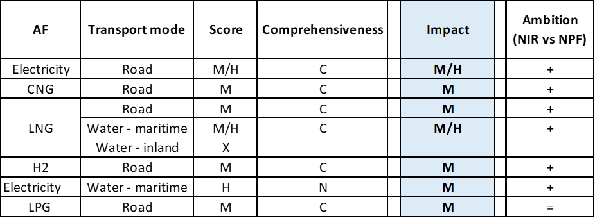 **Legend:** Score and Impact: H = high; M = medium; L = low; X = not assessable. Comprehensiveness: C = comprehensive; N = Not comprehensive. Ambition level: ‘+’ means ‘higher’; ‘=’ means ‘comparable’; ‘-‘ means ‘lower’.

In terms of expected impact of the measures to support the realisation of the AFV/AFI objectives as presented in the NPF and revised in the NIR, those for the pairs electricity/road and LNG/water-maritime result to have a medium-high impact; those for the pairs CNG/road, LNG/road, electricity/water-maritime, hydrogen/road and LPG/road have a medium impact; while all the others are not assessable.

#### Research, Technological Development & Demonstration

The Spanish NIR describes 25 RTD&D programmes, which represent a significant increase compared to the 7 RTD&D projects identified in the NPF. National financing and support for RTD&D projects target electricity, CNG, hydrogen, LPG and biofuels for road transport. The majority of the NIR projects can be considered follow-ups or expansions of the projects listed in the NPF. In addition, the Spanish government promotes the participation in European working groups and associations (for batteries, hydrogen, autogas LPG-cluster and bio-ethanol), in the IPCEIs (Important Projects of Common European Interest) for batteries and for hydrogen and in the Fuel Cell and Hydrogen Joint Undertaking. The Spanish NIR highlights several regional projects on biomethane production (from waste and from algae) and use. For maritime transport, the NIR mentions two RTD&D initiatives: one on LNG ships building and another on smart electricity grids in ports.

The Spanish NIR also describes four projects on AF in railways. Two projects are related to pilot tests of LNG locomotives and demonstration of the LNG refuelling infrastructure. The other two projects deal with hybridising with LNG and hydrogen sub-urban and mid-range trains and with the development of a hydrogen electric tram powered by battery and fuel cells.

On the basis of the available information, and compared to the NPF, the level of ambition in the NIR can be considered to have increased for RTD&D actions for most fuels and transport modes.

### Additional information on alternative fuels infrastructure developments

The Spanish NIR does not provide information on the changes in fuel use.

### Summary of the assessment

**Tabular overview**

*Table 5.9.6‑1 Overview of the NIR assessment*



The Spanish NIR considers all alternative fuels transport modes, with particular focus on CNG, LNG and electricity. While for CNG/road a moderate infrastructure is in place, Spain is putting efforts to deploy electric recharging points and LNG refuelling points. In its NPF, Spain had considered a strong growth of LPG, however the NIR recognises that the evolution of LPG vehicles since 2016 has not gone as quickly as expected and that deployment of LPG refuelling points is also proceeding at slower pace than initially anticipated. Spain’s continued support to LNG as a marine fuel has led to a good development of the market in LNG waterborne maritime transport.

The NIR does not establish infrastructure targets/vehicle estimates for all fuels and modes for each of the years of reference (2020, 2025 and 2030). Specifically, several targets are not provided for AFI in 2030. Therefore, it cannot be stated that the Spanish NIR covers the whole AFID period (2016-2030). Compared to the Spanish NPF that addressed most of the requirements of Article 3 of the Directive, the Spanish NIR almost fully addresses the requirements of Annex I of the Directive, with the exception of: a) information on the need for renewable jet fuel refuelling points in airports within the TEN-T Core Network; and b) information on any particular needs during the initial phase of AFI deployment.

The main outcomes of the technical assessment of the Spanish NIR on vehicles/vessels estimates and infrastructure targets can be summarised as follows:

###### Road transport

* **Electricity** – Concerning EVs, Spain recorded a total of 32,508 electric vehicles in 2018 (of which 28,562 were passenger cars, 3788 LCVs and 158 buses and coaches). The Spanish NIR estimates for the number of electric vehicles are 150,000 in 2020, 800,000 in 2025 and 5,000,000 in 2030, which translate in the same estimate as in the NPF for 2020 and 1,823% higher estimate for 2030. While Spain did not provide infrastructure targets in its NPF, the NIR targets for publicly accessible recharging points are 10,000 for 2020 and 17,000 for 2025. The 2018 progress results to be adequate for the vehicles and slow for infrastructure, while the sufficiency index remains adequate until 2018 and becomes insufficient from 2020, in particular in 2025, due to the low level of ambition in terms of recharging points.
* **CNG** – Spain recorded a total of 12,393 CNG vehicles in 2018 (of which 6,452 were passenger cars, 1,438 LCVs, 2,108 HCVs and 2,395 buses and coaches). Compared to the NPF, where only a vehicle estimate for 2020 was provided, the Spanish NIR presents a revised estimate of 23,000 CNG vehicles for 2020 (33.72% higher than in the NPF), and new estimates of 100,000 vehicles for 2025 and 200,000 vehicles for 2030. Spain recorded 60 CNG refuelling points in 2018; the NIR presents a revised set of targets for 2020 (150 points), which is 97.37% higher than in the NPF and expects to have 200 CNG refuelling points in 2025. The 2018 progress results to be adequate for both the vehicles and infrastructure and the sufficiency index is below the indicative value of 600 for the implementation period until computable (2025).
* **LNG** - Spain recorded 960 LNG vehicles in use in 2018, composed entirely by HCVs. The Spanish NPF expected to have 800 LNG vehicles registered in 2020; the NIR presents a revised set of vehicle estimates 150% higher than the NPF for 2020. The estimates for LNG vehicles in 2025 and 2030 are 7,000 and 25,000 respectively. In 2018, there were 34 LNG refuelling points in Spain. The NIR presents revised targets for LNG refuelling points for 2020 and 2025 that are respectively 93.18% and 150% higher than in the NPF.
* **Hydrogen** – There were 28 hydrogen-powered vehicles (20 passenger cars and 8 buses) in Spain in 2018. Spain had included hydrogen in its NPF. The NIR estimate for hydrogen vehicles in 2020 is 90% lower than the NPF. The new estimates are 50 hydrogen-powered vehicles by 2020, 200 by 2025 and 1,000 by 2030. Concerning hydrogen infrastructure, there were 4 publicly accessible hydrogen fuelling points in 2018 and, similarly to the vehicle estimates, the NIR presents revised targets for hydrogen infrastructure (6 points in 2020 and 15 in 2025), which for 2020 is 70% lower than in the NPF.
* **Biofuels** – The Spanish NIR does not contain data or estimates on the number of vehicles running on high concentrations of biofuels. In 2018, there were 63 Spanish service stations selling blends with higher bioethanol (8 stations) and biodiesel (55 stations) content.
* **LPG** - Spain had a fleet of 41,085 LPG vehicles in 2018 (of which 37,402 passenger cars, 3,455 LCVs, 132 HCV and 96 buses and coaches). The Spanish NIR presents a revised set of estimates for LPG vehicles (100,000 in 2020, 200,000 in 2025 and 500,000 in 2030) that for 2020 is 50% lower than in the less optimistic NPF scenario. Regarding LPG infrastructure, in 2018 there were 589 LPG refuelling points. In line with the vehicle reduction scenario, the NIR presents revised targets for LPG refuelling points (650 in 2020 and 750 in 2025) which for 2020 is 18.75% smaller than in the NPF.

###### Rail transport

The NIR indicates that almost 40% (over 6,000 km) of the Spanish rail network in the TEN-T Core is not electrified and there are plans to electrify over 1,000 km of those lines. For lines that will not be electrified, RENFE (Spanish national railways network) is planning the conversion of part of the diesel fleet to LNG, hydrogen or batteries, as the sole means of traction or in combination with electric traction.

###### Waterborne transport (maritime)

* **Electricity** - The number of shore-side electricity supply points at the Spanish maritime ports was 2 in 2018. According to the NIR, it is expected to have 45 electricity supply points in 2020.
* **LNG** - In 2018, Spain had one vessel using LNG in its auxiliary engine. The Spanish NPF only provided estimates for the number LNG seagoing vessels in 2020 whereas NIR presents a revised estimate for 2020 (9 vessels) which is 200% higher than in the NPF. The estimated number of LNG vessels in 2025 and 2030 is 10 and 12 respectively. As for LNG infrastructure, the ES NIR indicates that all 43 Spanish ports of general interest are currently in a position to supply LNG by means of truck tankers, complemented with LNG terminals in 2 ports. This means that the NPF targets for LNG supply points to ships and ferries (13 in 2020 and 42 in 2025) have been already attained.

###### Waterborne transport (inland)

Information is not available in the Spanish NIR.

###### Air transport

* **Electricity (for stationary airplanes**) - According to the NIR, there are currently 434 power supply points for stationary aircraft at the airports of general interest in Spain; the target is 470 points in 2030.

The Spanish NIR contains an extensive list with 108 national **measures**, covering various fuels and modes, mostly targeting electricity, CNG, LNG for road transport and LNG for maritime transport and to a lesser extent hydrogen. The NIR also showcases measures at Autonomous Communities level as well as local measures in major cities. The NIR contains 34 legal measures implemented at national level, of which nine are cross-cutting applicable to all alternative fuels and related to both vehicles and infrastructure. Considering all the legal measures, they appear to be designed as the necessary tools to allow the realisation of the AFV/AFI plans as described in the NPF and revised in the NIR.

There are 22 policy measures applicable at national level in the Spanish NIR. The majority of them can be considered updates of the measures provided in the NPF, in particular annual renewal of financial support measures. As for deployment and manufacture support, 27 measures have been identified from the NIR. The result of the applied assessment methodology shows that, if continuity is given to policy and support measures, the set seems sufficient to advance with the attainment of the declared targets and objectives. With the exception of LPG, the level of ambition for policy and deployment & manufacture support measures between the NPF and the NIR has increased for all the assessable clusters. In terms of expected impact of the measures to support the realisation of the AFV/AFI objectives as presented in the NPF and revised in the NIR, those for the pairs electricity/road and LNG/water-maritime result to have a medium-high impact, all the other assessable clusters have a medium impact

The Spanish NIR describes 25 RTD&D programmes. Based on the available information, and compared to the NPF, the level of ambition in the NIR can be considered to have increased for most alternative fuels and transport modes.

### Final remarks

The Spanish NIR provides a quite comprehensive report on the efforts to implement the Directive. The NIR is in line with the provisions of Annex I to the Directive and all alternative fuels are addressed. The market for electric passenger vehicles and heavy-duty LNG vehicles is expected to grow significantly in the coming years; the market for CNG and LPG vehicles is also foreseen to grow but to a lesser extent. The Spanish NIR expects hydrogen to remain a niche market. A significant number of measures to promote alternative fuels in all modes of transport are being implemented with different scopes and impacts. Spain is involved in the implementation of a significant number of R&D&I programmes, both at national and European level, for the production of alternative fuels and the development of new generations of batteries and fuel cells and, to a lesser extent, for the construction of LNG ships.

With regard to electricity, the NIR expects up to five million electric vehicles on the roads by 2030, representing around 16% of the vehicle fleet by that time. Taking into account the current situation and expected trend developments, this level of ambition appears to be broadly consistent with the pace of deployment of electric vehicles considered necessary for a full transition to carbon neutrality by 2050. Nevertheless, only 17,000 recharging points are planned for 2025, which seems insufficient for the estimated fleet of 800,000 electric vehicles in that year. An increase of ambition would contribute to better meeting the objective of realising a dense, wide-spread and easy to use network of recharging and refuelling infrastructure throughout the EU. Spain should provide information on its targets for recharging infrastructure in 2030. Information on charging efficiency is provided. Forty-five shore-side electricity supply facilities for ships and ferries are expected in 2020. For stationary aircraft 434 power supply points are already installed in the Spanish airports. Almost 40% (over 6,000 km) of the Spanish TEN-T Core rail Network is not yet electrified; further efforts are needed in this regard. The NIR indicates that there are already plans to electrify over 1,000 km of these lines. In general, the report highlights Spain’s strong commitment to promoting the use of electricity in the transport sector.

As for hydrogen, the NIR shows a low development of both vehicles and infrastructure. Fifteen hydrogen filling stations are planned for 2025 and no target has been defined for 2030. Spain should provide further information in future reporting on planning for 2030 and beyond.

Concerning natural gas, there were 12,393 CNG vehicles by 2018. The NIR estimates 100,000 CNG vehicles by 2025 and 200,000 CNG vehicles by 2030 as well as 200 refuelling points by 2025. Further, the NIR sets the target of 7,000 LNG vehicles in 2025 and 25,000 LNG vehicles by 2030. No 2030 target for LNG refuelling stations was provided. However, the NIR estimates 110 LNG refuelling points by 2025. This seems sufficient taking into account the length of the Spanish TEN-T Road Core Network, provided that the refuelling points are equally distributed along the network. Moreover, all Spanish ports of the TEN-T Comprehensive Network are in a position of supplying LNG by the use of road tankers, complemented by LNG terminals in two ports. On the other hand, the estimated number of LNG vessels by 2025 and 2030 is very small in relation to the number of ports with capacity to supply LNG. Spain should encourage the use of LNG vessels to take advantage of the existence of this infrastructure.

There were 41,085 LPG vehicles by 2018. Around 100,000 LPG vehicles are estimated for the year 2020. LPG vehicles will rank second in the alternative vehicle fleet in Spain in 2030. The NIR estimates around 500,000 LPG vehicles by 2030. The NIR shows a smaller development of the LPG vehicles market compared to the estimates provided in the NPF.

According to the NIR, only 0.5% of the service stations provide blends with higher bioethanol and biodiesel. Spain should provide more information in future reporting on efforts to promote the use of renewable fuels in transport, and particularly in aviation.

### ANNEX - Description of the Member State

On a surface area of 506,000 km², Spain has a population of 46.658 million people in 2018, which makes up for a population density of 92 inhabitants/km².

*Number of main urban agglomerations*

* 128 urban agglomerations > 50,000 inhabitants

In 2018, Spain achieves a per capita gross domestic product at market prices of €25,730, which represents a per capita gross domestic product in purchasing power standards of 91 if expressed in relation to the EU-28 average set to equal 100.

*Length of the road networks*

The length of the road TEN-T Core Network in Spain is 5,706 km. The total road network length is 165,749 km, of which 15,585 km are motorways.

The following lengths of the TEN-T Road Corridors are present in Spain: 48% (2,727 km) of the Mediterranean Corridor and 46% (2,040 km) of the Atlantic Corridor.

Through the TEN-T Road Corridors, Spain is connected with the following Member States:   
- Portugal (through the Mediterranean Corridor)   
- France (through the Mediterranean and the Atlantic Corridor)

*Number of registered road vehicles*

At the end of 2018, Spain accounts for 34,630,709 registered road vehicles of which 24,074,151 are categorized as passenger cars, 4,637,954 as light goods vehicles, 568,899 as heavy goods vehicles and 64,905 as buses and coaches. The motorisation rate is 516 passenger cars per 1,000 inhabitants.

*Number of ports in the TEN-T Core Network*

* 13 maritime ports in the TEN-T Core Network (A Coruña, Algeciras, Barcelona, Bilbao, Cartagena, Gijón, Huelva, Las Palmas, Palma de Mallorca, Sevilla, Tarragona, Tenerife-Santa Cruz, Valencia)
* 24 maritime ports in the TEN-T Comprehensive Network
* 1 inland ports in the TEN-T Core Network (Sevilla)
* No inland ports in the TEN-T Comprehensive Network

The inland waterways TEN-T Core Network in Spain is 92 km long.

*Number of airports in the TEN-T Core Network*

* 10 airports in the TEN-T Core Network (Alicante, Barcelona, Bilbao, Las Palmas, Madrid-Barajas, Málaga, Palma de Mallorca, Sevilla, Tenerife Sur-Reina Sofía, Valencia)
* 29 airports in the TEN-T Comprehensive Network

## France (FR)

### Main messages from the Commission assessment of the NPF

In its original assessment of the French NPF the Commission concluded:

*The French NPF fully addresses the requirements of Article 3. It contains an extensive discussion of the current state and future development of alternative fuels and corresponding infrastructure in the transport sector. For the different fuels and modes, it discusses targets as required by Article 3 of the Directive. However, for some fuels/modes the target commitment is ambiguous, which, at times, makes it difficult to understand the ambition of the French NPF.*

*The focus of the French NPF is mainly on electric vehicles with estimates of roughly 1.6% EV on the road in 2020. Based on the targets provided, it can be concluded that the aims for recharging infrastructure accessible to the public seem insufficient in comparison with the future estimated EVs. Each department of metropolitan France is already today equipped with at least one recharging point. It seems that the distance requirement on the TEN-T Core Network of one recharging point at least every 60 km is fulfilled. The French NPF also highlights the role that electricity can play in airports for use by stationary airplanes, shore-side electricity supply for inland waterway vessels and seagoing ships in maritime and inland ports of the TEN-T Core Network and in other ports.*

*The current and targeted number of CNG refuelling points can be considered sufficient, although the NPF does not provide future estimates for CNG vehicles. The NPF focus for CNG is on the TEN-T Core Network and nine French large urban areas. The French NPF emphasizes the role that natural gas vehicles can play for the public transport sector, cleaning vehicles, garbage trucks, and captive fleets of light-duty vehicles. The provided information indicates the fulfilment of the distance requirement of at least one CNG refuelling point every 150 km.*

*For heavy-duty trucks, the committed target provides the appropriate number of LNG refuelling points, which is strictly necessary in the sense of the Directive and this number is assumed to assure a normal circulation at least within the road TEN-T Core Network. The localisation map confirms the uniform geographical coverage without important gaps and the fulfilment of the distance requirement of at least one refuelling point every 400 km.*

*The French NPF commits to the provision of LNG bunkering by 2025, at least, on one maritime port of each coastal area of the country: Channel - North Sea, Atlantic and Mediterranean. According to evolving market demand, truck to ship mobile bunkering offers or small fixed points could emerge by 2030 in several inland ports of the TEN-T Core Network. France targets to equip at least three ports with LNG refuelling on its inland waterways.*

*France has taken steps to promote the deployment of a hydrogen-refuelling infrastructure and funds several ongoing projects in this field. This deployment is based on a bottom-up approach within specific networks and it involves establishing captive fleet clusters. The targets could be revised upwards in the event of a strong increase in the offer of available vehicles and related market conditions.*

*The French NPF has a big portfolio of measures, the great majority already in effect. These measures are structured in: legislative and regulatory (20), informative (11), incentive (15), call for projects (6), RTD&D (3) and measures for cross-border coordinated actions and projects funded by EU programmes (11). The measures defined in the French NPF are comprehensive for the following fuels in road transport: electricity, CNG, LNG, and hydrogen. They can be considered exemplary for electric vehicles and the associated infrastructure.*

*France cooperates with neighbouring countries and other Member States to support EU-wide circulation for AFV and cross-border continuity for AFI. An important enabler for this cooperation is, according to the French NPF the Connecting Europe Facility.*

### Overview of requirements’ fulfilment from Annex I of the Directive

*Table 5.10.2‑1 Checklist Table*

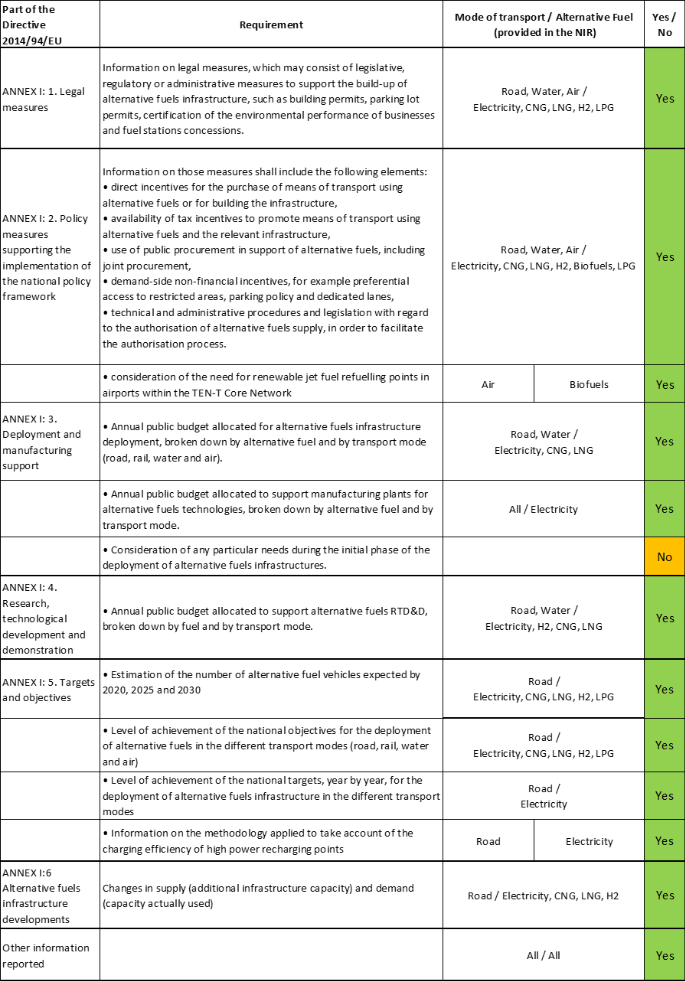

The checklist shows that most of the requirements of Annex I from the Directive are covered.

In several cases, the French NIR does not offer quantitative information on future AFI targets and AFV estimates for the years required by the Directive (2020, 2025 and 2030) but for different years, based on national strategies (2023 and 2028). In the case of AFV estimates, it only provided information on the natural gas vehicles (including both CNG and LNG vehicles in one category).

Regarding the combination of AF/AFV/AFI with transport mode, electricity and hydrogen are well covered for road transport, while natural gas (including biomethane), biofuels and LPG are partially covered for road transport; hydrogen is partially covered for rail transport; shore-side electricity supply and LNG are partially covered for waterborne transport; electricity supply for stationary airplanes is partially covered for air transport; all the other combinations are absent.

The French NIR reports around 55 measures. Under the Policy and Deployment & Manufacturing sections it was possible to identify 11 AF/transport mode clusters of measures, all assessable.

### Quantitative assessment: Vehicles and infrastructure

The French NIR mentions that the Clean Mobility Development Strategy 2 (*Stratégie de développement de la mobilité propre* 2 – SDMP2) proposal, appended to the Multiannual Energy Programme draft revision, will lay down the guidelines for the decarbonisation of transport and will set new objectives for 2023 and 2028. “*The SDMP2 chiefly clarifies scenarios of trends relating to vehicle fleets, the outlook in terms of increasing the number of recharging points to boost alternative fuels, changes in terms of transport’s consumption of the various energy sources and the proposed guidelines for each of the levers (decarbonisation of the fuel consumed by vehicles, vehicle energy efficiency, control of transport demand, modal shift, optimisation of vehicle use*). *The estimates presented in the reporting table on the fleet of vehicles using alternative fuels and the targets relating to the number of recharging and refuelling points are therefore based on the objectives of the SDMP2 proposal* ***which is still awaiting adoption****;**as yet these fleet deployment estimates are therefore not French commitments”.* Indeed, in order to carry out the assessment of the French NIR, these indicative targets have been considered, but in a conservative way, according to the following scheme: SDPM2 targets for 2023 are considered as 2025 targets in the NIR; SDPM2 targets for 2028 are considered as 2030 targets in the NIR.

*Table 5.10.3‑1 National AFV estimates and AFI targets established in the NIR at the horizon 2020, 2025 and 2030 and their comparison with the NPF situation*





(1) targets from the FR NPF; (2) at least the value indicated since this target refers to 2022; (3) natural gas (CNG+LNG) vehicles; (4) data from EAFO since the FR NIR did not provide this information; (5) at least the value indicated since this SDMP2 target refers to 2023; (6) at least the value indicated since this SDMP2 target refers to 2028; (7) data from “VIG'HY l'observatoire de l'hydrogène” (https://www.vighy-afhypac.org/) since the FR NIR did not provide this information.

#### Road transport

##### Electricity

###### Vehicles

France recorded 200,250 battery electric and plug-in hybrid electric vehicles in use in 2018 (see Table 5.10.3‑1), of which 160,000 (≈80%) were passenger cars, 39,600 LCVs, 100 HCV and 550 buses and coaches[33]. The French NIR also reports 24,000 PTWs in 2018. The French NIR EV’s estimates are 616,465 for 2020, 2,442,300 for 2025 and 6,929,700 for 2030[34]. They consist in a revised estimate for 2020 (35.78% lower than the NPF values), and new estimates for 2025 and 2030. The vast majority of the electric vehicles that France expects to see on the roads in 2030 will be passenger cars (6,200,000 out of which 4,100,000 BEVs), but 710,000 LCVs, 12,000 BEV HCVs, and 7,700 BEV buses and coaches are also foreseen.

The 2018 ***attainment*** of future EV estimates is 32.48% for 2020 and 2.89% for 2030. According to the assessment methodology described in Section 2.1, the 2018 situation corresponds to an ***adequate progress*** towards reaching the envisaged EV estimates. The calculated ***average*** ***annual growth rate*** corresponding to the period 2016-2030 for EV fleet evolution planned by France is equal to 34%.

###### Infrastructure

France recorded 24,800 publicly accessible recharging points in 2018 (Table 5.10.3‑1), corresponding to 9,566 normal power (≤22kW) recharging stations and to 855 high power (>22kW) recharging stations. The NIR also mentions that 225,000 private recharging points existed in France in 2018 according to the estimation of the public distribution system operator.

The FR NIR does not specifically provide targets for 2020/2025/2030. However, it states that, “*in 2018, the French government and manufacturers pledged to have 100,000 recharging points installed by the end of 2022.*” The NIR mentions that the density of recharging points is difficult to foresee because of several uncertainties (e.g. EV fleet numbers and composition (BEV and PHEV), geographical spread of EVs, access to private recharging points, vehicle range and driver behaviour) which prevent the setting of targets for 2025 and 2030. The FR NPF contained a target of 35,000 publicly accessible recharging points for 2020 and a 7,000,000 total target for private and publicly accessible recharging points for 2030.

The French NIR states that the existing recharging infrastructure network (10,421 stations in 2018 and 11,600 stations in 2019) provides a better geographic coverage than the one announced in the NPF for 2020, based on a scenario of 8,150 recharging stations.

The 2018 ***attainment*** of future publicly accessible recharging infrastructure target is 70.86% for 2020. According to the assessment methodology described in Section 2.1, the 2018 situation corresponds to an ***adequate progress*** towards reaching these envisaged targets. The calculated ***average annual growth rate*** corresponding to the period 2016-2025[35] for publicly accessible recharging infrastructure evolution planned by France is equal to 23%.

###### Ratio

Based on the French NIR, the following table shows the ratio between vehicles and publicly accessible recharging points (i.e. sufficiency index) for the pair electricity/road. For the past period 2016-2018, the ratios are inferior to the value of 10 and thus can be regarded as adequate. Instead, for 2020, the sufficiency index exceeds the recommended value and can be regarded as inadequate. For 2025 and 2030, the ratios could be not calculated because of the lack of AFI targets for these specific years.



Legend: *calculated using the AFI target value provided in the NPF

###### Information on charging efficiency

The French NIR states that the Corri-door network co-funded by CEF-T can be seen as representative in terms of the utilisation rate of high power (>22kW) recharging points. In 2018, the network of 200 high power recharging points recorded 40,000 recharges with an average duration of 32 minutes. Therefore, they recorded on average a charge time of 18 minutes per day with 0.55 recharges per day (one recharge every 1.825 days).

##### CNG

###### Vehicles

The French NIR does not differentiate between CNG and LNG vehicles, presenting data for natural gas vehicles. For the period 2016-2018, the French NIR only provides the situation for 2017: 12,150 natural gas vehicles in use, out of which 8,200 were LCVs, 1,350 HCVs and 2,600 buses and coaches. According to EAFO, there were 15,306 natural gas vehicles in 2018 in France. In contrast to the NPF, which did not contain natural gas vehicle estimates, the FR NIR presents all the required estimates for the next decade: 11,600 for 2020, 97,800 for 2025 and 207,700 for 2030. The foreseen composition of the natural gas fleet in 2030 is 129,000 LCVs, 70,000 HCVs and 8,700 buses and coaches.

The 2018 ***attainment*** of future natural gas vehicles estimates is 131.95% for 2020 and 7.37% for 2030. According to the assessment methodology described in Section 2.1, the 2018 situation corresponds to a ***slow progress*** towards reaching the envisaged natural gas vehicles estimates. The calculated ***average annual growth rate*** corresponding to the period 2016-2030 for the natural gas vehicle fleet evolution planned by France is equal to 26%.

###### Infrastructure

For the period 2016-2018, the French NIR does not provide numerical information on the existing CNG infrastructure[36]. According to EAFO, there were 61 CNG refuelling points in France at the end of 2018. As targets for the next decade, the FR NIR mentions only the SDMP2 proposal targets that represent the number of stations needed to supply the projected vehicle numbers. Thus, it is stated that France will require at least 121 CNG stations by 2023 and 285 by 2028. Therefore, this assessment considers as conservative target for 2025 at least 121 CNG stations and at least 285 CNG stations for 2030. The FR NPF contained targets of 79 CNG refuelling stations for 2020 and of 116 for 2025. The new considered NIR target for 2025 represents a slight increase of 4.31% compared to the NPF.

The 2018 ***attainment*** of future public CNG refuelling infrastructure targets is 77.22% for 2020 and 21.4% for 2030. According to the assessment methodology described in Section 2.1, the 2018 situation corresponds to an ***adequate progress*** towards reaching these envisaged targets. The calculated ***average annual growth rate*** corresponding to the period 2016-2030 for publicly accessible CNG refuelling infrastructure evolution planned by France is equal to 14%.

###### Ratio

The ratio between vehicles and publicly accessible refuelling points (i.e. sufficiency index) for the pair CNG/road cannot be computed since the FR NIR provided only information on natural gas vehicles (CNG+LNG).

##### LNG

###### Vehicles

No available data since the LNG vehicles are not discriminated from natural gas vehicles (see Section 5.10.3.1.2).

###### Infrastructure

For the period 2016-2018, the French NIR does not provide numerical information on the existing LNG infrastructure[37]. According to EAFO, there were 20 LNG refuelling points in France at the end of 2018. As targets for the next decade, the FR NIR mentions only the SDMP2 proposal LNG infrastructure targets that represent the number of stations needed to supply the projected vehicle numbers. Thus, it is stated that France will require at least 17 LNG stations by 2023 and 41 by 2028. The FR NPF contained a target of 25 LNG refuelling stations for 2025. This assessment considers as conservative target for 2030 at least 41 LNG refuelling stations since this value was indicated by SDMP2 for 2028.

The 2018 ***attainment*** of future public LNG refuelling infrastructure targets is 80% for 2025 and 48.78% for 2030. According to the assessment methodology described in Section 2.1, the progress obtained by France from 2016 until 2018 for public LNG refuelling infrastructure deployment is 47.5% of the overall planned deployment during the period 2016-2030.

###### Ratio

The ratio between vehicles and publicly accessible refuelling points (i.e. sufficiency index) for the pair LNG/road cannot be computed since the FR NIR provided only information on natural gas vehicles (CNG+LNG).

##### Hydrogen

The FR NIR mentions that the French government adopted the Energy Transition Hydrogen Deployment Plan (*Plan de déploiement de l’hydrogène pour la transition énergétique*) in 2018 which is setting objectives for the deployment of vehicles and refuelling infrastructure that will be appended to the SDMP2 when it is adopted. In this assessment, the objectives from this plan are therefore considered.

###### Vehicles

According to EAFO, there were 351 hydrogen-powered vehicles in use in France at the end of 2018 (77 passenger cars and 274 LCVs). The French NIR only indicates that around 100 hydrogen-powered passenger cars were in use in 2018, while the information for the other vehicles categories is missing. The FR NIR provides estimates of 235 vehicles (220 LCVs, 15 HDVs[38]) by 2020 and 9,050 vehicles (8,700 LCVs, 350 HDVs) by 2025 while the FR NPF had not included any estimate.

The 2018 ***attainment*** of future hydrogen vehicles estimates is above 100% for 2020 and 3.88% for 2030. According to the assessment methodology described in Section 2.1, the ***progress*** obtained by France for hydrogen vehicles deployment from 2016 until 2018 versus the period 2016-2030 could not be computed because the 2030 estimate is absent.

###### Infrastructure

For the period 2016-2018, the French NIR does not provide numerical information on the existing hydrogen refuelling infrastructure[39]. According to “VIG'HY l'observatoire de l'hydrogène”[40], there were 20 public hydrogen refuelling points in France at the end of 2018. As targets for the next decade, the FR NIR mentions only the total[41] hydrogen infrastructure targets from the hydrogen plan: 100 hydrogen stations by 2023 and 400 by 2028. This assessment considers as conservative target for 2025 at least 100 stations and at least 400 stations for 2030. The FR NPF contained a target of 30 hydrogen refuelling stations for 2025, and therefore the new considered target represents a significant increase of 233%.

The 2018 ***attainment*** of future hydrogen refuelling infrastructure targets is 20% for 2025 and 5% for 2030. According to the assessment methodology described in Section 2.1, the ***progress*** obtained by France from 2016 until 2030 for hydrogen refuelling infrastructure deployment is 2.31% of the overall planned deployment during the period 2016-2030.

###### Ratio

Based on the FR NIR and the assumptions described above, the following table shows the ratio between vehicles and refuelling points (i.e. sufficiency index) for the pair hydrogen/road.



Legend: * calculated using values provided in the NPF; ** calculated using values from EAFO and “VIG'HY l'observatoire de l'hydrogène” website (<https://www.vighy-afhypac.org/>); *** calculated using AFI targets provided by the Energy Transition Hydrogen Deployment Plan for 2023.

##### Biofuels

###### Vehicles

Information is not available in the FR NIR.

###### Infrastructure

Information is not available in the FR NIR.

##### LPG

###### Vehicles

For 2018, the French NIR does not provide quantitative information on the LPG fleet in use[42]. According to EAFO, France recorded 156,323 LPG vehicles in use in 2018, of which 142,105 were passenger cars and 14,218 LCVs. The French NIR considers that in the next decade the situation will remain constant and provides an estimate of 150,000 vehicles (all passenger cars) for the whole period (Table 5.10.3‑1).

Because the French NIR provided decreasing estimates for LPG vehicles, the 2018 ***attainment*** and ***progress*** have not been computed.

###### Infrastructure

For the period 2016-2018, the French NIR provides the same value stating that LPG is sold in almost 1,700 refuelling stations. The NIR considers that “*LPG is the alternative fuel that currently has the densest coverage in terms of stations, which are capable of supplying 10 times more vehicles than the current vehicle fleet*”.

Because the French NIR did not provide targets for publicly accessible LPG refuelling infrastructure, the 2018 ***attainment*** and ***progress*** could not be computed.

###### Ratio

Based on the FR NIR, NPF and EAFO, the following table shows the ratio between vehicles and publicly accessible refuelling points (i.e. sufficiency index) for the pair LPG/road. The sufficiency index for 2020, 2025 and 2030 could not be computed as the targets of infrastructure were not indicated.



Legend: * calculated using AFV values provided in the NPF; ** calculated using AFV values from EAFO

#### Rail transport

##### Electricity

Information is not available in the French NIR.

##### Hydrogen

The French NIR mentions as an AFI deployment measure the plans of SNCF (Société Nationale des Chemins de fer Français) to bring 15 regional hydrogen-powered trains into service on non-electrified lines that are currently covered by diesel trains. This alternative is considered less costly than electrification work and the first trains should come into service in 2022. It is mentioned that the regions will be involved in financing these trains and the State could support the project through the Hydrogen Plan.

#### Waterborne transport (maritime)

##### Electricity

###### Vessels

Information is not available in the French NIR.

###### Infrastructure

No quantitative information aggregated at national level regarding the shore-side electricity supply points in the maritime ports is provided in the FR NIR. The French NPF contained data on the 2016 situation and a list of additional targeted ports to provide SSE supply in the future. However, the French NIR noted that the port of Marseille has three existing supply points for five ferries operating between Corsica and the French mainland. For the future, it is mentioned that the South region recently announced its new ‘zero-fume stopovers’ electrification scheme, which should result in all ferry quays being connected by 2023 and the installation of a SSE supply for cruise ships in Marseille port by 2025. The FR NIR presents as well the intention of Dunkirk’s Grand Port Maritime to equip its container terminal with an 8 MW SSE supply point by the end of 2019 that should be able to cater for 7 vessels initially; depending on the needs’ evolution 2 additional supply points could be installed.

##### LNG

###### Vessels

Similarly to the NPF, information is not available in the French NIR.

###### Infrastructure

The FR NIR presents only information on the current situation without providing details regarding future targets. It mentions that all ports with LNG tanker terminals (Marseille-Fos, Dunkirk, and Nantes-Saint Nazaire) and the port of Le Havre (not having a terminal) currently offer LNG bunkering services by truck. The FR NPF had included a target of seven ports to provide LNG refuelling services by 2025.

The 2018 ***attainment*** of future LNG refuelling infrastructure targets in maritime ports is 57.14% for 2025. According to the assessment methodology described in Section 2.1, the ***progress*** obtained by France for LNG refuelling infrastructure deployment in maritime ports from 2016 until 2018 versus the period 2016-2030 could not be computed because of the lack of the 2030 target.

#### Waterborne transport (inland)

##### Electricity

###### Vessels

Information is not available in the French NIR.

###### Infrastructure

The FR NIR does not provide quantitative targets aggregated at national level regarding the shore-side electricity supply points in the inland ports. The French NPF contained data on the 2016 situation and a list of additional targeted inland ports to provide SSE supply by 2025. However, the French NIR notes that some waterways not included in the NPF targets offer or are installing SSE supply points. Vienne and Arles (on Rhône river) are provided as examples, having two high-power and seven medium-power SSE supply points. In total, the NIR mentions that the French inland waterway network had at least 110 SSE supply points for inland waterway vessels in 2019 (including 17 around the Seine basin and 91 in the Nord-Pas-de-Calais region). Investments are mentioned for the Seine basin for installing nine SSE supply points, each accommodating two vessels.

##### LNG

In contrast to the FR NPF that had provided a target of three inland ports to offer LNG refuelling supply in 2030, the FR NIR does not include any information on this topic.

#### Air transport

##### Electricity

###### Airplanes

Information is not available in the French NIR.

###### Infrastructure (for stationary airplanes)

No specific quantitative information was provided in the FR NIR on the electricity supply points in airports for stationary airplanes. The NIR mentions that 11 main airports in France have pledged to reduce their fossil fuel consumption; their plans are expected to result in a 20% cut in emissions from aircraft on the ground by 2025 compared to the 2010 reference year. These 11 airports have included objectives on the electrification of aircraft stands in their action plans according to the FR NIR.

##### Biofuels

The FR NIR mentions that a roadmap setting out the government’s aims in terms of deployment of biofuels for aviation is under preparation by several working groups including several stakeholders. Sustainable aviation fuels will be deployed in France by adding them to conventional fuels, with targets of 5% by 2030 and 50% by 2050.

###### Airplanes

No information on flights / airplanes powered by biofuels is provided in the French NIR.

###### Infrastructure

The FR NIR mentions that “*as aviation biofuels are ‘drop-in’ (i.e. fully miscible with fossil fuels), their distribution at airport hubs will use existing logistics in order to limit their costs and carbon footprint*”. As a next step, a demonstration project involving the use of pipelines to supply biofuels to airports is indicated.

### Measures assessment

Similarly to the NPF, a large portfolio of measures for the deployment of alternative fuels in transport is mentioned in the French NIR. The measures presented in the NIR cover a wide variety of types, several alternative fuels and all transport modes (with a focus on road). The policy direction in France is to encourage the move away from fossil fuelled vehicles to AFV (especially zero-emission mobility) and the following documents support the development of alternative fuels strategy:

* the National Low-Carbon Strategy (*Stratégie Nationale Bas-Carbone* – SNBC) setting the strategic guidelines for implementing the transition to a low-carbon and sustainable economy
* the Multiannual Energy Plan (*Programmation pluriannuelle de l’énergie* – PPE), the strategic document for French energy policy, establishing two main priorities: reducing energy consumption, particularly of fossil fuels, and developing renewable energy. In the transport sector, „*the PPE draft revision (PPE2) will set targets for reducing energy consumption and developing electric or plug-in hybrid electric vehicles and for the development of biogas and hydrogen”*.
* the Clean Mobility Development Strategy (*Stratégie de développement de la mobilité propre* – SDMP), appended to the Multiannual Energy Programme, laying down the guidelines for the decarbonisation of transport. The SDMP2 proposal[43] appended to the PPE draft revision (PPE2) is setting new objectives for 2023 and 2028 (the first SDMP set objectives for 2016-2018).
* The Mobility Framework Act (*Loi d’Orientation des Mobilités* – LOM[44]), providing a set of support measures for the development of the least polluting transport modes and promoting the transition to clean vehicles.

#### Legal measures

The French NIR mentions 23 legal measures, of which 13 in place (where 10 represent the continuation of measures presented in the NPF) and 10 in process of adoption. This fact highlights that the legal framework for alternative fuels is changing and improving in order to speed up the deployment of the related vehicles and infrastructure. The overall level of ambition of the legal measure set is clearly increased in the NIR compared to the NPF. The majority of legal measures refers specifically to infrastructure, and the most numerous cluster is electricity/road that contains 14 measures. Other pairs that include dedicated legal measures are hydrogen/road, electricity/water (maritime+inland), LNG/water (maritime+inland) and electricity/air. Considering all the legal measures, they appear, if fully implemented, to be fit to support the realisation of the AFV/AFI objectives as described in the NPF and NIR.

##### Legislative & Regulatory

There are 18 Legislative & Regulatory measures listed and described in detail in the French NIR. Eight of them are in place representing extensions of those described in the NPF, and two among these were amended in the last period. These eight measures notified in NPF were based mainly on measures derived from the Law No 2015-992 (Act on the Energy Transition for Green Growth, *Loi relative à la transition énergétique pour la croissance verte* – LTECV). The remaining ten measures in the process of adoption are the expression of the intention to overhaul the French legal framework and are based on the provisions of the Mobility Framework Act (*Loi d’Orientation des Mobilités* – LOM) that contains a “*set of support measures for the development of the least polluting transport modes and promotes the transition to clean vehicles*”. The LOM is aimed at supporting alternative transport systems and fuels: it schedules numerous support measures for the deployment of alternative fuels, by extending or widening existing schemes (e.g. the change of Restricted Traffic Areas to Low-Emission Zones, the strengthening of the right to install recharging points) or by creating new ones based on lessons learned (e.g. reservation of spaces for electric boats in marinas from 2022, authorisation of the reservation of lanes and parking spaces for ultra-low emission vehicles). It also transposes several EU Directives that pave the way for the market entry of alternative fuels vehicles (e.g. AFI Directive, Clean Vehicle Directive, Energy Performance of Buildings Directive). The LOM also sets decarbonisation targets for the land transport sector aiming at full decarbonisation in 2050 and at banning the sale of new fossil fuel passenger cars and LCVs from 2040.

##### Administrative

The French NIR presents five administrative measures, all in place in 2019. Three measures are continuations of NPF measures. The transport modes covered by these measures are road, water-inland and air. Four measures regard electricity as alternative fuel and infrastructure (e.g. setting the conditions for organising the public recharging service at service areas on the concessionary motorway network, specifications relating to the shore-side connection of inland waterway vessels, regulations on the use of means to supply aircraft with power and air-conditioning/heating during stopovers at the aerodromes of Paris-Charles-de-Gaulle, Paris-Orly and Paris-Le Bourget). The decree on air quality certificates is also listed as an administrative measure, with the purpose of the certificates being described as allowing users of the least polluting vehicles to enjoy traffic benefits.

#### Policy measures

The significant FR NIR policy measure portfolio proves the high level French involvement in fostering alternative fuels in transport that is continuously improving in the last years. The French NIR reports 18 measures for ensuring national objectives, 2 for public transport and 2 for private recharging infrastructure. The majority of these measures represent financial incentives addressing electricity and hydrogen, and were in place in 2019. Eleven measures appear only in the NIR; of the remaining 11 measures, which are common to the NIR and NPF, 7 were improved in the NIR, therefore the overall level of ambition increased.

##### Measures to ensure national targets and objectives

###### Road transport

The FR NIR comprises a set of 14 policy measures meant to support the achievement of the French AF objectives related to road transport (5 measures appear only in the NIR, 9 are common to the NIR and NPF). They cover all aspects of alternative fuels deployment: AF, AFV and AFI. The majority (12) is represented by financial incentives (sometimes with different conditions depending on the AF).

Within the financial measures in place, the French NIR includes:

* purchase subsidies – bonus (in place since 2008) - in 2018, grants of €6,000 (maximum 27% of the vehicle price) for the individuals or legal persons purchasing a new zero emission passenger car or LCV (previously PHEV were covered), other allowances existing for some M2, N2 or L-category vehicles and for electric bicycles. A plan of limiting the subsidy only to vehicle with a price inferior to a threshold is mentioned for 2020.
* scrappage scheme (in place since 2015 and set to continue at least until 2022) - payment of an allowance for purchasing a new or used passenger car or LCV (or an electric 2‑ or 3‑wheel vehicle or quadricycle that does not use lead batteries) if this is accompanied by the removal from circulation of a diesel passenger car or LCV registered before 2001 or a petrol passenger car or LCV registered before 1997. The allowance scale ranges from €1,500 to €5,000 depending on the emissions of the replacement vehicle and the household’s income.
* tax related incentives
  + tax on the registration of the most polluting vehicles (malus) - staggered additional tax that depends on the amount by which vehicles exceed an emission threshold that regularly changes to take account of developments in the market for passenger cars and LCVs and in the decarbonisation targets of this segment
  + accelerated depreciation for HCVs using natural gas, ethanol, electricity or hydrogen
  + increase in the depreciation ceiling for low-emission passenger cars (emitting less than 60 gCO2/km)
  + company vehicle tax reduction (since 2016) – calculated based on the value of CO2 emissions and air pollutant emissions
  + regional taxes on registration certificates – some regions provide an exemption (50% or 100%) to low-emissions vehicles powered by CNG, LPG, electricity and E85
  + benefit in kind – 50% reduction (with a maximum of €1,800 per year) for electric vehicles

Two other types of measures reported in the FR NIR regard a free parking incentive (green disk) for AFV in place since 2008 and the launch of an educational information website on EVs[45] in 2019.

###### Waterborne transport

Two foreseen financial measures refer to waterborne transport:

* accelerated depreciation for vessels using LNG
* application of a preferential rate of domestic final electricity consumption tax to increase the attractiveness of shore-side connections.

##### Measures that can promote AFI in public transport services

###### Buses

The French NIR lists two measures promoting electricity in public transport services:

* the Moebus programme that aims to support the purchase of electric buses and the installation of dedicated recharging points
* the partial coverage of the costs of connecting recharging points intended for public transport vehicles (existing but planned to improve with the new LOM law).

##### Measures that can promote the deployment of private electro-mobility infrastructure

The FR NIR lists two existing measures to promote private recharging infrastructure:

* energy transition tax credit for the deployment of recharging points in private homes covering 30% of the cost of one home recharging point, excluding installation costs (planned to evolve in 2020 with the introduction of a fixed amount subsidy of €300 per recharging point)
* the programme of Aid for the Development of Electric Vehicles through New Recharging Infrastructure (Aide au Développement du Véhicule Électrique grâce à de Nouvelles Infrastructures de Recharge – ADVENIR), launched in 2016 and supported by the system of energy savings certificates through which France funds part of the energy transition. Its aim is to facilitate the installation and partial financing of new intelligent recharging points outside public roads and multi-family buildings (mainly within the multi-family buildings and public enterprises and institutions).
  + The first phase of the programme had a target of 12,000 recharging points being installed before the end of 2018 and the aid for the purchase of the point and its installation amounted to 50% of the cost for individuals and 40% for enterprises, with a variable ceiling between €600 and €1,500, plus €360 in the case of an energy management device being also installed.
  + A new phase was launched in 2019, extending the programme to on-road publicly accessible recharging points with ceilings between €600 and €1,860. In addition, a new scheme will fund 50% of the cost of installing a collective recharging infrastructure in the car parks of the first 3,000 jointly-owned properties that submit an application. The funding will be directed to encourage the establishment of bidirectional recharging points and on-demand programmes (recharging points installed as part of an on-demand programme will receive a bonus of €300).

#### Deployment and manufacturing support

##### AFI deployment

The French NIR presents eight measures fostering AFI: one in place in the period 2016-2018, four existing in 2019 and three in process of adoption. They cover electricity, natural gas including biomethane, and hydrogen.

Five measures represent calls for projects supporting the deployment of infrastructure for road transport:

* electricity – two calls “Vehicles and Transport of the Future” (funding 21,241 recharging points through estimated subsidies of 64.7 million € between 2013 and 2017) and “Recharging infrastructure in non-interconnected areas” (in 2019, funding 13 projects with 3.3 million €) within the “Investing for the Future” programme
* natural gas – two calls “Integrated natural gas mobility solutions” (8 projects submitted in 2017 involving over 381 million € of investment, including 30 million € paid by the State, to install 100 stations on the TEN‑T network and to purchase 2,100 HCVs between 2018 and 2022) and “Natural gas and biogas in white areas” (funding the installation of 19 stations and the purchase of 470 vehicles with an estimated support paid of 4.2 million €)
* hydrogen – “Hydrogen mobility ecosystems” call launched in 2019 (funding 11 projects with 35.5 million € to develop ecosystems bringing together renewable hydrogen production, distribution and use for the purpose of mobility in a given territory; opening of 35 stations is expected; a second phase is expected in 2020).

Another mentioned measure refers to the deployment of 15 regional hydrogen-powered trains on non-electrified lines that are currently covered by diesel trains, with the first trains expected to come into service in 2022.

Regarding waterborne maritime transport, the “Zero Fumes Stopover” plan announced by the southern region aims, in the medium term, to drastically reduce GHG and pollutant emissions from vessels moored in the ports of Marseille, Nice and Toulon. The metropolitan areas of Toulon and Marseille have already announced a target for the electrification of all docks by 2023. The plan should also allow the installation of a power supply for cruise ships in Marseille by 2025. In the port of Nice, the plan will support the purchase of power supply equipment using fuel cells. The committed regional budget of 30 million € is expected to be topped up by the State, the “Investing for the Future” programme managed by ADEME and European funds.

##### Support of manufacturing plants for AF technologies

The French NIR noted the participation in the European Battery Alliance which is a programme of research, development and industrialisation of fourth generation rechargeable lithium electrochemical cells and batteries built around those cells. In February 2019, 700 million € of State aid were announced to be released for the launch of the programme.

##### Consideration of any particular needs during the initial phase of the deployment of alternative fuels infrastructures

Information is not available in the French NIR.

#### Quantitative assessment of Policy and Deployment & Manufacturing measures

Table 5.10.4‑1 presents an analysis of all the Policy and Deployment & Manufacturing measures, carried out according to the assessment methodology described in Section 2.2. Among the clusters of measures identified in the French NIR, six clusters contain dedicated measures (electricity/road, CNG/road, LNG /road[46], LNG/water-inland, hydrogen/road and hydrogen/rail) while the other five contain general measures addressing combinations of several alternative fuels. For all remaining pairs of AF and transport mode, there are either no measures or the pair is not applicable to France.

*Table 5.10.4‑1 Quantitative assessment of Policy and Deployment & Manufacturing support measures*

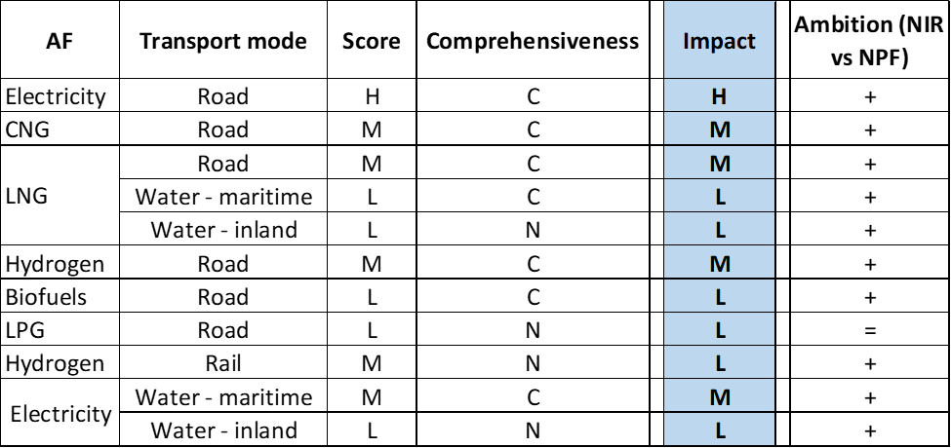

**Legend:** Score and Impact: H = high; M = medium; L = low; X = not assessable. Comprehensiveness: C = comprehensive; N = Not comprehensive. Ambition level: ‘+’ means ‘higher’; ‘=’ means ‘comparable’; ‘-‘ means ‘lower’.

In line with the overall focus in promoting zero-emission mobility reported in the NIR for the recent years, the most numerous cluster is the electricity/road followed by hydrogen/road. The electricity/road cluster contains a comprehensive set of 23 NIR measures, displaying a high overall score and showing an increased level of ambition compared with the NPF. This cluster contains several measures assuring subsidies and tax reductions/exemptions for electric vehicles (especially BEVs) and a significant support for the deployment of recharging points (public and private) with the majority of them improving compared with the NPF situation. The hydrogen/road cluster is formed by a comprehensive set of 13 NIR measures, displaying a medium overall score and showing an increased level of ambition compared with the NPF. The newly introduced measures originate in the 2018 Energy Transition Hydrogen Deployment plan.

In terms of expected impact of these measures to support the realisation of the AFV/AFI objectives as presented in the NPF and revised in the NIR, in some cases, the partial or total lack of future targets and estimates is making difficult putting this assessment into perspective. Based on a comparative analysis with the measures presented in the other NIRs, it seems reasonable to assume that the pairs electricity/road should have a high impact, the measures for the pairs CNG/road, LNG /road, hydrogen/road and electricity/water-maritime should have a medium impact, all the other pairs should have a low impact. Compared to the NPF, the level of ambition of the Policy and Deployment & Manufacturing support measures has increased for all identified pairs with the exception of LPG/road.

#### Research, Technological Development & Demonstration

This section contains three measures related to the “Investing for the Future programme”.

The first measure presents the Phases I & II of the programme concerning “Vehicles and Transport of the Future” and contributed with several tens of millions of euro to the funding between 2011 and 2017 of various innovative projects aiming to launch products on the market in the short term.

The other two measures are related to the Phase III of the programme.

* The “Transport and Sustainable Mobility” section aims to support projects developed by enterprises based in the national territory and deploying technologies resulting from the work of public research laboratories on several priorities, among which “Cleaner and more efficient vehicles” and “Maritime and inland waterway transport”.
* Innovation competition enabling repayable advances and subsidies of 1.7 million € to be granted to various innovative projects proposed by several SMEs ad start-ups engaged in developing innovative prototypes, in particular in the field of transport and sustainable mobility. Some of these innovations directly involve alternative fuels, such as rectification blocks for charging batteries, heat exchangers for cooling batteries and small hydrogen stations, magnetic charging systems or foils for electric boats.

### Additional information on alternative fuels infrastructure developments

The French NIR contains some information on the changes in fuels use in the transport sector (see Table 5.10.5‑1). Electricity and natural gas are foreseen to increase progressively in percentage use during the next decade while LPG present an almost constant trend. No data were provided for the waterborne transport mode.

*Table 5.10.5‑1 Changes in fuel use in transport sector (2016-2030)*



### Summary of the assessment

**Tabular overview**

*Table 5.10.6‑1 Overview of the NIR assessment*

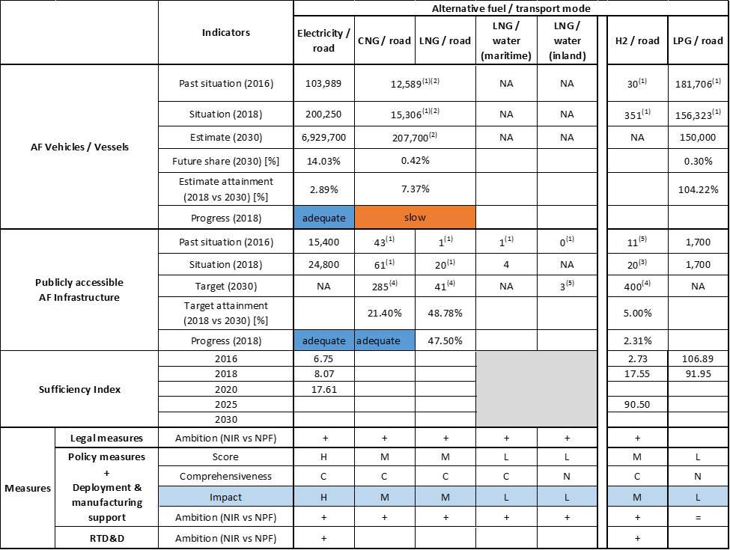



(1) data from EAFO since the FR NIR did not provide this information; (2) natural gas (CNG+LNG) vehicles; (3) data from “VIG'HY l'observatoire de l'hydrogène” (https://www.vighy-afhypac.org/) since the FR NIR did not provide this information; (4) at least the value indicated since this SDMP2 target refers to 2028; (5) targets from the FR NPF.

The checklist shows that most of the requirements of Annex I from the Directive are covered by the French NIR. However, the quantitative information provided on future AFI and AFV objectives is not adequate in several cases: either lacking or provided for different years than the years required by the Directive (2020, 2025 and 2030), or provided for merged sets of alternative fuels (CNG and LNG treated in common as natural gas).

Regarding the combination of AF/AFV/AFI with transport mode, electricity and hydrogen are well covered, while natural gas (including biomethane), biofuels and LPG are partially covered for road transport; hydrogen is partially covered for rail transport; shore-side electricity supply and LNG are partially covered for waterborne transport; electricity supply for stationary airplanes is partially covered for air transport; all the other combinations are absent.

The main outcomes of the technical assessment of the French NIR on vehicles/vessels estimates and infrastructure targets can be summarised as follows:

###### Road transport

* **Electricity** – France recorded a total of 200,250 electric vehicles and 24,800 publicly accessible recharging points in 2018. Compared to the NPF, the FR NIR presents a lower estimate for 2020 (-35.78%) but provides new estimates for 2025 and 2030. The situation foreseen in 2030 is of 6,929,700 EVs in use (of which 6,200,000 passenger cars, 710,000 LCVs, 12,000 HCVs and 7,700 buses and coaches). Instead, the FR NIR does not specifically provide infrastructure targets for 2020/2025/2030 but mentions a 2022 target set by the national government of 100,000 recharging points. The NPF had mentioned the target of 35,000 recharging points. The progress in 2018, calculated according to the assessment technology described in Section 2.1, is adequate both for EVs and recharging infrastructure. The ratio AFV to publicly accessible AFI is adequate for the period 2016-2018 but is foreseen to increase above 10 in 2020, becoming thus inadequate.
* **CNG** – Similarly to the NPF, the French NIR does not differentiate between CNG and LNG vehicles, presenting data for natural gas vehicles. According to EAFO, there were 15,306 natural gas vehicles in 2018 in France. In contrast to the NPF where natural gas vehicle estimates were absent, the FR NIR presents all the required vehicle estimates for the next decade: 11,600 for 2020, 97,800 for 2025 and 207,700 for 2030. The foreseen composition of the natural gas fleet in 2030 is 129,000 LCVs, 70,000 HCVs and 8,700 buses and coaches. The 2018 progress towards reaching the envisaged natural gas vehicle estimates results to be slow. According to EAFO, there were 61 CNG refuelling points in France at the end of 2018. As targets for the next decade, the FR NIR mentions only the Clean Mobility Development Strategy 2 proposal’s targets (at least 121 CNG stations by 2023 and 285 by 2028). The FR NPF contained targets of 79 CNG refuelling stations for 2020 and of 116 for 2025. The 2018 progress towards reaching the envisaged CNG refuelling infrastructure targets results to be adequate. The sufficiency index for the CNG/road pair cannot be computed since the FR NIR provides only information on natural gas vehicles (CNG+LNG).
* **LNG** – Similarly to the NPF, the French NIR does not differentiate between CNG and LNG vehicles, presenting data for natural gas vehicles. According to EAFO, there were 20 LNG refuelling points in France at the end of 2018. As targets for the next decade, the FR NIR mentions only the Clean Mobility Development Strategy proposal’s LNG infrastructure targets (at least 17 LNG stations by 2023 and 41 by 2028). The FR NPF contained a target of 25 LNG refuelling stations for 2025.
* **Hydrogen** – According to EAFO, there were 351 hydrogen-powered vehicles in use in France at the end of 2018. The FR NIR provides estimates of 235 vehicles (220 LCVs, 15 HDVs) by 2020 and 9,050 vehicles (8,700 LCVs, 350 HDVs) by 2025 while the FR NPF did not include any estimates. According to “VIG'HY l'observatoire de l'hydrogène”[47], there were 20 public hydrogen refuelling points in France at the end of 2018. As targets for the next decade, the FR NIR mentions only the total[48] hydrogen infrastructure targets from the Energy Transition Hydrogen Deployment Plan: 100 hydrogen stations by 2023 and 400 by 2028. The foreseen evolution represents a significant increase compared to the FR NPF target of 30 hydrogen refuelling stations for 2025.
* **Biofuels** – Information is not available in the FR NIR.
* **LPG** – According to EAFO, France recorded 156,323 LPG vehicles in use in 2018. The French NIR considers that in the next decade the situation will remain constant, estimating 150,000 vehicles (all passenger cars) to be in use. Regarding infrastructure, the French NIR provides the same value for the period 2016-2018 stating that LPG is sold in almost 1,700 refuelling stations. The NIR mentions that the current number of LPG refuelling points is capable of supplying 10 times more vehicles than the existing fleet.

###### Rail transport

* **Electricity** - Information is not available in the French NIR.
* **Hydrogen** - Through the Hydrogen Plan, the State will support the regions in funding the deployment of 15 hydrogen-powered trains foreseen to replace diesel trains functioning on non-electrified lines. This alternative is considered less costly than electrification work and the first trains should come into service in 2022.

###### Waterborne transport (maritime)

* **Electricity** - The French NIR notes that the port of Marseille has three existing supply points for five ferries operating between Corsica and the French mainland. For the future, a few projects are mentioned, like the South region’s recent ‘zero-fume stopovers’ electrification scheme for all ferry quays by 2023 and for a supply for cruise ships in Marseille port by 2025, as well as the intention of Dunkirk’s Grand Port Maritime to equip its container terminal with an 8 MW SSE supply point by the end of 2019 (to be supplemented by 2 other supply points if needed).
* **LNG** - Similarly to the NPF, no information is provided in the French NIR regarding LNG seagoing ships. As for LNG supply in the maritime ports, the FR NIR presents only information on the current situation without providing details on future targets. It mentions that all ports with LNG tanker terminals (Marseille-Fos, Dunkirk, and Nantes-Saint Nazaire) and the port of Le Havre (not having a terminal) currently offer LNG bunkering services by truck. The FR NPF had included a target of seven ports to provide LNG refuelling services by 2025.

###### Waterborne transport (inland)

* **Electricity** - The French NIR notes that some waterways, not included in the NPF targets, now offer or are installing SSE supply points. Vienne and Arles (on Rhône river) are provided as examples, having two high-power and seven medium-power SSE supply points. The French inland waterway network had at least 110 SSE supply points in 2019 (including 17 around the Seine basin and 91 in the Nord-Pas-de-Calais region). For the future, investments are foreseen for the Seine basin for installing nine SSE supply points, each accommodating two vessels.
* **LNG** - The FR NIR does not include any information on LNG refuelling supply while the FR NPF had provided a target of three inland ports offering LNG by 2030.

###### Air transport

* **Electricity** - The NIR only mentions that 11 main airports in France have pledged to reduce their fossil fuel consumption and that a 20% cut in emissions from aircraft on the ground by 2025 compared to the 2010 reference year is expected.
* **Biofuels** -The FR NIR mentions that a roadmap for the deployment of biofuels for aviation is under preparation. Sustainable aviation fuels will be deployed in France by adding them to conventional fuels, with targets of 5% by 2030 and 50% by 2050. As aviation biofuels are ‘drop-in’, their distribution at airport hubs will use existing logistics in order to limit their costs and carbon footprint.

Regarding the **measures**, the French NIR, similarly to the NPF, reports a solid policy package, consisting in 57 measures. The great majority of measures expresses an increase of ambition compared to the NPF, focusing more on zero-emission mobility. They cover a wide variety of types, several alternative fuels and all transport modes (with a focus on road).

The legal framework for alternative fuels is changing and improving in order to speed up the deployment of the related vehicles and infrastructure. The majority of legal measures refers specifically to infrastructure, and the most numerous cluster is electricity/road. Considering all the legal measures, they appear, if fully implemented, to be fit to support the realisation of the AFV/AFI objectives as described in the NPF and revised in the NIR.

As for the Policy and Deployment & Manufacturing support measures, they cover all aspects of alternative fuels deployment: AF, AFV and AFI. The majority of the policy measures represent financial incentives (e.g. purchase incentives, scrappage scheme, different tax related incentives) and are in place in 2019. In line with the overall focus in promoting zero-emission mobility reported in the NIR for the recent years, the most numerous clusters are the electricity/road and hydrogen/road. The electricity/road cluster contains a comprehensive set of 23 NIR measures, displaying a high overall score and showing an increased level of ambition compared with the NPF. The hydrogen/road cluster is formed by a comprehensive set of 13 NIR measures, displaying a medium overall score and showing an increased level of ambition compared with the NPF. The newly introduced measures originate in the 2018 Energy Transition Hydrogen Deployment plan. In terms of expected impact of the Policy and Deployment & Manufacturing measures to support the realisation of the AFV/AFI objectives as presented in the NPF and revised in the NIR, the measures for the pairs electricity/road results to have a high impact, the measures for the pairs CNG/road, LNG /road, hydrogen/road and electricity/water-maritime result to have a medium impact and all the other pairs result to have a low impact. Compared to the NPF, the level of ambition of the Policy and Deployment & Manufacturing support measures has increased for all identified pairs with the exception of LPG/road.

The Research, Technological Development & Demonstration section contains general information on three main initiatives all being part of the “Investing for the Future programme”: the “Vehicles and Transport of the Future” phase, the “Transport and Sustainable Mobility” section and an innovation competition for prototypes.

### Final remarks

The French NIR provides a comprehensive report on the efforts to implement the Directive. The NIR is largely in line with the provisions of Annex I to the Directive. However, due a lack of some data this assessment draws on information taken from the French Clean Mobility Development Strategy for 2023 and 2028 targets. Moreover, the French NIR only estimates the number of nature gas vehicles, without distinguishing between CNG and LNG. Some clarifications on the numerical data provided in the NIR will be relevant. A significant number of measures are being implemented in France to promote alternative fuels in all transport mode, but with a special focus on electro-mobility. Further detail on measures promoting fuels uptake in other modes of transport would be beneficial.

With regard to electricity, the NIR estimates that approximately 6,930,000 electric vehicles could be on the roads by 2030, representing about 14% of the fleet by that time. Taking into account the current situation and expected trend development, this level of ambition appears to be broadly consistent with the pace of deployment of electric vehicles considered necessary to complete the full transition to carbon neutrality by 2050. The NIR plans for 100,000 publicly accessible recharging points (target of 2022) for a fleet of some 2,234,000 electric vehicles by 2025. However, no estimates are provided for recharging points in 2030. Information on charging efficiency is provided. The NIR reports that shore-side electricity supply is supplied in certain maritime and inland ports but it lacks aggregated data at national level. There is hence a lack of consistent information to assess whether all ports of the TEN-T Core Network will be equipped with these facilities at a certain point in time, or not. Further information should be provided in future reporting on the electricity supply in airports to stationary aircraft and on the further electrification of railways.

Regarding hydrogen for transport, the NIR reports a small fleet of 351 FCHVs and 20 hydrogen refuelling stations in 2018. According to the French Clean Mobility Development Strategy for 2023 and 2028, 100 hydrogen refuelling stations and about 9,000 FCHVs are estimated by 2025 and a more ambitious target of 400 hydrogen-refuelling points is estimated by 2028. The number of refuelling stations seem to be sufficient considering the length of the TEN-T Core Network, provided that the refuelling stations are widely distributed along the network. SNCF plans to put into service 15 hydrogen power trains on non-electrified lines.

In terms of natural gas for transport, the NIR expects 285 CNG refuelling points by 2028. Further, 41 LNG refuelling points are estimated by 2028. These numbers seem sufficient taking into the length of the French TEN-T Core Network, provided that the refuelling stations are widely distributed along the network. The NIR targets a fleet of 207,700 CNG and LNG vehicles by 2028. The basic infrastructure in place seems largely sufficient. All ports with LNG tanker terminals (Marseille-Fos, Dunkirk, and Nantes-Saint Nazaire) and the port of Le Havre (not having a terminal) currently offer LNG bunkering by truck, but no estimates are provided for the future nor for inland ports.

As for LPG, a fleet of around 150,000 will remain stable over the next decade. A network of 1,700 refuelling stations already exists. No future estimates are provided in the NIR.

A roadmap for the deployment of biofuels for aviation is under preparation. France intends to deploy sustainable aviation fuels by mandating blending with kerosene at a rate of 5% by 2030 and 50% by 2050.

### ANNEX - Description of the Member State

On a surface area of 633,100 km², France has a population of 66.926 million people in 2018, which makes up for a population density of 106 inhabitants/km².

*Number of main urban agglomerations*

• 69 urban agglomerations > 50,000 inhabitants

In 2018, France achieves a per capita gross domestic product at market prices of €34,980, which represents a per capita gross domestic product in purchasing power standards of 104 if expressed in relation to the EU-28 average set to equal 100.

*Length of the road networks*

The length of the road TEN-T Core Network in France is 5,283 km. The total road network length is 398,605 km, of which 11,671 km are motorways.

The following lengths of the TEN-T Road Corridors are present in France: 13% (767 km) of the Mediterranean Corridor, 36% (1,583 km) of the Atlantic Corridor, 38% (1,611 km) of the North Sea –Mediterranean Corridor, 0.4% (18 km) of the Rhine - Danube Corridor.

Through the TEN-T Road Corridors, France is connected with the following Member States:

- Germany (through the Rhine - Danube Corridor)

- England (through the North Sea -Mediterranean Corridor)

- Belgium (through the North Sea - Mediterranean Corridor)

- Luxembourg (through the North Sea - Mediterranean Corridor)

- Spain (through the Mediterranean and the Atlantic Corridor)

- Italy (through the Mediterranean Corridor)

*Number of registered road vehicles*

At the end of 2018, France accounts for 41,895,886 registered road vehicles of which 32,034,000 are categorized as passenger cars, 6,179,771 as light goods vehicles, 547,604 as heavy goods vehicles and 100,511 as buses and coaches. The motorisation rate is 479 passenger cars per 1,000 inhabitants.

*Number of ports in the TEN-T Core Network*

• 8 maritime ports in the TEN-T Core Network (Bordeaux, Calais, Dunkerque, Le Havre, Marseille, Marseille-Fos-sur-Mer, Nantes Saint-Nazaire, Rouen)

• 19 maritime ports in the TEN-T Comprehensive Network

* 11 inland ports in the TEN-T Core Network (Chalon-sur-Saône, Dunkerque, Le Havre, Lille, Lyon, Marseille-Fos-sur-Mer, Metz, Mulhouse-Ottmarsheim, Paris, Rouen, Strasbourg

• 10 inland ports in the TEN-T Comprehensive Network

*Number of airports in the TEN-T Core Network*

• 8 airports in the TEN-T Core Network

• 19 airports in the TEN-T Comprehensive Network

## Croatia (HR)

### Main messages from the Commission assessment of the NPF

In its original assessment of the Croatian NPF the Commission concluded:

*The Croatian NPF addresses most of the requirements of Article 3. It contains a comprehensive discussion of the current state, but a somewhat limited discussion of future scenarios for most alternative fuels in the transport sector. For all fuels and some modes, it establishes targets as required by Article 3 of the Directive. The NPF does not contain concrete measures to encourage and facilitate the deployment of recharging points not accessible to the public.*

*The NPF does not contain vehicle estimates for the future deployment of EVs. The given recharging points target and especially high power recharging infrastructure seems to cover the needs of electric vehicles in terms of number of publicly accessible recharging points as well as minimum coverage requirements in Croatia in 2020. The NPF does neither consider electricity supply for stationary airplanes nor shore-side electricity.*

*The NPF does not contain vehicle estimates for the future deployment of CNG vehicles. Croatia currently has a sufficient network of CNG refuelling points when compared to CNG vehicles, but it does not meet the minimum coverage requirements. Regarding the 2025 minimum coverage target in terms of distance requirements, the existing measure for the deployment of CNG refuelling points seems sufficient. Croatia already counts a high number of CNG buses and future promotion of CNG vehicles for public transport is foreseen.*

*The Croatian NPF plans two LNG refuelling points for heavy-duty vehicles in road transport until 2025 and seven until 2030. Moreover, the NPF plans one LNG refuelling point in maritime transport in 2025 and seven until 2030. Furthermore, two LNG refuelling points for inland waterways are planned until 2030. It is not specifically stated in the NPF whether the inland waterways and maritime LNG refuelling points will be accessible for LNG heavy-duty vehicles. In case they are accessible, Croatia would meet the minimum distance requirement of one LNG refuelling point every 400 km on the road TEN-T Core Network in 2025.*

*The NPF does not consider hydrogen for transport.*

*The Croatian NPF contains a list of measures with a low impact score on overcoming deployment barriers in electro-mobility, CNG and LNG vehicles and infrastructure deployment. Only measures concerning electro-mobility are considered comprehensive. Most of the existing or planned measures end in 2018 or earlier, with no prolongation explicitly stated. The majority of measures stated in the NPF could not be assessed due to the limited information provided.*

*Croatia considered local authorities and stakeholders’ interest, and coordinated the NPF with the local authorities. Moreover, Croatia cooperated with many Member States in projects concerning electro-mobility and LNG infrastructure deployment.*

### Overview of requirements’ fulfilment from Annex I of the Directive

*Table 5.11.2‑1 Checklist Table*

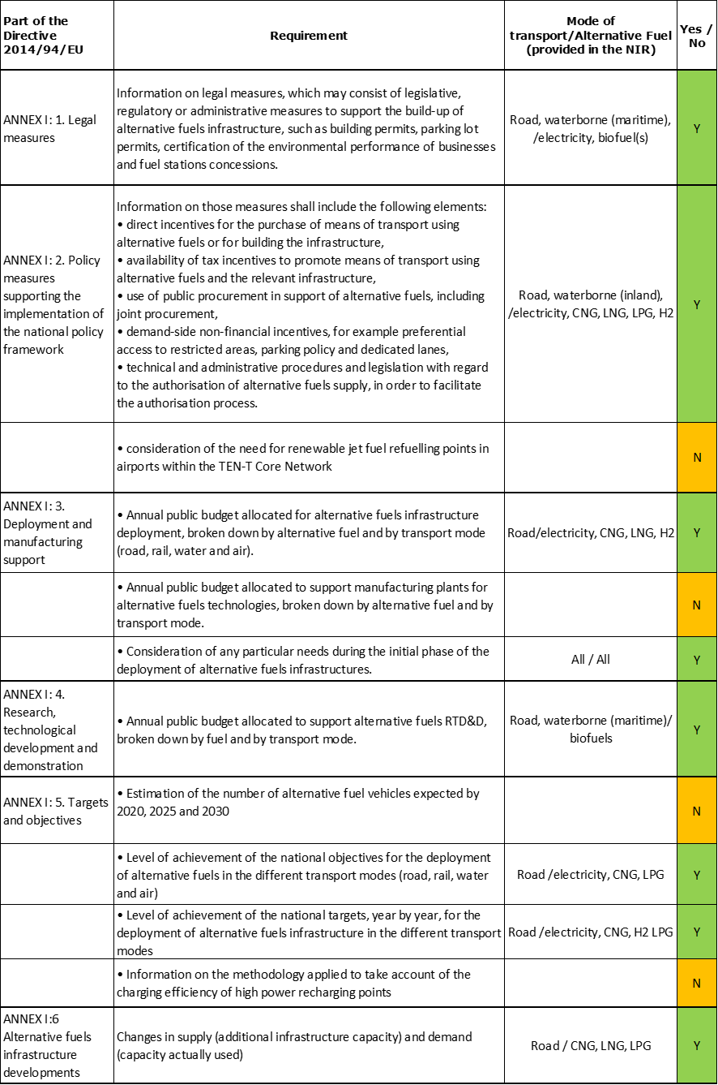

The checklist shows the requirements of Annex I from the Directive that are covered in the Croatian NIR.

The HR NIR does not provide AF vehicle estimates for 2020, 2025 and 2030, and presents AFI targets only for electricity/road, CNG/road, hydrogen/road and only for 2020. Electricity is partially covered also for waterborne transport, both maritime and inland. Other combinations AF/transport mode, are either just mentioned or not reported at all.

The Croatian NIR reports a long list of legal initiatives, but provide assessable information only on around 33 measures. Under the Policy and Deployment & Manufacturing sections it was possible to identify seven AF/transport mode clusters of measures, of which five were assessable.

### Quantitative assessment: Vehicles and infrastructure

*Table 5.11.3‑1 National AFV estimates and AFI targets established in the NIR at the horizon 2020, 2025 and 2030 and their comparison with the NPF situation*





#### Road transport

The Croatian NIR provides no vehicle estimates for the next decade and, concerning infrastructure, it presents quantitative AFI targets for electricity CNG, LNG and hydrogen only for the year 2020.

The HR NIR states that Croatia had set aside a dedicated budget until 2030 in order to reach the minimum share of AF vehicles, which is 1% of all vehicles registered. This includes vehicles powered by electricity, CNG/CBG, LNG/LBG and hydrogen, and the funds to reach the goal will be distributed by co-financing mechanisms.

##### Electricity

###### Vehicles

Croatia recorded 792 battery-electric and plug-in hybrid electric vehicles in use in 2018 (see Table 5.11.3‑1), of which 693 were passenger cars, 96 LCVs and 3 battery-electric buses and coaches. There are no electric HCVs recorded in Croatia in 2018. Similarly to the NPF, the Croatian NIR does not provide EV estimates for any vehicle category for 2020, 2025 or 2030. The EV numbers available for 2016, 2017 and 2018 show a moderate positive trend in the new EVs in the national fleet mix, however, still very low compared to the overall fleet, with only 0.04% in 2018.

As the NIR did not provide future vehicle estimates, the 2018 ***attainment*** and ***progress*** could not be computed.

###### Infrastructure

Croatia recorded 315 public recharging points in 2018 (Table 2), of which 45 normal power (≤22kW) and 270 high power (>22kW) recharging points (>22kW). This is more than the NPF target of 296 for 2020. The new NIR target of 515 publicly accessible recharging points for 2020 is almost 74% higher than the NPF target. While the NPF had set targets for both 2025 and 2030, which were 602 and 806 public recharging points respectively, the NIR does not state 2025 and 2030 targets.

The 2018 ***attainment*** of future public recharging infrastructure targets is 61.17% for 2020. According to the assessment methodology described in Section 2.1, the 2018 situation corresponds to a ***fast progress*** towards reaching these envisaged targets. The calculated ***average annual growth rate*** corresponding to the period 2016-2020 for publicly accessible recharging infrastructure evolution planned by Croatia is equal to 54%.

###### Ratio

Based on the HR NIR, the following table shows the ratio between vehicles and publicly accessible recharging points (i.e. sufficiency index) for the pair electricity/road. Since there are no estimates provided for the future, the sufficiency index could only be computed for the 2016 - 2018 period. It is considered adequate since it is inferior to the threshold value of 10.



###### Information on charging efficiency

Information is not available in the HR NIR.

##### CNG

###### Vehicles

Croatia reported 338 CNG vehicles in use in 2018, of which 133 were passenger cars, 96 LCVs, 9 HCVs and 100 buses and coaches. As in the NPF, there are no estimates in the HR NIR for 2020, 2025 and 2030 on CNG vehicles. For this reason, the 2018 ***attainment*** and ***progress*** could not be computed.

###### Infrastructure

The Croatian NIR indicates that two publicly accessible CNG refuelling points were in use in 2018. The NPF had CNG AFI targets for 2020 and 2025, while the HR NIR shows only the 2020 target (three publicly accessible CNG refuelling points for 2020, which is nearly 77%% lower than in the NPF, plus two private) but no targets for 2025 or 2030, thus reflecting a decreased ambition.

The 2018 ***attainment*** of future public CNG refuelling infrastructure targets is 66.67% for 2020. According to the assessment methodology described in Section 2.1, the 2018 level of ***progress*** cannot be evaluated, because the future 2020 target is only one unit above the number of CNG refuelling points in 2016. The calculated ***average annual growth rate*** corresponding to the period 2016-2020 for publicly accessible CNG refuelling infrastructure evolution planned by Croatia is equal to 11%.

###### Ratio

Based on the Croatian NIR, the following table shows the ratio between vehicles and publicly accessible refuelling points (i.e. sufficiency index) for the pair CNG/road. Since there are no estimates provided for the future, only 2016-2018 sufficiency index can be calculated, and it is considered adequate since it is inferior to the indicative value of 600 (see Section 2.1.5).



##### LNG

###### Vehicles

Similarly to the Croatian NPF, there is no information provided about LNG vehicles in the Croatian NIR. Therefore, the 2018 ***attainment*** and ***progress*** could not be computed.

###### Infrastructure

The Croatian NIR provides no information about 2016 to 2018 public refuelling points but presents a target of one LNG refuelling station for 2020. This represents a different scenario compared to the NPF that had not provided a target for 2020, but had provided targets for 2025 and 2030, of two and seven LNG refuelling points respectively, with a possibility of increasing facilities if a higher demand was present.

Since at the end of 2018 there are no road LNG refuelling points deployed, the 2018 ***attainment*** and ***progress*** could not be computed.

###### Ratio

Since there are no LNG vehicles in the HR NIR, either recorded or estimated, it is not possible to compute the sufficiency index.

##### Hydrogen

###### Vehicles

There were no hydrogen vehicles recorded in Croatia in 2018. The Croatian NIR mentions that for 2030 all AF vehicles will reach at least 1% of the total fleet, including vehicles running on hydrogen. In relation to this goal, the Croatian NIR clarifies that no concrete actions have yet been taken specifically on hydrogen vehicles. For this reason, the 2018 ***attainment*** and ***progress*** could not be computed.

###### Infrastructure

The Croatian NIR reports one publicly accessible hydrogen refuelling point in use in 2018. The target for 2020 is equal to two, while no 2025 or 2030 targets are provided. The NPF had not provided targets for 2020 or 2025, however it had provided a target for 2030, which could have been 1 or 2, depending on the demand.

The 2018 ***attainment*** of future publicly accessible hydrogen refuelling infrastructure targets is 50% for 2020. According to the assessment methodology described in Section 2.1, the ***progress*** obtained by Croatia for publicly accessible hydrogen refuelling infrastructure deployment from 2016 until 2018 versus the period 2016-2030 could not be computed because the 2030 target is not provided.

###### Ratio

Since there are no hydrogen vehicles in the HR NIR, either recorded or estimated, it was not possible to compute the sufficiency index.

##### Biofuels

The creation of a plan to develop the market for biofuels until 2030 affecting both AFI and AFV has been announced, and a significant effort in the research of third generation biofuels is noted.

###### Vehicles

Information is not available in the Croatian NIR.

###### Infrastructure

Information is not available in the Croatian NIR.

##### LPG

###### Vehicles

Croatia reported 61,558 LPG vehicles in use in 2018 (Table 5.11.3‑1), of which 60,527 were passenger cars and 1,031 LCVs. There are not future estimates for the LPG vehicles. The HR NIR does not mention LPG as a desirable AF in the national fuel mix by the year 2030.

Due to the lack of future estimates, the 2018 ***progress*** and ***attainment*** could not be computed.

###### Infrastructure

Croatia reported 557 publicly accessible LPG refuelling points in use in 2018. No future targets are provided in terms of publicly accessible LPG refuelling points and, therefore, the 2018 ***progress*** and ***attainment*** could not be computed. The HR NIR does not mention LPG as a desirable AF in the national fuel mix by 2030.

###### Ratio

Based on the HR NIR, the following table shows the ratio between vehicles and publicly accessible refuelling points (i.e. sufficiency index) for the pair LPG/road. The sufficiency index could only be computed for 2018.

|  |  |  |  |  |  |  |  |
| --- | --- | --- | --- | --- | --- | --- | --- |
| **Sufficiency Index** | | **2016** | **2017** | **2018** | **2020** | **2025** | **2030** |
| **Road** | **LPG** |  |  | 110.52 |  |  |  |

#### Rail transport

##### Electricity

###### Vehicles

Information is not available in the Croatian NIR.

###### Infrastructure

Information is not available in the Croatian NIR.

#### Waterborne transport (maritime)

No specific AF vessels estimates are provided for the future years, however a dedicated measure implies the conversion of obsolete fossil fuel vessels to different AF propulsion systems both in maritime and inland waterways by 2030.

##### Electricity

###### Vessels

The HR NIR reported one electric seagoing ship in 2018. Similarly to the NPF, the NIR does not provide any specific numerical estimates for the next decade.

###### Infrastructure

Information is not available in the Croatian NIR. The NPF had provided a target of three shore-sided electricity supplies for seagoing ships in maritime ports by 2025, but this is absent in the HR NIR.

##### LNG

###### Vessels

Information is not available in the Croatian NIR.

###### Infrastructure

The Croatian NIR explains that the LNG terminal mentioned earlier under the road/LNG section and targeted for 2020, will be used by both maritime and road transport. The NPF had presented a target of one refuelling point for 2025 and seven for 2030, but the NIR does not provide confirmation of this plan.

#### Waterborne transport (inland)

##### Electricity

As already mentioned in Section 5.11.3.3, the HR NIR mentions a dedicated measure concerning the conversion of obsolete fossil fuel vessels to different AF propulsion systems both in maritime and inland waterways by 2030.

###### Vessels

Croatia reported two electric vessels in 2018, used for touristic purposes in inland waterborne transport. No specific estimates are provided for the future years.

###### Infrastructure

The HR NIR does not state any current numbers or future targets regarding shore-side electricity supply. The NPF had reported two shore-side electricity supplies in inland ports in 2016, and a target of four for 2020, bur these numbers have not been confirmed in the HR NIR.

##### LNG

###### Vessels

Information is not available in the Croatian NIR.

###### Infrastructure

The NPF had presented a target of two refuelling points for 2030, but the NIR does not provide confirmation of this plan.

#### Air transport

##### Electricity

No specific information on electric airplanes/infrastructure was found in the Croatian NIR.

##### Biofuels

The Croatian NIR does not provide specific information related to the use of biofuels in aviation.

### Measures assessment

The Croatian NIR provides a portfolio of measures with a long list of legal initiatives, addressing different modes of transport and all the major alternative fuels to a certain degree. They cover a wide variety of combinations AF/transport mode, however they mostly focus on electricity and road transport. Noteworthy is the special attention of RTD&D measures towards advanced biofuels.

#### Legal measures

The Croatian NIR provides information on the national legal framework for the deployment of alternative fuels infrastructure by listing the relevant existing legislation elements (16 legal acts, 71 implementing regulations) and by mentioning seven strategic documents (national plans and strategies). Additionally, the HR NIR goes in details regarding three areas in which future legislation is foreseen (described in the next section) and five administrative measures. The three legislative & regulatory measures were also covered by the NPF, however the NIR provides an updated version and continuation of them, increasing their level of ambition.

##### Legislative & Regulatory

The three legal measures described in details in the Croatian NIR belong to the legislative & regulatory category and cover different transport modes. One measure addresses the overall integration of renewable energy sources in the 10-year national energy and climate plan, with the RES reaching the share of 13.2% in the overall Croatian transportation final energy consumption by 2030, following the legal restrictions laid down in the plan.

The second legal measure aims at legislative adjustments to increase the development of AFI and to promote the deployment of clean and energy efficient vehicles in all transport modes. In particular, for road transport, it aims to achieve a share of energy efficient purchased vehicles of 37% light commercial vehicles, 13% heavy commercial vehicles and 65% buses, achieved under the sustainable procurement act at a national level. The HR NIR mentions the intention to transpose in national legislation parts of several EU Directives (i.e. Directive 2018/2001/EU on the promotion of the use of energy from renewable sources, Directive 2019/1161/EU on the promotion of clean and energy-efficient road transport vehicles, Directive 2018/844/EU amending the Energy Performance of Buildings Directive).

The third measure aims at providing an action plan that lays down a policy for the promotion and use of biofuels in Croatia: assessment of the current situation, long-term objectives, targeted biofuels market and further measures to promote production and use of biofuels until 2020.

##### Administrative

The Croatian NIR contains five administrative measures, all applicable at national level. Out of these five measures, three measures are related to road transport and two concern a combination of different modes. Mostly, they are addressing the compliance with relevant EU and international standards and producing different plans and acts for classifications of the AFV performances. It is important to note that one measure is currently existing and four measures are either planned or in the process of adoption. These four measures address directly the AFs and AFVs, while the one measure currently existing is not directly related, as it deals with the training of truck drivers on eco-driving.

#### Policy measures

The Croatian NIR reports 19 policy measures intended to foster alternative fuels in Croatia. This is an improvement compared to the NPF, which contained nine policy measures. Most policy measures in the Croatian NIR are financial incentives.

##### Measures to ensure national targets and objectives

All the 19 policy measures in the Croatian NIR are measures that aim to ensure national targets and objectives.

Nine measures target AFVs, two target AFI, two target AFs and the rest target combinations of AF/transport modes. Road transport is the most covered, and to a lesser extent waterborne transport inland and other combinations. One of the most significant measures to directly incentivise the purchase of EVs and the construction of recharging infrastructure saw a considerable increase of budget, compared to the same measure in the NPF, which shows a positive ambition towards electrification of road vehicles.

Some measures from the NPF appear to be implemented in the NIR. They include purchasing of a smaller amount of AFVs and installing AFIs in national parks, nature parks, small islands etc. When assessed as single measures they do not significantly contribute to the overall target achievement, but are in themselves an indicator of good ambition and positive trend towards electro-mobility in touristic areas and areas of specific nature reserves.

Out of the 19 measures, two measures listed in the Croatian NIR can be seen as exceptions as they do not directly address AFI or AFV, but are rather indirect measures that aim to promote different modes of transport, increase fluidity of traffic by better optimising ICT solutions and an incentive programme for combined goods transport in order to decrease GHG, fuel consumption and increase safety.

##### Measures that can promote AFI in public transport services

The Croatian NIR does not list any measure to promote AFI in public transport services.

##### Measures that can promote the deployment of private electro-mobility infrastructure

The Croatian NIR does not list any measure to promote the deployment of private electro-mobility infrastructure.

#### Deployment and manufacturing support

##### AFI deployment

The Croatian NIR lists five measures to support the deployment and manufacturing of alternative fuels. All these five measures are listed under a specific cluster in the NIR, which started the implementation in 2017 with a dedicated budget of approximately €663,000 and aims at the deployment of AFI for electricity. They are related to the construction of fast recharging stations/points at the following localities: municipality of Pisarovina, municipality of Radoboj, town of Rab, island of Ugljan and the city of Zagreb. Since no end year was provided, it is fair to assume the construction of these stations has been finalised and the stations are in use. These measures are present only in NIR and this is considered to show a positive ambition towards electro-mobility in small, medium and large cities, along with the availability of publicly recharging stations on the remote islands of Ugljan and Rab.

The Croatian NIR does not consider any other alternative fuel besides electricity in this section.

##### Support of manufacturing plants for AF technologies

No measures regarding the support of manufacturing plants for AF technologies are present in the Croatian NIR.

##### Consideration of any particular needs during the initial phase of the deployment of alternative fuels infrastructures

The Croatian NIR highlights the need for financial incentives in the initial phase of AFI deployment. It is clear from the NIR that a dedicated measure and budget mark the necessary first step for the development of the market, foreseeing the co-financing of the AFI construction in order to reach at least the minimum coverage criteria laid down by the main text of the Directive. The measure is set to last from 2019 until 2030 with a budget of approximately 49 million € in that period.

#### Quantitative assessment of Policy and Deployment & Manufacturing measures

Table 5.11.4‑1 presents an overview of the analysis of all the Policy and Deployment & Manufacturing measures, carried out according to the assessment methodology described in Section 2.2. In total, seven clusters of measures were identified, of which five resulted assessable. No clusters of measures have emerged for LNG for inland waterborne transport, nor for rail or air transport.

All the five assessable clusters of measures get a high overall score, but only the one for the pair electricity/road results to be comprehensive. The clusters for the pairs electricity /water (both maritime and inland) are not assessable.In terms of expected impact of these measures to support the realisation of the AFV/AFI objectives as presented in the NPF and revised in the NIR, the partial or total lack of future targets and estimates does not allow putting this assessment into perspective. Based on the impact seen during the implementation period, for the future it can be said that the measures for the pair electricity/road might have a high impact, those for the pairs CNG/road, LNG/road, LNG/water-maritime and hydrogen/road might have a medium impact.

Compared to the NPF, the level of ambition of the Policy and Deployment & Manufacturing support measures has generally increased for all the identified clusters.

*Table 5.11.4‑1 Quantitative assessment of Policy and Deployment & Manufacturing support measures*

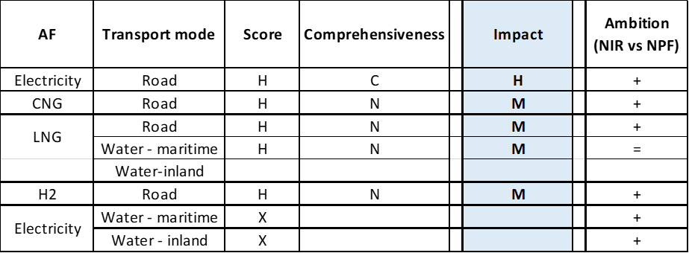Legend: Score and Impact: H = high; M = medium; L = low; X = not assessable. Comprehensiveness: C = comprehensive; N = Not comprehensive. Ambition level: ‘+’ means ‘higher’; ‘=’ means ‘comparable’.

#### Research, Technological Development & Demonstration

The Croatian NIR lists four RTD&D measures/projects. Since all of the measures are newly introduced in the NIR, it is not possible to compare the nature of the projects with the three RTD&D projects that were presented in the NPF. Out of these four new RTD&D projects, three are targeting biofuels production while the other is a promotional research project/campaign concerning solar powered vehicles. Two RTD&D measures are already in place with dedicated staff and budget. Both are addressing advanced biofuels (third generation biofuels) production in Croatia: one research project investigates the potential of Adriatic algae in third generation biofuel production, while the second one is broader and targets to produce 3.5% of advanced biofuels in transport from domestic feedstock by the year 2030. Finally, the third measure is planned to start in 2021 and aims to develop the market for advanced biofuels and to put in place the corresponding legal acts. The end result of this final measure is to set up a model for promoting and developing the market for biofuels in transport and designing funding instruments for projects regarding biofuels.

### Additional information on alternative fuels infrastructure developments

The Croatian NIR provided (partial) information suggesting that, until 2018, the percentage of the AFs in the total national fuel mix was 3.10%. The NIR does not provide past or future data on electricity, biofuels or hydrogen. The NIR estimates that CNG in road transport will grow from 0.10% in 2018 to 1% in 2025 and then to 3% in 2030. LNG for road use will increase from 0% in 2018 to 0.1% in 2020, to 1.5% in 2025, and up to 5% in 2030. Unlike CNG and LNG, the NIR foresees for LPG a constant share 3% from 2018 until 2030 (Table 5.11.5‑1).

*Table 5.11.5‑1 Changes in fuel use in transport sector (2016-2030)*



### Summary of the assessment

**Tabular overview**

*Table 5.11.6‑1 Overview of the NIR assessment*

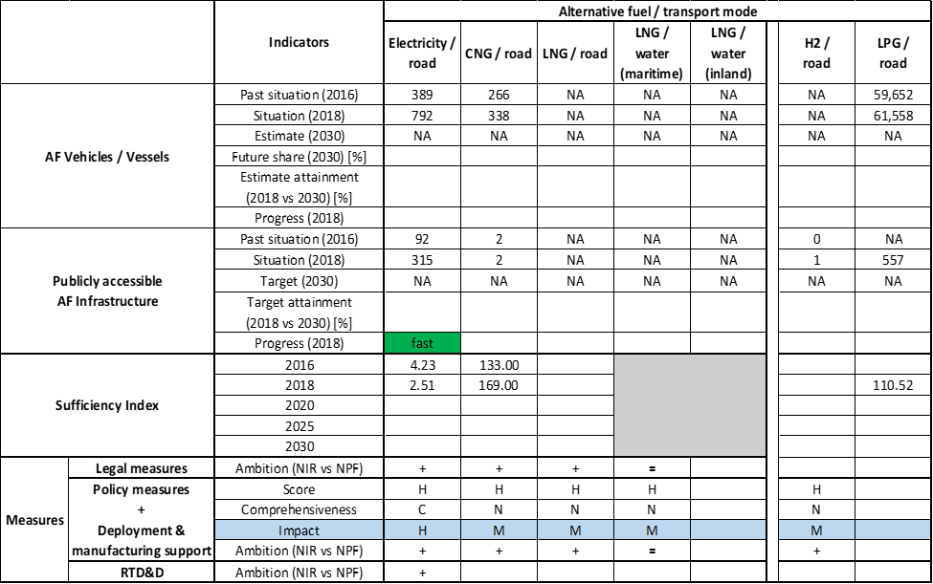



The Croatian NIR contains a sufficient description of the policy direction towards the introduction of alternative fuels in Croatia. The NIR however completely lacks the estimation of the number of AFVs for 2020, 2025 and 2030, similarly to the NPF. It does establish the 2020 targets for the AFI in detail for the majority of AFs, but it does not provide any targets for 2025 and 2030, unlike the NPF report that indeed had provided targets for the majority of AFs in 2020, 2025 and in 2030. Most of the measures address electricity in detail, with other AFs being covered in a 10-year plan, except LPG. The plan is rather generic, but it contains budget description and the authorities responsible for enforcing the deployment of AFs, signalling a positive ambition towards the achievement of the national plan.

The main outcomes of the technical assessment of the Croatian NIR on vehicles/vessels estimates and infrastructure targets can be summarised as follows:

###### Road transport

* **Electricity** – Croatia recorded 792 battery-electric and plug-in hybrid electric vehicles in use in 2018, of which 693 were passenger cars, 96 LCVs and 3 battery-electric buses and coaches. There were no electric HCVs recorded in Croatia in 2018. The Croatian NIR does not estimate the EVs for any vehicle category for 2020, 2025 or 2030, thus the progress and attainment could not be computed. Croatia recorded 315 publicly accessible recharging points in 2018, out of which 45 were normal power (≤22kW) and 270 high power points (>22kW). The NPF had set targets for 2020, 2025 and 2030, but the NIR does not mention any 2025 and 2030 targets. As for 2020, the NIR target of 515 for publicly accessible recharging points is 74% higher than the NPF target of 296 recharging points. The 2018 progress for AFI was fast, the sufficiency index in 2018 was adequate.
* **CNG** – Croatia reported 338 CNG vehicles were in use in 2018, out of which 133 were passenger cars, 96 LCVs, 9 HCVs and 100 buses and coaches. There are no estimates in the NPF nor in the NIR for 2020, 2025 and 2030 of CNG vehicles. The Croatian NIR indicates that two publicly accessible CNG refuelling points were in use in 2018. It also reports a target of three CNG publicly accessible refuelling points for 2020, but no targets for 2025 or 2030. The NPF had CNG AFI targets for 2020 and 2025, while the HR NIR shows only the 2020 target, which is 77 % lower than in the NPF, thus reflecting a decreased ambition.
* **LNG** – Like in the NPF, there is no information about LNG vehicles in the HR NIR, which also provides no information about 2016 to 2018 AFI, but does provide the target for 2020, which is one LNG refuelling station. The NPF target for 2020 had not been provided, however the 2025 target was of two LNG refuelling points and the 2030 target was of seven refuelling points.
* **Hydrogen** – The Croatian NIR does not report any information on existing or future hydrogen vehicles; it only mentions that, as a part of a global 2030 target, all AFVs will reach 1% of the total fleet, including vehicles running on hydrogen. The HR NIR informs that there was one hydrogen publicly accessible refuelling point in use in 2018. The target for 2020 is equal to two, while no 2025 or 2030 targets are provided. The NPF had no targets for 2020 nor 2025 publicly accessible hydrogen refuelling points, however it did provide a tentative target for 2030 which was stated to be one or two, depending on the demand.
* **Biofuels** – The Croatian NIR only mentions that, as a part of a global 2030 target, all AFVs will reach 1% of the total fleet, including vehicles running on biofuels, but it is not specified which biofuels and in what amount. The preparation of a plan to develop the market for biofuels is envisaged until 2030, and will affect both the AFI and AFV.
* **LPG** – Croatia reported 61,558 LPG road vehicles in use in 2018, of which 60,527 were passenger cars, and 1,031 LCVs. No future estimates for the LPG vehicles are reported in the HR NIR. Croatia reported 557 publicly accessible LPG refuelling points in use in 2018. No future targets are provided in terms of publicly accessible LPG refuelling points.

###### Rail transport

* **Electricity** – The HR NIR does not address rail electrification.

###### Waterborne transport (maritime and inland waterway)

* **Electricity** – Croatia reported three electric vessels in service in 2018, used for touristic purposes. No specific targets are provided for the future years, however a dedicated measure implies the conversion of obsolete fossil fuel vessels to different AF propulsion systems both in maritime and inland waterways by 2030, including electricity. The Croatian NIR does not provide any information on shore-side electricity supply. The NPF had reported two shore-sided electricity supplies in 2016 in inland ports, and for 2020 a target of four supplies in inland ports and of three shore-sided electricity supplies in maritime ports.
* **LNG** – The Croatian NIR does not provide any LNG vessel estimate. It presents a target of one LNG terminal that will be used by maritime and road transport from 2020. While the NPF had presented a target of one maritime refuelling point for 2025, and of seven refuelling points in maritime ports and two in inland ports in 2030, the NIR does not provide any targets in that aspect.

###### Air transport

* **Electricity/Biofuels** - The Croatian NIR does not specifically provide targets.

The Croatian NIR provides a list of **measures** related to road transport and all the major alternative fuels (to a certain degree), however mostly focusing on electricity and road transport. Waterborne transport (both maritime and inland) is also covered. The portfolio consists of a total of 33 assessable measures addressing several, but not all, provisions of the Annex 1 of the Directive. A significant number of the measures in place target either AFV public procurement, national co-funding scheme for electricity, or recharging infrastructure deployment. Furthermore, the Croatian government emphasises two general measures with dedicated budget addressing the deployment of AFI and AFV until 2030. These measures provide significant budget and aim to reach 2030 target set by the Croatian energy and climate plan. Concerning the Policy and Deployment & Manufacturing measures, seven clusters were identified, of which five were assessable. In terms of expected impact of these measures to support the realisation of the AFV/AFI objectives as presented in the NPF and revised in the NIR, the partial or total lack of future targets and estimates does not allow putting this assessment into perspective. Based on the impact seen during the implementation period, it can be said that future measures for the pair electricity/road might have a high impact, those for the pairs CNG/road, LNG/road, LNG/water-maritime and hydrogen/road might have a medium impact.

There are four RTD&D measures addressing the research for AFs, in particular advanced biofuels production in Croatia, showing a positive ambition towards a national target of 3.5% biofuels production from the domestic feedstock.

### Final remarks

The Croatian NIR provides a rather limited report on the efforts to implement the Directive. It partially meets the requirements of Annex I to the Directive and lacks information regarding vehicles and vessel estimates while providing infrastructure targets for road transport with regard to electricity, natural gas and hydrogen for 2020. In terms of measures, the Croatian NIR provides a rather comprehensive portfolio related to road transports, however mostly focusing on electricity. Waterborne maritime transport is also covered, but in a more discrete manner, while waterborne inland transport is not covered. With regard to air transport, Croatia announces the elaboration of a plan to decarbonise air transport. In future reports, Croatia should strengthen information on targets and measures promoting uptake of zero-emission vehicles infrastructures. The targets for the required coverage of publicly accessible infrastructure need to be established, where the number of alternative fuels vehicles and infrastructure are adequately quantified and reported for the different modes of transport.

Regarding electricity, Croatia recorded 792 battery-electric and plug-in hybrid electric vehicles in use in 2018. The NIR does not estimate the electric vehicles for any vehicle category for the target years of 2020, 2025 and 2030. As for infrastructure, Croatia recorded 315 publicly accessible recharging points in 2018. The NPF had set targets for 2020, 2025 and 2030, but the NIR does not mention any targets for 2025 and 2030. Croatia has considerably increased its ambitions for 2020 in the NIR compared to the NPF, but the lack of data prevents the assessment of ambition for 2030. Croatia should provide more information in future reporting in this regard. No information on charging efficiency is provided. Concerning waterborne transport, Croatia reported two electric vessels in service in 2018 used for touristic purposes and one electric seagoing ship. No specific targets nor information on shore-side electricity supply are provided for the target years of 2025 and 2030. However, a measure conveys the intention to promote different alternative fuel propulsion systems both in maritime and inland waterways by 2030, including electricity supply. The NIR does neither provide information on the supply of electricity to stationary aircraft nor on the further electrification of railways.

For hydrogen, the NIR does not report any information on existing or future deployment of FCHVs. It reports one hydrogen refuelling point for 2018 and another one planned for 2020. Although hydrogen is not binding under the Directive, it would be relevant that Croatia provides more information on how to ensure EU-wide connectivity for HCEV.

Croatia reported 338 CNG vehicles in use in 2018, without estimates in the NIR nor in the NPF for 2020, 2025 and 2030. In terms of infrastructure, the NIR indicates that two publicly accessible CNG refuelling points were in use in 2018 and sets a target of three CNG publicly accessible refuelling points for 2020. The NIR does not set targets for 2025 or 2030 and shows a decreased ambition in comparison to the NPF. Regarding LNG, the NIR does not contain information on vehicle and vessels estimates nor on infrastructure. For 2020, the NIR only foresees one LNG refuelling point. In this respect, Croatia needs to provide further information on its future planning.

On LPG, Croatia reported 61,558 vehicles and 557 refuelling points in 2018. No future vehicle estimates or infrastructure targets were provided.

Further information should be provided on the consumption of biofuels in road and air transport. Croatia should provide more information in future reporting on efforts to promote the use of renewable fuels in transport, and particularly in aviation.

### ANNEX - Description of the Member State

On a surface area of 56,600 km², Croatia has a population of 4.105 million people in 2018, which makes up for a population density of 73 inhabitants/km².

*Number of main urban agglomerations*

* 7 urban agglomerations > 50,000 inhabitants

In 2018, Croatia achieves a per capita gross domestic product at market prices of €12,620, which represents a per capita gross domestic product in purchasing power standards of 63 if expressed in relation to the EU-28 average set to equal 100.

*Length of the road networks*

The length of the road TEN-T Core Network in Croatia is 1,107 km. The total road network length is 17,800 km, of which 1,310 km are motorways.

The following lengths of the TEN-T Road Corridors are present in Croatia: 6% (315 km) of the Mediterranean Corridor.

Through the TEN-T Road Corridors, Croatia is connected with the following Member States:  
- Hungary (through the Mediterranean Corridor),   
- Slovenia (through the Mediterranean Corridor)

*Number of registered road vehicles*

At the end of 2018, Croatia accounts for 2,007,817 registered road vehicles of which 1,666,413 are categorized as passenger cars, 137,049 as light goods vehicles, 44,355 as heavy goods vehicles and 5,700 as buses and coaches. The motorisation rate is 406 passenger cars per 1,000 inhabitants.

*Number of ports in the TEN-T Core Network*

* 1 maritime port in the TEN-T Core Network (Rijeka)
* 6 maritime ports in the TEN-T Comprehensive Network
* 2 inland ports in the TEN-T Core Network (Slavonski Brod, Vukovar)
* 2 inland ports in the TEN-T Comprehensive Network

Through the 541 km inland waterways TEN-T Core Network, Croatia is connected with Hungary by the Rhine – Danube Corridor.

*Number of airports in the TEN-T Core Network*

* 1 airport in the TEN-T Core Network (Zagreb)
* 6 airports in the TEN-T Comprehensive Network

## Italy (IT)

The Italian NIR was not notified to the Commission on time and was thus not assessed.

## Cyprus (CY)

### Main messages from the Commission assessment of the NPF

In its original assessment of the Cypriot NPF the Commission concluded:

*From the Cyprus NPF, it is transparent that alternative fuels are at an early deployment stage in Cyprus. The Cyprus NPF addresses only a small part of the requirements of Article 3 of the Directive, mainly electro-mobility. For the future development and further penetration of alternative fuels in transport, a study entitled ‘Technical Assistance in order to assess and formulate recommendations for the promotion and penetration of alternative fuels in the transport sector’ has been commissioned. The purpose of the ongoing study is to present a comprehensive proposal regarding future penetration scenarios for various alternative fuels in the transport sector in Cyprus, as well as promotion policies and measures, taking account of the specific characteristics of Cyprus, to achieve the climate and energy targets related to the transport sector.*

*In the case of electricity for road transport, which constitutes the focus of the Cyprus NPF, the requirements of the Directive were fulfilled and details were given about the targeted recharging infrastructure for 2020 in terms of number and placement. Even though the future estimates of electric vehicle stock are rather modest, being situated in the range of 0.02% to 0.32% of the future vehicle stock, the proposed set of measures can support reaching the declared objectives since it was evaluated as being comprehensive and having a medium assessment score. In the case of electricity supply at airports and shore-side supply in its maritime ports, the Cypriot authorities are currently examining the situation and studies are carried out. The decision of setting targets and support measures is foreseen for the future.*

*Besides electro-mobility, the national strategy for the other alternative fuels is briefly or inadequately treated in the Cyprus NPF, being dependent on the results of currently ongoing studies. For CNG and LNG fuels, the NPF contains neither future estimates for vehicles nor targets for refuelling infrastructure. The lack of ambition for natural gas can be partially explained by the small market size in Cyprus and the lack of interconnections with other natural gas networks. However, the Cypriot NPF declares intentions to foster LNG use in maritime transport, also in cooperation with Greece and Italy*

*The Cyprus NPF does not contain any targets for hydrogen in transport.*

*The Cyprus NPF contains a medium size portfolio of support measures, many being currently discussed and planned and receiving in consequence the status ‘under consideration’. The majority of the proposed measures necessary to ensure national targets concern electricity for road transport, this cluster that contains 7 assessable measures received a medium overall assessment score. The use of alternative fuels for public transport activity is too vaguely addressed and additional concrete details would have been desirable.*

*Regarding the cooperation with other Member States, the NPF states that Cyprus cooperates with Greece and Italy in the frame of the EU funded POSEIDON-MED ΙΙ LNG project. A study regarding the future deployment and placement of LNG refuelling infrastructure at Cypriot ports will be carried out within this project.*

### Overview of requirements’ fulfilment from Annex I of the Directive

*Table 5.13.2‑1 Checklist Table*

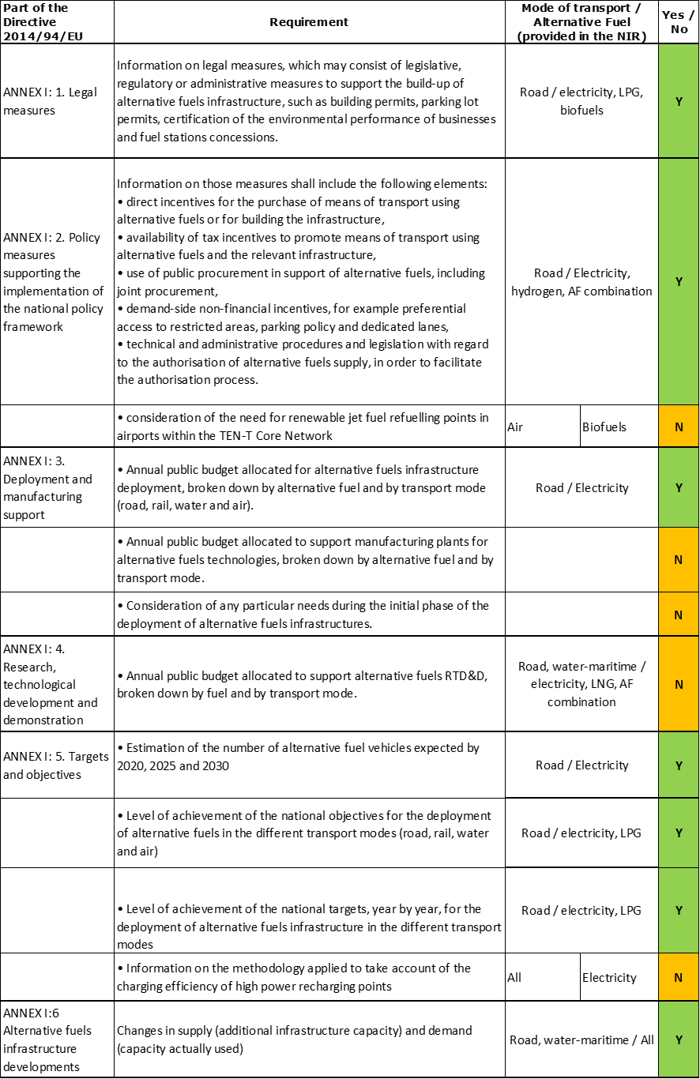

The checklist shows that only a limited part of the requirements of Annex I from the Directive are covered in the Cypriot NIR.

Regarding the combination of AF/AFV/AFI with transport mode, electricity is well documented for road transport; CNG, LNG and LPG are covered for road transport only in terms of AFI; shore-side electricity supply is covered for maritime water transport, and also LNG but only in terms of AFI; all the other combinations are either absent or not applicable.

The CY NIR reports around 25 measures. Under the Policy and Deployment & Manufacturing sections it was possible to identify four AF/transport mode clusters of measures, of which only two were assessable.

### Quantitative assessment: Vehicles and infrastructure

*Table 5.13.3‑1 National AFV estimates and AFI targets established in the NIR at the horizon 2020, 2025 and 2030 and their comparison with the NPF situation*

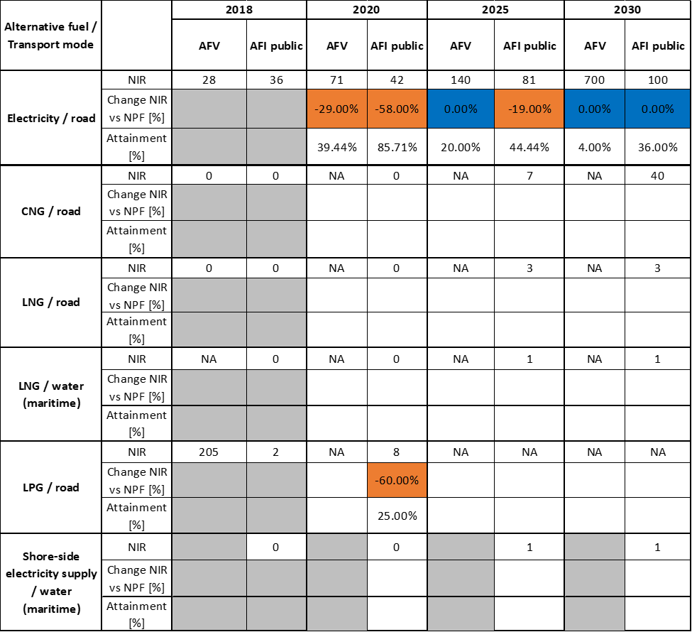



#### Road transport

##### Electricity

###### Vehicles

Cyprus recorded 28 battery-electric and plug-in hybrid electric vehicles in use in 2018 (all of which are passenger cars) (see Table 5.13.3‑1) and 73 electric powered two wheelers. The CY NIR provides revised estimates for the EVs expected to be registered in 2020, and new estimates for 2025 and 2030 (71, 140 and 700, respectively). Concerning the EV estimates for 2020, the NIR values are 29% lower than the most pessimistic NPF value, where a wide interval of 100-2000 was provided. It is worth mentioning that the NIR also shows estimates for electric powered two-wheelers (100, 200 and 300 respectively for 2020, 2025 and 2030), which were not reported in the NPF.

The 2018 ***attainment*** of future EV estimates is 39.44% for 2020 and 4.00% for 2030. According to the assessment methodology described in Section 2.1, the 2018 situation corresponds to a ***slow progress*** towards reaching the envisaged EV estimates. The calculated ***average*** ***annual growth rate*** corresponding to the period 2016-2030 for EV fleet evolution planned by Cyprus is equal to 27%.

###### Infrastructure

Cyprus recorded 36 publicly accessible recharging points in 2018, all of which are normal power (≤22kW) ones. As for the next decade, Table 5.13.3‑1 shows that the recharging points targets for 2020, 2025 and 2030 have been reduced by the CY NIR to 42, 81 and 100 respectively. In the NPF, the initial targets were 100 publicly accessible recharging points by 2020, and more than 100 by 2025 and 2030. DC fast recharging points are only targeted to be introduced by 2025 when they are foreseen to represent 32% of the total points, but no further details about their status in 2030 is provided.

The 2018 ***attainment*** of future publicly accessible recharging infrastructure targets is 85.71% for 2020 and 36.00% for 2030. According to the assessment methodology described in Section 2.1, the 2018 situation corresponds to a ***slow progress*** towards reaching these envisaged targets. The calculated ***average annual growth rate*** corresponding to the period 2016-2020 for publicly accessible recharging infrastructure evolution planned by Cyprus is equal to 9%.

###### Ratio

Based on the CY NIR, the following table shows the ratio between vehicles and publicly accessible recharging points (i.e. sufficiency index) for the pair electricity/road. The foreseen sufficiency index is inferior to the value of 10 and thus can be regarded as adequate for the next decade.



###### Information on charging efficiency

Information is unavailable in the Cypriot NIR.

##### CNG

###### Vehicles

The CY NIR does not provide any past or future quantitative information concerning CNG vehicles. The report states that the technology is currently not in use in the transport sector.

###### Infrastructure

Due to the geographical isolation of Cyprus, there is currently no natural gas market and interconnections with international gas networks are lacking. According to both the NIR and EAFO’s reported numbers, no CNG refuelling points were installed in Cyprus in 2018. The Cypriot NPF did not mention any CNG refuelling points targets. The Cypriot NIR, on the other hand, sets targets of 7 and 40 CNG refuelling points by 2025 and 2030, respectively. Introducing natural gas to meet the needs of the domestic market is an energy strategy priority for the Cypriot decision-makers.

Since at the end of 2018, there were no CNG refuelling points deployed, the 2018 ***attainment*** and ***average annual growth rate*** could not be computed. According to the assessment methodology described in Section 2.1, the 2018 situation corresponds to a ***slow progress*** towards reaching the CNG refuelling infrastructure envisaged targets.

###### Ratio

Since there are no CNG vehicle estimates in the Cypriot NIR, it is not possible to compute the sufficiency index.

##### LNG

###### Vehicles

The Cypriot NIR provides no LNG vehicle estimates for the future. At the end of 2018, there were no LNG vehicles in use.

###### Infrastructure

The Cypriot NIR introduced a new target of three publicly accessible LNG refuelling points for road vehicles by 2025/2030, up from no LNG refuelling infrastructure at the end of 2018. Additionally, a tender for medium/long-term LNG supply in Cyprus is expected to be announced in 2020. Consequently, the necessary LNG infrastructure is expected to be completed and natural gas supply to the Cypriot domestic market to be launched in early 2022.

Since at the end of 2018 there were no LNG refuelling points deployed, the 2018 ***attainment*** and ***progress*** could not be computed.

###### Ratio

Since there are no LNG vehicle estimates in the Cypriot NIR, it is not possible to compute the sufficiency index.

##### Hydrogen

###### Vehicles

The Cypriot NIR does not offer any estimates for hydrogen vehicles. At the end of 2018, there were no hydrogen vehicles in use.

###### Infrastructure

The Cypriot NIR does not commit to any targets for hydrogen refuelling points. At the end of 2018, there was no hydrogen refuelling infrastructure deployed.

###### Ratio

Since there is no quantitative information on hydrogen vehicles and infrastructure in the Cypriot NIR, it is not possible to compute the sufficiency index.

##### Biofuels

###### Vehicles

Information is unavailable in the Cypriot NIR.

###### Infrastructure

Although the Cypriot NIR does not commit to biofuels infrastructure targets, it mentions blending mandates for biofuels in diesel and petrol fuels in place (see Section 5.13.4.1.2).

###### Ratio

Since there is no quantitative information on biofuels vehicles and infrastructure in the Cypriot NIR, it is not possible to compute the sufficiency index.

##### LPG

###### Vehicles

The Cypriot NIR reports that motor LPG consumption remains at very low levels. There are no future estimates for LPG vehicles. In 2018, there were 205 LPG vehicles on Cypriot roads; more than double the amount of LPG vehicles (87) in 2016.

###### Infrastructure

The Cypriot NIR has a reduced target for LPG refuelling points compared to the NPF. The target was re-defined to 8 refuelling points in 2020, down from more than 20. The member state reports two existing LPG refuelling points in 2018. Although the target has been reduced, Cyprus reported in its NIR that 20 applications have been submitted seeking planning permission to install LPG refuelling points.

Since only a target corresponding to 2020 was provided, only the 2018 ***attainment*** of future LPG refuelling infrastructure target for 2020 could be calculated and is equal to 25%.

###### Ratio

Since there are no LPG vehicle estimates in the Cypriot NIR, it is not possible to compute the sufficiency index.

#### Rail transport

##### Electricity

###### Vehicles

Information is unavailable in the CY NIR.

###### Infrastructure

Information is unavailable in the CY NIR.

#### Waterborne transport (maritime)

##### Electricity

###### Vessels

Information is unavailable in the CY NIR.

###### Infrastructure

As an update to the 2016 NPF that did not contain any target, the Cypriot NIR introduced a target for shore-side electricity supply for seagoing ships in one maritime port in 2025 and 2030 (see Table 5.13.3‑1).

##### LNG

###### Vessels

Information is unavailable in the CY NIR.

###### Infrastructure

As an update to the 2016 NPF that did not contain any target, the Cypriot NIR reports a target of one maritime port to be equipped with LNG refuelling infrastructure by 2025. The studies anticipated in the NPF seem to have been conducted and used to determine the NIR committed targets.

#### Waterborne transport (inland)

Not applicable since Cyprus has no inland ports in the TEN-T Core Network.

(NOTE: The Cypriot NIR reports a target of one inland port to be equipped with LNG refuelling infrastructure by 2025 but, as Cyprus has no inland ports in the TEN-T Network, this information has not been treated).

#### Air transport

##### Electricity

###### Airplanes

Information is unavailable in the CY NIR.

###### Infrastructure (for stationary airplanes)

The target number of two airports offering electricity supply for stationary airplanes by 2020 from the NPF seems to have been revised due to the absence of any target information in the Cypriot NIR.

##### Biofuels

###### Airplanes

Information on flights / airplanes powered by biofuels is not available in the Cypriot NIR.

###### Infrastructure

Information is unavailable in the CY NIR.

### Measures assessment

As in the NPF, the Cypriot NIR mentions a limited number of measures. However, the situation has evolved in the NIR in the sense that measures that were already in place have been continued/improved, those under discussion have become more concrete and others were newly introduced.

#### Legal measures

The Cypriot NIR contains 11 legal measures to promote AF. Of those, four measures were mentioned in both the NIR and the NPF, while seven measures are exclusively reported in the NIR. The Cypriot NPF contained other four legal measures no longer in the NIR. Overall, the level of ambition of the legal measures is considered to have increased in the NIR, in comparison with the NPF.

##### Legislative & Regulatory

The legislative & regulatory category of the Cypriot NIR contains eight legal measures, five of which are exclusively reported in the NIR, while the other three are reported in both NIR and NPF. Except for one legal measure concerning LPG/road, all legal measures are part of the electricity/road cluster. Legal measures supporting the promotion of electric recharging infrastructure are mainly focusing on proper signage for recharging points and mandates for new buildings concerning the introduction of dedicated parking spots equipped with recharging points.

##### Administrative

The Cypriot NIR offers three administrative measures, two of which were only reported in the NIR and not in the NPF. Cyprus implemented Directives 2009/28/EC and 2009/30/EC with regards to increasing blending mandates for biofuels in diesel and petrol fuels. Cyprus also implemented an EU Support Programme for fuel price comparison for consumers and accepted Decision No 87.649 of the Council of Ministers. The Council decided to exercise its right to apply specific derogations with reference to Cyprus being an emergent natural gas market due to its geographical isolation. Further, Cyprus appointed the public natural gas company, DEFA, as the distribution system, transmission system and LNG facility operator.

#### Policy measures

The Cypriot NIR reports nine policy measures of which four have already been reported in the NPF and five are new. All the policy measures concern the road as transport mode and focus mainly on electricity as alternative fuel.

##### Measures to ensure national targets and objectives

###### Road transport

Of the nine policy measures reported, seven were categorised as measures to ensure national targets and objectives. The most impactful measures reported are financial incentives. The registration tax and annual road tax are based on CO2 emissions, thus favouring electric vehicles. Additionally, EVs receive a waiver for the vehicle registration fee of €150 and various municipalities and communities in Cyprus allow free EVs parking in public parking areas. The most promising plan, which became more concrete compared to the NPF, was in the process of adoption and represented a vehicle subsidy scheme worth 3 million €. However, only €500,000 were allocated to subsidising the purchase of fully electric vehicles with a €5,000 grant per vehicle. The remaining 2.5 million € are invested to subsidise the purchase of new low carbon vehicles when withdrawing old and polluting vehicles. This policy measure would be applicable to cars older than 15 years to be scrapped and to newly registered cars with less than 160 gCO2/km.

##### Measures that can promote AFI in public transport services

The Cypriot NIR lists one policy measure for the promotion of alternative fuel usage in public transport services.

###### Buses

The Cypriot NIR reports one measure for the integration of innovating green technologies in the existing public transport service. The plan foresees the introduction of hydrogen vehicles in the fleet of public diesel buses. The measure is projected to account for 5 to 30% fuel savings. The total estimated budget is €82.266 million between 2019 and 2022.

##### Measures that can promote the deployment of private electro-mobility infrastructure

The Cypriot NIR provides one policy measure that is under consideration concerning the provision of grants for installing/extending photovoltaic systems and for domestic installation of smart meters for recharging electric vehicles.

#### Deployment and manufacturing support

##### AFI deployment

The Cypriot NIR lists only one deployment and manufacturing support measure, which is already a small improvement compared to the NPF. The Electrical and Mechanical Services Department has launched a call for tenders for the installation of 20 public recharging points worth 1 million € in the period 2019-2020.

##### Support of manufacturing plants for AF technologies

The Cypriot NIR does not provide measures regarding the support of manufacturing plants for AF technologies.

##### Consideration of any particular needs during the initial phase of the deployment of alternative fuels infrastructure

The Cypriot NIR provides no information on this subject.

#### Quantitative assessment of Policy and Deployment & Manufacturing measures

Table 5.13.4‑1 presents an analysis of all the Policy and Deployment & Manufacturing measures, carried out according to the assessment methodology described in Section 2.2. As it can be seen, only clusters of measures on road transport could be identified in the Cypriot NIR, of which only the ones related to electricity and hydrogen contained dedicated measures to the respective fuels. Most of the assessable measures are targeting the pair electricity/road, which is the main focus of the CY NIR set of measures and resulted to have a medium score and to be comprehensive. In terms of expected impact of these measures to support the realisation of the AFV/AFI objectives as presented in the NPF and revised in the NIR, the measures for the pairs electricity/road result to have a medium impact, while those for the pair hydrogen/road have a low impact. Compared to the NPF, the level of ambition of the Policy and Deployment & Manufacturing support measures has increased for all identified clusters (electricity/road, CNG/road, LNG/road and hydrogen/road).

*Table 5.13.4‑1 Quantitative assessment of Policy and Deployment & Manufacturing support measures* 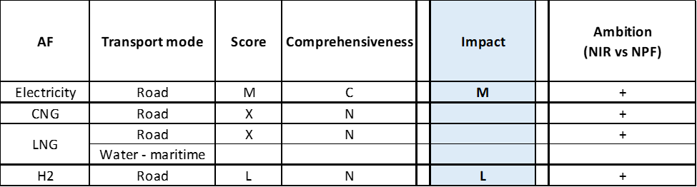

**Legend:** Score: H = high; M = medium; L = low; X = not assessable. Comprehensiveness: C = comprehensive; N = Not comprehensive. Ambition level: ‘+’ means ‘higher’; ‘=’ means ‘comparable’; ‘-‘ means ‘lower’.

#### Research, Technological Development & Demonstration

The Cypriot NIR lists five RTD&D measures, four of which are new and only reported in the NIR. All measures mentioned can be categorised as studies conducting research on implementation scenarios for different alternative fuels and the respective expected demands. Three studies were performed in the frame of the EU project “CYnergy” co-financed by CEF and are dedicated to the adoption of natural gas in Cyprus (two studies specifically target the LNG use for maritime transport).

### Additional information on alternative fuels infrastructure developments

The Cypriot NIR provides information on the changes in fuel use, see Table 5.13.5‑1. Diesel and gasoline are expected to play a dominating role, with a combined share of 91% in 2030. The share of electricity as an alternative fuel in the transport sector is expected to be 3% in 2030, whereas biofuels are estimated to have an almost constant share of 4 to 5% between 2020 and 2030. Increases in CNG and LNG shares in the transport fuel mix are not expected to be significant until 2030.

*Table 5.13.5‑1 Changes in fuel use in transport sector (2016-2030)*



### Summary of the assessment

**Tabular overview**

*Table 5.13.6‑1 Overview of the NIR assessment*

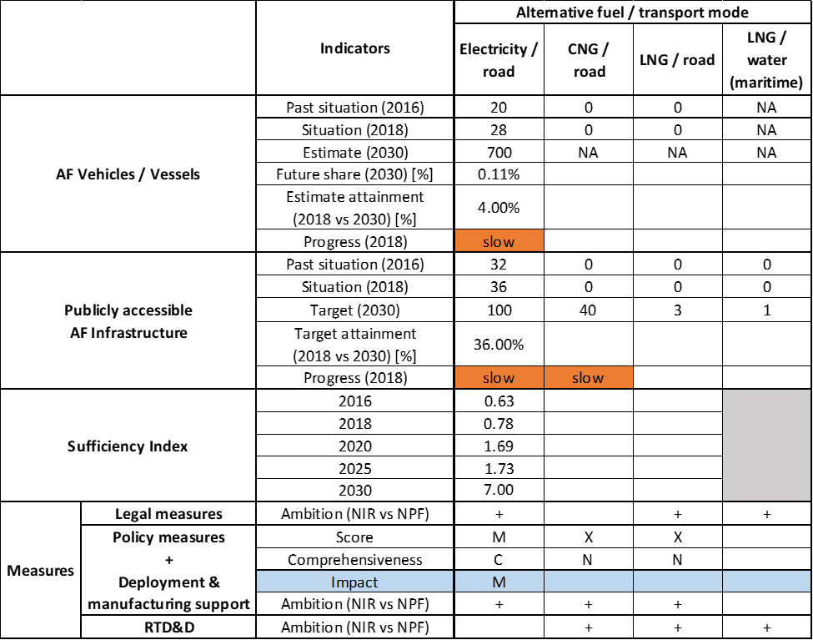



Not all the requirements of Annex I of the Directive are covered by the Cypriot NIR as outlined in the checklist of Table 5.13.2‑1.

With regards to the combination of AF/AFV/AFI with transport mode, electricity is well covered for road transport; CNG, LNG and LPG are also covered for road transport in terms of AFI; maritime water transport is covered for shore-side electricity supply and LNG in terms of AFI; all the other combinations are either absent or not applicable. The NIR has improved in terms of AFI target definition since it contains, contrary to the NPF, future targets for the pair CNG/road, LNG/road and LNG/water (maritime).

The main outcomes of the technical assessment of the Cypriot NIR on vehicles/vessels estimates and infrastructure targets can be summarised as follows:

###### Road transport

* **Electricity** – Concerning EVs, Cyprus recorded a total of 28 electric passenger cars and 73 electric powered two-wheelers in 2018. In contrast with the NPF where only a wide interval of 100-2000 was mentioned for 2020, the Cypriot NIR reports concrete quantitative vehicle estimates of 71, 140 and 700 for 2020, 2025 and 2030, respectively (all the values refer to passenger cars). Compared with the NPF, the recharging infrastructure targets in the CY NIR also became more concrete but have been reduced to 42, 81 and 100 respectively for 2020, 2025 and 2030. According to our methodology, the 2018 progress to achieve their objectives in 2030 is considered slow both for EVs and recharging infrastructure, while the sufficiency index is regarded as adequate for the next decade.
* **CNG** – The CY NIR states that CNG is currently not in use in the transport sector but introduces targets for CNG refuelling points in the future that were absent in the NPF (7 in 2025 and 40 in 2030). According to our methodology, the 2018 progress to achieve their objectives in 2030 is considered slow for CNG refuelling infrastructure.
* **LNG** – Cyprus does not record any LNG vehicles or refuelling infrastructure at the end of 2018. However, the CY NIR provides new LNG refuelling points targets that were absent in the NPF (3 in 2025 and 2030).
* **Hydrogen** – Similarly to the NPF, the CY NIR does not provide any quantitative future objective related to hydrogen vehicles or infrastructure. The intention of introducing hydrogen buses in the fleet of public transport is mentioned.
* **Biofuels** – The NIR only mentions that Cyprus implemented the EU Directives regarding increasing blending mandates for biofuels in diesel and petrol fuels.
* **LPG** – The Cypriot NIR shows only the situation in 2018 (205 passenger cars fuelled by LPG and gasoline), but does not report any LPG vehicle estimate for the future. The LPG infrastructure target for 2020 in the CY NIR has been reduced compared to the NPF by 60%, from 20 to 8 refuelling points.

###### Rail transport

Information is unavailable in the Cypriot NIR.

###### Waterborne transport (maritime)

* **Electricity** – As an update to the NPF that did not contain any target, the CY NIR introduced targets for shore-side electricity supply for seagoing ships in one maritime port in 2025 and 2030.
* **LNG** – The CY NIR presents the intention to have one maritime port equipped with LNG refuelling infrastructure by 2025, which was absent in the NPF.

###### Air transport

* **Electricity –** The NIR does not confirm the NPF target of two airports offering electricity supply for stationary airplanes by 2020.

As for the **measures**, the Cypriot NIR shows more focus on the development of electro-mobility. To a lower extent, also measures related to CNG, LNG, and hydrogen are present. The situation has evolved in the NIR compared with the NPF in the sense that there are measures that have been either continued/improved, became more concrete, or were newly introduced.

The Legal measures are mainly dedicated to allowing the development of electro-mobility. Overall, they appear, if fully implemented, to be fit to support the realisation of the AFV/AFI objectives as presented in the NPF and revised in the NIR. Based on the available information, their level of ambition can be considered to have increased between the NPF and the implementation report.

The Policy and Deployment & Manufacturing measures target only road as transport mode, in particular electro-mobility. Taken singularly, all these measures score low or medium and appear to show the same or higher level of ambition compared to the NPF. The most complete and numerous cluster of measures is for the pair electricity/road, followed by the pair hydrogen/road. The other pairs of alternative fuel and transport mode did not contain dedicated measures, thus their score could not be computed. In terms of expected impact of the measures to support the realisation of the AFV/AFI objectives as presented in the NPF and revised in the NIR, those for the pair electricity/road result to have a medium impact, those for the pair hydrogen/road have a low impact, while all the others were not assessable.

Concerning the RTD&D measures, the CY NIR shows a larger set of activities that translates in a higher ambition compared with the NPF. The measures presented relate to studies on implementation scenarios for different alternative fuels and the respective expected demands, with three studies dedicated to the introduction of natural gas (CNG and LNG) in the Cypriot transport.

The CY NIR states that the natural gas market is the subject of the Cypriot AF strategy. The Council of Ministers decision to treat the Cypriot natural gas market as emerging and geographically isolated market sets the base for further measures.

### Final remarks

The Cypriot NIR presents a relatively comprehensive report on the efforts to implement the Directive. The NIR partially meets the requirements of Annex I to the Directive, but shows a quite limited level of ambition. The NIR provides the targets for electric recharging points and the estimates of electric vehicles for 2020, 2025 and 2030, whereas for CNG and LNG only the targets for road refuelling points but no estimates are given for vehicles. The NIR includes measures to support the electrification of road transport. To a lower extent, measures related to CNG, LNG, and hydrogen are also included. In general, in view of the overall objective of achieving climate-neutrality in the EU by 2050, Cyprus should continue to increase its efforts to develop a comprehensive approach on promoting zero-emission vehicles. In this perspective, a higher level of ambition is required beyond road transport, where all transport modes are further considered, including air transport, towards the 2030 milestone.

Regarding electricity, the NIR estimates that 700 electric vehicles could be on the road by 2030, representing about 0.11% of the future fleet. Taking into account the current situation and expected trends, this level of ambition appears too low compared to the pace of deployment of electric vehicles considered necessary for a full transition to carbon neutrality by 2050. No information on charging efficiency is provided. The Cyprus maritime port in the TEN-T Core Network will be equipped with shore-side electricity supply for seagoing ships. Furthermore, the NIR does not address electricity supply in the Larnaca airport. Future reporting should provide further information on electricity supply for stationary airplanes.

Regarding hydrogen for road transport, the NIR, similarly to the NPF, does not provide any quantitative objective related to hydrogen vehicles or infrastructure. The NIR notes one measure devoted to introducing hydrogen buses in public bus fleets.

With regard to natural gas for transport, the NIR plans for seven CNG refuelling stations in 2025 and 40 in 2030. Three LNG refuelling points are foreseen from 2025 onwards. This appears to be sufficient taking into account the length of the TEN-T Core Network in Cyprus, provided that the refuelling stations are widely distributed along the network. In 2025, the port of Limassol will be equipped with one LNG refuelling point.

As regards LPG in road transport, the NIR only reports 205 LPG vehicles and two refuelling stations in 2018 and the revised infrastructure target for 2020. The LPG infrastructure target has been reduced compared to the NPF by 60%, from 20 to eight refuelling points.

As far as biofuels are concerned, further information should be provided on the consumption of biofuels. Cyprus should provide more information in future reporting on efforts to promote the use of renewable fuels in transport, and particularly in aviation.

### ANNEX - Description of the Member State

On a surface area of 9,300 km², Cyprus has a population of 864,000 people in 2018, which makes up for a population density of 93 inhabitants/km².

*Number of main urban agglomerations*

* 2 urban agglomerations > 50,000 inhabitants

In 2018, Cyprus achieves a per capita gross domestic product at market prices of €24,290, which represents a per capita gross domestic product in purchasing power standards of 89 if expressed in relation to the EU-28 average set to equal 100.

*Length of the road networks*

The length of the road TEN-T Core Network in Cyprus is 156 km. The total road network length is 4,789 km, of which 257 km are motorways.

The following lengths of the TEN-T Road Corridors are present in Cyprus: 3% (138 km) of the Orient - East Mediterranean Corridor.

*Number of registered road vehicles*

At the end of 2018, Cyprus accounts for 704,221 registered road vehicles of which 550,695 are categorized as passenger cars, 98,533 as light goods vehicles, 12,509 as heavy goods vehicles and 3,084 as buses and coaches. The motorisation rate is 638 passenger cars per 1,000 inhabitants.

*Number of ports in the TEN-T Core Network*

* 1 maritime port in TEN-T Core Network (Limassol)
* 1 maritime port in the TEN-T Comprehensive Network (Larnaca)
* No inland ports

*Number of airports in the TEN-T Core Network*

* 1 airport in the TEN-T Core Network (Larnaca)
* 1 airport in the TEN-T Comprehensive Network (Paphos)

## Latvia (LV)

### Main messages from the Commission assessment of the NPF

In its original assessment of the Latvian NPF the Commission concluded:

*The Latvian NPF addresses only part of the requirements of Article 3 of the Directive. It does not contain any target for LNG refuelling points to be put in place along the TEN-T Core Network, neither for heavy-duty vehicles nor for its two maritime ports in the core network.*

*The Latvian NPF considers that the deployment of an appropriate EV recharging infrastructure has a high priority for fostering electro-mobility. Latvia centres on deploying a comprehensive publicly accessible high power recharging infrastructure. The NPF lacks sufficient information on electricity supply for stationary airplanes. For vessels, two studies were carried out, concluding that the costs for the deployment of shore-side electricity supply for the ports of Riga and Ventspils outweigh the benefits.*

*The Latvian NPF admits that the absence of a national policy plan has jeopardised the use of natural gas and hydrogen in transport. The NPF does not provide future estimates thereof. The Latvian NPF indicates that a revision of the excise duty would be a candidate measure to promote natural gas use. It has established targets for the deployment of CNG refuelling points accessible to the public. The targeted number of CNG refuelling points could support a significant increase of CNG vehicles. The coverage of the TEN-T network with CNG refuelling points is unclear.*

*As indicated in the NPF, Latvia has no plans for the deployment of LNG refuelling points in its ports.*

*The NPF does not consider hydrogen for transport.*

*The Latvian NPF expects that the purchase price of ‘green’ vehicles will remain in the near-term higher than that of conventional vehicles. However, the government of Latvia considers it has “few instruments available to influence this”. Notwithstanding, the NPF mentions the possibility of financial support between 2018 and 2020 to reduce the current 7,000 EUR financial differential between internal combustion engine vehicles and EVs on sale in Latvia. Three levels of support are under discussion: 7,000 EUR for 2018, 5,000 EUR for 2019 and 3,000 EUR for 2020.*

### Overview of requirements’ fulfilment from Annex I of the Directive

*Table 5.14.2‑1 Checklist Table*



The checklist shows that the LV NIR covers only some of the requirements of Annex I from the Directive and mostly for electricity as fuel and road as transport mode. All the other AF and transport modes are either absent in the report or the level of information provided is such that it does not allow any assessment.

The Latvian NIR reports 29 measures. Under the Policy and Deployment & Manufacturing sections it was possible to identify six AF/transport mode clusters of measures, of which three were assessable.

### Quantitative assessment: Vehicles and infrastructure

*Table 5.14.3‑1 National AFV estimates and AFI targets established in the NIR at the horizon 2020, 2025 and 2030 and their comparison with the NPF situation*

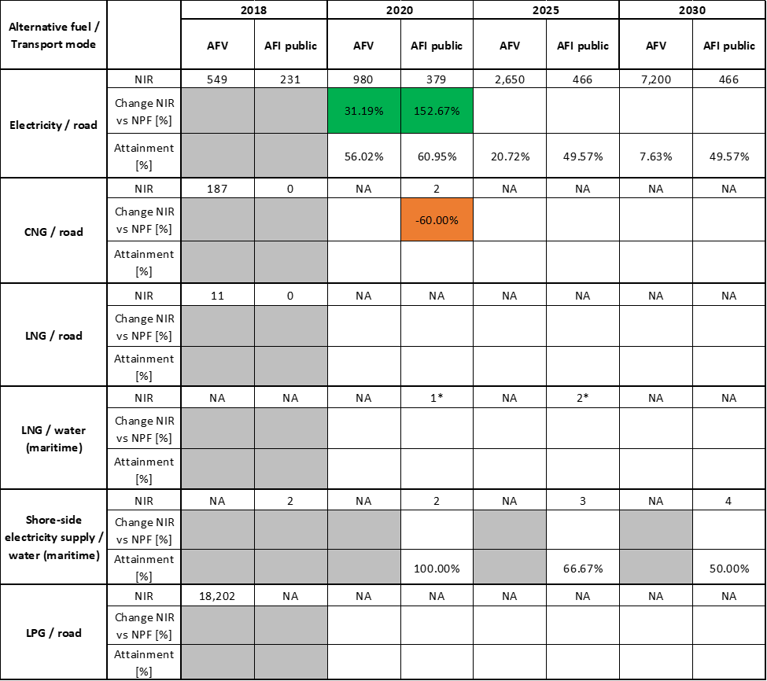



*The values with asterisks are reported as such in the LV NIR without explanation why there is the asterisk.

#### Road transport

##### Electricity

###### Vehicles

Latvia recorded 549 battery-electric and plug-in hybrid vehicles in use in 2018 (of which 531 were passenger cars, 13 LCVs and 5 buses and coaches). The LV NIR provides for 2020 a new and higher estimate of electric vehicles compared to the NPF (980 vs. 747) and presents for the first time EV estimates for 2025 and 2030 (2,650 and 7,200 EVs, respectively). These estimates for 2025 and 2030 seem to refer only to the passenger cars, as the values for LCVs and buses and coaches are indicated only for the 2020 (i.e. 14 LCVs and 6 buses and coaches). There is no mention of electrified Heavy Commercial Vehicles in the LV NIR.

The 2018 ***attainment*** of future EV estimates is 56.02% for 2020 and 7.63% for 2030. According to the assessment methodology described in Section 2.1, the 2018 situation corresponds to an ***adequate* *progress*** towards reaching the envisaged EV estimates. The calculated ***average* *annual growth rate*** corresponding to the period 2016-2030 for the EV fleet evolution is equal to 26%.

###### Infrastructure

Latvia recorded 231 publicly accessible recharging points in 2018 (see Table 5.14.3‑1). Like for the electrified vehicles, the LV NIR provides for 2020 a new and higher AFI target compared to the NPF (379 vs. 150) and presents for the first time AFI targets for 2025 (466 recharging points) and 2030 (the same value of 466 is reported in the LV NIR, but with the clarification that the number refers only to the approved and known projects) . The LV NIR clearly states that all these values of recharging points refer to the number of connectors, not to the number of recharging points, which therefore will probably be lower. It also states that the reported numbers of recharging points might not be comprehensive because “*owners of these points are not obliged to provide the Road Safety Directorate with information on station deployment*”. Concerning the recharging power, the LV NIR reports that those with a power below 22 kW will remain limited to a total of 30 recharging points until 2030, while those with higher power will increase (141 AC recharging points below 44 kW, 293 DC below 100 kW and 2 DC above 100 kW are foreseen in 2030).

Although the most relevant effort made by Latvia for the uptake of AF vehicles and infrastructure is for the pair electricity/road, the LV NIR still declares that “*the existing measures are not yet sufficient to ensure rapid increase in EVs in Latvia*”.

The 2018 ***attainment*** of future publicly accessible recharging infrastructure targets is 60.95% for 2020 and 49.57% for 2030. According to the assessment methodology described in Section 2.1, the 2018 situation corresponds to a ***fast progress*** towards reaching these envisaged targets. The calculated ***average annual growth rate*** corresponding to the period 2016-2030 for publicly accessible recharging infrastructure evolution planned by Latvia is equal to 23%.

###### Ratio

Based on the LV NIR, the following table shows the ratio between number of vehicles and publicly accessible recharging points (i.e. sufficiency index) for the pair electricity/road. As it can be seen, the number of recharging points was insufficient in 2016 and 2017 (and the sufficiency index was inadequate), but has grown considerably in 2018. Although the sufficiency index increases again above 10 in 2030, it can be considered adequate, because more than 90% of the recharging points are planned to be high power (>22kW) ones.



###### Information on charging efficiency

Information is not available in the Latvian NIR.

##### CNG

###### Vehicles

Latvia recorded 187 CNG vehicles in use in 2018 of which 177 were passenger cars, 8 LCVs and 2 HCVs. The Latvian NIR does not report any CNG vehicle estimate for 2020, 2025 and 2030, thus it is not possible to calculate the ***attainment,*** the ***progress*** or the ***average* *annual growth rate*** until 2030.

###### Infrastructure

Concerning CNG refuelling infrastructure (Table 2), the Latvian NIR reports nothing in 2018, but presents a target of two public refuelling points for 2020, which represents a decrease of 60% compared to the NPF target of five refuelling points. The NIR also mentions the plan to build a third public CNG refuelling point within 2020 and the presence of one private CNG refuelling point already in service. Like in the NPF, the Latvian NIR does not provide any target for 2025 and 2030.

As there was no CNG refuelling point in use in 2018, the ***attainment*** of future publicly accessible CNG infrastructure targets has not been computed. According to the assessment methodology described in in Section 2.1, the 2018 situation corresponds to a ***slow progress*** towards reaching these envisaged targets. The ***average annual growth rate*** corresponding to the period 2016-2030 for publicly accessible refuelling infrastructure could not be computed due to the zero value from 2016 to 2018.

###### Ratio

Due to the lack of data, it is not possible to calculate the sufficiency index for the pair CNG/road.

##### LNG

###### Vehicles

Latvia recorded 11 LNG vehicles in use in 2018 (of which eight were LCVs, two HCVs and one bus/coach). The Latvian NIR does not report any LNG vehicle estimate for 2020, 2025 and 2030. For this reason, it is not possible to calculate the ***attainment,*** the ***progress*** or the ***average* *annual growth rate*** until 2030.

###### Infrastructure

The Latvian NIR does not report any information on infrastructure for the pair LNG/road in 2018, nor any target for 2020, 2025 and 2030, thus it is not possible to calculate the ***attainment,*** the ***progress*** or the ***average annual growth rate*** until 2030.

###### Ratio

Due to the lack of data, it is not possible to calculate the sufficiency index for the pair LNG/road.

##### Hydrogen

###### Vehicles

Similarly to the NPF, the Latvian NIR does not report any information related to hydrogen-fuelled vehicles.

###### Infrastructure

Although the Latvian NIR mentions hydrogen refuelling points as being in the scope of some measures, there is no specific information on hydrogen infrastructure target until 2030.

###### Ratio

Since there are no vehicle estimates nor infrastructure targets in the Latvian NIR, it is not possible to calculate the sufficiency index for the pair hydrogen/road.

##### Biofuels

###### Vehicles

Information is unavailable in the LV NIR.

###### Infrastructure

Information is unavailable in the LV NIR.

##### LPG

###### Vehicles

Latvia recorded 18,202 LPG vehicles in use in 2018 of which 17,749 were passenger cars, 373 were LCVs and 80 were HCVs. The Latvian NIR does not report any LPG vehicle estimate for 2020, 2025 and 2030. For this reason, it is not possible to calculate the ***attainment,*** the ***progress*** or the ***average* *annual growth rate*** until 2030.

###### Infrastructure

Although there are clearly LPG refuelling points in Latvia (for example EAFO reports 240 LPG refuelling points in 2018), the Latvian NIR does not provide any information regarding LPG infrastructure in 2018, nor any target for 2020, 2025 and 2030, thus it is not possible to calculate the ***attainment,*** the ***progress*** or the ***average* *annual growth rate*** until 2030.

###### Ratio

Due to the lack of data, it is not possible to calculate the sufficiency index for the pair LPG/road.

##### Rail transport

##### Electricity

###### Vehicles

Information is unavailable in the LV NIR.

###### Infrastructure

The Latvian NIR confirms the plan, already presented in the NPF, to complete the electrification of railway lines Daugavpils - Krustpils, Rezekne - Krustpils and Krustpils - Riga by 2023. The LV NIR also mentions the plan to construct the European standard gauge rail line “Rail Baltica”, but does not provide any further information.

#### Waterborne transport (maritime)

##### Electricity

###### Vessels

Information is unavailable in the LV NIR.

###### Infrastructure

According to the LV NIR, two shore-side electricity supply installations were available in 2018 for use by vessels. The NIR also reports the target of one additional shore-side electricity supply installation in 2025 and one in 2030, but it states that this plan is subject to the outcome of the ongoing assessment of the necessity and economic feasibility of setting up shore-side electricity supply, due to be completed by 31 December 2020.

The 2018 ***attainment*** of future targets for shore-side electricity supply for seagoing ships in maritime ports is 100% for 2020 and 50% for 2030 (if the plan to build two additional installations is confirmed). According to the assessment methodology described in Section 2.1, the ***progress*** obtained by Latvia from 2016 until 2018 for the deployment of shore-side electricity supply in maritime ports is 50% of the overall planned deployment during the period 2016-2030.

##### LNG

###### Vessels

Information is not available in the Latvian NIR, apart from a generic mention of the development of shipbuilding with engines using only LNG as fuel (it is not clear whether this mention refers to Latvia specifically or to the EU in general).

###### Infrastructure

As it can be seen in Table 5.14.3‑1, the LV NIR reports the target of one LNG refuelling point in 2020 and another one in 2025, but it specifies that this plan is subject to the outcome of the ongoing assessment of the necessity and economic feasibility of setting up LNG refuelling points in ports (in TEN-T Core Network), due for completion by 31 December 2020. This could be the reason for the presence of the asterisk next to the numbers.

#### Waterborne transport (inland)

Not applicable since Latvia has no inland ports in the TEN-T Core Network.

#### Air transport

##### Electricity

###### Airplanes

Information is not available in the LV NIR.

###### Infrastructure (for stationary airplanes)

The LV NIR reports that *“most of the aircraft parking lots at Riga Airport that serve commercial passenger flights already have Fixed Power Units (FPUs), which provide power to aircraft systems during ground-handling services…. In the future, Riga Airport will also provide the construction of fixed power supply connection points”.*

##### Biofuels

###### Airplanes

Information on flights / airplanes powered by biofuels is unavailable in the Latvian NIR.

###### Infrastructure

Information is not available in the LV NIR.

### Measures assessment

As a general statement, it has to be anticipated that the description of the measures in the LV NIR is not sufficient to allow a complete assessment according to the methodology described in Section 2.2. In many instances the description is not clear as to what it applies to, furthermore the Policy and Deployment & Manufacturing measures do not provide quantitative information (budget per AF/vehicle/infrastructure) which makes the results of the assessment and of the clustering quite uncertain.

#### Legal measures

The LV NIR presents a list of 11 Legal measures, however only four of them can be considered strictly as Legal measures, while the other 7 are either Policy or Deployment & Manufacturing measures (and some of them are actually repeated in the Policy measures section). Overall, the Legal measures listed in the LV NIR do not appear to bring a different level of ambition compared to the NPF.

##### Legislative & Regulatory

The first and probably most important Legal measure is the Transport Energy Law, which will regulate the future transport sector in Latvia. Due to its importance, however, this measure is subject to a very lengthy procedure (presented to the LV Parliament in May 2018, expected to be adopted by December 2020), so it is currently still under discussion.

The second Legal measure is the Cabinet Regulation No 78 of 6 February 2018, laying down requirements for electric vehicle recharging points, natural gas refuelling points, hydrogen refuelling points and shore-side electricity supply facilities. The other two Legal measures, both adopted in 2017, amend respectively the previous law on circulation tax and company car tax, and the previous law on excise tax.

##### Administrative

The LV NPF does not provide specific information on administrative measures.

#### Policy measures

The LV NIR lists a series of 16 measures under the heading “Policy Measures”, however according to the classification adopted in the Guidelines for the reporting of the national implementation reports, only 13 measures can be considered Policy measures while the other three are Deployment measures and are described in the corresponding section.

##### Measures to ensure national targets and objectives

Ten out of the 13 Policy measures are intended to ensure the achievement of national targets and objectives. Eight measures focus on road transport and two on waterborne transport.

###### Road transport

Compared to the Policy measures already present in the NPF (and still in place), the new Policy measures presented in the NIR refer to studies and analysis that are seen as the necessary basis for future decisions. For example, two measures aim to “*conduct, in accordance with the ‘Tax Policy Guidelines 2017-2021’, an evaluation of tax incentives for CNG, LNG and FCEV, biofuel, paraffinic and synthetic fuels from RES, and the possibility of changing the excise tax rate for diesel to approximate the currently highest rate for gasoline*”. One measure aims to “*conduct an assessment in accordance with the Tax Policy Guidelines 2017-2021 of options for reducing the tax burden on eco-friendly vehicles (PHEV, FCEV, vehicles using biofuels, paraffinized and synthetic fuels derived from RES, hybrid vehicles, low-carbon vehicles, etc.) emitting less than 50 gCO2/km*”. Another measure is under discussion (deadline 31 December 2020) to “*examine options to facilitate purchases of EVs*”. Another measure is under discussion (deadline 31 December 2020) to discuss “*the possibility of increasing taxes on new non-ecological vehicles and, if necessary, amending laws and regulations*”.

###### Waterborne transport

Two Policy measures in the LV NIR address waterborne transport, one concerning the assessment of the potential use of LNG in ports, the other dedicated to studying the economics of shore-side electricity supply. The deadline for the conclusion of these analyses is 31 December 2020.

##### Measures that can promote AFI in public transport services

Two Policy measures are aimed at promoting AFI in public transport service. The first relates to supporting the deployment of environmentally friendly buses. This measure mentions six projects with a total budget (2018-2025) of around 16 million €, but there is no indication of the number of buses to incentivise. On the other hand, in the AFV Estimate section, there is only a mention of 6 Buses (BEV) for 2020 and no other type of bus. This however would be quite strange, because the average cost of an E-Bus is between €300,000 and €500,000, thus the budget would largely exceed the total cost.

The second measure is dedicated to the rail sector in cities (replacement of trams, rail lines, rolling stock). Total budget for the period 2017-2025 is slightly above30 million €, but there is no indication regarding the number AFV nor AFI, so once again the measure is not assessable.

##### Measures that can promote the deployment of private electro-mobility infrastructure

The LV NIR presents a measure to support the deployment of private electro-mobility infrastructure, i.e. “*consider simplifying administrative procedures for the deployment of EV recharging points that are not publicly accessible*”. The outcome of this analysis is expected by end of 2020.

#### Deployment and manufacturing support

##### AFI deployment

The Latvian NIR contains 5 AFI deployment support measures. One is a planning document developed between 2014 and 2016 that was the basis for the first round of deployment of EV recharging points. Three other Deployment measures relate to the actual construction of recharging points, firstly on the TEN-T roads or near them (total budget3.75 million €), secondly on urban areas with more than 5,000 inhabitants and on secondary roads (total budget7.80 million €). As these three measures have achieved the objective in 2018 of more than 50% of the infrastructure target for 2020, they get a score of high according to the assessment methodology (see Section 2.2). The fifth Deployment measure is related to the construction of the first three CNG refuelling points in Latvia (no indication of the budget in the LV NIR).

##### Support of manufacturing plants for AF technologies

Information is not available in the Latvian NIR.

##### Consideration of any particular needs during the initial phase of the deployment of alternative fuels infrastructures

Information is not available in the Latvian NIR.

#### Quantitative assessment of Policy and Deployment & Manufacturing measures

Table 5.14.4‑1 presents an overview of the analysis of all the Policy and Deployment & Manufacturing measures, carried out according to the assessment methodology described in Section 2.2. As it can be seen, six clusters of measures could be identified, of which only three were assessable. The pair electricity/road is the only one having a score of high and can be considered to be comprehensive. Support measures get a low/medium score for CNG/road and low score for LNG/road and are not comprehensive. Those for the pairs electricity/water, LNG/water and electricity/rail are not assessable, although for the last pair a budget is mentioned (around 30 million € for the period 2016-2025). In terms of the expected impact of these measures to support the realisation of the AFV/AFI objectives as presented in the NPF and revised in the NIR, the lack of future targets and estimates for several pairs coupled with the lack of information related to the measures makes the assessment almost impossible, with the only exception of the pair electricity/road, for which the expected impact is high.

Compared to the NPF, the level of ambition of the Policy and Deployment & Manufacturing support measures is substantially the same.

*Table 5.14.4‑1 Quantitative assessment of Policy and Deployment & Manufacturing support measures*



**Legend:** Score: H = high; M = medium; L = low; X = not assessable. Comprehensiveness: C = comprehensive; N = Not comprehensive. Ambition level: ‘+’ means ‘higher’; ‘=’ means ‘comparable’; ‘-‘ means ‘lower’.

#### Research, Technological Development & Demonstration

The Latvian NIR does not mention any RTD&D measure. It should be noted though that several measures presented in the LV NIR as either Legal or Policy measures could be considered as RTD&D measures (i.e. studies and analyses).

### Additional information on alternative fuels infrastructure developments

The Latvian NIR provides information on the changes in fuel use (see Table 5.14.5‑1). As it can be seen, LPG, CNG and LNG are expected to play a role in 2030, however this forecast is not accompanied by vehicle estimates and infrastructure targets for these fuels. No real increase in LNG use in maritime transport is expected.

*Table 5.14.5‑1 Changes in fuel use in transport sector (2016-2030)*



*Note: including trolleybuses and trams

### Summary of the assessment

**Tabular overview**

*Table 5.14.6‑1 Overview of the NIR assessment*

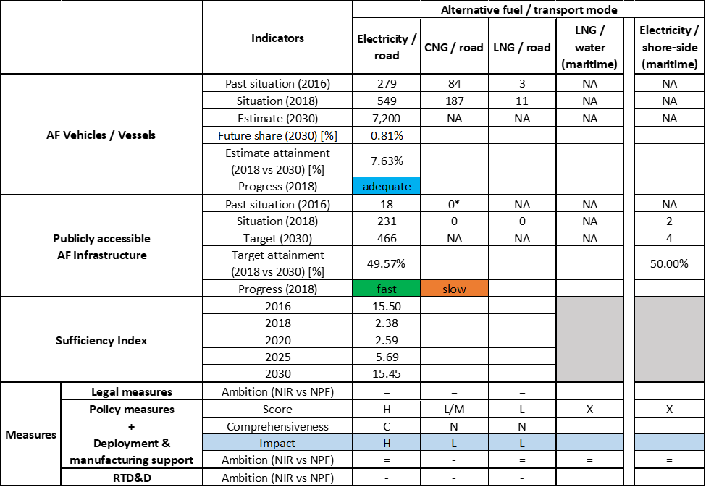



* Value taken or calculated from LV NPF.

With the only exception of the pair electricity/road, for which both vehicle estimates and infrastructure targets are provided until 2030, the Latvian NIR does not provide assessable information concerning the strategy for the uptake of alternative fuels for transport in the next decade. Several studies and analyses are being carried out, most of them with an expected deadline of December 2020, which will constitute the basis of the Latvian strategy for transport for the following years. This, on the other hand, implies that the NIR brings limited progress compared to the NPF and only for the pair electricity/road. Also, the Latvian NIR does not provide information on the methodology applied to take account of the charging efficiency of high power recharging points or on any particular needs during the initial phase of AFI deployment.

The main outcomes of the technical assessment of the Latvian NIR on vehicles/vessels estimates and infrastructure targets can be summarised as follows:

###### Road transport

* **Electricity** – With 549 electric vehicles and 231 publicly accessible recharging points recorded in 2018, Latvia’s progress is adequate for the deployment of EVs and fast in terms of recharging infrastructure. The sufficiency index indicating the ratio between number of EVs and number of recharging points, which was quite low in 2018 (2.38), increases progressively over time but in 2030 it can be still considered adequate, thanks to the relevant share of high power recharging points compared to the normal power recharging points. As for the heavy-duty sector, the LV NIR does not present any estimate for 2025 and 2030.
* **CNG** – There were 187 CNG vehicles in Latvia in 2018, the vast majority being passenger cars (plus 8 LCVs and 2 HCVs) and zero refuelling infrastructure. The Latvian NIR does not provide road vehicle estimates for the period 2020 – 2030. As for CNG refuelling points there is a target only for 2020, which is 60% lower than in the NPF (two versus five). The progress of infrastructure deployment results slow.
* **LNG** – The Latvian NIR only reported 11 LNG vehicles in use in 2018 (of which eight LCVs, two HCVs and one bus/coach) and zero refuelling points, but does not provide road vehicle estimates or LNG infrastructure targets for the period 2020 – 2030
* **Hydrogen** – The Latvian NIR does not provide road vehicle estimates or hydrogen road infrastructure targets for the period 2020 – 2030.
* **Biofuels** – The Latvian NIR foresees a decrease of biofuels market share from 3% in 2018 to 1% in 2030, but does not provide any specific information on biofuels for road transport.
* **LPG** – Despite the presence of an important number of LPG vehicles in Latvia in 2018 (17,749 passenger cars, 373 LCVs and 80 HCVs) and of the relevant forecast regarding the LPG market share as fuel in 2030 (14%), the Latvian NIR does not provide the infrastructure state of play in 2018 nor vehicle estimates/infrastructure targets for the period 2020 – 2030.

###### Rail transport

* **Electricity** - The Latvian NIR confirms the plan, already presented in the NPF, to complete the electrification of railway lines Daugavpils - Krustpils, Rezekne - Krustpils and Krustpils - Riga by 2023.

###### Waterborne transport (maritime)

* **Electricity** - In addition to the existing two shore-side electricity supply, two more shore-side electricity supply points are foreseen by 2030.
* **LNG** - There is a provisional plan to build two LNG refuelling points at maritime ports, one in 2020 and one in 2025, but this plan has to be confirmed by the outcome of an ongoing analysis of its economic feasibility.

###### Air transport

* **Biofuels** – The Latvian NIR does not provide information related to the need of renewable jet fuel refuelling points in airports within the TEN-T Core Network.

As regards to the **measures**, their description in the LV NIR is not sufficient to allow a complete assessment according to the methodology described in Section 2.2. Furthermore the Policy and Deployment & Manufacturing measures do not provide quantitative information (budget per AF/vehicle/infrastructure) which makes the results of the assessment and of the clustering quite uncertain. Six clusters of measures could be identified, of which only three were assessable. Tangible results during the implementation period and potentially high impact for the future could be seen only for the pair electricity/road, while for all the other fuels and transport modes the concretisation and quantification of supporting measures will depend on the outcome of the several studies and analyses on tax, incentives, feasibility, etc., undertaken by the Latvian authorities.

### Final remarks

The Latvian NIR provides a rather limited report on the efforts to implement the Directive. The NIR complies, to a certain extent, with the requirements of Annex I to the Directive. However, the report does not provide estimates on CNG vehicles and LNG vehicles and vessels. Furthermore, targets on natural gas infrastructures are only provided for CNG refuelling points in 2020 and LNG infrastructure in ports by 2025 and 2030. A certain number of the measures included in the Latvian NIR are not well described in terms of their objectives and timelines for policy implementation, in particular for waterborne transport.

With regard to electricity for road transport, the NIR estimates that approximately 7,200 electric vehicles could be on the roads by 2030, representing about 0.81% of the fleet by that time. Taking into account the current situation and expected trends, this level of ambition appears very low compared to the pace of deployment of electric vehicles considered necessary for a full transition to carbon neutrality by 2050. Further, in line with the low estimates for electric vehicles take up, there are only 466 recharging points estimated by 2030. An increase in ambition would contribute to better meeting the needs of realising a dense, wide-spread and easy to use network of recharging and refuelling infrastructure throughout the EU. No information on charging efficiency is provided. The NIR reports that the four major ports of Latvia will supply shore - side electricity by 2030. The report states that electricity is already supplied to stationary aircraft in the Riga airport. Further information should be provided on the current and future planned share of electrified rail network.

For hydrogen, the NIR does not report any information on existing or future FCHVs and the relevant infrastructure. It would be relevant that Latvia provides more information on how to ensure EU-wide connectivity for HCEV.

With regard to natural gas, the NIR shows that Latvia already had fleets of 187 CNG vehicles and 11 LNG vehicles in 2018. The NIR does not provide any estimates for natural gas vehicles for 2020, 2025 and 2030 and has only reported two public CNG refuelling points in 2020 and no information on LNG on roads. Two Latvian ports in the TEN-T Core Network might have LNG refuelling points by 2025 and thus complying, in this respect, with the requirements of the Directive.

With regard to LPG, the NIR shows that Latvia already had a medium LPG vehicle fleet and infrastructure, but the Latvian NIR does not provide any estimates of vehicles and infrastructure targets by 2020, 2025 and 2030. In this respect, Latvia should provide information on whether it intends to support LPG as a vehicle fuel in the future.

Further information should be provided on biofuels consumption in Latvia in road and air transport. Latvia should provide more information in future reporting on efforts to promote the use of renewable fuels in transport, and particularly in aviation.

### ANNEX - Description of the Member State

On a surface area of 64,600 km², Latvia has a population of 1.934 million people in 2018, which makes up for a population density of 30 inhabitants/km².

*Number of main urban agglomerations*

* 4 urban agglomerations > 50,000 inhabitants

In 2018, Latvia achieves a per capita gross domestic product at market prices of €15,080, which represents a per capita gross domestic product in purchasing power standards of 69 if expressed in relation to the EU-28 average set to equal 100.

*Length of the road networks*

The length of the road TEN-T Core Network in Latvia is 835 km. The total road network length is 7,130 km.

The following lengths of the TEN-T Road Corridors are present in Latvia: 9% (378 km) of the North Sea - Baltic Corridor.

Through the TEN-T Road Corridors, Latvia is connected with the following Member States:  
- Estonia (through the North Sea - Baltic Corridor),   
- Lithuania (through the North Sea - Baltic Corridor)

*Number of registered road vehicles*

At the end of 2018, Latvia accounts for 854,737 registered road vehicles of which 707,841 are categorized as passenger cars, 57,146 as light goods vehicles, 32,065 as heavy goods vehicles and 4,885 as buses and coaches. The motorisation rate is 366 passenger cars per 1,000 inhabitants.

*Number of ports in the TEN-T Core Network*

* 2 maritime ports in the TEN-T Core Network (Riga, Ventspils)
* 1 maritime port in the TEN-T Comprehensive Network
* No inland ports

*Number of airports in the TEN-T Core Network*

* 1 airport in the TEN-T Core Network (Riga)
* 3 airports in the TEN-T Comprehensive Network

## Lithuania (LT)

### Main messages from the Commission assessment of the NPF

In its original assessment of the Lithuanian NPF the Commission concluded:

*The Lithuanian NPF does not fully address the requirements of Article 3. A short discussion on the current state and future scenarios for alternative fuels in the transport sector in Lithuania is presented in the NPF. Targets as required by Article 3 of the Directive were established for CNG, LNG, and electricity for vehicles.*

*The Lithuanian NPF places attention on electric vehicles without possessing currently a dense network of publicly accessible recharging points. The spatial distribution of recharging points does not currently cover the needs of vehicles in terms of distance requirements; the ratio of only one public recharging point per 12 electric vehicles estimated for 2020 may be seen as a risk to the further market deployment of electric vehicles. It may be important to closely monitor this development and correct infrastructure targets in line with the market developments. Lithuania, today, has 10 hybrid buses (electricity + CNG). Bicycles as well as their infrastructure also receive support. The NPF neither contains any targets for increasing the availability of electricity supply for stationary airplanes nor for shore-side electricity.*

*Lithuania currently has a sufficient network of CNG refuelling points. Targets for an increase of the number of CNG refuelling points by 2020 and 2025 are foreseen. However, as the NPF does not provide estimates for the future deployment of CNG vehicles, their CNG infrastructure sufficiency for 2020 cannot be assessed.*

*Despite an existing fleet of 161 public transport buses with engines fuelled by LNG, no publicly accessible road LNG refuelling points are mentioned in the Lithuanian NPF. One LNG refuelling point for heavy-duty vehicles is targeted for 2025.*

*According to the Lithuanian NPF, there are no further plans for an extension of LNG refuelling points in ports, besides the already existing LNG refuelling point in Klaipėda, Lithuania's only maritime port in the TEN-T Core Network.*

*The NPF does not cover hydrogen for transport.*

*The Lithuanian NPF contains a list of measures, most of them, however, still under consideration with little details revealed in the NPF. Most of them can be considered having a low or medium impact on market actor's decisions. Their low implementation status could create uncertainty for market actors and hence decrease the likelihood that the national targets and objectives of the NPF could be reached.*

*The interests of regional and local authorities, as well as stakeholders have been considered during the drafting of the Lithuanian NPF. Further coordination is planned in order to ensure follow-up of the implementation actions, collaboration among authorities and advice from stakeholders.*

*Lithuania is actively involved in coordinating its plans on rail infrastructure with other Member States as well as collaborating with them in this field. Beyond that, the NPF does not mention any cooperation or coordination in the field of alternative fuels.*

### Overview of requirements’ fulfilment from Annex I of the Directive

*Table 5.15.2‑1 Checklist Table*

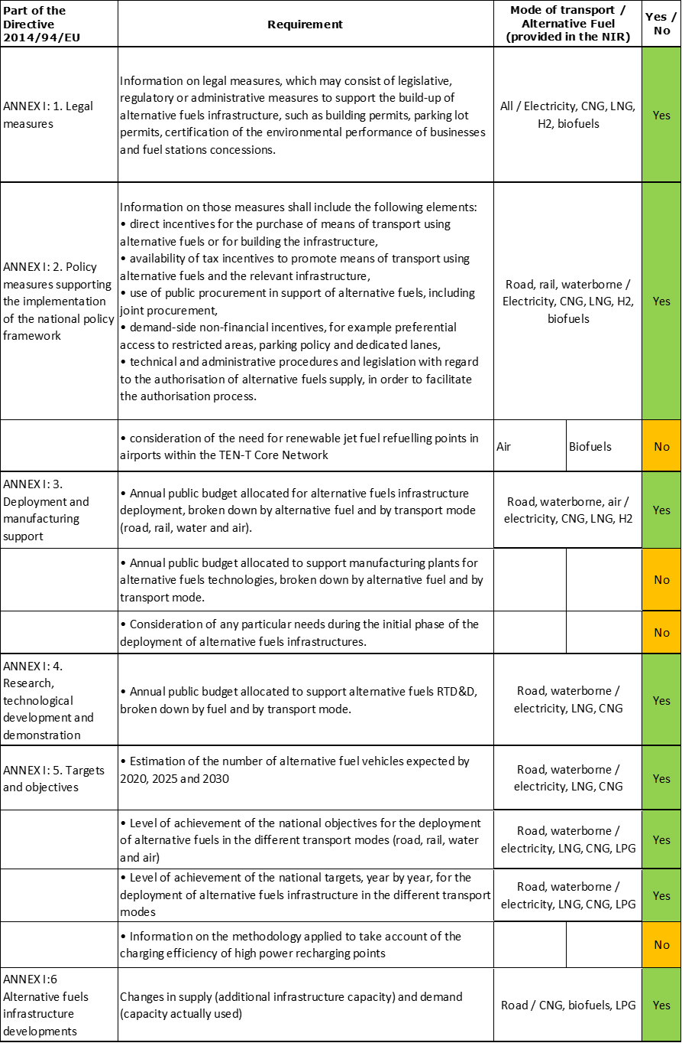

The checklist shows the requirements of Annex I from the Directive that are covered in the LT NIR.

Regarding the combination of AF/AFV/AFI with transport mode, electricity is covered for all transport modes; CNG, LNG, hydrogen and LPG are covered for road transport (but LPG only in terms of AFI); LNG is covered also for waterborne transport (both inland and maritime); all the other combinations are either absent or not applicable.

The LT NIR reports 44 measures. Under the Policy and Deployment & Manufacturing sections it was possible to identify nine AF/transport mode clusters of measures, of which eight were assessable.

### Quantitative assessment: Vehicles and infrastructure

The Lithuanian NIR signals that “*It should be noted that the previously planned targets and measures are currently being reviewed in the light of the EU’s GHG reduction targets for the transport sector*”. National objectives and targets according to the National Energy and Climate Action Plan of the Republic of Lithuania for 2021-2030 are also mentioned: “*The transport sector is aiming at a gradual shift towards cleaner fuels and electricity, and therefore, in line with the EU's commitments, the aim is to achieve a 10 per cent RES share by 2020 and a 15 percent RES share by 2030. However, Lithuania, like other Member States, is struggling to achieve the RES-T target for 2020 due to relatively high investment in the renewal of the vehicle fleet, which consists mainly of almost 1.5 million cars, 69% of which are diesel cars, with an average age of 15 years. For this reason, it is likely that the 2020 target will not be achieved by 2020 and the share of RES-T will be around 5 per cent.*”

*Table 5.15.3‑1 National AFV estimates and AFI targets established in the NIR at the horizon 2020, 2025 and 2030 and their comparison with the NPF situation*





#### Road transport

##### Electricity

###### Vehicles

Lituania reported a total of 1,556 electric vehicles in use in 2018 (Table 5.15.3‑1), of which 1,539 were passenger cars, 16 LCVs and one HCV. On top of that, the LT NIR reports 406 electric buses and coaches, but this number probably includes also trolleybuses, which do not fall under the scope of this assessment. The LT NIR reports also 132 PTWs in use in 2018. The Lithuanian NIR presents a new plan with increased ambition compared to the NPF and almost triples the EV estimates for 2020 (3,011 vs. 1,200 in the NPF). For the years 2025 and 2030, new estimates have been set (not given in NPF) for a total of 46,066 passenger cars and 5,469 LCVs by 2025, and a total of 230,332 passenger cars and 18,231 LCVs by 2030. The heavy-duty sector is excluded from future estimates in the LT NIR[49]. The report mentions that registration of ICE vehicles after 2030 will not be possible.

Therefore the level of ambition in the Lithuanian NIR has increased in comparison to the NPF.

The 2018 ***attainment*** of future electric light-duty vehicles estimates is 51.68% for 2020 and 0.63% for 2030. According to the assessment methodology described in Section 2.1, the 2018 situation corresponds to an ***adequate progress*** towards reaching the envisaged estimates. The calculated ***average*** ***annual growth rate*** corresponding to the period 2016-2030 for electric light-duty vehicles fleet evolution planned by Lithuania is equal to 61%.

###### Infrastructure

Lithuania reported 212 publicly accessible recharging points, of which 192 were high power (>22kW) recharging points and 20 normal power (≤22kW) recharging points. The Lithuanian NIR significantly increased the targets and ambition for public infrastructure in 2020 and 2025 compared to the NPF, as well as provided a new target for 2030. The revised targets of publicly accessible recharging points for 2020 and 2025 are 198% and 210% higher than those presented in NPF, however the revised target for 2025 does not seem sufficient to cope with the vehicle estimate for the same year. For 2030, Lithuania plans to have 15,055 public recharging points. The LT NIR also highlights the plan to have 60,000 private recharging points in 2030.

The 2018 ***attainment*** of future public recharging infrastructure targets is 71.14% for 2020 and 1.41% for 2030. According to the assessment methodology described in Section 2.1, the 2018 situation corresponds to an ***adequate progress*** towards reaching these envisaged targets. The calculated ***average annual growth rate*** corresponding to the period 2016-2020 for publicly accessible recharging infrastructure evolution planned by Lithuania is equal to 66%.

###### Ratio

Based on the LT NIR, the following table shows the ratio between vehicles and publicly accessible recharging points (i.e. sufficiency index) for the pair electricity/road. As it can be seen, the sufficiency index was very high (and inadequate) in 2016, but has adjusted in 2018. Also for 2020 the sufficiency index is close to the value of 10 and adequate. A big unbalance between EVs and public recharging points is foreseen in 2025, which, according to LT NIR data, should be mostly solved until 2030.



###### Information on charging efficiency

Lithuanian NIR did not provide direct information on charging efficiency of high power (>22kW) recharging points, but it reported the following: “*There are currently 25 combined charging stations along national roads (three types:* AC, DC CHAdeMO and DC Combo*). Two electric vehicles can be charged at the same time at one station (AC and DC connectors). The number of connections to individual stations ranges between 195 and 40,533 per month (as observed in the period from May 2019 to October 2019); for October, for instance, the average number of connections was 5,095 and the average electricity consumption was 2,217 Kwh*.”

##### CNG

###### Vehicles

Lithuania reported that 405 CNG vehicles were in use in 2018, of which 100 were passenger cars, 3 LCVs, 2 HCVs and 300 buses and coaches.

As regards to the years 2020, 2025 and 2030, the LT NIR provides new estimates (respectively 565, 1,500 and 12,300 vehicles). These were absent in the NPF. The new estimates specify also that the biggest growth is expected in numbers of CNG passenger cars (10,000 in 2030), but 500 LCVs, 1,000 HCVs and 800 buses and coaches are also foreseen.

The 2018 ***attainment*** of future CNG vehicles estimates is 71.68% for 2020 and 3.29% for 2030. According to the assessment methodology described in Section 2.1, the 2018 situation corresponds to a ***slow progress*** towards reaching the envisaged CNG vehicles estimates. The calculated ***average annual growth rate*** corresponding to the period 2016-2030 for the CNG vehicle fleet evolution planned by Lithuania is equal to 28%.

###### Infrastructure

Lithuania reported four publicly accessible CNG refuelling stations in 2018 (plus six private). The LT NIR reports that Lithuania aims to achieve 8 public CNG refuelling points in 2020 (20% less than in the NPF), 13 in 2025 (30% more than in the NPF) and 28 in 2030 (there was nothing in the NPF). The number of private CNG refuelling points is expected to decrease from the current six, to four in 2020 and two in 2025 and 2030.

The 2018 ***attainment*** of future public CNG refuelling infrastructure targets is 50% for 2020 and 14.29% for 2030. According to the assessment methodology described in Section 2.1, the 2018 situation corresponds to a ***slow progress*** towards reaching these envisaged targets. The calculated ***average annual growth rate*** corresponding to the period 2016-2025 for publicly accessible CNG refuelling infrastructure evolution planned by Lithuania is equal to 14%.

###### Ratio

Based on the LT NIR, the following table shows the ratio between vehicles and publicly accessible refuelling points (i.e. sufficiency index) for the pair CNG/road. The sufficiency index is always below the indicative value of 600 (see Section 2.1.5).



##### LNG

###### Vehicles

Lithuania reported 207 LNG vehicles in 2018 (Table 5.15.3‑1). They were mainly buses and coaches (172) and 35 passenger cars. Regarding the next decade, the LT NIR proposes new estimates for 2025 and 2030 (not present in NPF), while 2020 is not addressed. The LT NIR aims to achieve 310 LNG vehicles in 2025 and 1,075 in 2030. This estimated growth is planned mainly for the HCVs (300 in 2025 and 1,000 in 2030), but 50 LCVs and 25 buses and coaches are also expected in 2030. For the LNG vehicles the level of ambition in the LT NIR is higher than presented in NPF.

The 2018 ***attainment*** of future LNG vehicles estimates is 66.77% for 2025 and 19.26% for 2030. According to the assessment methodology described in Section 2.1, the ***progress*** obtained by Lithuania from 2016 until 2018 for LNG vehicles deployment is 3.45% of the overall planned deployment during the period 2016-2030.

###### Infrastructure

The LT NIR reports two public LNG refuelling points in 2018. The NIR provides also increased target for 2025 (three versus one in the NPF) and a new target of 5 public refuelling points for 2030 (2020 is not addressed). Also for the LNG infrastructure the level of ambition in the LT NIR is higher than in the NPF.

The 2018 ***attainment*** of future public LNG refuelling infrastructure targets is 66.67% for 2020 and 40% for 2030. According to the assessment methodology described in Section 2.1, the progress obtained by Lithuania from 2016 until 2018 for public LNG refuelling infrastructure deployment is 40% of the overall planned deployment during the period 2016-2030.

###### Ratio

Based on the LT NIR, the following table shows the ratio between vehicles and publicly accessible refuelling points (i.e. sufficiency index) for the pair LNG/road. The sufficiency indexes for 2016, 2017 and 2020 could not be computed as targets for infrastructure were not indicated.



##### Hydrogen

###### Vehicles

Lithuania recorded no hydrogen vehicle in use in 2018, but the LT NIR reports estimates for the number of hydrogen vehicles in 2020, 2025 and 2030 (all absent in NPF), which are 1, 65 and 1,250 respectively. As for 2030, 1,000 passenger cars, 100 LCVs, 50 HCVs and 100 buses and coaches are expected.

Because at the end of 2018 there were no hydrogen vehicles deployed, the 2018 ***attainment*** and ***progress*** have not been computed.

###### Infrastructure

The LT NIR does not report nor foresees any public hydrogen refuelling point in operation for the years from 2016 until 2020. However the LT NIR provides new targets for 2025 and 2030 (not reported in NPF), of respectively 2 and 10.

Because at the end of 2018 there are no hydrogen refuelling points deployed, the 2018 ***attainment*** and ***progress*** have not been computed.

###### Ratio

Based on the LT NIR, the following table shows the ratio between vehicles and publicly accessible refuelling points (i.e. sufficiency index) for the pair hydrogen/road. Obviously the sufficiency indexes could be computed only for the years 2025 and 2030.



##### Biofuels

###### Vehicles

The LT NIR only provides information that “*Biofuels are used for blending in petrol and diesel strictly in the manner provided for in national legislation. Lithuania aims to gradually transition to advanced biofuels produced from secondary waste. The ratios of biofuel blending in fossil fuels are increasing*”.

###### Infrastructure

Information is not available in the Lithuanian NIR.

##### LPG

###### Vehicles

Lithuania reported 109,576 LPG vehicles in 2018 (Table 5.15.3‑1), of which 108,565 passenger cars, 503 LCVs, 623 HCVs, and 87 buses and coaches. For the next decade, the LT NIR does not propose any estimate.

Because there are no LPG vehicle estimates, the 2018 ***attainment*** and ***progress*** could not be computed.

###### Infrastructure

The LT NIR reports 664 public LPG refuelling points in 2018. This number is expected to slowly decrease in the next decade, to reach a value of 545 public refuelling points in 2030.

Because the Lithuanian NIR provided decreasing targets for publicly accessible LPG refuelling infrastructure, the 2018 ***attainment*** and ***progress*** have not been computed.

###### Ratio

Based on the LT NIR, the following table shows the ratio between vehicles and publicly accessible refuelling points (i.e. sufficiency index) for the pair LPG/road. Clearly, the sufficiency index for 2020, 2025 and 2030 could not be computed as the number of vehicles was not indicated.



#### Rail transport

##### Electricity

###### Vehicles

The LT NIR reports that the implementation plan of the National Transport Development Programme (see Section 5.15.4.1) includes also the purchase of electric trains. The NIR also reports 13 electric locomotives in 2018, presumably new ones, and indicates 13 electric locomotives also for 2020, 22 for 2025 and 22 for 2030.

The 2018 ***attainment*** of future electric locomotives estimates is 100% for 2020 and 59.09% for 2030. According to the assessment methodology described in Section 2.1, the ***progress*** obtained by Lithuania from 2016 until 2018 for electric locomotives deployment is 59.09% of the overall planned deployment during the period 2016-2030.

###### Infrastructure

With reference to rail infrastructure, the LT NIR provides no numerical information but only a reference to the plan to proceed with the further electrification of rail with a budget of 250 million € up to 2020 (see Section 5.15.4.2.2).

#### Waterborne transport (maritime)

##### Electricity

###### Vessels

Information is not available in the Lithuanian NIR.

###### Infrastructure

The LT NIR reports that, as Klaipėda State Seaport (KSS) is already equipped with facilities that can be used by operators of ships, no additional need of shore-side electricity supply facilities is foreseen.

##### LNG

###### Vessels

The LT NIR reports one LNG seagoing ship in service since 2016, which will continue until 2030.

###### Infrastructure

Lithuania recorded one LNG refuelling point in its TEN-T Core port of Klaipėda in 2018. This LNG terminal has been in operation since December 2014, and recently the focus is put on Liquefied Natural Gas Distribution Station (LNG DS), which is an above-ground LNG terminal operated on a third-party access basis. The LNG DS is designed to receive LNG from small-scale carriers, to store it temporarily and to transfer it to LNG tank vehicles or vessels. LNG may also be loaded in ISO-compliant standard-sized containers which can be transported by rail and road. The LT NIR confirms this infrastructure until 2030.

#### Waterborne transport (inland)

##### Electricity

###### Vessels

Information is not available in the Lithuanian NIR.

###### Infrastructure

Lithuania did not record any shore-side electricity supply in 2018, but the LT NIR reports the plan to have three shore-side electricity supply for inland waterway vessels or recreational crafts in inland ports by 2030. The potential locations are Kaunas Lagoon pier, Nida pier and Uostdvaris inland waterway port.

Because at the end of 2018 there are no shore-side electricity supply points deployed in the inland ports, the 2018 ***attainment*** and ***progress*** have not been computed.

##### LNG

###### Vessels

The LT NIR reports that the first LNG inland waterway vessels is foreseen for 2025, followed by other five by 2030.

###### Infrastructure

Lithuania did not record any LNG refuelling point for inland waterway vessels in 2018, but the LT NIR mentions the proposal by the Lithuanian Inland Waterway Authority to establish a LNG refuelling point in Marvele cargo pier (Kaunas).

Because at the end of 2018 there are no LNG refuelling points in inland ports, the 2018 ***attainment*** and ***progress*** have not been computed.

#### Air transport

##### Electricity

###### Airplanes

Information is not available in the Lithuanian NIR.

###### Infrastructure (for stationary airplanes)

Lithuania recorded 37 electric power supply points for stationary airplanes, in use since 2016. This number is expected to increase to 44 points in 2020, and 45 points in 2025 and 2030. Since, according to the LT NIR, Lithuania’s international airports already have the necessary infrastructure to supply electricity to stationary airplanes, no additional need for electricity supply facilities at airports is expected.

The 2018 ***attainment*** of future targets for electricity supply points for stationary airplanes is 84.09% for 2020 and 82.22% for 2030. According to the assessment methodology described in Section 2.1, the ***progress*** obtained by Lithuania from 2016 until 2018 for the deployment of electricity supply points for stationary airplanes is 0% of the overall planned deployment during the period 2016-2030.

##### Biofuels

###### Airplanes

Information on flights / airplanes powered by biofuels is unavailable in the Lithuanian NIR.

###### Infrastructure

Information is not available in the Lithuanian NIR.

### Measures assessment

The LT NIR contains an extensive and wide-scope portfolio of measures, but it often lacks a sufficient description, which makes the assessment results less robust. The majority of the reported measures focus on electricity and CNG and on road as transport mode. In comparison to the NPF the measures in the LT NIR include hydrogen, which is an additional value to the program. Also the focus on LNG development continues to be strong in Lithuania, both for water and road transport.

#### Legal measures

The Lithuanian NIR contains 18 legal measures (versus 8 in the NPF) to promote AFs. The description of the measures is short and lacks relevant content.

The bases of the LT NIR legal measures are defined in the National Transport Development Programme for 2014-2022, containing policies for the development of alternative fuels and the implementation plan. The programme provides measures such as purchase of electric trains, installation of electric recharging points and the installation of LNG and CNG refuelling points.

The Law on Alternative Fuels is foreseen ‘*to be adopted in 2020*’ to clearly regulate issues related to alternative fuels, alternative fuel vehicles and refuelling/recharging infrastructure for alternative fuels. The LT NIR reports also on the 2019 draft of Lithuanian National Energy and Climate Plan[50], and the preparation of the Lithuanian Transport Development Strategy up to 2050[51]. The latter document describes also interactions between existing and planned policies and measures.

An overall assessment of the legal measures is that the LT NIR shows an increased ambition level compared to the NPF.

##### Legislative & Regulatory

Lithuania lists ten legislative and regulatory measures in its NIR, of which six are new compared to the NPF. Reported measures are proposed on the basis of the following acts:

* *Renewable Energy Act*, indicates targets of 10% RES share in transport and biofuels blending obligation;
* *Law on Alternative Transportation*, intended to draw the main concepts of alternative transportation, giving a clear direction for the market participants. It would include biofuels, biogas and electricity use in transport, the main targets and obligations, and also requirements for refuelling stations;
* *Electricity Law of the Republic of Lithuania*;
* *Gas Law of the Republic of Lithuania*.

Other regulatory measures reported in LT NIR are tackling public guidelines for the development of electric charging infrastructure, and are also derived from the following strategic documents:

* *National Transport Development Programme 2014-2022,* where the Objective 4 of the programme is to increase energy efficiency in transport and reduce the adverse impact of transport on the environment;
* *National Energy Independence Strategy*, with the goal to achieve independence from fossil fuels in both electricity generation and heating, by taking advantages of LNG development related to transport;
* *National strategy for climate change management*, tackling the mitigation in the areas of adaptation to the effects of climate change.

##### Administrative

The Lithuanian NIR reports on eight administrative measures.

* The *Law of the Republic of Lithuania on Energy from Renewable Sources* sets the basis for:
  + Guarantee of origin (GO) system, where gaseous fuels can have their origin proved and the GOs are issued electronically for each MWh of energy. The target is that 100% of biogas producers should be registered in the system by 2030;
  + Discount for biogas production infrastructure connection to the grid (40%);
  + Self-certification scheme, which is a control system establishing the compliance of biofuels with sustainability criteria;
* Within the implementation of the Directive 2014/94/EU, the following procedures have been indicated:
  + Assignment of Responsibilities and Provisions of Information on Directive 2014/94 /EU[52];
  + The use of electrical equipment;
  + Changes to service station operating rules;
  + Description of the procedure for the provision of information on the fuel used by motor vehicles;
  + Requirements for installing Electro-computer Charging Infrastructure in residential and non-residential buildings with a parking space.

#### Policy measures

The main focus in the LT NIR is on electric vehicles, but CNG and LNG on roads are also developing. LNG for waterborne transport (inland) is being addressed as well. The available financial instruments are not clearly defined in the LT NIR, but the measures have a wider scope compared to the NPF (for example, there are incentives not only for the purchase of new alternative fuel vehicles/vessels, but (in the case of waterborne transport) also for the replacement of old engines with new ones, running on alternative fuels). In comparison to NPF, hydrogen is also acknowledged and supported in the NIR. Lithuania reports the completion of optimisation of airport infrastructure as their international airports already have the necessary infrastructure to supply electricity to stationary airplanes, and there is no additional need for electricity supply facilities at airports. Lithuania also reports that Klaipėda State Seaport (KSS) and some of the country’s inland ports are already equipped with shore-side electricity supply facilities that can be used by operators of ships berthed off shore, and there is also no need to deploy additional facilities.

The policy direction in Lithuania is presented in National Energy and Climate Action Plan of the Republic of Lithuania for 2021-2030, which focuses on addressing issues of EU’s climate change and energy policy, but amongst others presents policies and measures for increasing the use of renewables in transport and its role in decarbonisation. This Action Plan presents existing, as well as planned up to 2030 policy measures in the transport sector. Taking into consideration that this plan is not a part of the LT NIR, it has been used as a back-up source of information, but only the measures reported by Lithuania in its NIR were assessed.

##### Measures to ensure national targets and objectives

The large majority of policy measures described in the Lithuanian NIR can be categorised as measures to ensure national targets and objectives. There are 20 of them (of which 11 financial, and 9 non-financial), mainly related to road transport, but including also LNG and electricity with their applicable transport modes.

###### Road

Two of the financial incentives involve taxation: vehicle registration/re-registration fees related to pollution (starting from 2020) and excise duty exemption for natural gas consumed in transport (existing since 2018). Although both of them were present also in the NPF, some changes have been brought. The excise duty exemption for natural gas is planned to be modified in order to promote other alternative fuel use (but not LPG) for the development of related infrastructure. On the other hand very limited information was given on the registration fees, stating only that: “*From next year* (excel: 2020) *the registration and re-registration of polluting vehicles would be taxed. Polluting vehicles are those which have a petrol and / or gas engine with a CO2 emissions greater than 130 g/km and a diesel engine with a CO2 emissions above 115 g/km.*”

The LT NIR also reports policy measures dealing with subsidies, in particular:

* Support to municipalities to purchase electric and other alternative fuel buses (43 million € in the period 2017-2020);
* Installation of primary necessary infrastructure for electric recharging points near state roads and in municipalities with a population >25,000 (2 million € in 2018-2020);
* Co-financing the purchase of natural gas buses that could be fuelled also with compressed biomethane gas, only for public transportation (37 million € in 2020-2030);
* Deployment of the measures of sustainable mobility (30 million € in 2019-2020);
* Reconstruction and development of pedestrian and bicycles paths (10.3 million € in 2017-2020) – this measure was excluded from assessment and clustering, as not directly referring to the AFID deployment, but was considered in the overall Lithuanian (climate) policy goals achievement.

The LT NIR reports also about the measure implemented from the EU funds in 2017 that allows for “*no charge fees for electric cars for 5 years at electric access points near national roads and municipalities”*, but does not give any further information*.*

Finally the LT NIR refers about a series of measures planned for the period 2022-2030, with a total budget of 900 million € (no allocations), as for example:

* incentives / subsidies for the purchase of pure electric vehicles, for the installation of electric vehicle recharging points;
* strengthening of national legislation to promote electric mobility and infrastructure development: obligation to provide recharging points in new or refurbished buildings and parking areas; obligation for new/refurbished conventional fuel stations adjacent to state roads to provide EV recharging access;
* widespread social dissemination, public awareness, habit building, pilot projects;
* annual taxes on internal combustion engine cars linked to pollution;
* creation of zero emission zones in cities.

###### Waterborne transport

The LT NIR reports two planned measures on financial incentives originating from the *Draft air pollution reduction plan[53]*. The first is to support building of new cargo vessels and barges with a budget of 50 million € for 2021-2030 period. The second refers to the replacement of current vessel engines with new, alternative fuel powered engines, and with a budget of 2 million € for 2021-2025.

Regarding shore-side electricity supply, the LT NIR states that, as Klaipėda State Seaport (KSS) and some of the inland ports are already equipped with shore-side electricity supply facilities, there is no need to deploy additional facilities.

###### Other transport modes

Optimisation of airport infrastructure of Lithuania’s international airports is reported as completed in terms of the necessary infrastructure to supply electricity to stationary airplanes. Therefore the LT NIR declares no additional need for electricity supply facilities at airports.

##### Measures that can promote AFI in public transport services

Eight of the policy measures described in the Lithuanian NIR can be categorised also as measures that can promote AFI in public transport services. Two of them are existing measures and refer to sustainable mobility plans and incentives for municipalities to buy alternative fuel buses.

Six new measures are reported as not fully operative yet. They aim at further AFI development, AFV rollout and public awareness.

###### Buses

The LT NIR reports on measures applied to support public transport only in tabularised way. One measure is planned to support the purchases of natural gas buses for public transportation, which could be driven on compressed biomethane gas. Partial compensation of investment costs is foreseen for the 2021-2030 period, with a budget of 37 million €. This measure seems to be a continuation of the support to municipalities to purchase electric and other alternative fuel buses, which counted 43 million € in 2017-2020.

###### Rail

The LT NIR reports on further electrification of rail, as a measure being implemented from EU funds. The total estimated budget is 250 million € for 2020.

##### Measures that can promote the deployment of private electro-mobility infrastructure

Private electro-mobility infrastructure deployment has not been covered in the implementation period (2016-2018). However, in the package of measures under discussion for the period 2022-2030 with a total budget or 900 million € (described earlier) a measure is included regarding the obligation to provide recharging points in new or refurbished buildings.

#### Deployment and manufacturing support

##### AFI deployment

The Lithuanian NIR lists three Deployment measures (there were two in the NPF). The first is related to a proposal, under adoption, to build four normal power (≤22kW) and eight high power (>22kW) road recharging points, one recharging point for stationary airplanes, five CNG refuelling points and two hydrogen refuelling points. The second measure (also under adoption) relates to the construction of an LNG infrastructure at the inland port in Marvele cargo pier (Kaunas). Finally, the LT NIR reports that the biggest challenge at present remains the installation of recharging infrastructure in towns outside large cities and along national roads in commercially unattractive places (complex/expensive installation). Therefore the possibility of subsidising the installation/purchase of electric recharging points in such places is reported as under consideration.

##### Support of manufacturing plants for AF technologies

Information on support of manufacturing plants for AF technologies is unavailable in the LT NIR.

##### Consideration of any particular needs during the initial phase of the deployment of alternative fuels infrastructures

Information is not available in the Lithuanian NIR.

#### Quantitative assessment of Policy and Deployment & Manufacturing measures

Table 5.15.4‑1 presents an analysis of all the Policy and Deployment & Manufacturing measures, carried out according to the assessment methodology described in Section 2.2. As it can be seen, several clusters of measures have been identified, however it shall be remarked that the description of the measures and the level of details provided in the LT NIR are not sufficient to carry out a robust assessment. Notwithstanding this, an attempt has been made to provide some insight. Nine clusters of measures have been identified and none of them obtains an overall high score. Only the clusters for electricity/road, CNG/road, LNG/road and hydrogen/road result to be comprehensive, while all the others are not comprehensive. In terms of expected impact of these measures to support the realisation of the AFV/AFI objectives as presented in the NPF and revised in the NIR, keeping in mind the caveat mentioned earlier, it can be said that the measures for the pairs electricity/road and CNG/road might have a medium impact, while all the others might have a lower impact.

Compared to the NPF, the level of ambition of the Policy and Deployment & Manufacturing measures support measures has increased for all pairs.

*Table 5.15.4‑1 Quantitative assessment of Policy and Deployment & Manufacturing support measures*



**Legend:** Score: H = high; M = medium; L = low; X = not assessable. Comprehensiveness: C = comprehensive; N = Not comprehensive. Ambition level: ‘+’ means ‘higher’; ‘=’ means ‘comparable’; ‘-‘ means ‘lower’.

#### Research, Technological Development & Demonstration

The LT NIR reports on three RTD&D projects versus none in the NPF. This show an increased level of ambition. The first RTD&D project is on buses powered by hydrogen-enriched natural gas (H2NG). The NIR adds that, at the time of writing, there were three CNG stations (in Ukmergė, Telšiai and Marijampolė), where natural gas was enriched with hydrogen. The second RTD&D measure is on the development of a LNG driven tugboat for shallow inland waterways, with a foreseen budget of 2.2 million € for 2021-2025. Finally, the LT NIR reports on the participation[54] in the multilateral pilot project initiated by the European Commission "*Data collection related to recharging/refuelling points for alternative fuels and the unique identification codes related to e-Mobility actors*", where the goal is to establish, at European Union level, an identification system for electric car charging access and electric car charging access operators, and an information system for consumers with information on electric car charging access. No information was provided on the financing instruments established to support RTD&D activities in Lithuania.

### Additional information on alternative fuels infrastructure developments

The LT NIR provides information on the changes in fuel use but only until 2018 and only for road transport (see Table 5.15.5‑1). As no future estimates were provided, one can only comment on a slight decrease in gasoline and LPG use for road and a comparable diesel increase. No growing use of biofuels or CNG is noticed, nor any noticeable consumption of electricity and LNG is reported.

*Table 5.15.5‑1 Changes in fuel use in transport sector (2016-2018)*



### Summary of the assessment

**Tabular overview**

*Table 5.15.6‑1 Overview of the NIR assessment*

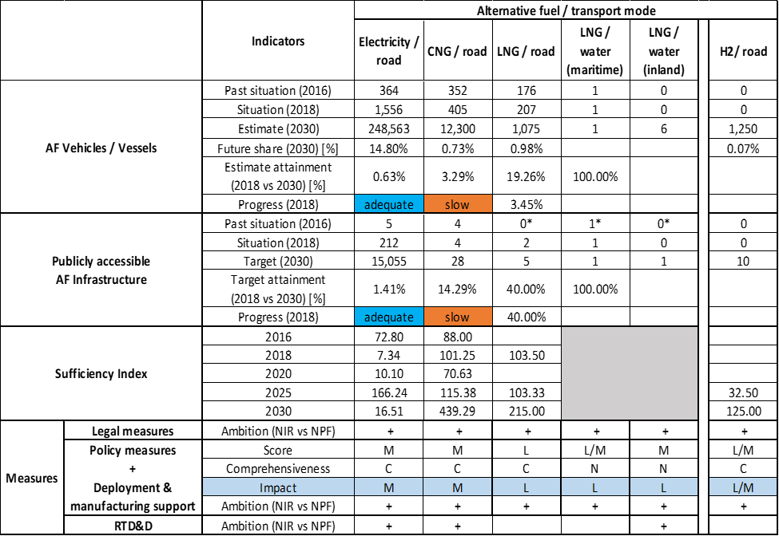



* Value taken from EAFO (absent in both NPF and NIR).

The LT NIR addresses most of the requirements of Annex I of the Directive, but only partially, and it does not provide specific information on the methodology applied to take account of the charging efficiency of high power recharging points. Also it does not provide considerations on any particular needs during the initial phase of AFI deployment.

The LT NIR contains an extensive and wide-scope portfolio of measures, but often it lacks a sufficient description, which makes the assessment results less robust. The majority of reported measures focus on electricity and CNG for road transport.

The main outcomes of the technical assessment of the Lithuanian NIR on vehicles/vessels estimates and infrastructure targets can be summarised as follows:

###### Road transport

* **Electricity** – Lituania reported a total of 1,556 electric vehicles in use in 2018 (Table 5.15.3‑1), of which 1,539 were passenger cars, 16 LCVs and 1 HCV. The Lithuanian NIR presents a new plan with increased ambition compared to the NPF, with an estimate of 230,332 passenger cars and 18,231 LCVs by 2030. The heavy-duty sector is excluded from future estimates in the LT NIR. With respect to this plan, the 2018 progress is adequate. Similarly to the vehicles, the level of ambition for infrastructure in the LT NIR is higher than presented in NPF. With 212 publically accessible recharging points recorded in 2018, Lithuania plans to have 15,055 public and 60,000 private recharging points in 2030. Also the progress towards this target is assessed as adequate in 2018. The sufficiency ratio is adequate in 2018 and in 2030, however a big unbalance exists in the foreseen progression of EVs and public recharging points between 2020 and 2025 (with a sufficiency index in 2025 equal to 166.24, thus highly inadequate).
* **CNG** – Lithuania recorded 300 CNG buses and coaches in 2018, out of a total CNG fleet of 405 vehicles. This indicates that CNG is the main alternative fuel used by public transport fleets in large cities in Lithuania. Lithuanian ambitions for the number of CNG vehicles and infrastructure in the LT NIR are again higher than presented in NPF. New estimates for CNG vehicles reveal that the biggest growth is expected in numbers of CNG passenger cars (10,000 in 2030) and HCVs (1,000 in 2030). The progress in 2018 is slow. Lithuania reported four publicly accessible CNG refuelling stations in 2018 (plus six private). The LT NIR reports that Lithuania aims to achieve 8 public CNG refuelling points in 2020 (20% less than in the NPF) and 28 in 2030 (no target was present in the NPF). Also for CNG infrastructure the 2018 progress is slow, while the sufficiency index is considered adequate for the whole period 2016-2030.
* **LNG** – Lithuania reported 207 LNG vehicles in 2018, mainly buses and coaches (172). With regard to the next decade, the LT NIR proposes new (not present in NPF) estimates for 2025 and 2030, while 2020 is not addressed. The LT NIR aims to achieve 1,075 LNG vehicles in 2030. This estimated growth is planned mainly for the HCVs (1,000), but 50 LCVs and 25 buses and coaches are also expected in 2030. As for the infrastructure, the LT NIR reports two public LNG refuelling points in 2018 and a new target of five public refuelling points for 2030.
* **Hydrogen** – There are currently no hydrogen vehicles in Lithuania but for 2030, 1,000 passenger cars, 100 LCVs, 50 HCVs and 100 buses and coaches are expected. The LT NIR does not report nor foresees any public hydrogen refuelling point in operation for the years from 2016 until 2020. However it provides new targets for 2025 and 2030 (not reported in NPF), respectively 2 and 10 refuelling points.
* **Biofuels** – LT NIR only provides the information that “*Biofuels are used for blending in petrol and diesel strictly in the manner provided for in national legislation. Lithuania aims to gradually transition to advanced biofuels produced from secondary waste. The ratios of biofuel blending in fossil fuels are increasing*”.
* **LPG** – Lithuania reported 109,576 LPG vehicles in 2018, of which 108,565 passenger cars, 503 LCVs, 623 HCVs, and 87 buses and coaches. It also recorded 664 public LPG refuelling points in 2018. Regarding the next decade, the LT NIR does not propose any vehicle estimate and forecasts a slow but steady decline of LPG infrastructure.

###### Rail transport

The LT NIR reports the plan to have 22 new electric locomotives in 2030 and a budget of 250 million € from EU funds for electrification of railway in 2020.

###### Waterborne transport (maritime)

* **Electricity** – The LT NIR reports that, as Klaipėda State Seaport (KSS) is already equipped with facilities that can be used by operators of ships, no additional need of shore-side electricity supply facilities is foreseen. Similarly, no plans about electric boats were revealed.
* **LNG** - Lithuania recorded one LNG refuelling point in its TEN-T Core port of Klaipėda in 2018. This LNG terminal has been in operation since December 2014, and recently the focus is put on Liquefied Natural Gas Distribution Station (LNG DS), which is an above-ground LNG terminal operated on a third-party access basis. The LT NIR confirms this infrastructure until 2030.

###### Waterborne transport (inland)

* **Electricity** - Lithuania did not record any shore-side electricity supply in 2018, but the LT NIR reports the plan to have three shore-side electricity supply for inland waterway vessels or recreational crafts in inland ports. The potential locations are Kaunas Lagoon pier, Nida pier and Uostdvaris inland waterway port.
* **LNG** - The LT NIR reports that the first LNG inland waterway vessels is foreseen for 2025, followed by other five by 2030. There was no LNG refuelling point for inland waterway vessels in 2018, but the LT NIR mentions the proposal by the Lithuanian Inland Waterway Authority to establish a LNG refuelling point in Marvele cargo pier (Kaunas).

###### Air transport

* **Electricity** - Lithuania recorded 37 electric power supply points for stationary airplanes in use since 2016. This number is expected to increase to 44 points in 2020, and 45 points in 2025 and 2030. Since according to the LT NIR Lithuania’s international airports already have the necessary infrastructure to supply electricity to stationary airplanes, no additional need for electricity supply facilities at airports is expected.

The LT NIR contains an extensive and wide-scope portfolio of **measures**, but often lacks a sufficient description, which makes the assessment results less robust. It presents 18 legal measures (versus 8 in the NPF) to promote AFs. Their description is short and mostly in the form of tables, but overall they show an increased ambition level compared to the NPF. As for the Policy and Deployment & Manufacturing support measures, the main focus in the LT NIR is on electric vehicles, but CNG and LNG on roads are developing as well and concrete plans are also presented for hydrogen/road and LNG/waterborne (inland) transport. Several clusters of measures have been identified, however their description and the level of details provided in the LT NIR are not sufficient to carry out a robust assessment. In terms of expected impact of these measures to support the realisation of the AFV/AFI objectives as presented in the NPF and revised in the NIR, keeping in mind the caveat mentioned earlier, it can be said that the measures for the pairs electricity/road and CNG/road might have a medium impact, while all the others might have a lower impact. Compared to the NPF, the level of ambition of the Policy and Deployment & Manufacturing measures support measures has increased for all pairs.

The LT NIR reports on three RTD&D projects versus none in the NPF, showing an increased level of ambition also in this field. The first RTD&D project is on buses powered by hydrogen-enriched natural gas (H2NG). The second measure is on the development of a LNG driven tugboat for shallow inland waterways. The third is on the participation in the multilateral pilot project initiated by the European Commission "*Data collection related to recharging/refuelling points for alternative fuels and the unique identification codes related to e-Mobility actors*".

### Final remarks

The Lithuanian NIR provides a quite comprehensive report on the efforts to implement the Directive. The NIR complies, to a large extent, with the requirements of Annex I to the Directive and provides a relevant number of measures to support the uptake of alternative fuels for transport. However, these measures lack granularity, which creates uncertainty about the impact of the overall Lithuanian approach for alternative fuels. Future reporting should provide further detail on measures planned to support ramp up of use of alternative fuels in all mode of transport.

For electricity, the NIR estimates that approximately 250,000 electric vehicles could be on the road by 2030, representing about 15% of the future fleet, as well as around 15,000 recharging points in the same year. Taking into account the current situation and expected trends, this level of ambition appears to be broadly consistent with the pace of deployment of electric vehicles considered necessary for a full transition to carbon neutrality by 2050. No direct information on charging efficiency is provided. The port of Klaipėda in the TEN-T Core Network is already equipped with shore-side electricity supply. Furthermore, Lithuania supports also the electrification for inland waterway vessels and recreational crafts in inland ports with shore-side electricity supply towards 2030. Lithuania’s international airports already have the necessary infrastructure to supply electricity to stationary airplanes. However, that the NIR outlines that the number of electricity supply to stationary aircraft should continue to grow to 45 in 2025, in an attempt to equip other airports. Future reporting should provide further information on the current and future share of electrified rail network. However, a budget of 250 million € is devoted to further electrification of rail up to 2020.

Currently there are no hydrogen vehicles in Lithuania. However, 1,000 passenger cars, 100 Light Commercial Vehicles, 50 Heavy-Duty Vehicles and 100 buses and coaches are estimated for 2030. Likewise, hydrogen infrastructure deployment by 2030 is estimated to include at least 10 refuelling points, with an initial uptake of two refuelling points in 2025.

Concerning natural gas, the NIR shows a limited ambition for CNG vehicles; it notes about 12,300 vehicles and 28 refuelling points in place by 2030. A significant growth in LNG HDV is expected (1,075 HDV by 2030). Furthermore, there will be three LNG refuelling points by 2025 and five by 2030. This seems sufficient taking into account the length of its TEN-T Road Core Network, provided that the refuelling points are widely distributed along the network. For waterborne transport, the first LNG inland waterway vessels is foreseen for 2025. In addition, Lithuania reports one LNG refuelling point in its TEN-T Core Network port of Klaipėda.

On LPG, Lithuania reported about 110.000 LPG vehicles in 2018, which corresponds to approximately 7% of its fleet. In terms of infrastructure, 664 public LPG refuelling points are reported, with a projection of 545 for 2030. Despite the lack of LPG vehicles estimates for 2030, the infrastructure targets indicate an expected steady decline of those vehicles.

Further information should be provided on the consumption of biofuels in road and air transport. Lithuania should provide more information in future reporting on efforts to promote the use of renewable fuels in transport, and particularly in aviation.

### ANNEX - Description of the Member State

On a surface area of 65,300 km², Lithuania has a population of 2.809 million people in 2018, which makes up for a population density of 43 inhabitants/km².

*Number of main urban agglomerations*

* 6 urban agglomerations > 50,000 inhabitants

In 2018, Lithuania achieves a per capita gross domestic product at market prices of €16,170, which represents a per capita gross domestic product in purchasing power standards of 80 if expressed in relation to the EU-28 average set to equal 100.

*Length of the road networks*

The length of the road TEN-T Core Network in Lithuania is 665 km. The total road network length is 21,242 km, of which 324 km are motorways.

The following lengths of the TEN-T Road Corridors are present in Lithuania: 20% (820 km) of the North Sea - Baltic Corridor.

Through the TEN-T Road Corridors, Lithuania is connected with the following Member States:  
- Latvia (through the North Sea - Baltic Corridor),   
- Poland (through the North Sea - Baltic Corridor)

*Number of registered road vehicles*

At the end of 2018, Lithuania accounts for 1,606,222 registered road vehicles of which 1,430,520 are categorized as passenger cars, 64,345 as light goods vehicles, 61,332 as heavy goods vehicles and 7,925 as buses and coaches. The motorisation rate is 509 passenger cars per 1,000 inhabitants.

*Number of ports in the TEN-T Core Network*

* 1 maritime port in the TEN-T Core Network (Klaipėda)
* No maritime ports in the TEN-T Comprehensive Network
* No inland ports

*Number of airports in the TEN-T Core Network*

* 1 airport in the TEN-T Core Network (Vilnius)
* 2 airports in the TEN-T Comprehensive Network

## Luxembourg (LU)

### Main messages from the Commission assessment of the NPF

In its original assessment of the Luxembourgish NPF, the Commission concluded:

*The Luxembourgish NPF broadly addresses the requirements of Article 3. It contains tables of the current state and future estimates for alternative fuels vehicles in the transport sector. For most fuels and modes, it establishes targets as required by Article 3 of the Directive. It does not provide a target for its inland port in the TEN-T Core Network.*

*The Luxembourgish NPF puts the accent on electric vehicles deployment with ambitious plans in terms of recharging infrastructure and share of electric vehicles on the road in 2020 (more than 9% from the total vehicle fleet). Bicycles and electric bikes also receive support. To be highlighted is the fact that Luxembourg has legislated a very detailed action plan for the implementation of the public recharging infrastructure for electric vehicles (including the exact number of recharging points per commune and TEN-T Core Network segments). The NPF foresees a small increase of available ground power units for stationary airplanes. The Mertert inland port does not have shore-side electricity and no targets are foreseen in the NPF.*

*While the spatial distribution of recharging points seems to cover appropriately the needs of electric vehicles in terms of distance requirements in Luxembourg, the ratio of more than 22 electric vehicles per one recharging point for 2020 could evolve to become a barrier for the further market deployment of electric vehicles. This could also lead to market fragmentation within the EU. It will be important to closely monitor this development and correct the infrastructure targets in line with the market developments.*

*In the case of CNG, the Luxembourgish government is pessimistic regarding the economic viability for this fuel. Therefore, it plans the decrease of the number of refuelling points to two CNG refuelling points considering this quantity to be sufficient in the medium term, estimating also a reduction of the CNG fleet.*

*Concerning LNG, the installation of a refuelling infrastructure for road transport is envisaged for 2020. Such an infrastructure will be intended to refuel apart from the LNG vehicles registered in Luxembourg the heavy-duty vehicles transiting the country. LNG-powered vessels having a high autonomy, an LNG refuelling infrastructure in the port of Mertert is not deemed as viable.*

*For the moment, the Luxembourgish government decided not to include in the current stage refuelling points for hydrogen accessible to the public in its NPF.*

*The Luxembourgish NPF contains a comprehensive list of measures, most already in place. According to the assessment methodology, a High overall assessment score is derived for electricity for vehicles, a Medium overall score for hydrogen for vehicles and a Low overall score for CNG for vehicles. This is a consequence of the government estimation that CNG will only play a marginal part in the future, the focus being placed on the promotion of electric mobility which is considered to be the most suited for the decarbonisation of the transport sector in the NPF.*

*Two regulations (one Grand Ducal and another Ministerial) provide evidence that the interests of local authorities and stakeholders have been considered. Luxembourg is actively involved in coordinating its plans on alternative fuels infrastructure with the Benelux countries and has signed a collaboration agreement with them in this field. It may be advisable to extend this cooperation effort also towards other neighbouring countries such as France and Germany*.

### Overview of requirements’ fulfilment from Annex I of the Directive

*Table 5.16.2‑1 Checklist Table*

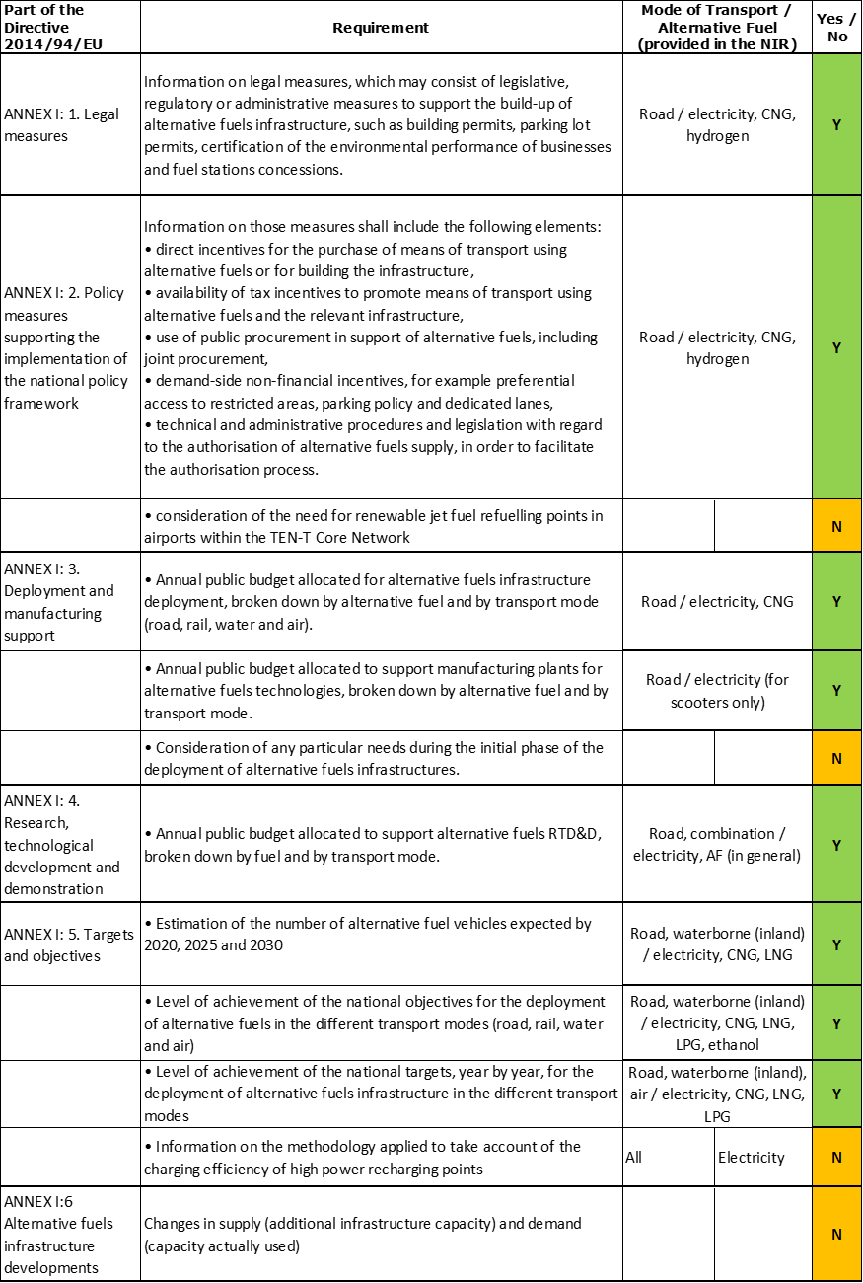

The checklist shows the requirements of Annex I from the Directive that are covered in the LU NIR.

Regarding the combination of AF/AFV/AFI with transport mode, electricity is fully covered for road and, to a lesser extent, for waterborne (inland) and air; CNG and LNG are covered for road; some other combinations are just mentioned (for example: hydrogen, LPG and biofuels for road, LNG for waterborne inland transport). All the other combinations are either absent or not applicable.

The LU NIR reports 29 measures. Under the Policy and Deployment & Manufacturing sections it was possible to identify three AF/transport mode clusters of measures, all assessable.

### Quantitative assessment: Vehicles and infrastructure

*Table 5.16.3‑1 National AFV estimates and AFI targets established in the NIR at the horizon 2020, 2025 and 2030 and their comparison with the NPF situation*





#### Road transport

##### Electricity

###### Vehicles

Luxembourg reported for 2018 a total number of 3,373 electric vehicles in use (Table 5.16.3‑1). These electric vehicles were divided in 3,118 passenger cars (1,360 battery-electric and 1,758 plug-in hybrid electric), 192 light commercial vehicles LCVs (all battery-electric), 8 heavy commercial vehicles HCV (all battery-electric), and 55 buses and coaches (33 battery-electric and 22 plug-in hybrid electric).

Regarding the vehicle estimates for the next decade, the LU NPF had presented a scenario with a ramping up of electric passenger cars from less than 1,000 in 2016 to 40,000 in 2020, followed by a moderate increase to 44,000 and 48,000 in 2025 and 2030 respectively. The LU NIR presents a new plan with a much higher ambition: whilst the estimate is lower in 2020 with 10,465 vehicles (74% less), it is by far more than compensated by the increase to 101,300 and 202,600 vehicles in 2025 and 2030 respectively (130% and 322% more). The vast majority of the electric vehicles in 2030 will be passenger cars (200,000), but 1,000 battery-electric LCVs, 100 battery-electric HCVs, 1,400 battery-electric buses and coaches and 100 plug-in hybrid electric buses and coaches are also foreseen. Furthermore, the LU NIR provides information regarding electric powered two wheelers (PTW). From the 488 PTWs registered in 2018, future estimates in the NIR go up to 1,000, 2,500 and 5,000 for the years 2020, 2025 and 2030 respectively.

The 2018 ***attainment*** of future EV estimates is 32.23% for 2020 and 1.66% for 2030. According to the assessment methodology described in Section 2.1, the 2018 situation corresponds to an ***adequate progress*** towards reaching the envisaged EV estimates. The calculated ***average*** ***annual growth rate*** corresponding to the period 2016-2030 for EV fleet evolution planned by Luxembourg is equal to 46%.

###### Infrastructure

Luxembourg recorded 841 publicly accessible recharging points in 2018 (Table 5.16.3‑1), four times more than in 2016. The NIR targets for 2020/2025/2030 are 1,635/5,160/10,320 recharging points, of which 35/160/320 are high power (>22kW) recharging points. Compared to the NPF, the LU NIR now targets a slightly lower (-7%) number of recharging points in 2020, but much higher numbers for the years 2025 (+163%) and 2030 (+375%). These higher recharging infrastructure targets confirm the government’s plan to become *“… one of the main players in electric mobility”* and the importance of road vehicle electrification in the Luxembourgish AFI development.

The 2018 ***attainment*** of future publicly accessible recharging infrastructure targets is 51.44% for 2020 and 8.15% for 2030. According to the assessment methodology described in Section 2.1, the 2018 situation corresponds to an ***adequate progress*** towards reaching these envisaged targets. The calculated ***average annual growth rate*** corresponding to the period 2016-2030 for publicly accessible recharging infrastructure evolution planned by Luxembourg is equal to 31%.

###### Ratio

Based on the LU NIR, the following table shows the ratio between vehicles and publicly accessible recharging points (i.e. sufficiency index) for the pair electricity/road. It can be seen that whilst until 2020 each publicly accessible charging point serves around five electric vehicles, the longer-term vehicle estimates and infrastructure targets foresee that one charging point needs to serve 20 vehicles from 2025 onwards. The LU NIR explains that the number is considered sufficient, based on a study conducted in 2011 showing that 95% of charging will be done at private charging points. However, considering the large distance to target already observed in the NPF and the very low share of high power charging points (3%) in the whole period, the future adequacy of recharging infrastructure for electric vehicles remains uncertain.

Luxembourg announced in the NIR that an inventory of private charging points should be available for the next report.



###### Information on charging efficiency

Information is not available in the Luxembourgish NIR

##### CNG

###### Vehicles

The CNG fleet in Luxembourg counted a total of 314 vehicles in 2018 (Table 5.16.3‑1), of which 195 passenger cars, 56 LCVs, 11 HCVs and 52 coaches and buses. According to the LU NIR, which broadly confirms the NPF estimates, CNG vehicle numbers in most categories will decrease to a total of 100 vehicles in 2030, with the exception of buses and coaches increasing slightly to 65 in 2030.

Because the Luxembourgish NIR provided decreasing estimates for CNG vehicles, the 2018 ***attainment*** and ***progress*** have not been computed.

###### Infrastructure

The Luxembourgish NIR indicates that 2 publicly accessible (and 1 private) CNG refuelling points were available in 2018. These numbers should be stable until 2020, after which only one public and one private CNG refuelling points should remain until 2030.

Because the Luxembourgish NIR provided decreasing targets for publicly accessible CNG refuelling infrastructure, the 2018 ***attainment*** and ***progress*** have not been computed.

###### Ratio

Based on the LU NIR, the following table shows the ratio between vehicles and publicly accessible refuelling points (i.e. sufficiency index) for the pair CNG/road. It can be seen that the sufficiency index is always well below the indicative value of 600 (see Section 2.1.5) for the whole 2016-2030 period.



##### LNG

###### Vehicles

Luxembourg recorded 13 LNG vehicles in total in 2018 (Table 5.16.3‑1), consisting of HCVs exclusively. Concerning the estimates for the next decade, while the NPF had foreseen only an increase to 30 vehicles in 2020, the LU NIR now indicates 50 HDVs in 2020, and 150 HCVs from 2025 until 2030.

The 2018 ***attainment*** of future LNG vehicles estimates is 26% for 2020 and 8.67% for 2030. According to the assessment methodology described in Section 2.1, the ***progress*** obtained by Luxembourg from 2016 until 2018 for LNG vehicles deployment is 8.05% of the overall planned deployment during the period 2016-2030.

###### Infrastructure

Luxembourg did not record any publicly accessible LNG refuelling point in 2018. The LU NIR does not plan to have any publicly accessible LNG refuelling point until 2030, in contrast to the NPF where a target of one was present for 2020 and 2025. The LU NIR indicates that only one private LNG refuelling point was in use in 2018 and will continue until 2030.

Since at the end of 2018 there were no publicly accessible LNG road refuelling points deployed, the 2018 ***attainment*** and ***progress*** could not be computed.

###### Ratio

For the same reason, it is not possible to compute the sufficiency index.

##### Hydrogen

###### Vehicles

At this moment, hydrogen is not considered in the Luxembourg fuel mix, therefore no information was provided in the Luxembourgish NIR.

###### Infrastructure

There was no hydrogen infrastructure registered in 2018 and no plan for the future, however the LU NIR declares that “*the government has committed, in its coalition agreement 2018-2023 ([55]), to arrange for at least one hydrogen refuelling station to be installed at one of the motorway service areas”*. This could take place by 2025.

##### Biofuels

###### Vehicles

The bioethanol vehicle fleet in Luxembourg consisted of 56 vehicles in 2018, not differing much from the numbers in previous years (57 and 61 in 2016 and 2017, respectively). This fleet is made up of passenger cars, with the exception of one LCV, operational since 2017. There are no estimates for the next decade in the LU NIR. For this reason, the 2018 ***attainment*** and ***progress*** could not be computed.

###### Infrastructure

Information is not available in the Luxembourgish NIR.

###### Ratio

Because of the lack of data, the sufficiency index could not be computed.

##### LPG

###### Vehicles

Luxembourg registered 377 LPG vehicles in 2018, of which 271 were passenger cars. Another 98 LCVs and 8 HCVs completed the LPG fleet. No estimates for the LPG fleet development in the years 2020-2030 are made in the LU NIR. For this reason, the 2018 ***attainment*** and ***progress*** could not be computed.

###### Infrastructure

According to the information provided by Luxembourg with the NIR, 14 public LPG refuelling points were operational in Luxembourg in 2018. No predictions for the development of the LPG refuelling points in the years 2020-2030 are made in the LU NIR. For this reason, the 2018 ***attainment*** and ***progress*** could not be computed.

###### Ratio

Based on the LU NIR, the following table shows the ratio between vehicles and publicly accessible refuelling points (i.e. sufficiency index) for the pair LPG/road for the years 2016-2018.



#### Rail transport

Information is not available in the Luxembourgish NIR.

#### Waterborne transport (maritime)

Not applicable since Luxembourg has no maritime ports in the TEN-T Core Network.

#### Waterborne transport (inland)

##### Electricity

###### Vessels

The LU NIR counts one electric inland waterway vessel since 2016. This number remains constant for the period up to 2030.

###### Infrastructure

Luxembourg recorded five shore-side electricity supplies in 2018 and presents a target of six in 2020 and of 10 from 2025 to 2030.

The 2018 ***attainment*** of future targets for shore-side electricity supply points in inland ports is 83.33% for 2020 and 50% for 2030. According to the assessment methodology described in Section 2.1, the ***progress*** obtained by Luxembourg from 2016 until 2018 for the deployment of shore-side electricity supply points in inland ports is 50% of the overall planned deployment during the period 2016-2030.

##### LNG

###### Vessels

The LU NIR lists one LNG powered vessel in 2018 expected to remain in service for the next decade.

###### Infrastructure

The Luxembourgish NIR confirms the NPF strategy that no LNG refuelling facilities for inland waterway navigation are foreseen until 2030.

#### Air transport

##### Electricity

###### Airplanes

Information on electric airplanes is not available in the LU NIR.

###### Infrastructure (for stationary airplanes)

The currently existing 44 electricity supply points for stationary aircraft at the TEN-T Core Luxembourg airport are considered sufficient and remain, according to the NIR, constant over coming years. The LU NIR mentions as well that 28 of the electricity supply points consist of Ground Power Units (GPUs) (diesel engines coupled to generators).

##### Biofuels

###### Airplanes

Information is unavailable in the Luxembourgish NIR.

###### Infrastructure

Information is unavailable in the Luxembourgish NIR.

### Measures assessment

The Luxembourgish NIR presents an extended portfolio of measures compared to the NPF. However, the overall strategy remains the same, with almost total focus on the combination electricity/road (targeting both AFI and AFV), and only some generic reference to other AFs/transport modes.

#### Legal measures

The Luxembourgish NIR contains 12 legal measures, including five new measures compared to the NPF. These measures represent a step forward to create a legally solid background to support the realisation of the AFV/AFI objectives as described in the NPF and revised in the NIR. The level of ambition of the legal measures has increased in the NIR, compared to the NPF.

##### Legislative & Regulatory

All legal measures described in the Luxembourgish NIR fall under legislative and regulatory measures, and most of them target road transport and electrification (addressing AFV and both public and private AFI). One legal measure introduced the obligation of owning a “zero-emission taxi” (i.e. BEV or fuel cell vehicles) in order to be eligible for any future operating licence. Ten measures were already in place in 2019. The remaining two have been adopted, and present an update or extension of two other measures. The first is the Grand-Ducal Regulation of 20 December 2019, amending the Grand-Ducal Regulation of 7 March 2019 and introducing financial aid for the promotion of zero or low CO₂ emission road vehicles. The second is the Grand-Ducal Regulation of 20 December 2019, amending the Grand-Ducal Regulation of 23 December 2016 and implementing Article 104(3) of the amended Income Tax Law of 4 December 1967. The first measure addresses electric vehicles (both BEV and PHEV) and hydrogen vehicles. The second one targets all company cars with an internal combustion engine and the application of the WLTP test cycle for the type-approval of vehicles.

##### Administrative

No administrative measures are reported in the NIR of Luxembourg.

#### Policy measures

The Luxembourgish NIR contains eight policy measures, which were all in place in 2019, and are different from the policy measures identified in the NPF. All measures focus on road transport. Seven policy measures target electricity as fuel, two of them in combination with hydrogen. One measure is related to CNG buses and infrastructure for public transport.

##### Measures to ensure national targets and objectives

Of all the policy measures described in the Luxembourgish NIR, four are categorised as measures to ensure national targets and objectives. The measures focus on road/electricity, with hydrogen included in two of them. These are:

* A tax allowance scheme, which was initially allowed only for BEV, fuel cell vehicles and bicycles with electric pedal assistance. This measure was later extended also to PHEV emitting less than 50 gCO2/km and was integrated with a revision of the benefit in kind, calculated on the basis of CO2 emission, with a further penalty for diesel vehicles.
* The obligation for government services to buy only BEV or, where appropriate, PHEV from 2018. Ordinary administrative-type cars with internal combustion engines (petrol or diesel) can only be purchased in exceptional circumstances, and with the necessary authorisation.
* An information campaign to raise public awareness regarding sustainable mobility and to inform municipalities, employers and citizens about the measures and incentives in place to support the uptake of alternative fuels solutions for mobility.
* Financial incentives for the purchase of BEV and fuel cell vehicles (€5,000), PHEV emitting less than 50 gCO2/km (€2,500) and up to €500 for battery-electric quadricycles, motorcycles and mopeds.

##### Measures that can promote AFI in public transport services

Four policy measures can be categorised as measures that can promote AFI in public transport services. They deal with the deployment of alternative fuel buses and related infrastructure by four public transport operators in Luxembourg, three focussing on BEV and PHEV buses and one on CNG buses.

##### Measures that can promote the deployment of private electro-mobility infrastructure

Concerning the measures that can promote the deployment of private electro-mobility infrastructure, the LU NIR mentions one measure in the Policy section, which is also included in the list of the Legal measures. It establishes obligations to install recharging point in private buildings and provide requirements to do so, however it does not report quantitative information that would allow an assessment.

#### Deployment and manufacturing support

The Luxembourgish NIR contains three measures in place during the implementation period to support AFI deployment and manufacturing. All were different to the one measure identified in the NPF.

##### AFI deployment

The Luxembourgish NIR reports two AFI deployment measures. One relates to the deployment of 1,600 charging points for electric vehicles by end 2020, coming with a budget of 10 million €. The second one is the modernisation of two CNG refuelling points, finished in 2018 with a budget of €100,000.

##### Support of manufacturing plants for AF technologies

The Luxembourgish NIR lists one measure to support a manufacturing plant for electric scooters. State funding in 2017 amounted to about €70,000.

##### Consideration of any particular needs during the initial phase of the deployment of alternative fuels infrastructures

Information is not available in the Luxembourgish NIR.

#### Quantitative assessment of Policy and Deployment & Manufacturing measures

Table 5.16.4‑1 presents an analysis of all the Policy and Deployment & Manufacturing measures, carried out according to the assessment methodology described in Section 2.2. As it can be seen, three clusters could be identified in the LU NIR. The electricity/road cluster is the only having a high score and being comprehensive; the clusters for the pairs CNG/road and hydrogen/road receive a medium score and are not comprehensive. No measure was mentioned in the LU NIR related to LNG. In terms of expected impact of these measures to support the realisation of the AFV/AFI objectives as presented in the NPF and revised in the NIR, the measures for the pair electricity/road result to have a high impact, those for the pairs CNG/road and hydrogen/road have a low impact.

Compared to the NPF, the level of ambition of the Policy and Deployment & Manufacturing support measures has increased for all three clusters.

*Table 5.16.4‑1 Quantitative assessment of Policy and Deployment & Manufacturing support measures*



**Legend:** Score and Impact: H = high; M = medium; L = low; X = not assessable. Comprehensiveness: C = comprehensive; N = Not comprehensive. Ambition level: ‘+’ means ‘higher’; ‘=’ means ‘comparable’; ‘-‘ means ‘lower’.

#### Research, Technological Development & Demonstration

The Luxembourgish NIR lists four RTD&D projects. The projects are new and differ from those presented in the NPF. For this reason, it is not possible to provide a comparison in terms of ambition between the NIR and the NPF. The MERLIN ([56]) project, which is funded by the European Regional Development Fund (ERDF), aims to develop a platform for assessing the impact of the country’s various mobility solutions. The eCoBus ([57]) project, funded by the Luxembourg National Research Fund (FNR), aims to develop a cooperative and integrated intelligent transport system (ITS), which will coordinate electric buses, recharging infrastructure and traffic management. The PorSi3DLIB project is a public-private cooperation, also funded by the FNR, focusing on developing new Li-ion 3D batteries. Finally, the “ID and Data Collection for Sustainable Fuels” (IDACS) project, in which Luxembourg participates with 14 other Member States of the European Union, is another very important technological development project involving alternative fuels infrastructure.

The total budget of these four projects sums up to 2.404 million €, with a portion of 1.299 million € (54%) for the two projects financed by national sources.

### Additional information on alternative fuels infrastructure developments

The Luxembourgish NIR indicates that official statistics on electricity use for private charging of electric vehicles will be available in 2020. It can also be expected that the project IDACS, carried out by Luxembourg in cooperation with additional 14 European Member States over the years 2019-2021, will deliver further information on alternative fuels infrastructure, including all fuels.

### Summary of the assessment

**Tabular overview**

*Table 5.16.6‑1 Overview of the NIR assessment*

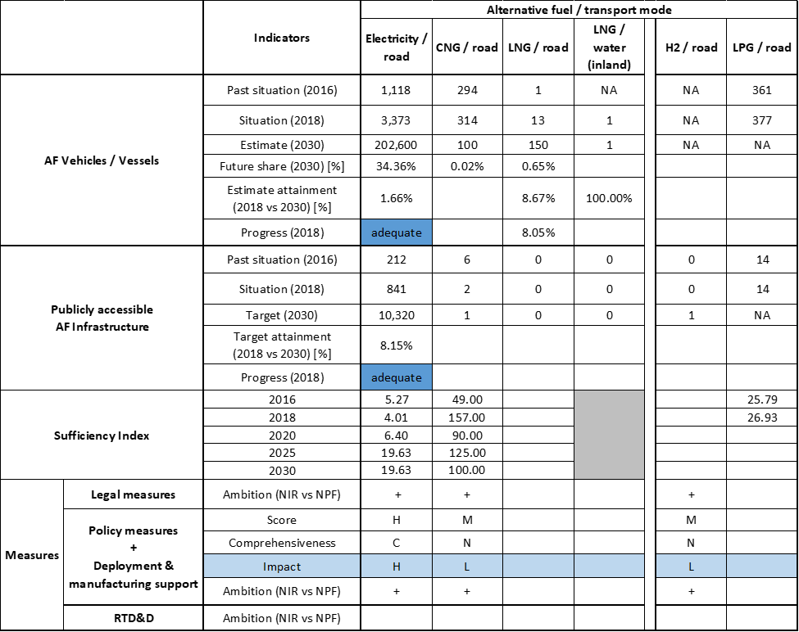



In its NIR, Luxembourg confirms and strengthens the NPF strategy to focus on electro-mobility for road transport. Concerning CNG, the LU NIR foresees only a marginal role and specifically for public transport (where the co-existence of BEV and PHEV buses and coaches will also be relevant). Regarding LNG, the LU NIR does not present a defined strategy. For hydrogen vehicles the same type of incentives of BEV vehicles are foreseen, but this AF is currently excluded from the Luxembourgish plans on AF. Finally, biofuels and LPG are and will continue to be marginal. The measures put in place by Luxembourg are coherent with this vision.

The main outcomes of the technical assessment of the Luxembourgish NIR on vehicles estimates and infrastructure targets can be summarised as follows:

###### Road transport

* **Electricity** – In 2018 Luxembourg recorded 3,373 EVs and 841 publicly accessible recharging points. EVs included 8 HCVs and 55 buses and coaches. As for the next decade, the LU NIR presents a new plan with a much higher ambition compared to the NPF: for EVs, whilst the estimate is lower in 2020, it is more than compensated by the increase until 2030 (322% more), when 202,600 EVs are foreseen (of which 1,000 LVCs, 100 HCVs and 1,500 buses and coaches). The same situation is observed for the recharging infrastructure, where the LU NIR now targets a slightly lower (-7%) number of recharging points in 2020, but much higher numbers for the years 2025 (+163%) and 2030 (+375%). With reference to this new scenario, Luxembourg is progressing adequately both in terms of EV and infrastructure. However, the calculated Luxembourgish sufficiency index is becoming potentially inadequate for the years 2025 and 2030.
* **CNG** – Luxembourg recorded a small number of 314 CNG vehicles in 2018, including 11 heavy-duty vehicles and 52 buses and coaches. The CNG fleet is expected to shrink to a total of 100 in 2030, with only the number of buses and coaches increasing slightly to 65. In line with the expected reduction in vehicles, the public infrastructure has been reduced, with two modernised refuelling stations remaining. This is considered sufficient by Luxembourg to cover current and future needs, and is confirmed by the adequate sufficiency index.
* **LNG** – The Luxembourg fleet consisted in 2018 of 13 LNG heavy-duty vehicles. An increase to 150 vehicles by 2030 is estimated, but no public LNG refuelling point is planned until 2030. There was however one private LNG refuelling point in service, which should continue until 2030.
* **Hydrogen** – At this moment hydrogen is not considered in the Luxembourgish fuel mix. There were no hydrogen vehicles/infrastructure registered in 2018 and no clear quantitative objectives provided for the future. However, the LU NIR declares that “*the government has committed, in its coalition agreement 2018-2023 ([58]), to arrange for at least one hydrogen refuelling station to be installed at one of the motorway service areas”* and this could take place by 2025.
* **Biofuels** – In Luxembourg, 56 ethanol fuelled vehicles were registered in 2018. No information on future vehicles developments and on refuelling infrastructure was provided.
* **LPG** – The LPG fleet of 377 vehicles registered in 2018 by Luxembourg included 8 heavy-duty vehicles. No assessment on LPG can be made since no information on future development and infrastructure was provided.

###### Rail transport

* **Electricity** – Information is unavailable in the LU NIR.

###### Waterborne transport (inland)

* **Electricity** – The LU NIR reports one electric vessel in service since 2016. It also recorded 5 shore-side electricity supplies in 2018 and presents a target of 6 in 2020 and of 10 from 2025 to 2030.
* **LNG** – The LU NIR lists one LNG powered vessel in 2018 and for the next decade. Due to the large autonomy of LNG vessels, LNG refuelling infrastructure at the inland port Merter is not considered viable.

###### Air transport

* **Electricity supply for stationary aircraft** – The infrastructure to supply electricity for stationary aircraft at the Luxembourg airport is considered sufficient (44 units) and no increase is foreseen. The LU NIR mentions that 28 supply points consist in ground power units (diesel engines coupled to electricity generators) and no information is provided for the rest.

The Luxembourgish NIR presents an extended portfolio of **measures** compared to the NPF. However, the overall strategy remains the same, with almost total focus on the combination electricity/road (targeting both AFI and AFV), and only some generic reference to other AFs/transport modes. The Legal measures represent a step forward, and with higher ambition, to create a legally solid background to support the uptake of electro-mobility. The Policy and Deployment measures are coherently designed to realise these objectives. In terms of their expected impact to support the realisation of the AFV/AFI objectives as presented in the NPF and revised in the NIR, the measures for the pair electricity/road result to have a high impact, while those for the pairs CNG/road and hydrogen/road have a low impact. The RTD&D measures confirm and complete the overall strategy of Luxembourg to become *“… one of the main players in electric mobility”.*

### Final remarks

The Luxembourgish NIR provides a comprehensive report on efforts to implement the Directive. The NIR is in line with the provisions of Annex I to the Directive. All alternative fuels are addressed in the NIR. However, the focus is on electro-mobility, as confirmed also by the measures included in the NIR.

As regards electricity, the NIR estimates that there could be around 203,000 electric vehicles on the roads by 2030, representing about 34% of the future fleet by that time, as well as around 10,300 recharging points in the same year. Taking into account the current situation and expected trends, this level of ambition appears to be fully consistent with the pace of deployment of electric vehicles considered necessary for a full transition to carbon neutrality by 2050. No information on charging efficiency is provided. Five shore-side electricity supply facilities have been installed in Luxembourg's inland ports already. This number is noted to increase to 10 by 2025. Luxembourg's national airport has already installed 44 electricity supply points for stationary aircraft. Further information should be provided on the current and planned electrification of the rail network.

Regarding hydrogen for transport, the NIR estimates one hydrogen refuelling station planned for 2025. No information was provided on the number of future FCHVs. It would be relevant that Luxembourg provides more information on how to ensure EU-wide connectivity for this alternative fuel.

Concerning natural gas, there were 314 CNG vehicles in Luxemburg. A significant decrease in the existing CNG – mainly public fleet – is expected (100 CNG vehicles by 2030). The number of LNG vehicles is anticipated to increase from 13 in 2018 to 150 by 2030. However, the NIR does not provide any indication on the planned LNG refuelling points for road transport. The NIR reports one LNG-powered vessel. No targets are provided for LNG refuelling points in inland ports. In this respect, Luxembourg needs to provide more information in future reporting.

There was already a small fleet of 377 LPG vehicles in Luxembourg by 2018. The fact that no estimates are provided for the next decade indicates a lack of interest by Luxembourg in this vehicle’s technology.

Further information should be provided on the consumption of biofuels for road and air transport. Luxembourg should provide more information in future reporting on efforts to promote the use of renewable fuels in transport, and particularly in aviation.

### ANNEX - Description of the Member State

On a surface area of 2,600 km², Luxembourg has a population of 602,000 people in 2018, which makes up for a population density of 232 inhabitants/km².

*Number of main urban agglomerations*

* 1 urban agglomeration > 50,000 inhabitants

In 2018, Luxembourg achieves a per capita gross domestic product at market prices of €98,640, which represents a per capita gross domestic product in purchasing power standards of 261 if expressed in relation to the EU-28 average set to equal 100.

*Length of the road networks*

The length of the road TEN-T Core Network in Luxembourg is 69 km. The total road network length is 2,889 km, of which 165 km are motorways.

The following lengths of the TEN-T Road Corridors are present in Luxembourg: 1% (32 km) of the North Sea - Mediterranean Corridor.

Through the TEN-T Road Corridors, Luxembourg is connected with the following Member States:  
- Belgium (through the North Sea - Mediterranean Corridor),   
- France (through the North Sea - Mediterranean Corridor)

*Number of registered road vehicles*

At the end of 2018, Luxembourg accounts for 492,481 registered road vehicles of which 415,145 are categorized as passenger cars, 34,833 as light goods vehicles, 10,161 as heavy goods vehicles and 2,042 as buses and coaches. The motorisation rate is 690 passenger cars per 1,000 inhabitants.

*Number of ports in the TEN-T Core Network*

* No maritime ports
* 1 inland port in the TEN-T Core Network (Luxembourg-Mertert)
* No inland ports in the TEN-T Comprehensive Network

Through the 37 km inland waterways TEN-T Core Network, Luxembourg is connected with Germany by the Rhine – Alpine and the North Sea – Mediterranean Corridor, and with France by the North Sea – Mediterranean Corridor.

*Number of airports in the TEN-T Core Network*

* 1 airport in the TEN-T Core Network (Luxembourg)
* No airports in the TEN-T Comprehensive Network

## Hungary (HU)

### Main messages from the Commission assessment of the NPF

In its original assessment of the Hungarian NPF the Commission concluded:

*The Hungarian NPF addresses most of the requirements of Article 3. It contains a comprehensive discussion of the current state and future scenarios for most alternative fuels in the transport sector. For all fuels and some modes, it establishes targets as required by Article 3 of the Directive.*

*It contains a large bandwidth of estimates for the future deployment of EV ranging for the 2 extreme EV penetration scenarios from 0.3% to 1.4% electric vehicles on the road in 2020. The given recharging points target and especially high power recharging infrastructure seems to cover the needs of electric vehicles in terms of number of publicly accessible recharging points as well as distance requirements in Hungary. The NPF mentions that new gates at the Liszt Ferenc International Airport will feature ground power units, but no quantitative targets are provided. For shore-side electricity it targets a modest growth at its ports.*

*For CNG cars, the estimated shares are slightly higher than for EV. Hungary currently does not meet the threshold of at least one CNG refuelling point per 600 CNG vehicles on the road. The NPF states very high estimates for CNG vehicles that would also for the future lead to a sufficiency index of less than one refuelling point per 600 CNG vehicles. Regarding the 2025 minimum coverage target in terms of distance requirements, the existing measure for the deployment of CNG refuelling points seems sufficient. Hungary already counts a high number of CNG trucks and buses and the NPF contains very ambitious estimates for 2020.*

*The Hungarian NPF has firm plans for building 5 LNG road refuelling points for 2020. Beyond, for 2025 it targets, between 36 and 182 LNG refuelling points for heavy-duty vehicles in road transport and plans a pilot liquefaction plant for vessels and heavy-duty trucks. It also describes a project for an LNG ship-to-ship bunkering vessel. Moreover, the NPF states that Hungary should already in 2020 appropriately cover with LNG infrastructure, both the TEN-T Corridors and the Comprehensive Network, for road and inland waterways.*

*Hungary, in its NPF, has established targets for the deployment of a hydrogen refuelling infrastructure, accessible to the public.*

*The Hungarian NPF contains a comprehensive list of measures that could have a medium impact on overcoming deployment barriers, especially in electro-mobility. Most of the existing or planned measures end in 2018 or earlier, with no prolongation foreseen. It may be challenging to achieve NPF targets and corresponding vehicle deployment estimates for electricity until 2020 even in the low penetration scenario. For CNG, the described measures may create a too low impact vis-à-vis the high estimates. The NPF does not list any measures in support of LNG refuelling point deployment.*

*Cooperation with neighbouring Member States is not mentioned in the NPF. It may be advisable for Hungary to coordinate its NPF with neighbouring Member States.*

### Overview of requirements’ fulfilment from Annex I of the Directive

*Table 5.17.2‑1 Checklist Table*

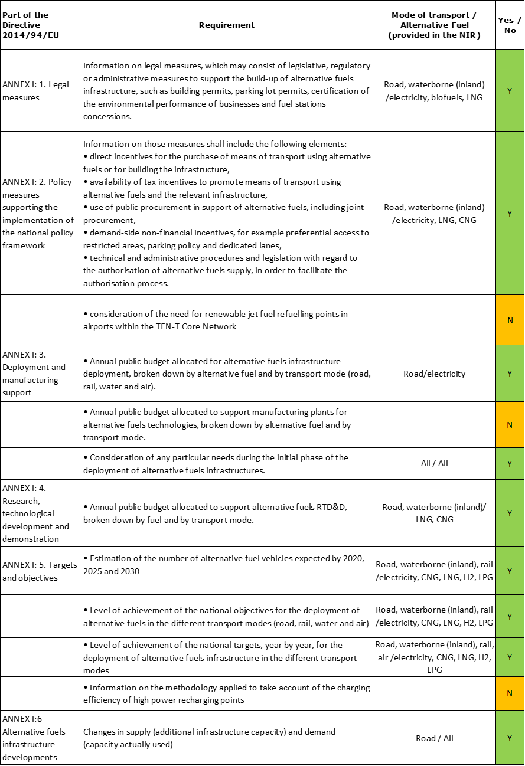

The checklist shows the requirements of Annex I from the Directive that are covered in the HU NIR.

Regarding the combination of AF/AFV/AFI with transport mode, electricity is covered for all modes; CNG, LNG, hydrogen and LPG are covered for road transport; LNG also for waterborne inland transport; all the other combinations are either absent or not applicable.

The Hungarian NIR reports 22 measures. Under the Policy and Deployment & Manufacturing sections it was possible to identify five AF/transport mode clusters of measures, of which four were assessable.

### Quantitative assessment: Vehicles and infrastructure

It is important to note that the Hungarian NIR provides two different scenarios in terms of AFV estimates and AFI targets: the WEM scenario (“with existing measures”) and WAM scenario (“with additional measures”). These two scenarios show different outcomes for each AFI/AFV development and market penetration in 2025 and 2030. WEM presents a more realistic scenario considering the measures implemented, and WAM presents a slightly more ambitious scenario in AFV/AFI deployment with anticipated measures. In this assessment report, the WEM (“with existing measures”) scenario is the only one used in the quantitative assessment as well as the measure assessment.

*Table 5.17.3‑1 National AFV estimates and AFI targets established in the NIR at the horizon 2020, 2025 and 2030 and their comparison with the NPF situation*





#### Road transport

##### Electricity

###### Vehicles

Hungary recorded 9,240 electric vehicles in use in 2018 (Table 5.17.3‑1), of which 8,844 were passenger cars (3,781 BEV), 372 LCVs (all BEV), 1 battery-electric HCV and 23 buses and coaches (all BEV). The HU NIR reports an estimate of 23,260 EVs in 2020, 193,700 EVs in 2025, and 389,800 EVs in 2030, of which 320,000 passenger cars (135,000 BEV), 60,000 LCVs (30,000 BEV), 8,500 HCVs (all BEV) and 1,300 buses and coaches (all BEV). Compared to the NPF, the Hungarian NIR reflects a higher policy ambition – the 2020 estimate is 14.43% higher, the 2025 estimate is nearly 140% higher and the 2030 estimate is almost 115% higher than the NPF estimates.

The 2018 ***attainment*** of the EV estimates set for 2020 and 2030 is 39.72% and 2.37% respectively. According to the assessment methodology described in Section 2.1, the 2018 situation corresponds to an ***adequate progress*** towards reaching the envisaged EV estimates. The calculated ***average*** ***annual growth rate*** corresponding to the period 2016-2030 for EV fleet evolution planned by Hungary is equal to 47%.

###### Infrastructure

Hungary recorded 671 public recharging points in 2018 (Table 5.17.3‑1), of which 630 normal power (≤22kW) recharging points and 41 high power (>22kW). The NIR targets for the public recharging points are 1,500 for 2020 and 14,600 for 2025. For 2030, the NIR reports a target of 35,000 publicly accessible recharging points, of which 26,200 normal power and 8,800 high power recharging points. Compared to the NPF, the 2020 NIR target reflects a 33% lower ambition, however, the ambition grows considerably in 2025, with an 80,25% increase and in 2030, with a 93,37% increase.

The 2018 ***attainment*** of the publicly accessible recharging infrastructure targets set for 2020 and 2030 is 44.73% and 1.92% respectively. According to the assessment methodology described in Section 2.1, the 2018 situation corresponds to an ***adequate progress*** towards reaching these envisaged targets. The calculated ***average annual growth rate*** corresponding to the period 2016-2020 for publicly accessible recharging infrastructure evolution planned by Hungary is equal to 45%.

###### Ratio

Based on the HU NIR, the following table shows the ratio between vehicles and publicly accessible recharging points (i.e. sufficiency index) for the pair electricity/road. The 2016 sufficiency index is based on the number of public recharging points taken from EAFO, as the HU NIR has not provided any value. It can be seen that the sufficiency index is above 10 from 2018 until 2030, but with a decreasing trend from 2020 onward. In the light of the non-negligible share of high power charging points in the next decade (25% in 2030) the sufficiency index can be considered adequate.



###### Information on charging efficiency

Information is not available in the HU NIR.

##### CNG

###### Vehicles

Hungary reported that 3,233 CNG vehicles were in use in 2018, of which 2,259 were passenger cars, 603 LCVs, 104 HCVs and 267 buses and coaches. For the next decade the Hungarian NIR reports an estimate of 7,000 CNG vehicles in 2020, 15,100 CNG vehicles in 2025 and 40,000 CNG vehicle estimate, of which 39,000 passenger cars, 700 LCVs, 100 HCVs and 200 buses and coaches. It is evident that the number of passenger cars rises steadily while the LCVs, HCVs and buses and coaches stagnate from 2018 to 2030. The NIR estimates for CNG passenger vehicles for 2020, 2025 and 2030 are respectively 82,50%, 92.94% and 87,76% lower than the NPF. This signals a lower ambition in the HU NIR towards CNG market development than originally estimated in the NPF.

The 2018 ***attainment*** of future CNG vehicles estimates is 46.19% for 2020 and 8.08% for 2030. According to the assessment methodology described in Section 2.1, the 2018 situation corresponds to a ***slow progress*** towards reaching the envisaged CNG vehicles estimates. The calculated ***average annual growth rate*** corresponding to the period 2016-2030 for the CNG vehicle fleet evolution planned by Hungary is equal to 21%.

###### Infrastructure

The Hungarian NIR indicates that 13 publicly accessible CNG refuelling points were available in 2018 (Table 5.17.3‑1). The NIR reports a target of 12 publicly accessible refuelling points in 2020, one less than in 2018. In 2025, the NIR target is 25 publicly accessible CNG refuelling points and in 2030 the target is 66. Similarly to the CNG vehicle estimates, also for CNG infrastructure, the NIR shows lower ambition and targets compared to the NPF. In particular, the HU NIR states a 81% lower target in 2020, a 83% lower target in 2025 and a nearly 77% lower target in 2030. The NIR report does clarify that this updated report takes into consideration the development and market penetration of all fuel technologies.

The 2018 ***attainment*** of future public CNG refuelling infrastructure targets is 111% for 2020 and 19.71% for 2030. According to the assessment methodology described in Section 2.1, the 2018 situation corresponds to an ***adequate progress*** towards reaching these envisaged targets. The calculated ***average annual growth rate*** corresponding to the period 2016-2030 for publicly accessible CNG refuelling infrastructure evolution planned by Hungary is equal to 15%.

###### Ratio

Based on the HU NIR, the following table shows the ratio between vehicles and publicly accessible refuelling points (i.e. sufficiency index) for the pair CNG/road. It can be seen that sufficiency index is below the indicative value of 600 (see Section 2.1.5) for the 2016-2020 period, and only slightly above 600 thresholds in 2025 and 2030, therefore the sufficiency index is considered adequate.



##### LNG

###### Vehicles

The Hungarian NIR indicates that natural gas is the most common alternative fuel to for the long distance transport. Hungary reported that the use of LNG is expected to appear in 2025, when 2,020 LNG vehicles are estimated to be in use, of which 2,000 HCVs and 20 buses and coaches. In 2030, the estimated number is 8,030 LNG vehicles, of which 8,000 HCVs and 30 buses and coaches. Hungary does not provide any LNG vehicles estimate in 2020, while the NPF had estimated 2,550 vehicles. A decrease in ambition between NIR and NPF is observed also for LNG vehicles, with almost 68% and 44% lower estimates in 2025 and 2030, respectively.

Since at the end of 2018 there are no LNG vehicles deployed, the 2018 ***attainment*** and ***progress*** have not been computed.

###### Infrastructure

The Hungarian NIR indicates that there was no LNG refuelling points in use in 2018. The HU NIR reports a target of one public LNG refuelling station in 2020, of 15 in 2025, and of 40 in 2030. In comparison with the NPF and in line with LNG vehicle estimates, the NIR reports a significant reduction in ambition towards LNG infrastructure targets. In 2020, the NIR reports a 95% lower target in publicly available LNG refuelling points, and a lower target around 82% for both 2025 and 2030.

Since at the end of 2018 there are no LNG refuelling points deployed, the 2018 ***attainment*** and ***progress*** have not been computed.

###### Ratio

Based on the HU NIR, the following table shows the ratio between vehicles and publicly accessible refuelling points (i.e. sufficiency index) for the pair LNG/road. Clearly, only the 2025 and 2030 sufficiency indexes could be computed.



##### Hydrogen

###### Vehicles

There was no hydrogen powered vehicles recorded in Hungary in 2018, and there is no vehicle estimate provided for 2020. In 2025, the Hungarian NIR estimates 330 hydrogen vehicles, of which 200 passenger cars, 60 LCVs, 50 HCVs and 20 buses and coaches. In 2030, the NIR estimates 1,460 vehicles, of which 700 passenger cars, 200 LCVs, 500 HCVs and 60 buses and coaches. Compared to the NPF, the HU NIR does not provide any number for 2020 while the NPF had estimated 35 vehicles. In 2025 and 2030 however, the estimates for hydrogen vehicles raise significantly. The Hungarian NIR reports a 340% higher estimate for 2025, and a 873% higher estimate for 2030.

Due to the absence of hydrogen vehicles in use at the end of 2018 the 2018 ***attainment*** and ***progress*** have not been calculated.

###### Infrastructure

The Hungarian NIR indicates that no publicly accessible hydrogen refuelling points were available in 2018 (Table 5.17.3‑1) and there is no infrastructure target for 2020. The target for 2025 is equal to six, of which four will be 350 bar and two will be 700 bar points. The HU NIR also reports a target of 26 hydrogen refuelling points for 2030, of which 17 will be 350 bar and 9 will be 700 bar. Compared to the NPF estimates, the NIR reports a 20% higher target for 2025 and a 85% higher target for 2030, reflecting an increased ambition in hydrogen infrastructure deployment.

Due to the absence of hydrogen refuelling points deployed at the end of 2018 the 2018 ***attainment*** and ***progress*** have not been calculated.

###### Ratio

Based on the HU NIR, the following table shows the ratio between vehicles and infrastructure (i.e. sufficiency index) for the pair hydrogen/road for the 2025-2030 period.



##### Biofuels

###### Vehicles

The Hungarian NIR does not provide the number of biofuels vehicles in use in 2018 nor any future vehicle estimates, however it does note that biofuel is the most important alternative fuel in road transport, due to the obligatory blending rate. The HU NIR states that next to electro-mobility, biofuels will be the most important contributor to achieve the national energy and climate targets for transport. In 2018, the share of biofuels in the national fuel mix was 4.2%. It is expected to be 4.4% in 2020, 5% in 2025 and 5.1% in 2030. The NIR does not specify what type of biofuels are considered.

Due to the lack of specific information, the 2018 ***attainment*** and ***progress*** could not be computed.

###### Infrastructure

The Hungarian NIR does not report any dedicated biofuels refuelling points in use in 2018, nor does it provide future targets. However, the NIR states that Hungary will encourage both consumption and domestic production of second-generation biofuels.

Due to the lack of specific information, the 2018 ***attainment*** and ***progress*** could not be computed.

##### LPG

The Hungarian NIR states a strong message that the financial support for LPG infrastructure is not foreseen in the future and that the demand for LPG vehicles is expected to decline.

###### Vehicles

Hungary recorded 28,528 vehicles in 2018, out of which 27,642 passenger cars, 881 LCVs and 5 HCVs. For the next decade the HU NIR estimates 26,000 LPG vehicles in 2020, 19,000 in 2025 and 14,000 in 2030, which represents a steady decline. Compared to the NPF, the NIR reports a 45% lower estimate in 2025 and a nearly 69% lower estimate in 2030, which reflects the lower level of ambition towards the LPG future estimates.

Since the HU NIR foresees a decreasing trend, the 2018 ***attainment*** and ***progress*** have not been computed.

###### Infrastructure

Hungary recorded 529 publicly accessible LPG refuelling points in 2018 (Table 5.17.3‑1). The HU NIR reports the same target also for 2020. In 2025 and in 2030, the NIR targets respectively 500 and 460 publicly accessible LPG refuelling points. Compared to the NPF, the NIR targets are 16% lower in 2020, 23% lower in 2025 and 34.3% lower in 2030, reflecting the reduced ambition towards LPG market development.

Since a decreasing trend is foreseen by the HU NIR, the 2018 ***attainment*** and ***progress*** have not been computed.

###### Ratio

Based on the HU NIR, the following table shows the ratio between vehicles and publicly accessible refuelling points (i.e. sufficiency index) for the pair LPG/road (see Section 2.1.5).

|  |  |  |  |  |  |  |  |
| --- | --- | --- | --- | --- | --- | --- | --- |
| **Sufficiency Index** | | **2016** | **2017** | **2018** | **2020** | **2025** | **2030** |
| **Road** | **LPG** | 48.10 | 49.26 | 53.93 | 49.15 | 38.00 | 30.43 |

#### Rail transport

##### Electricity

###### Vehicles

The HU NIR reports 672 electric locomotives in 2018, and estimates 680 electric locomotives in 2020, 673 in 2025 and 663 in 2030. The NPF however did not report any estimates for locomotives.

###### Infrastructure

The Hungarian NIR reports that 40% (i.e. 3113 km) of the total railways is electrified. Concerning energy consumption for rail transport, in 2018 it was composed by 70% electricity and 30% petroleum.

#### Waterborne transport (maritime)

Not applicable since Hungary has no maritime ports in the TEN-T Core Network.

#### Waterborne transport (inland)

##### Electricity

###### Vessels

The Hungarian NIR recorded 145 electric vessels in use in 2018, and estimates 210 vessels in 2020, 330 vessels in 2025 and 450 in 2030. There are no estimates provided by the NPF to be compared with the NIR.

The 2018 ***attainment*** of the foreseen deployment of electric inland waterway vessels is 69.05% for 2020 and 32.22% for 2030. According to the assessment methodology described in Section 2.1, the ***progress*** Hungary recorded from 2016 until 2018 for the deployment of electric inland waterway vessels in inland ports corresponds to 13.84% of the overall planned deployment during the period 2016-2030.

###### Infrastructure

Hungary reported 28 shore-side electricity supply points for inland waterway vessels in inland ports in 2018, and the target for the 2020 is 36 shore-side supply points. The target of 36 remains until 2030, and this is equal to the target reported in the NPF.

The 2018 ***attainment*** of shore-side electricity supply points in inland ports is constant and equal to 77.78% for 2020, 2025 and 2030. According to the assessment methodology described in Section 2.1, the ***progress*** Hungary recorded from 2016 until 2018 for the deployment of shore-side electricity supply points in inland ports corresponds to 0.02% of the overall planned deployment during the period 2016-2030.

##### LNG

###### Vessels

The Hungarian NIR reports that there were no LNG inland waterway vessels in use in 2018. For 2025 and for 2030 there is one estimated LNG vessel. In the NPF there were no estimates to be compared with the NIR.

Since at the end of 2018 there are no LNG vessels deployed in the inland ports, the 2018 ***attainment*** and ***progress*** have not been computed.

###### Infrastructure

Hungary reported that there were no LNG inland waterway refuelling points in 2018. The HU NIR presents a target of one for 2020, of nine for 2025 and of ten for 2030. Compared to the NPF, this represents a 50% higher target in 2025 and a 25% higher target in 2030, which reflects a higher ambition in LNG infrastructure deployment for inland waterways.

Since at the end of 2018 there are no LNG supply points deployed in the inland ports, the 2018 ***attainment*** and ***progress*** have not been computed.

#### Air transport

##### Electricity

###### Airplanes

The Hungarian NIR reports two electric airplanes in use in 2018, and it provides an estimate of three electric airplanes from 2020 until 2030. The NPF did not report any estimates for the comparison.

###### Infrastructure (for stationary airplanes)

Hungary reported 52 electricity supplies for stationary airplanes in use in 2018, and similarly to the NPF, the HU NIR does not provide and future targets. For this reason it is not possible to calculate the 2018 ***attainment*** and ***progress***.

##### Biofuels

Information is not available in the Hungarian NIR.

### Measures assessment

The Hungarian NIR contains a portfolio of measures that is numerically equivalent to the one in the NPF, however it appears overall more focused and aligned to the revised AFV estimates and AFI targets. The measures cover mostly road transport, in particular electricity and to a lesser extent CNG, LPG and LNG. The latter is considered also for waterborne inland transport. Biofuels are also covered but only in the Legal measures.

#### Legal measures

The Hungarian NIR contains seven legal measures (in the NPF there were eight). Of these seven measures, three were also in the NPF, while four are newly introduced in the NIR. Thus, the legal measures are a mix of updated NPF measures and new NIR measures and they present an increased level of ambition.

##### Legislative & Regulatory

All the seven legal measures listed in the NIR belong to legislative & regulatory category. They address a combination of alternative fuels and modes, with the majority addressing the road transport.

The first legal measure aims at revising the Governmental Decree 186/2019 (VII.26), so that in 2020 the minimum blend of biofuels in road transport would be raised from 6.4% to 8.4%. An information from the NPF states that Hungary aims to reach 10% overall, thus this represent a step forward towards meeting the target.

Secondly, two measures aim to revise a bill on electro mobility to better organise services, i.e. to clarify reporting obligations, licencing and reporting rules, for both AFV and AFI. The fourth legal measure had been listed in the NPF and considers green licence plates for electric cars. These plates would allow owners of electric vehicles to obtain tax allowances, free parking and more generally, they would help to raise public awareness.

The fifth legal measure aims at the deployment of recharging infrastructure, setting the obligation to consider recharging points in residential environments and in parking spaces.

The two last legal measures are under consideration. The sixth legal measure aims at amending the rules on establishing, operating and decommissioning of port and ferry crossings to create more favourable rules for LNG infrastructure development in inland water transportation. Lastly, there is a measure under discussion to incentivise the production of advanced biofuels and to investigate policies and measures to encourage production.

##### Administrative

The Hungarian NIR does not provide specific information on administrative measures.

#### Policy measures

The Hungarian NIR contains 10 policy measures, of which eight aim to ensure national targets and objectives, while two measures aim to promote AFI in public transport services. Compared to the policy measures identified in the NPF, a similar level of ambition can be considered. Most policy measures in the Hungarian NIR are financial incentives.

##### Measures to ensure national targets and objectives

Of the eight policy measures to ensure national targets and objectives, six are financial, one is educational and one is classified as other.

Five measures are addressing AFVs while three measures are addressing combinations of AF, AFV and AFI. They mainly cover road transport. One of the most significant measure is the updated version of the Jedlik Anyos plan, i.e. a ten-year plan addressing electro-mobility, aiming to roll out 450.000 EVs and deploy 45.000 recharging points by 2030. This comprehensive plan indicates a level of commitment to meet the 2030 estimates and targets for electro mobility. In fact it aims at exceeding the objectives of the WEM scenario (see the box at beginning of Section 5.17.3). Furthermore, other significant measures regarding the electro-mobility include annual subsidy scheme for purchasing EVs, non-refundable grants to lease EVs and various forms of grants and subsidies to deploy recharging infrastructure at national level. The remaining measures address various forms of tax reliefs and toll exemptions to decrease ownership costs of EVs, and they were also present in the NPF.

##### Measures that can promote AFI in public transport services

There are two policy measures listed in the NIR promoting AFI in public transport services. The first measure is a so-called Green Bus Programme that aims to replace 1,290 operating buses with 294 EURO-6 diesel buses, 99 CNG buses and 897 electric buses by 2029. This would be done through national subsidies for local authorities to cover 20% of the cost. Along with the conversion of the buses, the measure also foresees the appropriate recharging/refuelling infrastructure.

The second measure aims at supporting the use of LNG/LBG in both heavy-duty road transport and waterborne inland transport. This measure was in the process of being adopted, with no specific timeline or description provided on how it will exactly address public transport.

##### Measures that can promote the deployment of private electro-mobility infrastructure

The Hungarian NIR does not report any measures to promote the deployment of private electro-mobility infrastructure.

#### Deployment and manufacturing support

##### AFI deployment

The Hungarian NIR reports two measures concerning AFI deployment, both aiming at the pair electricity/road. The first measure provided direct national subsidies to municipalities to install recharging stations. As a result of this measure, 49 charging points were installed in 2016. The second measure consisted of non-refundable grants given to the state-owned bus company to install fast charging points in 2017.

No other fuels or modes of transport are mentioned in deployment and manufacturing support measure package.

##### Support of manufacturing plants for AF technologies

The Hungarian NIR does not provide information regarding the support of manufacturing plants for AF technologies.

##### Consideration of any particular needs during the initial phase of the deployment of alternative fuels infrastructures

The Hungarian NIR reports an elaborate summary on different AFI market development since the NPF report. The HU NIR states that between 2016 and 2018 the number of EVs doubled, while the number of charging points grew 14 times as a result of policies and measures, such as tax incentives and direct financial support. The HU NIR reports that circumstances have changed in the case of fuel cells and LNG, as the technology did not advance as expected in 2016. The NIR states that only in the case that fuel cell technology becomes viable, policies and measures to incentivise its spread will be introduced. On biofuels, Hungary reported increase in use since 2016, and the need to incentivise domestic biofuels production, especially second-generation biofuels.

#### Quantitative assessment of Policy and Deployment & Manufacturing measures

Table 5.17.4‑1 presents an analysis of all the Policy and Deployment & Manufacturing measures in the Hungarian NIR, carried out according to the assessment methodology described in Section 2.2. As it can be seen, five clusters of measures were identified, on electricity, CNG, LNG and LPG for road and on LNG for inland waterborne transport. Only the cluster for the pair electricity/road obtains a high overall score and results comprehensive. The CNG/road and LNG/road clusters are assessed as having a medium score and LPG/road a low score. The LNG/ waterborne inland cluster could not be assessed and since it does not cover in details AFI and AFV deployment, it is not comprehensive. In terms of expected impact of these measures to support the realisation of the AFV/AFI objectives as presented in the NPF and revised in the NIR, the measures for the pair electricity/road have a high impact, while those for the pairs and CNG/road, LNG/road, and LPG/road have a low impact.

Compared to the NPF, the level of ambition of the Policy and Deployment & Manufacturing support measures has increased only for the pair electricity/road.

*Table 5.17.4‑1 Quantitative assessment of Policy and Deployment & Manufacturing support measures*



**Legend:** Score and Impact: H = high; M = medium; L = low; X = not assessable. Comprehensiveness: C = comprehensive; N = Not comprehensive. Ambition level: ‘+’ means ‘higher’; ‘=’ means ‘comparable’; ‘-‘ means ‘lower’.

#### Research, Technological Development & Demonstration

The Hungarian NIR lists three RTD&D projects, all newly introduced in the NIR. They are all co-founded through the Connecting Europe Facility Transport programme (CEF). Two projects aim at fostering the deployment of LNG/LBG refuelling points, one for waterborne inland and one for road transport. The third project addresses the deployment of innovative (self-service, 24/7) CNG/CBG refuelling points for road transport across Hungary. The funds for these projects are 85% taken from the European Commission (CEF programme) and 15% from the national funds.

### Additional information on alternative fuels infrastructure developments

The Hungarian NIR provides a complete information on fuel use in road transport for the past and for the next decade (

Table *5.17.5‑1*). In 2018, the HU NIR reports that 64% of all fuel used in the road transport was diesel, followed by gasoline with 31%, biofuels with 4% and LPG with 1%. In 2030 the HU NIR estimates that diesel will remain the dominant fuel with 51% of the national fuel mix, followed by gasoline with 35%, biofuels with 5%, electricity with 4%, LNG with 2%, and CNG with 1%. Interestingly, the LPG will phase out already in 2025.

*Table 5.17.5‑1 Changes in fuel use in transport sector (2016-2030)*



### Summary of the assessment

**Tabular overview**

*Table 5.17.6‑1 Overview of the NIR assessment*

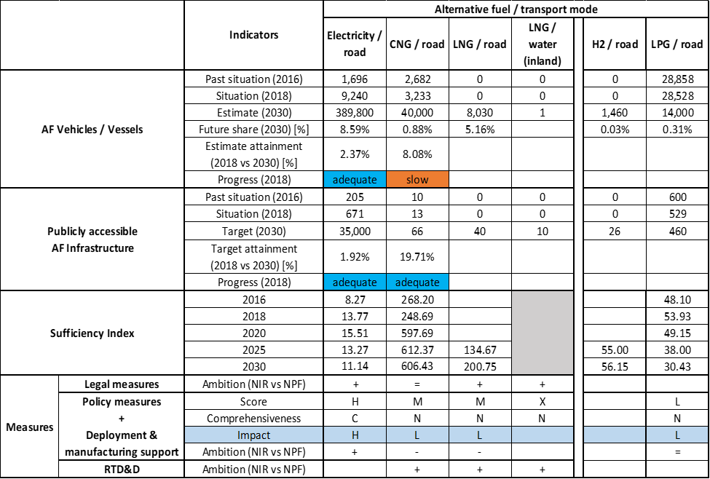



The Hungarian NIR is an updated and more focused version of the NPF as it considers the development of various alternative fuels over the past few years, adjusting the estimates and targets accordingly. Regarding the combination of AF/AFV/AFI with transport mode, electricity is covered for all modes; CNG, LPG, LNG and hydrogen for road transport, LNG also for waterborne inland transport; all the other combinations are either absent or not applicable. LPG is seen as inadequate in the Hungarian future fuel mix and will be gradually phased out.

Most of the measures address the pair electricity/road in detail, both in terms of vehicles and of recharging points. The NIR also reports some measures targeting CNG and LNG for road, and LNG for waterborne inland transport. Biofuels are also covered, but only in the Legal measures.

The main outcomes of the technical assessment of the Hungarian NIR on vehicles/vessels estimates and infrastructure targets can be summarised as follows:

###### Road transport

* **Electricity** – In 2018 Hungary recorded 9,240 EVs (of which 1 HCV and 23 buses and coaches) and 671 publicly accessible recharging points. Regarding the future estimates and targets, the HU NIR reports 389,800 EVs (320,000 passenger cars, 60,000 LCVs, 8,500 HCVs and 1,300 buses and coaches) and 35,000 publicly accessible recharging points (25% high power) in 2030. This represents an increase in ambition of around 100% for both AFV and AFI. The 2018 progress is adequate both for vehicles and infrastructure. The sufficiency index is also adequate for the whole period.
* **CNG** – Hungary reported that 3,233 CNG vehicles (of which 104 HCVs and 267 buses and coaches) and 13 publicly accessible refuelling point were in use in 2018. The Hungarian NIR indicates a steady increase of both CNG AFV and AFI by 2030. Regarding the future estimates and targets, the HU NIR reports an estimate of 40,000 CNG vehicles (39,000 passenger cars, 700 LCVs, 100 HCVs and 200 buses and coaches) and 66 refuelling points in 2030. This represent an overall decrease in ambition of around 80% compared to the estimates and targets in the NPF. The 2018 progress is slow for the vehicles and adequate for the infrastructure. The sufficiency index is adequate until 2030.
* **LNG** – Natural gas is seen as the most common alternative fuel to for the long distance transport in Hungary. However, similarly to the CNG, there is a considerable decrease in ambition between NIR and NPF, both in estimates and targets. The HU NIR reports that the use of LNG is expected to appear in 2025 and that by 2030 there will be 8,030 LNG vehicles (8,000 HCVs and 30 buses and coaches) and 40 publicly accessible refuelling points. The NIR estimate of LNG vehicles for 2030 is 43.45% lower and the related infrastructure target is 82.14% lower than in the NPF.
* **Hydrogen** – There were no hydrogen vehicles recorded in Hungary in 2018. For 2030 the HU NIR presents an estimate of 1,460 hydrogen-powered vehicles and a target of 26 publicly accessible refuelling points. This represents a 873% higher vehicle estimate and a 85.71% higher infrastructure target for 2030 compared to the NPF.
* **Biofuels** – The HU NIR reports that biofuels is the most important alternative fuel in road transport, due to the obligatory blending rate, but it does not provide any specific information for the future period.
* **LPG** – Hungary recorded 28,528 vehicles in 2018 and 529 publicly accessible refuelling points. In 2030 the HU NIR estimates 14,000 LPG vehicles and sets a target of 460 refuelling points, which represents a steady decline and lower level of ambition towards LPG.

###### Rail transport

* **Electricity** – The Hungarian NIR reports 672 electric locomotives in 2018, and estimates 680 electric locomotives in 2020, 673 in 2025 and 663 in 2030. The NIR also reports that, while 40% of the Hungarian railways is electrified, 70% of the total energy consumption for rail transport is based on electricity.

###### Waterborne transport (inland)

* **Electricity** – The Hungarian NIR recorded 145 electric vessels in use in 2018, and estimates 210 vessels in 2020, 330 vessels in 2025 and 450 in 2030. Hungary reported 28 shore-side electricity supply points in inland ports in 2018, and the target for the 2020 is of 36 shore-side supply points that will remain until 2030. This is a confirmation of the targets reported in the NPF
* **LNG** - The Hungarian NIR reports that there are no LNG inland waterway vessels in use in 2018, while the estimate for 2025 and for 2030 is equal to one. Similarly, there were no LNG inland waterway refuelling points in 2018. The HU NIR presents targets of 1 LNG refuelling point for 2020, 9 for 2025 and 10 for 2030. Compared to the NPF, this represents a 50% higher target in 2025 and 25% higher target in 2030.

###### Air transport

* **Electricity** – The Hungarian NIR reports two electric airplanes in use in 2018. It also provides an estimate of three electric airplanes from 2020 until 2030. Hungary reported 53 electricity supplies in use in 2018 for stationary airplanes, with no reported future targets.

The Hungarian NIR contains a portfolio of **measures** that is numerically equivalent to the one in the NPF, however it appears overall more focused. The portfolio consists of 22 measures, of which 6 Legal, 10 Policy, 2 Deployment and 3 RTD&D. A significant number of the measures in place are financial and target national co-funding scheme for electric vehicles or electricity infrastructure deployment. One of the most significant measure is the updated version of the Jedlik Anyos plan, a ten-year plan addressing electro-mobility, aiming to roll out 450.000 EVs and deploy 45.000 recharging points by 2030. This plan indicates a high level of commitment to meet or even exceed the 2030 WEM estimates and targets for electro-mobility (see the box at beginning of Section 5.17.3). Legislative and regulatory measures cover different acts on updating the rules and bills on electric AFI deployment, on the increase of minimum biofuels blend level and incentivising domestic biofuels production. One act aims at creating more favourable rules for LNG infrastructure development for inland waterway transport.

Concerning the Policy and Deployment & Manufacturing support measures, five clusters of measures were identified, on electricity, CNG, LNG and LPG for road and on LNG for inland waterborne transport (but this last was not assessable). In terms of expected impact of these measures to support the realisation of the AFV/AFI objectives as presented in the NPF and revised in the NIR, the measures for the pair electricity/road have a high impact, while those for the pairs and CNG/road, LNG/road, and LPG/road have a low impact.

The Hungarian NIR lists three RTD&D projects, financed through the Connecting Europe Facility transport programme (CEF). Two projects address the deployment of LNG/LBG infrastructure, one for waterborne inland and one for road transport. The third project addresses innovative CNG/CBG refuelling points for road transport across Hungary.

### Final remarks

The Hungarian NIR provides a quite comprehensive report on the efforts to implement the Directive. It meets almost all the requirements of Annex I to the Directive. All alternative fuels are addressed. The NIR provides estimates for alternative fuel vehicles and targets for the relevant infrastructures. The measures provided in the NIR cover mostly road transport, in particular electro-mobility and, to a lesser extent, CNG, LPG and LNG.

With regard to electricity, the NIR estimates that some 390,000 electric vehicles could be on the roads by 2030, representing about 8.6% of the fleet by that time. Taking into account the current situation and expected trends, this level of ambition does not appear to be fully compatible with the pace of deployment of electric vehicles considered necessary for a full transition to carbon neutrality by 2050. No information on charging efficiency is provided. The NIR also notes the ambition to electrify inland waterway transport. In 2018, there were already 145 electric vessels in use, and it is estimated that by 2030 there could be 450. In addition, in 2018 there were 28 shore-side electricity supply facilities in inland ports. This number should increase to 36 by 2030. Fifty-two electricity supply points provided electricity for stationary aircraft in 2018. Concerning rail transport, 40% of Hungary's railway lines are electrified. Future reporting should provide further information on the share of rail electrification.

Regarding hydrogen for transport, the NIR does not report current numbers on vehicles or infrastructure. However, it estimates six hydrogen refuelling points and a small fleet of 330 FCHVs by 2025. The NIR expects these figures to increase by 2030 to a fleet of 1,460 FCHVs and 26 refuelling points. The number of refuelling points seems sufficient taking into account the length of the Hungarian TEN-T Road Core Network, provided that the refuelling station are widely distributed along the network.

As for natural gas, in 2018 there was a small fleet of 3,223 CNG vehicles and 13 refuelling points in Hungary. These figures are expected to increase to 40,000 vehicles and 66 refuelling points by 2030, showing a lower level of ambition in the NIR on CNG compared to the NPF. Hungary has still a significant level of ambition regarding LNG for road transport (although again lower than in the NPF); the NIR targets 15 LNG refuelling points in 2025 and 40 in 2030. This seems sufficient taking into account the length of the Hungarian TEN-T Road Core Network, provided that the refuelling points are widely distributed along the network. The NIR also presents a target of nine LNG refuelling points for the inland ports by 2025 and 10 by 2030. These figures seem sufficient when considering that Hungary has two inland ports in the TEN-T Core Network and six inland ports in the Comprehensive TEN-T Core Network.

There was a significant fleet of LPG vehicles (28,520) and refuelling points (529) in 2018. The NIR expects the number of LPG vehicles to decrease significantly by 2030.

As regards biofuels, Hungary will encourage both consumption and domestic production of second-generation biofuels towards 2030, in accordance with the recast Renewable Energy Directive. Hungary should provide more information in future reporting on efforts to promote the use of renewable fuels in transport, and particularly in aviation.

### ANNEX - Description of the Member State

On a surface area of 93,000 km², Hungary has a population of 9.778 million people in 2018, which makes up for a population density of 105 inhabitants/km².

*Number of main urban agglomerations*

* 18 urban agglomerations > 50,000 inhabitants

In 2018, Hungary achieves a per capita gross domestic product at market prices of €13,690, which represents a per capita gross domestic product in purchasing power standards of 71 if expressed in relation to the EU-28 average set to equal 100.

*Length of the road networks*

The length of the road TEN-T Core Network in Hungary is 1,090 km. The total road network length is 31,993 km, of which 1,982 km are motorways.

The following parts of the TEN-T Road Corridors are present in Hungary: 11% (604 km) of the Mediterranean Corridor, 9% (469 km) of the Orient/ East - Mediterranean Corridor and 10% (469 km) of the Rhine - Danube Corridor.

Through the TEN-T Road Corridors, Hungary is connected with the following Member States:  
- Austria (through the Orient / East Mediterranean and the Rhine - Danube Corridor)  
- Slovakia (through the Orient / East Mediterranean and the Rhine - Danube Corridor)  
- Romania (through the Orient / East Mediterranean and the Rhine - Danube Corridor)  
- Croatia (through the Mediterranean Corridor)  
- Slovenia (through the Mediterranean Corridor)

*Number of registered road vehicles*

At the end of 2017, Hungary accounts for 4,398,832 registered road vehicles of which 3,641,823 are categorized as passenger cars, 444,588 as light goods vehicles, 125,887 as heavy goods vehicles and 19,134 as buses and coaches. The motorisation rate is 372 passenger cars per 1,000 inhabitants.

*Number of ports in the TEN-T Core Network*

* No maritime ports
* 2 inland ports in the TEN-T Core Network (Budapest Csepel, Komárom)
* 6 inland ports in the TEN-T Comprehensive Network

Through the 405 km inland waterways TEN-T Core Network, Hungary is connected with Croatia and Slovakia by the Rhine - Danube Corridor.

*Number of airports in the TEN-T Core Network*

* 1 airport in the TEN-T Core Network (Budapest-Liszt Ferenc)
* 2 airports in the TEN-T Comprehensive Network

## Malta (MT)

### Main messages from the Commission assessment of the NPF

In its original assessment of the Maltese NPF, the Commission concluded:

*The Maltese NPF addresses only partly the requirements of Article 3 of the Directive, focussing on electric vehicles and infrastructure for road. For determining the fuel or fuels (other than electricity) that are the most feasible for use in road transport in Malta, the Maltese government will be commissioning in 2018 the ‘Alternative Fuels in Road Transport Study’. Another study aiming at providing recommendations regarding the development of LNG as a marine fuel is currently underway.*

*In the case of electricity for road transport, which constitutes the focus of the Maltese NPF, the requirements of the Directive were fulfilled. The NPF contains, with around 1.7% share by 2020, high estimates for the future deployment of EVs, when compared with its current EV share of less than 0.1%. Already today, the spatial distribution of recharging points appropriately covers the needs of electric vehicles in terms of distance requirements in Malta. The given publicly accessible recharging points target is in line with the requirements of the Directive for 2020 and the assessment threshold of less than 10 EVs per recharging point is fulfilled. The proposed set of measures for electro-mobility could support reaching the declared objectives since it was evaluated as being comprehensive and having a medium overall assessment score.*

*The NPF does not contain concrete targets to increase the availability of electricity supply at airports for stationary airplanes. In the case of shore-side supply in its maritime ports no targets are provided, but an action plan for its implementation at the TEN-T Core Network ports of Valetta and Marsaxlokk is expected to be finalised by the end of 2018.*

*Besides electro-mobility, the national strategy for the other alternative fuels is briefly or inadequately treated in the Maltese NPF, being dependent on the results of currently ongoing studies. For CNG and LNG fuels, the NPF contains neither future estimates for vehicles and vessels nor targets for refuelling infrastructure. The lack of ambition for natural gas can be partially explained by the small market size in Malta and the lack of current interconnections with other natural gas networks. The best option known for Malta to be supplied with natural gas is the 159 km gas pipeline connecting Malta to Sicily but the earliest commercial operation of this pipeline is targeted for 2024.*

*The Maltese NPF does not contain any targets for hydrogen in transport.*

*The Maltese NPF contains a quite large portfolio of measures and most of them are already existing or adopted. The vast majority of the measures targets electricity for road and includes substantial direct incentives for purchase and tax incentives. Longer durations for the validity of financial support measures could provide certainty for market actors and hence increase the likelihood that the national targets and objectives of the NPF can be reached. The NPF also contains several support measures to promote the use of electricity in public transport which address mainly public procurement. Bicycles and electric bikes as well as their infrastructure also receive support. No future measures are discussed to promote the deployment of private electro-mobility infrastructure.*

*The Maltese NPF does not specify to which extent interests of regional and local authorities, as well as those of the stakeholders concerned have been considered in its drafting. However, it mentions plans to establish a stakeholder group (e.g. including representative of the private sector, NGOs, ministries and public entities) which will be involved in the drafting of the updated NPF.*

*Several European projects are mentioned in the Maltese NPF, mainly regarding cooperation with Italy. Two of them concern the promotion of electro-mobility while one is related to the connection of Malta to the European Gas Network.*

### Overview of requirements’ fulfilment from Annex I of the Directive

*Table 5.18.2‑1 Checklist Table*

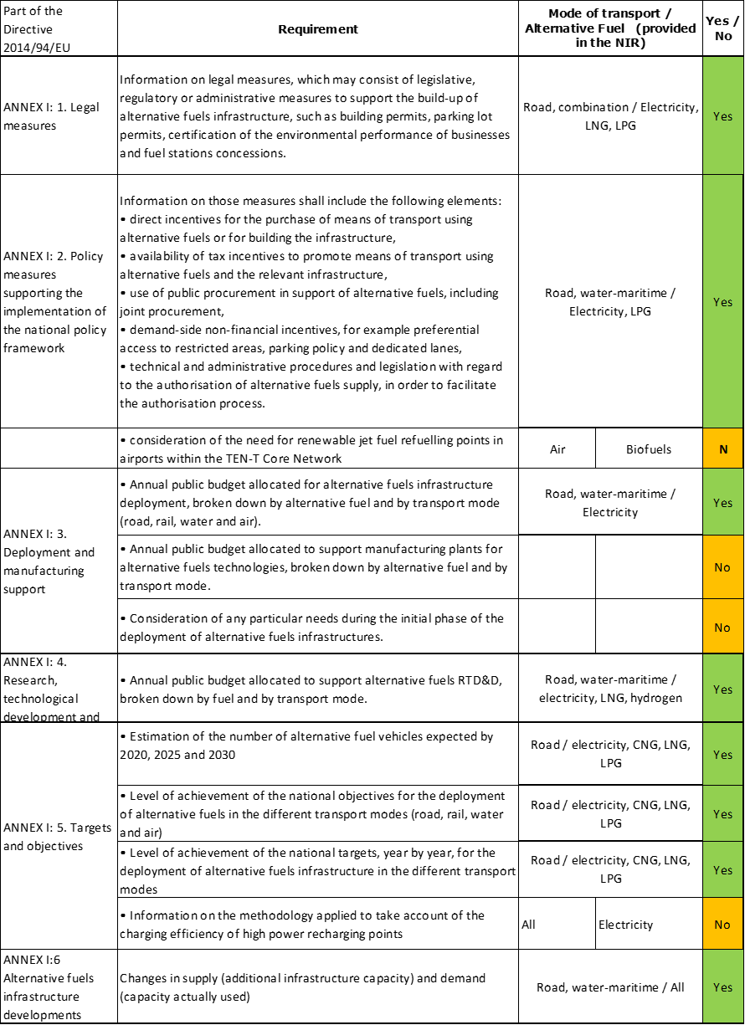

The checklist shows the requirements of Annex I from the Directive that are covered in the MT NIR.

Regarding the combination of AF/AFV/AFI with transport mode, electricity is partially covered for road and maritime transport; CNG, LNG and LPG are partially covered for road transport; LNG is also mentioned for maritime transport; other combinations are either absent or not applicable.

The Maltese NIR reports 30 measures. Under the Policy and Deployment & Manufacturing sections it was possible to identify three AF/transport mode clusters of measures, all assessable.

### Quantitative assessment: Vehicles and infrastructure

*Table 5.18.3‑1 National AFV estimates and AFI targets established in the NIR at the horizon 2020, 2025 and 2030 and their comparison with the NPF situation*

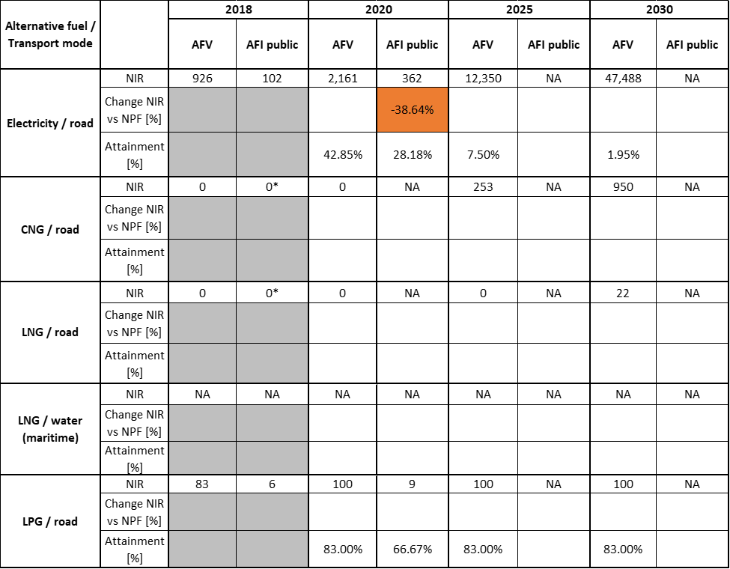



* Value taken from EAFO (absent in NIR)

#### Road transport

##### Electricity

###### Vehicles

Malta recorded 926 electric vehicles (EVs) in use in 2018 (all of them being BEVs and passenger cars) (see Table 5.18.3‑1) and 491 electric powered two wheelers (L-category vehicles). Regarding the next decade, the Maltese NIR confirms the NPF estimate of around 5,000 for 2020, and provides new estimates of 26,425 for 2025 and 89,994 for 2030. All these numbers also include powered two wheelers. The estimates for electric vehicles - excluding PTWs - presented in the MT NIR are 2,161 for 2020, 12,350 for 2025 and 47,488 for 2030 (see Table 5.18.3‑1). It is worth noticing that the PTWs are expected to represent around half of the total road electric vehicles in the future in the country. From 2020, the MT NIR expects 6 BEV buses to enter into service and to run up to 2030. No BEVs or PHEVs are expected for LCVs and HCVs.

The 2018 ***attainment*** of future EV estimates is 42.85% for 2020 and 1.95% for 2030. According to the assessment methodology described in Section 2.1, the 2018 situation corresponds to an ***adequate progress*** towards reaching the envisaged EV estimates. The calculated ***average*** ***annual growth rate*** corresponding to the period 2016-2030 for EV fleet evolution planned by Malta is equal to 43%.

###### Infrastructure

Malta recorded 102 publicly accessible recharging points in 2018 (Table 5.18.3‑1), including 3 solar recharging points. The revised NIR target of publicly accessible recharging points for 2020 is 362, which is 38.64% lower than in the NPF. However, it is worth mentioning that the high power (>22kW) recharging points number for 2020 increases from 10 in the NPF to 44 in the NIR (the share changes consequently from 1.69% to 12.15%). In both the NPF and the NIR, Malta did not provide targets for publicly accessible recharging points for 2025 and 2030.

Regarding recharging infrastructure, Malta foresees a national e-car sharing service under which 450 dedicated medium-fast recharging points will be deployed (see also Section 5.18.4.2.1). The Maltese Government is planning to support the development of an electric public transport, by installing four normal charging stations for a planned e-Bus service (see Section 5.18.4.2.2).

The 2018 ***attainment*** of future publicly accessible recharging infrastructure targets is 28.2% for 2020. According to the assessment methodology described in Section 2.1, the 2018 situation corresponds to a ***slow progress*** towards reaching the envisaged target. The calculated ***average annual growth rate*** corresponding to the period 2016-2020 for publicly accessible recharging infrastructure evolution planned by Malta is equal to 37%.

###### Ratio

Based on the Maltese NIR, the following table shows the ratio between vehicles and publicly accessible recharging points (i.e. sufficiency index) for the pair electricity/road. It can be seen that the sufficiency index is below 10 and adequate until 2020.



###### Information on charging efficiency

Information is not available in the MT NIR.

##### CNG

###### Vehicles

Malta did not record any CNG vehicles in use in 2018 (Table 5.18.3‑1), but the MT NIR provides estimates for the next decade, which were not present in the NPF. Assuming that CNG will be available from 2021, CNG vehicles are expected to ramp-up from 0 in 2020, to 252 in 2025 and to 950 in 2030. Of these 950 vehicles, 80.3% will be passenger cars, 10.5% LCVs, 3.1% HCVs and 6.1% buses and coaches.

Because at the end of 2018 there are no CNG vehicles in use, the 2018 ***attainment*** and ***progress*** could not be computed.

###### Infrastructure

As Table 5.18.3‑1 shows, similarly to the NPF, there is no information on CNG refuelling infrastructure in the Maltese NIR, neither for the past nor for the future. According to EAFO, Malta did not record any CNG refuelling points in 2018.

Because there are no CNG refuelling points targets provided in the Maltese NIR, the 2018 ***attainment*** and ***progress*** have not been computed.

###### Ratio

For the same reason it is not possible to compute the sufficiency index.

##### LNG

###### Vehicles

Malta did not record any LNG vehicles in use in 2018 (Table 5.18.3‑1). Under the assumption that LNG will be available from 2026, the Maltese NIR estimates 22 vehicles in 2030, all of which will be HCVs.

Because at the end of 2018 there are no LNG vehicles in use, the 2018 ***attainment*** and ***progress*** have not been computed.

###### Infrastructure

As shown in Table 5.18.3‑1, similarly to the NPF, there is no information on road LNG refuelling infrastructure in the Maltese NIR, neither for the past nor for the future. According to EAFO, Malta did not record any road LNG refuelling points in 2018.

Because there are no data on road LNG refuelling points in the Maltese NIR, the 2018 ***attainment*** and ***progress*** could not be computed.

###### Ratio

For the same reason it is not possible to compute the sufficiency index.

##### Hydrogen

###### Vehicles

In spite of the participation of Malta in two pilot initiatives for proving hydrogen production from renewable energies and its use, no future vehicle estimates were found in the MT NIR and therefore the 2018 ***attainment*** and ***progress*** could not be computed. According to EAFO, Malta did not record any hydrogen refuelling points in 2018.

###### Infrastructure

Information is not available in the MT NIR.

###### Ratio

As the Maltese government does not provide any figures for hydrogen, neither in the NPF or in the NIR, no sufficiency index could be computed.

##### Biofuels

###### Vehicles

No specific information was found in the Maltese NIR.

###### Infrastructure

As in the Maltese NPF, the NIR does not provide additional information on infrastructure requirements for biofuels, as these are expected to be distributed through existing conventional fuels infrastructure, and according to the target set by REDII.

##### LPG

###### Vehicles

Malta recorded 83 LPG vehicles in use in 2018 (Table 5.18.3‑1). In 2020, the Maltese NIR expects 100 vehicles on the road, without specification about the class and without further changes to that estimate for the period up to 2030.

The 2018 ***attainment*** of future LPG vehicles estimates is constant and equal to 83% for 2020, 2025 and 2030. According to the assessment methodology described in Section 2.1, the ***progress*** obtained by Malta from 2016 until 2018 for LPG vehicles deployment is 69.1% of the overall planned deployment during the period 2016-2030.

###### Infrastructure

Malta reported 6 LPG refuelling points in 2018 (see Table 5.18.3‑1). For the next decade, the Maltese NIR presents a plan that was not present in the NPF with a growth to 9 refuelling points in 2020, while for 2025 and 2030 no targets are provided. This lack of targets in the medium-long term could be explained by the decision of the Maltese government to investigate the timing for the phasing-out of Internal Combustion Engines (ICE). Nevertheless, as a limited LPG fleet is foreseen after 2020, this absence of refuelling points is not clearly justified in the Maltese NIR.

The 2018 ***attainment*** of future publicly accessible LPG refuelling infrastructure targets is 66.7% for 2020. According to the assessment methodology described in Section 2.1, the ***progress*** obtained by Malta for the deployment of publicly accessible LNG refuelling infrastructure from 2016 until 2018 versus the period 2016-2030 could not be computed because the 2030 target is not provided.

###### Ratio

Based on the MT NIR, the following table shows the ratio between vehicles and publicly accessible refuelling points (i.e. sufficiency index) for the pair LPG/road (see Section 2.1.5).



#### Rail transport

###### Vehicles

Information is not available in the MT NIR.

###### Infrastructure

Information is not available in the MT NIR.

#### Waterborne transport (maritime)

##### Electricity

###### Vessels

Information is not available in the MT NIR. Nevertheless, the description about infrastructure provides some information on the expected demand.

###### Infrastructure

According to the MT NIR, the appointed entity *Infrastructure Malta* will undertake the necessary investment to provide shore-side electricity supply on all the quays within the TEN-T Core port Grand Harbour (port of Valletta) that are utilised for Cruise Liner Ships by 2025. In spite of this initiative, the NIR does not report any figures for this kind of infrastructure. Shore-side electricity supply for the maritime ports on the TEN-T Comprehensive Network is not foreseen in the MT NIR.

Because of the lack of numerical data, no ***attainment*** and ***progress*** could be computed.

##### LNG

###### Vessels

The Maltese NIR reports the outcomes of a study aiming at defining the potential for LNG bunkering. The Government of Malta is expecting to adopt a national policy for the implementation of the required LNG bunkering. For the time being, the MT NIR does not report any information about LNG vessels.

###### Infrastructure

According to the results of the above-mentioned study, LNG bunkering demand in Malta is expected to start from 2025, and to increase up to 339,000 tonnes/year in 2056 (based on MID scenario). Before 2025, no demand is expected unless a pilot project takes place. For this reason, the MT NIR does not report any quantitative information about LNG infrastructure.

Because of the lack of numerical data, no ***attainment*** and ***progress*** could be computed.

#### Waterborne transport (inland)

Not applicable since Malta has no inland ports in the TEN-T Core Network.

#### Air transport

##### Electricity

###### Airplanes

The Maltese NIR does not consider any hybrid-electric or fully-electric airplanes by 2030.

###### Infrastructure (for stationary airplanes)

The MT NIR reports no immediate plans to invest in infrastructure for electricity supply at its TEN-T Core airport. There is a generic statement about the intention to move ground operations to fully electric, but no quantitative information is provided.

##### Biofuels

###### Airplanes

Despite MT NIR mentioning the participation of Malta to the ICAO/CORSIA initiative, no quantitative information on flights/airplanes powered by biofuels is provided.

###### Infrastructure

Information is not available in the MT NIR.

### Measures assessment

As in the NPF, a series of measures are mentioned in the MT NIR, which reflect mainly the focus on electro-mobility in the short term, as electricity “*is considered as the most promising fuel for future transport systems in Malta*”. Some of the measures are vaguely defined or lack concrete information needed to perform the assessment[59].

#### Legal measures

The Maltese NIR contains seven legal measures, in general with a higher level of ambition compared to those in the NPF. The majority of the reported measures are specifically concerning the electricity/road pair.

##### Legislative & Regulatory

The legislative & regulatory category of the Maltese NIR contains six legal measures, all of which are exclusively reported in the NIR. Three measures relate to the electricity/road cluster and the rest to combinations of AFs.

An important legal measure, currently under evaluation by Maltese institutions, is the ICE cut-off date. In 2018, the Maltese Government had decreed that a cut-off date for the importation and registration of new and second-hand ICE vehicles on the Maltese Territory should be fixed. The Cabinet of Ministers had mandated the setting up of an inter-ministerial Committee to study the implications of such a ban. It is expected that the Committee will present its findings and suggestions by the second half of 2020 (by time of publication this sentence should be reviewed). This measure is expected to significantly impact the deployment of electro-mobility in Malta.

In Malta’s Transport Master Plan 2025 there is a target of 20% of the national vehicle fleet to be composed of non-conventionally fuelled vehicles by 2025, and the gradual phasing out of ‘conventionally fuelled’ vehicles in urban areas by 50% in 2030. No specific details are reported, as the MT NIR declares that the Government plans to study further this issue and provide more detailed projections after 2020. The Maltese NIR mentions as well that the National Electro-mobility Action Plan is currently being updated.

Other measures concern transpositions into national legislation of articles of the AFI Directive and of the Energy Performance in Buildings Directive. The “Petroleum for the Inland (Retail) Fuel Market Regulations (545.22)” are also mentioned to ensure that the geographic location of the public alternative fuels refuelling points are accessible on an open and non-discriminatory basis to all users. A regulatory framework governing the personal and shared use of e-scooters put in place at the end of 2019 is presented as well.

##### Administrative

The only administrative measure mentioned in the MT NIR as well as in the NPF, targeted for completion by the end of 2020, relates to the integration of the Intelligent Transport Systems (ITS) Platform at the National Transport Control Centre aiming at facilitating the interface between vehicles and infrastructure.

#### Policy measures

The Maltese NIR reports 15 policy measures of which 11 had already been reported in the NPF and 4 are new. All the policy measures concern the road as transport mode and focus mainly on electricity as alternative fuel. Twelve of them can be categorised as measures to ensure national targets and objectives, two as measures that can promote AFI in public transport services and one as a measure that can promote the deployment of private electro-mobility infrastructure.

##### Measures to ensure national targets and objectives

###### Road transport

The Maltese NPF had mentioned quite a large number of measures to enhance the deployment of road electro-mobility, mainly financial measures like substantial direct incentives for purchase, taxation exemption schemes and public procurement incentives. The measures were often limited in time and budget, with annual extension foreseen. The NIR pursues many of them but in some cases (especially, the purchase subsidies and scrappage schemes) without providing enough details that are needed for their assessment according to the methodology described in Section 2.2. The continuation of these measures in the future is not clearly presented in the MT NIR.

More specifically, the MT NIR mentions that various schemes providing subsidies were launched on an annual basis with various changes over the years and their allocated budget was 1.9 million € for the period 2016-2019 (e.g. direct incentives for purchase for individuals and companies which supported the purchase of 373 EVs, 39 electric motorcycles and 185 pedelecs). EVs have been exempted since 2018 from paying the registration tax as well as the annual circulation tax (for a period of five years after registration). The EVs and the LPG vehicles are allowed to use the priority lane, while EVs are also exempt from tariffs related to the Controlled Vehicular Access system in Valletta.

To increase and stimulate the use of EVs in Malta as well as to promote the sharing economy and address congestion, a National e-Car Sharing Project started in 2018 to offer mobility as a service at no less than 45 mandatory locations. The service was launched with 150 BEVs and an additional 30 BEVs during the third quarter of 2019. In late 2019, electric motorcycle (scooter type) sharing was also introduced. In the NIR, it is reported that the company is expected to include electric van sharing services in 2020 as well as installation and operation of 450 medium-fast recharging points. According to the MT NIR, this deployment has already started. These recharging points will be offered to third party EV owners to charge their vehicle when the point is not being occupied by the EVs of the sharing fleet.

The use of EVs for the last mile delivery of goods is also under evaluation with a pilot project underway[60].

The measures detailed in the NPF on the promotion and support of electric bicycles (pedelecs) use are no longer mentioned in the NIR anymore.

The incentive scheme for the conversion of a conventional fuel motor vehicle to run on LPG continues since 2013 (granting €200 per vehicle).

###### Biofuels

Malta has introduced an obligation on fuel importers to blend 0.1% share of advanced biofuels in their mix in 2020. Local importers and wholesalers of petrol and diesel are expected to meet their post-2020 substitution obligation by blending regular diesel with FAME and HVO. High blends of bioethanol (>E5) are not distributed for consumption in Malta.

The Maltese NIR pointed out that, given the relatively small market, the country cannot take advantage of economies of scale in procurement and shipping, therefore the CIF costs[61] tend to be higher than for larger markets. This is expected to limit specific initiatives on biofuels in Malta. In spite of this remark, in the scenario proposed at page 23 of the Maltese NIR, the advanced biofuels are expected to contribute to 25% of the total consumption of biofuels by 2030.

##### Measures that can promote AFI in public transport services

The Maltese NIR reports that under the current scheduled public transport Concession Agreement expiring in 2030, fleet using alternative fuels is not contemplated. However, two measures with influence on promoting alternative fuels in the public transport service are present in the MT NIR.

###### Buses

Six electric buses are planned to operate an on-demand shuttle service, between the multi modal hub in Xewkija and the Mgarr Harbour Terminal (TEN-T comprehensive) in Gozo Island. The aim is to promote the use of greener transport contributing towards lower emissions in the area and reduced traffic congestion within and around the Mgarr Harbour. The total cost for these e-buses is €1,994,607 out of which €1,636,245 are eligible for EU funding. These electric buses will be supported by four slow recharging stations located within the multi modal hub with a cost for purchase and installation estimated at around €230,000. The Ministry of Gozo plans to procure them through National Funds. The ambition of these two measures is slightly reduced compared to that of the NPF, where 8 electric buses and 10 recharging points were foreseen.

##### Measures that can promote the deployment of private electro-mobility infrastructure

On private electro-mobility infrastructure, the Maltese NIR reports that the National Electric Vehicle Charging Network provides electric vehicles users with the possibility to charge using publicly accessible charging points in public parking spaces across Malta and Gozo at 4-hour slot intervals with a pre-booking system being available through a web-based interface.

During 2020, the electricity rate of recharging electric vehicles within residences is foreseen to be capped at €0.1298 per unit during off peak periods.

#### Deployment and manufacturing support

##### AFI deployment

The Maltese NIR contains two measures considered to address AFI deployment support.

According to the MT NIR, an unspecified number of fast charging points are planned to be installed by January 2021 at both ends of the Malta/Sicily ferry service (funded under the EnerNETMob Interreg Med project). This project’s implementation was delayed because, according to the NPF, the installation was foreseen to be accomplished in 2019.

The Maltese NIR reports that “*Infrastructure Malta will undertake all the necessary investment to provide shore side supply on all the quays within the TEN-T Core port Grand Harbour*” (port of Valletta). Phase I targeted the quays utilised for Cruise Liner Ships by 2025 and the foreseen investment is estimated at 40 million €. In phase II of the project, additional investments should allow for supplying other vessels such as cargo roll-on/roll-off (RORO), etc. Shore-side electricity supply for the maritime ports on the TEN-T Comprehensive Network is not foreseen in the MT NIR at this stage.

##### Support of manufacturing plants for AF technologies

The Maltese NIR contains no measures to explicitly support manufacturing plants for AF technologies.

##### Consideration of any particular needs during the initial phase of the deployment of alternative fuels infrastructures

Information is not available in the Maltese NIR.

#### Quantitative assessment of Policy and Deployment & Manufacturing measures

Table 5.18.4‑1 presents an overview of the analysis of all the Policy and Deployment & Manufacturing measures, carried out according to the assessment methodology described in Section 2.2. No clusters of measures have emerged for CNG, LNG and hydrogen related to road transport, nor for rail and air transport modes.

The vast majority of the assessable measures are targeting the pair electricity/road, which is the main focus of the MT NIR set of measures. While it results comprehensive since it concerns both vehicles and infrastructure (with financial and non-financial measures), it obtained a medium overall score, which is also due to the lack of details that limited the possibility of a robust assessment. Its ambition is considered to have increased compared to the NPF, but greater detail on planned measures is recommended.

Another cluster identified in the MT NIR concerns LPG/road and contains two measures but only one is specifically dedicated to LPG. It has been assessed to have a low score, not to be comprehensive and with a similar ambition level as in the NPF.

Electricity/water - maritime is a cluster newly introduced in the NIR, which contains only one measure. The reported measure seems to have the potential to positively impact on the most important port of Malta. However, the lack of specific details influences the assessment (the NIR reports only an estimated budget for the first phase) (see Section 5.18.4.3.1). Thus, this cluster has been evaluated with a low/medium overall score, and it is considered not comprehensive.

In terms of expected impact of these measures to support the realisation of the AFV/AFI objectives as presented in the NPF and revised in the NIR, the measures for the pair electricity/road result to have a medium impact, while those for electricity/maritime and LNG/maritime result to have a low impact.

*Table 5.18.4‑1 Quantitative assessment of Policy and Deployment & Manufacturing support measures*



**Legend:** Score and Impact: H = high; M = medium; L = low; X = not assessable. Comprehensiveness: C = comprehensive; N = Not comprehensive. Ambition level: ‘+’ means ‘higher’; ‘=’ means ‘comparable’; ‘-‘ means ‘lower’.

#### Research, Technological Development & Demonstration

The Maltese NIR contains six items than can be considered as RTD&D related actions.

Two projects of relevance are presented, both focusing on Hydrogen: BIG HIT (FCH JU) and SMARTHY-AWARE INTERREG Project. The total budget for Malta is lower than €200,000. It is worth noticing that, neither in the NPF nor in the NIR, Malta has foreseen any relevant development of hydrogen for transport. Specific details about each of these projects are not provided in the NIR.

Four measures regard national studies that have been conducted in order to prepare decisions on the future provision of the respective alternative fuels (“*Alternative Fuels in Road Transport Study*”, “*LNG Bunkering Study*”, “*Shore side Electricity in Ports Study*”, and a study in the form of an implementation plan as well as a Cost Benefit Analysis on the extension of the National Electric Vehicle Charging Network).

The Maltese NIR reports in details the outcomes of the study on LNG Bunkering. The market study shows that LNG bunkering demand in Malta is expected to start from 2025, reaching 31,000 tonnes/year in 2030 and increasing up to 339,000 tonnes/year in 2056 (based on MID scenario). Before 2025, no demand is expected unless a pilot project takes place. To date, the number of shipping operators that have committed to LNG is very small because emerging technologies such as biofuels, hybridisation and batteries are gaining more popularity and are considered as a cleaner alternative to LNG.

In the NPF, several European projects were reported (e.g. GrowSmarter, DESTINATIONS, EnerNETMob, DEMO EV and PORT-PVEV). The outcomes of these projects are mentioned in NIR, as base for the plans about the various alternative fuels.

### Additional information on alternative fuels infrastructure developments

The Maltese NIR provides information on the changes in fuels use (see Table 5.18.5‑1).

*Table 5.18.5‑1 Changes in fuel use in transport sector (2016-2030)*



As it can be noticed, biofuels are expected to remain the dominating alternative fuel in road transport throughout the period, followed by electricity that increases from 2025 onwards.

Additionally, the Maltese NIR provides a detailed overview of biofuels use in transport (see **Error! Reference source not found.**). As it can be seen, biofuels in road transport are projected to grow between 2021-2030. Biofuels are expected to continue increasing mainly as blends with regular road diesel and HVO, FAME (to a lesser extent), and advanced biofuels in line with the Renewable Energy Directive. Advanced biofuels are expected to contribute to 25% of the total consumption of biofuels by 2030. This scenario does not require any further investment in terms of infrastructure.

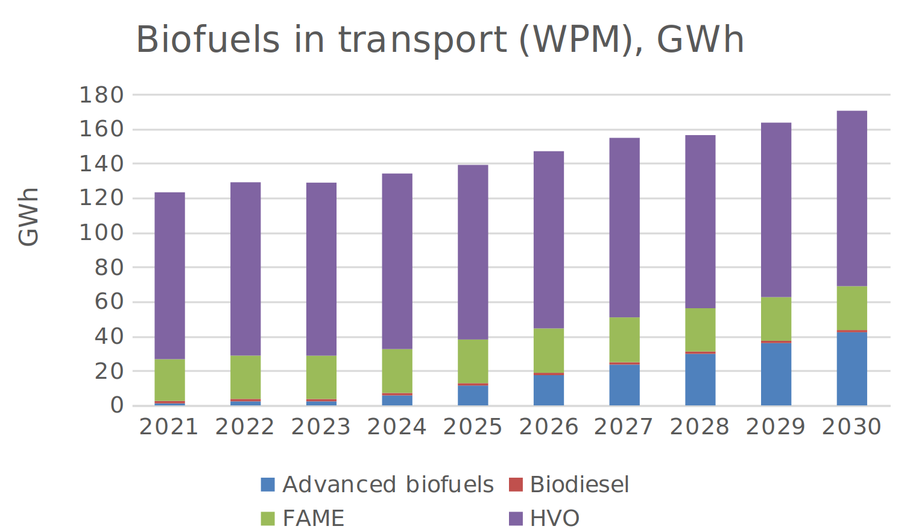

Figure 5.18.5‑1 Projections of biofuels under WPM scenario, 2021-2030, GWh (source MT NIR page 23).

### Summary of the assessment

**Tabular overview**

*Table 5.18.6‑1 Overview of the NIR assessment*

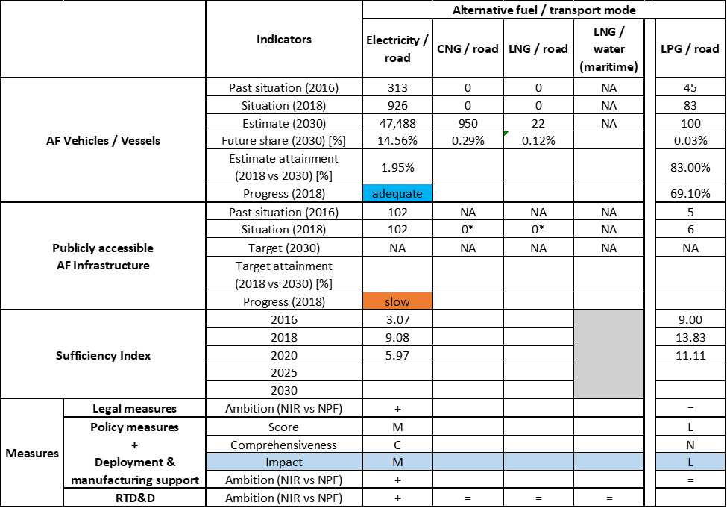



* Value taken from EAFO (absent in NIR).

The requirements of Annex I from the Directive are only partly covered in the Maltese NIR. The NIR does not contain a complete description of the policy direction towards the introduction of alternative fuels in Malta. Also, it does not establish clear AFI targets for the different kinds of alternative fuels. However, the Maltese NIR mentions several studies and evaluations to be completed in 2020 (e.g. ICE cut-off date, update of the Malta Transport Master Plan 2025, and evaluation of the outcomes of studies for LNG). This planning is expected to complement and integrate the current set of national targets for the deployment of alternative fuels and their infrastructure.

The main outcomes of the technical assessment of the Maltese NIR on vehicles/vessels estimates and infrastructure targets can be summarised as follows:

###### Road transport

* **Electricity** – In 2018, Malta reported 962 electric vehicles (all passenger cars). The 5,000 total road electric vehicles (including PTWs) planned in NPF for 2020 are still a valid commitment in the NIR. Additionally, the MT NIR provides estimates by category of vehicles, foreseeing 2,160 EVs (excluding PTWs) in 2020, and new estimates of 12,350 in 2025 and 47,488 EVs in 2030 (all passenger cars, except 6 buses and coaches). Malta recorded 102 recharging points in 2018; the NIR presents a revised target for 2020 (362 points), which is 38.64% lower than that in the NPF but does not provide targets for 2025 and 2030, similarly to the NPF. According to our methodology, the progress between 2016 and 2018 to achieve their objectives in 2030 is considered to be adequate for the vehicles and slow for infrastructure, while the sufficiency index is adequate until 2020.
* **CNG** – Malta did not record any CNG vehicles in use in 2018, but the MT NIR provides an estimate of 950 CNG vehicles in 2030 (of which 100 LCVs, 29 HCVs and 58 buses and coaches). This plan for the CNG vehicles is not accompanied by any information about the development of a specific infrastructure for refuelling.
* **LNG** – Similarly to CNG, no LNG vehicle was recorded in Malta in 2018. For 2030, there are 22 HDVs planned in the NIR. Again, no information is available for the LNG refuelling infrastructure.
* **Hydrogen** – The Maltese NIR mentions no concrete objectives or actions for hydrogen.
* **Biofuels** –Malta considers to increase the uptake of biofuels in the regular distribution system, in order to comply with the target set by the current European legislation (e.g. REDII commitments).
* **LPG** –Malta recorded 83 LPG vehicles on the road and 6 LPG refuelling points in 2018. In the MT NIR there is an estimate of 100 vehicles from 2020 until 2030, while the infrastructure is planned to grow up to 9 refuelling points in 2020, while after that year targets are missing.

###### Rail transport

* **Electricity** – No specific information was found in the Maltese NIR.

###### Waterborne transport (maritime)

* **Electricity** – The Maltese NIR states that *Infrastructure Malta* is expected to provide shore-side electricity supply on all the quays within the TEN-T Core port Grand Harbour (port of Valletta). In phase I, quays for Cruise Liner Ships are targeted by 2025 and the foreseen investment is estimated at 40 million €. In phase II of the project, additional investments should allow electricity supply to other vessels such as RO-RO, etc.
* **LNG** – The Maltese NIR reports outcomes of the study on LNG Bunkering. The market study shows an LNG bunkering potential demand in Malta, which is expected to start from 2025. Before 2025, no demand is expected unless a pilot project takes place. To date, the number of shipping operators that have committed to LNG is very small because emerging technologies such as biofuels, hybrid and batteries are gaining more popularity and are considered as a cleaner alternative to LNG.

###### Air transport

* **Biofuels and electricity** – Despite MT NIR mentions the participation of Malta to the ICAO/CORSIA initiative, it does not provide any quantitative information on flights/airplanes powered by biofuels. The Maltese NIR does not consider any hybrid-electric or fully-electric airplanes by 2030. The MT NIR reports no immediate plans to invest in infrastructure for electricity supply at its TEN-T Core airport.

As regards the **measures**, the MT NIR shows focus on the development of electro-mobility as electricity is considered as the most promising alternative fuel in short term. Some of the presented measures lack concrete information allowing for a proper assessment. Malta should improve the reporting on this matter.

The Legal measures are mainly dedicated to allowing the development of electro-mobility and are almost all exclusively presented in the NIR. Overall, they appear, if fully implemented, to be fit to support the realisation of the AFV/AFI objectives as presented in the NPF and revised in the NIR. The level of ambition is considered higher in the NIR compared with the NPF.

Concerning the policy measures, the MT NIR contains measures targeting only road as transport mode and focusing mainly on electricity as alternative fuel. The majority of them are a continuation of measures already presented and in place in the NPF. They cover financial aspects (e.g. purchase / conversion /scrappage subsidies, tax incentives) but also non-financial ones (e.g. car-sharing services, access to restricted lanes).

The AFI deployment measures address the electricity/road and electricity/water-maritime pairs.

As for the Policy and Deployment & Manufacturing support measures, in the NIR compared with the NPF, the level of ambition has increased for two identified clusters (i.e. electricity/road, electricity/water-maritime) and remained the same for the third one (i.e. LPG/road). The most complete and numerous cluster of measures is for the pair electricity/road. The assessment was influenced by the lack of concrete information in the description of some measures.

The expected impact of the measures to support the realisation of the AFV/AFI objectives as presented in the NPF and revised in the NIR is medium for the electricity/road pair, while for the pairs electricity/water-maritime and LPG/road it results to be low.

The Maltese NIR provides information about two main ongoing RTD&D initiatives (participation to international projects) ongoing to support the implementation of hydrogen in transport. It also presents four national studies related to electricity, CNG and LNG, which were conducted to facilitate decisions on the future provision of these respective alternative fuels.

### Final remarks

The Maltese NIR provides a relatively comprehensive report on the efforts to implement the Directive, but does not provide information on the target for electric vehicles’ recharging points in 2025 and 2030, nor for CNG refuelling points for vehicles and LNG refuelling points for vehicles and vessels in 2020, 2025 and 2030. A significant number of the measures included in the Maltese’s NIR aim at promoting electro-mobility in road transport, in public transport and, to a lower extent, in maritime transport.

With regard to electricity, the NIR estimates that 47,488 electric vehicles could be on the road by 2030, representing about 15% of the fleet by that time. Taking into account the current situation and expected trends, this level of ambition appears to be broadly consistent with the pace of deployment of electric vehicles considered necessary for a full transition to carbon neutrality by 2050. Nevertheless, the NIR does not indicate estimates for electric recharging infrastructure by 2025 and 2030. Malta should update its planning and reporting on this matter. No information on charging efficiency is provided. Further, no specific information is given on the electrification of waterborne and air transport. However, the NIR indicates that Malta will undertake the necessary investment to provide shore-side electricity supply on all quays within the TEN-T Core Network used for cruise liner ships.

The Maltese NIR does not report any information on existing or future HFCV and the relevant infrastructure.

Regarding natural gas for transport, the NIR does not report information on the development of CNG and LNG infrastructures for road and maritime transport. Only small fleets of 950 CNG vehicles and 22 LNG vehicles are estimated by 2030. There are no plans to use LNG in the maritime sector before 2025, as the current interest in LNG among shipping operators is noted to be limited.

Concerning LPG, the NIR shows that Malta had a small fleet of 83 LPG vehicles and six LPG refuelling stations by 2018. It estimates around 100 LPG vehicles by 2020, 2025 and 2030 as well as nine LPG refuelling stations at the end of 2020.

Malta should provide more information in future reporting on efforts to promote the use of renewable fuels in transport, and particularly in aviation.

### ANNEX - Description of the Member State

On a surface area of 300 km², Malta has a population of 476,000 people in 2018, which makes up for a population density of 1,587 inhabitants/km².

*Number of main urban agglomerations*

* 1 urban agglomeration > 50,000 inhabitants

In 2018, Malta achieves a per capita gross domestic product at market prices of €25,490, which represents a per capita gross domestic product in purchasing power standards of 98 if expressed in relation to the EU-28 average set to equal 100.

*Length of the road networks*

The length of the road TEN-T Core Network in Malta is 20 km. The total road network length is 2,855.

The following lengths of the TEN-T Road Corridors are present in Malta: 0.3% (20 km) of the Scandinavian - Mediterranean Corridor.

*Number of registered road vehicles*

At the end of 2018, Malta accounts for 375,634 registered road vehicles of which 300,140 are categorized as passenger cars, 36,571 as light goods vehicles, 12,223 as heavy goods vehicles and 2,100 as buses and coaches. The motorisation rate is 631 passenger cars per 1,000 inhabitants.

*Number of ports in the TEN-T Core Network*

* 2 maritime ports in the TEN-T Core Network (Marsaxlokk, Valletta)
* 2 maritime ports in the TEN-T Comprehensive Network
* No inland ports

*Number of airports in the TEN-T Core Network*

* 1 airport in the TEN-T Core Network (Valletta-Malta Luqa)
* No airports in the TEN-T Comprehensive Network

1. EAFO. (2020). European Alternative Fuels Observatory (EAFO). European Commission (EC). Retrieved from https://www.eafo.eu on 01/02/2020.
2. EAFO. (2020). European Alternative Fuels Observatory (EAFO). European Commission (EC). Retrieved from https://www.eafo.eu on 01/02/2020.
3. For Belgium there is an additional column, which has been deemed useful to provide some additional, necessary information.
4. If the MS did not provide any information for the 2016-2018 period, neither in the NIR or in the NPF, data from EAFO is used, if available.
5. “As an indication, the appropriate average number of recharging points should be equivalent to at least one recharging point per 10 cars”.
6. The average ratio in Member States between conventional vehicles and gasoline/diesel refuelling points is 600 to one (one fuel station typically has several refuelling points).
7. According to the Commission Frequently-Asked Questions document notified to the Member States on 16 September 2019, complying to this requirement can be ensured by providing information on usage from a representative sampling of high power recharging points.
8. Similarly to the NPF assessment, these future total fleet values are based on the Baseline scenario of the Impact Assessment accompanying the Proposal for a Directive amending Directive 1999/62/EC on the charging of heavy goods vehicles for the use of certain infrastructures (SWD (2017) 180), and thus on the EU Reference scenario 2016, but excludes the incentives for alternative fuels provided at the Member State level. It has been developed with the PRIMES-TREMOVE model (i.e. the same model used for the EU Reference scenario 2016) by ICCS-E3MLab.
9. In contrast to the NPF assessment, the clusters for LNG/water (maritime) and LNG/water (inland) can no longer be clearly identified, as measures relevant to these clusters tend to target a combination of AFs and/or modes.
10. One additional measure referring to the Ordinance for determining the rate of product charges for motor vehicles was included by Bulgaria as legal measure, but this is assessed here as a policy measure for consistency with our previous assessment and the Guidance Support document.
11. <https://ec.europa.eu/inea/en/connecting-europe-facility/cef-transport/2017-eu-tm-0065-w>
12. No data available for light goods vehicles.
13. We deduce that the NIR uses ‘EVs’ to refer to BEVs only, in contrast to PHEVs, and ‘gas vehicles’ to refer to CNG vehicles.
14. In terms of railway electrification, if a distinction is made between vehicles (which is included in the part on policy measures) and infrastructure, then a 12th measure can be identified, though information on budget is not available.
15. These can presumably be searched via the website Energiforskning.dk.
16. Adapted from the original table notified by Denmark.
17. The DK NIR expresses doubts about the appropriateness of maintaining the ‘ten-to-one ratio’ assumption.
18. Registrations of only vehicles with bivalent diesel-LNG propulsion are reported in the NIR, which however acknowledges that it is not possible to determine the number of past LNG vehicles and regards the reported figures as a very likely underestimation. Since 2019, vehicles with the more common monovalent LNG propulsion are being recorded under a specific category.
19. Including plug-in vehicles with hydrogen fuel cell and vehicles with hydrogen-powered internal combustion engines, as reported in the NIR.
20. Data unavailable for Brandenburg, Niedersachsen, Nordrhein-Westfalen and Schleswig-Holstein.
21. For the measure denominated “ExcellentBattery”, the NIR lists it as a national measure but it indicates that the measure is implemented at regional level.
22. In terms of the quantitative assessment, however, this cluster consists only of manufacturing measures that apply to other transport modes as well.
23. Though none of the measures in this cluster is exclusively dedicated to the use of hydrogen in maritime vessels.
24. As a result of applying the assessment methodology (Section 2.2), not the DE NIR’s own categorisation indicated above.
25. Irish Maritime Development Office, 2019, “The Development of Alternative Fuel Infrastructure in Irish Ports – A Feasibility Study”
26. A scheme that places an obligation on fuel suppliers in the road transport to ensure that a certain of all fuel is from renewable sources (the obligation rate increases over time - 4% by volume in 2010, 10% by volume in 2019 and 11% in 2020.
27. The cluster Synthetic & paraffinic fuels/road contained measures only in the IE NPF.
28. The decrease in level of ambition at cluster level originates from the disappearing in the NIR of measures that were present in the NPF.
29. In 2018, circa 216 million litres of sustainable biofuels (approximately 162 million litres biodiesel and 54 million litres of bioethanol) were placed on the Irish market
30. The decrease in level of ambition at cluster level originates from the disappearing in the NIR of measures that were present in the NPF.
31. No data available for 2018.
32. No data available for light and heavy goods vehicle categories.
33. In the case of HCVs and buses and coaches, data corresponds to the values from 2017 since the FR NIR did not provide values for 2018.
34. The SDMP2 estimates for EVs (excluding PTWs) and are 1,327,600 for 2023 and 5,296,900 for 2028, respectively.
35. Considering for 2025 the target provided for 2022.
36. It only provides the situation at the end of 2019, mentioning 110 CNG refueling stations deployed.
37. It only provides the situation at the end of 2019, mentioning 34 LNG refueling stations deployed.
38. The FR NIR provides one single value per year for the merged set of transport systems (HCVs+Buses and coaches+maritime vessels+ inland vessels+locomotives). In this assessment, these numbers are considered to refer to the road vehicle categories HCVs + Buses and coaches.
39. It only provides the situation at the end of 2019, mentioning 29 hydrogen refuelling stations deployed mainly with the support of the “Territoires hydrogène” labelling scheme.
40. https://www.vighy-afhypac.org/
41. The plan does not specify differentiated targets between stations open to the public and those for captive fleets.
42. The FR NIR provides one single value of 210,000 for the merged set of all LPG transport systems across all transport modes for 2017.
43. under adoption when the French NIR was submitted
44. examined at second reading in Parliament when the French NIR was submitted
45. Je-roule-en-electrique.fr
46. CNG/road and LNG/road are addressed together as natural gas within the AFI deployment measures
47. https://www.vighy-afhypac.org/
48. The plan does not specify differentiated targets between stations open to the public and those for captive fleets.
49. Since the estimates indicated for the next decade in the LT NIR address only the M1 and N1 categories of electric vehicles, the progress and attainment calculations only refer to light-duty vehicles. This implies also that the uncertainty about inclusion of trolleybuses in the number given for electric buses in 2018 by the LT NIR does not influence the progress and attainment results since the heavy-duty vehicles were not considered.
50. The National Energy and Climate Action Plans are documents EU Member States (including Lithuania) were required to submit to the European Commission until 31 December 2019 after the Energy Union Governance Regulation came into force at the end of 2018.
51. <https://ec.europa.eu/energy/sites/ener/files/documents/lt_final_necp_main_en.pdf> The National Energy and Climate Action Plans are documents EU Member States (including Lithuania) were required to submit to the European Commission until 31 December 2019 after the Energy Union Governance Regulation came into force at the end of 2018.
52. provided by the Government of the Republic of Lithuania February 1 resolution no. 87 'Concerning 2014 October 22 Implementing Directive 2014/94/EU of the European Parliament and of the Council on the deployment of alternative fuels infrastructure
53. National Energy and Climate Action Plan of the Republic of Lithuania for 2021-2030.
54. Together with France, the Netherlands, Poland, Austria, Belgium, Croatia, Luxembourg, Germany, Spain, Slovenia, Czechia, Portugal, Greece and Hungary
55. <https://gouvernement.lu/dam-assets/documents/actualites/2018/12-decembre/Accord-de-coalition-2018-2023.pdf>, Coalition agreement 2018-2013, Luxembourg Government, December 2018.
56. <https://mobilab.lu/merlin/>
57. <https://ecobus.lu/>
58. <https://gouvernement.lu/dam-assets/documents/actualites/2018/12-decembre/Accord-de-coalition-2018-2023.pdf>, Coalition agreement 2018-2013, Luxembourg Government, December 2018.
59. For allowing the measure assessment methodology to be employed and for consistency with the classification provided in the Guidance Support document, some measures have been re-classified in different categories.
60. The pilot project comprises a large light commercial electric van for delivery of goods in the capital city of Valletta as well as other touristic zones. This electric van will be shared by a number of small factories in the Ta’Qali Crafts Village.
61. Cost, Insurance, and Freight (CIF). This expense is the value paid by a seller to cover the costs, insurance, and freight of a buyer's order.