

Table of contents

Table of contents 1

PREFACE 6

1. Introduction and background 7

2. Approach to update and structure of this document 9

2.1 Structure of the report 9

2.2 Sources of information 11

3. Production 14

4. Placing on the market of Annex I and Annex II substances, use and export 17

4.1 Introduction 17

4.2 PFOS – placing on the market, use and export 17

4.3 Substances other than PFOS – placing on the market, use and export 26

4.4 Export of goods 31

5. Stockpiles 34

5.1 Stockpiles of PCB-containing equipment 34

5.2 Stockpiles of obsolete pesticides 38

5.3 Phase out of stockpiled goods 42

6. Waste Management and Storage 43

6.1 Management of waste stockpiles 44

6.2 Identification of contaminated sites 46

6.3 Derogations 48

7. Environmental releases 49

7.1 Identification of sources and development of source inventories 49

7.2 Emission inventory estimates for Annex III substances 53

7.3 Environmental monitoring 89

8. Control measures 113

9. Activities to promote knowledge exchange 117

9.1 Reporting activities 118

9.2 Information exchange 120

9.3 Financial and Technical assistance 122

9.4 Public awareness and consultation 130

9.5 Training 138

10. Dissuasive measures: Policy infringements and penalties 143

11. Concluding remarks and recommendations 148

11.1 Overview of the management of POPs substances 148

11.2 Overview of environmental releases and environmental concentrations of POP substances 149

11.3 Overview of the mechanisms for knowledge exchange and public involvement on the work surrounding POPs substances 152

11.4 Conclusions 153

Appendix A – Explanation of how Toxic Equivalent Factors (TEFs) are developed for dioxins and Furans, and dioxin-like PCBs 156

Appendix B - Technical Annexes 159

**Tables**

Table 2.1 Structure of this document 10

Table 2.2 Reports provided by Member States 11

Table 2.3 Status of National Implementation Reporting 13

Table 4.1 Summary of PFOS applications in the European Union 19

Table 4.2 Summary of PFOS being placed on the market during the 2010-2013 period 21

Table 4.3 Summary of PFOS uses within the European Union for the period 2010-2013 23

Table 4.4 Summary of PFOS reported in 2010-2013 and their uses 24

Table 4.5 Summary of substances reported as being placed on the market or exported during the 2010-2013 period (excluding PFOS) 28

Table 4.6 Summary of uses reported by Member States for substances in 2010-2013 period (excluding PFOS) 29

Table 4.7 Overview of POP exports in articles or as waste reported by Member States 32

Table 5.1 Overview of stockpiles of PCBs containing equipment 35

Table 5.2 Overview of stockpiles of PCB included in NIP 37

Table 5.3 Overview of stockpiles of obsolete pesticides reported by Member States 38

Table 5.4 Overview of stockpiles of obsolete pesticides included in NIP 39

Table 5.5 Overview of stockpiles of obsolete pesticides included in NIP 42

Table 6.1 Quantities of PCB destroyed within the EU 45

Table 6.2 Discussion of contaminated land sites within national implementation plans 47

Table 6.3 Derogations sought in the second synthesis report 48

Table 7.1 Status of emission inventories reported for 2010-2013 51

Table 7.2 Emissions reduction for dioxins and furans and per capita emissions 59

Table 7.3 Emissions of dioxins and furans to all vectors based on those reported to the EU and Stockholm Convention 59

Table 7.4 Comparison of emission estimates between inventories 63

Table 7.5 Emissions reduction for PCBs and per capita emissions 67

Table 7.6 Emissions of PCBs to all vectors based on those reported to the EU and Stockholm Convention 68

Table 7.7 Comparison of emission estimates between inventories 70

Table 7.8 Emissions reduction for PAHs (sum of 4 congeners) and per capita emissions 75

Table 7.10 Comparison of emission estimates between inventories for PAHs (sum of 4 congeners) 80

Table 7.11 Emissions reduction for HCB and per capita emissions 84

Table 7.12 Emissions of HCB and PeCB to all vectors based on reports to the EU and the Stockholm Convention 85

Table 7.13 Comparison of emission estimates between inventories for HCB 87

Table 7.14 Completeness for POP sources. Table reproduced from CEIP Inventory review 2012 88

Table 8.1 Breakdown of work completed based on Article 12 reports 115

Table 9.1 Information reported by Member States 119

Table 9.2 Overview of information exchange mechanisms reported by Member States 120

Table 9.3 Financial support provided to the Stockholm Convention Trust Fund 123

Table 9.4 Financial support provided to the GEF 124

Table 9.5 Financial support provided to the SAICM 124

Table 9.6 Financial support provided to UN institutions and projects 125

Table 9.7 Other international cooperation reported by Member States 126

Table 9.8 Information reported by Member States on public awareness 131

Table 9.9 Member States reports on public information and consultation 135

Table 9.10 Information reported by Member States on training 139

Table 10.1 Information reported by Member States on penalties and infringements 144

Table B.1: Control Measure details based on Article 12 reports for the period 2010 – 2012 160

Table B.2: Control measures to minimise emissions based on the data submitted in Article 12 reports 176

**Figures**

Figure 7.1 Overview of dioxins and furans to air for the EU 28 (based on UNECE reported data) 55

Figure 7.2 Overview of dioxins and furans to air for the EU 28 – Regulated sites only (based on UNECE reported data) 56

Figure 7.3 Dioxins and Furans emissions by Member State 58

Figure 7.4 Data reported to the E-PRTR for emissions of dioxins and furans to Air 61

Figure 7.5 Data reported to the E-PRTR for emissions of dioxins and furans to Water 62

Figure 7.6 Overview of PCB emissions to air for the EU 28 (based on UNECE reported data) 64

Figure 7.7 PCBs Emissions by Member State 66

Figure 7.8 Data reported to the E-PRTR for emissions of PCBs to Air 69

Figure 7.9 Data reported to the E-PRTR for emissions of PCBs to Water 70

Figure 7.10 Congener sets for PAHs under different schemes 72

Figure 7.11 Overview of PAHs to air for the EU 28 (based on UNECE reported data) 73

Figure 7.12 PAHs (sum of four congeners) Emissions by Member State 74

Table 7.9 Emissions of PAHs (sum of 4 congeners) to all vectors based on those reported to the EU 74

Figure 7.13 Data reported to the E-PRTR for emissions of PAHs to Air 77

Figure 7.14 Data reported to the E-PRTR for emissions of PAHs to Water 78

Figure 7.15 Data reported to the E-PRTR for pollutant transfers of PAHs 79

Figure 7.16 Overview of HCB emissions to air for the EU 28 (based on UNECE reported data) 82

Figure 7.17 HCB emissions by Member State as reported to the UNECE Aarhus Protocol 83

Figure 7.18 Data reported to the E-PRTR for emissions of HCB to Air 86

Figure 7.19 Data reported to the E-PRTR for emissions of PeCB to Air 87

Figure 7.20 EMEP monitoring stations operating in 2012. EMEP Status report 2014 90

Figure 7.21 Emissions estimates for the sum of 17PCDD/Fs (TEQ) for EMEP countries in 1990 (a) and 2012 (b) as ng TEQ/M2/year – EMEP Status report 2014 91

Figure 7.22 Emissions estimates for the sum of 17PCDD/Fs (TEQ) for EMEP countries in 1990 (a) and 2012 (b) as ng TEQ/Kg total – EMEP Status report 2014 92

Figure 7.23 Emissions estimates for the indicator congener PCB-153 for EMEP countries in 1990 (a) and 2012 (b) – EMEP Status report 2014 93

Figure 7.24 Emissions estimates for the sum of (4 congeners) PAHs for EMEP countries in 1990 (a) and 2012 (b) – EMEP Status report 2014 94

Figure 7.25 Emissions estimates for EMEP countries in 1990 (a) and 2012 (b) – EMEP Status report 2014 95

Figure 7.26 Predicted spatial distribution of ambient air concentrations for the sum of 17PCDD/Fs (TEQ) for EMEP countries in 1990 (a) and 2012 (b) – EMEP Status report 2014 96

Figure 7.27 Comparison of predicted ambient air concentrations for the sum of 17 congeners PCDD/Fs (TEQ) for EMEP countries and measurement data within Europe. Dashed lines within a factor of 2, solid lines within a factor of 5. – EMEP Status report 2014 97

Figure 7.28 Predicted spatial distribution of soil concentrations for the sum of 17 PCDD/Fs (TEQ) for EMEP countries in 1990 (a) and 2012 (b) – EMEP Status report 2014 98

Figure 7.29 Predicted spatial distribution of ambient air concentrations for PCB-153 for EMEP countries in 1990 (a) and 2012 (b) – EMEP Status report 2014 99

Figure 7.30 Comparison of predicted ambient air concentrations for PCB-153 for sites with long-term monitoring data – EMEP Status report 2014 100

Figure 7.31 Predicted spatial distribution of soil and vegetation concentrations for PCB-153 in 2012 – EMEP Status report 2014 100

Figure 7.32 Predicted spatial distribution of ambient air concentrations for the sum of 4PAHs for EMEP countries in 1990 (a) and 2012 (b) – EMEP Status report 2014 101

Figure 7.33 Predicted spatial distribution of soil and vegetation concentrations for B[a]P in 2012 – EMEP Status report 2014 103

Figure 7.34 Predicted spatial distribution of ambient air concentrations for HCB for EMEP countries in 1990 (a) and 2012 (b) – EMEP Status report 2014 104

Figure 7.35 Predicted spatial distribution of soil and vegetation concentrations for HCB in 2012 – EMEP Status report 2014 105

Figure 7.36 Comparison of predicted ambient air concentrations for PCB-153 (pg/m3) and HCB (pg/m3) for 1990 (a) and 2012 (b) – EMEP Status report 2014 106

Figure 7.37 Time trends and seasonal cycles for HCB (lnC) at three Arctic monitoring stations over the period 1993 to 2012. 107

Figure 7.38 Time trends and seasonal cycles for PCB153 (lnC) at four Arctic monitoring stations over the period 1993 to 2012. 108

Figure 7.39 Time trends and seasonal cycles for BDE47 (lnC) at three Arctic monitoring stations over the period 2002 to 2012 109

Figure 7.40 Time trends and seasonal cycles for alpha and beta-HBCD (lnC) at three Arctic monitoring stations over the period 2002 to 2012 110

Figure 7.41 Time trends and seasonal cycles for PFOS and PFOA (particle phase only, lnC) at three Arctic monitoring stations over the period 2002 to 2012 111

Figure A.1 WHO Toxic Equivalent Factors 2005 157

# PREFACE

This document presents the European Union synthesis report on the application of Regulation (EC) No 850/2004 on persistent organic pollutants in accordance with Article 12(6). The report will also be the basis for the reporting by the Union required by the Stockholm Convention on Persistent Organic Pollutants (POPs), of which the European Union is a Party. As requested in Article 12(6) of Regulation (EC) No 850/2004, this report integrates the information available from the European pollutant emission register (EPER)[1], the CORINAIR Emission Inventory of EMEP[2] and the information provided by Member States under Article 12(1-3). Regulation (EC) No 850/2004 has been repealed and replaced by Regulation (EU) 2019/1021 on persistent organic pollutants, which has modified provisions on the monitoring of implementation.

Two previous synthesis reports were published:

In 2009 the first synthesis report[3], covering the period from 2004 to 2006.

In 2011 the second synthesis report[4], covering the period from 2007 to 2009.

This document presents the third synthesis report, covering the period from 2010 to 2013. It includes the Member States triennial reports for 2010-2012, Member States Annual reports for 2010, 2011, 2012 and 2013 as well as the most recent available data from E-PRTR and EMEP CORINAIR emission inventories (2010–2012).

A summary of this synthesis report is submitted to the European Parliament and to the Council and made publicly available.

# Introduction and background

Persistent Organic Pollutants (POPs) are chemicals that persist in the environment, bio-accumulate and pose a risk of causing significant adverse effects to human health or the environment. These pollutants are transported across international boundaries far from their sources and even accumulate in regions where they have never been used or produced. POPs pose a threat to the environment and to human health all over the globe, with the Arctic, Baltic and the Alpine regions being examples of EU sinks of POPs. Because of the concern posed by POPs, international agreements were established to address their emissions:

* UNECE Protocol on POPs (“POPs Protocol”), adopted on 24 June 1998 in Aarhus as part of the Convention on Long Range Transboundary Air Pollution (CLRTAP)[5];
* Stockholm Convention[6] on POPs, adopted in 2001 and entered into force in 2004.

The European Union adopted Regulation (EC) No 850/2004[7] (hereafter called the “POP Regulation”) as legal instrument for the implementation of both the Stockholm Convention and the POPs protocol[8]. Regulation (EC) No 850/2004 has been repealed and replaced by Regulation (EU) 2019/1021 on persistent organic pollutants[9].

The POP Regulation contains provisions regarding production, placing on the market and use of POPs, management of stockpiles and wastes and measures to reduce unintentional releases of POPs. Identified POPs are listed in three Annexes (Annex I – banned, Annex II – restricted, Annex III – unintentionally released POPs). The POP Regulation contains provisions requiring the setting up of emission inventories for unintentionally produced POPs, national and European Union implementation plans and monitoring and information exchange mechanisms. It also includes provisions for waste management and the development of thresholds for POPs within waste, which are detailed in Annex IV and V of the Regulation.

Since its creation, the POP Regulation has been amended a number of times, mainly to incorporate new substances into its Annexes.

* In 2009 Regulation (EC) 304/2009[10] amended the POP Regulation to update the accepted toxic equivalent factors used for dioxins and furans.
* In 2010 Regulation (EC) 757/2010[11] amended the Annexes of the POP Regulation to include nine new substances, following their addition to the Stockholm Convention; this notably included poly brominated diphenyl ethers (PBDEs[12]) and perfluorooctane sulfonic acid and its derivatives (PFOS).
* In 2012 Regulation (EC) 519/2012[13] further amended the Annexes to add another four substances, including endosulfan (as added to the Stockholm Convention) and hexachlorobutadiene, poly chlorinated naphthalenes (PCNs) and short chained chlorinated paraffins (SCCPs) (as added to the POPs Protocol).
* In 2014 Regulation (EC) 1342/2014[14] amended Annex V to provide new details on the critical thresholds for POPs substances within waste.

Article 12 covered the reporting requirements for Member States under the POP Regulation. Member States needed to report annually statistical data on the production and placing on the market of Annex I and Annex II substances. Every three years, Member States needed to report to the European Commission summary information

* from stockpiles notifications, received pursuant to Art. 5(2);
* from release inventories, established pursuant to Art. 6(1);
* on dioxins furans and PCBs unintentionally released in the environment, compiled pursuant to Art. 9.

Such information, as received from Member States, is summarised in this report.

# Approach to update and structure of this document

## Structure of the report

The POP Regulation covers the cradle to grave management of substances included in Annexes I, II and III. This follows the logic of and adopts a life-cycle approach, to systematically manage the POPs at each stage of their life. This includes administrative procedures for assessing the enforcement of the Regulation and exchange of information between different Member States.

Article 12 reporting requirements for Member States largely followed the order of the articles set out in the regulation. One possible exception was that the reporting requirements did not specifically ask about plans to avoid POPs within wastes as per Article 7 of the regulation. Instead that information was captured more broadly within the reporting template for minimisation measures of Annex III substances and questions around the National Implementation Plan. In the past, POPs waste mostly covered the legacy of PCB-containing di-electric equipment, reported under the PCB directive 96/59/EC, as well as the final management options for obsolete pesticides. In recent years, the scope of POPs waste started to be enlarged due to the listing of new POPs.

Table 2.1 provides a description of the structure of this report. Each chapter refers to the main articles of the POP Regulation. This structure has been chosen to keep continuity with the previous synthesis reports for ease of review and comparison.

Table 2.1 Structure of this document

|  |  |  |
| --- | --- | --- |
| **Article and title of Regulation** | **Chapter and title of Synthesis Report** | **Description of what each chapter contains** |
| - | 1. Introduction and background | Background to the POP Regulation and related international work |
| - | 2. Approach to update and structure of this document | Structure of this document and key reference data used |
| Art. 3 Control of production, placing on the market and use | 3. Production | Production of Annex I and Annex II substances |
| Art. 3 Control of production, placing on the market and use; Art. 4 Exemptions from control measures | 4. Placing on the market | Placing on the market and use of Annex I and Annex II substances. Exemptions utilised as part of Article 4 of the regulation |
| Art. 5 Stockpiles | 5. Stockpiles | Stockpiles of PCBs in di-electric equipment, obsolete pesticides and phase out substances |
| Art. 7 Waste Management | 6. Waste management and storage | Waste management options, contaminated land and derogations under the regulation |
| Art. 6 Release reduction, minimisation and elimination; Art. 9 Monitoring | 7. Environmental releases | Identification of sources, emission inventories, environmental monitoring programmes and environmental concentrations |
| Art. 8 Implementation plans | 8. Control measures | Status of national implementation plans and action on POPs |
| Art. 10 Information exchange; Art. 11 Technical assistance | 9. Activities to promote knowledge exchange | Activities for knowledge exchange, public awareness and involvement and provision of technical and financial assistance |
| Art. 13 Penalties | 10. Dissuasive measures: Policy infringements and penalties | Infringements and penalties as part of enforcing the regulation in Member States |
| - | 11 Conclusions and recommendations | Summary of the preceding sections and key findings |

## Sources of information

The main sources of information used to compile information for the period 2010-2013 include:

* Annual reports from 2010, 2011, 2012, 2013 by Member States
* Triennial reports for the period 2010-2012 by Member States
* National Implementation Plans by Member States
* Notification of derogations (where relevant)
* Notification of penalties (where relevant)
* First and Second synthesis reports
* E-PRTR data
* CORINAIR EMEP data
* Monitoring data from EMEP and MSC-East
* Monitoring data from the Arctic Monitoring and Assessment Programme (AMAP)

The information submitted by the Member States Competent Authorities (MSCAs) on an annual and triennial basis is the core of this report. The additional sources quoted above are used as supplementary information.

Table 2.2 provides a breakdown of the information provided by MSCAs and used in the current synthesis report.

Table 2.2 Reports provided by Member States

| **Member State** | **Annual report 2010** | **Annual report 2011** | **Annual report 2012** | **Annual report 2013** | **Tri-annual report 2010-2012** |
| --- | --- | --- | --- | --- | --- |
| **Austria** | ✓ | ✓ | ✓ | ✓ |  |
| **Belgium** | ✓ | ✓ | ✓ | ✓ | ✓ |
| **Bulgaria** | ✓ | ✓ | ✓ | ✓ | ✓ |
| **Cyprus** | ✓ | ✓ | ✓ | ✓ | ✓ |
| **Czech Republic** | ✓ |  | ✓ | ✓ | ✓ |
| **Germany** | ✓ | ✓ | ✓ | ✓ | ✓ |
| **Denmark** | ✓ | ✓* | ✓* | ✓* | ✓* |
| **Estonia** |  |  | ✓ | ✓* |  |
| **Greece** |  |  |  |  |  |
| **Spain** |  |  |  | ✓ | ✓ |
| **Finland** | ✓ | ✓ | ✓ | ✓ | ✓ |
| **France** | ✓ | ✓ | ✓ | ✓ | ✓ |
| **Croatia** | ✓ | ✓ | ✓ | ✓ |  |
| **Hungary** |  | ✓ |  |  | ✓ |
| **Ireland** | ✓ | ✓ | ✓ | ✓ | ✓ |
| **Italy** |  |  |  |  |  |
| **Lithuania** | ✓ | ✓ | ✓ | ✓ | ✓ |
| **Luxembourg** | ✓* |  |  |  |  |
| **Latvia** |  |  | ✓ | ✓ |  |
| **Malta** |  |  |  |  |  |
| **Netherlands** | ✓ | ✓ | ✓ | ✓ | ✓ |
| **Poland** | ✓ | ✓ | ✓ | ✓ | ✓ |
| **Portugal** |  |  |  |  |  |
| **Romania** | ✓ | ✓ | ✓ | ✓ | ✓ |
| **Sweden** | ✓ | ✓ | ✓ | ✓ | ✓ |
| **Slovenia** | ✓ | ✓ | ✓ | ✓ | ✓ |
| **Slovakia** |  |  |  | ✓ |  |
| **United Kingdom** | ✓ |  | ✓ |  | ✓ |

*\* Reports were not taken into account in this triennial synthesis report due to late submission*

Alongside the Member States' reporting, the national implementation plans provide key information on national issues on POPs and the actions foreseen at national level. The POP Regulation states in Article 8(2):

*“As soon as a Member State has adopted its national implementation plan in accordance with its obligation under the (Stockholm) Convention, it shall communicate it both to the Commission and to the other Member States”.*

Moreover, in Article 7(1)b the Stockholm Convention states that parties will develop a national implementation plan and communicate it to the Secretariat of the Convention within two years of entry into force. Subsequent updates of the national implementation plan are required, but the frequency is not specifically indicated in the POP Regulation or in the Stockholm Convention.

The inclusion of nine new substances in the annexes of the POP Regulation in 2010 (Regulation (EC) 757/2010) highlighted the importance of updating the national implementation plans. This is important because the majority of the original 12 POPs included in the Convention and in the POP Regulation are obsolete pesticides, while the new substances added in 2010 are mainly industrial chemicals.

Table 2.3 provides the details of the current status of the national implementation plans, as reported to the Stockholm Convention. This information is used in this report to supplement the information in the Member State annual and triennial reports. For those Member States that have not provided reports under Article 12 of the POP Regulation, the national implementation plans have been used as the key reference for their activities on POPs.

Table 2.3 Status of National Implementation Reporting

|  |  |  |  |
| --- | --- | --- | --- |
| **Member State** | **Update of the National implementation Plans\*** | **If yes, date of update** | **If no, date of original NIP** |
| **Austria** | Yes | 2012 | - |
| **Belgium** | Yes | 2012 | - |
| **Bulgaria** | Yes | 2012 | - |
| **Croatia** | No | - | 2009 |
| **Cyprus** | Yes | 2014 |  |
| **Czech Republic** | No | - | 2006 |
| **Denmark** | Yes | 2012 | - |
| **Estonia** | Yes | 2012 | - |
| **Finland** | Yes | 2012 | - |
| **France** | Yes | 2012 | - |
| **Germany** | Yes | 2012 | - |
| **Greece** | No response received | No response received | No response received |
| **Hungary** | Yes | 2010 | - |
| **Ireland** | Yes | 2012 | - |
| **Italy** | No response received | No response received | No response received |
| **Latvia** | No | - | 2007 |
| **Lithuania** | No | - | 2008 |
| **Luxembourg** | No | - | 2006 |
| **Malta** | No response received | No response received | No response received |
| **Netherlands** | Yes | 2011 | - |
| **Poland** | Yes | 2013 | - |
| **Portugal** | No | - | 2006 |
| **Romania** | Yes | 2012 | - |
| **Slovakia** | Yes | 2013 | - |
| **Slovenia** | Update due to be submitted in 2015 | - | 2006 |
| **Spain** | Yes | 2013 | - |
| **Sweden** | Yes | 2012 | - |
| **United Kingdom** | Yes | 2013 | - |

*\* Update is assumed to mean revision and update of a Member States national implementation plan for inclusion of new substances added since 2010.*

# Production

Production covers all activities for the manufacture of chemical substances, or articles that contain chemical substances, for the substances in Annexes I and II of the POP Regulation. POP Regulation requirements on production are listed under Articles 3 and 4, shown in the information box below:

**Article 3** of the POP Regulation foresees that:

3.1 The production, placing on the market and use of substances listed in Annex I, whether on their own, in preparations or as constituents of articles, shall be prohibited.

3.2 The production, placing on the market and use of substances listed in Annex II, whether on their own, in preparations or as constituents of articles, shall be restricted in accordance with the conditions set out in that Annex.

3.3 Member States and the Commission shall, within the assessment and authorisation schemes for existing and new chemicals and pesticides under the relevant Community legislation, take into consideration the criteria set out in paragraph 1 of Annex D to the Convention and take appropriate measures to control existing chemicals and pesticides and prevent the production, placing on the market and use of new chemicals and pesticides, which exhibit characteristics of persistent organic pollutants

**Article 4** presents the derogations to the rules stated in article 3:

4.1 Article 3 shall not apply in the case of:

(a) a substance used for laboratory-scale research or as a reference standard;

(b) a substance occurring as an unintentional trace contaminant in substances, preparations or articles.

4.2 Article 3 shall not apply in respect of substances occurring as a constituent of articles produced before or on the date of entry into force of this Regulation until six months after the date of its entry into force.

Article 3 shall not apply in the case of a substance occurring as a constituent of articles already in use before or on the date of entry into force of this Regulation. However, immediately upon becoming aware of articles referred to in the first and second subparagraph, a Member State shall inform the Commission accordingly. Whenever the Commission is so informed or otherwise learns of such articles, it shall, where appropriate, notify the Secretariat of the Convention accordingly without further delay.

4.3 Where a substance is listed in Part A of Annex I or in Part A of Annex II, a Member State wishing to permit, until the deadline specified in the relevant Annex, the production and use of that substance as a closed-system site-limited intermediate shall notify accordingly the Secretariat of the Convention. However, such notification may be made only if the following conditions are satisfied:

(a) an annotation has been entered in the relevant Annex expressly to the effect that such production and use of that substance may be permitted;

(b) the manufacturing process will transform the substance into one or more other substances that do not exhibit the characteristics of a persistent organic pollutant;

(c) it is not expected that either humans or the environment will be exposed to any significant quantities of the substance during its production and use, as shown through assessment of that closed system in accordance with Commission Directive 2001/59/EC.

Member States reported under Article 12 the following information on production:

**Germany** reported the manufacture of PFOS in volumes around 9 tonnes per annum. Significant quantities are exported annually, with a high yearly variability (from 480 kg in 2012 to 10,300 kg in 2011). For the most recent reporting year (2013), 5.8 tonnes of the manufactured PFOS were exported, largely to non-EU countries. A small quantity (200 g) was also exported to one EFTA country, Switzerland. The remaining 3.2 tonnes were retained for use in Germany.

**Croatia** reported the production of alkanes (including C10-C13 chloro-alkanes, SCCPs) in 2010, 2011 and 2012 as follows:

* 2010: 240 kg; (15%) 36 kg C10-13, chloro;
* 2011: 720 kg; (15%) 108 kg C10-13, chloro;
* 2012: 2,160 kg; (15%) 324 kg C10-13, chloro.No production of POPs was reported in 2013 in Croatia.

No other Member States have reported the intentional production of POPs during the 2010-2013 period. One Member State (Belgium) indicated that, while no intentional production of POPs was carried out in the period 2010-2013, this does not cover existing specific exemptions on intermediate use, which are allowed under the POP Regulation as part of Article 4.

Article 3(3) of the POP Regulation requires that Member States prevent the production of new chemicals and pesticides which exhibit the characteristics of POPs as defined in Annex D of the Stockholm Convention. The EU Regulations that help to control substances with POPs characteristics are summarised below.

Regulation (EC) No 1907/2006 on Registration, Evaluation, Authorisation and Restriction of Chemicals (REACH) requires that companies producing or importing chemicals in the EU in a quantity above 1 tonne/year submit a registration dossier to the European Chemicals Agency (ECHA). This dossier has specific sections covering the assessment of substances for persistence, bioaccumulation, and toxicity (PBT) properties and for being very persistent and very bioaccumulative (vPvB). The criteria for identification of PBT and vPvB substances are detailed in Annex XIII of REACH. These criteria largely follow those of Annex D of the Stockholm Convention. However, for bioaccumulation, Annex XIII sets for PBT substances the bioconcentration criterion (Bioconcentration Factor (BCF) greater than 2000) at a lower level than the Stockholm Convention (BCF greater than 5000). The bioconcentration criterion for vPvB substances corresponds that of the Stockholm Convention. Moreover, REACH is stricter on toxicity and refers to thresholds based on No Observed effect (NOEC) concentrations, classification as a Carcinogenic, Mutagenic, or Reproductive toxicant (CMR), and other toxicological classification.

The REACH Regulation also sets out provisions for those substances identified as ‘substances of very high concern (SVHC)’, which include PBTs and vPvB substances. SVHCs may become subject to the authorisation process, which ultimately aims to substitute them with alternative substances or techniques where these are economically and technically viable. As of 18 November 2019, 201 substances and groups of substances were listed on the SVHC candidate list for potential inclusion in Annex XIV (the authorisation list)[15].

Regulation (EC) No 1107/2009 lays down rules for the placing on the market, use and control within the EU of plant protection products (PPPs), including for their authorisation. It states that an active substance which fulfils the POP, PBT or vPvB criteria, shall not be approved to be placed on the market. Similarly, Regulation (EU) No 528/2012 on the placing on the market and use of biocidal products stipulates that active substances that meet the PBT or vPvB criteria shall not be approved, in principle.

Where the mechanisms and processes of the Stockholm Convention, POP Regulation, REACH Regulation and PPP Regulation work together, it is possible for specific substances to be under review within the different systems at the same time. This requires attention to ensure consistency. A recent example of such a case is the brominated flame retardant hexabromocyclododecane (HBCDD). In 2012 a UN expert body (POPs Review Committee) recommended to remove HBCDD from the global market in order to protect human health and the environment[16]. Following this, the POP Review Committee, acting under the auspices of the Stockholm Convention, adopted a recommendation to include HBCDD in the Convention’s Annex A for elimination. The 2013 Conference of the Parties agreed to include HBCDD in Annex A of the Convention. Under REACH, HBCDD was identified as SVHC and added to the candidate list in 2008 and subsequently to the list of substances subject to authorisation (Annex XIV) in 2011.

The addition of HBCDD to the Stockholm Convention (which was taken over to the POP Regulation) included clauses to allow the continued use of HBCDD as per the requirements and obligations of the REACH Regulation in Europe. Under the REACH Authorisation procedure, the sunset date for HBCDD was August 2015, applications for authorisation to continue with two uses of HBCDD were submitted and authorisations were granted[17].

# Placing on the market of Annex I and Annex II substances, use and export

## Introduction

The POP Regulation (Article 3) foresees that the production, placing on the market and use of substances listed in Annex I is prohibited. The production, placing on the market and use of substances listed in Annex II of the Regulation are restricted. According to Article 4 of the POP Regulation, certain substances can be produced and used as closed-system site-limited intermediates, provided they meet the criteria set out in that Article. The POP Regulation also states that if an article containing restricted substances is already on the market or in use at the time of the inclusion of the constituent(s) in the Regulation’s annexes, then its use can continue. The Member State has to notify the use to the Commission, which in turn will notify the Secretariat of the Stockholm Convention.

The POP Regulation also follows the provisions of the Stockholm Convention for the so-called ‘specific exemptions’ for some POPs in Annex I and Annex II. For the period 2010 – 2013, the substances with specific exemptions were PFOS and SCCPs. Endosulfan, hexachlorobutadiene, polychlorinated napthalenes and polychlorinated biphenyls had exemptions in place for goods that had already been produced at the time of listing, with planned phase-out dates.

Based on the Article 12 submissions from the Member States, POPs that were placed on the market, used, or were exported are dominated largely by PFOS and SCCPs along with a number of other POPs that were produced in small quantities for research purposes. Since PFOS in particular has a large number of exemptions under the POP Regulation and also under the Stockholm Convention, this section of the report will focus on this substance, with substances other than PFOS discussed at the end of the chapter.

## PFOS – placing on the market, use and export

### Introduction and background on PFOS

The PFOS definition includes a group of chemical substances used as surfactant, with the major uses as stain repellent, in metal plating and fire-fighting foams. In 2009 PFOS was included in Annex B of the Stockholm Convention and in Annex I of the POP Regulation in 2010.

The following exemptions are applicable in the POP Regulation:

* for concentration of PFOS equal to or below 10 mg/kg in substances or preparations;
* for semi-finished products or articles or parts thereof, if the concentration of PFOS is lower than 0.1% by weight;
* for textiles or other coated materials, if the amount of PFOS is lower than 1µg/m2 of the coated material.

For articles already in use before 25 August 2010 and fire-fighting foams placed on the market before December 2006, the use was allowed until 27 June 2011. In addition, Member States are required to report every four years on progress made in eliminating PFOS.

Additionally, under the entry of Annex I (part A) of the POP Regulation for PFOS, point 5 states that the following applications have exemptions:

* wetting agents for use in controlled electroplating systems;
* photoresists or anti-reflective coatings for photolithography processes;
* photographic coatings applied to films, papers or printing plates;
* mist suppressants for non-decorative hard chromium plating in closed loop systems;
* hydraulic fluids for aviation.

These uses are permitted until August 2015, provided that the quantity released into the environment is minimised. The POP Regulation also foresees that the use of PFOS is to be phased out as soon as the use of safer alternatives is technically and economically feasible[18].

The Assessment of PFOS compounds (European Commission, 2015[19]) presented at the 13th Competent Authority meeting for POPs provided further detail of which Member States were using PFOS for specific applications. Table 4.1 provides details of these uses.

ESWI (2011[20]) estimated the European Union uses of PFOS in 2010 as 6,500 kg/yr for the metal plating industry, 730 kg/yr for hydraulic fluids, 562 kg/yr for photographic industry (plus 1,280 kg of historic stockpiles) and 9.3 kg/yr for semi-conductor industry.

Table 4.1 Summary of PFOS applications in the European Union

| Uses identified under the Convention (included in the POP Regulation) | PFOS was/is in use | PFOS was/is not used | Information not available |
| --- | --- | --- | --- |
| Wetting agents for use in controlled electroplating systems |  | Belgium  Denmark  Ireland  Norway  Sweden | Finland  Germany  France  Romania  United Kingdom |
| Photoresists or anti-reflective coatings for photolithography processes | Ireland | Denmark  Germany  Ireland  Poland  Sweden  United Kingdom | Belgium  Finland  France  Norway  Romania  Slovenia  Spain |
| Photographic coatings applied to films, papers or printing plates |  | Denmark  Finland  Germany  Ireland  Poland  Sweden  United Kingdom | Belgium  France  Norway  Romania |
| Mist suppressants for non-decorative hard chromium plating in closed loop systems | Denmark  Finland  Norway  Sweden  Slovenia | Belgium  Poland  Ireland | Germany  France  Romania  Spain  United Kingdom |
| Hydraulic fluids for aviation | Norway | Denmark  Ireland  Poland  Sweden | Belgium  Finland  France  Romania  Slovenia  Spain |

### Article 12 information provided by Member States for PFOS

#### Placing of PFOS on the market

The information submitted by the Member States under Article 12 includes new data, both for placing on the market of PFOS as well as uses of PFOS within applications following the specific exemptions set out under the POP Regulation. Details of the further information provided by Member States on the placing of PFOS on the market included:

* As already described, Germany manufactured around 9,000 kg of PFOS annually between 2010-2013, of which a part is used in Germany. There is no indications of the sectors where PFOS is used, but since the main application across Europe has been for use in chrome metal plating industries, it can be expected that this use would be the main one also in Germany.
* Austria indicated that in 2011 PFOS was used by two companies as an antifogging agent and as a surfactant to avoid the formation of chromium VI aerosols in chromium plating baths. The use of the PFOS was expected to stop once the stocks were depleted for one company, and for the other when conversion to PFOs free production was started. In 2012 PFOS was used as a mist suppressant and as a photo resist lacquer in a semiconductor company, using approximately 370 grams per year. Finally, in 2013 the same use of PFOS was reported with quantities of about 300 grams per year.
* Finland indicated that PFOS was placed on the market in 2010, 2011 2012 and 2013 and was registered for use in metal plating (under CAS 56773-42-3) and manufacture of computers, electronic and optical devices (under CAS 2795-39-3). Both uses are included within the exemptions of PFOS under Annex II of the POP Regulation. Quantities used in Finland were not specified but expected to be in the tens of kgs range.
* Ireland indicated that PFOS was placed on the market in 2010, 2011 and 2012. The substance was imported from Belgium, the United Kingdom and Japan. In 2013 Ireland indicated that no PFOS was placed on the market or exported. PFOS was initially imported under the ‘acceptable purpose’ exemption for use as ‘photo-resists & anti-reflective coatings for semi-conductors’. This use has now been replaced through technology changes. This includes the use of shorter-chain compounds (C-1 to C-4 carbon chains), the use of non-fluorinated substitutes and the elimination of the surfactant function within the photoresist[21].
* The Netherlands reported that PFOS was still on the market in 2010, 2011, 2012 and 2013. In 2010 PFOS was present in some fire extinction equipment (permitted until June 2011) and was used in metal plating industry (permitted until August 2015).
* Sweden indicated that PFOS and perfluorinated alkanes (PFOA) in preparations were placed on the market in 2010, 2011, 2012 and 2013.
* The United Kingdom indicated that a small quantity of PFOS (0.3 kg) was placed on the market in 2010.

Table 4.2 provides the quantities of PFOS placed on the market between 2010 and 2013. This data are for a small number of Member States (Germany, Austria, Ireland, Netherlands, Spain, Sweden, United Kingdom), who have reported total quantities of PFOS use for the European Union ranging between 330 and 567 kg/yr. The information from Article 12 reporting indicates that, with the exception of Germany, the production of PFOS within the European Union has ceased, and the few remaining uses of PFOS are based largely on imports from outside of the European Union.

Table 4.2 Summary of PFOS being placed on the market during the 2010-2013 period

|  |  |  |  |  |
| --- | --- | --- | --- | --- |
| Year | Member State | Quantity placed on the market (kg/year) | Quantity exported from MS to other EU MS/extra-EU | |
| 2011 | Austria | 25  (by 1 company as anti-fogging agent) | - | |
| 2011 | Austria | 2.15 litres per annum  (by 1 company for chrome plating) | - | |
| 2012 | Austria | 0.37  (by 1 company semi-conductors) | - | |
| 2013 | Austria | 0.30  (by 1 company semi-conductors) | - | |
| 2010 | Germany | 4,800 | 4,200 kg/year to non-EU countries primarily USA, East Asia and Brazil | |
| 2011 | Germany | 1,300 | 10,300 kg/year to non-EU countries primarily USA, Turkey, East Asia and Brazil | |
| 2012 | Germany | 8,520 | 480 kg/year to South Africa | |
| 2013 | Germany | 3,200 | 5,800 kg/year to non-EU countries primarily USA, East Asia and Brazil | |
| 2010 | Ireland | 2.55  (Imported from:  UK: 0.30kg  Belgium: 0.75kg  Japan: 1.50kg) |  | |
| 2011 | Ireland | 0.73  (imported from Belgium) | | - |
| 2010 | Netherlands | 390* | | - |
| 2011 | Netherlands | 390* | | - |
| 2012 | Netherlands | 145-150 | | - |
| 2013 | Netherlands | 150 | | - |
| 2013 | Spain | 205  (imported from Germany) | | - |
| 2010 | Sweden | Total: 60.5* (imported from Germany)  Potassium perfluorooctane sulfonate: 16*  Tetraethylammonium perfluorooctane sulfonate:43*  Diethanolammonium Perfluorooctane sulfonate:1.5* | | **-** |
| 2011 | Sweden | Tetraethylammonium perfluorooctane sulfonate: 174,5 (imported from Germany) | | - |
| 2012 | Sweden | Tetraethylammonium perfluorooctane sulfonate: 180 (imported from within the EU) | | - |
| 2013 | Sweden | 140  (imported from within the EU) | | - |
| 2010 | **Total based on Article 12 reports** | **5253.05** | | **-** |
| 2011 | **Total based on Article 12 reports** | **1892.38\*\*** | | **-** |
| 2012 | **Total based on Article 12 reports** | **8850.37** | | **-** |
| 2013 | **Total based on Article 12 reports** | **3545.30** | | **-** |

* 2009 data **assumes the 2.15 litres placed on the market by Austria are equivalent to 2.15 kg

#### Use of PFOS within the European Union

The uses of PFOS reported under the Article 12 are mostly for metal plating, fire extinction and electronic and optical equipment. Germany has reported having used the largest volumes of PFOS ranging from 1,300 kg to 8,500 kg per annum between 2010-2013, although annual usage rates vary significantly year on year. The Netherlands was the next most significant user with around 390kg per annum for 2010 and 2011 (although this was based on usage rates for 2009 and assumed to have continued at the same rate for 2010 and 2011 before ceasing). Additionally, the quantities reported by Ireland have decreased during the reporting period, for Sweden the quantities of PFOS reported have increased between 2010 and 2012 and decreased between 2012 and 2013. It needs to be considered that Germany, the Member State placing the largest volume of PFOS on the market, did not provide information on its uses.

Table 4.3 and Table 4.4 provides a further overview of the uses of PFOS reported under Article 12, and details on the quantity of PFOS used in different applications.

Table 4.3 Summary of PFOS uses within the European Union for the period 2010-2013

|  |  |
| --- | --- |
| Member State | Application |
| Belgium, Spain, Netherlands, Austria, Finland | Metal plating, mist suppressant |
| Ireland, Finland | Computer and electronic equipment |
| Ireland, Finland | Optical devices, photo resist and anti-reflective coatings |
| Netherlands | Fire extinguishers |
| Sweden | Import in preparation only, to be used by metal industry |
| United Kingdom | no further details included |

Table 4.4 Summary of PFOS reported in 2010-2013 and their uses

| **Year** | **Member State** | **Quantity (kg/year)** | **Comments** |
| --- | --- | --- | --- |
| 2011 | Austria | 25 | used as antifogging agent |
| 2011 | Austria | 2.15 litres/year | used as surfactant to impede chrome VI aerosols in chromium plating baths |
| 2012 | Austria | 0.37 | used as mist suppressant and metal lacquer |
| 2013 | Austria | 0.30 | used as mist suppressant and metal lacquer |
| 2013 | Belgium | 229 | used as mist suppressant for hard metal plating (chrome) |
| 2010 | Finland | Not specified | for use in metal plating (CAS 56773-42-3) and manufacture of computers, electronic and optical devices (CAS 2795-39-3) |
| 2011 | Finland | Not specified | for use in metal plating (CAS 56773-42-3) and manufacture of computers, electronic and optical devices (CAS 2795-39-3) |
| 2012 | Finland | Not specified | for use in metal plating (CAS 56773-42-3) and manufacture of computers, electronic and optical devices (CAS 2795-39-3).  Alternatives are being phased in |
| 2010 | Ireland | 2.21 | Use of PFOS as photo-resists and anti-reflective coatings for semi-conductors |
| 2011 | Ireland | 0.73 | Use of PFOS as photo-resists and anti-reflective coatings for semi-conductors |
| 2010 | Netherlands | 390* | Uses are for fire extinction (permitted until June 2011) and for metal plating industry (permitted until August 2015). Data on quantity used is for the metal plating industry, using PFOS as a mist suppressant / wetting agent |
| 2011 | Netherlands | 390* | Uses are for fire extinction (permitted until June 2011) and for metal plating industry (permitted until August 2015). Data on quantity used is for the metal plating industry, using PFOS as a mist suppressant / wetting agent |
| 2012 | Netherlands | 145-150 | Uses are for metal plating industry |
| 2013 | Netherlands | 150 | Uses are for metal plating industry |
| 2010 | Sweden | Total: 60.5*  Potassium perfluorooctane sulfonate: 16*  Tetraethylammonium perfluorooctane sulfonate: 43*  Diethanolammonium Perfluorooctane sulfonate: 1.5* | Import in preparation only |
| 2011 | Sweden | Potassium perfluorooctane sulfonate: -  Tetraethylammonium perfluorooctane sulfonate: 174,5  Diethanolammonium Perfluorooctane sulfonate: - | Import in preparation only |
| 2012 | Sweden | Tetraethylammonium perfluorooctane sulfonate: 180 | Import in preparation only |
| 2013 | Sweden | 140 | Import in preparation only |
| 2010 | United Kingdom | 0.30 | Produced for export |

* 2009 data

A review of the Member States’ National Implementation Plans provides further information on the uses of PFOS.

In Romania (NIP dated 2012), a preliminary inventory found that there was small scale use of substances containing PFOS, PFOS salts or precursors of PFOS in metal coating processes.

Germany indicated (NIP dated 2012) that PFOS was sold to German surface engineers for use in surface refinement. The Federal Environment Agency estimated the quantity of PFOS consumed in the surface treatment industry at approximately 3,600 kg a year. This is corroborated by the Article 12 reporting from Germany.

Additionally, the assessment of PFOS compounds (European Commission, 2015) reports ongoing uses of PFOS in a number of Member States:

* An estimated 50 kg/year between 2009-2014 in Finland for metal plating;
* An estimated 480 kg/year prior to 2009 for in Slovenia for closed-loop metal plating only.

Based on the data provided,the main use for PFOS within the EU is for closed-loop metal plating, specifically as a mist suppressant for hard chrome plating. Based on the data from Article 12 reports, Member State NIPs and ESWI (2011), this use broadly covers up 50% of all PFOS uses in the European Union. Secondary uses included hydraulic fluids and photographic applications, while the use in semi-conductor manufacture is a minor one.

## Substances other than PFOS – placing on the market, use and export

#### Substances placed on the market (excluding PFOS)

Article 12 reports from Member States highlighted that PFOS was the most commonly reported POP placed on the market and used within the European Union. Additionally, some other POPs substances were also placed to market and used during 2010 – 2013.

Austria reported the export to Burkina Faso of minimal quantities of aldrin and dieldrin in 2010. Austria also indicated that in 2011 and 2012, the Chemical Legislation European Enforcement Network (CLEEN) investigated the presence of HCB in fireworks. This enforcement action included sampling of firework products on the European market. However, none of the fireworks tested exceeded the limit value of 50 mg/kg.

Croatia indicated that a number of substances had been placed on the market, including alkanes, C10-13 and SCCP.

France reported that a number of substances had been placed on the market under Article 4.1.a provisions for research purposes. These included:

* + In 2010 the placing on the market of hexachlorobenzene;
  + In 2011 the placing on the market of hexabromobiphenyl;
  + In 2012 the import and placing on the market of DDT.

In addition France conducted a review of its custom statistics and registers and identified import and export of POPs containing products during the 2010-2013 period.

* + In 2010 products corresponding to the codes 29035100 and 29035200 were imported. Both of these codes relate to substances that are POPs.
  + In 2010, 2011, and 2012 products corresponding to a number of codes which may be related to POPs were imported and exported[22]. However, France could not determine whether substances covered by Regulation (EC) 850/2004 were included.

The United Kingdom reported that a quantity of lindane had been produced and exported to the republic of South Korea. The specific purposes for this export were not detailed within the Article 12 report provided by the United Kingdom.

Table 4.5 summarises the information reported on placing on the market of POPs other than PFOS and the quantities indicated by Member States.

Table 4.5 Summary of substances reported as being placed on the market or exported during the 2010-2013 period (excluding PFOS)

| **Substance** | **Year** | **Member State** | **Quantity (kg/year)** | **Exported to (if applicable)** |
| --- | --- | --- | --- | --- |
| Aldrin | 2010 | Austria | n.a. (minimal) | Burkina Faso |
| Dieldrin | 2010 | Austria | n.a. (minimal) | Burkina Faso |
| PCBs | 2012 | Austria | n.a. (minimal) | Moldova |
| Aldrin | 2013 | Austria | Laboratory reference material | North Macedonia |
| Aldrin, Lindane, Dieldrin, DDT | 2013 | Austria | Laboratory reference material | Belize |
| HCB | 2013 | Austria | Laboratory reference material | Kyrgyztan |
| C10-13 | 2010 | Croatia | 4,275 | - |
| C10-13 | 2011 | Croatia | 4,560 | - |
| C10-13 | 2012 | Croatia | 9,120 | - |
| Hexachloro-benzene | 2010 | France | Less than 1,000 | - |
| 29035100 | 2010 | France | Less than 1 | USA |
| 29035200 | 2010 | France | Less than 1 | USA |
| Hexabromo-biphenyl | 2011 | France | Less than 1,000 | - |
| DDT | 2012 | France | 0.004 | USA |
| AlkanesC10-13 | 2013 | Sweden | 2,800 (imported from other EU MS) | - |
| Lindane | 2010 | United Kingdom | 175 | - |

* 2009 data

#### Use of POPs substances within the European Union (excluding PFOS)

The second Union synthesis report (2011) indicated that most of the POP substances and articles were used under general exemptions, such as uses for research purposes. This was also observed for the 2010-2013 reporting period, where the uses reported are either for research and calibration purposes or for exempted uses. The majority of Member States who provided information under Article 12 included information on the use of the substances imported or placed on the market, with the exception of Sweden and the United Kingdom. In addition, Lithuania indicated that some POPs are used for research purposes but did not provide information on specific substances or quantities.

Detailed information on the uses reported by Member States is included in the table below.

Table 4.6 Summary of uses reported by Member States for substances in 2010-2013 period (excluding PFOS)

| **Substance** | **Member State reporting the use** | **Use reported** |
| --- | --- | --- |
| Pesticides (Aldrin, Dieldrin, DDT) | Austria | Laboratory reference material |
| Hexachlorobenzene | France | Research and calibration |
| Hexabromobiphenyl | France | Research and calibration |
| Alkanes C10-13 | Croatia, Sweden | Import in preparation only, no further details included |

The PCB Directive required Member States to dispose of equipment with PCB volumes of more than 5 litres by the end of 2010 at the latest. Several Member States indicated that PCB-containing equipment was being disposed of and exported to other countries for destruction during the reporting period. More information on this is presented in section 5.1.

Illegal use of POPs was identified in the Netherlands. It was reported that investigations were carried out in 2009 to identify the possible presence of HCB in fireworks. The Netherlands found that 15% of the fireworks investigated (26 samples) contained HCB in a range of 11 to 12,000 ppm per sample. The largest amount of HCB identified was 5.5 grammes. Further investigations were undertaken in 2010, indentifying a batch of single shot tubes containing HCB. However, the Netherlands indicated that this was not an EU certified product. In 2011 tests on fireworks articles to detect HCB levels were continued and 11 articles were selected and tested. In only one product HCB was present at a level between the detection limit and the allowed limit of 50mg/kg (below contamination level). HCB was not detected in the remaining ten products.

It is of note that the nine chemicals added to the POP Regulation through Regulation (EC) No 757/2010 have mainly been used in consumer products.

#### Polybrominated diphenyl ethers (PBDEs)

In 2009 the Stockholm Convention added four PBDE congeners to Annex A (banned) of the Convention. These congeners are typically found within the commercial pentabrominated diphenyl ether (C-PentaBDE) and commercial Octabrominated diphenyl ether (C-OctaBDE). Within the EU these commercial products had already been banned since 2004 through Directive 2003/11/EC regarding the marketing and use of certain dangerous substances. However, potential for environmental release is still an issue due to the long service life of equipment treated with these substances plus the potential for trace contamination where recycling and use of plastics may take place outside of the EU.

Regulation (EC) No 757/2010, which updates the POP Regulation, includes the prohibition for intentional production and sale of C-PentaBDE and C-OctaBDE through addition to Annex I of the POP Regulation. The addition of these congeners also allows specific provisions within the regulation to manage legacy issues and trace contamination. Derogations are allowed in the following conditions:

* Concentrations of the substance equal to or below 10mg/kg, in substances, preparations, articles or as constituents of flame-retarded parts of articles; or
* Articles and preparations containing concentrations below 0.1% by weight when produced partially or fully from recycled materials or materials from waste prepared for re-use; or
* For electrical and electronic equipment within the scope of Directive 2002/95/EC.

Both Spain and Ireland reported that PBDEs sampling and monitoring programmes are in place for the marketing of goods.

Additionally, Member States also provided information on the POPs added to the POP Regulation since 2011 within the Article 12 responses. These include the following substances.

#### Endosulfan

A ban of the production of endosulfan was agreed under the Stockholm Convention in April 2011 and took effect in December 2012 with five-year exemptions for specific uses. Commission Regulation (EU) 519/2012 amending the POP Regulation allows the placing on the market and use of articles (produced on or before 10 July 2012) containing endosulfan as a constituent until 10 January 2013.

In addition, a review of the Member States’ National Implementation Plans provides further information on endosulfan and its use during the reporting period:

* In its National Implementation Plan, Austria indicated that Endosulfan was banned in 2006.
* Finland indicated that it has been providing technical support to phase out the use of Endosulfan in Nepal since 2012.
* While Romania does not produce endosulfan, it has imported endosulfan and used it as a rodenticide product. As of January 2012, 41,700 litres of pesticide containing endosulfan were imported into Romania for commercial use. The provisions of regulation EC 519/2012 which came into force on the 10 July 2012 provide exemptions for use of goods already on the market with a set phase-out period after which further use is prohibited.

#### Hexachlorobutadiene

Hexachlorobutadiene is included in Part B of Annex I of the POP Regulation. The placing on the market and use of articles (produced on or before 10 July 2012) containing the substance was allowed until January 2013. Similarly, the placing on the market and use of articles already in use before July 2012 is allowed.

In their reports, Belgium and Lithuania included information on monitoring of HCBD. Belgium indicated that surface water quality is subject to regular monitoring during the year. Since 2001, for a range of POPs, measurements are taken 5 times a year or 12 times per year if the substance has been identified as problematic. HCBD is included in the list of substances being measured.

Lithuania indicated that in 2011 and 2013 all HCBD concentrations in surface waters were below the limit of quantification. Samples were taken 12 times per year at 16 stations for determining concentrations in the inland waters 1 time per year – for determining concentrations in the sediments.

#### Short Chained-Chlorinated Paraffins

SCCPs are a group of industrial chemicals used in metalworking, and the formulation and manufacturing of products such as polyvinyl chloride (PVC) plastics and leather working. They are persistent and have been found in remote areas such as the Arctic. SCCPs can accumulate to levels that are toxic to fish and other aquatic organisms.

## Export of goods

Export of hazardous chemicals for the period 2010 – 2012 was controlled by the prior informed consent (PIC) Regulation (EC) No 689/2008 on the export and import of dangerous chemicals. This was subsequently superseded by Regulation (EU) No 649/2012, which entered into application on 1 March 2014. Regulation (EU) No 649/2012 carries the same provisions as the predecessor but is better aligned with the REACH Regulation.

Both the PIC Regulation and its predecessor (which covers the 2010 – 2012 reporting period) prohibit the export of POP substances listed in Annexes A and B of the Stockholm Convention (aldrin, chlordane, dieldrine, DDT, endrin, heptachlor, hexachlorobenzene, mirex, toxaphene and polychlorinated biphenyls). Furthermore, the PIC Regulation implements, within the European Union, the Rotterdam Convention on the prior informed consent procedure for certain hazardous chemicals and pesticides in international trade. Finally, the parties to the Basel Convention on transboundary movements of hazardous waste and its disposal are required to submit annual information on movement of hazardous waste, including POP substances.

The European Chemicals Agency (ECHA) keeps a record of import and export notifications of certain substances to and from the EU. Exporters and importers of chemicals subject to the PIC Regulation need to provide to their national competent authority information on the exact quantities of the chemical (as a substance or contained in articles or mixtures) which is shipped to or from each non-EU country during the preceding year.

Article 12 of the POP Regulation on reporting asks Member States to provide annual data on chemicals listed in Annex I or II of the POP Regulation produced or placed on the market during the period covered.

As already described earlier, the largest export concerns PFOS (5,800 kg), exported mainly from Germany to countries and territories outside the EU, which includes:

* Australia 100 kg
* Brazil 390 kg
* Hong Kong 225 kg
* India 25 kg
* Republic South Korea 1,576 kg
* Singapore 150 kg
* South Africa 350 kg
* Switzerland 0.2 kg
* Taiwan 250 kg
* Thailand 0.1 kg
* Turkey 700 kg
* USA 2,000 kg

Other POP substances were exported as part of articles and waste for final elimination. In the second synthesis report, some Member States only considered the export of commercial goods, excluding the export of waste for final destruction. It is unclear from the Article 12 reports submitted for 2010-2012 if there is now a common interpretation of export or if some Member State have again not reported waste. More information on POPs in waste is reported under ‘stockpiles’ (chapter 5).

The information reported by Member States is summarised in Table 4.7 below.

Table 4.7 Overview of POP exports in articles or as waste reported by Member States

| **Member State** | **Name of the substance** | **Type of equipment** | **Year** | **Quantity (unit)** | **Quantity (kg)** | **Exported to** |
| --- | --- | --- | --- | --- | --- | --- |
| Bulgaria | Phased-out equipment containing PCB | Power transformers | 2010 | 9 | 29,075 | Netherlands |
| Power transformers | 2010 | 16 | 87,540 | Belgium |
| **Total power transformers** | **2010** | **25** | **116,615** |  |
| Power capacitors | 2010 | 3,839 | 144,902 | Netherlands |
| Power capacitors | 2010 | 346 | 19,168 | Belgium |
| **Total power capacitors** | **2010** | **4,185** | **164,070** |  |
| Total PCB Wastes | **Transformers, capacitors** | **2010** | **4,210** | **280,685** | Belgium, Netherlands |
| Obsolete pesticides | Undefined | 2010 | - | 4,352 | Germany |
| France | Dieldrin | Scientific analysis and research | 2012 | - | 1 | Morocco |
| Undefined – inspection procedure initiated | 2012 | - | 40 | Egypt |
| Romania | Oil containing PCBs | Oil containing PCBs | 2010 | - | 83,800 | Germany |
| Oil containing PCBs | 2011 | - | 41,400 | Germany |
| Slovenia | Waste Equipment containing PCB | Transformers | 2010-2012 | 7 | - | Germany, France, Austria |
| Capacitors | 223 | 4,286 |
| Other equipment | 15 | 9,622 |
| Total equipment | 232 | 13,258 |
| United Kingdom | PFOS | Undefined | 2010 | - | 0.30 | Ireland |
| Lindane | Undefined | 2010 | - | 175 | South Korea |

Based on the information reported by Member States, five Member States have exported POP substances during the 2010-2013 reporting period. These exports consisted of POP substances (i.e. PFOS and pesticides) and of waste (i.e. waste equipment containing PCBs). It is unclear whether the export of lindane from the United Kingdom is in compliance with the requirements of the Regulation, because of the lack of information on the final destiny in the United Kingdom response. Export is only allowed for destruction. Similarly, the export of dieldrin from France to Egypt was highlighted in the French report as a possible infringement. Indeed France reported that considering the quantities reported (i.e. 40 kg), this export does not comply with the exemption for less than 10 kg or for research or calibration. Inspection services have been requested to investigate this issue.

# Stockpiles

The POP Regulation includes provisions for POPs or products that contain POPs already manufactured and sold but no longer permitted for use. These are considered as ‘stockpiles’ of materials which have to be managed before their final destruction in order to prevent release to the environment. Article 5 of the POP Regulation covers provisions for stockpiles as detailed in the information box below:

**Article 5** of the POP Regulation foresees that:

5.1 The holder of a stockpile, which consists of or contains any substance listed in Annex I or Annex II, for which no use is permitted, shall manage that stockpile as waste and in accordance with Article 7.

5.2 The holder of a stockpile greater than 50 kg, consisting of or containing any substance listed in Annex I or Annex II, and the use of which is permitted shall provide the competent authority of the Member State in which the stockpile is established with information concerning the nature and size of that stockpile. Such information shall be provided within 12 months of the entry into force of this Regulation and of amendments to Annexes I or II and annually thereafter until the deadline specified in Annex I or II for restricted use. The holder shall manage the stockpile in a safe, efficient and environmentally sound manner.

5.3 Member States shall monitor the use and management of notified stockpiles.

Three main types of stockpiles were reported by Member States during the 2010-2013 reporting period:

* PCBs in di-electric equipment;
* Obsolete pesticides; and
* Waste articles containing POPs (in particular pesticide treated goods, and waste electrical plastics).

While the purpose of this report is to analyse the responses from Member States given in annual and triennial reports covering the 2010-2013 period, the NIPs were also considered to obtain additional information.

## Stockpiles of PCB-containing equipment

PCBs were commercially produced world-wide on a large scale between the 1930s and 1980s. Given their extraordinary chemical stability and heat resistance, they were extensively employed as components in electrical and hydraulic equipment and as lubricants. However, since 1985, the marketing and use of PCBs in the European Union has been very heavily restricted and eventually banned.

Directive 96/59/EC on the disposal of PCBs and PCTs covers the safe and complete disposal of PCBs and equipment containing PCBs and PCTs. Member States are required to develop a register of larger size equipment containing PCBs (i.e. over >5kg) and have to adopt a plan for disposal of inventoried equipment. In addition, they have to define processes for the collection and disposal of non-inventoried equipment (e.g. small electrical equipment that can be present in household appliances). Member States were required to dispose of larger equipment by the end of 2010.

Following the requirements of Directive 96/59/EC, PCB registers must include the following data:

* the names and addresses of the holders;
* the location and description of the equipment;
* the quantity of PCBs contained in the equipment;
* the date and types of treatment planned;
* the date of the declaration.

Any equipment in PCB registers must be labelled. Moreover, Member States must take the necessary measures to ensure that:

* PCBs, used PCBs and equipment containing PCBs which are subject to inventory are transferred to licensed undertakings, at the same time ensuring that all necessary precautions are taken to avoid the risk of fire;
* All undertakings engaged in the decontamination and/or the disposal of PCBs, used PCBs and/or equipment containing PCBs obtain permits;
* Transformers containing more than 0.05% by weight of PCBs are decontaminated under the conditions specified by the Directive.

Furthermore, in 2001 the Commission adopted a Strategy on Dioxins, Furans and PCBs[23] aimed at reducing the release of these substances in the environment and their introduction in the food chains.

The Article 12 information reported by Member States on stockpiles of PCB-containing equipment is summarised in Table 5.1 shown below.

Table 5.1 Overview of stockpiles of PCBs containing equipment

| **Member State** | **Year** | **Type of equipment** | **Number of pieces of equipment** | **Content mg/kg** | **Quantity / Volume** |
| --- | --- | --- | --- | --- | --- |
| Czech Republic | 2010 | Used or waste PCBs - Waste catalogue codes: 13 01 01, 13 03 01, 16 01 09, 16 02 09, 16 02 10, 17 09 02) | - | - | 5,104 tonnes |
| Liquid, fluid or oil | 8,011 | - | 459 tonnes |
| 2010-2012 | Equipment used by private companies | 22,914 | - | - |
| Ireland | 2010 | Confirmed or suspected PCB liquid or PCB contaminated liquid | - | >50 | 255,639 litres |
| 2011 | - | 50-500 | 107,355 litres |
| 2012 | - | 50-500 | 57,532 litres |
| 2011 | Not permitted PCB stockpile of contaminated material | - | >500 | 9,219 litres |
| 2012 | - | >500 | 11,500 litres |
| Lithuania | 2010 | PCB containing Equipment | 875 | Not specified | 312 tonnes |
| 2011 | PCB containing equipment | 61 | Not specified | 19 tonnes |
| 2012 | PCB containing equipment in service | 8 | Not specified | - |
| Romania | 2010 | Transformers - in service | 713 | 50-500 | 587,504 litres |
| 2010 | Capacitors - in service | 67,844 | 50-500 | 403,066 litres |
| 2010 | Transformers - not in service | 83 | 50-500 | 31,608 litres |
| 2010 | Capacitors - not in service | 36,978 | 50-500 | 183,168 litres |
| 2011 | Transformers - in service | 605 | Not specified | 482,875 litres |
| 2011 | Capacitors - in service | 50,558 | Not specified | 385,410 litres |
| 2011 | Transformers - not in service | 44 | Not specified | 22,736 litres |
| 2011 | Capacitors - not in service | 17,381 | Not specified | 144,566 litres |
| Slovenia | 2010-2012 | Transformers | 7 | Not specified | Not specified |
| 2010-2012 | Capacitors | 223 | Not specified | 4,286 kg |
| 2010-2012 | Other equipment | 15 | Not specified | 9,622 kg |
| 2010-2012 | Total equipment | 232 | Not specified | 13,258 kg |

The information reported by Member states has different levels of detail. For example, Romania provided information on whether the PCB equipment was in use or not and on the actual presence of PCBs based on the minimum/maximum share of PCBs in the contaminated oil. The Czech Republic included details on the waste code of the PCB equipment, while Slovenia’s inventory provides information per region. Finally, Romania and Slovenia provided details on the type of PCB-containing equipment.

In its triennial report, Slovenia indicated that some of the stockpiles of PCB containing equipment were still in use. It reported that tested PCB containing equipment which does not show any leakage and is operating safely can still be used. All other PCB containing equipments should have been disposed of by 31 December 2010. However, due to economic difficulties, some of the identified PCB containing equipment has not yet been disposed.

Further information on PCB stockpiles was included in Member States’ NIPs and is summarised in Table 5.2 below.

Table 5.2 Overview of stockpiles of PCB included in NIP

| **Country** | **Year** | **Summary** |
| --- | --- | --- |
| Denmark | 2012 | Denmark NIP (2012) reports that in 2010 less than 10 tonnes of PCB would remain, split between 5 buildings. However, the continued presence of PCB indicates that previous assessments were underestimated, in particular concerning PCBs in buildings which were built or renovated between 1950 and 1977. |
| France | 2012 | In France, a detailed schedule for decontamination of equipment containing more than 500 mg/kg of PCB/PCT was adopted. It defined specific milestones until 2010.  Since 2011, the Environment Ministry has worked to modify the rules surrounding the ownership and treatment of polluted equipment containing 50 to 500 mg/kg PCB.  All installations authorised for decontamination and destruction of equipment containing PCB were inspected in 2011. |
| Germany | 2010 | The NIP indicates that 2 PCB contaminated transformers with exemptions were still operated up to 2010. Moreover, a survey carried out for the European Commission discovered PCB contaminated transformers that had been overlooked in the previous inventory and for which disposal plans have been adopted. |
| Hungary | 2010 | Around 300 tonnes of PCB containing equipment was identified in the country and is in the process of being destroyed. Hungary indicated that the destruction should have been completed by the end of 2010. |
| Ireland | 2012 | In 2012 the PCB register included 27 confirmed large holdings (11,500 litres) and 90 suspected large holdings (32,500 litres). |
| Poland | 2013 | By the end of 2010 there were 8 waste storage sites with PCBs that were to be removed; this represented 801,676 tonnes of waste containing di-electric equipment with fill size capacity of more than 5dm3 (5 litres). |
| Romania | 2012 | In 2010 there were stockpiles of PCB containing equipment that had not been disposed of. Most of them were located in companies in uncertain legal situation (i.e. litigation, insolvency or bankruptcy) and in installations where the operators did not have financial funds necessary to process their elimination. 68,000 pieces of equipment containing PCB were listed in the inventory in 2011. |
| United Kingdom | 2012 | 77 companies registered their equipment in England and Wales in 2011. There are a total of 45,047 items of registered equipment, of which 380 are held by companies in Wales. |

## Stockpiles of obsolete pesticides

Member States are required to manage stockpiles of obsolete pesticides, i.e. pesticides containing POP substances whose production, placing on the market or use are prohibited. The table below presents the information in Member States’ reports.

Table 5.3 Overview of stockpiles of obsolete pesticides reported by Member States

| **Member State** | **Year** | **Quantity** | **Comments** |
| --- | --- | --- | --- |
| Bulgaria | 2010 | 4.3 tonnes | Exported to Germany for disposal |
| Hungary | 2010-2012 | 200 tonnes | Estimated that 5-20% of the contaminated sites identified are contaminated by POPs. Treatment is destruction in waste incinerator. |
| Lithuania | 2011 | 2.5 tonnes | Disposed of goods stored within warehouses |
| United Kingdom | 2011-2012 | 88.5 kg | 315kg of lindane containing products (equating to 88.5kg of lindane) were identified and destroyed. |

Only four Member States included information on stockpiles of obsolete pesticides in their reports. The quantities of obsolete pesticides reported vary between 88 kg in the United Kingdom to 200 tonnes in Hungary. All Member States indicated that the pesticides reported were destroyed, either nationally or by export to neighbouring Member States. Hungary indicated that the destruction of obsolete pesticides is one of its national priorities. These materials will be incinerated in hazardous waste incinerators. In the second synthesis report Hungary also referred to the difficulty in identifying POPs pesticides within the waste chain, and estimated that between 5% and 20% of its waste stockpiles contained obsolete pesticides (including POPs).

Bulgaria, Lithuania and Hungary also reported stockpiles of obsolete pesticides in the previous reporting period (2007-2009). For these three Member States the quantities of pesticides reported during the 2010-2013 period are lower than during the 2007-2009 period, indicating that phase out of stockpiles is progressing.

The International HCH and Pesticides Association in 2008 published a study that estimated the presence of around 30,000 tonnes of obsolete POPs containing pesticides in the EU-25. The estimates were calculated based on the information in Member States NIPs in the previous reporting round.

A review of the NIPs available on the Stockholm Convention website highlighted additional information for Member States, including those that have not reported annual and / or triennial information. Table 5.4 summarises the information on stockpiles of pesticides for the years covered by this report. Austria indicated that they were reviewing their stockpile levels, while eight Member States (Czech Republic, Denmark, Ireland, Croatia, Cyprus, Netherlands, Poland and United Kingdom) reported that they do not have stockpiles of obsolete pesticides. According to the information included in the NIPs, Belgium, Bulgaria, Latvia, Lithuania, Hungary, Slovenia and Slovakia have stockpiles of obsolete pesticides. Most reported that management plans have been adopted to for their safe disposal.

Table 5.4 Overview of stockpiles of obsolete pesticides included in NIP

| **Country** | **Year** | **Substance** | **Summary** |
| --- | --- | --- | --- |
| Austria | 2012 | Endosulfan | Sales figures for endosulfan have reduced between 1992 and its ban in 2006. Austria indicated that the situation of stockpiles shall be reviewed further. |
| Belgium | 2009 | Lindane and heptachlor | Four stocks containing Lindane and one containing Heptachlor were found in Belgium. A company has been contacted to undertake an ecological treatment. |
| 2011 | - | A total of 140 inspections were carried out throughout Belgium. The inspections included 40 supermarkets, 55 DIY stores, 22 garden centres, 4 pet stores, 4 paint/decoration stores, 1 dry-cleaner, 2 bathroom stores, 2 lumber traders and 10 others. A total of 4,045 products were checked and no POP substances were identified. |
| Bulgaria | 2011 | All | Bulgaria indicated holding obsolete pesticides stockpiles:   * 377 warehouses containing 6,067 tonnes * 92 centralised warehouses containing 4,467 tonnes * 285 municipal warehouses , containing 1,600 tonnes * Stored in 1,889 BB-cubes (concrete storage vessels): 7,556 tonnes   The total amount of safeguarded obsolete pesticides, stored in warehouses and in BB cubes is 12,023 tonnes. The total quantity of obsolete pesticides is 13,623 tonnes.  Around 300 tonnes of obsolete pesticides are planned to be destroyed. Bulgaria exported 82 tonnes of pesticides to Germany for distruction. |
| 2012 | All | The quantities of obsolete pesticides have increased from 7,416 tonnes in 2001 to 13,623 tonnes in 2011. However, were measures adopted for their safe disposal and custody. Bulgaria indicated that the quantity of obsolete pesticides, stored in newly-built and repaired state and municipal warehouses and disposed of in BB cubes, has increased from 1,851 tonnes in 2001 to 12,023 tonnes in 2011. |
| Croatia | 2012 | - | The inventory of POPs pesticides has not detected any stockpiles. |
| Cyprus | 2012 | - | According to the records and inspections carried out by the Department of Agriculture in factories and stores of agricultural products, there are no stockpiles of the chemicals listed in Annexes A and B of the Convention. |
| Czech Republic | 2012 | - | The NIP suggests that all obsolete pesticides were incinerated in the mid-1990s, mainly by sending to the United Kingdom for destruction. |
| Denmark | 2012 | All | Denmark indicated that activities are ongoing to remove pollutants (primarily parathion) from a 22,000 m2 area depot used to store pesticides.  It is unlikely that there are any stocks of obsolete POP pesticides in Denmark. |
| Hungary | 2010 | All | Surveys conducted from 2002 to 2004, identified around 60 tonnes of pesticide waste assumed to contain POPs. This waste is being managed for destruction. As of 2010, the Hungarian government was implementing a 2 - 3 years plan to destroy around 300 tonnes of remaining obsolete pesticides. |
| Netherlands | 2011 | - | The Dutch NIP only covers the period 2005 – 2008. It does address the issue of land contaminated with obsolete pesticides but not obsolete pesticides stockpiles. The Netherlands did not provide data on stockpiles of obsolete pesticides. |
| Poland | 2013 | - | There are no stockpiles of POPs-containing pesticides in Poland. |
| Slovakia | 2011 | All | The NIP reported 59 tonnes of obsolete pesticides in Slovakia, part of an active plan for distruction. |
| Slovenia | 2009 | All | The identification of obsolete pesticides containing POPs is part of the action plan in the Slovenian NIP. Based on surveys with agro-retailers, no obsolete pesticides containing POPs are being sold. In addition, a survey with the agricultural community in the framework of the Slovenian NIP (dated 2009) (26% response rate), indicated that there was still use of DDT. However the NIP suggested that only very low quantities remain (i.e. approximatively 90 kg). |
| Sweden | 2012 | All | Sweden indicated having carried out the early phase-out of both the previous and the newly listed POPs pesticide substances and due to its capacity for incineration of hazardous waste, it estimates that there are no stockpiles or waste of these substances. |
| United Kingdom | 2011-2012 | Lindane | In 2011/2012 the Environment Agency (England and Wales) instigated the destruction of 315 kg of redundant lindane products, equating to 88.5 kg of lindane. |

## Phase out of stockpiled goods

According to Commission Regulation (EU) 519/2012, endosulfan, hexachlorobutadiene, polychlorinated naphtalenes and short chain chlorinated paraffins should be phased out; Annex I of the POP Regulation sets the deadline of January 2013.

No information was included in Member States’ reports on stockpiles of these four substances.

Nevertheless, the review of the NIPs submitted by Member States provided some information on phase out of stockpiled goods (see Table 5.5 below).

Table 5.5 Overview of stockpiles of obsolete pesticides included in NIP

|  |  |  |  |
| --- | --- | --- | --- |
| **Country** | **Year** | **Substance** | **Summary** |
| Belgium | 2013 | PFOS | Belgian authorities received 32 notifications for PFOS containing fire fighting foams. This amounted to 704 tonnes of goods with a PFOS content of between 0.01% and 6% wt/wt concentration. As part of compliance checking, it owners of these goods needed to provide documentation for proof of removal. Continued use of these materials was not allowed. |
| Germany | 2012 | PFOS | The German authorities indicated the existence of PFOS stockpiles at three sites, that were being managed in a suitable way. 58.7 kg of a mixture contaning 45% PFOS was stored at two sites. Additionally a solution of 100% PFOS amounting to 49.7 kg was being stored at one further site. |
| Ireland | 2012 | PBDEs | Ireland carried out a study on the presence of PBDEs in PUR foams that ended up in waste streams in 2011. No detectable quantities of PentaBDE were found. |
| 2012 | PFOS | The Environment Protection Agency organised limited sampling and analysis of bulky waste to identify PFOS in upholstery and carpets. It found very low or undetected levels of PFOS in waste such as carpets, mattresses and upholstery. |
| Romania | 2012 | PBDEs | In January 2010 there were 1,750 kg of PBDE contained within stockpiles of articles in Romania.  In addition, in 2009 around 1 tonne of PFOS was included in articles. |

# Waste Management and Storage

The end of life management of stockpiled goods that contain POPs, as well as waste management for POPs within waste streams are covered by Article 7 of the POP Regulation. Annex IV and V provide maximum thresholds and accepted means of disposal. The requirements of Article 7 of the POP Regulation are provided by the information box below:

**Article 7** of the POP Regulation covers the management of waste materials, so that

7.1 Producers and holders of waste shall undertake all reasonable efforts to avoid, where feasible, contamination of this waste with substances listed in Annex IV.

7.2 Notwithstanding Directive 96/58/EC, waste consisting of, containing or contaminated by any substance listed in Annex IV shall be disposed of or recovered, without undue delay and in accordance with Annex V, part 1 in such a way as to ensure that the persistent organic pollutant content is destroyed or irreversibly transformed so that the remaining waste and releases do not exhibit the characteristics of persistent organic pollutants. In carrying out such a disposal or recovery, any substance listed in Annex IV may be isolated from the waste, provided that this substance is subsequently disposed of in accordance with the first subparagraph.

7.3 Disposal or recovery operations that may lead to recovery, recycling, reclamation or re-use of the substances listed in Annex IV shall be prohibited.

7.5 Concentration limits in Annex V, part 2 shall be established for the purposes of paragraph 4(b) before 31 December 2005 in accordance with the procedure referred to in Article 17(2).

7.6 The Commission may, where appropriate, and taking into consideration technical developments and relevant international guidelines and decisions and any authorisations granted by a Member State, or the competent authority designated by that Member State in accordance with paragraph 4 and Annex V, adopt additional measures relating to the implementation of this Article. The Commission shall define a format for the submission of the information by Member States in accordance with paragraph 4(b)(iii). Such measures shall be decided in accordance with the procedure laid down in Article 17(2).

7.7 The Commission shall, before 31 December 2009, review the derogations in paragraph 7(4) in the light of international and technical developments, in particular with regard to their environmental preferability.

**Article 7 (4)** on derogations states:

waste containing or contaminated by any substance listed in Annex IV may be otherwise disposed of or recovered in accordance with the relevant Community legislation, provided that the content of the listed substances in the waste is below the concentration limits to be specified in Annex IV before 31 December 2005, in accordance with the procedure referred to in Article 17(2). Until such time as concentration limits are specified in accordance with such procedure, the competent authority of a Member State may adopt or apply concentration limits or specific technical requirements in respect of the disposal or recovery of waste under this subparagraph; the substances listed in Annex IV shall be prohibited.

a Member State or the competent authority designated by that Member State may, in exceptional cases, allow wastes listed in Annex V, part 2 containing or contaminated by any substance listed in Annex IV up to concentration limits to be specified in Annex V, part 2, to be otherwise dealt with in accordance with a method listed in Annex V, part 2 provided that:

* + (i) the holder concerned has demonstrated to the satisfaction of the competent authority of the Member State concerned that decontamination of the waste in relation to substances listed in Annex IV was not feasible, and that destruction or irreversible transformation of the persistent organic pollutant content, performed in accordance with best environmental practice or best available techniques, does not represent the environmentally preferable option and the competent authority has subsequently authorised the alternative operation;
  + (ii) this operation is in accordance with the relevant Community legislation and the conditions laid down in relevant additional measures referred to in paragraph 6; and
  + (iii) the Member State concerned has informed the other Member States and the Commission of its authorisation and the justification for it.

## Management of waste stockpiles

### Introduction and background

Annex IV of the POP Regulation lists the substances subject to waste management provisions; these are the same substances listed in Annex I, II and III (Banned, Restricted, unintentionally produced) of the Regulation. Annex IV also includes the concentration limits above which the provisions of Article 7 apply, including the destruction or irreversible change of the waste to remove the POPs characteristics. Annex V provides the appropriate waste management options for meeting the obligations of Article 7 of the POP Regulation.

In 2007 the POP Regulation was amended by Council Regulation (EC) 172/2007 to include the concentration limits in Annex IV. The POP Regulation was further amended by Commission Regulation (EC) 323/2007 and Commission Regulation (EC) 304/2009, which included additional measures for pre-treatment of waste and aligned the waste management options in Annex V with the requirements of the Basel Convention for metals production. The POP Regulation was further updated by Commission Regulation (EU) 1342/2014 to expand the list of substances in Annex IV (in line with Annexes I, II and III) and also to expand the number of management options in Annex V.

### Management of old stockpiles

In line with the nature of the substances in Annexes I-III of the POP Regulation, waste stockpiles for final destruction / irreversible transformation in the period 2010-2013 concern three key sources:

* Polychlorinated biphenyls (PCBs) contained in the heat transfer fluids of di-electric equipment;
* Obsolete pesticide products collected for final destruction, particularly DDT and lindane;
* PBDEs contained in plastics and foams waste, particularly those plastics contained in electronics / end of life vehicles.

The Article 12 reports submitted by Member States focused on information on stockpiles themselves (as discussed in chapter 5 on stockpiles). There is less information on how they have been managed (for example, via destruction). However, some information can be gathered from review of the national implementation plans.

#### PCB containing di-electric

Chapter 5.1 reports the obligations for Member States on PCB containing equipment following Directive 96/59/EC on PCBs. The review of the previous synthesis report and of national implementation plans suggests that a great deal of work has already been completed for the identification, removal and destruction of PCB containing equipment.

Stockpiles of equipment contaminated by PCBs remain in five Member States (Czech Republic, Ireland, Lithuania, Romania and Slovenia) (see chapter 5), but they are likely covered by programmes of final destruction. The Article 12 reports provide limited information on the progresses of destruction. Only one Member State (Romania) reports the quantities of oils that contain PCBs and that were destroyed for the period 2010-2013 (see Table 6.1).

Additionally, Portugal stated within its national implementation plan (2006) that a programme of work was in place to export equipment containing PCBs to Germany for destruction. It is unclear whether this programme was completed by 2013.

Table 6.1 Quantities of PCB destroyed within the EU

|  |  |  |  |  |
| --- | --- | --- | --- | --- |
| **Member State** | **Type of stockpiles** | **Number of pieces of equipment** | **Year** | **Comments** |
| Romania | Oil containing PCB | 83 tonnes | 2010 | Destroyed in Germany |
| Romania | Oil containing PCB | 41 tonnes | 2011 | Destroyed in Germany |

#### Obsolete pesticides and veterinary products

The POP Regulation includes 15 pesticide-based substances in Annexes I, II and III, with many of these substances banned or phased out more than three decades ago. Based on the review of national implementation plans, the key obsolete pesticides of concern are lindane and DDT, for which some stocks still require destruction. Chapter 5 on stockpiles (in particular Tables 5.3 and 5.4) provide details on the quantities of obsolete pesticide destroyed in the period between 2010 and 2013. This largely relates to a small quantity of lindane containing products (315 kg) destroyed by the United Kingdom in 2011/2012.

The reason for this may be that many Member States either never manufactured/used large quantities of POP pesticides or began phase out programmes early. Sweden states in its national implementation plan that it phased out the POP pesticides early, so that stockpiles are not expected to exist. Seven Member States (Czech Republic, Denmark, Croatia, Cyprus, Netherlands, Poland and Sweden) report that no remaining stockpiles of obsolete pesticides exist within their territory. For another five Member States (Germany, Greece, Portugal, Romania and Finland,) the situation is unknown. The competent authority of Austria is investigating this issue.

Based on the Article 12 reports and the review of national implementation plans two key methods are being adopted for the final disposal of obsolete pesticides, namely:

* Active stockpiling and destruction of obsolete pesticides,
* Secure storage of pesticide goods for later management.

Table 5.4 reports actions for destruction of obsolete pesticides as part of the national implementation plans in Bulgaria, Hungary, Slovenia and Slovakia.

#### PBDEs flame retardants within plastics and foams

Four PBDE congeners were added to both the Stockholm Convention (2009) and POP Regulation (2010).

While the commercial products carry the name of a specific congener (C-PentaBDE and C-OctaBDE), in reality they are mixtures containing various substances from tetraBDE to NonaBDE. Globally, C-PentaBDE and C-OctaBDE were phased out in 2004, but, because of their use in plastics and the PUR foams used in soft furniture, they represent a significant legacy issue in waste.

The use of C-OctaBDE in the plastics sector for electrical goods is also covered at EU level by the Directive on Waste Electrical and Electronic Equipment (WEEE) (2012/19/EU)[24]. The Article 12 reports submitted by Member States contain limited information on final destruction of PBDEs. However, the German national implementation plan (2012) estimated a volume of 3.4 tonnes of C-PentaBDE and 2.6 tonnes of C-OctaBDE present in end of life vehicles in 2010. In Germany these materials are not recycled but destroyed. Based on research by UBA (2012)[25], Germany also estimated PBDE concentrations in plastics from waste electrical equipment of 0.12% of the total plastic fraction. 1,400 tonnes of such waste were generated in Germany in 2008. Based on two different methods of calculation, the potential quantity of C-OctaBDE within the waste stream for plastic in electronic waste ranges from 1.7 to 35.6 tonnes per annum.

## Identification of contaminated sites

Article 7 of the POP Regulation covers management of wastes contaminated with POPs, but it does not specifically cover contaminated land. However, there is a potential problem of soil contamination where POPs substances were previously manufactured and used. A number of national implementation plans cover the topic of contaminated land and activities to address the issue. These activities usually consisted of excavation, which generated contaminated waste that needs to be managed following Article 7 of the POP Regulation.

In its national implementation plan (2008), Lithuania states that, while programmes for the destruction of obsolete pesticides had been successful, there is a significant and longer term issue related to buried pesticides at three sites within the country - Zigmantiskes, Bausiskes and Kretinga - with total quantities estimated at 950 tonnes of obsolete pesticides. The Lithuanian Geological Service initiated a preliminary environmental assessment (soil and groundwater sampling) at 41 former pesticides storage places. In 24 sites detailed investigations were performed, including an assessment of the level of contamination of the soil and groundwater. Municipalities implementing the National programme on POP’s management for 2010–2015 initiated the clean-up of contaminated sites, which included cleaning 19,000 tonnes of soil contaminated by POPs.

Germany states in its national implementation plan (2012) that approximately 271,000 suspected contaminated sites were identified. This was an estimation and only a part of these sites were or are contamindated by POPs. Information regarding the use of those sites and the type of contamination is available from the German local authorities (Länder). The national implementation plan highlights that the manufacture of lindane generated large quantities of waste contaminated by alpha HCH and beta HCH, which was disposed of in surface facilities, such as landfills. Vijgen[26] (2006) estimated that around 390,000 – 450,000 tonnes of HCH residues were present within contaminated soils in Germany.

In its national implementation plan (2011), the Netherlands states that, to identify all actual and potential cases of soil pollution in the Netherlands, the central government, provinces and municipalities carried out the Landsdekkend beeld (nationwide picture) project. The project culminated in 2005 with the revelation that the soil in the Netherlands was possibly polluted at more than 600,000 locations. This number was also an estimation and the actual number of sites contaminated by POPs is smaller. The Netherlands reports another episode of soil contamination, which predates the 2010-2013 period. Between 2006 and 2008, 640 tonnes of soil contaminated with DDT had been reported. This material had come from a municipality, a demolition company and project developer.

Denmark discusses in its national implementation plan (2012) the issue of landfill leachate and loss to the environment. A sampling programme of landfill leachates within Denmark detected concentrations of PFOS around 3.8 ng/l of leachate.

In its national implementation plan (2013), the United Kingdom reports that during the Buncefield fire incident in 2005 firefighting foams, containing approximately 0.5 tonnes of PFOS were used, resulting in a contamination of the land that will require management in future years.

Based on the review of national implementation plans Table 6.2 provides information of where specific POPs are mentioned with regard to contaminated sites.

Table 6.2 Discussion of contaminated land sites within national implementation plans

| Member State | Date of National Implementation Plan | POPs named in relation to contaminated land sites |
| --- | --- | --- |
| Austria | 2012 | PAHs |
| Belgium | 2012 | PAHs, PCB |
| Bulgaria | 2012 | None reported |
| Croatia | 2009 | None reported |
| Cyprus | 2014 | PCB |
| Czech Republic | 2006 | PCB, DDT |
| Denmark | 2012 | PCB, PFOS |
| Estonia | 2012 | None reported |
| Finland | 2012 | PCB, Dioxins and Furans |
| France | 2012 | Chlordecone |
| Germany | 2012 | Alpha HCH, Beta HCH |
| Greece | - | No NIP |
| Hungary | 2010 | None reported |
| Ireland | 2012 | None reported |
| Italy | - | No NIP |
| Latvia | 2007 | DDT |
| Lithuania | 2008 | DDT, HCB |
| Luxembourg | 2006 | No data |
| Malta | - | No NIP |
| Netherlands | 2011 | DDT, PBDEs |
| Poland | 2013 | DDT, Alpha HCH, Beta HCH, Lindane |
| Portugal | 2006 | None reported |
| Romania | 2012 | Alpha HCH, Beta HCH, Lindane |
| Slovakia | 2013 | None reported |
| Slovenia | 2006 | DDT, PCB, Endrin, Dieldrin |
| Spain | 2013 | DDT, Lindane, PCB |
| Sweden | 2012 | Dioxins and Furans, PCB |
| United Kingdom | 2013 | PFOS |

## Derogations

Article 7 of the POP Regulation sets out how waste containing POPs should be managed, in particular by prohibiting the re-use/recycling and requiring destruction or irreversible change of POPs contained in the waste. Article 7(4) however sets a derogation for management and disposal of such waste for the activities included in Annex V part 2, provided the POPs concentration in the waste does not exceed the limits set in Annex IV. The derogation mostly applies to ashes, slags and combustion materials from a range of different processes. The alternative method of disposal in Annex V part 2 is described as:

*“Permanent storage only in: – safe, deep, underground, hard rock formations, – salt mines or – a landfill site for hazardous waste (provided that the waste is solidified or stabilised where technically feasible as required for classification of the waste in subchapter 19 03 of Decision 2000/532/EC)”*

In order to use this derogation, Member States are required to provide notifications and their justifications to the Commission. The review of the previous synthesis report showed that two Member States made use of this derogation (Table 6.3).

Table 6.3 Derogations sought in the second synthesis report

| **Member State** | **Year** | **Product** | **Amount (tonnes)** | **Type of disposal** |
| --- | --- | --- | --- | --- |
| Germany | 2008 | PCB containing construction and demolition waste | 50 | underground disposal site for hazardous wastes |
| Finland | 2009 | Soil contaminated with PCDD/Fs | 2000 | disposal, after a treatment by stabilisation at a landfill for hazardous waste |

No information on new derogations has been identified for the period 2010-2013.

# Environmental releases

The release of POPs, particularly of those substances included in Annex III as unintentionally produced POPs, represents a key issue for management of environmental concentrations. The development of emission estimates for specific sources provides to Member State Competent Authorities a key evidence base for addressing environmental emissions of POPs. Article 6 of the POP Regulation details what action Member States need to take to reduce, minimise and eliminate POPs emissions (see information box below).

**Article 6** of the POP regulation covers the release reduction, minimisation and elimination of POPs:

6.1 Within two years of the date of entry into force of this Regulation, Member States shall draw up and maintain release inventories for the substances listed in Annex III into air, water and land in accordance with their obligations under the Convention and the Protocol.

6.2 A Member State shall communicate its action plan on measures to identify, characterise and minimise with a view to eliminating where feasible as soon as possible the total releases developed in accordance with its obligations under the Convention, to both the Commission and the other Member States as part of its national implementation plan, pursuant to Article 8.

The action plan shall include measures to promote the development and, where it deems appropriate, shall require the use of substitute or modified materials, products and processes to prevent the formation and release of the substances listed in Annex III.

6.3 Member States shall, when considering proposals to construct new facilities or significantly to modify existing facilities using processes that release chemicals listed in Annex III, without prejudice to Council Directive 1996/61/EC 1, give priority consideration to alternative processes, techniques or practices that have similar usefulness but which avoid the formation and release of substances listed in Annex III.

**Article 9** of the POP regulation covers the obligations on Member States for monitoring:

The Commission and the Member States shall establish, in close cooperation, appropriate programmes and mechanisms, consistent with the state of the art, for the regular provision of comparable monitoring data on the presence of dioxins, furans and PCBs as identified in Annex III in the environment. When establishing such programmes and mechanisms, due account shall be taken of developments under the Protocol and the Convention.

## Identifation of sources and development of source inventories

A core requirement of the POP Regulation is the development and maintenance of emission inventories for the substances included in Annex III of the Regulation (dioxins and furans, PCBs, hexachlorobenzene, PAHs and pentachlorobenzene). These inventories are intended to provide information on source characterisation and emission trends for releases to air, land and water. The development of such inventories provides an important evidence base for the work of national implementation plans for the identification of sources and minimisation of emissions to environment.

Reporting of emission inventories to the European Commission is covered by Article 12 paragraph 3(b) of the POP Regulation, as part of the triennial reporting that Member States are required to complete. The development and reporting of emission inventories is also a core part of the Stockholm Convention (releases to five vectors: air, land, water, residue and product) and the Arhus protocol of the Convention on Long range Transboundary Air Pollution (releases to air only). Development of such inventories requires the use of a range of approaches, such as:

* monitoring at release,
* development of estimates using ‘activity’ data combined with emission factors,
* source flow modelling for aquatic environments.

To help in the development of inventories, international tools have been developed, such as the UNEP toolkit for Identification and Quantification of Releases of Dioxins, Furans and Other Unintentional POPs[27] and the EMEP guidebook[28]. The EMEP guidebook provides both emission factors by activity and guidance on how inventories can be developed, depending on the level of detailed information available.

In addition to to the international tools described above, Member States can also use a number of databases containing emission estimate information to help assess, compare and benchmark the work completed under their own inventory development. In particular, these include:

**CORINAIR Emission Inventory database: EMEP Webdab**

The UNECE Convention on Long range transboundary air pollution (CLR-TAP) covers multiple air pollutants. POPs are specifically covered by the Aarhus protocol to the Convention. Ratifying countries are required to submit emission estimates annually to the Centre on Emissions and Projections (CEIP), which is a part of the European Environment Agency. This data is collated and managed as a central pool of information, which is publically available through the EMEP webdab website. The detailed information provided covers the period from 1990 to present. It is a valuable source for Member State Competent Authorities to compare their emission estimates. The website is available from: http://www.ceip.at/

**E-PRTR database**

The European Pollutant Release and Transfer Register (E-PRTR) has been created by Regulation (EC) 166/2006. It replaces the former European Pollutant Emission Register (EPER) expanding upon the number of pollutants and economic activities covered. The E-PRTR is part of Europe’s response to the Aarhus Convention on making pollutant information publically available. It places obligations on operators through the environmental permits to calculate emission estimates for their given facility and report back to their competent authority on an annual basis. The E-PRTR acts as the central repository for this information, covering approximately 27,000 facilities and data on emission of 91 pollutants to air, land and water, including POPs. The E-PRTR provides emission data from regulated facilities from 2007 to present and again provides a valuable tool to Member State Competent Authorities, when deriving their own estimates. The E-PRTR website is publically available at: http://prtr.ec.europa.eu/

Other repositories of useful information for inventory development include:

* The Water Information Systems for Europe (WISE) website, developed by the European Commission, the Joint Research Centre and Eurostat to provide guidance and data on water and water quality issues, including monitoring and modelling.
* The US EPA 42 emission factor database, covering a wide range of regulated activities.

Table 7.1 provides a summary on the status of emission inventories reported under the Stockholm Convention, CLR-TAP, and the POP Regulation (based on Article 12 reports submitted). Review of the national implementation plans submitted under the Stockholm Convention demonstrate that many Member States have used the available emission inventories in their action plans for addressing emissions. A review of the second synthesis report also shows that the number of Member States with emission inventories has increased. The second round of data submission to the Stockholm Convention in October 2010 included inventories from 22 Member States, whereas only 13 Member States submitted emission estimates in the second synthesis report. However, many of these inventories reported emission to the air vector only (the Stockholm Convention requires reporting to five vectors). Emission estimates submitted to CLR-TAP for 2012 (data in the EMEP webdab database) included emission inventories from 26 Member States.

Table 7.1 Status of emission inventories reported for 2010-2013

| **Member State** | **Stockholm Convention** | **Convention on Long Range Transboundary Air Pollution (CLR-TAP)** | **POP Regulation** |
| --- | --- | --- | --- |
| Austria | X1◊ | X◊ |  |
| Belgium | X2 | X |  |
| Bulgaria | X1 | X | X1 |
| Croatia | X1□ | X |  |
| Cyprus | X1 | X |  |
| Czech Republic | X5 | X | X5 |
| Denmark | X1◊ | X |  |
| Estonia | X1 | X |  |
| Finland | X1 | X |  |
| France | X2 | X |  |
| Germany | X1◊ | X |  |
| Greece |  |  |  |
| Hungary |  | X |  |
| Ireland |  | X |  |
| Italy |  | X |  |
| Latvia | X1 | X |  |
| Lithuania | X1 | X | X1 |
| Luxembourg |  |  |  |
| Malta |  | X |  |
| Netherlands | X1 | X◊ | X5 |
| Poland | X1 | X |  |
| Portugal | X1 | X |  |
| Romania | X1 | X | X1 |
| Slovakia | X1 | X |  |
| Slovenia | X3 | X | X1 |
| Spain | X2 | X |  |
| Sweden | X4 | X | X5 |
| United Kingdom | X5 | X | X5 |

◊ PCB emissions not reported under emission inventories submitted

□ Dioxins and furans only.

1 air emissions only. 2 air and water emissions. 3 air and residue. 4 air, water and residue. 5 all vectors

The strategy to identify, characterise and manage potential sources of POPs is part of a larger policy framework, which includes additional actions contributing to the development of emission estimates:

* UNECE Convention on Long-Range Trans-boundary Air Pollution, ratified in 1981 and entering into force from March 1983;
* Aarhus Protocol on Persistent Organic Pollutants as a Protocol to the Convention on Long-Range Transboundary Air Pollution, ratified in 1998;
* Council Directive 96/59/EC of September 1996 on the disposal of polychlorinated biphenyls and polychlorinated terphenyls (PCB/PCT);
* Regulation (EC) No 166/2006 concerning the establishment of a European Pollutant Release and Transfer Register, which requires that emissions and waste transfers from specified industrial and waste management operations must be reported to the European Commission;
* Directive 2010/75/EU regarding industrial emissions (IED) which supercedes the directive on integrated pollution prevention and control (IPPC), this directive sets down best practice for industrial facilities and environmental permitting including reporting;
* Directive 2012/19/EU regarding control of major-accident hazards involving dangerous substances, known as the SEVESO III Directive;
* Regulation (EC) No 1907/2006 regarding the Registration, Evaluation, Authorisation and restriction of Chemicals (REACH). In particular the elements of REACH concerning substances of very high concern and PBT assessment;
* Regulation (EC) No 1272/2008 regarding the classification of labelling and packaging of substances and mixtures (CLP);
* Regulation (EU) No 649/2012 on the export and import of hazardous chemicals;
* Directive 2000/60/EC establishing a community framework for water policy, known as the Water framework directive;
* Directive 2013/39/EC concerning the establishment of environmental quality standards (EQS) for water which identifies lists of priority and priority hazardous substances. Following on from the water framework directive obligations are placed on Member States to develop inventories of losses and releases to surface water for priority and priority hazardous substances to be communicated to the EU through river basin management plans;
* Directive 2008/56/EC establishing a framework for community action in the field of marine environmental policy (Marine Strategy Framework Directive);
* Convention for protection of the marine environment of the north east Atlantic (OSPAR) which includes specific provisions regarding the release of persistent pollutants to marine waters;
* UNEP Barcelona Convention ratified in 1975 for the protection of Mediterranean which includes specific provisions regarding the release of persistent pollutants to marine waters;
* UNEP Rotterdam Convention ratified in 2004 covering trade of specific hazardous materials and transboundary movements of such chemicals;
* UNEP Basel Convention ratified in 1989 covering the transboundary movement of hazardous wastes.

## Emission inventory estimates for Annex III substances

Article 6(1) of the POP Regulation requires Member States to develop, maintain and report the details of emission inventories for the substances included in Annex III of the Regulation. Emissions shall be reported for air, land and water. This section of the report provides a summary of the information reported by Member States under Article 12, but has also been supplemented by the emission estimates reported to both the UNEP Stockholm Convention and the UNECE Convention on Long Range Transboundary Air Pollution. Data from the E-PRTR has also been used for comparative purposes. Additionally Whiting (reported in Mareckova et al 2012)[29] carried out a review of all submitted POPs emission inventories under the UNECE Protocol on behalf of the European Environment Agency. This study, based on 2010 data, included comments on the status of reported emission inventories and on potential gaps, and recommendations for improvement of inventories. This section of the report on emission inventory estimates concludes with a summary of the findings from that study.

When providing a summary of the emission inventories, it is also necessary to detail some of the terminology, in particular in relation to the development of emission inventories for the Stockholm Convention, which requires data on the following five vectors:

‘Air’ – relates to all emissions of POPs directly to air; deposition (wet or dry) and revolatisation to air, which can be important pathways for long range transport, are not covered within this definition. Only the initial release should be estimated.

‘Water’ – relates to all emissions of POPs directly to water.

‘Land’ – relates to all emissions of POPs directly to land, a good example being bonfires or backyard burning where the contaminated ash is lost directly to land.

‘Residue’ – relates to contaminated solid waste which is subsequently managed; again a good example might be air pollution control residues (ash) which are disposed of in a landfill.

‘Product’ – relates to POPs substances within a product; an example might be the granulated slags or ashes from combustion which can be used in the aggregate for road surfacing

#### Dioxins and Furans (PCDD/F)

Dioxins and Furans are a family of 210 congeners. The family of congeners vary in toxicity making analysis and comparison to health effects complex. To help quantify dioxins and furans, a system of toxic equivalent factors (TEFs) was developed, based on toxic equivalent to the most toxic and carcinogenic congener, 2,3,7,8 Tetrachlorodibenzo-p-dioxin (TCDD). Two systems of TEFs are in existence denoted by the suffix I-TEQ for the NATO system and WHO-TEQ for the WHO system. A more detailed explanation of TEFs is provided within Appendix A of this report. The summary provided within this chapter will be based on I-TEQ unless otherwise clearly stated.

Dioxins and furans have no known commercial use and have never been manufactured intentionally for any purpose. Typically they are produced as a by-product of incomplete combustion processes and can sometimes be formed in the exhaust systems of manufacturing / combustion plants where the correct temperature range exists to allow such formation. The key emission vector for dioxins and furans is air, as exhaust stacks of combustion processes. Where open burning occurs (such as bonfires), there is also a potential for direct release to land as contaminated ash.

Figure 7.1 provides a breakdown of the key sources for dioxins and furans emissions to air, based on the data provided by Member States to the UNECE for the CLRTAP protocol on POPs between 2010 – 2012.

Figure 7.1 Overview of dioxins and furans to air for the EU 28 (based on UNECE reported data)

Figure 7.1 highlights the importance of the so-called ‘diffuse’ sources. The UNECE data for 2012 estimate the total EU emissions of dioxins and furans to air to 1,772 grams I-TEQ. Around 38% originates from combustion in domestic residences, likely linked to the use of solid fuels such as coal. This is particularly important for source emissions in two of the reporting nations, Poland and Romania, with a share of 30% and 14%, respectively, of the EU’s dioxins and furans from residential combustion. Additionally, the ‘backyard burning’ or use of bonfires, along with accidental fires in properties and vehicles, account for 13% of the EU’s total dioxin and furan emissions. As detailed later in this section, releases of dioxins and furans into the environment have seen a sharp decline since 1990, when the first UNECE inventories began. Much of this decline has been the result of improved processes and abatement within industry. However, while industrial sources fall, the diffuse sources are becoming increasingly important. This is also an issue for inventory compilation because the diffuse nature of such burning events makes estimation difficult. These sources have the highest levels of uncertainty in all inventories.

Figure 7.2 provides an adjusted pie-chart to include only those sources from industrial sites. Based on this revised pie-chart, the key sources of dioxin and furan emissions to air are from industrial combustion of fuels for heat and power and manufacture of metals. In particular, iron and steel production represents the single largest point sources, as confirmed by the data provided to the E-PRTR.

Figure 7.2 Overview of dioxins and furans to air for the EU 28 – Regulated sites only (based on UNECE reported data)

Figure 7.3 provides a breakdown of dioxin and furan emissions to air for 2010 – 2012 by Member State, based on the data submitted to the UNECE protocol on POPs. The graph helps to identify where the highest quantities of dioxins and furans have been reported, with annual emissions ranging from 1g I-TEQ to 278 g I-TEQ. On emission trends for the period 2010 – 2012, figure 3 shows a decline or constant level of emissions for the majority of Member States, with a few cases of increase in the levels of emissions from year to year. A comparison with the data in the second synthesis report shows a reasonable level of agreement, with the same Member States identified for the highest emissions to air, particularly Italy, Poland, Romania and the United Kingdom. One exception is the Czech Republic, who was amongst the Member States with the highest emissions in the second synthesis report. However, as Figure 7.3 demonstrates, there has been a significant decline in dioxins and furans emissions to air for the period 2010 – 2012 in the Czech Republic.

Table 7.2 helps to provide additional context on these estimates by including data on the 1990 vs 2012 annual emission estimates and emission reduction, as well as per capita emissions by Member State for 2012. The average in dioxins and furans emissions to air since 1990 shows a 57% reduction. However, for specific Member States, notably France, the Czech Republic and the Netherlands, the reduction in emissions has been much greater, with a decline of 95%, 96% and 97%, respectively. A small number of Member States have shown no decline in emissions of dioxins and furans and in one case (Latvia) there was an increase in dioxins and furans emissions.

Table 7.2 also provides information on the per capita emissions of dioxins and furans for the year 2012, based on µg I-TEQ/person/year. While the levels of emissions presented in Figure 7.4 shows a high variability per Member State across the EU, the per capita estimates are much closer. The values range from 0.8 – 28.8 µg I-TEQ/ person/year, with a mean average value of 5.4 µg I-TEQ/person/year, and 12 Member States having per capita of emissions of between 2 – 4.5 µg I-TEQ/person/year.

There are likely to be various reasons for the sharp decline in emissions; however one key reason is probably the introduction of the waste incineration directive (WID) in 1998, now superceded by the Industrial Emissions Directive (IED). As previously stated, a key source of dioxins and furans emissions is the incomplete combustion, in particular at specific temperature ranges (400 – 700 degrees Celsius)[30]. The introduction of the WID led to improved performance of incineration plants. Moreover, emissions abatement systems had a significant impact on the reduction of dioxins and furans emissions, not only from incineration plants but also from the metals manufacture sector.

The reporting of emissions of dioxins and furans to other vectors beyond air is more limited, with only seven Member States reporting to more than one emission vector to either the Stockholm Convention or to the European Commission under Article 12. Table 7.3 provides a summary of these emissions estimates, including air as a comparative vector. The key point to note from Table 7.3 is the comparison between emissions to air and residue. The Czech Republic, Slovenia, Sweden and the United Kingdom report emission estimates for dioxins and furans in residues. In three cases out of four, similar levels of emissions are reported for air and residue, with Sweden estimating that residue is a much more significant emission vector than air.

Figure 7.3 Dioxins and Furans emissions by Member State

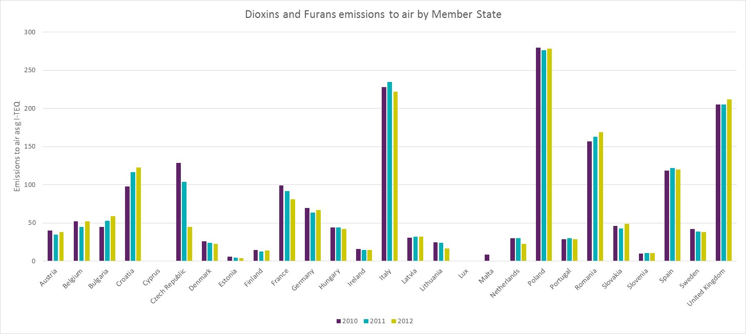

Table 7.2 Emissions reduction for dioxins and furans and per capita emissions

|  |  |  |  |  |
| --- | --- | --- | --- | --- |
| **Member State** | **Emission to air 1990**  **g I-TEQ** | **Emission to air 2012**  **g I-TEQ** | **Proportion of 2012 emission compared to 1990 baseline** | **Per Capita emissions 2012 µg I-TEQ/person** |
| Austria | 161 | 38 | 24% | 4.5 |
| Belgium | 542 | 52 | 10% | 4.7 |
| Bulgaria | 74 | 59 | 80% | 8.0 |
| Croatia | 155 | 123 | 79% | 28.8 |
| Cyprus | 2 | 1 | 50% | 0.9 |
| Czech Republic | 1252 | 45 | 4% | 4.3 |
| Denmark | 67 | 23 | 34% | 4.1 |
| Estonia | 6 | 4 | 67% | 3.0 |
| Finland | 37 | 14 | 38% | 2.6 |
| France | 1746 | 81 | 5% | 1.2 |
| Germany | 747 | 67 | 9% | 0.8 |
| Greece | - | - | - | - |
| Hungary | 119 | 42 | 35% | 9.9 |
| Ireland | 26 | 15 | 58% | 3.3 |
| Italy | 458 | 222 | 48% | 3.7 |
| Latvia | 27 | 32 | 119% | 2.0 |
| Lithuania | 24 | 17 | 71% | 5.8 |
| Luxembourg | - | - | - | - |
| Malta | - | - | - | - |
| Netherlands | 743 | 23 | 3% | 1.4 |
| Poland | 529 | 278 | 53% | 7.2 |
| Portugal | 54 | 29 | 54% | 2.8 |
| Romania | 3073 | 169 | 5% | 8.4 |
| Slovakia | 169 | 49 | 29% | 9.0 |
| Slovenia | 16 | 11 | 69% | 2.0 |
| Spain | 181 | 120 | 66% | 2.5 |
| Sweden | 60 | 38 | 63% | 4.0 |
| United Kingdom | 1304 | 212 | 16% | 3.3 |

As stated above, the introduction of the WID led to improvement of abatement technologies, with further reduction of air emissions. However, these abatement technologies lead to the production of air pollution control (APC) residues (fly ash), which can be highly contaminated with pollutants (including dioxins and furans) and needs further handling and management for a safe disposal. The improvements in air pollution control has reduced the emissions of dioxins and furans to air, but it has increased the quantity of dioxins and furans produced to the residue vector.

Table 7.3 Emissions of dioxins and furans to all vectors based on those reported to the EU and Stockholm Convention

|  |  |  |  |  |  |  |  |  |
| --- | --- | --- | --- | --- | --- | --- | --- | --- |
| Year | 2008 | 2009 | 2008 | 2011 | 2008 | 2008 | 2011 | 2011 |
| Member State | BE | CZ | FR | NL | SI | ES | SE | UK |
| Air | 71% | 54% | 89% | 86% | 56% | 99.6% | 2% | 24% |
| Water | 29% | NR | 11% | 14% | NR | 0.4% | NR | 3% |
| Land | NR | NR | NR | NR | NR | NR | NR | 37% |
| Residue | NR | 46% | NR | NR | 44% | NR | 98% | 24% |
| Product | NR | NR | NR | NR | NR | NR | NR | 11% |

NR – Not reported

However, care is required in the interpretation of the data. While the emission vectors for air, land and water represent a direct release to environment which cannot be controlled, the residue vector is constituted of solid materials contaminated with dioxins and furans which are then disposed of in a controlled manner. Possibilities include landfilling or further processing, such as further incineration of APC residues or generating inert materials such as slag.

In terms of emissions to surface waters, dioxins and furans are insoluble and highly lipophilic. In the waste water systems they will typically partition to the sewage sludge phase, with only very limited quantities emitted to water. Production of halo-organics could also be another potential source of dioxins and furans within waste waters and sludge, although such industrial waste is tightly controlled through environmental permitting in the EU. Belgium, France, Spain and the United Kingdom report emissions of dioxins and furans to water within their emission inventories, with estimates ranging from 0.2 to 10 g I-TEQ per annum.

One Member State (United Kingdom) reports emissions of dioxins and furans to both land as a direct release and also to the ‘product’ vector. Emissions to land for 2011 consisted of 282 g I-TEQ or 37% of the total release of dioxins and furans; this release is likely to be dominated by the open burning of waste, as well as accidental fires. Developing estimates for these sources is particularly difficult due to the diverse and wide-spread nature of the activity. As part of the United Kingdom’s national implementation plan, a nationwide survey was conducted on waste burning habits in 2012 to help improving the estimates.

The United Kingdom estimates for the product vector in 2011 amounted to 86 g I-TEQ and they refer to re-use of waste materials from combustion processes in the cements and aggregates industry. While APC residue is highly toxic and needs to be treated as hazardous waste, ashes from bottom grates tend to be less contaminated and represent an inexpensive material which can be used in aggregates industries, particularly for road surfacing materials. Annex IV of the POP Regulation sets concentration limits above which waste contaminated by POPs must be destroyed and cannot be re-used. Given the quantities involved and based on communication with waste incinerator operators, it is assumed that materials re-used within aggregate industries are bottom ashes with concentrations of dioxins and furans below the Annex IV thresholds.

The data submitted to the European Commission under Article 12 have been compared with data available under the UNECE POPs Protocol and Stockholm Convention and in the E-PRTR. Figure 7.4 provides an overview of emissions to air for dioxins and furans for the total number of sites that reported data to the E-PRTR (199 regulated sites). These data confirm that the key industrial sources are production of iron and steel. Disposal or recovery of hazardous waste (likely incineration) is the most significant source of emissions to air in 2012.

Figure 7.4 Data reported to the E-PRTR for emissions of dioxins and furans to Air

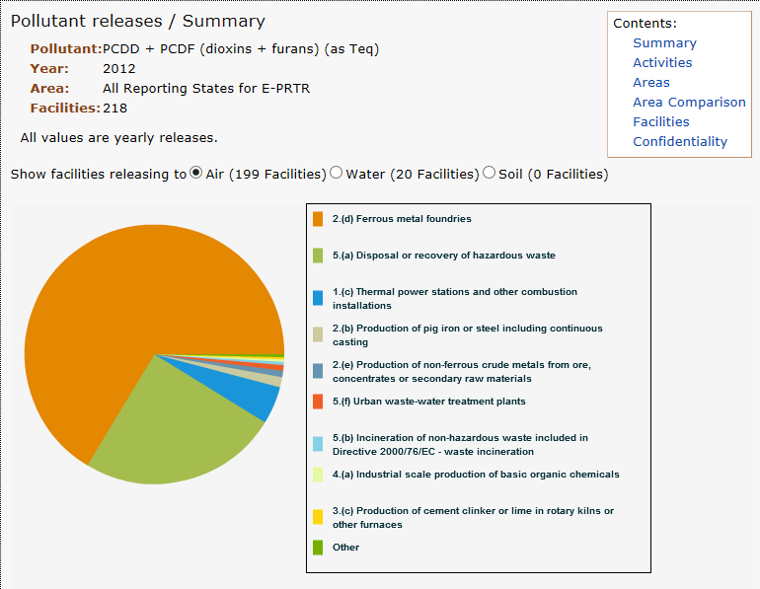

*taken from the E-PRTR website on the 07/04/15

Figure 7.5 provides the overview of E-PRTR data for all sites that reported dioxins and furans releases to water across the EU (20 regulated sites in total). This chart shows that emissions are dominated by waste water treatment plants. Of the reported 183 g I-TEQ emissions to surface water in 2012, 120 g I-TEQ appear to be emitted from one single waste water facility, suggesting a possible reporting error. The next largest source of emission (47 g I-TEQ) is manufacture of pharmaceutical products. Catalysts such as copper used for the manufacture of halo-organics can lead to the formation of dioxins and furans, which would then be present in waste liquors and sludge; however such waste is strictly controlled by environmental legislation, requiring an appropriate treatment.

Figure 7.5 Data reported to the E-PRTR for emissions of dioxins and furans to Water

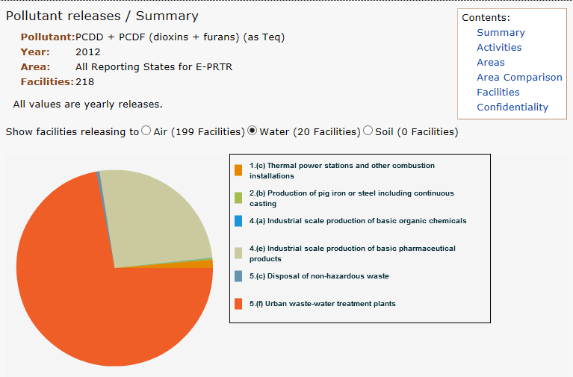

*taken from the E-PRTR website on the 2/04/15

Table 7.4 provides a comparison of the total quantities of dioxins and furans emitted to air from different emission inventories, namely the UNECE POPs protocol, the Article 12 reporting for the POP Regulation and the operator reporting for the E-PRTR. For the E-PRTR, it is important to note that there are reporting thresholds below which data is not required and that reporting is required only for activities listed in Annex I of the E-PRTR Regulation. The data reported under the POP Regulation and UNECE will also include unregulated sources, such as accidental fires. While the three inventories present different estimate levels, they all show a continued decline for the period 2010 – 2012.

Table 7.4 Comparison of emission estimates between inventories

|  |  |  |  |
| --- | --- | --- | --- |
| **Year** | **Article 12 POP Regulation Total emissions for EU28 g I-TEQ to air** | **UNECE EMEP emissions Total for EU28 g I-TEQ to air** | **E-PRTR emissions total for EEA (31 countries) g I-TEQ to air** |
| 2010 | 558 | 1853 | 1350 |
| 2011 | 533 | 1823 | 1002 |
| 2012 | 203 | 1772 | 660* |

*Reported total emission for E-PRTR in 2012 is 8,000 g I-TEQ. However, 7,340 g I-TEQs come from just two facilities. Assume these are outliers and have therefore provided the adjusted total. This is on the basis that the average national emission to air per EU Member States is 70 g I-TEQ with minimum of 8 g I-TEQ and maximum of 420 g I-TEQ.

#### Polychlorinated Biphenyls (PCBs)

Polychlorinated biphenyls are a family of chemicals constituted by two benzene rings linked by a single carbon to carbon bond and with a variable number of chlorine atoms. In total 209 different congeners exist, based on the number and position of chlorines on the basic structure. Similarly to dioxins and furans, the toxicity of individual congeners varies across the whole spectrum. 12 congeners have been identified by the World Health Organisation as having carcinogenic effects and have been more closely aligned with dioxins and furans. These 12 congeners are known as ‘dioxin-like PCBs’. Additional information on dioxin-like PCBs and how they are identified is provided within Appendix A.

PCBs have been widely used in the past, particularly as heat transfer fluids within di-electric equipment. They also found wide-spread use as lubricants for turbines and pumps and in the formulation of cutting oils for metal treatment, sealings, adhesives, paints and carbonless copy paper[31]. The production of PCBs as a commercial products within Europe began in the 1930s reaching its peak around the 1970s, with commercial goods using the trade names Aroclor and Clophen[32]. Production is believed to have ceased around the end of the 1980s but the long service life of large scale di-electric equipment in electric distribution networks presents a serious legacy issue.

PCBs can also be created during thermal processes where a source of chlorine and organic matter are present.

Figure 7.6 is based on data reported to the UNECE for CLRTAP over the period 2010 – 2012 and presents the major sources of PCB emissions to air in the European Union. The emissions are dominated by the loss of PCBs from leaking di-electric equipment, that constitutes a third of all PCBs present in the European Union.

Figure 7.6 Overview of PCB emissions to air for the EU 28 (based on UNECE reported data)

* The pie chart above has been amended to remove one significant release reported by a single Member States from the waste incineration sector in 2010. Data from the same Member State for 2011 and 2012 shows a significant drop in emissions from this source.

Other major sources of PCB emissions to air include metal manufacture, particularly iron and steel, residential combustion of fuel (particularly solid fuels like coal and waste wood), and also combustion of fuel from the energy generation sector. Minor sources of PCB emissions to air include diffuse burning events, such as backyard burning and accidental fires, as well as waste incineration, transport and industrial use of solid fuels for heat and power.

Figure 7.7 provides a breakdown of PCB emissions to air for 2010 – 2012 by Member State, while Table 7.5 lists the total emission reported to the UNECE for 1990 and 2012, emission reduction and emissions per capita. As in the similar graph for dioxins and furans (Figure 7.3), Figure 7.7 shows a mixture of trends, with the emissions in some Member States declining, a broadly static level of emissions in others and increasing emissions for a small number of Member States. It is important to note the lack of continuity in reporting the estimates by the different countries. This potentially represents an issue in terms of completeness and comparability of the estimates provided.

PCBs were widely used in di-electric equipment across Europe and there are different levels of success in the identification and removal of PCB-containing equipment. Equally, unintentional releases of PCBs are linked to the manufacture of metals as well as to domestic use of solid fuels, as shown in Figure 7.6. The Member States reporting identifies four Member States - Croatia, Poland, Portugal and United Kingdom - as the highest emitting nations (Figure 7.7).

To make a comparison, the Clean Legislation European Enforcement Network (2005)[33] suggested that in 2005 the remaining largest stockpiles of in-use PCBs were in Spain and France and, with significant in-use stockpiles also found in Estonia, Italy, Poland, Slovakia and the United Kingdom.

For unintentional emissions of PCBs from metal manufacture, the world steel organisation[34] indicates that the highest rates of steel production for the EU in 2012 came from Germany (42 Megatonnes), Italy (24 Megatonnes), France (16 Megatonnes), Spain (14 Megatonnes) and the United Kingdom (12 Megatonnes), Other Member States with high levels of iron and steel production included Poland (8 Megatonnes), Austria (8 Megatonnes) and the Netherlands (7 Megatonnes).

Table 7.5 provides further details on the variability in the emission estimates. The per capita emission estimates range from 0.01 mg/person/year – 101 mg/person/year. It is unclear what is the impact of source gaps and inventory approach on this large variability in per capita estimates. Overall, the average emission per capita per year for the EU is 13 mg/person/year. Table 7.5 also provides details of emissions reductions. The largest annual emission reduction between 1990 and 2012 was for Belgium and the Czech Republic, where emissions fell by over 90%. Other Member States with significant reductions of air emission include Germany, Slovenia and the United Kingdom.

Table 7.5 shows a small number of Member States with increases of estimated emissions, in particular Lithuania and Portugal. However, it is unclear whether this is a genuine increase or a change in the methodology used for the estimation. This may be the case for Lithuania, which shows a large increase in emissions in 2012 compared to earlier years. The other Member State with an increase in PCB emissions after 1990 was Spain, while Estonia and Cyprus present static levels of emissions for the years 1990 and 2012.

Figure 7.7 PCBs Emissions by Member State

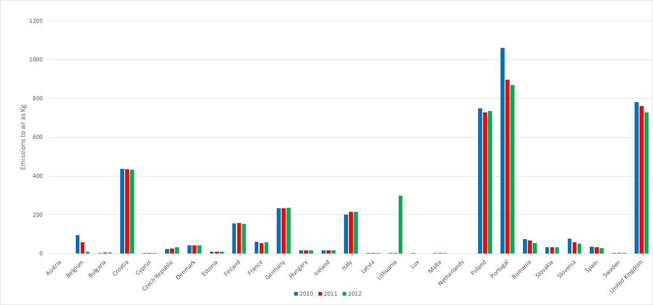

Table 7.5 Emissions reduction for PCBs and per capita emissions

|  |  |  |  |  |
| --- | --- | --- | --- | --- |
| **Member State** | **Emission to air 1990**  **Kg** | **Emission to air 2012**  **Kg** | **Proportion of 2012 emission compared to 1990 baseline** | **Per Capita emissions 2012 mg/person/year** |
| Austria | - | - | - | - |
| Belgium | 112 | 10 | 9% | 0.9 |
| Bulgaria | 6 | 5 | 83% | 0.7 |
| Croatia | 486 | 433 | 89% | 101 |
| Cyprus | 0.01 | 0.01 | 100% | - |
| Czech Republic | 773 | 34 | 4% | 3.2 |
| Denmark | 111 | 42 | 38% | 7.5 |
| Estonia | 10 | 10 | 100% | 7.5 |
| Finland | 314 | 154 | 49% | 28.5 |
| France | 182 | 58 | 32% | 0.9 |
| Germany | 1672 | 236 | 14% | 2.9 |
| Greece | - | - | - | - |
| Hungary | 37 | 16 | 43% | 1.6 |
| Ireland | 68 | 17 | 25% | 3.7 |
| Italy | 286 | 217 | 76% | 3.6 |
| Latvia | 4 | 1 | 25% | 0.5 |
| Lithuania | 6 | 300 | 5000% | 100.3 |
| Luxembourg | 73 | NR | - | - |
| Malta | - | - | - | - |
| Netherlands | - | - | - | - |
| Poland | 2425 | 735 | 30% | 19.1 |
| Portugal | 65 | 868 | 1335% | 82.6 |
| Romania | 135 | 53 | 39% | 2.6 |
| Slovakia | 67 | 34 | 51% | 6.3 |
| Slovenia | 417 | 53 | 13% | 25.7 |
| Spain | 24 | 29 | 121% | 0.6 |
| Sweden | 0.1 | 0.05 | 50% | 0.01 |
| United Kingdom | 6645 | 727 | 11% | 11.3 |

The majority of reported data for PCB emission estimates are for the air vector. However, a small number of Member States report data to other vectors, as part of the Article 12 reporting to the European Commission and also to the Stockholm Convention. Table 7.6 provides a breakdown of the emission data to proportionally illustrate the importance of the different emission vectors across the five vectors listed by the Stockholm Convention. The data from Table 7.6 show that in two Member States (France and Spain) air is the key pathway, likely from volatisation of PCB in di-electric equipment, along with combustion from industrial sources. Two Member States (Czech Republic and Netherlands) indicate water as the main emission pathway, most likely relating to water usage and contamination within the metal manufacture sector. One Member State (United Kingdom) indicates land as the key vector, likely from leaking di-electric equipment directly in the soil (including hard surfaces). One Member State (Sweden) reports that residue is the main pathway for PCBs, likely from the treatment of contaminated waste and residues from di-electric equipment disposal, metals manufacture and air filters.

Table 7.6 Emissions of PCBs to all vectors based on those reported to the EU and Stockholm Convention

|  |  |  |  |  |  |  |
| --- | --- | --- | --- | --- | --- | --- |
| Year | 2009 | 2008 | 2011 | 2008 | 2011 | 2011 |
| Member State | Czech Republic | France | Netherlands | Spain | Sweden | United Kingdom |
| Air | 11% | 62% | 0% | 97% | 27% | 22% |
| Water | 77% | 8% | 100% | 3% | NR | 0% |
| Land | 11% | 30% | 0% | NR | NR | 76% |
| Residue | NR | NR | 0% | NR | 73% | 1% |
| Product | NR | NR | 0% | NR | NR | 1% |

NR - Not Reported

A review of the data reported to the E-PRTR for 2012 allows a comparison of PCBs emission estimates to air and other vectors. Figure 7.10 provides a summary of the data reported to the E-PRTR for emissions of PCBs to air. The pie chart presented in Figure 7.8 shows that around 41% of all emissions comes from the manufacture of iron and steel. It should be noted that data are reported to the E-PRTR for the economic activities shown in Annex I. These activities do not cover the domestic use of solid fuels or emissions of PCB from in-use di-electric equipment where leaks may occur. If di-electric equipment and domestic fuel use are excluded, the largest source identified by the UNECE was metals manufacture and in this case there is a reasonable correlation with the E-PRTR.

Other key emission sources from the E-PRTR include the manufacture of glass and glass fibre, oil refineries and the combustion of fuels for energy generation.

Figure 7.9 provides a breakdown of the main sources in the E-PRTR for release of PCBs to water. In this case, the estimates reported by 24 facilities are dominated by urban waste water treatment works. 93% of the reported emissions, equivalent to 86 kg of PCBs, come from urban waste water treatment works, with the bulk of this emission originating from one wastewater plant based in Italy (65 kg).

Table 7.7 provides a comparison of the emission inventory estimates for the UNECE, E-PRTR and Article 12 reporting to the European Commission. The three inventories are in agreement regarding the emission trend, which is declining year on year. However the total estimates are very variable, ranging from 550 kg to 4 tonnes in 2010, and from 64 Kg to 3.7 tonnes in 2012. The Article 12 emission estimates are dominated by one Member State, which reported very high quantities of PCBs emissions to air.

Figure 7.8 Data reported to the E-PRTR for emissions of PCBs to Air

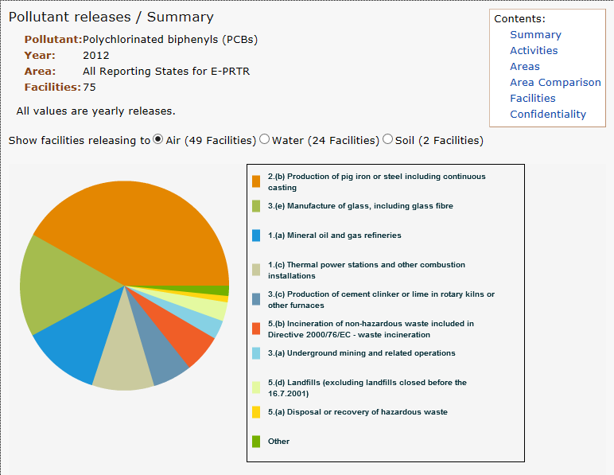

*taken from the E-PRTR website on 07/04/15

Figure 7.9 Data reported to the E-PRTR for emissions of PCBs to Water

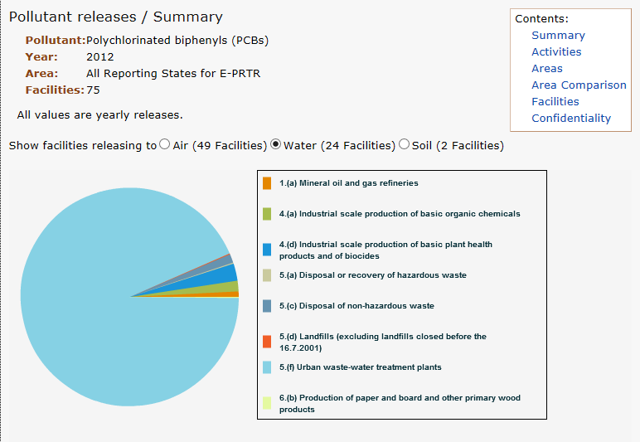

*taken from the E-PRTR website on the 07/04/15

Table 7.7 Comparison of emission estimates between inventories

|  |  |  |  |
| --- | --- | --- | --- |
| **Year** | **Article 12 POP Regulation Total emissions for EU28 kg to air** | **UNECE EMEP emissions Total for EU28 kg to air** | **E-PRTR emissions total for EEA (31 countries) kg to air** |
| 2010 | 78,113 (8MS) | 4010 | 548 |
| 2011 | 68,881 (8 MS) | 3854 | 106 |
| 2012 | 1,764 (3 MS) | 3736 | 64 |

#### Polyaromatic Hydrocarbons (PAHs)

Polyaromatic hydrocarbons (PAHs) are a complex family of organic chemicals composed by multiple aromatic rings. PAHs can occur naturally in the environment but are also generated by anthropogenic sources. Typically PAHs are associated with fossil fuels such as oil, gas and coal, but they can be generated from the incomplete combustion of solid materials such as wood and biomass as well as waste materials and even cigarettes.[35] Similarly to dioxins, furans and PCBs, the toxicity and physico-chemical behaviour of individual PAH congeners can be variable, but as a whole they are recognised as meeting the criteria for being considered persistent organic pollutants. As PAHs are generated as a complex mixture, their analysis focuses on key markers that act as representative for the whole group. Benzo[a]pyrene, one of the most toxic and carcinogenic PAH congeners, is normally considered as a representative of the whole group.

PAHs are included in Annex III of the POP Regulation and in the UNECE CLRTAP, but are not part of the Stockholm Convention.

In trying to qualify the emissions of PAHs, different international schemes have targeted different numbers of congeners. The different analytical schemes range from 4 congeners to 16 congeners. Figure 7.10 provides further detail on the breakdown of specific species for analysis. Under the Article 12 reporting and the UNECE reporting the focus has been on the main 4 congeners in the far right hand column of Figure 7.10, namely:

* Benzo[a]Pyrene
* Benzo[b] Fluoranthene
* Benzo[k]Fluoranthene
* Indendo[123 cd]pyrene

Research data needs to be used with care when developing the emission estimates for PAHs. Data can be presented and described as ‘PAHs total’, without explicitly stating which congeners have been monitored. In some cases the wording ‘PAHs total’ is used when referring to monitoring of benzo[a]pyrene only. Such issues can have a significant effect on the emission factors, on derived estimates, on the comparison between estimates for different sources within the same inventory and on comparison between inventories.

The best practice, based on the EMEP UNECE guidelines (EMEP guidebook), is to provide estimates either on an individual congener basis or to clearly indicate for ‘total’ value which and how many congeners were included in the analysis. The data in this chapter will be based on PAHs total, assuming that this is the sum of four congeners as defined in the Article 12 reporting and UNECE requirements. Information on individual congeners will not be provided.

Figure 7.10 Congener sets for PAHs under different schemes[36]

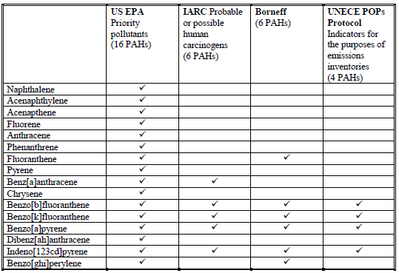

Figure 7.11 provides a summary of the data reported by EU Member States to the UNECE for the CLRTAP for the air vector between 2010 - 2012. It shows that PAHs emissions to air are dominated by the use of solid fuels, particularly coal, in residential premises, with 57% of the total emissions coming from this sector alone.

To make a comparison, the combustion of solid fuels for energy production (3%) and for heat and power in industry (5%) constitute a much smaller proportion of the total emissions. While these sectors are expected to use large volumes of fossil fuels for energy and heat production, the equipment used, particularly in the energy generation sectors, is designed to work at high temperatures of operation and will include improved abatement systems, as required by the industrial emissions directive (IED). The higher operating temperature and improved abatement will lead to much lower emissions of PAHs per tonne of fuel compared to equipment used in the domestic market.

The second largest source sector identified in Figure 7.11 is the combustion of materials in the agricultural sector. This is again largely due to the use of fossil fuels, particularly coal, but also waste biomass materials, for energy and heat production. As in the case of the residential sector, the equipment in use is expected to be less efficient and to operate at lower temperatures than in the power generation sector.

Other minor sources identified include the manufacture of metals (8%), diffuse burning events such as backyard burning and accidental fires (3%), waste incineration (2%), and transport, particularly road vehicles (2%).

Figure 7.11 Overview of PAHs to air for the EU 28 (based on UNECE reported data)

Figure 7.12 provides a summary of the emissions reported to the UNECE by Member State. It shows that the two highest emitting Member States are Germany and Spain, with the next largest emissions from Italy, Poland and Romania. Closer examination of the emission estimates from Germany and Spain highlight different key sources. For Germany the main source of PAHs is the use of fossil fuels in residential homes, mirroring closely the pie chart presented in Figure 7.11. As already discussed for dioxins and furans, both Poland and Romania have a high level of use of solid fuels in residential premises, which explains the reported PAH emissions. For Spain the main source of PAH emissions for the 2010-2013 period comes from the agricultural sector and in particular the practice of field burning to dispose of remaining vegetation post-harvest and to prepare the soil for the next cycle of crop plantation.

Also for Italy the major source of PAH is the use of fossil fuels in the residential sector. An important secondary source is the manufacture of iron and steel.

A review of the inventories submitted to the UNECE in 2010 shows a high level of correlation across the Member States, with most identifying residential use of fossil fuels as the main source of PAH emissions. Spain and Portugal also indicated field burning as the main source, while Cyprus identifies crematoria as the main source. Table 7.8 provides the data on emissions reduction by Member State in the period 1990 – 2012 and the per capita emissions.

Figure 7.12 PAHs (sum of four congeners) Emissions by Member State

Table 7.8 Emissions reduction for PAHs (sum of 4 congeners) and per capita emissions

|  |  |  |  |  |
| --- | --- | --- | --- | --- |
| **Member State** | **Emission to air 1990**  **Kg** | **Emission to air 2012**  **Kg** | **Proportion of 2012 emission compared to 1990 baseline** | **Per Capita emissions 2012 g/person/year** |
| Austria | 16,919 | 7,532 | 45% | 0.9 |
| Belgium | 68,036 | 16,917 | 25% | 1.5 |
| Bulgaria | 49,657 | 31,890 | 64% | 4.4 |
| Croatia | 19,625 | 11,870 | 60% | 2.8 |
| Cyprus | 4,732 | 1,105 | 23% | 1.0 |
| Czech Republic | 751,600 | 19,480 | 3% | 1.9 |
| Denmark | 4,782 | 7,686 | 161% | 1.4 |
| Estonia | 12,201 | 14,960 | 123% | 11.2 |
| Finland | 16,844 | 17,173 | 103% | 3.2 |
| France | 40,381 | 18,203 | 45% | 0.3 |
| Germany | 374,149 | 190,898 | 51% | 2.4 |
| Greece | - | - | - | - |
| Hungary | 98,264 | 29,960 | 30% | 3.0 |
| Ireland | 6,443 | 2,441 | 38% | 0.5 |
| Italy | 79,721 | 63,227 | 79% | 1.1 |
| Latvia | 16,968 | 12,352 | 73% | 6.1 |
| Lithuania | 19,303 | 11,500 | 60% | 3.9 |
| Luxembourg | 1,273 | 847* | 67% | 2.0 |
| Malta | - | - | - | - |
| Netherlands | 20,088 | 3,523 | 18% | 0.2 |
| Poland | 159,200 | 144,326 | 91% | 3.7 |
| Portugal | 71 | 69 | 97% | 0.01 |
| Romania | 274,260 | 129,007 | 47% | 6.4 |
| Slovakia | 29,000 | 19,221 | 66% | 3.6 |
| Slovenia | 16,125 | 13,253 | 82% | 6.4 |
| Spain | 272,539 | 230,665 | 85% | 4.9 |
| Sweden | 16,765 | 13,564 | 81% | 1.4 |
| United Kingdom | 204,691 | 9,496 | 5% | 0.1 |

*data from 2010

Table 7.8 shows that the per capita emissions for PAHs (sum of 4 congeners) ranges from 0.01 to 11.2 g/person/year with an average of 2.9 g/person/year. However, only four Member States have per capita emissions greater than 5 g/person/year, with the lowest per capita emissions in Portugal (0.01) and the highest in Estonia (11.2). Table 7.8 also shows the reduction of emissions since 1990, with the biggest reductions in the Czech Republic and the United Kingdom with emissions reduced by at least 95% in both cases. Overall, between 1990 and 2012, based on the reported emission estimates, the annual release of PAHs to air in the EU has declined by 1,500 tonnes, with an annual release of around 1,000 tonnes in 2012. This represents a reduction of 60% in emissions.

PAHs are not listed under the Stockholm Convention and the UNECE Aarhus Protocol requires reporting to the air vector only. However, the POP Regulation requires reporting of emissions to all vectors, similar to all other listed POPs. Very few Member States provide details of PAHs emissions other than to air; however, for those that do report, Tabel 7.9 shows the breakdown for each vector. The Article 12 submission from France does not distinguish between the ‘land’ and ‘residue’ vectors, instead referring to all emissions as a release to land. The key emission source is the automotive repair industry, probably including waste oils, scraps (including brake shoes, linings and tyres) and other waste contaminated with PAHs. These substances would likely not be directly released to land. Therefore, the estimates provided in Figure 7.13 assume the release as residue in contaminated waste.

Table 7.9 Emissions of PAHs (sum of 4 congeners) to all vectors based on those reported to the EU

|  |  |  |  |  |
| --- | --- | --- | --- | --- |
| Year | 2011 | 2012 | 2011 | 2011 |
| Member State | Czech Republic | France | Netherlands | United Kingdom |
| Air | 14% | 53% | 74% | 90% |
| Water | NR | 2% | 26% | 10% |
| Land | NR | NR | 0% | NR |
| Residue | 86% | 45% | NR | NR |
| Product | NR | NR | NR | NR |

Based on the four Member States (Czech Republic, France, Netherlands and United Kingdom) that report emissions to multiple vectors, three of the four indicate air as being the key emission pathway. These emissions are probably from PAHs in smoke and gaseous exhausts from combustion processes. Two Member States highlight the importance of waste residues from processes linked to oil and petroleum products, solid fossil fuels and metallurgy. Three of the four Member States also report emissions to water, with the Netherlands reporting the greatest contribution (26% of total emissions, equivalent to 1.3 tonnes of PAHs released).

A review of the data reported to the E-PRTR for 2012 allows a comparison for the emissions reported not only to air, but also to water and land. The E-PRTR provides also information on pollutant transfers, mostly from processing or final management of hazardous waste. The E-PRTR Regulation suggests that PAHs should be reported as the sum of 4 congeners, the same identified in the POP Regulation.

Figures 7.13 – 7.15 show the data from E-PRTR for emissions to air, water and pollutant transfers respectively. Releases of PAHs to soil were not reported in the E-PRTR. Figure 7.13 demonstrates that the key source of emissions of PAHs (around 40% of the total emissions, equivalent to 24 tonnes) is production of phosphorus, potassium and nitrogen based fertilisers. This emission comes from a single facility based in Poland. Apart from this major source, the other key sources to air are metallurgy (pig iron production, 17%, iron and steel, 6% and non-ferrous metals 3%) and large scale combustion of fossil fuels (power generation 12%, and petroleum refineries, 5%). The use of fossil fuels in residential properties is not listed as an activity in Annex I of the E-PRTR and is then outside the scope of the reporting requirements.

Figure 7.13 Data reported to the E-PRTR for emissions of PAHs to Air

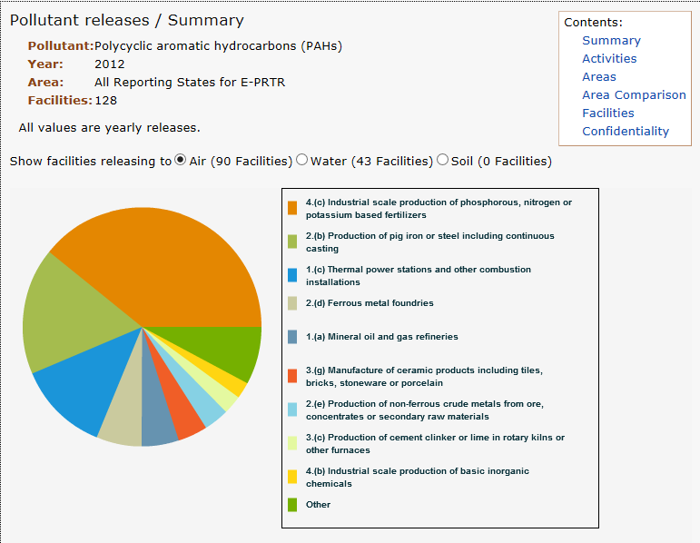

*taken from the E-PRTR website on 07/04/15

Figure 7.14 Data reported to the E-PRTR for emissions of PAHs to Water

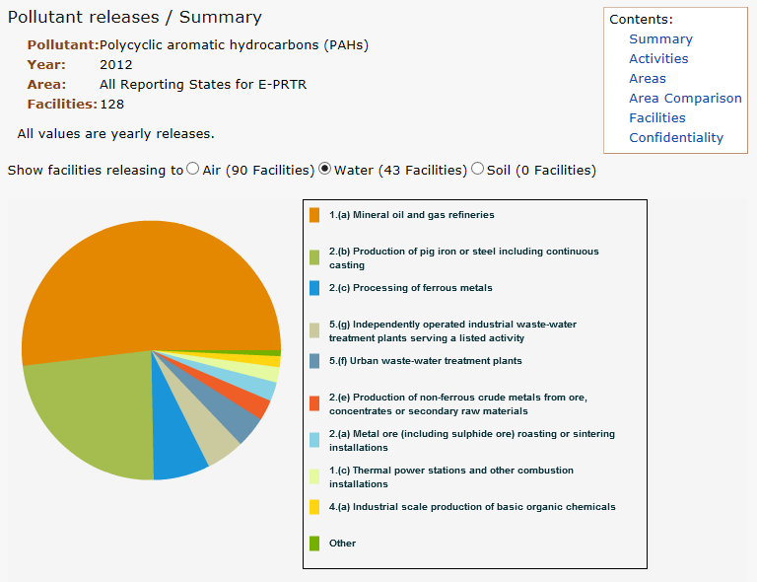

*taken from the E-PRTR website on 07/04/15

Figure 7.15 Data reported to the E-PRTR for pollutant transfers of PAHs

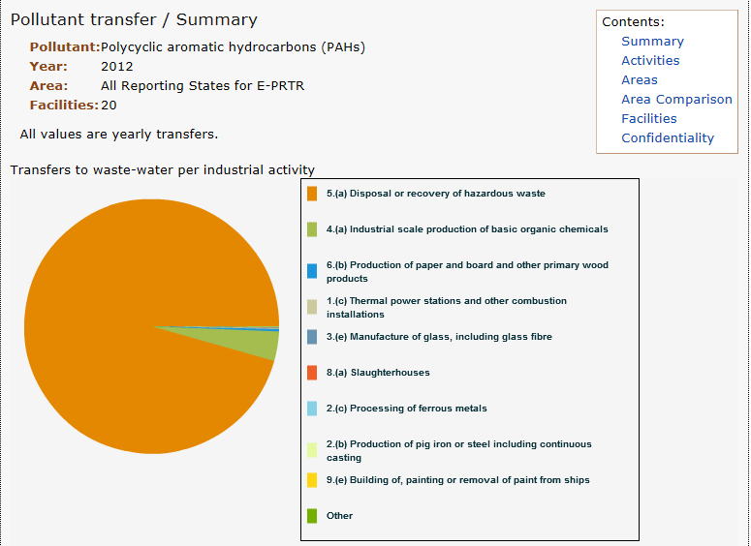

*Taken from the E-PRTR website on 07/04/15

Figure 7.14 shows that emissions of PAHs to surface water, reported by 43 facilities, are dominated by two sources:

* petroleum refineries (52% of emissions, equivalent to 2.8 tonnes of PAHs);
* metallurgy (pig iron, iron and steel, non-ferrous metals) (32% of emissions to surface water, equivalent to 1.6 tonnes).

Figure 7.15 provides data on pollutant transfers, with 95% of the total quantity, (equivalent to 181 tonnes of PAHs) reported for disposal or recovery of hazardous wastes. These are probably the same contaminated wastes referred to in the residue vector of the Article 12 reports. Under Article 12, the Netherlands reported 11 tonnes and France 16 tonnes for this vector. This potentially identifies a significant underreporting of Member States under Article 12.

Table 7.10 provides a comparison of the total emissions estimations from Article 12 reports, UNECE inventories and E-PRTR data. The E-PRTR and Article 12 reporting agree on a downward trend in emissions. It should be noted that the 2012 data from Article 12 reporting represent less Member States than the two preceding years. The UNECE data suggest stable emissions for the period 2010 to 2012. The key source of emissions is domestic combustion of fossil fuels. For Article 12 reports, it should be noted that the total emissions reported are dominated by one Member State, that contributes 67% of the total release.

Table 7.10 Comparison of emission estimates between inventories for PAHs (sum of 4 congeners)

|  |  |  |  |
| --- | --- | --- | --- |
| **Year** | **Article 12 POP Regulation Total emissions for EU28 tonnes to air** | **UNECE EMEP emissions Total for EU28 tonnes to air** | **E-PRTR emissions total for EEA (31 countries) tonnes to air** |
| 2010 | 202 (8 MS) | 1057 | 103 |
| 2011 | 196 (8 MS) | 999 | 146 |
| 2012 | 29 (3 MS) | 1038 | 61 |

#### Chlorobenzenes – Hexachlorobenzene (HCB) and Pentachlorobenzene (PeCB)

Chlorobenzenes are a family of chemicals with a single benzene ring and varying numbers of chlorine atoms (up to a maximum of six) substituting hydrogen atoms. Within this family, two specific substances have been identified as POPs, hexachlorobenzene (HCB) and pentachlorobenzene (PeCB). HCB was added to Annexes A (banned) and C (unintentional production) of the Stockholm Convention in 2004 and PeCB was added to both annexes in 2009. Both substances are included in Annexes I (banned) and III (unintentional production) of the POP Regulation.

As with many of the Annex III substances listed under the POP Regulation, HCB and PeCB can be formed from combustion processes in presence of a source of chlorine when there are suitable combustion mechanics (temperature, catalysts, and particulate size). However both substances have also had commercial uses in the past as detailed below:

Hexachlorobenzene (HCB) had commercial applications as a fungicide used in seed treatments. Its use started in the 1950s[37], with a peak in the EU around the mid-70s, before it was banned for agricultural use in 1981[38]. HCB remained present as a contaminant in other fungicides, notably chlorothalonil. Directive 2005/53/EC sets a maximum limit for HCB in chlorothalonil at 10 mg/kg (10ppm) and industry continued to work to reduce the levels of contamination. A sampling programme from the United Kingdom found an average concentration of 8 mg/kg of HCB in chlorothalonil in 2012[39]. In addition to the use as a fungicide, an industry dossier37 also identifies a number of emissions as a by-product of other production processes, notably the manufacture of industrial chlorinated organics, particularly the solvents perchloroethylene, trichloroethylene and carbon tetrachloride. HCB was also identified as a contaminant of hexachloroethane (HCE), used as a cover gas in metal manufacture. Other sources of HCB are the combustion of materials, particularly in the metallurgic sector, but also combustion of solid fuels and waste, particularly from open burning such as backyard burning of waste.

Pentachlorobenzene (PeCB) had a number of commercial uses in the past, mainly as a chemical intermediate. Eurochlor[40] states that PeCB was used as an intermediate in the manufacture of the pesticide quintozene. However, since 2001 production processes have adapted to avoid the use of PeCB, reducing contamination in quintozene to only trace quantities. PeCB was also used to reduce the viscosity of PCBs when used for heat transfer fluids in di-electric goods. The Stockholm Convention also states that PeCB was used as carrier within dyes and in some flame retardants[41]. Aside from use in commercial products, PeCB can be generated in combustion processes of solid fuels and waste and in thermal processes in metallurgy. In 2009 RIVM[42] published a study to review and derive emission factors for calculating estimates of PeCB emissions to air. This study includes a number of combustion sources and industry sectors, as well as read-across from data on generation of dioxins and furans from related sources.

#### Hexachlorobenzene emissions to air

Figure 7.16 provides a breakdown of the main sources for HCB as reported by Member States under the UNECE Aarhus Protocol. No data on reported PeCB emissions is currently available from the CEIP webdab website. Figure 7.16 highlights that iron and steel production dominates the HCB estimates for emissions to air (75% of all HCB emissions). Secondary sources include agriculture (pesticide use) (6%), hazardous waste incineration (5%) and power generation (5%). However, the iron and steel emission estimates are dominated by one Member State (Spain). Closer examination of the inventory data submitted to the UNECE as part of the review that was carried out in 201221 shows that there is less alignment between inventories than for the other Annex III substances. Based on the review of 21 Member States that had submitted data for HCB for the 2010 inventory year in different inventories, the following ten different key sources can be identified:

* Power generation (Czech Republic, Denmark, Germany, Netherlands),
* Combustion of fuels by industry for heat and power (Cyprus, Poland, Slovakia),
* Cement manufacture (Belgium),
* Iron and Steel (Bulgaria, Spain),
* Non-Ferrous metals (copper) (Finland),
* Transport (France, Slovenia),
* Residential combustion of fuels (Estonia, Latvia, Romania),
* Agriculture (pesticides) (Ireland, United Kingdom),
* Hazardous waste incineration (Hungary, Italy),
* Shipping (Sweden).

Figure 7.16 Overview of HCB emissions to air for the EU 28 (based on UNECE reported data)

Figure 7.17 provides a summary of reported HCB emissions by Member State, with eight Member States (Belgium, Bulgaria, France, Italy, Austria, Poland, Finland and United Kingdom) reporting 10 kg of HCB emitted to air per year or greater, and 18 reporting less than 5 Kg per annum. The EU total for 2012 is reported to be 41 Kg, as the sum of 28 Member States’ emissions. Figure 7.18 shows no clear trend, with the emissions fluctuating year on year for some Member States and a static position for others.

Table 7.11 provides further details, with information on per capita emissions and emissions reductions per Member State between 1990 – 2012. The per capita emissions range between 0.02 and 10.5 mg/person/year with an average emission of 1.17 mg/person/year. The majority of reporting Member States have emissions at or below 0.5 mg/person/year, with only five Member States (Belgium, Bulgaria, Czech Republic, France and Austria) reporting more than 2 mg/person/year. The emissions reductions shown in Table 7.10 highlight two Member States (Hungary and Lithuania) where emissions have remained static since 1990 and two more Member States (Estonia and Latvia) with increasing emissions since 1990. The remaining information shows significant emissions reductions, with the largest decreases in France, Spain and the United Kingdom (99% reduction).

Figure 7.17 HCB emissions by Member State as reported to the UNECE Aarhus Protocol

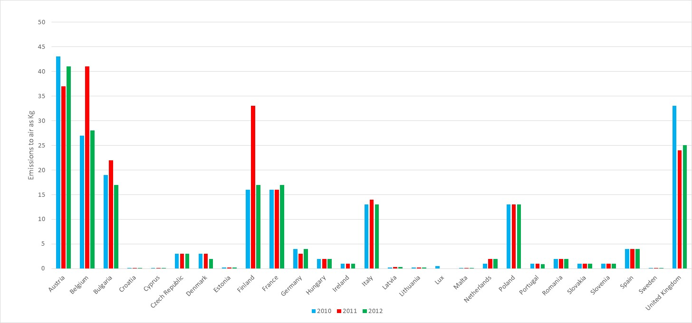

Table 7.11 Emissions reduction for HCB and per capita emissions

|  |  |  |  |  |
| --- | --- | --- | --- | --- |
| **Member State** | **Emission to air 1990 (kg)** | **Emission to air 2012 (kg)** | **Proportion of 2012 emission compared to 1990 baseline** | **Per Capita emissions 2012 mg/person/ year** |
| Austria | 92 | 41 | 45% | 4.9 |
| Belgium | 68 | 28 | 41% | 2.5 |
| Bulgaria | 23 | 17 | 74% | 2.3 |
| Croatia | 0.2 | 0.1 | 50% | 0.02 |
| Cyprus | 0.06 | 0.01 | 17% | 1.1 |
| Czech Republic | 5 | 3 | 60% | 10.5 |
| Denmark | 27 | 2 | 7% | 0.4 |
| Estonia | 0.1 | 0.2 | 200% | 0.2 |
| Finland | 41 | 17 | 41% | 3.1 |
| France | 1,200 | 17 | 1% | 0.3 |
| Germany | 5 | 4 | 80% | 0.1 |
| Greece | - | - | - | - |
| Hungary | 2 | 2 | 100% | 0.2 |
| Ireland | 40 | 1 | 3% | 0.2 |
| Italy | 43 | 13 | 30% | 0.2 |
| Latvia | 0.2 | 0.3 | 150% | 0.2 |
| Lithuania | 0.2 | 0.2 | 100% | 0.1 |
| Luxembourg | - | - | - | - |
| Malta | - | - | - | - |
| Netherlands | 45 | 2 | 4% | 0.1 |
| Poland | 62 | 13 | 21% | 0.3 |
| Portugal | 2 | 0.9 | 45% | 0.1 |
| Romania | 99 | 2 | 2% | 0.1 |
| Slovakia | 3 | 1 | 33% | 0.2 |
| Slovenia | 46 | 1 | 2% | 0.5 |
| Spain | 326 | 4 | 1% | 0.1 |
| Sweden | 0.02 | 0.01 | 50% | - |
| United Kingdom | 3,156 | 25 | 1% | 0.4 |

#### Pentachlorobenzene emissions to air

No data on emissions of PeCB to air is available from the UNECE EMEP Webdab website, while the Stockholm Convention reporting for the third round (from 2010) is still (as of April 2015) being compiled. Based on the Article 12 data submitted to the European Commission, two Member States reported PeCB emissions. The Netherlands reported emissions of PeCB of 0.8 kg in 1990, with an increasing emission trend to reach 2.3 kg emitted in 2012. The United Kingdom provides estimates of emissions to air for PeCB in 2009 -2011 of around 35 kg per annum. Without further data it is difficult to comment on trends and emission sources, apart from noticing that PeCB emissions seem comparable to those of HCB.

#### Hexachlorobenzene and Pentachlorobenzene emissions to other vectors

Only four Member States (Belgium, Netherlands, Sweden and United Kingdom) provided emission estimates for the release of HCB and PeCB to vectors other than air. Table 7.12 provides a breakdown of data reported to both the Stockholm Convention and to the to the European Commission via Article 12 reports. The data provided in Table 7.12 for HCB are in conflict on the main emission vectors. The data from Belgium and the United Kingdom indentify air as the main emission pathway, while the Netherlands identifies water and Sweden residues. Only United Kingdom provides estimates for PeCB to vectors other than air. The United Kingdom data indicates that the largest emissions are to land (84.4% of the total emissions, equivalent to 229 kg). This release is probably due to the contaminated ashes lost to land from open combustion of waste and to accidental building and vehicle fires. The next most important emission in the United Kingdom data is to air.

Table 7.12 Emissions of HCB and PeCB to all vectors based on reports to the EU and the Stockholm Convention (NR – not reported)

|  |  |  |  |  |
| --- | --- | --- | --- | --- |
| Hexachlorobenzene |  |  |  |  |
| Year | **2008** | **2012** | **2008** | **2011** |
| Member State | BE | NL | SE | UK |
| Air | 98% | 8% | 34% | 75% |
| Water | 2% | 92% | NR | 5% |
| Land | NR | NR | NR | 20% |
| Residue | NR | NR | 64% | 0% |
| Product | NR | NR | NR | 0% |
| Pentachlorobenzene |  |  |  |  |
| Year |  |  |  | **2011** |
| Member State |  |  |  | UK |
| Air |  |  |  | 13.0% |
| Water |  |  |  | 1.0% |
| Land |  |  |  | 84.4% |
| Residue |  |  |  | 1.3% |
| Product |  |  |  | **0.3%** |

For comparison, the data provided to the E-PRTR have also been reviewed. For HCB no emissions to air or land were reported in 2012, while a total of 88 Kg were reported to water from a very limited data set comprising only four facilities. For 2011, Figure 7.18 provides a breakdown of emissions reported to the E-PRTR by four facilities in total. While this data set is extremely limited, it indicates that 70% of the releases came from one facility in the basic inorganic chemicals sectors, with the release noted as accidental as opposed to a routine release. The remaining sources are in the manufacture of metals and incineration of non-hazardous waste. On water releases, four facilities from the waste water treatment sector provided data for 2011, reporting a total of 80Kg emitted. This would suggest that there are other key sources which emit HCB to water that then reaches the waste water treatment.

For PeCB, only one facility from the waste water treatment sector reported emissions to air in 2012 (1.5 kg). Figure 7.19 provides a breakdown of PeCB emissions to surface water from six facilities, with 54% (120 kg) coming from the petroleum refineries. Secondary sources include waste water treatment plants and production of basic organic chemicals contributing respectively for 25% and 20% of the total release of PeCB to water.

Figure 7.18 Data reported to the E-PRTR for emissions of HCB to Air

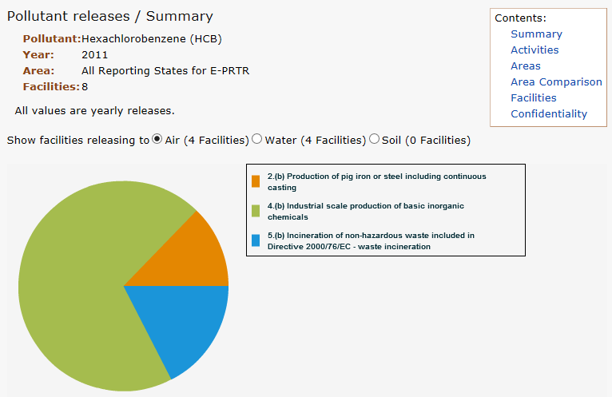

*taken from the E-PRTR website on the 07/04/15

Figure 7.19 Data reported to the E-PRTR for emissions of PeCB to Air

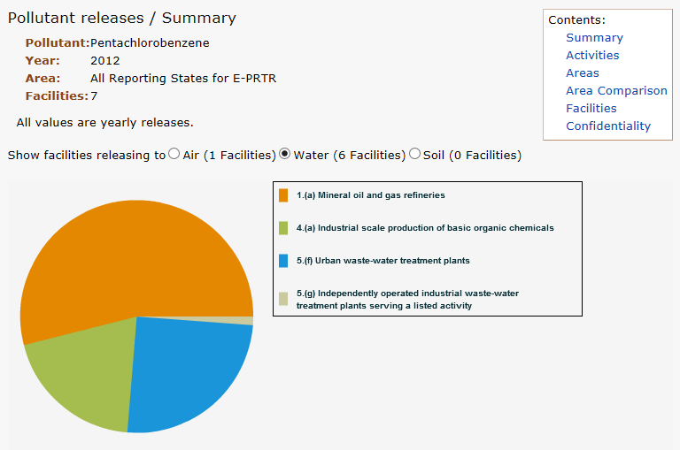

*taken from the E-PRTR website on the 07/04/15

Table 7.13 provides a final comparison between the inventory data provided for HCB emissions to air in the article 12 reports to the European Commission, the UNECE reporting and the E-PRTR. As seen in the previous figures and tables, the results presented in Table 7.12 show a high variability in the emissions with no clear trend over the years for emissions reported in the individual inventories. Comparison across inventories suggests emission rates ranging from 20 to 124 kg[43] per annum, with quantities reported in each inventory broadly in the same order of magnitude.

Table 7.13 Comparison of emission estimates between inventories for HCB

|  |  |  |  |
| --- | --- | --- | --- |
| **Year** | **Article 12 POP Regulation Total emissions for EU28 Kg to air** | **UNECE EMEP emissions Total for EU28 Kg to air** | **E-PRTR emissions total for EEA (31 countries) Kg to air** |
| 2010 | 56 (8 MS) | 70 | 20 |
| 2011 | 51 (8 MS) | 37 | 124 |
| 2012 | 2* (3 MS) | 41 | 0 |

*partial reporting of data compared to preceding years, 8 Member States in 2010 and 2011 and 3 Member States in 2012.

### Comparison to EMEP-UNECE inventories

In 2012 Whiting28 carried out a review on behalf of the Centre for Emissions and Inventory projections (CEIP) of the POPs emission inventories submitted under the UNECE Aarhus protocol. This review, based on the 2010 inventories, intended to assess the status of emission inventories, where data gaps existed, the overall consistency and comparability of emission inventories and to provide recommendations on how emission inventories could be improved. This review highlighted the inconsistencies between inventories across the UNECE, with a lack of transparency in the derivation of estimates and further need for clarity on the emission factors used.

Table 7.14, taken from the 2012 CEIP review for all UNECE reporting countries, provides a completeness assessment for substances in Annex III of the POP Regulation. While UNECE reporting for CLRTAP is beyond the EU 28, it gives an indication on the completeness of the analysed inventories. It suggests that the dioxins, furans and PAHs inventories are the most complete, while PCBs and HCB have less complete inventories. In particular only 25 nations reported PCB data for 2010 compared to the 35 national inventories for PAHs. Similarly, for HCB emission inventories, of the 28 nations who provide data, 7 nations had data for only three or less emission sources.

Table 7.14 Completeness for POP sources. Table reproduced from CEIP Inventory review 2012

|  |  |  |  |
| --- | --- | --- | --- |
| **Persistent Organic Pollutant** | **Number of countries with >50% emission from one source** | **Number of countries with three or fewer sources** | **Number of national inventories submitted to CLRTAP**  **2010 (emission year)** |
| Dioxins and Furans | 16 | 2 | 34 |
| PCBs | 16 | 4 | 25 |
| HCB | 23 | 7 | 28 |
| PAHs | 29 | 2 | 35 |

In addition to the issue of missing inventories, the 2012 CEIP review found some key gaps in emission estimates. The study began by building emission profiles using a number of robust recognised international sources for POPs (such as the UNEP dioxins tool-kit, and the EMEP guidebook). Using these profiles for expected sources an analysis was completed to look at which sources were included within the UNECE reported inventories. The analysis highlighted that for point sources that were well regulated, or required monitoring/emission estimation under IED a high number of countries included that source within their national inventory. For diffuse sources such as application of pesticides, accidental fires, and backyard burning, far fewer countries included the source.

For PCBs, only 4 out of the 25 reporting nations provide estimates of emissions from the use in di-electric equipment. This was the main commercial use of PCBs and should be the most important source; therefore, the lack of reporting highlights a key data gap. Further analysis, particularly of PCB registers, would help to improve emission estimates.

More in-depth analysis of emissions data for key sources showed that a broad range of emission factors are used. While different countries could need to use different emission factors to reflect country specificities, there could be important methodological differences. A greater transparency and clarity of emission inventories would be helpful when assessing the consistency and reliability of data sets. This issue was also highlighted in previous sub-chapters when comparing per capita emission estimates, with differences up to three orders of magnitude.

For HCB, the 2012 estimates show a lack of consistency among the different reporting nations. Greece and Luxembourg did not report inventory data to the UNECE for the years 2010, 2011 or 2012. Furthermore, 7 reporting nations (including Belgium, Cyprus, Ireland, Netherlands, Portugal and Sweden) have inventory estimates for HCB based on three or fewer sources. Considering that HCB can be generated from uncontrolled combustion, metallurgic processes, agricultural sources and manufacture of specific chloro-organic products, this small number of sources suggests a potentially significant underreporting and additional work is required to further develop the estimates.

## Environmental monitoring

The Article 12 reports to the European Commission include emission inventory estimates for releases of Annex III substances to the natural environment via five emission pathway vectors: air, land, water, residue and product. The development of emission inventory estimates is intended to provide the Member State Competent Authorities with a valuable tool to help assessing what are the key sources and trends for estimated emissions within their Member State. This allows the Member State Competent Authorities to have an informed position when planning policy actions and when developing implementation plans for the control and further reduction of the emissions.

The monitoring of POPs in the environment can help tracking the trans-boundary fluxes and the environmental concentration trends, which can be used to validate the trends shown by the emission inventory estimates. The European Monitoring and Evaluation Programme (EMEP) is the basis for pan-European monitoring of POPs in the environment. A summary of the findings from this report is presented below.

**EMEP report (2014) Status report on Persistent Organic Pollutants in the Environment**

The EMEP status report on POPs (2014) covers emissions, fate and transport modelling and measurement data for the EMEP region. In 2014, 41 countries reported estimated POP emissions for a period of at least one year, over the period from 1990 to 2012. Using these official data, the Centre on Emission Inventories and Projections (CEIP) and the Meteorological Synthesizing Centre-East (MSC-E) prepared gridded emission data with data gaps filled using expert estimates. The most significant decline in emissions over that period was for HCB and PCBs (~85%) followed by PCDD/Fs (~60%), and PAHs (~40%).

*EMEP monitoring network summary:*

The EMEP monitoring programme for POPs started in 1999, although some earlier data are available, and are reported in the EMEP database hosted by NILU (http://ebas.nilu.no/). There are approximately 28 sites within the EMEP region that report PAH data, whilst PCBs are measured at 8 stations and HCB at 13 stations. Figure 7.20 provides the location details for these stations. Some sites provide measurement data for selected POPs in rainfall. Data for other POPs, including PBDEs and Perfluoroalkoxy alkanes (PFAS, a group of chemicals that includes PFOS) are reported at selected stations.

Figure 7.20 EMEP monitoring stations operating in 2012. EMEP Status report 2014

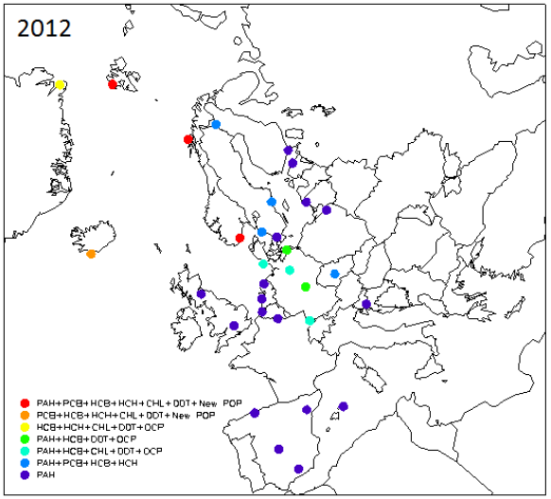

The Global EMEP Multi-media Modelling System (GLEMOS) uses both emission data and measurement data to assess the spatial distribution of POPs concentrations across the EMEP region in the main environmental media. The emission data are prepared by the Centre on Emission Inventories and Projections (CEIP) and by MSC-E (Meteorological Synthesizing Centre-Est) and are based on official emissions data reported by Parties to the Convention, with additional unofficial expert estimates (for example, the global PCB inventory provided by Breivik et al. (2007)). These data are converted into a gridded emission dataset by CEIP.

*Dioxins and Furans (PCDD/Fs)*

Emission estimates for the sum of 17 PCDD/Fs (expressed as TEQ) showed a decline across the EMEP countries from 15 kg TEQ to 6 kg TEQ (Figures 7.21 and 7.22). The decrease in emissions was variable in the different countries, with the largest reductions occurring in Luxemburg (97.5% reduction), the Netherlands (97% reduction), the Czech Republic (96% reduction) and France (95% reduction). Some countries reported an increase since 1990, namely Latvia for the EU.

Figure 7.21 Emissions estimates for the sum of 17PCDD/Fs (TEQ) for EMEP countries in 1990 (a) and 2012 (b) as ng TEQ/M2/year – EMEP Status report 2014

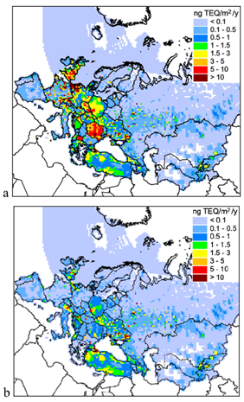

Figure 7.22 Emissions estimates for the sum of 17PCDD/Fs (TEQ) for EMEP countries in 1990 (a) and 2012 (b) as ng TEQ/Kg total – EMEP Status report 2014

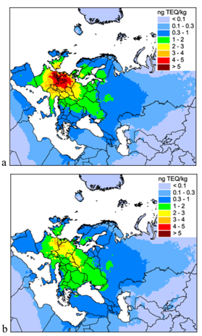

*PolyChlorinated Biphenyls (PCBs)*

The PCB emission inventory was compiled using data from Breivik et al (2007)[44], the data submitted officially by the countries and expert estimates. These data suggest a 6 fold overall emission reduction across the EMEP countries over the period from 1990 to 2012 (Fig. 7.23). The decrease in emissions varied by country, with the largest reductions occurring in Norway (93% reduction), the United Kingdom (92% reduction), and Greece (90% reduction).

Figure 7.23 Emissions estimates for the indicator congener PCB-153 for EMEP countries in 1990 (a) and 2012 (b) – EMEP Status report 2014

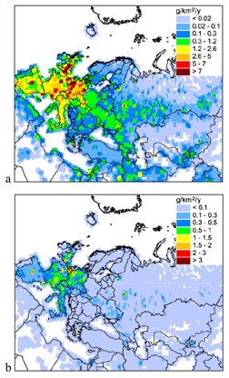

*PolyAromatic Hydrocarbons (PAHs)*

Emission estimates for the sum of 4 reference PAHs showed a decline across the EMEP countries from 2417 tonnes in 1990 to 1466 tonnes in 2012 (Figure 7.24). The decrease in emissions varied by country, with the largest reductions occurring in the United Kingdom (95%), the Netherlands (82%) and Cyprus (77%).

Figure 7.24 Emissions estimates for the sum of (4 congeners) PAHs for EMEP countries in 1990 (a) and 2012 (b) – EMEP Status report 2014

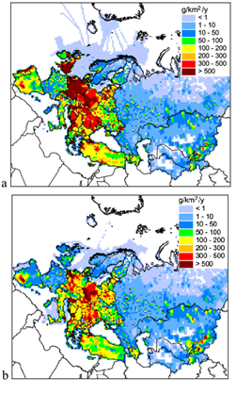

*Chlorobenzenes*

Total HCB emissions decreased from 6 tonnes to 0.95 tonnes across 29 EMEP countries over the period 1990 to 2012 (Fig. 7.25). The decrease in emissions varied by country, with the largest reductions occurring in the United Kingdom and Norway (99% reduction) followed by Spain, France and Slovenia, (98% reduction).

Figure 7.25 Emissions estimates for EMEP countries in 1990 (a) and 2012 (b) – EMEP Status report 2014

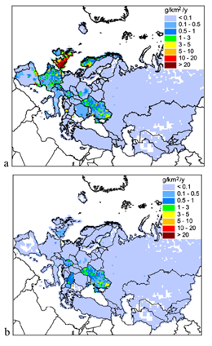

*PCDD/Fs*

The GLEMOS model predicts an air concentration for PCDD/F that shows an average reduction in emissions of 60% across the EMEP region. In the EU, a reduction of 75% in ambient air concentrations has been estimated for PCDD/Fs over the period 1990 to 2012 (see Figure 7.26). The model also suggests that PCDD/F concentrations in the EMEP region are dominated by secondary emissions (58%) with primary sources within the region accounting for 36% and non-EMEP emissions for 6%.

Figure 7.26 Predicted spatial distribution of ambient air concentrations for the sum of 17PCDD/Fs (TEQ) for EMEP countries in 1990 (a) and 2012 (b) – EMEP Status report 2014

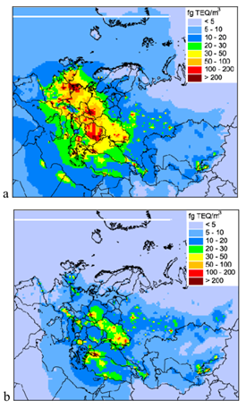

The measurement data collected across the EMEP region are used for model validation. Figure 7.27 shows that for Europe the agreement between predicted and measured concentrations are within a factor of five.

Figure 7.27 Comparison of predicted ambient air concentrations for the sum of 17 congeners PCDD/Fs (TEQ) for EMEP countries and measurement data within Europe. Dashed lines within a factor of 2, solid lines within a factor of 5. – EMEP Status report 2014

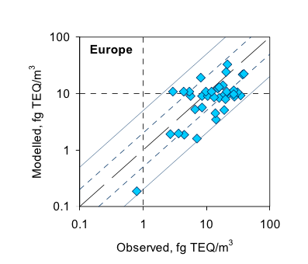

The GLEMOS model also provides estimates of surface soil concentrations. Figure 7.28 shows the spatial distribution of the sum of 17 PCDD/Fs congeners concentrations in soils across the EU from 1990 to 2012. These estimates suggest that soil concentrations have decreased approximately by 35% over this period, whilst across the EMEP region as a whole the decrease has been around 12%.

Figure 7.28 Predicted spatial distribution of soil concentrations for the sum of 17 PCDD/Fs (TEQ) for EMEP countries in 1990 (a) and 2012 (b) – EMEP Status report 2014

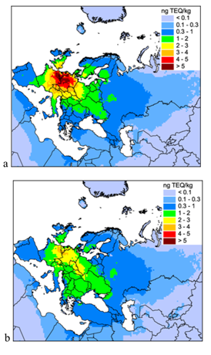

*PCBs*

The reduction in emissions across the EMEP region for PCBs is reflected in the predicted air concentrations provided by the GLEMOS model. Across the EMEP region there has been an 80% reduction in ambient air concentrations for PCBs (see Figure 7.29).

Figure 7.29 Predicted spatial distribution of ambient air concentrations for PCB-153 for EMEP countries in 1990 (a) and 2012 (b) – EMEP Status report 2014

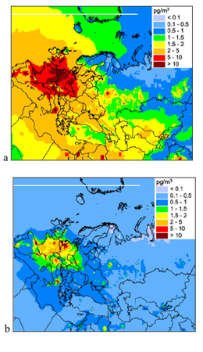

The good agreement between the predicted and measured PCB concentrations (see Figure 7.30) demonstrates that the emission inventories for PCBs and their environmental fate and behaviour are well captured in the model.

1. Commission Decision 200/479/EC of 17 July 2000 on the implementation of an European pollutant emission register (EPER)
2. Cooperative Programme for Monitoring and Evaluation of the Long-Range Transmission of Air Pollutants in Europe)
3. <http://ec.europa.eu/environment/pops/pdf/syntesis_report.pdf>
4. <http://ec.europa.eu/environment/pops/pdf/syntesis_report2.pdf>
5. <http://www.unece.org/env/lrtap/pops_h1.html>
6. http://[www.pops.int/](http://www.pops.int/)
7. <http://eur-lex.europa.eu/LexUriServ/LexUriServ.do?uri=OJ:L:2004:158:0007:0049:EN:PDF>
8. The two international treaties covering POPs differ slightly on the set of named substances included within their Annexes. The key difference is that Poly Aromatic Hydrocarbons (PAHs) are covered under the POPs Protocol but not under the Stockholm Convention.
9. <http://data.europa.eu/eli/reg/2019/1021/oj>
10. <http://eur-lex.europa.eu/LexUriServ/LexUriServ.do?uri=OJ:L:2009:096:0033:0036:EN:PDF>
11. <http://eur-lex.europa.eu/LexUriServ/LexUriServ.do?uri=OJ:L:2010:223:0029:0036:EN:PDF>
12. Polybrominated diphenyl ethers are a family of chemicals with multiple different species included under the same title. The Stockholm Convention has recognised specific species within this family as meeting the requirements under Annex D of the Convention for inclusion within the Convention Annexes. Only these named species (tetra, penta, hexa and hepta) are recognised as POPs under both the Stockholm Convention and EU POP Regulation. For the purposes of this report, the terms ‘PBDEs’ and ‘polybrominated diphenyl ethers’ refer only to those substances included within the Stockholm Convention and EU POP Regulation.
13. <http://eur-lex.europa.eu/LexUriServ/LexUriServ.do?uri=OJ:L:2012:159:0001:0004:en:PDF>
14. <http://eur-lex.europa.eu/legal-content/EN/TXT/HTML/?uri=CELEX:32014R1342&from=EN>
15. European Chemicals Agency, SVHC candidate list:  
    <https://echa.europa.eu/fr/candidate-list-table>
16. [http://chm.pops.int/Implementation/PublicAwareness/PressReleases/HBCDcontrolunderglobal  
    chemicalstreaty/tabid/2895/Default.aspx](http://chm.pops.int/Implementation/PublicAwareness/PressReleases/HBCDcontrolunderglobalchemicalstreaty/tabid/2895/Default.aspx)
17. The review period for the authorisation expired on 21 August 2017 and no re-application was submitted.
18. It is of note that the POPRC carried out a study to assess alternatives to PFOS and provided results at the 10th POPRC meeting held in October 2014.
19. European Commission (2015), ‘Assessment of PFOS compounds’, report presented to the 13th Competent Authority meeting for POPs March 2015.
20. ESWI, (2011), Study on waste related issues of newly listed POPs and candidate POPs. Service request under the framework contract No ENV.G.4/FRA/2007/0066. Draft final report. 25 March 2011 (update 13 April 2011).
21. Semiconductors control the flow electrons in very specific ways, with manufacture involving four basic steps; implant, deposition, etch/polish, and photolithography. Where semiconductor microchips have become increasingly sophisticated the level of control required for flow of electrons increases, meaning undesirable reflective actions of material surfaces can impair the chips. The use of photo-resist and anti-reflect technology reduces this issue, but needs to be applied in a very controlled and specific fashion. The use of PFOS as a surfactant within photo-resists and anti-reflect technology was important for application of these materials. The high potency of PFOS at very low concentrations being a key property and barrier to substitution. Information provided by Ireland, and others suggests that alternative processing means the need for PFOS as surfactant as now been removed.
22. Import of goods to France related to the product codes 2010: 29035980, 29036990, 29093038, 29109000, 29147000, and 38085000 were registered. 2011: import and export of products corresponding to the codes 29035980, 29036990, 29093038, 29109000, 29147000, 38085000, and 38248200 were registered. In 2012, import and export of products corresponding to the codes 29032900, 29038990, 29039990, 29049095, 29093038, 29109000, 29147000, 29209085, 38085000 and 38249097 were registered.
23. http://eur-lex.europa.eu/legal-content/EN/TXT/HTML/?uri=URISERV:l21280&qid=1429105530555&from=EN
24. WEEE Directive:  
    <http://eur-lex.europa.eu/LexUriServ/LexUriServ.do?uri=OJ:L:2012:197:0038:0071:en:PDF>
25. UBA (2012d): National Implementation of the Stockholm Convention on Persistent Organic Pollutants (POPs) – PBDEs and PFOS in Articles and the Recycling Cycle; Funding Code 3710 63 415; planned completion: May 2012.
26. Vijgen, 2006, ‘the Legacy of Lindane HCH Isomer Production: Main Report: A Global Overview of Residue Management, Formulation and Disposal; International HCH & Pesticides Association
27. <http://www.pops.int/Implementation/UnintentionalPOPs/ToolkitforUPOPs/Overview/tabid/372/Default.aspx>
28. EMEP guidebook, 2013  
    <http://www.eea.europa.eu/themes/air/emep-eea-air-pollutant-emission-inventory-guidebook>
29. Mareckova et al, 2012, ‘Inventory Review 2012 - Review of POP emission inventories’, report by the Centre for Emission Inventories and Projections (CEIP)
30. Tuomisto, J et al, 2011, ‘Synopsis on Dioxins and PCBs’, Report for the National Institute for Health and Welfare, Finland.
31. Eurochlor, 2002, ‘Euro Chlor Risk Assessment for the Marine Environment OSPARCOM Region - North Sea’.
32. UNEP,‘Technical guidelines on wastes comprising or containing PCBs, PCTs and PBBs (Y10)’
33. CLEEN, 2005, ‘EuroPCB: inventory PCB enforcement in Member States’, report on behalf of the European Commission.
34. Worldsteel association, global crude steel production rates,  
    <https://www.worldsteel.org/steel-by-topic/statistics/steel-statistical-yearbook.html>
35. USEPA, 2008, ‘PAHs factsheet’, guidance document
36. European Environment Agency, 2007 ’EMEP Emission Inventory Guidebook’, guidance document for inventory compilers
37. Barber et al., 2005 ‘Hexachlorobenzene - Sources, environmental fate and risk characterisation’, Eurochlor science dossier
38. EFSA, 2006, ‘Opinion of the scientific panel on contaminants in the food chain on a request from the Commission related to hexachlorobenzene as undesirable substance in animal feed’, The EFSA Journal (2006) 402, 1 - 49
39. Defra, 2012, A further update of the United Kingdom source inventories for emissions to air, land and water of dioxins, dioxin-like PCBs, PCBs and HCB, incorporating multimedia emission inventories for nine new POPs under the Stockholm Convention’, Report reference CB0429
40. Eurochlor, 2007, ‘Pentachlorobenzene – Sources, environmental fate and risk characterization’, Eurochlor science dossier
41. UNEP, 2007, ‘Draft risk profile for pentachlorobenzene’, Stockholm Convention
42. RIVM, 2009, ‘Inventory emission factors for pentachlorobenzene’, Letter report 601773002
43. 2012 data from Article 12 reports give only a partial picture compared to earlier years, due to fewer Member States reporting. Note that even the earlier years only had data from 8 Member States.
44. Breivik, K., Sweetman, A., Pacyna, J. and Jones, K.C. (2007) Towards a global historical emission inventory for selected PCB congeners – a mass balance approach 3. Submitted to Science of the Total Environment, 377, 296-307