

1. **Introduction: new and old challenges for EU humanitarian aid**

The European Union together with its Member States is the **world’s leading humanitarian donor**, accounting for some 36% of global humanitarian assistance[1]. In a world where the footprint of conflicts and disasters is expanding steadily, humanitarian aid is a key pillar of the EU’s external action and an important part of its ability to project its values globally.

However, humanitarian aid is now facing an unprecedented set of challenges, exacerbated by the COVID-19 pandemic. **Humanitarian needs are at an all-time high**, driven largely by the resurgence in state-based conflicts[2], combined with the impact of climate change, environmental degradation, global population growth and failed governance. Yet, the **gap between humanitarian needs and the resources available** globally is increasing. **Basic norms and principles are being challenged** as rarely before, making the delivery of aid more difficult and dangerous.

This Communication sets out how the EU, working with its diverse humanitarian partners and other donors, can step up to this challenge.

*Humanitarian needs: a rising curve – driven dramatically upward by COVID-19 and climate impacts*

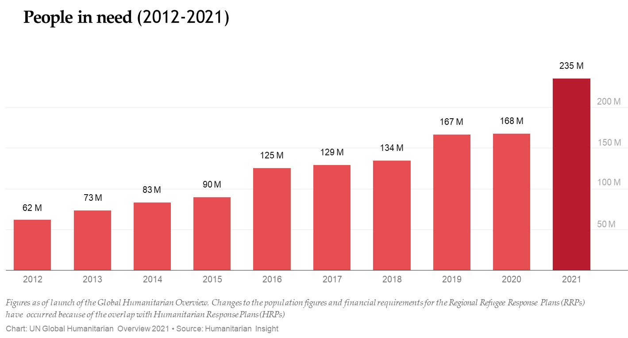

Never has the EU’s global responsibility as a humanitarian actor been more pronounced than since the onset of the **COVID-19 pandemic**. In 2021, 150 million people are projected to have fallen into extreme poverty as a result of the pandemic[3]. COVID-19 has exacerbated pre-existing fragilities and inequalities and further amplified humanitarian needs. The United Nations (UN) estimates that almost 235 million people **–** 1 in33 people worldwide – will need humanitarian assistance in 2021. This is an increase of 40% from 2020 estimated needs (prior to COVID-19) and a near tripling since 2014. The number of forcibly displaced people has doubled since 2010, reaching 79.5 million by the end of 2019[4]. The average humanitarian crisis now lasts more than 9 years, and many, including in Europe’s neighbourhood, last considerably longer. As a result, too many humanitarian crises are ‘forgotten[5]’.

The EU and its Member States have reacted by putting together, since April 2020, a **Team Europe**[6] response package of EUR 38.5 billion, EUR 3.49 billion of which are dedicated to the emergency response and humanitarian needs deriving from the pandemic.

**Climate change** is exacerbating environmental degradation and the consequences of unsustainable management of natural resources while adding to humanitarian needs. In addition to increasingly frequent and severe natural hazards triggering disasters, climate change and environmental degradation are among the root causes of conflict, food insecurity and displacement. In 2018, around 108 million people required international humanitarian assistance as a result of storms, floods, droughts and wildfires[7]. By 2050, over 200 million people could need humanitarian assistance every year as a result of climate-related disasters[8] and the socioeconomic impact of climate change.

*A growing funding gap – and a stubbornly narrow donor base*

In 2020, all UN humanitarian appeals jumped to almost EUR 32.5 billion – the highest figure ever, owing also to the impact of COVID-19. Moreover, there is a funding gap of EUR 17.5 billion – more than half the total. According to the UN, an initial EUR 29 billion are needed to cover the UN humanitarian appeals in 2021[9]. While the EU and some other donors have substantially stepped up their efforts in recent years, with global humanitarian funding for the UN humanitarian appeals increasing from EUR 4.1 billion in 2012 to EUR 15 billion in 2020, **the global humanitarian funding gap has nevertheless been expanding rapidly.** **This gap** **is likely to grow further** as donor economies will remain under stress from the economic and social fallout from COVID-19. Some major donors have already announced cuts in their aid budgets or in their contributions to major crises. Worryingly, global humanitarian funding continues to rely heavily on a very limited number of donors: in 2020, the top ten donors globally accounted for 83% of reported funding[10]. The same applies inside the EU, where the overwhelming bulk of the overall EU’s humanitarian funding comes from the budget of a very small number of Member States and that of the EU[11]. This is not sustainable.

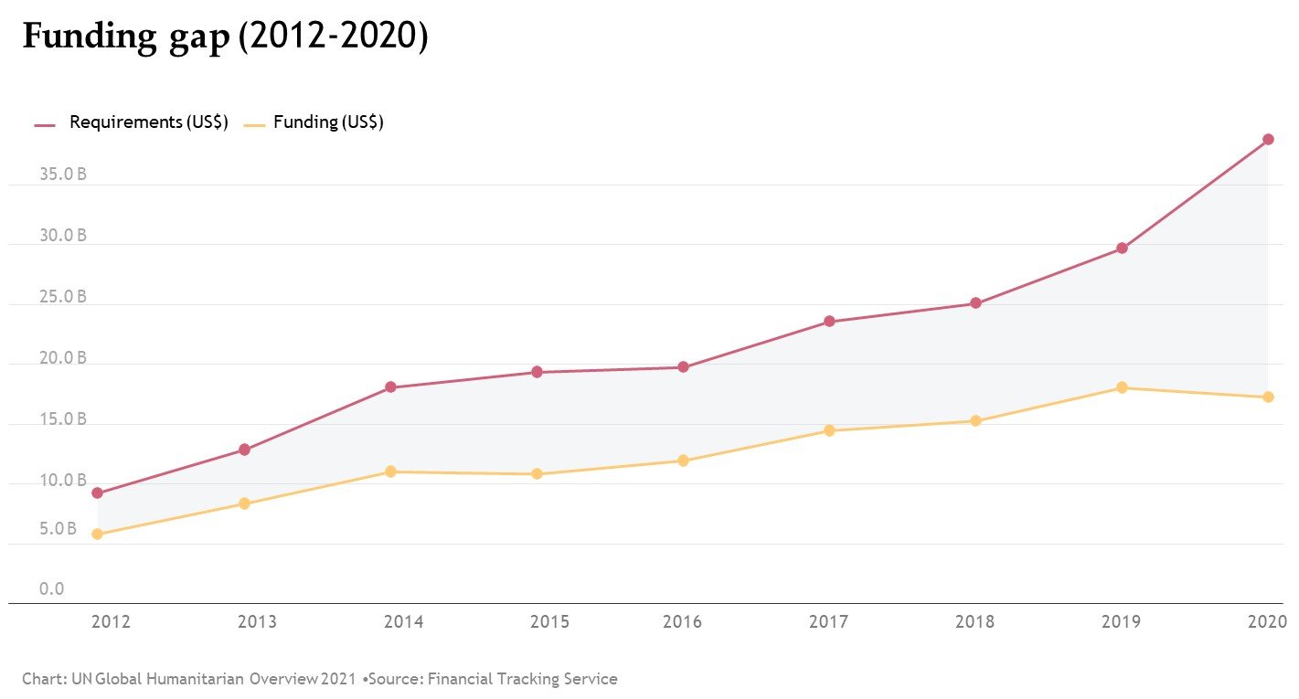

*Impediments to humanitarian aid access and delivery*

In many conflicts, direct and often deliberate attacks by belligerents against civilians, hospitals and schools in violation of international humanitarian law are increasing. In 2019, there were 277 reported attacks against humanitarian aid workers, with 125 killed[12]. In many crises, aid agencies also have to deal with administrative impediments and other restrictions, which may limit their ability to access affected people. COVID-19 lockdowns and ensuing movement restrictions have added another layer of challenges to the delivery of aid to affected populations.

**In light of these trends and challenges, the EU must give renewed impetus to its humanitarian aid policy so that it can more effectively address growing humanitarian needs and support a better enabling environment for the delivery of principled humanitarian aid. At the same time, it will continue to work closely with development and peacebuilding actors to promote long term solutions.**

**2. Building on a solid foundation: the tried and tested principles of humanitarian aid**

The EU’s humanitarian aid rests on a solid legal foundation and a set of core principles and common objectives. It will continue to adhere strictly to the universal humanitarian principles of humanity, neutrality, impartiality and independence, as enshrined in international law. Ensuring respect for international humanitarian law by state and non-state actors will remain an essential objective of the EU’s humanitarian aid policy.

The European Consensus on Humanitarian Aid[13] remains the reference framework for the EU’s humanitarian action. Together with the Humanitarian Aid Regulation[14], the Consensus sets out the specific nature and mandate of humanitarian aid: EU humanitarian aid is provided solely on the basis of needs, in line with the principles of good humanitarian donorship[15]. As also recalled in the EU’s integrated approach to external conflicts and crises[16], EU humanitarian aid is not influenced by any political, strategic, military or economic objective. This is also essential to ensure that aid can be delivered to people affected by crisis in often complex political and security environments.

While humanitarian aid is a key part of the EU’s overall response to crises, the EU safeguards the distinct nature of its humanitarian aid, while further deepening the link with EU development assistance, conflict resolution and peacebuilding initiatives.

The EU’s humanitarian response will continue to abide by the principle to ‘**do no harm**’ to affected populations and the environment[17] and strive to be **conflict-sensitive** so that it does not inadvertently reinforce conflict. It will continue to promote and strengthen effective humanitarian **civil-military coordination** so that humanitarian space is safeguarded.

Humanitarian aid is often the main form of assistance provided to people affected by crisis. With needs rising and aid budgets stretched to their limits, the risk that some people and communities will be left behind is very real. **The EU will continue to ensure a balanced response to needs** and will continue to devote 15% of its initial humanitarian budget to **‘forgotten crises’**.

The continued integration of **protection** for people caught in crisis situations, including through the prevention, mitigation and response to sexual and gender-based violence and sexual exploitation, abuse and harassment, will remain a strong feature of the EU’s humanitarian aid, in line with the EU Gender Action Plan[18]. The EU will continue to support the global **Call to Action on Protection from Gender-Based Violence in Emergencies**[19]. It will also uphold its commitments to rapidly address any type of misconduct in the international aid sector and increase accountability[20].

People will remain firmly at the centre of the EU’s humanitarian aid, with opportunities fora **meaningful participation of aid beneficiaries** in decisions that affect them. The EU is also committed to meeting the needs and rights of specific groups including women, children, older persons and people with disabilities. This contributes to the EU’s overall equality agenda[21], a top priority of the European Commission.

**Access for children in crisis settings to safe and consistent schooling** is crucial, yet this is far from being a reality everywhere. Educational establishments – and students themselves – have increasingly become a deliberate target of violent attacks, notably in the Sahel region. Meanwhile, although digital and remote solutions have helped ensure a level of continuity for students in many places during the COVID-19 pandemic, access to these opportunities has been elusive for many recipients of humanitarian aid, with refugee and internally displaced children facing particular challenges in accessing education. The UN estimates[22] that almost 24 million children and young people in humanitarian crisis situations are at risk of not returning to school due to COVID-19. Girls are even at a higher risk, as not attending school in many cases leads to early and forced marriages[23]. The EU will continue to put a strong focus on supporting **child protection and education in emergencies**, in particular access to education for girls in humanitarian contexts. It will continue to allocate at least 10% of its annual humanitarian budget to this priority (up from just 1% in 2015) and will fully engage in the ‘Safe Schools Declaration[24]’.

Finally, effective **multilateralism[25]** and **UN-led coordination** will remain central to the EU’s humanitarian action, as key enablers of a principled and coherent humanitarian response. Furthermore, the EU will continue to rely on a strong network of diverse partners, including non-governmental organisations, UN agencies, funds and programmes and other international organisations, as well as specialised agencies of EU Member States. Cooperation with these diverse partners is essential to make a difference and deliver quality results on the ground.

**3. Addressing the growing needs, reducing the funding gap**

**3.1 Delivering better: Boosting effectiveness and efficiency, leveraging innovation and capacities**

Already in 2016, at the World Humanitarian Summit, the main donors and humanitarian aid organisations recognised the structural challenge posed by growing needs and a finite resource base. They agreed on a ‘Grand Bargain’ to adapt donors’ and aid organisations’ working practices with a view to maximising efficiency and impact[26]. The central ideas behind the Grand Bargain are more valid and more urgent than ever before: **flexibility on the donor side** to enable humanitarian partners to deliver a timely and adapted response, while harmonising the often onerous reporting requirements of different donors. In return, aid organisations **renewed their commitment** to **coordinated needs assessments**, **accountability** to beneficiaries and taxpayers, **transparency and visibility** of donors’ assistance, while making sure that the highest possible proportion of funds reaches people in need of assistance. In parallel, it is essential that funding can be mobilised quickly in response to unforeseen emergencies (as demonstrated by COVID-19) and more frequent natural sudden-onset disasters, such as those caused by climate change. The EU will aim to further modernise its funding mechanisms to offer **greater operational flexibility** to its humanitarian partners while enhancing the **added value and visibility of the EU’s assistance.**

|  |
| --- |
| While the majority of the EU’s humanitarian assistance is allocated on an annual basis, the European Commission has piloted multi-year and multi-country ‘programmatic partnerships’, including with the International Committee of the Red Cross[27]. These partnerships seek to provide greater flexibility to humanitarian partners and to reduce the administrative burden for both humanitarian partners and the Commission, while maximising the impact of EU funding and enhancing EU visibility. This pilot approach will be expanded to UN entities, agencies and other international organisations. |

More generally, **the EU will further promote the development and uptake of innovative solutions** that deliver more efficient, cost-effective, environmentally-friendly and climate-proofed aid[28].

The use of **cash** transfers is now widely recognised as the most efficient and effective way of getting assistance to people affected by conflicts or disasters. The EU has a long-standing commitment to using cash assistance in humanitarian settings, whenever possible and appropriate[29]. It has also worked with key partners to ensure that the highest possible proportion of the funding provided for a cash programme reaches final beneficiaries.

Digital means are key for the secure delivery of cash transfers. When available, they can also play an important role in rolling out distance learning for education in emergencies, in line with the digital education action plan[30], and in enabling early warning systems for disasters, displacement monitoring and remote needs assessments. The EU will further **extend the** **use of secure and efficient digital tools** in its humanitarian actions, in particular to **shock-responsive social safety net programmes,** such as the Emergency Social Safety Net[31] in Turkey (the biggest humanitarian programme in the EU’s history) and to **enable the connectivity of aid recipients**, in full respect of data protection requirements[32].

*Support for local responders*

Local communities and organisations are usually the first responders to a crisis, playing a key role in delivering fast, quality and cost-efficient assistance to people in need. During the COVID-19 outbreak, local actors were often the first to respond, filling a vacuum left by departing international actors. The pandemic has also underscored the importance of local knowledge and contextual understanding to ensure that aid is more readily accepted and to speed up the capacity to intervene.

The Grand Bargain included a strong commitment from donors and international aid agencies to **channel more resources directly to local responders**. However, the flow of funding to local actors and national non-governmental organisations has been hampered by the need for many donors to reconcile this commitment with regulatory, transparency and accountability requirements, especially in conflict situations where financial tracking might be challenging.

The Commission will strive to step up EU support for localisation, taking into account country and context specificities, as well as by leveraging different instruments in line with the humanitarian-development-peace nexus, along four axes:

investing in strengthening local capacities, building on its experience with initiatives such as the Local Initiative Fund in Turkey (LIFT), which is providing technical and financial support to local responders so that aid reaches refugees and host communities;

favouring environmentally-friendly and local procurement of humanitarian supplies;

supporting localised financing models, such as multilateral pooled funding mechanisms with a strong focus on local responders;

encouraging consortia based on equal partnerships, shared responsibilities and funding between international and local responders.

|  |
| --- |
| In line with its Grand Bargain commitments, the EU is contributing to UN country-based pooled funds[33] in South Sudan and Ukraine on a pilot basis. These funds enable international donors to indirectly support local and national non-governmental organisations, including by promoting their participation in country-level humanitarian coordination mechanisms. |

|  |
| --- |
| ***Objective:*** *Promote flexible and efficient humanitarian action and funding mechanisms.*  ***Key actions:***   * *Extend multiannual and flexible funding arrangements with humanitarian partners* *– liaising with development instruments whenever a nexus approach can be foreseen – and simplify/harmonise reporting requirements in line with the Grand Bargain, while ensuring that needs assessments are coordinated between agencies and that the accountability, efficiency and visibility of EU support are strengthened.* * *Increase EU support to local responders, including by expanded use of country-based pooled funds and other funding mechanisms that prioritise local actors.* * *Develop guidance on the promotion of equal partnerships with local responders.* * *Encourage further use of digital tools by humanitarian partners, including through joint work to build an enabling environment.* * *Develop specific guidance on expanding the use of digital cash and ensure aid recipients’ access to digital solutions in the context of the revision of the EU’s thematic policy on cash transfers.* * *Support, scale up and promote investments in proven, cost-effective, technology-based solutions for humanitarian aid, also building on the example of the 2020 European Innovation Council awards[34].* |

**3.2Filling the gaps: a European Humanitarian Response Capacity**

While the EU’s humanitarian aid will continue to be delivered by the EU’s humanitarian partners, **there may be situations in which there is a clear added-value for the EU to intervene directly**, for instance to fill in a temporary gap when the habitual delivery mechanisms or available capacities from humanitarian organisations or national authorities may be ineffective or lacking[35]. In such cases, a **European Humanitarian Response Capacity**, in line with the EU Humanitarian Aid Regulation and financed from the EU’s humanitarian budget, would enable the EU to support the Member States and the EU’s humanitarian partners in the rapid delivery of assistance.

This capacity would draw on the experience gained during the COVID-19 pandemic, including the use of repatriation flights to transport humanitarian cargo and the establishment of the EU Humanitarian Air Bridge[36], in a Team Europe approach, to support the delivery of essential humanitarian aid.

|  |
| --- |
| Between May and October 2020, the EU successfully completed 67 **EU Humanitarian Air Bridge** operations to 20 countries in four continents. This initiative, financed from the EU’s humanitarian aid budget, deployed 1150 tonnes of essential medical and humanitarian cargo and 1700 medical and humanitarian staff, as well as other passengers. |

This capacity will function in complementarity with the **Union Civil Protection Mechanism** and will rely on the operational readiness of the EU’s **Emergency Response Coordination Centre**[37]. It will seek to further enable humanitarian action by the EU partners and Member States and will be implemented in close coordination with the latter. Where necessary, this capacity will aim to facilitate logistics including transport, enabling the pooling of resources and facilitating their deployment and initial operations in the field. It could, for instance, offer logistical assessments, support to initial deployment, support for procurement, stockpiling, transporting and/or distributing relief items, including COVID-19 vaccines and their delivery in fragile countries[38]. It could also further enhance the EU’s medical response capacity for future health emergencies, building on the existing EU Medical Corps, in cooperation, where relevant with the future EU Health Task Force[39] to be established under coordination of the European Centre for Disease Prevention and Control (ECDC) to assist local response to outbreaks of communicable diseases in synergy with the Union Civil Protection Mechanism, and to strengthen preparedness in Member States and in third countries. In addition, these efforts will also be complementary to other EU initiatives that can contribute to supporting the EU’s humanitarian action, such as the contribution of volunteers through the European Solidarity Corps, which provides a single entry point for solidarity activities throughout the Union and beyond[40].

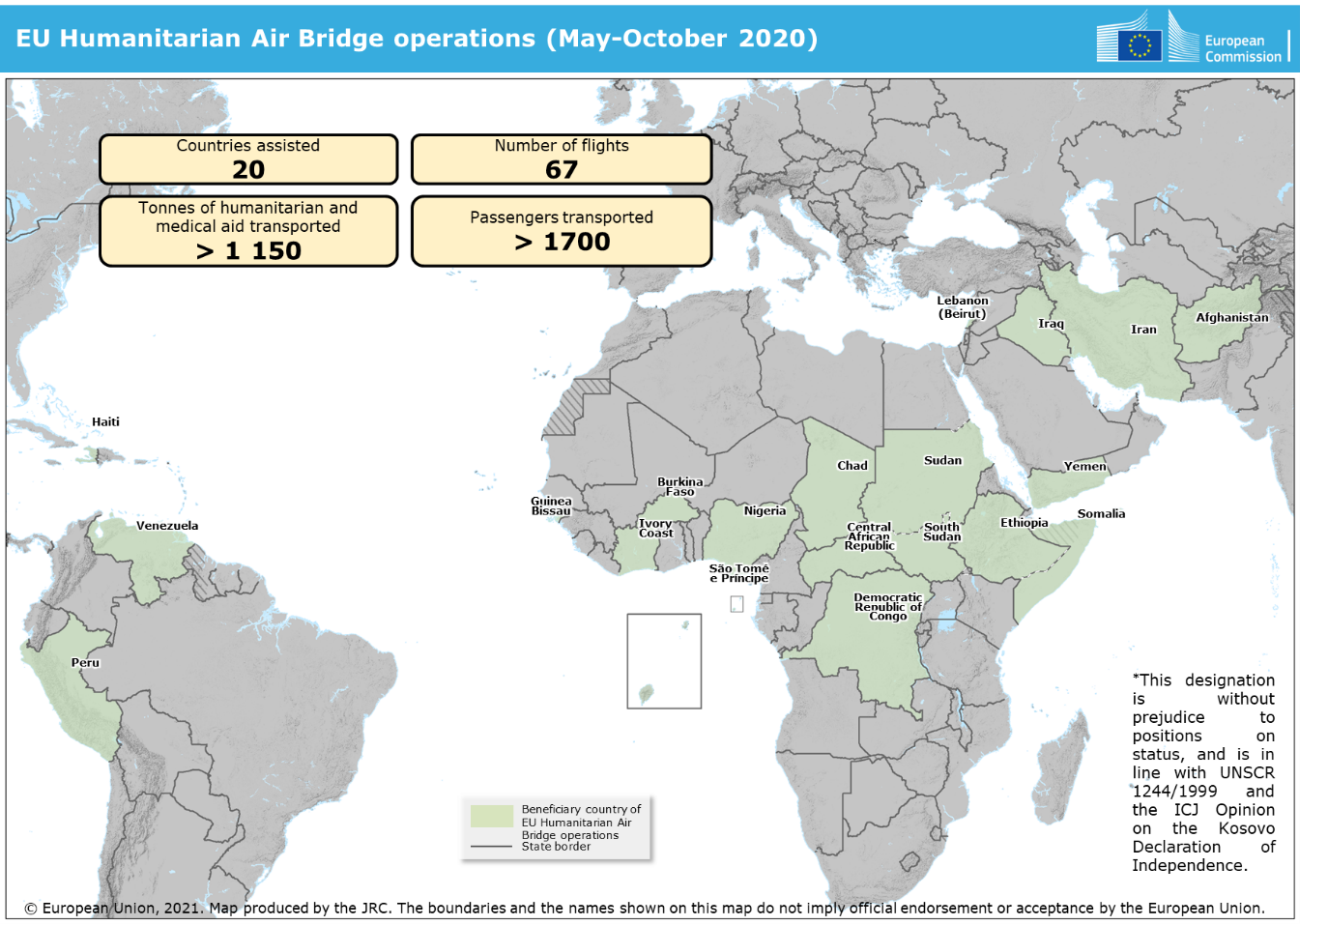

|  |
| --- |
| ***Objective:*** *Ensure that EU humanitarian aid can be delivered swiftly and efficiently to those in need.*  ***Key action:***   * *Develop a European Humanitarian Response Capacity to fill in gaps, as necessary, enabling the EU Member States and humanitarian partners to rapidly deliver humanitarian assistance, in coordination and complementarity with the Union Civil Protection Mechanism.* |

**3.3. A stronger focus on climate impacts and environmental factors: advocacy, preparedness and anticipatory action**

Disaster preparedness is already an integral part of the EU’s humanitarian response, with a dedicated budget and a key element of the EU’s long-term disaster risk reduction agenda. However, the growing impacts of climate change and environmental degradation are jeopardising the success of humanitarian action itself[41]. Climate change not only amplifies natural disasters, but is also a threat multiplier[42] which complicates and prolongs conflict situations, thus increasing humanitarian needs. It is therefore important to ensure that climate and environmental considerations (including risk awareness) are taken into account in humanitarian action wherever and whenever it is provided, with specific focus on supporting climate adaptation and environmental resilience as part of humanitarian programming in the most disaster-prone countries and regions.

In particular, **anticipatory approaches**[43] **to humanitarian action can help bolster the resilience of communities, including forcibly displaced groups, in regions vulnerable to climate-related and other hazards.** The effectiveness of such approaches depends on having in place sufficiently reliable information through early warning systems[44], including indicators or other criteria to trigger action. Building on more partnerships with climate and scientific communities, the EU will **scale up the use of these approaches**. The EU will also use its chairmanship of the Platform on Disaster Displacement in 2022 to promote global efforts to protect people displaced by disasters and climate change.

|  |
| --- |
| In July 2020, forecasting provided by the Global Flood Awareness System under the EU’s Copernicus Emergency Management Service (a tool available for the Union Civil Protection Mechanism) enabled humanitarian partners in Bangladesh[45] to act quickly in response to heavy flooding, providing cash assistance to 3 300 families in areas hardest hit. |

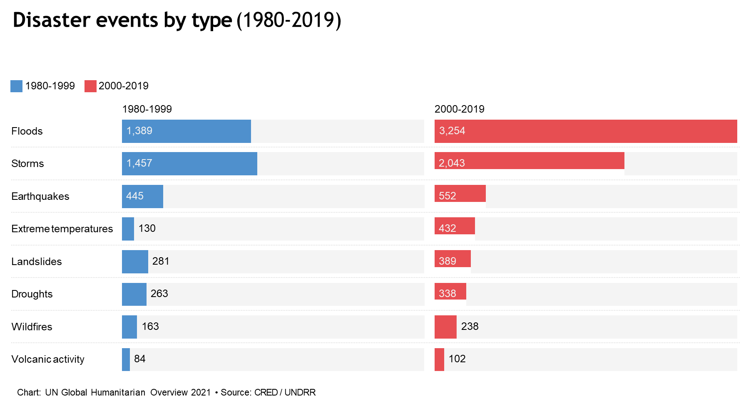

In spite of the growing humanitarian impact of climate change, far too little global climate finance is reaching the most vulnerable countries[46]. There is an urgent need for additional international finance for climate change adaptation, both from public and private sources. To avoid more strain on the humanitarian system, the EU will continue to **advocate for directing significantly more climate funds towards enhancing resilience and adaptation where needed the most**. This can only be effective through an integrated approach to climate and environmental resilience that brings together humanitarian, development and peacebuilding actors with a focus on prevention and preparedness, drawing on the expertise of the climate and environment policy and science communities[47].

While humanitarian aid is not subject to the 30% climate mainstreaming target under the EU’s 2021-2027 multiannual financial framework, it nevertheless contributes to climate action. As a contribution to overall efforts to track EU climate-related expenditure, the Commission will voluntarily apply such **tracking to the EU’s humanitarian aid.**

Humanitarian donors and actors should lead by example. The EU will therefore also **support humanitarian partners’ efforts to reduce their environmental footprint.** At the same time, the Commission will **continue the process of ‘greening’ its humanitarian field network (ECHOField) and its headquarters**[48] in support of the **European Green Deal[49]**.

|  |
| --- |
| ***Objective:*** *Further mainstream climate change impacts and environmental factors into humanitarian aid policy and practice and strengthen coordination with development, security and climate/environment actors to build resilience of vulnerable communities.*  ***Key actions:***   * *Significantly increase the share of climate funds dedicated to enhancing resilience and adaptation in the most disaster-prone countries and regions, in line with the new EU climate change adaptation strategy, and as part of the humanitarian-development-peace nexus approach.* * *Bolster climate and environmental resilience of vulnerable populations, through the humanitarian-development-peace nexus approach and ensure dissemination and implementation of new guidance on disaster preparedness among the EU’s humanitarian partners, in close coordination with development and climate actors.* * *Further develop and apply risk-informed approaches, including risk financing and scale up anticipatory action in different humanitarian contexts and regions.* * *Prepare guidelines and training for the EU’s humanitarian partners on greening humanitarian aid, with a view to reducing the climate and environmental footprint of humanitarian aid.* * *Track climate-related expenditure under the EU Humanitarian Aid Regulation.* |

* 1. **Delivering together: expanding the resource base, addressing the root causes of crises and ultimately reducing needs**

*Addressing root causes and advancing the humanitarian-development-peace nexus*

The aim of humanitarian assistance is **to provide emergency relief to people affected by crises**. Humanitarian aid on its own does not – and cannot – tackle the complex underlying drivers of conflicts and other crises, whether socio-economic, related to governance or environmental issues. All these factors should continue to be tackled in a holistic manner - by **addressing governance challenges, by respecting the fundamental rights of populations, by taking into consideration inequalities, by providing access to basic services, justice, economic opportunities and to security as well as by tackling climate and environmental challenges.** International support in any crisis situation will only have a lasting impact if it goes hand in hand with a strong commitment by the national and local authorities to put people at the centre of this effort, by tackling exclusion, protecting rights and ensuring accountability. This needs to be at the heart of the EU’s approach to conflicts and crises.

As part of this effort, the EU will **step up its work to link humanitarian relief with development and peacebuilding**. Humanitarian aid is not designed as a long-term solution to the needs of people impacted by crises. Through the humanitarian-development-peace nexus, the EU will deploy all the instruments needed not only to address short-term needs but also to provide long-term solutions and, in conflicts, contribute to building lasting peace. This involves **joint analysis and operational response frameworks** as well as a **conflict-sensitive approach** so that external assistance does not inadvertently reinforce conflict.

The nexus approach is now a reality in EU external assistance in many fragile and conflict-prone countries. This includes both the six EU nexus pilot countries designated in 2017 (Chad, Iraq, Myanmar, Nigeria, Sudan, and Uganda) and other contexts (e.g. joint humanitarian-development-peace frameworks in response to the Syria crisis in Lebanon and Jordan). Examples include:

* supporting social safety nets designed in close coordination between humanitarian and development actors;
* coordinated support for disaster preparedness and resilience across development and humanitarian funding (especially in regions severely impacted by land degradation, water scarcity and climate change, such as the Sahel);
* increasing attention to the protection of civilians;
* pushing for structural reforms to address the underlying causes of violence;
* promoting long-term solutions in the context of forced displacement, in line with the EU’s 2016 Communication ‘Lives in Dignity’[50] and the Global Compact on refugees[51].

The continuing presence of conflicts and the socio-economic impact of COVID-19, only heighten the need to expand these efforts – mainly through even stronger cooperation betweenthe EU, its Member States, their diplomatic network and finance institutions (including national development banks and implementing agencies, as well as the European Investment Bank and the European Bank for Reconstruction and Development) **building on the Team Europe approach**[52]. A particular effort will be made on food security, health and education, given the dramatic impact of the pandemic in these areas. Drawing on positive lessons from the 2014-2020 programming period, **the EU will continue** **strengthening synergies and complementarities among the different actors and EU services** while respecting humanitarian principles.

|  |
| --- |
| ***Objective:*** *Ensure that humanitarian, development, peacebuilding and other policies all work together to better link urgent relief and longer-term solutions, aiming at reducing needs and tackling the root causes of conflicts and crises.*  ***Key actions****:*   * *Undertake systematic EU joint analyses of the risks, needs, vulnerabilities and structural drivers of crisis as well as, when appropriate, joined-up programming and planning of EU’s policies, in line with the humanitarian-development-peace nexus.* * *Strengthen coordination mechanisms at field level across the EU’s humanitarian, development and peacebuilding actions to ensure joined-up and coherent outcomes, with the support of EU Delegations and ECHO field offices. Work closely with the EU Member States in this framework in a Team Europe approach.* * *Implement effective linkages between the different humanitarian, development and peace actions and use existing tools, such as policy dialogue, to strengthen national and local capacities – including the capacity of non-state authorities – to provide basic services and support resilience building.* * *Expand support for cash-based, shock-responsive social safety nets.* * *Use the EU’s political and diplomatic engagement and all the instruments available to prevent crises, resolve conflicts and build peace, while stepping up advocacy in support of humanitarian operations so as to facilitate access and respect for humanitarian principles, protection of civilians and international humanitarian law.* * *Promote effective humanitarian civil-military coordination in all relevant contexts, as a framework to protect the humanitarian space, avoid duplication, minimise inconsistencies and maximise potential synergies with security and defence actors.* * *Build synergies with EU peace mediation and conflict prevention efforts, in full respect of humanitarian principles, with a view to increasing efforts to alleviate suffering.* * *Integrate education into the priority areas for the humanitarian-development-peace nexus to help bridge the global gap on education, alongside sectors such as health, food security, disaster preparedness and climate resilience.* |

*Expanding the resource base – both inside and outside Europe*

The dramatic increase in recent years in the scope and severity of humanitarian crises is a challenge to humanity as a whole. COVID-19 has underlined the imperative that ‘no one be left behind’. The key recommendations made by the High-Level Panel on Humanitarian Financing convened by the UN Secretary-General in 2015 are even more acutely relevant in 2021[53]: there is **an urgent need for more resources to address substantially expanded humanitarian needs.**

Despite this, **the resource base for humanitarian aid remains disturbingly narrow**. In 2020, the top three donors (the United States, Germany and the European Commission) provided 62% of reported humanitarian funding globally. Within the EU, just four Member States and the European Commission account for approximately 90% of its humanitarian financing[54]. While a number of countries have stepped up their humanitarian funding in recent years, including certain EU Member States, there is substantial scope to expand the list of donors and enhance the contributions of existing donors to respond to the shared global effort that is urgently needed.

Against this background, the EU should **increase its advocacy for a substantially enhanced humanitarian financing effort** and a better sharing of responsibility among donors, including EU Member States. The EU - working with its Member States, as well as with other committed humanitarian donors such as the United States - should leverage its bilateral, regional and multilateral engagement with both traditional and emerging donors (particularly those whose weight in the global economy has expanded substantially in recent years, such as China and the Gulf states) to encourage higher levels of funding and more systematic support to the global humanitarian system. This engagement should be based on, and recall, the existing 0.7% of gross national income target[55] for official development assistance and should encourage stepped up humanitarian funding commitments commensurate with the steep increase in recent years in humanitarian needs and requirements. These efforts should go hand in hand with rallying support for respect for the humanitarian principles, good humanitarian donorship and international humanitarian law.

|  |
| --- |
| The EU and the US have a strong partnership in humanitarian aid, based on dialogue and cooperation on specific crises and thematic issues. Building on this strong relationship, the EU and the US can also jointly work towards a better sharing of responsibility among donors in supporting the global humanitarian system, in line with the new transatlantic agenda for global change[56]. |

The EU should also explore ways on how to better promote and involve the **private sector** in delivering services for people affected by humanitarian crises, when appropriate. There have been a number of innovative initiatives in recent years by humanitarian actors to pioneer tools such as humanitarian impact bonds. Significant progress has been made in the use of insurance and re-insurance for disaster risks. However, there is scope for the EU to do more to leverage additional funding through greater engagement with the private sector in support to humanitarian response.

Building on the extensive scoping work to which it has contributed in the multilateral context[57], the Commission will work towards introducing innovative methods of financing in its humanitarian toolbox and will actively promote the involvement of the private sector in humanitarian financing.

|  |
| --- |
| ***Objective****: Significantly increase the resource base for humanitarian action.*  ***Key actions****:*   * *Recalling the EU’s commitment to provide 0.7% of gross national income as official development assistance, work with Member States towards stepped-up humanitarian funding commitments commensurate with the steep increase in recent years in humanitarian needs and requirements.* * *Step up EU engagement with traditional and emerging donor countries to recall the shared responsibility to support humanitarian response and integrate it more systematically into the EU’s political dialogue with relevant non-EU countries. Strengthen or forge alliances at the global level with like-minded countries to promote the global humanitarian agenda.* * *Launch a pilot blending initiative from the EU’s humanitarian budget to leverage additional funding from the private sector in* *a humanitarian context in 2021.* |

**4. Supporting a better enabling environment for humanitarian aid**

**4.1 Championing respect for International humanitarian law**

**International humanitarian law (IHL)** is a set of internationally agreed and universally recognised rules to limit the effects of armed conflict and to protect civilians and others not taking part in hostilities. **Respect for IHL** is an important objective in itself; it is also a precondition for effective humanitarian aid and can avoid the need for such aid in the first place. Today, violations of these rules are a recurrent phenomenon. Civilians, including humanitarian or health care workers, are too often deliberately targeted by belligerents.

The EU has established guidelines on the promotion of compliance with IHL[58] and provides support for the training of military, security forces and diplomatic personnel. This will continue under the new EU’s external instruments (for 2021-2027). **The EU should continue to put the promotion and application of IHL consistently at the heart of its external action**. In this context, the EU will continue to strongly support the role of the International Committee of the Red Cross in its mandate for the effective application of IHL.

Serious IHL violations should be consistently denounced as part of a coordinated EU approach. Ensuring respect for IHL as part of the EU’s external instruments should be strengthened, including through due diligence. The EU should also leverage its political and economic weight to promote IHL compliance by partner countries, for instance through its political and human rights dialogues, as well as in trade and aid relations with partner countries, where relevant.

The **increasing use of sanctions** – notably non-EU countries’ unilateral sanctions, some of these extra-territorial in scope – is also complicating the delivery of humanitarian aid and impeding principled humanitarian action. As banks and other financial institutions seek to reduce their exposure by reducing or terminating their activities in jurisdictions that are under sanctions, humanitarian transactions become more difficult – if not impossible. While EU restrictive measures are targeted and are not meant to impede the supply of humanitarian aid, they entail a number of **obligations,** whose violation can lead to legal action, including criminal penalties at national level.

The EU has undertaken outreach activities to facilitate the provision of humanitarian assistance in environments that are under sanctions, including the Commission’s guidance in the context of the COVID-19 pandemic[59]. **The EU should continue and further step up its support to its humanitarian partners with regard to their rights and responsibilities in the different EU sanctions regimes[60].** At the same time, the EU should pursue the consistent inclusion of **humanitarian exceptions** in EU sanctions regimes[61]. As per the ‘Call for Action to strengthen respect for international humanitarian law and principled humanitarian action’, which the EU recently joined[62], humanitarian and health care workers engaged in activities conducted in accordance with IHL and the humanitarian principles should not be the target of criminal prosecution. The EU should also consider including **IHL violations as a criterion for listing individuals or entities in relevant EU sanctions regimes.**

|  |
| --- |
| ***Objective:*** *Put compliance with international humanitarian law (IHL) at the heart of EU external action to protect civilian populations, support principled humanitarian action and protect humanitarian and health care workers.*  ***Key actions:***   * *Establish an EU-level coordination mechanism on IHL to ensure a better monitoring of IHL violations in the world, facilitate the coordination of relevant EU actors and support stronger EU humanitarian diplomacy.* * *Further strengthen the IHL compliance framework including as part of the EU’s external instruments, inter alia through due diligence and through its political, security and human rights dialogues and trade agreements with partner countries, where relevant.* * *Consider including serious IHL violations as grounds for listing in EU sanctions regimes whenever appropriate while ensuring that any potential negative impact on humanitarian activities is avoided.* * *Continue ensuring that IHL is fully reflected in EU sanctions policy including through the consistent inclusion of humanitarian exceptions in EU sanctions regimes. Work towards an effective framework for the use of such exceptions by humanitarian organisations receiving EU funding. Provide further practical support to humanitarian organisations with regard to their rights and responsibilities in the different EU sanctions regimes.* * *Continue promoting dialogue between all parties involved in humanitarian assistance (donors, regulators, NGOs and banks) in order to facilitate the delivery of humanitarian assistance to all those in need.* |

**4.2 Enhancing the EU’s engagement and leadership**

*Working as ‘Team Europe’*

The EU’s humanitarian aid enjoys strong public support[63] as one of the most visible facets of the EU external action. Under the EU Treaties, both Member States and the EU have important and distinct roles to play in humanitarian aid. There is scope to leverage this collective impact by coordinating efforts and ensuring complementarity and by promoting a humanitarian-development-peace nexus approach.

Specifically, **common EU messages on key humanitarian crises** can sustain ‘humanitarian diplomacy’ initiatives at bilateral, regional and international level. **Consolidated EU pledges** (alongside national ones by Member States) can enhance the visibility of the EU’s commitment at international pledging events.

Member States and the Commission in a Team Europe approach can also benefit from even closer **sharing and pooling of analysis** in crisis situations. The Commission will thus continue to make the expertise of its humanitarian field network[64], alongside that of the EU Delegations, available for the benefit of Member States. This will include offering more systematically the option of implementing part of their funding in specific crises through direct contribution to EU budget instruments as **external assigned revenue**.

**Pooling of resources** can also help maximise the impact of EU and Member States’ interventions, while offering Member States the possibility to extend the reach of their humanitarian assistance. Such efforts will of course be complementary to – and should not compete with – established pooled funding mechanisms.

At the operational level, the Commission will bring its own expertise and resources to the table, both in humanitarian assistance and in civil protection, including its network of humanitarian field experts and the Union Civil Protection Knowledge Network[65]. In parallel, the EU will continue to develop policies and guidelines in relevant areas of humanitarian aid, building on the impact its thematic policies have had in areas such as protection, gender, disability, food, nutrition, health – including mental health and psycho-social support – shelter, water, sanitation and hygiene, education in emergencies, environment and aid delivery methods (e.g. cash assistance).

While contributing actively to dialogue on humanitarian issues at the multilateral level, the Commission will organise in 2021 a **European Humanitarian Forum** to promote a **more sustained discussion and dialogue, including on the humanitarian policy issues raised in this Communication** in a Team Europe spirit. This will involve key stakeholders from Member States, the EU institutions including the European Parliament and operational humanitarian actors.

The Commission will moreover continue its efforts to promote the **visibility of the EU’s humanitarian aid**. The Commission will update the guidance and monitoring of visibility obligations, empowering its humanitarian partners to invest more in awareness raising with regard to the EU’s humanitarian aid. The Commission’s communication actions will support the overall principles of transparency, accountability and dialogue with the citizens.

*Strengthening the EU’s humanitarian engagement at multilateral level*

In a challenging geopolitical environment, the EU is committed to supporting the central coordinating role of the UN in the response to humanitarian crises and in establishing and upholding international normative and legal frameworks. To support the UN effectively, it is critical that the EU and its Member States strive **systematically to consolidate positions** in international and multilateral forums, including at the UN hubs in New York, Geneva and Rome. The EU will continue to play an active role in international dialogues on humanitarian issues, including in the UN General Assembly and the UN Economic and Social Council. The EU **will further strengthen its engagement in the governing bodies of UN agencies, funds and programmes[66]**.

|  |
| --- |
| ***Objective:*** *Enhance the EU’s engagement and leadership on humanitarian aid to maximise its impact.*  ***Key actions****:*   * *Encourage common messages by the EU and its Member States on key humanitarian crises and encourage consolidated EU and Member States pledges at international humanitarian pledging events (alongside national ones) in a Team Europe approach. Strive to consolidate the EU and Member States’ positions in relevant international and multilateral forums.* * *Develop the option of use of external assigned revenue for EU Member States to avail themselves of the EU’s humanitarian field presence and expertise.* * *Organise a European Humanitarian Forum in 2021 to promote dialogue on humanitarian policy issues.* * *Promote and engage in further dialogue with key stakeholders on taking forward the key proposed actions set out in this Communication.* |

1. **Conclusions**

Humanitarian aid is a concrete expression of EU solidarity, a fundamental and much-needed value during these challenging times. Against the backdrop of growing humanitarian needs and limited resources and in line with its founding principles and values, the EU must continue leading by example in this area. The ambitious agenda set out in this Communication can only be achieved in close coordination with the EU Member States and the EU’s humanitarian partners. The Commission invites the European Parliament and the Council to join in supporting and taking forward the proposed actions in this Communication.

**Appendix: overview of key actions**

**Key actions for the EU**

***Objective:*** *Promote flexible and efficient humanitarian action and funding mechanisms.*

* Extend multiannual and flexible funding arrangements with humanitarian partners – liaising with development instruments whenever a nexus approach can be foreseen – and simplify/harmonise reporting requirements in line with the Grand Bargain, while ensuring that needs assessments are coordinated between agencies and that the accountability, efficiency and visibility of EU support are strengthened.
* Increase EU support to local responders, including by expanded use of country-based pooled funds and other funding mechanisms that prioritise local actors.
* Develop guidance on the promotion of equal partnerships with local responders.
* Encourage further use of digital tools by humanitarian partners, including through joint work to build an enabling environment.
* Develop specific guidance on expanding the use of digital cash and ensure aid recipients’ access to digital solutions in the context of the revision of the EU’s thematic policy on cash transfers.
* Support, scale up and promote investments in proven, cost-effective, technology-based solutions for humanitarian aid, also building on the example of the 2020 European Innovation Council awards.

***Objective:*** *Ensure that EU humanitarian aid can be delivered swiftly and efficiently to those in need.*

* Develop a European Humanitarian Response Capacity to fill in gaps, as necessary, enabling the EU Member States and humanitarian partners to rapidly deliver humanitarian assistance, in coordination and complementarity with the Union Civil Protection Mechanism.

***Objective:*** *Further mainstream climate change impacts and environmental factors into humanitarian aid policy and practice and strengthen coordination with development, security and climate/environment actors to build resilience of vulnerable communities.*

* Prepare guidelines and training for the EU’s humanitarian partners on greening humanitarian aid, with a view to reducing the climate and environmental footprint of humanitarian aid.
* Track climate-related expenditure under the EU Humanitarian Aid Regulation

***Objective:*** *Ensure that humanitarian, development, peace and other policies all work together to better link urgent relief and longer-term solutions, aiming at reducing needs and tackling the root causes of conflicts and crises.*

* Undertake systematic EU joint analyses of the risks, needs, vulnerabilities and structural drivers of crisis as well as, when appropriate, joined-up programming and planning of EU’s policies, in line with the humanitarian-development-peace nexus.
* Implement effective linkages between the different humanitarian, development and peace actions and use existing tools, such as policy dialogue, to strengthen national and local capacities – including the capacity of non-state authorities – to provide basic services and support resilience building.
* Expand support for cash-based, shock-responsive social safety nets.
* Promote effective humanitarian civil-military coordination in all relevant contexts, as a framework to protect the humanitarian space, avoid duplication, minimise inconsistencies and maximise potential synergies with security and defence actors.
* Build synergies with EU peace mediation and conflict prevention efforts, in full respect of humanitarian principles, with a view to increasing efforts to alleviate suffering.
* Integrate education into the priority areas for the humanitarian-development-peace nexus to help bridge the global gap on education, alongside sectors such as health, food security, disaster preparedness and climate resilience.

***Objective****: Significantly increase the resource base for humanitarian action.*

* Launch a pilot blending initiative from the EU’s humanitarian budget to leverage additional funding from the private sector in a humanitarian context in 2021.

***Objective:*** *Put compliance with international humanitarian law (IHL) at the heart of EU external action to protect civilian populations, support principled humanitarian action and protect humanitarian and health care workers.*

* Establish an EU-level coordination mechanism on IHL to ensure a better monitoring of IHL violations in the world, facilitate the coordination of relevant EU actors and support stronger EU humanitarian diplomacy.
* Further strengthen the IHL compliance framework including as part of the EU’s external instruments, inter alia through due diligence and through its political, security and human rights dialogues and trade agreements with partner countries, where relevant.
* Continue promoting dialogue between all parties involved in humanitarian assistance (donors, regulators, NGOs and banks) in order to facilitate the delivery of humanitarian assistance to all those in need.

***Objective:*** *Enhance the EU’s engagement and leadership on humanitarian aid to maximise its impact.*

* Organise a European Humanitarian Forum in 2021 to promote dialogue on humanitarian policy issues.
* Promote and engage in further dialogue with key stakeholders on taking forward the key proposed actions set out in this Communication.

**Key actions for the EU and Member States**

***Objective:*** *Further mainstream climate change impacts and environmental factors into humanitarian aid policy and practice and strengthen coordination with development, security and climate/environment actors to build resilience of vulnerable communities.*

* Significantly increase the share of climate funds dedicated to enhancing resilience and adaptation in the most disaster-prone countries and regions, in line with the new EU climate change adaptation strategy, and as part of the humanitarian-development-peace nexus approach.
* Bolster climate and environmental resilience of vulnerable populations, through the humanitarian-development-peace nexus approach and ensure dissemination and implementation of new guidance on disaster preparedness among the EU’s humanitarian partners, in close coordination with development and climate actors.
* Further develop and apply risk-informed approaches, including risk financing and scale up anticipatory action in different humanitarian contexts and regions.

***Objective:*** *Ensure that humanitarian, development, peacebuilding and other policies all work together to better link urgent relief and longer-term solutions, aiming at reducing needs and tackling the root causes of conflicts and crises.*

* Strengthen coordination mechanisms at field level across the EU’s humanitarian, development and peacebuilding actions to ensure joined-up and coherent outcomes, with the support of EU Delegations and ECHO field offices. Work closely with the EU Member States in this framework in a Team Europe approach.
* Use the EU’s political and diplomatic engagement and all the instruments available to prevent crises, resolve conflicts and build peace, while stepping up advocacy in support of humanitarian operations so as to facilitate access and respect for humanitarian principles, protection of civilians and international humanitarian law.

***Objective****: Significantly increase the resource base for humanitarian action.*

* Recalling the EU’s commitment to provide 0.7% of gross national income as official development assistance, work with Member States towards stepped-up humanitarian funding commitments commensurate with the steep increase in recent years in humanitarian needs and requirements.
* Step up EU engagement with traditional and emerging donor countries to recall the shared responsibility to support humanitarian response and integrate it more systematically into the EU’s political dialogue with relevant non-EU countries. Strengthen or forge alliances at the global level with like-minded countries to promote the global humanitarian agenda.

***Objective:*** *Put compliance with international humanitarian law (IHL) at the heart of EU external action to protect civilian populations, support principled humanitarian action and protect humanitarian and health care workers.*

* Consider including serious IHL violations as grounds for listing in EU sanctions regimes whenever appropriate while ensuring that any potential negative impact on humanitarian activities is avoided.
* Continue ensuring that IHL is fully reflected in EU sanctions policy including through the consistent inclusion of humanitarian exceptions in EU sanctions regimes. Work towards an effective framework for the use of such exceptions by humanitarian organisations receiving EU funding. Provide further practical support to humanitarian organisations with regard to their rights and responsibilities in the different EU sanctions regimes.

***Objective:*** *Enhance the EU’s engagement and leadership on humanitarian aid to maximise its impact.*

* Encourage common messages by the EU and its Member States on key humanitarian crises and encourage consolidated EU and Member States pledges at international humanitarian pledging events (alongside national ones) in a Team Europe approach. Strive to consolidate the EU and Member States’ positions in relevant international and multilateral forums.
* Develop the option of use of external assigned revenue for EU Member States to avail themselves of the EU’s humanitarian field presence and expertise.

1. In 2020, the combined EU and Member States’ allocated funding amounted to EUR 7.577 billion (<https://fts.unocha.org/>)
2. Peace Research Institute Oslo, *Conflict Trends: A Global Overview, 1946–2019.*
3. World Bank, *Global Economic Prospects*, January 2021.
4. UNHCR, *Global Trends, Forced Displacement in 2019*, <https://www.unhcr.org/globaltrends2019>
5. Humanitarian crises marked by limited donor-response, overall funding shortages and a low-level of media attention.
6. Team Europe is composed of the EU, its Member States, their diplomatic network, finance institutions including national development banks and implementing agencies, as well as the European Investment Bank (EIB) and the European Bank for Reconstruction and Development (EBRD). More info: <https://ec.europa.eu/international-partnerships/topics/eu-global-response-covid-19_en#header-2844>
7. World Meteorological Organization, *State of Climate Services 2020 Report.* 
8. International Federation of Red Cross and Red Crescent Societies, *The Cost of Doing Nothing,* September 2019.
9. United Nations, *Global Humanitarian Overview 2021*
10. UN OCHA, Financial Tracking Service, <https://fts.unocha.org/>
11. <https://fts.unocha.org/>
12. Humanitarian Outcomes, *Aid Workers Security Database*, <https://aidworkersecurity.org/incidents/report>
13. <http://eur-lex.europa.eu/legal-content/EN/TXT/?qid=1431445468547&uri=CELEX:42008X0130(01)>.
14. Council Regulation 1257/96 defines how the EU’s humanitarian assistance is delivered; it establishes that the EU’s humanitarian assistance should reach people affected by disaster or conflict, irrespective of their race, ethnic group, religion, sex, age, nationality or political affiliation and must not be guided by, or subject to, political considerations.
15. <https://www.ghdinitiative.org/ghd/gns/principles-good-practice-of-ghd/principles-good-practice-ghd.html>
16. <https://data.consilium.europa.eu/doc/document/ST-5413-2018-INIT/en/pdf>
17. The European Consensus on Humanitarian Aid calls for the integration of environmental considerations in humanitarian aid sectoral policies and interventions.
18. <https://ec.europa.eu/international-partnerships/news/gender-action-plan-putting-women-and-girls-rights-heart-global-recovery-gender-equal-world_en>
19. The EU led the Call to Action (<https://www.calltoactiongbv.com/>) from June 2017 to December 2018 and issued an operational guidance on the inclusion of people with disabilities in EU-funded humanitarian actions: <https://ec.europa.eu/echo/sites/echo-site/files/2019-01_disability_inclusion_guidance_note.pdf>
20. The EU has endorsed the ‘Commitments made by donors to tackle sexual exploitation and abuse and sexual harassment in the international aid sector’ and the 2019 ‘Development Assistance Committee Recommendation on Ending Sexual Exploitation, Abuse, and Harassment in Development Co-operation and Humanitarian Assistance’.
21. ‘Equality for all and equality in all its senses’ is a key policy priority of the European Commission. To turn this objective into reality, since March 2020, the Commission has put forward a series of specific equality initiatives and strategies related notably to gender equality, disability, and the fight against different forms of discrimination. Those include notably the EU Gender Action Plan III in external relations; the EU Gender Equality Strategy 2020-2025; the EU Disability Rights Strategy; the EU LGBTIQ equality strategy 2020-2025; the EU anti-racism Action Plan 2020-2025; the EU Roma strategic framework for equality, inclusion and participation 2020-2030. (<https://ec.europa.eu/commission/commissioners/2019-2024/dalli/announcements/union-equality-first-year-actions-and-achievements_en>). See also EU action plan on human rights and democracy 2020-2024 (<https://ec.europa.eu/transparency/regdoc/rep/10101/2020/EN/JOIN-2020-5-F1-EN-ANNEX-1-PART-1.PDF>)
22. United Nations, *Global Humanitarian Overview 2021.*
23. See the UN Secretary-General’s policy brief ‘The impact of COVID-19 on women’: <https://www.unwomen.org/en/digital-library/publications/2020/04/policy-brief-the-impact-of-covid-19-on-women>; See also the European Institute of Gender Equality’s website on the gendered impacts of COVID-19: <https://eige.europa.eu/topics/health/covid-19-and-gender-equality>
24. The Safe Schools Declaration (2015) is an inter-governmental initiative led by Norway and Argentina that seeks to strengthen the protection of education from attack and ensure the continuity of safe education during armed conflicts.
25. Joint Communication on strengthening the EU’s contribution to rules-based multilateralism <https://eeas.europa.eu/sites/default/files/en_strategy_on_strengthening_the_eus_contribution_to_rules-based_multilateralism.pdf>
26. See High-Level Panel on Humanitarian Financing: *Too important to fail - addressing the humanitarian financing gap*, and <https://agendaforhumanity.org/initiatives/3861>
27. The others involve ACTED-FR, Save The Children-DK, Concern-IRL and International Rescue Committee-DE.
28. For example, through the European Innovation Council prize for Affordable High-Tech for Humanitarian Aid that supported projects providing, among others, smart solutions to communities and refugees for affordable energy, health and medical care. In detail: <https://ec.europa.eu/research/eic/index.cfm?pg=prizes_aid>
29. Council Conclusions on cash transfers: <http://data.consilium.europa.eu/doc/document/ST-10184-2015-INIT/en/pdf>.
30. <https://ec.europa.eu/education/sites/default/files/document-library-docs/deap-communication-sept2020_en.pdf>
31. <https://ec.europa.eu/echo/essn_en>
32. <https://eur-lex.europa.eu/legal-content/EN/TXT/?uri=CELEX%3A32016R0679>.
33. <https://www.unocha.org/our-work/humanitarian-financing/country-based-pooled-funds-cbpf>
34. <https://ec.europa.eu/research/eic/index.cfm?pg=prizes_aid>
35. The humanitarian response was significantly affected by transport and supply chain disruptions, along with travel restrictions and lockdowns imposed across the world in the early stages of the COVID-19 pandemic.
36. <https://ec.europa.eu/echo/what/humanitarian-aid/humanitarian-air-bridge_en>
37. <https://ec.europa.eu/echo/what/civil-protection/emergency-response-coordination-centre-ercc_en>
38. <https://ec.europa.eu/info/sites/info/files/communication-united-front-beat-covid-19_en.pdf>
39. <https://ec.europa.eu/info/sites/info/files/proposal-mandate-european-centre-disease-prevention-control_en.pdf>
40. <https://europa.eu/youth/solidarity_en>
41. In the first half of 2020, around 10 million people were displaced largely due to weather related hazards and disasters, mainly in South and South-east Asia and the Horn of Africa - World Meteorological Organization, 2020.
42. Council conclusions on Climate and Energy Diplomacy - <https://www.consilium.europa.eu/media/48057/st05263-en21.pdf>, Climate Change and Defence Roadmap - <https://data.consilium.europa.eu/doc/document/ST-12741-2020-INIT/en/pdf>
43. Anticipatory action involves pre-planning early actions based on which funding can be disbursed quickly before a natural or human-induced disaster takes place or any other trigger for action is reached. It is also relevant for other types of anticipated emergencies, not only those linked to climate change.
44. <https://www.undrr.org/terminology/early-warning-system>
45. Actions implemented by the International Federation of Red Cross and Red Crescent Societies, Bangladesh Red Crescent, World Food Programme.
46. None of the 20 countries most vulnerable to climate change and climate-related disasters featured among the top 20 per capita recipients of climate change adaptation funding, according to the IFRC World Disasters Report 2020.
47. For example, in the context of its cooperation with the World Meteorological Organization.
48. Part of the Commission’s climate-neutral commitments.
49. <https://ec.europa.eu/info/strategy/priorities-2019-2024/european-green-deal_en>
50. ‘Lives in Dignity’ <https://ec.europa.eu/echo/files/policies/refugees-idp/Communication_Forced_Displacement_Development_2016.pdf>
51. <https://www.unhcr.org/the-global-compact-on-refugees.html>
52. <https://ec.europa.eu/info/sites/info/files/joint_communication_global_eu_covid-19_response_en.pdf>
53. <https://reliefweb.int/report/world/high-level-panel-humanitarian-financing-report-secretary-general-too-important-fail>
54. <https://fts.unocha.org/global-funding/overview/2020>
55. <https://ec.europa.eu/international-partnerships/system/files/european-consensus-on-development-final-20170626_en.pdf>
56. <https://ec.europa.eu/info/sites/info/files/joint-communication-eu-us-agenda_en.pdf>
57. For instance, in the context of its co-chairmanship of the Good Humanitarian Donorship initiative (2018-2021) or as a member of the Humanitarian and Resilience Investing Initiative <https://www.weforum.org/projects/humanitarian-investing-initiative?emailType=Newsletter)>
58. <https://eur-lex.europa.eu/legal-content/EN/TXT/?uri=LEGISSUM:ah0004>
59. Commission Guidance Note on the provision of humanitarian aid to fight the COVID-19 pandemic in certain environments subject to EU restrictive measures:

    <https://ec.europa.eu/info/sites/info/files/business_economy_euro/banking_and_finance/documents/201116-humanitarian-aid-guidance-note_en.pdf>
60. For instance, the Communication “The European economic and financial system: fostering openness, strength and resilience” envisages a review of existing regimes to inter alia assess their impact on the provision of humanitarian aid <https://eur-lex.europa.eu/legal-content/EN/TXT/?uri=CELEX%3A52021DC0032&qid=1611728656387>
61. Out of 42 EU sanctions regimes currently in force, 7 include humanitarian exceptions of some kind.
62. Launched by the French and German Foreign Ministers in New York on 26 September 2019. The EU endorsed it in December 2020. (<https://onu.delegfrance.org/Strengthening-respect-for-international-humanitarian-law>)
63. According to December 2020 Eurobarometer insights, 91% of the interviewed EU citizens say it is important or very important that the EU funds humanitarian aid activities

    <https://ec.europa.eu/commfrontoffice/publicopinion/index.cfm/survey/getsurveydetail/instruments/special/surveyky/2265>
64. The Commission’s humanitarian field (ECHOField) network consists of 49 offices in 41 countries with around 450 experts providing technical assistance and monitoring of EU humanitarian aid.
65. <https://ec.europa.eu/echo/what/civil-protection/knowledge-network_en>
66. Joint Communication on strengthening the EU’s contribution to rules-based multilateralism <https://eeas.europa.eu/sites/default/files/en_strategy_on_strengthening_the_eus_contribution_to_rules-based_multilateralism.pdf>