

ANNEX 1

**Record once per set/shot/operation**

**Note: for all gears in this annex use the follow format for date and time**

**For date: when recording date of the set/shot/operation: record the YYYY/MM/DD**

**For time: record 24hr time as either the local time, GMT or national time and clearly specify which time has been used.**

**OPERATION**

**For longline:**

Date of set

Position in latitude and longitude: either position at noon or position of start of gear or area code of operation (e.g. Seychelles EEZ, High seas, etc.) may be optionally used

Time of starting setting and, when possible, retrieving the gear

Number of hooks between floats: if there are different hooks counts between floats in a single set then record the most representative (average) number

Total number of hooks used in the set

Number of light–sticks used in the set

Type of bait used in the set: e.g. fish, squid, etc.

Optionally, sea surface temperature at noon with one decimal point (XX.XoC)

**For purse seine:**

Date of set

Type of event: fishing set or deployment of a new FAD

Position in latitude and longitude and time of event, or if no event during the day, at noon

If fishing set: specify if the set was successful, nil, well; type of school (free swimming school or FAD associated. If FAD associated, specify the type (e.g. log or other natural object, drifting FAD, anchored FAD, etc.). Refer to the CMM 18/08

*Procedures on a fish aggregating devices (FADs) management plan, including a limitation on the number of FADs, more detailed specification of catch reporting from FAD sets, and the development of improved FAD designs to reduce the incidence of entanglement of non-target species* (or any subsequent superseding Resolution)

Optionally, sea surface temperature at noon with one decimal point (XX.XoC)

**For gillnet:**

Date of set: record the date for each set or day at sea (for days without sets)

Total length of net (meters): floatline length used for each set in meters

Start fishing time: record the time when starting each set and, when possible, gear retrieving

Start and end position in latitude and longitude: record start and end latitude and longitude that represent the area that your gear is set between or, if no set, record the latitude and longitude at noon for days without sets

Depth at which net is set (meters): approximate depth at which the gillnet is set

**For Pole and Line:**

Fishing effort information in logbooks shall be recorded by day. Catch information in logbooks shall be recorded by trip or, when possible, by fishing day.

Date of operation: record the day or date

Position in latitude and longitude at noon

Number of fishing poles used during that day

Start fishing time (record the time immediately after bait fishing is complete and the vessel heads to the ocean for fishing. For multiple days, the time at which search starts should be recorded) and end fishing time (record the time immediately after fishing is complete from the last school; on multiple days this is the time fishing stopped from the last school). For multiple days number of fishing days should be recorded.

Type of school: FAD associated and/or free school

**CATCH**

Catch weight (kg) or number by species per set/shot/fishing event for each of the species and form of processing in section Species below:

For longline by number and weight

For purse seine by weight

For gillnet by weight

For pole and line by weight or number

**SPECIES**

**For Longline:**

|  |  |  |  |
| --- | --- | --- | --- |
| **Primary Species** | **FAO code** | **Other Species** | **FAO code** |
| Southern bluefin tuna (*Thunnus maccoyii*) | SBF | Shortbill spearfish (*Tetrapturus angustirostris*) | SSP |
| Albacore (*Thunnus alalunga*) | ALB | Blue shark (*Prionace glauca*) | BSH |
| Bigeye tuna (*Thunnus obesus*) | BET | Mako sharks (*Isurus* spp*.*) | MAK |
| Yellowfin tuna (*Thunnus albacares*) | YFT | Porbeagle shark (*Lamna nasus*) | POR |
| Skipjack tuna (*Katsuwonus pelamis*) | SKJ | Hammerhead sharks (*Sphyrna* spp.) | SPN |
| Swordfish (*Xiphias gladius*) | SWO | Silky shark (*Carcharhinus falciformis*) | FAL |
| Striped marlin (*Tetrapturus audax*) | MLS | Other bony fishes | MZZ |
| Blue marlin(*Makaira nigricans*) | BUM | Other sharks | SKH |
| Black marlin (*Makaira indica*) | BLM | Seabirds (in number)[1] |  |
| Indo–Pacific sailfish (*Istiophorus platypterus*) | SFA | Marine Mammals (in number) | MAM |
|  |  | Marine turtles (in number) | TTX |
|  |  | Thresher sharks (*Alopias* spp.) | THR |
|  |  | Oceanic whitetip shark (*Carcharhinus longimanus*) | OCS |
|  |  | **Optional species to be recorded** |  |
|  |  | Tiger shark (*Galeocerdo cuvier*) | TIG |
|  |  | Crocodile shark (*Pseudocarcharias kamoharai*) | PSK |
|  |  | Great white shark (*Carcharodon carcharias*) | WSH |
|  |  | Mantas and devil rays (*Mobulidae*) | MAN |
|  |  | Pelagic stingray (*Pteroplatytrygon violacea*) | PLS |
|  |  | Other rays |  |

**For Purse Seine:**

|  |  |  |  |
| --- | --- | --- | --- |
| **Primary Species** | **FAO code** | **Other species** | **FAO code** |
| Albacore (*Thunnus alalunga*) | ALB | Marine turtles (in number) | TTX |
| Bigeye tuna (*Thunnus obesus*) | BET | Marine mammals (in number) | MAM |
| Yellowfin tuna (*Thunnus albacares*) | YFT | Whale sharks(*Rhincodon typus*) (in number) | RHN |
| Skipjack tuna (*Katsuwonus pelamis*) | SKJ | Thresher sharks (*Alopias* spp.) | THR |
| Other IOTC species |  | Oceanic whitetip shark (*Carcharhinus longimanus*) | OCS |
|  |  | Silky sharks (*Carcharhinus falciformis*) | FAL |
|  |  | **Optional species to be recorded** | **FAO code** |
|  |  | Mantas and devil rays (*Mobulidae*) | MAN |
|  |  | Other sharks | SKH |
|  |  | Other rays |  |
|  |  | Other bony fish | MZZ |

**For Gillnet:**

|  |  |  |  |
| --- | --- | --- | --- |
| **Primary Species** | **FAO code** | **Other Species** | **FAO code** |
| Albacore (*Thunnus alalunga*) | ALB | Shortbill spearfish (*Tetrapturus angustirostris*) | SSP |
| Bigeye tuna (*Thunnus obesus*) | BET | Blue shark (*Prionace glauca*) | BSH |
| Yellowfin tuna (*Thunnus albacares*) | YFT | Mako sharks (*Isurus* spp*.*) | MAK |
| Skipjack tuna (*Katsuwonus pelamis*) | SKJ | Porbeagle shark (*Lamna nasus*) | POR |
| Longtail tuna (*Thunnus tonggol*) | LOT | Hammerhead sharks (*Sphyrna* spp.) | SPN |
| Frigate tuna (*Auxis thazard*) | FRI | Other sharks | SKH |
| Bullet tuna (*Auxis rochei*) | BLT | Other bony fish | MZZ |
| Kawakawa (*Euthynnus affinis*) | KAW | Marine turtles (in number) | TTX |
| Narrow barred Spanish mackerel (*Scomberomorus commerson*) | COM | Marine mammals (in number) | MAM |
| Indo–Pacific king mackerel (*Scomberomorus guttatus*) | GUT | Whale sharks (*Rhincodon typus*) (in number) | RHN |
| Swordfish (*Xiphias gladius*) | SWO | Seabirds (in number)[2] |  |
| Indo–Pacific sailfish (*Istiophorus platypterus*) | SFA | Thresher sharks (*Alopias* spp.) | THR |
| Marlins (*Tetrapturus* spp, *Makaira* spp.) | BIL | Oceanic whitetip shark (*Carcharhinus longimanus*) | OCS |
| Southern bluefin tuna (*Thunnus maccoyii*) | SBF | **Optional species to be recorded** |  |
|  |  | Tiger shark (*Galeocerdo cuvier*) | TIG |
|  |  | Crocodile shark (*Pseudocarcharias kamoharai*) | PSK |
|  |  | Mantas and devil rays (Mobulidae) | MAN |
|  |  | Pelagic stingray (*Pteroplatytrygon violacea*) | PLS |
|  |  | Other rays |  |

**For Pole and Line:**

|  |  |  |  |
| --- | --- | --- | --- |
| **Primary Species** | **FAO code** | **Other Species** | **FAO code** |
| Albacore (*Thunnus alalunga*) | ALB | Other bony fish | MZZ |
| Bigeye tuna (*Thunnus obesus*) | BET | Sharks | SKH |
| Yellowfin tuna (*Thunnus albacares*) | YFT | Rays |  |
| Skipjack tuna (*Katsuwonus pelamis*) | SKJ | Marine turtles (in number) | TTX |
| Frigate and bullet tuna (*Auxis* spp.) | FRZ |  |  |
| Kawakawa (*Euthynnus affinis*) | KAW |  |  |
| Longtail tuna (*Thunnus tonggol*) | LOT |  |  |
| Narrow barred Spanish mackerel (*Scomberomorus commerson*) | COM |  |  |
| Other IOTC species |  |  |  |

**REMARKS**

Discard of tuna, tuna-like fish and sharks to be recorded by species in weight (kg) or number for all gears should be recorded in the remarks

Any interactions with whale sharks (*Rhincodon typus*), marine mammals, and seabirds should be recorded in the remarks

Other information is also written in the remarks

**Note:** The species included in the logbooks are regarded as minimum requirement. Optionally other frequently caught shark and/or fish species should be added as required across different areas and fisheries.

ANNEX 2

**GUIDELINES FOR PREPARATION OF DRIFTING FISH AGGREGATING DEVICE (DFAD) MANAGEMENT PLANS**

To support obligations in respect of the DFAD Management Plan (DFAD–MP) to be submitted to the Commission by Member States with fleets fishing in the IOTC area of competence, associated to DFADs, DFAD–MP should include:

1. An objective

2. Scope

Description of its application with respect to:

vessel-types and support and tender vessels

DFAD numbers and DFADs beacon numbers to be deployed

reporting procedures for DFAD deployment

incidental bycatch reduction and utilisation policy

consideration of interaction with other gear types

plans for monitoring and retrieval of lost DFADs

statement or policy on “DFAD ownership”

3. Institutional arrangements for management of the DFAD Management Plans:

institutional responsibilities

application processes for DFAD and /or DFAD beacons deployment approval

obligations of vessel owners and masters in respect of DFAD and /or DFAD beacons deployment and use

DFAD and/or DFADs beacons replacement policy

reporting obligations

4. DFAD construction specifications and requirements:

DFAD design characteristics (a description)

DFAD markings and identifiers, including DFADs beacons

lighting requirements

radar reflectors

visible distance

radio buoys (requirement for serial numbers)

satellite transceivers (requirement for serial numbers)

5. Applicable areas:

Details of any closed areas or periods e.g. territorial waters, shipping lanes, proximity to artisanal fisheries, etc.

6. Applicable period for the DFAD–MP.

7. Means for monitoring and reviewing implementation of the DFAD–MP.

8. DFAD logbook template (data to be collected specified in Annex 3).

ANNEX 3

**DATA COLLECTION FOR DFADS**

a) For each activity on a DFAD, whether followed by a set or not, each fishing, support and supply vessel to report the following information:  
i. Vessel (name and registration number of the fishing, support or supply vessel)  
ii. Position (as the geographic location of the event (Latitude and Longitude) in degrees and minutes)  
iii. Date (as DD/MM/YYYY, day/month/year)  
iv. DFAD identifier (DFAD or beacon ID)  
v. DFAD type (drifting natural FAD, drifting artificial FAD),  
vi. DFAD design characteristics  
• Dimension and material of the floating part and of the underwater hanging structure  
vii. Type of the activity (visit, deployment, hauling, retrieving, loss, intervention to service electronic equipment).

b) If the visit is followed by a set, the results of the set in terms of catch and bycatch, whether retained or discarded dead or alive. CPCs to report this data aggregated per vessel at 1*1 degree (where applicable) and monthly to the Secretariat

**DATA COLLECTION FOR AFADS**

a) Any activity around an AFAD.  
b) For each activity on an AFAD (repair, intervention, consolidation, etc.), whether followed or not by a set or other fishing activities, the,  
i. Position (as the geographic location of the event (Latitude and Longitude) in degrees and minutes)  
ii. Date (as DD/MM/YYYY, day/month/year)  
iii. AFAD identifier (i.e. AFAD Marking or beacon ID or any information allowing to identify the owner).

c) If the visit is followed by a set or other fishing activities, the results of the set in terms of catch and bycatch, whether retained or discarded dead or alive.

ANNEX 4

**Mitigation measures for seabirds in longline fisheries**

|  |  |  |
| --- | --- | --- |
| **Mitigation** | **Description** | **Specification** |
| Night setting with minimum deck lighting | No setting between nautical dawn and before nautical dusk. Deck lighting to be kept to a minimum. | Nautical dusk and nautical dawn are defined as set out in the Nautical Almanac tables for relevant latitude, local time and date. Minimum deck lighting should not breach minimum standards for safety and navigation. |
| Bird-scaring lines (Tori lines) | Bird-scaring lines shall be deployed during the entire longline setting to deter birds from approaching the branch line. | For vessels greater than or equal to 35 m:   * Deploy at least 1 bird-scaring line. Where practical, vessels are encouraged to use a second tori pole and bird scaring line at times of high bird abundance or activity; both tori lines should be deployed simultaneously, one on each side of the line being set. * Aerial extent of bird-scaring lines must be greater than or equal to 100 m. * Long streamers of sufficient length to reach the sea surface in calm conditions must be used. * Long streamers must be at intervals of no more than 5m.   For vessels less than 35 m:   * Deploy at least 1 bird-scaring line. * Aerial extent must be greater than or equal to 75 m. * Long and/or short (but greater than 1 m in length) streamers must be used and placed at intervals as follows: * Short: intervals of no more than 2 m. * Long: intervals of no more than 5 m for the first 55 m of bird scaring line.   Additional design and deployment guidelines for bird-scaring lines are provided in Annex 5 of this regulation. |
| Line weighting | Line weights to be deployed on the snood prior to setting. | Greater than a total of 45 g attached within 1 m of the hook or; Greater than a total of 60 g attached within 3.5 m of the hook or; Greater than a total of 98 g weight attached within 4 m of the hook. |

ANNEX 5

**Supplemental Guidelines for Design and Deployment of Tori Lines**

**Preamble**

Minimum technical standards for deployment of tori lines are found in annex 4 of this regulation, and are not repeated here. These supplemental guidelines are designed to assist in the preparation and implementation of tori line regulations for longline vessels. While these guidelines are relatively explicit, improvement in tori line effectiveness through experimentation is encouraged, within the requirements of annex 4 in the regulation. The guidelines take into account environmental and operational variables such as weather conditions, setting speed and ship size, all of which influence tori line performance and design in protecting baits from birds. Tori line design and use may change to take account of these variables provided that line performance is not compromised. On-going improvement in tori line design is envisaged and consequently review of these guidelines should be undertaken in the future.

**Tori line design (see Figure 1)**

1. An appropriate towed device on the section of the tori line in the water can improve the aerial extension.  
2. The above water section of the line should be sufficiently light that its movement is unpredictable to avoid habituation by birds and sufficiently heavy to avoid deflection of the line by wind.  
3. The line is best attached to the vessel with a robust barrel swivel to reduce tangling of the line.  
4. The streamers should be made of material that is conspicuous and produces an unpredictable lively action (e.g. strong fine line sheathed in red polyurethane tubing) suspended from a robust three-way swivel (that again reduces tangles) attached to the tori line.  
5. Each streamer should consist of two or more strands.  
6. Each streamer pair should be detachable by means of a clip so that line stowage is more efficient.

**Deployment of tori lines**

1. The line should be suspended from a pole affixed to the vessel. The tori pole should be set as high as possible so that the line protects bait a good distance astern of the vessel and will not tangle with fishing gear. Greater pole height provides greater bait protection. For example, a height of around 7 m above the water line can give about 100 m of bait protection.  
2. If vessels use only one tori line it should be set to windward of sinking baits. If baited hooks are set outboard of the wake, the streamer line attachment point to the vessel should be positioned several meters outboard of the side of the vessel that baits are deployed. If vessels use two tori lines, baited hooks should be deployed within the area bounded by the two tori lines.  
3. Deployment of multiple tori lines is encouraged to provide even greater protection of baits from birds.  
4. Because there is the potential for line breakage and tangling, spare tori lines should be carried onboard to replace damaged lines and to ensure fishing operations can continue uninterrupted. Breakaways can be incorporated into the tori line to minimize safety and operational problems should a longline float foul or tangle with the in-water extent of a streamer line.  
5. When fishers use a bait casting machine (BCM), they must ensure coordination of tori line and machine by: i) ensuring the BCM throws directly under the tori line protection, and ii) when using a BCM (or multiple BCMs) that allows throwing to both port and starboard, two tori lines should be used.  
6. When casting branchline by hand, fishers should ensure that the baited hooks and coiled branchline sections are cast under the tori line protection, avoiding the propeller turbulence which may slow the sink rate.  
7. Fishers are encouraged to install manual, electric or hydraulic winches to improve ease of deployment and retrieval of tori lines.

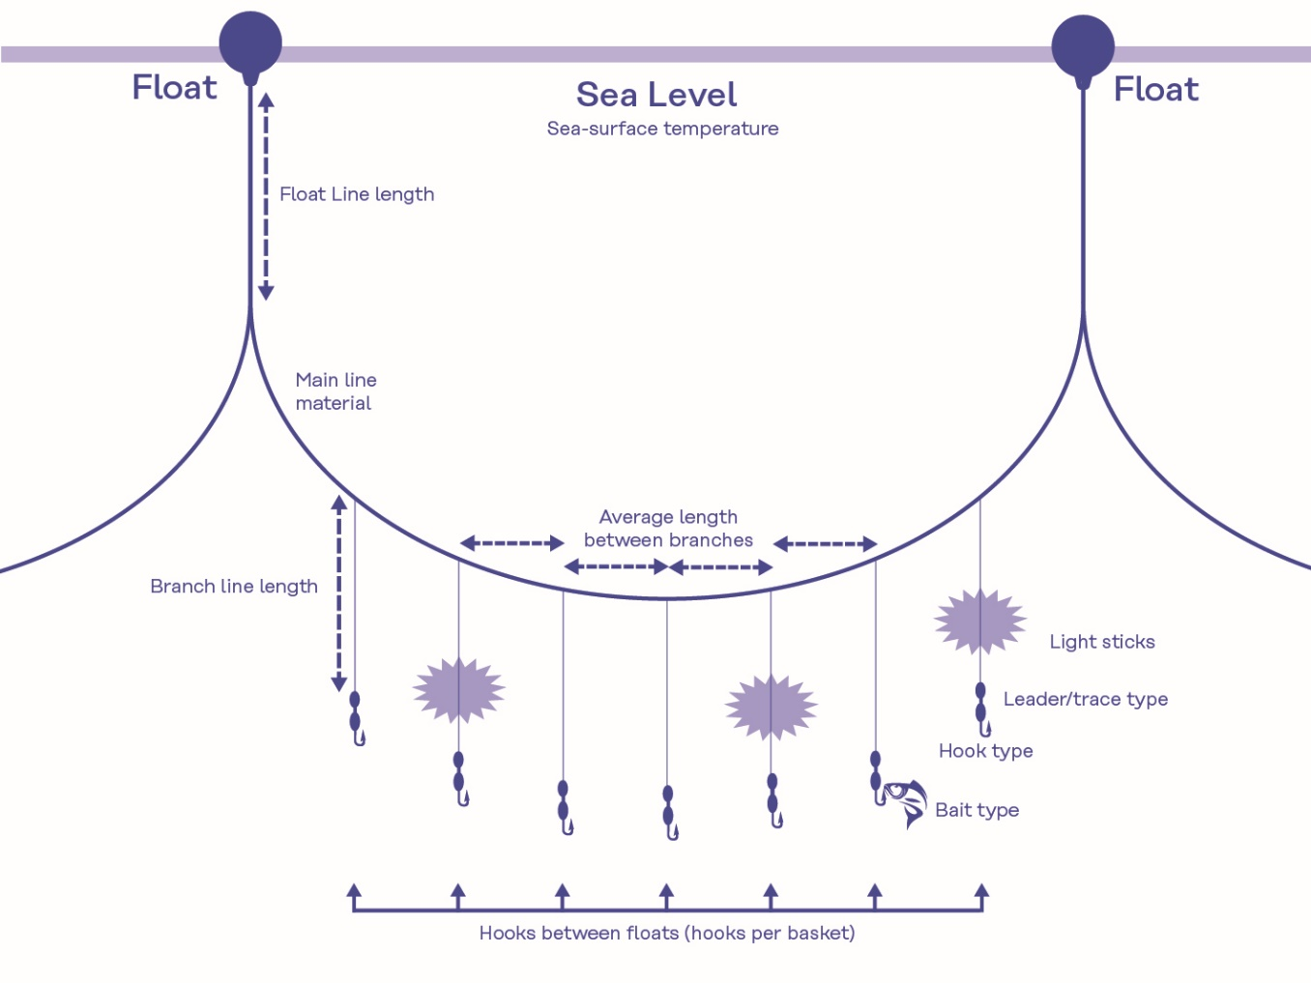

Longline (Gear Configuration): Average branch line length (meters): straight length in meters between snap and hook.

Translation:

Float

Sea level

Sea-surface temperature

Float line length

Main line material

Average length between branches

Branch line length

Light sticks

Leader/trace type

Hook type

Bait type

Hooks between floats (hooks per basket)

ANNEX 6

**General provisions of chartering agreement**

The chartering agreement shall contain the following conditions:

The flag CPC has consented in writing to the chartering agreement;

The duration of the fishing operations under the chartering agreement does not exceed 12 months cumulatively in any calendar year;

Fishing vessels to be chartered shall be registered to responsible Contracting Parties and Cooperating Non-Contracting Parties, which explicitly agree to apply IOTC Conservation and Management Measures and enforce them on their vessels. All flag Contracting Parties or Cooperating Non-Contracting Parties, concerned shall effectively exercise their duty to control their fishing vessels to ensure compliance with IOTC Conservation and Management Measures.

Fishing vessels to be chartered shall be on the IOTC record of vessels authorized to operate in the IOTC Area of Competence.

Without prejudice to the duties of the chartering CPC, the flag CPC shall ensure that the chartered vessel complies with both the legislation of the chartering CPC and of the flag CPCs and shall ensure compliance by chartered vessels with relevant Conservation and Management Measures established by IOTC, in accordance with their rights, obligations and jurisdiction under international law. If the chartered vessel is allowed by the chartering CPC to go and fish in the high seas, the flag CPC is then responsible for controlling the high seas fishing conducted pursuant to the charter arrangement. The chartered vessel shall report VMS and catch data to both the CPCs (chartering and flag) and to the IOTC Secretariat.

All catches (historical and current/future), including bycatch and discards, taken pursuant to the chartering agreement, shall be counted against the quota or fishing possibilities of the chartering CPC. The observer coverage (historical, current/future) on board such vessels shall also be counted against the coverage rate of the chartering CPC for the duration that the vessel fishes under the Charter Agreement.

The chartering CPC shall report to the IOTC all catches, including bycatch and discards, and other information required by the IOTC, and as per the Charter Notification Scheme detailed in Part IV of CMM 19/07.

Vessel Monitoring Systems (VMS) and, as appropriate, tools for differentiation of fishing areas, such as fish tags or marks, shall be used, according to the relevant IOTC Conservation and Management Measures, for effective fishery management.

There shall be observer coverage of at least 5% of fishing effort.

The chartered vessels shall have a fishing license issued by the chartering CPC, and shall not be on the IOTC IUU list, and/or IUU list of other Regional Fisheries Management Organisations.

When operating under charter agreements, the chartered vessels shall not, to the extent possible, be authorized to use the quota (if any) or entitlement of the flag Contracting Parties or Cooperating Non-Contracting Parties. In no case, shall the vessel be authorized to fish under more than one chartering agreement at the same time.

Unless specifically provided in the chartering agreement, and consistent with relevant domestic law and regulation, the catches of the chartered vessels shall be unloaded exclusively in the Ports of the chartering Contracting Party or under its direct supervision in order to assure that the activities of the chartered vessels do not undermine IOTC Conservation and Management Measures.

The chartered vessel shall at all times carry a copy of the charter documentation.

1. When a CPC is fully implementing the observer program the provision of seabird data is optional
2. When a CPC is fully implementing the observer program the provision of seabird data is optional