

**Introduction**

This Staff Working Document presents a synopsis of the consultation activities related to the Action Plan for the Development of the Organic Production, as set out in the consultation strategy for the initiative, notably the roadmap consultation, the open public consultation and additional submissions from stakeholders. As for the latter, stakeholders were invited several times to submit additional position papers and documents and they did so also directly, not only linked to the roadmap or open public consultation.

The roadmap consultation ran from 4 September to 23 October 2020, and the open public consultation was carried out between 4 September and 27 November 2020, via the website of the European Commission in all official EU languages. The consultations aimed at gathering information and feedback from EU citizens and relevant stakeholders (public authorities, businesses and their associations, NGOs, research and academic institutions) as input into the finalisation of the Action Plan.

Targeted consultation activities were also carried out with the competent authorities of the EU Member States responsible for organic production (at different meetings of the Committee on Organic Production); with business and professional organisations having activities at EU level in the organic sector (producers, retails, processors); with EU citizens and consumer organisations and with civil society organisations active at EU level in organic farming (e.g. meeting of the Civil Dialogue Group); and with several non-EU countries.

**Overview of responses**

A total of 124 replies were received on the roadmap consultation. EU citizens provided most contributions to this consultation, accounting for 33% of all respondents (41 responses), followed by business associations (23% - 28 responses) and company/business organisations (19% - 23 responses). NGOs submitted 16 responses (13%), public authorities accounted for 3 replies (2%), academic/research institutions and trade unions participated with 2 replies each (2%) and 1 reply came from a non-EU citizen. The remaining 6% (8 responses) of respondents identified themselves as ‘other’.

The open public consultation attracted 841 replies, of which one response was a duplicate, resulting in 840 responses being considered for the assessment of replies to the consultation.

*Figure 1. Number of respondents to the public consultation by country of origin*

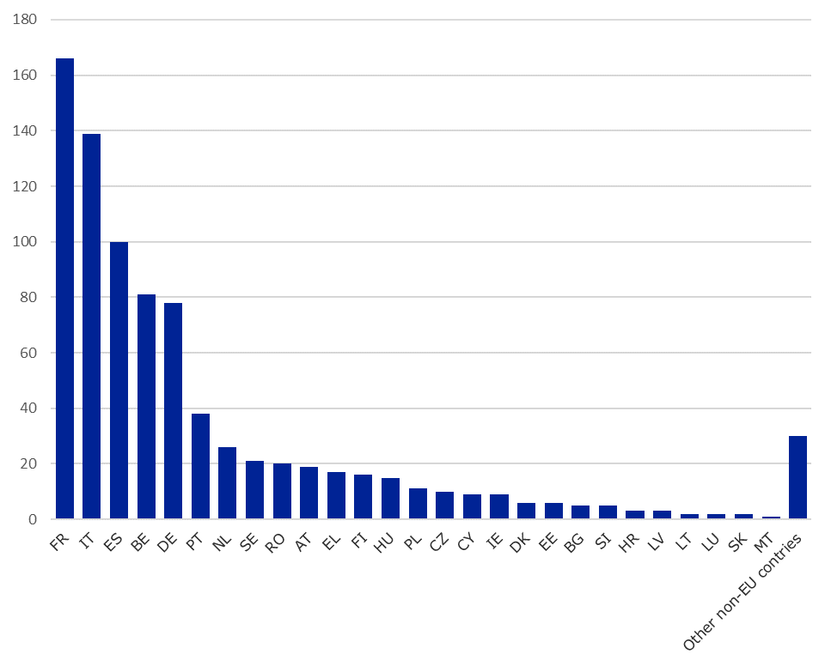

EU citizens provided most contributions to this consultation, accounting for 52% of all respondents (437 responses), followed by company/business organisations (16% - 133 responses) and business associations (8% - 69 responses). NGOs submitted 51 responses. Of all the respondents, academic/research institutions accounted for 4% (36 respondents) and public authorities for about the same share with 33 responses. 1% of the responses stemmed from environmental organisations (9 responses), from non-EU citizens (9 responses), and from trade unions (5 responses). Two consumer organisations submitted responses. The remaining 7% (56 responses) of respondents identified themselves as ‘Other’.

In addition, 87 documents attached to the public consultation, 16 documents attached to the roadmap, and 7 additional submissions were retained for analysis, for a total of 110 documents.

**Results for the closed and open questions of the public consultation**

More than three quarter of the respondents (78%) recognised the presence of obstacles to greater production and consumption of organic food in the EU (sum of respondents that indicated “strongly disagree” or “somewhat disagree” for the option “I don’t see any problems”). The obstacles perceived as most important (sum of “strongly agree” and “somewhat agree”) were “*Insufficient financial incentives for producers to convert to organic production*” (76%), followed by “*Competition with other ways of producing and/or other schemes*” (74%) and “*Low consumer awareness of the benefits of organic production for climate and the environment*” (73%).

*Figure 2. Obstacles to greater production and consumption of organic food in the EU today*

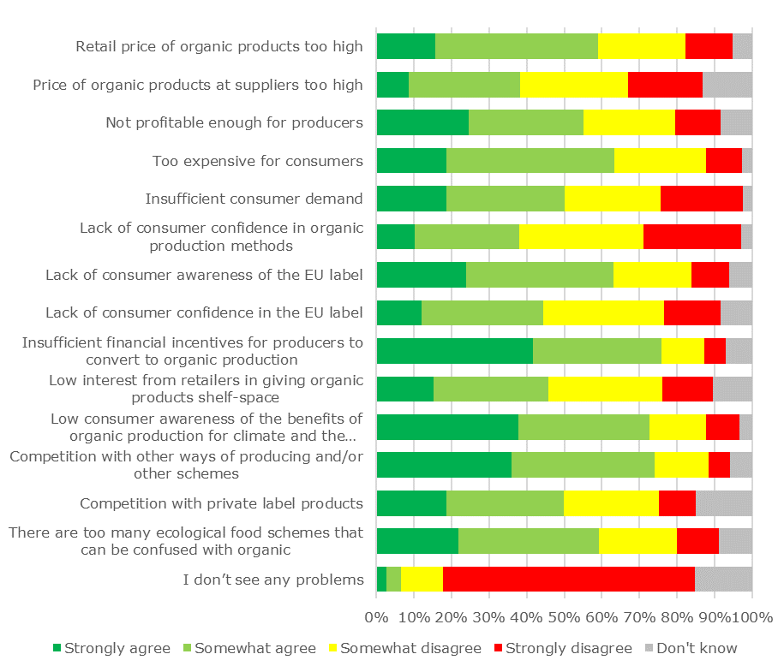

A majority of respondents (63%) considered organic food too expensive for consumers and reported a lack of consumer awareness of the EU label (63%) together with the presence of too many ecological food schemes that can be confused with organics (59%). When asked about other existing obstacles to the greater production and consumption of organic food in the EU, respondents identified the price of conventional products as the first obstacle (43 mentions). A lack of trust in the EU organic label and of information about the health and environmental benefits of organic farming were also identified as obstacles by 12 and 11 respondents.

Concerning the impacts of the COVID-19 crisis on the food system and the production and consumption of organic food, a large majority of respondents (85%) considered that “*the crisis has shown our reliance on seasonal organic farming*”. A majority of respondents (59%) considered that the crisis has “*strengthened organic farming and its role in the EU food supply”*. The crisis has “*accelerated the structural changes in food consumption in favour of organic farming”* for 53% of the participants. The greater demand for organic products will be maintained after the COVID-19 crisis according to 51% of the respondents.

*Figure 3. Measures important to stimulate the production of organic products*

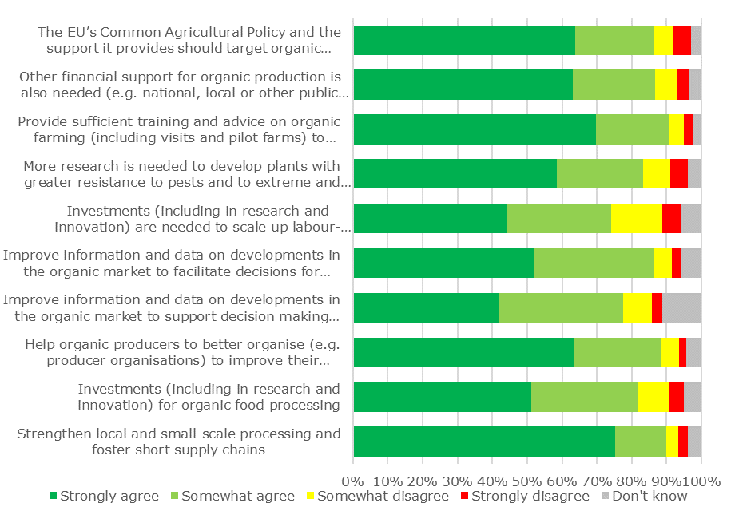

Overall, there was a high level of agreement on the nine actions proposed for developing the organic production sector in the EU (from 57% to 91%). There was a large consensus (91% of the replies) on raising awareness of the environmental and climate benefits of organic farming. The level of support was above 80% for four actions: (i) school schemes to promote healthy diets (83%), (ii) organic products in public/private offices and canteens (83%), (iii) increasing the visibility and choice of organic products at retailers (83%), and (iv) more public procurement of organic products (81%). Two actions related to promotion were supported by more than three quarters of the respondents: information campaigns on the EU organic logo (78%) and targeting promotion campaigns of agricultural products on organic products (77%). The price competitiveness of organic products should be improved for 76% of the participants. Finally, 57% of the respondents indicated that the EU organic logo is not sufficiently recognised. When asked about other actions to develop the organic production sector in the EU, respondents first mentioned the need to inform consumers better (47 mentions), particularly on the health (12) and social (9) benefits of organic farming. The need to inform about, and apply, the true costs (taking account of externalities) of conventional agriculture was also a recurring action mentioned (37) and public procurement was identified as a positive factor to increase demand for organic products (27 mentions).

There was a high level of agreement on the seven actions proposed for improving consumer confidence in the organic production sector in the EU (from 70% to 92%). There was a large consensus (91% of the replies) that information on organic producers should be transparent and available for consumers and that actions are needed to help consumers clearly distinguish between the EU organic logo and other environmental/quality schemes. It should be easier to trace organic products back to their origin for 88% of respondents and more effort is needed to tackle fraud in the organic sector for 84% of respondents. There is also a need to further explore the reasons for the lack of consumer confidence (86%) and for more effort to tackle fraud in the organic sector (84%). Finally, respondents stated that compliance with the rules for organic production must be better controlled by public authorities (77%) and information technologies should be used more often to improve the tracing of organic products (70%). When asked about other important actions to improve consumer confidence in the organic production sector in the EU, respondents identified the need for more transparency and for more efforts to tackle fraud, especially in third countries, as the most important actions (35 mentions). Informing consumers (23) and combining the EU organic label with a local/origin label (18) were also mentioned. Respondents were more divided on the need for more controls: 21 mentioned that controls are already sufficient while 10 mentioned the need to increase them.

Like for the previous question, there was a large consensus supporting the actions proposed for stimulating the production of organic products (from 74% to 91% of the replies). The largest share of respondents agreed that, in order to stimulate conversionfrom conventional to organic farming,it is important toprovide sufficient training and advice (91%) and that it is necessary to strengthen local and small-scale processing and foster short supply chains (90%). Respondents recognised the need for organic producers to receive help to better organise (e.g. in producer organisations) to improve their bargaining power in the supply chain (88%). There is also a need to improve information and data on developments in the organic market to facilitate decisions for producers (87%). They agreed on the fact that organic production should benefit from financial support, including from the Common Agricultural Policy.

Concerning the question on the organic animal production sector, respondents agreed that “*Producers should be helped to find appropriate organic feed for animal nutrition*” (86%) and that “*More research is needed to identify and develop best practices on feeding methods suitable for organic feed, and alternative feeding ingredients*” (82%). A similar level of agreement applied to the opinion that “*Organic animal production should benefit from specific support*” (82%), followed by “*Aquaculture should be supported to gain more knowledge on breeding and feeding methods, including through research*” (78%).

Regarding the question on the main environmental advantages of organic production, respondents identified the beneficial effects of organic production in relation to biodiversity (92%), the protection of soil quality (88%) and of water quality (84%). Organic production promotes a circular economy for 83% of the respondents and it ensures a responsible use of energy and natural resources for 80%. It promotes carbon neutrality, it allows for adaptation to a changing climate and it helps reduce air pollution for 78% of the participants.

More than two thirds of the respondents agreed strongly with the statement that the sustainable use of water in organic farming and the replacement of plastics in packaging should be promoted. Greater investment in research and innovation and the maintenance of networks of organic farms received equal levels of support. A notably smaller share of respondents agreed strongly with the suggestion to phase out the use of contentious inputs, such as copper. Here, only 38% of respondents agreed strongly. It must be noted though that strong support for this suggestion was largest among respondents identifying as citizens and academia/ research institutions.

There was a consensus that the “*development of the organic sector requires a mix of EU and Member State support as well as private initiative”*. More than 70% of respondents agreed with this statement strongly, and another 23% agreed at least somewhat. Mirroring this statement, 84% of the respondents strongly disagreed (63%) or somewhat disagreed (21%) with the idea of leaving the development of the organic sector to the market alone. The response patterns suggest that more than half of the respondents (59%) see national authorities as mainly responsible for promoting organic production. When asked about any other additional actions to strengthen the production and consumption of organic food, respondents suggested to re-balance the costs between conventional and organic products (36 mentions), improve the income and working conditions for farmers (29) and identified the need of research to foster innovation (23).

*Figure 4. Development of the organic sector: public support or private initiative?*

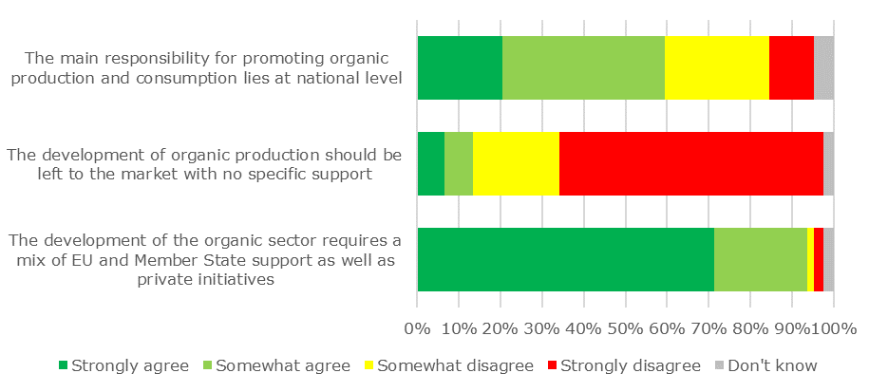

Respondents also identified as important the need to assist farmers in accessing markets as a way to support the organic sector (15), improving biodiversity on farms (13), further supporting farmers during conversion (11) and conducting research on the impacts of organic agriculture (11).

Finally, additional actions related to education on organic farming (9), support for small scale farming (8) and developing farm advisory services (5) were mentioned and concerns were raised regarding the power of retailers (6).

**Combined analysis of closed/open questions and position papers submitted to the public consultation on proposed themes and actions**

As for the different themes in the Action Plan, all of them are to varying extent supported by the quantitative and qualitative inputs from the open public consultation:

* All 15 themes received strong support or support in the quantitative responses. Among all themes, a slightly lesser degree of support was given to Themes 1.1 ‘Promoting the EU Logo’; 1.4 ‘Preventing food fraud and enhancing controls’; 2.3 ‘Supporting the organisation of the food chain; and 3.3 Funding research on alternatives to contentious inputs.
* Four themes were mentioned as relevant aspects in relation to the Action Plan particularly often in the qualitative inputs (30 and more position papers and responses to open questions): Themes 1.1 Promoting the EU logo; 1.2 ‘Promoting organic canteens and increasing the use of green public procurements’; 2.1 ‘Encouraging conversion, investments and exchanges of best practices’; and 2.3 ‘Supporting the organisation of the food chain’.
* Additional themes that were highlighted by some qualitative contributions (15 to 29 position paper and responses to open questions) refer to themes 1.5 ‘Improving traceability’; 2.4 ‘Reinforcing local and small-scale processing and fostering short trade circuits’; 3.1 ‘Enhancing genetic biodiversity’; and 3.2 ‘Reducing carbon footprint’.

As for the different actions in the Action Plan:

* Most of the 22 actions (41 sub-actions) received strong support or support in the quantitative responses. For three actions, no quantitative information was available. In the qualitative responses, the 41 sub-actions were referenced to varying degrees.
* General support for all actions was strongest for Axis 3. Slightly more than half of the sub-actions under Axis 1 received strong support through quantitative responses. Most sub-actions in Axis 2 received strong support.
* For two actions, no information was provided through the quantitative inputs: Action 13 ‘raise awareness and provide better information about group certification’; and Action 15 ‘design measures for organic farming with special focus on gender and social aspects. Aspects of both actions were however mentioned by contributors in the position papers.
* The qualitative contributions provided a more variable number of references to the 41 sub-actions. Two sub-actions received many qualitative contributions (between 22 and 33 position papers and answers to open questions): sub-actions 2a - ‘allocate budget in agricultural promotion policy, use for raising consumer awareness and stimulate demand’, and sub-action 9b ‘ensure best use of new CAP to support’.
* Four further (sub-)actions were referred to in some of the contributions (12 to 22 position papers and responses to open questions): 1c ‘identify events to inform about organics’; 9a ‘assess Member State circumstances and needs’; 15 ‘design measures for organic farming with special focus on gender and social aspects’; and Action 20 ‘funding research on alternatives to contentious inputs’. The remaining 35 (sub-)actions were only referred to by few or no contributions (up to 11 position papers and responses to open questions).

The qualitative responses also provided additional specifications for the actions proposed in the Organic Action Plan. Respondents proposed ideas for actions and sub-actions. At the same time, respondents provided input on how to implement concretely the different actions and sub-actions.

Contributors provided divergent opinions on the role of retailers in the organic value chain. In relation to increasing demand for, and consumption of, organic products, contributors saw a need to ensure the affordability of organic products for consumers while ensuring profitability for producers; and to ensure local accessibility of (quality) organic products. Other actions mentioned related to the structure of the organic distribution network and price competition and asked for measures that avoid independent retailers being disadvantaged. Certification was also seen as an indirect obstacle to the distribution of organic food.

General concerns relating to aspects covered in the draft Organic Action Plan were also raised by about a quarter of all contributors. They included aspects related to strategies, targets and the monitoring of both, the regulatory framework related to organic agriculture (e.g., inconsistencies, exclusion of certain products), controversial opinions on the contribution of organic farming to global issues of sustainability, questions about the general policy approach, and consumers and demand.