EN
COMMISSION OF THE EUROPEAN COMMUNITIES
Brussels, 10.1.2007
COM(2006) 846 final

COMMUNICATION FROM THE COMMISSION TO THE COUNCIL AND THE EUROPEAN PARLIAMENT
Priority Interconnection Plan
{SEC(2006) 1715}
{SEC(2007) 12}
TABLE OF CONTENTS
1. Urgent action needed 3
2. Current development of Europe's energy infrastructure 6
3. Action needed: The Commission proposals 8
3.1. Key infrastructure undergoing significant difficulties 8
3.2. Appointing European coordinators to pursue identified priority projects 10
3.3. Planning of grids according to consumer needs 11
3.4. Ensuring acceleration of authorization procedures 12
3.5. Providing a clear framework for investment 13
4. Conclusions 15
Annex 1 16
Annex 2 17
Annex 3 18
Annex 4 20
COMMUNICATION FROM THE COMMISSION TO THE COUNCIL AND THE EUROPEAN PARLIAMENT
Priority Interconnection Plan

1. Urgent action needed
Interconnectors facilitate the inter-regional and cross-border transport of power and energy and are a pre-requisite for a functioning internal market. The need for a strengthened policy to facilitate the completion of priority infrastructure projects was underlined by the EU Heads of State and Government at Hampton Court in October 2005. Previously, at the Barcelona European Council in 2002, it was also agreed to increase minimum interconnection levels between Member States to 10%. Today a significant number of Member States have still not achieved this target. The European Council of March 2006 called for the adoption of a Priority Interconnection Plan (the Plan), as part of the Strategic European Energy Review (SEER). The European Council of June 2006 asked to give full support to external energy infrastructure projects aimed at enhancing security of supplies.
Energy Policy for Europe (EPE) must pursue the development of an effective energy infrastructure to achieve the objectives of sustainability, competitiveness and security of supply.
Sustainability. Substantial new energy infrastructure is needed to integrate electricity generated from renewable energy sources. This infrastructure will also improve the efficiency of the new and installed generation capacity at the European level and will lessen the chance of inefficient investment in generating capacity.
Competitiveness. Effective performance of energy infrastructure is vital for the operation and development of an efficient internal energy market. It serves to boost inter-regional trade, which leads to effective competition and reduces the scope for market power abuse.
Security of supply. Due to the high dependency of the internal energy market from external supplies, diversification sources and adequate interconnected networks are needed to increase security of supply and solidarity amongst Member States (e.g. energy islands).
EU policies and measures
The European Union (EU) has formulated a series of policies aimed at supporting the development of an effective energy infrastructure in Europe.
Firstly, in its Guidelines for trans-European energy networks (TEN-E Guidelines), the EU has identified 314 infrastructure projects ("projects of common interest") whose completion should be facilitated and speeded up. These include 42 high-priority "projects of European interest" (Annexes 1 and 2), which may be cross-border in nature or have significant impact on cross-border transmission capacity. The Guidelines provide a framework for increased coordination, for monitoring progress in implementation and where appropriate, for EC financial support, including loans by the European Investment Bank (EIB).
Secondly, the EU has recently introduced specific rules to ensure an appropriate level of electricity interconnection and gas supply between Member States, while facilitating a stable investment climate (Directives to safeguard security of electricity supply and infrastructure investment and concerning measures to safeguard security of gas supply).
Thirdly, the European Council, in its June 2006 meeting conclusions asked to “give full support to infrastructure projects compatible with environmental considerations and aimed at opening up new supply routes with a view to diversifying energy imports which would benefit all Member States”.
Finally, in its meeting of 14-15 December 2006 the European Council highlighted the importance of the 'realisation of an interconnected, transparent and non-discriminatory internal energy market, with harmonised rules,' and 'the development of cooperation to meet emergencies, in particular in the case of disruption of supply.'
Urgent action needed
Despite this legislation, progress on the development of networks is insufficient. Significant obstacles remain.
As explained in more detail in the Communication of the Commission on 'Prospects for the internal gas and electricity market', at present, the European Union is far from being able to guarantee to any EU company the right to sell electricity and gas in any Member State on equal terms with the existing national companies, without discrimination or disadvantage. In particular, non-discriminatory network access and an equally effective level of regulatory supervision in each Member State do not yet exist.
In addition, the European Union has not yet adequately addressed the challenge of investing in the right level of new infrastructure based on a common stable European regulatory framework in support of the internal market. The necessary degree of co-ordination between national energy networks in terms of technical standards, balancing rules, gas quality, contact regimes, and congestion management mechanisms, which are necessary to permit cross-border trade to work effectively, is at present largely absent. It is relevant to mention, in particular, that investments are distorted as result of insufficient unbundling. The network operators have no incentive to develop the network in the overall interest of the market with the consequence of facilitating new entry at generation or supply levels. The above referred Communication on the internal market has shown that there is considerable evidence that investment decisions of vertically integrated companies are biased to the needs of supply affiliates. Such companies seem particularly disinclined to increase, for example, gas import capacity (i.e. LNG terminals) in an open process which has, in some cases, led to security of supply problems. The same applies, in some cases, to the availability of connection capacity for new generation.
Networks are operating each year closer to their physical limits with an increased probability of temporary supply interruptions. Many countries and regions are still an "energy island", largely cut off from the rest of the internal market. This holds in particular for the Baltic States and the new Member States in South-East Europe.
Amounts invested in cross-border infrastructure in Europe appear dramatically low. Only €200 million yearly is invested in electricity grids with as main driver the increase of cross-border transmission capacity. This only represents 5% of total annual investment for electricity grids in the EU, Norway, Switzerland and Turkey.
These figures do not even match the needs of an effective infrastructure in line with the objectives of the EPE. The EU will need to invest, before 2013, at least €30 billion in infrastructure (€6 billion for electricity transmission, €19 billion for gas pipelines and €5 billion for Liquefied Natural Gas (LNG) terminals), if it wants to address fully the priorities outlined in the TEN-E Guidelines.
Connecting more electricity generated from renewable sources to the gridand internalising balancing costs for intermittent generatorswill for instance require an estimated €700-800 million yearly.
With domestic gas reserves on the decline, imports will cover an increasing part of gas demand. This higher reliance requires the alignment of timely investment in all parts of the gas chain as well as full support to external energy network interconnections. Despite these needs, concerns have been expressed (IEA) about the serious risks of underinvestment in the gas sector overall.
If the EU continues on its present infrastructure course, none of the EPE objectives will be met. Because of congestion, energy prices will be higher. The development of renewable energy sources will be hampered by the lack of network transmission capacities either within or between Member States. Recent experience shows that a significant bottleneck exists for the development of green sources of energy, when the average period for the construction of wind farms is roughly three years, and the time needed for connecting and integrating geographically dispersed wind farms can be about 10 years. As a result of insufficient network transmission capacities and constrained production, each national electricity market will also be more reserve generation capacity to face unpredicted peak increases of demand or unexpected failures of generators leading to a less efficient power system.
Objectives of the Plan
This Plan illustrates the current state of completion of the 42 projects of European interest, for gas and electricity. Although not considered to be projects of European interest, Liquefied Natural Gas (LNG) terminals are also examined. Many of these projects are progressing well but others are not. This Plan accordingly proposes specific measures for the progressive completion of the critical projects which are currently experiencing significant delays. Finally it proposes measures to facilitate a stable investment framework.
An accompanying Commission Staff Working Document complements this Plan which extends an earlier analysis.
The present plan focuses on the projects of European interest agreed upon by the Council and the European Parliament in the TEN-E Guidelines. Other projects might be considered in the medium or long term in the framework of the next revision of the TEN-E Guidelines.

2. Current development of Europe's energy infrastructure
The analysis conducted by the Commission services unearthed various shortcomings.
Electricity
20 out of 32 projects of European interest (Annex 3) face delays. 12 of the 20 projects face a delay of one to two years while eight are delayed by more than three years. No delays are reported for only 12 of the 32 projects of European interest (37%); only five have been fully or virtually completed. A section of one project is waiting the realisation of the other section for more than 10 years. Two projects are under partial construction.
Various conclusions can be highlighted regarding the lack of progress:
- The complexity of planning and other authorisation procedures is the major reason for most delays. Even if legal procedures are generally comparable in most Member States, the main phases (overall planning application process) are implemented through differently structured procedures. This is the case when different networks need to be integrated, when various authorities are involved, or when lengthy consultation periods and authorisation procedures exist.
- When two or more Member States are concerned by a project, lack of harmonised planning and authorisation procedures often lead to excessive delays.
- Objections other than on environmental or health grounds may significantly delay the completion of many projects. Costly and difficult under-sea cables, facing little public opposition, have actually progressed quicker than certain contested land interconnections.
- Financing difficulties for certain projects have also caused delays, especially with regard to the inclusion of "green electricity" and the connections to neighbouring countries.
- Certain transmission System Operators (TSOs) appear to have been slow to increase cross-border capacity. This is often the result of inadequate incentives provided through the regulatory framework or because some TSOs are part of vertically integrated companies unwilling to increase existing supply that might be to the detriment of their supply affiliates. Similarly, inappropriate regulated supply tariffs recalculated on short-term basis (i.e. every three months or per year); have allegedly hindered the development of priority infrastructure.
Gas
Overall, most of the 10 gas pipelines of "European interest" are progressing reasonably well (Annex 4).
No significant delays have been reported for the majority of the projects. At least seven of the 10 pipeline projects of European interest should start operating by 2010-2013: one gas pipeline has already been completed, two are under construction, and two others are partly under construction. This infrastructure will represent yearly additional import capacity for the EU of around 80-90 bm³ by 2013 (16-17% of EU estimated gas needs for 2010).
On the other hand, work on the 29 LNG terminals and storage facilities has been seriously hampered in various Member States. Nine projects had to be abandoned and it was necessary to look for alternative solutions. Five other LNG's are currently blocked.
In summary, investment and commitment in the gas chain appears satisfactory. However, although several significant pipeline projects are coming to fruition, risks for pipeline investments crossing multiple frontiers are perceived to be growing. Delays are also caused by environmental concerns or local opposition notably regarding LNG terminals. Rising raw material costs and shortages of skilled labour have also been mentioned.

3. Action needed: The Commission's proposals

3.1. Key infrastructure undergoing significant difficulties
The Commission's assessment has provided a basis to ensure that appropriate attention and effort are focussed on both EU and national levels. Stakeholders and national authorities should now commit themselves to rapid completion.
Action 1: Identification of the most important infrastructure encountering significant difficulties has been made
Electricity
The Commission has identified the following key projects which are vital to completing the internal market, integrating generation from renewable energy sources into the market and significantly improving security of supply, and where facts are known which may lead to delays in implementation.
Projects | Justification | Completion date communicated in 2004 (2006) | Reasons for Delay
Kassø (DK) – Hamburg/Dollern (DE) | This link is essential for integration of large volumes of wind electricity in Northern DE, DK, North Sea and Baltic Sea and for trade with Northern Europe; also for security of the grid and trade. | 2010 (2012); Project is still in study phase | Densely populated area: numerous land owners.
Hamburg/Krümmel (DE) – Schwerin (DE) | Integration of wind electricity; closing a gap between EU Eastern and Western grid. | 2007 (2007)  Authorisation phase | Opposition from local population: routing, fear of electromagnetic fields, deterioration of landscape view;  Time-consuming public consultation procedures; Numerous stakeholders;  No perception of supra-regional or European perspectives.
Halle/Saale (DE) – Schweinfurt (DE) | Same reasons as immediately above. | 2010 (2009)  Authorisation phase | Crossing of Thüringer Wald;  Opposition of local population: negative impact on tourism, routing, fear of EMF, landscape view; Diversity of stakeholders;  No perception of supra-regional or European perspectives.
St-Peter (AT) – Tauern (AT) | Most severely congested area in Central Europe causing risks for a secure operation of the grid | 2010 (2011)  Authorisation/ study phase | Slowness of the authorisation procedure: additional coordination needed; Opposition of local population : EMF, landscape view, protected birds and insects; Difficult terrain; Authorities responsible for EIA and permission are not suited to large infrastructure projects;
Südburgenland (AT) – Kainachtal (AT) | See reasons immediately above. | 2007 (2009)  Authorisation phase | Slowness of the authorisation procedure; Opposition of local population: landscape view, EMF, underground cable requested; Possible opposition to building of access roads to the site; Authorities responsible for EIA and permission are not suited to large infrastructure projects.
Dürnrohr (AT) – Slavětice (CZ) | Essential link to new Member State and to Central Europe | 2007 (2009); Project is still in study phase | AT's opposition to nuclear; Linked to strengthening of the Austrian grid (North–South);  Protected area; Local population sensitivity to EMF (AT)
Udine Ovest (IT) – Okroglo (SI) | Lines between SI and IT heavily overloaded;  Significant risk of blackout in Italy  Link of great importance for power flows at EU level | 2009 (2011)  Project is still in study phase | Difficult to identify the cross-border points between Italy and Slovenia;  Highly populated area; Potential commercial problem; Definition of the routing: 35% of SI territory is devoted to Natura 2000 programme; Opposition of local population: EMF, landscape view; Pre-condition on SI side : completion of Berecevo-Krsko line and interconnection to HU;  Prior enhancement of IT grid;
Power link between Lithuania and Poland including upgrade of the Polish grid(DE-PL) | Crucial to link the Baltic grid to the UCTE | 2012 (2013)  Project is still in study phase | Coordination and lack of sufficient political support in the past; Uncertainty due to different synchronisation areas; Stability of Polish grid;  Natural protected area crossed; Expropriation requires law amendments in PL; Back to back' transformer station needed; Uncertainty about synchronisation areas.
Sentmenat (ES) – Bescanó (ES) – Baixas (FR) | Crucial for linking the UCTE with the Iberian electricity "island". | 2007 (2009); Authorisation phase | Crossing the Pyrenees; difficult to define of cross-border points between Spain and France;  Opposition of local population.
Moulaine (FR) – Aubange (BE) |  | 2010 (2012)  The Belgian part of the project is finalised whereas the French section is still in study phase | Priority given to the project Avelin-Avelgem;  Difficult acceptability in rural and urban areas;  Route not defined yet on FR side (13 to 16 km are missing).
Undersea cable link between England (UK) and the Netherlands (NL) |  | 2008 (2010)  Authorisation phase | Lengthy environmental procedures; lengthy Dutch regulations procedure; time-consuming public consultation procedures in both countries; uncertainty over funding and additional grants; uncertainty over regulation of the link (e.g. exemption requirements / congestion management guidelines).
Gas
In the gas sector, the EU needs to diversify its current gas supplies (Norway, Russia and Northern Africa). It is important to have a "fourth corridor" pipeline, bringing alternative gas (30 bcm or 7% of 2010 gas demand for the EU) from Central Asia, the Caspian region and Middle East through the Nabucco Pipeline.
The EU also needs to ensure that all currently delayed prioritised gas projects are rapidly completed. The Commission notes that the GALSI pipeline linking Algeria and Italian peninsula (via Sardinia) is facing significant delays.
Delivery of increased gas imports also needs to be guaranteed at the end of the supply chain, for the gas to reach final consumers. The development of downstream distribution is crucial (i.e. pipelines linking the German, Danish and Swedish gas markets, as well as between the German, the Benelux and the British markets). Finally, LNG can provide greater flexibility, particularly to Member States relying exclusively on one single source of gas supply. LNG may constitute a good reserve contributing to secure gas supply and increasing competitiveness in the market. In this context, the Commission will consider in 2007 whether Community action is necessary to increase energy solidarity through an action plan for LNG.

3.2. Appointing European coordinators to pursue identified priority projects
Under the TEN-E Guidelines, the Commission may designate a European coordinator, in agreement with the Member States concerned and after consultation of the European Parliament.
The coordinator will promote the European dimension of the project and initiate a cross-border dialogue between promoters, the public and the private sector as well as local and regional Authorities and the local population. The coordinator will help to coordinate the national procedures (including environmental procedures) and will submit a report on the progress of the project or projects and on any difficulties or obstacles which are likely to result in a significant delay.
Action 2: Appointing European coordinators (See section 3.1)
The Commission will propose early in 2007 the designation of European Coordinators to facilitate the completion of the following projects:
For electricity:
Power link between Germany, Poland and Lithuania, especially Alytus – Elk (back-to-back station);
Connection of offshore wind power in Northern Europe (Denmark, Germany and Poland);
Connection between France and Spain, especially Sentmenat (ES) – Bescanó (ES) – Baixas (FR) line.
For gas:
NABUCCO pipeline.
At a later stage, depending on progress, the nomination of European coordinators for the following projects will be considered:
For electricity:
- Links within and to Austria;
- Connections between Italy and Slovenia;
- Links between UK and the Continental Europe;
- Moulaine (FR) – Aubange (BE) line.
For gas:
- GALSI pipeline linking Algeria, Italy via Sardinia and Toscani, with a branch to France via Corsica;
- The Sweden-Denmark-Germany pipeline;
- Downstream gas capacity between Germany, Netherlands, Belgium and United Kingdom;
- Completion of various LNG terminals encountering significant delays.

3.3. Planning of grids according to consumer needs
The recent blackout which occurred in eight EU countries on 4 November 2006 has highlighted the fact that Continental Europe is already behaving in some respects as a single power system, but with a network not designed accordingly.
Europe's power system (including its network infrastructure) has to be planned, built and operated for the consumers it will serve. Identifying, planning and building such infrastructure in liberalised markets is an ongoing process that requires regular monitoring and coordination between market actors. This task is not simply about building more interconnections or power plants in each region. It is also about the future energy mix in the EU, about the operation of the system with larger quota of intermittent generation, as well as about the geographical location of generation sites. Transparency on short and long-term congestion network paths is essential.
In the EU, enhanced coordinated and early planning on the necessary infrastructure and/or generation capacity should be carried out in each of the various energy regions as well as between the regions. This objective is outlined in the Commission Communication on prospects for the internal gas and electricity markets. Two main avenues for an enhanced level of TSO coordination will be considered.
The use of GALILEO for accurate real-time surveillance of the energy networks is indispensable for the development of an innovative 'smart' grid. It will allow monitoring and controlling the power system in real time. This technology will also contribute the upcoming European Initiative for the protection of Critical Energy Infrastructure.
Action 3: Coordinated planning at regional levels
The Commission will propose in 2007 establishing a strengthened framework for TSOs responsible for coordinated network planning.
As explained in more detail in the Communication on 'Prospects for the internal gas and electricity market' this framework should provide a platform for undertaking monitoring and analyses on the existing and future developments of networks in each energy area that improves the transmission capacities between Member States on a regional basis. It will facilitate the dialogue between stakeholders with due regard to socio-economic and environmental considerations. It will prepare, fully in line with national planning procedures, regional plans for network developments as well as forecasts for balancing supply and demand (for peak and baseload). In carrying out its tasks, it will take due account of the opinion of regulators and other relevant fora for electricity and gas (i.e. Florence and Madrid fora, respectively).
This enhanced coordination should be complemented with an overview of the planning and development of infrastructure on a more European basis. Potential investors for generation and transmission need up-to-date information on short and medium-term developments. The Office of the Energy Observatory should accordingly analyse the EU demand for new infrastructure. On the basis of such analysis, the Commission will, if necessary, propose amendments to the TEN-E Guidelines and will designate further priority infrastructure of European interest. Any potential shortfall should be identified in advance to enable the market to react. The Office should provide technical and material support to EU-appointed coordinators.

3.4. Ensuring acceleration of authorization procedures
Time-consuming legal and licensing procedures constitute significant obstacles to the development of certain gas infrastructure and for electricity transmission projects. Fragmentation of procedures, strong opposition from local and regional communities, unjustified use of veto powers, and large number of entities responsible for the granting of permission represent major obstacles. For connections between Member States, lack of coordination and different timescales often delay the authorisation procedures.
Notwithstanding the introduction in some countries of simplified authorisation procedures, the main difficulties still persist. Building a new connection may in some cases take more than 10 years, whereas the construction time for a wind farm or a combined cycle gas turbine is between two and three years.
In the United States, similar problems have occurred in the past (e.g. blackouts in California caused by insufficient interconnection and a poorly designed market model leading to market abuse). As a result, in case of excessive delay in the realisation of a priority network infrastructure in a State, planning and authorisation of US inter-federal infrastructure is now decided at federal level by the US Federal Energy Regulatory Commission (FERC) providing the priority projects are not authorised in due time at the State level.
The Commission does not consider such an approach to be appropriate for the EU. However, effective action is needed if there is to be any realistic hope that the EU gas and electricity infrastructure will be able to adapt efficiently to the changing realities of today's energy markets. It is vital to reduce the planning and construction time for prioritised EU infrastructure, in a way that duly takes into account environmental, safety and health concerns.
Firstly, on the basis of the TEN-E Guidelines, declaring certain priority projects as being of "European interest" should help to accelerate them significantly. This declaration includes the setting-up of a timetable for completion of the project; including details of the envisaged submission of the project through the approval process (co-ordinated assessments may help to simplify procedures). For the sake of ensuring the effectiveness of such declaration, the Commission considers that identification in the future of projects of European Interest should be subject to strict conditions. It should only be granted to projects with significant impact on power flows and on trading in the region concerned, where the planning and authorisation phase appears to be clear and realistic, and with a positive and robust European added value; all parties involved would have to be in agreement.
Secondly, the Commission will propose, after having consulted the Member States and key stakeholders, the streamlining of national authorisation procedures.
Action 4: Streamlining of authorisation procedures
The Commission will in 2007 begin revising the TEN-E Guidelines with a view to requiring the Member States, with due regard to the subsidiarity principle, to set up national procedures under which planning and approval processes for projects of European interest should be completed in a maximum time span of five years.
This does not mean that new standards should be set at EU level on the substantive issues to be considered during a planning process. It concerns only the requirement that in such cases national procedures be completed within a reasonable time frame, which needs to be done whilst respecting environmental legislation and legitimate interest of the affected citizens; this should be complemented by appropriate benchmarking of best practices in evaluating national standards.

3.5. Providing a clear framework for investment
TEN-E projects should primarily be financed by the economic operators concerned. Investment in new transmission lines has, however, slowed down. This trend may be partially explained by past reserve transmission capacity but, current market design does not create incentives for efficient transmission investment. Inappropriate regional pricing models unduly mask intra-regional transmission congestion or do not provide access to accurate and timely information about the performance of transmission networks. Low investment is surprisingly at odds with the increased private-sector appetite for investment in long-term infrastructure projects.
It is thus essential to guarantee a stable and attractive regulatory framework allowing the private sector to predict the successful completion of its investment and guaranteeing stable rates of return, while offering a high level of service to customers. In its associated Communication on the internal gas and electricity markets, the Commission presents a number of actions with such objectives in mind. Proposals are made in particular on unbundling and on the need to strengthen the powers of energy regulators; an increase in transparency is also referred to.
Public financing of TEN-E has been an excellent catalyst in enabling private operators to embark on the completion of infrastructure projects encountering lengthy procedures or substantial costs. EU funding reduces risks of delay; it provides incentives for projects to explore the potential use of new technologies or helps to trigger a decision on specific projects.
The EU needs to move towards a better-performing energy infrastructure. The current TEN-E budget (€20 million yearly) will not suffice to bring about the vast new investments that are needed. The TEN-E budget now has to face:
- The increasing need for integration of 'green' electricity into the grid;
- Increasing infrastructure needs due to the enlargement of the European Union to 27 Member States;
- The need to further improve cohesion as requested by the Treaty and the TEN-E Guidelines and to connect a larger number of regional isolated markets within one single market (integration of the new South-East Energy Community, integration of the UCTE system with other systems such as the CIS and the Euro-Med link, etc.).
This calls for a reflection on whether current EU financing levels are sufficient to address EPE objectives.
Action 5: EU funding
For these specific purposes the Commission will examine whether increased EU funding for TEN-E networks is necessary.
Again looking to the future, TEN- E financing should mainly be deployed for socio economic and planning studies of a much greater EU impact (e.g. extension of the synchronous UCTE system into neighbouring countries or incorporation of offshore wind generation into the main grid). For gas, studies might address issues such as gas quality standards, possible technical harmonisation or the impact of supply pipelines on internal downstream gas networks.
The Community Strategic Guidelines for Cohesion Policy in 2007-2013 have identified as a priority the need to address Europe's intensive use of traditional energy resources. This will include support for the completion of interconnections, with special emphasis on Trans-European networks, the improvement of electricity grids, and the completion and improvement of gas transmission and distribution networks. The Commission encourages Member States and their regions and in particular those that joined the Union in 2004 and 2007, to implement these Guidelines through their investment programmes. Closer coordination is also necessary with the EIB and the EBRD for facilitating investment of a cross-European nature. Both financial Institutions should consider the projects of European interest as one of their top priorities for lending operations. For projects involving countries participating in the European Neighbourhood Policy, financing could be made available under the Neighbourhood Investment Fund. The Fund is estimated to leverage four to five times the amount of grant funding available under the European Neighbourhood Policy Instrument. Equally the African Infrastructure Facility could contribute to promote relevant energy links to Europe.
At the same time, in order to avoid possible impacts on competition in the liberalised energy market, which may result from public support to infrastructure investments, it is necessary to respect existing Community state aid rules.

4. Conclusions
With infrastructure investment as it currently stands, the EU will not be able to construct a real single internal market. It will not be able to integrate the required increased production of electricity from renewable sources. It will also continue paying higher costs as a result of congestion and of maintaining inefficient capacity in each of the insufficiently interconnected energy areas.
Full and determined implementation of projects of European interest as well as of the actions listed in this Communication is vital.
Annex 1
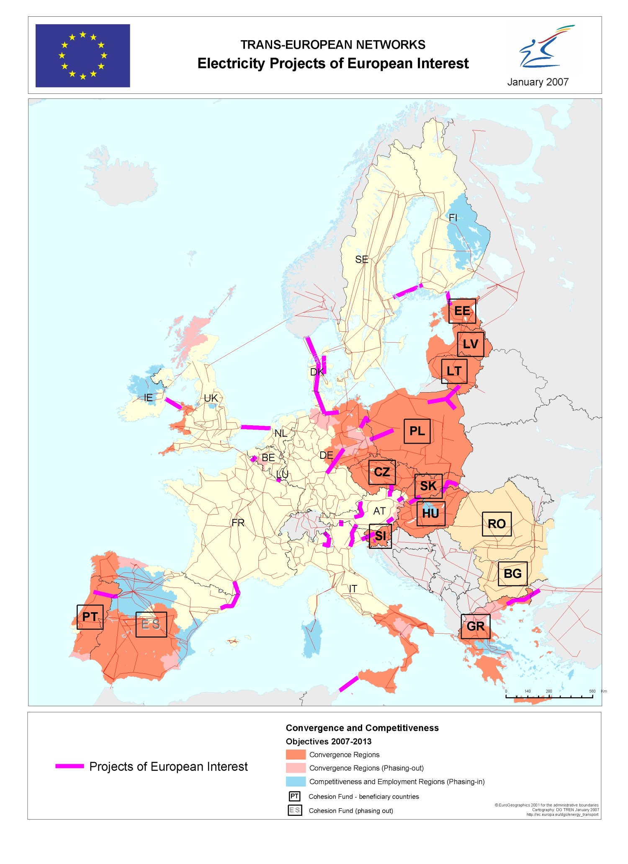
Annex 2
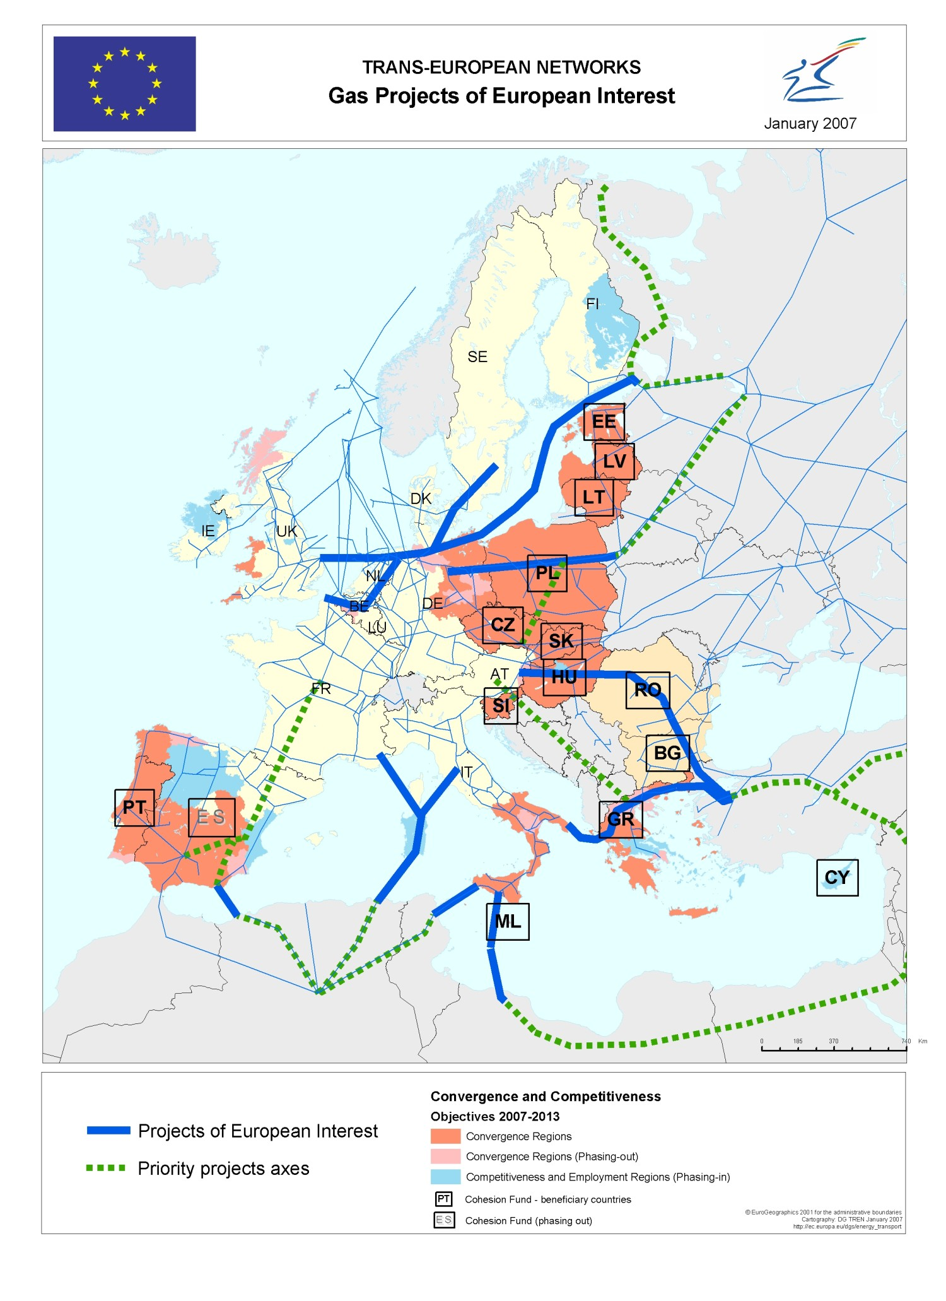
Annex 3
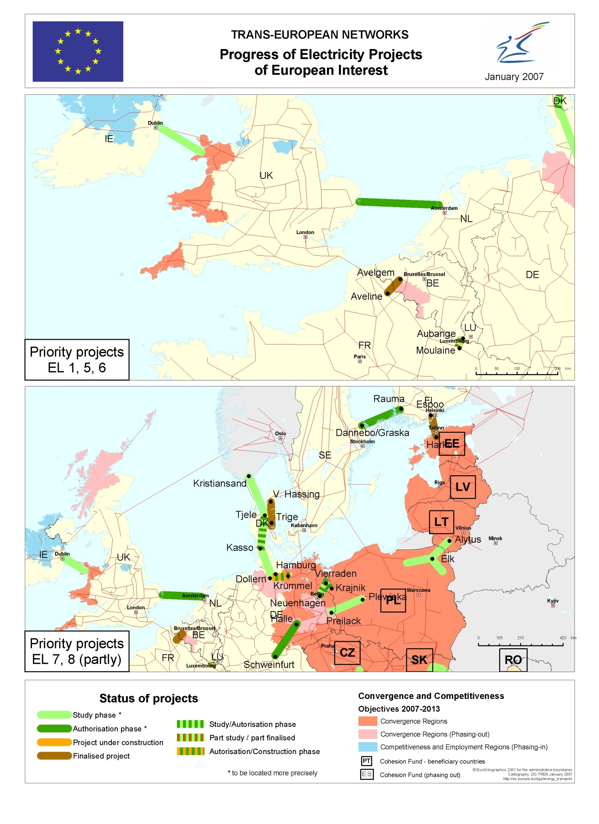
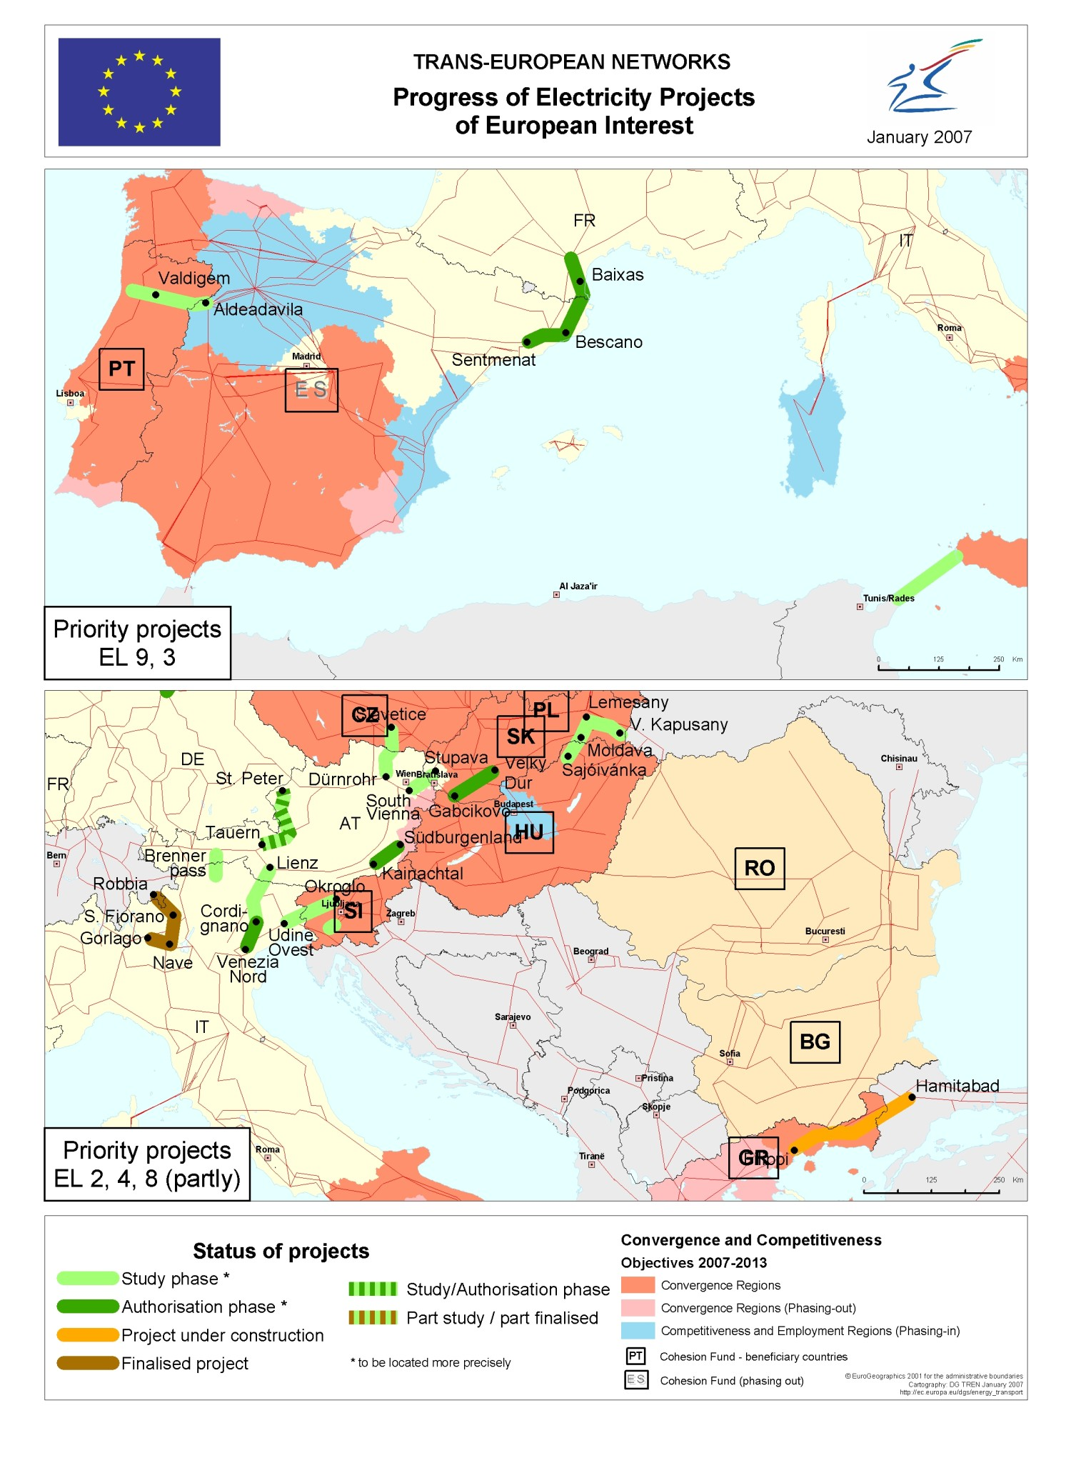
Annex 4
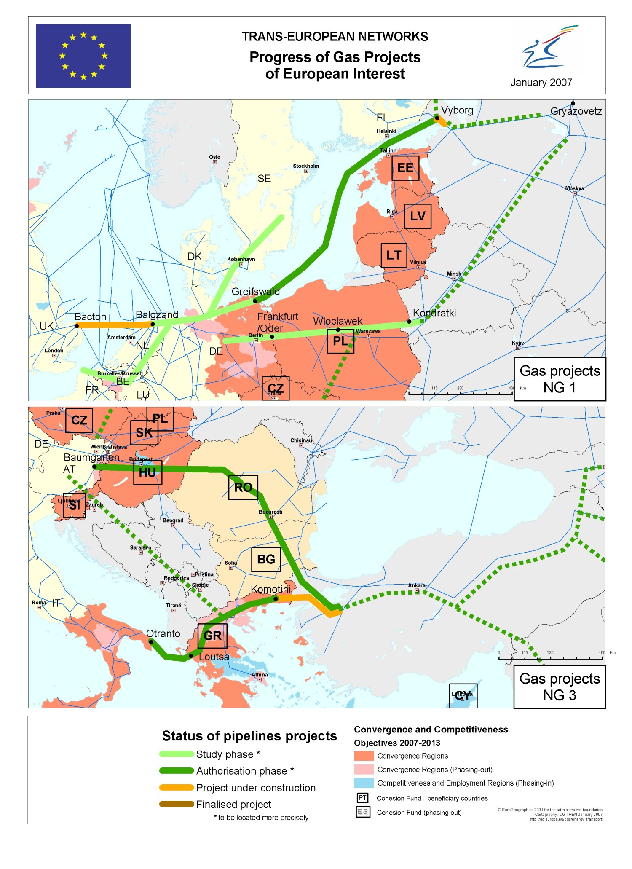
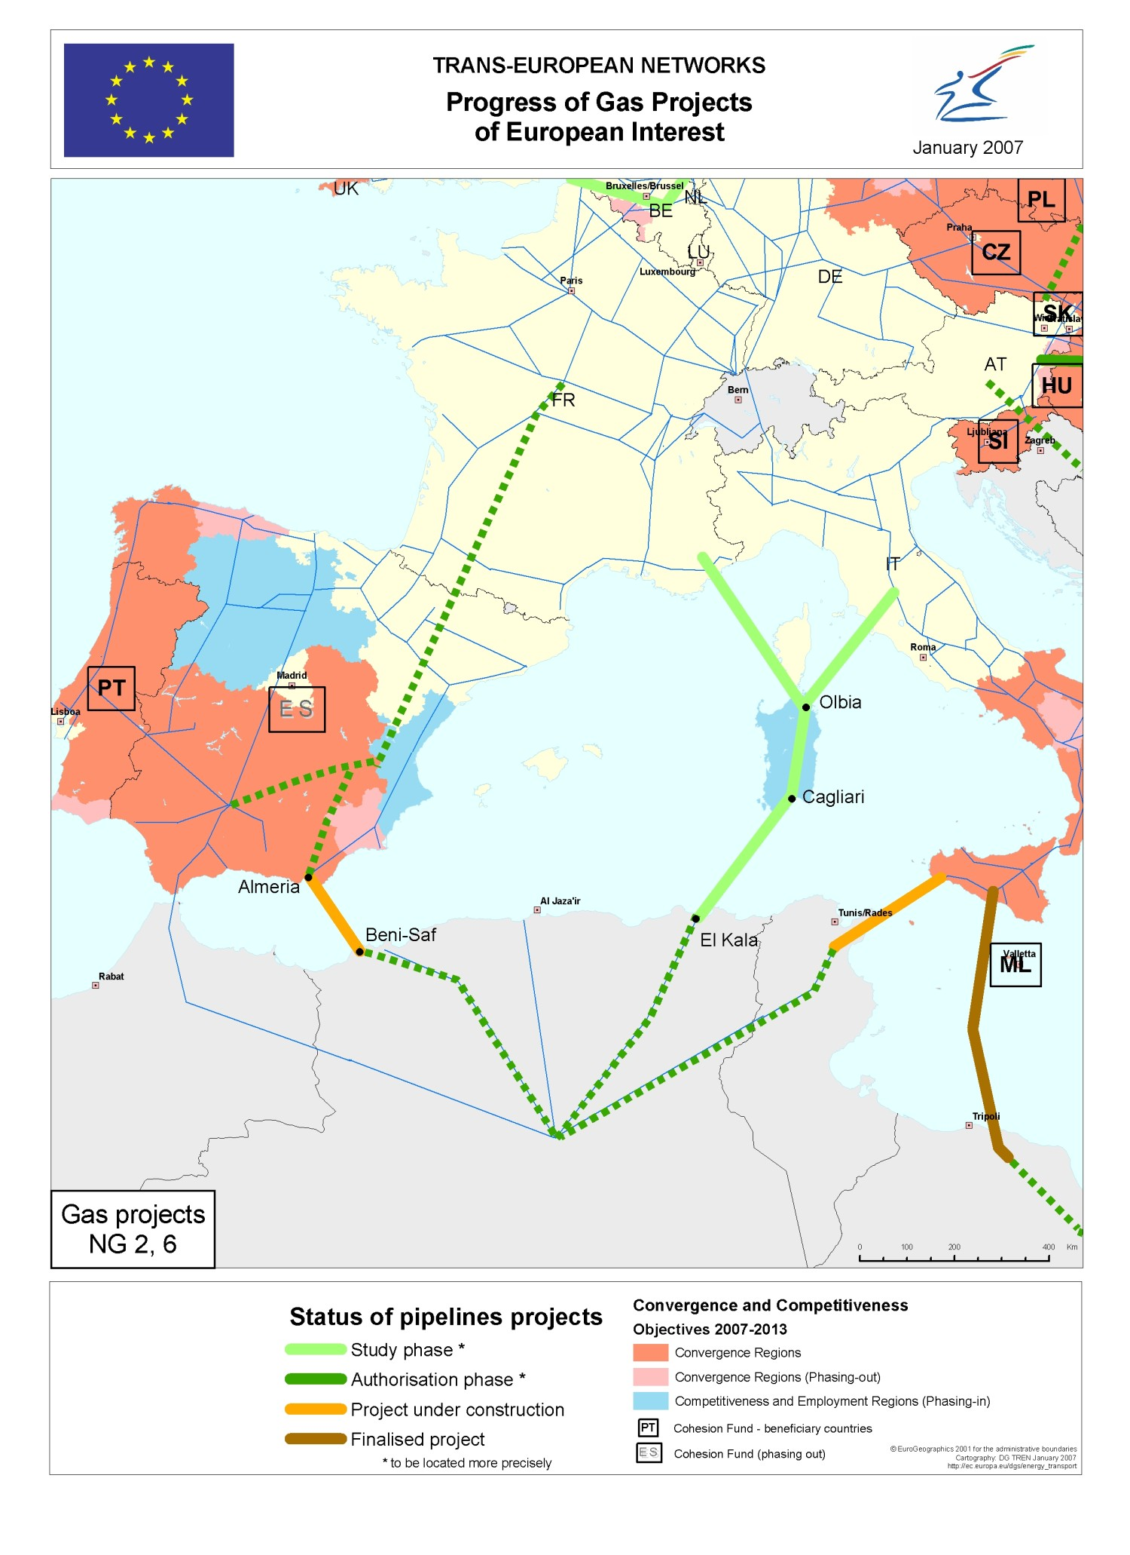

E.g. Poland, United Kingdom, Spain, Ireland, Italy, France, Portugal as well as Bulgaria and Romania.
COM(2007) 1, 10.1.2007.
Decision No 1364/2006/EC (OJ L 262, 22.9.2006, p. 1).
Directive 2005/89/EC (OJ L 33, 4.2.2006, p. 22).
Council Directive 2004/67/EC (OJ L 127, 29.4.200, p. 92).
Commission report on creating an internal market in gas and electricity - COM(2005) 518.
Even though recently a link between Estonia and Finland was realised.
Yearly investments for the whole grid accounted for €3.5 billion (€4 billion by 2006); "TEN-E invest' study" (2005).
The €6 billion figure corresponds to electricity projects of European interest. This amount is only part of the total EU grid needs. IEA projections for total grid investment needs in the EU between 2001 and 2010 are for instance €49 billion. Investment to relieve congestions is thus only a part of the total required. "Lessons from Liberalised Electricity Markets" (OCDE/IEA 2005).
Installed wind power in Europe will grow from 41 GW in 2005 to nearly 67 GW in 2008 ("The European Wind Integration Study (EWIS) for a successful integration of Wind power into European Electricity Grids").
High concentration of wind power in Northern Germany, mainly connected to distribution networks and with insufficient transmission capacity in the North-South direction, produces huge power flows through the neighbouring transmission systems, increasingly affecting system stability and trading capacities (EWIS).
IEA Report on "Natural Gas. Market Review 2006. Towards a Global Gas Market".
EWIS
A proper look at the interconnections related to oil and petroleum products will also be needed in the near future as oil continues to play an important role in EU energy landscape and EU's oil import dependency rises to around 90%. New transport infrastructure, such as pipelines, will be needed not only for geographical diversification but also to respond to the challenges related to general trends towards processing heavier and more sour crudes and to the insufficiency of currently used capacities. This will be of particular importance for the EU Member States in Central Europe and the Mediterranean.
SEC(2007) 1715.
SEC(2006)1059.
E.g. the development of the Central Asia – Trans Caspian – Black Sea energy corridor as well as the Baku – Erzurum gas pipeline.
Aveline (FR)- Avelgem (BE) line; S- Fiorano (IT) – Robbia (IT) line; S. Fiorano (IT)– Nave (IT) – Gorlago (IT) line; V. Hassing (DK) – Trige (DK) line; Estlink undersea cable link between Finland and Estonia.
Belgian part of the Moulaine (FR) –Aubange (BE) project, waiting for the French section.
Philippi (EL) – Hamitabad (TR) line; Hamburg/Krümmel (DE) – Schwerin (DE) line.
Delays as a result of the need to integrate high-voltage lines with railway projects (Thaur (AT) -Brixen (IT) line).
Fennoscan undersea cable link between Finland and Sweden, where authorisation procedures include dealing with water rights.
Undersea cable link between the UK and the Netherlands, with lengthy authorisation procedures.
Visual impact is often a major concern for local populations.
St-Peter (AT) – Tauern (AT) line, Lienz (AT) – Cordignano (IT) line, Sentmenat (ES) – Bescanó (ES) – Baixas (FR) line, Hamburg/Krümmel (DE) – Schwerin (DE) line, Neuenhagen (DE) – Vierraden (DE) – Krajnik (PL) line.
Extension of the UCTE network eastwards to include the Baltic States; German extension of the grid to integrate green electricity; Tunisia and Italy line.
The Green-stream pipeline between Libya and Italy via Sicily.
TRANSMED II pipeline between Algeria-Tunisia and Italy via Sicily; the Balgzand – Bacton pipeline between NL and UK.
North European gas pipeline; Turkey-Greece-Italy gas pipeline.
PRIMES. "European Energy and Transport. Scenarios on key drivers" (2004).
LNG terminals on the Ionian Coast, at Corigliano Calabro, on the Tyrrhenian Coast, at Montaldo di Castro, Tyrrhenian Lamezia Terme, Tyrrhenian San Ferdinando, on the Ligurian Coast, at Vado Ligure and second LNG terminal in continental Greece.
LNG terminal at Muggia, LNG terminal at Brindisi, LNG terminal at Taranto, LNG terminal in Sicily, LNG terminal at Livorno (offshore).
IEA. 2006.
COM(2006) 841.
As proposed in the Strategic European Energy Review.

