EN
COMMISSION OF THE EUROPEAN COMMUNITIES
Brussels, 16.7.2007
COM(2007) 434 final

COMMUNICATION FROM THE COMMISSION TO THE COUNCIL,
THE EUROPEAN PARLIAMENT, THE EUROPEAN ECONOMIC AND SOCIAL COMMITTEE, THE COMMITTEE OF THE REGIONS AND
THE EUROPEAN CENTRAL BANK
Fifth report on the practical preparations for the future enlargement of the euro area
COMMUNICATION FROM THE COMMISSION TO THE COUNCIL,
THE EUROPEAN PARLIAMENT, THE EUROPEAN ECONOMIC AND SOCIAL COMMITTEE, THE COMMITTEE OF THE REGIONS AND
THE EUROPEAN CENTRAL BANK
Fifth report on the practical preparations for the future enlargement of the euro area

1. Introduction
Since the adoption of the euro by Slovenia on 1 January 2007, the euro area consists of thirteen EU Member States. Among the remaining fourteen EU Member States, twelve are "Member States with a derogation" which are expected to adopt the euro once the necessary conditions are fulfilled, while Denmark and the United Kingdom are not obliged to introduce the euro.
In addition to meeting the "Maastricht" convergence criteria, the introduction of the euro requires Member States to undertake extensive practical preparations, which involve all sectors of the countries' economies, the public sector as well as the public at large. Slovenia's successful euro changeover confirms the experience of the first-wave euro-area countries that timely and comprehensive practical preparations are crucial for a smooth changeover and its positive perception by the public.
The present Report assesses the state of practical preparations for the future enlargement of the euro area. It focuses on the recent developments in Cyprus and Malta, as these countries will enter the euro area on 1 January 2008, following the Council's decisions that they fulfil the necessary conditions for the adoption of the euro. Furthermore, the report gives special attention to the preparations in Slovakia which aspires to adopt the euro on 1 January 2009.

2. State of preparations at national and Community level

2.1. National euro adoption strategies
A national target date provides impetus for timely preparations for introducing the euro and helps to focus these preparations, provided that there is sufficient credibility as to the country's ability to fulfil the convergence criteria in time.
In the course of 2006, several countries (Czech Republic, Estonia, Latvia, Lithuania, Hungary) withdrew their target dates for the adoption of the euro, mainly with respect to their difficulties in fulfilling the convergence criteria as originally planned. Bulgaria, Poland and Sweden have not yet put forward any target date. In Sweden, preparations are stalled in practice since the negative outcome of the referendum of 14 September 2003. The current situation concerning the national target dates is summarised in the table below.
Romania set 2014 as its target year.
Target date for euro adoption | Member States
1 January 2008 | Cyprus, Malta
1 January 2009 | Slovakia
2014 | Romania
To be (re-)determined | Bulgaria, Czech Republic, Estonia, Latvia, Lithuania, Hungary, Poland, Sweden

2.2. Preparations in Cyprus

2.2.1. General framework
Cyprus will adopt the euro on 1 January 2008 under a "big bang" scenario with a dual circulation period of one month.
In the Fourth Report on the state of practical preparations, the Commission concluded that Cyprus' national changeover plan generally covered most of the practical issues for the introduction of the euro, while further measures were considered necessary in order to ensure consumer confidence in stable pricing around the changeover. It was moreover noted that the National Changeover Plan was still short of detail in many respects and several elements needed to be further defined.
Progress has been achieved during the last few months. An updated version of the National Changeover Plan, approved in July 2006, was adopted by the Ministry of Finance, with the consent of the Central Bank, on 21 June 2007. Moreover, the Central Bank updated the Cash Changeover Plan, national legislation on the introduction of the euro was adopted and the Fair Pricing Code was launched.

2.2.2. Financial sector and enterprises
The Central Bank of Cyprus published the latest update of the Cash Changeover Plan in May 2007. The details of the frontloading operation have been specified. Frontloading of euro coins and banknotes will start on 22 October and 19 November 2007, respectively, and will be finalised by mid-December 2007. Sub-frontloading or euro cash to retailers is envisaged to start at the same time as the frontloading operation. In addition, 40 000 pre-packed coin kits containing a suitable structure of denominations for cash transactions in the first days after €-day (starter-kits), worth € 172 each, will be available to businesses and retailers as from 3 December 2007. 250 000 mini-kits, worth CYP 10 each, will be available to the general public as from the same date.
Around 70% of the credit institutions' cash dispensers (ATMs; approximately 500 in total) will be converted to dispensing exclusively euro banknotes (€ 10 and 20) within the first hour of €-day, while the remaining 30% will be converted by noon on the same day at the latest. As from €-day, retailers will give change in euro only.
On 1 January 2008, which is a bank holiday, a number of centrally located bank branches will open in every district to facilitate the exchange of Cyprus pounds into euro.
In November 2006, the Central Bank of Cyprus launched a campaign encouraging citizens to use hoarded national cash or to deposit it with banks, in order to contribute to reducing the amount of Cyprus pound cash in circulation at the end of 2007. An intensified advertising campaign for the use of hoarded cash is planned for September 2007.
A special Coin Centre of the Central Bank of Cyprus was constructed, which will be used for the storage and distribution of euro coins (frontloading of banks and supply of coins during the changeover), and thereafter for the collection, processing and destruction of national coins.
The Central Bank provides training for professional cash handlers in the banking, retail and public sectors on the security features of euro cash.

2.2.3. Public administration
On 15 March 2007, the Parliament adopted the "Adoption of the Euro Law 2007"; amendments to this Law were adopted on 21 June 2007. This "umbrella law" establishes, inter alia, the length of the dual circulation period, the exchange of Cyprus pound banknotes and coins into euro cash by commercial banks without charges, the conversion of monetary amounts and rounding rules, the dual display of prices and the establishment of Euro Observatories.
Following a public call for tenders, Cyprus selected the Finnish Mint to produce its euro coins (see Annex 3 for the designs). Mass production started after the Council's Decision of 10 July 2007 lifting Cyprus' derogation.

2.2.4. Consumers and the general public
According to the "Adoption of the Euro Law 2007", the obligation for businesses and retailers to display prices both in Cyprus pound and in euro will be effective from 1 September 2007 until 30 September 2008. The results of the latest Eurobarometer, conducted for the Commission in March 2007, confirm that a very strong majority of respondents in Cyprus (83%) fear price increases or even price abuses on the occasion of the changeover to the euro. According to a survey among enterprises, conducted for the Commission in January 2007, almost one out of six enterprises indicated that it would adjust its prices upwards. In the hotel and restaurants sector, as many as 27% of the enterprises mentioned that they envisaged such action.
In order to address consumers' fears of price increases and to encourage 'fair pricing', the government launched, on 26 June 2007, a campaign inviting businesses and retailers to adopt a Fair Pricing Code. The Code will be in effect from 10 July 2007 until 10 July 2008. Under the Code businesses and retailers commit to carry out the changeover fairly and not to seek advantage from it. The list of participating businesses will be published, while the businesses will be authorised to use the logo of the Code in their shop or enterprise. The initiative received public support from several larger enterprises and business organisations.
In each of the provinces, a Euro Observatory became operational on 1 July 2007, which consists of ten members, including the district commissioner, representatives of the government, consumer associations, trade unions and the business sector. Assisted by more than 100 inspectors, the Observatories monitor the introduction of the euro and the compliance of businesses with the Adoption of the Euro Law 2007, coordinate the Fair Pricing Code and provide information on the euro to citizens.

2.2.5. Communication activities
Since accession of Cyprus to the EU, the support of the general public for the euro has been declining from initially comparatively high levels. It was therefore obvious that the authorities had to embark on a rather intensive communication campaign in the run-up to the euro introduction to turn around this negative trend, in particular by explaining the benefits and by addressing fears. The implementation of the intense phase of the Cypriot information campaign started with some delay because of problems in the tender process for the selection of a PR agency, which was only chosen in February 2007.
Beforehand several communication activities were carried out, some of them in close co-operation with the European Commission. Conferences on the euro changeover with internal and external stakeholders were organized in May and November 2006. The European Commission's 'Euro Coins Genesis' exhibition was displayed in Cyprus from October 2006 until January 2007. Seminars were organized, including for the financial sector and for Cypriot journalists in the first months of 2007. A national website for the euro was set up. Following the selection of the PR agency, Cyprus started to intensify its mass media communication efforts for the introduction of the euro, particularly focussing on SMEs, rural areas and vulnerable groups, on countering expectations of unjustified price increases and on building consumer confidence. A long running television media campaign strategy was launched at the end of May 2007: in a first phase the campaign will focus on the changeover and the benefits of the euro. The Cypriot authorities have also organized several press activities. The latest Flash Eurobarometer results confirm that these activities seem to bear fruit as the support has improved substantially over the last 6 months, but further progress is still necessary.
The European Commission is supporting Cyprus through its central activities and the provision of publications and promotional materials. It is also partially financing, under the umbrella of a partnership agreement, the work of several communication officers, a free telephone help line (launched on 11th June 2007) and the media budget for the campaigns during the second half of 2007 and into 2008. It will also provide portable stands for use in public buildings and work together with Cypriot schools to organize a national competition to raise the level of knowledge of the euro.
The Central Bank of Cyprus, partly in cooperation with the European Central Bank, plans an extensive information campaign, in particular on the euro banknotes and coins as well as their security features.

2.2.6. Conclusion
While Cyprus achieved progress in its practical preparations for the introduction of the euro, it should speed them up. Particular attention should be given to the effective and country-wide implementation of the Fair Pricing Code and of the communication campaign on the euro.

2.3. Preparations in Malta

2.3.1. General framework
Malta will adopt the euro on 1 January 2008 under a "big bang" scenario with a dual circulation period of one month.
In the Fourth Report, the Commission concluded that Malta's "Second updated Masterplan for the Euro Changeover in Malta" addressed the relevant changeover aspects in a detailed and comprehensive manner, while some features required further specification. The National Euro Changeover Committee (NECC) published the "Third updated Masterplan" in February 2007 and the "Final Masterplan" on 11 July 2007, both of which contain further specifications and improvements.

2.3.2. Financial sector and enterprises
Since January 2007, banks were obliged to accept deposits of euro banknotes into euro denominated bank accounts without the imposition of bank charges. In the absence of fees for depositing euro cash into (euro) accounts, retailers who are prepared to accept euro cash payments already in 2007 (e.g. in the tourism sector) are legally required to do so at the conversion rate (or, before the latter was fixed, at the central parity rate), without any charges.
In addition, since the irrevocable conversion rate was fixed by the Council on 10 July 2007, credit institutions accept, on a voluntary basis, euro banknotes deposited by their business clients into Maltese lira accounts at the conversion rate and free of any exchange charges.
Frontloading of euro banknotes to credit institutions will start in late September/early October 2007, and frontloading of euro coins in late October/early November 2007. Sub-frontloading operations to businesses will start on 1 December 2007, together with the distribution of coin starter-kits with a value of €131 for small businesses, notably retailers. The general public will be able to buy mini-kits worth €11.65 as from 10 December 2007.
In addition, as from 1 December 2007, credit institutions will exchange Maltese lira into euro, and vice-versa, at the irrevocably fixed conversion rate without any exchange charges. The general public will however be reminded that the euro will only become legal tender on 1 January 2008.
Around 60% of all ATMs (approximately 150 in total) will dispense low denomination euro banknotes (€ 10 and 20) as from 1 January 2008 at 0:00, while the remaining ATMs will all be converted in the course of the same day.

2.3.3. Public administration
On the basis of the Euro Adoption Act 2006, which entered into force on 29 September 2006, the Minister of Finance issued the Legal Notice 4 of 2007 on 'Dual Display and Euro Pricing' (see section 2.3.4.).
As Malta does not have a national mint, the Maltese euro coins (see Annex 3 for the designs) are produced by the Monnaie de Paris, following a public call for tenders. Mass production started after the Council's Decision of 10 July 2007 lifting Malta's derogation.

2.3.4. Consumers and the general public
The dual display of prices in euro and Maltese lira became mandatory after the fixing of the conversion rate by the Council on 10 July 2007, and will continue to be mandatory until 30 June 2008. All governmental entities, businesses, non-profit organisations or other entities have to apply the dual display of monetary amounts, prices or values of goods and services offered to the consumer, in line with the Legal Notice 4 of 2007 on 'Dual Display and Euro Pricing'. With a view to assisting businesses and informing consumers, the NECC published the 'Dual Display Guidelines'.
In order to address consumers' fears of price increases in the changeover period and to contribute to stable prices, the government and the NECC launched a comprehensive set of measures.
Firstly, the FAIR (Fair-pricing Agreements in Retailing) initiative became effective in January 2007. Businesses subscribing to FAIR commit themselves to apply correct dual display of prices and not to increase prices of goods and services "for the reason that a monetary changeover is taking place". Enforcement measures, such as the imposition of fines, shall ensure that businesses honour their commitments. The list of businesses participating in FAIR is published on the NECC's website; more than 5 000 businesses have subscribed to it so far. They are authorised to use the FAIR logo for advertising purposes, and receive support and training from the NECC for their changeover preparations.
Secondly, the Euro Observatory, established in the last quarter of 2006, coordinates the FAIR initiative, monitors price developments during the changeover period and carries out investigations in cases of alleged infringements of the provision on the dual display of prices and of commitments under FAIR. The Euro Observatory is supported by 70 Euro Assistants.
Thirdly, a series of anonymous 'mystery shopping' exercises are being conducted by a Trade Union on behalf of the NECC, following a call for tenders. The prices of 200 products and 40 services are monitored. The results are analysed with a view to publishing sector specific pricing trends as well as specific cases of high price increases in the changeover period.
Finally, as a general rule, monetary amounts in national legislation and any amounts to be paid or accounted for (e.g. fees, penalties) will be replaced with the exact equivalent in euro resulting from the application of the conversion and rounding rules. Smoothing, i.e. the adjustment of monetary amounts to convenient amounts in euro, is only applied in exceptional cases and in favour of the consumer, thus setting an example to the private sector.

2.3.5. Communication activities
Given the initially relatively low support ratings for the euro in Malta, in autumn 2006 the NECC started an exceptionally comprehensive and intensive communication campaign in preparation for the changeover. The first phase of the information campaign (until May 2007) focused on creating awareness of the core messages and the benefits of the euro among the general public and in specific consumer sectors via a telephone helpline ('154'), daily television and radio spots, a euro newsletter, weekly adverts in national newspapers, targeted articles in magazines, conferences and seminars. The campaign that will be intensified in a second phase, aims to reach every single group of society and therefore uses a multitude of channels and tailor-made tools (e.g. audiovisual and printed matter were developed to reach and educate vulnerable people and their tutors). The mass media campaign was supported by the distribution of a euro calendar to all households and the telephone helpline ('154'). The intensified mass media campaign again consists of daily television and radio spots, a euro newspaper for the general public, weekly adverts in all national newspapers, targeted articles in magazines, conferences and seminars. For business target groups special attention was given to the FAIR Pricing Agreement in Retailing. These activities have clearly borne fruit as the latest Flash Eurobarometer results show an impressive improvement in support of the euro and in the perceived level of information.
The European Commission partially financed, via a partnership agreement, the production of publications, the media campaign and the work of information officers. The European Commission's exhibition 'The euro, our currency', travelled to Malta for display during the International Trade Fair (27 June – 8 July 2007). A new partnership agreement was signed in June 2007, covering the continued employment of information officers and a large media campaign during the second phase (June 2007 to 15 February 2008).

2.3.6. Conclusion
Malta's practical preparations for the introduction of the euro are very well advanced. The country's communication activities on the euro are exceptionally comprehensive and of a very high quality. Malta should maintain the current momentum of its preparations with a view to an efficient and smooth changeover.

2.4. Preparations in Slovakia

2.4.1. General framework
Slovakia aspires to adopt the euro on 1 January 2009 under a "big bang" scenario with a dual circulation period of 16 days. Slovakia adopted a comprehensive national changeover plan on 6 July 2005. Since then, preparations slowed down, mainly because of parliamentary elections in June 2006. On 21 March 2007, the government approved an update of the national changeover plan, which covers, inter alia, the front- and sub-frontloading of euro cash, the dual display of prices and several initiatives dealing with consumer protection issues.

2.4.2. Financial sector and enterprises
Frontloading of euro coins and banknotes to commercial banks is planned to start in September and mid-November 2008, respectively. The sub-frontloading of the retail sector is envisaged for November and December 2008. By the end of March 2008, banks should inform the National Bank of Slovakia of their requirements for euro banknotes and coins broken down by denominations for the purpose of frontloading as well as the first two weeks of 2009. It is envisaged that as of 1 January 2009, all ATMs will distribute euro only, while retailers will give change in euro only. Sub-frontloading to the general public before €-day is currently not foreseen as a significant part of the population is already in possession of a certain quantity of euro cash.
The National Bank of Slovakia will continue to exchange national coins free of charge during five years after €-day and national banknotes without time limit. Commercial banks will exchange koruna coins and banknotes for euro free of charge until the end of June and December 2009, respectively.

2.4.3. Public administration
The National Coordination Committee for the Euro Changeover is the supreme managing and coordination body preparing the changeover in Slovakia. The committee is chaired by the Minister of Finance (which is the National Coordinator for the changeover) and co-chaired by the Governor of the Bank of Slovakia. A government plenipotentiary was appointed in December 2005 to intensify preparatory activities.
The final designs of the national sides of the Slovak euro coins were approved in April 2007 (see Annex 3 for the designs). A Memorandum of Understanding between the Slovak Republic, euro-area Member States and the European Commission on the start of preparatory tasks prior to the start of mass production of euro coins was signed in June 2007.
Slovakia has designated the authorities competent for the protection of the euro against counterfeiting. In particular Slovakia has established a National Central Office at the Ministry of Interior as well as a national analysis centre (banknotes) and a coin national analysis centre, both situated within the National Bank of Slovakia. Slovakia also participates at the regular meetings of the relevant committees as well as at the training actions under the Pericles programme.

2.4.4. Consumers and the general public
Dual display of prices both in Slovak koruna and euro will be mandatory at the latest one month after the setting of the irrevocable conversion rate. This obligation will last for 12 months following the euro introduction. The National Coordinator for the euro changeover recommends the retail sector to make a public commitment to maintain price stability and not to increase retail prices due to the changeover. An ethical code on fair behaviour during the changeover period was prepared by the business community and voluntarily endorsed by more than 70 mostly large companies. It is envisaged that municipalites and local administrations will adhere to the ethical code. Moreover, payments to the government (fees, taxes, etc.) will be rounded downwards, while payments by the government to the citizens will be rounded upwards.
The Statistical Office of the Slovak Republic and the National Bank of Slovakia plans to monitor price developments in co-operation with consumer associations by using a limited basket of the most frequently purchased consumer goods. Consumers will be informed of the results on a regular basis.

2.4.5. Communication activities
As an integral part of the updated national changeover plan, the Ministry of Finance and the National Bank of Slovakia prepared a Euro Adoption Communication Strategy. The communication campaign will target the general public and a range of specific population groups, including ethnic minorities and vulnerable groups. During the first half of 2007, specific activities to inform small and medium sized enterprises about the benefits of the euro were carried out by the National Bank of Slovakia and government departments. The European Commission and the Slovak authorities are preparing the conclusion of a partnership agreement in the autumn 2007.

2.4.6. Conclusion
The update of the national changeover plan is quite comprehensive but still short of detail in some respects and several important elements need to be further defined (e.g. details of frontloading and sub-frontloading, the withdrawal of koruna cash, details of the communication strategy). Starter-kits for the general public should be foreseen, so that citizens have sufficient amounts of euro coins at their disposal for payments immediately as from €-day, which contributes to accelerating the cash changeover and to enabling retailers to give change in euro only. Further measures should be taken to ensure consumer confidence in stable pricing around the changeover, such as the implementation of a comprehensive fair-pricing strategy agreed between consumers and retailers. In these fields, Slovakia should definitely step up its preparations.

2.5. Preparations in other countries
The Czech Republic gives a good example of timely preparations for the changeover in the absence of a target date. The government adopted a comprehensive national changeover plan on 11 April 2007. The country will opt for a "big bang" scenario with a dual circulation period of 2 weeks. The national changeover plan covers, inter alia, frontloading and sub-frontloading (starting three months and one month ahead of €-day, respectively), the exchange of national banknotes and coins, dual displays of prices, a fair-pricing agreement with the retail business and outlines a communication strategy. A leaflet with general information on the euro has been distributed.
The Estonian government approved the fifth version of the national changeover plan on 31 October 2006, which largely corresponds to the previous one. Due to the abandonment of a specific target date, it abstains from mentioning specific dates and refers to "€-day" instead.
In Lithuania, an update of the national changeover plan and a new communication strategy were adopted by the government on 25 April 2007. The new version foresees, inter alia, a longer period for dual display of prices (120 days before and after €-day) and an earlier start of the frontloading to the commercial banks (before 1 December at the latest).
Romania set 2014 as its target year for the adoption of the euro.
In the other Member States, there have been no noteworthy developments since the previous report.
Annexes 1 and 2 provide a list of relevant changeover characteristics and an overview of the state of practical preparations at national level.

3. State of public opinion in the recently acceded Member States
Annex 5 gives an overview of the state of public opinion in the recently acceded Member States.

ANNEX 1
List of relevant changeover characteristics
The table below provides an overview of certain relevant changeover characteristics in each Member State concerned. It is solely based on officially approved and publicly available information and does therefore not reflect preparations which are still under way. It should be noted that the state and degree of progress of preparations should be assessed in the context of the target date, as preparations tend to speed up as the changeover approaches.
X: Officially approved/established and published (in particular in the national changeover plan)

 | BG | CZ | EE | CY | LV | LT | HU | MT | PL | RO | SK | SE
Changeover plan
National target date |  |  |  | X |  |  |  | X |  | X | X
National Changeover Plan |  | X | X | X | X | X |  | X |  |  | X
National Changeover Committee |  | X | X | X | X | X |  | X |  |  | X
Cash Changeover details
Type of scenario |  | X | X | X | X | X | X | X |  |  | X
Length of dual circulation period |  | X | X | X | X | X | X | X |  |  | X
Exchange at commercial banks after dual circulation period |  | X | X | X | X | X | X | X |  |  | X
Exchange at central bank after dual circulation period |  | X | X | X | X | X |  | X |  |  | X
Frontloading of financial institutions |  |  | X | X | X | X |  | X |  |  | X
Sub-frontloading of retailers |  |  | X | X | X | X |  | X |  |  | X
Sub-frontloading of the general public |  |  | X | X |  |  |  | X
Deferred debiting |  |  |  | X |  | X |  | X
Campaign for early cash withdrawal |  |  | X | X |  | X |  | X
Arrangements for extended bank opening hours around €-day |  |  |  | X |  |  |  | X
ATMs dispensing euro only as from €-day |  |  | X | X | X | X |  | X |  |  | X
Denominations of notes in ATMs specified |  |  | X | X |  |  |  | X
Transport and storage for euro cash |  |  | X | X |  |  |  | X
Transport and storage for legacy cash |  |  | X | X | X |  |  | X
Change only given in euro by retailers as from €-day |  |  | X | X |  | X |  | X |  |  | X
Coin starter kits for retailers |  |  |  | X |  |  |  | X
Coins mini-kits for general public |  |  |  | X |  |  |  | X
Design of national side of the euro coins |  |  | X | X |  | X |  | X |  |  | X
Supply arrangements for euro coins |  |  | X | X |  |  |  | X

 | BG | CZ | EE | CY | LV | LT | HU | MT | PL | RO | SK | SE
Further changeover details
Necessary adaptations of national law identified |  |  | X | X | X | X |  | X |  |  | X
Dual display of prices before €-day |  | X | X | X | X | X |  | X |  |  | X
Dual display of prices after €-day |  | X | X | X | X | X |  | X |  |  | X
Dual display of utility bills |  |  | X | X |  |  |  | X |  |  | X
Dual display of civil servants’ wages |  |  |  | X |  |  |  | X
Voluntary dual display of prices |  |  | X |  |  | X |  | X |  |  | X
Agreements on price stability or fair pricing |  |  |  | X | X | X |  | X |  |  | X
Price monitoring projects |  |  | X | X | X | X |  | X |  |  | X
Training for cash handlers |  |  | X | X | X |  |  | X |  |  | X
Accounting adaptations |  |  | X | X | X |  |  | X |  |  | X
Share capital conversion |  |  | X | X |  |  |  | X |  |  | X
Rounding rules in legislation |  |  | X | X |  |  |  | X |  |  | X
Evaluation of the costs involved for the public sector
Twinning agreement |  |  |  | X |  | X | X | X | X |  | X
Communication activities
Communication strategy |  |  | X | X | X | X |  | X |  |  | X
Partnership agreement |  |  | X | X |  | X |  | X

ANNEX 2
State of practical preparations (June 2007)
 | Bulgaria |  |  |  | Czech Republic
Changeover plan
National target date for euro adoption |  |  |  |  | The preliminary target date (1 January 2010) has been withdrawn by the government on 25 October 2006. No new date has been officially set for the time being.
National co-ordinating institution |  |  |  |  | On 23 November 2005, the Deputy Minister of Finance was appointed as the National Co-ordinator of Euro Adoption. The National Co-ordination Group was established and held its first meeting on 20 February 2006. Two other meetings were organised during 2006 and one in February 2007. Six Working Groups were established for particular areas of preparatory activity for the euro.  On 28 March 2007, a new National Co-ordinator for Euro Adoption was appointed by the Czech government.
(Approved) National Changeover Plan |  |  |  |  | The Czech Republic’s Euro Accession Strategy was approved by the Government in October 2003:  http://www.cnb.cz/euro_index.php.  The Institutional Arrangements for the Introduction of the Euro in the Czech Republic were adopted by the Government on 23 November 2005.  The first National Changeover Plan was approved by the Czech government on 11 April 2007:  http://www.mfcr.cz/cps/rde/xbcr/mfcr/Narodni_plan_verze_10-FV_pdf.pdf
Changeover details
Type of scenario |  |  |  |  | "Big bang".  On 30 June 2006, the National Co-ordination Group adopted a recommendation to the government concerning the changeover scenario, suggesting that it opt for the "big bang" scenario. The recommendation was approved by the government on 25 October 2006.
Dual circulation period |  |  |  |  | The length of this period is intended to be 2 full calendar weeks as from €-day.
Exchange of national banknotes and coins |  |  |  |  | The Czech National Bank, commercial banks and other selected entities will exchange cash for at least 6 months after€-day. After the 6 months period, the legacy currency will be only exchangeable at the Czech National Bank. The length of the banknote exchange period has still to be decided; coins will be exchangeable for a period of 5 years.
Campaign for rapid withdrawal of national banknotes and coins
Frontloading and sub-frontloading |  |  |  |  | Frontloading of banks will start 3 months ahead of €-day and sub-frontloading of the non-financial sector will start one month ahead.
ATMs issuing euro only
Change in euro only
Dual display of prices |  |  |  |  | Dual display of prices will be introduced within one month after the fixing of the conversion rate and will continue for 12 months after the changeover date.
Consumer confidence building measures (e.g. agreements with retailers) |  |  |  |  | A voluntary commitment of retailers (fair-pricing agreement) is planned. In addition, a 'memorandum of understanding', to be signed by the retail and services sector and the consumer protection associations, is envisaged. These measures are planned to be implemented no later than one month after the fixing of the conversion rate.
Adaptation of national law |  |  |  |  | The necessary adaptations of national law for the introduction of the euro are being analysed in the framework of the Working Group for Legislation of the National Co-ordination Group. A special group will be constituted in order to prepare the General Act on the Euro Introduction in the Czech Republic.
Euro banknotes and coins
Design of the national side |  |  |  |  | Competition under consideration.
Nr of different coin designs
Coin supplier |  |  |  |  | Not decided yet.  The current coin supplier, the Czech Mint, is an independent division of Jablonex Group a.s.; the Czech Mint is connected with the National Bank by business contracts based on tender procedures.
Estimation on the need for banknotes and coins |  |  |  |  | 230 million banknotes and 950 million coins.
Communication activities
Communication strategy |  |  |  |  | Under preparation within the framework of the Working Group for Communication.
Addresses of websites on euro changeover, activation date:  Government/Ministry of Finance;  Central Bank |  |  |  |  | Governmental EU information department: http://www.euroskop.cz/euro  Ministry of Finance:  http:// www.mfcr.cz/euro  Czech National Bank: http://www.cnb.cz/cz/mezinarodni_vztahy/euro/  Ministry of Industry and Trade: http://www.mpo.cz/cz/eu-a-vnitrni-trh/euro-pristoupeni-cr-k-eurozone/default.html
Partnership agreement
Other issues
ERM II entry
Twinning agreement |  |  |  |  | Project with the National Bank of Belgium, Czech Ministry of Finance and the Czech National Bank, to be approved by the EC.

State of practical preparations (June 2007)
 | Estonia |  | Cyprus
Changeover plan
National target date for euro adoption | Estonia targets euro area membership as soon as possible (2011 being the earliest possible envisaged date according to current inflation forecasts). |  | 1 January 2008
National co-ordinating institution | The National Changeover Committee, chaired by the Secretary General of the Ministry of Finance, was set up on 27 January 2005. |  | Joint co-ordination by the Minister of Finance and the Central bank of Cyprus, established on 29 December 2004.
(Approved) National Changeover Plan | The first draft of the euro adoption plan was approved by the government on 1 September 2005:  http://www.fin.ee/index.php?id=13324.  The fifth version of Estonia's National Changeover Plan was approved by the government on 31 October 2006:  http://euro.eesti.ee/EU/Prod/Euroveeb/Main_Page/left_menu_content4748/Changeover_to_the_euro_in_Estonia/europlaan_en.jsp |  | The National Changeover Plan was approved by the National Advisory Committee on 29 March 2006 and by the Council of Ministers on 13 July 2006. An updated version was approved by the Ministry of Finance, with the consent of the Central Bank of Cyprus, on 21 June 2007. Part of the National Changeover Plan is the Cash Changeover Plan, which was published by the Central Bank of Cyprus as a separate document. Both plans are published on the national euro website (www.euro.cy).  The Cash Changeover plan is also published on the website of the Central Bank of Cyprus (http://www.centralbank.gov.cy/nqcontent.cfm?a_id=4764).
Changeover details
Type of scenario | "Big bang". |  | "Big bang".
Dual circulation period | Two weeks. |  | 1-31 January 2008.
Exchange of national banknotes and coins | Banknotes and coins: commercial banks at least 6 months after €-day free of charge, some branches 12 months. Central Bank indefinitely, free of charge. |  | 'The exchange of national banknotes and coins is governed by the 'umbrella law' ('Adoption of the Euro Law 2007'). The Law provides for the exchange of banknotes and coins by the Central Bank for 10 years and 2 years, respectively. Commercial banks will exchange national banknotes and coins for euro, free of charge, at least for the amount of CYP 1000 for banknotes and CYP 50 for coins per transaction, for a period of 6 months after €-day. There will be no limits or charges for deposits at commercial banks of national banknotes and coins during the 6-months period.
Campaign for rapid withdrawal of national banknotes and coins | Campaign for collection of coins before €-day planned; credit institutions are recommended to launch early cash deposit campaigns. |  | A campaign to encourage citizens to use hoarded cash or to deposit it with banks before the introduction of the euro has been launched in November 2006 and will be intensified in September 2007.
Frontloading and sub-frontloading | Frontloading 2 months before €-day; sub-frontloading by credit institutions to major clients 1 month before €-day (precondition: no distribution to general public before €-day).  Banks will offer to change kroons into euro banknotes at the conversion rate and without a service fee at least one month prior to €-day. |  | Frontloading and sub-frontloading of banknotes will start on 19 November 2007, and frontloading and sub-frontloading of coins on 22 October 2007.  The frontloading of coins will be carried out from a Coin Centre.  Starter-kits will be available at banks both to businesses and the general public as from 3 December 2007.
ATMs issuing euro only | All ATMs will dispense euro only within 48h as of €-day. |  | Commercial banks will dispense only small denomination euro banknotes (10- and 20-euro banknotes) from ATMs as from €-day. During the first hour of 1 January 2008, around 70% of each banks' ATMs, which includes all machines operating at central locations, will dispense only euro banknotes. The remaining ATMs will be converted to dispensing only euro banknotes at the latest by noon on the same day.
Change in euro only | In general, change will be given in euro, but the option of giving change in kroon remains for the dual circulation period. |  | The retail sector will be sub-frontloaded with euro coins so as to give change in euro only as from €-day.
Dual display of prices | Compulsory: 6 months before and after €-day. |  | According to the 'Adoption of the Euro 2007 law', the dual display of prices will be mandatory from 1 September 2007 until 30 September 2008.
Consumer confidence building measures (e.g. agreements with retailers) | Monitoring of the prices of certain frequently consumed goods and services under the supervision of the Ministry of Economic Affairs and Communications.  Leaflets containing information on the euro were made available to the public in summer 2006. |  | The Ministry of Finance is implementing an action plan for enhancing consumer confidence. The measures undertaken include mandatory dual display of prices, the establishment of euro observatories and the introduction of the Fair Pricing Code.
Adaptation of national law | Draft Act on the Introduction of the Euro ('umbrella law') and draft amendments to the Business Code are in the final stage of inter-ministerial consultation. |  | The 'Adoption of the Euro 2007 law' for the introduction of the euro was adopted by Parliament on 15 March 2007. Amendments to this law were adopted on 21 June 2007.
Euro banknotes and coins
Design of the national side | Design selected and published in December 2004. |  | The government of Cyprus approved the designs for the national sides of the euro coins on 22 June 2006. The designs were unveiled on 11 October 2006
Nr of different coin designs | One design. |  | Three designs.
Coin supplier |  |  | Coins will be minted by the Finnish Mint which was selected through a tender procedure.
Estimation on the need for banknotes and coins | 150-200 million coins. |  | 79 million banknotes (value €1730m), 395 million coins (value € 100.26m).
Communication activities
Communication strategy | Endorsed by the National Changeover Committee on 21 June 2005 and updated on 18 May 2006. |  | A Comprehensive Strategic Communication Plan for the Adoption of the Euro in the Republic of Cyprus was approved by the Council of Ministers on 5 April 2006. In addition, the Central Bank of Cyprus prepared its own euro information campaign plan. Both plans are published on the national euro website (www.euro.cy).  The Central Bank’s euro information campaign plan is also published on the Bank’s website (http://www.centralbank.gov.cy/nqcontent.cfm?a_id=4425).  Realisation of the planned communication activities is handled by a PR/Advertising agency in close co-operation with the Ministry of Finance and the Central Bank of Cyprus, especially for issues relating to consumer confidence building measures and cash changeover matters.  According to the communication campaign plans, the campaign will be intensified immediately after the abrogation of the derogation, and all events will be announced on the national euro website and the Central Bank’s website.
Addresses of websites on euro changeover, activation date: Government/Ministry of Finance; Central Bank | www.euro.eesti.ee, launched in January 2006. |  | www.euro.cy, activated on 31 May 2006 as part of the communication campaign's official kick-off event. Other government websites provide links to the changeover website. The Central Bank's website (www.centralbank.gov.cy) also provides information and links regarding the changeover.  On 11 June 2007, a free telephone line has been launched.
Partnership agreement | Signed 8 November 2005. |  | Signed on 5 May 2006.
Other issues
ERM II entry | 28 June 2004 |  | 2 May 2005
Twinning agreement |  |  | Between IE – MT – CY: communication and information strategy (finalised); between GR – CY: technical issues related to the changeover.

State of practical preparations (June 2007)
 | Latvia |  |  |  | Lithuania
Changeover plan
National target date for euro adoption | The specific target date has not been set. |  |  |  | The specific target date has not been set. According to the government, Lithuania will aim to join the euro area as soon as possible and the more favourable period for Lithuania to join the euro area starts from 2010.
National co-ordinating institution | The Steering Committee for the preparation and co-ordination of the euro changeover was established on 18 July 2005. |  |  |  | Commission for the Co-ordination of the Adoption of the Euro in Lithuania, established on 30 May 2005.
(Approved) National Changeover Plan | The Cabinet of Ministers of the Republic of Latvia approved the Action Plan for Implementation of the Single European Currency on 1 November 2005, and the first draft of Latvia's National Euro Changeover Plan on 28 February 2006 (Government Order No 148, 6 March 2006). |  |  |  | The second version of the National Changeover Plan was approved by the government on 25 April 2007 and published: http://www3.lrs.lt/pls/inter3/dokpaieska.showdoc_l?p_id=296518&p_query=&p_tr2= (Translation is under preparation and will be posted on www.euro.lt)
Changeover details
Type of scenario | "Big bang". |  |  |  | "Big bang".
Dual circulation period | One month. |  |  |  | 15 days.
Exchange of national banknotes and coins | Commercial banks, currency exchange offices and post offices for 6 months after €-day free of charge; the Bank of Latvia will exchange without time limit free of charge. |  |  |  | Commercial banks: free of charge for 60 days after €-day. Central bank: free of charge for an unlimited period.
Campaign for rapid withdrawal of national banknotes and coins | Not envisaged due to the high nominal value of coins in Latvia and their intensive use in day-to-day payments. |  |  |  | Consumers will be encouraged to deposit cash with banks as early as possible.
Frontloading and sub-frontloading | Frontloading to banks starts one month before €-day (1 December), sub-frontloading two weeks before €-day (15 December) - (precondition: euro banknotes and coins may not be publicly circulated before €-day). |  |  |  | Frontloading of euro banknotes to commercial banks one month before €-day at the latest and of euro coins three months before €-day at the latest. Sub-frontloading of euro banknotes and coins to retailers during the last month before €-day.
ATMs issuing euro only | As from € day ATMs will dispense euro banknotes only. |  |  |  | As from €-day ATMs will dispense euro banknotes.
Change in euro only | After the end of the dual circulation period. |  |  |  | Recommendation to give change in euro only.
Dual display of prices | Compulsory three months from before until one year after €-day. |  |  |  | Compulsory: 120 calendar days before €-day until 120 days after €-day; voluntary: recommendation to use dual display as early as possible after the fixing of the conversion rate.
Consumer confidence building measures (e.g. agreements with retailers) | Monitoring of price developments in the retail trade, verification of the accuracy of price displays and 'fair trader' campaign envisaged. |  |  |  | Business organisations will be encouraged to adopt a Code of Good Business Practice (on correct conversion, no price increases etc.); enterprises committing themselves will be authorised to use the special logo of the Code.
Adaptation of national law | 'Umbrella law' on basic provisions for the euro changeover in Latvia is currently being prepared. All ministries are involved in reviewing national legislation to identify the necessary amendments and new legislation required. |  |  |  | A Law on the Adoption of the Euro has been drafted (rules on conversion and exchange of the litas to the euro, withdrawal of litas from circulation, publication of the images of notes and coins, redenomination of securities, dual display of prices etc.). The law will be adopted once the decision to lift the derogation has been taken.  All existing legal acts that need to be adapted with a view to the euro were identified by December 2005.
Euro banknotes and coins
Design of the national side | In process. |  |  |  | Approved.
Nr of different coin designs | Four designs. |  |  |  | Three designs.
Coin supplier | Coins will be minted abroad following a call for tender. |  |  |  | Lithuanian Mint.
Estimation on the need for banknotes and coins | 87 million banknotes and 300 million coins. |  |  |  | Estimation of 118 million banknotes and 290 million coins has been made on the condition that the euro will be introduced on 1 January 2007.
Communication activities
Communication strategy | 'Communication strategy for the euro changeover in Latvia' approved by the Steering Committee of Latvia's euro implementation project on 12 April 2006. |  |  |  | The 'Public information and communication strategy on the adoption of the euro of Lithuania' was approved by the government on 29 September 2005. The second version was approved by the government on 25 April 2007 and published: http://www3.lrs.lt/pls/inter3/dokpaieska.showdoc_l?p_id=296518&p_query=&p_tr2= . (Translation is under preparation and will be posted on www.euro.lt)
Addresses of websites on euro changeover, activation date:  Ministry of Finance/Government; Central Bank | Planned euro changeover website: www.eiro.lv. A working group has been set up to develop the concept of this site.  Updated information on the euro changeover process is available on the website of the Ministry of Finance: http://www.fm.gov.lv/page.php?id=105. |  |  |  | A national website (www.euro.lt) was launched in May 2007.  Websites of the Bank of Lithuania (www.lb.lt) and of the Ministry of Finance (www.finmin.lt).
Partnership agreement |  |  |  |  | Signed on 8 November 2005.
Other issues
ERM II entry | 2 May 2005 |  |  |  | 28 June 2004
Twinning agreement |  |  |  |  | Between NL – SI – LT: communication and information strategy;  between BE – LT on tax-related questions;  between BE – LT on departmental management related to the changeover.

State of practical preparations (June 2007)
 | Hungary |  |  |  | Malta
Changeover plan
National target date for euro adoption | The Convergence Programme of 1 December 2006 aims at meeting the Maastricht criteria in 2009. A new target date for the adoption of the euro has not been specified. |  |  |  | 1 January 2008
National co-ordinating institution | Preparatory work is ongoing in the Ministry of Finance and Magyar Nemzeti Bank (Central Bank of Hungary). |  |  |  | Two Committees appointed on 13 June 2005: a Steering Committee and a National Euro Changeover Committee (NECC) reporting to it.
(Approved) National Changeover Plan | In 2006, the Central Bank prepared a proposal for a national changeover plan focusing on its tasks. A summary of this proposal was published in October 2006. |  |  |  | The Second Updated Master Plan for the Euro Changeover in Malta was adopted by the government on 12 June 2006:  http://mfin.gov.mt/page.aspx?site=NECC&page=downloads.  The Third Updated Master Plan for the Euro Changeover in Malta was published by the NECC in February 2007:  http://mfin.gov.mt/page.aspx?site=NECC&page=downloads.  The 'Final Masterplan' was published by the NECC on 11 July 2007:  http://mfin.gov.mt/page.aspx?site=NECC&page=downloads.
Changeover details
Type of scenario | "Big bang". |  |  |  | "Big bang".
Dual circulation period | One month. |  |  |  | January 2008.
Exchange of national banknotes and coins | Credit institutions and post offices: at least during the dual circulation period.  Magyar Nemzeti Bank: in the case of banknotes for 20 years and in the case of coins for 5 years after the end of the dual circulation period. |  |  |  | As from 2 January 2008, credit institutions will exchange Maltese lira notes and coins into euro notes and coins, free of charge for their clients and up to a 'household amount' of MTL 250 for non-bank clients. In the case of bank clients, exchange amounts of more than 250 MTL may be subject to a ‘2 day’ notice period. For both notes and coins, free exchange is planned to be provided until the end of March 2008.  The Central Bank of Malta will continue to exchange Maltese lira coins and notes for two years and ten years, respectively, after the Maltese lira ceases to be legal tender (31 January 2008). All cash exchanges will be subject to anti-money-laundering regulations.
Campaign for rapid withdrawal of national banknotes and coins |  |  |  |  | A de-hoarding campaign is planned by the NECC and the Central Bank of Malta. The campaign will target the general public and specific target groups and unfold as of mid-2007 (after the decision lifting Malta's derogation). The Currency and Bank Deposits Registration Scheme (Amendment) Regulations (Legal Notice 126 of 2007) provided an opportunity for the general public and businesses to register undeclared income until the end of July 2007 (http://www.doi.gov.mt/EN/legalnotices/2007/04/LN%20126.pdf).
Frontloading and sub-frontloading |  |  |  |  | Frontloading to credit institutions is planned to start from late September/early October 2007 and sub-frontloading by credit institutions to businesses and other cash handlers is planned to start from 1 December 2007.  As from 1 December 2007, credit institutions will exchange Maltese lira into euro, and vice versa, at the irrevocably fixed conversion rate without exchange charges.  Coin starter-kits for businesses (worth € 131) will be available at commercial banks from 1 December 2007, while mini-kits for the public (worth € 11.65) will be available from the banks and authorised channels from 10 December 2007. In addition, from 1 December 2007 commercial banks will offer low denomination euro notes to the business community (with exchange charges waived), subject to availability.
ATMs issuing euro only |  |  |  |  | Around 60% of all ATMs (at least one ATM in all major localities) will dispense euro banknotes as from 1 January 2008 at 00:00h, while the remaining ATMs will be converted in the course of the same day – 85 to 90% by noon and the remaining by 16:00h on 1 January 2008. This agreement was reached following a study on historic data concerning typical withdrawal cycles on 31 December 2005 and 2006, to ensure that enough ATMs will remain meeting demand requirements for Maltese lira notes on 31 December 2007.
Change in euro only |  |  |  |  | As from 1 January 2008, all change will be given in euro.
Dual display of prices |  |  |  |  | Mandatory dual display of prices from the irrevocable fixing of the conversion rate until 30 June 2008. Voluntary dual display has been promoted by the NECC since 1 January 2007. Government departments and agencies have been fully dual display compliant since April 2007.
Consumer confidence building measures (e.g. agreements with retailers) |  |  |  |  | In order to address consumers' fears of price increases in the changeover period, the government and the NECC launched initiatives that intend to empower the consumer and to prevent the retailer from increasing prices:  The FAIR (Fair-pricing Agreements in Retailing) initiative became effective in January 2007. The initiative invites businesses to voluntarily subscribe to FAIR and thus to commit themselves to apply correct dual display of prices and not to increase prices due to the euro changeover. Legislation and enforcement measures, including the possibility to impose administrative fines, are in place to ensure that businesses honour their commitments. The FAIR initiative receives positive feedback from the business community, with well over 5 000 businesses having subscribed to it so far.  The Euro Observatory, which was established in the last quarter of 2006, is in charge of co-ordinating the FAIR initiative and of monitoring pricing trends during the changeover period. Moreover, 70 Euro Assistants are responsible for providing support and training to the retail sector, with a view to ensuring that the rules on dual display of prices are correctly applied and that the commitments undertaken by businesses under the FAIR initiative are honoured.  A 'Price Watch' Initiative is being conducted. A twinning agreement is well underway with the former Austrian Price Commission, where one of the main deliverables of the agreement was the planning and starting up of this initiative.  A series of anonymous 'mystery shopping' exercises are being conducted. The results of the shopping exercises are being analysed with a view to publishing sector specific pricing trends, as well as specific cases of high price increases over the changeover period.
Adaptation of national law |  |  |  |  | The Euro Adoption Act 2006 entered into force on 29 September 2006. Legal Notice 4 of 2007, issued in January 2007, mainly regulates details of the mandatory dual display of prices.
Euro banknotes and coins
Design of the national side |  |  |  |  | The three designs for the national sides of the Maltese euro coins were selected following a public consultation; the final designs were published by the Central Bank on 13 October 2006.
Nr of different coin designs |  |  |  |  | Three designs.
Coin supplier | National Mint. |  |  |  | As Malta does not have a national mint, the Maltese euro coins will be produced by the Monnaie de Paris, the mint chosen following a public call for tenders
Estimation on the need for banknotes and coins | 0,5 billion banknotes and 1 billion coins. |  |  |  | Estimated 80 million euro notes.  Estimated 200 million euro coins.
Communication activities
Communication strategy |  |  |  |  | 'Multi-annual communication strategy in preparation for the adoption of the euro (2006-2008)' adopted by the Steering Committee for the adoption of the euro on 19 April 2006.  The NECC has prepared a detailed action plan for 2006 and 2007 including a significant information campaign reaching specific target groups, such as consumers, the business community, children, the elderly and vulnerable groups. It has recruited a team of information officers to assist the general public and has also launched a national helpline to assist the different target groups.  The NECC launched its information campaign in June 2006. The NECC unveiled the slogan 'the euro – in our common interest' and launched a three-digit helpline which has proven popular among the general public. The campaign includes public relations initiatives, articles on national newspapers and magazines and an advertising campaign. The team of information officers is also constantly participating in television and radio programmes as well as giving public talks to NGOs, local councils and other important multipliers. A specific campaign targeting businesses in planned in autumn.
Addresses of websites on euro changeover, activation date:  Ministry of Finance/Government; Central Bank | www.euro.mnb.hu (activated in December 2006) |  |  |  | NECC: http://www.euro.gov.mt  Central Bank of Malta: http://www.centralbankmalta.com/site/euroadoption.html  Ministry of Finance: http://mfin.gov.mt
Partnership agreement |  |  |  |  | Signed on 5 May 2006.
Other issues
ERM II entry |  |  |  |  | 2 May 2005
Twinning agreement | Between AT and HU: communication and information strategy (finalised) |  |  |  | Between IE – MT – CY: communication and information strategy (finalised).  Between AT-MT: establishing procedures around price monitoring and analysis, as well as measures for building up price awareness and consumer confidence in the changeover period.  Between FR-MT: The main objective of this twinning is to build the NECC’s capacity, enabling it to educate and provide public and consumer information. This includes:  Study visits to learn about the challenges posed by changeover in euro zone countries;  Training in communication with vulnerable/disadvantaged groups;  Training in Six Sigma Methodology;  Training to euro assistants on how to inform and educate retailers;  Cooperation with representatives of sectoral committees and task forces;  Support to the business awareness campaign;  Training on broadcasting.

State of practical preparations (June 2007)
 | Poland |  | Romania
Changeover plan
National target date for euro adoption |  |  | 2014
National co-ordinating institution | Inter-institutional working group Ministry of Finance / national central bank.  Note: The national central bank established the 'Bureau for the Integration with the Euro Area', the main task of which is to prepare a report on Poland's membership in the euro area. The report, which is planned to be finalised by the end of 2008, will notably define the optimal conditions for the adoption of the euro in Poland and provide guidance for decisions taken in the process of the adoption of the euro
(Approved) National Changeover Plan
Changeover details
Type of scenario
Dual circulation period
Exchange of national banknotes and coins
Campaign for rapid withdrawal of national banknotes and coins
Frontloading and sub-frontloading
ATMs issuing euro only
Change in euro only
Dual display of prices
Consumer confidence building measures (e.g. agreements with retailers)
Adaptation of national law
Euro banknotes and coins
Design of the national side | Public survey.
Nr of different coin designs
Coin supplier | National Mint.
Estimation on the need for banknotes and coins | Between 4 and 5 billion coins.
Communication activities
Communication strategy
Addresses of websites on euro changeover, activation date:
Government/Ministry of Finance;
Central Bank
Partnership agreement
Other issues
ERM II entry
Twinning agreement | Between DE – PL: communication and information strategy and practical issues.

State of practical preparations (June 2007)
 | Slovakia |  |  | Sweden
Changeover plan
National target date for euro adoption | 1 January 2009 |  |  | Not decided.
National co-ordinating institution | The National Coordination Committee is the supreme managing and coordination body preparing the euro changeover. It is chaired by the Minister of Finance (being the National Coordinator for the changeover) and the Governor of the Bank of Slovakia.
(Approved) National Changeover Plan | The first version of the National Changeover Plan was approved on 6 July 2005. On 21 March 2007, the government endorsed an update of this plan:  http://www.nbs.sk/EURINT/EURO/NP_AKT.PDF (Slovak)  http://www.nbs.sk/ZAKLNBS/PUBLIK/BROZURY/NARPLANA.PDF (English).
Changeover details
Type of scenario | "Big bang".
Dual circulation period | 16 days.
Exchange of national banknotes and coins | Commercial banks exchange banknotes until end 2009 and coins until June 2009 (free of charge). The Central Bank exchanges banknotes without time limit and coins for 5 years.
Campaign for rapid withdrawal of national banknotes and coins
Frontloading and sub-frontloading | Commercial banks will be able to receive from the National Bank of Slovakia frontloaded supplies of euro coins from September 2008 and supplies of euro banknotes from mid-November 2008. The sub-frontloading of the retail sector will take place in November to December 2008.
ATMs issuing euro only | As of €-day ATMs will dispense euro only.
Change in euro only | Change will be given in euro only.
Dual display of prices | Compulsory: from one month after the fixing of the conversion rate to one year after euro adoption. Voluntary: for further 6 months.
Consumer confidence building measures (e.g. agreements with retailers) | Evolution of prices in 2008 and 2009 will be closely monitored; consumers will be informed of the results; consumers can raise complaints with supervisory bodies or apply to the courts; voluntary ethical code has been drafted with retailers and entrepreneurs.  With the aim of facilitating the euro changeover for citizens and of protecting them against unjustified price increases, the Ministry of Economy of the Slovak Republic prepared a 'White Paper on Consumer Protection in the euro changeover process'.
Adaptation of national law | 'Umbrella law' is planned to be adopted by the end of 2007 so that it could be effective from 1 January 2008. The necessary amendments to existing legislation have been identified by January 2006 and are envisaged to be adopted in 2008 at the latest.
Euro banknotes and coins
Design of the national side | Final design of the national side for the euro coins was chosen by public tender followed by an opinion poll and announced in December 2005. Slightly revised designs were approved in April 2007.
Nr of different coin designs | Three designs.
Coin supplier | National Mint.
Estimation on the need for banknotes and coins | 188 million banknotes, 400 million coins.
Communication activities
Communication strategy | Communication strategy on the euro introduction in the Slovak Republic is part of the National Changeover Plan.
Addresses of websites on euro changeover, activation date:  Government/Ministry of Finance;  Central Bank | http://www.nbs.sk/EURINT/EURO/INDEX.HTM  http://www.nbs.sk/MEDZINAR/EU/INDEXA.HTM  http://www.finance.gov.sk/En/Default.aspx  www.euro.gov.sk  www.euromena.sk
Partnership agreement
Other issues
ERM II entry | 28 November 2005
Twinning agreement | Between AU – SK: communication and information strategy (finalised);  Between BE – SK: technical issues related to the changeover (finalised).

ANNEX 3
Euro coins designs of the future national sides of Slovakia, Malta and Cyprus
Cyprus
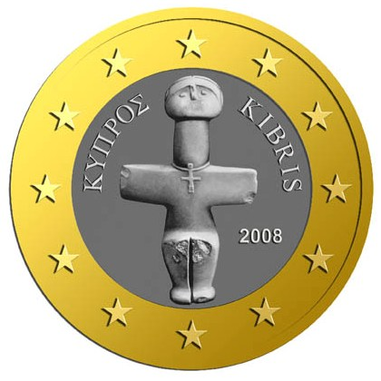 | 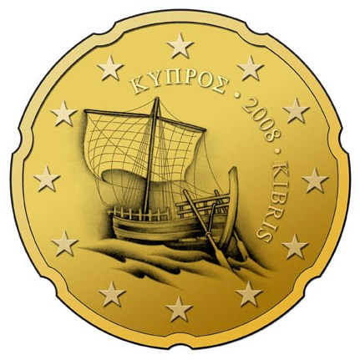 | 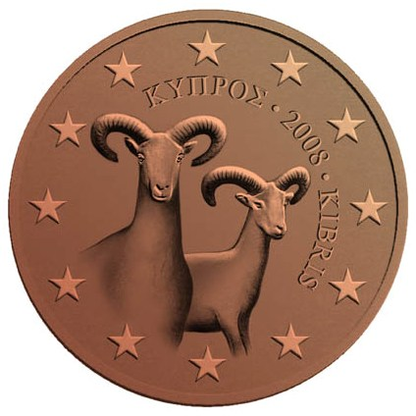
2 euro, 1 euro | 50 cent, 20 cent, 10 cent | 5 cent, 20 cent, 1 cent
Malta
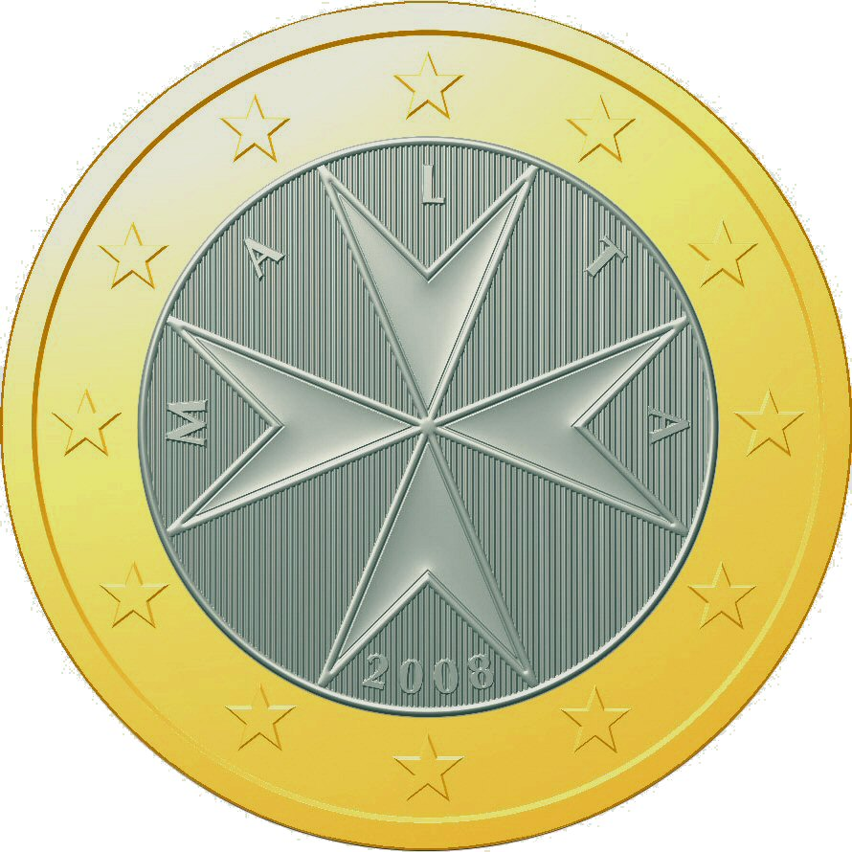 | 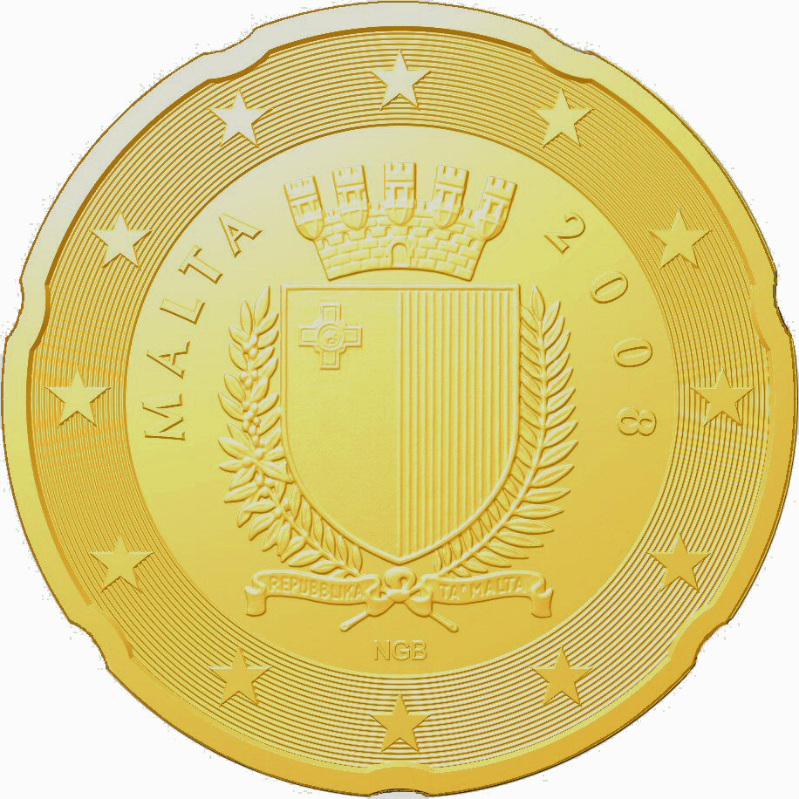 | 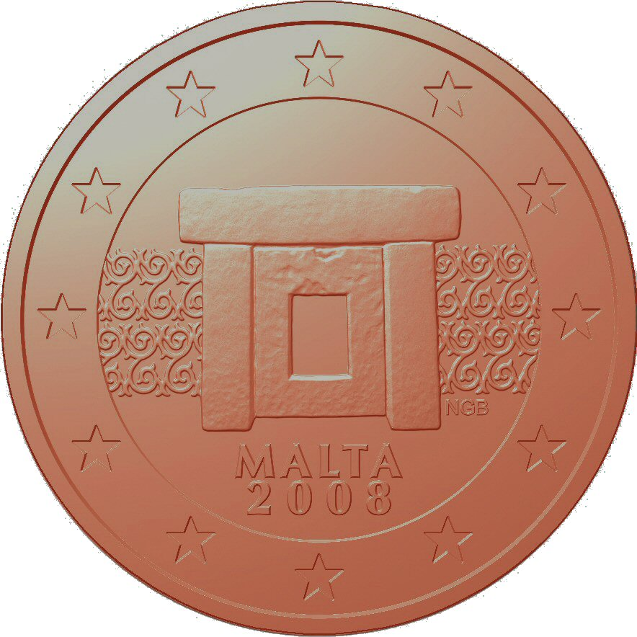
2 euro, 1 euro | 50 cent, 20 cent, 10 cent | 5 cent, 20 cent, 1 cent
Slovakia
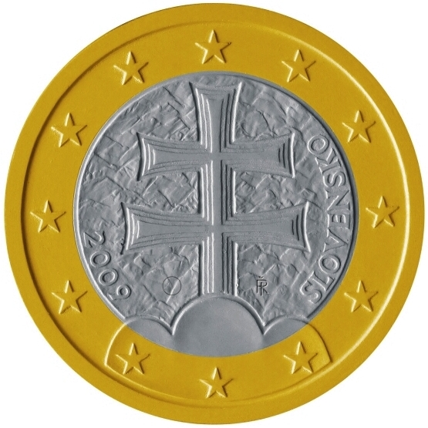 | 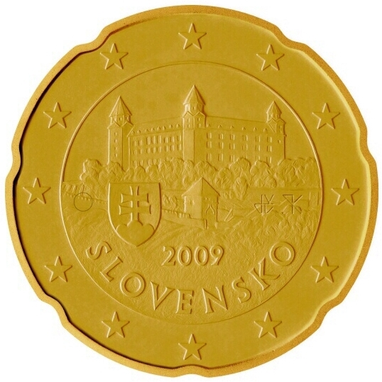 | 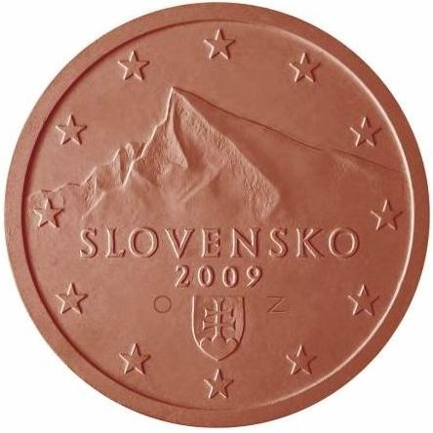
2 euro, 1 euro | 50 cent, 20 cent, 10 cent | 5 cent, 20 cent, 1 cent

ANNEX 4
Information and communication policy at Community level
The European Commission has continued to implement a whole range of communication activities on the euro and EMU in close co-operation with Member States and other Community institutions. In particular it continued to implement partnership agreements with a number of Member States preparing for the introduction of the euro: Slovenia, Estonia, Lithuania, Malta and Cyprus. The partnership agreement with Slovenia was successfully brought to a close following the introduction of the euro on 1 January 2007, and discussions are now at an advanced stage with the Slovak Republic for the conclusion of a new partnership agreement in the second half of the year.
The purpose of the partnership agreements is to provide technical and financial support to the Member States for their national euro communication campaigns. They provide the framework within which the Commission supports various activities developed by the national authorities, such as publications, media campaigns, promotional material, conferences and seminars, competitions, opinion polls, etc. The Commission also concluded grant agreements in June with Malta and Cyprus to co-finance their national communication activities.
The Commission has also, since the beginning of the year, conducted on its own account a number of activities linked to the enlargement of the euro area, such as opinion polls and surveys, conferences, and seminars for journalists both in Brussels and in the Member States. It has also produced brochures, posters, CD-ROMS and promotional material for the general public and a new website dedicated to the euro. Moreover, it has developed a new exhibition on the euro and EMU which will travel to various Member States, starting in Malta in June/July and in Cyprus after the summer break.
Preparing citizens in Cyprus and Malta for the euro introduction has been a priority for the Commission's communication policy in the first half of 2007 and will continue to be so for the remainder of the year.

ANNEX 5
State of public opinion in the recently acceded Member States
The European Commission commissioned a Eurobarometer survey on public opinion in the recently acceded Member States concerning their attitudes towards and knowledge about the introduction of the euro, and Gallup Europe conducted the survey at the end of March 2007. It was the fifth such Eurobarometer survey (following the ones in September 2004 and 2005 as well as in April and September 2006). Slovenia was no longer covered since it adopted the euro on 1 January 2007. Bulgaria and Romania, however, were covered for the first time, having joined the EU on the same date. In total, over 11 000 randomly selected citizens were interviewed.
1. Familiarity with and knowledge about the euro
The March 2007 results broadly confirm the results of the previous surveys as to familiarity and knowledge about the euro. Respondents were relatively familiar with the common currency: 77% had already seen euro banknotes of which some 62% had already used them, and 68% had already seen euro coins of which 60% had used them already. The usage of euro banknotes and coins was as usual particularly high in the Czech Republic, Cyprus and Malta – and also this time in Romania.
In addition to these practical aspects, the survey also tested the respondents' knowledge of the euro's general features. Here the results were mixed. More respondents than in the last survey were aware that the design of banknotes was the same in all countries (50%, up from 45%) but fewer people knew about the partly different designs of euro coins (31%, down from 37% in autumn 2006). The enlargement of the euro area to Slovenia unsurprisingly increased the uncertainty as to how many euro-area Member States there are. Only 28% of the interviewees were able to give the correct answer of 13 countries (down from 40% in autumn 2006) while 25% did not know, up from 17% previously. A relatively stable majority of citizens (64%, previously 67%) in the surveyed countries believed that their country had the option of deciding whether it would adopt the euro or not.
Regarding the expected date of introduction of the euro, the results show a continued shift since 2006, corresponding to actual developments. An overwhelming majority in Cyprus and Malta expect the euro to be adopted in those countries in 2008, which is indeed the official national target date, and a strong majority in Slovakia expect euro adoption in 2009. The absence of national target dates in most other countries results in very diverging expectations among the population, reflecting the high degree of uncertainty.
2. Perceptions of and support for the single European currency
Similarly to previous 2006 findings, citizens in the recently acceded Member States are prepared – at least mentally – to have their currency replaced by the euro: 48% were very or rather happy about a future changeover, which is comparable to April and September 2006. The trends vary strongly from one country to another, with the relative share of citizens happy about the euro changeover increasing in five of the eleven recently acceded Member States compared to the results of the autumn 2006 survey. Most notably, the support increased in Cyprus by 8 percentage points to a support rate of 40% and in Malta by 6 percentage points to a support rate of 54%. The level of support in the other four countries had slightly decreased or remained unchanged from September 2006 (no comparison can be made in the case of Bulgaria and Romania since they were covered here for the first time).

Generally, citizens expect that the euro will be more positive for their country than for themselves as individuals. 53% (up from 50% in autumn 2006) think that it will have a rather or very positive effect for the country. 48% (up from 44%) expect very or rather positive consequences for themselves personally. Only 24% of the respondents would like the euro to become their currency as soon as possible.
3. Expectations and fears regarding the adoption of the euro
The September results broadly confirm previous surveys as regards citizens' expectations of the euro. There is still a broadly shared recognition in the recently acceded Member States of the euro’s status as an international currency and that there are a number of benefits associated with their country's adoption of the euro.
The questionnaire was changed this time to differentiate more clearly between expectations of one-off changeover effects in the short term, and expectations of medium- and long-term effects on prices. Thus, while in the previous survey only 28% believed that the euro would help maintain price stability, this time 55% identified ensuring price stability as one of the main advantages of the euro. On the other hand, the survey sends a clear message about the fears during the changeover period: 75% thought that the euro will increase prices when first introduced.
Regarding the euro's economic or political effects, respondents generally acknowledge that positive effects will appear in the area of public finances (46%, +2). Citizens also seem to be more positive about the impact of the euro on growth and employment: now 43% (+3) think it will improve the situation in this area while 36% (-3) think it will have a negative effect.
4. Information and information channels
The results of the March 2007 survey reveal a slight decrease in the perceived information level on average. 37% of the respondents thought that they were rather or very well informed (40% in autumn 2006) while 61% think they are not (up from 58%). This is due both to Slovenia, which had a very high level of perceived information, no longer being covered by the survey, and a significant fall in the figure for Poland. For all other countries, the perceived information level remained stable or increased. The increase was most conspicuous in Malta (+33) and in Cyprus (+14) where the national information campaigns for euro adoption in 2008 are at full speed or have recently been intensified, though there was also a notable increase in Slovakia. The results suggest that the demand for information, which increases as the adoption date approaches, is still considerable.
As in past surveys, national central banks are the most trusted source of information: an average of 79% (autumn 2006: 77%) thought so. European institutions were again perceived as the second most trusted source (results being slightly higher than in September 2006: 69% relative to 67%). As to which information channels were preferred, most respondents continued to prefer mass media and banks; and, as regards the type of information they were looking for, they were mainly interested in practical information on the introduction of the euro, e.g. the value of the euro (90%), the changeover scenario (87%), practical implications (85%), and how to ensure that conversion rules are respected (83%). The survey confirms once more that that the public consider an essential element in preparing for the changeover to be the dual display of prices, both in shops (83%) and on utility bills (75%).

In their Convergence Reports, the Commission and the ECB examine whether the different countries have met the formal requirements allowing them to adopt the euro. The latest Commission Convergence Reports were adopted on 16 May 2007 at the request of Cyprus (COM(2007) 255) and Malta (COM(2007) 258). The Commission will issue the next regular Convergence Report in 2008.
On the Slovenian changeover, see Communication from the Commission "The introduction of the euro in Slovenia", COM(2007) 233, of 4 May 2007.
It is the fifth report on this subject. See COM(2004) 748 of 10 November 2004; COM(2005) 545 of 4 November 2005; COM(2006) 322 of 22 June 2006; COM(2006) 671 of 10 November 2006.
Based on information collected up to 2 July 2007.
Under the "big bang" scenario, euro banknotes and coins are introduced at the same time as the euro is introduced as the currency of the Member State concerned.
The dual circulation period is the period starting on the day on which euro banknotes and coins are put into circulation (€-day) and during which both the national currency and the euro are legal tender in the Member State concerned.
Frontloading refers to the supply of euro banknotes and coins by the national central bank to credit institutions before the introduction of euro cash. Sub-frontloading means the distribution by credit institutions of frontloaded euro banknotes and coins to retailers and other businesses, and possibly to the public at large, before euro cash is introduced.
Flash Eurobarometer 207, Introduction of the euro in the New Member States. All Eurobarometer surveys on the euro are available at http://ec.europa.eu/public_opinion/euro_en.htm.
Flash Eurobarometer 200. See footnote 8.
See http://www.euro.cy/euro/euro.nsf/dmlbusinesssector_en/dmlbusinesssector_en?OpenDocument.
Issued in January 2007. Available at http://www.doi.gov.mt/EN/legalnotices/2007/default.asp.
See http://www.mfin.gov.mt/page.aspx?site=NECC&page=fair.
See 11.(1)(d) of Legal Notice 4 of 2007 (footnote 11).
See Articles 4 and 5 of Council Regulation (EC) No 1103/97 on certain provisions relating to the introduction of the euro (OJ L 162, 19.6.1997, p. 1), amended by Council Regulation (EC) No 2595/2000 of 27 November 2000 (OJ L 300, 29.11.2000, p. 1).
See http://www.euro.gov.sk/index.php?ID=1434.
Exchange at banks at the conversion rate without service fees.
I.e. debiting of frontloaded euro cash at a date later than the date of delivery of the frontloaded cash.
http://ec.europa.eu/economy_finance/publications/general/general_en.htm
http://ec.europa.eu/economy_finance/euro/our_currency_en.htm
Flash Eurobarometer 207.

