EN
COMMISSION OF THE EUROPEAN COMMUNITIES
Brussels, 27.7.2007
COM(2007) 451 final
2007/0162 (COD)

Proposal for a
DIRECTIVE OF THE EUROPEAN PARLIAMENT AND OF THE COUNCIL
on rear registration plate lamps for motor vehicles and their trailers
(Codified version)
(presented by the Commission)
EXPLANATORY MEMORANDUM
1. In the context of a people’s Europe, the Commission attaches great importance to simplifying and clarifying Community law so as to make it clearer and more accessible to the ordinary citizen, thus giving him new opportunities and the chance to make use of the specific rights it gives him.
This aim cannot be achieved so long as numerous provisions that have been amended several times, often quite substantially, remain scattered, so that they must be sought partly in the original instrument and partly in later amending ones. Considerable research work, comparing many different instruments, is thus needed to identify the current rules.
For this reason a codification of rules that have frequently been amended is also essential if Community law is to be clear and transparent.
2. On 1 April 1987 the Commission therefore decided to instruct its staff that all legislative acts should be codified after no more than ten amendments, stressing that this is a minimum requirement and that departments should endeavour to codify at even shorter intervals the texts for which they are responsible, to ensure that the Community rules are clear and readily understandable.
3. The Conclusions of the Presidency of the Edinburgh European Council (December 1992) confirmed this, stressing the importance of codification as it offers certainty as to the law applicable to a given matter at a given time.
Codification must be undertaken in full compliance with the normal Community legislative procedure.
Given that no changes of substance may be made to the instruments affected by codification, the European Parliament, the Council and the Commission have agreed, by an interinstitutional agreement dated 20 December 1994, that an accelerated procedure may be used for the fast-track adoption of codification instruments.
4. The purpose of this proposal is to undertake a codification of Council Directive 76/760/EEC of 27 July 1976 on the approximation of the laws of the Member States relating to the rear registration plate lamps for motor vehicles and their trailers. The new Directive will supersede the various acts incorporated in it; this proposal fully preserves the content of the acts being codified and hence does no more than bring them together with only such formal amendments as are required by the codification exercise itself.
5. The codification proposal was drawn up on the basis of a preliminary consolidation, in all official languages, of Directive 76/760/EEC and the instruments amending it, carried out by the Office for Official Publications of the European Communities, by means of a data-processing system. Where the Articles have been given new numbers, the correlation between the old and the new numbers is shown in a table contained in Annex IV to the codified Directive.

ê 76/760/EEC (adapted)
2007/0162 (COD)
Proposal for a
DIRECTIVE OF THE EUROPEAN PARLIAMENT AND OF THE COUNCIL
on rear registration plate lamps for motor vehicles and their trailers
(Text with EEA relevance)
THE EUROPEAN PARLIAMENT AND THE COUNCIL OF THE EUROPEAN UNION,
Having regard to the Treaty establishing the European Community, and in particular Article Ö 95 Õ thereof,
Having regard to the proposal from the Commission,
Having regard to the opinion of the European Economic and Social Committee,
Acting in accordance with the procedure laid down in Article 251 of the Treaty,
Whereas:

ê
(1) Council Directive 76/760/EEC of 27 July 1976 on the approximation of the laws of the Member States relating to the rear registration plate lamps for motor vehicles and their trailers has been substantially amended several times. In the interests of clarity and rationality the said Directive should be codified.

ê 97/31/EC Recital 1 (adapted)
(2) Ö Directive 76/760/EEC is one of the separate Directives of the EC type-approval system provided for in Council Directive [70/156/EEC of 6 February 1970 on the approximation of the laws of the Member States relating to the type-approval of motor vehicles and their trailers] and laid down technical prescriptions concerning the rear registration plate lamps. Those technical prescriptions concerned the approximation of the laws of the Member States to allow for the EC type-approval procedure established by Directive [70/156/EEC] to be applied in respect of each type of vehicle. Consequently, the provisions laid down in Directive [70/156/EEC] relating to vehicle systems, components and separate technical units apply to this Directive. Õ

ê 76/760/EEC Recital 4
(3) A harmonised type-approval procedure for rear registration plate lamps makes it possible for each Member State to check compliance with the common construction and testing requirements and to inform the other Member States of its findings by sending a copy of the component type-approval certificate completed for each type of rear registration plate lamp. The placing of an EC component type-approval mark on all rear registration plate lamps manufactured in conformity with the approved type obviates any need for technical checks on these rear registration plate lamps in the other Member States.

ê 76/760/EEC Recital 5 (adapted)
(4) Ö It is desirable to take into account the technical requirements adopted by the UN Economic Commission for Europe (UN/ECE) in its corresponding Regulation annexed to the Agreement of the United Nations Economic Commission for Europe concerning the adoption of uniform technical prescriptions for wheeled vehicles, equipment and parts which can be fitted and/or be used on wheeled vehicles and the conditions for reciprocal recognition of approvals granted on the basis of these prescriptions (Revised 1958 Agreement). Õ

ê 76/760/EEC Recital 6 (adapted)
(5) Ö The EC type approval procedure should entail reciprocal recognition by Member States of the checks carried out by each of them on the basis of the common requirements. Õ

ê
(6) This Directive should be without prejudice to the obligations of the Member States relating to the time-limits for transposition into national law and application of the Directives set out in Annex III, Part B,

ê 76/760/EEC
HAVE ADOPTED THIS DIRECTIVE:
Article 1

ê 97/31/EC Art. 1 pt. 4 (adapted)
For the purposes of this Directive, “vehicle” means any motor vehicle intended for use on the road, with or without bodywork, having at least four wheels and a maximum design speed exceeding 25 km/h, and its trailers, with the exception of vehicles which run on rails and of agricultural and forestry tractors and all mobile machinery.

ê 76/760/EEC
Article 2

ê 97/31/EC Art. 1 pt. 1 (adapted)
1. Each Member State shall grant EC component type-approval in respect of any type of rear registration plate lamp which satisfies the construction and testing requirements laid down in Annexes Ö I and II Õ .

ê 76/760/EEC
2. The Member State which has granted EC component type-approval shall take the measures required in order to verify that production models conform to the approved type, in so far as this is necessary and if need be in cooperation with the competent authorities in the other Member States. Such verification shall be limited to spot checks.
Article 3

ê 97/31/EC Art. 1 pt. 2 (adapted)
1. Member States shall for each type of rear registration plate lamp which they approve pursuant to Article 2 , issue to the manufacturer an EC component type-approval mark conforming to the model shown in Annex Ö I Õ, Appendix 3.

ê 76/760/EEC
2. Member States shall take all appropriate measures to prevent the use of marks liable to create confusion between rear registration plate lamps which have been type-approved pursuant to Article 2 , and other devices.

ê 76/760/EEC (adapted)
Article 4
1. No Member State may prohibit the placing on the market of rear registration plate lamps on grounds relating to their construction or method of functioning if they bear the EC component type-approval mark.
2. A Member State may prohibit the placing on the market of rear registration plate lamps bearing the EC component type-approval mark which consistently fail to conform to the approved type.
That Member State shall forthwith inform the other Member States and the Commission of the measures taken, specifying the reasons for its decision.

ê 97/31/EC Art. 1 pt. 3
Article 5
The competent authorities of the Member States shall inform each other, by means of the procedure specified in Article [4(6)] of Directive [70/156/EEC], of each approval which they have granted, refused or withdrawn pursuant to this Directive.

ê 76/760/EEC (adapted)
Article 6
1. If the Member State which has granted EC component type-approval finds that a number of rear registration plate lamps bearing the same EC component type-approval mark do not conform to the type which it has approved, it shall take the necessary measures to ensure that production models conform to the approved type.
The competent authorities of that Member State shall advise those of the other Member States of the measures taken, which may, where there is consistent failure to conform, extend to withdrawal of EC component type-approval. Those authorities shall take the same measures if they are informed by the competent authorities of another Member State of such failure to conform.
2. The competent authorities of the Member States shall within one month inform each other of any withdrawal of EC component type-approval, and of the reasons for such a measure.
Article 7
Any decision taken pursuant to the provisions adopted in implementation of this Directive to refuse or withdraw EC type-approval for a rear registration plate lamp or prohibit its placing on the market or use shall set out in detail the reasons on which it is based.
Such decisions shall be notified to the party concerned, who shall at the same time be informed of the remedies available to him under the laws in force in the Member States and of the time-limits allowed for the exercise of such remedies.
Article 8
No Member State may refuse to grant EC type-approval or national type-approval of any vehicle on grounds relating to its rear registration plate lamps if these bear the EC component type-approval mark and are fitted in accordance with the requirements laid down in Directive [76/756/EEC].
Article 9
No Member State may refuse or prohibit the sale or registration, entry into service or use of any vehicle on grounds relating to its rear registration plate lamps if these bear the EC component type-approval mark and are fitted in accordance with the requirements laid down in Directive [76/756/EEC].
Article 10
Ö The Õ amendments necessary to Ö adapt Õ the requirements of Annexes Ö I and II to this Directive Õ to take account of technical progress shall be adopted in accordance with the procedure Ö referred to Õ in Article [13(3)] of Directive [70/156/EEC].
Article 11
Member States shall Ö communicate to Õ the Commission Ö the texts of the main provisions of national law which they adopt in the field covered by this Directive Õ .

ê
Article 12
Directive 76/760/EEC, as amended by the acts listed in Annex III, Part A, is repealed, without prejudice to the obligations of the Member States relating to the time-limits for transposition into national law and application of the Directives set out in Annex III, Part B.
References to the repealed Directive shall be construed as references to this Directive and shall be read in accordance with the correlation table set out in Annex IV.
Article 13
This Directive shall enter into force on the twentieth day following that of its publication in the Official Journal of the European Union.
It shall apply from […]

ê 76/760/EEC Art. 12
Article 14
This Directive is addressed to the Member States.
Done at Brussels, […]
For the European Parliament For the Council
The President The President
[…] […]

ê 97/31/EC Art. 1 pt. 5 (adapted)
LIST OF ANNEXES
ANNEX I: | Administrative provisions for EC type approval
ANNEX I: | Appendix 1: | Information document
ANNEX I: | Appendix 2: | Model: EC Type-approval certificate
ANNEX I: | Appendix 3: | Examples of the EC component type-approval mark
ANNEX II: | Scope and technical requirements
Ö ANNEX III: Õ | Ö Part A: Repealed Directive with list of its successive amendments  Part B: List of time-limits for transposition into national law and application Õ
Ö ANNEX IV: Õ | Ö Correlation table Õ

ê 97/31/EC Art. 1 pt. 5
ANNEX I
ADMINISTRATIVE PROVISIONS FOR EC TYPE APPROVAL

1. APPLICATION FOR EC COMPONENT TYPE-APPROVAL
1.1. The application for EC component type-approval pursuant to Article [3(4)] of Directive [70/156/EEC] of a type of rear registration plate lamp shall be submitted by the manufacturer.
1.2. A model for the information document is given in Appendix 1.
1.3. The following must be submitted to the technical service responsible for conducting the type-approval tests:
1.3.1. two samples, equipped with the lamp or lamps recommended.

2. MARKINGS
2.1. The devices submitted for EC component type-approval must bear:
2.1.1. the trade name or mark of the manufacturer;
2.1.2. in the case of lamps with replaceable light sources: the type(s) of filament lamp prescribed;
2.1.3. in the case of lamps with non-replaceable light sources: the nominal voltage and wattage.
2.2. These markings shall be clearly legible and indelible and shall be affixed to the illuminating surface, or to one of the illuminating surfaces, of the device. They shall be visible from the exterior when the device is fitted to the vehicle.
2.3. Each device shall have sufficient space for the component type-approval mark. This space shall be indicated on the drawings referred to in Appendix 1.

3. GRANTING OF EC COMPONENT TYPE-APPROVAL
3.1. If the relevant requirements are satisfied, EC type-approval pursuant to Article [4(3)] and, if applicable, [4(4)] of Directive [70/156/EEC] shall be granted.
3.2. A model for the EC type-approval certificate is given in Appendix 2.
3.3. An approval number in accordance with Annex [VII] to Directive [70/156/EEC] shall be assigned to each type of rear registration plate lamp approved. The same Member State shall not assign the same number to another type of rear registration plate lamp.
3.4. Where EC component type approval is requested for a type of lighting and light-signalling device comprising a rear registration plate lamp and other lamps, a single EC component type-approval number may be assigned provided that the rear registration plate lamp complies with the requirements of this Directive and that each of the other lamps forming part of the lighting and light-signalling device for which EC component type approval is requested complies with the separate Directive applying to it.

ê 97/31/EC Art. 1 pt. 5 (adapted)

4. EC COMPONENT TYPE-APPROVAL MARK
4.1. In addition to the markings referred to in point 2.1, every rear registration plate lamp conforming to the type approved pursuant to this Directive shall bear an EC component type-approval mark.
4.2. This mark shall consist of:
4.2.1. a rectangle surrounding the letter “e” followed by the distinguishing number of the Member State which has granted type approval:
1 for Germany
2 for France
3 for Italy
4 for the Netherlands
5 for Sweden
6 for Belgium

ê 2003 Act of Accession Art. 20 and Annex II, p. 53
7 for Hungary
8 for the Czech Republic

ê 97/31/EC Art. 1 pt. 5
9 for Spain
11 for the United Kingdom
12 for Austria
13 for Luxembourg
17 for Finland
18 for Denmark

ê 2006/96/EC Art. 1 and Annex pt. A.17.
19 for Romania

ê 2003 Act of Accession Art. 20 and Annex II, p. 53
20 for Poland

ê 97/31/EC Art. 1 pt. 5
21 for Portugal
23 for Greece
24 for Ireland

ê 2003 Act of Accession Art. 20 and Annex II, p. 53
26 for Slovenia
27 for Slovakia
29 for Estonia
32 for Latvia

ê 2006/96/EC Art. 1 and Annex pt. A.17.
34 for Bulgaria

ê 2003 Act of Accession Art. 20 and Annex II, p. 53
36 for Lithuania
49 for Cyprus
50 for Malta;

ê 97/31/EC Art. 1 pt. 5 (adapted)
4.2.2. in the vicinity of the rectangle the “base approval number” contained in section 4 of the type-approval number referred to in Annex [VII] of Directive [70/156/EEC], preceded by the two figures indicating the sequence number assigned to the most recent major technical amendment to this Directive on the date EC type approval was granted. In this Directive the sequence number is 00;
4.2.3. an additional symbol as follows: the letter “L”.
4.3. The EC component type-approval mark shall be affixed to the lens of the lamp or one of the lenses in such a way as to be indelible and clearly legible even when the lamps are fitted to the vehicle.
4.4. Examples of the EC component type-approval mark are given in Appendix 3, Figure 1.
4.5. Where a single EC component type-approval number is issued, as per point 3.4, for a type of lighting and light-signalling device comprising a rear registration plate lamp and other lamps, a single EC component type-approval mark may be affixed, consisting of:
4.5.1. a rectangle surrounding the letter “e” followed by the distinguishing number of the Member State which has granted type approval (see point 4.2.1);
4.5.2. the base approval number (see point 4.2.2, first half-sentence);
4.5.3. if necessary, the required arrow, in so far as it relates to the lamp assembly as a whole.
4.6. This mark may be located anywhere on the lamps which are grouped, combined or reciprocally incorporated, provided that:
4.6.1. it is visible after the installation of the lamps;
4.6.2. no light-transmitting components of the grouped, combined or reciprocally incorporated lamps can be removed without simultaneously removing the approval mark.
4.7. The identification symbol for each lamp corresponding to each Directive pursuant to which EC component type approval was granted, together with the sequence number (see point 4.2.2, second half-sentence) and, where necessary, the letter “D” and the required arrow shall be marked:
4.7.1. either on the appropriate light-emitting surface;
4.7.2. or in a group, in such a way that each of the grouped, combined or reciprocally incorporated lamps may be clearly identified.
4.8. The dimensions of the components of this mark must not be less than the minimum dimensions specified for individual marks by the various Directives pursuant to which EC component type approval was granted.
4.9. Examples of an EC component type-approval mark for a lamp that is grouped, combined or reciprocally incorporated with other lamps are given in Appendix 3, Figure 2.

ê 97/31/EC Art. 1 pt. 5

5. MODIFICATIONS OF THE TYPE AND AMENDMENTS TO APPROVALS
5.1. In the case of modifications of the type approved pursuant to this Directive, the provisions of Article [5] of Directive [70/156/EEC] shall apply.

6. CONFORMITY OF PRODUCTION
6.1. As a general rule, measures to ensure the conformity of production shall be taken in accordance with the provisions laid down in Article [10] of Directive [70/156/EEC].
6.2. The luminance B of any device picked at random from a mass produced batch shall not be lower than 2 cd/m² and, in the formula for the gradient, the factor 2 may be replaced by 3 (see paragraph 9 of the documents referred to in point 2.1 of Annex II to this Directive).

ê 97/31/EC Art. 1 pt. 5 (adapted)
Appendix 1
Information document No …
relating to the EC component type approval of rear registration plate lamps
(Directive [76/760/EEC])
The following information, if applicable, must be supplied in triplicate and include a list of contents. Any drawings must be supplied in appropriate scale and in sufficient detail on size A4 on a folder of A4 format. Photographs, if any, must show sufficient detail.
If the systems, components or separate technical units have electronic controls, information concerning their performance must be supplied.
0. GENERAL
0.1. Make (trade name of manufacturer): …………………………………………….
0.2. Type and general commercial description(s): …………………………………….
0.5. Name and address of manufacturer: ……………………………………………..
0.7. In the case of components and separate technical units, location and method of affixing of the EC Ö type Õ - approval mark: ……………………………..
0.8. Address(es) of assembly plant(s): ………………………………………………..
1. DESCRIPTION OF THE DEVICE
1.1. Type of device: ………………………………………………………………….
1.1.1. Device function(s): ………………………………………………………………
1.1.2. Category or class of device: ……………………………………………………..
1.1.3. Colour of the light emitted or reflected: …………………………………………..
1.2. Drawing(s) in sufficient detail to permit identification of the type of the device and showing ………………………………………………………………………….
1.2.1. in what geometrical position the device is to be mounted on the vehicle (not applicable to rear registration plate lamps): ………………………………………
1.2.2. the axis of observation to be taken as the axis of reference in the tests (horizontal angle H = 0°, vertical angle V = 0°) and the point to be taken as the centre of reference in the said tests (not applicable to retro-reflecting devices and rear registration plate lamps): …………………………………………………………
1.2.3. the position intended for the EC component type-approval mark: …………………
1.2.4. for rear registration plate lamps, the geometrical position in which the device is to be fitted in relation to the space to be occupied by the registration plate, and the outline of the area adequately illuminated: ………………………………………………….
1.2.5. for headlamps and front fog lamps, a frontal view of the lamps with details of lens ribbing, if any, and the cross section: ………………………………………………..
1.3. A brief technical description stating, in particular, with the exception of lamps with non-replaceable light sources, the category or categories of light sources prescribed which shall be one or more of those contained in Directive [76/761/EEC] (not applicable to retro-reflecting devices): ………………………………………………..
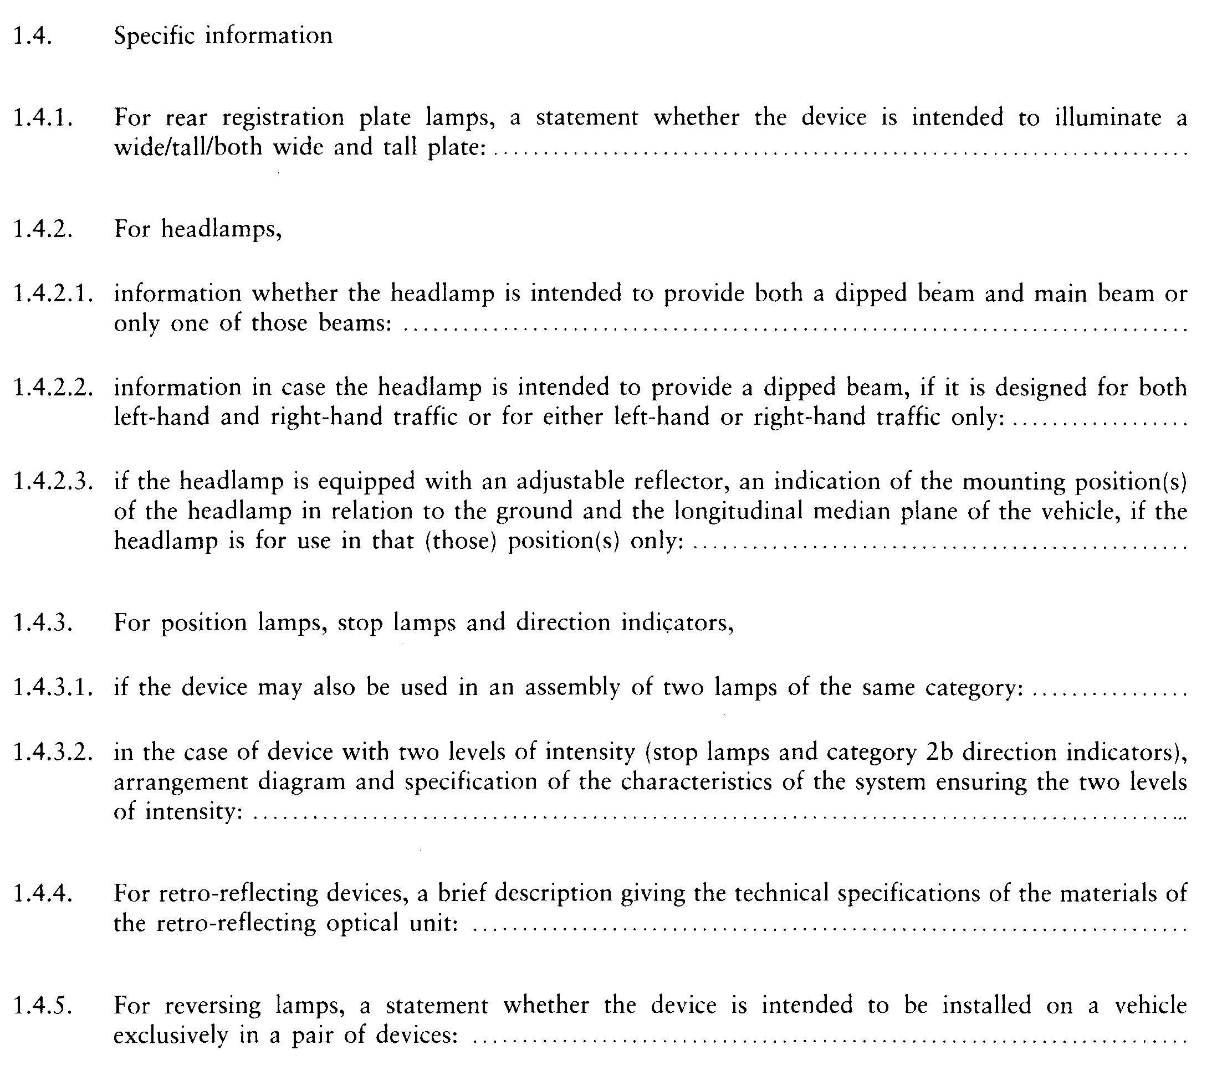
Appendix 2
MODEL
(maximum format: A4 (210 × 297 mm))
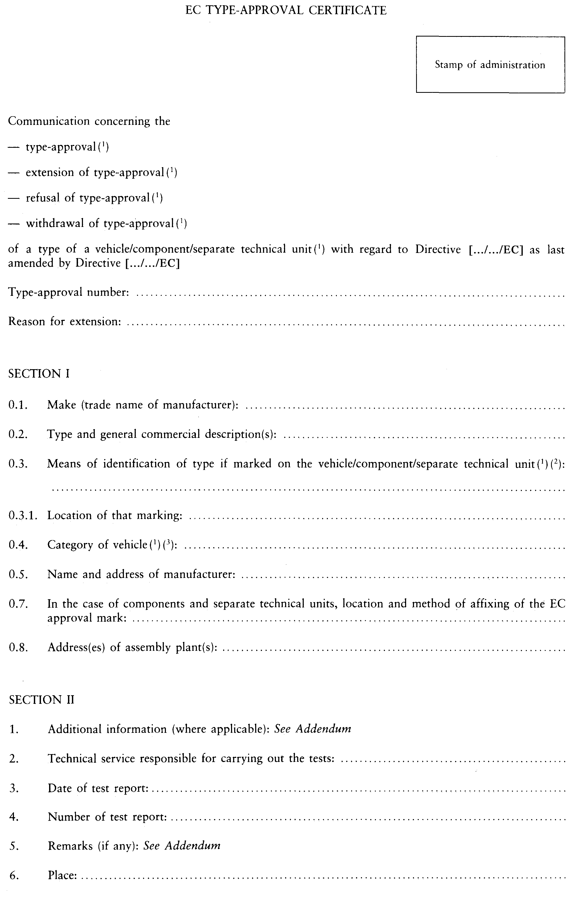
7. Date: ……………………………………………………………………………
8. Signature: ……………………………………………………………………….
9. The index to the information package lodged with the approval authority, which may be obtained on request, is attached.
_________
⁽¹⁾ Delete where not applicable.
⁽²⁾ If the means of identification of type contains characters not relevant to describe the vehicle, component or separate technical unit types covered by this type-approval certificate such characters shall be represented in the documentation by the symbol: “?” (e.g. ABC??123??).
⁽³⁾ As defined in Annex IIA to Directive [70/156/EEC].
Addendum to EC type-approval certificate No …
concerning the component type-approval of a lighting and/or light-signalling device with regard to Directive(s) [76/757/EEC]; [76/758/EEC]; [76/760/EEC]; [76/761/EEC]; [76/762/EEC]; [77/538/EEC]; [77/539/EEC] and [77/540/EEC]^{(*)} as last amended by Directive(s) …
1. Additional information
1.1. Where applicable, indicate each lamp
1.1.1. The category(ies) of the device(s): ………………………………………………
1.1.2. The number and category of light sources (not applicable to retro reflector^{(**)}: ……………………………………………………………………………..
1.1.3. The colour of the light emitted or reflected: …………………………………….
1.1.4. Approval granted solely for use as a replacement part on vehicles already in service: Yes/No^{(*)}
1.2. Specific information for certain types of lighting or light-signalling devices
1.2.1. For retro-reflecting devices: In isolation/part of an assembly of devices^{(*)}
1.2.2. For rear registration plate lamps: Device for illuminating a tall plate/a wide plate^{(*)}
1.2.3. For headlamps: If equipped with an adjustable reflector, the mounting position(s) of the headlamp in relation to the ground and the longitudinal median plane of the vehicle, if the headlamp is for use in that (those) position(s) only: …………………………………………………………………………………………
1.2.4. For reversing lamps: This device shall be installed on a vehicle only as part of a pair of devices: Yes/No^{(*)}
5. Remarks
5.1. Drawings
5.1.1. For rear registration plate lamps: the attached drawing No … shows the geometric position in which the device is to be fitted in relation to the space to be occupied by the registration plate, and the outline area adequately illuminated;
5.1.2. For retro-reflecting devices: the attached drawing No … shows the geometric position in which the device is to be fitted to the vehicle;
5.1.3. For all other lighting and light-signalling devices: the attached drawing No … shows the geometric position in which the device is to be fitted to the vehicle, and the axis of reference and centre of reference of the device.
5.2. For headlamps: Operating mode used during the test (Ö point Õ 5.2.3.9 of Annex I to Directive [76/761/EEC]): …………………………………………………
^{(*)} Delete where not applicable
^{(**)} For lamps with non-replaceable light sources, indicate the number and the total wattage of the light sources.

ê 97/31/EC Art. 1 pt. 5 (adapted)
Appendix 3
EXAMPLES OF THE EC COMPONENT TYPE-APPROVAL MARK
Figure 1
The device bearing the EC component type-approval mark shown above is a rear registration plate lamp, type approved in Germany (e1) pursuant to this Directive (Ö sequence No Õ00) under the base approval number 1471.
Figure 2
Simplified marking of grouped, combined or reciprocally incorporated lamps when two or more lamps are part of the same assembly
(The vertical and horizontal lines schematize the shape of the light-signalling device. These are not part of the approval mark).
MODEL A
MODEL B
MODEL C
Note: The three examples of approval marks, models A, B and C, represent three possible variants of the marking of a lighting and light-signalling device when two or more lamps are part of the same unit of grouped, combined or reciprocally incorporated lamps. Ö These approval marks show Õ that the device was approved in Germany (e1) under the base approval number 1712 and comprises:
- a retro reflector of class IA approved in accordance with [Council] Directive [76/757/EEC] , sequence No 02,
- a rear direction indicator of category 2a approved in accordance with [Council] Directive [76/759/EEC] , sequence No 01,
- a red rear position lamp (R) approved in accordance with Annex [II] to [Council] Directive [76/758/EEC] , sequence No 02,
- a rear fog lamp (F) approved in accordance with [Council] Directive [77/538/EC] , sequence No 00,
- a reversing lamp (AR) approved in accordance with [Council] Directive [77/539/EEC] , sequence No 00,
- a stop lamp with two levels of intensity (S2) approved in accordance with Annex [II] to Directive [76/758/EEC] sequence No 02,
- a rear registration plate lamp (L) approved in accordance with this Directive , sequence No 00.
____________

ê 97/31/EC Art. 1 pt. 5
ANNEX II
SCOPE AND TECHNICAL REQUIREMENTS

1. SCOPE
This Directive applies to rear registration plate lamps for motor vehicles and their trailers.

2. TECHNICAL REQUIREMENTS

ê 97/31/EC Art. 1 pt. 5 (adapted)
2.1. The technical requirements are those set out in paragraphs 1 and 5 to 9 and Annexes 3 to 5 of UN-ECE Regulation No 4 Ö Õ which consists of a consolidation of the following documents:

ê 97/31/EC Art. 1 pt. 5
- the Regulation in its original form (00),
- the Supplement 1 to Regulation No 4,
- the Supplement 2 to Regulation No 4,
- the Supplements 3 and 4 to Regulation No 4,
- the Supplement 5 to Regulation No 4,
except that:

ê 97/31/EC Art. 1 pt. 5 (adapted)
2.1.1. Where reference is made to “Regulation No 48”, this shall be understood as “Directive [76/756/EC]”.
2.1.2. Where reference is made to “Regulation No 37”, this shall be understood as “Annex [VII] to Directive [76/761/EEC] ”.
____________

é
ANNEX III
Part A
Repealed Directive with list of its successive amendments
(referred to in Article 12)
Council Directive 76/760/EEC
(OJ L 262, 27.9.1976, p. 85)
Point X.9. of Annex I to the 1979 Act of Accession
(OJ L 291, 19.11.1979, p. 109)
Point IX.13(d) of Annex I to the 1985 Act of Accession
(OJ L 302, 15.11.1985, p. 213)
 | Council Directive 87/354/EEC  (OJ L 192, 11.7.1987, p. 43) |  | Only point 7(d) of the Annex concerning Directive 76/760/EEC
Point XI.C.I.10 of Annex I to the 1994 Act of Accession
(OJ C 241, 29.8.1994, p. 205)
Commission Directive 97/31/EC
(OJ L 171, 30.6.1997, p. 49)
Point I.A.18 of Annex II to the 2003 Act of Accession
(OJ L 236, 23.9.2003, p. 58)
 | Council Directive 2006/96/EC  (OJ L 363, 20.12.2006, p. 81) |  | Only as regards the reference to Directive 76/760/EEC in Article 1 and Annex, point A.17.
Part B
List of time-limits for transposition into national law and application
(referred to in Article 12)
Directive | Time-limit for transposition | Date of application
76/760/EEC | 30 June 1977 | 1 October 1977
87/354/EEC | 31 December 1987 | -
97/31/EC | 1 January 1998^{(*)} | 1 January 1998
2006/96/EC | 1 January 2007 | —
(*) In accordance with Article 2 of Directive 97/31/EC:
“1. From 1 January 1998, or, if the publication of the texts referred to in Article 3 is delayed beyond 1 July 1997, six months after the actual date of publication of these texts, Member States may not, on grounds relating to rear registration plate lamps:
- refuse, in respect of a type of vehicle or a type of lamp mentioned above, to grant EC type-approval or national type-approval, or
- prohibit the registration, sale or entry into service of vehicles, or the sale or entry into service of rear registration plate lamps,
provided that the lamps comply with the requirements of Directive 76/760/EEC, as amended by this Directive, and that, as far as vehicles are concerned, they are installed in accordance with the requirements laid down in Directive 76/756/EEC.
2. From 1 October 1998 Member States:
- shall no longer grant EC type-approval, and
- may refuse to grant national type-approval
for any type of vehicle on grounds relating to rear registration plate lamps, and for any type of rear registration plate lamp, if the requirements of Directive 76/760/EEC, as amended by this Directive, are not fulfilled.
3. From 1 October 1999 the requirements of Directive 76/760/EEC relating to rear registration plate lamps as components, as amended by this Directive, shall be applicable for the purposes of Article 7(2) of Directive 70/156/EEC.
4. Notwithstanding paragraphs 2 and 3 above, for the purposes of replacement parts Member States shall continue to grant EC type-approval of rear registration plate lamps, and to permit their sale and entry into service, in accordance with previous versions of Directive 76/760/EEC provided that such lamps
- are intended to be fitted to vehicles already in use, and
- comply with the requirements of that Directive which were applicable when the vehicles were first registered.”
ANNEX IV

Correlation Table
Directive 76/760/EEC | This Directive
Article 1  Article 2 first paragraph  Article 2 second paragraph  Articles 3 and 4  Article 5(1) first sentence  Article 5(1) second and third sentence  Article 5(2)  Article 6, first sentence  Article 6, second sentence  Articles 7 and 8  Article 9  Article 10  Article 11(1)  Article 11(2)  - | Article 2  Article 3(1)  Article 3(2)  Articles 4 and 5  Article 6(1) first subparagraph  Article 6(1) second subparagraph  Article 6(2)  Article 7, first paragraph  Article 7, second paragraph  Articles 8 and 9  Article 1  Article 10  -  Article 11  Articles 12 and 13
Article 12 | Article 14
Annexes I – II | Annexes I – II
– | Annex III
– | Annex IV
_______________

COM(87) 868 PV.
See Annex 3 to Part A of the Conclusions.
Carried out pursuant to the Communication from the Commission to the European Parliament and the Council – Codification of the Acquis communautaire, COM(2001) 645 final.
See Annex III, Part A of this proposal.
OJ C […],[…],p. […].
OJ C […],[…],p. […].
OJ L 262, 27.9.1976, p. 85. Directive as last amended by Directive 2006/96/EC (OJ L 363, 20.12.2006, p. 81).
See Annex III, Part A.
[OJ L 42, 23.2.1970, p. 1. Directive as last amended by Directive 2006/96/EC.]
Published as Annex I to Council Decision 97/836/EC (OJ L 346, 17.12.1997, p. 78).
[OJ L […], […], p. […].]
[OJ L […], […], p. […].]
[OJ L […],[ …], p. […].]
[OJ L […], […], p. […].]
[OJ L […], […], p. […].]
[OJ L […], […], p. […].]
OJ L 203, 30.7.1997, p. 74.
E/ECE/324 Add. 3. E/ECE/TRANS/505
E/ECE/324 Add. 3/Amend. 1 and …/Amend. 1/Corr. 1. E/ECE/TRANS/505
E/ECE/324 Add. 3/Amend. 2 and …/Amend. 1/Corr. 1. E/ECE/TRANS/505
E/ECE/324 Add. 3/Amend. 3. E/ECE/TRANS/505
TRANS/WP.29/447.
[OJ L […],[…],p. […].]
See Articles 3 and 4(1) of Directive 97/31/EC. The time-limit for transposition was 6 months after the date of publication of UN/ECE Regulation No 4 (OJ L 203, 30.7.1997, p. 74).
See Articles 3 and 4(1) of Directive 97/31/EC. The time-limit for application was 6 months after the date of publication of UN/ECE Regulation No 4 (OJ L 203, 30.7.1997, p. 74).

