EN
COMMISSION OF THE EUROPEAN COMMUNITIES
Brussels, 18.10.2007
COM(2007) 608 final

COMMUNICATION FROM THE COMMISSION TO THE COUNCIL AND THE EUROPEAN PARLIAMENT
Towards a rail network giving priority to freight
{SEC(2007) 1322}
{SEC(2007) 1324}
{SEC(2007) 1325}
COMMUNICATION FROM THE COMMISSION TO THE COUNCIL AND THE EUROPEAN PARLIAMENT
Towards a rail network giving priority to freight

1. Background

1.1 A small share of the market but opportunities for rail freight
Between 1995 and 2005 freight transport performance grew by 2.8% per annum, outstripping GDP growth over the same period. Transport technology (infrastructure and vehicles) evolved considerably, as did the approach of the consigners, who became increasingly demanding with regard to the carriers. Rail freight’s market share steadily declined, levelling off at around 10% in 2005, its lowest level since 1945 (see Annex I).
Rail freight is at present encountering a number of difficulties which can be partly explained by its inability to increase its market share. They mainly concern its reliability, the capacities available, information management, average speed and flexibility.
Nevertheless, new opportunities do seem to be presenting themselves. Rail freight, which has now been opened up to competition, is becoming revitalised in some Member States, as a result in particular of the increase in trade, road congestion, the high price of oil and growing concerns about environmental conservation. Container transport and long-haul journeys, segments where the railways have genuine advantages, are continuing to expand (see Annexes I and II).

1.2 Action already undertaken by the European Community
The European Community has, over the last 15 years or so, been engaged in a policy aimed at revitalising the rail sector on the basis of a three-fold approach:
- A freight market on a European scale was established by means of the first and second railway packages. The gradual opening–up of the rail freight market, which became complete in January 2007, was accompanied by the restructuring of the incumbent undertakings. Rail freight costs fell by 2% per annum between 2001 and 2004, while rail transport tariffs fell by 3% per annum over the same period.
- The development of technical interoperability and common safety rules. The recent initiatives concerning the European train driver's licence and the proposal submitted by the Commission towards the end of 2006 on the cross-acceptance of rolling stock come under this heading.
- The identification of a rail network in the context of the trans-European transport network (TEN-T). Financial support has been granted to many rail projects via the TEN-T funds. In the context of the TEN-T programme, the Commission has also launched and encouraged the development of ERTMS (European rail traffic management system), a common control, command and signalling system designed to replace the existing national systems. The Community also provides considerable financial support for the rail sector through its cohesion policy.
These initiatives have not yet produced the results that were hoped for. The Member States need to complete the implementation of European rail legislation. Progress towards interoperability is slow, and the difficulties at the borders remain. Consequently, some major problems concerning the quality of rail freight also persist. For example, according to the UIRR, only 53% of rail-road intermodal transport trains arrived on time in 2006.
Overall, an analysis of the results of Community action indicates more favourable results at national level than at transnational level. EU initiatives have not yet made it possible to reduce the fragmentation of the European rail market sufficiently.

1.3 Common transport policy guidelines
In pursuit of the objective of a modal shift from road to rail, the White Paper on European transport policy for 2010 envisaged the creation of “multimodal corridors giving priority to freight”. The 2006 review of the White Paper stressed the EU’s objective of developing co-modality, i.e. “the efficient use of different modes on their own and in combination” and takes up the idea of promoting a “rail freight network” (see Annex III).
The need for measures to encourage the emergence of a rail network giving priority to freight was also indicated in the Commission’s June 2006 communication “Freight transport logistics in Europe, the key to sustainable mobility”. The establishment of such a network is also part of the process of bringing about a single market, as envisaged in the Treaty and the economic growth and employment objectives set out in the Lisbon Agenda. It will also contribute to the sustainable development policy being pursued by the European authorities.

2. The objectives and options for a rail network giving priority to freight

2.1 The aim of this communication: to create a strong European rail network, part of the TEN-T on which freight transport will be more reliable and efficient
As road transport steadily becomes more efficient, rail transport has to become more competitive, especially as regards quality. For logistics customers, quality means in particular competitive journey times, reliability of goods transport and capacity adapted to needs. Several factors need to come together to reach this objective, including an approach integrating operational procedures and coordinated processes throughout the European Union. Infrastructure availability is another factor.
The aim of this communication is to promote the creation of a strong European rail network which will offer a better quality of service in freight transport than today in terms of journey times, reliability and capacity. Improving service throughout this network should have a positive impact on all segments of the freight market, including that of the single wagonload. This objective ties in with the Commission's initiatives to improve the quality of freight transport in Europe. After the rejection of the proposal for a Regulation which it had made in the framework of the third railway package, the Commission undertook to keep a close watch on progress in this area and to propose possible new measures to support and encourage the sector's efforts.
It is possible to form a picture of how this network might become by looking at the existing trans-European networks, including the freight network described in Directive 2001/12/EC and the corridors identified as having priority for the deployment of ERTMS or defined in the framework of European research projects (Eufranet, Trend, Reorient and New Opera). The following map gives a first indication of the corridors which could be included in the network.
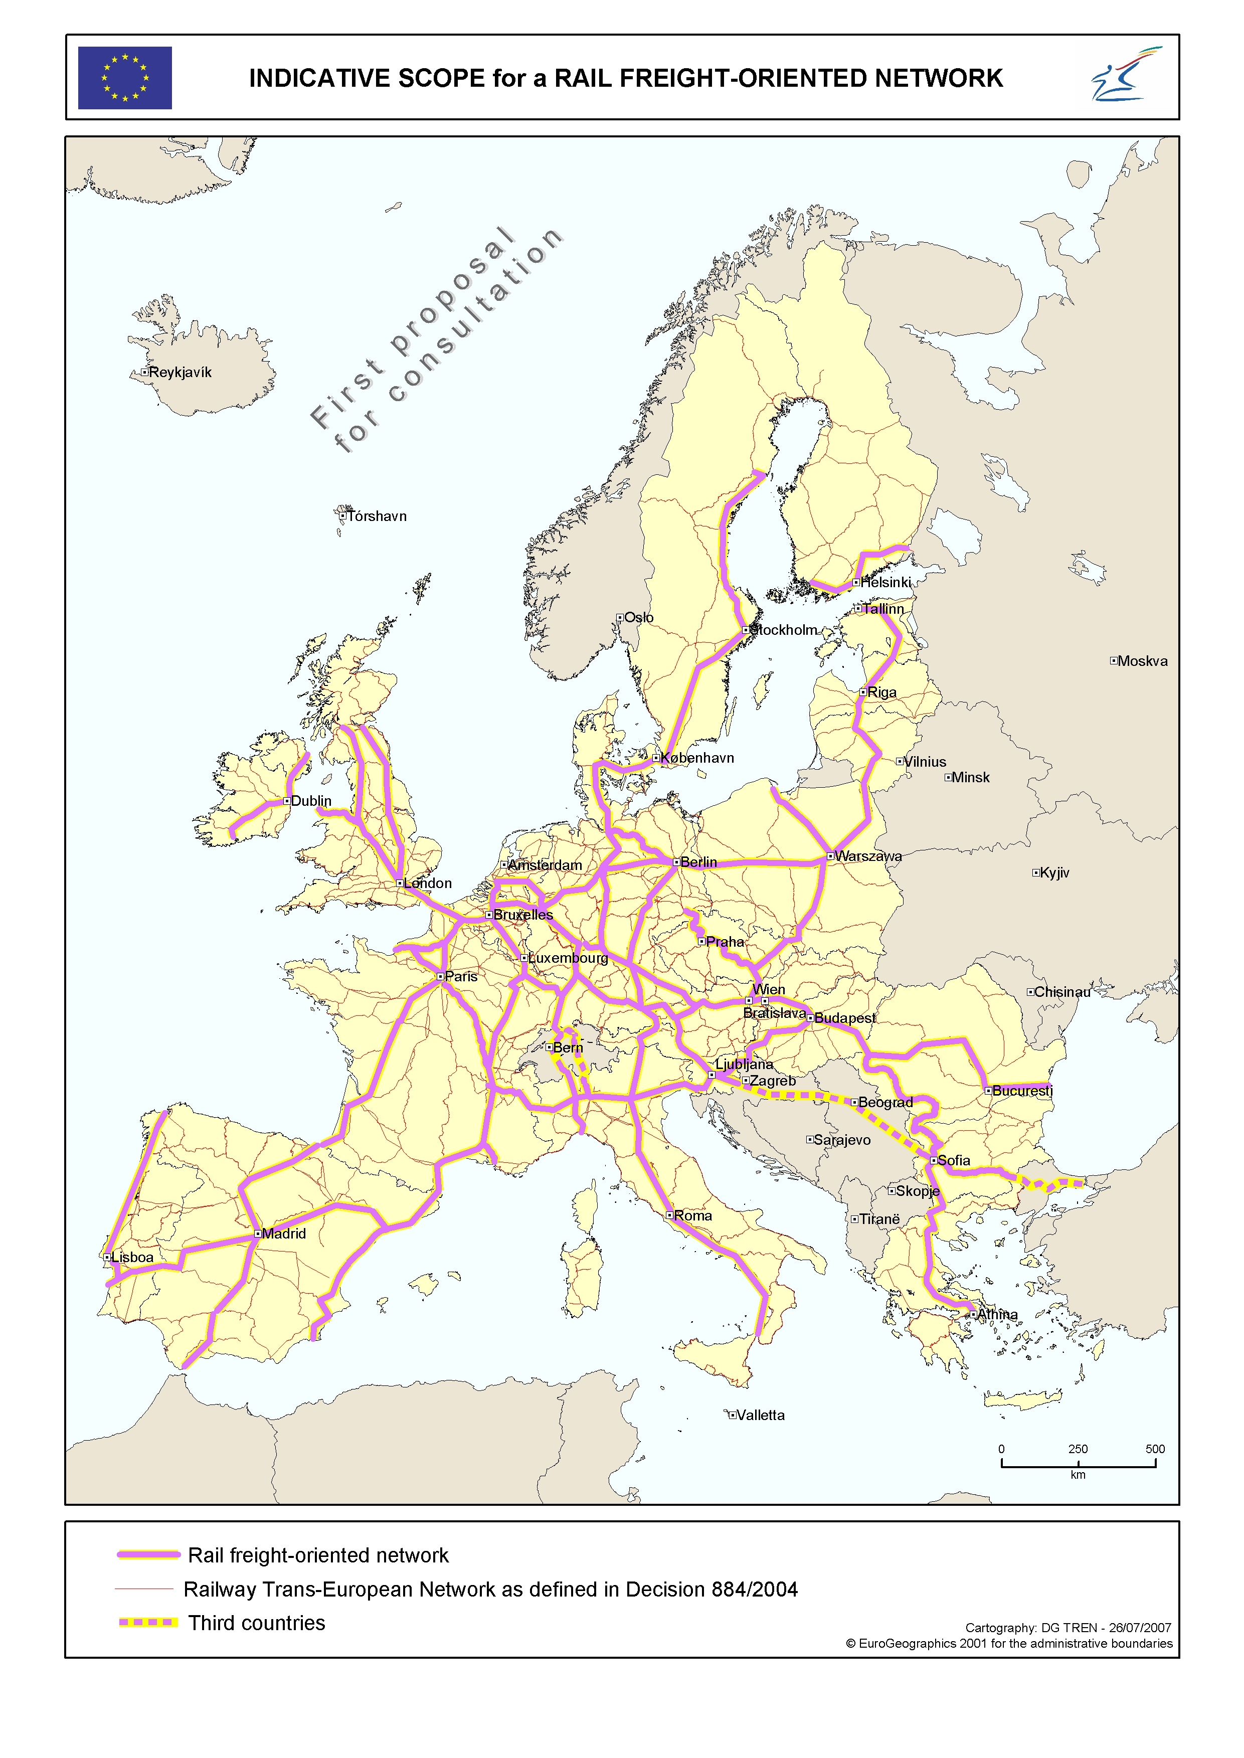

2.2 Initiatives already launched to set up a rail network giving priority to freight
The players in the sector and the Member States, occasionally with the encouragement of the Commission, have already engaged in a number of actions towards developing international rail routes ensuring good conditions for the movement of freight or developing coordination among infrastructure managers in investment planning or improving international freight traffic management.
These initiatives include the following (see Annex IV):
- the development of interoperability, in particular by way of the Technical Specification for Interoperability relating to Traffic Operations and Management (TOM TSI) and the deployment of the Technical Specification for Interoperability relating to Telematics Applications for Freight (TAF TSI), which is designed to improve the management of information on train traffic throughout the continent;
- the introduction of Europtirails, which informs its users in real time on train positions and possible delays in a number of Member States;
- the creation of RailNetEurope (RNE), which, in particular, offers its customers international train paths and is a useful coordination tool for most infrastructure managers;
- the construction of important infrastructures in the TEN-T network such as the Betuwe Line;
- the creation of corridor structures by the Member States and infrastructure managers as part of the development of ERTMS along 6 major European routes that are important for freight. This initiative, which for each corridor is based on a letter of intent signed at ministerial level, is backed by a European coordinator appointed by the Commission. The main measures proposed in this communication have been inspired by this venture.
Alongside the TEN-T programme, all these initiatives are contributing effectively to the creation of a European rail network giving priority to freight. The Commission wishes to monitor them, encourage their more widespread use and add to them.

2.3 The option adopted: undertake new measures to create a freight-oriented network
Several options have been studied for creating the European rail network giving priority to freight: allowing the players in the sector and the Member States to act without any new Community input; embarking on a series of new measures to create a freight-oriented network made up of sections dedicated to freight and others receiving mixed passenger and freight traffic; and launching a specific programme leading to a European freight-dedicated network.
The latter option seems to be the most likely to meet the Commission's objective as set out above. There is, however, a risk that it will become too large, too costly and too much of a long-term prospect. Looking at the results of the actions already undertaken, it appears that the first option, the Community status quo, is inadequate.
The second option, which would comprise initiatives designed in particular to underline the coordination between the infrastructure managers of different Member States, and to encourage and establish a framework for the creation of corridors, seems to offer, for the medium term, a balanced response to the objectives set. It will have to complement the initiatives already under way with legislative, financial and political schemes. The financial commitment required is also less than that for creating a dedicated network. For all that, the need to identify possible sources of financing has not been underestimated. In the longer term, this work could lead to the formation of a rail network that is partially or even entirely dedicated to freight.

3. Creating a European freight-oriented rail network: the actions proposed
Developing transnational corridors is one possible approach to creating a European freight-oriented network. It would complement the process already under way for the deployment of ERTMS by focusing on problems of management and operation. The corridors identified would combine a correctly-sized infrastructure with the implementation of measures for managing and operating them. The identification and implementation effort calls for action on the part of infrastructure managers as well as the Member States and the Community. It is intended to provide each corridor with a structure for running it, designed to manage its infrastructure capacity in a coordinated manner and with a bias towards freight, giving freight the priority in the event of any disturbance, improve access to ancillary rail services and measure the performance of the service (see also Annex V, which identifies the issues and current objectives for each of the themes mentioned below). At this stage the Commission intends to include a number of legislative measures mentioned in this action programme in its proposal for recasting the first rail package, planned for 2008.

3.1 Creation of a freight-oriented corridor
The excessive fragmentation of infrastructure management, due to variance in national thinking, limits the effectiveness of financial investment and the management of international traffic operations. The initiatives already undertaken in the framework of the TEN-T programme and the deployment of ERTMS deserve to be properly monitored and followed up. The concept of corridor structures under the aegis of the Member States and infrastructure managers will permit much more intense coordination than today's operational infrastructure management, including as regards infrastructure charging, train movement and identification of investment requirements. Corridor structures will help to optimise the use of financial resources for the purposes of investment, simplify administrative and technical procedures at borders, ensure better continuity of service by the infrastructure across the Member States, and generally offer an easy-access service to international rail freight operators.
The Commission will propose a legal definition of a freight-oriented corridor structure, in particular setting down the main rules applying to this type of corridor.
It will encourage Member States and infrastructure managers to create transnational freight-oriented corridors. Each Member State will have to be participating in at least one corridor structure by 2012.
It will examine the possible sources of finance for corridor structure activities within existing programmes.

3.2 Measure on service quality along a corridor
Quality of service seems still to be a weak point in rail freight and customers are asking for more commitment and transparency in the area. The Commission thinks service quality should be exemplary throughout the European freight-oriented rail network. Quality improvement on this network should have a positive impact on rail freight in general. The quality attained on the freight-oriented corridors could ultimately become a benchmark for the sector in Europe.
The Commission will, after an impact assessment, propose a legislative measure on the publication of quality indicators.
Generally, it will continue to promote all measures designed to improve the transparency of information on the quality of rail freight service.
Before 2008 it will publish a report on steps taken by rail freight operators to improve their quality of service.

3.3 Infrastructure capacity of a corridor
Mainly in certain central regions of the Union there is currently saturation on some sections along major freight routes. The various study forecasts of rail traffic in Europe show that additional bottlenecks are likely to appear and become very problematical towards 2020. This phenomenon, if not sufficiently resisted, might even be aggravated by traffic buildup along freight-oriented corridors. It is, incidentally, possible to improve the competitiveness of freight by increasing the volume of freight each train is able to carry. This presupposes an improvement in the capacity of the infrastructure particularly in terms of train length, gauge, axle load and maximum speed. All this goes to show that the necessary investments will have to be coordinated and well targeted on freight-orientated corridors in order for the traffic in them to run as smoothly as possible and for rail to be more competitive.
The Commission will ask the corridor structures to draw up a programme of investments aimed at eliminating bottlenecks and harmonising and improving infrastructure capacity especially in terms of train length and gauge.
It will study the advisability of extending the Community legal framework to include the technical characteristics with which freight-oriented corridors will have to comply.
It will examine the possible sources of finance for these investments within existing programmes.

3.4 Allocation of train paths: more coordination and more priority to international freight
At present the allocation of train paths is decided by each infrastructure manager according to rules which differ from one Member State to another. These differences can concern the procedures for this type of allocation or the priority accorded to freight compared with other types of traffic. A useful solution might be to harmonise the rules for the allocation of train paths along each corridor and, in order to make it into a corridor that is truly freight-oriented, organise the distribution of its capacity in such a way that freight, especially international freight, benefits from efficient and reliable train paths. This may require, for example, joint planning of capacity distribution by all the corridor managers, which will take account of local and national constraints on passenger traffic, while making it possible at the same time to optimise the management of this capacity thanks to greater international coordination. Incidentally, to make rail freight more attractive to customers, bodies other than the railway operators could be authorised to request train paths on the freight-oriented network. Present community legislation already contains measures concerning these points. They should be made more specific or more stringent in order to boost coordination between infrastructure managers and improve the management of international traffic.
The Commission will propose additional legislation on the international allocation of train paths and on the priority accorded to international freight.
It will propose enabling authorised applicants to request train paths throughout the freight-oriented network.
It will encourage infrastructure managers to offer additional efficient international train paths and to intensify the work already started in the framework of RailNetEurope.
It will specify the powers of the regulatory authorities in regard to international traffic and encourage the development of cooperation between them.

3.5 Priority rules applying in the case of traffic disturbance
A number of points on the network as described in section 2 regularly reach saturation. Others are quite likely to do so in the next few years. For those routes on which freight will be given priority it will be necessary to tighten up the existing legislation on traffic prioritisation in the event of disturbance on the line. Indeed, rail freight will never be able to improve its performance and quality if it continues to be handicapped by the difficulties other types of traffic can sometimes give rise to, especially near the major conurbations. If it is to do so, it will need to have more reliable train paths available to it. To this end the priority rules along the freight-oriented corridors will have to be harmonised better.
The Commission will propose tightening up the existing legislation relating to the priority of international freight in the event of disturbance of the network.
It will ask the corridor structures and infrastructure managers concerned to harmonise the priority rules throughout the infrastructure under their charge.

3.6 Ancillary rail services (especially terminals and marshalling yards)
Ancillary rail services, and above all terminals and marshalling yards, are essential links in the modern rail freight production chain. The measures designed to coordinate and improve the use of freight-oriented corridors therefore have to be complemented by initiatives favouring the development of terminal and marshalling yard capacities throughout the freight-oriented network. For this development it will be necessary to encourage investment in increasing terminal and marshalling yard capacities, making access to them clearer and easier for all the rail operators using the corridors. Particular attention will also have to be given to access to rail infrastructures in the ports and to their management.
The Commission will encourage the corridor structures and infrastructure managers to set up, together with the players concerned, an efficient and appropriate network of terminals and marshalling yards.
It will examine the possible sources of finance for the development of this type of infrastructure within existing programmes.
It will look into the possibility of additions to the existing legislation to improve the transparency and ease of access to ancillary rail services.

4. Monitoring of the measures proposed
All of these measures will be examined in the framework of structured deliberations in the form of a strategic group, for example with representatives of the Member States and rail infrastructure managers and users. This group will have in its remit in particular to define and identify the characteristics of the corridors, to determine what legislative and operational measures are required and to fix the powers and responsibilities of the corridor structures. It will have to have completed its work in the first half of 2008.
The work on the deployment of ERTMS along the European rail routes on which priority is given to freight will continue with the encouragement of the European coordinator alongside the initiatives proposed in this communication.
It should be noted that this communication is part of a Commission work programme comprising a number of different activities, some of which are contributing more or less directly to the emergence of a freight-oriented European rail network. They include:
- the legislative proposal relating to cross-acceptance of rolling stock;
- the initiative on reducing rail noise;
- consideration of the introduction of multiannual contracts between infrastructure managers and Member States;
- the communication on an action plan for logistics in Europe;
- the communication on the Rail Market Monitoring Scheme (RMMS);
- the establishment of a European deployment plan for ERTMS;
- the completion of the TEN-T network including the priority projects identified in Decision No 884/2004/EC;
- the work in progress on the internalisation of external costs.
Many of the measures proposed call for initiatives on the part of the Member States and all of the parties concerned in the rail sector and the success of the action plan proposed depends on their joining in the project to create a freight-oriented network and becoming actively involved in achieving it. It also depends on continuation of the efforts already begun, in particular on developing technical interoperability and simplifying the administrative and technical operations at the frontiers between the Member States. Finally, the initiatives taken by States, Regions or other public or private players to develop rail freight at regional and local level will have to complement Community action to set up a strong European rail network.

EU-25, in terms of performance (tonne-km).
The annexes are grouped together in the Commission staff working paper "Annex to the Communication 'Towards a rail network giving priority to freight' ".
Directives 2001/12, 2001/13 and 2001/14 of 26 February 2001. See the report on the implementation of the first package - COM(2006)189 of 3 May 2006.
Directives 2004/49/EC, 2004/50/EC, 2004/51/EC and Regulation 881/2004/EC of 29 April 2004.
CER, The Future of Rail Freight in Europe.
Intermodal transport represents in volume about 15% of rail freight traffic.
The UIRR (International Union of Combined Road-Rail Transport companies) allows a maximum tolerance of 30 minutes delay.
Definition of co-modality given in the mid-term review of the transport White Paper.
COM(2006) 336 final.
The TAF TSI and its deployment plan are aimed at developing interoperable information management systems for rail freight traffic.
Europtirails is a software developed by a group of infrastructure managers with Community support. It allows them to track international trains in real time.
RNE, a structure set up on the initiative of infrastructure managers, offers, in particular, "ready-made" international train paths and provides operators with a one stop shop for the allocation of these paths.
The 6 ERTMS corridors: A (Rotterdam-Genoa), B (Stockholm-Naples), C (Antwerp-Basle-Lyon), D (Valencia-Lyon-Ljubljana-Budapest) , E (Dresden-Prague-Budapest), F (Duisburg-Berlin-Warsaw).

