EN
COMMISSION OF THE EUROPEAN COMMUNITIES
Brussels, 13.11.2007
COM(2007) 708 final

COMMUNICATION FROM THE COMMISSION TO THE COUNCIL, THE EUROPEAN PARLIAMENT, THE EUROPEAN ECONOMIC AND SOCIAL COMMITTEE AND THE COMMITTEE OF THE REGIONS
A European initiative for the development of micro-credit in support of growth and employment
COMMUNICATION FROM THE COMMISSION TO THE COUNCIL, THE EUROPEAN PARLIAMENT, THE EUROPEAN ECONOMIC AND SOCIAL COMMITTEE AND THE COMMITTEE OF THE REGIONS
A European initiative for the development of micro-credit in support of growth and employment

1. Why an initiative in this field?
While micro-credit takes many forms, and performs different roles, in the Member States and regions of the European Union it is often used as a means of encouraging the growth of self-employment and the formation and development of micro-enterprises. In many cases this is linked to efforts to promote the transition from unemployment into self-employment. As such, micro-credit can play an important role in the realisation of the Lisbon strategy for growth and jobs and the promotion of social inclusion in accordance with the modern emphasis on "flexi-curity" (the combination of flexibility and social security).
While there is an active micro-credit sector in many Member States and regions, and a number of actions have been taken at Community level to reinforce the growth of the sector, there is clear evidence that much more can be done. In its Communication on financing SME's of 2006 the Commission drew attention to one of the obstacles in the way of developing micro-credit, calling on Member States:
"to ensure that national legislation facilitates the provision of microfinance (loans less than €25 000). Such loans offer an important means to encourage entrepreneurship through self-employment and micro-enterprises, in particular among women, and minorities. This instrument favours not only competitiveness and entrepreneurship, but also social inclusion"
The present Communication proposes ways in which this and other obstacles could be eliminated, or their significance reduced. Concretely, it proposes the following:
First, it invites the Member States to adapt as appropriate national institutional, legal and commercial frameworks necessary to promote a more favourable environment for the development of micro-credit. The Commission is willing to help the Member States on matters of targeting and by compiling an inventory of good regulatory practices.
Secondly, it proposes the establishment of a new facility with a dedicated staff to provide:
- technical assistance and general support for the consolidation and development of non-bank micro-finance institutions (MFIs) in the Member States and regions;
- information and publicity regarding this initiative for Member States, regions, banks and MFIs in general. This would include the publication of brochures, the organization of conferences and seminars, exchange visits etc;
- technical manuals, guides and software designed to help MFIs adopt best practices, with assistance from specialized centres; draft guidelines for the creation and management of MFIs, etc;
- greater access to finance for selected “model MFIs” through the provision of financial resources (seed capital) combined with technical assistance.
Financial support for this facility would come from the existing technical assistance budget of the Structural Funds (European Regional Development Fund - ERDF) managed by the European Commission. In view of the interest expressed by the European Investment Fund in this field, the facility could be managed within the Fund which is also responsible for the JEREMIE initiative to support access to finance to SMEs.

2. Evidence of an emerging gap between supply and demand for micro-credit in Europe
In general terms, micro-credit in Europe addresses two groups: “micro-enterprises”, defined as enterprises employing less than 10 people (which covers some 91% of all European enterprises) and “disadvantaged persons” (unemployed or inactive people, those receiving social assistance, immigrants, etc.) who wish to go into self-employment but do not have access to traditional banking services. Micro-credit is of particular importance for rural areas and can play an important role in helping to integrate ethnic minorities, and immigrants both economically and socially. An overview of the distribution of the market is given in Annex 2.
Over recent decades, the EU economy has evolved from one driven by large-scale industrial enterprises to a greater dependence on smaller businesses, including one–person business, mostly in services. This has led to increased demand for micro-credit. For example, while only 16% of the European active population is self-employed, 45% of Europeans would now appear to prefer to work for themselves rather than as employees. In the EU as a whole, the potential demand for micro-credit that could be granted by non-banking financial institutions for start-ups could be well over half-a-million new customers. This is a figure that could grow significantly over the years due to potential demand, the recycling of micro-loans and the expected positive impact of the proposed micro-credit initiative.
Assessing the availability, or supply, of micro-credit in the Member States appears to be quite difficult. In terms of the size of individual loans estimates suggest the typical micro-loan in Europe is of the order of EUR 7000 – 8000. Surveys conducted by the Microfinance Centre for Central and Eastern Europe (MFC) in EU Member States in Central and Eastern Europe and by the European Microfinance Network (EMN) throughout the EU provide information on the volume of loans. Banks themselves do not keep specific statistics on micro-credit, and what data they have can be ambiguous in that some loans are classified as personal credit, while others form part of a larger category of loans to SMEs or, in some countries, are combined with loans to agriculture. The savings and credit cooperatives that are highly developed in Central and Eastern Europe, and the credit unions in the United Kingdom and Ireland, essentially lend to individuals and do not distinguish the proportion of the lending which is used as micro-credit to enterprises as opposed to, for example, private consumption.
On the whole, micro-credit is developing in many of the new Member States, and a similar trend can be discerned over recent years in the EU-15. However, much remains to be done to exploit its full potential especially in view of the potential demand referred to above.

3. Towards a European micro-credit initiative
A closer look at the dynamics of micro-credit supply and demand reveals that micro-credit operations need to be seen in a broader legal and support framework because financial, employment and social welfare systems are interrelated. Although micro-credit is not a new concept, it is important to note that it is diversely dealt with in the Member States of the Union, depending on the policy framework and the legislation in place. Indeed, the EU and Member States have already taken measures to promote micro-credit, but these measures appear to be quite specific and sometimes only locally applicable.
Micro-credit uses a financial approach to business development, so that the costs of capital, risk and operating expenses are appropriately covered, ensuring the sustainability of the institutions and services provided. However, the problem of suitable access to finance for micro-enterprises and the potential self-employed remains and is recognised as such. Both the Council and the European Commission, in partnership with the national authorities, have initiated a series of actions (see Annex 3).
These efforts combined with the efforts of certain Member States are unlikely by themselves to increase the supply of micro-credit on a sufficient scale and within a reasonable time-frame in the absence of deliberate and comprehensive actions devised by the authorities at national and Community level. In spite of their increasing awareness of the future potential of the micro-credit market, the evidence suggests that banks engage in micro-credit activities, (directly or, more often, in partnership with non-bank institutions) where they are encouraged to do so by public support mechanisms (for example, the EU's PHARE programme, the European Investment Fund (EIF) and the European Bank for Reconstruction and Development (EBRD).
There is therefore scope for more action in this field, building on the work at Community level and on the work of banks and MFIs and their mutual co-operation. The proposed initiative has four different strands:
- Improving the legal and institutional environment in the Member States;
- Further changing the climate in favour of entrepreneurship;
- Promoting the spread of best practices, including training;
- Providing additional financial capital for micro-credit institutions.
Given that banks generally already provide access to finance for existing micro-enterprises and traditional start-ups, this document focuses on the more difficult segment, that of what might be called the "non-bankable" market. Note, however, that any improvement in the institutional environment and the spread of best practice will benefit both segments.

3.1. Strand 1: Improving the legal and institutional environment in the Member States
The institutional framework in the Member States appears to be often ill-suited to the development of micro-credit. Indeed, it is because micro-credit is usually not addressed specifically in the national or Community legislation that the statistics on micro-credit are underdeveloped.
Releasing the potential for the growth of micro-credit however does not require a major investment of scarce public resources. On the contrary, one of the attractions of micro-credit lies in its self-sustaining nature in the long run. What is generally required is a series of actions improving what can be broadly described as the legal and institutional environment for micro-credit.
The following highlights seven areas where improvement can be achieved at national level, citing examples of best practice where available.
Create an environment allowing the development of micro-finance institutions (MFIs) and covering all segments of the clientele
Given the number and diversity of potential clients, all types of bank and non-bank MFIs should have easy access to financial resources allowing them to develop micro-credit. This supposes that banks be encouraged to develop micro-credit operations. This development could be achieved by a wider provision of loan guarantees and, as portfolios develop, by securitisation. It also supposes that credit unions or similar institutions involved in micro-credit operations keep or receive the authorization of collecting savings and are entitled to finance income generating activities.
It is worth mentioning that the Commission, in co-operation with Member States and CEBS, operates a web-based system referred to as the Capital Requirement Directive (CRD) Transposition Group, where the general public may ask questions in relation to CRD through this facility. This medium would also be available for any clarification on the treatment of micro-credit under the CRD.
Help micro-credit to become sustainable by relaxing interest caps for micro-credit operations
Alongside measures specific to different categories of intermediaries, there are measures common to all micro-credit institutions and programmes. One of these is the relaxing of interest rate caps on loans to enterprises, which block any possibility of covering the costs of micro-credit. It must be underlined that, given the small size and short duration of loans, the absolute value of the interest, even with a high rate, is small. Simple access to credit is the most important factor for micro-entrepreneurs in Europe, as elsewhere. In Member States where interest caps are implemented, it is advisable to fix them at a sufficiently high level to allow lending institutions to cover costs, while evaluating its economic and social impact regularly, as is done for example in Ireland, so that the security of borrowers is not undermined. In Germany, the interest rate ceiling in a given sector cannot exceed twice the average rate or be more than 12 points higher than it.
Allow MFIs access to borrower databases and facilitate their evaluation of the risks
Among other general measures, access of credit bureau information that records borrower defaults is important for all micro-credit institutions, including non-banks. In certain countries, notably the United Kingdom, community development finance institutions (CDFI) are encouraged to supply data to credit bureaux. In other countries, notably France, these records are held by the Central Bank and recognised micro-credit institutions cannot yet access them.
Common databases at EU-level on default and losses related to micro finance (individuals, enterprises and MFIs), together with common EU wide rating tools consistent with best practice in the sector can support credit institutions in developing microfinance operation. Such tools, used by banks applying the most sophisticated approach to credit risk, would allow them to fully benefit from the provisions of the Capital Requirements Directive. These data bases could best be developed by market stakeholders.
It is important to mention that the required contribution of equity capital can be limited by loan guarantees and, as portfolios develop or are combined, by securitization.
Reduce operating costs applying favourable tax schemes
More favourable tax regimes are equally important for an emerging industry, whether they consist of tax exemption for MFIs or reductions in taxes for individuals or enterprises that invest in their activities or intervene by way of grants. Thus, in the United Kingdom, under the Community Interest Tax Relief, individuals or companies can deduct 25% of an investment in the form of loans, securities or risk capital from taxable income over five years. In France, the philanthropy law allows a tax deduction of 66% on gifts up to 20% of taxable income for individuals, and 60% of outlays up to 0.5% of turnover for companies.
Adapt national regulation and supervision to the specificity of micro-finance
Under EU legislation, MFIs fall under the scope of EU prudential regulation if they receive deposits and other repayable funds from the public, in which case they are regulated and supervised accordingly. If MFIs do not receive deposits or other repayable funds from the public and are not prudentially consolidated by a credit institution, the Capital Requirement Directive does not oblige them to be subject to specific harmonised capital requirements. Where Member States apply prudential rules to institutions which do not take customer deposits, it is important that any further regulation and supervision put in place must be proportionate to its cost and to the risks that MFIs pose, so that it does not put a brake on the supply of micro-credit and the growth of specialist MFIs.
Ensure single market rules are applied to micro-credit
In Europe, regulatory harmonisation allows banks authorized in one EU Member State to operate elsewhere in the Union by means of cross-border services or through establishment of branches. It is worth examining to what extent and under what conditions similar rights could be enjoyed by micro-credit providers which are not credit institutions within the meaning of EC law.
Incorporate micro-credit into regulation and accounting standards
Experience, notably in Rumania, shows that over-regulation can have a negative impact on the development of micro-credit if it limits flexibility of operation or imposes high burden to the lenders. This risk can be reduced by making a prior inventory of best practices and by confronting the proposed legislative framework with the reality of national micro-credit operations. A way to increase visibility of micro-credit in the long run would be to categorize it as such in banking industry practice and the new accounting standards (IFRS).

3.2. Strand 2: Further changing the climate in favour of entrepreneurship
Europe’s shift towards knowledge, services and new technology under the renewed Lisbon Strategy of 2005 could be boosted by greater attention to three factors in the link between business generation and micro-credit at three levels: adapting of the micro-enterprise institutional framework; smoothing the transition between unemployment and micro-enterprise creation; and providing technical support to micro-entrepreneurs.
Improve the institutional framework for self-employment and micro-enterprises
Employment policies increasingly need to ensure equal treatment to the self-employed and to wage-earners. Recognising self-employment and micro-enterprises requires a programme of publicity and consciousness-raising in schools, universities and employment agencies, aimed at public opinion in general. It requires measures to lower legal, tax and administrative barriers, such as exemption from social insurance charges for start-ups, simplified registration procedures for new micro-enterprises and access to more numerous and less expensive outlets. A new concept in Germany “Ich AG”, (I Incorporated) disseminates the idea that self-employment is a viable and challenging career choice. In France, the creation of micro-enterprises has been recognised as a way of integrating the unemployed, who benefit from certain exemptions from social charges for the first three years.
Design solutions to enable unemployed people and welfare recipients to make the transition into self-employment
Smoothing the transition between unemployment or social welfare dependence and self-employment is essential. Possible measures include temporary public income support during the transition combined with provisions to allow a return to unemployment benefit or social welfare assistance in case of failure. For example, Irish welfare recipients may continue to receive social welfare benefits on a decreasing scale over four years. Such a policy requires that welfare and employment agency officials be specifically trained on the different aspects of enterprise creation and self-employment issues so as make them competent to advise potential candidates.
Increase chances of success of new micro-enterprises through training, mentoring and business development services
While micro-credit can help new entrepreneurs and socially excluded people gain access to finance, there is also evidence that access to finance does not in itself solve all the problems on the demand side. The complexity of the micro-enterprises' environment demands a supply of business development services and requires on the part of the starting-up entrepreneur various competencies that he can often not demonstrate. Training, mentoring or coaching the new entrepreneur are essential to improve the enterprise’s chances of success. As business development services raise costs, they make micro-enterprises business less attractive to the commercial banking sector. Experience shows that such services tend to rely on public and volunteer support. Last but not least, outsourcing activities linked to loan transactions (business plan preparation, business monitoring, etc.) helps facilitate access to credit. Greater use of the resources made available through the ERDF, ESF (European Social Fund) and EARDF (European Agricultural Regional Development Fund to promote entrepreneurship, innovation and business start-ups could also help fill the gap (see Annex 7).
Proposal 1
From theory to practice: Promoting micro-credit and micro-enterprise development at national level
One way of taking the above 10 issues under Strands 1 and 2 forward would be to invite Member States to undertake a programme of reform aimed at improving the conditions for micro-credit according to national circumstances and priorities. In view of the focus in the Lisbon strategy improving access to finance, in general, and promoting micro-credit in particular, Member States are encouraged within the context of their National Reform Programmes under the Lisbon strategy to take on board those actions necessary to promote a more favourable environment for the development of micro-credit which fall within the national institutional, legal and commercial frameworks. The Commission could also help the Member States by indicating quantitative targets for loans and by compiling an inventory of good regulatory practices.

3.3. Strand 3: Promoting the spread of best practices
Allowing banking and non-banking institutions to continue their activities and to develop sustainable actions is a key factor in proving the value of micro-credit. Using public aid to take temporary measures that disappear once public support is discontinued is not efficient. It is more useful to support the development of banking services and permanent non-bank MFIs, with a view to encouraging them to share experience and best practice and to use a common language that will help them to work together more effectively. If non-bank organisations have much to learn from the banks, the opposite is also true, as methods developed for providing and recovering micro-credit differ from traditional banking techniques. This exchange of know-how would allow inter alia better integration of quantitative methods such as scoring, which are beginning to extend to micro-credit and trust-generating contact, on which the micro-project and its reimbursement depends. Dissemination of best practices is an important factor in the development of micro-credit which will continue to be fostered by existing resource centres such as the Microfinance Centre for Central and Eastern Europe, the European Microfinance Centre and the banks themselves.
A central body with micro-financial expertise
The scope of the work to be carried out suggests that there is a need for oversight and coordination, for example by a central body with financial and social expertise and the ability to monitor and coordinate action in support of micro-credit and to act as a permanent discussion partner for those in the field. The EIF, which is already involved in JEREMIE and in micro-credit guarantee schemes on behalf of the European Commission, has proven its operational capability in this respect.
A micro-credit specific label to better involve EU citizens
It should be possible to increase the available funds for MFIs by taking measures to encourage individuals or socially responsible enterprises to invest in them. Green investment funds" are increasingly attracting private contributions and savings. In the same way, a micro-credit specific label could be developed to improve the visibility of investment funds dedicated to micro-credit, improve citizen's confidence in microfinance investment vehicles and steer resources towards MFIs with the best social and financial performance.
The need for a code of conduct for MFIs
One way to increase confidence in a micro-credit label would be to draft a code of conduct for MFIs, which would be an excellent way to spread ethic and customer-friendly best practices among MFIs. This code would be best worked out by the different stakeholders. It would be based on the social and financial performances of MFIs as described in section 4. (Communication and evaluation) and would take their commercial behavior into account.
It should be mandatory for MFIs to give information about their legal status, supervision and compliance with the Code of Conduct in the documents they publish

3.4. Strand 4: Providing additional financial capital for new and non-bank MFIs
Fostering the development of micro-credit in Europe requires a complex set of initiatives calling on the involvement of stakeholders, national and European institutions. Many of the suggestions developed in the previous pages underline the importance that action at EU level could have in providing impulse to and coordinating actions in favour of micro-credit. To respond to this challenge, the Commission intends to strengthen its contribution by setting up in the framework of EU cohesion policy a specific micro-credit facility providing funding and technical assistance to new and non-bank MFIs to enhance the supply of micro-credit.
This facility would target the most promising non-bank MFIs by means of calls for proposals. Ideally, it would combine the provision of technical assistance with funding mobilised from various sources, such as EU structural funds, the EIB, the EUROFI network, banks and donors. It would aim at helping MFIs becoming self-sustaining and it would contribute improving the use of micro-credit in the EU by conducting market analysis, establishing guidelines and promoting training and learning opportunities that incorporate best practice in the field.
Proposal 2
A dedicated support structure for micro-credit
In order to set this facility up rapidly and with a cost-effective structure, it is proposed to ask the European Investment Fund (EIF) to create and host a dedicated unit within their JEREMIE department.
Its activities would cover technical assistance and general support for the consolidation and development of MFIs e.g. handling information and publicity about the micro-credit initiative aimed at Member States, regions, banks and MFIs in general; publishing brochures, organizing conferences seminars and exchange visits, etc.; drafting manuals and guides designed to help MFIs adopt best practices in setting up and management of MFIs; facilitating access to finance for MFIs by mobilising financial resources (seed capital).
The funding for the staffing of the unit and the technical assistance work to MFIs would be covered through the technical assistance budget of the Structural Funds managed by the European Commission.
A possible scheme for the micro-fund is outlined in Annex 9.

4. Communication and evaluation
Communication is necessary to raise awareness of the micro-credit initiative among all stakeholders, public authorities, bankers, financial intermediaries and end-users. Appropriate campaigns need to be designed in order to support the launching of the micro-credit initiative and area-specific permanent information needs to be provided and will need to be designed to ensure long-term promotion of micro-credit in Europe.
Evaluation at various levels needs to be given careful consideration to assess the economic and social impact of the initiative in the framework of the Lisbon strategy. Objectives have to be set early, to make change measurement possible. (See Annex 10).

5. Conclusion
The proposed initiative seeks to develop micro-credit in the European Union in the framework of the Lisbon Strategy and represents a further step to the Communication of the Commission "Financing SME Growth – Adding European Value". It recommends setting up a dedicated support structure for micro-credit with the view to develop mentoring services which are essential to support micro-borrowers setting up a business, to develop good market practices by creating a specific micro-credit label and a guide of good conduct. It also seeks to improve the provision of capital and proposes to set up of a micro-credit fund which would help finance the loan activities of MFIs, In view of the need for a number of changes at national level in terms of the institutional and legal frameworks supporting micro-credit, it is proposed that these aspects could feature in the annual Lisbon governance cycle. In other words, by their inclusion in the National Reform Programme Member States could be encouraged to introduce reforms that are appropriate in their circumstances to encourage micro-credit. Appropriate communication campaigns must be undertaken in order to boost micro-credit in Europe and contribute to its development in the longer run, and evaluations carried out. All these elements are complementary and are important for the development of a favourable environment for the sustainability and expansion of micro-credit in Europe.
This initiative fits with the European Union's policy to promote entrepreneurship and economic initiative, to promote "flexi-curity", the social inclusion of disadvantaged persons and to develop human capital and renew trust-based social links, which correspond to the true meaning of the word “credit.” The expected impact of implementing this initiative would initially be an increase in entrepreneurship and job creation with direct and indirect effects on growth. In countries that have large ethnic minorities, for example in central Europe, or receive large numbers of immigrants, micro-credit could play a significant role in integrating the relevant groups both economically and socially.
The proposals included in this initiative would provide a base to start concrete actions aimed at developing and implementing micro-credit in the European Union.

6. Annexes

6.1. ANNEX 1: About micro-credit
Micro-credit is the extension of very small loans (micro-loans) to entrepreneurs, to social economy enterprises, to employees who wish to become self-employed, to people working in the informal economy and to the unemployed and others living in poverty who are not considered bankable. It stands at the crossroads between economic and social preoccupations. It contributes to economic initiative and entrepreneurship, job creation and self-employment, the development of skills and active inclusion for people suffering disadvantages.
Micro-credit has also proven its cost effectiveness as a public policy tool, costing a fraction of equivalent passive labour market measures: the average cost of support for micro-credit schemes in Europe is reported to be under €5 000 per job created.
Experience shows a survival rate of well over 60 % after two years for businesses set up thanks to micro-credit. In purely economic terms public support for micro-credit is worthwhile even if the job created only lasts a year.
Micro-credit is defined by:
- its target: micro-entrepreneurs, the self-employed, and socially excluded people lacking access to traditional sources of capital;
- its object: the creation or expansion of income-generating and job-creating activities or micro-enterprises, whose principal need is usually the financing of initial investment or of the working capital;
- the small amount of the individual loans required which in turn relates to the limited debt-servicing capacity of the target clientele. Typically, this amount does not exceed EUR 25 000. The average micro-loan provided by Micro-finance Institutions (MFIs) in Europe is approximately 7 700 euros;
- a more labour-intensive delivery system for making loans, involving greater knowledge of borrower capacity and a close relationship with the borrower, especially during the start-up phase of the micro-enterprise, through mentoring and general business support.

6.2. ANNEX 2: The market pyramid
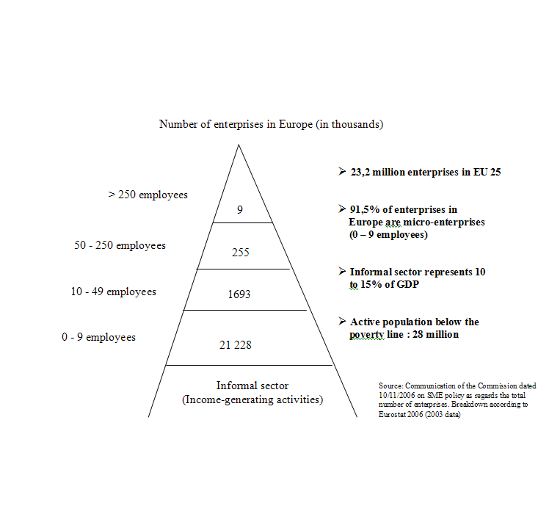

6.3. ANNEX 3: Review of Community initiatives on micro-credit
- The new JEREMIE (Joint European Resources for Micro and Medium Enterprises) scheme has been set up with the support of the European Investment Fund (EIF) to improve access to finance, including micro-credit, in European regional programmes for 2007-2013. It can provide micro-credit, guarantees for both loans and equity and venture capital finance to SMEs. In the past, national and regional programmes supported by the Structural Funds have provided capital and other support in a less systematic way for micro-credit operations, for example, in disadvantaged urban areas.
- Under the growth and employment initiative (1998-2000), and the multi-annual programme for the promotion of enterprise and entrepreneurship, in particular SMEs (2001-2005), the European Union provided partial guarantees to cover portfolios of micro-loans for borrowers lacking security. These provisions have been extended to cover 2007-2013 with the Competitiveness and Innovation Framework Programme (CIP). This micro-credit guarantee window is managed by the European Investment Fund (EIF) on behalf of the European Commission.
- The Community Action Programme to Combat Social Exclusion (2002-2006) supported the European Microfinance Network (EMN) and the Microfinance Centre (MFC) for Central and Eastern Europe and the New Independent States with a view to promoting microfinance as a tool to fight social and economic exclusion and to promoting micro-entrepreneurship and self-employment.
- With the same support, these organisations and Community Development Finance Association (CDFA – United Kingdom) led the trans-national exchange project "From exclusion tot inclusion through micro-finance" whose purpose was to reduce the lack of information exchange between organizations working in the area of social and financial exclusion in the East and West. New Member States have developed micro-credit with strong institutions capable of serving thousands of socially and financially excluded people, but are now facing an environment which has new challenges and opportunities. Western institutions have developed tools that fit the EU environment (such as a mix of financial and non-financial services to excluded people) but their programmes tend to have a relatively smaller client base due to design issues and generally stricter environment. The final reports provide new data about characteristics of micro-credit in the EU, based on a mapping exercise, and express recommendations to policy makers, practitioners and networks.
- Under the same programme, a study of “policy measures to promote the use of micro-credit for social inclusion” (2005) showed that micro-credit might play a more important role in the active inclusion of vulnerable groups of people if policies in the economic, employment and social fields were retargeted accordingly. He elaboration of different relevant policy dimensions - the micro-entrepreneurial context, the legal framework, funding and support, the “financial bridge” and the “welfare bridge”- has lately allowed the creation of a tool for a multidimensional and contextualised benchmarking of national microfinance environments named "Evaluation Scorecard" (see Annex 6).
- Since 2001 the EQUAL initiative has supported 300 development partnerships developing and testing new ways to promote “Entrepreneurship for All”. These partnerships have identified key barriers or obstacles that prevent disadvantaged groups and deprived areas from being able to set up viable businesses, developed integrated support packages, including microfinance, and demonstrated the advantages and benefits of an integrated approach (focusing on creating an entrepreneurial culture, providing tailor-made business support, facilitating access to finance, and supporting business consolidation and growth). EQUAL also supported a platform and a number of conferences for exchanging and validating good practice in supporting inclusive entrepreneurship.
- Article 11 of Regulation 1081/2006/EC on the European Social Fund states that ESF “[…] assistance shall take the form of non-reimbursable individual or global grants, reimbursable grants, loan interest rebates, micro-credits, guarantee funds and the purchase of goods and services in compliance with public procurement rules.”
- Under the new generation of rural development programmes, the European Agricultural Fund for Rural Development (EAFRD) may co-finance expenditure in respect of an operation comprising contributions to support venture capital funds, guarantee funds and loan funds. EAFRD supports also the creation and development of micro-enterprises
- The newly created European Globalisation Adjustment Fund, which can intervene to mitigate the economic and social impacts of restructuring and relocation, can provide support for redundant workers to create new businesses or move into self-employment.
- The Commission has organised working groups on micro-credit with representatives of Member States, and a 2004 conference in Brussels in partnership with the institutional networks concerned. In April 2006, a report "The regulation of Micro-credit in Europe" and in November 2003, a report “Micro-credit for small businesses and business creation: bridging a market gap.” were published
- Single market initiatives have included the integration of the financial services market and the simplification of administrative constraints on enterprises. In this area, administrative and other constraints represent a much bigger obstacle, relative to their size, for micro-enterprises than for larger businesses. The "White Paper on financial services" and the "Green Paper on retail financial services in the single market" have provided useful guidance in this respect.
- Efforts have been made to simplify competition and state aid rules regarding the granting of public aid to micro-enterprises.
- In 2005 and 2006, the European Investment Fund (EIF) supported microfinance through securitisation in two milestones transactions in the Western Balkans and South-East Europe. The EIF structured and co-arranged the securitisation of loans to microfinance institutions and acted as a guarantor in the first securitisation of micro-loans in Europe.
- “Preparatory Action for SMEs in the new financial environment”, a development of PHARE’s SME Finance Facility, is encouraging institution-building by funding technical assistance for small, regional banks and credit institutions, especially in the new Member States, with a particular focus on micro-loans to SMEs.

6.4. ANNEX 4: Estimated demand for micro-credit in the EU
Micro-loans for Commencing Business Activity
EIF has analysed access to debt financing by SMEs and potential entrepreneurs in the framework of JEREMIE evaluations. The following figures are based on the last Eurostat data available (2004) and examine the provision of micro loans primarily by non-banking financial institutions (loan funds, micro finance institutions, credit unions, etc.) to the disadvantaged group of people ‘at risk of poverty’ subject to the following assumptions:
At risk of poverty group – group in relative income poverty, i.e. individuals living in households where equivalised income is below the threshold of 60% of the national equivalised median income
Potential entrepreneurs – group of people of productive age (16-64) facing the risk of poverty; it is assumed that on average only 45% of this group would be willing to set up micro-enterprises (source : Eurobarometer 2005).
Target group – number of potential entrepreneurs who actually have set up micro businesses; it is assumed that this group represents at most 4% of potential entrepreneurs (source : ILO study 2002 on micro-finance in industrialized countries).
The methodology for estimating demand for micro finance for commencing business activity can be shown as follows:
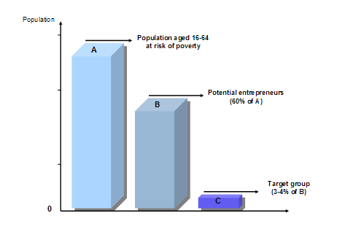
According to this methodology, the figures can be calculated for the EUR15 (old) Member States and EU-12 (new) Member States as follows
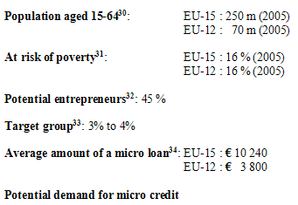
Potential demand for micro-loans for EU-15:
557 000 * €10 000 = €5 570 million
Potential demand for micro-loans for EU-12:
155 900 * €3 800 = €575 million
TOTAL EU-27
712 900 loans - €6 145 million
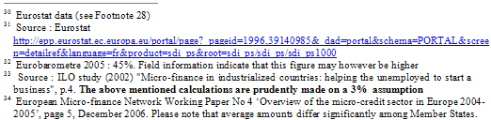

6.5. ANNEX 5: Supply of micro-credit in Europe
Information about the supply of micro-credit in Europe (27) is very uncertain. The MFC and EMN conducted two surveys in 2005, but they provide only a partial view of the real situation.
The MFC survey covers the ten countries of Central and Eastern Europe that are new members of the European Union. It lists bank and non-bank institutions providing microfinance and loans to SMEs in these countries. In both cases available statistics cover much more than micro-credit alone. In many countries no data are available. Adding up country figures thus provides only a rough figure, but the total number of clients by different types of institutions is estimated at 671 000.
The EMN survey covers the pre-2004 European Union (15 Member States), three new members (Poland, Slovakia and Hungary), Switzerland, and Norway. With a few exceptions, it does not cover the banking sector and micro-credit cooperatives. In all, 110 organisations responded, of which 89 are de facto lenders, while the others work in partnership with Spanish savings banks. Here, too, the figures are only very approximate. The major conclusions that can be drawn from the survey are as follows:
- At present the three large MFIs created before 1996 dominate the market. Out of a total of 27 000 loans disbursed in 2005, Adie (France), Finnvera (Finland) and Fundusz Mikro (Poland) account for 70%. The first of these, created by volunteers without up-front capital, works in partnership with banks; the second was set up at the initiative of the state; the third has benefited from exceptional funding (to the tune of USD 20 million) from USAID.
- At the extreme opposite, 65% of MFIs disburse no more than 100 loans a year.
- The majority of institutions are very young: 70% were set up after 2000, and 17% from 2005.
- In the EU-15, the sector’s growth rate was on the order of 15% between 2004 and 2005.
- The average loan amount is 7 700 euros, with wide variations (€10 240 in the EU-15 and €3 800 in the new member countries).
- The sector’s average repayment rate is 92%.
- Over half the MFIs offer parallel advisory and training services.
The diversity of MFIs is illustrated in the following table.
Diversity of micro-credit institutions in Europe
The ProCredit Banks, specialising in microfinance, are undergoing rapid expansion in Bulgaria and Romania, as well as in many countries bordering the EU. At this stage they do not appear replicable in Western Europe.
Credit unions represent a significant part of the small-loan market in several member countries, but are not geared primarily to production credit.

6.6. ANNEX 6: The segmentation of the micro-credit market
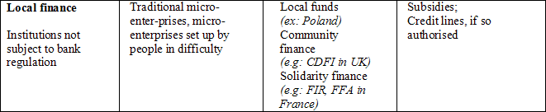
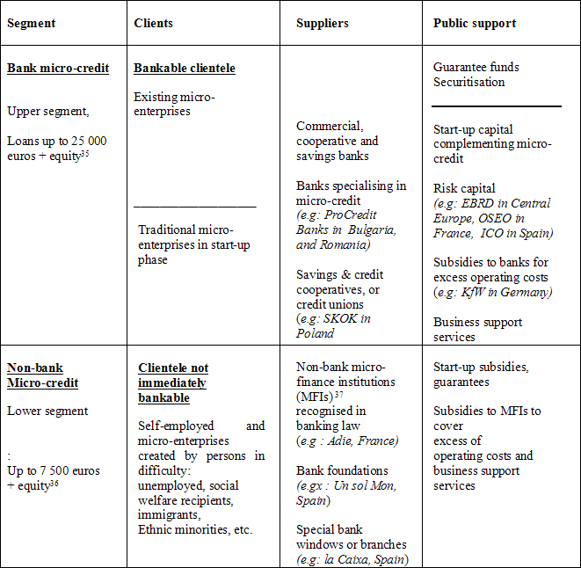
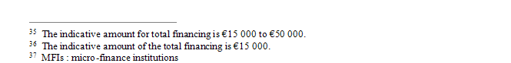
Two specific business models have been developed in Europe to serve the micro-credit market:
- Direct intervention by financial institutions addresses the bankable clientele segment. It is often facilitated by guarantee funds (such as CONFIDI in Italy) and official advisory agencies such as chambers of commerce offsetting costs, including risks;
- Partnership between financial institutions and non-banking institutions, serving as intermediaries for a public that is not immediately bankable, but which becomes so, once it acquires a balance sheet and credit history. Since in some countries (e.g. Portugal and Italy) lending by non-banks is not allowed, partnerships between banks and business support services leave the non-bank sector the task of preparing projects and monitoring loan repayment, while the financial institution grants the loan and accounts for it in its balance sheet. In other countries, MFIs are authorized to borrow and on-lend

6.7. ANNEX 7: Providing mentoring and business support
Micro-credit has already proved to be an efficient tool to promote entrepreneurship and self-employment among people who do not have access to finance or who are furthest from the labour market where they can benefit from adequate mentoring. Successful experiences have demonstrated that even low-qualified people and people facing social difficulties can recover autonomy though self-employment if they are properly accompanied through the development of a project. However, setting up and increasing investment in loan funds, which offer micro-credit, does not suffice and not all business proposals or people are "investment ready"
This is why the provision of business development services is important. These may include assistance with business plans, management, bookkeeping and computer training, identification of suppliers and support for marketing, as they are essential to ensure proper operations and help the new entrepreneur build a sustainable activity. Business development services may utilise both direct contact and new technologies (Internet, mobile telephone).
Traditional micro-enterprises very often receive advice from institutional networks such as chambers of commerce and crafts. People in difficulty receive such support from social networks and, in some countries, local authorities. Incubators and networks supported by the EC, such as European Information Centres and Innovation Relay Centres, could play an important part in this activity.
In implementing their strategies for micro-credit development, Member States could usefully mainstream good practice developed in EQUAL-led development partnerships since 2001. As the Structural Funds and especially ESF can provide assistance to Member States and support national or multi-country initiatives on training, common report standards and the application of new technologies to financial services, the Commission intends to support the following initiatives through ESF technical assistance in order to intensify the use of micro-credit as a tool for active inclusion of all on the labour market:
- research aiming to improve knowledge of the target groups, their social and economic situation and their financial and business needs;
- integrated tools to assess the effectiveness of support schemes and actions to promote inclusive entrepreneurship locally or regionally;
- validation of and exchange of good practice in mentoring and business support services complementing the provision of micro-credit, with the aim of financial capacity building among micro-credit customers (teaching people how to manage income flows in such a way that they can gradually capitalise their activities);
- validation and exchange of good practice in capacity building for microfinance institutions, including the development of benchmarking and accreditation services in order to provide a means to track and guide progress;
- research on issues associated with the transition from welfare to entrepreneurship with a view to supporting the development of products and methods suited to the specific needs of micro-credit customers.
Other ways of supporting micro-enterprises are the options for creation of new SMEs under the European Agricultural Fund for Rural Development (EAFRD) as well as the establishment of business networks between them in rural areas. Training support and upgrading of the skills are also eligible ways of enhancing the business development of these business units. Provision of basic services under the EU rural development policy, including ICT, further facilitates their operations and adaptability to the economic situation and to the competitive markets in which they operate.
These initiatives at European level will complement policies on micro-credit at national level taking into account that there is a need for an approach that combines delivery of loans and mentoring.

6.8. ANNEX 8: Comments on financial institutions delivering micro-credit
Banks
As regards banks, the new Capital Requirements Directive (implemented on 1 January 2007), gives banks the option of using different methods to calculate their capital requirements, ranging from simple allocation into different categories of loan, to the use of sophisticated quantitative modelling techniques. The new capital rules are more risk-sensitive, in that they differentiate between types of loan based on the risk of the underlying borrower.
- For direct bank loans to micro-enterprises or individuals, either standard retail bank’s weighting or internal rating and loss assessments apply.
Under the standard approach, the weighting of assets applicable to a ratio of 8% equity is 75%, thus yielding an effective ratio of 6%. As noted above, this is a reduction from the 8%, which was applied under the old scheme (100% x 8%).
Under the internal rating approach, used by larger, more sophisticated banks , as far as the bank has not sufficient track records to demonstrate the actual repayment rates, micro-credit may be considered as relatively riskier and on the whole less attractive, given its higher distribution costs, than other types of loans.
For encouraging banks to use an internal approach tailored to microfinance, it may be relevant to build common data bases collecting information at EU-level on default and losses related to micro finance (individuals, enterprises ), as well as common rating tools consistent with the best practices in the sector. This may demonstrate the actual micro-finance cost of risk and encourage incomers to enter this market.
- For credit lines provided to MFIs, specific ratings may be relevant. This approach would also be facilitated by establishment of a common data base and a common rating tool mentioned above, consistent with standard criteria, making it possible to measure the results of non-bank MFIs from the point of view of risk.
In both cases the required contribution of equity capital could be limited by loan guarantees and, as portfolios develop or are combined, by securitization.
Credit unions
- Credit unions are mutual financial cooperatives, one of the core principles of which is that funds deposited by members are utilised to provide loans to members. The members of a credit union are linked by a "common bond" of membership (geography, employer, vocational, common interest, etc) which creates a strong community link for the cooperative.
Credit unions provide micro- and social finance services to their members. They play a major role in providing micro-credit in many EU regions. However, in some EU Member States in which credit unions operate, they face limitations as regards savings mobilisation from their members and provision of small loans to legal persons such as small businesses.
It may be possible for micro-enterprises (or the individuals running them) to fall within a particular common bond, but a general permission to lend to any micro-enterprise cannot exist as there would then be no difference between a credit union and a bank. It is the common bond (i.e., a restricted client base on both sides of the balance sheet) that is the main argument for credit unions to be exempt from EU banking regulation and supervision.
Non-bank institutions
- As regards non-bank institutions, in several European countries these are not authorised to lend or can only lend their capital. The principal step would thus be to authorise them to borrow from banks in order to play the role of intermediary vis-à-vis a clientele which the banks cannot reach directly. It might also be useful to authorise them to finance their activities with withdraw able share capital exempt from bank regulation, as is the case in the United Kingdom for Community Development Finance Institutions, or as it is the case with wage savings in France for institutions recognized as “solidarity enterprises.” It must be underlined however that if non-bank institutions would finance their activities via retail savings, then they are taking deposits and would fall within the definition of "credit institution", and be regulated / supervised accordingly.
All MFIs
- Finally, as regards all MFIs, taking micro-credit into account by creating a specific category for retail credit for banks and non-bank institutions, would allow to develop statistics and appropriate rules for micro-credit. Attention should also be paid to lifting within definite limits the interest rate caps on credit to enterprises, as this would contribute to help these operators to better cover their operating costs and envisage sustainability;
Similarly, access to records of borrower performance should be considered as a factor of development of micro-credit, as helps reducing risks, and hence, costs.

6.9. ANNEX 9: A possible scheme for the Micro-fund
The objective of the European initiative for the development of micro-credit is the promotion of micro-credit throughout the EU. One of the measures foreseen in the initiative concerns the setting up of a fund (“Fund”) providing seed capital and technical assistance to selected non-banking Micro-finance Institutions (MFIs), helping them to become self-sustainable and creating models for the whole sector. It is proposed that the Fund, would be managed by EIF.
The Fund’s legal structure will be chosen having regard to various aspects, including taxation. More in particular the Fund’s legal form should permit:
  - to raise capital in the form of equity, donations, issuance of bonds (including bonds with different repayment priorities), debt financing etc;
  - to invest directly in MFIs by means of senior and subordinated/junior debt, equity investments, contributions to risk funds and reserves, start- up grants etc;
  - to invest in operations providing indirect funding to MFIs (both debt and equity), including the participation in structured operations originated by MFIs such as securitisation transactions.
In addition, the Fund is expected attract a variety of investors/donors which may have different investment preferences e.g. in terms of risk profile of the investments, geographic areas of operation of the MFIs, or actions/type of investments to be carried out and entities to be financed. This aspect may be solved by the possibility offered by the Luxembourgish law of setting up “umbrella funds”, i.e. to create several separate compartments under a single legal entity.
The Luxembourgish legal framework offers a wide range of legal forms for this type of funds, either as incorporated companies (SICAV, SICAF, SICAR, Fonds d’investissment specialisés) or non-incorporated companies (Fonds de placement).
The Fund’s investor base could include:
  - Donors/sponsors;
  - Shareholders and Investors (banks-Eurofi, EIB, EC, private persons, foundations, etc);
  - Investors/donors/sponsors with specific objectives
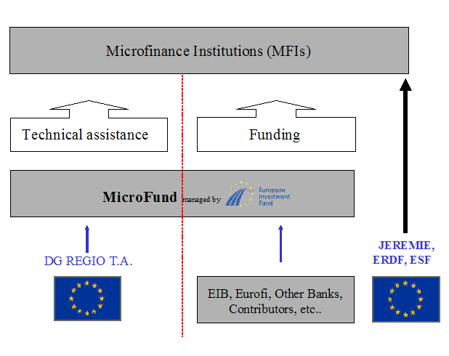

6.10. ANNEX 10: A multidimensional Evaluation Scoreboard
Evaluation could be conducted at different levels. Member States could conduct an annual evaluation of the progress of micro-credit for the Spring European Council, to be included in the Commission’s Spring report. In order to achieve this, the European initiative for Micro-credit should be incorporated into the National Lisbon Reform Plans. Under the open method of coordination, progress in meeting individualised, national targets relating to micro-credit could be evaluated by applying a scoring system based on the different factors of progress noted above. An example of such a scoring system is given below.
For micro-credit supported by the European regional programmes, progress could also be monitored in the network or in Regions for Economic Change. This activity would take the form of twinning between regions participating in the JEREMIE programme, promoting mutual exchanges on best practice. While currently geared to technological innovation, the Network of Regions for Economic Change could perfectly well open itself to social and financial innovation.
Evaluation could also include activities by banks and investment funds. Their micro-credit activities could be explicitly included in the rating agencies’ criteria for socially responsible investment.
Finally, a code of conduct would enable micro-credit institutions financed by JEREMIE to be monitored and evaluated on the basis of international social and financial performance indicators. They could also be subject to more precise rating by specialised agencies. Financing of MFIs from European funds would be linked to their results, and would inevitably have an impact on their private financing as well.
The following graph shows six countries’ scores as given in a micro-credit study carried out for the Directorate-General for Employment and Social Affairs in 2004.
The two networks (MFC and EMN) are currently developing software (eScorecard) that should make it possible to produce annual national and European reports with a view to monitoring the national environments in which micro-credit is developing. Support for such an initiative would facilitate evaluation.
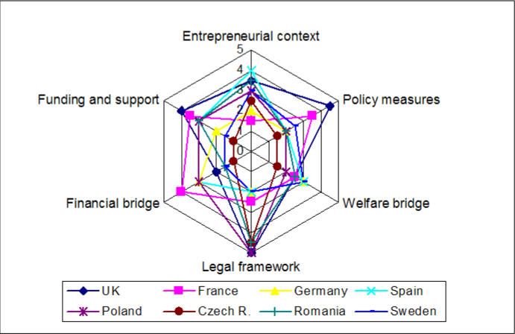

COM(2007)359 – "Towards common principles of flexi-curity
Accordingly, this document is not concerned with matters of "financial inclusion" or "microfinance". These broader concepts integrate other financial services such as savings, micro-insurance or transfers.
COM(2006)349 – 29/06/2006 – p.7 – "Implementing the Community Lisbon Programme: Financing SME Growth – Adding European Value
Eurobarometer survey 06/2004
The calculation is based on Eurostat figures and set out in Annex 4
See Annex 5.
For example, according to the market development analysis done by MFC in Poland at the request of EIF, only 15% of micro-enterprises use micro-credit. The total market gap amounts there to about two million potential clients.
Those who lack collateral, steady employment and a verifiable credit history.
http://ec.europa.eu/internal_market/bank/regcapital/transposition_en.htm
See Annex 8.
Directives 2006/48/EC and 2006/49/EC
Article 4 of Directive 2006/48/EC.
The MFC and EMN are already highly active in the areas of information, training, technical assistance, etc.
COM 2006/349 - p.7
Estimates of between €1 000 and €8 000 - Financial Instruments of the Social Economy in Europe and their impact on job creation, 1997. Under €5 000 - Finance for Local Development 2002: http://www.localdeveurope.org
This amount varies according to the target population and the GDP per inhabitant. According to Overview of the Micro-credit Sector in Europe (EMN, 2004- 2005), the average micro-loan in the EU-15 is € 10 240, while in new Member States (EU-12) it is € 3800.
Council Decision (98/347/EC) of 19 May 1998 on measures of financial assistance for innovative and job-creating small and medium-sized enterprises (SMEs) - the growth and employment initiative, OJ L 155, 29.5.1998.
Council Decision (2000/819/EC) of 20 December 2000 on a multiannual programme for enterprise and entrepreneurship, and in particular for small and medium-sized enterprises (SMEs) (2001-2005), OJ L 333, 29.12.2000,
Decision No 1639/2006/EC of the European Parliament and of the Council of 24 October 2006 establishing a Competitiveness and Innovation Framework Programme (2007 to 2013), OJ L 310, 9.11.2006.
Article 71(5) of Regulation No 1698/2005 of 20 September 2005 on support for rural development by the European Agricultural Fund for Rural Development (EAFRD), OJ L 277, 21.10.2005, and Articles 50 to 52 of Regulation No 1974/2006 (the relevant implementing rules), OJ L 368, 23.12.2006.
Regulation (EC) No 1927/2006/EC of the European Parliament and of the Council of 20 December 2006 – OJ L 406 on establishing the European Globalisation Adjustment Fund, OJ L 406, 30.12.2006.
http://ec.europa.eu/enterprise/entrepreneurship/financing/docs/microcredit_regulation_report_2007.pdf
Commission Working Paper SEC (2004) 1156.
COM(2005) 629 of 1.12.2005.
COM(2007) 226 of 30.04.2007.
Commission Regulation No 1998/2006 of 15.12.2006 on the application of Articles 87 and 88 of the Treaty to de minimis aid, OJ L 379, 28.12.2006.
Commision Decision PE/2004/2632.
See Eurostat’s definition (‘Income Poverty and Social Exclusion in the EU 25’, Statistics in Focus – Population and Social Conditions, 13/2005) and data available at: http://epp.eurostat.ec.europa.eu/portal/page?_pageid=1996,39140985&_dad=portal&schema=PORTAL&screen=detailref&language=fr&product=sdi_ps&root=sdi_ps/sdi_ps/sdi_ps1000
ILO : International Labour Office
Directives 2006/48/EC and 2006/49/EC.
The OCM is based on the common definition of objectives and measuring tools, comparison of performance among States and exchange of best practice (benchmarking).
Policy measures to promote the use of micro-credit for social inclusion by FACET BV, Evers Jung, New Economics Foundation, supported by MFC and EMN.

