EN
COMMISSION OF THE EUROPEAN COMMUNITIES
Brussels, 29.11.2007
COM(2007) 763 final
2007/0268 (COD)

Proposal for a
REGULATION OF THE EUROPEAN PARLIAMENT AND OF THE COUNCIL
on the submission of nominal catch statistics by Member States fishing
in the north-east Atlantic
(Recast)
(presented by the Commission)
EXPLANATORY MEMORANDUM
1. On 1 April 1987 the Commission decided to instruct its staff that all legislative acts should be codified after no more than ten amendments, stressing that this is a minimum requirement and that departments should endeavour to codify at even shorter intervals the texts for which they are responsible, to ensure that the Community rules are clear and readily understandable.
2. The codification of Council Regulation (EEC) No 3880/91 of 17 December 1991 on the submission of nominal catch statistics by Member States fishing in the north-east Atlantic has been initiated by the Commission, and a relevant proposal has been submitted to the legislative authority. The new Regulation was to have superseded the various acts incorporated in it.
3. In the meantime Decision 1999/468/EC of 28 June 1999 laying down the procedures for the exercise of implementing powers conferred on the Commission has been amended by Decision 2006/512/EC, which introduced a regulatory procedure with scrutiny for measures of general scope designed to amend non-essential elements of a basic instrument adopted in accordance with the procedure referred to in Article 251 of the Treaty, including by deleting some of those elements or by supplementing the instrument by the addition of new non-essential elements.
4. In accordance with the joint statement of the European Parliament, the Council and the Commission on Decision 2006/512/EC, for this new procedure to be applicable to instruments adopted in accordance with the procedure laid down in Article 251 of the Treaty which are already in force, those instruments must be adjusted in accordance with the applicable procedures.
5. It is therefore appropriate to transform the codification of Regulation (EEC) No 3880/91 into a recast in order to incorporate the amendments necessary for the adjustment to the regulatory procedure with scrutiny.

ê 3880/91 (adapted)
2007/0268 (COD)
Proposal for a
REGULATION OF THE EUROPEAN PARLIAMENT AND OF THE COUNCIL
on the submission of nominal catch statistics by Member States fishing
in the north-east Atlantic
(Text with EEA relevance)
THE EUROPEAN PARLIAMENT AND THE COUNCIL OF THE EUROPEAN UNION,
Having regard to the Treaty establishing the European Community, and in particular Article Ö 285(1) Õ thereof,
Having regard to the proposal from the Commission,
Having regard to the opinion of the European Economic and Social Committee,
Having regard to the opinion of the Statistical Programme Committee,
Acting in accordance with the procedure laid down in Article 251 of the Treaty,
Whereas:

ò new
(1) Council Regulation (EEC) No 3880/91 of 17 December 1991 on the submission of nominal catch statistics by Member States fishing in the north-east Atlantic has been substantially amended several times. Since further amendments are to be made, it should be recast in the interests of clarity.

ê 3880/91 Recital 1
(2) The management of the Community's fishery resources requires accurate and timely statistics on the catches by Member States' vessels fishing in the north-east Atlantic.

ê 3880/91 Recital 2
(3) The Convention on future multilateral cooperation in north-east Atlantic fisheries approved by Council Decision 81/608/EEC and establishing the North-East Atlantic Fisheries Commission requires the Community to supply that Commission with the available statistics that it may request.

ê 3880/91 Recital 3
(4) Advice received from the International Council for the Exploration of the Sea under the Cooperation Agreement between that organisation and the Community will be enhanced by the availability of statistics on the activities of the Community fishing fleet.

ê 3880/91 Recital 4
(5) The Convention on fishing and conservation of the living resources in the Baltic Sea and the Belts approved by Council Decision 83/414/EEC and establishing the International Baltic Sea Fishery Commission requires the Community to supply that Commission with the available statistics that it may request.

ê 3880/91 Recital 5
(6) The Convention for the conservation of salmon in the north Atlantic Ocean approved by Council Decision 82/886/EEC and establishing the North Atlantic Salmon Conservation Organization (Nasco), requires the Community to supply that organisation with the available statistics that it may request.

ê 1637/2001 Recital 5
(7) Several Member States have requested submission of data in a different form or through a different medium from that specified in Annex IV (the equivalent of the Statlant questionnaires).

ê 3880/91 Recital 6
(8) There is a need for fuller definitions and descriptions used in fishery statistics and in the management of the fisheries of the north-east Atlantic.

ò new
(9) The measures necessary for the implementation of this Regulation should be adopted in accordance with Council Decision 1999/468/EC of 28 June 1999 laying down the procedures for the exercise of implementing powers conferred on the Commission.
(10) Power should be conferred on the Commission in particular to adapt the lists of species and statistical fishing regions, descriptions of those fishing regions and the permitted degree of aggregation of data. Since those measures are of general scope and are designed to amend non-essential elements of this Regulation, they should be adopted in accordance with the regulatory procedure with scrutiny provided for in Article 5a of Decision 1999/468/EC,

ê 3880/91
HAVE ADOPTED THIS REGULATION:
Article 1
Each Member State shall submit to the Statistical Office of the European Communities, hereinafter referred to as ‘Eurostat’, data on the annual nominal catches by vessels registered in or flying the flag of that Member State fishing in the north-east Atlantic.
The nominal catch data shall include all fishery products landed or transhipped at sea in no matter what form but shall exclude quantities which, subsequent to capture, are discarded at sea, consumed on board or used as bait on board. Aquaculture production shall be excluded. The data shall be recorded as the live weight equivalent of the landings or transhipments, to the nearest tonne.
Article 2
1. The data to be submitted shall be the nominal catches of each of the species listed in Annex I in each of the statistical fishing regions listed in Annex II and defined in Annex III.
2. The data for each calendar year shall be submitted within six months of the end of the year. No submissions shall be required for species/fishing region combinations for which no catches were recorded in the annual period of the submission. The data for species of minor importance in a Member State need not be individually identified in the submissions but may be included in an aggregated item provided that the weight of the products thus recorded does not exceed 10% by weight of the total catch in that Member State in that month.

ê 3880/91 (adapted)
ð new
3. ð The Commission may amend ï the lists of species and statistical fishing regions, the descriptions of those fishing regions and the permitted degree of aggregation of data.
ð Those measures, designed to amend non-essential elements of this Regulation, shall be adopted ï in accordance with the ð regulatory ï procedure ð with scrutiny ï Ö referred to Õ in Article 5(2).

ê 3880/91
Article 3
Except where provisions adopted under the common fisheries policy dictate otherwise, a Member State shall be permitted to use sampling techniques to derive catch data for those parts of the fishing fleet for which the complete coverage of the data would involve the excessive application of administrative procedures. The details of the sampling procedures, together with details of the proportion of the total data derived by such techniques, must be included by the Member State in the report submitted pursuant to Article 6(1).
Article 4
Member States shall fulfil their obligations to the Commission pursuant to Articles 1 and 2 by submitting the data on magnetic medium, the format of which is given in Annex IV.

ê 1637/2001 Art. 2
Member States may submit data in the format detailed in Annex V.

ê 3880/91
With the prior approval of Eurostat, Member States may submit data in a different form or on a different medium.

ê 1882/2003 Art. 1 and Annex I pt. 4 (adapted)
ð new
Article 5
1. The Commission shall be assisted by the Standing Committee on Agricultural Statistics, Ö set up by Council Decision 72/279/EEC Õ hereinafter referred to as ‘the Committee’.
2. Where reference is made to this paragraph, Article 3 ð 5a(1) to (4) ï and Ö Article Õ 7 of Decision 1999/468/EC shall apply, having regard to the provisions of Article 8 thereof.
3. The Committee shall adopt its rules of procedure.

ê 3880/91 (adapted)
Article 6
1. Ö By 1 January 1993 Õ Member States shall submit a detailed report to Eurostat describing how the data on catches are derived and specifying the degree of representativeness and reliability of these data. Eurostat, in collaboration with the Member States, shall draw up a summary of these reports.
2. Member States shall inform Eurostat of any modifications to the information provided under paragraph 1 within three months of their introduction.
3. Methodological reports, data availability Ö and Õ data reliability Ö referred to in paragraph 1 Õ and other relevant issues connected with the application of this Regulation shall be examined once a year within the competent Working Party of the Committee.

ê
Article 7
Regulation (EEC) No 3880/91 is repealed.
References to the repealed Regulation shall be construed as references to this Regulation and shall be read in accordance with the correlation table in Annex VII.

ê 3880/91
Article 8
This Regulation shall enter into force on the twentieth day following that of its publication in the Official Journal of the European Union .
This Regulation shall be binding in its entirety and directly applicable in all Member States.
Done at Brussels, […]
For the European Parliament For the Council
The President The President
[…] […]

ê 1637/2001 Art. 1 and Annex I
ANNEX I
LIST OF SPECIES WHICH HAVE BEEN REPORTED IN THE COMMERCIAL CATCH STATISTICS FOR THE NORTH-EAST ATLANTIC
Member States must report the nominal catches of those species marked with an asterisk (*). The reporting of nominal catches of the remaining species is optional as concerns the identification of the individual species. However, where data for individual species are not submitted the data shall be included in aggregate categories. Member States may submit data for species not in the list provided that the species are clearly identified.
Note: ‘n.e.i.’ is the abbreviation for ‘not elsewhere identified’.
English name | 3-alpha identifier | Scientific name
Freshwater breams n.e.i. | FBR | Abramis spp.
Ide (Orfe) | FID | Leuciscus (= Idus) idus
Roach | FRO | Rutilus rutilus
Common carp | FCP | Cyprinus carpio
Crucian carp | FCC | Carassius carassius
Tench | FTE | Tinca tinca
Cyprinids n.e.i. | FCY | Cyprinidae
Northern pike | FPI | Esox lucius
Pikeperch | FPP | Stizostedion lucioperca
European perch | FPE | Perca fluviatilis
Burbot | FBU | Lota lota
Freshwater fishes n.e.i. | FRF | ex Osteichthyes
Sturgeons n.e.i. | STU | Acipenseridae
European eel | ELE (*) | Anguilla anguilla
Vendace | FVE | Coregonus albula
Whitefishes n.e.i. | WHF | Coregonus spp.
Atlantic salmon | SAL (*) | Salmo salar
Sea trout | TRS | Salmo trutta
Trouts n.e.i. | TRO | Salmo spp.
Chars n.e.i. | CHR | Salvelinus spp.
European smelt | SME | Osmerus eperlanus
Salmonids n.e.i. | SLX | Salmonoidei
European whitefish | PLN | Coregonus lavaretus
Houting | HOU | Coregonus oxyrinchus
Lampreys | LAM | Petromyzon spp.
Shads n.e.i. | SHD | Alosa alosa, A. fallax
Diadromous clupeoids n.e.i. | DCX | Clupeoidei
Diadromous fishes n.e.i. | DIA | ex Osteichthyes
Megrim n.e.i. | MEG (*) | Lepidorhombus whiffiagonis
Fourspot megrim | LDB | Lepidorhombus boscii
Megrims n.e.i. | LEZ (*) | Lepidorhombus spp.
Turbot | TUR (*) | Psetta maxima
Brill | BLL (*) | Scophthalmus rhombus
Atlantic halibut | HAL (*) | Hippoglossus hippoglossus
European plaice | PLE (*) | Pleuronectes platessa
Greenland halibut | GHL (*) | Reinhardtius hippoglossoides
Witch flounder | WIT (*) | Glyptocephalus cynoglossus
Long-rough dab | PLA (*) | Hippoglossoides platessoides
Common dab | DAB (*) | Limanda limanda
Lemon sole | LEM (*) | Microstomus kitt
European flounder | FLE (*) | Platichthys flesus
Common sole | SOL (*) | Solea vulgaris
Sand sole | SOS | Solea lascaris
Senegalese sole | OAL | Solea senegalensis
Soles n.e.i. | SOO (*) | Solea spp.
Flatfishes n.e.i. | FLX | Pleuronectiformes
Tusk (= cusk) | USK (*) | Brosme brosme
Atlantic cod | COD (*) | Gadus morhua
European hake | HKE (*) | Merluccius merluccius
Ling | LIN (*) | Molva molva
Blue ling | BLI (*) | Molva dypterygia (= byrkelange)
Greater forkbeard | GFB | Phycis blennoides
Haddock | HAD (*) | Melanogrammus aeglefinus
Wachna cod (= navaga) | COW | Eleginus navaga
Saithe (= pollock = coalfish) | POK (*) | Pollachius virens
Pollack | POL (*) | Pollachius pollachius
Polar cod | POC | Boreogadus saida
Norway pout | NOP (*) | Trisopterus esmarki
Pouting (= bib) | BIB | Trisopterus luscus
Blue whiting (= poutassou) | WHB (*) | Micromesistius poutassou
Whiting | WHG (*) | Merlangius merlangus
Roundnose grenadier | RNG | Coryphaenoides rupestris
Morid cods | MOR | Moridae
Poor cod | POD | Trisopterus minutus
Greenland cod | GRC | Gadus ogac
Arctic cod | ATG | Arctogadus glacialis
Gadiformes n.e.i. | GAD | Gadiformes
Greater argentine | ARU | Argentina silus
Argentine | ARY | Argentina sphyraenia
Argentines | ARG | Argentina spp.
European conger | COE | Conger conger
Atlantic John Dory | JOD | Zeus faber
Sea bass | BSS | Dicentrarchus labrax
Dusky grouper | GPD | Epinephalus guaza
Wreckfish | WRF | Polyprion americanus
Sea basses, sea perches | BSX | Serranidae
Grunts n.e.i. | GRX | Haemulidae (= Pomadasyidae)
Meagre | MGR | Argyrosomus regius
Red (= common) sea bream | SBR | Pagellus bogaraveo
Common pandora | PAC | Pagellus erythrinus
Large-eye dentex | DEL | Dentex macrophthalmus
Dentex n.e.i. | DEX | Dentex spp.
Red porgy | RPG | Sparus pagrus (= sedicum)
Gilthead sea bream | SBG | Sparus aurata
Bogue | BOG | Boops boops
Porgies, sea breams n.e.i. | SBX | Sparidae
Red mullet | MUR | Mullus surmuletus
Greater weaver | WEG | Trachinus draco
Atlantic wolf-fish (= catfish) | CAA (*) | Anarhichas lupus
Spotted wolf-fish | CAS (*) | Anarhichas minor
Eel-pout | ELP | Zoarces viviparus
Sand eels (= sand lances) | SAN (*) | Ammodytes spp.
Atlantic gobies | GOB | Gobius spp.
Atlantic redfishes | RED (*) | Sebastes spp.
Scorpion fishes n.e.i. | SCO | Scorpaenidae
Gurnards n.e.i. | GUX (*) | Triglidae
Lumpfish (= lumpsucker) | LUM | Cyclopterus lumpus
Monk (= anglerfish) | MON (*) | Lophius piscatorius
Blackbellied angler | ANK | Lophius budegassa
Monkfishes n.e.i. | MNZ (*) | Lophius spp.
Sticklebacks | SKB | Gasterosteus spp.
Axillary (= Spanish) seabream | SBA | Pagellus acarne
Common dentex | DEC | Dentex dentex
Snipe fishes | SNI | Macrorhamphosidae
Striped bass | STB | Morone saxatilis
Wolf-fishes (= catfishes) n.e.i. | CAT (*) | Anarhichas spp.
Beaked redfish | REB (*) | Sebastes mentella
Golden redfish | REG (*) | Sebastes marinus
Red gurnard | GUR (*) | Aspitrigla (= Trigla) cuculus
Grey gurnard | GUG (*) | Eutrigla (= Trigla) gurnardus
Long-finned gurnard | GUM | Chelidonichthys obscura
Streaked gurnard | CTZ | Chelidonichthys lastiviza
Red bandfish | CBC | Cepola rubescens
St Paul's fingerfin | TLD | Acantholatris monodactylus
… | IYL | Sicyopterus lagocephalus
Black cardinal fish | EPI | Epigonus telescopus
Mediterranean slimehead | HPR | Hoplostethus mediterraneus
Atlantic thornyhead | TJX | Trachyscorpia cristulata
Ballan wrasse | USB | Labrus bergylta
Brown wrasse | WRM | Labrus merula
Splendid alfonsino | BYS | Beryx splendens
Demersal percomorphs n.e.i. | DPX | Perciformes
Capelin | CAP (*) | Mallotus villosus
Garfish | GAR | Belone belone
Atlantic saury | SAU | Scomberesox saurus
Mullets n.e.i. | MUL | Mugilidae
Bluefish | BLU | Pomatomus saltatrix
Atlantic horse mackerel | HOM (*) | Trachurus trachurus
Blue jack mackerel | JAA | Trachurus picturatus
Mediterranean horse mackerel | HMM | Trachurus mediterraneus
Jack and horse mackerels n.e.i. | JAX (*) | Trachurus spp.
Leerfish | LEE | Lichia amia
Atlantic pomfret | POA | Brama brama
Silversides (= sandsmelt) | SIL | Atherinidae
Pelagic percomorphs n.e.i. | PPX | Perciformes
Atlantic herring | HER (*) | Clupea harengus
Sardinellas n.e.i. | SIX | Sardinella spp.
European sardine (= pilchard) | PIL (*) | Sardina pilchardus
Sprat | SPR (*) | Sprattus sprattus
European anchovy | ANE (*) | Engraulis encrasicholus
Clupeoids n.e.i. | CLU | Clupeoidei
Atlantic bonito | BON | Sarda sarda
Swordfish | SWO | Xiphias gladius
Frigate tuna | FRI | Auxis thazard
Northern bluefin tuna | BFT | Thunnus thynnus
Albacore | ALB | Thunnus alalunga
Yellowfin tuna | YFT | Thunnus albacares
Skipjack tuna | SKJ | Katsuwonus pelamis
Bigeye tuna | BET | Thunnus obesus
Tuna-like fishes n.e.i. | TUX | Scombroidei
Chub mackerel | MAS (*) | Scomber japonicus
Atlantic mackerel | MAC (*) | Scomber scombrus
Mackerels n.e.i. | MAX | Scombridae
Silver scabbardfish | SFS | Lepidopus caudatus
Black scabbardfish | BSF | Aphanopus carbo
Mackerel-like fishes n.e.i. | MKX | Scombroidei
Porbeagle | POR (*) | Lamna nasus
Basking shark | BSK | Cetorrhinus maximus
Picked (= spiny) dogfish | DGS (*) | Squalus acanthias
Greenland shark | GSK | Somniosus microcephalus
Dogfish sharks n.e.i. | DGX (*) | Squalidae
Skates n.e.i. | SKA (*) | Raja spp.
Dogfishes and hounds | DGH (*) | Squalidae, Scyliorhinidae
Various sharks n.e.i. | SKH | Selachimorpha (Pleurotremata)
Crest-tail catsharks n.e.i. | GAU | Galeus spp.
Blackmouth catshark | SHO | Galeus melastomus
Small-spotted catshark | SYC | Scyliorhinus canicula
Deep-water catsharks | API | Apristurus spp.
False catshark | PTM | Pseudotriakis microdon
Little sleeper shark | SOR | Somniosus rostratus
Gulper shark | GUP | Centrophorus granulosus
Little gulper shark | CPU | Centrophorus uyato
Leafscale gulper shark | GUQ | Centrophorus squamosus
Lowfin gulper shark | CPL | Centrophorus lusitanicus
Velvet belly | ETX | Etmopterus spinax
Great lanternshark | ETR | Etmopterus princeps
Smooth lanternshark | ETP | Etmopterus pusillus
Lantern sharks n.e.i. | SHL | Etmopterus spp.
Deania dogfishes n.e.i. | DNA | Deania spp.
Birdbeak dogfish | DCA | Deania calcea
Portuguese dogfish | CYO | Centroscymnus coelolepis
Longnose velvet dogfish | CYP | Centroscymnus crepidater
Shortnose velvet dogfish | CYY | Centroscymnus cryptacanthus
Smallmouth knifetooth dogfish | SYO | Scymnodon obscurus
Knifetooth dogfish | SYR | Scymnodon ringens
Kitefin shark | SCK | Dalatias licha
Black dogfish | CFB | Centroscyllium fabricii
Angular roughshark | OXY | Oxynotus centrina
Sailfin roughshark | OXN | Oxynotus paradoxus
Bramble shark | SHB | Echinorhinus brucus
Rays and skates n.e.i. | RAJ | Rajidae
Starry ray | RJR | Amblyraja radiata
Blonde ray | RJH | Raja brachyura
Sandy ray | RJI | Raja circularis
Small-eyed ray | RJE | Raja microocellata
Undulate ray | RJU | Raja undulata
White skate | RJA | Raja alba
Round ray | RJY | Raja fyllae
Rabbit fish | CMO | Chimaera monstrosa
Ratfishes n.e.i. | HYD | Hydrolagus spp.
Knife-nosed chimaeras | RHC | Rhinochimaera spp.
Longnose chimaeras | HAR | Harriotta spp.
Cartilaginous fishes n.e.i. | CAR | Chondrichthyes
Groundfishes n.e.i. | GRO | ex Osteichthyes
Pelagic fishes n.e.i. | PEL | ex Osteichthyes
Marine fishes n.e.i. | MZZ | ex Osteichthyes
Finfishes n.e.i. | FIN | ex Osteichthyes
Edible crab | CRE (*) | Cancer pagurus
Green crab | CRG | Carcinus maenas
Spinous spider crab | SCR | Maja squinado
Marine crabs n.e.i. | CRA | Reptantia
Swimcrabs n.e.i. | CRS | Portunus spp.
Palinurid spiny lobsters n.e.i. | CRW (*) | Palinurus spp.
European lobster | LBE (*) | Homarus gammarus
Norway lobster | NEP (*) | Nephrops norvegicus
Common prawn | CPR (*) | Palaemon serratus
Northern prawn | PRA (*) | Pandalus borealis
Common shrimp | CSH (*) | Crangon crangon
Penaeus shrimps n.e.i. | PEN (*) | Penaeus spp.
Palaemonid shrimps | PAL (*) | Palaemonidae
Pink (= pandalid) shrimps | PAN (*) | Pandalus spp.
Crangonid shrimps | CRN (*) | Crangonidae
Natantian decapods n.e.i. | DCP | Natantia
Goose barnacles | GOO | Lepas spp.
Rockpool prawn | PNQ | Palaemon elegens
Delta prawn | PIQ | Palaemon longirostris
St Paul rock lobster | JSP | Jasus paulensis
Lobsters n.e.i. | LOX | Reptantia
Craylets, squat lobsters n.e.i. | LOQ | Galatheidae
Marine crustaceans n.e.i. | CRU | ex Crustacea
Whelk | WHE | Buccinium undatum
Periwinkle | PEE | Littorina littorea
Periwinkles n.e.i. | PER | Littorina spp.
European flat oyster | OYF (*) | Ostrea edulis
Pacific cupped oyster | OYG | Crassostrea gigas
Cupped oyster n.e.i. | OYC (*) | Crassostrea spp.
Blue mussel | MUS (*) | Mytilus edulis
Sea mussels n.e.i. | MSX | Mytilidae
Common scallop | SCE (*) | Pecten maximus
Queen scallop | QSC (*) | Chlamys opercularis
Scallops n.e.i. | SCX (*) | Pectinidae
Common cockle | COC | Cardium edule
Grooved carpet shell | CTG | Tapes decussatus
Ocean quahog | CLQ | Arctica islandica
Clams n.e.i. | CLX | Bivalvia
Razor clams | RAZ | Solen spp.
Carpet shell | CTS | Tapes pullastra
Striped venus | SVE | Venus gallina
Venus clams n.e.i. | CLV | Veneridae
Mactra surf clams n.e.i. | MAT | Mactridae
Chamber venus | KFA | Circomphalus casinus
Common European bittersweet | GKL | Glycymeris glycymeris
Donax clams | DON | Donax spp.
Cockles n.e.i. | COZ | Cardiidae
Norwegian egg cockle | LVC | Laevicardium crassum
Limpets n.e.i. | LPZ | Patella spp.
Abalones n.e.i. | ABX | Haliotis spp.
Gastropods n.e.i. | GAS | Gastropoda
Oval surf clam | ULV | Spisula ovalis
Tellins n.e.i. | TWL | Tellina spp.
Common cuttlefish | CTC (*) | Sepia officinalis
Common squids | SQC (*) | Loligo spp.
Short-finned squid | SQI (*) | Illex illecebrosus
Octopuses n.e.i. | OCT | Octopodidae
Squids n.e.i. | SQU (*) | Loliginidae, Ommastrephidae
Cuttlefishes n.e.i. | CTL (*) | Sepiidae, Sepiolidae
European flying squid | SQE (*) | Todarodes sag. Sagittatus
Cephalopods n.e.i. | CEP | Cephalopoda
Marine molluscs n.e.i. | MOL | ex Mollusca
Starfish | STH | Asterias rubens
Starfishes n.e.i. | STF | Asteroidae
Sea urchin | URS | Echinus esculentus
Stony sea urchin | URM | Paracentrotus lividus
Sea urchins n.e.i. | URX | Echinoidea
Sea cucumbers n.e.i. | CUX | Holothurioidea
Echinoderms n.e.i. | ECH | Echinodermata
Grooved sea squirt | SSG | Microcosmus sulcatus
Sea squirts n.e.i. | SSX | Ascidiacea
Horseshoe crab | HSC | Limulus polyphemus
Aquatic invertebrates n.e.i. | INV | ex Invertebrata
Brown seaweeds | SWB | Phaeophyceae
Carragheen | IMS | Chondrus crispus
Gelidium spp. | GEL | Gelidium spp.
Gigartina spp. | GIG | Gigartina spp.
Lithothamnion spp. | LIT | Lithothamnion spp.
Red seaweeds | SWR | Rhodophyceae
Wracks n.e.i. | UCU | Fucus spp.
North Atlantic rockweed | ASN | Ascophyllum nodosum
Toothed wrack | FUU | Fucus serratus
Sea lettuce | UVU | Ulva lactuca
Seaweeds n.e.i. | SWX | ex Algae
___________

ê 3880/91
ANNEX II

ê 448/2005 Art. 1 and Annex I
STATISTICAL FISHING REGIONS OF THE NORTH-EAST ATLANTIC FOR WHICH DATA ARE TO BE SUBMITTED
ICES division Ia
ICES division Ib
ICES subdivision IIa 1
ICES subdivision IIa 2
ICES subdivision IIb 1
ICES subdivision IIb 2
ICES division IIIa
ICES division IIIb, c
ICES division IVa
ICES division IVb
ICES division IVc
ICES subdivision Va 1
ICES subdivision Va 2
ICES subdivision Vb 1a
ICES subdivision Vb 1b
ICES subdivision Vb 2
ICES division VIa
ICES subdivision VIb 1
ICES subdivision VIb 2
ICES division VIIa
ICES division VIIb
ICES subdivision VIIc 1
ICES subdivision VIIc 2
ICES division VIId
ICES division VIIe
ICES division VIIf
ICES division VIIg
ICES division VIIh
ICES subdivision VIIj 1
ICES subdivision VIIj 2
ICES subdivision VIIk 1
ICES subdivision VIIk 2
ICES division VIIIa
ICES division VIIIb
ICES division VIIIc
ICES subdivision VIIId 1
ICES subdivision VIIId 2
ICES subdivision VIIIe 1
ICES subdivision VIIIe 2
ICES division IXa
ICES subdivision IXb 1
ICES subdivision IXb 2
ICES subdivision Xa 1
ICES subdivision Xa 2
ICES division Xb
ICES subdivision XIIa 1
ICES subdivision XIIa 2
ICES subdivision XIIa 3
ICES subdivision XIIa 4
ICES division XIIb
ICES division XIIc
ICES division XIVa
ICES subdivision XIVb 1
ICES subdivision XIVb 2
BAL 22
BAL 23
BAL 24
BAL 25
BAL 26
BAL 27
BAL 28-1
BAL 28-2
BAL 29
BAL 30
BAL 31
BAL 32
Notes
1. Those statistical fishing regions preceded by ‘ICES’ have been identified and defined by the International Council for the Exploration of the Sea.
2. Those statistical fishing regions preceded by ‘BAL’ have been identified and defined by the International Baltic Sea Fishery Commission.
3. Data should be submitted so as to include as much detail as possible. ‘Unknown’ and aggregate regions should only be used where the detailed information is not available. Where detailed information is submitted the aggregate categories should not be used.
Statistical fishing regions of the north-east Atlantic
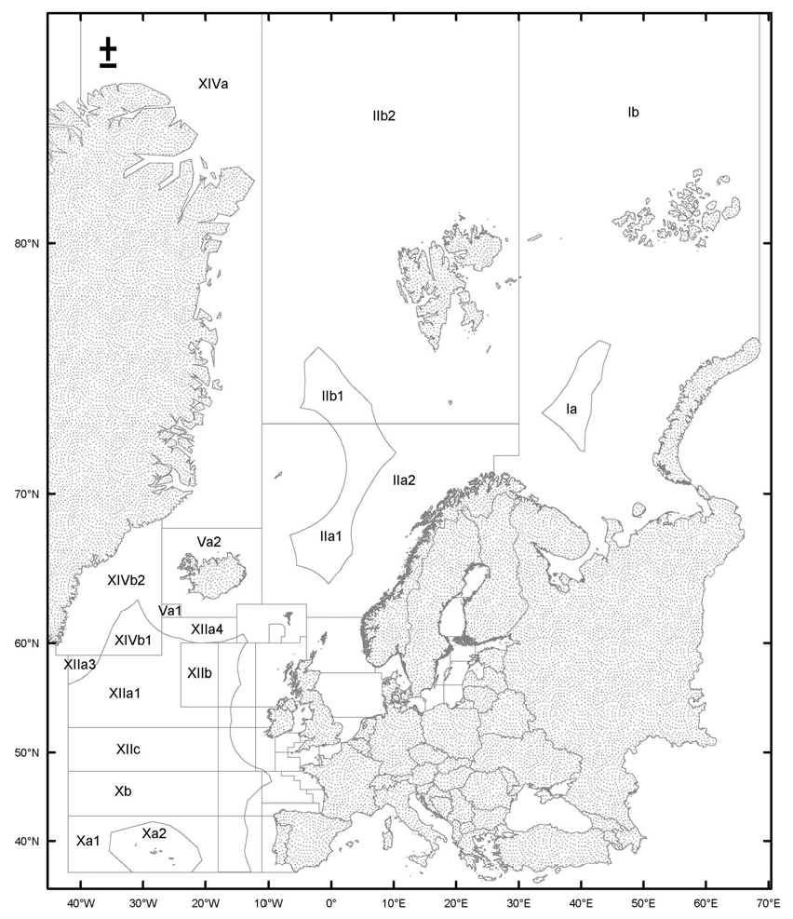
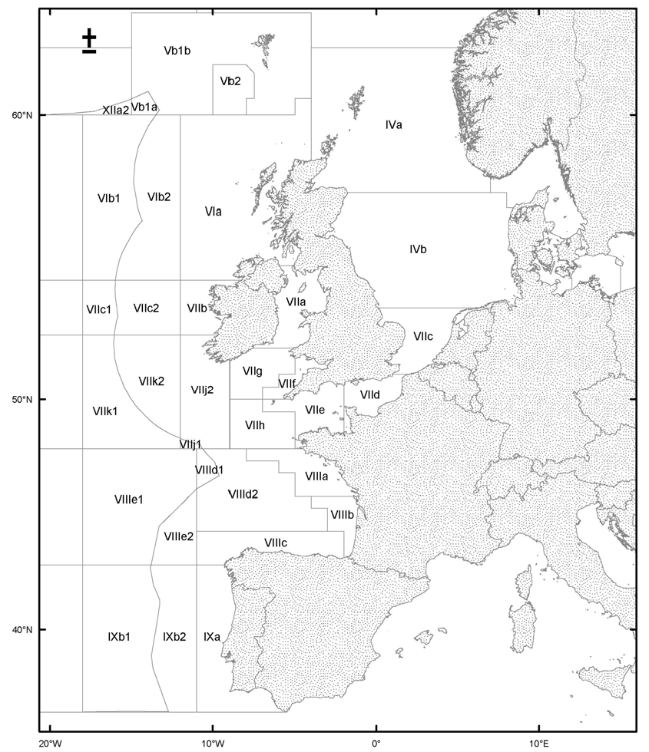
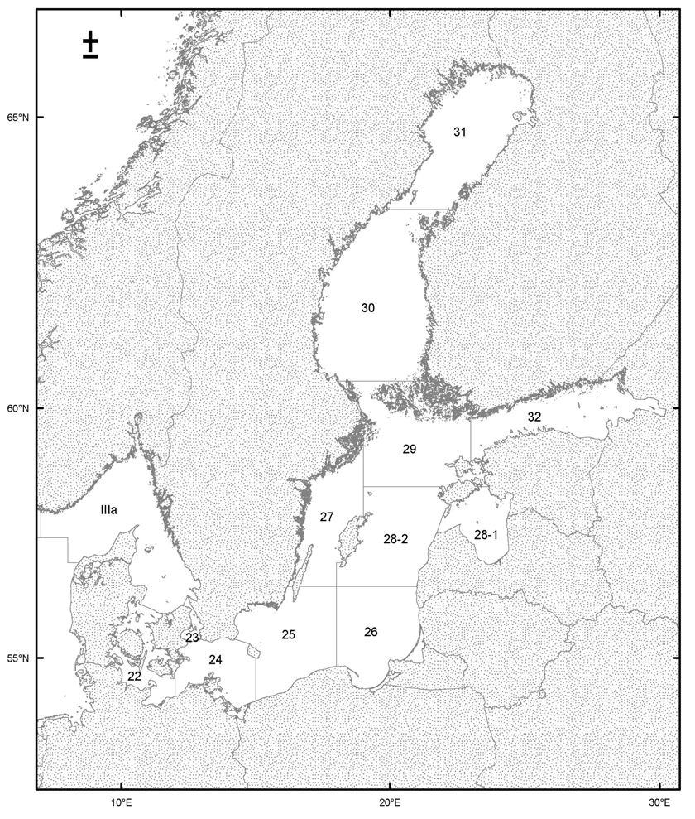
______________

ê 3880/91
ANNEX III

ê 448/2005 Art. 1 and Annex II
DESCRIPTION OF THE ICES SUBAREAS AND DIVISIONS USED FOR THE PURPOSE OF FISHERY STATISTICS AND REGULATIONS IN THE NORTH-EAST ATLANTIC
ICES STATISTICAL AREA (NORTH-EAST ATLANTIC)
All waters of the Atlantic and Arctic Oceans and their dependent seas bounded by a line from the geographic North Pole along the meridian of 40° 00′ west to the north coast of Greenland; then in an easterly and southerly direction along the coast of Greenland to a point at 44° 00′ west; then due south to 59° 00′ north; then due east to 42° 00′ west; then due south to 36° 00′ north; then due east to a point on the coast of Spain (Punta Marroqui isthmus) at 5° 36′ west; then in a north-westerly and northerly direction along the south-west coast of Spain, the coast of Portugal, the north-west and north coasts of Spain, and the coasts of France, Belgium, the Netherlands and Germany to the western terminus of its boundary with Denmark; then along the west coast of Jutland to Thyboroen; then in a southerly and easterly direction along the south coast of the Limfjord to Egensekloster Point; then in a southerly direction along the east coast of Jutland to the eastern terminus of the boundary of Denmark with Germany; then along the coast of Germany, Poland, Russia, Lithuania, Latvia, Estonia, Russia, Finland, Sweden and Norway, and the north coast of Russia to Khaborova; then across the western entry of the Strait of Yugorskiy Shar; then in a westerly and northerly direction along the coast of Vaigach Island; then across the western entry of the Strait off the Karskiye Vorota; then west and north along the coast of the south island of Novaya Zemlya; then across the western entry of the Strait of Matochkin Shar; then along the west coast of the north island of Novaya Zemlya to a point at 68° 30′ east; then due north to the geographic North Pole.
This area also represents statistical area 27 (north-east Atlantic statistical area) in the FAO International Standard Statistical Classification of Fishing Areas.

ICES statistical subarea I
The waters bounded by a line from the geographic North Pole along the meridian of 30° 00′ east to 72° 00′ north; then due west to 26° 00′ east; then due south to the coast of Norway; then in an easterly direction along the coasts of Norway and Russia to Khaborova; then across the western entry of the Strait of Yugorskiy Shar; then in a westerly and northerly direction along the coast of Vaigach Island; then across the western entry of the Strait off the Karskiye Vorota; then west and north along the coast of the south island of Novaya Zemlya; then across the western entry of the Strait of Matochkin Shar; then along the west coast of the north island of Novaya Zemlya to a point at 68° 30′ east; then due north to the geographic North Pole.
- ICES statistical division Ia
That part of subarea I enclosed by the line joining the following coordinates:
Latitude | Longitude
73.98 N | 33.70 E
74.18 N | 34.55 E
74.36 N | 35.28 E
74.71 N | 36.38 E
75.14 N | 37.57 E
75.45 N | 38.31 E
75.84 N | 39.05 E
76.26 N | 39.61 E
76.61 N | 41.24 E
76.96 N | 42.81 E
76.90 N | 43.06 E
76.75 N | 44.48 E
75.99 N | 43.51 E
75.39 N | 43.18 E
74.82 N | 41.73 E
73.98 N | 41.56 E
73.17 N | 40.66 E
72.20 N | 40.51 E
72.26 N | 39.76 E
72.62 N | 38.96 E
73.04 N | 37.74 E
73.37 N | 36.61 E
73.56 N | 35.70 E
73.98 N | 33.70 E
- ICES statistical division Ib
That part of subarea I outside of division Ia.

ICES statistical subarea II
The waters bounded by a line from the geographic North Pole along the meridian of 30° 00′ east to 72° 00′ north; then due west to 26° 00′ east; then due south to the coast of Norway; then in a westerly and south-westerly direction along the coast of Norway to 62° 00′ north; then due west to 4° 00′ west; then due north to 63° 00′ north; then due west to 11° 00′ west; then due north to the geographic North Pole.
- ICES statistical division IIa
The waters bounded by a line beginning at a point on the coast of Norway at 62° 00′ north; then due west to 4° 00′ west; then due north to 63° 00′ north; then due west to 11° 00′ west; then due north to 72° 30′ north; then due east to 30° 00′ east; then due south to 72° 00′ north; then due west to 26° 00′ east; then due south to the coast of Norway; then in a westerly and south-westerly direction along the coast of Norway to the point of beginning.
- ICES statistical subdivision IIa 1
That part of division IIa within the line joining the following coordinates:
Latitude | Longitude
73.50 N | 00.20 W
73.50 N | 07.21 E
73.45 N | 07.28 E
73.14 N | 07.83 E
72.76 N | 08.65 E
72.49 N | 09.33 E
72.31 N | 09.83 E
72.18 N | 10.29 E
71.98 N | 09.94 E
71.91 N | 09.70 E
71.64 N | 08.75 E
71.36 N | 07.93 E
71.13 N | 07.42 E
70.79 N | 06.73 E
70.17 N | 05.64 E
69.79 N | 05.01 E
69.56 N | 04.74 E
69.32 N | 04.32 E
69.10 N | 04.00 E
68.86 N | 03.73 E
68.69 N | 03.57 E
68.46 N | 03.40 E
68.23 N | 03.27 E
67.98 N | 03.19 E
67.77 N | 03.16 E
67.57 N | 03.15 E
67.37 N | 03.18 E
67.18 N | 03.24 E
67.01 N | 03.31 E
66.84 N | 03.42 E
66.43 N | 03.27 E
66.39 N | 03.18 E
66.23 N | 02.79 E
65.95 N | 02.24 E
65.64 N | 01.79 E
65.38 N | 01.44 E
65.32 N | 01.26 E
65.08 N | 00.72 E
64.72 N | 00.04 E
64.43 N | 00.49 W
64.84 N | 01.31 W
64.92 N | 01.56 W
65.13 N | 02.17 W
65.22 N | 02.54 W
65.39 N | 03.19 W
65.47 N | 03.73 W
65.55 N | 04.19 W
65.59 N | 04.56 W
65.69 N | 05.58 W
65.96 N | 05.60 W
66.22 N | 05.67 W
66.47 N | 05.78 W
67.09 N | 06.25 W
67.61 N | 06.62 W
67.77 N | 05.33 W
67.96 N | 04.19 W
68.10 N | 03.42 W
68.33 N | 02.39 W
68.55 N | 01.56 W
68.86 N | 00.61 W
69.14 N | 00.08 E
69.44 N | 00.68 E
69.76 N | 01.18 E
69.97 N | 01.46 E
70.21 N | 01.72 E
70.43 N | 01.94 E
70.63 N | 02.09 E
70.89 N | 02.25 E
71.14 N | 02.35 E
71.35 N | 02.39 E
71.61 N | 02.38 E
71.83 N | 02.31 E
72.01 N | 02.22 E
72.24 N | 02.06 E
72.43 N | 01.89 E
72.60 N | 01.68 E
72.75 N | 01.48 E
72.99 N | 01.08 E
73.31 N | 00.34 E
73.50 N | 00.20 W
- ICES statistical subdivision IIa 2
That part of division IIa not falling within subdivision IIa 1.
- ICES statistical division IIb
The waters bounded by a line from the geographic North Pole along the meridian of 30° 00′ east to 73° 30′ north; then due west to 11° 00′ west; then due north to the geographic North Pole.
- ICES statistical subdivision IIb 1
That part of division IIb confined by the following coordinates:
Latitude | Longitude
73.50 N | 07.21 E
73.50 N | 00.20 W
73.60 N | 00.48 W
73.94 N | 01.88 W
74.09 N | 02.70 W
74.21 N | 05.00 W
74.50 N | 04.38 W
75.00 N | 04.29 W
75.30 N | 04.19 W
76.05 N | 04.30 W
76.18 N | 04.09 W
76.57 N | 02.52 W
76.67 N | 02.10 W
76.56 N | 01.60 W
76.00 N | 00.80 E
75.87 N | 01.12 E
75.64 N | 01.71 E
75.21 N | 03.06 E
74.96 N | 04.07 E
74.86 N | 04.55 E
74.69 N | 05.19 E
74.34 N | 06.39 E
74.13 N | 06.51 E
73.89 N | 06.74 E
73.60 N | 07.06 E
73.50 N | 07.21 E
- ICES statistical subdivision IIb 2
That part of division IIb not falling within subdivision IIb 1.

ICES statistical subarea III
The waters bounded by a line, beginning at a point on the coast of Norway at 7° 00′ east; then due south to 57° 30′ north; then due east to 8° 00′ east; then due south to 57° 00′ north; then due east to the coast of Denmark; then along the north-west and east coasts of Jutland to Hals; then across the eastern entrance of the Limfjord to Egensekloster Point; then in a southerly direction along the coast of Jutland to the eastern terminus of the boundary of Denmark and Germany; then along the coasts of Germany, Poland, Russia, Lithuania, Latvia, Estonia, Russia, Finland, Sweden, and Norway to the point of beginning.
- ICES statistical division IIIa
The waters bounded by a line beginning at a point on the coast of Norway at 7° 00′ east; then due south to 57° 30′ north; then due east to 8° 00′ east; then due south to 57° 00′ north; then due east to the coast of Denmark; then along the north-west and east coasts of Jutland to Hals; then across the eastern entrance of the Limfjord to Egensekloster Point; then in a southerly direction along the coast of Jutland to Hasenoere Head; then across the Great Belt to Gniben Point; then along the north coast of Zealand to Gilbjerg Head; then across the northern approaches of the Œresund to Kullen on the coast of Sweden; then in an easterly and northerly direction along the west coast of Sweden and the south coast of Norway to the point of beginning.
- ICES statistical division IIIb and c
The waters bounded by a line from Hasenoere Head on the east coast of Jutland to Gniben Point on the west coast of Zealand to Gilbjerg Head; then across the northern approaches of the Œresund to Kullen on the coast of Sweden; then in a southerly direction along the coast of Sweden to Falsterbo Light; then across the southern entrance of the Œresund to Stevns Light; then along the south-east coast of Zealand; then across the eastern entrance of the Storstroem Sound; then along the east coast of the island of Falster to Gedser; then to Darsser Ort on the coast of Germany; then in a south-westerly direction along the coast of Germany and the east coast of Jutland to the point of beginning.
- ICES statistical subdivision 22 (BAL 22)
The waters bounded by a line from Hasenoere Head (56° 09′ north, 10° 44′ east) on the east coast of Jutland to Gniben Point (56° 01′ north, 11° 18′ east) on the west coast of Zealand; then along the west and south coasts of Zealand to a point at 12° 00′ east; then due south to the island of Falster; then along to the east coast of the island of Falster to Gedser Odd (54° 34′ north, 11° 58′ east); then due east to 12° 00′ east; then due south to the coast of Germany; then in a south-westerly direction along the coast of Germany and the east of Jutland to the point of beginning.
- ICES statistical subdivision 23 (BAL 23)
The waters bounded by a line from Gilbjerg Head (56° 08′ north, 12° 18′ east) on the north coast of Zealand to Kullen (56° 18′ north, 12° 28′ east) on the coast of Sweden; then in a southerly direction along the coast of Sweden to the Falsterbo Light (55° 23′ north, 12° 50′ east), then through the southern entrance to the Sound to the Stevns Light (55° 19′ north, 12° 29′ east) on the coast of Zealand; then in a northerly direction along the east coast of Zealand to the point of beginning.
- ICES statistical subdivision 24 (BAL 24)
The waters bounded by a line from the Stevns Light (55° 19′ north, 12° 29′ east) on the east coast of Zealand through the southern entrance to the Sound to the Falsterbo Light (55° 23′ north, 12° 50′ east) on the coast of Sweden; then along the south coast of Sweden to the Sandhammaren Light (55° 24′ north, 14° 12′ east); then to the Hammerodde Light (55° 18′ north, 14° 47′ east) on the north coast of Bornholm; then along the west and south coasts of Bornholm to a point at 15° 00′ east; then due south to the coast of Poland; then in a westerly direction along the coasts of Poland and Germany to a point at 12° 00′ east; then due north to a point at 54° 34′ north, 12° 00′ east; then due west to Gedser Odde (54° 34′ north, 11° 58′ east); then along the east and north coasts of the island of Falster to a point at 12° 00′ east; then due north to the south coast of Zealand; then in a westerly and northerly direction along the west coast of Zealand to the point of beginning.
- ICES statistical subdivision 25 (BAL 25)
The waters bounded by a line beginning at a point on the east coast of Sweden at 56° 30′ north; then due east to the west coast of the island of Œland; then, after passing south of island of Œland to a point on the east coast at 56° 30′ north, due east to 18° 00′ east; then due south to the coast of Poland; then in a westerly direction along the coast of Poland to a point at 15° 00′ east; then due north to the island of Bornholm; then along the south and west coasts of Bornholm to the Hammerodde Light (55° 18′ north, 14° 47′ east); then to the Sandhammaren Light (55° 24′ north, 14° 12′ east) on the south coast of Sweden; then in a northerly direction along the east coast of Sweden to the point of beginning.
- ICES statistical subdivision 26 (BAL 26)
The waters bounded by a line beginning at a point at 56° 30′ north, 18° 00′ east; then due east to the west coast of Latvia; then in a southerly direction along the coasts of Latvia, Lithuania, Russia and Poland to a point on the Polish coast at 18°00′ east; then due north to the point of beginning.
- ICES statistical subdivision 27 (BAL 27)
The waters bounded by a line beginning at a point on the east mainland coast of Sweden at 59° 41′ north, 19° 00′ east; then due south to the north coast of the island of Gotland; then in a southerly direction along the west coast of Gotland to a point at 57° 00′ north; then due west to 18° 00′ east; then due south to 56° 30′ north; then due west to the east coast of the island of Œland; then, after passing south of the island of Œland, to a point on its west coast at 56° 30′ north; then due west to the coast of Sweden; then in a northerly direction along the east coast of Sweden to the point of beginning.
- ICES statistical subdivision 28 (BAL 28)
The waters bounded by a line beginning at a point at 58° 30′ north, 19° 00′ east; then due east to the west coast of the island of Saaremaa; then, after passing north of the island of Saaremaa, to a point on its east coast at 58° 30′ north; then due east to the coast of Estonia; then in a southerly direction along the west coasts of Estonia and Latvia to a point at 56° 30′ north, then due west to 18° 00′ east; then due north to 57° 00′ north; then due east to the west coast of the island of Gotland; then in a northerly direction to a point on the north coast of Gotland at 19° 00′ east; then due north to the point of beginning.
- ICES statistical subdivision 28-1 (BAL 28.1)
The waters bounded on the west by a line drawn from Ovisi lighthouse (57° 34.1234′ N, 21° 42.9574′ E) on the west coast of Latvia to the southern Rock of Cape Loode (57° 57.4760′ N, 21º 58.2789′ E) on the island of Saaremaa, then southwards to the southernmost point of the peninsula of Sõrve and then in a north-eastern direction along the east coast of the island of Saaremaa, and in the north by a line drawn from 58° 30.0′ N, 23° 13.2′ E to 58º 30′ N, 23° 41.1′ E.
- ICES statistical subdivision 28-2 (BAL 28.2)
That part of subdivision 28 outside of subdivision 28-1.
- ICES statistical subdivision 29 (BAL 29)
The waters bounded by a line beginning at a point on the east mainland coast of Sweden at 60° 30′ north, then due east to the mainland coast of Finland; then in a southerly direction along the west and south coasts of Finland to a point on the south mainland coast at 23° 00′ east; then due south to 59° 00′ north; then due east to the mainland coast of Estonia; then in a southerly direction along the west coast of Estonia to a point at 58° 30′ north; then due west to the east coast of the island of Saaremaa; then, after passing north of the island of Saaremaa, to a point on its west coast at 58° 30′ north; then due west to 19° 00′ east; then due north to a point on the east mainland coast of Sweden at 59° 41′ north; then in a northerly direction along the east coast of Sweden to the point of beginning.
- ICES statistical subdivision 30 (BAL 30)
The waters bounded by a line beginning at a point on the east coast of Sweden at 63° 30′ north, then due east to the mainland coast of Finland; then in a southerly direction along the coast of Finland to a point at 60° 30′ north; then due west to the mainland coast of Sweden; then in a northerly direction along the east coast of Sweden to the point of beginning.
- ICES statistical subdivision 31 (BAL 31)
The waters bounded by a line beginning at a point on the east coast of Sweden at 63° 30′ north; then, after passing north of the Gulf of Bothnia, to a point on the west mainland coast of Finland at 63° 30′ north; then due west to the point of beginning.
- ICES statistical subdivision 32 (BAL 32)
The waters bounded by a line beginning at a point on the south coast of Finland at 23° 00′ east; then, after passing east of the Gulf of Finland, to a point on the west coast of Estonia at 59° 00′ north; then due west to 23° 00′ east; then due north to the point of beginning.

ICES statistical subarea IV
The waters bounded by a line beginning at a point on the coast of Norway at 62° 00′ north; then due west to 4° 00′ west; then due south to the coast of Scotland; then in an easterly and southerly direction along the coasts of Scotland and England to a point at 51° 00′ north; then due east to the coast of France; then in a north-easterly direction along the coasts of France, Belgium, the Netherlands, and Germany to the western terminus of its boundary with Denmark; then along the west coast of Jutland to Thyboroen; then in a southerly and easterly direction along the south coast of the Limfjord to Egensekloster Point; then across the eastern entrance of the Limfjord to Hals; then in a westerly direction along the north coast of the Limfjord to the southernmost point af Agger Tange; then in a northerly direction along the west coast of Jutland to a point at 57° 00′ north, then due west to 8° 00′ east; then due north to 57° 30′ north; then due west to 7° 00′ east; then due north to the coast of Norway; then in a north-westerly direction along the coast of Norway to the point of beginning.
- ICES statistical division IVa
The waters bounded by a line beginning at a point on the coast of Norway at 62° 00′ north; then due west to 3° 00′ west; then due south to the coast of Scotland; then in an easterly and southerly direction along the coast of Scotland to a point at 57° 30′ north; then due east to 7° 00′ east; then due north to the coast of Norway; then in a north-westerly direction along the coast of Norway to the point of beginning.
- ICES statistical division IVb
The waters bounded by a line beginning at a point on the west coast of Denmark at 57° 00′ north; then due west to 8° 00′ east; then due north to 57° 30′ north; then due west to the coast of Scotland; then in a southerly direction along the coasts of Scotland and England to a point at 53° 30′ north; then due east to the coast of Germany; then in a north-easterly direction along the coast of Jutland to Thyboroen; then in a southerly and easterly direction along the south coast of the Limfjord to Egensekloster Point; then across the eastern entrance of the Limfjord to Hals; then in a westerly direction along the north coast of the Limfjord to the southernmost point of Agger Tange; then in a northerly direction along the west coast of Jutland to the point of beginning.
- ICES statistical division IVc
The waters bounded by a line beginning at a point on the west coast of Germany at 53° 30′ north; then due west to the coast of England; then in a southerly direction to a point at 51° 00′ north; then due east to the coast of France; then in a north-easterly direction along the coasts of France, Belgium, the Netherlands, and Germany to the point of beginning.

ICES statistical subarea V
The waters bounded by a line beginning at a point at 68° 00′ north, 11° 00′ west; then due west to 27° 00′ west; then due south to 62° 00′ north; then due east to 15° 00′ west; then due south to 60° 00′ north; then due east to 5° 00′ west; then due north to 60° 30′ north; then due east to 4° 00′ west; then due north to 63° 00′ north; then due west to 11° 00′ west; then due north to the point of beginning.
- ICES statistical division Va
The waters bounded by a line beginning at a point at 68° 00′ north, 11° 00′ west; then due west to 27° 00′ west; then due south to 62° 00′ north; then due east to 15° 00′ west; then due north to 63° 00′ north; then due east to 11° 00′ west; then due north to the point of beginning.
- ICES statistical subdivision Va 1
The area inside the rectangle defined by the following coordinates:
Latitude | Longitude
63.00 N | 24.00 W
62.00 N | 24.00 W
62.00 N | 27.00 W
63.00 N | 27.00 W
63.00 N | 24.00 W
- ICES statistical subdivision Va 2
That part of division V a not in subdivision Va 1.
- ICES statistical division Vb
The waters bounded by a line beginning at a point at 63° 00′ north, 4° 00′ west; then due west to 15° 00′ west; then due south to 60° 00′ north; then due east to 5° 00′ west; then due north to 60° 00′ north; then due east to 4° 00′ west; then due north to the point of beginning.
- ICES statistical subdivision Vb 1
The waters bounded by a line beginning at a point at 63° 00′ north, 4° 00′ west; then due west to 15° 00′ west; then due south to 60° 00′ north; then due east to 10° 00′ west; then due north to 61° 30′ north; then due east to 8° 00′ west; then along a rhumb-line to a point at 61° 15′ north, 7° 30′ west; then due south to 60° 30′ north; then due west to 8° 00′ west; then due south to 60° 00′ north; then due east to 5° 00′ west; then due north to 60° 30′ north; then due east to 4° 00′ west; then due north to the point of beginning.
- ICES statistical subdivision Vb 1a
That part of subdivision Vb 1 enclosed by the line joining the following coordinates:
Latitude | Longitude
60.49 N | 15.00 W
60.71 N | 13.99 W
60.15 N | 13.29 W
60.00 N | 13.50 W
60.00 N | 15.00 W
60.49 N | 15.00 W
- ICES statistical subdivision Vb 1b
That part of subdivision Vb 1 not within subdivision Vb 1a.
- ICES statistical subdivision Vb 2
The waters bounded by a line beginning at a point at 60° 00′ north, 10° 00′ west; then due north to 61° 30′ north; then due east to 8° 00′ west; then along a rhumb-line to a point at 61° 15′ north, 7° 30′ west; then due south to 60° 30′ north; then due west to 8° 00′ west; then due south to 60° 00′ north; then due west to the point of beginning.

ICES statistical subarea VI
The waters bounded by a line beginning at a point on the north coast of Scotland at 4° 00′ west; then due north to 60° 30′ north; then due west to 5° 00′ west; then due south to 60° 00′ north, then due west to 18° 00′ west; then due south to 54° 30′ north; then due east to the coast of Ireland; then in a northerly and easterly direction along the coasts of Ireland and Northern Ireland to a point on the east coast of Northern Ireland at 55° 00′ north; then due east to the coast of Scotland; then in a northerly direction along the west coast of Scotland to the point of beginning.
- ICES statistical division VIa
The waters bounded by a line beginning at a point on the north coast of Scotland at 4° 00′ west; then due north to 60° 30′ north; then due west to 5° 00′ west; then due south to 60° 00′ north, then due west to 12° 00′ west; then due south to 54° 30′ north; then due east to the coast of Ireland; then in a northerly and easterly direction along the coasts of Ireland and Northern Ireland to a point on the east coast of Northern Ireland at 55° 00′ north; then due east to the coast of Scotland; then in a northerly direction along the west coast of Scotland to the point of beginning.
- ICES statistical division VIb
The waters bounded by a line beginning at a point at 60° 00′ north, 12° 00′ west; then due west to 18° 00′ west; then due south to 54° 30′ north; then due east to 12° 00′ west; then due north to the point of beginning.
- ICES statistical subdivision VIb 1
That part of division VIb enclosed by the line joining the following coordinate:
Latitude | Longitude
54.50 N | 18.00 W
60.00 N | 18.00 W
60.00 N | 13.50 W
60.15 N | 13.29 W
59.65 N | 13.99 W
59.01 N | 14.57 W
58.51 N | 14.79 W
57.87 N | 14.88 W
57.01 N | 14.63 W
56.57 N | 14.34 W
56.50 N | 14.44 W
56.44 N | 14.54 W
56.37 N | 14.62 W
56.31 N | 14.72 W
56.24 N | 14.80 W
56.17 N | 14.89 W
56.09 N | 14.97 W
56.02 N | 15.04 W
55.95 N | 15.11 W
55.88 N | 15.19 W
55.80 N | 15.27 W
55.73 N | 15.34 W
55.65 N | 15.41 W
55.57 N | 15.47 W
55.50 N | 15.54 W
55.42 N | 15.60 W
55.34 N | 15.65 W
55.26 N | 15.70 W
55.18 N | 15.75 W
55.09 N | 15.79 W
55.01 N | 15.83 W
54.93 N | 15.87 W
54.84 N | 15.90 W
54.76 N | 15.92 W
54.68 N | 15.95 W
54.59 N | 15.97 W
54.51 N | 15.99 W
54.50 N | 15.99 W
54.50 N | 18.00 W
- ICES statistical subdivision VIb 2
That part of division VIb not in subdivision VI b 1.

ICES statistical subarea VII
The waters bounded by a line beginning at a point on the west coast of Ireland at 54° 30′ north; then due west to 18° 00′ west; then due south to 48° 00′ north; then due east to the coast of France; then in a northerly and north-easterly direction along the coast of France to a point at 51° 00′ north; then due west to south-east coast of England; then in a westerly and northerly direction along the coasts of England, Wales and Scotland to a point on the west coast of Scotland at 55° 00′ north; then due west to the coast of Northern Ireland; then in a northerly and westerly direction along the coasts of Northern Ireland and Ireland to the point of beginning.
- ICES statistical division VI1a
The waters bounded by a line beginning at a point on the west coast of Scotland at 55° 00′ north; then due west to the coast of Northern Ireland; then in a southerly direction along the coasts of Northern Ireland and Ireland to a point on the south-east cost of Ireland at 52° 00′ north; then due east to the coast of Wales; then in a north-easterly and northerly direction along the coasts of Wales, England and Scotland to the point of beginning.
- ICES statistical division VIIb
The waters bounded by a line beginning at a point on the west coast of Ireland at 54° 30′ north; then due west to 12° 00′ west; then due south to 52° 30′ north; then due east to the coast of Ireland; then in a northerly direction along the west coast of Ireland to the point of beginning.
- ICES statistical division VIIc
The waters bounded by a line beginning at a point at 54° 30′ north, 12° 00′ west; then due west to 18° 00′ west; then due south to 52° 30′ north; then due east to 12° 00′ west; then due north to the point of beginning.
- ICES statistical subdivision VIIc 1
That part of division VII c confined by the following coordinates:
Latitude | Longitude
54.50 N | 15.99 W
54.42 N | 15.99 W
54.34 N | 16.00 W
54.25 N | 16.01 W
54.17 N | 16.01 W
54.08 N | 16.01 W
53.99 N | 16.00 W
53.91 N | 15.99 W
53.82 N | 15.97 W
53.74 N | 15.96 W
53.66 N | 15.94 W
53.57 N | 15.91 W
53.49 N | 15.90 W
53.42 N | 15.89 W
53.34 N | 15.88 W
53.26 N | 15.86 W
53.18 N | 15.84 W
53.10 N | 15.88 W
53.02 N | 15.92 W
52.94 N | 15.95 W
52.86 N | 15.98 W
52.77 N | 16.00 W
52.69 N | 16.02 W
52.61 N | 16.04 W
52.52 N | 16.06 W
52.50 N | 16.06 W
52.50 N | 18.00 W
54.50 N | 18.00 W
54.50 N | 15.99 W
- ICES statistical subdivision VIIc 2
That part of division VIIc not within subdivision VIIc 1.
- ICES statistical division VIId
The waters bounded by a line beginning at a point on the west coast of France at 51° 00′ north; then due west to the coast of England; then in a westerly direction along the south coast of England to 2° 00′ west; then due south to the coast of France at Cap de la Hague; then in a north-easterly direction along the coast of France to the point of beginning.
- ICES statistical division VIIe
The waters bounded by a line beginning at a point on the south coast of England at 2° 00′ west; then in a southerly and westerly direction along the coast of England to a point on the south-west coast at 50° 00′ north; then due west to 7° 00′ west; then due south to 49° 30′ north; then due east to 5° 00′ west; then due south to 48° 00′ north; then due east to the coast of France; then in a northerly and north-easterly direction along the coast of France to Cap de la Hague; then due north to the point of beginning.
- ICES statistical division VIIf
The waters bounded by a line beginning at a point on the south coast of Wales at 5° 00′ west; then due south to 51° 00′ north; then due west to 6° 00′ west; then due south to 50° 30′ north; then due west to 7° 00′ west; then due south to 50° 00′ north; then due east to the coast of England; then along the south-west coast of England and the south coast of Wales to the point of beginning.
- ICES statistical division VIIg
The waters bounded by a line beginning at a point on the west coast of Wales at 52° 00′ north; then due west to the south-east coast of Ireland; then in a south-westerly direction along the coast of Ireland to a point at 9° 00′ west; then due south to 50° 00′ north; then due east to 7° 00′ west; then due north to 50° 30′ north; then due east to 6° 00′ west; then due north to 51° 00′ north; then due east to 5° 00′ west; then due north to the south coast of Wales; then in a north-westerly direction along the coast of Wales to the point of beginning.
- ICES statistical division VIIh
The waters bounded by a line beginning at a point at 50° 00′ north, 7° 00′ west; then due west to 9° 00′ west; then due south to 48° 00′ north; then due east to 5° 00′ west; then due north to 49° 30′ north; then due west to 7° 00′ west; then due north to the point of beginning.
- ICES statistical division VIIj
The waters bounded by a line beginning at a point on the west coast of Ireland at 52° 30′ north; then due west to 12° 00′ west; then due south to 48° 00′ north; then due east to 9° 00′ west; then due north to the south coast of Ireland; then in a northerly direction along the coast of Ireland to the point of beginning.
- ICES statistical subdivision VIIj 1
That part of division VIIj enclosed by the line joining the following coordinates:
Latitude | Longitude
48.43 N | 12.00 W
48.42 N | 11.99 W
48.39 N | 11.87 W
48.36 N | 11.75 W
48.33 N | 11.64 W
48.30 N | 11.52 W
48.27 N | 11.39 W
48.25 N | 11.27 W
48.23 N | 11.14 W
48.21 N | 11.02 W
48.19 N | 10.89 W
48.17 N | 10.77 W
48.03 N | 10.68 W
48.00 N | 10.64 W
48.00 N | 12.00 W
48.43 N | 12.00 W
- ICES statistical subdivision VIIj 2
That part of division VIIj not in subdivision VIIj 1.
- ICES statistical division VIIk
The waters bounded by a line beginning at a point at 52° 30′ north, 12° 00′ west; then due west to 18° 00′ west; then due south to 48° 00′ north; then due east to 12° 00′ west; then due north to the point of beginning.
- ICES statistical subdivision VIIk 1
That part of division VIIk enclosed by the line joining the following coordinates:
Latitude | Longitude
48.00 N | 18.00 W
52.50 N | 18.00 W
52.50 N | 16.06 W
52.44 N | 16.07 W
52.36 N | 16.08 W
52.27 N | 16.09 W
52.19 N | 16.09 W
52.11 N | 16.09 W
52.02 N | 16.08 W
51.94 N | 16.07 W
51.85 N | 16.07 W
51.77 N | 16.05 W
51.68 N | 16.04 W
51.60 N | 16.02 W
51.52 N | 15.99 W
51.43 N | 15.96 W
51.34 N | 15.93 W
51.27 N | 15.90 W
51.18 N | 15.86 W
51.10 N | 15.82 W
51.02 N | 15.77 W
50.94 N | 15.73 W
50.86 N | 15.68 W
50.78 N | 15.63 W
50.70 N | 15.57 W
50.62 N | 15.52 W
50.54 N | 15.47 W
50.47 N | 15.42 W
50.39 N | 15.36 W
50.32 N | 15.30 W
50.24 N | 15.24 W
50.17 N | 15.17 W
50.10 N | 15.11 W
50.03 N | 15.04 W
49.96 N | 14.97 W
49.89 N | 14.89 W
49.82 N | 14.82 W
49.75 N | 14.74 W
49.69 N | 14.65 W
49.62 N | 14.57 W
49.56 N | 14.48 W
49.50 N | 14.39 W
49.44 N | 14.30 W
49.38 N | 14.22 W
49.32 N | 14.13 W
49.27 N | 14.04 W
49.21 N | 13.95 W
49.15 N | 13.86 W
49.10 N | 13.77 W
49.05 N | 13.67 W
49.00 N | 13.57 W
48.95 N | 13.47 W
48.90 N | 13.37 W
48.86 N | 13.27 W
48.81 N | 13.17 W
48.77 N | 13.07 W
48.73 N | 12.96 W
48.69 N | 12.85 W
48.65 N | 12.74 W
48.62 N | 12.64 W
48.58 N | 12.54 W
48.55 N | 12.43 W
48.52 N | 12.32 W
48.49 N | 12.22 W
48.46 N | 12.11 W
48.43 N | 12.00 W
48.00 N | 18.00 W
- ICES statistical subdivision VIIk 2
That part of division VIIk not in subdivision VIIk 1.

ICES statistical subarea VIII
The waters bounded by a line beginning at a point on the west coast of France at 48° 00′ north; then due west to 18° 00′ west; then due south to 43° 00′ north; then due east to the west coast of Spain; then in a northerly direction along the coasts of Spain and France to the point of beginning.
- ICES statistical division VIIIa
The waters bounded by a line beginning at a point on the west coast of France at 48° 00′ north; then due west to 8° 00′ west; then due south to 47° 30′ north; then due east to 6° 00′ west; then due south to 47° 00′ north; then due east to 5° 00′ west; then due south to 46° 00′ north; then due east to the coast of France; then in a north-westerly direction along the coast of France to the point of beginning.
- ICES statistical division VIIIb
The waters bounded by a line beginning at a point on the west coast of France at 46° 00′ north; then due west to 4° 00′ west; then due south to 45° 30′ north; then due east to 3° 00′ west; then due south to 44° 30′ north; then due east to 2° 00′ west; then due south to the north coast of Spain; then along the north coast of Spain and the west coast of France to the point of beginning.
- ICES statistical division VIIIc
The waters bounded by a line beginning at a point on the north coast of Spain at 2° 00′ west; then due north to 44° 30′ north; then due west to 11° 00′ west; then due south to 43° 00′ north; then due east to the west coast of Spain; then in a northerly and easterly direction along the coast of Spain to the point of beginning.
- ICES statistical division VIIId
The waters bounded by a line beginning at a point at 48° 00′ north, 8° 00′ west; then due west to 11° 00′ west; then due south to 44° 30′ north; then due east to 3° 00′ west; then due north to 45° 30′ north; then due west to 4° 00′ west; then due north to 46° 00′ north; then due west to 5° 00′ west; then due north to 47° 00′ north; then due west to 6° 00′ west; then due north to 47° 30′ north, then due west to 8° 00′ west; then due north to the point of beginning.
- ICES statistical subdivision VIIId 1
That part of division VIIId enclosed by the line joining the following coordinates:
Latitude | Longitude
48.00 N | 11.00 W
48.00 N | 10.64 W
47.77 N | 10.37 W
47.45 N | 09.89 W
46.88 N | 09.62 W
46.34 N | 10.95 W
46.32 N | 11.00 W
48.00 N | 11.00 W
- ICES statistical subdivision VIIId 2
That part of division VIIId outside of subdivision VIIId 1.
- ICES statistical division VIIIe
The waters bounded by a line beginning at a point at 48° 00′ north, 11° 00′ west; then due west to 18° 00′ west; then due south to 43° 00′ north; then due east to 11° 00′ west; then due north to the point of beginning.
- ICES statistical subdivision VIIIe 1
That part of division VIIIe enclosed by the line joining the following coordinates:
Latitude | Longitude
43.00 N | 18.00 W
48.00 N | 18.00 W
48.00 N | 11.00 W
46.32 N | 11.00 W
44.72 N | 13.31 W
44.07 N | 13.49 W
43.00 N | 13.80 W
- ICES statistical subdivision VIIIe 2
That part of division VIIIe not within subdivision VIIIe 1.

ICES statistical subarea IX
The waters bounded by a line beginning at a point on the north-west coast of Spain at 43° 00′ north; then due west to 18° 00′ west; then due south to 36° 00′ north; then due east to a point on the south coast of Spain (Punta Marroqui isthmus) at 5° 36′ west; then in a north-westerly direction along the south-west coast of Spain, the coast of Portugal, and the north-west coast of Spain to the point of beginning.
- ICES statistical division IXa
The waters bounded by a line beginning at a point on the north-west coast of Spain at 43° 00′ north; then due west to 11° 00′ west; then due south to 36° 00′ north; then due east to a point on the south coast of Spain (Punta Marroqui isthmus) at 5° 36′ west; then in a north-westerly direction along the south-west coast of Spain, the coast of Portugal and the north-west coast of Spain to the point of beginning.
- ICES statistical division IXb
The waters bounded by a line beginning at a point at 43° 00′ north, 11° 00′ west; then due west to 18° 00′ west; then due south to 36° 00′ north; then due east to 11° 00′ west; then due north to the point of beginning.
- ICES statistical subdivision IXb 1
That part of division IXb enclosed by the lines joining the following points:
Latitude | Longitude
43.00 N | 18.00 W
43.00 N | 13.80 W
42.88 N | 13.84 W
42.04 N | 13.64 W
41.38 N | 13.27 W
41.13 N | 13.27 W
40.06 N | 13.49 W
38.75 N | 13.78 W
38.17 N | 13.69 W
36.03 N | 12.73 W
36.04 N | 15.30 W
36.02 N | 17.90 W
36.00 N | 18.00 W
43.00 N | 18.00 W
- ICES statistical subdivision IXb 2
That part of division IXb not within subdivision IXb 1.

ICES statistical subarea X
The waters bounded by a line beginning at a point at 48° 00′ north, 18° 00′ west; then due west to 42° 00′ west; then due south to 36° 00′ north; then due east to 18° 00′ west; then due north to the point of beginning.
- ICES statistical division Xa
That part of subarea X south of 43° N.
- ICES statistical subdivision Xa 1
That part of division Xa enclosed by the line joining the following coordinates:
Latitude | Longitude
36.00 N | 18.00 W
36.00 N | 22.25 W
37.58 N | 20.62 W
39.16 N | 21.32 W
40.97 N | 23.91 W
41.35 N | 24.65 W
41.91 N | 25.79 W
42.34 N | 28.45 W
42.05 N | 29.95 W
41.02 N | 35.11 W
40.04 N | 35.26 W
38.74 N | 35.48 W
36.03 N | 31.76 W
36.00 N | 32.03 W
36.00 N | 42.00 W
43.00 N | 42.00 W
43.00 N | 18.00 W
36.00 N | 18.00 W
- ICES statistical subdivision Xa 2
That part of division Xa not included in subdivision Xa 1.
- ICES statistical division Xb
That part of subarea X north of 43° N.

ICES statistical subarea XII
The waters bounded by a line beginning at a point at 62° 00′ north, 15° 00′ west; then due west to 27° 00′ west; then due south to 59° 00′ north; then due west to 42° 00′ west; then due south to 48° 00′ north; then due east to 18° 00′ west; then due north to 60° 00′ north; then due east to 15° 00′ west; then due north to the point of beginning.
- ICES statistical division XIIa
That part of subarea XII enclosed by the line joining the following coordinates:
Latitude | Longitude
62.00 N | 15.00 W
62.00 N | 27.00 W
59.00 N | 27.00 W
59.00 N | 42.00 W
52.50 N | 42.00 W
52.50 N | 18.00 W
54.50 N | 18.00 W
54.50 N | 24.00 W
60.00 N | 24.00 W
60.00 N | 18.00 W
60.00 N | 15.00 W
62.00 N | 15.00 W
- ICES statistical subdivision XIIa 1
That part of division XIIa enclosed by the line joining the following coordinates:
Latitude | Longitude
52.50 N | 42.00 W
56.55 N | 42.00 W
56.64 N | 41.50 W
56.75 N | 41.00 W
56.88 N | 40.50 W
57.03 N | 40.00 W
57.20 N | 39.50 W
57.37 N | 39.00 W
57.62 N | 38.50 W
57.78 N | 38.25 W
57.97 N | 38.00 W
58.26 N | 37.50 W
58.50 N | 37.20 W
58.63 N | 37.00 W
59.00 N | 36.77 W
59.00 N | 27.00 W
60.85 N | 27.00 W
60.69 N | 26.46 W
60.45 N | 25.09 W
60.37 N | 23.96 W
60.22 N | 23.27 W
60.02 N | 21.76 W
60.00 N | 20.55 W
60.05 N | 18.65 W
60.08 N | 18.00 W
60.00 N | 18.00 W
60.00 N | 24.00 W
54.50 N | 24.00 W
54.50 N | 18.00 W
52.50 N | 18.00 W
52.50 N | 42.00 W
- ICES statistical subdivision XIIa 2
That part of division XIIa enclosed by the line joining the following coordinates:
Latitude | Longitude
60.00 N | 20.55 W
60.00 N | 15.00 W
60.49 N | 15.00 W
60.44 N | 15.22 W
60.11 N | 17.32 W
60.05 N | 18.65 W
60.00 N | 20.55 W
- ICES statistical subdivision XIIa 3
That part of division XIIa enclosed by the line joining the following coordinates:
Latitude | Longitude
59.00 N | 42.00 W
56.55 N | 42.00 W
56.64 N | 41.50 W
56.75 N | 41.00 W
56.88 N | 40.50 W
57.03 N | 40.00 W
57.20 N | 39.50 W
57.37 N | 39.00 W
57.62 N | 38.50 W
57.78 N | 38.25 W
57.97 N | 38.00 W
58.26 N | 37.50 W
58.63 N | 37.00 W
59.00 N | 36.77 W
59.00 N | 42.00 W
- ICES statistical subdivision XIIa 4
That part of division XIIa enclosed by the line joining the following coordinates:
Latitude | Longitude
62.00 N | 27.00 W
60.85 N | 27.00 W
60.69 N | 26.46 W
60.45 N | 25.09 W
60.37 N | 23.96 W
60.22 N | 23.27 W
60.02 N | 21.76 W
60.00 N | 20.55 W
60.05 N | 18.65 W
60.11 N | 17.32 W
60.44 N | 15.22 W
60.49 N | 15.00 W
62.00 N | 15.00 W
62.00 N | 27.00 W
- ICES statistical division XIIb
That part of subarea XII enclosed by the line joining the following coordinates:
Latitude | Longitude
60.00 N | 18.00 W
54.50 N | 18.00 W
54.50 N | 24.00 W
60.00 N | 24.00 W
60.00 N | 18.00 W
- ICES statistical division XIIc
That part of subarea XII enclosed by the line joining the following coordinates:
Latitude | Longitude
52.50 N | 42.00 W
48.00 N | 42.00 W
48.00 N | 18.00 W
52.50 N | 18.00 W
52.50 N | 42.00 W

ICES statistical subarea XIV
The waters bounded by a line from the geographic North Pole along the meridian of 40° 00′ west to the north coast of Greenland; then in an easterly and southerly direction along the coast of Greenland to a point at 44° 00′ west; then due south to 59° 00′ north; then due east to 27° 00′ west; then due north to 68° 00′ north; then due east to 11° 00′ west; then due north to the geographic North Pole.
- ICES statistical division XIVa
The waters bounded by a line from the geographic North Pole along the meridian of 40° 00′ west to the north coast of Greenland; then in an easterly and southerly direction along the coast of Greenland to a point at Cape Savary at 68° 30′ north; then due south along the meridian of 27° 00′ west to 68° 00′ north; then due east to 11° 00′ west; then due north to the geographic North Pole.
- ICES statistical division XIVb
The waters bounded by a line beginning at a point on the south coast of Greenland at 44° 00′ west; then due south to 59° 00′ north; then due east to 27° 00′ west; then due north to a point at Cape Savary at 68° 30′ north; then south-westerly direction along the coast of Greenland to the point of beginning.
- ICES statistical subdivision XIVb 1
That part of division XIVb enclosed by the line joining the following coordinates:
Latitude | Longitude
59.00 N | 27.00 W
59.00 N | 36.77 W
59.35 N | 36.50 W
59.50 N | 36.35 W
59.75 N | 36.16 W
60.00 N | 35.96 W
60.25 N | 35.76 W
60.55 N | 35.50 W
60.75 N | 35.37 W
61.00 N | 35.15 W
61.25 N | 34.97 W
61.50 N | 34.65 W
61.60 N | 34.50 W
61.75 N | 34.31 W
61.98 N | 34.00 W
62.25 N | 33.70 W
62.45 N | 33.53 W
62.50 N | 33.27 W
62.56 N | 33.00 W
62.69 N | 32.50 W
62.75 N | 32.30 W
62.87 N | 32.00 W
63.03 N | 31.50 W
63.25 N | 31.00 W
63.31 N | 30.86 W
63.00 N | 30.61 W
62.23 N | 29.87 W
61.79 N | 29.25 W
61.44 N | 28.61 W
61.06 N | 27.69 W
60.85 N | 27.00 W
59.00 N | 27.00 W
- ICES statistical subdivision XIVb 2
That part of division XIV b not included in subdivision XIV b 1.
____________

ê 3880/91
ANNEX IV
FORMAT FOR THE SUBMISSION OF CATCH DATA FOR THE NORTH-EAST ATLANTIC
Magnetic media
Computer tapes: Nine track with a density of 1 600 or 6 250 BPI and EBCDIC or ASCII coding, preferably unlabelled. If labelled, an end-of-file code should be included.
Floppy discs: MS-DOS-formatted 3,5″ 720 K or 1,4 Mbyte discs or 5,25″ 360 K or 1,2 Mbyte discs.
Record format
Byte Nos | Item | Remarks
1 to 4 | Country (ISO 3-alpha code) | e.g. FRA = France
5 to 6 | Year | e.g. 90 = 1990
7 to 8 | FAO major fishing area | 27 = North-east Atlantic
9 to 15 | Division | e.g. IV a = ICES division IV a
16 to 18 | Species | 3-alpha identifier
19 to 26 | Catch | Metric tonnes
Notes:
(a) All numeric fields should be right justified with leading blanks. All alphanumeric fields should be left justified with trailing blanks.
(b) The catch is to be recorded in the live weight equivalent of the landings to the nearest metric tonne.
(c) Quantities (bytes 19 to 26) of less than half a unit should be recorded as ‘− 1’.
(d) Unknown quantities (bytes 19 to 26) should be recorded as ‘− 2’.
_______________

ê 1637/2001 Art. 2 and Annex II
ANNEX V
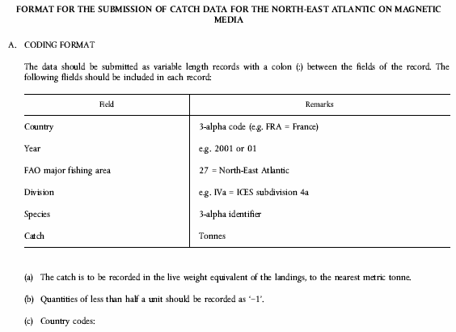
Belgium  Bulgaria  Czech Republic  Denmark  Germany  Estonia  Greece  Spain  France  Ireland  Iceland  Italy  Cyprus  Latvia  Lithuania  Luxembourg  Hungary  Malta  Netherlands  Norway  Austria  Poland  Portugal  Romania  Slovenia  Slovakia  Finland  Sweden  Turkey  United Kingdom  England and Wales  Scotland  Northern Ireland | BEL  BGR  CZE  DNK  DEU  EST  GRC  ESP  FRA  IRL  ISL  ITA  CYP  LVA  LTU  LUX  HUN  MLT  NLD  NOR  AUT  POL  PRT  ROM  SVN  SVK  FIN  SWE  TUR  GBR  GBRA  GBRB  GBRC
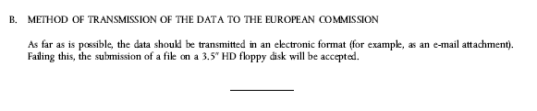

é
ANNEX VI
Repealed Regulation with list of its successive amendments
Council Regulation (EEC) No 3880/91
(OJ L 365, 31.12.1991, p. 1)
Commission Regulation (EC) No 1637/2001
(OJ L 222, 17.8.2001, p. 20)
 | Regulation (EC) No 1882/2003 of the European Parliament and of the Council  (OJ L 284, 31.10.2003, p. 1) |  | only Annex I, pt. 4
Commission Regulation (EC) No 448/2005
(OJ L 74, 19.3.2005, p. 5)
_____________
ANNEX VII

Correlation Table
Regulation (EEC) No 3880/91 | This Regulation
Article 1 | Article 1
Article 2 | Article 2
Article 3 | Article 3
Article 4, first subparagraph | Article 4, first paragraph
_______ | Article 4, second paragraph
Article 4, second subparagraph | Article 4, third paragraph
Article 5(1) and (2) | Article 5(1) and (2)
Article 5(3) | _______
Article 6(1) and (2) | Article 6(1) and (2)
Article 6(3) | _______
Article 6(4) | Article 6(3)
______ | Article 7
Article 7 | Article 8
Annex I | Annex I
Annex II | Annex II
Annex III | Annex III
Annex IV | Annex IV
______ | Annex V
______ | Annex VI
______ | Annex VII
_____________

COM(87) 868 PV.
Carried out pursuant to the Communication from the Commission to the European Parliament and the Council – Codification of the Acquis communautaire, COM(2001) 645 final.
COM(2006) 497 final.
See Annex VI of this proposal.
OJ L 184, 17.7.1999, p. 23. Decision as amended by Decision 2006/512/EC (OJ L 200, 22.7.2006, p. 11).
OJ C 255, 21.10.2006, p. 1.
OJ C […], […], p. […].
OJ C […], […], p. […].
OJ C […], […], p. […].
OJ L 365, 31.12.1991, p. 1. Regulation as last amended by Commission Regulation (EC) No 448/2005 (OJ L 74, 19.3.2005, p. 5).
See Annex VI.
OJ L 227, 12.8.1981, p. 21.
OJ L 149, 10.6.1987, p. 14.
OJ L 237, 26.8.1983, p. 4.
OJ L 378, 31.12.1982, p. 24.
OJ L 184, 17.7.1999, p. 23. Decision as amended by Decision 2006/512/EC (OJ L 200, 22.7.2006, p. 11).
OJ L 179, 7.8.1972, p. 1.

