EN
COMMISSION OF THE EUROPEAN COMMUNITIES
Brussels, 11.11.2008
SEC(2008) 2712

COMMISSION STAFF WORKING DOCUMENT
Accompanying the
COMMUNICATION FROM THE COMMISSION TO THE EUROPEAN PARLIAMENT, THE COUNCIL, THE EUROPEAN ECONOMIC AND SOCIAL COMMITTEE AND THE COMMITTEE OF THE REGIONS
on Rare Diseases: Europe's challenges
and the
Proposal for a
COUNCIL RECOMMENDATION
on a European action in the field of rare diseases
IMPACT ASSESSMENT
{COM(2008) 679}
{SEC(2008) 2711}
{SEC(2008) 2713}
TABLE OF CONTENTS
1. Executive Summary 4
2. Procedural Issues and Consultation of Interested Parties 4
2.1. Organisation and Timing 4
2.2. Consultation and Expertise 5
2.2.1. Stakeholder Consultation 5
2.2.2. European Conference on Rare Diseases 5
2.2.3. Inter-Service Steering Group 6
2.2.4. Public Consultation 6
2.2.5. Impact Assessment Board 6
3. Introduction 7
3.1. Introduction to Rare Diseases 7
3.2. The contribution of the ongoing EU actions to create best practices 9
4. Problem Definition 10
4.1. Lack of Recognition and Visibility of Rare Diseases 10
4.2. Lack of Policies on Rare Diseases in the Member States 10
4.3. Lack of Effective Healthcare, Research, and Regulation for Rare Diseases in Europe 11
4.3.1. Inequitable Access to Expert Healthcare 11
4.3.2. Fragmented Research 12
4.3.3. Insufficient Legislative Framework 12
4.4. Subsidiarity 12
4.4.1. Necessity Test 13
4.4.2. Added-Value Test 13
5. Objectives 14
5.1. Improving Recognition and Visibility on Rare Diseases 14
5.2. Supporting Policies on Rare Diseases in the Member States 15
5.3. Developing European cooperation, coordination, and regulation for rare diseases 15
6. Policy Options 15
6.1. Baseline Option 16
6.2. Commission Communication and Proposal for a Council Recommendation 16
6.3. Re-establish Formal Rare Diseases Programme 17
7. Analysis of impacts 18
7.1. Baseline Option 19
7.2. Commission Communication and Proposal for a Council Recommendation 20
7.3. Re-establish Formal Rare Diseases Programme 21
8. Comparing the Options 22
8.1. Improving Recognition and Visibility of Rare Diseases 22
8.2. Supporting Policies on Rare Diseases in the Member States 23
8.3. Developing European Cooperation, Coordination, and Regulation for Rare Diseases 23
8.4. Summary 24
9. Monitoring and evaluation 24
9.1. Data Collection 24
9.1.1. Demography, Epidemiology, and Health Status 25
9.1.2. Determinants of Health and Socio-economic Factors 25
9.1.3. Health Services 25
9.1.4. Research and Technology Development 25
9.1.5. Equity, Regional Differences, and EU Initiatives 25
9.2. Comitology and Monitoring Mechanism 25
10. Annexes 27
10.1. List of Diseases by Decreasing Prevalence 27
10.2. Previous and Ongoing Activities 33
10.3. Results of the EURORDIS Survey 36

Executive Summary
Based on present scientific knowledge, there are between 5 000 and 8 000 distinct rare diseases that affect up to 6% of the total EU population at one point in life. In other words, this equates to between 29 and 36 million people in the European Union 27 Member States that are, or will be, affected by a rare disease.
Rare diseases present a special case to public health systems due to their specific characteristics, vast number and diversity, low patient density, limited resources, limited access to experts, and difficulties with effective treatment. There is probably no other area in public health in which 27 national approaches could be considered as inefficient and ineffective as with rare diseases. The reduced number of patients for these diseases and the need to mobilise resources means that the scale and nature of effective action makes action at European level in support of the Member States relevant, in accordance with Article 152 of the Treaty establishing the European Community.
The definition of the main problems posed by rare diseases can categorised into three main areas: (i) lack of recognition and visibility of rare diseases; (ii) lack of strategies for rare diseases in the Member States; and (iii) lack of European cooperation, coordination, and regulation for rare diseases. The problems identified in this final category can be further defined as inequitable access to healthcare, limited research, and an insufficient and incoherent legislative framework within the European Union.
Thus, there is a need to act in a cohesive manner, as there is no effective way in which the Member States can ensure proper recognition and visibility of rare diseases on their own. This initiative would give formal visibility and recognition to this process, which also provides the opportunity to follow through with solutions to many of the problems posed by rare diseases that have been outlined above and will be discussed further in this Impact Assessment.
On this basis, the preferred option is to set out a Community strategy for rare diseases set out in a Commission Communication, focusing on:
- ensuring appropriate codification and classification of rare diseases and facilitating the acquisition, provision and dissemination of scientific information on rare diseases for patients and clinicians;
- a proposal for a Recommendation of the Council on establishment of coherent and comprehensive strategies for rare diseases in the Member States, based on Article 152 TEC.

Procedural Issues and Consultation of Interested Parties

Organisation and Timing
A White Paper on a European Action in the Field of Rare Diseases (Rare Diseases: Europe's Challenges) was included as a strategic initiative in the Commission's Legislative Work Programme for 2008, with DG SANCO as the lead Directorate General. Work on the Impact Assessment began after the completion of the Roadmap in late October 2006, and concluded in May 2008. The Impact Assessment Board was consulted on 18 June 2008, and its comments have been incorporated into the final version of the Impact Assessment. The proposals envisaged are intended to be adopted in autumn 2008.

Consultation and Expertise

Stakeholder Consultation
The EU Task Force on Rare Diseases (RDTF) was set up in January 2004 by the European Commission's Public Health Directorate. Its aims are:
- to advise and assist the European Commission in promoting the optimal prevention, diagnosis and treatment of rare diseases in Europe, in recognition of the unique added value to be gained for rare diseases through European coordination;
- to provide a forum for discussion and exchange of views and experience on all issues related to rare diseases.
The Task Force is led by Dr. Ségolène Aymé, medical geneticist and director of the Orphanet database of rare diseases. The Deputy Leader is Professor Helen Dolk, director of the Eurocat programme on congenital disorders. It currently has 36 members comprising current and former project leaders of European research projects related to rare diseases, Member State experts and representatives from relevant international organisations.
After the preparation of the First Draft of the Public Consultation on a European Action in the Field of Rare Diseases, the first presentation of the strategic orientations of this Consultation took place in the EU Task Force on Rare Diseases on 20 June, 2007. The RDTF decided to appoint a Drafting Group to support the European Commission on a voluntary basis in the preparation of the text for the Public Consultation. This Drafting Group consisted of six experts in the field of rare diseases. The Drafting Group met on 11 July and 15 October, 2007.
The First Draft of the Public Consultation on a European Action in the Field of Rare Diseases prepared by the Drafting Group and the European Commission was submitted for discussion with the most relevant stakeholders at the following meetings:
- The European Workshop on Reference Networks on Rare Diseases (Prague, Czech Republic, 11-13 July, 2008)
- The EU Task Force on Rare Diseases (Luxembourg, 23 October, 2007)
- The Annual International Conference on Rare Diseases and Orphan Drugs organised by the Italian authorities (Rome, 5-8 November, 2007)
- The Committee for Orphan Medicinal Products from the European Medicines Agency (London , 5 February, 2008)
- The Working Group on European Reference Networks from the High Level Committee on Health Care (Brussels, 30 January, 2008)
- A discussion with the patients’ organisations was organised during the European Conference on Rare Diseases (see point 2.2.2).
After the conclusion of the Public Consultation, the Drafting Group met on 13 February, in order to help the Commission in the analysis of the results of the Public Consultation and for the preparation of the final text of the Commission Communication and the Council Recommendation.

European Conference on Rare Diseases
The 4th European Conference on Rare Diseases was organised in Lisbon on 26-28 November, 2007, under the Portuguese Presidency of the Council. During the conference, the Public Consultation regarding European Action in the Field of Rare Diseases was officially launched by Andrzej Ryś (Director of Public Health at the European Commission) in the opening speech of the Conference. Questions formulated in the Public Consultation refer to the main topics affecting rare diseases: definition of rare diseases, classification, and codification, need of a European inventory of rare diseases, equity of citizens’ access to orphan drugs, coordination of compassionate use of orphan drugs, antenatal screening, specialised social services, reference networks, research, etc. The conference was attended by 500 persons representing all the stakeholders acting in the rare diseases community.

Inter-Service Steering Group
An Inter-Service Steering Group was set up for the Public Consultation and met in Brussels on 28 January. DGs participating were SANCO, RTD, DEV, ENTR, ESTAT, SG and EMPL. As well as offering input into the development of this Impact Assessment, the group members contributed to a mapping exercise on their work on rare diseases.

Public Consultation
In total, 584 responses were received, including contributions from 15 Member States. Key outcomes were that stakeholders want a comprehensive approach to rare diseases issues in the EU. All the answers consider that the national or regional level is insufficient to offer adequate alternatives to the problem. The EU level is retained in 100% of answers as the most appropriate. There was a general support for a new overarching, strategic and coherent framework for rare diseases policy in the near future. The vast majority supported the ten broad priorities proposed by the Commission:
- to improve information, identification and knowledge on rare diseases;
- to support implementation of National Plans for Rare Diseases;
- to improve prevention, diagnosis and care of patients with Rare Diseases;
- to develop national/regional centres of reference and establish EU reference networks;
- to ensure equitable access to all EU patients to orphan drugs and compassionate use;
- to develop specialised and adapted social services for rare diseases patients;
- to accelerate research and developments in the field of Rare Diseases and Orphan Drugs in order to strengthen at European level the limited and scattered expertise on rare diseases;
- to empower patients with Rare Diseases at individual and collective level;
- to develop the international cooperation on rare diseases;
- to coordinate the policies and initiatives at EU level.
Only in this last point do certain controversies appear referring to whether or not to create a European Agency on Rare Diseases. Key outcomes of the consultation meetings have also been fed into this paper.

Impact Assessment Board
The Impact Assessment Board was consulted on 18 June 2008. Following the Board’s opinion, the following important modifications, amongst others, have been made to this impact assessment.
- In the introduction, an extra section has been added to show the contribution of the ongoing EU actions to create best practices in the field of rare diseases.
- In section 4.2 of the problem definition, we have outlined to current baseline activities taking place in the Member States, providing more clarity on existing polices.
- The policy options section has been reorganised.

Introduction

Introduction to Rare Diseases
Rare diseases are life-threatening or chronically debilitating diseases with a low prevalence and a high level of complexity. Most of them are genetic diseases, the others being rare cancers, autoimmune diseases, congenital malformations, toxic and infectious diseases, among other categories (see Annex ). They call for a global approach based on specific and combined efforts to prevent significant morbidity or avoidable premature mortality, and to improve quality of life or socio-economic potential of affected persons.
A Community action programme on rare diseases, including genetic diseases, was adopted for the period 1 January, 1999, to 31 December, 2003. This programme defined the prevalence for a rare disease as affecting no more than 5 per 10 000 persons in the European Union. Additionally, Regulation (EC) No. 141/2000 of the European Parliament and of the Council of 16 December, 1999, on orphan medicinal products establishes the definition of an "orphan medicinal product" [article 2(b)] as well as criteria for designation of a medicinal product as an orphan medicinal product [article 3]. According to the relevant provisions of article 3, a medicinal product shall be designated as an "orphan medicinal product" when intended for the diagnosis, prevention or treatment of a life-threatening or chronically debilitating condition affecting not more than 5 in 10 000 persons in the Community when the application is made. Whilst this prevalence rate of 5 per 10 000 seems low, it translates into approximately 246 000 persons per disease in the EU 27 Member States (MS). Based on present scientific knowledge, there are between 5 000 and 8 000 distinct rare diseases that affect up to 6% of the total EU population at one point in life. In other words, this equates to between 29 and 36 million people in the European Union 27 MS that are affected, or will be affected, by a rare disease.
According to available sources in medical literature, less than 100 rare diseases have prevalence near the threshold of 5 per 10,000, such as Gelineau disease, triple X syndrome, scleroderma or neural tube defects. Most rare diseases are very rare, affecting one in 100,000 people or less, such as Gaucher disease, Ewing sarcoma, Duchenne muscular dystrophy, or Von Hippel-Lindau disease. Thousands of rare diseases affect only a few patients in Europe such as Pompe disease, alternating hemiplegia, or Ondine syndrome. Patients with very rare diseases and their families are particularly isolated and vulnerable.
There is also a great diversity in the age at which the first symptoms occur; half of the rare diseases can appear at birth or during childhood (such as Williams’ syndrome, Prader-Willi syndrome, and retinoblastoma). The other half of rare diseases can appear in adulthood (such as Huntington’s disease, Creutzfeld-Jacob disease, amyotrophic lateral sclerosis).
Although most rare diseases are genetic diseases, they can also result from environmental exposures during pregnancy or later in life, often in combination with genetic susceptibility. Some are rare forms or rare complications of other common diseases.
Relatively common conditions can hide underlying rare diseases; examples include autism (which is a major symptom in Rett syndrome, fragile X, Angelman syndrome, adult phenylketonuria, Sanfilippo disease, et al.) or epilepsy (in tuberous sclerosis, Shokeir syndrome, Dravet syndrome, et al.). Many conditions classified in the past as mental deficiency, cerebral palsy, autism, or psychoses are manifestations of rare diseases still to be characterised. Most congenital malformations and many types of cancers, including all cancers affecting children, are rare diseases.
Research on rare diseases has been fundamental in the identification of most human genes identified so far and a quarter of the innovative medicinal products that received market approval in the EU (orphan drugs). Research on rare diseases has proved to be very useful to understand better the mechanism of common conditions like obesity and diabetes, as they represent a model of dysfunction of a biological pathway. However, research on rare diseases is not only scarce but also scattered throughout the EU. Under normal market conditions, the pharmaceutical industry is reluctant to invest in medicinal products and medical devices for rare conditions because of the very limited market for each disease. This explains why rare diseases are also called “orphan diseases” – they are “orphan” of a research focus and market interest, as well as of public health policies.
At the same time, there are growing concerns that health systems are now willing to pay much more for orphan diseases (in terms of costs per Quality Adjusted Life Years or cost per life year gained) than for other diseases which have—if dealt with—bigger potential for health gain on global populations. The price for research and drugs makes it impossible for treatment of rare diseases to meet the conventional criteria for cost-effectiveness.
The Commission has already been active in the field of rare diseases; however, as will be explained further in defining the problems posed by rare diseases, there is still a lot more work that can and needs to be done to improve the situation for the citizens of Europe. Moreover, any action needs to involve cooperation and coordination between the Member States to be effective, and the current EU legislative framework is poorly adapted to rare diseases (see 4.3.3). Below is a brief list of previous and ongoing activities in the field of rare diseases; for a detailed list with explanations, please refer to Annex 10.2.
- Community Action Programme on Rare Diseases adopted for the period 1999-2003.
- Rare diseases were a priority in the EU Public Health Programme 2003-2007.
- Rare diseases continue to be a priority in the new Health Programme 2008-2013.
- Decision 1350/2007/EC of the Parliament and Council promotes action on rare diseases.
- The White Paper “Together for Health: A Strategic Approach for the EU 2008-2013” also identifies rare diseases as a priority for action.
- European Community Framework Programmes for Research and Technological Development has contributed to advancing knowledge on rare diseases for two decades.
- FP6 supported around 60 rare disease-relevant projects, including coordination projects such as the OrphanPlatForm (part of the Orphanet platform) and ERA-Net projects.
- FP7 recognises rare diseases a priority for research activities.
- The Orphan Medicinal Product Regulation was adopted to set up the criteria for orphan designation in the EU and describes the incentives (Regulation (EC) No 141/2000 of the European Parliament and of the Council of 16 December, 1999, on orphan medicinal products)
- A Committee for Orphan Medicinal Products was established in 2000 within EMEA.
- DG SANCO has established the High Level Group on Health Services and Medical Care. One of its Working Groups deals with reference networks of centres of expertise for rare diseases.
- The Health Programme will also continue to integrate the support of patients’ organisations as a priority for action.

The contribution of the ongoing EU actions to create best practices
The Health Programme and the previous programmes have since 1999 supported 39 projects in the area of rare diseases with a funding of around €14 million. Some of these projects are international references used extensively by experts and patients around the World, and have created the necessary sharing of expertise that permits a solid basis for more in depth sharing of good practices and political values in this area. Such projects, amongst others, are:
- the ORPHANET database, the most important database for rare diseases and orphan drugs for the general public in Europe;
- the successive projects implemented by EURORDIS for building a public policy on rare diseases, improving quality information on rare diseases and orphan drugs, based on a survey, workshops and guidance documents;
- the EUROCAT network (Surveillance of congenital anomalies in Europe) that provides essential epidemiologic information on congenital anomalies and acts as a resource centre for people and professionals;
- the ENERCA (European Network for Rare Congenital Anaemias)
The contribution of the existing EU Task Force on Rare Diseases, created by DG SANCO in 2003, in defining of the framework for the creation of European Reference Networks and the ongoing revision of the International Classification of Diseases are examples of good practices of cooperation between Member States, with the Commission having a direct impact in the improvement of the situation of the patients.
A substantial contribution to advancing knowledge on rare diseases has also been provided for two decades through collaborative and coordinated research projects supported by the successive European Community Framework Programmes for Research and Technological Development. The support provided to some 60 multidisciplinary collaborative projects on rare diseases has created a solid basis for a more extensive cooperation. The support from the FP6 to the ERA-Net project dedicated to rare diseases (E-Rare) for the development of joint and trans-national activities (survey on national programmes, identification of gaps and overlaps among national research programs and activities on rare diseases) is also an example of good practices.
Under the responsibility of DG ENTR and the EMEA (the European Medicines Agency), the EC implements a policy on Orphan Drugs. The Orphan Medicinal Product Regulation (Regulation (EC) No 141/2000 of the European Parliament and of the Council of 16 December, 1999, on orphan medicinal products) was proposed to set up the criteria for orphan designation in the EU and describes the incentives. In 2000, a Committee for Orphan Medicinal Products (COMP) was established within EMEA to review applications from persons or companies seeking “orphan medicinal product designation” for products they intend to develop for the diagnosis, prevention, or treatment of rare diseases. In the period between April 2000 and August 2007, the EMEA has received more than 740 applications for orphan designation. As of July 2007, more than 40 different new orphan medicinal products have received a marketing authorisation for the treatment of more than 40 different life-threatening or chronically debilitating rare diseases. In addition, more than 500 further medicines have already been designated by the Committee on Orphan Medicinal Products (COMP) as orphan medicinal products, but are still undergoing clinical tests.
The Commission is well aware that a lot of additional effort is needed in this area, but the good practices created by the COMP constitutes a solid basis for a future integrated European approach for rare diseases.

Problem Definition

Lack of Recognition and Visibility of Rare Diseases
Although rare diseases heavily contribute to morbidity and mortality, they are mostly invisible in health care information systems due to the lack of appropriate coding and classification systems. The lack of formal identification in health systems thus imposes medical and financial barriers to receiving treatment for an unrecognised disease that consequently lacks allocated funds and resources, thus creating a cycle that maintains the current inefficiency and lack of recognition of rare diseases.
Furthermore, misdiagnosis and non-diagnosis are the main hurdles to improving life-quality for thousands of rare disease patients. A serious issue is the length of time required for diagnosis, which currently can be from nine months to 4-5 years, if not longer in some cases. This is particularly a problem with rare diseases; on average, a doctor will see approximately 300 diseases during the course of their professional life, thus it is impossible for any one medical practitioner to be able to identify all of the 6,000-7,000 rare diseases. There is currently no central reference (e.g. inventory of symptoms, definitions, treatments, etc.) for a clinician to refer to, compounding the problem of poor diagnosis. This thus further enhances the lack of sufficient recognition of rare diseases. Moreover, for many rare diseases, such information does not even exist, which emphasises the need for more research.

Lack of Policies on Rare Diseases in the Member States
The focus on rare diseases is a relatively new phenomenon in most EU Member States. Until recently, public health authorities and policy makers largely ignored these challenges due to the splintering of policy debates across many different rare diseases rather than the identification of common themes for all rare diseases.
Rare diseases require a correlated, integrated approach to research, diagnosis, and treatment. Within the Member States, there is fragmentation of the limited resources available for rare diseases, thus it is essential to have a specific plan to concentrate and make efficient use of these limited resources that would otherwise fall below the threshold for efficacy.
Only a limited number of Member States have adopted or will soon adopt a National Plan or launch relevant initiatives in the area of rare diseases. While only France has established a comprehensive and integrated action plan (2005-2008), the rest of MS have national policies in a limited number of areas:
- focus only in centres of expertise (Italy, Denmark, United Kingdom);
- focus only on research (Spain, Germany, The Netherlands);
- priority only the orphan drugs dimension (Ireland);
- support to patient's organisations in absence of a national public health action (Romania, Luxembourg).
In certain cases initiatives in order to establish a National Plan on Rare Diseases are in process (Bulgaria, Portugal). In the rest of MS no evident targeted policy seems to exist.
This lack of specific health policies for rare diseases in the large majority of Member States and the scarcity of the expertise, translate into delayed diagnosis and difficult access to care. This results in additional physical, psychological, and intellectual impairments, sometimes birth of affected siblings, inadequate or even harmful treatments, and loss of confidence in the health care system. However, some rare diseases are compatible with normal quality of life if diagnosed on time and properly managed. A common approach on what a health policy on rare diseases can provide will improve, if done on a European scale of cooperation and sharing of expert resources, the protection of patients and their families.

Lack of Effective Healthcare, Research, and Regulation for Rare Diseases in Europe

Inequitable Access to Expert Healthcare
The national healthcare services for diagnosis, treatment, and rehabilitation of people with rare diseases differ significantly with respect to their availability and quality. There is a lack of reference networks, and access to care, resources, and expertise may well only be available in another Member State. A few MS have successfully addressed some of these issues raised by the rarity of some diseases, but most have not, leading to an overall inefficiency in tackling the problem across the EU.
Eurordis launched a patient survey of the EurordisCare Programme, which is part of the EU Rare Disease Patient Solidarity Project (RAPSODY, supported through the Public Health Programme), aimed at describing and comparing experiences and expectations of patients and their families concerning access to health services for 16 rare diseases in Europe. Some of the main results and findings are as follows (see Annex 10.2 for further details):
- In terms of specialised centres, respondents are asking for: centres that know their disease well; multidisciplinary approach; better communication between the various professionals; improved social services, especially those linked to the rarity of the disease; and the right balance between specialisation (a centre with critical mass and knowledge) and proximity from home (to avoid having to travel) .
- 20% of patients experienced some rejection by health professionals because of their disease (main reason: complexity of the disease, in 80% of cases).
- 70% of patients needed the services of a social worker, but in 30% of cases, the access to this service was difficult; the less frequent the needs, the less satisfying the assistance provided; when social services were offered by associations, patients were more satisfied.
- Difficulties in access to care vary greatly per disease; 18% of respondents had difficulties, with the time for first appointment being the main factor of difficulty. 12% of patients failed to access at least one of the eight essential health services surveyed (the main reason being the lack of referral).

Fragmented Research
There are at least 6 000 to 7 000 distinct rare diseases, the great majority of them being of genetic origin. Although individually rare, rare diseases in total affect at least 20 million persons in Europe. They represent a major issue in healthcare since a large percentage of these diseases lead to a significant decrease of life expectancy, and most of them cause chronic illness with a large impact on quality of life and the healthcare system. Diagnosis of a rare disease is often delayed, and for the majority of rare diseases no appropriate treatment exists. However, there is a very close link between research and the possibilities for diagnosis and treatment of rare diseases. Therefore, further research on rare diseases is needed but is hampered by inefficiency and fragmentation of the limited resources available at several levels:
- Few scientists work on one specific disease;
- There are few patients scattered over a large geographic area, causing difficulties to gather cohorts required for studies;
- Existing databases and material collections are usually local, small, and not accessible nor standardised;
- Diseases often have complex clinical phenotypes and require interdisciplinary approaches to treatment and interdisciplinary cooperation for research.
Due to the limited expertise and resources (material, human, financial) mobilised for research in each individual European country, efforts are obviously limited in objectives and power. Therefore, rare diseases are a prime example of a research area that could strongly profit from coordination on a trans-national scale. The European research area should be enabled to realize its potential by reorganizing and combining scientific expertise, research infrastructure, well-defined patient cohorts, and biological material.

Insufficient Legislative Framework
The current EU legislative framework is poorly adapted to rare diseases, which present a special case due to their specific characteristics, vast number and diversity, low patient density, and limited resources. The relevant existing Community legislation, for example on clinical trials and marketing authorisation of medicinal products, is proving unsuitable and insufficient when applied to rare diseases. Thus, the current legal framework is unable to tackle adequately the problems that have been outlined in this chapter—lack of recognition, research, specific policies, access to expert healthcare, and insufficient Europe-wide information exchange—that specifically relate to rare diseases.

Subsidiarity
There is probably no other area in public health in which 27 national approaches could be considered as inefficient and ineffective as with rare diseases. The reduced number of patients for these diseases and the need to mobilise resources means that the scale and nature of effective action requires action at European level in support of the Member States, in accordance with Article 152 of the Treaty establishing the European Community.
At national level, Centres of Expertise for at least some rare diseases exist in 12 Member States. However, it is not feasible to have a centre for every disease in every Member State due to the high levels of (especially financial and human) resources that would be required; for example, for many diseases, there is simply not a large enough patient population in each country to sustain safe and efficient care in a specific centre for each Member State. The idea is that the expertise, rather than the patients, should travel - although patients should also be able to travel to the centres if they need to.
However, many interventions that would have an impact in this field are in settings that either are fully outside the competence of the Community or need a shared management with national authorities (reference networks) or with the WHO (classification and codification).
The subsidiarity test asks whether EU action is necessary (the 'necessity test'), or whether action by Member States is sufficient to solve the problem. It asks whether action at EU-level adds value to the work done by Member States (the 'added-value test'), and it asks if the measures chosen are proportionate to the objectives (the 'boundary test'). This section looks at the first two tests.

Necessity Test
Member States have the prime responsibility for protecting and improving the health of their citizens. As part of that responsibility, it is for them to decide on the organisation and delivery of health services and medical care to patients suffering from a rare disease. However, the fundamental aims of the EU in terms of free movement of patients, equitable recognition of diseases, and equitable access to safe and efficient orphan drugs or cooperative research on rare diseases, necessarily have an EU health dimension.
As the problems defined above show, the area of rare diseases is an area where action needs effective cooperation and coordination between countries. There is a need to act in a cohesive manner, as there is no effective or efficient way in which the Member States can ensure proper recognition, visibility, and management of rare diseases on their own.
A key reason for taking action now on rare diseases is the current revision of the International Classification of Diseases (ICD). The ICD is the international reference for classification of diseases and conditions coordinated by the World Health Organisation (WHO). It is key step in raising awareness and recognition of rare diseases at an international-level (see section 5.1). The current tenth revision of the ICD (ICD-10) was endorsed by the forty-third World Health Assembly in May 1990, but emerging diseases and scientific developments, advances in service delivery, and changes in health information systems require a revision of ICD. The new ICD-11 also aims to include rare diseases and to do this effectively from a European perspective there needs to be a central coordinating point. This initiative would give formal visibility and recognition to this process, which also provides the opportunity to follow through with solutions to many of the problems posed by rare diseases that have already been presented.
In the field of rare diseases, there are no links between established actions of other international organisations. WHO has only recently launched some consultations on essential medicines, which can be compared to certain problems associated with the orphan drugs. However, there is no WHO specific action in the field of rare diseases. For some diseases such as the congenital anomalies, the EU is contributing via projects (Eurocat) to some WHO actions (International Database on Craniofacial Anomalies (IDCFA)). In the case of OECD, rare diseases are not planned to be part of any action of this organisation.

Added-Value Test
There is also a wide range of health issues where the EU has a key role in undertaking actions, which add value to and complement the work done by Member States in making European Citizens healthier. In recent years, the EU, in partnership with Member States, has made important progress in improving and protecting health.
The EU can add value through a wide range of activities. These include working to reach critical mass or obtain economies of scale—for example sharing information on rare diseases where only a small number people are affected in each Member State—or performing collaborative multidisciplinary research, which proves the most efficient way to better understand the diseases and develop preventive, diagnostics and therapeutic methods. Sharing best practice and benchmarking activities in many areas can contribute to the efficient and effective use of scarce resources and therefore the European coordination of MS action can prove particularly important in terms of future financial sustainability.
The EU therefore clearly adds value in a wide range of areas relating to health. Given the need to tackle current and emerging health challenges in the most effective manner and to advance good governance in health at the EU level, there is also an important added-value resulting from taking an integrated approach in relation to rare diseases. Clear added-value examples can be identified in the following five areas:
- Reducing Inequities in Health in the EU
Added-value of a new EU approach on rare diseases is found in the contribution of the Communication to an equitable access to all EU patients to safer and more efficient orphan drugs and to the compassionate use. In an EU contribution to develop specialised and adapted social services for rare diseases patients and, especially, to the development national/regional centres of expertise establishing EU reference networks
- Creating a Coherent Framework for Identification of Rare Diseases and Europe-wide information sharing.
- Added-value of a new EU approach on rare diseases is found in the improvement of information, identification and knowledge on rare diseases to set a strong basis for diagnosis and care of patients; rationalise current mechanisms; support strategic action on rare diseases at national level; strengthen cooperation between Member States at EU level and to improve a common approach to prevention, diagnosis and care of patients with Rare Diseases.
- Creating an Improved Framework for Research on Rare Diseases
Added-value of an EU approach on rare diseases is found to accelerate research and developments in the field of Rare Diseases and Orphan Drugs by allowing multidisciplinary collaborative research, by strengthening the limited and scattered expertise on rare diseases at European level.

Objectives
The overall objective for Community action on rare diseases is to support Member States in ensuring effective and efficient recognition, prevention, diagnosis, treatment, care, and research for rare diseases. This is supported by the Commission’s strategic goals of prosperity, solidarity, and security. This is to be achieved through three specific objectives.

Improving Recognition and Visibility on Rare Diseases
The key to improving overall strategies for rare diseases is to ensure that they are recognised, so that all the other linked actions can follow appropriately. The international reference for classification of diseases and conditions is the International Classification of Diseases, coordinated by the World Health Organisation (WHO). The ICD is defined by the WHO as being “the international standard for diagnostic classification for epidemiological and health management purposes.” This includes the monitoring of the incidence and prevalence of diseases. The ICD is used to classify diseases and other health problems recorded on many types of health and vital records including death certificates and hospital records. These records also provide the basis for the compilation of national mortality and morbidity statistics. The EU should thus cooperate closely with the WHO in the process of revising the existing ICD (International Classification of Diseases) in order to ensure a better codification and classification of rare diseases.
To improve diagnosis and care in the field of rare diseases, appropriate identification also needs to be accompanied by accurate information, provided, and disseminated in a format adapted to the needs of professionals and of affected persons. This will contribute to tackling some of the main causes of neglecting the issue of rare diseases. A better coding and classification system will also help patients to understand the rare disease in order to talk about it to their peers, relatives, carers, and doctors.

Supporting Policies on Rare Diseases in the Member States
Efficient and effective action for rare diseases depends on a coherent overall strategy for rare diseases mobilising scarce and scattered resources in an integrated and well-recognised way, and integrated into a common European effort. That common European effort itself also depends on a common approach to work on rare diseases across the EU, in order to establish a shared basis for collaboration. The EU could therefore bring together and clearly define best practices that could be taken as a basis for rare diseases strategies within the Member States.

Developing European cooperation, coordination, and regulation for rare diseases
Community action can help Member States to achieve efficiency in bringing together and organise the scarce resources in the area of rare diseases, and can help patients and professionals to collaborate across Member States in order to share and coordinate expertise and information. The Community should also aim to coordinate better the policies and initiatives at EU-level, and to strengthen the cooperation between EU programmes, in order to maximise further the resources available for rare diseases at Community level, in particular to ensure:
- effective coordination of research and technological development;
- access to appropriate expert healthcare to, as well as specialised and adapted social services for rare disease patients;
- and adaptation of the framework of legislation and action at Community level to the specific needs of rare disease, in areas such as compassionate use of medicines, regulatory framework for orphan drugs, incentives for development of new, safe and efficient medicine or applications introducing added therapeutic value for rare diseases.

Policy Options
This section sets out the different options that could be taken for each of the three specific objectives above. In selecting the main options to consider, this impact assessment focuses on appropriate tools for the rare diseases sector and the challenges to be met. In particular, we do not explore self-regulation or harmonisation in any detail, as the problems and objectives to be addressed in the field of rare diseases are not appropriate for either self-regulation or Community harmonisation.
As set out in the report on self-regulation practices in SANCO policy areas, self-regulation refers to “the possibility for economic operators, the social partners, non-government organisations, or associations to adopt amongst themselves and for themselves common guidelines at European level (particularly codes of practice or sectoral agreements)". However, this is not a viable solution for resolution of the problems identified, which cannot be effectively addressed by independent operators but which precisely require a collective approach also involving public authorities. Effective recognition and visibility of rare diseases depend on involvement of public authorities and has certain procedural requirements; national strategies likewise depend on political engagement of public authorities; and the problems requiring European action need actions to be undertaken by the Institutions. The options chosen therefore focus on options including engagement of those stakeholders in appropriate ways, in particular through “soft law” and technical cooperation structures.

Baseline Option
Continuing with project-based work without a European reference point within current legal framework
Under this option, the Commission would continue to support individual projects aiming to improve the recognition and visibility of rare diseases, without providing formal guidance or recommendation to Member States regarding how to ensure efficient and effective strategies. This option would build on the previous programmes and existing actions, but without combining these with the political authority and visibility of a formal Commission initiative. The Commission would continue to support individual actions in different programmes, and existing legal provisions such as the legislative framework for orphan drugs would remain. However, these would not be brought together into a single integrated strategy.

Commission Communication and Proposal for a Council Recommendation
Under this option, the Commission would provide a formal statement of the definition of rare diseases within the EU, and set out its intentions for recognition and visibility of rare diseases at European and global level and set out an overall strategy for European work on rare diseases, bringing together the different strands of action into an integrated approach. Specific actions would include:
- Confirming the EU definition of rare disease based on a prevalence of no more than 5 per 10 000;
- Contributing to the ongoing process of revision of the ICD (International Classification of Diseases) in order to ensure appropriate codification and classification of rare diseases in the future ICD-11, to constitute an agreed international reference point, which can be used by all Member States if they wish.
- Providing and disseminating scientific information on rare diseases for patients and clinicians, through the health programme and building on the EU health portal.
- Establishing a committee of experts to provide advice on rare diseases to the different areas of Community action, such as research priorities and medicines licensing;
- Facilitating networking between patients and professionals across Europe (eg: through financing projects under the existing Health Programme) in order to share and develop knowledge and information regarding rare diseases across the EU as a whole;
- Building on the procedure for designation and evaluation of European reference networks covered by the forthcoming proposals on patient rights in cross-border healthcare, to establish a list of existing national centres of expertise for rare diseases identified in the MS, and to explore the potential for Community financial support to ensure appropriate healthcare infrastructure across the EU;
- Working to develop European guidelines for compassionate use of medicines and associated requirements, in liaison with the European Medicines Agency (EMEA) in particular;
- Reviewing the existing legislative framework, including the regulation on orphan drugs, with a view to considering whether any additional proposals are necessary in order to meet the needs of people with rare diseases.
The Commission would also propose a Recommendation of the Council, recommending that Member States establish coherent and comprehensive strategies for rare diseases, and setting out the overall elements that such strategies should cover, based on Article 152 TEC, and building on the results of Community action so far in this field. The recommendation would not set out detail on how these areas should be addressed by Member States, which would then be adapted by Member States in the ways best suited to their health system. Member States would be recommended to:
- Establish formal strategies for the identification and recognition of rare diseases;
- Ensure access to information for patients and professionals about their diagnosis and treatment with plans and mechanisms for referral where appropriate;
- Establish priorities for research and development for rare diseases and their treatments;
- Support patients’ groups with the involvement of health professionals.

Re-establish Formal Rare Diseases Programme
Under this option, the Commission would propose establishing a specific programme with a single detailed strategy for rare diseases healthcare at Community level. The programme would be established under Article 152 of the Treaty, in order to take forward specific projects on rare diseases in a similar way to the previous specific programme on rare diseases.
The aim of the previous programme was to contribute, in coordination with other Community measures, towards ensuring a high level of health protection in relation to rare diseases. This would be achieved by improving knowledge, for example by promoting the setting-up of a coherent and complementary European information network on rare diseases, and facilitating access to information about these diseases, in particular for health professionals, researchers and those affected directly or indirectly by these diseases, by encouraging and strengthening trans-national cooperation between voluntary and professional support groups for those concerned, and by ensuring optimum handling of clusters and by promoting the surveillance of rare diseases.
However, this Programme was conceived as a financial instrument in order to finance actions in the fields mentioned above and was never an instrument to define a Commission policy or a framework of cooperation with Member States. The utility of the former Programme was limited to the support and impulse of the first European actions in the field of rare diseases integrating the public health dimension. The former FP5 and FP6 Programmes have over the years played an exclusive role in this area. A re-establishment of the former Rare Diseases Programme would not correspond to the current expectations of a European action in the field.
Under this option, the Commission could also adopt measures under the Statistical Regulation of the Council and Parliament on statistics on public health and health and safety in order to put in place a binding legal requirement for the collection of data on rare diseases by the Member States.

Analysis of impacts
There is probably no other area in public health in which 27 national approaches could be considered so inefficient and ineffective as is the case with rare diseases. The low number of patients with these diseases as well as relatively small number of experts (due to the number and diversity of recognised rare diseases) and the need to mobilise resources could be only efficient if done in a coordinated European way. The results of the actions financed so far have provided sufficient availability of data to demonstrate the link between best-practice actions and resulting treatment, information, and sharing of knowledge influencing the well-being of rare diseases patients.
Social Impacts
In general terms, improving the situation for rare diseases brings social benefits of equity of access to healthcare for the citizens affected by rare diseases, regardless of the rarity of their condition or where they live within the Union. The innovative tools and methods developed during research on rare diseases can often subsequently be applied to more common diseases, thereby benefiting a wider population than only the rare diseases patients. Currently, many patients have difficulty identifying their condition or in finding a doctor with sufficient relevant expertise to do so; this is often exacerbated by expertise being unevenly distributed across the Union, and often only available in a limited number of languages (typically English).
Environmental Impact
Due to the nature of the initiative, the environmental impact is negligible, and will not be considered further in the following analyses.
Economic Impacts
Successful intervention on rare diseases could also have economic impact in improving efficiency and effectiveness in the use of resources for rare diseases. Also, innovation fostered by researching rare diseases can benefit the society at large. Rare diseases are often complex and difficult to treat, given the high cost of the rare diseases treatment, and have clear economies of scale from efficiently bringing together expertise and treatment facilities. Although the number of people with individual diseases is low, as outlined above the total number of people affected by rare diseases is substantial. Improving the efficiency of action to address them will therefore bring significant benefits both for the individual patients and for the efficient use of resources for health systems overall.
It is therefore clear that the major impacts (both positive and negative) from any initiative on rare diseases will be in the social and economic areas, and these are thus analysed below. The analysis is primarily qualitative in nature; this is proportionate, given that the options under consideration and ultimately recommended are for technical cooperation, non-binding "soft" law and European-level cooperation, not harmonisation or binding legal measures. Given the non-binding nature of the initiative, the likely impacts are not expected to be burdensome to any group or sector, and the proposal itself is neither controversial nor contested.

Baseline Option
Continuing with project-based work without a European reference point within current legal framework
Social Impact
Existing project work can continue to better identify and categorise different rare diseases. However, without some form of formal political recognition and visibility, this work will lack effectiveness, as the identification and categorisation will not be accepted and taken up throughout the Union, leading to inequities across the Union regarding access. Currently, only one Member State has a formal national strategy for rare diseases (France), although some others have other relevant actions. This leads to great inequity within the Union, with the vast majority of EU citizens receiving suboptimal healthcare provision. These impacts on mortality and morbidity rates would be subsequently higher if relevant healthcare services specific for rare diseases were provided. Moreover, without this consensus throughout the Union, any proposed revisions to the international classification of disease at global level through the WHO will be less likely to be accepted and adopted, again undermining their effectiveness. This approach would mean accepting a level of cooperation with international institutions that is not optimal as well as an approach to global health information serving EU policies that is heterogeneous, fragmented, and sometimes contradictory.
Given the complexity and time-consuming nature of establishing such strategies from scratch, it seems unlikely that without providing a clear reference point bringing together existing best practices from across the Union, Member States would be able to establish such strategies – and doing so would certainly be less efficient that being able to draw on an agreed European reference point. As Member States work to develop their own actions on rare diseases, it is important to have clarity about what is being done at Community level and how the different elements fit together. Simply continuing individual actions risks being inefficient with regard to action within Member States, who will not always be aware of what is being done in the different areas at Community level. This could lead to even greater inequities developing between the Member States.
Economic Impact
As with social impacts, the lack of formal recognition and visibility for a common system of identification of rare diseases will have an 'opportunity cost' from the inefficiencies of fragmented actions and duplication of effort. As always with rare diseases, the resources available remain limited; simply continuing individual actions risks not using those resources efficiently. This means a consequent opportunity cost through inefficiency of public budgets for healthcare in the area of rare diseases. The lack of a shared identification and recognition of rare diseases will also undermine innovation; developing new safe and efficient therapies which bring a new added therapeutic value depends on a sufficiently large patient population to participate in research and provide an economic incentive for development, which will be hindered by the lack of a common system of recognition of diseases that would enable pooling of such resources, groups and efforts.
The establishment of the French multiannual (2005-2008) strategy for rare diseases will cost €86.66m with a further €20m to be spent on research. The budgetary consequences for public authorities in establishing these strategies without guidance and a European approach makes this option nonviable for many Member States. In the current situation, resources are highly fragmented and are inefficient at best, many falling below the threshold required for efficacy.
Existing actions have laid a good basis for Community action on rare diseases. Actions have grown up and spread across a wide variety of policy areas, legal instruments and programmes, potentially now including the structural funds, research funds, health programme, e-health initiatives, licensing frameworks for medicines and medical devices, and the EU health portal. However, precisely because of the results now available and variety of initiatives being taken, there is a risk of inefficiency from a lack of a single overall strategy.

Commission Communication and Proposal for a Council Recommendation
Social Impact
By setting out its processes for improving recognition and visibility of rare diseases through a Communication, the Commission would help to ensure that this process would have the involvement of all relevant stakeholders, and that the results would be coherent, accepted, and used throughout the Union. Databases and registries at European level will be a powerful instrument of knowledge of diseases providing tools for future actions. National registries could be significant contributors to these European registries but would never be able to provide the necessary amount of information on a certain disease due to the scarcity of patients by MS. Giving central information resources formal visibility through a Commission Communication would also help to ensure their recognition by patients, professionals, and health authorities, ensuring that they will effectively centralise knowledge and avoid duplication within the Union.
Increasing cooperation between the Member States in the field of rare diseases would also lead to improve efficiency of national resources currently dedicated to RD. It would serve to narrow the inequity gap of healthcare service provision, particularly with respect to access to expert services. An overall strategy would not only improve the equity of access to services and treatment, but also the quality of the treatment provided. Moreover, coordinated cooperation and regulation would enhance the cross-border provision of healthcare services. There would thus be a substantial effect on the health status of the population as a whole and a decrease in rare diseases-related mortality and morbidity.
A Council Recommendation would provide a formal legal and political commitment to the Member States whilst maintaining flexibility in the implementation. This approach is specifically provided for in Article 152 as an appropriate tool in the health area, balancing effective guidance and shared commitment with respect for subsidiarity. This would lead to greater equity and quality in the provision and access of services, and thus have a positive effect on the health of the population within the Member States.
A Council Recommendation has been successfully used already; the 2003 Council Recommendation on population-based cancer screening is an example of how such a recommendation has been successful in codifying and bringing together scientific consensus and best practice, and generating a shared political commitment to implementation.
Economic Impact
The technical work for this option can be taken forward with support from the existing health programme, and by centralising efforts, which will be more efficient and less burdensome for national health systems and public authorities. The most relevant project in this area to use as an example is Orphanet (now the Rare Diseases and Orphan Drugs Portal); established in 1997, Orphanet is a broad partnership of public and private institutions, which has cost €6 036 376 since 2000 (with the Commission being only one of the six contributors to the project). The Health Programme and the FP7 will continue to finance any action at EU level creating or consolidating databases and registries. The economic impact of a formal Commission Initiative would thus be positive overall, even taking into account the central Community investment through the existing health programme. Moreover, the dissemination of the subsequent information would be greatly facilitated with a minimal incremental increase in costs, as it would take advantage of already established web portals and networks, in particular the EU Health Portal.
Coordinated support is especially important in the field of rare diseases where resources are so limited and scattered throughout the EU. A coherent approach would significantly increase the efficiency and efficacy of any proposed actions, whereas the recognition of a formal procedure would support the implementation in the Member States thus pooling the resources available so that they reach the threshold for efficacy. Thus, the budgetary burden already faced by public authorities of the Member States in providing care for rare diseases efficiently and effectively would be substantially reduced through coordinated use of available resources at the EU-level.
A coordinated approach would also stimulate research and development, which would thus lead to a greater global knowledge and better identification of rare diseases. Enhanced regulation would subsequently facilitate the introduction and dissemination of new technologies such as orphan medical products, and allow more efficient use of resources currently available within the EU, but perhaps not available in all Member States. This would further reduce the budgetary burden on the public authorities within individual Member States, through permitting cooperation in the different areas of research and expertise.

Re-establish Formal Rare Diseases Programme
Social Impact
The solid evidence base would improve access to health systems and increase awareness, and thus visibility, of rare diseases. It would also allow improved monitoring of life expectancy, mortality, and morbidity in the Member States, and thus have an impact on health and provision of services. The resulting impact on services would most likely improve the quality and access specifically for rare diseases.
Under this option, the Commission would through a Communication and accompanying guidelines set out a detailed strategy on organisation of healthcare for diagnosis, treatment, and care of rare diseases within health systems. This would undoubtedly provide more detailed guidance at Community level than a Council recommendation, which would set out general principles that are then adapted to the circumstances of each health system. On this basis, more detailed guidance might be more effective in detailing best practice in the different areas of action on rare diseases. This would ensure an increased quality in the provision of rare disease-specific healthcare across the Union, thus reducing the current inequities. The increased service provision would thus positively affect health of the population.
The re-establishment of a formal rare disease programme would offer very little increase in the efficiency of actions compared to a Commission strategy. Thus, relaunching a formal programme would not offer significant advantages over the other options outlined.
Economic Impact
Following definition of rare diseases with a requirement for compulsory data collection under the Eurostat Regulation would certainly have advantages in terms of ensuring comprehensive data regarding rare diseases. However, the administrative burden on public authorities of requiring such data for the 5 000-8 000 rare diseases from throughout the Union would be substantial. The additional cost of integrating data collection on rare diseases into the European statistical system would be substantial. Using the cost of establishing surveillance networks as an example; Eurocat (Surveillance of congenital anomalies in Europe, funded through the Public Health Programme) cost €1 471 299 for a 42-month period, and Enerca (European Network for Rare Congenital Anaemias) cost €1 129 667 for a 36-month period. This is a total of over €2.6m for only two surveillance projects. This cost of establishing such networks for all rare diseases does not appear to be proportionate given that reasonably accurate data is already frequently available through less administratively burdensome routes (e.g. through patients’ organisations and expertise networks).
This option would also raise questions about subsidiarity, given the differences in organisation and delivery of health services and medical care throughout the Union. The more detail that is set out at European level, the greater the consequent required adaptations and restructuring of the different national health systems, and thus the greater the implementation costs and administrative burden for both the public administration at the Member States level and EU level.
Although areas such as research and technological development would benefit, to re-establish a formal EU programme on rare diseases would require a substantial level of funding to be viable. It would also lose the advantages of having rare diseases integrated into a wide range of different policy areas and actions, potentially creating much broader synergies and releasing greater resources than any specific programme on rare diseases could generate. This therefore does not appear to be the most efficient approach.

Comparing the Options

Improving Recognition and Visibility of Rare Diseases
 | Baseline Option | Commission Communication | Compulsory Requirement for Data Collection
Advantages | Better identification & categorisation of rare diseases | Improved recognition of rare diseases; engagement of relevant stakeholders; adoption of the results. | Improved evidence base on rare diseases; improved monitoring of public health; improved and more equitable provision of services.
Disadvantages | Reduced likelihood of classifications being adopted; duplication and inefficiency of work; continued inequities in access to care across the Union. | Depends on collaboration of a wide range of stakeholders to succeed. | High administrative burden; high cost of integration into statistical system; disproportionate level of action.

Supporting Policies on Rare Diseases in the Member States
 | Baseline Option | Council Recommendation | EU-Level Healthcare Strategy for RD
Advantages | Maximum flexibility for Member States to organise health systems as they wish. | Formal legal & political commitment; maintain flexibility; increased efficiency & efficacy of actions; pooling of resources. | Detailed guidance at EU-level; more effective in detailing best practice; increased healthcare provision.
Disadvantages | Inequities in access and quality of healthcare for rare diseases persist; lack of clear reference point; inefficient establishment of national strategies; resources remain fragmented. | No legal requirement for Member States to comply. | Significant restructuring of national health systems; issues with subsidiarity.

Developing European Cooperation, Coordination, and Regulation for Rare Diseases
 | Baseline Option | Commission Communication | Re-establish Rare Diseases Programme
Advantages | Avoids any need for redirection of existing Community actions. | Improve equity in access to and quality of healthcare provision for rare diseases; enhance cross-border cooperation; decrease in mortality & morbidity from rare diseases; reduce inefficiencies; stimulate research; facilitated introduction of technology. | Provides political visibility of Community funding for rare diseases.
Disadvantages | Continuing actions inefficient; lead to greater inequities; resources remain limited and scattered. | Depends on cooperation across a wide range of programmes and actors at Community level. | Substantial level of funding required which is not available under the existing financial perspectives; lack of integration in other policy areas; inefficient approach.

Summary
On this basis, the preferred option is to bring forward proposals for a Community strategy for rare diseases set out in a Commission Communication, focused on:
- confirming the definition of rare diseases for Community work, and setting out next steps for technical work to ensure appropriate codification and classification of rare diseases and a central database to provide and disseminate scientific information on rare diseases for patients and clinicians, building on the EU health portal;
- key elements for rare diseases strategies for the Member States, with a shared commitment to be sought through an accompanying proposal for a Recommendation of the Council on establishment of coherent and comprehensive strategies for rare diseases based on Article 152 TEC;
- together with a work plan of supporting actions at Community level as set out in option.

Monitoring and evaluation

Data Collection
A Data Set for Rare Diseases Indicators will be established based on the ongoing works of the technical support structures. The Data Set would cover the following areas, with example indicators shown (an indicative, non-comprehensive list only):

Demography, Epidemiology, and Health Status
For example:
- Proportion of rare diseases identified in the ICD;
- Number of people affected in EU, by disease, geographical distribution;
- Average duration from first symptoms to diagnosis;
- Registered deaths due to rare diseases;
- Health expectancy indicators: PYLL (Potential Years of Life Lost), DALY (Disability-Adjusted Life Years), HLY (Healthy Life Years)
- HTA tools to measure efficacy of the treatments.

Determinants of Health and Socio-economic Factors
For example:
- Biological and personal factors;
- Perceived and functional health (Quality of Life, Education, Employment).

Health Services
For example:
- Health Care expenditure for rare diseases as a percentage of total health care expenditure (at national/regional level);
- Average length of stay in hospitals due to rare diseases;
- Number of laboratories certified for genetic testing;
- Number of national registries and databases;
- Number of patients’ associations.

Research and Technology Development
For example:
- Number and list of diagnostic tests and biomarkers for rare diseases;
- The approval and availability in the market of new Orphan products by the EMEA;
- Number and list of databases and laboratory networks created to share knowledge and information on rare diseases;
- National and international funds available for rare diseases.
- Possibilities and outcome of increasing R&D in field of orphan drugs under public-private partnerships (national and EC level)

Equity, Regional Differences, and EU Initiatives
For example:
- The National and Regional Rare Diseases Plans implemented and designed in the EU;
- The number of reference networks on rare diseases approved at EU-level.

Comitology and Monitoring Mechanism
As set out above, an EU Advisory Committee on Rare Disease (EUACRD) would be created in order to accomplish the tasks currently performed by the EU Rare Disease Task Force. The Committee would be assisted by a scientific secretariat set up to contribute to the strategic development of health action in the field of rare diseases. The existing EU Task Force on Rare Diseases is composed of Project leaders of the Health Programme and FP Projects; the official participation of the MS is currently very limited. The future EUACRD shall be composed of representatives of the 27 MS, incorporating experts from the Health Programme and FP Projects, representatives of the patient's organisations, representatives from industry, and other interested bodies.

Annexes

List of Diseases by Decreasing Prevalence
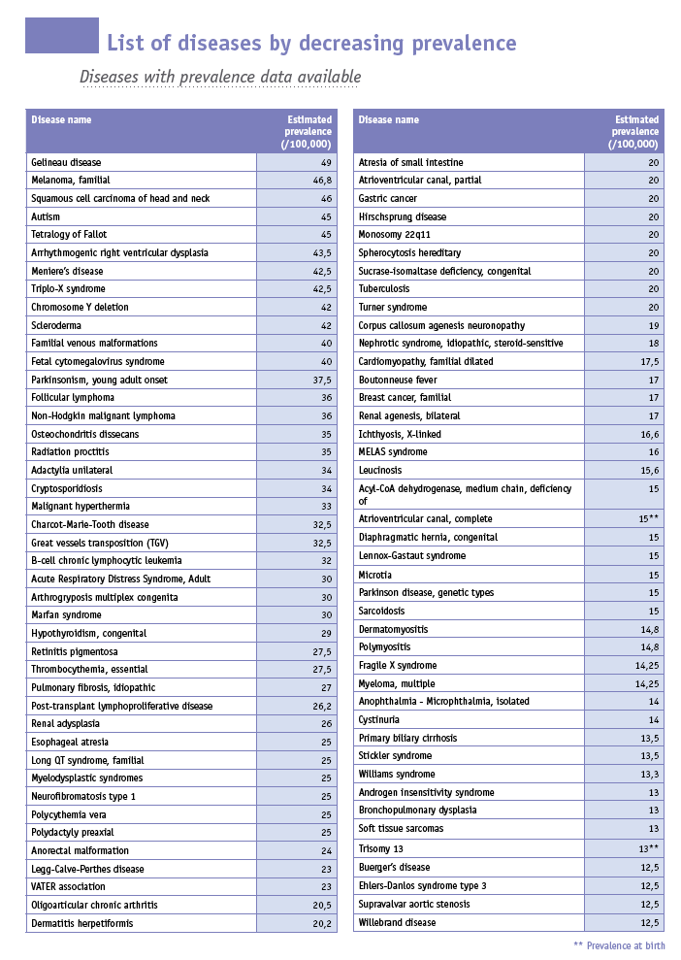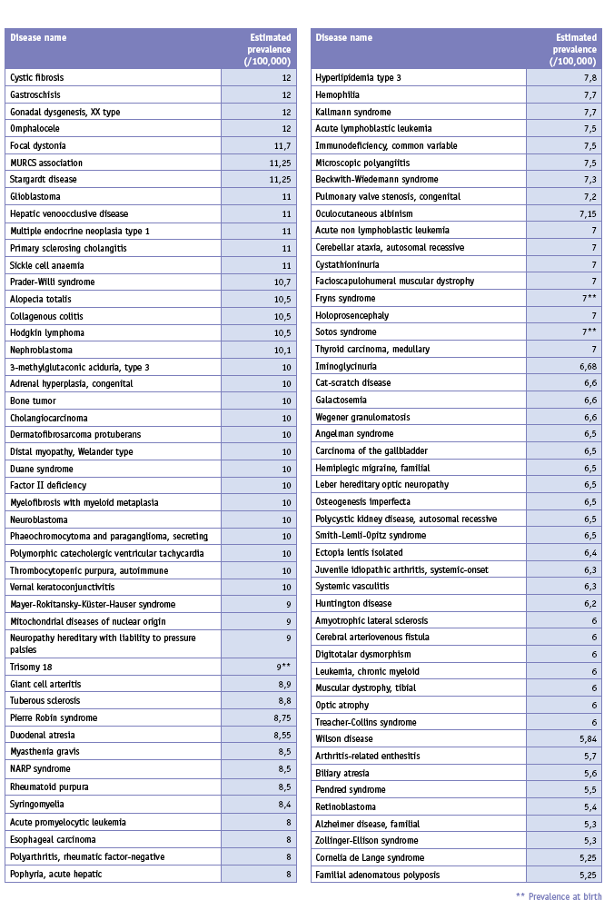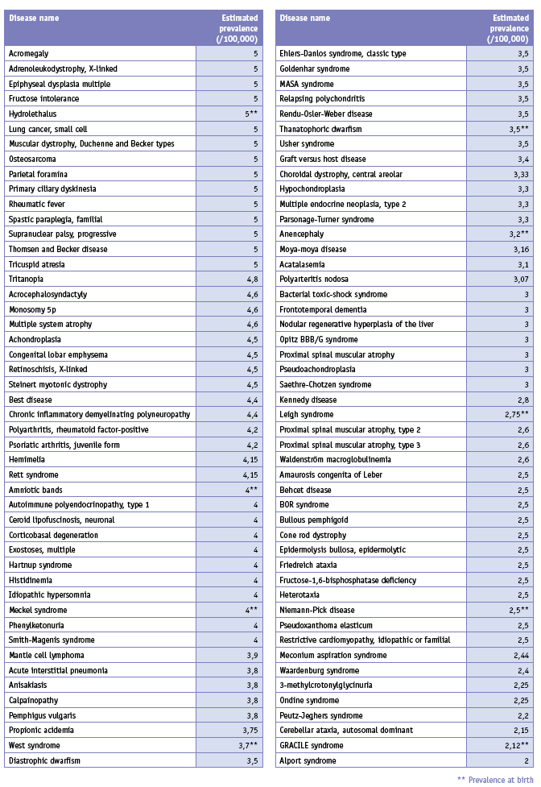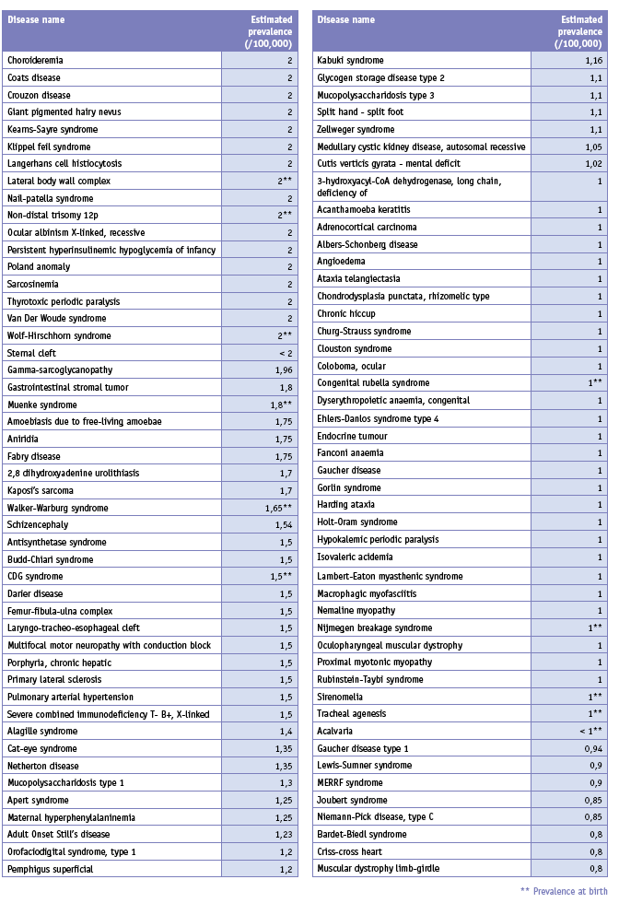
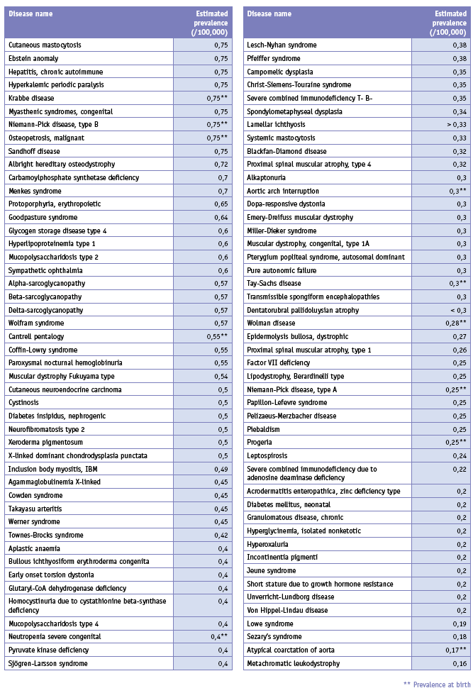
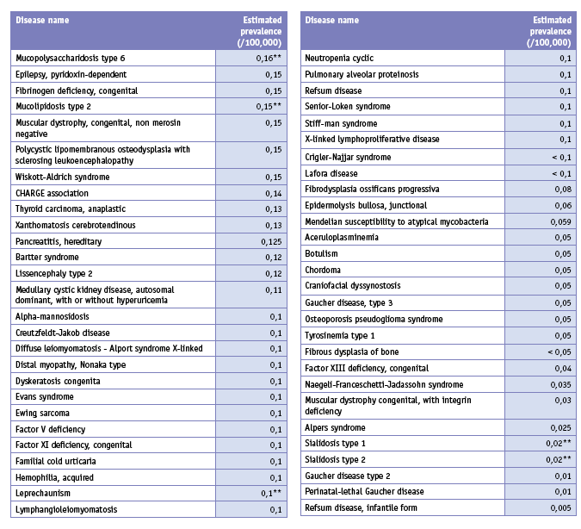

Previous and Ongoing Activities
Based on Article 152, a Community action programme on rare diseases, including genetic diseases, was adopted for the period 1 January 1999, to 31 December 2003. The aim of the programme was to contribute, in coordination with other Community measures, to ensure a high level of health protection in relation to rare diseases. As a first EU effort in this area, specific attention was given to improving knowledge and facilitating access to information about these diseases. Actions of the programme included developing a coherent European information network on rare diseases; contributing to training and refresher courses for professionals in order to improve early detection, recognition, intervention, and prevention; promoting and encouraging transnational collaboration and networking; and supporting at Community level the monitoring of rare diseases in the Member States. Rare Diseases were one of the priorities in the EU Public Health Programme 2003-2007.
Rare diseases will continue to be a priority for action in the new Health Programme (2008-2013). The Decision 1350/2007/EC of the European Parliament and of the Council adopted the second programme of Community action in the field of health (2008-2013) establishes in point 2.2.2. of the Annex: 'Promote action on the prevention of major diseases of particular significance in view of the overall burden of diseases in the Community, and on rare diseases, where Community action by tackling their determinants can provide significant added value to national efforts'.
The White Paper COM(2007) 630 final “Together for Health: A Strategic Approach for the EU 2008-2013” of 23 October 2007 developing the EU Health Strategy also identifies rare diseases as a priority for action.
A substantial contribution to advancing knowledge on rare diseases has been provided for two decades through collaborative and coordinated research projects supported by the successive European Community Framework Programmes for Research and Technological Development. The necessity of multidisciplinary approaches, the low number of patients available for each study and the scattered specialists with complementary expertise makes it indispensable to pool resources at European level. The coordination and collaboration efforts put in place in the three preceding FPs were much amplified during FP6, which brought an incomparable European added-value in the field, through the support provided to some 60 multidisciplinary collaborative projects. These mobilised top researchers, tackled fragmentation in the field, and produced new knowledge on rare diseases, on which future researches can be built.
Amongst others, FP6 supported coordination projects such as the OrphanPlatForm project (part of the Orphanet platform) which references national and European research projects at a near-to-the-market stage of development, offers a platform for collaboration between academic and industrial partners, and allows patients to signal their interest in participating in current/future research. In this context, the FP6 supported also an important ERA-Net project dedicated to rare diseases (E-Rare) for the development of joint and trans-national activities (survey on national programmes, identification of gaps and overlaps among national research programs and activities on rare diseases). The rare diseases activities in FP6 also allowed involvement of representative patient organisations (by participation in projects, including co-sponsoring, agenda setting, workshops, and conferences).
In the current framework programme, FP7, rare diseases have been recognised a priority for research activities. Research on rare diseases is expected to be supported mostly through collaborative and coordination research projects in the Health Theme of the "Cooperation" Specific Programme, designed to improve the health of European citizens, increase the competitiveness, and boost the innovative capacity of European health-related industries and businesses, while addressing global health issues. In the Health Theme, emphasis will be put on translational research (translation of basic discoveries into clinical applications, including scientific validation of experimental results), the development, and validation of new therapies, methods for health promotion and prevention (including promotion of child health), healthy ageing, diagnostic tools and medical technologies, as well as sustainable and efficient healthcare systems. More specifically, the focus for rare disease research in FP7 is on Europe-wide studies of natural history, pathophysiology, and the development of preventive, diagnostic, and therapeutic interventions.
Under the responsibility of DG ENTR and the EMEA (the European Medicines Agency), the EC implements a policy on Orphan Drugs. The Orphan Medicinal Product Regulation (Regulation (EC) No 141/2000 of the European Parliament and of the Council of 16 December, 1999, on orphan medicinal products) was proposed to set up the criteria for orphan designation in the EU and describes the incentives. The incentives in place are a 10-year market exclusivity, protocol assistance, and access to the Centralised Procedure for Marketing Authorisation. This aims to encourage the research, development, and marketing of medicines to treat, prevent, or diagnose rare diseases. The EU pharmaceutical legislation completed the policy in 2003 with a compulsory EU centralised procedure for market authorisation for all orphan drugs.
In 2000, a Committee for Orphan Medicinal Products (COMP) was established within EMEA to review applications from persons or companies seeking “orphan medicinal product designation” for products they intend to develop for the diagnosis, prevention, or treatment of rare diseases.
DG SANCO has established the High Level Group on Health Services and Medical Care (HLG) as a means of taking forward the recommendations made by the reflection process on patient mobility. One of the Working Groups of this High Level Group deals with reference networks of centres of expertise for rare diseases. In 2006, the Rare Diseases Task Force submitted a report ‘Contribution to policy shaping: For a European collaboration on health services and medical rare in the field of rare diseases’ to the HLG, updating the information about reference networks in Europe. The report details the use of the concept of reference networks for rare diseases in Europe as well as their respective functions. The Work Plans 2006 and 2007 for the implementation of the EU public health programme have introduced the development of European Reference Networks for Rare Diseases as a priority in the area.
In this sense the Consultation regarding Community action on health services SEC (2006) 1195/4 from 26 September 2006 proposed under point 3.2.1. European networks of centres of reference: 'Some types of health services require a particular concentration of resources or expertise, for example for rare diseases. Establishing European networking for such centres of reference would help to provide high-quality and cost-effective care, and would thus bring benefits to both patients and healthcare systems as well as helping to promote the highest possible quality of care'.
The Health Programme will also continue to integrate the support to the patients’ organisations as a priority for action, such as the European Organisation for Rare Diseases (Eurordis). Eurordis gathers organisations in 33 countries, permitting a direct dialogue between the European Commission, other stakeholders, and the patient community of rare diseases.

Results of the EURORDIS Survey

http://ec.europa.eu/atwork/programmes/docs/clwp2008_en.pdf
Decision No 1295/1999/EC of the European Parliament and of the Council of 29 April, 1999, adopting a programme of Community action on rare diseases within the framework for action in the field of public health (1999 to 2003).
Prevalence of rare diseases: A bibliographic survey July 2007 - Orphanet
ERA-Nets are projects aiming to step up the cooperation and coordination of research activities carried out at national or regional level in the Member States and Associated States through the networking of research activities conducted at national or regional level, and the mutual opening of national and regional research programmes.
See http://cordis.europa.eu/fp7/home_en.html
See http://www.e-rare.eu/cgi-bin/index.php
Regulation (EC) No 141/2000 of the European Parliament and of the Council of 16 December 1999 on orphan medicinal products
See http://www.emea.europa.eu/htms/general/contacts/COMP/COMP.html
See http://www.orpha.net/actor/EuropaNews/2006/doc/French_National_Plan.pdf
See http://www.who.int/classifications/icd/en/.
see http://ec.europa.eu/dgs/health_consumer/self_regulation/index_en.htm
Any such proposals would of course be accompanied by their own impact assessment.
See Decision No 1295/1999/EC of the European Parliament and of the Council of 29 April 1999 adopting a programme of Community action on rare diseases within the framework for action in the field of public health (1999 to 2003), OJ L 155/1 of 26.6.1999.
According to the “Plan national maladies rares 2005-2008” the total cost of €86.66m can be broken down as follows: epidemiology €2m, information €1.2m, professional training €400 000, helpline €400 000, screening €20m, access to and quality of services €40m, research €22.5m (with an additional €20m from ministry of research), and developing partnerships €160 000.
Decision No 1295/1999/EC of the European Parliament and of the Council of 29 April, 1999, adopting a programme of Community action on rare diseases within the framework for action in the field of public health (1999 to 2003)
Decision No 1786/2002/EC of the European Parliament and of the Council of 23 September, 2002, adopting a programme of Community action in the field of public health (2003-2008)
Amended proposal for a Decision of the European Parliament and of the Council establishing a second Programme of Community action in the field of Health and consumer protection (2007-2013) COM(2006) 234 final
See http://ec.europa.eu/health/ph_overview/strategy/health_strategy_en.htm
See http://cordis.europa.eu/fp7/home_en.html
See http://www.e-rare.eu/cgi-bin/index.php
Regulation (EC) No 141/2000 of the European Parliament and of the Council of 16 December 1999 on orphan medicinal products
See http://www.emea.europa.eu/htms/general/contacts/COMP/COMP.html
See http://ec.europa.eu/health/ph_threats/non_com/rare_8_en.htm
See http://www.eurordis.org

