EN
COMMISSION OF THE EUROPEAN COMMUNITIES
Brussels, 13.6.2008
COM(2008) 351 final
2008/0115 (COD)

Proposal for a
DIRECTIVE OF THE EUROPEAN PARLIAMENT AND OF THE COUNCIL
on the approximation of the laws of the Member States relating to the driver's seat on wheeled agricultural or forestry tractors
(Codified version)
(presented by the Commission)
EXPLANATORY MEMORANDUM
1. In the context of a people’s Europe, the Commission attaches great importance to simplifying and clarifying Community law so as to make it clearer and more accessible to the ordinary citizen, thus giving him new opportunities and the chance to make use of the specific rights it gives him.
This aim cannot be achieved so long as numerous provisions that have been amended several times, often quite substantially, remain scattered, so that they must be sought partly in the original instrument and partly in later amending ones. Considerable research work, comparing many different instruments, is thus needed to identify the current rules.
For this reason a codification of rules that have frequently been amended is also essential if Community law is to be clear and transparent.
2. On 1 April 1987 the Commission therefore decided to instruct its staff that all legislative acts should be codified after no more than ten amendments, stressing that this is a minimum requirement and that departments should endeavour to codify at even shorter intervals the texts for which they are responsible, to ensure that the Community rules are clear and readily understandable.
3. The Conclusions of the Presidency of the Edinburgh European Council (December 1992) confirmed this, stressing the importance of codification as it offers certainty as to the law applicable to a given matter at a given time.
Codification must be undertaken in full compliance with the normal Community legislative procedure.
Given that no changes of substance may be made to the instruments affected by codification, the European Parliament, the Council and the Commission have agreed, by an interinstitutional agreement dated 20 December 1994, that an accelerated procedure may be used for the fast-track adoption of codification instruments.
4. The purpose of this proposal is to undertake a codification of Council Directive 78/764/EEC of 25 July 1978 on the approximation of the laws of the Member States relating to the driver's seat on wheeled agricultural or forestry tractors. The new Directive will supersede the various acts incorporated in it; this proposal fully preserves the content of the acts being codified and hence does no more than bring them together with only such formal amendments as are required by the codification exercise itself.
5. The codification proposal was drawn up on the basis of a preliminary consolidation, in all official languages, of Directive 78/764/EEC and the instruments amending it, carried out by the Office for Official Publications of the European Communities, by means of a data-processing system. Where the Articles have been given new numbers, the correlation between the old and the new numbers is shown in a table contained in Annex VII to the codified Directive.
2008/0115 (COD)

ê 78/764/EEC (adapted)
Proposal for a
DIRECTIVE OF THE EUROPEAN PARLIAMENT AND OF THE COUNCIL
on the approximation of the laws of the Member States relating to the driver's seat on wheeled agricultural or forestry tractors
(Text with EEA relevance)
THE EUROPEAN PARLIAMENT AND THE COUNCIL OF THE EUROPEAN UNION,
Having regard to the Treaty establishing the European Community, and in particular Article 100 Ö 95 Õ thereof,
Having regard to the proposal from the Commission,
Having regard to the opinion of the European Economic and Social Committee,
Acting in accordance with the procedure laid down in Article 251 of the Treaty,
Whereas:

ê
- Council Directive 78/764/EEC of 25 July 1978 on the approximation of the laws of the Member States relating to the driver's seat on wheeled agricultural or forestry tractors has been substantially amended several times. In the interests of clarity and rationality the said Directive should be codified.
- Directive 78/764/EEC is one of the separate Directives of the EC type-approval system provided for in Council Directive 74/150/EEC, as replaced by Directive 2003/37/EC of the European Parliament and of the Council of 26 May 2003 on type-approval of agricultural or forestry tractors, their trailers and interchangeable towed machinery, together with their systems, components and separate technical units and repealing Directive 74/150/EEC and lays down technical prescriptions concerning the design and construction of agricultural or forestry tractors as regards the driver's seat. Those technical prescriptions concern the approximation of the laws of the Member States to enable the EC type-approval procedure provided for in Directive 2003/37/EC to be applied in respect of each type of tractor. Consequently, the provisions laid down in Directive 2003/37/EC relating to agricultural and forestry tractors, their trailers and interchangeable towed machinery, together with their systems, components and separate technical units apply to this Directive.
- This Directive should be without prejudice to the obligations of the Member States relating to the time-limits for transposition into national law and application of the Directives set out in Annex VI, Part B,

ê 78/764/EEC
HAVE ADOPTED THIS DIRECTIVE:
Article 19
1. For the purposes of this Directive, ‘agricultural or forestry tractor’ means any motor vehicle, fitted with wheels or endless tracks, having at least two axles, the main function of which lies in its tractive power and which is specially designed to tow, push, carry or power certain tools, machinery or trailers intended for agricultural or forestry use. It may be equipped to carry a load and passengers.

ê 82/890/EEC Art. 1(1) (adapted)
è1 97/54/EC Art. 1
2. This Directive shall apply only to tractors defined in paragraph 1 which are equipped with pneumatic tyres and have at least two axles and a maximum design speed of between 6 and è1 40 km/h ç.

ê 78/764/EEC (adapted)
Article 12
1. Each Member States shall grant EEC EC component type-approval for any type of driver's seat which satisfies the construction and testing requirements laid down in Annexes I and II.
2. The Member State which has granted EEC EC component type-approval shall take the measures required in order to verify, in so far as is necessary and if need be in cooperation with the competent authorities in the other Member States, that production models conform to the approved type. Such verification shall be limited to spot checks.
Article 23

ê 78/764/EEC
Member States shall, for each type of driver's seat which they approve pursuant to Article 12, issue to the manufacturer or to his authoriszed representative, an EEC EC component type-approval mark conforming to the model shown in point 3.5 of Annex II.
Member States shall take all appropriate measures to prevent the use of marks liable to create confusion between driver's seats which have been granted EC component type-approval pursuant to Article 1 2 and other devices.
Article 34

ê 78/764/EEC (adapted)
1. No A Member State Ö shall not Õ may prohibit the placing on the market of driver's seats on grounds relating to their construction if they bear the EEC EC component type-approval mark.

ê 78/764/EEC
2. Nevertheless, a Member State may prohibit the placing on the market of driver's seats bearing the EEC EC component type-approval mark which consistently fail to conform to the approved type.
That Member State shall forthwith inform the other Member States and the Commission of the measures taken, specifying the reasons for its decision.

ê 78/764/EEC (adapted)
Article 45
The competent authorities of each Member State shall within one month send to the competent authorities of the other Member States a copy of the EC component type-approval certificates, an example Ö a model Õ of which is Ö shown Õ given in Annex III, completed for each type of driver's seat which they approve or refuse to approve.

ê 78/764/EEC
Article 56
1. If the Member State which has granted EEC EC component type-approval finds that a number of driver's seats bearing the same EEC EC component type-approval mark do not conform to the type which it has approved, it shall take the necessary measures to ensure that production models conform to the approved type.
The competent authorities of that Member State shall advise those of the other Member States of the measures taken, which may, if necessary, where there is a serious and repeated failure to conform, extend to withdrawal of the EEC EC component type-approval.
The said Those authorities shall take the same measures if they are informed by the competent authorities of another Member State of such failure to conform.
2. The competent authorities of the Member States shall inform each other within one month of any withdrawal of EEC EC component type-approval, and of the reasons for such a measure.
Article 67
Any decision taken pursuant to the provisions adopted in implementation of this Directive to refuse or withdraw EEC EC component type-approval for a driver's seat or to prohibit its placing on the market or use, shall set out in detail the reasons on which it is based.
Such decisions shall be notified to the party concerned, who shall at the same time be informed of the remedies available to him under the laws in force in the Member States and of the time-limits allowed for the exercise of such remedies.
Article 78
No Member State may refuse to grant EEC EC type-approval or national type-approval for a tractor on grounds relating to its driver's seat if this bears the EEC EC component type-approval mark and is fitted in accordance with the requirements laid down in Annex IV.
Article 89
No Member State may refuse or prohibit the sale, registration, entry into service or use of any tractor on grounds relating to the driver's seat if this bears the EEC EC component type-approval mark and is fitted in accordance with the requirements set out in Annex IV.

ê 78/764/EEC (adapted)
Article 10
Ö The Õ Any amendments necessary to adapt adjust the requirements of the Annexes Ö I to V Õ to this Directive to take account of technical progress shall be adopted in accordance with the procedure Ö referred to Õ laid down in Article Ö 20(2) Õ 13 of Directive Ö 2003/37/EC Õ 74/150/EEC.
Article 11
1. Member States shall bring into force the provisions necessary in order to comply with this Directive within 18 months of its notification and shall forthwith inform the Commission thereof.
2. Member States shall ensure that the texts of the main provisions of national law which they adopt in the field covered by this Directive are communicated to the Commission.
Ö Member States shall communicate to the Commission the texts of the main provisions of national law which they adopt in the field covered by this Directive. Õ

ê
Article 12
Directive 78/764/EEC, as amended by the acts listed in Annex VI, Part A, is repealed, without prejudice to the obligations of the Member States relating to the time-limits for transposition into national law and application of the Directives set out in Annex VI, Part B.
References to the repealed Directive shall be construed as references to this Directive and shall be read in accordance with the correlation table set out in Annex VII.
Article 13
This Directive shall enter into force on the twentieth day following that of its publication in the Official Journal of the European Union.
It shall apply from [...].

ê 78/764/EEC
Article 1412
This Directive is addressed to the Member States.
Done at Brussels, […]
For the European Parliament For the Council
The President The President
[…] […]

ê
LIST OF ANNEXES
Annex I: | DEFINITIONS
Annex II: | CONSTRUCTION AND TESTING REQUIREMENTS — EC COMPONENT TYPE-APPROVAL AND MARKING REQUIREMENTS
 | Appendix 1 | Method of determining the seat reference point (S)
 | Appendix 1 | Figure 1 | Device for determining the seat reference point (S)
 | Appendix 1 | Figure 2 | Device in position
 | Appendix 2 | Determination of the characteristic curves of the suspension system and the load adjustment range (point 2.5.1)
 | Appendix 3 | Test on standard roadway
 | Appendix 4
 | Appendix 5
 | Appendix 6
 | Appendix 7 | Test stand (point 2.5.3.1); example of construction (dimensions in mm)
 | Appendix 8 | Characteristic of the filter of the vibration measuring instrument (point 2.5.3.3.5)
 | Appendix 9 | Example of an EC component type-approval mark (point 3.5)
Annex III: | MODEL EC COMPONENT TYPE-APPROVAL CERTIFICATE
Annex IV: | DRIVER'S SEAT INSTALLATION REQUIREMENTS FOR EC TYPE-APPROVAL OF A TRACTOR
Annex V: | ANNEX TO THE EC TYPE-APPROVAL CERTIFICATE FOR A TRACTOR WITH REGARD TO THE DRIVER'S SEAT
Annex VI: | Part A: Repealed Directive with list of its successive amendments
Annex VI: | Part B: List of time-limits for transposition into national law and application
Annex VII: | Correlation table

ê 78/764/EEC
ANNEX I
DEFINITIONS

1. Driver's seat
‘Driver's seat’ means that seat capable of accommodating one person only, provided for the use of the driver when driving the tractor.

2. Seat surface
‘Seat surface’ means the almost horizontal area of the seat which supports the driver when seated.

3. Backrest
‘Backrest’ means the almost vertical area of the seat supporting the driver's back when seated.

4. Lateral seat supports
‘Lateral seat supports’ means the devices or forms of the seat surface which prevent the driver from sliding sideways.

4.1. Seat armrests
‘Seat armrests’ means the devices on either side of the seat which support the driver's arms when he is seated.

5. Seat reference point (S)
‘Seat reference point (S)’ means the point of intersection in the median longitudinal plane of the seat between the tangential plane at the base of the padded backrest and a horizontal plane. This horizontal plane intersects the lower surface of the seat 150 mm in front of the seat reference point (S) (see Appendix 1 to Annex II).

6. Depth of the seat surface
‘Depth of the seat surface’ means the horizontal distance between the seat reference point (S) and the front edge of the seat surface.

7. Width of the seat surface
‘Width of the seat surface’ means the horizontal distance between the outside edges of the seat surface measured in a plane perpendicular to the median plane of the seat.

8. Load adjustment range
‘Load adjustment range’ means the range between the two loads corresponding to the mean positions in the suspension system curves plotted for the heaviest and lightest driver.

ê 83/190/EEC Art. 1 and Annex

9. Suspension travel
‘Suspension travel’ means the vertical distance between the highest position and the position at a given moment of a point situated on the seat surface 200 mm in front of the seat reference point in the median longitudinal plane.

ê 78/764/EEC
è1 83/190/EEC Art. 1 and Annex

10. Vibration
‘Vibration’ means the vertical movement up and down of the driver's seat.

11. Vibration acceleration (a)
‘Vibration acceleration (a)’ means the second differential of the vibration displacement with respect to time.

12. Rms value of the acceleration (a_{eff})
‘Rms value of the acceleration (a_{eff})’ means the square root of the mean square of the accelerations.

è1 13. ç Weighted vibration acceleration (a_{w})
‘Weighted vibration acceleration (a_{w})’ means the weighted vibration acceleration determined with the help of a weighting filter in accordance with point 2.5.3.3.5.2 of Annex II.

ê 83/190/EEC Art. 1 and Annex
a_{wS} = rms value of the weighted seat vibration acceleration measured during a bench test or a standard roadway test;
a_{wB} = rms value of the weighted vibration acceleration measured at the seat attachment during a bench test;
a_{wB}* = reference rms value of the weighted vibration acceleration measured at the seat attachment;
a_{wS}* = corrected rms value of the weighted seat vibration acceleration measured during a bench test;
a_{wF}* = rms value of the weighted vibration acceleration measured at the seat attachment during a standard roadway test.

ê 78/764/EEC
è1 83/190/EEC Art. 1 and Annex

è1 14. ç Vibration ratio
‘Vibration ratio’ means the ratio of the weighted vibration acceleration measured on the driver's seat to that measured at the seat attachment in accordance with point 2.5.3.3.2 of Annex II.

è1 15. ç Vibration class
‘Vibration class’ means the class or group of tractors which show the same vibration characteristics.

ê 83/190/EEC Art. 1 and Annex

16. Category A tractor
‘Category A tractor’ means a tractor which can be assigned to a given vibration class by reason of similar design features.

ê 88/465/EEC Art. 1 and Annex
16.1. The characteristics of these tractors are as follows:
Number of axles: two.
Suspension: unsuspended rear axle.
16.2. Category A tractors shall be divided up into three classes:
Class I: | tractors having an unladen mass of up to 3 600 kg.
Class II: | tractors having an unladen mass of 3 600 — 6 500 kg.
Class III: | tractors having an unladen mass of more than 6 500 kg.

ê 83/190/EEC Art. 1 and Annex

17. Category B tractor
‘Category B tractor’ means a tractor which cannot be assigned to a vibration class in Category A.

ê 78/764/EEC
è1 83/190/EEC Art. 1 and Annex

è1 18. ç Seats of the same type
‘Seats of the same type’ means seats which do not differ in any essential respects; the only aspects in which the seats may differ being as follows:
è1 18.1. ç dimensions;
è1 18.2. ç position and inclination of the backrest;
è1 18.3. ç inclination of the seat surface;
è1 18.4. ç longitudinal and vertical adjustment of the seat.
_____________
ANNEX II
CONSTRUCTION AND TESTING REQUIREMENTS — EEC EC COMPONENT TYPE-APPROVAL AND MARKING REQUIREMENTS

1. GENERAL REQUIREMENTS
1.1. The driver's seat must be designed to ensure a comfortable position for the driver when controlling and manoeuvring the tractor, and to afford him the utmost protection as regards health and safety.
1.2. The seat must be adjustable in the longitudinal direction and in the height without the use of a tool.
1.3. The seat must be designed to reduce shocks and vibration. It must therefore be well sprung, have good vibration absorption and provide adequate support at the rear and sides.
The lateral support is considered adequate if the seat is designed to prevent the driver's body from slipping sideways.
1.3.1. The seat must be adjustable for persons of different mass. Any adjustment necessary in order to comply with this requirement must be carried out without the use of tools.
1.4. The seat surface, the backrest, the lateral supports and, where fitted, the removable, folding or fixed armrests, must be padded.
1.5. The seat reference point (S) must be calculated in the manner specified in Appendix 1 to Annex II.
1.6. Save as otherwise provided, the measurements and tolerances must comply with the following requirements:
1.6.1. the measurements given must be expressed in whole units, if necessary rounded off to the nearest whole number of units;
1.6.2. the instruments used for making measurements must enable the measured value to be rounded off to the nearest whole unit and must be accurate within the following tolerance limits:
for length: ± 0·5%,
for angle measurements: ± 1°,
for determination of the mass of the tractor: ±20 kg,
for measurement of tyre pressure: è1 ±0,1 bar ç;
1.6.3. for all data relating to dimensions, a tolerance of ± 5% is allowed.
1.7. The seat must undergo the following tests, carried out on the same seat and in the order indicated below:
1.7.1. determination of the suspension characteristics and the range of adjustment to the driver's mass;
1.7.2. determination of lateral stability;

ê 83/190/EEC Art. 1 and Annex
1.7.3. Ddetermination of vertical vibration characteristics.;
1.7.4. Ddetermination of the damping characteristics in the resonance range.

ê 78/764/EEC
è1 88/465/EEC Art. 1 and Annex
1.8. If the seat is manufactured so that it can revolve about a vertical axis then tests are carried out with the seat facing the forward position, locked in a position parallel with the median longitudinal plane of the tractor.
1.9. The seat undergoing the above tests must possess the same characteristics with respect to construction and fittings as the seats in series production.
1.10. Before the tests are carried out, the seat must have been run in by the manufacturer.
1.11. A test report, which confirms that the seat has completed all the specified tests without damage and which includes details of the seat vibration characteristics, must be prepared by the test laboratory.
1.12. Seats tested for Class I tractors are suitable only for tractors of that class, whereas seats tested for Class II tractors are suitable for Class I or Class II tractors è1 and seats tested for Class III tractors are suitable for Class II and III tractors ç.

2. SPECIAL REQUIREMENTS

2.1. Seat surface dimensions
2.1.1. The depth of the seat surface, measured parallel to and at a distance of 150 mm from the median longitudinal plane of the seat, must be 400 ± 50 mm (see figure below).
2.1.2. The width of the seat surface, measured perpendicular to the median plane of the seat, 150 mm in front of the seat reference point (S) and at not more than 80 mm above that point, must be at least 450 mm (see figure below).

ê 83/190/EEC Art. 1 and Annex
2.1.3. The depth and width of the surface of seats intended for tractors in which the minimum rear-wheel track width does not exceed 1 150 mm may be reduced to not less than 300 and 400 mm respectively if the design of the tractor prevents compliance with the requirements of Items points 2.1.1 and 2.1.2.

ê 78/764/EEC

2.2. Position and inclination of the backrest
2.2.1. The upper edge of the backrest of the seat must be at least 260 mm above the seat reference point (S) (see figure below).
2.2.2. The backrest must have an inclination of 10 ± 5° (see figure below).

2.3. Inclination of the seat surface
2.3.1. The inclination towards the rear (see angle α in the figure below) of the surface of the loaded cushion must be 3 to 12° in relation to the horizontal, measured with the loading device in accordance with Appendix 1.

2.4. Seat adjustment (see figure below)

ê 83/190/EEC Art. 1 and Annex
2.4.1. The seat must be adjustable in the longitudinal direction over a minimum distance of:
- 150 mm for tractors with a minimum rear-wheel track width of more than 1 150 mm,
- 60 mm for tractors with a minimum rear-wheel track width of 1 150 mm or less.
2.4.2. The seat must be adjustable in the vertical direction over a minimum distance of:
- 60 mm for tractors with a minimum rear-wheel track width of more than 1 150 mm,
- 30 mm for tractors with a minimum rear-wheel track width of 1 150 mm or less.

ê 78/764/EEC
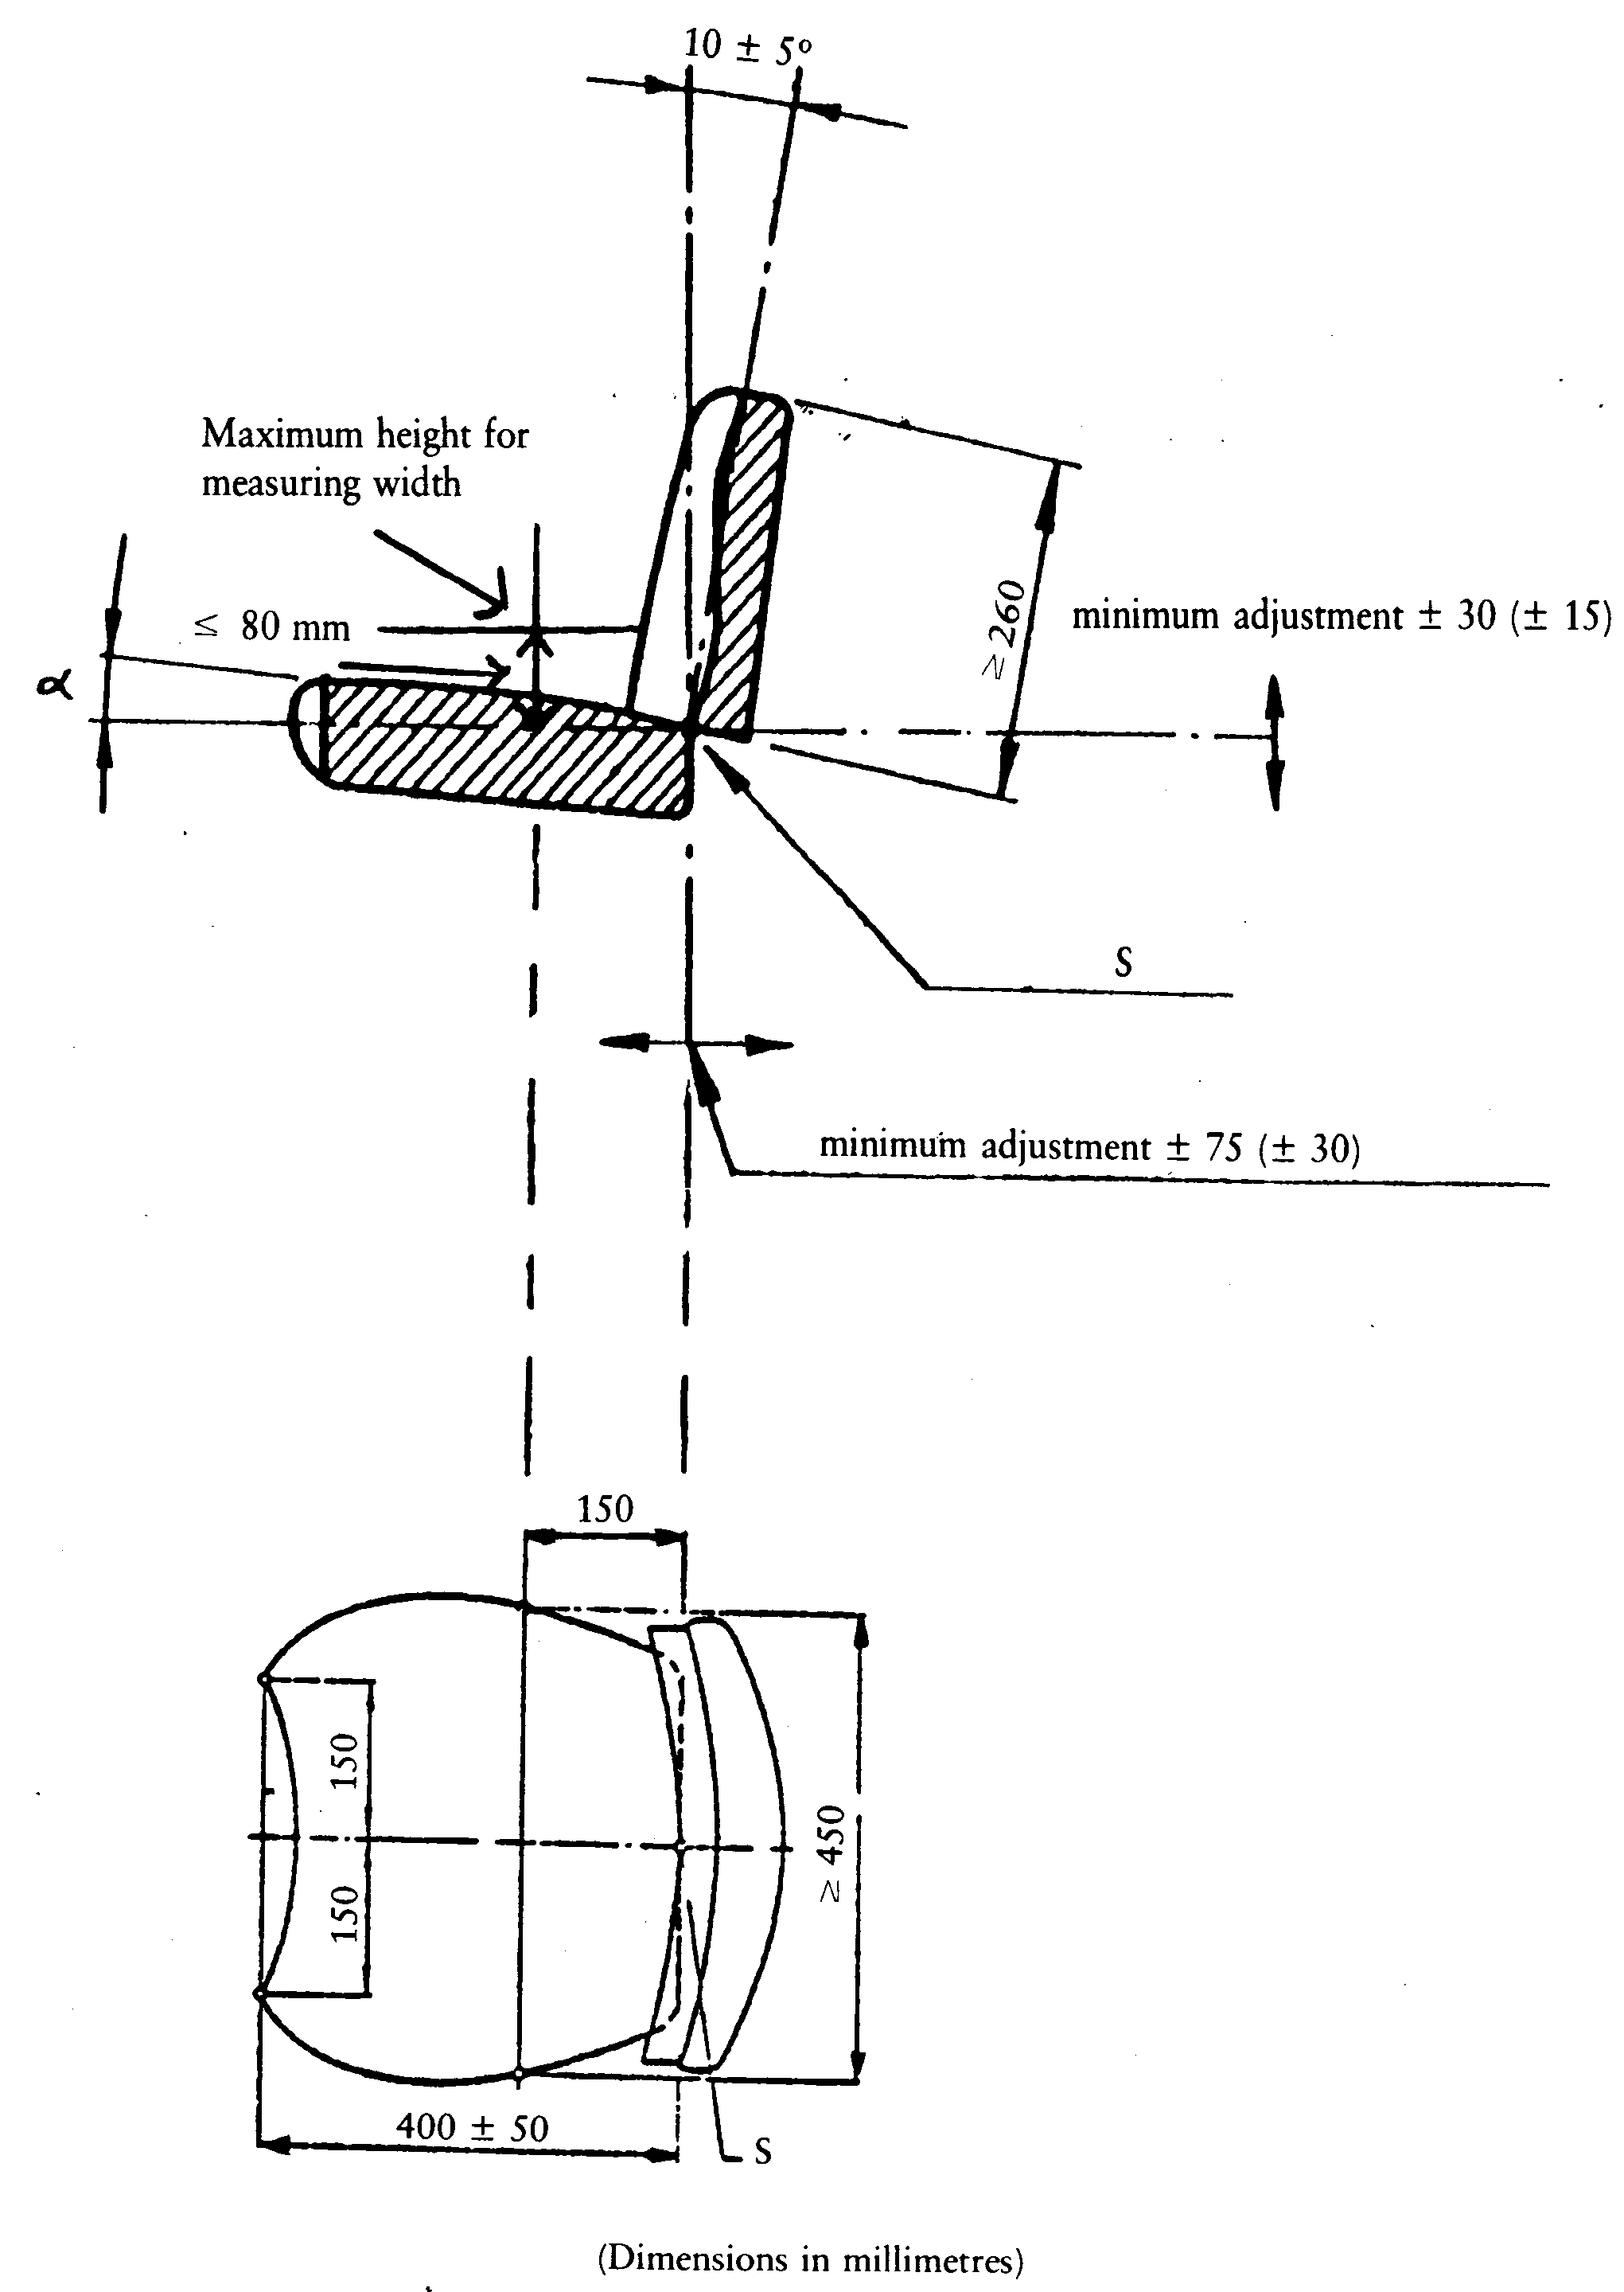

2.5. Seat tests

ê 83/190/EEC Art. 1 and Annex

2.5.1. Determination of the suspension characteristics and the range of adjustment to the driver's mass
2.5.1.1. The suspension characteristics are determined by a static test. The range of adjustment to the driver's mass is calculated from the suspension characteristics. These calculations are not necessary in the case of seats that cannot be manually adjusted to the driver's mass.

ê 78/764/EEC
è1 83/190/EEC Art. 1 and Annex
2.5.1.2. The seat is mounted on a test stand or on a tractor and a load applied to it, either directly or by means of a special device; this load must not differ by more than 5 N from the nominal load. è1 The measuring error for the suspension travel shall not exceed ± 1 mm. ç The load must be applied in accordance with the procedure laid down in section point 3 of Appendix 1.

ê 83/190/EEC Art. 1 and Annex (adapted)
2.5.1.3. A complete characteristic curve representing the deflection of the suspension system must be plotted from zero load to maximum load, and back to zero. The load graduations at which the suspension travel is measured must not exceed 100 N; at least eight measurement points must be plotted at approximately equal intervals in the suspension travel. The point taken as the maximum load should Ö shall Õ be either that at which no further suspension travel can be measured, or a load of 1 500 N. After each application or removal of the load, the suspension travel must be measured 200 mm in front of the seat reference point in the median longitudinal plane of the seat surface. After application or removal of the load, the seat must be allowed to return to its at-rest position.
2.5.1.4. In the case of seats with a mass adjustment scale, the characteristic curves representing the deflection of the suspension system are plotted at mass adjustments for drivers having a mass of 50 and 120 kg. In the case of seats without a mass adjustment scale and with adjustment stops, measurements are taken at the lowest and the highest mass adjustment. In the case of seats without a mass adjustment scale or adjustment stops, the adjustment must be so selected that:
2.5.1.4.1. for the lower mass adjustment limit, the seat just returns to the top of the suspension travel when the load is removed, and
2.5.1.4.2. for the upper mass adjustment limit, the load of 1 500 N depresses the seat to the lowest limit of the suspension travel.

ê 78/764/EEC (adapted)
è1 83/190/EEC Art. 1 and Annex
2.5.1.5. The mean position of the suspension system is the position which the seat assumes when it is depressed by half the full travel of the suspension system.
2.5.1.6. Since the characteristic curves of the suspension system are generally hysteresis loops, the load è1 in the mean position of the suspension system ç must be determined by drawing a centre line through the loop (see section point 8 of Annex I, and sections points A and B of Appendix 2 to Annex II).

ê 83/190/EEC Art. 1 and Annex (adapted)
2.5.1.7. To determine the limits of the adjustment range as a function of the driver's mass, the vertical forces determined in accordance with Item point 2.5.1.6 for points A and B (see Appendix 2 to this Annex) must be multiplied by the scale factor 0,13 kg/N.

2.5.2. Determination of lateral stability
2.5.2.1. The seat must be set for the upper limit of the weight adjustment and connected to the test stand or to the tractor in such a way that its base plate rests on a rigid plate (test stand) not smaller than the base plate itself.

ê 78/764/EEC
2.5.2.2. A test load of 1 000 N is applied to the surface or cushion of the seat. The point of application must lie 200 mm in front of the seat reference point (S) and alternately on the two sides 150 mm from the plane of symmetry through the seat.
2.5.2.3. During application of the load, the variation in the lateral angle of inclination of the seat surface is measured in the end settings for horizontal and vertical seat adjustment. The permanent deformation close to the point of application of the load is not to be taken into consideration.

ê 83/190/EEC Art. 1 and Annex

2.5.3. Determination of the vertical vibration characteristics

ê 78/764/EEC
The seat vibration is determined by tests on a test stand and/or a standard roadway depending on whether the seat is intended for a class (or classes) of Category A tractor or for a Category B tractor.

2.5.3.1. Testing on the test stand

ê 83/190/EEC Art. 1 and Annex (adapted)
è1 88/465/EEC Art. 1 and Annex
2.5.3.1.1. The test stand must simulate the vertical vibrations at the point of attachment of the driver's seat. The vibrations are generated by means of an electro-hydraulic device. The set values to be used are either those specified in Appendices è1 4, 5a and 5b Ö 4, 5 and 6 Õ ç to Annex II for the class of tractor in question or the double-integrated acceleration signals recorded at the seat attachment of a Category B tractor moving at a speed of 12 ± 0,5 km/h on a standard roadway as defined in Item point 2.5.3.2.1. To generate the vibrations, an uninterrupted double run of the set values must be used.
The transition from the end of the sequence of acceleration signals recorded on the standard roadway in the first run to the start of the second run must be smooth and jolt-free. The measurements must not be made during the first run of the set values or of the acceleration signals. More values than the 700 laid down in Appendices è1 4, 5a and 5b Ö 4, 5 and 6 Õ ç to Annex II may be used if these values were calculated, for example, with a cubic Spline function from the original 700 values.

ê 78/764/EEC
2.5.3.1.2. Besides an attachment for the test seat, the platform must contain a steering wheel and footrest. Its configuration must be as shown in Appendix 67.

ê 83/190/EEC Art. 1 and Annex
2.5.3.1.3. The test stand must have a high degree of flexural and torsional rigidity and its bearings and guides must have no more than the technically necessary clearance. If the platform is carried on an oscillating arm, the dimension R must be not less than 2 000 mm (see Appendix 67). The magnitude of the vibration ratio at frequencies between 0,5 and 5,0 Hz shall be within the range 1,00 ± 0,05, measured at intervals not exceeding 0,5 Hz. The phase shift shall not vary by more than 20° throughout the same frequency range.

ê 78/764/EEC

2.5.3.2. Testing on a standard roadway

ê 83/190/EEC Art. 1 and Annex (adapted)
2.5.3.2.1. The roadway consists of two parallel strips spaced according to the wheel track of the tractor. Both strips must be made of a rigid material, such as wood or concrete, and be formed either of blocks set in a base structure or of a continuous smooth surface. The longitudinal profile of each track strip is defined by the ordinates of elevation in relation to a base level; these ordinates are shown in the tables in Appendix 3. With regard to the roadway, the elevation is defined at intervals of 16 cm along each strip.
The roadway must be firmly set in the ground and the distance between the strips must deviate only slightly over its entire length; the tractor's wheels must be fully supported at all times.
Where the strips are formed of blocks, these must be 6 to 8 cm thick, with a distance of 16 cm between the centres of the blocks. The length of the standard roadway shall be 100 m.
The measurements must begin as soon as the axis of the rear axle of the tractor is perpendicular to point D = 0 on the roadway, and end as soon as the axis of the front axle of the tractor is perpendicular to point D = 100 of the test roadway (see the table in Appendix 3 to this Annex).
2.5.3.2.2. Measurements shall be taken at a speed of 12 ± 0,5 km/h.
The prescribed speed must be maintained without the use of brakes. The vibrations must be measured on the seat and at the point where the seat is attached to the tractor, with a light and a heavy driver.
The speed of 12 km/h must be reached after a run-up track has been traversed. The surface of this run-up track must be flat and must join the standard roadway without any change in level.

ê 78/764/EEC
2.5.3.2.3. The seat must be set for the driver's mass in accordance with the manufacturer's instructions.
2.5.3.2.4. The tractor must be fitted with a protective frame and/or cab unless of a type for which this equipment is not required. It must not carry any ancillary equipment. Moreover, there must be no ballast on the wheels or framework, and no fluid in the tyres.
2.5.3.2.5. The tyres used during the test must have the standard dimensions and ply-rating, as specified in the manufacturer's instructions. The depth of the tread must not be less than 65 % of the depth of a new tread.
2.5.3.2.6. The side-walls of the tyres must not be damaged. The pressure of the tyre must correspond to the arithmetical mean of the reference pressures recommended by the tyre manufacturer. The wheel track must correspond to that used under normal working conditions for the tractor model on which the seat is fitted.
2.5.3.2.7. The measurements at the point of seat attachment and on the seat itself must be made during the same run.
For measuring and recording the vibrations, an accelerometer, a measuring amplifier and a magnetic tape recorder or direct-reading vibration meter shall be used. The specifications for these instruments are as laid down in points 2.5.3.3.2 to 2.5.3.3.6.

2.5.3.3. Specifications for tests on roadway and test stand

ê 83/190/EEC Art. 1 and Annex
2.5.3.3.1. Driver's mass
The tests must be carried out with two drivers: one with a total mass of 59 ± 1 kg, of which not more than 5 kg may be carried in a weighting belt around the body; the other with a mass of 98 ± 5 kg with a maximum mass of 8 kg in the weighting belt.
2.5.3.3.2. Position of the accelerometer
To measure the vibrations transmitted to the driver, an accelerometer is fixed on a flat plate with a diameter of 250 ± 50 mm, the central part of which must be rigid up to a diameter of 75 mm and must include a rigid device to protect the accelerometer. This plate must be placed in the middle of the seat surface between the seat and the driver and have a non-slip surface.
To measure the vibrations at the seat attachment, an accelerometer must be fixed near to this attachment at a point not more than 100 mm from the median longitudinal plane of the tractor and not outside the vertical projection of the seat surface on the tractor.

ê 78/764/EEC
è1 83/190/EEC Art. 1 and Annex
2.5.3.3.3. Measurement of vibration acceleration
The accelerometer and the associated amplifying and transmitting equipment must respond to vibrations with an rms value of 0·05 m/s², and be capable of measuring vibrations with an r.m.s. value of 5 m/s² and a crest factor (ratio of peak to r.m.s. value) of 3 without distortion and with a maximum error of ± 2·5 % over the range 1 to 80 è1 Hz ç.
2.5.3.3.4. Magnetic tape recorder
If a tape recorder is used, it must have a maximum reproduction error of ± 3·5 % in a frequency range of 1 to 80 Hz, including change of tape speed during replay for analysis.
2.5.3.3.5. Vibration meter
2.5.3.3.5.1. Vibrations of more than 10 Hz may be disregarded. It is therefore permissible to connect upstream of the measuring instrument a low-pass filter with a cut-out frequency of about 10 Hz and an attenuation of 12 dB per octave.
2.5.3.3.5.2. This instrument must incorporate an electronic weighting filter between the sensor and the integrator device. The filter must correspond to the curve shown in Appendix 89 and the margin of error must be ± 0·5 dB in the 2 to 4 Hz frequency band and ± 2 dB for the other frequencies.
2.5.3.3.5.3. The electronic measuring device must be capable of indicating either:
- the integral (I) of the square of the weighted vibration acceleration (a_{w}) for a test time (T)
I = (∫^{T}_{o})(a_{w})² dt
- or the square root of that integral
- or directly the r.m.s. value of the weighted vibration acceleration (a_{weff})
a_{weff} = ²√I/T = (²√I/²√T)

ê 83/190/EEC Art. 1 and Annex
The inaccuracy of the entire system for measuring the rms value of the acceleration must not exceed ± 5% of the measured value.

ê 78/764/EEC
2.5.3.3.6. Calibration
All instruments must be regularly calibrated.
2.5.3.3.7. Evaluation of vibration tests

ê 83/190/EEC Art. 1 and Annex
2.5.3.3.7.1. During each test, the weighted vibration acceleration for the whole test time must be determined with the vibration meter specified in Item point 2.5.3.3.5.
2.5.3.3.7.2. The test report must give the arithmetic mean value of the rms values of the weighted seat vibration acceleration (a_{wS}) for both the light driver and the heavy driver. The test report must also give the ratio of the arithmetic mean of the rms values of the weighted vibration acceleration measured on the seat (a_{wS}) to the arithmetic mean of the rms values of the weighted vibration acceleration measured at the seat attachment (a_{wB}). This ratio shall be given to two decimal places.
2.5.3.3.7.3. The ambient temperature during the vibration test must be measured and shown in the report.

2.5.4. Vibration test for tractor seats in accordance with their intended use

ê 78/764/EEC (adapted)
2.5.4.1. A seat intended for use on a class (or classes) of Category A tractors must be tested on a vibration stand using the appropriate set value signals.
2.5.4.2. A seat intended for use on a type of Category B tractor must be tested on a standard roadway with a tractor of that type. However, a simulation test may also be carried out using a set value signal corresponding to the acceleration curve which was determined during the standard roadway test with the type of tractor for which the seat is intended.
2.5.4.3. A seat intended for use only on a particular type of Category A tractor may also be tested in accordance with the requirements of point 2.5.4.2. In this case, EC component type-approval will Ö shall Õ be granted only for the type of tractor for which the test seat is intended.

ê 83/190/EEC Art. 1 and Annex

2.5.5. Procedure used for determining the weighted vibration acceleration of seats intended for Category A tractors
2.5.5.1. The test on the vibration test stand shall be carried out in accordance with Item point 2.5.3.1. the value a_{wB} actually occurring at the seat attachment during measurement must be determined. In the case of deviations from the reference value:

ê 88/465/EEC Art. 1 and Annex
a_{wB}* = 2,05 m/s² for class I, category A tractors.
a_{wB}* = 1,5 m/s² for class II, category A tractors.
a_{wB}* = 1,3 m/s² for class III, category A tractors.

ê 83/190/EEC Art. 1 and Annex (adapted)
The acceleration a_{wS} measured at the driver's seat must be corrected in accordance with the following equation:
(a_{wS}*) = (a_{wS})(a(_{wB}*)/(a_{wB})) Ö a_{wS}* = (a _{wS})((a_{wB}*)/(a_{wB})) Õ

ê 88/465/EEC Art. 1 and Annex (adapted)
2.5.5.2. For each of the two drivers provided for in point 2.5.3.3.1, the weighted acceleration of the vibratory movement shall be measured at the seat for 28 seconds in the case of classes I and III, and for 31 seconds in the case of class II. The measurement must begin at the set value signal corresponding to t = 0 seconds and end at the set value signal corresponding to t = 28 or 31 seconds (see table in Appendices 4, 5a and 5b Ö 4, 5 and 6 Õ of this Annex).
At least two test runs must be carried out. The measured values must not deviate from the arithmetical mean by more than ± 5 %. Each complete set point sequence must be reproduced in 28 or 31 ± 0,5 s.

ê 83/190/EEC Art. 1 and Annex

2.5.6. Procedure used for determining the weighted vibration acceleration of seats intended for Category B tractors
2.5.6.1. In accordance with the requirements of Item point 2.5.4.2, the seat vibration tests are not applicable to a class of tractors, but only to each tractor type for which the seat is intended.
2.5.6.2. The standard roadway test must be carried out in accordance with the requirements of Items points 2.5.3.2 and 2.5.3.3. The vibration acceleration measured on the driver's seat (a_{wS}) need not be corrected. At least two test runs must be carried out on the standard roadway. The measured values must not deviate from the arithmetic mean by more than ± 10%.
2.5.6.3. If a bench test is conducted, it must be carried out in association with a standard roadway test pursuant to the requirements of Items points 2.5.3.1 and 2.5.3.3.
2.5.6.4. The vibration test stand shall be adjusted in such a way that the rms value of the weighted vibration acceleration recorded at the seat attachment (a_{wB}) deviates by less than ± 5 % from the rms value of the weighted vibration acceleration at the seat attachment recorded on the standard roadway (a_{wF}*).
In the event of deviations from the value (a_{wF}*) measured at the seat attachment during the test run, the weighted vibration acceleration recorded at the driver's seat during the test on the test stand must be corrected as follows:
(a_{wS}*) = (a_{wS})((a_{wF}*)/(a_{wB})).
Each of the tests on the test stand must be carried out twice. The measured values must not deviate from the arithmetic mean by more than ± 5%.

2.5.7. Test for determining the damping characteristics in the resonance range
2.5.7.1. This test is carried out on the test stand as specified in Item point 2.5.3.1. However, account must be taken of the following:

ê 83/190/EEC Art. 1 and Annex (adapted)
è1 88/465/EEC Art. 1 and Annex
2.5.7.2. Instead of the set values specified in the second paragraph of Item point 2.5.3.1.1 (see Appendices è1 4, 5a and 5b Ö 4, 5 and 6 Õ ç to this Annex), sinusoidal oscillations of ± 15 mm amplitude with a frequency of 0,5 to 2 Hz are generated. The frequency range is to be run through with a constant rate of frequency change in not less than 60 seconds or at intervals no greater than 0,05 Hz with increasing frequency, and in an identical manner with decreasing frequency. During this measurement, it is permissible to filter the signals emitted by the accelerometers through a bandpass filter with cut-off frequencies of 0,5 and 2,0 Hz.

ê 83/190/EEC Art. 1 and Annex
2.5.7.3. The seat is to be loaded with a ballast of 40 kg in the first test and with a mass of 80 kg in the second test; the ballast is to be applied on the device illustrated in Figure 1 of Appendix 1, with the same line of action of the force as when determining the seat reference point.
2.5.7.4. The ratio of the rms values of the vibration acceleration on the seat surface a_{wS} to those at the seat attachment a_{wB}:
V = (a_{wS})/(a_{wB})
is to be determined in the frequency range from 0,5 to 2,0 Hz at intervals no greater than 0,05 Hz.
2.5.7.5. The ratio measured must be given in the test report to two decimal places.

ê 78/764/EEC

3. EEC EC COMPONENT TYPE-APPROVAL AND MARKING REQUIREMENTS

3.1. Conditions necessary for EEC EC component type-approval of a seat
To be granted EEC EC component type-approval, a seat must, in addition to fulfilling the requirements set out above, satisfy the following conditions:
3.1.1. the range of adjustment as a function of the driver's mass must extend from at least 50 to 120 kg;
3.1.2. the change in the angle of inclination measured during the lateral stability test must not exceed 5°;
3.1.3. neither of the two values described in point 2.5.3.3.7.2 must exceed 1·25 m/s².;

ê 83/190/EEC Art. 1 and Annex
3.1.4. Tthe ratio referred to in Items points 2.5.7.4 and 2.5.7.5 shall not exceed the value of 2.

ê 78/764/EEC

3.2. Application for EEC EC component type-approval
3.2.1. The application for EEC EC component type-approval must be submitted by the owner of the trade name or mark or by his authoriszed representative.
3.2.2. For each type of driver's seat, the application must be accompanied by:
3.2.2.1. a brief technical description, stating in particular the type of tractor or tractors for which it is intended;
3.2.2.2. drawings in triplicate, sufficiently detailed to permit identification of the type of seat and showing in particular its dimensions, its weight, its suspension system and its means of attachment;
3.2.2.3. at least one seat;
3.2.2.4. one tractor (if necessary) representative of the type of tractor for which the seat is intended.

3.3. Inscriptions
3.3.1. The seat submitted for EEC EC component type-approval must bear the applicant's trade name or mark, clearly and indelibly inscribed.
3.3.2. On each seat there must be a space large enough for the EEC EC component type-approval mark; this space must be shown on the drawings referred to in point 3.2.2.2.

3.4. EEC EC component type-approval
3.4.1. If the seat submitted in accordance with point 3.2 complies with the requirements of points 3.1 and 3.3, EEC EC component type-approval is granted and a component type-approval number allocated.
3.4.2. This number must not be allocated to any other type of seat.

3.5. Marking
3.5.1. Every seat conforming to a type approved in pursuance of this Directive must bear an EEC EC component type-approval mark.
3.5.2. This mark must consist of:

ê 78/764/EEC (adapted)
3.5.2.1. a rectangle surrounding the lower-case letter ‘e’ followed by the distinguishing number or letters of the Member State which has granted the component type-approval:

ê 1985 Act of Accession, Art. 26 and Annex I, p. 214
1 for Germany
2 for France
3 for Italy
4 for the Netherlands

ê 1994 Act of Accession, Art. 29 and Annex I, p. 206
5 for Sweden

ê 1985 Act of Accession, Art. 26 and Annex I, p. 214
6 for Belgium

ê 2003 Act of Accession, Art. 20 and Annex II, pt. 1(A)(27), p. 61
7 for Hungary
8 for the Czech Republic

ê 1985 Act of Accession, Art. 26 and Annex I, p. 214
9 for Spain
11 for the United Kingdom

ê 1994 Act of Accession, Art. 29 and Annex I, p. 206
12 for Austria

ê 1985 Act of Accession, Art. 26 and Annex I, p. 214
13 for Luxembourg

ê 1994 Act of Accession, Art. 29 and Annex I, p. 206
17 for Finland

ê 1985 Act of Accession, Art. 26 and Annex I, p. 214
DK18 for Denmark

ê 2006/96/EC Art. 1 and Annex, pt. A(26)
19 for Romania

ê 2003 Act of Accession, Art. 20 and Annex II, pt. 1(A)(27), p. 61
20 for Poland

ê 1985 Act of Accession, Art. 26 and Annex I, p. 214
P21 for Portugal

ê 87/354/EEC Art. 1 and Annex pt. 9(f)
EL23 for Greece

ê 1985 Act of Accession, Art. 26 and Annex I, p. 214
IRL24 for Ireland

ê 2003 Act of Accession, Art. 20 and Annex II, pt. 1(A)(27), p. 61
26 for Slovenia
27 for Slovakia
29 for Estonia
32 for Latvia

ê 2006/96/EC Art. 1 and Annex, pt. A(26)
34 for Bulgaria

ê 2003 Act of Accession, Art. 20 and Annex II, pt. 1(A)(27), p. 61
36 for Lithuania
CY49 for Cyprus
MT50 for Malta

ê 78/764/EEC
3.5.2.2. the EEC EC component type-approval number which corresponds to the number of the EEC EC component type-approval certificate issued for the type of seat, below and close to the rectangle; and
3.5.2.3. the indication, above and close to the rectangle, of the type of Category A tractor for which the seat is intended. This is to be shown as follows:
for Category A tractors in Class I: I.
for Category A tractors in Classes I and II: I and II.

ê 88/465/EEC Art. 1 and Annex (adapted)
Ö for Category A tractors in Classes II and III: II and III. Õ

ê 78/764/EEC
If no indication is given above the rectangle, the seat is intended for a Category B tractor.
3.5.3. The EEC EC component type-approval mark must be affixed to the seat in such a way that it is indelible and clearly legible even when the seat is mounted on the tractor.
3.5.4. An example of the EC component type-approval mark is given in Appendix 119.
3.5.5. The dimensions of the various parts of this mark must not be smaller than the minimum dimensions specified for marking as illustrated in Appendix 119.
Appendix 1
Method of determining the seat reference point (S)

1. DEFINITION OF THE REFERENCE POINT (S)
‘Seat reference point’ (S) means the point of intersection in the median longitudinal plane of the seat between the tangential plane at the base of the padded backrest and a horizontal plane. This horizontal plane intersects the lower surface of the seat 150 mm in front of the seat reference point (S).

2. DEVICE FOR DETERMINING THE SEAT REFERENCE POINT (S)
The device illustrated in Figure 1 consists of a seat pan board and backrest boards. The lower backrest boards must be hinged in the region of the ischium humps (A) and the loin (B), the hinge (B) being adjustable in height.

3. METHOD OF DETERMINING THE SEAT REFERENCE POINT (S)
The seat reference point (S) must be obtained by using the device illustrated in Figures 1 and 2, which simulates loading by a human occupant. The device must be positioned on the seat. It must then be loaded with a force of 550 N at a point 50 mm in front of hinge (A) and two parts of the backrest lightly pressed tangentially against the padded backrest.
If it is not possible to determine definite tangents to each area of the padded backrest (below and above the lumbar region) the following procedure must be adopted:
(a) where there is no possibility of defining the tangent to the lowest possible area:,
the lower part of the backrest board in a vertical position must be lightly pressed against the padded backrest;
(b) where there is no possibility of defining the tangent to the highest possible area:,
if the lower part of the backrest board is vertical, the hinge must be fixed at a height of 230 mm above the seat reference point (S). The two parts of the backrest board in a vertical position must then be lightly pressed tangentially against the padded backrest.
Figure 1
Device for determining the seat reference point (S)
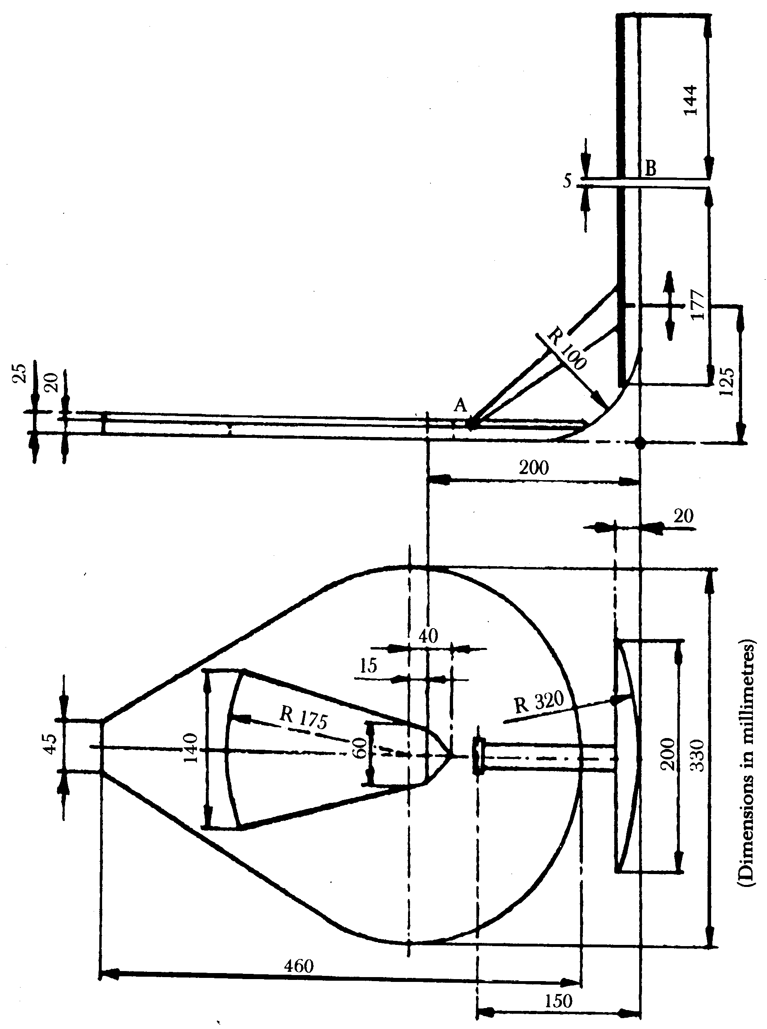
Figure 2
Device in position
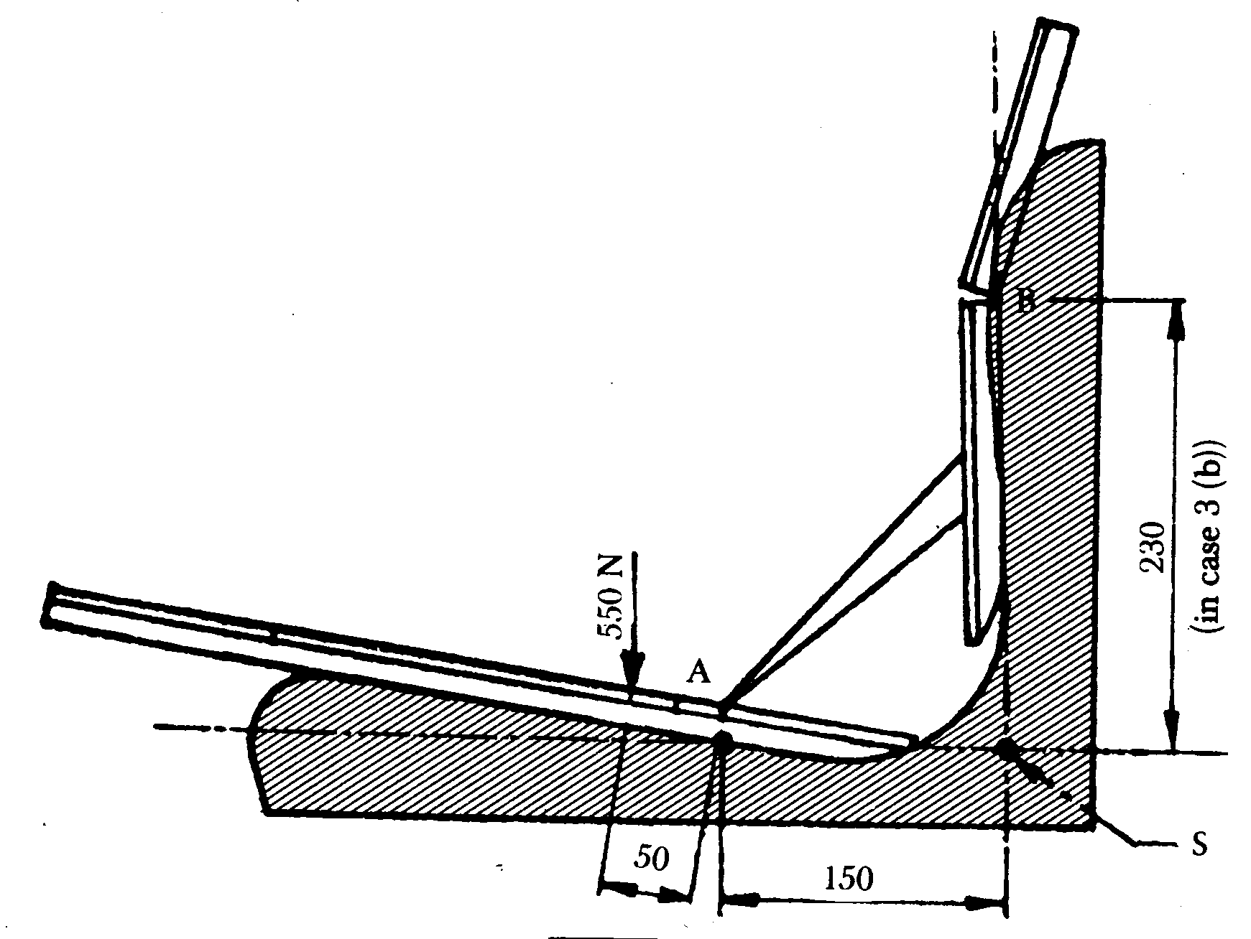

ê 83/190/EEC Art. 1 and Annex
Appendix 2
Determination of the characteristic curves of the suspension system and the load adjustment range (Item point 2.5.1)
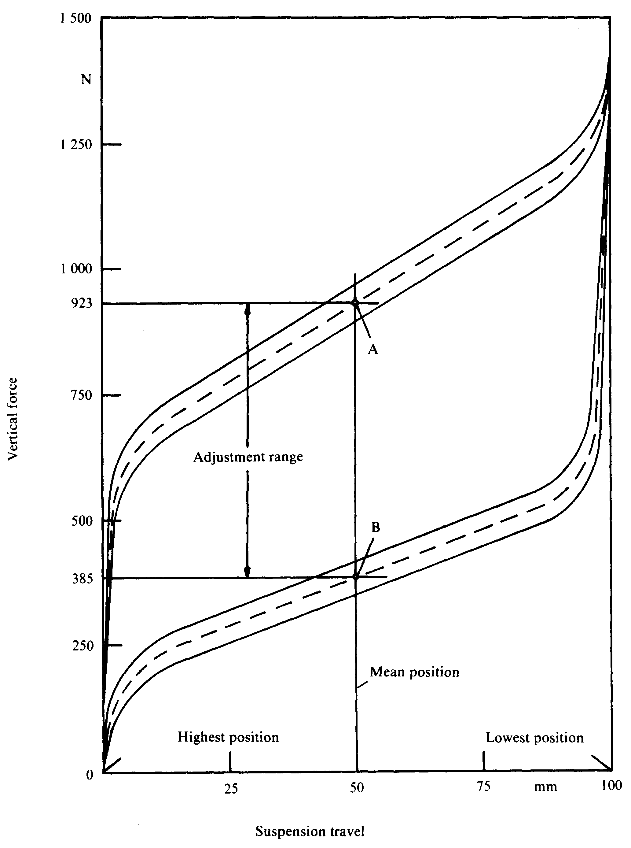

ê 78/764/EEC
è1 83/190/EEC Art. 1 and Annex
Appendix 3
Test on standard roadway
Table of elevation ordinates in relation to è1 a ç basic level defining the surface of each strip of the roadway (point 2.5.3.2.1)

ê 83/190/EEC Art. 1 and Annex
D = distance from the beginning of the standard roadway (in metres)

ê 78/764/EEC (adapted)
L = ordinate of the left-hand strip (mm)
R = ordinate of the right-hand strip (mm)
D | L | R
0 | 115 | 140
0·16 | 110 | 125
0·32 | 110 | 140
0·48 | 115 | 135
0·64 | 120 | 135
0·80 | 120 | 125
0·96 | 125 | 135
1·12 | 120 | 125
1·28 | 120 | 115
1·44 | 115 | 110
1·60 | 110 | 100
1·76 | 110 | 110
1·92 | 110 | 110
2·08 | 115 | 115
2·24 | 110 | 110
2·40 | 100 | 110
2·56 | 100 | 100
2·72 | 95 | 110
2·88 | 95 | 95
3·04 | 90 | 95
3·20 | 90 | 100
3·36 | 85 | 100
3·52 | 90 | 100
3·68 | 90 | 115
3·84 | 95 | 110
4·00 | 90 | 110
4·16 | 90 | 95
4·32 | 95 | 100
4·48 | 100 | 100
4·64 | 100 | 90
4·90 | 90 | 90
4·96 | 90 | 90
5·12 | 95 | 90
5·28 | 95 | 70
5·44 | 95 | 65
5·60 | 90 | 50
5·76 | 95 | 50
5·92 | 85 | 50
6·08 | 85 | 55
6·24 | 75 | 55
6·40 | 75 | 55
6·56 | 70 | 65
6·72 | 75 | 75
6·88 | 65 | 75
7·04 | 65 | 85
7·20 | 65 | 90
7·36 | 75 | 95
7·52 | 75 | 100
7·68 | 95 | 95
7·84 | 115 | 110
8·00 | 115 | 100
8·16 | 125 | 110
8·32 | 110 | 100
8·48 | 110 | 100
8·64 | 110 | 95
8·80 | 110 | 95
8·96 | 110 | 95
9·12 | 110 | 100
9·28 | 125 | 90
9·44 | 120 | 100
9·60 | 135 | 95
9·76 | 120 | 95
9·92 | 120 | 95
10·08 | 120 | 95
10·24 | 115 | 85
10·40 | 115 | 90
10·56 | 115 | 85
10·72 | 115 | 90
10·88 | 120 | 90
11·04 | 110 | 75
11·20 | 110 | 75
11·36 | 100 | 85
11·52 | 110 | 85
11·68 | 95 | 90
11·84 | 95 | 90
12·00 | 95 | 85
12·16 | 100 | 95
12·32 | 100 | 90
12·48 | 95 | 85
12·64 | 95 | 85
12·80 | 95 | 90
12·96 | 85 | 90
13·12 | 85 | 85
13·28 | 75 | 90
13·44 | 75 | 95
13·60 | 75 | 90
13·76 | 70 | 75
13·92 | 70 | 90
14·08 | 70 | 100
14·24 | 70 | 110
14·40 | 65 | 95
14·56 | 65 | 100
14·72 | 65 | 90
14·88 | 65 | 90
15·04 | 65 | 85
15·20 | 55 | 85
15·36 | 65 | 85
15·52 | 65 | 85
15·68 | 55 | 75
15·84 | 55 | 85
16·00 | 65 | 75
16·16 | 55 | 85
16·32 | 50 | 75
16·48 | 55 | 75
16·64 | 65 | 75
16·80 | 65 | 75
16·96 | 65 | 85
17·12 | 65 | 70
17·28 | 65 | 65
17·44 | 65 | 75
17·60 | 65 | 75
17·76 | 50 | 75
17·92 | 55 | 85
18·08 | 55 | 85
18·24 | 65 | 85
18·40 | 70 | 75
18·56 | 75 | 75
18·72 | 95 | 75
18·88 | 90 | 75
19·04 | 90 | 70
19·20 | 95 | 70
19·36 | 85 | 70
19·52 | 85 | 75
19·68 | 75 | 85
19·84 | 85 | 85
20·00 | 75 | 90
20·16 | 85 | 85
20·32 | 75 | 70
20·48 | 70 | 75
20·64 | 65 | 75
20·80 | 70 | 75
20·96 | 65 | 75
21·12 | 70 | 75
21·28 | 70 | 85
21·44 | 70 | 85
21·60 | 70 | 90
21·76 | 75 | 95
21·92 | 75 | 95
22·08 | 75 | 90
22·24 | 85 | 90
22·40 | 85 | 95
22·58 | 90 | 85
22·72 | 90 | 85
22·88 | 95 | 85
23·04 | 95 | 85
23·20 | 100 | 85
23·36 | 100 | 75
23·52 | 110 | 85
23·68 | 110 | 85
23·84 | 110 | 85
24·00 | 100 | 75
24·16 | 100 | 75
24·32 | 95 | 70
24·48 | 100 | 70
24·64 | 100 | 70
24·80 | 115 | 75
24·96 | 110 | 75
25·12 | 110 | 85
25·28 | 100 | 75
25·44 | 110 | 95
25·60 | 100 | 95
25·76 | 115 | 100
25·92 | 115 | 100
26·08 | 110 | 95
26·24 | 115 | 95
26·40 | 110 | 95
26·56 | 100 | 95
26·72 | 100 | 95
26·88 | 100 | 100
27·04 | 100 | 95
27·20 | 100 | 95
27·36 | 110 | 90
27·52 | 115 | 90
27·68 | 115 | 85
27·84 | 110 | 90
28·00 | 110 | 85
28·16 | 110 | 85
28·32 | 100 | 85
28·48 | 100 | 90
28·64 | 90 | 85
28·80 | 90 | 75
28·96 | 75 | 90
29·12 | 75 | 75
29·28 | 75 | 75
29·44 | 70 | 75
29·60 | 75 | 75
29·76 | 75 | 85
29·92 | 85 | 75
30·08 | 75 | 75
30·24 | 85 | 75
30·40 | 75 | 75
30·56 | 70 | 75
30·72 | 75 | 75
30·88 | 85 | 75
31·04 | 90 | 75
31·20 | 90 | 85
31·36 | 100 | 75
31·52 | 100 | 75
31·68 | 120 | 85
31·84 | 115 | 75
32·00 | 120 | 85
32·16 | 120 | 85
32·32 | 135 | 90
32·48 | 145 | 95
32·64 | 160 | 95
32·80 | 165 | 90
32·96 | 155 | 90
33·12 | 145 | 90
33·28 | 140 | 95
33·44 | 140 | 85
33·60 | 140 | 85
33·76 | 125 | 75
33·92 | 125 | 75
34·08 | 115 | 85
34·24 | 120 | 75
34·40 | 125 | 75
34·56 | 115 | 85
34·72 | 115 | 75
34·88 | 115 | 90
35·04 | 115 | 100
35·20 | 120 | 100
35·36 | 120 | 100
35·52 | 135 | 95
35·68 | 135 | 95
35·84 | 135 | 95
36·00 | 135 | 90
36·16 | 120 | 75
36·32 | 115 | 75
36·48 | 110 | 70
36·64 | 100 | 65
36·80 | 110 | 55
36·96 | 115 | 55
37·12 | 100 | 50
37·28 | 115 | 50
37·44 | 110 | 50
37·60 | 100 | 65
37·76 | 90 | 55
37·92 | 95 | 55
38·08 | 90 | 35
38·24 | 90 | 35
38·40 | 110 | 35
38·56 | 100 | 35
38·72 | 115 | 35
38·88 | 100 | 35
39·04 | 100 | 35
39·20 | 110 | 30
39·36 | 110 | 45
39·52 | 110 | 50
39·68 | 100 | 55
39·84 | 110 | 50
40·00 | 90 | 55
40·16 | 85 | 55
40·32 | 90 | 65
40·48 | 90 | 65
40·64 | 90 | 70
40·80 | 95 | 75
40·96 | 95 | 75
41·12 | 95 | 75
41·28 | 90 | 90
41·44 | 90 | 95
41·60 | 85 | 95
41·76 | 85 | 100
41·92 | 90 | 100
42·08 | 90 | 95
42·24 | 85 | 100
42·40 | 85 | 110
42·56 | 95 | 110
42·72 | 95 | 115
42·88 | 95 | 115
43·04 | 100 | 100
43·20 | 100 | 95
43·36 | 100 | 95
43·52 | 100 | 90
43·68 | 110 | 95
43·84 | 100 | 100
44·00 | 110 | 90
44·16 | 100 | 85
44·32 | 110 | 90
44·48 | 110 | 85
44·64 | 100 | 85
44·80 | 100 | 90
44·96 | 95 | 90
45·12 | 90 | 95
45·28 | 90 | 100
45·44 | 95 | 100
45·60 | 90 | 90
45·76 | 85 | 90
45·92 | 75 | 90
46·08 | 85 | 90
46·24 | 75 | 90
46·40 | 75 | 90
46·54 | 75 | 90
46·72 | 85 | 90
46·88 | 85 | 85
47·04 | 90 | 85
47·20 | 75 | 85
47·36 | 65 | 75
47·52 | 70 | 70
47·68 | 70 | 75
47·84 | 70 | 75
48·00 | 75 | 85
48·16 | 90 | 95
48·32 | 95 | 95
48·48 | 100 | 120
48·64 | 110 | 100
48·30 Ö 48·80 Õ | 115 | 100
48·96 | 115 | 115
49·12 | 120 | 115
49·28 | 120 | 110
49·44 | 115 | 95
49·60 | 115 | 90
49·76 | 115 | 90
49·92 | 110 | 95
50·08 | 110 | 100
50·24 | 100 | 110
50·40 | 100 | 120
50·56 | 95 | 120
50·72 | 95 | 115
50·88 | 95 | 120
51·04 | 95 | 120
51·20 | 90 | 135
51·36 | 95 | 125
51·52 | 95 | 120
51·68 | 100 | 120
51·84 | 100 | 120
52·00 | 100 | 120
52·16 | 100 | 125
52·32 | 110 | 125
52·48 | 110 | 125
52·64 | 100 | 125
52·80 | 100 | 120
52·96 | 100 | 120
53·12 | 110 | 115
53·28 | 100 | 110
53·44 | 110 | 110
53·60 | 95 | 110
53·76 | 95 | 110
53·92 | 100 | 110
54·08 | 95 | 100
54·24 | 100 | 100
54·40 | 100 | 100
54·56 | 100 | 100
54·72 | 95 | 100
54·88 | 100 | 100
55·04 | 100 | 115
55·20 | 110 | 115
55·36 | 100 | 110
55·52 | 110 | 100
55·68 | 100 | 110
55·84 | 100 | 110
56·00 | 100 | 110
56·16 | 95 | 115
56·32 | 90 | 110
56·48 | 95 | 110
56·64 | 95 | 110
56·80 | 90 | 100
56·96 | 100 | 100
57·12 | 100 | 95
57·28 | 95 | 100
57·44 | 100 | 100
57·60 | 95 | 115
57·76 | 85 | 110
57·92 | 90 | 115
58·08 | 90 | 110
58·24 | 90 | 100
58·40 | 85 | 95
58·56 | 90 | 95
58·72 | 85 | 90
58·88 | 90 | 90
59·04 | 90 | 95
59·20 | 90 | 115
59·36 | 90 | 115
59·52 | 90 | 115
59·68 | 85 | 110
59·84 | 75 | 110
60·00 | 90 | 115
60·16 | 90 | 120
60·32 | 90 | 120
60·48 | 90 | 120
60·64 | 95 | 120
60·80 | 95 | 120
60·96 | 90 | 120
61·12 | 90 | 115
61·28 | 95 | 110
61·44 | 95 | 110
61·60 | 100 | 100
61·76 | 110 | 100
61·92 | 100 | 100
62·08 | 100 | 100
62·24 | 95 | 100
62·40 | 95 | 100
62·56 | 95 | 100
62·72 | 90 | 100
62·88 | 90 | 100
63·04 | 90 | 100
63·20 | 90 | 90
63·36 | 90 | 90
63·52 | 85 | 90
63·68 | 85 | 90
63·84 | 75 | 85
64·00 | 75 | 85
64·16 | 75 | 75
64·32 | 75 | 75
64·48 | 70 | 75
64·64 | 70 | 70
64·80 | 70 | 55
64·96 | 70 | 45
65·12 | 65 | 55
65·28 | 65 | 55
65·44 | 65 | 65
65·60 | 55 | 70
65·76 | 55 | 75
65·92 | 55 | 75
66·08 | 55 | 75
66·24 | 55 | 85
66·46 | 55 | 85
66·56 | 65 | 90
66·72 | 70 | 90
66·88 | 70 | 110
67·04 | 65 | 100
67·20 | 55 | 100
67·36 | 65 | 100
67·52 | 50 | 100
67·68 | 50 | 85
67·84 | 50 | 90
68·00 | 50 | 100
68·16 | 55 | 100
68·32 | 55 | 95
68·48 | 65 | 90
68·64 | 50 | 85
68·80 | 50 | 70
68·96 | 50 | 70
69·12 | 50 | 65
69·28 | 50 | 55
69·44 | 45 | 50
69·60 | 35 | 50
69·76 | 35 | 55
69·92 | 35 | 65
70·08 | 35 | 65
70·24 | 35 | 65
70·40 | 35 | 55
70·58 Ö 70·56 Õ | 45 | 55
70·72 | 50 | 55
70·88 | 50 | 50
71·04 | 50 | 45
71·20 | 50 | 45
71·36 | 50 | 50
71·52 | 45 | 45
71·68 | 45 | 55
71·84 | 55 | 65
72·00 | 55 | 65
72·16 | 70 | 65
72·32 | 70 | 75
72·48 | 75 | 85
72·64 | 75 | 85
72·80 | 75 | 90
72·96 | 85 | 95
73·12 | 90 | 100
73·28 | 90 | 110
73·44 | 90 | 115
73·60 | 90 | 120
73·76 | 90 | 115
73·92 | 90 | 115
74·08 | 110 | 115
74·24 | 100 | 100 Ö 110 Õ
74·40 | 100 | 110
74·56 | 100 | 110
74·72 | 95 | 115
74·88 | 95 | 120
75·04 | 95 | 125
75·20 | 95 | 135
75·36 | 100 | 135
75·52 | 100 | 140
75·68 | 100 | 140
75·84 | 100 | 140
76·00 | 110 | 135
76·16 | 100 | 125
76·32 | 100 | 125
76·48 | 100 | 125
76·64 | 110 | 125
76·80 | 115 | 125
76·96 | 120 | 125
77·12 | 120 | 125
77·28 | 120 | 135
77·44 | 110 | 125
77·60 | 100 | 125
77·76 | 120 | 135
77·92 | 120 | 125
78·03 Ö 78·08 Õ | 120 | 125
78·24 | 115 | 125
78·40 | 115 | 120
78·56 | 115 | 120
78·72 | 110 | 120
78·88 | 100 | 120
79·04 | 100 | 120
79·20 | 95 | 120
79·36 | 95 | 120
79·52 | 95 | 125
79·68 | 95 | 125
79·84 | 100 | 120
80·00 | 95 | 125
80·16 | 95 | 125
80·32 | 95 | 125
80·48 | 100 | 120
80·64 | 100 | 125
80·80 | 100 | 125
80·96 | 110 | 125
81·12 | 115 | 135
81·28 | 110 | 140
81·44 | 115 | 140
81·60 | 110 | 140
81·76 | 115 | 140
81·92 | 110 | 140
82·08 | 110 | 140
82·24 | 110 | 135
82·40 | 110 | 135
82·56 | 100 | 125
87·72 Ö 82·72 Õ | 110 | 125
82·88 | 110 | 125
83·04 | 100 | 125
83·20 | 100 | 120
83·36 | 100 | 125
83·52 | 100 | 120
83·68 | 100 | 135
83·84 | 95 | 140
84·00 | 100 | 135
84·16 | 110 | 140
84·32 | 110 | 140
84·48 | 110 | 140
84·64 | 110 | 140
84·80 | 120 | 155
84·96 | 115 | 145
85·12 | 115 | 155
85·28 | 120 | 160
85·44 | 120 | 165
85·60 | 120 | 160
85·76 | 125 | 165
85·92 | 135 | 160
86·08 | 135 | 160
86·24 | 125 | 155
86·40 | 125 | 155
86·56 | 120 | 145
86·72 | 120 | 145
86·98 | 110 | 140
87·04 | 110 | 140
87·20 | 110 | 140
87·36 | 110 | 140
87·52 | 110 | 140
87·68 | 100 | 135
87·84 | 100 | 135
88·00 | 100 | 135
88·16 | 100 | 125
88·32 | 110 | 120
88·48 | 115 | 120
88·64 | 110 | 120
88·80 | 110 | 125
88·96 | 100 | 125
89·12 | 100 | 125
89·28 | 95 | 125
89·44 | 95 | 125
89·60 | 100 | 120
89·76 | 100 | 135
89·92 | 110 | 140
90·08 | 110 | 135
90·24 | 110 | 140
90·40 | 100 | 145
90·56 | 100 | 155
90·72 | 110 | 155
90·88 | 110 | 155
91·04 | 100 | 155
91·20 | 110 | 155
91·36 | 110 | 160
91·52 | 115 | 160
91·68 | 110 | 155
91·84 | 115 | 155
92·00 | 115 | 140
92·16 | 115 | 155
92·32 | 120 | 155
92·48 | 125 | 145
92·64 | 125 | 155
92·80 | 125 | 155
92·96 | 120 | 155
93·12 | 120 | 145
93·28 | 120 | 145
93·44 | 115 | 145
93·60 | 120 | 145
93·76 | 115 | 140
93·92 | 115 | 140
94·08 | 115 | 140
94·24 | 115 | 140
94·40 | 115 | 140
94·56 | 115 | 140
94·72 | 115 | 135
94·88 | 115 | 135
95·04 | 110 | 135
95·20 | 110 | 135
95·36 | 110 | 135
95·52 | 115 | 135
95·68 | 100 | 140
95·84 | 95 | 135
96·00 | 100 | 125
96·16 | 95 | 125
96·32 | 95 | 125
96·48 | 95 | 125
96·64 | 110 | 125
96·80 | 95 | 120
96·96 | 95 | 120
97·12 | 95 | 120
97·28 | 95 | 110
97·44 | 100 | 115
97·60 | 110 | 120
97·76 | 110 | 115
97·92 | 100 | 115
98·08 | 95 | 115
98·24 | 100 | 115
98·40 | 95 | 115
98·52 | 100 | 115
98·72 | 100 | 110
98·88 | 110 | 100
99·04 | 95 | 95
99·20 | 90 | 100
99·36 | 90 | 100
93·52 Ö 99·52 Õ | 75 | 110
99·68 | 75 | 115
99·84 | 75 | 115
100·00 | 75 | 110

ê 83/190/EEC Art. 1 and Annex
è1 88/465/EEC Art. 1 and Annex
Appendix 4
Set-value signals for the test-stand inspection of the driver's seat on Category A (Class I) tractors (Item point 2.5.3.1.1):
PS = set point;
a = amplitude of the set-value signal (in 10⁻⁴ m);
t = measurement time (in seconds).
When the sequence of signals is repeated in the table for 701 points, points 700 and 0 coincide in time at an amplitude of a = 0:
PS No | a  10⁻⁴ m | t  s
0 | 0 000 | 0
1 | 0 089 | .
2 | 0 215 | .
. | . | .
. | . | .
. | . | .
699 | 0 023 | .
700 | 0 000 | 28,0
Appendix è1 5a5 ç
Set-value signals for the test-stand inspection of the driver's seat on Category A (Class II) tractors (Item point 2.5.3.1.1):
PS = set points;
a = amplitude of the set-value signal (in 10⁻⁴ m);
t = measurement time (in seconds).
When the sequence of signals is repeated in the table for 701 points, points 700 and 0 coincide in time at an amplitude of a = 0:
PS No | a  10⁻⁴ m | t  s
0 | 0 000 | 0
1 | 0 022 | .
2 | 0 089 | .
. | . | .
. | . | .
. | . | .
699 | 0 062 | .
700 | 0 000 | è1 31,0 ç

ê 88/465/EEC Art. 1 and Annex (adapted)
Appendix 5b6
Set-value signals for the test-stand testing of drivers' seats for category A tractors in class III (point 2.5.3.1.1)
PS = set point
a = amplitude of the set value signal in mm
t = measurement time in seconds
If the signal sequence is repeated for 701 points in the table, point 700 and 0 merge in time, with amplitude a = 0.
PS  No | a  mm | t  s
1 | 0 | 0,000
2 | − 3 | 0,027
3 | − 0 | 0,055
4 | 2 | 0,082
5 | 4 | 0,109
6 | 6 | 0,137
7 | 6 | 0,164
8 | 5 | 0,192
9 | 3 | 0,219
10 | 1 | 0,246
11 | − 0 | 0,274
12 | − 2 | 0,301
13 | − 4 | 0,328
14 | − 4 | 0,356
15 | − 4 | 0,383
16 | − 2 | 0,411
17 | − 1 | 0,439
18 | 0 | 0,465
19 | 2 | 0,493
20 | 3 | 0,520
21 | 4 | 0,547
22 | 3 | 0,575
23 | 1 | 0,602
24 | 0 | 0,630
25 | − 1 | 0,657
26 | − 3 | 0,684
27 | − 4 | 0,712
28 | − 4 | 0,739
29 | − 4 | 0,766
30 | − 2 | 0,794
31 | − 0 | 0,821
32 | 2 | 0,848
33 | 4 | 0,876
34 | 6 | 0,903
35 | 6 | 0,931
36 | 6 | 0,958
37 | 4 | 0,985
38 | 1 | 1,013
39 | − 1 | 1,040
40 | − 4 | 1,067
41 | − 6 | 1,093
42 | − 8 | 1,122
43 | − 8 | 1,150
44 | − 7 | 1,177
45 | − 4 | 1,204
46 | − 1 | 1,232
47 | 2 | 1,259
48 | 6 | 1,286
49 | 8 | 1,314
50 | 10 | 1,341
51 | 10 | 1,369
52 | 8 | 1,396
53 | 4 | 1,423
54 | 0 | 1,451
55 | − 4 | 1,478
56 | − 8 | 1,505
57 | − 11 | 1,533
58 | − 13 | 1,560
59 | − 12 | 1,587
60 | − 9 | 1,613
61 | − 4 | 1,642
62 | 6 | 1,670
63 | 6 | 1,697
64 | 11 | 1,724
65 | 15 | 1,752
66 | 16 | 1,779
67 | 14 | 1,806
68 | 11 | 1,834
69 | 5 | 1,861
70 | − 1 | 1,869
71 | − 8 | 1,916
72 | − 14 | 1,943
73 | − 18 | 1,971
74 | − 19 | 1,998
75 | − 17 | 2,025
76 | − 13 | 2,053
77 | − 6 | 2,080
78 | 0 | 2,108
79 | 8 | 2,135
80 | 15 | 2,162
81 | 19 | 2,190
82 | 21 | 2,217
83 | 19 | 2,244
84 | 15 | 2,272
85 | 8 | 2,299
86 | 0 | 2,326
87 | − 7 | 2,354
88 | − 15 | 2,361
89 | − 19 | 2,409
90 | − 21 | 2,436
91 | − 20 | 2,463
92 | − 15 | 2,491
93 | − 8 | 2,518
94 | − 0 | 2,545
95 | 7 | 2,573
96 | 14 | 2,600
97 | 19 | 2,628
98 | 21 | 2,655
99 | 19 | 2,662
100 | 14 | 2,710
101 | 7 | 2,737
102 | − 0 | 2,764
103 | − 8 | 2,792
104 | − 15 | 2,819
105 | − 19 | 2,847
106 | − 20 | 2,874
107 | − 18 | 2,901
108 | − 13 | 2,929
109 | − 5 | 2,956
110 | 2 | 2,983
111 | 10 | 3,011
112 | 16 | 3,038
113 | 20 | 3,055
114 | 20 | 3,093
115 | 17 | 3,120
116 | 12 | 3,148
117 | 5 | 3,175
118 | − 3 | 3,202
119 | − 10 | 3,230
120 | − 17 | 3,257
121 | − 20 | 3,284
122 | − 21 | 3,312
123 | − 18 | 3,339
124 | − 13 | 3,367
125 | − 6 | 3,396
126 | 2 | 3,421
127 | 10 | 3,449
128 | 16 | 3,476
129 | 21 | 3,503
130 | 22 | 3,531
131 | 20 | 3,558
132 | 15 | 3,586
133 | 8 | 3,613
134 | 0 | 3,640
135 | − 8 | 3,668
136 | − 15 | 3,695
137 | − 20 | 3,722
138 | − 23 | 3,750
139 | − 22 | 3,777
140 | − 18 | 3,804
141 | − 11 | 3,832
142 | − 3 | 3,859
143 | 5 | 3,887
144 | 13 | 3,914
145 | 19 | 3,941
146 | 23 | 3,969
147 | 23 | 3,996
148 | 20 | 4,023
149 | 14 | 4,051
150 | 6 | 4,078
151 | − 2 | 4,106
152 | − 11 | 4,133
153 | − 17 | 4,160
154 | − 21 | 4,188
155 | − 22 | 4,215
156 | − 20 | 4,242
157 | − 14 | 4,270
158 | − 7 | 4,297
159 | 0 | 4,325
160 | 8 | 4,352
161 | 14 | 4,379
162 | 18 | 4,407
163 | 19 | 4,434
164 | 17 | 4,461
165 | 13 | 4,489
166 | 7 | 4,516
167 | 0 | 4,543
168 | − 6 | 4,571
169 | − 11 | 4,598
170 | − 14 | 4,626
171 | − 16 | 4,653
172 | − 14 | 4,680
173 | − 11 | 4,708
174 | − 6 | 4,735
175 | − 1 | 4,762
176 | 4 | 4,790
177 | 8 | 4,817
178 | 12 | 4,845
179 | 13 | 4,872
180 | 13 | 4,899
181 | 11 | 4,927
182 | 7 | 4,954
183 | 3 | 4,981
184 | − 1 | 5,009
185 | − 5 | 5,036
186 | − 9 | 5,064
187 | − 11 | 5,091
188 | − 12 | 5,118
189 | − 12 | 5,146
190 | − 10 | 5,173
191 | − 6 | 5,200
192 | − 2 | 5,228
193 | 1 | 5,255
194 | 5 | 5,283
195 | 9 | 5,310
196 | 11 | 5,337
197 | 13 | 5,365
198 | 12 | 5,392
199 | 11 | 5,419
200 | 7 | 5,447
201 | 3 | 5,474
202 | − 0 | 5,501
203 | − 5 | 5,529
204 | − 9 | 5,556
205 | − 12 | 5,584
206 | − 14 | 5,611
207 | − 14 | 5,638
208 | − 12 | 5,666
209 | − 9 | 5,693
210 | − 4 | 5,720
211 | 0 | 5,748
212 | 5 | 5,775
213 | 9 | 5,803
214 | 13 | 5,830
215 | 15 | 5,857
216 | 15 | 5,885
217 | 13 | 5,912
218 | 9 | 5,939
219 | 4 | 5,967
220 | − 1 | 5,994
221 | − 7 | 6,022
222 | − 11 | 6,049
223 | − 15 | 6,076
224 | − 16 | 6,104
225 | − 16 | 6,131
226 | − 12 | 6,158
227 | − 7 | 6,186
228 | − 1 | 6,213
229 | 4 | 6,240
230 | 10 | 6,268
231 | 16 | 6,295
232 | 17 | 6,323
233 | 17 | 6,350
234 | 14 | 6,377
235 | 9 | 6,405
236 | 3 | 6,432
237 | − 3 | 6,459
238 | − 10 | 6,487
239 | − 15 | 6,514
240 | − 19 | 6,542
241 | − 19 | 6,569
242 | − 17 | 6,596
243 | − 12 | 6,624
244 | − 6 | 6,651
245 | 1 | 6,678
246 | 9 | 6,706
247 | 16 | 6,733
248 | 21 | 6,761
249 | 22 | 6,783
250 | 21 | 6,815
251 | 16 | 6,843
252 | 9 | 6,870
253 | 0 | 6,897
254 | − 8 | 6,925
255 | − 16 | 6,952
256 | − 22 | 6,979
257 | − 25 | 7,007
258 | − 24 | 7,034
259 | − 20 | 7,062
260 | − 13 | 7,089
261 | − 4 | 7,116
262 | 5 | 7,144
263 | 14 | 7,171
264 | 24 | 7,198
265 | 25 | 7,226
266 | 26 | 7,253
267 | 23 | 7,281
268 | 17 | 7,308
269 | 8 | 7,335
270 | − 1 | 7,363
271 | − 11 | 7,390
272 | − 20 | 7,417
273 | − 26 | 7,445
274 | − 27 | 7,472
275 | − 25 | 7,500
276 | − 19 | 7,527
277 | − 11 | 7,554
278 | − 1 | 7,582
279 | 9 | 7,609
280 | 18 | 7,636
281 | 24 | 7,664
282 | 27 | 7,691
283 | 26 | 7,718
284 | 21 | 7,746
285 | 13 | 7,773
286 | 4 | 7,801
287 | − 5 | 7,828
288 | − 13 | 7,855
289 | − 20 | 7,883
290 | − 24 | 7,910
291 | − 25 | 7,937
292 | − 22 | 7,965
293 | − 17 | 7,992
294 | − 9 | 8,020
295 | − 1 | 8,047
296 | 7 | 8,074
297 | 14 | 8,102
298 | 20 | 8,129
299 | 22 | 8,156
300 | 22 | 8,184
301 | 19 | 8,211
302 | 13 | 8,239
303 | 6 | 8,266
304 | − 1 | 8,293
305 | − 9 | 8,321
306 | − 15 | 8,348
307 | − 19 | 8,375
308 | − 20 | 8,403
309 | − 19 | 8,430
310 | − 14 | 8,457
311 | − 8 | 8,485
312 | − 0 | 8,512
313 | 6 | 8,540
314 | 12 | 8,567
315 | 16 | 8,594
316 | 18 | 8,622
317 | 16 | 8,649
318 | 12 | 8,676
319 | 6 | 8,704
320 | 0 | 8,731
321 | − 7 | 8,759
322 | − 12 | 8,786
323 | − 15 | 8,813
324 | − 16 | 8,841
325 | − 13 | 8,868
326 | − 8 | 8,895
327 | − 1 | 8,923
328 | 5 | 8,950
329 | 11 | 8,978
330 | 15 | 9,005
331 | 17 | 9,032
332 | 15 | 9,060
333 | 11 | 9,087
334 | 5 | 9,114
335 | − 2 | 9,142
336 | − 9 | 9,169
337 | − 15 | 9,196
338 | − 18 | 9,224
339 | − 19 | 9,261
340 | − 16 | 9,279
341 | − 11 | 9,306
342 | − 3 | 9,333
343 | 4 | 9,361
344 | 11 | 9,388
345 | 16 | 9,415
346 | 19 | 9,443
347 | 19 | 9,470
348 | 16 | 9,498
349 | 11 | 9,525
350 | 4 | 9,552
351 | − 2 | 9,580
352 | − 9 | 9,607
353 | − 14 | 9,634
354 | − 17 | 9,662
355 | − 18 | 9,689
356 | − 16 | 9,717
357 | − 12 | 9,744
358 | − 7 | 9,771
359 | − 1 | 9,799
360 | 4 | 9,826
361 | 9 | 9,853
362 | 13 | 9,881
363 | 16 | 9,908
364 | 15 | 9,935
365 | 14 | 9,963
366 | 10 | 9,990
367 | 5 | 10,018
368 | − 0 | 10,045
369 | − 5 | 10,072
370 | − 10 | 10,100
371 | − 13 | 10,127
372 | − 15 | 10,154
372 Ö 373 Õ | − 14 | 10,182
374 | − 12 | 10,209
375 | − 7 | 10,237
376 | − 2 | 10,264
377 | 2 | 10,291
378 | 8 | 10,319
379 | 11 | 10,346
380 | 13 | 10,373
381 | 13 | 10,401
382 | 11 | 10,428
383 | 7 | 10,456
384 | 2 | 10,483
385 | − 2 | 10,510
386 | − 7 | 10,538
387 | − 10 | 10,565
388 | − 11 | 10,592
389 | − 11 | 10,620
390 | − 8 | 10,647
391 | − 5 | 10,674
392 | − 0 | 10,702
393 | 3 | 10,729
394 | 7 | 10,757
395 | 9 | 10,784
396 | 9 | 10,811
397 | 8 | 10,839
398 | 5 | 10,866
399 | 1 | 10,893
400 | − 2 | 10,921
401 | − 6 | 10,949
402 | − 7 | 10,975
403 | − 8 | 11,003
404 | − 7 | 11,030
405 | − 5 | 11,058
406 | − 2 | 11,085
407 | 0 | 11,112
408 | 4 | 11,140
409 | 6 | 11,167
410 | 7 | 11,195
411 | 7 | 11,222
412 | 6 | 11,249
413 | 4 | 11,277
414 | 1 | 11,304
415 | − 1 | 11,331
416 | − 4 | 11,359
417 | − 7 | 11,386
418 | − 8 | 11,413
419 | − 8 | 11,441
420 | − 6 | 11,468
421 | − 4 | 11,496
422 | − 1 | 11,523
423 | 1 | 11,550
424 | 4 | 11,578
425 | 7 | 11,605
426 | 8 | 11,632
427 | 8 | 11,660
428 | 7 | 11,687
429 | 5 | 11,715
430 | 2 | 11,742
431 | − 0 | 11,769
432 | − 2 | 11,797
433 | − 4 | 11,824
434 | − 6 | 11,851
435 | − 7 | 11,879
436 | − 6 | 11,906
437 | − 6 | 11,934
438 | − 4 | 11,961
439 | − 3 | 11,988
440 | − 1 | 12,016
441 | 0 | 12,043
442 | 2 | 12,070
443 | 4 | 12,098
444 | 6 | 12,125
445 | 7 | 12,152
446 | 7 | 12,180
447 | 7 | 12,207
448 | 6 | 12,235
449 | 4 | 12,262
450 | 1 | 12,289
451 | − 1 | 12,317
452 | − 5 | 12,344
453 | − 8 | 12,371
454 | − 10 | 12,399
455 | − 11 | 12,426
456 | − 11 | 12,454
457 | − 9 | 12,481
458 | − 5 | 12,509
459 | − 1 | 12,536
460 | 3 | 12,563
461 | 8 | 12,590
462 | 11 | 12,618
463 | 13 | 12,645
464 | 12 | 12,673
465 | 10 | 12,700
466 | 7 | 12,727
467 | 2 | 12,755
468 | − 2 | 12,782
469 | − 6 | 12,809
470 | − 9 | 12,837
471 | − 10 | 12,864
472 | − 10 | 12,891
473 | − 8 | 12,915
474 | − 5 | 12,946
475 | − 2 | 12,974
476 | 1 | 13,001
477 | 3 | 13,028
478 | 6 | 13,056
479 | 6 | 13,083
480 | 5 | 13,110
481 | 4 | 13,138
482 | 2 | 13,165
483 | 0 | 13,193
484 | − 0 | 13,220
485 | − 1 | 13,247
486 | − 2 | 13,275
487 | − 2 | 13,302
488 | − 1 | 13,329
489 | − 1 | 13,357
490 | − 0 | 13,384
491 | 0 | 13,412
492 | 1 | 13,439
493 | 1 | 13,466
494 | 1 | 13,494
495 | 0 | 13,521
496 | 0 | 13,548
497 | − 0 | 13,576
498 | − 1 | 13,603
499 | − 1 | 13,630
500 | − 1 | 13,659
501 | − 1 | 13,685
502 | − 1 | 13,713
503 | − 1 | 13,740
504 | − 0 | 13,767
505 | − 0 | 13,795
506 | 0 | 13,822
507 | 1 | 13,849
508 | 1 | 13,877
509 | 2 | 13,904
510 | 2 | 13,932
511 | 2 | 13,959
512 | 2 | 13,986
513 | 1 | 14,014
514 | 1 | 14,041
515 | 0 | 14,068
516 | − 0 | 14,096
517 | − 1 | 14,123
518 | − 1 | 14,151
519 | − 2 | 14,178
520 | − 2 | 14,205
521 | − 2 | 14,233
522 | − 2 | 14,260
523 | − 1 | 14,287
524 | − 1 | 14,316
525 | − 1 | 14,342
526 | − 0 | 14,370
527 | − 0 | 14,397
528 | 0 | 14,424
529 | 0 | 14,452
530 | 1 | 14,479
531 | 2 | 14,506
532 | 2 | 14,534
533 | 3 | 14,561
534 | 4 | 14,598
535 | 4 | 14,616
536 | 3 | 14,643
537 | 2 | 14,671
538 | 1 | 14,698
539 | − 0 | 14,725
540 | − 2 | 14,753
541 | − 5 | 14,780
542 | − 7 | 14,807
543 | − 8 | 14,835
544 | − 8 | 14,862
545 | − 7 | 14,890
546 | − 5 | 14,917
547 | − 1 | 14,944
548 | 1 | 14,972
549 | 6 | 14,999
550 | 9 | 15,026
551 | 12 | 15,054
552 | 13 | 15,081
553 | 11 | 15,109
554 | 9 | 15,136
555 | 4 | 15,163
556 | − 0 | 15,191
557 | − 6 | 15,218
558 | − 11 | 15,245
559 | − 15 | 15,273
560 | − 16 | 15,300
561 | − 15 | 15,327
562 | − 12 | 15,356
563 | − 6 | 15,382
564 | − 0 | 15,410
565 | 6 | 15,437
566 | 12 | 15,464
567 | 17 | 15,492
568 | 19 | 15,519
569 | 18 | 15,546
570 | 14 | 15,574
571 | 8 | 15,601
572 | 1 | 15,629
573 | − 6 | 15,656
574 | − 12 | 15,683
575 | − 17 | 15,711
576 | − 19 | 15,738
577 | − 19 | 15,766
578 | − 15 | 15,793
579 | − 10 | 15,820
580 | − 8 | 15,848
581 | 4 | 15,875
582 | 11 | 15,902
583 | 16 | 15,930
584 | 18 | 15,957
585 | 18 | 15,984
586 | 15 | 16,012
587 | 10 | 16,039
588 | 3 | 16,066
589 | − 3 | 16,094
590 | − 10 | 16,121
591 | − 15 | 16,149
592 | − 17 | 16,176
593 | − 17 | 16,203
594 | − 15 | 15,231
595 | − 10 | 16,258
596 | − 3 | 16,285
597 | 2 | 16,313
598 | 9 | 16,340
599 | 14 | 16,368
600 | 16 | 16,395
601 | 17 | 16,422
602 | 14 | 16,450
603 | 10 | 16,477
604 | 5 | 16,504
605 | − 1 | 16,532
606 | − 7 | 16,559
607 | − 12 | 16,587
608 | − 15 | 16,614
609 | − 16 | 16,641
610 | − 16 | 16,669
611 | − 13 | 16,696
612 | − 8 | 16,728
613 | − 3 | 16,741
614 | 2 | 16,776
615 | 8 | 16,803
616 | 12 | 16,833
617 | 15 | 16,860
618 | 16 | 16,888
619 | 15 | 16,915
620 | 12 | 16,942
621 | 8 | 16,970
622 | 2 | 16,997
623 | − 2 | 17,024
624 | − 8 | 17,052
625 | − 12 | 17,079
626 | − 14 | 17,107
627 | − 15 | 17,134
628 | − 14 | 17,161
629 | − 11 | 17,189
630 | − 7 | 17,216
631 | − 2 | 17,243
632 | 1 | 17,271
633 | 6 | 17,298
634 | 9 | 17,326
635 | 11 | 17,353
636 | 12 | 17,380
637 | 11 | 17,408
638 | 9 | 17,435
639 | 6 | 17,462
640 | 2 | 17,490
641 | − 0 | 17,517
642 | − 3 | 17,544
643 | − 5 | 17,572
644 | − 6 | 17,599
645 | − 6 | 17,627
646 | − 6 | 17,654
647 | − 4 | 17,681
648 | − 3 | 17,709
649 | − 1 | 17,736
650 | − 0 | 17,763
651 | 0 | 17,791
652 | 1 | 17,818
653 | 0 | 17,845
654 | 0 | 17,873
655 | 0 | 17,900
656 | − 0 | 17,928
657 | − 0 | 17,955
658 | − 0 | 17,982
659 | 0 | 18,010
660 | 1 | 18,037
661 | 3 | 18,065
662 | 4 | 18,092
663 | 5 | 18,119
664 | 5 | 18,147
665 | 5 | 18,174
666 | 4 | 18,201
667 | 2 | 18,229
668 | − 0 | 18,256
669 | − 3 | 18,283
670 | − 6 | 18,311
671 | − 9 | 18,339
672 | − 10 | 18,366
673 | − 10 | 18,393
674 | − 9 | 18,420
675 | − 6 | 18,448
676 | − 3 | 18,475
677 | 1 | 18,502
678 | 6 | 18,530
679 | 10 | 18,557
680 | 12 | 18,585
681 | 14 | 18,612
682 | 13 | 18,639
683 | 10 | 18,667
684 | 6 | 18,694
685 | 1 | 18,721
686 | − 3 | 18,749
687 | − 6 | 18,776
688 | − 11 | 18,804
689 | − 13 | 18,831
690 | − 13 | 18,858
691 | − 10 | 18,886
692 | − 7 | 18,913
693 | − 3 | 18,940
694 | 1 | 18,968
695 | 4 | 18,996
696 | 7 | 19,022
697 | 8 | 19,050
698 | 8 | 19,077
699 | 6 | 19,105
700 | 4 | 19,132
701 | 1 | 19,159
702 | − 0 | 19,187
703 | − 2 | 19,214
704 | − 2 | 19,241
705 | − 2 | 19,269
706 | − 1 | 19,296
707 | 0 | 19,324
708 | 1 | 19,351
709 | 2 | 19,978
710 | 2 | 19,406
711 | 1 | 19,433
712 | − 0 | 19,460
713 | − 2 | 19,488
714 | − 5 | 19,515
715 | − 6 | 19,543
716 | − 7 | 19,570
717 | − 7 | 19,597
718 | − 5 | 19,625
719 | − 3 | 19,652
720 | 0 | 19,679
721 | 3 | 19,707
722 | 7 | 19,734
723 | 9 | 19,761
724 | 11 | 19,789
725 | 11 | 19,816
726 | 10 | 19,844
727 | 7 | 19,871
728 | 3 | 19,898
729 | − 0 | 19,926
730 | − 4 | 19,953
731 | − 8 | 19,980
732 | − 11 | 20,008
733 | − 12 | 20,035
734 | − 12 | 20,063
735 | − 10 | 20,090
736 | − 7 | 20,117
737 | − 3 | 20,145
738 | 0 | 20,172
739 | 5 | 20,199
740 | 8 | 20,227
741 | 11 | 20,254
742 | 12 | 20,282
743 | 11 | 20,309
744 | 9 | 20,336
745 | 6 | 20,354
746 | 1 | 20,391
747 | − 2 | 20,418
748 | − 6 | 20,446
749 | − 9 | 20,473
750 | − 10 | 20,500
751 | − 9 | 20,526
752 | − 7 | 20,556
753 | − 4 | 20,583
754 | − 1 | 20,610
755 | 2 | 20,637
756 | 5 | 20,665
757 | 7 | 20,692
758 | 8 | 20,719
759 | 7 | 20,747
760 | 5 | 20,774
761 | 2 | 20,802
762 | − 1 | 20,829
763 | − 4 | 20,856
764 | − 7 | 20,884
765 | − 9 | 20,911
766 | − 9 | 20,938
767 | − 7 | 20,966
768 | − 5 | 20,993
769 | − 1 | 21,021
770 | 2 | 21,048
771 | 5 | 21,075
772 | 8 | 21,103
773 | 10 | 21,130
774 | 10 | 21,157
775 | 8 | 21,185
776 | 6 | 21,212
777 | 2 | 21,239
778 | − 1 | 21,267
779 | − 4 | 21,294
780 | − 7 | 21,322
781 | − 9 | 21,349
782 | − 9 | 21,376
783 | − 8 | 21,404
784 | − 7 | 21,431
785 | − 4 | 21,458
786 | − 1 | 21,486
787 | 1 | 21,513
788 | 4 | 21,541
789 | 6 | 21,568
790 | 7 | 21,595
791 | 7 | 21,623
792 | 7 | 21,650
793 | 5 | 21,677
794 | 3 | 21,705
795 | 0 | 21,732
796 | − 1 | 21,760
797 | − 4 | 21,787
798 | − 5 | 21,814
799 | − 6 | 21,842
800 | − 5 | 21,869
801 | − 4 | 21,896
802 | − 2 | 21,924
803 | − 0 | 21,951
804 | 2 | 21,978
805 | 4 | 22,006
806 | 5 | 22,033
807 | 5 | 22,061
808 | 4 | 22,088
809 | 3 | 22,115
810 | 0 | 22,143
811 | − 1 | 22,170
812 | − 3 | 22,197
813 | − 5 | 22,225
814 | − 6 | 22,252
815 | − 5 | 22,280
816 | − 4 | 22,307
817 | − 3 | 22,334
818 | − 0 | 22,362
819 | 1 | 22,389
820 | 4 | 22,416
821 | 5 | 22,444
822 | 6 | 22,471
824 | 6 | 22,526
825 | 5 | 22,553
826 | 3 | 22,581
827 | 0 | 22,608
828 | − 2 | 22,635
829 | − 4 | 22,663
830 | − 7 | 22,690
831 | − 8 | 22,717
832 | − 9 | 22,745
833 | − 8 | 22,772
834 | − 7 | 22,800
835 | − 4 | 22,827
836 | − 1 | 22,854
837 | 2 | 22,882
838 | 6 | 22,909
839 | 9 | 22,936
840 | 11 | 22,964
841 | 12 | 22,991
842 | 11 | 23,019
843 | 9 | 23,046
844 | 5 | 23,073
845 | 0 | 23,101
846 | − 5 | 23,128
847 | − 9 | 23,155
848 | − 13 | 23,183
849 | − 15 | 23,210
850 | − 15 | 23,238
851 | − 13 | 23,265
852 | − 9 | 23,292
853 | − 3 | 23,320
854 | 3 | 23,347
855 | 9 | 23,374
856 | 14 | 23,402
857 | 18 | 23,429
858 | 18 | 23,457
859 | 16 | 23,484
860 | 12 | 23,511
861 | 5 | 23,539
862 | − 1 | 23,566
863 | − 7 | 23,593
864 | − 13 | 23,621
865 | − 16 | 23,648
866 | − 17 | 23,675
867 | − 16 | 23,703
868 | − 12 | 23,730
869 | − 7 | 23,758
870 | − 1 | 23,785
871 | 4 | 23,812
872 | 9 | 23,840
873 | 12 | 23,867
874 | 14 | 23,894
875 | 13 | 23,922
876 | 11 | 23,949
877 | 7 | 23,977
878 | 2 | 24,004
879 | − 1 | 24,031
880 | − 6 | 24,059
881 | − 9 | 24,086
882 | − 11 | 24,113
883 | − 11 | 24,141
884 | − 9 | 24,168
885 | − 6 | 24,196
886 | − 3 | 24,223
887 | 0 | 24,250
888 | 4 | 24,278
889 | 7 | 24,305
890 | 9 | 24,332
891 | 9 | 24,360
892 | 8 | 24,387
893 | 6 | 24,414
894 | 3 | 24,442
895 | − 0 | 24,469
896 | − 3 | 24,497
897 | − 6 | 24,524
898 | − 8 | 24,551
899 | − 9 | 24,579
900 | − 8 | 24,606
901 | − 6 | 24,633
902 | − 2 | 24,661
903 | 0 | 24,688
904 | 4 | 24,716
905 | 7 | 24,743
906 | 8 | 24,770
907 | 9 | 24,798
908 | 7 | 24,825
909 | 5 | 24,852
910 | 1 | 24,880
911 | − 2 | 24,907
912 | − 6 | 24,935
913 | − 8 | 24,962
914 | − 10 | 24,989
915 | − 9 | 25,017
916 | − 7 | 25,044
917 | − 3 | 25,071
918 | 0 | 25,099
919 | 4 | 25,126
920 | 8 | 25,153
921 | 11 | 25,181
922 | 12 | 25,208
923 | 11 | 25,236
924 | 9 | 25,263
925 | 4 | 25,290
926 | − 0 | 25,318
927 | − 5 | 25,345
928 | − 9 | 25,372
929 | − 12 | 25,400
930 | − 13 | 25,427
931 | − 12 | 25,455
932 | − 9 | 25,482
933 | − 5 | 25,509
934 | − 0 | 25,537
935 | 4 | 25,564
936 | 8 | 25,591
937 | 11 | 25,619
938 | 13 | 25,645
939 | 13 | 25,674
940 | 11 | 25,701
941 | 7 | 25,728
942 | 3 | 25,756
943 | − 1 | 25,783
944 | − 5 | 25,810
945 | − 8 | 25,839
946 | − 10 | 25,855
947 | − 11 | 25,892
948 | − 10 | 25,920
949 | − 8 | 25,947
950 | − 6 | 25,975
951 | − 2 | 26,002
952 | 0 | 26,029
953 | 3 | 26,057
954 | 5 | 26,084
955 | 7 | 26,111
956 | 8 | 26,139
957 | 8 | 26,166
958 | 7 | 26,194
959 | 6 | 26,221
960 | 4 | 26,248
961 | 2 | 26,276
962 | 0 | 26,303
963 | − 2 | 26,330
964 | − 4 | 26,358
965 | − 5 | 26,385
966 | − 6 | 26,413
967 | − 7 | 26,440
968 | − 7 | 26,467
969 | − 7 | 26,495
970 | − 6 | 26,522
971 | − 4 | 26,549
972 | − 2 | 26,577
973 | 0 | 26,604
974 | 3 | 26,631
975 | 6 | 26,659
976 | 9 | 26,686
977 | 10 | 26,714
978 | 11 | 26,741
979 | 10 | 26,768
980 | 8 | 26,796
981 | 5 | 26,823
982 | 1 | 26,850
983 | − 3 | 26,878
984 | − 7 | 26,905
985 | − 10 | 26,933
986 | − 12 | 26,960
987 | − 13 | 26,987
988 | − 12 | 27,015
989 | − 10 | 27,042
990 | − 6 | 27,069
991 | − 2 | 27,097
992 | 2 | 27,124
993 | 6 | 27,152
994 | 10 | 27,179
995 | 12 | 27,206
996 | 14 | 27,234
997 | 13 | 27,261
998 | 11 | 27,288
999 | 8 | 27,316
1000 | 3 | 27,343
1001 | − 0 | 27,370
1002 | − 5 | 27,399
1003 | − 9 | 27,426
1004 | − 12 | 27,453
1005 | − 13 | 27,480
1006 | − 13 | 27,507
1007 | − 11 | 27,535
1008 | − 7 | 27,562
1009 | − 2 | 27,589
1010 | 1 | 27,617
1011 | 6 | 27,644
1012 | 9 | 27,672
1013 | 11 | 27,699
1014 | 12 | 27,726
1015 | 10 | 27,754
1016 | 8 | 27,781
1017 | 4 | 27,808
1018 | 0 | 27,836
1019 | − 3 | 27,863
1020 | − 6 | 27,891
1021 | − 8 | 27,918
1022 | − 9 | 27,945
1023 | − 8 | 27,973
1024 | 0 | 28,000

ê 78/764/EEC
Appendix 67

ê 83/190/EEC Art. 1 and Annex
Test stand (Item point 2.5.3.1); example of construction (dimensions in mm)

ê 78/764/EEC
è1 83/190/EEC Art. 1 and Annex
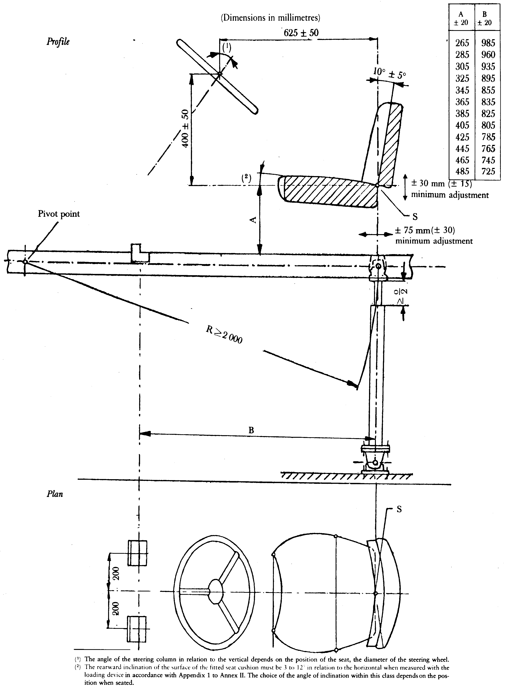
⁽¹⁾ The angle of the steering column in relation to the vertical depends on the position of the seat, the diameter of the steering wheel.
⁽²⁾ The rearward inclination of the surface of the fitted seat cushion must be 3 to 12° in relation to the horizontal when measured with the
loading device in accordance with Appendix 1. The choice of the angle of inclination within this class depends on the position when seated.

Appendix è1 78 ç
Characteristic of the filter of the vibration measuring instrument (point 2.5.3.3.5)
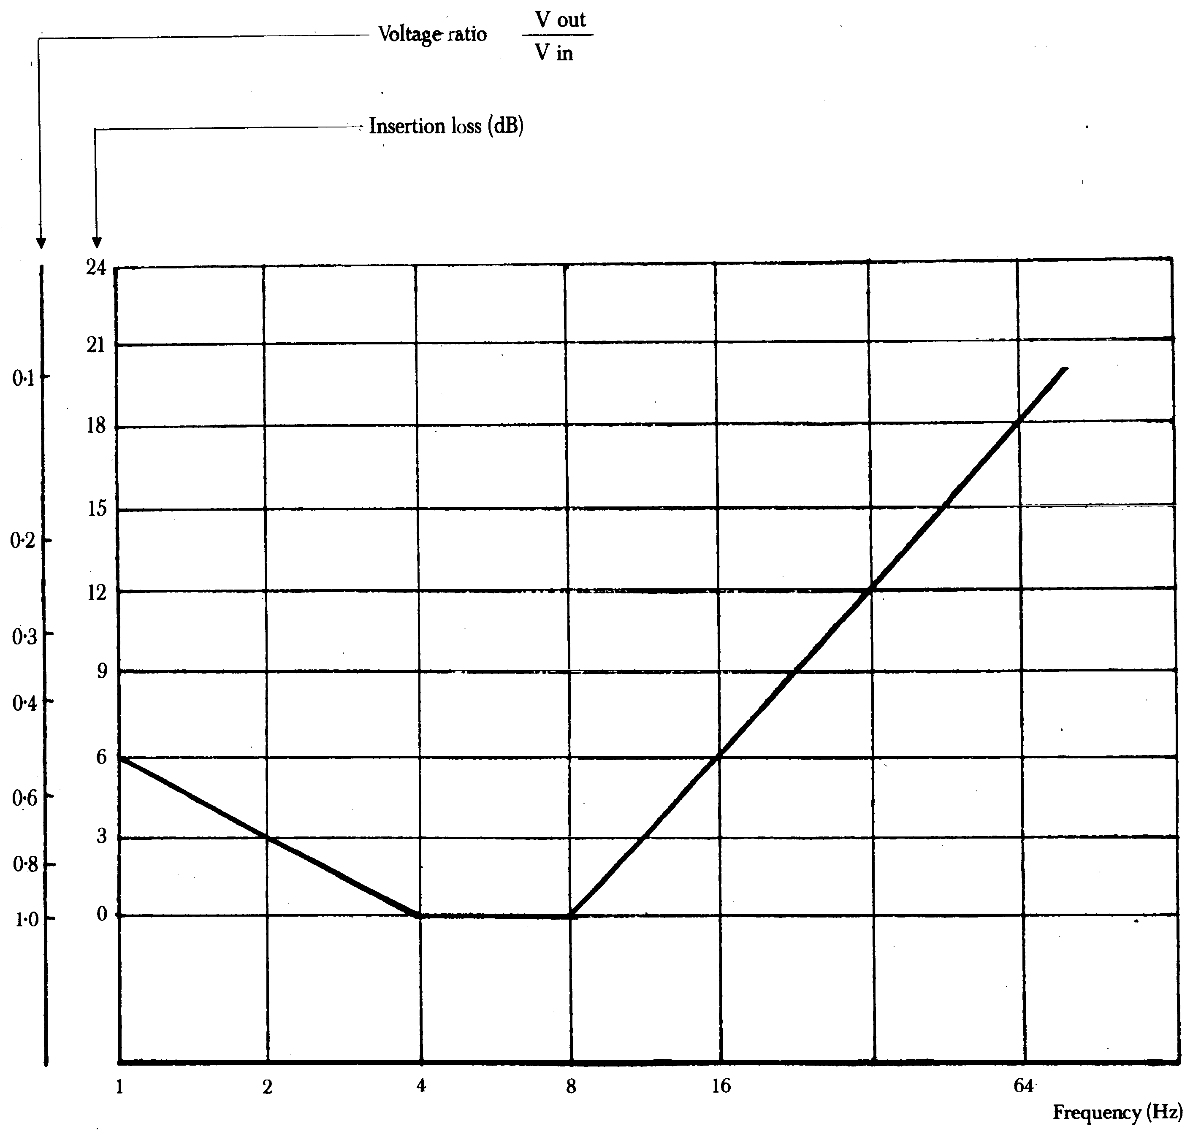
Appendix è1 89 ç
Example of an EEC EC component type-approval mark (point 3.5)
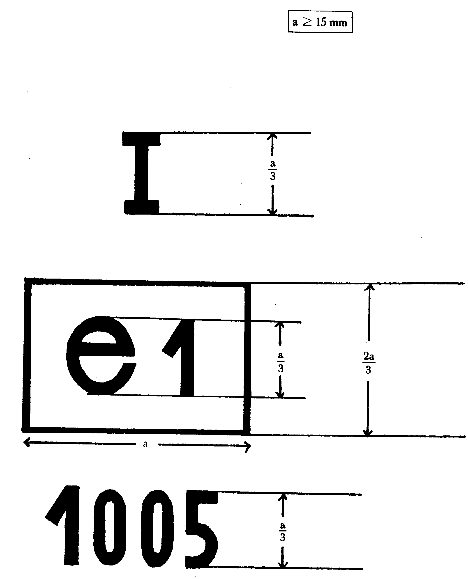
The seat bearing the EEC EC type-approval mark above is a seat intended for a Category A tractor in Class I and approved in Germany (e1) under number 1 005.
_____________
ANNEX III
MODEL EEC EC COMPONENT TYPE-APPROVAL CERTIFICATE
 |  | Name of administration
Notification concerning the grant, refusal or withdrawal or extension of EEC EC component type-approval for a type of driver’s seat for a wheeled agricultural or forestry tractor
EEC EC component type-approval No ....................................................................................
1. | Trade name or mark of seat ....................................................................................
 | ....................................................................................................................................
2. | Name and address of manufacturer ............................................................................
 | ....................................................................................................................................
3. | If applicable, name and address of manufacturer’s authorized representative ............................
 | ....................................................................................................................................
4. | Mark, type and trade name of tractor(s) for which seat is intended (¹) .................
 | ....................................................................................................................................
5. | Date of submission for EEC EC component type-approval ...................................
6. | Test laboratory ....................................................................................
 | ....................................................................................................................................
7. | Date and number of laboratory report .....................................................................
8. | Date on which EEC EC component type-approval was granted/refused/withdrawn (²) ....................................................................................
 | ....................................................................................................................................
9. | Place ....................................................................................
10. | Date ....................................................................................
11. | A note describing the seat, particularly the range of adjustment, the total weight, the suspension system characteristics, type and thickness of padding and directions for attachment, is attached to this certificate. Designs of the sides of the seat in DIN A4 form (210 x 297 mm) with a lateral and frontal view are enclosed with this note. è1 This note must be sent to the competent authorities of the other Member States if they so request. ç
12. | Remarks ....................................................................................
 | ....................................................................................................................................
13. | Signature ....................................................................................
⁽¹⁾ In the case of a seat intended for a tractor in Class I or II, state the class(es) of the tractor(s) for which the seat is intended.
⁽²⁾ Delete whichever is inapplicable.
_____________
ANNEX IV
DRIVER'S SEAT INSTALLATION REQUIREMENTS FOR EEC EC TYPE-APPROVAL OF A TRACTOR
1. Every driver's seat must bear the EEC EC component type-approval mark and comply with the following installation requirements:
1.1. the driver's seat must be installed in such a way that:
1.1.1. the driver is assured of a comfortable position for driving and manoeuvring the tractor;
1.1.2. the seat is easily accessible;
1.1.3. the driver, when seated in the normal driving position, can easily reach the various controls of the tractor that are likely to be actuated during operation;
1.1.4. no part of any of the seat or tractor components is likely to cause the driver to suffer cuts or bruises;

ê 1999/57/EC Art. 1
1.1.5. where the position of the seat is adjustable only lengthwise and vertically, the longitudinal axis passing through the seat reference point shall be parallel with the vertical longitudinal plane of the tractor passing through the centre of the steering wheel and not more than 100 mm from that plane;

ê 78/764/EEC
1.1.6. where the seat is designed to revolve round a vertical axis it must be capable of being locked in all or certain positions and in any case in the position mentioned in point 1.1.5.
2. The holder of the EEC EC type-approval may request that it be extended to other types of seat. The competent authorities must grant this extension on the following conditions:
2.1. the new type of seat has received EEC EC component type-approval;
2.2. it has been designed to be installed on the type of tractor for which the extension of the EEC EC type-approval has been requested;
2.3. it is installed in such a manner as to comply with the installation requirements in this Annex.

ê 83/190/EEC Art. 1 and Annex
3. Seats intended for tractors with a minimum rear-wheel track of not more than 1 150 mm may have the following minimum dimensions in respect of the depth and width of the seat surface:
- depth of seat surface: 300 mm;
- width of seat surface: 400 mm.
This provision is applicable only if the values specified for the depth and the width of the seat surface (i.e. 400 ± 50 mm and at least 450 mm respectively) cannot be adhered to on grounds relating to the tractor.

ê 78/764/EEC
4. A certificate conforming to the model shown in Annex V is to be attached to the EEC EC type-approval certificate for each type-approval or extension of type-approval granted or refused.
_____________

ê 78/764/EEC (adapted)
ANNEX V
ANNEX TO THE EEC EC TYPE-APPROVAL CERTIFICATE FOR A TRACTOR WITH REGARD TO THE DRIVER'S SEAT
(Articles 4 (2) and 10 of Directive 2003/37/EC of the European Parliament and of the Council of 26 May 2003 on type-approval of agricultural or forestry tractors, their trailers and interchangeable towed machinery, together with their systems, components and separate technical units and repealing Directive 74/150/EEC Council Directive 74/150/EEC of 4 March 1974 on the approximation of the laws of the Member States relating to the type-approval of wheeled agricultural or forestry tractors)
 |  | Name of administration
EEC EC type-approval No .......................................................................................................
.............................................................................................................................extension(¹)
1. | Trade name or mark of tractor ....................................................................................
 | ....................................................................................................................................
2. | Type of tractor ......................................................................................................
3. | Name and address of tractor manufacturer .............................................................
 | ....................................................................................................................................
4. | If applicable, name and address of authorized representative ............................
 | ....................................................................................................................................
5. | Trade name or mark of driver’s seat and EC component type-approval number.........
 | ....................................................................................
6. | Extension of EEC EC type-approval of the tractor to cover the following seat type...
 | ....................................................................................................................................
7. | Tractor submitted for EEC EC type-approval on........................................................
8. | Technical department responsible for checking conformity for the purpose of EEC EC type-approval
 | ....................................................................................................................................
9. | Date of report issued by that department.....................................................................
10. | Number of report issued by that department...............................................................
11. | EEC EC type-approval with respect to the driver’s seat has been granted/refused(²)
12. | An extension of EEC EC type-approval with respect to the driver’s seat has been granted/refused(²)
13. | Place ....................................................................................
14. | Date ....................................................................................
15. | Signature ....................................................................................
(¹) Where appropriate, state whether the extension of the initial EEC EC type-approval is the first, second, etc.
(²) Delete whichever is inapplicable.
_____________

é
ANNEX VI
Part A
Repealed Directive with list of its successive amendments
(referred to in Article 12)
Council Directive 78/764/EEC
(OJ L 255, 18.9.1978, p. 1)
 | 1979 Act of Accession
 | Council Directive 82/890/EEC  (OJ L 378, 31.12.1982, p. 45) | Only as regards the reference to Directive 78/764/EEC in Article 1(1)
Commission Directive 83/190/EEC
(OJ L 109, 26.4.1983, p. 13)
Point IX.A.15.(f) of Annex I to the
1985 Act of Accession
(OJ L 302, 15.11.1985, p. 213)
 | Council Directive 87/354/EEC  (OJ L 192, 11.7.1987, p. 43) | Point 9(f) of the Annex only
Commission Directive 88/465/EEC
(OJ L 228, 17.8.1988, p. 31)
Point XI.C.II.3 of Annex I to the
1994 Act of Accession
(OJ C 241, 29.8.1994, p. 206)
 | Directive 97/54/EC of the European Parliament and of the Council  (OJ L 277, 10.10.1997, p. 24) | Second indent of Article 1 only
Commission Directive 1999/57/EC
(OJ L 148, 15.6.1999, p. 35)
Point I.A.27 of Annex II to the
2003 Act of Accession
(OJ L 236, 23.9.2003, p. 61)
 | Council Directive 2006/96/EC  (OJ L 363, 20.12.2006, p. 81) | Only as regards the reference to Directive 78/764/EEC in Article 1 and point A.(26) of the Annex
Part B
List of time-limits for transposition into national law and application
(referred to in Article 12)
Directive | Time-limit for transposition | Date of application
78/764/EEC | 29 January 1980 | -
82/890/EEC | 21 June 1984 | -
83/190/EEC | 30 September 1983^{(*)} | -
87/354/EEC | 31 December 1987 | -
88/465/EEC | 30 September 1988^{(**)} | -
97/54/EC | 22 September 1998 | 23 September 1998
1999/57/EC | 30 June 2000^{(***)} | -
2006/96/EC | 1 January 2007 | -
^{(*)} In conformity with Article 2 of Directive 83/190/EEC:
“1. With effect from 1 October 1983, no Member State may refuse to grant EEC type approval, to issue the document referred to in the last indent of Article 10(1) of Directive 74/150/EEC or to grant national type approval in respect of a type of tractor, or
- prohibit the entry into service of tractors,
if the driver's seat on this type of tractor or of these tractors complies with the provisions of this Directive.
2. With effect from 1 October 1984, Member States:
- shall no longer issue the document referred to in the last indent of Article 10(1) of Directive 74/150/EEC in respect of a type of tractor in which the driver's seat does not comply with the provisions of this Directive,
- may refuse to grant national type-approval in respect of a type of tractor in which the driver's seat does not comply with the provisions of the present Directive.”
^{(**)} In conformity with Article 2 of Directive 88/465/EEC:
“1. From 1 October 1988, no Member State may:
(a) refuse, in respect of a type of tractor, to grant EEC type approval, to issue the document referred to in Article 10(1), final indent, of Directive 74/150/EEC, or to grant national type approval, or
- prohibit the entry into service of tractors,
if the driver's seat on this type of tractor or tractors complies with the provisions of this Directive;
(b) refuse, in respect of a type of driver's seat, to grant EEC component type approval or national type-approval if seats of that type comply with the provisions of this Directive, or
- prohibit the placing on the market of driver's seats which bear the EEC component type approval mark issued in accordance with the provisions of this Directive.
2. From 1 October 1989, Member States:
(a) shall no longer issue the document referred to in Article 10 (1), final indent, of Directive 74/150/EEC in respect of a type of tractor the driver's seat of which does not comply with the provisions of this Directive,
- may refuse to grant national type approval in respect of a type of tractor the driver's seat of which does not comply with the provisions of this Directive;
(b) shall not grant EEC component type approval in respect of a type of driver's seat if it does not comply with the provisions of this Directive,
- may refuse to grant national component type approval in respect of a type of driver's seat if it does not comply with the provisions of this Directive.”
^{(***)} In conformity with Article 2 of Directive 1999/57/EC:
“1. From 1 July 2000, Member States may not:
- refuse to grant EC type-approval, to issue the document provided for in the third indent of Article 10(1) of Directive 74/150/EEC, or to grant national type-approval, in respect of any of tractor, or
- prohibit the entry into service of tractors,
if the tractors in question meet the requirements of Directive 78/764/EEC, as amended by this Directive.
2. From 1 January 2001, Member States:
- may no longer issue the document provided for in the third indent of Article 10(1) of Directive 74/150/EEC in respect of a type of tractor which does not meet the requirements of Directive 78/764/EEC, as amended by this Directive,
- may refuse to grant national type-approval in respect of a type of tractor which does not meet the requirements of Directive 78/764/EEC, as amended by this Directive.”
_____________
ANNEX VII

Correlation Table
Directive 78/764/EEC | This Directive
Articles 1 and 2 | Articles 2 and 3
Article 3(1) | Article 4, first paragraph
Article 3(2) | Article 4, second and third paragraphs
Articles 4 and 5 | Articles 5 and 6
Article 6, first sentence | Article 7, first paragraph
Article 6, second sentence | Article 7, second paragraph
Articles 7 and 8 | Articles 8 and 9
Article 9 | Article 1
Article 10 | Article 10
Article 11(1) | -
Article 11(2) | Article 11
- | Article 12
- | Article 13
Article 12 | Article 14
Annex I | Annex I
Annex II | Annex II
Appendices 1 to 4 | Appendices 1 to 4
Appendix 5a | Appendix 5
Appendix 5b | Appendix 6
Appendix 6 | Appendix 7
Appendix 7 | Appendix 8
Appendix 8 | Appendix 9
Annexes III, IV and V | Annexes III, IV and V
- | Annex VI
- | Annex VII
_____________

COM(87) 868 PV.
See Annex 3 to Part A of the Conclusions.
Carried out pursuant to the Communication from the Commission to the European Parliament and the Council – Codification of the Acquis communautaire, COM(2001) 645 final.
See Annex VI, Part A of this proposal.
OJ C […], […], p. […].
OJ C […], […], p. […].
OJ L 255, 18.9.1978, p. 1. Directive as last amended by Directive 2006/96/EC (OJ L 363, 20.12.2006, p. 81).
See Annex VI, Part A.
OJ L 171, 9.7.2003, p. 1. Directive as last amended by Directive 2006/96/EC.

