EN
COMMISSION OF THE EUROPEAN COMMUNITIES
Brussels, 13.6.2008
COM(2008) 357 final
2008/0123 (COD)

Proposal for a
DIRECTIVE OF THE EUROPEAN PARLIAMENT AND OF THE COUNCIL
relating to common provisions for both measuring instruments and methods of metrological control
(Recast)

EXPLANATORY MEMORANDUM
1. On 1 April 1987 the Commission decided to instruct its staff that all legislative acts should be codified after no more than ten amendments, stressing that this is a minimum requirement and that departments should endeavour to codify at even shorter intervals the texts for which they are responsible, to ensure that the Community rules are clear and readily understandable.
2. The codification of Directive 71/316/EEC of 26 July 1971 on the approximation of the laws of the Member States relating to common provisions for both measuring instruments and methods of metrological control has been initiated by the Commission. The new Directive was to have superseded the various acts incorporated in it.
3. In the meantime Council Decision 1999/468/EC of 28 June 1999 laying down the procedures for the exercise of implementing powers conferred on the Commission has been amended by Decision 2006/512/EC, which introduced a regulatory procedure with scrutiny for measures of general scope designed to amend non-essential elements of a basic instrument adopted in accordance with the procedure referred to in Article 251 of the Treaty, including by deleting some of those elements or by supplementing the instrument by the addition of new non-essential elements.
4. In accordance with the joint statement of the European Parliament, the Council and the Commission on Decision 2006/512/EC, for this new procedure to be applicable to instruments adopted in accordance with the procedure laid down in Article 251 of the Treaty which are already in force, those instruments must be adjusted in accordance with the applicable procedures.
5. It is therefore appropriate to transform the codification of Directive 71/316/EEC into a recast in order to incorporate the amendments necessary for the adjustment to the regulatory procedure with scrutiny.

ê 71/316/EEC (adapted)
2008/0123 (COD)

Proposal for a
DIRECTIVE OF THE EUROPEAN PARLIAMENT AND OF THE COUNCIL
relating to common provisions for both measuring instruments and methods of metrological control
(Text with EEA relevance)

THE EUROPEAN PARLIAMENT AND THE COUNCIL OF THE EUROPEAN UNION,
Having regard to the Treaty establishing the European Community, and in particular Article Ö 95 Õ thereof,
Having regard to the proposal from the Commission,
Having regard to the opinion of the European Economic and Social Committee,
Acting in accordance with the procedure laid down in Article 251 of the Treaty,
Whereas:

ò new
- Council Directive 71/316/EEC of 26 July 1971 on the approximation of the laws of the Member States relating to common provisions for both measuring instruments and methods of metrological control has been substantially amended several times. In the interests of clarity and rationality the said Directive should be codified.

ê 71/316/EEC Recital 1
- In each Member State, mandatory provisions determine the technical characteristics of measuring instruments and the methods of metrological control. Those requirements differ from one Member State to another. Those differences hinder trade and may create unequal conditions of competition within the Community.

ê 71/316/EEC Recital 2
- One of the objects of controls in each Member State is to give assurance to customers that quantities delivered correspond to the price paid. Consequently the aim of this Directive is not to abolish these controls but to eliminate differences between rules in so far as these constitute a hindrance to trade.

ê 71/316/EEC Recital 3 (adapted)
- Those hindrances to the functioning of the Ö internal Õ market can be reduced and eliminated if the same requirements apply in Member States, initially complementing national provisions in force and later, when the necessary conditions exist, replacing those provisions.

ê 71/316/EEC Recital 4
- Even during the period when they coexist with national provisions, the Community requirements will enable firms to manufacture products which have uniform technical characteristics and can therefore be marketed and used throughout the Community after they have undergone EC controls.

ê 71/316/EEC Recital 5
- Community technical requirements for design and functioning should ensure that instruments continuously give measurements that are sufficiently accurate for their intended purpose.

ê 71/316/EEC Recital 6
- Compliance with technical requirements is usually confirmed by Member States before measuring instruments are placed on the market or used for the first time, and where appropriate when they are in service, such confirmation being carried out in particular by means of pattern approval and verification procedures. In order to achieve free movement of these instruments within the Community, it is also necessary to provide for mutual recognition of controls among Member States and to establish appropriate EC pattern approval and initial verification procedures for this purpose as well as EC methods of metrological control in accordance with this Directive and with the relevant separate directives.

ê 71/316/EEC Recital 7
- The presence, on a measuring instrument or a product, of signs or marks showing that it has undergone the appropriate controls indicates that such instrument or product satisfies the relevant technical requirements of the Community, and therefore that when the instrument or product is imported or put into operation it is unnecessary to repeat the controls which have already been carried out.

ê 71/316/EEC Recital 8 (adapted)
- National metrological rules cover numerous categories of measuring instruments and products. This Directive should lay down the general provisions dealing, in particular, with EC pattern approval and initial verification procedures, as well as EC methods of metrological control. Implementing directives covering the various categories of instruments and products will lay down the technical requirements as to design, functioning and accuracy, Ö and Õ the control procedures.

ò new
- The measures necessary for the implementation of this Directive should be adopted in accordance with Council Decision 1999/468/EC of 28 June 1999 laying down the procedures for the exercise of implementing powers conferred on the Commission.
- Power should be conferred on the Commission in particular to amend Annexes I and II to this Directive and the Annexes to the separate Directives. Since those measures are of general scope and are designed to amend non-essential elements of this Directive and the separate Directives, they should be adopted in accordance with the regulatory procedure with scrutiny provided for in Article 5a of Decision 1999/468/EC.
- The new elements introduced into this Directive only concern the committee procedures. They therefore do not need to be transposed by the Member States.
- This Directive should be without prejudice to the obligations of the Member States relating to the time-limits for transposition into national law of the Directives set out in Annex III, Part B,

ê 71/316/EEC

HAVE ADOPTED THIS DIRECTIVE:

CHAPTER I
Basic principles

ê 83/575/EEC Art. 1 pt. 1 (adapted)

Article 1
1. This Directive Ö shall apply Õ to:
(a) instruments Ö as defined in paragraph 2 Õ;
(b) units of measurement, the harmonisation of methods of measurement and metrological control and, where appropriate, the means required for application of such methods;
(c) the prescription, methods of measurement, metrological control and marking of quantities of pre-packaged products.
Ö 2. For the purpose of this Directive, “instruments” shall mean measuring instruments, components of measuring instruments, additional devices and measurement equipment. Õ
3. No Member State may, on the basis of this Directive and the separate directives relating to it, prevent, prohibit, or restrict the placing on the market and/or entry into service of an instrument if that instrument bears EC marks and/or signs in accordance with the conditions laid down by this Directive and by the separate directives relating to the instrument in question.
4. Member States shall attach the same value to EC pattern approval and initial verification as to the corresponding national measures.
5. The separate directives concerning the subjects referred to in paragraph 1 shall specify in particular, measurement procedures and characteristics and technical Ö construction and functioning Õ requirements.
6. Ö The separate directives Õ may fix the date on which the existing national provisions are to be replaced by Community provisions.

ê 71/316/EEC

CHAPTER II
EC pattern approval

ê 83/575/EEC Art. 1 pt. 2 (adapted)

Article 2
1. Member States shall grant EC pattern approval in accordance with the provisions of this Directive and of the relevant separate directives.
2. EC pattern approval of instruments Ö shall constitute Õ their admission to EC initial verification and, where the latter is not required, the authorisation to place them on the market and/or to put them into service. If the separate directive(s) applicable to a category of instruments exempt(s) that category from EC pattern approval, the instruments in that category shall be admitted directly to EC initial verification.
3. If their inspection equipment so permits, Member States shall grant EC pattern approval for every instrument which satisfies the requirements laid down in this Directive and the separate directives relating to the instrument in question.
4. An application for EC pattern approval may be made only by the manufacturer or his representative established within the Community. For one and the same instrument, application may be made in one Member State only.
5. A Member State which has granted EC pattern approval shall take the necessary steps to ensure that it is kept informed of any modification or addition to the approved pattern. It shall inform the other Member States of such alterations.
Modifications or additions to an approved pattern must receive additional pattern approval from the Member State which granted EC pattern approval, where such changes influence or might influence measurement results or the prescribed conditions for use of the instrument.
However, in the case of a modified pattern, a new EC pattern approval shall be granted instead of an addition to the original EC pattern approval certificate, if the pattern is modified after the provisions of this Directive or of the relevant Ö separate Õ directive have been amended or adapted in such a way that the modified pattern could be approved only pursuant to the new provisions.

ê 71/316/EEC

Article 3
When EC pattern approval is granted for ancillary equipment, this approval shall specify:
(a) the patterns of instrument to which this equipment may be attached or in which it may be incorporated;
(b) the general conditions for the overall functioning of the instruments for which it is approved.

ê 83/575/EEC Art. 1 pt. 3

Article 4
When an instrument has successfully completed the EC pattern approval examination laid down in this Directive and in the separate directives relating to it, the Member State which carried out that examination shall draw up an EC pattern approval certificate.
That Member State shall forward it to the applicant.
In the cases provided for in Article 11 or in a separate directive, the applicant must, and in all other cases he may, affix or cause to be affixed on each instrument conforming to the approved pattern the EC approval sign shown in the certificate.

ê 83/575/EEC Art. 1 pt. 4 (adapted)

Article 5
1. EC pattern approval shall be valid for 10 years. It may be extended for successive periods of 10 years. The number of instruments which may be manufactured in accordance with the approved pattern shall not be limited.
EC pattern approvals granted on the basis of the provisions of this Directive and of a separate directive may not be extended after the date of the entry into force of any amendment to, or adaptation of, these Community provisions, in cases where such EC pattern approvals could not have been granted on the basis of the new provisions.
When EC pattern approval is not extended, that approval shall nevertheless continue to apply to instruments already in service.
2. Where use is made of new techniques not provided for in a separate directive, EC pattern approval with limited effect may be granted, after prior consultation of the other Member States.
It may include the following restrictions:
(a) limit on the number of instruments which may be covered by the approval;
(b) obligation to notify the competent authorities of the places of installation;
(c) restrictions on use;
(d) special restrictions concerning the technique used.
However, it may not be granted unless:
(a) the separate directive for that category of instruments has come into force;
(b) no derogation has been made from the maximum permissible errors laid down in the separate directives.
The period of validity of such approval shall not exceed two years. It may be extended by up to three years at most.
3. The Member State which has granted the limited EC pattern approval referred to in paragraph 2 shall apply for adjustment to technical progress of Annexes Ö I and II Õ to this Directive, where appropriate, and of the separate directives, in accordance with the procedure Ö referred to Õ in Article 17(2), as soon as it considers that a new technique has proved to be satisfactory.

ê 71/316/EEC (adapted)
è1 83/575/EEC Art. 1, pt. 6(a)

Article 6
When EC pattern approval is not required for a category of instruments which meets the requirements of a separate directive, the manufacturer may, on his own responsibility, affix to the instruments in this category the special sign described in Ö point Õ 3.3 of Annex I.

Article 7
1. The Member State which has granted EC pattern approval may withdraw it:
(a) if instruments for which this approval was granted do not conform to the approved pattern or to the provisions of the relevant separate directive;
(b) if the metrological requirements specified in the certificate of approval or the provisions of è1 Article 5(2) ç are not met;

ê 83/575/EEC Art. 1, pt. 6(b)
(c) if it ascertains that approval was granted in an improper manner.

ê 71/316/EEC
2. The Member State which has granted EC pattern approval must withdraw it if the instruments constructed according to an approved pattern reveal in service a defect of a general nature which makes them unsuitable for their intended use.

ê 71/316/EEC (adapted)
3. If the Member State Ö which granted an EC pattern approval Õ is informed by another Member State of the occurrence of one of the cases covered by paragraphs 1 and 2, it shall likewise take the measures provided for in those paragraphs, after consulting with that other Member State.

ê 71/316/EEC
4. The Member State which declares that the case referred to in paragraph 2 has arisen may forbid the placing on the market and putting into service of the instruments concerned until further notice.
It shall immediately inform the other Member States and the Commission, stating the reasons on which its decision is based.
The same procedure shall apply in the cases mentioned in paragraph 1, with respect to instruments which have been exempted from EC initial verification, if the manufacturer, after due warning, does not bring the instruments into line with the approved pattern or with the requirements of the relevant separate directive.
5. If the Member State which granted the EC pattern approval disputes that the case referred to in paragraph 2 of which it has been informed has arisen, or disputes that the measures taken in pursuance of paragraph 4 are justified, the Member States concerned shall endeavour to settle the dispute.
The Commission shall be kept informed and shall, where necessary, hold appropriate consultations for the purpose of reaching a settlement.

CHAPTER III
Initial verification
Article 8

ê 83/575/EEC Art. 1, pt. 7(a) (adapted)
1. EC initial verification constitutes the examination of a new or reconditioned instrument and the confirmation of its conformity to the approved pattern and/or to the requirements of this Directive and the separate directives relating to the instrument in question. It is certified by the EC initial verification mark.
Ö 2. Õ EC initial verification of instruments may be carried out by a method other than unit checking in the cases specified in the separate directives and in accordance with the procedures adopted.

ê 71/316/EEC
è1 83/575/EEC Art. 1, pt. 7(b)
3. If they have the requisite equipment, Member States shall carry out EC initial verification of instruments submitted as having the measurement characteristics and satisfying the technical construction and functioning requirements laid down by the separate directive on this category of instruments.
4. In the case of instruments bearing the EC initial verification mark, the obligation imposed on Member States by è1 Article 1(3) ç shall last until the end of the year following that in which the EC initial verification mark was affixed, unless separate directives make provision for a longer period.

ê 83/575/EEC Art. 1, pt. 8

Article 9

1. When an instrument is submitted for EC initial verification, the Member State carrying out the examination shall determine:
(a) whether the instrument belongs to a category exempt from EC pattern approval and, if so, whether it satisfies the technical construction and functioning requirements laid down by the separate directives relating to that instrument;
(b) whether the instrument has received EC pattern approval and, if so, whether it conforms to the approved pattern, and to the separate directives relating to that instrument, in force on the date of issue of this EC pattern approval.

2. The examination carried out in EC initial verification relates in particular, in accordance with the separate directives, to:
(a) the metrological characteristics;,
(b) the maximum permissible errors;,
(c) the construction, in so far as this guarantees that the measurement characteristics are not likely to deteriorate to any great extent under normal conditions of use;,
(d) the presence of prescribed inscriptions and stamp plates or provisions for EC initial verification marking.

ê 83/575/EEC Art. 1, pt. 9 (adapted)

Article 10
When an instrument has successfully undergone EC initial verification, in accordance with the requirements of this Directive and of the separate directives, the EC partial or final verification marks described in Annex II, Ö point 3 Õ shall be affixed to that instrument under the responsibility of the Member State in accordance with the rules laid down in that Ö point Õ.

ê 71/316/EEC (adapted)

Article 11
When EC initial verification is not required for a category of instruments which meet the requirements of a separate directive, the manufacturer shall, on his own responsibility, affix to the instruments in that category the special symbol described in Öpoint Õ 3.4 of Annex I.

CHAPTER IV
Provisions for both EC pattern approval and EC initial verification

Article 12
Member States shall take all necessary measures to prevent the use on instruments of marks or inscriptions liable to be confused with the EC signs or marks.

ê 83/575/EEC Art. 1, pt. 10 (adapted)

Article 13
Each Member State shall notify the other Member States and the Commission of the services, agencies and institutes which are duly authorised to carry out the examinations Ö provided for Õ in this Directive and in the separate directives, to issue the EC pattern approval certificates and to affix the EC initial verification marks.

ê 71/316/EEC

Article 14
Member States may require that the prescribed inscriptions be drawn up in their official language or languages.

CHAPTER V
Control of instruments in service

ê 83/575/EEC Art. 1, pt. 11

Article 15
The separate directives shall specify the control requirements for instruments in service which bear EC signs or marks and in particular the maximum errors permitted in service. If national provisions on instruments which do not bear EC signs or marks lay down less stringent requirements, the latter may serve as criteria for the controls.

ê 83/575/EEC Art. 1, pt. 12 (adapted)
ð new

CHAPTER VI
Adjustment of directives to technical progress
Article 16
The amendments necessary for adjusting to technical progress Annexes Ö I and II Õ to this Directive and the Annexes to the separate directives referred to in Article 1 shall be adopted ð by the Commission. Those measures, designed to amend non-essential elements of those directives, shall be adopted in accordance with the regulatory procedure with scrutiny referred to in Article 17(2). ï .in accordance with the procedure laid down in Article 18
However, this procedure shall not apply to the chapter relating to imperial units of measurement of the Annex to the Directive on units of measurement and the Annexes, concerning quantity ranges for pre-packed quantities of products, to the directives on pre-packed products.
Article 17

ê 807/2003 Art. 3 and Annex III pt. 5
ð new
1. The Commission shall be assisted by the Committee for Adjustment to Technical Progress of the Directives referred to in Article 16.
ð 2. Where reference is made to this paragraph, Article 5a(1) to (4), and Article 7 of Decision 1999/468/EC shall apply, having regard to the provisions of Article 8 thereof. ï
2. Where reference is made to this Article, Articles 5 and 7 of Decision 1999/468/EC shall apply.
The period laid down in Article 5(6) of Decision 1999/468/EC shall be set at three months.
3. The Committee shall adopt its rules of procedure.

ê 83/575/EEC Art. 1, pt. 13

CHAPTER VII

ê 71/316/EEC

Final provisions

ê 71/316/EEC (adapted)
è1 83/575/EEC Art. 1, pt. 13
è2 83/575/EEC Art. 1, pt. 14

Articleè1 18 ç
All decisions taken pursuant to the provisions adopted in implementation of this Directive and of the separate directives on the instruments in question and refusing to grant or extend EC pattern approval, withdrawing such approval, refusing to carry out EC initial verification or è2 prohibiting placing on the market or entry into service ç shall state the reasons on which they are based. Such refusal, withdrawal or prohibition shall be notified to the party concerned, who shall at the same time be informed of the remedies available to him under the laws in force in the Member States and of the time limits allowed for the exercise of such remedies.

Article è1 19 ç
Member States shall Ö communicate to the Commission Õ the text of the main provisions of national law which they adopt in the field covered by this Directive.

ê

Article 20
Directive 71/316/EEC, as amended by the acts listed in Annex III, Part A, is repealed, without prejudice to the obligations of the Member States relating to the time-limits for transposition into national law of the directives set out in Annex III, Part B.
References to the repealed Directive shall be construed as references to this Directive and shall be read in accordance with the correlation table in Annex IV.

Article 21
This Directive shall enter into force on the twentieth day following that of its publication in the Official Journal of the European Union.

ê 71/316/EEC
è1 83/575/EEC Art. 1, pt. 13

Article è1 22 ç
This Directive is addressed to the Member States.
Done at Brussels,
For the European Parliament For the Council
The President The President

ê 71/316/EEC (adapted)

ANNEX I
EC PATTERN APPROVAL

1. Application for EC approval
1.1. The application and the correspondence relating to it shall be drawn up in an official language in accordance with the laws of the Member State to which the application is made. The Member State has the right to require Ö that Õ the annexed documents should also be written in the same official language.
The applicant shall send simultaneously to all Member States a copy of his application.
1.2. The application shall contain the following information:
(a) the name and address of the manufacturer or the firm, or of his or its authorised representative or of the applicant;,
(b) the category of instrument;,
(c) the intended use;,
(d) the measurement characteristics;,
(e) the commercial designation if any, or the type.
1.3. The application shall be accompanied by the documents necessary for its evaluation, in duplicate, and in particular:
1.3.1. A description in particular of:
(a) the construction and operation of the instrument;,
(b) the protecting arrangements ensuring correct working;,
(c) the devices for regulation and adjustment;,
(d) the intended locations for:
- verification marks
- seals (where applicable).
1.3.2. General arrangement drawings and, where necessary, detailed drawings of important components.
1.3.3. A schematic drawing illustrating the principles of operation and, where necessary, a photograph.
1.4. The application shall be accompanied, where appropriate, by documents relevant to the national approvals already granted.

2. Examination for EC approval
2.1 The examination shall comprise:
2.1.1. Study of the documents and an examination of the measurement characteristics of the pattern in the laboratories of the metrological service, in approved laboratories or at the place of manufacture, delivery or installation.
2.1.2. If the measurement characteristics of the pattern are known in detail, only an examination of the documents submitted.
2.2 The examination shall cover the entire performance of the instrument under normal conditions of use. Under such conditions, this instrument must maintain the measurement characteristics required.
2.3. The nature and scope of the examination mentioned in Ö point Õ 2.1 may be specified by separate directives.
2.4. The metrological service may require the applicant to put at its disposal the standards and the appropriate means in material and assisting personnel for the performance of the approval tests.

3. EC certificate and sign of approval
3.1. The certificate shall give the results of the examination of the pattern and shall specify the other requirements which must be complied with. It shall be accompanied by descriptions, drawings and diagrams necessary to identify the pattern and to explain its functioning. The sign of approval provided for in Article 4 shall be a stylised letter ε containing:

ê 1972 Act of Accession Art. 29 and Annex I, p. 118
è1 1985 Act of Accession Art. 26 and Annex I, p. 212
è2 87/354/EEC Art. 1 and Annex 4
è3 1994 Act of Accession Art. 29 and Annex I, p. 211
è4 2003 Act of Accession Art. 20 and Annex II, p. 64
è5 2006/96/EC Art. 1 and Annex, pt. B.1
- in the upper part, the distinguishing capital letter of the Member State which granted the approval è1 (B for Belgium, ç è5 BG for Bulgaria, ç è4 CZ for the Czech Republic, ç è1 DK for Denmark, D for Germany, ç è4 EST for Estonia, ç è1 IRL for Ireland, ç è2 EL for Greece, ç è1 E for Spain, F for France, I for Italy, ç è₄ CY for Cyprus, LV for Latvia, LT for Lithuania, ç è1 L for Luxembourg, ç è₄ H for Hungary, M for Malta, ç è1 NL for Netherlands, ç è3 A for Austria, ç è4 PL for Poland, ç è1 P for Portugal, ç è5 RO for Romania, ç è₄ SI for Slovenia, SK for Slovakia, ç è3 FI for Finland, S for Sweden, ç è1 UK for the United Kingdom) ç and the last two digits of the year of approval.

ê 71/316/EEC (adapted)
- in the lower part, a designation to be determined by the metrological service which granted approval (an identification number).
An example of this approval sign is shown in Ö point Õ 6.1.
3.2. In the case of EC limited approval, the letter P, having the same dimensions as the stylised letter ε, shall be placed before this letter.
An example of this limited approval sign is shown in Ö point Õ 6.2.

ê 83/575/EEC Art. 1, pt. 5 (adapted)
3.3. The sign mentioned in Article 6 is the same as the EC approval sign, except that the stylised letter E is reversed symmetrically about a vertical axis and bears no other indication unless the separate directives stipulate otherwise.
An example of this sign is shown in Ö point Õ 6.3.

ê 71/316/EEC (adapted)
3.4. The sign mentioned in Article 11 is the same as the EC approval sign in a hexagon.
An example of this sign is shown in Ö point Õ 6.4.
3.5. The signs mentioned in points 3.1 to 3.4 and affixed by the manufacturer in accordance with the provisions of this Directive must be affixed at a visible point of each instrument and all ancillary equipment submitted for verification, and must be legible and indelible. If their affixation presents technical difficulties, exceptions may be made in separate directives or accepted after agreement among the metrological services of Member States has been reached.

4. Depositing of a sample instrument
In the cases mentioned by separate directives, the service which granted the approval may, if it considers this necessary, request the deposition of the sample instrument for which approval has been granted. Instead of this sample instrument, the service may authorise the depositing of parts of the instrument, of scale models or of drawings, and will mention this on the EC certificate of approval.

5. Announcement of approval
5.1 At the same time as the party concerned is notified, copies of the EC certificate of approval shall be sent to the Commission and to the other Member States; the latter can also obtain copies of the reports of the metrological examinations if they wish.

ê 71/316/EEC (adapted)
5.2. Withdrawal of EC pattern approval and other communications concerning the extent and validity of EC pattern approval shall also be subject to the announcement procedure mentioned in Ö point 5.1 Õ.
5.3. A Member State which refuses to grant EC pattern approval shall inform the other Member States and the Commission of its decision.

6. Signs relative to EC pattern approval

6.1. Sign of EC pattern approval
Example: |  | EC pattern approval granted by the Metrological Service of Germany in 1971 (see Ö point Õ 3.1 first indent)  Identification number of the EC pattern approval (see Ö point Õ 3.1 second indent)

6.2. Sign of EC limited pattern approval (see Ö point Õ 3.2)
Example: | 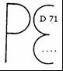 | EC limited pattern approval granted by the Metrological Service of Germany in 1971.  Identification number of the EC limited pattern approval

ê 83/575/EEC Art. 1, pt. 5 (adapted)

6.3. Sign of exemption from ECEEC pattern approval(see Ö point Õ 3.3)
Example:

ê 71/316/EEC (adapted)

6.4. Sign of EC pattern approval for instruments exempt from EC initial verification
(see Ö point Õ 3.4)
Example: | 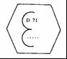 | EC pattern approval granted by the Metrological Service of Germany in 1971.  Identification number of the EC pattern approval.
_____________

ANNEX II

EC INITIAL VERIFICATION

1. General points
1.1. The EC initial verification may be carried out in one or more stages (usually two).
1.2. Subject to the provisions of the separate directives:
1.2.1. The EC initial verification shall be carried out in one stage on instruments which constitute a whole on leaving the factory, that is to say instruments which, theoretically, can be transferred to their place of installation without first having to be dismantled.
1.2.2. The EC initial verification shall be carried out in two or more stages for instruments whose correct functioning depends on the conditions in which they are installed or used.
1.2.3. The first stage of the verification procedure must ensure, in particular, that the instrument conforms to the approved EC pattern or, in the case of instruments exempt from pattern approval, that they conform to the relevant provisions.

2. Place of the EC initial verification
2.1. If the separate directives do not specify the place where verification is to be carried out, instruments which have to be verified in only one stage shall be verified at the place chosen by the metrological service concerned.
2.2. Instruments which have to be verified in two or more stages shall be verified by the metrological service territorially competent.
2.2.1. The last stage of verification must be carried out at the place of installation.
2.2.2. The other verification stages of verification shall be carried out as laid down in Ö point Õ 2.1.
2.3. In particular, when the verification takes place outside the office of verification the metrological service carrying out the verification may require the applicant:
- to put at its disposal the standards and the appropriate means in material and assisting personnel for the performance of the verification.
- to provide a copy of the EC certificate of approval.

3. EC initial verification marks

3.1. Description of EC initial verification marks.
3.1.1. Subject to the provisions of separate directives, EC initial verification marks which are affixed in accordance with Ö point Õ 3.3 shall be as follows:
3.1.1.1. The final EC verification mark shall be composed of two stamps:

(a) the first consists of a letter "e" containing:

ê 1972 Act of Accession Art. 29 and Annex I, p. 118
è1 1985 Act of Accession Art. 26 and Annex I, p. 212
è2 87/354/EEC Art. 1 and Annex 4
è3 1994 Act of Accession Art. 29 and Annex I, p. 211
è4 2003 Act of Accession Art. 20 and Annex II, p. 64
è5 2006/96/EC Art. 1 and Annex, pt. B.1
- in the upper half, the distinguishing capital letter of the Member State where the original check is carried out è1 (B for Belgium, ç è5 BG for Bulgaria, ç è4 CZ for the Czech Republic, ç è1 DK for Denmark, D for Germany, ç è4 EST for Estonia, ç è1 IRL for Ireland, ç è2 EL for Greece, ç è1 E for Spain, F for France, I for Italy, ç è₄ CY for Cyprus, LV for Latvia, LT for Lithuania, ç è1 L for Luxembourg, ç è₄ H for Hungary, M for Malta, ç è1 NL for Netherlands, ç è3 A for Austria, ç è4 PL for Poland, ç è1 P for Portugal, ç è5 RO for Romania, ç è₄ SI for Slovenia, SK for Slovakia, ç è3 FI for Finland, S for Sweden, ç è1 UK for the United Kingdom) ç together, where necessary, with one or two figures identifying a territorial or administrative subdivision;

ê 71/316/EEC (adapted)
- in the lower half, the identification number of the verifying agent or office;

(b) the second stamp shall consist of the last two digits of the year of the verification, in a hexagon.
3.1.1.2. The mark of EC partial verification shall consist solely of the first stamp. It shall also serve as a seal.

3.2. Shape and dimensions of marks
3.2.1. The attached drawings show the shape, dimensions and outline of the letters and numbers for the EC initial verification marks as laid down in Ö point Õ 3.1; the first two drawings show the various parts of the stamp, the third is an example of a stamp. The dimensions given in the drawings are relative values; they are a function of the diameter of the circle described about the small letter "e" and about the field of the hexagon.
The actual diameters of the circles described about the marks are 1·6 mm, 3·2 mm, 6·3 mm, 12·5 mm.
3.2.2. The metrological services of Member States shall mutually exchange the original drawings of the EC initial verification marks, conforming to the models in the annexed drawings.

3.3. Affixing the marks
3.3.1. The final EC verification mark shall be affixed at the appointed location on the instrument when the latter has been completely verified and is recognised to conform to EC requirements.
3.3.2. The partial EC verification mark shall be affixed:
3.3.2.1. When verification is made in several stages on the instrument or part of an instrument which fulfils the conditions laid down for operations other than those at the place of installation, at the place where the stamp-date is affixed or in any other place specified in the separate directives.
3.3.2.2. In all cases as a seal, in the places specified in the separate directives.

ê 2007/13/EC Art. 1 and Annex (adapted)
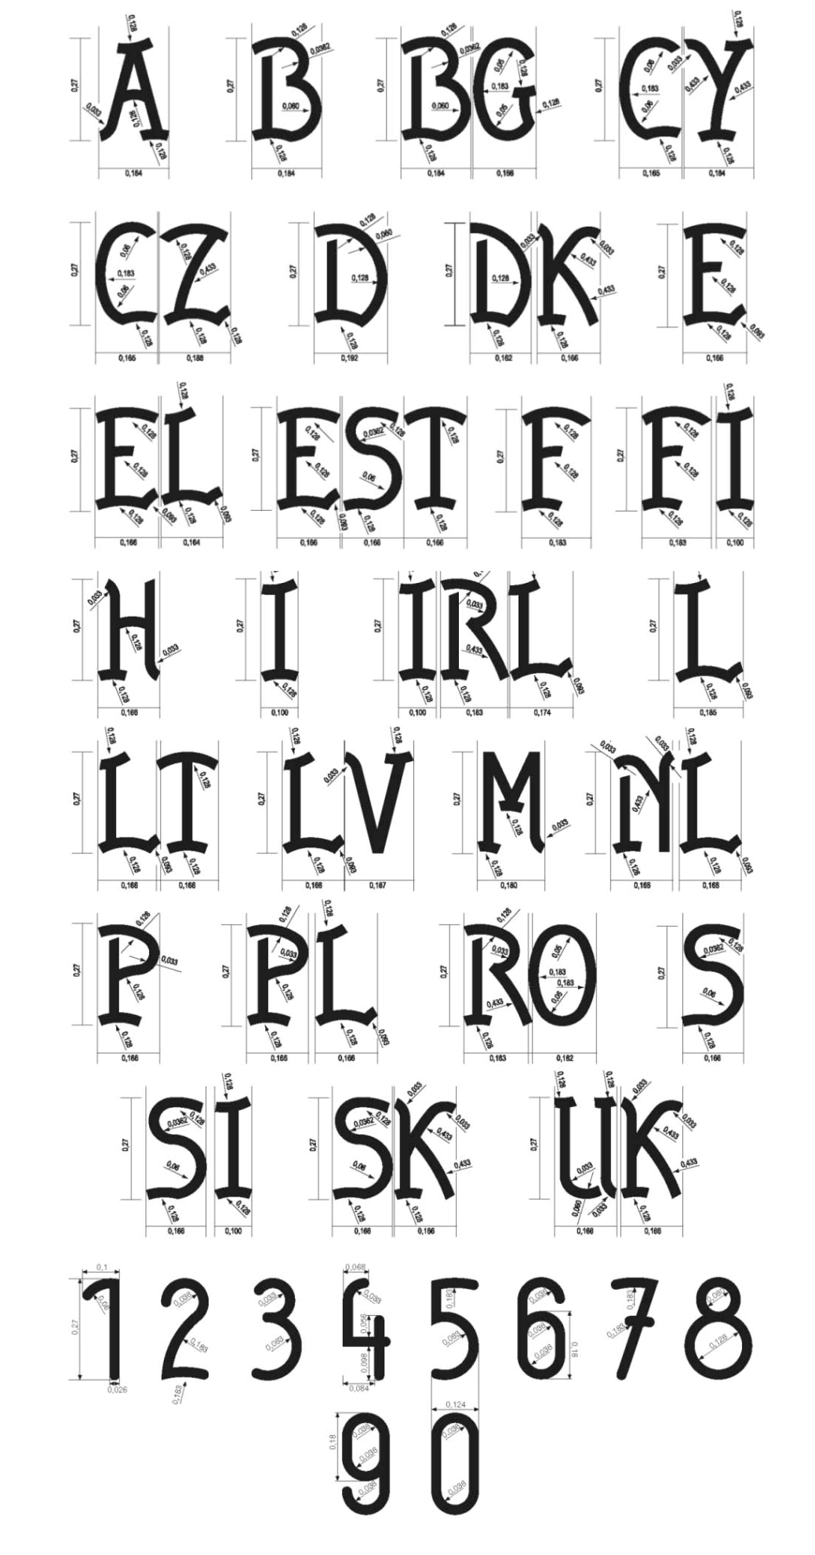

ê 71/316/EEC
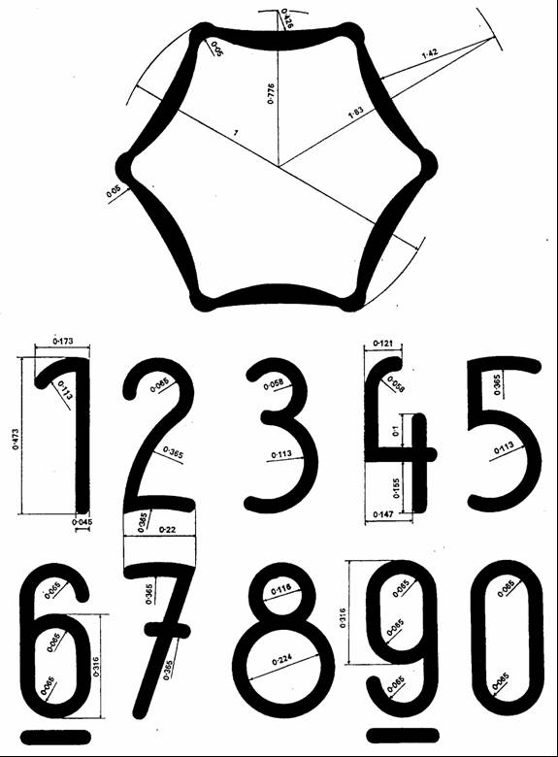
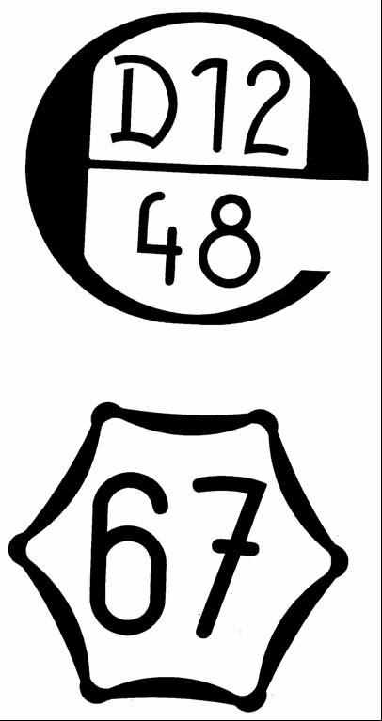
_____________

é

ANNEX III
Part A
Repealed Directive with list of its successive amendments
(referred to in Article 20)
Council Directive 71/316/EEC
(OJ L 202, 6.9.1971, p. 1)
1972 Act of Accession, Annex I, point X.12
(OJ L 73, 27.3.1972, p. 118)
Council Directive 72/427/EEC
(OJ L 291, 28.12.1972, p. 156)
Council Directive 83/575/EEC
(OJ L 332, 28.11.1983, p. 43)
1985 Act of Accession, Annex I, point IX.A.7
(OJ L 302, 15.11.1985, p. 212)
Council Directive 87/354/EEC  (OJ L 192, 11.7.1987, p. 43) | Only regarding references made to Directive 71/316/EEC in Article 1 and Annex, point 4
Council Directive 87/355/EEC
(OJ L 192, 11.7.1987, p. 46)
Council Directive 88/665/EEC  (OJ L 382, 31.12.1988, p. 42) | Only Article 1(1)
1994 Act of Accession, Annex I, point XI.C.VII.1
(OJ C 241, 29.8.1994, p. 211)
Council Regulation (EC) No 807/2003  (OJ L 122, 16.5.2003, p. 36) | Only Annex III, point 5
2003 Act of Accession, Annex II, point I.D.1
(OJ L 236, 23.9.2003, p. 64)
Council Directive 2006/96/EC  (OJ L 363, 20.12.2006, p. 81) | Only regarding references made to Directive 71/316/EEC in Article 1 and Annex, point B.1
Commission Directive 2007/13/EC
(OJ L 73, 13.3.2007, p. 10)

Part B
List of time-limits for transposition into national law
(referred to in Article 20)
Directive | Time-limit for transposition
71/316/EEC | 30 January 1973
83/575/EEC | 1 January 1985
87/354/EEC | 31 December 1987
87/355/EEC | 31 December 1987
2006/96/EC | 1 January 2007
2007/13/EC | 9 March 2008
_____________

ANNEX IV

Correlation Table
Directive 71/316/EEC | This Directive
Chapter I | Chapter I
Article 1(1)(a) | Article 1(1)(a) and Article 1(2)
Article 1(1)(b) | Article 1(1) (b)
Article 1(1)(c) | Article 1(1)(c)
Article 1(2) | Article 1(3)
Article 1(3) | Article 1(4)
Article 1(4) first subparagraph, introductory wording and first indent | Article 1(5)
Article 1(4) first subparagraph, second indent | -
Article 1(4) second subparagraph | Article 1(6)
Chapter II | Chapter II
Article 2(1) | Article 2(2)
Article 2(2) | Article 2(3)
Article 2(3) | Article 2(4)
Article 2(4) | Article 2(5)
Article 2(5) | Article 2(1)
Article 3 introductory wording | Article 3 introductory wording
Article 3 first indent | Article 3 point (a)
Article 3 second indent | Article 3 point (b)
Article 4, first sentence | Article 4, first subparagraph
Article 4, second sentence | Article 4, second subparagraph
Article 4, third sentence | Article 4, third subparagraph
Article 5(1) | Article 5(1)
Article 5(2) first subparagraph | Article 5(2) first subparagraph
Article 5(2) second subparagraph introductory wording | Article 5(2) second subparagraph introductory wording
Article 5(2) second subparagraph first indent | Article 5(2) second subparagraph, point (a)
Article 5(2) second subparagraph second indent | Article 5(2) second subparagraph, point (b)
Article 5(2) second subparagraph third indent | Article 5(2) second subparagraph, point (c)
Article 5(2) second subparagraph fourth indent | Article 5(2) second subparagraph, point (d)
Article 5(2) third subparagraph introductory wording | Article 5(2) third subparagraph introductory wording
Article 5(2) third subparagraph first indent | Article 5(2) third subparagraph, point (a)
Article 5(2) third subparagraph second indent | Article 5(2) third subparagraph, point (b)
Article 5(2) fourth subparagraph | Article 5(2) fourth subparagraph
Article 5(3) | Article 5(3)
Article 6 | Article 6
Article 7(1), (2) and (3) | Article 7(1), (2) and (3)
Article 7 (4) first sentence | Article 7(4) first subparagraph
Article 7(4) second sentence | Article 7(4) second subparagraph
Article 7(4) third sentence | Article 7(4) third subparagraph
Chapter III | Chapter III
Article 8(1) point (a) | Article 8(1)
Article 8(1) point (b) | Article 8(2)
Article 8(2) | Article 8(3)
Article 8(3) | Article 8(4)
Article 9(1) | Article 9(1)
Article 9(2) introductory wording | Article 9(2) introductory wording
Article 9(2) first indent | Article 9(2)(a)
Article 9(2) second indent | Article 9(2)(b)
Article 9(2) third indent | Article 9(2)(c)
Article 9(2) fourth indent | Article 9(2)(d)
Articles 10 and 11 | Articles 10 and 11
Chapter IV | Chapter IV
Articles 12, 13 and 14 | Articles 12, 13 and 14
Chapter V | Chapter V
Article 15 | Article 15
Chapter VI | Chapter VI
Article 16 first sentence | Article 16 first subparagraph
Article 16 second sentence | Article 16 second subparagraph
Article 17 | -
Article 18(1) | Article 17(1)
Article 18(2), first subparagraph | Article 17(2)
Article 18(2), second subparagraph | -
Article 18(3) | -
Chapter VII | Chapter VII
Article 19 | Article 18
Article 20(1) | -
Article 20(2) | Article 19
- | Articles 20 and 21
Article 21 | Article 22
Annex I | Annex I
Points 1 and 1.1 | Points 1 and 1.1
Point 1.2 introductory wording | Point 1.2 introductory wording
Point 1.2 first indent | Point 1.2(a)
Point 1.2 second indent | Point 1.2(b)
Point 1.2 third indent | Point 1.2(c)
Point 1.2 fourth indent | Point 1.2(d)
Point 1.2 fifth indent | Point 1.2(e)
Point 1.3 | Point 1.3
Point 1.3.1 introductory wording | Point 1.3.1 introductory wording
Point 1.3.1 first indent | Point 1.3.1(a)
Point 1.3.1 second indent | Point 1.3.1(b)
Point 1.3.1 third indent | Point 1.3.1(c)
Point 1.3.1 fourth indent | Point 1.3.1(d)
Point 1.3.2 to Point 5 | Point 1.3.2 to Point 5
Point 5.2 | Point 5.1
Point 5.3 | Point 5.2
Point 5.4 | Point 5.3
Point 6 to Point 6.4 | Point 6 to Point 6.4
Annex II | Annex II
_ | Annex III
_ | Annex IV
_____________

COM(87) 868 PV:
Carried out pursuant to the Communication from the Commission to the European Parliament and the Council – Codification of the Acquis communautaire, COM(2001) 645 final.
See Annex III, Part A, of this proposal.
OJ L 184, 17.7.1999, p. 23. Decision as amended by Decision 2006/512/EC (OJ L 200, 22.7.2006, p. 11).
OJ C 255, 21.10.2006, p. 1.
OJ C […], […], p. […].
OJ C […], […], p. […].
OJ C[…], […], p. […].
OJ L 202, 6.9.1971, p. 1. Directive as last amended by Commission Directive 2007/13/EC (OJ L 73, 13.3.2007, p. 10).
See Annex III, Part A.
OJ L 184, 17.7.1999, p. 23. Decision amended by Decision 2006/512/EC (OJ L 200, 22.7.2006, p. 11).

