EN
COMMISSION OF THE EUROPEAN COMMUNITIES
Brussels, 19.6.2008
COM(2008) 391 final

COMMUNICATION FROM THE COMMISSION TO THE COUNCIL AND THE EUROPEAN PARLIAMENT
REPORT ON THE FIRST YEAR OF IMPLEMENTATION OF THE BLACK SEA SYNERGY

COMMUNICATION FROM THE COMMISSION TO THE COUNCIL AND THE EUROPEAN PARLIAMENT
REPORT ON THE FIRST YEAR OF IMPLEMENTATION OF THE BLACK SEA SYNERGY

1. Introduction
In May 2007 the Council adopted Conclusions on the Commission Communication “Black Sea Synergy – a New Regional Cooperation Initiative”. It invited the future Presidencies and the European Commission to continue work on an enhanced and coherent EU engagement in and with the Black Sea region. Given the strategic importance of the Black Sea area for the EU, the Council invited the Commission to carry out a review in the first half of 2008 of the development of the Black Sea Synergy Initiative.
The Black Sea Synergy has been a recurrent topic of discussion in the relevant Council Working Party both under the Portuguese and the Slovenian Presidencies. This has given ample opportunities for Member States and the Commission to examine its evolution.
The European Parliament has adopted a Report on the Black Sea Synergy. It underlines the need for the EU to concentrate on a limited set of priority objectives, avoiding dispersion and duplication of efforts. The European Parliament also considers that, in order to adopt a coherent, effective and result-oriented regional policy approach, the Communication has to be followed by further consistent steps to encourage a genuine regional dimension tailored to this area. It considers that Bulgaria, Greece and Romania, as EU Member States in the Black Sea region, could and should lead the way in promoting enhanced cooperation with and within the region.
The Committee of the Regions has completed an opinion on the Black Sea Synergy which was adopted by its Plenary of 6-7 February 2008.
At the request of the Commission, the Economic and Social Committee is preparing an exploratory opinion on the 2007 Black Sea Synergy Communication.
This report on the first year of the Black Sea Synergy describes the progress achieved so far in implementing the tasks set by the 2007 Communication. It also renders account of the series of contacts and discussions with partners in the Black Sea region. These have led to the launch and endorsement of the Synergy as a collective endeavour and have produced a number of forward-looking proposals.
The Black Sea Synergy Initiative is complementary to the European Neighbourhood Policy, the enlargement policy for Turkey and the Strategic Partnership with the Russian Federation.

2. Progress in carrying out the concrete tasks
The 2007 Communication formulated concrete goals and tasks in sectors or thematic fields. The Commission has started implementing most of these tasks.

2.1. Environment
The Commission is examining the conditions for European Community accession to the Convention to protect the Black Sea against pollution. It has supported studies on the legal changes that would allow for accession. The Ministerial Conference of the Convention to be held in Kyiv in October 2008 is expected to address this question. Full membership of the Bucharest Convention is particularly relevant in view of the recently adopted Marine Strategy Framework Directive. The latter relies largely on regional cooperation, including the framework of regional sea conventions.
Work has begun on exploring the feasibility of replicating the approach of the DABLAS Task Force for other environment sectors, waste being the most promising area. Furthermore, the Commission has launched a project to continue and intensify the work of the Task Force. As a result, the DABLAS Secretariat will provide services for the full DABLAS region, as well as direct investment support to river basin management–related projects.
The Commission will launch soon a climate change technical assistance project which includes the Black Sea region. This will focus on enhancing capacity to implement the Kyoto Protocol and to participate in international negotiations on a post-2012 agreement. Discussions are under way with our partners about region-wide efforts to address climate change.

2.2. Maritime policy and fisheries
In the framework of the recently adopted Integrated Maritime Policy for the European Union the Commission is promoting better cooperation between national authorities responsible for offshore government activities, including in the Western Black Sea region, through the creation of an integrated network of maritime surveillance systems. In this context, it will also look at the possibility of extending such a network to other non-EU Black Sea littoral states.
The Black Sea countries have already established Exclusive Economic Zones and currently prepare to develop a regional Strategy for Integrated Coastal Zones Management. The Commission will complete a Road Map in order to facilitate the development of maritime spatial planning by the end of 2008. Member States in the Black Sea region are encouraged to start their own reflection on maritime spatial planning and learn from the experience of other Member States.
The Commission is in the process of establishing a European Marine Observation and Data Network for all sea basins, including the Black Sea.
EU fisheries management measures have been established in the Council Regulation fixing the fishing opportunities and the conditions relating to certain fish stocks applicable in the Black Sea for 2008. These measures refer only to Bulgaria and Romania while fisheries management and a correct ecosystem approach need to involve all countries around the Black Sea. Therefore the Commission has started working on options for establishing regional fisheries management cooperation. The results of this analysis and the concrete proposals will be consulted with the Member States and the Black Sea coastal states.

2.3. Energy
The Black Sea region has made good progress in mobilising existing instruments and resources. The Republic of Moldova, Turkey and Ukraine have confirmed their intention to engage in formal negotiations to join the Energy Community Treaty, which provides for the implementation of the Community acquis in the electricity and gas sectors. Georgia was accepted as an observer in December 2007.
Concerning energy infrastructure, the Commission has sponsored a feasibility study on a Trans-Caspian-Black Sea Gas Corridor which is examining all the transportation options (pipeline and non-pipeline).

2.4. Transport
The Commission has started streamlining the various transport cooperation efforts. It has launched exploratory talks with the countries of the region on extension of the trans-European transport networks. This involves the possibility of preparing the TRACECA structures to serve as institutions for the south-eastern axis. Together with the TRACECA countries, the Commission is preparing a Transport Ministerial Meeting for the end of 2008 that might adopt the relevant decisions.
Through a series of related projects the Commission has increased its focus on maritime safety and security. Furthermore, it has begun to implement the Motorways of the Sea concept in the Black Sea, closely linked to the TRACECA programme.
Work has started to extend the Common Aviation Area to the Black Sea countries, involving improvement of safety oversight and strengthening of the civil aviation authorities.

2.5. Managing movement and improving security
The Conclusions on the Global Approach to Migration adopted by the European Council in June 2007 endorsed a number of priority actions, including the establishment of a Cooperation Platform on Migration in the Black Sea region. In April 2008 the EU decided to establish this platform, bringing together Member States, EU agencies, countries bordering the Black Sea and regional organisations. The platform will aim to provide for a focused and strengthened migration dialogue and for improving practical cooperation between Member States and the countries in the region, as well as between those countries themselves.
There are advanced plans to fund the further development of the Burgas Black Sea Coordination Centre. Each Black Sea country is expected to establish national centres that will feed/exchange relevant information to/through the Coordination Centre. The Commission is co-funding two projects against trafficking in human beings through labour market based measures and police measures respectively.

2.6. Research, science and education networks
The Commission has been supporting institutional cooperation and structural reforms in higher education via the Tempus programme. Black Sea regional cooperation in higher education will benefit from the new phase of the programme that will give priority to multi-country projects. Higher education cooperation and academic mobility continues to be fostered via the Erasmus Mundus programme.
The Black Sea Interconnection (BSI) project (approved for funding in 2007) will build a regional research and education network linking it to GÉANT2, the high bandwidth, pan-European research network. This flagship project is the largest of its kind in the region.
The Commission also supports regional scientific cooperation, i. a. through the INCONet EECA project which started in January 2008.

2.7. Employment and social affairs
Activities at regional level started recently. They either address specific issues of the Black Sea region (such as a seminar on social dialogue to take place in 2008) or, in a larger context, thematic subjects (such as the seminar on gender equality in November 2007).

2.8. Trade
The EU has continued to encourage Black Sea regional trade liberalisation, supporting in particular the partner countries' efforts to join the WTO.

2.9. Democracy, respect for human rights and good governance
The first of a series of Black Sea Synergy civil society seminars on human rights issues took place in May 2008 in the Republic of Moldova. This event presented standards on freedom of expression in a civil society perspective. Participants included government officials and members of civil society from the Black Sea countries. Recommendations to governments concerning freedom of expression were adopted.

2.10. The “frozen conflicts”
The Commission has continued to advocate an active EU role in addressing the underlying causes of these conflicts, i. a. in the Black Sea regional framework. Attention has been paid to promoting confidence-building measures also in wider regional context, including cooperation programmes specifically designed to bring the otherwise divided parties together.

3. Cross-border Cooperation, working with civil society
The European Neighbourhood and Partnership Instrument Cross-border Cooperation programmes promote cooperation between local authorities of bordering regions addressing common challenges. They also facilitate people-to-people contacts.
The Black Sea CBC Programme is in its launch phase. A “Joint Operational Programme” has been drawn up by the parties (representing the national and regional authorities of 10 states). The programme is allocated € 17.5 million. The first calls for proposals are expected to be published before the end of 2008.
The Romania-Moldova-Ukraine CBC programme covers the north-western coast of the Black Sea with an allocation of € 126 million. Its implementation should start in the autumn of 2008.
The Black Sea Forum has increased its focus on civil society. Its first civil society activities have already taken place.
The Black Sea Synergy has attracted considerable NGO interest. An alliance of 29 environmental NGOs met in Odessa on 7 February 2008 and adopted a position paper on “Greening the Black Sea Synergy”.

4. Assistance
In 2007 € 837 Million worth of Community assistance under ENPI and the Instrument of Pre-Accession were committed for the seven non-EU countries of the Black Sea region. (Details are provided in the Annex.)
In addition, the creation of the Neighbourhood Investment Facility (NIF) offers a vehicle for pooling grant resources from the Community and the Member States. These resources can also leverage additional loan financing from European public finance institutions for investments in neighbouring countries, including in the Black Sea region. The NIF will make it easier to mobilise additional funding for priority projects and can thus also sustain Black Sea regional cooperation efforts.

5. Other cooperation with partner countries, regional and international organisations
All Black Sea countries have been involved in Black Sea Synergy discussions. The Presidencies and the Commission have conducted a series of consultations with them in different formats.
The recent period has seen the rapid development of relations between the European Union and the Organisation of the Black Sea Economic Cooperation (BSEC). In June 2007 the Commission obtained observer status in the BSEC. Representatives of the EU Presidency, the incoming Presidency and the Commission joined the Foreign Ministers of the BSEC at a working breakfast in Kyiv in February 2008. The extended BSEC troika had three meetings with the respective Council Working Party. Commission representatives attended all high level BSEC meetings and contributed to the activities of BSEC Working Groups.

6. The Foreign Ministers’ meeting in Kyiv (14 February 2008)
A Foreign Ministers’ meeting took place at the initiative of the European Union involving all regional partners, the EU Member States and the EU institutions.
The meeting launched the Black Sea Synergy as a common endeavour. A Joint Statement was adopted by participants. It welcomes the Black Sea Synergy and states that greater involvement by the European Union can increase the potential of Black Sea regional cooperation. The Black Sea Synergy will benefit from the European Neighbourhood Policy and other EU policies applied in the relationship with countries of the region. EU support to Black Sea regional cooperation is aimed at producing tangible results in a number of priority areas, notably energy, transport, communication, trade, environment, maritime policies, fisheries, migration, law enforcement and the fight against organised crime. The Statement adds that increased EU engagement has the potential to bring benefits also in the fields of trade, science, research, culture and education as well as employment and social affairs.

7. The way forward

Experience of the first year has proven the validity of the principles contained in the 2007 Communication. The initiative’s main goal remains to invigorate action at regional level promoting stability and prosperity in the Black Sea area. It is a flexible, inclusive and transparent framework, based on the common interests of the EU and of all Black Sea states.
The Commission welcomes the fact that Black Sea Synergy participants envisage continuing the present pragmatic and project-oriented approach. Consequently, work should proceed to accomplish the tasks set by the 2007 Communication and the Kyiv Joint Statement. Interaction with the BSEC and other regional bodies providing added value should continue.
During the Foreign Ministers’ meeting in Kyiv and the months thereafter, EU Member States and Black Sea Synergy partners have made suggestions as to how the Black Sea Synergy co-operation process can be firmly rooted as a long-term endeavour. These proposals can provide new impetus to regional cooperation with our partners to the east of the European Union. The Commission intends to explore and actively take them forward to promote more effective and ambitious action:
- Long-term, measurable objectives in fields like transport, environment, energy or maritime safety should be set to spur more concerted action. These would require the support of all BSS members. In each case a lead country and/or organisation should be identified to ensure coordination of activities which might be undertaken at national or regional level to achieve the objectives set.
- To facilitate the realisation of projects, sectoral partnerships could be established to provide a framework for co-financing (including through the NIF) and a basis for the involvement of IFIs. These partnerships might bring together all or some of the Black Sea Synergy participants to cooperate on a series of projects. The successful experience of the Northern Dimension provides a useful example of how this could work.
- The frequency of ministers’ meetings should reflect concrete needs. In some cases they could take place in the existing sectoral frameworks (such as TRACECA or the Baku Initiative) or could follow the Kyiv model (back-to-back with BSEC meetings, with full EU participation or involving an open troika). Foreign ministers could meet as required to mark the major milestones of the process.
There have been a number of other proposals that also deserve further study:
- involvement of Belarus in some of the sectoral activities, related to the Synergy
- creation of a Black Sea Civil Society Forum
- strengthening of academic and student networks
- establishment of an Institute of European Studies in the Black Sea Region
The Commission stands ready to work with Member States and all stakeholders on these and other new ideas, strengthening Black Sea regional co-operation that:
- complement the bilateral, tailor-made cooperation we have with our partners under the ENP and other policies applying in the region
- are inclusive, involve all Member States and Black Sea countries
- provide added value

8. Conclusion
The initial results of the Black Sea Synergy reveal the practical utility and the potential of this new EU regional policy approach. The launch phase of the Synergy has been completed and implementation has begun. Participants favour the establishment of a long-term Black Sea co-operation process and have formulated converging ideas about its content and arrangements.
Experience in the first year also demonstrates that the development of EU-supported Black Sea regional cooperation is a process taking place in a complex environment. Continued progress requires the consistent and active involvement of a growing number of actors, including both Member States and Black Sea partners. As in the first year, the Commission will be ready to contribute to this important work.
ANNEX I
Black Sea Country Map
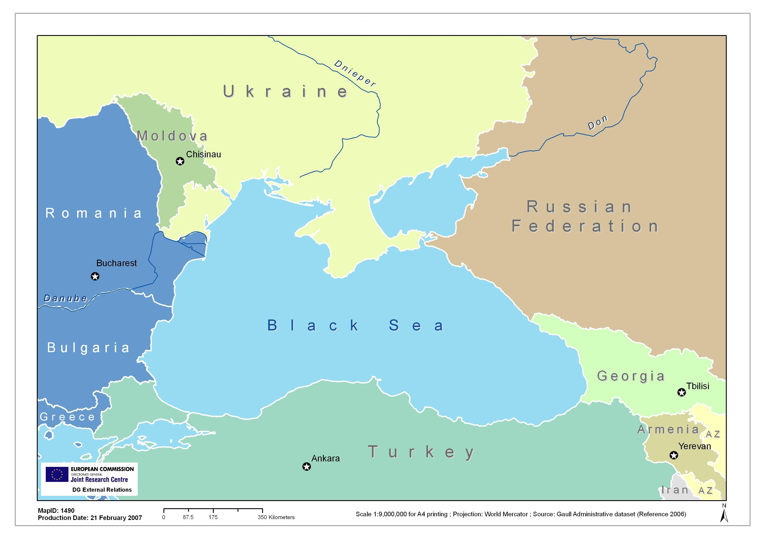
ANNEX II
EC Assistance to Countries covered by the Black Sea Synergy (Commitments € million)
 | 2000-2006 under Tacis and instruments for Turkey | 2007 under ENPI /IPA | 2007 under EC humanitarian aid instrument
Bilateral Co-operation
Armenia | 44,8 | 24
Azerbaijan | 72,6 | 22 | 1,35
Georgia | 65 | 28,8 | 2
Moldova | 86,5 | 45,7 | 3
Russian Federation | 559 | 13 | 19,45
Turkey | 1040 | 497,2
Ukraine | 501,5 | 144
Total Bilateral | 2369,4 | 774,7
Regional Co-operation | 962,2 | 62
Total | 3331,6 | 836,7 | 25,8

COM 2007 (160) final, adopted 11. 04. 2007
The Black Sea region (See Map in Annex) includes Greece, Bulgaria, Romania and Moldova in the west, Ukraine and Russia in the north, Georgia, Armenia and Azerbaijan in the east and Turkey in the south. Though Armenia, Azerbaijan, Moldova and Greece are not littoral states, history, proximity and close ties make them natural regional actors.
Report on a Black Sea Regional Policy Approach (2007/2101(INI))
RELEX-IV-008 COR
The Danube-Black Sea Task Force was set up by the countries of the Danube and the Black Sea regions to encourage a strategic focus in investments concerning water.
COM (2007) 575 final - An Integrated Maritime Policy for the European Union
The TRAnsport Corridor Europe-Caucasus-Central Asia (TRACECA) programme provides assistance covering road, rail, aviation and maritime transport connections.
Black Sea Border Coordination and Information Centre based in Burgas, Bulgaria.
Armenia, Azerbaijan, Bulgaria, Georgia, Greece, Moldova, Romania, Russian Federation, Turkey and Ukraine
The participation of Turkey in the programme is financed additionally by funds under the Instrument of Pre-Accession
A Romanian initiative
The BSEC was established in 1992. Initially focusing on economic cooperation, its remit has been gradually widened. Membership includes all Black Sea countries as listed under footnote 2 plus Albania and Serbia.
The Russian Federation did not take part in discussions about the Joint Statement., since it preferred an EU-BSEC Statement. However, the Russian Federation stressed that it supported the increased EU role contained in the Joint Statement. Therefore it did not oppose the document’s adoption.
Northern Dimension Partnerships select and finance projects serving agreed goals and using dedicated funds

