EN
COMMISSION OF THE EUROPEAN COMMUNITIES
Brussels, 3.7.2008
COM(2008) 423 final

GREEN PAPER
Migration & mobility: challenges and opportunities for EU education systems

{SEC(2008) 2173}
(Presented by the Commission)

1. Introduction
1. This Green Paper addresses an important challenge facing education systems today, a challenge which, while not new, has in recent years intensified and become more widespread – the presence in schools of large numbers of children from a migrant background who are in a weak socio-economic position.
2. The terms "children from a migrant background", "children of migrants" and "migrant pupils" will be used for the specific purpose of this Paper to refer to the children of all persons living in an EU country where they were not born, irrespective of whether they are third-country nationals, citizens of another EU Member State or subsequently became nationals of the host Member State. This is, at the same time, a broad concept of "migration" which differs from certain EU-level texts dealing with immigration policy. Despite important legal and practical differences with the situation concerning third-countries citizens, EU citizens residing in another Member State have been included in this Paper on the basis that the specific educational issues addressed in the text are likely to apply also to a significant number of them. This is also mirrored by the fact that the data sources on which the Paper relies extensively, PIRLS and PISA, do not distinguish between the countries of origin, whether their citizens come from the EU or third countries.
3. Historically high inflows of third country nationals into the EU, coupled with high internal EU mobility in the wake of the two most recent enlargements, mean that schools in a number of EU countries are experiencing a sudden and steep rise in the numbers of such children. PISA (2006) data show that at least 10% of the school population at age 15 within the EU 15 countries was either born abroad or has both parents born in another country; the figure approaches 15% at the fourth grade of primary school. In some countries, such as Ireland, Italy and Spain, the percentage of school pupils born in another country has multiplied by three or four since 2000. In the UK, the number of pupils joining schools shortly after arriving from abroad has grown 50 per cent in two years, augmenting an already high number of pupils from a migrant background. Furthermore, migration flows tend to result in concentrations of migrant pupils in urban areas and in particular cities; for example, in Rotterdam, Birmingham or Brussels, approximately half of the school population has an immigrant background. In Madrid, the share of migrant pupils has multiplied by ten since 1991.
4. The presence of significant numbers of migrant pupils has important implications for education systems. Schools must adjust to their presence and build their particular needs into the traditional focus on providing high quality and equitable education. Education is key to ensuring that these pupils are equipped to become integrated, successful and productive citizens of the host country, in other words that migration can be positive both for migrants and for the host country. Schools must play a leading role in creating an inclusive society, as they represent the main opportunity for young people of migrant and host communities to get to know and respect each other. Migration can be enriching for the educational experience of all: linguistic and cultural diversity may bring an invaluable resource to schools. It can help to deepen and strengthen pedagogies, skills, and knowledge itself.
5. Migration influences the education of children even where their families have a high socio-economic and educational status. Such pupils may be adversely affected at least in the short run by interrupted schooling or by having to face linguistic and cultural difference; however, longer-term prospects for their education success look good and their exposure to new cultures and languages is likely to enhance their human capital. Clearly many children of migrants, including many in the wave of recent arrivals, will fall into this group. However, the focus of this Green Paper is on the combination of linguistic and cultural difference with socio-economic disadvantage, its tendency to be concentrated in certain areas and particular schools. This is a substantial educational challenge and whether systems succeed or fail has important social consequences. As the evidence presented below will show, there are significant and often persistent gaps in the educational attainment of children from a migrant background vis-à-vis their peers. In a report published in 1994, the Commission highlighted the risks which could flow if educational opportunities for children of migrants were not improved – widening social divisions which are passed down across generations, cultural segregation, exclusion of communities and inter-ethnic conflict. The potential for such consequences remains.
6. Responsibility for setting educational policies remains firmly a matter for Member States. Nevertheless, the challenges outlined here are, increasingly, widely shared. The European Council of 13-14 March 2008 called on Member States to improve the achievement levels of learners with a migrant background. The 2008 Joint Report on the implementation of the Education and Training 2010 Work Programme drew attention to educational disadvantage of many migrant pupils as they require additional attention. The analysis which follows shows that some countries succeed better than others in reducing the gaps in educational attainment between migrant pupils and the rest of the host peers. There is clear potential for mutual learning about the factors which shape educational disadvantage and the policies which can help to address it.
7. Directive 77/486/CEE represents an earlier attempt by the EU to promote a focus by Member States on the education of the children of migrant workers. This Directive applies to children for whom school attendance is compulsory under the laws of the host Member State, and who are dependants of a worker who is a national of another Member State. It provides that Member States should:
- ensure free tuition in their territory, adapted to the specific needs of such children, in particular the teaching of an official language of the host State; and
- promote teaching of the mother tongue and culture of the country of origin, in coordination with normal education, in cooperation with the Member State of origin.
8. The Green Paper invites a reflection on the future of the Directive, on what role it might now play in addressing the objective which originally underpinned its adoption - to strengthen the education of children of migrant workers from EU countries and thus to contribute to one of the main four freedoms secured by the Treaty.
9. The educational challenge which school systems face has evolved considerably since Directive 77/486/CEE was adopted. In that it deals only with the education of children who are EU citizens, this Directive does not address a substantial part of that challenge – the education of children who are third-country nationals. As will be seen, the Directive's implementation has been patchy. The proposed reflection should address whether the Directive adds value to Member States' policy efforts in this field and whether it represents the best way for the EU to support such efforts.
10. This Green Paper also outlines a framework for looking at the entire set of challenges surrounding the education of children of migrants and invites interested parties to contribute their ideas about how the EU might in future support Member States in formulating their education policies in this area and on how a possible future process of exchange and mutual learning might be organised and what it should cover.

2. The educational situation of children from a migrant background

2.1. Many children of migrants suffer from educational disadvantage
11. There is clear and consistent evidence that many children of migrants have lower levels of educational attainment than their peers. The PIRLS survey on literacy shows migrant pupils scoring less well than their non-migrant peers by the end of primary school.
Figure 1 - Difference in performance in reading between pupils with both parents born in the country and neither of parents born in the country, 2006
(performance on the PIRLS reading scale – mean score)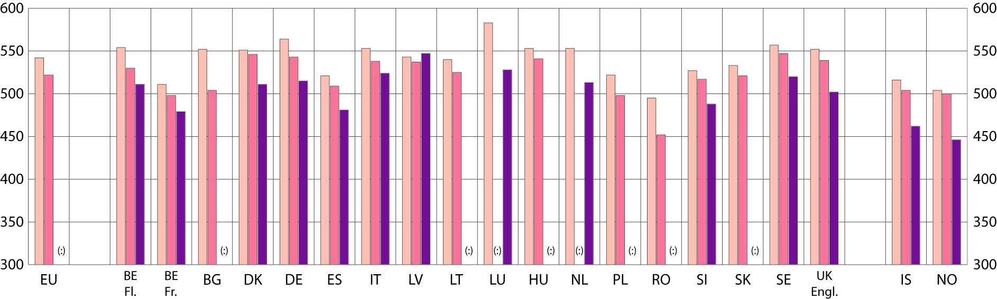
 | both parents born in the country |  | Only one parent born  in the country |  | Neither parent born  in the country
Data source: 2006 PIRLS data set
12. The OECD PISA survey on standard academic skills of 15-year-olds confirms that migrant pupils in this age group tend to systematically perform less well than host countries pupils across each of the tested subject areas, science, mathematics and, most strikingly, reading.
Figure 2 - Differences in student performance in mathematics, by immigrant status and country
(Performance on the mathematics scale – mean score)
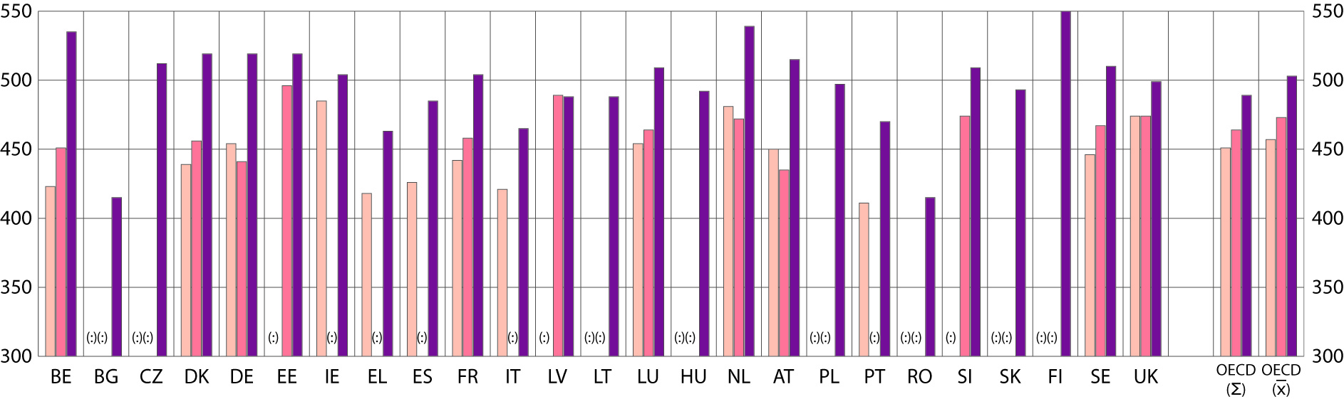
 | First-generation students |  | Second-generation students |  | Native students

Data source: OECD PISA 2006
Figure 3 - Differences in student performance in reading, by immigrant status and country
(Performance on the reading scale – mean score)
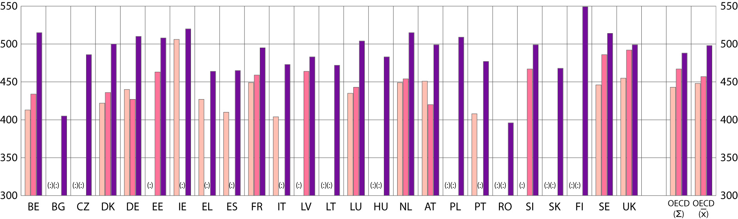
 | First-generation students |  | Second-generation students |  | Native students

Data source: OECD PISA 2006
Figure 4 - Differences in student performance in science, by immigrant status and country
(Performance on the science scale – mean score)
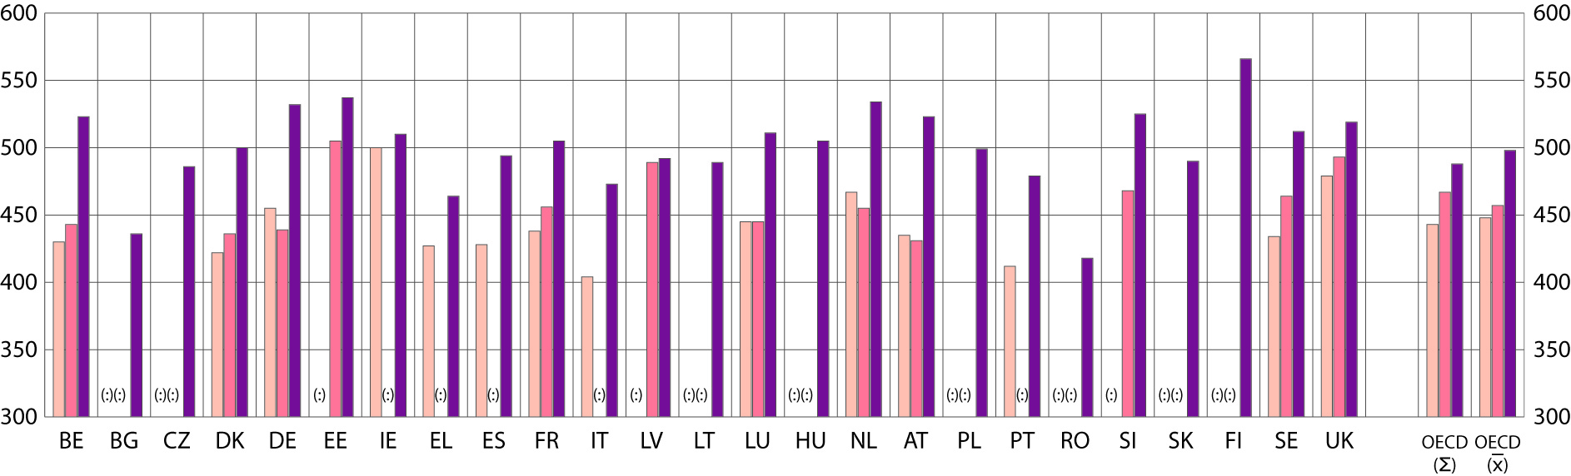
 | First-generation students |  | Second-generation students |  | Native students

Data source: OECD PISA 2006
13. National indicators confirm this observation.
14. This pattern of underperformance in educational attainment is echoed in the comparative patterns of enrolment of migrant pupils. Although there has been some improvement over the years, in most countries it is less common for migrant pupils to enrol in pre-primary education and they tend to do so later than their peers. In primary school, compulsory enrolment ensures that there is no difference between the levels of participation of migrant and other pupils. However, at secondary level, a clear degree of segregation in enrolment emerges as migrant pupils are over-represented in vocationally oriented schools that typically do not lead to higher education. And, most clearly of all, there is a greater incidence of early school leaving among migrant pupils in almost all countries. All these factors contribute to the relatively low numbers of migrant students completing university studies.
15. Finally, PISA highlights a particularly stark point for education policy makers – attainment gaps in certain countries within each of the three study domains actually worsen from the first generation of migrant pupils to the second. This means that education is in these situations failing to act as a force to include migrants, indeed that the increased gaps in educational attainment are likely to cement and intensify their social exclusion.
Figure 5 - Share of early school leavers by nationality, 2005
(Percentage of the population aged 18-24 with only lower-secondary education and not in education or training, by nationality, 2005)
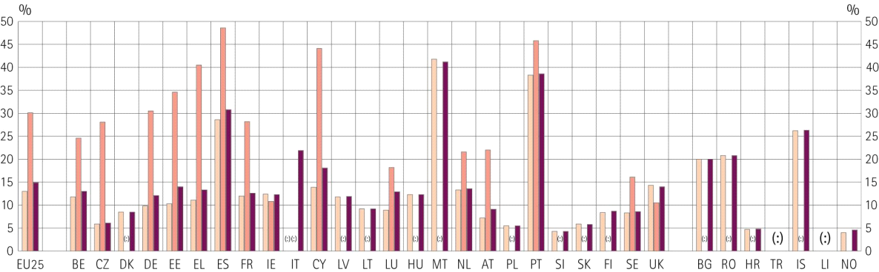
 | National |  | Non-national |  | Total

Data source: Eurostat (Labour Force Survey), 2005

2.2. Impact of migration on education systems
16. Adapting to the presence of high numbers of migrant pupils poses a range of challenges for education at the level of the classroom, the school and for school systems.
17. Within classes and schools, it is necessary to accommodate increased diversity of mother tongues, cultural perspectives and attainments. New, adapted teaching skills will be needed and new ways of building bridges with migrant families and communities need to be developed.
18. At the level of the school system, the presence of large concentrations of migrant pupils can intensify tendencies – already there in even the best school systems - toward segregation along socio-economic lines. This can take different forms, as the socially advantaged may quit schools with high numbers of migrant pupils. Whatever the mechanism, the phenomenon increases disparities between schools and adds significantly to the challenge of achieving educational equity.
19. The educational challenge must always be seen in the broader social cohesion context – any failure to fully integrate migrant pupils within schools is likely to be echoed in a broader failure of social inclusion. Low educational attainment, low rates of school completion and high early school leaving will undermine the chances of young migrant pupils for successful labour market integration later in life. Failure to integrate education systems can also hinder development of the positive social bonds and interaction between different groups necessary for a cohesive society. If children of migrants leave school with an experience of underachievement and segregation which carries on in their later life, the risk is that such a pattern is perpetuated also in the next generation. Conversely, where schools succeed in serving their migrant pupils well, this will prepare the way for their successful integration in the labour market and society. In this way, good schooling of migrant pupils answers both to equity and efficiency objectives.
20. Migration can bring culturally and educationally valuable elements to the school. Being confronted with other viewpoints and perspectives has the potential to be enriching both for students and teachers. Intercultural skills and the capacity to enter into a tolerant and respectful dialogue with people from a different cultural background are competences that need to be, and can be, built.

3. reasons for educational disadvantage among children from a migrant background
21. Many factors are likely to lie behind the pattern of educational disadvantage among children from a migrant background described above.

3.1. The situation and background of children from a migrant background
22. School performance is generally strongly correlated with socio-economic conditions. Thus a first cause of difficulties for migrant pupils is their often poor socio-economic background. Nevertheless, socio-economic situation does not account for the full extent of disadvantage among migrant pupils - PISA shows that they are likely to have worse school results than other children from a similar socio-economic background, and that this happens more in some countries than in others.
23. Among the factors which bring this about are the following:
- Migrants and their families experience a loss of value of the knowledge they have accumulated, notably their native language, but also their knowledge on the functioning of institutions and particularly of education systems. Furthermore, their qualifications may not be formally recognised or may be less well regarded.
- Language is a key factor. Proficiency in the language of instruction is a vital condition for success at school. Even for children of migrants born in the host country, this may be an issue if the language of school cannot be reinforced in the home. Language may also be a barrier between migrant families and the school, making it hard for parents to support their children.
- Expectations matter enormously in education. Families and communities that attach great importance to education are likely to support their children at school more strongly. Mothers are particularly influential on school performance. The way women are educated, empowered and able to take decisions for their children in a particular community can strongly influence their children’s performance. Incomplete education for girls may not only affect them, but may transmit disadvantage to the next generation. Children's attitudes to education may be less positive if they live in a world where unemployment among their own community is high and labour market and entrepreneurial success is rare.
- Role models and supportive community attitudes can have a significant influence, but may be absent if the socio-economic position of the community is weak. Some migrant communities illustrate the point in a positive way; certain groups of Asian origin in the UK are comparatively disadvantaged, yet produce very high levels of admissions to the national higher education system.

3.2. The educational environment
24. Even where patterns of migration are similar, the performance of migrant pupils of the same origin varies between European countries. This suggests that policies and educational approaches do matter. The structure of the education system, and the way schools and teachers relate to them, can have a significant impact on attainment. Peer pressure influences achievement. Migrant pupils tend to perform better when they are taught together with classmates skilled in the host language and who have high educational aspirations.
25. But the tendency towards segregation in many systems is strong. Migrant pupils are often concentrated in schools that are de facto segregated from the mainstream and which are in a downward quality spiral, reflecting, for example, high teacher turnover. PISA shows lower performance of pupils in schools with high concentrations of migrant pupils. Segregation also happens within schools: there is evidence that ability grouping/tracking places a disproportionately high share of migrant pupils into lower-ability streams – reflecting, possibly, lower initial levels of educational attainment and/or linguistic capacity. Finally, the high concentration of children of migrants in special schools for disabled pupils evident in some countries is an extreme case of segregation. It is a priori unlikely that migrant pupils suffer from very different levels of disability across countries.
26. All forms of school segregation will weaken the ability of education to deliver on one of its main objectives – to build social inclusion, friendships and societal bonds between children of migrants and their peers. In general, the more the school policies counteract all forms of de facto segregation of migrant pupils, the better will be the educational experience.
27. Educational approaches may contribute to the problem of low expectations referred to above. Expectations formed, for instance, in respect of less verbal pupils (likely, for language reasons, to include many migrant pupils) may underestimate their potential.

3.3. Some Positive Policy Responses
28. Research and exchanges have identified policies and approaches that are likely to foster educational success for migrant pupils. In general, research shows that migrant pupils perform better where socio-economic status and educational achievement are less correlated. In other words, those systems which strongly prioritise equity in education are likely to be most effective in responding to their particular needs. Comprehensive strategies across all levels and strands of the system will work best; partial measures may simply transfer problems of inequality or poor attainment from one segment of the system to another. Furthermore, policies to build equity in education will work best within a broader framework to build an inclusive society.
29. There are also a range of policy approaches which address specific aspects of migrant pupils' educational experiences.
- Member States all stress acquisition of the host language as key to integration and have all put in place specific provisions to support this, for example, language classes for newly arrived migrant pupils (sometimes also offered to pupils of a migrant background born in the host country who have not yet mastered its language). Other practices promote language proficiency as early as possible - early language testing for all children; pre-school language training; and equipping teachers with the competence to teach the host language as a second language.
- In addition to this primary focus on the host language, there have been efforts to promote learning of the heritage language, sometimes within the framework of bilateral agreements with other Member States envisaged under Directive 77/486/CEE. Scope for such learning is increased by new opportunities for mobility, media and internet contact with the country of origin and e-twinning between schools of host and sending countries. There is some evidence that reinforcing the heritage language can be educationally advantageous. Fluency in the heritage language is valuable for the cultural capital and the self confidence of children of migrants and it may also represent a key asset for their future employability. Furthermore, an eventual return to the country of origin may be a desirable option for some migrant families; education in the heritage language will ease this.
- Many countries offer targeted support to counterbalance educational disadvantage. While not directed at migrant groupsper se, such measures are likely to be highly relevant to them. These may be aimed at individuals – scholarships and possible quotas for participation in prestigious educational institutions (quotas are often highly controversial). Others are aimed at families, in the form of grants conditional on school attendance or performance; there is evidence that these have had some success. Targeted support is also allocated to schools with a high proportion of migrant pupils but results seem modest, perhaps due to lack of critical mass or from being poorly targeted.
- There are numerous programmes to offer additional educational support to target groups, for example, learning and homework centres after regular classes, often implemented in partnership with the community. Mentoring and tutoring of children, for example by higher education students, is provided. It has proved particularly successful when undertaken by people of the same origin, and as part of wider partnerships with parents’ organisations and community institutions, which may also include other measures, such as the appointment of school mediators.
- Second chance education has been used in some systems but with a clear recognition that it should not become a parallel, segregated provision for those who do not succeed in the mainstream. Adult education, in particular language training, is widely promoted among migrant communities as a means to help to break the intergenerational transmission of disadvantage highlighted earlier and to ease communication between school and families.
- Pre-school education brings major benefits. And, where it places a strong focus on language development, it can be of particular help in equipping migrant pupils for later schooling. As noted in section 2.1, children of migrants are often the ones with the lowest access; systems which have put in place financial support to socially disadvantaged families to access childcare have shown some good results.
- Integrated education, which counters the tendencies towards segregation mentioned before, is an explicit goal in some systems. As segregation is difficult to eliminate once it has developed, countries newly experiencing large-scale migration may have an interest in a prevention strategy, to ensure that socio-economic and ethnic balance is maintained right from the start. Schools and services can be networked to spread migrant pupils and so avoid concentrations. Measures to improve the attractiveness of schools catering to large numbers of disadvantaged pupils - the creation of so-called "magnet schools” have yielded encouraging results.
- Ensuring quality standards in all schools is a key step. Building quality can involve policies to build bridges with parents, improve infrastructure, broaden extra-curricular activities and establish an ethos of respect. Above all practices have focused on teaching and leadership. Some systems have sought to address high teacher turnover among disadvantaged schools by creating incentives for teachers to opt for and remain at such schools. Training and professional development of teachers on how to deal with diversity and motivate children in vulnerable situations is increasing. Increasing the number of teachers from migrant backgrounds is an explicit goal in some systems.
- Deepening knowledge about one's own culture and about the cultures of others may support migrant pupils' self-confidence while providing value for all pupils. Such intercultural education in no way needs to weaken the primary focus on the identity, values and symbols of the host country. It involves above all building mutual respect, developing understanding of the negative effects of prejudices and stereotypes and cultivating the ability to take different viewpoints, while increasing knowledge of and seeking respect for the core values and fundamental rights of the host society.

4. Addressing the issue at the European level
30. The content and organisation of education and training are national competences. It is at the national or regional level that strategies need to be defined and implemented. Member states have expressed an interest in co-operating on inclusion of children of migrants. The European Commission can facilitate such co-operation. The shared nature of the challenge and of the factors which lie behind it, coupled with the range of approaches being implemented in different Member States, regions and cities, suggests that there is scope for a fruitful dialogue.
31. The European Union already undertakes a number of different types of activity which impact, directly or indirectly, on Member States policies on these issues. In addition, the role played by Directive 77/486/CEE in shaping the policy effort in this field needs to be considered.

4.1. Role of EU programmes and Actions
32. The European Commission already supports a number of programmes and actions which relate, inter alia, to this issue. In 2005, the Commission put forward 'A Common Agenda for Integration: a framework for the integration of third-country nationals in the European Union', proposing measures to put into practice the Common Basic Principles on Integration (CBPs), together with a series of supportive EU mechanisms including National Contact Points on Integration, European Integration Forum and Annual Reports on Migration and Integration. In addition, the European Fund for the Integration of Third-country Nationals is further facilitating integration measures for migrant youth and children. The Recommendation of the European Parliament and the Council on “Key Competences for Lifelong Learning” of 18 December 2006 lists the type of attitudes, knowledge and skills with which education should provide people to facilitate their personal fulfilment and development, active citizenship, social inclusion and employment in modern Europe. Competences numbers 6 (Social and Civic Competences) and 9 (Cultural awareness) are particularly relevant in the context of a high incidence of migrant pupils and may be useful as a framework for developing national educational approaches.
33. The Lifelong Learning Programme, especially the actions Comenius (school education), Leonardo da Vinci (vocational training) and Grundtvig (adult education) and the Youth Programme support projects related to intercultural education, school integration of migrant pupils and social inclusion for disadvantaged youth. Examples are listed in the Annex.
34. Cohesion Policy, via the Structural Funds, in particular the ESF and the ERDF, have the capacity to support social inclusion projects and measures at national level and regional level. The “Regions for economic change” through the Urbact Programme initiative will foster trans-national cooperation and exchange of best practices. Social inclusion of migrant youth has a high priority. The Community programme for employment and social solidarity, Progress, also provides scope for trans-national co-operation.
35. The 2007 European Year on Equal opportunities for all and the 2008 European Year on Intercultural Dialogue provide a framework for promoting a European debate on inclusion and on migrant youth.

4.2. European level policy exchanges
36. The Open Method of Coordination for Education and Training provides a forum for co-operation and exchange between Member States on common educational challenges. The Commission will make proposals for a new framework for this process in December 2008, which could, inter alia, accommodate policy exchange on this issue. This could include an exploration of the possible development of indicators or benchmarks related to the gaps in educational attainment and enrolment of migrant pupils.
37. The European Commission works closely with international organisations who also address education and migration as part of their work, such as the OECD and the Council of Europe. This co-operation will continue to be a priority.

4.3. The role of Directive 77/486/CEE on the education of the children of migrant workers
38. In the context of the policy reflection set out here, the question arises as to what role Directive 77/486/CEE can in future play in helping to shape national policy making.
39. Transposition, implementation and monitoring of the Directive have proven difficult, at least in part because the context of managed migration through bilateral agreements between Member States, in which the Directive was conceived, was not current anymore by the time of its adoption. Given the difficulty experienced in generating the bilateral cooperation needed for formal implementation within the then EC of nine member states, it is not clear how implementation can now be meaningfully improved within an EU of 27 Member States.
40. There is, secondly, a question of the Directive's scope. The challenge now concerns to a considerable extent the education of children coming from third countries. Their situation is not covered by the Directive.
41. Finally, the added-value of the Directive's provisions for educational policy-making should be assessed. The Directive's first provision – that Member States shall "ensure that free tuition to facilitate initial reception is offered in their territory [to the children of migrant workers], including, in particular, the teaching of the official language or one of the official languages of the host State " – seems to have had little impact in shaping Member States' policies in the face of the complex set of challenges described in this text. Member States have all developed their own approaches to the teaching of the host country language. Looking to the wider questions regarding the teaching of children from a migrant background, the question must be asked whether Member States are likely to be helped more by the Directive or through a mix of policy exchange and programme support for policy development.
The Directive's second provision – that Member States shall "in cooperation with the States of origin, take appropriate measures to promote in coordination with normal education, teaching of the mother tongue and culture of the country of origin" – allows a large degree of flexibility in the way the obligation is to be achieved. It has had some patchy impact and can, in the circumstances as outlined in section 3.1 above, be shown as an educationally valid approach. Moreover, the volume of intra-EU mobility of workers from EU Member States has increased sharply in recent years in the wake of the 2004 and 2007 enlargements. This, potentially, may bring about a renewed interest in the promotion of heritage language learning among children of migrants in general. Whether this is best implemented via legislative instruments based on the Treaty's different legal regimes for EU and third-country nationals or via the promotion of voluntary arrangements – which might be within or outside the formal school system – is unclear. Reflecting the Directive's requirement to deliver this objective in cooperation with the Member State of origin, the creation of networks, school twinning could be used to develop teaching of the heritage language in particular schools or localities with the support of the Lifelong Learning programme. Teacher training could also be developed to support such teaching.

5. Proposal for a consultation
42. The Commission feels that it would be valuable to undertake a consultation with interested parties about education policy for children from a migrant background. Interested parties are invited to make their views known about:
- the policy challenge;
- good policy responses to this challenge;
- the possible role of the European Union in supporting Member States to address these challenges; and
- their views on the future of Directive 77/486/EEC.
43. Respondents are invited to use the following broad questions as a guide when framing their contributions.
A. The policy challenge
1. What are the important policy challenges related to the provision of good education to children from a migrant background? In addition to those identified in this paper, are there others that should be taken into account?
B. The policy response
2. What are the appropriate policy responses to these challenges? Are there other policies and approaches beyond those listed in this paper that should be taken into account?
C. The role of the European Union
3. What actions could be undertaken via European Programmes to impact positively on the education of children from a migrant background?
4. How should these issues be addressed within the Open Method of Coordination for Education and Training? Do you feel that there should be an exploration of possible indicators and/or benchmarks as a means to focus policy effort more strongly on closing the gaps in educational attainment?
D. The future of Directive 77/486/EEC
5. How can Directive 77/486/EEC, taking into account the history of its implementation and bearing in mind the changed nature of migration flows since its adoption, play a role in supporting Member States' policies on these issues? Would you recommend that it be maintained as it stands, that it should be adapted or repealed? Would you propose alternative approaches to support Member States' policies on the issues it addresses?
44. Consultation on the issues above will be open until 31 December 2008.
45. Contributions may be sent to:
European Commission
DG Education and Culture
Consultation on Education and Migration
B-1049 Bruxelles
E-mail EAC-migrantchildren@ec.europa.eu
46. The European Commission will analyse the results of this consultation and publish its conclusions in early 2009. Please note that contributions and the names of the authors may be published, unless the authors explicitly refuse their consent to publication when sending the contribution.

In this context, it is important to recall that EU citizens, unlike third-country nationals, enjoy a fundamental right – granted to them by the EC Treaty – to move freely within the European Union, without any particular integration requirement for their residence in another Member State. This constitutes a fundamental difference in comparison to the conditions third-country nationals have to fulfil under the existing EU and national immigration rules, before they can reside in a EU Member State.
Where the text refers to migrant communities, it is intended to convey the important point set out in Section 2.1 that the phenomenon of gaps in educational attainment and the factors which lie behind them may apply also to subsequent generations (whether naturalised or not), notably where segregation from the mainstream community of the host Member State takes place. Finally, the text makes no reference to groups of non-migrant EU citizens with a distinct ethnicity or cultural identity and who also have a high tendency to social exclusion (e.g. Roma). However, many aspects of the analysis and of the set of educational challenges described here would also apply to them.
The Programme for International Student Assessment (PISA) is a triennial world-wide test of 15-year-old schoolchildren's scholastic performance, the implementation of which is coordinated by the Organisation for Economic Co-operation and Development (OECD).
Table in the annex.
Joint report 2008 of the Council and the Commission, Delivering lifelong learning for knowledge, creativity and innovation, February 2008.
Children of third-country nationals do enjoy access to education on the basis of equal treatment with children who are nationals of the host Member State if they come under the scope of Directive 2003/86/EC on the right to family reunification (OJ L 251 of 3 October 2003, p. 12) and/or Directive 2003/109/EC on the status of long-term residents (OJ L 16 of 23 January 2004, p. 44).
The Green Paper draws on extensive research and documentary analysis (see bibliography in annex). This starts with the Eurydice and OECD work on education of migrant pupils and a wide literature review provided by the European Forum for Migration Studies at the University of Bamberg. The issues have been discussed with the Peer Learning Cluster on Access and Social Inclusion, in the framework of the Education and Training 2010 Work Programme.
See in Germany Mikrozensus, 2005; in the UK “Ethnicity and education: the evidence on minority ethnic pupils aged 5 – 16”, 2006; in Italy “Scolarizzazione dei minori immigrati in Italia”, CENSIS 2007.
Bloem and Diaz (2007) report a school in Aarhus, in Denmark, without a single student of Danish origin; McGorman et al. (2007) describe the situation in Dublin 15; Burgess et al. (2006) report that in Bradford (UK) 59% of children attend schools with a single identity; Karsten et al. (2006) describe similar developments in the Netherlands.
EU-SILC (Statistics on Income and Living Conditions), 2005.
Table in annex and OECD (2006). This is confirmed by studies such as Jacobs, Hanquinet & Rea (2007), but contrasted by other research – according for instance to Kristen and Granato (2004), who found that, after cross-analysing with SES, migrant/national differences largely disappear.
The European Qualifications Framework (EQF) provides a common EU framework for the linking of national qualifications frameworks. It should improve the transparency and transferability of qualifications earned in any Member State and make this less of a problem for migrating EU citizens.
Esser (2006).
A wide array of research, especially in the USA, has focused on the influence of parental and community expectations on achievement of different ethnic groups. A seminal work is Ogbu (1991).
Progress towards the Lisbon objectives in education and training - Indicators and benchmarks, 2007.
Wiley (1977).
See OECD 2006, Where immigrant students succeed.
A seminal study on this issue is Coleman et al. (1966), demonstrating that minority students in segregated schools perform below their potential. Farley (2005) has reviewed more recent research on the influence of peers on academic achievement and his conclusions basically support the earlier findings.
Table in the annex.
Schofield (2006). The consequences of early tracking for equity in education have already been dealt with in the Commission Communication on Equity and efficiency in education and training systems.
For instance, in 1999 migrant pupils in Germany were 9.4% of the overall population, but they made up 15% of the special schools population. See also EUMC (2004). The European Agency for Special Needs Education is currently carrying out a comparative analysis of the situation of migrant pupils in special education in 23 Member States. Results should be published by early 2009.
Rutter et al. (1979).
See the Eurydice Report on school integration of immigrant pupils (2004); an update will be carried out in 2008.
Eurydice Report on school integration of immigrant pupils (2004).
See the basis of the reform of the priority education policy in France.
See examples in the annex.
See the Commission Communication on equity and efficiency in education and training systems, COM(2006) 481 final and the Conclusions of the Education Council of November 2007 on education and training as a key driver in the Lisbon Strategy.
For example, Spies, Büchel and Wagner (2003) found that attending kindergarten in Germany substantially increased the likelihood of migrant children attending higher level secondary schools.
A major and well evaluated example is the HeadStart programme in the US, referenced in the annex.
Magnet schools were originally initiated in the US in the late 70s. The principle is to attract pupils from a variety of middle class neighbourhoods in a metropolitan area through the provision of interesting and rare curricula and activities. This may redress socioeconomic balance in the school while strengthening the educational programme in vulnerable quarters. There is some experience with magnet schools in Europe as well – see http://schulpreis.bosch-stiftung.de.
McKinsey report (2007).
See the Recommendations of the European Parliament and the Council on Key competences for lifelong learning, notably competences number 6 (Social and Civic Competences) and 9 (Cultural awareness).
COM(2005) 389.
Council Document 14615/04.
Council Directive 77/486/EEC of 25 July 1977 on the education of the children of migrant workers, OJ L 199, 6.8.1977, p. 32–33.
See COM(94) 80 and the Eurydice Report 2004.
Eurydice Report 2004.

