EN
COMMISSION OF THE EUROPEAN COMMUNITIES
Brussels, 13.11.2008
COM(2008) 779 final
2008/0221 (COD)

Proposal for a
DIRECTIVE OF THE EUROPEAN PARLIAMENT AND OF THE COUNCIL
on labelling of tyres with respect to fuel efficiency and other essential parameters
(presented by the Commission)
{SEC(2008) 2860}
{SEC(2008) 2861}
EXPLANATORY MEMORANDUM

1. Context of the proposal
110 | - Grounds for and objectives of the proposal  With as much as 23% of total CO₂ emissions coming from road transport, reducing vehicles’ energy intensity and emissions is a major challenge for the EU.  The Energy Efficiency Action Plan and the Communication on Greening Transport announced a proposal regarding the energy labelling of tyres by 2008. The objective is to promote the market transformation towards fuel-efficient tyres, also called low-rolling-resistance tyres (LRRTs).  The labelling proposal follows an integrated approach on tyres which will ensure that standardised information is supplied not only on fuel efficiency but also on wet grip and external rolling noise, so that consumers and end-users can make an informed choice. The aim is to promote, through the operation of market forces, dynamic improvement of all parameters beyond the minimum requirements set for type approval (the procedure which grants access to the EU market).
120 | - General context  Tyres can play a significant part in reducing transport energy intensity and emissions since they account for 20% to 30% of vehicles’ total fuel consumption. This proportion of fuel is used to overcome rolling resistance (RR) due mainly to “hysteretic loss” (loss of energy through the heating and deformation of the wheels while rolling). New technologies make it possible to reduce RR, so that it currently varies by up to 100% across all tyre categories. For passenger cars, for instance, this means a difference of up to 10% in fuel consumption between the worst- and the best-performing tyre set.  Studies show that fuel efficient tyres are cost-effective: the price differential of better-performing tyres will be compensated by savings over their lifetime. There is therefore a direct interest for tyre purchasers to reduce their fuel bill and for society as a whole to reduce emissions due to road transport. The impact at EU level could be impressive; the external study conducted within the impact assessment identified a savings potential of from 0.56 to 1.51 Mtoe per year depending on the speed of market transformation. This is equivalent to removing 0.5 million to 1.3 million passenger cars from EU roads (or 3% to 8% of new passenger cars registered).  Improvements in RR have been and will be further driven on the original equipment market by car producers who have an incentive to fit their vehicles with fuel efficient tyres in order to reduce vehicle emissions measured in compliance with type-approval legislation. The Regulation on the general safety of motor vehicles will in addition ban the worst-performing tyres in terms of fuel efficiency through implementation of minimum requirements governing RR. The market transformation achieved through these two drivers will not, however, achieve its optimum level because of the lack of information available to end-users, in particular for the replacement market.  On the replacement market, which accounts for 78% of market share, consumers and companies have no access to objective data on tyre rolling resistance, and cannot compare increased purchasing costs with fuel savings. Market surveys have also shown that consumers would be interested in buying fuel-efficient tyres.  In addition, tyre performances are interrelated, so that acting on one parameter, such as energy efficiency, may have an adverse impact on other parameters, such as wet grip, whereas optimising wet grip may have an adverse impact on external rolling noise. Potential has been identified for improving tyre wet-grip performance characteristics and external rolling noise above the minimum requirements set in the type-approval legislation. It is therefore in society’s interest to promote optimisation of these two parameters along with rolling resistance.  A labelling scheme for tyres at EU level aims to respond to the suboptimal market-transformation towards fuel efficient tyres arising from lack of information. It would allow consumers to make an informed choice, give incentives to tyre manufacturers to upgrade their products and contribute to awareness-raising.
130 | - Existing provisions in the area of the proposal  The proposal on tyre labelling is part of an integrated approach to reduce fuel consumption and emissions in road transport. Directed at the demand side, it will complement the type-approval legislation on tyres which addresses the supply side by means of minimum requirements. The minimum requirements governing rolling resistance, wet grip and external rolling noise scheduled to take effect by October 2012 in the proposal for a Regulation on the general safety of motor vehicles will guarantee a standard level of tyre quality, while further improvements above these levels will be driven by the labelling scheme. In a context of increased competition on the tyre market, it will introduce a level playing field for all; with the possibility for producers to benefit from product differentiation so that competition will not only be based on prices but also on product quality. It is also likely to decrease the entry barriers for new entrants based on reputation. The industry will, for its part, receive more return on its R&D investment since consumers and end-users will have access to objective, reliable and comparable information on tyre parameters.  Harmonised and accurate testing methods will be instrumental in providing comparable information on tyre parameters. In order to reduce the administrative burden on producers and the costs of testing, the same testing methods should be applied as those defined in the type-approval legislation on tyres.
140 | - Consistency with the other policies and objectives of the Union  Increased market take-up of fuel-efficient tyres through introduction of an energy labelling scheme will contribute to achieving the 20% energy saving potential by 2020 identified in the Energy Efficiency Action Plan – subsequently endorsed by the Energy Council, the European Council and the European Parliament.  The proposal is in line with the revised Commission strategy on CO₂ from passenger cars and light commercial vehicles and the input from the CARS 21 high-level group. This strategy is based on an integrated approach for achieving the 120g/km CO₂ target by 2012, with 130g/km achieved through a legislative instrument on car emissions as measured at type approval and a further 10g/km or equivalent achieved through a closed list of additional measures, including the promotion of fuel efficient tyres. Synergies with the revised car labelling proposal will also increase recognition of the labelling scheme for tyres.  Promotion of the market transformation towards fuel efficient tyres complies with the Lisbon and renewed Sustainable Development Strategy as it will encourage investment in R&D, provide for a level playing field for all and reduce the carbon footprint of road transport, thereby contributing to the policy goal concerning sustainable mobility.  One of the key objectives defined in the Community Lisbon Programme for 2008-2010 is promotion of an “industrial policy geared towards more sustainable consumption and production”, as further elaborated on in the Action Plan on Sustainable Consumption and Production and Sustainable Industrial Policy.  Tyre labelling will also play an important part in the objective of “empowering consumers” as formulated in the EU Consumer Policy Strategy 2007-2013 since it will enable consumers to make an informed choice when buying replacement tyres.

2. Consultation of interested parties and impact assessment
 | - Consultation of interested parties
211 | Consultation methods, main sectors targeted and general profile of respondents  Stakeholders’ opinions were consistently gathered throughout the process by means of bilateral meetings and various consultations with Member State representatives, NGOs, consumer and business organisations, the tyre industry, fleet managers, tyre dealers and car producers.  - First reactions were gathered during DG ENTR’s public consultation on the Advanced Safety of Motor Vehicles conducted from August to October 2007, which included a proposal for a grading of tyre fuel efficiency. This provision was finally withdrawn from ENTR’s proposal so as to allow for a more in-depth analysis, but feedback from this consultation has been taken into account.  - An expert group meeting with representatives of the tyre industry took place on 21 April 2008 in order to clarify technical issues.  - A stakeholder workshop was held on 26 May 2008. The working document containing questions regarding various policy choices to be addressed at the workshop, stakeholders’ replies and the workshop minutes were published on the Europa website.
212 | Summary of responses and how they have been taken into account  Stakeholder consultation was instrumental in defining policy options and the possible design of a labelling scheme. All respondents throughout the consultation process in general supported the introduction of a labelling scheme, but with reservations on some technical issues:  - The first public consultation by ENTR highlighted the need of avoiding downgrading tyre safety performance characteristics when designing a labelling scheme to support fuel-efficient tyres. The tyre industry developed the concept of a “Tyre Performance Integrated Approach” calling for simultaneous consideration of all relevant parameters. This concern was taken into account in the design of the labelling scheme, which provides for a multi-criteria grading scheme.  - The request was put forward for more ambitious fuel efficiency classes, and for the same design to be followed as for household appliances (the “A to G” scale). Extensive research was conducted as a follow-up under the external study in order to precisely identify the state of the art, the technological potential for further improvements of tyre fuel efficiency and the related production costs. The results were taken into account in drafting the fuel efficiency classes so as to allow for band A to be demanding enough to drive the market towards fuel-efficient tyres but ensure that they remain cost-effective for end-users, in other words that fuel savings will compensate for increased purchasing costs.  - Some stakeholders requested the inclusion of external rolling noise in the labelling scheme. External rolling noise, which was not originally included within the scope of the impact assessment, was consequently addressed.  - Finally, there was extensive debate as to the relevance of including C2 and C3 tyres (tyres fitted on light- and heavy-duty vehicles) in the labelling scheme. The road transport companies, including their federation, the International Road Transport Union (IRU), called for these tyre classes to be included in the labelling scheme. Since the impact assessment showed a significant fuel saving potential on these markets, it was decided to include them in the scope of the legislative proposal.
213 | An open consultation was conducted over the Internet from 28.04.2008 to 30.05.2008. The Commission received 14 responses. The results are available on http://ec.europa.eu/energy/demand/legislation/under_discussion_en.htm.
 | - Collection and use of expertise
221 | Scientific/expertise domains concerned  An external study was contracted with the European Policy Evaluation Consortium from December 2007 to July 2008 to provide input into the impact assessment.
222 | Methodology used  The study looked at the technical background supporting the design of a labelling scheme, including trade-off between tyre parameters, market structure and cost/benefit analysis.  The specific design of the fuel efficiency and wet grip classes is based inter alia on the following factors: (1) the state of the art, (2) production costs to achieve a certain level of RR or wet grip which compared to related fuel savings or safety gains will determine the (3) cost-effective levels towards which the market can be rationally expected to be driven, (4) the accuracy of testing methods which may influence the width of the bands.
223 | Main organisations/experts consulted  Member State representatives, NGOs, consumer and business organisations, the tyre industry, tyre dealers and car producers were consulted.
2249 | Summary of advice received and used  The existence of potentially serious risks with irreversible consequences was not mentioned.
225 | The technical input and cost/benefit analysis were included in the impact assessment.
226 | Means used to make the expert advice publicly available  The external study can be downloaded at http://ec.europa.eu/energy/demand/legislation/under_discussion_en.htm.
230 | - Impact assessment  The impact assessment considered the following policy options for promoting market transformation towards more fuel-efficient tyres.  - Option 1: No EU action. This constitutes the baseline scenario, including the adoption of minimum requirements governing rolling resistance (RR) as proposed in the Regulation on the general safety of motor vehicles and existing incentives for car producers to fit their vehicles with fuel efficient tyres in order to reduce type-approved emissions measurement levels.  - Option 2: Single-criterion labelling scheme for passenger car tyres (C1 tyres) regarding fuel efficiency (RR), with minimum requirements on other parameters (wet grip and external rolling noise).  - Option 3: Dual-labelling scheme for C1 tyres regarding fuel efficiency and wet grip, with minimum requirements on external rolling noise.  - Option 4: Multi-criteria labelling scheme for C1 tyres regarding fuel efficiency and wet grip extended to external rolling noise.  - Option 5: Extension of the labelling scheme developed for C1 tyres (Option 2, 3 or 4) to C2 and C3 tyres.  - Option 6: Economic instruments and public procurement.  Comparison of the policy options shows that a multi-criteria grading scheme on C1 tyres (Option 4) brings the most benefits when it is also extended to C2 and C3 tyres (Option 5). The slower market take-up of fuel-efficient tyres compared to Option 2 (single-criterion labelling scheme) would be compensated by safety gains, while the extension of the labelling scheme to C2 and C3 tyres would greatly increase total fuel savings.
231 | The Commission carried out an impact assessment listed in the Work Programme, whose report is accessible on: http://ec.europa.eu/governance/impact/cia_2008_en.htm

3. Legal elements of the proposal
305 | - Summary of the proposed action  The proposal concerns creating a labelling scheme for tyre parameters including fuel efficiency, wet grip and external rolling noise, addressing C1, C2 and C3 tyres (tyres fitted on passenger cars, light- and heavy-duty vehicles). It will provide harmonised and easy-to-understand information to consumers, companies and retailers by grading tyre performance characteristics. It will guarantee that the information is made available to end-users via different media (e.g. electronic, catalogues, stickers).
310 | - Legal basis  The legal basis for the proposal is Article 95 of the Treaty.
320 | - Subsidiarity principle  The subsidiarity principle applies insofar as the proposal does not fall under the exclusive competence of the Community.
 | The objectives of the proposal cannot be sufficiently achieved by the Member States for the following reasons.
321 | As highlighted in connection with implementation of the Car Labelling Directive, the existence of 27 different labelling schemes places a major burden on producers which have to grade their products differently depending on in which countries they sell their products, and is not efficient in promoting market transformation. The discrepancies that exist between product grading contribute to confusion among consumers and undermine their ability to make an informed choice. In addition, Member States, consumer organisations and the tyre industry have expressed their support for a harmonised labelling scheme.
 | Community action will better achieve the objectives of the proposal for the following reasons.
324 | A harmonised labelling scheme will reduce the administrative burden on Member States and the tyre industry. It will avoid fragmentation of the internal market and provide a level playing field for all.
327 | The scope of the proposal is limited to harmonisation of product information; implementation and market surveillance will fall under Member States’ responsibility.
 | The proposal therefore complies with the subsidiarity principle.
- Proportionality principle
The proposal complies with the proportionality principle for the following reasons.
331 | The proposal does not go beyond what is necessary in order to achieve the objectives of the legislative proposal. The same tests procedure are foreseen as in the type approval procedure in order to decrease costs lying on tyre producers. Self declaration should also decrease costs of testing which were estimated around 0.03 euro per tyre in the worst case.  It is also proposed to develop a sticker displaying the label in a format understandable without translation. In order to minimise logistics costs, pictograms will ensure the labelling scheme is understood without requiring the industry or tyre dealers to attach a dedicated sticker in all EU official languages. Complementary information in the relevant language will be provided on-line (web) to explain the label. Easy recognition of the label’s message by consumers will also be facilitated by making use of a layout for the label similar to the one used for white goods under the Energy Labelling Directive for household appliances.
332 | Labelling tyres should not lead to increased tyre prices. Low-budget tyres will still be provided for sale on the market; the only change is that objective information on tyre quality will be provided to consumers so that competition does not operate on prices alone but on actual performance.
 | - Choice of instruments
341 | Proposed instruments: Directive.
342 | Other means would not be adequate for the following reasons.  Market surveillance and compliance with the Directive will be crucial to ensure the scheme’s success. Member States should therefore develop their own monitoring procedures. Awareness-raising campaigns explaining the labelling scheme will be better addressed to end-users and consumers if they are drafted at national level. It is therefore proposed to adopt a Directive for transposition into Member States’ legislation.  The proposal uses the “split-level approach” whereby the Directive’s fundamental provisions will be adopted under co-decision, while the technical specifications and adaptation to technical progress will be adopted under comitology, in accordance with the regulatory procedure with scrutiny provided for in Article 5a of Decision 1999/468/EC.

4. Budgetary implication
409 | The proposal has no implication for the Community budget.

5. Additional information
560 | - European Economic Area  The proposed act concerns an EEA matter and should therefore extend to the European Economic Area.
E-14824

2008/0221 (COD)
Proposal for a
DIRECTIVE OF THE EUROPEAN PARLIAMENT AND OF THE COUNCIL
on labelling of tyres with respect to fuel efficiency and other essential parameters
Text with EEA-relevance
THE EUROPEAN PARLIAMENT AND THE COUNCIL OF THE EUROPEAN UNION,
Having regard to the Treaty establishing the European Community, and in particular Article 95 thereof,
Having regard to the proposal from the Commission,
Having regard to the opinion of the European Economic and Social Committee,
Having regard to the opinion of the Committee of the Regions,
Acting in accordance with the procedure laid down in Article 251 of the Treaty,
Whereas:
(1) Sustainable mobility is a major challenge facing the Community in the light of climate change and the need to support European competitiveness as stressed in the Commission Communication on Greening Transport.
(2) The Communication of the Commission "Action Plan on Energy Efficiency- Realising the potential" highlighted the potential to reduce total energy consumption by 20% by 2020 by means of a list of targeted actions including labelling of tyres.
(3) Tyres, mainly because of their rolling resistance, account for 20% to 30% of the fuel consumption of vehicles. A reduction of the rolling resistance of tyres may therefore contribute significantly to the energy efficiency of road transport and thus to the reduction of emissions.
(4) Tyres are characterised by a number of parameters which are interrelated. Improving one parameter such as rolling resistance may have an adverse impact on other parameters such as wet grip, while improving wet grip may have an adverse impact on external rolling noise. Tyre manufacturers should be encouraged to optimise all parameters.
(5) Fuel-efficient tyres are cost-effective as fuel savings over-compensate for the increased purchasing price of tyres stemming from higher production costs.
(6) [Regulation (EC) No …/… concerning type-approval requirements for the general safety of motor vehicles] sets out minimum requirements on rolling resistance of tyres. Technological developments make it possible to significantly decrease energy losses due to tyre rolling resistance beyond those minimum requirements. To reduce the environmental impact of road transport, it is therefore appropriate to lay down provisions to encourage end-users to purchase more fuel efficient tyres by providing them harmonised information about this parameter.
(7) Traffic noise is a significant nuisance and has a harmful effect on health. [Regulation (EC) No …/… concerning type-approval requirements for the general safety of motor vehicles] sets out minimum requirements on external rolling noise of tyres. Technological developments make it possible to significantly reduce external rolling noise beyond those minimum requirements. To reduce traffic noise it is therefore appropriate to lay down provisions to encourage end-users to purchase tyres with low external rolling noise by providing them harmonised information about this parameter.
(8) The provision of harmonised information on tyre external rolling noise would also facilitate the implementation of measures against traffic noise and contribute to increased awareness of the effect of tyres on traffic noise within the framework of Directive 2002/49/EC of the European Parliament and of the Council of 25 June 2002 relating to the assessment and management of environmental noise.
(9) [Regulation (EC) No …/… concerning type-approval requirements for the general safety of motor vehicles] sets out minimum requirements on wet grip performance of tyres. Technological development make it possible to significantly improve wet grip beyond those minimum requirements, and thus to reduce wet breaking distances. To improve road safety it is therefore appropriate to lay down provisions to encourage end-users to purchase tyres with high wet grip performance by providing them harmonised information about this parameter.
(10) Other tyre parameters, such as aquaplaning or handling in curves, also affect road safety. However, at this stage, harmonised testing methods are not yet available in respect of such parameters. Therefore, it is appropriate to provide for the possibility, at a later stage and if necessary, of laying down provisions on harmonised information to end-users about such tyre parameters.
(11) The provision of information on tyre parameters in the form of a standard label is likely to influence purchasing decisions by end-users in favour of safer, quieter and more fuel efficient tyres. This in turn is likely to encourage tyre manufacturers to optimise those tyre parameters, which would pave the way for more sustainable consumption and production.
(12) Multiplicity of rules concerning labelling of tyres across Member States would create barriers to intra-Community trade and increase the administrative burden and testing costs for tyre manufacturers.
(13) Replacement tyres account for 78% of the tyre market. It is therefore justified to inform the end-user about the parameters of replacement tyres as well as tyres fitted on new vehicles.
(14) The need for greater information on tyre fuel efficiency and other parameters is relevant for consumers, including fleet managers and transport companies, who cannot easily compare the parameters of different tyre brands in the absence of a labelling and harmonised testing regime. It is therefore appropriate to include C1, C2 and C3 tyres in the scope of the directive.
(15) The energy label which ranks products on a scale from “A to G”, as applied to household appliances pursuant to Directive 1992/75/EC on the indication by labelling and standard product information of the consumption of energy and other resources by household appliances, is well known by consumers and has proven to be successful in promoting more efficient appliances. The same design should be used for the labelling of tyre fuel efficiency.
(16) The display of a label on tyres at the point of sale, as well as in technical promotional literature, should ensure that distributors as well as potential end-users receive harmonised information on tyre fuel efficiency, wet grip performance and external rolling noise.
(17) Some end-users choose tyres before arriving at the point of sale or purchase tyres by mail order. To ensure that those end-users can also make an informed choice on the basis of harmonised information on tyre fuel efficiency, wet grip performance and external rolling noise, labels should be displayed in all technical promotional literature, including where such literature is made available on the Internet.
(18) Information should be provided in accordance with the harmonised testing methods laid down in [Regulation (EC) No …/… concerning type-approval requirements for the general safety of motor vehicles] to enable end-users to compare different tyres and to limit testing costs for manufacturers.
(19) Where Member States put in place incentives in favour of fuel-efficient tyres, it is appropriate that minimum fuel efficiency classes be determined in order to avoid fragmentation of the internal market. Such incentives might constitute State aid. This Directive is without prejudice to the outcome of any future State aid procedure that may be undertaken in accordance with Articles 87 and 88 of the Treaty in their respect.
(20) Compliance with provisions on labelling by manufacturers, suppliers and distributors is essential to achieve the aims of those provisions. Member States should therefore monitor such compliance through market surveillance and regular ex-post controls.
(21) The measures necessary to implement this Directive should be adopted in accordance with Council Decision 1999/468/EC of 28 June 1999 laying down the procedures for the exercise of implementing powers conferred on the Commission.
(22) In particular, power should be conferred on the Commission to introduce requirements with respect to wet grip grading of C2 and C3 tyre classes, to introduce requirements with respect to essential tyre parameters other than fuel efficiency, wet grip and external rolling noise and to adapt the Annexes to technical progress. Since those measures are of general scope and are designed to amend non-essential elements of this Directive by supplementing it, they must be adopted in accordance with the regulatory procedure with scrutiny provided for in Article 5a of Decision 1999/468/EC,
HAVE ADOPTED THIS DIRECTIVE:
Article 1
Aim and subject matter
The aim of this Directive is to increase the fuel-efficiency of road transport by promoting fuel-efficient tyres.
This Directive establishes a framework for the provision of information on tyre parameters through labelling.
Article 2
Scope
1. This Directive shall apply to C1, C2 and C3 tyres.
2. By derogation from paragraph 1, this Directive shall not apply to:
(a) re-treaded tyres;
(b) off-road professional tyres;
(c) tyres designed to be fitted only to vehicles registered for the first time before 1. October 1990;
(d) T-type temporary-use spare tyres;
(e) tyres whose speed rating is less than 80 km/h;
(f) tyres whose nominal rim diameter does not exceed 254 mm or is 635 mm or more;
(g) tyres fitted with additional devices to improve traction properties, such as studded tyres.
Article 3
Definitions
For the purpose of this Directive:
(1) ‘C1, C2 and C3 tyres’ means the tyre classes defined in Article 8 of [Regulation (EC) No …/… concerning type-approval requirements for the general safety of motor vehicles];
(2) ‘T-type temporary-use spare tyre’ means a temporary-use spare tyre designed for use at inflation pressures higher than those established for standard and reinforced tyres;
(3) ‘point of sale’ means a location where tyres are displayed, stored or offered for sale, including car show rooms as regards displayed tyres which are not fitted on the vehicles;
(4) ‘technical promotional literature’ means all printed and electronic material used in the marketing of tyres or vehicles aimed at end-users or distributors which describes the specific parameters of a tyre, including technical manuals, brochures, Internet marketing, leaflets and catalogues;
(5) ‘technical documentation’ means information relating to tyres, including the manufacturer and brand of the tyre; description of the tyre type or the grouping of tyres determined for the declaration of the fuel efficiency class, wet grip class and external rolling noise measured value; test reports and testing accuracy.
(6) ‘manufacturer’ means any natural or legal person who manufactures a product, or has a product designed or manufactured and markets that product under his name or trademark;
(7) ‘importer’ means any natural or legal person established within the Community who places a product from a third country on the Community market;
(8) ‘supplier’ means the manufacturer or its authorised representative in the Community or the importer;
(9) ‘distributor’ means any natural or legal person in the supply chain, other than the supplier or the importer, who makes a tyre available on the market;
(10) ‘making available on the market’ means any supply of a product for distribution or use on the Community market in the course of a commercial activity, whether in return for payment or free of charge;
(11) ‘end-user’ means a consumer, including a fleet manager or road transport company that is buying or expected to buy a tyre;
(12) ‘essential parameter’ means a tyre parameter such as rolling resistance, wet grip or external rolling noise that has a notable impact on the environment, road safety or health during use.
Article 4
Responsibilities of tyre suppliers
Member States shall ensure that tyre suppliers comply with the following provisions:
(1) suppliers shall ensure that C1 and C2 tyres, which are delivered to distributors or end-users, are equipped with a sticker on the tyre tread displaying a label indicating the fuel efficiency class as set out in Annex I, Part A and the external rolling noise measured value as set out in Annex I, Part C; C1 tyre labels shall also indicate the wet grip class as set out in Annex I, Part B;
(2) the format of the sticker referred to in paragraph 1 shall be as prescribed in Annex II;
(3) suppliers shall state the fuel efficiency class, wet grip class and the external rolling noise measured value on technical promotional literature as set out in Annex I in the order specified in Annex III;
(4) suppliers shall make technical documentation available to the authorities of Member States on request, for a period ending five years after the last tyre of a given tyre type has been made available on the market; the technical documentation shall be sufficiently detailed as to allow the authorities to verify the accuracy of information provided on the label on fuel efficiency, wet grip and external rolling noise.
Article 5
Responsibilities of tyre distributors
Member States shall ensure that tyre distributors comply with the following provisions:
(1) distributors shall ensure that tyres, at the point of sale, bear the sticker provided by suppliers in accordance with Article 4(1) in a clearly visible position;
(2) where tyres offered for sale are not visible to the end-user, distributors shall provide end-user with information on the fuel efficiency class, wet grip class and external rolling noise measured value of those tyres;
(3) for C1 and C2 tyres, distributors shall provide the fuel efficiency class and external rolling noise measured value with the bills delivered to end-users when they purchase tyres. For C1 tyres, the wet grip class shall also be provided.
Article 6
Responsibilities of car suppliers and car distributors
Member States shall ensure that car suppliers and car distributors comply with the following provisions:
(1) car suppliers and car distributors shall ensure that technical promotional literature provides information on tyres which are fitted on new vehicles; that information shall include the fuel efficiency class as set out in Annex I, Part A, the external rolling noise measured value as set out in Annex I, Part C and, for C1 tyres, the wet grip class as set out in Annex I, Part B;
(2) where different tyre types may be fitted on a new vehicle, without end-users being offered a choice between them, the lowest fuel efficiency class, wet grip class and the highest external rolling noise measured value of these tyre types shall be mentioned in the technical promotional literature in the order specified in Annex III;
(3) where end-users are offered a choice between different tyre types to be fitted on a new vehicle, car suppliers shall state the fuel efficiency class, wet grip class and external rolling noise measured value of these tyre types in the technical promotional literature in the order specified in Annex III;
(4) where end-users are offered a choice between different tyre types to be fitted on a new vehicle, car distributors shall provide information on the fuel efficiency class, wet grip class and external rolling noise measured value of these tyre types before sale.
Article 7
Harmonised testing methods
The information to be provided under Articles 4, 5 and 6 on the fuel efficiency class, the external rolling noise measured value, and the wet grip class of tyres shall be obtained by applying the harmonised testing methods referred to in Annex 1.
Article 8
Verification procedure
Member States shall assess the conformity of the declared fuel efficiency and wet grip classes, within the meaning of Annex I Parts A and B, and the declared external rolling noise measured value within the meaning of Annex I Part C, in accordance with the procedure laid down in Annex IV.
Article 9
Internal market
1. Where the provisions of this Directive are satisfied, Member States shall neither prohibit nor restrict the making available of tyres on the market on grounds of product information covered by this Directive.
2. Unless they have evidence to the contrary, Member States shall consider that labels and product information comply with the provisions of this Directive. They may require suppliers to provide technical documentation in order to assess the accuracy of the declared values.
Article 10
Incentives
Member States shall not provide incentives with regard to tyres below the fuel efficiency level class C within the meaning of Annex I Part A.
Article 11
Amendments and adaptations to technical progress
The following measures designed to amend non-essential elements of this Directive inter alia by supplementing it shall be adopted in accordance with the regulatory procedure with scrutiny referred to in Article 13(2):
(1) introduction of requirements with respect to wet grip grading of C2 and C3 tyres, provided that suitable harmonised testing methods are available;
(2) introduction of requirements with respect to other essential parameters insofar as those parameters affect the environment, health or safety, provided that suitable harmonised testing methods are available and provided that such requirements are cost-effective;
(3) adaptation of Annexes I to IV to technical progress.
Article 12
Penalties
Member States shall lay down the rules on penalties applicable to infringements of the national provisions adopted pursuant to this Directive and shall take the measures necessary to ensure that they are implemented. The penalties provided for must be effective, proportionate and dissuasive. The Member States shall notify those provisions to the Commission no later than eighteen months after the entry into force of this Directive and shall notify it without delay of any subsequent amendment affecting those provisions.
Article 13
Committee
1. The Commission shall be assisted by a committee.
2. Where reference is made to this paragraph, Articles 5a(1) to (4) and Article 7 of Decision 1999/468/EC shall apply, having regard to the provisions of Article 8 thereof.
Article 14
Review
Not later than 5 years after the date of application of this Directive, the Commission shall assess the need to review the energy efficiency and wet grip classes as laid down in Annex I.
Article 15
Transposition
1. Member States shall adopt and publish by 1 November 2011 at the latest, the laws, regulations and administrative provisions necessary to comply with this Directive. They shall forthwith communicate to the Commission the text of those provisions and a correlation table between those provisions and this Directive.
They shall apply those provisions from 1 November 2012.
When Member States adopt those provisions, they shall contain a reference to this Directive or be accompanied by such a reference on the occasion of their official publication. Member States shall determine how such reference is to be made.
2. Member States shall communicate to the Commission the text of the main provisions of national law which they adopt in the field covered by this Directive.
Article 16
This Directive shall enter into force on the twentieth day following that of its publication in the Official Journal of the European Union.
Article 17
This Directive is addressed to the Member States.
Done at Brussels,
For the European Parliament For the Council
The President The President
Annex I
Grading of tyre parameters
Part A: Fuel efficiency classes
The fuel efficiency class must be determined on the basis of the rolling resistance coefficient (RRC) according to the A to G scale specified below and measured in accordance with [UNECE Regulation…, OJ reference to be added before final adoption of the Directive by the legislature].
If a tyre type is approved for more than one tyre class (e.g. C1 and C2), the grading scale used to determine the fuel efficiency class of this tyre type should be that which is applicable to the highest tyre class (e.g. C2, not C1).
C1 tyres |  | C2 tyres |  | C3 tyres
RRC in kg/t | Energy efficiency class | RRC in kg/t | Energy efficiency class | RRC in kg/t | Energy efficiency class
RRC≤6.5 | A | RRC≤5.5 | A | RRC≤4.0 | A
6.6≤RRC≤7.7 | B | 5.6≤RRC≤6.7 | B | 4.1≤RRC≤5.0 | B
7.8≤RRC≤9.0 | C | 6.8≤RRC≤8.0 | C | 5.1≤RRC≤6.0 | C
Empty | D | Empty | D | 6.1≤RRC≤7.0 | D
9.1≤RRC≤10.5 | E | 8.1≤RRC≤9.2 | E | 7.1≤RRC≤8.0 | E
10.6≤RRC≤12.0 | F | 9.3≤RRC≤10.5 | F | RRC≥8.1 | F
RRC≥12.1 | G | RRC≥10.6 | G | Empty | G

Part B: Wet Grip Classes
The wet grip classes of C1 tyres must be determined on the basis of the wet grip index (G) according to the "A to G" scale specified below and measured in accordance with UNECE Regulation 117 on uniform provisions concerning the approval of tyres with regard to rolling sound emissions and to adhesion on wet surfaces.
G | Wet grip classes
155≤G | A
140≤G≤154 | B
125≤G≤139 | C
Empty | D
110≤G≤124 | E
G≤109 | F
Empty | G
Part C: External Rolling noise
The external rolling noise measured value shall be declared in decibels and measured in accordance with UNECE Regulation 117 on uniform provisions concerning the approval of tyres with regard to rolling sound emissions and to adhesion on wet surfaces.
Annex II: Format of the label
The sticker referred to in Articles 4(1) and 5(1) consists of two parts: (1) a label printed in the format described below and (2) a space where the name of the supplier and the tyre line, tyre dimension, load index, speed rating and other technical specification are displayed (hereinafter “brand space”).
1. Label design
1.1 The label printed on the sticker, referred to in Articles 4(1) and 5(1), must be in accordance with the illustration below:
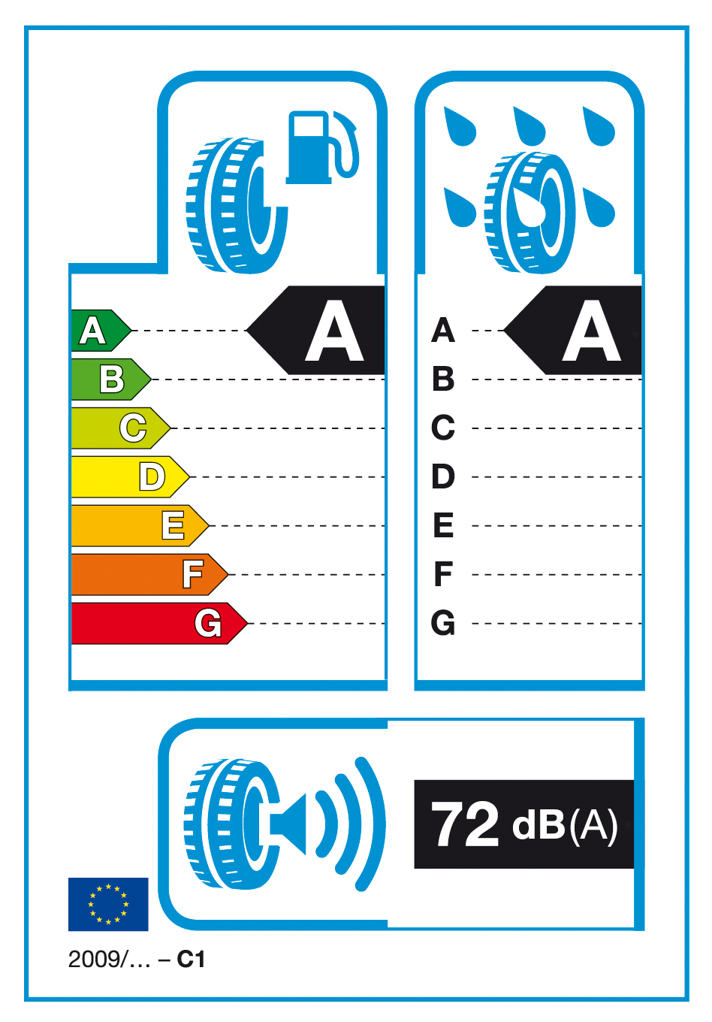
1.2 The following provides specifications for the label:
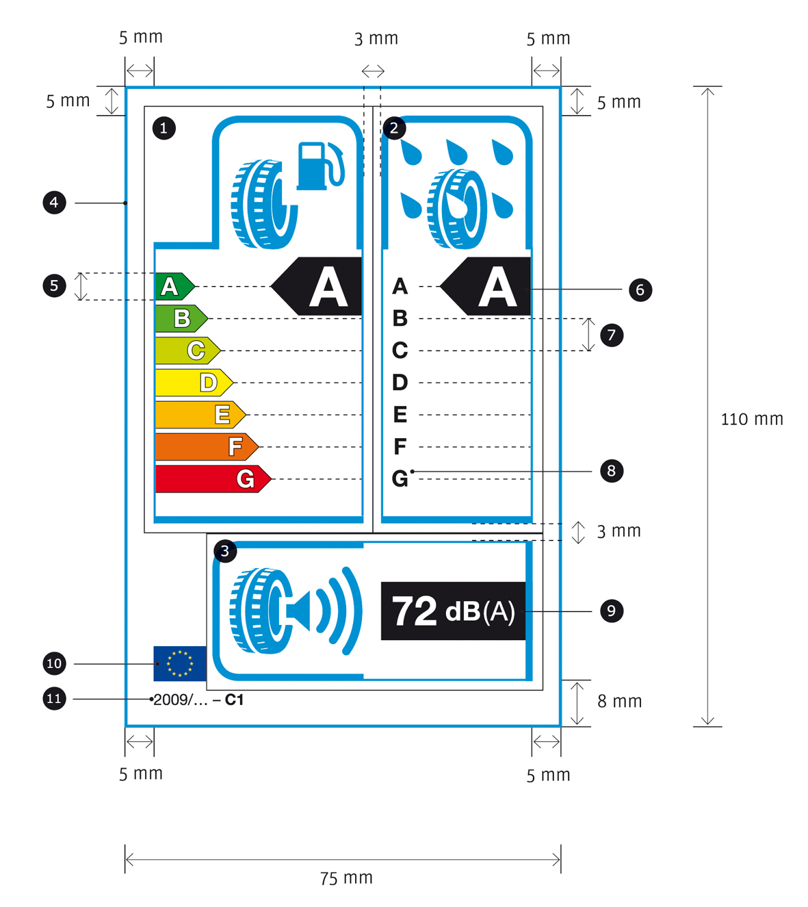
1.3 The label must be at least 75 mm wide and 110 mm high. Where the label is printed in a larger format, its content must nevertheless remain proportionate to the specifications above.
1.4 The label must conform to the following requirements:
a) Colours are CMYK – cyan, magenta, yellow and black – and are given following this example: 00-70-X-00: 0 % cyan, 70 % magenta, 100 % yellow, 0 % black;
b) The numbers listed below refer to the legends indicated in section 1.2;
 Fuel efficiency
Pictogram as supplied: width: 19.5 mm, height: 18.5 mm – Frame for pictogram stroke: 3.5 pt, width: 26 mm, height: 23 mm – Frame for grading: stroke: 1 pt – Frame end: stroke: 3.5 pt, width: 36 mm – Colour: X-10-00-05;
 Wet grip
Pictogram as supplied: width: 19 mm, height: 19 mm – Frame for pictogram: stroke: 3.5 pt, width: 26 mm, height: 23 mm – Frame for grading: stroke: 1 pt – Frame end: stroke: 3.5 pt, width: 26 mm – Colour: X-10-00-05;
 External rolling noise
Pictogram as supplied: width: 23 mm, height: 15 mm – Frame for pictogram: stroke: 3.5 pt, width: 26 mm, height: 24 mm – Frame for value: stroke: 1 pt – Frame end: stroke: 3.5 pt, height: 24 mm – Colour: X-10-00-05;
 Label border: stroke: 1.5 pt – Colour: X-10-00-05;
 A-G scale
- Arrows: height: 4.75 mm, gap: 0.75 mm, black stroke: 0.5 pt – colours:
• A: X-00-X-00;
• B: 70-00-X-00;
• C: 30-00-X-00;
• D: 00-00-X-00;
• E: 00-30-X-00;
• F: 00-70-X-00;
• G: 00-X-X-00.
- Text: Helvetica Bold 12 pt, 100% white, black outline: 0.5 pt;
 Grading
- Arrow: width: 16 mm, height: 10 mm, 100% black;
- Text: Helvetica Bold 27 pt, 100% white;
 Lines in scale: stroke: 0.5 pt, dashed line interval: 5.5 mm, 100% black;
 Scale text: Helvetica Bold 11 pt, 100% black;
 Value of noise
- Box: width: 25 mm, height: 10 mm, 100% black;
- Text: Helvetica Bold 20 pt, 100% white;
- Unit text: Helvetica Bold Regular for ‘(A)’ 13 pt, 100% white;
 EU logo: width: 9 mm, height: 6 mm;
 Directive reference: Helvetica Regular 7.5 pt, 100% black;
Tyre class reference: Helvetica Bold 7.5 pt, 100% black;
c) The background must be white.
1.5 The tyre class (C1, C2 or C3) must be indicated on the label in the format prescribed in the illustration section 1.2.
2. Brand space
2.1 Suppliers must add their name, the tyre line, tyre dimension, load index, speed rating and other technical specification on the sticker along with the label in any colour, format and design, provided that the proportional size of brand space does not exceed a 4:5 ratio against the size of the label and the message published along with the label does not disrupt the message of the label.
Annex III
Information provided in technical promotional literature
1. Information on tyre shall be provided in the order specified as follows:
(i) the fuel efficiency class (letter A to G);
(ii) the wet grip class (letter A to G);
(iii) the external rolling noise measured value (dB).
2. This information must meet the following requirements:
(i) be easy to read;
(ii) be easy to understand;
(iii) if different grading are available for a given tyre type depending on dimension or other parameters, the range between the least- and best-performing tyre is stated.
3. Suppliers must also make available on their website:
(i) an explanation of the pictograms printed on the label;
(ii) a statement highlighting the fact that actual fuel savings and road safety heavily depend on drivers' behaviour, in particular the following:
- eco-driving can significantly reduce fuel consumption;
- tyre pressure should be regularly checked for higher wet grip and fuel efficiency performance characteristics;
- stopping distances should always be strictly respected.
Annex IV: Verification procedure
The conformity of the declared fuel efficiency and wet grip classes as well as the declared external rolling noise measured value shall be assessed for each tyre type or each grouping of tyres as determined by the supplier; according to the following procedure:
(1) a single tyre shall be tested first. If the measured value meets the declared class or external rolling noise measured value, the test is passed;
(2) if the measured value does not meet the declared class or external rolling noise measured value, three more tyres shall be tested. The average measurement value stemming from the four tyres tested shall be used to assess accordance with the declared information.

European Environment Agency, Annual European Community Greenhouse Gas Inventory 1990-2005 and Inventory Report 2007, p. 88.
COM(2006) 545.
COM(2008) 433.
Tyres fitted on new vehicles, which constitute 22% of market share.
Proposal COM(2008) 316 under adoption, OJ C , , p. .
Tyres fitted on vehicles once the original ones are worn out, usually after 40 000 km for passenger cars.
COM(2008) 316, see footnote 5.
COM(2006) 545.
TTE, (Energy) Council of 23 November 2006, 15210/06; Brussels European Council 8/9 March 2007, Presidency Conclusions, 7224/07; European Parliament Resolution of 24 October 2007 on the Community Strategy to reduce C0₂ emissions from passenger cars and light commercial vehicles (2007/2119 (INI)), point 32.
COM(2007) 19.
COM(2007) 22.
COM(2007) 856.
Recast of Directive 1999/94/EC.
COM(2007) 804.
COM(2008) 397/3.
COM(2007) 99.
Directive 1992/75/EC.
Directive 1999/94/EC.
OJ C , , p. .
OJ C , , p. .
OJ C , , p. .
OJ C , , p. .
COM(2008) 433
(COM(2006)545).
Proposal COM(2008) 316 under adoption, OJ C , , p. .
OJ L 189, 18.7.2002, p. 12.
OJ L 297, 13.10.1992, p. 16.
OJ L 184, 17.7.1999, p. 23.
[NB: The current tyre classification of the proposal for a Regulation (COM(2008)316) has omitted light duty vehicles (N1). There is an agreement at Council level to revise the definition proposed in Article 8 of COM(2008) 316 to include N1 tyres, the agreement will be reached in October at the latest before the adoption of this proposal for a Directive on tyre labelling- this is for information during the legislative procedure and must be deleted at the time of adoption].
OJ L 231, 29.08.2008, p. 19.

