EN
COMMISSION OF THE EUROPEAN COMMUNITIES
Brussels, 10.1.2007
SEC(2006) 1724
VOLUME IV
COMMISSION STAFF WORKING DOCUMENT
Accompanying the
COMMUNICATION FROM THE COMMISSION
Inquiry pursuant to Article 17 of Regulation (EC) No 1/2003 into the European gas and electricity sectors (Final Report)
{COM(2006) 851 final}

ANNEX A

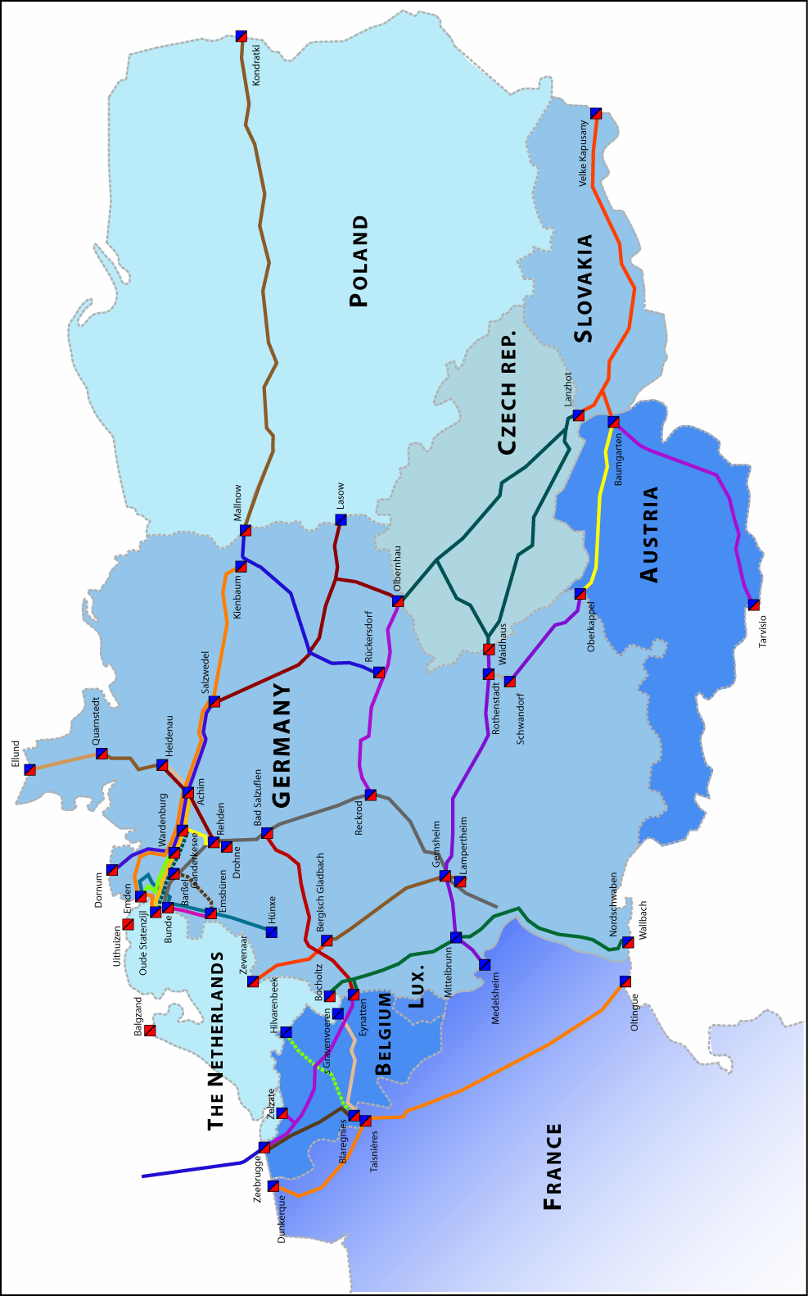

Source: Energy Sector Inquiry 2005/2006.

ANNEX B
Geographic markets for electricity

- As regards geographic markets for electricity, despite efforts by the Community to integrate further the different territorial markets in the EU, the Commission has usually found that the geographic market is most of the time national, but that it may sometimes be smalleror larger. Relevant elements which support the existence of a smaller or larger market include in particular system designs, the existence and frequency of congestion at points in the grid, the existence of prices correlation (see table g) and price differentials, and the differing nature of supply and demand on both sides of such congestion points (in particular the existence of an operator that is indispensable to meet demand). This is a preliminary analysis of situations where it has been alleged that geographic markets are smaller or larger than national.

A1. Cases of geographic markets smaller than national
- Data provided by TSOs regarding congestion inside their networks indicates at this stage that only the networks of the Italian TSO and the Austrian TSO experience internal congestion points.. We are thus in a position to consider possible geographic markets smaller that Member States only in these cases and in cases where network and market designs already foresee it. This is at present the case in Italy and Nord Pool (Denmark and Norway). Thus, the most congested links in Italy and the Nord Pool area have been identified, as well as the most frequent “aggregations of zones” in both systems. Also, a correlation study has been performed of prices between zones and in the case of Nord Pool, the prices of the Contract for Differences (CfD) of the different zones have been studied. The data gathered over the period 2004-2005 indicated four smaller geographic markets in Italy (Macro-zone North, Macro zone Centre-South, Macro-Sicily, and Sardinia). It also suggests that, in the Nord Pool area, three (West Denmark, East Denmark and South Norway) areas can be considered as separate geographic markets.

- More precisely, in the case of Italy, this segmentation corresponds to the links which are by far the most congested ones and aggregates the zones whose prices are almost perfectly correlated. The Macro zone Centre-South constitutes a special case in that respect. It does not occur on its own a large part of the time and is sometimes part of a wider aggregation of zones (often including the North zone). However, the Macro zone Centre-South is characterised by the existence of an operator who is indispensable to cover the demand most of the time: the analysis will thus be carried out on the level of that macro zone. The result would of course be subject to revisions if the changes in configuration (e.g. Sardinia becoming far less separated than it used to be) are confirmed in the future.

a)
Source: GME TUR=Turbigo, MON=Monfalcone, CN=CentroNord, CS=CentroSud, PIO=Piombino; ROS=Rossano, BRN=Brindisi, CAL=Calabria, SIC=Sicily, SAR=Sardinia.
Note: All figures are rounded. Figures for 2005 correspond to the period January-August. All percentages are rounded.

b)
Source: GME data and COMP calculations on the period January2004-August2005.

- In the case of Nord Pool, it is likely that West Denmark represents a separate market: it is separated from other markets half of the time and its price is not correlated at all with the prices of other zones. As regards East Denmark, it is usually not separate from other zones but the correlation of its price with prices of other zones remains lower than the correlation between the prices of other zones. Further, the price of the CfDs for that zone is significantly different from the price of the CfD for other zones. Last but not least, there is an operator which is indispensable to meet demand in that zone. Thus there are good reasons to consider this zone as a separate market. South Norway could also be considered as a separate market for similar reasons.

c)
Source: Nord Pool. WDK= West Denmark, EDK= East Denmark, SWE=Sweden, SNO= South Norway, NNO=North Norway.
Note: All percentages are rounded.

d)
Source: Nord Pool data and COMP calculations on the period January2004-August2005.

e)
Source: Energy Sector Inquiry 2005/2006.

f)
Source: Energy Sector Inquiry 2005/2006.

A.2. Cases of geographic markets larger than national
- The first case where a market is larger than national could be considered is Nord Pool because of the existence of its integrated market design. According to the analysis above, one could consider at most Sweden, North Norway and Finland to be part of the same geographic market. First the correlation of prices is fairly high. Second the prices of the Contract for Differences between the different zones in the forward markets indicate that operators consider that there is not much risk of trading forward between the remaining zones (except to a certain extent for North Norway). On the other hand, North Norway is separated from Sweden for one third of the time and Finland can be separated from Sweden during substantial amount of hours (especially during certain months separation can reach 40%). It is difficult to conclude without making a detailed calculation of residual demand in each of the zones, which at this stage has not yet been assessed. In line with previous Commission practice, the issue will be left open.

- Some market participants have also argued that the increasing correlation of the prices of the different markets on the continent has already led to the creation of a continental market involving at least France, Belgium Germany, the Netherlands and Austria. First of all, it is important to note that this correlation remains fairly low in most cases as seen below. Second, price level differentials between spot markets and forward market products remain substantial. Further, the chapter on market integration demonstrates that congestion remains high on the borders between these MS and is in some cases even increasing. The same chapter demonstrates also that the procedures to trade between MS contain important administrative procedures that players experience as difficult (e.g. transaction costs) and risky. Further, France and Belgium continue to have a main operator which provides most of the generation in the market and is thus indispensable to meet demand. Thus, at this stage it is not possible to conclude that a continental market has emerged.

g)
Source: data from the exchanges and COMP calculations.
Note: The figures for 2005 correspond to the period January-September. For Italy, the first column corresponds to the whole system price (PUN), the second column to the North Zone.

- That being said, the data about congestion of interconnectors provided in the chapter B.b.II.3 indicates that some borders (DE-AT, DE-CH, CZ-SK) are never or almost never congested in both directions. This could lead to three possible cases where a geographic market could be larger than national. First, for the case Germany-Austria, it must be noted that while the price of the EXAA is rather well correlated to that of EEX, this correlation is decreasing (see table A1). Further there are some congestion points inside the Austrian grid and more importantly, the main operator in Austria generates roughly half of the generation needed to cover consumption, so it is indispensable to meet demand. For that reason, it is difficult to conclude that the market comprises both Member states. The size of the incumbent operator leads to the same conclusion in the case of the Czech and Slovak republics. As regards the possible integration of Switzerland and Germany in the same geographic market, it is first important to note that congestion has started to occur on the border and that an auction mechanism was put in place in early January 2006. In any event, the absence of liberalisation and corresponding regulation of networks in Switzerland make the two national markets too different to be considered as part of the same relevant market.

- Finally, reference is made to the analysis made in chapter C.c.III, in particular as regards residual demand and the existence of an operator that is indispensable to meet demand in several Member States.

ANNEX C
Shares in available installed capacity and effective generation
for a selection of countries, 2004

Source: Energy Sector Inquiry 2005/2006.

The figures on capacity (graphs on the left) are based on capacity installed and owned within the Member State concerned: they do not include capacity owned by the same undertaking in another Member State and do not include capacity which could be used through the use of drawing rights in plants owned by another undertaking. The use of drawing rights is reflected in figures about effective production (graphs on the right) only the extent that these drawing rights and the corresponding output were identified by market participants.
Some comments made in the public consultation argued that the graph of effective production for Spain was not consistent with publicly available figures. The figures have been checked again and the chart remains the same. The graph is based on the data provided by the operators for their own production and for total production on publicly available figures. The discrepancy may result thus from the fact that publicly reported generation for individual generators is not equal to individual generation reported to DG COMP.

ANNEX D
Sales and purchases shares in existing forward markets, 2004

Note: the graphs represent sellers on the left side and buyers on the right side. The same pattern/color is not meant to represent the same operator in both graphs.
The pattern represents in each Figure the category “other undertakings”, i.e. the aggregation of all undertakings which have not been represented individually in the Figures.

Source: Energy Sector Inquiry 2005/2006

ANNEX E
Evolution of sales and purchases shares in existing forward markets, 2004

Note: the graphs represent successively sellers and buyers for each market. The same pattern/colour is not meant to represent the same operator in both graphs, but for very few exceptions.
The pattern represents in each Figure the category “other undertakings”, i.e. the aggregation of all undertakings which have not been represented individually in the Figures.

The charts for Belgium cannot be shown given the very few operators actively trading: these charts would reveal the strategy of those operators.

Source: Energy Sector Inquiry 2005/2006.

ANNEX F
Shares of spot sales in the different power exchanges in 2004 and 2005.

Note: the same pattern/colour represents the same undertaking in both pies for a given market.

ANNEX G
First elements of analysis of balancing markets

Figure a) show the concentration in the German balancing market segment aggregated for the whole of Germany. The shares (in percentages) represent the volumes supplied (MWh) by generators aggregating secondary and tertiary reserves that have been supplied during 2003 until May 2005. To be clear, though Germany has four so-called control areas it is reasonable to aggregate the volumes for reserves across these areas since supplying reserve power across control areas is possible. The figure reveal that four actors are mainly supplying reserves.

a)

The figure b) shows the share of income that operators received from the French TSO for balancing services (only tertiary reserves). All main actors in the balancing markets are either owners of generation assets or have drawing rights in generation capacity of third parties.

b)

ANNEX H
Importance of transparency on 49 individual issues,
according to market participants

Note: These figures are discussed in section B.b.II.4.3

Source: Energy Sector Inquiry 2005/2006.
ANNEX I
Load factors of power plants of the main generators in Germany
Calculation on all hours of the year

Source: Energy Sector Inquiry 2005/2006.

ANNEX J
Statistics on the results of the public consultation (Electricity)

Source: Energy Sector Inquiry 2005/2006.

ANNEX K

Source: Ernst & Young's elaboration of Maritime Business Strategies' data.

Source: Ernst & Young's elaboration of Maritime Business Strategies' data.

ANNEX L

Cost of a spot unloading of 1 TWh with an emission on the transmission network of 30 days

 | Italy
 | Per unit (MWh) | 1 TWh
Charge per unload | 17.477,79 € | 17.477,79 €
Unit Commodity charge (1) | 0,1315 € | 128.870,00 €
(2) | 0,0159 € | 15.582,00 €
Unit Capacity charge (3) | 0,29 € | 290.000,00 €
Gas Consumption (reference : 20 €/MWh) | 2,0% | 400.000,00 €
Total | 851.929,79 €
(1) : 0,036556 €/GJ ; 1 GJ = 0,278 MWh
(2) : 0,004424 €/GJ ; 1GJ = 0,278 MWh
(3) : 1,97 €/liquid m3 ; 1 liquid m3 equivalent to 600 gas m3 ; 1 gas m3 = 11,3 kWh

 | Belgium (new tariff)
 |  |  | 1 TWh
Charge per unload | included in slot |  | included in slot
Charge per slot | 750.443,00 € |  | 750.443,00 €
Unit charge per additional emission / kWh/h/year | 1,95 € |  | 2.706.600,00 €
Gas Consumption (reference: 20 €/MWh) | 1,3% |  | 260.000,00 €
Total | 3.717.043,00 €
A slot includes unloading, storage and regasification capacity for 10,35 days
We suppose that the emission is constant during 30 days, i.e. 1388 MWh/h
 | France
 | Per unit (MWh) | 1 TWh
Charge per unload | 30.000,00 € | 30.000,00 €
Unit Commodity charge | 0,57 € | 570.000,00 €
Charge for reception service | 0,03 € | 30.000,00 €
Gas Consumption (reference: 20 €/MWh) | 0,5% | 100.000,00 €
Total | 730.000,00 €
Source: Commission elaboration of IEFE and national regulators data.

Cost of a spot unloading of 1 TWh with an emission on the transmission network of 8 or 10 days

 | Italy
 | Per unit (MWh) | 1 TWh
Charge per unload | 17.477,79 € | 17.477,79 €
Unit Commodity charge (1) | 0,1315 € | 128.870,00 €
(2) | 0,0159 € | 15.582,00 €
Unit Capacity charge (3) | 0,29 € | 290.000,00 €
Gas Consumption (reference : 20 €/MWh) | 2,0% | 400.000,00 €
Total | 851.929,79 €
Guarantee | 33% of the value of the volume of gas | 6.666.666,67 €
(1) : 0,036556 €/GJ ; 1 GJ = 0,278 MWh
(2) : 0,004424 €/GJ ; 1GJ = 0,278 MWh
(3) : 1,97 €/liquid m3 ; 1 liquid m3 equivalent to 600 gas m3 ; 1 gas m3 = 11,3 kWh

 | Belgium (new tariff)
 |  | 1 TWh
Charge per slot | 750.443,00 € | 750.443,00 €
Gas Consumption (reference: 20 €/MWh) | 1,3% | 260.000,00 €
Total | 1.010.443,00 €
Guarantee | 100 % of the average monthly invoice | 1.010.443,00 €
A slot includes unloading, storage and regasification capacity for 10 days

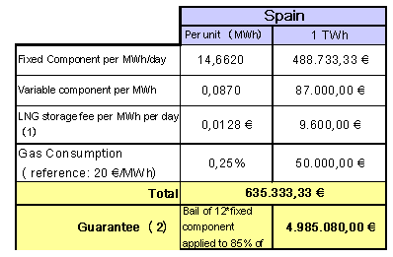
A slot includes unloading of cargoes, 5 days of free storage, regasification rights and loading of LNG trucks
(1) : 0,086873 €/m3/day
(2): It is recovered one year later. It is lost in case of infrautilization of the capacity. There is no need for bail in case the TPA contract duration < 1 year. In consequence, not applicable for a spot cargo

Source: Commission elaboration of IEFE and national regulators data.

For France, the calculation is not possible for less than 30 days, since GdF proposes only a constant emission during 30 days for a spot cargo. Nevertheless, it is technically possible to decrease the number of days of emission by using the secondary market on the point of exchange of LNG.

ANNEX M
This annex shows additional charts on market shares in balancing markets.

Source: Energy Sector Inquiry 2005/2006
Note: though Germany has four so-called control areas it is reasonable to aggregate the volumes for reserves across these areas since supplying reserve power across control areas id possible. The figure reveals that four actors are mainly supplying reserves.
ANNEX N
This annex shows the merit curves in different markets.

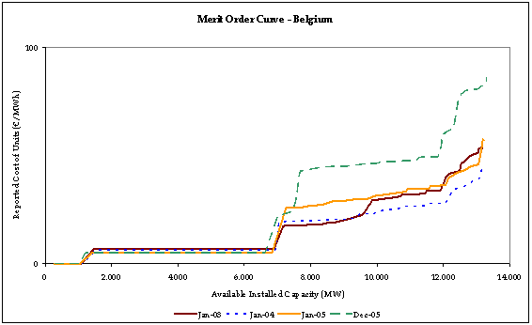

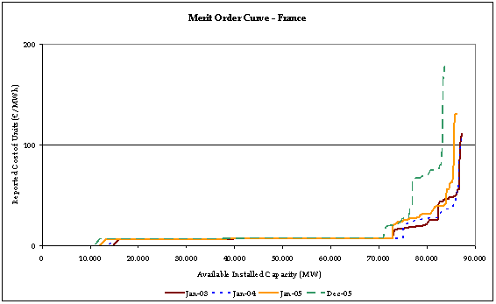
Source: Energy Sector Inquiry 2005/2006.
Note: For these two graphs, since there is one operator representing most of the curve, figures on the vertical axis are rounded.

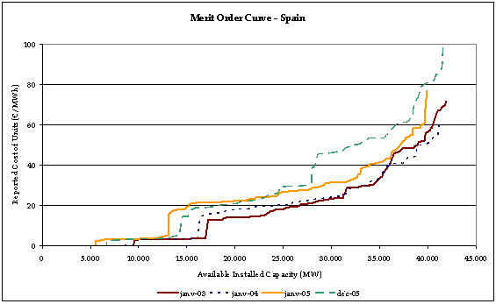

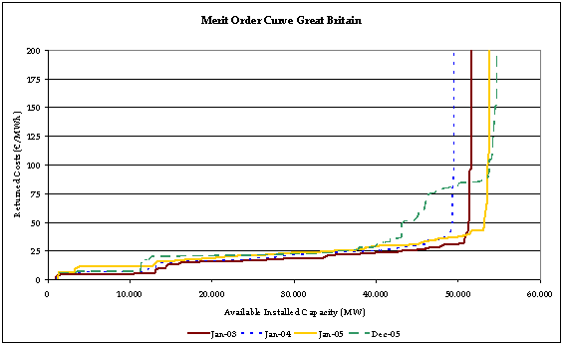
Source: Energy Sector Inquiry 2005/2006.

See i.a. cases COMP/M.3440 EDP/ENI/GDP, COMP/M.3696 E.ON/MOL.
See case COMP/M.3729 Edf/AEM/Edison.
See cases COMP/M.3268 Sydkraft Graninge and COMP/M.2847 Verbund/Energie Allianz.
An operator is theoretically indispensable to meet demand if total demand (D) in the area is larger than the sum of the capacity (SC) of the other generators in the area and of the import capacity (IC) of the area. Given the little flexibility of demand and provided that the capacity of this operator is not much larger than (D-SC-IC), such an operator would be a hypothetical monopolist. Please consult the results of the chapter C.c.III in that respect.
fD in Nord Pool commit the seller of the CfD to pay the net difference between the price of the zone and the “average price of Nord Pool” at the time of “delivery” of those contracts: the price of those contracts reflect thus to a certain extent the average price difference between the zones expected by market participants.
This includes the Zone Nord as well as four smaller zones (Ene, Enw, Turbigo and Monfalcone)).
This includes the Zones Centro Nord, Piombino, Centro Sud, Sud, Rossano, Brindisi, and Calabria.
This includes the zones Sicilia, Priolo and Calabria.
This result is coherent with the approach taken by the Italian Energy Authority (Autorità per l’Energia Elettrica e il Gas, “AEEG”) and the Italian Competition Authority (Autorità Garante della Concorrenza nel Mercato, “AGCM”) in a Joint Report published on 9 February 2005 (the “Joint Report”). The Joint Report “Indagine consoscitiva sullo stato della liberalizzazione del settore dell’energia elettrica” is available on the website of AEEG http://www.autorita.energia.it/elettricita/index.htm as well as on the website of AGCM, http://www.agcm.it/index.htm
See the Joint Report in that respect.
Some comments made in the public consultation indeed note that the configurations may have been changing since August 2005 (notably the frequency of a single price area for the whole of Italy has increased). That being said, some other factors have not changed: in particular the existence of an operator which is indispensable to meet demand in the different macro-zones. See the Joint Report in that respect.
West Denmark also cannot be considered as in the same market as Germany as the interconenctor between them is congested most of the time. In any event, there is one main operator in West Denmark which is indispensable to meet demand in that zone.
See case COMP/M.3867 Vattenfall/Elsam and Energi E2.
This means in particular that there is no regulation of networks which would allow non-discriminatory access, a prerequisite for a true wholesale market to emerge.
An operator is theoretically indispensable to meet demand if total demand (D) in the area is larger than the sum of the capacity (SC) of the other generators in the area and of the import capacity (IC) of the area. Given the little flexibility of demand and provided that the capacity of this operator is not much larger than (D-SC-IC), such an operator would be a hypothetical monopolist.

