EN
COMMISSION OF THE EUROPEAN COMMUNITIES
Brussels, 21.12.2006
SEC(2006) 1772

COMMISSION STAFF WORKING DOCUMENT
Accompanying document to the
COMMUNICATION FROM THE COMMISSION
TO THE COUNCIL AND THE EUROPEAN PARLIAMENT
Employment in rural areas: closing the jobs gap
{COM(2006) 857 final}
TABLE OF CONTENTS
1. Introduction 3
2. Labour force in the EU-27 rural areas: current trends and situation 4
2.1. Current situation 4
2.2. Agricultural labour force in the rural areas 9
2.3. Non-agricultural labour force in the rural areas 11
3. Long-term future trends and projections for agricultural employment 13
3.1. Size of the workforce 13
3.2. Impact of CAP reform and enlargement on rural employment 14
3.3. Impact of Rural Development policies on rural employment 15
4. Concluding remarks 17
5. References 18
6. Annexes 19

COMMISSION STAFF WORKING DOCUMENT
Report on employment in rural areas

Introduction
At its meeting in Lisbon in 2000, under the European employment strategy launched in 1997, the European Council set the goal of full employment and, as a medium-term target, an employment rate of 70% by 2010. As part of this process, the Agricultural Council of July 2003 agreed conclusions on "Employment in rural areas under the European Employment Strategy". The Agriculture Council identified several challenges for the future of rural employment such as the ageing of the farming population, the participation of young people and women in the rural economy, the enlargement of the European Union and the switch from product to producer support under the revised CAP. It called on the Commission to carry out an in-depth assessment of employment prospects in rural areas and to initiate the discussion on the creation of statistical tools for rural areas.
On 2 February 2005, the Commission proposed a new start for the Lisbon Strategy focusing on two principal tasks – delivering stronger, lasting growth and creating more and better jobs. Under the European Employment Strategy there is need to improve the adaptability of workers and enterprises and to increase investment in human capital through better education and skills. The guiding principles for the contribution of the CAP – markets and rural development – to the Lisbon Strategy were set by the European Council in Göteborg in 2001 and confirmed in the Lisbon Strategy Conclusions in Thessaloniki in June 2003 – Strong economic performance must go hand in hand with the sustainable use of natural resources. This was reaffirmed in the renewed EU Sustainable Development Strategy adopted by the European Council on 16 June 2006.
The new CAP is based on a market policy where intervention is a safety net, income stabilisation is delivered through decoupled aids subject to cross-compliance, and on a rural development policy focused on jobs, growth and sustainability. The Community strategic guidelines for rural development identify the areas key to the realisation of EU priorities for the period 2007–2013, in relation to the renewed EU Sustainable Development Strategy and to the Lisbon Strategy for growth and jobs.
Based on the Council Regulation of 20 September 2005 on support for rural development by the European Agricultural Fund for Rural Development (EAFRD), the rural development programmes 2007–2013 of the Member States and the Community Strategic Guidelines on rural development establish the framework for interventions in rural areas which will contribute to the achievement of the Lisbon targets.
This report presents an analysis of recent trends, current situation and future projections with regards to employment in Europe's rural areas. This is based on external studies, Commission reports and statistics and statistical instruments developed in the framework of the Common Framework for Monitoring and Evaluation of Rural Development programmes. It aims at analysing the questions of demography, agricultural and off-farm employment as well a providing a first assessment of the recent impacts of CAP reform and rural development policies on employment.

Labour force in the EU-27 rural areas: current trends and situation

Current situation
Achieving the Lisbon targets on employment will require a further improvement of efforts made by Member States, notably among young and older workers, and further utilisation of the unused potential. This is of special importance for rural areas where observable differences across the EU are particularly marked in the structure of rural employment, which varies significantly from one Member State to another regarding numbers of people employed, employment intensity, workers' average age and relative percentages of employed and self-employed workers. Furthermore, a variety of social, demographic, economic and institutional factors have substantially affected labour force participation, especially for the young, women and the elderly.
Faced with several major global challenges including enlargement, more open trading arrangements, environmental issues, changes in consumer preference and in the degree and nature of public support, European agriculture has undergone an impressive evolution. Historically, one of the main ways in which the sector has adjusted to these competitive pressures is by continually reducing labour via the adoption of new technologies and structural adjustment. As a result in many regions agriculture now makes up a small part of total employment.

Rural areas
Based on population density, rural areas represent 93% of the territory in EU-27. 20% of the population live in predominantly rural areas and 38% live in significantly rural areas.
The EU enlargement in 2004 resulted in the accession of countries where about two-thirds of the population lives in rural areas. The forthcoming accession of Bulgaria and Romania will further consolidate this process.
In EU-25, the largest proportion of the rural population is in Sweden, Finland, Bulgaria, Slovenia and Ireland. At the other extreme are the most urbanised countries such as Belgium, Netherlands, Denmark, Germany and the UK. The population in predominantly rural areas in the New Member States are higher than in the EU-15 (34.5% versus 15.5% in 2003). The situation is similar in significantly rural areas, while in urban areas the opposite occurs – 18.2% of the population in the New Member States is concentrated there, while in the EU-15 it is more than double (49%).
In countries such as Czech Republic, Italy, Estonia, Spain and France, the population in predominantly rural areas is below 17% of total population, but significantly rural areas of these countries account for more than 41%. In countries such as Finland, Sweden, Slovenia, Bulgaria and Ireland population in predominantly rural areas is considerably larger than in the significantly rural and predominantly urban areas and accounts for more than half of the total population.

Income
Rural areas generate 45% of Gross Value Added in EU-27 and 53% of the employment, but tend to lag as regards a number of socio-economic indicators, compared to predominantly urban areas.
In 2001 EU-27 predominantly rural areas had lower income per capita than the significantly rural areas and especially predominantly rural areas. The differences between the three different types of areas are significant in New Member States, where income in predominantly rural areas on average is about half that in predominantly urban areas. Low levels of income make it harder to retain and attract skilled individuals. This gap is reflected also in other key indicators. At the same time, in all regions where agricultural employment has a high share of total employment, GDP per capita is below the average level for EU-25. In richer regions, investment and better access to capital helps the creation of employment potential and its efficient utilisation. Higher levels of GDP per capita also means a higher standard of living accompanied by greater access to quality products and services with implications for size and value added generated by the service sector.

Demography
The proportion of the rural population in the EU total population has remained fairly constant in recent decades. This relative stability at an aggregate level, however, masks significant variations between and within individual Member States and hides important population developments over the last 15 years at regional level.
Two large scale processes of demographic change are taking place in Europe: a long established “urbanisation” trend drawing population and economic activity out of more remote rural areas into urban and accessible rural areas, and a more recent “counter-urbanisation” flow out of urban areas into accessible rural areas (made possible by new transport and ICT infrastructure) increasingly under pressure from an urbanised lifestyle. As a result, accessible parts of significantly rural areas represent a zone of growth, with an economic structure increasingly similar to that of the urban areas. In contrast, predominantly rural areas, especially in the more remote parts of the EU are still being depleted of population and economic activity.
Demographic changes over the last decade were caused by many factors, but major drivers remained migration flows and natural population growth. In general, annual net-migration in the predominantly rural areas has decreased since 2003 and migration trends in EU rural areas were higher only in the 1995–1999 period when urban and significantly areas encountered slow development. An increase in the overall growth of gross population from the year 2000 onwards took place. However, predominantly rural areas continue to develop sluggishly compared to urban areas.
On average, population growth in the predominantly rural areas of the EU-15 is slightly below that of significantly rural or predominantly rural areas of the EU-15. Moreover, one quarter of the predominantly rural areas and about half of the significantly rural areas in the EU-15 had a growth above the average national level.
Demographic ageing is an important issue throughout large parts of Europe and is altering the composition of the labour force, reducing future labour supply and ultimately employment levels and is putting a significant strain on public finances. It is especially evident in the predominantly rural areas of some Member States, notably Portugal, Spain, Greece, Italy and France, where the populations of predominantly rural areas have a higher proportion of people over 65 (higher than 19.3% of total population in predominantly rural areas). same countries show a relatively low ratio of children (0–15) to pensioners (>65), a low ratio of young adults (15–24) to pensioners, and a high overall dependency ratio (total population/population aged 15–64). This could bring a lack of labour supply, especially for services related to the older population in the least dynamic areas. Older people (above 65 years) in the predominantly rural areas in New Member States account for a much smaller proportion than in EU-15 (13.0% versus 18.1% as of 2001).

Employment and unemployment
Across the EU-25, in the period 1996–2001, employment has increased fastest in urban areas. The employment rate has increased by 3.6% in predominantly urban areas compared to 1.9% in predominantly rural areas. This suggests a widening urban-rural employment rate gap. In 2004 employment rates in EU-27 were almost 5% higher in predominantly urban (64.7%) than predominantly rural areas (60.1%). Some rural areas, particular in peri-urban areas have experienced high rates of employment growth, in line with a general trend in OECD countries. At a sub-regional level, trends can be very different compared to those at a regional level, notably where labour moving out of agriculture in the countryside has been absorbed in market towns and large villages.
Unemployment rates are generally significantly higher in rural than in urban areas. Urban-rural differences are particularly pronounced in countries characterised by high unemployment rates. Long-term unemployment is relatively high only in significantly rural areas, which could indicate growing exclusion of low-income groups. It is estimated that “hidden unemployment” (involving underemployed farmers and farm workers) probably accounts for around 5 million people in rural areas. In this context agricultural plays a role of a social buffer during transition.
In all regions where agriculture plays an important role in employment, unemployment rates stay in the range of 10.3–10.9%. Over the period 1999–2004 the unemployment rate in predominantly rural areas in the EU-27 changed only slightly – from 10.5% in 1999 to 10.6% in 2004. Unemployment rates in the predominantly rural areas in the New Member States are higher than the rates in the predominantly rural areas located in EU-15. However, two completely opposite long-term trends characterise EU-15 and New Member States. While in the EU-15's predominantly rural areas unemployment went down from 9.9% in 1999 to 8.8% in 2004, in New Member States it has grown from 12.2% in 1999 to 15.8% in 2004. Combined with the increased gap between unemployment rates in predominantly rural and significantly rural areas in New Member States and reduced gap between unemployment rates in the same regions in EU-15 this suggests that structural adjustments in the most rural areas in New Member States are still occurring relatively quickly.
Regional employment and unemployment disparities remain widespread, with very high rates of unemployment in many predominantly and significantly rural areas. Regions with low levels of employment tend to be the ones with lower productivity levels. Increases in labour productivity in regions with low overall levels of productivity have not yet been followed by substantial increases in employment.

Human capital and skills
Over the last 10 years there has been a continued decline in productivity growth in the EU's rural areas. This can be partially explained by the re-entry of a significant number of less-skilled workers into employment. However, a large part of this negative impact could be attributed to low levels of business investment, a slowdown in the rate of technological progress and innovation, and relatively slow diffusion of information and communication technologies.
Skills and human capital are generally lower in rural areas than in urban areas. In many Member States education beyond primary or lower secondary education is more generalised in urban areas. In urban areas almost 20% of the adult population has received tertiary education, while in rural areas the proportion is only around 15%. Tertiary education can often lead to out-migration of skilled individuals from rural to urban areas who stay on after their studies due to better employment opportunities in urban areas.

Women and young people
In terms of gender differences based on the comparison of male and female economic activity rates between rural/rural area types, there is a greater difference for men than women. In 2001, for EU-25, overall male activity rates were around 77% in predominantly rural and significantly rural areas compared to nearly 80% in predominantly rural areas. For women the rates were virtually the same for predominantly urban and predominantly rural areas (61%), but slightly lower in significantly rural areas. Traditionally female activity rates have been lower in rural areas as females working on farms are not always counted in the labour force and fewer paid employment opportunities exist compared with more urban areas.
Employment rates of both men and women are lower in rural areas (predominantly rural and significantly rural areas for men at 73% and 72% respectively compared to 75% in predominantly urban areas in 2001, for EU-25). For women the rates were 56% and 55% in the rural areas and 59% in predominantly urban areas. Male rates tend to be relatively high, except in the New Member States, Southern Italy, Bulgaria, southern Spain, northern France, northern Finland and Romania. Bulgaria and southern Poland have particularly low male employment rates. Female employment rates show a different pattern with low rates in most of the southern EU (Malta, Italy, Greece, Spain), Poland, Hungary, northern and southern France, Belgium, small parts of western and eastern Germany, and Western Ireland.
The situation of women and young people in rural areas remains precarious often resulting in the out-migration of females and youngsters in economically active age groups. In some rural areas, the lack of training infrastructure and appropriate child-care facilities prevent entry or up-skilling in the labour market. Female and youth unemployment rates tend to be relatively high in rural areas. In 2001, for EU-25, the rates for women in rural areas were 10.6% but male rates were relatively lower at 7.9%. In urban areas female (6.8%) and male rates (6.2%) were more similar. Youth unemployment was significantly higher in both predominantly and significantly rural areas, 17.6% and 16.2% respectively, compared with 10.7% in urban areas.
In the Nordic and Baltic countries, and in Southern Europe, strong rural-urban migration of females in the economically active age groups continues to result in a degree of “masculinisation” of the rural population, leading to a secondary effect on fertility rates.

Agricultural labour force in the rural areas

Size of the work force
Agriculture accounts for 4.9% of the overall employment in EU-25, but over the period 2000–2005 some 1.2 million people have left the sector. The decline covers both male and female workers. This agricultural labour outflow is not a new process and it has been broadly constant at around 2-3% per year over the past twenty years.
Agriculture in New Member States holds a higher share in total employment compared to EU-15 (12% versus 4%) with notable differences between Member states. For example, in Poland and Lithuania agriculture comprised about 17% and 15% of total employment in 2005, in contrast to the UK, Malta and Luxemburg where this proportion is below 2%. Greece, Latvia and Portugal also account for large agricultural employment shares.

Employment in the primary sector
In most rural areas the primary sector accounts for less than 10% of total employment. In a third of rural areas its share is less than 5% (around the EU-25 average). However, in some rural areas – particularly in the East and South of the EU – its share is above 25%. Moreover, agricultural productivity is far lower in most predominantly rural areas.
In general, the primary sector is following a downward trend but increases in importance in the newest members of the EU-27. Bulgaria and Romania had the highest proportions in employment in the primary sector in predominantly rural areas among all Member States in 2002. These countries account also for the highest proportion of primary sector in total Gross-Value Added in the predominantly rural areas (18% and 20% respectively for Bulgaria and Romania). However, strong regional disparities exist. In addition, study evidence suggests that in countries such as Poland, Latvia and Romania the high number of small-farm holdings leads to over-employment in agriculture with low labour productivity.
The fact that the share of primary sector employment is the greatest in these EU rural areas suggests both a low rate of past adjustment and a lack of alternative employment opportunities. As a result, the potential for a marked future reduction in agricultural employment in such regions is high, especially if their economies grow and opportunities in other sectors emerge.

Age structure of the farm workforce
At present less than one fifth of the EU-15 family farm workforce and less than 10% of the EU-25 farm holders are younger than 35 years old. In addition, more than a fifth of the EU-15 family farm workforce, and a quarter (24%) of the EU-25 farm holders are over 65 years old with the highest shares in southern Mediterranean countries. It is important to notice that over the period 2000–2005, EU-25 agriculture has lost mainly work force in the prime-age group (25–54), followed by young labour forces (15–24) and only then by old persons (55–64). The decreasing number of young people in the agricultural sector can create specific difficulties for generational renewal.
The age structure in agriculture differs considerably at Member State level. Only in three Member states (Poland, Austria and Germany) do young farmers dominate the age structure, respectively with coefficient of 0.56, 0.52 and 0.48 (measured as ratio between the number of farmers younger than 35 years and those older than 55 years). At the other end of the scale are countries such as Portugal, Italy, United Kingdom, Slovenia and Bulgaria, where an ageing farm workforce has become a serious issue and coefficients are below 0.08. Close to these values are five other Member states (Slovakia, Hungary, Lithuania, Sweden, Malta, Spain, Greece and Cyprus) as well as Romania, all with coefficients in the range of 0.10–0.14.

Structure of the agricultural sector and employment
In 2003 about 13.35 million annual work units were directly employed by the EU-27 farm holdings. Of these, 47% were in EU-15, about 26% in New Member States and the remaining 26% in the two acceding countries (Bulgaria and Romania). About 90% of the total agricultural work units (AWU) were employed on sole holder holdings, the rest being employed by legal entities or holding groups. At the same time, sole holder holdings comprised about 97.9% of all EU-27 holdings.
Over the last nine years structural changes in the agricultural labour in EU-15 can be observed. The total number of AWU directly employed on sole holder holdings has declined by 13% over the period 1995–2003, but at the same time the AWU employed in legal entities or holders groups have almost tripled. This was accompanied by a decline of 15% in the number of all types of farms. Consolidation on farms is generally taking place by ex-farmers entering non-agricultural employment or retiring due to demographic ageing of the cohort.

Part-time farming
Part-time working in agriculture has become a common feature with almost 80% of the EU-25 farm workers working part-time. This is still on the increase in most Member States although it is less common in central and the North-Western parts of Europe. In the EU-15 predominantly rural areas part-time farming has slightly increased by 7% over a decade (from 70% in 1990 to 77% in 2000). This is in line with the overall developments in the EU-25, where the proportion of part-time employment and of employment under fixed-term contracts are rising strongly. However, the share of part-time farming is rather determined by country specific conditions than by degree of rurality. Significantly, the share of farm holders with other gainful activities remained stable over the 1990-2000 period, with significant variations for some Member States (e.g. Belgium, Portugal, Ireland, UK, etc.).

Seasonal agricultural employment
Several agricultural activities during certain seasonal periods require extra labour that cannot be replaced by machinery or cannot be provided by the farmer, farm or family workers. Even when the extra labour demand can be satisfied to certain extent by machinery, hired seasonal labour often remains a considerably more attractive and cost-efficient option. Sectors where seasonal labour is prevalent are fruit and vegetables and horticulture.
Despite the fact that Member States have very different policies regarding employment of seasonal farm workers and that statistical datasets are incomplete, it was estimated that in 2002 the number of seasonal farm-workers in the EU-15 was around 4.5 million, corresponding to at least 1 million full-time employees.

Non-agricultural labour force in the rural areas
The service sector is the most important sector in rural areas in terms of employment and Gross Value Added, followed by manufacturing and the primary sector While the service sector is currently the fastest growing sector in Europe, employment in the manufacturing tends to have a stable towards declining trend (with some regional exceptions).

Secondary and tertiary employment
The urban and rural economies of Europe have become less distinctive in the 21st century than they were two or three decades ago. Most accessible rural areas (especially in the EU-15) are characterised by structures similar to their urban neighbours. Therefore, traditional regional profiles are more likely to survive only in the remote parts of the EU. However, significant differences between rural and urban areas remain.
The most significant recent general trend in employment has been the rising importance of the tertiary sector. Although tertiary employment is the strongest growing sector in the predominantly rural areas, it is nevertheless growing at a slower pace than in significantly rural and predominantly urban areas. Within the tertiary sector the main growth sector is financial services, which is under-represented in rural areas. Tertiary employment in rural areas tends to be dominated by the public sector, mainly caused by the underdevelopment of private services which remain largely urban-based.
Tertiary employment is on average the largest of the three sectors in all region types across the EU-27, although it is less dominant in significantly rural and predominantly rural areas, where it accounts for 65% and 57% of employment respectively, compared to 75% in the predominantly urban areas. This is reflected in the slower shift to activities centred in the knowledge-based economy. The share of employment in tertiary activities also exhibits a broadly North-West/South-East gradient across Europe. The highest positive growth (1999–2003) in tertiary employment is in Cyprus (18.7%), Ireland (18.2%), Spain (18.0%) and Sweden (10.8%). Negative growth was experienced only in two countries: Romania (–2.1%) and Latvia (–1.9%).
In 2001 employment in the secondary sector industries in the EU-27 rural areas was higher than in urban areas, with significantly rural at 29% and predominantly rural at 28%, compared to the urban average of 25%. New Member States in the East have the highest percentage employed in the secondary sector, while North Western Member States have the lowest.
The current trends also indicate that some form of “employment counter-urbanisation” is taking place, with secondary and tertiary activities, having greater spatial freedom due to changes in transport travel and communication technologies, moving out from urban to more rural areas thus avoiding congestion and taking advantage of better working/living environments.
Secondary and tertiary employment markets tend to operate over more extensive territories, whereas agricultural activity is spatially more restricted due to farming’s long and irregular working hours. Many farm households are integrated into both of these labour markets, through part-time off-farm employment by farmers/farm workers, or through the co-habitation of younger family members not involved in the farm business.

Infrastructure provision and access to basic services
The availability of infrastructure and basic services constitutes an important determinant of the successful economic development and quality of life of a region. Good business-related infrastructure supply is a precondition for a vigorous economy, and household-related services are crucial for the retention of the existing population and attraction of new residents.
Infrastructure and access to basic services is a particularly significant issue in rural areas, especially in regions affected by negative population trends, out-migration or structural economic change. Without continued support for investments in transport, tourism, education, training, healthcare, telecommunication and the renovation of the villages, these regions will fall into a downwards spiral of decline which will unable them to attract new businesses and citizens and even to keep their current population within the area.

New employment opportunities for the workforce in rural areas
Adjustments which take place in the agricultural sector and their impact upon employment have in part been absorbed through the creation of new employment opportunities on the farm or the combination of part-time farm employment with off-farm employment.
Overall, the proportion of farms with 'other gainful activities' besides farming is increasing in most Member States. Currently several forms of on-farm diversification are occurring of which farm tourism is the most developed.
At the same time, renewable energy developments, nature and landscape conservation, diversification into cultural activities, organic and quality production, teleworking and the development of health and social services are fields which have a potential to create new activity. This can form the basis both for the diversification of farm household income and of the rural economy more generally. Women and young people are often key players in this diversification.

Long-term future trends and projections for agricultural employment
The patterns of change in agricultural employment involve complex processes that are influenced by labour saving technical progress, the macro-economic environment, farm structures, and relative wage levels.

Size of the workforce
Overall, the general trend for agricultural employment is expected to be downwards through a shift from full-time to part-time work and a movement of family labour into off-farm employment. The loss of hired workers will take place in smaller holdings while larger holdings will probably stabilize as they increase in economic size due to amalgamation. Projections of future development based on recent trends in the EU-15 suggests that between 2000 and 2014 a further 4-5 million workers, or 28–35% of the agricultural workforce, may leave the sector. The trend towards part time work means that the forecast percentage losses measured in annual work units (AWU) are greater, averaging 35–47% across the EU-15, i.e., 2–2.5 million full-time equivalent workers.
Forecasting change in the farm workforce in the New Member States and in the acceding countries is more difficult and speculative. By using a range of assumptions regarding long-term structural adjustment processes it can be estimated that between 28% and 59% of the workforce of the New Member States may potentially leave agriculture by 2014. This is equivalent to 1-2 million AWU, or 2–4 million persons. A further 1-2 million persons may leave the farming sector in Romania and Bulgaria. However, in some regions restored farmland has provided a “social buffer” for those who previously worked in other sectors, and who, in unemployment, have turned to semi-subsistence agriculture.
As regards young people, the key issue for the near future is the decline of the traditional form of succession on medium-small holdings since more inheritors work away from the farm until the parent retires. It is expected that less young people will take over the farms, as remuneration is too low. The availability of attractive off-farm jobs will influence the proportion of young people in agriculture and their decision not to migrate to more urbanised areas. At the same time, the trend of movement of women from agricultural employment to off-farm jobs is likely to continue.
The future role of semi-subsistence farms will largely depend on the development of other income opportunities. Although growth rates in the non-agricultural economy have been high in the New Member States, it is yet uncertain whether these will provide sufficient opportunities to maintain employment in rural areas.
Because of the preponderance of family labour in most Member States adjustment will probably occur by “non entry” into the sector by farm children, especially on small farms and especially for females, and the increase of off-farm working by other members of the farm household. Conversely, in Member States where hired labour forms a high share of the farm workforce a faster adjustment is to be expected.
The effect of this released labour on the regional labour market will vary from region to region. Much will depend on the existence of alternative opportunities and the capacity of the rural economy to absorb (often part-time) labour coming out of the agricultural sector. This is likely to be less problematic in the more diversified and dynamic significantly rural areas, and more difficult in remoter predominantly rural areas (where the relative scale of movement out of agriculture is also more substantial).

Impact of CAP reform and enlargement on rural employment
The main determinants of labour adjustment in the farm sector are technological change, returns on capital and the relative remuneration of agricultural labour compared to other sectors. Through successive reforms of the Common Agricultural Policy over the past twenty years, labour outflows from the agricultural sector have been broadly constant at around 2-3% per year. The introduction of direct aids as compensation for price support reductions over this period ensured that this restructuring process has taken place in a socially acceptable manner. Without direct aids many rural areas of Europe would have faced major economic, social and environmental problems. Rural development has played an important role in preventing depopulation and land abandonment in many rural areas.
The impact of decoupling introduced in the 2003 CAP Reform is expected to be broadly neutral with respect to employment. Adjustment in production structures will be balanced by a more efficient use of capital and land leading to more economically sustainable activities. Increased market orientation is expected to bring new income opportunities through both agricultural and non-agricultural diversification by farmers. Due to the obligation to maintain land in good agricultural and environmental condition, there may be some shift from production activities to land management activities in the most marginal areas.
Evidence suggests that adjustments that took place in the agricultural sector and their impact upon employment have in part been absorbed through the creation of new employment opportunities on the farm or the combination of part time farm employment with off-farm employment. Rural development measures have been instrumental to accompany and support this process, leading to the creation or the maintenance of a significant number of jobs.
Enlargement has changed the agricultural map. However, the integration of the agricultural sector of the New Member States into the CAP has taken place in a generally smooth and positive manner, particular as regards incomes.
Accession saw major positive developments in the New Member States. There was a very sharp rise in income recorded in 2004 in the wake of accession to the European Union when farm income increased by 69 %. Consequently, agricultural income was some 65 % higher than before accession and 58 % above its 2000 level. This one off-adjustment can be attributed to implementation of the CAP instruments (market instruments and phasing in of direct aids). In 2005, income trends in the New Member States were broadly similar to EU-15 (a reduction of around 5%). Beyond this one-off effect, it is expected that other factors such as technological change, returns on capital, the level of development of the regional economy and the relative remuneration of agricultural labour compared to other sectors will be the determining factors in agricultural labour adjustment, as is the case in EU-15.
Successful agricultural adjustment in the New Member States will be the key to improving the competitiveness and environmental sustainability of the agricultural sector and boosting jobs and growth in related areas of the economy.

Impact of Rural Development policies on rural employment
During recent years, rural development measures have noticeably contributed to maintenance and creation of jobs in rural areas. Their positive impacts in terms of employment are already appearing as suggested by early evidence included in the EC "Synthesis of Rural Development Mid-Term Evaluations".
The extent of the employment impact at the level of single programmes is heavily linked with the balance of measures adopted at the region/Member State level and therefore the scope for the generalisation of findings is limited. Subject to these limitations, overall the impact of the measures on the maintenance of employment has tended to be more significant than the impact in terms of job creation and the impact on on-farm employment is more significant than the impact on off-farm employment. This reflects in part the allocation of resources. A significant number of jobs were created in some cases: in England, for example, a total of 3,846 full-time equivalent jobs were created whereas 7,233 jobs were maintained. In Finland, some 3,300 jobs were created or maintained in the ALMA area.
Impacts of investments on farm, training, forestry measures, measures promoting the adaptation and development of rural areas are mostly considered to have had significant impact as individual measures. As regards the effects on employment of assisted investments on farm, impact is said to be more relevant in relation to securing employment rather than its creation. Improvements in working conditions were specified as a direct investment aim in some Member States (for example, Denmark, Austria and France) and reductions in workload and hard physical work have been realised in the majority of Member States. Training activities carried out, had a positive impact in terms of employment conditions, usually through higher pay.
Concerning forestry measures, assisted actions had a positive impact on employment on-farm, although this is generally small-scale and concentrated in periods where demand is low for agricultural activities. A positive off-farm employment impact was also identified, arising from local processing of basic forestry products supported under this measure.
Employment, maintained and created on-farm, was reported as a result of measures promoting the adaptation and development of rural areas. Evidence from a range of regions/Member States suggests the presence of a positive impact on employment in the non-agricultural sector. Whereas the evaluations of the RD measures took place early in the programming period, the high proportion of the relatively high financial weight of these measures in rural development programmes (26% of total funding at EU level) implies that the final impact on employment will be more significant.
Jobs directly produced by Leader II (direct employment) were mainly created in less diversified, less structured rural areas (often Objective 1) compared to the more diversified and more accessible rural areas. This difference has to do with the different role of the programme and the local groups fulfilled in different types of regions.
Starting from indications in the "Ex post Evaluation of the Community Initiative LEADER II" with data taken from national evaluation, specific study and national surveys from a subset of 222 on a total of 998 Local Action Groups (LAG), an indicative estimation suggests that in the course of the initiative up to 100.000 permanent full time jobs (Full Time Equivalent – FTE) have been created or maintained in Europe’s rural areas. Half of the jobs (49%) concerned women, which shows that promotion of gender equality gives positive results.
The employment effects from applying LEADER II could be summarized as follows. First, there are more indirect than direct effects in areas where the LAG focused on training, qualification, networking and concentration. Direct jobs were created through innovative business start-ups, e.g. in agro-tourism, food processing and marketing and most of these start-ups were micro-businesses, many of them involving women. Rural diversification measures helped to safeguard many agricultural jobs and at the same time temporary jobs were created in environmental and village renewal activities. A number of permanent jobs in new social and health care services, landscape preservation and cultural heritage were created and the public investment per job created seems to be, according to most cost-effectiveness studies, lower than in comparable mainstream programmes. Last, but not least, the more innovation was emphasized in the local programme, the better was employment effect.

Concluding remarks
Europe's rural areas are diverse and include many leading regions. However, some rural areas, and in particular those which are most remote, depopulated or dependent on agriculture face particular challenges as regards growth, jobs and sustainability in the coming years. These include:
- lower levels of income,
- an unfavourable demographic situation,
- lower employment rates and higher unemployment rates,
- a slower development of the tertiary sector,
- weaknesses in skills and human capital,
- a lack of opportunities for women and young people,
- a lack of necessary skills in parts of the agricultural sector and food processing industry.
Furthermore, the continued restructuring and modernisation of Europe's agriculture will place a heavy burden on many rural areas. On the basis of current trends it is to be expected that in EU-15 some 2 million workers on a full time basis will leave the sector by 2014. In addition, 1-2 million full-time workers may potentially leave the sector within the ten New Member States, and 1-2 million workers in Bulgaria and Romania. To this must be added around 5 million hidden unemployed persons on farms. These changes will touch most rural areas. In significantly rural areas, the challenge will be to avoid the risk of exclusion associated with lack of skills and low incomes. In remoter areas with higher levels of agricultural employment, the management of the restructuring process will play a significant role in the broader rural economy.
But rural areas offer real opportunities in terms of their potential for growth in new sectors, the provision of rural amenities and tourism, their attractiveness as a place to live and work, and their role as a reservoir of natural resources and highly valued landscapes. Europe's agriculture offers many high quality products. The agricultural and food sectors must seize the opportunities offered by new approaches, technologies and innovation to meet evolving market demand both in Europe and globally. This will require the development of new skills, entrepreneurship and the capacity to adapt to delivering new types of service.
In short, Europe's rural areas must exploit their potential or risk falling further behind urban areas in meeting the Lisbon targets, particularly in the remotest and most agricultural areas.

References
COM(2005) 141, 2005, Integrated Guidelines for Growth and Jobs (2005–2008),
Council Decision of 12 July 2005 on Guidelines for the employment policies of the Member States (2005/600/EC), OJ L 205, 6.8.2005, p. 21.
Council Decision of 20 February 2006 on Community strategic guidelines for rural development (programming period 2007 to 2013)
Council of the European Union, 2003, Council conclusions on "Employment in rural areas under the European Employment Strategy”, Brussels, Belgium.
Council of the European Union, 2006, Presidency conclusions on "Land, Life, Future of European Farmers (Education, Advisory services, research and Development, Innovation and diversification)", No. 10479/06, Brussels 16 June 2006, Belgium.
Council Regulation (EC) No 1698/2005 of 20 September 2005 on Support for rural development by the European Agricultural Fund for Rural Development (EAFRD), OJ L 277, 21.10.2005, p. 1.
European Commission, 2006a, Employment in Europe Report 2006, DG Employment and Social Affairs, European Commission, Brussels.
European Commission, 2006b, Rural Development in the European Union – Statistical and Economic Information – Report 2006, DG Agriculture and Rural Development, European Commission, Brussels.
European Commission, 2006d, "Synthesis of Rural Development Mid-Term Evaluations", DG Agriculture and Rural Development, Brussels, Belgium.
European Commission, 2006e, More and Better Jobs: Delivering Priorities of the European Employment Strategy, Joint Employment Report 2005/2006 7347/06
European Commission Communication, 2006, Le défi démographique, une chance pour l'Europe
Eurostat, 2006, Measuring progress towards a more sustainable Europe: Economic Development Employment, Eurostat, European Commission, Brussels.
Extended Impact Assessment, SEC(2004) 931, Brussels, Belgium.
GEOPA, 2002, Seasonal Workers in European Agriculture, GEOPA Inquiry, EA(02)97S2, Brussels, Belgium, 19 pages.
Network of Independent Experts in the CEE Candidate Country, 2003, The Future of Rural Areas in the CEE Candidate Countries, DG AGRI document.
OECD 2006. Rural Policy Reviews. The New Rural Paradigm. POLICIES AND GOVERNANCE
SERA, 2006, Study of Employment in Rural Areas, Consultancy Report, European Commission, DG Agriculture and Rural Development, Brussels.

Annexes
Annex 1 – Targets and benchmarks set in the framework of the
European Employment Strategy
The following targets and benchmarks were agreed in the context of the European Employment Strategy in 2003:
- every unemployed person is offered a new start before reaching 6 months of unemployment in the case of young people and 12 months in the case of adults in the form of training, retraining, work practice, a job or other employability measure, combined where appropriate with on-going job search assistance;
- 25% of long-term unemployment should practice by 2010 in an active measure in the form of training, retraining, work practice, or other employability measure, with the aim of achieving the average of the three most advanced Member States;
- jobseekers throughout the EU are able to consult all job vacancies advertised through Member States' employment services;
- an increase by 5 years, at EU level, of the effective average exit age from the labour market by 2010 (compared to 59.9 in 2001);
- the provision of childcare by 2010 to at least 90% of children between 3 years old and the mandatory school age and at least 33% of children under 3 years of age;
- an EU average rate no more than 10% early school leavers;
- at least 85% of 22-year olds in the EU should have completed upper secondary education by 2010;
- the EU average level of participation in lifelong learning should be at least 12.5% of the adult working-age population (25 to 64 age group).
Annex 2 – Key characteristics of rural areas in EU-27
Territorial characteristics
% Territory in rural areas
2003 – NUTS 3
Country | % predominantly rural | % significantly rural | % predominantly urban
Belgium | 21.7 | 23.4 | 54.8
Czech Republic | 8.8 | 90.6 | 0.6
Denmark | 67.7 | 27.7 | 4.6
Germany | 36.5 | 44.1 | 19.4
Estonia | 20.7 | 71.6 | 7.7
Greece | 73.9 | 23.2 | 2.9
Spain | 47.4 | 46.5 | 6.1
France | 48.4 | 47.2 | 4.4
Ireland | 98.7 |  | 1.3
Italy | 27.4 | 50.0 | 22.6
Cyprus |  | 100.0
Latvia | 55.9 | 43.6 | 0.5
Lithuania | 65.0 | 35.0
Luxembourg |  | 100.0
Hungary | 64.6 | 34.8 | 0.6
Malta |  |  | 100.0
Netherlands | 2.8 | 41.1 | 56.1
Austria | 78.5 | 20.2 | 1.4
Poland | 60.3 | 36.8 | 2.9
Portugal | 69.7 | 21.7 | 8.5
Slovenia | 69.5 | 30.5
Slovakia | 32.2 | 63.6 | 4.2
Finland | 93.1 | 6.9
Sweden | 95.9 | 4.1
United Kingdom | 30.1 | 48.9 | 20.9
Bulgaria | 76.5 | 22.3 | 1.2
Romania | 61.6 | 38.3 | 0.1
EU25 | 56.2 | 35.9 | 7.9
EU15 | 57.4 | 33.5 | 9.1
NMS10 | 50.8 | 47.0 | 2.2
EU27 | 57.0 | 35.7 | 7.3
Source: Rural Development in the European Union – Statistical and Economic Information – Report 2006.
% Population in rural areas
2003 – NUTS 3
Country | % predominantly rural | % significantly rural | % predominantly urban
Belgium | 3.5 | 11.7 | 84.7
Czech Republic | 5.1 | 83.5 | 11.4
Denmark | 38.8 | 31.8 | 29.4
Germany | 13.2 | 29.3 | 57.5
Estonia | 10.5 | 76.5 | 13.0
Greece | 37.2 | 27.2 | 35.6
Spain | 15.0 | 49.8 | 35.3
France | 16.8 | 53.7 | 29.6
Ireland | 71.6 |  | 28.4
Italy | 9.6 | 40.7 | 49.8
Cyprus |  | 100.0
Latvia | 38.8 | 29.5 | 31.7
Lithuania | 44.3 | 55.7
Luxembourg |  | 100.0
Hungary | 47.1 | 36.0 | 16.9
Malta |  |  | 100.0
Netherlands | 1.3 | 15.8 | 82.9
Austria | 46.3 | 30.7 | 22.9
Poland | 39.6 | 37.5 | 22.9
Portugal | 21.4 | 26.6 | 52.0
Slovenia | 61.7 | 38.3
Slovakia | 25.5 | 63.4 | 11.1
Finland | 62.2 | 37.8
Sweden | 66.5 | 33.5
United Kingdom | 2.6 | 28.2 | 69.2
Bulgaria | 58.4 | 26.3 | 15.4
Romania | 47.1 | 44.0 | 8.9
EU25 | 18.6 | 37.7 | 43.7
EU15 | 15.5 | 35.9 | 48.6
NMS10 | 34.5 | 47.2 | 18.2
EU27 | 20.5 | 37.8 | 41.7
Source: Rural Development in the European Union – Statistical and Economic Information – Report 2006.
% GVA⁽¹⁾ in rural areas
2002 – NUTS 3
Country | % predominantly rural | % significantly rural | % predominantly urban
Belgium | 2.2 | 8.1 | 89.7
Czech Republic | 3.9 | 70.4 | 25.7
Denmark | 34.0 | 27.6 | 38.5
Germany | 9.7 | 22.5 | 67.8
Estonia | 7.4 | 85.0 | 7.6
Greece | 35.8 | 26.4 | 37.7
Spain | 11.9 | 46.0 | 42.1
France | 13.1 | 47.4 | 39.5
Ireland | 63.1 |  | 36.9
Italy | 7.8 | 36.7 | 55.5
Cyprus |  | 100.0
Latvia | 23.3 | 19.0 | 57.7
Lithuania | 34.0 | 66.0
Luxembourg |  | 100.0
Hungary | 33.4 | 30.5 | 36.1
Malta |  |  | 100.0
Netherlands | 1.0 | 14.2 | 84.8
Austria | 35.4 | 33.6 | 31.0
Poland | 32.3 | 30.2 | 37.5
Portugal | 16.1 | 21.6 | 62.3
Slovenia | 52.1 | 47.9
Slovakia | 21.5 | 52.5 | 26.0
Finland | 52.0 | 48.0
Sweden | 59.6 | 40.4
United Kingdom | 1.8 | 24.0 | 74.2
Bulgaria | 48.4 | 22.5 | 29.2
Romania | 36.5 | 44.4 | 19.0
EU-25 | 13.1 | 31.7 | 55.3
EU-15 | 12.4 | 31.1 | 56.4
NMS-10 | 26.0 | 43.3 | 30.8
EU-27 | 13.2 | 31.7 | 55.0
⁽¹⁾ gross value added.
Source: Rural Development in the European Union – Statistical and Economic Information – Report 2006.

% Employment in rural areas
2002 – NUTS 3
Country | % predominantly rural | % significantly rural | % predominantly urban
Belgium | 2.7 | 9.6 | 87.7
Czech Republic | 4.8 | 79.9 | 15.4
Denmark | 36.4 | 29.7 | 33.9
Germany | 11.3 | 24.9 | 63.8
Estonia | 9.2 | 79.2 | 11.6
Greece | 34.2 | 27.5 | 38.3
Spain | 13.2 | 47.1 | 39.7
France | 16.1 | 51.8 | 32.1
Ireland | 66.5 |  | 33.5
Italy | 8.6 | 37.8 | 53.6
Cyprus |  | 100.0
Latvia | 37.9 | 26.7 | 35.4
Lithuania | 42.7 | 57.3
Luxembourg |  | 100.0
Hungary | 44.6 | 36.0 | 19.4
Malta |  |  | 100.0 | 2001
Netherlands | n.a. | n.a. | n.a.
Austria | 38.6 | 34.5 | 26.9
Poland | 36.7 | 35.0 | 28.4
Portugal | 19.6 | 24.7 | 55.7
Slovenia | 58.6 | 41.4
Slovakia | 23.6 | 57.7 | 18.6
Finland | 56.6 | 43.4
Sweden | 64.0 | 36.0
United Kingdom | 2.4 | 26.1 | 71.5
Bulgaria | 56.9 | 24.7 | 18.4 | 2001
Romania | n.a. | n.a. | n.a.
EU-25 | 16.3 | 34.9 | 48.9 | incl. NL NUTS2 data
EU-15 | 13.8 | 32.8 | 53.4 | incl. NL NUTS2 data
NMS-10 | 31.1 | 47.1 | 21.8
EU-27 | 18.7 | 34.6 | 46.7 | incl. NL & RO NUTS2 data
Source: Rural Development in the European Union – Statistical and Economic Information – Report 2006.
% of UAA in the different types of areas
2003 – FSS District level
Country | % predominantly rural | % significantly rural | % predominantly urban |  | MS total UAA (ha)
Belgium | 10.6 | 23.3 | 66.1 |  | 1 394 400
Czech Republic | 10.4 | 89.4 | 0.3 |  | 3 631 550
Denmark | 70.4 | 25.4 | 4.2 |  | 2 658 210
Germany | 8.8 | 74.7 | 16.4 |  | 16 981 750
Estonia | 28.1 | 69.4 | 2.5 |  | 795 640
Greece | 74.1 | 24.4 | 1.6 |  | 3 967 770
Spain | n.a. | n.a. | n.a. |  | 25 175 260
France | 41.3 | 54.9 | 3.8 |  | 27 795 240
Ireland | 90.3 | 9.7 |  |  | 4 371 710
Italy | 29.3 | 49.3 | 21.4 |  | 13 115 810
Cyprus |  | 100.0 |  |  | 156 380
Latvia | 55.6 | 44.4 | 0.0 |  | 1 489 350
Lithuania | 69.2 | 30.8 |  |  | 2 490 960
Luxembourg |  | 100.0 |  |  | 128 160
Hungary | 68.0 | 30.7 | 1.3 |  | 4 352 370
Malta |  |  | 100.0 |  | 10 790
Netherlands |  | 39.3 | 60.7 |  | 2 007 260
Austria | 71.0 | 28.8 | 0.3 |  | 3 257 220
Poland | 61.7 | 36.5 | 1.8 |  | 14 426 320
Portugal | 80.2 | 15.0 | 4.8 |  | 3 725 190
Slovenia | n.a. | n.a. | n.a. |  | 486 470
Slovakia | 36.3 | 59.7 | 4.0 |  | 2 137 500
Finland | 77.8 | 22.2 |  |  | 2 244 700
Sweden | 80.4 | 19.6 |  |  | 3 126 910
United Kingdom | 11.5 | 57.6 | 31.0 |  | 16 105 810
Bulgaria | 72.5 | 27.1 | 0.4 |  | 2 904 480
Romania | 61.1 | 38.2 | 0.8 |  | 13 930 710
EU-25 | 40.6 | 48.2 | 11.2 | excl. ES, SI | 156 032 740
EU-15 | 36.8 | 49.2 | 14.0 | excl. ES | 126 055 410
NMS-10 | 53.5 | 44.9 | 1.5 | excl. SI | 29 977 330
EU-27 | 43.2 | 46.8 | 10.0 | excl. ES, SI | 172 867 930
Note: the total for France and therefore the European aggregates include the overseas departments.
Source: Rural Development in the European Union – Statistical and Economic Information – Report 2006.

Demographic characteristics
Population Density
inhabitant/km² – 2003 – NUTS 3
Country | predominantly rural | significantly  rural | predominantly urban |  | MS value
Belgium | 54.9 | 170.4 | 525.3 |  | 340.0
Czech Republic | 76.0 | 121.8 | 2 399.1 |  | 132.1
Denmark | 71.6 | 143.8 | 803.1 |  | 125.1
Germany | 83.9 | 153.4 | 684.2 |  | 231.2
Estonia | 15.7 | 33.4 | 52.2 |  | 31.2
Greece | 42.2 | 97.9 | 1 031.5 |  | 83.7
Spain | 26.2 | 88.8 | 480.9 |  | 83.0
France | 33.8 | 111.0 | 649.8 |  | 110.4
Ireland | 42.4 |  | 1 238.7 |  | 58.4
Italy | 66.7 | 155.4 | 421.5 |  | 191.2
Cyprus |  | 126.9 |  |  | 126.9
Latvia | 25.8 | 25.4 | 2 879.7 |  | 37.3
Lithuania | 36.2 | 83.6 |  |  | 52.9
Luxembourg |  | 174.0 |  |  | 174.0
Hungary | 79.3 | 112.8 | 3 261.5 |  | 108.9
Malta |  |  | 1 263.0 |  | 1 263.0
Netherlands | 184.7 | 216.7 | 645.9 |  | 480.3
Austria | 57.2 | 147.5 | 1 631.4 |  | 96.8
Poland | 80.3 | 124.5 | 966.6 |  | 122.2
Portugal | 34.9 | 139.0 | 690.5 |  | 113.6
Slovenia | 88.1 | 124.1 |  |  | 99.1
Slovakia | 86.7 | 109.4 | 292.3 |  | 109.7
Finland | 11.5 | 89.2 |  |  | 17.1
Sweden | 15.2 | 171.2 |  |  | 21.8
United Kingdom | 20.8 | 141.0 | 807.5 |  | 244.3
Bulgaria | 53.8 | 83.0 | 891.1 |  | 70.5
Romania | 69.8 | 104.7 | 8 113.4 |  | 91.2
EU-25 | 38.5 | 119.6 | 632.0 |  | 117.5
EU-15 | 32.3 | 124.9 | 620.8 |  | 121.1
NMS-10 | 68.9 | 102.6 | 843.3 |  | 101.7
EU-27 | 40.9 | 118.2 | 638.7 |  | 114.8
Note: for France and, consequently, for the European aggregates, the overseas departments are covered for the summary by rural character, whereas they are excluded from the MS value (leading to a population density of 110 hab./km² against 98 hab./km² for France, and 117 hab./km² against 115 for EU-25).
Source: Rural Development in the European Union – Statistical and Economic Information – Report 2006.

Age structure – 2001 – NUTS 3
 | predominantly rural |  |  | significantly rural |  |  | predominantly urban |  |  |  | MS value (national accounts)
Country | % 0–14 y. old | % 15–64 y. old | % 65+ y. old | % 0–14 y. old | % 15–64 y. old | % 65+ y. old | % 0–14 y. old | % 15–64 y. old | % 65+ y. old |  | % 0–14 y. old | % 15–64 y. old | % 65+ y. old
Belgium | n.a. | n.a. | n.a. | n.a. | n.a. | n.a. | n.a. | n.a. | n.a. |  | 17.5 | 65.5 | 16.9
Czech Republic | 17.3 | 68.9 | 13.8 | 16.5 | 70.0 | 13.5 | 13.4 | 70.5 | 16.1 |  | 16.2 | 70.0 | 13.8
Denmark | n.a. | n.a. | n.a. | n.a. | n.a. | n.a. | n.a. | n.a. | n.a. |  | 18.6 | 66.6 | 14.8
Germany | 16.5 | 67.2 | 16.4 | 16.3 | 67.2 | 16.5 | 14.9 | 68.3 | 16.8 | excl. DE21i | 15.5 | 67.8 | 16.6
Estonia | 20.6 | 64.0 | 15.3 | 18.1 | 67.1 | 14.8 | 16.5 | 67.7 | 15.8 |  | 18.1 | 66.9 | 15.0
Greece | 15.5 | 65.2 | 19.3 | 16.0 | 68.4 | 15.6 | 14.4 | 70.8 | 14.8 |  | 15.2 | 68.1 | 16.7
Spain | 15.0 | 64.3 | 20.7 | 15.0 | 68.8 | 16.2 | 13.9 | 70.3 | 15.8 |  | 14.6 | 68.7 | 16.7
France | 17.8 | 62.5 | 19.7 | 19.1 | 65.1 | 15.8 | 20.0 | 66.9 | 13.2 |  | 18.9 | 65.2 | 15.9
Ireland | 22.2 | 66.5 | 11.4 |  |  |  | 19.3 | 70.6 | 10.1 |  | 21.4 | 67.7 | 11.0
Italy | 14.2 | 66.1 | 19.7 | 14.4 | 66.3 | 19.2 | 14.1 | 67.9 | 18.0 |  | 14.2 | 67.1 | 18.7
Cyprus |  |  |  | 21.4 | 66.9 | 11.7 |  |  |  |  | 21.4 | 66.9 | 11.7
Latvia | n.a. | n.a. | n.a. | n.a. | n.a. | n.a. | n.a. | n.a. | n.a. |  | 18.1 | 67.1 | 14.8
Lithuania | 20.7 | 64.2 | 15.1 | 18.6 | 68.2 | 13.2 |  |  |  |  | 19.5 | 66.4 | 14.0
Luxembourg |  |  |  | 18.9 | 67.2 | 13.9 |  |  |  |  | 18.9 | 67.2 | 13.9
Hungary | 17.5 | 67.5 | 15.0 | 17.4 | 68.5 | 14.1 | 12.8 | 69.6 | 17.6 |  | 16.6 | 68.2 | 15.2
Malta | n.a. | n.a. | n.a. | n.a. | n.a. | n.a. | n.a. | n.a. | n.a. |  | 20.1 | 67.7 | 12.2
Netherlands | 19.1 | 65.7 | 15.3 | 19.2 | 66.9 | 13.9 | 18.5 | 68.0 | 13.5 |  | 18.6 | 67.8 | 13.6
Austria | 18.0 | 66.6 | 15.4 | 16.3 | 68.2 | 15.5 | 15.4 | 69.2 | 15.5 |  | 16.8 | 67.7 | 15.5
Poland | 19.8 | 68.2 | 12.0 | 18.9 | 68.6 | 12.6 | 14.6 | 71.9 | 13.5 | excl. PL111,112,113 | 18.2 | 69.1 | 12.7
Portugal | 14.2 | 63.6 | 22.2 | 16.9 | 67.0 | 16.1 | 16.3 | 69.8 | 13.9 |  | 16.0 | 67.7 | 16.4
Slovenia | n.a. | n.a. | n.a. | n.a. | n.a. | n.a. | n.a. | n.a. | n.a. |  | 14.7 | 71.2 | 14.1
Slovakia | 17.8 | 69.8 | 12.4 | 20.2 | 68.9 | 10.9 | 15.4 | 72.2 | 12.4 |  | 19.0 | 69.5 | 11.5
Finland | 18.1 | 65.7 | 16.1 | 17.9 | 68.9 | 13.1 |  |  |  |  | 18.1 | 66.9 | 15.0
Sweden | 18.3 | 63.6 | 18.1 | 18.4 | 66.1 | 15.5 |  |  |  |  | 18.4 | 64.4 | 17.2
United Kingdom | 19.4 | 63.8 | 16.8 | 18.3 | 64.3 | 17.4 | 19.1 | 65.7 | 15.2 |  | 18.9 | 65.2 | 15.9
Bulgaria | 16.5 | 67.0 | 16.4 | 15.5 | 68.0 | 16.5 | 14.0 | 71.4 | 14.6 |  | 15.9 | 67.9 | 16.2
Romania | 18.5 | 66.6 | 15.0 | 17.7 | 69.1 | 13.2 | 12.6 | 73.7 | 13.8 |  | 17.6 | 68.3 | 14.1
EU-25 | 17.6 | 65.8 | 16.6 | 17.1 | 66.9 | 15.9 | 16.4 | 68.0 | 15.6 | excl. BE, DK, LV, MT, SI | 16.9 | 67.2 | 16.0
EU-15 | 16.9 | 65.0 | 18.1 | 16.8 | 66.4 | 16.7 | 16.5 | 67.7 | 15.7 | excl. BE, DK | 16.7 | 66.8 | 16.5
NMS-10 | 19.2 | 67.8 | 13.0 | 18.2 | 68.9 | 12.9 | 14.3 | 71.4 | 14.4 | excl. LV, MT, SI | 17.8 | 69.0 | 13.3
EU-27 | 17.6 | 65.9 | 16.4 | 17.1 | 67.1 | 15.8 | 16.3 | 68.0 | 15.6 | excl. BE, DK, LV, MT, SI | 16.9 | 67.2 | 15.9
Notes: for France and, consequently, for the European aggregates, the overseas departments are covered for the summary by rural character, whereas they are excluded from the MS value.
Source: Rural Development in the European Union – Statistical and Economic Information – Report 2006.

Net migration crude rate per 1000
2003 – NUTS 2
Country | predominantly rural | significantly rural | predominantly urban | MS – summary of available data |  | MS value (2003)
Belgium | 4.4 | 4.3 | 3.2 | 3.4 |  | 3.4
Czech Republic |  | 2.1 | 6.1 | 2.5 |  | 2.5
Denmark |  | 1.3 |  | 1.3 |  | 1.3
Germany | 1.8 | 1.6 | 1.9 | 1.7 |  | 1.7
Estonia |  | 0.1 |  | 0.1 |  | 0.1
Greece | 3.2 | 0.6 | 6.4 | 3.1 | 2002 | 3.2
Spain | 13.3 | 11.9 | 19.0 | 15.3 |  | 14.9 | e
France | 4.0 | 2.8 | –4.1 | 1.0 | 2001 | 2.2 | e
Ireland | 16.1 | 8.0 |  | 10.1 | 2001 | 7.9 | e
Italy | 7.4 | 10.1 | 11.5 | 10.6 |  | 10.6
Cyprus |  | 17.1 |  | 17.1 |  | 17.1
Latvia |  | –0.4 |  | –0.4 |  | –0.4
Lithuania | –1.8 |  |  | –1.8 |  | –1.8
Luxembourg |  | 4.6 |  | 4.6 |  | 4.6
Hungary | –0.9 | 1.0 | 5.6 | 1.6 |  | 1.5
Malta |  |  | 4.3 | 4.3 |  | 4.3
Netherlands |  | 2.4 | 0.1 | 0.4 |  | 0.4
Austria | 3.8 | 3.0 | 9.6 | 4.7 |  | 4.7
Poland | –1.5 | 0.6 | –2.1 | –0.4 |  | –0.4
Portugal | 7.0 | 4.9 | 6.9 | 6.1 |  | 6.1 | p
Slovenia | 1.8 |  |  | 1.8 |  | 1.8
Slovakia |  | 0.0 | 2.1 | 0.2 | 2001 | 0.3
Finland | 1.1 |  |  | 1.1 |  | 1.1
Sweden | 3.5 | 2.7 |  | 3.2 |  | 3.2
United Kingdom | –2.6 | 4.2 | 2.6 | 3.1 | 1999 | 2.5 | e
Bulgaria | –2.8 | 7.7 |  | 0.0 |  | 0.0
Romania | –0.8 | –0.7 | 3.2 | –0.3 |  | –0.3
EU25 | 2.7 | 4.1 | 4.8 | 4.2 | excl. EE, CY, LU, MT | 4.3 | e
EU15 | 4.5 | 4.9 | 5.0 | 4.9 | excl. LU | 5.0 | e
NMS10 | –1.1 | 0.8 | 1.5 | 0.4 | excl. EE, CY, MT | n.a.
EU27 | 1.8 | 4.0 | 4.8 | 3.9 | excl. EE, CY, LU, MT | n.a.
Note: The total for France and therefore the European aggregates include the overseas departments.
Source: Rural Development in the European Union – Statistical and Economic Information – Report 2006.

Economic characteristics
GDP(pps) / capita (EU-25=100)
"2001" – NUTS 3
Country | predominantly rural | significantly rural | predominantly urban |  | MS value
Belgium | 72.9 | 80.7 | 123.7 |  | 116.9
Czech Republic | 52.5 | 55.9 | 147.2 |  | 66.2
Denmark | 109.1 | 108.2 | 164.3 |  | 125.1
Germany | 80.8 | 84.7 | 129.9 |  | 110.1
Estonia | 31.4 | 49.8 | 27.2 |  | 44.9
Greece | 71.5 | 73.0 | 79.0 |  | 74.6
Spain | 71.9 | 85.3 | 113.0 |  | 92.9
France | 88.8 | 100.6 | 152.0 |  | 113.8
Ireland | 112.7 |  | 171.0 |  | 129.6
Italy | 90.7 | 99.3 | 123.2 |  | 110.4
Cyprus |  | 85.7 |  |  | 85.7
Latvia | 22.7 | 25.9 | 65.4 |  | 37.3
Lithuania | 31.8 | 47.6 |  |  | 40.6
Luxembourg |  | 214.6 |  |  | 214.6
Hungary | 40.6 | 48.0 | 116.1 |  | 56.2
Malta |  |  | 74.8 |  | 74.8
Netherlands | 97.3 | 110.7 | 125.2 |  | 122.6
Austria | 93.0 | 134.7 | 168.7 |  | 123.0
Poland | 36.4 | 38.8 | 73.9 |  | 45.9
Portugal | 57.0 | 62.3 | 92.9 |  | 77.0
Slovenia | 62.9 | 93.0 |  |  | 74.4
Slovakia | 41.7 | 41.3 | 112.2 |  | 49.4
Finland | 95.7 | 144.4 |  |  | 114.0
Sweden | 104.9 | 140.8 |  |  | 116.9
United Kingdom | 79.5 | 97.4 | 124.4 |  | 115.6
Bulgaria | 23.9 | 24.3 | 51.2 |  | 28.1
Romania | 21.1 | 26.8 | 58.0 |  | 26.9
EU-25 | 72.1 | 86.2 | 123.9 |  | 20 478 pps
EU-15 | 87.1 | 96.1 | 126.7 |  | 109.6
NMS-10 | 38.2 | 47.0 | 86.2 |  | 51.1
EU-27 | 64.5 | 82.3 | 122.8 |  | 95.5
Note: the total for France and therefore the European aggregates include the overseas departments.
Source: Rural Development in the European Union – Statistical and Economic Information – Report 2006.

Share of GVA in primary sector (agriculture – as % of total GVA)
2002 – NUTS 2
Country | predominantly rural | significantly rural | predominantly urban | MS – summary of available data (regional accounts) |  | MS value (national accounts, unless precised)
Belgium | 3.6 | 1.4 | 1.2 | 1.2 |  | 1.5
Czech Republic |  | 4.1 | 0.1 | 3.1 |  | 5.3
Denmark |  | 2.2 |  | 2.2 |  | 3.2
Germany |  | 1.7 | 0.6 | 1.1 | NUTS 1 | 1.2
Estonia |  | 4.7 |  | 4.7 |  | 4.8
Greece | 10.9 | 8.9 | 0.4 | 6.4 |  | 7.0
Spain | 8.6 | 4.8 | 1.1 | 3.0 | excl. ES63 | 3.8
France | 4.6 | 3.6 | 0.5 | 2.5 |  | 3.1
Ireland | 5.2 | 1.8 |  | 2.4 |  | 2.4 | reg. accounts
Italy | 3.5 | 3.0 | 1.9 | 2.5 | ex ITD1/2 | 2.8
Cyprus |  | 3.7 |  | 3.7 |  | 3.8
Latvia |  | 4.4 |  | 4.4 |  | 6.7
Lithuania | 6.9 |  |  | 6.9 |  | 8.7
Luxembourg |  | 0.6 |  | 0.6 |  | 0.6
Hungary | 7.8 | 4.2 | 0.9 | 3.7 |  | 5.4
Malta | n.a. | n.a. | n.a. | n.a. |  | 2.1 | reg. accounts
Netherlands |  | 4.2 | 2.2 | 2.5 |  | 2.9
Austria | 3.3 | 1.9 | 0.2 | 2.0 |  | 2.5
Poland | 4.4 | 3.0 | 1.0 | 3.1 |  | 5.5
Portugal | 7.5 | 3.1 | 0.7 | 3.2 |  | 3.2 | reg. accounts
Slovenia | 3.1 |  |  | 3.1 |  | 3.5
Slovakia |  | 5.7 | 0.9 | 4.4 |  | 5.5
Finland | 3.5 |  |  | 3.5 |  | 3.9
Sweden | 2.6 | 0.7 |  | 1.8 |  | 2.4
UK | 4.3 | 2.0 | 0.4 | 0.9 |  | 0.9 | reg. accounts
Bulgaria | 17.4 | 3.6 |  | 12.1 |  | 12.1 | reg. accounts
Romania | 16.7 | 14.6 | 0.7 | 12.6 |  | 17.1
EU-25 | 4.6 | 2.8 | 0.9 | 2.0 | excl. MT | 2.3 | excl. MT
EU-15 | 4.5 | 2.7 | 0.9 | 1.9 |  | 2.2
NMS-10 | 5.1 | 3.7 | 0.7 | 3.4 | excl. MT | 5.4 | excl. MT
EU-27 | 5.1 | 2.8 | 0.9 | 2.1 | excl. MT | 2.3 | excl. MT
Notes: – the total for France and therefore the European aggregates include the overseas departments;
– the difference between national accounts and regional accounts may be explained by a difference in the pace of update.
Source: Rural Development in the European Union – Statistical and Economic Information – Report 2006.

Structure of the economy (% GVA by branch) – 2002 – NUTS 3
 | predominantly rural |  |  | significantly rural |  |  | predominantly urban |  |  |  | MS value (national accounts)
Country | % primary sector | % secondary sector | % tertiary sector | % primary sector | % secondary sector | % tertiary sector | % primary sector | % secondary sector | % tertiary sector |  | % GVA in prim. sector | % GVA in second. sector | % GVA in tert. sector
Belgium | 4.5 | 19.3 | 76.3 | 2.9 | 26.2 | 70.9 | 1.0 | 25.7 | 73.2 |  | 1.2 | 25.5 | 73.3
Czech Republic | 9.6 | 49.8 | 40.6 | 3.8 | 45.0 | 51.2 | 0.1 | 16.5 | 83.4 |  | 3.1 | 37.9 | 59.0
Denmark | 4.8 | 29.5 | 65.7 | 2.6 | 25.4 | 72.0 | 0.2 | 16.6 | 83.1 |  | 2.3 | 25.7 | 72.0
Germany | 3.7 | 32.1 | 64.2 | 2.2 | 33.1 | 64.7 | 0.4 | 26.9 | 72.7 |  | 1.1 | 29.0 | 69.9
Estonia | 14.7 | 34.1 | 51.2 | 4.3 | 25.4 | 70.3 | 2.1 | 45.9 | 52.0 |  | 4.7 | 27.6 | 67.7
Greece | 14.0 | 24.4 | 61.6 | 6.9 | 20.1 | 73.0 | 0.6 | 21.8 | 77.6 |  | 7.0 | 22.0 | 71.1
Spain | 9.0 | 27.5 | 63.5 | 4.0 | 28.5 | 67.5 | 0.8 | 28.9 | 70.4 |  | 3.9 | 29.0 | 67.1
France | 6.0 | 29.4 | 64.6 | 3.4 | 27.9 | 68.7 | 0.5 | 19.3 | 80.2 |  | 2.7 | 21.8 | 75.5
Ireland | 4.1 | 49.2 | 46.6 |  |  |  | 0.2 | 28.5 | 71.2 |  | 2.6 | 41.3 | 56.1
Italy | 4.5 | 24.0 | 71.5 | 3.7 | 26.5 | 69.8 | 1.6 | 27.8 | 70.6 |  | 2.6 | 27.1 | 70.3
Cyprus |  |  |  | 3.9 | 19.4 | 76.7 |  |  |  |  | 3.8 | 19.8 | 76.5
Latvia | 11.8 | 29.7 | 58.4 | 7.7 | 24.0 | 68.2 | 0.6 | 19.2 | 80.1 |  | 4.6 | 22.6 | 72.8
Lithuania | 12.9 | 34.5 | 52.6 | 4.0 | 27.6 | 68.5 |  |  |  |  | 7.0 | 29.7 | 63.2
Luxembourg |  |  |  | 0.6 | 16.8 | 82.6 |  |  |  |  | 0.6 | 16.8 | 82.6
Hungary | 7.0 | 33.8 | 59.1 | 3.9 | 37.8 | 58.3 | 0.4 | 20.5 | 79.2 |  | 3.7 | 30.3 | 66.0
Malta |  |  |  |  |  |  | 2.6 | 27.0 | 70.4 |  | 2.6 | 26.9 | 70.5
Netherlands | 6.0 | 32.3 | 61.8 | 4.0 | 31.9 | 64.1 | 2.2 | 22.8 | 75.0 |  | 2.3 | 24.1 | 73.6
Austria | 4.4 | 37.8 | 57.8 | 1.2 | 32.4 | 66.5 | 0.3 | 19.7 | 80.0 |  | 2.0 | 30.1 | 67.9
Poland | 5.8 | 30.9 | 63.3 | 3.8 | 30.9 | 65.4 | 0.2 | 27.9 | 71.9 |  | 4.5 | 28.7 | 66.8
Portugal | 10.6 | 29.3 | 60.2 | 5.8 | 31.2 | 63.0 | 1.1 | 25.5 | 73.5 |  | 4.0 | 25.5 | 70.4
Slovenia | 4.6 | 42.9 | 52.5 | 1.6 | 27.2 | 71.2 |  |  |  |  | 3.2 | 35.3 | 61.5
Slovakia | 7.8 | 32.9 | 59.3 | 4.9 | 35.8 | 59.3 | 0.9 | 20.7 | 78.5 |  | 4.4 | 31.0 | 64.6
Finland | 5.8 | 34.9 | 59.3 | 1.1 | 27.0 | 71.9 |  |  |  |  | 3.5 | 30.9 | 65.6
Sweden | 2.6 | 32.6 | 64.8 | 0.7 | 20.1 | 79.3 |  |  |  |  | 1.8 | 27.5 | 70.7
United Kingdom | 6.2 | 26.5 | 67.3 | 2.5 | 29.3 | 68.2 | 0.4 | 23.0 | 76.6 |  | 0.9 | 24.9 | 74.2
Bulgaria | 18.0 | 30.5 | 51.5 | 14.3 | 27.5 | 58.2 | 0.7 | 28.0 | 71.3 |  | 12.1 | 29.1 | 58.8
Romania | 19.9 | 34.5 | 45.5 | 12.0 | 42.7 | 45.3 | 0.1 | 30.6 | 69.3 |  | 12.5 | 37.5 | 50.0
EU-25 | 5.5 | 31.8 | 62.7 | 3.1 | 28.9 | 68.0 | 0.7 | 24.7 | 74.5 |  | 2.1 | 26.6 | 71.2
EU-15 | 5.3 | 31.7 | 63.0 | 3.0 | 28.5 | 68.5 | 0.8 | 24.7 | 74.5 |  | 2.1 | 26.4 | 71.5
NMS-10 | 6.6 | 33.5 | 59.9 | 3.8 | 34.8 | 61.4 | 0.4 | 24.2 | 75.5 |  | 4.1 | 30.7 | 65.2
EU-27 | 5.7 | 31.9 | 62.4 | 3.2 | 29.0 | 67.9 | 0.7 | 24.7 | 74.5 |  | 2.2 | 26.7 | 71.1
Notes: – the total for France and therefore the European aggregates include the overseas departments;
– data sources differ at regional (economic accounts) and national (national accounts) levels, and primary sector includes also fisheries, whereas it is excluded from the previous table.
Source: Rural Development in the European Union – Statistical and Economic Information – Report 2006.

Employment characteristics
Employment Rate
Employed persons as a share of total population of the same age class – 2004 – NUTS 2
Country | predominantly rural | significantly rural | predominantly urban | MS value
Belgium | 60.1 | 55.6 | 61.1 | 60.3
Czech Republic |  | 63.4 | 70.3 | 64.2
Denmark |  | 75.7 |  | 75.7
Germany | 66.5 | 64.8 | 63.5 | 64.3
Estonia |  | 63.0 |  | 63.0
Greece | 59.0 | 58.0 | 60.8 | 59.4
Spain | 57.0 | 57.6 | 65.4 | 61.1
France | 62.4 | 63.0 | 61.5 | 62.5
Ireland | 65.2 | 66.7 |  | 66.3
Italy | 54.0 | 56.5 | 59.3 | 57.6
Cyprus |  | 68.9 |  | 68.9
Latvia |  | 62.3 |  | 62.3
Lithuania | 61.2 |  |  | 61.2
Luxembourg |  | 61.6 |  | 61.6
Hungary | 52.0 | 57.0 | 62.9 | 56.8
Malta |  |  | 54.1 | 54.1
Netherlands |  | 71.3 | 73.4 | 73.1
Austria | 68.1 | 70.0 | 63.8 | 67.8
Poland | 51.6 | 52.5 | 48.1 | 51.7
Portugal | 70.8 | 66.4 | 67.0 | 67.8
Slovenia | 65.3 |  |  | 65.3
Slovakia |  | 55.6 | 67.7 | 57.0
Finland | 67.6 |  |  | 67.6
Sweden | 71.3 | 73.5 |  | 72.1
United Kingdom | 72.6 | 72.9 | 71.0 | 71.6
Bulgaria | 52.1 | 59.7 |  | 54.2
Romania | 59.1 | 54.8 | 59.6 | 57.7
EU-25 | 61.1 | 62.2 | 64.8 | 63.1 | G2
EU-15 | 64.9 | 63.6 | 65.3 | 64.5 | G2
NMS-10 | 54.6 | 56.6 | 56.5 | 56.0 | G2
EU-27 | 60.1 | 61.9 | 64.7 | 62.7 | G2
Note: the total for France and therefore the European aggregates include the overseas departments.
Source: Rural Development in the European Union – Statistical and Economic Information – Report 2006.

Rate of Unemployment (% of active population)
2004 – NUTS 3
Country | predominantly rural | significantly rural | predominantly urban |  | MS value
Belgium | 8.0 | 12.2 | 7.8 | NUTS 2 | 8.4
Czech Republic | 6.9 | 9.1 | 3.8 |  | 8.3
Denmark | 5.8 | 5.7 | 5.0 |  | 5.5
Germany | 11.0 | 10.2 | 10.2 |  | 10.3
Estonia | 8.2 | 8.5 | 17.9 |  | 9.7
Greece | 11.2 | 11.5 | 9.1 | NUTS 2 | 10.5
Spain | 12.7 | 12.0 | 9.0 |  | 11
France | 8.1 | 9.2 | 11.2 |  | 9.6
Ireland | 4.6 |  | 4.4 |  | 4.5
Italy | 9.8 | 8.9 | 7.1 |  | 8
Cyprus |  | 4.9 |  |  | 4.9
Latvia | 9.6 | 11.7 | 10.3 |  | 10.4
Lithuania | 11.7 | 11.2 |  |  | 11.4
Luxembourg |  | 5.1 |  |  | 5.1
Hungary | 6.7 | 6.1 | 4.4 |  | 6.1
Malta |  |  | 7.2 |  | 7.2
Netherlands | 5.9 | 5.1 | 4.4 |  | 4.6
Austria | 4.0 | 3.9 | 8.2 |  | 4.9
Poland | 19.4 | 20.2 | 16.3 |  | 19
Portugal | 6.0 | 5.1 | 8.0 | excl. PT20&30 | 6.7
Slovenia | 7.2 | 4.8 |  |  | 6.3
Slovakia | 23.4 | 18.1 | 8.3 |  | 18.2
Finland | 10.2 | 7.2 |  | excl. FI20 | 8.8
Sweden | 6.6 | 6.3 |  |  | 6.5
United Kingdom | 4.8 | 4.0 | 5.0 | NUTS 2 | 4.7
Bulgaria | 12.2 | 13.0 | 10.0 |  | 12
Romania | 7.3 | 9.1 | 7.5 |  | 8.1
EU-25 | 10.9 | 9.7 | 8.1 | NUTS 2 for BE, EL, UK | 9.2
EU-15 | 8.8 | 8.6 | 7.8 | NUTS 2 for BE, EL, UK | 8.2
NMS-10 | 15.8 | 13.9 | 12.5 |  | 14.3
EU-27 | 10.6 | 9.7 | 8.1 | NUTS 2 for BE, EL, UK | 9.2 | G2
Source: December 2006 update of Rural Development in the European Union – Statistical and Economic Information – Report 2006.

Long-term unemployment (as a share of active population)
2004 – NUTS 2
Country | predominantly rural | significantly rural | predominantly urban |  | MS harmonised long term unemployment rate
Belgium | 3.5 | 6.7 | 3.7 |  | 4.1
Czech Republic |  | 4.6 | 1.7 |  | 4.2
Denmark |  | 1.2 |  |  | 1.2
Germany | 1.2 | 5.9 | 4.9 | DE4-2003 | 5.4
Estonia |  | 5.0 |  |  | 5.0
Greece | 5.8 | 6.5 | 4.7 |  | 5.6
Spain | 3.7 | 4.1 | 2.9 |  | 3.5
France | 4.2 | 3.5 | 5.6 |  | 3.9
Ireland | 1.8 | 1.5 |  |  | 1.6
Italy | 5.6 | 4.5 | 3.3 |  | 4.0
Cyprus |  | 1.3 |  |  | 1.4
Latvia |  | 4.6 |  |  | 4.6
Lithuania | 5.8 |  |  |  | 5.8
Luxembourg |  | 1.1 |  |  | 1.1
Hungary | 3.0 | 3.0 | 2.0 |  | 2.7
Malta |  |  | 3.4 |  | 3.6
Netherlands |  | 2.0 | 1.5 |  | 1.6
Austria | 1.0 | 0.6 | 3.4 |  | 1.3
Poland | 9.4 | 10.4 | 11.9 |  | 10.3
Portugal | 2.2 | 3.4 | 3.2 |  | 3.0
Slovenia | 3.2 |  |  |  | 3.2
Slovakia |  | 12.9 | 3.9 |  | 11.8
Finland | 2.1 |  |  |  | 2.1
Sweden | 1.3 | 1.2 |  |  | 1.2
United Kingdom | 1.0 | 0.8 | 1.0 |  | 1.0
Bulgaria | 7.9 | 5.5 |  |  | 7.2
Romania | 4.4 | 5.6 | 4.2 |  | 4.5
EU-25 | 4.2 | 4.7 | 3.3 |  | 4.1
EU-15 | 2.7 | 3.8 | 3.2 |  | 3.4
NMS-10 | 7.1 | 8.2 | 6.6 |  | 7.6
EU-27 | 4.5 | 4.7 | 3.3 |  | 4.1 | G2
Note: the total for France and therefore the European aggregates include the data for overseas departments at regional level, on the contrary of the harmonised rate of long-term unemployment.
Source: Rural Development in the European Union – Statistical and Economic Information – Report 2006.

Self-employment development (as a share of total employment)
2004 – NUTS 2
Country | predominantly rural | significantly rural | predominantly urban |  | MS value
Belgium | 14.3 | 12.7 | 13.2 |  | 13.1
Czech Republic |  | 15.5 | 21.0 |  | 16.2
Denmark |  | 8.1 |  |  | 8.2
Germany | 10.8 | 11.1 | 10.8 |  | 10.9
Estonia |  | 9.1 |  |  | 9.1
Greece | 37.9 | 33.3 | 20.5 |  | 30.3
Spain | 21.8 | 18.2 | 14.4 |  | 16.5
France | 12.3 | 10.5 | 7.5 |  | 9.7
Ireland | 20.8 | 15.5 |  |  | 16.9
Italy | 26.6 | 26.0 | 24.9 |  | 25.5
Cyprus |  | 20.2 |  |  | 20.3
Latvia |  | 9.7 |  |  | 9.7
Lithuania | 15.1 |  |  |  | 15.1
Luxembourg |  | 8.0 |  |  | 8.1
Hungary | 14.3 | 11.5 | 15.5 |  | 13.7
Malta |  |  | 14.0 |  | 14.0
Netherlands |  | 12.2 | 11.4 |  | 11.5
Austria | 12.5 | 11.6 | 9.8 |  | 11.7
Poland | 25.0 | 21.2 | 11.7 |  | 21.2
Portugal | 31.5 | 25.4 | 15.7 |  | 24.7
Slovenia | 9.8 |  |  |  | 9.8
Slovakia |  | 11.6 | 13.6 |  | 11.8
Finland | 12.2 |  |  | excl FI20 (PR) | 12.3
Sweden | 9.4 | 11.6 |  |  | 10.2
United Kingdom | 12.4 | 13.2 | 12.6 |  | 12.8
Bulgaria | 13.5 | 12.0 |  |  | 13.1
Romania | 24.6 | 17.6 | 5.4 |  | 20.3
EU-25 | 18.7 | 15.2 | 13.9 |  | 15.1
EU-15 | 18.2 | 14.8 | 13.8 |  | 14.7
NMS-10 | 19.6 | 16.9 | 14.5 |  | 17.4
EU-27 | 19.3 | 15.2 | 13.8 |  | 15.3
Note: at regional level, the total for France and therefore the European aggregates include the overseas departments, whereas they are not included at national level.
Source: Rural Development in the European Union – Statistical and Economic Information – Report 2006.

% of adults participating in education and training
2004 – NUTS 2
Country | predominantly rural | significantly rural | predominantly urban |  | MS value
Belgium | 5.3 | 6.1 | 9.1 |  | 8.6
Czech Republic |  | 5.0 | 11.2 |  | 5.8
Denmark |  | 25.6 |  |  | 25.6
Germany | 6.8 | 7.3 | 7.6 |  | 7.4
Estonia |  | 6.4 |  |  | 6.4
Greece | n.a. | n.a. | n.a. |  | 1.8
Spain | 4.2 | 5.0 | 4.4 | excl. ES64 (PU) | 4.7
France | 6.9 | 6.8 | 7.4 | excl. FR83 & FR93 (PR) | 6.9
Ireland | 5.2 | 6.4 |  |  | 6.1
Italy | 6.7 | 6.1 | 6.5 |  | 6.3
Cyprus |  | 6.2 |  |  | 6.2
Latvia |  | 8.4 |  |  | 8.4
Lithuania | 5.9 |  |  |  | 5.9
Luxembourg |  | 9.4 |  |  | 9.4
Hungary | 3.0 | 3.4 | 6.0 |  | 4.0
Malta |  |  | 4.3 |  | 4.3
Netherlands |  | 15.5 | 16.6 |  | 16.4
Austria | 11.1 | 11.7 | 12.6 |  | 11.6
Poland | 4.5 | 5.3 | 5.1 |  | 5.0
Portugal | 4.2 | 4.1 | 4.9 | excl. PT20 (IR) & PT30 (PU) | 4.3
Slovenia | 16.2 |  |  |  | 16.2
Slovakia |  | 3.2 | 12.3 |  | 4.3
Finland | 22.8 |  |  |  | 22.8
Sweden | 31.4 | 33.2 |  |  | 32.1
United Kingdom | 22.1 | 21.0 | 22.3 |  | 21.9
Bulgaria | 0.9 | 2.3 |  | excl. BG11 (PR) | 1.3
Romania | 1.2 | 1.3 | 2.2 |  | 1.4
EU-25 | 10.5 | 8.1 | 10.2 | excl. EL | 9.0
EU-15 | 13.5 | 8.9 | 10.4 | excl. EL | 9.7
NMS-10 | 5.6 | 5.1 | 6.6 |  | 5.4
EU-27 | 8.2 | 7.8 | 10.1 | excl. EL | 8.5
Note: the total for France and therefore the European aggregates include the overseas departments.
Source: Rural Development in the European Union – Statistical and Economic Information – Report 2006.

Employment in primary sector (A – as % of total employment)
2002 – NUTS 2
Country | predominantly rural | significantly rural | predominantly urban |  | MS value
Belgium | 6.7 | 2.4 | 2.3 |  | 2.4
Czech Republic |  | 4.4 | 0.4 |  | 3.8
Denmark |  | 3.5 |  |  | 3.5
Germany |  | 3.4 | 1.5 | NUTS 1 | 2.4
Estonia |  | 6.5 |  |  | 6.5
Greece | 27.3 | 19.6 | 1.1 |  | 15.5
Spain | 12.0 | 9.1 | 2.2 | excl. ES63 | 5.9
France | 6.3 | 4.3 | 0.7 |  | 3.3
Ireland | 10.7 | 5.5 |  |  | 6.8
Italy | 6.9 | 5.8 | 2.9 | excl. ITD1 & 2 | 4.5
Cyprus |  | 7.1 |  |  | 7.1
Latvia |  | 14.6 |  | 2001 | 14.6
Lithuania | 17.7 |  |  |  | 17.7
Luxembourg |  | 1.4 |  |  | 1.4
Hungary | 11.2 | 5.8 | 2.0 | 2001 | 6.6
Malta |  |  | 1.7 | 2001 | 1.7
Netherlands |  | 3.8 | 2.6 | LFS A_B | 2.8
Austria | 7.1 | 4.8 | 0.5 |  | 4.9
Poland | 25.1 | 16.8 | 6.2 |  | 17.9
Portugal | 16.2 | 10.2 | 1.8 |  | 9.2
Slovenia | 11.2 |  |  |  | 11.2
Slovakia |  | 5.8 | 1.5 |  | 5.0
Finland | 5.3 |  |  |  | 5.3
Sweden | 3.0 | 1.3 |  |  | 2.4
United Kingdom | 8.1 | 3.1 | 0.9 | 2001 | 1.6
Bulgaria | 31.8 | 11.5 |  |  | 25.8
Romania | 45.7 | 31.2 | 2.7 | LFS A_B | 36.8
EU-25 | 13.0 | 6.0 | 1.7 |  | 4.9
EU-15 | 9.5 | 4.9 | 1.7 |  | 3.7
NMS-10 | 19.5 | 11.0 | 3.3 |  | 12.2
EU-27 | 20.6 | 6.9 | 1.7 |  | 6.7
Notes: – the total for France and therefore the European aggregates do not include the overseas departments;
– primary sector consists in agriculture, forestry, hunting.
Source: Rural Development in the European Union – Statistical and Economic Information – Report 2006.

Structure of employment (% employment by branch) – 2002 – NUTS 3
 | predominantly rural |  |  | significantly rural |  |  | predominantly urban |  |  |  | MS value (as of national totals in regional series)
Country | % primary sector | % secondary sector | % tertiary sector | % primary sector | % secondary sector | % tertiary sector | % primary sector | % secondary sector | % tertiary sector |  | % employment  in primary sector |  | % employment in secondary sector |  | % employment  in tertiary sector
Belgium | 7.5 | 17.3 | 75.2 | 4.6 | 21.7 | 73.7 | 2.0 | 21.7 | 76.3 |  | 2.4 |  | 21.6 |  | 76.1 | i
Czech Republic | 10.7 | 46.4 | 43.0 | 4.1 | 41.8 | 54.1 | 0.4 | 18.8 | 80.8 |  | 3.9 |  | 38.4 |  | 57.7
Denmark | 6.3 | 28.1 | 65.6 | 4.3 | 23.9 | 71.8 | 0.5 | 14.2 | 85.3 |  | 3.7 |  | 22.4 |  | 73.9
Germany | 6.4 | 32.6 | 61.0 | 4.1 | 32.7 | 63.2 | 1.0 | 25.1 | 73.8 |  | 2.4 |  | 27.8 |  | 69.7
Estonia | 18.2 | 33.6 | 48.1 | 6.2 | 28.7 | 65.2 | 2.5 | 46.2 | 51.3 |  | 6.8 |  | 31.2 |  | 62.0
Greece | 32.2 | 21.2 | 46.6 | 16.8 | 24.2 | 59.0 | 1.3 | 25.8 | 72.9 |  | 16.2 | p | 23.8 | p | 60.1 | p
Spain | 15.9 | 28.8 | 55.3 | 7.5 | 29.0 | 63.5 | 1.6 | 29.4 | 68.9 |  | 6.2 |  | 29.1 |  | 64.6
France | 7.9 | 26.6 | 65.5 | 4.0 | 25.1 | 70.9 | 0.9 | 17.3 | 81.8 |  | 3.6 |  | 22.8 |  | 73.6
Ireland | 10.2 | 31.7 | 58.1 |  |  |  | 0.6 | 20.4 | 79.0 |  | 7.0 |  | 27.9 |  | 65.1
Italy | 8.6 | 26.7 | 64.7 | 6.6 | 28.5 | 64.9 | 2.6 | 30.0 | 67.4 |  | 4.6 |  | 29.2 |  | 66.2
Cyprus |  |  |  | 7.5 | 20.5 | 72.0 |  |  |  |  | 7.5 |  | 20.5 |  | 72.0
Latvia | 24.4 | 23.2 | 52.4 | 20.6 | 24.1 | 55.3 | 1.0 | 25.8 | 73.2 |  | 15.1 |  | 24.4 |  | 60.5
Lithuania | 27.4 | 27.3 | 45.3 | 10.6 | 27.5 | 61.9 |  |  |  |  | 17.8 |  | 27.4 |  | 54.8
Luxembourg |  |  |  | 1.4 | 21.6 | 77.0 |  |  |  |  | 1.4 |  | 21.6 |  | 77.0
Hungary | 10.2 | 35.0 | 54.9 | 5.5 | 36.5 | 58.1 | 0.6 | 20.6 | 78.8 | 2001 | 6.6 | 2001 | 32.7 | 2001 | 60.7 | 2001
Malta |  |  |  |  |  |  | 1.6 | 28.3 | 70.0 |  | 1.6 |  | 28.3 |  | 70.1
Netherlands | n.a. | n.a. | n.a. | n.a. | n.a. | n.a. | n.a. | n.a. | n.a. |  | 3.0 | LFS | 20.8 | LFS | 76.2 | LFS – g_to_q
Austria | 9.7 | 30.5 | 59.7 | 2.8 | 25.2 | 72.0 | 0.6 | 17.8 | 81.5 |  | 4.9 |  | 25.3 |  | 69.8
Poland | 27.6 | 27.5 | 44.9 | 21.0 | 29.0 | 50.0 | 1.7 | 30.4 | 67.9 |  | 17.9 |  | 28.8 |  | 53.2
Portugal | 23.0 | 25.3 | 51.7 | 14.4 | 33.2 | 52.5 | 2.8 | 30.6 | 66.6 |  | 9.6 |  | 30.1 |  | 60.3
Slovenia | 15.0 | 42.0 | 43.0 | 5.8 | 30.9 | 63.3 |  |  |  |  | 11.2 |  | 37.4 |  | 51.4
Slovakia | 7.5 | 33.6 | 59.0 | 5.1 | 38.1 | 56.9 | 1.4 | 23.4 | 75.2 |  | 5.0 |  | 34.3 |  | 60.8
Finland | 8.0 | 29.5 | 62.6 | 1.9 | 23.1 | 74.9 |  |  |  |  | 5.3 |  | 26.7 |  | 68.0
Sweden | 3.1 | 26.1 | 70.8 | 1.3 | 18.0 | 80.7 |  |  |  |  | 2.4 |  | 23.2 |  | 74.4
United Kingdom | 8.4 | 20.2 | 71.5 | 3.3 | 23.2 | 73.5 | 0.7 | 19.3 | 80.0 | 2001 | 1.6 | 2001 | 20.3 | 2001 | 78.1 | 2001
Bulgaria | 33.0 | 29.1 | 37.9 | 26.8 | 27.6 | 45.7 | 2.4 | 24.4 | 73.2 |  | 25.8 |  | 27.8 |  | 46.3
Romania | n.a. | n.a. | n.a. | n.a. | n.a. | n.a. | n.a. | n.a. | n.a. |  | 36.8 | LFS | 29.7 | LFS | 33.5 | LFS – g_to_q
EU-25 | 13.2 | 28.7 | 58.1 | 6.3 | 28.5 | 65.2 | 1.3 | 24.0 | 74.7 | excl. NL | 5.0 | G2 | 26.2 | G2 | 68.8 | G2
EU-15 | 10.1 | 28.0 | 62.0 | 5.2 | 27.1 | 67.7 | 1.3 | 23.8 | 74.9 | excl. NL | 3.9 | G2 | 25.3 | G2 | 70.8 | G2
NMS-10 | 21.6 | 30.5 | 47.8 | 11.0 | 34.0 | 55.0 | 1.3 | 27.2 | 71.5 |  | 12.2 | G2 | 31.4 | G2 | 56.3 | G2
EU-27 | 14.2 | 28.7 | 57.1 | 6.6 | 28.5 | 65.0 | 1.3 | 24.0 | 74.7 | excl. NL, RO | 6.8 | G2 | 26.4 | G2 | 66.8 | G2
Note: the total for France and therefore the European aggregates include the overseas departments, primary sector includes fisheries
Source: Rural Development in the European Union – Statistical and Economic Information – Report 2006.

Age structure in agriculture in 2003, ratio: farmers <35 y. old / >55 y. old, FSS District level
Country | (1) predominantly rural | (2) significantly rural | (3) predominantly urban |  | MS value
Belgium | 0,23 | 0,24 | 0,20 |  | 0,20
Czech Republic | 0,22 | 0,21 | 0,07 |  | 0,21
Denmark | 0,22 | 0,19 | 0,16 |  | 0,21
Germany | 0,68 | 0,49 | 0,40 |  | 0,48
Estonia | 0,24 | 0,18 | 0,13 |  | 0,19
Greece | 0,13 | 0,12 | 0,07 |  | 0,13
Spain | n.a. | n.a. | n.a. |  | 0,11
France | 0,28 | 0,26 | 0,30 |  | 0,27
Ireland | 0,26 | 0,26 |  |  | 0,26
Italy | 0,07 | 0,06 | 0,06 | IT: missing data mainly in predominantly urban circumscriptions | 0,06
Cyprus |  | 0,14 |  |  | 0,14
Latvia | 0,16 | 0,19 | 0,00 |  | 0,17
Lithuania | 0,13 | 0,11 |  |  | 0,12
Luxembourg |  | 0,23 |  |  | 0,23
Hungary | 0,12 | 0,09 | 0,09 |  | 0,11
Malta |  |  | 0,13 |  | 0,13
Netherlands |  | 0,16 | 0,17 |  | 0,17
Austria | 0,46 | 0,71 | 0,20 |  | 0,52
Poland | 0,63 | 0,50 | 0,31 |  | 0,56
Portugal | 0,03 | 0,05 | 0,04 |  | 0,04
Slovenia | n.a. | n.a. | n.a. |  | 0,07
Slovakia | 0,10 | 0,12 | 0,07 |  | 0,11
Finland | 0,33 | 0,24 |  |  | 0,31
Sweden | 0,13 | 0,13 |  |  | 0,13
United Kingdom | 0,07 | 0,06 | 0,05 |  | 0,06
Bulgaria | 0,08 | 0,06 | 0,04 |  | 0,08
Romania | 0,14 | 0,15 | 0,05 |  | 0,14
EU-25 | 0,23 | 0,18 | 0,10 | excl. ES, SI | 0,18
EU-15 | 0,14 | 0,12 | 0,09 | excl. ES | 0,12
NMS-10 | 0,33 | 0,32 | 0,26 | excl. SI | 0,32
EU-27 | 0,18 | 0,17 | 0,10 | excl. ES, SI | 0,16
Source: Rural Development in the European Union – Statistical and Economic Information – Report 2006.
Age Structure in Agriculture
Ratio: farmers <35 y. old / >55 y. old – 2003 – FSS District level
Country | predominantly rural | significantly rural | predominantly urban |  | MS value
Belgium | 0.23 | 0.24 | 0.20 |  | 0.20
Czech Republic | 0.22 | 0.21 | 0.07 |  | 0.21
Denmark | 0.22 | 0.19 | 0.16 |  | 0.21
Germany | 0.68 | 0.49 | 0.40 |  | 0.48
Estonia | 0.24 | 0.18 | 0.13 |  | 0.19
Greece | 0.13 | 0.12 | 0.07 |  | 0.13
Spain | n.a. | n.a. | n.a. |  | 0.11
France | 0.28 | 0.26 | 0.30 |  | 0.27
Ireland | 0.26 | 0.26 |  |  | 0.26
Italy | 0.07 | 0.06 | 0.06 | IT: missing data mainly in PU circonscriptions | 0.06
Cyprus |  | 0.14 |  | IT: missing data mainly in PU circonscriptions | 0.14
Latvia | 0.16 | 0.19 | 0.00 |  | 0.17
Lithuania | 0.13 | 0.11 |  |  | 0.12
Luxembourg |  | 0.23 |  |  | 0.23
Hungary | 0.12 | 0.09 | 0.09 |  | 0.11
Malta |  |  | 0.13 |  | 0.13
Netherlands |  | 0.16 | 0.17 |  | 0.17
Austria | 0.46 | 0.71 | 0.20 |  | 0.52
Poland | 0.63 | 0.50 | 0.31 |  | 0.56
Portugal | 0.03 | 0.05 | 0.04 |  | 0.04
Slovenia | n.a. | n.a. | n.a. |  | 0.07
Slovakia | 0.10 | 0.12 | 0.07 |  | 0.11
Finland | 0.33 | 0.24 |  |  | 0.31
Sweden | 0.13 | 0.13 |  |  | 0.13
United Kingdom | 0.07 | 0.06 | 0.05 |  | 0.06
Bulgaria | 0.08 | 0.06 | 0.04 |  | 0.08
Romania | 0.14 | 0.15 | 0.05 |  | 0.14
EU-25 | 0.23 | 0.18 | 0.10 | excl. ES, SI | 0.18
EU-15 | 0.14 | 0.12 | 0.09 | excl. ES | 0.12
NMS-10 | 0.33 | 0.32 | 0.26 | excl. SI | 0.32
EU-27 | 0.18 | 0.17 | 0.10 | excl. ES, SI | 0.16
Note: the total for France and therefore the European aggregates include the overseas departments.
Source: Rural Development in the European Union – Statistical and Economic Information – Report 2006.

Annual average change in employment in agriculture, hunting, forestry and fishing
(persons with main employment in the primary sector) in %, EU-27, 1995–2001
 | predominantly urban | significantly  rural | predominantly rural | all
EU-27 | n.a. | n.a. | n.a. | n.a.
AT | –1.7 | –0.9 | –2.3 | –2.1
BE | –1.7 | –2.7 | –2.6 | –2.0
BG | –1.9 | –1.6 | –0.3 | –0.6
CY |  | –2.0 |  | –2.0
CZ | +3.2 | –6.4 | –3.4 | –5.9
DE | –1.1 | –2.9 | –3.0 | –2.6
DK | –0.7 | –3.4 | –4.1 | –3.8
EE | –11.7 | –7.8 | –7.1 | –7.9
ES | –1.4 | –0.8 | 0.0 | –0.6
FI |  | –4.2 | –3.4 | –3.5
FR | –2.0 | –1.6 | –2.1 | –1.7
GR | n.a. | n.a. | n.a. | –2.1
HU | –5.5 | –3.8 | –2.8 | –3.1
IE | +7.4 |  | –1.9 | –1.7
IT | –2.1 | –3.0 | –1.1 | –2.4
LT |  | –10.1 | –6.9 | –8.1
LU |  | 0.0 |  | 0.0
LV | n.a. | n.a. | n.a. | –3.7
MT | +4.7 |  |  | +4.7
NL | n.a. | n.a. | n.a. | n.a.
PL | –12.4 | –13.2 | –11.8 | –12.5
PT | –3.7 | –2.4 | –2.4 | –2.6
RO | n.a. | n.a. | n.a. | n.a.
SE |  | –1.8 | –2.3 | –2.2
SI |  | n.a. | n.a. | –1.1
SK | –10.0 | –8.9 | –7.8 | –8.8
UK | –2.0 | –2.6 | –3.2 | –2.7
Note: PT 1995–2000, PL 1998–2002, LV 1995–2002, BG 1996–2000.
Source: Study on Employment in Rural Areas (2006).
Annex 3 – Key characteristics of rural areas in EU-27: Maps
Territorial characteristics
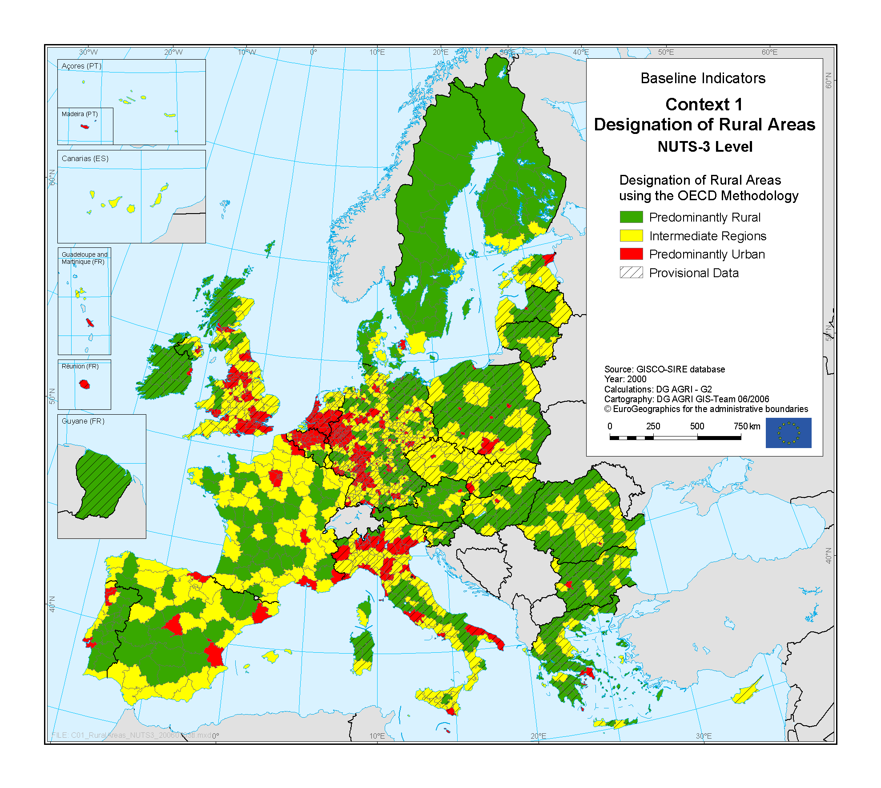
Source: Rural Development in the European Union – Statistical and Economic Information – Report 2006.
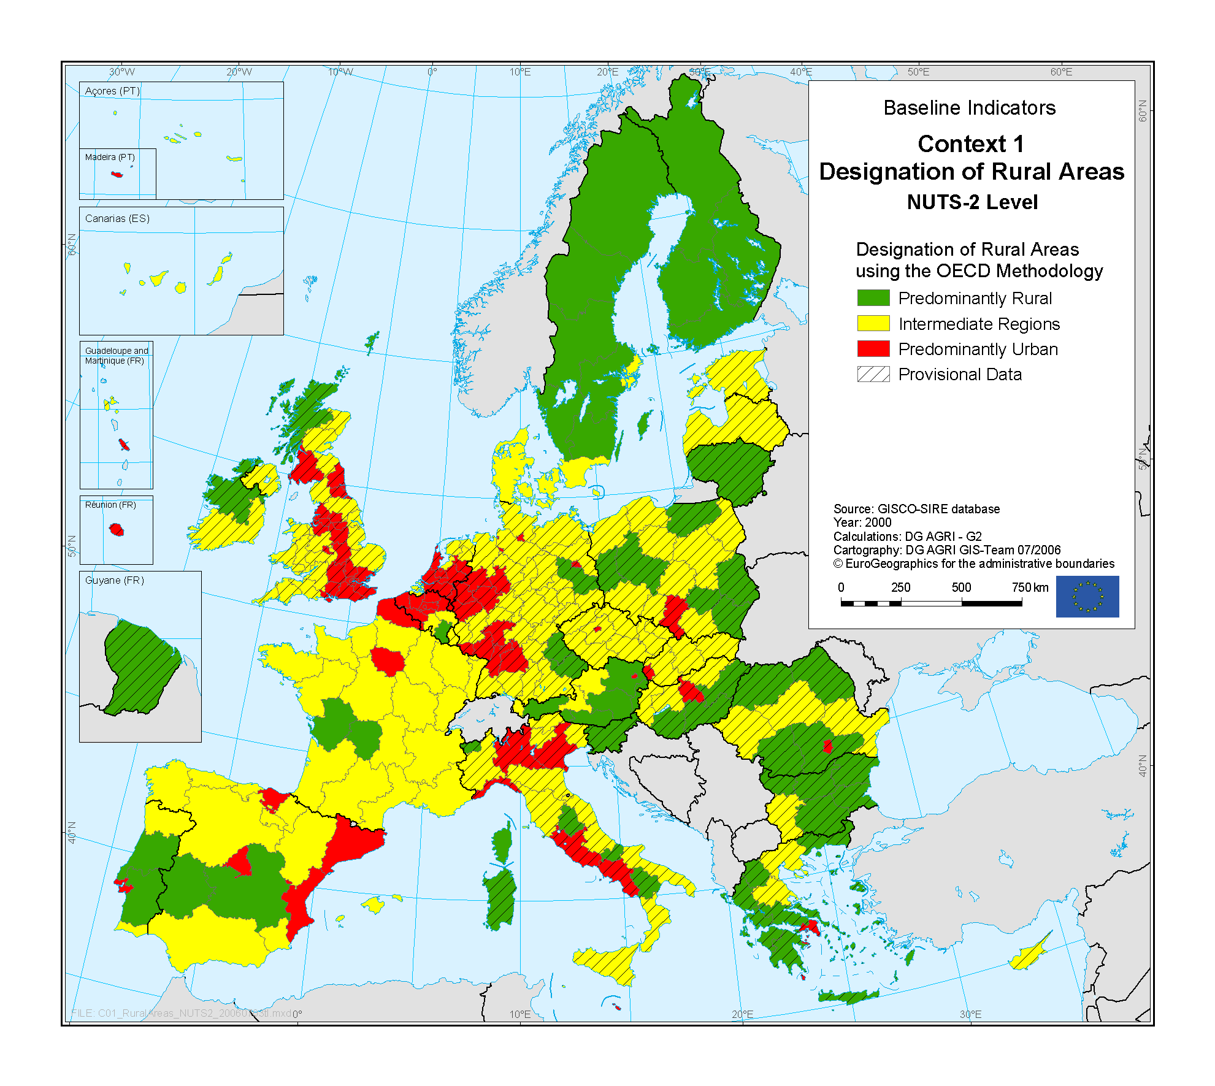
Source: Rural Development in the European Union – Statistical and Economic Information – Report 2006.
Source: Rural Development in the European Union – Statistical and Economic Information – Report 2006.
Source: Rural Development in the European Union – Statistical and Economic Information – Report 2006.
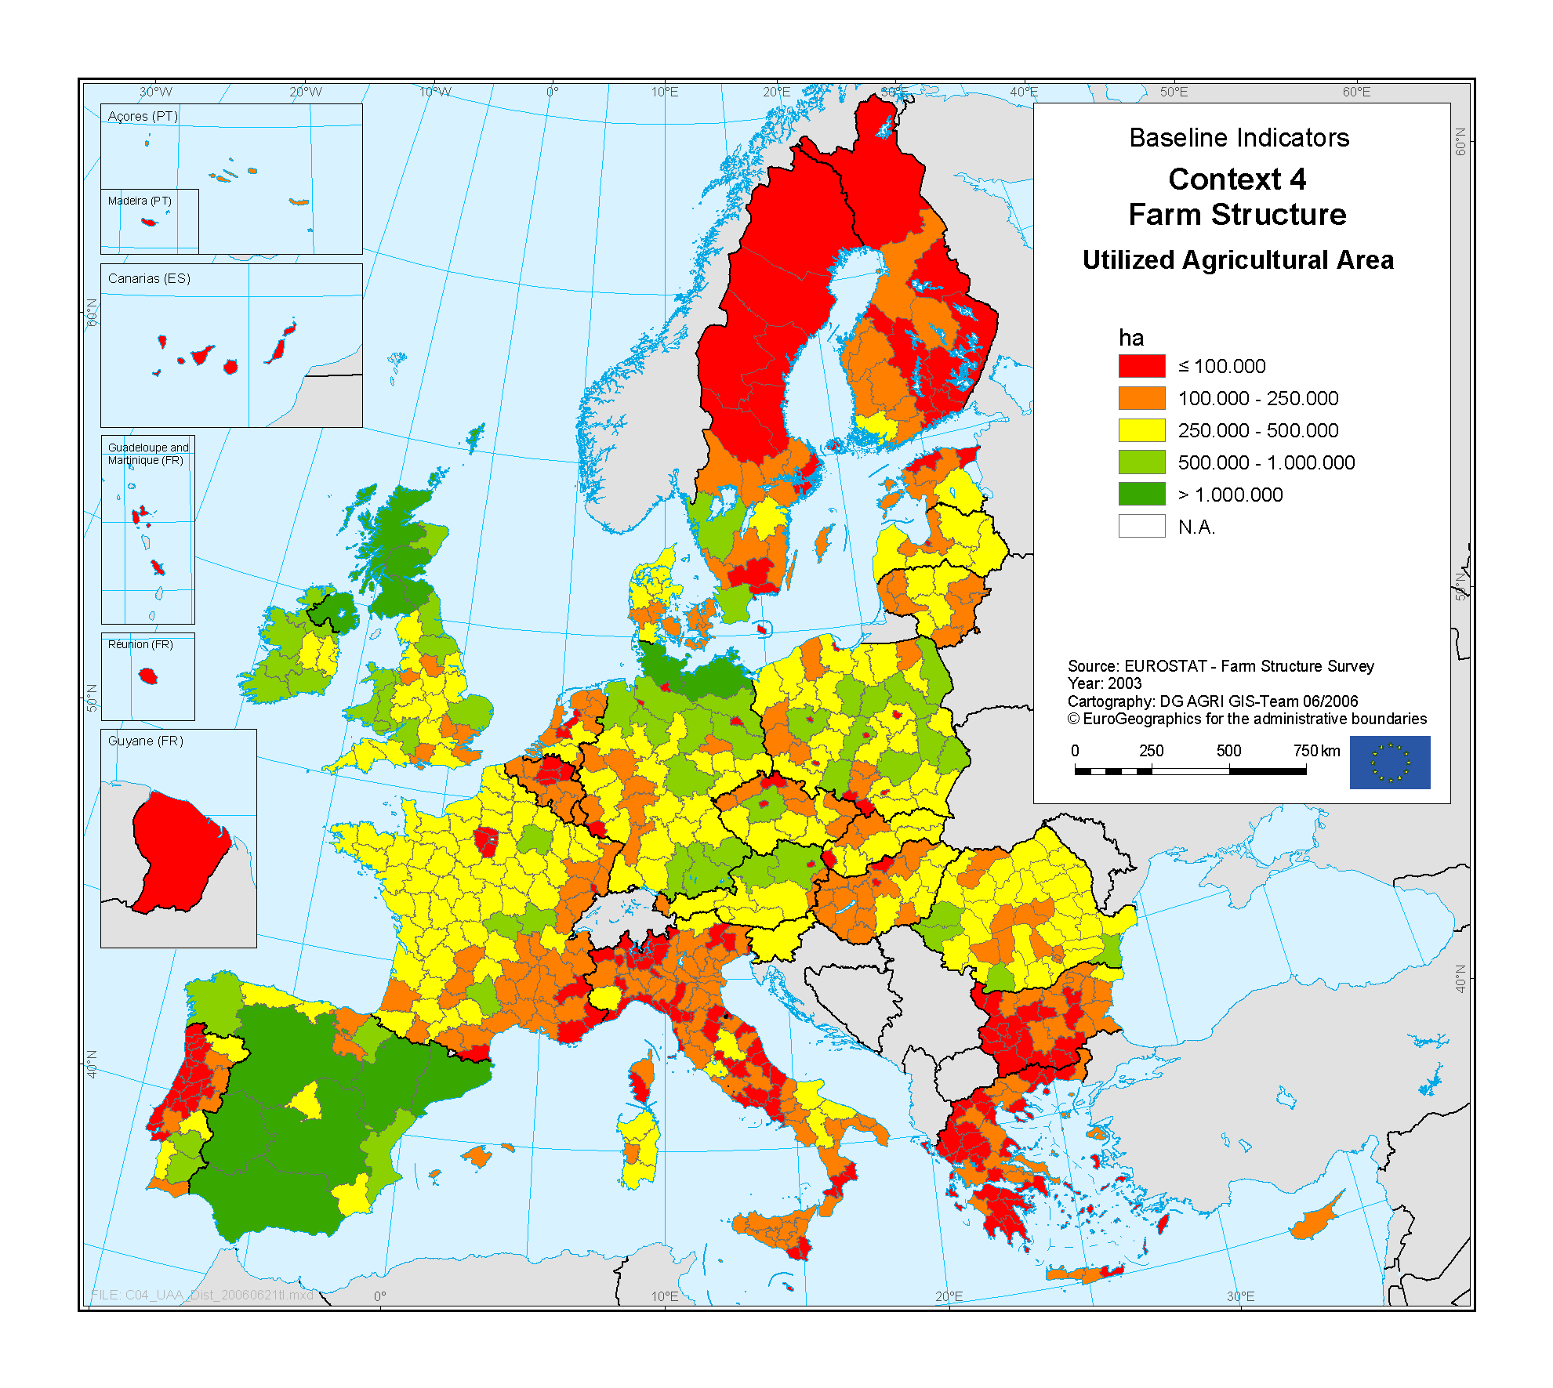
Source: Rural Development in the European Union – Statistical and Economic Information – Report 2006.
Demographic characteristics
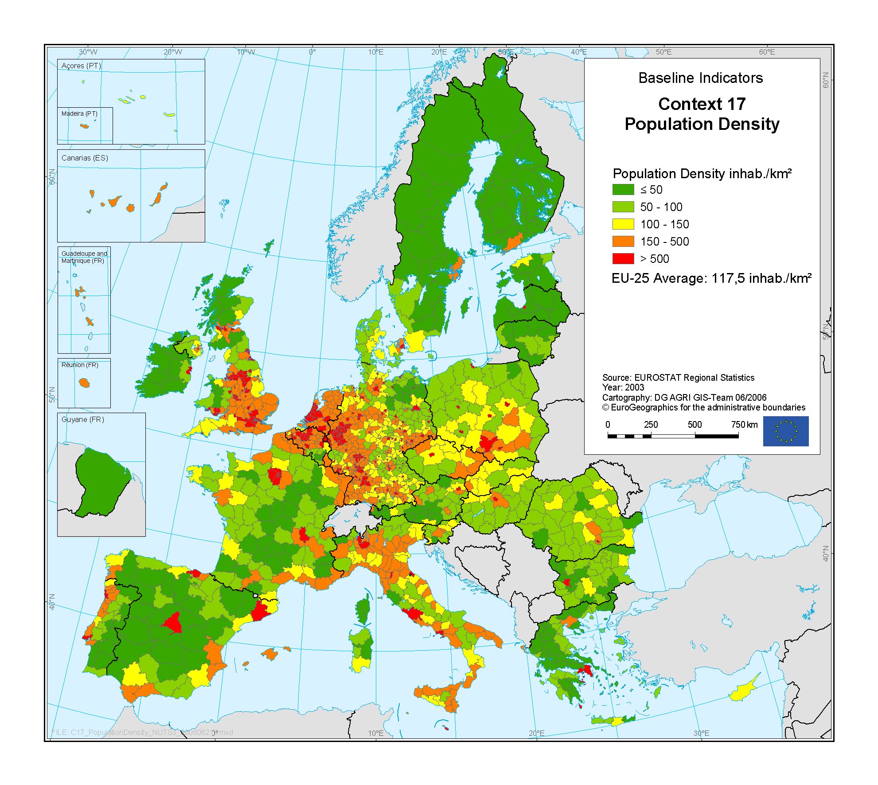
Source: Rural Development in the European Union – Statistical and Economic Information – Report 2006.
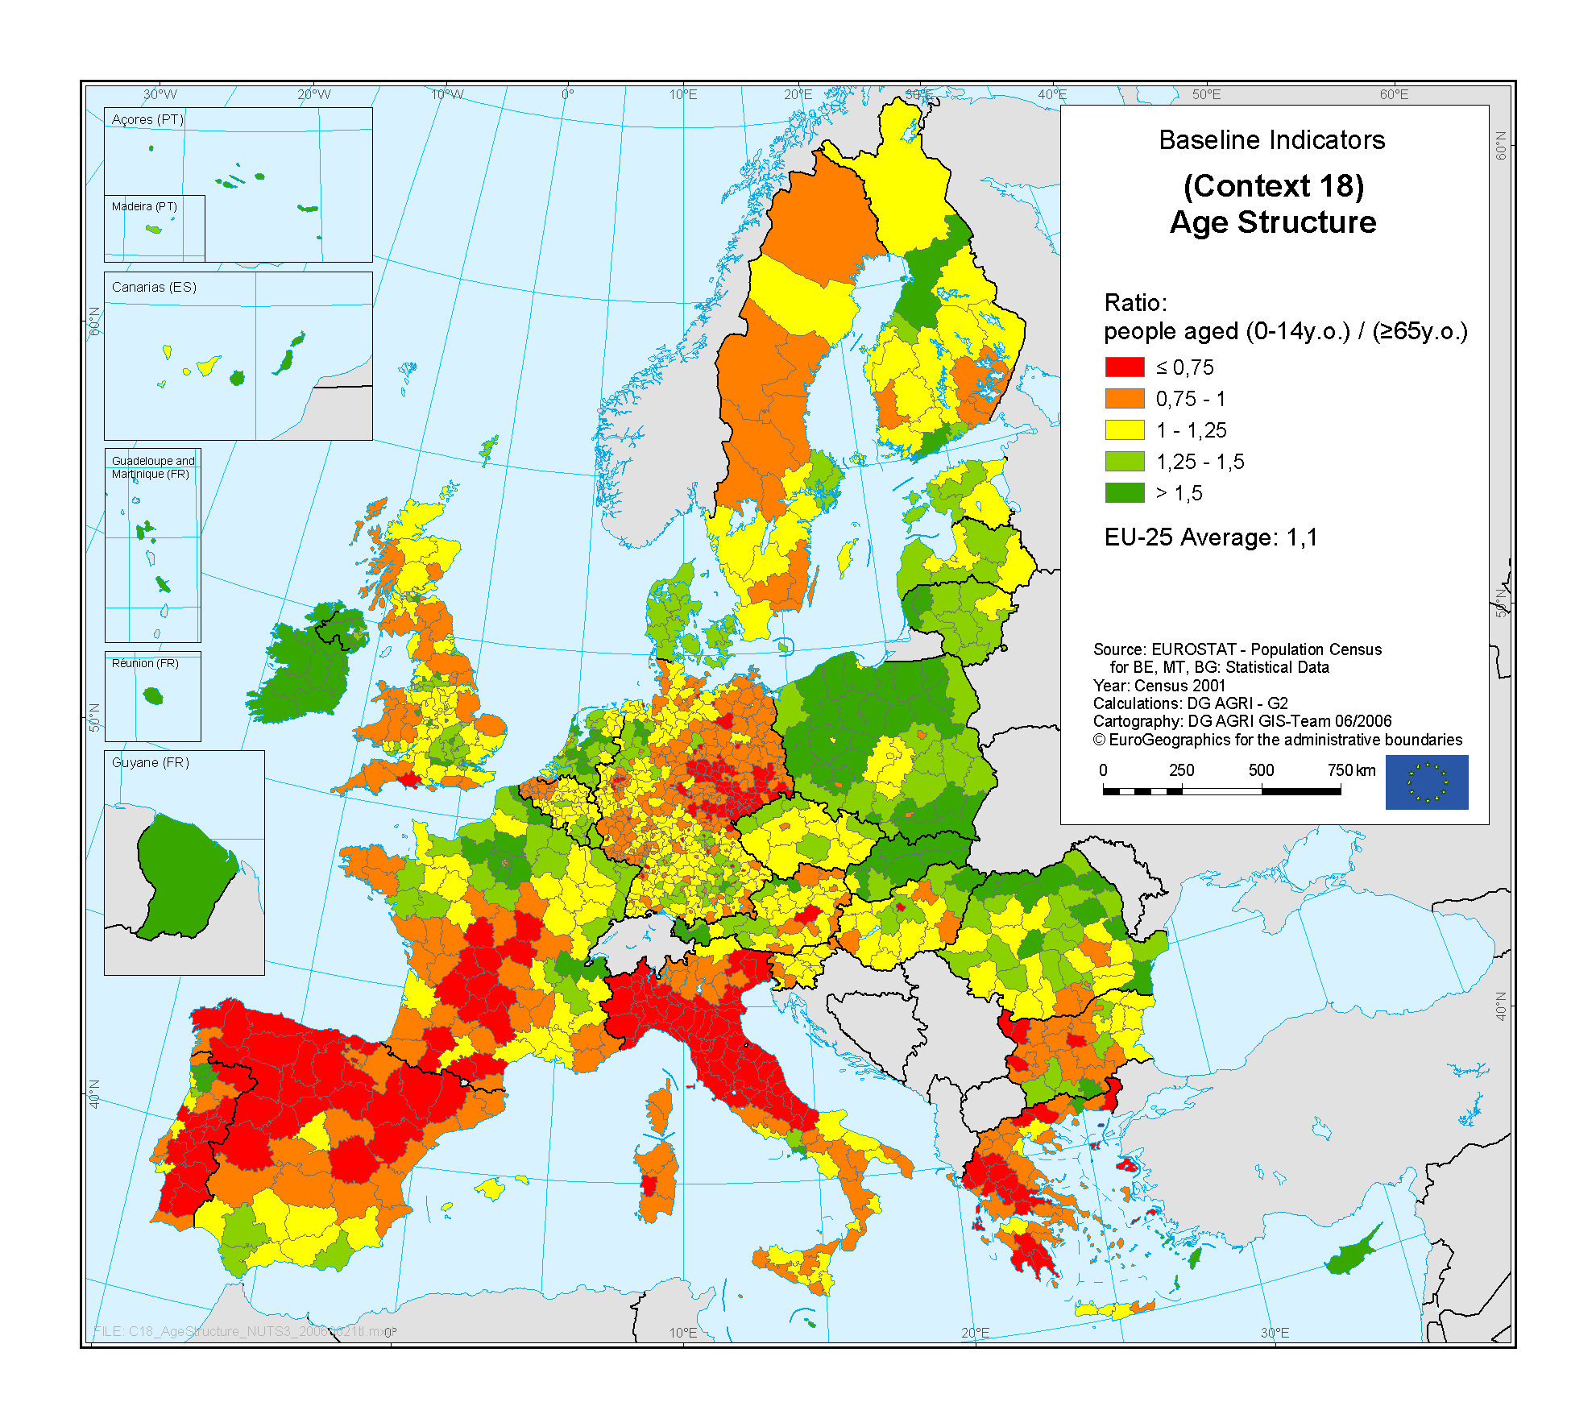
Source: Rural Development in the European Union – Statistical and Economic Information – Report 2006.
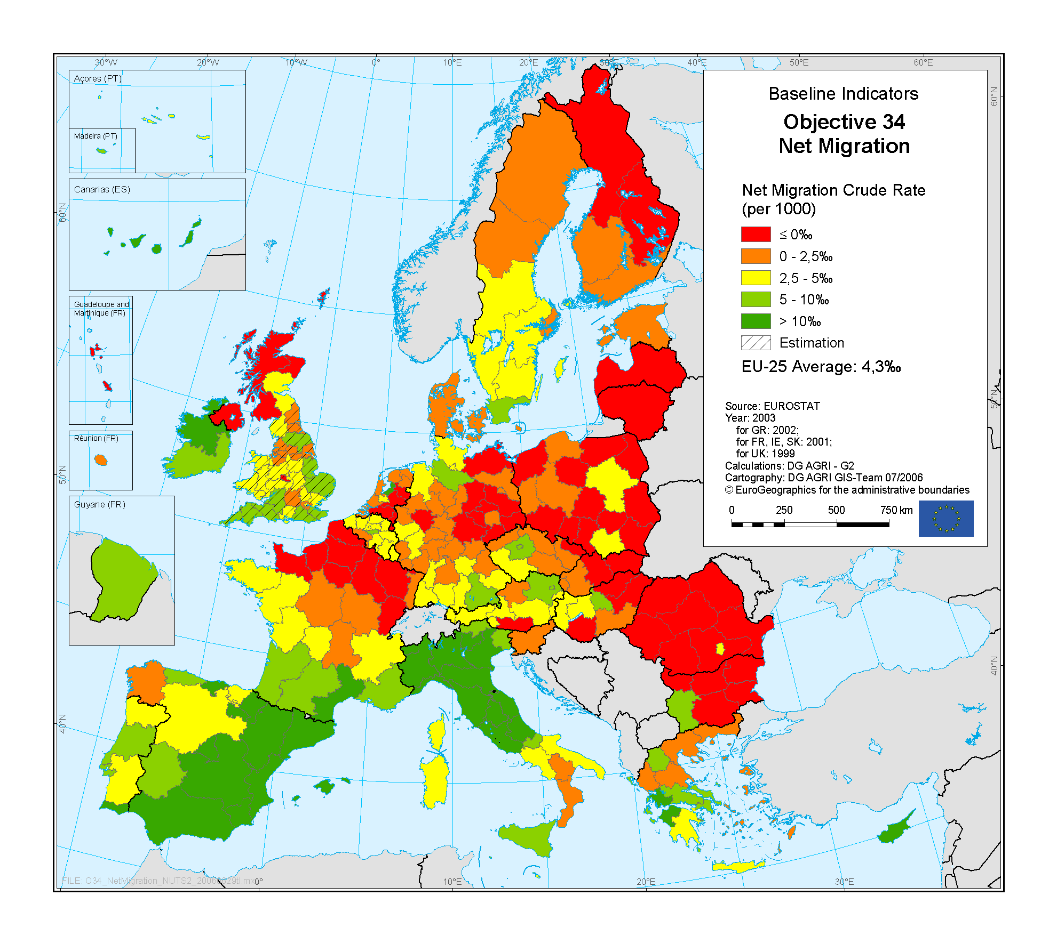
Source: Rural Development in the European Union – Statistical and Economic Information – Report 2006.
Economic characteristics
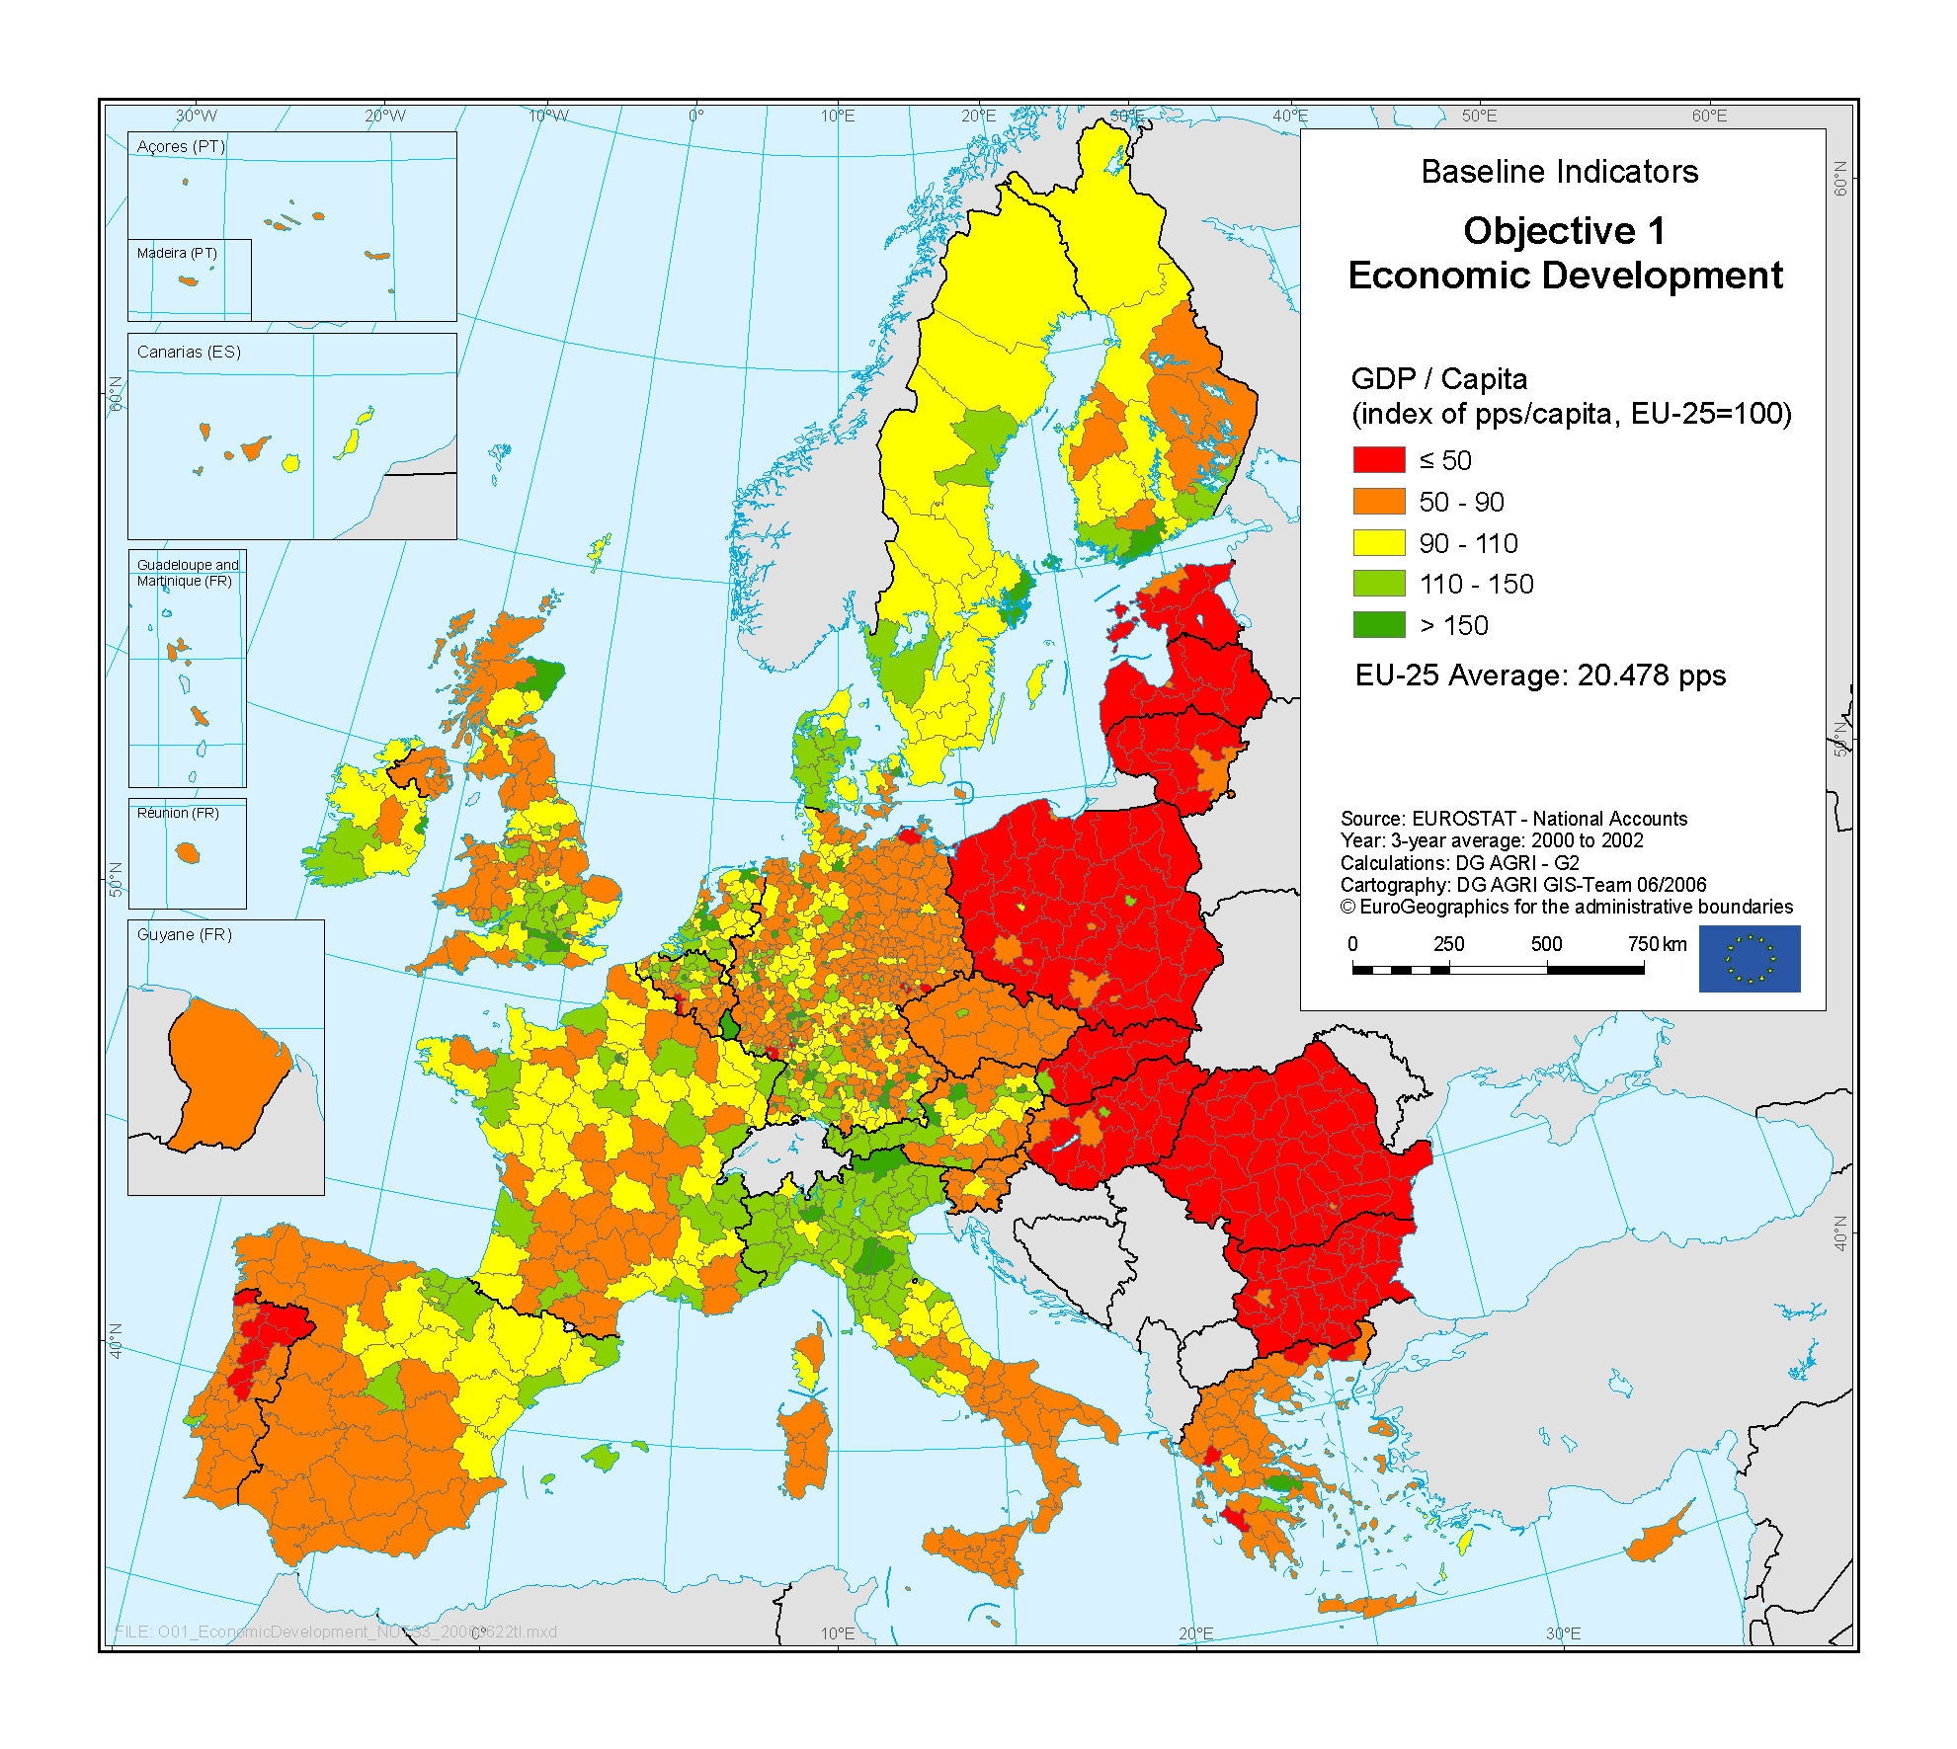
Source: Rural Development in the European Union – Statistical and Economic Information – Report 2006.
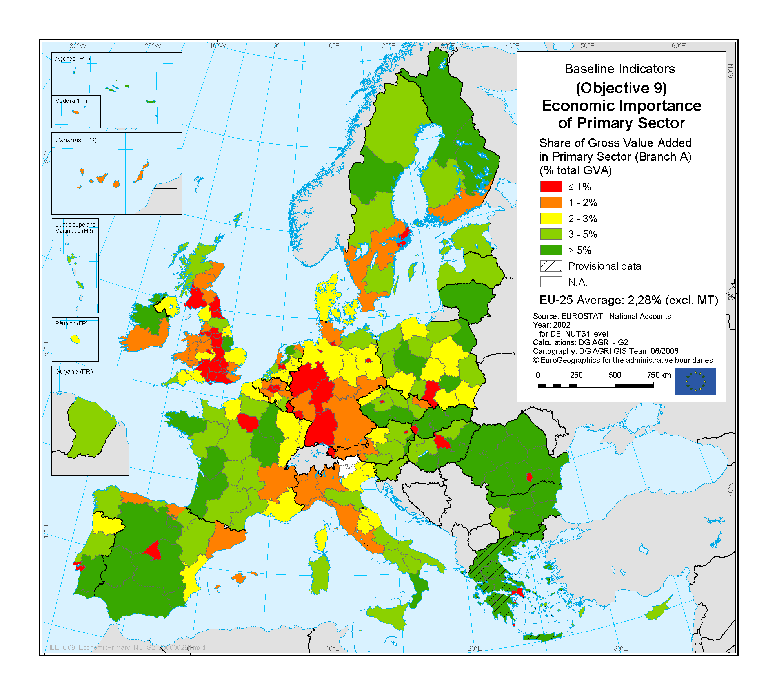
Source: Rural Development in the European Union – Statistical and Economic Information – Report 2006.
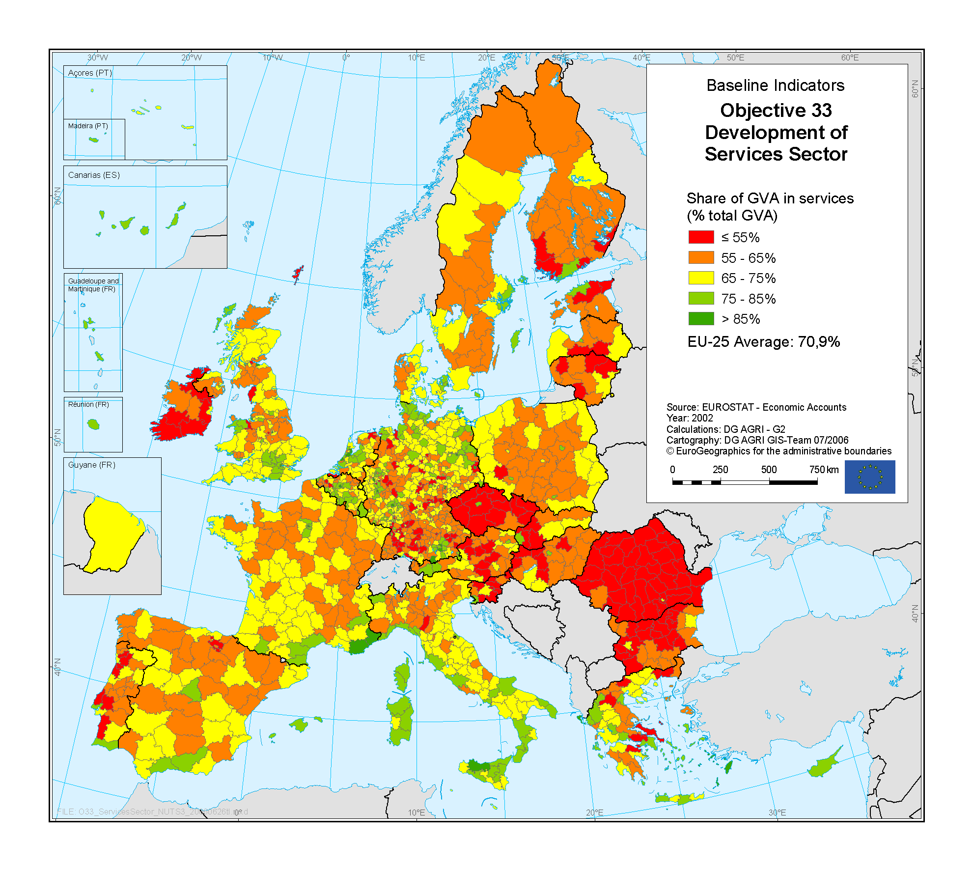
Source: Rural Development in the European Union – Statistical and Economic Information – Report 2006.
Employment characteristics
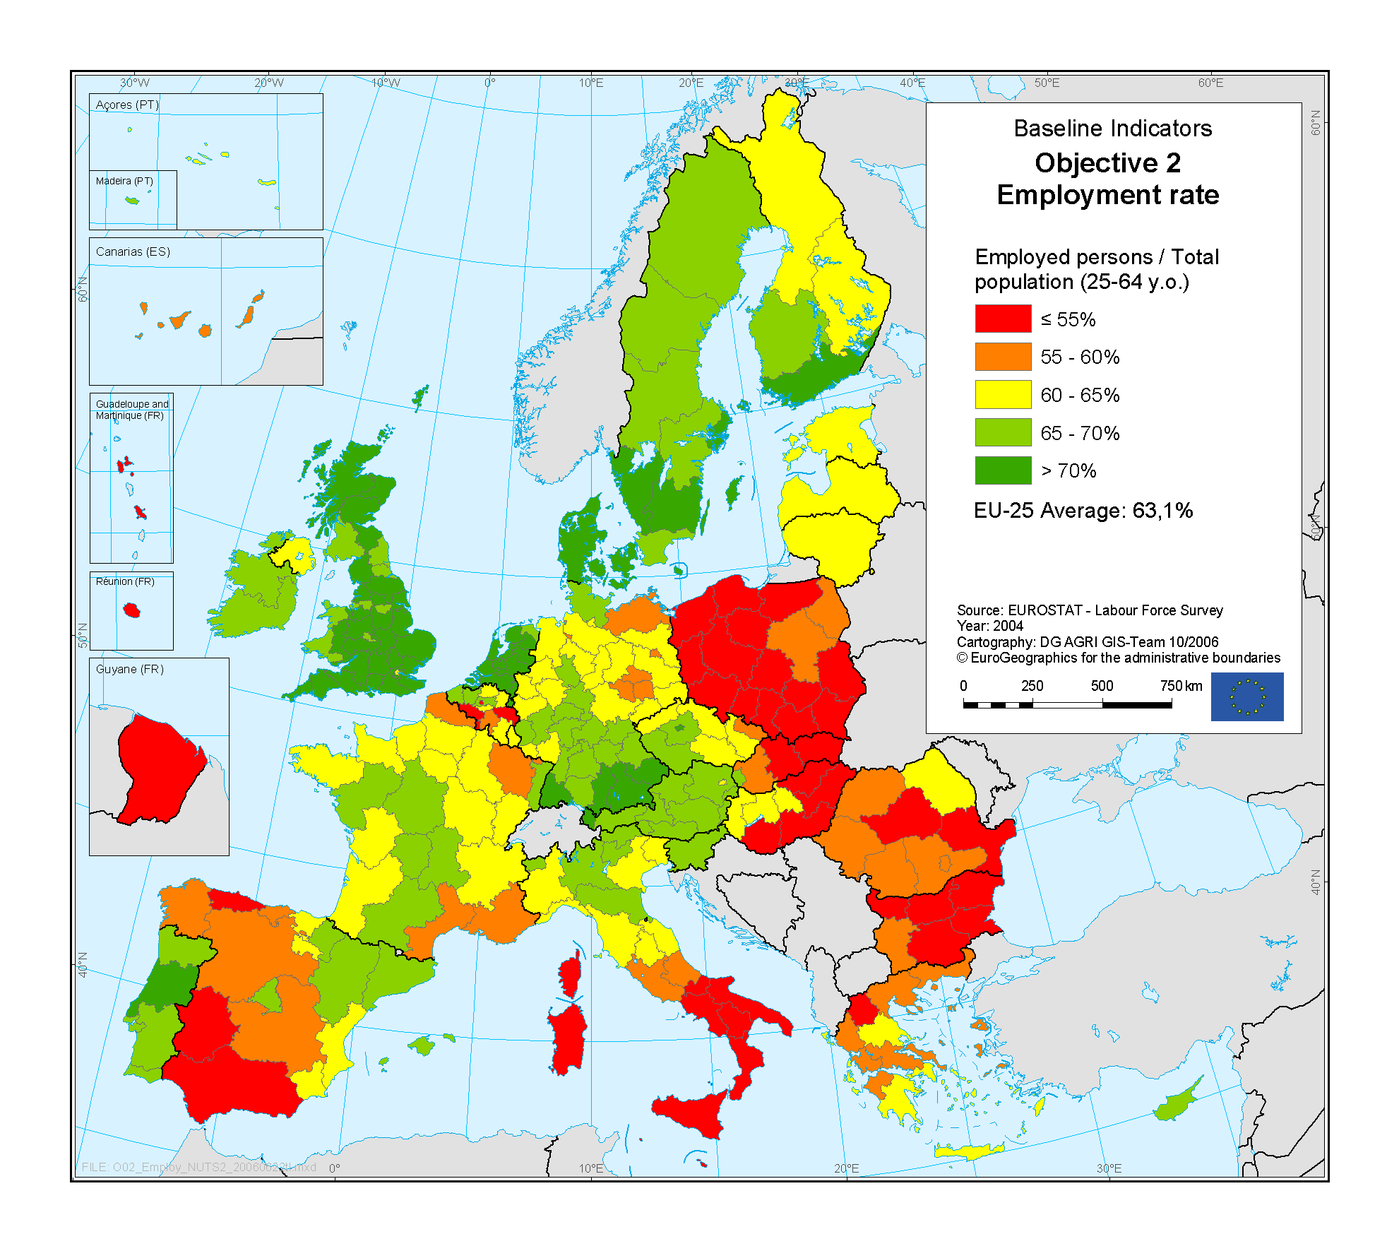
Source: Rural Development in the European Union – Statistical and Economic Information – Report 2006.
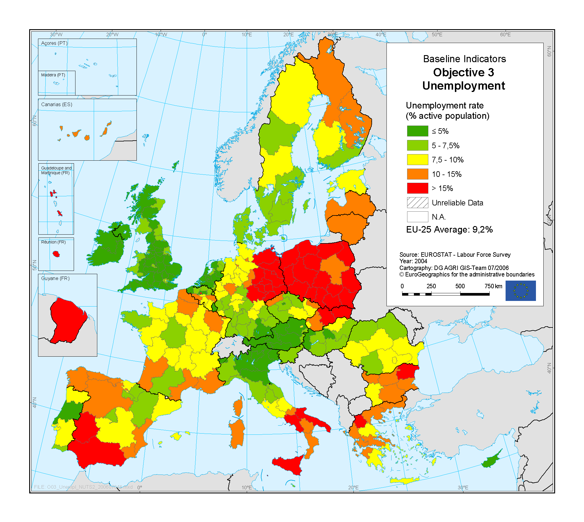
Source: Rural Development in the European Union – Statistical and Economic Information – Report 2006.
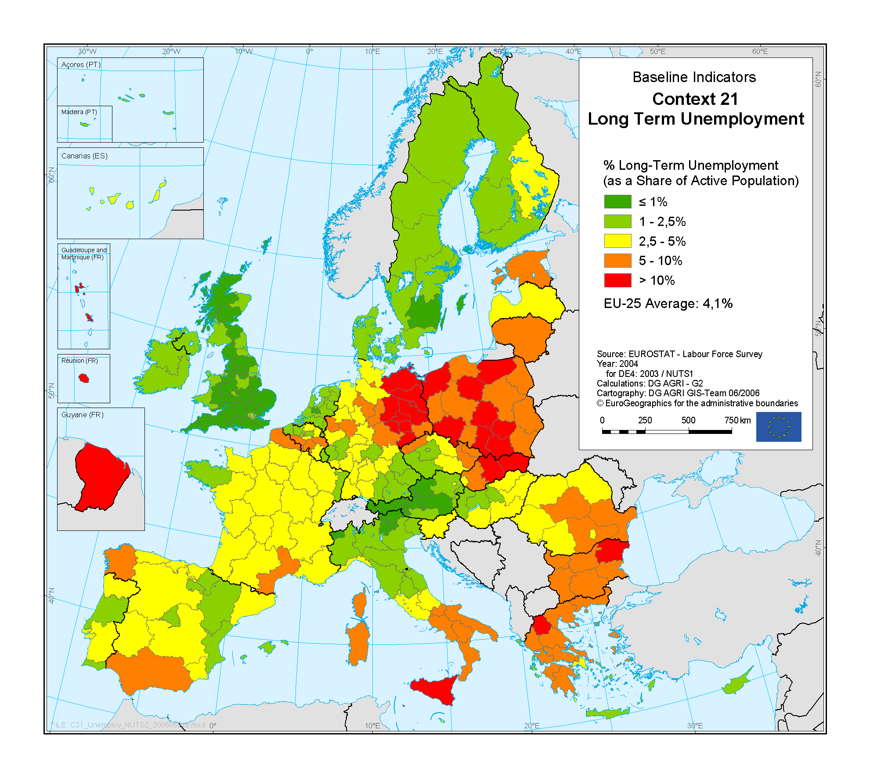
Source: Rural Development in the European Union – Statistical and Economic Information – Report 2006.
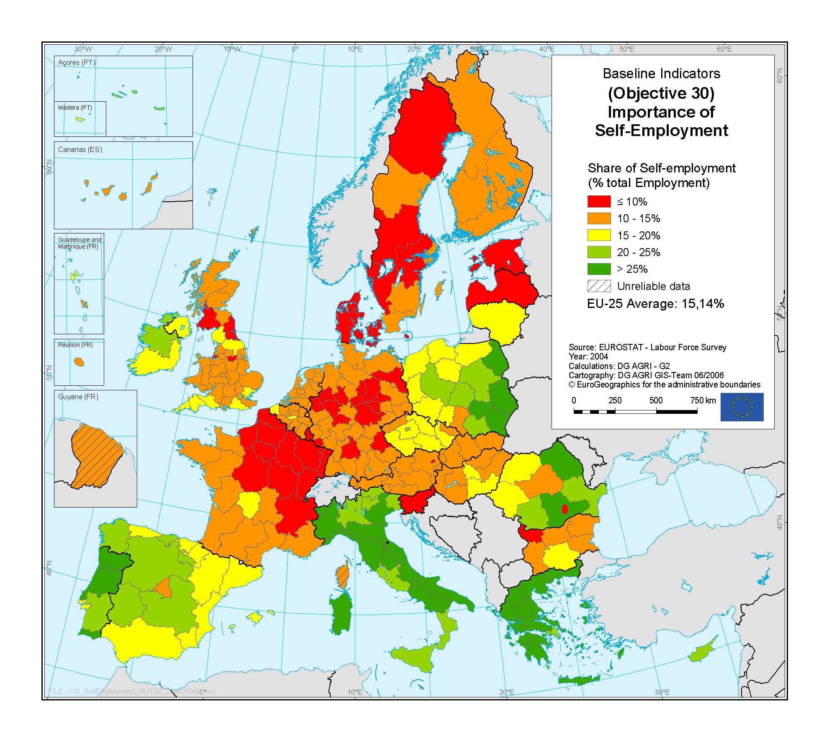
Source: Rural Development in the European Union – Statistical and Economic Information – Report 2006.
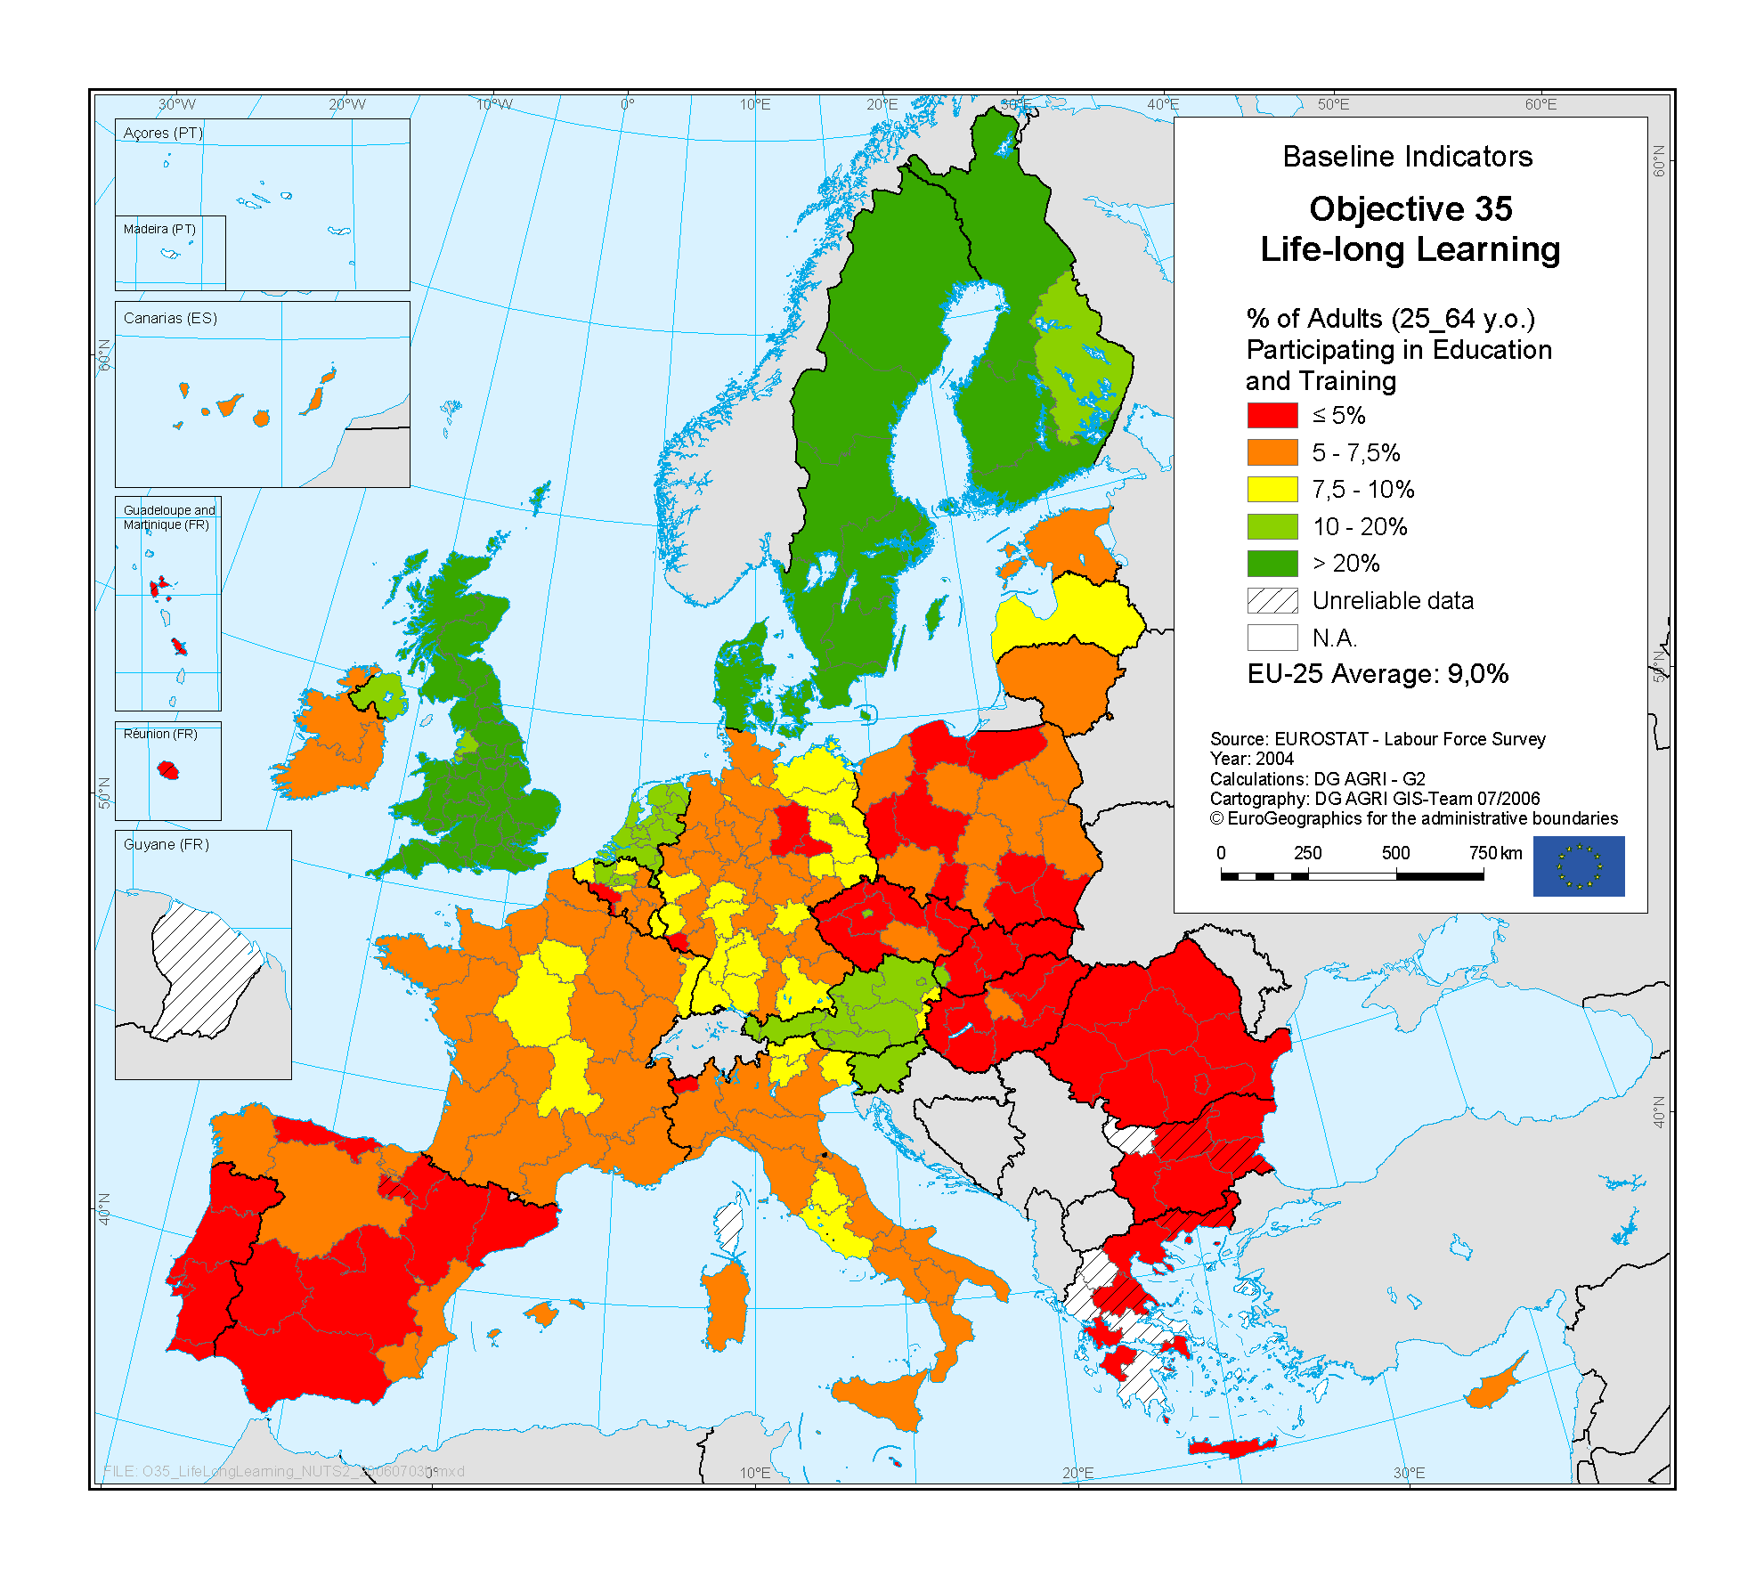
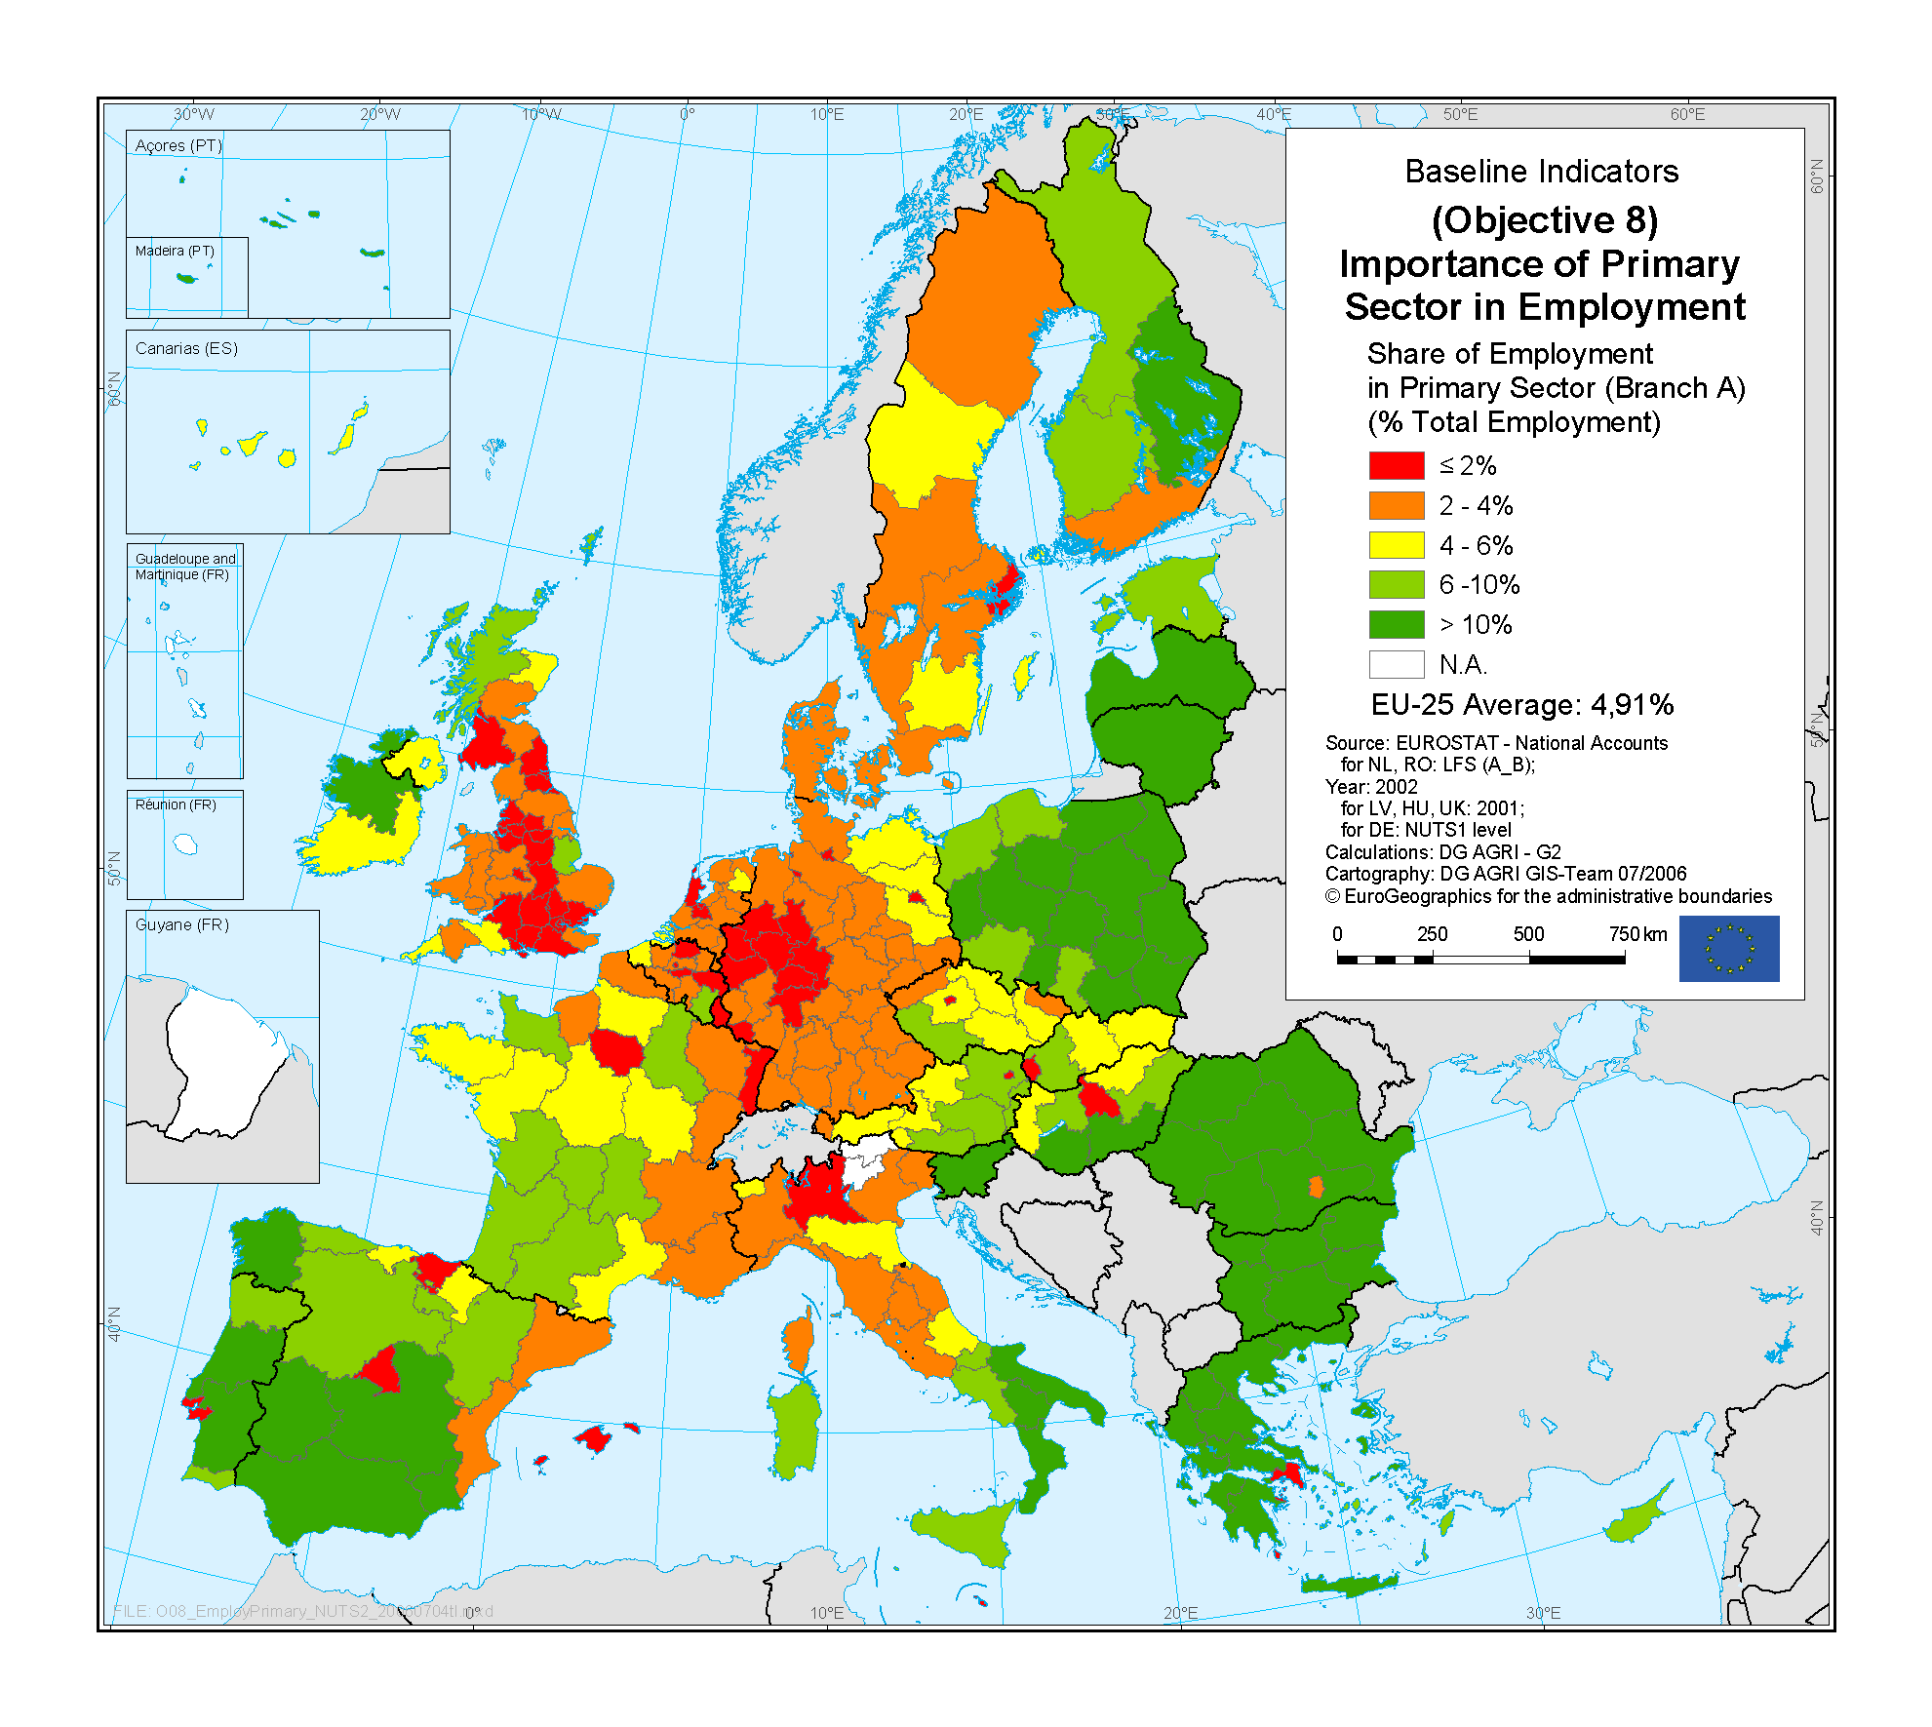
Source: Rural Development in the European Union – Statistical and Economic Information Report 2006.

COM(2005) 24.
Council Regulation (EC) No 1698/2005 (OJ L 277, 21.10.2005, p. 1).
Council Decision of 20 February 2006 on Community strategic guidelines for rural development (programming period 2007 to 2013), (2006/144/EC), OJ L 55, 25.2.2006, p. 20.
SERA – Study of Employment in Rural Areas 2006; The Future of Rural Areas in the CEE Candidate Countries, 2003.
Employment in Europe Report 2006, Rural Development in the European Union – Statistical and Economic Information 2006, Extended Impact Assessment for a Commission Proposal for a Rural Development Regulation 2004, Prospects for agricultural markets and income 2006–2013.
COM(2005) 141, 12.4.2005, Integrated guidelines for growth and jobs (2005–2008).
Council conclusions – Employment in rural areas under the European Employment Strategy, 11486/03, 16 July 2003.
This definition of rural areas has been adopted in the context of Council Decision of 20 February 2006 on Community strategic guidelines for rural development (programming period 2007 to 2013) (2006/144/EC). The OECD defines areas as predominantly rural, significantly rural or predominantly urban according to population density and is based on the share of population living in rural communes (i.e. with less than 150 inhabitants per km²) in a given NUTS II or III region. See Extended Impact Assessment SEC(2004) 931 and SEC(2005) 914. The 1284 NUTS 3 regions of the EU-27 are broadly evenly divided between the three rural-urban categories. The Commission is currently undertaking work on alternative definitions that better reflect the diversity of significantly rural areas, including peri-urban areas. Employment trends identified in this document generally correspond to Labour Force Survey data at NUTS II or NUTS III level and therefore correspond to regional and travel to work area dynamics.
Rural Development in the European Union – Statistical and Economic Information – Report 2006.
Study on Employment in Rural Areas (SERA), p. 214.
Study on Employment in Rural Areas (SERA), p. 20.
Study on Employment in Rural Areas (SERA), p. 15.
Rural Development in the European Union – Statistical and Economic Information – Report 2006.
Study on Employment in Rural Areas (SERA), p. 24.
European Commission communication, 2006f, Le défi démographique, une chance pour l'Europe.
Study on Employment in Rural Areas (SERA), p. 44.
Employment rates in Europe vary significantly across countries, with most of the New Member States below the 65% level and large part of the European economies (17 Member States) below the 2005 target of 67%.
OECD 2006. Rural Policy Reviews. The New Rural Paradigm. POLICIES AND GOVERNANCE, p. 27.
Rural Development in the European Union – Statistical and Economic Information – Report 2006.
EC (2006e) Joint Employment Report 2006.
Study on Employment in Rural Areas (SERA), p. 133.
Study on Employment in Rural Areas (SERA), p. 41.
Study on Employment in Rural Areas (SERA), p. 44.
Study on Employment in Rural Areas (SERA), p. 47-48.
Study on Employment in Rural Areas (SERA), p. 34.
Rural Development in the European Union – Statistical and Economic Information – Report 2006.
Report by the Network of independent experts in the CEE candidate country "The Future of Rural Areas in the CEE Candidate Countries", delivered in 2003.
FSS 2003, Labour Force Survey.
The GEOPA report (2002) shows that costs of an hour's work of a seasonal worker ranged from 3.6–4.0 EUR/hour in Portugal and Greece up to 12.9–16.7 EUR/hour in Sweden and Denmark. In most countries the rate was in the range of 6.0–9.0 EUR/hour. Illegal labour is hired for much less compared to these amounts.
Rural Development in the European Union – Statistical and Economic Information – Report 2006.
Study on Employment in Rural Areas (SERA), p. 101.
Study on Employment in Rural Areas (SERA), p. 91.
Study on Employment in Rural Areas (SERA), p. 214.
Study on Employment in Rural Areas (SERA), p. 84.
COM(2002) 394 final Communication from the Commission to the Council and the European Parliament: "Mid-Term Review of the Common Agricultural Policy".
Preliminary findings on the effects on employment of the implementation of measures related to Rural Development Programmes during the first three years of execution of the 2000–2006 programming period are available in the context of EC "Synthesis of Rural Development Mid-Term Evaluations". This section draws on the same mid-term evaluations.
SERA, p. 84.

