EN
COMMISSION OF THE EUROPEAN COMMUNITIES
Brussels, 25.9.2007
SEC(2007) 1209
COMMISSION STAFF WORKING DOCUMENT
Accompanying the
GREEN PAPER
Towards a new culture for urban mobility
{COM(2007) 551 final}

Introduction
To support the preparation of its Green Paper on urban mobility, the European Commission has organised a broad consultation of stakeholders and citizens during the first half of 2007.
Large-scale conferences, with participation ranging from expert to ministerial level, were organised by the European Commission to mark the beginning and the end of the consultation period, which lasted from 31 January 2007 to 4 June 2007. Technical workshops on specific themes - Green Propulsion, Financing, Intermodality and Intelligent Transport, and Integrated Urban Transport Approaches - were also held.
The Commission also launched an internet consultation that took place in March and April 2007 and that yielded 915 responses from citizens, associations, and public bodies. Suggestions for urban mobility policy measures and proposals were included in 64 letters and position papers that were submitted by different organisations, public bodies and citizens. The Joint Expert Group on Transport and Environment discussed urban transport and clean and energy-efficient vehicles in a special meeting.
The results from this consultation phase together with lessons from long-running Community programmes on integrated urban transport approaches are presented in this staff working document as an annex to the Green Paper on urban mobility. The Green Paper includes a set of policy options and 25 open questions addressing these options.
The stakeholders that provided contributions during the preparation of the Green Paper on urban mobility include the following groups: private sector (private companies, industries, businesses associations); public sector (non-governmental organizations, not-for-profit associations and research institutes) and (local, regional and national) authorities. All contributions that have been received have provided valuable input.
The Green Paper indicates where suggestions made by stakeholders were taken up for further discussion, and where existing policies might require additional action.
A new intensive consultation process shall be undertaken following the publication of the Green Paper, in order to prepare an Action Plan that will be presented in autumn 2008.
TABLE OF CONTENTS
1. Launch conference — Urban transport: problems, solutions and responsibilities — Brussels, 31 January 2007 4
2. First Technical Workshop — Urban Transport and Green Propulsion — Brussels, 31 January 2007 5
3. Second technical workshop — Urban Transport Financing: Experiences from different Cities — Szentendre, Hungary, 6 March 2007 6
4. Third technical workshop — Public Transport, intermodality and intelligent transport — Szentendre, Hungary, 7 March 2007 7
5. Fourth technical Workshop — Integrated urban transport approaches for successful and attractive cities — Brussels, 16 May 2007 8
6. Lessons from CIVITAS I: Integrated approaches for clean urban mobility "in practice" 9
7. Closing Conference — Towards a European Policy for Urban Transport — Brussels, 4 June 2007 13
8. Internet Questionnaire 15
9. Summary results of the Internet consultation 23
10. Internet comments on clean and energy-efficient vehicles 32
11. Joint Expert Group on Transport and Environment 34
12. Summary of contributions in position papers 35
- Launch conference — Urban transport: problems, solutions and responsibilities — Brussels, 31 January 2007
  - Participants
Around 400 representatives from all public and private sectors interested in urban transport.
  - Main theme of the event
The focus of the conference was the significant role of urban transport in achieving policy objectives in areas such as climate change, energy efficiency, congestion, alternative fuels, modal split, road safety, industrial competitiveness, environment, health and social inclusion. In addition, the principle of subsidiarity was discussed.
  - Sessions by theme and main discussion points
The conference had two sessions: the first was devoted to the expectations of local authorities and the actors concerned by the Green Paper; the second investigated the possible added value of actions at EU level in this field, taking into account the subsidiarity and governance principles.
The speakers and stakeholders addressed the following questions:
- What are your expectations from a Green Paper on urban transport?
- In which fields do you see an added value for action on urban transport at EU level, if any?
- Are there barriers at EU level that hinder you in implementing an effective and efficient urban transport policy?
- What role should subsidiarity and governance issues play in the debate on action on urban transport at EU level?
The three main messages that emerged were:
- Broad support for the initiative to prepare a Green Paper and consensus on the need for a joint approach to prepare it. Subsidiarity is not an obstacle but rather a challenge and an opportunity that could enrich actions taken at different levels, whether local, regional, national or European;
- Agreement on the need for an integrated approach: urban transport is important not only for European transport policy, but also in the wider context of other European policies;
- Need for financial support for public transport through the Structural Funds, the Cohesion Fund and other innovative instruments, this being an essential tool for a successful urban transport policy, especially in the new Member States, where cities should not repeat mistakes made by the old Member States (for instance abolishing existing public transport infrastructure, like tramways).
  - Overall summary
European cities offer a successful model for urban transport, and the cities themselves are in the best position to select and implement the right portfolio of measures. The role of the EU will be to identify, in partnership with all parties, whether there are obstacles to successful urban transport policies and, where there is added value at EU level, propose joint solutions for specific actions. The need for action at EU level in the area of urban transport is widely supported.
- First Technical Workshop — Urban Transport and Green Propulsion — Brussels, 31 January 2007
  - Participants
About 120 stakeholder representatives interested in the Commission initiative on clean and energy-efficient vehicles.
  - Main theme of the event
The main purpose of the first technical workshop was to discuss a possible new approach for Commission action to promote clean and energy-efficient road transport vehicles.
  - Sessions by theme and main discussion points
The workshop had two sessions: the first devoted to the technological and economic aspects of clean and energy-efficient vehicles, the second devoted to possible ways to obtain political support for introducing these technologies.

Main comments
- Green propulsion should be a core element of European transport policy;
- An integrated approach on the part of all stakeholders involved is required to reconcile the diverse and sometimes conflicting demands for lower pollutant emissions, lower CO₂ emissions, lower noise, higher safety, and higher comfort for users;
- Vehicles and fuels should be treated as a single system;
- Vehicle and fuel standards therefore need to be interlinked;
- An integrated assessment of the environmental and economic aspects of fuels should be based on a well-to-wheels analysis for future legislation;
- Pollutant emission has been reduced over the past 30 years through the introduction of new vehicle technologies, as required by the progressively lower EURO emission standards;
- Research and development projects under way in industry and funded by the Community Framework Programme promise further reductions in energy consumption, CO2 emissions, and pollutant emissions through technological improvements to vehicles;
- Intelligent Transport Systems (ITS) play a key role in clean and efficient mobility;
- Harmonised definitions for clean vehicles should be established as a basis for state aid;
- Support measures for clean and energy-efficient vehicles should also be harmonised within the European Union to avoid market fragmentation;
- Economic incentives should be provided in combination with access regulation and awareness raising;
- Public procurement should consider all public concerns, such as energy, climate, air quality, safety, and noise, possibly with an eco-point award system;
- Harmonised tendering rules including lifetime costs would be useful, with optional application advocated by some and mandatory implementation requested by others;
- Joint procurement could improve green vehicle economics.
  - Overall summary
During the workshop, broad support was expressed for action at EU level to promote the market introduction of clean and energy-efficient vehicles. Public procurement was regarded as an effective tool for this purpose.
- Second technical workshop — Urban Transport Financing: Experiences from different Cities — Szentendre, Hungary, 6 March 2007
  - Participants
About 120 senior transport experts and representatives from stakeholder organisations.
  - Main themes of the event
The financial aspects of urban transport were discussed during the workshop: cohesion policy, financing of transport investments and operations, financial innovations and transport pricing, and access and charging schemes as one possible solution for raising revenues for transport investments.
  - Sessions by theme and main discussion points
The second technical workshop had four sessions: the first devoted to transport and cohesion policy; the second devoted to financing of urban transport investments and operations (all modes); the third to regulated access and charging schemes, and the fourth to financial innovations and transport pricing.

Main comments
- Successful cities need good public transport. The long-term financing of investments and operations is a key issue;
- Different forms of public-private partnerships may offer solutions that should be given more attention. Example: development of exchange nodes between different modes;
- EU regional policy facilitates significant investment in eligible regions;
- Cohesion policy for 2007-2013 promotes comprehensive strategies and integrated sustainable urban development;
- Urban transport plays an important role in the balanced and polycentric development of cities;
- Cities should profit from existing financing possibilities — the money is there! (e.g. for public transport, clean transport, integrated packages, soft measures, etc.);
- Many of the new Operational Programmes for 2007 – 2013 pay significant attention to urban (public) transport, but seem to be dominated to some extent by single ‘big’ projects;
- The EIB offers loans, special instruments (such as Jessica) and knowledge.
  - Overall summary
Funding seems to be a key concern across Europe. The Structural Funds, the Cohesion Fund and other innovative instruments offer essential funding for investments in many urban transport systems, especially in the new Member States. The European Investment Bank also helps with money, special instruments and knowledge, but there is a need to utilise existing possibilities. Financing is an issue not only for infrastructure investments but also for day-to-day operation and maintenance.
- Third technical workshop — Public Transport, intermodality and intelligent transport — Szentendre, Hungary, 7 March 2007
  - Participants
About 120 senior transport experts and representatives from stakeholder organisations.
  - Main themes of the event
The efficiency and effectiveness of public transport, intermodality in urban areas together with safety and security, intelligent transport systems, and environmental performance and noise were discussed during the workshop.
  - Sessions by theme and main discussion points
The third technical workshop had four sessions: the first devoted to the efficiency and effectiveness of public transport; the second to intermodality in urban areas, along with safety and security; the third to intelligent transport systems; and the fourth to environmental performance and noise.

Main comments
- Intelligent transport (ITS) offers ways to reduce congestion, pollution and energy consumption, better services for travellers and freight, better management of traffic, and possible tools for transport planning;
- Security in public transport has two dimensions: the general security of travellers and anti-terrorism security. The sector seems to be targeting action in the latter area;
- National governments do not always assume their responsibility in facilitating urban transport development, which leads to a lack of vertical policy coherence;
- There is a lack of common definitions and statistics;
- The link between urban transport policy and road safety policy was underlined several times;
- Local environmental pollution and noise, and compliance with EU legislation, require attention.
  - Overall summary
On policy coherence, definitions and statistics, and ITS, a number of clear recommendations were made. The trend to make polluting vehicles pay more for road use offers an opportunity to introduce Electronic Vehicle Identification. There is also a need to update the Vehicle Registration Document Directive (1999/37) to incorporate environmental vehicle data. The EU can also help with standardisation. There was also a request to support large-scale, policy-driven ITS demonstration projects and take-up actions.
- Fourth technical Workshop — Integrated urban transport approaches for successful and attractive cities — Brussels, 16 May 2007
  - Participants
About 80 experts and stakeholder representatives.
  - Main themes of the event
Different aspects of an integrated transport approach, including the links between urban planning, transport accessibility and demographics, were covered.
  - Sessions by theme and main discussion points
The workshop had four sessions: urban freight, urban transport and successful cities, innovation and research, and planning, behaviour and lifestyle.

Main comments
- Freight should be part of the urban agenda and there is a need to build long-lasting synergies with all the stakeholders involved;
- New delivery approaches both in terms of urban transport policy (the case of Göteborg) and in terms of new vehicles and fuels (environmentally friendly, safe and efficient) offer a range of benefits;
- The integration of different policies (land use, housing policy, etc.) and measures is the key to better and cleaner transport in European cities. The Leipzig Charter on Sustainable European Cities gives good recommendations for integration.
- All modes of transport in urban areas have a role to play (co-modality);
- Demographic trends and social dimension have to be considered for sustainable transport. Social inclusion should be delivered at local level, but policy, legal frameworks and guidance are needed;
- This is convincing evidence on the impacts of integrated strategies for clean urban transport from CIVITAS I. Change for the better is possible through: integrating technology and policy measures, combining transport and energy objectives; building up critical mass and markets; and working in partnership;
- The potential of taxis in urban passenger and freight transport could be better exploited;
- Personal mobility is the key to independence in particular for people with reduced mobility;
- The idea is to achieve maximum accessibility with minimum mobility;
- ‘Mobility management’ can complement traditional measures and help in shifting people’s attention towards more sustainable transport behaviour.
  - Overall summary
During the fourth workshop, the link between sustainable mobility and sustainable cities and the accessibility of retail activities was clarified. Social exclusion can only be successfully combated at local level but the EU can help with the framework, guidance and the promotion of best practices. The potential role of taxis in urban transport is not always exploited. Travellers’ rights in urban (public) transport were raised as an issue.
- Lessons from CIVITAS I: Integrated approaches for clean urban mobility "in practice"
The CIVITAS Initiative is an EU-funded demonstration programme that brings together policy makers, experts, practitioners, businesses and users. It supports integrated and bold strategies for clean and sustainable urban mobility. The success of this approach has been recognised and the programme continues. So far an EU contribution of €100 Million has been made available to 36 participating demonstration cities.
The first 19 CIVITAS I cities implemented 212 transport-related measures, which involved some 100 public and private organisations and more than 500 experts. The 212 CIVITAS I measures had a total value in excess of €150 Million (of which around €50 Million provided by CIVITAS). CIVITAS has demonstrated the success of urban mobility policies that combine, in an integrated way, different categories of tools and measures.
The implementation of the measures has now been evaluated and the experiences of the cities have been compared. Implementation was largely successful, despite the occasional delays due to technical, political or financial obstacles. Nearly 70% of the measures were satisfactorily completed, some 28% proved to be troublesome, while just 3% had to be replaced with alternative schemes or were halted altogether.
A number of factors had positive or negative effects on implementation. Planning technicalities, the lack of firm and reliable funding sources, and strong political opposition were all cited as significant barriers by the CIVITAS cities. On the other hand, the strong commitment of responsible politicians, synergies between policies and measures, the promotion of local partnerships, and the involvement of end users were identified as the main drivers of successful projects.
In terms of actual results, the work of the CIVITAS I cities has given a real and measurable benefit for the development of more attractive cities and the improvement of quality of life for millions of European citizens. This has been achieved through reduced congestion, lower pollutant and greenhouse-gas emissions, reduced energy consumption and lower noise levels. The next table provides a visual overview of the impacts of each measure category across the main areas of assessment.

CIVITAS I impacts by theme
positive impacts | neutral impacts | negative impacts | insufficient information

Analysis of the CIVITAS I results allows us to generalise the relationship between transport and energy policies and their likely impacts, although of course these will also depend to a great extent on the specific features of local urban contexts. The following table gives a list of common goals for sustainable urban transport and the measures expected to be most effective in the light of the experience gained with CIVITAS I.

Goals of sustainability and effective measures
If the goal is to… | …effective measures are…
Reduce congestion | - transport information and management  - mobility management  - access restriction  - public transport promotion  - goods distribution and logistics services  - parking management  - urban pricing
Reduce energy consumption and traffic emissions | - mobility management  - cycling  - car sharing and car pooling  - clean vehicles and fuels  - public transport promotion  - urban pricing
Decrease local emissions and improve quality of life in city centres | - access restriction  - goods distribution and logistic services  - parking management
Increase the market share of clean vehicles in private and public fleets | - car sharing and car pooling  - access restriction  - clean vehicles and fuels  - parking management
Increase the efficiency of the transport system | - multimodal interchanges  - mobility management  - cycling  - car sharing and car pooling  - public transport promotion  - goods distribution and logistic services
Increase the attractiveness of public transport | - transport information and management  - multimodal interchanges  - mobility management  - car sharing and car pooling  - access restriction  - public transport promotion  - urban pricing
Decrease parking pressure | - cycling  - car sharing and car pooling  - mobility management  - parking management

The CIVITAS I cities have not only implemented a number of measures, but has also generated what many experts regard as an even more crucial, though less tangible, series of achievements. These include and increased public confidence in the practicality and feasibility of innovative transport policies, exchange of knowledge in terms of technical design and practical applications, creation of a network of international contacts, leading to new collaborative projects and a critical mass for new technology adoption;
CIVITAS has also helped to launch a new project evaluation culture, looking both at impacts and at processes of measure implementation, and has fostered the creation of a political dimension, which is today expressed by the network of politicians active in the meetings of the CIVITAS Policy Advisory Committee and in the conferences of the CIVITAS Forum.
CIVITAS has proven a useful laboratory and a good investment. The continuing experience of dedicated cities is producing valuable information in terms of innovative solutions, emerging technologies, and policy impacts, and is conversely pointing out barriers to policy implementation, be them of political, technological or financial nature. All European cities, both inside and outside the CIVITAS Initiative, national and European policy makers, researchers, businesses and citizens are the main beneficiaries of this learning process. More information about the CIVITAS Initiative can be found online at www.civitas-initiative.eu.
- Closing Conference — Towards a European Policy for Urban Transport — Brussels, 4 June 2007
  - Participants
Around 350 participants, up to ministerial level, representing the major stakeholders.
  - Main theme of the event
Assessment of the public consultations and discussion of key messages for the Green Paper.
  - Sessions by theme and main discussion points
The conference had two sessions: the first devoted to presenting the feedback from the four technical workshops and the internet consultation and collecting the reactions from representatives of European cities; the second devoted to examining the main lessons from this exercise for a European Policy for Urban Transport.
The main messages that emerged are:
- There is presently no coherent urban transport policy at European level. Other EU policies, such as environment, internal market and public procurement, regional policy or research, touch upon urban transport on the basis of their own objectives. The subsidiarity principle should be respected;
- Urban transport is one of the main sources of greenhouse gases in transport. How can the EU respond effectively to the new demands to fight climate change without including urban transport in our policy focus?
- There is no single best policy solution. Every city is different and this diversity makes our cities attractive. But integrated and intelligent urban transport policies work well;
- Funding really seems to be a key issue. The Structural and Cohesion Funds and other instruments, including the European Investment Bank, offer essential tools for investment in many urban transport systems, but it is necessary to exploit the existing possibilities. Recognised good practice cases could be used as a basis for criteria for allocating funds at European level in the evaluation of project proposals in the area of urban transport;
- Green propulsion has an important role to play in urban transport. Ambitious standards for fuels and new vehicles have ensured real progress in the past years. The proposal for the public procurement of clean vehicles could help to create markets for new, clean vehicle technologies;
- The Green Paper should address the role of the private car in cities and other important issues such as enforcement, road safety, demand management tools and urban transport statistics. It should also cover urban freight transport and logistics and walking and cycling;
- It is necessary to adopt policies to ensure that public transport is a real alternative to private transport in European cities. There is a need to establish a new balance between public and private transport;
- Citizens expect public transport to meet their needs for mobility but society is changing. It has been suggested that the European Union should make sure that all European citizens have some basic rights when they use public transport;
- The added value of action at European level can be to promote the sharing of good practices, but it can also involve harmonisation, better coordination and cooperation, financial support, and simplification of existing legislation. The idea should not be to impose solutions, but to enable them.
- Internet Questionnaire
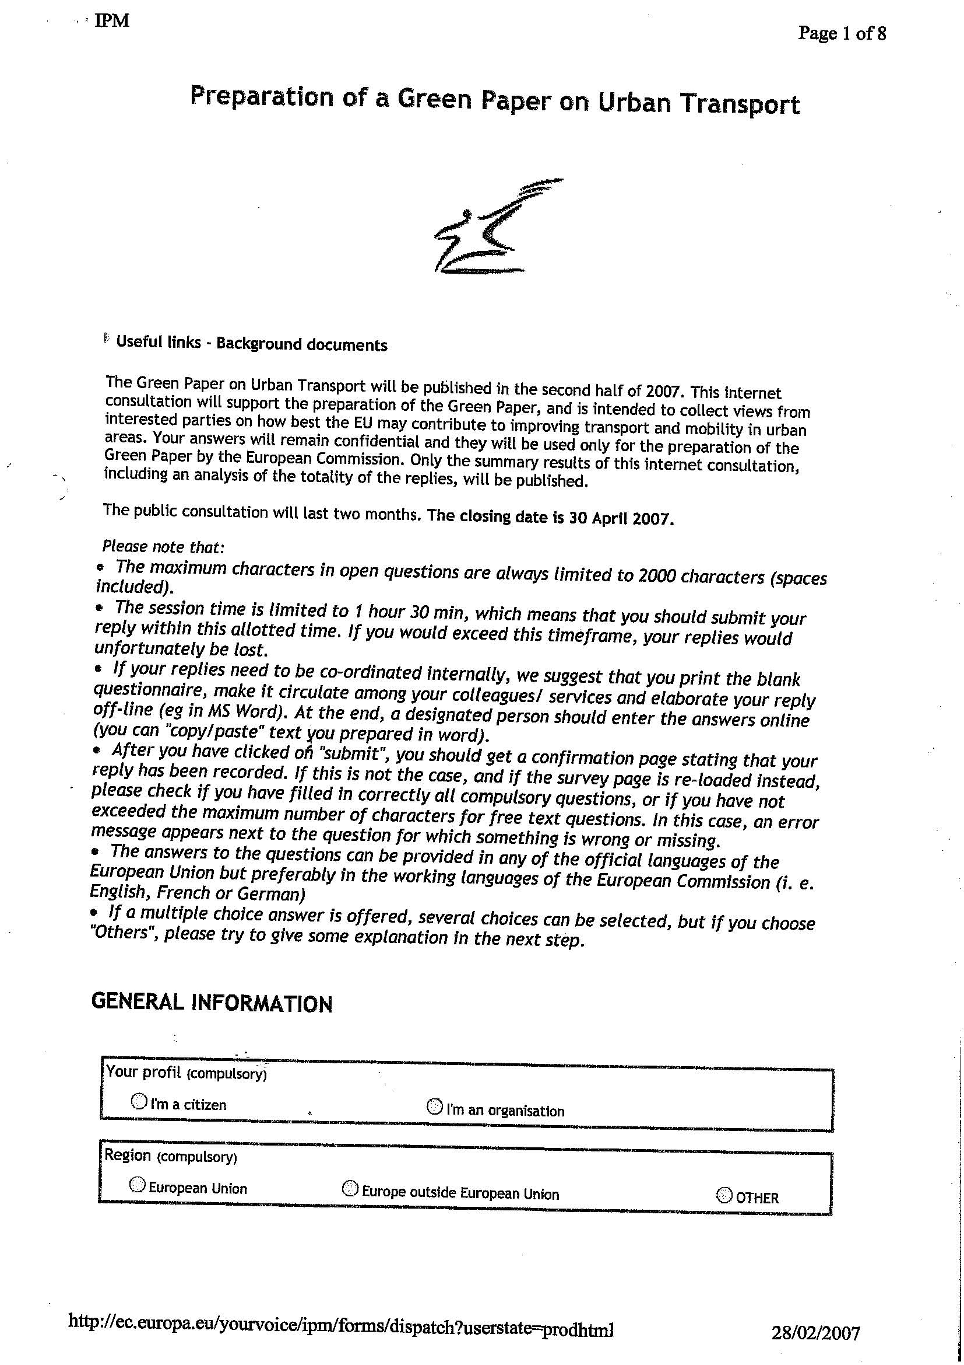
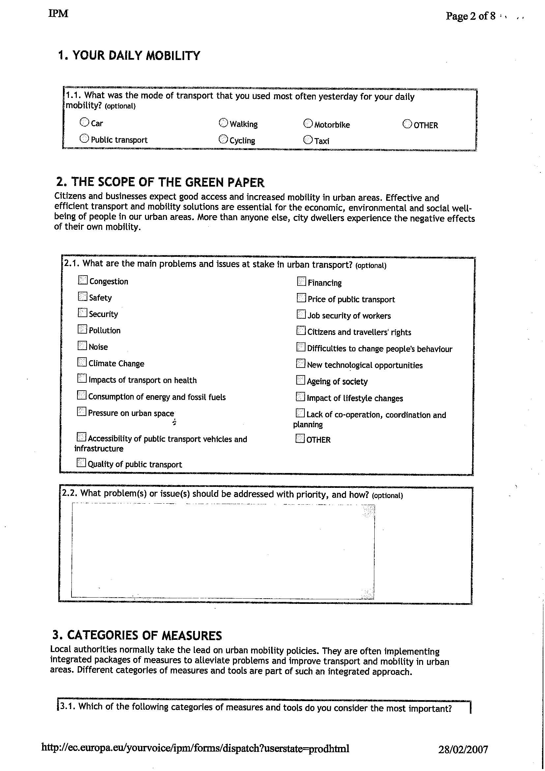
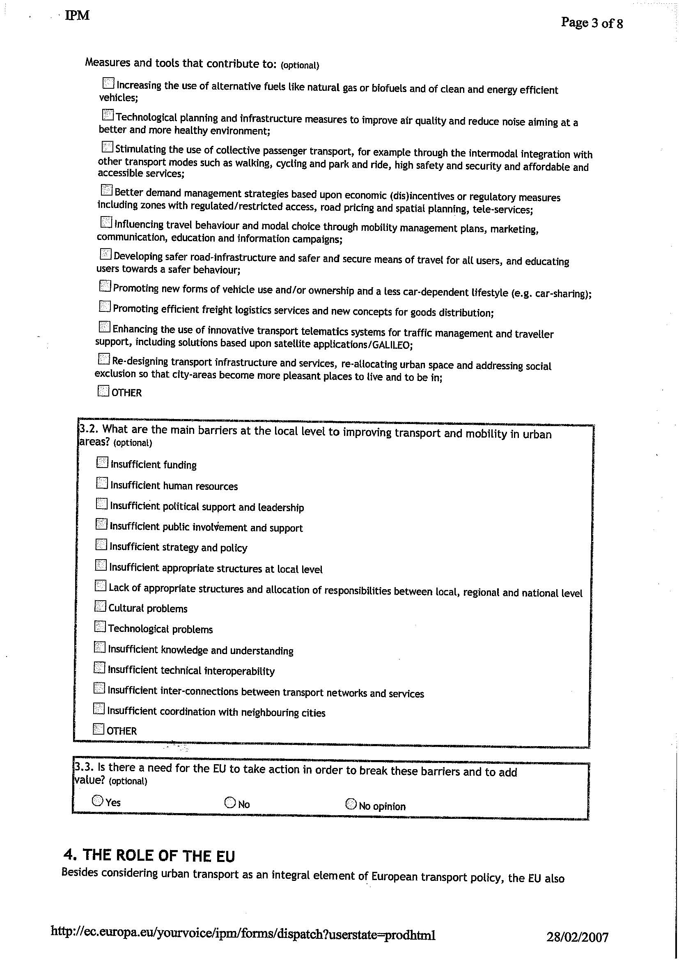
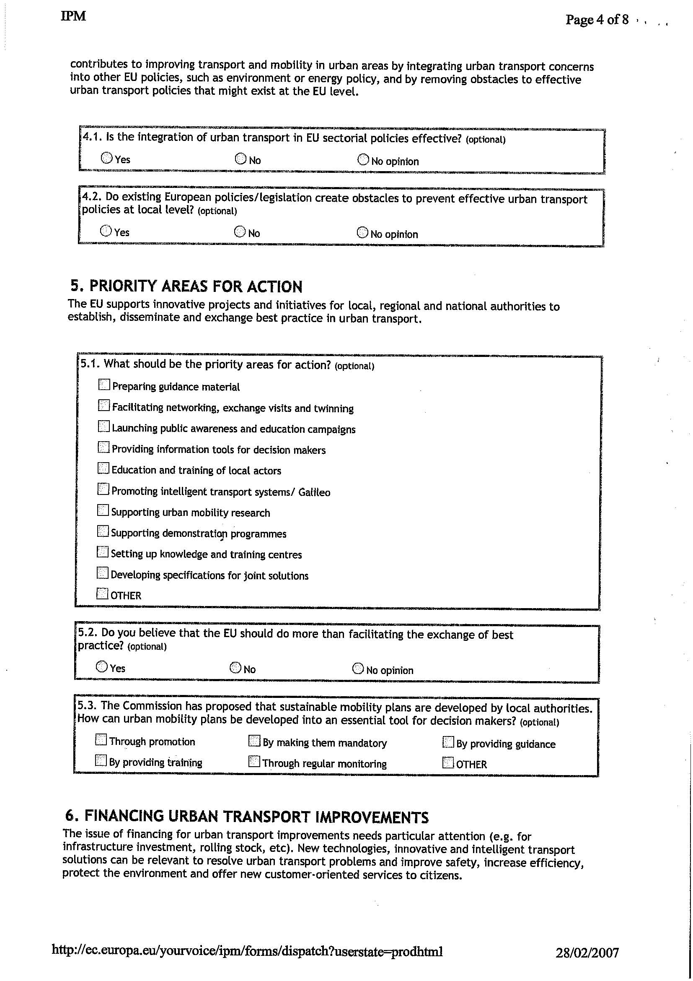
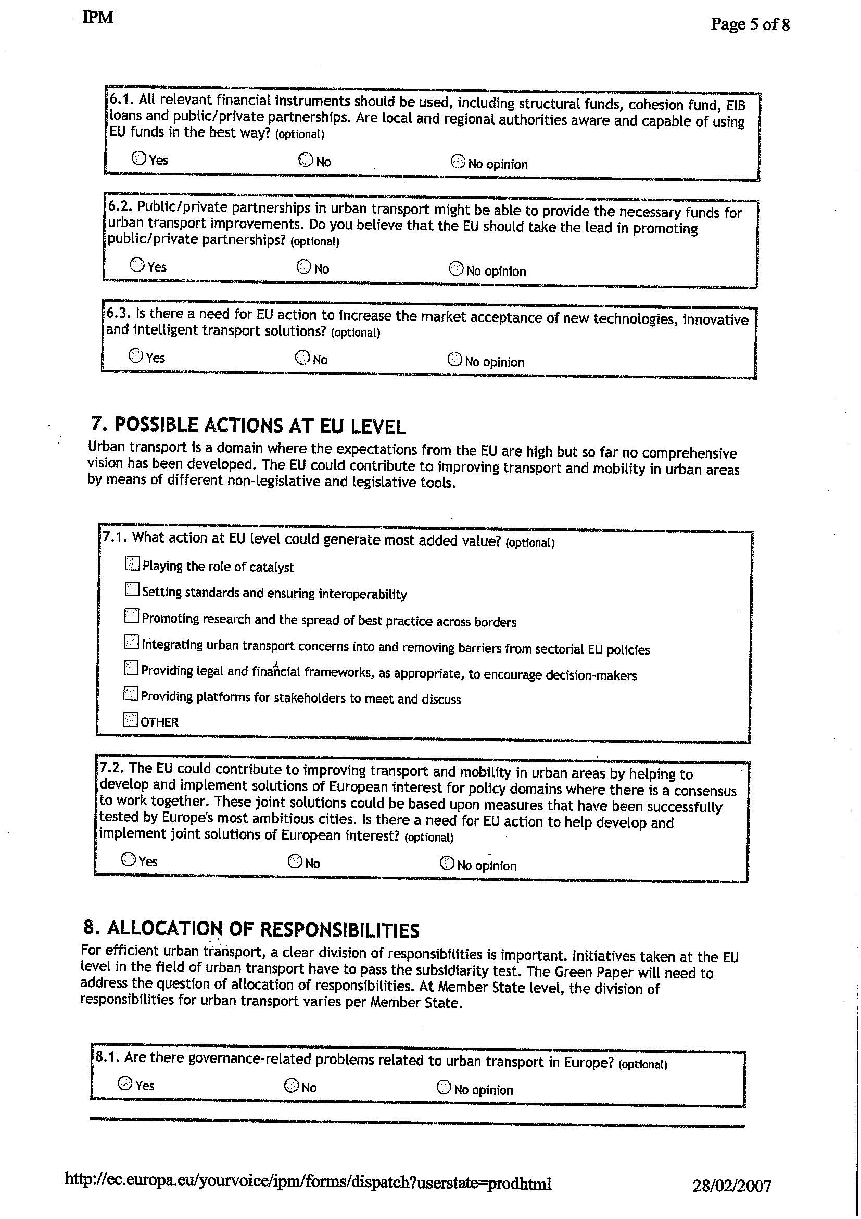
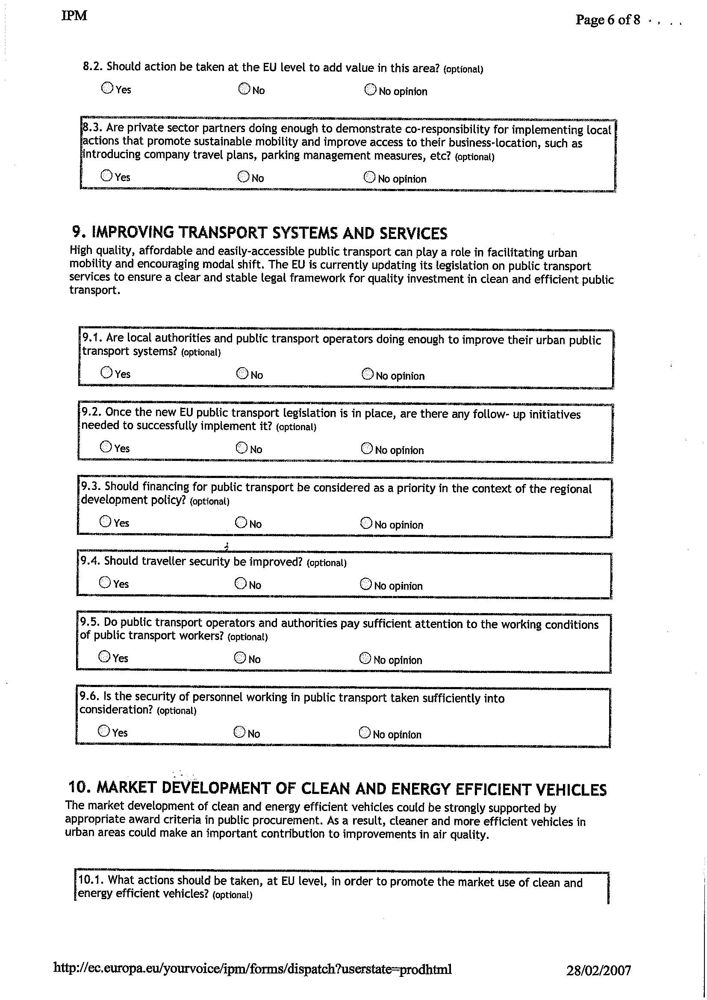
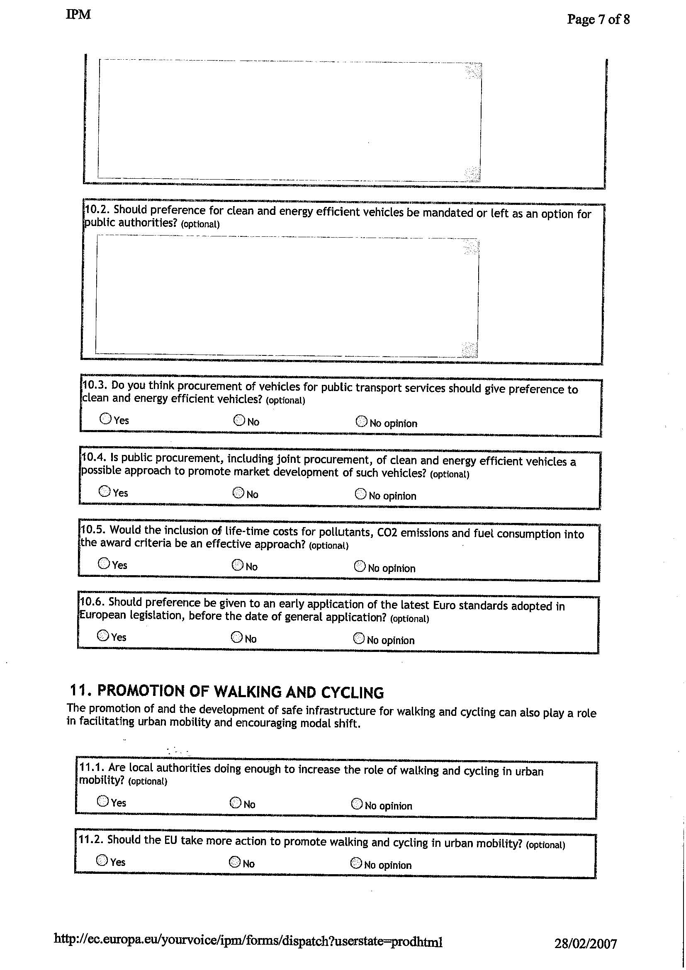
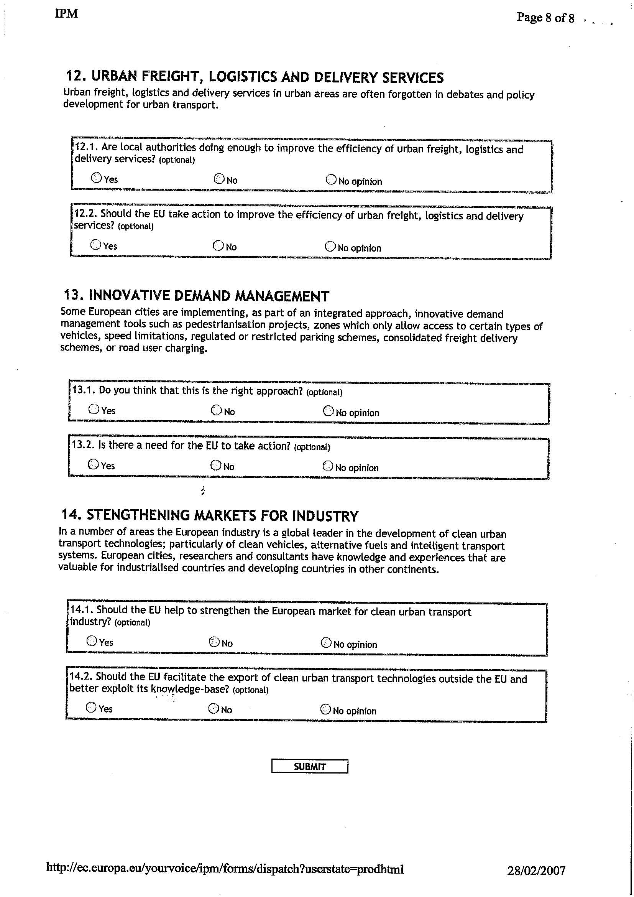
- Summary results of the Internet consultation
The European Commission launched an internet consultation to support the preparation of the Green Paper on urban mobility. As mentioned in the introduction to the questionnaire, this consultation was intended to collect views from interested parties on how best the EU may contribute to improving transport and mobility in urban areas. The consultation was open for two months, from 28 February to 30 April 2007.
Representativity of the results
The internet consultation was an open consultation to which citizens and organisations wishing to express their opinions could contribute. The results are therefore not statistically representative for the whole European population.
In total, 915 contributions were received, of which:
- 545 from private citizens
- 370 from organisations.
The geographical areas of origin of the respondents were as follows:
- European Union: 97.2%
- Europe outside EU: 2.1%
- Other: 0.8%
Detailed and extensive results are available from the consultation. The following charts show the results for a selection of the “closed” questions (i.e. those with pre-defined answers). For the questions asking for a “yes” or “no” answer, a distinction is made between the answers received from private citizens and from organisations.
  - Scope of the Green Paper
The main problems and issues at stake in urban transport for all the respondents are in order of importance: pollution, congestion, climate change, energy consumption, noise, quality of urban transport, and pressure on urban space.
N.B. Multiple answers were allowed.
  - Categories of measures
    - Main barriers
The three main barriers at local level to improving transport and mobility in urban areas are in order of importance (for all respondents): insufficient political support and leadership, insufficient strategy and policy, and insufficient funding.
N.B. Multiple answers were allowed.
    - Need for EU action
In response to the question “Is there a need for the EU to take action to solve problems of urban transport?”, a larger proportion of private citizens (76%) answered positively compared to organisations (51%).
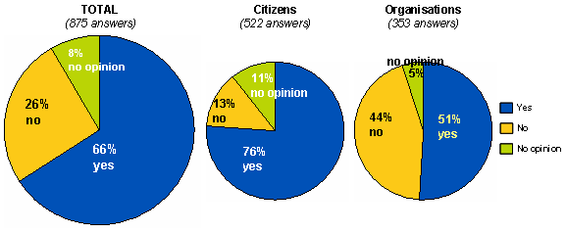
    - Some possible actions at EU level
The actions at EU level that would generate the most added value, for all respondents, are the following.
N.B. Multiple answers were allowed.
  - Allocation of responsibilities
In response to the question “Are private-sector partners doing enough to demonstrate co-responsibility for implementing local actions that promote sustainable mobility and improve access to their business location?”, a smaller proportion of private citizens (14%) answered positively compared to organisations (32%), whereas 62% of citizens and 41% of organisations gave a negative answer.
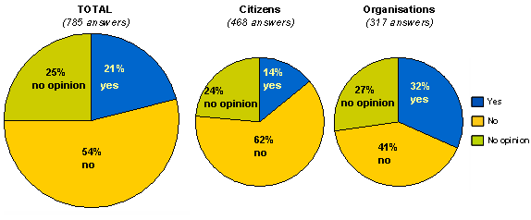
  - Improving transport systems and services
In response to the question “Are local authorities and public transport operators doing enough to improve their urban public transport systems?”, a smaller proportion of private citizens (12%) answered positively compared to organisations (34%), whereas 77% of citizens and 48% of organisations gave a negative answer.
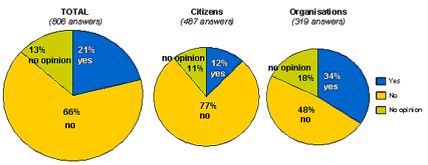
    - Public transport and regional policy
In response to the question “Should financing for public transport be considered as a priority in the context of the regional development policy?” 70% of all respondents replied “yes” with a larger proportion of citizens (74%) answering positively compared to organisations (65%).
    - Development of sustainable urban transport plans
The replies to the question “How can sustainable urban mobility plans be developed into an essential tool for decision takers?” were as follows:
  - Market development of clean and energy-efficient vehicles
    - Procurement of clean and energy-efficient vehicles
In response to the question “Do you think procurement of vehicles for public transport services should give preference to clean and energy-efficient vehicles?”, a larger proportion of private citizens (85%) answered positively compared to organisations (79%).
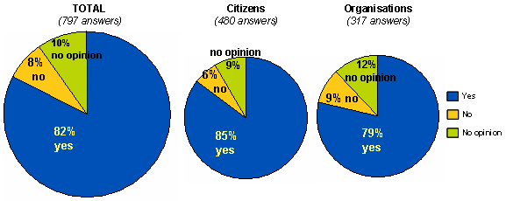
    - Public procurement of clean and energy efficient vehicles
In response to the question “Is public procurement, including joint procurement, of clean and energy-efficient vehicles a possible approach to promote market development of such vehicles?”, a slightly larger proportion of private citizens (69%) answered positively compared to organisations (66%).
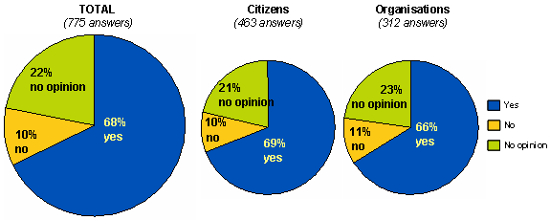
    - Inclusion of lifetime costs in the procurement of clean and energy-efficient vehicles
In response to the question “Would the inclusion of lifetime costs for pollutants, CO2 emissions and fuel consumption within the award criteria be an effective approach?”, 68% of respondents replied “yes”.
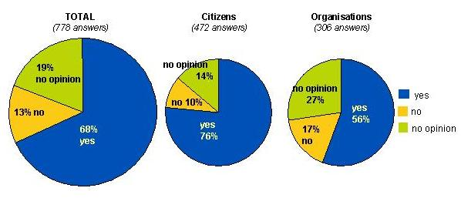
  - Promotion of walking and cycling
In response to the question “Are local authorities doing enough to increase the role of walking and cycling in urban mobility?”, a much smaller proportion of private citizens (13%) answered positively compared to organisations (36%), whereas 82% of citizens and 47% of organisations gave a negative answer.
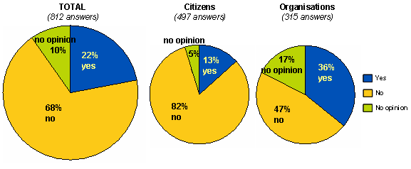
  - Urban freight, logistics and delivery services
    - Role of local authorities
In response to the question “Are local authorities doing enough to improve the efficiency of urban freight, logistics and delivery services?”, a much smaller proportion of private citizens (11%) answered positively compared to organisations (21%), whereas 64% of citizens and 54% of organisations gave a negative answer.
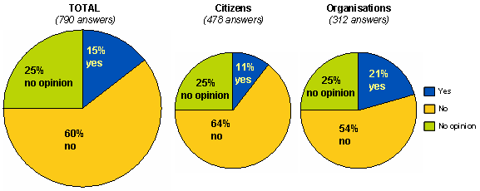
    - Role of the EU
In response to the question “Should the EU take action to improve the efficiency of urban freight, logistics and delivery services?”, a larger proportion of private citizens (59%) answered positively compared to organisations (36%), whereas only 14% of citizens gave a negative answer compared to 45% of organisations.
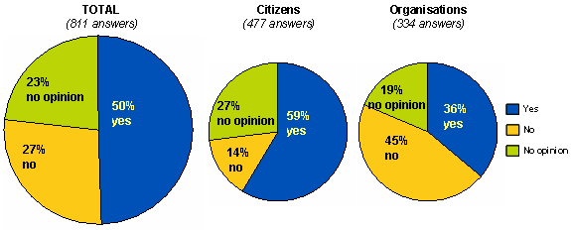
  - Innovative demand management
    - What is the right approach?
In response to the question “Is the implementation of innovative demand management tools, such as pedestrianisation projects, limited access zones, speed limitations, regulated or restricted parking schemes, consolidated freight delivery schemes or road user charging, the right approach?”, a larger proportion of private citizens (80%) answered positively compared to organisations (51%), whereas only 14% of citizens gave a negative answer compared to 40% of organisations.
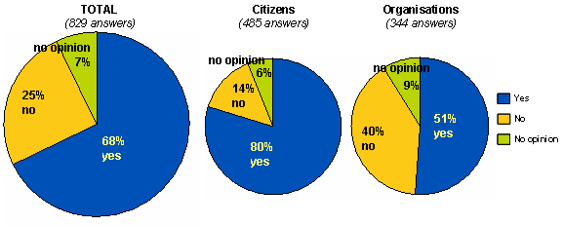
    - Role of the EU
In response to the question “Is there a need for the EU to take action?”, a larger proportion of private citizens (64%) answered positively compared to organisations (40%), whereas only 21% of citizens gave a negative answer compared to 50% of organisations.
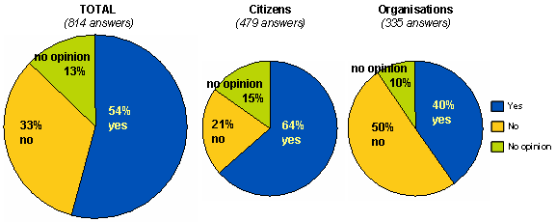
    - Action to be taken
The action that could be taken at EU level, for all respondents, includes the following.
N.B. Multiple answers were allowed.
- Internet comments on clean and energy-efficient vehicles
Question 10 of the internet consultation on the preparation for the Green Paper focused specifically on the promotion of clean and energy-efficient vehicles through public procurement and asked about possible action at EU level and a mandatory or voluntary approach.
Main comments
- Provide recommendations for best practices and guidance material, such as a comparison of lifetime costs of vehicles and the running costs of clean and energy-efficient vehicles, information tools, such as a European benchmarking website, and an awareness campaign;
- Include costs for noise, safety, and disposal of old vehicles in the procurement criteria;
- Provide a clear definition of clean vehicles;
- Promote the use of real-world test cycles instead of test-bed cycles;
- Develop EU-wide standards for retrofitting;
- Publish guidelines for the standardisation of procurement;
- Set green procurement targets for public transport services;
- Provide data and an assessment of the current composition of public-sector vehicle fleets to allow public authorities to benchmark their performance;
- Mandate reports on public procurement, including transport;
- Facilitate and promote joint procurement;
- Provide financial support;
- Clarify state aid rules to enable Member States to offer comprehensive financial incentives;
- Establish a Regulation on public procurement including environmental criteria;
- Create a carbon credit market for the automotive industry and for purchasers which rewards manufacturers and public and private customers with saleable CO₂ credits based upon the purchase and sale of low-CO₂ vehicles;
- Specify, as guidance, CO₂ and particulate emission levels so that public authorities can use these in their procurement or service contracts;
- Develop CO₂ and energy efficiency standards and incorporate them into Euro standards;
- Develop fiscal measures, such as tax on fuel, CO₂ based taxation, environmental taxes, minimum taxation standards, reduction of VAT on clean vehicles, etc.;
- Ban heavily polluting vehicles, e.g. SUVs;
- Limit the power and speed of new vehicles;
- Facilitate the creation of environmental zones and transport-related charges;
- Develop energy-efficiency standards for urban transport;
- Establish a ‘shared savings’ financial lending scheme whereby public authorities and private fleet operators would receive loans for the price differential on a non-petroleum, alternatively fuelled vehicle (non-petroleum in order to support energy security) that could be paid back by purchasing the alternative fuel at the petroleum rate until repayment is complete, when the customer (the public entity or the private transport provider acting on behalf of the public entity) would then begin paying the cheaper price of the alternative fuel;
- Enhance alternative fuel infrastructure;
- Provide support to promote eco-driving;
- Apply environmental requirements to the EU institutions and their personnel.
- Joint Expert Group on Transport and Environment
A Special Meeting of this expert group on 30 March 2007 was devoted to the preparation of the Green Paper on urban transport and a new approach to the promotion of clean and energy-efficient vehicles.
Green Paper on urban transport
The intention of the Commission to present a Green Paper on urban transport and mobility was broadly supported. The relationship between the Green Paper and the Thematic Strategy on urban environment should be made clear. The aspect of subsidiarity was considered very important, also to clarify the different responsibilities. The initiative should go beyond the exchange of best practice and support broad horizontal integration between the different sectors, cooperation between urban centres and their periphery and surrounding regions, and links to the trans-European network, in particular in view of growing urban sprawl. Added value could be created by providing a common framework for these links and opening up European funds for urban infrastructure investments.
Logistics issues should be given more attention in urban transport. Inter-compatibility of intelligent transport systems is essential in fighting congestion. Intelligent charging can be supported by GALILEO. Non-motorised transport needs to be strengthened. Planning for low-transport areas should be supported. Demographic change and the risk of social exclusion should be taken into account in infrastructure planning and urban development.
The development of technical and environmental standards would be particularly useful. Minimum quality criteria for public transport were broadly suggested. A Framework Directive on quality standards for public transport, i.e. on information for users, could be envisaged. The development of a harmonised city toll charging system would be very useful. Possible harmonised access criteria for Low Emission Zones could build on the work of the Joint Expert Group. Harmonised signposting of environmental zones would be helpful. Ticketing and signing systems, however, could also be improved through the sharing of best practice.
Promotion of clean and energy-efficient vehicles
The deployment of clean vehicles was considered very important. Public authorities should give a positive example. Their actions would have an important impact through their visibility and steering influence on a wider public, even if the direct impact was not so large.
A minimum set of harmonised technology-neutral environmental criteria should be defined for all public procurement, covering all vehicle categories. There was support for full lifetime costing of external costs in the public procurement process and for internalisation to be carried out on this basis step-by-step. No mandatory requirements should be imposed, however, and criteria selection should be left to the local public authority. The proposed standard for environmentally enhanced light-duty vehicles in the Commission Communication of February 2007 on a Community CO₂ strategy could be used in this context. Representative real-world test cycles should be used for environmental performance assessment instead of type approval cycles.
- SUMMARY OF CONTRIBUTIONS in position papers
During the preparations of the Green Paper, 64 organisations, bodies and citizens sent letters, documents and position papers to the European Commission. Their remarks included views on urban transport in general as well as specific suggestions. The main points are presented here. Where possible, contributions are grouped by:
- Public organisations (local and national authorities)
- Private organisations (industry, Chambers of Commerce)
- Transport authorities (rail, road, harbours, etc.)
- Associations, NGOs etc.
Objectives of urban mobility
Most of the contributions consider urban transport and mobility as a whole, while some highlight a particular topic, such as the importance of local crafts, urban planning or a specific mode of transport.
The vast majority of responses stressed the importance of a balanced approach to urban transport: they asked for the necessary equilibrium between economy and ecology to be considered. Some contributors (public authorities) commented on the social aspect of urban transport as well. According to several (public and private) contributors, urban mobility allows people to visit their work, friends and family and should therefore be safe, clean, fluid and accessible. It should not pose an impediment to anyone.
In all contributions, a positive effect was expected from inter-modality. Public and private organisations alike placed a lot of emphasis on strengthening the chain of modes; for instance, combining public transport modes with ‘soft’ modes such as cycling and walking in order to reduce the (solo) use of cars.
Some private organisations stressed the role of local suppliers within urban areas and suggested innovative means for carrying freight. They pointed out that inner-city (including small-scale and craft) enterprises contributed substantially to the city economy.
Another frequently mentioned theme was urban planning. The smart design of urbanisation could reduce unnecessary transport. One contribution recommended including the effects of urban planning (and changing mobility patterns) within impact assessment analyses.
Outlook, role of the EU
Almost all contributors touched upon the topic of subsidiarity. The majority stated that, although action should be taken by local authorities, they welcomed the thoughts of the European Commission on the subject of urban mobility. Some responses pointed out that this would be a logical step, following on from the views expressed by the Member States in Lisbon and recently in the Leipzig Charter.
On the other hand, a few contributors stated there was no need for detailed European-wide regulations regarding urban transport. There seemed to be differences among organisations in their views on what the exact role of the EU should be.
Frequent suggestions included the exchange of ideas and best (some also suggested: worst) practices, stimulating twinning projects, and promoting (and funding) research and development. According to some contributors, the strategy should be: decentralised where possible, European when necessary.
Many responses called for funding for sustainable urban transport. Suggestions included encouraging local authorities to have local public transport (co-)financed
- by landowners whose property value has increased
- by income from a (widely applicable) Eurovignette
- by income from road charging systems
- by eliminating (legal) uncertainties surrounding PPS so that the private financing sector will expand.
Some contributors commented on the existing European Regional Development Fund, saying that this was not sufficient to enhance sustainable urban transport, since only the poorest regions benefit. They pleaded for a dedicated fund for sustainable urban transport. Although recognising that such an earmarked fund would be difficult to obtain, a recommendation would be highly appreciated.
Some contributions also proposed not limiting the TEN-network only to long-distance infrastructure, but also providing financing for public transport across urban areas. A small proportion of the contributions (mostly NGOs and associations) linked urban transport and mobility to global policy objectives such as climate change and sustainable development.
Several local governments and transport authorities proposed an observatory for urban transport or an urban transport monitoring system as an interesting option to explore.
Collaboration between authorities was also considered to play an essential part. In addition, an Urban Mobility Platform was suggested in order to stimulate collaboration between authorities, the private sector and transport authorities. The EU should promote this idea.
Public and private organisations alike stressed the importance of bringing together different policy sectors (energy, environment, structural funds) to tackle the urban mobility challenges. Such coherent policy-making should apply at all levels: local, regional and national.
Some contributors added that the EU could help in making regulations more transparent, e.g. with regard to the legal uncertainty surrounding traffic restrictions for low-emission zones (Green Zones) or privacy in traffic control management. The EU could ensure standardisation and thus help local authorities handle complex procedures for sustainable development.
The following paragraphs summarise the main comments by topics.
- Congestion / fluidity
Many of the contributors asked for a reduction in the use of cars within conurbations. Also suggested was not only having fewer cars, but also ensuring higher occupancy. Public transport could play a role here, according to a large proportion of organisations. They recommended buses on demand, the taxi bus, or innovative car hire. Some contributions suggested that taxis could be part of the solution: taxi drivers should be educated and encouraged to drive “green” (ecologically) in clean vehicles, not only accommodating passengers but also delivering freight to the inner city. Furthermore, fiscal disincentives for car use in cities along with incentives for high-occupancy vehicle lanes were some of the suggestions received. The promotion of (mandatory) travel plans for education and work was recommended by some private organisations.
The use of bicycles in cities was mentioned by many participants (i.e. urban transport authorities, NGOs). Most contributors emphasised the green character of cycling and walking in general. They should be stimulated as part of an inter-modal approach for easily connecting modes of transport. Some technical proposals included improving the technical requirements for bicycle brake systems, mandatory helmets, etc. The use of (light) 2-wheeled motorcycles could also play a role in connecting modes, and was mentioned as an important option when space is scarce.
Freight and logistics were dealt with in a number of contributions. Some suggested dedicated lanes for delivery and collection vehicles (“bus for goods”, “bus for people”).
A transport mode hierarchy was proposed, ranging from most to least sustainable: walking; cycling; public transport; car sharing and car pooling; private car use. This priority scheme could be used in road charging systems.
- Environment (pollution, CO2, energy consumption, noise)
Contributors from public and private organisations recommended environmental/green zones, but pointed out the need for a consistent approach, such as an EU certification system. Regional authorities stressed the importance of harmonised green zones, while asking for guidance on how best to design environmental zones so as not to infringe internal market rules.
Harmonisation of the methodology for assessing environmental impact, common standards for retrofitting particle filters, and cross-border enforcement of penalties for non-compliance were also proposed.
Support for the development and procurement of environmentally friendly vehicles was proposed. These vehicles should be allowed to share public transport lanes with taxis/buses.
Some (public) contributors asked for urban transport to be included in an emissions trading scheme.
Noise is seen one of the environmental issues. Definitions of low-noise vehicles and traffic noise reduction measurements were suggested, in addition to improved tyre and vehicle technology.
- Mobility, intelligent transport
Inter-modality and co-modality were often mentioned, by public and private organisations alike. Some NGOs and organisations in the private sector stressed a balance between all modes.
Local authorities in particular emphasised the role that intelligent transport or mobility systems (ITS) should play. This should be done with an eye to interoperability and standardisation, preferably by means of an ITS platform for European cities. Comments also proposed the encouragement of teleworking, teleshopping, etc.
Many contributors commented on how information services in general could enhance urban transport systems, facilitating the (inter-)connection of different modes of (public) transport
Standardisation in general was perceived as an efficient way to improve mobility and also to develop a high-quality public transport system. Examples were a technically harmonised market for rolling stock, signalling and infrastructure complying with basic standards, as well as the harmonisation of technical requirements. Furthermore, the cross-acceptance of urban rail equipment and common homologation standards was suggested, thus allowing for a leasing market.
- Accessibility
The physical accessibility of all modes was stressed in many contributions. Stakeholders placed importance on the availability of all modes in the chain of urban transport. Particular emphasis was placed on walking and cycling. Other modes were mentioned as well, such as inland waterways and inland ports, with regard to their contribution to sustainable mobility.
Furthermore, the accessibility of the inner city was addressed in many contributions. Local authorities pointed out that people and businesses needed transport in order to keep their cities alive and economically sound. Restrictions should therefore be applied wisely.
On a side note, public transport authorities highlighted the role public transport could play in social cohesion.
Accessibility for the disabled was raised in only a few comments. Public transport authorities expressed their concern about specific participants in urban transport. In addition, a European minimum standard for passenger rights in public transport was suggested by NGOs.
- Connection with surrounding regions
Most of the contributions focused on inner cities. Some mentioned how inter-modality could play a role in connecting urban areas with their surrounding regions. For instance, connecting different public transport modes was suggested in order to improve the interaction between (regional) trains and (urban) trams for suburb–centre mobility. Private organisations called for enhancing park & ride facilities to ensure a better link between private and public transport. A link between urban transport plans and the Trans-European Networks was also proposed.
Mandatory urban transport plans involving all stakeholders were suggested by public contributors.
- Safety and security
Cross-border enforcement of traffic offences was advocated by quite a few regional authorities. They suggested the creation of a common legal framework or data sharing system, covering civil, criminal and administrative penalties.
Many public authorities underlined the importance of the safety of cyclists and pedestrians, since their major contribution to urban fluidity should be safeguarded. Amongst other things, they called for a dedicated infrastructure.
Some public transport authorities urged the Commission not to introduce a common EU approach/policy for antiterrorism and security on a mandatory basis for all public transport networks.
- Funding/financing
On the subject of finances, the Commission received many suggestions. The need for gaining a clear picture of all external costs (including safety, environmental and social impacts) was emphasised many times, by local authorities, NGOs and the private sector alike. Some asked for guidance on how to internalise the external costs of car traffic in urban areas. Regional authorities expressed their concern about higher costs and confusion for users, and stressed the importance of standards for congestion charging to avoid incompatibility.
With regard to road pricing schemes, suggestions were made (by local authorities and transport authorities) to earmark the revenue from charges (including the Eurovignette) for investment in sustainable urban transport. Suggestions also included earmarking the increase in excise duty revenue resulting from the proposed directive on professional diesel [COM (2007) 52].
Some public contributors underlined that the Eurovignette should be redesigned, applying it to all types of transport or introducing an urban dimension to it. Other recommendations, predominantly from regional authorities, included fiscal measures to stimulate green propulsion.
Most contributors, private and public organisations alike, asked for new forms of financing for urban transport. Suggestions ranged from specific regulations (such as extending the Jessica initiative to Member States not eligible for Cohesion Funding) to the launch of a European initiative for financing sustainable transport systems and infrastructures. Some contributors urged the creation of a dedicated fund at EU level exclusively for financing sustainable transport investments, while others suggested exploring EIB financing in more detail. According to some, the changed nature of structural funding is limiting the implementation of efficient urban transport policies.
The EU was asked to explore the possibility of toll “mark-ups” on motorways and across urban areas.

