EN
COMMISSION OF THE EUROPEAN COMMUNITIES
Brussels, 28.2.2007
SEC(2007) 248

COMMISSION STAFF WORKING PAPER
Annex to the
Communication from the Commission to the Council and the European Parliament
Proposal for a
EU Code of Conduct on Division of labour in Development Policy
{COM(2007) 72 final}
{SEC(2007) 249}
This Staff Working Paper is attached to the Communication "EU Code of Conduct of labour in Development Policy. It entails a set of annexes to this Communication.
ANNEX 1
EU Code of Conduct on Division of Labour in Development Policy
This Code of Conduct presents operational principles for EU donors regarding complementarity. Their aim is to enhance effectiveness by reducing the transaction costs, improving overall development results and impact for poverty reduction, through a division of labour between donors. In doing so the Code will enhance the complementarity of the EU's activities and cooperation in pursuing the development policy objectives in the context of sustainable development as set out in the EU Consensus on Development.
The Code is embedded in the principles of ownership, alignment, harmonisation and management by results of the Paris Declaration as well as the additional objectives and values highlighted by the European Consensus.
The Code is voluntary and self-policing. It is a dynamic document that establishes targets towards which EU donors will strive to work progressively and accordingly. It is generic in nature and focuses on broad guidelines. It is directed towards all EU decision-makers who may be engaged in any form of definition and implementation of development assistance.
The partner country should be responsible for coordinating donors. EU Donors will encourage the partner country to assume that responsibility while structuring themselves, in an appropriate manner as further detailed below, using – where appropriate – good existing practices as inspiration
EU donors are committed to implement the joint programming framework set out in the April 2006 Council Conclusions as a tool to advance division of labour,. A medium to long-term perspective is needed including special efforts to synchronise programming schedules based on the partner countries' national planning and budget cycles (e.g. PRSs).
EU donors will base their engagement on the below outlined principles. They have to be approached in a pragmatic and flexible manner. It is hoped that other donors will want to commit themselves to abiding by it and are invited to base their activities on similar principles as those outlined in this Code of conduct.
The European Commission will apply this code on the basis of the objectives and principles laid out in the legal framework applicable to its development and external assistance policy, namely the Development and Cooperation Instrument and the European Development Fund.
The European Commission will apply this code on the basis of the objectives and principles laid out in the legal framework applicable to its development and external assistance policy, namely the Development and Cooperation Instrument and the European Development Fund.
General principles
EU donors (The Member States and the Commission) commit themselves to further progress on complementarity and division of labour, including closer cooperation among them, in line with the following general principles:
- The primary leadership and ownership in in-country division of labour should first and foremost lie in the partner country government. If such leadership and ownership do not exist, the EU should promote such a process. In any case, the EU should always play an active role in promoting complementarity and division of labour. All initiatives need to be open for other donors, build on existing processes whenever possible, and be readily transferred to the government whenever appropriate. The EU should provide capacity building support to the partner countries to enable them to take on this responsibility
- It is crucial that the division of labour is not implemented at the expense of global aid volumes or predictability of aid flows and is carried out in collaboration with the partner countries.
- Implementation needs to be based on (i) country-level priorities and needs, (ii) a long-term perspective, as well as (iii) a pragmatic and well-sequenced approach.
- It is recognised that the EU donors share common development objectives, vision, values and principles. When limiting the involvement of Member States or the Commission in a partner country or sector, situations where all EU donors are absent from a strategic sector for poverty reduction should be avoided.
- While implementation needs to be based at field-level, political commitment and adequate support and impetus need to be made both in headquarters and in the field. It is also important to improve coordination between the field-level and the headquarters to ensure a coherent approach. This should not, however, undermine the partner country leadership and ownership. Instead, it should increase transparency and reduce the potential for corruption, and hence contribute to both to the overall effectiveness of donor aid and to good governance in the partner countries.
- Comparative advantage is not primarily based on financial resources available, but (also) on a wide range of issues such as geographic or thematic expertise. Therefore, each Member State has a role to play.
Guiding Principle 1 – Concentrate on focal sectors in country
EU donors will aim in principle at focussing their active involvement in a partner country on a maximum of two sectors, based on the following criteria:
- The partner government has formally identified the sector as a priority in its poverty reduction strategy (or equivalent). This should be done in a flexible manner, at local level and match the definition of the recipient country;
- The donor has a comparative advantage which is recognised by the government and other donors;
In addition to the two focal sectors, which should absorb the bulk of available funding, donors can provide general budget support, where conditions permit to do so, and finance activities in other areas such as support to civil society, research, or university/school co-operation. The appreciation of what constitutes a sector, being intuitive or informed, should be done in a flexible manner, at local level and match the definition of the recipient country.
A donor's comparative advantage can be determined by, inter alia, any of the following criteria:
- presence in the field,
- experience in the country, sector or context,
- trust and confidence of partner governments and other donors,
- technical expertise and specialization of the donor,
- volume of aid, at global, country or sector level,
- capacity to enter into new or forward looking policies or sectors,
- capacity to react quickly and/or long term predictability,
- efficiency of working methodologies, procedures, and quality of human resources,
- in certain exceptional circumstances the sole fact to take action.
The comparative advantage of a given donor should be self assessed, endorsed by the partner government, and recognized by other donors. The EU encourages partner countries to provide clear views on donors' comparative advantage.
The partner countries will be encouraged to identify the areas for increased or reduced support and to indicate their preferences as to which donors should remain actively involved in each sector.
EU donors will work together with the partner country to identify sectors in which to remain, and propose exits from sectors from which they shall withdraw. The creation of orphan sectors should be avoided in this process.
EU donors will aim at a long term engagement in a given focal sector (i.e. minimum of 5-7 years, or a minimum of one period of a national poverty reduction strategy)
The European Consensus defined the roles through which the Commission will aim to provide added value (paragraphs 46 to 55). Moreover, the added value in the external dimension of internal Community Policies has been recognized.
Guiding Principle 2 – Redeployement for other in-country activities
A redeployment process should be based on local negotiations and will very much depend on the situation in the country. It is recommended that headquarters offers field offices/delegations a flexible enough mandate with room for negotiation and capacity to adapt.
EU donors that are active in sectors that are no longer focal should pursue one of the following options:
- stay financially engaged in the sector through the use of delegated cooperation/partnership arrangement
- redeploy the freed-up resources into general budget support while still being engaged in developments in the non-focal sector through the structures and dialogue processes surrounding general budget support
- exit from the sector in a responsible manner while using the freed-up resources in scaling-up support for the remaining focal sectors
Responsible exit from a sector entails a well planned and managed process with the full participation of the partner country and with the change/redeployment process being well communicated to all stakeholders.
a) Sub Principle 2 a – Lead donorship arrangement
In each priority sector, donors will seek to establish a lead donorship arrangement in charge of all donor coordination in the sector. Ideally, there should be only one lead donor per sector although the lead donorship model might differ from one case to another. The important objective is to ensure that the partner country is faced with a structured donor set-up.
The lead donor(s) should be given a substantial mandate for specific aspects of sector policy dialogue and have an obligation to continuously consult other donors in the sector. In order to allow for efficient specialisation and continuity, rotation of lead donor responsibility should be limited (for example sequenced on national planning cycles if applicable). Troika models or other burden sharing arrangements could be envisaged where relevant.
b) Sub Principle 2 b – Delegated cooperation/partnership
If a given sector is considered strategic for the partner country or the donor and there is a financing gap, donors may enter into a delegated cooperation/partnership arrangement with another donor, and thereby delegate authority to the other donor to act on its behalf in terms of administration of funds and/or sector policy dialogue towards the partner government. Partner governments should be consulted on the donors' delegating agreements. Delegating donors should be enabled to review policies and procedures of the lead donor relevant to their delegating agreements. A delegated cooperation/partnership role in a sector will be considered additional to the maximum of three focal sectors in which a given donor is engaged.
Guiding Principle 3 – Ensure an adequate EU presence
When implementing sector concentration, the EU should ensure that at least one EU donor is actively involved in each strategic sector considered relevant for poverty reduction.
EU donors will furthermore seek to limit the number of active donors to a maximum of 3 per sector by 2010, based on their comparative advantage. Other donors can still take part in sector activities by means of delegated cooperation modalities.
Guiding Principle 4 – Replicate practices in the cooperation with partner regional institutions
Taking into account the increasing/scaling up of aid volumes and activities at regional level, the EU donors will apply the above principles of in-country division of labour also in their work with partner regional institutions.
Guiding Principle 5 – Establish priority countries
EU donors commit to reinforcing the geographical focus of their assistance to avoid spreading their resources too thinly. They will strive to establish limited number of priority countries, aiming at an adequate balance between number of partner countries and aid allocations.
This process will be informed by a dialogue within the EU, take into account the broader donor engagement, and be carried out in dialogue with partner countries. Decisions should be based on:
- transparent information on EU donors' activities and plans;
- self-assessments conducted by each donor and incorporating comparative benchmarks;
- regular EU-wide consultations when Member States modify their list of priority countries;
In non-priority countries, EU donors will provide their support inter alia through delegated cooperation arrangements or by redeploying on the basis of responsible exit strategies prepared with the partner country. EU donors will share information on good practices.
The European Consensus recognises its global presence as an added value for the EC (paragraph 48). Therefore Community assistance will remain universal
Guiding Principle 6 – Address the "orphans" gap
Committed to address the current discrepancies in resources provided to different partner countries and to avoiding the creation of new imbalances, EU donors will strive to dedicate part of their aid budget to "under funded" or neglected countries. These are often 'fragile states' whose stabilisation has a positive spill-over effect for the wider region.
This should be done in line with the ongoing initiatives on fragile states and good practices being developed within the OECD/DAC in dialogue with other donors and relevant international bodies.
Guiding Principle 7 – Analyse and expand global areas of strength
EU donors will deepen the self-assessment of their comparative advantages as regards their preferred sectors and modalities. They should identify those in which they would like to expand, as well as those where they might be willing to reduce their own activities.
The Commission will further develop its expertise and capacities in the areas where it has comparative advantages, paying particular attention to building the necessary capacity and expertise at the country level.
On this basis, EU donors should move towards more specialisation while maintaining, in a coordinated way, the diversity of expertise for the EU as a whole.
Guiding principle 8 – Pursue progress on other dimensions of complementarity
EU donors commit themselves to advancing on the other dimensions of complementarity as follows:
- On vertical complementarity, primarily in the context of relevant international fora and ongoing discussion on the rationalisation of the international aid architecture
- On cross-modality and instruments, in the context of specific partnership and the implementation of joint/coordinated programs
Guiding Principle 9 – Promote jointly the division of labour
In order to clarify purpose, modalities and outcome of division of labour, and achieve greater impact of the EU's collective contribution in a particular sector/country, EU donors will increasingly rely on joint statements:
- for information of their domestic audiences,
- for advancing the agenda within the international fora and in partner countries
Guiding Principle 10 – Deepen the reforms
EU donors recognize that division of labour between individual donors becomes coherent only through a collective approach on redeployment of financial and human resources - which will imply real structural changes, reforms and staffing consequences.
EU donors will therefore consider implications of a division of labour on resources (including staff) and strive to reach complementarity arrangements also regarding staffing. In order to achieve optimal use of resources at both headquarters and the field, close collaboration amongst all donors needs to be promoted.
ANNEX 2
Definition of comparative advantage and added value
A donor's comparative advantage can be determined by:
- its added value,
- where it relatively performs the best - without necessarily having an absolute advantage,
- where it performs the best - amongst all of its activities -, including in terms of results and impact on poverty eradication,
- where it has a lower cost compared to other donors.
A donor's added value can be determined by any combination of the following criteria:
- presence in the field,
- experience in the country, sector or context,
- possession of technical expertise and specialization of the donor,
- volume of aid, at global, country or sector level,
- trust and confidence of partner governments and other donors,
- capacity to enter into new or forward looking policies or sectors,
- capacity to react quickly and/or long term predictability,
- efficiency of working methodologies, procedures, and quality of human resources,
- in certain exceptional circumstances the sole fact to take action.
Ideally, the comparative advantage of a given donor should be:
- self assessed,
- endorsed by the partner government,
- recognized by other donors and non state actors.
ANNEX 3
Good Practices on division of labour
Successful cases exist in each of the five dimensions of complementarity highlighted by the attached communication (i.e. the in-country, cross-country complementarity, cross-sector, vertical and cross modality/instrument dimensions of complementarity).
Sector concentration
Some EU donors have already adopted policies to limit the number of sectors in which they are active, however such policies vary considerably. In Zambia, a division of labour exercise preceded a donor wide formulation of a joint assistance strategy.
The division of labour matrix in Zambia in Annex 3 shows that EU donors today remain active in a maximum of 3 to 6 sectors (excluding general budget support). Most donors are committing to reducing the number of sectors in which they are active, and/or have announced plans for phasing out. Sweden for example has scaled down its active involvement from 6 to 3 sectors. However, the same Zambia donor matrix shows that there is still room for further improvements - even for donors which have already defined a maximum number of sectors.
The European Commission Country Strategy Papers, as launched in 2001 and revised in 2005 define the strategic programming of the Commission's aid allocation for all developing countries. . The concentration of activities and financial assistance on two sectors is a key principle of these Strategy Papers and has greatly increased the focus and efficiency of the Commission's cooperation.
Comparative advantage
In the context of the Zambian harmonisation process which started in 2003, each donor had by 2005 gone through a voluntary self-assessment exercise evaluating its own comparative advantage(s).
Based on mutual recognition of each others' comparative advantages, including that of the partner Government (Ministry of Finance), each respective donor had by 2006 been assigned to different sectors. On the basis of this sector designation, donors have since then taken concrete steps toward decongestion of donor sector presence.
Sector decongestion
Donors have launched in Tanzania an interesting process of sector decongestion. As it can be seen in the Donor Matrix in Annex 6, progress has been slow in reducing the number of donors/actors per sector in the ongoing division of labour exercise. Very few donors are phasing out from sectors, and there are still a large number of donors in many sectors - maintaining high transaction costs for policy dialogue and coordination meetings.
For example, 17 donors remain active in the sectors of Health and Education, as well as 21 in the area of Governance (of which 7 are from the EU). Nevertheless, some improvements have been noted in the Natural resources, environment and tourism sector, where the number of EU donors has been reduced to four (primarily due to the withdrawal of Sweden and Germany).
Lead donor arrangement
In Uganda, Austria has been active in the Water & Sanitation (W&S) sector since 1996 and in 2005 it dedicated nearly one third of its total ODA to the country to this sector. Within the context of the harmonisation process context in Uganda, Austria has since autumn 2006 become a lead donor in the sector of Water and Sanitation (W&S).
Austria was chosen as a leader by the other donors on the basis of a dialogue as well as various selection criteria such as: (i) credibility and historical record, (ii) staffing and capacity, (iii) decentralisation-headquarter relations, (iv) financing and system alignment. This decision was later endorsed by the partner country.
Austria has been given this lead role on a one to two years rotational basis, and is assisted by a deputy lead donor. Its lead donor functions are quite extensive: (i) in charge of facilitating policy and political dialogue with the government, (ii) supporting joint reviews and sector performance monitoring,(iii) acting on specific issues or processes as requested by the other active donors in the sector, and finally (iv) for general information sharing, communication and coordination.
The European Neighborhood & Partnership Policy (ENP) aims to build a privileged partnership with neighboring countries, using appropriate - including development – instruments to promote effective management & implementation. Therefore, as indicated in Article 62 of the European Consensus, the ENP policy and the relevant financing Instrument contain specific arrangements for programming of EU support at overall, country & regional levels, for political & sector dialogues, for the mobilization of particular strengths of the Member States (i.e. through Twinning programs) and for coordination by the Commission.
Delegated cooperation/partnership
There are many cases of delegated cooperation between EU donors.
- In South Africa, UK/DFID has delegated the implementation of its support to land reform to Belgium
- In Rwanda, Sweden has delegated the monitoring and auditing of funds in support to the education sector to the UK/DFID which is providing general budget support.
- In Malawi, Sweden has delegated its entire country program to Norway.This means that Norway plans and manages the country program together with the government of Malawi, while Sweden contributes money and expertise. In response, Norway has delegated the management of its country program in Mali to Sweden.
Ensure an adequate presence
The Nordic Plus donors (Denmark, Finland, Norway, Sweden, Ireland, Netherlands and UK) adopted "complementarity principles" that should guide their participation in the division of labour exercises in Tanzania, Zambia and Uganda. They committed to focus on a maximum of three sectors (following the sector definition of the partner country) in a given partner country - plus general budget support and support to civil society.
In this context, they included the commitment that: "The Nordic plus donors will seek to be represented in all strategic sectors - as defined by the partner government - by a minimum of one, and a maximum of three donors".
Reduce the number of priority countries
Most of EU donors have started a process of reducing their list of priority countries. As an example, the Netherlands has gone through a drastic reduction in the number of core/priority countries (from over 70 to some 20 priority countries), by broadly speaking using three selection criteria: (i) poverty level, (ii) macroeconomic performance and (iii) good governance performance. This reduction in priority country was accompanied by a process to reduce the number of sectors – in larger partner countries maximum 3 sectors, and in smaller partner countries to maximum 2 sectors. It is worth noting, however, that in addition to the above-mentioned 20 plus priority countries, the Netherlands still had another 20 plus "sector countries" through which it could channel aid.
Address the "orphans" gap
The Fast Track Initiative on Education is assisting low income countries - with sound policies, but insufficient resources - reach the Millennium Development Goal (MDG) on education. One of its instruments, the Catalytic Fund, is dedicated to achieve the financial gap for countries with too few donors identified according to pragmatic criteria. A donor "orphan" in education sector is defined as: a country with less than five or fewer bilateral donors, contributing at least US$ 1 millions in that sector.
European Community Humantiarian Office's (ECHO) aid strategy strongly focuses on forgotten crises. In 2002, ECHO has set as a target to channel 10% of its funds to forgotten crises. Today this target has been largely achieved. Already in the course of the year 2004 support totaling €239 million was allocated to forgotten crises (i.e. 42% of total funds). ECHO has defined an analysis and methodology for identifying forgotten crises based on both quantitative data (lack of media coverage or low donor support combined with high needs) and qualitative factors (field assessment by DG ECHO experts and desk officers). For 2006, ECHO has classified the following as forgotten crises: Chechnya, Myanmar, the Saharawi refugees in Algeria, Nepal and, to a lesser degree, India for the crisis in Kashmir.
Analyse and expand areas of strength at agency level
In line with the idea that increased focus on a limited number of (sub-)sectors leads to improve effectiveness, Slovenia has decided to concentrate its development assistance in almost all countries on a limited number of sectors in which it has demonstrated abilities and advantages. For example, it has taken an active involvement and has strengthen its assistance on the protection and treatment of vulnerable children in areas which have been affected by armed conflicts, natural disasters or technical accidents, and by the unfavourable social consequences they bring. Slovenia has since February 2002 developed activities and programmes intended to improve the well-being of children in the regions of South-Eastern Europe, Iraq, and North Caucasus.
ANNEX 4
Zambia Donor Matrix
The division of Labour Matrix has many similarities with CDF matrices contained in country strategy papers of many donors (i.e. European Commission), with the differences being that it provides for a an agreed picture of future activities and specific roles of all donor partners.
ANNEX 5
Uganda Donor Matrix
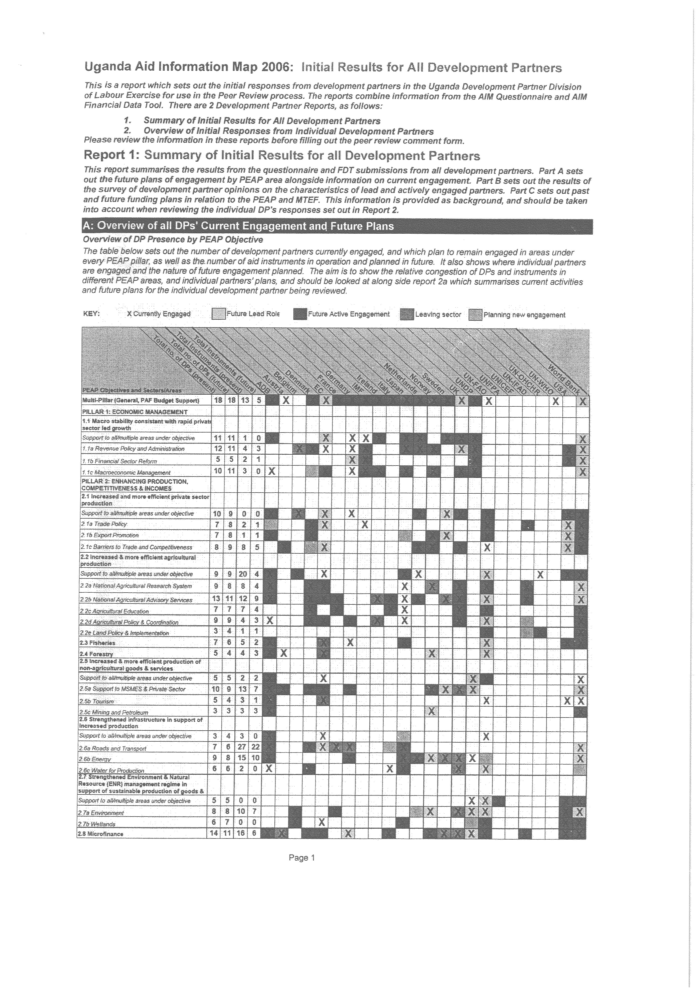
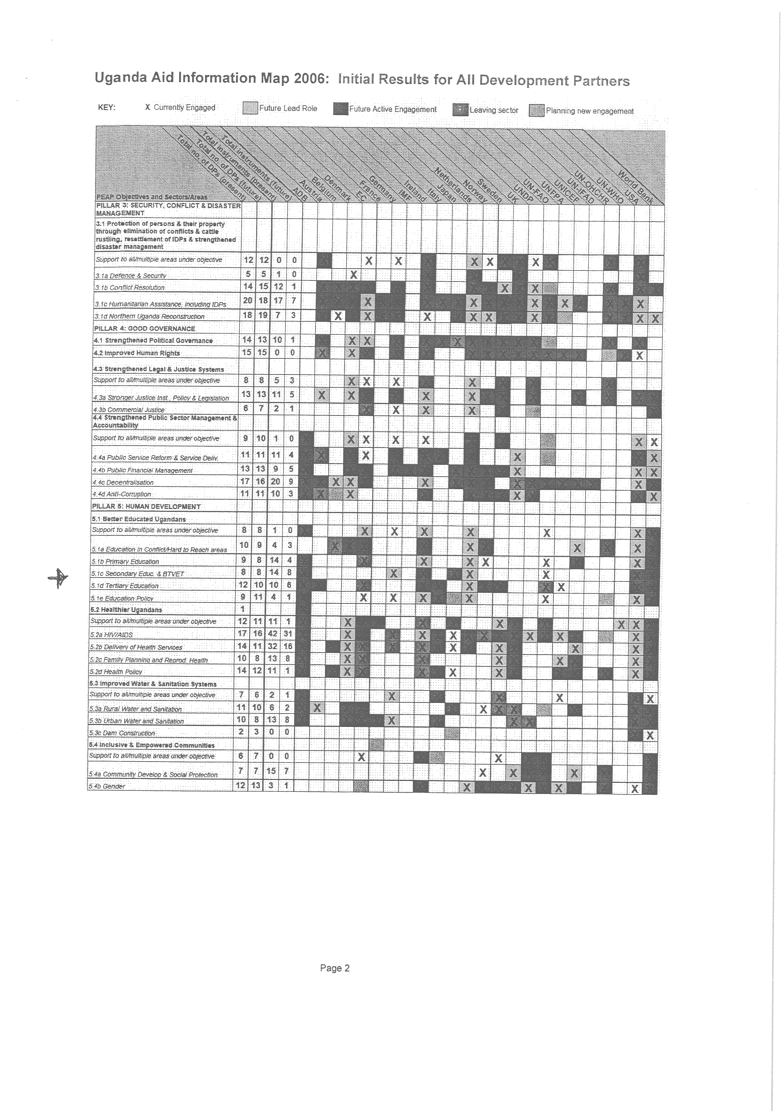
ANNEX 6
Tanzania Donor Matrix
ANNEX 7
Pharmaceutical pathways in Kenya
ANNEX 8
EU Donor Atlas- Geographical Concentration of EU aid

With EU Donors are understood here all those EU members considered donors in the OECD/DAC context (i.e. at Member States level).
Conclusions of the GAERC of October 2006.
Text in line with paragraph 70 of European Consensus on Development.

